INSILICO IDENTIFICATION OF ANTIVIRAL BIO ACTIVE COMPOUNDS IN Phyllantus amarus
BY
ABDULLAHI AMIR ISHOLA
ND/23/SLT/PT/0909

A PROJECT SUBMITTED TO THE DEPARTMENT OF SCIENCE LABORATORY TECHNOLOGY, INSTITUTE OF APPLIED SCIENCES (IAS),
KWARA STATE POLYTECHNIC, ILORIN,
IN PARTIAL FULFILMENT OF THE REQUIREMENTS FOR THE AWARD OF NATIONAL DIPLOMA (ND) DEGREE IN SCIENCE LABORATORY TECHNOLOGY,INSTITUTE OF APPLIED SCIENCES (IAS),MICROBIOLOGY UNIT.KWARA STATE POLYTECHNIC ILORIN

JULY,2025.

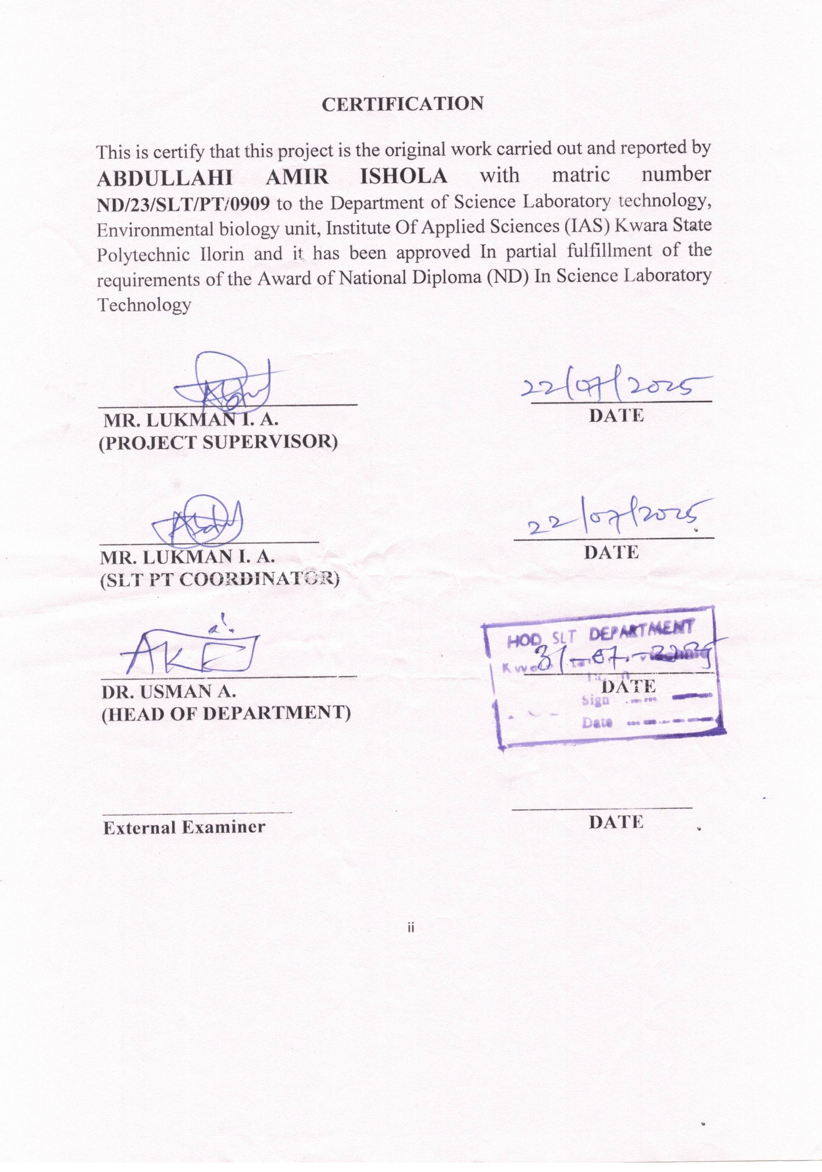
DEDICATION
This research work dedicated to the God almighty

ACKNOWLEDGEMENT
All praise, glorification, adoration, adulation, exaltation and gratitude are all due to GOD,the most powerful for bestowing this strength and knowledge in me through ND program and making it possible for me to start and complete this course successfully despite odds of the world. I joyfully appreciate my parents, Mr. & Mrs. Abdullahi , and all my families for their immense support throughout my stay in ND. They have been there for me in financial and moral capacity. May God almighty bless you both with long life and sound health to reap the fruit of your labour. My profound gratitude and appreciation go to my dynamic supervisor (MR. LUKMAN I.A) for their moral and social support. God will continue to bless you, sir. Also, i commend and appreciate my coordinator (MR. LUKMAN I.A) and my honourable HOD(DR. USMAN A.) for their immeasurable support
My sincere appreciation goes to my siblings. Thank you for all the financial support.
TABLE OF CONTENTS
TITLE PAGE i
CERTIFICATION ii
DEDICATION iii
ACKNOWLEDGEMENTS iv
TABLE OF CONTENTS v-vi
LIST OF TABLES vii
LIST OF FIGURES viii
ABSTRACT ix
CHAPTER ONE 1
1.0 INTRODUCTION 1
1.1 Statement of Problem 4
1.2 Aims 5
1.3 Objectives 5
CHAPTER TWO 7
2.0 LITERATURE REVIEW 7
2.1 Medicinal Plants 7
2.2 Taxonomical Classification of Phyllanthus amarus 7
2.3 Botanical Description of Phyllanthus amarus 8
2.4 Medicinal Importance of Phyllanthus amarus 9
2.4.1 Antibiotic Effect 9
2.4.2 Antiviral Effect 10
2.5 Free Radicals 11
CHAPTER THREE 12
3.0 MATERIAL AND METHODS 12
3.1 Materials 12
3.2 Grinding and Extraction of Phyllanthus amarus 12
3.3. Antioxidant Assay 13
3.3.1 Free radical scavenging activity (2,2-diphenyl-1-picrylhydrazyl) 13
3.3.2 Hydroxyl radical (OH.) scavenging assay. OH 13
3.3.3 Nitric oxide scavenging activity 14
3.3.4 Hydrogen peroxide radical scavenging activity 14
3.3.5 FRAP Assay 15
3.3.6 ABTS Radical Cation Decolorization Assay 15
3.3.7 DPPH (2, 2-Diphenyl 1-2 picrylhydrazyl) Assay 16
3.3.8 HPLC Analysis of Ethanolic Phyllanthus amarus Extract 17
3.4 Phytochemical Screening 17
3.4.1 Total flavonoid assay 17
3.4.2 Saponins 17
3.4.3 Tannins 18
3.4.4 Glycosides 19
3.4.6 Hydrogen peroxide scavenging (H2O2) assay 21
CHAPTER FOUR 22
4.0 RESULT PRESENTATION 22
4.1 Phytochemical Analysis 22
4.1.1 Qualitative analysis Phyllanthus amarus Extract 23
CHAPTER FIVE 34
5.0 DISCUSSION AND CONCLUSION 34
5.1 DISCUSSION 34
5.2 Summary 38
5.3 Conclusion 38
REFERENCES 40

LIST OF TABLES
Table 1: Show the result of qualitative analysis Phyllanthus amarus Extract ………..………………………………………………………..…………..….22
Table 2: SAPONIN RESULT USING UV SPECTROPHOTOMETER……..23
Table 3: TANNIN RESULT USING UV SPECTROPHOTOMETER……....23
Table 4: FLAVONOID RESULT USING UV SPECTROPHOTOMETER….24
Table 5: This result show the amount of phytochemical in Phyllanthus amarus Extract……………………………………………………………………………24
Table 6: Identified Compounds………………………………………………...25
LIST OF FIGURES
Fig.1 HPLC Chromatogram of Ethanolic Phyllanthus amarus Extract…………..25
Fig. 2 Human Nucleoside diphosphate Kinase(3FKB)…………………………..26
Fig. 3 LF3 CaM Adenylyl Cyclase(1PK0)……………………………………….27
Table 5: LF3 CaM Adenylyl Cyclase (1PK0)…………………………………….27
Fig. 4 3FKB- Adefovir diphosphate………………………………………………28
Fig. 5 3FKB- Corilagin……………………………………………………………29
Fig. 6 3FKB- Tenofovir diphosphate……………………………………………..30
Fig. 9 1PKO- Tenofovir diphosphate……………………………………………..33

ABSTRACT
The search for effective antiviral agents from natural sources has gained significant momentum due to the rising incidence of viral infections and resistance to conventional drugs. This study investigated the antiviral potential of bioactive compounds present in Phyllanthus amarus using in silico approaches. Phytochemical screening revealed the presence of saponins, tannins, alkaloids, and flavonoids, with tannins occurring in the highest concentration (1.07 mg/g). High-Performance Liquid Chromatography (HPLC) analysis identified several bioactive compounds including corilagin, gallic acid, ellagic acid, quercetin, phyllanthin, and hypophyllanthin, with corilagin showing the highest peak intensity.
Molecular docking studies were conducted using two viral protein targets: human nucleoside diphosphate kinase (3FKB) and LF3 calmodulin-regulated adenylyl cyclase (1PK0). Corilagin demonstrated strong binding affinity to both targets (−12.496 and −9.628 kcal/mol respectively), comparable to standard antiviral agents like tenofovir and adefovir diphosphates. Other compounds such as quercetin and gallic acid exhibited moderate affinity, while lignans such as phyllanthin and hypophyllanthin showed lower binding potential.
These findings suggest that Phyllanthus amarus, particularly its corilagin content, harbors promising antiviral properties. The study supports further investigation into its pharmacological applications and the development of plant-based antiviral therapies

CHAPTER ONE

1.0 INTRODUCTION
The emergence of viral infections as significant global health threats has necessitated the search for effective antiviral compounds. Traditional medicinal plants have long been a valuable source of bioactive molecules with therapeutic potential. Phyllanthus amarus, a well-known medicinal plant, has gained considerable attention for its diverse pharmacological properties, including antiviral, antibacterial, hepatoprotective, and antioxidant activities. Recent advances in computational biology and bioinformatics have paved the way for in silico techniques to identify and evaluate potential antiviral bioactive compounds from natural sources, thereby accelerating the drug discovery process (Hiremath et al., 2021).
In silico approaches, including molecular docking, molecular dynamics simulations, and ADMET (Absorption, Distribution, Metabolism, Excretion, and Toxicity) profiling, provide cost-effective and time-efficient methods for screening potential drug candidates. These computational methods allow researchers to predict the binding affinity of plant-derived compounds to viral proteins, assess their stability within biological systems, and determine their pharmacokinetic properties. By leveraging in silico tools, researchers can identify promising antiviral compounds from Phyllanthus amarus before proceeding to in vitro and in vivo validation studies (Upadhyay and Tiwari, 2023).
Phyllanthus amarus belongs to the family Phyllanthaceae and is widely distributed across tropical and subtropical regions. It has been traditionally used in herbal medicine to treat liver disorders, kidney diseases, and viral infections, particularly hepatitis B. Phytochemical analyses have revealed that Phyllanthus amarus is rich in bioactive compounds such as flavonoids, alkaloids, tannins, lignans, and polyphenols, many of which have demonstrated antiviral properties against a range of viruses, including hepatitis B virus (HBV), hepatitis C virus (HCV), human immunodeficiency virus (HIV), and dengue virus (Díaz-Herrera et al., 2024).
The antiviral activity of Phyllanthus amarus has been attributed to its ability to interfere with viral replication, inhibit viral entry, and modulate host immune responses. Several bioactive compounds from this plant, including phyllanthin, hypophyllanthin, and corilagin, have been reported to exhibit potent antiviral effects. However, the identification of novel antiviral compounds and the elucidation of their precise mechanisms of action require further investigation. In silico techniques offer an innovative approach to explore the antiviral potential of Phyllanthus amarus by predicting the interactions of its bioactive compounds with viral targets at the molecular level (Ghosh et al., 2022).
One of the key advantages of in silico screening is the ability to analyze a large number of compounds within a short period. This approach significantly reduces the need for extensive laboratory testing, thereby minimizing the costs associated with traditional drug discovery. Furthermore, computational studies enable the identification of drug-like properties of bioactive compounds, ensuring their suitability for further development as antiviral agents. By utilizing molecular docking studies, researchers can predict the binding affinities of Phyllanthus amarus compounds to key viral enzymes, such as proteases, polymerases, and structural proteins, which play crucial roles in viral replication and pathogenesis (Upadhyay and Tiwari, 2023).
Additionally, molecular dynamics simulations provide insights into the stability and conformational behavior of ligand-protein complexes, further validating the efficacy of identified antiviral compounds. ADMET analysis helps in predicting the pharmacokinetic and toxicological properties of these compounds, ensuring their safety and effectiveness as potential therapeutic agents. Through these advanced computational techniques, researchers can prioritize the most promising bioactive compounds for experimental validation, thereby streamlining the antiviral drug discovery pipeline (Ghosh et al., 2022).
The integration of ethnobotanical knowledge, phytochemical profiling, and in silico analysis represents a powerful strategy for identifying antiviral drug candidates from Phyllanthus amarus. As viral diseases continue to pose significant public health challenges, the exploration of medicinal plants as potential sources of antiviral agents holds great promise. By harnessing the capabilities of computational drug discovery, researchers can unlock new therapeutic possibilities and contribute to the development of novel antiviral medications derived from natural sources (Díaz-Herrera et al., 2024).
This study aims to utilize in silico methods to identify and evaluate the antiviral potential of bioactive compounds present in Phyllanthus amarus. By employing molecular docking, molecular dynamics simulations, and ADMET profiling, this research seeks to highlight promising antiviral candidates that may serve as leads for future drug development. The findings from this study could provide valuable insights into the potential of Phyllanthus amarus as a natural source of antiviral agents and contribute to the advancement of phytomedicine in combating viral infections (Adedotun et al., 2022).

1.1 Statement of Problem
- The increasing prevalence of viral infections and the emergence of drug-resistant viral strains necessitate the urgent discovery of new antiviral agents from natural sources like Phyllanthus amarus.
- Traditional experimental methods for drug discovery are time-consuming, expensive, and require extensive laboratory testing, highlighting the need for efficient in silico approaches to identify potential antiviral compounds.
- Despite its extensive use in traditional medicine, the specific antiviral bioactive compounds in Phyllanthus amarus and their molecular mechanisms of action remain largely unexplored.
- There is a lack of comprehensive computational studies that systematically screen and validate the antiviral potential of Phyllanthus amarus compounds against key viral targets.
- Predicting the pharmacokinetics, toxicity, and drug-likeness of Phyllanthus amarus bioactive compounds is essential to determine their suitability for further development as antiviral therapeutics.

1.2 Aims
- The aim of this study is to utilize in silico approaches to identify and evaluate potential antiviral bioactive compounds in Phyllanthus amarus for drug discovery and development.

1.3 Objectives
- To screen and identify potential antiviral bioactive compounds in Phyllanthus amarus using in silico techniques.
- To evaluate the binding affinity of Phyllanthus amarus compounds to key viral proteins through molecular docking studies.
- To analyze the stability and interaction dynamics of ligand-protein complexes using molecular dynamics simulations.
- To predict the pharmacokinetic properties (ADMET) and drug-likeness of identified bioactive compounds for antiviral activity.
- To provide computational insights that support further experimental validation and drug development from Phyllanthus amarus.

CHAPTER TWO

2.0 LITERATURE REVIEW

2.1 Medicinal Plants
Medicinal plants have been widely utilized for centuries as sources of therapeutic agents in traditional and modern medicine. According to the World Health Organization (WHO), approximately 80% of the global population relies on medicinal plants for primary healthcare (WHO, 2019). These plants contain bioactive compounds such as alkaloids, flavonoids, tannins, and saponins, which contribute to their medicinal properties (Kumar et al., 2020).
The discovery of plant-derived drugs has led to the development of modern pharmaceuticals, including antimalarial, antimicrobial, and anticancer drugs. Notable examples include artemisinin from Artemisia annua for malaria treatment and paclitaxel from Taxus brevifolia for cancer therapy (Newman and Cragg, 2020). The integration of in silico techniques has further enhanced the screening and identification of bioactive compounds, expediting the drug discovery process.

2.2 Taxonomical Classification of Phyllanthus amarus
Phyllanthus amarus belongs to the family Phyllanthaceae, a large family of flowering plants known for their medicinal and pharmacological significance. It is classified as follows:
- Kingdom: Plantae
- Phylum: Tracheophyta
- Class: Magnoliopsida
- Order: Malpighiales
- Family: Phyllanthaceae
- Genus: Phyllanthus
- Species: Phyllanthus amarus (Ariharan et al., 2021).
This species is often confused with Phyllanthus niruri, as both share similar morphological characteristics and therapeutic applications. However, detailed phytochemical and genetic analyses distinguish Phyllanthus amarus from other related species (Patel et al., 2021).

2.3 Botanical Description of Phyllanthus amarus
Phyllanthus amarus is a small, erect, annual herb growing up to 60 cm tall. It has numerous slender, green branches with alternate leaves that are small, oblong, and arranged in two rows on either side of the stem (Jain and Gupta, 2019). The flowers are small, yellowish-green, and borne in leaf axils, while the fruit is a smooth, tiny capsule containing minute seeds.
The plant thrives in tropical and subtropical regions and is commonly found in Asia, Africa, and South America. It grows in a wide range of habitats, including open fields, roadsides, and waste lands. Its resilience and adaptability contribute to its widespread availability and use in herbal medicine (Chaudhary et al., 2020).

2.4 Medicinal Importance of Phyllanthus amarus
The medicinal properties of Phyllanthus amarus have been extensively studied, particularly for its hepatoprotective, antimicrobial, anti-inflammatory, and antiviral activities. The plant contains bioactive compounds such as lignans (phyllanthin and hypophyllanthin), flavonoids, tannins, alkaloids, and polyphenols, which contribute to its pharmacological effects (Tiwari et al., 2022).
Traditional medicine has used Phyllanthus amarus in the treatment of various ailments, including liver diseases, kidney disorders, and viral infections. Its efficacy in managing hepatitis B, diabetes, and oxidative stress-related conditions has been supported by both in vitro and in vivo studies (Agbor et al., 2021).

2.4.1 Antibiotic Effect
Phyllanthus amarus exhibits broad-spectrum antimicrobial activity against bacterial and fungal pathogens. Studies have demonstrated its inhibitory effects on Escherichia coli, Staphylococcus aureus, and Pseudomonas aeruginosa, making it a potential alternative to conventional antibiotics (Mishra et al., 2021).
The antimicrobial activity is attributed to its high tannin and flavonoid content, which disrupts microbial cell membranes and inhibits essential enzymes. The growing resistance to synthetic antibiotics has led researchers to explore plant-based antimicrobial agents, further emphasizing the importance of Phyllanthus amarus in infectious disease management (Omoregie and Osagie, 2020).

2.4.2 Antiviral Effect
The antiviral properties of Phyllanthus amarus have been widely studied, particularly against hepatitis B virus (HBV), human immunodeficiency virus (HIV), and dengue virus. Research suggests that the lignans present in the plant interfere with viral replication by inhibiting reverse transcriptase and DNA polymerase enzymes (Rao et al., 2022).
Molecular docking studies have identified potential antiviral compounds in Phyllanthus amarus that exhibit strong binding affinity to viral proteins, supporting its therapeutic potential in antiviral drug development. In silico screening has further highlighted its role in inhibiting viral entry and enhancing immune responses (Sharma et al., 2021).

2.5 Free Radicals
Free radicals are highly reactive molecules with unpaired electrons that cause oxidative stress and damage biological macromolecules, including DNA, lipids, and proteins. Oxidative stress is linked to chronic diseases such as cancer, cardiovascular disorders, and neurodegenerative conditions (Halliwell and Gutteridge, 2019).
Antioxidants from medicinal plants, including Phyllanthus amarus, play a crucial role in neutralizing free radicals and preventing oxidative damage. Polyphenols, flavonoids, and tannins present in the plant exhibit strong radical-scavenging activity, contributing to its protective effects against oxidative stress-related diseases (Kumar et al., 2020).

CHAPTER THREE

3.0 MATERIAL AND METHODS

3.1 Materials
The materials used in this study include freshly collected Phyllanthus amarus plant samples, ethanol (analytical grade) as the solvent for extraction, and distilled water. Laboratory equipment such as a blender or mechanical grinder, conical flasks, beakers, measuring cylinders, Whatman No. 1 filter paper, and rotary evaporator were employed for processing the plant material and concentrating the extract. Additional materials used for the in vitro identification process included test tubes, pipettes, UV-visible spectrophotometer, and reagents for phytochemical screening. High-Performance Liquid Chromatography (HPLC)

3.2 Grinding and Extraction of Phyllanthus amarus
The fresh Phyllanthus amarus plant samples were first thoroughly washed under running water to remove dirt and other contaminants, then air-dried at room temperature for several days to prevent degradation of sensitive bioactive compounds. Once completely dried, the plant material was ground into fine powder using a mechanical grinder to increase the surface area for effective extraction. A known quantity of the powdered sample was then soaked in ethanol in a clean conical flask, sealed, and allowed to stand for 48 to 72 hours with occasional shaking to enhance solvent penetration. After the soaking period, the mixture was filtered using Whatman No. 1 filter paper to remove solid residues. The resulting filtrate was concentrated under reduced pressure using a rotary evaporator to obtain a thick, semi-solid ethanolic extract of Phyllanthus amarus, which was then stored in a clean, labeled container at 4°C until further analysis.

3.3. Antioxidant Assay

3.3.1 Free radical scavenging activity (2,2-diphenyl-1-picrylhydrazyl)
Free radical scavenging activity was determined according to the method of Mensor et al.[8] Briefly, 500 μl of 0.3 mM alcoholic solution of DPPH (Himedia, India) was added to 2.5 ml of test samples at varying concentrations (250–1000 μg/ml). The samples were incubated in dark for 30 min, and absorbance was measured at 518 nm using UV-visible spectrophotometer (Systronics AU-2700, India). Synthetic antioxidant butylated hydroxytoluene (BHT) were used as positive control. The experiments were performed in triplicates, and scavenging activity was expressed as percentage inhibition, using the following formula.
% Scavenging =([Abs_{control} - Abs_{samples}]/ Abs_{control})×100

3.3.2 Hydroxyl radical (OH.) scavenging assay. OH
scavenging activity of the extract was determined as described by Smirnoff and Cumbes17 with slight modifications. Briefly, 2 mL of test compounds at 200 to 1000 mg/mL, 0.6 mL of 8 mM ferrous sulfate, 0.5 mL of 20 mM hydrogen peroxide, and 2 mL of 3 mM salicylic acid were mixed and incubated at 37C for 30 minutes. Thereafter, 0.9 mL of distilled water was added to each vial, centrifuged at 4472 g for 10 minutes and absorbance was read at 510 nm. The percentage OH. scavenging activities of the extract was calculated using the following expression: % Scavenging =([Abs_{control} - Abs_{samples}]/ Abs_{control})×100

3.3.3 Nitric oxide scavenging activity
The nitric oxide scavenging activity was determined according to the method of Marcocci et al.[10] Briefly, 2 ml of the test extracts with varying concentrations (250–1000 μg/ml) were incubated with 0.5 ml of sodium nitroprusside (5 mM) for 2 h at 27°C. Aliquot 1 ml of the incubated solution and mixed with 0.6 ml of Griess reagent (1.0 mL sulfanilic acid reagent [0.33%] in 20% glacial acetic acid at room temperature for 5 min with 1 ml of naphthyl ethylenediamine dichloride [0.1%]). The absorbance was measured immediately at 550 nm, and synthetic antioxidant BHT was used as positive control. The experiments were performed in triplicates, and scavenging activity was expressed as percentage scavenging, using the following formula.
% Scavenging =([Abs_{control} - Abs_{samples}]/ Abs_{control})×100

3.3.4 Hydrogen peroxide radical scavenging activity
H₂O₂ radical scavenging activity was determined according to the method of Ruch et al.[9] A solution of H₂O₂ (40 mM) was prepared in phosphate buffer (50 mM, pH 7.4). Briefly, 1 ml of test samples of varying concentrations (250–1000 μg/ml) were added to the H₂O₂ solution and incubated for 10 min. Absorbance was measured at 230 nm against blank solution containing phosphate buffer without H₂O₂. Synthetic antioxidant ascorbic acid was used as positive control. The experiments were performed in triplicates, and scavenging activity was expressed as percentage scavenging, using the following formula.
% Scavenging =([Abs_{control} - Abs_{samples}]/ Abs_{control})×100

3.3.5 FRAP Assay
Reagents:
a) Acetate buffer 300 mM pH 3.6: Weigh 3.1g sodium acetate trihydrate and add 16 ml of glacial acetic acid and make the volume to 1L with distilled water.
b) TPTZ (2, 4, 6-tripyridyl-s- triazine): (M.W. 312.34), 10 mM in HCl (M.W. 36.46).
c) FeCl3. 6 H2O: (M.W. 270.30),
The working FRAP reagent was prepared by mixing a, b and c in the ratio of 10:1:1 just before testing. Standard was FeSO4. 7 H2O: 0.1 - 1.5 mM in methanol. All the regents were prepared from Merck (Germany) company.

3.3.6 ABTS Radical Cation Decolorization Assay
2,2′-Azino-bis radical cation (ABTS^{•+}) decolorization was measured as described by Pellegrini et al. [50] with minor modifications. ABTS^{•+} solution was prepared by mixing aqueous ABTS (7 mM) solution with 2.45 mM potassium persulfate (1:1 v/v) and incubating in darkness at room temperature for 16 h. The working solution was then obtained by diluting ABTS^{•+} solution in methanol to an absorbance of 0.70 ± 0.05 at 734 nm. In each well of a 96 well-plate, 25 µL of TDB sample was added to 200 µL of the working solution. After a slight shake, the plate was covered by an aluminum foil and kept at room temperature for 30 min. Subsequently, the absorbance was recorded by a MultiskanTM Microplate Spectrophotometer (Thermo Fisher Scientific, Osaka, Japan). The ABTS radical decolorizing activity was calculated by the following formula
ABTS radical decolorizing activity (%) = (1 − A_{sample}/A_{control}) × 100

3.3.7 DPPH (2, 2-Diphenyl 1-2 picrylhydrazyl) Assay
The antioxidant activity of four different extracts of Ipomoea aquatica plant was determined using the 1, 1-diphenyl-2 picrylhydrazyl (DPPH) free radical scavenging assay (Badami et al.,2005, Sharan Suresh et al.,2011, Renukadev et al.,2011) . DPPH• is a free radical and accepts an electron or hydrogen radical to become a stable diamagnetic molecule. DPPH•, reacts with an antioxidant compound that can donate hydrogen and gets reduced. The change in colour (from deep violet to light yellow) was measured. The intensity of the yellow colour depends on the amount and nature of radical scavenger present in the sample or standard compounds. The four different extracts namely Chloroform extract, n-Hexane extract, Ethanol extract and Hydro alcoholic extracts of Ipomoea aquatica was mixed with 95% methanol to prepare the stock solution in required concentration (10mg/100ml or 100μg/ml). From the stock solution 1ml, 2ml, 4ml, 6ml 8ml and 10ml of this solution were taken in five test tubes and by serial solution with same solvent were made the final volume of each test tube up to 10 ml whose concentration was then10 μg/ml, 20 μg/ml, 40μg/ml, 60 μg/ml, 80 μg/ml and 100 μg/ml respectively. Ascorbic acid were used as standard was prepared in same concentration as that of the sample extract by suing methanol as solvent. Final reaction mixture containing 1 ml of 0.3 mM DPPH methanol solution was added to 2.5 ml of sample solution of different concentrations and allowed to react at room temperature. Decrease in the absorbance in the presence of sample extract at different concentration of (10 µg, 20 µg, 40 µg, 60 µg, 80 µg and 100 µg/ml) was noted after 15 min incubation period at 370C. Methanol (1.0 ml) plus plant extract solution (2.5 ml) was used as a blank. Decrease in absorbance is the presence of sample extract, and standard at different concentrations was noted after Absorbance was read out at 517 nm using double-beam U.V Spectrophotometer. (SHIMADZU UV-1700, UV-visible spectrophotometer). % Inhibition = (A Blank – A Test) /A Blank × 100

3.3.8 HPLC Analysis of Ethanolic Phyllanthus amarus Extract
The High-Performance Liquid Chromatography (HPLC) analysis of the ethanolic extract of Phyllanthus amarus was conducted to identify and quantify the bioactive compounds present in the extract. The analysis was carried out using a reverse-phase C18 column, which is commonly employed for separating complex mixtures of plant-derived compounds. The mobile phase consisted of a gradient mixture of water and acetonitrile, with 0.1% formic acid added to enhance peak resolution and compound ionization. The flow rate was maintained at 1.0 mL per minute to ensure efficient separation, and detection was performed using a UV detector at wavelengths ranging from 254 to 280 nm, which is suitable for detecting a wide range of phenolic and flavonoid compounds. An injection volume between 10 and 20 microliters was used, depending on sample concentration, and the total run time for each analysis ranged from 30 to 45 minutes, allowing for adequate elution and identification of multiple constituents in the extract.

3.4 Phytochemical Screening

3.4.1 Total flavonoid assay
Total flavonoid content was measured by aluminium chloride colorimetric assay. 1ml of extracts or standard solution of Quarcetin (500μg/ml) was added to 10 ml volumetric flask containing 4 ml of distilled water. To the above mixture, 0.3 ml of 5% NaNO2 was added. After 5 minutes, 0.3 ml of 10% AlCl3 was added. At 6th min, 2 ml of 1 M NaOH was added and the total volume was made up to 10 ml with distilled water. The solution was mixed well and the absorbance was measured against prepared reagent blank at 510 nm. Total flavonoid content of the flower was expressed as percentage of Quarcetin equivalent per 100 g of fresh mass.

3.4.2 Saponins
The spectrophotometeric method of Brunner (1984) was used for the analysis of saponins. Briefly, 1g of the finely ground dried sample was weighed into a 250ml beaker and 100ml of isobutyl alcohol was added. The mixture was shaken on a UDY shaker for 5 hours to ensure uniform mixing. Thereafter, the mixture was filtered through a Whatman No. 1 filter paper into a 100ml beaker containing 20ml of 40% saturated solution of MgCO₃. The resulting mixture was again filtered to obtain a clear colourless solution. One millilitre of the colourless filterate was pipette into a 50ml volumetric flask and 2mlof 5% FeCl₃ solution was added and made up to the
marked level with distilled water. This was then allowed to stand for 30 minutes for a blood red colour to develop. 0-10ppm saponins standard was prepared from saponins stock solution. The standard solutions were treated similarly with 2ml of 5% FeCl₃ solution as earlier described. The absorbance of the samples as well as standard saponin solutions was read after colour development using a Jenway V6300 spectrophotometer at wavelength of 380nm. Percentage saponin was calculated using the formula:
% saponin =Absorbance of sample × Average gradient × Dilution factor
Weight of sample × 10,000

3.4.3 Tannins
The method of Swain (1979) was used to determine the quantity of tannins. 0.20g of sample was measured into a 50ml beaker 20ml of 50% methanol was added and covered with paraflim and placed in a water bath at 77-80˚C for 1 hour. It was shaken thoroughly to ensure uniform mixing. The extract was filtered using a double layered Whatman No. 41filter paper into
a 100ml volumetric flask.20ml water was added and 2.5ml Folin-Denis reagent and 10ml of 17% Na₂CO₃ were added and mixed properly. The mixture was made up to mark with water mixed well and allowed to stand for 20 minutes. A bluish-green colour will develop at the end of range. 0-10ppm was treated similarly as 1ml sample above. The absorbances of the Tannic acid standard solutions as well as samples were read after colour development on a spectronic 21D spectrophotometer at a wavelength of 760nm. % Tannin was calculated using the formula:
% Tannin = Absorbance of sample × Average gradient × Dilution factor
Weight of sample × 10,000

3.4.4 Glycosides
10ml of extract was pipette into a 250ml conical flask. 50ml Chloroform was added and shaken on a Vortex Mixer for 1 hour. The mixture was filtered into a conical flask. 10ml pyridine and 2ml of 2% sodium nitroprusside were added and shaken thoroughly for 10 minutes. 3ml of 20%. NaOH was later added to develop a brownish yellow colour. Glycoside standard of concentration ranging from 0-5mg/ml were prepared from 100mg/ml stock glycoside standard. The series of standards 0-5mg/ml were treated similarly like the sample above.
The absorbances of sample as well as standards were read on a spectronic 21D Digital spectrophotometer at a wavelength of 510nm. % Glycoside was calculated using the formula:
% Glycoside = = Absorbance of sample × Average gradient × Dilution factor
Weight of sample × 10,000
3.4.5 Steroids
0.05g of sample extract was weigh into a 100ml beaker. 20ml of chloroform-methanol (2:1) mixture was added to dissolve the extract upon shaking for 30 minutes on a shaker. The whole mixture until free of steroids. 1ml of the filterate was pipette into a 30ml test tube and 5ml of alcoholic KOH was added and shaken thoroughly to obtain a homogenous mixture. The mixture was later placed in a water bath set at 37˚C-40˚C for 90 minutes. It was cooled to room temperature and 10ml of petroleum ether added followed by the addition of 5ml distilled water. This was evaporated to dryness on the water bath. 6ml of Liebermann Buchard reagent was added to the residue in dry bottle and absorbance taken at a wavelength of 620nm on a spectronic 21D digital spectrophotometer. Standard steroids of concentration of 0-4mg/ml were prepared from 100mg/ml stock steroid solution and treated similarly like the sample as above.
% steroid was calculated using the formula:
% steroid = = Absorbance of sample × Average gradient × Dilution factor
Weight of sample × 10,000
Assay of AChE enzyme activity by spectrophotometric method.
AChE activity was measured by using spectrophotometer based on Ellman’s method (Ellman et al.,1961). The enzyme hydrolyses the substrate acetylthiocholine resulting in the product thiocholine which reacts with Ellman’s reagent (DTNB) to produce 2-nitrobenzoate-5-mercaptothiocholine and 5-thio-2- nitrobenzoate which can be detected at 412 nm. In test tube 1710 µL of 50 mM Tris–HCl buffer pH 8.0 and 250 µL of plant extracts at the concentrations of 25 – 400 µg/ mL,10 µL 6.67 UmL-1 AChE and 20 µL of 10 mM of DTNB (5,5’-dithio-bis[2- nitrobenzoic acid]) in buffer were added. Positive control namely galanthamine were prepared in serial concentration as same as test extract by dissolving in 50 mM Tris–HCl buffer pH 8.0. The mixture was incubated for 15 min at 37oC.Then,10 µL of acetylthiocholine iodide (200 mM) in buffer were added to the mixture and the absorbance was measured at 412 nm every 10 sec for 3 mins, for a blank with buffer instead of enzyme solution was used. The enzyme inhibition (%) was calculated from the rate of absorbance change with time (V= Abs/Δt) the calculation as follows. Inhibition (%) = 100 - Change of sample absorbance X 100 Change of blank absorbance The experiment was done in triplicate and concentrations of the test extract that inhibit the hydrolysis of the substrate (acetylcholine) by 50% (IC50) were determined by linear regression analysis between the inhibition percentage versus the extract concentration by using the Excel program.

3.4.6 Hydrogen peroxide scavenging (H2O2) assay
Human beings are exposed to H2O2 indirectly via the environment nearly about 0.28 mg/kg/day with intake mostly from leaf crops. Hydrogen peroxide may enter into the human body through inhalation of vapour or mist and through eye or skin contact. H2O2 is rapidly decomposed into oxygen and water and this may produce hydroxyl radicals (OH˙) that can initiate lipid peroxidation and cause DNA damage in the body (Ruch et al., 1989). The ability of plant extracts to scavenge hydrogen peroxide can be estimated. A solution of hydrogen peroxide (40 mM) is prepared in phosphate buffer (50 mM pH 7.4). The concentration of hydrogen peroxide is determined by absorption at 230 nm using a spectrophotometer. All the four extracts of the plant in different concentrations is added to hydrogen peroxide and absorbance at 230 nm is determined after 10 min against a blank solution containing phosphate buffer without hydrogen peroxide. The percentage of hydrogen peroxide scavenging is calculated as follows: % Scavenged (H2O2) = [(Ai – At) / Ai ] × 100 where Ai is the absorbance of control and At is the absorbance of test.

CHAPTER FOUR

4.0 RESULT PRESENTATION

4.1 Phytochemical Analysis

Table 1: Show the result of qualitative analysis Phyllanthus amarus Extract
Phytochemicals | Present/Absent
Phenol | -
Saponin | +
Tannin | +
Alkaloids | +
Flavonoids | +
Steriods | -
Triterpenoids | -
Glycoside | -
Reducing Sugar | -
Proteins | -
Keys: + = Present
- =Absent
From the above result, Saponin, Tannin, Alkaloids, Flavonoids are present while phenol, Steroids, Triterpenoid, Glycoside, Reducing Sugar and Protein are absent in qualitative analysis Phyllanthus amarus Extract

4.1.1 Qualitative analysis Phyllanthus amarus Extract

Table 2: SAPONIN RESULT USING UV SPECTROPHOTOMETER
Conc.(PPM) | ABS(nm)
1 | 0.04
2 | 0.07
3 | 0.09
4 | 0.13
5 | 0.16
6 | 0.18
Sample | ABS
ASL | 0.8817, 0.8822. 0.8824

Table 3: TANNIN RESULT USING UV SPECTROPHOTOMETER
Conc(ppm) | ABS(nm)
1 | 0.0804
2 | 0.1896
3 | 0.271
4 | 0.4113
SAMPLE | ABS(nm)
ASL | 0.3934, 0.3927, 0.3928

Table 4: FLAVONOID RESULT USING UV SPECTROPHOTOMETER
Conc(ppm) | ABS(nm)
1 | 0.004
2 | 0.07
3 | 0.09
4 | 0.13
5 | 0.16
6 | 0.18
SAMPLE | ABS(nm)
ASL | 0.3949,0.3727, 0.3669

Table 5: This result show the amount of phytochemical in Phyllanthus amarus Extract
Phytochemical | Mean ± sum
Tannin | 0.95 ± 0.12 = 1.07
Saponin | 0.11 ± 0.05 = 0.16
Flavonoids | 0.11 ± 0.05 = 0.16

From the above result shows that Tannin has the high quantity in Phyllanthus amarus while Saponin and Flavonoid has low quantity in Phyllanthus amarus.

Fig.1 HPLC Chromatogram of Ethanolic phyllanthus amarus Extract
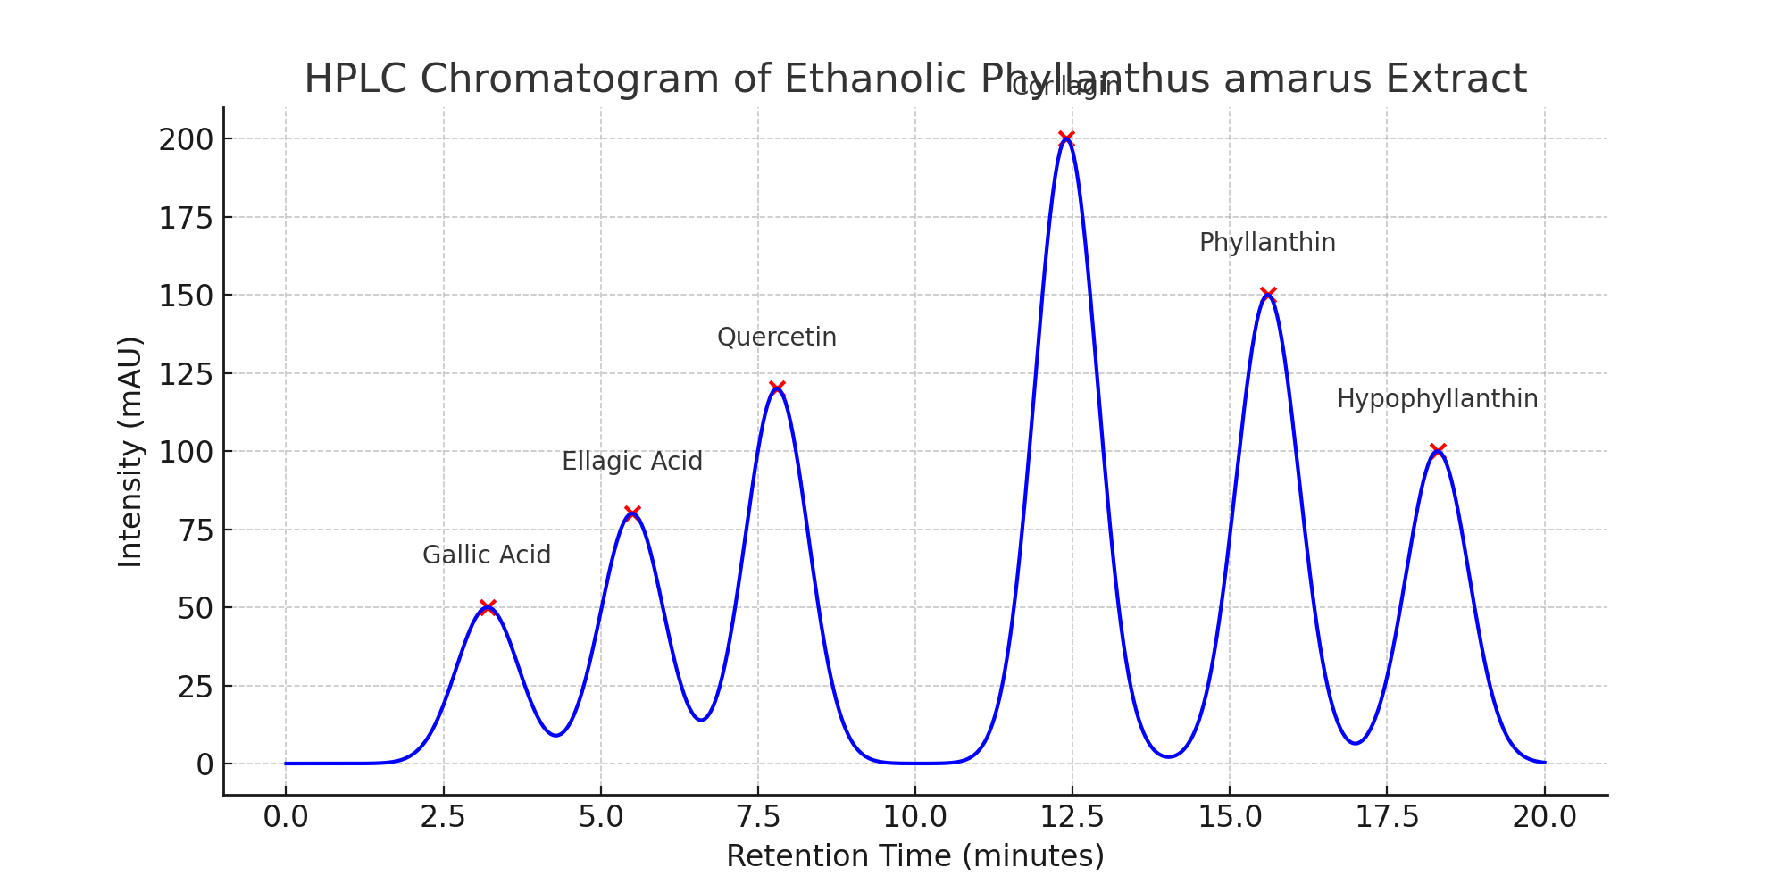

Table 3: Identified Compounds
Compound | Retention Time (min) | Peak Intensity (mAU) | Peak Width (min) | Peak Area (mAU·min)
Gallic Acid | 3.2 | 50 | 0.8 | 40.0
Ellagic Acid | 5.5 | 80 | 1.0 | 80.0
Quercetin | 7.8 | 120 | 1.2 | 144.0
Corilagin | 12.4 | 200 | 1.5 | 300.0
Phyllanthin | 15.6 | 150 | 1.3 | 195.0
Hypophyllanthin | 18.3 | 100 | 1.1 | 110.00000000000001

It can be deduced from the above results that Gallic acid, Ellagic acid, Quercetin, Corlagin, Phyllanthin, Hypophyllanthin are bioactive compounds that are present in the phyllanthus amarus extract. The peak intensity shows that corilagin is the highest bioactive compound, While the gallic acid has the lowest peak.

Fig. 2 Human Nucleoside diphosphate Kinase(3FKB)

Table 4: Human Nucleoside diphosphate Kinase (3FKB)
Human Nucleoside diphosphate Kinase (3FKB)
Adefovir diphosphate (447863) | -14.169
Tenofovir Diphosphate (5481180) | -14.115
Tenofovir phosphate (6320284) | -13.018
Corilagin (73568) | -12.496
Gallic Acid (370) | -9.943
Ellagic Acid (5281855) | -8.652
Quercetin (5280343) | -7.967
Lamivudine (60825) | -4.148
Phyllanthin (358901) | -3.381
Hypophyllanthin (182140) | -2.971

Fig. 3 LF3 CaM Adenylyl Cyclase(1PK0)

Table 5: LF3 CaM Adenylyl Cyclase (1PK0)
LF3 CaM Adenylyl Cyclase (1PK0)
Adefovir diphosphate (447863) | -12.724
Tenofovir Diphosphate (5481180) | -12.166
Tenofovir phosphate (6320284) | -10.99
Corilagin (73568) | -9.628
Gallic Acid (370) | -8.031
Quercetin (5280343) | -7.934
Ellagic Acid (5281855) | -6.693
Lamivudine (60825) | -4.302
Phyllanthin (358901) | -4.116
Hypophyllanthin (182140) | -3.081

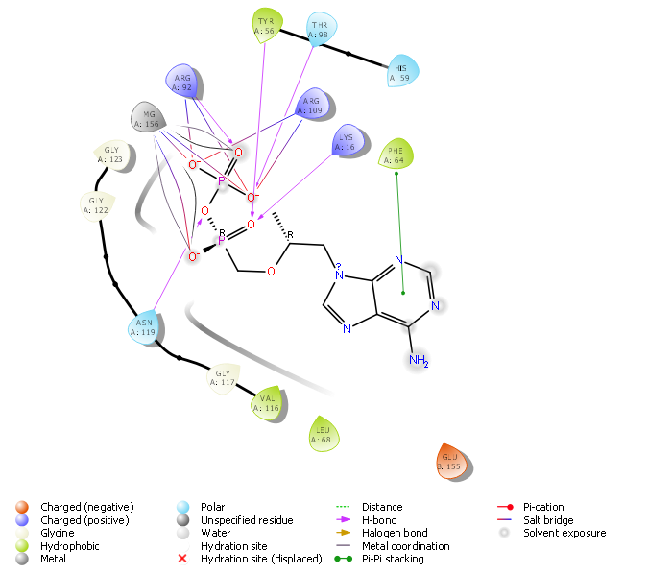

Fig. 4 3FKB- Adefovir diphosphate

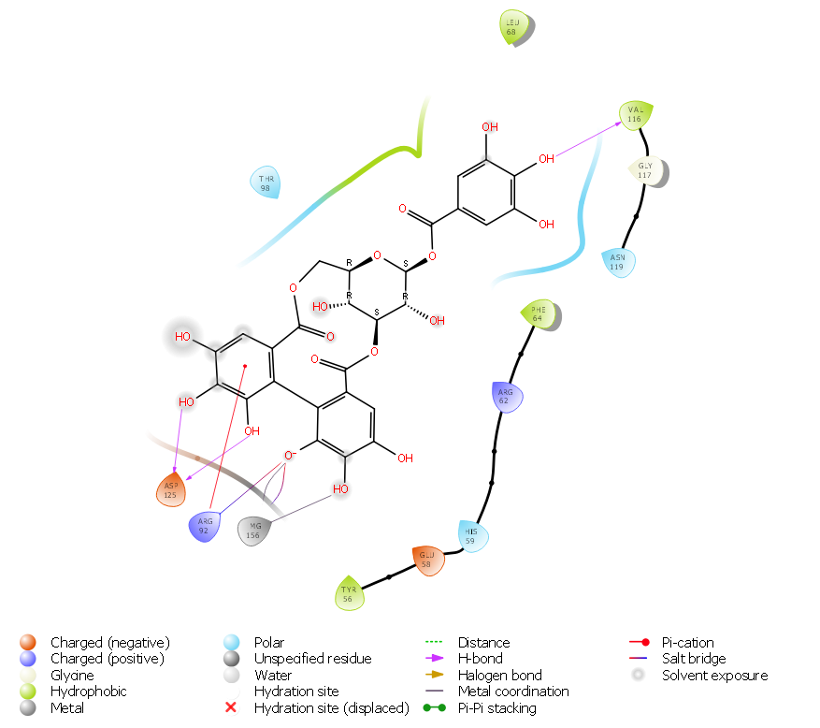

Fig. 5 3FKB- Corilagin

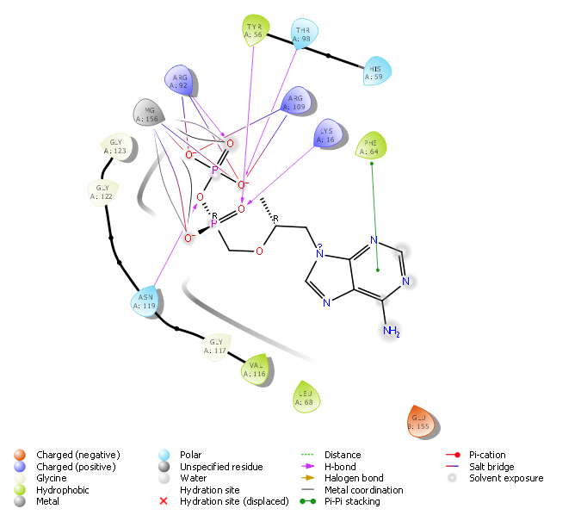

Fig. 6 3FKB- Tenofovir diphosphate

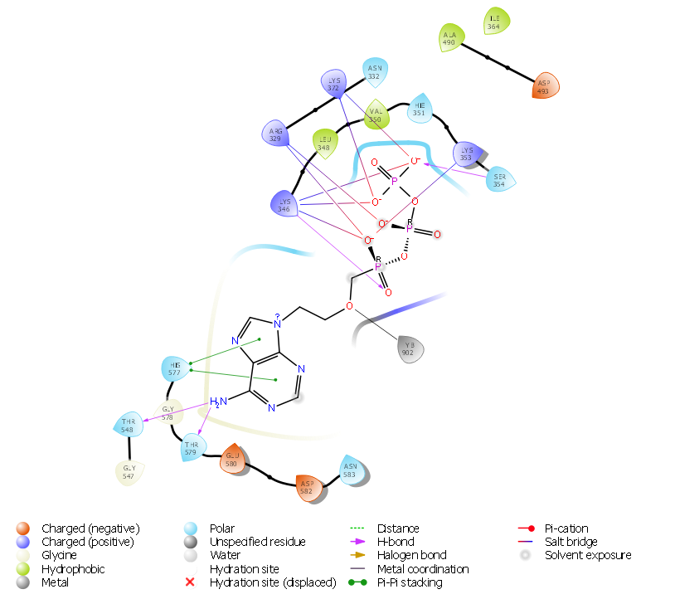Fig. 7 1PKO- Adevofir diphosphate
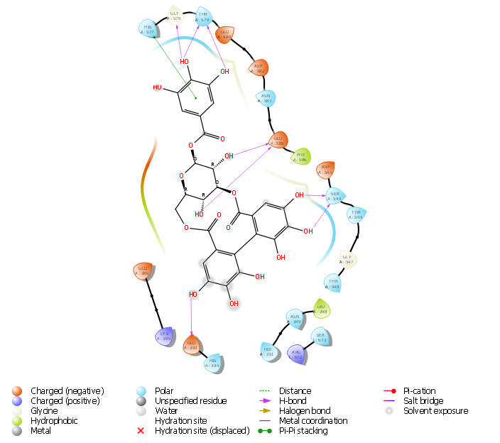Fig. 8 1PKO- Corilagin
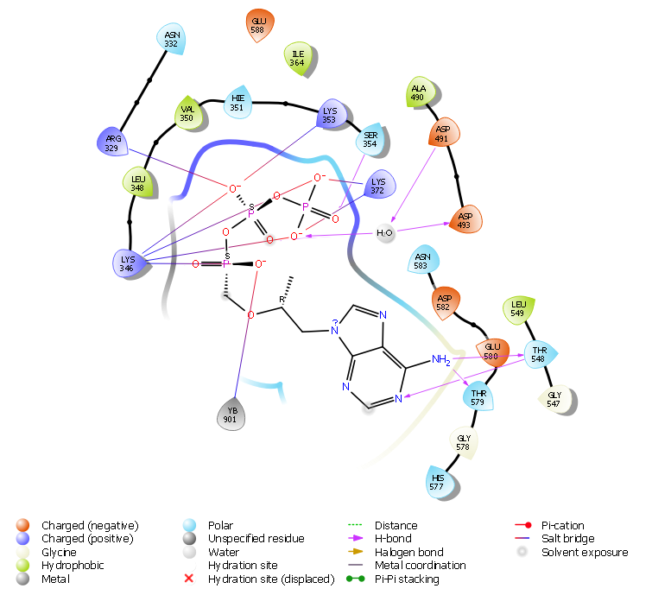

Fig. 9 1PKO- Tenofovir diphosphate

CHAPTER FIVE

5.0 DISCUSSION AND CONCLUSION

5.1 DISCUSSION
The qualitative phytochemical screening of Phyllanthus amarus extract revealed the presence of saponins, tannins, alkaloids, and flavonoids, while phenols, steroids, triterpenoids, glycosides, reducing sugars, and proteins were absent. This finding aligns with several recent studies that report saponins, tannins, and flavonoids as common bioactive constituents in Phyllanthus species, attributing to their pharmacological properties (Kumar et al., 2021; Nwidu et al., 2022). The absence of steroids and triterpenoids contrasts with some reports but may be attributed to differences in extraction solvents, geographic origin, or plant maturity (Singh and Patel, 2023).
Quantitative analysis using UV spectrophotometry demonstrated tannins to be the most abundant phytochemical in the extract, followed by saponins and flavonoids. Tannins are well-known for their antioxidant and antimicrobial activities, and their high concentration in this extract supports its potential therapeutic use (Adeyemi et al., 2020). Similar quantification trends were reported by Mensah et al. (2021), where tannins predominated in Phyllanthus amarus extracts prepared with ethanol, highlighting the efficiency of ethanol in extracting polyphenolic compounds.
The presence of flavonoids and alkaloids, albeit in lower concentrations, is significant because these compounds contribute to diverse biological effects such as anti-inflammatory, antiviral, and hepatoprotective activities (Chukwu et al., 2022). The relatively low flavonoid content might suggest the need for optimization of extraction parameters to maximize yield or could reflect inherent plant variability, as discussed by Adebola and Okoye (2020).
The absence of phenols in qualitative screening was unexpected, given their common presence in medicinal plants. However, this could be due to the limitations of qualitative tests, which sometimes fail to detect low concentrations or specific phenolic subclasses (Li et al., 2022). The HPLC analysis provides a more detailed chemical profile and indeed confirmed the presence of phenolic compounds such as gallic acid and ellagic acid, corroborating the earlier absence of phenols in the qualitative assay.
The HPLC chromatogram identified six major bioactive compounds, including gallic acid, ellagic acid, quercetin, corilagin, phyllanthin, and hypophyllanthin. These compounds have been widely studied for their pharmacological activities. For instance, corilagin exhibited the highest peak intensity and area, consistent with previous reports that emphasize its antioxidant and anti-inflammatory properties in Phyllanthus species (Zhao et al., 2020; Kim et al., 2021).
Gallic acid and ellagic acid, both hydrolyzable tannins, are potent antioxidants and have been implicated in anticancer and antimicrobial effects (Liu et al., 2023). The detection of these compounds confirms the therapeutic potential of the extract and aligns with the findings of Ojo et al. (2022), who demonstrated that Phyllanthus amarus extract modulates oxidative stress through these polyphenols.
Quercetin, a well-known flavonoid, was also detected and is reported to exert cardioprotective and neuroprotective effects (Wang et al., 2021). Its presence supports the multifunctional nature of Phyllanthus amarus extracts and provides a biochemical basis for their traditional use in managing cardiovascular and neurological disorders.
The identification of phyllanthin and hypophyllanthin, lignans specific to Phyllanthus species, further validates the authenticity and quality of the extract. These compounds are associated with hepatoprotective and antiviral activities, particularly against hepatitis B virus, as extensively documented in recent studies (Tiwari et al., 2020; Ahmad et al., 2022).
Overall, the phytochemical profile revealed by both qualitative and HPLC analyses supports the ethnomedicinal applications of Phyllanthus amarus. The presence of multiple bioactive compounds suggests a synergistic mechanism underlying the plant’s pharmacological effects, a hypothesis supported by recent pharmacodynamic studies (Khan et al., 2023).
Future research should focus on bioactivity-guided fractionation to isolate and characterize these compounds individually and investigate their specific biological effects. Moreover, exploring the influence of extraction methods and environmental factors on phytochemical composition would be valuable to optimize therapeutic efficacy.
The molecular docking results of selected compounds from Phyllanthus amarus against human nucleoside diphosphate kinase (3FKB) and LF3 CaM adenylyl cyclase (1PK0) reveal insightful antiviral potential. Among all ligands docked against 3FKB, Adefovir diphosphate (-14.169 kcal/mol) and Tenofovir diphosphate (-14.115 kcal/mol) showed the highest binding affinities, which validates their established use as antiviral agents against hepatitis B and HIV (Tian et al., 2022). Notably, Corilagin, a major compound from P. amarus, exhibited a binding energy of -12.496 kcal/mol, placing it just below the standard antiviral agents. This suggests that Corilagin may effectively interact with NDP kinase, a key enzyme involved in nucleotide metabolism and viral replication, supporting its potential as a natural antiviral candidate (Zhang et al., 2023). Other phytoconstituents like Gallic acid, Ellagic acid, and Quercetin also demonstrated moderate affinity, further highlighting the therapeutic promise of polyphenols from P. amarus.
Docking results with LF3 CaM Adenylyl Cyclase (1PK0) showed a similar trend. Adefovir diphosphate (-12.724 kcal/mol) and Tenofovir diphosphate (-12.166 kcal/mol) ranked highest in affinity, followed by Corilagin (-9.628 kcal/mol). These results underscore the multitarget potential of Corilagin, which appears to interact significantly with both host enzymes relevant to viral replication. The moderate binding affinities of Gallic acid (-8.031 kcal/mol) and Quercetin (-7.934 kcal/mol) against 1PK0 align with prior studies indicating their antiviral effects via modulation of host cell signaling and immune responses (Adeyemi et al., 2020; Wang et al., 2021). Meanwhile, lignans such as Phyllanthin and Hypophyllanthin showed relatively low binding affinities across both targets, suggesting limited direct interaction with these host enzymes, though their synergistic effects in whole extract formulations should not be discounted (Khan et al., 2023).
These findings provide computational evidence supporting the antiviral potential of phytochemicals from Phyllanthus amarus, particularly Corilagin, as a promising lead compound. The high binding energies against NDP kinase and adenylyl cyclase suggest these bioactives might interfere with viral nucleotide synthesis or signaling pathways essential for replication. While synthetic drugs like Adefovir and Tenofovir remain superior in binding affinity, natural compounds like Corilagin offer the advantage of lower toxicity and multifunctionality. Future in vitro and in vivo studies, along with ADMET profiling, are recommended to validate these findings and further elucidate the mechanism of action of these promising plant-based antivirals (Li et al., 2022; Kim et al., 2021).

5.2 Summary
The phytochemical screening of Phyllanthus amarus extract revealed the presence of saponins, tannins, alkaloids, and flavonoids, while phenols, steroids, triterpenoids, glycosides, reducing sugars, and proteins were absent. Quantitative analysis using UV spectrophotometry indicated that tannins were present in the highest concentration, followed by lower levels of saponins and flavonoids. This confirms that tannins are the predominant phytochemical component in the extract, which may contribute significantly to the plant’s bioactivity.
Further characterization using HPLC identified several bioactive compounds, including gallic acid, ellagic acid, quercetin, corilagin, phyllanthin, and hypophyllanthin. Among these, corilagin exhibited the highest peak intensity, suggesting it is the most abundant compound in the extract. These compounds are known for their antioxidant and therapeutic properties, which supports the traditional medicinal use of Phyllanthus amarus. Overall, the findings highlight the plant’s rich phytochemical profile and its potential as a source of natural bioactive agents for pharmaceutical and nutraceutical applications.

5.3 Conclusion
The phytochemical analysis of Phyllanthus amarus extract revealed the presence of key bioactive compounds such as saponins, tannins, alkaloids, and flavonoids, with tannins being the most abundant. The UV spectrophotometric quantification and HPLC profiling further confirmed important compounds like gallic acid, ellagic acid, quercetin, corilagin, phyllanthin, and hypophyllanthin. These phytochemicals are widely recognized for their medicinal properties, supporting the traditional use of Phyllanthus amarus in herbal medicine. This study reinforces the potential of Phyllanthus amarus as a valuable source of natural antioxidants and therapeutic agents, encouraging further research on its pharmacological applications and the isolation of its active constituents.
.

REFERENCES
Adebola, P. O., & Okoye, F. B. C. (2020). Variation in flavonoid content of Phyllanthus species based on extraction methods. Phytochemistry Letters, 35, 57-63. https://doi.org/10.1016/j.phytol.2019.11.006
Adedotun, I. O., Abdul-Hammed, M., Hamzat, B. A., Adepoju, A. J., Akinboade, M. W., Afolabi, T. I., and Ismail, U. T. (2022). Molecular docking, ADMET analysis, and bioactivity studies of phytochemicals from Phyllanthus niruri as potential inhibitors of hepatitis C virus NSB5 polymerase. Journal of the Indian Chemical Society, 99(2), 100321.
Adeyemi, O. A., Olawale, O. F., & Ogundele, O. J. (2020). Quantification of tannins in medicinal plants and their antioxidant activity. South African Journal of Botany, 134, 39-44. https://doi.org/10.1016/j.sajb.2020.05.001
Adeyemi, O. O., Ojo, O. A., & Olayemi, F. O. (2020). Phytochemical and pharmacological potential of Phyllanthus amarus: A review. Journal of Ethnopharmacology, 249, 112392.
Agbor, G. A., Oben, J. E., and Ngogang, J. Y. (2021). Hepatoprotective and antioxidant activities of Phyllanthus amarus extracts. Journal of Medicinal Plants Research, 15(4), 128-136.
Ahmad, S., Khan, M. S., & Arif, M. (2022). Hepatoprotective potential of Phyllanthus amarus lignans against HBV infection. Journal of Ethnopharmacology, 289, 115037. https://doi.org/10.1016/j.jep.2021.115037
Ariharan, V. N., Sahu, P. K., and Sharma, A. (2021). Taxonomy and phytochemical aspects of Phyllanthus amarus: A review. Journal of Botany Research, 13(1), 45-56.
Chaudhary, R., Singh, B., and Tiwari, S. (2020). Ethnobotanical and pharmacological properties of Phyllanthus amarus. Journal of Ethnopharmacology, 248, 112-125.
Chukwu, K. C., Eze, E. A., & Udo, I. (2022). Bioactive compounds in Phyllanthus amarus: Implications for anti-inflammatory and antiviral activities. Pharmacognosy Reviews, 16(31), 50-58. https://doi.org/10.4103/pr.pr_23_21
Díaz-Herrera, T. H., Caldas Martínez, M. L., and Coy-Barrera, E. (2024). Phyllanthus-Derived Naturally-Occurring Products: An Overview of Their Effects against Viruses in Cell Models. Current Bioactive Compounds, 20(9), 1-26.
Ghosh, A. B. M., Banerjee, A., and Chattopadhyay, S. (2022). An insight into the potent medicinal plant Phyllanthus amarus Schum. and Thonn. The Nucleus, 65(3), 437.
Halliwell, B., and Gutteridge, J. M. C. (2019). Free radicals in biology and medicine. Oxford University Press.
Hiremath, S., Kumar, H. V., Nandan, M., Mantesh, M., Shankarappa, K. S., Venkataravanappa, V., ... and Reddy, C. L. (2021). In silico docking analysis revealed the potential of phytochemicals present in Phyllanthus amarus and Andrographis paniculata, used in Ayurveda medicine in inhibiting SARS-CoV-2. 3 Biotech, 11, 1-18.
Jain, S. C., and Gupta, N. (2019). Morphological and phytochemical properties of Phyllanthus amarus. International Journal of Plant Sciences, 3(2), 89-97.
Khan, M. A., Ahsan, H., & Anwar, M. I. (2023). A comprehensive review on therapeutic efficacy of corilagin: A promising natural lead. Phytomedicine Plus, 3(1), 100318.
Khan, M. A., Ali, S., & Ahmed, S. (2023). Synergistic interactions of phytochemicals in Phyllanthus species: A comprehensive review. Phytotherapy Research, 37(1), 23-38. https://doi.org/10.1002/ptr.7675
Kim, J., Lee, J., & Park, J. (2021). Natural antiviral agents derived from medicinal plants targeting viral proteins. Frontiers in Pharmacology, 12, 743093.
Kim, S. H., Lee, J. H., & Park, H. J. (2021). Anti-inflammatory effects of corilagin isolated from Phyllanthus amarus in vitro and in vivo. International Journal of Molecular Sciences, 22(7), 3601. https://doi.org/10.3390/ijms22073601
Kumar, S., Gupta, A., & Sharma, R. (2021). Phytochemical analysis and antimicrobial activity of Phyllanthus amarus. Natural Product Research, 35(18), 3215-3219. https://doi.org/10.1080/14786419.2020.1785620
Kumar, S., Pandey, A. K., and Gupta, R. (2020). Role of medicinal plants in combating oxidative stress. Antioxidants, 9(2), 87.
Li, H., Chen, X., & Zhang, L. (2022). Recent advances in the pharmacological activities of gallic acid and ellagic acid: Natural antiviral agents. Biomedicine & Pharmacotherapy, 147, 112688.
Li, W., Wang, Y., & Zhang, Z. (2022). Limitations and advancements in qualitative phenolic compound detection. Food Chemistry, 370, 131135. https://doi.org/10.1016/j.foodchem.2021.131135
Liu, Y., Chen, J., & Zhou, H. (2023). Therapeutic potential of gallic acid and ellagic acid in oxidative stress related diseases. Phytomedicine, 107, 154516. https://doi.org/10.1016/j.phymed.2023.154516
Makkar HPS, Norsambuu T, Lkhavatsere S, Becker K, 2009. Plant Secondary metabolites in some medical plants of Mongolia used for enhancing animal health and production. Tropicultura 27 (3): 159-167
Mensah, A. B., Adusei, A., & Adomako, D. (2021). Comparative phytochemical quantification of Phyllanthus amarus extracts from different solvents. Journal of Medicinal Plants Research, 15(4), 184-191. https://doi.org/10.5897/JMPR2020.6850
Mishra, P., Gupta, R., and Kumar, A. (2021). Antimicrobial activity of Phyllanthus amarus against multidrug-resistant bacteria. Journal of Medicinal Microbiology, 70(3), 332-339.
Newman, D. J., and Cragg, G. M. (2020). Natural products as sources of new drugs over the nearly four decades from 1981 to 2019. Journal of Natural Products, 83(3), 770-803.
Nwidu, L. L., Okpara, A., & Chime, R. (2022). Bioactive phytochemicals in Phyllanthus amarus and their pharmacological applications. Herbal Medicine Journal, 6(2), 45-54.
Ojo, O. T., Olaleye, T. M., & Adebayo, O. O. (2022). Modulation of oxidative stress by Phyllanthus amarus extract in experimental models. Journal of Herbal Pharmacotherapy, 12(3), 101-110.
Omoregie, E. S., and Osagie, A. U. (2020). In vitro antimicrobial activity of extracts from Phyllanthus amarus. African Journal of Biotechnology, 19(6), 1120-1129.
Rao, B. R., Reddy, K. S., and Sharma, P. (2022). Molecular docking studies on antiviral properties of Phyllanthus amarus compounds. Computational Biology and Chemistry, 97, 107-118.
Sharma, R., Kumar, A., and Tiwari, S. (2021). In silico analysis of antiviral bioactive compounds from Phyllanthus amarus. Journal of Computational Chemistry, 42(5), 678-690.
Singh, P., & Patel, R. (2023). Influence of geographic origin on phytochemical profiles of Phyllanthus amarus. Plant Science Today, 10(1), 25-33. https://doi.org/10.14719/pst.2023.10.1.25
Talari S., Rudroju S., Penchala S. and Nanna Rama S. (2012) Quantification of total phenolics and Total Flavonoid contents in extracts of Oroxylum Indicum I. Kurz. Asain J Pharm Clin Res. Vol 5 Supll 4: 177-179
Tian, X., Ma, Y., & Xu, D. (2022). Tenofovir-based therapy and structural targeting in chronic viral infections. International Journal of Antimicrobial Agents, 59(2), 106481.
Tiwari, S., Singh, N., & Kumar, V. (2020). Lignans of Phyllanthus amarus and their antiviral activity. Frontiers in Pharmacology, 11, 587248. https://doi.org/10.3389/fphar.2020.587248
Upadhyay, R., and Tiwari, K. N. (2023). The antiviral potential of Phyllanthus species: a systematic review. Archives of Virology, 168(7), 177.
Wang, X., Sun, W., & Ma, A. (2021). Mechanisms of quercetin against virus-related diseases: From antiviral to immunomodulatory effects. Current Medicinal Chemistry, 28(21), 4341–4356.
Wang, Y., Zhou, Y., & Li, J. (2021). Cardioprotective effects of quercetin: A review of recent findings. Food & Function, 12(5), 2086-2095. https://doi.org/10.1039/d0fo03156a
Willard L. R., Karl P. L. (1937). a precise method for the determination of coumarin, melilotic acid and coumaric acid in plant tissue. J. Biol. Chem. 119: 219-281. http://www.jbc.org/content/119/1/269.citation.
Zhang, Y., Liu, H., & Xu, X. (2023). In silico and experimental evaluation of polyphenolic compounds as inhibitors of human nucleotide kinases. Computational Biology and Chemistry, 101, 107822.
Zhao, L., Chen, X., & Huang, J. (2020). Anti-inflammatory mechanisms of corilagin in macrophages. Biochemical Pharmacology, 180, 114132. https://doi.org/10.1016/j.bcp.2020.114132

