A PROJECT REPORT
ON
PROPOSED FEMALE INSTITUTIONAL HOSTEL
For
THE OKE OGUN POLYTECHNIC SAKI (Tops) OYO STATE

BY

MORUF SOFIAT OPEYEMI
HND/23/ARC/FT/0055

SUBMITTED TO
DEPARTMENT OF ARCHITECTURAL TECHNOLOGY, INSTITUTE OF ENVIRONMENT STUDIES, KWARA STATE POLYTECHNIC, ILORIN

IN PARTIAL FULFILMENT OF THE REQUIREMENTS FOR THE AWARD OF HIGHER NATIONAL DIPLOMA [HND] IN ARCHITECTURAL KWARA STATE POLYTECHNIC, ILORN KWARA STATE.

JULY, 2025




DEDICATION
This project is dedicated to almighty Allah and also to my parents (Mr. and Mrs. MORUF)

ACKNOWLEDGEMENT
My profound gratitude goes to my Parents (Mr. and Mrs. MORUF)for supporting and taking care of me. I also thank them for contributing greatly for the success of this project.
I also acknowledge the support of my project supervisor Arc FAMILUA O.S who went through the project manuscripts despite his tight schedule. May God strengthen him in wealth and health.
I also acknowledge the support of the project coordinator in person of Arc OLANREWAJU F.A and the Head of Department, Arc. TOMORI J.M for their contributions. May God increase them in strength. Also, I express my sincere gratitude to all my departmental lecturers, may God also increase them in strength.
My heartfelt gratitude to my benefactor, specifically (Mr. MORUF Ayinde and Mrs. Mujeedat Temitope ) for their care and support in my times of need. Thanks for your love and care you have all shown to me

ABSTRACT
This report presents an architectural design proposal for a female students' hostel at The Oke Ogun Polytechnic, Saki. The project aims to create a secure, sustainable, and comfortable living environment that meets the unique needs of female students. Through careful consideration of safety features, sustainable building practices, and ergonomic design, the hostel is designed to enhance the well-being and academic performance of its residents. The proposal integrates modern architectural trends, such as the use of smart technologies and inclusive design principles, to ensure a welcoming and efficient living space. Additionally, communal areas are thoughtfully designed to foster a strong sense of community among students. This report provides a comprehensive analysis of the site, detailed architectural plans, and an implementation strategy that aligns with the institution’s goals and budget constraints. The proposed hostel will not only serve as a safe and comfortable residence but also contribute to the overall development of the students by offering a supportive environment conducive to learning and personal growth.

TABLE OF CONTENT
TITLE-PAGE……………………………………………………………………………… i
DECLARATION………………………………………………….…………………………ii
CERTIFICATION………………………………………………….………………………..iii
ACKNOWLEDGEMENT…………………………………………………………………..iv
DEDICATION………………………………………………….……………………………v
ABSTRACT…………………………………………………………………..……………..vi
LIST OF TABLES…………………………………………………………………………..vii
LIST OF FIGURES……………………..…………………….……………………….……viii
LIST OF PLATES…………………………………………………………….……...……..ox

CHAPTER ONE
1.0 INTRODUCTION…………………………….………….……………….…………10
1.1 HISTORICAL BACKGROUND………...…………………………………………..10
1.2 STATEMENT OF FEMALE INSTITUTIONAL HOSTEL …………..…………….11
1.3 AIM AND OBJECTIVES…………………………………..……………………..…12
1.4 JUSTIFICATION…………………………………………………………..…..…….12
1.5 CLIENT’S BACKGROUND………………………………………………………...13
1.6 SCOPE OF STUDY……………………………………………………………….…13
1.7 LIMITATIONS OF CONSTRAINTS………………………..…....…………..……..14
1.8 RESEARCH METHODOLOGY ……………………………………………………14
1.9 DEFINITION OF TERMS……………………………………………………….14-15

CHAPTER TWO
2.1 LITERATURE REVIEW AND CASE STUDY……………………………………. 16
2.2 DEFINITION OFFEMALE INSTITUTIONAL HOSTEL …………………………17
2.3 HISTORICAL DEVELOPMENT OF HOSTEL ……………….……………..……..18

CHAPTER THREE
3.0 CASE STUDY…………………………………………………………..…………. 19
3.1. CASE STUDY 1(OSUN STATE UNIVERSITY )…………………………………..19
3.2 CASE STUDY 2(RECTEM PRIVATE POLYTECHNIC (R.C.C.G) CAMP………25
3.3 CASE STUDY 3(KWARA STATE UNIVERSITY ILORIN…………………………29
3.4 ONLINE CASE STUDY 1(BLUEBERRY LADIES HOSTEL IN INDIA………….35
3.5 ONLINE CASE STUDY TWO (UNIVERSITY STUDENTS’ HOUSING ITALY)….…….39

CHAPTER FOUR
4.0 DESIGN PROPOSAL……………………………………………………………..44
4.1 STUDY AREA / PROJECT SITE……………………………………...…………44
4.2 SITE LOCATION MAP……………………….…………………………………………………………………46
4.3 SITE LOCATION ……………………………………………………………………………………………………….47
4.4 Site Characteristics ………………….……………………………………………48
4.5 SITE ANALYSIS. ……………………………….………….……………………………………………………..49
4.6 GEOGRAPHICAL/ CLIMATIC DATA……………………………………………………………………… 50
4.7 ANALYSIs OF THE IMMEDIATE ENVIRONMENTAL CONDITIONS OF THE SITE……….45
4.8 PROJECT ANALYSIS/DESIGN CRITERIA……………………………………………………………….. 55
4.9 DESIGN CONCEPT………………………………………………………………56
4.10 PROJECT GOAL……………………………………………………………………………………………………56
4.11 APPRAISAL OF PROPOSED SCHEMES…………………………………………………………………. 57
4.12 EQUIPMENT AND OPERATIONAL AND PERFORMANCE REQUIREMENT …………..... 58
4.13 SPATIAL ALLOCATION / SCHEDULE OF ACCOMMODATION ………………………….…..…61
4.14 FUNCTIONAL RELATIONSHIP…………………………………………………………….63

CHAPTER FIVE
5.0 APPROACH TO THE DESIGN / DESIGN REALIZATION………………….64
5.1 DESIGN CONCEPT……………………………………………………………………………………………….64
5.2 CONSTRUCTION METHODS………………………………………………….65
5.3 SUB-STRUCTURE……………………………………………………………….66
5.4 SUPER STRUCTURE……………………………………………………………67
5.5 CONSTRUCTION MATERIALS……………………………………………….67
5.6 SUBSTRUCTURE AND SUPERSTRUCTURE……………………………….67
5.7 SERVICES/ INFRASTRUCTURE………………………………………………68

6.0 DESIGN CONTRIBUTION…………………………………………………………………………………………70
6.1 Introduction……………………………………………………………………….70
6.2 Recommendations…………………………………………………………………70
6.3. Conclusion…………………………………………………………………………71
REFERENCES……………………………………………………………………72
APPENDICES………………………………………………………………………………….

CHAPTER ONE
INTRODUCTION
1.1 BACKGROUND TO THE STUDY
According to Schemers (1972), tertiary institutions should be designed to accommodate students in hostels within the school environment for effective and optimal of academic activities. These hostels should be comfortable and could be in the form of rooms, halls or apartments. Facilities like toilets, laundry, lounge, amongst others, should be provided for the convenience of students. The provision of these facilities is usually guided by set standards as well as the number of students expected to reside in the hostels (Ernst and Neuters, 1993).

As housing is one of the most fundamental needs of man, the provision of quality accommodation is necessary. Afolayan (1981) opines that, a good accommodation should serve the purposes of providing physical shelter, useable living space, and self-fulfillment. It follows that the provision of a good accommodation implies the provision of adequate shelter, space and facilities for the general well-being of the inhabitant. Furthermore, accommodation conditions have been identified as having appreciable effects on the quality of health, work efficiency, social behavior, satisfaction and general welfare of any community. This situation applies not only to urban and rural housing areas, but also to accommodation facilities within institutions.
The little attention paid by Nigerian government and authorities of institutions to housing has led to gross inadequacy in hostel facilities, resulting to overcrowding, over-utilization, deterioration of facilities and higher fire risks. It has increased the number of off-campus students who cannot find spaces in the available hostels. The effect of this situation on academic performance, health and social behavior of students is negative and cannot be over emphasized (Onwuka, 1990).
The current trend of frequent fire outbreak in hostels has become a major concern for all. There have been a lot of incidences of fire in hostels, where students lost their lives and properties.
It is necessary to think of how to avoid these problems than coping with it.
This study intends to identify the problems and attitudes associated with fires in buildings
with the view to proffering solution. The historical background of institutional hostels can be traced back to the medieval times when monasteries and religious institutions provided accommodation for travelers and pilgrims. However, the modern concept of institutional hostels emerged in the 19th century with the establishment of educational institutions and industrial complexes. These hostels were designed to provide affordable and convenient housing for students and workers who needed to reside near their places of study or employment.
During the industrial revolution, the demand for labor in urban areas led to the creation of worker hostels near factories. Similarly, universities and colleges began establishing hostels to accommodate students who often traveled from distant locations. The idea was to create a communal living environment that fostered learning, collaboration, and a sense of community.
In the 20th century, the concept of hostels expanded beyond education and industry to include various institutional settings such as research centers, training institutes, and government facilities. Today, institutional hostels play a crucial role in providing temporary housing for individuals associated with diverse institutions, contributing to the overall development of communities and societies.

1.2 STATEMENT OF PROBLEM
A careful study of hostels, private and public, has revealed that not much has been done in the articulation of fire safety in the design of buildings. Most hostels have only one entrance and exit in them.
Compartmentation in the design of buildings was not employed, to help in the containment of fire spread. Also the number of stores of some hostels makes evacuation of people difficult during fire incidents.
In addition, building materials used in the construction of most of the hostels studied, are not fire resistant, rather will aid cases of fire.
Thus, this study becomes necessary in other to provide student accommodation that will be safe for the occupants (students) and their belongings.

1.3 AIM AND OBJECTIVES OF THE STUDY
The aim of this project is to design and develop a female students' hostel that provides a safe, comfortable, and supportive living environment, tailored to the specific needs of female students, while incorporating sustainable and modern architectural practices.

OBJECTIVES
The above stated aim will be achieved through the following objective and they are to;
- create a hostel design that prioritizes the safety and security of female students through secure access points, surveillance systems, and well-planned emergency exits.
- incorporate sustainable design practices, including the use of eco-friendly materials, energy-efficient systems, and waste reduction strategies, in order to minimize the environmental impact of the hostel.
- ensure that the hostel is accessible to all students, including those with disabilities, by integrating inclusive design features like ramps, wide doorways, and accessible bathrooms.

1.4 JUSTIFICATION OF STUDY
This study intends to access how fire safety can be enhanced in the design of a female hostel. One of the significance of this study is that it will help in resolving problems of fire outbreak in student hostel.
Again most universities lack sufficient accommodation. There is shortage of accommodation in most campuses in Nigeria. And lack of hostel accommodation encourage truancy and consequently poor concentration on academics works.
Also, in the case of security, hostels built inside school are more secured. With every passing day, we hear news about how arm robbers attack students who live outside the school and take valuable properties from them. But that doesn’t happen in school hostels because the school provides them with tight security.
Hence, this study provides standards, requirements and pre-requisites that would enhance fire safety in the design of female hostel

1.5 CLIENT BACKGROUND
The Oke Ogun Polytechnic, Saki, like many higher education institutions, faces the challenge of providing adequate housing for its growing student population. As the number of female students continues to rise, there is an increasing demand for safe, comfortable, and well-designed accommodations that cater specifically to their needs. Student hostels play a crucial role in supporting academic success by providing an environment that is conducive to studying, social interaction, and personal development. Historically, student housing has often been designed with a focus on functionality, sometimes at the expense of comfort and safety. However, the modern approach to hostel design places a greater emphasis on creating living spaces that not only meet the basic needs of students but also enhance their overall well-being. This is particularly important for female students, who may have distinct requirements in terms of privacy, security, and community support. The Oke Ogun Polytechnic, located in Saki, Oyo State, Nigeria, recognizes the importance of addressing these needs through thoughtful architectural design. This technical report is a response to the institution's commitment to providing high-quality accommodation for its female students. It explores the architectural aspects of designing a female students' hostel, focusing on elements such as safety, sustainability, comfort, and community.

1.6 SCOPE OF THE PROJECT
The design of the female students' hostel at The Oke Ogun Polytechnic, Saki, should include a variety of spaces that cater to the needs of its residents. Below is a list of the essential spaces required in the project:

1. Residential Units

2. Common Areas

3. Kitchen Areas

4. Sanitary Facilities

5. Administrative and Support Spaces

6. Accessibility Features

7. Outdoor Spaces

8. Safety and Security Features

9. Storage Spaces

1.7 LIMITATION OF STUDY
The limitation experienced during this course of study include:
- Time constraint
- Finance: funding of the project research and the project itself has been asurmountable task which God has intervened in its management.
- Research materials: There have not been enough local sources of informationand getting the proper architectural plans required for assessment during case studies was not very easy.

1.8 RESEARCH METHODOLOGY
- Case study
- Oral interview
- Literature review
- online review

1.9 DEFINITION OF TERMS
- ENTRANCE:An entrance is an opening, such as a door or gate, that allows access to a place such as land, building or room. The word entrance is typically associated with the primary doorway giving access to a building. This might be referred to as the main entrance
- ROOMS:In a building or ship, a room is any enclosed space within a number of walls to which entry is possible only via a door or other dividing structure. The entrance connects it to either a passageway, another room, or the outdoors. The space is typically large enough for several people to move about.
- COMMON ROOM: A common room is a type of shared lounge, most often found in halls of residence or dormitories, at (for example) universities, colleges, military bases, hospitals, rest homes, hostels, and even minimum-security prisons. They are generally connected to several private rooms, and may incorporate a bathroom.
- PROTAL OFFICE: Porter service available to help you with luggage and make your journey a little more comfortable.. Porter staff will help you carry your luggage and escort you to the check-in counter.
- LAUNDRY
- STORAGE
- KITCHEN
- EXIT
- TOILET

CHAPTER TWO
INTRODUCTION
2.1 LITERATURE REVIEW
In this chapter, Definition of Residence (Hostel), history, causes of fire, types of fire, principle of fire safety and other related literatures are discussed. This Literatures were studied in order to know the trend and scope for research in the chosen field. Many doctoral thesis, reports and articles published in leading journals were subjected to analysis. Institutional hostels are residential facilities provided by educational or other institutions to accommodate students, professionals, or individuals affiliated with the organization. These hostels offer a structured living environment, fostering a sense of community and providing essential amenities such as living quarters, dining facilities, and common areas. The primary purpose is to create a conducive environment for academic or professional pursuits while promoting social interaction and personal development.
2.2 DEFINITION OF HOSTEL
A hostel is a form of low cost, short term sharable lodging, where students can rent a bedspace, usually a bunk bed in a dormitory, with shared use of a lounge and sometimes a kitchen.
Davies et al (2008), defined hostel as an establishment which provides cheap lodging and food for travelers, a place of residence for students.
It is also defined as a budget-oriented, shared-room ("dormitory") accommodation that accepts individual travelers or groups for short-term stays, and that provides common areas and communal facilities (Wikipedia Encyclopedias). It further stated that for it to be considered a hostel, the property must provide short-term, shared (dormitory-style) accommodation for individual travelers, though many hostels also provide private rooms.
Hostel has become an opportunity to develop and improve the quality of education in most academic institutions. The desire to provide spaces for students that allow active interaction, comfort and convenience, and opportunities for socialization is foremost in university and college planning (Perk-in& Will, 2001). They also stated that all these need to be considered along with the realistic spatial needs of furnishings, integration of efficient effective mechanical, electrical, plumbing and safety requirements when planning for hostel buildings. An institutional hostel is a residential facility typically operated by an institution, such as a school, college, or other organization. It provides accommodation for individuals associated with that institution, such as students or staff, offering a communal living environment with shared facilities and services.
The institutional hostels are those hostels that are provided for the institutions by their owners or their benefactors while private hostels are the hostels developed by private estate developers and investors for profit maximization purposes
A hostel is a lower-priced inn of sorts that offers basic, shared accommodations. Typically, a hostel features a large room with separate beds, a shared bathroom, and a communal kitchen. Some hostels have private rooms, but the lower-cost ones generally offer bunk beds
2.2 Definition of female institutional hostel
A female institutional hostel is a purpose-built residential facility provided within or in association with an educational, training, or professional institution, specifically designed to accommodate female students, trainees, or staff. These hostels offer secure, comfortable, and supportive living environments that promote academic focus, personal development, and well-being.

Key Features of a female institutional hostel
- Exclusively for female occupants
- Located within or near schools, colleges, universities, or training institutions
- Includes essential amenities such as sleeping areas, bathrooms, kitchens, study rooms, lounges, and laundry facilities
- Emphasises security, privacy, and cultural sensitivity
- Managed by the institution or affiliated administrative bodies

2.3 REVIEW OF LITERATURE ONFEMALE INSTITUTIONAL HOSTEL
HISTORICAL DEVELOPMENT OF HOSTEL
The first youth hostel was founded by Richard Sherman around 1909. He was a German teacher who organized trips and visits with his students. During one of these excursions, a sudden rainstorm forced his group to seek shelter in an empty school. It was then that Sharman had the idea of using schools that were empty during holidays as guest houses for young people that were traveling in groups in the countryside. The concept of student "youth hostels" was born.
The movement flourished in Germany. Permanent hostels were established by gifts of hiking and recreation clubs, wealthy patrons and local communities. By 1932, Germany had more than 2000 youth hostels recording more than 4.5 million overnights annually.
In the meantime, Switzerland, Poland, the Netherlands, Norway, Denmark, the British Isles, Ireland, France and Belgium had joined the movement and added another 600 hostels in Europe.
With national hosteling associations spreading across Europe, in 1932 the first international meeting was held in Amsterdam to develop common standards. The International Youth Hostel Federation was formed. Shortly afterwards, they opened the first U.S. youth hostel in Northfield, Massachusetts in 1934.
Pre-war European political currents overshadowed much of the international movement in the late 1930's. Hostels were closed, and even appropriated by governments for military purposes. The operations of many European hosteling associations were suspended. During the war, the growth of the hosteling movement stalled, although parts of the European youth hostel system still continued to operate, as well as a small network of hostels in the US and Canada.
The end of the war brought a time of rebuilding and reflection worldwide. Groups of American youth went to Europe to help rebuild hostels. International youth travel, while still nascent, was embraced by governments as a way to encourage understanding, and avoid future conflict. The International Youth Hostel Federation grew, as the German youth hostel system was re-established and new hostel associations were formed in Africa, Asia, Australia and South America.
In recent times, the concept of hostel has broadened, and now providing cheap but comfortable accommodation and a unique atmosphere that cannot be found in hotels. Worldwide, there about 4000 hostels recording over 33 million overnights in more than 80 countries.
CHAPTER THREE
3.0 CASE STUDY
According to JSTOR (January 2019), a case study is about a person, group, or situation that has been studied over time. It can be defined as an intensive, systematic investigation about a person, group of people, or a unit in which the researcher examines in depth data relating to several variables. Case studies can be produced by following a formal research method. These case studies are likely to appear in formal research venues, as journals and professional conferences, rather than popular works. The resulting body of 'case study research' has long had a prominent place in many disciplines and professions, ranging from psychology, anthropology, sociology, and political science to education, clinical science, social work, and administrative science. In doing case study research, the "case" being studied may be an individual, organization, event, or action, existing in a specific time and place.
Outline of Cases Studies
. OSUN STATE UNIVERSITY LOCATED AT OSOGBO
. RECTEM PRIVATE POLYTECHNIC (R.C.C.G) CAMP LOCATED AT MOWE OGUN STATE
.KWARA STATE UNIVERSITY, ILORIN, KWARA STATE
. BLUEBERRY LADIES HOSTEL LOCATED AT TWO KERALA INDIA (ONLINE CASE STUDY
3.1 CASE STUDY 1: OSUN STATE UNIVERSITY
Location: osogbo state university.
Brief Description:
Osun State University (UNIOSUN) is a multi-campus university in Nigeria, established by Osun State Government under the administration of Prince Olagunsoye Oyinlola. The University currently operates six campuses distributed across the six administrative zones of the state.

Merits
- Good orientation; the rooms are taken advantage of the trade winds.
- Good internal arrangement.
- Cross ventilation was achieved
- The width of escape (corridor) is okay

Demerits
- Fire resistance construction was not considered in the design of the building.
- Fire resistance door and walls were not used in the hostel, in case of any inferno to contain the fire to a certain period of time for escape of occupants.
- No provision was made for a first aid firefighting gadgets E.g. Hose reels, Extinguishers, fire buckets, fire blankets, Hydrant systems etc.
- Poor landscaping

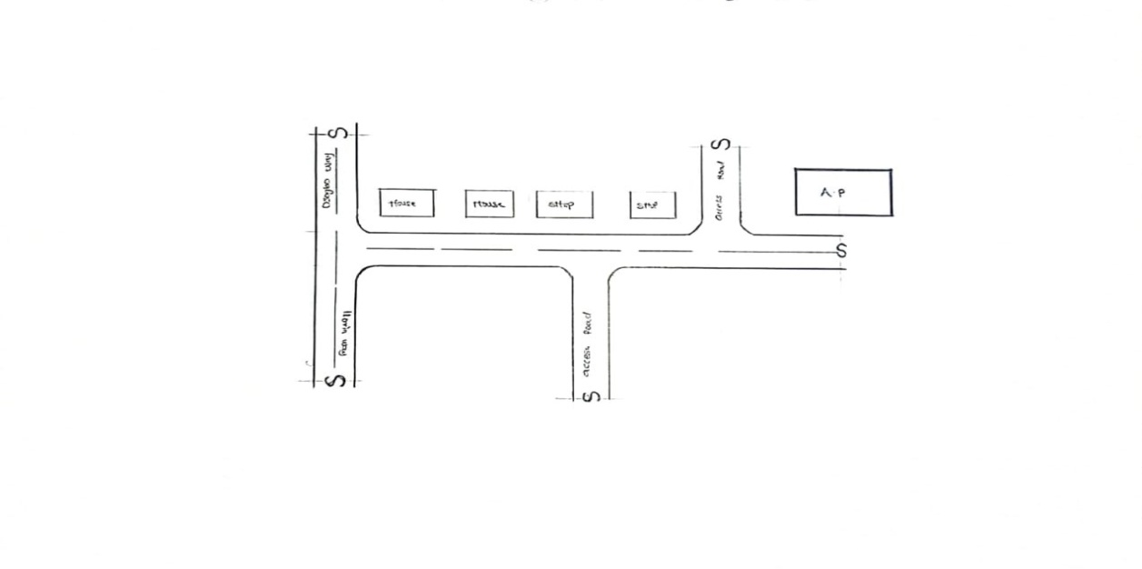
FIG 3.1:- LOCATION PLAN

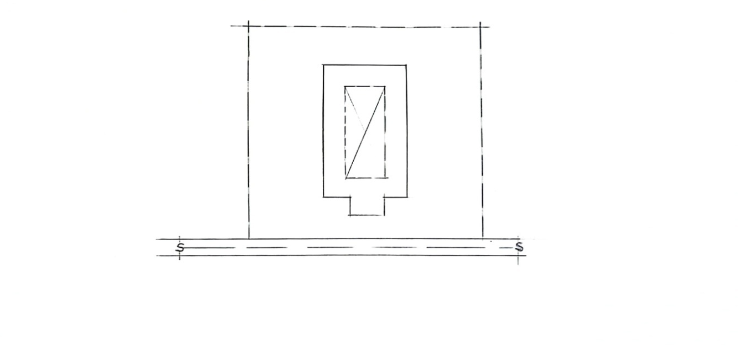

FIG 3.2:- SITE PLAN
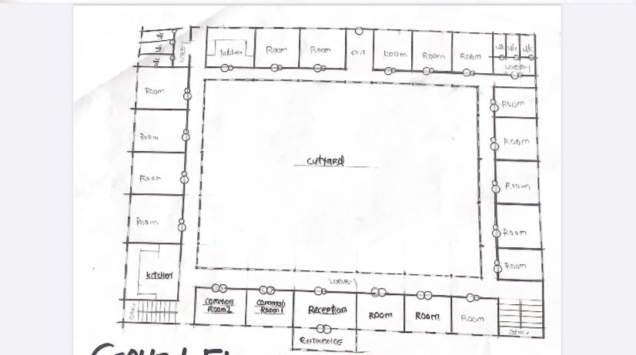
FIG 3.3:- GROUND FLOOR PLAN

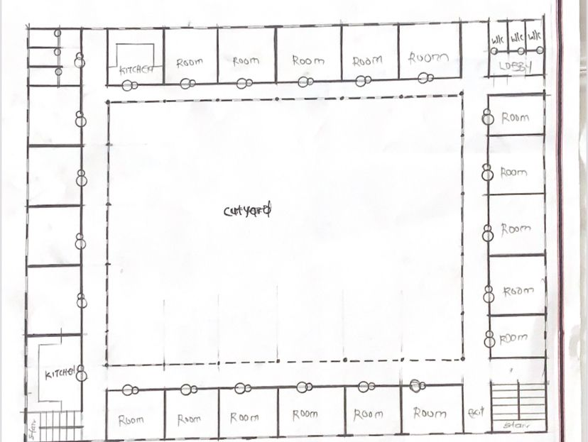
FIG.3.4:-UPPER FLOOR PLAN

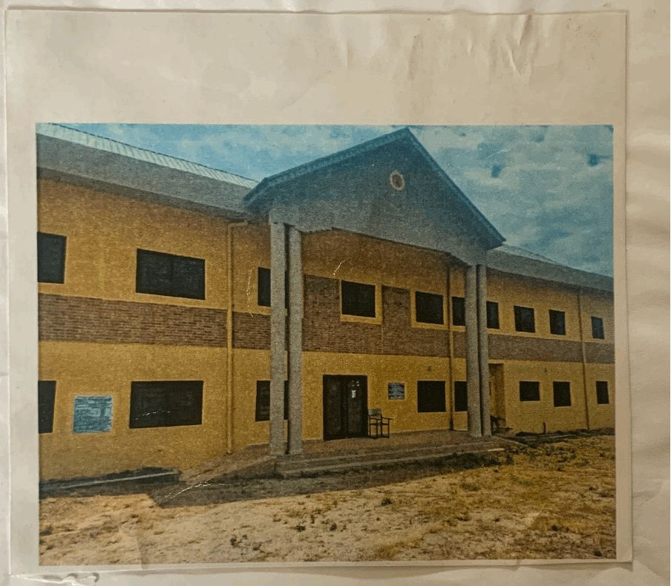
PLATE.3.1:- FRONT VIEW

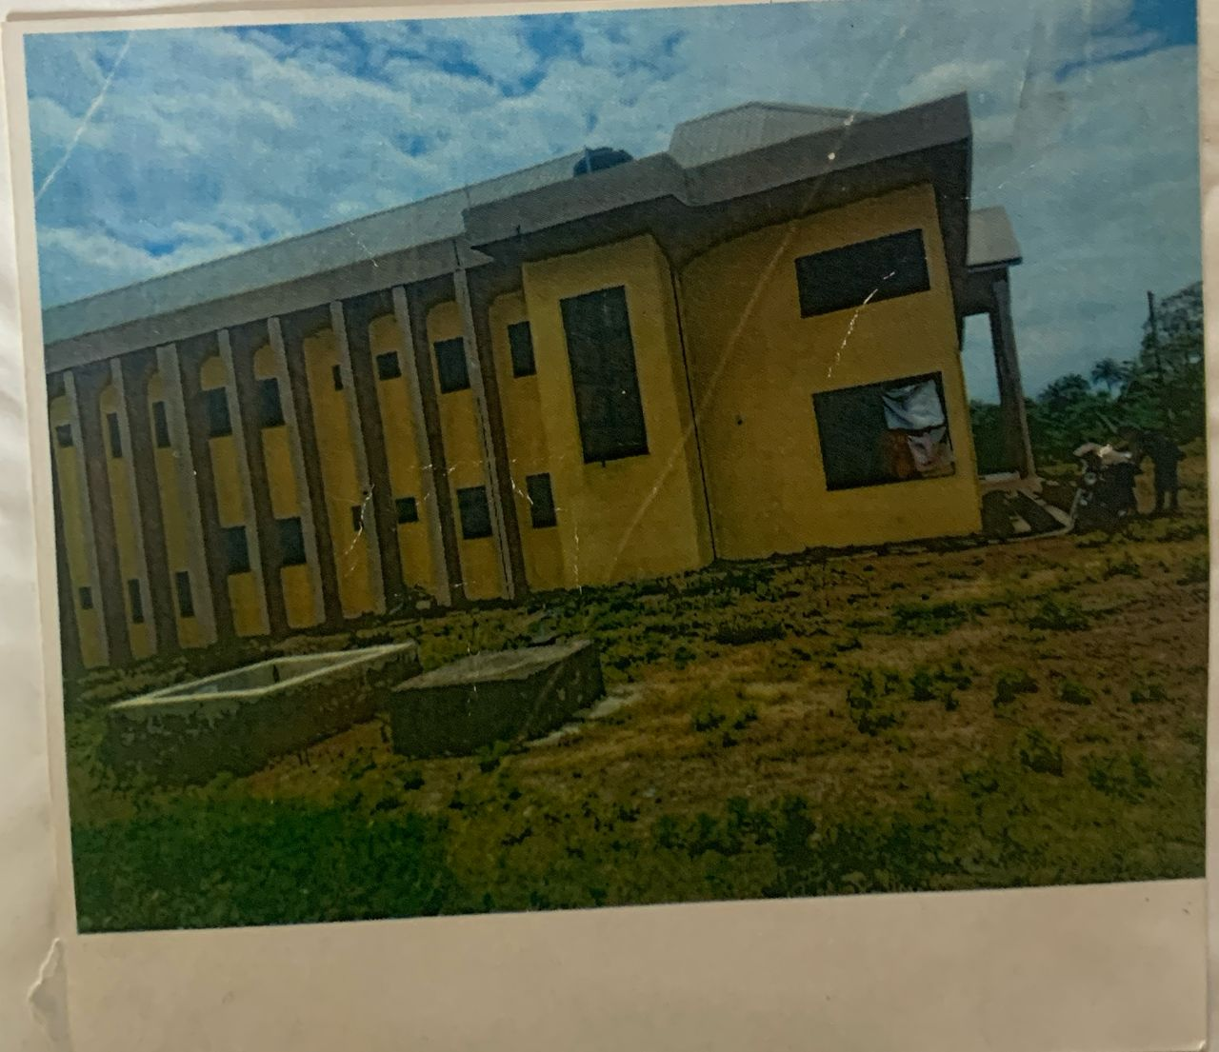
PLATE.3.2:-LEFT SIDE VIEW

CASE STUDY 2:
Location: Mowa Ogun state
Brief Description:
Redeemer’s College of Technology and Management (RECTEM)—the private polytechnic established by the Redeemed Christian Church of God (RCCG) in the RCCG Camp at Mowe, Ogun State:
- Founded in 2018 under the vision of RCCG General Overseer Pastor E.A. Adeboye to provide top-tier technical and vocational education in Nigeria .
- Located at KM 46 Lagos–Ibadan Expressway, Redemption City, Mowe, Obafemi Owode LGA, Ogun State .
- As the first private polytechnic to be accredited by the NBTE for both ND and HND programmes, RECTEM represents a landmark in Nigeria’s technical education landscape
- Merits
- Good orientation on site; the rooms take advantage of the Trade Winds, thereby being well ventilated.
- The rooms are spacious with capacity of 4 occupants i.e. 2 double bunk
- They provided not only room facilities, but also social facilities.
- Demerits
- No good security.
- No proper landscaping.
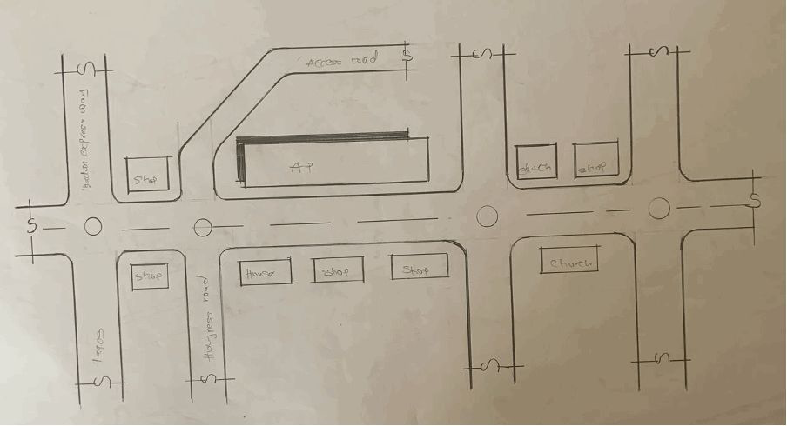
FIG.3.5:- LOCATION PLAN

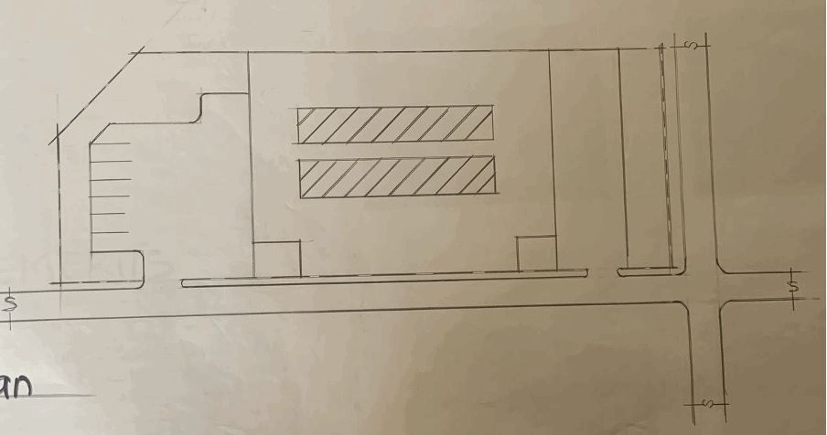
FIG.3.6:- SITE PLAN
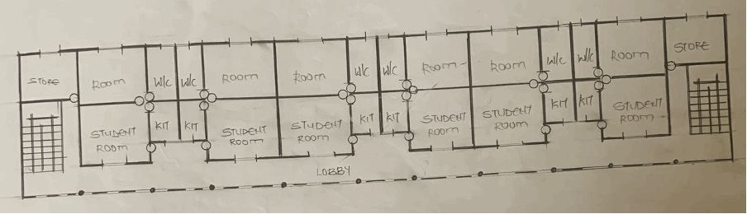
FIG.3.7:- GROUND FLOOR PLAN
FIG.3.7:- UPPER FLOOR PLAN
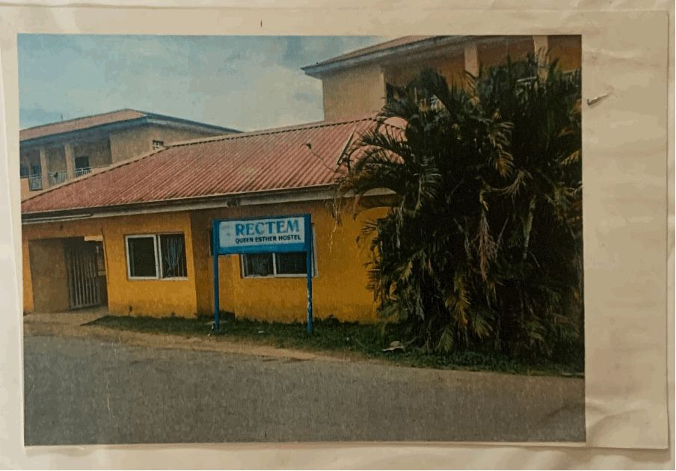

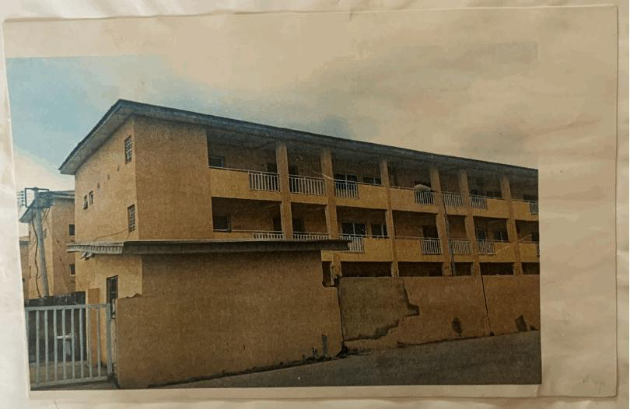
PLATE.3.3:- SIDE VIEW

3.2 Case Study TWO(3) Kwara State University Malete
Location: Kwara State University Female Hostel, Malate
Brief Description:
Kwara State University (KWASU) was established in 2009 as a state-owned and funded institution of higher education. The university was founded with the goal of providing high-quality education to students in the Kwara State region of Nigeria, with a focus on innovation and research.
- Merits

- Good orientation on site; the rooms take advantage of the Trade Winds, thereby being well ventilated.
- The rooms are spacious with capacity of 4 occupants i.e. 2 double bunk
- They provided not only room facilities, but also social facilities.
- Demerits
- Very far from school area
- No provision was made for a first treatment box
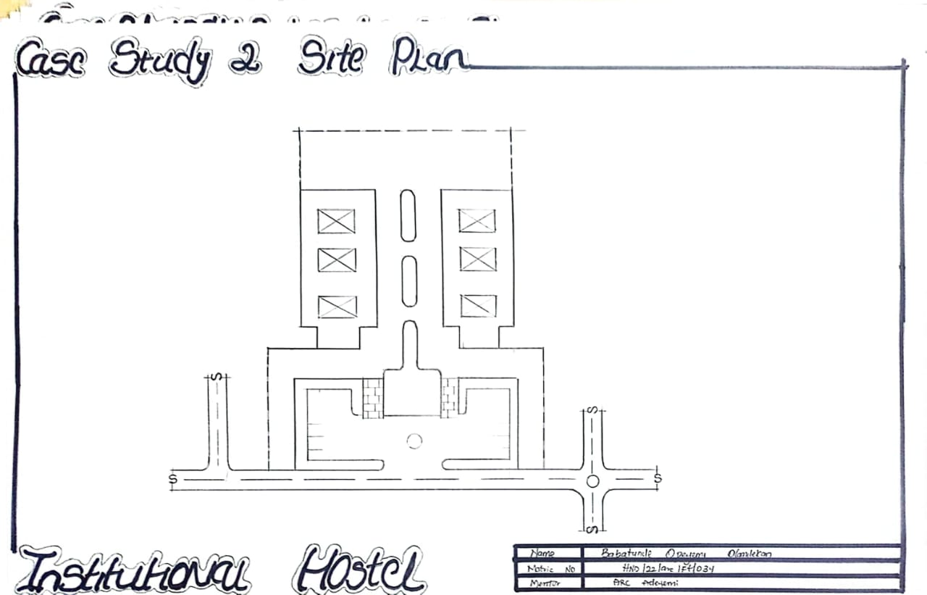
- No proper landscaping.

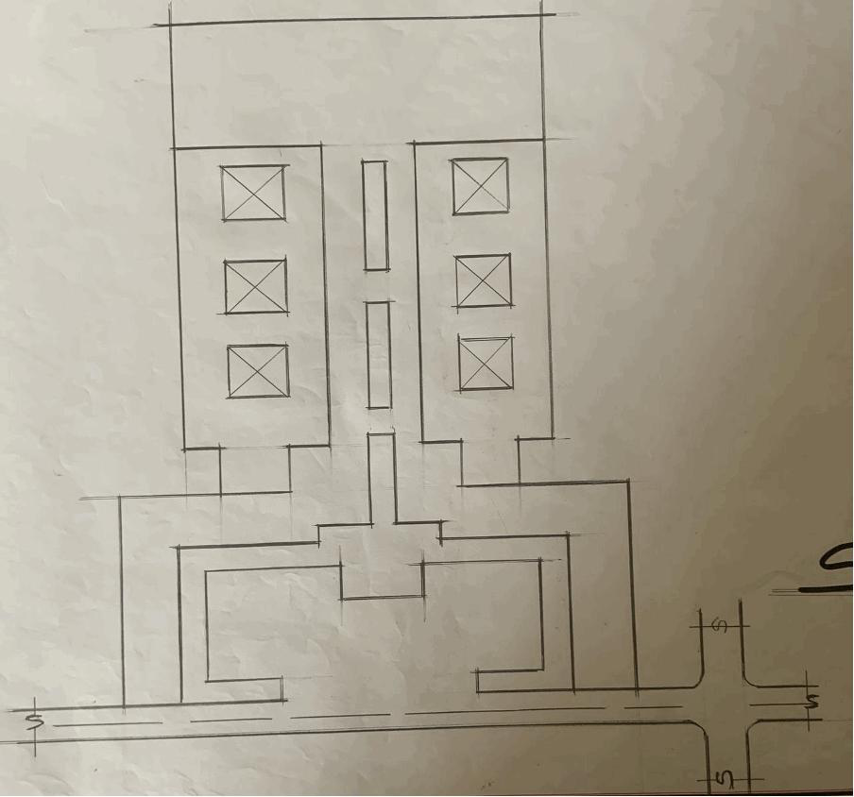
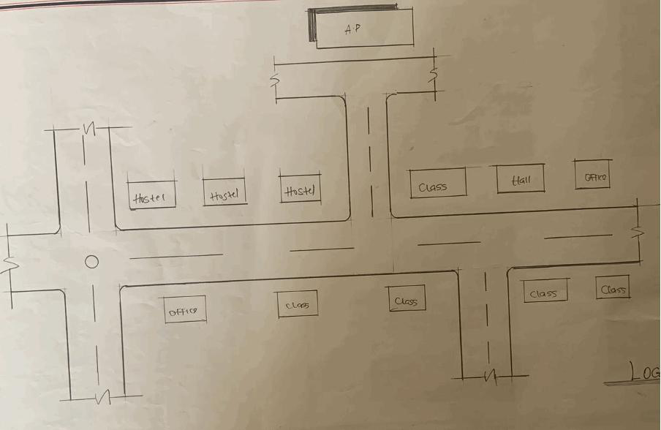
FIG.3.9:- LOCATION PLAN

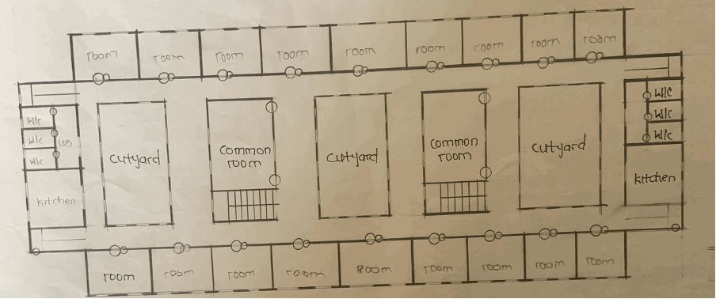
FIG. 3.11:- GROUND FLOOR PLAN

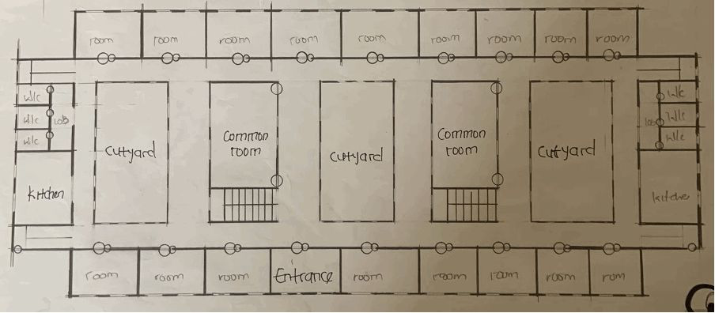
FIG.3.12:- UPPER FLOOR PLAN

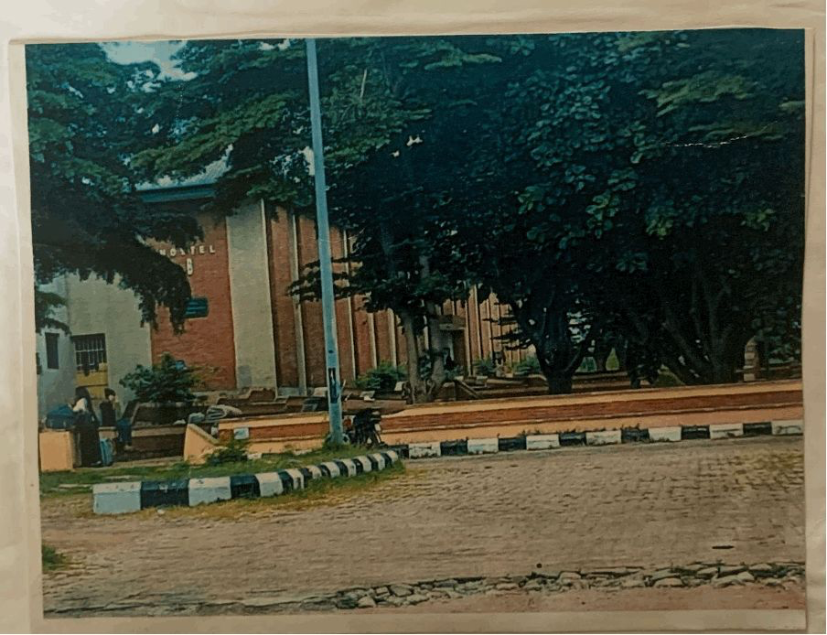
PLATE.3.4:- SIDE VIEW

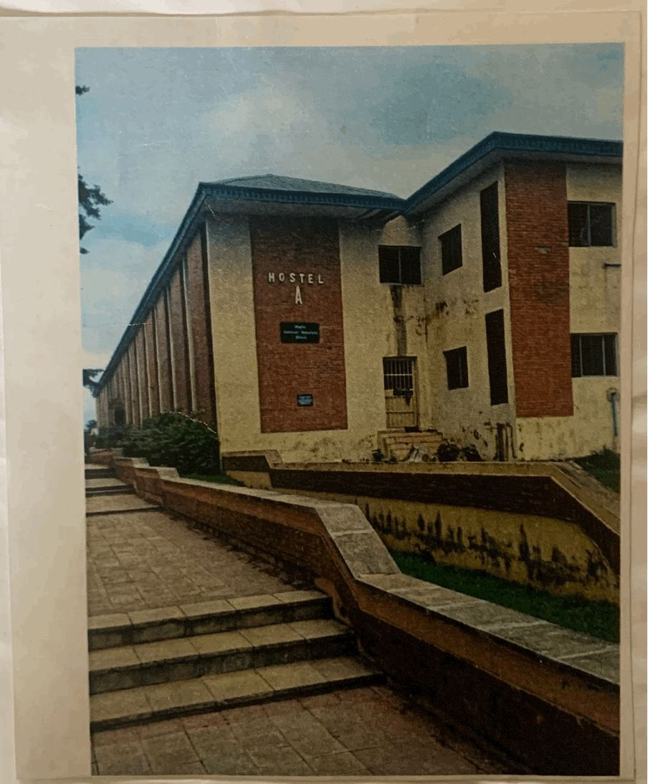
PLATE.3.5:- BACK VIEW

ONLINE CASE STUDYS
3.5Case Study (1): BLUEBERRY LADIES HOSTEL
Brief description
Blueberry Ladies Hostel is a women-only residential facility providing accommodation for female students and working professionals in the Infopark/Kakkanad area. It emphasizes safety, hygiene, shared living amenities, and affordable rates.
- Date Established: Not publicly documented (assumed post-2018, typical of newer hostels)
- Architect: Not specified
- Location: Padathikkara Thuruth Rd, Infopark Phase 2, Brahmapuram, Kakkanad, Kochi, Kerala 682303, India

Climate:Climate type: Tropical monsoon climate with high humidity and seasonal rains. Heavy rainfall during monsoon months, warm temperatures year-round

Topography & Vegetation:Typical urban flat terrain of Kochi–Kakkanad region. Vegetation in the hostel area is minimal, with paved surroundings and built-up environment.

Site Area:No official site area publicly listed. Residential building likely occupies a small urban plot typical in Infopark area (often under 1000 m²).
Facilities & Spaces
Provided amenities include:
- Student rooms (single and multiple-share with attached bathrooms, cots and wardrobes)
- Laundry service, ironing services, housekeeping
- Private lockers and secure storage
- High-speed Wi-Fi, power backup, TV with dish in rooms
- Gated and CCTV-secured premises
- Kitchen/dining meals provided, tea & coffee access
- Two-wheeler parking
Site Zoning
Typically a multi-storey building with shared corridors and facilities.
- Room shares vary from two-bed to eight-bed occupancy.
- Common communal areas likely include a lounge/study space and dining/kitchen zone.
- No publicly available floor plans or wing separations like the Epinay example.

Orientation:Likely designed for ventilation and natural light in tropical conditions through courtyard form or ventilated façade. Specific orientation details not disclosed.

Activities Supported:Sleeping, studying, relaxation and daily living (laundry, meals).,Communal social interaction and access to kitchen, dining, and lounge settings.

Circulation Pattern:Internal corridors for room access, common lounge/dining area circulation.

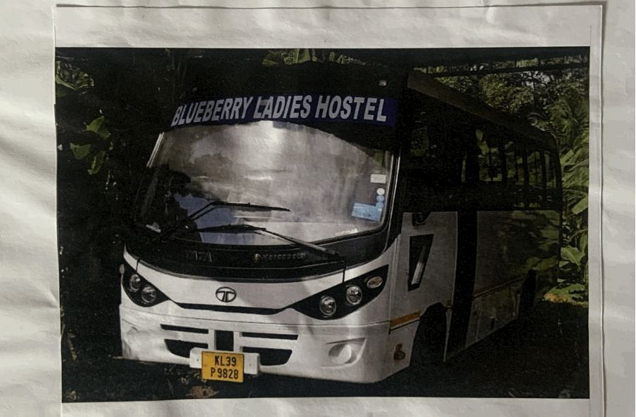

PLATE.3.6:-showing the motto of the hostel

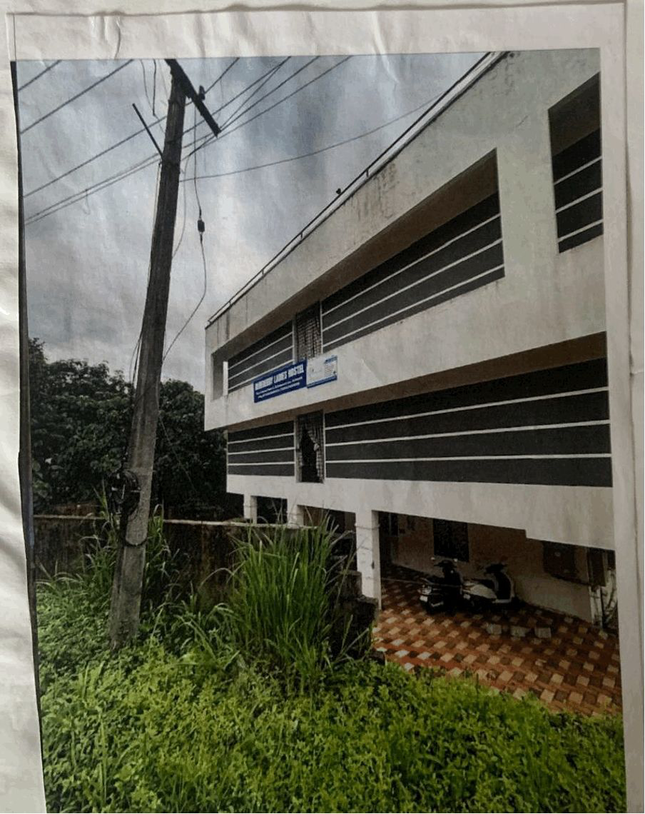

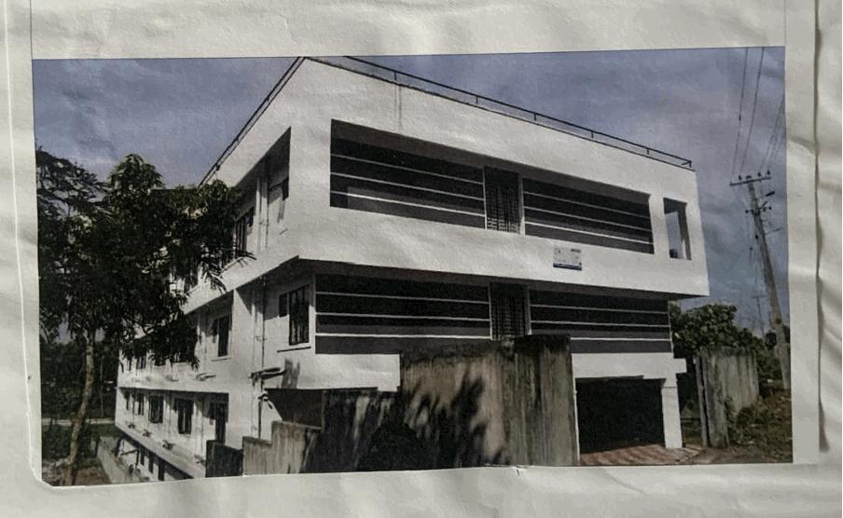
PLATE.3.7:-showing the view of the hostel

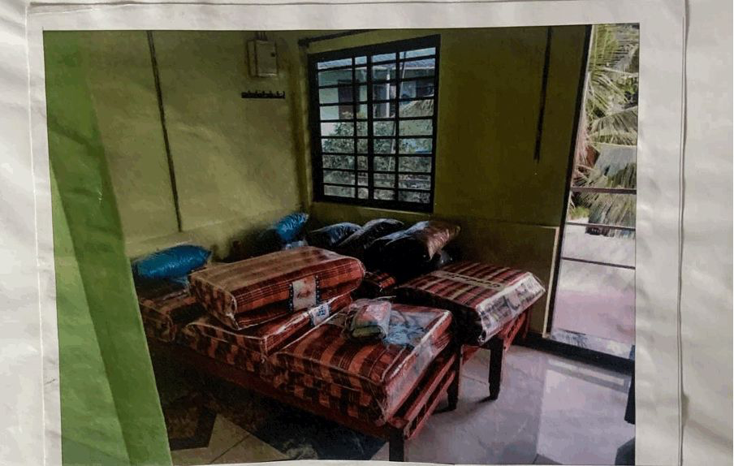

PLATE.3.9:- showing the view of the hostel

3.6 Case Study 2: University Students’ Housing Italy
Date of Establishment: 2007
Architect: C+S Associates
Location: Florence, Italy
Brief Description:
The students’ university housing in the former Fiat area at Novoli, Florence, was designed to adapt to the constraints of the brief – the perimeter of the lot, the alignment, the building height – and to use them as a springboard for original compositional and typological solutions that have produced articulated, light-filled interior landscape inside severe walls. Despite the double-courtyard layout the building is far from inward-looking and imposes order on the wider context.
Climate: The climate of Florence Italy is generally mild, and can be defined as Mediterranean, with relatively mild, wet winters and hot sunny summers.
Topography: The site is relatively flat with gentle slope.
Vegetation: The vegetation on the site sparse.
Building Materials: Reinforced concrete base, wood shingles, glass, brick.
Site Area: 6000 m²
Facilities:
- Shops
- Entrance hall
- Refectory
- Study rooms
- Lodgings (250 students)
- Balcony
- Courtyards
- Gardens
Site Zoning:
Main building: shops, entrance, refectory, on the ground floor; study rooms and services on the upper levels, and lodgings on the other floors.
Orientation: The building is oriented towards the south west breeze which takes advantage of the wind direction.
Activities: Activities in the building includes sleeping, studying and relaxation.
Circulation Pattern: Circulation is through the double courtyards pattern and also a passageway that cuts crosswise through the blocks and a focus for communal activities, as well as access to the student’s lodgings.
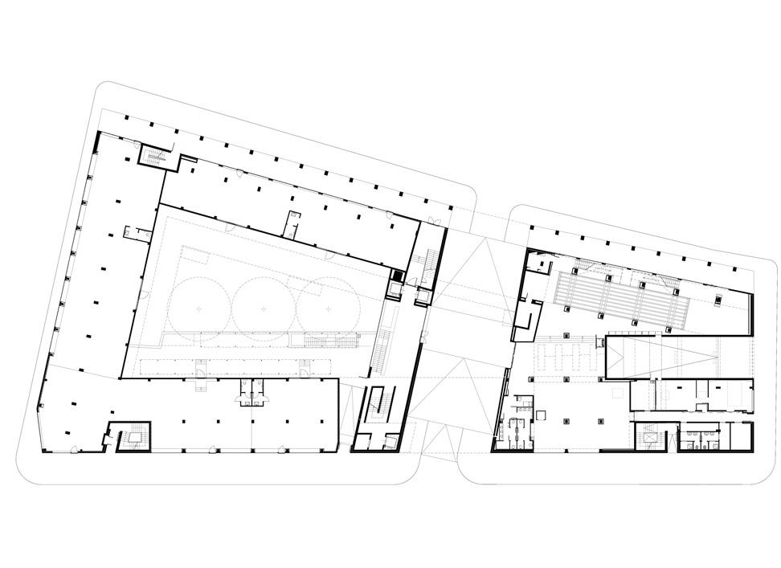
Figure IX: Showing Ground floor plan
Source: www.archdaily.com(2021)

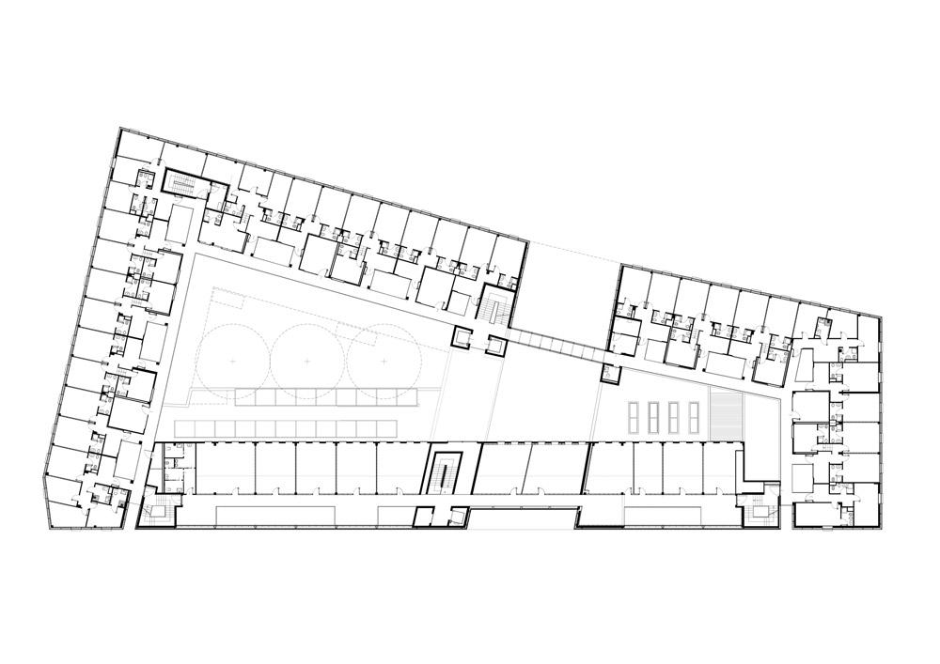 Figure X: Showing First floor plan
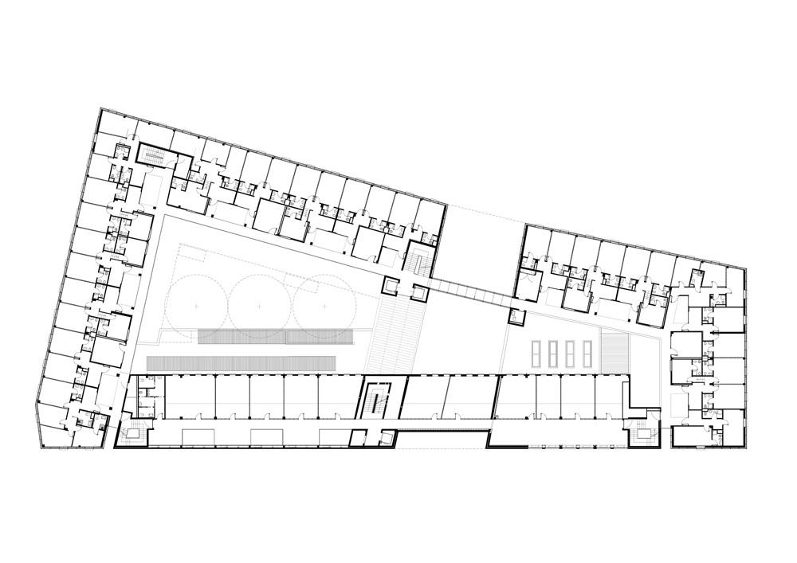
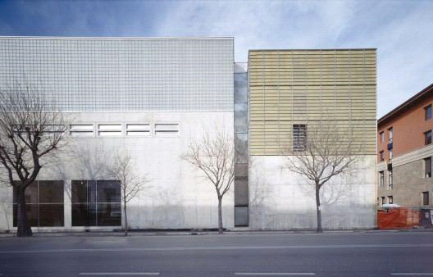

PLATE.3.10:-: Showing view of the hostel

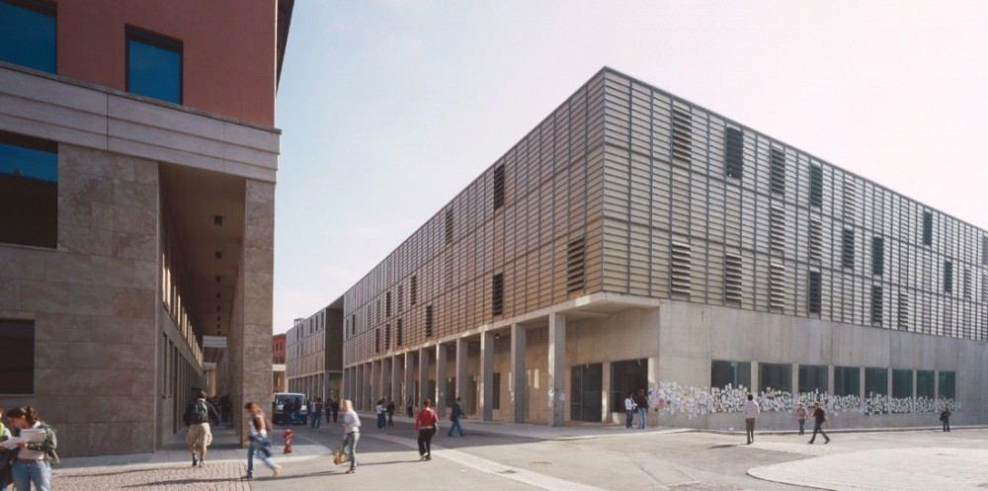
PLATE. 3.11: showing the view of the hostel

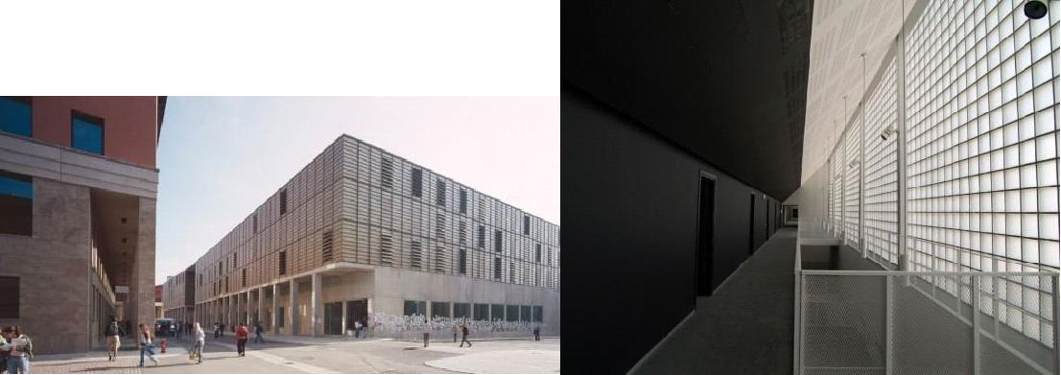

CHAPTER FOUR
DESIGN PROPOSAL
4..0. INTRODUCTION OF STUDY AREA/SITE SELECTION
4.1. HISTORY OF SAKI
Saki is one of the oldest towns in Yorubaland and has a rich cultural and historical heritage. It is believed to have been founded several centuries ago, and oral traditions trace its origins to Oduduwa, the legendary progenitor of the Yoruba people.
Saki’s founders were descendants of the Oyo Empire, which was one of the most powerful and influential Yoruba kingdoms between the 14th and 19th centuries. After internal conflicts and wars (especially the collapse of Old Oyo around the 1830s), many people migrated to safer areas in the forested regions — Saki became one of such resettlement areas.
The name “Saki” is thought to have originated from the phrase “Sa ki”, which means “to run and block” in Yoruba — a reference to a military strategy during the period of war and migration.
4.2 SITE LOCATION
The site is located at Oke Ogun polytechnic oyo state saki..
Location of the Oke Ogun polytechnic saki
The Oke-Ogun Polytechnic, Saki—often abbreviated TOPS—is located in Saki (Shaki), the headquarters of Saki West Local Government Area, situated in the Oke-Ogun region of Oyo State, Nigeria. Here’s a precise overview of its site and address:

Location & Address
- The campus is situated along Ago-Are Road, in Shaki town, bearing the postal code 203101 .
- It is also referred to as Ago-Are – Shaki, 203101, Shaki, Nigeria .
- Additionally, official listings include PMB 21, Shaki 203101, Oyo State, Nigeria as the mailing address .

Description of the Oke Ogun polytechnic saki
-The Oke-Ogun Polytechnic, Saki (TOPS) is a public, state-government tertiary institution in Saki (Shaki), Oyo State, Nigeria, formerly a satellite campus of The Polytechnic, Ibadan, until gaining full autonomy on July 17, 2014 .
-It is officially recognized by the National Board for Technical Education (NBTE) and currently led by Rector Dr. Surv. Ajibola Sikiru Adetona
-TOPS is organised into multiple schools or faculties offering a range of ND (National Diploma) and HND (Higher National Diploma) programs:
Criteria of the Oke Ogun polytechnic saki

Autonomous Status:The institution began as the Saki campus of The Polytechnic, Ibadan.
It was granted full autonomous status on July 17, 2014, by the then-Governor of Oyo State, Senator Abiola Ajimobi .
Academic status:National Diploma (ND) Programs:
Duration: 2 years, available in full-time and part-time formats .
Ideal for students with five (5) O’Level credit passes (including English and Mathematics), obtained in no more than two sittings. Entry for full-time ND also requires a JAMB UTME score (minimum 120) and Post-UTME screening; part-time ND may not require UTME
- TOPS offers approximately 29 accredited ND programs across disciplines such as Engineering, Science & Applied Technology, Environmental Studies, Agriculture, Business & Financial Management, Communication, and more

4.3 Site Location Map
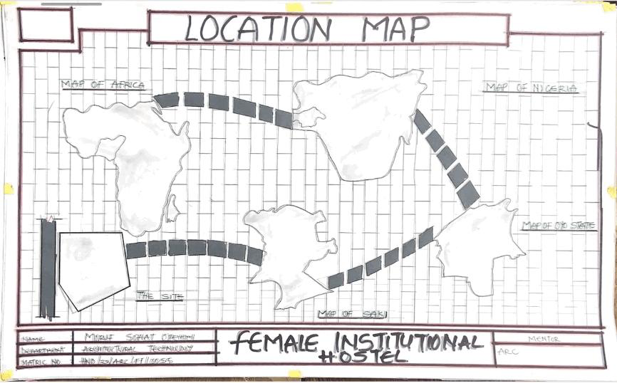
FIG.3.13:-: Map of Nigeria showing location of OYO state

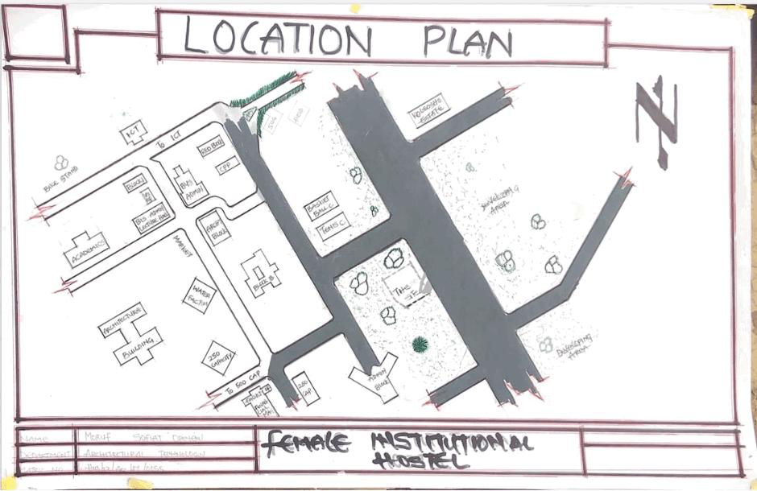
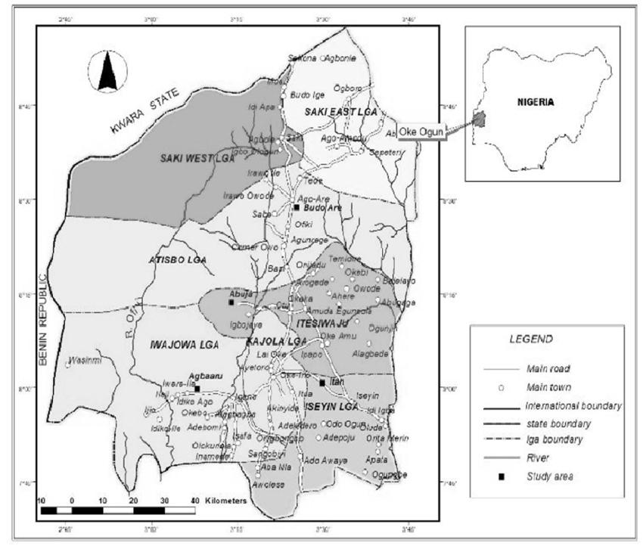
FIG.3.14: Map of OYO state showing location of oke Ogun polytechnic saki
- Location:
The site is located along existing female hostels within the school.
- Ease of Access:
The site can be accessed easily as there is an existing road that leads to it.
- Availability of Enough land:
To adequately provide for the various facilities required in the building and on the site, the area of land required for the project must be adequate. Therefore, the site was selected because it is wide enough to accommodate the proposed design.
- Security:
The site is located within the school thereby is covered by the school security ensuring safety of the students. But also, additional security would be provided on the site.
- Nature of Site and Vegetation:
The topography of the site is fairly levelled and the slightly unlevelled part can be adequately levelled. The sub soil is mainly red lateritic soil, with barches of sandy soil. The site also contains few trees and shrubs, which can help enhance the landscape of the site, and also act as wind-breakers and dust filters during the harmattan.
4.4. SITE CHARACTERISTICS
Soil type
The sub soil is mainly red lateritic soil, with barches of sandy soil. It is a high load bearing capacity soil.
Vegetation
The vegetation on the site consists of few trees of different species and shrubs. Some trees and shrubs will be retained to enhance the landscape of the site, and also act as wind-breakers and dust filters during the harmattan.
Topography
The topography of the site is fairly levelled and the slightly unlevelled part can be adequately levelled.
Drainage
There is no existing drainage on the site, so drainage would be constructed.
Accessibility
The site is accessible by an existing road along the adjoining buildings which leads to the site.
4.5. SITE ANALYSIS
A site analysis involving a study of the site is carried out, it takes into consideration natural and man-made components present in and around the site, as well as climatic conditions of Lagos state. The plate below shows a schematic summary of the analysis of the proposed site.
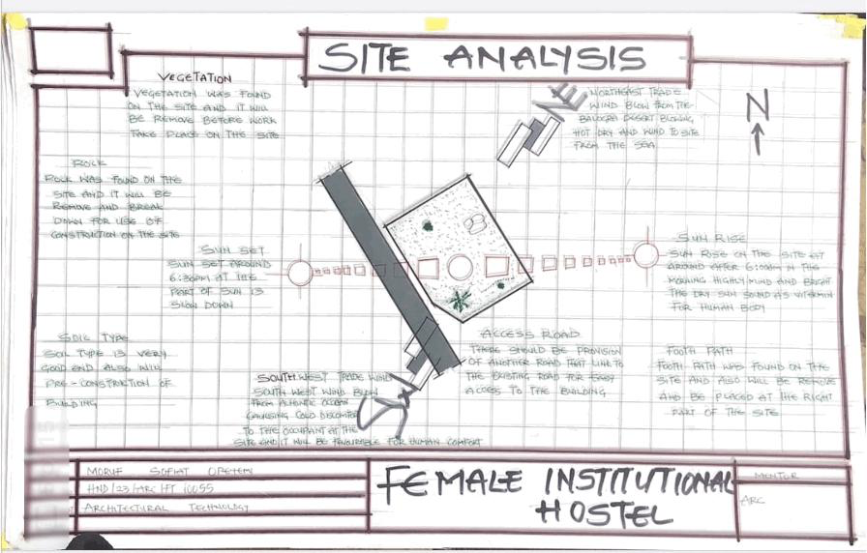
FIG.3.15:-: Site Analysis
Source; Authors fieldwork 2025
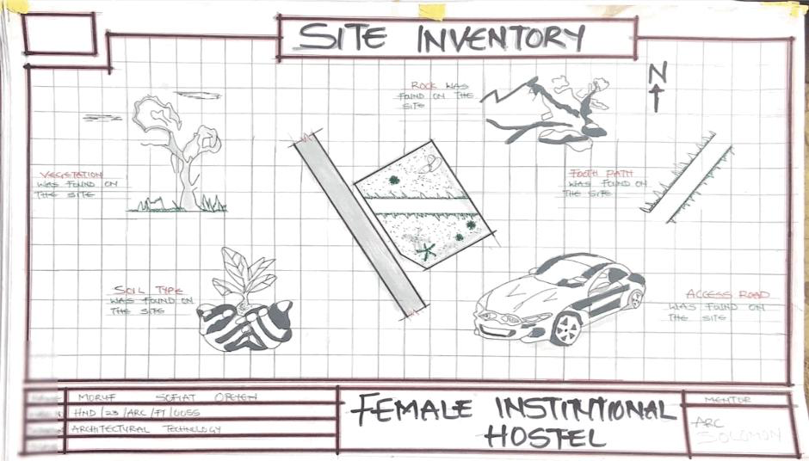

FIG.3.16 Site Inventory
4.6 GEOGRAPHICAL/ CLIMATIC DATA
- Climate
Lagos is one of the cold regions in Nigeria with an average daily high temperature of only 31 degrees centigrade. High humidity and hot temperatures make the weather at times pleasant but also tropical humid. It is warm to hot all year round and invites to bathe at average water temperatures of 27 degrees. Due to the lesser rain the best time for traveling is from November to March. Most precipitation decrease from June to October.
- Hours of sunshine per day

Figure 4.3 Hours of Sunshine per day
Source; Worlddata.info
The number of hours of sunshine refers to the time when the sun is actually visible. That is, without any obstruction of visibility by clouds, fog or mountains. With 7 hours per day, February is the sunniest month in the state of Lagos. In August the sun shines the shortest.
- Rainy days per month

Figure 4.4 Rainy days per month
Source; Worlddata.info
A rainy day is a day on which at least an amount of 0.1 mm precipitation (=0.1 liter) per square meter falls. This can be rain, snow, hail or even dew. So it does not have to rain the whole day. With 18 rainy days, June offers the most number of rainy days, and in December the least.
- Precipitation in mm/day

Figure 4.5 Precipitation in mm/day
Source; Worlddata.info
The amount of precipitation is measured in millimeters per square meter. Thus, at two mm/day, two litres of water fall on one square meter within 24 hours. With only 0.4 mm, the least rain falls in December. June, on the other hand, has the most rain.
- Water temperature

Figure 4.6 Water temperature
Source; Worlddata.info
Water temperature depends not only on solar radiation within the same region, but also on ocean currents. For example, depending on the season, cold or warm water masses are moved from other areas. The warmest temperatures in Lagos are in March, when the water is 28 °C.
- Relative humidity in %

Figure 4.7 Water temperature
Source; Worlddata.info
Warm air can absorb more moisture than cold air. The relative humidity indicates how much moisture of the physically possible is actually contained in the air. At high humidity, the person feels uncomfortable and perceives this as oppressive. In general, a relative humidity of 40-60% gives as pleasant. With humidity averaging 87%, June is the most uncomfortable. In March, on the other hand, it is easier to endure.
4.7 ANALYSES OF THE IMMEDIATE ENVIRONMENTAL CONDITIONS OF THE SITE
- Site Features and Infrastructure
The site features electrical lines which proposes that open power supply is promptly accessible inside the site.
Perfectly drained soil; soils water moves through easily to allow good soil aeration and at the same time sufficient amount is retained for plant growth.
Other features are water supply and an access road.
- Noise SourcesThere are no much noises on the site but the few noises that can be heard comes from the adjacent structures which are the existing female hostels.
- Rainfall:
Minimum rainfalls are recorded in December, while June offers the most amount of rainfall.
- Vegetation and Topography:
The vegetation on the site consists of few trees of different species and few shrubs. The site is relatively gentle sloping and has a high load bearing capacity soil.
- Prevailing Wind Direction & Sun-Path Angles
The two predominant winds blowing across this area are the South West Trade wind and the North East Trade wind. The former, which blows across the Atlantic Ocean, is characteristically cold and results in the wet season. Being a cold wind, it is capable of holding much moisture contents across the ocean, and hence an increase in relative humidity of the area affected. However, the North East Trade wind, which blows across the Sahara Desert, is dusty and dry wind. Consequently, the two predominant seasons experienced in this area are characteristically marked by the two wind types. The summer (the season between spring autumn when the sun is hot and there are many flowers) is experienced between April and September, when the south west Trade wind is more predominant, while the winter season is shortly marked between November and March, when the north east trade wind is more predominant. This later season {winter} is however characterized by cool and hazy mornings, couple with dusty afternoons, because of the dust particles it brings forth from the desert. To reduce the effects of wind driven, trees were planted.
- Sunrise and sunset:
The sun rises from the east in the early hours of the morning at about 6:30am - 7:00 am and sets in the west at about 6:45 pm in the evening daily.
- Accessibility:
The site is accessible by an existing road along the adjoining buildings which leads to the site.
- Man-made features

- Electricity: Electricity is supply to the site through overhead cables along the site boundary.
- Footpath: There are no existing footpaths on the site, few would be channeled.
- Noises: Caused by adjacent structures

4.8 PROJECT ANALYSIS/DESIGN CRITERIA
The proposed design is the design of a female hostel with emphasis on fire safety to ensure the safety of the students and occupants.

- ​Design Considerations:
The following are the factors considered when designing the building;
- Passive and Active Fire safety: Fire safety measures would be considered in designing the building to increase safety in the building,
- Aesthetics: In any architectural design, aesthetics is most common factor to consider which shall be achieved by the use of attractive and lively finishing materials.
- Functionality: In any architectural design, functionality plays major role, design must be functional to meet the taste and convenience of the occupants.
- Ventilation: This includes the orientation of the building, sizes and locations of fenestrations, vegetation.
- Circulation and Zoning: Appropriate and well-articulated pattern of circulation in a building alleviates confusion and at the same time tailor the movement of students to their respective destination.
- Landscaping: The form of landscaping in the building is aimed at satisfying user requirements, having aesthetic value and improving environmental comfort. Hence, landscaping will be considered in the design
- Security: The provision of security in the hostel involves the protection of the students, the building and its contents.

4.9 DESIGN CONCEPT
The design approach was based on functionalism, which is an architectural principle that says that building should be designed based solely on purpose and function of the building.
4.10 PROJECT GOAL
The proposed design is the design of a female hostel with emphasis on fire safety to ensure the safety of the students and occupants.
The hostel is to provide the students with accommodation facilities and other functional spaces and facilities. These facilities include:
- Reception
- Rooms en-suite
- Laundry
- Porter’s room
- Fire safety Equipment rooms
- Retail shops
- Relaxation area
- Car park
4.11APPRAISAL OF PROPOSED SCHEMES.
An appraisal of a proposed scheme for institutional hostels involves evaluating the plan's feasibility, effectiveness, and potential impact. Here's a comprehensive appraisal framework:
I. Location and Accessibility
- Proximity to academic buildings and facilities
- Safety and security features
- Accessibility for students with disabilities
II. Capacity and Accommodation
- Number of students to be accommodated
- Room types (single, shared, etc.) and amenities (e.g., beds, desks, storage)
- Common areas (e.g., lounge, kitchen, laundry)
III. Infrastructure and Amenities
- Water and electricity supply
- Sanitation and waste management
- Internet and Wi-Fi connectivity
- Furniture and appliances
IV. Management and Supervision
- Hostel administration and staff
- Rules and regulations
- Maintenance and repair procedures
V. Cost and Funding
- Construction and operational costs
- Funding sources (e.g., government, private investment)
- Student fees and payment structures
VI. Sustainability and Environmental Impact
- Energy efficiency and renewable energy sources
- Water conservation measures
- Waste reduction and recycling programs
VII. Student Life and Well-being
- Support services (e.g., counseling, health services)
- Social and recreational activities
- Community engagement and inclusivity
VIII. Future Expansion and Flexibility
- Potential for expansion or renovation
- Adaptability to changing student needs and demographics
IX. Compliance with Regulations
- Adherence to local building codes and regulations
- Compliance with accessibility and safety standard
X. Stakeholder Engagement
- Involvement of students, staff, and faculty in the planning process
- Community engagement and outreach
4.12 EQUIPMENT AND OPERATIONAL AND PERFORMANCE REQUIREMENT
Designing an institutional hostel involves considering various equipment, operational, and performance requirements to ensure the facility meets the needs of its residents effectively and efficiently. Here’s a detailed breakdown of these aspects:

Equipment Requirements

Essential Equipment
Furniture:
Beds: Comfortable and durable, typically with storage options (e.g., drawers under the bed).
Desks and Chairs: Ergonomic and suitable for study or work, with ample space for personal belongings.
Wardrobes/Closets: Adequate storage for clothing and personal items.
Common Area Furniture: Sofas, chairs, and tables for lounges and social spaces.
Kitchen Appliances:
Refrigerators: Sufficient capacity to store food for all residents.
Stoves/Ovens: For cooking, with safety features and adequate ventilation.
Microwaves and Toasters: For convenience and quick meals.
Dishwashers: Optional, depending on the size and budget.
Laundry Facilities:
Washing Machines and Dryers: Easily accessible and with sufficient capacity.
Ironing Boards and Irons: For personal clothing care.
Cleaning Equipment:
Vacuum Cleaners, Mops, and Brooms: For maintaining cleanliness.
Trash Bins and Recycling Containers: Strategically placed in common areas and individual rooms.
Safety Equipment:
Fire Extinguishers: Properly placed and maintained.
Smoke Detectors and Alarm Systems: For fire safety.
First Aid Kits: Easily accessible and stocked with essential supplies.

Technological Equipment
Wi-Fi and Networking: Reliable and high-speed internet access throughout the hostel.
Televisions and Entertainment Systems: Optional for common areas.
Climate Control: Air conditioning, heating, and ventilation systems to ensure comfort.

Operational Requirements

Facility Management
Maintenance Schedule: Regular checks and maintenance of equipment and infrastructure to ensure everything is in good working condition.
Cleaning Protocols: Daily and periodic cleaning schedules for rooms, common areas, and facilities.
Security Measures: Surveillance systems, security personnel, and controlled access points to ensure resident safety.

Resident Services
Reception and Check-In/Out Procedures: Efficient management of guest arrivals and departures, including handling of keys and room assignments.
Support Services: Availability of staff or resident assistants for addressing issues or concerns.
Emergency Procedures: Clear protocols for handling emergencies, including evacuation plans and communication procedures.

Administrative Management
Booking and Reservation Systems: Efficient systems for managing reservations, room assignments, and payments.
Documentation and Record-Keeping: Proper documentation of resident information, maintenance records, and operational logs.

Performance Requirements

Comfort and Usability
Space Planning: Effective use of space to ensure comfortable living conditions, including adequate room sizes and communal areas.
Noise Control: Soundproofing measures to minimize noise disruptions, especially in shared spaces and sleeping areas.
Lighting and Ventilation: Adequate natural and artificial lighting, and good ventilation to create a pleasant environment.

Safety and Compliance
Building Codes and Regulations: Adherence to local building codes, fire safety regulations, and health standards.
Accessibility: Compliance with accessibility standards to ensure ease of use for all residents, including those with disabilities.

Efficiency
Energy Efficiency: Use of energy-efficient appliances, lighting, and HVAC systems to reduce operational costs and environmental impact.
Water Efficiency: Implementation of water-saving fixtures and systems to reduce consumption and operational costs.

User Satisfaction
Resident Feedback: Regular collection of feedback from residents to address concerns and make improvements.
Quality of Amenities: Ensuring that all provided amenities meet quality standards and are in good working order.
The design of an institutional hostel requires a comprehensive approach to equipment, operations, and performance. Addressing these requirements effectively ensures that the hostel provides a safe, comfortable, and functional living environment for its residents, while also being manageable and efficient for the institution.
4.13 SPATIAL ALLOCATION / SCHEDULE OF ACCOMMODATION
It is the allocation of spaces required in the building design in order to make the most appropriate use of spaces available.
Schedule of Accommodation
Table 6.1 Schedule of Accommodation

S/NO | SPACE | UNITS | LENGTH(M) |  | BREADTH(M) | AREA(M2)
1 | Reception | 1 | 7.6 |  | 4.4 | 33.44
2 | Waiting area | 1 | 2.8 |  | 3.5 | 9.8
3 | Porter room | 1 | 2.8 |  | 1.5 | 4.2
4 | Common rooms | 8 | 10 |  | 5.2 | 52
5 | Conference room | 1 | 2.5 |  | 3.9 | 9.75
6 | Maintenance rooms | 8 | 2.5 |  | 2.0 | 5
7 | Landry | 1 | 6.0 |  | 4.5 | 27
8 | Rooms (4student) | 1 | 2.5 |  | 2.0 | 5
9 | Kitchen | 40 | 3.6 |  | 3.6 | 12.96
10 | Toilet | 60 | 3.6 |  | 3.6 | 12.96
11 | Courtyard 1 | 100 | 2.0 |  | 2.5 | 5
12 | Courtyard 2 | 100 | 1.5 | 2.5 |  | 3.75

4.14FUNCTIONAL RELATIONSHIP
Functional relations in architectural design refer to the way in which different spaces, elements, and components of a building interact and support each other to achieve the intended purpose of the structure. These relations are crucial for creating efficient, practical, and aesthetically pleasing environments.

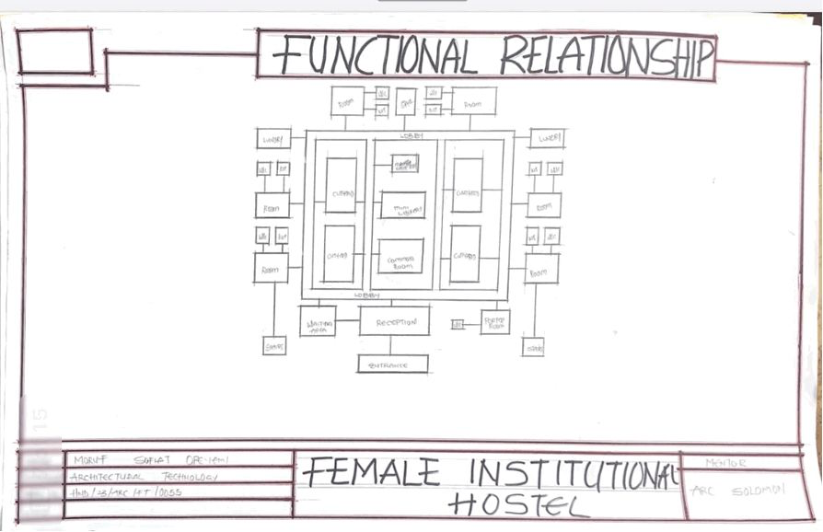

CHAPTER FIVE
5.0. PROJECT APPRAISAL

5.1DESIGN CONCEPT
To achieve a spatial configuration –in the design National Library Umuahia – that facilitates user orientation, way-finding and efficient library usage by the application of the findings in this study, certain design guidelines and recommendations studied are adopted as the basis for evolving a conceptual framework on which the design is built.

​Architectural Way-finding
Site Logic: To aid the user's ability to understand and to be properly oriented in the library‘s outdoor environment, external spaces grouped into logical function-zones. Also, this involves the articulation of the edges of salient nodes into a legible system to visually separate one functional district from another. For instance, the visual dominance of the library‘s main entrance(s) and the definition of public space from private space which are important factors in navigating large scale landscapes form critical elements of the design.
Building Form and Floor Plan: Equally, functionally related activity areas form zones consciously planned to preserve the ‗sense of place‘ and connectivity between spaces. This entails creating clear, logical hierarchies of such other architectural way-finding elements as markers, edges and paths to facilitate user cognitive perception and orientation in space.

​Graphic Information Way finding Design
A clear, organized set of sign elements are potential elements in any good way-finding design scheme. In this process, therefore, related graphic devices such as wall and
Floor graphics, strategic placement of sculpture, and art programs form directional components of the way-finding plan.

​Design Concept Synthesis
Researching case studies helped to give direction in determining best practices in solving the way-finding and orientation design issues in public libraries. Thus, this informs the following configuration of spaces to achieve legibility in the design:
      - A hierarchical characterization of activity zones and nodes in logical scales to help direct library patrons to other sections of the library. For instance, the most crucial space is a large, well lit lobby area or atrium, followed closely by large reading and study areas.
      - Simple floor layout with immediate visual and physical access to various designated library destinations.
      - Visual perception of major circulation pathways and systems, especially vertical transport systems to ease orientation and locomotion.
      - Visual prominence and definition of major entry points to facilitate access to designated library destinations.

Design Philosophy
- To achieve a successful architectural way-finding in the design of the National Library Umuahia, the author takes on the universal design approach which seeks to design environments that are specifically inclusive and equal for all users, the key idea being thecreationofspacesorfeaturesthatdonottreatsomepeopledifferently. This entails the design of the environment; buildings, products and communications that equitably accommodate the spatial needs of all types of people and, takes into account as much as possible their differences, particularly those of people with physical impairments or difficulties speaking the dominant language. Also, of particular interest to the universal design approach is the provision of spaces flexible enough to accommodate a wide range of individual preferences and abilities; simple and consistent in use without unnecessary complexity and hazardous elements. Further, universal design promotes the creation of structures that facilitate user efficiency and comfort, with adequate space for various user activities including the use of assistive devices or personal assistance and, legible and universally perceptible communication systems.

5.2 CONSTRUCTION METHODS
The soil type of the proposed site will highly be instrumental to the construction considerations to be explored in order to bring about the structure build ability. However, the proposed site is a gently sloped site with good draining capacity and a good safe load bearing capacity and as such the need for additional strengthening and treatment of soil before construction may not be needed unless the geological experts requests so. Subsoil water drainage is necessary to improve the run-off of ground water to maintain the water table at some depth below the surface with a purpose of;
1. Improving the soil stability.
2 Prevent surface flooding.
3. Avoiding dampness in underground occupation such as basement or the ground floor.
4. Reducing the humidity in the immediate environment of the building structure.
The building lines are taken into consideration at the inception of this design, so with the building lines and the existing access road other wall flanks can be set out at right angles to the building line:
1. By using a large builders square placed against the building line and sideline produced to length required.
2. By using the proprietary optical square which comprises two small sighting telescopes permanently set at precise sight angles to one another.
3. By using an optical instrument with a base ring graduated to degrees and sighting along angles required.
The method of construction is as follows
Digging of trenches
Filling of hardcore
Block laying
Filling of hollow blocks with hardcore
Filling of laterite into foundation
Casting of mass over-site slab
Laying of block wall
Casting of column and lintel
Roof construction
Plastering
Fixing of window frame
Finishing

5.3SUB-STRUCTURE
This is the part of the building that has direct contact with the ground and carries the majority of the building load. The stability of the proposed structure depends to a large extent on the type and load which the proposed design will exert on the ground. The strip foundation is to be adopted as the foundation type for this project and its depth is to be determined by a combined effort of the geological experts and structural engineers. Recommendations on the depth and foundation type proposed will be subjected to the architect’s approval so as to get a unified approach which will in every possible means align with the proposed design. All other details as regards the material type, configurations, spacing to be used during the construction of the substructure will be to the structural engineer’s specification and design.
5.4 SUPER STRUCTURE
The super structure comprises different components and because of the complexity of the proposed structure, explicit care and consideration needed to be explored all in a bid to recommend the best forms of materials to be used to achieve the concept taking into consideration cost, structural stability, maintenance and build-ability.
1 The Walls: The internal walls basically serving as party walls were constructed entirely of sand Crete block walls with reinforced concrete columns at the end to keep the structure firm. The structure is to be constructed with 150mm sand Crete hollow blocks and reinforced concrete for the floors. However, Expansion joint will be introduced at intervals of 25-30m to prevent buckling or cracking which may occur due to temperature change and other factors.
2 Floor: Floor slab of 150mm reinforced concrete is to be used for the project.
3 Roof: Steel trusses are to be used for the roof carcass and long span aluminum roofing sheets are to be used. Adequate care needs to be taken during installation so as to achieve first and foremost the building plan and reduce the amount of wasted sheets to be placed while coupling the roof members. The roof slab incorporated mostly at the gutter of the auditorium section is to be covered with 3 layers of bituminous felt with sawdust and sand to reduce the heat radiation from the slab.

5.5 CONSTRUCTION MATERIALS
The choice of materials to be used is influenced by several factors, some of these factors include;
1 The availability of materials
2 The durability and suitability of such materials
3 The climatic situation/condition
4 The cost of material, etc.

5.6 SUBSTRUCTURE AND SUPERSTRUCTURE
1 Suspended Floors: Unglazed vitrified ceramic floor finish; unglazed vitrified ceramic tiles; polished granite tiles; glazed vitrified ceramic tiles.
2 Walls: Sand Crete block for all walls of load bearing capacity finished with 25mm thick wall plaster rendered and finally painted with white emulsion paint on the exterior and other colors in the interior as may be specified. In the conveniences- toilets, changing, etc, the walls are to be finished with glazed ceramic tiles to a height of 2.1m.
3 Doors: Sizes of doors in the design range from 750mm to 2500mm. The door schedule to be provided in the proposed design drawings shows each as applicable in the design. The surface coating of these doors especially the interior ones must be able to withstand incessant cleaning and must be able to prevent sound and odour transmission. Single and double leaf doors shall be of approved quality, solid hardcore flush door installed with all necessary ironmongery while the main entrance door shall be glazed aluminum double leaf swing door installed with all necessary accessories.
4 Ceiling: Acoustically proofed white cellotex ceiling boards will be used. Acoustic ceiling tiles (suspended ceiling)
- External Works: Grass, trees and shrubs, interlocking paving stones, plain in-situ concrete and asphalt will be incorporated in the design. The existing site is finished with coal tar and that will be retained for the driveway and parking lot.
5.7 SERVICES/ INFRASTRUCTURE
All necessary infrastructures ranging from access roads to power supply to mains water supply and drainage facilities are already existing on the proposed site. This will be needed to ensure that the centre is functional and self-sustaining. Electricity is to be tapped from the nearest electric pole at the side of the site to power activities within the centre. All roof drains runs to the underground drains which passes on to the main public drainage. Light fixtures and electrical wiring are to be concealed in the various ducts provided.
- FIRE PROTECTION
Proper installation of cables and adequate power rating by the use of excessive current circuit breakers will help in minimizing the risk of fire outbreak especially through electrical fault. However, in the probable case of fire outbreak, the following shall help in quick quenching of the outbreak;
1. Adoption of the sprinkler system in every unit,
2. Installation of smoke/fire detecting alarms in all units,
3. Fire extinguishers are to be placed at strategic locations, and
4. Employment of the fire brigade services in the event of an outbreak.

- VENTILATION
As much as possible, every space provided will be ventilated naturally but for efficiency sake, the auditorium section shall be serviced by split unit air conditioning system.
- LIGHTING AND GLARE
The windows and courtyards provided will ensure that the centre is well lit. Glare which may result from natural lighting or the artificial one used in complementing
It shall be hugely reduced by the use of shading devices and suitable building exterior colours that will significantly reduce or eliminate the glare. In order to reduce glare and contrast, bench tops and furniture generally will be of high reflectance i.e. light colours, likewise for the walls and ceiling.
- NOISE CONTROL
In achieving noise level reduction, adequate setback from the main access road is provided. Buffer zones are provided also. Catering for the noise generated within the building, an internal buffer has been introduced by separating the noisy areas from the quiet areas.
- ACOUSTICS
Several spaces within the auditorium will require different acoustic considerations. The amount and location of acoustically absorptive finishes within a space dictates and helps to achieve comfort in such spaces. Partitions (walls, floors and ceiling) should maintain privacy and limit the transmission of noises that could cause distractions. Sound absorptive finishes are considered for the auditorium, the performance theatre and the exhibition spaces. Full height partitions with adequate sound isolation are provided also.
- External Works The walkways will be finished with interlocking paving stones to enhance the aesthetics of the surroundings. The vehicular access will be finished with asphalt for durability. Trees and shrubs will be planted at regular intervals in the car parks to serve as shades for the cars. All other spaces are landscaped with carpet-grass and randomly with trees and shrubs to absorb noise from surroundings and to reduce glare. A buffer zone of trees and shrubs are provided along the main and minor roads to reduce noise generated by moving vehicles on such roads.

6.0. DESIGN CONTRIBUTION
The study of way-finding design strategies and their application in the design of public libraries culminates in a design proposal for the National Library Umuahia which seekstocontributetothedevelopmentinNigeriaofeffectivearchitectural way-finding models that articulate a variety of architectural elements, principles and components as way-finding elements that aid user navigation within her public realm. Above all, the design explores the application of such planning requirements as zoning as well as the use of such architectural design components as lighting, graphics, form and volume in creating a visually legible and coherent library building.

RECOMMENDATIONS AND CONCLUSION
6.1 Introduction
This section presents the general conclusion for the study, recommendations observed in the course of study and the areas identified in which further investigations can be carried out which were not treated in this research.
6.2 Recommendations
- The Nigerian University Commission (NUC) should as a matter of need incorporate into its guidelines policies that would encourage the design of fire safety in hostels. This is to safe guard the life and property of Nigerian students. It will also enhance the continuity of the building in question
- University
- thorities should set up committees comprising of representative of students, academic and non-academic staff as well as the physical planning unit. Through this medium they can communicate ways of enhancing fire safety and other problems encountered before design of hostels are initiated. This is called user participation.
- Also, seminars and talks on green building should be organized and aired for professionals in the building industry especially the architects.

6.3 Conclusion
In responding to the inherent problems associated with fire in hostel buildings, this thesis synthesized the analysis carried out during the process of the research. In trying to have a compound analysis and solution alike, case studies were critically analyzed with all the positive attributes employed to the advantage of the research.
All the features above that were analyzed in this study, if adopted, will provide an effective fire safety, in the sense that the problems and attitudes associated with fire in hostels has been taken care of through design approach that helps prevent ignition of fire, alert occupants about its outbreak, provide means of escape, limit spread of fire through proper use of material and construction methods. This enhances the safety of both occupants and firefighters.

REFERENCES
- Neufert, E. (2012). Architects' Data (4th ed.). Wiley-Blackwell.
- Ching, F. D. K. (2014). Architecture: Form, Space, and Order (4th ed.). Wiley.
- Lawson, B. (2001). The Language of Space. Architectural Press.
- Rapport, A. (1969). House Form and Culture. Prentice-Hall.
ACADEMIC JOURNALS AND PAPERS
1. Gou, Z., & Xie, X. (2017). "Elderly Hostel Design in High-Density Urban Contexts: A Socio-Spatial Perspective." Journal of Housing and the Built Environment, 32(3), 565-578.
2. Schneider, T. (2017). "The Role of Communal Spaces in Student Accommodation: A Case Study of British University Halls of Residence." Journal of Architecture and Urbanism, 41(2), 125-135.
ONLINE RESOURCES
1. World Health Organization (WHO). (2020). "Guidelines on Sanitation and Health." Available at: https://www.who.int/publications/i/item/9789241515524
2. American Institute of Architects (AIA). (2017). "Designing for Wellness: The Impact of Environmental Design on Student Housing." Available at: https://www.aia.org/

APPENDIX
