A PROJECT REPORT ON PROPOSED OFFICE COMPLEX FOR AFRILAND PROPERTIES PLC, ILORIN, KWARA STATE

BY

MOHAMMED ABDULRAHMON HND/23/ARC/FT/0054

A RESEARCH THESIS SUBMITTED TO THE:

DEPARTMENT OF ARCHITECTURAL TECHNOLOGY, INSTITUTE OF ENVIRONMENTAL STUDIES, KWARA STATE POLYTECHNIC, ILORIN

"BEING A DISSERTATION SUBMITTED TO THE DEPARTMENT OF ARCHITECTURAL TECHNOLOGY IN PARTIAL FULFILLMENT OF THE REQUIREMENTS FOR THE AWARD OF HIGHER NATIONAL DIPLOMA IN ARCHITECTURAL TECHNOLOGY KWARA STATE POLYTECHNIC, ILORIN, KWARA STATE.

JULY, 2025



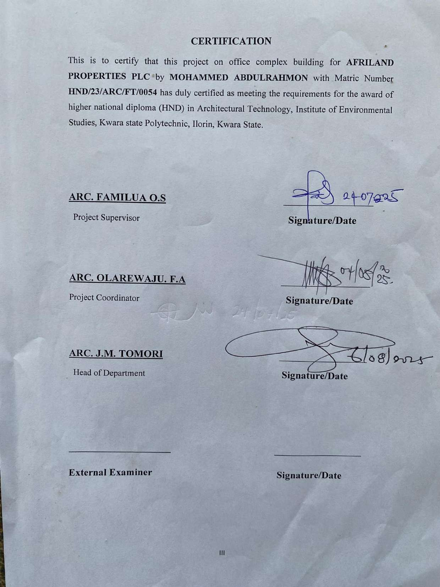

DEDICATION

This project is fully dedicated to the almighty Allah, who is the source of my strength and guidance all the praises to him alone I also dedicate this work to my parents, Mr. and Mrs. Mohammed for their uncompromising moral and financially support throughout my educational career so far.

ACKNOWLEDGEMENT

My first appreciation goes to the almighty Allah the beginning and the end, the knowing of all things and the most knowledgeable one, for his abundant blessing and protection over me.
Inspiration is Mostly from god, Motivation from Man, for the inspiration and motivation singularly given to me by project supervisor in person of Arc. Familua oluwaseun solomon i cannot thank you enough but surely Almighty God shall reward you abundantly.
My sincere appreciation also goes to my departmental lecturers and my able HOD in person of Arc. J.M. Tomori toward a successful completion of this programme (HND).
My sincere appreciation also goes to my project coodinator in person of Arc. Olarewaju,
F.A. toward a successful completion of this programme (HND).

My special appreciation goes to my beloved parent Mr. And Mrs. Mohammed for their support both financially and morally, I pray Allah will grant them good health and long life to eat the fruit of their labour (Amin).
I also acknowledge and appreciate the support and encouragement of my big brother Yusuf Mohammed, Ismail Mohammed and my junior brother Faruq Mohammed I am using this medium to say thank you to you all.
How can I forget my lovely uncle Mr. Isiak Adeniyi who has always been there financially and morally I am using this medium to say big thanks to you,
How can I forget my lovely aunt Mrs. Ramat Faruk Aka (Hajia Ramat Aribidesi) who has always been there financially,and morally, I say a big thank you,
I will like to express my appreciation to my boss and mentor during my (IT) with avantiline design limited QS. Nwose chinedum Prince who has always been there for supports, I use this medium to say big thanks to you, I cannot thank you enough I pray may almighty god reward you abundantly
I will like to express my appreciation to big friend of mine imam-eleshinla aka(papa) who has always been there financially and morally, I say a big thank you,

I will also like to express my appreciation to my boss and mentor during my (IT) with avantiline design limited like of Arc. Abagun Gabriel, Arc. Adesoga Oluwatunmida, Arc. Fayehun blessing, Arc. Eniola ayomide who has always been there in terms of learning architectural softwares, financially and morally I say a big thank you to all I pray almighty god reward you abundantly
How can I forget you my boss, my colleague my mentor during my (IT) with avantiline design limited Fuad Abiola aka (white lion) who has always been there in terms of learning architectural softwares, financially and morally I say a big thank you may almigty allah reward you abundantly.
I will also like to express my appreciation to Mr. and Mrs.bello and family for accommodation and being there morally and financially, I say big thank to you all, I cannot thank you enough but surely Almighty Allah shall reward you abundantly.
I will like to express my appreciation to school friends the likes of Tijani quadri, Naallah abdullateef, Ismail abdulazeez, Musa fatimoh, Hammed shamsudeen, Habeeb, ogunronbi samson, atunde daniel, faruq ajadi, faruq yusuf and others who has always been there for me , I say a big thank you all.
Finally I want to use this medium to appreciate everybody that has contributed in one way or the other to this success, I say a Zillion thanks once again and God bless you all.

TABLE OF CONTENTS
Title Page i
Declaration Page ii
Certification iii
Dedication iv
Acknowledgement v
Table of contents vi
Abstract vii
List of figures viii
List of plates ix
List of tables x
CHAPTER ONE
  - Introduction 1
  - Background of the study 1
  - Statement of problem 3
  - Aim and objectives 5
  - Client Background 4
  - Scope of study 2
  - Limitation 2
  - Research methodology 2

CHAPTER TWO
2.0 Literature review (Introduction) | 9
2.1 Definition | 9
2.1 Office complex building | 9
2.2 Historical development of Office complex building | 10
2.3 Office complex building in Nigeria | 11
CHAPTER 3  3.0 Case Study | 4

  - Case Study 1 afriland tower 4
  - Case Study 2 lofty height office complex 4
  - Case Study 3 zam zam office complex 4
  - Case Study 4 one canada tower (UK) 4
  - Case Study 5 steel tower(USA) 4

CHAPTER FOUR

4.0 | Design Proposal | 17
4.1 | Introduction | 17
4.2 | Site Location | 18
 | 4.2.1 Site Location Map | 19
 | 4.2.2 Site Selection Criteria | 20
4.3 | Site Characteristics | 21
 | 4.3.1 Soil type | 22
 | 4.3.2 Vegetation | 23
 | 4.3.3 Topography | 24
 | 4.3.4 Drainage | 25
 | 4.3.5 Accessibility | 26
 | 4.3.6 Climate | 27
 | 4.3.7 Site Features and Infrastructure | 28
 | 4.3.8 Noise Sources | 29
4.4 | Site Analysis | 30
4.5 | Proposed Design | 31
 | 4.5.1 Design Considerations | 32
 | 4.5.2 Design Concept | 33
 | 4.5.3 Brief Analysis | 34
 | 4.5.4 Schedule of Accommodation | 35
4.6 | Specifications and Construction | 36
 | 4.6.1 Materials and Finishes | 37
 | 4.6.1.1 Walls | 38

      - Floors 39
      - Ceiling 40
      - Roof 41
      - Windows and Doors 42
    - Structural System 43
    - Building Services 44
    - Landscaping and External Works 45
4.7 Chapter Summary 46

CHAPTER FIVE

5.0 DESIGN APPRAISAL | 47
5.1 Introduction | 47
5.2 Design appraisal | 48
5.3 Building structure | 48
5.4 Recommendation | 49
5.5 Summary and conclusion | 48
5.6 Summary | 48
5.7 Conclusion | 48
REFRENCES
APPENDIX

ABSTRACT

The design of contemporary office environments has evolved in response to the growing demand for spaces that support efficiency, sustainability, and user well-being. With urbanization and technological advancements shaping the modern workplace, architectural solutions must now address environmental concerns, operational functionality, and aesthetic appeal. This project explores the design of a sustainable, functional, and aesthetically pleasing office complex building tailored to the needs of a modern business setting. Commissioned by Afriland Properties Ltd., the project integrates context-sensitive design principles and innovative building strategies that reflect both global standards and local realities. This project focuses on the architectural design of a sustainable, functional, and aesthetically pleasing office complex building tailored to the contemporary business environment in Nigeria. With Afriland Properties Ltd. as the client, the project responds to the growing demand for modern office infrastructure that promotes productivity, environmental responsibility, and user comfort. The design integrates passive and active sustainable strategies, including natural ventilation, daylighting, and the use of eco-friendly materials. It also emphasizes spatial flexibility, structural efficiency, and integration of essential building services such as HVAC, water supply, power systems, and vertical circulation. Site selection and planning are based on accessibility, proximity to business districts, and infrastructure availability. The methodology combines qualitative and quantitative research, including case studies and contextual analysis. Ultimately, the project contributes to the advancement of office architecture in Nigeria by setting a precedent for environmentally conscious and user-centered design.

LIST OF FIGURES

Pages
3.1: Showing the location plan of afriland tower 12
3.1: Showing showing the Site plan afriland tower 48
  - : Showing Floor plan and the upper floor plan of land tower 48

3.2: | Showing the location plan of lofty height office complex | 53
3.2: | Showing the Site plan of lofty height office complex | 53
3.2: | Showing the ground and the upper floor plan of lofty height office complex | 53
3.3: | Showing the location plan of zam zam office complex | 53
3.3: | Showing the Site plan of zam zam office complex | 53
3.3: | Showing the ground and the upper floor plan of zam zam office complex | 53

  - : Map of Nigeria showing Kwara State 61
  - : Map of Kwara showing 62
  - : Bar chart showing Hours of Sunshine per day 65
  - : Bar chart showing Rainy days per month 65
  - : Bar chart showing Precipitation per day 66
  - : Bar chart showing Water Temperature 66
  - : Bar chart showing Relative Humidity 67

LIST OF PLATES

Pages

  - : Showing the location of Afriland tower office complex 39

  - : Showing approach view of Afriland tower office complex 39

  - : Showing the side view of Afriland tower office complex 40

  - : Showing the location of the lofty height office complex 40

  - : Showing the approach view of lofty height office complex 40

  - : Showing the side view of lofty height office complex 40

  - : Showing Location of zam zam office complex 43

  - : Showing the approach view of zam zam office complex building 43

  - : Showing Aerial view of the site 62

  - : Showing Site Analysis 68

LIST OF TABLES

Pages
  - : Showing sustainable and functional office complex building 10
  - : Showing sustainable materials in building 28
  - : Showing functional unit in an office complex building 30
  - : Showing energy efficient building 30
  - : Building materials and sustainable 31
  - : Assessment of sustainability office complex variables in Case Study 1 41
  - : Assessment of sustainability office complex variables in Case Study 2 46
  - : Assessment of sustainability office complex variables in Case Study 3 50
  - : Assessment of sustainability office complex variables in Case Study 4 55
  - :Assessment sustainability office complex variables in Case Study 5 59
  - : Schedule of Accommodation 72

CHAPTER ONE

Introduction
  - Back Ground of the study

The concept of office buildings can be traced back to ancient civilizations, where administrative tasks were centralized in dedicated structures. In ancient Rome, the basilica served as an early prototype for modern offices, functioning as a space for legal proceedings and business transactions. Similarly, in the Middle Ages, guildhalls and administrative chambers were used for trade and record-keeping activities, laying the foundation for the modern office.

The Industrial Revolution in the 18th and 19th centuries marked a significant turning point in office building history. The expansion of bureaucratic institutions and corporate enterprises created a need for dedicated office spaces. The advent of steel-frame construction and the elevator enabled vertical expansion, leading to the development of high-rise office buildings. One of the most notable early examples is the Home Insurance Building in Chicago, built in 1885, considered the first skyscraper. The 20th century saw a surge in the construction of office complexes, especially in urban centers. These were often designed to house multiple businesses and provide centralized services, marking the transition from individual office buildings to multi-tenant office complexes. Innovations in HVAC systems, fluorescent lighting, and modular layouts allowed for greater flexibility and comfort in the workplace.

In the late 20th and early 21st centuries, the emphasis shifted toward open-plan offices, sustainable design, and technology integration. Office complexes began incorporating green building practices, such as energy-efficient systems, natural lighting, and environmentally friendly materials. The rise of co-working spaces and smart office systems also redefined how office complexes were conceptualized, moving toward more adaptable, collaborative, and tech-enabled environments.

Today, the modern office complex is not only a space for work but also a hub for innovation, wellness, and community interaction. The architectural design of office complexes continues to evolve in response to cultural, economic, and technological changes, emphasizing sustainability, inclusivity, and flexibility.

Statement of Problem

The rapid urbanization and changing dynamics of the modern workplace have exposed significant shortcomings in many existing office buildings. Traditional office designs often lack flexibility, environmental responsiveness, and user-centered planning. Many current facilities are energy-intensive, poorly ventilated, and fail to accommodate the diverse needs of contemporary businesses and their employees. This results in decreased productivity, high operational costs, and negative environmental impacts.

Furthermore, the aesthetic quality of many office buildings is often overlooked in favor of functionality alone, leading to uninspiring and monotonous work environments that fail to attract or retain tenants. There is an urgent need for office complexes that are not only efficient and adaptable but also environmentally sustainable and architecturally engaging.

Aim

To design a sustainable, functional, and aesthetically pleasing office complex building.

Objectives

    - to create a flexible and efficient layout that maximizes the use of available space, providing a balance between private offices, open work areas, and collaborative zones.
    - to ensure the building design prioritizes user comfort and well-being through natural lighting, ventilation, and ergonomic spaces.
    - to incorporate eco-friendly design principles, such as energy-efficient systems, renewable energy sources, sustainable materials, and water conservation methods.
    - to deliver a modern and visually appealing architectural design that reflects the identity and purpose of the businesses it serves.

Client Background

Afriland Properties Ltd is a leading real estate investment and development company based in Nigeria. As a subsidiary of the Heirs Holdings Group, Afriland operates with a bold vision to transform African cities through innovative and sustainable real estate solutions. The company has established a strong reputation in the development, management, and revitalization of commercial, residential, and mixed-use properties across Nigeria’s urban landscape.

Afriland Properties is driven by a commitment to excellence, customer satisfaction, and long- term value creation. The company’s operations are grounded in global best practices, incorporating modern technology and environmentally responsible design into every stage of the development process. With a focus on strategic locations and dynamic urban environments, Afriland has been instrumental in redefining the future of real estate in Nigeria.

For this project, Afriland seeks to develop a sustainable, functional, and aesthetically innovative office complex building that reflects its brand values of progress, professionalism, and environmental stewardship. The proposed office complex will serve as a commercial hub designed to meet the needs of modern tenants while contributing positively to the surrounding urban fabric.

Justification
This project is justified by the need to bridge the gap between functionality, sustainability, and visual appeal in office complex building. By designing a sustainable, functional, and aesthetically pleasing office complex.

Scope of Study

This study focuses on the architectural design and planning of a sustainable, functional, and aesthetically pleasing office complex building, The project addresses the spatial, environmental, and operational needs of a contemporary office environment within an urban Nigerian context.

The scope of the study includes the following components:

Sustainable Design Integration: Application of passive design principles (natural lighting, ventilation, shading) and also selection of sustainable building materials

Architectural Design Development: Conceptual and schematic design proposals showing building form, massing, elevation, and aesthetics.

Space Planning and Functional Zoning: Design of key spaces such as open-plan workspaces, private offices, meeting rooms, communal areas, support facilities efficient circulation and zoning based on privacy, noise levels, and access

Landscape and Site Planning: Outdoor design including parking, green spaces, pedestrian movement, and site circulation

Limitation of Study
The limitation experienced during this course of study include:

Time constraint
- Finance: funding of the project research and the project itself has been asurmountable task which God has intervened in its management.
- Research materials: There have not been enough local sources of informationand getting the proper architectural plans required for assessment during case studies was not very easy.

Research Methodology

Research methods are methods used for conducting a research. It involves systematic process in which specific tools or instrument are employed to carry out scientific investigation. It is the techniques and procedure utilized for generating information’s and data for this research work and To ensure a thorough and informed design process, the following research methods were employed:

Literature Review

Analysis of academic and professional literature on office building design, sustainability, workplace psychology, and commercial architecture to form the theoretical framework of the project.

Case Studies

Examination of existing office complexes, both locally and internationally, to draw lessons on spatial organization, material selection, user experience, and energy efficiency.

CHAPTER TWO

Literature review
  - Introduction
In this chapter, Definition of an office complex building, history, sustainable building, types of sustainable material in building, function in office complex building and other related literatures are discussed. This Literatures were studied in order to know the trend and scope for research in the chosen field. Many doctoral thesis, reports and articles published in leading journals were subjected to analysis.

Definition
An office complex building is a purposely designed architectural structure or group of structures that accommodates multiple workspaces, organized into functional zones such as open-plan areas, private offices, meeting rooms, and communal facilities. The design emphasizes efficiency, spatial hierarchy, circulation flow, and aesthetic quality to support professional productivity.
Kohn, M., Katz, W., & Kohn Pedersen Fox Associates (2002). Office Buildings: a Design Manual. Birkhäuser define an office complex building as and open planed areas that accommodates multiple office.

It is also defined as an type of commercial building that integrates multiple office functions within a cohesive architectural framework, emphasizing sustainable practices such as passive design strategies, energy-efficient systems, green materials, and user well-being through daylighting, ventilation, and ecological integration.
Edwards, B. (2005). Rough Guide to Sustainability: A Design Primer. RIBA Publishing

Historical development of an office complex building
Pre-Industrial Precursors

Ancient and Medieval Administrative Hubs: Early ―office‖ functions were housed in multipurpose civic buildings—Roman basilicas for legal and commercial transactions and medieval guildhalls for trade administration. These spaces introduced the idea of dedicated zones for organized paperwork and record-keeping (Markus, 1993).

Industrial Revolution and Early High-Rise Offices (19th Century)

Rise of Bureaucracy: Rapid growth of corporations and government bureaus created demand for centralized workspaces.

Technological Innovations: Introduction of iron and steam-powered systems, followed by steel-frame construction and the safety elevator, enabled vertical office buildings.

Iconic Examples: The Home Insurance Building in Chicago (1885) is often cited as the first skyscraper, combining steel framing with multiple tenant floors (Willis, 1995).

Interwar Period and Corporate Campuses (Early–Mid 20th Century)

Campus Model Emerges: Companies like General Motors and AT&T began developing low-rise office parks with multiple buildings, landscaped grounds, and internal road networks, anticipating today’s suburban office parks (Duffy, 1997).

Modernist Principles: Emphasis on functional layouts, rational planning, and minimalist aesthetics, as advocated by the Bauhaus and International Style movements.

Post–World War II Boom and the Open-Plan Revolution

Open-Plan Offices: Inspired by efficiency studies (e.g., Taylorism) and Harried Sundstrom’s research on group dynamics, architects began favoring large, flexible floor plates over cellular offices (Sundstrom et al., 1980).

High-Rise Corporate Headquarters: Cities like New York and London saw a proliferation of glass-and-steel towers housing multiple divisions of large firms

Late 20th Century: Multi-Tenant Complexes and Mixed-Use Integration

Office Complexes vs. Single Buildings: Developers moved toward multi-building complexes with shared amenities (conference centers, food courts, fitness facilities), catering to a diversified tenant mix.

Urban Regeneration: Brownfield sites in city centers were repurposed into office-led mixed-use developments, integrating residential, retail, and leisure functions (Carmona et al., 2010)

21st Century Trends: Sustainability, Technology, and Well-Being

Green Certification: LEED, BREEAM, and other rating systems shaped the design of eco-efficient façades, smart energy systems, and water-reuse strategies (Edwards, 2005).

Smart Buildings: Integration of IoT sensors, building management software, and data analytics to optimize comfort and resource use (Arup, 2017).

Wellness Centered Design: Biophilic elements, daylight maximization, and flexible work environments respond to research linking design with occupant health and productivity (Kellert, 2015)

Office Complex Building in Nigeria

Office complex buildings in Nigeria represent a critical component of the country’s commercial infrastructure. They provide centralized, formal environments for businesses, government agencies, banks, and multinational corporations. With Nigeria’s rapid urbanization, growing service sector, and increasing demand for high-quality commercial space, office complexes have evolved in both scale and sophistication, especially in cities like Lagos, Abuja, and Port Harcourt

During the colonial and early post-independence era, office buildings in Nigeria were predominantly low-rise, functional structures serving administrative and government needs. The emergence of oil wealth in the 1970s and the liberalization of the economy in the 1990s spurred a construction boom, including commercial real estate development.

Early examples include the Federal Secretariat Complex (Ikoyi, Lagos) and NECOM House, once the tallest building in West Africa. These structures were designed with utilitarian goals but lacked long-term sustainability features.

Modern Developments
Today, office complexes in Nigeria are increasingly designed to meet international standards of aesthetics, efficiency, and sustainability. New developments often include:

Multiple office blocks within a gated complex

Shared facilities such as parking, conference halls, cafés, and fitness centers Integration of ICT infrastructure and security systems
Emphasis on green building practices, although uptake is still limited compared to global standards

Prominent examples include:

Heritage Place (Lagos) – Nigeria’s first LEED-certified building, featuring energy-efficient systems and a modern glass façade

Eko Towers (Victoria Island, Lagos) – A twin-tower office complex with panoramic city views and high-end office suites

The Wings Office Complex (Victoria Island, Lagos) – Designed with sustainability and waterfront views in mind, including underground parking and green features

MKO Abiola House (Abuja) – A major office development offering modular spaces for public and private sector use

Challenges
Despite the growth, Nigeria’s office complex sector faces several challenges: Inconsistent power supply, leading to high generator use and energy costs Inadequate transport infrastructure around business districts
Regulatory delays in permits and zoning approvals

Limited local adoption of sustainable materials and construction technique

Trends and Outlook
Smart office integration (ICT and automation systems

Sustainable design interest, driven by cost savings and investor demand

Mixed-use developments, blending office space with residential, retail, and hospitality components

Increased demand for flexible workspace and co-working environments (e.g., The Village, Lagos; Venia Business Hub)

As Nigeria continues to attract both foreign and domestic investment, the design and development of office complexes are expected to become more sophisticated, sustainable, and user-centered

Sustainability and functionality in an office complex building

Sustainability in office architecture refers to the design and construction of buildings that minimize environmental impact, reduce energy consumption, and promote long-term efficiency. A sustainable office complex integrates eco-friendly materials, energy-efficient systems, and environmentally conscious planning to create a building that benefits both users and the planet.

Key Features:

Energy Efficiency: Use of solar panels, LED lighting, energy-saving HVAC systems, and natural ventilation.

Sustainable Materials: Use of recycled steel, bamboo, low-VOC paints, and locally sourced construction materials.

Water Conservation: Incorporation of rainwater harvesting, greywater systems, and low-flow fixtures.

Waste Reduction: Emphasis on construction waste management and space planning that supports recycling within the building.

Green Certification: Designing to meet standards like LEED (Leadership in Energy and Environmental Design) or Nigeria’s Green Building Council requirements.

Benefits:

Reduces operating costs.

Improves indoor air quality and worker health. Minimizes carbon footprint.
Enhances corporate image and environmental responsibility. Functionality in Office Complex Design
Functionality focuses on how well a building serves its intended purpose — in this case, providing efficient and comfortable workspaces for a variety of users. A functional office complex ensures ease of use, spatial efficiency, and adaptability to changing organizational needs.

Key Functional Design Principles:

Efficient Space Planning: Clear zoning for different departments, circulation, and support services.

Flexibility: Modular layouts and partition systems that allow for future expansion or reconfiguration.

Accessibility: Design in compliance with universal access standards (e.g., elevators, ramps, accessible toilets).

Vertical and Horizontal Circulation: Adequate provision for elevators, stairs, and corridors to support user movement and emergency evacuation.

Technology Integration: Infrastructure for modern IT systems, communication networks, and smart building technologies.

Security and Surveillance: Secure entry points, CCTV systems, and access control measures.

Comfort: Ergonomic furniture layout, acoustic treatment, thermal comfort, and natural daylighting.

Benefits:

Enhances productivity and collaboration.

Supports diverse user needs (e.g., executives, staff, visitors). Reduces operational inefficiencies.
Improves building longevity and adaptability.

Conclusion

Combining sustainability and functionality in office complex design leads to smarter, healthier, and more efficient buildings. It aligns with global environmental goals and meets the evolving demands of modern businesses, making it a vital approach in contemporary architectural practice.

CHAPTER THREE

Case Study
According to Yin, R. K. (2018). Case Study Research and Applications: Design and Methods (6th ed.). Sage Publications.case study is a detailed, in-depth examination of a specific subject—such as an event, individual, group, organization, or project—within its real-life context. It is commonly used in qualitative research to explore complex issues where multiple variables are involved and where generalizing from a larger population is not the goal, but understanding particular dynamics is essential.

Case Study 1: Afriland tower

Afriland Towers, located on Broad Street in Lagos Island, is a revitalized office complex developed by Afriland Properties Plc. Formerly known as Raymond House, this seven-story building was acquired and redeveloped into a modern, open-plan office facility to meet the growing demand for high-quality commercial space in the Lagos Marina Business District. Completed and officially commissioned in 2019, Afriland Towers features energy-efficient systems, modern elevators, central air conditioning, and a dedicated PHCN transformer. The redevelopment was part of a strategic investment to rejuvenate Lagos Island's commercial real estate landscape. The building now stands as a symbol of Afriland's commitment to quality infrastructure, sustainable urban development, and a forward-thinking business environment. It has been praised for its contribution to the transformation of the Lagos central business district, offering premium space to businesses in a strategically located area.

Location: Along Broad street, off nnamdi azikwe, Lagos Island, Lagos state, Nigeria.

Merits
    - It is well located in a business district.
    - It is Flexible and Aesthetically pleasing
    - There is other means of transport in the building e.g elevator.

Demerits
- It is not not properly natural lighting.
- It is not well landscaped with soft landscape.
- Its highly cost in term s of maintenance

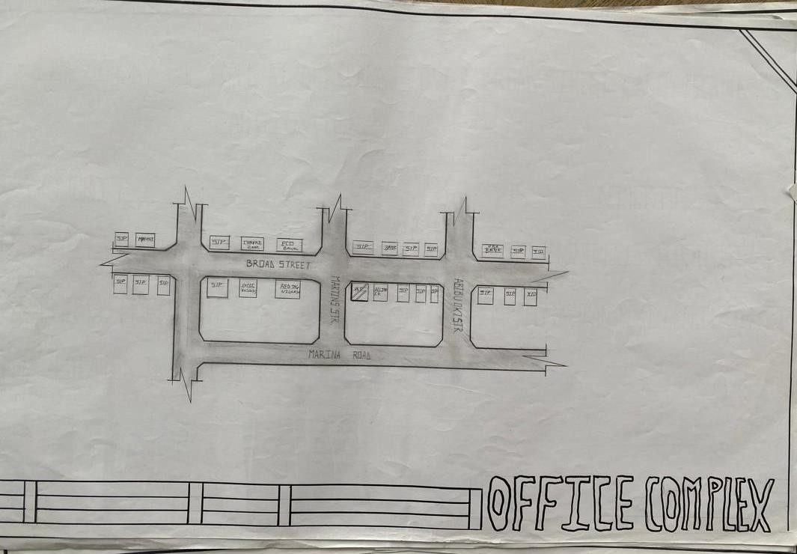
FIG 3.2.1: SHOWING THE LOCATIONAL PLAN OF CASE STUDY ONE

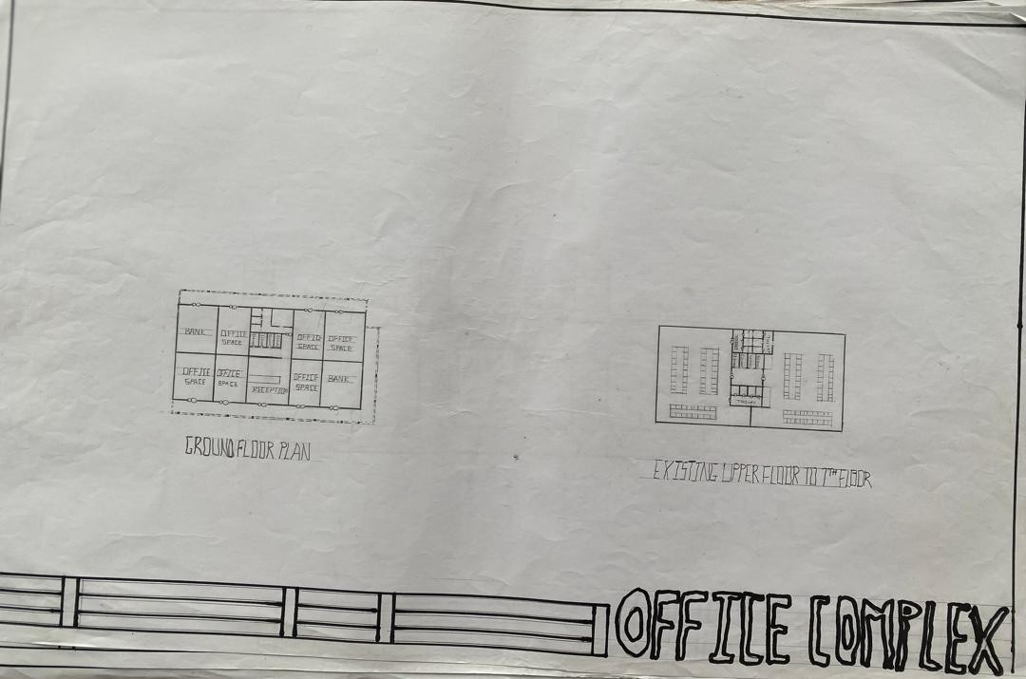
FIG 3.2.2: SHOWING THE GROUND FLOOR AND UPPER FLOOR PLAN OF CASE STUDY ONE

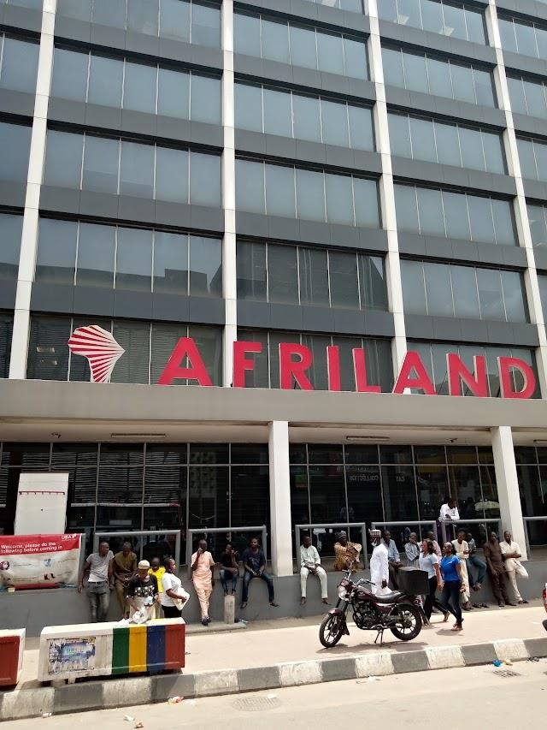
PLATE 3.2.1: SHOWING THE FRONT VIEW OF CASE STUDY ONE
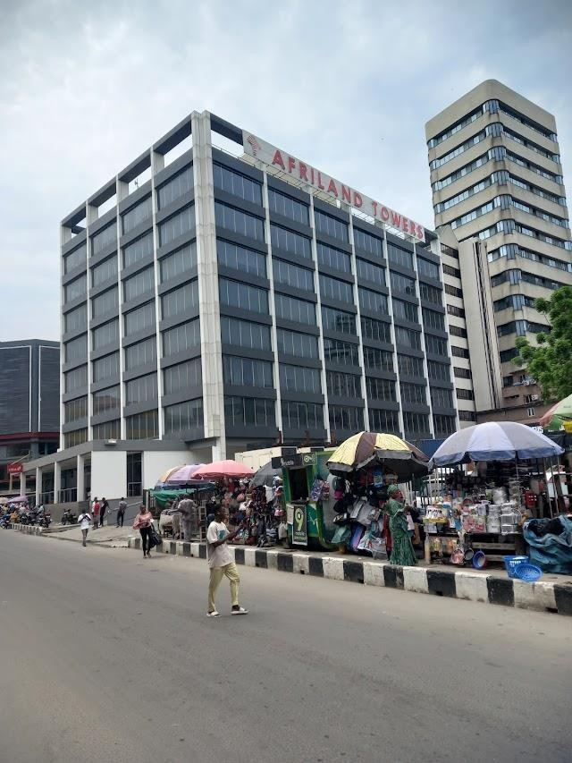
PLATE 3.2.2: SHOWING THE SIDE VIEW OF CASE STUDY ONE

Case Study 2: lofty height office complex building
Lofty Heights Office Complex is a mid-rise commercial building situated in Lekki Phase 1, Lagos — an area known for its rapid urbanization and growing reputation as a business hub. Developed by Groveworld Realties Limited, the building spans approximately five floors and provides around 1,000 square meters of office space. Though relatively modest in scale compared to skyscraper developments, Lofty Heights is designed to serve the increasing demand for professional workspaces in the Lekki peninsula.
Location: Along Baderinwa Alabi Street , lekki, Etiosa, Lagos state, Nigeria.

Merits
- It is well located in a business district.
- It is Flexible and Aesthetically pleasing
- There is other means of transport in the building e.g elevator.

Demerits
- It is not properly natural lighting.
- It is not well landscaped with soft landscape.
- Its highly cost in term s of maintenance

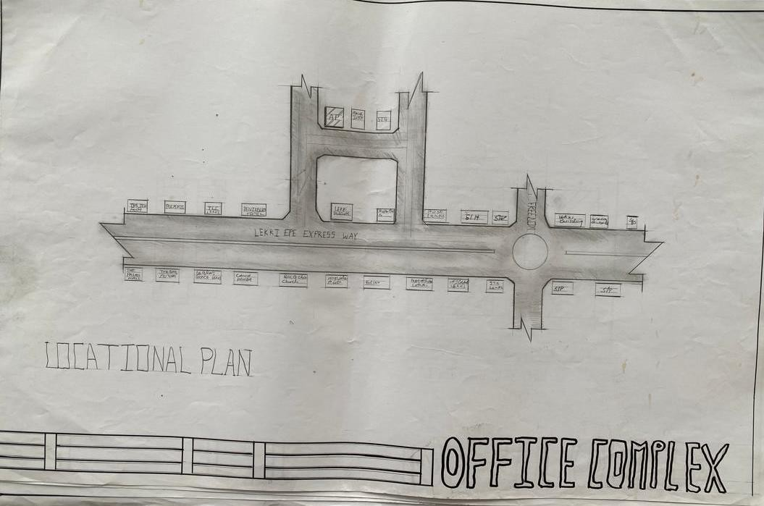
FIG 3.3.3: SHOWING THE LOCATIO NAL PLAN OF CASE STUDY TWO

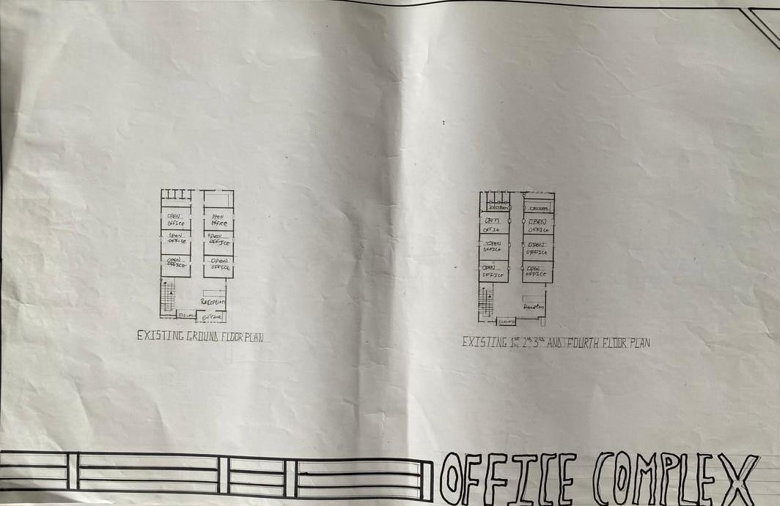
FIG 3.3.4: SHOWING THE FLOOR AND THE UPPER FLOOR PLAN OF CASE STUDY TWO

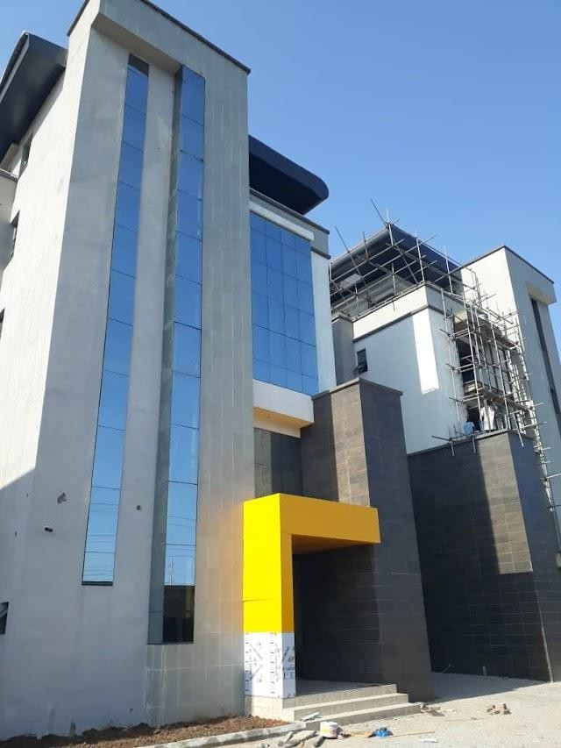
PLATE 3.3.3: SHOWING THE SIDE VIEW OF CASE STUDY TWO
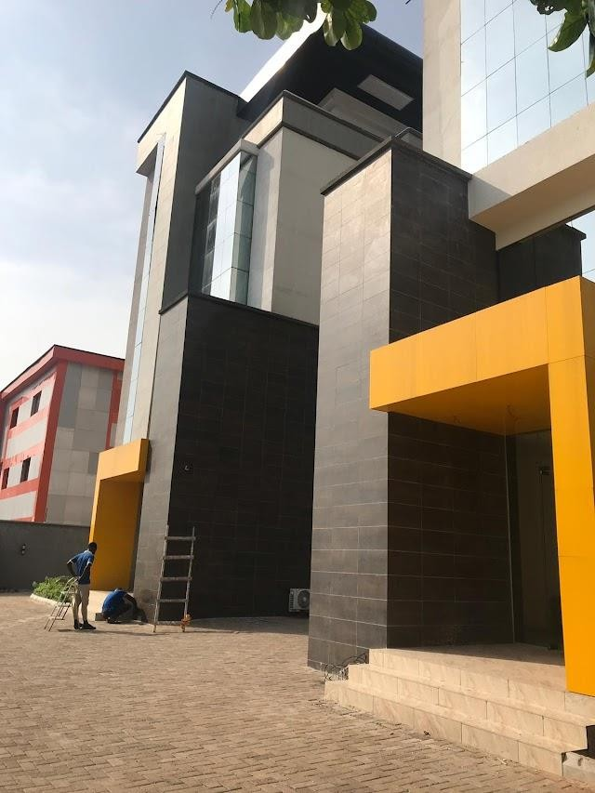
PLATE 3.3.4: SHOWING THE SIDE VIEW OF CASE STUDY TWO

Case Study 2: Zam Zam office complex building

Zamzam appears to be an office complex development located within Nigeria, possibly in the South-Western region. The name is associated with a few mixed-use and retail facilities, particularly in cities like Ibadan.
Location: Along Gastab Street, off New garage Road, Ibadan, Oyo state, Nigeria.

Merits
    - Its fair in term of maintenance
- It is Flexible and Aesthetically pleasing
- It is well ventilated.

Demerits
- It is not properly natural lighting.
- It is not well landscaped with soft landscape.
- There is no other means of transport in the building e.g elevator.

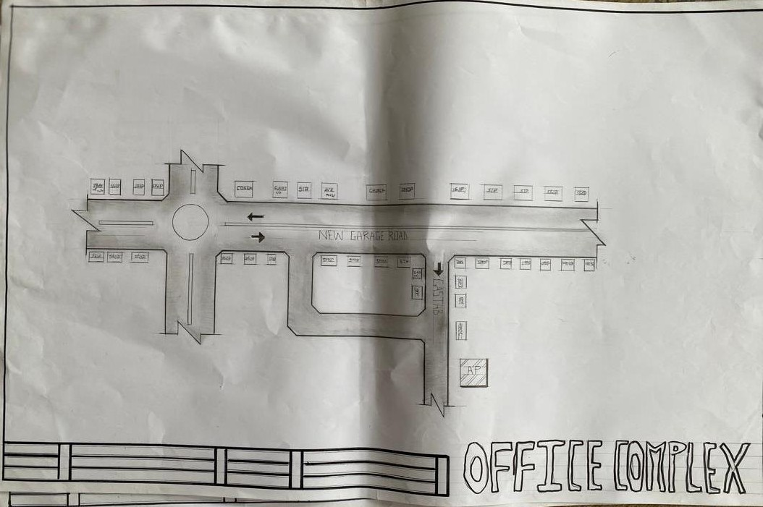
FIG 3.4.5: SHOWING THE LOCATIONAL PLAN OF CASE STUDY THREE

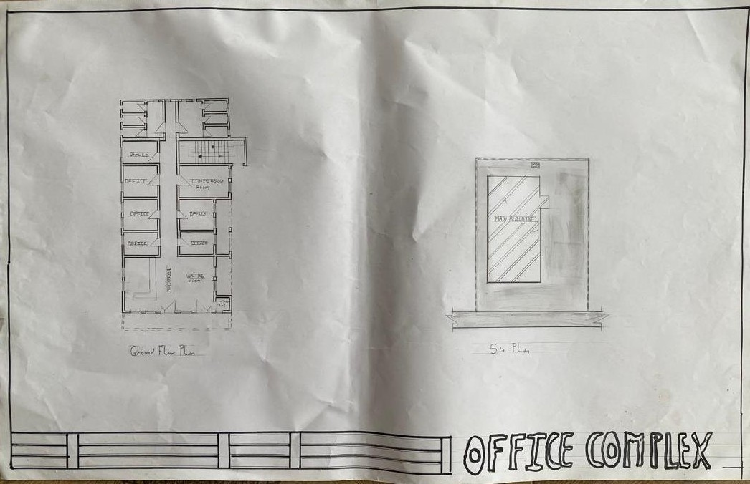
FIG 3.4.6: SHOWING THE LOCATIONAL TYPICAL FLOOR AND SITE PLAN OF CASE STUDY THREE

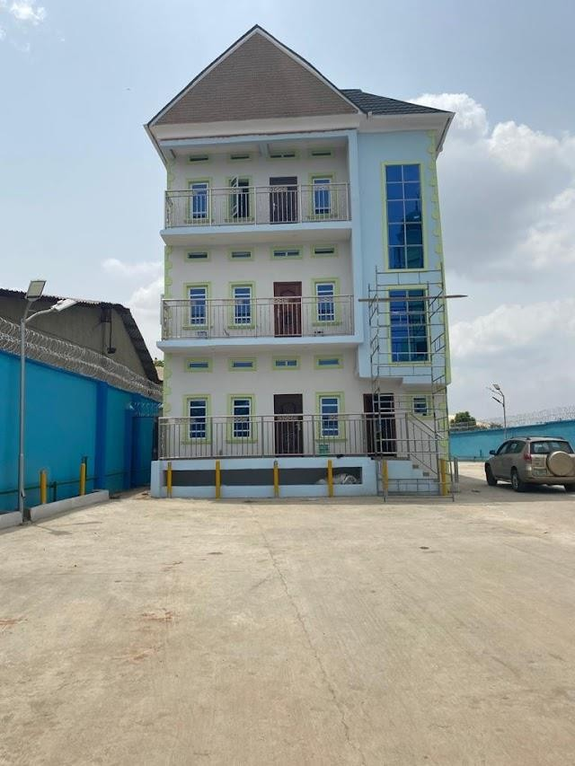
PLATE 3.4.5: SHOWING THE FRONT VIEW OF CASE STUDY THREE
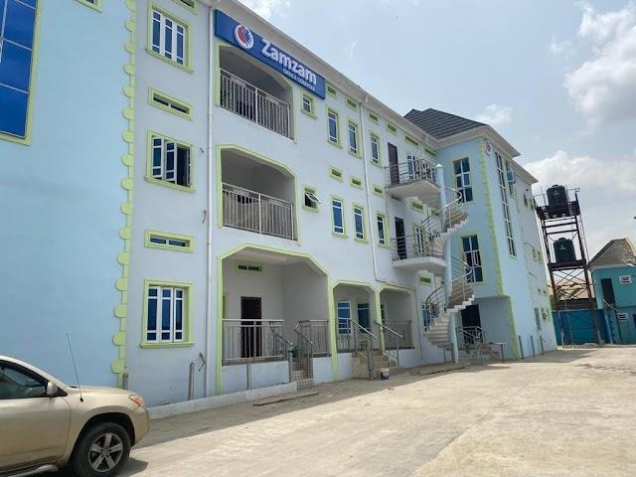
PLATE 3.4.6: SHOWING THE FRONT VIEW OF CASE STUDY THREE

Case Study 4 (Online) One Canada square office complex

One Canada Square is a 50-storey, 235◻ m-high office skyscraper located at the heart of the Canary Wharf business district in London. Completed in 1991 and designed by César Pelli in collaboration with Adamson Associates and Frederick Gibberd & Partners, the building remained the tallest in the United Kingdom until 2011, Developed by Olympia & York, it reflects postmodernist architectural principles, clad in stainless steel with a distinctive pyramid roof. The building was constructed atop a 4-meter-thick concrete raft supported by deep piles driven into former dockland. Following economic challenges after opening, the building was enhanced with expansions like the Park Pavilion in 2009 and substantial façade and interior modernization to maintain relevance. Awarded a BREEAM rating for sustainable design, it includes recycled aggregate concrete, waste-heat recovery systems, and structural upgrades to reduce energy consumption by approximately 30% since the 2000s .
Location: United kingdom (UK).

Merits
    - It is properly natural lighting.
    - There other Means of transport in the building e.g Elevators
    - It is well ventilated.

Demerits
- It is not well landscaped with soft landscape.
- No celebrated entrance.
- Its highly cost in terms of maintenance

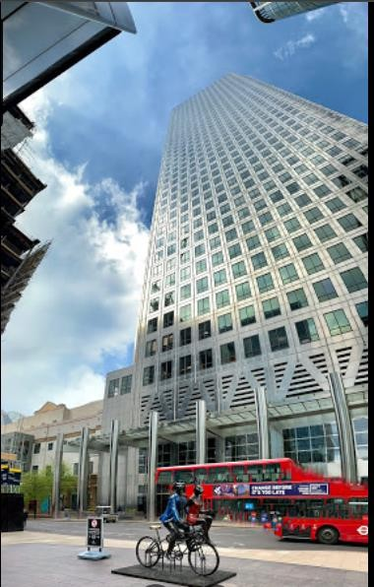

PLATE 3.5.7: SHOWING THE FRONT VIEW OF CASE STUDY FOUR
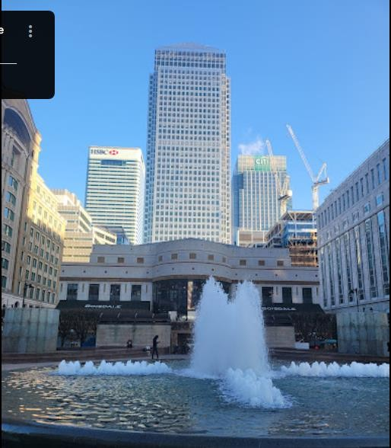
PLATE 3.5.8: SHOWING THE FRONT VIEW OF CASE STUDY FOUR

3.5 Case Study 5 (Online) Steel tower.

The U.S. Steel Tower, also known as the U.S. Steel Building or USX Tower, stands at
256.3◻ m with 64 storeys in downtown Pittsburgh. Completed in 1971 and originally named
U.S. Steel Tower, it was designed by Harrison, Abramovitz & Abbe and engineered by Leslie E. Robertson Associates, As the tallest structure in Pennsylvania, it features a robust all-steel construction and deep-foundation system to support its massive scale. The tower accommodates over 2.3 million sq ft of commercial office space and was configured with multiple elevator banks, including six banks of passenger elevators and freight elevators for operational efficiency. Symbolic of corporate resilience, the building’s name reverted to U.S. Steel in 2002 after a brief period as USX Tower
Location: United State of America (USA).

Merits
- It is properly natural lighting.
- There other Means of transport in the building e.g Elevators
- It is well ventilated.

Demerits
    - It is not well landscaped with soft landscape.
    - No celebrated entrance.
    - Its highly cost in terms of maintenance

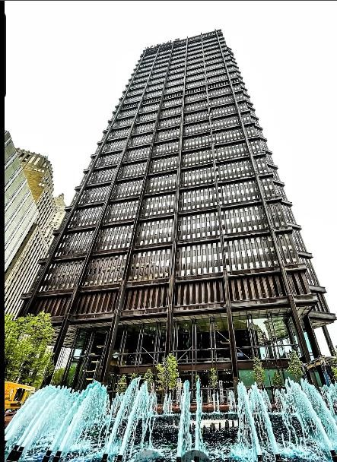
PLATE 3.5.9: SHOWING THE FRONT VIEW OF CASE STUDY FIVE
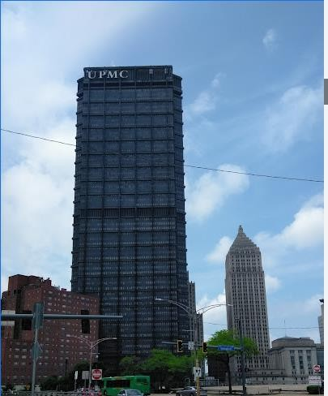
PLATE 3.5.10: SHOWING THE SIDE VIEW OF CASE STUDY FIVE

CHAPTER FOUR
  - Design Proposal
  - Introduction
This chapter discuss and analyse the proposed site, analysis of its location and an in-depth study into the reasons for the selection of the particular site for the design. Site analysis of the proposed site will be carried out to show suitability of the proposed site for the design of an Office complex building.

Site Location

Ilorin, the capital of Kwara State, is one of Nigeria’s historically significant cities, located in the North-Central geopolitical zone. It was founded in the late 18th century (around 1450– 1500 by some accounts) as a Yoruba settlement but later became an important part of the Sokoto Caliphate following the Fulani Jihad of the 19th century. Originally a provincial military outpost of the Oyo Empire, Ilorin grew in importance due to its strategic location along trade routes connecting the northern and southern regions of Nigeria.

In the early 1800s, Ilorin’s commander, Afonja, rebelled against the Oyo Empire and allied with Fulani jihadists led by Shehu Alimi. Over time, Afonja was overthrown, and the city came under the influence of the Sokoto Caliphate, marking a cultural and political shift from Yoruba to Fulani leadership. Despite this, Ilorin has remained a melting pot of both Yoruba and Fulani heritage, which is evident in its language, culture, and traditional institutions.

Today, Ilorin is known for its rich Islamic scholarship, cultural diversity, and its role as a commercial and administrative center. The city is home to several institutions of learning, including the University of Ilorin, and serves as a hub linking northern and southern Nigeria.

The site is located at Old jebba Road, Ilorin , Kwara State is one of the states in Nigeria, at coordinates 6.5244N, 3.3792E located in the southwest of Nigeria.

Site Location Map
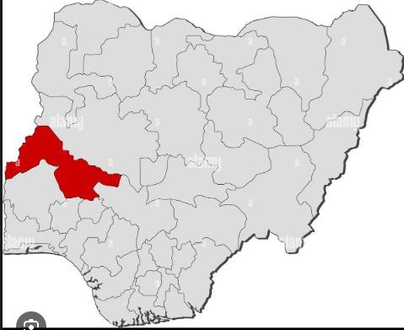

Figure 4.1 Map of Nigeria showing location of kwara State Source: Google images

Site Selection Criteria

The site was selected based on the following category;

- Location
- Ease of access
- Availability of enough land
- Security
- Nature of the site and vegetation
- Good infrastrutures
- Business district

Location:
The site is located along Old jebba Road, Sango, Ilorin, Kwara State.

Ease of Access:
The site can be accessed easily as there is an existing road that leads to it.

Availability of Enough land:
To adequately provide for the various facilities required in the building and on the site, the area of land required for the project must be adequate. Therefore, the site was selected because it is wide enough to accommodate the proposed design.

Security:
The site is located in well secured area in the part of the state .

Nature of Site and Vegetation:
The topography of the site is fairly levelled and the slightly unlevelled part can be adequately levelled. The sub soil is mainly red lateritic soil, with barches of sandy soil. The site also contains few trees and shrubs, which can help enhance the landscape of the site.
- Good infrastructure:the proposed site is positioned in a well developed considering the availability of good roads networkings, availability dranages e.t.c
- Business district:the proposed site is within or near a central business district (CBD) or established commercial hub which provides visibity, accessibility and enable synergy with nearby corprate.

Site Characteristics

    - Soil type

The site is characterized by sandy, loam soil, suitable for medium- to high-rise structures. A geotechnical investigation confirmed the soil bearing capacity is adequate for the proposed building’s structural loads.

Vegetation

The vegetation on the site consists of few trees of different species and shrubs. Some trees and shrubs will be retained to enhance the landscape of the site, and also act as wind-breakers and dust filters during the harmattan.

Topography

The topography of the site is fairly levelled and the slightly unlevelled part can be adequately levelled.

Drainage

There is no existing drainage on the site, so drainage would be constructed.

Accessibility

The site is accessible by an existing road along the adjoining buildings which leads to the site.

Climate

kwara is one of the cold regions in Nigeria with an average daily high temperature of only 31 degrees centigrade. High humidity and hot temperatures make the weather at times pleasant but also tropical humid. It is warm to hot all year round and invites to bathe at average water temperatures of 27 degrees. Due to the lesser rain the best time for traveling is from November to March. Most precipitation decrease from June to October.

Hours of sunshine per day
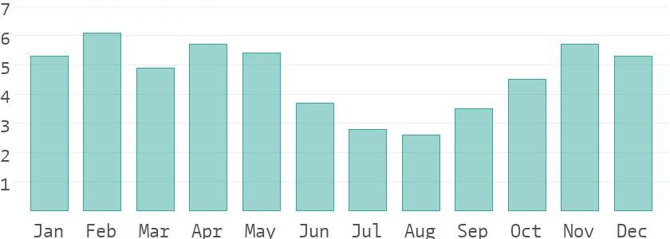

Figure 4.3 Hours of Sunshine per day Source; Worlddata.info

The number of hours of sunshine refers to the time when the sun is actually visible. That is, without any obstruction of visibility by clouds, fog or mountains. With 7 hours per day, February is the sunniest month in the state of kwara. In August the sun shines the shortest.

Rainy days per month
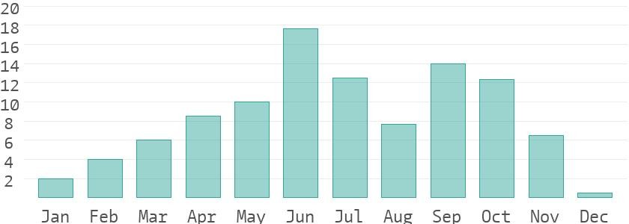

Figure 4.4 Rainy days per month Source; Worlddata.info
A rainy day is a day on which at least an amount of 0.1 mm precipitation (=0.1 liter) per square meter falls. This can be rain, snow, hail or even dew. So it does not have to rain the whole day. With 18 rainy days, June offers the most number of rainy days, and in December the least.

Precipitation in mm/day
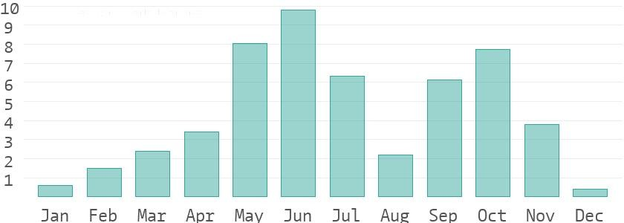

Figure 4.5 Precipitation in mm/day

Source; Worlddata.info

The amount of precipitation is measured in millimeters per square meter. Thus, at two mm/day, two litres of water fall on one square meter within 24 hours. With only 0.4 mm, the least rain falls in December. June, on the other hand, has the most rain.

Water temperature

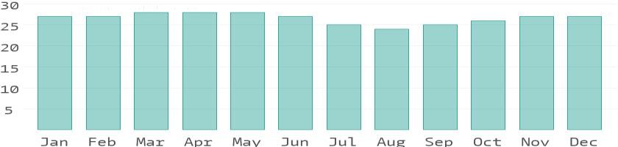

Figure 4.6 Water temperature Source; Worlddata.info
Water temperature depends not only on solar radiation within the same region, but also on ocean currents. For example, depending on the season, cold or warm water masses are moved from other areas. The warmest temperatures in kwara are in March, when the water is 28 °C.

Relative humidityin %
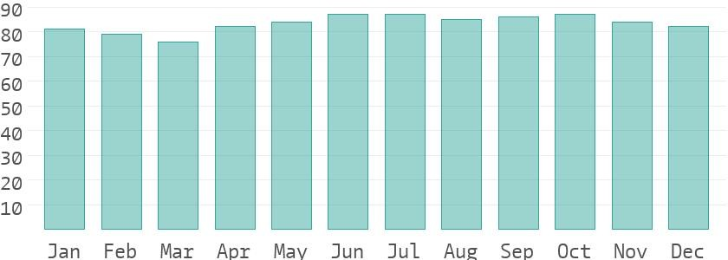

Figure 4.7 Water temperature Source; Worlddata.info
Warm air can absorb more moisture than cold air. The relative humidity indicates how much moisture of the physically possible is actually contained in the air. At high humidity, the person feels uncomfortable and perceives this as oppressive. In general, a relative humidity of 40-60% gives as pleasant. With humidity averaging 87%, June is the most uncomfortable. In March, on the other hand, it is easier to endure.

Site Features and Infrastructure

The site features electrical lines which proposes that open power supply is promptly accessible inside the site.
Perfectly drained soil; soils water moves through easily to allow good soil aeration and at the same time sufficient amount is retained for plant growth.

Other features are water supply and an access road.

Noise Sources

There are no much noises on the site but the few noises that can be heard comes from the adjacent structures which are the existing around the site.

Site Analysis.

A site analysis involving a study of the site is carried out, it takes into consideration natural and man-made components present in and around the site, as well as climatic conditions of Lagos state. The plate below shows a schematic summary of the analysis of the proposed site.
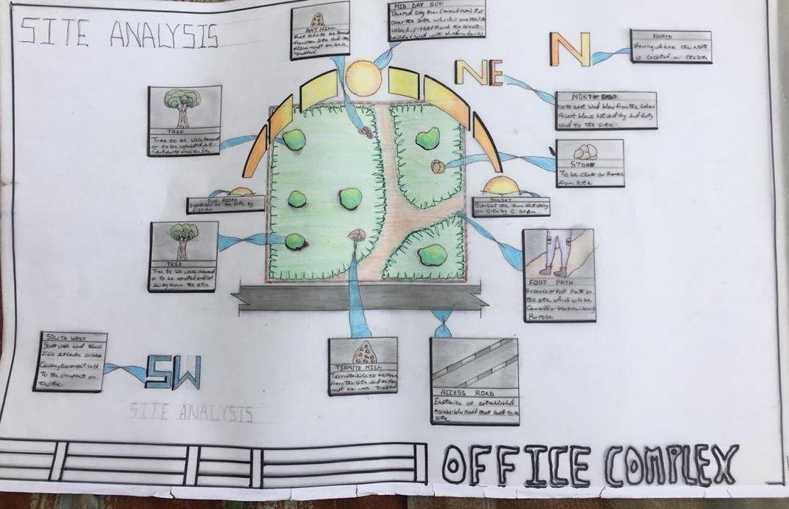

Plate 4.2 Site Analysis Source; Authors fieldwork

Rainfall:
Minimum rainfalls are recorded in December, while June offers the most amount of rainfall.

Vegetation and Topography:

The vegetation on the site consists of few trees of different species and few shrubs. The site is relatively gentle sloping and has a high load bearing capacity soil.

Prevailing Wind Direction & Sun-Path Angles
The two predominant winds blowing across this area are the South West Trade wind and the North East Trade wind. The former, which blows across the Atlantic Ocean, is characteristically cold and results in the wet season. Being a cold wind, it is capable of holding much moisture contents across the ocean, and hence an increase in relative humidity of the area affected. However, the North East Trade wind, which blows across the Sahara Desert, is dusty and dry wind. Consequently, the two predominant seasons experienced in this area are characteristically marked by the two wind types. The summer (the season between spring autumn when the sun is hot and there are many flowers) is experienced between April and September, when the south west Trade wind is more predominant, while the winter season is shortly marked between November and March, when the north east trade wind is more predominant. This later season {winter} is however characterized by cool and hazy mornings, couple with dusty afternoons, because of the dust particles it brings forth from the desert. To reduce the effects of wind driven, trees were planted.

Sunrise and sunset:
The sun rises from the east in the early hours of the morning at about 6:30am - 7:00 am and sets in the west at about 6:45 pm in the evening daily.

Accessibility:

The site is accessible by an existing road along the adjoining buildings which leads to the site.

Man-made features

  - Electricity: Electricity is supply to the site through overhead cables along the site boundary.
  - Footpath: There areexisting footpaths on the site which will remove from the site
  - Noises: Caused by adjacent structures

Proposed Design

The proposed design of the office complex building is conceptualized to reflect a modern, environmentally responsive, and highly functional workspace tailored to meet the dynamic needs of contemporary businesses. The design is rooted in the core objectives of sustainability, flexibility, functionality, and aesthetic excellence, while also responding

sensitively to the environmental, infrastructural, and socio-economic context of the selected site.

Design Considerations:

The following are the factors considered when designing the building;

- Sustainability: Sustainability is a core design principle, with strategies aimed at reducing the building’s environmental impact over its lifecycle. E.g Use of locally available and renewable materials, Natural lighting and ventilation to reduce energy demand.
- Functionality: In any architectural design, functionality plays major role, design must be functional to meet the taste and convenience of the occupants.
- Ventilation: This includes the orientation of the building, sizes and locations of fenestrations, vegetation.
- Circulation and Zoning: Appropriate and well-articulated pattern of circulation in a building alleviates confusion and at the same time tailor the movement of students to their respective destination.
- Landscaping: The form of landscaping in the building is aimed at satisfying user requirements, having aesthetic value and improving environmental comfort. Hence, landscaping will be considered in the design
- Security: The provision of security in the office complex buildinginvolves the protection of the students, the building and its contents.

Design Concept

The design approach was based on functionalism, which is an architectural principle that says that building should be designed based solely on purpose and function of the building.

Brief Analysis

The proposed design is the design of a office complex building with emphasis on sustainable and aesthetically pleasing.

The office complex building is to provide the business and services with accommodation facilities and other functional spaces and facilities. These facilities include:

- Entrance
- Reception
- Elevators
- Open offices
- Convienience
- Staircases
- Exit
- Car park
- Cafeteria
- Waste area
- Gen house

Schedule of Accommodation

Table 6.1 Schedule of Accommodation

S/NO | SPACE | UNITS | DIMENSION(M) | AREA(M2)
1 | Entrance | 1 | 7.6*4.4 | 33.44
2 | Reception | 1 | 2.8*3.5 | 9.8
3 | Elevators | 3 | 2.8*1.5 | 4.2
4 | Convienience | 13 | 10*5.2 | 52
5 | Open offices | 13 | 15*20 | 300
6 | Staircases | 2 | 2.5*3.9 | 9.75
7 | Exit | 2 | 3.3*8 | 26.4
Source: Author’s fieldwork (2025)

Specifications and Construction

    - Material and Finishes

The materials and finishes used plays a vital role to the level of sustainability in the building. To also enhance fire safety in the building, several factors need to be considered in the selection of material and finishes. Material and finishes to be used will be discussed further.

Walls

Block work will be used in conjunction with reinforced concrete columns. For each fire compartment the blocks will be filled with concrete to increase its resistance to fire and also reduce the spread. Stone trowel paint or graphitex trowel paint can be used as finishes on the wall as natural stone definitely has inherent fire resistance.

Floors

Ground Floor:Reinforced concrete slab with non-slip ceramic or porcelain tiles for public areas; polished screed or epoxy finish for utility zones.

Upper Floor:Reinforced concrete slab with raised access flooring for IT and electrical cabling; covered with carpet tiles or laminate wood flooring for office spaces.

Ceiling

A good ceiling material for an office complex must be durable, easily cleaned, of acceptable fire rating, acoustically accepted.Suspended acoustic panel ceilings (mineral fiber or gypsum) for sound control and maintenance access.

Roof

The trusses roofing structure will be used, while the roof covering will be of aluminium long span roofing sheets.

Windows and Door

Windows: Powder-coated aluminum frame glazing system with double-glazed units for energy efficiency and acoustic control. Tinted or low-E glass to reduce glare and solar heat gain.

Doors:Main Entrance: Frameless tempered glass automatic sliding doors. Interior Office Doors: Flush hardwood or metal doors with stainless steel handles. Toilet and Service Doors: PVC-coated or aluminum doors for moisture resistance

Structural System

The structural systems of the proposed project (divided into sub-structure and super-structure) include foundation, walls, columns, beams, roof, etc.

Sub-structure (Foundation)

A foundation is the lower portion of a building structure or substructure that transfers all coming load of the structure to the ground. The foundation system must distribute vertical loads and hold the super structure of the building against uplift and racking forces.
The nature, texture and composition of the soil in the site show that it has a high load bearing capacity. The use of a deep strip foundation is being proposed.

Super-structure

The super-structural systems such as walls, floors and roofs of the proposed office complex buildingshall be constructed with adherence to the specifications already stated under the materials and finishes section.

Building Service
- Power Supply.
The main source of power supply to the proposed building will be from the University’s PHCN. Due to the fluctuation in power from PHCN, it will be connected to the university independent power source to cater for the requirements of the hostel.

Lighting
The effect of natural lighting was greatly considered within the building. This factor is one which is largely considered in buildings. Adequate fenestration is provided within each space for effective luminosity, the courtyards also aid natural lighting flow, artificial lighting will be in the form of incandescent luminaries which will maximize direct light into the space.

Staircase
Staircases are important form of access to the floors and should be sited in a convenient position in relation to the lobby. Several staircases will be provided in the building including the escape staircases in cases of fire incidents.

Ventilation

Natural ventilation also is achieved in the building spaces through cross openings in all spaces provided with special interest on the direction of the southwest wind on site. Courtyard, Large air spaces and adequate openings are some design strategies put in place to

achieve proper ventilation within the building. The ventilation system is a hybrid of both natural and artificial means. Temperature is controlled actively with the use of mechanical fans.

Elevator
Vertical transportation is provided by a set of high-speed, energy-efficient machine- room-less (MRL) elevators strategically located in the building core. These elevators are designed to minimize wait times, reduce energy consumption, and offer universal accessibility. All lifts are powered by a central electrical system with backup via a standby generator and solar battery bank to ensure 24/7 operation.

Plumbing and Electrical Installation

Mechanical and electrical installations within the building are done through conduits pipes passed through specially moulded conduit wall; this is in other to ensure that services are concealed in the walls therefore giving the walls neater finish.

Water Supply

The major source of water supply for the site is through the use of bore holes channeled to other parts of the building and site through the use of pipes. Consequently, overhead water storage tank will also be utilized as a storage facility and use in time of water shortage on campus. This will help in fighting fire in case of any outbreak.

Drainage and Sewage Disposal

Surface water will be drained out to the direction of flow towards the topography of the site while an underground system of sewage disposal such as inspection chambers, septic tanks and soak away pit shall be utilized through the connection of 300mm poly vinyl chloride (PVC) channels and pipes.

Refuse Disposal

Solid waste from site is collected by placing dustbins, open cans and baskets at strategic positions in every facility provided in the hostel.

Landscaping and External Works

Landscaping deals with an alteration of the earth’s existing feature, planting tree, shrubs and flowers to re-create an environment more habitable, aesthetical and functional to man.
Landscape features provide a major aesthetic benefit to any environment. The main objective is to create a good interrelation between the building and the site. And to also integrate available site features to its utmost advantage.
For the purpose of this project, both the soft and hard landscape were used. such as the use of different shrubs and trees that will survive well and add to the environment positively, well paved walkways for easy access and link to various buildings, Proper vehicular access such that there is a well-coordinated flow of traffic within the premises and also provision of adequate parking spaces.
The site can be accessed from 1 points. The main access (gate) to the office complex buildingis from the south-west of the site while the other gate is behind the building. The second gate serve the office complex buildingresidents and non-office complex buildingresident such as people who come to the retail shops. Both accesses are for easy accessibility and movement.

Chapter Summary

To effectively realize the objectives of this project, the design must be guided by a well- defined architectural philosophy. This philosophy is rooted in a deep understanding of the site’s context, environmental conditions, and socio-cultural dynamics. It promotes a holistic approach that balances functionality, sustainability, and user well-being. The design aims to accommodate a diverse range of users by creating an inclusive and inspiring environment one that supports productivity, refreshes the mind, and provides comfort and visual relief, offering a harmonious setting away from home for meaningful and focused work.

CHAPTER FIVE

Design appraisal

  - Introduction

This chapter presents the final stage of the architectural design process by providing a comprehensive overview and evaluation of the proposed office complex. It builds upon earlier research, analysis, and design considerations to assess the overall effectiveness of the design in fulfilling the project’s aimto create a sustainable, functional, and aesthetically pleasing office complex building. The chapter includes a critical design appraisal, an outline of the building structure, and the services required to ensure smooth operation and user comfort within the facility.

Design appraisal

The design of the office complex has been approached holistically, combining spatial efficiency, structural logic, and environmental sensitivity. The layout allows for flexible office configurations while ensuring ease of access, natural lighting, and ventilation. Public areas and private workspaces are clearly defined, with shared facilities such as conference rooms, restrooms, and lounges strategically located for optimal circulation. Sustainable materials and energy-saving features, such as large glazed areas for daylighting and provisions for solar energy systems, contribute to the building's performance. The architectural language conveys professionalism and corporate identity, with a clean, modern façade and strong visual rhythm.

Building structure

The proposed building structure is a reinforced concrete frame system, chosen for its durability, adaptability, and resistance to local climatic conditions. The structural grid supports large column-free spaces that allow for flexible interior planning. Floor slabs are cast-in-situ concrete, providing thermal mass and acoustic separation between levels.

The foundation system is designed in response to the site’s soil characteristicslikely to be either pad foundations or pile foundations depending on geotechnical recommendations. The structure is optimized for both vertical and lateral loads, ensuring safety, stability, and longevity.

Building structure

The design successfully integrates aesthetics, function, and sustainability into a coherent architectural solution. Spatial planning meets both operational and user needs, while building materials and systems respond appropriately to environmental and economic concerns. The proposal offers a viable solution for a modern office complex in an urban Nigerian context, serving as a model for future commercial developments.

Summary

In summary, this project addresses the challenges of designing a contemporary office complex by incorporating:

Sustainable building practices, flexible and functional interior spaces, structurally sound and services-integrated system and visual identity that reflect professionalism and innovation

Recommendation

It is recommended that during the implementation phase:

Further energy modeling should be conducted to fine-tune building performance.

Green certifications (e.g., EDGE, LEED) should be pursued to validate sustainability goals. Smart building technologies be integrated to enhance operational efficiency.
Stakeholder engagement be continued throughout the development to ensure responsiveness to end-user needs.

Conclusion

The proposed office complex building design reflects a thoughtful response to both contextual and user needs. It delivers on its core aim of providing a sustainable, functional, and aesthetically appealing environment that promotes productivity, corporate identity, and environmental stewardship. As cities like Ilorin continue to grow, such developments will contribute to the creation of more livable, efficient, and inspiring urban spaces.

REFERENCES

Kohn, M., Katz, W., & Kohn Pedersen Fox Associates (2002). Office Buildings: a Design Manual. Birkhäuser define an office complex building as and open planed areas that accommodates multiple office.

Adebayo, A. A. (2000). Climate design for energy efficiency in buildings. Journal of Environmental Design, 1(2), 56–63.

Ajayi, M. T., & Afolabi, A. O. (2019). Design and sustainability: An assessment of Nigerian office buildings. International Journal of Architecture and Built Environment, 7(1), 35–47.

Chudley, R., & Greeno, R. (2016). Building Construction Handbook (11th ed.). Routledge. Edwards, B. (2005). Rough Guide to Sustainability: A Design Primer. RIBA Publishing.
Federal Republic of Nigeria. (2006). National Building Code. Lagos: Federal Ministry of Housing and Urban Development.

Meek, J. (2014). Office Buildings: A Design Manual. Birkhäuser.

Mohammed, A. B. (2012). Sustainable development in architectural design: A case study of selected office buildings in Abuja. Nigerian Journal of Sustainable Design, 3(2), 18–26.

Ogunsemi, D. R. (2001). The Construction Industry and its Socio-economic Significance. Akure: FUTA Press.

Oluyemi, A., & Odusami, K. T. (2013). Modern office design and user satisfaction in Lagos.
Nigerian Journal of Architecture, 11(4), 22–33.

Smith, P. F. (2001). Architecture in a Climate of Change: A Guide to Sustainable Design. Architectural Press.

U.S. Green Building Council. (2013). LEED v4 for Building Design and Construction. Retrieved from https://www.usgbc.org

Unwin, S. (2014). Analysing Architecture (4th ed.). Routledge.

Neufert, E., & Neufert, P. (2012). Architects’ Data (4th ed.). Wiley-Blackwell.

Otegbulu, A. C. (2011). Greening the Nigerian built environment: Barriers and opportunities.
Journal of Sustainable Development in Africa, 13(2), 172–184.

Oyedepo, S. O., & Adeyemo, S. A. (2014). Energy efficiency and sustainability in commercial buildings in Nigeria. Energy and Environment Research, 4(2)

APPENDIX
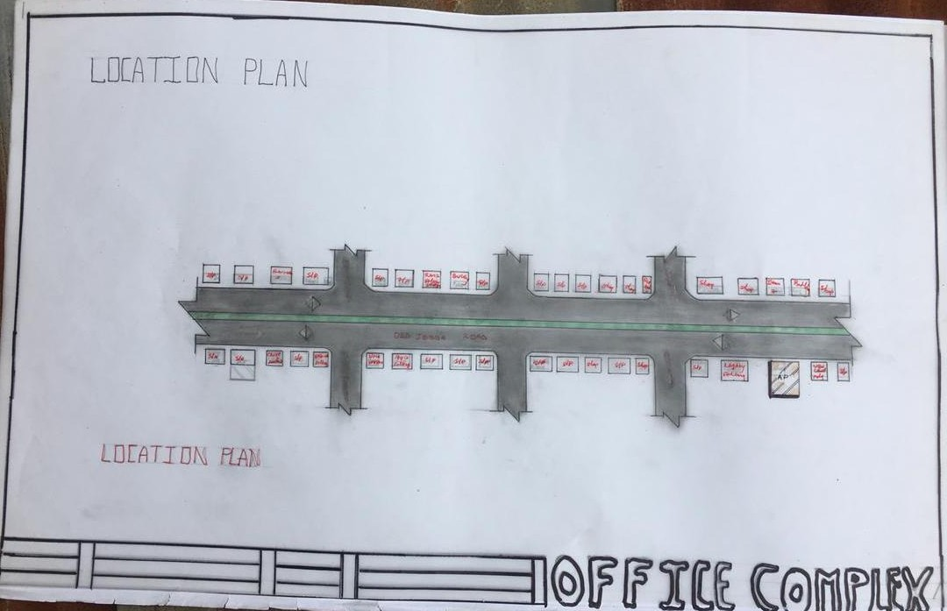

Appendix 1
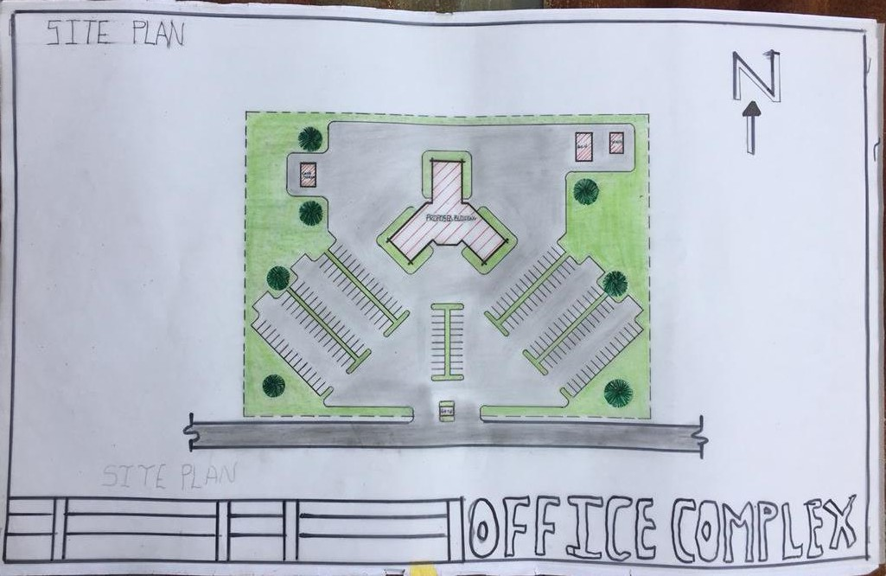
Appendix 2

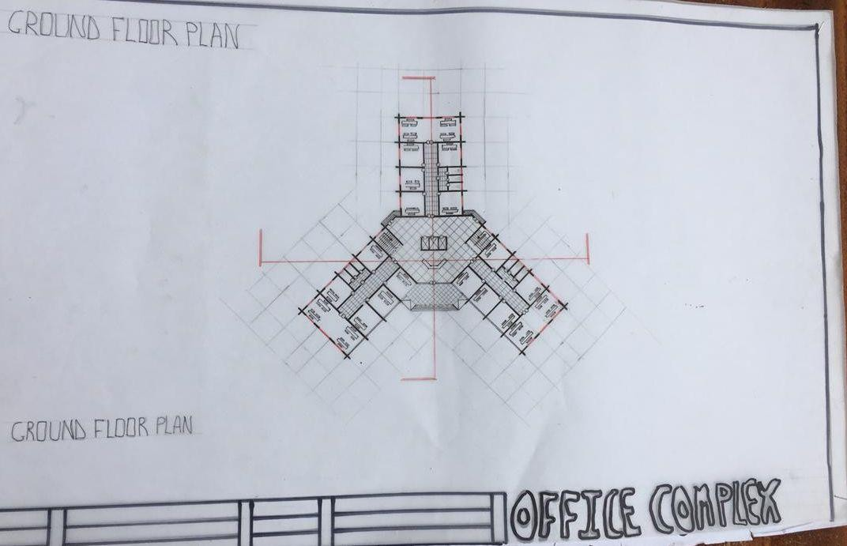

Appendix 3
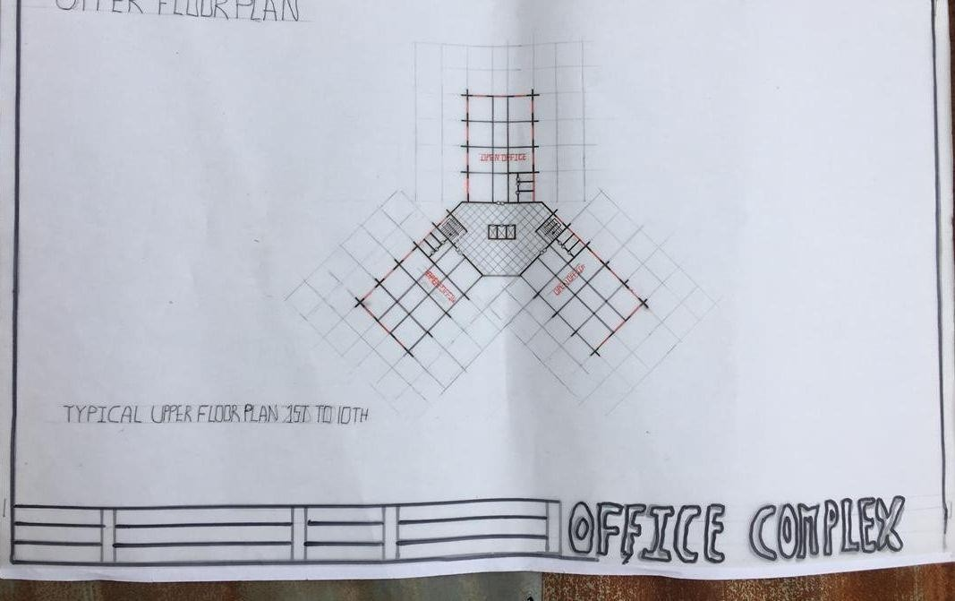

Appendix 4

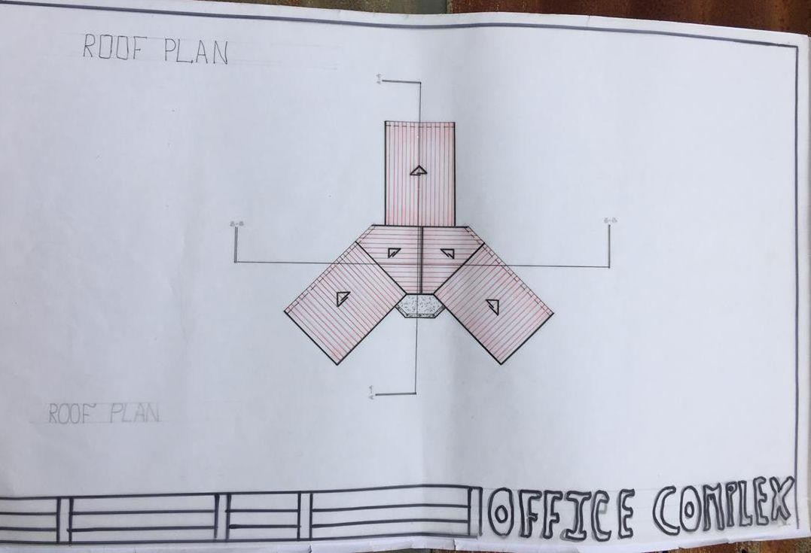
Appendix 5
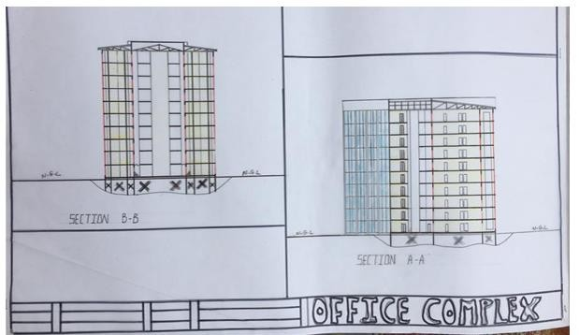

Appendix 6

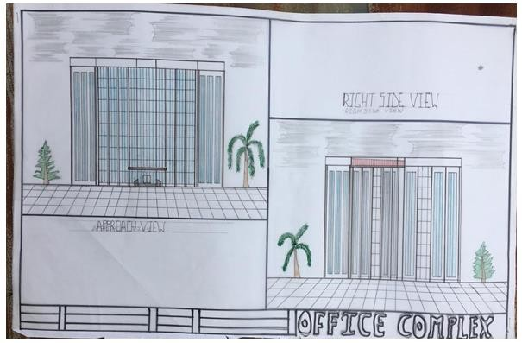
Appendix 7
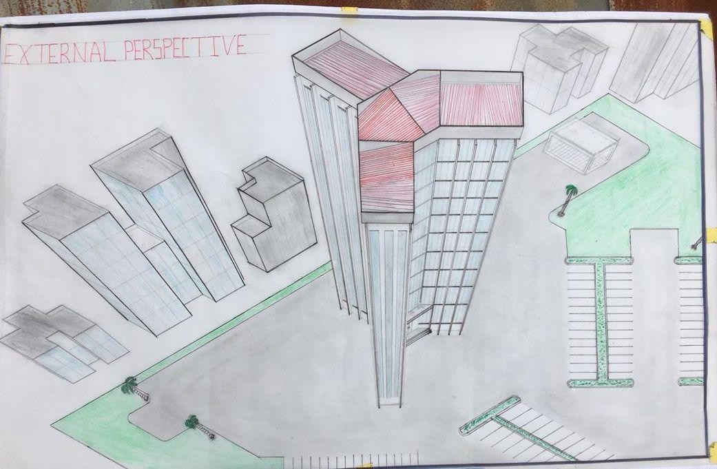

Appendix 8

