A PROJECT REPORT
ON
PROPOSED FEMALE INSTITUTIONAL HOSTEL
For
OSUN STATE POLYTECHNIC, IREE

BY
ISIAKA HABIBAT ANJOLAOLUWA
HND/23/ARC/FT/036

SUBMITTED TO
DEPARTMENT OF ARCHITECTURAL TECHNOLOGY, INSTITUTE OF ENVIRONMENT STUDIES, KWARA STATE POLYTECHNIC, ILORIN

IN PARTIAL FULFILLMENT OF THE REQUIREMENTS FOR THE AWARD OF HIGHER NATIONAL DIPLOMA [HND] IN ARCHITECTURAL TECHNOLOGY KWARA STATE POLYTECHNIC, ILORIN KWARA STATE.

JULY, 2025

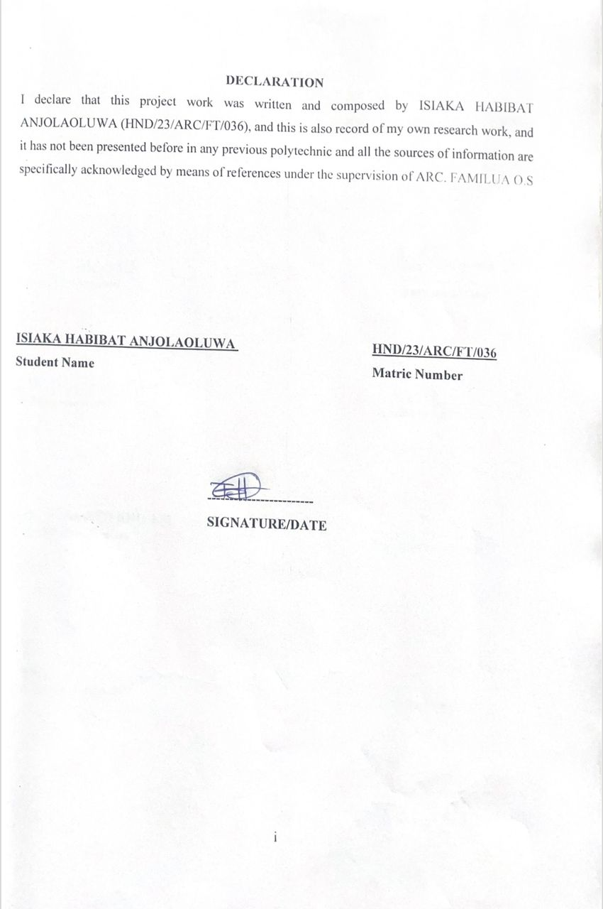

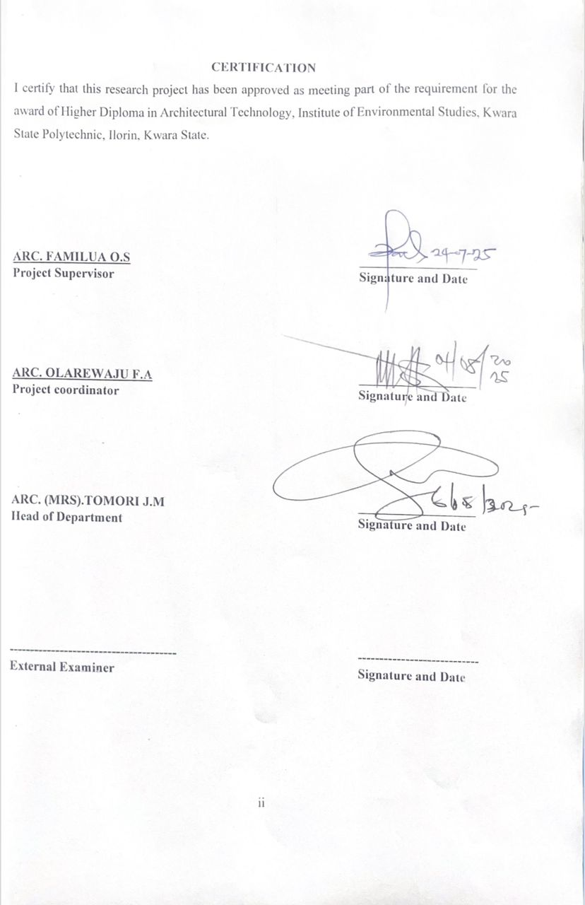

DEDICATION
I dedicate this project to almighty Allah, who is the source of my strength and guidance all the praises to him alone I also dedicate this work to my parent, Mr and Mrs. Isiaka for their uncompromising moral and financially support throughout my educational career so far.

ACKNOWLEDGEMENT
All praise and gratitude go to Almighty Allah for granting me the strength, knowledge, and courage to complete this project.
I express my heartfelt gratitude to my project supervisor, Arc. Familua O.S., for his invaluable guidance, support, and encouragement throughout this project. His expertise and constructive feedback significantly elevated the quality of my work.
I am deeply thankful to the Head of Department, Arc. J.M. Tomori, for his leadership and support, which were instrumental in the successful completion of my HND program.
My sincere appreciation extends to my project coordinator, Arc. Olarewaju F.A., for his guidance and contributions to this endeavor.
I am also grateful to the management, academic, and non-academic staff of the Architectural Department at Kwara State Polytechnic for providing the academic foundation and resources necessary for this project.
My profound thanks go to my parents, Mr. and Mrs. Isiaka, for their unwavering support, patience, and motivation throughout my academic journey.
I deeply appreciate the encouragement and support from my siblings and family members. Thank you all for your love and belief in me.
Special thanks to my partner, Ajibulu Victor, for his financial, moral, and emotional support, as well as his invaluable advice and encouragement. Words cannot express my gratitude.
Finally, I extend my heartfelt appreciation to my classmates and friends for their collaborative spirit, thoughtful contributions, and unwavering support. Their encouragement and shared insights greatly enriched this project.

ABSTRACT
Female Institutional hostels serve as crucial facilities designed to accommodate individuals—typically female students, employees, or other institutional members—within an organized and supervised environment. These hostels are integral to educational institutions, corporate organizations, and other entities requiring structured living arrangements. The primary objective of institutional hostels is to provide a safe, supportive, and conducive living environment that enhances the overall experience and productivity of its residents. Institutional hostels are characterized by their adherence to specific rules and regulations aimed at ensuring the well-being of occupants. They often offer amenities such as communal living spaces, dining facilities, and recreational areas, fostering a sense of community and collaboration among residents. The management of these hostels usually includes a structured framework for addressing issues related to accommodation, maintenance, and student welfare. This study outlines the significance of institutional hostels in promoting academic success, personal development, and professional growth. It emphasizes the role of these facilities in providing a stable and supportive environment that facilitates the achievement of institutional objectives.

TABLE OF CONTENT
TITLEPAGE…………………………………………………………………………………… i
DECLARATION……………………………………………………….…………………………ii
CERTIFICATION……………………………………………………….………………………..ii
ACKNOWLEDGEMENT………………………………………………………………………..iv
DEDICATION……………………………………………………….……………………………v
LIST OF TABLES………………………………………………..………………………………vi
LIST OF FIGURES……………………..……………………….……………………….……..vii
LIST OF PLATES………………………………………………………………….……...……viii
ABSTRACT………………………………………………………………………..…………….ix
CHAPTER ONE
1.0 INTRODUCTION………………………………….………….……………….…………1
1.1 HISTORICAL BACKGROUND………...………………….……………………………1
1.2 STATEMENT OF INSTITUTIONAL HOSTEL …………..……………………….……2
1.3 AIM AND OBJECTIVES………………………………………..……………………..…2
1.4 JUSTIFICATION………………………………………………………………..…..……3
1.5 CLIENT’S BACKGOUND…………………………………………………………….…3
1.6 SCOPE OF STUDY…………………………………………………………………….…3
1.7 LIMITATIONS OF CONSTRANTS ………………………..…....……………..…….…4
1.8 RESEARCH METHODOLOGY…………………………………………………………4
1.9 DEFINASION OF TERMS……………………………………………………………..13

CHAPTER TWO

2.1 LITERATURE REVIEW AND CASE STUDY………………………………………. 15
2.2 DEFINITION OF HOSTEL …………………………………………………………....15
2.3 HISTORICAL DEVELOPMENT OF HOSTEL ……………….……………..………..16
CHAPTER THREE
3.0 CASE STUDY………………………………………………………………..………… 18
3.1 CASE STUDY 1 ONE (QUEEN ELIZABETH HOSTEL UNIVERSITY OF IBADAN )…18
3.2 CASE STUDY TWO (OLABISI ONABANJO UNIVERSITY )……………… 21
3.3 CASE STUDY THREE (OLORI HOSTEL IBADAN POLYTECHNIC … 24
3.4 ONLINE CASE STUDY ONE (HOOSAC SCHOOL US)……...28
3.5 ONLINE CASE STUDY TWO (UNIVERSITY STUDENTS’ HOUSING ITALY)…….....32

CHAPTER FOUR
3.7 DESIGN PROPOSAL………………………………………………………………..38
3.8 STUDY AREA / PROJECT SITE……………………………………...……………38
3.9 SITE LOCATION ……………………….……………………………………………………………………………. 33
4.0 SiteLocationMap………………………………………………………………………………………………………………39
4.1 Site Characteristics ………………….………………………………………………..41
4.2 SITE ANALYSIS. ……………………………….………….………………………………………………………….42
4.3 GEOGRAPHICAL/ CLIMATIC DATA………………………………………………………………………… 43
4.4 ANALYSES OF THE IMMEDIATE ENVIRONMENTAL CONDITIONS OF THE SITE………….45
4.5 PROJECT ANALYSIS/DESIGN CRITERIA………………………………………………………………….. 47
4.6 DESIGN CONCEPT………………………………………………………………….48
4.7 PROJECT GOAL……………………………………………………………………………………………………….…48
4.8 APPRAISAL OF PROPOSED SCHEMES……………………………………………………………………….. 48
4.9 EQUIPMENT AND OPERATIONAL AND PERFORMANCE REQUIREMENT ………………..... 50
5.0 SPATIAL ALLOCATION / SCHEDULE OF ACCOMMODATION …………………………….…..… 53
5.1 FUNCTIONAL RELATIONSHIP……………………………………………………………….54
5.2 CONCEPTUAL DEVELOPMENT ……………………………………………………………………………….55
CHAPTER FIVE
5.3 APPROACH TO THE DESIGN / DESIGN REALIZATION………………………56
5.4 DESIGN CONCEPT………………………………………………………………………………………………………56
5.5 CONSTRUCTION METHODS……………………………………………………..56
5.6 SUB-STRUCTURE……………………………………………………………………57
5.7 SUPER STRUCTURE…………………………………………………………………57
5.8 CONSTRUCTION MATERIALS…………………………………………………...58
5.9 SUBSTRUCTURE AND SUPERSTRUCTURE…………………………………….58
6.0 SERVICES/ INFRASTRUCTURE……………………………………………….59

6.1 DESIGN CONTRIBUTION……………………………………………………………………………………………..60
6.2 Introduction…………………………………………………………………………62
6.3 Recommendations…………………………………………………………………..62
6.4 Conclusion………………………………………………………………………….62
REFERENCES………………………………………………………………………………
APPENDICES………………………………………………………………………………….

CHAPTER ONE
1.0 INTRODUCTION
1.1 BACKGROUND TO THE STUDY
According to Schemers (1972), tertiary institutions should be designed to accommodate students in hostels within the school environment for effective and optimal of academic activities. These hostels should be comfortable and could be in the form of rooms, halls or apartments. Facilities like toilets, laundry, lounge, amongst others, should be provided for the convenience of students. The provision of these facilities is usually guided by set standards as well as the number of students expected to reside in the hostels (Ernst and Neufert, 1993).
As housing is one of the most fundamental needs of man, the provision of quality accommodation is necessary. Afolayan (1981) opines that, a good accommodation should serve the purposes of providing physical shelter, useable living space, and self-fulfillment. It follows that the provision of a good accommodation implies the provision of adequate shelter, space and facilities for the general well-being of the inhabitant. Furthermore, accommodation conditions have been identified as having appreciable effects on the quality of health, work efficiency, social behavior, satisfaction and general welfare of any community. This situation applies not only to urban and rural housing areas, but also to accommodation facilities within institutions.
The little attention paid by Nigerian government and authorities of institutions to housing has led to gross inadequacy in hostel facilities, resulting to overcrowding, over-utilization, deterioration of facilities and higher fire risks. It has increased the number of off-campus students who cannot find spaces in the available hostels. The effect of this situation on academic performance, health and social behavior of students is negative and cannot be over emphasized (Novak, 1990).
The current trend of frequent fire outbreak in hostels has become a major concern for all. There have been a lot of incidences of fire in hostels, where students lost their lives and properties.
It is necessary to think of how to avoid these problems than coping with it.
This study intends to identify the problems and attitudes associated with fires in buildings With the view to proffering solution. A female institutional hostel is a residential facility established to provide safe, secure, and supportive accommodation for women, typically students, working professionals, or trainees affiliated with an institution such as a university, college, training center, or company. These hostels aim to create a conducive environment for personal growth, academic excellence, and professional development while ensuring the physical and emotional well-being of the residents.
The need for female hostels has grown significantly in recent years due to increasing female participation in higher education and the workforce, particularly in urban and semi-urban areas. Institutional hostels help address concerns about safety, affordability, and proximity to academic or workplace campuses.
1.2 STATEMENT OF PROBLEM
The increasing number of students in tertiary institution in several Nigerian cities has cause serious accommodation problems and hampers hostels accommodation no longer cope with demand.
Presently the situation of hostels is opposite of what is used to be, as a result of sporadic increase in numbers of prospective candidates seeking admission into Nigerian tertiary institutions. This phenomenon has made hostels lose its original purpose of providing conducive academic atmosphere, good for learning and social integration. Institutional hostels are no longer able to cope with the population leading to unacceptable levels of overcrowding, stress on existing facilities, and incessant breakdown of services.
The problems of hostel accommodation in Nigeria resolve around inadequate number of hostels, limited facilities and poor building. There is unhealthy competition for the limited hostel fees, overcrowding, frequent breakdown and deterioration of available amenities.
1.3 AIM AND OBJECTIVES OF THE STUDY
Aim
The aim of project is to design standard, functional and well accommodating female hostel for osun state polytechnic iree
.

Objectives
The objectives to achieve the aim above are to:
- To ensure the design has multiple entrances, exits and ramp and other features that facilitate easy access for all students including the disabled.
- To ensure the provision of adequate space that meets recommended standards for comfort, privacy, and functionality in female hostel rooms.
- To incorporate safety and security features, including fire prevention systems, surveillance, proper lighting, and access control, to ensure the protection of occupants.
- To integrate sustainable and cost-effective building materials and technologies to ensure long-term affordability, durability, and environmental friendliness.
1.4 JUSTIFICATION OF STUDY
This study intends to access how fire safety can be enhanced in the design of a female hostel. One of the significances of this study is that it will help in resolving problems of fire outbreak in student hostel.
Again most universities lack sufficient accommodation. There is shortage of accommodation in most campuses in Nigeria. And lack of hostel accommodation encourage truancy and consequently poor concentration on academics works.
Also, in the case of security, hostels built inside school are more secured. With every passing day, we hear news about how arm robbers attack students who live outside the school and take valuable properties from them. But that doesn’t happen in school hostels because the school provides them with tight security.
Hence, this study provides standards, requirements and pre-requisites that would enhance fire safety in the design of female hostel.
1.5 CLIENT BACKGROUND
Osun State Polytechnic, Iree, was initially established in 1981 as a satellite campus of The Polytechnic, Ibadan. It became an autonomous institution in October 1992, following the enactment of its establishment law by the first Executive Governor of Osun State, Otunba Isiaka Adetunji Adeleke. The polytechnic was founded to train middle-level professionals in fields such as Science, Engineering, Environmental Studies, Information and Communication Technology, Management, and Financial Studies.
This Staff Handbook consolidates essential information on the institution’s establishment, procedures, and regulations. It outlines the academic, administrative, financial, and technical planning policies, clarifying expectations for staff at departmental, faculty, and institutional levels.
The institution began with eight programs at Pre-ND, ND, and HND levels. Today, it offers over thirty programs accredited by the National Board for Technical Education, along with additional programs accredited by the National Commission for Colleges of Education.
1.6 SCOPE OF THE PROJECT
This study focuses on enhancing safety in the design of a female residence in iree polytechnic . The design project will provide facilities that are necessary in the hostel with more emphasis on means of students safety. The outdoor spaces as much as the indoor spaces will receive attention, and also the scope of an institutional guest hostel typically includes providing accommodation for visitors, guests, or individuals affiliated with the institution. These hostels are usually located within or near the institution's premises and offer temporary lodging facilities. The services provided by institutional guest hostels can vary but often include comfortable rooms, amenities like Wi-Fi, laundry facilities, and sometimes meals. Additionally, these hostels may offer conference facilities for events, meetings, or workshops. The scope also involves maintaining cleanliness, security, and a welcoming environment for guests.
The research design is intended for undergraduate students of iree polytechnic, Osun state. It will accommodate only female students.
Facilities to be provided in the hostel would include;
Reception area,
Common room
Portal room
Reading room,
Kitchen,
Laundry,
Store, etc.
1.7 LIMITATION OF STUDY
The limitation experienced during this course of study include:
- Time constraint
- Finance: funding of the project research and the project itself has been a surmountable task which God has intervened in its management.
- Research materials: There have not been enough local sources of information and getting the proper architectural plans required for assessment during case studies was not very easy.
1.8 RESEARCH METHODOLOGY
research on female institutional hostel requires a detailed and systematic approach to uncover insights about hostel operations, user experiences, and resource effectiveness. Here's a deep dive into the research methodology for female institutional hostel, covering key aspects and detailed steps.
Institutional Background: Familiarize yourself with the female institutional hostel’s context, including its mission, services, user demographics, and challenges.
Scope and Objectives: Define the specific areas of focus (e.g., user satisfaction, resource usage, digital integration).
- Case study
- Oral interview
- Literature review
- 0nline review

1.9 DEFINITION OF TERMS
- ENTRANC: An entrance is an opening or passage that allows access into a place, such as a door or gate.
- ROOMS: A room is an enclosed space within a building, separated by walls, and typically used for a specific purpose such as sleeping, studying, cooking, or relaxing.
- COMMON ROOM: A common room is a shared space in a building where people gather to relax, socialize, or interact, commonly found in schools, offices, hotels, and community centers.
- PROTAL OFFICE: portals office is the administrative center where residents handle tasks like room allocation, fee payments, maintenance requests, and other hostel services, often through an online system.
- LUNDARY
- STORAGE
- KITCHINE
- EXIT
- TOILET

CHAPTER TWO
2.1 LITERATURE REVIEW
In this chapter, Definition of Residence (Hostel), history, causes of fire, types of fire, principle of fire safety and other related literatures are discussed. This Literatures were studied in order to know the trend and scope for research in the chosen field. Many doctoral thesis, reports and articles published in leading journals were subjected to analysis.

1. Definition of Residence (Hostel)
A residence or hostel is a type of accommodation provided primarily for students, workers, or other occupants in an institutional setting. Hostels typically consist of shared or individual rooms and communal facilities such as bathrooms, kitchens, and lounges. In the context of tertiary institutions, a female hostel is a designated residential facility specifically for female students, offering not only shelter but also a safe and conducive environment for learning and personal development. According to the Oxford English Dictionary, a hostel is “an establishment that provides inexpensive food and lodging for a specific group of people, such as students, workers, or travelers.”

2. Historical Background of Hostels
The concept of hostels dates back to ancient times, when communal living spaces were established for travelers, pilgrims, and students. In the modern academic setting, hostels became common in the 19th and 20th centuries, particularly with the expansion of higher education institutions. Female hostels emerged later as a response to increasing female participation in education, with emphasis on privacy, safety, and gender-specific needs. Over time, hostel design has evolved from basic shared dormitories to more structured accommodations that incorporate modern facilities and comply with safety standards.

3. Causes of Fire in Hostels
Fire outbreaks in hostels are often caused by a variety of factors, many of which stem from human negligence or inadequate infrastructure. Common causes include:
- Electrical faults such as overloaded sockets, faulty wiring, or the misuse of electrical appliances.
- Open flames from candles, stoves, or incense burning in rooms.
- Improper handling of flammable materials, such as cleaning agents or cooking oils.
- Smoking in unauthorized areas, especially near combustible materials.
- Neglected cooking activities, particularly in shared kitchens without supervision.
- Arson or intentional fire-setting, although less common, also contributes to fire incidents in residential facilities.

4. Types of Fire
Fires are classified based on the nature of the fuel involved. According to fire safety standards (such as NFPA and BS EN classifications), the main types of fire include:
- Class A: Fires involving ordinary combustible materials such as wood, paper, cloth, and plastics.
- Class B: Fires involving flammable liquids like petrol, oil, and solvents.
- Class C: Fires involving flammable gases such as propane or butane.
- Class D: Fires involving combustible metals (less common in hostel settings).
- Class E (or Class C in some systems): Fires involving electrical equipment.
- Class F (or K in the U.S.): Fires involving cooking oils and fats, common in kitchens.

Understanding the type of fire is essential for selecting the appropriate extinguishing method and equipment.

5. Principles of Fire Safety
Fire safety is based on a set of principles aimed at preventing fires and minimizing their impact when they occur. Key principles include:
- Prevention: Identifying and reducing fire risks through proper design, maintenance, and behavior (e.g., avoiding overloaded circuits, installing smoke detectors).
- Detection and Warning: Early identification of fire through alarms, smoke detectors, and monitoring systems.
- Containment: Designing buildings with fire-resistant materials, compartmentalization, and fire doors to prevent the spread of fire.
- Escape: Providing clear, accessible escape routes, emergency lighting, and signage to allow safe evacuation.
- Firefighting Facilities: Ensuring the availability of fire extinguishers, sprinklers, and other equipment to suppress fire at the source.
- Training and Awareness: Educating occupants on fire risks, emergency procedures, and the use of firefighting equipment.
2.2 DEFINITION OF HOSTEL
. A female institutional hostel is a lodging facility, typically located on a campus or within an educational institution, that primarily provides accommodation for female students. It serves as a temporary residence for these students, often offering a supportive and safe environment. Oxford Advanced Learners Dictionary (2000) defines hostels as buildings that provide cheap, inexpensive, supervised, short lodging, especially for young people. A female institutional hostel is a residential facility provided by an institution—such as a school, college, university, or training center—specifically for female students, trainees, or staff. It offers accommodation along with basic amenities like meals, security, and common areas, aiming to provide a safe and supportive living environment for women.
A hostel is a residential facility that provides temporary accommodation, primarily for students, trainees, or workers, typically associated with an educational institution, training center, or workplace. Hostels are designed to offer affordable lodging and basic amenities such as beds, bathrooms, meals, and common areas, fostering a community living environment.
In educational or institutional settings, hostels aim to create a disciplined and secure atmosphere conducive to learning and personal development. They often include rules and supervision to maintain order and safety among residents.
2.3 HISTORICAL DEVELOPMENT OF HOSTEL
The concept of female institutional hostels has developed over time in response to changing societal roles, particularly the increasing participation of women in education and the workforce. This chapter outlines the key phases in the historical development of such hostels, highlighting how social, political, and economic factors influenced their growth.

Pre-1900s: Informal Arrangements and Limited Access
Before the 20th century, the concept of institutional hostels for women was virtually nonexistent. Societal norms largely confined women to domestic roles, and opportunities for formal education or employment were extremely limited. In rare cases, boarding was provided by religious or missionary organizations for girls attending church-run schools, especially in colonial settings such as British India and parts of Africa and Southeast Asia.

Early 1900s–1940s: Emergence of Female Hostels
With the gradual spread of girls’ education in the early 20th century, particularly through missionary and reformist efforts, the need for safe and regulated residential facilities began to emerge. Hostels attached to girls’ schools and training centers were established in urban centers. These were often run by women superintendents and followed strict rules to ensure safety and uphold social norms.

1950s–1970s: Post-Independence Expansio
Following independence in many nations, including India in 1947, significant emphasis was placed on nation-building through education. Governments began to expand access to education for all, including girls from rural and disadvantaged communities. During the 1950s to 1970s, institutional hostels for female students were constructed across universities, teacher training colleges, polytechnics, and nursing institutions. The focus was on access, affordability, and discipline.

1980s–1990s: Urbanization and Government Support
This period witnessed accelerated urbanization and increased mobility among women seeking education and employment. In response, governments introduced policies and schemes to support the construction and operation of girls’ hostels. Additionally, working women’s hostels were introduced in urban areas to support female professionals, particularly those without family support in cities.

2000s–Present: Modernization and Empowerment
In the 21st century, female hostels have evolved into comprehensive residential facilities with modern amenities. Safety, privacy, and mental well-being have become central to hostel design and management. Features such as CCTV surveillance, biometric access, internet connectivity, health facilities, and recreational spaces are now common.
In line with global movements for gender equality, hostels today not only provide accommodation but also serve as platforms for empowerment, personal development, and leadership. Special attention is given to inclusive access for students from marginalized or remote backgrounds through government-aided schemes and institutional partnerships.

CHAPTER THREE
3.0 CASE STUDY:
A case study is a detailed and in-depth analysis of a particular individual, group, organization, event, or situation over a specific period. It is a qualitative research method used to explore and understand complex issues in real-life contexts. Case studies are commonly employed in social sciences, education, business, and health care to gather insights, identify patterns, and develop theories or practical solutions.
In the context of project work, a case study helps illustrate how theoretical knowledge is applied to real-world scenarios, offering a practical understanding of the subject under investigation.
OUTLINE OF CASES STUDIED
- Queen Elizabeth Hostel, University of Ibadan
- Olabisi Onabanjo University
- Olori Hostel, Ibadan Polytechnic
- Hoosac School, USA
- Groton School, USA
3.1 Case Study 1: QUEEN ELIZABETH HOSTEL, UNIVERSITY OF IBADAN
Brief Description
Queen Elizabeth II Hall: This Hall is located along Oduduwa Road of the University. It is a female undergraduate hall and was named after Her Majesty, Queen Elizabeth II of Great Britain and Northern Ireland. It was formally opened in February 1956 by the Queen. The Hall has a capacity of One Thousand Two Hundred and Seventy-Five (1275) bed space for Students.
Hall Mistress: Professor Oluremi E. Ayodele-Bamisaiye Hall Warden: Dr. Omobola Adelore
Department: Adult Education Area of Specialization:
- Facilities include:
- Shared bedrooms and bathrooms
- Dining hall and kitchen facilities
- Reading rooms and lounges
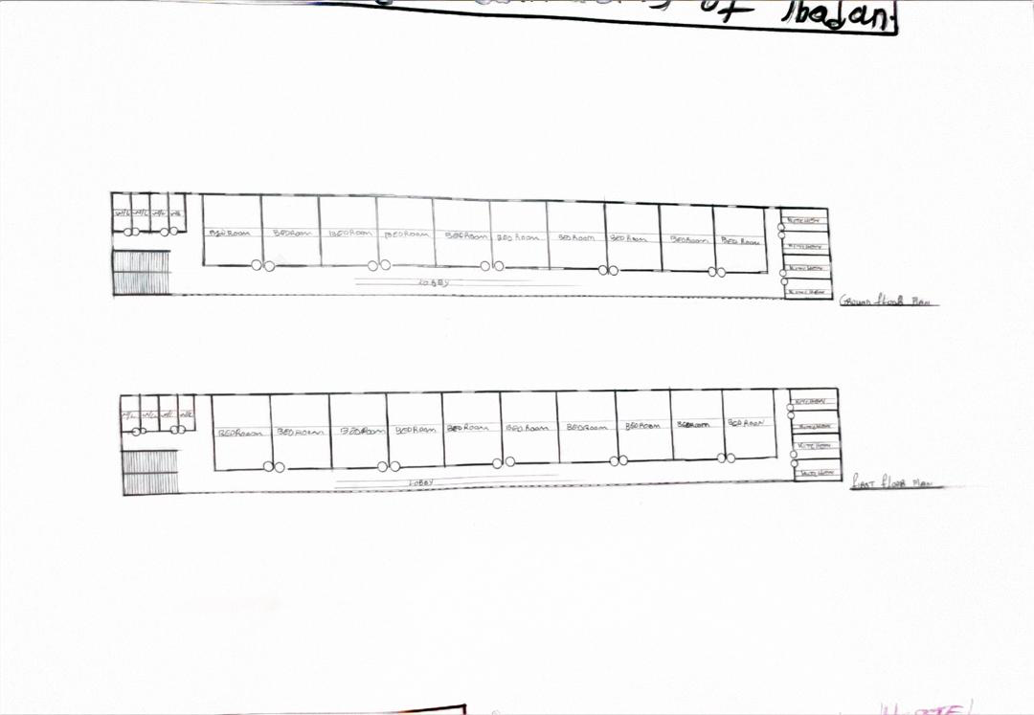
- Fire exits and safety provisions (though some of these are in need of modernization)
Figure 3.1.1 plan of the hostel
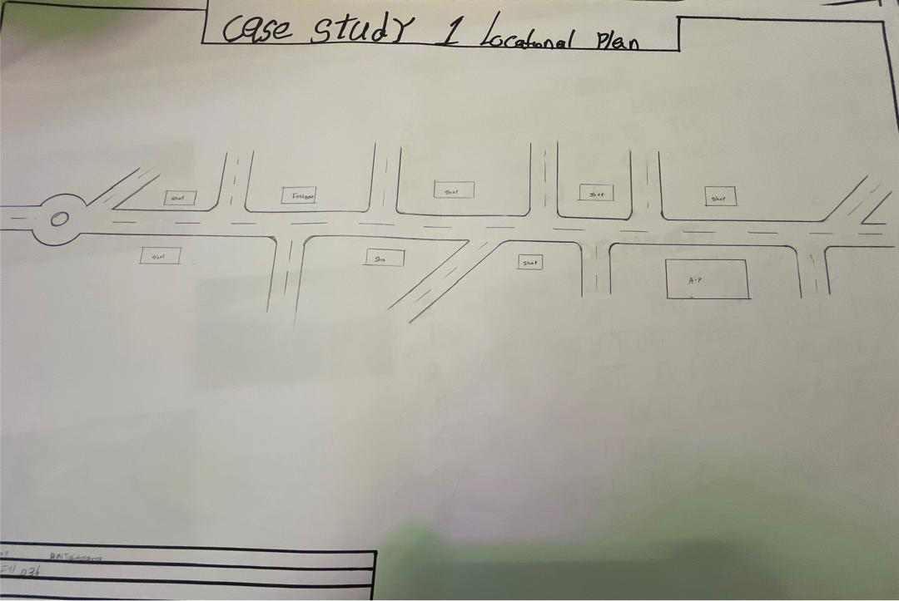
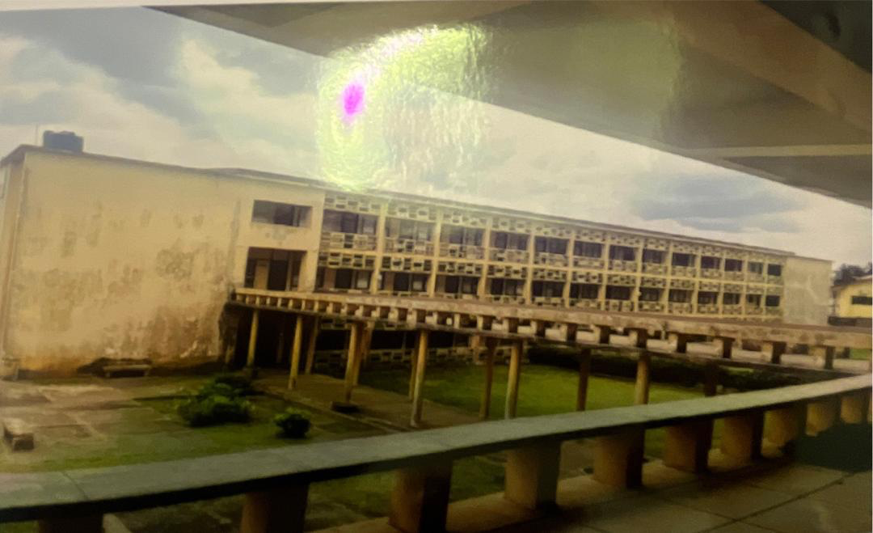
Figure 3.1.2 Locational plan
Plate 3.1.1 Showing the exterior view of the hostel of university of Ibadan
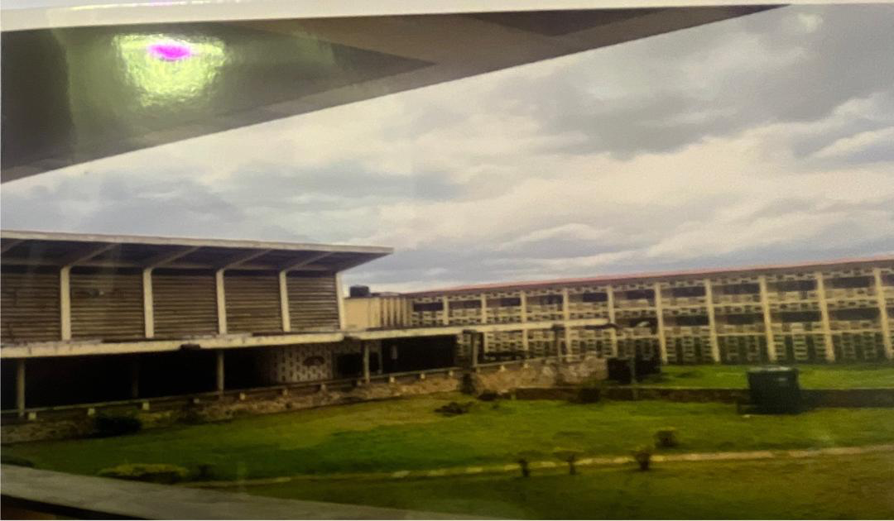
Plate 3.1.2 View of the hostel
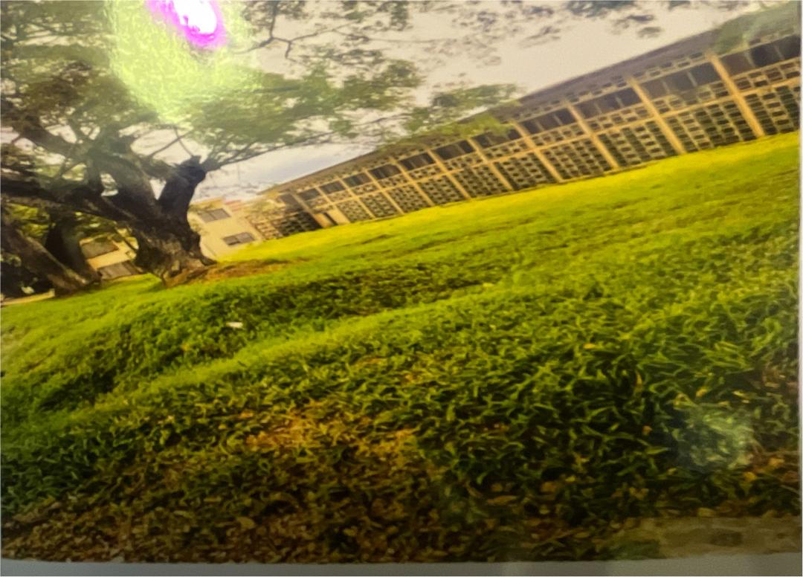
Plate3.1.3 view of the hostel

Merits
- Provision of toilets and kitchen were made available in each rooms.
- There are spaces for future development on the site.
Demerits
- No proper landscaping.
- Too many dead ends are found in the building.
- Fire resistance construction was not considered in the building. Compartmentation was not considered in the design of the building to slow down the spread of fire
3.2 Case Study 2: Olabisi Onabanjo University
Brief Description
- OOU began developing on-campus hostels in phases, especially after student protests and pressure for safer, more affordable accommodation. The hostels are managed by the Student Affairs Division of the university.
- Key features:
  - Gender-segregated hostels
  - Shared rooms and bathrooms
  - Basic amenities like water supply, power (sometimes with backup generators), and study areas

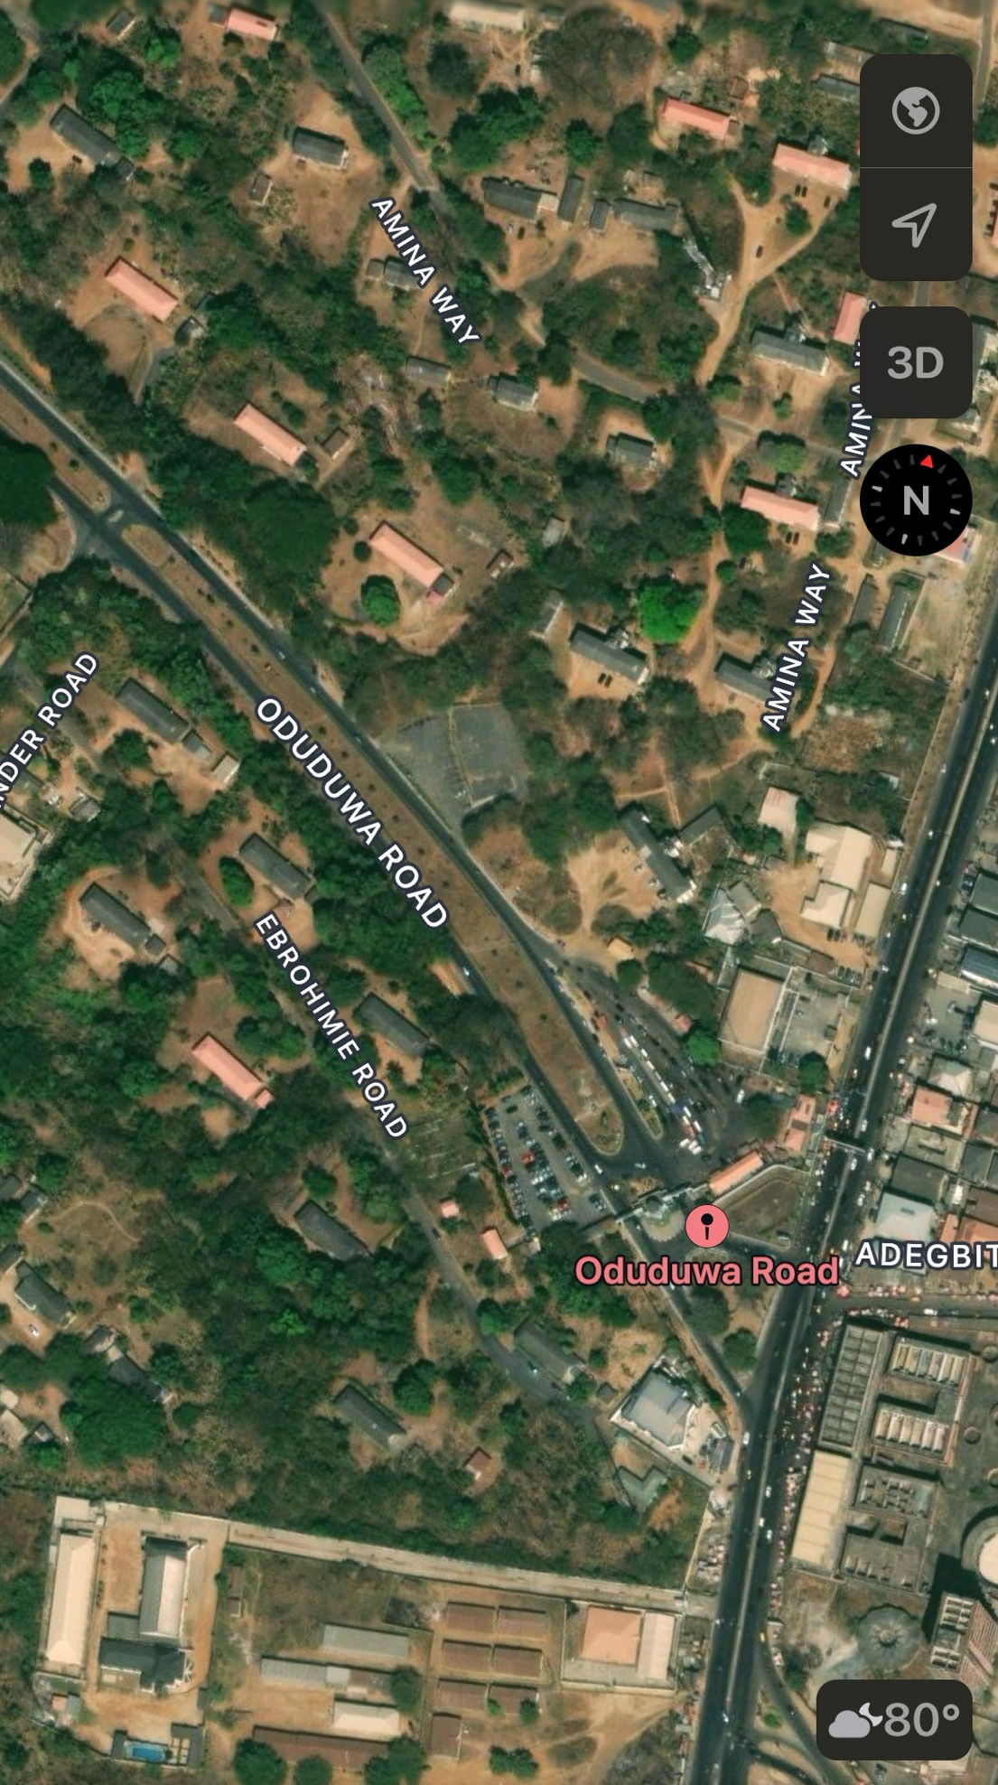
Figure 3.2.1 Locational Plan
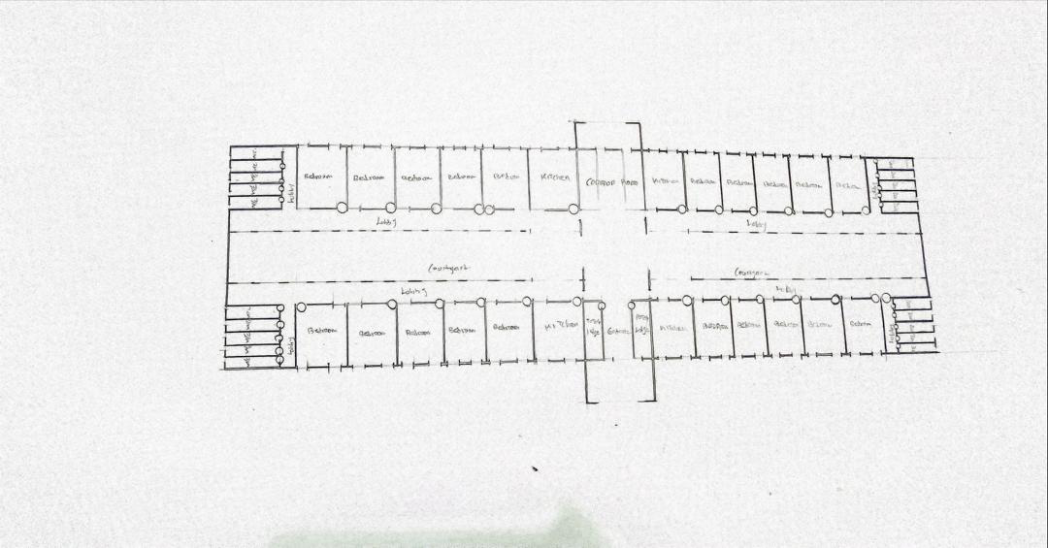
Figure 3.2.2 plan of the hostel
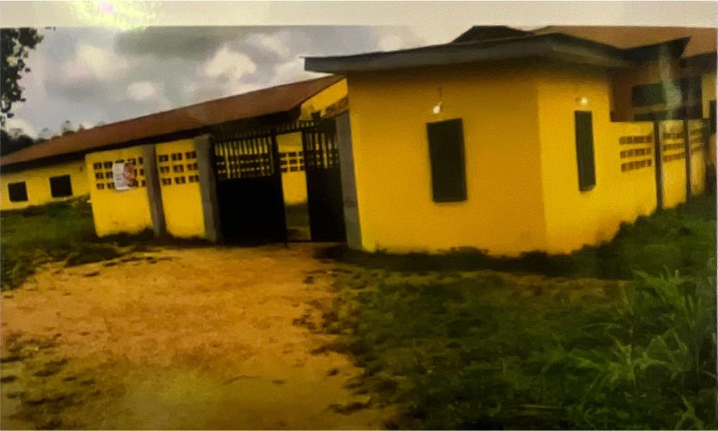
Plate 3.2.1 Entrance of the hostel
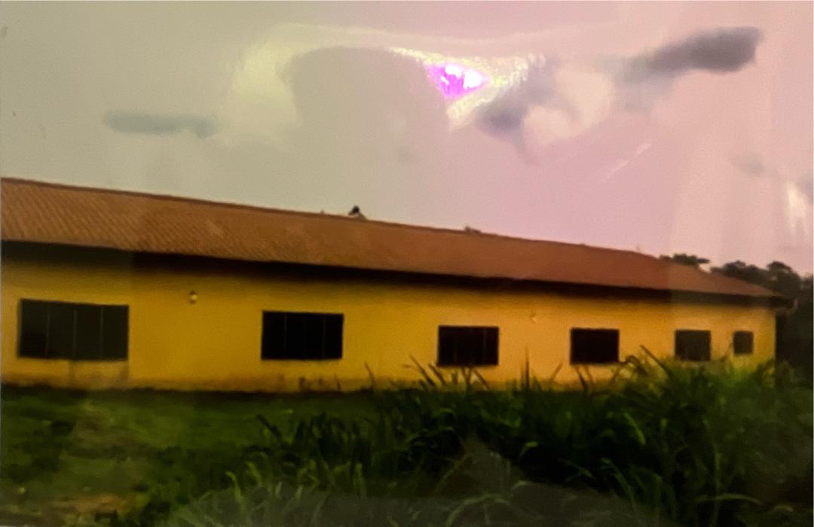
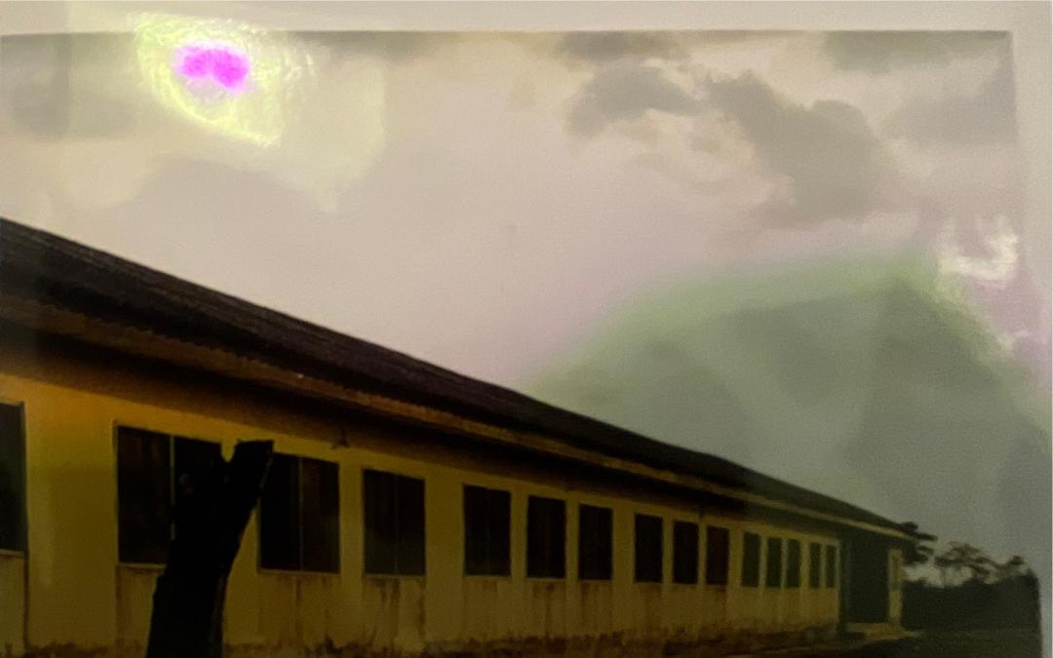
Plate3.2.2 The view of the hostel
Plate 3.2.3 The view of the hostel

Merits
- Good orientation on site; the rooms take advantage of the Trade Winds, thereby being well ventilated.
- The rooms are spacious with capacity of 4 occupants i.e. 2 double bunk
- They provided not only room facilities, but also social facilities.
Demerits
- Fire resistance construction was not considered in the building. Compartmentation was not considered in the design of the building to slow down the spread of fire.
- No provision was made for a first aid firefighting gadgets E.g. Hose reels Extinguishers, fire buckets, fire blankets, Hydrant systems etc.
- No proper landscaping.
ONLINE CASE STUDY
3.3 Case Study 3: Hoosac school New York
Brief Description:
Hoosac School is a private college preparatory boarding school located in Hoosick, New York. The school offers both boarding and day programs for students in grades 8–12 and postgraduate.
- The campus architecture reflects a mix of Gothic Revival and traditional New England boarding school style—characterized by brick and stone structures, pitched roofs, and collegiate-style dormitories.
- Many of the original buildings, like Tibbits Hall, date back to the early 20th century and retain their historic charm.
Orientation: The building is oriented to take advantage of the winds direction.
Activities: Activities in building Climate: The climate of Epinay-sur-Seine, France is warm and temperate. The city is a city with a significant rainfall. Even in the driest month, there is a lot of rain.
Topography: The site is relatively flat with gentle slope.
Vegetation: Sparse vegetation.
Site Area: 9000 m²
Facilities:
Available spaces and facilities provided are:
- Students rooms
- Guard’s accommodation,
- Private study rooms,
- Laundry,
- Space out relaxation
- Gardens
Site Zoning:
are sleeping, studying, relaxation and cleaning.
Circulation Pattern: Passageways are provided or internal circulation while the open spaces at each centre on the wings gives space for free flow of

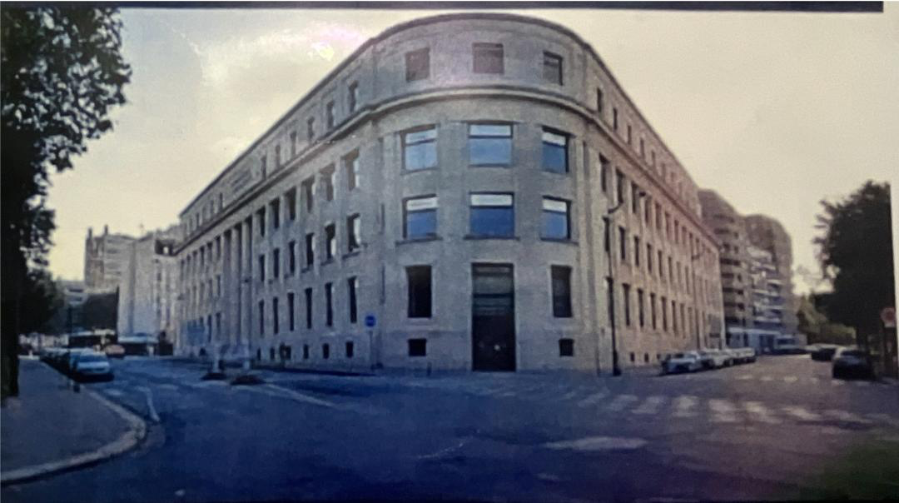
Plate 3.3.1 The view of the hostel
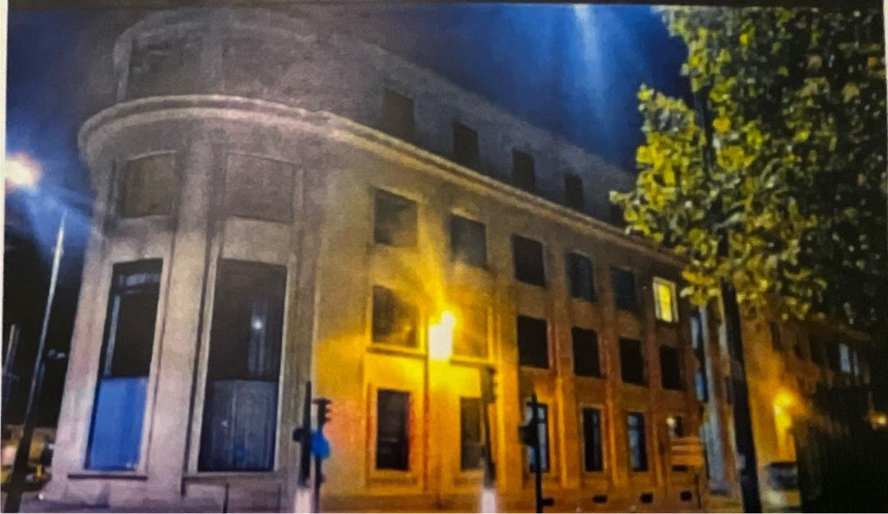
Source: www.archdaily.com HYPERLINK "http://www.archdaily.com(2021)/"(2021)
Plate3.3.2 View of the hostel
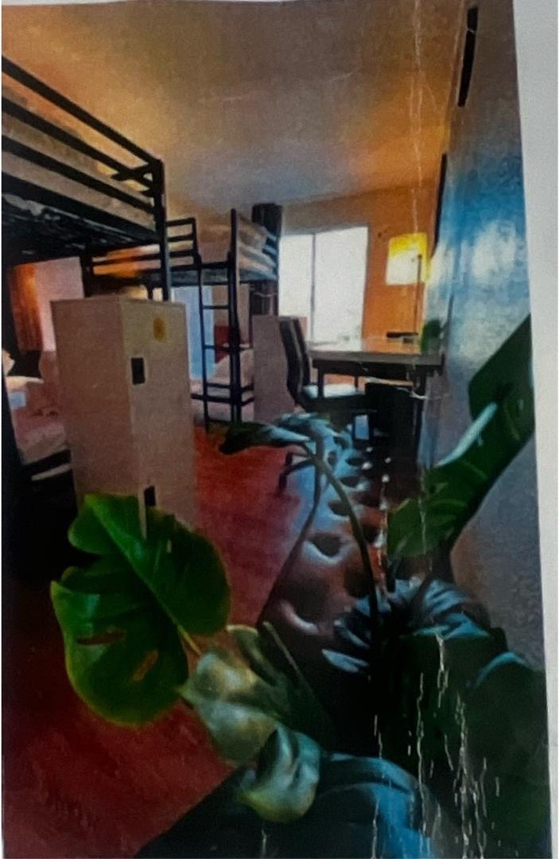
Plate 3.3.3 View of the hostel
Source: www.archdaily.com (2021)
Merits
- Made from durable materials (stone, brick, wood) that have stood the test of time.
- Serene Environment conducive for learning.
- Good orientation to take advantage of the winds direction
- Bathrooms and dorm rooms are modern enough for daily comfort.
Demerits
- Room sizes vary, and some may feel small for two students.
- Certain dorm buildings are over 100 years old, which can mean Creaky floors
  - Narrow hallways
  - Limited modern design features
3.4 Case Study 4: Groton school US
Date of Establishment:1884
Architect: Sheplay, Rutan &Coolidge
Shepley, Rutan & Coolidge
Location: Groton, Massachusetts, USA
Brief Description:
Groton is one of the most prestigious boarding schools in the U.S., known for its academic rigor, elite alumni (e.g. Franklin D. Roosevelt), and highly structured residential life.The campus was originally designed by the architectural firm Shepley, Rutan and Coolidge, influenced by Georgian and Collegiate Gothic styles.
Campus features include:
  - St. John’s Chapel (iconic)
  - Brooks House, Nash House, and other historic dorms
  - Expansive green quads and brick-lined academic halls

Building Materials: Reinforced concrete base, wood shingles, glass, brick.
- Site Area 480 acres (around 1.94 square kilometers or 194 hectares).
Facilities:
- Dormitories
- Religious facilities
- Outdoor space
- Study rooms
- Courtyards
- Gardens
Site Zoning:
Main building: shops, entrance, refectory, on the ground floor; study rooms and services on the upper levels, and lodgings on the other floors.
Orientation: The building is oriented towards the south west breeze which takes advantage of the wind direction.
Activities: Activities in the building includes sleeping, studying and relaxation.
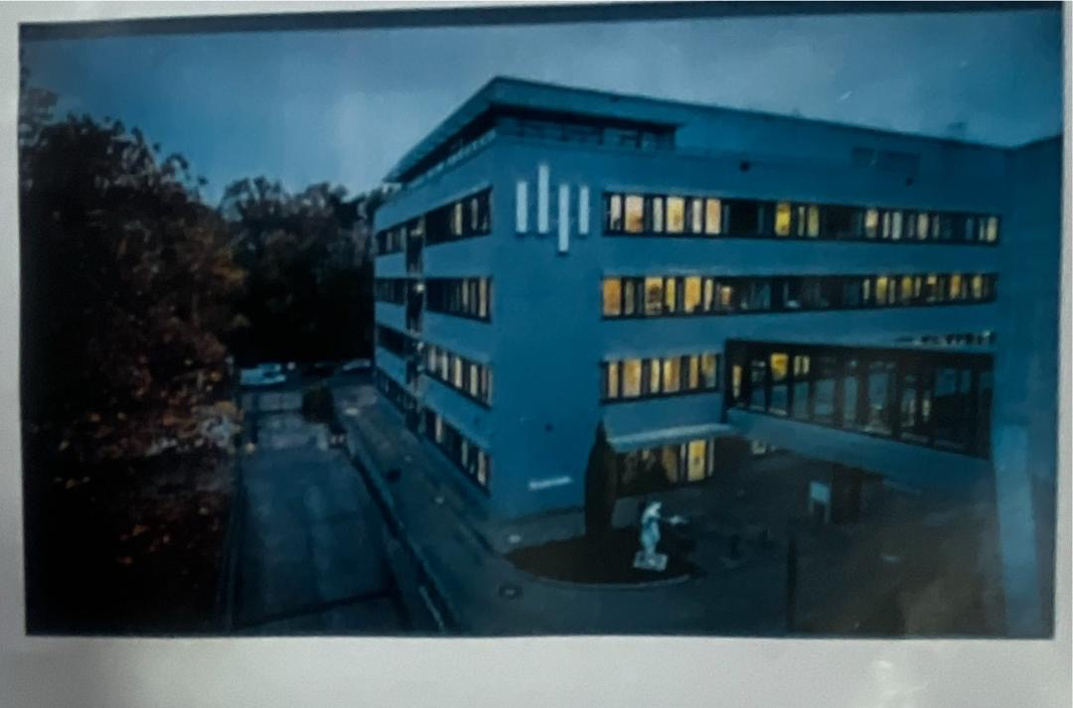
Circulation Pattern: Circulation is through the double courtyards pattern and also a passageway that cuts crosswise through the blocks and a focus for communal activities, as well as access to the student’s lodgings.
Plate 3.4.1 The view of the hostel
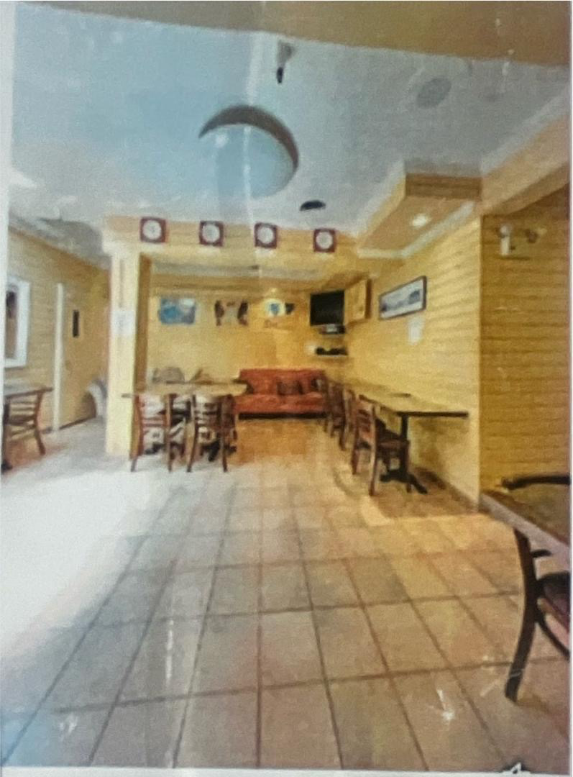
Plate 34.2 View of the hostel
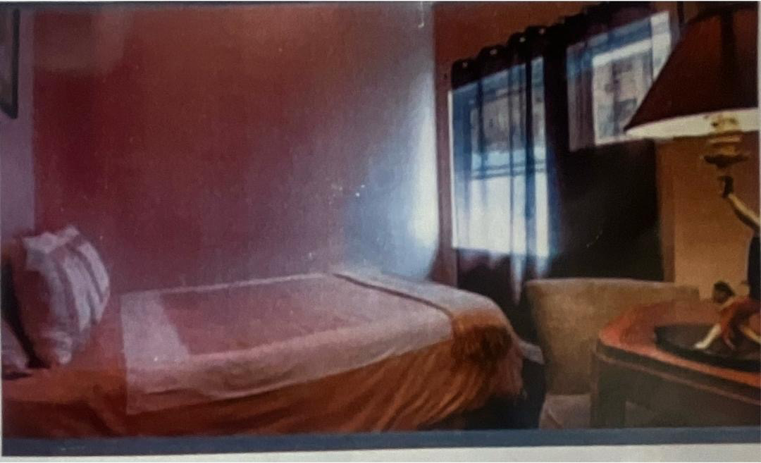
Plate 3.4.3 The view of the hostel
Merits
- Most of the rooms are en-suite
- Room varieties to serve for different space needs
- Ventilation was enhanced with the introduction of opening
Demerits
- Limited personal customization in dorm
- Highly structured environments
3.5 Case Study 5: Olori hostel Ibadan polytechnic
Brief Description
Olori hall is an OND and HND female hall. It was built in 1971, with a capacity of 639 students. The hall consists of seven blocks lettered A to G. Each of the blocks has three floors, with fourteen rooms in each floor. Block C, D and E have basement, each contains five rooms. Two students are allocated to each room and the size of the room is 3.0m x 2.0m. Rooms are cross ventilated, one door and in each rooms is a reading table and chair, one wardrobe and no bunk. Each of the floors has a kitchen, three bathrooms and toilets attached to it. Available open spaces are not organized, but flowers are planted in front of some of the blocks. Provision is made for common room, reading room, supervisor's office, porter's lodge and a store within the hall.

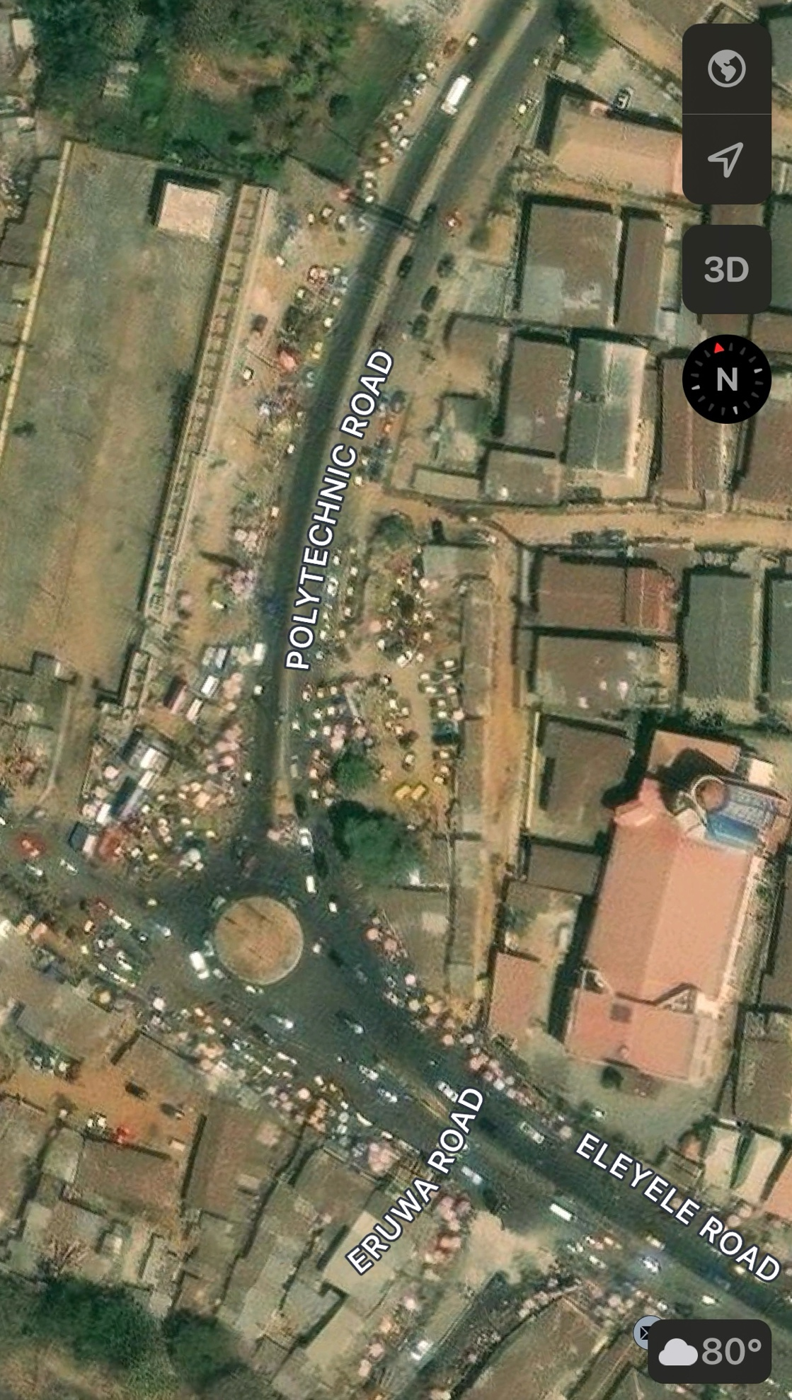
Figure 3.5.1 Locational Plan
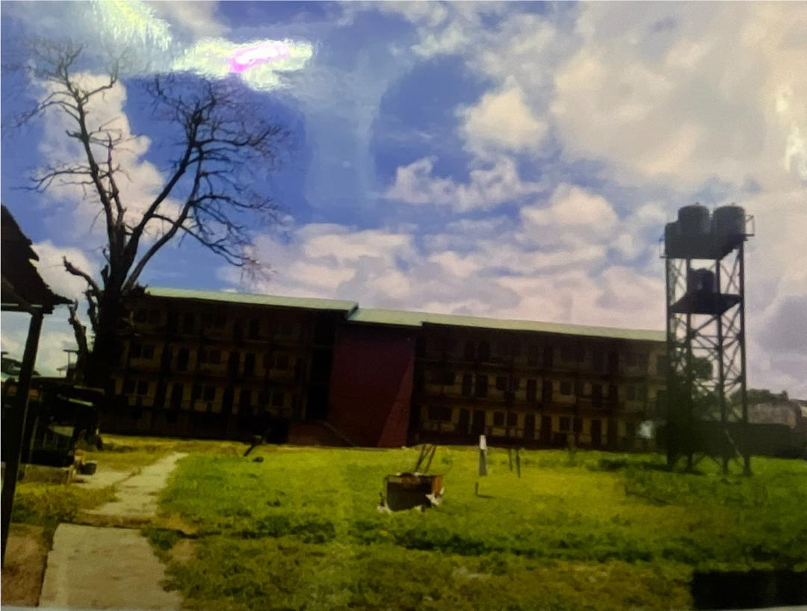
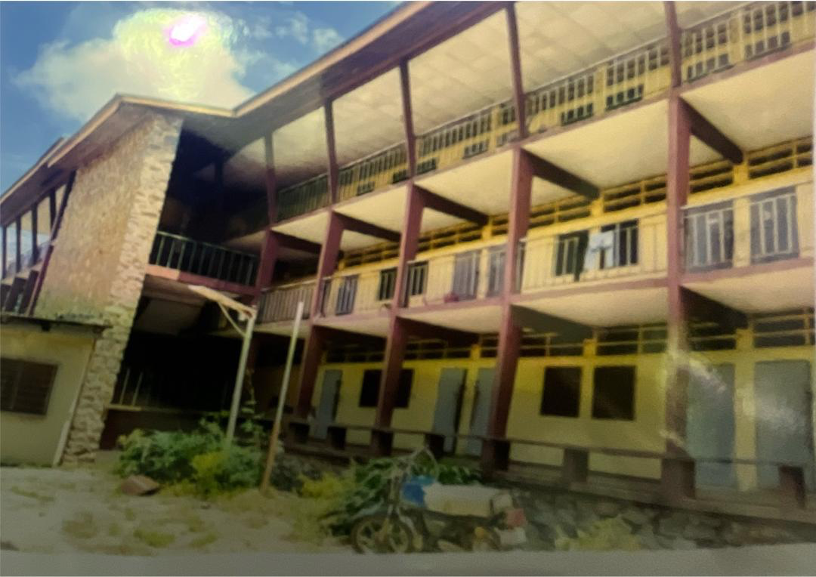
Plate 3.5.1 View of the hostel
Plate 3:5.2 picture showing the exterior part of the hostel
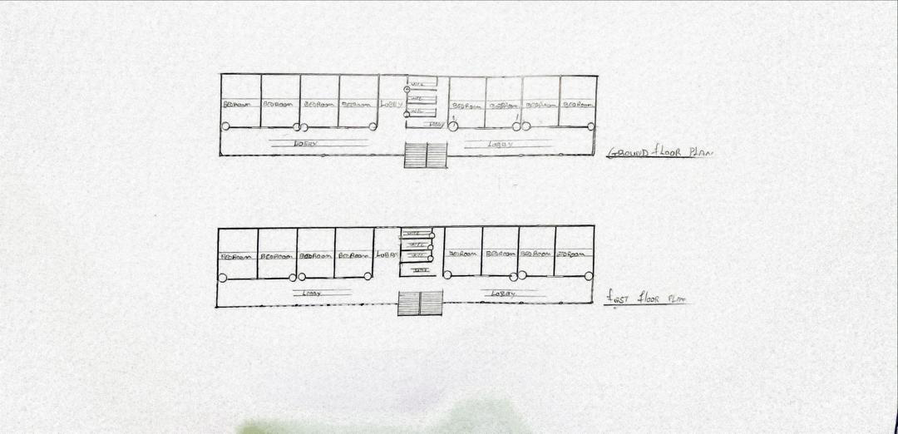
Figure 3.5.2 plan of the hostel
Merits
- Good orientation; the rooms are taken advantage of the trade winds.
- Good internal arrangement.
- Cross ventilation was achieved
- The width of escape (corridor) is okay
Demerits
- The bathroom and kitchen are not enough for the students
- Fire resistance door and walls were not used in the hostel, in case of any inferno to contain the fire to a certain period of time for escape of occupants.
- No provision was made for a first aid firefighting gadgets E.g. Hose reels, Extinguishers, fire buckets, fire blankets, Hydrant systems etc.
- Poor landscaping

CHAPTER FOUR
DESIGN PROPOSAL
4:0 INTRODUCTION OF STUDY AREA/SITE SELECTION
4:1 HISTORY OF IREE
Iree was founded by three brothers: Larooye, Arolu, and Oyekun, who are known in oral tradition as "the three great brothers". Larooye, the first to settle in the area, was an immigrant from Ipee and a son of the Onipe, a figure who himself had migrated from Oyo. Osun State Polytechnic, Iree, was established in 1992 as a satellite campus of the Polytechnic, Ibadan, before becoming an autonomous institution.
4:2 SITE LOCATION
The site is located at Osun state polytechnic iree
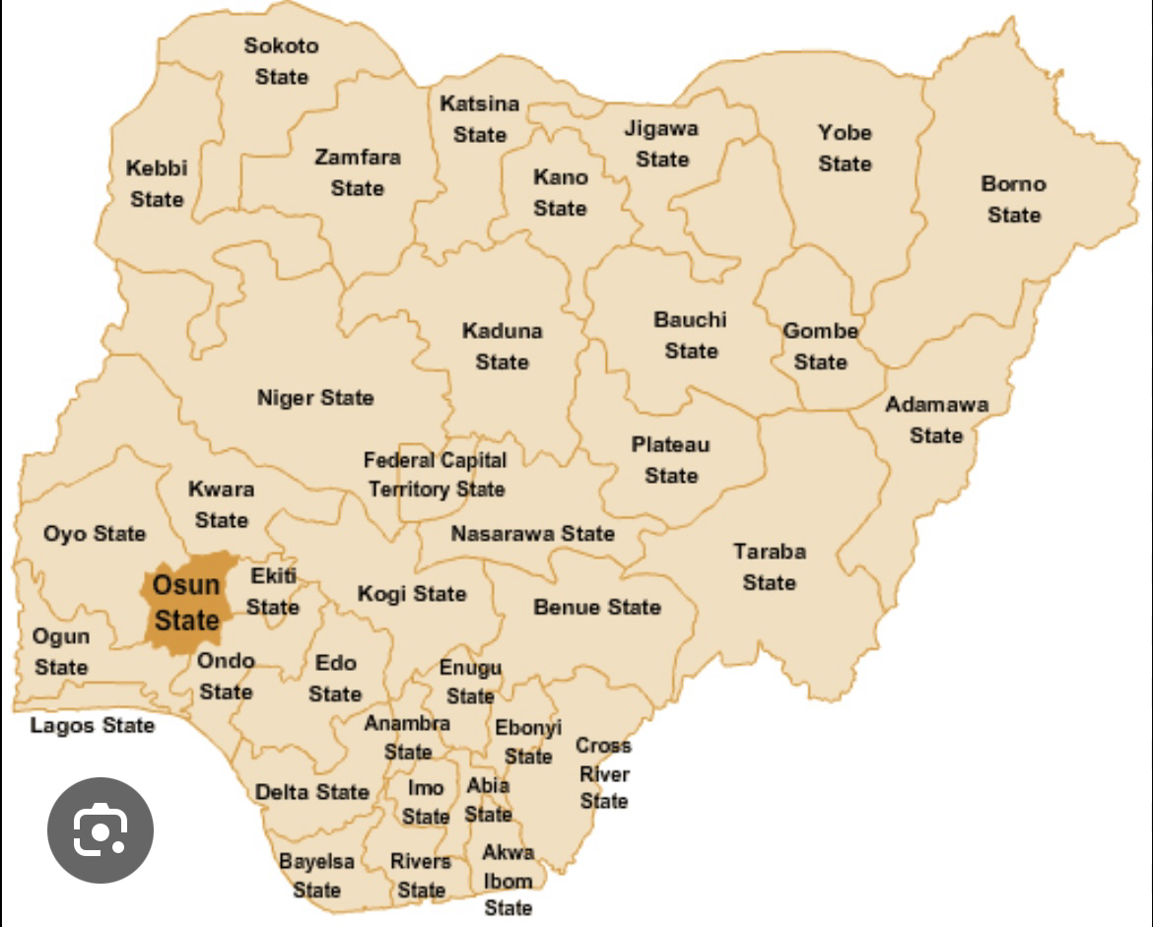
SITE LOCATION MAP
Source: Google images
Figure 4.1.1 Map of Nigeria showing location of osun stat

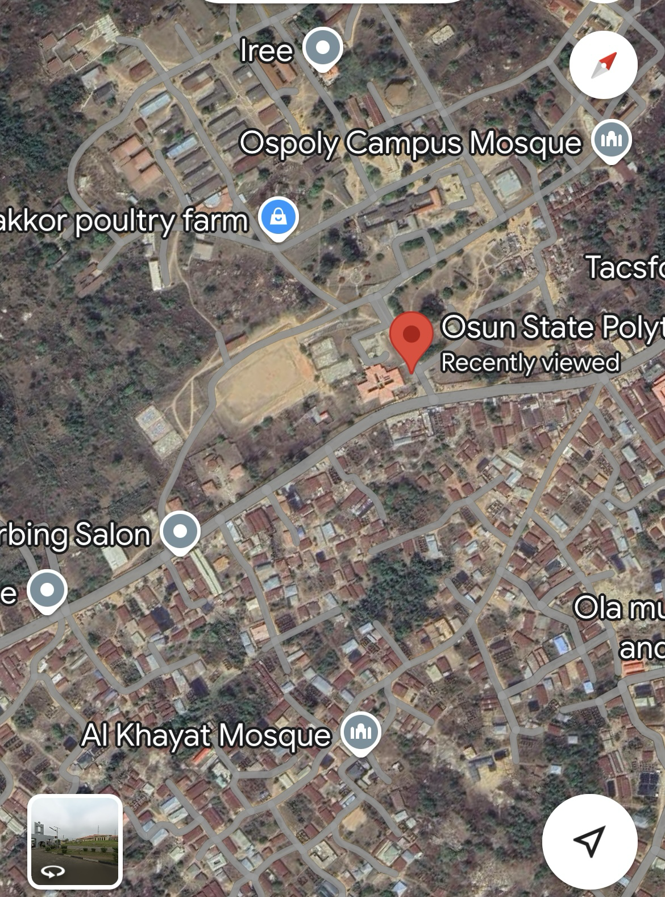
Source: Google Figure 4.1.2: Aerial View of Site.
4:3 SITE SELECTION CRITERIA
The site is located along stadium within the school Location
- Ease of access
- Availability of enough land
- Security
- Nature of Site and Vegetation

- Location:
The site is located along stadium within the school.
- Ease of Access:
The site can be accessed easily as there is an existing road that leads to it.
- Availability of Enough land:
To adequately provide for the various facilities required in the building and on the site, the area of land required for the project must be adequate. Therefore, the site was selected because it is wide enough to accommodate the proposed design.
- Security:
The site is located within the school thereby is covered by the school security ensuring safety of the students. But also, additional security would be provided on the site.
- Nature of Site and Vegetation:
The topography of the site is fairly levelled and the slightly unlevelled part can be adequately levelled. The sub soil is mainly red lateritic soil, with barches of sandy soil. The site also contains few trees and shrubs, which can help enhance the landscape of the site, and also act as wind-breakers and dust filters during the harmattan.
4.4 SITE CHARACTERISTICS
Soil Type
  - This is the most common soil type in Iree and surrounding areas.
  - It is well-drained, reddish due to high iron and aluminum content.
  - Formed under humid tropical conditions with high rainfall.
  - Typically, acidic and low in organic matter.
Vegetation
The vegetation around Iree Polytechnic is best described as derived savanna, a transition zone between tropical rainforest and guinea savanna, shaped significantly by human activity and characterized by a mix of grasses, shrubs, and scattered trees.
Topography
The topography of Iree Polytechnic area is gently undulating with moderate elevation, part of the ancient Precambrian Basement Complex. It is suitable for development, agriculture, and infrastructure, with appropriate land management practices.
Drainage
There is no existing drainage on the site, so drainage would be constructed.
Accessibility
The site is accessible by an existing road along the adjoining buildings which leads to the site.
4:5 SITE ANALYSIS.
Site analysis is the process of researching, observing, and evaluating the physical, environmental, cultural, and legal characteristics of a specific location to determine its suitability for a proposed project or development.
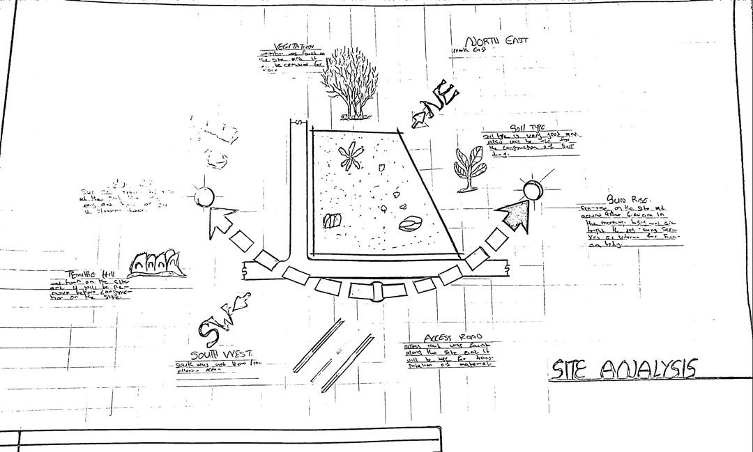
Plate 4.5.1: Site Analysis
Source; Authors fieldwork
4:6 GEOGRAPHICAL/CLIMATIC DATA
- Location: Iree is in Boripe LGA, Osun State, southwestern Nigeria.
- Terrain: Hilly with valleys and seasonal streams; elevation ~400–450 m.
- Climate: Tropical wet and dry (Aw type).
  - Dry season: November–March (hot, dusty Harmattan winds).
  - Rainy season: April–October (humid, with peak rains in June & Sept).
- Temperature: 27–30°C average; hottest months are Feb–April.
- Rainfall: 1,200–1,500 mm annually.
- Vegetation: Mix of savannah and forest; used mainly for farming.

Hours of sunshine per day

Figure 4.6.1 Hours of Sunshine per day
Source; Worlddata.info
The number of hours of sunshine refers to the time when the sun is actually visible. That is, without any obstruction of visibility by clouds, fog or mountains. With 7 hours per day, February is the sunniest month in the state of Lagos. In August the sun shines the shortest.
- Rainy days per month

Figure 4.6.2 Rainy days per month
Source; Worlddata.info
A rainy day is a day on which at least an amount of 0.1 mm precipitation (=0.1 liter) per square meter falls. This can be rain, snow, hail or even dew. So it does not have to rain the whole day. With 18 rainy days, June offers the greatest number of rainy days, and in December the least.
- Precipitation in mm/day

Figure 4.6.3 Precipitation in mm/day
Source; Worlddata.info
The amount of precipitation is measured in millimeters per square meter. Thus, at two mm/day, two litres of water fall on one square meter within 24 hours. With only 0.4 mm, the least rain falls in December. June, on the other hand, has the most rain.
- Water temperature

Figure 4.6.4 Water temperature
Source; Worlddata.info
Water temperature depends not only on solar radiation within the same region, but also on ocean currents. For example, depending on the season, cold or warm water masses are moved from other areas. The warmest temperatures in Lagos are in March, when the water is 28 °C.

- Relative humidityin %

Figure 4.6.5 Water temperature
Source; Worlddata.info
Warm air can absorb more moisture than cold air. The relative humidity indicates how much moisture of the physically possible is actually contained in the air. At high humidity, the person feels uncomfortable and perceives this as oppressive. In general, a relative humidity of 40-60% gives as pleasant. With humidity averaging 87%, June is the most uncomfortable. In March, on the other hand, it is easier to endure.
4:7 ANALYSES OF THE IMMEDIATE ENVIRONMENTAL CONDITIONS OF THE SITE
Site Features and Infrastructure
The site features electrical lines which proposes that open power supply is promptly accessible inside the site.
Perfectly drained soil; soils water moves through easily to allow good soil aeration and at the same time sufficient amount is retained for plant growth.
Other features are water supply and an access road.
- Noise Sources
There are no much noises on the site but the few noises that can be heard comes from the adjacent structures which are the existing female hostels.
- Rainfall:
Minimum rainfalls are recorded in December, while June offers the most amount of rainfall.
- Vegetation and Topography:
The vegetation on the site consists of few trees of different species and few shrubs. The site is relatively gentle sloping and has a high load bearing capacity soil.
- Prevailing Wind Direction & Sun-Path Angles
The two predominant winds blowing across this area are the South West Trade wind and the North East Trade wind. The former, which blows across the Atlantic Ocean, is characteristically cold and results in the wet season. Being a cold wind, it is capable of holding much moisture contents across the ocean, and hence an increase in relative humidity of the area affected. However, the North East Trade wind, which blows across the Sahara Desert, is dusty and dry wind. Consequently, the two predominant seasons experienced in this area are characteristically marked by the two wind types. The summer (the season between spring autumn when the sun is hot and there are many flowers) is experienced between April and September, when the south west Trade wind is more predominant, while the winter season is shortly marked between November and March, when the north east trade wind is more predominant. This later season {winter} is however characterized by cool and hazy mornings, couple with dusty afternoons, because of the dust particles it brings forth from the desert. To reduce the effects of wind driven, trees were planted.
- Sunrise and sunset:
The sun rises from the east in the early hours of the morning at about 6:30am - 7:00 am and sets in the west at about 6:45 pm in the evening daily.
- Accessibility:
The site is accessible by an existing road along the adjoining buildings which leads to the site.
- Man-made features
- Electricity: Electricity is supply to the site through overhead cables along the site boundary.
- Footpath: There are no existing footpaths on the site, few would be channeled.
- Noises: Caused by adjacent structures
4:8 PROPOSED DESIGN
The proposed design is the design of a female hostel with emphasis on the safety of the students and occupants.
- ​Design Considerations:
The following are the factors considered when designing the building;
- Passive and Active Fire safety: Fire safety measures would be considered in designing the building to increase safety in the building,
- Aesthetics: In any architectural design, aesthetics is most common factor to consider which shall be achieved by the use of attractive and lively finishing materials.
- Functionality: In any architectural design, functionality plays major role, design must be functional to meet the taste and convenience of the occupants.
- Ventilation: This includes the orientation of the building, sizes and locations of fenestrations, vegetation.
- Circulation and Zoning: Appropriate and well-articulated pattern of circulation in a building alleviates confusion and at the same time tailor the movement of students to their respective destination.
- Landscaping: The form of landscaping in the building is aimed at satisfying user requirements, having aesthetic value and improving environmental comfort. Hence, landscaping will be considered in the design
- Security: The provision of security in the hostel involves the protection of the students, the building and its contents.
4:9 DESIGN CONCEPT
The design approach was based on functionalism, which is an architectural principle that says that building should be designed based solely on purpose and function of the building.
4.10 PROJECT GOAL
The proposed design is the design of a female hostel with emphasis on fire safety to ensure the safety of the students and occupants.
The hostel is to provide the students with accommodation facilities and other functional spaces and facilities. These facilities include:
- Reception
- Rooms en-suite
- Communal Rooms
- Laundry
- Reading rooms
- Porter’s lodge
- Fire safety Equipment rooms
- Stores
- Relaxation area
- Car park
4.11 APPRAISAL OF PROPOSED SCHEMES.
An appraisal of a proposed scheme for institutional hostels involves evaluating the plan's feasibility, effectiveness, and potential impact. Here's a comprehensive appraisal framework:
- I. Location and Accessibility
- - Proximity to academic buildings and facilities
- - Safety and security features
- - Accessibility for students with disabilities
- II. Capacity and Accommodation
- - Number of students to be accommodated
- - Room types (single, shared, etc.) and amenities (e.g., beds, desks, storage)
- - Common areas (e.g., lounge, kitchen, laundry)
- III. Infrastructure and Amenities
- - Water and electricity supply
- - Sanitation and waste management
- - Internet and Wi-Fi connectivity
- - Furniture and appliances
- IV. Management and Supervision
- - Hostel administration and staff
- - Rules and regulations
- - Maintenance and repair procedures
- V. Cost and Funding
- - Construction and operational costs
- - Funding sources (e.g., government, private investment)
- - Student fees and payment structures
- VI. Sustainability and Environmental Impact
- - Energy efficiency and renewable energy sources
- - Water conservation measures
- - Waste reduction and recycling programs
- VII. Student Life and Well-being
- - Support services (e.g., counseling, health services)
- - Social and recreational activities
- - Community engagement and inclusivity
- VIII. Future Expansion and Flexibility
- - Potential for expansion or renovation
- - Adaptability to changing student needs and demographics
- IX. Compliance with Regulations
- - Adherence to local building codes and regulations
- - Compliance with accessibility and safety standard
- X. Stakeholder Engagement
- - Involvement of students, staff, and faculty in the planning process
- - Community engagement and outreach

  - EQUIPMENT AND OPERATIONAL AND PERFORMANCE REQUIREMENT
Designing an institutional hostel involves considering various equipment, operational, and performance requirements to ensure the facility meets the needs of its residents effectively and efficiently. Here’s a detailed breakdown of these aspects:
- Equipment Requirements
- Essential Equipment
- Furniture:
- Beds: Comfortable and durable, typically with storage options (e.g., drawers under the bed).
- Desks and Chairs: Ergonomic and suitable for study or work, with ample space for personal belongings.
- Wardrobes/Closets: Adequate storage for clothing and personal items.
- Common Area Furniture: Sofas, chairs, and tables for lounges and social spaces.
- Kitchen Appliances:
- Refrigerators: Sufficient capacity to store food for all residents.
- Stoves/Ovens: For cooking, with safety features and adequate ventilation.
- Microwaves and Toasters: For convenience and quick meals.
- Dishwashers: Optional, depending on the size and budget.
- Laundry Facilities:
- Washing Machines and Dryers: Easily accessible and with sufficient capacity.
- Ironing Boards and Irons: For personal clothing care.
- Cleaning Equipment:
- Vacuum Cleaners, Mops, and Brooms: For maintaining cleanliness.
- Trash Bins and Recycling Containers: Strategically placed in common areas and individual rooms.
- Safety Equipment:
- Fire Extinguishers: Properly placed and maintained.
- Smoke Detectors and Alarm Systems: For fire safety.
- First Aid Kits: Easily accessible and stocked with essential supplies.
- Technological Equipment
- Wi-Fi and Networking: Reliable and high-speed internet access throughout the hostel.
- Televisions and Entertainment Systems: Optional for common areas.
- Climate Control: Air conditioning, heating, and ventilation systems to ensure comfort.
- Operational Requirements
- Facility Management
- Maintenance Schedule: Regular checks and maintenance of equipment and infrastructure to ensure everything is in good working condition.
- Cleaning Protocols: Daily and periodic cleaning schedules for rooms, common areas, and facilities.
- Security Measures: Surveillance systems, security personnel, and controlled access points to ensure resident safety.
- Resident Services
- Reception and Check-In/Out Procedures: Efficient management of guest arrivals and departures, including handling of keys and room assignments.
- Support Services: Availability of staff or resident assistants for addressing issues or concerns.
- Emergency Procedures: Clear protocols for handling emergencies, including evacuation plans and communication procedures.
- Administrative Management
- Booking and Reservation Systems: Efficient systems for managing reservations, room assignments, and payments.
- Documentation and Record-Keeping: Proper documentation of resident information, maintenance records, and operational logs.
- Performance Requirements
- Comfort and Usability
- Space Planning: Effective use of space to ensure comfortable living conditions, including adequate room sizes and communal areas.
- Noise Control: Soundproofing measures to minimize noise disruptions, especially in shared spaces and sleeping areas.
- Lighting and Ventilation: Adequate natural and artificial lighting, and good ventilation to create a pleasant environment.
- Safety and Compliance
- Building Codes and Regulations: Adherence to local building codes, fire safety regulations, and health standards.
- Accessibility: Compliance with accessibility standards to ensure ease of use for all residents, including those with disabilities.
- Efficiency
- Energy Efficiency: Use of energy-efficient appliances, lighting, and HVAC systems to reduce operational costs and environmental impact.
- Water Efficiency: Implementation of water-saving fixtures and systems to reduce consumption and operational costs.
- User Satisfaction
- Resident Feedback: Regular collection of feedback from residents to address concerns and make improvements.
- Quality of Amenities: Ensuring that all provided amenities meet quality standards and are in good working order.
- The design of an institutional hostel requires a comprehensive approach to equipment, operations, and performance. Addressing these requirements effectively ensures that the hostel provides a safe, comfortable, and functional living environment for its residents, while also being manageable and efficient for the institution.
4.13 Schedule of Accommodation
Table 6.1 Schedule of Accommodation
S/NO | SPACE | UNITS | DIMENSION(M) | AREA(M2)
1 | Reception | 1 | 7.6*4.4 | 33.44
2 | Supervisor’s office | 1 | 2.8*3.5 | 9.8
3 | Toilet | 1 | 1.8*1.5 | 2.7
4 | Communal rooms | 2 | 10.5*4.0 | 42
5 | Buttery | 1 | 2.5*3.9 | 9.75
6 | Stores | 2 | 3.6*4.0 | 14.4
7 | Portar’s lodge | 1 | 5.5*5.0 | 27.5
8 | Toilet | 1 | 1.8*1.5 | 2.7
9 | Rooms(2 students) | 2 | 3.6*4.0 | 14.4
10 | Rooms (4 students) | 48 | 4.5*4.0 | 18
11 | Bathrooms | 54 | 2.0*2.5 | 5
12 | Toilets | 54 | 1.5*2.5 | 3.75
13 | Laundry | 2 | 5.5*4.5 | 24.75
14 | Reading rooms | 2 | 5.0*4.5 | 22.5
15 | Reading rooms 2 | 2 | 6.5*4.0 | 26
16 | FSER | 2 | 4.0*3.0 | 12
17 | Stairwell | 4 | 2.6*3.6 | 9.36
18 | Stairwell 2 | 4 | 4.0*3.0 | 12
19 | Courtyard 1 | 2 | 6.0*8.0 | 48
20 | Courtyard 2 | 2 | 6.0*6.0 | 48
Source: Author’s fieldwork (2022)

4.14 FUNCTIONAL RELATIONSHIP
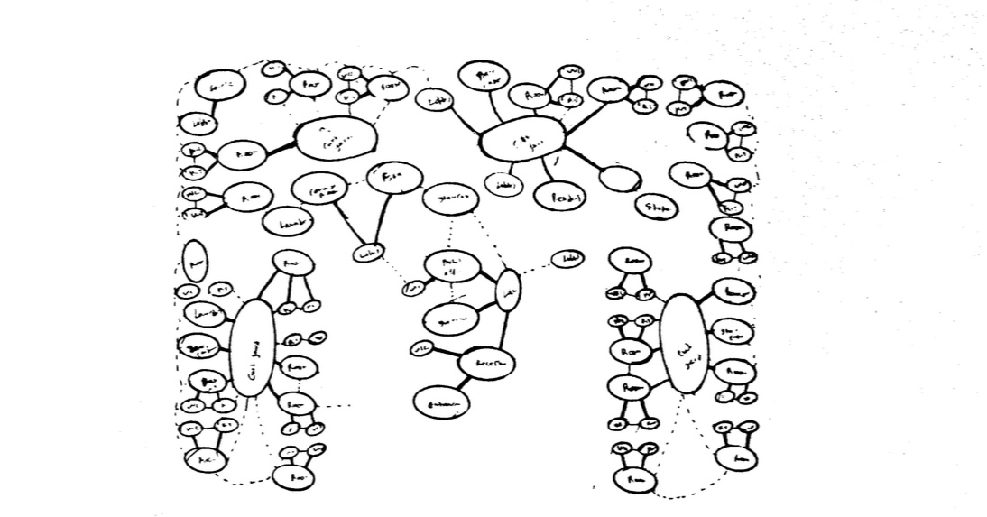
Functional relations in architectural design refer to the way in which different spaces, elements, and components of a building interact and support each other to achieve the intended purpose of the structure. These relations are crucial for creating efficient, practical, and aesthetically pleasing environments.

4.15 CONCEPTUAL DEVELOPMENT
Conceptual development in architectural design is the process of generating and refining ideas that form the basis of a building’s design. It involves translating abstract concepts into concrete architectural solutions.

CHAPTER FIVE
5:0 PROJECT APPRAISAL

5:1 DESIGN CONCEPT
To achieve a spatial configuration –in the design National Library Umuahia – that facilitates user orientation, way-finding and efficient library usage by the application of the findings in this study, certain design guidelines and recommendations studied are adopted as the basis for evolving a conceptual framework on which the design is built.

​Architectural Way-finding
Site Logic: To aid the user's ability to understand and to be properly oriented in the library‘s outdoor environment, external spaces grouped into logical function-zones. Also, this involves the articulation of the edges of salient nodes into a legible system to visually separate one functional district from another. For instance, the visual dominance of the library‘s main entrance(s) and the definition of public space from private space which are important factors in navigating large scale landscapes form critical elements of the design.
Building Form and Floor Plan: Equally, functionally related activity areas form zones consciously planned to preserve the ‗sense of place‘ and connectivity between spaces. This entails creating clear, logical hierarchies of such other architectural way-finding elements as markers, edges and paths to facilitate user cognitive perception and orientation in space.

​Graphic Information Way finding Design
A clear, organized set of sign elements are potential elements in any good way-finding design scheme. In this process, therefore, related graphic devices such as wall and
Floor graphics, strategic placement of sculpture, and art programs form directional components of the way-finding plan.

​Design Concept Synthesis
Researching case studies helped to give direction in determining best practices in solving the way-finding and orientation design issues in public libraries. Thus, this informs the following configuration of spaces to achieve legibility in the design:
      - A hierarchical characterization of activity zones and nodes in logical scales to help direct library patrons to other sections of the library. For instance, the most crucial space is a large, well lit lobby area or atrium, followed closely by large reading and study areas.
      - Simple floor layout with immediate visual and physical access to various designated library destinations.
      - Visual perception of major circulation pathways and systems, especially vertical transport systems to ease orientation and locomotion.
      - Visual prominence and definition of major entry points to facilitate access to designated library destinations.

Design Philosophy
To achieve a successful architectural way-finding in the design of the National Library Umuahia, the author takes on the universal design approach which seeks to design environments that are specifically inclusive and equal for all users, the key idea being thecreationofspacesorfeaturesthatdonottreatsomepeopledifferently. This entails the design of the environment; buildings, products and communications that equitably accommodate the spatial needs of all types of people and, takes into account as much as possible their differences, particularly those of people with physical impairments or difficulties speaking the dominant language. Also, of particular interest to the universal design approach is the provision of spaces flexible enough to accommodate a wide range of individual preferences and abilities; simple and consistent in use without unnecessary complexity and hazardous elements. Further, universal design promotes the creation of structures that facilitate user efficiency and comfort, with adequate space for various user activities including the use of assistive devices or personal assistance and, legible and universally perceptible communication systems.
5:2 CONSTRUCTION METHODS
The soil type of the proposed site will highly be instrumental to the construction considerations to be explored in order to bring about the structure build ability. However, the proposed site is a gently sloped site with good draining capacity and a good safe load bearing capacity and as such the need for additional strengthening and treatment of soil before construction may not be needed unless the geological experts requests so. Subsoil water drainage is necessary to improve the run-off of ground water to maintain the water table at some depth below the surface with a purpose of;

1. Improving the soil stability.
2 Prevent surface flooding.
3. Avoiding dampness in underground occupation such as basement or the ground floor.
4. Reducing the humidity in the immediate environment of the building structure.
The building lines are taken into consideration at the inception of this design, so with the building lines and the existing access road other wall flanks can be set out at right angles to the building line:
1. By using a large builder square placed against the building line and sideline produced to length required.
2. By using the proprietary optical square which comprises two small sighting telescopes permanently set at precise sight angles to one another.
3. By using an optical instrument with a base ring graduated to degrees and sighting along angles required.
The method of construction is as follows
Digging of trenches
Filling of hardcore
Block laying
Filling of hollow blocks with hardcore
Filling of laterite into foundation
Casting of mass oversite slab
Laying of block wall
Casting of column and lintel
Roof construction
Plastering
Fixing of window frame
Finishing
5.3 SUB-STRUCTURE
This is the part of the building that has direct contact with the ground and carries the majority of the building load. The stability of the proposed structure depends to a large extent on the type and load which the proposed design will exert on the ground. The strip foundation is to be adopted as the foundation type for this project and its depth is to be determined by a combined effort of the geological experts and structural engineers. Recommendations on the depth and foundation type proposed will be subjected to the architect’s approval so as to get a unified approach which will in every possible means align with the proposed design. All other details as regards the material type, configurations, spacing to be used during the construction of the substructure will be to the structural engineer’s specification and design.
5:4 SUPER STRUCTURE
The super structure comprises different components and because of the complexity of the proposed structure, explicit care and consideration needed to be explored all in a bid to recommend the best forms of materials to be used to achieve the concept taking into consideration cost, structural stability, maintenance and build-ability.
1 The Walls: The internal walls basically serving as party walls were constructed entirely of sandcrete block walls with reinforced concrete columns at the end to keep the structure firm. The structure is to be constructed with 150mm sandcrete hollow blocks and reinforced concrete for the floors. However, Expansion joint will be introduced at intervals of 25-30m to prevent buckling or cracking which may occur due to temperature change and other factors.
2 Floor: Floor slab of 150mm reinforced concrete is to be used for the project.
3 Roof: Steel trusses are to be used for the roof carcass and long span aluminum roofing sheets are to be used. Adequate care needs to be taken during installation so as to achieve first and foremost the building plan and reduce the amount of wasted sheets to be placed while coupling the roof members. The roof slab incorporated mostly at the gutter of the auditorium section is to be covered with 3 layers of bituminous felt with sawdust and sand to reduce the heat radiation from the slab.
5:5 CONSTRUCTION MATERIALS
The choice of materials to be used is influenced by several factors, some of these factors include;
1 The availability of materials
2 The durability and suitability of such materials
3 The climatic situation/condition
4 The cost of material, etc.
5:6 SUBSTRUCTURE AND SUPERSTRUCTURE
1 Suspended Floors: Unglazed vitrified ceramic floor finish; unglazed vitrified ceramic tiles; polished granite tiles; glazed vitrified ceramic tiles.
2 Walls: Sandcrete block for all walls of load bearing capacity finished with 25mm thick wall plaster rendered and finally painted with white emulsion paint on the exterior and other colors in the interior as may be specified. In the conveniences- toilets, changing, etc, the walls are to be finished with glazed ceramic tiles to a height of 2.1m.
3 Doors: Sizes of doors in the design range from 750mm to 2500mm. The door schedule to be provided in the proposed design drawings shows each as applicable in the design. The surface coating of these doors especially the interior ones must be able to withstand incessant cleaning and must be able to prevent sound and odour transmission. Single and double leaf doors shall be of approved quality, solid hardcore flush door installed with all necessary ironmongery while the main entrance door shall be glazed aluminum double leaf swing door installed with all necessary accessories.
4 Ceiling: Acoustically proofed white cellotex ceiling boards will be used. Acoustic ceiling tiles (suspended ceiling)
- External Works: Grass, trees and shrubs, interlocking paving stones, plain in-situ concrete and asphalt will be incorporated in the design. The existing site is finished with coal tar and that will be retained for the driveway and parking lot.
5:7 SERVICES/ INFRASTRUCTURE
All necessary infrastructures ranging from access roads to power supply to mains water supply and drainage facilities are already existing on the proposed site. This will be needed to ensure that the centre is functional and self-sustaining. Electricity is to be tapped from the nearest electric pole at the side of the site to power activities within the centre. All roof drains runs to the underground drains which passes on to the main public drainage. Light fixtures and electrical wiring are to be concealed in the various ducts provided.
- FIRE PROTECTION
Proper installation of cables and adequate power rating by the use of excessive current circuit breakers will help in minimizing the risk of fire outbreak especially through electrical fault. However, in the probable case of fire outbreak, the following shall help in quick quenching of the outbreak;
1. Adoption of the sprinkler system in every unit,
2. Installation of smoke/fire detecting alarms in all units,
3. Fire extinguishers are to be placed at strategic locations, and
4. Employment of the fire brigade services in the event of an outbreak.
- VENTILATION
As much as possible, every space provided will be ventilated naturally but for efficiency sake, the auditorium section shall be serviced by split unit air conditioning system.
- LIGHTING AND GLARE
The windows and courtyards provided will ensure that the centre is well lit. Glare which may result from natural lighting or the artificial one used in complementing
It shall be hugely reduced by the use of shading devices and suitable building exterior colors that will significantly reduce or eliminate the glare. In order to reduce glare and contrast, bench tops and furniture generally will be of high reflectance i.e. light colors, likewise for the walls and ceiling.
- NOISE CONTROL
In achieving noise level reduction, adequate setback from the main access road is provided. Buffer zones are provided also. Catering for the noise generated within the building, an internal buffer has been introduced by separating the noisy areas from the quiet areas.
- ACOUSTICS
Several spaces within the auditorium will require different acoustic considerations. The amount and location of acoustically absorptive finishes within a space dictates and helps to achieve comfort in such spaces. Partitions (walls, floors and ceiling) should maintain privacy and limit the transmission of noises that could cause distractions. Sound absorptive finishes are considered for the auditorium, the performance theatre and the exhibition spaces. Full height partitions with adequate sound isolation are provided also.
- External Works The walkways will be finished with interlocking paving stones to enhance the aesthetics of the surroundings. The vehicular access will be finished with asphalt for durability. Trees and shrubs will be planted at regular intervals in the car parks to serve as shades for the cars. All other spaces are landscaped with carpet-grass and randomly with trees and shrubs to absorb noise from surroundings and to reduce glare. A buffer zone of trees and shrubs are provided along the main and minor roads to reduce noise generated by moving vehicles on such roads.

5:8 DESIGN CONTRIBUTION
The study of way-finding design strategies and their application in the design of public libraries culminates in a design proposal for the National Library Umuahia which seekstocontributetothedevelopmentinNigeriaofeffectivearchitectural way-finding models that articulate a variety of architectural elements, principles and components as way-finding elements that aid user navigation within her public realm. Above all, the design explores the application of such planning requirements as zoning as well as the use of such architectural design components as lighting, graphics, form and volume in creating a visually legible and coherent library building.
RECOMMENDATIONS AND CONCLUSION
5:9 Introduction
This section presents the general conclusion for the study, recommendations observed in the course of study and the areas identified in which further investigations can be carried out which were not treated in this research.
5.9 Recommendations
- The Nigerian University Commission (NUC) should as a matter of need incorporate into its guidelines policies that would encourage the design of fire safety in hostels. This is to safe guard the life and property of Nigerian students. It will also enhance the continuity of the building in question
- University
- thorities should set up committees comprising of representative of students, academic and non-academic staff as well as the physical planning unit. Through this medium they can communicate ways of enhancing fire safety and other problems encountered before design of hostels are initiated. This is called user participation.
- Also, seminars and talks on green building should be organized and aired for professionals in the building industry especially the architects.
6.0 Conclusion
In responding to the inherent problems associated with fire in hostel buildings, this thesis synthesized the analysis carried out during the process of the research. In trying to have a compound analysis and solution alike, case studies were critically analyzed with all the positive attributes employed to the advantage of the research.
All the features above that were analyzed in this study, if adopted, will provide an effective fire safety, in the sense that the problems and attitudes associated with fire in hostels has been taken care of through design approach that helps prevent ignition of fire, alert occupants about its outbreak, provide means of escape, limit spread of fire through proper use of material and construction methods. This enhances the safety of both occupants and firefighters.

REFERENCES
Aqua group (1984). Fire and Building, Granada Publishing, Great Britain.
Beryl Menzies (1999); Metric handbook planning and design data, second edition, edited by David Adler, Architectural press. Linacre House, Jordan Hill, Oxford OX2 8DP.
Brembeck, C.S, (1971); Social foundation of education: environmental factors in teaching and learning. London: john: Herper and Roy publishers
Coburn, Oliver (1950). Youth Hostel Story. London: National Council of Social Service.
David V. Chadderton, Building Service Engineering, fifth edition (2007), Taylor & Francis, 2 Park Square, Milton Park, Abingdon, Oxon OX14 4RN.
Ernst and peter Neufert (1993); Architects’ data, third edition, Blackwell science publishers.
FEMA - Federal Emergency Management Agency, 1999, Fire in the United States 1987-1996, 11th Edition, US Fire Administration, Federal Emergency Management Agency, Maryland, 21727
Fred Malven (1997); Time savers standards, for architectural design standards, seventh edition, McGraw-Hill, Inc.
Ger Herbert (1999), Fire safety in hostels. McGraw-Hill, Inc.
James Patterson, (1993); Simplified design for building fire safety. John Wiley and sons Inc.
Neal, Tim; Neal, Simon (1993). Youth Hostels of England and Wales 1931-1993. St Albans: YHA. ISBN 0952225409.
Nikolas Davies, Erkki Jokiniemi (2008); Dictionary of Architecture and building construction, first edition; Architectural press. Linacre House, Jordan Hill, Oxford OX2 8DP.
Perkin & Will (2001); Time savers standards, Building types, fourth edition, McGraw-Hill, Inc.
Schmerts H.T. (1972); Institutional Housing Strategies Educational and Realisation. London: Patrick Wakely.
Schneider, T., & Till, J. (2007). Flexible Housing. Oxford, United Kingdom: Architectural Press.
JOURNALS, NEWSPAPERS AND ARTICLES.
Christianity Today magazine, March edition, 2004.
Daily independent, 26 August 2010.
Daily Sun (2006). It was Like Armageddon. Daily Sun, Thursday, March 23.
David N. Bilow, Mahmoud E. Kamara (2008); Fire and Concrete Structures.
Hassan, H (1999); Fire and safety management in Building.
National University commission procedures guide and physical development manual for the University system in Nigeria (2004); Third edition.
Odeleye A. (1983) Fire protection in buildings: Nigerian Institute of Architects Journal; edited by Aku Omokhodion.
Olaitan P. B, Dairo M. D, (Feb. 2009) Journal of Rescue and Disaster Medicine™ ISSN: 1531- 2992, Domestic Fire Accidents In A Developing Country: Reducing Morbidity / Mortality By Modifying The "Burglar Proofs".
The Guardian (2006). Nigerians Fire Incidents and Safety at Workplace. The Guardian Newspaper, May 2006.
Vanguard newspaper, April 4, 2011.
Wikipedia encyclopaedia.
WEB PAGES
History of hostelling: http://hiusa.org/about_us/history
History of youth hostel movement: www.hostelscentral.com/hostels-article
Fire safety in hostels:
http://www.environ.ie/en/Publications/LocalGovernment/FireandEmergencyServices/FileDownLoad,1026,en.pdf
Student Housing in Epinay France: http://www.archdaily.com/28390/student-housing-in- epinay-ecdm/
University Students’ Housing Italy: http://www.archdaily.com/49294/university- students%E2%80%99-housing-and-services-cs-associati/-6.htm).
Climate in Lagos:https://www.worlddata.info/Africa/Nigeria/climate-lagos.php

