A PROJECT REPORT
ON
PROPOSED MUSIC CONCERT CENTER
AT
TANKE, UNIVERSITY ROAD, ILORIN, KWARA STATE
By
OTESHILE QUYUUM GBOLAHAN
HND/23/ARC/FT/0067

SUBMITTED TO THE DEPARTMENT OF ARCHITECTURAL TECHNOLOGY INSTITUTE OF ENVIRONMENTAL STUDIES, (I.E.S) KWARA STATE POLYTECHNIC ILORRIN, KWARA STATE.

IN PARTIAL FULFILLMENT OF THE REQUIREMENTS FOR THE AWARD OF HIGHER NATIONAL DIPLOMA (HND) IN ARCHITECTURAL TECHNOLOGY

JULY, 2025

DECLARATION
I declare that this project project/dissertation is a product of my personal research work. It has not been presented for the award of any degree in any polytechnic. The ideas, observations, comments, suggestions herein represent my own convictions, except quotations, which have been acknowledged in accordance with conventional academic traditions.

Name: OTESHILE QUYUUM GBOLAHAN
Matric no: HND/23/ARC/FT/0067



________________ ________________
Signature Date

CERTIFICATION
I certify that this Research/Dissertation entitled mass housing was carried out by OTESHILE QUYUUM GBOLAHAN under my supervision and has been approved as meeting the requirements for the award of HND in Architectural Technology, of Kwara State Polytechnic, Ilorin, Kwara State Nigeria.


ARC. FAMILUA O.S __________________
Project Supervisor



ARC. OLAREWAJU F.A __________________
Project coordinator Signature and Date



ARC. (MRS). TOMORI J.M __________________
Head of Department

--------------------------------------- ----------------------------
External Examiner Signature and Date

DEDICATION
This report is dedicated to Almighty Allah the universe, the creator of all creators and the source of mankind who has always been my strength throughout this project and also for his unconditional and infinite mercy showered upon me through my studies.
Also, I dedicated this project to my parent Mr. and Mrs. OTESHILE for their parental, financial and moral support.
Finally to my brothers and sisters and my colleague and other for their contribution to attain great achievement. I pray Almighty Allah reward everyone abundantly.

ACKNOWLEDGEMENT
All praise and adoration and glorification to Almighty (S.W.T) the creator of the universe that gave me the privilege to take part in this program. First and foremost, I am grateful to my able Hardworking and untiring project supervisor ARC FAMILUA O.S and the member staff of the Architecture Department, Kwara State Polytechnic, Ilorin for their encouragement, expert advice and continuous kind assistant and supervision that made the completion of this study successful.
I am deeply thankful to the Head of Department, Arc. J.M. Tomori, for his leadership and support, which were instrumental in the successful completion of my HND program. My gratitude goes to my able, amiable and knowledgeable guidance MR OTESHILE for his inexplicable finance, moral, parent prayers support from birth till date, I say a very big thanks you sir & ma. I pray almighty Allah grant your life long to reap the fruit of your labor in good health and wealth who support morally, financially and spiritually at all time towards my success in this program.
However, I would like to express my gratitude to all my entire families and friends for all forms the benefit receives from them.

Table of Contents
DECLARATION ii
CERTIFICATION iii
DEDICATION iv
ACKNOWLEDGEMENT v
CHAPTER ONE 1
1.0 INTRODUCTION 1
1.1 HISTORICAL BACKGROUND 1
1.2 DEFINITION 2
1.3 JUSTIFICATION 2
1.4 AIM AND OBJECTIVES 3
1.4.1 AIM 3
1.4.2 OBJECTIVES 3
1.5 SCOPE OF THE PROJECT 3
1.6 STATEMENT OF DESIGN PROBLEM 4
1.7 DEDUCTION 4
1.8 LIMITATIONS OF THE STUDY 5
1.9 RESEARCH METHODOLOGY 5
CHAPTER TWO 6
LITERATURE REVIEW 6
2.0 INTRODUCTION 6
2.1 EVOLUTION AND TYPOLOGIES OF MUSIC VENUES 6
2.2 ACOUSTICS IN CONCERT HALL DESIGN 7
2.3 AUDIENCE EXPERIENCE AND VISUAL CONNECTION 7
2.4 INTEGRATION OF TECHNOLOGY IN PERFORMANCE SPACES 8
2.5 SUSTAINABLE AND ENVIRONMENTAL APPROACHES 8
2.6 CULTURAL AND CONTEXTUAL INTEGRATION 9
2.7 PROBLEMS AND DESIGN CHALLENGES IN MUSIC VENUES 9
2.8 CASE EXAMPLES OF SUCCESSFUL MUSIC CENTRES 9
2.9 SUMMARY 10
CHAPTER THREE 11
3.1 CASE STUDIES 11
3.2 CASE STUDY ONE 11
3.3 CASE STUDY TWO 13
3.4 CASE STUDY THREE 15
3.5 CASE STUDY FOUR 17
4.0 BACKGROUND OF THE SITE LOCATION TOWN 22
4.1 HISTORICAL BACKGROUND 22
4.2 SITE LOCATION/DESCRIPTION 23
4.2.1 SITE ANALYSIS/SITE INVENTORY 25
4.3 GEOGRAPHIC/CLIMATIC DATA 28
CLIMATE CHARACTERISTICS: 28
4.4 DESIGN CRITERIA 29
4.5 BRIEF 29
4.6 CONCEPTUAL DEVELOPMENT 30
CHAPTER FIVE 32
5.0 APPRAISAL OF PROPOSED SCHEME 32
5.1 DESIGN APPRAISAL 32
5.2 RECOMMENDATIONS 35
5.3 CONCLUSION AND SUMMARY 36
REFERENCES 38

LIST OF FIGURES
FIG 3.2.1: LOCATION & PLAN FOR CASE STUDY ONE…………………………….15
FIG 3.2.2: SHOING PICTURE CASE STUDY ONE………………..……………….…...15
FIG 3.3.1: LOCATION & PLAN FOR CASE STUDY TWO…………..…………...……16
FIG 3.3.2: SHOWING PICTURE CASE STUDY TWO ………………..………………..16
FIG3.4.1: LOCATION & PLAN FOR CASE STUDY THREE………….……………….18
FIG 3.4.2: SHOWING PICTURE CASE STUDY THREE….…….…....…………………19
FIG 3.5.1: LOCATION & PLAN FOR CASE STUDY FOUR….………………………...20
FIG; 3.5.2: SHOWING PICTURE CASE STUDY FOUR……………..………………….20
FIG; 3.6.1: ONLINE CASE STUDY…………………….………….….………………….20
FIG 4.1 LOCATIONAL PLAN…………………………….............………………………24
FIG; 4.2.1. SHOW SITE ANALYSIS……………..……........….………..……………….26
FIG; 4.2.2 SHOW SITE INVENTORY....................................................…........................26
FIG; 4.2.3 SHOW SITE ZONING............................................................…........................27

LIST OF PLATES
PLATE 3.2: LOCATION & PLAN FOR CASE STUDY ONE……………………..…….15
PLATE 3.2: SHOWING PICTURE CASE STUDY ONE…………..………………….…15
PLATE 3.3: LOCATION & PLAN FOR CASE STUDY TWO……..……..…………….16
PLATE 3.3: SHOWING PICTURE CASE STUDY TWO ……………...……………….16
PLATE 3.4: LOCATION & PLAN FOR CASE STUDY THREE……………………….18
PLATE 3.4: SHOWING PICTURE CASE STUDY THREE….….....…...........................19
PLATE 3.5: LOCATION & PLAN FOR CASE STUDY FOUR…..….............................20
PLATE; 3.5: SHOWING PICTURE CASE STUDY FOUR……….…………………….20
PLATE 4.1 ONLINE CASE STUDY…………………………...........…………………...20

LIST OF APPENDICES
APPENDIX 5. FLOW CHAT………………………………………....……….……..39
APPENDIX 5. BUBBLE…………………………………………..………………….40
APPENDIX 5. SITE PLAN………………..…………………..…....………………..41
APPENDIX 5. GROUND FLOOR PLAN……………….………………….….…….42
APPENDIX 5. ROOF PLAN………………………………….….…………………..43
APPENDIX 5. SECTIONS……………………………….….……………………….44
APPENDIX 5. ELEVATIONS……………………………….….….………………...45
APPENDIX 5. EXTERNAL PERSPECTIVE…………….………..………………..46

.

ABSTRACT
This thesis presents the architectural design and development of a Music Concert Centre, envisioned as a dynamic and inclusive space for musical performance, cultural expression, and community engagement. Music plays a vital role in shaping identity and fostering unity, yet many urban and regional communities lack dedicated, acoustically sensitive venues that meet contemporary performance standards. The proposed Music Concert Centre addresses this gap by integrating functional performance spaces, advanced acoustic systems, and contextual architectural aesthetics to create an environment that supports a diverse range of musical genres and audience experiences. The study explores the evolution of music performance spaces through literature review, case studies of global and local concert venues, and site-specific analysis. Emphasis is placed on acoustic optimization, technological integration, environmental sustainability, and audience comfort. Research methodologies include field observation, oral interviews, and architectural analysis to ensure that the final design meets both international standards and local cultural needs. By combining technical innovation with artistic sensitivity, the project aims to create a landmark structure that enhances the musical life of its community, supports professional and amateur musicians, and contributes to cultural tourism and urban revitalization. The Music Concert Centre is not merely a venue, but a cultural beacon—celebrating sound, form, and community in harmony.

CHAPTER ONE

1.0 Introduction
Music is a universal language that transcends borders, cultures, and generations. It plays a vital role in entertainment, cultural preservation, education, and mental well-being. As societies evolve, there is a growing demand for spaces dedicated to the performance, appreciation, and cultivation of music. A Music Concert Centre serves as a hub for musical expression, creativity, and audience engagement, offering a dynamic venue for performances ranging from orchestral concerts and jazz sessions to contemporary pop events and cultural festivals.
The architectural design of a Music Concert Centre is a complex endeavor requiring the integration of functionality, acoustics, aesthetics, and audience experience. Unlike conventional event halls, concert centres must be acoustically sensitive, technically equipped, and spatially adaptable to suit various performance types and audience sizes. These venues not only provide platforms for artists and performers but also serve as cultural icons, contributing to the artistic and economic vibrancy of the cities they inhabit.
This research aims to develop a Music Concert Centre that responds to the specific social, cultural and environmental context of its location, integrates cutting-edge performance technologies, and provides an inclusive, accessible, and memorable experience for performers and audiences alike.

1.1 Historical Background
The concept of musical performance spaces has evolved significantly over time. In ancient civilizations, music was performed in open-air amphitheaters, temple courts, and royal palaces. During the Renaissance and Baroque periods, the emergence of opera and orchestral music led to the development of more specialized spaces like opera houses and concert halls.
In the 19th and 20th centuries, concert venues became architectural landmarks—such as the Vienna Musikverein, Carnegie Hall in New York, and the Royal Albert Hall in London. These structures combined artistic expression with engineering innovation, incorporating refined acoustics and elegant aesthetics.
The late 20th and early 21st centuries saw further innovation with the use of modern materials, digital acoustics, and flexible seating arrangements. Venues like the Walt Disney Concert Hall in Los Angeles and the Elbphilharmonie in Hamburg represent the pinnacle of contemporary music architecture spaces that not only amplify sound but also shape the cultural identity of their cities.
Today, Music Concert Centres are more than performance spaces; they are community anchors, educational platforms, and tourist attractions that bridge tradition with innovation.

1.2 Definition
A Music Concert Centre is an architectural facility purpose-built for the performance and appreciation of music in various forms. It typically comprises a main performance hall, rehearsal spaces, backstage areas, audience amenities, acoustic systems, sound and light control rooms, and auxiliary facilities such as recording studios, art galleries, and educational zones.
It is designed to optimize the acoustic quality of sound, visual accessibility, and audience comfort. The space is often flexible to accommodate a wide range of performances—from solo recitals to full symphonic orchestras, and from traditional folk music to amplified electronic shows.

1.3 Justification
The proposed Music Concert Centre will address a growing demand for quality performance venues, especially in regions where music plays a central role in social and cultural life but lacks dedicated infrastructure. This center will:
- Serve as a platform for emerging and established artists.
- Promote cultural exchange and musical diversity.
- Enhance community engagement through workshops, music festivals, and public performances.
- Stimulate tourism and economic development in the host city or town.
- Act as an educational hub for music students and scholars.
Additionally, the project contributes to sustainable architecture by integrating green building practices and promoting social inclusion through accessible design

1.4 Aim and Objectives

1.4.1 Aim
To design a state-of-the-art Music Concert Centre that harmonizes acoustic excellence with architectural beauty, cultural relevance, and community inclusiveness.

1.4.2 Objectives
- To create a functional, acoustically optimized space for a variety of musical performances.
- To integrate cultural and artistic elements into the architectural design.
- To ensure accessibility for all categories of users, including the disabled and elderly.
- To provide auxiliary spaces for rehearsal, education, and recording.
- To develop a flexible and environmentally responsive design suitable for future expansion.

1.5 Scope of the Project
- The Music Concert Centre will include the following:
- Main Auditorium (Concert Hall)
- Secondary Performance Hall
- Rehearsal Studios
- Recording and Control Rooms
- Backstage (Green rooms, Dressing Rooms)
- Musicians’ Lounge
- Foyers and Public Lobbies
- Ticketing and Reception Area
- Administration Offices
- Cafe and Merchandise Area
- Toilets and Support Services
- Parking Area
- Landscaped Outdoor Event Space

1.6 Statement of Design Problem
- Designing a Music Concert Centre presents a series of architectural challenges:
- Acoustic Design: How to optimize sound distribution and clarity across diverse performance types.
- Audience Flow: Creating intuitive circulation routes for performers, staff, and guests.
- Aesthetic Identity: How to represent cultural values and artistic expression through form, material, and detail.
- Technological Integration: Designing for modern sound, lighting, and stagecraft systems without compromising on spatial quality.
- Sustainability: How to reduce energy consumption and improve environmental performance.

1.7 Deduction
From previous case studies and research, it has been deduced that:
Proper acoustic treatment and noise isolation are essential to concert venue performance.
Spatial zoning between audience, performers, and staff must be efficient and intuitive.
Flexibility and accessibility are key to creating a venue that meets a wide variety of user needs.
A concert hall is as much about visual drama and ambiance as it is about sound quality.

1.8 Limitations of the Study
Limited access to in-depth acoustic engineering data from existing concert halls.
Budget constraints may limit certain high-tech features in local context.
Some case studies may not share full construction or system design details due to confidentiality.
Local site conditions such as noise, traffic, or unstable soil may pose design constraints.

1.9 Research Methodology
To ensure comprehensive understanding and effective design, the following methods will be used:
Observation: Site visits to similar music venues and analysis of audience behavior and space interaction.
Literature Review: Academic books, journals, architectural reviews, and performance arts publications.
Oral Interviews: Discussions with musicians, sound engineers, stage managers, and venue designers.
Case Studies: Detailed analysis of both local and international music concert center’s to inform spatial planning and functional distribution.

CHAPTER TWO

LITERATURE REVIEW

2.0 Introduction
This chapter explores scholarly works, architectural theories, and professional practices that inform the design and functionality of Music Concert Centre’s. It highlights key issues in acoustic performance, audience experience, spatial programming, environmental integration, and the technological evolution of performance spaces. By synthesizing global best practices and relevant architectural literature, this chapter provides a foundation for developing a Music Concert Centre suited to contemporary cultural, social, and artistic demands.

2.1 Evolution and Typologies of Music Venues
Music venues have evolved from ancient open-air amphitheaters to complex, technologically advanced concert halls. Historically, structures like the Roman Odeon and Greek amphitheaters were designed for natural acoustic performance, leveraging site topography and materiality.
In modern architecture, concert venues fall into various typologies:
Concert Halls: Designed primarily for unamplified music, such as classical, opera, and chamber music (e.g., Vienna Musikverein).
Multipurpose Theatres: Designed to host music, drama, and public events (e.g., Royal Festival Hall, London).
Arena-Style Venues: Designed for amplified performances and large audiences (e.g., Madison Square Garden, New York).
Open-Air Amphitheatre’s: Often seasonal, used for large festivals and natural acoustic performances (e.g., Hollywood Bowl, USA).
The typology determines form, acoustic design, and spatial planning. Contemporary music venues increasingly embrace flexibility, accommodating both amplified and acoustic performances in a single structure.

2.2 Acoustics in Concert Hall Design
- Acoustic quality is central to concert hall performance. According to Leo Beranek’s “Concert Halls and Opera Houses: Music, Acoustics, and Architecture,” key parameters include:
- Reverberation Time: Ideally between 1.8–2.2 seconds for symphonic music.
- Sound Diffusion: Achieved through textured surfaces, balcony undersides, and diffusive wall shapes.
- Clarity and Warmth: Balanced through architectural proportions, ceiling height, and stage positioning.
- Noise Isolation: External and internal noise sources (HVAC systems, traffic) must be acoustically isolated through materials and layout.
- Innovative designs (e.g., Elbphilharmonie, Hamburg) incorporate custom-designed acoustic panels and “vineyard seating” to enhance audience experience and performer-audience interaction.

2.3 Audience Experience and Visual Connection
A music concert center must ensure optimal visual connection to the stage, ease of circulation, and a welcoming environment. According to the Journal of Architecture and Performance Spaces, audience experience is affected by:
- Comfortable, tiered seating that offers clear sightlines.
- Balanced lighting that enhances visibility without glare.
- Lobbies and foyers that create anticipation and social engagement before and after performances.
- Clear signage and circulation paths to minimize disorientation.
- A well-designed concert centre engages all the senses visual, auditory, and tactile creating an immersive environment that supports emotional connection with the performance.

2.4 Integration of Technology in Performance Spaces
Modern concert centers integrate advanced technologies to support a wide range of performances. These include:
- Digital soundboards and acoustic tuning systems (variable acoustics using adjustable panels and curtains).
- Lighting systems with programmable scenes and color variation.
- Multimedia integration, enabling live streaming, projection mapping, and synchronized visuals.
- Structural rigging systems for flexible stage setups.
Such systems demand proper space planning control rooms, tech lofts, cable runs, and acoustic enclosures to avoid compromising spatial aesthetics and acoustic quality.

2.5 Sustainable and Environmental Approaches
Music venues consume significant energy, especially in lighting and HVAC systems. Environmentally conscious designs focus on:
- Natural ventilation and daylighting through clerestory windows and operable louvers
- Use of locally sourced and low-VOC materials to minimize environmental impact.
- Green roofing and solar panel systems to reduce energy consumption.
- Water-sensitive landscaping and rainwater harvesting.
Architects like Renzo Piano and Norman Foster have emphasized that concert halls should not only be performance-driven but also climate-responsive and ecologically integrated.

2.6 Cultural and Contextual Integration
A music centre must reflect its cultural identity and local context. This is achieved through:
- Inclusion of indigenous materials and motifs in finishes and furnishings.
- Programmatic spaces for local music genres or traditional performances.
- Sculptural or symbolic form inspired by regional musical instruments or rhythms.
- Community engagement areas like open plazas, gardens, or street-facing galleries.
This strengthens the emotional connection between the community and the space, turning the building into a cultural landmark.

2.7 Problems and Design Challenges in Music Venues
Despite advancements, several challenges persist:
- Balancing acoustics and visual transparency in glass-dominant designs.
- Accommodating various performance types in one venue without sacrificing quality.
- Budget limitations for high-end acoustic and tech installations.
- Accessibility issues in older, historic venues or those with complex layouts.
Designers must solve these issues with creative zoning, modular design, and universal accessibility principles (ramps, tactile guides, sign language screens, etc.).

2.8 Case Examples of Successful Music Centres
National Theatre, Lagos: One of Nigeria’s major performance venues; represents cultural heritage, but faces acoustic and maintenance challenges.
Muson Centre, Lagos: Known for its intimate concert spaces and educational programs, though spatial limitations restrict large-scale events.
Walt Disney Concert Hall, Los Angeles: Designed by Frank Gehry with acoustics by Yasuhisa Toyota. It demonstrates organic form, state-of-the-art sound, and urban integration.
Philharmonie de Paris, France: Combines layered circulation, public accessibility, and acoustic excellence.
Lessons from these examples will inform the spatial and conceptual direction of the proposed Music Concert Centre.

2.9 Summary
This review has established that a Music Concert Centre must be:
- Acoustically superior.
- Technologically equipped.
- Audience-friendly.
- Culturally contextual.
Environmentally responsive.
Designing such a facility requires interdisciplinary knowledge—combining architecture, acoustic engineering, user experience, and cultural studies.

CHAPTER THREE

3.1 CASE STUDIES
Case Studies can be defined as the process of investigation or researching and analyzing an existing project in order to allow creating and improvement in a proposed project.
The need for case studies in this type of project is very important and cannot be over looked due to the following reason:
- To have a board knowledge and detailed about the project you embarking on through careful study of the existing one.
- To examine, evaluate the existing problem and how it was tackled by the processors in order to avoid such problems in the proposed design or often a better solution for both the future and present design.

3.2 Case Study One
NAME: Muson Centre
LOCATION: At No. 8/9 Marina Onikan, Lagos Island, Lagos State.
Merits:
- Good structure
- Well landscaped (both hard and soft)
- Well-ventilated and lighted
- Easy to locate and accessible
- Adequate parking lot
Demerits:
- No natural light for the lobby and some areas
- Auditorium not spacious enough

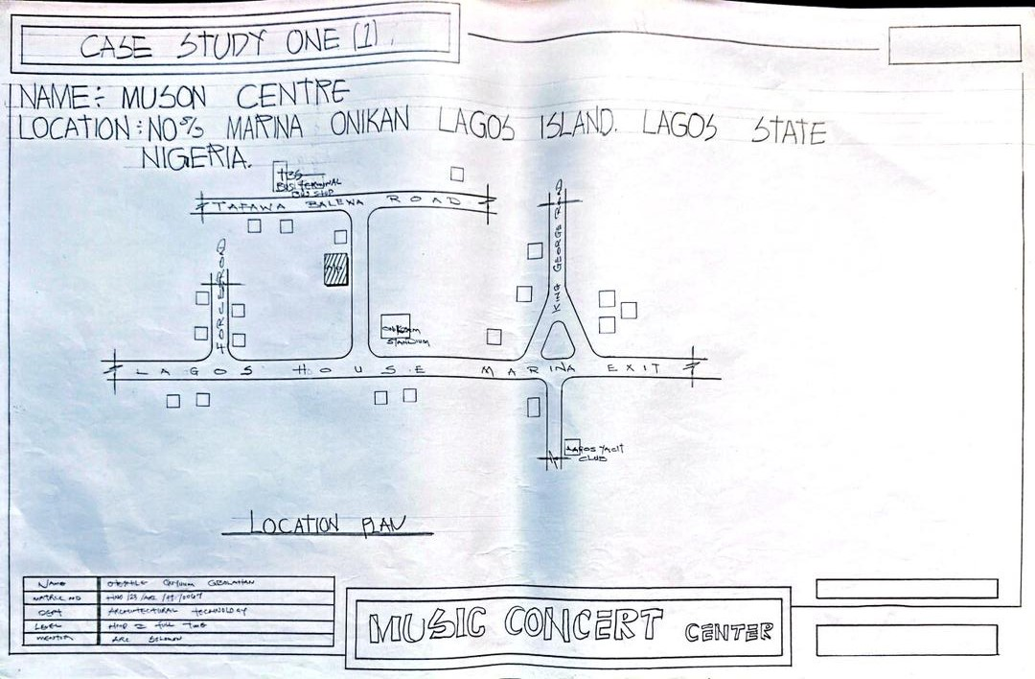
FIG 3.2.1 SITE LOCATIONAL PLAN
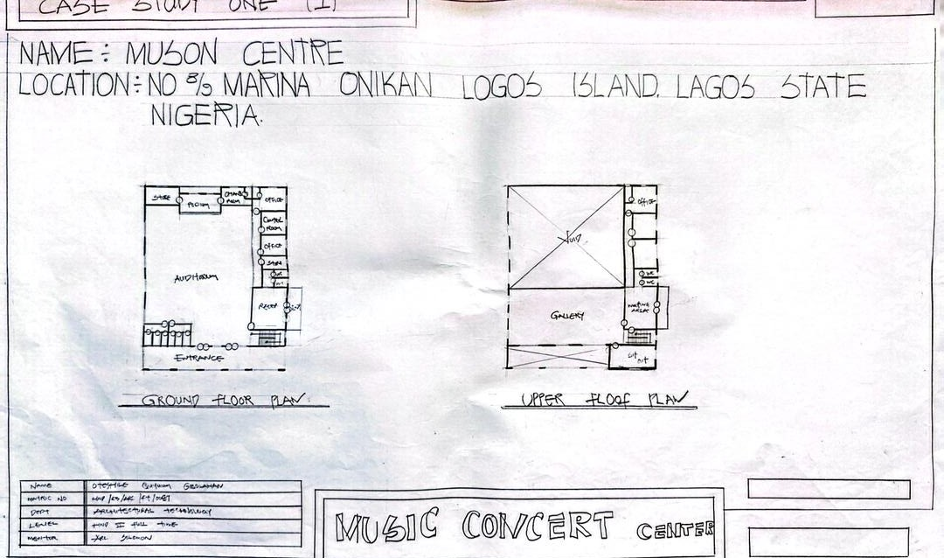
FIG 3.2.2 GROUND FLOOR PLAN
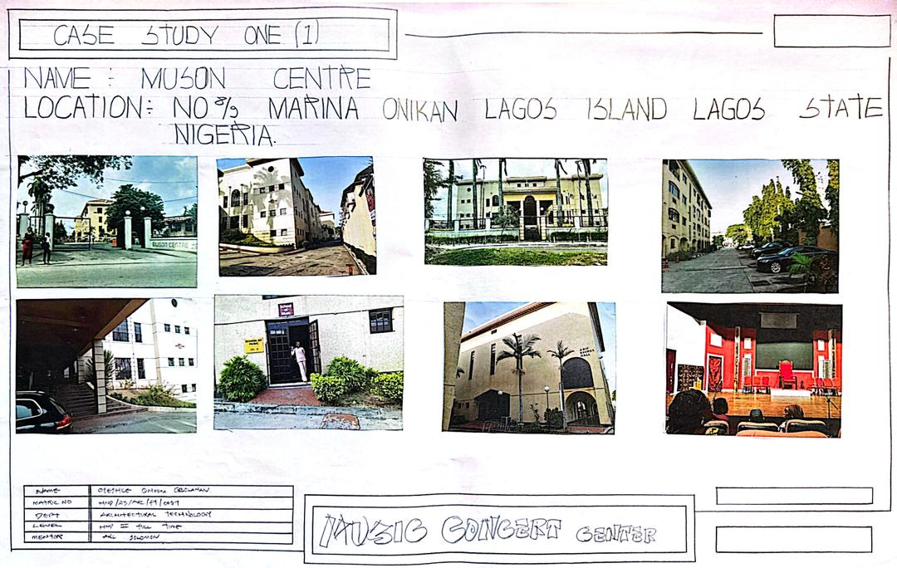
PLATE 3.2.1 SHOWING VIEW

3.3 Case Study two
NAME: TV Blue Roof Arena Studio
LOCATION: TV Blue Roof Arena Studio, Agidingbi, Ikeja, Lagos
Merits:
- Well-landscaped
- Defined parking area
- Spacious (can accommodate over 2000 guests)
- Located at the centre of Ikeja
- Maximum security
- Enough parking space
- Multi-use premises
- Easy to navigate from/to major roads
Demerits:
- Disclosed arena
- No proper restroom for guests
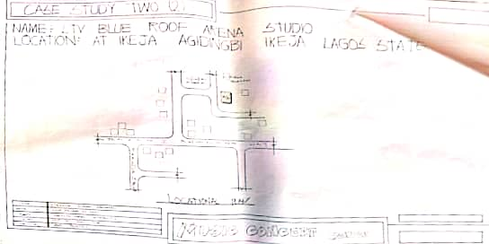
FIG 3.3.1 SITE LOCATIONAL
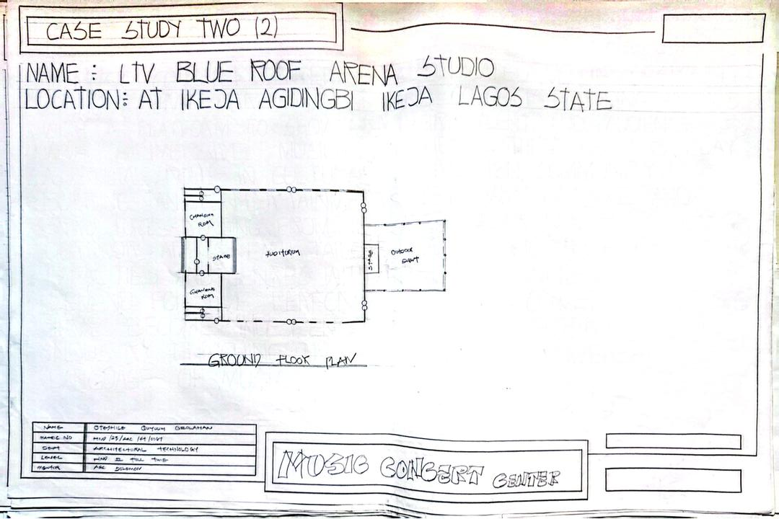
FIG 3.3.2 GROUND FLOOR PLAN

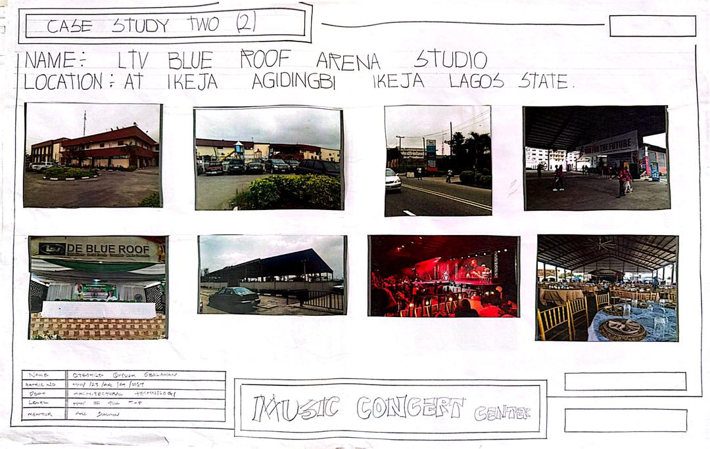
PLATE 3.3.1 SHOWING APPROACH VIEW

3.4 Case study three
NAME: WODIF Center
LOCATION: Iwo Road, Osogbo, Osun State.
Merits
- Very spacious and a big hall.
- Conducive environment.
- Has a gymnasium center.
- Good structure.
- Well-landscaped (both soft and hard landscaping).
- Well ventilated (air and lighting).
Demerits
- Insufficient convenience (likely refers to toilets or ease of access).
- Lack of maintenance.
- Podium is too small for events.
- Insufficient parking lots.
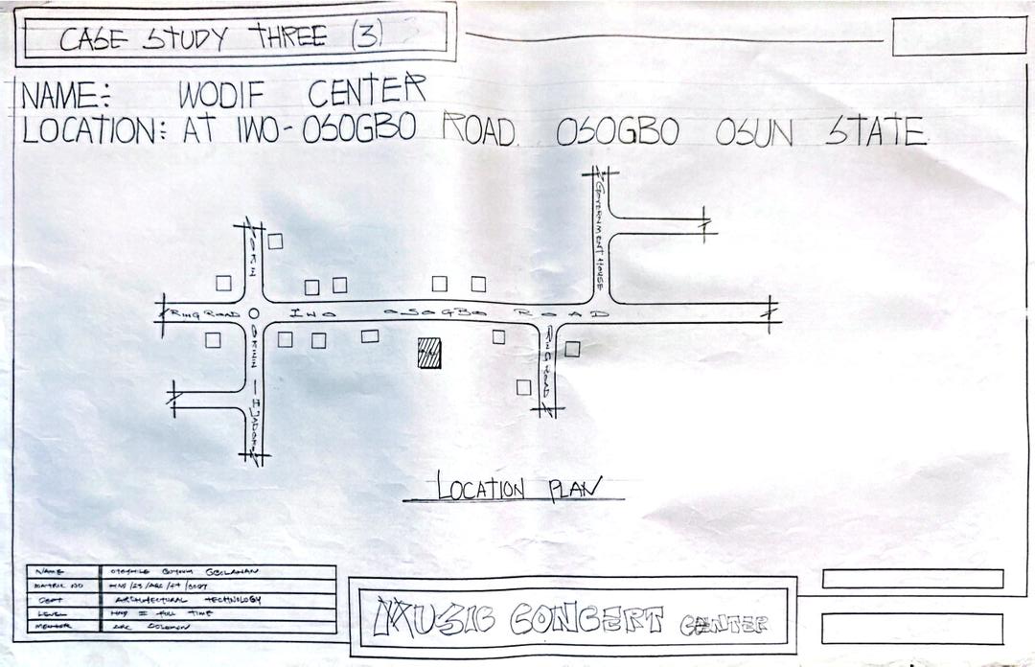
FIG 3.4.1 SITE LOCATION PLAN
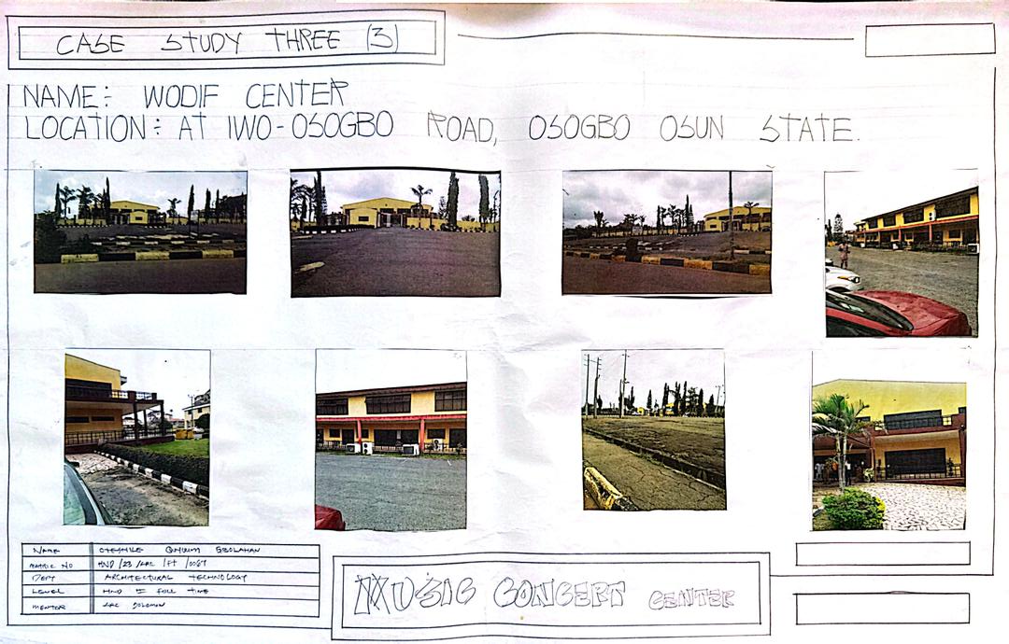
PLATE 3.4.1 SHOWING PICTURES

3.5 Case study four
NAME: D ‘Podium International Event Centre
LOCATION:31B Aromire Avenue, off Adeniyi Jones, Ikeja, Lagos.
Merits:
- Spacious wedding and gathering area
- Spacious car park for guests
- Good sound and shops for basic needs
- Awesome location
- Properly planned and structured
- Good soundproofing
Demerits:
- Staircase is outside the building (not ideal for guest flow)
- Structure not originally built for a music concert center
- possibly lacking in acoustics or specialized facilities
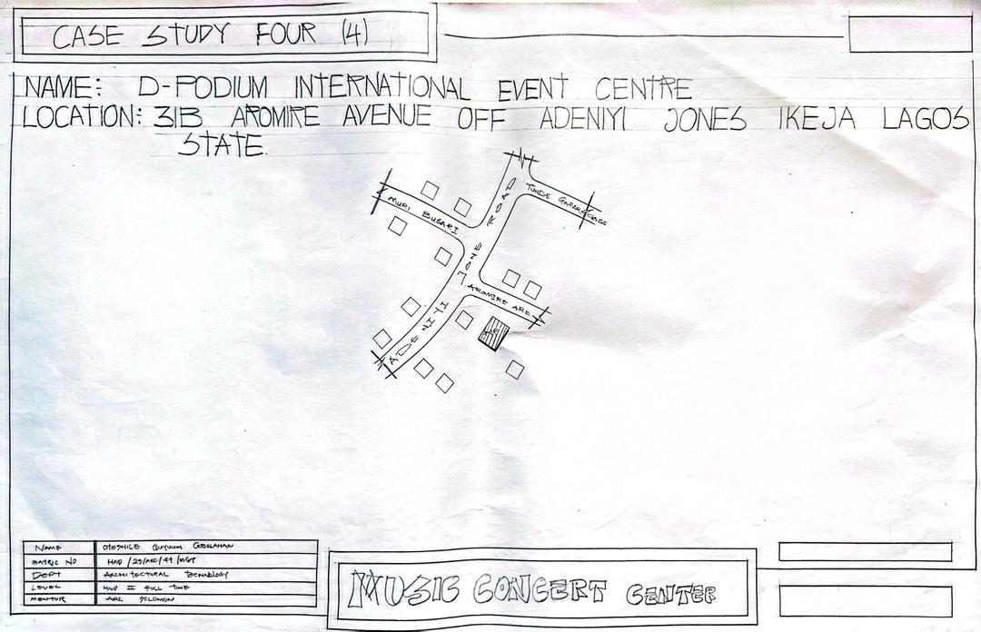
FIG 3.5.1 SITE LOCATION PLAN

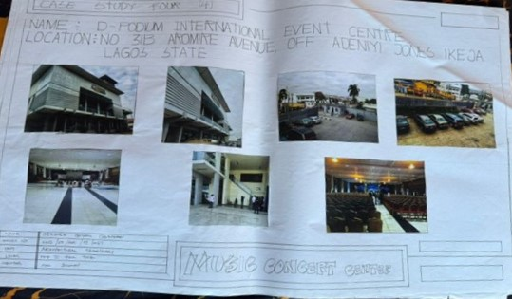
PLATE 3.5.1 SHOWING PICTURES
3.6 Online Case Study: Walt Disney Concert Hall
Location: 111 South Grand Avenue, Los Angeles, California, USA
Description: Designed by Frank Gehry with acoustics by Yasuhisa Toyota, the Walt Disney Concert Hall is an iconic architectural masterpiece known for its organic, flowing forms and state-of-the-art acoustic design. It serves as a cultural landmark, integrating seamlessly with its urban surroundings.
Merits:
- Distinctive organic form with stainless steel curves, creating a visually striking landmark.
- Exceptional acoustics, designed by Yasuhisa Toyota, providing unparalleled sound quality for performances.
- Urban integration, enhancing the cultural and civic identity of downtown Los Angeles.
- Well-lit interiors with strategic use of natural light in public spaces.
- Ample parking and accessible public transport links.
Demerits:
- Limited natural light in some interior areas, such as administrative spaces.
- High construction and maintenance costs due to its complex design.

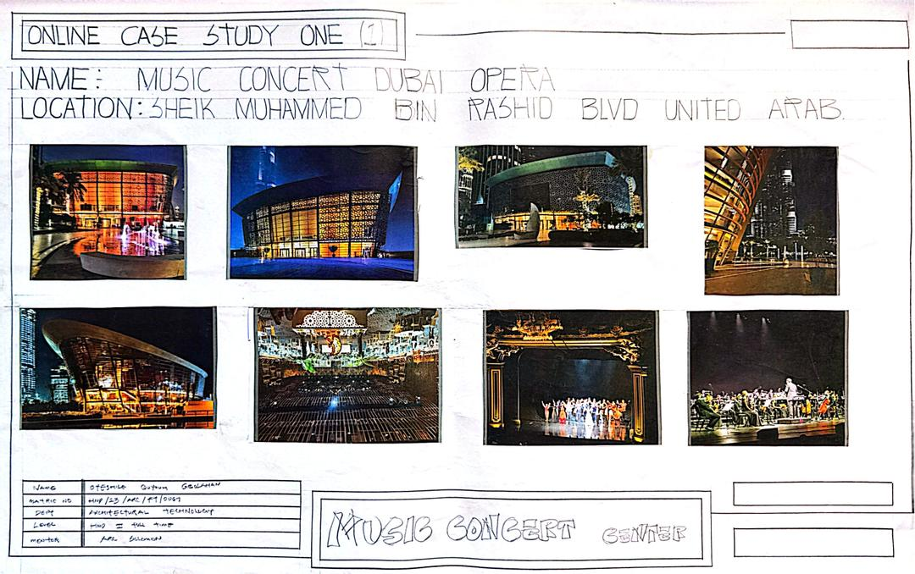
3.7 Online Case Study: Philharmonic de Paris
Location: 221 Avenue Jean Jaurès, 75019 Paris, France
Description: Designed by Jean Nouvel, the Philharmonic de Paris is a modern concert hall celebrated for its layered circulation, public accessibility, and acoustic excellence. It serves as a hub for musical performances and community engagement.
Merits:
- Innovative layered circulation design, enhancing visitor flow and accessibility.
- Outstanding acoustic performance, optimized for a wide range of musical genres.
- High public accessibility with inclusive design features and public spaces.
- Striking exterior with a textured, bird-like aluminum façade, creating a unique aesthetic.
- Well-integrated with the urban fabric of Parc de la Villette.
Demerits:
- Some interior spaces, such as foyers, lack sufficient natural light.
- High operational costs due to the building’s complex systems and maintenance needs.
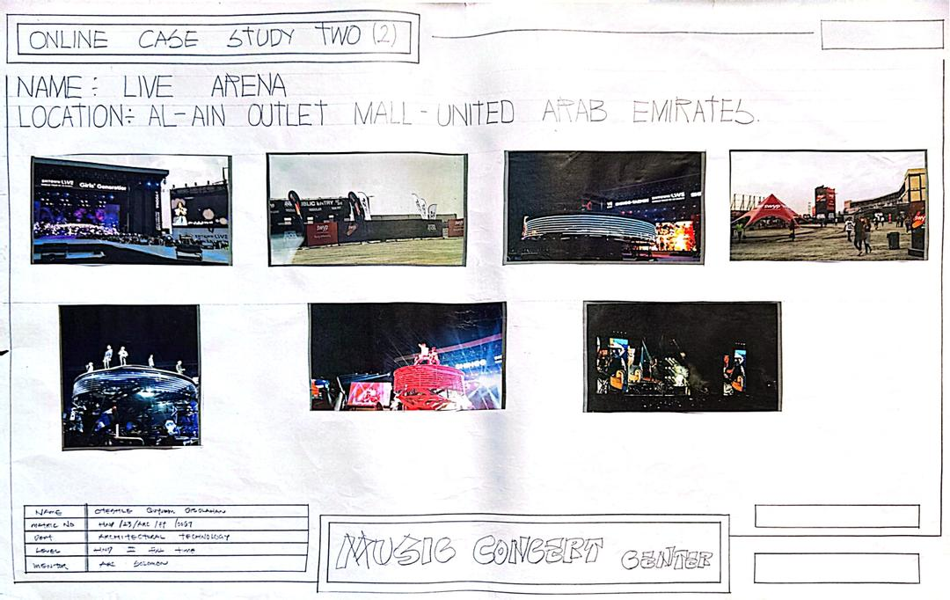

CHAPTER FOUR

4.0 BACKGROUND OF THE SITE LOCATION TOWN
Ilorin South is one of the sixteen local government areas in Kwara State, Nigeria. It lies within the city of Ilorin, the state capital, and encompasses several notable areas, including the Tank community, which is a densely populated urban neighborhood. The area is situated in the North-Central geopolitical zone of Nigeria and is approximately located between latitude 8° 30' N and longitude 4° 33' E.
Ilorin South, particularly the Tank area, is a vibrant and fast-growing locality characterized by mixed land use comprising residential, commercial, educational, and religious establishments. The area experiences a tropical wet and dry climate, with distinct rainy and dry seasons. The average annual temperature ranges from 24°C to 35°C, with significant rainfall between April and October.
The population of Ilorin South is predominantly Yoruba, although the area is ethnically diverse, with significant Hausa, Fulani, Nupe, and Igbo communities. The people are largely engaged in small-scale trading, civil service, education, and artisan work. The locality boasts several educational institutions, markets, health centers, and places of worship, contributing to its bustling nature.

4.1 Historical Background
Ilorin, the capital city where Ilorin South is located, has a rich historical and cultural heritage. Founded in the late 18th century by the Yoruba people, Ilorin later became part of the Fulani emirate under the leadership of Shehu Alimi. This blend of Yoruba and Islamic Fulani influence has shaped the city’s unique cultural identity.
Ilorin has historically served as a center for Islamic scholarship and commerce, linking the northern and southern parts of Nigeria. The Tank area in Ilorin South emerged as a strategic urban settlement due to its accessibility and proximity to major roads, markets, and institutions. Over time, it has grown into a bustling residential and commercial hub, attracting people from various walks of life.
GOALS OF THE PROPOSAL
- The proposed project for Ilorin South, Tank area, is guided by the following goals:
- To Address Community Needs: The proposal aims to provide infrastructure or facilities that meet the immediate needs of the growing population in the Tank area, whether in education, health, recreation, or commerce.
- To Foster Economic Development: By creating opportunities for local businesses and artisans, the project seeks to boost the economic vitality of the community and promote self-reliance.
- To Enhance Urban Livability: The proposal intends to improve the quality of life through the provision of well-designed, functional, and sustainable spaces that cater to the social, cultural, and environmental well-being of residents.
- To Preserve Cultural Identity: The design and implementation will respect the unique cultural and historical heritage of Ilorin, blending modern development with traditional values.
- To Promote Inclusivity and Accessibility: The proposal will ensure that the project is accessible to people of all backgrounds, fostering unity and social cohesion within the diverse community.

4.2 SITE LOCATION/DESCRIPTION
The proposed site is located in Ilorin South Local Government Area, specifically within the Tank area, one of the most active and densely populated neighborhoods in Ilorin, Kwara State, Nigeria. The Tank area is strategically positioned along major access roads that connect various parts of the city, making it easily accessible from both the city center and surrounding communities.
The site enjoys proximity to key landmarks such as educational institutions, residential estates, commercial centers, markets, and places of worship. This central positioning makes it an ideal location for community-based developments aimed at serving the diverse population of the area.
The topography of the site is generally flat with gentle undulations, which makes it suitable for construction with minimal land grading. The soil composition is predominantly lateritic, common to the region, and is known for its good bearing capacity for building structures. The area is supplied with essential utilities such as electricity, water, and road access, although improvements may be required to support increased demand from the proposed development.
The surrounding environment reflects a mix of residential, commercial, and institutional land uses, with a bustling atmosphere driven by trade, transportation, and daily community activities. The site offers an opportunity to tap into the economic vibrancy of the Tank area while addressing the need for improved infrastructure and services to cater to the growing population.

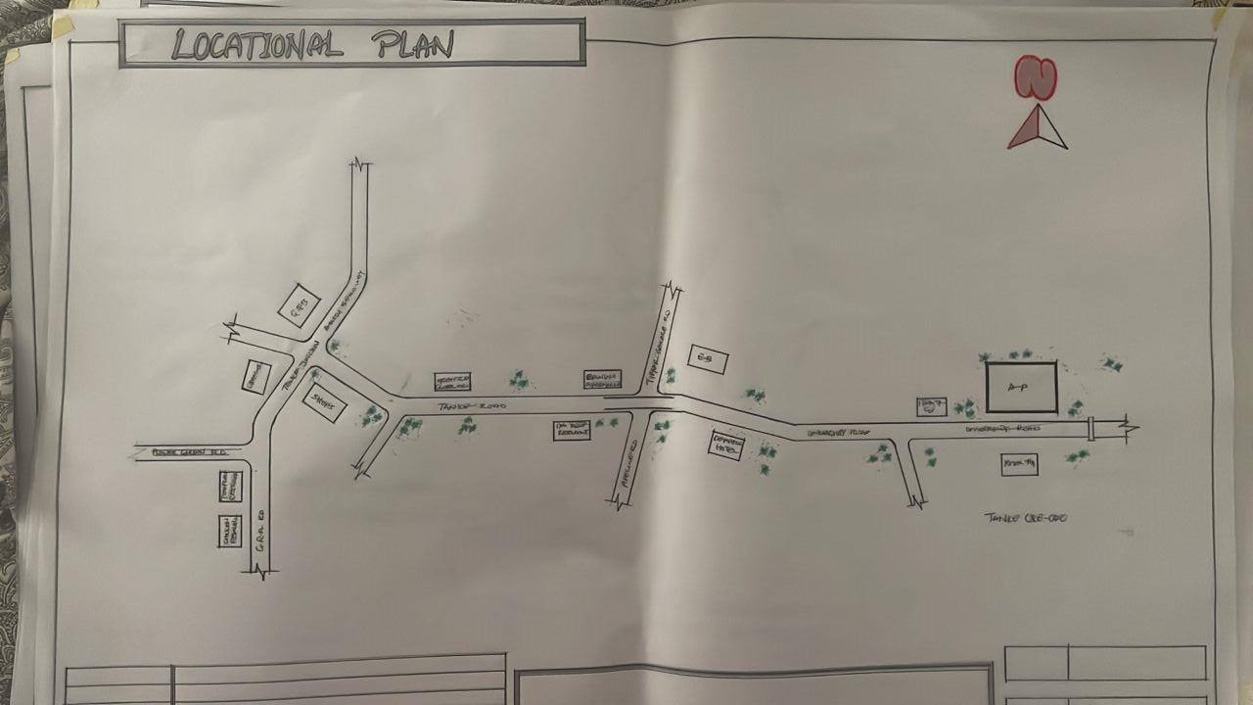
FIG 4.2 LOCATIONAL PLAN
The chosen site meets the following essential criteria:
- Accessibility: Easily accessible from major roads and transport systems.
- Proximity: Near residential areas and existing infrastructure.
- Social Infrastructure: Good access to water supply, electricity, communication, and emergency services.

4.2.1 SITE ANALYSIS/SITE INVENTORY
Location: At Tanke Area Ilorin Kwara sate, South ocal government area kwara State.
Orientation: The site’s shorter sides face east and south; the longer sides face east and west.
Environmental Considerations: The site lies in a moderately busy area. Environmental noise is managed through:
- Natural Means: Tree planting and landscape buffers.
- Structural Design: Orientation to reduce exposure to noise and maximize ventilation.
- Mechanical Systems: Acoustic treatments and HVAC systems ensure internal comfort.
Soil Type: Lateritic soil with good load-bearing capacity, suitable for foundation and structural works.
ventilation and artificial/structural devices. Natural, by adequate plantation, while opening are employed as artificial devices structure by proper structural orientation.
All the unwanted sound/noise which cannot be controlled structurally are controlled through mechanical means to increase the comfort of human life. The soil type is brownish nature underlined by sedimentary rock with good bearing capacity
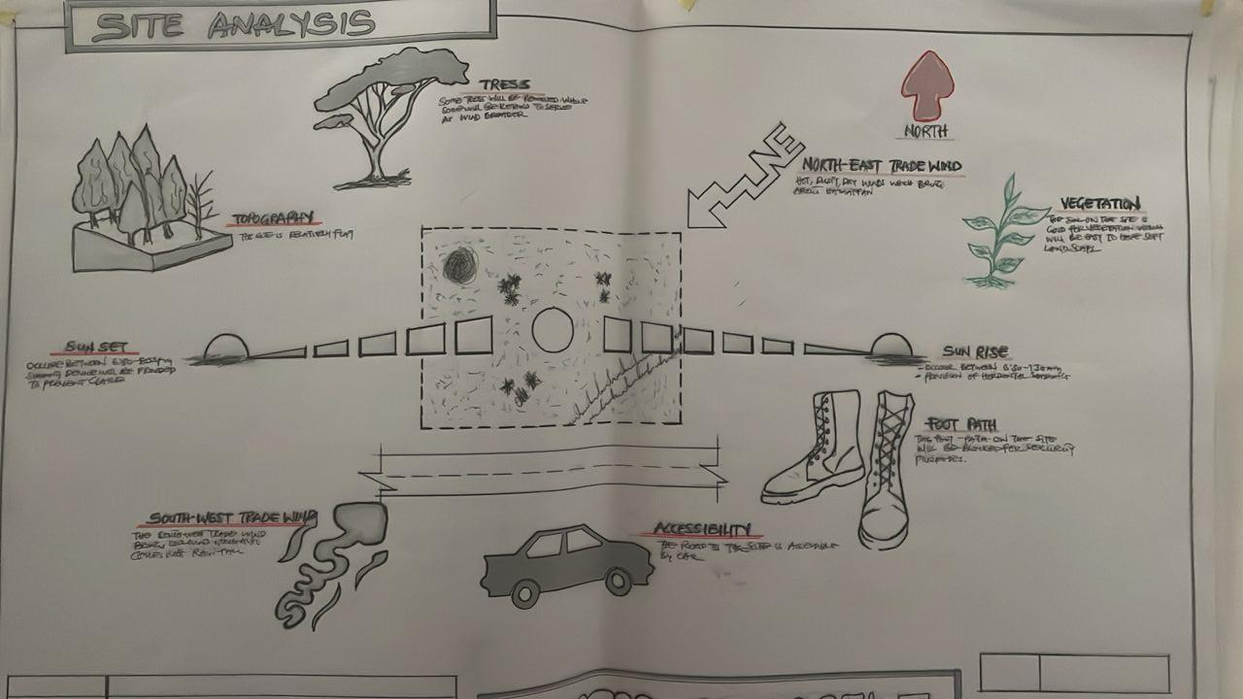
FIG; 4.2.1 SHOWIHG SITE ANALYSIS
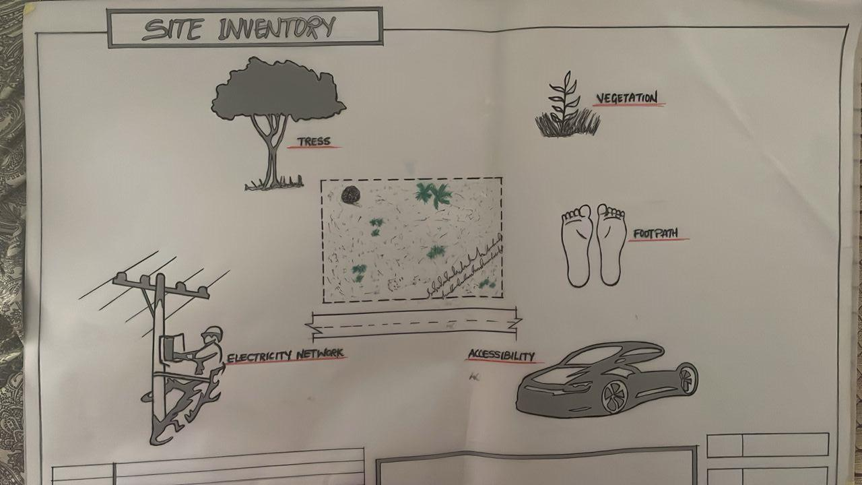
FIG; 4.2.2SHOW SITE INVENTORY
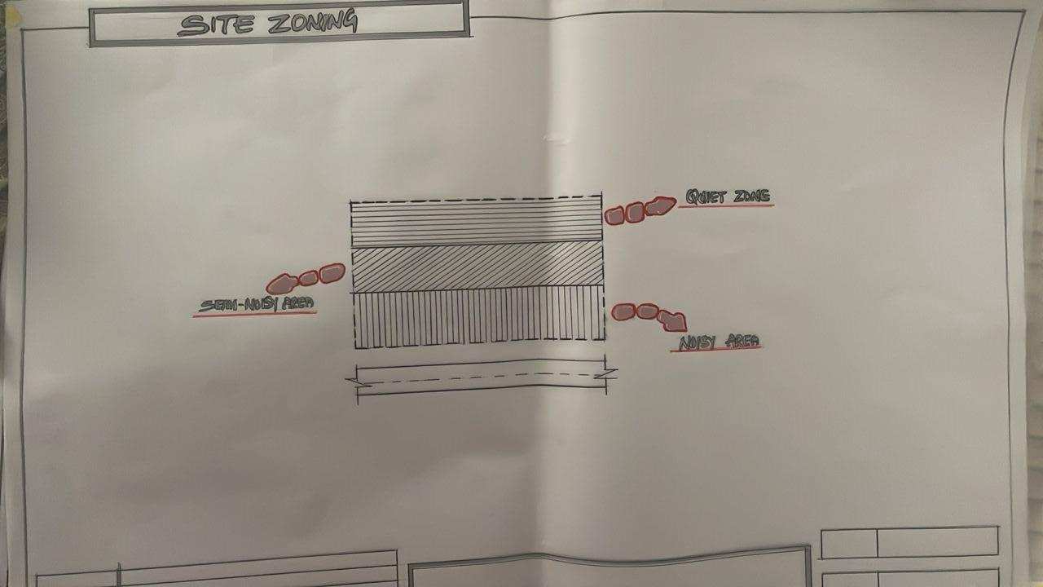
FIG; 4.2.3 SHOW SITE ZOINIG

4.3 GEOGRAPHIC/CLIMATIC DATA
Ede North experiences a tropical wet and dry climate, typical of southwestern Nigeria.
- Average Annual Temperature: ~25.5°C
- Annual Rainfall: Approx. 1400 mm

Climate Characteristics:
- Driest Month: December–January (8–15 mm rainfall)
- Wettest Months: May–October (200 mm+ per month)
- Temperature Range:
  - Warmest Month: March (~28°C)
  - Coolest Month: August (~22°C)
  - Annual Temperature Variation: ~5–6°C
THE CLIMATE GRAPH
The least amount of rainfall occurs in January. Average in this month is 9mm. most of the precipitation here falls in is average 1334mm.
THE TEMPERATURE
The temperature is the highest on average in March, at around 26.5. August is the coldest month, with temperature averaging 22.2°C

THE CLIMATE TABLE
The variation in the precipitation between the dries and wettest months is 229mm. throughout the year, temperatures vary by 4.3°C.

4.4 DESIGN CRITERIA
Design principles for the music concert in Ilorin south include:
- Durability: Construction materials and finishes will be selected for strength and longevity under high usage.
- User Comfort: All users—including patients, staff, and visitors—should experience comfort through ergonomic design, air circulation, and lighting.
- Efficient Layout: Zones for reception, studio, emergency response, music services, records, and administrative areas will be organized to allow efficient flow and accessibility.
- Sustainable & Practical Aesthetics: Focus on sustainable building materials, local craftsmanship, and a welcoming atmosphere without excessive decoration.
- Ventilation & Acoustic Control: Combination of natural ventilation (via courtyards and windows) and mechanical systems for noise control and climate regulation.

4.5 BRIEF
1. Entrance
2. Lobby
3. Restaurant
4. Security
5. Office
6. Office
7. Janitor
8. Mini Kitchen
9. Male Toilet
10. Female Toilet
11. Ticket Room
12. Drink Store
13. Unisex Rest Room
14. Kitchen
15. Popcorn & Snacks
16. Store
17. Foyer
18. Equipment Store
19. Auditorium
20. Stage
21. Cross Over
22. Back Stage
23. Workshop
24. Female Dressing
25. Male Dressing
26. Rehearsal
27. Lounge
28. Control Room

4.6 CONCEPTUAL DEVELOPMENT
The conceptual development for the proposed Music Concert Center in Ilorin South, Tank Area, is inspired by the need to create a vibrant cultural hub where music, entertainment, and community engagement can thrive. The concept draws from the rich cultural heritage of Ilorin, known for its diverse music styles ranging from traditional Yoruba drumming to contemporary Afrobeat, gospel, and hip-hop.
The central idea of the design is to create a flexible, inclusive, and interactive space that can host a variety of musical performances, from large-scale concerts to smaller intimate shows, community events, and talent development programs. The design seeks to celebrate the power of music as a universal language that unites people across cultures, ages, and backgrounds.

CHAPTER FIVE

5.0 Appraisal of Proposed Scheme

5.1 Design Appraisal
In any project design, there are two basics factors that should be taken into consideration. These factors are functionally and aesthetics of the design, although to some designers, aesthetics and functionally of any building are impartibly but in the case of project both aesthetics and functionality of the design were take care of to satisfy the highly demanded functional requirement and to create aesthetically and proportionally balanced design.
The functional efficiency of institute of business and vocational studies depends largely on the closeness of the immediate section that are strongly related in function all these are being taken up as seen on the site and floor respectively.
Construction Methodology
The choice of materials and constructions techniques is influence by a number of factors.
- The cost of Materials
- The climate condition as it affects material
- The topography of the site
- Economics: the initial cost and maintenance cost should be reasonable.
- The availability of construction materials.
- The durability and suitability of materials.
Services
Electricity to trap from the nearest pole of the institute building. The main water pipeline is closely located to the site where drinking water can be tapped telephone line is within the polytechnic which makes connection easy. All of the drain’s ruins to the surrounding gutter which finally drains to the solid and liquid waste are effectively dispose of by the soak away put and septic tanks.
Circulation
Horizontal circulation based on guided principle of separating human activities from reticular activities.
Ventilation
- Natural Ventilation: this ventilation is experienced in the building through openings. This depends on material wind force and their directions of movement due to the temperature, different between the air and the building.
- Artificial Ventilation: this method of ventilation is often used to improve the colonies of the interior of the units. Such artificial mechanism includes fan and air conditioners where necessary.
Lighting
This is a means of providing brightness naturally by sun or moon or artificially by lamps good natural and artificial lighting is important in lecture room and library. It always easy to make mistake and time the eye is in a situation of poor lightening.
Plumbing
Water services are necessary in an installation and both the scope and design of these systems are subjected to statutory and water authority regulation. There is need to install water system to guide against water supply failure. Adequate installation of pipes is recommended.
Electrical Installation
The light fitting should be designed to avoid glare and should be easy to clean and maintain the main sources of electricity supply shall be from the Power Bolding Company of Nigeria but since it is well known that PHCN cannot guarantee uninterrupted services of electricity supply.
Water Disposal
Site slopes is of major factors to be considered in the location and changeling of drains, the use of reinforced concrete drainage covered with precast lead and drainage pipe will be constructed from where waste water will be carried to the drainage zones on the site using surface drainage system.
Fire Protection
Building regulations and construction with local fire authority backed up by insurance policy survey takes care of fire protection.
Noise Control
The is an unpleasant sound often load harsh excessive noise and liberation can cause fatigue, leading to errors and general dissatisfaction in the classrooms, lecture, library, external noise could be easily be controlled with the aid of landscape materials and enough setbacks.
Orientations
The orientation of a building involves the arrangement of the building toward a way from the surreys across or along the trade winds normally determine the thermal comfort in the building.
Sun and Wind Breaking
In the pre-ventilation design gets rid excessive heat moisture and obvious product such as smoke moisture (generator house) and dust the use of terrace couple with spacious and useful often courtyard to avoid all functional part of the building enough natural ventilation.
Materials and Finish
The influencer of building material on construction work in Ibadan and its environment is similar to what prevail in the middle belt of the country.
The materials choice and finishes are influenced by the following:
- The durability and suitability of materials
- Geology and topography of the site
- Availability of materials
- The climatic condition
- Prospective of materials
- The cost of materials
Roof
Roof should preferably of light weight construction with parapet converging it and the external super should absorb as little solar energy as possible.
Ceilings
Suspended ceiling is used in some lecture room with fang ceiling suitable center to center.
Doors
The door type and size depend on the door location but generally metal door are used for the administrative block, mechanical workshop, aluminum glass door and steel door are used.
Window
The windows use are glassed pivot aluminum windows.

5.2 Recommendations
Integration of Local Culture and Music Heritage:
The design should reflect the rich cultural and musical traditions of Ilorin by incorporating local motifs, artworks, and traditional music elements into both the architectural style and programming of the concert center.

Acoustic Design Excellence:
Professional acoustic consultation is recommended to ensure optimal sound quality within the main concert hall and auxiliary spaces. This will enhance audience experience and attract high-quality performances.
Flexible and Multipurpose Spaces:
The facility should be designed with flexible spaces that can be adapted for concerts, rehearsals, exhibitions, and community events to maximize usage and sustainability.
Sustainable Design Approach:
It is recommended that the building employs passive design strategies such as natural ventilation, daylighting, and the use of local materials to minimize energy consumption and create a comfortable environment.
Youth Empowerment and Talent Development:
The center should include provisions for music education, talent development programs, and workshops that engage youth and emerging artists in the community.
Adequate Parking and Accessibility:
Sufficient parking and barrier-free access should be provided to accommodate all visitors, including people living with disabilities, ensuring an inclusive design.

5.3 Conclusion and Summary
The proposed Music Concert Center in Ilorin South, Tank Area, is a visionary project aimed at fostering cultural expression, community interaction, and entertainment within the heart of Ilorin. The design draws inspiration from the city’s rich musical traditions and diverse community, providing a platform for local and national artists to showcase their talents.
By prioritizing flexibility, acoustic performance, cultural identity, and sustainability, the Music Concert Center is set to become a landmark destination for music lovers, creative industries, and the general public. It not only addresses the current need for modern performance spaces in Ilorin but also contributes to economic development, youth empowerment, and cultural preservation.
The recommendations provided serve as a guide to ensuring that the proposed center meets functional, aesthetic, environmental, and social expectations, resulting in a facility that is both impactful and sustainable.

REFERENCES
Long, M. (2014). Architectural Acoustics. Elsevier Academic Press. (Focuses on designing buildings with good sound performance, crucial for music venues.)
Forsyth, M. (2003). Buildings for Music: The Architect, the Musician, and the Listener from the Seventeenth Century to the Present Day. MIT Press.
Watson, J., & Totten, M. (2011). Designing for Acoustics in Performance Spaces. Acoustical Society of America Journal.
Frith, S. (2007). Taking Popular Music Seriously: Selected Essays. Ashgate Publishing.
Ching, F. D. K. (2015). Architecture: Form, Space, and Order. John Wiley & Sons.
Pallasmaa, J. (2005). The Eyes of the Skin: Architecture and the Senses. Wiley.
UN-Habitat (2014). Urban Planning for City Leaders. United Nations Human Settlements Programme.
Heschong Mahone Group (2003). Daylighting in Schools: An Investigation into the Relationship Between Daylighting and Human Performance.
Obateru, O. I. (2003). The Yoruba City in History: Urbanism and Environment in West Africa. Ibadan University Press.
National Building Code of Nigeria (2006). Federal Republic of Nigeria National Building Code.

APPENDIX

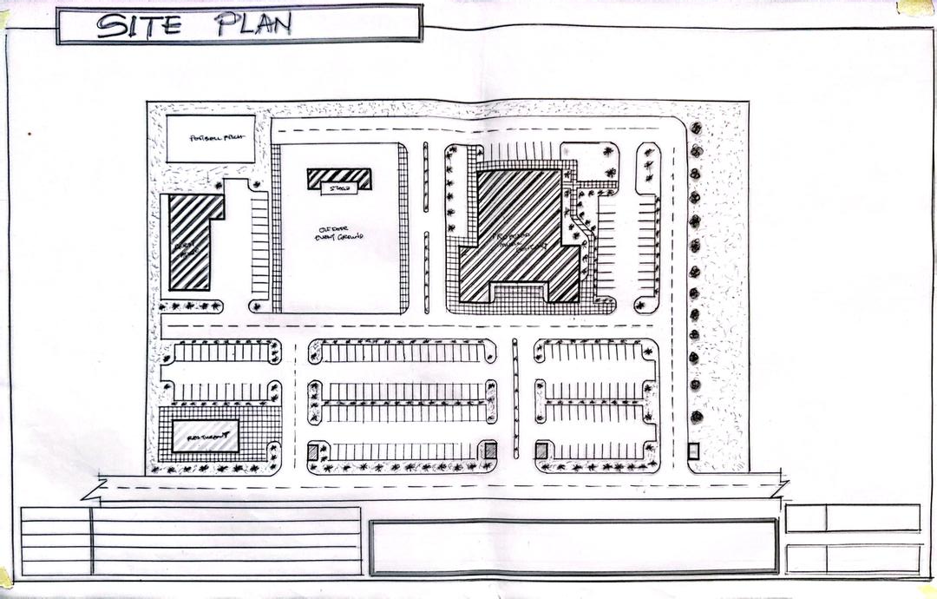
FIG 5.5.1 SITE PLAN
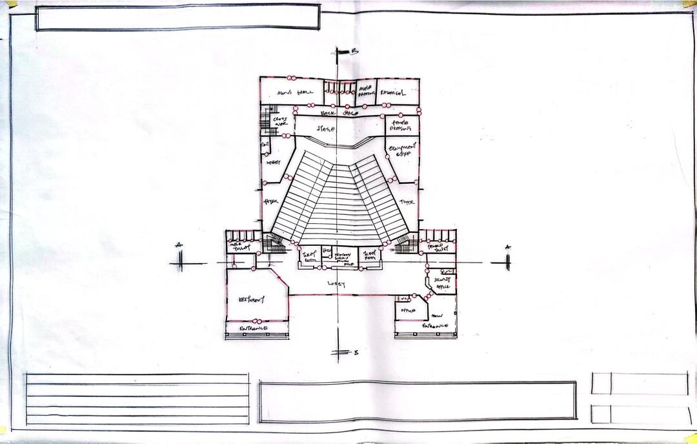
FIG 5.5.2 GROUND FLOOR PLAN

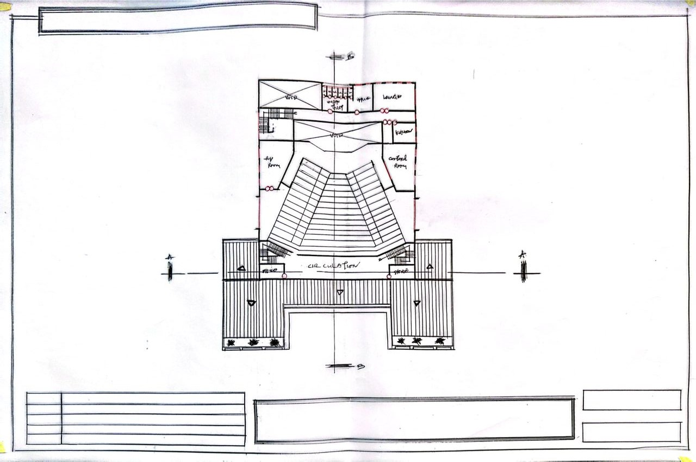
FIG 5.5.3 UPPER FLOOR PLAN
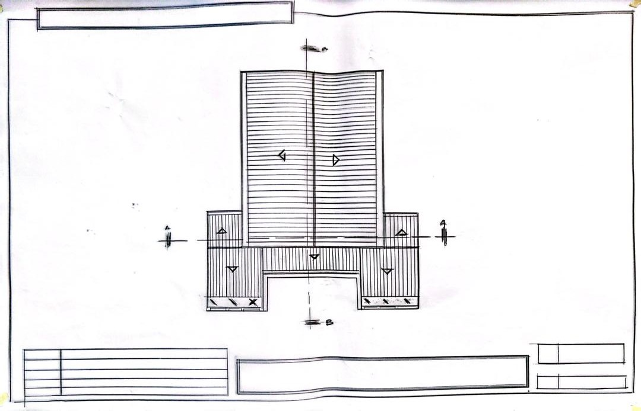
FIG 5.5.4 ROOF PLAN

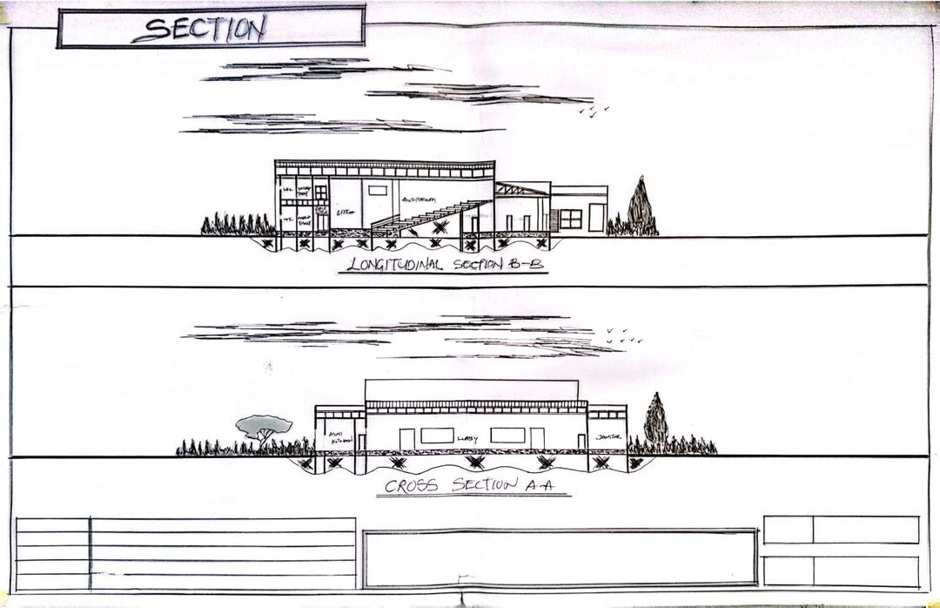
FIG 5.5.5 SECTIONS
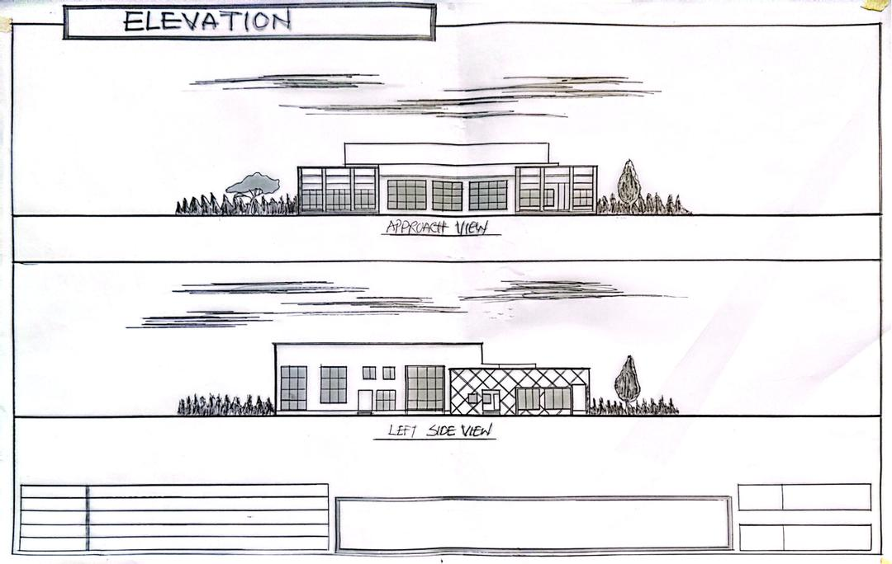
FIG 5.5.6 ELEVATIONS

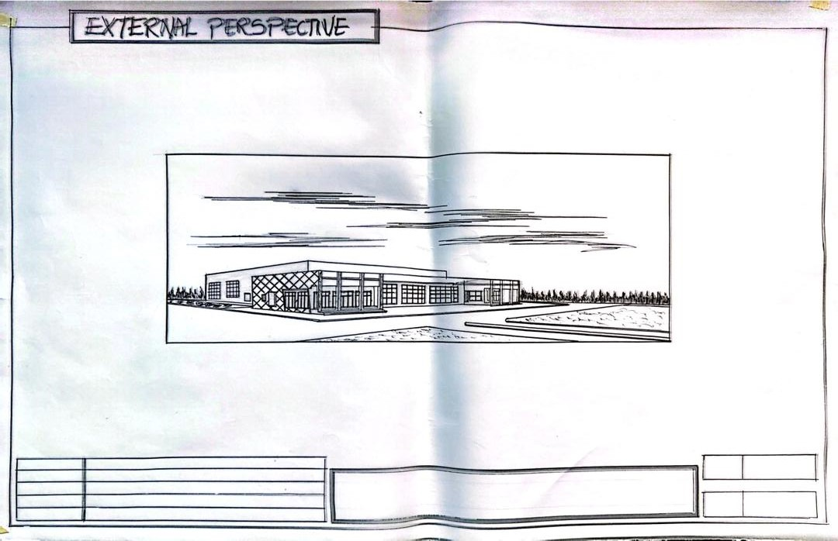
FIG 5.5.7 EXTERIOR PERSPECTIVE
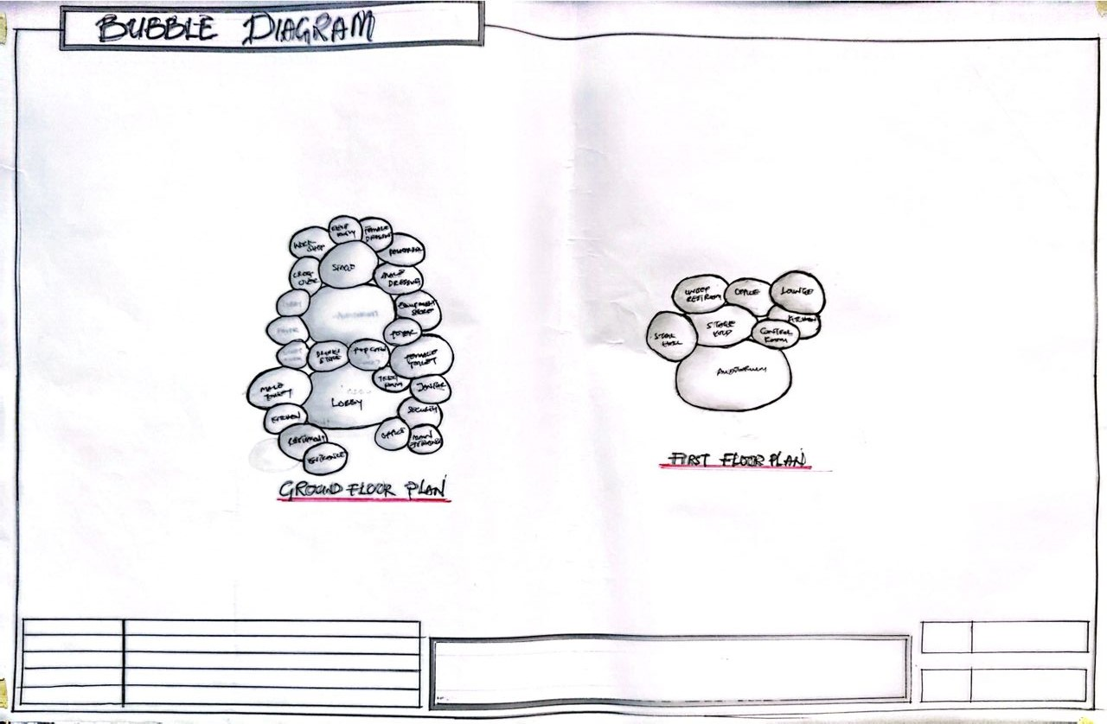
FIG 5.5.8 BUBBLE DIAGRAM

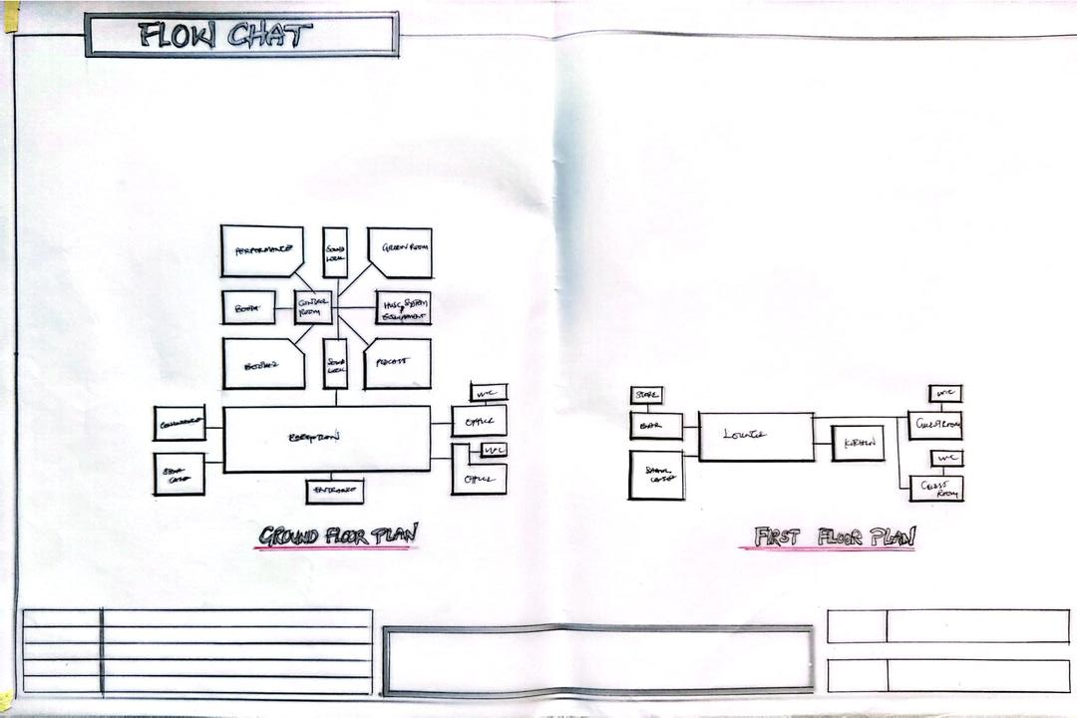
FIG 5.5.9 FLOW CHART
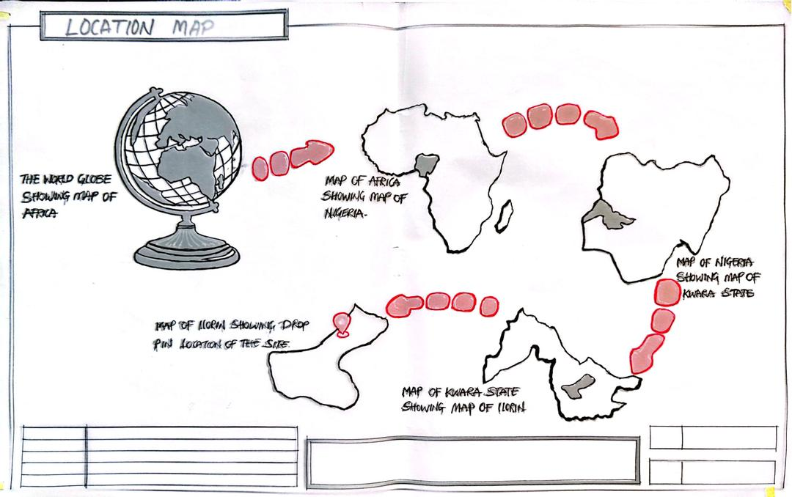
FIG 5.5.10 LOCATION MAP
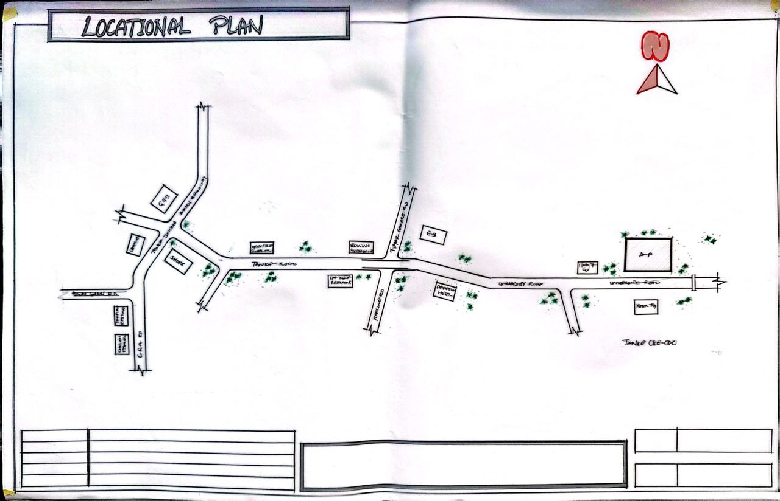
FIG 5.5.11 LOCATIONAL PLAN
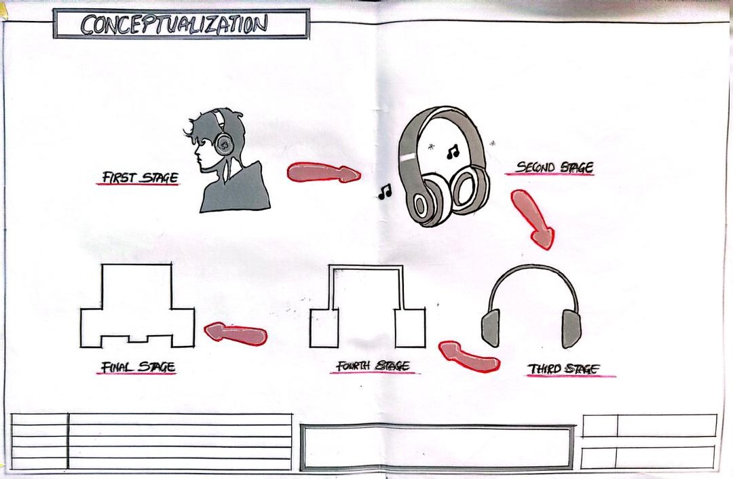
FIG 5.5.12 CONCEPTUALIZATION

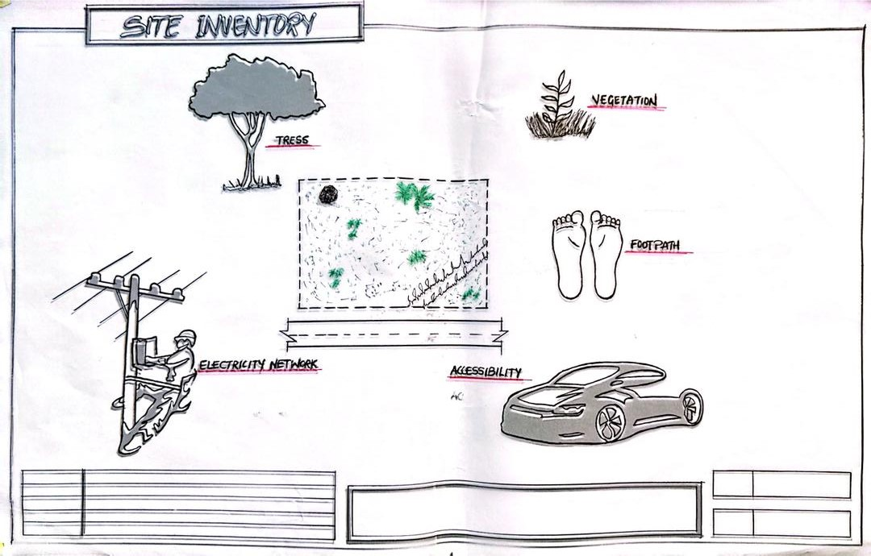
FIG 5.5.13 SITE INVENTORY
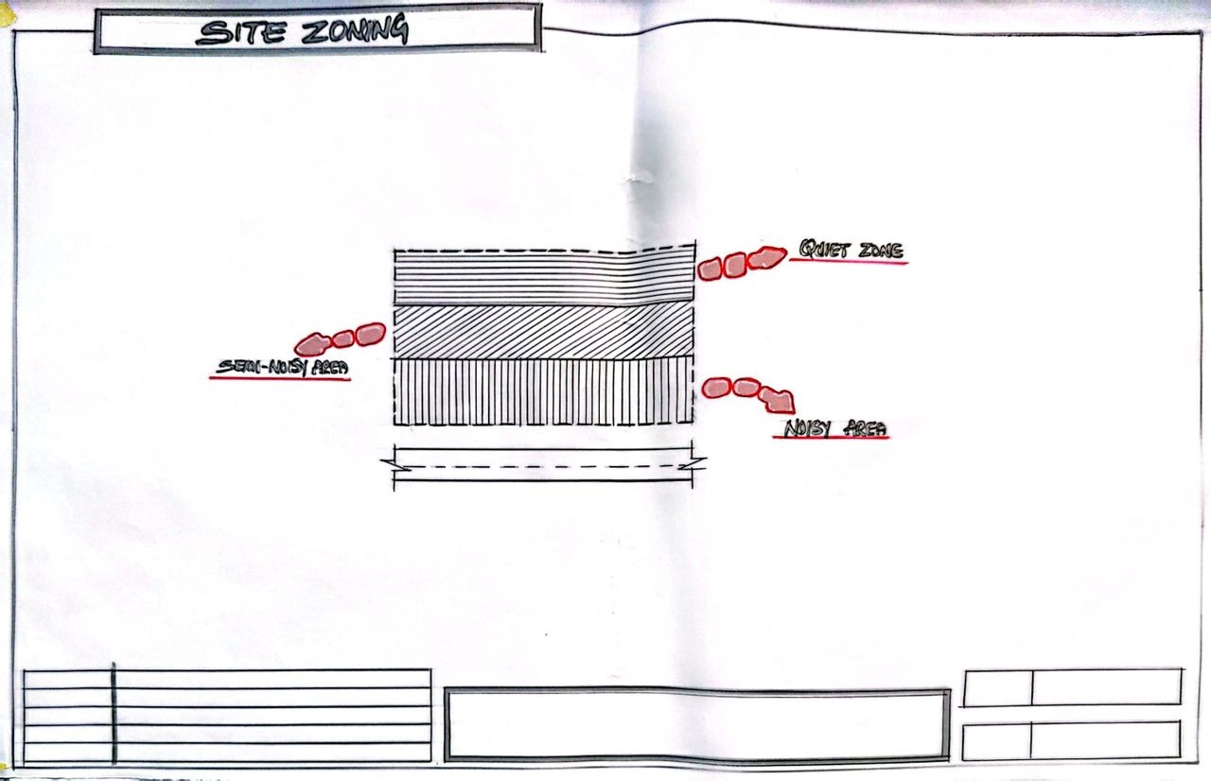
FIG 5.5.14 SITE ZONING
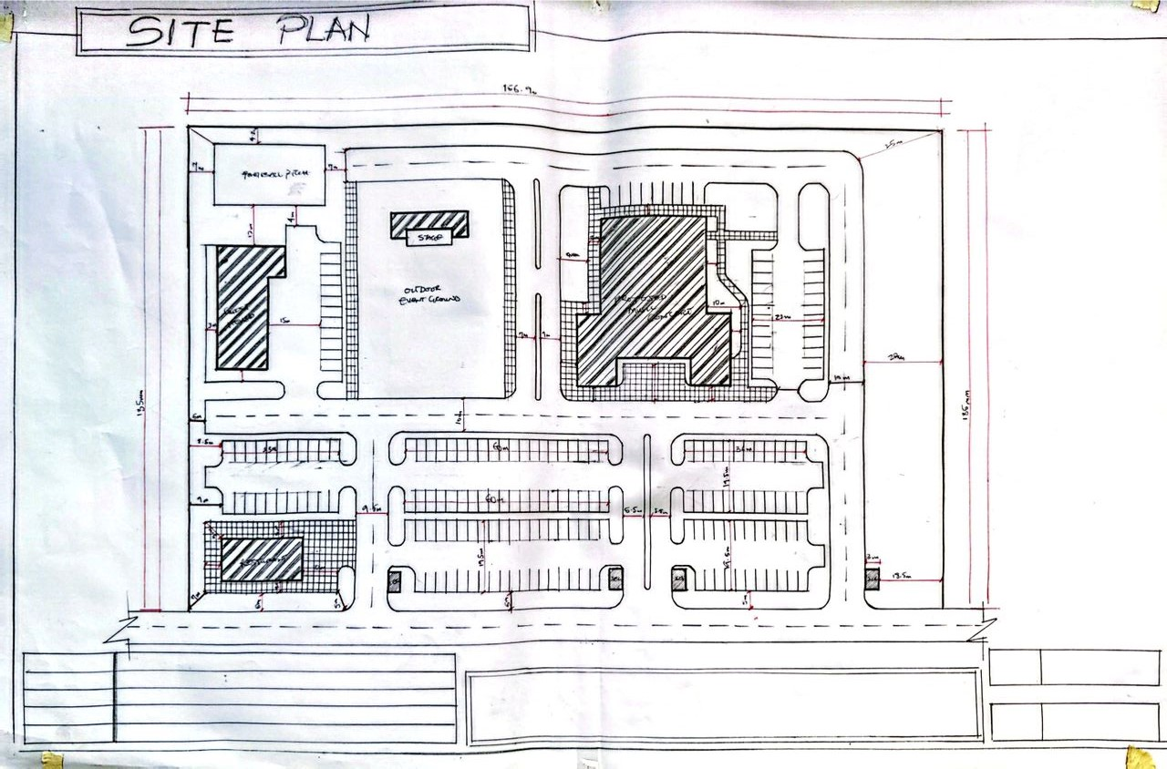
FIG 5.5.15 SITE PLAN
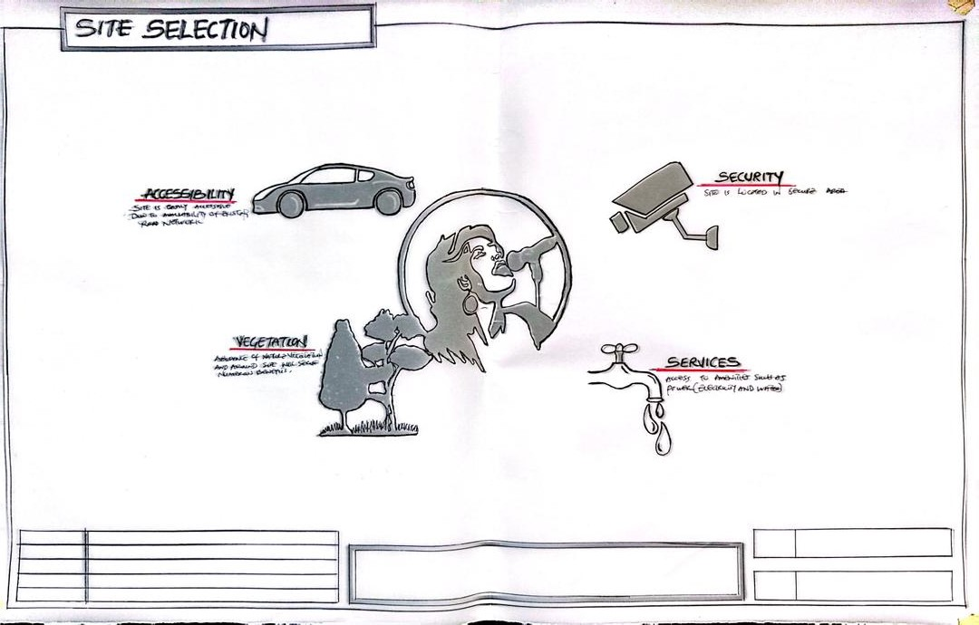
FIG 5.5.16 SITE SELECTION
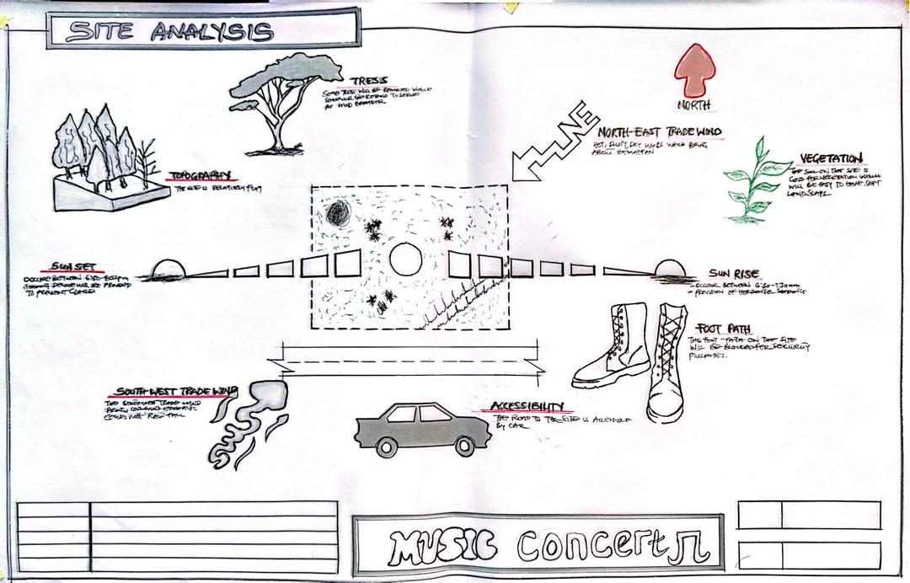
FIG 5.5.17 ANALYSIS

