A PROJECT REPORT
ON
PROPOSED PHARMACEUTICAL INDUSTRY
FOR
OYEMEKUN, OWO LOCAL GOVERNMENT AREA, AKURE, ONDO STATE

BY
JOSEPH SAMSON OLUWASEGUN
HND/23/ARC/FT/0050

SUBMITTED TO
THE DEPARTMENT OF ARCHITECTURAL TECHNOLOGY, INSTITUTE OF ENVIRONMENTAL STUDIES (IES), KWARA STATE POLYTECHNIC ILORIN.

IN FULFILLMENT OF THE REQUIREMENT FOR THE AWARD OF HIGHER NATIONAL DIPLOMA (HND) IN ARCHITECTURAL TECHNOLOGY

JULY, 2025
DECLARATION
This is a work carried out by me JOSEPH SAMSON OLUWASEGUN with the Matric Number HND/22/ARC/FT/0050 of the Department of Architectural Technology, Kwara State Polytechnic, under the Supervision of ARC. OLAREWAJU F.A
All the sources of information are specifically acknowledge by means of reference
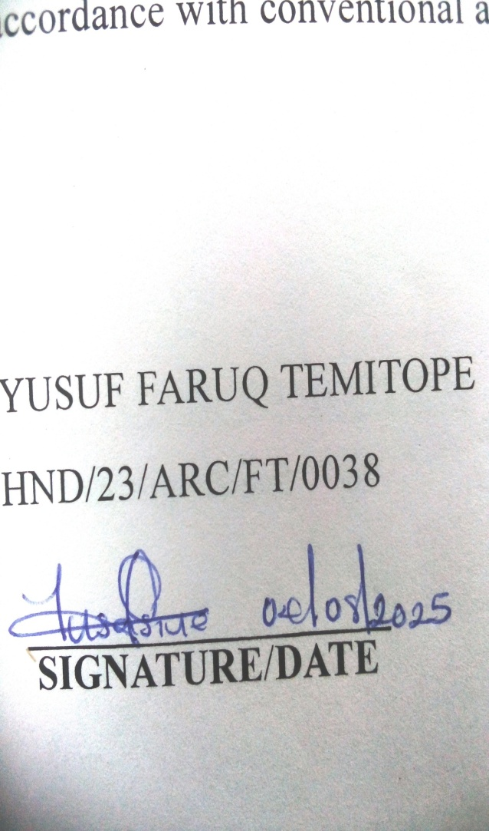

SIGNATURE DATE

CERTIFICATION
This project report on the proposed pharmaceutical industry for OYEMEKUN, OWO, LGA, AKURE, ONDO STATE by JOSEPH SAMSON OLUWASEGUN with the matriculation number HND/23/ARC/FT/0050 has been dully certified as meeting the requirement for the award of Higher National Diploma (HND) in Architectural Technology, Institute of Environment Studies, Kwara State Polytechnic, under the supervision of ARC. OLAREWAJU F.A


ARC. OLAREWAJU F. A.
(Project Supervisor) SIGNATURE/DATE

ARC. OLAREWAJU F. A.
(Project Coordinator) SIGNATURE/DATE



ARC. (MRS). J.M TOMORI
(Head of Department) SIGNATURE/DATE

EXTERNAL SUPERVISOR SIGNATURE/DATE

DEDICATION
This report is dedicated to God Almighty the first and the last, who is sole inspiration of all things and also to my wonderful parents of inestimable value , Mr. and Mrs. JOSPEH .A.O

ACKNOWLEDGEMENT
I give all praises and adoration to Almighty God for granting me the knowledge, wisdom, and understanding which I used in carrying out this design project and making it a success.
I thank my project supervisor (mentor) ARC OLAREWAJU F.A, his colleague and other lecturers for their countless support they rendered on the course of carrying out this design project and project report may God bless you all abundantly (amen)
My pro-fond gratitude goes to my dear parent MR & MRS JOSEPH for their financial and moral support in making this projects a success. I also appreciate the effort of my amiable, humble and generous ladies and gentlemen, you deserve to be call brother and sister.
I recognize the effort of my partner AREMU CHRISTIANA, thanks for the contribution toward the success of this project and I also salute the courage and support of amiable friend who stood by my side at time of challenges of this project.
May God bless you all (Amen)

TABLE OF CONTENTS
Title Page
Declaration………………………………………………………………………………… ii
Certification……………………………………………………………………………….. iii
Dedication…………………………………………………………………………………. iv
Acknowledgment…………………………………………………………………………... v
Table Of Contents………………………………………………………………………….. vi
List Of Plates……………………………………………………………………………… vii
List Of Table………………………………………………………………………………. viii
List Of Figures…………………………………………………………………………….. ix
List Of Appendices………………………………………………………………………… x
Abstract…………………………………………………………………………………….. xi
CHAPTER ONE
1.0 Introduction………………………………………………………… ……………... 1
1.1 Historical Background……………………………………………………………... 1
1.2 Statement Of Design Problem\……………………………………………………. 3
1.3 Aim And Objective………………………………………………………………. 4
1.4 Justification For The Project………………………………………………………. 4
1.5 Client Background…………………………………………………………………. 4
1.6 Scope Of The Project………………………………………………………………. 5
1.7 Limitation Of Design ……………………………………………………………… 6
1.8 Research Methodology…………………………………………………………….. 6
CHAPTER TWO
2.0 Literature Review……………………………………………………………………… 7
2.1 Reviewing Facility Planning…………………………………………………………… 7
2.2 Reviewing Quality Control…………………………………….. …………………….. 12
2.3 Challenges For Pharmaceutical Company…………………………………………….. 12
2.4 Development Of Customer-Oriented Architecture…….. ……………………………... 13
CHAPTER THREE
3.0 Case Study…………………………………………………………………………….. 22
3.1 Case Study One…………………..……………………………………………………. 22
3.1.1 Description And Location …………………………………………………………… 22
3.1.2 Merit And Demerit ………………………………………………………………….. 25
3.2 Case Study Two ………………………………………………………………………. 25
3.2.1 Description And Location …………………………………………………………… 25
3.2.2 Merit And Demerit ………………………………………………………………… 25
3.3 Case Study Three ……………………………………………………………………… 29
3.3.1 Description And Location …………………………………………………………… 29
3.3.2 Merit And Demerit …………………………………………………………………... 31
3.4 Case Study Four ……………………………………………………………………….. 31
3.4.1 Description And Location …………………………………………………………… 31
3.4.2 Merit And Demerit ………………………………………………………………… 33
3.5 Online Case Study One ……………………………………………………………….. 35
3.5.1 Description And Location …………………………………………………………… 34
3.6 Online Case Study Two ……………………………………………………………….. 35
3.6.1 Description And Location …………………………………………………………… 35
CHAPTER FOUR
4.0 Study Area/Project Site………………………………………………………………… 36
4.1 Historical Background Of Ondo State…………………………………………………. 36
4.2 History Of Stufy Area………………………………………………………………….. 37
4.3 Site Location ………………………………………………………………………… 40
4.3.1 Site Criteria ………………………………………………………………………….. 41
4.3.2 Site Inventory/ Analysis……………………………………………………………… 41
4.4 Geographical/Climatic Data…………………………………………………………… 43
4.5 Brief Development Criteria……………………………………………………………. 46
4.5.1 Design Brief/ Scope Analysis……………………………………………………….. 47
4.5.2 Planning Principle …………………………………………………… …………… 48
4.7 Spatial Allocation …………………………………………………………………….. 49
4.7.1 Functional Relations ………………………………………………………………… 50
4.7.2 Conceptual Development ……………………………………………………………. 50
4.7.3 Desihn Parameter …………………………………………………………………… 50
4.7.4 Planning Consideration………………………………………………………………. 50
4.7.5 Environmental Consideration ……………………………………………………… 51
4.7.6 Design Consideration……………………………………………………………….. 51
4.8 Appraisal Of Proposed Scheme………………………………………………………... 52
CHAPTER FIVE
5.0 Construction Methodology And Materials ……………………………………………. 54
5.2. Services Required: Circulation, Ventilation, Lighting …………………………… 54
And Plumbing And Electrical Installatio………………………………………………… 55
5.3 Summary And Conclusions……………………………………………………………. 57
5.4 Recommendation………………………………………………………. …………….. 57
5.4 Reference…………………………………………………………………………... 59
Appendices…………………………………………………………………………. 62

LIST OF FIGURE
Figure 3.1.1 : Showing the location plan of case study one located at De-Shalom Pharmaceutical Company …………………………………………………………………………………………. 23
Figure 3.1.2: Showing the Ground Floor Plan of case study one located at De-Shalom Pharmaceutical Company …………………………………………………………………………. 23
Figure 3.1.3: showing the upper Floor of case study one located at De-Shalom Pharmaceutical Company ………………………………………………………………………………………….. 26
Figure 3.2.1: showing the location plan of unique Pharmaceutical Industry…………….………. 27
Figure 3.2.2: showing the ground floor plan of unique Pharmaceutical Industry…………………. 28
Figure 3.2.3: Showing the Floor plan of case study two………………………………………….. 28
Figure 3.3.1: Showing the location plan of Dana pharmaceutical industry ………………………. 29
Figure 3.3.2: Showing the floor plan of case study three …………………………. ………………30
Figure 3.4.1: Showing the location plan of case study bio-Medical pharmaceutical industry………………………………………………………………………………..…………… 32
Figure 3.4.2: Showing the floor plan of case study four………………………………………… 32

LIST OF PLATE
Plate 3.1.1 : Showing the Front view of case study one located at De-Shalom Pharmaceutical Company…………………………………………………………………………………………… 24
Plate 3.1.2: showing the Back view of case study one at De-Shalom Pharmaceutical Company …………………………………………………………………….………………………..…….. 24
Plate 3.2.1: Showing the side view of case study two……………………………………………. 27
Plate 3.2.2: Showing the front view of case study two ………………………………..………….. 28
Plate 3.3.1: Showing the front view of case study three …………………………………………... 30
Plate 3.4.3: Showing the front view of case study four……………………………………..…….. 25
Plate 5.1.1: showing side view of janssen pharmaceutical industry…………………………….… 34
Plate 5.1.2: showing back view of jassen pharmaceutical……………………………………….… 34
Plate 5.1.3: showing front view of Jazz Pharmaceutical Industry……………………………….… 35
Plate 5.1.4: showing interior view of Jazz Pharmaceutical Industry………………………………. 35
LIST OF APPENDICES
APPENDIX 1:Location map --------------------------------------------------------------------------------- 62
APPENDIX 2:Production Flow Chart………-------------------------------------------------------------- 63
APPENDIX 4:Concept derivation --------------------------------------------------------------------------- 64
APPENDIX 5: Site plan---------------------------------------------------------------------------------------- 65
APPENDIX 6: Admin Floor Plan ---------------------------------------------------------------------------- 66
APPENDIX 7:Admin Upper floor Plan--------------------------------------------------------------------- 67
APPENDIX 8: Admin Roof Plan ----------------------------------------------------------------------------- 68
APPENDIX 9: Production floor Plan ------------------------------------------------------------------------ 69
APPENDIX 10: Production Roof Plan ---------------------------------------------------------------------- 70
APPENDIX 11: Section --------------------------------------------------------------------------------------- 71
APPENDIX 12: Perspective------------------------------------------------------------------------72

ABSTRACT
Modern trends are being shaped by science and technology today and pharmaceutical industry is no excluded in this technology agcras manufacture and other stakes holders seek more advance method as in any other sector to run their business. In Oyemekun, Owo, Lga, Akure, Ondo State, though at a slower pace the industry is gradually embracing the advanced trends in technology system daily running of their industries. Among the advantages is an improvement in quality of production are large customers. Base and an increase in sales, which priority for any business minded person. Technology has become an integral of the industrial, beginning at conceptual state of the designer of the facilities. Aside function, intelligence and aesthetic have become integral in modern trends in technology and is being applied in kind of machinery and equipment being manufacture security system, construction materials and finished control parameters such as lighting, temperature, humidity, ventilation, and maintenances schedule among other. The extent of evolving trends, especially in term of technology in industry like any other sector, cannot be foretold, this study therefore there. Also as the industry health related/ trends regarding regulation procedure and requirement are continually being charged, upgrading and explained. For better appreciation all this culminate in a design proposal highlight possibility to modern trends in a tropical settings and possibility to the way forward. This project sets out to produce a design that is adequately, functional aesthetically balances with good orientation for the proposed pharmaceutical industry for Oyemekun, Owo, Lga, Akure, Ondo State this becomes necessary because in Oyemekun, Owo, Lga, Akure, Ondo State is or largest local government do not have any industry, also to several entire local government and create for people in Oyemekun, Owo, Lga, Akure, Ondo State and its environment. The deduction and experience gained from the research have exposed me to pharmaceutical industry design; these information and deduction were used to develop the design of proposed pharmaceutical industry. This project enables me to contribute my quota to the enhancement of architectural technology study in Oyemekun, Owo, Lga, Akure, Ondo State.

CHAPTER ONE
- INTRODUCTION
  - HISTORICAL BACKGROUND
The pharmaceutical industry began to take shape in united state during the latter half of the 19th century by the early 1900B; federal government passed a series of law that called for regulation of prescription drugs. The modern pharmaceutical industry traces its origin to two (2) sources: apothecaries of drug such as morphine, Quine and Stryonine in the middle of the 19th century and companies that established research labs and discounted medical application for their products starting in 1880bc firms whose name carry recognition today began with the production of organic chemicals (especially dyestuffs) before moving into pharmaceutical. These include AGFA , buyar and Hoechst in Germany, GOBA, Geigy and Sandaz in Switzerland impurity chemical industrial in England and Pfizer in the U. A. S. a merging of these two types of film into identifiable pharmaceutical industry took place in conjunction with the emergency of pharmaceutical chemistry and pharmacology as scientific field at the end of the (19th century oriented to identifying and preparing synthetics drugs and studying their impact on pathological condition other discipline were intimately with rise of the industry
The modern pharmaceutical industry began with local apothecaries that expanded from their traditional role distributing botanical drugs such as morphine and quinine to wholesale manufacture in the mid-1800s, and from discoveries resulting from applied research. Intentional drug discovery from plants began with the isolation between 1803 and 1805 of morphine - an analgesic and sleep-inducing agent - from opium by the German apothecary assistant Friedrich Sertürner, who named this compound after the Greek god of dreams, Morpheus. By the late 1880s, German dye manufacturers had perfected the purification of individual organic compounds from tar and other mineral sources and had also established rudimentary methods in organic chemical synthesis. The development of synthetic chemical methods allowed scientists to systematically vary the structure of chemical substances, and growth in the emerging science of pharmacology expanded their ability to evaluate the biological effects of these structural changes.
By the 1890s, the profound effect of adrenal extracts on many different tissue types had been discovered, setting off a search both for the mechanism of chemical signaling and efforts to exploit these observations for the development of new drugs. The blood pressure raising and vaso constrictive effects of adrenal extracts were of particular interest to surgeons as hemostatic agents and as treatment for shock, and a number of companies developed products based on adrenal extracts containing varying purities of the active substance. In 1897, John Abel of Johns Hopkins University identified the active principle as epinephrine, which he isolated in an impure state as the sulfate salt. Industrial chemist Jōkichi Takamine later developed a method for obtaining epinephrine in a pure state, and licensed the technology to Parke-Davis. Parke-Davis marketed epinephrine under the trade name Adrenalin. Injected epinephrine proved to be especially efficacious for the acute treatment of asthma attacks, and an inhaled version was sold in the United States until 2011 (Primatene Mist). By 1929 epinephrine had been formulated into an inhaler for use in the treatment of nasal congestion.
While highly effective, the requirement for injection limited the use of epinephrine [clarification needed] and orally active derivatives were sought. A structurally similar compound, ephedrine, (actually more similar to norepinephrine,) was identified by Japanese chemists in the Ma Huang plant and marketed by Eli Lilly as an oral treatment for asthma. Following the work of Henry Dale and George Barger at Burroughs - Welcome, academic chemist Gordon Allies synthesized amphetamine and tested it in asthma patients in 1929. The drug proved to have only modest anti-asthma effects but produced sensations of exhilaration and palpitations. Amphetamine was developed by Smith, Kline and French as a nasal decongestant under the trade name Benzedrine Inhaler. Amphetamine was eventually developed for the treatment of narcolepsy, post-encephalitic Parkinsonism, and mood elevation in depression and other psychiatric indications. It received approval as a New and Nonofficial Remedy from the American Medical Association for these uses in 1937[7] and remained in common use for depression until the development of tricyclic antidepressants in the 1960s.
  - PROJECT DEFINITION
Definition of pharmaceutical industry
The pharmaceutical industry discovers develops produce, and market drugs or pharmaceutics for use as medication to be administered to patients with the aim to cure them vaccinate them , or alleviate synthetic pharmaceutical companies many deal in generics or brand medication and medical devices.
Pharmaceutical industry can be defined as public and private organization involve discounting development and manufacture of drugs and me dictation.
INDUSTRY: Economic activity concerned with the processing of raw materials and manufacture of goods in factories.
PHARMACEUTICAL INDUSTRY discovers, develops, produces, and markets drugs or pharmaceutical drugs for use as medications to be administered (or self-administered) to patients, with the aim to cure them, vaccinate them, or alleviates the symptoms. Pharmaceutical companies may deal in generic or brand medications and medical devices. They are subject to a variety of laws and regulations that govern the patenting, testing, safety, efficacy and marketing of drugs.
1.3 DESIGN PROBLEM
The pharmaceutical industry plays a critical role in improving global health by developing, providing and distributing medication. However the industry faces several significant challenges that hinder its ability to deliver affordable, effective and accessible healthcare. Rising drug prices, stringent regulatory requirements, lengthy and costly drug development processes. Additionally ethnical issues, lack of innovation in certain therapeutic areas, supply chain disruption are limited access to essential medicine in low-income regions further complicate the landscape. these challenges raise important question about the sustainability efficiency and equity of pharmaceutical operation and necessitate strategic interventions and policy reform to ensure the industry meets the evolving need of patients worldwide
1.4 AIM OF THE DESIGN
To design a standard pharmaceutical industry of great aesthetic and functional value that will enhance effective and quality pharmaceutical production for Oyemekun, Owo, LGA, Akure, Ondo State.
OBJECTIVES OF THE DESIGN
- To ensure suitable structure that will accommodate modern pharmaceutical industry in terms of drugs production
- To facilitate quality control and assurance create a visually facility
- To create a safe and comfortable environment for employees including adequate lighting and temperature control

1.5 JUSTIFICATION FOR THE PROJECT
Investment in new drugs generates savings throughout the health care system. Increased use of drugs, especially newer agents, has also resulted in increased longevities and reduced disability benefits from new pharmaceutical for outweigh their costs for many key diseases of the elderly.
Pharmaceutical industry is highly essential and the innovation needs to be up to standard in order to cope with the present design of pharmaceutical industry. Therefore, I wish to design pharmaceutical industry for Oyemekun, Owo, Lga, Akure, Ondo State order to develop, boost their economic sector.

1.6 CLIENT BACKGROUND
Owo Local Government Area (LGA) is one of the most historically significant and culturally rich regions in Ondo State, southwestern Nigeria. It derives its name from the town of Owo, which has long served as a major center of Yoruba civilization, governance, and commerce. The name “Owo” is derived from the Yoruba word "Ogho" or "Oghowo", which means respect or honor.
Owo town is the seat of the Owo Kingdom, one of the oldest and most respected Yoruba kingdoms. Historically, Owo was a powerful city-state and played a crucial role in regional politics and trade between the Benin Kingdom and other Yoruba towns.
1.7 SCOPE OF THE PROJECT
The scopes of the project (pharmaceutical industry) outline below accommodate the following structures and facilities.
FACTORY UNIT (GROUND FLOOR)
- Entrance
- Male and female cloak with toilets
- Offloading bay
- Raw material store
- Control room for production
- analyst office
- Courtyard
- Finished goods store
- Finished goods quarantine
- Production hall for tablet
- Production hall for capsule
- Production hall for syrup
- QC Lab
ADMINISTRATION BLOCK
- Entrance
- Reception and conveniences
- CMO office
- Secretary office
- Conference hall
- Store
- Training room
- Exit
1.8 LIMITATION OF DESIGN
Limitation to the research are very many but some of the could be overcome in the course of the study the following limitation are experienced during the course of research.
- Photograph taking was restricted in some areas which could have been used to explain some features seen during the course of carrying out the case study research
- Restriction of movement by the securities and the authorities of the incused for study research
1.9 RESEARCH METHODOLOGY
Research is been carried out on the proposed project for a better option and aesthetics design to the proper functionality of the building in relation to the site and landscape with aids of the following method:
CASE STUDY: This is done by close study of existing modern structure or building which is also dedicated to the same or similar use of functions as the project assignment. For the purpose of the project, the use of photography and close study of architectural drawing (floor and location plans) for each of these studies.
ORAL INTERVIEW: In order to acquire basic information of data as a guide for the design of a proposed modern market, the designer/ architect need to have some oral and personal contact or about formal discussion with users/ occupies of an existing modern market.
LITERATURE REVIEW: Relevant and reliable information or data, on design and construction of modern market are collected from text books, past project, journals and media. Etc.
INTERNET: This is a research that was done and gained from the internet in order to get further information.

CHAPTER TWO
2.0 LITERATURE REVIEW
Project architects play a vital role in the design of pharmaceutical manufacturing facilities. In addition to complex architectural requirements, these sites require the integration of essential process engineering, mechanical, electrical, and plumbing (MEP) engineering, and regulatory compliance. Involving a project architect as part of the team from the beginning of the project can help ensure that it is planned, designed, and executed to meet requirements within a limited budget and on schedule. Architects are trained to be integrators, organizers, and collaborators. As building designers with three-dimensional thinking, they have a global view of all disciplines and are able to link the various players involved in a project. Trained to work within a technical engineering context, project architects are key to integrating process engineering, MEP engineering, specialized construction requirements, building code compliance, and overall building design.
2.1 REVIEWING FACILITY PLANNING
As with any building, a pharmaceutical facility design must incorporate design elements, functionality (flow and adjacencies), and space (environment and human scale). All of these are balanced against regulatory concerns. To balance these competing concerns, process architects can leverage three-dimensional thinking and building information modeling (BIM) to develop optimal design solutions. At the Canadian architectural firm NFOE Inc., the design of a pharmaceutical facility begins with an understanding of the company’s corporate vision. Aligning these business objectives at the project outset is important. Questions posed at this time may include:
What products are to be manufactured and what are the target commercial markets?
Single or multiple products?
What is/are the proposed product(s)?
Confinement levels, toxicity, etc.?
Have regulatory requirements been satisfied to sell the product(s) in the proposed markets?
Once products and markets have been identified, regulatory guidelines— such as FDA good manufacturing practice (GMP), building code regulations, local biosafety requirements—and corporate facility guidelines—including health, safety, and environment standards (HSE)—are incorporated into the project design.
Functional design begins with an understanding of product fabrication. At this time the project site master plan is reviewed, developed, and refined. The existing context and future plans are examined and explored. The process architect follows the process engineer and the process flow diagram to collect, synthesize, and analyze base information to prepare early functional blocking. The process architect leads the data collection effort, and produces the space program to create a common understanding of the project requirements. Room cards—documents that summarize the functional, equipment, architectural, MEP, and information technology/telecom requirements for each space—are often used to compile this information. These requirements are distributed to all project stakeholders for review and comment; they serve as base documentation for development of the design. Once this information has been documented and confirmed, the process architect analyzes, synthesizes, identifies, and graphically communicates the relationships between various building components, space groupings, adjacency relationships, circulations, etc.
It is essential to address equipment integration early in the design process, and get it right the first time—it’s expensive if not done properly. Once the equipment has been selected, operating heights, clearance, maintenance access, servicing strategy, and delivery logistics are addressed. Initial design is typically based on generic equipment models or, if the parameters are unknown, by using worst-case scenarios. Early communication about personnel flow and gowning is essential to promote a common understanding. The process architect shares the protocols of the various gowning steps, together with their related accessories, to all project stakeholders by means of pictograms, diagrams, and plans. Standard operating procedures such as hand washing or sanitizing and the use of use of personal protective equipment should be defined and simplified. Sterility concerns should be reviewed with all stakeholders, including HSE. Airlocks and their respective circulation spaces for material and personnel transfer within the facility require significant amounts of expensive space. Planning for an adequate number of airlocks requires accurate information about required current GMP (cGMP) zone classifications, bio containment, and pressurization. Choices about linens management for airlocks and interlocks will have major effects on project planning and engineering. Other design criteria to be reviewed include ergonomic design and product manipulations, as well as biological and toxicity levels for dangerous products such as flammable corrosive substances.
Reviewing Renovations and Retrofits
Designing for alterations, renovations, and retrofits presents the project architect with a different set of challenges. These can include negative air pressure zones, erection of temporary partitions, construction in operational plants, and decontamination of spaces, dust management, and clean waste removal. "Surprises" are inevitable when working in existing conditions; rapid problem solving is often required.
2.2 CASE STUDIES
In order to achieve a well analyze design, some certain finding are to enable a successful design approach by doing series of case study which is relevant to pharmaceutical industry.
The sole aim of the procedure is to subject each case studies to critical analysis based on the following
- Functionality of the case studies
- Flexibility of design
- Merits and demerits of building quality
- Landscape
- Accessibility to various units on site (RasmussenN., 2008)
- Reviewing Renovations and retrofits
- Designing for alterations, renovations, and retrofits presents the project architect with a different set of challenges. These can include negative air pressure zones, erection of temporary partitions, construction in operational plants, and decontamination of spaces, dust management, and clean waste removal. "Surprises" are inevitable when working in existing conditions; rapid problem solving is often required.
- The IT-driven transformation in the pharma industry creates strategic opportunities and competitive pressures at the same time. On the one hand, existing and new players are developing websites and portals for customer interaction as well as for enhanced quality of care. On the other hand, the Internet creates opportunities for pharma companies to improve the depth and/or breadth of interaction with existing and new customer segments. Both effects emphasize Porter’s view that Internet technologies are complementary to existing interaction channels (e.g. sales force, call centers) and need to leverage a company’s existing competencies. Therefore, pharma companies are forced to assess their existing strategies and to (re)position themselves. It is the goal of this paper to present a framework for understanding the changes and for developing solutions for electronic customer interaction for a pharma company. CRM systems from Siebel, SAP and others are key enablers for CRM strategies as they provide a consistent and consolidated customer database, electronic support for customer interactions, and sophisticated analytical tools. However, CRM projects are merely technological. Studies show that the organization around the customer, the prototyping of new (electronic) processes, and cultural factors determine CRM adoption. Business process redesign (BPR) methodologies such as business engineering recognize the process as the link between strategy and systems development. However, these BPR methods have mainly been applied to processes within organizations and are not focused on shaping customer-oriented solutions. In cooperation with nine international companies an architecture framework has been developed between 2000 and 2002 for customer and supplier interaction. Based on individual research projects with each company, the research team drafted an architecture which was subsequently refined in several workshops with representatives of the partner companies.1 In applying the architecture at Pharma Corp, one of the largest pharma companies worldwide, this research follows the tradition of action research where the researcher is directly involved in the project work.

2.3 CHALLENGES FOR PHARMACEUTICAL COMPANIES
Challenges
- High research and development costs: Developing new drugs is costly and time-consuming.
- Regulatory hurdles: Navigating complex regulatory frameworks can be challenging.
- Drug pricing and accessibility: Ensuring affordable access to medications is a key issue.
- Counterfeit drugs: Combating counterfeit medications is a significant challenge.
- Supply chain disruptions: Maintaining a stable supply chain is crucial.
Solutions
- Collaborative research partnerships: Partnering with academia and other companies can share costs and expertise.
- Streamlined regulatory processes: Advocating for more efficient regulatory frameworks can speed up approvals.
- Pricing strategies and patient assistance programs: Implementing tiered pricing and patient assistance programs can improve accessibility.
- Anti-counterfeiting technologies: Implementing technologies like blockchain and serialization can help combat counterfeits.
5. Supply chain diversification and risk management: Diversifying supply chains and implementing risk management strategies can mitigate disruptions. By addressing these challenges, the pharmaceutical industry can continue to innovate and provide life-saving medications to those in need.
2.4 DEVELOPMENT OF A CUSTOMER-ORIENTED ARCHITECTURE
- Architecture is an instrument for the systematic development of solutions in many areas such as civil and systems engineering. In the latter it describes the integration of different components to deliver one or more (technological) capabilities. Although various e business architecture frameworks have emerged (e.g.) these are mainly technology driven. In the

following a top-down approach is described that encompasses three levels: a business architecture which provides the frame for understanding the transformation of the sales channels within the industry, a process architecture which develops the main design elements for shaping customer-oriented services, and a systems architecture which structures the supporting applications.
- On a strategic level customer orientation requires a sound understanding of the downstream business network which depicts all actors involved. Figure 2 shows the existing business architecture with Pharma Corp’s marketing, sales and service departments as well as the customer segments along the various interaction channels (business-to-business, business-to-doctor, business-to-consumer, and business-togovernment).3 This structure represents the European market since the greatest changes were expected here. • Physicians are the most important customers for pharma companies as they possess the authority and the know-how to decide on the prescribed products.4 Nearly all academic physicians and a growing number of community physicians are regularly using the Internet. Pharma companies strive to reduce the current cost of EUR 1,000 per visit and to increase the length of each visit which today takes only approx. nine minutes. Although physicians make the product decision, patients are the final buyers of pharma products. They are more likely to prepare themselves for discussions with their doctors and have independently decided on their preferred drug. Pharma companies aim at providing information which may influence the choice of drugs. • Hospitals are high-volume customers for medicines. For example, the hospitals in Switzerland purchased 20.7% of prescription medicines in 2000. Although product decisions are still influenced by physicians, hospitals increasingly employ professional procurement staff that exerts competitive pressures on pharma companies. • Wholesalers are not regarded as customers but rather as a distribution channel. In Switzerland the three largest wholesalers (Galenica, Amedis and Voigt ) together command a 90% share of the market, while in most of Southern Europe the market is still less concentrated. Consolidation is expected to increase, for example, the three largest wholesalers already operate throughout Europe and aim at downstream integration of pharmacies and hospitals. • Pharmacies sell drugs to patients on a prescription basis. In 2001 pharmacies sold 55.6% of all prescription drugs in Switzerland. Pharmacies buy their drugs from wholesalers and do not source direct from pharma companies. • Patient groups are interest groups who offer information and support regarding specific illnesses. They influence politics and the pharma industry. An interest group, for example, was effective in securing approval of Herceptin (a drug used against breast cancer) by promoting the drug to gain faster approval from the food and drug administration (FDA). Pharma companies aim at addressing these patient groups with suitable services and information at the right moment in time.
- When Pharma Corp evaluated the changes in their business architecture in 2001 they decided to provide state-of-the-art regarding their websites (e.g. uniform layout worldwide, consistent product information), to maintain parity in the area of online pharmacies and downstream marketplaces (i.e. act upon strategic necessity), and to develop competitive advantages by establishing portals for specific customer segments. In a number of workshops with Pharma Corp’s country organizations, the existing and expected importance of the customer segments was evaluated. As Figure 4 suggests, patients and wholesalers should receive more attention in the future. However, physicians still remain the most important segment for pharma companies.
- 3.2 Process Architecture
- 3.2.1 Customer Processes Analysis On the process level Pharma Corp analyzed each customer segment to identify required and valued services to be included in a portal. The customer process encompasses all tasks which customers go through in order to satisfy their needs. Internal workshops and customer surveys in six European countries with an average of ten sales and marketing representatives were conducted. Three hospitals, two buying syndicates and two wholesalers took part in the external survey. From this analysis the customer processes as well as possible portal services were derived (see Figure 5): • The customer process of patients evolves around the prevention and treatment of an illness. The sub-processes may differ in length and show that healthy persons can also be customers of pharma companies (‘prevent’). • The physician’s process focuses on patient treatment, i.e. providing advice and prescribing drugs. Included are knowledge management, i.e. systematic archiving of information from medical journals or newsletters, professional development, i.e. continuous medical education (CME) with online seminars etc, patient data management, i.e. the storage of patient data and their medical histories, and back-office, i.e. all administrative activities. • Hospital pharmacies have an emphasis on warehouse management. The pharmacy manager’s process starts with observing medical developments and searching information on sales figures, approval requirements and side effects of drugs. After checking inventory and comparing terms of delivery, the hospital pharmacist initiates a purchase order, the goods and the invoice are checked upon receipt, and the goods are assigned to the warehouse. • Compared to hospital pharmacies, ‘independent’ pharmacies are more sales- than logistics-driven. Dispensing drugs and advising customers is important here. Necessary support processes are prescription handling and ordering.
- Building on previous work The systematic review found very few studies which examined pharmacy spaces as its primary aim. Instead, pharmacy patients and staff only mentioned their experience about the pharmacy space as part of a wider conversation about a particular health service. Therefore, questions about the experience of the pharmacy space were not directly explored with pharmacy patients or staff. Independent prescribing pharmacists would also need to be more professionally integrated within other health, social care, and voluntary organisations. Pharmacists and their team will need to know how to engage with these organisations and communities, including arts-based organisations, to support their patients. This may require the MPharm degree programme and professional training to become more interdisciplinary in nature, possibly crossing traditional arts-sciences boundaries as well as applying practices from other disciplines. With these changes we are also likely to see growth and support for social prescribing practices (Drinkwater et al., 2019), and pharmacy will have even greater significance as a key community health space. These changes may require alternative forms of knowledge and evidence to make pharmacy spaces more engaging. Pharmacy practice usually brings with it an array of complex situations and daily challenges, especially when providing health care to those who are unwell, preventing illness, and creating a social space for diverse communities and visitors – which it regularly attracts and who value the space. Notably, community pharmacy accounts for 52% of all registered pharmacists, while others are employed in hospitals, industry, academia, and other sectors (Health Education England, 2023). This further emphasises the importance of the pharmacy space where most pharmacy graduates will go on to develop their professional careers. Therefore, we need to ensure community pharmacy spaces are nurturing environments, conducive to effective development of a new generation of pharmacists and pharmacy team.
- Search terms were developed by applying the PICOC framework (Table 1) (Booth et al., 2016). The final search strategy was informed by combining terms relating to: Population (P) of pharmacy service users and pharmacy health team (including pharmacist, pharmacy technician and medicine counter assistant (General Pharmaceutical Council, 2020)). Phenomena of Interest (I) covering any physical and social elements of the pharmacy space (including pharmacy layout, pharmacy counter, dispensary, consultation room and pharmacy retail area, lighting, noise and privacy); Comparison (C) included any health interventions reported; Outcome (O): were of reported experiences of the physical and social aspects of the pharmacy space, including satisfaction, engagement, attitudes, performance or health intervention outcomes; and Context (C): comprised of studies conducted within any community pharmacy settings, from any country and location (e.g. chain and independent establishments). Studies based in hospitals pharmacies, clinics or online were excluded. The relevant synonyms and MeSH were incorporated into the final search strategy which was adjusted for each database. Reference list of the included studies and relevant systematic reviews were checked.
- Serious dysfunction of the building due to its absolute submission to the above-mentioned function of appeal: Here we could refer to examples taken from l’architecture parlante by Boullée, Ledoux and Lequeu.24 In the 1960s, Robert Venturi and Denise Scott Brown studied this case and it featured in his article On Ducks and Decoration,25 which used the example of the restaurant building in the shape of a duck on the edge of the road to address this idea.26 For Venturi and Scott Brown, the building-duck (which they referred to as the decorated shed), illustrated the collision between the functional programme and the a priori image that the building needs, in the difficult context of the highway, where architecture has a very limited amount of time to attract customers. Due to this collision, it is the substance (the technical functions) that makes matters worse. This is exactly what happens, from an openly postmodern perspective, to the detriment of the modern image (imposed a priori), on the functional substance in some buildings. Solomonic split of the building: a curious phenomenon analysed by this couple of architects from Philadelphia in Las Vegas and fairly present in all American highway architecture. On the one hand, the advertisement, which focuses on the formal aspects that constitute the image or message of the building, perform the important appeal function, at the edge of the road. On the other hand, you have what they call the technical shed, which has no intentional image and is set back from traffic. While the design meets both the programmatic and image requirements, it is, at its core, an architectural failure, as it does not solve the problems raised without dissolving the unity of the building.27 In this text we will defend the skill of the Spanish architects, who faced the challenge of finding solutions for the pharmaceutical laboratories project in the second period of the Franco era. We do not find dissociation nor a lowering of the functional importance, nor much less dysfunctional results or splitting the building. At least three mature examples of this architecture, the Made laboratory (1958-1964), Profidén laboratory (1963-1965) and Jorba laboratory (1965-1967)28 work on the project as a whole, salvaging the physical unity of the building, integrating it and giving expression to the functional diversity of the same so that the publicity part is successful at the same time that the technical shed finds its expression. To verify this hypothesis, we will first introduce the necessary modifications to the concepts of primary function and technical programme in order to persist in an architecture whose forms are not always consistent with function. The key may be found in the idea of the programme as architectural reason, as shared by Miguel Fisac. However, the following laboratory cases will illustrate the opposite problem of an excess of image: Vekar, Farmabión, Médix, Boehringer and Pérez Jiménez. In the Made and Profidén laboratories, as well as the phytosanitary installations of Granollers, we will see how the programme is expressed. At the beginning of those projects, we could almost say that they clumsily yielded to formulas. In order to try to understand the evolution and its final outcome, it would be worth mentioning a final daring hypothesis: the need to find a suitable transcription of the primary utilitas, with all its complexity, as the appealing

CHAPTER THREE
3.0 CASE STUDY
In order to achieve a well analyze design, some certain finding are to enable a successful design approach by doing series of case study which is relevant to pharmaceutical industry.
The sole aim of the procedure is to subject each case studies to critical analysis based on the following
- Functionality of the case studies
- Flexibility of design
- Merits and demerits of building quality
- Landscape
- Accessibility to various units on site (RasmussenN., 2008)
OUTLINE OF CASE STUDIES
- De-Shalom Pharmaceutical Company
- Unique Pharmaceutical Company
- Dana Pharmaceutical Limited
- Bio-Medical Pharmaceutical Limited

3.1 CASE STUDY ONE
3.1.1 HISTORICAL BACKGROUND OF DE-SHALOM PHARMACEUTICAL COMPANY
LOCATION: KIM 4, ILOKO IJESA ROAD, ILESA OSUN STATE
HISTORICAL BACKGROUND
De-Shalom Pharmaceutical Laboratory Nigeria Limited was establish in the year 1998 operations in pharmaceutical manufacturing began in 2004 with the registration of oral liquid and external liquid lines.
The old factory was located at G141F Oke-Oye Ilesa Osun State while it later located at Kim 4 Ilooko Ijesa Road Ilesa, Osun State Nigeria.

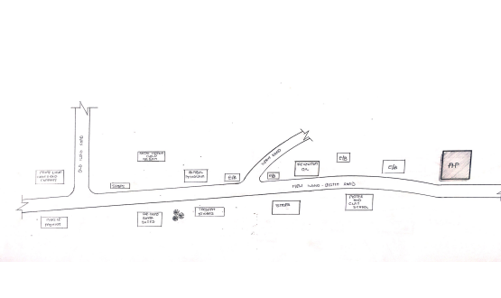

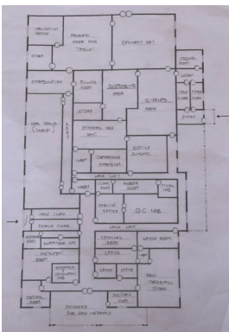
Figure 3.1.1 : Showing the location plan of case study one located at De-Shalom Pharmaceutical Company

Figure 3.1.2: Showing the Ground Floor Plan of case study one located at De-Shalom Pharmaceutical Company

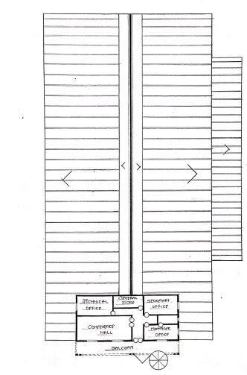

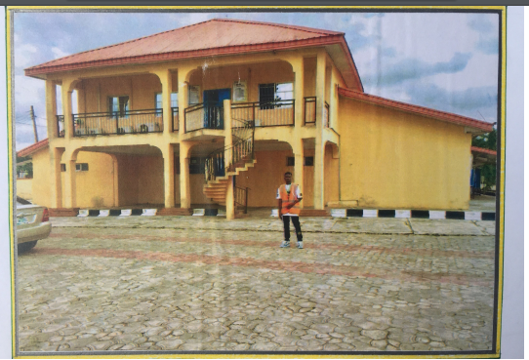
Figure 3.1.3: showing the upper Floor of case study one located at De-Shalom Pharmaceutical Company

Plate 3.1.1 : Showing the Front view of case study one located at De-Shalom Pharmaceutical Company
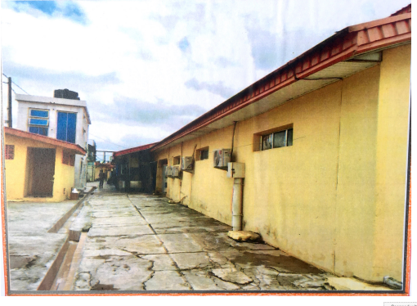

Plate 3.1.2: showing the Back view of case study one at De-Shalom Pharmaceutical Company

MERITS
- Well structural view
- It convey sustainable design principle
- Located in a civilized area
DEMERITS
- Poor landscaping
- It has poor illumination and ventilation
3.2 CASE STUDY TWO
NAME: UNIQUE PHARMACEUTICAL LIMITED
Name: 11, Fatai Atare way, Matori Mushin Lagos, State Nigeria.
HISTORICAL BACKGROUND
Case study two
UNIQUE PHARMACEUTICAL LIMITEDwas incorporate in the year 1985. The manufacturing activities started in the year 1988 with the manufacturing facilities for intravenous fluid production initially and later expended over the year to include other tablet, syrup and other.
Unique pharmaceutical limited is located at 11, fatal, atare Matori Mushin Lagos State Nigeria.

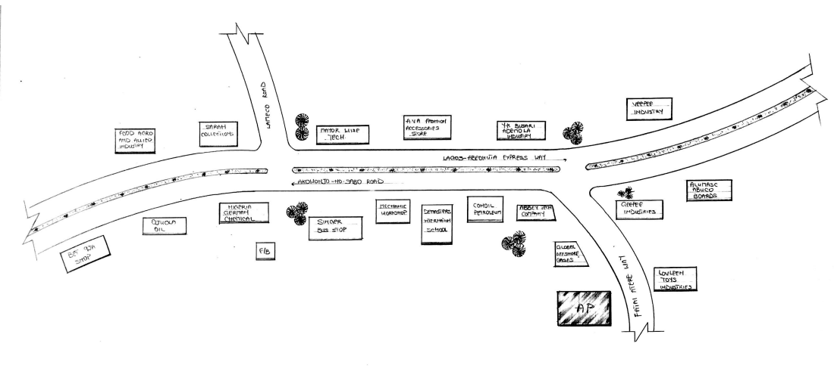

Figure 3.2.1: showing the location plan of unique Pharmaceutical Industry

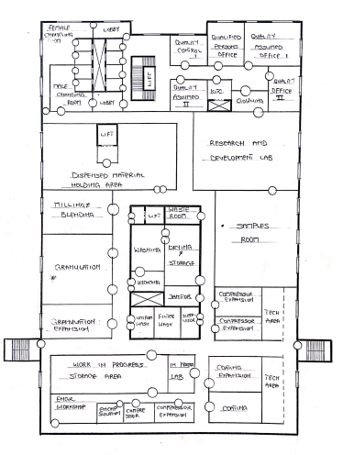

Figure 3.2.2: showing the ground floor plan of unique Pharmaceutical Industry

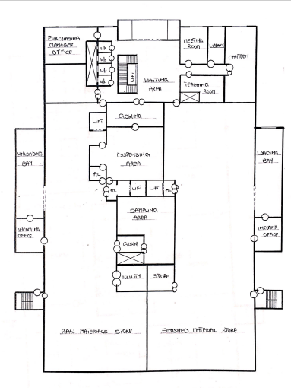

Figure 3.2.3: Showing the Floor plan of case study two
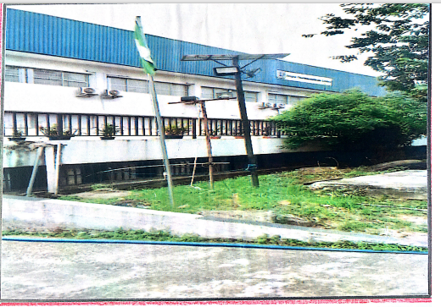

Plate 3.2.1: Showing the side view of case study two

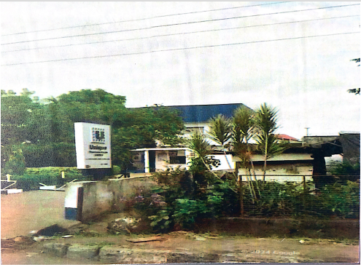

Plate 3.2.2: Showing the front view of case study two
Merits
- It has adequate our conditioning
- It has good functional flows
- It creates welcoming and inclusive atmosphere
Demerits
- No provision of standard Q.C. lab units
- No Provision for warehousing
- Poor circulation
3.3 CASE STUDY THREE
Case study 3
DANA PHARMACEUTICAL LIMITED commenced commercial manufacturing in 1985 with the production of large volume intravenous infusion for critical care the product range has broadened to include a wide range of pharmaceutical formulation in 2003.
Dana pharmaceutical limited is also an 150 9001: certified organization upholding the quality management system standard and its located at 8A olubadan industrial estate olluyole Ibadan 2000273 oyo State
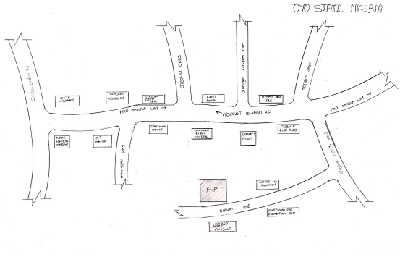

Figure 3.3.1: Showing the location plan of Dana pharmaceutical industry
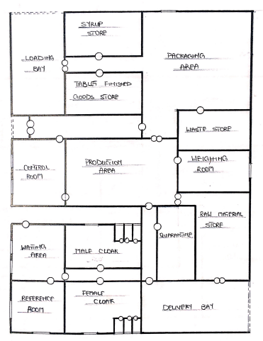

Figure 3.3.2: Showing the floor plan of case study three

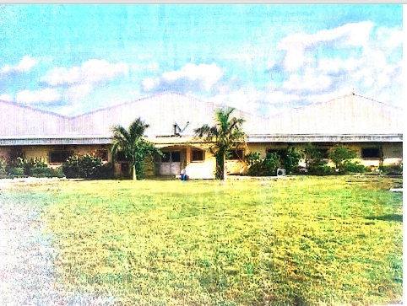

Plate 3.3.1: Showing the front view of case study three
MERIT
- It has adequate our conditioning
- It has good functional flows
- It creates welcoming and inclusive atmosphere
DEMERITS
- No provision of standard Q.C. lab units
- No Provision for warehousing

3.4 CASE STUDY FOUR

Biomedical limited is a wholly private indigenous pharmaceutical manufacturing and distribution which is into production and marketing of intravenous fluid branded as (Bioflex Range) very recently (2019) officially declared open its ultra-modern syrup factory and launched into the Nigeria & African healthcare.
Biomedical limited is located at industrial estate, Gaa-Imam road Ilorin, Kwara State, Nigeria..

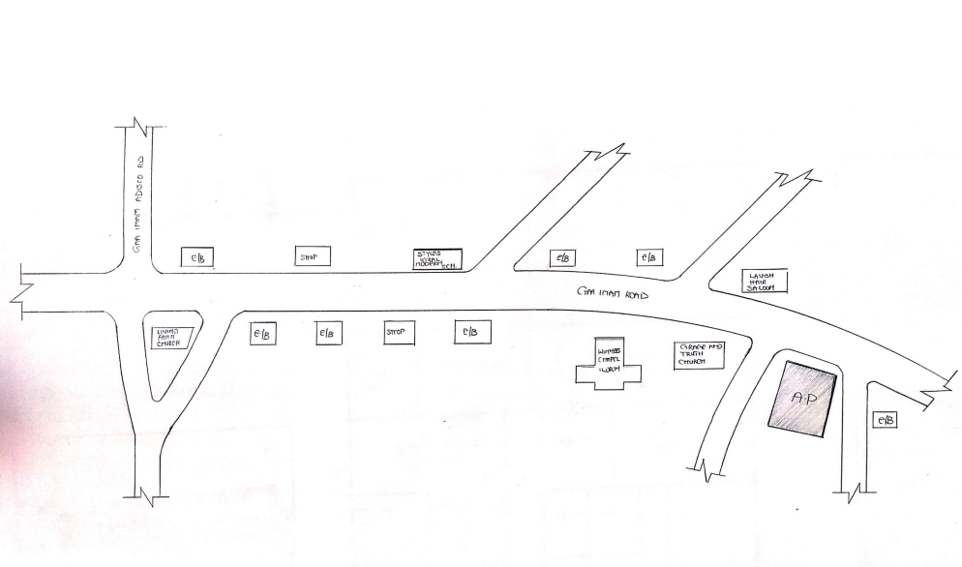

Figure 3.4.1: Showing the location plan of case study bio-Medical pharmaceutical industry
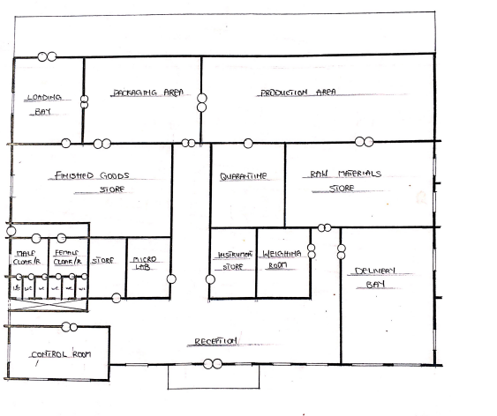

Figure 3.4.2: Showing the floor plan of case study four

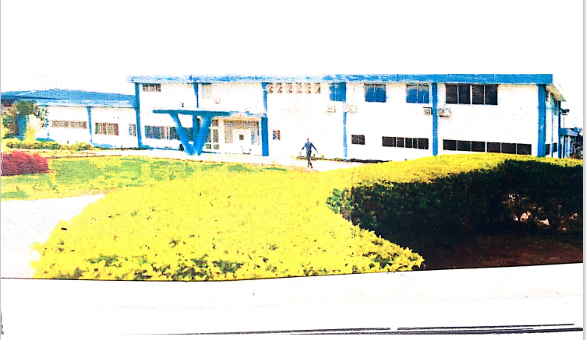

Plate 3.4.3: Showing the front view of case study four

MERITS
- It is easily accessible and enjoys natural ventilation
- It is well ventilated and lightened
- The layout is well planned landscaped

3..4.1 DEMERIT
- The site going has been mixed
- There is no room /space for future expansion

3.5 ONLINE CASE STUDY ONE
JANSSEN PHARMACEUTICAL LATINA OFFICE
LOCATION:CONTRADA DEL CACCIATORI ITALY SS156.40 LT ITALY
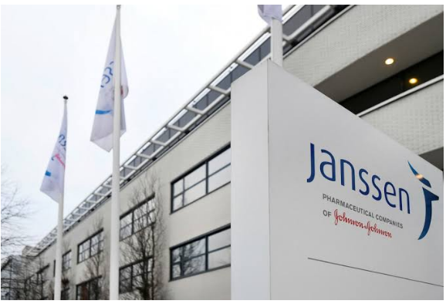
Plate 5.1.1: showing side view of janssen pharmaceutical industry
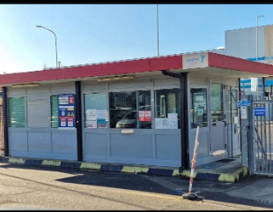
Plate 5.1.2: showing back view of jassen pharmaceutical
3.6 ONLINE CASE STUDY TWO
JAZZ PHARMACEUTICAL INDUSTRY
LOCATION:309 REGENT SJ. LONDON WIB 2UW UNITED KINGDOM
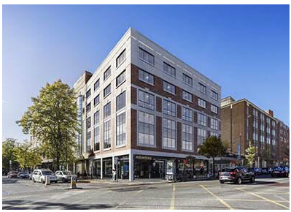
Plate 5.1.3: showing front view of Jazz Pharmaceutical Industry
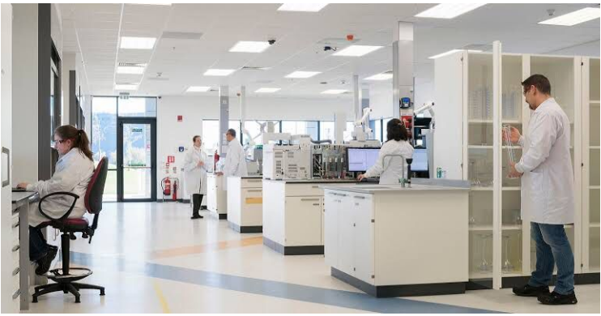
Plate 5.1.4: showing interior view of Jazz Pharmaceutical Industry
CHAPTER FOUR
4.1 HISTORY OF THE STUDY AREA (ONDO STATE
The Ondo Kingdom is a traditional state that traces its origins back for over 500 years, with its capital in ondo City, Ondo State, Nigeria. Ondo Kingdom was established by Princess Pupupu, one of the twins of Alafin Oluaso, and the present Ondo State is a state in south western Nigeria. Created in February 1976 from the former Western State, with boarders on Edo State to the east, and Delta State to the southwest, currently, the state occupies about 15,000kmsq.
Ondo State contains the largest number of public schools in Nigeria – over 880 primary schools and 190 secondary schools.
4.2 ONDO STATE, TRIBES, ETHNICITY AND BELIEFS
The ethnic composition of Ondo State is largely from the Yoruba subgroups of the Akoko (the Edo Speaking), Akure, Ikale, Ilaje, Ondo, and Owo people. Ijaw people, such as the Apoi, Furupagha and Arogbo populations, inhabit the coastal areas, and a sizeable number of the Ondo State people who speak a variant of the Yoruba language similar to the Ife dialect reside in Oke-Igbo.The area is inhabited by more than 3 million people with the highest number and the biggest density having about 18 local government areas.
Ondo State is mostly agricultural and does not have many impressive urban sites. Instead, it offers tourists wildlife attractions like waterfalls, picturesque hills and so on.
The state is recognized worldwide as the place with the highest chances for local women giving birth to twins. The Ondo city itself was founded by twin sisters and the number of twins of all possible ages is one of the main attractions of the state.
The modern people of the Ondo State are farmers, traders, and sellers of food products.
Anotherhistorical relic is the palace of Osemawe, which was built more than a century ago, although now successfully refurbished and can compete with other cultural places in the country. Another part of the traditional life includes festivals, which are held four times during the year. The state is inhabited by both Muslims and Christians and so cities are packed with both churches and mosques. This blend of cultures and rich history makes the state unique and really deserving the name of a cultural center.
4.3 HISTORY OF STUDY AREA (OWO LOCAL GOVERNMENT)
Owo is believed to have been founded around 1019 AD by Prince Ojugbelu Arere, a descendant of Odudua, the progenitor of the Yoruba people. According to oral traditions, Owo traces its origins back to Ile-Ife, the spiritual center of Yoruba culture. The name "Owo" is derived from the phrase "Omo – Òwò," meaning "Child of Respect or Honour," reflecting the town's esteemed heritage.
Politcal Structure and Independence
From 1400 to 1600 CE, Owo served as the capital of a Yoruba city-state, maintaining a degree of independence from the neighboring Benin Kingdom, although it occasionally paid tribute. The cultural exchange between Owo and Benin was significant, with Owo's artisans renowned for their ivory carvings, which were highly valued in Benin
Owo came under British control in 1893 and became part of the Western Region of Nigeria upon independence in 1960. In 1976, it was incorporated into the newly created Ondo State. The town has played a crucial role in Nigerian politics, particularly during the First Republic.
Cultural Significance
Owo is known for its rich cultural heritage, including traditional festivals, art, and craftsmanship. The town celebrated its 1000th anniversary in 2019, highlighting its historical importance and ongoing cultural relevance. The Owo Kingdom is also recognized for its well-preserved traditions and political structures, which have survived colonial influences
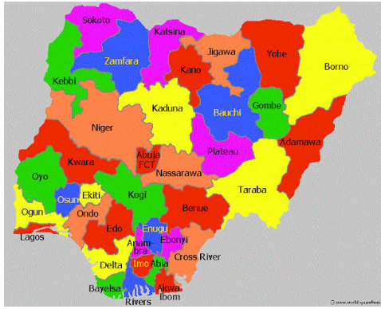
Plate 3.3.1: Map of Nigeria showing Ondo State
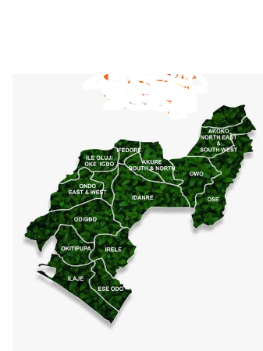
Plate 3.3.2: Map of Ondo State
4.3 SITE LOCATION
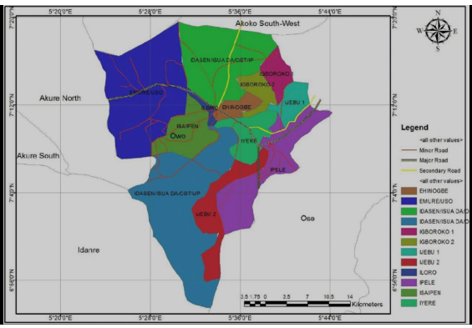
The selected site for the proposed pharmaceutical industry is rectangular in sha with large expanse of land, which occupy 18,000sqm and situated at owo local government area, along Oyemekun road Ondo state

Plate 3.3.1: Map of Nigeria showing Owo local government
4.4 SITE SELECTION CITERIA
Numerous elements go into a given site location criteria and analysis. The success of this project proposal depends largely on the site chosen for this development. According to Skystone (2008), the following site selection process was developed to assist the art museum, in selecting an optimal site for the proposed centre.
1. Identify, refine and prioritize the selection criteria.
2. List and describe the identified site options.
3. Interview key community members.
The following factor forms the basis for choosing the site
1Accessibility: The site is easily accessible from the roads leading to the public transport.
2. Sufficient Spaces: There is ample space on the proposed site that can conveniently take the cultural centre, parking lots and the ancillary facilities.
3. Its environmental impact on the surroundings and existing developments in the area.
4. Availability of infrastructures such as electricity power supply, access roads, water supply, covered drains and other utilities.
4.4.1 SITE ANALYSIS/INVENTORY
For architects and planners to start placing the various elements of the design on the site, they must first assemble elaborate data about the site. Good site planning reflects research about the physical features of the area, such as existing landscape, utilities, services and infrastructure, topography, views, climate and even traffic flow.

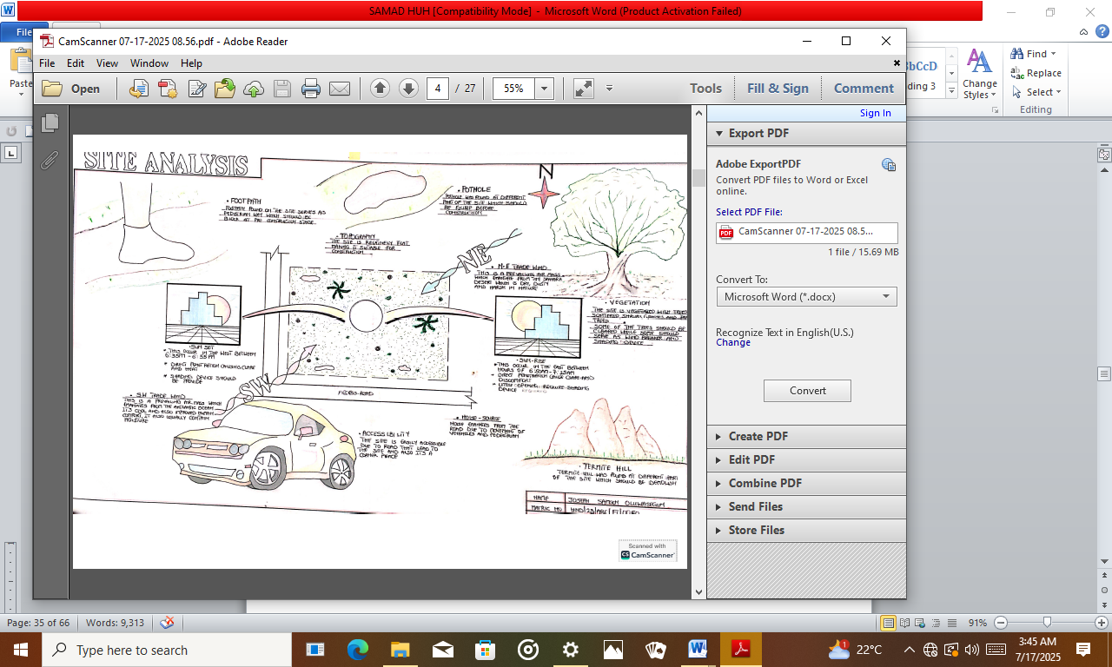
Plate 4.1.1: Showing the site inventory/analysis
Topography:-The site is highly economical in terms of topography as it is fairly flat with Low lying strip of land with 0.5% gradient sloping towards the south-east end of the site and would not require much investment to drain EARTHWORK to be carried out and table tops created for parking spaces.
Access: The site is readily accessible from the northern part, off the high-way. At the moment, vehicular access is through the above mentioned road.
4.4.2 GEOGRAPHICAL/ CLIMATIC DATA
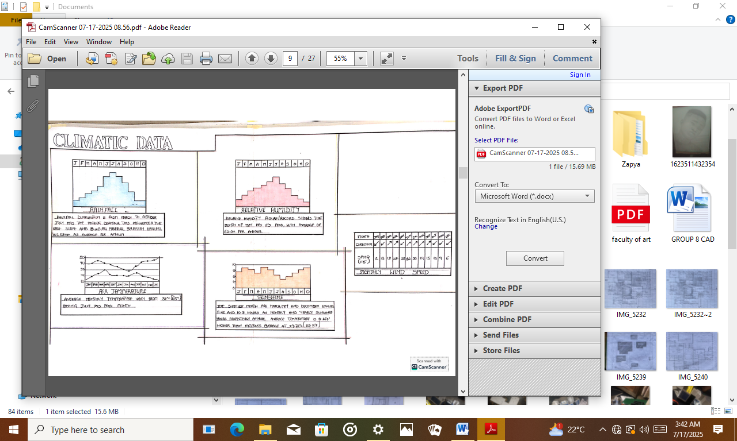
In owo local government, the wet season is warm, oppressive, and overcast and the dry season is hot, humid, and partly cloudy. Over the course of the year, the temperature typically varies from 63°Fto 92°F and is rarely below 57°F or above 97°F

Plate 3.4.2: Showing the climatic data
TOPOGRAPHY:
Terrain: The topography of OWO LGA is characterized by a mix of gentle slopes and flat areas. The region generally features rolling terrain with some undulating hills.
Elevation:The average elevation of owo is about 300-500meters above sea level.This moderate elevation influences local climate and vegetation.
SOIL TYPES
Soil composition: The soil in owo typically includes a mix of loamy and sandy soil, suitable for agriculture. The soil fertility varies across different parts of the area, impacting local farming practice.

4.5 AVERAGE TEMPERATURE IN OWO LGA
The hot season lasts for 2.4 months, from January 23 to April 4, with an average daily high temperature above 90°F. The hottest day of the year is February 19, with an average high of 92°F and low of 69°F.
The cool season lasts for 3.8 months, from June 19 to October 11, with an average daily high temperature below 83°F. The coldest day of the year is December 30, with an average low of 63°F and high of 88°F.
4.5.1 RAINFALL
Annual Rainfall: The annual rainfall in owo average around 1,000 to 1,500 millimeter. The rainfall pattern is influence by the West African Monsoon.
Rainy Season: The primary rainy season lasts from May to October with peak rainfall usually occurring between July to September. The dry season spans from November to April.
4.5.2 HUMIDITY
We base the humidity comfort level on the dew point, as it determines whether perspiration will evaporate from the skin, thereby cooling the body. Lower dew points feel drier and higher dew points feel more humid. Unlike temperature, which typically varies significantly between night and day, dew point tends to change more slowly, so while the temperature may drop at night, a muggy day is typically followed by a muggy night.
The muggier period of the year lasts for 10 months, from February 2 to December 8, during which time the comfort level is muggy, oppressive, or miserable at least 38% of the time. The muggiest day of the year is June 24, with muggy conditions 100% of the time.
The least muggy day of the year is December 31, with muggy conditions 17% of the time.

4.5.3 WIND
This section discusses the wide-area hourly average wind vector (speed and direction) at 10 meters above the ground. The wind experienced at any given location is highly dependent on local topography and other factors, and instantaneous wind speed and direction vary more widely than hourly averages.
The average hourly wind speed in ondo experiences significant seasonal variation over the course of the year.
The windier part of the year lasts for 6.6 months, from February 18 to September 7, with average wind speeds of more than 6.2 miles per hour. The windiest day of the year is August 2, with an average hourly wind speed of 7.9 miles per hour.
The calmer time of year lasts for 5.4 months, from September 7 to February 18. The calmest day of the year is November 14, with an average hourly wind speed of 4.4 miles per hour.
4.6 BRIEF DEVELOPMENT CRITERIA
a. Accessibility of the site: the accessibility of the earmarked site for this project is very adequate. The site is situated at Owo.
b. Site service: necessary infrastructure facilities is available within the site which include electricity supply, pipe born water supply and telephone lines, good road e t.c
C. Proximity to the users: the site if nearness to users for both higher institution and general public. All the area that’s the people reside are links to the site with good network of motor able roads.
d. Nature of the Site: the site is gently slopes down south west will allow for easy drainage of water on the site.
e. Less Noise: the location of the site is an area where noise coming from outside the site is minimal. The next thing to do in the course of the project is the DESIGN “itself in other to achieve an ideal, unique, function and well balance designing There must be a brief work On the brief depend generally and basically on- The-go scope of individual design.
The brief of this project is therefore based in the pharmaceutical industry the case studies and research that were carried out enhanced incoming coming out comprehensive brief of the proposed pharmaceutical industry. As a result of this enable me to put some new unit inside this propose project, e. G granulation and drying room, blending, compression room etc.
4.6.1 Design Brief/scope analysis
Analyzing some basic factors and index units of the design and what it comprises of; such asdry granulation, powder blending,Fluid bed granulation, Pharmaceutical milling, Compression of powder, Pharmaceutical en-capsulationetc
DRY GRANULATION: Compaction of a low-density powder to a granule. The roller compaction process consists of screw feed, compaction, and milling systems.
POWDER BLENDING: A wide range of excipients may be blended to create the final blend used to manufacture the solid dosage form in the pharmaceutical industry. The uniqueness of each drug formulation assures that no two blending processes can ever be identical.
FLUID BED GRANULATION: Top spray, bottom spray (Wurster), and rotary (tangential spray) are commonly used in the food and pharmaceutical industries.
PHARMACEUTICAL MILLING: The process of using rotary cutters in pharmaceutical equipment machinery to remove materials from a work piece by feeding in at an angle with the axis of the tool.
COMPRESSION OF POWDER: An efficient process for producing a solid dose medication.
PHARMACEUTICAL ENCAPSULATION: The containment of a solid or liquid dose of a drug in a soft shell or hard pre-formed capsule.
SCOPE
- Finished Goods store
- Raw materials
- Maintenance and firefighting arena
- Admin block
- Factory
- Parking lot
- Security post
Brief (Industry)
- Quarantine room
- Cloak room
- Raw materials store
- Offices
- Finished goods store
- Conference hall
- Research laboratory
- Quality assurance laboratory
- Maintenance office
- Cooling room
- Syrup production area
- Tablet production area
- Capsule production area
- Security and control unit
Admin Block
- Reception
- Stair hall
- Sales point
- C.M.O offices
- Manager office
- Secretary to the manager’s office
- Conference room
- Store
- Pharmacist offices
- Control room
- Rest rooms
4.6.2 PLANNING PRINCIPLE
Principle of planning is based on zoning the related unit according to its scope and Limitation accordance with bubble diagram.
The planning of various units is taken into consideration. The activity performed in each unit how they are related to one another and the use of the various units Design.
In this design there is three (3) main entrance porch that link each unit to production area, in each unit there is passage for them to have well accessible for everybody working under each unit.
Also this unit are categorized into two (2) there liquid manufacture area, liquid
And table manufacture but this unit have access to common room because is centralized in floor plan. Toilet appropriately

4.7 SPATIAL ALLOCTION
NO | BRIEF | DIMENSION  (lengthxbreadth) | TOTAL AREA  ( M²)
 | Main Entrance | 3300 x 12600 | 30.24
 | Delivery bay | 4800 x 7800 | 37.44
 | Raw material store | 7500 x 11100 | 83.25
 | Weighing room | 5100 x 3900 | 19.89
 | Laboratory | 6900 x 7200 | 49.68
 | Analyst office | 3900 x 7200 | 28.08
 | Changing room | 3000 x 4050 | 1.215
 | Maintenance unit | 7800 x 12000 | 93.6
 | Control room | 4500 x 3600 | 16.2
 | Tablet unit | 20400 x 25500 | 520.2
 | IPQC | 5100 x 6300 | 32.13
 | Store | 5100 x 3600 | 18.36
 | Finished product store 1 | 6000 x 10200 | 61.2
 | Loading bay | 3000x 10200 | 30.6
 | Capsule unit | 12600 x 18600 | 234.36
 | IPQC | 5700 x 5100 | 29.07
 | Syrup unit | 12000 x 18000 | 216
 | Wash room | 4200 x 5700 | 23.94
 | Finished product store 2 | 8400 x 12000 | 100.8
 | Convenience | 1200 x 2100 | 2.52

4.7.1 FUNCTIOAL RELATIONS
Functionalism is the principle that architects should design a building base on the purpose of that building .This statement is less-evident than it first appears, and is a matter of confusion and controversy with the profession, particularly about modern architecture.

4.7.2 Conceptual development
Examine of the proposed concept development for the design base on the aesthetic, functionality, growth, influence and cost is been considered for a better and simple concept choice. Relating the concept to the proposed environment to propagate the functionality, space and other factors to be considered.
4.7.3 DESIGNPARAMETER
Pharmaceutical Industry required planning consideration which an Architect and a site planner needs to put into consideration. This should be note that areas of industry and facilities should be adequately pleasant spaces for machinery used in the industry to be well allocated, fit to the environmental aesthetic and functionality factors.
Three basic fundamental to evaluate the purpose of the design are:-
- Planning Consideration
- Elementary Environmental Consideration
- Design Consideration
4.7.4 PLANNING CONSIDERATION
This involves site planning, orientation, and the evaluation of needs to the church promoting people settlement within the identifiable geographical settings of an area.
Site planning aids to aim at some basic principles such as :-
- Aesthetic and functionality factors
- Flexibility and growth of the design relating to the environment
- Adequate movement and circulation control.
4.7.5 ENVIRONMENTAL CONSIDERATION
These are important environmental factors affecting man and structures aiding to elongate basic prominent environmental factor to be considered in the design such as wind control, thermal comfort etc.
4.7.6 DESIGN CONSIDERATION
This aspect involved thorough and adequate information details and understanding the consideration of the pharmaceutical industry orientation and relationship with analysis of space, aesthetic and functional usage of the structure.
Space analysis evaluate the physical characteristics, qualities and the condition that can satisfy the client which purpose may be by providing, deduction of space area of land. This analysis influences the design by ultimating the translation of the criteria to physical dimension.
These are physical elements which comprise of space needed, including types and number of difference space, area requirement, comfort criteria requirement, and furnishings needed to make the space usable and functional.

OTHER ELEMENT FOR ENVIRONMENTAL IMPROVEMENT AND PROTECTION
LANDSCAPING
The general appearance of a building with its surroundings and increase its value of the design improves through landscaping.
Landscaping also can be used for thermal control such as to reduce wind effects, to provide shading against direct sun rays and assist ground drainage. Landscape elements are including soft and hard element, Manmade sculptures, garden, lawns, sit out etc.
ORIENTATION
This involves climatic and geographical control of the building on site in relationship to other site elemental factors to suit it adequate site planning.
4.8 APPRAISAL OF PROPOSED SCHEME
The construction method is based on-the method of appropriate technology that it is required by the design and the construction materials.
In other to minimize cost of construction there is need to employ the use or labour intensive and not capital intensive method. This is because the project IS being handled by league of professionals in the building term so there is need to employ more labour in view of the present problem of unemployment in the country. In term of materials, concrete mixes of required strength would be used for the construction of foundation, the floor slabs are completely reinforced for tensile loading. Sand create blocks should also be used for walls in all part of building; the comment to used for this construction must be elephant cement or Portland.
THE DESIGN IDEAS/CONCEPTS
Design concept or idea used is derived from the machinery use in the pharmaceutical industry
OCTAGONAL BLENDER
Octagonal blender is used for mixing and blending dry powder/Granules and other dry material. The bearinghouse and frame extracted from the octagonal blender machine led to the concept used.

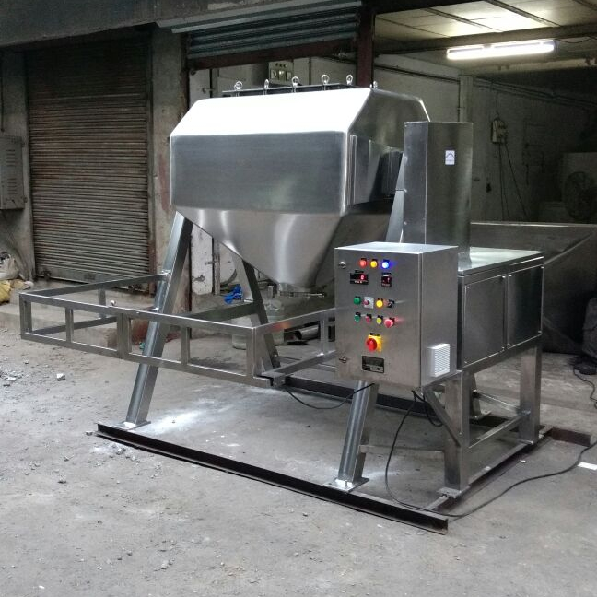

Figure 5.1: Octagonal blender

CHAPTER FIVE
5.1 CONSTRUCTION METHODOLOGY AND MATERIALS
The influence of building material construction works in Bida and its environment is similar to what prevails on-the-go middle belt of the control blocks in rectangular moulds are often use for wall in rectangular moulds are often used for wall construction with are often used for wall constructions with a standard of 100mm, 150mm and 225mm thickness the choice of materials and finishes are influenced by a number of factor Which include.
1. Available of materials
2. Climatic condition
3. The geology and topography of the site.
4. The durability and suitability of materials.
5. The choice of materials
5.1.1 ROOF: in the region where llorin belongs there are heavy rain falls and the roof should absolve as little solar energy as possible over to this long span galvanized aluminum roofing sheet is recommended for this project. Treated hardwood timber is used for the root member I. e 50 * 150mm hard wood timber tied been 50 * 150mm hard wood timber rafter etc
5.1.2 CEILING: the ceiling materials should be attractive and easily cleaned. It should also of moderate cost. The finishing for all part of the building should be Cellotex.
5.2 SERVICE CIRCULATION
Adequate care is taken in ensuring that the circulation routes within the entire building are well planned. There will be a clear definition of the pedestrian and vehicular routes on the sites.
5.2.1 VENTILATION
The space should be well ventilated in order to provide the users natural
ventilation, natural ventilation is provided is throughout the building orientating,
However the window openings are wide enough to permit penetration or movement of natural air or natural ventilation.
5.2.2 LIGHTING
Lighting is to be properly controlled through the combination of natural and artificial means. The most important place requiring special lighting effect is the factory where transparent roofing sheets are to be used. A courtyard will be introduced to throw in light in some parts of the building.
5.2.3 ELECTRICAL INSTALLATION
Electricity supply is provided by power holding PHCN. The magnitude of the voltage to be consumed by the machines, may suggest additional provision of transformers within the community.
5.2.4 WASTE DISPOSAL
On the issue of waste, the ISPE baseline Pharmaceutical Engineering
Guides for New Facilities Volume 2: oral Solid Dosage Forums -First Edition states
Among others that provisions should be made for the proper and the safe storage of waste materials awaiting disposal. Toxic substances and flammable materials should be stored in unsuitably designed, separate, enclosed cupb0ards separate, enclosed cupboards as required by nationals’ legislation. For this to be undertaken effectively waste disposal should be part of the design thought process. It is import to it is import for the designer to know the type and nature of waste to be generated by the plant and how best these can be safely disposed off as directed by national regulations.
5.2.5 FIRE PROTECTING DEVICES
Fire points are to be located at strategic position in the complex in case of any fire outbreak or Hazard. Fire resistance retarded floor and wall finishes are to be used e.g Texacote wall granolithic floor finishes etc also fire protection derives such as sprinklers are used in spreading water over fire, while the drencher ISA dervish used in keeping the whole over surrounding the fire.
5.2.6 DRAINAGE
The roads within the site will be provided with covered drainage which will enhance smooth run off of surface water and enable ease of clearing the drainage Blockage.
5.2.7 RAIN PROTECTION DEVICES
The weather and climate condition of an area determine the comfort associated with that surrounding hence, the provision should be made for fast disposal of rain water. Therefore, to control the heavy rain fall during the wet season (April- October). The construction of gutter and other rain devices will be provided.
5.2.8 OVER HEATING
There is an introduction of cavity Wall within the larger sides of the building for Expansion purpose this prevent over-heating and continuous of cracking
5.2.9 EXTERNAL WORKs
This deals with Roads, Landscaping, and Drainage etc.
5.2.10 ACCESS REQUIREMENT
Relationship between the building, public walk way, road, landscaped, and also provision will be made for entrance staff and service, entrance all of which De Separated.
5.2.11 PEDESTRIAN WALK WAY
Main pedestrian walkway in to the production unit 2400mm wide to allow three person passing at once, and the walkway has a very good connectivity to every part of the site.
Road: this is the vehicular access and easy movement inside, which has a good Link from the gate to every parking space provided. It finished with bitumen surfacing to a thickness specified by the engineer.
Landscaping: the whole of the site is planned to have an aesthetically administrable impression and good environment by given the entire site adequate landscaping. Planning of shrub and tress around the site is used to provide shade and reduce noise from the surrounding.
LANDSCAPING
These works are carried out on the site and surroundings of the building. It comprises of elements used in provision of aesthetics and general human comfort in and out round the building. This includes
- Hard Landscaping
- Soft Landscaping
HARD LANDSCAPING
This is done by paving the whole of the open ground and such paving area include the parking lot, the walk - ways, roads etc.
SOFT LANDSCAPING
This is done by planting of trees, shrubs and flowers around the building surrounding to serve as barrier to the thermal discomfort and beautify the structures.
5.3 SUMMARY AND CONLUSION
This project sets out to produce a design that is adequately, functional aesthetically balances with good orientation for the proposed pharmaceutical industry for Owo local government Ondo state ,this becomes necessary because in Owo local government is largest local government that do not have much industry, also to several entire local government and create for people in Owo and its environment.
The deduction and experience gained from the research have exposed me to pharmaceutical industry design; these information and deduction were used to develop the design of proposed pharmaceutical industry. This project enables me to contribute my quota to the enhancement of architectural technology study in Kwara State Polytechnic, llorin.

5.4 RECOMMENDATION
- Leverage Digital Technologies: Integrate AI, machine learning, and big data analytics to accelerate clinical trials, optimize supply chains, and enhance drug safety monitoring. Digital tools also enable better patient engagement and remote healthcare services.
- Focus on Regulatory Agility and Compliance:Navigate increasingly complex global regulations by building agile compliance frameworks and fostering strong relationships with regulatory bodies. Speeding up approvals without compromising safety is critical.
- Expand Access Through Global Markets and Partnerships:Explore emerging markets with high growth potential through collaborations, licensing deals, and localized manufacturing. Strategic partnerships can also share R&D costs and reduce risks.
- Sustainability and Ethical Practices:Integrate sustainable manufacturing processes and transparent ethical standards to build trust among patients, healthcare providers, and regulators.

REFERENCES
ASHARE. (2000). ASHARE Handbook 200HVAC Svstems and Equipment, Atldntd
Ching Frank D.K. and Adams Cassandra. (1991), Building construction Illustrated second Edition, Van Nostránd, New York
Chudley R. And Green R., (2001), Building Construction Handbook-fourn
Edition, Elseveir Butter-Worth Heinemann, Oxtord. Commission of the European Communities (1991), the Rules Governing Medical Products in the European community-volume IV Good Manufacturing Practice for Medical product, Office for official Publications of the European communities, Luxumbourg.
Graham Cole, (1998), pharmaceutical product facilities design and Applications (second edition), Taylor and Francis, London.
Hornby A.S (200), Oxford Advanced Learner’s Dictionary of Current English Sixth edition, Oxford University Press. ISO, (1999), International Clean room Standard-Iso 14644 part 1-6, Geneva, Switzerland. ISPE,(1996), ISPE Baseline Pharmaceutical Engineering Guides for New
Facilities Volume 2: Oral Solid Dosage Forms-First Edition, Tampa.
McGuire, John L.; Hasskarl, Horst; Bode, Gerd; Klingmann, Ingrid; Zahn, Manuel (2007). Pharmaceuticals, General Survey". Ullmann's Encyclopedia of Industrial Chemistry. Wiley. doi:10.1002/14356007.a19_273.pub2. ISBN 978-3527306732.
Bozenhardt, Erich H.; Bozenhardt, Herman F. (18 October 2018). "Are You Asking Too Much From Your Filler?". Pharmaceutical Online (Guest column). VertMarkets. Archived from the original on 17 November 2020. Retrieved 30 October 2018. The core mission of the pharmaceutical industry is to manufacture products for patients to cure them, vaccinate them, or alleviate a symptom, often by manufacturing a liquid injectable or an oral solid, among other therapies.
Markets, Research and (31 March 2021). "Global Pharmaceuticals Market Report 2021: Market is Expected to Grow from $1228.45 Billion in 2020 to $1250.24 Billion in 2021 - Long-term Forecast to 2025 & 2030". GlobeNewswire News Room. Archived from the original on 29 November 2021. Retrieved 29 November 2021.
Multinational corporations including Merck, Hoffman-La Roche, Burroughs-Wellcome (now part of Glaxo Smith Kline), Abbott Laboratories, Eli Lilly and Upjohn (now part of Pfizer) began as local apothecary shops in the mid-1800s.
Emergence of Pharmaceutical Science and Industry(1870-1930)". Chem Eng News. 83 (25). 20 June 2005. Archived from the original on 10 November 2018. Retrieved 23 July 2022.
Sneader, Walter (31 October 2005). "13 Neurohormones". Drug Discovery: A History. John Wiley & Sons. pp. 155–156. ISBN 978-0-470-01552-0. Retrieved 23 July 2022.
Rasmussen, Nicolas (2006). "Making the First Anti-Depressant: Amphetamine in American Medicine, 1929-1950". J Hist Med Allied Sci. 61 (3): 288–323. doi:10.1093/jhmas/jrj039. PMID 16492800. S2CID 24974454.
Rasmussen N (2008). "America's First Amphetamine Epidemic 1929–1971". Am J Public Health. 98 (6): 974–985. doi:10.2105/AJPH.2007.110593. PMC 2377281. PMID 18445805.
Yasiry Z, Shorvon SD (December 2012). "How phenobarbital revolutionized epilepsy therapy: the story of phenobarbital therapy in epilepsy in the last 100 years". Epilepsia. 53 Suppl 8: 26–39. doi:10.1111/epi.12026. PMID 23205960. S2CID 8934654.
López-Muñoz F, Ucha-Udabe R, Alamo C (December 2005). "The history of barbiturates a century after their clinical introduction". Neuropsychiatr Dis Treat. 1 (4): 329–43. PMC 2424120. PMID 18568113.
Drug Abuse Control Amendments of 1965". NEJM (Editorial). 273 (22): 1222–1223. 25 November 1965. doi:10.1056/NEJM196511252732213. Officers of the Food and Drug Administration, aware of the seriousness of the problem, estimate that approximately half the 9,000,000,000 barbiturate and amphetamine capsules and tablets manufactured annually in this country are diverted to illegal use. The profits to be gained from the illegal sale of these drugs have proved an attraction to organized crime, for amphetamine can be purchased at wholesale for less than $1 per 1000 capsules, but when sold on the illegal market, it brings $30 to $50 per 1000 and when retailed to the individual buyer, a tablet may bring as much as 10 to 25 cents.
Sedative-Hypnotic Drugs — the Barbiturates — I". NEJM. 255 (24): 1150–1151. 1956. Doi:10.1056/NEJM195612132552409. THE barbiturates, introduced into medicine by E. Fischer and J. von Mering1 in 1903, are certainly among the most widely used and abused drugs in medicine. Approximately 400 tons of these agents are manufactured each year; this is enough to put approximately 9,000,000 people to sleep each night for that period if each were given a 0.1-gm. Dose
Rosenfeld L (December 2002). "Insulin: discovery and controversy". Clin Chem. 48 (12): 2270–88. doi:10.1093/clinchem/48.12.2270. PMID 12446492.
Leading Causes of Death, 1900-1998" (PDF). CDC.gov. Archived (PDF) from the original on 13 December 2020. Retrieved 23 July 2022.
Anderson, Robert N. (13 December 1999). "United States Life Tables, 1997" (PDF). National Vital Statistics Reports. 47 (28). Archived from the original (PDF) on 25 October 2020. Retrieved 23 July 2022.
Sepkowitz, Kent A. (July 2011). "One hundred years of Salvarsan". N. Engl. J. Med. (Perspective). 365 (4): 291–3. doi:10.1056/NEJMp1105345. PMID 21793743.
Williams, KJ (1 August 2009). "The introduction of 'chemotherapy' using arsphenamine – the first magic bullet". J. R. Soc. Med. 102 (8): 343–348. doi:10.1258/jrsm.2009.09k036. ISSN 0141-0768. PMC 2726818. PMID 19679737.

APPENDICES

APPENDICES 1

APPENDICES 2

APPENDICES 3

APPENDICES 4

APPENDICES 5

APPENDICES 6

APPENDICES 7

APPENDICES 8

APPENDICES 9

APPENDICES 10

APPENDICES 10

APPENDICES 10

APPENDICES 11

