A PROJECT REPORT

ON

PROPOSED COMPREHENSIVE HEALTH CENTER

FOR

OKOLOWO COMMUNITY AREA.

BY

TAJUDEEN, AZEEZ OPEYEMI
HND/23/ARC/FT/0051

A PROJECT REPORT SUBMITTED TO THE DEPARTMENT OF ARCHITECTURAL TECHNOLOGY, INSTITUTE OF ENVIROMENTAL STUDIES (IES), KWARA STATE POLYTECHNIC, ILORIN

IN PARTIAL FULFILMENT OF THE REQUIREMENT FOR THE AWARD OF HIGHER NATIONAL DIPLOMA (HND) IN ARCHITECTURAL TECHNOLOGY

JULY, 2025

DECLARATION
I declare that this Project/report is a product of my personal research work. It has not been presented for the award of any degree in any Polytechnic . The ideas, observations, comments, suggestions herein represent my own convictions, except quotations, which have been acknowledged in accordance with conventional academic traditions.

Name: TAJUDEEN AZEEZ OPEYEMI

Matric NO.: HND/23/ARC/FT/0051

___________________________
Signature and Date

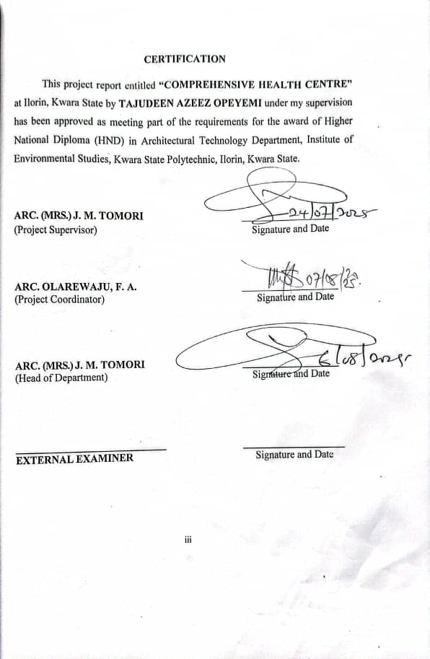
DEDICATION
This project is dedicated to God Almighty and to my Parents Mr. and Mrs. Tajudeen also to Twins and as well my brothers.

ACKNOWLEDGEMENTS
I am grateful to Almighty Allah, The Omniscience, Omnipotent, Alpha and Omega for granting me the opportunity to complete the project for my Higher National Diploma and to study Architecture in the great Institute of Environmental Studies, Kwara State Polytechnic, Ilorin, Kwara State.
I would like to express my heartfelt appreciation to my supervisor in person of ARC. (MRS.) J. M. TOMORI for the valuable time she spent going through this work and making all necessary corrections where due. Also, I extend my gratitude to the Project Coordinator of the department of Architectural Technology for his innovative ideas and priceless contributions towards the growth of the department.
I would like to acknowledge the effort of ARC. SOLOMON FAMILUA, ARC. CHUCKS, ARC. OLAREWAJU, F. A. and all the lecturers in the department for their harmony and positive impact on the growth of the department. May Almighty Allah continue to bless and protect you and your various families.
I am indebted to my parents Mr. and Mrs. Tajudeen for their unwavering support both financially and morally throughout my years of study. I pray that they will live long to enjoy the fruits of their labour.
Finally, I would like to appreciate my Siblings, Brothers and Sisters, Juniors and as well friends for their compassionate concern for my progress “Thank You” yet again for your support, guidance and encouragement. May God Almighty bless you all.

ABSTRACT
This design project covers the development nature of Comprehensive Health Activities and their Impact in the Surrounding Environment. The first chapter provides a Historical Background, Introduction, Definition, Scope of the Study, Justification and other relevant information. With the second chapter reviews relevant information on Literature and Presents a Case Study. The third chapter discusses the proposed site, including a brief history of Ilorin, Climate Considerations, Site Location, Site Description, Site Analysis, Existing Infrastructure, Site Selection Criteria and Site Planning. Chapter outlines the project concept and design including design scopes & briefs analysis of the scopes and briefs details of the parapet/ drainage details & space allocation. Chapter five covers design solutions such as Acoustic, Ventilation, Lighting, Orientation, Fire Protection and Central Services, Landscape Design, Construction Specification and Materials finishes and Maintenance. Finally, Chapter six provides a project Summary, Conclusion and References.

TABLE OF CONTENTS
Title Page………………………………………………………………… i
Declaration ...…………………………………………………………….. ii
Certification ……………………………………………………………… iii
Dedication…………………………………………………………………. iv
Acknowledgements………………………………………………………… v
Abstract……………………………………………………………………. vi
Table of Content…………………………………………………………… vii - viii
List of Figures……………………………………………………………… ix
List of Plates………….…………………………………………………… x
List of Tables……………………………………………………………… xi
List of Appendices………………………………………………………… xii
CHAPTER ONE
1.0 Introduction……………………………………………………… 1
1.1 Historical Background…………………………………………… 1
1.2 Statement of Design Problems…………………………………… 2
1.3 Aim………………………………………………………………… 3
1.4 Objectives………………………………………………………… 3
1.5 Justification……………………………………………………… 3
1.6 Client’s Background……………………………………………… 3
1.7 Definition………………………………………………………… 4
1.8 Scope of the Project……………………………………………… 4
1.9 Limitation of the Study…………………………………………… 6
1.10 Research Methodology……………………………………………. 7
CHAPTER TWO
2.0 Literature Review: Brief Literature Review: ……………………… 8
2.1 Historical Development of Health Care Centers in Nigeria……… 9
2.2 Importance of the Project………………………………………… 11
2.3 Impact of the Project to the Society……………………………… 13
2.4 Significant to the Proposed Location……………………………… 15
CHAPTER THREE
3.0 Case Studies……………………………………………………… 17
3.1 Brief History of Case Study One………………………………….. 17
3.2 Case Study Two…………………………………………………… 22
3.3 Case Study Three………………………………………………… 26
3.4 Case Study Four…………………………………………………… 30
CHAPTER FOUR
4.0 Introduction to Study Area………………………………………………… 34
4.1 Historical Background of Kwara State…………………………………….. 34
4.2 Physical Feature of the Location…………………………………………… 36
4.3 Population of Kwara State…………………………………………………. 37
4.4 Social Services……………………………………………………………... 37
4.5 General Climatic Condition………………………………………………... 37
4.6 Site Analysis……………………………………………………………….. 39
4.7 Design Brief……………………………………………………………….. 41
4.8 Design Analysis…………………………………………………………… 42
4.9 Design Concept/Planning Principle……………………………………….. 44
CHAPTER FIVE
5.0 Design Appraisal…………………………………………………………… 47
5.1 Design Characteristics……………………………………………………. 47
5.2 Building Structure………………………………………………………… 49
5.3 Service……………………………………………………………………. 49
5.4 General Requirement……………………………………………………… 50
5.5 Material and Finishes…………………………………………………….. 51
5.6 Summary, Conclusion and Recommendations……………………………... 53
Reference…………………………………………………………………... 56
Appendices………………………………………………………………… 57

LIST OF FIGURES
Figure 3.1.1: Showing the Location Plan of Case Study One Located…………..19
at Ogidi Area, Ilorin, Kwara State.
Figure 3.1.2: Showing the Site Plan of Case Study One Located……………….. 20
at Ogidi Area, Ilorin, Kwara State.
Figure 3.1.3: Showing the Floor Plan of Case Study One Located……………….20
at Ogidi Area, Ilorin, Kwara State.
Figure 3.2.1: Showing the Location Plan of Case Study Two Located……………23
at Boripe Local Government Area, Osun State.
Figure 3.2.2: Showing the Site Plan of Case Study Two Located…………………24
at Boripe Local Government Area, Osun State.
Figure 3.2.3: Showing the Floor Plan of Case Study Two Located……………….24
at Boripe Local Government Area, Osun State.
Figure 3.3.1: Showing the Locational Plan of Case Study Three Located…………27
at Ogbomoso Area, Oyo State.
Figure 3.3.2: Showing the Site Plan of Case Study Three Located………………..28
at Ogbomoso Area, Oyo State.
Figure 3.3.3: Showing the Floor Plan of Case Study Three Located………………28
at Ogbomoso Area, Oyo State.
Figure 3.4.1: Showing the Locational Plan of Case Study Four Located…………..31
at Ile-Alawo Okelele Road, Ilorin.
Figure 3.4.2: Showing the Site Plan of Case Study Four Located………………….32
at Ile-Alawo Okelele Road, Ilorin.
Figure 3.4.3: Showing the Floor Plan of Case Study Four Located………………..32
at Ile-Alawo Okelele Road, Ilorin.
Figure 4.5.1: Climatic Data………………………………………………………….38
Figure 4.6.1: Site Analysis…………………………………………………………..39
Figure 4.9.1: Functional Relationship……………………………………………….45
Figure 4.9.2: Site Zoning……………………………………………………………46

LIST OF PLATES
Plate 3.1.1: Showing the Floor Plan of Case Study One Located……………21
at Ogidi Area, Ilorin, Kwara State.
Plate 3.1.2: Showing the Floor Plan of Case Study One Located……………21
at Ogidi Area, Ilorin, Kwara State.
Plate 3.2.1: Showing the Front View of Case Study Two Located…………..25
at Boripe Local Government Area, Osun State.
Plate 3.2.2: Showing the Side View Of Case Study Two Located…………..25
at Boripe Local Government Area, Osun State.
Plate 3.3.1: Showing the Front View of Case Study Three Located…………29
at Ogbomoso Area, Oyo State.
Plate 3.3.2: Showing the Side View of Case Study Three Located………….29
at Ogbomoso Area, Oyo State.
Plate 3.4.1: Showing the Front View of Case Study Four Located………….33
at Ile-Alawo Okelele Road, Ilorin.
Plate 3.4.2: Showing the Side View of Case Study Four Located…………..33
at Ile-Alawo Okelele Road, Ilorin.
Plate 4.1.1: Kwara State Map………………………………………………..36
Plate 4.6.1: Locational Plan………………………………………………….40

LIST OF TABLES
Table 4.8.1: Unit's of the Project……………………………………………………..42

LIST OF APPENDICES
Appendix 1: Locational Map of Okolowo Comprehensive Health Care…………...57
Appendix 2: Site Plan of Okolowo Comprehensive Health Care…………………..58
Appendix 3: Section of Okolowo Comprehensive Health Care……………………59
Appendix 4: Front and Side View of Okolowo Comprehensive Health Care……...60
Appendix 5: Internal Perspective of Okolowo Comprehensive Health Care ………61
Appendix 6: External Perspective of Okolowo Comprehensive Health Care……...62
Appendix 7: Roof Plan of Okolowo Comprehensive Health Care…………………63
Appendix 8: Floor Plan of Okolowo Comprehensive Health Care………………...64

CHAPTER ONE
GENERAL INTRODUCTION
1.0 INTRODUCTION
A comprehensive Health Center (CHC) is a Health Care faculty that provides a wide range of medical services to individuals and communities, focusing on preventive, curative and rehabilitative care. CHC are designed to serve as one-step location where patients can receive various types of healthcare services under one roof, healthcare center offer the following type of healthcare services, family planning, immunizations, treatment or chronic diseases.
A comprehensive health center (CHC) provides a broad range of medical services to meet the diverse needs of a community. CHC aim to deliver accessible high-quality and patient-centered care, promoting overall health and well-being.
CHC plays a vital role in improving healthcare outcomes reducing disparities and enhancing the overall quality of life for individuals and communities.
1.1 HISTORICAL BACKGROUND
Comprehensive health center in Nigeria have a history rooted in the countries adoption of primary health care (PHC) as a core components of its healthcare system. In 1975 - 1980, Nigeria sports attempt at implementing PHC was through the basic health service scheme (BHSS), part of the third National Development plan. The BHSS aimed to increase healthcare accessibility but it's sustainability was charging by inadequate infrastructure and poor community involvement.
In the year 1978 Nigeria signed the Alma Mata declaration emphasizing the importance of PHC in achieving health for all the year 2000 and the Federal government selected 52 pilots local Government Areas (LGAs) as models for PHC implementation on established world health technology to support the initiative and PHC was adopted as the cornerstone of Nigeria's National Health Policy.
The national primary health care's development agency (NPHCDA) launched the word minimum health made up over 85% of healthcare institution in Nigeria and quarterly primary healthcare planning and reviews PHC wear introduced to monitor progressing PHC implementation, management and decentralizing were been controlled by the National health act under the authority of LGAs.
1.2 STATEMENT OF DESIGN PROBLEMS
Despite the strategic importance of Comprehensive Health Centers in delivering primary health care, many of these facilities across Nigeria, including the one in Okolowo Community, face significant challenges that hinder their effectiveness. These challenges are primarily architectural, functional, environmental, and operational in nature, and they form the basis of this design project.
One major design problem is the lack of adequate spatial planning to accommodate the range of services expected in a comprehensive health center. Many existing facilities are either too small or poorly structured to support departments such as outpatient clinics, maternity wards, laboratory units, administrative offices, and pharmacy services under one roof. This often leads to congestion, poor workflow, and reduced efficiency in health service delivery.
Another key issue is the poor integration of environmental design principles, such as natural lighting, ventilation, and sanitary layout. Many health centers in rural or peri-urban areas like Okolowo lack proper waste disposal systems, ventilation corridors, and infection control zoning, thereby increasing the risk of disease transmission and patient discomfort.
Additionally, the lack of provision for future expansion and community-specific needs presents a challenge. As Okolowo continues to grow, the demand for health services will increase. Most existing centers were not designed with flexibility or scalability in mind, making it difficult to adapt the facility to changing health care demands over time.

1.3 AIM
The primary aim of this design is to carry out an index study on a planning of effective circulation in Comprehensive Health Care Center that will ask what movement and direct to secure both patient and staff.
1.4 OBJECTIVES
- To ensure a well-ventilated on where lightness structure in the design.
- To design a model and well equipped Comprehensive Health Care Center.
- To improve the capacity of healthcare system and infrastructure will bring the community.
1.5 JUSTIFICATION
Due to the current situation of healthcare Center issues in the area. Healthcare and assistant couldn't be administered to patient as a result of poor infrastructure, healthcare amenities so the proposed Comprehensive Health Care Center will provide an essential design that will cater, provide the need of health issues to the beneficiary of the community people of Okolowo Area.
1.6 CLIENT’S BACKGROUND
Okolowo Community, located along the Ilorin–Jebba expressway in Ilorin West Local Government Area of Kwara State, Nigeria, is a rapidly growing peri-urban settlement with a diverse population. Traditionally an agrarian community, Okolowo has experienced significant population growth in recent years due to increased migration, urban expansion, and commercial activity. Despite its proximity to Ilorin metropolis, the community still faces major challenges in terms of access to essential public services, especially health care.
The Comprehensive Health Center in Okolowo serves as the primary health care facility for residents of the community and surrounding villages. It is strategically positioned to cater to the health needs of a population that includes farmers, traders, artisans, and low-income earners. The center is expected to provide a range of services including maternal and child health, immunization, treatment of common illnesses, health education, and minor emergency care. However, anecdotal evidence suggests that the facility may be underutilized or under-equipped, with issues such as inadequate manpower, poor infrastructure, and limited medical supplies affecting service delivery.
The health-seeking behavior of residents is also influenced by socio-economic and cultural factors, which may lead them to rely on traditional medicine or private chemists for care. As a result, preventable health conditions often go untreated, and complications arise due to delayed access to professional medical services.
Given the growing population of Okolowo and the critical role of comprehensive health centers in delivering primary health care, there is a pressing need to assess the operational efficiency, service delivery capacity, and community perception of the Okolowo Comprehensive Health Center. This background provides the foundation for investigating how well the center is meeting the health needs of the community and what improvements can be made to strengthen the PHC system in the area.
1.7 DEFINITION
HEALTH CENTER: Health center is a faculty that provides primary healthcare service to individuals and communities. It’s a place where people can receive medical care, preventive care and health education.
COMPREHENSIVE HEALTH CENTER: A Comprehensive Health Center is a type of medical facilities that provides a wide range of health service including primary care. Specialty care and preventive care providing patient with access to variety of medical services.
1.8 SCOPE OF THE PROJECT
1.8.1 PROJECT SCOPE
- Entrance Gate
- Parking Lot
- Pedestrian Walkway
- Main Building
- Mini Mart
- External Utilities
- Generator House
1.8.2 BRIEF DEVELOPMENT OF THE PROJECT
- Entrance
- Reception
- General Waiting Room
- Registration Office
- Medical Records Room
- Accounting Office
- Head of Staff Office
- Nurse Station
- Matrons Room
- Laundry Kitchenette
- Conference Room
IN PATIENT
- Male Ward
- Female Ward
- Children Ward
- Maternity Ward (Labour Room, Incubator Room).
OUT PATIENTS
- Consultation Room
- Eye Care
- Dental Care
- Immunization
- Family Planning
DIAGNOSTIC UNIT
- Pharmacy (Dispensing)
- Laboratory (Blood Donor, Storage)
- X-ray (Dark Room, Film Collector)
EMERGENCY UNIT
- Ambulance Garage
- Reception
- Emergency Ward Room
- Convenience
- Storage
SURGICAL UNITS
- Operating Theatre
- Sterilization
- Recovery Room
1.9 LIMITATION OF THE STUDY
This study, while aiming to provide a detailed and functional design proposal for a Comprehensive Health Center in Okolowo Community, is not without limitations. One significant challenge encountered is the limited access to accurate and up-to-date data on the current state of health care services in the area, including patient turnout, staff availability, and infrastructural conditions. This limitation affects the precision of some design assumptions. Additionally, financial constraints restricted the scope of the study, limiting the ability to carry out extensive fieldwork, expert consultations, or broader community engagement, which could have enriched the design process. Time limitations also posed a challenge, as the study had to be completed within a set academic or professional deadline, reducing opportunities for prolonged research or real-time feedback. Furthermore, frequent changes in government health policies and standards pose a challenge, as any shift in policy direction might affect the applicability or implementation of the proposed design. Lastly, the unavailability of certain construction materials, medical technologies, or sustainable features in local markets may limit the practical realization of the design. Despite these challenges, the study strives to offer a realistic, context-driven, and sustainable approach to improving primary health care delivery in the Okolowo community.
1.10 RESEARCH METHODOLOGY
The research and play both primary and secondary source of data. The primary data was so true personal observation and interview from professionals in the field of study.
Why the secondary source involve consultation of textbooks, online journal and article. The data will be presented in a simple and self-explanatory method to allow for easy understanding by all.
The Method Engages:
- Library
- Oral Interview
- Internet
- Case Studies

ORAL INTERVIEW: Oral Interview was also conducted with people involved with the indoor sport complex such as the Secretary to the Sport Director.
INTERNET: Research was made through Internet from different website about indoor sport hall and indoor games.
LIBRARY: Research was also made from books and write-up research was made on books such as Architectural Data.
CASE STUDIES: Case Studies research was made by both physical Case Studies in different States and Online Case from two different Countries.

CHAPTER TWO
2.0 LITERATURE REVIEW
BRIEF LITERATURE REVIEW:
Comprehensive Health Centers Comprehensive health centers (CHCs) are community-based facilities that provide a wide range of healthcare services including primary care, mental health, dental care, preventive services, and health education—especially targeting underserved populations Nagel et al. (2021).
Studies show that CHCs improve healthcare access, reduce disparities, and enhance health outcomes, particularly for low-income and uninsured individuals. Research highlights their effectiveness in managing chronic diseases, increasing preventive care uptake, and lowering emergency room visits.
The integrated care model—such as Patient-Centered Medical Homes—used in CHCs ensures coordination across multiple services. Despite these strengths, CHCs face challenges like limited funding, workforce shortages, and policy barriers. Globally, CHCs align with WHO's goal of achieving universal health coverage through primary care. Future efforts should focus on sustainable financing, expanding telehealth, and deeper integration of mental health services.
A comprehensive literature review on comprehensive health centers reveals that they are a vital component of effective primary health care, often characterized by multidisciplinary teams, community engagement, and a broad scope of services. They can be impactful in improving health outcomes, particularly in addressing health inequities and promoting preventative care. However, they also face challenges in maintaining their comprehensiveness and navigating integration within larger health systems.

2.1 HISTORICAL DEVELOPMENT OF HEALTH CARE CENTERS IN NIGERIA
The development of health care centers in Nigeria has evolved significantly from pre-colonial times to the present day. Below is a broad overview of the historical progression:
1. Pre-Colonial Era (Before 1860s)
Before Western medicine was introduced, health care in Nigeria was largely based on traditional medicine, which included the use of herbs, spiritual healing, and rituals performed by traditional healers, herbalists, and diviners. These indigenous health practices were deeply rooted in cultural and spiritual beliefs and were highly respected within communities. Health care was provided within family units or by community elders, with no formal health care centers.
2. Colonial Era (1860s – 1960)
The introduction of Western-style medicine came with European missionaries and colonial administrators in the late 19th century. This period marked the beginning of organized health care in Nigeria.
- Missionary Contributions: Christian missionaries established the first health care centers, primarily in southern Nigeria. Hospitals and clinics were attached to mission schools and churches, focusing on treating common ailments and controlling epidemics.
- Colonial Government Involvement: The British colonial government began building hospitals mainly in urban areas and areas of economic interest (ports, railways, and mines).
- Focus was mainly on curative services, and there was limited access in rural areas.
- Notable early hospitals: Sacred Heart Hospital in Abeokuta (established in 1895) is often regarded as the oldest hospital in Nigeria.

3. Post-Independence Era (1960 – 1980s)
After independence in 1960, the Nigerian government took over the health system and began expanding health care services to meet the needs of its growing population.
- Establishment of Tiers: A three-tier health care system was introduced—primary, secondary, and tertiary care—each with defined responsibilities.
  - Primary Health Care (PHC): Basic services at community level.
  - Secondary Health Care: General hospitals at local or state level.
  - Tertiary Health Care: Specialized services at teaching hospitals and federal medical centers.
- National Health Policies: The first National Development Plans emphasized building hospitals and training health professionals.
- The 1978 Alma Ata Declaration led Nigeria to adopt the Primary Health Care (PHC) approach as a key strategy to achieve "Health for All."
4. Structural Adjustment and Decline (1980s – 1990s)
During the 1980s and 1990s, Nigeria’s health system faced serious challenges:
- Economic downturn and Structural Adjustment Programs (SAPs) led to cuts in public health funding.
- Brain drain of medical professionals due to poor working conditions.
- Deterioration of infrastructure and service delivery in health centers.
- PHC systems weakened, and access to affordable care declined.
5. Health Sector Reforms and Decentralization (2000s – Present)
Since 2000, there have been renewed efforts to revamp the health care system:
- National Health Policy (2004) and National Health Act (2014) aimed to restructure health care delivery.
- Expansion and revitalization of Primary Health Care Centers (PHCs) through the National Primary Health Care Development Agency (NPHCDA).
- State and local governments were given more responsibilities in managing health centers, especially PHCs.
- Introduction of the Basic Health Care Provision Fund (BHCPF) in 2018 to strengthen PHC systems and ensure access to quality services.
- Emphasis on Universal Health Coverage (UHC), health insurance schemes, and public-private partnerships.
6. Recent Developments and Challenges
- Efforts to digitalize health care delivery, improve maternal and child health, and respond to pandemics (e.g., COVID-19).
- Ongoing challenges include:
  - Poor infrastructure
  - Inadequate funding
  - Uneven distribution of health care facilities (rural vs urban)
  - Shortage of trained health workers
2.2 IMPORTANCE OF THE PROPOSED OKOLOWO PROJECT
A comprehensive health center is crucial to society because it provides accessible, affordable, and holistic healthcare services. It helps prevent and manage diseases, reduces the burden on hospitals, and promotes healthier lifestyles through education. By offering physical, mental, and social health support in one place, it ensures all community members, especially the underserved, receive quality care. This leads to a healthier, more productive society and strengthens community well-being.
A comprehensive health center plays a key role in improving the overall well-being of a community. It offers a wide range of services including medical care, mental health support, dental care, preventive services, and health education—all in one location. This makes healthcare more accessible and convenient, especially for low-income, rural, and underserved populations.
These centers help reduce health disparities by providing affordable care regardless of a person's ability to pay. They also focus on disease prevention and health promotion, which lowers the risk of serious illness and reduces healthcare costs in the long term.
By managing chronic conditions and providing continuous care, comprehensive health centers decrease the burden on hospitals and emergency services. Additionally, they create jobs and support the local economy, while building community trust through culturally sensitive and community-based care.
In summary, comprehensive health centers are essential for ensuring equitable healthcare access, improving public health outcomes, and supporting a stronger, more resilient society.
A comprehensive health center is vital to society as it improves health outcomes, increases access to healthcare, promotes health education, reduces healthcare costs, enhances quality of life, and supports the local economy. By providing comprehensive healthcare services, these centers contribute significantly to the overall well-being of the community.
A comprehensive health center is essential to society for several reasons:
Improved Health Outcomes
- Increased Access to Healthcare: Comprehensive health centers provide a wide range of medical services, making healthcare more accessible to the community.
- Better Management of Chronic Diseases: The center can provide ongoing care and management for chronic conditions, improving health outcomes and reducing complications.
Community Benefits
- Promoting Health Education: Comprehensive health centers can educate the community on healthy behaviors, disease prevention, and management.
- Reducing Healthcare Costs: By providing preventive care and early intervention, the center can help reduce healthcare costs in the long run.
Social Benefits
- Improved Quality of Life: Comprehensive health centers can improve the overall quality of life for community members by providing comprehensive healthcare services.
- Increased Productivity: By improving health outcomes, comprehensive health centers can help community members be more productive and contribute to the local economy.
Economic Benefits
- Job Creation: Comprehensive health centers can create jobs for healthcare professionals and support staff, contributing to the local economy.
- Stimulating Local Economy: The center can attract patients from surrounding areas, stimulating the local economy through increased foot traffic and spending.
Overall, comprehensive health centers play a vital role in promoting the health, well-being, and economic stability of the community.
2.3 IMPACT OF THE PROPOSED OKOLOWO PROJECT TO THE SOCIETY
Comprehensive Health Centers (CHCs) have a significant impact on society by improving overall public health. They provide accessible, preventive, and primary care services, which help in the early detection and management of diseases. This leads to a reduction in the spread of preventable illnesses and promotes healthier lifestyles within communities.
CHCs also play a key role in promoting health equity. By serving people regardless of their income, insurance status, or background, these centers help reduce disparities in healthcare access. This ensures that even the most vulnerable populations receive the care they need. Economically, CHCs contribute by lowering the costs of healthcare. They reduce the need for expensive emergency room visits and hospital stays through regular and preventive care. Additionally, they create employment opportunities, supporting local economies.
The presence of CHCs enhances the quality of life for individuals by providing continuous care, mental health support, and health education. This enables people to live healthier, more productive lives. Moreover, by engaging in community outreach and education, CHCs empower individuals to take charge of their own health.
Overall, Comprehensive Health Centers strengthen healthcare systems and build more resilient, informed, and equitable communities. Their presence is essential for long-term societal well-being.
The impact of a Comprehensive Health Center (CHC) on society is wide-ranging and deeply transformative. Here are the key areas where CHCs make a significant difference:
- Improved Public Health CHCs provide preventive, primary, and specialized care, leading to early detection and management of diseases. This reduces the prevalence of preventable illnesses and promotes healthier communities.
- Greater Health Equity By offering services to underserved populations—regardless of income, insurance status, or location—CHCs reduce health disparities and ensure that everyone has access to quality care.
- Economic Benefits CHCs help lower healthcare costs by reducing emergency room visits and hospitalizations through preventive care. They also create jobs and stimulate local economies by employing healthcare professionals and support staff.
- Enhanced Quality of Life Regular access to medical care, mental health services, and health education leads to improved physical and emotional well-being, enabling individuals to lead more productive and fulfilling lives.
- Community Empowerment Health centers often engage in outreach and education, empowering individuals with the knowledge and tools to take control of their health, leading to more informed and proactive communities.
- Stronger Healthcare Infrastructure CHCs strengthen local healthcare systems by acting as reliable, community-based access points for coordinated, continuous care, and they often play a critical role in public health emergencies.
In summary, comprehensive health centers not only improve individual health outcomes but also contribute to a more equitable, economically stable, and healthier society as a whole.

2.4 SIGNIFICANT TO THE PROPOSED OKOLOWO HEALTH CARE LOCATION
Comprehensive Health Centers (CHCs) are highly significant to Nigeria as they improve access to essential healthcare services, especially in rural and underserved areas. In a country where many communities have limited access to hospitals or specialists, CHCs serve as a vital point of care, bringing medical services closer to the people.
These centers play a key role in reducing the nation’s disease burden. By offering immunizations, health education, and treatment for common illnesses, they help prevent the spread of communicable diseases and manage non-communicable conditions like hypertension and diabetes more effectively.
CHCs are especially important for maternal and child health. They provide antenatal care, skilled delivery services, postnatal care, and child nutrition programs, which help lower Nigeria’s high maternal and infant mortality rates and improve overall family health.
Moreover, CHCs support the strengthening of Nigeria’s primary healthcare system. They function as community-based centers that coordinate patient care, offer referrals when needed, and reduce pressure on secondary and tertiary healthcare facilities.
In addition to their health impact, CHCs contribute to the economy by creating jobs and improving the productivity of the population through better health. During public health emergencies, such as outbreaks or pandemics, they act as frontline responders, helping with disease surveillance, early treatment, and public awareness.
Overall, Comprehensive Health Centers are crucial to achieving equitable, affordable, and effective healthcare in Nigeria, making them a cornerstone of the country’s health development.
The significance of Comprehensive Health Centers (CHCs) to Nigeria is substantial, given the country’s diverse population and healthcare challenges. CHCs play a vital role in strengthening the national health system and improving the well-being of Nigerians, especially in underserved rural and semi-urban areas. Here are the key points:

- Improved Access to Healthcare CHCs brings essential medical services closer to the people, particularly in rural and remote areas where healthcare facilities are limited. This helps bridge the gap in access to basic and preventive care.
- Reduction in Disease Burden By providing immunizations, maternal and child health services, health education, and treatment for common diseases, CHCs help reduce the prevalence of communicable and non-communicable diseases in Nigeria.
- Support for Maternal and Child Health CHCs play a crucial role in reducing maternal and infant mortality rates by offering antenatal care, skilled birth attendance, postnatal care, and child nutrition programs.
- Strengthening of Primary Healthcare System CHCs support Nigeria’s goal of revitalizing primary healthcare by serving as a backbone of the health delivery system. They coordinate care and refer patients to higher-level facilities when necessary.
- Economic and Social Impact CHCs contribute to local economies by creating jobs and improving workforce productivity through better health. Healthy citizens are more capable of contributing to national development.
- Response to Public Health Crises During disease outbreaks or pandemics, CHCs are frontline responders, helping with early detection, surveillance, and community education. This strengthens Nigeria’s public health preparedness and resilience.
In summary, Comprehensive Health Centers are essential to Nigeria’s healthcare landscape. They help ensure equitable access to care, reduce health disparities, support national development goals, and build a healthier, more stable society.

CHAPTER THREE
3.0 CASE STUDIES
Case Study is the process of researching into a project and documenting through writings, sketches, diagrams and photos. To understand the various aspects of designing and constructing a building case study gives a clue of the type of equipment used, circulation flow and the type of activities carried out at different location.
A case study can be a starting point of any project or it can also serve as a link of reference which can help in explaining the project with ease. The following case studies were visited and carried out:
- At Ogidi comprehensive Health Center, Ogidi Area, Ilorin, Kwara State.
- At Iragbiji Comprehensive Health Center, Boripe Local Government Area, Osun State.
- At Kajola Comprehensive Health Center, Ogbomoso Area, Oyo State.
- At Okelele Comprehensive Health Center, Ile-Alawo, Okelele Road, Ilorin.
3.1 BRIEF HISTORY OF CASE STUDY ONE
NAME: OGIDI COMPREHENSIVE HEALTH CENTER, ILORIN
The Ogidi Comprehensive Health Center, located in the heart of Ogidi Area within Ilorin West Local Government Area of Kwara State, stands as a vital health facility serving a densely populated and rapidly expanding urban community. Ogidi is one of the traditional quarters of Ilorin, known for its rich cultural heritage and increasing residential and commercial activity. As the population of the area grew steadily over the years, so did the demand for accessible and affordable health services.
In response to the growing health needs of the community, the Ogidi Comprehensive Health Center was established by the Kwara State Government, in collaboration with the Local Government Health Authority, as part of efforts to strengthen Primary Health Care (PHC) delivery in the state. The facility was set up to function as a comprehensive primary care center, offering essential health services such as outpatient care, maternal and child health, immunization, antenatal care, family planning, health education, and treatment of common diseases.
Since its establishment, the center has played a significant role in promoting community health and reducing the burden on secondary and tertiary health facilities in Ilorin. However, over the years, the center has faced several operational challenges, including inadequate staffing, limited medical equipment, and infrastructural decay. Despite these challenges, the health center remains a cornerstone of the local health system, providing basic health services to residents of Ogidi and nearby communities.
Continuous support from government programs such as the National Primary Health Care Development Agency (NPHCDA), and the introduction of initiatives like the Basic Health Care Provision Fund (BHCPF), have contributed to modest improvements in the center’s operations. Nevertheless, there is still a pressing need for redesigning, upgrading, and expanding the facility to meet the evolving health care needs of the people of Ogidi.
Location: Ogidi Area, Ilorin, Kwara State.
MERITS
- The wardroom is well ventilated.
- Conveniences are well placed for the patients.
- It’s well designed with good shape and form which enables natural lighting and ventilation.
DEMERITS
- General outstanding patient department is not ventilated and lighting.
- The waiting area is not ventilated.
- The site is not well planned, space for parking is not indicated.
- Limited funding or budget constraints.
- Potential financial burden on patients.

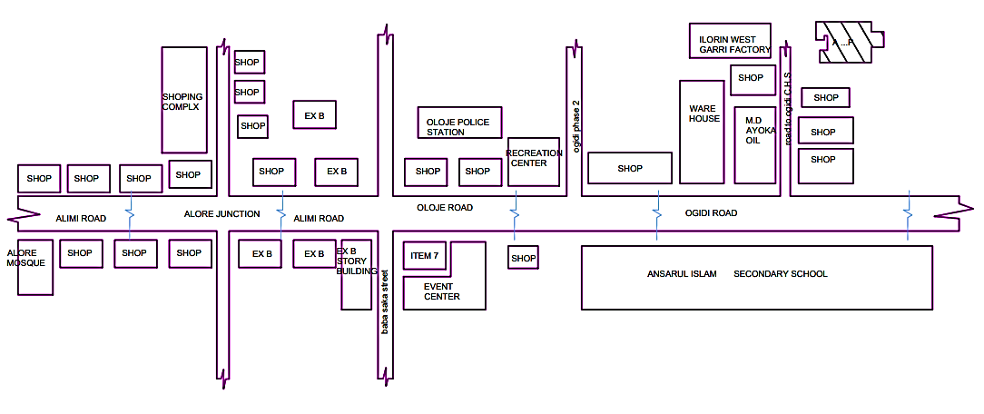

Figure 3.1.1: Showing the Location Plan of Case Study One Located at Ogidi Area, Ilorin, Kwara State.
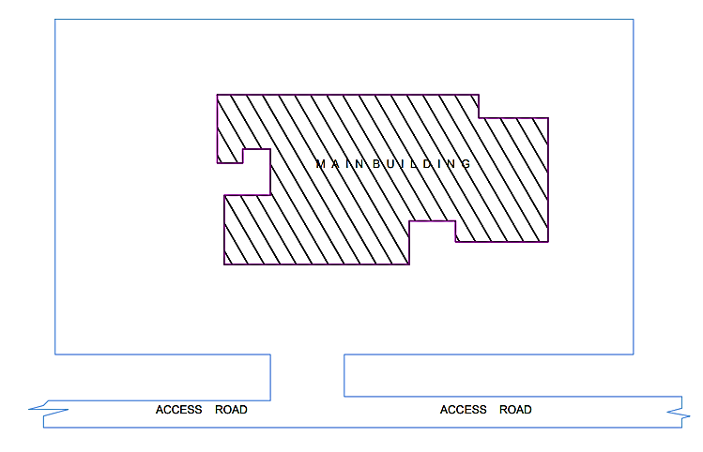

Figure 3.1.2: Showing the Site Plan of Case Study One Located at Ogidi Area, Ilorin, Kwara State.

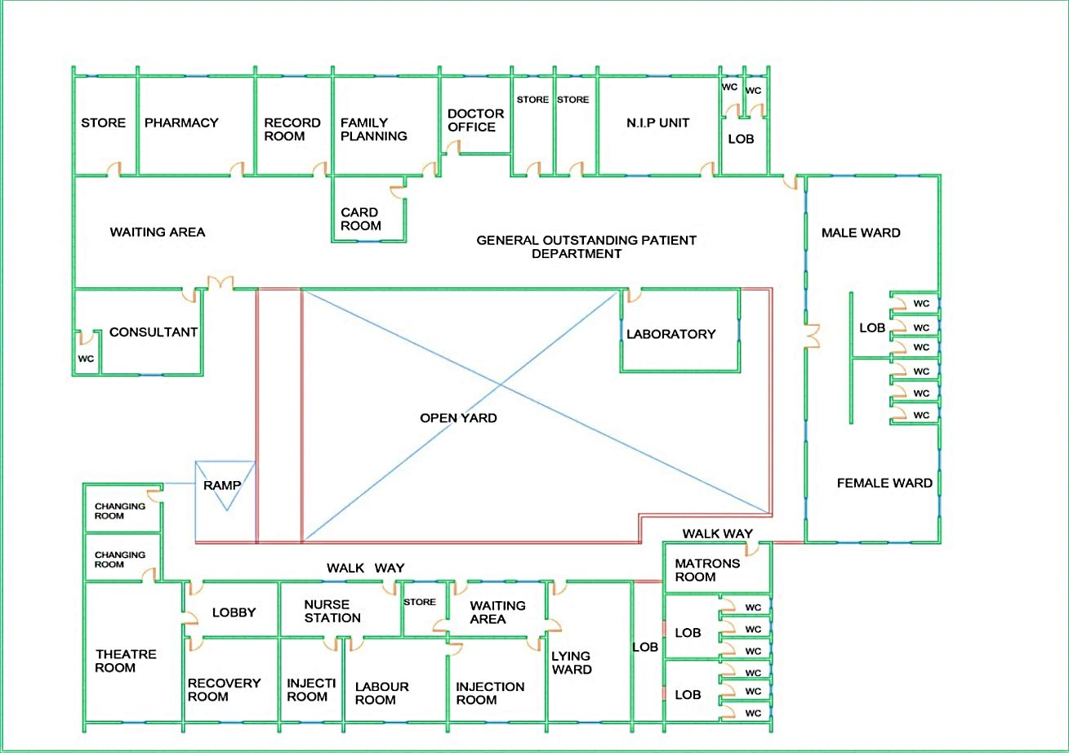

Figure 3.1.3: Showing the Floor Plan of Case Study One Located at Ogidi Area, Ilorin, Kwara State.
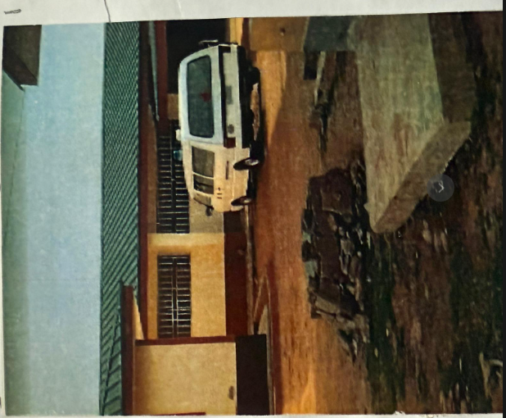

Plate 3.1.1: Showing the Floor Plan of Case Study One Located at Ogidi Area, Ilorin, Kwara State.
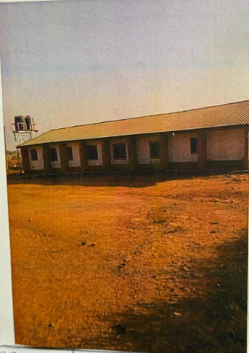

Plate 3.1.2: Showing the Floor Plan of Case Study One Located at Ogidi Area, Ilorin, Kwara State.

3.2 CASE STUDY TWO
NAME: IRAGBIJI COMPREHENSIVE HEALTH CENTER, BORIPE
The Iragbiji Comprehensive Health Centre was officially established on 11 May 2002, registered with the Federal Ministry of Health as a Secondary Health Care Centre (Facility code: 29/06/1/2/1/0002). It operates daily on a 12-hour schedule.
As a secondary-level facility, it serves as a step-up from primary health centres, delivering medical, surgical, paediatrics, antenatal care, immunizations, HIV/AIDS services, family planning, and communicable/non-communicable disease management—but notably lacks ambulance, dental, laboratory, imaging, pharmacy, and mortuary onsite services.
In June 2022, the Osun State government commissioned two modern facilities in Iragbiji: an 80-bed multipurpose hospital and a 100-bed Mother & Child hospital, to complement existing healthcare services in Boripe LGA.
Between November 2022 and March 2023, the Nigerian Army constructed and handed over a fully equipped maternity centre in Iragbiji to the State Primary Health Care Development Board—a major boost for maternal and neonatal care in the area
Location: Boripe Local Government Area, Osun State.
MERITS
- It’s easily accessible by people with physical disability.
- Male and female ward is provided.
- Kitchen and laundry space is provided.
- Conference & orientation room is present.

DEMERITS
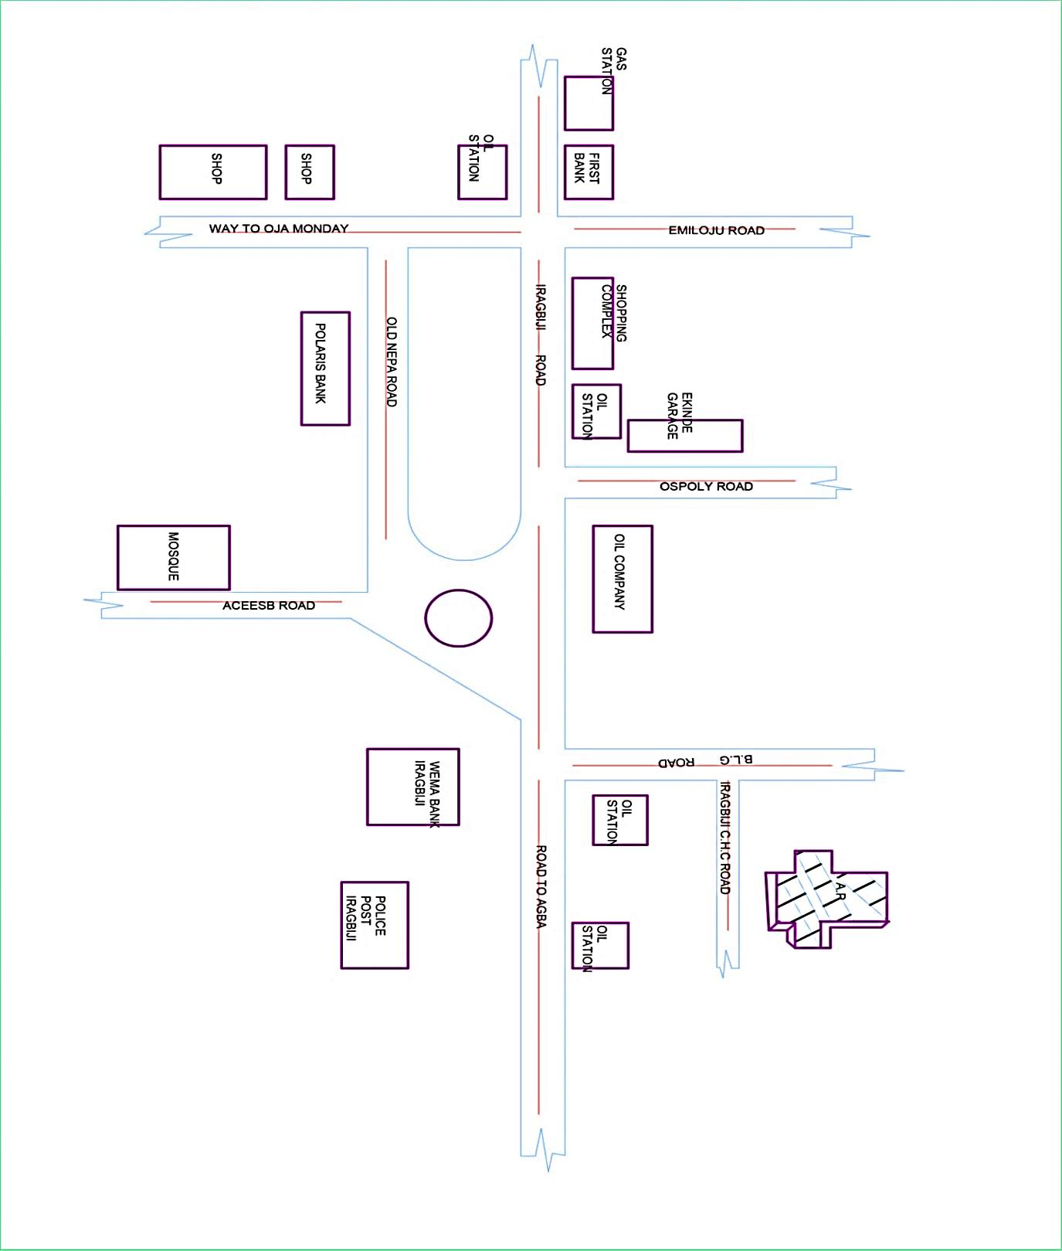
- Wardroom’s are not well cross vent.
- The toilets are too distance to the wardrooms.
- Rest room is not provided.
- Emergency & accident unit is not available.
- Staffing and training requirements.
- Managing complex patient needs.

Figure 3.2.1: Showing the Location Plan of Case Study Two Located at Boripe Local Government Area, Osun State.

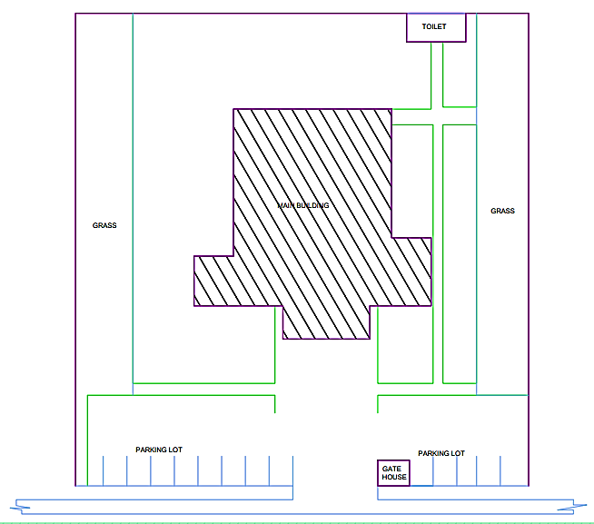

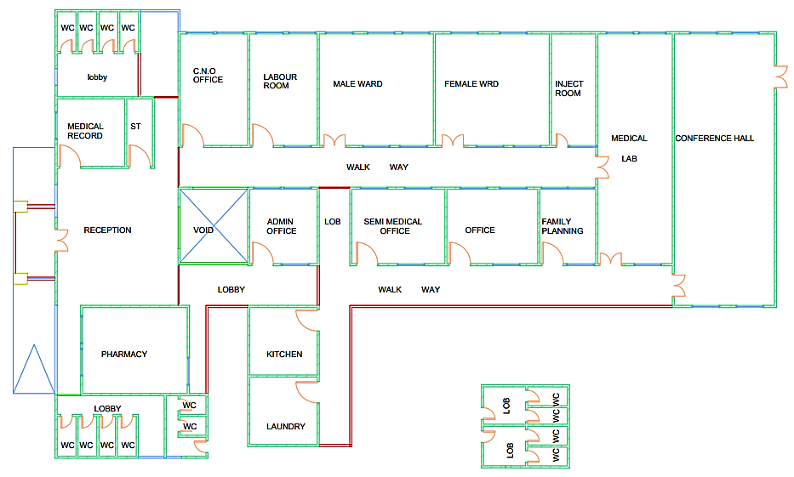
Figure 3.2.2: Showing the Site Plan of Case Study Two Located at Boripe Local Government Area, Osun State.

Figure 3.2.3: Showing the Floor Plan of Case Study Two Located at Boripe Local Government Area, Osun State.
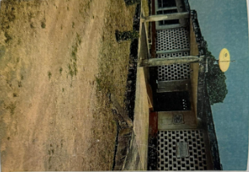

Plate 3.2.1: Showing the Front View of Case Study Two Located at Boripe Local Government Area, Osun State.
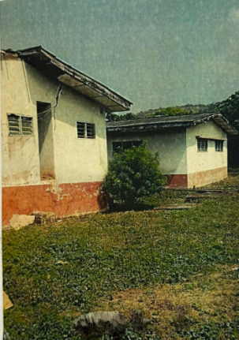

Plate 3.2.2: Showing the Side View of Case Study Two Located at Boripe Local Government Area, Osun State.
3.3 CASE STUDY THREE
NAME: KAJOLA COMPREHENSIVE HEALTH CENTER, OGBOMOSO
The Kajola Comprehensive Health Centre is a Public hospital, located at Alapata, Ogbomosho South Local Government, Oyo State. It was established on 12/4/2007, and operates on 24 Hours basis. The Kajola Comprehensive Health Centre is Licensed hospital by the Nigeria Ministry of Health, with facility code 30/22/1/1/1/0018 and registered as Secondary Health Care Centre.
In 1987, the Oyo State Hospital Management Board was inaugurated. The Board has three zonal offices at Ibadan/Ibarapa, Oyo/Ogbomoso and Oyo North managing fifty one health outlets within the state. The Board is expected to provide an all- encompassing health care that is accessible, affordable and high quality with a view to restoring, transforming and repositioning our health sector. Other health facilities within Oyo North are located at Saki, Iseyin, Iwere, Iganna and Ado-Awaye.
During subsequent administrations, especially under Governor Ajimobi (2011–2019), primary and secondary health care infrastructures were expanded statewide. This included building and equipping new maternal and pediatric centres, renovating existing clinics, rolling out state health insurance, and upgrading health training schools.
Location: Ogbomoso Area, Oyo State.
MERITS
- It’s well oriented.
- It has a good aesthetic.
- Kitchen and laundry space is provided.
- It’s well lightened & circulated.
DEMERITS
- Ramp is not provided for patient with physical disabilities.
- No theatre room for operation.
- Space for emergency unit is not provided for emergency & accident.
- Matron room is not provided.
- Limited accessibility for rural or underserved communities.

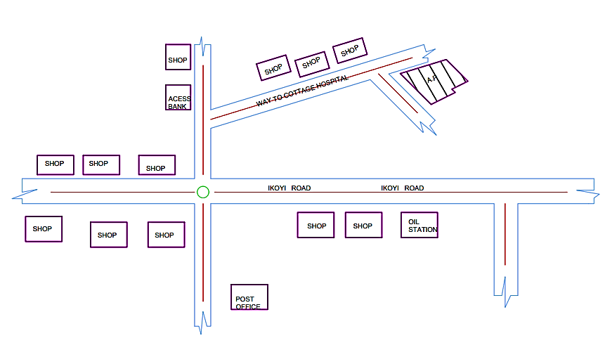

Figure 3.3.1: Showing the Locational Plan of Case Study Three Located at Ogbomoso Area, Oyo State.

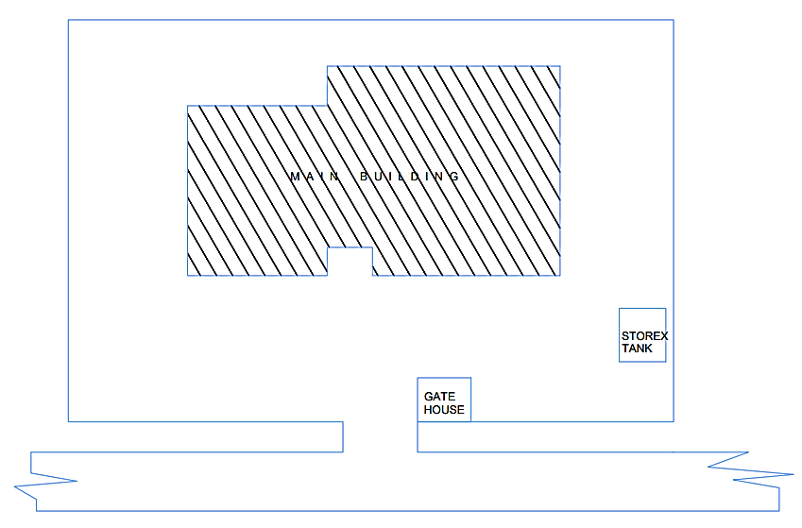

Figure 3.3.2: Showing the Site Plan of Case Study Three Located at Ogbomoso Area, Oyo State.
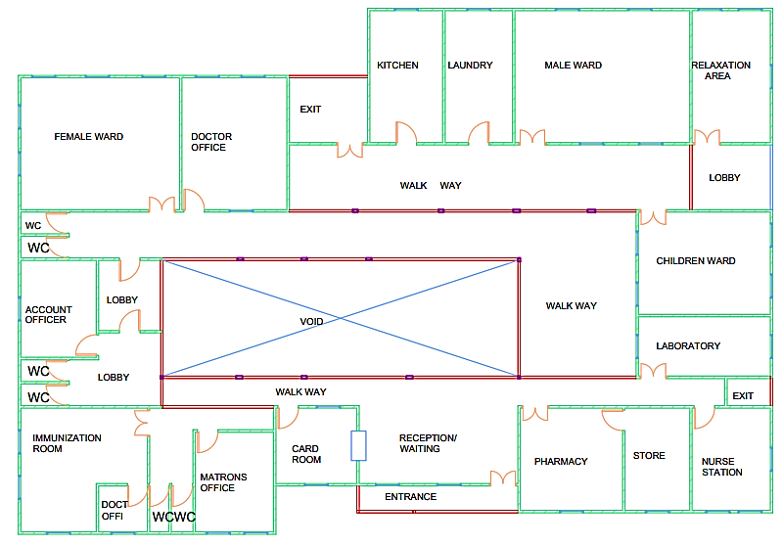

Figure 3.3.3: Showing the Floor Plan of Case Study Three Located at Ogbomoso Area, Oyo State.
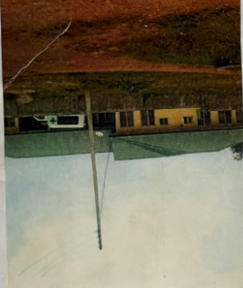

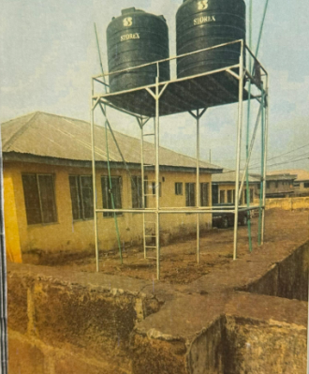
Plate 3.3.1: Showing the Front View of Case Study Three Located at Ogbomoso Area, Oyo State.

Plate 3.3.2: Showing the Side View of Case Study Three Located at Ogbomoso Area, Oyo State.
3.4 CASE STUDY FOUR
NAME: OKELELE COMPREHENSIVE CENTER, ILE-ALAWO
Although no formal founding date is readily documented in publicly accessible registries, the facility likely evolved from local primary health services to its current comprehensive status in alignment with Kwara State’s healthcare expansion efforts post-1990s.
It is closely associated with the Okelele Primary Health Centre at Ile Alawo, originally established in 1978 and operating on a 24/7 basis with services such as ambulance, laboratory, pharmacy, and maternal care.
The Okelele Comprehensive Health Center, located in the Ile Alawo area of Okelele, Ilorin East Local Government Area of Kwara State, serves as a secondary-level healthcare facility offering essential services to the surrounding community. Though its exact founding date is not formally documented, the centre evolved from the long-standing Okelele Primary Health Centre, which was established in 1978 and has since operated on a 24-hour basis. As the demand for more advanced health services increased over the years, a more comprehensive facility was established within the same compound to handle referrals and provide broader care, including general outpatient services, maternal and child healthcare, emergency stabilization, and community health programs. This transition reflects Kwara State’s broader efforts to improve rural and semi-urban health infrastructure. In 2021, healthcare in the area received a boost when Senator Ibrahim Oloriegbe and his wife donated medical equipment and flagged off a maternal health initiative at the primary centre, indirectly benefiting the comprehensive facility. The Okelele Comprehensive Health Center continues to serve as a vital healthcare access point for residents of Ilorin East, supporting state-level health goals by bridging the gap between primary care and tertiary medical services.
Location: Ile-Alawo Okelele Road, Ilorin.

MERITS
- It’s well located & easily accessible by the user’s and community.
- The units provided are functioning to the user’s such as immunization, family planning and incubation room.
DEMERITS
- The site is not landscaped.
- There is no provision of walkway to facilitate easy navigation.
- Managing patient data and confidentiality.
- Ensuring infection control and patient safety.
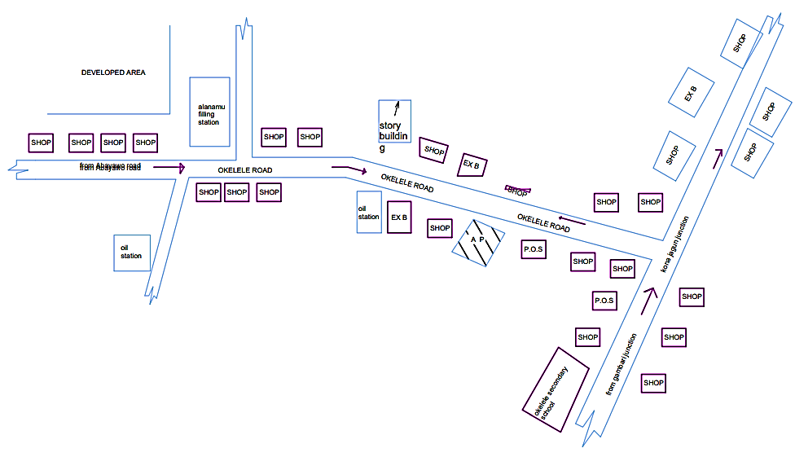
- Overcrowding and long wait times.

Figure 3.4.1: Showing the Locational Plan of Case Study Four Located at Ile-Alawo Okelele Road, Ilorin.
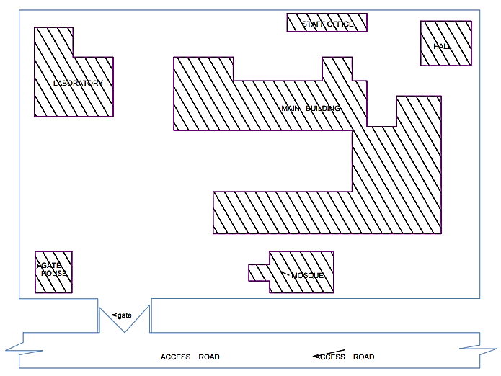

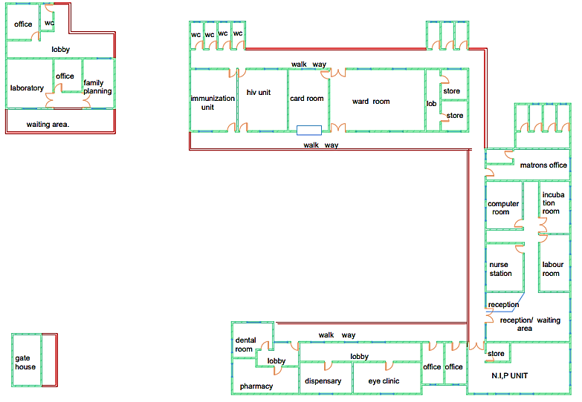
Figure 3.4.2: Showing the Site Plan of Case Study Four Located at Ile-Alawo Okelele Road, Ilorin.

Figure 3.4.3: Showing the Floor Plan of Case Study Four Located at Ile-Alawo Okelele Road, Ilorin.
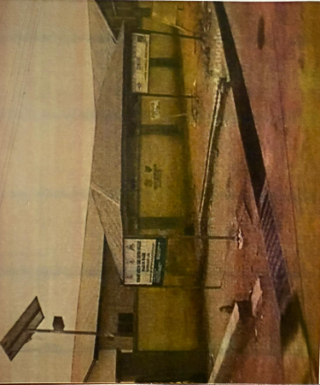
Plate 3.4.1: Showing the Front View of Case Study Four Located at Ile-Alawo Okelele Road, Ilorin.


Plate 3.4.2: Showing the Side View of Case Study Four Located at Ile-Alawo Okelele Road, Ilorin.
CHAPTER FOUR
4.0 INTRODUCTION TO STUDY AREA
4.1 HISTORICAL BACKGROUND OF KWARA STATE
Kwara State is a state in North Central Nigeria, bordered to the east by Kogi State, to the north by Niger State, and to the south by Ekiti, Osun, and Oyo states, while its western border makes up part of the international border with Benin Republic. Its capital is the city of Ilorin and the state has 16 local government areas. Of the 36 states of Nigeria, Kwara is the ninth largest in area, but the sixth least populous, with an estimated population of about 3.2 million as of 2016.
Geographically, Kwara State is split between the West Sudanian savanna in the west, and the Guinean forest–savanna mosaic ecoregion in the rest of the state. Important geographic features of the state include rivers, with the Niger flowing along the northern border into Lake Jeba, before continuing as the border, while the Awun, Asa, Aluko, and Oyun rivers flow through the interior. In the far northwest of the state is the Borgu section of the Kainji National Park, a large national park that contains populations of grey heron, Kob, hippopotamus, African bush elephant, olive baboon, and roan antelope, along with some of the last remaining West African lions on Earth. In the far southwest, a small part of the Old Oyo National Park contains crowned eagle, martial eagle, African buffalo, oribi, and patas monkey populations. Kwara state has been inhabited for years by various ethnic groups, primarily the majority Yoruba people that live throughout the state, but there are sizeable minorities of Nupe people in the northeast, Bariba (Baatonu) and Busa (Bokobaru) peoples in the west, and a small Fulani population in Ilorin, moving through the state as nomadic herders.
Kwara State has been inhabited for ages by various ethnic groups, primarily the majority yoruba people that live throughout the state. There are also sizable minorities of Nupe people in the northeast, Bariba baatonu and Busa Bakobaru peoples in the west, and Fulani people in Ilorin and moving through the state as nomadic herders.In the pre-colonial period, the majority of the area that is now Kwara state was part of the Oyo Empire, with part of the western portions in the Borgu Kingdoms peopled by the Bariba, Boko and Bissa people, and Nupe Kingdom (1531–1835). In the mid-1800s, the Fulani jihad annexed some part of what is now the state of Kwara and placed the area under the Gwandu sphere of the Sokoto Caliphate. In the 1890s and 1900s, British expeditions occupied the area and incorporated it into the Northern Nigeria Protectorate. The Northern Nigeria Protectorate later merged into British Nigeria in 1914, before becoming part of independent Nigeria in 1960. Originally, the modern-day Kwara state was a part of the post-independence Northern Region until 1967, when the region was split and the area became the west central States In 1976, the state was renamed Kwara State and the name remained until the 1990s when its southeast was split off to form a part of Kogi state and its far northwest Borgu division was annexed into the Borgu division of Niger state
Economically, Kwara state is largely based around agriculture, mainly of coffee, cotton, groundnut, cocoa, oil palm, and kola nut crops. Other key industries are services, especially in the city of Ilorin, and the livestock herding and ranching of cattle, goats, and sheep. Kwara state has the joint-twentieth highest Human Developments Index in the country and numerous institutions of tertiary education.

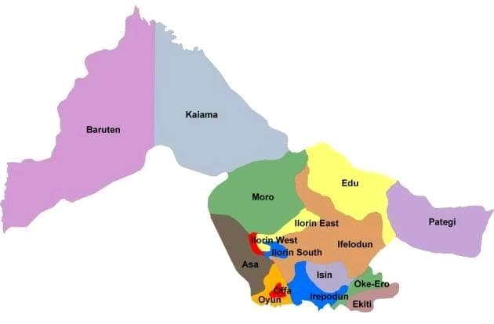

Plate 4.1.1: Kwara State Map
4.2 PHYSICAL FEATURE OF THE LOCATION
Ilorin City with its location on the longitude of 4.544°E and latitude of 8.537°N is seated on an undusting plain with an elevation of 257 m above sea level in the south and 431 m above sea level in the north. The town is situated about 4,473 km north of the watershed between the Atlantic basin and the Niger River basin.
The town is drained by three main streams namely:
- River Oyun: Flowing northwest in the distance of about 4km coast of the town.
- River Asa: This roughly bisects the town into east and west blocks along its course.
- River Moro: Passing at about 6km west of the city on its northeast course to later join with River Awun which discharges into River Niger at Jebba in the Northeast. The general landscape is gentle undulating topography with soft rounded hills, on a few river valleys and some high granite of dummy shape contract locality with general moderate morphology.
4.3 POPULATION OF KWARA STATE
The projected population of Kwara State according to the 2016 national census projection was around 3.2 million. It is, however, expected to be more than that now.
4.4 SOCIAL SERVICES
4.4.1 ROAD
The tarred regional roads pass through Ilorin, Aree and Atolokun are some of the major roads in the town, and the school tap its access road from the major road. Another road that is of greater importance is Ilorin/Bode-Sadu Road which links up with the centre of the city.
4.4.2 HEALTH SERVICE
Among other social infrastructural facilities in the school is a health service centre and in the town a government-owned general hospital, private hospital, clinic and maternity home.
4.4.3 WATER AND ELECTRICITY
There are pipe-borne water networks and boreholes water which serves as the inhabitant of Ilorin and its environs. There is an electricity supply from IBEDC that serves the institute and Kwara State in general.
4.5 GENERAL CLIMATIC CONDITION
Ilorin, the site in Kwara State falls under the climatic region referred to as Guinea Savannah and is in the middle belt of the country.

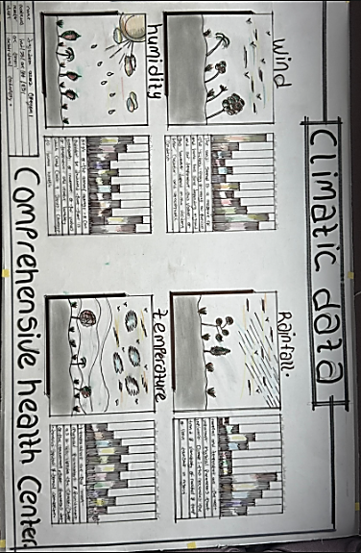

Figure 4.5.1: Climatic Data
4.5.1 RELATIVE HUMIDITY
The town is under the influence of high humidity throughout the year with a monthly relative humidity remaining above 66%. This is even higher between May and September with a relative humidity figure of about 80% on average as shown in Fig. 12
4.5.2 WIND
There are two prevailing winds namely: The rain-bearing southwest monsoon wind which blows across the Atlantic Ocean between the months of May and October. This is called the wet season. The dusty northeast trade wind which is laden with dust blows through the Sahara Desert during the month of November to April with very little rainfall toward April. This is called the dry season and it brings along Harmattan during its driest period.

4.5.3 TEMPERATURE
The monthly average temperature is quite uniform, having February and March as the hottest months recording a higher average of about 480c (about 850f). July and August are the coolest (lowest monthly average of 760F).
4.5.4 VEGETATION
The proposed site is covered with grasses, a few trees and shrubs. Some will be removed before the construction while some will be retained for ornamentation.
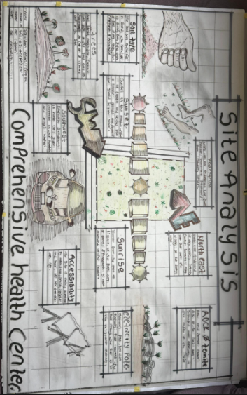
4.6 SITE ANALYSIS

Figure 4.6.1: Site Analysis
4.6.1 Site Selection/ Justification
The selection of a suitable site is crucial for the success and efficiency of any project. Not only does the functionality of the design matter, but also the careful choice of location. In this regard, the site for this project has been carefully chosen. It is situated in okolowo Community, along okolowo express way in Moro local government of Kwara State. The site offers interesting facilities that are worth emulating.
The following factors affect the site selection
- Accessibility
- Location
- Infrastructural Facilities
- Topography
- Soil Structure
- Termite House
ACCESSIBILITY
The site is easily accessible from ogidi road and also from ayelabowo road and can also be access through Sao community along old Jebba road., Ilorin Kwara State.
LOCATION
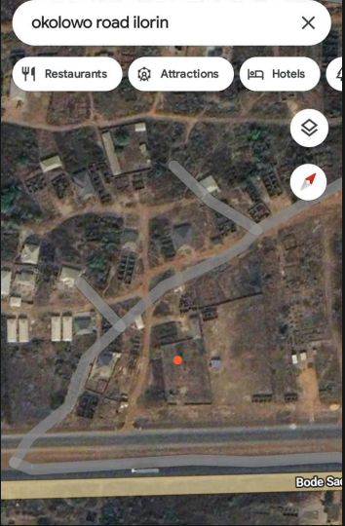

Plate 4.6.1: Locational Plan
Site location: It is a well-located site because the site is very quiet (there is no noise). The site is conducive and effective for health activities and it's very significant to the proposed location because there is no present comprehensive health center in the whole Okolowo community, is a very wide land suitable for the proposed project.
INFRASTRUCTURAL FACILITIES
Facilities such as water, electricity, telephone network
INFRASTRUCTURAL FACILITIES
Facilities such as water, electricity, telephone network and road network etc. Hence it can easily be tapped to the proposed site.
TOPOGRAPHY
The topography of the land is a gentle slope towards the east which can assist in the construction of drainage on site.
SOIL STRUCTURE
The soil has a very high load-bearing capacity; thus, the structure will lie in a hard crust and firm land.
4.7 DESIGN BRIEF
After conducting research and careful planning, the next step in the project program is to commence with the design phase. To achieve a functional and visually appealing design, it is crucial to have a brief to work with. This brief is dependent on the scope of each design. For this particular project, the brief is based on the various activities in a comprehensive health center.
To ensure that there is enough information to create a comprehensive brief for the proposed comprehensive health Center, case studies were carried out on the existing comprehensive health center in Nigerian States and different local governments. These studies provided insight into the nature of required medical facilities and how they relate.
A comprehensive health center consist of different department and units which include Administration units, inpatient units, outpatient units, diagnostic units, emergency units and surgical.
4.8 DESIGN ANALYSIS
This is the process of itemizing units within the components of the entire design to establish a solid understanding and appreciation of the space relationships.
SPACE ALLOCATION
TABLE 4.8.1: UNIT'S OF THE PROJECT.
S/N | Unit | Length (mm) | Breadth (mm) | Total (m²)
1 | Entrance | 8000 | 1400 | 11.2
2 | Reception | 8000 | 2400 | 20.8
3 | General Waiting Area | 11000 | 2500 | 27.5
4 | Card Room | 6000 | 3000 | 18.0
5 | Doctor Office | 3000 | 4000 | 12.0
6 | Consulting Room | 3000 | 5000 | 15.0
7 | Accounting Office | 4800 | 3000 | 14.4
8 | Accountancy Office | 3000 | 5000 | 15.0
9 | Head of Department Office | 4500 | 5000 | 22.5
10 | Immunization Room | 5100 | 3000 | 15.3
11 | Family Planning | 3000 | 1700 | 5.1
12 | Changing Room | 3000 | 1500 | 4.5
13 | Eye Care | 5100 | 3000 | 15.3
14 | Dental Office | 6000 | 3000 | 18.0
15 | Office | 3000 | 3000 | 9.0
16 | Ambulance Garage | 11000 | 4000 | 44.0
17 | Emergency Reception | 3000 | 3000 | 9.0
18 | Emergency Ward | 6000 | 9000 | 54.0
19 | Salvage | 3000 | 3000 | 9.0
20 | Kitchen | 3600 | 3000 | 10.8
21 | Laundry Room | 3600 | 3000 | 10.8
22 | Director of Department | 4700 | 6000 | 24.0
23 | Courtyard 1 | 6000 | 2850 | 17.1
24 | Matron’s Room | 6000 | 4000 | 24.0
25 | Nurse Station | 6000 | 4000 | 24.0
26 | Injection Room | 2700 | 1800 | 4.9
27 | Male Wardroom | 15000 | 7000 | 105.0
28 | Female Wardroom | 15000 | 7000 | 105.0
29 | Children Wardroom | 6000 | 6000 | 36.0
30 | Courtyard 2 | 15000 | 7000 | 105.0
31 | Conference Room | 5500 | 8000 | 44.0
32 | General Dressing Room | 6000 | 6000 | 36.0
33 | Pharmacy | 7600 | 3000 | 22.8
34 | Dispensing | 3000 | 3000 | 9.0
35 | Drug Store | 3000 | 3000 | 9.0
36 | Maternity Wardroom | 9600 | 6000 | 57.6
37 | Labour Room | 5500 | 6000 | 33.0
38 | Incubation Room | 5400 | 6000 | 32.4
39 | 2C - 7Q | 6000 | 6000 | 36.0
40 | Dark Room | 3000 | 6000 | 18.0
41 | Film Collector | 3000 | 6000 | 18.0
42 | Laboratory | 3000 | 9000 | 27.0
43 | Blood Donating | 3000 | 4000 | 12.0
44 | Operating Theatre | 6000 | 7200 | 43.2
45 | Resting Room | 4500 | 6000 | 27.0
46 | Sterilizing Room | 6000 | 2000 | 12.0

Table 4.8.1: Space Allocation
4.9 DESIGN CONCEPT/PLANNING PRINCIPLE
DESIGN CONCEPT
Firstly, the process of analysis is the design of the necessary units required for the design based on the data collected through research methodologies.
Secondly, the grouping of the various together according to their relationship with one another is also based on the data and information gathered. The concept of the design was arrived at from the functional relationship and bubble diagrams prepared out of the design brief which is based on the activities performed within the health center. The relationship of these various activities with one another within different units makes up the design and is also based on the zoning in accordance with the level of noise produced by each unit.

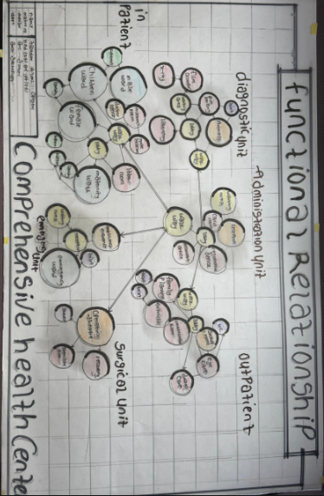

Figure 4.9.1: Functional Relationship
PLANNING PRINCIPLE
The planning principle is one of the most important aspects of any design. The planning of various units takes into consideration the activities performed in each unit, how they are related to one another and the users of the various units in the design. In respect to the design above factors, the building is being segregated into different units. The first units are the administrative units, the second units are the inpatient, the third units are the outpatient, the fourth units are the diagnostic units, the fifth units are the emergency units, and the last units in the block are the surgical units which are the last block units of the building.
Concerning zoning, site zoning is divided into three parts. The first division A is a noisy area while the second division B is a semi noisy area and third division C is a quiet area.

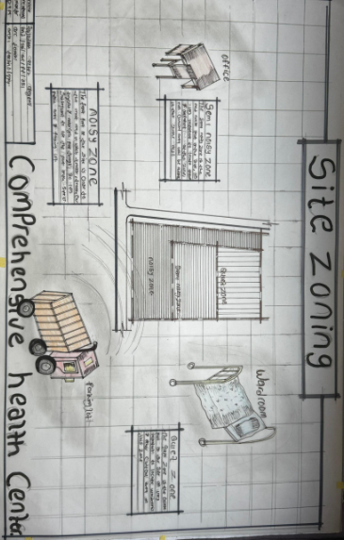

Figure 4.9.2: Site Zoning

CHAPTER FIVE
5.0 DESIGN APPRAISAL
When designing a project, there are several important factors that must be considered which are functionality accessibility, Durability, sustainability, space and forms, aesthetics etc. While these factors can sometimes be at odds with each other, in this particular project, both were given equal attention. The aim was to meet the functional requirements while also creating a design that is aesthetically and proportionally balanced. The efficiency of the comprehensive health center depends largely on the proximity of the functional areas, which were taken into account during the planning process as seen on the site and floor plans.
5.1 DESIGN CHARACTERISTICS
Creating a pleasant environment involves several crucial factors. First and foremost, it should provide a visually appealing view of the structure. Secondly, it should enhance the psychological well-being of the public by making the area more usable. And finally, it should contribute to a healthier environment by keeping it clean and well-planned. As the saying goes, "Cleanliness is next to godliness". A well-planned and clean site is essential for a healthy environment. By incorporating these principles into site planning, we can improve the overall environment for everyone.
LANDFORM: As earlier discussed under the topography the land has a gentle slope hence it will affect good planning.
TREES: Trees are planted within the building to effect natural ventilation. Trees which will not be more than 2.5m high when grown are to be planted at reasonable spacing to provide shade for the car park. shrubs and trees such as Amelina, Aborea, Flamboyant, Allernande etc. will goo foliage be planted along the fence and some strategies placed within the site to provide shade and serve as sun and wig breakers. The trees also reduce the atmospheric temperature and release of oxygen during photosynthesis makes the atmosphere cold.
Humans need trees for health and proximity to nature has demonstrated significant benefits for mental and physical wellbeing. Specifically, spending time in woodland areas has been found to stabilize blood. Pressure reduce, stress levels, and induce a sense of calm
GRASSES: Grasses give a good impression of the environment and also protect the land surface from erosion for this project, Bahama grass is recommended for all the lawn areas. Some busy courtyards are covered with lawns, fine grasses like Kikuyu grass are planted in the courtyard and some parts are cemented for relaxation purposes.
Landscaped areas reduce pollutants from leaching through the soil into the water supply or from entering surface water runoff. Turfgrasses filter stormwater excess and reduce sediment and pollutants from entering water bodies. Turfgrass plants also redirect the flow of water, slowing it and allowing more water to be absorbed by the soil, which aids in preventing soil erosion and flooding.
Grass Plants play an essential role in the success, comfort, health, and social well-being of millions of people, particularly in urban/suburban environments. Grasses are some of the most efficient plants on Earth. 4 of the 5 top food crops in the world are grasses, and they provide over 90% of the world’s calories. These efficiencies make grasses the ideal choice for lawns where they produce fresh oxygen, capture carbon, cool our homes, capture rainfall, reduce stormflow, protect watersheds and filter urban pollutants.
FLOWER BEDS: A well-planned flower arrangement gives an aesthetic to the environment. Flowers are grown along the walkways around the main building generally except where it can obstruct vehicular pedestrian movement. Flowers such as splendour, Bryphallion roses, the lady on boat, ice plant etc. are planted.
HEDGES: Hedges are also planted along some parts of the walkway. In the courtyard, shrubs are also used along vehicular ways. The following shrubs are used for the hedge. Dodoneaviscosal (Josorevet). The vital (bush mil) casavatinalequstifolic (Whistling pie). Shrub such as spotted croton. Euphobiasplender (desert rose) are planted for their beautiful leaves and good scents for ornamentation.
PARKING SPACE: Parking lots are located at the noisy zone of the site to make it easy for the visitors to park their cars . Loading sand concrete block should be Portland cement delivered in good condition to the construction site. All the instructions given in civil engineering drawings will be thoroughly and strictly adhered to to avoid failure. The walkways should be constructed of concrete roof laid to fall with 2 layers of bitumen fact. The roof member should be firmly secured. The mortar bed should have at least a 25mm thick bond of block should be a stretcher bond.
5.2 BUILDING STRUCTURE
The whole comprehensive health center has an administrative units and other operational units which makes the environment more comfortable for both inpatient and out patients as well as the the staff in the environment. The building is supported by beams and columns at appropriate intervals. Most modern health center building structure are usually constructed by introducing a grid into the design. There are two types of grid system:
- Modular grid
- Structure grid
For this project, a structure grid system was employed in filled concrete blocks used for all the retaining walls of the structure The roofing system used for the building is wooden struss roofing. Some parts of concrete roofs facial were also used along with timber, Prevalent damage usually caused by termites is prevented by the application of termaterum treatment like Gamalin 20 Solignum etc.
5.3 SERVICE
Electricity is tapped from the nearest pole of higher tension. The main source of water is made from drilled bore holes located on the site where drinking water can be tapped, telephone line is within the areas which makes connection easy.
The entire roof drains run to the surrounding gutter which finally drains to the main gutter along the public drainage all the solid and liquid wastes are effectively disposed of by the soak-away pits and septic tanks, and a central AC system shall be fixed where appropriate.
5.4 GENERAL REQUIREMENT
5.4.1 LIGHTING
Lighting is an essential aspect of any building, whether it's achieved naturally through sunlight or artificially using lamps. Good natural and artificial lighting is crucial in the laboratory, operating theatre, wardroom's, corridors, cardroom e.t.c and other significant units Poor lighting conditions can lead to mistakes and may strain the eyes, making it difficult to focus.
In this project, we have made an effort to provide as much natural lighting as possible throughout the building. To maximize the amount of natural light, we have added more openings in the court yard, ward rooms, laboratory orientation hall, and However, artificial lighting will still be provided in situations where it's necessary, such as at night or during adverse weather conditions.
5.4.2 ORIENTATION
The thermal comfort of a building greatly depends on its orientation. The way a building is arranged, whether it faces the sun or not, and its position in relation to trade winds, affects its overall thermal comfort. To ensure optimal comfort, a building should be oriented such that the shorter sides face east without any openings. The longer sides should face the trade winds from the northeast and southwest monsoon winds. This helps to minimize the impact of the sun's temperature on the building, while also allowing the building to benefit from the other winds. To reduce the harsh effects of the northeast trade wind, it is advisable to plant trees along the side of the building that faces it. This will act as a windbreaker and enhance the permeable screening of the building, making it more comfortable to live in.

5.4.3 RAIN PROTECTION DEVICES
The amount of rainfall in a location can significantly impact the living conditions and overall comfort of the area. Therefore, it is essential to facilitate the fast dispersal of rainwater and associated conditions. To achieve this, a study of the nature of rainfall in the area is necessary. During the wet season (April-October), controlling heavy rainfall becomes crucial. For this purpose, a sloping roofing system is commonly used, which comes with a gutter system linked to the ground drainage network via PVC drain pipes.
A damp-proof membrane is laid on the parapet wall of the roof gutter to prevent water from seeping through. Additionally, damp-proof and draught-proof materials are used to reinforce the joints of the roof to withstand the passage of rainwater. A 25mm thick rendering is applied to the external wall to prevent water from reflecting on the internal side of the wall.
5.4.4 NOISE CONTROL DEVICE
Excessive noise and vibration can cause fatigue, leading to errors and general dissatisfaction in wardrooms, operating theatre. It’s important to control external noise levels with the use of landscape materials and rough setbacks. At our facility, the Inpatient units are separated from the administrative units by introducing zoning on the site to place each units into a comfortable zoning areas. Landscape elements such as trees and shrubs are added as noisy buffer zones between semi-noisy and quiet zones.
Acoustic ceiling tiles are highly recommended for offices, wardrooms and other administration area, other units where conversations are confidential in nature, such as the boardroom. They are very effective in reducing overall noise levels.
5.5 MATERIAL AND FINISHES
The influence of building materials on construction works in Ilorin and its environs is similar to what prevails in the middle belt of the country. In the south, the rainfall encourages the use of parapet walls to reduce falling out of the roof by heavy wind (either North-East or South-West trade wind). Concrete/ Sandcrete blocks in regular moulds are often used for wall construction with a standard of 100mm, 150mm and thickness.
The material choice and finishes are influenced by several factors such as follows:
- The durability and suitability of materials
- Geology and topography of the site
- Availability of material
- The climate conditions
- Properties of materials
- Cost of the materials
ROOF
In Guinea Savannah region such as Ilorin where there is fair rainfall, the roof should preferably be of lightweight construction with a parapet covering it and the external surface should absorb as little solar energy as possible. For these reasons, long-span span galvanised aluminium roofing sheets are recommended for all parts of the building in addition to the reinforced concrete roof gutter and concrete roof slab. Wood is recommended as the roofing material of the structure and other unit timber is to be used also.
CEILING
A suspended ceiling is used in some wardroom's roofs with wooden nogging with a fanny ceiling at the suitable centre to centre. The ceiling material is prepared to be attractive and easily cleaned. It should be of moderate cost for the above reasons the recommendation furnishing of all the offices is collotex expect the wardroom's that acoustic material is used to reduce the effect of the noise.
WALL
The structural walls of the building are to be constructed with 225mm engine moulded sand/cement hollow blocks. The column and beans are properly reinforced with a wall of the wall whole applicable column and beans are furnished with 25mm gauged smooth. Also, most of the units are framed structured which carries most of the loads. Load-bearing masonry walls are also used and furnished with 25mm thick wall rendering and finally painted according to the colour specification schedule in the toilet/lavatories, walls are to be furnished with ceramic tile to a height of about 2100 mm.
DOORS
The door type and size depend on the door location but generally range from transparent aluminium glass door size from 750mm for toilets to 2400mm for the main entrance, and 1500mm to 1200mm for other departments and 900mm for offices. Some doors are purposely made swinging doors for durability, fire resistance and noise control.
WINDOWS
The windows that are to be used in this project Include Alluminium sliding windows, Alluminium fixed light windows, glass block window for proper ventilation, awning window for the cardroom for serving.
COVERED WALKWAYS
The roofing to all covered walkways within the health center should be made of reinforced concrete slab finish laid to fall two layers of bitumen felt, the walking paying should be made of present concrete slab finished roughly to prevent slippery when wet.
5.6 SUMMARY AND CONCLUSION
The research intended to propose comprehensive health Care center to the state it's the first segment tried to make an insight about the topic related to literature reviewed, Due to the magnitude of the research topic, the research has tried to segment chapter to identify, analysis and evaluate research method where the data obtain have been further analyzed in accordance. Based on criteria and guideline for the designing of a functional and convenient comprehensive health care center for the Okolowo community people in order to provide good health care for the people in the area and also to provide functional space that will make the healthcare conducive for good health. Finally in designing such health care center there was a careful consideration in each aspect of design so as to archive the project as well as to carry out the project with limited scope.

CONCLUSION
The project is Design to solve the problem of health care facilities and management for the Okolowo community people, since the present comprehensive health center are not capable to solved the problem, the project also Contains necessary information and various process of designing and construction of functional and standard modern comprehensive health center that can solve the problem of health care Management in the Okolowo community.

RECOMMENDATIONS
Upgrade Infrastructure and Facilities: Government and relevant health authorities should prioritize the renovation and expansion of comprehensive health centers to meet current health demands. This includes modernizing existing buildings, improving ventilation and sanitation, and providing adequate space for all departments such as outpatient units, maternity wards, laboratories, pharmacies, and waiting areas.
Recruitment and Training of Health Personnel: There is a critical need to recruit more qualified health workers—including doctors, nurses, midwives, and community health extension workers—to enhance service delivery. Continuous training and professional development programs should also be instituted to keep staff updated with current medical practices and community health approaches.
Provision of Adequate Medical Equipment and Supplies: To ensure effective diagnosis and treatment, comprehensive health centers must be equipped with essential medical tools, diagnostic machines, and a consistent supply of medications. Efforts should be made to establish supply chain systems that prevent frequent stockouts of life-saving drugs and consumables.
Strengthen Primary Health Care Funding: Sustainable funding mechanisms—such as increased government budgetary allocations, utilization of the Basic Health Care Provision Fund (BHCPF), and strategic partnerships with donor agencies—should be leveraged to improve the functionality of health centers, particularly in underserved communities.
Community Engagement and Health Education: Local populations should be actively involved in the planning, monitoring, and management of health centers. Community health committees can be established to support awareness programs, improve trust, and encourage health-seeking behavior among residents. Public health education campaigns should also be intensified to reduce reliance on self-medication and traditional healers.
Incorporate Sustainable and Inclusive Design: Future designs or redesigns of health centers should integrate sustainable practices such as solar power, rainwater harvesting, and energy-efficient systems. The design should also provide for accessibility features, including ramps, clear signage, and user-friendly layouts for people with disabilities and the elderly.
Establish Monitoring and Evaluation Mechanisms: To ensure continuous improvement, periodic assessment of the performance of comprehensive health centers should be conducted. This will help in identifying service delivery gaps, measuring patient satisfaction, and informing evidence-based policy and funding decisions.
Promote Health Insurance Enrollment: To reduce out-of-pocket expenses and improve access to care, residents should be encouraged to enroll in the National Health Insurance Scheme (NHIS) or State Health Insurance Schemes. Awareness campaigns and flexible registration models can help increase uptake, especially among informal workers.

REFERENCES
Acheson Report London, (2020) Public Health. C.R. Kothari, Research Methodology, Methods and Techniques: Second Edition 2020.
Daryaganj, New Delhi- 11002. Greene, R., Effective community health participation strategies: a Cuban example. Donald Mpeniwaka (MD) Mult-consultancy Architectures: (2015) bills of quantities International Journal of Health Planning and Management, 2015. 18: p. 105-116.
Kinondoni Municipal Medical Services: health facilities in Kinondoni Municipal.
United Republic of Tanzania (2022): National Strategy for Growth and Reduction of WHO Constitution of 1948.
Walt G (2021) Management capacity and institutional reform Poverty, 2^ draft.
WHO, Geneva, 2013: Glossary of Terms used in health for all series.
Ministry of health: (2020) Tanzania health policy.
Ministry of health: (2018) health facilities in Tanzania.
Mitchell, M., Community involvement in constructing village health buildings in Ministry of Health, (2022) Proposals for Health Reforms, (HSR).
Uganda and Sierra Leone. Dev Pract, 2023. 5(4): p. 324-33.

APPENDICES

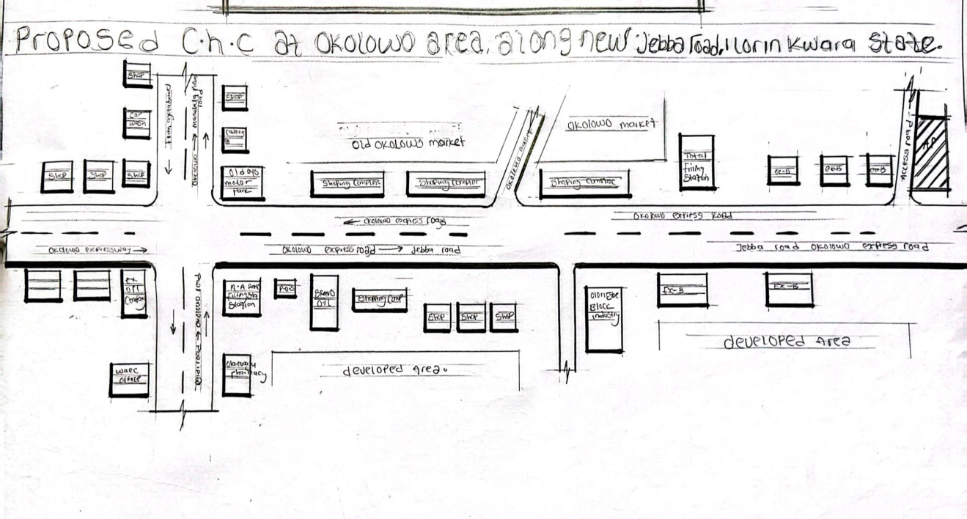

*

Appendix 1: Locational Map of Okolowo Comprehensive Health Care
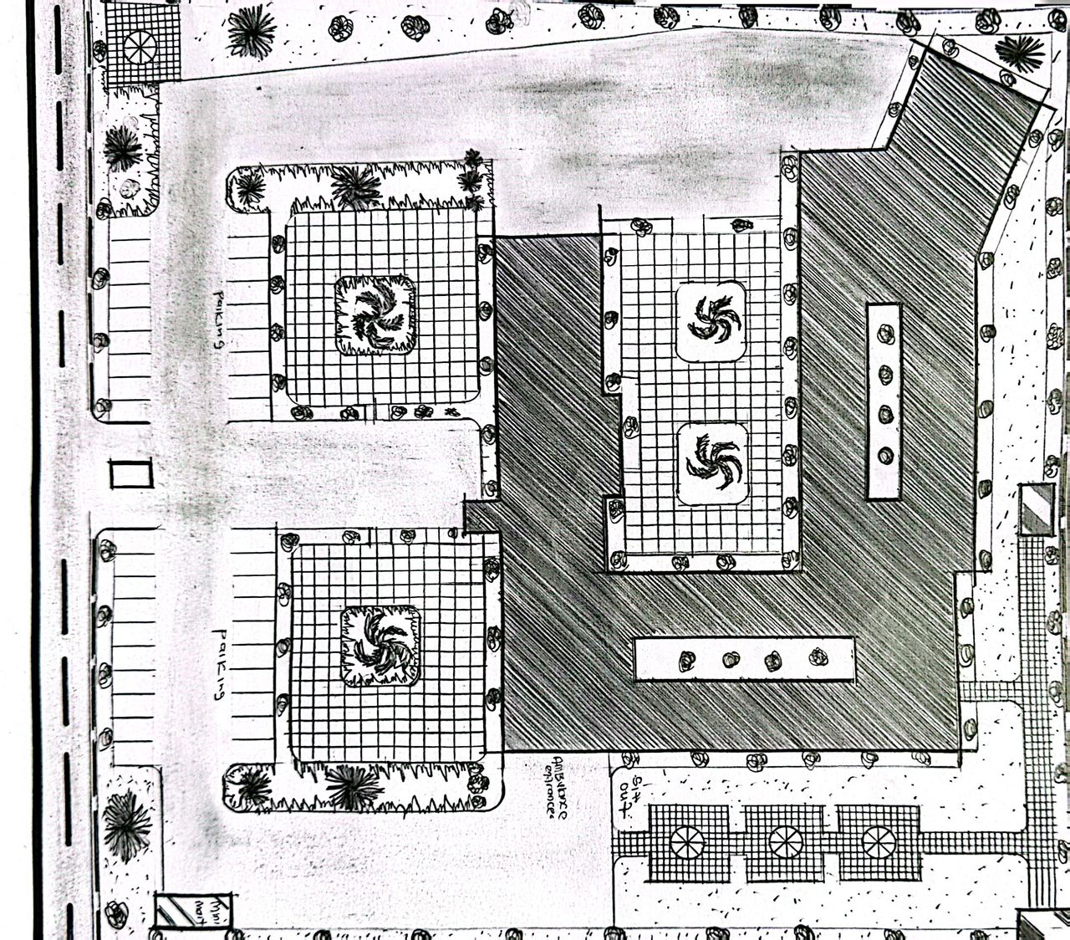

Appendix 2: Site Plan of Okolowo Comprehensive Health Care
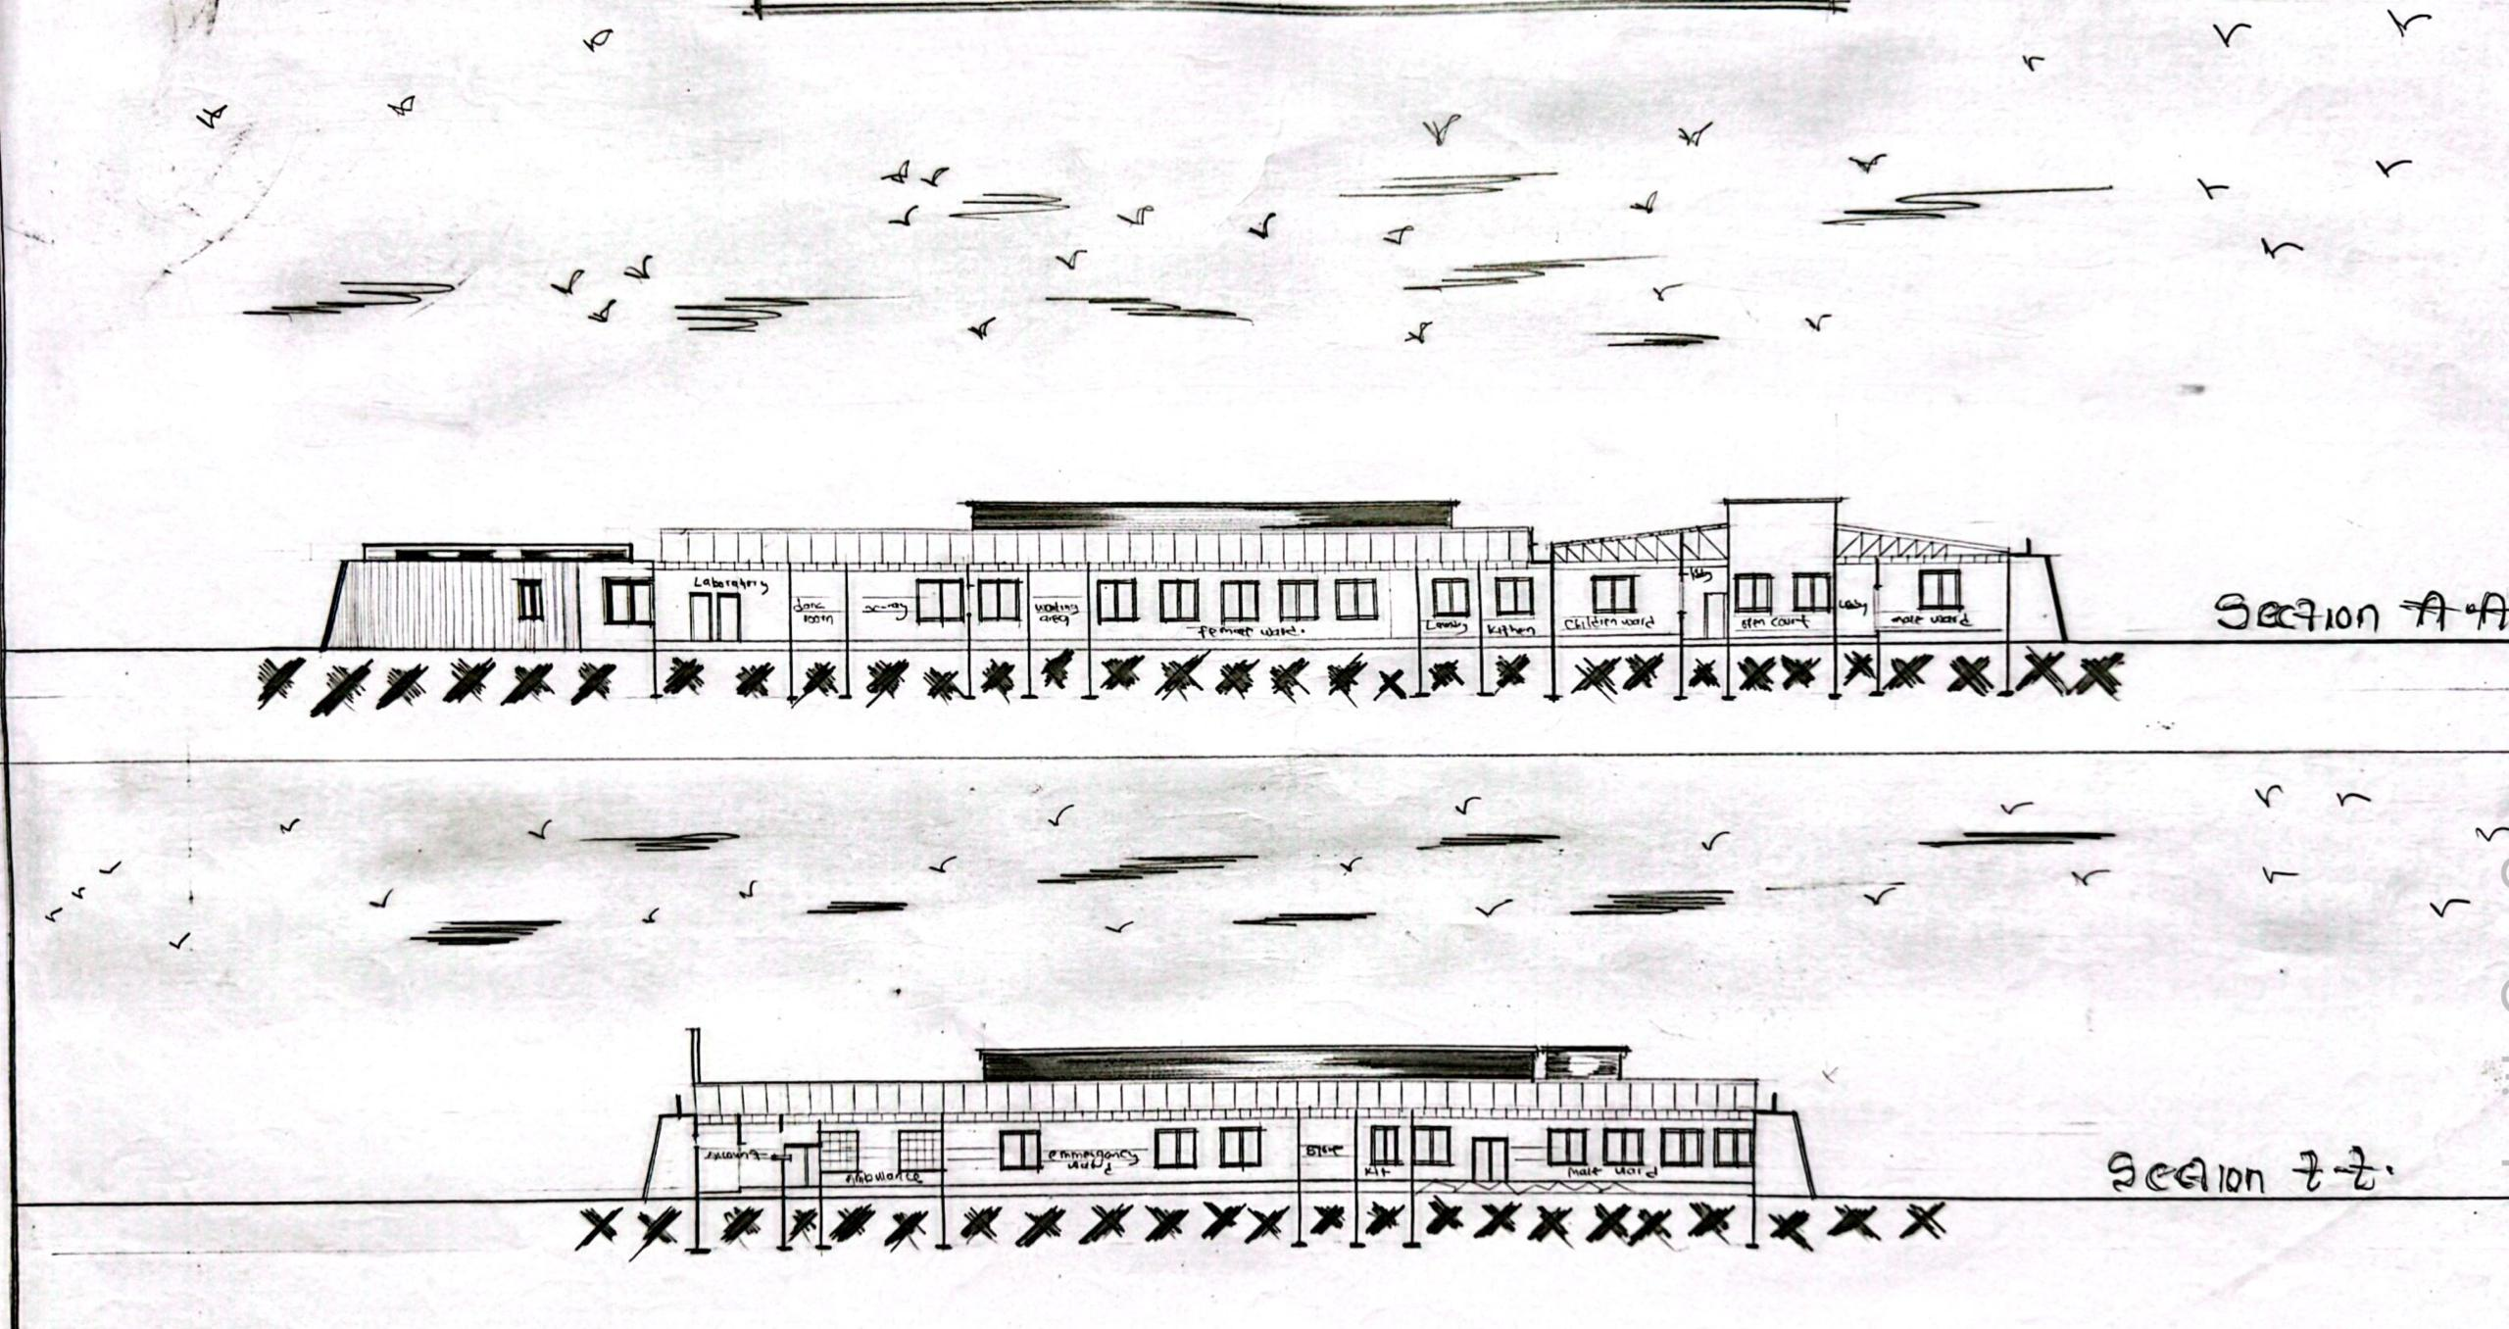
Appendix 3: Section of Okolowo Comprehensive Health Care

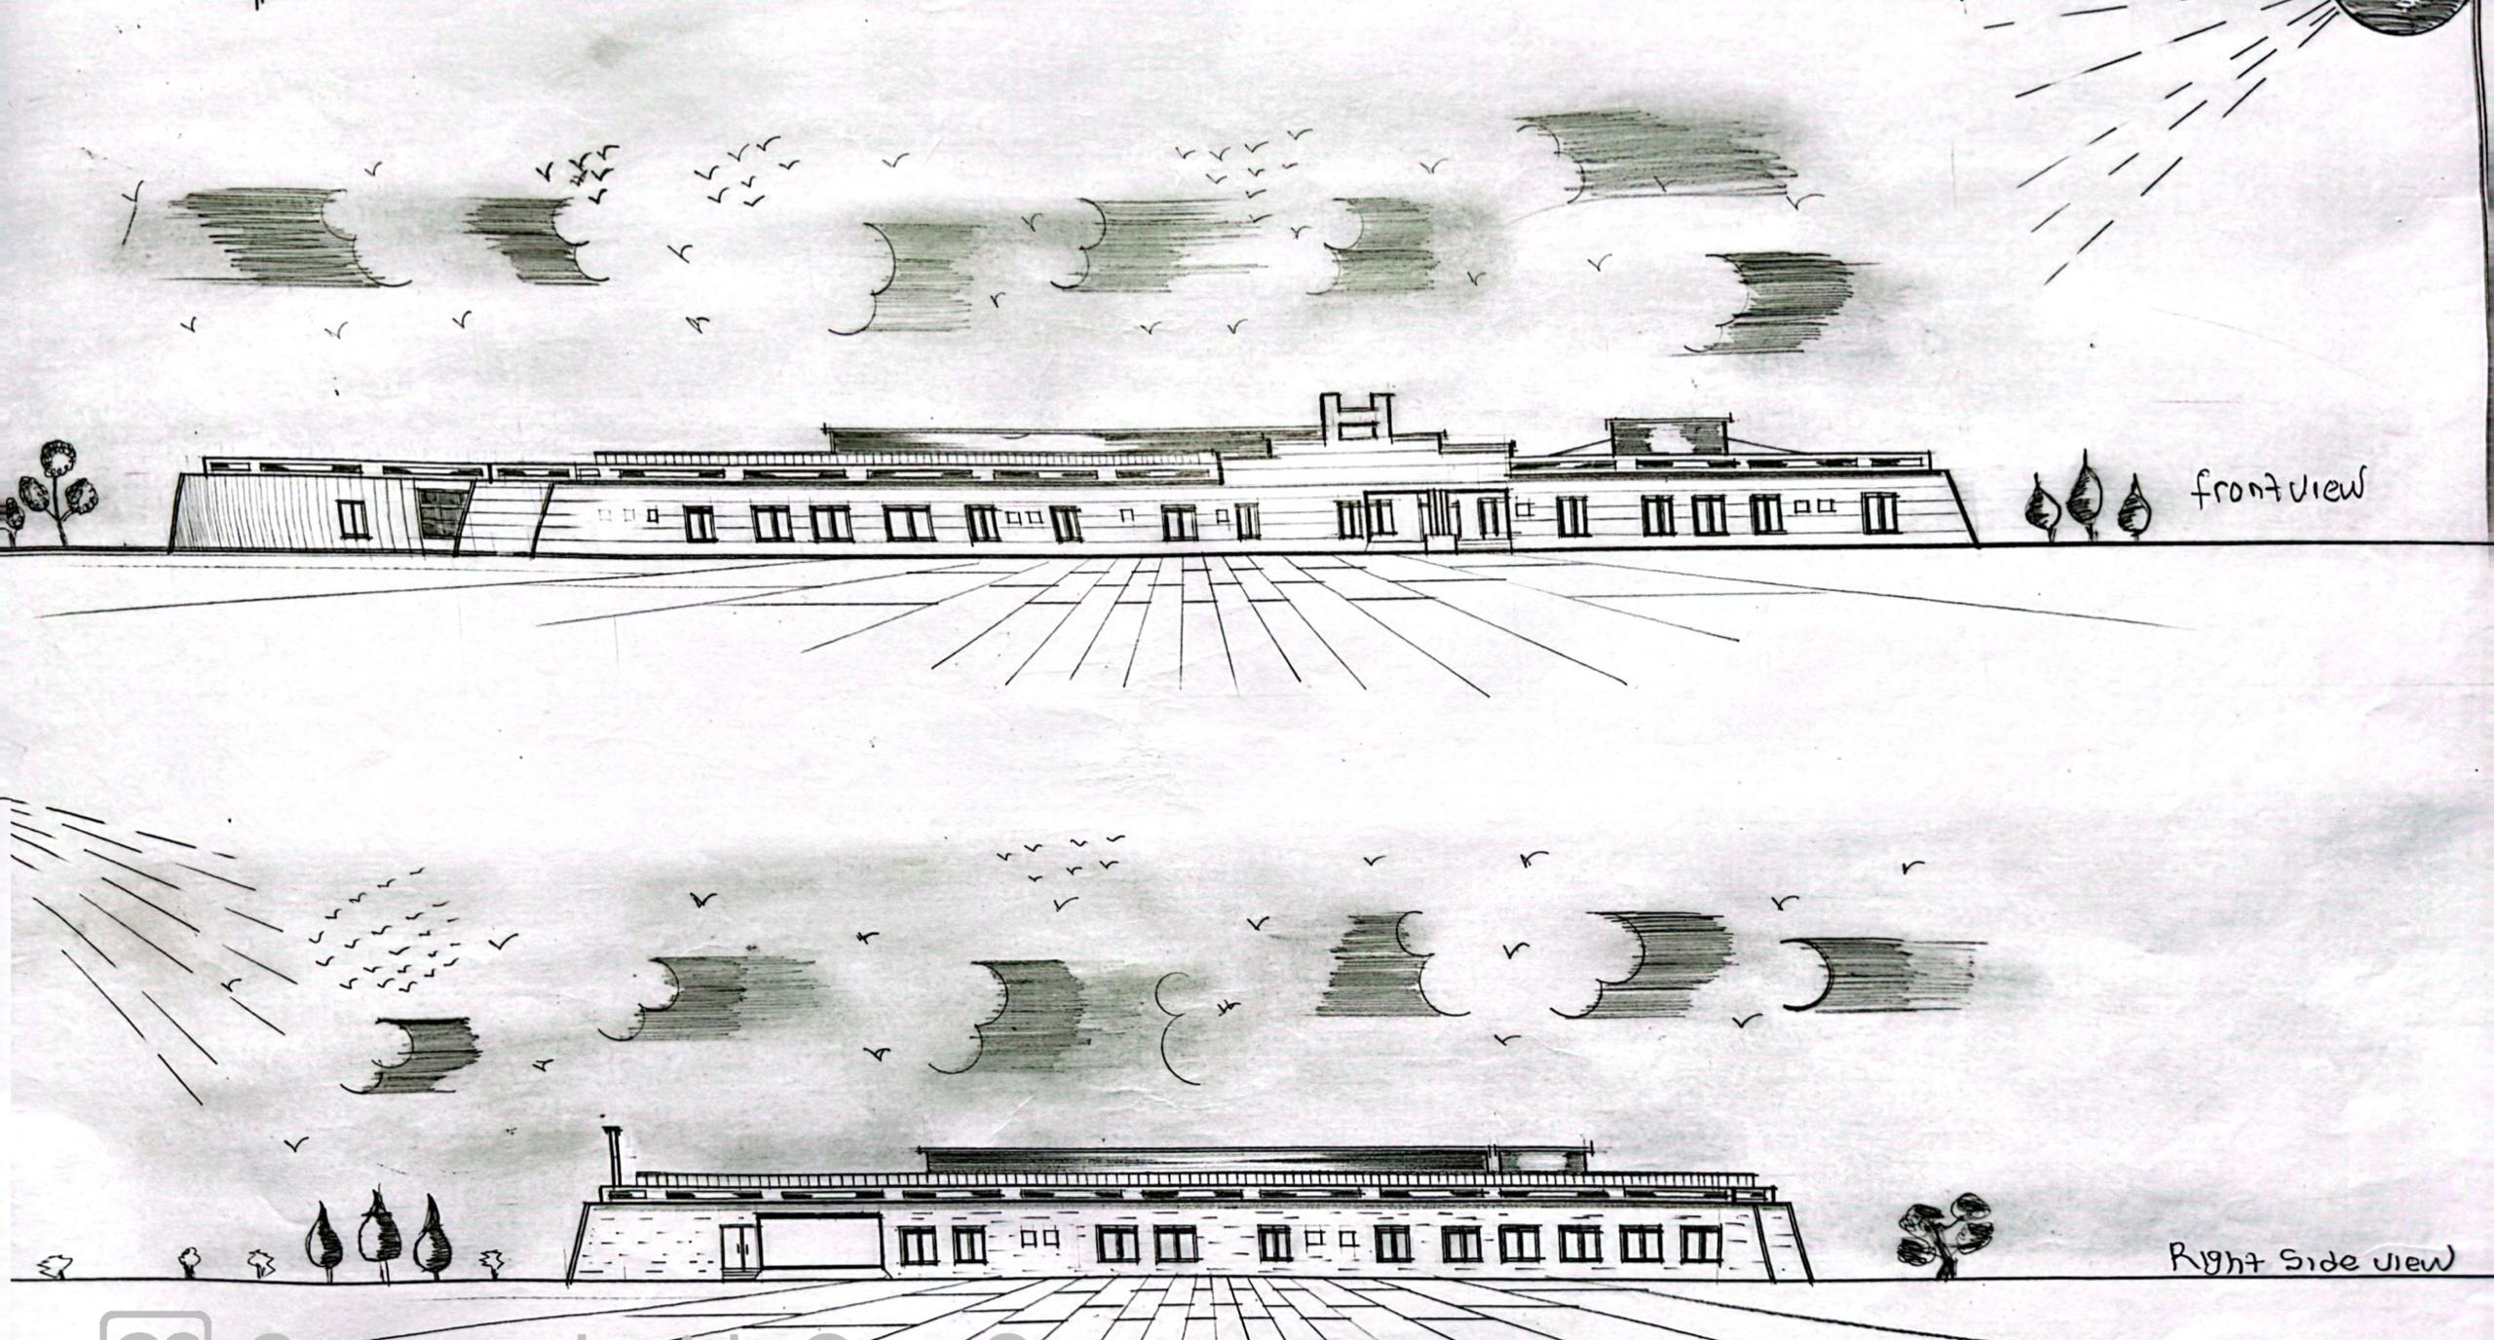
Appendix 4: Front and Side View of Okolowo Comprehensive Health Care
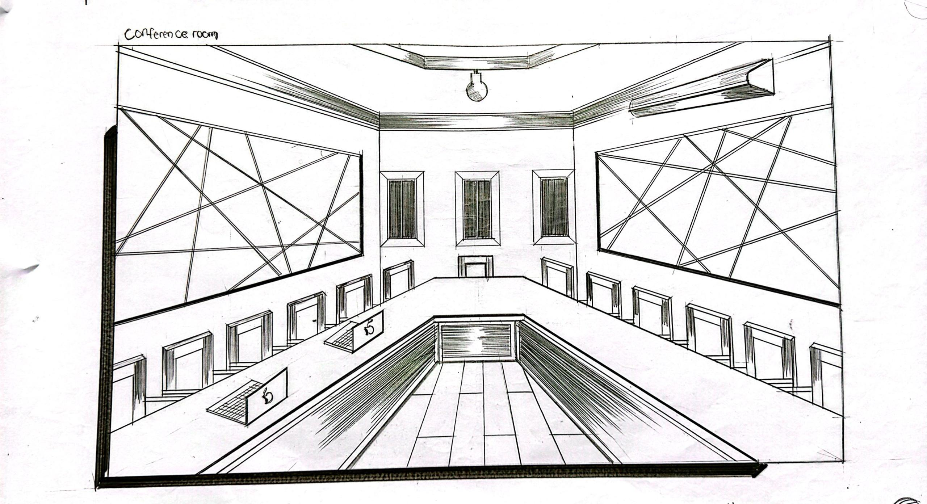
Appendix 5: Internal Perspective of Okolowo Comprehensive Health Care
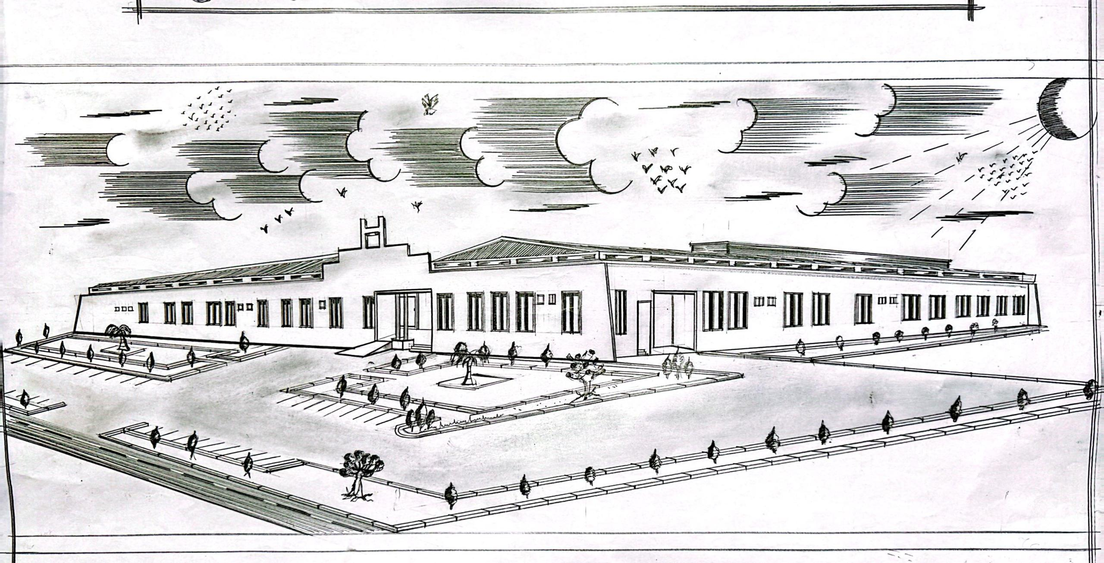
Appendix 6: External Perspective of Okolowo Comprehensive Health Care
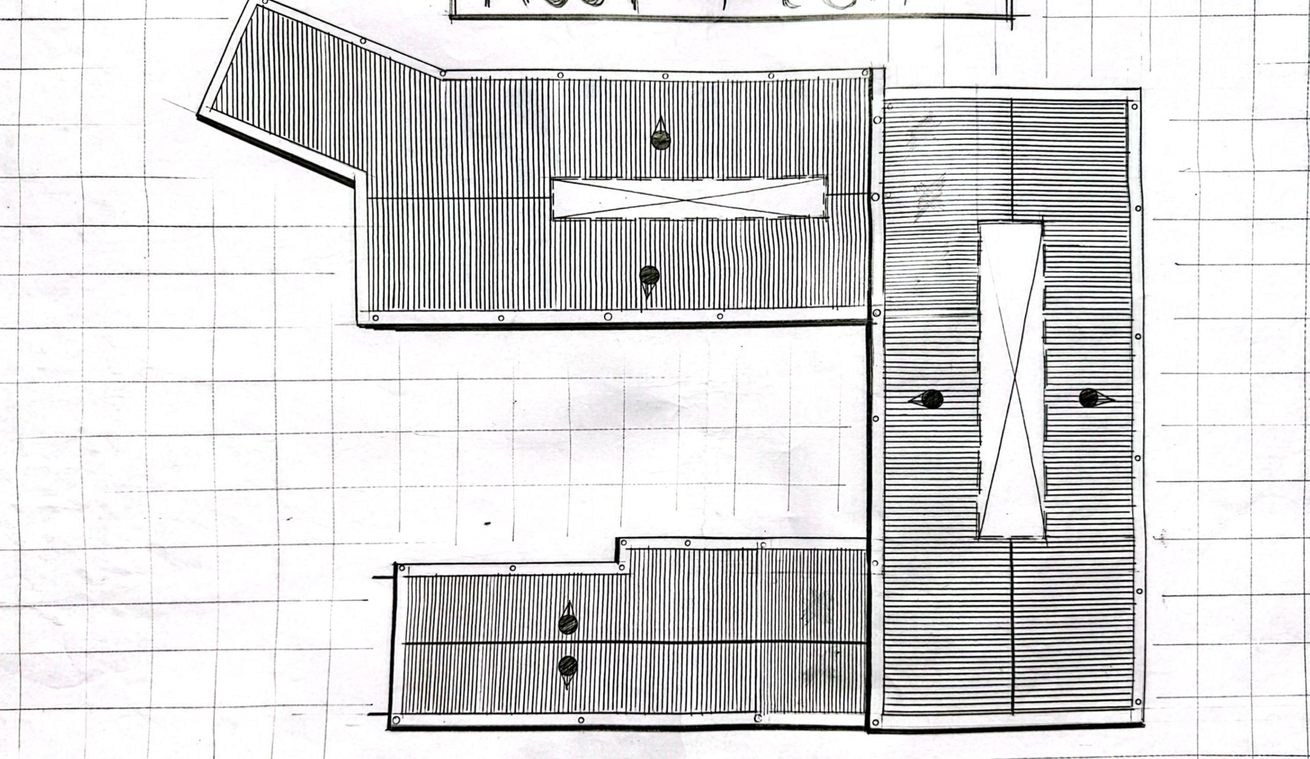
Appendix 7: Roof Plan of Okolowo Comprehensive Health Care

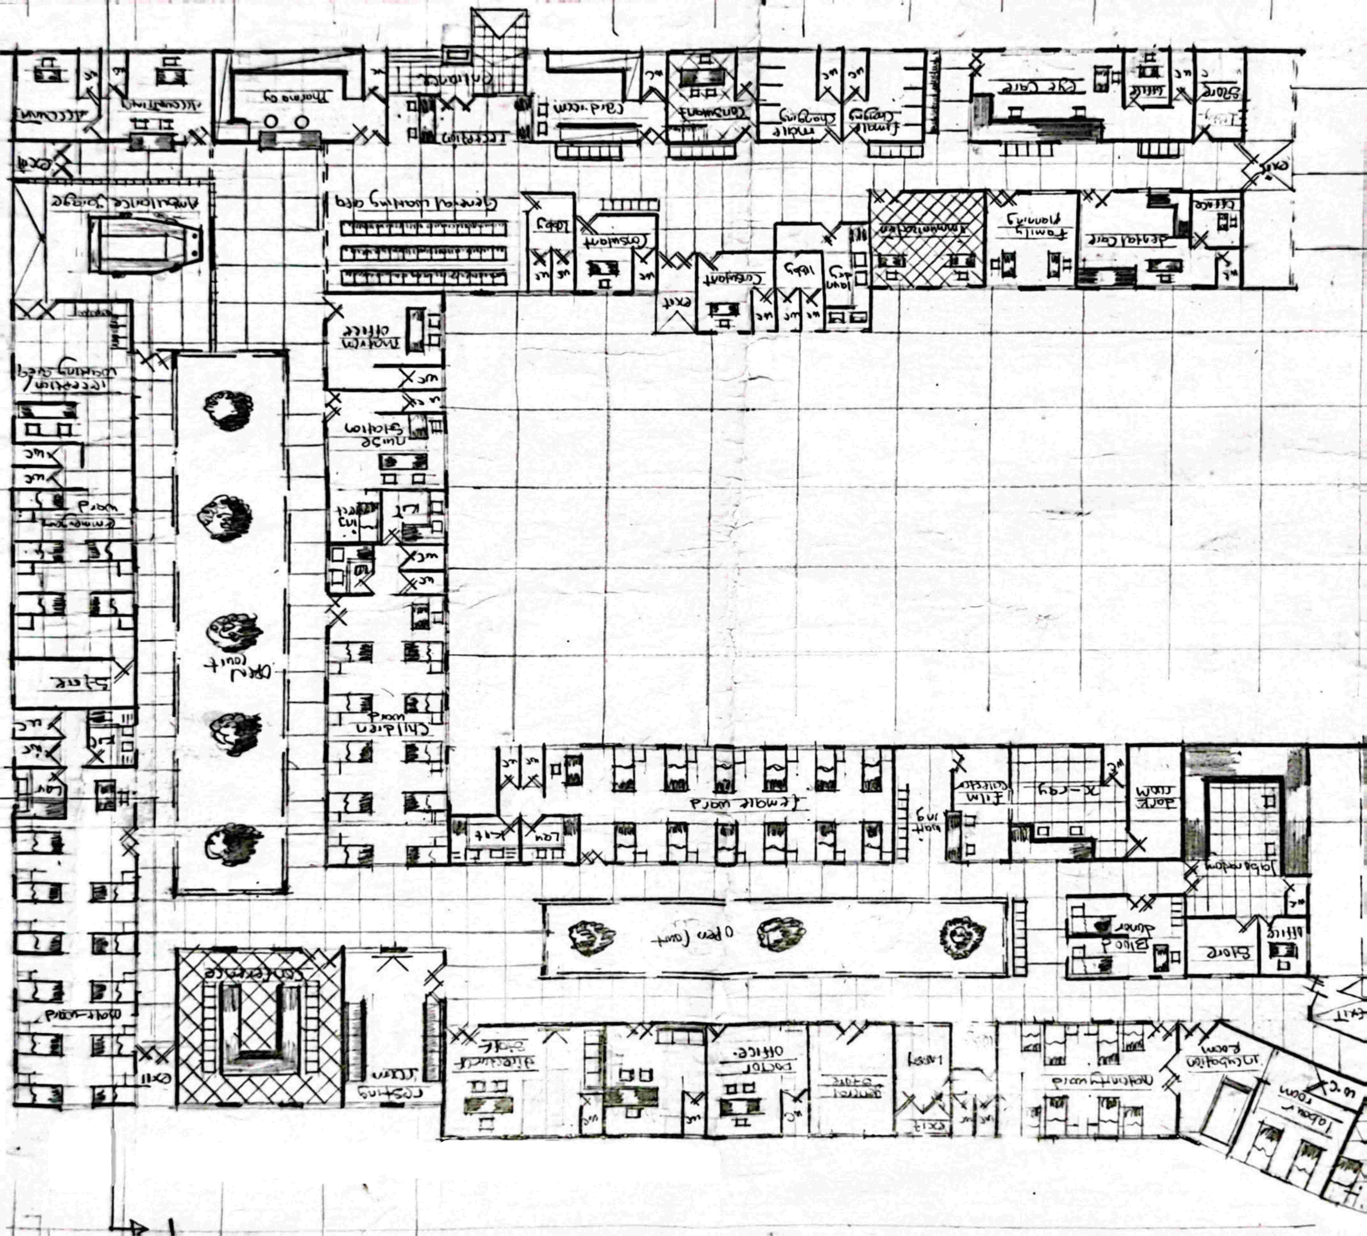
Appendix 8: Floor Plan of Okolowo Comprehensive Health Care

