A PROJECT REPORT
ON
PROPOSED VOCATIONAL CENTER
FOR
KWARA STATE GOVERNMENT, NEW YIDI, ASA DAM ROAD, ILORIN, KWARA STATE
BY
SALMAN RAHMAT ONAOLAPO
HND/23/ARC/FT/0057

SUBMITTED TO:
TO THE DEPARTMENT OF ARCHITECTURAL TECHNOLOGY
INSTITUTION OF ENVIRONMENTAL STUDIES (IES)
KWARA STATE POLYTECHNIC ILORIN

IN PARTIAL FULFILMENT OF THE REQUIREMENT FOR THE AWARD OF HIGHER NATIONAL DIPLOMA (HND) IN ARCHITECTURAL TECHNOLOGY

JULY 2025

DECLARATION
I Salman, Rahmat Onaolapo with matriculation number HND/23/ARC/FT/0057 declare that this project/dissertation is a product of my personal research work. It has not been presented for any award of degree in any polytechnic. These ideas, observation, comments, suggestion herein represent my own convictions, except quotations, which have been acknowledged in accordance with conventional tradition.



………………………….. ……………………………..
Signature Date

CERTIFICATION
I certify that this research and has been approved as meeting the requirement for the award of Higher National Diploma (HND) in Architectural technology Department of Kwara State Polytechnic, Ilorin, Kwara State.



ARC. ADEYEMI F.O ________________________
(Project supervisor) SIGNATURE/DATE

ARC. ADEYEMI F.O ________________________
(Project Coodinator) SIGNATURE/DATE



ARC. MRS. J.M TOMORI _______________________
(Head of Department)

_____________________ _____________________
External Examiner DATE

DEDICATION
This project report is dedicated to the Almighty Allah (S.W.T.), and my parents Mr and Mrs. Salman Onaolapo

ACKNOWLEDGEMENT
I express my immeasurable gratitude to Almighty Allah, who sustained me throughout my academic programme, by granting me strength, guidance and the preservation of life. My heartfelt gratitude goes to my supervisor, Arc. Olarewaju F. A., who also doubles as the project coordinator. I appreciate his guidance, encouragement and unwavering support in accomplishing this feat. Thank you sir, for offering insightful feedback and penetrating criticism at every step. I have indeed benefitted from the versatile reservoir of your expertise and knowledge.
I am especially grateful to the Head of Department, Arc. Tomori J. M., for her support and contributions to this project. My appreciation goes to other academic members of staff in the Department who in one way or the other have contributed to the success of my programme.
I sincerely express my gratitude and appreciation to my parents, for without them my longing for education could not have been achieved, I appreciate the great role they played in making me what I am today, for your prayers, love, care support, in cash and kind, throughout my programme. They have been my pillar of strength.
To my dearest husband, Engr. Yunusa Muhammed K. and daughter, I say thank you for your endless patience, understanding and encouragement, especially during the long nights and challenging moments.
Lastly, my special appreciation goes to my colleagues in the Department.I acknowledged the inexhaustible works of all the researchers whose work was consulted in the course of this project report.

Table of Contents
TITLEPAGE
DECLARATION ii
CERTIFICATION iii
DEDICATION iv
ACKNOWLEDGEMENT v
ABSTRACT viii
CHAPTER ONE 1
1.0 INTRODUCTION 1
1.1 HISTORICAL BACKGROUND 2
1.2 STATEMENT OF PROBLEMS 4
1.3 AIM AND OBJECTIVES 4
1.4 JUSTIFICATION 4
1.5 CLIENT’S BACKGROUND, PHILOSOPHY, OPERATIONAL STRUCTURE, AND GOAL OF THE PROPOSAL 5
1.6 SCOPE OF THE STUDY 5
1.7 LIMITATION OF THE STUDY 6
1.8 RESEARCH METHODOLOGY 6
CHAPTER TWO 7
2.1 LITERATURE REVIEW 7
2.1.1 Historical Context of Vocational Education 7
2.1.2 Impact on Employment and Economic Development 7
2.1.3 Curriculum and Skills Development 8
2.1.4.1 Functional and Aesthetic Spaces 9
2.1.4.2 Natural Lighting and Ventilation 9
2.1.4.3 Accessibility and Inclusivity 9
2.1.4.4 Landscaping and Site Planning 9
2.1.4.5 Capacity and Scalability 9
2.1.5 Role of Vocational Centers in Community Development 10
2.1.6 Case Studies of Vocational Centers 10
2.1.7 Challenges and Recommendations 10
2.1.8 Conclusion 11
CHAPTER THREE 12
3.0 CASE STUDY 12
3.1 Introduction to Case Studies 12
3.2 Case Study One 13
3.3 Case Study Two 17
3.4 Case Study Three 22
3.5 Case Study Four 26
3.6 Online Case Study One 30
3.7 Online Case Study Two 34
3.8 Comparative Analysis 36
3.9 Lessons for the Proposed Vocational Center 37
CHAPTER FOUR 38
INTRODUCTION OF STUDY AREA / SITE SELECTION 38
4.1 Introduction of Study Area 38
CHAPTER FIVE 52
5.0 DESIGN CONSIDERATIONS AND PROPOSED DESIGN 52
5.1 Introduction 52
5.2 Design Objectives 52
5.3 Architectural Considerations 53
5.3.2 Accessibility and Inclusivity 54
5.3.3 Sustainability 54
5.3.4 Aesthetic and Cultural Integration 54
5.3.5 Scalability and Flexibility 55
5.4 Zoning and Layout 55
5.5 Proposed Facilities 56
5.7 Sustainability Strategies 59
5.8 Safety and Security 59
5.9 Proposed Curriculum Integration 60
5.10 Conclusion 60
REFERENCES 62

ABSTRACT
This project report presents the design and proposal of a Vocational Center for Ilorin West Local Government, strategically located along New Yidi Road, Ilorin, Kwara State. The project emerges in response to the growing demand for functional, inclusive, and sustainable learning environments that support technical and skill-based education. With increasing youth unemployment and a widening gap between academic knowledge and practical skills, the need for purpose-built vocational training institutions has become more urgent and relevant than ever. The aim of this proposed center is to serve as a community-based hub for skills development, capacity building, and economic empowerment. It is envisioned as a solution that will contribute to national and local development goals by equipping young people and adults with employable, income-generating skills. The architectural design reflects a deep understanding of the socio-economic context of the area, with emphasis on functionality, cost-effectiveness, sustainability, and adaptability. The design concept integrates modern and context-sensitive architectural principles, including proper zoning, flexible learning spaces, accessible circulation routes, and climate-responsive features such as cross ventilation, natural daylighting, and passive cooling systems. The facility is designed to accommodate various vocational disciplines including but not limited to tailoring, ICT, welding, carpentry, catering, cosmetology, and electrical installation. Supporting facilities such as administrative offices, seminar rooms, multipurpose halls, sanitary facilities, and recreational spaces are also included to enhance user comfort and operational efficiency. Furthermore, the design considers landscape elements to improve the aesthetics of the site and reduce heat gain, while also promoting community engagement and interaction. Safety, inclusiveness, and future expansion were key considerations in the planning of both indoor and outdoor spaces. The report covers extensive background research, site analysis, architectural programming, conceptual development, spatial planning, and detailed design strategies that align with the project’s goals. The proposed vocational center is not only a place of learning but a platform for transformation designed to foster self-reliance, innovation, entrepreneurship, and sustainable livelihoods for residents of Ilorin West and its environs.

CHAPTER ONE

1.0 INTRODUCTION
In today’s dynamic and rapidly evolving world, education must go beyond the boundaries of theoretical knowledge to include practical skills that meet the realities of the labor market. This need has given rise to the increasing relevance of Vocational Centers, which serve as critical institutions for delivering technical and occupational training tailored to industry demands. A vocational center sometimes referred to as a technical school, trade institute, or skills acquisition center is an educational establishment that equips individuals with practical expertise required for specific trades or professions. The goal is not merely to educate but to empower individuals with the capacity to become economically productive, whether through employment or entrepreneurship.
Unlike conventional schools that primarily prepare students for tertiary academic progression, vocational centers are structured to provide learners with hands-on experience in their chosen fields. The learning process emphasizes practical engagement, task-oriented exercises, and the application of learned skills in real-world scenarios. These centers typically offer short- to medium-term programs focused on market-driven skills such as tailoring, automobile repair, ICT, welding, electrical installation, hospitality, and other applied trades. Upon completion, trainees are often certified and ready to engage directly in the workforce or start their own businesses.
Vocational education plays a crucial role in national development strategies, especially in countries where youth unemployment and underemployment remain pressing challenges. In the context of Nigeria, vocational centers have become vital in addressing the skills gap that exists between graduates and the demands of modern industries. By producing skilled artisans and technicians, these institutions support the informal sector, which forms a significant part of the national economy.
Furthermore, vocational centers are increasingly being recognized as tools for social inclusion, especially for those who may have missed out on formal academic progression. They provide opportunities for school dropouts, rural dwellers, women, and other marginalized groups to acquire life-changing skills. As the world moves toward knowledge-based and innovation-driven economies, the integration of vocational and technological education into mainstream development plans is no longer optional it is essential.

1.1 HISTORICAL BACKGROUND
The history of vocational education is deeply intertwined with the history of human development. Long before formal education systems were established, societies relied on informal apprenticeship models, where skills in blacksmithing, weaving, farming, fishing, and building were passed from masters to apprentices. This system ensured the survival of communities by maintaining a skilled and productive workforce.
The concept of formal vocational training began to take shape during the Industrial Revolution in Europe and North America in the 18th and 19th centuries. As machines replaced manual labor and factories became central to production, the need for a labor force with technical expertise became paramount. Governments and private enterprises established vocational schools to train people in areas such as mechanics, engineering, and construction. These schools were intended to support industrial expansion and to fill the growing demand for skilled manpower in urban centers.
In Nigeria, vocational training has its origins in the colonial era, when missionary schools taught basic vocational subjects like carpentry, tailoring, and agricultural practices alongside literacy. The colonial government later established trade centers and technical colleges, recognizing the need to train artisans and craftsmen to support infrastructural development and basic public services.
After independence in 1960, the Nigerian government intensified efforts to promote vocational and technical education as part of national development planning. The National Policy on Education (NPE) placed special emphasis on vocational training, stressing its importance in equipping citizens with the knowledge and skills required for productive work and self-reliance. As a result, technical colleges, trade schools, and skills acquisition centers were established across the country, often under the supervision of state ministries of education, the National Board for Technical Education (NBTE), or other regulatory bodies.
By the late 20th century, vocational centers began to adopt modern instructional methods and incorporate technological innovations. The rise of computer-based industries and digital economies further influenced the curriculum of many vocational institutions, prompting the introduction of ICT training and entrepreneurship development.
In recent years, government initiatives such as the National Directorate of Employment (NDE), Industrial Training Fund (ITF), and Youth Empowerment Schemes have revitalized interest in vocational education. Non-governmental organizations and international development partners have also contributed by supporting the establishment and modernization of vocational centers, particularly in underserved communities.
Today, vocational centers continue to evolve, aligning their programs with global standards and technological trends. The goal is not only to reduce unemployment but also to build a workforce that is resilient, adaptable, and capable of driving sustainable economic growth.
DEFINITION
A Vocational Center is an educational and training institution specifically established to provide individuals with practical knowledge and hands-on skills required for specific trades, occupations, or technical careers. Unlike conventional academic institutions that emphasize theoretical instruction, vocational centers focus on competency-based training aimed at preparing learners for direct entry into the workforce or self-employment.
These centers typically offer short- to medium-term programs in fields such as construction, tailoring, information technology, hospitality, electrical installation, cosmetology, welding, and other skilled professions. The core objective of a vocational center is to develop a skilled and self-reliant population that can contribute meaningfully to the economic and industrial development of a nation.
Vocational centers may be run by government agencies, private organizations, or non-governmental bodies, and they often serve both youths and adults seeking technical education, skill upgrading, or retraining opportunities.

1.2 STATEMENT OF PROBLEMS
- Inadequate Learning Space: Design a vocational center that provides an effective learning environment for a large number of students.
- Limited Flexibility: Create a vocational center that offers flexibility in seating arrangements and technology integration to accommodate diverse teaching methods and training styles.
- Inaccessible and Inconvenient: Develop a vocational center that provides equitable access for students with disabilities while ensuring convenient services and surrounding buildings.
- Insufficient Capacity and Overflow: Create a vocational center that accommodates large student enrollment, minimizes overflow, and provides a comfortable learning environment.

1.3 AIM AND OBJECTIVES
1.3.1 Aim
The aim of this project is to design and propose a vocational center that provides training and skills development programs for students and members of the community.
1.3.2 Objectives
- To design aesthetic and functional spaces that enhance learning and practical work
- To provide techniques and strategies that enhance natural lighting and ventilation in the vocational center.
- To integrate sustainable design principles such as water management systems, passive cooling, and eco-friendly building materials.
- To design with consideration for local culture, climate, and materials to ensure the center is contextually appropriate and cost-effective.

1.4 JUSTIFICATION
Due to the increasing population of unemployed individuals, especially physically challenged persons in Kwara State, I, as a final-year student, am compelled to initiate plans to equip this category of people with vocational skills so they can become empowered and self-reliant. This project will be located along New Eid Road, Ilorin, Kwara State, with standard facilities.

1.5 CLIENT’S BACKGROUND, PHILOSOPHY, OPERATIONAL STRUCTURE, AND GOAL OF THE PROPOSAL
Ilorin West is one of the sixteen (16) local government areas in Kwara State, Nigeria. It is located within the state capital, Ilorin, and serves as a key administrative and commercial hub. The area is predominantly Yoruba-speaking and is home to several districts including Oja-Oba, Adewole, UITH, and Ogidi. With an estimated population of over 365,000 residents (2006 census), Ilorin West remains one of the most densely populated and economically active local government areas in the state.
The Ilorin West Local Government Council operates through a decentralized administrative structure that promotes grassroots participation and development. The council is committed to improving public infrastructure, social engagement, and economic empowerment within the local communities.
This proposal advocates the establishment of a Vocational Center that will serve as a central point for social, cultural, and economic activities. Ilorin West is in urgent need of such a facility to foster civic engagement, provide a venue for public dialogue, and promote community development. A Vocational Center in this urban district will enhance the architectural identity of the area, support small businesses, and provide accessible space for educational programs, exhibitions, and events.
The ultimate goal of the project is to validate the necessity for a Vocational Center within Ilorin West, Kwara State, and to outline the specific components and design elements that will make the centre functional, inclusive, and sustainable. This initiative aligns with the local government’s broader vision of urban modernization, cultural preservation, and socioeconomic advancement.

1.6 SCOPE OF THE STUDY
The center will focus on a vocational center by providing adequate facilities for its intended users, which shall be divided into two sections: Information and Communication Section and Art and Craft Section. The Information and Communication Section will comprise computer training for beginner, intermediate, and professional levels, while the Art and Craft Section will include fashion designing, electrical, catering, and salon services for males and females.

1.7 LIMITATION OF THE STUDY
The study’s execution may face limitations due to the following:
- Time constraints
- Financial constraints
- Restriction to certain spaces during case studies
- Limited resources

1.8 RESEARCH METHODOLOGY
To gain a clear understanding of how to design and propose a vocational center, the following methodologies were employed:
- Case studies
- Internet browsing
- Literature review
- Oral interviews

CHAPTER TWO

2.1 LITERATURE REVIEW
This chapter provides a comprehensive review of existing literature on vocational centers, focusing on their role in employment generation, curriculum development, architectural design considerations, and their broader impact on community development. The review draws on empirical studies, theoretical frameworks, and architectural research to establish a robust foundation for the proposed vocational center along New Yidi Road, Ilorin, Kwara State. By synthesizing insights from various sources, this chapter aims to address the challenges and opportunities associated with vocational education and its physical infrastructure, with a particular emphasis on inclusivity, sustainability, and alignment with modern industry needs.

2.1.1 Historical Context of Vocational Education
Vocational education has its roots in the industrial revolutions of the 19th century, when rapid technological advancements necessitated a skilled workforce. According to Johnson (2016), vocational centers emerged in Europe and the United States to meet the growing demand for trained workers in industries such as manufacturing, construction, and transportation. These early institutions focused on trades like blacksmithing, carpentry, and masonry, providing hands-on training to prepare individuals for immediate employment. Over time, vocational centers evolved to incorporate modern technologies and teaching methodologies, reflecting changes in industrial and societal needs.
In Nigeria, vocational education gained prominence in the mid-20th century as part of efforts to reduce unemployment and promote economic self-sufficiency. The establishment of technical colleges and vocational training centers in the 1960s marked a significant milestone in formalizing skill-based education (Adebayo, 2020). However, these institutions have faced challenges such as inadequate funding, outdated curricula, and limited access to modern equipment, which have hindered their ability to fully address contemporary workforce demands (Okeke & Musa, 2021). Understanding this historical context is crucial for designing a vocational center that addresses past shortcomings while meeting current and future needs.

2.1.2 Impact on Employment and Economic Development
Vocational centers play a pivotal role in reducing unemployment by equipping individuals with practical, job-ready skills. Empirical studies consistently demonstrate a positive correlation between vocational training and employment outcomes, particularly in developing economies where formal sector jobs are limited. Smith and Jones (2018) found that vocational training programs increase employability by 30-40% in regions with high unemployment rates, as they provide skills that align with local labor market demands. In Nigeria, vocational centers have been instrumental in empowering youth and marginalized groups, including physically challenged individuals, by offering training in trades such as tailoring, electrical work, and computer technology (Ola, 2019).
The economic impact of vocational centers extends beyond individual employability to community and national development. According to Adebayo (2020), vocational training fosters entrepreneurship by enabling individuals to start small businesses, thereby reducing dependency on formal employment. For instance, graduates of vocational programs in carpentry and fashion designing often establish their own workshops, contributing to local economies. Moreover, vocational centers address the skills gap in industries critical to economic growth, such as construction and information technology, by producing a steady supply of skilled workers (Mohammed, 2020).
Despite these benefits, challenges persist, including limited access to vocational training for rural populations and insufficient industry partnerships to ensure training relevance. To address these issues, researchers recommend integrating vocational centers with local industries and adopting flexible training models that cater to diverse learner needs (Okeke & Musa, 2021). These insights highlight the importance of designing the proposed vocational center in Ilorin to maximize its economic and social impact.

2.1.3 Curriculum and Skills Development
The curriculum in vocational centers is designed to prioritize practical, hands-on learning over theoretical instruction, distinguishing them from traditional academic institutions. According to Thompson (2017), effective vocational curricula balance technical skills with soft skills, such as communication, problem-solving, and teamwork, to prepare graduates for the workplace. Common programs include carpentry, fashion designing, electrical work, catering, and information technology, each tailored to meet industry standards and local market needs.
However, the effectiveness of vocational curricula is often compromised by challenges such as outdated equipment, lack of qualified trainers, and curricula that do not reflect current industry trends. Mohammed (2020) notes that many vocational centers in Nigeria rely on obsolete tools, which limits students’ exposure to modern technologies. To address this, researchers advocate for regular curriculum reviews, investment in state-of-the-art equipment, and continuous professional development for trainers (Davis & Okoro, 2019). Additionally, incorporating digital literacy and emerging technologies, such as computer-aided design and programming, is essential for preparing students for the digital economy.
Inclusivity is another critical aspect of curriculum design. Vocational centers must cater to diverse learners, including those with disabilities, by offering adaptive training methods and accessible learning materials. For example, providing braille resources or sign language interpreters can ensure that physically challenged students have equal access to training (Ola, 2019). The proposed vocational center in Ilorin should prioritize a flexible, inclusive curriculum that addresses these challenges while aligning with the needs of the local community.
2.1.4 Architectural Design Considerations for Vocational Centers
The design of vocational centers significantly influences their functionality, accessibility, and overall effectiveness as learning environments. According to Ola M. Mohammad Ahmed (2019), well-designed vocational centers foster creativity, flexibility, and inclusivity, creating spaces that enhance both teaching and learning. The following subsections outline key architectural considerations for the proposed vocational center.

2.1.4.1 Functional and Aesthetic Spaces
Vocational centers require spaces that are both practical and aesthetically pleasing to create an optimal learning environment. Workshops for hands-on trades, such as carpentry, electrical work, and fashion designing, need ample space for equipment, tools, and workstations, while classrooms for theoretical instruction should support flexible seating arrangements to accommodate diverse teaching methods (Ahmed, 2019). Aesthetic elements, such as vibrant colors, natural materials, and ergonomic furniture, can enhance the learning experience by creating an inviting and motivating atmosphere.

2.1.4.2 Natural Lighting and Ventilation
Natural lighting and ventilation are critical for creating comfortable and sustainable learning environments. According to Green and Associates (2020), well-lit spaces improve student concentration and productivity, while adequate ventilation reduces health risks and enhances comfort. Architectural strategies such as large windows, skylights, and cross-ventilation systems can optimize natural light and airflow while reducing reliance on artificial lighting and air conditioning, thereby lowering operational costs (Adeyemi, 2021). For the proposed vocational center, incorporating these elements will be essential to ensure a healthy and energy-efficient facility.

2.1.4.3 Accessibility and Inclusivity
Vocational centers must be designed to accommodate all users, including those with disabilities, to ensure equitable access to education. The Universal Design principles, which emphasize flexibility, simplicity, and accessibility, provide a framework for creating inclusive spaces (Ola, 2019). Key features include ramps, wide doorways, accessible restrooms, and sensory-friendly spaces for learners with visual or auditory impairments. Additionally, incorporating tactile signage and adjustable workstations can further enhance accessibility for physically challenged students.

2.1.4.4 Landscaping and Site Planning
Effective site planning and landscaping are essential for minimizing congestion and enhancing the user experience. According to Adeyemi (2021), well-designed landscapes, including green spaces, shaded walkways, and clear signage, create a serene and navigable environment. Proper zoning of facilities—such as separating noisy workshops from quiet study areas—ensures functionality and minimizes disruptions. For the proposed vocational center, a well-planned site layout will be critical to accommodate large student enrollments and facilitate smooth operations.

2.1.4.5 Capacity and Scalability
To address issues of overcrowding and insufficient capacity, vocational centers must be designed to accommodate large student populations while allowing for future expansion. Modular designs, which enable the addition of new facilities as needed, are recommended to ensure scalability (Mohammed, 2020). Additionally, incorporating multi-purpose spaces, such as lecture halls that can double as community meeting rooms, can maximize resource utilization and enhance the center’s role as a community hub.

2.1.5 Role of Vocational Centers in Community Development
Vocational centers serve as catalysts for community development by fostering skill acquisition, economic empowerment, and social inclusion. Ahmed (2019) argues that these centers not only provide technical training but also promote cultural exchange and collaboration among diverse groups. By offering programs in fields like information technology, arts and crafts, and technical trades, vocational centers bridge the gap between traditional skills and modern technological demands, contributing to the socio-economic renaissance of communities.
In the context of Kwara State, vocational centers can address the growing unemployment rate, particularly among physically challenged individuals, by equipping them with marketable skills. For example, training in computer technology and fashion designing can empower individuals to start their own businesses, reducing dependency on government support (Adebayo, 2020). Additionally, vocational centers can serve as platforms for community engagement, hosting workshops, exhibitions, and skill-sharing events that foster social cohesion and cultural exchange.

2.1.6 Case Studies of Vocational Centers
Case studies of successful vocational centers provide valuable insights for the proposed project. The Lagos State Vocational Training Center in Nigeria is a notable example, offering modern facilities such as computer labs, sewing workshops, and electrical training rooms (Okeke & Musa, 2021). The center’s design emphasizes flexibility, with modular classrooms that can be reconfigured for different training needs, and accessibility features such as ramps and accessible restrooms. Similarly, the Technical and Vocational Education and Training (TVET) centers in Ghana have successfully integrated industry partnerships to ensure their curricula remain relevant, offering a model for collaboration with local businesses in Ilorin (Thompson, 2017).
Another relevant case study is the Vocational Training Center in Accra, Ghana, which incorporates sustainable design elements such as solar panels and rainwater harvesting systems to reduce operational costs (Green & Associates, 2020). These features align with global trends toward sustainability and can serve as a blueprint for the proposed vocational center in Ilorin, ensuring it is both environmentally and economically sustainable.

2.1.7 Challenges and Recommendations
Despite their potential, vocational centers face several challenges that must be addressed to maximize their impact. These include:
- Outdated Equipment and Technology: Many vocational centers rely on obsolete tools, limiting students’ exposure to modern industry practices. Regular investment in equipment upgrades is essential (Mohammed, 2020).
- Lack of Qualified Trainers: The shortage of skilled instructors hinders the quality of training. Continuous professional development and competitive remuneration can attract and retain qualified trainers (Davis & Okoro, 2019).
- Limited Funding: Insufficient funding restricts the ability of vocational centers to modernize facilities and expand programs. Public-private partnerships and government subsidies can address this challenge (Okeke & Musa, 2021).
- Accessibility Barriers: Many vocational centers lack adequate facilities for physically challenged students. Incorporating Universal Design principles can ensure inclusivity (Ola, 2019).
To overcome these challenges, the proposed vocational center in Ilorin should prioritize partnerships with local industries, adopt sustainable design practices, and invest in modern equipment and trainer development. Additionally, engaging the community through outreach programs can enhance the center’s visibility and impact.

2.1.8 Conclusion
The literature review highlights the critical role of vocational centers in addressing unemployment, fostering skills development, and promoting community development. Effective design, incorporating functional spaces, accessibility, sustainability, and scalability, is essential for creating a conducive learning environment. By addressing challenges such as outdated equipment, limited funding, and accessibility barriers, the proposed vocational center along New Yidi Road, Ilorin, can become a model facility that empowers students, particularly physically challenged individuals, and contributes to the economic and social growth of Kwara State. The insights from this review will guide the design and implementation of the proposed center, ensuring it meets the needs of its users and aligns with global best practices.

CHAPTER THREE

3.0 CASE STUDY
This chapter presents a detailed analysis of six vocational centers to inform the design and operational framework of the proposed vocational center along New Yidi Road, Ilorin, Kwara State. The case studies include four local centers in Nigeria and two international centers in Pakistan, selected for their relevance to the project’s objectives, diversity in location, and alignment with vocational education goals. Each case study examines the historical background, architectural design, facilities, curriculum, accessibility, merits, demerits, and lessons applicable to the proposed center. The analysis draws parallels with the provided library case studies, adapting the structure to suit vocational centers while maintaining a focus on functionality, inclusivity, and sustainability.

3.1 Introduction to Case Studies
Case studies provide an in-depth investigation of existing vocational centers to identify successful design strategies, operational frameworks, and areas for improvement. By analyzing both local and international examples, this chapter aims to extract best practices that can enhance the proposed vocational center’s ability to address unemployment, empower physically challenged individuals, and contribute to community development in Ilorin. The case studies were selected based on their relevance to vocational education, architectural innovation, and alignment with the project’s aim of creating a functional, accessible, and sustainable facility.
Outline of Case Studies
The following vocational centers have been selected for analysis based on their relevance to the proposed project, diversity in location, and availability of data. Each case study will examine the center’s background, architectural design, facilities, curriculum, accessibility, and challenges, with a focus on lessons applicable to the proposed vocational center in Ilorin.
- Alhaji Shakiru Akani Seriki Vocational Center
Location: Papa Epe Oluwo, Lagos State, Nigeria
- Vocational Training Center Isheri
Location: Borderline Berger, Lagos State, Nigeria
- Brace Spring Business and Vocational School
Location: Suza Mogaji Street, Lagos State, Nigeria
- A and F Vocational Hub
Location: 3 New Bussa Close, Off Orli Street, Area 3, Garki, Abuja, Nigeria
- National and Technical Center
Location: Kirthair Road, Sector H9, Plot 38, Islamabad, Pakistan
- NAVTTC Center of Excellence
Location: Plot 39, Kirthair Road, Islamabad, Pakistan

3.2 Case Study One
Name: Alhaji Shakiru Akani Seriki Vocational Center
Location: Papa Epe Oluwo, Lagos State, Nigeria
Historical Background
The Alhaji Shakiru Akani Seriki Vocational Center, established under the Lagos State Ministry of Women Affairs and Poverty Alleviation, was created to empower women, youth, and underprivileged communities in the Epe division. Opened in the early 2000s, the center focuses on skill acquisition to combat unemployment and promote self-reliance. It has grown into a key community resource, training over 1,000 individuals annually in trades such as tailoring, hairdressing, and catering.
Architectural Design
The center is a single-story structure with a modular layout, featuring separate zones for workshops (tailoring, catering, hairdressing) and classrooms for theoretical instruction. The building incorporates high ceilings and large windows to optimize natural lighting and ventilation, creating a comfortable learning environment. The site includes basic landscaping with pathways and greenery to reduce congestion and enhance aesthetics. The design prioritizes functionality but is constrained by its compact footprint.
Facilities
The center is equipped with industrial sewing machines, kitchen appliances for catering, and hairdressing tools. A small computer lab supports basic ICT training, but the lack of advanced equipment limits offerings in fields like graphic design or programming. A multi-purpose hall serves as a venue for community events and exhibitions.
Curriculum
The curriculum offers short-term courses (3–12 months) in tailoring, hairdressing, catering, and basic computer skills. Entrepreneurship and financial literacy are integrated to encourage self-employment. The center’s focus on community-relevant trades has led to high employment rates among graduates, particularly women.
Accessibility
The center includes ramps and wide doorways for physically challenged students, but lacks advanced features like tactile signage or sensory-friendly spaces. Its semi-rural location ensures accessibility for local residents but poses challenges for those from distant areas.
Merits
- Modular design allows flexibility in accommodating different trades.
- High ceilings and large windows enhance natural lighting and ventilation.
- Strong community focus, empowering women and youth through relevant skills.
Demerits
- Limited advanced technological equipment restricts modern skill offerings.
- Insufficient accessibility features for physically challenged learners.
- Occasional overcrowding during peak enrollment periods.
Lessons for Proposed Center
The center’s modular design and community-focused curriculum are replicable in Ilorin. Incorporating advanced accessibility features and modern equipment, such as updated computers, will enhance inclusivity and relevance. Sustainable energy solutions, like solar panels, could address power disruptions.

Visuals
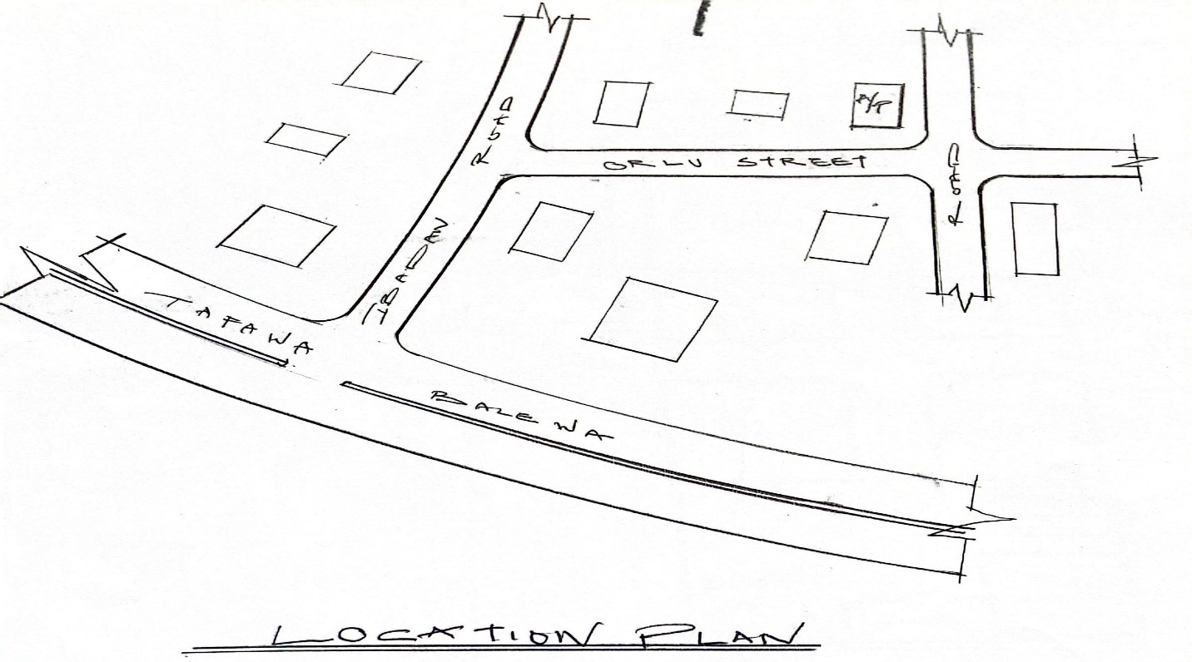
Figure 3.2.1: Site Location Plan
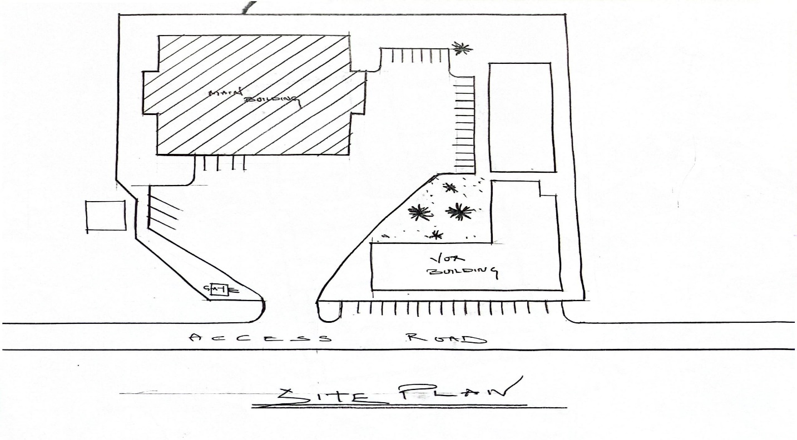
Figure 3.2.2: Site Plan

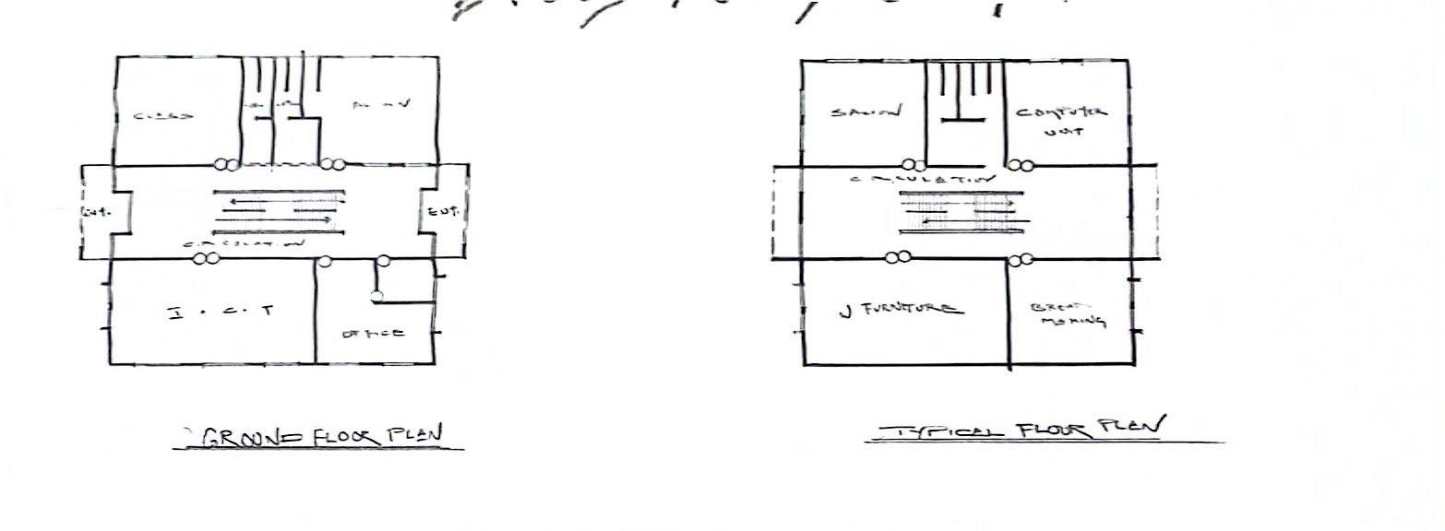
Figure 3.2.3: Ground and Typical Floor Plan
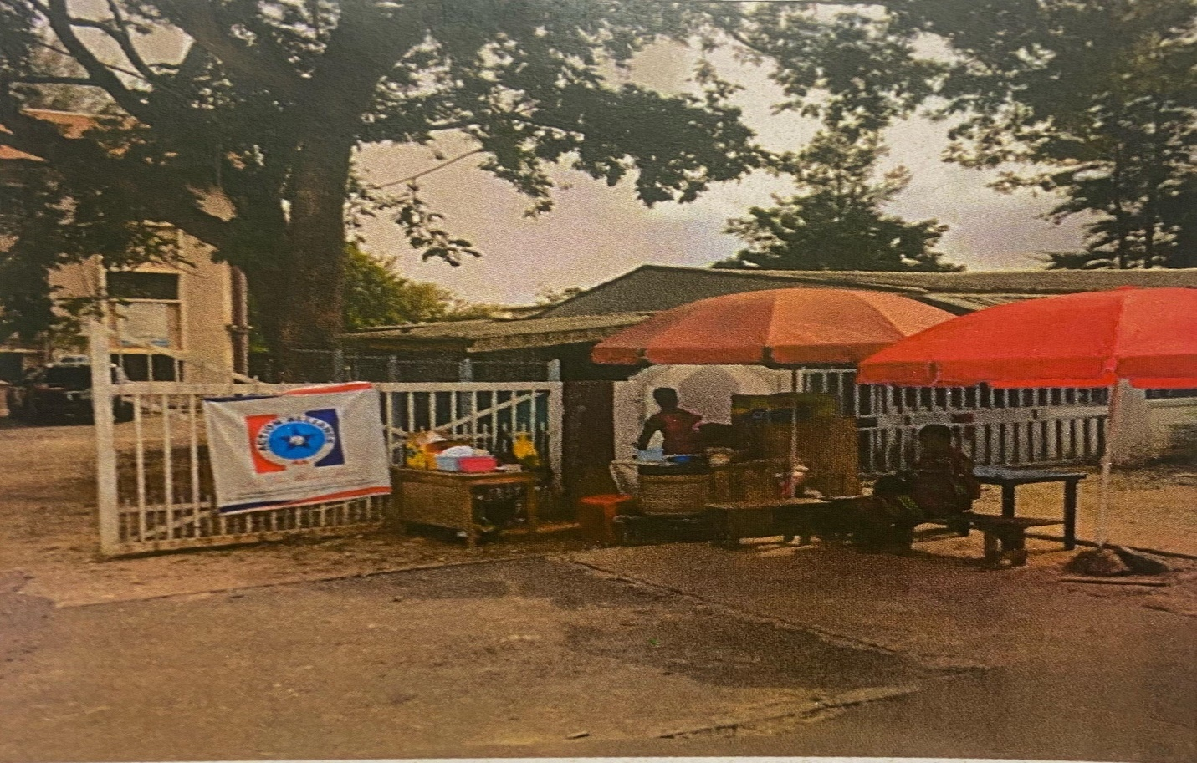
Plate 3.2.1: Entrance view of vocational hub
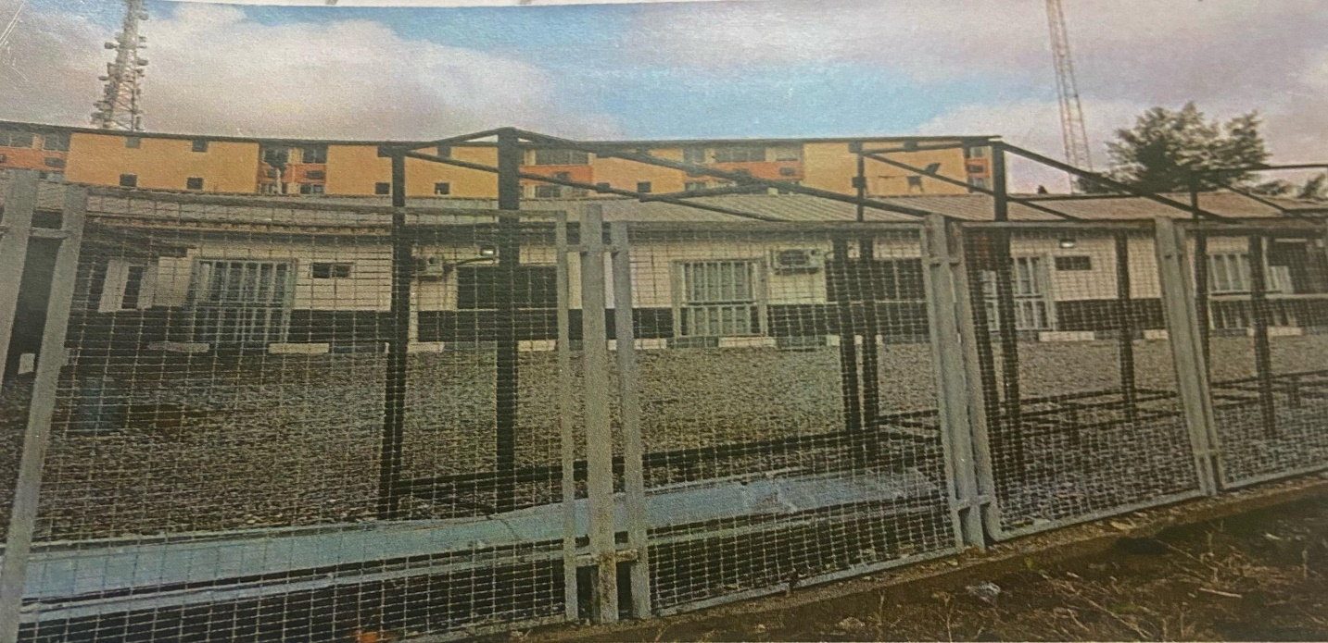
Plate 3.2.2: backview of vocational hub

3.3 Case Study Two
Name: Vocational Training Center Isheri
Location: Borderline Berger, Lagos State, Nigeria
Historical Background
Established as part of Lagos State’s skill acquisition network in the 1990s, the Vocational Training Center Isheri targets urban youth and women in the Berger area. The center aims to reduce unemployment by offering training in trades like fashion designing, carpentry, and ICT. It has become a vital resource in Lagos’s metropolitan environment, serving a diverse urban population.
Architectural Design
The center occupies a two-story building designed for space efficiency due to its urban location. The layout includes dedicated workshops for carpentry and fashion designing, alongside classrooms for ICT and theoretical instruction. Large windows facilitate natural ventilation, but limited window space necessitates reliance on artificial lighting. The compact site has minimal landscaping, with paved pathways for accessibility.
Facilities
The center is equipped with modern carpentry tools, industrial sewing machines, and a computer lab with 20 workstations. However, outdated software limits ICT training scope. A small library provides resources on entrepreneurship and business management, enhancing the curriculum’s practical focus.
Curriculum
The curriculum includes six-month to one-year programs in carpentry, fashion designing, and basic computer skills. Partnerships with local businesses ensure training aligns with market needs, resulting in high employment rates. Entrepreneurship training encourages graduates to start small businesses.
Accessibility
The center’s urban location ensures connectivity via major roads, but accessibility for physically challenged students is limited to basic ramps. The lack of adjustable workstations or sensory-friendly spaces excludes some learners.
Merits
- Strategic urban location enhances accessibility for city residents.
- Industry partnerships ensure curriculum relevance.
- Compact design optimizes space in a high-density area.
Demerits
- Limited space restricts enrollment and expansion.
- Inadequate accessibility features for physically challenged students.
- Reliance on grid electricity leads to disruptions during outages.
Lessons for Proposed Center
The center’s industry partnerships and urban accessibility are models for Ilorin. The proposed center should prioritize scalable designs and backup power systems to address space constraints and power challenges. Enhanced accessibility features will ensure inclusivity.
Visuals
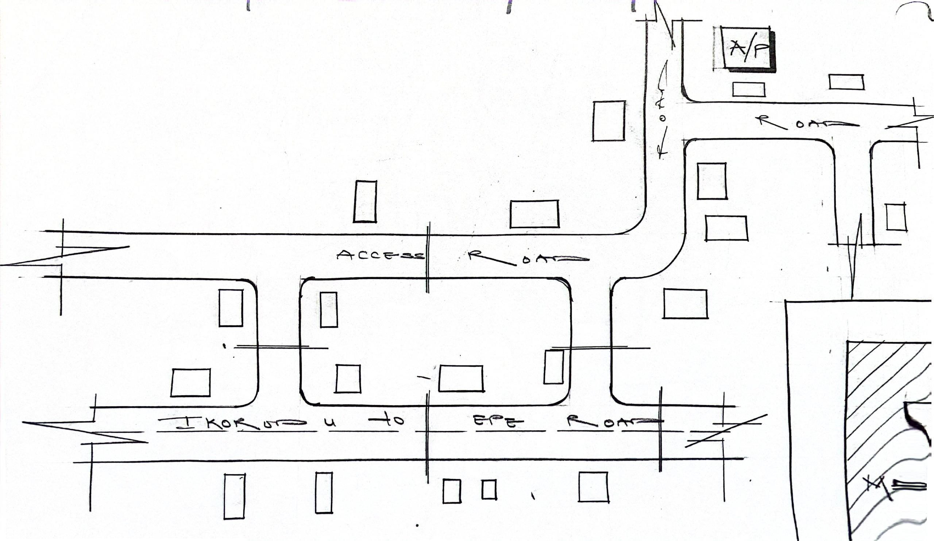
figure 3.3.1: Site Location Pla
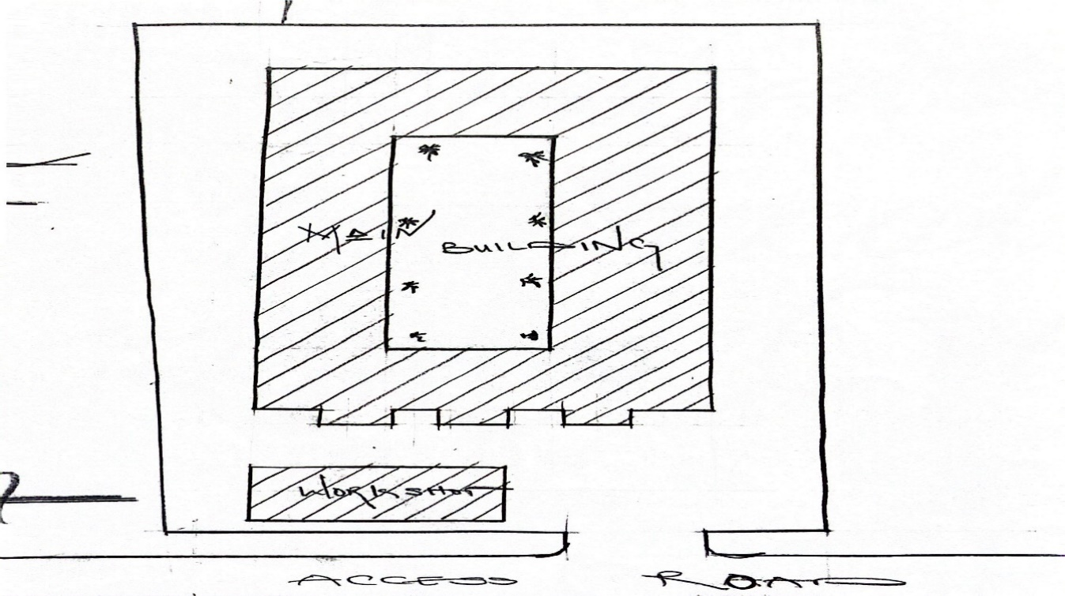
figure 3.3.2: Site Location Plan

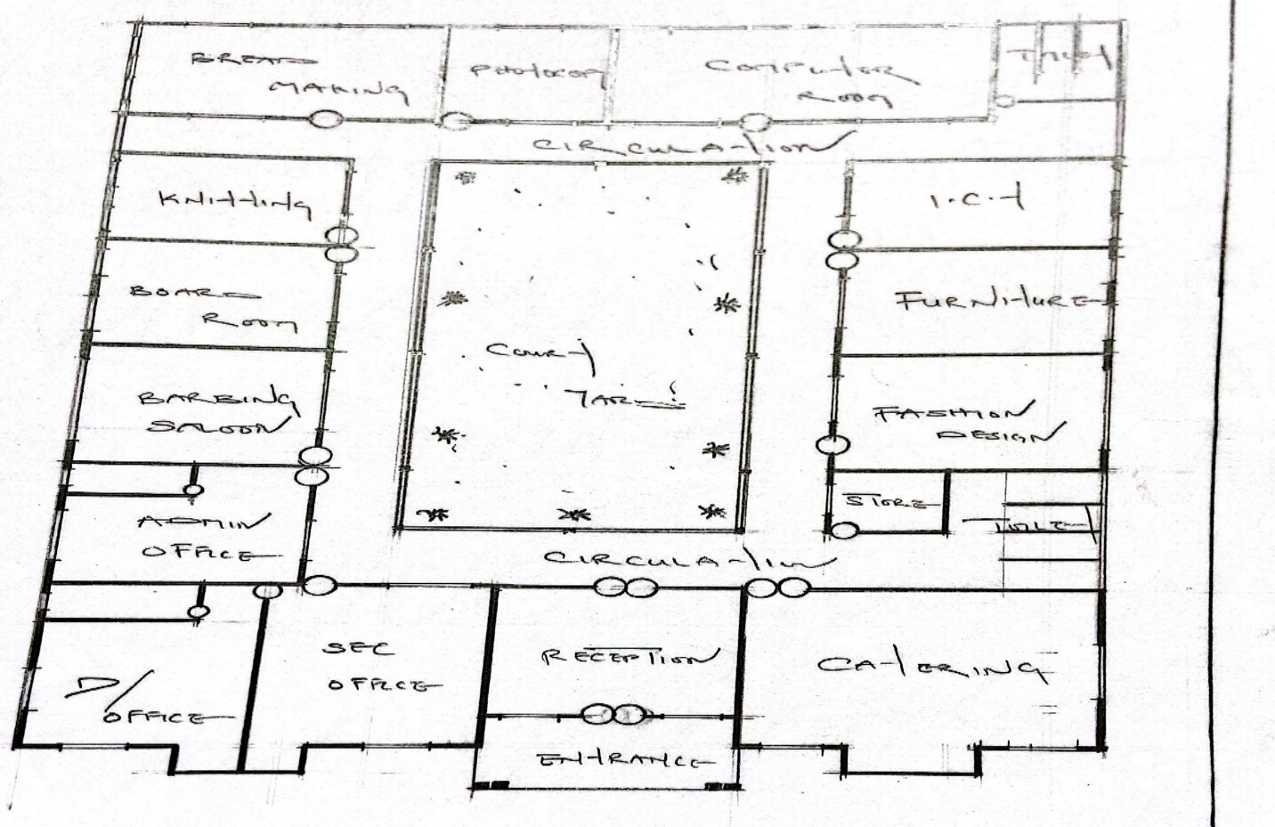
figure 3.3.3: ground floor plan

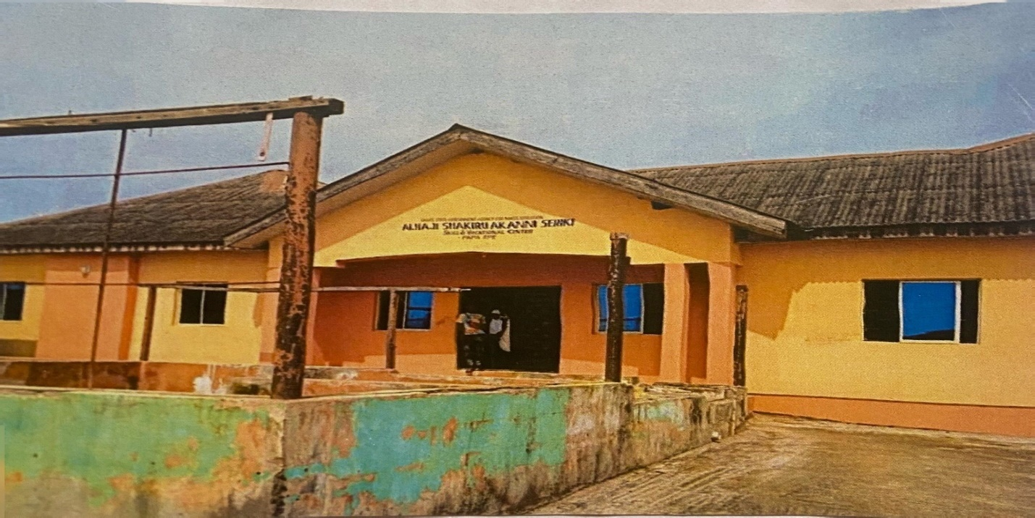
Plate 3.3.1: Front View of the Vocational Center
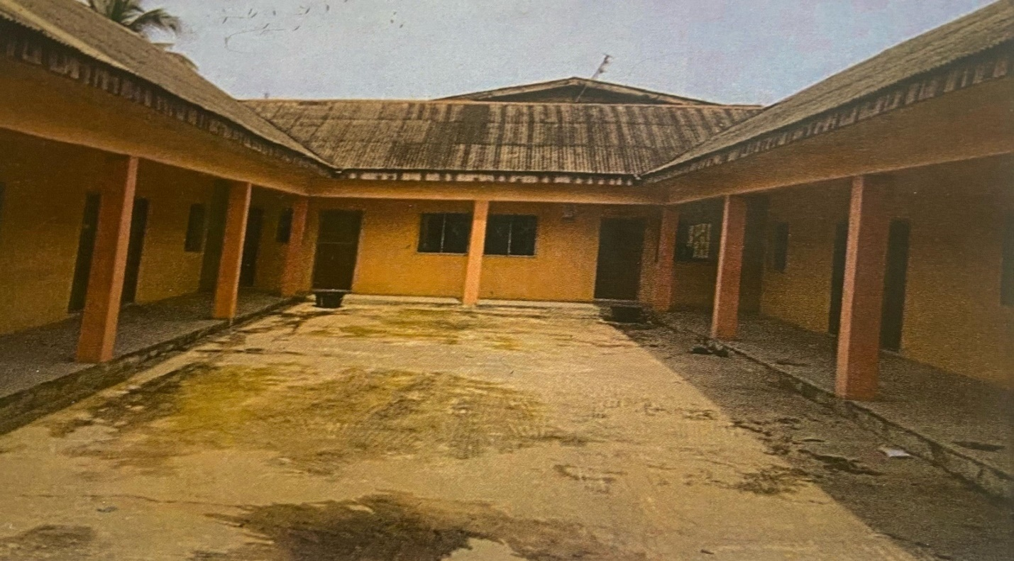
Plate 3.3.2: Exterior view of the vocational center
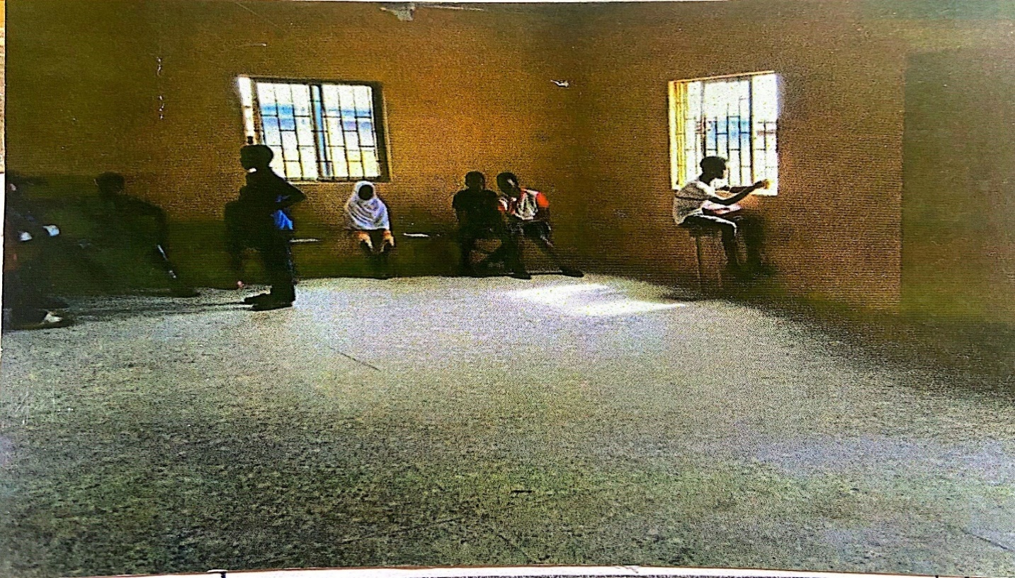
Plate 3.3.3: Interior View of Vocational center

3.4 Case Study Three
Name: Brace Spring Business and Vocational School
Location: Suza Mogaji Street, Lagos State, Nigeria
Historical Background
Brace Spring Business and Vocational School, established in the 2000s, is a private institution on Suza Mogaji Street, focusing on business-oriented vocational training. It serves professionals seeking to upskill and unemployed youth, offering programs in catering, event management, and beauty therapy. The school’s private funding model allows for personalized training but limits affordability.
Architectural Design
The school operates in a compact, single-story building with multi-purpose rooms that serve as both classrooms and workshops. Movable partitions provide flexibility for different training needs. The design uses vibrant colors and ergonomic furniture to enhance aesthetics, but limited outdoor space restricts landscaping.
Facilities
The school is equipped with modern kitchen appliances, professional-grade beauty therapy tools, and a small computer lab for business management courses. The compact design limits workstation capacity, restricting enrollment to smaller groups.
Curriculum
Programs range from three to nine months and include catering, event management, and beauty therapy, with a strong emphasis on entrepreneurship. Courses on business planning and marketing prepare graduates for self-employment. The small class sizes allow for personalized instruction.
Accessibility
The school’s urban location ensures easy access via public transport, but narrow doorways and the absence of ramps exclude physically challenged students. Parking challenges further limit accessibility.

Merits
- Personalized training due to small class sizes.
- Strong focus on entrepreneurship and business skills.
- Aesthetic interior design enhances the learning environment.
Demerits
- Limited space restricts enrollment capacity.
- Lack of accessibility features excludes physically challenged learners.
- High tuition fees limit access for low-income individuals.
Lessons for Proposed Center
The focus on entrepreneurship and personalized training is a model for Ilorin, but the proposed center should prioritize accessibility and affordability. Public funding or subsidies could broaden access, and a scalable design would accommodate larger enrollments.
Visuals
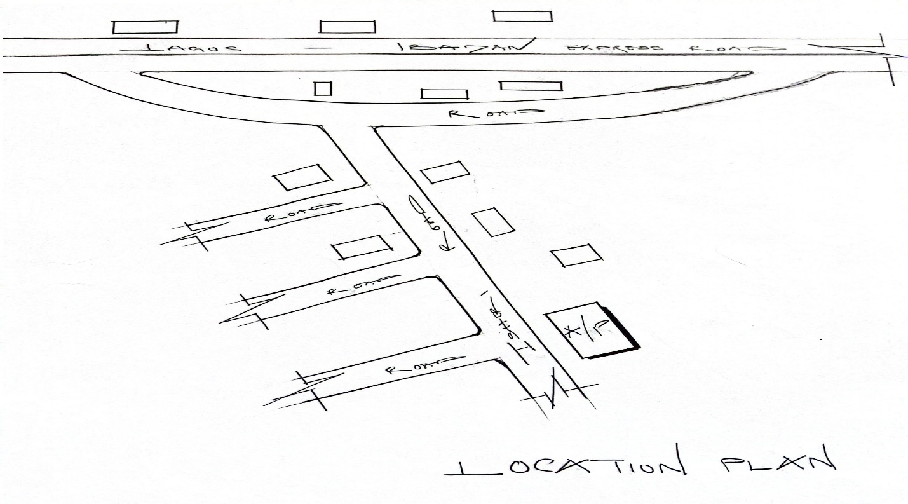
figure 3.4.1: Site Location Plan
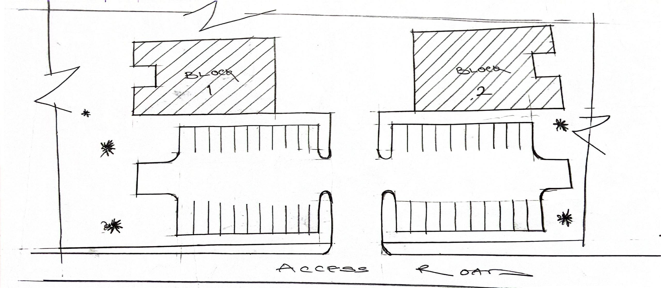
figure 3.4.2: Site Plan

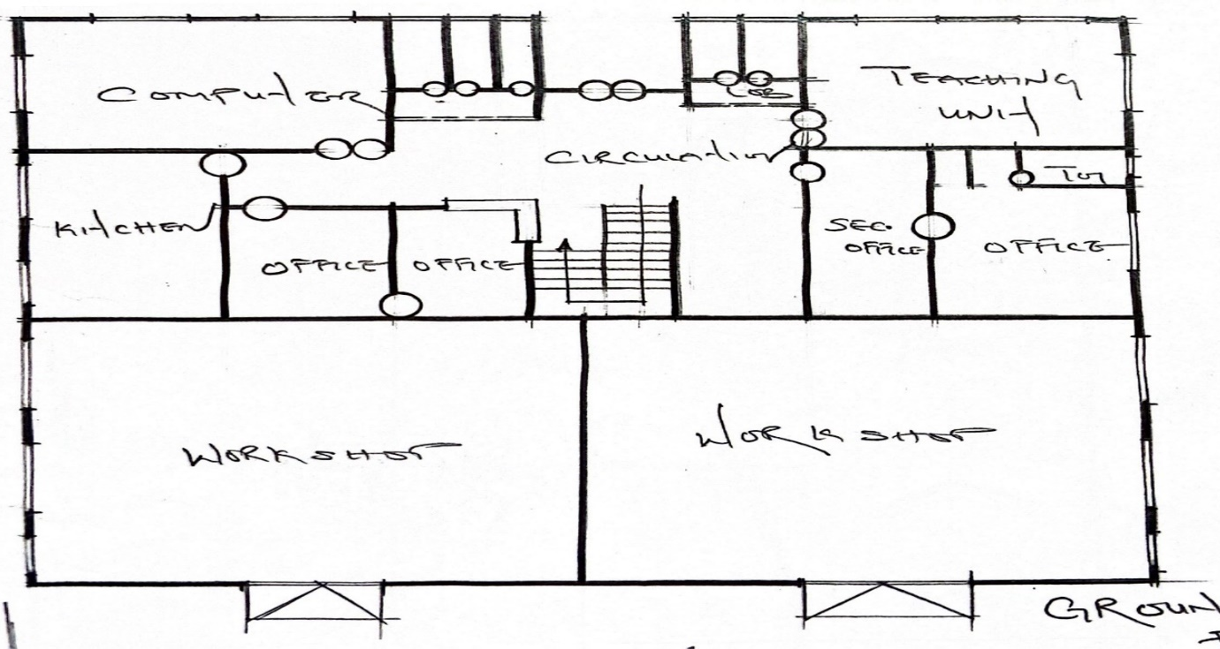
Plate 3.4.3: ground floor plan
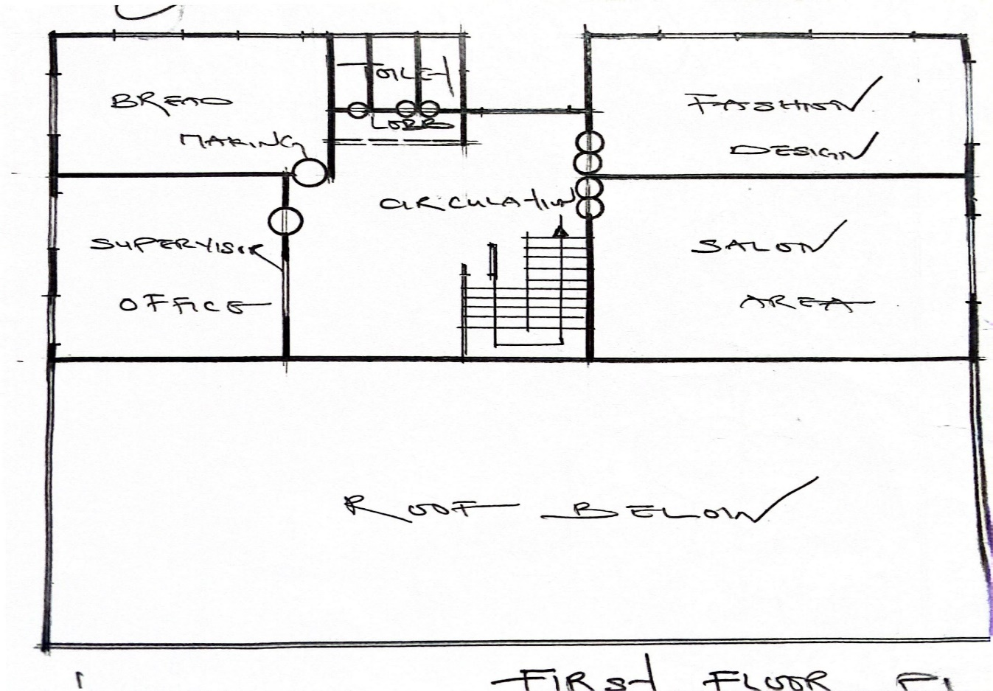
figure 3.4.4: first floor plan
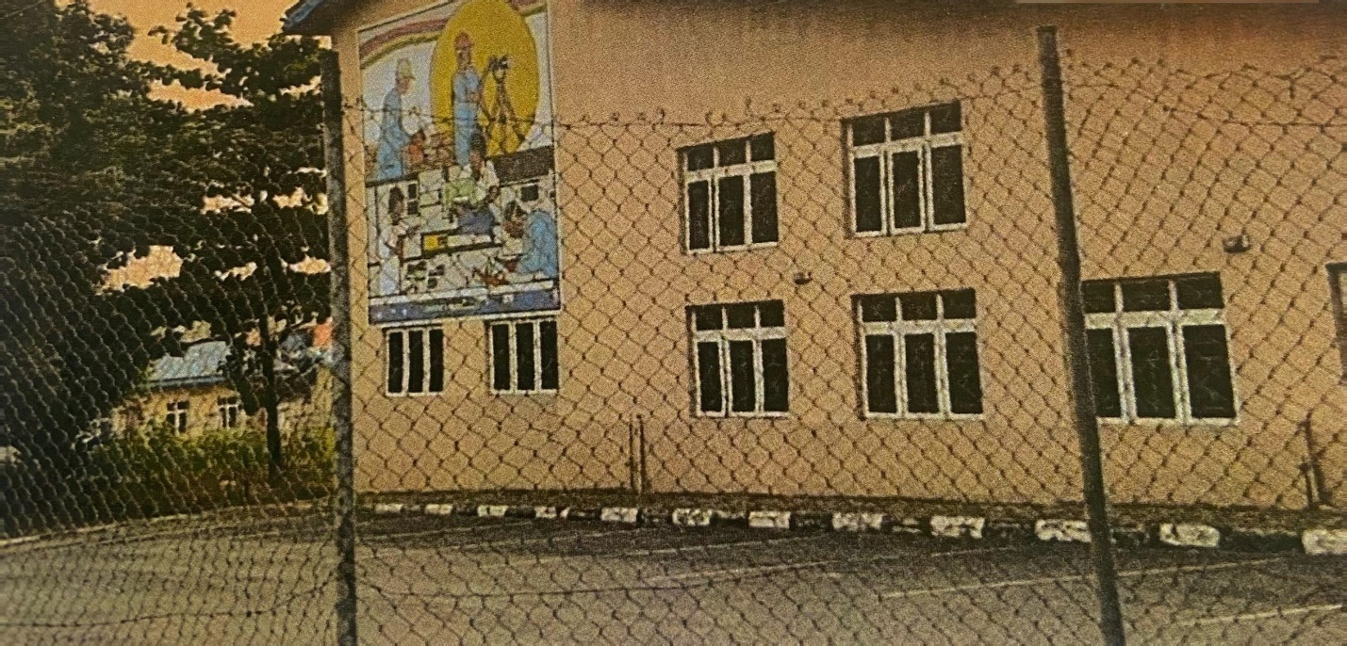
Plate 3.4.1: side View of Vocational center
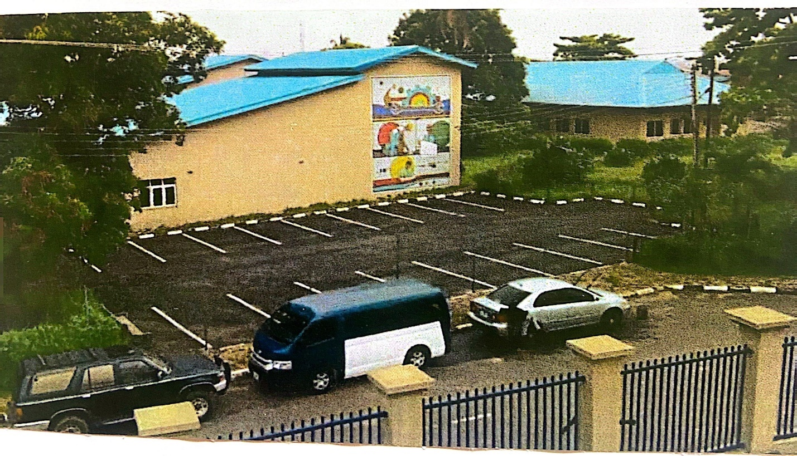
Plate 3.4.2: external perspective view

3.5 Case Study Four
Name: A and F Vocational Hub
Location: 3 New Bussa Close, Off Orli Street, Area 3, Garki, Abuja, Nigeria
Historical Background
The A and F Vocational Hub, established in the 2010s, is a privately-run center in Abuja, catering to government workers, unemployed youth, and professionals seeking to upskill. Located in the capital city, it offers training in ICT, fashion designing, and electrical work, focusing on advanced skills to meet urban market demands.
Architectural Design
The hub occupies a modern, two-story building with dedicated workshops for electrical work and fashion designing, alongside a computer lab. Large windows optimize natural lighting, and a rooftop terrace provides space for outdoor training. The urban site has minimal landscaping but includes paved pathways for accessibility.
Facilities
The hub is equipped with advanced ICT equipment, industrial sewing machines, and electrical toolkits. A backup generator ensures uninterrupted training, addressing Nigeria’s power challenges. A digital resource center supports research and online learning.
Curriculum
Programs range from six months to two years, covering ICT, fashion designing, and electrical work, with advanced offerings like software development and circuit design. Partnerships with tech firms enhance curriculum relevance, facilitating internships and job placements.
Accessibility
The hub features ramps, wide doorways, and accessible restrooms, making it inclusive for physically challenged students. Its central location in Abuja ensures connectivity via public transport.
Merits
- Advanced facilities and industry partnerships enhance training quality.
- Comprehensive accessibility features for physically challenged learners.
- Backup power system ensures uninterrupted training.
Demerits
- High tuition fees limit access for low-income learners.
- Limited space restricts expansion potential.
- Competition with other Abuja centers requires continuous innovation.
Lessons for Proposed Center
The hub’s accessibility features and industry partnerships are models for Ilorin. Incorporating backup power systems and a mix of traditional and advanced trades will enhance the proposed center’s effectiveness. Public funding could address affordability issues.
Visuals
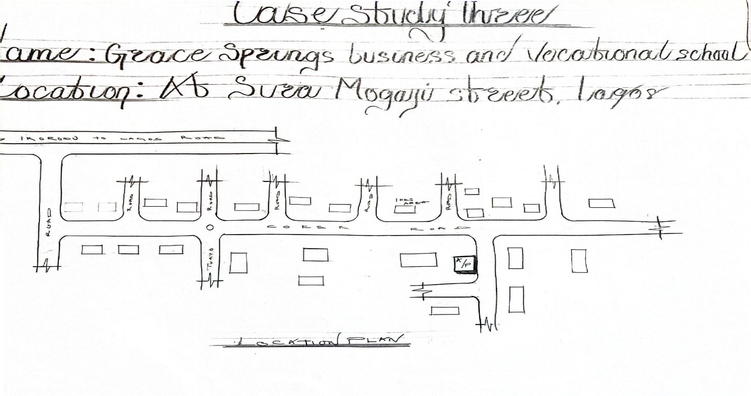
figure 3.5.1: Site Location Plan
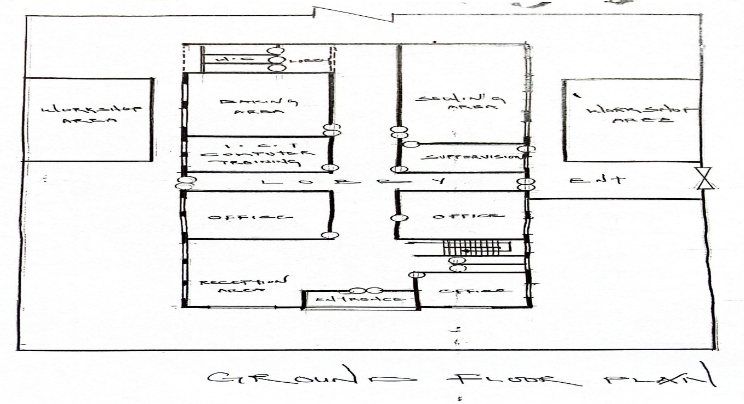
figure 3.5.1: Grounf floor plan
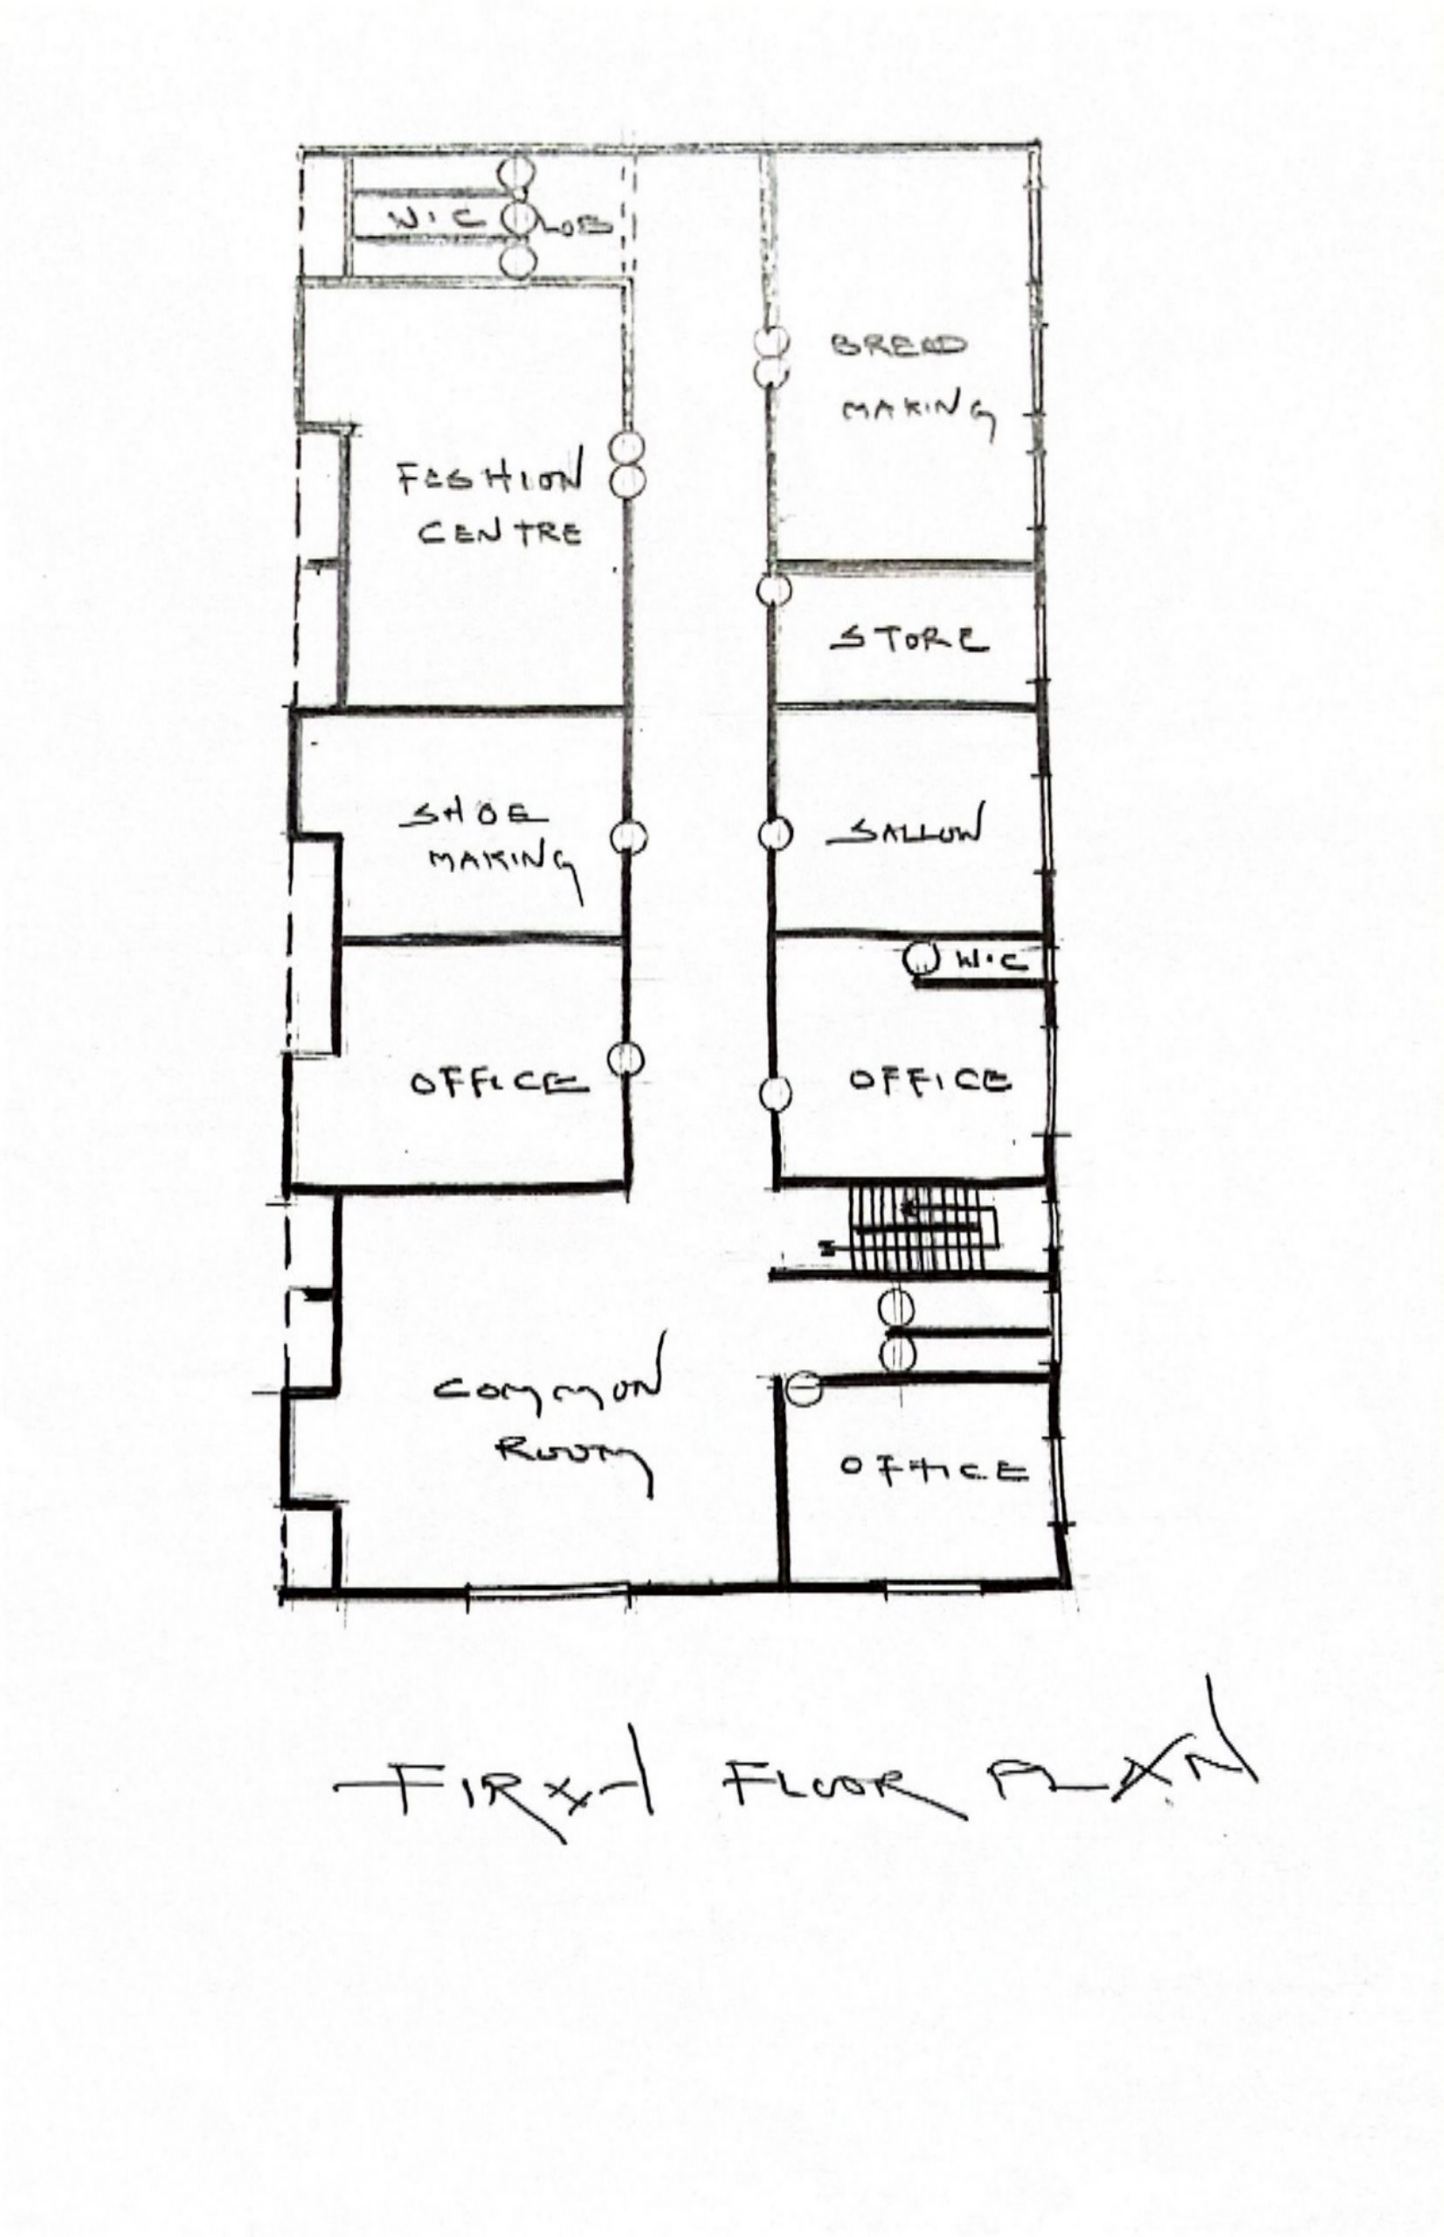
figure 3.5.3: Furst floor plan
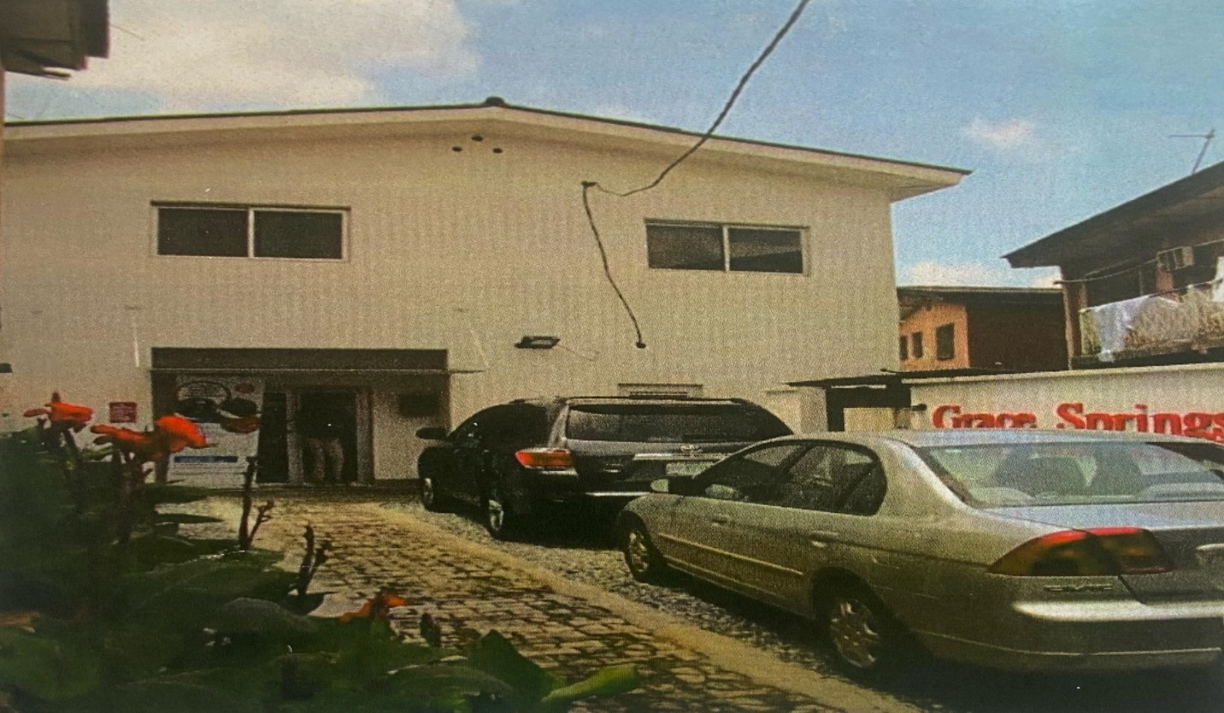
Plate 3.5.1: Front View of the Vocational Hub
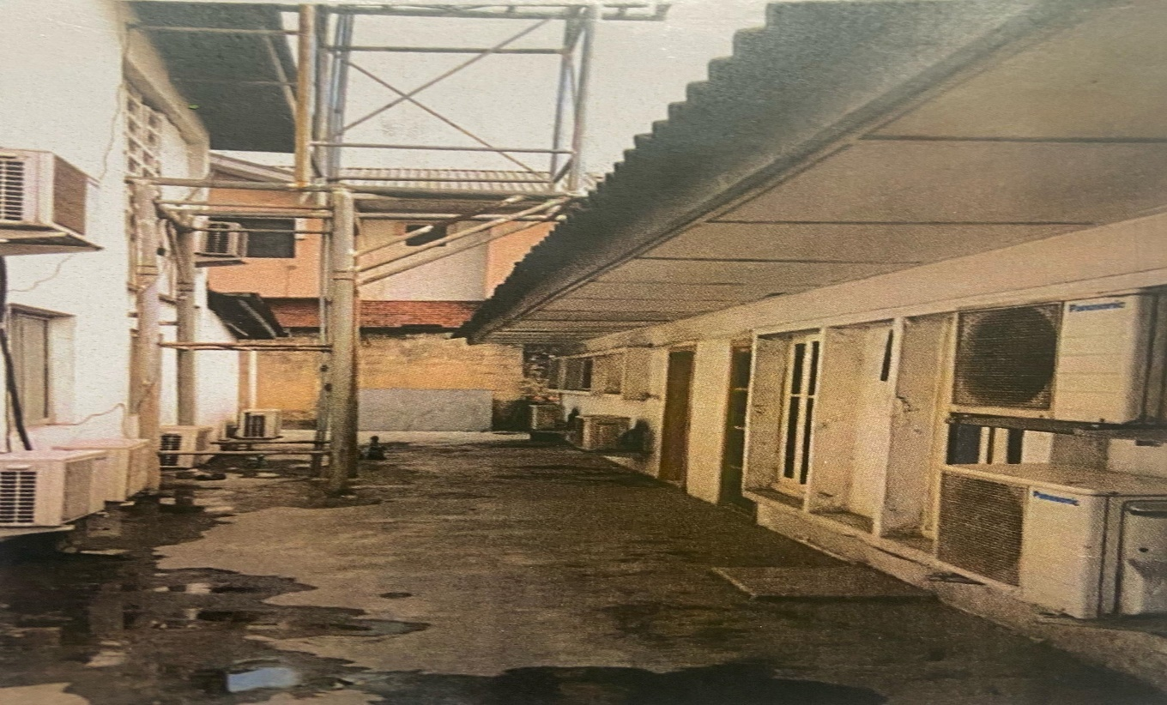
Plate 3.5.3: Back view of vocational hub

Plate 3.5.4: Interior View of Computer Lab

3.6 Online Case Study One
Name: National and Technical Center
Location: Kirthair Road, Sector H9, Plot 38, Islamabad, Pakistan
Historical Background
The National and Technical Center, established in the 2000s by Pakistan’s government, is a leading vocational institution in Islamabad, focusing on technical trades like automotive repair, welding, and IT. It aims to produce skilled professionals for Pakistan’s industrial sector, serving both urban and semi-rural populations.
Architectural Design
The center is a multi-story, purpose-built facility with state-of-the-art workshops and classrooms. Sustainable design elements include solar panels and rainwater harvesting systems, reducing operational costs. A central courtyard enhances ventilation and provides recreational space, while large windows and skylights optimize natural lighting.
Facilities
The center features advanced automotive repair tools, welding stations, and a high-tech computer lab. A library and e-learning platform support both in-person and online training, increasing accessibility. A multi-purpose hall hosts community events and skill exhibitions.
Curriculum
Programs range from one to three years, covering automotive repair, welding, IT, and entrepreneurship. International partnerships ensure global standards, and the e-learning platform supports remote learners, expanding the center’s reach.
Accessibility
The center is fully accessible, with elevators, ramps, and tactile signage for physically challenged students. Its urban location ensures connectivity via public transport, though rural learners face travel challenges.
Merits
- Sustainable design reduces operational costs and environmental impact.
- E-learning platform expands access to remote learners.
- Comprehensive accessibility features ensure inclusivity.
Demerits
- High operational costs for maintaining advanced facilities.
- Limited outreach to rural populations.
- Need for continuous trainer training to keep pace with technology.
Lessons for Proposed Center
The integration of sustainable design and e-learning platforms is highly relevant for Ilorin. Adopting similar accessibility features and online training options will enhance inclusivity and reach, particularly for rural learners.
Visuals
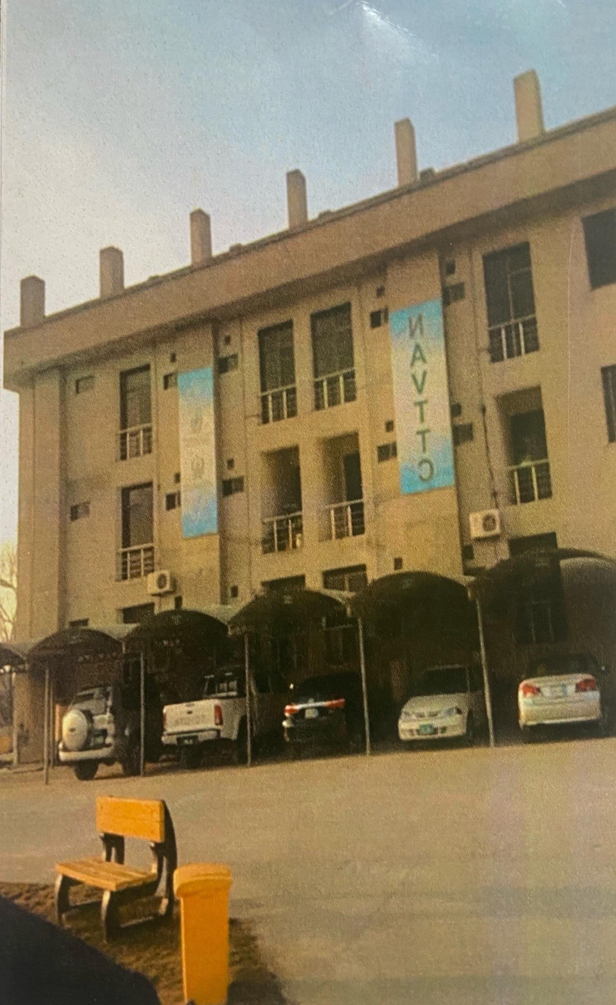
Plate 3.6.1: front view
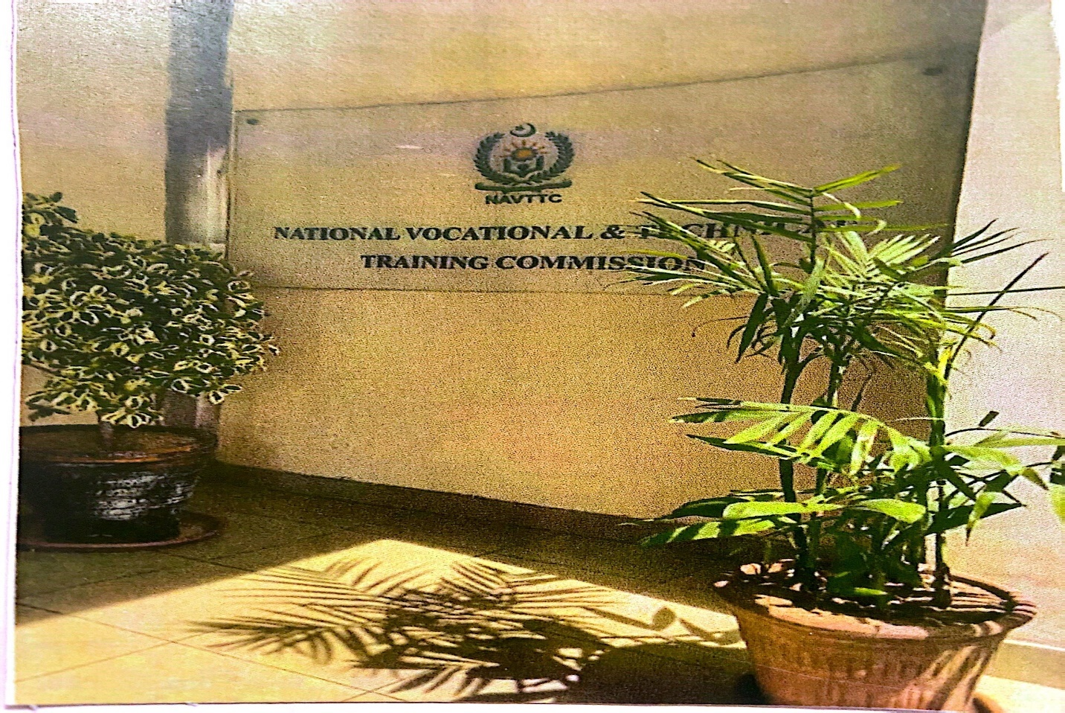
Plate 3.6.2: Entrance View of the National and Technical Center
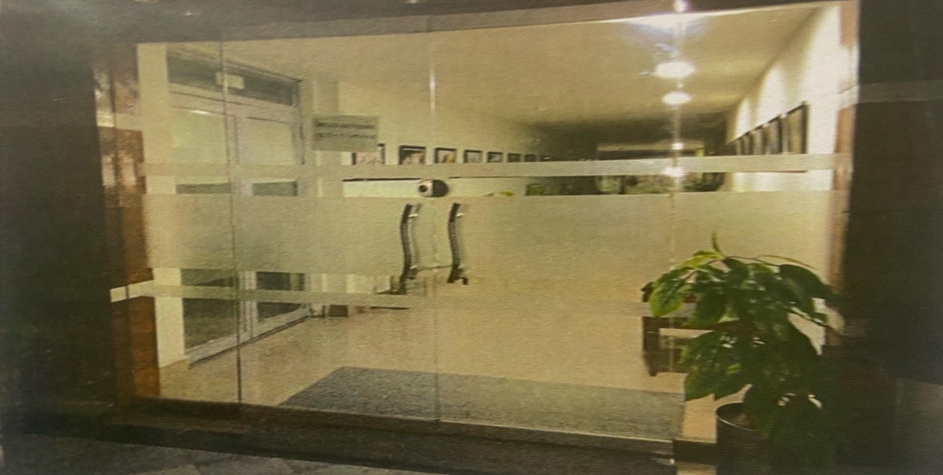
Plate 3.6.3: Interior View of National and Technical Center

3.7 Online Case Study Two
Name: NAVTTC Center of Excellence
Location: Plot 39, Kirthair Road, Islamabad, Pakistan
Historical Background
The NAVTTC Center of Excellence, established by Pakistan’s National Vocational and Technical Training Commission in the 2010s, is a flagship institution focusing on advanced fields like robotics, renewable energy, and ICT. Announced as part of Pakistan’s Vision 2025, the center aims to produce highly skilled professionals for global markets. Construction was completed in 2018, costing approximately PKR 1 billion (~USD 6M).
Architectural Design
The center features a modern, multi-story building with smart classrooms and specialized labs. Sustainable design elements include green roofs, energy-efficient lighting, and solar panels generating ~15% of energy needs. A central atrium maximizes natural lighting, while landscaped grounds with recreational areas enhance the learning environment. The design resembles a modern tech campus, symbolizing innovation.
Facilities
The center boasts robotics labs, renewable energy workshops, and advanced ICT facilities. A digital resource center supports research and innovation, and high-speed internet ensures seamless online training. An automated storage system for training materials increases efficiency.
Curriculum
Programs range from six months to two years, covering robotics, renewable energy, software development, and digital marketing. Industry partnerships facilitate internships and job placements, ensuring graduates are competitive in global markets.
Accessibility
The center is fully accessible, with elevators, ramps, sensory-friendly spaces, and tactile signage. Its urban location ensures connectivity, but outreach to rural areas is limited.

Merits
- Advanced facilities support cutting-edge training programs.
- Sustainable design reduces environmental impact and costs.
- Strong industry partnerships enhance employability.
Demerits
- High construction and maintenance costs for advanced technologies.
- Focus on high-tech fields may exclude learners seeking traditional trades.
- Limited rural outreach due to urban focus.
Lessons for Proposed Center
The emphasis on emerging technologies and sustainable design is inspirational for Ilorin. Incorporating a mix of traditional and modern trades, along with sustainable features like solar panels, will ensure relevance and longevity. Online training options could expand access to rural learners.
Visuals
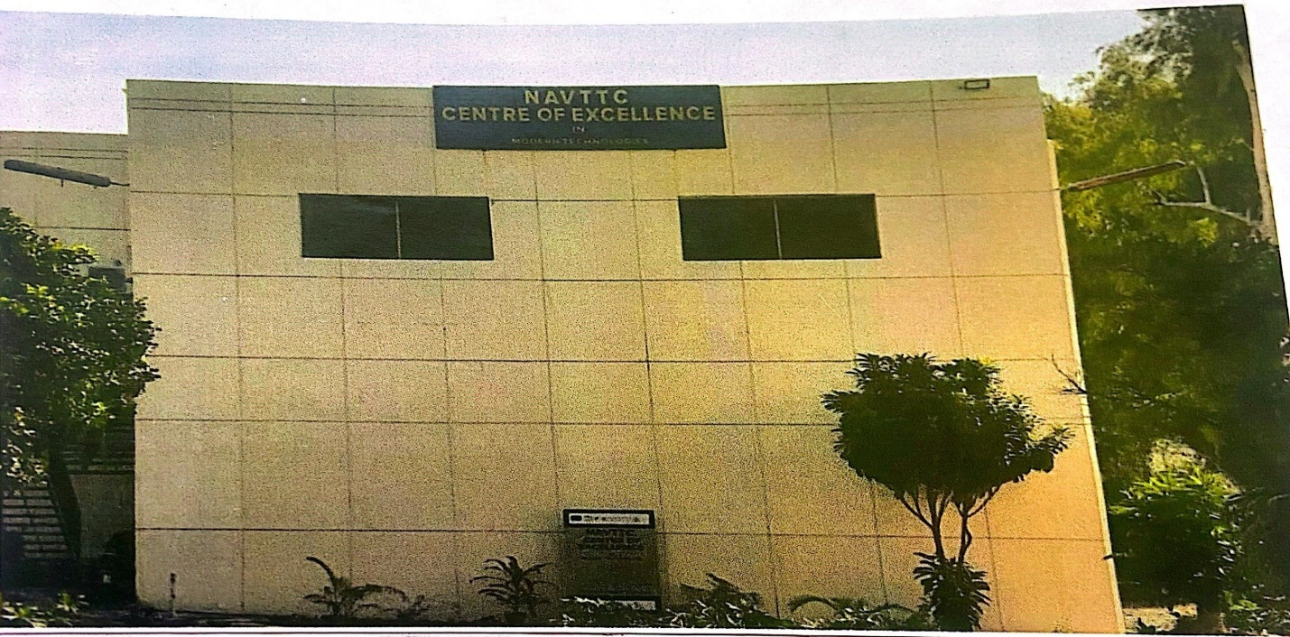
Plate 3.7.1: Front view of the NAVTTC Center of Excellence
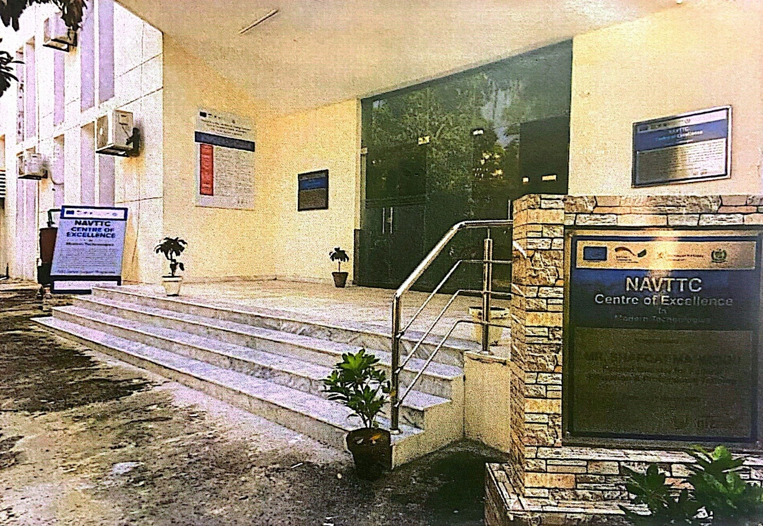
Plate 3.7.2: Entrance View of the NAVTTC Center of Excellence

3.8 Comparative Analysis
The case studies reveal key similarities and differences:
- Design and Facilities: Urban centers (Isheri, A and F Vocational Hub) prioritize space efficiency, while larger facilities (National and Technical Center, NAVTTC) incorporate sustainable design. The Ilorin center should balance compactness with scalability and sustainability.
- Curriculum: Local centers focus on traditional trades, while international centers emphasize modern skills. A mixed curriculum will cater to Ilorin’s diverse needs.
- Accessibility: International centers demonstrate stronger accessibility features, which Ilorin should emulate to ensure inclusivity.
- Challenges: Common issues include funding, outdated equipment, and limited rural outreach. Partnerships and sustainable design can mitigate these.

3.9 Lessons for the Proposed Vocational Center
The case studies provide actionable insights for the proposed center in Ilorin:
- Modular and Scalable Design: Adopt flexible, modular layouts to accommodate diverse trades and future expansion.
- Sustainable Features: Incorporate solar panels, rainwater harvesting, and natural lighting to reduce costs and environmental impact.
- Inclusivity: Include ramps, wide doorways, tactile signage, and sensory-friendly spaces to ensure accessibility for all learners.
- Industry Partnerships: Collaborate with local industries to align training with market needs and facilitate job placements.
- Mixed Curriculum: Offer traditional trades (tailoring, carpentry) and modern skills (ICT, graphic design) to cater to diverse learners.
- Backup Power Systems: Install generators or solar panels to address power disruptions.
- Online Training: Incorporate e-learning platforms to expand access, particularly for rural learners.

CHAPTER FOUR

INTRODUCTION OF STUDY AREA / SITE SELECTION
This chapter provides a comprehensive overview of the study area and site selection process for the proposed vocational center along New Yidi Road, Ilorin, Kwara State. It includes a brief history and cultural context of Kwara State, accessibility analysis, physical characteristics of the site, site analysis, neighboring facilities, climatic conditions with temperature graphs, and a detailed project analysis. The information presented aims to justify the choice of location and inform the design process to ensure the vocational center meets the needs of its intended users and aligns with the environmental and cultural context of the area.

4.1 Introduction of Study Area
Kwara State Overview
Kwara State, located in Western Nigeria, is known as the “State of Harmony” due to its diverse yet cohesive ethnic composition. Its capital, Ilorin, serves as the administrative, economic, and cultural hub of the state. Created on May 27, 1967, by the Federal Military Government under General Yakubu Gowon, Kwara State was formed from the former Ilorin and Kabba provinces of the then Northern Region. Initially named West Central State, it was later renamed “Kwara,” a local term derived from the Nupe word for the River Niger, reflecting the state’s geographical and cultural connection to this major waterway.
Covering a land area of approximately 36,825 km², Kwara State is situated within the North Central geopolitical zone of Nigeria. According to the 2006 census, the state had a population of 777,667, with Ilorin ranking as the seventh largest city by population in Nigeria. The population has since grown, driven by urbanization and economic activities in Ilorin and other major towns like Offa. The primary ethnic group is Yoruba, with significant minorities including Nupe, Bariba, and Fulani, contributing to a rich cultural tapestry that influences the state’s social and economic dynamics.
Since its creation, Kwara State’s geographical boundaries have been redefined through multiple state creation exercises. On February 13, 1976, the Idah/Dekina area was excised and merged with parts of Benue/Plateau State to form Benue State. On August 27, 1991, five local government areas (Oyi, Yagba, Okene, Okehi, and Kogi) were transferred to form part of Kogi State, while Borgu Local Government Area was merged with Niger State. Today, Kwara State comprises sixteen Local Government Areas: Asa, Baruten, Edu, Ekiti, Ifelodun, Ilorin East, Ilorin South, Ilorin West, Irepodun, Isin, Kaiama, Moro, Offa, Oke Ero, Oyun, and Pategi.
Cultural Context
Kwara State’s cultural diversity is a significant asset, fostering harmony among its ethnic groups. The Yoruba culture dominates, characterized by vibrant festivals, traditional crafts, and a strong emphasis on education and entrepreneurship. The Nupe, Bariba, and Fulani communities contribute additional layers of cultural practices, including unique art forms, music, and agricultural traditions. This cultural diversity makes Kwara State an ideal location for a vocational center, as it can offer training programs tailored to the region’s varied economic activities, such as farming, crafting, and modern trades like ICT.
Economic and Social Context
Kwara State’s economy is primarily agrarian, with agriculture employing a significant portion of the population. Key crops include yam, cassava, maize, and rice, while livestock farming is also prevalent. Ilorin, as the economic hub, hosts commercial activities, educational institutions, and government offices, making it a focal point for skill development initiatives. However, unemployment, particularly among youth and physically challenged individuals, remains a challenge, underscoring the need for vocational training to promote self-reliance and economic empowerment.
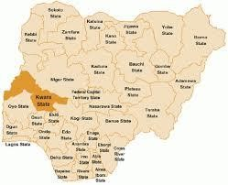
Figure 4.0: Map of Nigeria Showing Kwara State
Source: Wikipedia

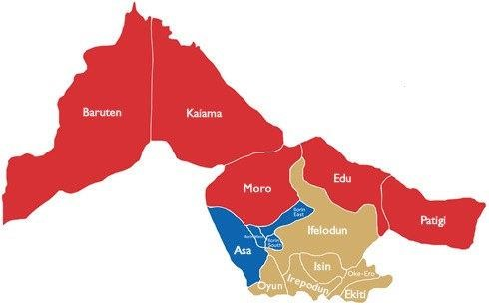
Figure 4.1: Map of Kwara State
Source: Wikipedia

SITE LOCATION/ DESCRIPTION/CRITERIA
The selected site for the Proposed vocational centre which will be located along New Yidi road Ilorin, Kwara State.
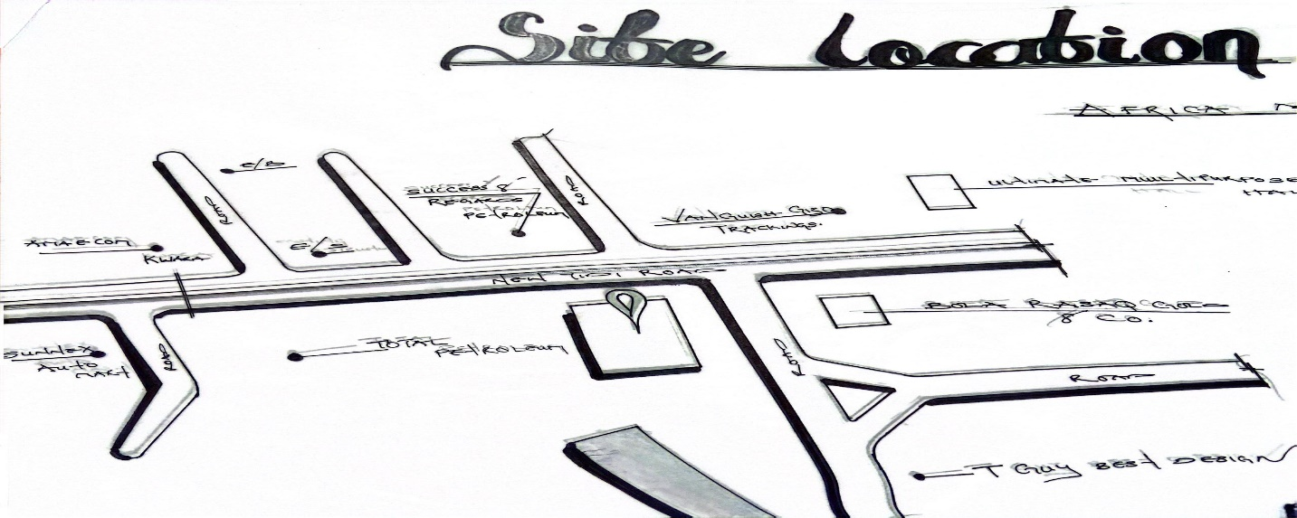
Site Locational Plan
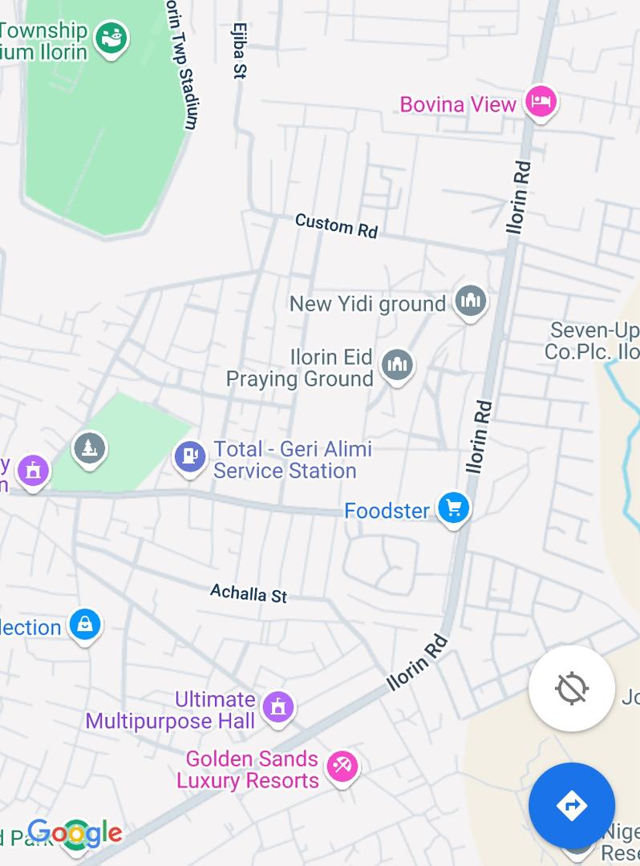
Area View of the Site
Source: Google Map

SITE CRITERIA
- Accessibility: the site is easily accessible for easy movement of construction materials to the site.
- Vegetation: at the site, there is a lot of trees some will be removed while some will be retained and serve as wind breakers and shading devices.
- Utilities: Existing Electricity, water and telecommunication network are accessible around the site.
- Topography: the site is sloppy toward North region but the slop is not much which will be levelled up during the construction
- Air Movement: A prevailing air mass emanate from Sahara Desert. It is Harsh hot and dust in nature
- Soil type: the site natural sand are Loamy and Sandy soil
- Safety: the site is located in an area with less security threats to life and property
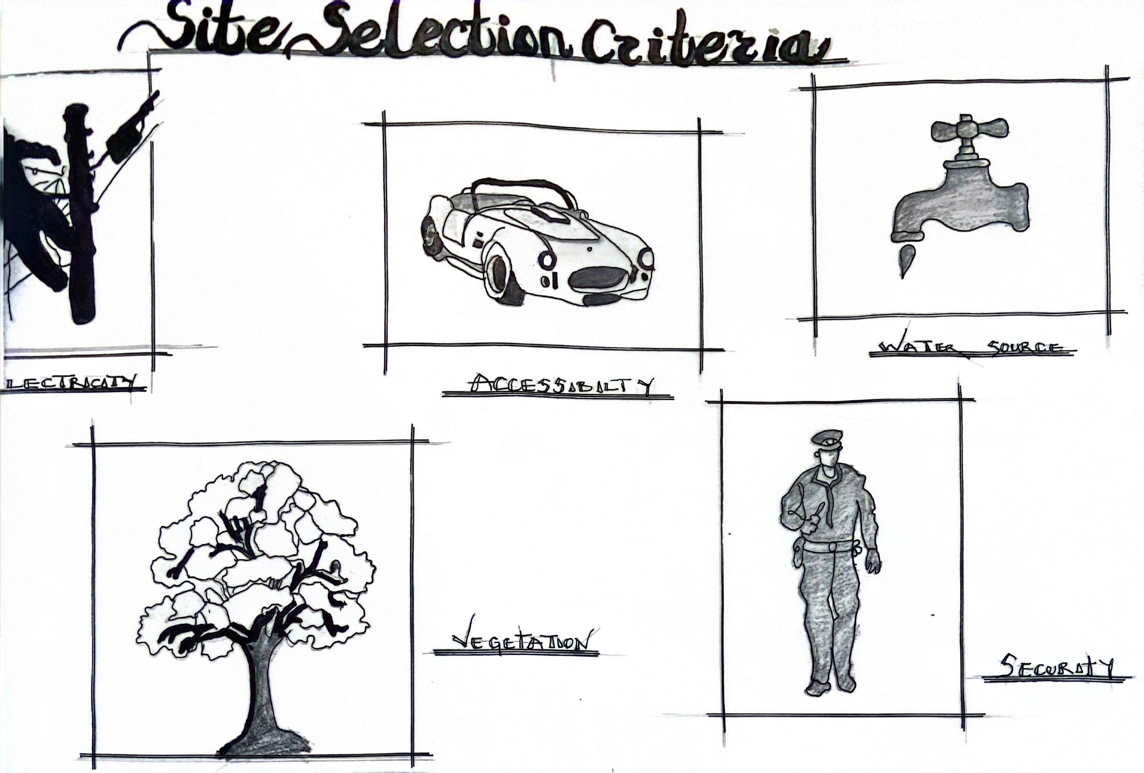
Site Selection Criteria
Source: Author

SITE ANALYSIS
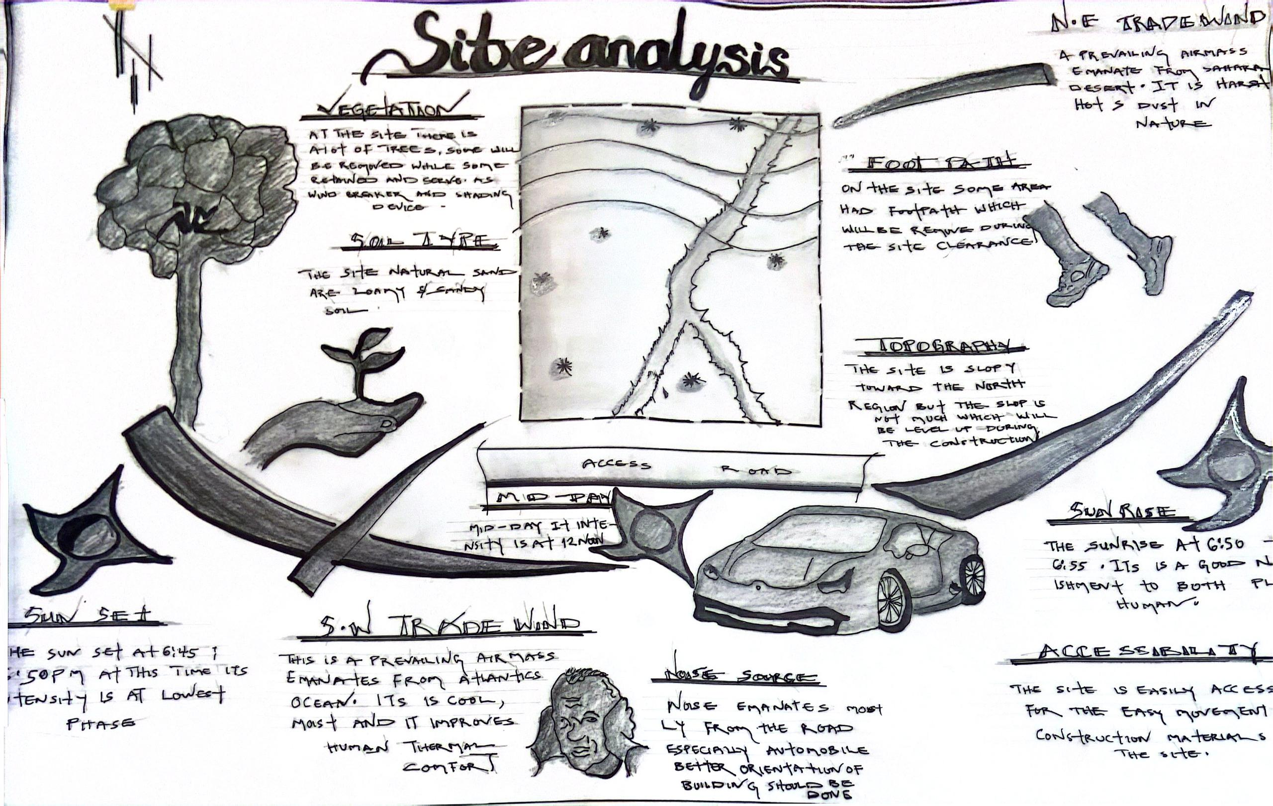
Site Analysis
Source: Author

SITE INVENTORY
This site Inventory contain Climate and Environmental conditions of the site and it was discovered that the site is still a virgin which give an advantage to it proper use. Proper research has been carried out in view of acquiring relevant data that will be further analysised to inform the design process of the building to achieve functionality, stability and create a unique building experience.
TOPOGRAPHY AND SLOPE OF THE SITE
The topography of the site selected is sloppy but the slope is not much which will be level up during the construction
CLIMATE DATA
Climatic Condition characteristically are measured over wider areas and lengthier time frames. In considering the climate condition of the site the rainfall, temperature and prevalent wind speed were carefully consider using available climatic date
RAINFALL
The driest month is January, with 18mm of rainfall. Most precipitation falls in September, with an average of 1217mm rainfall / 47.9 per year. The rainy season is characterized by continuous rainfall, which is usually referred to as wet season; sunshine period without rain increases the temperature of the surroundings thereby causing discomfort during the afternoon period. The relative humidity has to do with the amount of moisture in the atmosphere. In January it is about 75-90% while in July it is over 95%. Ilorin lies on 317m above sea level, this city has a tropical climate.
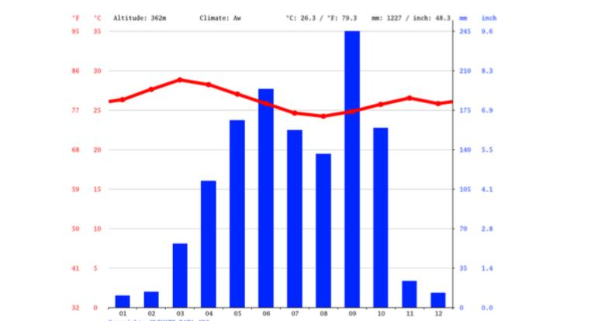

TEMPERATURE
The temperature are highest on average in March, at around 29.0 ºC. The lowest average temperatures in the year occur in August, when it is around 24.5 ºC. Hence the problem of temperature should be considered from the conceptualization stage all through to the construction stage, this will enable the effective use of the building in terms of comfort and environmental adaptability to enhance an acceptable and useable architectural piece.
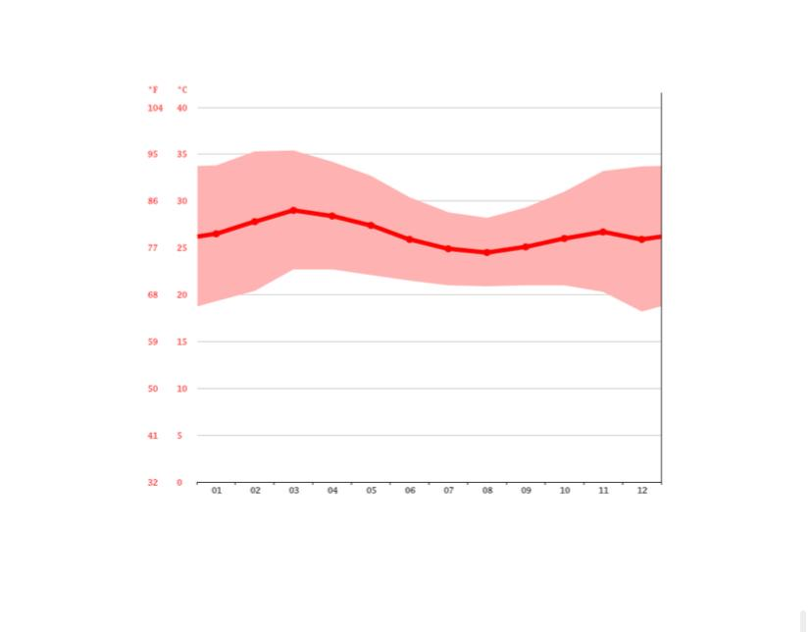
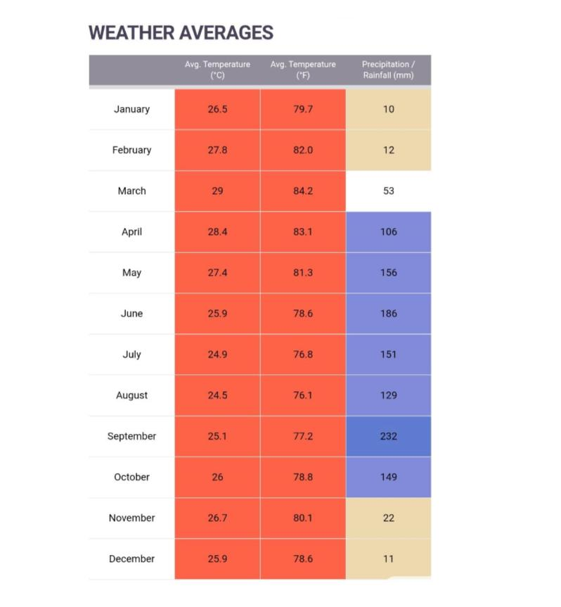
PREVAILING WIND
The prevailing wind over the site determines the quality and intensity of the air around the building, this further determines the level of comfort within and around the building, if the air is static, discomfort is experienced which in other words increases the heat in building hence, cross ventilation, open courtyard and proper fenestration should be a paramount importance, this will help in bringing cooler and fresh air into the building there by cooling body and removing used saturated air which can in effect leads to stack action within the building.
PROJECT ANALYSIS
DESIGN BRIEF
The proposed vocational centre is to serve the whole kwara and it environment and to reduce the population of unemployment most especially physically challenge people in kwara state.
The vocational centre would have the following facility:
1. Reception
2. Conference room
3. Rector office
4. Library
5. Exhibition hall
6. Displace room
7. Shops
8. Convince
9. Court yard
10. Admin block
11. Classes

FUNCTIONAL ANLYSIS
RECEPTION
This space is located next to the entrance of the building from which other space can be accessed it is merit to contain the receptionist and the necessary furniture and working equipment guest and worker alike to the entering the building
CONFRENCE
Room space are provided to making a cooperate meeting conducive within the duration they are to hold.it houses the conference table provision of seating
EXHIBTIONB HALL/ AUDTORIUM
This space is meant for display and serve as auditorium that contain a sizeable population of people with the space.
COURTYARD
The courtyard a place in the design to ventilation and throw lighting to the dark space within the structure
SHOP
The space provided to allow for the sales of item of important to both student and lecturer of the vocational centre to run permanent through the life cycle of the building.
DISPLAY ROOM
This space provide enough accommodation for the display of the following
CONVINENCE
Toilet is provided at the different position in the building.
APPRAISAL OF PROPOSED SCHEME IN THE RELATIONSHIPS, SPACE AND SIZES
A RECEPTION HALL
The reception hall is the first space you came across while entering the building .it directly links to the display room .it is essentially a welcome point from which virtually every space within building assessable.it is designed to be 95.200m²
CONFERENCE ROOM
The conference room is located on the first floor covering the total of 43.350m² in total
It has entrance directly to the circulated area and directly into rector’s office
EXHIBITION HALL
This space is the centre of the building and is design for function and it cover total of 814.200m²
SHOP
The shopping area consist of eight shop from ground floor and first floor, it covers a total of 40.000m²
DISPLAY
This space is directly link to the reception and they are two display room which cover the total of 167.280m²
CLASSES
This space is created to enhance learning for the students and it covers the total of 220.320m²

Spatial Allocation/ Schedule of Accommodation
Schedule of accommodation
S/N | Units | L (mm) | B (mm) | Number | Remark (m²)
1 | ENTRANCE | 11000 mm | 5000 mm | 1 | 55.000 m²
2 | RECEPTION | 11000 mm | 5500 mm | 1 | 60.500 m²
3 | DISPLAY ROOM | 10200 mm | 9500 mm | 2 | 193.800 m²
4 | STAFF HALL | 8400 mm | 5000 mm | 1 | 42.000 m²
5 | TOILETS | 6000 mm | 1500 mm | 24 | 57.600 m²
6 | SHOP | 6500 mm | 2000 mm | 8 | 104.000 m²
7 | KITCHEN | 4500 mm | 2000 mm | 1 | 9.000 m²
8 | CHIEF OFFICE | 2500 mm | 2500 mm | 1 | 6.250 m²
9 | SERVICE | 2500 mm | 2500 mm | 1 | 6.250 m²
10 | CANTEEN | 8000 mm | 8500 mm | 1 | 68.000 m²
11 | LUNCH ROOM | 7000 mm | 8000 mm | 1 | 56.000 m²
12 | EXHIBITION HALL | 35400 mm | 23000 mm | 1 | 814.200 m²
13 | CONSULTANT OFFICE | 4100 mm | 2500 mm | 1 | 10.250 m²
14 | AMBULANCE BAY | 3900 mm | 2500 mm | 1 | 9.750 m²
15 | FIRST AID TREATMENT | 4100 mm | 2500 mm | 1 | 10.250 m²
16 | COMPUTER PROGRAMME | 9500 mm | 8500 mm | 1 | 70.520 m²
17 | FASHION DESIGN WORKSHOP | 8600 mm | 7200 mm | 1 | 61.920 m²
18 | CONFERENCE ROOM | 8500 mm | 5100 mm | 1 | 43.350 m²
19 | RECTOR OFFICE | 6500 mm | 7700 mm | 1 | 50.050 m²
20 | SECRETARY OFFICE | 3000 mm | 3900 mm | 1 | 11.850 m²
21 | ADMIN OFFICE | 3300 mm | 3000 mm | 1 | 19.800 m²
22 | BARBING SALOON | 8500 mm | 8200 mm | 1 | 70.520 m²
23 | ART & CRAFT | 8500 mm | 8200 mm | 1 | 70.520 m²
24 | ACTING | 2500 mm | 2700 mm | 1 | 6.750 m²
25 | LIBRARY | 8200 mm | 6900 mm | 1 | 56.580 m²
26 | ELECTRICAL | 8500 mm | 7200 mm | 1 | 61.920 m²
27 | CRAFT/ENG | 6500 mm | 7200 mm | 1 | 46.800 m²
28 | OFFICES | 3450 mm | 3000 mm | 1 | 10.350 m²
29 | TOILET | 2100 mm | 1200 mm | 8 | 20.160 m²
30 | RAMP | 6500 mm | - | 2 | 23.940 m²

TOTAL: 2194.86 m²
Functional Relationship
Functional relations in architectural design refer to the way in which different spaces, elements, and components of a building interact and support each other to achieve the intended purpose of the structure. These relations are crucial for creating efficient, practical, and aesthetically pleasing environments.

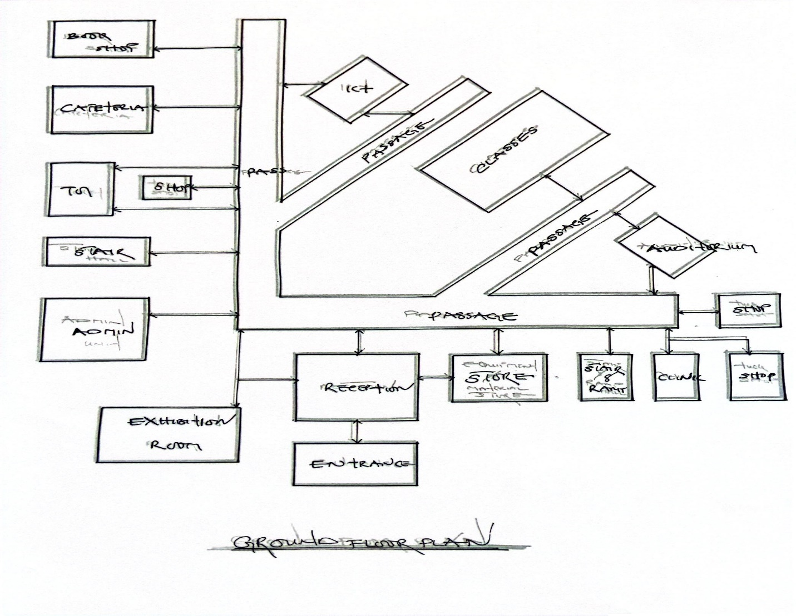
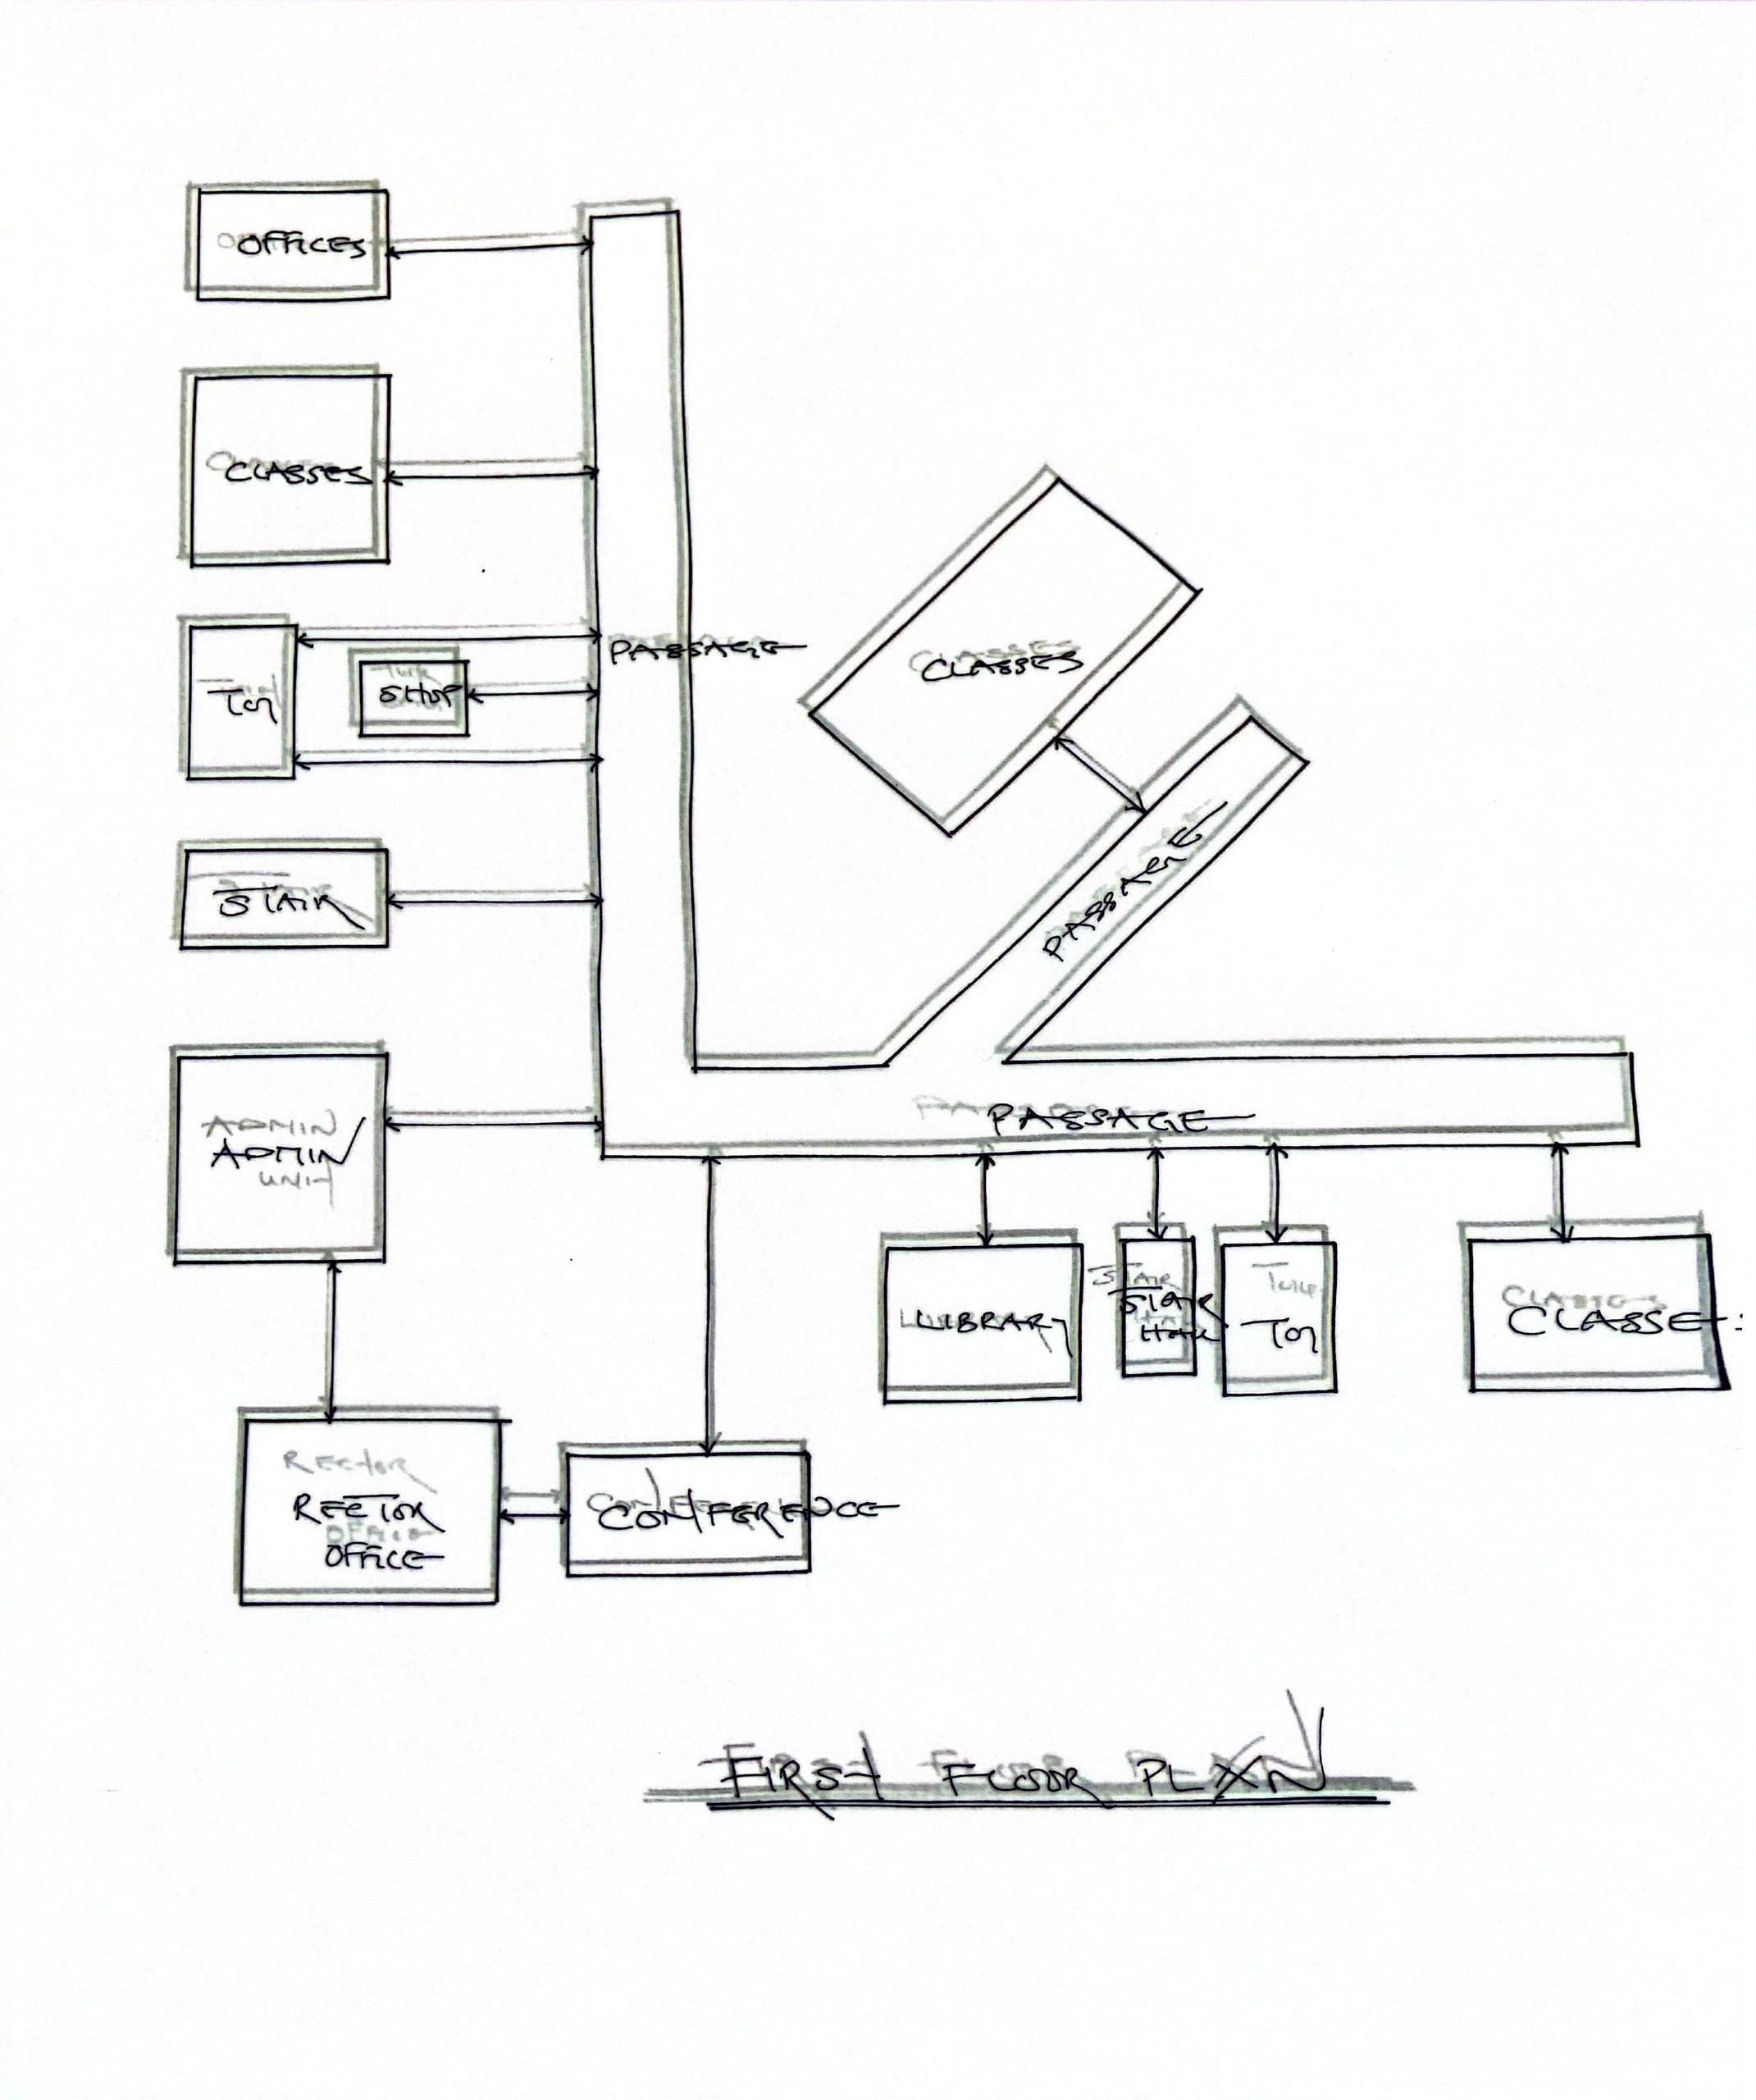
Conceptual Development
Conceptual Development in designing a Vocational Centre involve a strategic and creative process that aligns physical space with educational goals, community needs, and vocational training outcomes. Adequate parking space are provided to accommodate the anticipated large numbers of Cars.

CHAPTER FIVE

5.0 DESIGN CONSIDERATIONS AND PROPOSED DESIGN
This chapter outlines the design considerations and proposed architectural framework for the vocational center along New Yidi Road, Ilorin, Kwara State. It integrates findings from the literature review, case studies, and site analysis to develop a functional, accessible, and sustainable facility that addresses the needs of its users, particularly youth and physically challenged individuals. The chapter covers design objectives, architectural considerations, zoning and layout, sustainability strategies, accessibility features, and proposed facilities, supported by conceptual plans and design strategies.

5.1 Introduction
The proposed vocational center aims to provide practical training in trades such as carpentry, tailoring, computer skills, and catering, fostering self-reliance and reducing unemployment in Kwara State. The design prioritizes functionality, aesthetics, inclusivity, and sustainability to create an environment that enhances learning and supports community development. Drawing on insights from Chapter Two (Literature Review), Chapter Three (Case Studies), and Chapter Four (Site Analysis), this chapter presents a comprehensive design framework tailored to the site’s physical, cultural, and climatic context.

5.2 Design Objectives
The design of the vocational center is guided by the following objectives:
- Functional Learning Spaces: Create flexible and well-equipped spaces for practical and theoretical training in diverse trades.
- Accessibility: Ensure equitable access for all users, including physically challenged individuals, through Universal Design principles.
- Sustainability: Incorporate energy-efficient and environmentally friendly features to reduce operational costs and environmental impact.
- Aesthetic Appeal: Design an inviting and inspiring environment that reflects the cultural heritage of Kwara State while promoting creativity.
- Scalability: Develop a modular design that accommodates current needs and allows for future expansion.
- Community Integration: Foster community engagement through multi-purpose spaces for exhibitions, workshops, and skill-sharing events.

5.3 Architectural Considerations
The design of the vocational center is informed by the site’s characteristics, climatic conditions, and lessons from case studies. Key considerations include:
5.3.1 Site Orientation and Climatic Response
- Orientation: The building will be oriented to maximize prevailing southwest winds for natural ventilation, with workshops and classrooms positioned to avoid direct heat gain from the western sun.
- Natural Lighting: Large windows, skylights, and clerestory windows will optimize daylight penetration, reducing reliance on artificial lighting. Light shelves and louvers will control glare and heat gain.
- Ventilation: Cross-ventilation will be achieved through strategically placed windows and vents, ensuring a comfortable indoor environment during Ilorin’s hot dry season (20°C–35°C).
- Rainfall Management: Robust roofing with overhangs and a comprehensive drainage system will address heavy rainfall (1,200–1,500 mm annually) during the wet season (April–October).

5.3.2 Accessibility and Inclusivity
- Universal Design: Incorporate ramps, wide doorways (minimum 90 cm), and accessible restrooms to accommodate physically challenged users.
- Sensory-Friendly Spaces: Provide quiet zones and tactile signage for learners with visual or auditory impairments.
- Adjustable Workstations: Equip workshops with height-adjustable tables to cater to diverse physical needs.

5.3.3 Sustainability
- Energy Efficiency: Install rooftop solar panels to generate at least 15% of the center’s energy needs, addressing frequent power outages in Ilorin.
- Water Management: Implement rainwater harvesting systems to support landscaping and non-potable uses, reducing reliance on municipal water.
- Materials: Use locally sourced materials like laterite bricks and recycled steel to minimize environmental impact and construction costs.
- Passive Cooling: Employ high-performance insulation and reflective roofing to reduce heat gain, supplemented by ceiling fans for low-energy cooling.

5.3.4 Aesthetic and Cultural Integration
- Cultural Elements: Incorporate Yoruba-inspired motifs, such as geometric patterns and vibrant colors, in the façade and interior design to reflect local heritage.
- Landscaping: Use native plants like neem and mango trees for shading and aesthetics, creating a serene environment that aligns with Kwara’s cultural emphasis on nature.

5.3.5 Scalability and Flexibility
- Modular Design: Use prefabricated components and modular layouts to allow reconfiguration of spaces for different trades and future expansion.
- Multi-Purpose Spaces: Design a central hall that serves as a lecture space, exhibition area, and community event venue.

5.4 Zoning and Layout
The vocational center will be organized into distinct zones to optimize functionality and user experience. The 2-hectare site allows for a comprehensive layout that includes training, administrative, and recreational areas.
Zoning Plan:
- Training Zone: Comprises workshops for carpentry, tailoring, electrical work, and catering, and computer labs for ICT training. Each workshop will be equipped with modern tools and flexible workstations.
- Academic Zone: Includes modular classrooms for theoretical instruction, equipped with projectors and movable furniture to accommodate various teaching methods.
- Administrative Zone: Houses offices for staff, trainers, and a reception area, designed with accessibility features.
- Community Zone: Features a multi-purpose hall for exhibitions, community events, and skill-sharing programs, with adjacent outdoor spaces for practical training (e.g., agricultural demonstrations).
- Recreational Zone: Includes landscaped courtyards and shaded seating areas to enhance the learning environment and encourage social interaction.
Site Layout:
- Entrance and Circulation: A central entrance along New Yidi Road with clear signage and accessible pathways. Wide, paved walkways connect all zones, ensuring ease of movement.
- Workshop Placement: Noisy workshops (carpentry, electrical) are located on the northern end to minimize disruption to classrooms and quiet zones.
- Parking and Access: A parking area for 50 vehicles and bicycles near the entrance, with designated spaces for physically challenged users.
- Green Spaces: Landscaped areas with native plants surround the buildings, providing shade and reducing congestion.

5.5 Proposed Facilities
The vocational center will include the following facilities, designed to support a diverse range of training programs and community activities:
- Workshops:
  - Carpentry Workshop: Equipped with workbenches, saws, and power tools, with space for 20 trainees.
  - Tailoring Workshop: Includes industrial sewing machines, cutting tables, and storage for fabrics, accommodating 25 trainees.
  - Electrical Workshop: Features circuit boards, wiring kits, and safety equipment for 15 trainees.
  - Catering Workshop: Equipped with commercial kitchen appliances, including ovens, refrigerators, and prep stations, for 20 trainees.
- Computer Labs:
  - Two labs with 20 workstations each, equipped with modern computers, high-speed internet, and software for graphic design, programming, and office skills.
  - One lab dedicated to advanced ICT training, including CAD and web development.
- Classrooms:
  - Four modular classrooms, each accommodating 30 trainees, with movable furniture, projectors, and whiteboards for theoretical instruction.
  - One quiet study room for individual learning, with soundproofing and sensory-friendly features.
- Administrative Block:
  - Offices for trainers, administrative staff, and a project coordinator, with accessible design features.
  - A reception area with a resource center for training materials and career guidance.
- Multi-Purpose Hall:
  - A 200-seat hall for lectures, exhibitions, and community events, equipped with audiovisual systems and flexible seating.
  - Adjacent outdoor space for practical demonstrations and exhibitions.
- Support Facilities:
  - Accessible restrooms with grab bars and wide stalls.
  - A small cafeteria for trainees and staff, with a focus on affordable, locally sourced meals.
  - Storage rooms for tools, materials, and training resources.
- Outdoor Spaces:
  - Landscaped courtyards with shaded seating and native plants.
  - A small agricultural plot for practical training in farming techniques.
5.6 Accessibility Features
To ensure inclusivity, the vocational center will incorporate the following accessibility features, informed by Universal Design principles and case study findings:
- Ramps and Elevators: Ramps at all entrances and an elevator for multi-story sections to accommodate wheelchair users.
- Wide Doorways and Corridors: Minimum 90 cm doorways and 1.5 m corridors for easy navigation.
- Tactile Signage and Braille: Signage for visually impaired users, including braille labels and tactile floor indicators.
- Sensory-Friendly Spaces: Quiet zones with low lighting and minimal noise for learners with sensory sensitivities.
- Adjustable Workstations: Height-adjustable tables in workshops and labs to cater to diverse physical needs.
- Accessible Restrooms: Equipped with grab bars, low sinks, and wide stalls.

5.7 Sustainability Strategies
The design incorporates sustainable features to minimize environmental impact and operational costs:
- Solar Power: Rooftop solar panels to generate 15–20% of the center’s energy needs, reducing reliance on the unstable grid.
- Rainwater Harvesting: Systems to collect and store rainwater for landscaping and non-potable uses, addressing water scarcity during the dry season.
- Energy-Efficient Materials: Use of high-performance insulation, reflective roofing, and double-glazed windows to reduce heat gain and energy consumption.
- Passive Cooling: Cross-ventilation, ceiling fans, and shaded courtyards to maintain comfortable indoor temperatures without air conditioning.
- Waste Management: Recycling bins and a composting area for organic waste from the catering workshop.

5.8 Safety and Security
- Fire Safety: Install fire extinguishers, smoke detectors, and clearly marked emergency exits, addressing the case study demerit of insufficient exit routes (e.g., Hezekiel Oluwasanmi Library).
- Security: Perimeter fencing, CCTV cameras, and a security post at the entrance to ensure safety for trainees and staff.
- Lighting: Adequate outdoor lighting for evening classes and community events, enhancing safety and accessibility.

5.9 Proposed Curriculum Integration
The design supports a curriculum divided into two sections, as outlined in Chapter One:
- Information and Communication Section: Computer labs will support beginner, intermediate, and professional ICT training, including programming, graphic design, and office skills.
- Art and Craft Section: Workshops will facilitate training in fashion designing, electrical work, catering, and hairdressing (male and female). Each workshop is designed to accommodate hands-on learning with modern equipment.
The multi-purpose hall will support entrepreneurship training and community workshops, fostering self-employment and collaboration with local businesses.

5.10 Conclusion
The proposed vocational center along New Yidi Road, Ilorin, is designed to be a functional, inclusive, and sustainable facility that addresses the educational and economic needs of Kwara State. By integrating modular layouts, accessibility features, and sustainable technologies, the center will provide a conducive environment for skill acquisition and community engagement. The design draws on best practices from case studies and site-specific analysis, ensuring alignment with local cultural, climatic, and economic contexts. This chapter provides a blueprint for a state-of-the-art vocational center that empowers youth, physically challenged individuals, and the broader community, contributing to the socio-economic development of Ilorin and beyond.

REFERENCES
Adebayo, A. (2020). Vocational Training and Youth Employment in Nigeria. Journal of Technical Education, 12(3), 45-56.
Ahmed, O. M. (2019). The Role of Vocational Training Centers in Society Development. International Journal of Architectural Studies, Issue 1, 23-30.
Green, T., & Associates (2020). Sustainable Design in Educational Facilities. Journal of Environmental Design, 15(4), 89-102.
Okeke, C., & Musa, R. (2021). Case Studies on Vocational Training Centers in Nigeria. African Journal of Education and Technology, 14(5), 112-125.
Kwara State Government. (2023). History and Culture of Kwara State. Retrieved from kwarastate.gov.ng

