PHYTOCHEMICAL ANALYSIS OF WATER LEAF (TALINUM TRIANGULARE)
BY
JIMOH STELLA SHADE
ND/23/SLT/PT/0646

A PROJECT SUBMITTED TO THE DEPARTMENT OF SCIENCE LABORATORY TECHNOLOGY, INSTITUTE OF APPLIED SCIENCES (IAS),
KWARA STATE POLYTECHNIC, ILORIN,
IN PARTIAL FULFILMENT OF THE REQUIREMENTS FOR THE AWARD OF NATIONAL DIPLOMA (ND) IN SCIENCE LABORATORY TECHNOLOGY,INSTITUTE OF APPLIED SCIENCES (IAS),MICROBIOLOGY UNIT.KWARA STATE POLYTECHNIC ILORIN

JULY,2025.

CERTIFICATION
This is certify that this project is the original work carried out and reported by JIMOH STELLA SHADE, with matric number ND/23/SLT/PT/0646 to the Department of Science Laboratory Technology, Microbiology unit, Institute of Applied Sciences (IAS) Kwara State Polytechnic Ilorin and it has been approved In partial fulfilment of the requirements of the award of National Diploma (ND) In Science Laboratory Technology

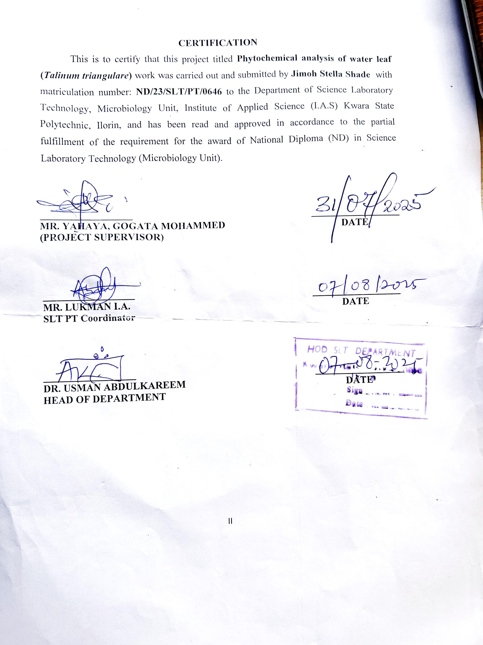

__________________________ __________________
MR. YAHAYA, GOGATA MOHAMMED DATE
(Project supervisor)

__________________________ ___________________
DR. USMAN A. DATE
(Head of Department)

___________________ __________________
External Examiner DATE

DEDICATION
This seminar write up is dedicated to almighty God who saw me through the commencement and completion of this research work

ACKNOWLEDGEMENTS
I give thanks to almighty God, the omnipotent, omniscience, omnipresence who has allowed me to witness the end of my course which reach the highest print in the writing of this project may his name be praised forever
Also I will like to appreciate the effort and total support of my caring parent MR. and MRS. JIMOH, and my big daddy MR PETER OLOWONONI, for their morally, financially and spiritual support toward the success of my course may Almighty GOD spare their life to eat the fruit of their labor.
My gratitude also goes to my project supervisor MR YAHAYA GOGATA MOHAMMED, also, HOD in person of MR ABDULKAREEM USMAN, I say a very big thank you for your support, advise and skilled supervision which made this project a successful one I pray that God will continue to enlarge your coast.
To my lecturers, I really appreciate you all for impacting to me this immeasurable knowledge which no doubt will prepare me face future challenges.
I will also like to appreciate my brother’s and sister’s, and my lover (Daniel kayoed) and also my roommate (Mariam and joy) and also my school momma (habitat) God will continue to bless you all and support you also

TABLE OF CONTENTS
TITLE PAGE i
CERTIFICATION ii
DEDICATION iii
ACKNOWLEDGEMENTS iv
TABLE OF CONTENTS v-vi
LIST TABLES vii
ABSTRACT viii
CHAPTER ONE
- INTRODUCTION……………………………………………………..1
1.1history of Water Leaf…………………………………………………..2
1.2Botany of Water Leaf…………………………………………………..3
1.3Uses of the Parts Of Water Leaf……………………………………….5
1.4 Physicology of Waterleaf…………………………………….………6
1.5 Morphology of Waterleaf……………………………….....................7
CHAPTER TWO
  - Structure of Waterleaf………………………………………………..9
  - Life Cycle of Waterleaf………………………………………………9
  - Effect of Waterleaf on Human Health……………………………….11
  - Economic Important of Water Leaf………………………………….13
  - Mode of Reproduction of Water Leaf……………………………….14
  - Characteristics of Water Leaf………………………………………..15
  - Bio Systematic and Taxonomy of Water Leaf………………………16
CHAPTER THREE
3.1 Experimental site………………………………………………….17
3.2 Collection of plant materials ……………………………………...17
3.3 Preparation of Leaf extract………………………………………..17
3.4 Test microorganism……………………………………………….18
3.5 Inoculum preparation……………………………………………..18
3.6 Phytochemicals Analysis………………………………………….18
3.7 Preparation of Extractions Impregnated Paper Disc………………20
3.8 Determination of Antimicrobail Activities ……………………….21
CHAPTER FOUR
4.0 RESULT AND DISCUSSION
4.1 Physical Appearance of the Extracts Recovered…..................................22
4.2 Phytochemical Screening………………………………………..………23
4.3 Antibacterial Activity of Methanolic Extracts of Water Leaf… …….….25
4.4 Antibacterial Activity of Aqeous Extract of Water Leaf…………….…..27
4.5 Discussion………………………………………......................................28
CHAPTER FIVE
5.0 CONCLUSION AND RECOMMEDATION
5.1 CONCLUSION……………………………………….……………...30
5.2 RECOMMENDATION………………………………….…………..30
5.3 REFERENCES………………………………………………..……..32-37
CONCLUSION
REFERENCES

ABSTRACT
Water leaf (Talinum triangulare) is a leafy vegetable commonly consumed in Nigeria and other parts of West Africa. This study aimed to investigate its phytochemical composition and antibacterial properties. Phytochemical screening was conducted to identify the presence of alkaloids, flavonoids, tannins, saponins, and phenols using standard methods. Antibacterial activity was evaluated against selected bacterial strains using disc diffusion and broth microdilution methods. The results indicated the presence of flavonoids, tannins, and alkaloids, with significant variations in their concentrations. The aqueous extract exhibited potent antibacterial activity against tested pathogens, including Escherichia coli and Staphylococcus aureus, suggesting its potential as a natural antimicrobial agent. Further studies are warranted to elucidate the mechanisms of action and explore its therapeutic applications.

CHAPTER ONE
1.0 INTRODUCTION OF WATER LEAF
Water leaf also known as Talinum fruitcosum is a herbaceous perennial plant that is native to mexico, the Caribbean, west Africa central America, and much of south America common American and much of south America. Common names include Ceylon spinach, water leaf, cariru, gbure, Surinam, purslane, Philippine, spinach florida spinach, patherb fame flower lagos bologi, sweetheart, and kutu. Bata win Ghana from the akan language. It is widely grown in tropical regions as a leaf vegetable. Sung hee et al 2017
Water leaf is a leafy vegetable that is commonly found in Nigeria. It is known for its slightly slippery texture and mild slightly bitter taste. It is often used in soups and stews, and it is a popular ingredients in Nigerian cuisine. Water leaf is rich in vitamins and minerals, making it a nutritious addition to meals. (aj cal 2019)
Water leaf is an erect perennial herb species with swollen roots and obtuse-angular, hairless, and succulent stems, which can grow to 3-10 feet in height (c anembom 2022). Stem branches have two lateral and basal buds. The leafs are arranged spirally and more clustered at the top of the stem.
Water leaf vegetable, sometimes accompanied by tender petioles and shoots leaf. Vegetables eaten raw water leaf originated from tropical Africa widely grown in West Africa. It is often harvested from the wild for local consumption and cultivated in various parts of the tropics for its edible leaves.
Talinum triangulare commonly known as water leaf has a high moisture content of almost 90.8 per 100gm of edible leaf, it is an erect perennial herb with swollen roots and succulent stems, 30 to 100cm tall. The branches have two lateral basal bubs the leaves are spirally arranged to nearly opposite often crowded at the top of the stem. Water leaf is fast growing and once established early reseeds itself. Water leaf flowers early year round and its mainly self-pollinating. The flowers are pink in colour and open in the morning, water leaf is relatily tolerant to drought condition as they tend to adapt a crassulaccean acid meta.
Water leaf can grow to 5 feets by some accounts and has simple pink flowers. It is an excellent source of iron, zinc and molybdenum, water leaf is native to the Americas and Caribbean, it has been cultivated in many places across the world.
1.1 HISTORY OF WATER LEAF
Water leaf, also known as Talinum triangulare, is a leafy vegetable commonly found in Nigeria. It has a rich history and widely used in Nigeria cuisine. People have been consuming water leaf for countries because of its nutritional value and delicious taste. It is often used in soups, stew, and salads. Water leaf is know for its high water content, which makes it refreshing and hydrating. It is a versatile and popular ingredient in Nigerian cooking .
Water leaf has been cultivated and consumed for generations people have been using water leaf in various traditional dishes, water leaf most commonly used in Nigeria, where it is a popular ingredient in traditional Nigeria cuisine. Nigerians have been enjoying water leaf in their dishes for a long time, and it is an essential part of their culinary culture water leafs history stretches back for centuries and it continues to be enjoyed by many people today. Water leaf originated from tropical Africa, widely grown in West Africa, Asia and south America, it has succulent stems ranging from 30-100cm heights. It is often harvested from the wild for local consumption and cultivated in various parts of the tropics for its edible leaves (18 mar 2020).
Water leaf is known as EFO GBURE in Yorùbà and is a very important leafy vegetable in Nigeria. Water leaf (Talinum triangulare wild) is often used interchangeably with Talinum fruitcosum (L) Juss (Sehippers 2000). (USDA, NDGS, 2020).
1.2 BOTANY OF WATER LEAF
Water leaf is a vegetable crop native to growth in Africa, and central and south America (USDA, NRCS 2020). This crop belongs to the purslane family, portulaceae. Water leaf (Talinum triangulare (Jacox). Wild) is often used interchangeably with talinum fruticosum (Li).
Waterleaf also known as Talinum triangulare is a leafy vegetable that belongs to the portulacaceae family. It is commonly found in west Africa and is known for its succulent leaves and stems. Waterleaf is rich in vitamin A and C, as well as minerals like calcium and iron. It is often used in soups, stews and salads. The plant itself is herbaceous and grow up to 1 meter in height. Water leaf has a shallow root system and thrives in moist environments, hence its name. it is commonly found near rivers, steams and other water sources. The leaves of waterleaf are green and succulent with a slightly tangy taste. They are rich in nutrients, including vitamins A and C, calcium, iron and antioxidants in terms of its reproductive cycle, waterleaf produces small inconspicuous flowers that are usually pink or white in color. These flowers are followed by small round fruits that contain tiny seeds. The plant can reproduce through both seeds and vegetative propagation. (IREN etal. 2019)
Waterleaf is not only valued for its nutritional content but also for its culinary uses. It is a versatile ingredient and can be cooked in various ways, such as in soups stews, stir-fries and salads. It tangy flavour adds a unique taste to dishes and make it a popular choice in many west African cuisines. Water leaf plant division is Angiosperm (flowering seed plant) (Dicotyledon) it is an annual plant and it is mode of nutrition is autotrophic its plant shape is compact and height maximum of 0.3m to 1m
1.3 USES OF THE PARTS OF WATER LEAF
Water leaf is a good source of vitamin A. research indicates that eating a diet rich in vitamin C reduces the risk of developing Alzheiner’s diseases and slows age related cognitive decline. Water leaf is an excellent source of vitamin C, with about 31mg for every 100g rams of vegetable matter.
The leaf: The leaf are edible as vegetable, and are used to spread up the elimination of faces from the body, and are also used to feed livestock’s treat gastrointestinal disorder.
The roots: The root is used for the preparation of rat poison
The stem: it aids weight loss
It aids proper digestion
It prevent cardiovascular disease
It helps to regulate hypertension
It prevents anemia
It protects brain tissues
It promotes proper eyesight
The stem branches have two lateral and basal buds
The waterleaf seeds : is a good source of calcium, magnesium, potassium, vitamins, crude proteins, alphatocopherols, beta-to copherols, total lipids and essential oils. Which helps prevent scurvy.
The flower: can be used in various ways some people use them in salads for fresh and vibrant touch. You can also use them as a garnish for dishes to add a pop of colour. It is like adding a touch of natures beauty to your food.
1.4 PHYSICOLOGY OF WATERLEAF
Waterleaf, or Talinum triangulare, has interesting physiological characteristics like other plants. Waterleaf undergoes photosynthesis, a process by which it converts sunlight, water and carbon dioxide into energy-rich sugars and oxygen. This process occur in the choropalsts found in the cells of its leaves.
Waterleaf has adaptations that allows it to thive in its natural habitat. Its succulent leaves and stem help it store water, making it well-suited for environments with limited water availability. This adaptation allows waterleaf to survive in arid or semi-arid regions.
Additionally, waterleaf has a mechanism called stomata regulation, which helps control water loss through tiny openings called stomata on its leaves. This helps prevent excessive water loss during hot and dry conditions.
The physiological processes of water leaf, such as photosynthesis and water regulation, contribute to its ability to survive and grow in various environment its fascinating how plants have evolved different strategies to adapt to their surroundings. Waterleaf absorb sunlight through its green pigments called chlorophyil, which are located in the chloropalsts of its leaf, it has a Bi sexual flower and the flower color is pink its flower grouping cluster/inflorescence its light preference is full sun and water preference is moderate water it is a green leafy vegetable.
1.5 MORPHOLOGY OF WATERLEAF
Waterleaf or Talinum triangulare, has distinct morphological features. It is an herbaceous plant that that typically grows up to 1meter in height. The plant has a shallow root system, which allows it to thrive in moist environments near water sources like rivers and stems.
The leaves of waterleaf are one of its prominent features. They are green, succulent, and triangular in shape, hence the scientific name triangulare. The leaves are arranged alternately along the stems and have smooth edges. The size of the leaves can vary, but they are generally medium sized.
Waterleaf produces small, inconspicuous flowers that can be pink or white in color. These flowers are usually clustered together and are followed by small, round fruits that contains tiny seeds. The plant can reproduce through both seeds and vegetative propagation

CHAPTER TWO
2.0 STRUCTURE OF WATERLEAF
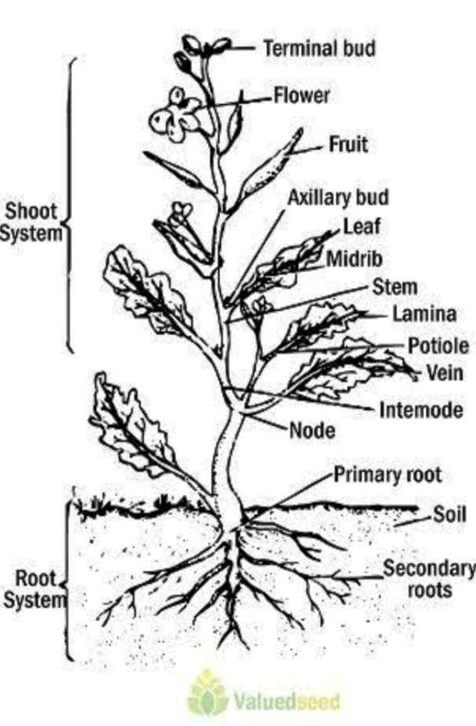

2.1 LIFE CYCLE OF WATERLEAF
Waterleaf is a short life-span species and take an average of only 30-45 days from planting to harvest (IREN etal. 2020). The edible leaves are soft, succulent and highly nutritious.
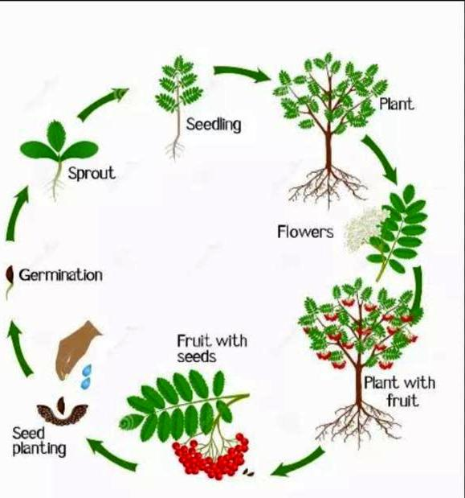

Waterleaf goes through a life cycle similar to other plants. It starts as a seed, then germinates and grows into a young plant. As it continues to grow, it develops leaves and stems. Eventually, it reaches maturity and produces flowers, after the flower are pollinated, they form seeds, which can be used to grow new waterleaf plants.

2.2 EFFECT OF WATER LEAF ON HUMAN HEALTH
Waterleaf is extremely nutritious; it is also high in (oxalate) oxalate is a natural chemical found in foods like spinach, rhubarbs, beets, sweet potatoes and waterleaf for those with kidney disorders, oxalate m ay contribute to kidney stones. (wiki-p) some of the health benefits of waterleaf include
Bone health: waterleaf is an excellent source of calcium and phosphorus, both of which are essential for healthy bones.
Eye health: waterleaf is a good source of vitamin A, maintaining sufficient level of vitamin A is essential for healthy eyes. Research indicates that vitamin A can slow the progression of retinal disease.
Cognitive health: waterleaf is an excellent source of vitamin C, with about 31mg for every 100grams of vegetable matter, research indicates that eating a diet rich in vitamin C reduces the risk of developing Alzhemer’s disease and slow age-related cognitive decline.
Waterleaf is a rich source of the essential nutrients calcium, phosphorus, iron and vitamin C. (wiki
It is also a good source of
- Vitamin A
- Thiamine
- Riboflavin
- Nalcin
Every 100grams of waterleaf contains approximately
- Calories % 25
- Protein % 2.4 grams
- Fat % 0.4 grams
- Carbohydrate% 4.4 grams
- Fiber % 1.0 grams (Wikipedia)
When it comes to eating too much waterleaf stem from its oxalate lontent. Too much oxalate can be unhealthy for individual with kidney disease. Those individuals should refrain from consuming raw waterleaf (Wikipedia.org).
2.3 EFFECT OF WATERLEAF ON HUMAN HEALTH
Waterleaf may also have the potential for regulating cardiovascular diseases such as stroke and obesity. Waterleaf can serve as a part of a weight loss diet due to its high fiber contents and its leaves are used to treat several diseases, including measles (Oluwole et al.).
Classification of water leaf
Kingdom: plantae-plant
Phyum: magnoliophyta
Class: magnoliopsida – dicotyledons
Order: solanales
Family: Hydrophyllaceae R.Br-water leaf family
Genus: Hydrophylum
Sub class : Asteridae
2.4 ECONOMIC IMPORTANT OF WATER LEAF
Water has significant economic importance in Nigeria. It is popular leafy vegetable that is cultivated and sold in local markets, providing income for farmer and traders. Its high demand makes it a profitable contributing to the agricultural economy. Additionally water leaf is exported to other countries, further its economic value makes it an important part of the live hood of many people in Nigeria. Water leaf is a vegetable that are important constituents of the human diet since they supply the body with vitamins, minerals some hormones as well as protein and energy, its also an anti oxidants compounds that protect cell against the damaging effects of reactive oxygen species. Water leaf is an excellent source of calcium and phosphorus, both which are essential for healthy bones, in fact, some research has shown that taking calcium without phosphorus does very little for bone strength the two elements appear to work together. Water leaf leave is edible vegetable and are used to speed up the elimination of feaces from the body; it can also used to treat gastrointestinal disorder, dropsy, swelling oedema and to reduce cardiovascular diseases.
The root is used for the preparation of rat poison water leaf can serve as a part of a weight loss diet due ti its high fiber content. And its leaves are used to treat several diseases including measles [ oluwale et al 2003] also, leaf and root extracts are used for treating asthma, fresh cuts, scabies, anemia and high blood pressure (hypertension) [ogunlesi et al].
2.5 MODE OF REPRODUCTION OF WATER LEAF
Waterleaf is usually propagated by seeds or vegetative cuttings. The 1000-seed weight is a approximately 3.86 grains (0.25g, grain 1/7000 pound], water leaf reproduces through both sexual and asexual means. In sexual reproduction water leaf produces flowers that contain male and female organs, leading to the formation of seeds, water leaf can also reproduce asexually through processes such as stem cutting, where a portion of stem is cut and planted to grow into a new plant, pollination occurs when pollen from the male organs is transferred to the female organs leading to the formation of seeds. Asexual reproduction allows water leaf to rapidly multiply and spread in suitable environment. They are propergated by its stem no need for nursery plant the stem directly in a raised bed, by putting the stems in the ground to a certain height but closely together
2.6 CHARACTERISTICS OF WATER LEAF
Waterleaf is an erect perennial heal species with swollen roots and obtuse angular, hairless and succulent stems which can grow 3-10 feet in height . Stem branches have two lateral and basal buds the leaves are arranged spirally and more clustered at the top of the stem. (so oluwole).
Talinum fruticosum is an evergreen perennial growing to 0.5m (1ft 8in) by 04m (1ft 4in) at a fast rate, it bears small, pin flowered and broad. Fleshy leaves used edit, as a leaf water leaf vegetable, fruit consume is rich in vitamins including vitamins A and C.
Small trees, bunches, and herbaceous plants. Often hairy, the leaves are sometimes 10 bed; alternate or lower ones opposite. The flowers are on curling at the base of the leaf stalks, the calyx is below the ovary [Nicholas Rougex.com]
Its leafs are triangular in shape, hence name triangulare. The plant has succulent stem and leaves, which means they store water. Water leaf produces delicate pink flower that add a touch of beauty to it’s a appearance. It is a versatile plant that can thrive in various environments. That can adapt to various environment, making it suitable for different climates (sanders g.j 2019).

2.7 BIO SYSTEMATIC AND TAXONOMY OF WATER LEAF
Water leaf is a vegetable crop native and grown in Africa, Asia, Central and south America (USDA, NRCS 2020). This crop belongs to the purslane family portulaceae (carolin 1987) water leaf. (talinum triangulare (jacx) (Wild) is often used interchangeably with a talinum fruticosun (L).
Water leaf, scientifically known as talinum triangulare belongs to the family portulacacae. It’s a fascinating plant with triangular-shaped leaves and delicate pink flowers, bio systematic classification includes being a flowering plant (magnoliophyta) and belonging to the order caryophyllales. Taxonomically, it falls under the kingdom plantar, division magnoliophyta class magnoliopsida and genus talinum.
CHAPTER THREE
METHODOLOGY
3.1 EXPERIMENTAL SITE
The experimental was carried out at a Microbiology laboratory, Department of Science Laboratory Technology Kwara State Polytechnic, Ilorin.
3.2 COLLECTION OF PLANT MATERIALS
Leaves were collected from the water leaf plant at Kwara State Polytechnic, Ilorin no Nigeria. It was ensured that the plant was healthy and uninfected. The leaves were washed under running tap water to climate dust and other foreign particles and to clean the leaves throughly. It was dried under shade at room temperature and grinded into powder. The powdered samples were sealed in a polythene bags until the time of extraction.
3.3 PREPARATION OF LEAF EXTRACTS
Two solvents were used in the preparation of leaf extracts (methanol and distilled water).
Two amber bottles were used with coach containing 20grams of the grinded plants material, 200ml of each solvents was added. It was shaken and left to soak for 5days, during the period of 5days it was shaken twice daily. Thereafter, it was filtered using Whatman No. I filter paper. The solvents was placed in a water bath and leave to evaporate to make the final volume one-fifth of the original volume. It was stored in airtight bottles for further studies (Sahira and Cathrine, 2015)
3.4 TEST MICRO-ORGANISMS
Three pathogenic bacteria, viz., staphylococcus aureus, salmonella typhi, and klebsiella pneumonia were used during the present study and were obtained from Micro biology laboratory of the department of Microbiology at Kwara State Polytechnic, Ilorin, the cultures were sub-cultured and maintained on nutrients agar slants and stored at 4ºC.
3.5 INOCULUM PREPARATION
For standardizing the inoculums, the test organisms were sub-culture on nutrients agar plates and incubated overnight, colony material from this overnight culture of the test organisms was taken with the aid of sterilized wire loop and transferred into a tube containing 5.oml of normal saline until the turbidity was matched with 0.5 McFarland standards (McFarland, 1907)
3.6 PHYTOCHEMICALS ANALYSIS
Phytochemical test were done to find the presence of the active chemical constituents such as Alkaloids, Glycoside, Terpenoids, Flavonoids, Phenol, Saponins and Tannins by the following proceedure.
3.6.1 Test for alkaloids (Meyer’s test)
The extracts of water leaf was evaporated to dryness and the residue was heated on a boiling water bath with 2º/_{o} Hydrochloric acid. After cooling, the mixture was filtered and treated with a few drops of Meyer’s reagent12. The samples were then observed for the presence of turbidity or yellow precipitation (Trease and Evan, 2009).
3.6.2 Test for glycoside
Tp the solution of the extract in Glacial acetic acid, few drops of Ferric chloride and concentrated sulphure acid are added, and reddish brown collouration was observed at the junction of two layers and the bluish green colour in the upper layer (Chessbrough, 2000,).
3.6.3 Test for terpenoids
4 mg of extract was treated with 0.5 ml of acetic anhydride and 0.5 ml of chlorofone.
Then concentrated solution of sulphuric acid was added slowly and red violet colour was observed for terpenoids (chessbrough, 2000)
3.6.4 Test for flavonoid
4mg of extract solution was treated with 1.5 ml of 50⁰/₀ methanol solution. The solution was warmed and metal magnesium was adedd and red colour was observed for flavonoids orange colour for flavonoids (chessbrough, 2000,)
3.6.5 Test for reducing sugars
To 0.5 ml of extract solution, 1 ml of water and 5-8 drops of Fehling’s solution was added at hot and observed for brick red percipitate (Trease and Evan, 2009)
3.6.6 Test for phenolic compounds (ferric chloride Test)
300 mg of extracts was diluted in 5 ml of distilled water and filtered to the filtrate 5⁰/₀ Ferric chloride was added and observed for dark green colour formation (Trease and Evan, 2009)
3.6.7 Test for tannins
To 0.5 ml of extracts solution, 1 ml of water and 1-2 drops of ferric chloride solution was added Blue colour was observed for garlic tannins (Trease and Evan, 2009).
3.6.8 Test for saponins
2g of the powered sample was boiled in 20 ml of distilled water in a water bath 10ml of the filterable was mixed with 5 ml of distilled water shaken vigorously for a stable persistent broth. The following was mixed 3 drops of olive oil and shaken vigorously and then observed for the formation of emulsion (Trease and Evan, 2009).
3.7 PREPARATION OF EXTRACTS IMPREGNATED PAPER DISCS
A paper puncher was used to punched out 100 Discs of 6mm diameter from Whatman no. 1 filter paper, the discs were then sterilized by autoclaving at 121ºC for 15 minutes and then allowed to cool. Ten bijou bottles were used, three (3) for the aqueous extracts another three (3) for Methanolic extracts the remaining two is for control both positive and negative.
0.1gram of extracts was dissolved in 1ml of DSMO (Dimethyl suffoxide) which is equivalent to 100,000ug/ml to which 100 discs were added and shaken to equilibrium so that, each discs absorbed 0.001g equivalent to 1000ug/discs.
0.5g of extracts was dissolved in 1ml of DMSO which is equivalents to 50,000ug/ml to which 100 disc were added with the help of shaking at equilibrium each disc absorted 0.0005g equivalents to 500ug/disc.
0.5g of extracts was dissolved in 1ml of DMSO which is equivalents to 50,000ug/ml to which 100 disc were added with the help of shaking at equilibrium each disc absorted 0.0005g equivalents to 500ug/disc.
0.5g of extracts was dissolved in 1ml of DMSO which is equivalents to 12.500ug/ml to which 100 disc were added with the help of shaking at equilibrium,, each disc absorted 0.0012g which is equivalents to 125ug/ml. these were stored and kept for further use.
The positive control used was Ampiclox and it was dissolved with 1ml of DMSO after which 100 discs was added. The negative control was used 1ml of DMSO (Bonev et al., 2008)
3.8 DETERMINATION OF ANTIBACTERIA ACTIVITY
The antibacterial activity of the leaf extracts was determined using agar disc diffusion method; the known procedure by Kirby-Bauer was adopted. Four (4) nutrients agar plate was used for each bacteria inoculums. Two (2) for the aqueous extracts: one of the it was divided into four parts (each for different concentration of the extracts) the others were divided into two (one side for the positive control and the other for negative control). The same was done for the Methanolic extracts. Nutrients agar was inoculated with the given microorganisms by spreading the bacteria inoculums on the media by the use of sterile swap stick. The extracts impregnated paper discs containing different concentration of the neem extracts (100,000ug, 50,000ug, 25,000ug, and 12,5000ug) was picked with sterile forceps, it was placed firmly on the surface of inoculated plates, two control were used these are: the positives control disc of Ampiclox (500mg) and a negative control disc (with DMSO). Both disc were then allowed for pre-difussion time of 15minutes and they were then inverted and incubated at 37ºC for 24hours and the diameter of the zone of inhibition formed was measured after incubation with the aid of meter rule to determine the effectiveness of the extracts on the test organisms (Bonev et al., 2008)

CHAPTER FOUR
RESULT AND DISCUSSION

4.1 PHYSICAL APPERANCE OF THE EXTRACTS RECOVERED.
Table 1: physical properties of leaf extracts of water leaf extracts
_______________________________________________________________________________
Extracts Wight of Volume of Weight of Colour Odour Texture
Sample solvent used extracts
Used recovered
________________________________________________________________________________
Aqueous 10g 100ml 3.19g Dark pungent Creamy
Methanolic 10g 100ml 2.6g Greenish Pungent Hard
Black
_______________________________________________________________________________
The result showed the weight of plants sample used, the volume of the solvent, the volume of extracts recovered, the colour, odour and texture.

4.2 PHYTOCHEMICAL SCREENING
The result for phytochemical screening has shown in Table 2 shows that alkaloids, saponins, flavonoids, tannins, and phenol are present in both methanolic and aqueous extracts glycoside is present in the Methanolic extracts but absent in the Aqueous extract while terpenoids is absent in both extract.

Table 2: qualitatives phytochemical analysis of water Leaf.

Extracts/phytochemical Aqueous Methanol
Alkaloids + -
Flavonoids - +
Glycosides + +
Phenol - +
Saponins + +
Tannins + +
Terpenoids + -

4.3 ANTIBACTERIAL ACTIVITY OF METHANOLIC EXTRACTS OF WATER LEAF
Table 3: Sensitivity test of Methanolic extracts against the test organism (zone of inhibition)
Isolates 1000ug/dis 500ug/dis 250ug/dis 125ug/dis Ampeol D.M.S.
C c c c x O
5mg/dis

Staphylococcus 23 02 10 11 25 00
Yaureus 08 01 00 02 01 01
Klebsiella 10 11 03 10 01 00
Pneumonia 05 01 00 01 00
00
Salmonella 08 06 07 01 01 00
Typhi 01 00 02 01 00
00

Based on the experiment carried out on the Methanolic extracts of water leaf against bacteria inoculum was observed that there was high inhibitory activity on staphylococcus aureus 27mm at concentration of 1,000ug/disc, 9mm at 500ug.disc, 8mm at 250ug/disc, 7mm at 125ug/disc. The positive control was 25mm and the negative control is 0. The act extracts is higher than the positive control.
For klebsiella pneumonia the highest is 8mm at the concentration of 1000ug/disc, 8mm at 500ug/disc, 0 at 250ug/disc and 0 at 125ug/disc. The negative is 0 and the positive 40mm, the positive is higher than the extracts.
For salmonella typhi the highest is at 1000ug/disc and 500ug/disc with 10mm, followed by 5mm at 250ug/disc. There was no activity at 125ug/disc. The negative is 0 while the positive is 32mm.

4.4 ANTIBACTERIAL ACTIVITY OF AQEOUS EXTRACT OF WATER LEAF
Table 4: sensitivity test of aqueous extract against the test organism (zone of inhibition)
Isolates 1000ug/disc 500ug/disc 250/disc 125ug/disc Ampiclo D.M.S.O
V
5mg/disc
Staphylococcus 10 08 06 05 25 00
Us aureus
Klebsiella 18 10 00 00 45 00
Pneumonia
Salmonella 10 06 00 00 25 00
Typhi

Interpretation
Based on the experiment carried out on the aqueous extract of water leaf against bacteria inoculums 18mm was observed that there was high inhibitory activity on klebsiella
pneumonia 18mm at the concentration of 1000ug/disc, 10mm at 500ug/disc, 0 at 250ug/disc and 0 at 125ug/disc. The negative 0 is the positive 45mm.the positive is higher than the extract.
For salmonella typhi the highest inhibition is at 1000ug/disc with 10mm and 6mm at 500uh/disc. There was no activity at 250ug/disc and 125ug/disc, the negative is 0 while the positive is 25mm.
4.5 DISCUSION
The result of phytochemicals in the present investigation showed that the plant leaves contain components like tannins, saponins, phenol, flavonoids, glycosides. The antibacterial activity of Methanolic extract of waterleaf showed maximum zone of inhibition (27mm) against staphylococcus aureus, followed by salmonella typhi (10mm) and klebsiella pneumonia (18mm) against klebsiella spp, followed by staphylococcus aureus ans salmonia typhi with 10mm. the methanol and aqueous extract showed considerable activity against the bacterial inoculum, the methanol extract was more active than the standard against staphylococcus aureus, previuos study cinducted by (Gueddeur et al .2002) suggests that the essential oil of O, majorana possess antibacterial activity. The work conducted by (Farooqi and Sreeramu, 2004) reveals that the leaves of majoram have antibacterial acitivity against Escherichia Coli, pseudomonas aeroginosa, staphylococcus aureus and salmonella typhi, similary antibacterial activity of ethanol, chlorofon and water extract of Marrubium vulgare, was further assessed against, salmonella typhi, staphylococcus aureus, Escherichia coli and pseudomonas aeruginosa, were recorded (AL-Bakri et al., 2006).

The presence of these phytochemical components may be responsible for the observed antimicrobial activity of the plant leaf extract. This findings conforms to the report of (Anyanwu and Dawet, 2005) in which similar constituents was found to exhibits antiprotozoal and antibacterial activities, Flavonoids has also been reported to have greater potential benefit to human health (Jouad et al., 2001). Imran Khan et al., 2010 studied that phytochemicals analysis of water leaves by using different solvent such as petroleum ether, chloroforms, methanol show the pressure of triterpenes, glycoside and fatty acids. Other phytochemicals studied in this analysis were absent in all extract of leaves Antibacterial activity of water leaf was analysed by previous workers showed that the chloroform extract of leaves possess significant activity, than petroleum other and methanol extract. Himal paudel et al., 2008 reported that the ethanol extract of water leaf whole plant shows presence of flavonoids and tannins only similarly the extract of water leaf is active against Ecoli followed by staphylococcus aureus, Earlier observation done by (Srinivasan et al., 2001) also showed the antifungal and antibacteria activity of water leaf.

CHAPTER FIVE
CONCLUSION AND RECOMMENDATION
5.0 CONCLUSION OF WATER LEAF
Waterleaf is fascinating plant, it belongs to the family Talinaceae and is known for its triangular shaped leaves, is a popular leafy vegetable in Nigeria. It is rich in vitamin A, C and E, as well as minerals like calcium and iron.
The leaf are usually cooked and used in soups, stews and salad. And water leaf has been found to have various health benefits, such as promoting digestion and boosting the immune system.
The study revealed that water leaf has antibacterial activity against bacterial pathogens. This can explain the use of the plants in treating infections in traditional medicine. It shows that there is presence of phytochemical compounds such like tannins, saponins, glycoside, alkaloids, flavonoids, and phenol. The plant could be a veritable and cheaper substitute for conventional drugs since the plants is easily obtained and the extract can easily be made via a simple process of maceration or infusion. Thus this plant could be utilized as an alternative of useful antimicrobial drugs.
5.1 RECOMMENDATION
- Further studies should be carried out with other pathogenic bacteria in evaluate the antibacterial activity.
- Further studies should be carried out on other parts of water leaf to determine the presence of photochemical in them
- Further studies should be carried out with the other solvent to know their effectiveness.

REFERENCES
Anyanwu, G. I. and (2005), pharma-cological and phytochemical screening of hyptis
Suaveolens poit (Laminceae) for bioactivity in rodents.

Badam, L, joshi, S.P., Bedekar, S.S., (1999) in viro antiviral activity of neem (Azadirachta
Indica. A juss) leaf extract againstgroup B Coxsakie viruses
j Commun Dis, 31:79-90

Bahuguna, V.K, (1997) Silviculture and management practices for cultivation of water leaf . Indian For, 123: 379-386.

Bandyopadhyay, U, Biswa, K., Sengupta, A., et al.,2004. Clinical studies on the effect of neem
(Azadirachta indica) bark extract on gastric secretion and
gastroduodenal ulcer. Life Set 75: 2867-2878.

Chari, M,S, (1996) Neem and transfer of technology in Neem and environment (Vol 1)
(Singh, R,P., Chari, M.S., Rabeja, K, et al, Eds). Oxford and IBH
publishing Co. Pvt. Ltd., New Delhi, India

Chessbrough, M.(2000). Microbiological test: District Labouratory practice in
tropical countries in:Cremer, A and Evan, G. (eds).
Cambridge University press, UK. Pp: 1-226.

Cornel University, 14 August 2008’’ saponins…. Retrieved 23 February 2009.

Cashine TP, Cushine B, Lamb AJ (2014),’’ Alkaloids: An overview of their antibacterial, antibiotic-
enhancing and antivirus activities’’ In J Antimicro Agents.
44 (5): 377-386: doi: 10. 1016fj j Jantimicag.
2014.06.001.PMID 25130096.

Evans William Charles, Daphne Evans George Edward Trease 2002, Trease and Evans
pharmacognosy Edinburgh: saunders/Elsevier.

Farooqi, A, A. and B. S. Sreeramu: cultivation of medicinal and aromatic crops.
Universities press, India. pp, 465-470 (2004).

Fathima, S.K, (2004) investigation on the biology and management of
phomopsis azadirachta on neem. Ph.D thesis,
University of Mysore,

Firn, Richard (2010). Nature’s Chemical. Oxford: Biology.

Galeotti, F: Barile, E: Curir, P: Dolci, M: Lanzotti, V (2008), Flavanoids from
carnation (Dianthus caryophyllus)And their antifumgal
activity’’ Phytochemistry Letter 1: 44-48. Doi: 10.1016fj.
phytol.2007.10.001.

Hammer KA, Carson CF, Riley TV (1999). Antimicrobial activity of essential oils
and other plants extracts. J. Appl. Microbiol., 86(6): 985.

Hedge, N.G (1995) Neem and small farmersconstraints at at grass root level.
India For, 121:1040-1048.

Heukelbach, j,, Oliveira, F.A.S, Spare, R, (2006) A new shampoo based on
neem (Azadirachta indica) is highly Effective against
head lice inviro.Parasitol Res, 99: 353-356

HIMAL Paudel Chhetri et al., 2008. Phytochemical and antimicrobial evaluation
of some Medicinal plants of Nepal, Kathmandu university journal
of science, engineering and technology vol. no, V, september 2008,
pp 49-54,

Hostettmann, K: A. Marston (1995), Saponinns, Cambridge University Press, p.
3ff. ISBN 0-521-32970-1,OCLC 29670810.

I.P Ogbuewa, Odoemenam, H.O, Obikaonu, M.N, Opara, O.O. Emenalon, M.C. Uchegbu,
I.C. Okoli B.O Esonu and M.U, Iloeje, 2011. The Growing importance
of Neem (Azadirachta indica A, Juss) in Agriculture, Industry,
Medicine, and Environment: A Review Research Journal of Medicinal
plants, 5: 230-245. published: August 13,2010

Imran, M., H. Khan, M, Shah and F. Khan 2010. Chemical emposition and antoxidant
activity of certain Morus species. J Zheftang Univ.
Set B., 11: 973-980.

Janick J., Whipkey A., eds (2007) issues in new crops. ASHA publication, alexandria,
VA

Jattan, S.S., Shashikumar, Pujar G., et al, (1995) perspectives in intensive management
of neem plantations. Indican For, 121: 981-988. Hedge, N.G.,
(1995) Neem and small farmer’s constraints At grass root level.
Indian For, 121: 1040-1048.

Jibunoh,D,N (2012), we use neem trees to combact desertification and create
jobs (Orakpo E, interview.) vanguard newspaper.

Jiva Ayruveda, M.D. jama (1907). The Nephelometer: an instruments for estimating
the number of bacteriaIn suspension used for calculating the
opsonic index and for vaccines .XLIX (14): 1176-1178

Jouad, H., Laccale- duboi, M.A., lyoussi B. and Eddouks M. (2001). Effects of
the flavonoidsextracted from Spergularia purpurea pers
on arterial blood pressure and renal function in normal
and hypertensive rats. J. Ethnopharmacol, 76(2): 159-163

Katie E, Ferrell; Thorinton, Richward W. (2006). Squirrels: the animal answer
guide. Baltimore: Johns Hopkins University Press. P. 91.
ISBN 0-8018-8402-0

Khan, P.K., Awasthy, K.S., (2003) cytogenetiic toxicity of neem. Food Chem Toxicol,
41: 1325-1328

Khanna, A., (1992) Neem gains honour as India’s wonder tree. Down to earth
1:511.

Khillare, B., Shrivstav, T,G., (2003) Spermicidal activity of Azadirachta indica (neem)
leaf extract contraceotion 68:225-229

Khoddami, A: et al, (2013). Techniques for analysis of plant phenolic compounds’’
moleccules, 18 (2): 2328-75, Doi : 103390/molecules18022328.

Kittakoop P. Mahidol C, Ruchirawat S (2014). ‘’Alkaloids as important scaffolds
in therapeutics drugs for the Treatment of cancer, tuberculosis,
and smoking cessation’’, Curr Top Med Chem, 14 (2): 239-252.
Doi : 10.2174/15680266105049. PMID 24359196.

Kumar, A.R.V., (2003) Neem for the industry or for the common man: where
does India stand:? Curr set,84:265-267.

Kumar R.V., Gupta, V.K., (2002) Thrust on neem is needed of today. In:
employment news, july 20-26, new Delhi, India.

Manandhar, NP (2000). Plants and People of Nepal. Timber Press, USA, p. 50.

McGree, Harold (2004). On food and cooking: the science and lore of the kitchen.
New York Scribner. P. 714. ISBN 0-684-80001-2.

McNaught and A. Wilkinson (1997). Compendium of Chemical terminology, 2nd ed.
(The’’ Gold Book’’). Blackwell Scientific Publication,
Oxford ISBN 0-9678550-9-8 doi: 10.1351/goldbook

Michael Specter (September 28, 2009). ‘’A Life of Its Own’’ The New Yorker.

Nathan, S.S., Kalaivani, K., Murugan, K, (2005) Effects of neem limonoids on
the malaria vectorAnophele, stephensi Liston
(Direct: Culicidae). Aeta trop.96:47-55

Ncube NS, Afolayan AJ, Okoh AI, Assesment techniques of antimicrobial
properties of natural Compounds of plant origin:
current method and future trensd. Africa Journal
of Biotechnology 2008: 7 (2): 1797-1806.

Neem foundation (Internet) Mumbai, India-{cited 2014 Jun 20}. Available from:
http:/www.neemfoundation.org/

Sai Ram M ilavazhagun, G Sharma S.K (2000) Anti-microbial activity of a new vaginal
contraceptive NIM 76 from neem oil ( atadirahtaindica)
j Ethmophamarcol, 71: 377-382

Sateesh, M.K, (1998)microbiological investigation and die-back disease of neem
(azadirachita indica A juss). Ph.D thesis. University of
Mysorte, Mysore India

Siddiqui B.S, Afshan F, Gulzar, T,. et al, (2004) Tetracyclic triterpenoids from the
leaves of azadirachita Indica phytachemistry 65:2363
-2367.

Siddiqui, S, Faizi S, siddiqui B.S,.et al, (1992) contituent of azadirachtaindica isolation
and structure elucidation of a new antibacterial
tetranortritepenoids mahmoodin, and a new
protolimonoid, naheedin. jNat prod, 55:303-310

Sidhu, D,S, (1995) Neem in ago forestry as a source of plant derived chemicals for
pest management Indian For, 121:1012-1021

Sidhu, O, P; Kumar, Visha; Behi, Hari M. (2003-03-15), “ Variability in Neem
(Azadirachta indica) with respect to Azadirachtin
content’ journal of agricultural and Food Chemistry
51 (4): 910-915. Do: 10.1021/j1025994m. {33} Anonymous,
(1992) Neem A tree for solving global problems National
Academy Press Washinton D,C, U.S.A.

Sigma-Aldrich ‘’Saponim from quilija bark”—Retrieved 23 February 2009,

Sindhuveerendra, H.C, (1995) Variation studies in prevenances of
Azadirachtaindica (The neem tree) indian For,121:1053-1956.

Sithisam, P., Supabphol, R, Gritsanapan, W., (2005) Antioxidant activity of siamese
Neem tree (VP1209).J Ethmopharmacool, 99: 109-11.2

Srinivasan, DN Nathan Sangeeta, Sursh, T., Perumalsany and P, Lakshman, 2001.
Antimicrobial avtivities of certain India medicinal plants
used in Folkoric medicine. Journal of Ethmopharmacology,
74: 217-220,

Steve C. Surshes (2008). Plants risk assesment, Neem Tree Azadirachta indica
(PDF) biosecurity Queensland. Retrieved january 2014

Subapriya R, Bhuvaneswari, V, Ramesh V., (2005) Ethanolic leaf extract of neem
(azadirachta indica inhibits bucca pouch careinogenesis hamsters
Cell Biochem funct 23. 229-238.

Subapriya, R., Nagini, s., (2005) Medicinal properties of neem leaves: a review.
Curr Med Chem Anticancer Agents 5: 149-156.

Thakkar, IJ., Mbah, A.U., Chijioke C.P., et al., (2004) and antimalaria extract
from neem leaves is antiretovial. Trans R Soc Trop Med Hyg,
98: 435-437.

Zillur S Rahman and shamim M Jairapuri Neem in Unani Medicine, Neem
Research and development Society of Pesticide Science, India
New Delhi, February 1993, p. 2028-219. Edited by N.S.
Randhawa and B.S. Parmer. 2nd revised edition (chapter 21),
1996 “Neem”Tamilanadu.com. 6 December 2012

