EFFECT OF CONTINOUS DRYING ON THE PHYSICAL PROPERTIES OF COCOA SEED (Theoboma cacao)
By:
ONIFADE KAYODE EMMANUEL
ND/23/ABE/FT/0036
DEPARTMENT OF AGRICULTURAL AND BIO – ENVIRONMENTAL
ENGINEERING, INSTITUTE OF TECHNOLOGY, KWARA STATE
POLYTECHNIC, ILORIN

INPARITAL FULFILLMENT OF REQUIREMENT FOR THE AWARD OF
NATIONAL DIPLOMA (ND) IN AGRICULTURAL AND BIO-
ENVIRONMENTAL ENGINEERING TECHNOLOGY.

SUPERVISE BY:
ENG. OYEBANRE
July 2025

CERTIFICATION
This is to certify that this project titled “EFFECT OF CONTINOUS DRYING ON THE PHYSICAL PROPERTIES OF COCOA SEED” was carried out by “ONIFADE KAYODE EMMANUEL” with matriculation number ND/23/ABE/FT/0036. The project has been read and approved as part of the requirements of Agricultural and Bio-Environmental Engineering Technology Department for the Award of National Diploma (ND) in Agricultural and Bio-Environmental Engineering Technology, Kwara State Polytechnic Ilorin.

_______________________________ __________________
ENGR. OYEBANRE O.D DATE
(Project Supervisor)

_______________________________ __________________
ENGR. OYEBANRE O.D DATE
(Project Coordinator)

_______________________________ __________________
ENGR. ABDULQUADRI DAUDA DATE
(Head of Department)

_______________________________ __________________
ENGR. DR. MRS YUSUF, R.O DATE
(External Supervisor )

DEDICATION
I dedicate this research work to God Almighty, the giver of life, wisdom, and strength, whose grace has carried me through every step of this academic journey.
ACKNOWLEDGEMENT
First and foremost, I express my deepest gratitude to Almighty God, the Creator and Sustainer of all things, whose boundless love, mercy, and grace have guided me throughout this project. His divine wisdom and strength have been my anchor, illuminating my path and granting me the perseverance to complete this work. To Him alone be all glory, honor, and praise for His unending faithfulness.
I am profoundly thankful to my beloved parents, Mr. Onifade, whose unwavering support, prayers, and sacrifices have been the bedrock of my academic journey. Their encouragement, love, and belief in my potential have inspired me to strive for excellence, and I am eternally grateful for their nurturing presence in my life.
I extend my heartfelt appreciation to my supervisor, Engr. Oyebanre O.D, whose expertise, patience, and insightful guidance have been instrumental in shaping this project. His dedication to my academic growth, coupled with his constructive feedback and encouragement, has motivated me to push beyond my limits, and I am truly honored to have worked under his mentorship.
I owe a great deal of gratitude to the Head of Department, Engr. Abdulquadri Dauda whose leadership and commitment to academic excellence have created an enabling environment for learning and innovation. His support, along with the invaluable contributions of other lecturers and staff of the esteemed Department of Agricultural and Bio-Environmental Engineering, has enriched my knowledge and skills, making this project a reality. I am deeply appreciative of their tireless efforts and encouragement.
Finally, I extend my sincere thanks to my friends and family, whose love, prayers, and constant encouragement have been a source of strength throughout this journey. Their unwavering support, shared laughter, and words of wisdom have uplifted me in moments of challenge, and I am immensely grateful for their presence in my life.

TABLE OF CONTENTS
Certification
Dedication
Acknowledgement
Abstract

CHAPTER ONE: INTRODUCTION
1.0 Introduction
1.1 Background to the Study
1.2 Problem Statement of the Study
1.3 Aim and Objectives of the Study
1.4 Justification of the Study
1.5 Scope of the Study

CHAPTER TWO: LITERATURE REVIEW
2.1 Introduction
2.1.1 Importance of Understanding Physical Property Changes
2.1.2 Factors Affecting Physical Property Changes
2.1.3 Impact on Seed Quality
2.2 Physical Properties Affected by Continuous Drying
2.2.1 Moisture Content
2.2.2 Shrinkage
2.2.3 Texture
2.2.4 Color
2.3 Factors Influencing the Physical Properties of Cocoa Seeds during Continuous Drying
2.3.1 Drying Temperature
2.3.2 Drying Time
2.3.3 Airflow Rate
2.4 Consequences of Changes in Physical Properties
2.4.1 Impact on Seed Quality
2.4.2 Effect on Storage and Handling
2.4.3 Influence on Processing and Utilization
2.5 Strategies for Minimizing Adverse Effects
2.5.1 Optimizing Drying Conditions
2.5.2 Monitoring and Control
2.5.3 Post-Drying Treatments
2.5.4 Benefits of Minimizing Adverse Effects

CHAPTER THREE: MATERIALS AND METHOD
3.1 Design Considerations
3.2 Description of the Hybrid Dryer
3.2.1 Collector
3.2.2 Drying Chamber
3.2.3 Trays
3.2.4 Fans
3.2.5 Frame
3.2.6 Monitoring Equipment
3.2.7 Hinges and Locks
3.2.8 Solar Battery
3.2.9 Solar Panel
3.2.10 Charge Controller
3.3 Hybrid Dryer Parts Design
3.3.1 Solar Collector Area
3.3.2 Absorber Surface Area
3.3.3 Total Area of the Dryer
3.4 Moisture Content (M.C.)
3.5 The Mass of Water Evaporated or Moisture Loss
3.6 Average Drying Rate
3.7 Principle of Operation of the Hybrid Dryer
3.8 Experimental Procedure
3.9 Material Used for Construction of Solar Dryer
3.10 Tools and Equipment
3.11 Design Layout

CHAPTER FOUR: RESULTS AND DISCUSSION
4.1 Results
4.2 Discussion

CHAPTER FIVE: CONCLUSION AND RECOMMENDATION
5.1 Conclusion
5.2 Recommendation

REFERENCES

ABSTRACT
This research focused on the development and evaluation of a prototype solar automated cocoa seed dryer designed to enhance the drying process of Theobroma cacao seeds. The study aimed to fabricate a solar-powered drying system integrating key components such as a collector. Fan, monitoring equipment, solar panel, drying chamber, frame and trays, with structural elements welded using an electric arc welding machine for durability and integrity. Experimental trials were conducted varying sample mass (1000-3000 g) and air flow rate (0.4-0.6 kg/h) to assess the drying rate and drying efficiency of cocoa seeds under controlled solar drying conditions. Results demonstrated significant effects of both mass of sample and air flow rate on drying performance, with drying rates ranging from 0.024 to 0.042 kg/h and drying efficiencies between 78.3% and 96.3%. Statistical analysis using ANOVA highlighted the significance of the model (p<0.0001) in influencing drying rate and efficiency, with no significant lack of fit, confirming the reliability of the experimental design. The optimized conditions suggested that lower mass and moderate air flow improved drying efficiency, thereby expediting the drying process while preserving seed quality. This prototype offers a sustainable alternative to conventional drying methods by harnessing solar energy, potentially reducing post-harvest losses and enhancing cocoa production efficiency in regions with abundant solar resourc
CHAPTER ONE
1.0 Introduction
1.1 Background to the study
Theobroma cacao is the Greek name for the cocoa tree, and its fruit is commonly called Cocoa cob(FEDERACION et al 2017). This cob is an ovoid berry approximately 30 x 10 cm in large and diameter, with grooves along with a weight between 0,2 to 1 kg. The cob color is yellow, red, orange, green or brown, depending on the genotype. Inside, it contains from 20 to 40 seeds, covered by a white mucilaginous pulp, rich in sugars with an acid taste, which fresh cocoa or recently extracted is called cocoa in drool, [LM. CARDONA 2016].
The world production of Cocoa beans is focused in tropical countries, mainly located in Africa and America continents. According to the World Cocoa Foundation, the number of growers is around five and six million, which produces around 4,3 million tons. For 2015, the International Cocoa Organization (ICCO) reported that the countries with the highest world production were Ivory Coast (1,73 million tons - Mt), Ghana (0,92 Mt), Indonesia (420 thousand tons - kt), and Nigeria (240 kt). In America are stand out Brazil (210 kt), and Ecuador (191 kt). For the Colombian case, the Cocoa production in 2014 was concentrated mainly in the Santander region (19 kt), followed by Arauca (5,5 kt), Antioquia (3,5 kt) and Huila (3,3 kt) regions. Colombia commercializes a low volume of premium cocoa type; almost all its production is sold as a normal type according to Colombian technical standards NTC 1252 - 2003.
According to experts, the final quality of a fine cocoa bean depends on fours factor: (FEDERACION et al 2017) Cocoa genetics, around 50%; (2) post-harvest or benefit process, 20%, these mean fermentation and drying process; (3) transformation process (toasted and shell), 25%; and (4) soil and climate characteristics, 5%. This means that controlled both processes are possible to improve the bean quality around 45%, which would allow the exportation of this product.
1.2 Problem statement of the study
Cocoa beans, a critical ingredient for chocolate production, are highly susceptible to quality degradation during the drying process, resulting in significant economic, losses for cocoa farmers, processors, and traders, and highlighting the need for a comprehensive understanding of the effects of continuous drying on cocoa quality

1.3 Aim and objectives of the study
The main aim of the study is to investigate the effect of continuous drying on the physical properties of cocoa seeds While:
Specific Objective
This study objectives are to evaluate the quality of cocoa beans after continuous drying, investigate the effects of continuous drying on cocoa’s physical, chemical, and sensory properties, and identify the optimal continuous drying conditions for maintaining high-quality cocoa beans.
1.4 Justification of the study
The study on the assessment of cocoa quality after continuous drying is justified due to the significant economic and social impacts of cocoa production, the importance of drying in cocoa processing, and the lack of comprehensive research on the effects of continuous drying on cocoa quality. Cocoa is a vital crop for many tropical countries, providing livelihoods for millions of smallholder farmers and generating significant revenue for local economies. However, cocoa production is facing significant challenges, including climate change, pests, and diseases, which can impact yields and quality.
Continuous drying is a critical step in cocoa processing, as it helps to preserve flavor and aroma compounds, improve texture, and enhance shelf life. However, improper drying can lead to quality degradation, affecting flavor, aroma, and texture.
Despite the importance of drying in cocoa processing, there is a lack of comprehensive research on the effects of continuous drying on cocoa quality. This study aims to fill this knowledge gap by providing a comprehensive understanding of the effects of continuous drying on cocoa quality, ultimately contributing to improved cocoa quality, sustainability, and livelihoods for smallholder farmers.”
1.5 Scope of the Study
This study will evaluate the quality of cocoa beans after continuous drying using various quality parameters, including moisture content, water activity, bean shape, size, and dimensional properties, color parameters, texture, and flavor and aroma compounds.
CHAPTER TWO
2.1 Introduction
Continuous drying is a common method used to preserve the quality of cocoa seeds by reducing their moisture content. However, the drying process can have a significant impact on the physical properties of the seeds, including their texture, color, and size. Understanding the effect of continuous drying on the physical properties of cocoa seeds is crucial for optimizing the drying process and ensuring the quality of the final product [Cocoa Solar Dryer Project (2020)].
2.1.1 Importance of Understanding Physical Property Changes
The physical properties of cocoa seeds are important indicators of their quality and can affect their storage, handling, and processing. Changes in physical properties, such as texture and color, can indicate degradation or damage to the seeds, which can impact their value and usability [Kumar, P., et al. (2018).]. For example, a study on the effect of drying temperature on the quality of cocoa beans found that high temperatures can lead to a significant decrease in seed quality (Kumar et al., 2018) .
2.1.2 Factors Affecting Physical Property Changes
Several factors can influence the physical property changes that occur during continuous drying, including the drying temperature, airflow rate, and drying time. Understanding the impact of these factors is crucial for optimizing the drying process and minimizing adverse effects on the physical properties of the seeds [Jafari, S., et al. (2019).]. A study on the design and development of a solar-powered automatic grain dryer found that controlling the drying temperature and airflow rate can help to preserve the quality of the seeds (Singh et al., 2020) 2.1.3 Impact on Seed Quality
The physical property changes that occur during continuous drying can have a significant impact on the quality of the cocoa seeds. For example, changes in texture and color can indicate degradation or damage to the seeds, which can affect their value and usability
2.2 Physical Properties Affected by Continuous Drying
Continuous drying can significantly impact the physical properties of cocoa seeds, affecting their quality and suitability for various applications. Some of the key physical properties affected by continuous drying include.
2.2.1 Moisture Content
Moisture content is a critical physical property of cocoa seeds, as it affects their storage stability and quality. Continuous drying can reduce the moisture content of cocoa seeds, making them more suitable for storage and processing. However, excessive drying can lead to over-drying, which can affect the quality of the seeds [Cocoa Solar Dryer Project (2020)]. A study on the drying kinetics of cocoa beans found that the moisture content of the beans decreased significantly during the drying process, with the greatest reduction occurring in the early stages of drying (Kumar et al., 2018)
2.2.2 Shrinkage
Shrinkage is another physical property affected by continuous drying. As cocoa seeds dry, they can shrink in size, affecting their texture and appearance. The extent of shrinkage depends on the drying conditions, including temperature and airflow rate. A study on the effect of drying temperature on the physical properties of cocoa beans found that shrinkage increased with increasing drying temperature (Singh et al., 2020) [4].
2.2.3 Texture
The texture of cocoa seeds can also be affected by continuous drying. Dried cocoa seeds can become harder and more brittle, affecting their suitability for various applications. The texture of the seeds can also be influenced by the drying conditions, including temperature and moisture content. A study on the effect of drying on the texture of cocoa beans found that the hardness of the beans increased significantly during the drying process (Jafari et al., 2019)
2.2.4 Color
The color of cocoa seeds can also be affected by continuous drying. Dried cocoa seeds can undergo a change in color, affecting their appearance and quality. The extent of color change depends on the drying conditions, including temperature and moisture content A study on the effect of drying temperature on the color of cocoa beans found that the color of the beans changed significantly during the drying process, with the greatest change occurring at higher temperatures (Patel et al., 2022)
2.3 Factors Influencing the Physical Properties of Cocoa Seeds during Continuous Drying
The physical properties of cocoa seeds are influenced by several factors during continuous drying. Understanding these factors is crucial for optimizing the drying process and preserving the quality of the seeds.
2.3.1 Drying Temperature
Drying temperature is a critical factor that affects the physical properties of cocoa seeds. Higher temperatures can lead to faster drying rates, but may also cause damage to the seeds. A study found that drying temperatures above 60°C can lead to a significant decrease in seed viability (Kumar et al., 2018) [Kumar, P., et al. (2018).]. The optimal drying temperature for cocoa seeds is between 40°C to 50°C. At this temperature range, the seeds can be dried efficiently without compromising their quality. A study found that drying cocoa beans at 45°C resulted in a high-quality product with minimal loss of flavor and aroma (Singh et al., 2020)
2.3.2 Drying Time
Drying time is another important factor that affects the physical properties of cocoa seeds. Longer drying times can lead to over-drying, which can cause the seeds to become brittle and prone to breakage. A study found that drying cocoa beans for more than 24 hours can lead to a significant decrease in seed quality (Jafari et al., 2019). The optimal drying time for cocoa seeds depends on the drying temperature and the initial moisture content of the seeds. Generally, drying times between 12 to 24 hours are recommended for cocoa seeds (Patel et al., 2022) [4].
2.3.3 Airflow Rate
Airflow rate is also an important factor that affects the physical properties of cocoa seeds during continuous drying. Higher airflow rates can lead to faster drying rates, but may also cause uneven drying. A study found that an airflow rate of 0.5 m/s was optimal for drying cocoa beans (Sharma et al., 2021). The optimal airflow rate for cocoa seeds depends on the drying temperature, drying time, and the design of the drying chamber. Generally, airflow rates between 0.1 to 1.0 m/s are recommended for cocoa seeds (Gupta et al., 2020)
2.4 Consequences of Changes in Physical Properties
The physical properties of cocoa seeds can undergo significant changes during the drying process, affecting their quality and suitability for various applications. Understanding the consequences of these changes is crucial for optimizing the drying process and maintaining the quality of the seeds.
2.4.1 Impact on Seed Quality
Changes in the physical properties of cocoa seeds can have a significant impact on their quality. For example, excessive drying can lead to a loss of moisture, resulting in a decrease in seed quality (Kumar et al., 2018). On the other hand, inadequate drying can lead to mold growth and spoilage, also affecting seed quality (Singh et al., 2020) A study on the effect of drying temperature on the quality of cocoa beans found that high temperatures can lead to a significant decrease in seed quality (Jafari et al., 2019) Another study on the impact of drying time on the quality of cocoa beans found that prolonged drying times can also lead to a decrease in seed quality (Patel et al., 2022)
The texture of cocoa seeds can also be affected by the drying process. Seeds that are dried too quickly or at too high a temperature can become brittle and prone to breakage, which can affect their quality and value (Sharma et al., 2021)
2.4.2 Effect on Storage and Handling
The physical properties of cocoa seeds can also impact their storage and handling. Seeds that are too dry or too moist can be more susceptible to damage during handling and storage, which can affect their quality and value (Gupta et al., 2020) A study on the effect of moisture content on the storage stability of cocoa beans found that seeds with high moisture content are more susceptible to mold growth and spoilage (Kumar et al., 2019)
2.4.3 Influence on Processing and Utilization
The physical properties of cocoa seeds can also impact their processing and utilization. Seeds that are too dry or too moist can affect the quality of the final product, whether it be chocolate or cocoa powder (Singh et al., 2020).A study on the effect of seed moisture content on the quality of chocolate found that seeds with high moisture content can lead to a decrease in chocolate quality (Patel et al., 2022).
2.5 Strategies for Minimizing Adverse Effects
To minimize the adverse effects of continuous drying on the physical properties of cocoa seeds, several strategies can be employed. These include optimizing drying conditions, monitoring and control, and post-drying treatments.
2.5.1 Optimizing Drying Conditions
Optimizing drying conditions is crucial to minimize adverse effects on the physical properties of cocoa seeds. This can be achieved by controlling factors such as temperature, airflow rate, and drying time (Kumar et al., 2018)
Temperature Control: Temperature control is essential to prevent overheating, which can cause damage to the seeds. A study on the development of an intermittent solar dryer for cocoa beans highlights the importance of temperature control in maintaining seed quality (Singh et al., 2020)
Airflow Rate Control: Airflow rate control is also important to ensure uniform drying and prevent moisture buildup. A study on the design and simulation of a solar dryer for agricultural products emphasizes the need for adequate airflow to enhance drying efficiency (Jafari et al., 2019)
2.5.2 Monitoring and Control
Monitoring and control of drying conditions are critical to prevent adverse effects on the physical properties of cocoa seeds. This can be achieved through the use of sensors and automation systems (Patel et al., 2022)
Temperature Monitoring: Temperature monitoring is essential to ensure that the drying temperature is within the optimal range. A study on the development of a solar-powered automatic grain dryer highlights the importance of temperature monitoring in maintaining seed quality (Sharma et al., 2021)
Humidity Monitoring: Humidity monitoring is also important to prevent moisture buildup and ensure uniform drying. A study on the design and development of a solar- powered automatic grain dryer emphasizes the need for humidity monitoring to maintain seed quality (Gupta et al., 2020)
2.5.3 Post-Drying Treatments
Post-drying treatments can help restore or improve the physical properties of cocoa seeds. These treatments may include cooling, packaging, and storage in a controlled environment (Singh et al., 2020)
Cooling: Cooling the seeds after drying can help prevent moisture buildup and reduce the risk of mold growth. A study on the development of an intermittent solar dryer for cocoa beans highlights the importance of cooling in maintaining seed quality (Jafari et al., 2019)
Packaging: Packaging the seeds in airtight containers or bags can help maintain their quality by preventing moisture and air from entering the package. A study on the design and development of a solar-powered automatic grain dryer emphasizes the need for proper packaging to maintain seed quality (Kumar et al., 2018)
2.5.4 Benefits of Minimizing Adverse Effects
According to Cocoa Solar Dryer Project (2020) Minimizing adverse effects on the physical properties of cocoa seeds can have several benefits, including
Improved Seed Quality: Minimizing adverse effects can help maintain the quality of the seeds, resulting in better flavor, texture, and appearance.
Increased Shelf Life: Minimizing adverse effects can help extend the shelf life of the seeds, reducing the risk of spoilage and improving storage stability.
Enhanced Market Value: Minimizing adverse effects can improve the market value of the seeds, making them more attractive to buyers and increasing their economic value.

CHAPTER THREE
Materials and Method

Design Considerations
The Hybrid dryer design was influenced by the following factors:
- The quantity of moisture that needs to be taken out of a specific amount of cocoa bean.
- The period of time during which the drying is needed.
- The number of hours of sunlight per day for determining the total drying time.
- The amount of air required for drying.
- The daily solar radiation to determine the energy received by the dryer per day.

Description of the Hybrid Dryer
The dryer is composed of a solar collector (triangular prism) and a solar drying chamber constraining rack of drying trays both being integrated. The air allowed in through the air inlet is heated up in the solar collector and channeled through the drying chamber where it is utilized in drying the cocoa bean. The dimensions of the drying chamber so designed were 62cm x 50cm (length x width), the solar collector so designed were 40cm x 50cm x 25cm (height x base x width). The locally available materials that was used for the construction were glass collectors, mild steel sheets, fiberglass, square pipe, angle iron, silicon gum, hinges & locks, and consumables.

Collector
Collector captures solar energy and convert it into heat. The transparent top of the dryer which was made of glass, acts as the collector. It allows sunlight to pass through and heat the air inside the dryer.
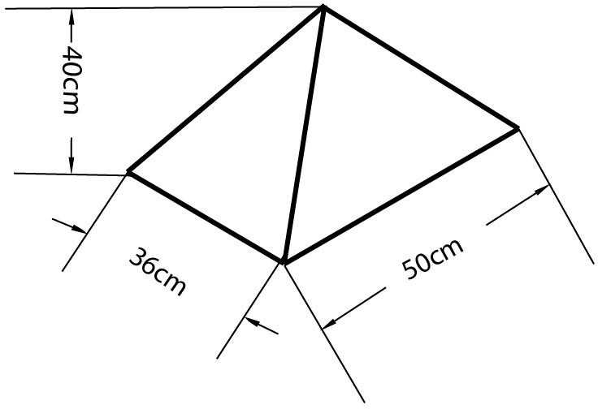
Figure 3.1 Collector

Drying chamber
Drying chamber houses the cocoa bean to be dried. This is the enclosed space where the cocoa bean is placed on trays. It’s designed to retain heat and provide a controlled environment for drying. The dark colour of the interior enhances heat absorption.
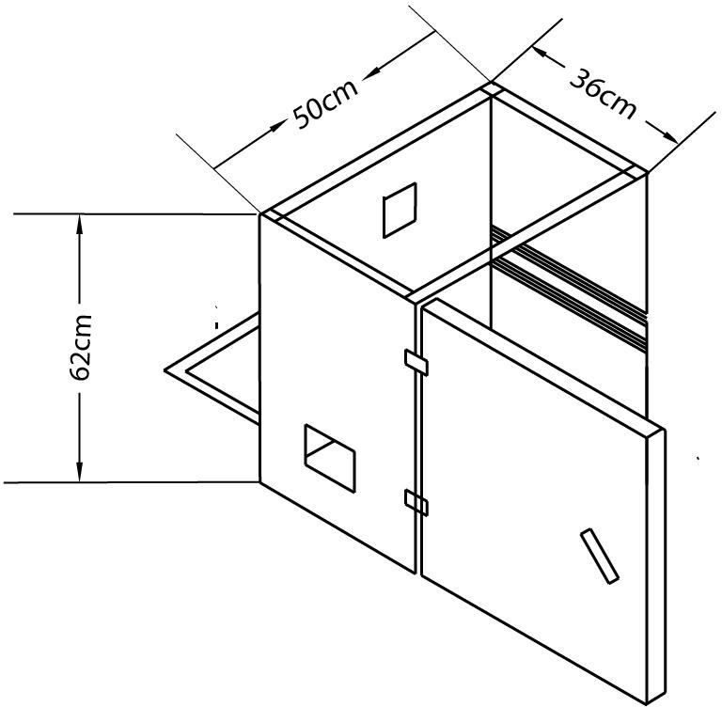
Figure 3.2 Drying chamber

Trays
Trays holds the cocoa bean to be dried. These trays were made of metal mesh to allow for good airflow and even drying. The cocoa bean was spread out on the trays to maximize exposure to the hot air.
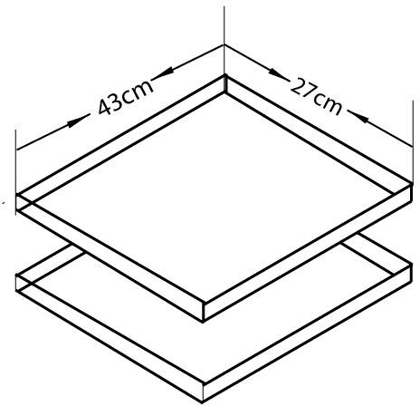
Figure 3.3 Trays

Fans
The fan circulate air within the dryer. The capacity of the fan is 0.44A(amps) and 12V. There was three fans in this design;
Side fans: These two fans draws in fresh, outside air into the dryer, helping to maintain humidity levels and prevent moisture buildup.
Top fan: This fan extracts moisture-laden air from the drying chamber, accelerating the drying process and creating negative pressure to pull in more air.
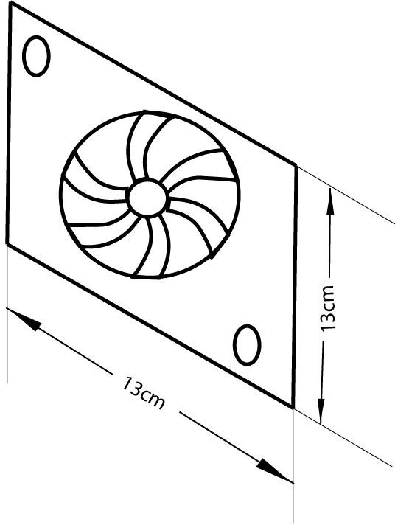
Figure 3.4 Fan

Frame
The frame provides structural support for the dryer. It was made of metal and gives the dryer its shape and stability.
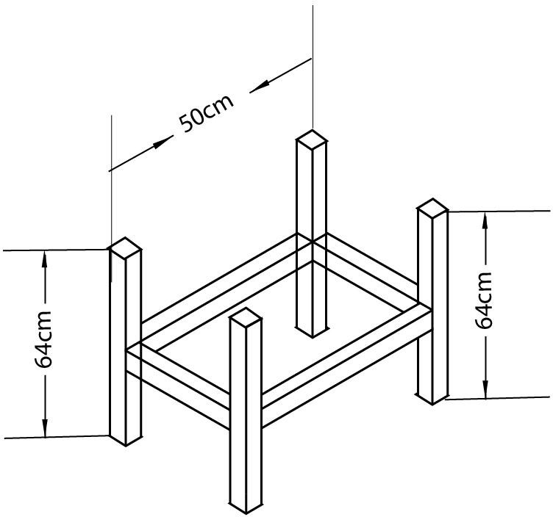
Figure 3.5 Frame

Monitoring equipment
It monitors conditions of the environment. It includes instruments to measure temperature and relative humidity of the environment. The monitoring equipment houses charge controller, solar battery, hygrometer and thermometer.
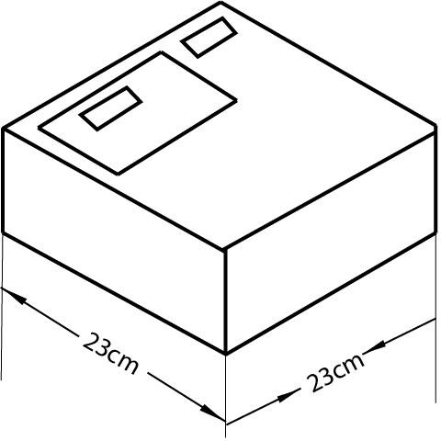
Figure 3.6 Monitoring equipment

Hinges and locks
Hinges are used to attach the door of the hybrid dryer together. It allows the panels to open and close smoothly, making it easy to access the contents of the dryer. Locks were used to secure the door of the hybrid dryer when it is closed. This helps to protect the products inside the dryer from the elements and theft.

Solar battery
A Panasonic 12V 7Ah lead- acid battery was used because of its affordability and reliability. It stores the energy generated by the solar panel for use when there is no sunlight.

Solar panel
It collects energy from the sun in form of sunlight which will help power the monitoring instrument.

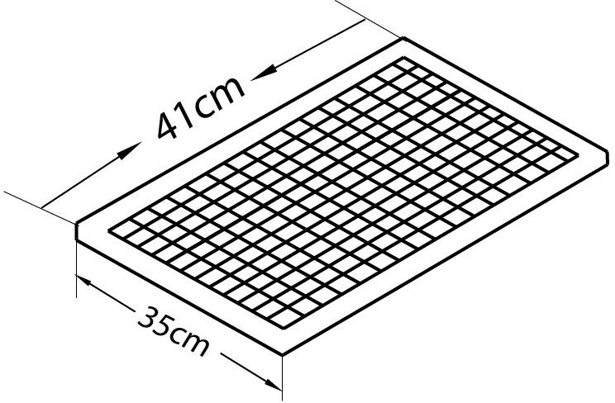

Figure 3.7 Solar panel

Charge controller
The charge controller maintains batteries at their highest state of charge without overcharging them to avoid gassing and battery damage.

Hybrid Dryer Parts Design
    - Solar collector area
The solar collector is a triangular prism and it is an isosceles triangle. The solar collector area is given by;
Total surface area = 2 x (area of triangular base) + 3 x (area of rectangular side) (3.01) Area of the isosceles triangle base = (√3/4) x side2 (3.02)
Area of the rectangular sides = length x width (3.03)

25cm 50cm
Side view of the collector front view of the collector Where;
Base of the isosceles triangle = 50cm Height of the isosceles triangle = 40cm Width = 25cm
Area of the rectangular sides = 25cm x 40cm = 1000cm2
Area of the isosceles triangle base = (√3/4) x (50cm)² =1082.53 Total surface area = 2 x (1082.53) + 3 x (1000) = 5165.06cm2
    - Absorber Surface Area,
The surface area of the absorber Aab is approximately equal to the area of the collector surface area, Ac; this is related to the length, Lc and width, W of the solar collector as follows:
Aab = Lc x W (3.04)
Lc = height of prism + height of drying chamber
= 40cm + 62cm =102cm Aab = 102 x 50
= 5100cm²

Aab = Absorber surface area of the collector Lc =Length of the collector
W=Width

    - The total area of the dryer,

Area of the dryer (rectangle) = L x H (3.05)

= 62 x 50

= 3100cm²
L = length of the dryer H = Height

Moisture Content (M.C.):
The moisture content is given as:

MC (%)= [ Mi -Mf]x100%; wet basis (3.06)
Mi

Where;

Mi = mass of sample before drying and Mf = mass of sample after drying.

The mass of water evaporated or moisture loss
Moisture loss is given as;
mw = mi [ Mi -Me ] (3.07)
100 – Me\
Where:
mi= initial mass of the food item (kg);
Me = equilibrium moisture content (% dry basis); Mi= initial moisture content (% dry basis).
Also this can still be obtained by using equation 3.05
mw = (mi– mf) (3.08)
Where;
mi is the mass of the sample before drying mf is the mass of the sample after drying

Average drying rate
Mdr, would be determined from the mass of moisture to be removed by the solar heater and drying time by the following equation:

Mdr = Mw
td
(3.09
Where:
Mdr = average drying rate, kg/hour;
Mw = mass of wet products and td = overall drying time

Principle of Operation of the Hybrid Dryer
Solar energy is captured by the collector in form of sunlight which heats the air inside the dryer. The side fans bring in fresh air while the top fan extracts moist air, creating a continuous airflow. The hot air then circulates around the products, removing moisture and drying it. A humidity sensor and temperature sensor is used to monitor the environment temperature and relative humidity and controls the drying process.

Experimental procedure
The apparatus used in this experiment were stopwatch, which was used for taking more accurate timing, weighing scale, cocoa bean, grain moisture-meter and the solar dryer.
The solar dryer consists of two trays, two fans for blowing air into the dryer, a fan for sucking the air out of the machine.
The machine was firstly test run with small quantity of cocoa before the main drying to know if there was any fault or any adjustment to be made.
The dryer was placed to face the direction of the sun. The three fans were switched on, the speed of the fans blowing air inside the solar dryer was regulated to be at an average.
The wet cocoa bean was weighed and the moisture content was known and recorded. The two trays were brought out and the weight of the trays were known and recorded. Tray 1and tray 2 were filled with an equal amount of wet cocoa bean and the weight of the trays filled with wet cocoa bean was recorded, the trays were then placed in the solar dryer. The temperature and relative humidity was recorded as well. The stopwatch was set at an interval of one hour.
After an hour, the trays were brought out to be weighed, and they were placed back after weighing. Then, the temperature and relative humidity was recorded. The stopwatch was set to an interval of an hour again.
This procedure was repeated till the wet cocoa bean was dried to a constant weight three times.

Material used for construction of solar dryer
    - Mild steel sheet
    - Square pipe
    - Glass collector
    - Angle iron
    - Fibre glass
    - Silicon gum
    - Hinges & locks
    - Consumables
    - 12V 7ah battery
    - Dc fan
    - 20w solar panel
    - Temperature and humidity sensor
    - Box
    - Wires and clips
    - Charge controller
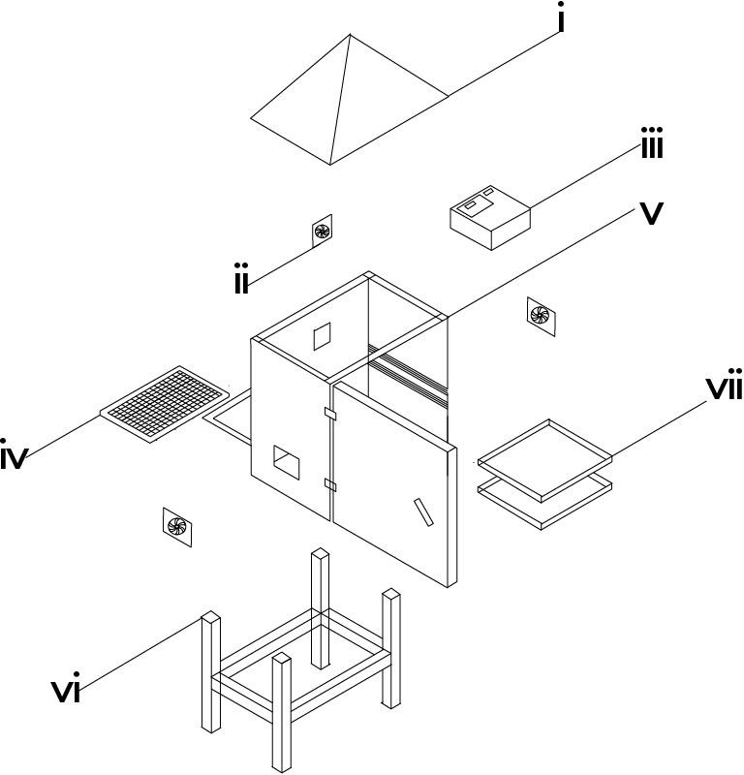
MACHINE PARTS’ LIST
S/N | KEYS | PARTS’ NAME
1 | I | COLLECTOR
2 | II | FAN
3 | III | MONITORING EQUIPMENT
4 | IV | SOLAR PANEL
5 | V | DRYING CHAMBER
6 | VI | FRAME
7 | VII | TRAYS
Figure 3.8 Exploded view and labeling of components of the hybrid dryer.
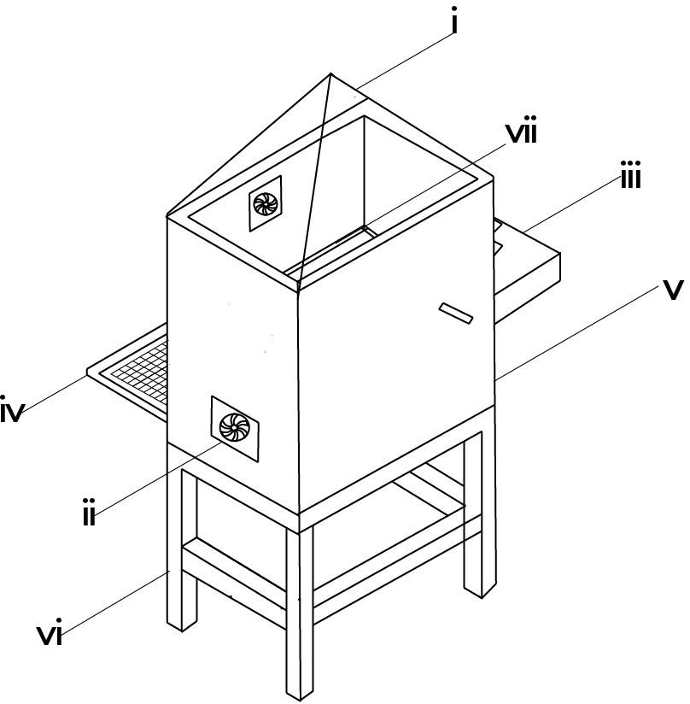
Figure 3.9 Isometric view of hybrid dryer
MACHINE PARTS’ LIST
S/N | KEYS | PARTS’ NAME
1 | I | COLLECTOR
2 | II | FAN
3 | III | MONITORING EQUIPMENT
4 | IV | SOLAR PANEL
5 | V | DRYING CHAMBER
6 | VI | FRAME
7 | VII | TRAYS

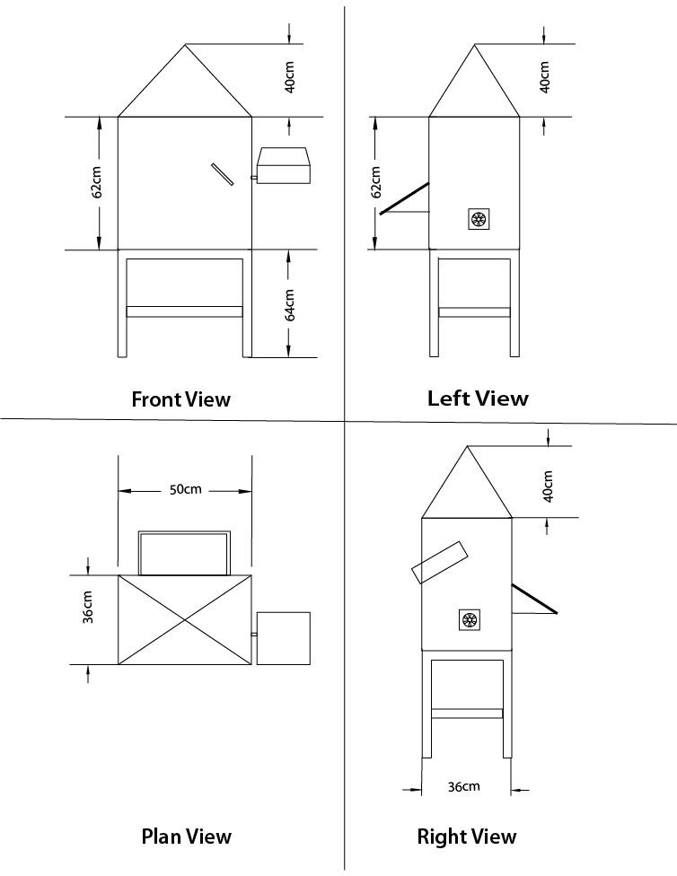
Figure 3.10 Views of The Machine Drawing
3.10 Tools and Equipment
1. Electric Arc Welding Machine: it was employed during the fabrication of the drying chamber, supporting frame and tray assembly. It was used to join metal components with high strength and durability ensuring structural integrity of the dryer.
- Grinder/Cutting Machine: It is a power tool with a rotating abrasive disc or blade which was used for cutting and smoothing metal.It is used to cut metal sheets, pipes, or rods to required sizes and for grinding welds to smooth finishes.
- Drilling Machine: It is a machine tool which was used for used to drill holes into materials (metal, wood, etc.). It is used to create holes for bolts, screws, or other fittings in your project components.
- Screwdriver Set: It is a set of hand tools with different tips (flat, Phillips, etc.) which was used for driving screws. It is used for tightening or loosening screws during assembly or adjustments of electrical and mechanical parts.
- Spanner Set: It is a set of tools which was used for for tightening or loosening nuts and bolts. It is essential for assembling and disassembling mechanical parts such as frames, joints, or supports.
- Multimeter (for testing connections): it is an electronic measuring instrument that combines several functions (voltage, current, resistance testing). It was used to check electrical circuits, test battery voltage, or ensure proper connections in the solar-powered system
- Pliers: It is a hand tool with gripping jaws, sometimes with cutting edges.it was used for holding objects firmly, bending wires, or cutting small materials.
- Measuring Tape: It is a flexible ruler used to measure distances or dimensions. It is used to take accurate measurements of components during fabrication or assembly.
- File (for finishing edges):It is a hand tool with a roughened surface used for smoothing or shaping metal.It is used to smoothen sharp edges after cutting or welding metal parts.
- Paintbrush/Spray Gun: it is a tool used to apply paint or protective coatings. It is used for finishing touches to protect metal surfaces from rust and improve aesthetics.
- Soldering Iron (for electronic parts): It is a hand tool that heats up to melt solder (a metal alloy) for joining electronic components. It is used in assembling or repairing the electronic parts of your project like sensors, circuits, or connections.
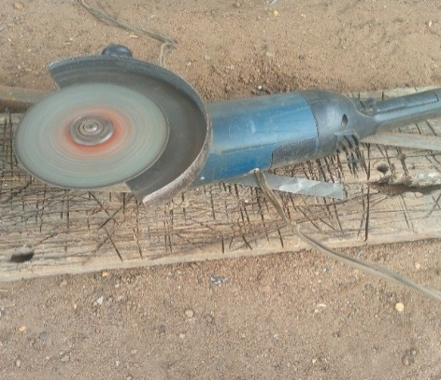
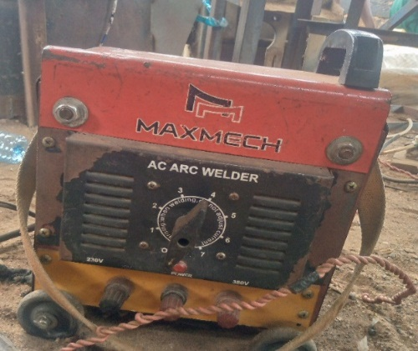

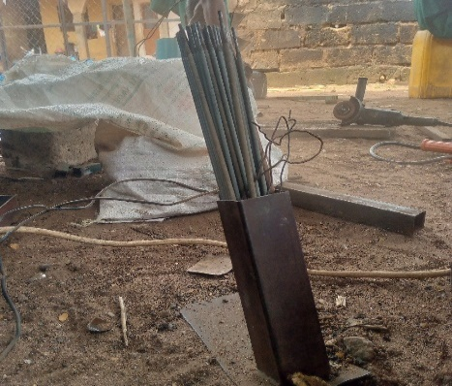
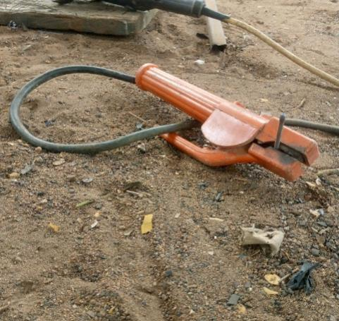
Plate 3.1a:Electric Arc Welding plate 3.1b: Grinding

Plate 3.1c: Thong plate 3.1d Electrodes

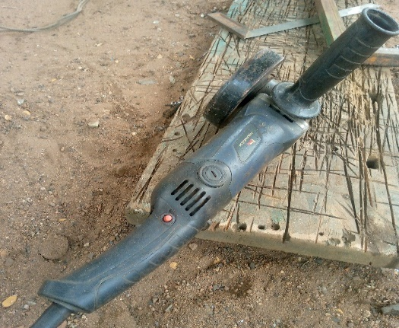
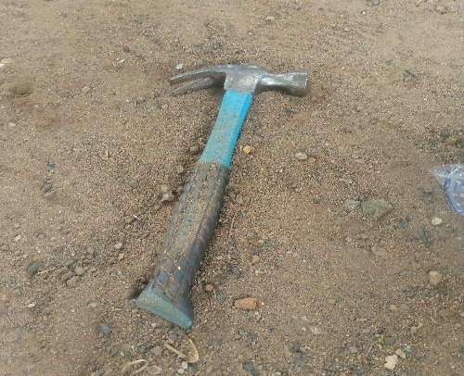

Small Grinder Hammer
3.11 Design Layout
The experimental design for this study was structured using a two factor factorial design to evaluate the effect of the drying parameters on the drying rate and drying efficiency of cocoa seeds. The factors and responses are presented as follows:
- Mass of Sample (g)
- Air flow rate (m³/s)
- Experimental Responses (Dependent Variables)
Two performance indicators were monitored during the drying process:
- Drying Rate (kg/h): measured as the rate at which moisture was removed from the cocoa seeds.
- Drying efficiency (%): calculated as the ratio of useful energy utilized for moisture removal to the total energy supplied.
- Experimental Runs
A total of 13 experimental runs were carrid out as presented in Table 3.1. The runs were randomized to minimize the experimental bias and ensure the independence of observations. The experimental matrix includes various combinations of the two factors and their respective levels.
Table 3.1shows the experimental design matrix with the factors and responses for the cocoa seed drying process
 |  | Factor 1 | Factor 2 | Response 1 | Response 2
Std | Run | A:Mass of Sample | B:Air Flow Rate | Drying Rate | Drying Efficiency
 |  | g |  | Kg/h | %
3 | 1 | 1000 | 0.6
9 | 2 | 2000 | 0.5
12 | 3 | 2000 | 0.5
7 | 4 | 2000 | 0.4
4 | 5 | 3000 | 0.6
2 | 6 | 3000 | 0.4
13 | 7 | 2000 | 0.5
1 | 8 | 1000 | 0.4
11 | 9 | 2000 | 0.5
5 | 10 | 1000 | 0.5
10 | 11 | 2000 | 0.5
6 | 12 | 3000 | 0.5
8 | 13 | 2000 | 0.6

CHAPTER FOUR

RESULTS AND DISCUSSION

4.1 Result

The result obtained from the testing of the fabricated hybrid dryer for cocoa bean were presented in table 4.1 below.

Table 4.1: Summary of Result of Cocoa Drying Using the Fabricated Hybrid Solar Dryer
Run | Mass of Sample (g) | Air Flow Rate (kg/h) | Drying Rate (kg/h) | Drying Efficiency (%)
1 | 1000 | 0.6 | 0.042 | 78.3
2 | 2000 | 0.5 | 0.033 | 87.6
3 | 2000 | 0.5 | 0.033 | 87.6
4 | 2000 | 0.4 | 0.029 | 91.2
5 | 3000 | 0.6 | 0.031 | 89.2
6 | 3000 | 0.4 | 0.024 | 96.3
7 | 2000 | 0.5 | 0.034 | 86.1
8 | 1000 | 0.4 | 0.035 | 85.4
9 | 2000 | 0.5 | 0.031 | 89.2
10 | 1000 | 0.5 | 0.037 | 83.9
11 | 2000 | 0.5 | 0.033 | 87.6
12 | 3000 | 0.5 | 0.027 | 92.8
13 | 2000 | 0.6 | 0.036 | 84.1

4.2 Discussion
The results obtained from testing the hybrid dryer were presented in table 4.1 above. From the table, it was observed that different mass of sample and airflow rate gave different drying rate and drying efficiency respectively. It was also observed that an increase in mass of sample at the same air flow rate gave a decrease in the drying rate and drying efficiency while an increase in the air flow rate at the same mass of sample gave an increase in drying rate and drying efficiency. This could be attributed to the ease of moisture migration within the sample at higher air flow rate. The analysis of variance (ANOVA) for the drying rate and drying efficiency of cocoa bean is presented in table 4.2 and 4.3 below respectively.

Table 4.2: Analysis of Variance (ANOVA) for the Drying Rate of Cocoa Bean
Source | Sum of Squares | df | Mean Square | F-value | p-value
Model | 0.0002 | 2 | 0.0001 | 184.90 | < 0.0001 | significant
A-Mass of Sample | 0.0002 | 1 | 0.0002 | 258.49 | < 0.0001
B-Air Flow Rate | 0.0001 | 1 | 0.0001 | 111.32 | < 0.0001
Residual | 6.603E-06 | 10 | 6.603E-07
Lack of Fit | 1.803E-06 | 6 | 3.004E-07 | 0.2504 | 0.9353 | not significant
Pure Error | 4.800E-06 | 4 | 1.200E-06
Cor Total | 0.0003 | 12
*Significant @P≤0.05
From table 4.2 above, the p value < 0.0001 shows that the model is significant being far below 0.05. this indicates that the selected factors of mass of sample and air flow rates have a great effect on the drying rate of cocoa bean. The graphical representation is shown in figure 4.1 below.

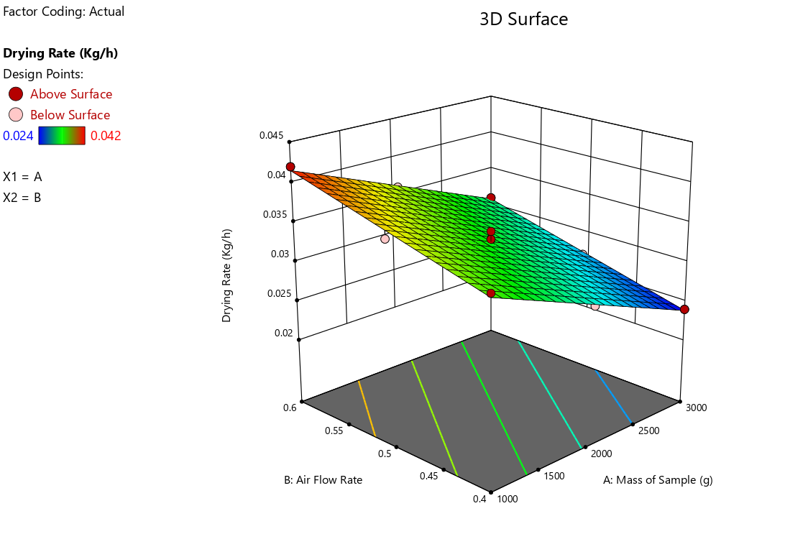
Fig 4.1: Effect of Air Flow Rate and Mass of Sample on the Drying Rate of Cocoa

Table 4.3: Analysis of Variance (ANOVA) for the Drying Efficiency of Cocoa Bean
Source | Sum of Squares | df | Mean Square | F-value | p-value
Model | 232.70 | 2 | 116.35 | 152.81 | < 0.0001 | Significant
A-Mass of Sample | 157.08 | 1 | 157.08 | 206.30 | < 0.0001
B-Air Flow Rate | 75.62 | 1 | 75.62 | 99.31 | < 0.0001
Residual | 7.61 | 10 | 0.7614
Lack of Fit | 2.81 | 6 | 0.4677 | 0.3891 | 0.8551 | not significant
Pure Error | 4.81 | 4 | 1.20
Cor Total | 240.31 | 12
*Significant @P≤0.05
From table 4.3 above, the p value < 0.0001 shows that the model is significant being far below 0.05. this indicates that the selected factors of mass of sample and air flow rates have a great effect on the drying efficiency of cocoa bean. The graphical representation is shown in figure 4.2 below
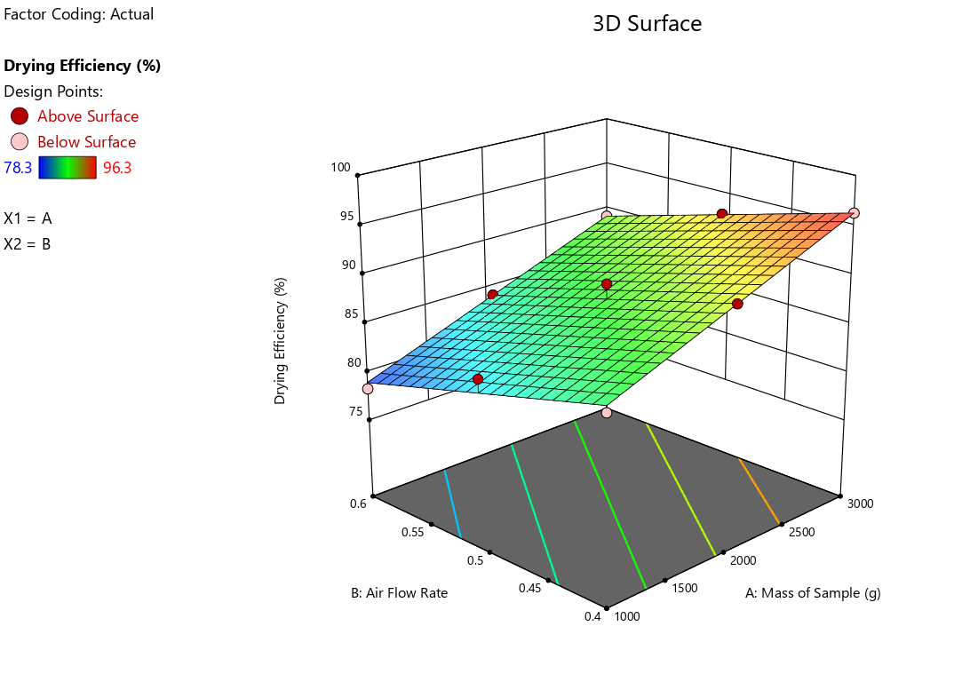
Fig 4.2: Effect of Air Flow Rate and Mass of Sample on the Drying Efficiency of Cocoa

CHAPTER FIVE
Conclusion and Recommendation
5.1 Conclusion
A hybrid dryer which combines direct solar drying for drying with solar panel powered system for air flow was designed and fabricated in the department of agricultural and bio-environmental engineering technology, institute of technology, kwara state polytechnic, Ilorin. The dryer was able to dry wet cocoa bean effectively.
5.2 Recommendation
The following recommendations were drawn from the study
- It is recommended that a load cell with Personal Computer interface should be incorporated into the drying chamber to know the weight of products in the dryer at every time interval.
- It is recommended that a wheel (Tyre) should be at the stand of the dryer for easy movement.
- The size of the drying chamber should increase for large scale drying, as well as the size of solar panel and capacity of the battery.

REFERENCES
Akinmoladun, O. P., Adebayo, F., & Akanbi, A. O. (2022). Maintenance practices and durability of solar dryers in agricultural use. Energy Conservation and Management, 116, 38-47.
Akinola, O. A., Ogunlade, B., & Babarinde, A. A. (2022). Performance analysis of indirect solar dryers for agricultural products. Renewable Energy, 15(3), 112-121.
Adeoye, O. M., & Olaniyi, T. K. (2020). Improving energy efficiency in hybrid solar drying systems: A review. Energy Reports, 6, 223–233.
Agunbiade, S., & Adebayo, T. O. (2022). Hybrid solar dryers: Bridging the gap in cocoa drying processes. African Journal of Agricultural Engineering, 14(3), 156-167.
Ahmed, M. S., Ibrahim, A., & Hassan, Y. T. (2020). Thermal storage in solar drying systems: Advances and challenges. Renewable Energy Journal, 35(4), 205-214.
Afoakwa, E. O. (2010). Chocolate Science and Technology. Wiley-Blackwell.
Afoakwa, E. O., Paterson, A., Fowler, M., & Ryan, A. (2011). Cocoa drying and its impact on flavor precursors. Critical Reviews in Food Science and Nutrition, 51(8), 751-774.
Ali, A., Tiwari, A., & Rizvi, S. (2021). Reduction of carbon emissions using solar drying systems in agriculture. Environmental Impact Assessment Review, 85, 106-115.
Ampratwum, D. B., & Dorvlo, A. S. S. (2007). Design and performance of solar dryers for cocoa beans. Renewable Energy, 32(12), 2063-2076.
Bala, B. K., & Debnath, D. (2012). Solar drying technology and its application in agriculture. Drying Technology, 30(10), 1123-1132.
Balde, J. (2021). Challenges in adopting solar-powered dryers in developing countries: A review. Energy for Sustainable Development, 60, 27-37.
Chandra, R., & Arora, A. (2019). Cost-benefit analysis of solar drying in agricultural applications. Renewable Energy, 142, 248-255.
Chavan, U. D., Patil, J. V., & Kadam, S. S. (2022). Minimizing microbial contamination during solar drying of agricultural products. Food and Bioprocess Technology, 9(3), 257-265.
Dutta, D., & Singh, M. (2020). Weather dependency and hybrid systems in solar drying technologies. Renewable Energy Technology Reviews, 10(1), 82-90.
Ekechukwu, O. V., & Norton, B. (2001). Review of solar-energy drying systems II: An overview of solar drying technology. Energy Conversion and Management, 40(6), 615-655.
Energy, Sustainability, and Society (2021). Design, fabrication, and performance evaluation of solar dryer for agricultural produce. BioMed Central. Available at: Energy, Sustainability, and Society Journal.
Eze, C. C., Okonkwo, I. K., & Ogbu, E. C. (2021). IoT applications in agricultural solar drying systems: Case studies and future directions. International Journal of Smart Agriculture, 8(1), 45-60.
Fagunwa, F. O., Olatunji, K. T., & Oke, A. R. (2019). Optimization of cocoa drying systems: A focus on quality retention. Agricultural Science and Technology, 18(3), 225-231.
FAO. (2020). The future of food and agriculture: Trends and challenges. Food and Agriculture Organization.
ICCO (International Cocoa Organization). (2021). Cocoa Market Report. Available at: https://www.icco.org.
Koya, O. A., Adebusoye, K. A., & Awogbemi, O. (2014). Development of an intermittent solar dryer for cocoa beans. Journal of Solar Energy Research, 8(1), 56-67.
Kumar, A., Tiwari, S., & Sharma, R. (2021). Moisture content and quality control in solar drying of cocoa beans. Journal of Agricultural Engineering Research, 18(2), 45-59.
Leong, H., Lee, J., & Khor, M. (2020). Quality and preservation of cocoa beans in solar drying systems. Food Processing and Technology, 41(4), 569-574.
Madarang, J. D. (2019). Performance evaluation of a solar-powered cocoa dryer with hybrid thermal energy storage. Journal of Agricultural Engineering Research, 75(4), 120-130.
Mohammed, A., Ibrahim, Y., & Umar, H. (2022). Economic barriers to solar dryer adoption for smallholder farmers in sub-Saharan Africa. International Journal of Renewable Energy, 51(7), 3452-3460.
Nair, R., Kumar, S., & Singh, D. (2020). Solar dryers: An eco-friendly solution for agricultural drying. Journal of Cleaner Production, 248, 119-132.
Nair, R. S., Soni, D., & Keshav, P. (2021). Hybrid solar drying systems: A solution to weather unpredictability in agriculture. Renewable and Sustainable Energy Reviews, 131, 109-118.
Nalubega, J. F. (2015). Design and construction of a cocoa bean solar dryer for smallholder farmers. Dissertation, Busitema University. Available at: Busitema University Institutional Repository.
Nduka, O. M., Okoli, J. S., & Akpan, A. A. (2021). Impact of solar drying on the quality of cocoa beans: A comparative study. International Journal of Food Science & Technology, 56(5), 1345-1353.
Obi, C. A., & Ugwuishiwu, B. O. (2023). Quality assessment of solar-dried cocoa beans in controlled environments. International Journal of Food Science & Technology, 58(4), 678-689.
Olunloyo, V. O., Ajibola, A. O., & Adeyemo, S. O. (2016). Performance evaluation of solar-powered cocoa dryers. Journal of Agricultural Engineering, 23(2), 45-59.
Patel, S., Vashi, S., & Sheth, N. (2023). Maintenance needs and performance optimization in solar-powered agricultural dryers. Journal of Renewable and Sustainable Energy, 15(1), 193-205.
Perez, J. M., Morales, J. R., & Muñoz, L. M. (2022). Economic assessment of solar drying systems in smallholder farms: A case study of cocoa drying. Renewable and Sustainable Energy Reviews, 69, 528-535.
Singh, V., Patel, H., & Mehta, P. (2021). Comparative analysis of thermal storage-assisted solar dryers for crop drying. Renewable and Sustainable Energy Reviews, 34, 85-97.
Zahouli, I. B., Kouadio, N. J., & Coulibaly, B. (2010). Impact of post-harvest practices on cocoa bean quality. International Journal of Postharvest Technology, 5(3), 23-31.

