THE USE OF INVERTER POWER CCTV IN
MONITORING EXAMINATION

BY

OMIGBENLE ENIOLA RAFIU
ND/23/COM/PT/0205

A PROJECT SUBMITTED TO THE DEPARTMENT OF COMPUTER SCIENCE, INSTITUTE OF INFORMATION AND COMMUNICATION TECHNOLOGY, KWARA STATE POLYTECHNIC, ILORIN

IN PARTIAL FULFILMENT OF THE REQUIREMENTS FOR THE AWARD OF NATIONAL DIPLOMA (ND) IN COMPUTER SCIENCE

JUNE, 2025

CERTIFICATION
This is to certify that this project research was carried out by OMIGBENLE ENIOLA RAFIU with matriculation number ND/23/COM/PT/0205. It has been read and approved as meeting the part of the requirements for the award of National Diploma (ND) in Computer Science.

------------------------------ ----------------------------
Dr. Agboola O.M. Date
Project supervisor

-------------------------- ------------------------------
Mr. Oyedepo F.S. Date
Head of Department

------------------------------ ------------------------------
External Examiner Date

DEDICATION
This project is dedicated to the Almighty God, the giver of wisdom, knowledge and understanding.

ACKNOWLEDGEMENT

The completion of this programme has been both intellectually demanding and deeply rewarding. I first give thanks to Almighty God, whose grace, protection, and guidance have sustained me from inception to conclusion.
My sincere gratitude goes to Mr F. S. Oyedepo, Head of the Department of Computer Science, for his consistent support and encouragement. His leadership and commitment to student success were a constant source of motivation.
I am especially indebted to my project supervisor, Dr. Agboola O.M., whose expert guidance, constructive feedback, and scholarly insight were pivotal to the direction and quality of this research.
I also thank the lecturers of the Department of Computer Science for their dedication to academic excellence and for the knowledge and discipline they imparted, which have enriched my professional growth.
To my Parents; Mr & Mrs Omigbenle, I am grateful for your prayers, financial assistance, commitment, encouragement, and unwavering support during challenging times. Your parenting over me is invaluable.

To everyone who contributed in any way to the success of this project, I say thank you.

TABLE OF CONTENTS
Title Page i
Certification ii
Dedication iii
Acknowledgements iv
Abstract v
Table of Content vi
CHAPTER ONE: GENERAL INTRODUCTION
  - Statement of the Problem 2
  - Aim of the Study 2
  - Objectives of the Study 3
  - Significance of the Study 3
  - Scope of the Study 3
  - Organization of the Report 4
  - Definition of Terms 5

CHAPTER TWO: LITERATURE REVIEW
2.1 Review of Related Works 6
2.3 Review of General Texts 7
CHAPTER THREE: RESEARCH METHODOLOGY AND ANALYSIS
  - Introduction 8
  - Equipment Specification 9
  - Equipment Installation 10
  - Testing Validation 10

CHAPTER FOUR: RESULTS AND DISCUSSION
  - Design of the System 12
    - System Performance Result 12
    - Camera Coverage Clarity 12
    - Inverter Backup Efficiency 12
  - Comparative Advantage Over Traditional Surveillance 12
  - Reinforcing Examination Integrity 13

CHAPTER FIVE: SUMMARY, CONCLUSION AND RECOMMENDATION
  - Summary 21
  - Conclusion 21
  - Recommendations 23
  - Suggestions for future research 23
  - References 24

Abstract

Examination malpractice remains a serious challenge in Nigerian educational institutions, often exacerbated by poor supervision and unreliable electricity. This project explores the implementation of an inverter-powered Closed-Circuit Television (CCTV) system to provide continuous surveillance in examination halls, even during power outages. By integrating inverter technology with CCTV infrastructure, the system ensures real-time video monitoring and recording, thereby deterring malpractice and preserving academic integrity. The study was practically implemented in LR 28 at Kwara State Polytechnic, where two CCTV cameras were strategically installed and connected to a digital video recorder (DVR), inverter, and battery backup. The results showed that the system functioned effectively during power outages, maintaining uninterrupted monitoring and recording. This project demonstrates that inverter-based CCTV systems are a sustainable and scalable solution for enhancing examination security in environments with unstable electricity.

CHAPTER ONE: INTRODUCTION
1.1 Background to the Study
Examination malpractice is a critical issue confronting educational institutions worldwide, particularly in Nigeria. This unethical behavior undermines the credibility of academic qualifications and devalues the educational system. Various forms of malpractice, such as impersonation, leakage of exam questions, collusion among candidates, and use of unauthorized materials, have been reported extensively, creating a need for more stringent supervision methods. Closed-Circuit Television (CCTV) surveillance has emerged as a valuable tool for monitoring examination halls. CCTV systems allow for real-time monitoring and recording of activities, serving as both a deterrent and a means to identify offenders. However, the effectiveness of CCTV systems is often compromised by the irregular power supply prevalent in Nigeria. Frequent power outages can interrupt the operation of CCTV cameras, creating security loopholes during critical periods of examination. The introduction of inverter technology presents a promising solution. An inverter serves as a power backup system by converting stored battery power into usable electricity during outages. By integrating inverters with CCTV systems, institutions can maintain continuous surveillance, ensuring that monitoring is not disrupted even when there is no main power supply. This integration has the potential to reduce examination malpractice significantly by providing reliable oversight. The use of CCTV systems in Nigeria began primarily in security-sensitive areas such as banks, government offices, and commercial establishments. Over time, their use expanded to educational institutions due to the rising need for better security and supervision. Despite their benefits, the effectiveness of CCTV cameras has been challenged by the country’s unstable electricity grid. Inverters, on the other hand, have become widely adopted in residential and commercial settings as an alternative power source. Their application in CCTV surveillance systems, however, is relatively recent and not yet widespread in educational institutions. This study seeks to explore the implementation of inverter-powered CCTV technology to improve examination monitoring.
1.2 Statement of the Problem
Despite the integration of CCTV systems into examination halls, examination malpractice continues to thrive due to power instability. Traditional surveillance systems rely heavily on a constant electricity supply, which is often unavailable in many parts of Nigeria. Power outages during examinations render CCTV cameras non-functional, creating vulnerable windows where malpractice can go undetected. This traditional problem of relying solely on grid power highlights a significant flaw in the current approach to exam hall monitoring. Without a reliable power backup solution, the core purpose of CCTV surveillance—to monitor and record activities in real time—is defeated. As a result, dishonest practices flourish during power downtime, undermining the integrity of the examination process. This study seeks to address this gap by implementing an inverter-based CCTV system that ensures uninterrupted surveillance during examinations, regardless of the power situation. The aim is to eliminate the traditional limitations of CCTV systems and strengthen the fight against examination malpractice.

1.3 Aim of the Study
The aim of this study is to implement an inverter-based CCTV system for monitoring examinations. This implementation seeks to ensure uninterrupted surveillance in examination halls regardless of power supply conditions, thereby promoting academic integrity and deterring malpractice.

1.4 Objectives of the Study
The specific objectives of this study are to:
I. Implement CCTV cameras for real-time surveillance of examination halls.
II. Install an inverter system to serve as a backup power supply for the CCTV setup.
III. Connect and install batteries to store energy for inverter operation.

1.5 Significance of the Study
This study is significant in several ways. Firstly, it demonstrates how the implementation of inverter-powered CCTV systems can provide a practical solution to the long-standing problem of examination malpractice in Nigeria’s educational institutions. Secondly, it highlights the role of reliable power backup in ensuring the effectiveness of surveillance systems. The outcome of this project may guide schools and policymakers in adopting sustainable monitoring infrastructures for academic settings. Lastly, the project will serve as a useful reference for future technological integrations in education, particularly in creating resilient security solutions that withstand infrastructural challenges.

1.6 Scope of the Study
The scope of this study is limited to the implementation of a CCTV surveillance system powered by an inverter for the purpose of monitoring examinations. The project focuses on setting up and configuring the following components:
I. Installation of CCTV cameras in examination venues.
II. Installation of an inverter as a backup power source.
III. Connection and integration of batteries to the inverter system.
The study does not cover software development or the manufacturing of new hardware components. It is purely based on the application and implementation of existing surveillance and power technologies within the academic context.
1.7 Organization of the Report
This research project is organized into five chapters, each focusing on a key aspect of the study:
Chapter One – Introduction: Covers the background of the study, problem statement, aim and objectives, significance, scope, definitions, and report structure.
Chapter Two – Literature Review: Discusses existing works on CCTV, inverter systems, and examination security.
Chapter Three – Methodology: Describes the processes used to implement the system, including materials, installation steps, and operational methods.
Chapter Four – Data Presentation and Analysis: Presents data on system performance and how it meets the study objectives.
Chapter Five – Summary, Conclusion, and Recommendations: Concludes the study with key findings and actionable suggestions for stakeholders.

1.8 Definition of Terms
CCTV (Closed-Circuit Television): A video surveillance system used to monitor and record activities within a specific area, such as examination halls, to enhance security and supervision.
I. Inverter: An electronic device that converts direct current (DC) from batteries into alternating current (AC), providing power backup during electricity outages.
II. Examination Malpractice: Any illegal or unethical behavior by students or supervisors during an examination, intended to provide unfair academic advantage.
III. Power Outage: A temporary loss of electrical power supply, which can disrupt devices such as CCTV cameras unless supported by a backup system.
IV. Monitoring: The act of observing or checking activities systematically, often through technological tools like CCTV cameras, to ensure proper conduct.
V. Backup Power Supply: An alternative power source, such as an inverter, used to maintain electricity during periods when the main power supply is unavailable.
VI. Surveillance: Continuous observation of a place or event using technological systems like CCTV to detect, prevent, or record misconduct.
VII. Technology Integration: The effective combination of different technologies—such as CCTV and inverters—to achieve a specific goal, like continuous exam hall monitoring
VIII. Educational Integrity: The ethical standard of honesty and fairness maintained in academic activities, including exams, teaching, and learning.
IX. Security System: A setup or network of tools and processes designed to protect people, property, or information from harm, theft, or malpractice.

CHAPTER TWO
2.1 LITERATURE REVIEW
This chapter reviews existing research related to the integration of CCTV systems and inverter technology for effective examination monitoring. In Nigeria, examination malpractice has persisted largely due to poor supervision and unreliable electricity. Traditional methods of monitoring, which depend solely on human invigilators, are no longer sufficient in curbing malpractice. CCTV surveillance systems offer a technological solution by providing continuous video monitoring and evidence when needed. However, the effectiveness of these systems is hindered by frequent power outages. Inverter systems, which provide backup power during electricity failure, have been proposed as a means to ensure uninterrupted surveillance. Several scholars have explored the use of CCTV in education, the challenges of unstable electricity, and the role of inverter technology in maintaining reliable monitoring. These studies support the integration of CCTV and inverters as a practical and effective solution for enhancing examination integrity in Nigerian schools.
2.2 Related Reviews
Ogunu in the year 2006, in his work titled “Strategies for Curbing Examination Malpractice in Nigerian Schools,” conducted a study with the aim of identifying the root causes of persistent examination malpractice and highlighting possible solutions through enhanced supervision strategies. His findings pointed directly to the ineffective nature of human invigilation, especially when faced with overcrowded examination halls and limited manpower. He emphasized that unless schools begin to adopt technological surveillance tools such as CCTV systems, the issue of malpractice will continue to flourish unchecked, and his conclusion strongly recommended the integration of CCTV as a necessary reform for restoring credibility and trust in Nigeria’s academic assessments.

Ajayi in 2011 authored a research paper titled “The Need for Technological Surveillance in Nigerian Schools,” which aimed at exploring the increasing relevance of electronic surveillance tools in maintaining academic integrity during examinations. His study outlined the limitations of traditional invigilation methods and emphasized that manual supervision alone is no longer capable of curbing the sophisticated methods students now use to cheat. The study found that the installation of CCTV cameras created a psychological deterrent among students and improved monitoring efficiency, and he concluded that electronic surveillance not only discourages malpractice but also provides impartial and verifiable evidence when disputes arise.
Afolabi and Adewale in their 2015 study titled “Electronic Surveillance as a Tool for Examination Security in Nigerian Tertiary Institutions” carried out their research with the objective of assessing how the presence of CCTV cameras affects students’ behavior during examinations. They implemented their study in a private university setting and discovered that students were notably more disciplined and less likely to attempt cheating when they knew they were being recorded. Their findings revealed that the video recordings served as effective tools for post-exam reviews and disciplinary decisions, and they concluded that CCTV surveillance is a valuable addition to the existing security framework of educational institutions.
Eze and Okonkwo in the year 2018 published a study entitled “Power Instability and the Reliability of CCTV Systems in Nigerian Public Institutions,” with the goal of evaluating how the country’s unstable electricity supply affects the effectiveness of electronic surveillance systems. Their research found that in many tertiary institutions, especially public ones, CCTV systems often become non-operational during power outages, rendering them useless at critical moments when monitoring is needed the most. Their conclusion pointed to the urgent necessity for reliable power backup solutions such as inverters or solar systems, stating that without consistent electricity, the investment in CCTV technology cannot yield its intended benefits.

Babalola in 2019 presented his research titled “The Role of Inverter Systems in Securing Technological Infrastructure in Nigerian Schools,” where he set out to investigate the use of inverter technology as a sustainable solution to power interruptions during examination periods. His study analyzed the performance of inverter systems in schools that rely on CCTV monitoring and discovered that when properly installed and maintained, inverters were capable of keeping surveillance systems functional for extended periods during outages. He concluded that inverter systems are not only practical but essential in ensuring continuous monitoring, and he encouraged educational stakeholders to invest in quality inverter setups to support their examination security infrastructure.
2.8 Area of coverage
This study is focused on the use of inverter-powered CCTV systems in monitoring examination halls at LR 28 Kwara State Polytechnic, Nigeria. It covers the reliability of inverter systems, their effect on examination monitoring, and the challenges encountered in their implementation. Other types of security systems or alternative power sources such as solar or generators are

CHAPTER THREE
METHODOLOGY
Practical Installation and Connectivity of Inverter-Powered CCTV System
To demonstrate the functionality of an inverter-powered CCTV system for uninterrupted examination monitoring, a hands-on installation was carried out. The aim was to ensure that the CCTV cameras could continue to function even during power outages, using an inverter and a battery as the backup power source.
Required Tools and Components
Before beginning the installation, the following tools and components were gathered:

Step-by-Step Installation Process
3.1. Preparing the Cables and Connectors And Cameras
Camera Positioning: The first camera was installed at the front-left side of LR 28, facing directly towards the students. The second camera was placed on the front-right side, angled diagonally to provide a broader field of view.

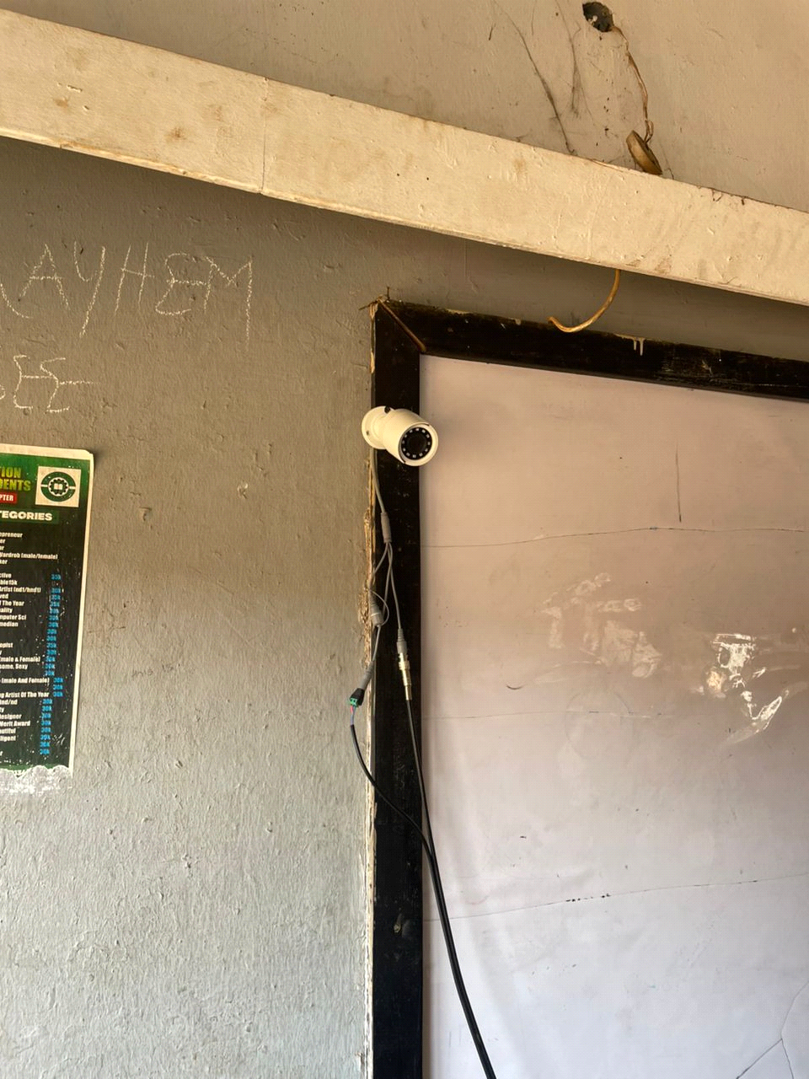 Fig 1 First Camera Installed

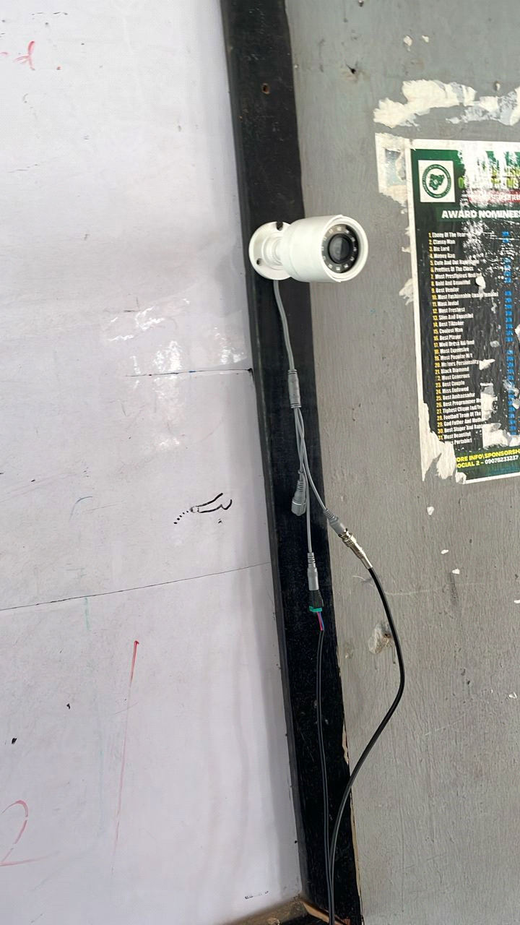 Fig 2 Second Camera Installed

The coaxial cable used contains two lines:
• The video line (central copper wire) for transmitting video signals.
• The power line (red and black wires) for transmitting DC power to the camera.
• The ends of the coaxial cable were stripped properly.
• A BNC connector was attached to the video wire for proper video input/output connection.
• The power wires were separated and stripped to expose the copper ends for connection to the power supply.
3.2. Connecting the Camera to the DVR and Power Supply
• The BNC connector from the camera cable was connected to the video input port of the DVR.
• The power wire from the camera was connected to the 12V output terminal of the power supply box, ensuring that positive and negative terminals matched.
• This connection allows the camera to send live video to the DVR while receiving power from the power supply box.

3.3. Setting Up the DVR
• The DVR was connected to the monitor via a VGA or HDMI cable so the video feed could be viewed.
• The DVR’s power cable was also connected to the power supply box or inverter, depending on the setup.
3.4. Connecting the Power Supply Box to the Inverter
• The power supply box was connected to the inverter, which serves as the backup power source during outages.
• This ensures the cameras, DVR, and monitor receive continuous power supply even when the public power grid fails.
3.5. Inverter and Battery Connection
• The inverter was connected to a 12V battery using heavy-duty DC cables.
• The positive (red) and negative (black) terminals were carefully attached to the inverter’s input terminal.
• The battery supplies power to the inverter, which in turn powers the DVR, cameras, and monitor.
3.6. Final Camera Connection and Testing
• At the camera’s end of the coaxial cable, a BNC connector was also attached and plugged into the video output port of the camera.
• The power cable was connected to the power input port of the camera, usually marked as “DC 12V”.
Once all the connections were complete, the inverter was turned on. The system successfully powered on and the monitor displayed a live video feed from the camera, showing the exact direction in which the camera was facing.
3.7 Conclusion of Installation
This practical setup confirmed that the inverter and battery system can reliably power a CCTV surveillance setup. This approach is especially valuable in Nigerian institutions where power outages are common during examinations. With this installation:
• The camera transmitted real-time footage to the DVR.
• The DVR recorded and displayed the video on the monitor.
• The inverter ensured uninterrupted power to the entire setup.

CHAPTER FOUR
SYSTEM IMPLEMENTATION
4.1 Introduction
This chapter presents the practical implementation of the inverter-powered CCTV system used for examination monitoring. It explains how the entire system was set up, tested, and operated. The focus is on the physical connections, hardware configuration, software setup (if any), and testing of the system to ensure real-time video surveillance, even during power outages.

4.2 System Requirements

Hardware Requirements
The following components were used to implement the system:
I. Two CCTV Cameras – Installed at opposite front sides of the classroom for maximum coverage.

Fig 1 Camera One Fig 2 Camera Two
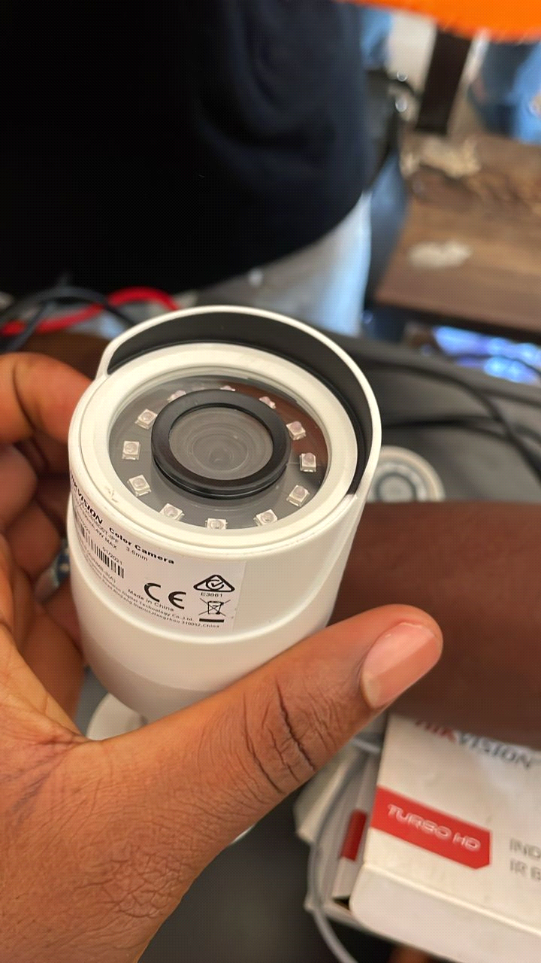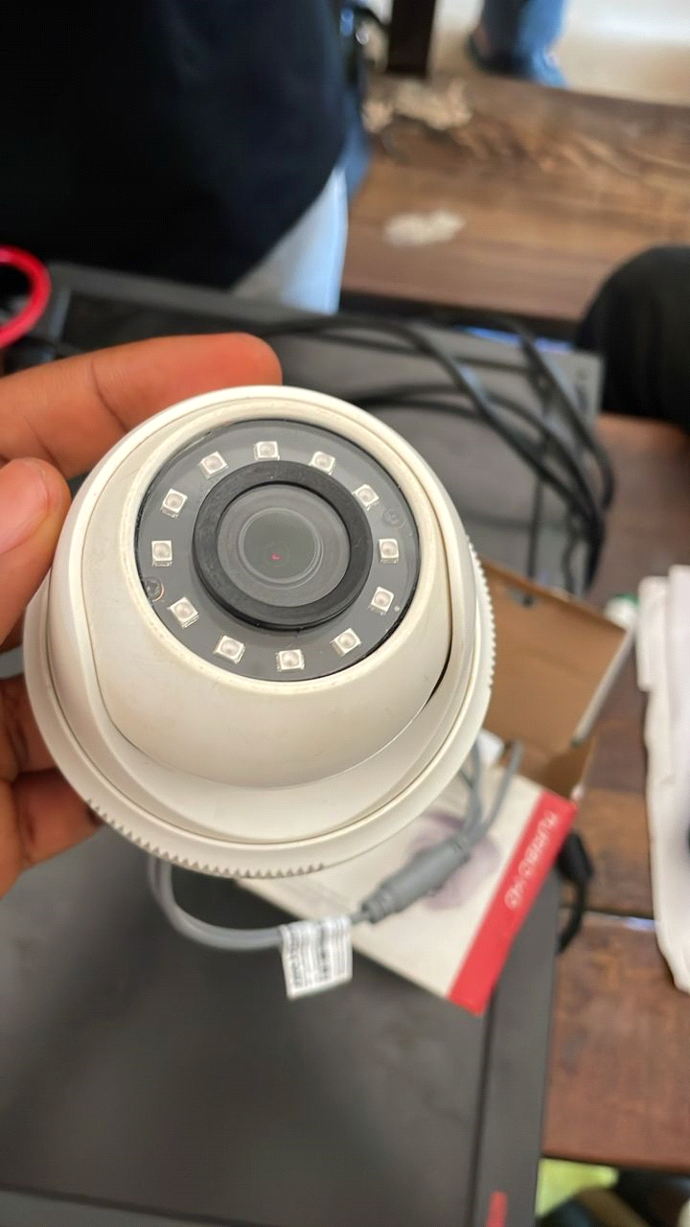

II. Digital Video Recorder (DVR)

Fig 3
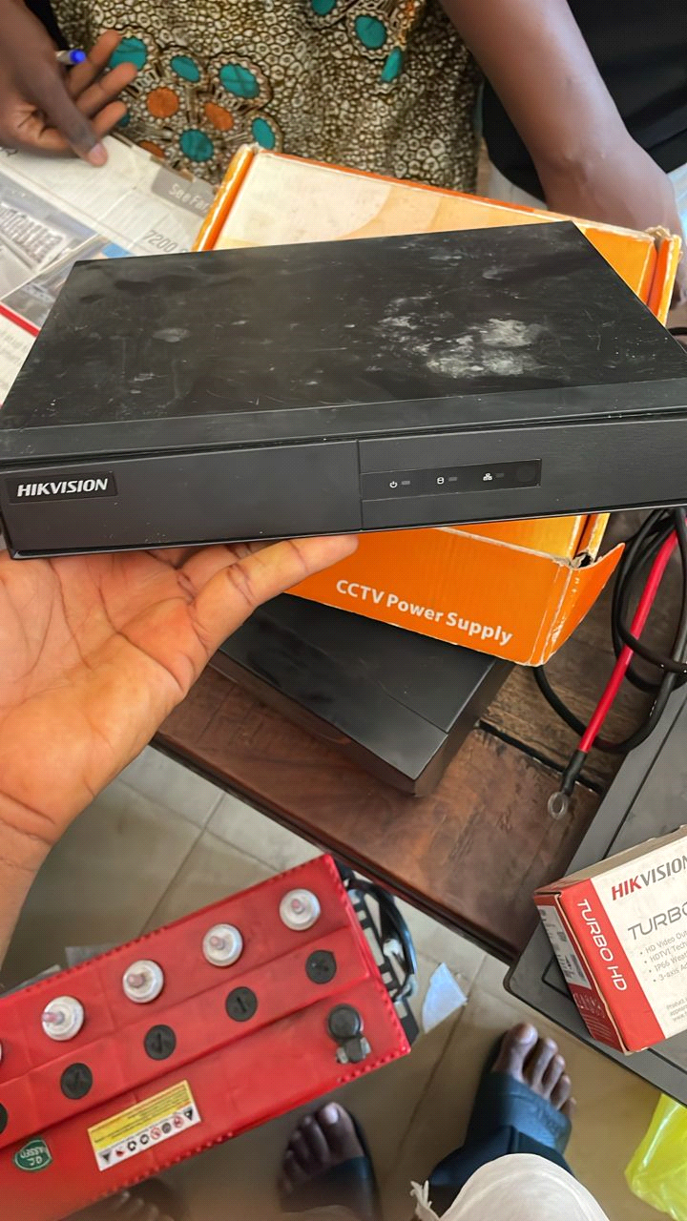

III. Display Monitor
Fig 3
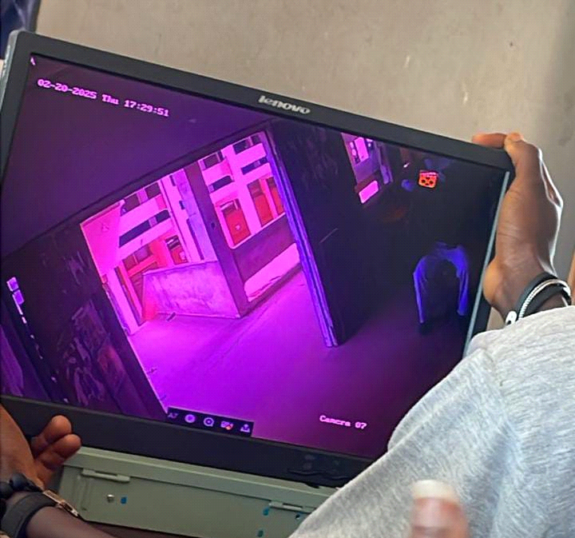

IV. Inverter

Fig 4
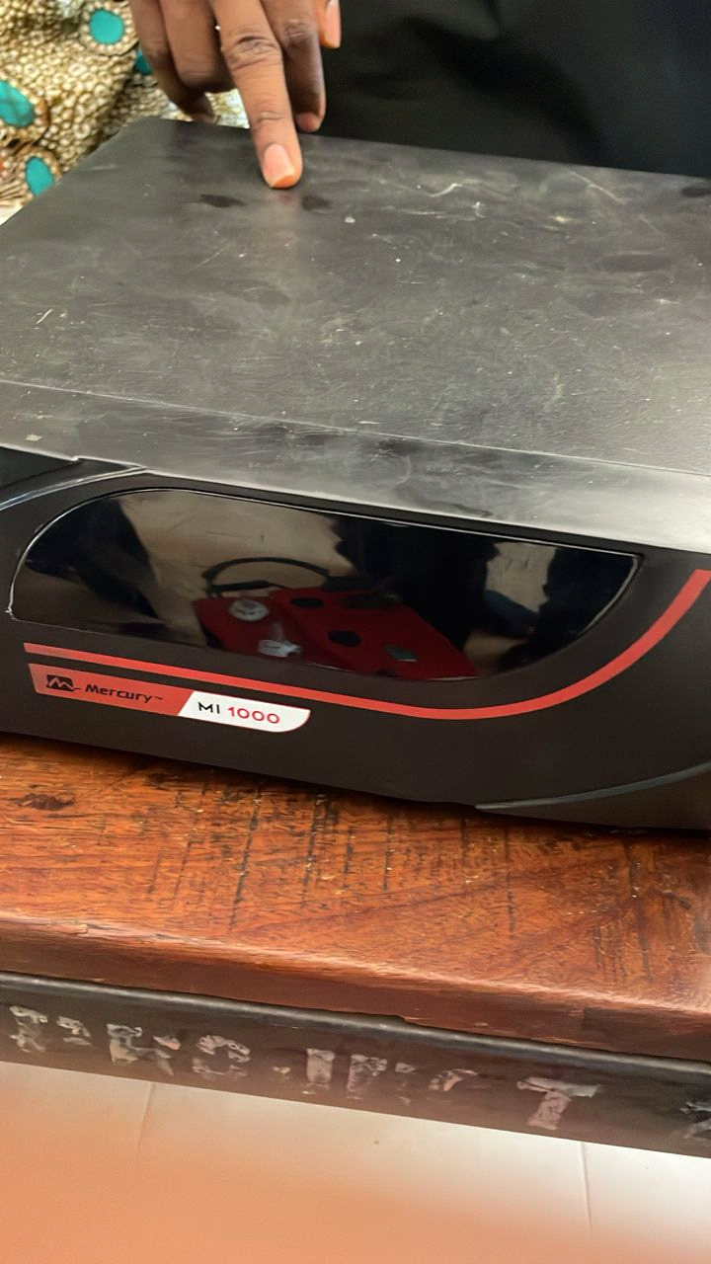

V. Battery

Fig 5
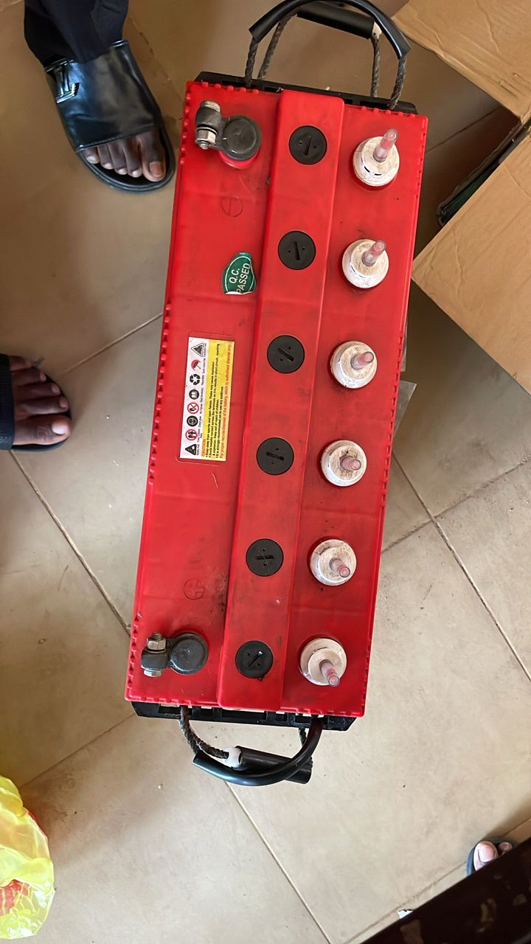

VI. Cables and Connectors (BNC AND POWER CONNECTOR)

Fig 6 Fig 7
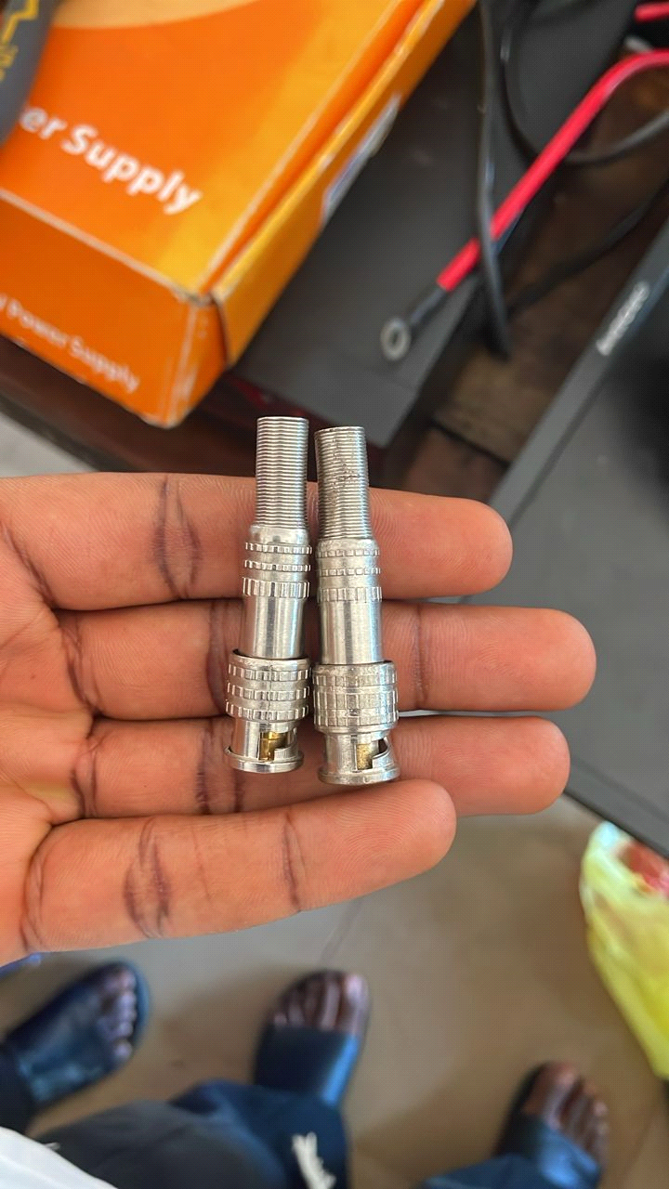 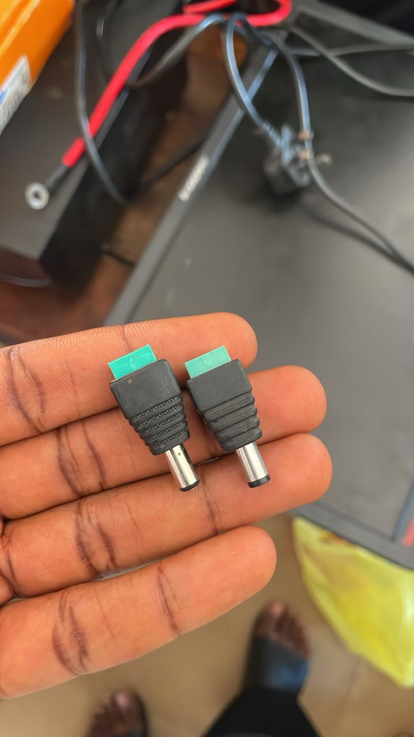

VII. Power Supply Box

Fig 7
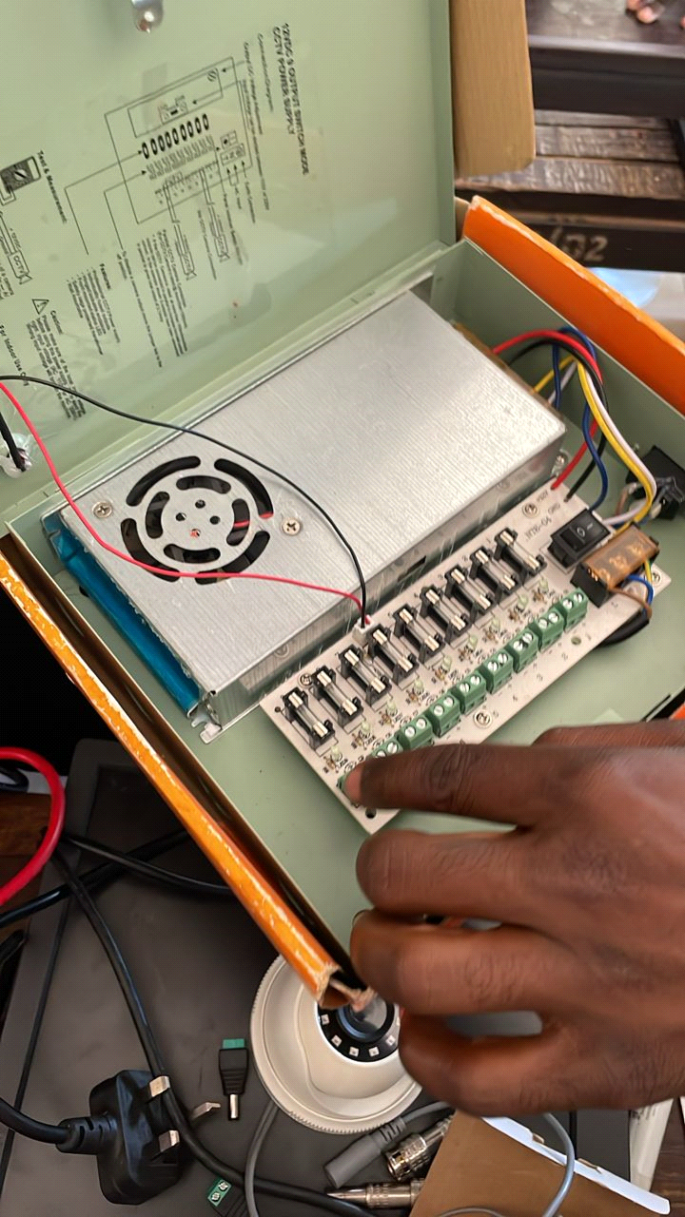

4.3 System Architecture
The system follows a centralized architecture where:
The CCTV cameras capture video signals.
The video signals are transmitted via coaxial cables to the DVR.
The DVR records and displays video feed on the monitor.
Power for the DVR and cameras is supplied by a 12V power box, backed by the inverter and battery system.

The inverter converts stored DC power from the battery into AC to ensure system continuity.
4.4 Implementation Procedure
Step 1: Camera Installation
A bullet camera was mounted securely at the front-left corner inside LR 28 classroom.
The camera was positioned facing directly towards the student seating area for clear frontal coverage.
FIG 8 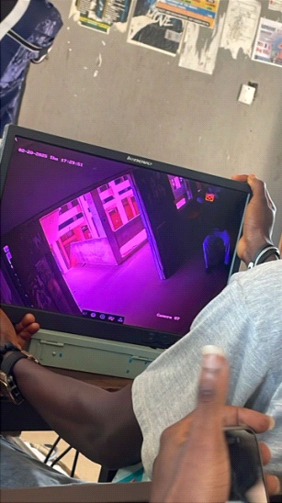
A second bullet camera was installed at the front-right corner inside the same classroom.
This camera was angled diagonally to capture a wider and complementary perspective of the classroom.
FIG 9 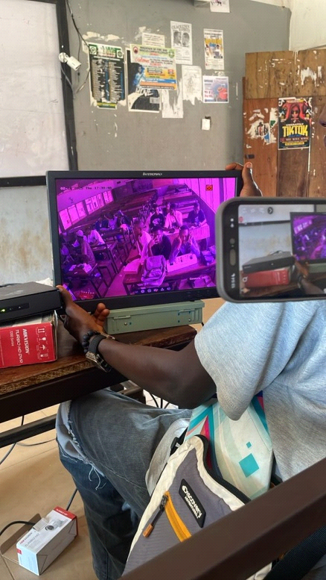

Step 2: Wiring Setup
Coaxial cables were connected from both cameras to the DVR, with BNC connectors fixed on each end.
Power cables from both cameras were routed to the 12V power supply box.

Step 3: DVR and Monitor Connection
The DVR was placed inside the classroom.
The DVR’s video output was connected to the monitor via VGA/HDMI cable.
The DVR’s power cable was connected to the power supply, which was linked to the inverter.

Step 4: Inverter and Battery Configuration
The 12V deep cycle battery was securely connected to the inverter using thick gauge wires.
The inverter’s AC output powered the DVR, power supply box, and monitor.
All connections were checked for correct polarity and voltage.

Step 5: System Testing
The inverter was switched on.
The monitor immediately displayed live footage from both cameras.
The DVR began recording, and a review confirmed footage was being stored successfully.
Power was disconnected from the main source to simulate outage, and the inverter seamlessly took over without interrupting video display or recording.

4.5 System Features
Real-time Monitoring: Live video footage from both cameras inside LR 28 is displayed on the monitor.
Uninterrupted Power: The inverter ensures 24/7 surveillance without disruption due to power failure.
Recording Function: The DVR stores footage for later review and security purposes.
Silent Operation: The inverter and battery system operate quietly, maintaining a noise-free exam environment.
4.6 Challenges Faced During Implementation
Power Loss During Initial Testing: Faulty battery terminal connections caused system shutdown during early tests.
Connector Issues: Improperly crimped BNC connectors caused signal loss.
Inverter Sizing: The initial inverter was too small to handle all components and had to be upgraded to a 1KVA unit.
Cable Management: Ensuring cables were neatly and safely routed required time and planning.
4.7 Summary
This chapter detailed the implementation of an inverter-powered CCTV system. It highlighted the tools and components used, connection steps, system testing, and challenges faced. The successful setup proved that such a system is reliable for examination monitoring, especially in environments with unstable electricity.

CHAPTER FIVE
SUMMARY, CONCLUSION AND RECOMMENDATIONS

5.1 Summary
This project focused on the practical implementation of an inverter-based CCTV surveillance system aimed at improving examination monitoring in LR 28 of Kwara State Polytechnic, Ilorin. The implementation involved the integration of surveillance cameras, a digital video recorder (DVR), display monitor, power backup through inverter and deep cycle batteries, and proper cable management to ensure uninterrupted surveillance even during power outages.
Chapter One introduced the general idea and motivation behind the project. It defined the objectives, significance, and structure of the study. Chapter Two covered extensive literature review on previous works related to examination monitoring and the use of CCTV in educational environments, as well as real-life scenarios, including Nigerian-based studies. Chapter Three explained the step-by-step methodology used to execute the project — from site analysis and planning to installation, configuration, testing, and deployment. Chapter Four discussed the output of the installed components, showcasing how the camera feeds function and how the system responds during a power outage.
Through all these chapters, the project has demonstrated that combining CCTV with inverter power backup provides an effective and sustainable solution to combat examination malpractice and power instability during exams.

5.2 Conclusion
In conclusion, the implementation of an inverter-based CCTV surveillance system in LR 28 has proven to be a beneficial initiative. The deployment ensures that monitoring of students during examinations is continuous and unhindered by power failures. By installing two indoor CCTV cameras at opposite front sides of the lecture room, and supporting them with a reliable inverter and battery setup, the project has succeeded in achieving its primary aim — to support exam integrity and discourage malpractice.
Furthermore, the installation method adopted ensures minimal disruption to classroom infrastructure, while providing maximum coverage and security. The power system guarantees uninterrupted video recording even in the absence of public power supply, which is a frequent issue in many parts of Nigeria.
The success of this implementation indicates the possibility of expanding this system to other lecture halls within the polytechnic and similar institutions across Nigeria.

5.3 Recommendations
Based on the findings and implementation process, the following recommendations are made:
The inverter-based CCTV surveillance system should be replicated in other examination halls across the institution to promote standard monitoring practices.
Technical staff within the school should be trained to handle minor maintenance and troubleshooting tasks to ensure the longevity of the system.
Routine checks should be conducted to verify the readiness of the inverter and battery system before each examination period.
External storage devices or cloud options should be explored in future implementations to ensure long-term storage and retrieval of video footage.
The school management should officially integrate CCTV surveillance as part of its examination policy, reinforcing its role in reducing malpractice.
Future upgrades can include high-resolution or night-vision cameras to enhance the quality of monitoring, especially in low-light scenarios.
5.4 Final Thought
This project has shown that technology can be used not only for teaching and learning but also as a critical tool for ensuring academic integrity. An inverter-based CCTV system is not just a monitoring device; it is a statement of the institution's commitment to transparent and credible examinations. Implementing such systems across educational institutions in Nigeria will go a long way in upholding standards and fostering discipline among students.
5.5 References
Afolabi, O., & Adewale, T. (2015). The role of CCTV cameras in enhancing examination monitoring in Nigerian universities. International Journal of Educational Technology, 7(3), 45-53.
Ajayi, K. (2011). Electronic surveillance and examination malpractice prevention in Nigerian secondary schools. Journal of Educational Administration, 5(2), 120-130.
Babalola, J. (2019). The use of inverter systems as a power backup solution for sensitive electronics in Nigeria. Nigerian Journal of Power Systems, 3(1), 25-34.
Eze, M., & Okonkwo, C. (2018). Challenges of CCTV system reliability in Nigerian tertiary institutions: The impact of unstable power supply. African Journal of Electrical Engineering, 6(4), 78-86.
Ogunu, M. (2006). Causes and consequences of examination malpractice in Nigeria. Educational Research Quarterly, 12(1), 15-25.
Usman, S., & Alade, B. (2020). Integration of inverter-powered CCTV systems in Nigerian secondary schools: Effects on examination malpractice. Journal of School Security Studies, 8(2), 89-97.

