EVALUATION OF GEOTECHNICAL LATERITIC SOIL IN UNDEVELOPED AREA IN KWARA STATE POLYTECHNIC, ILORIN

By

Rahmat Mukadam ABUBAKAR,
HND/23/MNE/FT/028

SUBMITTED TO:
THE DEPARTMENT OF MINERALS AND PETROLEUM RESOURCES ENGINEERING TECHNOLOGY INSTITUTE OF TECHNOLOGY, KWARA STATE POLYTECHNIC, ILORIN
IN PARTIAL FULFILLMENT OF THE REQUIREMENT FOR THE AWARD OF HIGHER NATIONAL DIPLOMA (HND) IN MINING ENGINEERING TECHNOLOGY

JULY, 2025

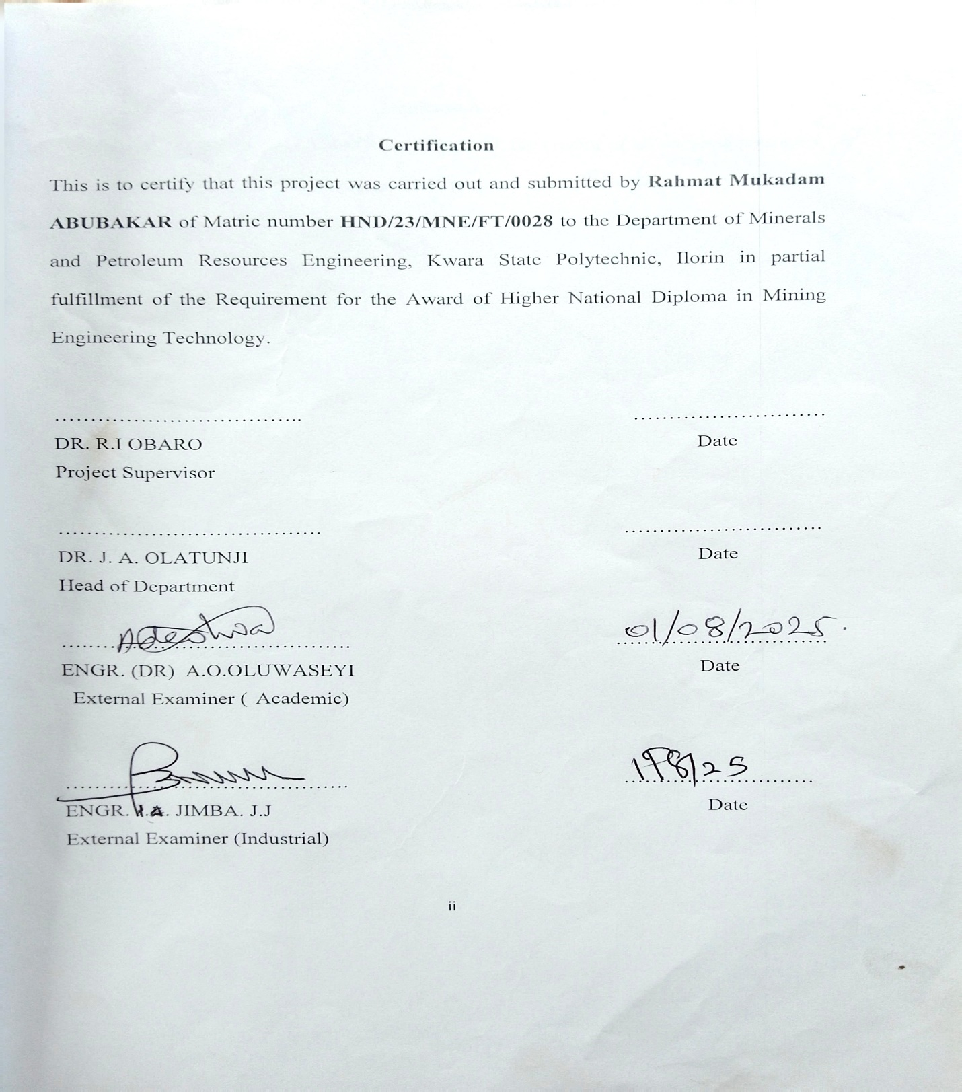
Dedication
I am delighted to dedicate this project to Almighty GOD, the creator of all universe who gave me the grace and opportunity to complete my HND program and this research, may His name be glorified.

Acknowledgements
I give all the glory and adoration to Almighty GOD, the beginning and the End, for his greatest protection and love given to me as a privilege to start and complete this research work.
I wholeheartedly extend my special thanks to my amiable supervisor Dr. Reuben Obaro for his professional guidance and support towards the success of this project.

ABSTRACT
Lateritic soils, predominant in tropical regions, are fundamental to Nigeria’s construction industry, particularly in road, foundation and embankment works. Despite their abundance and cost-effectiveness, their highly variable engineering properties have contributed to structural failures, pavement deterioration, and costly maintenance. This study evaluates the geotechnical properties of lateritic soils within Kwara State Polytechnic, Ilorin, to assess their suitability for civil engineering applications. Comprehensive laboratory analyses – including natural moisture content, specific gravity, grain size distribution, Atterberg limits, compaction, and California Bearing Ratio (CBR) – were conducted in accordance with British Standard procedures. The results reveal that the soils are predominantly sandy gravel with moderate plasticity, optimum moisture content of 15%, and maximum dry densities between 1.79-1.8 g/cm^{3,} indicating fair to good compaction characteristics. However, soaked CBR values classify the soils as poor to very poor for base applications, restricting their use to subgrade and sub-base layers in road construction. Despite these limitations, their compaction behavior and stability suggest potential suitability for dam embankments and low-load foundations when appropriately engineered. This research underscores the critical importance of rigorous geotechnical evaluation before construction. It provides actionable date to guide material selection, enhance infrastructure durability, and reduce failures caused by inappropriate soil use. Further studies incorporating advanced tests such as triaxial shear and permeability analyses are recommended to optimize lateritic soil applications in Nigeria’s rapidly growing infrastructure sector.

Table of Contents
Title page i
Certification ii
Dedication iii
Acknowledgement iv
Abstract v
Table of content vi
List of Figures ix
List of Tables x
CHAPTER ONE 1
1.0 Introduction 1
1.1 Background of the study 1
1.2 Aim of the study 3
1.3 Objectives of the study 3
1.4 Problem Statement 3
1.5 Justification of the study 3
1.6 Scope of the study 4
CHAPTER TWO 5
2.0 LITERATURE REVIEW 5
2.1 Review of Previous studies 5
2.2 Overview of Laterite 5
2.3 Formation and Occurrence of Laterite 6
2.4 Characteristics of Laterite 6
2.5 Economic Relevance of Laterite 6
CHAPTER THREE 7
3.0 MATERIALS AND METHOD 7
3.1 Description of the study area 7
3.2 Field Activities 9
3.3 Laboratory Analysis 9
3.3.1 Procedure of Natural Moisture Content Test 9
3.3.2 Grain Size Analysis Test 10
3.3.3 Atterberg Limits 11
3.3.4 Specific Gravity 13
3.3.5 Compaction Test 14
3.3.6 California Bearing Ratio Test 15
CHAPTER FOUR 16
RESULTS AND DISCUSSION 16
4.1 Results of Natural Water Determination 16
4.2 Discussion on Natural Water Determination 16
4.3 Results of Specific Gravity 17
4.4 Discussion on Specific Gravity Determination 17
4.5 Results of Grain Size Analysis 19
4.6 Discussion of Grain Size Analysis 20
4.7 Results of Atterberg Limit Determination 24
4.8 Discussion on Atterberg Limit Determination 27
4.9 Results of Compaction tests 30
4.10 Discussion on Compaction results 35
4.11 Results of California Bearing Ratio 37
4.12 Discussion of CBR Results 42
CHAPTER FIVE 44
5.0 Conclusion and Recommendation 44
5.1 Conclusion 44
5.2 Recommendation 44
References 45

List of Figures
Fig. 3.1: Location of the study area 8
Fig. 4.1: Grain Size Analysis for Sample A 21
Fig. 4.2: Grain Size Analysis for Sample B 22
Fig. 4.3: Plots of Sample A and B on Plasticity Chart 28
Fig. 4.4: Compaction Curves for Sample A 31
Fig. 4.5: Compaction Curves for Sample B 34
Fig. 4.7: Plots of California Bearing Ratio for Sample A 38
Fig. 4.8: Plots of California Bearing Ratio for Sample B 40

List of Tables
Table 4.1: Natural Water Content Determination for Sample A and B 16
Table 4.2. Specific Gravity Determination for Sample A and B 17
Table 4.3. Typical Values of Specific Gravity of Soil Samples 18
Table 4.4: Grain Size Analysis for Sample A and B 19
Table 4.5: Unified Soil Classification System (USCS) 23
Table 4.6: Liquid Limit Determination for Sample A 24
Table 4.6.1. Plastic Limit Determination for Sample A 25
Table 4.6.2: Liquid Limit Determination for Sample B 26
Table 4.6.3: Plastic Limit Determination for Sample B 27
Table 4.6.4: Relationship between Atterberg limit and Volume Change Potential 28
Table 4.6.5: Engineering Used Chart (After Wagner, 1957) 29
Table 4.7: Compaction Tests for Sample A (Standard Proctor) 30
Table 4.7.1: Compaction Tests for Sample A (Modified Proctor) 32
Table 4.7.2: Presentation of Compaction Results 35
Table 4.7.3: Compaction Characteristics and Rating of Unified Soil Classification Classes for Construction 36
Table 4.8.1: California Bearing Ratio tests for Sample A 37
Table 4.8.2: California Bearing Ratio tests for Sample B 39
Table 4.8.3: Summary of CBR Results for Standard Proctor 41
Table 4.8.4: Summary of CBR Results for Modified Proctor 41
Table 4.8.5: General Rating for Soil Based on CBR Values (AfterAsphalt Institute, 1962) 42
CHAPTER ONE
INTRODUCTION
1.1 Background of the study
Lateritic soils are among the most widespread residual soils in tropical regions, formed through prolonged weathering of crystalline and sedimentary rocks under hot, humid conditions. Rich in iron and aluminum oxides, these soils are reddish to brown and commonly used in civil engineering works across Nigeria. In Kwara State, laterites serve as road subase material, embankment fill, and foundation backfill because they are abundant and affordable. However, their engineering behavior is highly variable—dictated by mineral composition, degree of weathering, drainage regime, and topography. Inadequate characterization has led to pavement failures, unstable foundations, and costly maintenance. A detailed location and specific evaluation is therefore essential for safe and economical infrastructure development (Gidigasu, 1976; Ola, 1983). In the region of Nigeria Laterite are used for various constructions especially for small residential purposes. Laterite soils have wider application in the Nigeria construction industry, especially in road construction project where they are utilized as fill materials, mainly because they are easy to manipulate on the road surface and have natural stable grading and flexible pavement foundation, their usage as sub-base and base construction materials. One of the major causes of a road accidents is a bad road, which is usually caused by wrong application of constructional material especially laterite as base and sub-base material by construction companies (Oke et al., 2009).
Laterite is a soil and rock type rich in iron and aluminum, is commonly considered to have formed in hot and wet tropical area. Nearly all laterite are of rust-red coloration because of high iron oxide. The suitability of a material to be used as either a base course or sub-base course depends on its strength in transmitting the axle-load to the sub-soil and or sub-grade (the mechanical interlock). The degree of success in each depends on the genetic characteristic of the soil and the specific purpose for which they have been used. The performance of laterite soil as foundations for structure varies and appears to depend on the nature of the soil, the degree of the weathering, topography, the drainage condition and more importantly on the type of foundation and amount of loads imposed (Ojo et al., 2016).
In laterite deposits it may be possible to build ordinary structure on suitable design footing located a few below the ground surface. However, heavier structures may have to be based on firm layers, which are determined by sub-soil investigations. The actual design bearing values will depend on the degree of weathering of laterite soil and the geotechnical characteristic of the soil layers of a particular site. Laterite soils develop from many rock types under different climatic and chemical conditions. Hence, in many instances of laterization. The process of laterization involves the breaking down of silicate materials such as illite and kaolinite leading towards the formation of hydrous oxides of iron and aluminum. The dominants of iron oxides give laterites the characteristic reddish brown or dark brown colour with a unique set of physical, chemical and engineering properties. (Madu, 1976).
The mineralogical composition of the laterite soil has an influence on the geotechnical parameters such as specific gravity shear strength, atterberg limits, bearing capacity and petrographic properties (Amadi et al., 2012). A literature review has revealed that the geotechnical characteristics and engineering behavior of red soils depends mainly on the genesis and degree of weathering (i.e. decomposition, laterization, desiccation and hard erring). Morphological characteristics as well as the type and confend of secondary minerals are another genetic characteristic (Agbede 1992). Good understandings of the basement soil on which highways and other transportation. Facilities are constructed are very important. Saltar (1998) said the performance of a high-way pavement is influenced to a very considerable extent by the sub-grade material.
1.2 Aim of the Study
The aim of the study is to determine the geotechnical properties of laterite
1.3 Objective of the Study
i. To carryout geotechnical analysis of laterite soil
ii. To compare the result of geotechnical properties with the standard parameters
1.4 Problem Statement
Despite the economic advantages of using local materials, the inconsistent behaviour of lateritic soils has led to premature road deterioration and structural distress in Kwara State Polytechnic, Ilorin. Structural failure on roads, buildings and pavement has become rampant due to improper selection of filling and base materials. This study will help in determine the suitability of this laterite strength and durability for construction purpose and filling materials.
1.5 Justification of the study
The research work will be of benefit in selecting construction materials based on accessibility, reduction in cost and high quality of laterite aggregate. The study will also support the data base in construction industries.

1.6 Scope of the study
The scope of this study is limited to Natural Moisture Content, Specific Gravity, Grain Size Analysis, Consistency test, Compaction tests and California bearing ratio.

CHAPTER TWO
LITERATURE REVIEW
2.1 Review of Previous studies
Several authors has reported evaluation of lateritic soil in Nigeria. Layade and Ogunkoya (2018) reported geotechnical properties of laterite soil as sub-grade and base materials for road construction in Abeokuta-South-West Nigeria and concluded that the geotechnical properties of lateritic soil in Mohammedu Buhari Estate Abeokuta had been carried out in compliance with regulatory standard of Federal Ministry of work and Housing Nigeria (1992) for road construction. The result shows that the studied soil samples are classified as clay, silty clay easily compatible with good drainage, the soil samples tested from the study area indicate a general cohesion nature with low moisture content high granular materials which is suitable for road construction.
Osuyi and Akinwamide (2018) worked on engineering properties of lateritic soils in Ado-Ekiti, South Western Nigeria, and concluded the soils were classified as clay of low compressibility (cl), clay of high compressibility (CH) and sulty gravity sandy soils classification system (uses) and A-2-4, A-b and A -7, 5 which describe the soil as excellent to good fair to poor and clayed for (AASHTO).
2.2 Overview of Laterite
Laterite is the reddish brown coloured product of intense tropical weathering made up of mineral assemblages that may include Fe or Az oxides, oxydroxides or hydroxides, kaolinite and quartz. Its characterized by a ratio S₁O₂: R₂ O₂ (where R₂ O₃ = Al₂ O₃ + Fe2 O₃) and subject to hardening upon exposure to alternate. Abdel-Mohsen et al., (2018).

2.3 Formation and Occurrence of Laterite
The laterite soil is formed under conditions of high temperature and heavy rainfall with alternate wet and dry periods, which leads to leaching of soil leaving only oxides of iron and aluminum. It lacks fertility due to a lower base-exchanging capacity and a lower content of Nitrogen, Phosphorus and Potassium (Alka Dweredi et al., 2017).
2.4 Characteristics of Laterite
Laterite is both a soil and rock type rich in iron and aluminum and the developed by intensive and prolonged weathering of the underlying parent rock (www.studyrankeronline.com.ng).
- Laterite soil are leached soil and coarse and crumbly in texture.
- The proportion of lime and silica is reduced when leaching takes places
2.5 Economic Relevance of Laterite
Laterites are economically most important for ore deposit such as bauxite. In addition, strong, hardened varieties of laterite are sometimes cut into blocks and used as brickstones for building houses, hardened laterite varieties air also applied solid lateritic gravel is readily put in aquaria where it favours the growth of tropical plants (Bàrdossy et al., 1990).

CHAPTER THREE
MATERIALS AND METHOD
3.1 Description of the study area
The location of the study is in Kwara State Polytechnic, Ilorin. It is located within latitude N08⁰ 33¹.18.2¹¹ and longitude E004⁰ 45¹33. 011. Geologically, the area lies in the Precambrian Basement complex of north central Nigeria and is underlain by rock of metamorphic and igneous type (Fig. 3.1). However, migmatite predominantly underlies the rocks in the area while other principal rocks include granites and gneisses which are emplaced by Precambrian time and have overtime subjected to tectonic activities characterized by large changes on temperature and resulting in folding and fractures such as joints, faults and fractures within the basement complex rock. (Ibrahim et al., 2012). The mineralogical composition in these rocks include quartz, feldspar, mica (muscovite and biotite), hornblende (Fig. 3.1).
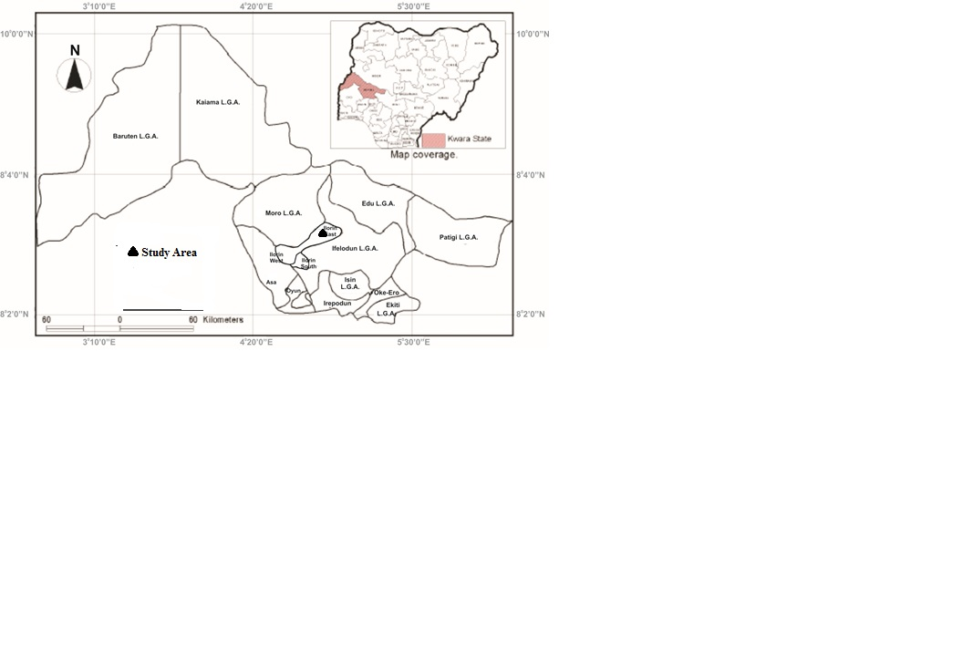
Fig. 3.1: Location of the study area

3.2 Field Activities
At the field some sample are taken, by using digger and shovel to dig the ground up to 4 feet. Lateritic soil in two different regions at the same area were taken. The Global Positioning System was used to take the coordinate of the different locations where the samples are taken. Other equipment used includes hammer, chisel, sampling bags, paper tape and marker. The two samples were separated in different sample bags and transported to University of Ilorin, Geology and Mineral Sciences Laboratory for detailed analysis.
3.3 Laboratory Analysis
Experimental laboratory analysis for natural moisture content, grain size analysis, specific gravity, atterberg limit, compaction and California bearing ratio was carried out at Civil Department, University of Ilorin, Nigeria.
3.3.1 Procedure of Natural Moisture Content Test
The water content was determined by weighing the soil samples then drying the samples in an oven at a temperature of 105⁰C – 110⁰C and reweighting. A drying period of 24 hours was allowed for the soil samples before the commencement of the experiment, after taking from the oven allow to cool down for five to ten minutes and determine the weight of dry soil and now reweight back and now calculate it to know the water presence in it.
Method of laboratory is British Standard BS EN ISO 17892-2.
Apparatus
- Weight balance
- Moisture content can with label
- Dry oven

3.3.2 Grain Size Analysis Test
The sieve analysis test involves the determination of the percentage by weight the soil particles within the various sieve sized. This aids the classification of the soil sample and also to predict soil water movement.
The soil sample was washed, oven dried and cooled in a desiccator before weighing. This was then passed through the sieve resemblage cleaned with wire both the sieve assemblage was placed on the sieve shaker which vibrated initially at a low speed and then at a higher speed in order to ensure that the assemblage was properly shaken. The respective weights of the sieves and the amount of soil sample retained on each sieve were recorded. The test was repeated for the remaining sample B soil. Method of laboratory is British Standard BS ISO 11277 2009. The equipment used includes; Wire brush, Sieves, Weigh balance, Cans and Mechanical Sieve shaker (ELE).

3.3.3 Atterberg Limits
The atterberg limits is an indirect measure of soil apparatus of the reconstituted soil. These deal with the consistency of the soil and their limits based on water content (Williams et al., 1980).
Liquid Limits Determination
The soil sample at different elevations was sieved with 0.4mm BS sieve out of which 300grammes was measured out. This was mixed with a small amount of water to form stiff paste on a glass plate using a spatula. Thereafter, the paste was placed in the cup with the surface smoothened. A grooving tool was utilized to produce a clean cut through the middle portion of the sample.
The crank of the apparatus was turned about 2 revolutions per second after ensuring that the falling height of the cup was about 10mm. The turning was continued until the groove was observed to have closed to almost 2.5mm at the bottom of the cut and the number of blows required to close the groove recorded. Immediately small portion of the sample at the point of closure of the groove in the cup was removed and the weight was observed. This was placed in a drying oven at 105⁰C for 24hours after which the sample was removed, cooled in a desiccators and the dried weight noted.
Additional small accounts of water were added to the soil sample to reduce the number of blows required to close the groove the recording the corresponding weights earlier described.
The weight of water in the sample and the weight of the dried sample were determined after which the water content corresponding to the recorded number of blows also evaluated. The water content was plotted against the corresponding numbers of blows. The water content corresponding to determine as the liquid limit of the sample. The procedure was repeated for soil sample B.
Plastic Limit Determination
Small portion of the remaining soil sample after the liquid test was rolled out between finger and thunk on a dry glass plate into a thin thread of about 5mm in diameter until it crumbled. The crumbled thread was weighed and he moisture content determined as in the liquid limit determination
The test was repeated three times for this sample and for sample B in the same way. The different between the liquid and plastic limits was calculated as the plasticity index of the sample.
Method of laboratory is British Standard BS 1377 part 24.3.
That is Plasticity index (PL) = Liquid Limit (LL) - Plastic Limit (PL) P1= LL - PL
Atterberg Limit equipment
- Spatula apparatus (ELE)
- Cutting groove (ELE)
- Washing bottle
- Glass plate
Casagrande apparatus (ELEThe BS standard use the result of the liquid limit to classify soil according to their clay content for example. If the Liquid Limit is less than 35% the soil is classify as low clay (CL). Between 35% to 50% is classify as Intermediate clay (CI)
Between 50% to 75% is classify as Light clay (CH). 75% and Above is classify as Extremely High clay content

3.3.4 Specific Gravity
Specific gravity is to know the ratio of the density of any substance to the density of any substance to the density of some other substance taken as standard water being the standard for liquids (Schetz et al., 1990).
It involves first stage to carry it out. Determine the weight of empty measuring cylinder; after weigh 50g of soil into the measuring cylinder and reweight it, it will give us weight of empty bottle to dry soil (g). Water is added to the soil in the measuring cylinder up to 100ml, before it gets to 100ml we leave space and shake it very well so that its mix up thoroughly. The purpose of shaking is to expel the bubble and void of the soil, without shaking well if can cause an error or is source of error, after then it been reweigh to determine the weight of empty bottle, soil and water added. After taking the reading, empty the bottle and clean it very well and fill it with water up to 100ml and reweight it to get the weight of empty bottle + water only and also fake the record. The procedure to repeated for the water soil sample and the method of laboratory is according to British Standard BS EN 1097-6. The equipment used includes Measuring cylinder, Weigh balance (Camry), and Washing bottle

3.3.5 Compaction Test
Compaction of a soil test is defined as a process by which the solid particles are packed more close by together usually by a mechanical means such as rolling, ramming or vibration. This lead to an increase in the dry density of the soil mass as a result of expulsion of air voids. A known weight of soil sample passing the 20mm BS sieve was thoroughly mixed with equivalent percent of water. A rammer of 2.5kg was employed to provide evenly distributed blows falling freely through a 300mm height on the soil sample at the same time slightly rotating the rammer in order to ensure uniform distribution of blows. The process was repeated with the second and third layers by adding equal quantities of soil sample and the surface finally reveled. This was weighed after which soil samples were removed from both top and bottom of the mould for water content determination as earlier described. Different amount of water were added to the soil samples one after the other before repeating the procedure already describe.
The procedure was later repeated for the other soil sample. The wet and dry density of the soil samples were calculated: Wet density,
Pw = $\frac{Wt of mould+soil-wt of mould}{volume of mould}$
$$Dry density, P_{D}=\frac{Wet Density}{100 x Average moisture content} x 100$$
A relationship of dry density and water content of each of the soil samples was potted from which the maximum dry density at optimum moisture content was determined for each of the soil samples.
The samples taken for top and bottom of the mould will then be dry for 24hours after dry we now reweight it back again and calculated. Method of laboratory is British Standard BS1377.
3.3.6 California Bearing Ratio Test
Mix California bearing ratio test (CBR) method is essentially a measure of the resistance by a compacted soil sample to the penetration of a standard plunger. The optimum moisture content already evaluated for compaction test was used to bring the sample to the design moisture content. The calculated amount was added to the sample and mixed thoroughly before the sample was compacted into the CBR mould in three layers using 25 blows of the rammer per each layer. The mould with the compacted soil in it was weighed after which a surcharge of 2kg was placed on it before the upper gauge is the load gauge while the lower gauge is the penetration gauge started reading and we start recording. The methods was carried out according to British Standard (1990). The equipment includes CBR Mould 6kg, CBR Rammer weight 4.5kg and CBR Machine Height 0.45m.
The reverse side of the mould was placed face up and the sample procedure which means the top and bottom. The CBR test was repeated for the other soil sample and after calculation and graph was plotted.

CHAPTER FOUR
RESULTS AND DISCUSSION
4.1 Results of Natural Water Determination
The results of natural water determination are shown in table 4.1 below.
Table 4.1: Natural Water Content Determination for Sample A and B
SAMPLE A SAMPLE B
Boring no. | T | J
Container no (Cup)
Wt of cup + Wet soil (g) | 134.5 | 135.0 |  | 162.5 | 118.0
Wt of cup + dry soil (g) | 128.0 | 129.5 |  | 154.5 | 112.5
Wt of cup (g) | 25.5 | 25.0 |  | 34.5 | 24.5
Wt of dry soil. (g) | 102.5 | 104.5 |  | 120.0 | 88.0
Wt of water (g) | 6.5 | 5.5 |  | 8.0 | 5.5
Water content % | 6.3 | 5.3 |  | 6.7 | 6.3
Average water content (%) = 5.8% 6.5%
4.2 Discussion on Natural Water Determination
The natural water determination for sample A and Sample B is 5.8% and 6.5% respectively. It is to determine the amount of water present in a quantity of soil in terms of its dry weight. The natural water determination of various soils varies generally ranging from about 10 to15% for sand, 15 to 30% for silt and 30 to 50% for clay. The low value of natural water determination content for Sample A and B indicates that the water table fluctuates during the dry season (Sidi et al., 2015).
4.3 Results of Specific Gravity
The results of Specific Gravity is shown in Fig. 4.2 below
Table 4.2. Specific Gravity Determination for Sample A and B
SAMPLE A SAMPLE B
SAMPLE LABEL
WT OF EMPTY BOTTLE (g) (W1) | 103.0 | 103.0
WT OF EMPTY BOTTLE+1/3 OF SOIL (g) (W2) | 153.0 | 153.0
WT OF EMPTY BOTTLE+1/3 OF SOIL+WATER (g) (W3) | 229.5 | 230.0
WT OF EMPTY BOTTLE+WATER ONLY (g) (W4) | 198.0 | 198.0
SPECIFIC GRAVITY = $\frac{W_{2}W{}_{1}}{\left(W4-W1\right)\left(W3-W2\right)}$ | 2.70 | 2.78

4.4 Discussion on Specific Gravity Determination
The specific gravity of the soil depends on the amount of sand and also depends on their mineral constituents and mode of formation of the soil. The results of the specific gravity analysis on soil samples of Sample A and Sample B are 2.70 and 2.78 respectively. Comparing these specific gravity values to some common soil types from (Lambe, 1969). (Table 4.3) shows the specific gravity of each soil type. It can be deduced from Table 4.3 that the specific gravity of soil sample A and B can be described as inorganic soil.

Table 4.3. Typical Values of Specific Gravity of Soil Samples (Lambe and Whiteman, 1969)
SOIL TYPES | SPECIFIC GRAVITY
Sand | 2.65 – 2.67
Silty sand | 2.67 – 2.70
Inorganic soil | 2.70 – 2.80
Soil with mica or iron | 2.75 – 3.00
Organic | Variable but may be under 2.0

4.5 Results of Grain Size Analysis
The results of grain size analysis are shown in table 4.4 below.
Table 4.4: Grain Size Analysis for Sample A and B
Sieve analysis and Grain Size A Sieve analysis and Grain Size B
Sieve No | Diam. (mm) | Wt. retained | % retained | % passive | Diam. (mm) | Wt. retained | % retained | % passive
 | 19.00 |  |  |  | 19.00 | 0.0 | 0.0 | 100.0
 | 16.00 | 0.0 | 0.0 | 100.0 | 16.00 | 12.5 | 2.5 | 97.5
 | 8.00 | 68.5 | 13.7 | 86.3 | 8.00 | 67.0 | 13.4 | 84.1
 | 4.75 | 141.0 | 28.2 | 58.1 | 4.75 | 111.0 | 22.2 | 61.9
 | 2.36 | 134.0 | 26.8 | 31.3 | 2.36 | 149.5 | 29.9 | 32.0
 | 1.00 | 88.0 | 17.6 | 13.7 | 1.00 | 124.0 | 24.8 | 7.2
 | 0.50 | 37.0 | 7.4 | 6.3 | 0.50 | 29.0 | 5.8 | 1.4
 | 0.425 | ------- | --------- | -------- | 0.425 | --------- | --------- | ---------
 | 0.30 | 12.0 | 2.4 | 3.5 | 0.30 | 3.0 | 0.6 | 0.8
 | 0.25 | 5.0 | 1.0 | 2.9 | 0.25 | 0.2 | 0.04 | 0.76
 | 0.150 | 6.5 | 1.3 | 1.6 | 0.150 | 0.2 | 0.04 | 0.72
 | 0.090 | ------- | ------- | ------- | 0.090 | ------- | ------- | -------
 | 0.75 | 5.5 | 1.1 | 0.5 | 0.075 | 1.0 | 0.2 | 0.52
 | PAN | 2.0 | 0.4 |  | PAN | 1.0 | 0.2

4.6 Discussion of Grain Size Analysis
The graphical representation of the results of the grain size analysis (Fig. 4.1) of Sample A indicates that the Gravel is of high dominance with percentage of 72%, followed by Sand with percentage of 28% while Sample B (Fig. 4.2) contains 73% gravel and the sand is 27%, this as such is classified as sandy gravels in accordance to the USCS classification (Table 4.5).
In accordance to the USCS classification. On the Unified Soil Classification Chart (Table 4.5), sample A and Sample B have the group symbol SW and are classified as pervious, and it has an excellent shear strength when compacted and saturated, negligible compressibility when compacted and saturated and has excellent workability as construction material which can resist erosion.

100
90
80
70
60
50
40
30
20
10
0
SILT
0.002
0.003
0.004
0.006
0.008
0.010
0.015
0.020
0.030
0.040
0.050
0.060
0.095
0.105
0.125
0.150
0.212
0.250
0.300
0.425
0.500
0.500
1.00
1.18
1.20
2.0
2.36
4.0
6.25
8.0
9.30
12.50
16.75
13.75
25.0
31.5
37.5
37.5
38.0
39.5
40.0
42.5
45.5
50.0
100
90
80
70
60
50
40
30
20
10
0
Tine
Medium
Coarse
Fine
Medium
Coarse
Sand
Grave
PERCENTAGE FINER THAN 0

Fig. 4.1: Grain Size Analysis for Sample A

100
90
80
70
60
50
40
30
20
10
0
SILT
0.002
0.003
0.004
0.006
0.008
0.010
0.015
0.020
0.030
0.040
0.050
0.060
0.095
0.105
0.125
0.150
0.212
0.250
0.300
0.425
0.500
0.500
1.00
1.18
1.20
2.0
2.36
4.0
6.25
8.0
9.30
12.50
16.75
13.75
25.0
31.5
37.5
37.5
38.0
39.5
40.0
42.5
45.5
50.0
100
90
80
70
60
50
40
30
20
10
0
Tine
Medium
Coarse
Fine
Medium
Coarse
Sand
Grave
PERCENTAGE FINER THAN 0

Fig. 4.2: Grain Size Analysis for Sample B

Major divisions | Subdivisions | USCS Symbol | Typical names | Laboratory classification criteria
Coarse gained soils (more than 50% retained on no. 200 sieve) | Gravels (more than 50% of coarse fraction retained on no. 4 sieve | GW | Well graded gravels or gravel-sand mixture, little or no fines | Less than 5% fines
 |  | GP | Poorly graded gravels or gravel-sand mixture, little or no fines | Less than 5% fines
 |  | GM | Silty gravels, gravel-sand-silt mixtures | More than 12% fines
 |  | GC | Clayey gravels, gravel-sand-clay mixtures | More than 12% fines
 | Sands (50% or more coarse fraction passing no. 4 sieve | SW | Well graded sands or gravel-sand, little or no fines | Less than 5% fines
 | Sands (50% or more coarse fraction passing no. 4 sieve | SP | Poorly graded sands or gravel-sand mixture, little or no fines | Less than 5% fines
 | Sands (50% or more coarse fraction passing no. 4 sieve | SM | Silty sand, sand-silt mixture | More than 12% fines
 | Sands (50% or more coarse fraction passing no. 4 sieve | SC | Clayey sand, sand-clay mixture | More than 12% fines
Fine grained soils (50% or more passes the no. 200 sieve) | Silts and Clays  (liquid limit less than 50%) | ML | Inorganic silts, rock flour, silts of low plasticity | Inorganic soils
Fine grained soils (50% or more passes the no. 200 sieve) | Silts and Clays  (liquid limit less than 50%) | CL | Inorganic clays of low plasticity, gravelly clays, sandy clays, etc | Inorganic soils
Fine grained soils (50% or more passes the no. 200 sieve) | Silts and Clays  (liquid limit less than 50%) | OL | Organic silts and organic clays of low plasticity | Organic soils
Fine grained soils (50% or more passes the no. 200 sieve) | Silts and Clays (liquid limit 50% or more) | MH | Inorganic silts, micaceous silts, silts of high plasticity | Inorganic soils
Fine grained soils (50% or more passes the no. 200 sieve) | Silts and Clays (liquid limit 50% or more) | CH | Inorganic highly plastic clays, fat clays, silty clays, etc | Inorganic soils
Fine grained soils (50% or more passes the no. 200 sieve) | Silts and Clays (liquid limit 50% or more) | OH | Organic silts and organic clays of high plasticity | Organic soils
Peat | Highly organic | PT | Peat and other highly organic soils | Primarily organic matter, dark in colour and organic odour
TABLE 4.5: Unified Soil Classification System (USCS)

4.7 Results of Atterberg Limit Determination
The results of Atterberg Limit Determination are shown below.
Table 4.6: Liquid Limit Determination for Sample A
Can no. | 26 | 12 | K5 | AA
Container no (Cup)
Wt of Wet soil + can (g) | 36.5 | 35.5 | 35.5 | 32.5
Wt of dry soil + can (g) | 34 | 32.5 | 33 | 30
Wt can (g) | 24.5 | 24 | 25.5 | 24
Wt moisture (g) | 9.5 | 8.5 | 7.5 | 6
Water content, w% | 26.3 | 37.5 | 33.3 | 41.7
No of blows N | 45 | 34 | 22 | 16
50
40
30
20
10
0
10
15
20
25
30
35
40
50
60
70
80
WATER CONTENT W%
NO. OF BLOWS N

Flow index F1 =
Liquid limit = 37.0%
Plastic limit = 16.1%
Plasticity Index Ip = 20.9%
IP = LL - PL= 37 - 16.1 = 20.9
Table 4.6.1. Plastic Limit Determination for Sample A
Can no. | 25 | E1
Wt. of Wet soil + can (g) | 31 | 30
Wt. of dry soil + can (g) | 30 | 29
Wt. of can (g) | 23.5 | 23
Wt. of dry soil | 6.5 | 6
Wt. of moisture (g) | 1 | 1
Water content. w% = w | 15.4 | 16.7
$$\frac{15.4+16.7}{2}$$

Table 4.6.2: Liquid Limit Determination for Sample B
Can no. | T1 | A1 | H3 | G2
Wt. of Wet soil + can (g) | 34 | 32.5 | 32.5 | 31.5
Wt. of dry soil + can (g) | 31.5 | 29.5 | 30 | 29
Wt. can (g) | 25 | 22.5 | 25.5 | 24
Wt. of dry soil | 6.5 | 7 | 4.5 | 5
Wt. moisture (g) | 2.5 | 3 | 2.5 | 2.5
Water content, w% | 38.5 | 42.9 | 55.6 | 50.0
No of blows N | 40 | 22 | 20 | 10
50
40
30
20
10
0
10
15
20
25
30
35
40
50
60
70
80
WATER CONTENT wt%
NO. OF BLOWS
60

Flow index F1 =
Liquid limit = 43.0%
Plastic limit = 21.1%
Plasticity index Ip = 21.9%
IP = LL - PL
= 43.0% - 21.1% = 21.9%
Table 4.6.3: Plastic Limit Determination for Sample B
Can no. | D4 | 24
Wt. of Wet soil + can (g) | 24 | 24.5
Wt. of dry soil + can (g) | 23 | 23.5
Wt. of can (g) | 18.5 | 18.5
Wt. of dry soil | 4.5 | 5
Wt. of moisture (g) | 1 | 1
Water content. w% = w | 22.2 | 20.0

4.8 Discussion on Atterberg Limit Determination
The results of Atterberg consistency limits carried out on the soil sample, Sample A gave the following values: liquid limit of 37.0%, plastic limit of 16.1%, plasticity index of 20.9%, while Sample B has the following values for each of the parameter: liquid limit of 43.0%, plastic limit of 21.1% and plasticity Index of 21.9%. According to Holtz and Cubbs, Volume change potential, 1936) as having a moderate volume change (Table 4.6.4). Drawing inferences from these values, the soil samples suggests that they have moderate potential to swell or shrink (Madedor, 1983). The plot of the result on the plasticity chart for both samples A and B falls within the CL zone (Fig. 4.3). According to engineering use chart (Table 4.6.5) they are impervious, inorganic clays which can be used as a dam construction.
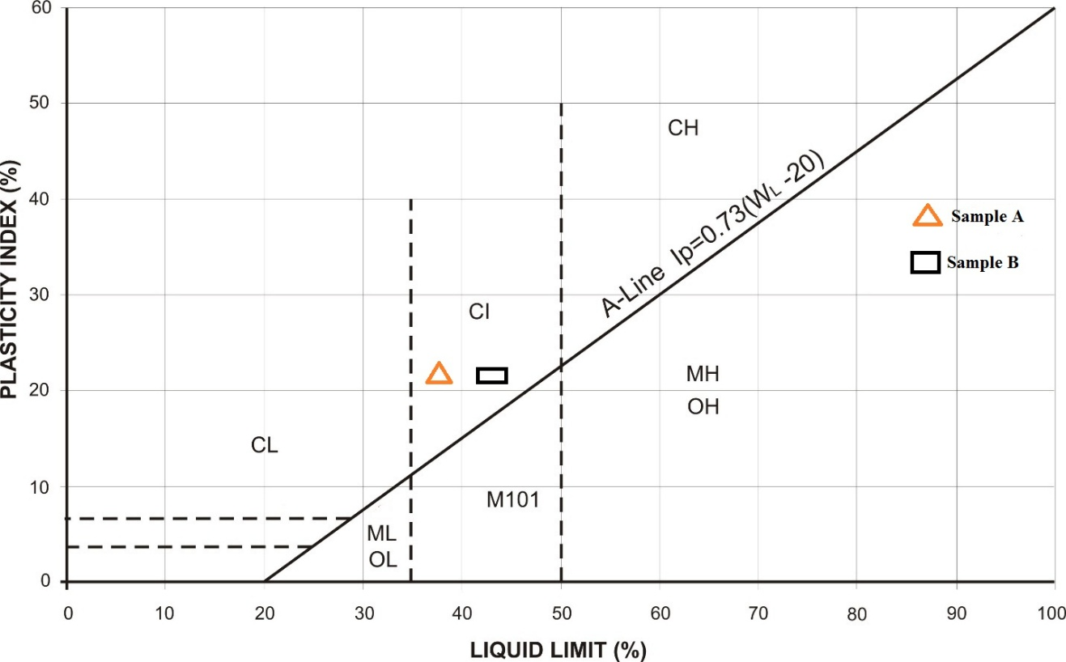
Fig. 4.3: Plots of Sample A and B on Plasticity Chart
Table 4.6.4: Relationship between Atterberg limit and Volume Change Potential (After Holtz and Cubbs, 1936)
Volume Change  Potential | Plasticity Index Ip |  | Shrinkage
Volume Change  Potential | Arid Area | Humid Area
Little | 0 – 15 | 0 – 30 | < 12
Moderate | 15 – 30 | 30 – 50 | 10 – 12
High | >30 | >50 | >10

Typical names of Soil groups | Group Symbols | Important Properties
Typical names of Soil groups | Group Symbols | Permeability when compacted | Shearing strength with compacted and saturated | Compressibility when compacted and saturated | Workability as a construction material
Well graded gravels or gravel-sand mixture, little or no fines | GW | Pervious | Excellent | Negligible | Excellent
Poorly graded gravels or gravel-sand mixture, little or no fines | GP | Very pervious | Good | Negligible | Good
Silty gravels, gravel-sand-silt mixtures | GM | Semi-pervious to impervious | Good | Negligible | Good
Clayey gravels, gravel-sand-clay mixtures | GC | Impervious | Good to fair | Very low | Good
Well graded sands or gravel-sand, little or no fines | SW | Pervious | Excellent | Negligible | Excellent
Poorly graded sands or gravel-sand mixture, little or no fines | SP | Pervious | Good | Very low | Fair
Silty sand, sand-silt mixture | SM | Semi-pervious to impervious | Good | Low | Fair
Clayey sand, sand-clay mixture | SC | Impervious | Good to fair | Low | Good
Inorganic silts, rock flour, silts of low plasticity | ML | Semi-pervious to impervious | Fair | Medium | Fair
Inorganic clays of low plasticity, gravelly clays, sandy clays, etc | CL | Impervious | Fair | Medium | Good to fair
Organic silts and organic clays of low plasticity | OL | Semi-pervious to impervious | Poor | Medium | Fair
Inorganic silts, micaceous silts, silts of high plasticity | MH | Semi-pervious to impervious | Fair to poor | High | Poor
Inorganic highly plastic clays, fat clays, silty clays, etc | CH | Impervious | Poor | High | Poor
Organic silts and organic clays of high plasticity | OH | Impervious | Poor | High | Poor

Table 4.6.5: Engineering Used Chart (After Wagner, 1957)

4.9 Results of Compaction tests
The results of Compaction tests are shown below for Sample A and B
Table 4.7: Compaction Tests for Sample A (Standard Proctor)
Sample no | 1 |  | 2 |  | 3 |  | 4
Moisture can no | 7 | P8 | TB | 33 | P14 | Y2 | E8 | 4
Wt. of can + wet soil | 73 | 1/7 | 72.5 | 78 | 178 | 173.5 | 169.5 | 179.5
Wt. of can + dry soil (g) | 68.5 | 11.2 | 67.5 | 72.5 | 162 | 158 | 148.5 | 158
Wt. of can (g) | 4.5 | 5 | 5 | 5.5 | 16 | 15.5 | 21 | 21.5
Wt. of can (g) | 20 | 51.5 | 23.5 | 24.5 | 58.5 | 57 | 25 | 34
Wt. of dry soil (g) | 48.5 | 54.5 | 44 | 48 | 103.5 | 101 | 123.5 | 124
Water content w% | 9.3 | 9.2 | 11.4 | 11.5 | 15.5 | 15.3 | 17.0 | 17.3
DENSITY DETERMINATION
Assumed water content  (g) |  | 9.5 | 11.5 |  |  | 15.5 | 17.0
Average water content% |  | 9.3 | 11.5 |  |  | 15.4 | 17.2
Wt. of soil + mould (g) |  | 4693 | 4912 |  |  | 5044 | 4961
Wt. of mould (g) |  | 2976 | 2976 |  |  | 2976 | 2976
Wt. of soil in mould (g) |  | 1717 | 1936 |  |  | 2068 | 1985
Wet Density, DW (g/cm³) |  | 1.717 | 1.936 |  |  | 2.068 | 1.985
Dry density (g/cm³) |  | 1.571 | 1.736 |  |  | 1.792 | 1.694

Fig. 4.4: Compaction Curves for Sample A

Table 4.7.1: Compaction Tests for Sample A (Modified Proctor)
WATER CONTENT DETERMINATION
Sample no | 1 |  | 2 |  | 3 |  | 4
Moisture can no | Bo | J | 3 | LA | 1 | 5 | 2 | 4
Wt of can + wet soil | 99.5 | 94.5 | 120.5 | 122 | 174.5 | 206.5 | 254.5 | 246.5
Wt. of can + dry soil (g) | 95 | 89.5 | 110 | 110.5 | 155.5 | 184.5 | 218.5 | 210
Wt of can (g) | 4.5 | 5 | 10.5 | 11.5 | 19 | 22 | 36 | 36.5
Wt of can (g) | 32.5 | 25 | 19 | 15 | 18.5 | 18 | 19 | 19.5
Wt of dry soil (g) | 62.5 | 64.5 | 91 | 95.5 | 137 | 166.5 | 199.5 | 190.5
Water of content w% | 7.2 | 7.8 | 11.5 | 12.0 | 13.9 | 13.2 | 18.0 | 19.2

DENSITY DETERMINATION
Assumed water content  (g) | 7.5 | 11.8 | 13.5 | 18.5
Average water content% | 7.5 | 11.8 | 13.6 | 18.6
Wt. of soil + mould (g) | 4658 | 4904 | 5038 | 4952
Wt. of mould (g) | 2976 | 2976 | 2976 | 2976
Wt. of soil in mould (g) | 1682 | 1928 | 2062 | 1976
Wet density, DW(g/cm³) | 1.682 | 1.928 | 2.062 | 1.976
Dry density (g/cm³) | 1.565 | 1.725 | 1.815 | 1.666

Fig. 4.5: Compaction Curves for Sample B

Table 4.7.2: Presentation of Compaction Results
SAMPLE NO | STANDARD PROCTOR |  | MODIFIED PROCTOR
 | Optimum Moisture Content (OMC) % | Maximum Dry Density (MDD) g/cm³ | Optimum Moisture Content OMC (%) | Maximum Dry Density (MDD) g/cm³
Sample A | 15.0 | 1.80 | 15.0 | 1.83
Sample B | 15.0 | 1.83 | 15.0 | 1.79

4.10 Discussion on Compaction results
The relationship between the dry density and the optimum moisture content of the soil samples are shown in Fig 4.2. The compaction curves show that dry density increases with further increase water content. From compaction tests carried out, at the energy of standard proctor, sample A has 15.0% and 1.80 g/cm³ as optimum moisture content and maximum dry density respectively, while at the energy of modified proctor, it has 15.0 % and 1.83 g/cm³ as optimum moisture content and maximum dry density respectively. Sample B has 15.0% and 1.83 g/cm³ as optimum moisture content and maximum dry density respectively, while at the energy of modified proctor, it has 15.0 % and 1.79 g/cm³ as optimum moisture content and maximum dry density respectively.
The compaction characteristics and ratings of the Unified soil classification classes for soil construction (ASTM, 1557-91) (Table 4.7.2), from the values obtained, it can be concluded that soil samples A and B have a fair to good performance as an embankment material and can be used as a subgrade material with a good to fair performance as base course material.
Table 4.7.3: Compaction Characteristics and Rating of Unified Soil Classification Classes for Construction (ASTM, 1557-91)
Visual Description | Maximum Dry-Weight Range (g/cm³) | Optimum Moisture Range (%) | Anticipated Embankment Performance | Value as Subgrade Material | Value as base course
Granular material | 2.00-2.27 | 7-15 | Good to excellent | Excellent | Good
Granular material with soil | 1.76-2.16 | 9-18 | Fair to Excellent | Good | Fair to Poor
Fine sand and sand | 1.76-1.84 | 9-15 | Fair to Good | Good to fair | Poor
Sandy silts and silts | 1.52-2.08 | 10-20 | Poor to Good | Fair to Poor | Not suitable
Elastic silts and Clays | 1.36-1.60 | 20-35 | Unsatisfactory | Poor | Not suitable
Silty-Clays | 1.52-1.92 | 10-30 | Poor to Good | Fair to Poor | Not suitable

4.11 Results of California Bearing Ratio
The results of California Bearing Ratio tests are shown below for Sample A and B
Table 4.8.1: California Bearing Ratio tests for Sample A

Penetration of Plunger (mm) | TOP Piston Load on Plunger (KN) |  | BOTTOM Piston Load on Plunger (KN)
0.00 | 2.9 | 0 | 0 | 0
0.50 | 26 | 76 | 33 | 96
1.00 | 51 | 149 | 60 | 175
1.50 | 67 | 196 | 75 | 219
2.00 | 81 | 237 | 92 | 269
2.50 | 90 | 263 | 106 | 310
3.00 | 96 | 281 | 114 | 334
4.00 | 103 | 301 | 121 | 354
5.00 | 108 | 316 | 126 | 359
6.00 | 11.6 | 339 | 130 | 380
7.00 | 120 | 351 | 134 | 392

400
300
200
100
0
LOAD ON PLUNGER (KN)
0
1.0
2.0
3.0
4.0
5.0
6.0
PENETRATION (MM)
7.0
8.0

Fig. 4.7: Plots of California Bearing Ratio for Sample A

Table 4.8.2: California Bearing Ratio tests for Sample B
Penetration of Plunger (mm) | TOP Piston Load on Plunger (KN) |  | BOTTOM Piston Load on Plunger (KN)
0.00 | 0 | 0 | 0 | 0
0.50 | 19 | 55 | 27 | 79
1.00 | 37 | 108 | 48 | 140
1.50 | 53 | 155 | 69 | 202
2.00 | 70 | 205 | 87 | 254
2.50 | 83 | 243 | 99 | 290
3.00 | 89 | 260 | 105 | 307
4.00 | 94 | 275 | 112 | 328
5.00 | 99 | 290 | 116 | 339
6.00 | 102 | 298 | 121 | 354
7.00 | 107 | 313 | 125 | 366

400
300
200
100
0
LOAD ON PLUNGER (KN)
0
1.0
2.0
3.0
4.0
5.0
6.0
PENETRATION (MM)
7.0
8.0

Fig. 4.8: Plots of California Bearing Ratio for Sample B

Table 4.8.3: Summary of CBR Results for Standard Proctor
SAMPLE NUMBER | CBR VALUES | PENETRATION AVERAGE VALUE (%)
 |  | 2.5mm | 5.0mm
Sample A | SOAKED | 2 | 2
Sample A | UNSOAKED | 4 | 3
Sample B | SOAKED | 2 | 1
Sample B | UNSOAKED | 3 | 2

Table 4.8.4: Summary of CBR Results for Modified Proctor
SAMPLE NUMBER | CBR VALUES | PENETRATION AVERAGE VALUE (%)
 |  | 2.5mm | 5.0mm
Sample A | SOAKED | 2 | 2
Sample A | UNSOAKED | 5 | 4
Sample B | SOAKED | 2 | 2
Sample B | UNSOAKED | 4 | 3

Table 4.8.5: General Rating for Soil Based on CBR Values (After The Asphalt Institute,
1962)
CBR NO | GENERAL RATING | USES | CLASSIFICATION UNIFIED | SYSTEM AASTHO
0-3 | Very poor | Sub-grade | OH, CH, MH, OL | A5, A6, A7
3-7 | Poor-fair | Sub-base | OH, CH, MH, OL | A4, A5, A6, A7
7-20 | Fair | Base | OL ,CL, ML, SC, SM, SP | A2, A4, A6, A7
20-50 | Good | Asphalt material | GM, GL, SIN, SM, SP, GP, W,GM | Aib, A2-5, A3, Al,A2-4 ,A3

4.12 Discussion of CBR Results
The CBR values for Sample A unsoaked sample for Standard Proctor and Modified Proctor were 4% and 5% respectively. For Sample A SOAKED for standard Proctor and modified Proctor were 2% and 2% respectively. For UNSOAKED sample B for Standard Proctor and Modified Proctor were 3% and 4% respectively, while for SOAKED Sample B Standard Proctor and modified Proctor were 2% and 2% respectively. Table 4.8.3 shows the general rating of soil material based on the CBR values of the material. Soil meet requirement better when they are classified based on the CBR value of soaked materials. Sample A CBR indicate a very poor general rating based on it CBR values which means that it can only be used as subgrade material in road construction. Sample B also have a general poor rating based on its soaked CBR values means it is only good for subgrade material in road construction. The UNSOAKED modified CBR test result shows that Sample A can be used as a sub base material in road construction and Sample B can be used as both subgrade and sub base material in road construction based on the UNSOAKED modified CBR value of both sample which were 5% and 4% respectively.

CHAPTER FIVE
CONCLUSION AND RECOMMENDATIONS
5.1 CONCLUSION
The geotechnical properties of laterite soil in Kwara State Polytechnic, Ilorin has been carried out in compliance with the regulatory standard. Grain size distribution for Sample A and Sample B obtained shows that they are poorly graded and on the basis both soil samples will be suitable for use as a road sub-base materials. The Atterberg consistency limits, shows that the both samples meet the requirement to be used as a sub-base material. The compaction properties possessed by Sample A and Sample B makes them good engineering construction materials based on the MDD and OMC values obtained at both energies Standard Proctor and Modified Proctor. According to The Asphalt Institute (1962), both Sample A and Sample B have CBR which are considered to be very poor to poor and can only be used as sub-grade and sub-base material and also both samples possess fairly high initial and long term stability when used in dam or embankment construction. In conclusion from the tests carried out, it can be deduce that Sample A and Sample B can be used as construction material such as road, dam, foundation and embankment.
5.2 RECOMMENDATION
i. Geotechnical properties of laterite soil should be analyzed and recommended as a suitable material for civil engineering purpose particularly for construction of infrastructural facility.
ii. Further investigation and analysis such as Triaxial test and permeability should be carried out on laterite soil before construction begins.
References
Abdel-Mohsen Onsy Mohamed, Eran K. Paleologos, (2018). In fundamentals of Geo environment Engineering. 122-169.
Agbede, O.A (1992). Characteristics of Trophical Red Soils as Foundation materials, Niger can Journal of Science, 26, 237-242
Alka Dweredi, Arvind M. Kayastha, (2017). In New Pesticides and Soil Sensors.
Amadi, A.N, Eze, C.J., Igwe, C.O, Okunlola, L.A and Okoye N.O, (2012). Architect’s and Geologist’s view on the causes of building families in Nigeria modern applied science 6 (6) 31-38
Bàrdossy, Gyogy, and Gerardus, Jacobus Johannes Aleva (1990). In Economic Relevance of Laterite. 320-344.
Gidigasu, M.D. (1976). Laterite Soil Engineering: Pedogenesis and Engineering Principles. Elsevier.
Holtz and Cubbs, (1936) Relationship between Atterberg Limits and Volume Change Potential. Journal of Mountain Science. 12, 6, 1471–1483
Lambe, T. W and Whiteman, R.V. (1969). Soil mechanisms. John Wiley and sons Inc., New York. 165
Madu, R.M (1976). An Investigation into the geotechnical and engineering properties of some laterites of Eastern Nigeria. Engineering Geology ii.101-125 https://doi.org/10.1016/0013-7952 (77)90022-9
Madedor, A. C. (1983): Pavement Design Guidelines and Practice for Different Geological Areas in Nigeria. In: Ola, S. A. (ed) Tropical Soils of Nigeria in Engineering Practices. AA Balkema, Rotterdam, 291 – 297
Ojo, G.P. Igbokwe, u.g, Nwozok, K.K and Egbuachor, C.J. 2016. Geotechnical properties of the latarite Overburden materials on the Charnockite and Gnesis complexes in Ipele- Owo Area, Southwestern Nigerian. America journal of Engineering Research (AJER) 5. 9, 53-59
Oke, S.A, Okeke, O.E, Amadi, A.N& Onoduku, U.S. (2009). “Geotechnical properties of the subsoil for Designing Shallow Foundation in some selected parts of ChanChaga area, Minna, Nigeria,” Journal of Environmental Science,1 (1), 45-54
Ola, S.A. (1983). Geotechnical Properties and Behaviour of Some Nigerian Lateritic Soils. Engineering Geology, 18(14), 165 - 177.
Salter, R.J. (1988). Highway Design and Construction, Macmillian Education Limited, London, 341.
Sidi, M. W., Thaffa, A .B. and Garga, A.B. (2015). Geotechnical Investigation of Soil around Arawa-Kundulum Area of Gombe Town, North-Eastern Nigeria, IOSR Journal of Applied Geology and Geophysics, 07-15
Wagner, A. A. (1957). The use of unified Soil Classification System by the Bureau of Reclamation. Proceedings. 4th International conference on soil mechanics and foundation engineering (London), I, 125.

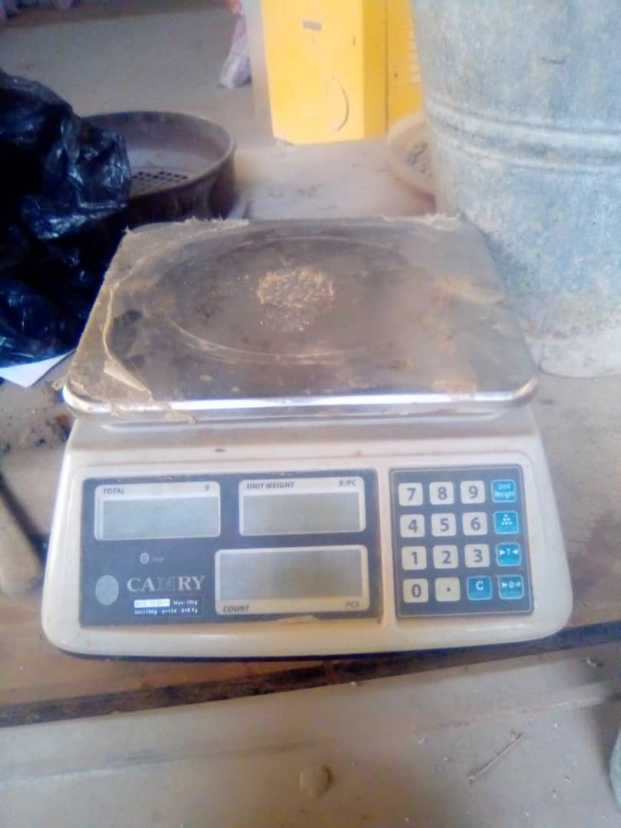
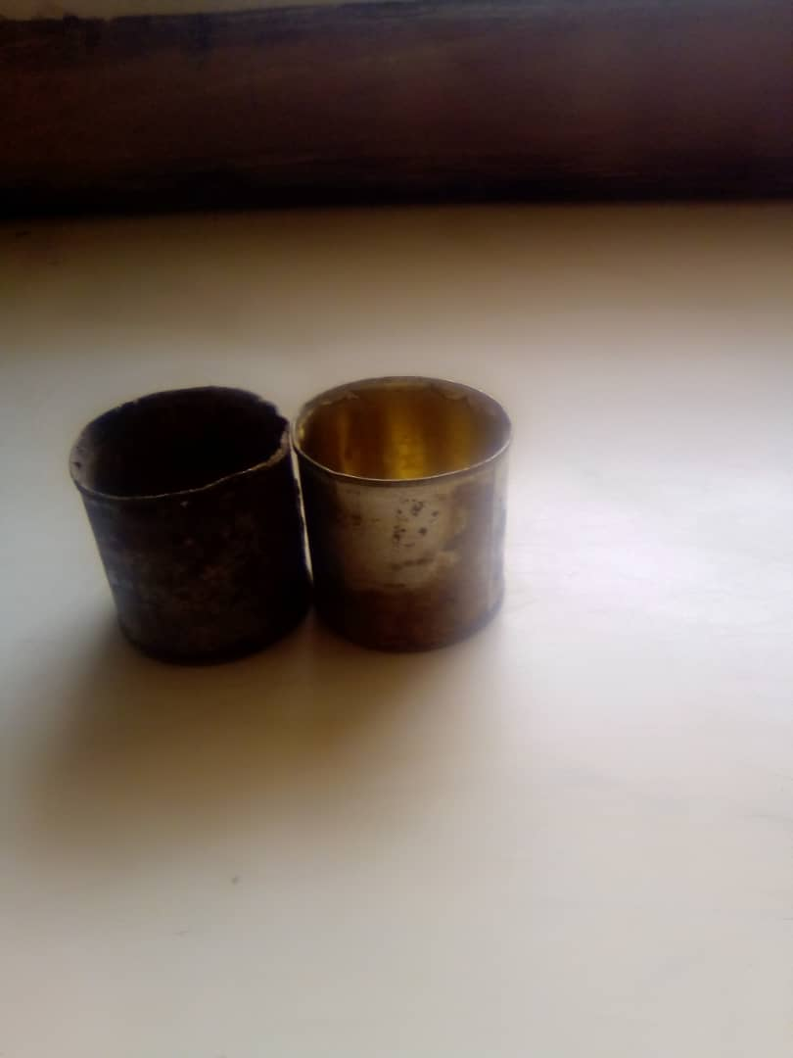
APPENDIX

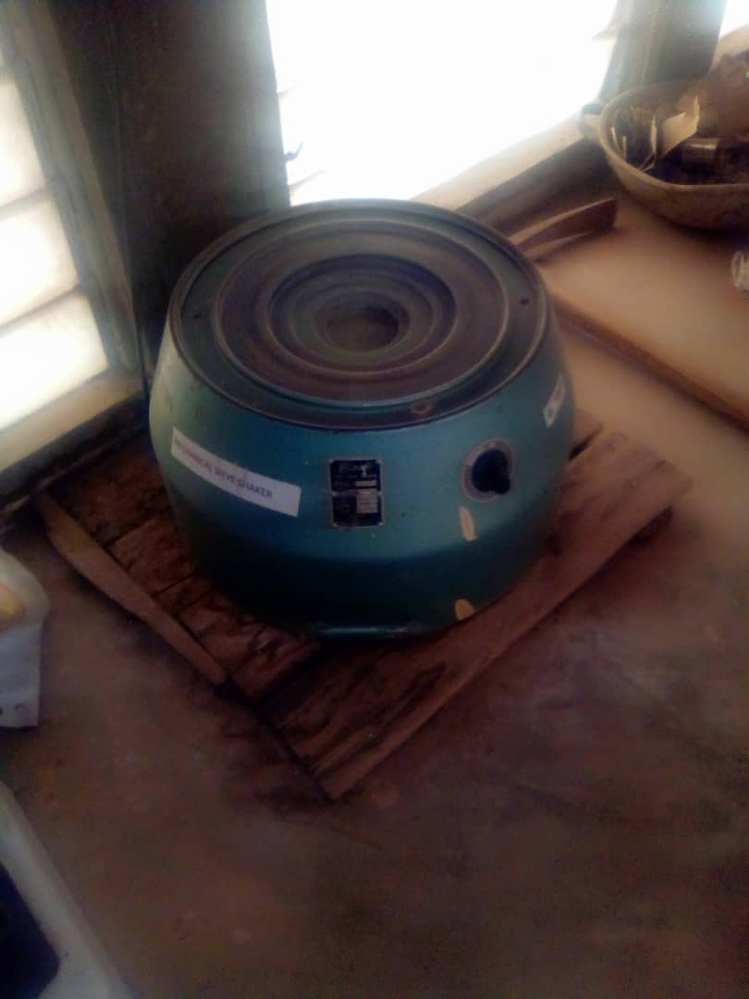
Plate 1. Can Plate 2. Weigh Balance
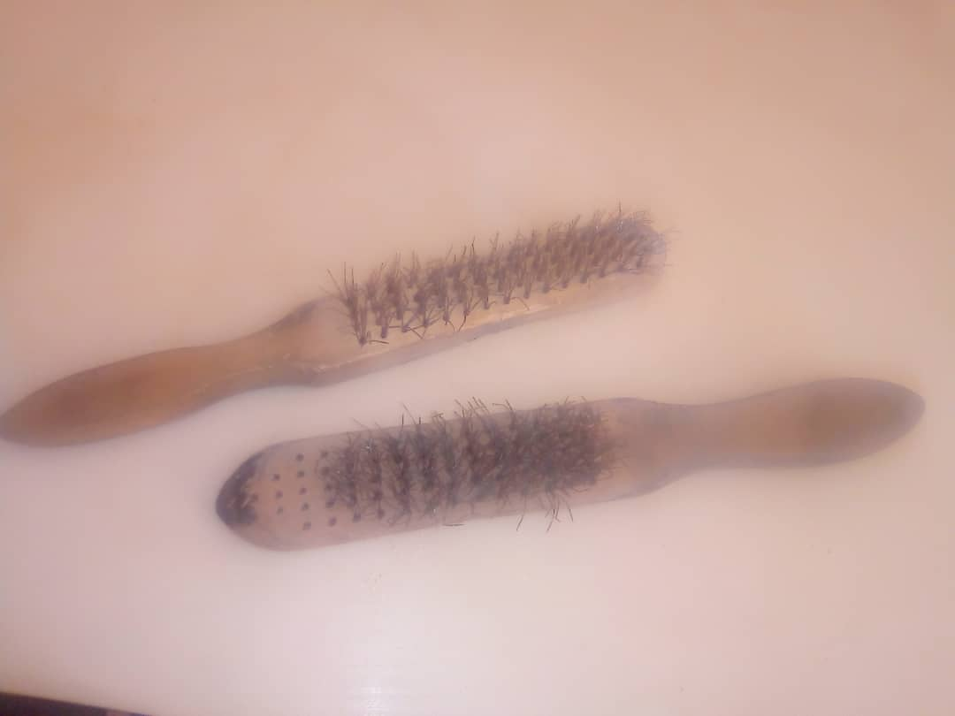

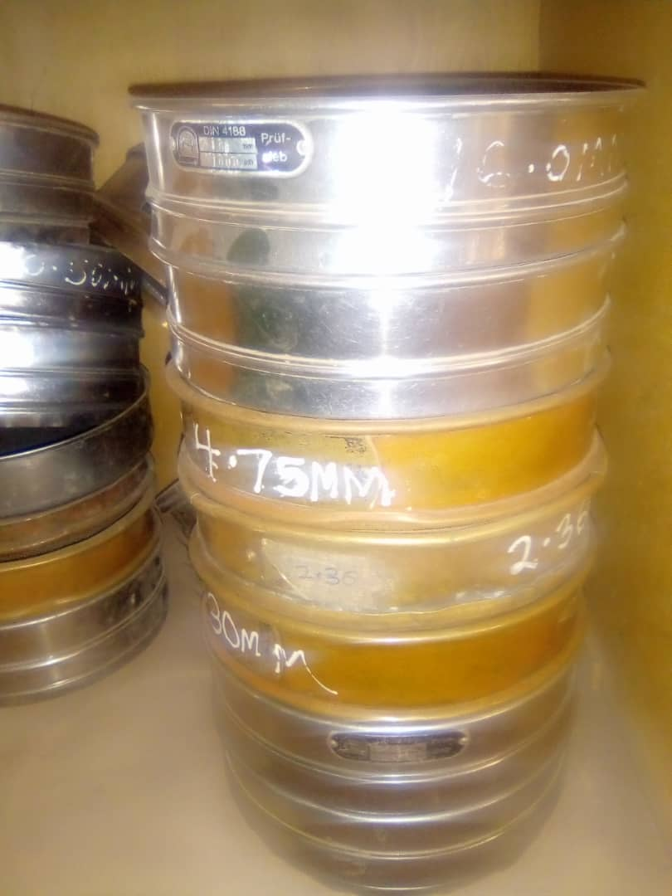
Plate 3. Mechanical Sieve Shaker Plate 4. Wire Brush
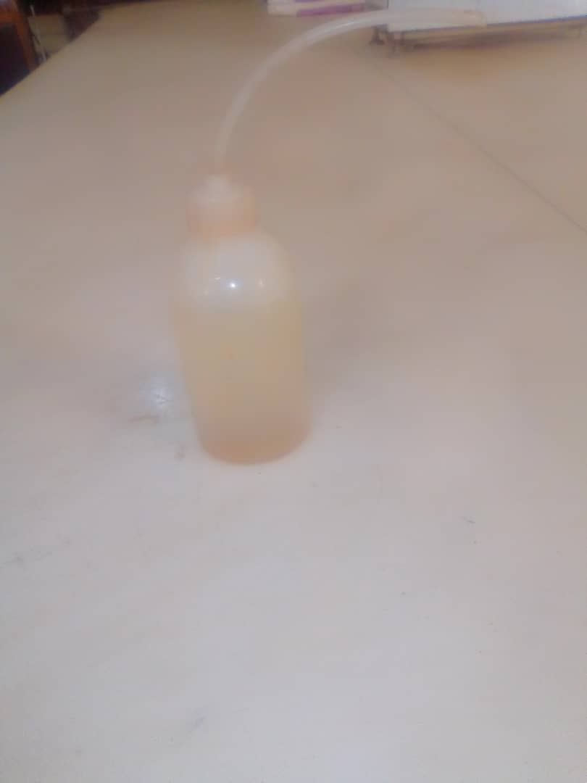

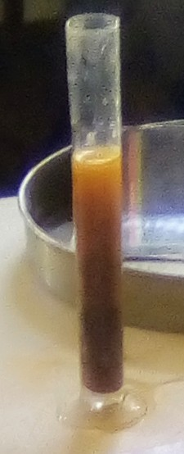
Plate 5. Sieves Plate 6. Washing Bottle

Plate 7. Measuring Cylinder Plate 8. Weighing balance


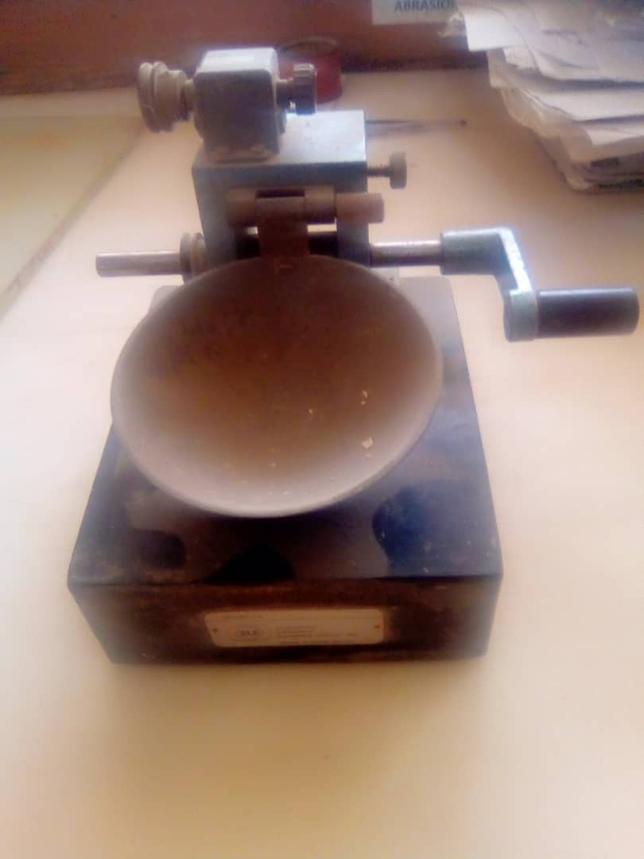

Plate 9. Cutting Groove Plate 10. Casagrande Apparatus


Plate 11. Bottle Plate 12. Glass
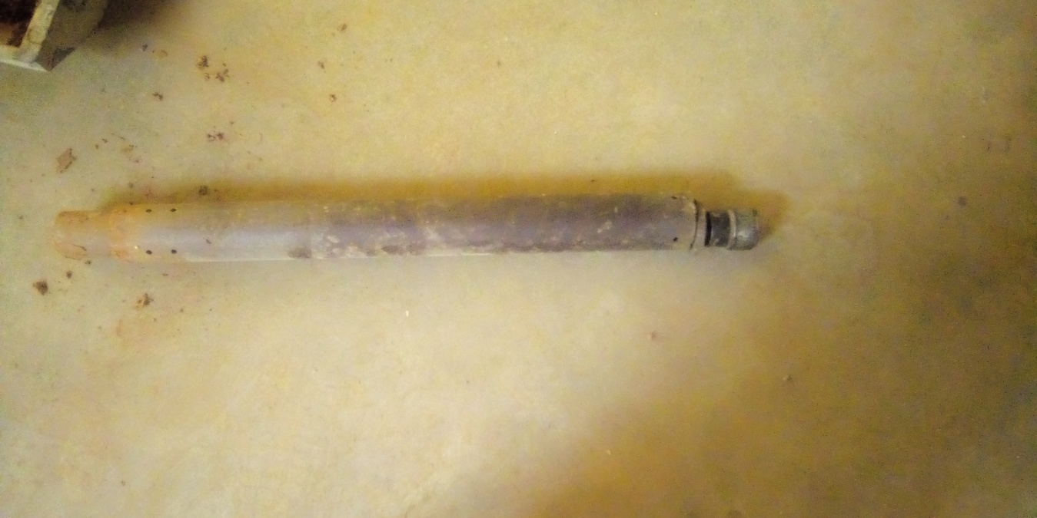
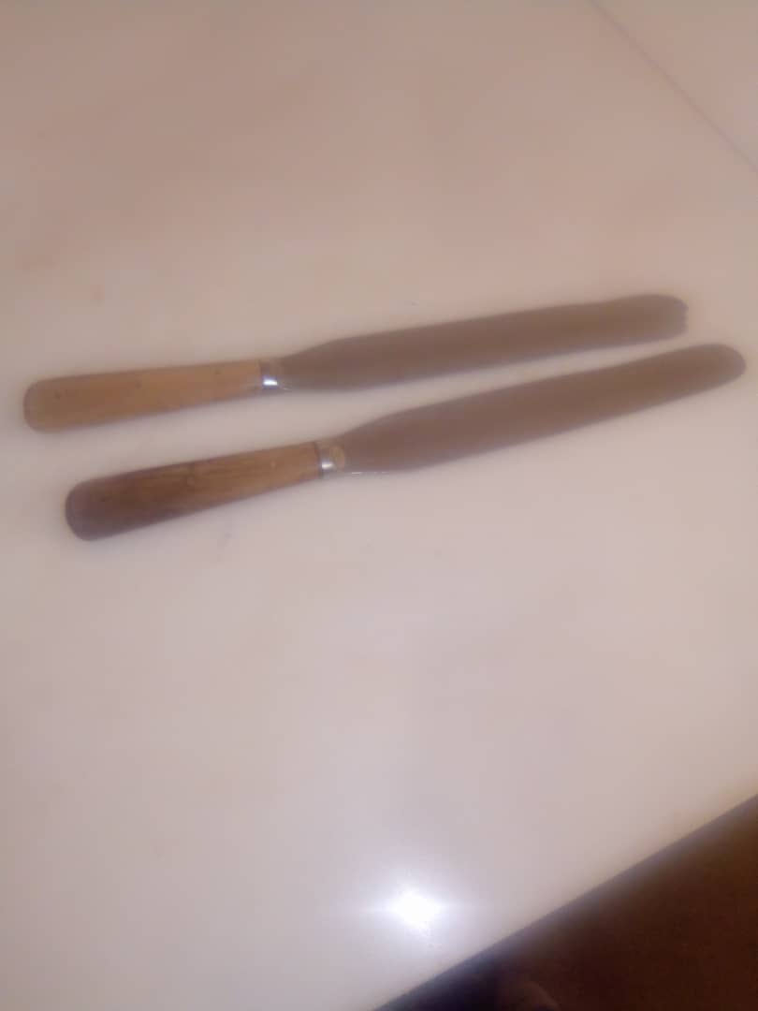

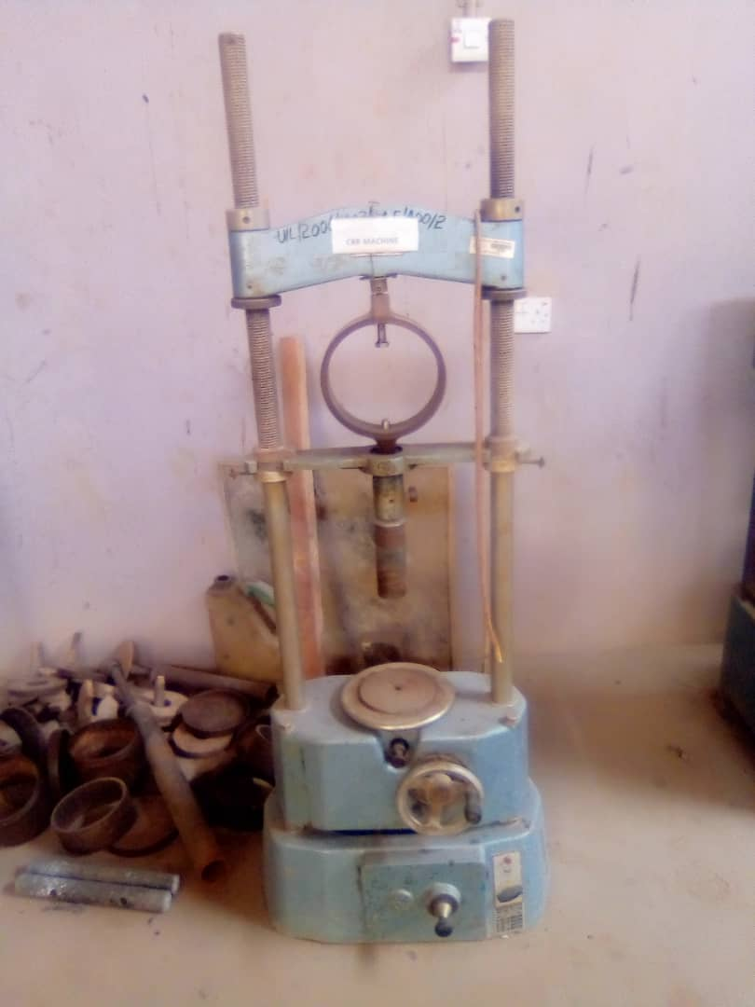
Plate 13: Spatula Apparatus Plate 14. CBR Rammer
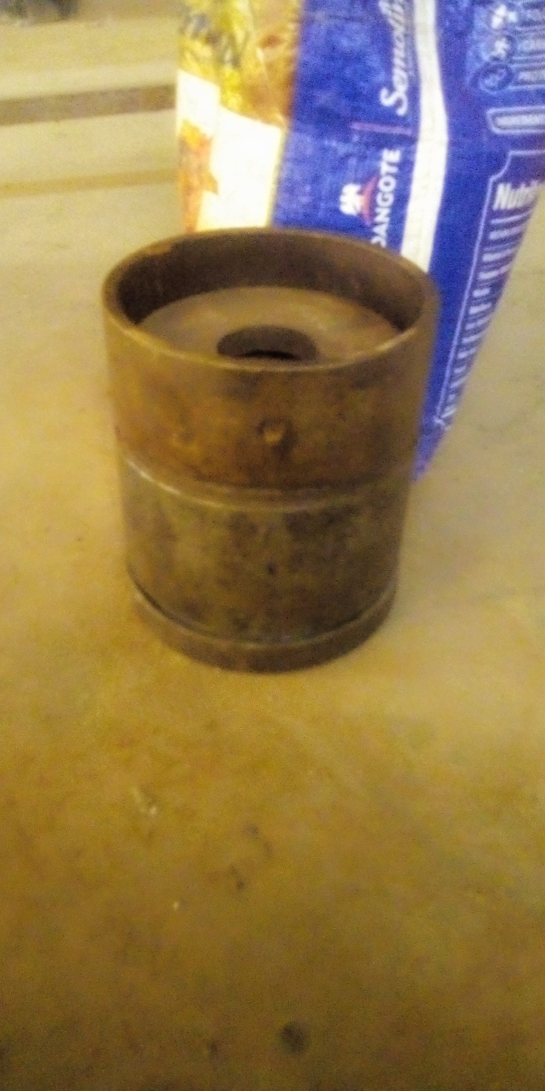

Plate 15. CBR Machine Plate 16. CBR Mould

