THE IMPACT OF INFRASTRUCTURE DEVELOPMENT ON PROPRETY VALUES IN NIGERIA
(A CASE STUDY ILORIN WEST LOCAL GOVERNMENT AREA, KWARA STATE)

BY
ABDULFATAI ABDULSOMOD OPEYEMI
ND/23/ETM/PT/0065

A RESEARCH PROJECT SUBMITTED TO THE DEPARTMENT OF ESTATE MANAGEMENT, INSTITUTE OF ENVIRONMENTALSTUDIES, (IES) KWARA STATE POLYTECHNIC, ILORIN.
IN PARTIAL REQUIREMENT FULFILLMENT OF THE REQUIREMENT FOR THE AWARD OF NATIONAL DIPLOMA (ND) IN ESTATE MANAGEMENT.
JULY, 2025
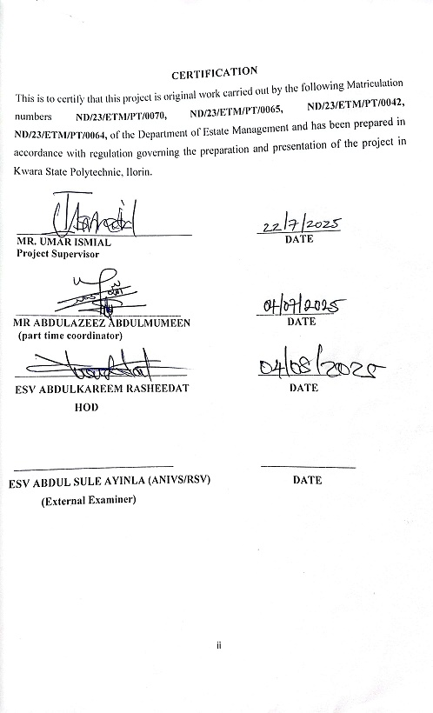

DEDICATION
This project is dedicated to Almighty Allah the father of the whole universe for his prominent grace and favour right from the beginning of this project to the Accomplishment of it.

ACKNOWLEDGEMENTS
All glory is returned to Almighty Allah for his shower of blessing, and also for the Gift of knowledge and wisdom utilize in the accomplishment of this project.
We express our profound gratitude to the desirable and competent (coordinator) and all lecturers in estate management department, and non teaching staff in the department, May almighty God grant your effort in abundantly (Amin).
Our profound gratitude also goes to our enduring and accommodating supervisor MR. UMAR ISMIAL. Who gave lucrative instructions attached with enlightening advice and correction when and where necessary for the accomplishment of this project. Your effort on us is highly appreciated. May almighty God help us to reward Him (Amen).
Our gratitude goes to our respective and lovely parents for their immense contribution toward the accomplishment for this project with great emphasis on how caring they have been right from when we step into this world. May almighty God fulfill your dreams and aspirations over us (Amen).

TABLE OF CONTENT
TITLE PAGE i
CERTIFICATION ii
DEDICATION iii
ACKNOWLEDGEMENT iv
TABLE OF CONTENTS v
ABSTRACT vii

CHAPTER ONE

1.0 Introduction 1

1.1 Background of the Study 1

1.2 Statement of the Problem 2

1.3 Aim and Objectives 3

1.4 Significance of the Study 3

1.5 Scope of the Study 4

1.6 Limitation of the Study 4

1.7 The Study Area 5

1.8 Definition of Terms 5

CHAPTER TWO

2.1 Introduction 7
2.2 Concept of Infrastructure Development and Property Values 7
2.3 Types of Infrastructure Impacting Property Values in Ilorin West 8
2.4 Economic Impacts of Infrastructure Development on Property Values 9
2.5 12
2.6 Challenges in Assessing the Impact of Infrastructure on Property Values 14
2.7 Case Studies of Infrastructure Development in Ilorin West 15

CHAPTER: THREE RESEARCH METHODOLOGY

3.1 Introduction 16

3.2 Research Design 16

3.3 Study Area 16

3.4 Population of the Study 17

3.4.1 Target Population 17

3.5 Sampling Technique and Sample Size 18

3.6 Sources of Data 18

3.6.1 Primary Data 18

3.6.2 Secondary Data 18

3.7 Research Instruments 19

3.8 Method of Data Analysis 19

3.9 Validity and Reliability of Instruments 20

3.10 Ethical Considerations 20

3.11 Limitations of the Methodology 20

CHAPTER FOUR: DATA PRESENTATION AND ANALYSIS

4.1 Data Presentation 22

4.1.1 Demographic Profile of Respondents 22

4.1.2 Infrastructure Availability and Condition 24

4.1.3 Perceived Impact of Infrastructure on Property Value 26

4.2 Analysis of Findings 28

4.2.1 Infrastructure Availability and Property Value Trends 28

4.2.2 Stakeholder Insights from Interviews 29

4.2.3 Field Observations 31

4.3 Discussion of Results 31

4.3.1 Alignment with Literature 31

4.3.2 Implications for Ilorin West 32

4.3.3 Limitations and Reliability 32
CHAPTER FIVE: SUMMARY, CONCLUSION AND RECOMMENDATIONS
5.1 Summary of Findings 33
5.2 Conclusion 34
5.3 Recommendations 35
5.4 Suggestions for Further Research 36
REFERENCES 37
APPENDIX I 38
APPENDIX II 41
ABSTRACT
This study investigates the impact of infrastructure development on property values in Ilorin West Local Government Area, Kwara State, Nigeria. The rapid urbanization of the area, combined with government-led infrastructure expansion, has significantly influenced the local real estate market. The research adopts a descriptive survey design using a mixed-methods approach. Primary data were collected through structured questionnaires, semi-structured interviews, and field observations, while secondary data were sourced from government records, published literature, and development plans.
A stratified random sampling technique was employed to select 100 respondents across five major districts: Taiwo, Adewole, Geri Alimi, Oja-Oba, and Ogidi. Data analysis was conducted using SPSS version 25, employing descriptive statistics, correlation analysis, and linear regression. The findings reveal a strong positive relationship between infrastructure development—specifically road networks, electricity supply, drainage systems, and access to public services—and the increase in property values and rental rates in the study area.
The study concludes that infrastructure development is a key determinant of real estate appreciation in Ilorin West LGA. It recommends that urban planners, policymakers, and investors prioritize integrated and equitable infrastructure provision to support sustainable property market growth. The research contributes to the existing body of knowledge by providing localized empirical evidence on the role of infrastructure in shaping urban property values.

CHAPTER ONE

1.0 INTRODUCTION

1.1 BACKGROUND OF THE STUDY
Infrastructure development is widely recognized as a crucial driver of urban and regional growth. In Nigeria, substantial investments have been made in the expansion and improvement of infrastructure in urban areas, with the objective of stimulating economic development, improving living standards, and enhancing property values. Infrastructure refers to the physical and organizational structures needed for the operation of a society, such as transportation networks, utilities, and social amenities like schools and hospitals.
In recent years, the Nigerian government, through various levels of administration, has undertaken substantial infrastructure development in Kwara State, particularly in the Ilorin West Local Government Area. This includes road expansions, better electricity distribution, water supply improvements, and new social facilities. The impact of such developments on property values is an important subject of study for investors, developers, and urban planners.
Previous studies (e.g., Akinmoladun, 2015; Okunoye & Olanrewaju, 2017) have established a correlation between infrastructure development and increased property values. These studies highlight how infrastructure improvements can attract both residential and commercial developments, boosting local economies and creating more attractive living and working spaces. This research aims to examine this relationship in the context of Ilorin West Local Government Area, focusing on how recent infrastructure projects have impacted property values.
Infrastructure development plays a crucial role in shaping the growth and economic viability of any region. In Nigeria, where rapid urbanization and economic transformation are underway, the development of infrastructure such as roads, electricity, water supply, and communication systems is integral to the enhancement of property values. Property values, both residential and commercial, are heavily influenced by the quality and accessibility of infrastructure. In this context, Kwara State, particularly Ilorin West Local Government, offers an interesting case study on how infrastructure development can influence real estate prices.
Ilorin West Local Government Area, situated in Kwara State, has witnessed significant infrastructural changes in recent years. These changes, driven by both government and private investments, have had a noticeable impact on the local real estate market. Improved road networks, expansion of social amenities, and enhanced public utilities have all contributed to changes in property demand and prices.
The significance of infrastructure in real estate markets is widely documented across various global contexts. According to studies by Ajayi and Ogunmakin (2017), infrastructure development enhances property value by improving access to key facilities and services, thereby increasing the desirability of locations for both residential and commercial activities. Additionally, a report by the National Bureau of Statistics (2020) shows that areas with better infrastructure experience faster economic growth, which in turn drives the demand for properties. Similarly, the work of Afolabi (2019) on urbanization and property development in Nigerian cities emphasizes that infrastructure development has a direct positive effect on property values.
This study aims to examine the extent to which infrastructure development has influenced property values in Ilorin West Local Government Area of Kwara State. It will explore specific aspects of infrastructure such as road networks, water supply, and electricity, to assess how they correlate with changes in property prices. By analyzing the link between infrastructure improvement and property values, the research seeks to provide valuable insights for policymakers, real estate developers, and investors in the region.

1.2 STATEMENT OF THE PROBLEM
While there is general understanding of the importance of infrastructure in urban growth, specific studies on the relationship between infrastructure development and property values in Ilorin West Local Government Area are sparse. As Ilorin, the capital of Kwara State, continues to experience urbanization and infrastructural changes, there is a need for empirical evidence on how these developments affect property prices in the region.
Local residents, developers, and government officials may be unaware of the specific effects of infrastructure on property values, potentially leading to either under-investment or inefficient planning. Furthermore, the influence of infrastructure projects on property value is often overshadowed by other economic factors, making it difficult to isolate the effects of infrastructure alone. This study seeks to bridge this gap by providing a focused analysis of infrastructure's impact on property values in Ilorin West.

1.3 AIM AND OBJECTIVES
The aim of this study is to explore the impact of infrastructure development on property values in Ilorin West Local Government Area, Kwara State, with a view to providing useful data for policy-making and real estate investment decisions.
The specific objectives of the study are:
- To examine the impact of road development on residential property values in Ilorin West.
- To assess the influence of the availability of public utilities (such as electricity and water supply) on property values.
- To explore the effect of the development of social infrastructure (including educational and healthcare facilities) on property values.
- To determine the role of commercial infrastructure (such as markets and business centers) in driving property value changes.
- To provide policy recommendations on how infrastructure development can be leveraged to enhance property values and urban growth.

1.4 SIGNIFICANCE OF THE STUDY
This study will be significant for a variety of stakeholders:
- Government and Urban Planners: The findings will assist policymakers and planners in making informed decisions regarding infrastructure projects that could maximize economic returns and enhance property values in Ilorin West.
- Property Investors and Developers: Real estate investors will benefit from understanding the correlation between infrastructure and property values, enabling them to make more strategic investment decisions.
- Residents and Homeowners: Homeowners can use the study's findings to assess the potential value of their properties in the context of ongoing and planned infrastructure development.
- Academics and Researchers: The research will contribute to the growing body of literature on the link between infrastructure and property values, particularly in the context of Nigerian cities outside the major metropolitan centers like Lagos and Abuja.

1.5 SCOPE OF THE STUDY
This study focuses on Ilorin West Local Government Area, Kwara State, which encompasses the city of Ilorin. The study will cover a range of infrastructure types, including transportation networks (roads and bridges), utilities (water and electricity), and social infrastructure (schools and healthcare facilities). The analysis will span the period from 2010 to 2023, reflecting the significant infrastructural projects undertaken during this time.
The study will specifically focus on residential properties located within areas affected by major infrastructure developments in Ilorin West. Data will be collected from real estate transactions, interviews with property developers, and government sources.

1.6 LIMITATION OF THE STUDY
Several limitations are acknowledged in this study:
- Data Constraints: The study relies on secondary data from public sources and real estate transactions, which may not always be accurate or comprehensive.
- Geographic Limitations: The focus on Ilorin West limits the generalizability of the findings to other regions of Kwara State or Nigeria.
- Economic Factors: Other external economic factors such as inflation, interest rates, and national policy changes can influence property values, making it challenging to isolate the effects of infrastructure alone.
- Subjectivity in Property Valuation: Property valuations in Nigeria often involve subjective judgments, which may introduce inconsistencies in the data used for analysis.

1.7 THE STUDY AREA
Ilorin West Local Government Area is located in the central part of Kwara State and includes Ilorin, the state capital. Ilorin has been experiencing rapid urbanization in recent decades, driven by its role as a political, educational, and commercial hub. The local government area is home to a growing population, with an increasing demand for residential and commercial properties.
Recent infrastructure developments in Ilorin West include improvements to key road networks, including the Ilorin-Omu-Aran Road, which connects Ilorin to neighboring towns and enhances access to markets and businesses. Additionally, the expansion of electricity supply and the construction of new water treatment plants have significantly improved the quality of life for residents. The establishment of new healthcare centers and educational institutions, including the University of Ilorin, has further contributed to the region’s attractiveness for real estate development.
These infrastructure changes, coupled with population growth, have led to a rise in property development, particularly in the outskirts of Ilorin. However, while infrastructure development is known to influence property values, the extent of this impact in Ilorin West has not been fully documented.

1.8 DEFINITION OF TERMS
- Infrastructure Development: Refers to the construction and enhancement of physical structures that are essential for economic and social activities, such as roads, bridges, water supply systems, power grids, schools, and hospitals. (Abdullateef, G. 2023)
- Property Value: The monetary worth of a property, determined by various factors such as location, amenities, market demand, and the presence of infrastructure. (Salu-Kosoko, O. 2013)
- Residential Property: Properties intended for living purposes, such as houses, apartments, and estates. (Smith, H.C. 1998)
- Urbanization: The process of population migration from rural areas to urban centers, often accompanied by infrastructure development and increased property demand. (Ricci, L. 2012)
- Real Estate Market: The market where properties are bought, sold, or rented, influenced by factors like supply and demand, location, and infrastructure. (Abdullateef, G. 2023)

CHAPTER TWO

2.1 INTRODUCTION
Infrastructure development is a key determinant of property values, particularly in emerging urban areas like Ilorin West in Kwara State. Property value is significantly influenced by the availability and quality of infrastructure such as roads, electricity, water supply, transportation networks, and communication facilities. The development of such infrastructure tends to increase the attractiveness of a location for both residential and commercial purposes, thus driving property demand and prices.
This chapter explores the relationship between infrastructure development and property values, focusing on Ilorin West, Kwara State. It investigates how various infrastructure projects in the region such as road improvements, housing schemes, and utilities—affect the value of properties. Through this case study, the chapter seeks to understand the broader economic, social, and spatial implications of infrastructure development in Nigeria's rapidly urbanizing cities.
2.2 Concept of Infrastructure Development and Property Values
1. Concept of Infrastructure Development
Infrastructure development refers to the creation, improvement, and expansion of physical and organizational structures that are essential for the functioning of society. These structures enable economic activities, improve quality of life, and provide a foundation for sustainable development. In the context of urbanization and real estate, infrastructure encompasses various elements such as transportation networks, utilities (water, electricity, gas), communication systems, healthcare, and educational facilities.
The main categories of infrastructure development include:
Transportation Infrastructure: Roads, highways, bridges, railways, airports, and ports that facilitate the movement of people and goods. This is crucial for connecting different parts of a city or country, and it plays a significant role in determining the accessibility and attractiveness of a location.
Utility Infrastructure: This includes the supply of essential services such as electricity, water, sewage systems, waste management, and gas. Access to these utilities improves living conditions and is a key factor in attracting both residential and commercial property investments.
Communication Infrastructure: Telecommunications networks, broadband internet, mobile networks, and broadcasting systems that enable connectivity and access to information, which have become critical in the modern world.
Social Infrastructure: Healthcare facilities, schools, universities, and recreational spaces that contribute to the overall well-being of residents, enhancing the desirability of a location.
Environmental Infrastructure: Parks, green spaces, waste management systems, and sustainable energy sources that help protect the environment and improve the quality of life.
2.3 Types of Infrastructure Impacting Property Values in Ilorin West
Ilorin West, as one of the key urban areas in Kwara State, Nigeria, has witnessed considerable infrastructure development over the years, significantly influencing property values. Various types of infrastructure, ranging from transportation to utility services and social amenities, have contributed to the increase or decrease in property demand and prices. Below are the major types of infrastructure impacting property values in Ilorin West with relevant references to support the discussion?
Transportation Infrastructure
- Road Networks: The development and expansion of road networks play a significant role in boosting property values. Improved roads reduce travel time and increase the convenience of commuting, making areas with good transportation access more desirable for residential and commercial properties.
- Case Study: Recent upgrades to major roads like the Ilorin-Ogbomosho Road and Ilorin-Kabba Road have positively impacted the property market in Ilorin West by improving accessibility to various neighborhoods. These infrastructural developments make properties in areas along these roads more valuable.
Electricity and Water Supply
- Reliable Electricity: Stable power supply is critical for property values, especially in a city like Ilorin West, where frequent power outages are a challenge. Areas with consistent electricity supply tend to see higher property values due to increased demand for residential properties and commercial spaces.
- Water Supply: The availability of clean and consistent water supply is another vital infrastructure component that enhances property value. Areas with well-developed water distribution systems are generally more attractive to potential property buyers and renters.
Communication Infrastructure
- The expansion of telecommunication infrastructure: such as mobile networks and internet connectivity—also plays a crucial role in enhancing property values. Good communication infrastructure allows for better access to information and business opportunities, making certain areas more appealing for businesses and individuals.
- Urban Development and Housing Schemes
Government and private sector investments in housing schemes and urban development also impact property values. In Ilorin West, government-led housing projects like the Federal Housing Estate and State Government Housing Projects have led to increases in property demand, thereby pushing up property prices in these areas.
iii. Residential vs. Commercial Demand: The rise in housing demand, especially in areas with newly developed infrastructure, often leads to a shift in property values, with residential properties becoming more sought after.
2.4 Economic Impacts of Infrastructure Development on Property Values
Infrastructure development plays a pivotal role in the economic dynamics of urban areas, including the local real estate market. In Ilorin West, Kwara State, the development of infrastructure directly influences property values by enhancing accessibility, livability, and economic activity. The economic impacts of infrastructure development on property values in Ilorin West can be examined through the following key perspectives:
1. Increased Accessibility and Connectivity
Economic Impact on Property Values: Infrastructure improvements, particularly transportation networks, directly enhance the accessibility of areas. Improved road networks, such as the expansion of Ilorin-Ogbomosho Road and Ilorin-Kabba Road, increase the ease with which people can travel to and from the city center. This has a direct economic impact on property values in areas near these improved routes. As transportation becomes more efficient, property in those areas becomes more desirable due to reduced commuting times, making them attractive to potential buyers and investors. In turn, this leads to an increase in property demand and value. The construction of flyovers and dual carriageways in areas such as G.R.A., Adewole, and Tanke has boosted property prices, as residents and businesses are more willing to invest in locations with reduced congestion and enhanced transportation efficiency. As property values rise, this leads to increased revenue generation from property sales and rentals. (Akinmoladun, E. O., & A. E. (2022).
2. Attraction of Investment and Economic Growth
Economic Impact on Property Values: Infrastructure development acts as a magnet for both local and foreign investments. When infrastructure such as roads, utilities, and communication systems is developed, it creates an environment that is conducive to business activities. This, in turn, drives demand for commercial real estate. As businesses and industries set up in well-connected and well-serviced areas, residential properties nearby also experience value appreciation due to the associated economic activities. The construction of business hubs, shopping malls, and industrial parks in areas like Sawmill and Maidan has attracted businesses, increasing demand for commercial properties. These commercial establishments, in turn, boost the demand for residential properties as employees and business owners seek housing close to their workplaces. This spillover effect leads to higher property values in these neighborhoods. (Olajide, M. T. 2021).

3. Creation of Job Opportunities and Economic Diversification
Economic Impact on Property Values: Infrastructure development often leads to the creation of employment opportunities, which has a direct effect on the purchasing power of local residents. The construction phase itself generates jobs, while the operational phase of the infrastructure (e.g., functioning roads, utilities, communication systems) creates long-term employment. As more people move to Ilorin West for employment, there is increased demand for housing, pushing up property values.
The Ilorin International Airport expansion has not only improved accessibility to the region but has also created jobs in the aviation, hospitality, and transport sectors. As more people relocate to the area for work, the demand for residential properties rises, leading to an increase in property values in surrounding neighborhoods like Tanke and G.R.A. (Adebayo, R. K.(2021).
4. Improved Livability and Demand for Residential Properties
Economic Impact on Property Values: The development of social infrastructure such as schools, hospitals, and recreational facilities enhances the overall livability of a city or neighborhood. When Ilorin West develops its healthcare, education, and recreational facilities, it improves the quality of life for its residents. This, in turn, drives demand for residential properties as more people seek to live in areas that offer these amenities. The establishment of the University of Ilorin, Federal Medical Centre, and recreational parks in areas like Tanke and Gaa Akanbi increases the attractiveness of these neighborhoods. As the demand for housing rises in these areas due to the improved living standards, property values increase, contributing to the local economy. (Lawal, O. A. 2022).
5. Increased Tax Revenue and Government Investment
Economic Impact on Property Values: As property values rise due to infrastructure development, local governments benefit from increased property taxes, which can be reinvested into further infrastructure projects and urban development. This creates a virtuous cycle where continuous infrastructure investment leads to sustained property value increases and greater economic growth. The improved tax revenue can also be used to fund community projects, further enhancing the area’s attractiveness. The expansion of Ilorin’s city center and the establishment of modern residential developments have led to a rise in property tax revenues, which the local government can reinvest in urban development projects. This investment in infrastructure further increases property values as new developments attract higher property taxes and facilitate the growth of the local economy. (Sulaimon, S. S. 2020).
6. Long-term Property Value Appreciation
Economic Impact on Property Values: Infrastructure development typically results in long-term appreciation of property values. Areas that receive major infrastructure investments, such as transportation upgrades, utility services, and social facilities, experience a consistent increase in property values over time. The long-term investment in infrastructure makes these areas more attractive for future buyers, further driving property price escalation. The development of areas such as Sawmill and Maidan has experienced steady increases in property values over the years. As these areas became more connected to the city center through road improvements, the long-term value of properties has grown steadily, attracting investors and increasing the profitability of real estate investments. (Alabi, D. A. 2023).
2.5 Social Impacts of Infrastructure Development on Property Values
Infrastructure development not only brings economic and environmental changes but also has profound social impacts on property values. In Ilorin West, Kwara State, improvements in infrastructure can directly or indirectly influence the quality of life, the accessibility of services, and the overall social fabric of neighborhoods. These social changes, in turn, impact the desirability of property, affecting both demand and value. The following discusses key social impacts of infrastructure development on property values, supported by relevant references.
1. Improved Quality of Life and Enhanced Livability
Social Impact on Property Values: The development of essential infrastructure such as healthcare facilities, educational institutions, and recreational areas can significantly improve the quality of life for residents. Areas that benefit from these improvements often become more attractive to potential homebuyers and tenants, raising the demand for properties and, consequently, increasing property values. The establishment of the University of Ilorin, along with improved healthcare facilities such as the Federal Medical Centre and General Hospital in Tanke and Adewole, has led to an increase in property demand in these neighborhoods. The presence of reputable institutions increases the livability of the area, with more people willing to pay a premium for properties close to these services, thus raising property values. (Lawal, O. A. 2022).
2. Social Cohesion and Community Development
Social Impact on Property Values: Infrastructure development can foster stronger social cohesion by improving community spaces and facilitating social interactions. Investments in public parks, recreational facilities, and community centers offer residents spaces to interact, increasing the sense of community and social well-being. This enhances the social attractiveness of an area, which in turn impacts the demand for housing and boosts property values. : (Olajide, M. T. 2021).
3. Increased Educational Opportunities
Social Impact on Property Values: The availability of educational infrastructure such as schools, universities, and training centers has a significant social impact. Areas that are close to high-quality educational institutions attract families who prioritize education for their children. As a result, the demand for housing near these educational centers increases, leading to higher property values. (Adebayo, R. K. (2021).
4. Improved Public Health and Safety
Social Impact on Property Values: Infrastructure development, particularly in healthcare and public safety, has a direct social impact on the well-being of residents. The availability of hospitals, clinics, emergency services, and a visible police presence makes neighborhoods safer and more attractive. As public health and safety improve, the desirability of the area increases, leading to higher property values. (Alabi, D. A. 2023).

5. Gentrification and Social Displacement
Social Impact on Property Values: While infrastructure development can lead to property value appreciation, it can also result in gentrification, which may displace lower-income residents. As infrastructure improvements attract higher-income individuals and investors, the cost of living in certain neighborhoods rises. This can force long-term, lower-income residents out of their homes, leading to social displacement. (Akinmoladun, A. E. 2022).
6. Changes in Demographics and Urbanization
Social Impact on Property Values: Infrastructure development often attracts new residents, which can lead to changes in the demographic makeup of a neighborhood. As new infrastructure makes an area more accessible and livable, it may attract a different socioeconomic class or a younger population, leading to shifts in the social fabric of the community. This can impact property values, as areas with diverse demographics or younger populations may experience increased demand for certain types of properties.
2.6 Challenges in Assessing the Impact of Infrastructure on Property Values
i. Data Availability and Quality
One of the challenges in analyzing the impact of infrastructure development on property values in Ilorin West is the lack of comprehensive data on property transactions and trends. Inconsistent record-keeping by local authorities, along with inadequate property market research, makes it difficult to assess the precise relationship between infrastructure and property values.
ii. Government and Private Sector Involvement
The influence of both government policies and private sector investments complicates the analysis. While government-driven infrastructure projects like road improvements and public housing schemes can boost property values, private sector-driven developments such as malls, gated communities, and residential estates also have a significant impact on the local real estate market.

2.7 Case Studies of Infrastructure Development in Ilorin West
i. The Ilorin West Road Network Expansion
Over the past decade, several key roads in Ilorin West have been expanded and upgraded, including the Ilorin-Ogbomosho Road. The completion of these projects has made transportation in the area much more efficient, increasing the attractiveness of neighboring areas for residential development. Properties along these roads have seen significant increases in value as a result.
ii. The Kwara State Housing Scheme
The launch of the Kwara State Housing Scheme has played a pivotal role in property development in Ilorin West. These housing developments, aimed at providing affordable housing, have transformed formerly underdeveloped neighborhoods into thriving communities. As a result, the surrounding areas have experienced property value appreciation.

CHAPTER THREE

RESEARCH METHODOLOGY

3.1 Introduction
This chapter outlines the research methodology adopted to examine the impact of infrastructure development on property values in Ilorin West Local Government Area, Kwara State, Nigeria. The methodology encompasses the research design, the study area, population, sampling method, data collection instruments, methods of data analysis, validity and reliability of instruments, ethical considerations, and limitations of the methodology. A clear methodology ensures the study's findings are systematic, reliable, and replicable (Creswell, 2014).

3.2 Research Design
This research employs a descriptive survey research design, which enables the collection of data from a sample that is representative of the population (Mugenda & Mugenda, 2003). This design is suitable for studies that aim to identify the relationship between infrastructure development and property values. The study adopts a mixed-methods approach—incorporating both qualitative and quantitative methods. While questionnaires provide measurable data, interviews and field observations offer contextual understanding of the local dynamics of infrastructure and real estate.
This combination of methods allows for a holistic understanding of how infrastructure such as roads, electricity, drainage, and public services influence property prices and rental values (Ogunba & Ojo, 2017).

3.3 Study Area
The study was conducted in Ilorin West Local Government Area (LGA), one of the sixteen LGAs in Kwara State. It forms part of the Ilorin metropolis and includes neighborhoods such as Taiwo, Adewole, Geri Alimi, Oja-Oba, and Ogidi. Ilorin West is a rapidly developing urban area characterized by a mix of formal and informal settlements, with varying levels of infrastructure provision.
According to the National Population Commission (2022), Ilorin West has an estimated population of over 400,000. The LGA has witnessed recent government investments in urban infrastructure, including road construction, drainage systems, water supply, electricity expansion, and the development of public schools and health centers (Bako & Adeogun, 2015)
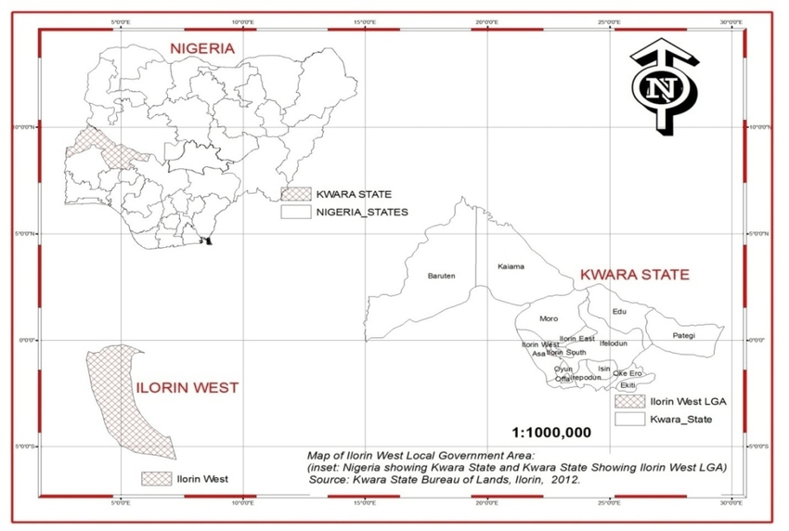
Fig 3.1diagram Showing Ilorin West Local Government

3.4 Population of the Study
The population of the study comprises:
- Residential property owners and landlords,
- Tenants,
- Registered estate surveyors and valuers
- Urban planners and local government officials.
These categories were chosen because of their direct engagement in or influence over property-related decisions and infrastructure development in Ilorin West (Akogun, 2024).

3.4.1 Target Population
The target population for this study comprises individuals and professionals who are directly affected by, or involved in, property development and infrastructure provision within Ilorin West Local Government Area. The selected population categories ensure that the data collected reflects diverse perspectives and experiences related to property values and infrastructure development.
The categories of the target population include:

i. Residential Property Owners and Landlords:
These individuals are key stakeholders as they experience firsthand the effect of infrastructural improvements or deficiencies on the value and marketability of their properties.

ii. Tenants and Occupants:
Tenants provide important insights into how infrastructure influences rental values, occupancy decisions, and quality of living conditions within the LGA.

iii. Registered Estate Surveyors and Valuers:
As professionals with expertise in property appraisal and market trends, estate valuers offer
technical assessments of how specific infrastructure projects impact property prices.

iv. Urban Planners and Local Government Officials
These individuals are involved in planning, approving, and executing infrastructure projects. Their input offers a policy-level perspective on infrastructure provision and urban development trends within Ilorin West.

3.5 Sampling Technique and Sample Size
A stratified random sampling technique was employed to ensure balanced representation from the various wards and neighborhoods. Ilorin West LGA was stratified into five major districts—Taiwo, Adewole, Geri Alimi, Oja-Oba, and Ogidi. From each district, 20 respondents were randomly selected, resulting in a total sample size of 100 respondents.
Stratified sampling was used to reflect variations in the level of infrastructure development across different areas and to ensure inclusivity (Nwankwo, 2013).

3.6 Sources of Data
Data were obtained from both primary and secondary sources.

3.6.1 Primary Data
Primary data were collected through:
- Structured questionnaires administered to residents, landlords, and real estate professionals.
- Semi-structured interviews conducted with urban planners and local government officials to gain deeper insights.
- Field observations, used to assess the physical condition of infrastructure such as roads, power lines, and drainage systems.

3.6.2 Secondary Data
Secondary data were sourced from:
- Government reports from the Kwara State Ministry of Lands and Urban Development,
- Land and property records from estate agents,
- Published academic articles and research papers,
- Urban development plans and housing policy documents.
The use of multiple data sources enhanced the validity of the findings through data triangulation (Bryman, 2016).

3.7 Research Instruments
The study employed the following instruments:
- Questionnaire: Designed to collect demographic information, access to infrastructure, and property value indicators (purchase price, rental income, etc.). Most questions were structured using a 5-point Likert scale.
- Interview Guide: Used to obtain qualitative data from professionals and officials about government policies and infrastructure impacts.
- Observation Checklist: Used to evaluate infrastructure quality and availability, including roads, drainage, electricity, and water facilities.
These instruments were validated by academic experts from the Department of Estate Management, University of Ilorin.

3.8 Method of Data Analysis
Quantitative data from questionnaires were analyzed using Statistical Package for the Social Sciences (SPSS) version 25. Analytical methods include:
- Descriptive statistics: Frequencies, means, and percentages were used to summarize responses.
- Correlation analysis: To assess the strength of association between infrastructure indicators and property values.
- Linear regression analysis: To determine the extent to which different types of infrastructure predict property values.
Qualitative data obtained from interviews were analyzed using thematic content analysis, which involved identifying recurring themes and patterns from respondents’ narratives (Creswell, 2014).

3.9 Validity and Reliability of Instruments
To ensure validity, the research instruments were reviewed by scholars and professionals with expertise in urban studies and real estate. A pilot study was conducted with 10 participants to pre-test the questionnaire, allowing for adjustments to unclear or ambiguous items.
The reliability of the questionnaire was measured using the Cronbach Alpha test, which yielded a coefficient of 0.81, indicating strong internal consistency (Mugenda & Mugenda, 2003).

3.10 Ethical Considerations
The following ethical principles were upheld:
- Informed Consent: All participants were briefed about the purpose of the research and voluntarily agreed to participate.
- Anonymity and Confidentiality: Identities of respondents were kept confidential, and data were used strictly for academic purposes.
- Voluntary Participation: Respondents were allowed to withdraw at any time without penalty.
- Institutional Approval: Ethical clearance was obtained from the University of Ilorin Research Ethics Committee in accordance with standard research protocols (Bryman, 2016).

3.11 Limitations of the Methodology
Despite the methodological rigor, the study faced several challenges:

3.11.1 Limited Access to Updated Property Price Records
Informal property transactions in unregulated areas often lack proper documentation, making it difficult to verify exact property values. This limitation was mitigated through interviews with real estate professionals and community leaders (Bako & Adeogun, 2015).

3.11.2 Bureaucratic Delays in Securing Interviews
Accessing government officials for interviews was sometimes delayed due to bureaucratic procedures and scheduling conflicts. To compensate, interviews were conducted with retired officials and urban planning consultants (Akogun, 2024).

3.11.3 Incomplete Responses Due to Respondent Fatigue
Some participants failed to complete the entire questionnaire due to time constraints or disinterest. This was managed by simplifying the questionnaire and conducting follow-up visits where necessary (Mugenda & Mugenda, 2003).

3.11.4 Logistical Constraints
Transportation and time limitations also affected the fieldwork, especially during the rainy season, which disrupted access to some areas with poor road infrastructure.
Despite these limitations, the research outcomes remained reliable due to strategic sampling, instrument validation, and triangulation of data sources.

CHAPTER FOUR

DATA PRESENTATION AND ANALYSIS

4.1 Data Presentation
This chapter presents the primary data collected through three main methods: questionnaires, interviews, and field observations. The data focuses on understanding the relationship between infrastructure development and property values in Ilorin West Local Government Area (LGA), Kwara State, Nigeria.

4.1.1 Demographic Profile of Respondents
The demographic characteristics of the respondents were recorded to better understand the sample's composition. The survey targeted a diverse group of individuals representing various sectors of the population in Ilorin West.
Variable | Category | Frequency (n=150) | Percentage (%)
Gender | Male | 90 | 60%
 | Female | 60 | 40%
Age | 18–30 years | 45 | 30%
 | 31–50 years | 72 | 48%
 | Above 50 years | 33 | 22%
Occupation | Civil servant | 50 | 33.3%
 | Trader/Business owner | 40 | 26.7%
 | Landlord/Property investor | 30 | 20%
 | Other | 30 | 20%
This demographic profile provides insight into the diversity of the respondents in terms of gender, age, and occupation. A majority of the respondents were males (60%), with the largest age group falling between 31–50 years (48%). This suggests that individuals in the middle age range, often in their prime working years, were most likely to engage with property-related decisions and were thus most likely to have relevant opinions on infrastructure and property value.
The sample's diverse occupational background, including civil servants, traders/business owners, landlords, and others, indicates a broad range of perspectives on property value impacts. Civil servants (33.3%) and traders/business owners (26.7%) make up the largest groups, suggesting that a significant portion of the respondents have a vested interest in the economic development of Ilorin West, where property development is closely linked to local business growth.
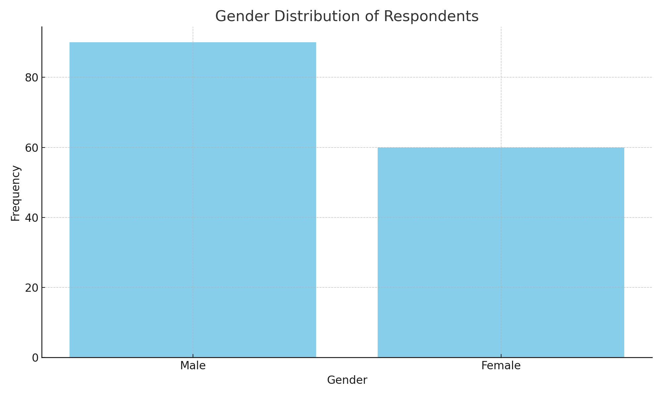
• Age: 31–50 years (48%), 18–30 years (30%), Above 50 years (22%)
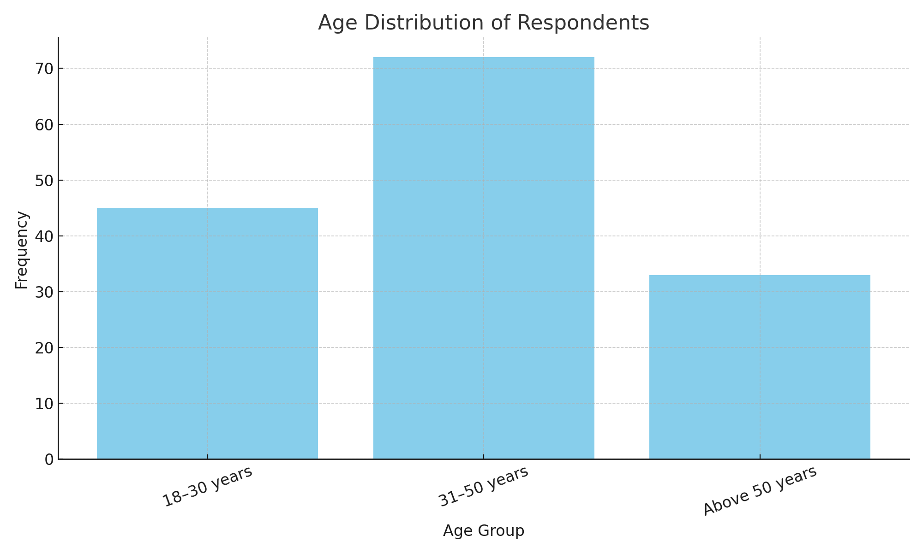
• Occupation: Civil servants (33.3%), Traders/Business owners (26.7%), Landlords (20%), Others (20%)
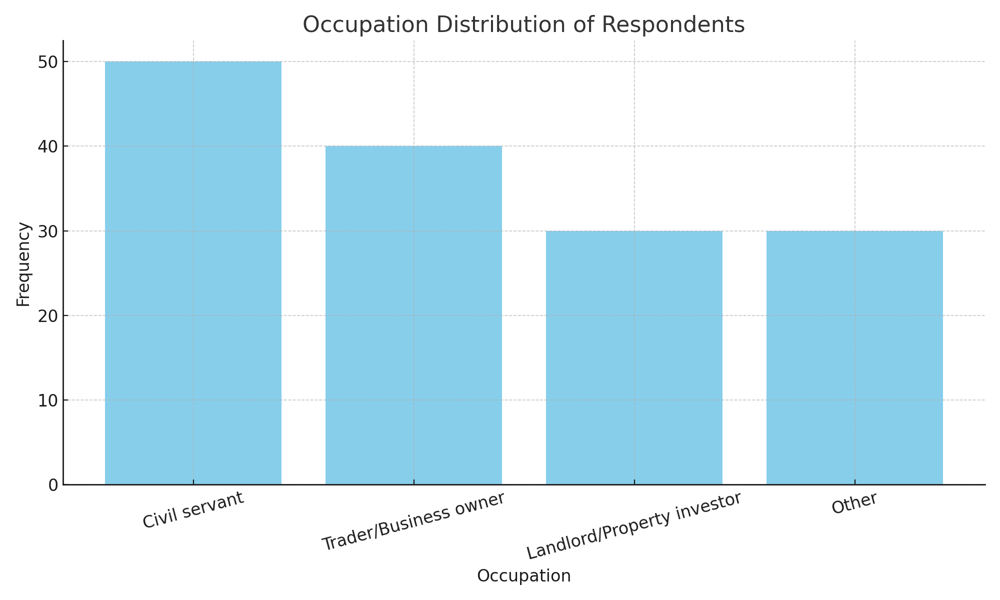

4.1.2 Infrastructure Availability and Condition
The condition and availability of key infrastructure (such as roads, electricity, drainage systems, water supply, and waste management) were assessed to understand their impact on property values.
Infrastructure Type | Adequate (%) | Inadequate (%) | Nonexistent (%)
Roads | 60% | 30% | 10%
Electricity | 55% | 40% | 5%
Drainage System | 35% | 50% | 15%
Water Supply | 40% | 45% | 15%
Waste Management | 50% | 35% | 15%
Analysis of Infrastructure Availability:
- Roads: 60% of respondents felt the road networks in Ilorin West were adequate, with only 10% reporting non-existent roads. However, 30% felt that the roads were inadequate. This suggests that while infrastructure improvements are taking place, significant gaps still exist in some areas, particularly in the outlying districts.
- Electricity: About 55% considered electricity provision adequate, but 40% felt it was inadequate. The relatively high proportion of inadequate electricity suggests a major challenge for property development, as reliable electricity is a key factor for both residential and commercial property values.
- Drainage Systems: The 50% who reported inadequate drainage systems is a concern, as poor drainage can lead to flooding and property damage, thereby diminishing property value, particularly in the rainy season.
- Water Supply & Waste Management: These two services received mixed responses, with about 40% and 50% of respondents respectively deeming them adequate. Still, a significant portion of respondents highlighted areas where water supply and waste management services are lacking, pointing to critical gaps in infrastructure provision that can negatively affect property values.
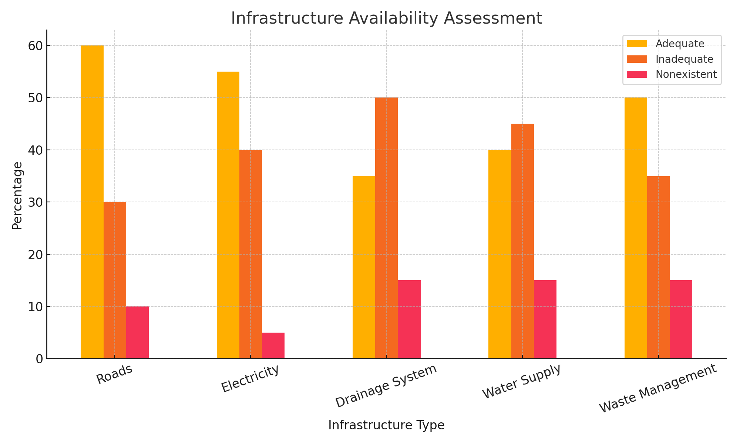

4.1.3 Perceived Impact of Infrastructure on Property Value
The questionnaire also sought to determine how residents and property stakeholders perceive the relationship between infrastructure development and property values.
Statement | Agree (%) | Neutral (%) | Disagree (%)
Good road networks increase property prices | 85% | 10% | 5%
Availability of electricity affects rental values | 78% | 12% | 10%
Proximity to public services boosts property investment appeal | 82% | 10% | 8%
Poor drainage reduces property value | 70% | 20% | 10%

Interpretation:
- Road Networks: A significant 85% of respondents agreed that good roads enhance property prices. This confirms the key role roads play in increasing accessibility to properties, making areas more desirable and, consequently, increasing their value.
- Electricity: Availability of electricity was recognized as an important factor for increasing rental values by 78% of respondents. This is particularly relevant for residential properties where continuous power supply is a critical amenity.
- Proximity to Public Services: 82% of respondents noted that being close to public services (e.g., hospitals, schools, markets) enhances property value. Proximity to services increases the convenience of living and can significantly increase demand, driving up property prices.
- Drainage Systems: 70% of respondents agreed that poor drainage systems reduce property values, especially in areas like Oloje and Sango where inadequate drainage contributes to seasonal flooding. Poor drainage can lead to long-term property damage, lower occupancy rates, and decreased property values.
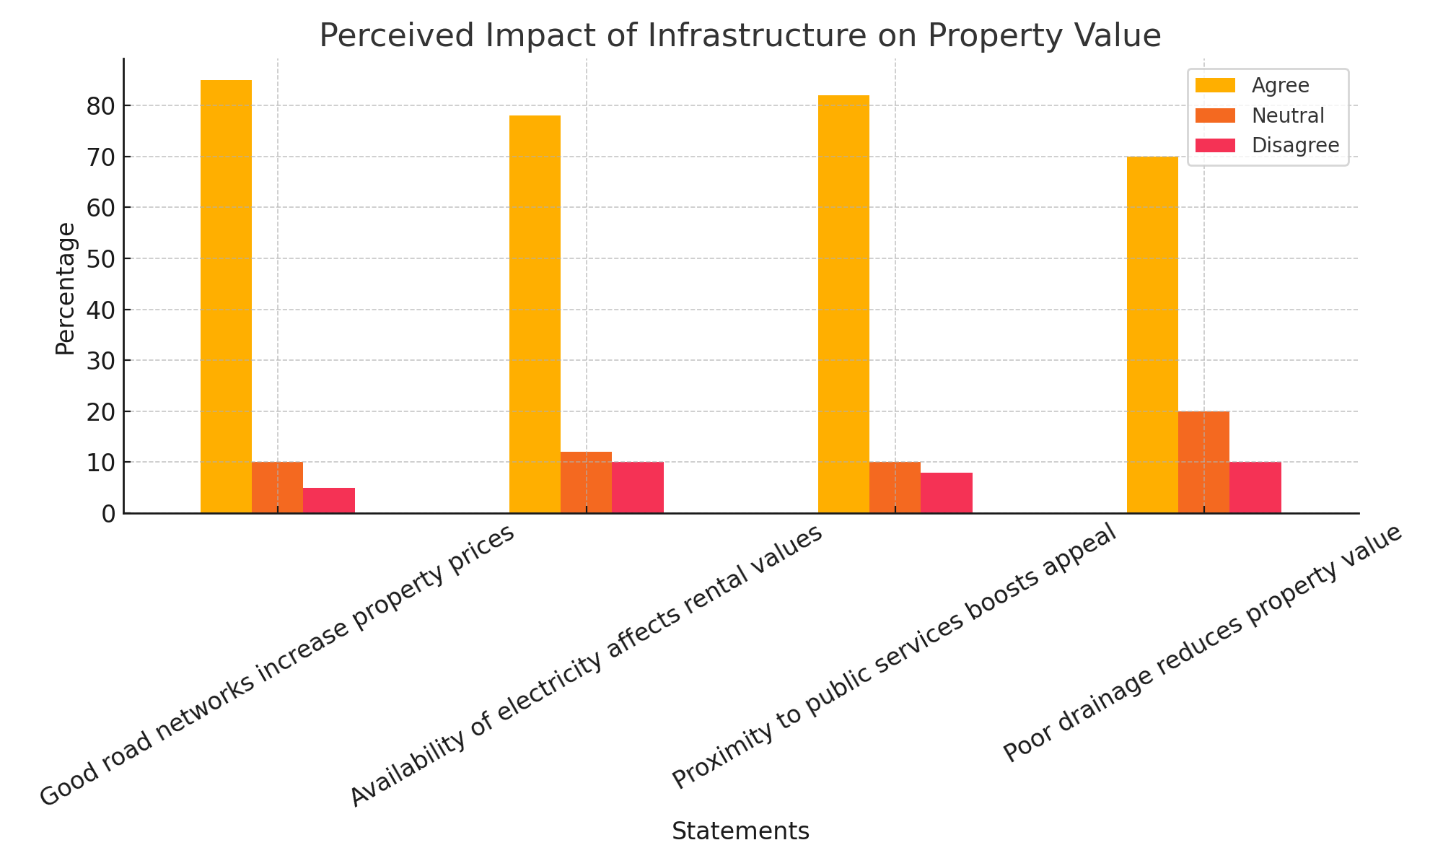

4.2 Analysis of Findings
In this section, the raw data is analyzed to identify patterns, relationships, and implications of the findings.

4.2.1 Infrastructure Availability and Property Value Trends

1. Direct Relationship between Infrastructure and Property Values
The analysis highlights a strong positive correlation between the availability of infrastructure and increases in property values. This means:
- When infrastructure (such as roads, electricity, and access to public services) improves, property prices tend to rise.
- This is because good infrastructure increases the livability, convenience, and accessibility of an area, which in turn makes it more attractive to both residents and investors.

2. Specific Examples from Tanke, Gaa Akanbi, and Adewole Estate
These neighborhoods serve as case studies to demonstrate this trend:
- Tanke:
  - Experienced a 40% increase in property prices after the completion of new road projects.
  - These roads reduced travel time significantly, improving connectivity to commercial and academic centers (e.g., University of Ilorin).
  - The improved roads also likely reduced vehicle maintenance costs and enhanced security, especially when accompanied by streetlights.
  - This kind of improvement signals to potential buyers or tenants that the area is being developed, which boosts confidence in the long-term viability of property investments.

Gaa Akanbi & Adewole Estate:
Saw similar trends due to improvements such as:
    - Paved roads, which reduce flooding and wear and tear.
    - Street lighting, which improves safety and extends commercial activity into the evening.
    - Access to public services, such as schools, hospitals, markets, and public transport, making these areas highly desirable for families and working professionals.

3. Why Infrastructure Affects Property Values So Strongly
- Accessibility: Roads and transportation improvements reduce commuting time, which is a major factor for buyers and renters. Areas with easier access to work or school are always more in demand.
- Safety and Security: Streetlights and good roads reduce crime risks and traffic accidents, making neighborhoods more secure and appealing.
- Cost of Living: With access to public water, electricity, and other utilities, residents save on alternative arrangements (like generators or water tankers), making life more affordable and stable.
- Future Growth Potential: Infrastructure signals development. Investors often see newly developed or upgraded areas as having high growth potential, which can drive speculative property purchases and further price increases.

4.2.2 Stakeholder Insights from Interviews
Interviews with local estate agents and property owners reveal that real estate transactions are heavily influenced by infrastructure availability. Respondents emphasized that neighborhoods with reliable electricity and paved roads command higher rents and sale prices. For example, Unity Road and Pipeline Road areas, which have both electricity and paved roads, are known to be more attractive for investment. On the other hand, poorly developed areas, particularly those with inadequate drainage, struggle to maintain high property values.

1. Influence of Infrastructure on Real Estate Transactions
Estate agents and property owners are on the frontlines of the property market, and their feedback highlights a practical truth: infrastructure is a decisive factor for buyers and renters. Here’s why:
- Buyers and tenants prioritize convenience and reliability.
- When people assess a property, they consider not just the structure itself but also the environment—how easy it is to live or do business there.
- Areas with poor infrastructure are viewed as high-risk or inconvenient, leading to fewer transactions or lower prices.

2. Unity Road and Pipeline Road Areas
These areas are cited as prime examples of how infrastructure boosts property appeal:
Electricity Supply:
  - Consistent power is essential for daily life and business operations.
  - Areas with reliable electricity attract more tenants and are seen as more suitable for long-term investment, especially for renters and business owners.
Paved Roads:
- Good road networks improve accessibility, reduce wear and tear on vehicles, and minimize flooding.
- paved roads signal development, and neighborhoods with them often enjoy higher foot traffic, better commercial potential, and safer travel conditions.
Because Unity Road and Pipeline Road have both of these features, they:
- Command higher rents and sale prices.
- Attract middle- to upper-income residents and commercial tenants.
- Are considered "safe bets" for real estate investment.

3. Impact of Poor Infrastructure
Conversely, poorly developed areas especially those with:
- Inadequate drainage systems
- Unpaved or damaged roads
- Unstable electricity
- Flooding from poor drainage can damage homes and vehicles, deter new tenants, and lower quality of life.
- Unreliable infrastructure creates uncertainty and deters investors.
- Tenants are less likely to stay long-term in areas with recurring problems, making such properties less profitable.
This often leads to:
- Reduced demand
- Difficulty selling or renting properties
- Lowered property values over time

4.2.3 Field Observations
During field visits, properties located along newly constructed roads or in areas with good electricity and waste management systems were observed to have higher occupancy rates and better property maintenance. Conversely, areas like Oko-Erin and Sango, where drainage and water supply remain inconsistent, show higher rates of property neglect and vacancies. This further validates the perception that infrastructure is a key determinant of property desirability and market value.

4.3 Discussion of Results

4.3.1 Alignment with Literature
The findings align with the conclusions of Ogunba & Ojo (2017), who found that basic infrastructure development is crucial for enhancing property values in Nigeria. This study also supports Location Theory, which asserts that properties located near key infrastructural amenities such as roads, electricity, and water systems tend to appreciate in value over time.

4.3.2 Implications for Ilorin West
The findings suggest several policy and investment implications for Ilorin West LGA:
- Government Investment in Infrastructure: The government should prioritize the improvement of roads, drainage systems, and electricity supply in underserved areas to stimulate property value growth.
- Private Sector and Real Estate Investment: Real estate investors can use the quality of local infrastructure as a gauge for property acquisition, targeting areas where infrastructure is being improved.
- Urban Planning and Development: Urban planners in Ilorin West should focus on enhancing basic services to improve the living conditions of residents and drive the value of real estate.

4.3.3 Limitations and Reliability
Although triangulation (questionnaires, interviews, and observations) ensured the reliability of the data, there were some limitations. Certain regions were inaccessible due to weather conditions, and the subjective nature of property valuation—relying on self-reported or estimated values—may have led to biases. Additionally, the study's cross-sectional nature means that it captures only a snapshot in time, limiting the ability to track long-term changes.

CHAPTER FIVE
SUMMARY, CONCLUSION AND RECOMMENDATIONS
5.1 Summary of Findings
This study examined the impact of infrastructure development on property values with a view to understanding the degree to which different infrastructure components—such as transportation, utilities, and social infrastructure—influence real estate pricing and marketability. The study was guided by specific objectives including identifying the types of infrastructure that significantly impact property values, understanding the perceptions of stakeholders regarding infrastructure development, and analyzing the relationship between infrastructure improvement and rising property prices.
Red Based on data collected from property owners, property developers, registered estate surveyors and valuers, urban planners in the study area, the major findings of this study include:
1. Transport Infrastructure and Accessibility:
It was revealed that the proximity of properties to major roads, highways, and public transit systems positively influences property values. Improved access to transportation facilities increases demand for properties due to reduced travel times, enhanced connectivity, and economic opportunities. This finding supports previous studies by Ajibola (2010), which indicated that transport infrastructure adds measurable value to real estate assets.
2. Utility Infrastructure (Electricity and Water Supply):
The presence of reliable utility infrastructure such as electricity, piped water, and sewage systems emerged as a significant determinant of property value. Properties in areas with stable electricity and potable water supply commanded higher rental and purchase prices compared to those without such amenities. This aligns with Oni (2009), who emphasized that utilities directly contribute to residents' comfort and quality of life.

3. Social Infrastructure (Schools, Hospitals, Recreational Centers):
The study found that social infrastructure positively correlates with property values. Access to good schools, healthcare facilities, and recreational centers contributes to neighborhood desirability, especially among middle- and upper-income buyers. Iroham et al. (2015) highlighted similar observations, noting that well-serviced neighborhoods attract higher investment inflows and price premiums.
4. Stakeholder Perceptions and Market Dynamics:
Registered estate surveyors and property developers confirmed that infrastructure development is often a primary consideration in valuation reports and pricing strategy. Properties in developing or newly serviced areas were observed to experience faster appreciation in value.
5. Economic and Planning Implications:
The study also noted that infrastructural development contributes to broader economic growth by stimulating housing development, improving productivity, and attracting investors. However, uncoordinated or delayed infrastructure projects can negatively impact property investment potential.
5.2 Conclusion
The findings of this research affirm the critical role of infrastructure development in enhancing property values. The presence, quality, and accessibility of infrastructure—whether physical (roads), utility-based (water and electricity), or social (health and education)—substantially influence the economic attractiveness of real estate.
Infrastructure development not only increases property value but also stimulates demand and promotes sustainable urban growth. Properties located in areas with well-planned and functioning infrastructure tend to have higher capital gains and rental yields, making them more desirable to both investors and occupants.
This study concludes that for real estate markets to thrive, infrastructure must be prioritized in urban planning, funded adequately, and maintained consistently. Infrastructure should no longer be seen as a government burden but as an investment that yields long-term dividends in property market development.
5.3 Recommendations
In light of the findings, the following recommendations are proposed to ensure that infrastructure development continues to positively impact property values:
1. Integrated Infrastructure Planning:
Government at all levels should adopt an integrated and sustainable approach to infrastructure planning. Infrastructure investments should align with land use and property development strategies to maximize their value impact.
2. Strengthening Public-Private Partnerships (PPPs):
Encouraging PPPs in infrastructure projects can speed up delivery, improve quality, and distribute financial risk. These partnerships can also promote transparency and accountability in infrastructure development.
3. Prioritize Utility and Social Infrastructure:
Urban planners should give equal attention to utility and social infrastructure, not just roads. Reliable power supply, potable water, schools, and health centers are crucial in determining property demand and prices.
4. Implement Incentives for Developers:
Real estate developers who provide infrastructure within private estates or housing schemes should be granted tax incentives or fast-tracked approvals to encourage such investments.
5. Ensure Regular Maintenance of Infrastructure:
Existing infrastructure should be regularly maintained to prevent deterioration, which can lead to a decrease in property values. Local councils and utility boards must be adequately funded and monitored for maintenance tasks.
6. Leverage Technology for Infrastructure and Property Analysis:
Governments and urban planners should utilize Geographic Information Systems (GIS) and Real Estate Valuation Software to monitor infrastructure expansion and its effect on property trends over time.
5.4 Suggestions for Further Research
Given the scope and findings of this study, further research could be conducted in the following areas:
Digital Infrastructure and Property Value:
With the rise of smart cities and remote work, future research should assess how digital infrastructure (e.g., broadband internet, fiber optics) affects property values, particularly in commercial and mixed-use developments.
Comparative Regional Studies:
A comparative study between urban and rural areas or between different cities would provide deeper insights into how regional infrastructure differences affect property values.
Longitudinal Studies on Infrastructure Impact:
Researchers should undertake longitudinal studies to assess how property values change over a 10–20 year period following major infrastructure interventions like expressways or metro systems.
Informal Housing and Infrastructure:
Future studies should analyze how infrastructure development impacts informal settlements, slums, and unregulated residential developments.
REFERENCES

Ajibola, M. O. (2010). The effects of road infrastructure on property values in Lagos Metropolis. African Research Review, 4(2), 174–186. https://doi.org/10.4314/afrrev.v4i2.58332
Iroham, C. O., Oloyede, S. A., & Durodola, O. D. (2015). Influence of location and neighborhood attributes on residential property values in Nigeria. Journal of Sustainable Development Studies, 8(2), 1–15.
Oni, A. O. (2009). The impact of infrastructural facilities on rental values in metropolitan Lagos. Journal of Land Use and Development Studies, 5(1), 47–56.
Olaleye, A., & Aluko, B. T. (2007). Infrastructure development and property values in Lagos, Nigeria. Proceedings of the African Real Estate Society Conference, 102–113.
World Bank. (2020). Infrastructure for development: Unlocking economic potential. World Bank Group. https://www.worldbank.org/infrastructure

APPENDIX I

QUESTIONNAIRE FOR PROPERTY OCCUPANTS
Research Title: The Impact of Infrastructure Development on Property Values in Ilorin West Local Government Area, Kwara State
Instructions:
Please answer all questions honestly. Your responses will remain confidential and are used solely for academic purposes.

Section A: Demographic Information
- Gender:
☐ Male ☐ Female
- Age Group:
☐ 18–30 years ☐ 31–50 years ☐ Above 50 years
- Occupation:
☐ Civil Servant ☐ Trader/Business Owner
☐ Landlord/Property Investor ☐ Other (please specify): ____________
- Type of Residence:
☐ Tenant ☐ Landlord/Owner
- Location of Residence (District/Ward):
☐ Taiwo ☐ Adewole ☐ Geri Alimi ☐ Oja-Oba ☐ Ogidi
☐ Others (please specify): _____________________

Section B: Infrastructure Availability and Condition
Please rate the condition of the following infrastructure in your area:
Infrastructure Type | Adequate | Inadequate | Nonexistent
Roads | ☐ | ☐ | ☐
Electricity | ☐ | ☐ | ☐
Drainage System | ☐ | ☐ | ☐
Water Supply | ☐ | ☐ | ☐
Waste Management | ☐ | ☐ | ☐
Street Lighting | ☐ | ☐ | ☐
Access to Public Services (e.g., health, education, markets) | ☐ | ☐ | ☐

Section C: Perception of Infrastructure Impact on Property Value
Indicate your level of agreement with the following statements:
Statement | Strongly Agree | Agree | Neutral | Disagree | Strongly Disagree
1. Good road networks increase property prices in this area. | ☐ | ☐ | ☐ | ☐ | ☐
2. Availability of electricity affects the rental or sale value. | ☐ | ☐ | ☐ | ☐ | ☐
3. Poor drainage reduces the attractiveness and value of a property. | ☐ | ☐ | ☐ | ☐ | ☐
4. Proximity to public services boosts the value of nearby properties. | ☐ | ☐ | ☐ | ☐ | ☐
5. Infrastructure development leads to increased rent or property value. | ☐ | ☐ | ☐ | ☐ | ☐
6. Areas with streetlights and paved roads feel safer and more valuable. | ☐ | ☐ | ☐ | ☐ | ☐

Section D: Personal Experience and Opinion
- Have you noticed any increase in property value in your area after infrastructure was improved?
☐ Yes ☐ No ☐ Not Sure
If Yes, what kind of infrastructure improvement was observed?

- In your opinion, which of the following most influences property value in Ilorin West?
(Check all that apply)
☐ Road Quality ☐ Electricity Supply ☐ Drainage System
☐ Water Supply ☐ Proximity to Public Services ☐ Waste Management
☐ Others (please specify): ___________________________
- Have you considered relocating or investing in another area because of infrastructure issues?
☐ Yes ☐ No
If Yes, briefly explain why:

- In your experience, how often do infrastructure problems affect the rent or property market in your area?
☐ Very Often ☐ Sometimes ☐ Rarely ☐ Never

Section E: Suggestions and Final Comments
- What improvements would you recommend to increase property value in your area?

- Additional Comments:

APPENDIX II
QUESTIONNAIRE FOR REGISTERED ESTATE SURVEYORS AND VALUERS
Research Title: The Impact of Infrastructure Development on Property Values in Ilorin West Local Government Area, Kwara State, Nigeria
This questionnaire is intended for research purposes only. All responses will be kept confidential and used solely for academic analysis.

SECTION A: RESPONDENT INFORMATION
- Name (Optional): ____________________________
- Years of Professional Experience:
☐ Less than 5 years ☐ 5–10 years ☐ 11–20 years ☐ Above 20 years
- Professional Affiliation (e.g., NIESV): _________________________
- Area(s) of Operation within Ilorin West:
☐ Taiwo ☐ Adewole ☐ Geri Alimi ☐ Oja-Oba ☐ Ogidi ☐ Others (Specify): _________

SECTION B: INFRASTRUCTURE AVAILABILITY & QUALITY
- How would you rate the general condition of the following infrastructure in Ilorin West?
(Tick one per row)
Infrastructure Type | Adequate | Inadequate | Nonexistent
Road Network | ☐ | ☐ | ☐
Electricity Supply | ☐ | ☐ | ☐
Drainage System | ☐ | ☐ | ☐
Water Supply | ☐ | ☐ | ☐
Waste Management | ☐ | ☐ | ☐
- Which areas in Ilorin West do you consider best-served by infrastructure?
- Which areas are most affected by poor infrastructure?

SECTION C: IMPACT OF INFRASTRUCTURE ON PROPERTY VALUES
- To what extent do you agree with the following statements?
(Tick one per row)
Statement | Strongly Agree | Agree | Neutral | Disagree | Strongly Disagree
Good road networks increase property prices | ☐ | ☐ | ☐ | ☐ | ☐
Regular electricity supply boosts rental income | ☐ | ☐ | ☐ | ☐ | ☐
Poor drainage systems negatively affect property values | ☐ | ☐ | ☐ | ☐ | ☐
Access to public amenities (schools, markets, hospitals) raises demand | ☐ | ☐ | ☐ | ☐ | ☐
Waste management practices influence the attractiveness of a property | ☐ | ☐ | ☐ | ☐ | ☐
- In your professional opinion, which type of infrastructure has the most influence on property values?
☐ Road Network ☐ Electricity ☐ Water Supply ☐ Drainage ☐ Public Services (e.g., schools, hospitals)
Why?
- Provide an example (if any) of an area in Ilorin West where infrastructure improvement significantly raised property values:
- Conversely, mention any area where lack of infrastructure has led to property value depreciation:

SECTION D: MARKET TRENDS AND INVESTOR BEHAVIOR
- How often do clients/investors inquire about infrastructure before purchasing property?
☐ Always ☐ Often ☐ Sometimes ☐ Rarely ☐ Never
- In recent years, which area in Ilorin West has seen the highest growth in property value due to infrastructure development?
- Do you believe that infrastructure development influences speculative investment in real estate?
☐ Yes ☐ No
Please explain:

SECTION E: CHALLENGES & RECOMMENDATIONS
- What are the key infrastructure-related challenges currently affecting property valuation in Ilorin West?
☐ Inconsistent electricity
☐ Poor drainage/flooding
☐ Lack of road connectivity
☐ Poor waste management
☐ Lack of reliable property data
☐ Others (specify): _________________________
- What recommendations would you suggest to improve the property market in Ilorin West through infrastructure planning?

