TAXIDERMY OF RABBIT

BY
ABASS AISHAT ABEBI
ND/23/SLT/PT/0010

A RESEARCH PROJECT SUBMITTED TO THE DEPARTMENT OF SCIENCE LABORATORY TECHNOLOGY (ENVIRONMENTAL BIOLOGY UNIT), INSTITUTE OF APPLIED SCIENCES, KWARA STATE POLYTECHNIC, ILORIN

IN PARTIAL FULFILMENT OF THE REQUIREMENTS FOR THE AWARD OF NATIONAL DIPLOMA (ND) IN SCIENCE LABORATORY TECHNOLOGY

JUNE, 2025

CERTIFICATION
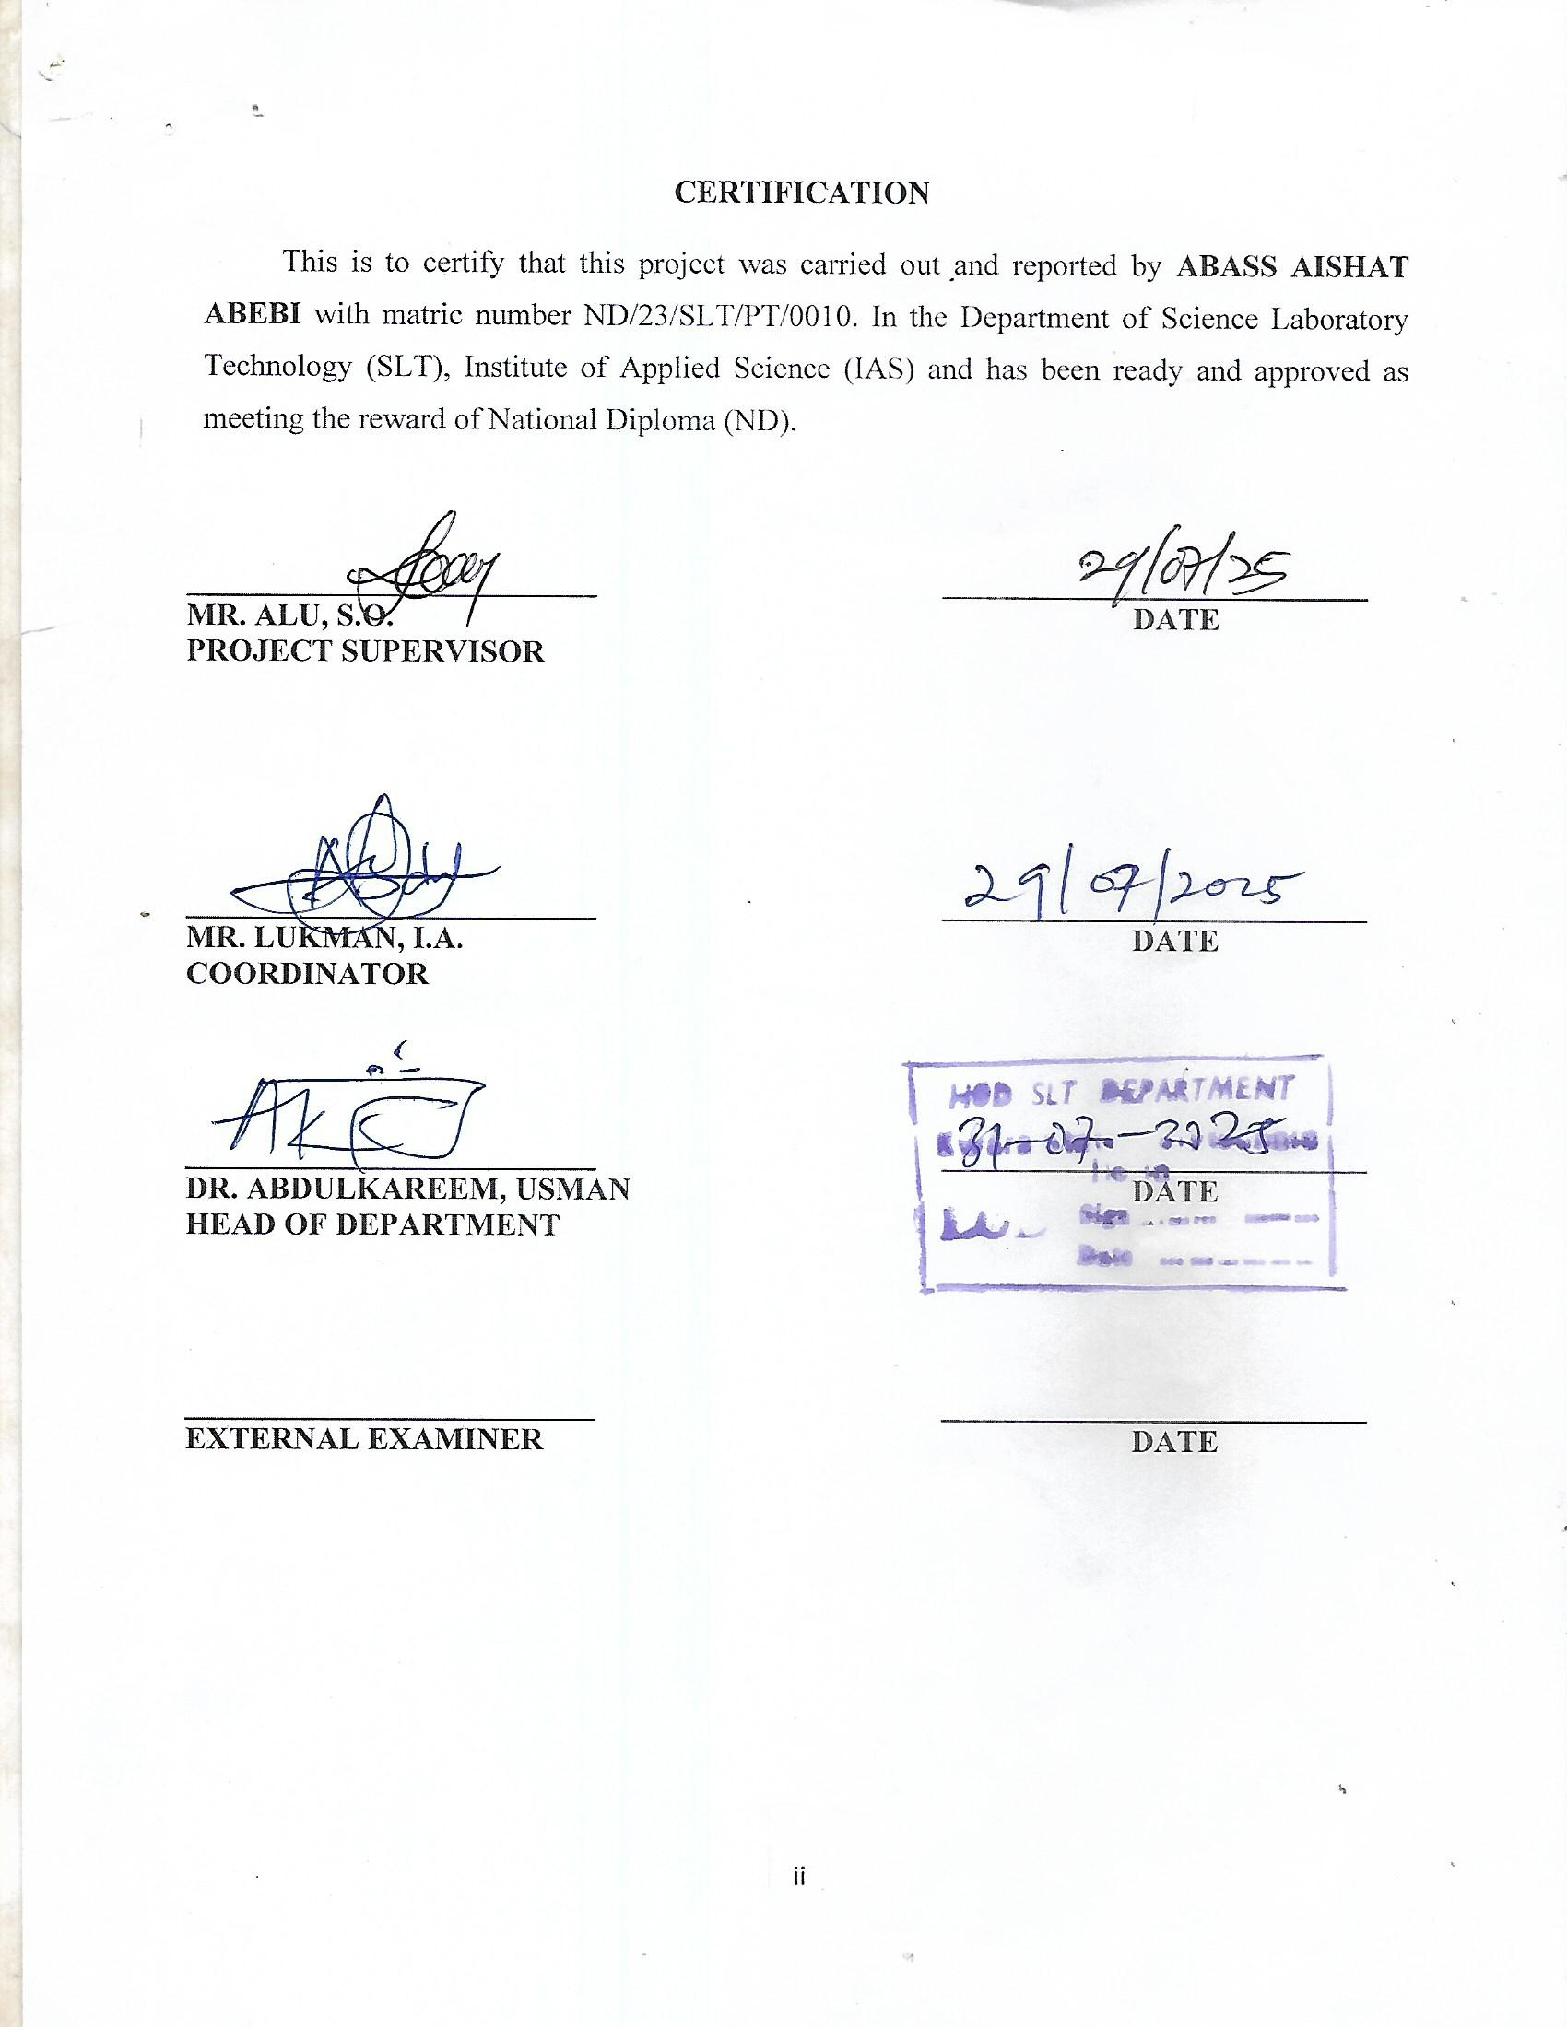

DEDICATION
This research work is solemnly dedicated to Almighty God. We also dedicate this project to our loving parents.

ACKNOWLEDGEMENT
My gratitude goes to Almighty Allah, the most high, the omnipotent and omniscience for His guidelines, His grace and unending mercy that was evidence in my life and for making me to complete my National Diploma (ND) successfully.
My profound gratitude goes to my project supervisor Mr. Alu, S.O., for his advise, encouragement and perseverance during the course of my National Diploa. I pray Almighty Allah will grant all you favour.
I appreciate my entire lecturers for their moral, academic and advice, you are all a pillar to my success.
I also acknowledge the efforts of my parents Mr. and Mrs. Abass, for their spiritual, moral, financial and perseverance during my National Diploma program. I pray Almighty Allah will allow you to reap the fruit of your labor (Amen)
Finally, I appreciate my distinguished friends; for their advice, kinds and moral support during the course of my program. We shall all meet at higher places (Amen).

TABLE OF CONTENTS
CERTIFICATION ii
DEDICATION iii
ACKNOWLEDGEMENT iv
TABLE OF CONTENTS v
ABSTRACT vi
CHAPTER ONE 1
1. Introduction 1
1.2 Short historical overview 1
CHAPTER TWO 5
2.1 Materials and methods 5
2.2 Treatment design 5
CHAPTER THREE 6
3.1 Results 6
CHAPTER FOUR 7
4.1 Discussion 7
REFERENCES 9

ABSTRACT
The situation of taxidermy and taxidermists in Bangladesh is discussed. An analysis of scientific collections of vertebrates in all universities and zoological institutes of Bangladesh is given. The results are unsatisfied. A modern taxidermy and collection storage and collection management is missing in the whole country. Some proposals of future development and saving the small number of well prepared specimens are shown. For modern taxidermy Bangladesh needs well educated and trained taxidermists. The scientific collections need more attention, because they are the basic of a modern biological education and for research. Also a professional pest control and protection management of the collection is needed.

CHAPTER ONE

1. Introduction
Taxidermy is a general term describing the many methods of reproducing a life-like three-dimensional representation of an animal for permanent display (layne 1998). In some cases, the actual skin (including the fur, feathers or scales) of the specimen is preserved and mounted over an artificial armature (WilliaMs 1996). In other cases, the specimen is reproduced completely with man-made materials. The word „taxidermy“ is derived from ancient Greek: taxis = means movement, and derma = skin (WilliaMson 1994). This is a fairly appropriate definition as many taxidermy procedures involve removing the natural skin from the specimens, replacing this skin over an artificial body, and adjusting the skin until it appears life like (Farber 1977). The art of bio-design is also called taxidermy. This usually means entire skin of an animal have to skinning with a particular strategy and makes an animal like previous exact live animal by a specific method (Cook 1954). Bengali meaning of taxidermy is animal skin representation or skin reflection. Taxidermy can be done on all vertebrate species of animals. Modern taxidermy can be done also for some invertebrates (Chan 1961).
Several authors described the process of taxidermy and their progress beginning from the last decades of 18th century up to now as well as the methods of pest control of the prepared animals (Walker 1869, luCas 1898, davie & oliver 1900, east 1954, PrinCe et al. 2003). For modern taxidermists the knowledge about anatomy, behavior and ecology of their objects is absolutely necessary.

1.2 Short historical overview
Taxidermy has existed since man began hunting. Archeological evidence of very early taxidermy shows the remains of animals draped over rocks and blocks of wood, which experts speculate may have served either a totemic purpose, or simply served as target practice for novice hunters (allard et al. 1994). Taxidermy in modern sense, however, didn’t really begin until the
18th century (Wonders 2005).
Initially, taxidermy was a crude and unsophisticated process. Animals were literally gutted, their hides were tanned and then stuffed with cotton or straw and sewed back up for display. These early attempts did not go over so well, though, because the animal was never properly preserved. This mean that the eyes, nose, teeth and tongue would eventually rot (broWn 1833). The majority of taxidermists have a deep knowledge and appreciation of natural history as this helps them to accurately preserve the specimen and recreate the natural living environment. Taxidermy is a highly skilled craft and the quality of work depends on the knowledge, patience and artistic ability of the exponent. Modern materials are available and techniques are constantly being updated, giving far better results (sterling 1989).
Taxidermy is becoming a growing wildlife art all over the world. Ever since the pioneers’ introduction of more detailed taxidermy procedures, taxidermists around the world have been continuously looking for more ways to create artistic reproduction of animals. Canada has been one of the countries fervently supporting the art of taxidermy (sMith & PaMela 2004).
The methods of taxidermy were found in the books of Belon (1517-1564) who was the naturalist in France. belon wrote the earliest scientific explanation and instructions for taxidermy procedures in 1555. His principal achievement was a history of birds ,L’Histoire de la nature des oyseaux‘ (The Natural History of Birds)
After that olina (1622) and aitinger (1626) gave a brief description of taxidermy or likely methods of their century and described the procedures of taxidermy. In the same year, olina & Pietro (1622) wrote the book „Uccelliera overo discorso della natura e proprieta di diversi uccelli“ in Rome and described the method of taxidermy.
After many years, reauMur & eerChault (1748) published the „Preserving Dead Birds as Taxidermy“ in London. kuCkhan (1771) also described the process of bird taxidermy.
Other scientists of the 18th century published also several papers and books about early taxidermy, like lettsoM (1774) and Cutler (1795). The more developed methods in the beginning time of industrial revolution during the 19th century was described by many specialists and those who want to become one. Examples are the works boWdiCh (1820), broWn (1833), lee (1843), baird (1854), Peale (1864), Walker (1869), Manton (1876), holder (187a, b), Maynard (1883) and allen (1891). They all described several and different methods of taxidermy on vertebrates and only a few also on insects or other invertebrates.
The more or less same situation can be found in the beginning of the 20th century, but some methods were developped on a more scientific base. The natural history museums in the United Kingdom, USA, Germany and France increased their collections hardly and so the interest on a good and sustain conservation and preparation for bigger public exhibitions demand modern methods of taxidermy. These were published for example by holden (1914), nutting (1917), shuFeldt (1917), Preble & grinnell (1926) and soPer (1943). From the last decades of the 20th century the number of publications about modern taxidermy is enormously. For example we listed only a few of them in this paper, like vonendt (1959), Waller & WilliaM (1965), Parker & holliMan (1972), Farber (1977), Morris (1982), PiMM (1986), held (1989) and layne (1998). The development of new synthetic materials and coulours, special instruments, connected with scientific research of pest control in collections bring a new quality in the science of taxidermy as well for scientific collections as in exhibitions. Altogether with new methods of storage in collections the new taxidermy shows in the present time a high level of science and aesthetics.
In the beginning 21st century the papers on taxidermy deal with more special facts of preparation, conservation, pest control or coulouration of single groups. So sirois & sansouCy (2001) described an analysis of museum objects for hazardous pesticides residues for a guide to techniques. desMond (2002) published his book on ‘Displaying Death Animating Life’ in India for Changing Fictions of liveness from taxidermy to animatronics.
PrinCe et al. (2003) also published ‘Stuffing Birds, Pressing Plants, and Shaping Knowledge’ from USA for the natural history in North America. sMith & beentjes (2010) published an overview of taxonomy USA, while hagen et al. (2003) give an overview of the methods of bird taxidermy in Germany from ancient time up to the Renaissance.
For Bangladesh evident are the papers of das (2010). He described the history of taxidermy, the necessity of taxidermy and the necessity of natural history museum in Bangladesh. FisCher (2010) described these facts too and give some ideas for teaching and future projects.

CHAPTER TWO

2.1 Materials and methods
A total of 12 guinea pigs [Cavia porcellus (Linnaeus, 1758)] samples were collected from a private farm in Rajshahi. Guinea pigs were selected for this experiment because of their availability and they are farmed. Wild animals should not be taken for this type of experiment where they are killed. Age of the guinea pigs were 21days.The average weight of the animals was 150 g and they was couloured black, yellow and white. This experiment started on May, 2012 to February, 2013.

2.2 Treatment design
Twelve guinea pigs were divided into four groups and treated as:
Group A: Treated with Copper (ΙΙ) sulfate.
Group B: Treated with Arsenic trioxide. Group C: Treated with neem and borax.
Group D: Control.

CHAPTER THREE

3.1 Results
Degrees of infection on treated and control guinea pigs are provided in Table 1. As a result it was evident that R1, R2 and R3 treated with neem and borax were moderately infected by fungus. Pest infection did not find in samples of R1, R2, R3 treated with copper (ΙΙ) sulfate and arsenic trioxide. Control guinea pigs were moderately infected by fungus and insect pests.
R1 treated with copper (ΙΙ) sulfate were moderately infected by fungus. Whereas pest infection did not find in samples of R2, R3 with copper (ΙΙ) sulfate and the samples of R1, R2 and R3 with arsenic trioxide. R1, R2 treated with neem and borax were highly infected by fungus and moderately infected in R3 replication. Control guinea pigs were highly infected by fungus and insects. R1, R2 treated with neem and borax were severe infected by fungus and highly infected in R3 replication.
Control guinea pigs were highly infected by fungus and insects.
R1, R3 treated with copper (ΙΙ) sulfate were moderately infected by fungus. Pest infection did not find in samples of R2 with copper (ΙΙ) sulfate and the samples of R1, R2 and R3 with arsenic trioxide. Whereas R1, R2, R3 treated with neem and borax were severe infected by fungus. Control guinea pigs were severe infection by fungus and insects.

CHAPTER FOUR

4.1 Discussion
From the result it is evident that fungus and insect pests were found in the stuffed animals of different replications (R1, R2, and R3) and control group. From the Table 19, it is also evident that highest degrees of pest infection were in the Neem and Borax followed by Copper (ΙΙ) Sulfate. Fungus and pest infection did not find in the replications R1, R2, R3 treated with Arsenic Trioxide.
Treated guinea pigs with Copper (ΙΙ) Sulfate were attacked by arachnids and fungus after three months. Fungus and Mallophagas insects were found in the control group. Altogether insect’s species, arachnid and fungal species were recorded as the pests of stuffed animals in the experimented animals.
Although very early in the beginning (16th to 18th) of taxidermy, arsenic was a popular in museum stuffed animals but day by day the use of arsenic is relatively low now (from 19th century) depending on the harmful effect of arsenic. It has become evident that increasing human activities have modified the global cycle of heavy metals and metalloids, including the toxic nonessential elements like As, Hg, Cd, and Pb (roy & saha 2002).
In taxidermy, arsenic is better known for the preservative arsenical soap, invented by the French Jean-Baptiste Becoeur (1718-1777). During his lifetime, Becoeur kept the composition of his miraculous product a secret and it was not revealed until 1800 (duFresne 1800). The preservative was composed of camphor, arsenic oxide, carbonate of potash, soap and lime powder. This composition has been fairly constant through the centuries (Pequignot 2002).
The history of taxidermy shows us that the vast majority of stuffed animals found in museum collections may have been prepared with arsenic. This does not only cover ,ancient specimens‘ as arsenic has been used in more recent times (haWks & WilliaMs 1986, knaPP 2000).
Arsenic produced good results, however, due to its tremendous side effects on human health this cannot be recommended in taxidermy. The second option (copper sulfate) from the present experiment could be used but this is also not enough for long lasting. However, in order to have more effective result, mixture of copper sulfate and different types of botanicals (following permutation and combination method) are recommended.
Although arsenic is dangerous for human health then it can be used for taxidermy work in Bangladesh by taking lot of awareness or caution. Air condition and proper management must be needed for any kind of museums for keeping long lasting of the animals. On the other hand, it can be also used by looking tannery factory in Bangladesh which chemicals they used for making skin tanning so that a taxidermist can use these chemicals by following permutation and combination method. But to make competition with other countries, all chemicals can be ordered from different taxidermy companies or looked in alternative chemicals in Bangladesh which can be ideal used for the animal Preparation.

REFERENCES
Aitinger, J. C. (1626): Kurtzer und einfeltiger Bericht von dem Vogelstellen. - Cassel.
Allard, M., s. bouCher & l. Forest (1994): The Museum and the School. - McGill Journal of Education 29 (2):1-12.
Allen, J. A. (1891): Hornaday’s Handbook of Taxidermy and Zoological Collecting: Taxidermy and Zoological Collecting a Complete Handbook for the Amateur Taxidermist, Collector, Osteologist, Museum Builder, Sportsman and Traveller by William T. Hornaday. - The Auk 8 (4): 381-383.
Baird, S. E. (1854): Directions for collecting, preserving and transporting specimens of natural history. Prepared for the use of the Smithsonian Institution Washington, D.C.: Government Printing Office.
Belon, P. (1555): L’histoire de la nature des oyseaux. - Paris: Guillaume Cauellat.
Bowdich, T. L. (1820): Taxidermy: or the art of collecting, preparing and mounting objects of natural history. For the use of museum and travelers. - London: Longman.
Brown, T. (1833): The taxidermist’s manual: or, the art of collecting, preparing and mounting objects of natural history. - Glasgow: Archibald Fullartor.
Chan, G. (1961): An Ancient Method of Fish Mounting. - The American Biology Teacher 23 (7): 436-438.
Cook, E. F. (1954): A modification of Hopkins’ technique for collecting ectoparasites from mammalian skins. - Entomological News 65 (2):35-37.
Cutler, M. (1795): ,Doctor Cutler’s Method of Preserving the Skins of Birds.‘ - Collections of the Massachusetts Historical Society 4: 9-10.
Das, B. C. (2010): The History of Taxidermy, its Importance and Necessity of Natural History Museum in Bangladesh. Suvinil of a month long workshop on ‘Art of Bio-Design: Taxidermy’ 21 December 2010 to 22 January 2011, Department of Zoology, Rajshahi University, Bangladesh.
Davie & Oliver (1900): Methods in the art of taxidermy. - Philadelphia: David McKay.
Desmond, J. C. (2002): Displaying death, animating life: changing fictions of ,liveness‘ from taxidermy to animatronics. - In: Representing Animals (ed. rothFels, N.). University of Indiana Press, pp. 159-179.
Dufresne, L. (1800): Sur l’art de la taxidermie, considere par rapport aux Oiseaux, c’est-a-dire sur lart de depouiller, de droguer, de conserver et de monter les Peaux d’Oiseaux. - In: Traite Elementaire et Complet d’Ornithologie ou Histoire Naturelle des Oiseaux. (eds. F.M. daudin), pp. 439-462, 474. Paris,
France. east, C. S. (1954): Practical Taxidermy, A Working Guide by John W. Moyer. - The scientific monthly 78 (5): 330-331.
Farber, P. L. (1977): The Development of Taxidermy and the History of Ornithology. - Isis 68 (4): 550-566.
Fischer, M. (2010): The History of Taxidermy, its Importance and Necessity of Natural History Museum in Bangladesh. Suvinil of a month long workshop on ,Art of Bio-Design: Taxidermy‘ 21 December 2010 to 22 January 2011, Department of Zoology, Rajshahi University, Bangladesh.
Goldberg, L. (1996): A History of Pest Control Measures in the Anthropology Collections, National Museum of Natural History, Smithsonian Institution. - Journal of the American Institute for Conservation 35 (1): 23-43.
Grinnell, J. (1926): Taxidermy and Museum Exhibition by John Rowley. - Science, N. S. 63 (1639): 546-548. hagen, k., F. steinheiMer, r. kinzelbaCh & C. gasser (2003): Avian taxidermy in Europe from the Middle Ages to the Renaissance. - Journal of Ornithology 144: 459-478. hasan , a. M., M. d.
Hossain, M. M. Hasan & M. S. Rahman (2007): A pest of stuffed museum species Anthrenus scrophularie (L.) (Coleoptera: Dermestidae). - University journal of Zoology, Rajshahi University 26: 99-102.
haWks, C. A. & S. Williams (1986): Arsenic in natural history collections. - Leather Conservation News 2 (2): 1-4.
Held, Y. (1989): Regarding Taxidermy. - The North American Review 274 (4): 35-37. holden, F. H. (1914): A Method of Cleaning Skulls and Disarticulated Skeletons. - The Condor 16 (5): 239-241.
Holder, J. B. (1879a): Amateur Taxidermy. - The Art Amateur 1 (2): 40-41.
- (1879b): Amateur Taxidermy. - The Art Amateur 1 (3): 63-64. knaPP, A. M. (2000): Arsenic Health and Safety Update. - Conserve O Gram Washington, DC.
Kuckhan, T. S. (1771): Four letters from Mr. T. S. Kuckhan, to the President and Members of the Royal Society on the preservation of dead birds. - Philosophical Transactions 60: 302-320.
Layne, L. L. (1998): Introduction to taxidermy. - Science, Technology, & Human Values 23 (1): 4-23.
Lee, S. (1843): Taxidermy: or the art of collecting, preparing and mounting objects of natural history. - Sixth edition, London: Longman.
Lettsom, J. C. (1774): The naturalist’s and traveler’s companion, containing instructions for collecting and preserving objects of natural history and for promoting inquiries after human knowledge in general. - London.
Lucas, F. A. (1898): The Art of Taxidermy by John Rowley. - Science, N. S. 8 (188): 165-166.
Manton, W. P. (1876): Manton’s Taxidermy : Taxidermy without a Teacher. - The American Naturalist 10 (10): 1-623.
Maynard, C. J. (1883): Maynard’s Manual of Taxidermy: A Complete Guide in Collecting and Preserving Birds and Mammals by C. J. Maynard. - Science 2 (31): 312-313.
Morris, P. A. (1982): Stuffing for longevity. - New Scientist 95 (1320): 575. nutting, C. C. (1917): Museum Methods. - Transactions of the American Microscopical Society 36 (1): 13-19.
Olina & G. Pietro (1622): Uccelliera overo discorso della natura e proprieta di diversi uccelli. - Rome: Andrea Fei.
Peale, T. R. (1864): Method of preserving Lepidoptera. - Annual report of the board of regents of the Smithsonian Institution, 1864.Washington, D. C.: Government Printing Office.
PiMM, J. W. (1986): Using Taxidermy as a Science Motivator. - The American Biology Teacher 48 (7): 422-424.
Pinniger, D. & P. Winsor (1998): Integrated pest Management: A guide for museums, libraries and archives. - Museum and Gallaries Commission. London.
Preble, E. A. & J. Grinnell (1926): Taxidermy and Museum Exhibition by John Rowley. - Journal of Mammalogy 7 (4): 336-347.
PrinCe, S. A., F. H. T. Rhodes, R. M. M. PeCk, G. J. E. ChaPlin& j. e. boyd (2003): Stuffing Birds, Pressing Plants, Shaping Knowledge: Natural History in North America. - Transactions of the American Philosophical Society, N. S. 93 (4): 1-113.
Reaumur, R. A. & D. Eerchault (1748): Divers means for preserving from corruption dead birds, intended to be sent to remote countries, so that they may arrive there in a good condition. - Philosophical transactions of the Royal Society of London 45: 304-320.
Shufeldt, R. W. (1917): Taxidermy as an Art. - The Art World 3 (3): 210-214.
Sirois, j. P. & g. sansouCy (2001): Analysis of Museum Objects for hazardous pesticides residues: A guide to techniques. - Collection Forum 17 (1-2): 49-66.
Smith, P. H. & T. Beentjes (2010): Nature and Art, Making and Knowing: Reconstructing Sixteenth-Century Life-Casting Techniques. - Renaissance Quarterly 63 (1): 128-179.
Smith, P. h. & h. PaMela (2004): The Body of the Artisan: Art and Experience in the Scientific Revolution. - Chicago.
Soper, J. D. (1943): A Method of Remaking Old Bird Skins. - The Auk 60 (2): 284-286. sterling, K. (1989): A Natural History Bookshelf: Martha Maxwell: Rocky Mountain Naturalist by Maxine Benson; Gary R. Goff;
American Wildlife in Symbol and Story by Angus K. Gillespie. - Journal of Forest History 33 (3): 145-149.
Vonendt, D. W. (1959): Pest control in galleries and natural history museums. - Pest Control 27 (11): 9-12.
Walker, C. A. (1869): Hints on Taxidermy. - The American Naturalist 3 (3): 136-146.
Waller, r. a. & n. e. WilliaM (1965): A method for preserving color in biological specimens. - Biological Sciences 15 (5): 36.
WilliaMs, L. W. (1996): Taxidermy. - The Iowa Review 26 (3): 69-85. WilliaMson, G. (1994): Taxidermy. - Poetry 164 (5): 282.
Wonders, K. (2005): Hunting Narratives of the Age of Empire: A Gender Reading of Their Iconography. - Environment and History 11 (3): 269-291.

