A PROJECT REPORT
ON
PROPOSED DENTAL CLINIC
FOR
MUSTAPHA AKANBI COMMUNITY, ILORIN, KWARA STATE.

By:
BILAL MUBARAK BABATUNDE
ND/23/ARC/FT/0017

Submitted to:
THE DEPARTMENT OF ARCHITECTURAL TECHNOLOGY INSTITUTE OF ENVIRONMENTAL STUDIES (IES) KWARA STATE POLYTECHNIC, ILORIN

IN PARTIAL FULFILMENT OF THE REQUIREMENTS FOR THE AWARD OF NATIONAL DIPLOMA (ND) IN ARCHITECTURAL TECHNOLOGY

JULY, 2025.
DECLARATION
I declare that this design project/Dissertation is a project of my personal work. It has been presented for the award of any National Diploma in any Polytechnic. The ideas, observation, comment, suggestions herein represent my own convictions, except quotations, which have been acknowledged in accordance with conventional academic traditions under the supervision of ARC. OLAREWAJU F. A
BILAL MUBARAK BABATUNDE __________________________
ND/23/ARC/FT/0017 DATE/SIGNATURE

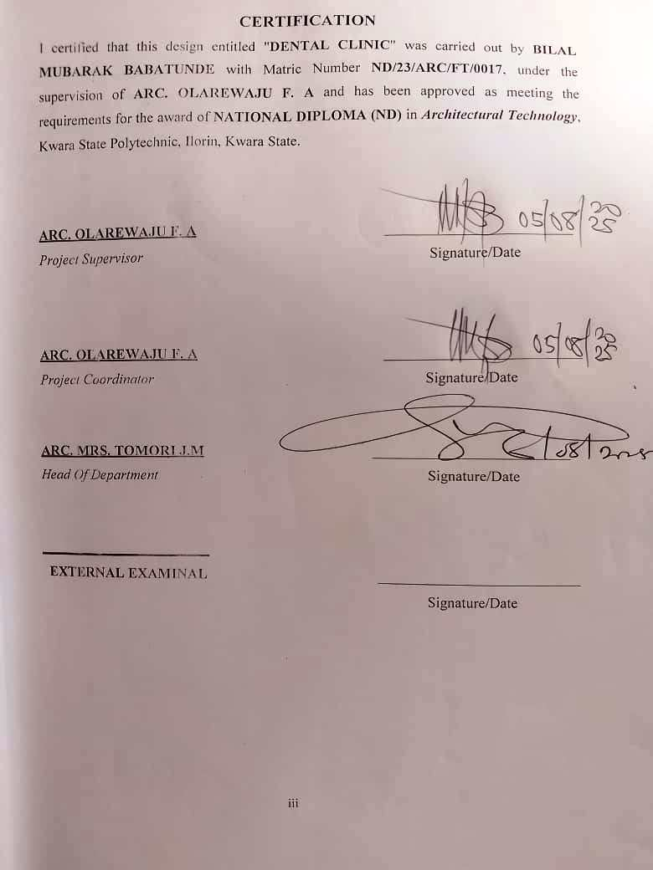

DEDICATION
I dedicate this project to Almighty God, the source of my wisdom, strength, and inspiration. His grace has guided me through every challenge, and His blessings have made this achievement possible. And I also to my beloved parents, MR & MRS BILAL and MR AJAO whose unwavering love, sacrifices, and support and prayers have been greatest motivation.
iv

ACKNOWLEDGEMENTS
Everything that has beginning must have an end, I express my deepest gratitude to Almighty Allah for granting me the strength, wisdom and perseverance to successfully complete this project. His guidance and blessing have been my greatest support throughout this journey.

A very special thanks and appreciation goes to my able supervisor ARC.OLAREWAJU F.A for the invaluable guidance, patience and constructive feedback. Their expertise and mentorship have played a crucial role in shaping this project and I am truly grateful for their support.

Also I appreciate my H.O.D. ARC. MRS.TOMORI J.M and my lovely lecturer in my department.

I extend my heartfelt appreciation to my parents [MR & MRS BILAL] and MR AJAO for their unwavering love, encouragement and sacrifices, their constant support and belief in me have been a source of motivation.

My sincere appreciation goes to my friends and colleagues who gave provided encouragement, advice and companionship throughout this project, their support has made this experience more fulfilling.
v

ABSTRACT
The report write-up covers the design and development of a proposed dental clinic. It includes the location of the proposed site, a brief history of dental care services, the aim and objectives of the project, relevant case studies, along with drawings and pictures from each case study. This proposed dental clinic is to be located in Kwara State, with the purpose of providing a more functional, hygienic, and accessible healthcare facility for both patients and professionals in the area. The design takes into serious consideration the standards for medical environments, patient comfort, aesthetics, and the proper zoning of spaces for smooth workflow. This project will be a helpful guide to anyone interested in designing or understanding the layout of a dental healthcare facility.

TABLE OF CONTENTS
TITLE PAGE…………………………………………………………………..........i
DECLERATION………………………………………………………………...…. ii
CERTIFICATION………………………………………………………………….. iii
DEDICATION………………………………………………………………………iv
ACKNOLEDGMENT …………………………………………………………… v
ABSTRACT……………………………………………………………………...…. vi
TABLE OF CONTENTS…………………………………………………………… vii
LIST OF PLATES……………………………………………………………….…. x
LIST OF FIGURES………………………………………………………………… xi
LIST OF TABLES………………………………………………………………… xii
LIST OF APPENDICES…………………………………………………………….xiii
CHAPTER ONE
1.0 INTRODUCTION………………………………….………….………………………1
1.1 HISTORICAL BACKGROUND…………………………….………………..………2
1.2 DEFINITION…………………………….…………………….…...…………………3
1.3 STATEMENT O F THE RESEARCH PROBLEM. ………………………………….3
1.4 AIM AND OBJECTIVES………………………………………..………………..…..3
1.5 JUSTIFICATION………………………………………………………………….…..4
1.6 SCOPE OF STUDY………………………………………………………………..…4
1.7 LIMITATIONS OF STUDY………………………………………………………..…4
1.8 RESEARCH METHODOLOGY…………………………………………………...…5

vii

CHAPTER TWO

2.1 LITERATURE REVIEW …………………………….…………………………………. 6
2.1.1 INTRODUCTION………………………………………………………………………...6
2.1.2 IMPORTANT ISSUES AND PROBLEMS PECULIAR TO DENTAL CLINIC TYPOLOGY………………………………………………………………………....7
2.1.3 TECHNOLOGICAL AND ENVIRONMENTAL APPROACHES FOR DESIGNING A DENTAL CLINIC……………………………...……………………………….………..8
2.2 MERIT OF STUDYING……………………………………………………….…10
2.3 CONCLUSION ………………………………………………………………….10

CHAPTER THREE
3.0 CASE STUDY……………………………………………………………….….…. 11
3.1 OUTLINES OF THE CASE STUDIES……………………………...………….…..11
3.1.1 CASE STUDY ONE (1): General Hospital Dental Clinic Ilesa Osun State……….11
3.1.2 CASE STUDY TWO (2): University Of Ilorin Teaching Hospital Dental Clinic.……………………………………………………………………..………………...16
3.1.3 CASE STUDY ONE (3): Choice Dental Clinic Ikeja Lagos State.…………………....19
3.1.4 CASE STUDY FOUR (4): Hicks Orthodontics Dental Clinic United State (Online Case Study).………………..………………………………………………………………...23
3.1.5 CASE STUDY FIVE (5): Yokoi Dental Clinic Japan (Online Case Study)……………………………………………………………………………………….27

CHAPTER FOUR
4.1 ANALYTICAL STUDY OF THE PROJECT LOCATION…………………………24
4.1.1 INTRODUCTION…………………………………………………………………….24
4.1.2 SITE LOCATION…………………………………………………………………….24
4.1.3 SITE INVENTORY…………..…...…………………………………………………26
4.1.4 SITE ANALYSIS………………...…………………………………………………..26
4.1.5 GENERAL GEOGRAPHICAL CONDITION…………………….……………..….27
4.1.6 CLIMATE …………………………………………………………………………………...27
4.1.7 VEGETATION………………...………………………………………………..…..29
4.1.8 TOPOGRAPHY………………...……………………………………………… …..29
4.1.9 NATURAL RESOURCES………………...…………………………………….… 29
4.1.10 ENVIRONMENTAL CHALLENGES…………………………………………… ..29
4.1.11 SITE SERVICES………………………………………………………………… …30
4.1.12 SITE UNIQUENESS AND BENEFIT………………………………………………30
4.1.13 SITE SUITABILITY……………………………………………………………….30
4.2. DESIGN CRITERIA……………………………………………………………….30
4.2.1 SITE SELECTION………………………………………………………...……….30
4.2.2 BUILDING ARRANGEMENT…………………………………………………….31
4.2.3 DESIGN SCOPE…………………………………………...……………………….31
4.2.4 DESIGN BRIEF 9ANALYSIS…………………………………………………….31
4.2.5 SPACES DERIVATION ANALYSIS/SCHEDULE FOR ADMINBLOCK………32
4.2.6 FUCTIONAL ANALYSIS AND RELATIONSHIP………………………………32

CHAPTER FIVE
5.1 APPRAISAL OF PROPOSED SCHEME………………………………………….34
5.2 CONSTRUCTION METHODOLOGY AND MATERIALS. …………………….34
5.21 MATERIALS FOR CONSTRUCTION……………………………………………34
5.2.2 CONSTRUCTION METHODOLOGIES………………………………………….34
5.2.1 SERVICE……………………………………………………………………….….36
5.2.2 CIRCULATION……………………………….……………………………….….36
5.2.3 VENTILATION……………………………………….……………………….….36
5.2.4 LIGHTING……………………………………….……………………………….37
5.2.5 PLUMBING ……………………………………….……………….…………….37
5.2.6 ELECTRICAL INSTALLATION……………………………..………………….37
5.2.7 WASTE DISPOSAL……………………………………….…….……………….37
5.2.8 FIRE PROTECTION……………………………………………………………..38
5.2.9 EXTERNAL WORKS……………………………………………..……………..38
5.3 CONCLUSION AND RECOMMENDATION………………………………….38
REFERENCES………………………………………………………………………….39

LIST OF PLATES
CASE STUDY 1
PLATE 3:1.1 LOCATION MAP………………………………………………………….13
PLATE 3.1.2 ELEVATION……………………………………………………………….14
PLATE 3.1.3 ELEVATION ……………………………………………………………….15
PLATE 3.1.4 ELEVATION …………….……………………………………...………….15
CASE STUDY 2
PLATE 3.2.1 ELEVATION………………..……………………………………………18
PLATE 3.2.2 ELEVATION … ………………………………………………………….18
CASE STUDY 3
PLATE 3.3.1 LOCATION MAP………………………………………………………….20
PLATE 3.3.2 ELEVATION ……………………………………………………………….21
PLATE 3.3.3 ELEVATION ….…………...……………………………………...……….22
PLATE 3.3.4 ELEVATION ….…………...……………………………………….……...22

LIST OF FIGURES
FIGURE 3:1:1 LOCATION PLAN CASE STUDY 1…………………………..………12
FIGURE 3.1.2 FLOOR PLANS CASE STUDY 1…….……………………………..…13
FIGURE 3:1.3 SITE PLAN CASE STUDY 1 ……………………...…………….……14
FIGURE 3.2.1 LOCATION PLAN CASE STUDY 2…………………………………15
FIGURE 3.2.2 FLOOR PLANS CASE STUDY 2………………………………….…15
FIGURE 3.3.1 LOCATION PLAN CASE STUDY 3…………………………….……20
FIGURE 3.3.2 FLOOR PLAN. CASE STUDY 3…………………..……………….…21
FIGURE 4.1.11.1 MAP OF NIGERIA, 36 STATES AND FCT. ……………..………24
FIGURE 4.1.11.2 KWARA STATE MAP…………………………………..…………25
FIGURE 4.1.11.1 LOCATION PLAN …………………………………..………….…25
FIGURE 4.1.12.1 SITE INVENTORY …………………………………….……….…26
FIGURE 4.1.12.2 SITE ANALYSIS ……………………………..………..……….…27
FIGURE 4.1.3.1 AVERAGE MONTHLY RAINFALL IN ILORIN. …….….………28
FIGURE 4.1.3.2 SUNSHINE DURATION IN ILORIN. ………………………..……28
FIGURE 4.1.3.3 RELATIVE HUMIDITY IN ILORIN. ………………………..……29
FIGURE 4.2.6.1: FUNCTIONAL ANALYSIS ………………………………….…32
FIGURE 4.2.6.2: FUNCTIONAL RELATIONSHIP……………………………….…33

LIST OF TABLES

TABLE 4.2.5: SPACE ALLOCATION………………………………………………32

LIST OF APPENDICES
APPENDICES 5.1: FLOOR PLAN…………………………………………..40
APPENDICES 5.2: ROOF PLAN ………………………………………………………..41
APPENDICES 5.3: SITE PLAN……………………………………………………..…..42
APPENDICES 5.4: SECTIONS……………………………………………………..…..42
APPENDICES 5.5: ELEVATION……………………………………………….…..…..43
APPENDICES 5.6: INTERNAL PERSPECTIVE. ………………………………………43
APPENDICES 5.7: EXTERNAL PERSPECTIVE. ………………………………………43

CHAPTER ONE
INTRODUCTION TO DENTAL CLINIC
A dental clinic is a specialized healthcare facility designed for the diagnosis, prevention, and treatment of oral health problems. It serves as a dedicated environment where dental professionals, including dentists, dental surgeons, hygienists, and technicians, deliver a wide range of services—from basic teeth cleaning to complex oral surgeries. Unlike general hospitals, dental clinics are tailored to meet the unique spatial, hygienic, and technological needs of oral healthcare.
The importance of oral health in maintaining overall physical well-being has been widely recognized. Poor dental hygiene can lead to various health issues such as infections, heart disease, and low self-esteem. As such, the role of dental clinics in public health cannot be overemphasized. In addition to clinical services, modern dental clinics also focus on patient comfort, psychological support, and education on preventive care.

1.1 HISTORICAL BACKGROUND OF THE PROJECT
Oral healthcare has evolved significantly over the centuries, from informal traditional practices to modern dental medicine supported by advanced technology and professional regulation. In ancient civilizations such as Egypt and Greece, dental treatment was often primitive, performed by general healers using crude tools. Over time, dentistry emerged as a specialized field, especially in the 18th and 19th centuries, when formal training and dedicated dental practices began to appear in Europe and North America.
In Nigeria, traditional oral care existed long before the introduction of Western dental medicine. Herbal remedies and extractions by local healers were common methods used to manage toothaches and infections. However, with colonial influence and the establishment of medical institutions, modern dentistry gradually developed. The first formal dental services in Nigeria were provided in government hospitals during the early 20th century. By the 1970s, dental schools had been established, and more trained professionals were entering the field.

Despite these advancements, access to quality dental care remains limited in many parts of the country. Many dental clinics operate from converted residential or office spaces that are not purpose-built, often lacking proper zoning, ventilation, and hygiene control. As the awareness of oral health continues to grow, there is a need for the architectural design of dental clinics to meet global standards in terms of functionality, patient comfort, and infection prevention.

1.2 DEFINITION
A dental clinic is a healthcare facility that provides services for the prevention, diagnosis, treatment, and management of oral health issues. It is staffed by dental professionals, including dentists, hygienists, and assistants, who offer a range of services such as routine checkups, cleanings, fillings, extractions, orthodontic treatments, and more.
1.3 STATEMENT O F THE RESEARCH PROBLEM.
Many existing dental clinics in Ilorin are constrained by poor layout planning, inadequate waiting and consulting spaces, insufficient ventilation, lack of privacy and absence of modern digital systems for patient data and queue management. These issues compromise service delivery, increase patient wait times, and reduce staff efficiency.
There is a need for a new kind of dental clinic — one that is accessible, technologically equipped, and spatially optimized to deliver safe and efficient oral healthcare services in a conductive environment.
1.4 AIM AND OBJECTIVES
1.3.1 AIM OF THE STUDY
The aim of this project is to design a modern, functional and sustainable dental clinic that provide high-quality, comprehensive and enhance patient satisfaction and contributes positively to the community's well-being
1.3.2 OBJECTIVES
- To ensure that the architectural design supports a clean, calm, and welcoming healthcare environment for both patients and staff.
- To create functional spaces that meet the clinical and operational needs of a modern dental clinic.
- To prioritize the use of natural lighting and cross ventilation for energy efficiency, hygiene, and user comfort.
- To propose a flexible and accessible design that meets the needs of all users.

1.5 JUSTIFICATION.
Many communities face disparities in access to dental care, leading to untreated dental issues and poor oral health outcomes. This is to justify and identify specific barriers to access and propose solutions to improve service delivery in underserved populations, at akerebiata Ilorin.

1.6 SCOPE OF THE STUDY
The proposed dental clinic is to be designed as a modern, purpose-built facility that focuses on delivering efficient oral healthcare services within a functional and hygienic environment. The study covers the planning and architectural design of core spaces such as reception areas, consulting rooms, sterilization units, X-ray rooms, and staff areas. It also explores how healthcare standards, patient comfort, and sustainable design principles can be integrated.

1.7 LIMITATIONS OF STUDY
The limitations experienced during this course of study include:
- Time constraints limited the number of physical case studies that could be visited.
- Access to detailed health facility regulations was partially restricted.
- Budgetary concerns for full digital system implementation were assumed, not actualized.

1.8 RESEARCH METHODOLOGY
In order to archive a well-functioning and organization farmstead and to know what the farmer need; the research was done.
- Case Studies: Existing dental clinics were visited to evaluate their spatial organization, design merits, and operational challenges.
- Literature Review: Relevant architectural texts and healthcare design manuals were consulted to understand the spatial, technical, and functional requirements of dental facilities.
- Internet Research: Online platforms were used to explore modern dental clinic designs globally, with emphasis on digital integration and user-centered layouts.
- Personal Observation: Direct site visits and informal interviews were conducted to observe real-life clinic operations, document activities, and gather user feedback for informed design decisions.
CHAPTER TWO
2.1LITERATURE REVIEW
2.1.1 Introduction
This literature review explores the architectural design principles, functional requirements, and modern innovations relevant to the development of a dental clinic. As oral healthcare facilities require both clinical precision and patient comfort, the review draws on established architectural standards, case studies, and technological trends to guide the proposed design.

The review aims to understand how dental clinics have evolved in terms of spatial planning, digital integration, infection control, and environmental design. It also considers how current practices in Nigeria compare with international standards, with the goal of designing a dental clinic that is efficient, user-friendly, and adaptable to local needs.

2.1.2 IMPORTANT ISSUES AND PROBLEMS PECULIAR TO DENTAL CLINIC TYPOLOGY
1. Variants of the Building Type

Dental clinic designs can vary significantly depending on their scale, function, ownership, and location. These differences directly affect the design approach, spatial planning, and technological integration.

- PRIVATE VS. PUBLIC DENTAL CLINICS

Private Clinics
- Design Focus: Emphasis on patient comfort, aesthetics, and personalized services.
- Scale: Typically smaller, with 2–4 treatment rooms.
- Flexibility: Greater freedom in spatial layout, design style, and digital system integration.
- Limitations: May lack advanced surgical facilities due to space or budget constraints.

Public or Teaching Clinics
- Design Focus: Efficiency, high capacity, and compliance with government standards.
- Scale: Larger, with multiple consulting rooms, teaching spaces, and diagnostic units.
- Zoning Needs: Clear separation of clinical, academic, and administrative functions.
- Challenges: Overcrowding, complex circulation, and high maintenance demand.

- STAND-ALONE VS. HOSPITAL-BASED CLINICS

Stand-Alone Clinics
- Operate independently, typically located in residential or commercial areas.
- Require full administrative, sterilization, and emergency systems within the same facility.
- Greater emphasis on outpatient flow and street-level accessibility.

Hospital-Based Dental Clinics
- Function as a department within a general hospital.
- Share central facilities such as laboratories, records, and emergency services.
- Design must accommodate multidisciplinary interaction and compliance with hospital-wide standards.

2. Environmental and Contextual Issues

- URBAN CLINICS
- Space Limitations: Clinics located in urban centers often struggle with compact sites.
- External Noise: Proximity to busy roads affects patient comfort.
- Parking and Access: Limited space for vehicle access and drop-off.

- Rural or Semi-Urban Clinics
- Infrastructure Gaps: Poor access to electricity, water, or waste disposal services.
- Material Availability: Limited options for hygienic, durable building materials.

2.1.3 TECHNOLOGICAL AND ENVIRONMENTAL APPROACHES FOR DESIGNING A DENTAL CLINIC.
Designing a modern dental clinic requires an integrated approach that leverages both technological innovations and environmentally sustainable strategies. These approaches not only enhance the efficiency and functionality of the clinic but also improve patient experience, reduce operational costs, and promote environmental stewardship.
- TECHNOLOGICAL APPROACHES
1.1 Digital Integration and Health Management Systems
- Electronic Medical Records (EMR): A centralized, secure system for storing and retrieving patient data, improving record accuracy and minimizing paperwork.
- Automated Appointment Systems: Use of digital scheduling software to manage bookings, send reminders, and reduce patient wait times.
- Patient Self-Check-In Kiosks: Touchscreen kiosks can streamline patient registration and reduce front desk congestion.
- Dental Imaging Systems: Integration of digital X-rays, intraoral cameras, and 3D imaging (CBCT) improves diagnostic accuracy and patient communication.

1.2 IT and Communication Infrastructure
- High-Speed Internet: Essential for cloud-based record systems, real-time consultation, and digital imaging.
- Intranet Systems: For internal communication between departments (e.g., reception to lab or sterilization room).
- Secure Network and Backup Systems: Ensuring data security, confidentiality, and recovery in case of system failure.

1.3 Smart Clinic Features
- Automated Lighting and HVAC Controls: Motion or schedule-based systems to reduce energy waste.
- Voice-Activated Assistants and Touchless Controls: For improved hygiene and workflow in treatment areas.
- Central Display Monitors: Used in consulting rooms for treatment planning, patient education, and real-time imaging display.

- ENVIRONMENTAL APPROACHES
2.1 Sustainable Building Design
- Passive Cooling and Cross Ventilation: Oriented window openings, openable clerestory windows, and ventilated roofing help reduce reliance on mechanical cooling systems.
- Natural Daylighting: Maximize use of daylight through skylights and wide glazed surfaces, particularly in waiting and circulation areas.
- Thermal Insulation: Use of insulated roofing materials and cavity walls to reduce indoor temperature fluctuation and cooling load.

2.2 Renewable Energy Integration
- Solar Power Systems: Rooftop solar panels can supply energy for lighting, computers, and low-power devices, reducing utility costs and environmental impact.
- Solar Water Heaters: Used for handwashing stations and sterilization rooms.

2.3 Water Conservation Strategies
- Rainwater Harvesting: Captured rainwater can be reused for landscaping, flushing toilets, and exterior cleaning.
- Low-Flow Fixtures: Faucets, toilets, and dental unit water lines fitted with flow restrictors to reduce consumption.
- Greywater Recycling: Where feasible, wastewater from handwash sinks can be filtered and reused for toilet flushing.

2.4 Waste Management
- Segregated Waste Bins: For proper sorting of general, infectious, and sharp wastes in compliance with medical regulations.
- Sharps Disposal Units and Incinerator Access: Essential for hygienic and legal disposal of contaminated waste.
- Digital Communication: Reduces reliance on paper through electronic prescriptions, digital referrals, and online reporting.

3. Landscape And Environmental Enhancement
- Healing Gardens and Outdoor Waiting Spaces: Landscaped zones with shade trees, benches, and greenery provide a calming atmosphere for patients.
- Green Roof or Wall Options: Improve insulation and promote biodiversity in dense urban areas.
- Permeable Paving and Drainage Design: Enhances stormwater management and reduces surface runoff around the site.

4. Cultural and Community Considerations
- Accessible and Inclusive Design: Ramps, wide corridors, and signage to accommodate all users, including the elderly and physically challenged.
- Locally Sourced Materials: Use of indigenous materials for walls, ceilings, and finishes to promote local economy and reduce environmental impact.
- Community Engagement: Involving staff and community health workers during planning helps tailor design to real user needs, ensuring the clinic serves the population effectively.

CHAPTER THREE

3.0 CASE STUDY
A case study involves an up-close, in-depth, and detailed examination of a particular case or cases, within a real-world context. Case study research is to establish a firm research focus to which the research can refer over the course of a complex phenomenon or object.
Case study can be view as the study of an existing project for a reference purpose in order to determine adjustment point of that particular building. Case study research is to establish a firm research focus to which the research can refer over the course of a complex phenomenon or object.
According to researcher Robert K. Yin, defined case study method as an empirical inquiry that investigate a contemporary phenomenon within its real-life context,

3.1 OUTLINES OF THE CASE STUDIES
1. General Hospital Dental Clinic Ilesa Osun State.
2. University Of Ilorin Teaching Hospital Dental Clinic Ilorin Kwara State.
3. Choice Dental Clinic Ikeja Lagos State.
4. Hicks Orthodontics Dental Clinic United State (Online Case Study).
5. Yokoi Dental Clinic Japan (Online Case Study)

3.1.1CASE STUDY ONE (1): General Hospital Dental Clinic Ilesa Osun State.
Date of Establishment: 1966
Architect: Unknown
Location: General Hospital Road, Ilaje (7), Ilesa West Local Government Area, Osun State Nigeria.
Brief Description:
The Dental Clinic is a state-operated oral health unit within Ilesa State Hospital, managed under the Osun State Hospitals’ Management Board. It provides services like oral and maxillofacial surgery, tooth extractions, scaling, fillings, and general dental consultations. It serves Ilesa and neighboring communities, functioning alongside core hospital departments such as laboratory, pharmacy, and emergency care
Climate: Tropical Savanna
Topography: A Flat Terrain
Vegetation: Sparse vegetation
Merits:
- Operates 24/7 with multiple service offerings (dental, surgical, lab, pharmacy), ensuring comprehensive care for patients.
- One of only two state-designated dental centres in Osun State, giving it regional importance and official support.
- Located within a hospital complex with well‑organized infrastructure and on‑site diagnostic services.

Demerits:
- Reports indicate infrastructure challenges, including unreliable borehole water sources and aging facilities that affect operational efficiency.
- Periods of staff shortages and underfunding have occasionally led to reduced service capacity and long wait times

LOCATION PLAN
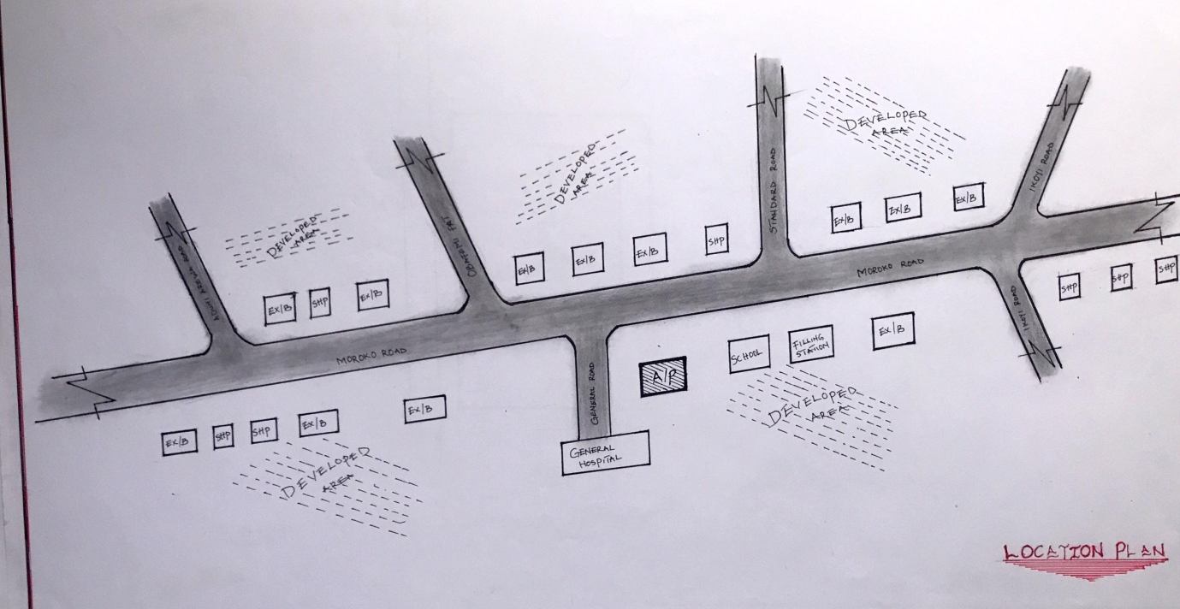

Figure 3:1:1 Location Plan

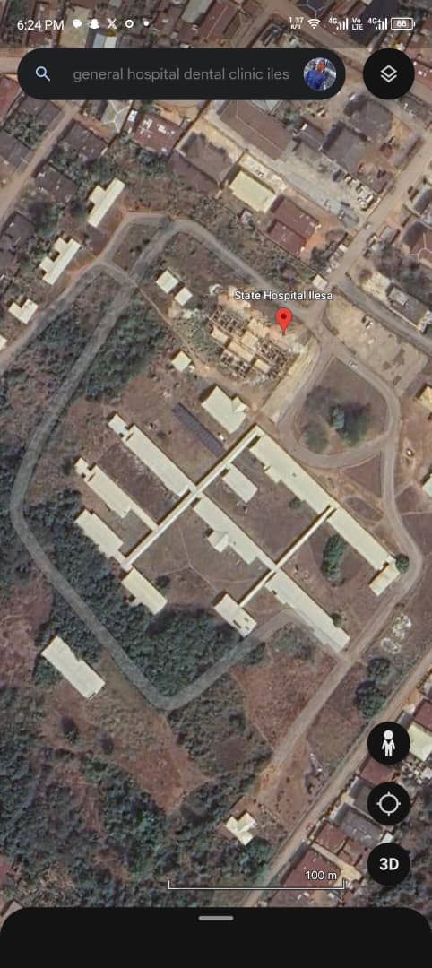

Plate 3:1.1Geographical Layout
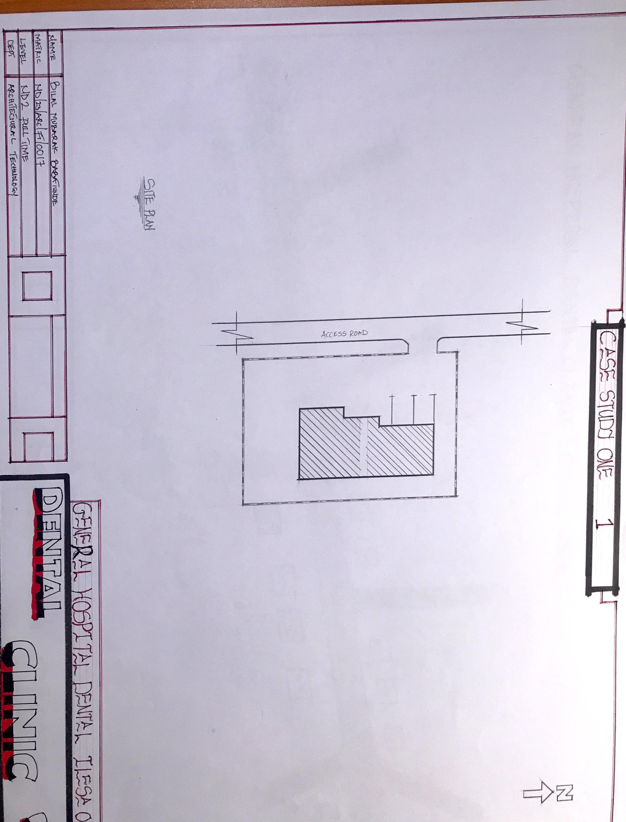
SITE PLAN

Figure 3.1.2Site Plan
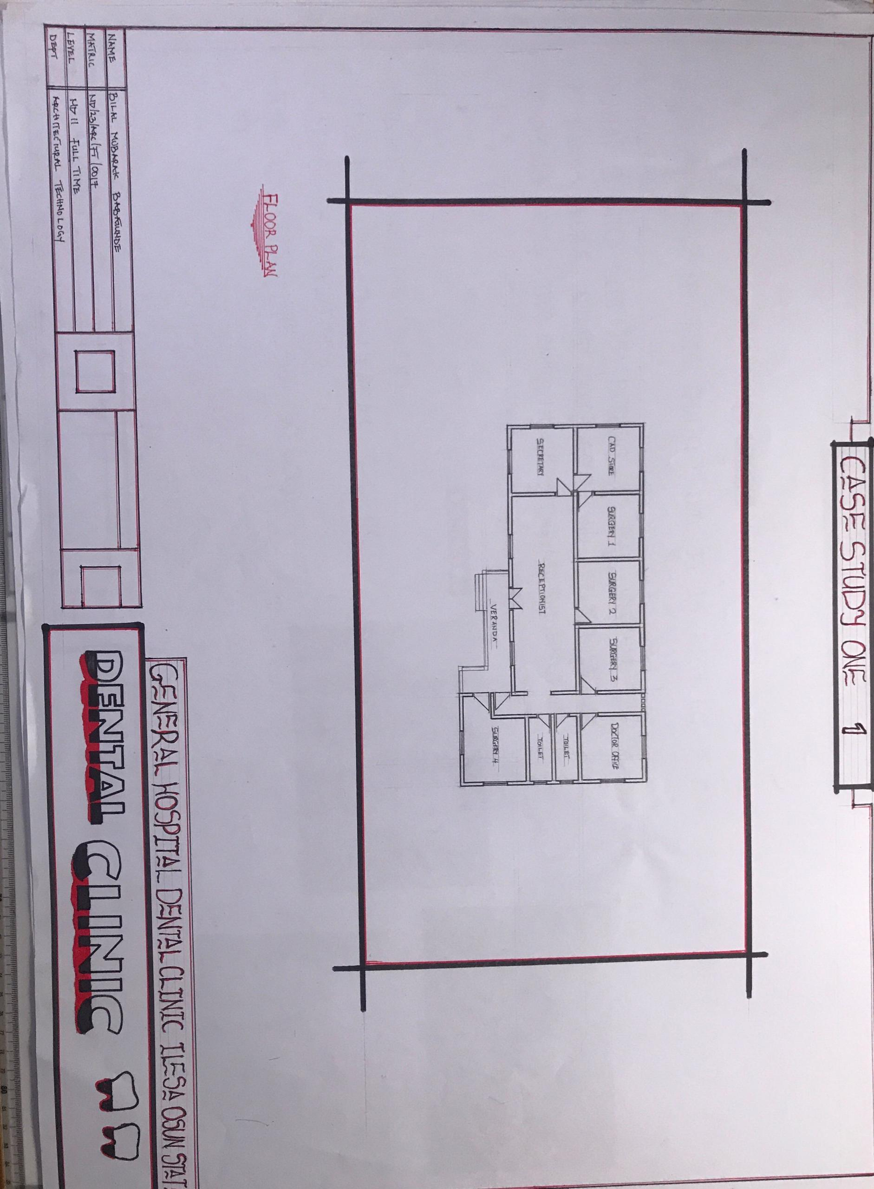
FLOOR PLAN

Figure 3:1.3Floor Plan
PICTURES
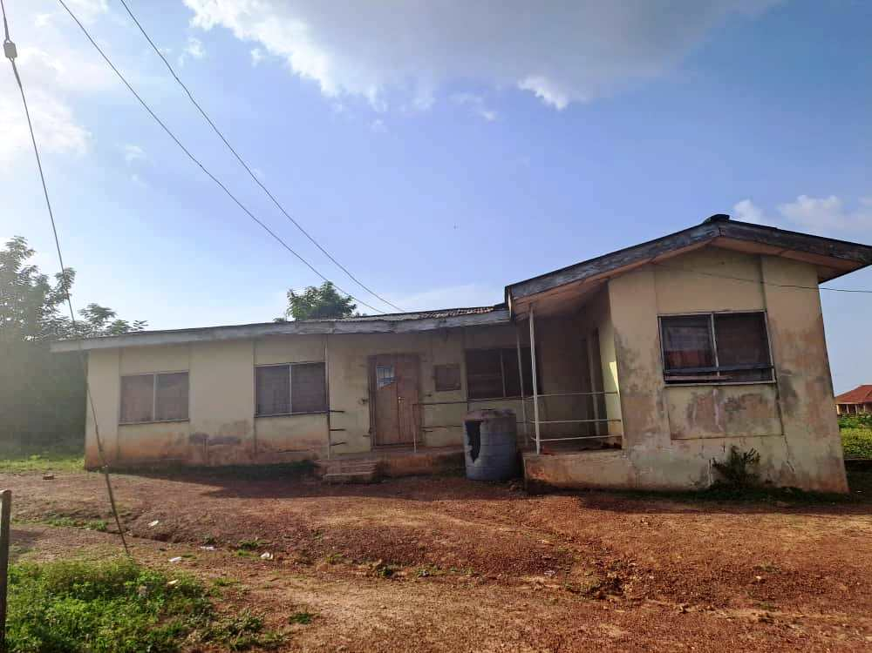
Plate 3.1.2Elevation
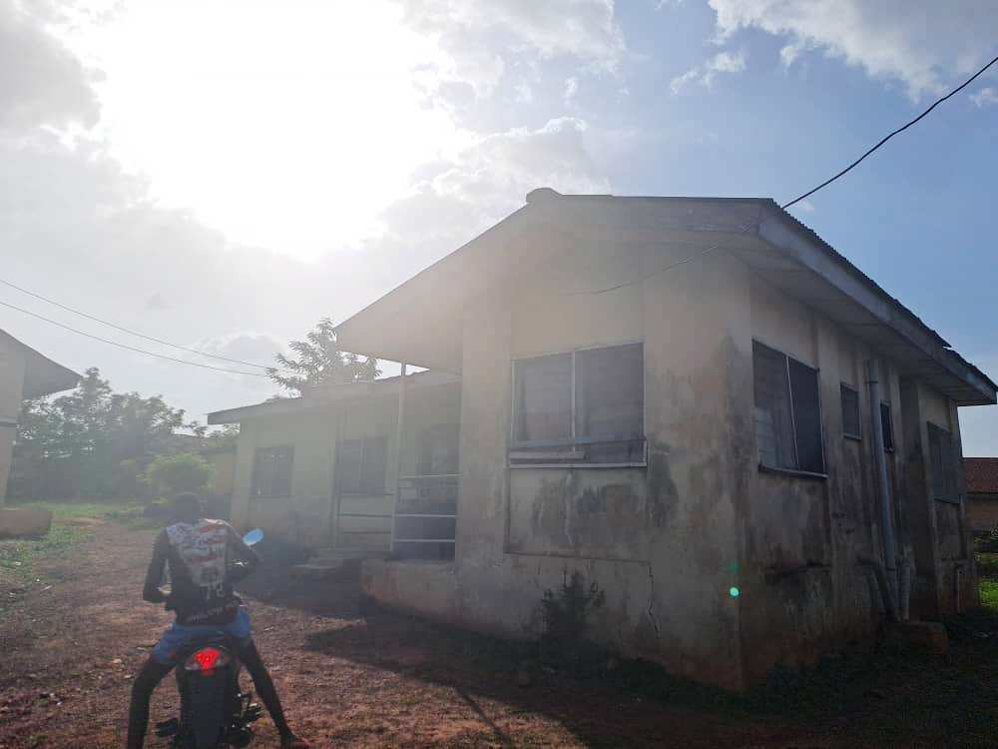

Plate 3.1.3 Elevation

3.1.2 CASE STUDY TWO (2): University of Ilorin Teaching Hospital Dental Clinic Ilorin Kwara State.
Date of Establishment: 2010
Architect: Unknown
Location: Old Jebba Road Oke-Ose/Ile-Apa, Ilorin East LGA, Kwara State.

Brief Description:
A public Tertiary level dental department within UITH, offering comprehensive dental care including extractions, restoration, oral and maxillofacial surgery, and specialist consultations. It supports both patient care and teaching, training dental students and professionals as part of UITH’s multi-specialty services Initially, the school operate junior section before they letter add secondary school section.
Climate: Tropical Savanna Zone with Average Temperature
Topography: Flat Terrain
Vegetation: The vegetation on the site is sparse.

Merits
- Multi-disciplinary tertiary institution with state-of-the-art oral health services and extensive referral network across Kwara and neighboring states .
- Academic integration, providing training and research opportunities for dental students and professionals
Demerits
- Aging infrastructure and some structural inefficiencies noted, with parts of the site still in older wings before full permanent relocation in 2010 .
- Service strain due to high patient load, occasional staff shortages, and infrastructure maintenance challenges affecting reliability of services

LOCATION PLAN
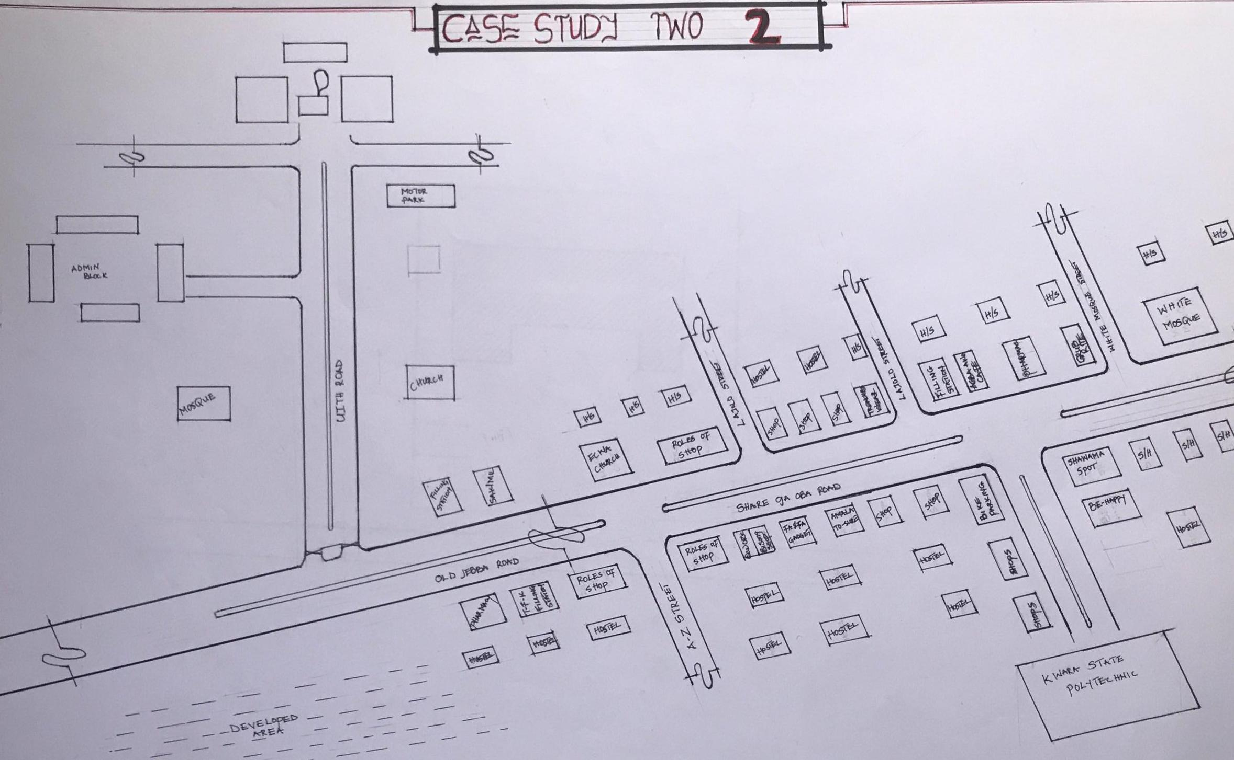
Figure 3.2.1 Location Plan

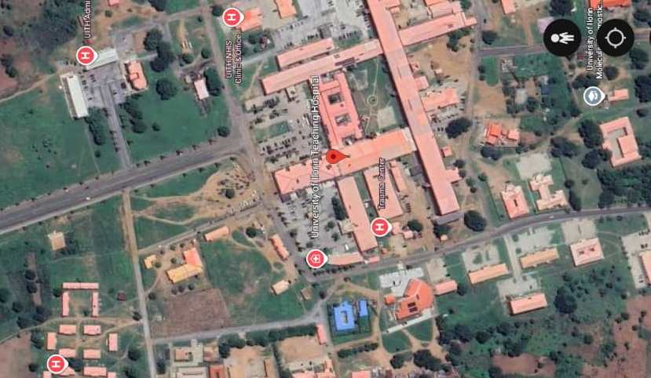

Plate 3.2.1 Geographical Layout

FLOOR PLAN
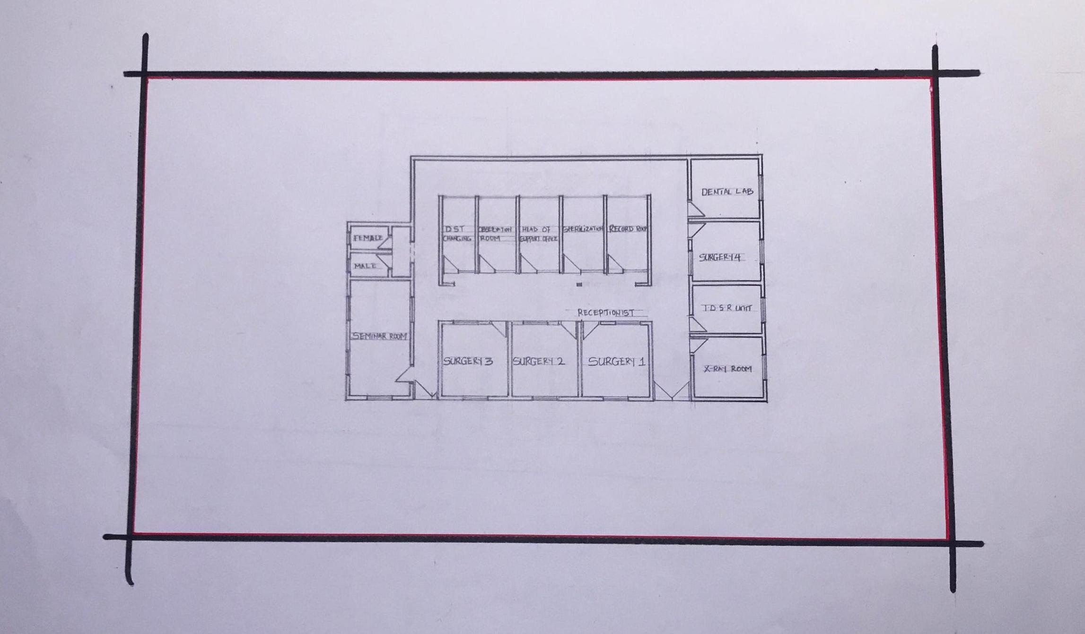
Figure 3.2.2 Floor Plans

PICTURES
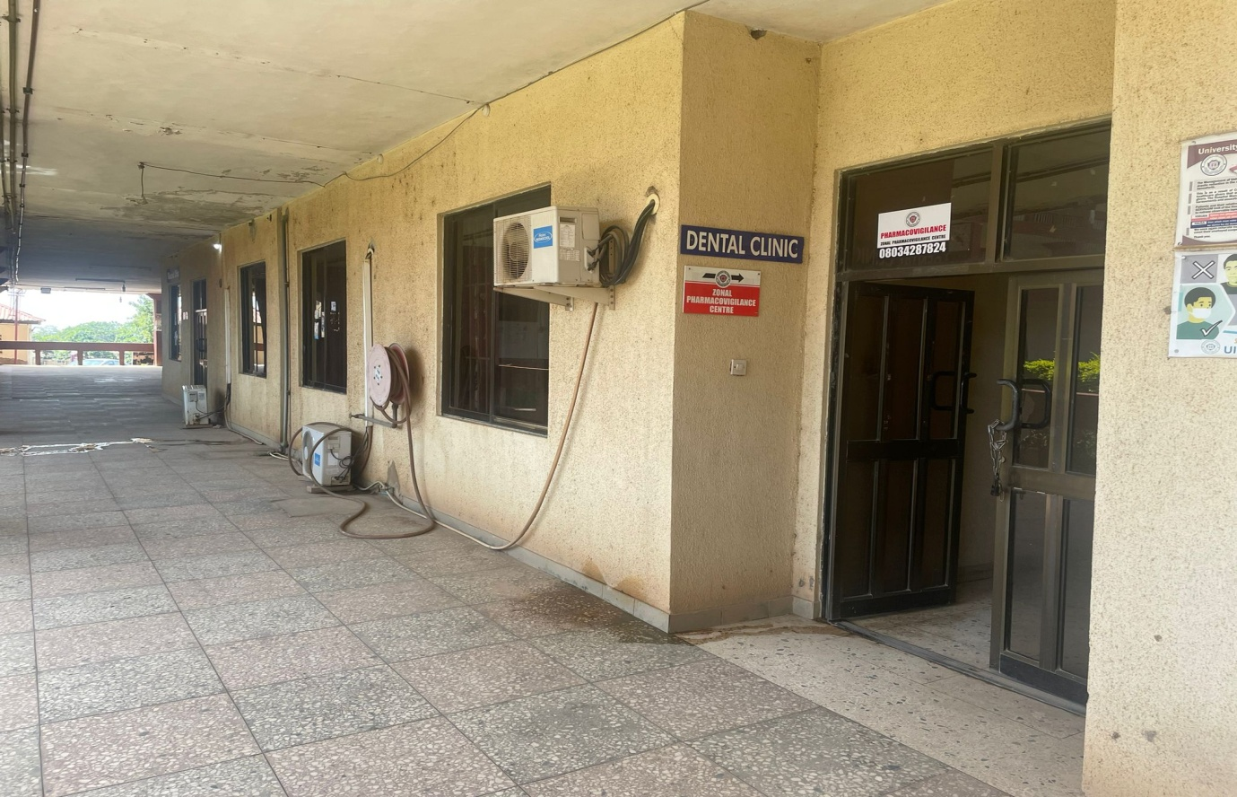

Plate 3.2.2 Elevation
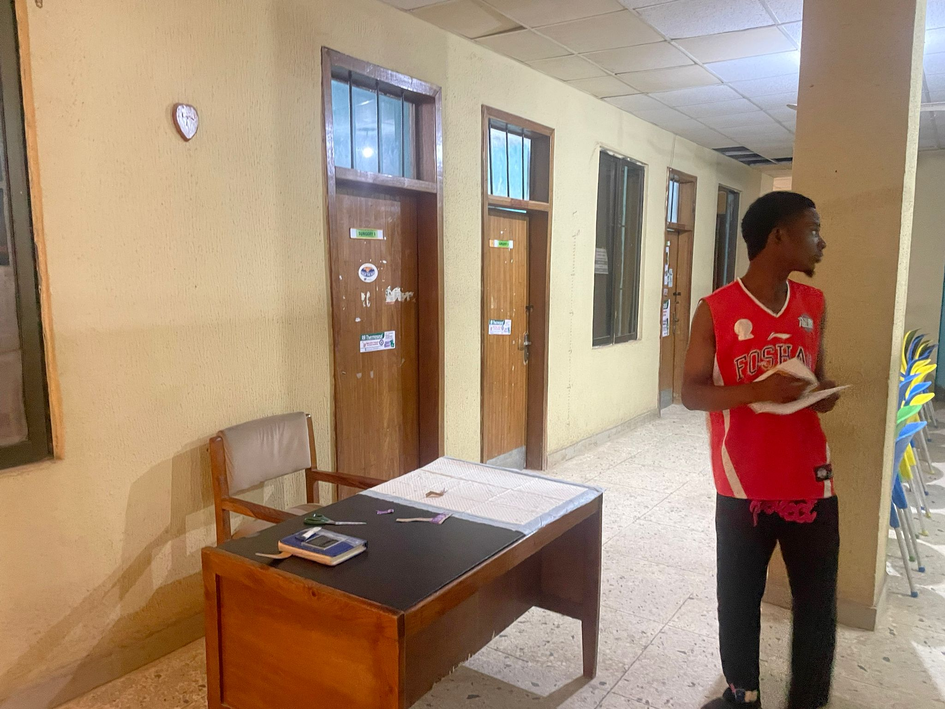
Plate 3.2.3 Elevation

3.1.3 CASE STUDY ONE (3): Choice Dental Clinic Ikeja, Lagos State
Date of Establishment: 2022
Architect: Unknown
Location: 3, Micheal Otedola Crescent, GRA, Ikeja, Lagos State.

Brief Description:
Choice Dental Ikeja is a modern, digitally equipped dental clinic offering preventive, cosmetic, and general dentistry. The facility features nine operating suites divided among general, VIP, and children’s sections, staffed by qualified dentists and radiographers.
Climate: Tropical Monsoon
Topography: Gently Sloping
Vegetation: Landscaped urban environment with ornamental planting

Merits:
- State-of-the-art digital infrastructure including digital X‑rays and preventive dentistry systems.
ii Offers a wide range of services (cosmetic, orthodontic, surgical, pediatric) in a welcoming, child friendly environment
Demerits:
- Reaching the clinic could be inconvenient for some patients because of traffic
- More expensive

LOCATION PLAN
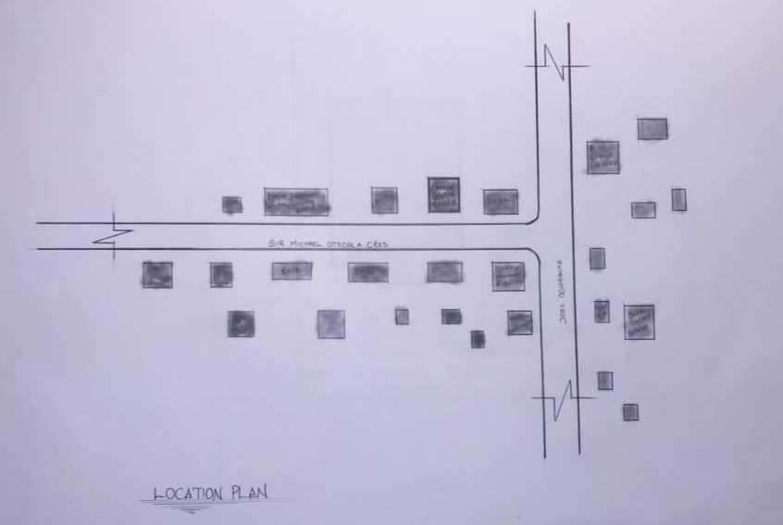

Figure 3.3.1 Location Plan
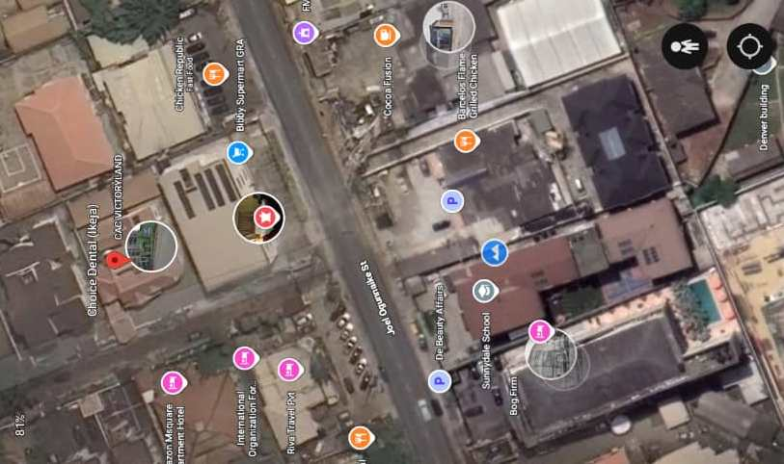
Plate 3.3.1Geographical Layout
FLOOR PLAN
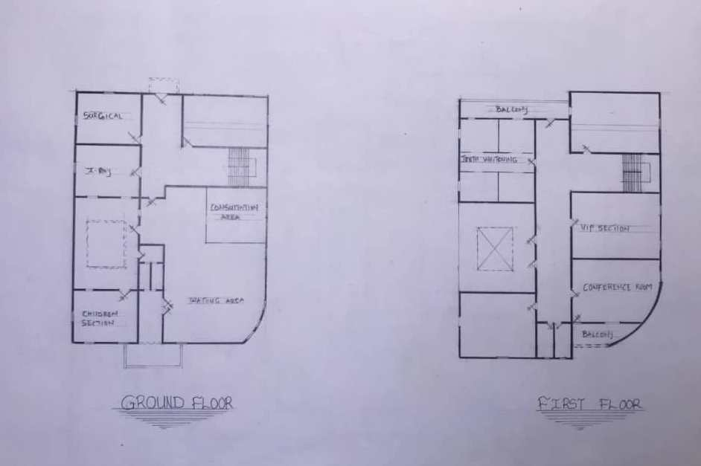
Figure 3.3.2 Floor Plan.

PICTURES
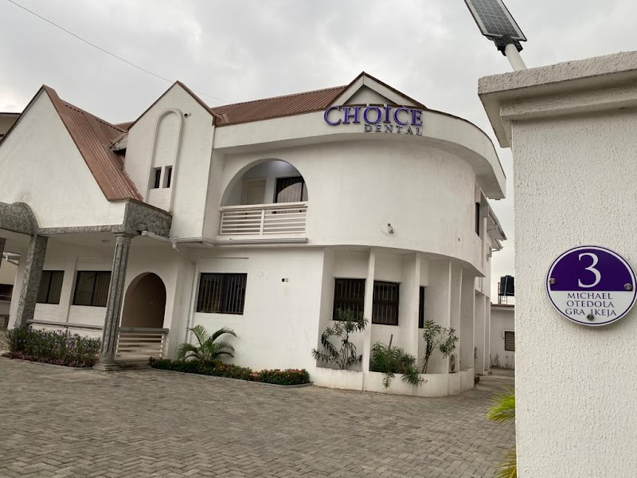Plate 3.3.2 Elevation
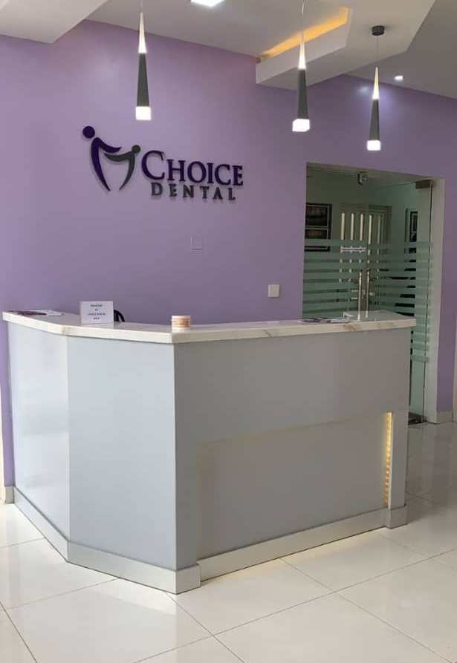
Plate 3.3.3 Elevation
20
3.1.4 ONLINE CASE STUDY FOUR (4): Hicks Orthodontics Dental Clinic United
Date of Establishment: 2014
Architect: BarberMcMurry Architects
Location: Dental Clinic, Healthcare Center. Lenoir City, United State.

Brief Description:
A 6,800 ft² progressive orthodontic clinic located in a rural/suburban setting. It features a central circulation spine connecting the glass-front waiting area at one end with the 8-station treatment operatory at the other. The interior uses a limited palette: glass, metal, cypress wood, brick, and concrete, with natural day lighting and visual connection to adjacent wooded landscape
Climate: Humid subtropical
Topography: Gently Sloping Site
Vegetation: Sparse vegetation
Merits:
- Efficient Workflow Design: A single corridor spine provides clear, sequential patient flow from reception to treatment.
- Day lighting & Views: Ample glass and orientation to natural vegetation enhance user comfort and visual engagement.
Demerits:
- Site Constraints: Nearby gas station required careful visual shielding using board-formed concrete walls.
- Rural Limits: As a rural location, expansion and scalability may be limited by surrounding land use conditions

3.1.5 ONLINE CASE STUDY FIVE (5): Yokoi Dental Clinic Japan
Date of Establishment: 2014
Architect: Unknown
Location: Residential block, Kiyosu, Aichi Prefecture, Japan.

Brief Description:
Yokoi Dental Clinic is a minimalist white cubic structure featuring randomly arranged square windows and skylights to maximize natural lighting and visual interest.
21

Signage is deliberately minimal to maintain aesthetic continuity with its suburban surroundings. Interior lighting is embedded in wooden beams to soften the bright white environment and create a calming clinical ambiance
Climate: Humid subtropical
Topography: Flat
Vegetation: Unknown
Merits:
- Visual Identity: The pure white facade with geometric window composition makes the building a local visual icon.
- User Comfort: Skylights and soft diffuse lighting enhance the spatial atmosphere and reduce patient anxiety.
Demerits:
- Size Constraints: The compact form limits scalability—expansion could be challenging.
- Minimal Signage: Reduced visibility might make it less instantly recognizable to new users or pedestrians unfamiliar with its location.

CHAPTER FOUR
4.1 ANALYTICAL STUDY OF THE PROJECT LOCATION
4.1.1 INTRODUCTION
Ilorin is one of 36 states of federal of republic of Nigeria. Ilorin, the capital city of Kwara State, Nigeria, is a city with a rich historical, cultural, and economic background. Ilorin was founded in 1450 and has a significant historical legacy as a prominent center in the Yoruba and Fulani empires.
Ilorin is a city with a rich historical heritage and cultural diversity, serving as an economic and educational hub in Kwara State. Its strategic location, coupled with ongoing development efforts, positions it as a key city in Nigeria’s socio-economic landscape.

4.1.2 SITE LOCATION
This is very important point to be considered before establishing the setting of houses, should take advantage of topographical features speeds and directions should be studied to ensure the best orientation to take advantage of the prevailing wind.
Avoiding site prone to water logging and rain and draught which depends on wind direction and speed in the raining season placement of a building so that the length extends along the East and West direction.
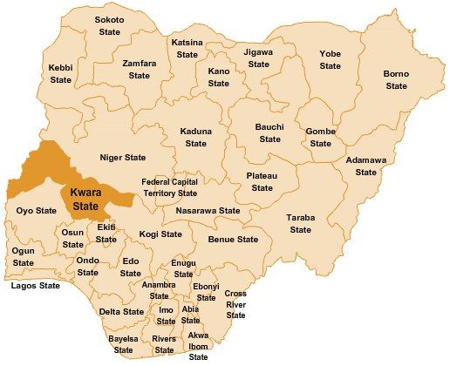
The proposed project is sited at Sobi Road Akerebiata Ilorin, Kwara State. It is surrounded with built up environment with various commercial activities being taken up in the area.

Figure 4.1.11.1 Map of Nigeria, 36 States and FCT.

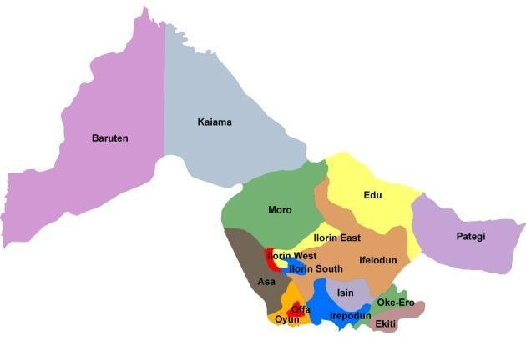

Figure 4.1.11.2 Kwara State Map

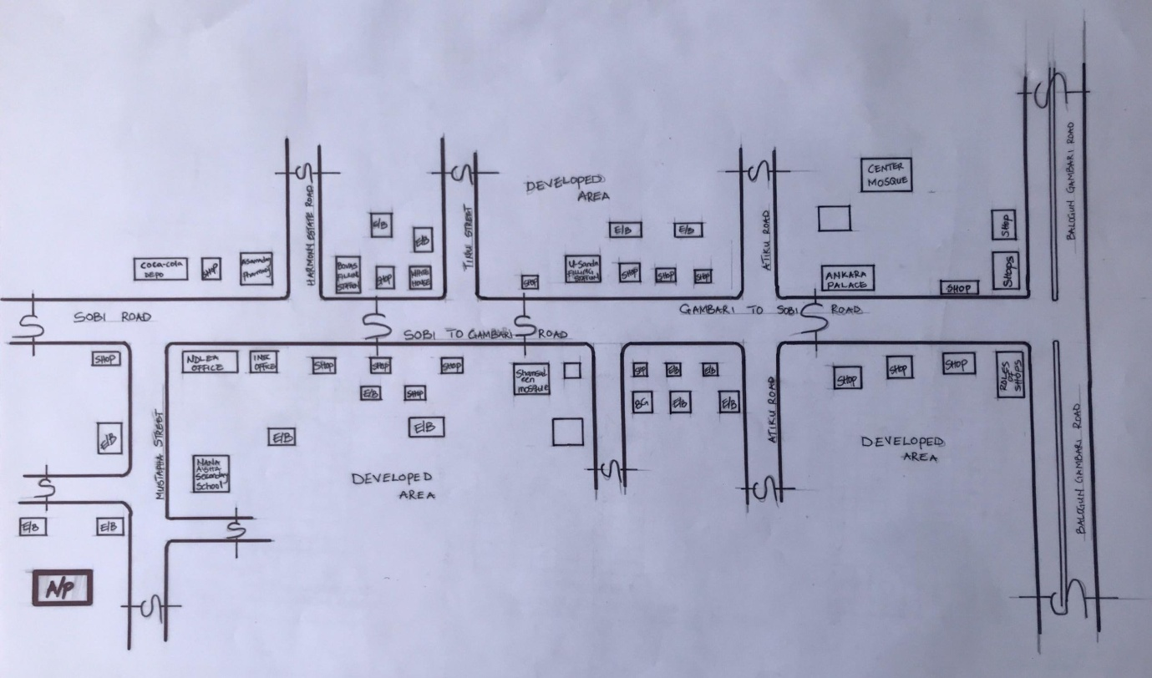

Figure 4.1.11.1 Location Plan

4.1.3 SITE INVENTORY
Site inventory is the synthesis of the physical feature and facilities that are present on the site and over the site such as trees, footpath, soil, topography, vegetation, stream and shrubs etc.
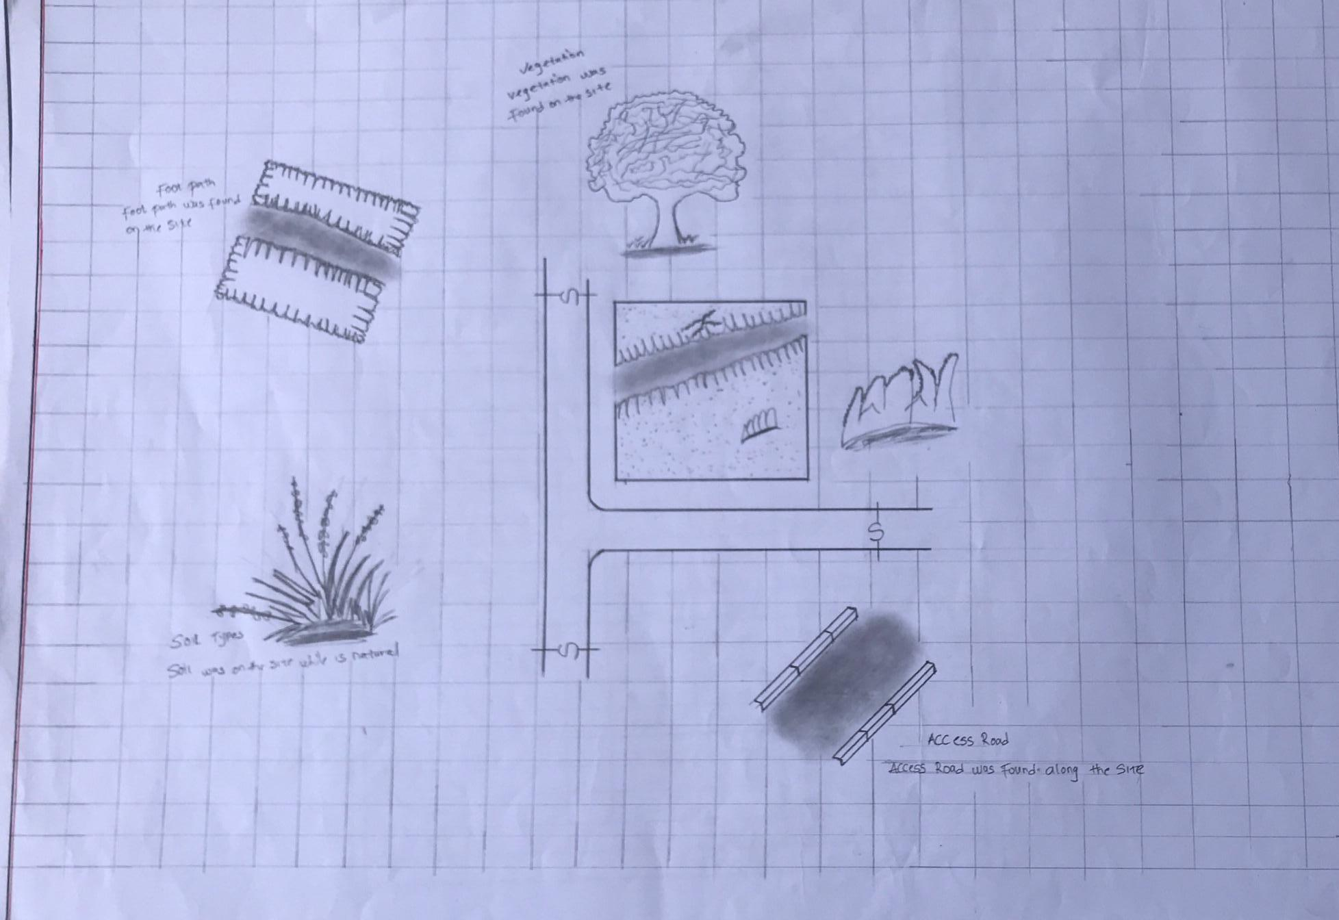

Figure 4.1.12.1 Site Inventory

4.1.4 SITE ANALYSIS
Site Analysis is the process of evaluating how a proposed site system will integrate with the existing site infrastructure by assessing physical obstructions, electrical interference, and noise to identify suitable interrogation zones for coexistence with the infrastructure.

The site selected for the project is a very gentle slope, it is a site that has never been used for any form of building construction i.e. it has not been developed in the past which make it an abode for several trees and shrubs, it is also observed during the course of inventory that some of the trees are to be removed as it could obstruct the construction process during the project, while some are to be retained to help control the adverse of the wind storm.
25
The soil is well compacted Soil in nature with good soil texture. The sun rises from the eastern part of the site and sets on the western part. The Construction does not need a special type of foundation due to the fact that the site is having a good bearing capacity and strength.

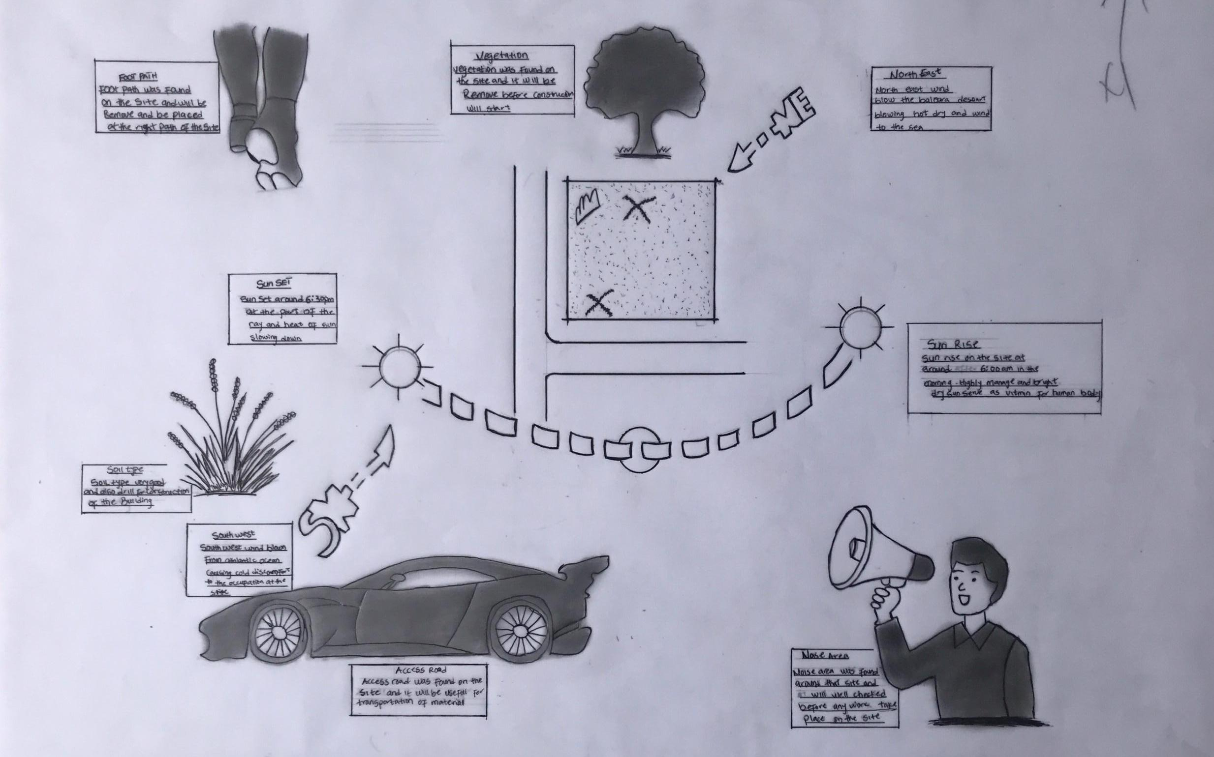

Figure 4.1.12.2 Site Analysis

4.1.5 GENERAL GEOGRAPHICAL CONDITION
Ilorin, the capital city of Kwara State, Nigeria, is characterized by specific geographical conditions that influence its climate, vegetation, and overall environmental features. Here's an overview of the general geographical conditions of Ilorin.
Ilorin is situated approximately at latitude 8.5°N and longitude 4.55°E. The city is positioned at an elevation of about 290 meters (951 feet) above sea level. Ilorin is centrally located in Nigeria, serving as a significant connection between the northern and southern parts of the country.

4.1.6 CLIMATE:
Tropical Savanna Climate: Ilorin experiences a tropical savanna climate (Aw according to the Köppen climate classification), characterized by distinct wet and dry seasons.
Temperature: Average temperatures in Ilorin range from 22°C (72°F) to 33°C (91°F). During the dry season, daytime temperatures can rise significantly, while nights are cooler, especially during Harmattan.

Rain Season: The wet season typically spans from April to October, with the heaviest rainfall occurring between June and September. Annual rainfall averages around 1,200 mm (47 inches).

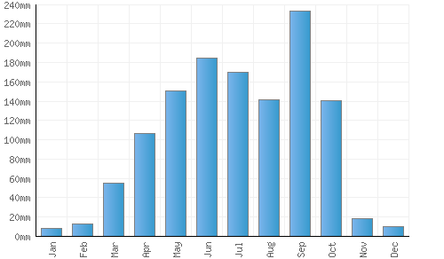

Figure 4.1.3.1 Average Monthly Rainfall in Ilorin.

Dry Season: The dry season lasts from November to March, marked by significantly lower humidity and occasional dust-laden winds from the Sahara Desert, known as Harmattan.

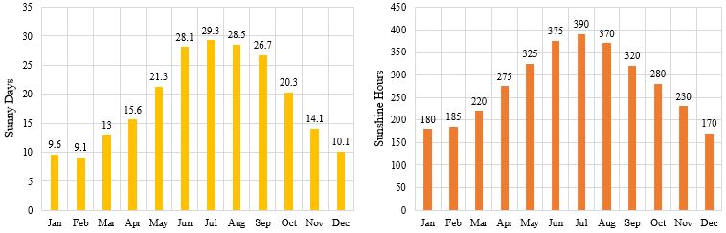

Figure 4.1.3.2 Sunshine Duration in Ilorin.
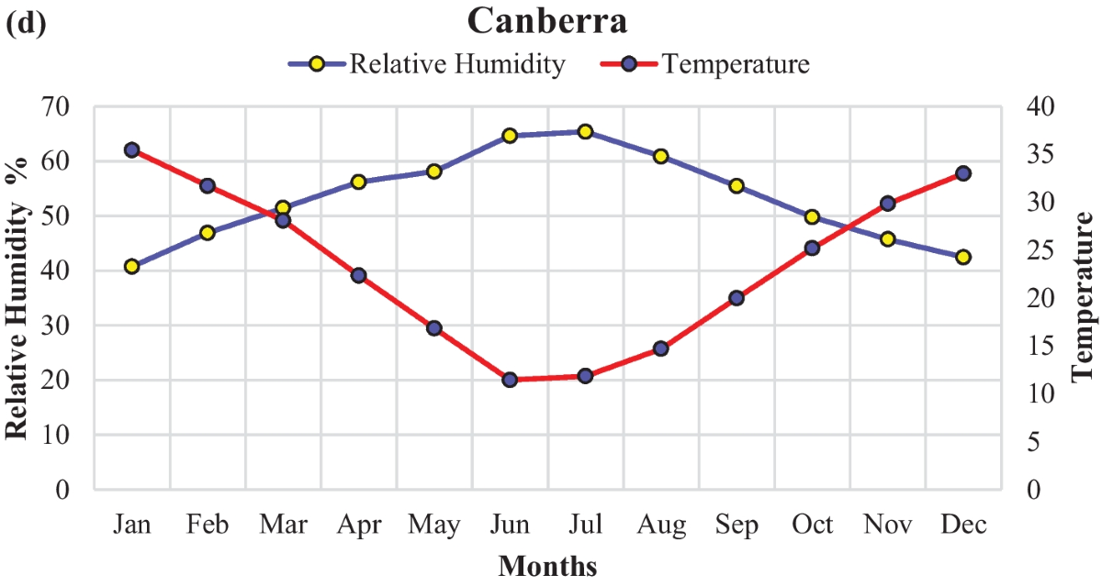

Figure 4.1.3.3 Relative Humidity in Ilorin.

4.1.7 VEGETATION
Guinea Savanna: The predominant vegetation type in Ilorin is the Guinea Savanna, characterized by a mix of grassland and scattered trees. This vegetation type is typical of the transitional zone between the forest regions in the south and the Sahel in the north.
Flora: Common plant species include acacia, baobab, shea butter trees, and various grasses and shrubs adapted to the savanna climate.

4.1.8 TOPOGRAPHY
Gently Undulating Plains: Ilorin's topography consists mainly of gently undulating plains, with occasional hills and low-lying areas.

4.1.9 NATURAL RESOURCES
Mineral Resources: Kwara State, including Ilorin, is endowed with various mineral resources such as limestone, gold, and kaolin. These resources offer potential for mining and related industries.

4.1.10 ENVIRONMENTAL CHALLENGES
Urbanization: Rapid urbanization in Ilorin has led to challenges such as deforestation, waste management issues, and pressure on infrastructure and services.
Climate Change: Like many regions, Ilorin faces the impacts of climate change, including variability in rainfall patterns and increased frequency of extreme weather even.

4.1.11 SITE SERVICES
There are good services around the site, which include good access road, for people coming to Dental Clinic, availability of electricity very close to the site which will be useful before and after construction. Also, availability of pipe born water at the chosen site.

4.1.12 SITE UNIQUENESS AND BENEFIT
- The site is accessible
- Natural factor like, is very useful
- Utility services such as water, electricity, telephone, etc. cause no problem to the inhabitants.

4.1.13 SITE SUITABILITY
The appropriateness or suitability of the site for the construction and planning of the proposed project is based on the fact that is possesses and meets the entire requirements. All the existing features were strictly considered with the intension of making advantage of them to maximum level most especially the geographical, topographical features of the site.
Types Of Forest Region
- Mangrove (Salt Quarter) Swamp Forest
- Fresh water swamp forest
- High forest

4.2. DESIGN CRITERIA
Planning is an important activity which determines the success of any endeavor. It is often said that without plans, purposes are frustrated, planning is the first and most important steps in designing a Dental Clinic, so as to achieve aims of designing and the criteria’s and should be take into consideration.

4.2.1 SITE SELECTION
A number of factors necessary for site selection for a farmstead are outlined below:
  - ﻿﻿﻿Access Road
  - ﻿﻿﻿Water
  - ﻿﻿﻿Utilizes and services (electricity, telephone, access drives etc.)
  - ﻿﻿﻿Orientation (air drainage and maximum sunshine may require orientation on a gentle Southerly slope).
  - ﻿﻿﻿Expansion.
4.2.2 BUILDING ARRANGEMENT
The arrangement of facilities for maximum efficiency of operation should be a prime concern. Proper arrangement increase efficiency by reducing walking distance to a minimum and providing adequate drive ways and turn around. It is important to note that five protections, safely and security and all influenced by the design planning.

4.2.3 DESIGN SCOPE
These are scope of designing a Dental Clinic which includes the followings;
Security House, Main Building, Mosque, Generator House, Park Lots.

4.2.4 DESIGN BRIEF9ANALYSIS
Entrance, Reception and Card Room, Waiting Area, Pharmacy, Therapy, Nurse Station, Dentist Office, Laboratory, Surgery Room, Recovery Room, Cosmetic, X-ray, Sterilization, Conference Room, Changing Room, Storage, Toilet, Exit.

4.2.5 SPACES DERIVATION ANALYSIS/SCHEDULE FOR ADMINBLOCK
S/N | SPACE | UNIT | LENGTH (M) | BREADTH (M) | L x B | AREA (M²)
 | Entrance | 1 | 3.8m | 3.0m | 3.8m x 30m | 114m²
 | Waiting Area | 1 | 5.85m | 5.4m | 5.85m x 54m | 31.59m²
 | Reception & Card | 1 | 5.4m | 3.6m | 54m x 6m | 19.44m
 | Toilet | 2 | 2.4m | 0.9m | 2.4m x 0.9m | 4.32m²
 | Pharmacy | 1 | 4.2m | 3.0m | 4.2m x 3.0m | 12.6m²
 | Therapy | 2 | 4.2m | 3.0m | 4.2m x 3.0m | 25.2m²
 | Toilet | 2 | 2.4m | 1.2m | 2.4m x 12m | 5.76m²
 | Nurse Station | 1 | 3.6m | 3.3m | 3.6m x 3.3m | 11.88m
 | Toilet | 1 | 2.4m | 1.2m | 2.4m x 1.2m | 2.88m
 | Dentist Office | 2 | 4.2m | 4.2m | 4.2m x 4.2m | 35.28m
 | Toilet | 2 | 2.7m | 1.5m | 2.7m x 1.5m | 8.1m
 | Laboratory | 1 | 4.2m | 3.0m | 42m x 3.0m | 12.6m
 | Toilet | 1 | 2.4m | 1.2m | 2.4m x 1.2m | 2.88m
 | Surgery | 3 | 4.2m | 4.2m | 4.2m x 4.2m | 52.92m
 | Toilet | 3 | 2.4m | 1.2m | 2.4 x 12.mx3 | 8.64m
 | Recovery | 2 | 4.2m | 3.6m | 4.2m x 3.6m | 30.24m
 | Toilet | 2 | 24.m | 1.2m | 2.4 x 1.2x2 | 5.76m
 | Cosmetic | 1 | 4.2m | 3.3m | 4.2m x 3.3m | 13.86m
 | Toilet | 1 | 2.4m | 1.2m | 2.4m x 1.2m | 2.88m
 | X-ray | 1 | 5.0m | 3.3m | 5.0m x 3.3m | 16.5m
 | Sterilization | 1 | 5.0m | 3.3m | 5.0m x 3.3m | 16.5m
 | Conference Hall | 1 | 6.0m | 3.3m | 6.0m x 3.3m | 19.8m
 | Changing Room | 1 | 3.6m | 3.3m | 3.6m x 3.3m | 11.88m
 | Toilet | 1 | 2.4m | 1.2m | 2.4m x 1.2m | 2.88m
 | Storage | 1 | 3.3m | 3.0m | 3.3m x 3.0m | 9.9m2
 | Toilet | 1 | 2.4m | 1.2m | 2.4m x 1.2m | 2.88m
 | Exit | 1 | 5.4m | 1.2m | 5.4 x 1.2m | 6.48m
 |  |  | TOTAL |  | 385.05m²
Table 4.2.5: Space Allocation
4.2.6 FUCTIONAL ANALYSIS AND RELATIONSHIP
The Main Building plan is well function, the unit are so well related to each other,
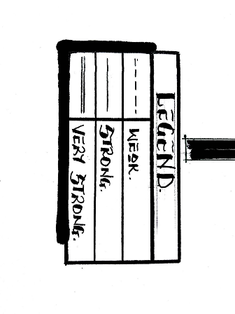
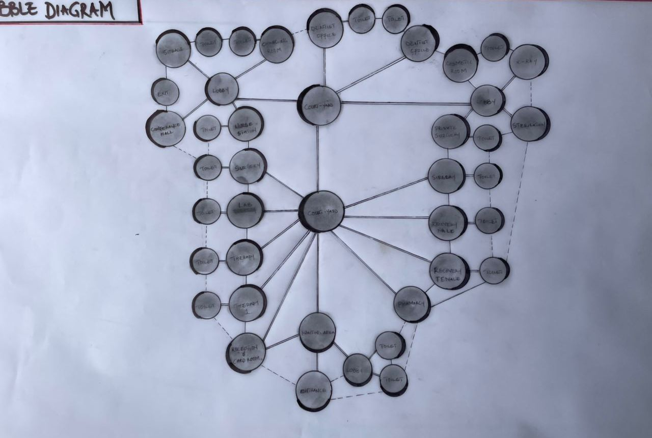
Figure 4.2.6.1: Bubble Diagram

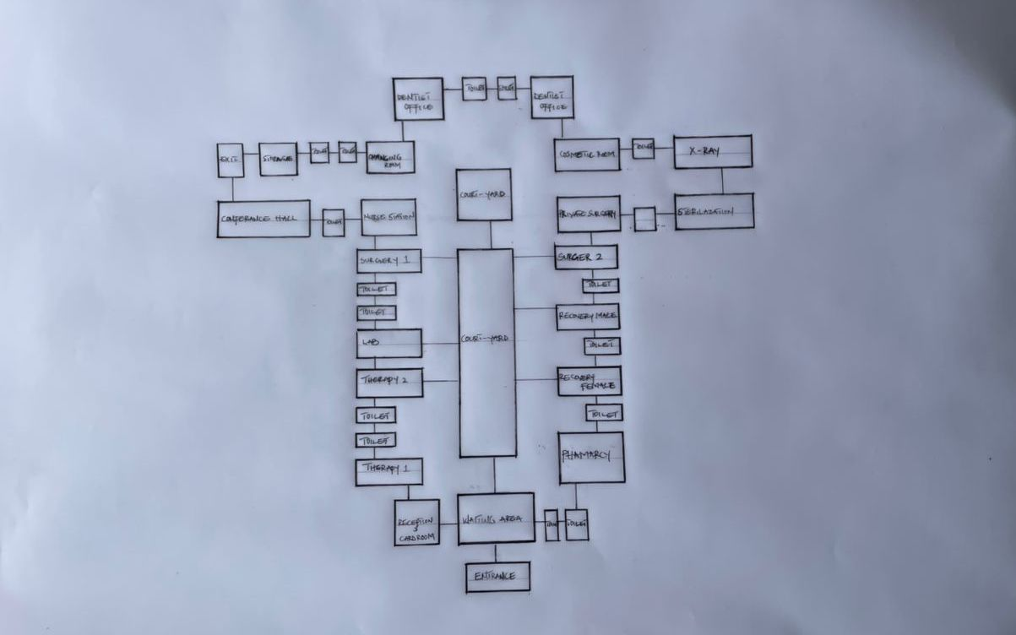
Figure 4.2.6.3: Functional Relationship

CHAPTER FIVE
5.1 APPRAISAL OF PROPOSED SCHEME
The proposed Project is to satisfy the appropriate building regulations. The design is to confirm the aid intended use of building taking into consideration with both natural factors and human factors that earn us a threat on the validity and stability of the building.

5.2 CONSTRUCTION METHODOLOGY AND MATERIALS.
The construction is to be carried out following the due process of construction ranging from:
- Preliminary: This involves the clearing of the site, setting out and excavation of foundation trench and foundation works.
- Sub-Structure: This process also entails the positioning and erection of Columns and beans, masonry works etc.
- Post Structure Stage: Is the stage which has to do with the application and installation of the paints, tiles, other finishes and construction of external works etc.

  - MATERIALS FOR CONSTRUCTION
- Sustainable and Eco-Friendly Materials
- Bamboo and Timber: Renewable and low-carbon materials, suitable for non-structural interior elements like ceiling finishes and decorative wall panels.
- Recycled Materials: Recycled steel, glass, and concrete will be considered to minimize environmental impact.
- Insulating Materials: Eco-friendly insulation such as cellulose or sheep wool may be used in walls and ceilings to enhance indoor thermal comfort.
- Traditional and Cultural Materials
- Clay and Adobe: Where applicable, these can be used in landscaping features or accent walls, reflecting cultural identity and promoting thermal comfort in hot climates.
- Stone: Locally sourced stone may be used for external cladding, boundary walls, or pathways to reflect cultural relevance and add durability.
- Tiles and Ceramics: Geometric ceramic tiles with Islamic patterns can be applied in interior decor, particularly in waiting areas, ablution spaces, and reception zones, for both aesthetic and cultural expression.
- Modern Materials
- Concrete: Reinforced concrete will be used for the main structural framework—foundations, slabs, beams, and columns—for strength and longevity.
- Steel: Steel will be used for reinforcement and roof framing, offering structural reliability and adaptability.
- Glass: Aluminum-framed windows with glazed panels will allow natural lighting while maintaining privacy and energy efficiency. Double-glazed options may be used in specific zones to enhance insulation and sound control.

    - CONSTRUCTION METHODOLOGIES
- Green Building Practices
- Passive Solar Design: The clinic is oriented to take advantage of natural sunlight and ventilation, reducing reliance on artificial lighting and cooling systems.
- Green Elements: Landscaping around the building and potential use of green wall features will enhance the environment, support insulation, and promote healing.
- Rainwater Harvesting: A system will be integrated to collect and reuse rainwater for landscaping and cleaning purposes, minimizing water waste.
2. Energy-Efficient Construction
- Thermal Insulation: High-performance insulation materials will be used in walls and roofing to reduce indoor temperature fluctuations and improve energy efficiency.
- LED Lighting: The building will utilize LED lighting for all spaces, ensuring long-term energy savings and low maintenance.
- Solar Energy: Solar panels may be installed to power essential services like lighting and ventilation, reducing dependency on grid electricity.
3. Cultural and Functional Considerations
- Building Orientation: The layout ensures proper orientation of designated prayer spaces towards Mecca, respecting religious needs.
- Islamic Architectural Features: The design may incorporate subtle Islamic elements such as arches, patterned screens, and courtyards, enhancing both identity and aesthetics.
- Community Engagement: Input from local stakeholders, healthcare workers, and community members will be considered to ensure the facility reflects cultural expectations and serves practical healthcare needs

5.2.1 SERVICE
A building can be said to be good when it performs the service required by it. In order to have well-functioning building. There calls for an installation of underground water pipes in other to provide water to all the restrooms and other necessary units in the building. A borehole system of water supply is to be adopted alongside the government supplied services and a storage facility is to be provided for effective management of water supply.

5.2.2 CIRCULATION
As a healthcare facility designed to serve a significant number of patients and staff daily, effective circulation within the proposed dental clinic is essential. The layout has been carefully planned to ensure smooth movement, reduce congestion, and maintain privacy where necessary.

The building is a single-story structure, making navigation easier and more accessible for all users, including the elderly and physically challenged. Public areas such as the reception, waiting area, and consultation rooms are positioned near the main entrance for easy access, while more private zones like treatment rooms, sterilization units, and staff offices are strategically placed to limit unnecessary traffic.

Clear separation between public, semi-public, and private spaces ensures a logical flow and enhances both functionality and hygiene control within the clinic.

5.2.3 VENTILATION
As it relates to architecture, is the intentional introduction of outside air into a space. It is mainly used to control indoor air quality by diluting and displacing indoor pollutants. It can also be used for purpose of thermal comfort of dehumidification when the introduction of outside air will help to achieve desired indoor psychometric condition.

This could be either mechanical or natural ventilation. As a regard the proposed project design, there is an introduction of a very spacious courtyard in other to make cross ventilation in most of the building units. There should also a provision of wide passage to allow free movement of air, patient and materials. Artificial ventilation is also provided through the installation of air conditioning system and fans.

5.2.4 LIGHTING
The dental clinic is designed to make use of both natural and artificial lighting. Large windows allow natural light into waiting and consultation areas, creating a calm and energy-efficient environment. Artificial lighting, using LED fixtures, is provided in all spaces—especially treatment rooms—ensuring clear visibility, safety, and compliance with healthcare standards.
5.2.5 PLUMBING
The plumbing system in this proposed building is made easy since the building has a courtyard. Water drained pipes are to be installed underground right from the courtyard to the soak away in other to discharge rainwater.

All water or sewage from the toilets are also channeled into their various inspection chambers using good and appropriate diameter PVC pipes, and taken from the inspection chamber to septic tank and soak away pit.

Rain water is also collected from gutter if the roof using 100mm diameter PVC rain water pipes and channeled into various drainage or soak away pits. There shall be no ponding; the size of any channel shall effectively discharge rain and water without causing any over lowing stagnation and mosquito breeding. All rain water channeled shall be laid to fall and shall not cause any pounding or splashing unto the committers neighboring area.

5.2.6 ELECTRICAL INSTALLATION
The type of wiring system chosen should be full conduit system of wiring. Office and other operation areas should be wired with strong, durable and light current resistance cable because of the careless operate by the students. Also, electrical installation is to be done to allow for the use of quality electrical fittings and fixtures in the whole building.

5.2.7 WASTE DISPOSAL
Waste disposal bins are to put every office of the building and also in some specific necessary area. These water bins should dispose in the incinerator which will be provided within the compound of the station. The waste should therefore be burnt in the incinerator.

5.2.8 FIRE PROTECTION
Electrically, fire alarms and sensors are to be installed in the Dental Building. This should be done in case of fire occurrence; fire extinguisher is to be placed at certain distances in the cobbles and some other necessary area. It is also serving as protector in case of fire.

5.2.9 EXTERNAL WORKS
The external works are to be carned out uncrate Krebs laid and shrubs, flowers grasses and trees planted.
Concrete interlocking tiles to be adopted of hard landscape and parking spaces both for visitors and staffs have been provided on the site.

  - CONCLUSION AND RECOMMENDATION
Conclusion
This project was undertaken to design a modern, functional, and sustainable dental clinic that meets the needs of patients and dental professionals alike. Through critical literature review, site analysis, and case study exploration, the design addressed challenges such as poor spatial organization, lack of comfort, infection control, and operational inefficiencies common in existing clinics.
The proposed clinic achieves clear spatial zoning, ease of movement, natural lighting, and integration of technology to enhance service delivery and patient experience. Environmental considerations such as passive ventilation, daylighting, and noise control were embedded in the design. In addition, attention was given to hygiene, accessibility, and regulatory compliance—core requirements for any healthcare facility.

Ultimately, this design proposal represents an academic contribution toward improving healthcare architecture in Nigeria, especially in the area of dental care delivery.
Recommendation
Based on the findings and experiences throughout this project, the following recommendations are made:
- Future dental clinics should be purpose-built with architectural input from the earliest planning stage, rather than converting residential spaces.
- Architects and health professionals should collaborate closely to ensure functional efficiency and regulatory compliance in design.
- Universal accessibility features (e.g., ramps, handrails, signage) must be included as standard in all healthcare facilities.
- Sustainable design strategies should be applied to reduce energy consumption and long-term maintenance costs.
- Further research should be done on the psychological effect of spatial design on dental patients, especially children and people with dental anxiety.
- Government and private developers should invest more in the modernization and expansion of oral healthcare infrastructure across Nigeria.

REFERENCES
Akintoye, A. (2015). Designing for Health: Architecture and Healthcare Spaces. Lagos: Urban Design Press.
Chima, F. O., & Yakubu, A. (2018). Spatial Planning in Outpatient Clinics. Nigerian Journal of Architecture, 14(2), 122–135.
WHO. (2020). Oral Health: World Health Organization Fact Sheet. Retrieved from https://www.who.int/news-room/fact-sheets/detail/oral-health
Lawal, M. A. (2019). Design of Medical Facilities in West Africa: Challenges and Trends. Abuja: MedArch Publishing.
Oduro, K. (2021). Psychological impacts of clinic architecture. International Journal of Healthcare Design, 9(1), 55–66.
Ching, F. D. K. (2014). Architecture: Form, space, and order (4th ed.). John Wiley & Sons.
Gupta, V. (2011). Building construction: Principles, materials, and systems. Pearson Education India.
Arigbede, A. O., & Dosumu, E. B. (2013). Design considerations in the construction of dental clinics in Nigeria. Nigerian Journal of Clinical Practice, 16(2), 234–239
Okunola, R. (2020). Health facility planning in developing countries: The role of architecture. African Journal of Built Environment Research, 8(1), 77–90.
Dental Design Systems. (n.d.). Dental clinic layout guidelines. https://www.dentaldesign.com/
Hick Orthodontics Dental Clinic. (n.d.). Retrieved August 4, 2025, from https://www.hickorthodontics.com/
Choice Dental Clinic. (n.d.). Retrieved August 4, 2025, from https://www.choicedentalng.com/

38

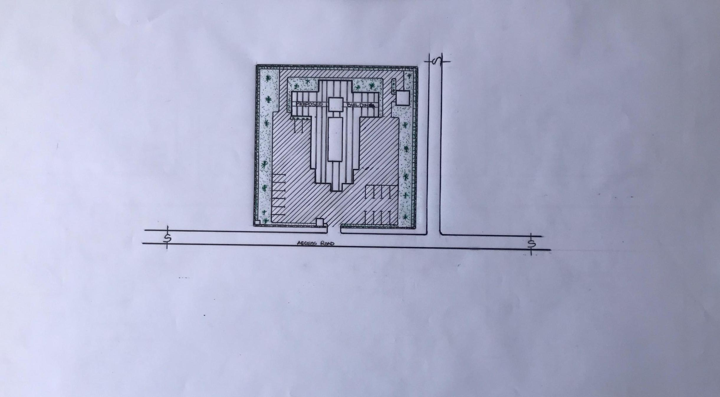

Appendix 5.1: Site Plan

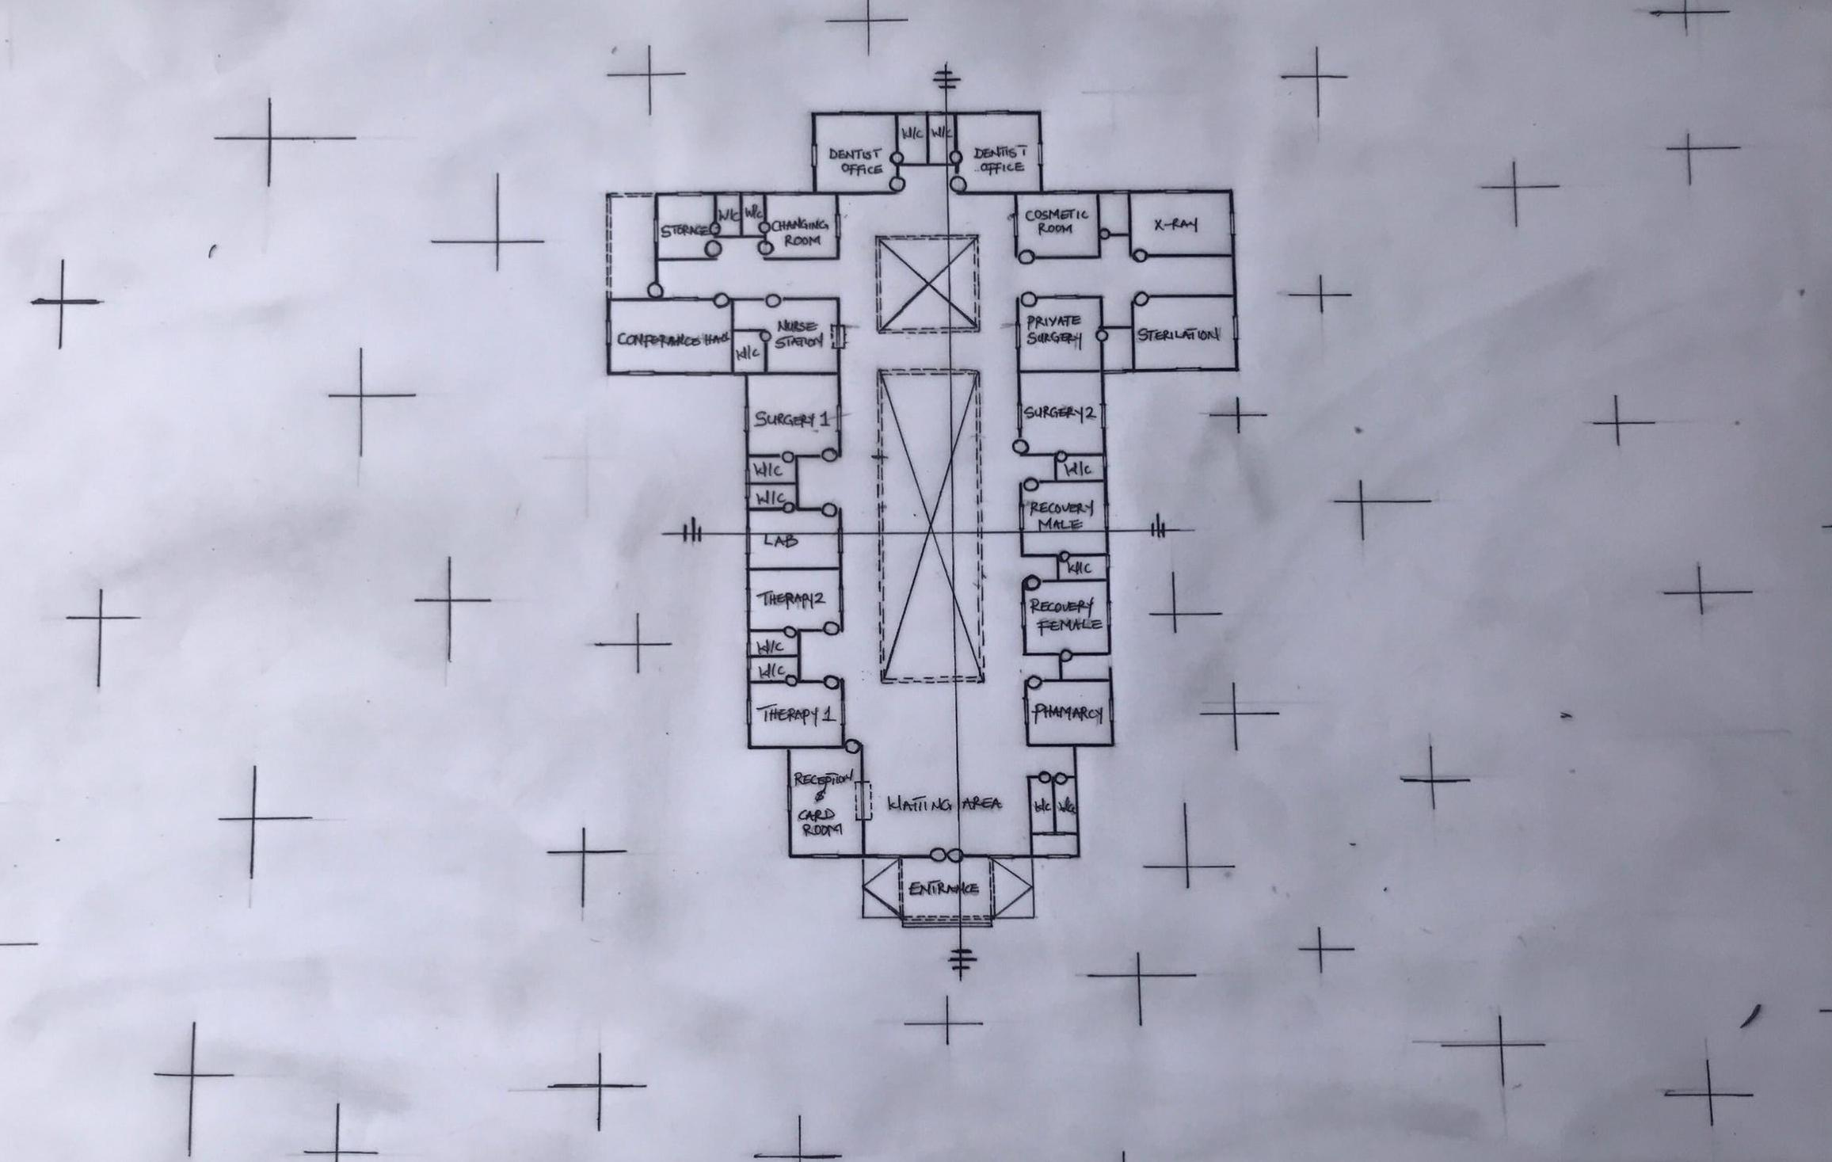

Appendix5.2: Floor Plan.

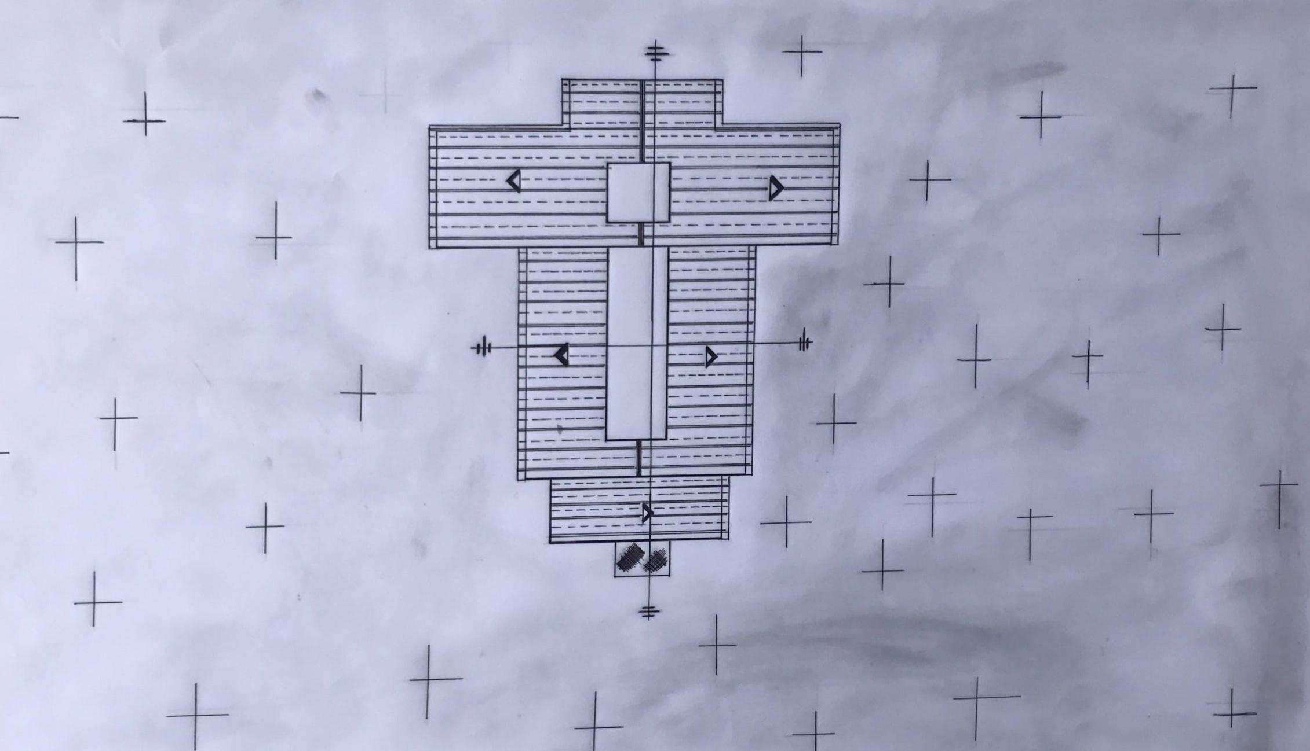

Appendix 5.5: Roof Plan
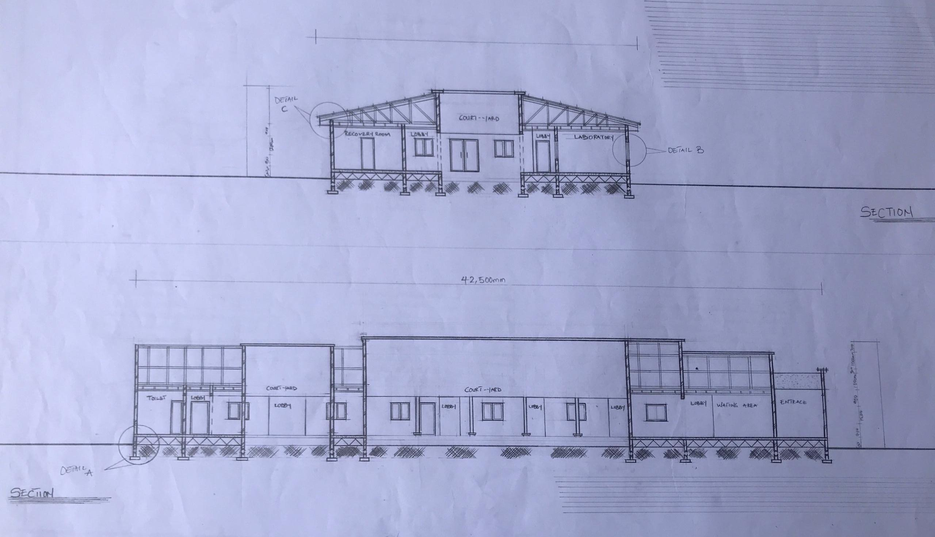

Appendix5.6: Sections

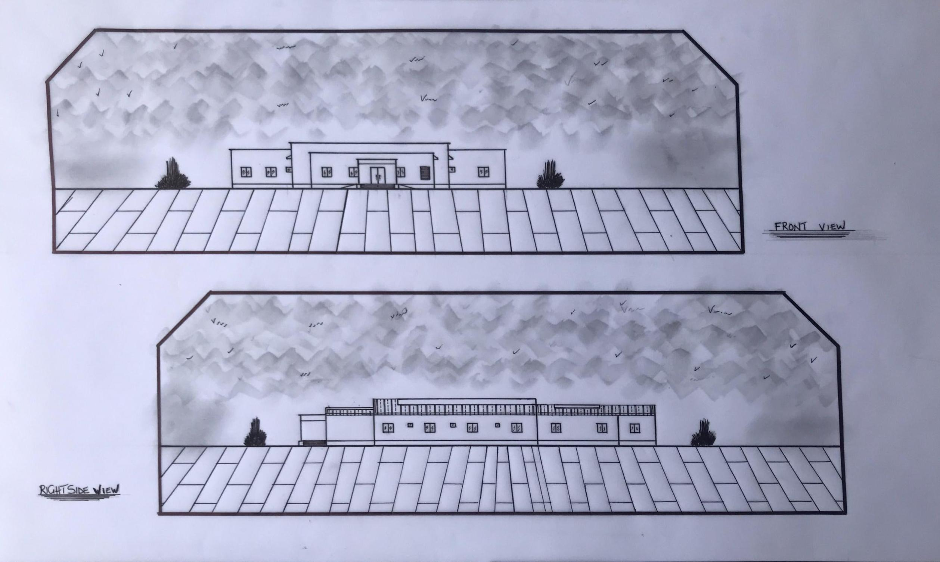

Appendix5.7: Elevation

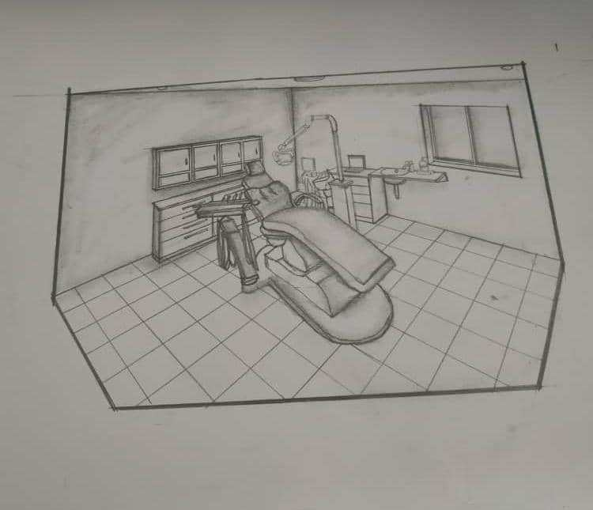

Appendix 5.8: Internal Perspective.

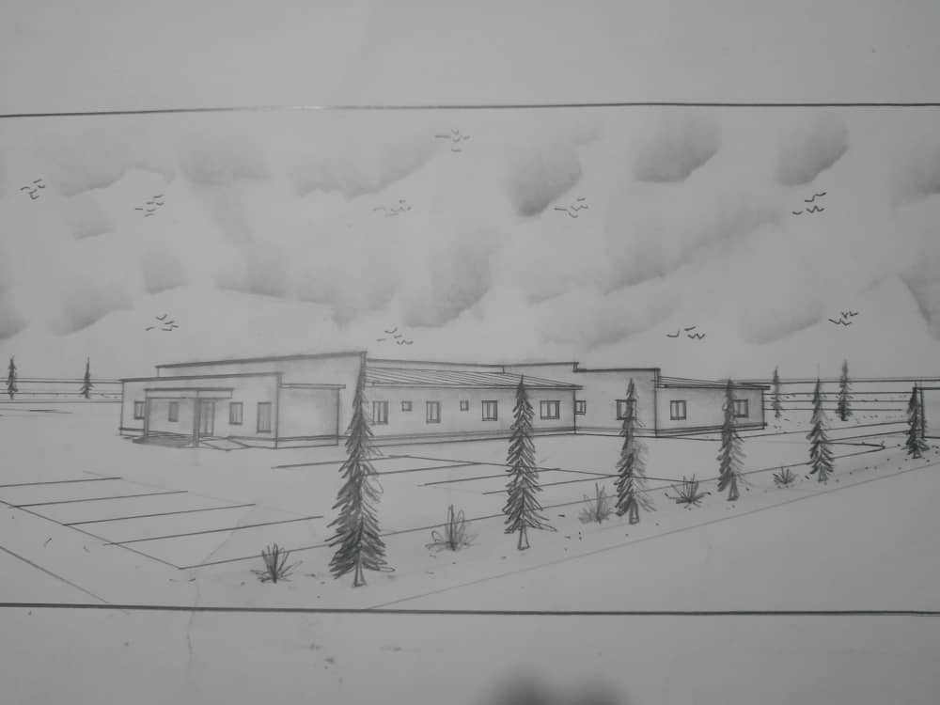

Appendix 5.9: External Perspective.

