CHAPTER ONE
1.0 INTRODUCTION
1.1 Background to the Study
Surveying can be defined as science, art and technology of making measurement (usually angular and linear) of the relative positions of natural and artificial (man-made) features on the earth’s surface and the representation of these information whether graphically or numerically i.e. inform of plans or maps.
Land surveying is the first point of reference in all meaningful land development projects. Provision of infrastructures; planning of towns and cities; management of hazardous natural events and human actions such as erosion, flooding, earthquakes, and subsidence; coastal management; exploration and exploitation of minerals; sitting of industries; resources exploitation on the land and on the sea, all are dependent on Land Surveying products.
Topography of an area describes the surface characteristics of relief features of such area as depicted by hills, valleys and plains. It can be used to study and represent, as a surface, any characteristic that has a continuously changing value other than elevation.
Topographical Surveying involves the acquisition of topographic data of the features on the earth’s surface, both man-made and natural features in three-dimensions (X,Y,Z). This employs the techniques of plane surveying and other special techniques to establish both horizontal and vertical controls A topographic survey has some varieties of uses which include: - planning and zoning, site layout, engineering and architectural design, and construction. The main objectives of this kind of survey is to produce a topographical map or plan which indicates or shows the three dimensional relationship for a particular area i.e. (X, Y, Z) co-ordinates.
The implications of the above is that no meaningful development can be embarked upon by an
individual, government and any other agencies without information about the topography of the land in the area where such development is to take place. Topographic Information System can be derived from the topographical data with the employment of the analytical capabilities of Geographic Information System (GIS).
According to Burrough, P,A (1986) Principle Of Geographical Information System For Land Resources Assessment:- Oxford University Press, New york, pp194. GIS is a tool for collecting, storing, retrieving at will, transforming and displaying spatial data from the real world for a particular set of purposes. In short, GIS can be used to add value to spatial data (Sharma et al 2006), Modelling through Geographical Information System and Global System in shatma, H.1, Ram, D.R Rara Prasad and Binda P.R (eds) Mathematical Modelling in Geographical Information System and Digital Cartography. Concept Publication, New Delhi, India.p2. This is by allowing data to be organized and viewed effectively, by integrating them with other data, by analysis and by the creation of new data that can be operated on in turn to create useful information that can help decision making. The uniqueness of GIS is in its ability to integrate data from a variety of sources.
Topographic Information System Digital technology was successfully introduced in the field of mapping in the late 1960‟s as a means of speeding up map production. (Perera and Shanta, 2002). With the change in technology in the last two decades and the growth in the number of spatial information systems, the concept of topographic database has been introduced in several mapping-surveying organizations in the world, in order to deliver more Geo-information to the user community.

1.2 Statement of Problem
It was observed that the study area (Maigida housing estate) has an outdated topographic plans/maps showing the relief of the estate premises. Therefore, this project would provide a relevant data of the topography of the estate, hence the need for carrying out the job. Topographical information system is very essential for areas where any physical developments are to be carried out. Such information like location, size, nature and terrain features of the area required. The existing topographical map showing the position of features of the area failed to meet the user’s need in terms of decision making and in development planning. Therefore, this project will serve as the digital base plan and spatial database that can be used in planning and also in the retrieval of information for the purpose of decision making.

1.3 Aim and Objectives
1.3.1 Aim
The aim of this project is to create a Topographical Information System (of both natural and man-made features) for Maigida Housing Estate, Ilorin Kwara State.
1.3.2 Objectives
In order to achieve the aim of this project, the following objectives were considered:
- Designing a suitable topographic database of the project area
- Data Acquisition using ground-based method with the aid of Total station
- Creation of database about the attribute and Geometric data
- Performing relevant spatial Queries like Overlay Analysis, Buffering, Classification and Retrieval
1.3 Significance of the Study
The importance of carrying out this project can be enumerated as follows:
- To provides quick and easy access to large volumes of data of Maigida housing estate.
- To provides the means of map updating and data quickly of Maigida housing estate.
- It gives room to search for particular characteristics of features in an area, and information on the map for future use. It gives the ability to merge one data set with another (e.g geometric data and attribute data).
- It helps to facilitates efficient information retrieval.
- Gives information on environmental impact assessment and planning.

1.4 Scope of the Project
The scope of the project involves,
- The design and creation of a spatial database
- The use of automated surveying equipment for data acquisition
- Processing of field data with the aid of computer hardware and software, query generation for the topographic database.
- Representation of the information in digital form both softcopy and hardcopy
- And the compilation of a comprehensive report writing.

1.6 Study Area
The study area falls within Maigida Housing Estate, Ilorin, Ilorin South Local Government area of Kwara State. The area falls on latitude 04°37'55"N and longitude 08°33'32"E. The area is approximately found to be 11.70 hectares. The site is a developed area with features, both natural and artificial made such as buildings, roads, trees, electricity lines, street lights, and telecommunication masts.
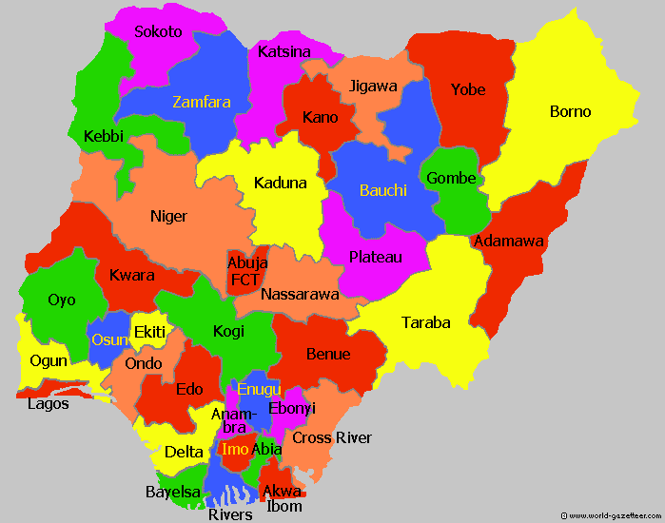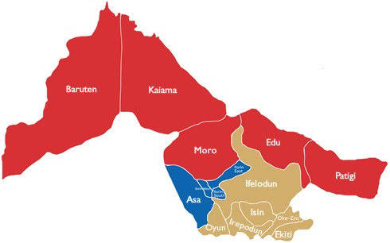
MAP OF KWARA STATE`
MAP OF NIGERIA

`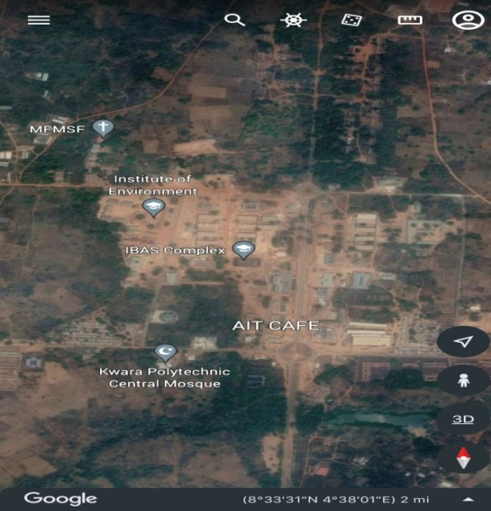 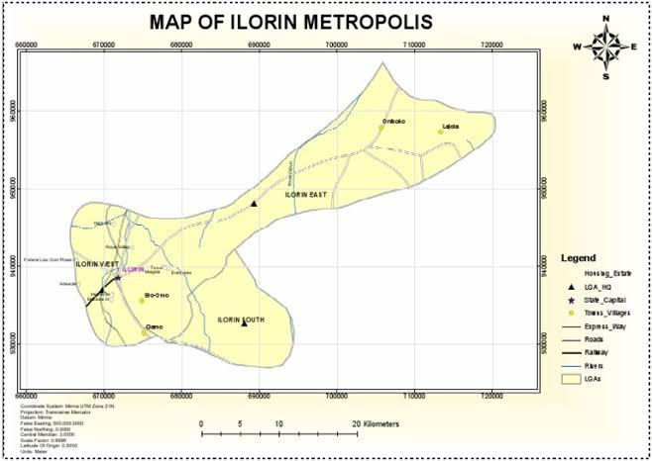
MAP OF ILORIN METROPOLIS
GOOGLE IMAGERY 0F THE STUDY AREA
Fig1.10: Map Showing Study Area
CHAPTER TWO
2.0 LITERATURE REVIEW
This project shall be received from textbooks, journal papers, conferences, manuals and reports with reference to the following sub topic,
- Topographic Survey.
- Topographic Information System.
- Topographic Information and Geographic Information System.
Surveying, which has recently also been interchangeably called geomatics has traditionally been defined as the science, art and technology of determining the relative positions of points above, on, or beneath the Earth’s surface, or of establishing such points. In a more general sense, however, surveying can be regarded as that discipline which encompasses all methods for measuring and collecting information about the physical earth and our environment, processing that information, and disseminating a variety of resulting products to a wide range of clients. Surveying has been important since the beginning of civilization. Its earliest applications were in measuring and marking boundaries of property ownership. Throughout the years, its importance has steadily increased with the growing demand for a variety of maps and other spatially related types of information and the expanding need for establishing accurate line and grade to guide construction operations. (Charles D. Ghilani, and Paul R. Wolf (2012) Elementary Surveying An Introduction To Geomatics, Thirteenth Edition Pearson Education, Inc. Upper Saddle River, New Jersey O7458 P.1 – 2. Geomatics is a relatively new term that is now commonly being applied to encompass the areas of practice formerly identified as surveying.
The name has gained widespread acceptance in the United States, as well as in other English-speaking countries of the world, especially in Canada, the United Kingdom, and Australia. In the United States, the Surveying Engineering Division of The American Society of Civil Engineers changed its name to the Geomatics Division. Many college and university programs in the United States that were formerly identified as “Surveying” or “Surveying Engineering” are now called “Geomatics” or “Geomatics Engineering.” (Charles D. Ghilani, and Paul R. Wolf (2012) Elementary Surveying An Introduction To
Geomatics, Thirteenth Edition Pearson Education, Inc. Upper Saddle River, New Jersey O7458 P.1 – 2.
The principal reason cited for making the name change is that the manner and scope of practice in surveying have changed dramatically in recent years. This has occurred in part because of recent technological developments that have provided surveyors with new tools for measuring and/or collecting information, for computing, and for displaying and disseminating information. It has also been driven by increasing concerns about the environment locally, regionally, and globally, which have greatly exacerbated efforts in monitoring, managing, and regulating the use of our land, water, air, and other natural resources. These circumstances, and others, have brought about a vast increase in demands for new spatially related information. (Charles and Paul, 2012). (Charles D. Ghilani, and Paul R. Wolf (2012) Elementary Surveying an Introduction to Geomatics, Thirteenth Edition Pearson Education, Inc. Upper Saddle River, New Jersey O7458 P.1 – 2.
Surveying has been described as a beginning of recorded history. It has been discovered to be an imperative requirement in the planning and execution of every form of meaning development (Bannister, A. & Raymond, S. 1986): Surveying (4thed). Essex: ELBS/Longman. Provision of infrastructure; planning of towns and cities; management of hazardous natural events and human actions such as erosion, flooding, earthquakes and subsidence; coastal management; exploration and exploitation of minerals; sitting of industries; resources exploitation on the land and on the sea are dependent on land surveying products (E.O. Oriola, and Asonibare S.O,2011) ― Topographic Information System as a Tool For Environmental Management ‖ Journal of Asian Scientific Research , Vol.1, No.8,pp.441-450. Topography of an area describes the surface characteristics of relief features of such area as depicted by hills, valleys and plains. It can be used to study and represent as a surface, any characteristic that has a continuously changing value other than elevation, for geo-chemical data. Topographical surveying involves the acquisition of topographic data of the features on the earth‘s surface, both man-made and natural in three-dimension (x y z). This employs the techniques of plane surveying and other special techniques to establish horizontal and vertical controls. The implications of the above is that no meaningful development can be embarked upon by an individual, government and any other agencies without information about the topography of the area where such development is to take place. Topographic information system can be derived from the topographic data with the employment of the analytical capabilities of geographic information system [GIS]. Geographic Information System (GIS) evolved as a new technology in surveying. It combines geographic data (location) and attribute data about object feature on the earth‘s surface with cartographic representation in order to perform spatial decision making using spatial analysis.
According to Burrough, P,A (1986) Principle Of Geographical Information System For Land Resources Assessment:- Oxford University Press, New york, pp194., GIS is a tool for collecting, storing, retrieving at will, transforming and displaying spatial data from the real Topographic Information System as a Tool for Environmental Management.
In short, GIS can be used to add value to spatial data (Sharma et al 2006), Modelling through Geographical Information System And Global System in shatma, H.1, Ram, D.R Rara Prasad and Binda P.R (eds) Mathematical Modelling in Geographical Information System and Digital Cartography. Concept Publication, New Delhi, India.p2. This is by allowing data to be organized and viewed effectively, by integrating them with other data, by analysis and by the creation of new data that can be operated on in turn to create useful information that can help decision making. GIS is unique in its ability to integrate data from variety of sources. A GIS can thus be described as a form of spatial decision support system.
A digital terrain model (DTM) is a topographic model of the terrain relief that can be manipulated by computer programs Ndukwe, K. N. (2001): ―Digital Technology In Surveying and Mapping; Principle, Application And Legislative Issue.‖ P.101.
The data files contain the spatial elevation of the terrain in digital format which are usually represented as a rectangular grid. Vegetation, buildings and other man made (artificial) features are removed leaving only the underlying terrain. Modeling terrain relief using DTM is a powerful tool in GIS analysis and visualization. DTM can be stored in GIS database in several ways: -As a set of contour vectors, a rectangular grid of equal spaced corner/point height or an irregularly spaced set of point connected in triangles (TINTriangular Irregular Network).

2.1 Topographic Survey
Topography is generally known as the study of earth surface, and its features and shape. It also gives the description of the features (such as surface, shapes, vegetation cover & elevations), depicted in maps (Ojiako, J.C, and Jimoh, S.O. 2017). Topographic Information System of Federal School of Surveying, Oyo East Local Government Oyo State Nigeria. International Journal of Advanced Engineering Management and Science (IJAEMS), 7,811-815. These characteristics are natural and artificial (or manmade).Man-made features are highways, bridges, dams, wharfs, buildings, and so forth.
A topographic survey is a survey conducted to obtain the data needed for the preparation of a topographic map. This data consists of the horizontal and vertical locations of the features to be shown on the map. Topographic Surveys are surveys made to determine the configuration of the earth’s surface and to locate natural and cultural features on it. Topographic surveys establish the different manmade and the natural features of land. This type of survey can be very beneficial to home owners, industrial owners, or even for properties under construction. Land may include hills, trees, fences, buildings, ravines. A topographical survey will provide exact figures of the size, height and position of different changes that have occurred over the course of time with regard to their presence or that of any manmade structures. A graphic representation of the topography of this area is called a topographic map. A topographic map is simply a drawing that shows the natural and artificial features of an area. Topographic maps with larger scales as well as digital map products are necessary for better planning (Charles D. Ghilani, and Paul R. Wolf (2012)
Elementary Surveying an Introduction to Geomatics, Thirteenth Edition Pearson Education, Inc. Upper Saddle River, New Jersey O7458 P.1 – 2.
This report comprises the few of the activities involved in topographic map compilation such as field data acquisition, processing of field data, analyses of data and presentation of results and elevation models of acquired topographic field data using AutoCAD Civil 3D, Surfer 10 and ArcGIS 10.3.

Topographic Information System
Digital technology was successfully introduced in the field of mapping in the late 1960‟s as means of speeding up map production. (Perera, S. and Shanta, K. O). (2002). “A Topographic Database for Geoinformation Process in the Survey Department of Sir Lanka”.Pp 1-6. With the change in technology in the last two decades and the growth in the number of spatial information systems, the concept of topographic database has been introduced in several mapping-surveying organizations in the world, in order to deliver more Geo-information to the user community.
Topographic Information System is very crucial in this present age in other to be able to update maps and retrieve necessary data at any given time with minimal efforts. Topographic Information System can be explained as the combination of human effort and computer-based tools for the collection, storage, analysis, manipulation and retrieval of various kinds of data relating to geographic features (man-made and natural) on the surface of the earth (Lexicon Universal Encyclopedia , 1989), Lexicon publication Inc. New York N.Y (1989).
In view of this, it is necessary to create Topographic Information System for different locations because the information generated from such system can be used for various purposes in physical planning and decision making in such locations. Some of the usefulness and advantages of this digital database for such system over the conventional maps include:
- Possibility of fast amendment and dynamic updating of data
- Fast capturing of data with Total Stations or GPS
- Analysis of many important spatial problems
- Versatility in integrating data collected from various sources
- Flexibility output possibilities
- Provides bases for additional information with relative ease for production of maps.

2.2 Topographic Information and Geographic Information Systems (GIS)
Topographic detailing and Geographic Information Systems (GIS) are a sine-qua-non for the successful creation of any Topographic Information System. A TIS would be best described as an incorporation of human efforts, Information and Communication Technology ICT using computerized tools and relevant software for the collection, storage, analysis, manipulation and retrieval of various kinds of earth related data (natural and artificial). The demand for Geo-Information about topographic features of the landscape has been increasing continuously. Its ranges of application are for the planning of power supply, transportation, construction among others.
Topographic data are vital for many scientific, technical, and other applications. Even when not used directly in a study, topographic data are often used in preparing visualization tools such as perspective or stereoscopic views of terrain. (NOAA. 2017, January 12). Topographic information system can be derived from the topographic data with the employment of the analytical capabilities of GIS (Onuigbo, I. C., Zita, N., Gbedu, A. M., Pious, N. O., & Samaila, I. F. (2015).
Topographic Information System (TIS): A Critique to Sustainable Physical Development and Decision Making. Journal of Multidisciplinary Engineering Science and Technology (JMEST), 1298- 1304. The modern digital techniques for the compilation of topographic maps greatly differ from the conventional processes.
Today, the collection of topographical data by modern digital tools is carried with the view of building a complex topographic multi-purpose system. Thus, the focus of topographic surveying has shifted from production of analogue topographic maps printed on paper to the structuring, production, capture and maintenance of an organized and regulated database of digital spatial information (Igor, V. 2010). The Official Topographic and Mapping System of the Republic of Croatia. FIG Conference, (p. 1). Croatia.
The acronym GIS sometimes used for Geographic Information Science is used to refer to the academic discipline that studies Geographic Information Systems and is a large domain within the broader academic discipline of Geo-informatics. Geographic Information System (GIS) evolved as a new technology in surveying. It combines geographic data (location) and attribute data about object feature on the earth‘s surface with cartographic representation in order to perform spatial decision making using spatial analysis (Odo, K. O., Idhoko, K. E., Oha, C. P., Okoro, E. G., & Okafor, C. E. 2015). Topographic Information System as a Tool for Environmental Management, a Case of Part of Delta State Polytechnic Ogwashi- uku, Aniocha South, Delta State, Nigeria. Journal of Environmental Science, Toxicology and Food Technology (IOSR-JESTFT), 117-122. GIS is becoming essential to understanding what is happening and what will happen in geographic space. Once we understand, we can prescribe action. This new approach to management-managing geographically-is transforming the way organizations operate.
A GIS is a computer-based system that provides the following four sets of capabilities to handle georeferenced data (Otto, H., & Rolf, A. d. 2009). Principles of Geographic Information Systems. Enscheda, The Netherlands: International Institute for Geo-Information Science and Earth Observation.
- Data capture and preparation.
- Data management, including storage and maintenance. Data manipulation and analysis.
- Data presentation.
A geographic information system (GIS) lets us visualize, question, analyze, and interpret data to understand relationships, patterns, and trends. “GIS is an integrated system of computer hardware, software, and trained personnel linking topographic, demographic, utility, facility, image and other resource data that is geographically referenced. “National Aeronautics and Space Administration (NASA)”. Salimon O., (2015); approached Topographical Information System of Durbar Grammar School, Oyo East Local Government Area, Oyo State. The processes involved in the execution of the project include: spatial data acquisition, designing and creation of the database, data downloading, data processing, etc. spatial data were acquired using SOUTH (S/No:S16126) Total Station, while attribute data were acquired through social surveys. All the techniques involved were explicitly itemized and discussed. Spatial analysis and product generation were carried out. Plotting was done using AutoCAD 2007 Land Development, Surfer 10 was used in generating the contour. Database design and creation were carried out using ArcGIS 10.1
software. The topographic database was tested by running queries and subsequently the required information necessary for decision making were generated.
Also, Bayewumi S., (2009); approached his Topographical Surveying for Awe High School, Awe, Oyo State. Using an analogue approach of spatial data acquisition using analogue Theodolite, automatic leveling instrument, processing of data acquired manually using programmable calculator and presentation of the product in analogue map. The final product of his plan shows the perimeter boundary, features and contour plan of the area. Limitation using this approach is that the form of data acquisition is time consuming and the product is rigid and all information are kept in analogue form and could not be easily
updated and converted to digital spatial database.
Furthermore, Odo, K. O., Idhoko, K. E., Oha, C. P., Okoro, E. G., & Okafor, C. E. (2015) Topographic Information System as a Tool for Environmental Management, a Case of Part of Delta State Polytechnic Ogwashi- uku, Aniocha South, Delta State, Nigeria. Journal of Environmental Science, Toxicology and Food Technology (IOSR-JESTFT), 117-122., using digital methods of data acquisition and data processing. Total Station (KOLIDA K46346) was used to acquire spatial data (X, Y, Z Coordinates) within the study area through the process of traversing, leveling and detailing, which were simultaneously carried out. The data processing was adequately and effectively done with the use of AutoCAD 2013, ArcGIS 10.1 and Surfer 9.0 software using the data processing as the management phase, a spatial database was modeled and structured using the relational table format. A digital terrain model (DTM) was created to enhance further analysis on slope, aspect, hill shade and view shed analysis of the study site. Limitation to his product is that only part of the study area was sampled and information about the neighboring environment was not included in his approach. Another study by (Ojiako, J. C., & Jimoh, S. O. (2017). TIS of Federal School of Surveying, Oyo East Local Government, Oyo State Nigeria. International Journal of Advanced Engineering, Management and Science (IJAEMS), 811-815, on Topographic Information System (TIS) of Federal School of Surveying, Oyo East Local Government Oyo State Nigeria carried out TIS with the aim of producing a tool for effective planning and land management of the school. Field and Office reconnaissance were carried out in order to be familiar with the terrain and do proper planning on the methodology and equipment to be used for the acquisition and assembling of spatial and attribute data. The geometric (spatial) data were acquired by ground survey method using Total station (South S74301) through the process of traversing, detailing and obtaining spot heights which were carried out simultaneously. The data processing was adequately and effectively done using Leica Geo Office Tools and South NTS Software for Data downloading, Notepad and Microsoft Excel for editing and preprocessing, AutoCAD 2016 for droughting, Surfer 11 for generating the Digital Terrain Model (DTM) and 3D Wireframe Map while ArcGIS 10.0 version was used for spatial analysis, query generation and information presentation. A model database was created and structured using the relational table format.
Finally, a study by Adewara M. B. and Kolawole O.A. on Topographic Information System (TIS): A Tool for Effective Planning and Proper Environmental Management (A part of The Federal Polytechnic, Ilaro, Nigeria). In their study, Landsat 8 (2010) image of the project site was used during the planning stage to have a general overview of the project site. Field data were collected using Total station instrument and processed using the Microsoft excel spreadsheet then saved into notepad to be called up in AutoCAD Civil 3D 2013 for scripting and generation a surface contour. Topographic information (TI) was created in the computer based on the collected datasets. Digital Terrain Model was created for further enhancement of the slope map, aspect map, hill shade and view shed analysis of the area using ArcGIS 10.2 and Surfer 10 software. The TI is available for manipulations and querying. The study concludes that TIS is essential for physical planning and accurate decision making as it is a system that allows easy updating of information and quick retrieval of information for better planning and environmental management.

CHAPTER THREE
3.0 METHODOLOGY
This stage outlines the methods and procedures used throughout the project, including planning, data collection, data processing, database creation, development of a database management system, and presentation of information. These activities were systematically organized and executed in phases, particularly focusing on database design. The process typically involves a spatially referenced, structured digital database and suitable application software for geospatial analysis. Overall, this section details the techniques and principles applied during the execution of the project.

3.1 Reconnaissance
This is the preparatory stage before the execution of this project; it involves collection of available information about the project area.
The necessary step taken for the successful execution of the project involves two stages, which are: -
- Office Planning
- Field reconnaissance

    - Office Planning
This phase involves gathering detailed information about the study area, testing the tools and instruments required for project execution, and outlining the necessary resources. It includes listing the equipment needed, estimating the number of days for each task, defining the procedures for carrying out each activity, and assigning responsibilities to team members based on the supervisor’s guidance and instructions.

3.1.2 Field Reconnaissance
The field reconnaissance is the first visitation to the project site to get intimated with the environment.
- Boundary points was selected
- The distribution of features was studied
- Controls to be used were located
- Method and type of instrument to be uses was determined
- Subsidiary point for Ground control Points were picked and define using nail and bottle cock
- A diagram of the study area was drawn.

Fig. 3.2.2.1: shows Recce diagram of the study area (not drawn to scale)

  - Equipment Used/ System Selection and Software
3.2.1 Hardware Used
- Total station
- 1 reflector with a tracking rod.
- 1 Tripod
- One (1) 50m tape
- One (1) umbrella
- 1 cutlass
- Hand held GPS
- Hammer
- Nails and bottle cover
- Field book and writing materials
- 1-No of Personal Computer HP655 and its accessories
- 1-No of HP DeskJet K7100 A3 printer

    - Software Component

- Notepad.
- Microsoft Excel.
- AutoCAD 2007
- ArcMAP10.2
- Surfer 25
- Microsoft Word.

3.3 Instrument Test
To ensure data quality, the Total Station used for this project was tested for both vertical index and horizontal collimation errors. It was also to ascertain the efficiency and reliability of the instrument. The procedure used is described below.

3.3.1 Horizontal Collimation Test
This test was performed to verify that the line of sight was perpendicular to the trunnion axis. The Total Station was set up over a known point, with initial adjustments made for proper alignment, levelling, and focusing to eliminate parallax. A vertical target was placed 100 meters away from the instrument. To begin the test, the configuration menu was accessed by holding the menu key for about two seconds. From the main menu, the calibration sub-menu was selected, followed by the horizontal collimation test. The target was then observed and bisected, and horizontal readings were taken for both Face Left and Face Right positions. The recorded results are presented in Table 3.4.1 below.
Total Station
REFLECTO R (TARGET)
100m

STATION A
Fairly Level Ground
STATION B

Fig 3.4.1.1: Horizontal Collimation and Vertical Index error test.

Table 3.4.1.1: Horizontal Collimation Data
Station | Target | Face | Hz Reading | Difference | Error
A | B | L | 38˚42‟32”
 |  | R | 218˚42‟35” | 180˚00‟03” | 03”

3.3.2 Vertical Index Error Test
This test was conducted to verify the accuracy of the vertical reading when the line of sight is horizontal. The desired measurement for this test is exactly ninety degrees (90˚), any deviation from this value is referred to as the vertical index error.
The Total Station was positioned over a specific point, and necessary temporary adjustments were made to ensure proper alignment and functionality. A target was placed approximately 100 meters away from the Total Station, and the instrument was aimed at the target. The target was bisected by aligning the instrument on the face left, and the corresponding reading was recorded. Similarly, the target was then bisected on the face right, and the respective reading was also recorded. The recorded readings are provided below:

Table 3.4.2.1: Vertical Index Data
Instrument Station | Target Station | Face | Vertical | Sum | Error
A | B | L | 90˚00‟00”
 |  | R | 270˚00‟02” | 360˚00‟02” | 02”

3.3.3 Analysis of Collimation and Vertical Index Data
The reading obtain during calibration were reduced to obtain new collimation and vertical errors.
Horizontal collimation = {(FR – FL) – 180}/2 = {(00˚00‟03”}/2 = 1.5”
Vertical collimation = {(FL + FR) – 360} = (90˚00‟00” + 270˚00‟02”) - 360} = 02” The result shows that the instrument is still in good working condition.

3.4 Control Check
Three control beacons (PBIL3304, PBIL3306 and NILL) were used. In order to ascertain the in-situ of the control beacons, a check was carried out on them by observing the angle between them and comparing the result obtained with the computed angles from the giving coordinates.
The total station instrument was set on the control beacon PBIL3306. After performing all the necessary temporary adjustment, the reflector was placed on the control beacon PBIL3306 which served as the back station. The horizontal angular reading was taken and recorded while the instrument was on face left. The reflector was then taken to the NILL which serves as the forward station, the horizontal angle reading was then taken and recorded on both face left and face right. The reflector was taken back to the back station, the horizontal angle was then recorded on face right.

Table 3.5.1: Table showing the back computation of the control coordinates
From STN | Bearing | Dist (m) | ∆N | ∆E | Northing (m) | Easting (m) | To STN
 |  |  |  |  | 940288.197 | 678281.701 | PBIL3306
PBIL3306 | 245°11'  30’’ | 30.242 | -12.689 | -27.451 | 940275.508 | 678254.250 | PBIL3304
PBIL3304 | 188°19'  41” | 264.560 | -261.774 | -38.320 | 940013.734 | 678215.930 | NILL

Table 3.5.2: Table showing the distance observation result of the control check
FROM | OBSERVED DISTANCE  (m) | COMPUTED DISTANCE  (m) | TO
PBIL3306 | 30.240 | 30.242 | PBIL3304
PBIL3304 | 264.559 | 11.562 | NILL

Table 3.5.3: Table showing the observation result of the control check
STN | SIGHT | FACE | OBSERVED HZ ANGLE | REDUCED HZ ANGLE | MEAN
 | PBIL3306 | L1 | 350°22' 43''
PBIL3304 | PBIL3306 | L2 | 105° 11' 24'' | 245° 11' 19''
 | PBIL3306 | R2 | 285° 14' 13'' | 245° 11' 26''
 | PBIL3306 | R1 | 170° 25' 39'' |  | 245° 11' 23''

Difference in angle (observed - computed) =245° 11' 23''-245° 11' 19'' = 00° 00' 04''
Since the allowable accuracy (angular) of third order traverse of one station is 00° 00' 30'' and the result obtained from the control check (00° 00' 04'') is less than allowable error. Therefore, the controls were angularly intact.

3.5 Monumentation
The boundary of the designated area was marked using precast concrete beacons, following the clearing of necessary lines of sight. Points where the boundary changed direction were identified, excavated, and beacons were installed, leaving approximately 15 cm of each beacon exposed above ground level. The beacons were placed at intervals determined by the terrain and the nature of the boundary.
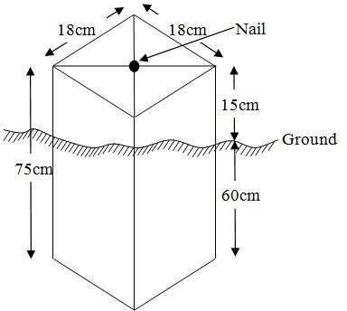

Fig. 3.6.1: Pillar Description

3.6 Data Acquisition

3.6.1 Primary Data Source
Field observation was the primary source of data for this project. Ground based method was used in acquiring data with the use of Total Station Instrument, which involved the collection of X, Y, Z data through coordinated Ground control Points (GCP) established at conspicuous points within the study area.

3.6.2 Secondary Data Source
An imagery of the area was acquired through Updated Google earth; this was used to ascertain the extent of coverage of the project area.

    - Geometric Data Acquisition

The Total Station was carefully set up over control point ND20, with a back sight taken to point KW3009PT after performing the necessary station adjustments, including cantering, levelling, and focusing. The same procedure was repeated to determine the coordinates of the next point (NL1), and continued progressively until the site was reached. The radiation method was used for data acquisition, where two or more points were coordinated from a single instrument station.
The following steps outline the procedure:
- After completing temporary adjustments, the instrument was powered on, and a new job titled GRP2B was created in the internal memory under the job menu.
- The coordinates of two control points were input into the instrument's memory, along with predefined feature codes such as "RD" for roads, "SP" for spot heights, and "BD" for buildings.
- The height of the instrument and the reflector height were measured and entered into the instrument's memory.
- In the coordinate menu, orientation was established by inputting the coordinates of the instrument station and back sight. The reflector at the back sight was accurately bisected before confirming the orientation.
- Once oriented, the reflector was aimed at the next target (nail), and the "OBS" (observe) function was selected. The three-dimensional coordinates (Easting, Northing, and Height) were displayed and saved by pressing "REC" (record). For subsequent observations, the "ALL" option was used to streamline the process.
- It was ensured that the centre of the prism on the reflector was properly aligned and securely mounted on the tripod to minimize height determination errors.
- Once all visible details, including spot heights and boundary points, had been observed from the current station, the instrument was relocated to the next control nail, and the temporary adjustments were repeated.
This process was systematically carried out until all boundary points and elevation data were captured. In this project, spot heights were not recorded at regular grid intervals but were instead collected randomly. For each building, three corner points were surveyed. Upon completing the data acquisition phase, all relevant features were accurately recorded and positioned accordingly on the final site plan.
    - Attributes Data Acquisition
Attribute data refers to information that describes the characteristics and properties of spatial features. It provides details such as names, classifications, and functions of geographic objects. In this study, the attribute data collected included the names and uses of buildings (e.g., classrooms), as well as information on roads, water facilities, and significant natural features such as rivers, trees, and surrounding vegetation. These attributes were accurately identified and documented within and around the study area.

3.7 Data Downloading and Processing

3.7.1 Data Downloading
This stage involves transferring all acquired data, which were automatically stored in the Total Station, to a personal computer. The data download was carried out using a connecting cable and supported by compatible software installed on the computer to facilitate the transfer and management of the data.

3.7.2 Data Editing
The downloaded geometric data were further processed to convert them into usable formats and improve their accuracy. The resulting coordinate data were edited and exported in multiple formats, including .txt, .xls, and .pdf. These files were then imported into ArcGIS 10.3 for additional processing and to perform spatial analysis.

3.7.3 Data Processing using Autocad 2007
Before using AutoCAD, we processed the coordinate data observed in the field by first transferring it into Notepad, then copying it into AutoCAD. The following steps outline the process for handling the data in AutoCAD:
- Launch AutoCAD on the computer.
- Click "New" from the application menu to start a new drawing.
- Type UNITS in the command line and press Enter.
- Select the desired unit type (e.g., decimal, architectural, engineering).
- In the menu bar, select the "Polyline" tool.
- Copy the data from Notepad and paste it into AutoCAD.
- Type Z (for zoom) and press Enter, then type E (for extents) and press Enter to adjust the view.

3.7.4 Data Processing using Arcgis 10.3
ArcGIS, AutoCAD was used to plot feature data, saving them separately in different files such as roads, boundary lines, buildings, and trees.
To load and process this data in ArcGIS 10.3, follow these steps:
- Launch ArcMap in ArcGIS 10.3.
- When the dialog box appears, click on "A NEW EMPTY MAP" to start a new project.
- Click on "Tools" in the menu bar, then select "Extensions." Mark all extensions and click "Close."
- On the left-hand side (LHS), right-click on "Layers" and select "Properties."
- In the "Layer Properties" window, click on the "Coordinate System" tab to set the projection system to "Minna Datum Zone 31N." Then, go to the "General" tab to set the units and click "Apply," followed by "OK."
- On the toolbar, click "Add Data," select all the saved AutoCAD files, and load them into the "Table of Contents" layer section.

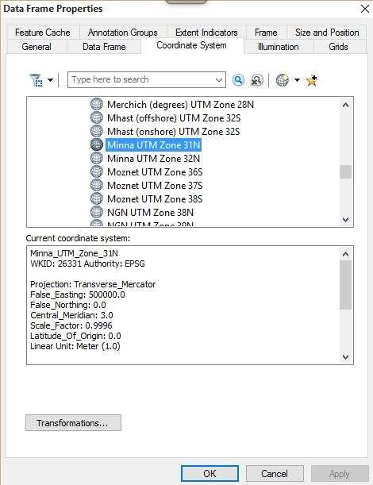
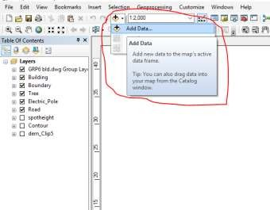

All drawings were exported to a shapefile. Once the feature class was created, click on the "Editor" button to start editing, then select "Start Editing" to load the object.

Creating Contours:
- First, create a Digital Elevation Model (DEM) by searching for "INTERPOLATION > NATURAL NEIGHBOR" in the search icon. Select the XYZ data to create the DEM, using the boundary line as the extent.
- To create contours, enable the Spatial Analyst Toolbar by going to Customize > Toolbars > Spatial Analyst, or you can open the search bar by clicking on Windows > Search or using the search icon.

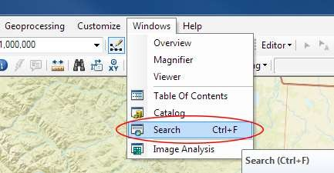

In the search bar type Contour, and select Contour (Spatial Analyst) from the search results list.
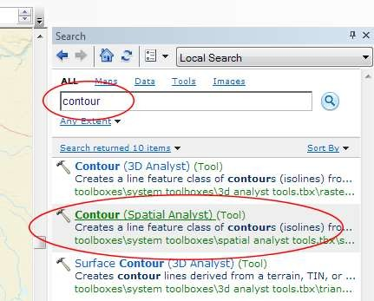

After selecting Contour, a dialog window will appear, prompting you to set the following five parameters:
- Input Raster: Select the DEM file from which you want to generate contours. You can either locate it on your hard drive or choose it from the dropdown menu that shows layers present in the Table of Contents.
- Output Polyline Features: Specify the location where you want to save your output contours.
- Contour Interval: Set the distance between contour lines in meters. A smaller interval results in more contour lines. For example, setting a contour interval of 10 meters will create more frequent contour lines compared to a 50-meter interval.
- Base Contour (Optional): Define the starting point from which the contours will be generated. The default is 0, so with a 25-meter interval, the contours will be generated at 25, 50, 75, 100, and so on. If the base contour is set to 40, the contours will be generated at 65, 90, 115, 140, etc.
- Z Factor (Optional): Adjusts the vertical scale of the data. For example, if your data is in meters and you want to display contours in feet, use a Z-factor of 3.28 (since 1 meter = 3.28 feet).

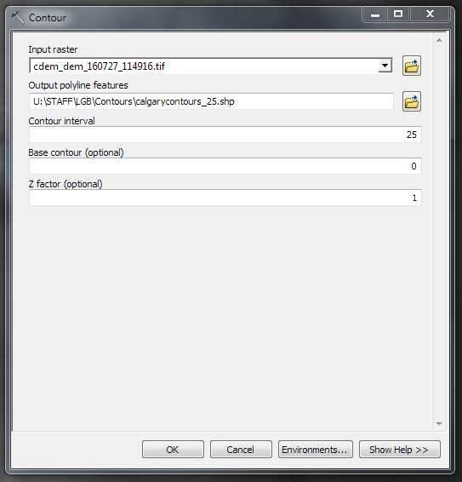

The generated contours will automatically be added to the map.
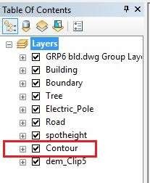

- Input Data: Load the AutoCAD drawing and select the feature type you want to import.
- Click "Add": Click "Next" to proceed, then choose the Target Layer where the feature will be loaded.
- Load Data: Import the data from the feature class that was created in ArcGIS.
- Query the Feature: Click "Next" and select "Only the features that satisfy the query." Then, click on Query Builder to create a query for the feature you want to load, for example: "layer" = 'Boundary'.
- Finish Setup: Click "Next" and then "Finish" to complete the process.
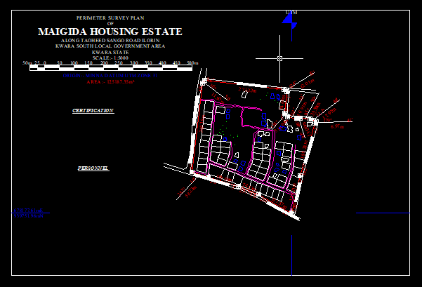
- View the Feature: Right-click on the Boundary layer in the Table of Contents and click Zoom to Layer to display the feature on the map.

Editing, Converting, and Merging Geodatabase
- Removing Features:
  - To remove unnecessary features, right-click on the feature and select Remove.
- Converting Features:
  - If features are not correctly classified (e.g., points, lines, polygons), they need to be converted to the appropriate feature type.
- Converting a Geodatabase Feature Class:
  - For Converting Line Feature Class to Polygon Feature Class:
    - Go to Window on the menu bar and select Arc Toolbox.
    - In Arc Toolbox, select Data Management Tools, then Features, and click on Feature to Polygon.
    - In the Input Features section, select the feature you want to convert. In the Output Feature Class, specify the location (e.g., save in the GRP6C folder), and click OK.
    - After the conversion, remove the feature class from both the Layer Menu and ArcCatalog.
- Merging Feature Classes:
  - To merge multiple feature classes:
    - In Input Datasets, select the features you wish to merge.
    - In Output Datasets, specify where to save the merged file (e.g., in the GRP6C folder), and click OK.
    - After the merge is complete, remove the merged feature class from both the Layer Menu and ArcCatalog.

Table Creation
- Creating Attribute Tables:
  - Attribute tables are essential for performing queries. Ensure that Editing is stopped before adding fields to the table.
- Steps to Add Fields:
  - Right-click on the feature class and select Open Attribute Table.
  - Click on Options and select Add Field.
  - In the Field Name section, give the field a name.
  - In the Type dropdown, select the appropriate type:
    - Short Integer or Long Integer for whole number variables.
    - Double for decimal variables.
    - Text for text variables.
    - Date for date variables.
  - For Text fields, set the Length (e.g., text width), and for Decimal fields, set the Scale (decimal places). Click OK.
- Inputting Data into the Attribute Table:
  - To input data, go to the Editor menu on the menu bar and select Start Editing.
  - Click on Attributes on the menu bar (behind the Target).
  - Select the features in the Data View Display and input the required variables, which may come from social surveys or field data.
  - Once the data is entered, click Save Edits in the Editor menu.
  - To switch between layers, select Stop Editing from the Editor menu.
  - Repeat the steps above to create additional fields and populate the table, then save the edits.

Table 3.8.3.1: Building
ENTITY | FIELD ALIAS | DATA TYPE | FIELD SIZE
B_ID | Building Identification | Numeric | -
B_name | Building Name | Text | 14
B_Area | Building Area | Numeric | -
B_E | Building Easting | Numeric | -
B_Northing | Building Northings | Numeric | -

Table 3.8.3.2: Road
ENTITY | FIELD ALIAS | DATA TYPE | FIELD SIZE
R_ID | Road Identifier | Numeric | -
R_Length | Road Length | Numeric | -
R_Width | Road Width | Numeric | -
R_Type | Road Type | Text | 14
R_Condition | Road Condition | Text | 14

Table 3.8.3.3: Trees
ENTITY | FIELD ALIAS | DATA TYPE | FIELD SIZE
TR_ID | Tree Identifier | Numeric | -
TR_Spp | Tree specy | Text | 14
TR_E | Tree_Easting | Numeric | -
TR_N | Tree Northing | Numeric | -

Table 3.8.3.4: Electric Poles
ENTITY | FIELD ALIAS | DATA TYPE | FIELD SIZE
EP_ID | Electric pole Identifier | Numeric | -
EP_Type | Electric pole Type | Text | 14
EP_Height | Electric pole Height | Numeric | -
EP_E | Electric pole Easting | Numeric | -
EP_N | Electric pole Northing | Numeric | -

ADDING SPOT HEIGHTS DATA

- NOTE: STOP EDITING on the EDITOR MENU before adding data field,

- Go to FIELD ON THE MENU BAR, scroll to add Data and then ADD XYZ DATA

- Browse the EXCEL FILE for SPOT HEIGHTS, select EASTING VALUE on X - FIELD and NORTHING VALUE on Y - IELD and ELEVATION
- « Select DATA the EXPORT DATA, locate the folder created and give it name then YES AND OK, remove the previous layer by right clicking on it and select REMOVE.

TIN, ASPECT AND SLOPE CREATION USING ARCMAP

NOTE: Making sure the 3D Analyst Extension is active, select VIEW on MENU bar, then click TOOLBARS and MARK the 3D Analyst EXTENTION Then X, Y Data

TO CREATE TIN

- Click on 3D Analyst arrow, select create TIN and then create TIN from FEATURE.

- On layers mark the SPOTHEIGHT LAYER, select height data on HEIGHT, then ok.
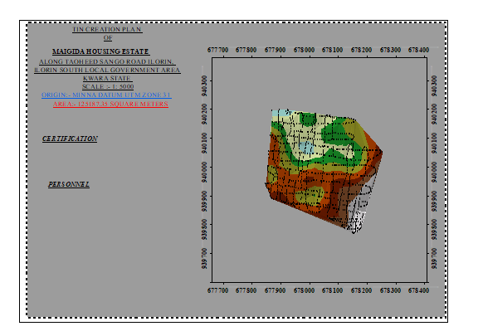

TO CHANGE THE FACE OF THE TIN ACCODING TO ITS ELEVATION

- RIGHT CLICK on the TIN, select PROPERTIES, and click on SYMBOLOGY.

- Then ADD, select FACE ELEVATION WITH COLOR RAMP, click ADD, and then select APPLY and OK.

TO CREATE ASPECT

- Click on 3D analyst arrow, select SPATIAL ANALYST TOOLS, SURFACE and THEN DOUBLE CLICK on ASPECT.
- Browse to where the raster format of all the acquired data created from the surfer was saved to.
- Browse to where you want the OUTPUT RASTER to be saved

- You can change the OUTPUT MEASUREMENT to Degree OR percent

- Click OK [then it displays on the data view screen], then Close.

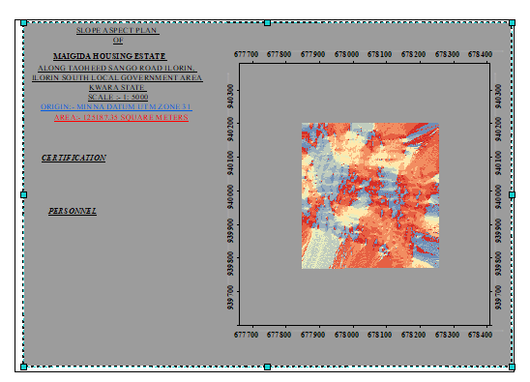

3.8 Database Implementation
This phase involves the creation of the database. After completing the three stages of the design process—Reality, Conceptual, and Logical design—the database was established using ArcGIS 10.3 software. This process combines and stores both the acquired graphical data and attribute data, facilitating spatial analysis and queries.
A database is an organized, integrated collection of data stored in a way that allows it to be accessed by relevant applications. The data is structured so it can be retrieved by different logical components. After populating the attribute table through manual input, certain attributes, such as the areas of settlements, were automatically displayed using specific commands in ArcGIS 10.3. The software was then used to link the graphical data with the attribute table, enabling query generation.
    - Database Management Systems
Database management refers to a collection of software used for creating, storing, manipulating, updating, organizing, and querying information within a database (Kufoniyi, 1998). It is a software system designed to manage and manipulate a database on behalf of the user.
A good Database Management System (DBMS) should provide the following essential functions:
a. Storage and Retrieval of Data: Efficient storage and retrieval of data within the database.
b. Concurrent Access: The ability to allow multiple users to access the database simultaneously without compromising data integrity.
c. Standardized Interface: A standardized interface between the database and application programs, enabling seamless integration and communication.
d. Separation of Data Functions: Standardized access to data, with a clear separation of the data storage and retrieval functions from the applications using the data.
e. Data Security and Integrity: Ensuring the security and integrity of the data, protecting it from unauthorized access, corruption, and loss.

3.8.2 Database Maintenance
Once the database is created, it is essential to perform proper maintenance to ensure it meets its intended objectives. Regular maintenance allows for the inclusion of new data and the removal of irrelevant or outdated data. Since physical changes can occur in the landscape over time, it is crucial that the database is updated frequently to reflect these changes.
Both data security and integrity are integral aspects of maintenance, ensuring that the database remains reliable and functional. Proper database management, including regular updates and consistent monitoring, helps to maintain its currency and quality, which is essential for effective use in a Spatial Decision Support System (SDSS). The quality of a database is determined by its timeliness and its fitness for use as part of a decision support system (DSS).
The storage media used for the database must be periodically assessed to prevent potential issues such as data inaccessibility or the physical deterioration of the media. Additionally, careful attention should be paid during data entry, as the integrity of the database is only as good as the quality of the data provided. For archiving purposes, stable and durable storage media should be employed, such as:
- Computer-compatible tape readers
- Magnetic tape
- Optical discs and compact discs

CHAPTER FOUR

4.0 SPATIAL ANALYSES AND PRESENTATION
GIS stands out from other information systems due to its spatial analytical capabilities, which include overlay operations, buffering, spatial search, topographic analysis, and neighbourhood and connectivity operations. These features allow GIS to address key generic questions related to location, condition, trends, routing, patterns, and modelling by manipulating and analysing input data. In this project, the primary analyses performed were overlay operations, topographic operations, and spatial search.
4.1 Testing of Database
This test was conducted to determine whether a relationship exists between the data modelled about entities in the spatial database and to assess its retrieval capabilities. The test involved designing a sample query with specific conditions, which was then executed to verify if the desired results were achieved.
4.2 Analysis of Result
The contour with a value greater than or equal to 350 meters indicates areas that are less likely to be prone to flooding within the project area, as shown in Fig. 4.5 (Query 1). This contour represents the elevation of points above 350 meters. The displayed attribute table confirms that the north-eastern part of the institute has the highest elevation. Elevation is a critical factor when assessing the surface or slope of the terrain. Conversely, the southwestern part of the school has the lowest elevation and is highly susceptible to erosion. Buildings constructed in this region must have elevated foundations to protect them from potential damage. The results of this query will help the school management make informed decisions about the terrain characteristics and guide them in choosing the appropriate type of construction for each area of the project site, considering the unique terrain conditions.

SINGLE SELECTION CRITERION

Query 1: Shows the retrieving Area whose height is Greater than 310 meters

SELECT* FROM Contour WHERE "CONTOUR">310

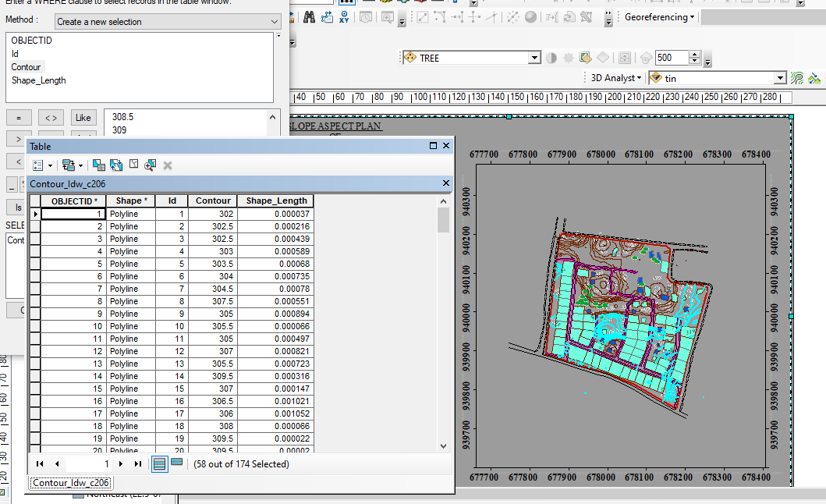

Fig 4.1.1: Shows the retrieving Area whose height is greater than 310 meters

Fig 4.1.2: Shows the result of area whose height is greater than 310 meters
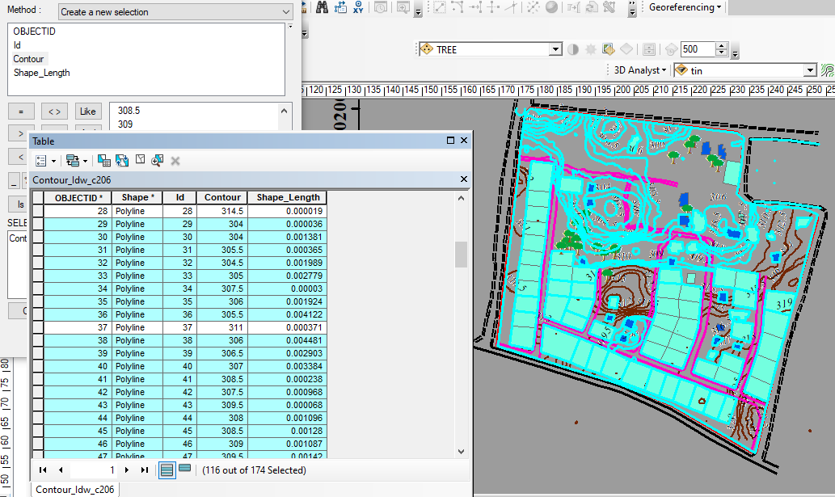

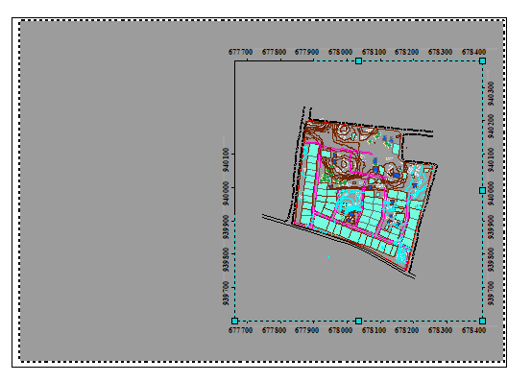
Fig 4.1.3: Show the result of area whose height is greater than 310 meters
Fig 4.1.4 Query Shows the result of Buildings that painted in white collor for (BLD_COLOUR = 'WHITE')

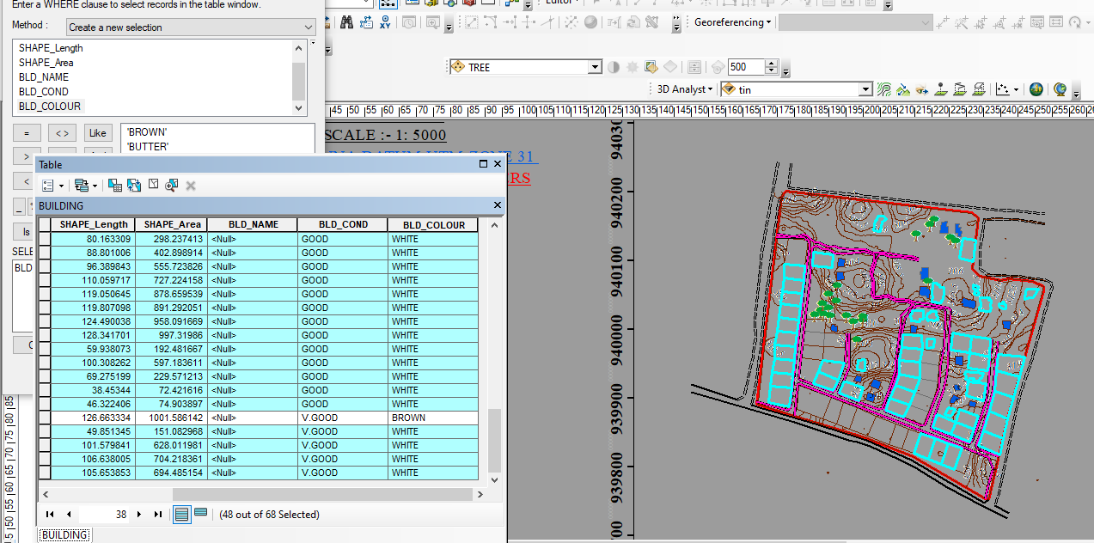

Fig 4.1.5 Query Shows the result of Buildings that painted in brown color (B_NAME = 'BROWN')

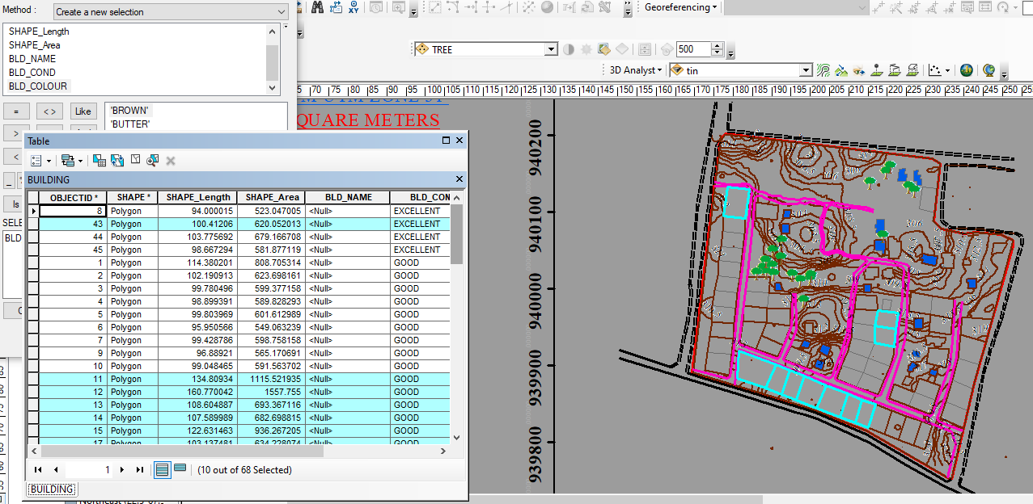

Fig 4.1.6 Query Shows the result of Buildings that painted in butter color (B_NAME = 'BUTTER')

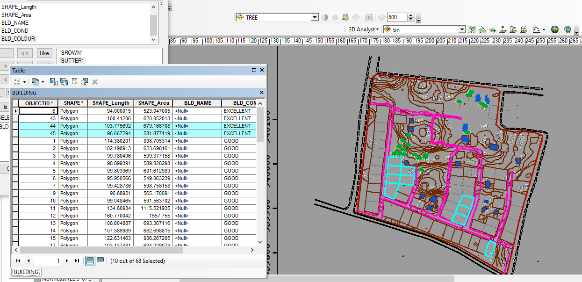

CHAPTER FIVE
5.0 SUMMARY RECOMMENDATION AND CONCLUSION
5.1 Summary
The primary objective of this project is to accurately determine the elevation differences in the terrain and identify the various features within the designated site area. This was achieved through the implementation of a ground survey method using specialized equipment like the Total Station instrument and its associated accessories. By utilizing the radiation method, the instrument efficiently collected precise data on coordinates and elevation. The acquired data was then processed and analyzed to generate several informative outputs. Plans were created, offering a comprehensive visualization of the area in dimensions, effectively highlighting the variations in elevation. Additionally, a perimeter and detailed plan were developed to depict the boundaries and specific features present within the site. A wireframe plan was also constructed to visualize the surface and its contour lines, while a contour plan was generated to illustrate the different elevation levels across the entire area.
To facilitate the analysis and processing of the collected data, a range of software tools were employed. ArcGIS was utilized for spatial analysis and data manipulation, Surfer9 was employed for generating contour plots and visually representing the terrain, Microsoft Excel was used for efficient data management and analysis, and Notepad served as a text editor for handling data in a tabular format.

5.2 Recommendation
Throughout the execution of this project, a plethora of new insights and knowledge were acquired. Based on these experiences, I highly recommend conducting similar projects in a practical manner, as it offers students a profound understanding of the subject matter. Additionally, it is crucial to provide students with an enhanced learning environment equipped with digital tools and equipment to further enhance their educational experience.

5.3 Conclusion
In conclusion, the topographical survey conducted in this project holds significant importance for planning, design, and landscaping purposes. The accurate and comprehensive information gathered through the survey provides valuable insights for Engineers and Architects to make informed decisions and design infrastructure that is safe, accessible, and efficient. The project's adherence to survey rules and regulations further validates the credibility of the survey results and ensures the quality of the project's outcomes.

