PETROGRAPHIC STUDIES OF ROCK IN KWARA STATE POLYTECHNIC, ILORIN

By

RAHEEM, FATIMO TAIWO
ND/23/MPE/FT/0069

SUBMITTED TO:
THE DEPARTMENT OF MINERALS AND PETROLEUM RESOURCES ENGINEERING TECHNOLOGY INSTITUTE OF TECHNOLOGY, KWARA STATE POLYTECHNIC, ILORIN
IN PARTIAL FULFILLMENT OF THE REQUIREMENT FOR THE AWARD OF NATIONAL DIPLOMA (ND) IN MINERALS AND PETROLEUM RESOURCES ENGINEERING TECHNOLOGY

JULY, 2025

Certification
This is to certify that this project was carried out and submitted by RAHEEM, FATIMO TAIWO of Matric number ND/23/MPE/FT/0069 to the Department of Minerals and Petroleum Resources Engineering, Kwara State Polytechnic, Ilorin in partial fulfilment of the Requirement for the Award of National Diploma in Minerals and Petroleum Resources Engineering Technology.

…………………………….. ………………………
Dr. Reuben Obaro Date
Project Supervisor

………………………………. ……………………….
Dr. J. A. Olatunji Date
Head of Department

….………………………………. ………………………
Engr. C.T Oluwole Date
External Examiner

Dedication
I am delighted to dedicate this project to Almighty GOD, the creator of all universe who gave me the grace and opportunity to complete my National Diploma program and this research, may His name be glorified.

Acknowledgements
I give all the glory and adoration to Almighty GOD, the beginning and the End, for his greatest protection and love given to me as a privilege to start and complete this research work.
I wholeheartedly extend my special thanks to my amiable supervisor Dr. Reuben Obaro for his professional guidance and support towards the success of this project My gratitude goes to God Almighty for his grace, kindness, and love upon my life. My project supervisor, Dr. Reuben Obaro for his understanding and guidance. To my Head of department Dr. Olatunji and other lecturer in minerals and petroleum resources engineering technology department, and Kwara state polytechnic for availing me with their wealth of experience, may you all be reward abundantly.
I am also using this medium to say a big thank you to my loving parents Mr. & Mrs. Raheem for their support towards my pursuit for academic excellence. To my brothers and sisters for their encouragement and prayers. My sincere appreciation also goes to my course mates who directly or indirectly affected my life in the progress of this work.
I won’t fail to acknowledge the admirable support and
encouragement of my Dad Zackman, my lovely boyfriend Obey Oriade (Hindia), my twinny Rukayat Kemisola, roommates, and many others for their prayers and support throughout the period of this work.

ABSTRACT
This study presents a comprehensive petrographic analysis of rocks within the Kwara State Polytechnic, Ilorin, aimed at understanding their mineralogical composition, textural characteristics, and implications for construction and geological applications. The research focused on three major rock types: Migmatite Gneiss, Porphyritic Granite, and Biotite Granite, which were collected from different parts of the campus. Using standard petrographic methods, including thin-section preparation and microscopic analysis, key minerals such as quartz, feldspar (plagioclase, orthoclase, and microcline), biotite, muscovite, and hornblende were identified and described.

The results reveal that quartz and feldspars dominate the mineral composition, making up nearly 88% of the rocks, with accessory minerals contributing to the overall texture and durability. The presence of features like foliation, twinning, and pleochroism indicates a history of intense metamorphism and deformation, consistent with the region’s Precambrian Basement Complex setting. Economically, the rocks exhibit strong potential for use in construction, ceramics, glass manufacturing, and soil enrichment due to their mineral content.

Table of Contents
Title page i
Certification ii
Dedication iii
Acknowledgement iv
Abstract v
Table of content vi
List of Figures ix
List of Tables x
CHAPTER ONE 1
1.0 Introduction 1
1.1 Background of the study 1
1.2 Aim of the study 2
1.3 Objectives of the study 2
1.4 Problem Statement 2
1.5 Justification of the study 3
1.6 Scope of the study 3
1.7 Limitations of the Study 3
CHAPTER TWO 5
2.0 LITERATURE REVIEW 5
2.1 Review of Previous work 5
2.2 Occurrence of Rock 6
2.3 Physical composition of Rocks 7
2.4 Chemical Properties of Rock 8
2.5 Mineralogical Composition of Rock 8
2.5 Economic Importance of Rock 9
CHAPTER THREE 11
3.0 MATERIALS AND METHODS 11
3.1 Geology of Nigeria 11
3.2 Geology of the Study Area 13
3.3 Sample Collection 15
3.4 Sample Preparation 15
CHAPTER FOUR 16
4.0 RESULTS AND DISCUSSION 16
4.1 Results of Petrographic studies of the Thin Sections 16
4.2 Discussion on Petrographic Studies of Migmatite Gneiss 16
4.3 Petrographic Description of some of the Prominent Minerals in the Migmatite 17
4.3.1 Quartz (SiO₂) 17
4.3.2 Plagioclase Feldspar (Na₂AlSi₃O₈.Ca₂Al₂Si₂O₈) 17
4.3.3 Orthoclase Feldspar 17
4.3.4 Microcline Feldspar 18
4.3.5 Muscovite (KF)₂(Al₂O₃)₃(SiO₂)₆ 18
4.3.6 Biotite (Mg,Fe)₃ AlSi₃O₁₀(OH,F)₂ 18
4.3.7 Hornblende (Ca₂(Mg,Fe)₅(AI,Si)₈O₂₂(OH)₂ 19
4.4 Discussion on Petrographic Studies of Porphyritic Granite (Sample B) 21
4.5 Discussion on Petrographic Studies of Biotite Granite (Sample C) 23
4.6 Economic Potential of the Rocks 25
CHAPTER FIVE 26
5.0 Conclusion and Recommendation 26
5.1 Conclusion 26
5.2 Recommendation 26 References 27

List of Figures
Figure 3.1: Geological Map of Nigeria (Modified from Africa Atlases, 2007) 12
Figure 3.2: Location Map of the Study Area (modified after Olasehinde et al., 1998) 14

List of Plates
Plate 4.1. Photomicrograph of migmatite gneiss under Crossed Polarized Light 20
Plate 4.2. Photomicrograph of migmatite gneiss under Plane Polarized Light 20
Plate 4.3. Photomicrograph of porphyritic granite under Crossed Polarized Light 22
Plate 4.4. Photomicrograph of porphyritic granite under Plane Polarized Light 22
Plate 4.5. Photomicrograph of Biotite granite under Crossed Polarized Light 24
Plate 4.6. Photomicrograph of porphyritic granite under Plane Polarized Light 24

CHAPTER ONE
INTRODUCTION
1.1 Background of the study
Petrography is the branch of geology focused on the microscopic analysis of rock composition and texture, remains crucial to understanding Earth's geologic history, especially in regions rich in mineral resources like Nigeria. In recent years, the significance of petrographic studies has expanded, driven by the growing need for accurate geological data to support construction, environmental planning, and mineral resource exploration (Ajibade and Folarin, 2020). Kwara State, situated in the north-central part of Nigeria, lies within the Precambrian Basement Complex, a region characterized by a variety of metamorphic and igneous rocks. The Kwara State Polytechnic campus in Ilorin presents a unique opportunity for localized petrographic study, offering not only educational relevance but also practical implications for site development and resource utilization. This study aims to explore and classify the rock types within the institution through petrographic methods to gain deeper insights into their composition, origin, and potential use. The analysis is expected to contribute meaningfully to academic research, while also aiding infrastructural and environmental planning within the polytechnic and its environs.
In Nigeria, petrographic studies are gaining traction due to the increasing emphasis on sustainable construction practices and resource management. Many urban development projects fail to consider the underlying rock types and their suitability for load-bearing structures or environmental interaction (Akinbami et al., 2021). As an institution that continuously develops its physical infrastructure, Kwara State Polytechnic must understand the characteristics of the rocks beneath its soil. Without adequate petrographic investigation, construction risks such as structural failures or poor foundation integrity may arise. Therefore, petrographic data becomes a fundamental input for geotechnical evaluations and material testing. This project bridges the gap between theoretical geology and practical applications by offering a detailed analysis of the rocks present on campus.
1.2 Aim of the study
The aim of this study is to conduct a comprehensive petrographic analysis of rocks within the Kwara State Polytechnic, Ilorin, in order to identify their mineralogical compositions of rocks.
1.3 Objective of the study
The specific objectives of the study are to:
- achieve the above aim, the study will pursue the following specific objectives:
- collect representative rock samples from different locations within the Kwara State Polytechnic campus.
- prepare thin sections of the collected rock samples for petrographic examination under a polarizing microscope.
- identify and classify the mineral constituents and textures of the rocks using standard petrographic techniques.
1.4 Problem Statement
Despite the growing awareness of the importance of petrographic analysis in civil engineering, environmental planning, and academic research, there remains a significant gap in localized geological studies within institutional environments in Nigeria. Specifically, Kwara State Polytechnic, Ilorin—a rapidly developing tertiary institution—lacks a comprehensive petrographic database of the rocks within its immediate surroundings. As construction projects continue on campus, there is minimal geological reference to guide decision-making related to foundation stability, material suitability, and land-use planning. Without detailed petrographic information, developers and planners risk selecting unsuitable construction sites or using rock materials with unfavorable mechanical properties, which could lead to structural failure, environmental degradation, or increased maintenance costs.
1.5 Justification of the Study
The justification for this study stems from the increasing demand for site-specific geological data in infrastructure development, environmental management, and science education. Kwara State Polytechnic, Ilorin, is undergoing continuous structural expansion without a documented petrographic profile of the rocks underlying the campus. This lack of localized geological data could compromise the quality and safety of future construction projects. Petrographic analysis offers a practical and scientific approach to identifying the physical and mineralogical characteristics of rocks, which are critical factors in determining their strength, durability, and weathering behavior (Akinyemi and Aladejana, 2021).
1.6 Scope of the study
The research covers activities such as field mapping, sample collection, thin-section preparation, microscopic observation, and interpretation of the geological history of the rocks. Additionally, the study explores the engineering implications of the rocks' properties to determine their suitability for construction and related infrastructural uses within the polytechnic environment. Emphasis is placed on applying the results to support academic instruction, campus development, and localized geological documentation.
1.7 Limitations of the Study
Despite its contributions, the study is constrained by a number of limitations. First, the investigation is restricted to rock exposures and accessible outcrops within the Polytechnic campus, meaning the findings may not be fully representative of the broader Ilorin geological setting. Second, due to budgetary and equipment limitations and also advanced geochemical studies.

CHAPTER TWO
LITERATURE REVIEW
2.1 Review of Previous Works
Petrographic studies play a crucial role in unraveling the mineralogical and textural characteristics of rocks, which in turn provide insights into their formation history, mechanical behavior, and potential applications. Several researchers have examined the petrography of rocks within Nigeria’s Basement Complex, revealing a rich diversity of rock types such as granite gneisses, migmatites, schists, and quartzites (Rahaman, 2019). These studies have emphasized the importance of petrographic analysis for determining rock quality, especially in geotechnical and civil engineering applications. For instance, Olorunfemi and Jimoh (2020) investigated rocks from the Akure area and identified their geotechnical relevance for road construction based on petrographic characteristics. Their work showed that rocks with high quartz content and equigranular textures are more suitable for aggregate production due to their durability and resistance to weathering. Such findings have laid a foundational understanding that underscores the value of petrographic assessments in local infrastructural planning.
Research carried out in Kwara and surrounding states has also highlighted the significance of localized geological studies. Olarewaju and Akinola (2021) conducted a petrographic and structural study of rocks in Jebba, Kwara State, and concluded that most of the rocks belong to the Pan-African orogenic belt and have undergone multiple episodes of metamorphism. Their thin-section analysis revealed the presence of biotite, feldspar, quartz, and minor accessory minerals, which allowed them to infer the tectonic history of the area. In a related study, Yusuf et al. (2022) examined granite outcrops in Igbeti, Oyo State, and linked their mineralogy to the region’s potential for quarrying and dimension stone production. These studies serve as models for the present research, as they demonstrate how petrography can be used to evaluate rock quality, economic potential, and tectonic implications. However, few studies have targeted institutional environments like polytechnics, where ongoing infrastructure development makes geological insights particularly relevant.
2.2 Composition of Rocks
The study area is in Kwara State Polytechnic, Ilorin, is predominantly characterized by rocks from Nigeria's Precambrian Basement Complex, which is the result of billions of years of geological processes. This complex is made up of various types of rocks, including granites, migmatite-gneiss complexes, and schists, each contributing to the region’s geologic diversity. These rock types are integral in understanding the structural integrity of the area, especially for construction, geological studies, and resource exploration. The granites, in particular, are widespread in the area and form a significant part of the bedrock. They are primarily composed of quartz, feldspar, and mica, with quartz making up a significant portion of the rock, contributing to its hardness and resistance to weathering (Rahaman, 2020). Granites are often light-colored, ranging from gray to pink, and their massive form makes them essential for understanding the local topography.
Granites in this region are primarily of the sodic type, where albite feldspar predominates, although orthoclase feldspar is also present. These minerals are chemically stable and provide the granite with its remarkable resilience against weathering and erosion. The quartz component in granites contributes to their high silicon dioxide (SiO₂) content, which in turn affects their durability and strength. The mica content, especially biotite, adds a degree of flexibility and can influence the rock's weathering patterns over time. Granites in the Ilorin area are typically coarse-grained and display a crystalline structure, which is essential for geological studies as it indicates the conditions under which the rock crystallized. Their widespread distribution in the study area means they significantly impact the region’s soil properties and ground stability.
2.3 Physical composition of Rocks
The physical composition of the rocks in the Kwara State Polytechnic area, Ilorin, plays a crucial role in understanding their behavior under various environmental and engineering conditions. The main rock types in this area, including granites, migmatites, and schists, have distinct physical properties due to their mineral content and the geological processes that formed them. Granite, for example, is a coarse-grained, igneous rock composed primarily of quartz, feldspar, and mica. These minerals are well crystallized and visible to the naked eye, which contributes to the rock's characteristic grainy texture. The quartz content, in particular, provides granite with high hardness, making it resistant to weathering and erosion, which is one of the reasons it is commonly used in construction (Rahaman, 2020).
Granites in the Ilorin area often exhibit a variety of colors, ranging from light gray to pink, depending on the proportion of feldspar and mica present. The feldspar minerals in granite are responsible for its lighter tones, while the mica imparts a darker hue. The presence of biotite mica in some granites adds a slight metallic sheen, contributing to the aesthetic appeal of the rock. The texture of granite is also impacted by its grain size, with larger crystals indicating slower cooling of the molten rock. This coarse-grained structure not only adds to its strength but also allows for easier identification of the mineral components in the field. As a result, granite is widely used in architectural and engineering projects in Ilorin and beyond, due to its robustness and durability.

2.4 Chemical Composition of Rocks
The chemical composition of the rocks in the Kwara State Polytechnic area, Ilorin, is crucial for understanding their properties, behavior under stress, and weathering patterns. The primary rock types in the region—granite, migmatites, and schists—each have distinct chemical signatures that are a result of the minerals that form them. Granite, for example, is composed mostly of quartz, feldspar, and mica, with quartz being the most abundant mineral, contributing to its high silicon dioxide (SiO₂) content. Quartz accounts for approximately 30-40% of granite's overall composition, providing it with remarkable durability and resistance to chemical weathering (Rahaman, 2020). The feldspar content, primarily composed of orthoclase (KAlSi₂O₃) and albite (NaAlSi₂O₃), adds potassium, sodium, and calcium to the rock’s chemical profile, which influences its crystallization and overall stability.
The presence of mica minerals like biotite and muscovite also contributes to the chemical composition of granite. Biotite (K(Mg,Fe)₂AlSi₂O₃(OH)₂) contains iron (Fe) and magnesium (Mg), which impart a darker color to the rock and affect its chemical weathering characteristics while muscovite (KAl₂(AlSiO₂)(OH)₂) is less abundant, its aluminum (Al) and potassium (K) content can affect the rock's structural integrity and resistance to breakdown under acidic conditions. Together, these minerals give granite its stable chemical profile and contribute to its long-lasting physical properties in environments prone to weathering and erosion.
2.5 Mineralogical Composition of Rocks
The mineralogical composition of the rocks in the Kwara State Polytechnic area, Ilorin, is fundamental in understanding their formation, stability, and behavior under different environmental conditions. The primary rock types in this region—granite, migmatites, and schists—each have distinct mineralogical compositions that result from specific geological processes. Granite, being an igneous rock, is predominantly composed of quartz, feldspar, and mica minerals. The most abundant mineral, quartz (SiO₂), constitutes around 30-40% of granite’s overall mineral content, providing it with exceptional hardness and resistance to both mechanical weathering and chemical alteration (Rahaman, 2020). Feldspar, consisting of both orthoclase (KAlSi₂O₃) and albite (NaAlSi₂O₃), contributes significantly to the rock's mineralogical profile, providing potassium, sodium, and calcium, which are essential in the formation and crystallization of granite.
In addition to quartz and feldspar, mica minerals, such as biotite and muscovite, are essential components of granite. Biotite (K(Mg,Fe)₂AlSi₂O₃(OH)) is rich in iron and magnesium and gives the rock a darker color and a slightly flexible texture. Muscovite (KAlSi₂O₃)(OH)₂), on the other hand, is lighter in color and more abundant in potassium and aluminum.
2.6 Economic Importance of Rocks
Rocks in the Kwara State Polytechnic area, Ilorin, have significant economic importance due to their various applications in construction, industry, and agriculture. One of the most notable uses of rocks in this region is in the construction industry. Granite, with its high durability, is a preferred material for building foundations, road construction, and pavement works. The hardness of granite makes it highly resistant to weathering and erosion, ensuring that structures built with this material last longer, especially in areas subject to environmental stress. The availability of granite quarries in and around Ilorin makes it a key resource for the local and national economy, providing both raw materials for construction and employment opportunities in mining and processing industries (Rahaman, 2020).
In addition to granite, the region's migmatites and schists are valuable for certain industrial processes. Migmatites, with their mineral-rich composition of quartz, feldspar, and mica, have applications in the production of ceramics and glass. The feldspar component, in particular, is essential in the glass-making industry as a fluxing agent, lowering the melting temperature of silica. This makes the local migmatites a resource for industries involved in glass production, as well as the manufacturing of tiles, pottery, and porcelain. Similarly, mica, found abundantly in schists and migmatites, is used in the electrical industry due to its insulating properties, further contributing to the economic value of these rocks (Akinyemi and Adepoju, 2021).
The agricultural sector also benefits from the mineral content of the region’s rocks, particularly the weathering products of granite and schist. When rocks such as granite weather, they release important nutrients like potassium, calcium, and magnesium, which are essential for soil fertility.The resulting soil formation from weathered rocks provides fertile land for agricultural activities in the region. Additionally, the clay minerals derived from weathered feldspar contribute to soil structure, improving water retention and nutrient availability for crops. This makes the region's rocks indirectly beneficial to local farmers, ensuring sustainable agricultural practices in Ilorin (Ogunleye et al., 2022).

CHAPTER THREE
MATERIALS AND METHOD
3.1 Geology of Nigeria
Nigeria's geology is characterized by a diverse and complex structure that spans several geological time periods, making the country rich in both geological history and mineral resources (Fig. 3.1). Broadly, the geology of Nigeria can be divided into three major components: the Precambrian Basement Complex, the Younger Granites, and the Sedimentary Basins (Obaje, 2019). The Precambrian Basement Complex, which dominates the southwestern, northern, and central parts of the country, is composed mainly of migmatites, gneisses, granites, schists, and quartzites. This basement terrain is believed to have undergone several tectonothermal events, including the Liberian, Eburnean, Kibaran, and Pan-African orogenies, with the Pan-African event being the most significant in shaping the current structural configuration (Rahaman, 2020). The Younger Granites, mostly found on the Jos Plateau, are a series of ring complexes formed during the Jurassic period and are associated with tin and columbite mineralization. The third major component, the Sedimentary Basins, including the Niger Delta, Benue Trough, and Chad Basin, occupy the southern and northeastern parts of the country and contain vast petroleum, gas, and other mineral resources (Nwajide, 2021). Understanding the geology of Nigeria is vital not only for mineral exploration and hydrocarbon development but also for engineering geology, groundwater studies, and environmental planning—especially in regions such as Ilorin that lie near the transition zone between the Basement Complex and younger sedimentary units.

Figure 3.1: Geological Map of Nigeria (Modified After Rahaman, 1988)

3.2 Geology of the Study Area
Kwara State Polytechnic is located in Ilorin, the capital of Kwara State, which falls within the southwestern region of Nigeria’s Basement Complex (Fig. 3.2). This area is well known for its ancient rock formations that have been around for hundreds of millions of years. Most of the rocks in and around the polytechnic are part of the Precambrian Basement Complex, which is made up of rocks like granite, migmatite-gneiss, quartzite, and schist. These rocks were formed under intense heat and pressure deep within the Earth’s crust and later exposed at the surface over time due to erosion and tectonic activity. Their presence plays a big role in shaping the physical landscape of the area, including the type of soil, vegetation, and even the drainage system.
A closer look at the geology of the campus reveals widespread exposures of granite and gneissic rocks, often seen in the form of rock outcrops scattered across parts of the school environment. These rocks usually display features like foliation and jointing, which tell stories about how they were formed and the natural forces that acted upon them. For instance, the foliation seen in gneiss is a result of minerals aligning due to pressure during metamorphism. Meanwhile, joints and fractures in the rocks suggest that the area has experienced some tectonic stress in the past, which could also influence how groundwater moves through the subsurface today. These structural features are important to consider, especially for engineering purposes like construction or borehole drilling within the school.

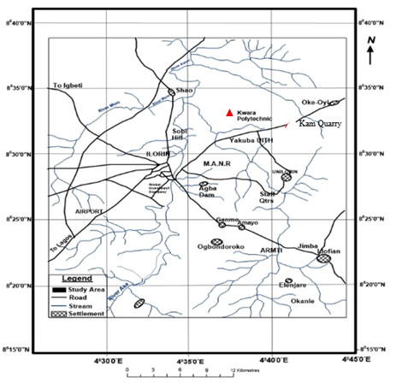
Figure 3.2. Location Map of the Study Area (modified after Olasehinde et al., 1998)

3.3 Sample Collection
Fresh representative samples of Migmatite Gneiss tagged Sample A, Porphyritic Granite tagged Sample B and Biotite Granite (Sample C) were collected on the open-cast mine site on outcrops. Structural features were observed based on tectonic activities and visual studies were also carried out to identify the different types of rocks. The Global Positioning System was used to take the coordinate of the different locations where the samples are taken. Other equipment used includes hammer, chisel, sampling bags, paper tape and marker. The three sample were separated in different sample bags and transported to University of Ilorin, Geology and Mineral Sciences Laboratory for detailed analysis.
3.4 Sample Preparation
The laboratory analysis was carried out on three different types of rocks labeled Sample A (Migmatite Gneiss), Sample B (Porphyritic Granite) and Sample C (Biotite Granite). The petrographical analysis carried out include thin section analysis and optical observations. During the preparation of thin sections analysis for all the samples, a thickness of 1.0 cm of a square shape of each of the rock sample was cut with the cutting machine. Applying emery cloth and caborundum powder, the specimen is further flattening to a thickness of about 0.04 mm. This flattened specimen is overlaid by the boiled Canada basalm and it is covered with a cover slip and left for about a day, then it is washed, rinsed with spirit and later with water. A total of six (6) thin sections (2 slides from each rock sample) were prepared from the samples for effective analysis and control. The analyses were subjected to microscopic examinations. Petrographic studies of the selected samples were made with the aid of a polarizing microscope. Some of the major minerals were observed under the microscopic examinations.

CHAPTER FOUR
RESULTS AND DISCUSSION
4.1 Results of Petrographic studies of the Thin Sections
The results based on petrographic studies of the thin sections revealed the various mineral distributions such as quartz, biotite, hornblende and feldspar (orthoclase, plagioclase and microcline). The quartz and feldspar constitute almost 88% of the thin section with other accessory minerals in both plane polarized and cross polarized light.
4.2 Discussion on Petrographic Studies of Migmatite Gneiss
The migmatite gneiss is the oldest type of rock in the study area. According to Abba (1983) gneiss occurs as the most widespread lithological unit in basement terrains and the imprints of the Pan – African deformation were evident by regional metamorphism, migmatization, extensive granitization and gneissification which produce syntectonic granites and homogeneous gneisses. It is common and appears to demonstrate undifferientiated pattern within the area. They are depicted generally by alternating light and dark coloured bands. The felsic bands of the rock consist of quartz, plagioclase and orthoclase feldspar with large percentage composition while the hornblende, muscovite or biotite constitutes smaller percentage of minerals in mafic bands. Based on mineral assemblages, quartz is however a dominant minerals while others such as feldspar and biotite are also making up a vital part. It has textural classification of fine to medium grained. In addition, the rock has undergo numerous orogenic cycles which has essentially lead to large scale deformation (Obaje, 2009). The imprints has been widely reported in the Precambrian rocks of Nigeria (Rahaman, 1989). The macro and micro structures is as a result of fracturing (Olayinka, 1992) such as folding, jointing, veins, intrusions, foliations and mineral lineations which were found in the study area.
4.3 Petrographic Description of some of the Prominent Minerals in the Migmatite Gneiss
The studied thin section with the aid of petrological microscope and slides were analyzed under plane polarized light and crossed nicol. The studied minerals include quartz, feldspar, biotite and hornblende.
4.3.1 Quartz (SiO₂)
The quartz is colourless in plane polarized light and shaped in euhedal. In coss polarized light, the quartz is colourless, reddish and conchoidal fracture with anhedral shape (Plate 4.1 and 4.2). It also display pleinchoism crystal of quartz that exhibit low relief and sometimes exhibit undulose extinction indicative of deformation or straining (Obini and Omietimi, 2020).
4.3.2 Plagioclase Feldspar (Na₂AlSi₃O₈.Ca₂Al₂Si₂O₈)
The feldspar mineral observed are plagioclase feldspar which is clearly from Albite twining characteristics (Ojelokun and Fawole, 2019) which is as a result of angle parallel to the large crystals in plane polarized light is colourless (Plate 4.1) but it demonstrate first order grey colour when the polar is crossed. It can be characterized from other types of feldspar because of its polysynthetic twining visible in the crystal. Some of the plagioclase in the slides occur as phenocryst (Plate 4.2).
4.3.3 Orthoclase Feldspar
The orthoclase feldspar under plane polarized light and crossed polarized light (XPL) appears cloudy and colourless (Plate 4.1 and 4.2). The crystals have low relief and are anhedral in shape. It is often colourless crystals with grey and reddish. The darker portion in the thin section suggest weathered feldspar with no definite cleavage.

4.3.4 Microcline Feldspar
The microcline feldspar exhibit a cystal system known as triclinic. This mineral is colourless under plane polarized light (PPL) and appears milky white under cross polarized light (XPL) with higher relief to quartz and orthoclase plate (Plate 4.1 and 4.2). The physical and chemical composition of microcline feldspar can be compare with the orthoclase feldspar. A thin section study implies large anhedral to subhedralmicroperthitic microcline with good polysynthetic crosshatched crystals with elongated crystals that exhibit subhedral habit.
4.3.5 Muscovite (KF)₂(Al₂O₃)₃(SiO₂)₆
The muscovite appears colourless under plane polarized light (PPL) (Plate 4.1) and has a pale green appearance under cross polarized light (XPL) (Plate 4.2) which makes it pleochroic. It exhibit parallel extinction with high relief and perfect cleavage in all direction. However, many of the crystals has twining and those near to the extinction shows position display appearance which is characteristics of mica family.
4.3.6 Biotite(Mg,Fe)₃ AlSi₃O₁₀(OH,F)₂
The colour of the biotite is between grey to brown colouration with subhedral to anhedral shape and has no twining. It has a directional cleavage. The mineral plate does not have extinction angles but form interstitial lamellae which may occur as linear aggregates with alteration to chlorite. It exhibits different pleonchoic orientation. The biotite has some inclusion of accessory minerals like zicon, rutile and apatite (Plate 4.1 and 4.2). It has strong birefringence under crossed polarised light, interference colour of dark green with symmetrical extinction and polysynthetic twinning.

4.3.7 Hornblende (Ca₂(Mg,Fe)₅(AI,Si)₈O₂₂(OH)₂
The colour of hornblende under plane polarized light is greenish black and it also displays pleochroism from green to brown.Under plane polarized light, a few of the hornblende crystals showed the characteristics shape and two cleavages. Under crossed nicol, twinning was seen in a few hornblende crystals and the highest interference colour seen is a second-order blue.

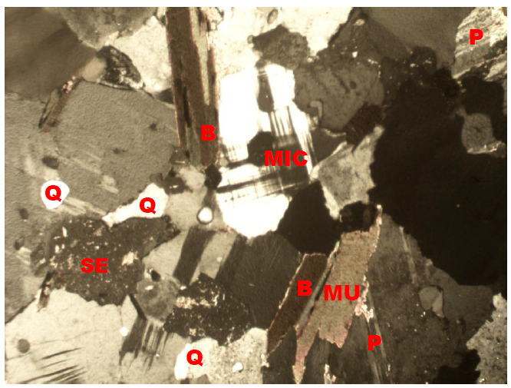
Plate 4.1: Photomicrograph of migmatite gneiss under Crossed Polarized Light (XPL), showing quartz (Q), biotite (B), plagioclase feldspar (P).
Plate 4.2: Photomicrograph of migmatite gneiss under Plane Polarized Light (PPL) showing the various shades of colours of mineral grains, Quartz (Q), Biotite (B), Plagioclase feldspar.

4.4 Discussion on Petrographic Studies of Porphyritic Granite (Sample B)
Porphyritic granite is the second most abundant rock type in the study area and it exhibits the characteristics of both slow and rapid rates of cooling magma. This has resulted to large or giant crystals of minerals (Phenocrysts) due to slow cooling, nevertheless, it has been subjected to further rapid cooling as the magma eventually move to the surface to form finer groundmass in which the phenocryst are embedded to form porphyritic texture (Saad and Baba, 2017). The major mineral constituents that occur include quartz, biotite, hornblende and plagioclase feldspar. The quartz in the porphyritic granite is euhedral in shape and it displays undulose extinction. The biotite exhibits different pleonchoic orientation. The biotite has some inclusion of accessory minerals like zircon, rutile and apatite. The plagioclase feldspar occurs as phenocrysts with lamellar twinning within the groundmass. Accessory minerals in the rock include zircon, apathite, magnetite and titanite (Plate 4.3 and 4.4)

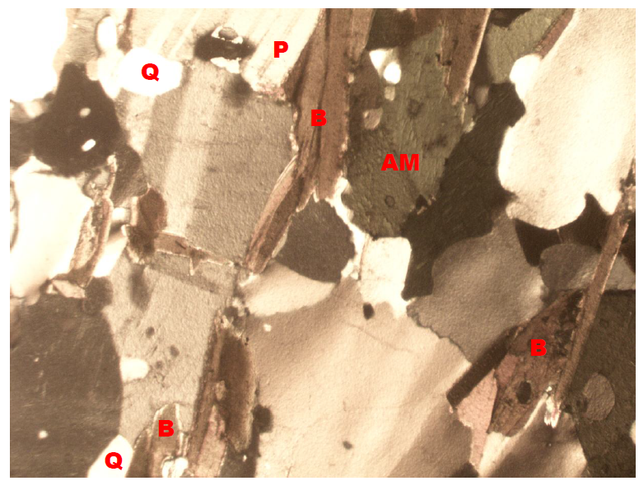
Plate 4.3: Photomicrograph of porphyritic granite under Crossed Polarized Light (XPL), showing quartz (Q), biotite (B), plagioclase feldspar (P).

Plate 4.4: Photomicrograph of porphyritic granite under Plane Polarized Light (PPL) showing the various shades of colours of mineral grains, Quartz (Q), Biotite (B), Plagioclase feldspar.
4.5 Discussion on Petrographic Studies of Biotite Granite (Sample C)
The biotite granite is a medium to coarse grained rock. The colour has resulted from the disintegration of biotite to fom chlorite (Aga and Haruna, 2019). Biotite is pleochroic form green to brown and are subhedral in shape (Plate 4.5 and Plate 4.6). The chlorite that occurs within the fractures has light green colouration and occurs mainly in cracks present within mineral matrixes. The crystal form of the chlorite is anhedral and occurs as a different product. However, the quartz in the biotite granite is euhedral to crystal in shape with crypto crystalline inclusions. It displays undulose extinction. This essentially proves that the rocks were highly deformed. The huge tectonic activities that took place or occur might have led to the exposure of the rocks to the surface of the study area. The occurrence of feldspar in the biotite granite is known as plagioclase feldspar and it is an irregular formed perthite with patches of it formed at the surface.The iron oxide occurs as tiny black patches in some biotite crystals and it is less abundant in the sample.

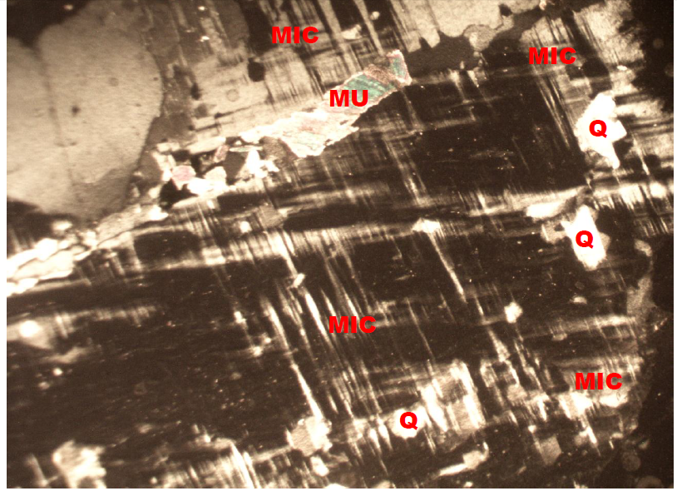
Plate 4.5: Photomicrograph of Biotite granite under Crossed Polarized Light (XPL), showing quartz (Q), biotite (B), plagioclase feldspar (P).
Plate 4.6: Photomicrograph of porphyritic granite under Plane Polarized Light (PPL) showing the various shades of colours of mineral grains, Quartz (Q), Biotite (B), Plagioclase feldspar.
4.6 Economic Potential of the Rocks
Economically, the sampled rocks (Migmatite Gneiss, Porphyritic Granite and Biotite Granite) in the studied area have good potentials for engineering purposes. Industrially, the quartzite can be used as industrial silica sand, silicon and silicon carbide. It can also be used as decorative stone used to cover walls. It is also useful in flooring, star steps and as roofing tiles. It is sometimes used as railway ballast and also in road construction purposes such as bridges, building houses, road pavement etc. The petrographic analysis examined indicate that mineral distribution quality are essentially made up economic minerals quartz, feldspar, biotite, muscovite and other accessory minerals. It is important to reiterates that these minerals are conspicuously present in both rocks and it is evidenced that the minerals presents are randomly distributed in accordance to their lithological variations (Ajali, 1997). Feldspar can be mined as profit by ceramics and glass industries for making product. The feldspar (plagioclase and orthoclase) can also be mined for fertilizers and cements.

CHAPTER FIVE
Conclusion and Recommendation
5.1 Conclusion
Petrographic studies and geochemical analysis of two different rock samples were carried out in the study area. Petrographically, the granitic rocks in the study area are composed of major rock forming silicate minerals such as quartz, biotite mica, and feldspars. The geochemical analysis on the rocks in the study area shows that the rocks are mineralogically composed of quartz, orthoclase and plagioclase feldspar, albite, microcline and other minor constituents such as hornblende and biotite. The rocks in the study area are chemically characterized by high percentage of silica (SiO₂), alumino-silicate minerals and the ferromagnesian compounds (Fe₂O₃ and MgO) which have varying low amount in both rock samples with calcium oxide which could be attributed to the calc-alkaline nature of the magma which serves as the precursor of the rocks. The chromium oxide (Cr₂O₃), phosphorus oxide (P₂O₅), sulphide (SO₃), manganese oxide (MnO), titanium oxide (TiO₂), zinc oxide (ZnO) and copper oxide (CuO) are the least abundant mineral with very low percentage weight composition of less than 1% in both samples. Economically, the various rocks in the area have good potentials for engineering purposes. The petrographic analysis examined indicate that mineral distribution quality are essentially made up economic minerals quartz, feldspar, biotite, muscovite and other accessory minerals.
5.2 Recommendation
The federal government should establish and equip the existing laboratories to carry out detailed analysis particularly on petrographic analysis of rocks for engineering construction purposes.
Measures should also be put in place to exploit and explore solid mineral resources in order to enhance industrialization and boost the economy of the country.
References
Adeoye, R. A., Ojo, T. A., &Balogun, D. A. (2021).Weathering susceptibility of gneissic rocks in Ekiti State: A petrographic and engineering approach.Journal of Earth and Environmental Sciences, 6(3), 88–97
Akinbami, J. F., Oladele, M. T., &Okeke, A. C. (2021).Petrographic evaluation of subsurface rocks for infrastructural development in southwestern Nigeria.Journal of African Earth Sciences, 181, 104263.https://doi.org/10.1016/j.jafrearsci.2021.104263
Akinlolu, O., Adeyemi, T., &Ajayi, K. (2020).Petrographic assessment of rocks within the University of Ilorin campus and its implication for infrastructural planning.Nigerian Journal of Geology, 38(2), 145–158.
Akinyemi, L., &Aladejana, J. A. (2021).Geological profiling and its implications for structural development in Southwestern Nigeria.Journal of Applied Geosciences, 12(1), 21–30.
Akinyemi, O. D., &Adepoju, K. A. (2021). Geological controls on soil fertility in parts of Kwara State, Nigeria. Nigerian Journal of Soil Science, 31(1), 23–32.
Akinyemi, T. O., &Adepoju, A. O. (2021).Petrology and Geochemistry of Migmatite-Gneiss in Southwestern Nigeria.Journal of African Earth Sciences, 172, 103955.https://doi.org/10.1016/j.jafrearsci.2020.103955
Ajibade, A. C., &Folarin, D. A. (2020).The relevance of petrographic studies to geotechnical site assessments in Nigeria.Nigerian Journal of Geology and Mining Research, 5(2), 44–52.
Bamidele, J. T., & Thomas, S. A. (2019).Petrographic and mechanical characterization of rocks in the Ibadan Basement Complex.Engineering Geology Journal, 45(1), 55–67.
Ibrahim, T. M. (2023). Application of petrography in construction material selection in Nigeria's basement complex terrain. Earth and Environmental Science Journal, 40(3), 157–167.
Mohammed, S. A., Yusuf, B. I., &Danjuma, A. R. (2022).Geological characterization of crystalline rocks in the Ilorin area of North Central Nigeria.Journal of African Earth Sciences, 193, 104635.https://doi.org/10.1016/j.jafrearsci.2022.104635
Musa, F. M., & Ibrahim, T. Y. (2020). Mineralogical and weathering profiles of rocks in Lokoja: Implications for environmental planning. Nigerian Journal of Environmental Geology, 7(2), 74–85.
Nwajide, C. S. (2021). Geology of Nigeria’s Sedimentary Basins. University Press PLC.
Obaje, N. G. (2019). Geology and Mineral Resources of Nigeria.Springer.https://doi.org/10.1007/978-3-642-04431-7
Obaje, N. G., Okwoli, E. C., &Ehinola, O. A. (2020). Potential of basement rocks in Nigeria for industrial application: A petrographic perspective. Journal of Mining and Geology, 56(1), 55–64.
Ogunlaja, T. M., Usman, B. I., & Salami, K. (2023).Petrography and hydrogeology of fractured Basement Complex rocks in Nigeria.Journal of Groundwater and Environmental Sustainability, 10(1), 33–42.
Ogunleye, A. O., Ajayi, T. R., &Fasuyi, S. A. (2022).Structural and Petrological Assessment of Metamorphic Rocks in Ilorin, Nigeria.Nigerian Journal of Geological Research, 5(1), 22–35.
Ogunleye, A. O., Lawal, K. M., &Owolabi, T. A. (2022). Mineralogical and geochemical investigation of basement complex rocks in parts of Ilorin, Nigeria. Ife Journal of Science, 24(2), 199–211.
Okoye, E. C. and Eze, P. O. (2021). Campus petrography and its relevance to sustainable landscaping: A study of NnamdiAzikiwe University. Earth Science and Education Journal, 4(2), 112–124.
Okunlola, O. A. and Adewoye, S. O. (2019). Petrographic teaching aids: A case study using local samples from Nigerian tertiary institutions. Journal of Science Education and Technology, 28(1), 45–53.
Olarewaju, V. O. and Akinola, T. B. (2021). Structural and petrographic study of Pan-African rocks in Jebba, Kwara State. Nigerian Journal of Geosciences, 35(1), 57–69.
Olorunfemi, M. O. and Jimoh, A. A. (2020).Petrographic and geotechnical investigation of rocks in Akure area for construction purposes.Bulletin of Engineering Geology and the Environment, 79(5), 2047–2058.
Rahaman, M. A. (2019). Geology of Nigeria’s Basement Complex: Petrographic insights and implications. Journal of African Earth Sciences, 63(4), 117–130.
Rahaman, M. A. (2020). Geology of Nigeria: Basement Complex and Tectonic Framework. Nigerian Journal of Mining and Geology, 56(2), 1–14.
Rahaman, M. A. (2020). The basement complex of Nigeria: An overview. In O. A. Obaje (Ed.), Geology and Mineral Resources of Nigeria (pp. 15–37). Springer.https://doi.org/10.1007/978-3-030-15226-6_2
Usman, A. M., &Gbadamosi, K. A. (2021).Weathering characteristics of basement rocks and implications for slope stability in Ilorin, Nigeria.Environmental Earth Sciences, 80(5), 188.https://doi.org/10.1007/s12665-021-09423-9
Usman, M. B., &Gbadamosi, R. T. (2022). Micro-regional petrography and construction risk assessment in Nigeria’s Basement Complex. Geoscience Reports of Nigeria, 5(3), 98–109.
Yusuf, M. T., Adebanjo, K., &Aluko, R. (2022).Petrographic evaluation of granitic outcrops in Igbeti and their industrial potential.Nigerian Journal of Mining and Geology, 43(2), 129–139.

