A PROJECT REPORT
ON
PROPOSED DOMESTIC AIRPORT
AT
KOGI STATE GOVERNMENT

By
ABDULKADIR OPEYEMI
HND/23/ARC/FT/0006

SUBMITTED TO THE DEPARTMENT OF ARCHITECTURAL TECHNOLOGY INSTITUTE OF ENVIRONMENTAL STUDIES, (I.E.S) KWARA STATE POLYTECHNIC ILORIN, KWARA STATE.

IN PARTIAL FULFILLMENT OF THE REQUIREMENTS FOR THE AWARD OF HIGHER NATIONAL DIPLOMA (HND) IN ARCHITECTURAL TECHNOLOGY

JULY, 2025

DECLARATION
I declare that this project project/dissertation is a product of my personal research work. It has not been presented for the award of any degree in any polytechnic. The ideas, observations, comments, suggestions herein represent my own convictions, except quotations, which have been acknowledged in accordance with conventional academic traditions.

Name: ABDULKADIR OPEYEMI AKEEM
Matric no: HND/23/ARC/FT/0006

Opeyemi 07-06-2025
________________ ________________
Signature Date

CERTIFICATION

I certify that this Research/Dissertation entitled mass housing was carried out by ABDULKADIR OPEYEMI AKEEM under my supervision and has been approved as meeting the requirements for the award of HND in Architectural Technology, of Kwara State Polytechnic, Ilorin, Kwara State Nigeria.

____________________ _______________
ARC. ABDULAZEEZ B.Y.F DATE
PROJECT SUPERVISOR

_____________________ _________________
ARC OLAREWAJU F.A DATE
PROJECT COORDINATOR

_____________________ ________________
ARC: J.M TOMORI DATE
HEAD OF DEPARTMENT


---------------------------------- ----------------------
EXTERNAL EXAMINER DATE

DEDICATION
This report is dedicated to Almighty Allah the universe, the creator of all creators and the source of mankind who has always been my strength throughout this project and also for his unconditional and infinite mercy showered upon me through my studies.
Also, I dedicated this project to my parent Mr. and Mrs. ABDULKADIR for their parental, financial and moral support.
Finally, to my brothers and sisters and my colleague and other for their contribution to attain great achievement. I pray Almighty Allah reward everyone abundantly.

ACKNOWLEDGEMENT
All praise and adoration and glorification to Almighty (S.W.T) the creator of the universe that gave me the privilege to take part in this program. First and foremost.
I am grateful to my able Hardworking and untiring project supervisor ARC ABDULAZEEZ B.Y.F and I must appreciate all lecturers of the department of architectural technology, ARC TOMORI the (H..O.D) ARC.CHUCKWUMA NMOM, ARC.OLAREWAJU F.A, ARC. ABDULAZEEZ B.Y.F, ARC SOLOMON FAMILUA. God bless you all for your encouragement, expert advice and continuous kind assistant and supervision that made the completion of this study successful.
My gratitude goes to my able, amiable and knowledgeable guidance MR ABDULKADIR for his inexplicable finance, moral, parent prayers support from birth till date, I say a very big thanks you sir & ma. I pray almighty Allah grant your life long to reap the fruit of your labor in good health and wealth who support morally, financially and spiritually at all time towards my success in this program.
However, I would like to express my gratitude to all my entire families and friends for all forms the benefit receives from them.

TABLE OF CONTENTS
DECLARATION ii
CERTIFICATION iii
DEDICATION iv
ACKNOWLEDGEMENT v
ABSTRACT Error! Bookmark not defined.
CHAPTER ONE 1
1.0 INTRODUCTION 1
1.1 HISTORICAL BACKGROUND 1
1.2 DEFINITION 2
1.3 AIM AND OBJECTIVES 3
1.4 JUSTIFICATION OF THE STUDY 3
1.5 LIMITATIONS AND CONSTRAINTS 3
1.6 RESEARCH METHODOLOGY 4
1.7 RESEARCH METHODOLOGY Error! Bookmark not defined.
CHAPTER TWO 4
2.1 LITERATURE REVIEW 5
2.2 DEFINITION OF CASE STUDY 5
2.3 OUTLINES OF CASE STUDY 5
2.3.1 CASE STUDY ONE: 6
2.3.2 CASE STUDY TWO 7
2.3.3 CASE STUDY THREE 7
2.3.4 CASE STUDY FOUR 8
CHAPTER THREE 9
3.1 INTRODUCTION TO KOGI STATE 9
3.2 THE LOCATION OF LOKOJA AIRSTRIP 9
3.2.1 CLIMATE CONDITION OF THE LOKOJA AIRSTRIP 10
3.2.2 IMPLICATION FOR APPLICATION OF THE GEOGRAPHICAL AND CLIMATIC CONDITIONS OF LOKOJA 10
3.3 SITE SELECTION 10
CHAPTER FOUR 13
4.1 SITE ZONING 13
4.2 CONCEPT DERIVATION 13
4.3 SCOPE OF THE PROJECT 13
4.4 THE DESIGN FUNCTIONAL RELATIONSHIP AND ANALYSIS 15
4.5 SPACE ANALYSIS, CALCULATION, DERIVATIVE & MANAGEMENT 16
4.6 CONCEPTUAL DEVELOPMENT 16
CHAPTER FIVE 18
5.0 APPRAISAL OF PROPOSED DESIGN SCHEME 18
5.1 Construction Methodology 18
5.2 GENERAL DESIGN CONSIDERATION 18
5.3 CIRCULATION AND ZONING 18
5.3 STRUCTURAL PRINCIPLE 18
5.4 LANDSCAPE DESIGN 18
5.5 GENERAL CONCLUSION 19
REFERENCES 20

ABSTRACT
This project presents the architectural design and development of a proposed domestic airport in Kogi State, Nigeria. The aim is to create a modern, functional, and efficient aviation facility that addresses the increasing demand for internal mobility, regional development, and national integration. As Nigeria continues to experience urban expansion and economic diversification, the need for accessible and reliable domestic air transport becomes increasingly critical especially in underserved regions such as Kogi State. The conceptual design of the airport draws inspiration from the dynamic movement of fleets and the precision of drone technology, which symbolizes innovation, directionality, and responsiveness. The architectural approach emphasizes fluid passenger circulation, modular and scalable layouts, natural ventilation systems, and sustainable energy strategies, including daylight optimization and renewable power options. Extensive research informs the design process. Case studies of local and international domestic airports such as the Nnamdi Azikiwe Domestic Terminal (Nigeria) and Qatar’s Hamad Domestic Extension were analyzed to understand common design challenges such as limited capacity, inadequate service areas, and outdated facilities. These insights help guide the creation of an airport that avoids past mistakes while embracing innovation. Lokoja, the capital of Kogi State, was strategically selected as the project location due to its geographic centrality, accessibility via road and water transport, and potential to serve as a regional aviation hub connecting the North, South, East, and West of Nigeria. The site analysis evaluates terrain suitability, wind direction, visibility, infrastructure availability, and environmental impact to ensure long-term viability and minimal disruption to existing ecosystems. The methodology includes qualitative data gathering, stakeholder interviews, site visits, and digital architectural modeling using 3D visualization tools and Building Information Modeling (BIM). The final design incorporates essential zones such as terminal buildings, airside operations (runways, taxiways, and aprons), support facilities (control towers, hangars, firefighting units), and passenger services (check-in, lounges, security, and commercial spaces). Emphasis is placed on universal accessibility, security compliance, traffic flow optimization, and low-impact construction materials. Ultimately, this domestic airport is envisioned as more than a transportation facility. It aims to be a catalyst for economic stimulation, job creation, tourism development, and increased connectivity within Nigeria. By addressing both current needs and future demands, the proposed design aligns with global best practices while remaining sensitive to local context and aspirations.

CHAPTER ONE

1.0 INTRODUCTION
A Domestic Airport is a facility that handles flights within the same country. Unlike international airports, domestic airports are designed primarily for local travelers, facilitating air transport between cities, states, and regions within the nation. These airports play a critical role in enabling transportation and efficient travel within internal borders.
Domestic aviation facilities typically include basic amenities such as check-in counters, baggage screening, passport systems, and security protocols, albeit scaled for smaller operations. Unlike international airports, domestic airports may lack immigration and customs services.
They are vital in enhancing national connectivity, supporting regional development, promoting tourism, and fostering economic activities. Often located near urban centers or accessible to rural communities, domestic airports bridge geographical gaps and provide strategic access to remote areas.
Airlines operating in domestic airports generally run short-haul or medium-haul flights with relatively shorter durations. Additionally, domestic airports often serve private aviation and government-related functions.
In summary, domestic airports are an essential component of a nation's infrastructure. They support internal mobility, promote national integration, and significantly contribute to economic growth and social development.

1.1 HISTORICAL BACKGROUND
The concept of the airport has evolved for over a century, closely tied to the advancement of aviation technology.

Early Beginnings [1900 - 1930]
- The first powered flight by the Wright brothers in 1903 marked the advent of modern aviation.
- Early airports were simply flat open fields, sometimes repurposed racetracks or farmlands.
- London’s Heathrow Aerodrome began serving flights to Paris.
Growth and Development [1930s - 1940s]
- Airports became more structured with control towers, hangars, and terminals.
- Many airports were built or expanded during WWII for military purposes and later converted for civilian use.
Modernization [1950s - 1990s]
- The introduction of jet aircraft led to longer and more durable runways.
- Airports began integrating automated systems and facilities for higher passenger volumes.
Contemporary Era [1980 - Present]
- Airports transformed into global hubs, incorporating advanced security, automated check-ins, shopping malls, and entertainment facilities.
- The hub-and-spoke system emerged, improving airline operations.
- Airports like Dubai and Doha adopted smart and sustainable technologies.

1.2 DEFINITION
A domestic airport is an airport that operates flights strictly within the borders of a particular country. It is designed to facilitate the movement of passengers, cargo, and aircraft between cities or regions of the same nation. Unlike international airports, domestic airports do not handle flights that cross national boundaries and therefore do not require customs or immigration services. These airports primarily support short to medium-distance travel and are essential for regional connectivity, internal commerce, and national mobility.

1.3 AIM AND OBJECTIVES
1.3.1 Aim
To design a functional, safe, and efficient domestic airport that meets contemporary needs and future growth.
1.3.2 Objectives
- To integrate sustainable and modern technologies into airport operations.
- To design user-friendly and accessible facilities for all categories of passengers.

1.4 JUSTIFICATION OF THE STUDY
This project aims to address the growing demand for air travel due to population growth, tourism development, and increased business mobility. The need for a modernized and efficient domestic airport is essential for national development and regional integration.

1.5 LIMITATIONS AND CONSTRAINTS
Environmental Impact
Although the design incorporates sustainable practices in study it faced limitation in fulfilling the needs and effect on environment of available technology and materials in the region may result in a lighter carbon footprint than highly desired.
Technological Limitations
The study was conducted on existing technological tools and resources which may have constrained the extent of more innovative smart and even expensive devices, the limitation of available software and hardware influenced the scope and details of architectural plans

1.6 RESEARCH METHODOLOGY
To address the study aims and objectives of this study on the architectural design of an airport, proposed methodology will encompass research methodology and qualitative approach to gather and analyze data effectively the research methodologies which are:
- Literature Review: In-depth analysis of academic books, journals, and architectural publications related to airport planning and design. Focus areas include terminal layout, passenger flow, security protocols, aviation technology, and sustainable airport infrastructure.
- Case Studies: Examination of successful domestic airports both within Nigeria and internationally to identify best practices, operational challenges, and innovative design approaches relevant to medium-scale aviation facilities.
- Oral Interviews: Engagements with aviation professionals, airport planners, engineers, government officials, and potential users to gather insights on functional requirements, safety standards, and user expectations specific to Kogi State.
- Site Observation: On-site assessment of the proposed location to evaluate physical characteristics such as topography, accessibility, existing infrastructure, prevailing wind direction, and environmental conditions crucial to airport planning.
- Online Research and Network Browsing: Review of up-to-date digital resources including aviation authority guidelines (e.g., NCAA and ICAO standards), architectural databases, and airport master planning tools to support the integration of modern technology and regulatory compliance.
This multi-faceted research approach ensures the proposed airport design is informed by both theoretical frameworks and practical realities, meeting both international standards and the unique needs of the Kogi State context.

CHAPTER TWO

2.1 LITERATURE REVIEW
Domestic airports play a vital role in regional connectivity and economic development. According to the International Civil Aviation Organization (ICAO), domestic air transport has significantly increased in recent years to support business mobility. A study by [unnamed source] highlights the growing demand for improved structure, maintenance, and passenger experience in domestic airports.
Elements like runway planning, terminal layout, and integrated technology complement aesthetically appealing and functional designs that balance passenger experience requirements.
In summary, the literature indicates that modern domestic airport design must address infrastructure quality, passenger experience, environmental sustainability, and regulatory compliance to meet the growing demands of domestic airport.

2.2 DEFINITION OF CASE STUDY
A case study is an architectural approach used to detail or examine a building or project to analyze its functionality, design impact, construction, and principles and materials. It includes a thorough investigation of architectural principles, materials, techniques, and user experiences. Case studies help in understanding the project themes and provide valuable insights.

2.3 OUTLINES OF CASE STUDY
- IBADAN AIRPORT, OYO STATE
- AKURE AIRPORT, ONDO STATE
- MURTALA MUHAMMED AIRPORT [DOMESTIC TERMINAL]

2.3.1 CASE STUDY ONE:
IBADAN AIRPORT, OYO STATE
This case study is of an airport is located in Oyo state. This airport is located established in 1982 which the main purpose of the establishment during that time is to connect Southwestern Nigeria.
MERITS:
- Simple and functional terminal design
- Strategically located near major city
DEMERITS
- Poorly maintained facilities.
- Limited passenger capacity.
KEY FEATURES
- Location: Suburban area, business-class area with ample green spaces.
- Design Philosophy: Emphasis on smart, sustainable use of building materials.
- Building Materials: Use of recycled and locally sourced materials.
- Energy Efficiency: Use of renewable energy systems.

2.3.2 CASE STUDY TWO
AKURE AIRPORT
This airport is located in Ondo State, Nigeria. Established and commissioned in 1996, it serves Akure and neighboring areas.
MERITS:
- Serves Akure and other key cities in Ondo State with an efficient terminal design.
- Straightforward terminal design ensuring easy navigation for passengers and operational efficiency.
- Well-constructed runway suitable for domestic aircraft operations.
- Minimalist design requiring lower operational and maintenance expenses.
DEMERITS:
- Safety devices were not included in the design.
- Lack of a clinic or first aid unit for accidents or emergencies.

2.3.3 CASE STUDY THREE
MURTALA MUHAMMED AIRPORT [DOMESTIC TERMINAL]
Located in Ikeja, Lagos State, along Bishop Airport Road, this airport was established in 1974 and is Nigeria’s largest airport. The domestic terminal (MMA2) serves local routes.
MERITS:
- Well-designed for high passenger traffic.
- Incorporates modern facilities for a seamless travel experience.
- Located in a prime area with good transport connectivity.
DEMERITS:
- Design constraints due to insufficient space.
- Aging infrastructure requiring frequent upgrades (not including sustainability).

2.3.4 CASE STUDY FOUR
NNAMDI AZIKIWE DOMESTIC TERMINAL
Located in Abuja, Federal Capital Territory, this airport was established to serve western region connectivity.
MERITS:
- Functional terminal design.
- Well-ventilated with adequate lighting.
- Incorporates technology.
- Features good landscaping.
DEMERITS:
- Limited sustainability in the use of commercial areas within the terminal.

CHAPTER THREE

3.1 INTRODUCTION TO KOGI STATE
Kogi State is one of the 36 states in the Federal Republic of Nigeria, located in the North Central geopolitical zone. It is popularly referred to as the "Confluence State" because it is where the two major rivers in Nigeria River Niger and River Benue meet at the capital city, Lokoja.
Created on August 27, 1991, from parts of Kwara and Benue States by the military government under General Ibrahim Babangida, the state consists of three major ethnic groups: Igala, Ebira, and Okun (Yoruba). This northern state serves as a bridge between the northern and southern parts of Nigeria, giving it a strategic geographic and economic position.
Kogi State is bordered by ten states, making it the state with the most borders in Nigeria. The state is gaining interest in tourism due to its historical landmarks and natural beauty, including the confluence of the two rivers. Lokoja was the first British trading capital of modern-day Nigeria, adding to its historical significance.

3.2 THE LOCATION OF LOKOJA AIRSTRIP
Lokoja Airstrip is located in Kogi State, in the North Central region of Nigeria, approximately 17 kilometers northwest of Lokoja town, the state capital. It is accessible via the Lokoja-Oweto Road, which connects to major roads, including the Abuja-Lokoja Expressway.
Geographically, the site is situated at an altitude of approximately 7m above sea level, with the road elevation at 9m above sea level. The surrounding landscape is relatively flat with patches of vegetation, making it suitable for construction. The confluence of the Niger and Benue Rivers gives the site strategic significance in regional trade and logistics.
The location provides a potential hub for future state development due to its central position between Abuja and Lokoja town.

3.2.1 CLIMATE CONDITION OF THE LOKOJA AIRSTRIP
Lokoja Airstrip experiences a tropical savannah climate characterized by distinct wet and dry seasons, significantly influencing environmental and living conditions in the area.
The wet season in Lokoja generally lasts from April to October, with the heaviest rainfall occurring between June and September. During this period, the area receives significant rainfall, essential for agricultural activities. The average annual rainfall supports the region’s agricultural practices.

3.2.2 IMPLICATION FOR APPLICATION OF THE GEOGRAPHICAL AND CLIMATIC CONDITIONS OF LOKOJA
- Seasonal Implications for Construction: Infrastructure planning must consider the potential impact of heavy rainfall during the wet season on buildings. Systems to manage waterlogging should be implemented in site planning.
- Health and Safety: During the dry season, increased dust hazards pose health risks. It is important to implement measures to preserve existing vegetation in buildings to minimize dust and improve air quality during the wet season.
- Agricultural Activities: The wet season supports agricultural activities, such as green cultivation. The community can leverage available climatic conditions to promote crop cultivation, research, and sustainability initiatives.

3.3 SITE SELECTION
The selection of a suitable site for the development of Lokoja Airstrip was influenced by key factors such as accessibility, environmental conditions, and proximity to social resources. The chosen site aligns with the project's mission and goals.
- Accessibility:
The site is strategically located in Lokoja, a major transportation hub connecting northern and southern Nigeria. This ensures accessibility for citizens and workers from various parts of the country. The presence of major roads and transportation networks ensures connectivity and convenience.
- Climate Data
The climate of Lokoja is classified as a tropical savanna climate characterized by distinct wet and dry seasons. The key climate features include:
- Temperature: The average yearly temperature in Lokoja is around 26°C. The hottest months are March and April, with average daytime temperature exceeding 35°C. The coolest months are December and January when nighttime drops to about 18°C.
- Rainfall: Lokoja receives an average annual rainfall mainly from Atlantic approximately 1,200 mm to 1,300 mm. The wet season extends from April to October, with peak rainfall occurring between June and September. The dry season lasts from November to March with minimal rainfall.
- Humidity: It is the highest during the wet season reaching up to 90%. It is minimal during the dry season, especially during harmattan. Humidity level drops considerably.
- Winds: The harmattan winds blowing from the northern dominate the dry season bringing dry and dusty conditions. These winds can reduce visibility and negatively affect air quality.
Lokoja: Weather Data
- Latitude: 8.4746618 N / 29.9611 E
- Longitude: 4.5464642 E / 32.467106
- State/Region: Kogi
- Continent: Africa
- Population: Large
3.4 Site Location Criteria
The site was carefully selected due to various architectural, accessibility, mechanical, and technical reasons, even up to environmental support. For a multi-unit lecture theatre project, the site must be:
- Properly sited and relatively located on campus, roughly within 5-mins walking from the landmark academic buildings and administrative blocks.
- Access to Social Amenities:The site has relative access to great amenities such as electricity, water, good networks, etc.
Land Mass Area
A minimum of 1.5 ha (hectares) area is required to accommodate a multi-unit lecture theatre with 2-3 interconnected (each seating 400-600 students) along with shared infrastructure like toilets, technical room, etc.

CHAPTER FOUR

4.1 SITE ZONING
The proposed domestic airport has three main functional units:
- Airside Zone:
This includes the runway, taxiway, and apron. This area is primarily for aircraft operations.
- Landside Zone:
Comprises the terminal building, access roads, parking, and public services.
- Support Zone:
Includes utility buildings, maintenance hangars, staff quarters, cargo facilities.

4.2 CONCEPT DERIVATION
The concept is inspired by fleet movement. Therefore, to ease flow of people and aircraft, the terminal adopts a linear or radial form to ease circulation with emphasis on daylight, natural ventilation, and passenger comfort.
Analysis of Client Requirement
- Client Requirement: This involves efficient passenger processing, adequate security, scalability, energy efficiency, and cost-effectiveness.
- User Requirement: Easy navigation, clear signage, comfort, safety, and amenities such as lounges, food court, etc.
BRIEF ANALYSIS

4.3 SCOPE OF THE PROJECT
The scope of the project will encompass the use and functional requirements, which includes the project scope as follows:
Terminal Building Units
- Check-in and ticketing area
- Security screening 1
- Security screening 2
- Departure area
- Boarding gates
- VIP Lounge
- Circulation area
Administrative Units
- Airport management office
- Staff offices
- Air traffic control tower
- Utility rooms
Air-side Units
- Runway
- Taxiway
- Apron / parking bay
- Helipad
- Fueling station
Land-side Units
- Parking lot (long & short time)
- Drop-off
- Public terminal transports
- Circulation paths & access roads
Passenger Service Support
- Stationery
- Shops / duty-free stores
- Restaurant
- Medical clinic
- Information desk
- Prayer room / Guest zones
Safety and Emergency Units
- Fire rescue station
- Security office
- Emergency evacuation route
Support Facilities
- Waste Management Unit
- Power Supply (Back-up and Sub-stations / Generators)
- Water supply and treatment unit

4.4 THE DESIGN FUNCTIONAL RELATIONSHIP AND ANALYSIS
Space are merged for serving passengers:
- Entry →
- Check →
- Security →
- Waiting Lounge →
- Boarding Gate →
- Entry to the Aircraft
- ARRIVAL →
- Immigration →
- Baggage Claim →
- Exit
Support services (cargo, emergency, utilities) are kept apart but accessible.

4.5 SPACE ANALYSIS, CALCULATION, DERIVATIVE & MANAGEMENT
Space requirements are based on passenger volume:
- Scope
- Check-in hall
- Departure lounge
- Parking
- Runway length
Required volume per passenger:
- 1.8 – 2 m²
- 1.0 – 1.5 m²
- 25 – 30% of site
- 1.5 – 2.5 km for domestic aircraft
Space allocated based on peak hour demand.
Here is the full transcription of the handwritten pages:

4.6 CONCEPTUAL DEVELOPMENT
The design of the building is inspired by a drone which is a device used in video coverage, remote sensing, survey, etc., which is controlled by a remote control.
The roof mimics wing-like curves and glazing, providing connection with the airspace. Emphasis is placed on modular planning for future expansion.

CHAPTER FIVE

5.0 APPRAISAL OF PROPOSED DESIGN SCHEME

5.1 Construction Methodology
- Method: Reinforced concrete frame with trusses for wide span
- Material: Glass curtain wall for daylighting, aluminium roofing sheets, polished terrazzo flooring, and energy-efficient lightings

5.2 GENERAL DESIGN CONSIDERATION
- Sustainability: Solar panel, rainwater harvesting, and natural ventilation
- Accessibility: Ramps, elevators, and tactile floor indicator for the disabled
- Safety: Fire exits, CCTV, smoke detectors, and emergency plans

5.3 CIRCULATION AND ZONING
- Horizontal Circulation: Clear signage, linear pathways for movement from check-in to gate
- Vertical Circulation: Escalator and lift connector connecting different levels

5.3 STRUCTURAL PRINCIPLE
- Use long span truss systems to allow column free spaces in lounge.
- Foundation type: raft / pad / pile
  - Concrete raft or pile, depending on soil
- Estimate of wind load consideration (as per local building codes)

5.4 LANDSCAPE DESIGN
- Soft landscape: green areas, flower beds, shade trees, leaf park
- Hard landscape: walkways, drop off zones, seating area
- Water feature: small fountain or reflecting pool for aesthetics and cooling effects

5.5 GENERAL CONCLUSION
The proposed domestic airport is designed to meet current transportation demand with flexibility for future expansion. The planning emphasizes attractive user comfort, operational efficiency, and safety.
It is recommended that smart technologies like automated baggage handling and digital boarding systems be integrated to enhance functionality.

REFERENCES
Adedokun, A. (2015). Airport Design and Planning in Nigeria. Lagos: Maxline Publications.
Akintoye, A., & Fadiya, O. O. (2014). The Impact of Regional Airports on Economic Development in Nigeria. Journal of Transport and Logistics, 9(3), 45–59.
Federal Airports Authority of Nigeria (FAAN). (2021). Annual Report and Statistics on Nigerian Airports. Retrieved from https://www.faan.gov.ng
International Civil Aviation Organization (ICAO). (2018). Planning and Design of Airports. Montreal, Canada: ICAO Publications.
Kogi State Government. (2022). Economic Development Blueprint. Lokoja: Kogi State Ministry of Planning and Budget.
Murtala Muhammed Airport (MMA2). (2020). Operational Overview and Passenger Services. Retrieved from https://www.mma2lagos.com
National Bureau of Statistics (NBS). (2023). Air Transport Data: Passenger Traffic Report. Abuja, Nigeria.
Ojo, A. O. (2019). Principles of Sustainable Architecture in Airport Design. Ibadan: University Press.
Smith, J., & Croft, D. (2017). Airport Terminal Design: Functional Relationships and Passenger Experience. London: Routledge.
United Nations Development Programme (UNDP). (2020). Infrastructure for Development in Sub-Saharan Africa. New York: UNDP.

APPENDIX

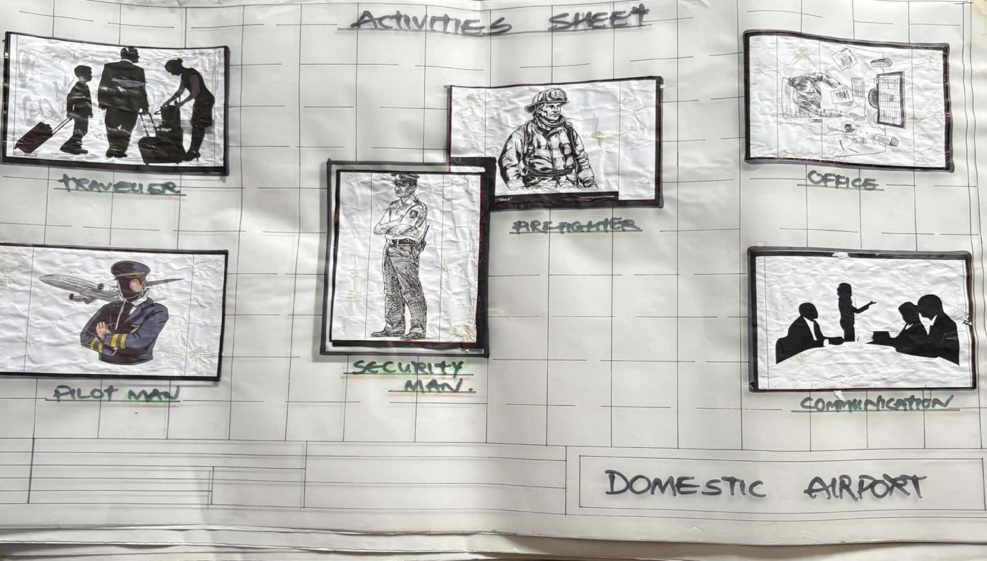
ACTIVITIES SHEET
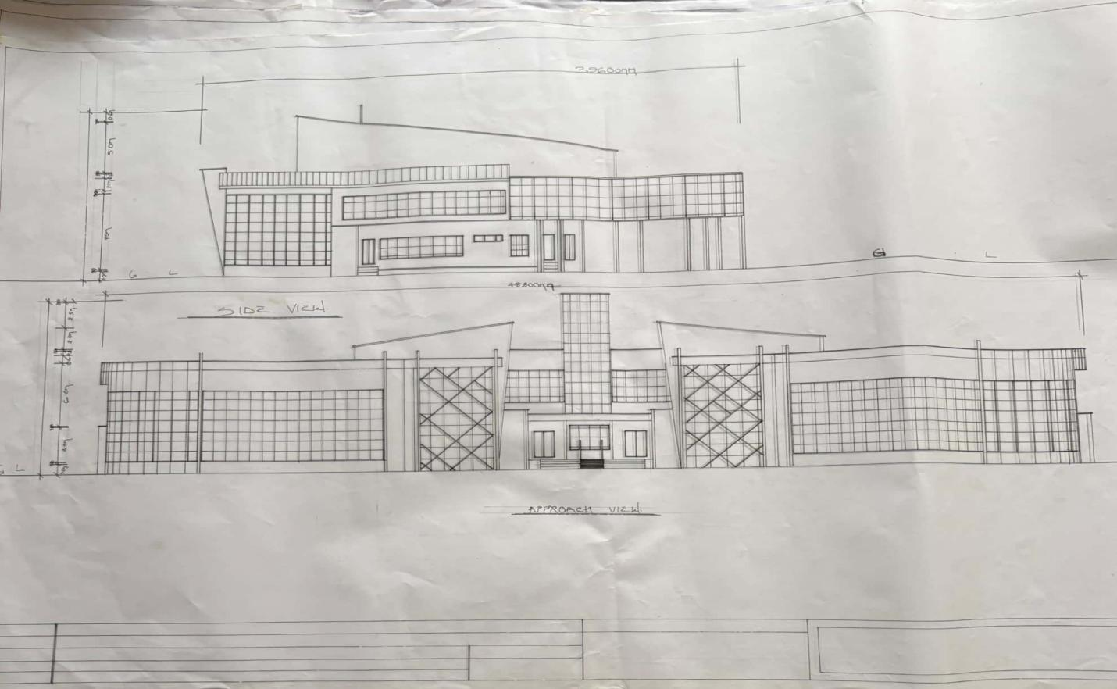
ELEVATION
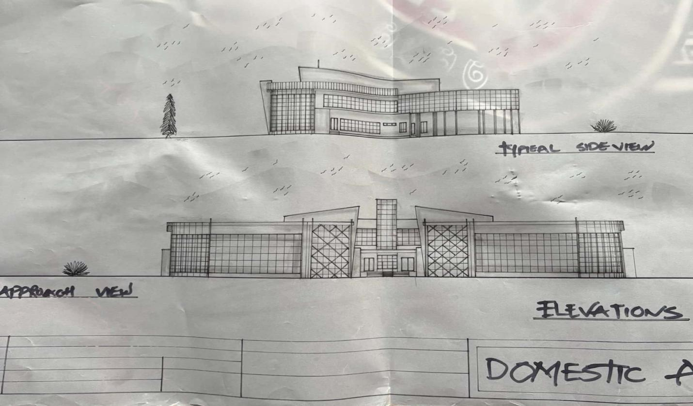
ELEVATION 2
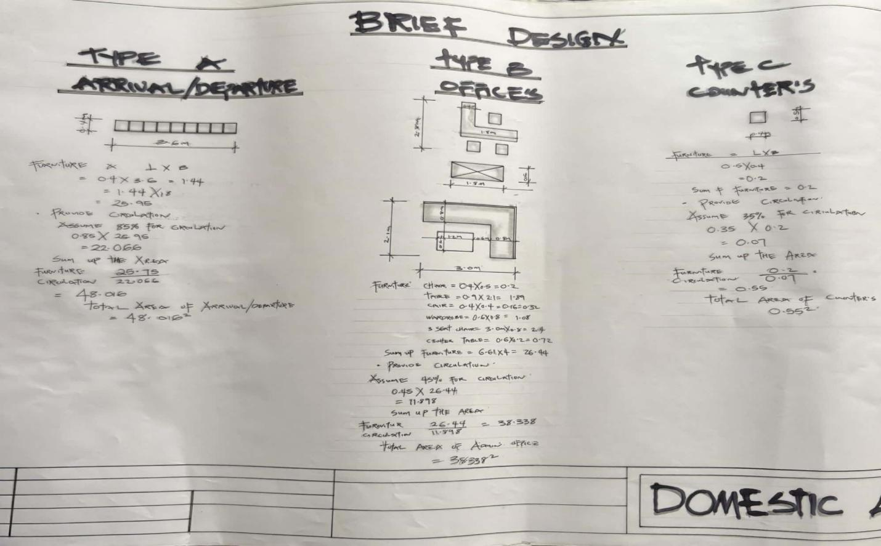
BRIEF DESIGN
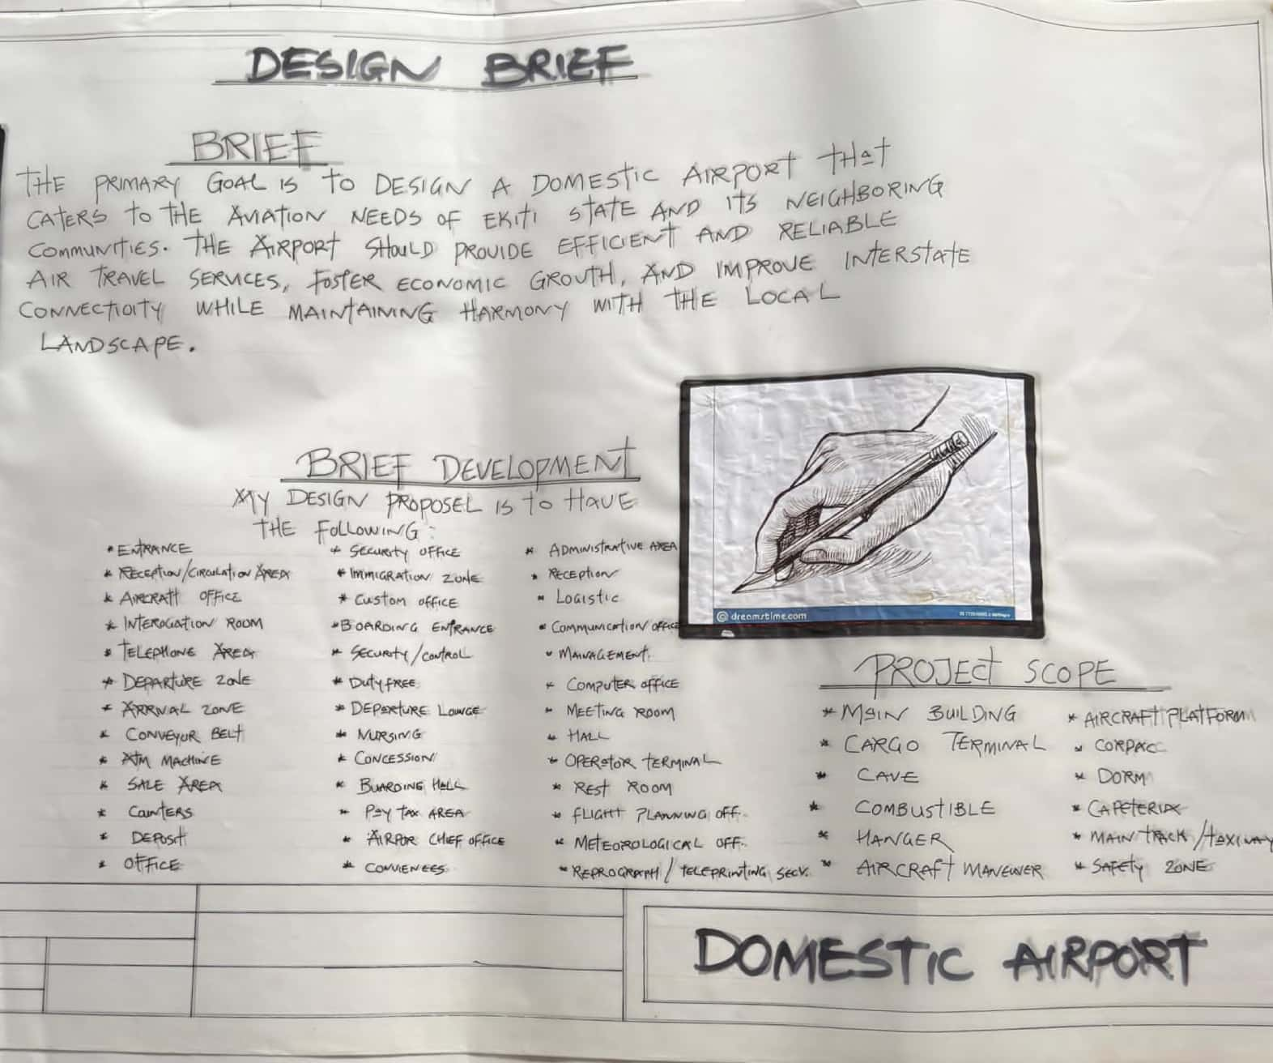
DESIGN BRIEF
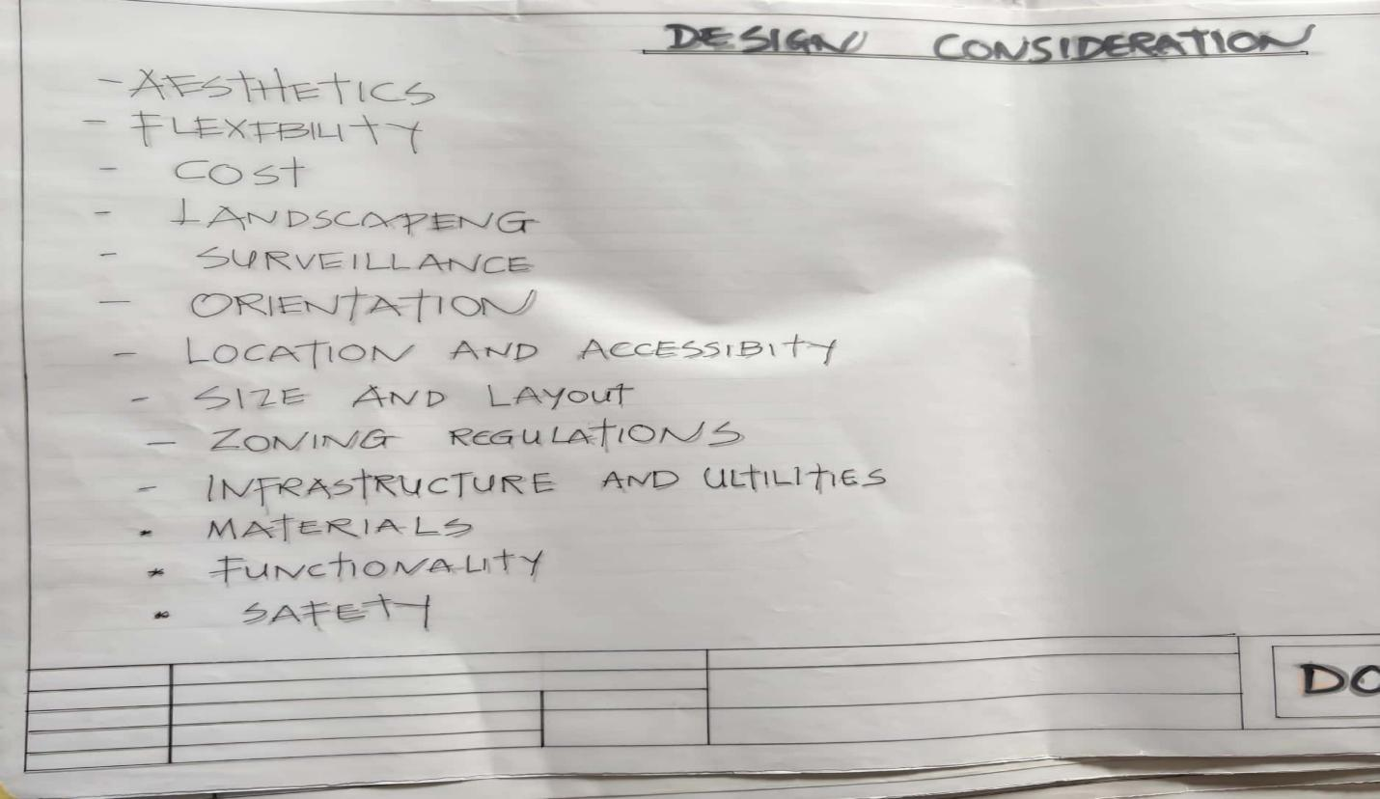
DESIGN CONSIDERATION
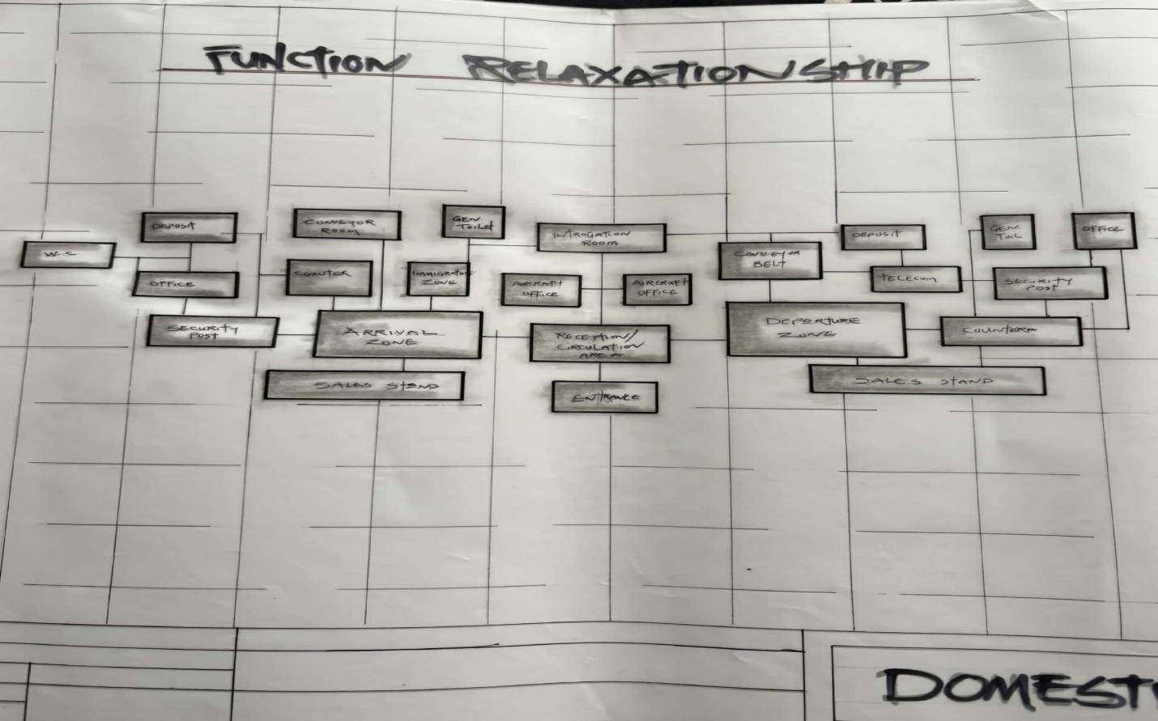
FUNCTIONAL RELATIONSHIP
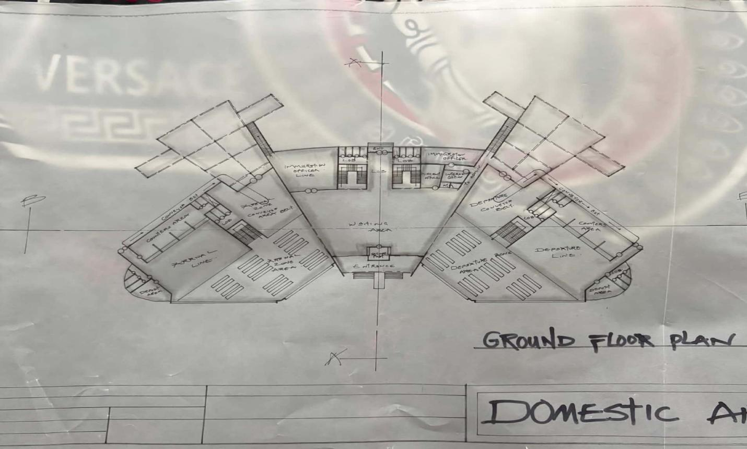
GROUND FLOOR PLAN
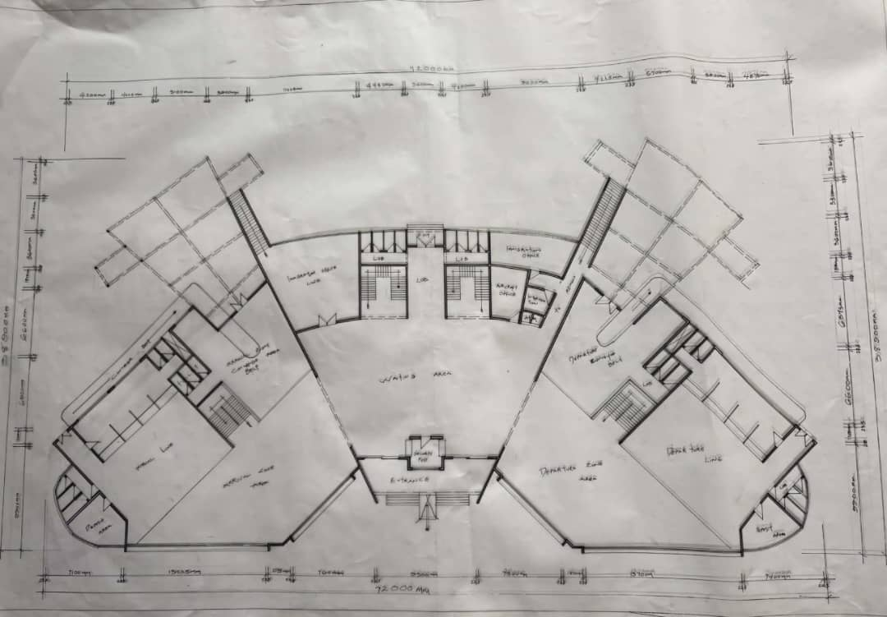
GROUND FLOOR PLAN 2
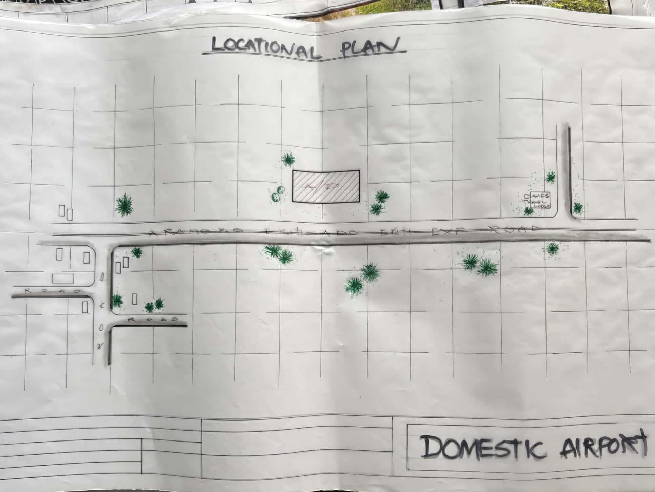
LOCATIONAL PLAN
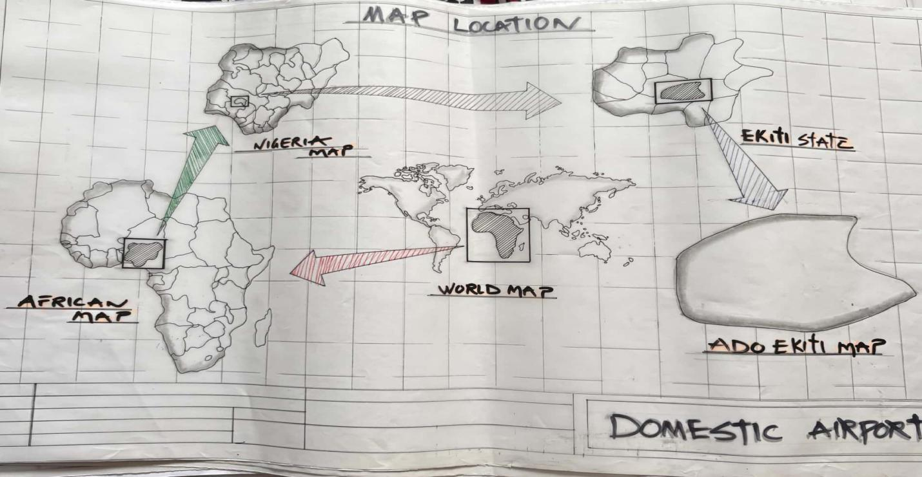
MAP LOCATION
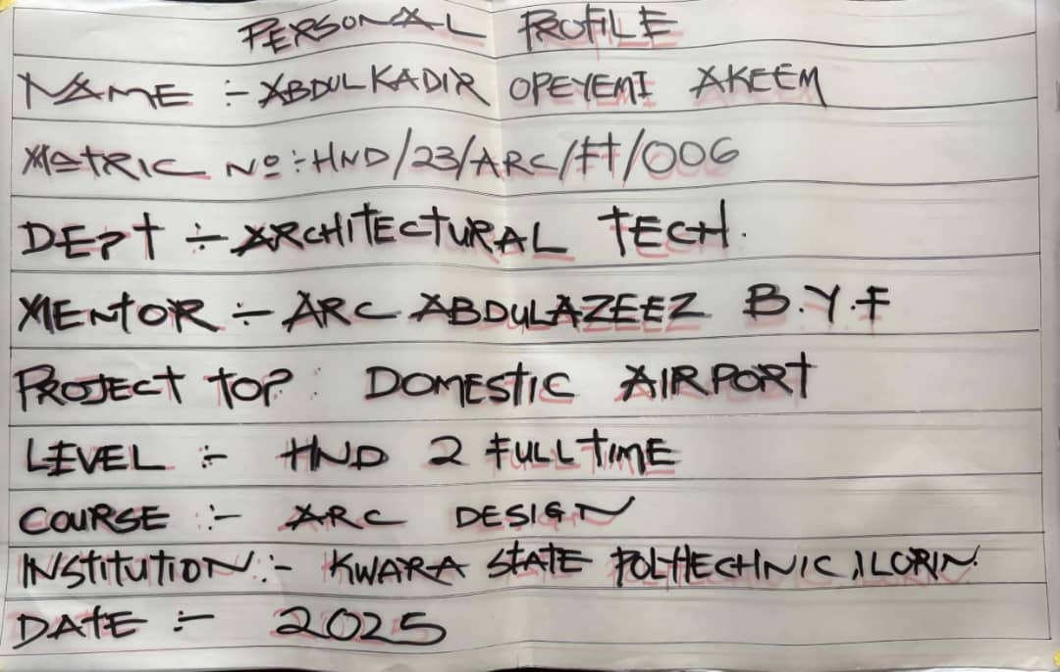
PERSONAL PROFILE
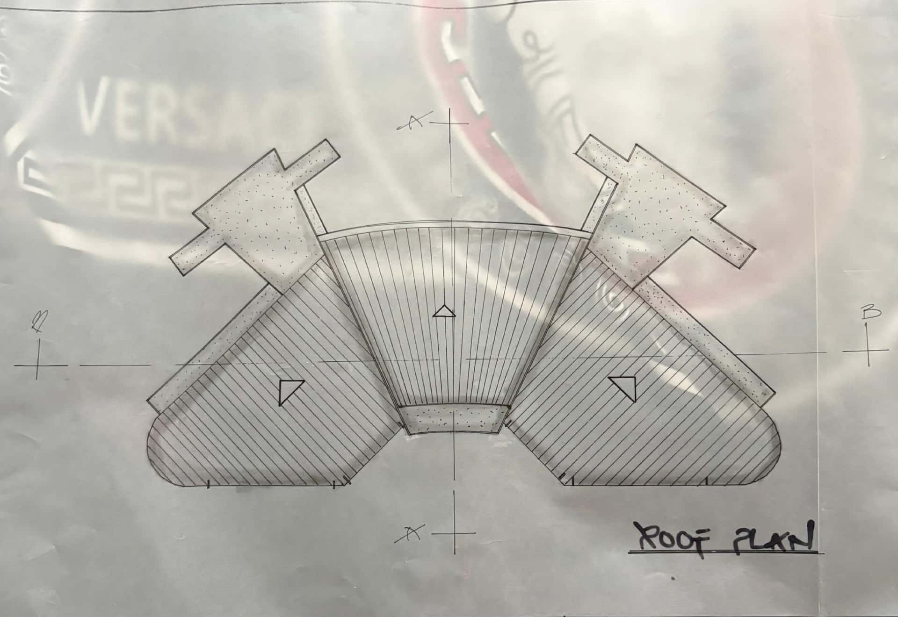
ROOF PLAN
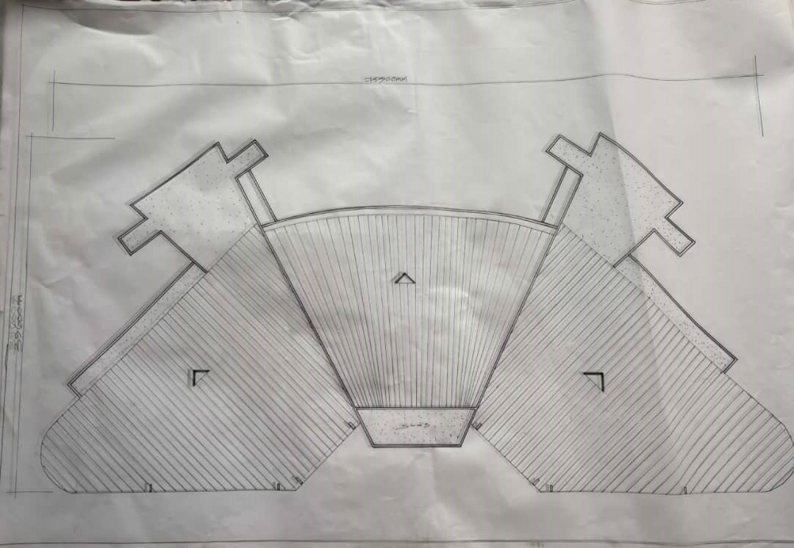
ROOF PLAN 2
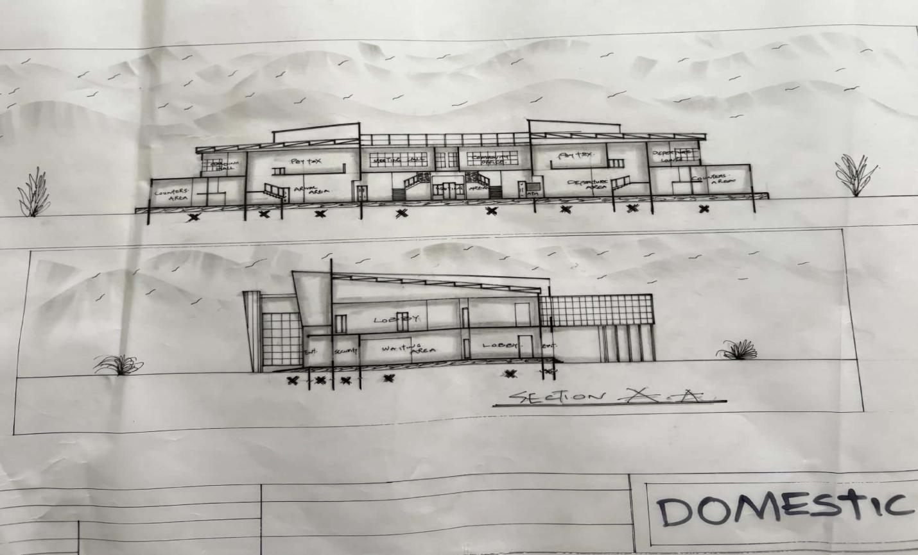
SECTION 1
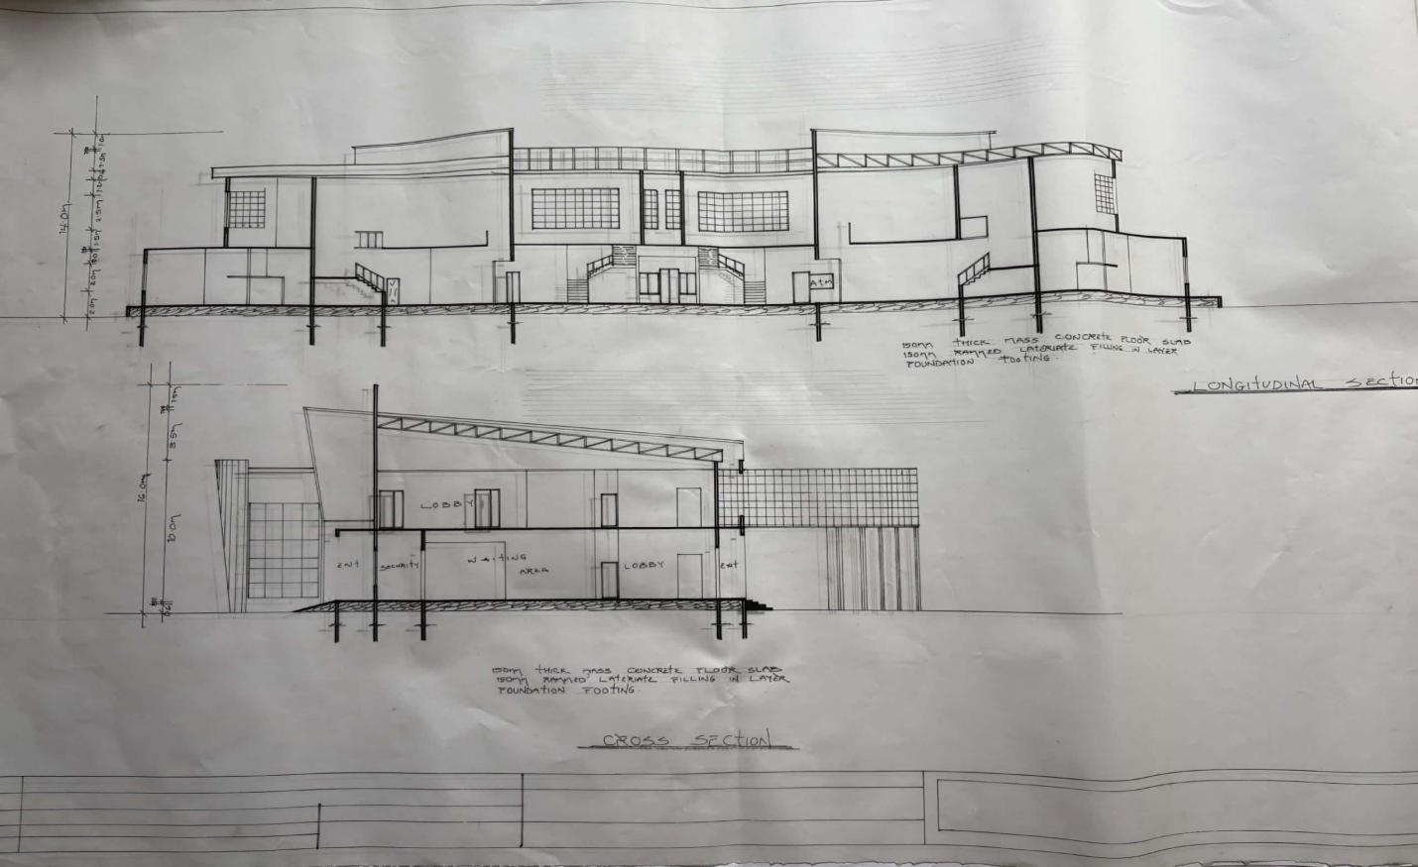
SECTION 2
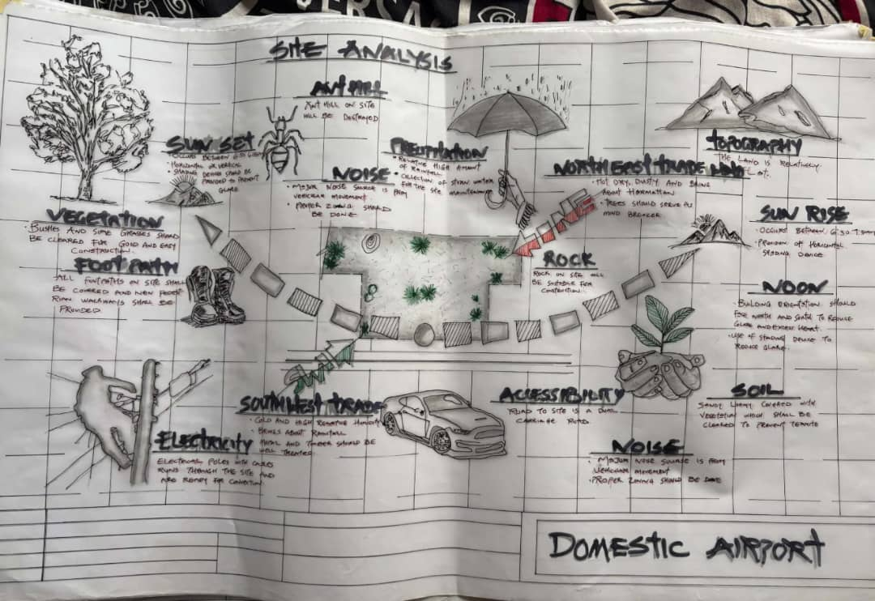
SITE ANALYSIS
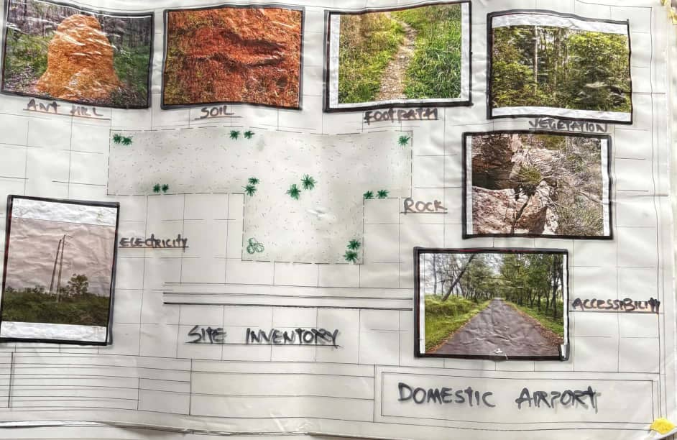
SITE INVENTORY
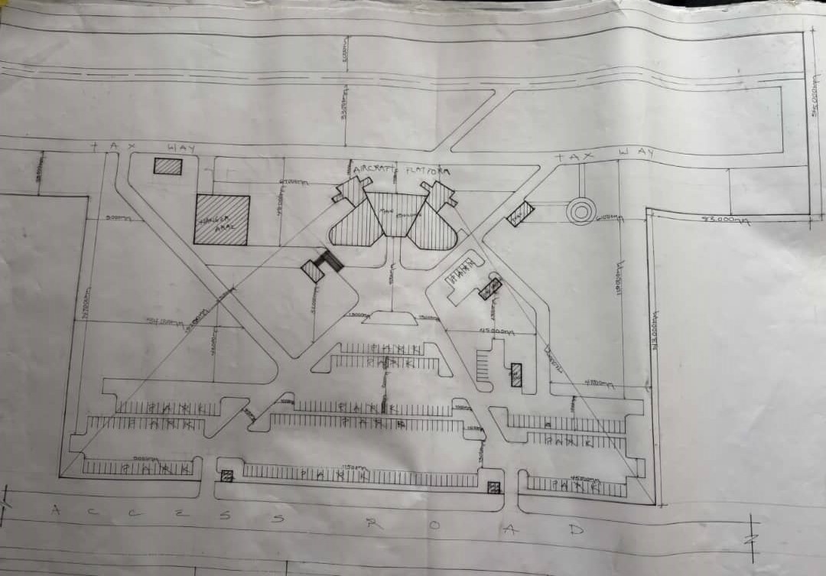
SITE PLAN
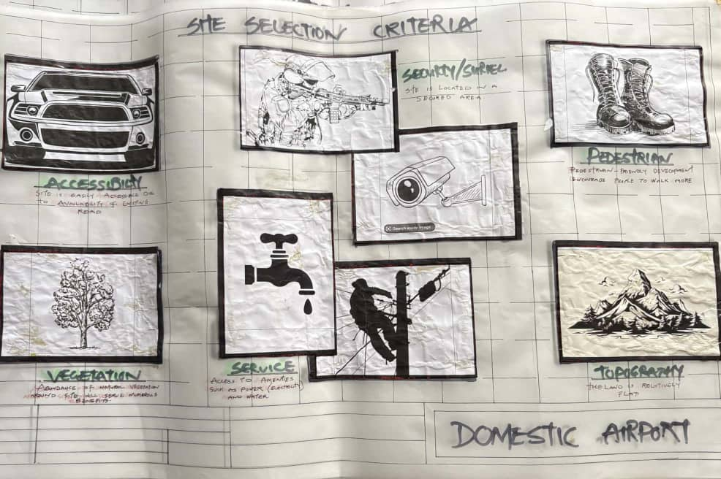
SITE SELECTION CRITERIA
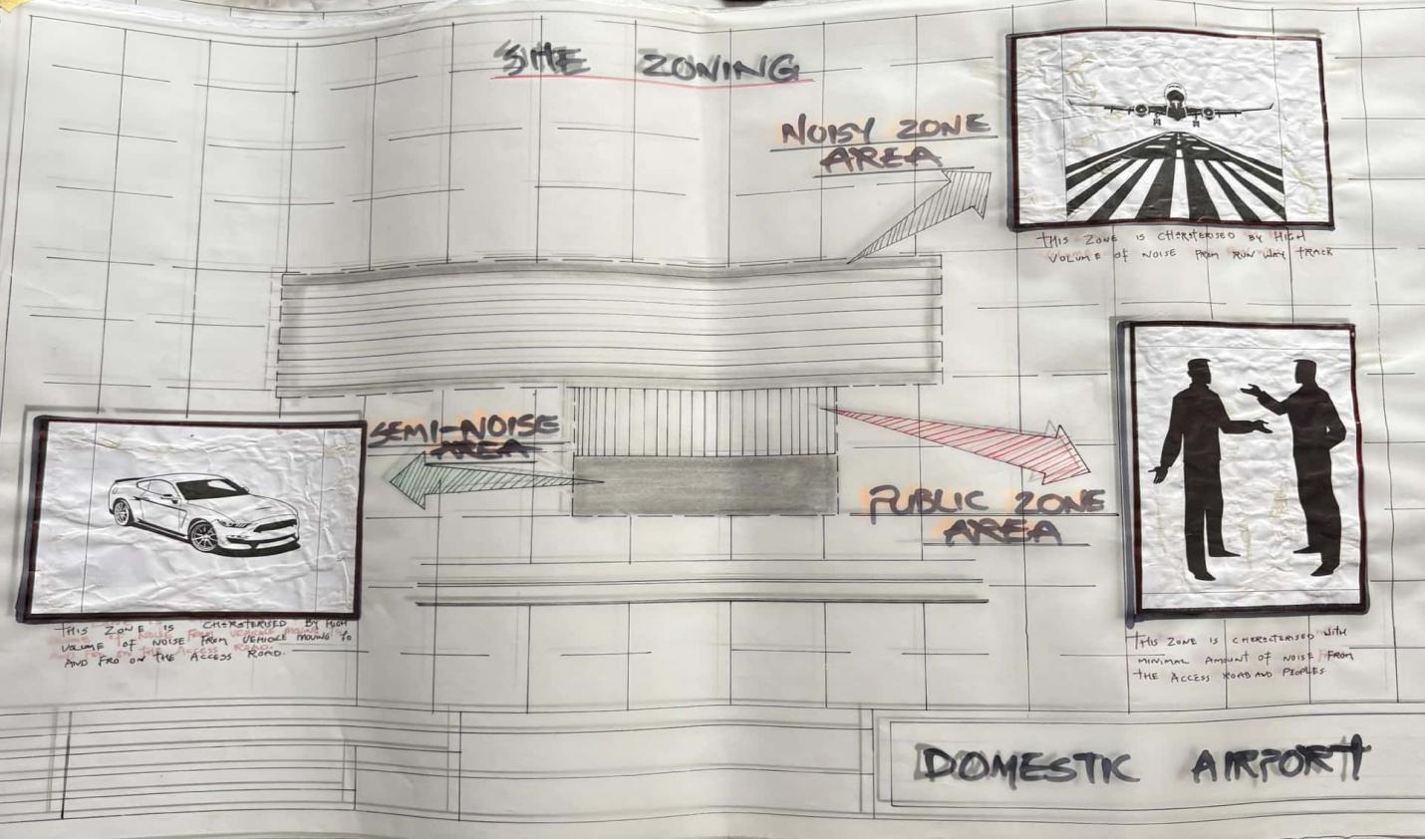
SITE ZONING
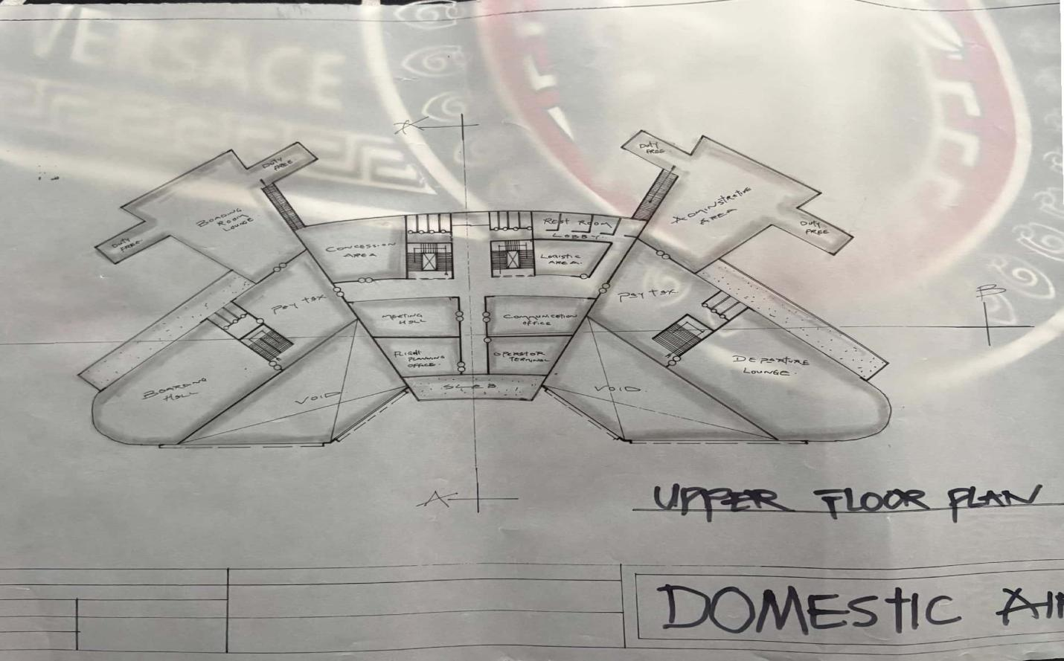
UPPER FLOOR PLAN
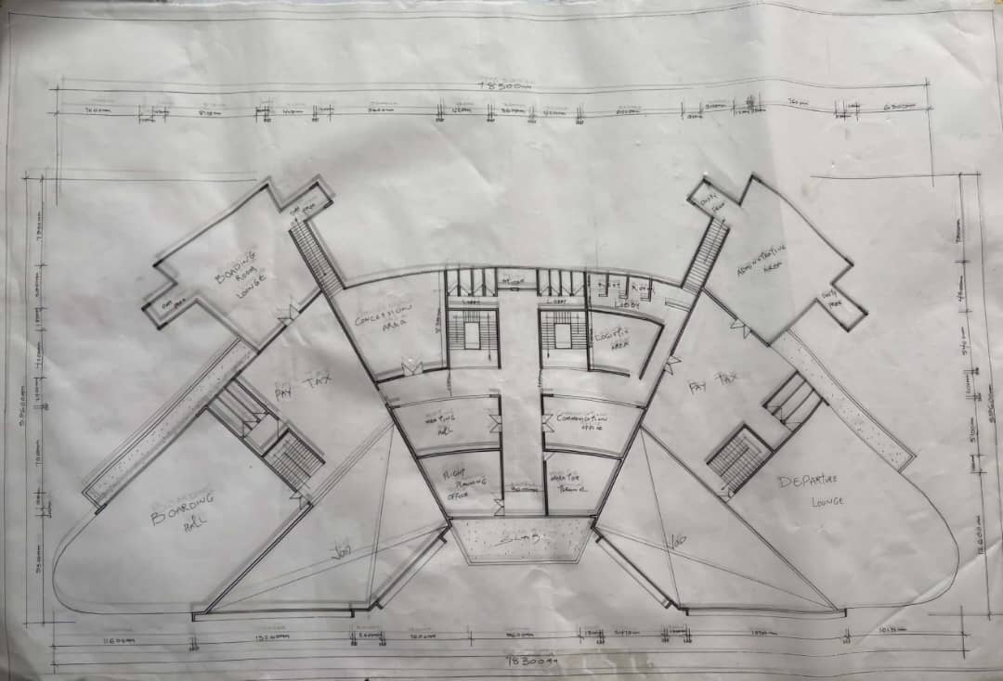
UPPER FLOOR PLAN 2

