A TECHNICAL PROJECT REPORT ON

A PROPOSED BAKERY FOR
(FORTUNATE BAKERY INVESMENT)

LOCATED AT: AKATA OSHODE VILLAGE, ILORIN SOUTH L.G.A

BY

IBRAHIM ABDULAHI DAMILARE ND/22/ARC/FT/0053

SUBMITED TO:

DEPARTMENT OF ARCHITECTURAL TECNOLOGY, INSTITUTE OF ENVIRONMENTAL STUDIES, KWARA STATE POLYTECHNIC ILORIN.

IN PARTIAL FULFILMENTS OF THE REQUIREMENTS, FOR AWARD OF NATIONAL DIPLOMA
(ND) IN ARCHITECTURAL TECHNOLOGY

SUPERVISOR: ARC. FAMILUA S.O

JULY, 2025

DECLARATION

I Ibrahim Abdulahi Damilare of matric number ND/22/ARC/FT/0053 I hearby declare that this project research BAKERY is my own unaided technical report works. It has not been presented for the award of any ND in any Polytechnic. The ideas, observations, comments, suggestions of this report represent my own convictions, except quotations, which have been acknowledged in accordance with conventional academic traditions

IBRAHIM ABDULAHI DAMILARE ………………………….

ND/22/ARC/FT/0053 SIGNATURE

CERTIFICATION

I certify that this Research Project/Dissertation entitle Bakery as carried out by Ibrahim Abdulahi Damilare, under my supervision and has been approved as meeting the requirements for the award of ND in Architectural Technology, Kwara State Polytechnic, Ilorin Kwara State.

ARC. FAMILUA O.S
...................................... ……………………….
(Project Supervisor) SIGNATURE/ DATE

ARC. OLAREWAJU F.A ......................................
………………………….
(Project coordinator) SIGNATURE/DATE

ARC. J. M TOMORI .....................................
………………………
(Head of Department) SIGNATURE/DATE

.................................... ....................................
(External Examiner) SIGNATURE/DATE

ACKNOWLEDGEMENT

I utmost gratitude goes to almighty God for his grace, guidance protection and infinite mercy that gave me courage, wisdom and endurance needed to start and finish the research in spite of all difficulties. I cannot but appreciate the effort to my supervisor in person of ARC.FAMILUA O.S for her support and assistant. I also grateful to my head of department (H O D) ARC.J. M. And my course mate for their readiness to help, to all my guidance and suggestions. Finally, my gratitude and adoration goes to almighty GOD for his protection, enduring mercy over me throughout the period of my study. I also wish to express our profound gratitude to my parents (Mr and Mrs IBRAHIM ), for their love, care, assistance, financial moral support and most importantly for always been there for us, and to my love ones.

DEDICATION

This research is dedicated to almighty GOD whose guidance and protection has been more than enough for me since the beginning of this research to the end.I also to my parents MR AND MRS IBRAHIM for been there for me at all time.

TABLE OF CONTENTS

TITTLE PAGE i
DECLARATION ii
CERTIFICATION iv
ACKNOWLEDGEMENT v
TABLE OF CONTENT vi
LIST OF FIGURE vii
LIST OF PLATES viii
LIST OF APPENDIX ix
ABSTRACT x
CHAPTER ONE
  - INTRODUCTION 1
  - PROJECT DEFINITION 1
  - HISTORICAL BACK GROUND 2
  - JUSTIFICATION 2
  - AIM 3
  - OBJECTIVES 3
  - CLIENT BACKGROUND, PHILOSOPHY 3
  - SCOPE OF STUDY 3
  - LIMITATION OF DESIGN 4
  - RESEARCH METHODOLOGY 5
CHAPTER TWO
  - LITERATURE REVIEW 6
  - REVIEW OF ALL LITERATURE ON THE SUB-TOPIC 8
CHAPTER THREE
  - CASE STUDY ONE 9
  - CASE STUDY TWO 12
  - CASE STUDY THREE 15
CHAPTER FOUR
  - INTRODUCTION OF STUDY AREA 18
  - SITE LOCATION/DESCRIPTION 19
  - SITE ANALYSIS/INVENTORY 19
  - GEOGRAPHICAL/CLIMATIC CONDITIONS 20
  - DESIGN CRITERIA 20
  - BRIEF ANALYSIS 20
  - SPATIAL PROGRAMMING (REAQUIREMENT AND ANALYSIS) 21
  - CONCEPTUAL DEVELOPMENT 21
  - SITE CONCEPT 22
  - BUILDING CONCEPT 23
CHAPTER FIVE
  - PROJECT APPRAISAL 24
  - CONSTRUCTION METHODOLOGY AND MATERIALS 26
  - BUILDING SERVICE 28
  - CONCLUSION AND RECOMMENDATION 32
  - REFERENCES 33

LIST OF FIGURES

FIGURE 2.1: LOCATIONAL PLAN CASE STUDY ONE 9

FIGURE 2.2: FLOOR PLAN OF CASE STUDY ONE 9

FIGURE2. 3: LOCATIONAL PLAN OF CASE STUDY TWO 12

FIGURE2. 4: FLOOR PLAN OKELERIN CASE STUDY TWO 13

FIGURE2. 5: LOCATIONAL PLAN OF CASE STUDY THREE 15

FIGURE2. 6: FLOOR PLAN OF CASE STUDYTHREE… 15

FIGURE3.1. GEOGRAPHICAL/ CLIMATIC DATA 18

FIGURE3.2. AVERAGE MONTHLY TEMPERATURE 23
FIGURE3.3. AVERAGE MONTHLY RAINFALL IN ILORIN 24

FIGURE 4.1 BUILDING CONCEPT 27

LIST OF PLATE
PLATE 2.1 .FRONT VIEW OF CASE STUDY ONE 10
PLATE 2.2 .INTERNAL VIEWS OF CASE STUDY ONE 10
PLATE 2.2 .INTERNAL VIEWS OF CASE STUDY TWO 11
PLATE 2.3 .FRONT VIEW OF CASE STUDY TWO 13
PLATE 2.4 .PICTURES OF CASE STUDY THREE 16
PLATE 2.4 .PICTURES OF CASE STUDY THREE 16

LIST OF APPENDIX
APPENDIX 5 .1; SHOWING LOCATIONAL MAP 32
APP ENDIX 5 .2; SHOWING LOCATIONAL PLAN 32
APPENDIX.5;3 SHOWINGINTERNAL PERSPECTIVE 33
APPENDIX 5. 4; SHOWING SITE ANALYSIS 33
APPENDIX 5. 5; SHOWING ROOF 34
APPENDIX 5 .6; SHOWING FLOOR PLAN 34

ABSTRACT
This project proposes the establishment of a bakery in Ilorin South, specifically in the rural areas of Akata Oshode, to cater to the growing demandforbreadandotherbaked goods in the region. The project aims to reduce transportation costs, create jobs, and stimulate local economic growth while providing high-quality baked products to the community. Fortunate Bread, a reputable bakery brand in Ilorin, is poisedtobenefitfrom this project by expanding its operations and increasing its market share.The proposed bakery will utilize modern facilities and equipment to produce a wide range of baked goods, including bread, cakes, and pastries. The project will create employment opportunities for local residents, contributing to the community's economicdevelopment and well-being. By establishing a local production facility, Fortunate Bread willbeable to reduce its transportation costs, improve product freshness, and enhance customer satisfaction. This project will have a positive impact on the local economy,contributing to the growth and development of the community. The establishment of the bakery will also promote the preservation of traditional baking techniques and the promotion of local flavors. With a strong market demand for baked goods in Ilorin South, this project is expected to be a viable and profitable venture, contributing to the success of Fortunate Bread and the local community.

CHAPTER ONE

  - INTRODUCTION

A bakery is a business that specializes in producing and selling a wide variety of delicious baked goods, such as bread, cakes, pastries, and cookies, which have been an integral part of human culture for thousands of years. The history of baking dates back to ancient civilizations, where people first discovered the art of baking bread around 10,000 BCE, and over time, baking techniques and ingredients have evolved, leading to the diverse array of baked goods we enjoy today. From traditional bakeries that have been passed down through generations to modern artisanal bakeries that experiment with new flavors and ingredients, bakeries play a vital role in providing freshly baked products to communities around the world. Whether it's a small, family-owned shop or a large commercial operation, bakeries are an essential part of many communities, offering a wide range of products that cater to different tastes and preferences Bakeries not only provide delicious food but also serve as community gathering places where people can socialize and enjoy baked goods, and they offer employment opportunities for bakers, decorators, and other support staff. The importance of bakeries extends beyond just providing food, as they also play a significant role in preserving cultural traditions and customs, with many bakeries offering unique and authentic baked goods that showcase local flavors and ingredients. In addition to their cultural significance, bakeries also contribute to the local economy, and with the rise of artisanal and craft bakeries, there has been a resurgence of interest in traditional baking techniques and high-quality ingredients. As a result, bakeries continue to thrive and evolve, offering a wide range of opportunities for entrepreneurs, bakers, and food enthusiasts alike. Overall, bakeries are an integral part of many communities, providing a wide range of
benefits that extend beyond just the delicious baked goods they produce.

  - HISTORICAL BACKGROUND

The historical background of bakeries dates back thousands of years, with evidence of ancient civilizations baking bread as far back as 10,000 BCE. In ancient Egypt, Greece, and Rome, baking was a revered craft, with bakers playing a crucial role in providing bread for the population. The ancient Egyptians are credited with developing advanced baking techniques, including the use of yeast, while the ancient Greeks and Romans refined these techniques and developed new recipes. During the Middle Ages, baking continued to evolve, with guilds of bakers forming in Europe to regulate the trade and ensure quality standards. The Industrial Revolution brought significant changes to baking, with the introduction of new technologies and machinery enabling mass production of bread and other baked goods. In the 19th and 20th centuries, bakeries continued to adapt to changing consumer demands, with the rise of artisanal and craft bakeries offering unique and high- quality products. Today, bakeries around the world offer a diverse range of products, from traditional breads and pastries to modern cakes and desserts. Throughout history, baking has played a significant role in many cultures, with bread and other baked goods often serving as symbols of hospitality, community, and celebration. The evolution of baking has been shaped by technological advancements, cultural exchange, and changing consumer preferences, resulting in the rich diversity of baked goods we enjoy today. By understanding the historical background of bakeries, we can appreciate the craft and tradition that goes into creating the delicious treats we enjoy every day.
  - DEFINITION.
A bakery is a business establishment that specializes in the production and sale of baked goods, such as bread, cakes, pastries, and cookies. Bakeries can range from small, family-

owned shops to large commercial operations, and they often employ skilled bakers and decorators who use traditional and modern techniques to create a wide variety of delicious treats. Bakeries may offer custom ordering services for special occasions, such as weddings and birthdays, and they often play a vital role in their local communities, providing fresh, high-quality baked goods to residents and businesses. By combining artistry with culinary expertise, bakeries create delightful experiences for customers.
  - JUSTIFICATION

Designing a bakery for Fortunate Bread in rural areas of Ilorin South, such as Akata Oshodi, would significantly reduce transportation costs by minimizing the distance between production and consumption points. This strategic move would lower fuel costs, reduce vehicle wear and tear, and decrease the likelihood of product damage during transportation. By producing bread locally, Fortunate Bread can ensure timely deliveries, maintain product freshness, and improve customer satisfaction. Additionally, the bakery would create jobs and stimulate local economic growth, contributing to the community's development. This initiative would be a wise business decision, enhancing the company's efficiency and competitiveness.
  - AIM AND OBJECTIVES

The aim of designing a bakery for Fortunate Bread in Ilorin South is to reduce transportation costs, improve product freshness, and enhance customer satisfaction while creating jobs and stimulating local economic growth. By establishing a local production
facility, Fortunate Bread can increase efficiency, competitiveness, and profitability,

ultimately contributing to the community's development and well-being, while meeting the growing demand for bread in the area.
  - OBJECTIVE

- To Reduce transportation costs and improve logistics efficiency

- To Increase product freshness and quality

- To Enhance customer satisfaction through timely deliveries

- To Create jobs and stimulate local economic growth

- To Improve competitiveness and profitability

- To Meet the growing demand for bread in the local market

- To Contribute to the community's development and well-being

  - CLIENTS BACKGROUNG, PHYLOSHOPHY

Fortunate Bread in Ilorin has a rich history of producing high-quality baked goods, particularly bread, that has earned it a loyal customer base in the community. With its modern bakery facilities and commitment to quality, Fortunate Bread has become a household name in Kwara State. The bakery's products are known for their soft, fluffy texture and delicious flavor, making them a favorite among locals. Over time, Fortunate Bread has built a strong reputation for reliability, consistency, and customer satisfaction, with customers praising its attention to detail and commitment to quality .The bakery's history is marked by a passion for baking and a dedication to meeting the needs of its customers. With a range of products that cater to different tastes and preferences, Fortunate Bread has become a go-to destination for bread and other baked goods in Ilorin. The

bakery's commitment to using quality ingredients and modern facilities has enabled it to maintain high standards of quality and hygiene, ensuring that its products are always fresh and delicious. Today, Fortunate Bread is a trusted brand that is synonymous with quality and excellence in the baking industry. Its history is a testament to the power of hard work, dedication, and a passion for baking.
  - SCOPE AND BRIFE OF PROJECT

* Gate house

*Proposed building (bakery)

*Parking lot

*water storage/ whare house

*Power house

LIMITATION

Types of Limitations

- Methodological Limitations: Limitations related to the research design, sampling strategy, or data collection methods.
- Sampling Limitations: Limitations related to the sample size, population, or sampling frame.
- Data Limitations: Limitations related to the quality, accuracy, or completeness of the data.

Examples of Limitations

- Small sample size: Limited statistical power and reduced generalizability.

- Biased sampling: Non-representative sample, which may lead to inaccurate conclusions.

- Limited access to data: Incomplete or inaccurate data, which may impact the validity of the findings.

Importance of Acknowledging Limitations

- Transparency: Acknowledging limitations demonstrates transparency and honesty in research.
- Contextualizing findings: Recognizing limitations helps to contextualize the findings and interpret them accurately.
- Future research directions: Identifying limitations can inform future research directions and improve the quality of subsequent studies.
  - RESEARCH METHODOLOGY

Types of Research Methodologies

- Quantitative Research: Uses numerical data and statistical methods to investigate research questions or hypotheses.
- Qualitative Research: Employs non-numerical data, such as text, images, or observations, to gain insights into research phenomena.
- Mixed-Methods Research: Combines quantitative and qualitative approaches to provide a more comprehensive understanding of the research topic.
Research Methodology Steps

- Literature Review: Conducting a thorough review of existing research on the topic to identify gaps and inform the research question.

- Research Design: Selecting an appropriate research design, such as experimental, quasi- experimental, or descriptive, to investigate the research question.
- Data Collection: Collecting data using various methods, such as surveys, interviews, observations, or experiments.

Importance of Research Methodology

- Ensures Validity and Reliability: A well-designed research methodology ensures that the findings are valid, reliable, and generalizable.
- Provides a Framework : Research methodology provides a systematic approach to conducting research, guiding the researcher through the entire process.
- Enhances Credibility: A rigorous research methodology enhances the credibility of the research findings and contributes to the advancement of knowledge in the field.

CHAPTER TWO

  - LITERATURE REVIEW
The bakery industry is a significant contributor to the global food market, providing a wide range of products that cater to diverse consumer preferences. According to a report by Grand View Research (2022), the global bakery market is expected to reach USD 545.8 billion by 2025, driven by increasing demand for artisanal and premium bakery products.
CONSUMER PREFERENCES AND TRENDS
Consumer preferences and trends play a crucial role in shaping the bakery industry. A study by Euromonitor International (2020) found that consumers are increasingly seeking healthier and more sustainable bakery options, driving demand for products with natural ingredients, reduced sugar, and environmentally friendly packaging. Additionally, the rise of online shopping and food delivery services has transformed the way consumers purchase bakery products, with many bakeries adapting to this trend by offering online ordering and delivery options (Food Dive, 2022).
PRODUCTION AND SUPPLY CHAIN MANAGEMENT
Effective production and supply chain management are critical to the success of bakeries. A study by the Journal of Food Engineering (2019) found that optimizing production processes and supply chain management can help bakeries reduce costs, improve product quality, and increase customer satisfaction. The use of technology, such as automated production systems and inventory management software, can also help bakeries streamline their operations and improve efficiency.

FOOD SAFETY AND QUALITY CONTROL
Food safety and quality control are essential considerations for bakeries, with consumers expecting high-quality products that meet strict safety standards. A study by the Journal of Food Protection (2020) found that bakeries must implement robust food safety protocols, including proper ingredient handling, storage, and sanitation practices, to minimize the risk of contamination and ensure product safety.
SUSTAINABILITY AND ENVIRONMENTAL IMPACT
The bakery industry has a significant environmental impact, with bakeries generating waste, consuming energy, and contributing to greenhouse gas emissions. A study by the Journal of Cleaner Production (2020) found that bakeries can reduce their environmental impact by implementing sustainable practices, such as reducing energy consumption, minimizing waste, and using eco-friendly packaging.
  - REVIEW OF ALL LITERATURE ON THE SUB-TOPIC

TYPES OF LITERATURE REVIEWS
- Narrative Review: Provides a broad overview of studies on a particular topic, often including qualitative and quantitative research.
- Systematic Review: A structured and rigorous review that uses a detailed plan andsearch strategy to gather and analyze literature.
- Meta-Analysis: A statistical analysis that combines the results of multiple studies to draw more general conclusions

STEPS TO WRITING A LITERATURE REVIEW ON SUB-TOPICS
- Define Your Research Question: Identify the specific sub-topic you want to explore and formulate a research question.
- Conduct a Literature Search: Use scholarly databases and search terms to identify relevant studies.
- Evaluate and Select Sources: Filter sources based on relevance, credibility, and quality.

- Analyze and Synthesize: Review each source, summarize the main arguments, and identify themes.

TIPS FOR WRITING A LITERATURE REVIEW

1 Use a Clear and Concise Writing Style: Avoid jargon and technical terms unless necessary for your audience.
2 Use Connecting Verbs: Compare and contrast findings, methodologies, and conclusions.

3 Summarize and Synthesize: Use tables or concept maps to visualize information.

4 Critique and Evaluate: Assess the strengths and limitations of each study.

EXAMPLE OF LITERATURE REVIEW ON SUB-TOPICS

For instance, if your topic is "Tourism as a Tool for International Cooperation between Kenya and Egypt," you could divide your review into sub-topics such as ²:
1 Theoretical Frameworks: Discuss relevant theories and models of international cooperation.
2 Empirical Studies: Analyze case studies or research papers on tourism cooperation between Kenya and Egypt.
3 Challenges and Opportunities: Identify potential challenges and opportunities for tourism cooperation between the two countries.

CHAPTER THREE
3.0 CASE STUDY

This can be defined as the gathering of information through various means o: was Case Study 2.2 This is a research or an exercise that is carried out on existing building which 1s Similar to the one researcher is writing on. The objective of a case study is to take a critical appraisal of existing related project with a view to identity the positive and negative aspect of such project. It is only with time that a project can be adjusted so that it can be successful. The information obtained from the appraisal will guide the designer of new and similar project, the project position aspect of it shall be incorporated in the View proposal while attempts will be made to solve the problem of negative aspect. lt is only through this that a design can better enhance the quality and efficiency of building in the society, tor a comprehensive analysis their case studies have been conducted.

3.1 CASE STUDY

CASE STUDY ONE

NAME: FORTUNATE BREAD LOCATION: ILORIN KWARA STATE MERIT
1 It has a large and mass area of land

2. It is easily accessible through existing road DEMERIT
1 The roof needs renovation

2. It has no toilets to use

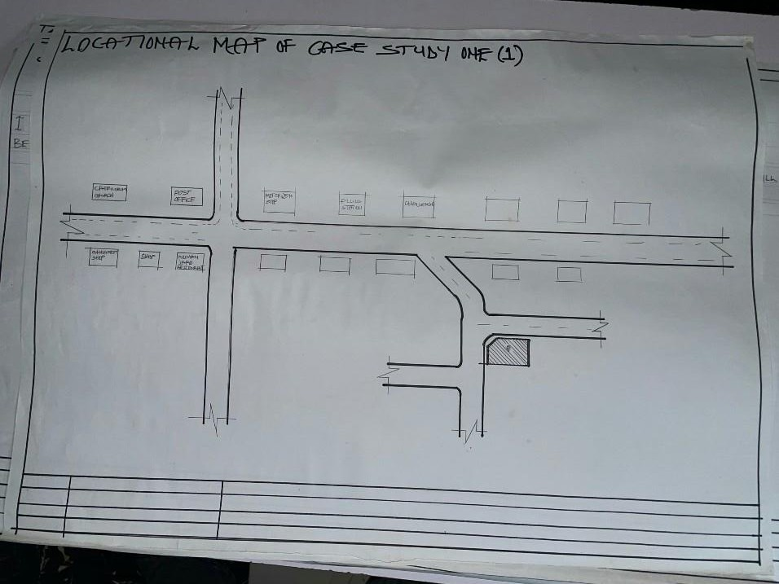

FIGURE3.1: LOCATIONAL PLAN OF CASE STUDY ONE
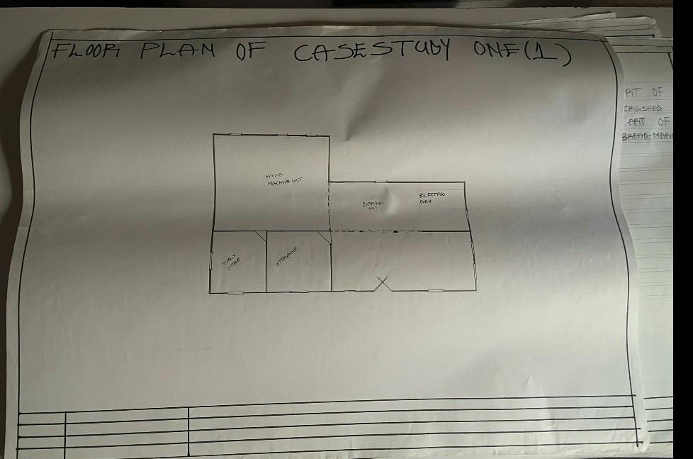
FIGURE3.2: FLOOR PLAN OF CASE STUDY ONE

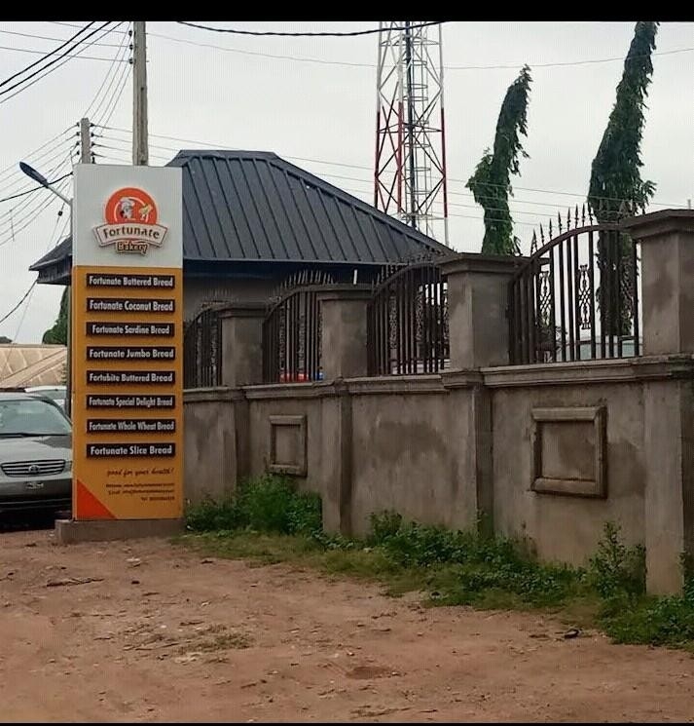
PLATE3.1: FRONT VIEW CASE STUDY ONE
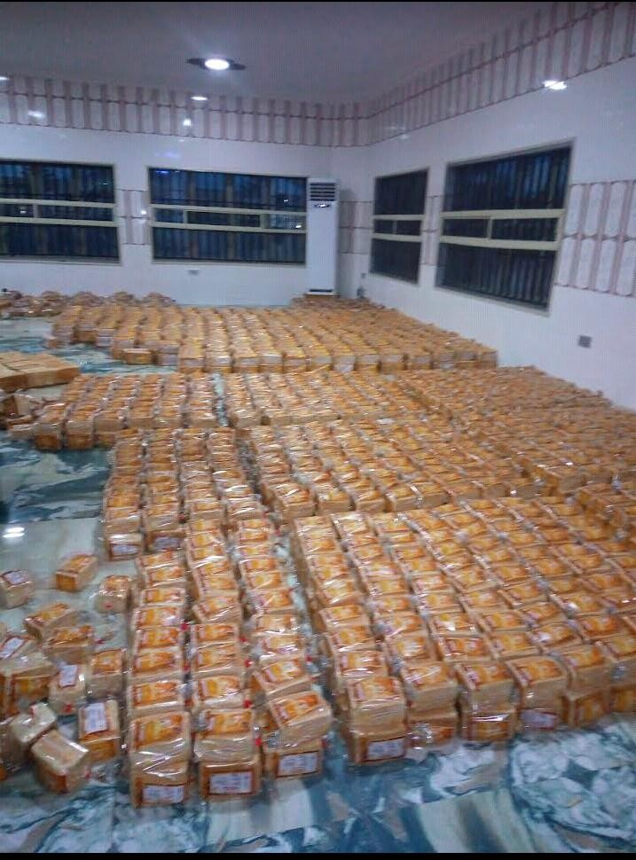
PLATE3.2: INTERNAL VIEW CASE STUDY ONE

CASE STUDY TWO NAME: PARIS BAKERY
LOCATION: OPPOSITI-ORE PRIMARY SCHOOL, IBADAN OYO STATE MERIT
1 It is well ventilated

2 The approach is well aesthetic DEMERIT
1 It has no landscape

2 not enough space for further development

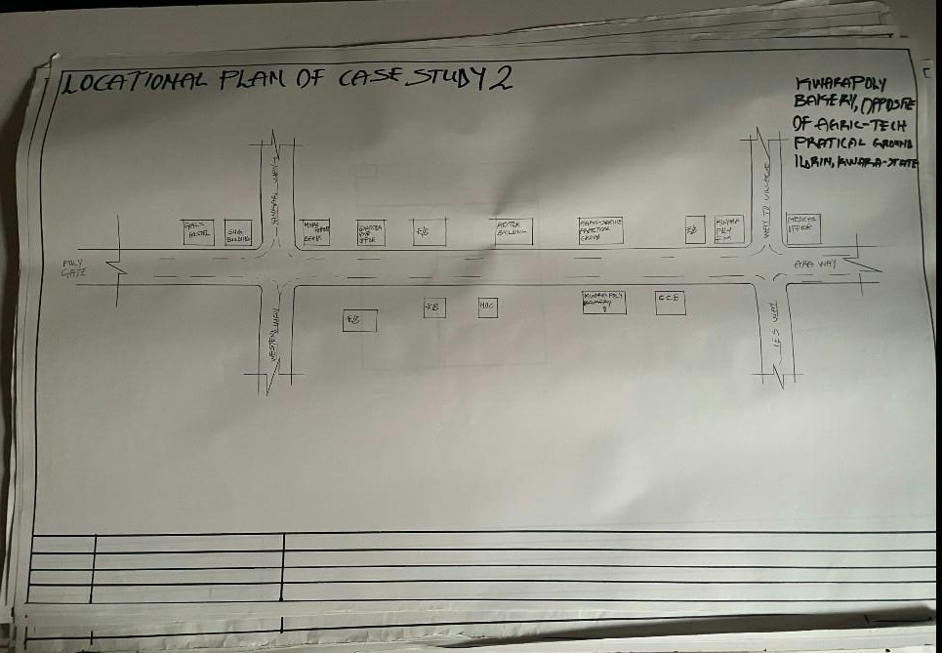

FIGURE3.3: LOCATIONAL PLAN F CASE STUDY THREE

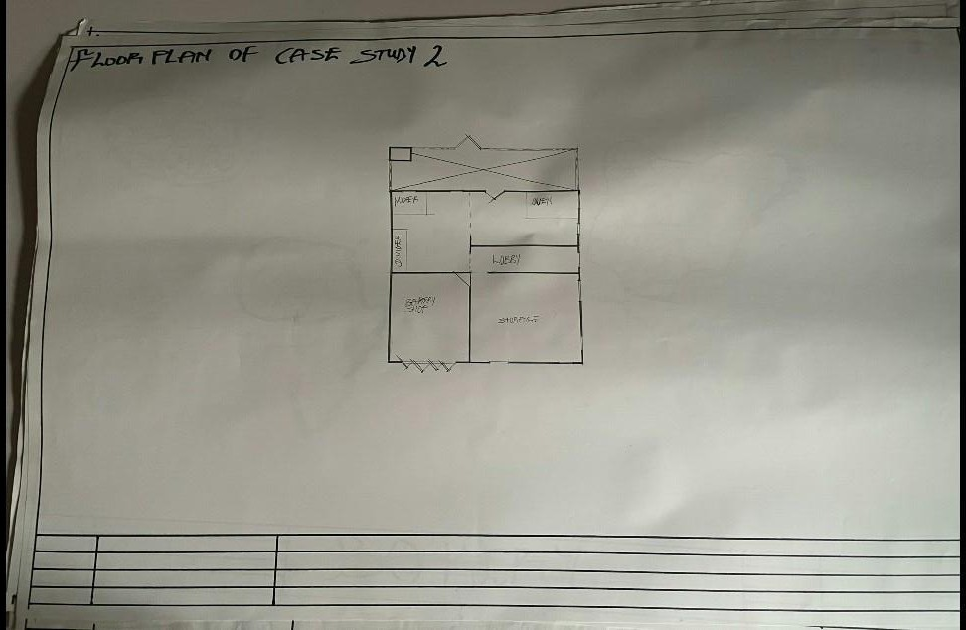

FIGURE3.4: FLOOR PLAN OF CASE STUDY THREE

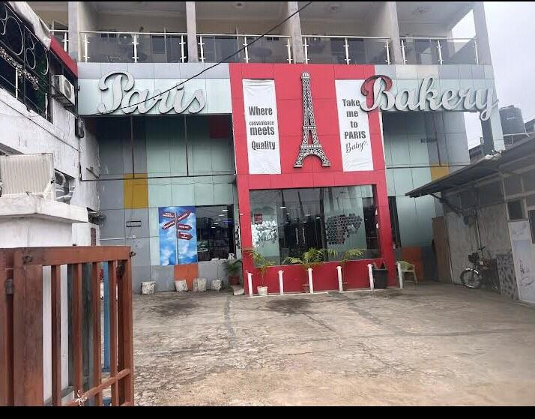
PLATE 3.3 .FRONT VIEW OF CASE STUDY THREE

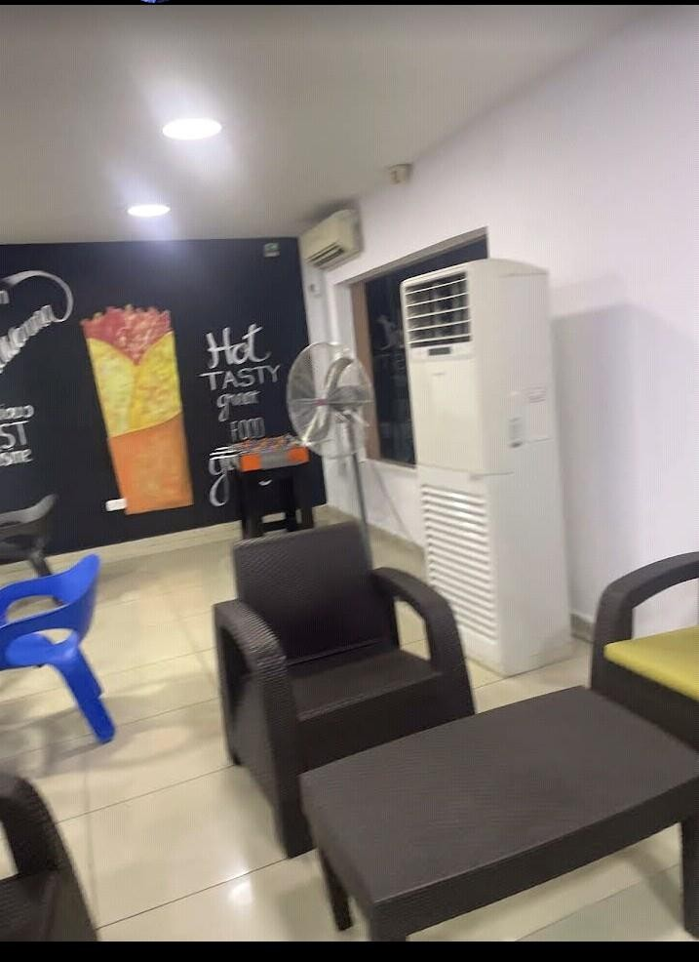

PLATE 3.4 INSIDE VIEW OF CASE STUDY TWO

STUDY THREE

NAME: SUMAL BAKERY

LOCATION: OGBOMOSHO, OYO STATE MERIT
- It is easily accessible through existing road DEMERIT
- It is not well ventilated

- The approach is aesthetically poor

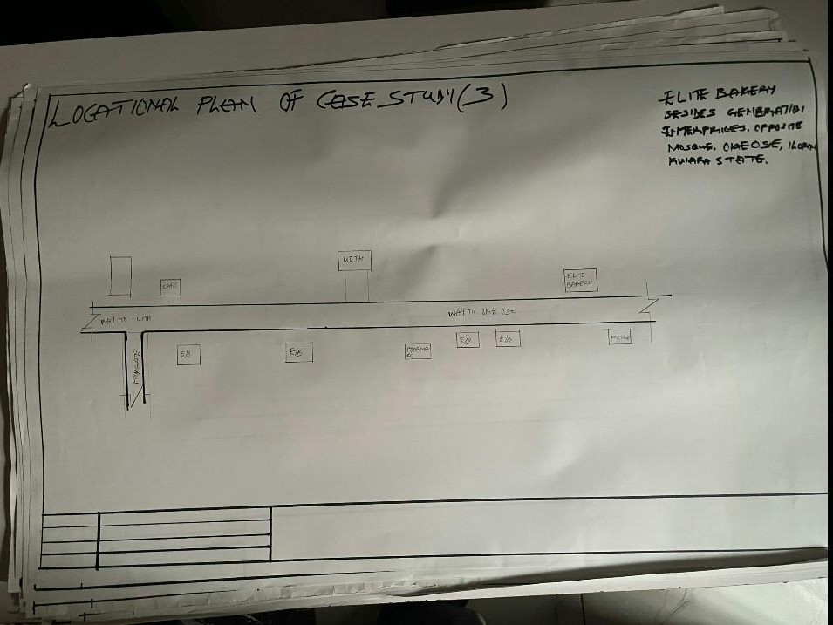

FIGURE3. 5: LOCATIONAL PLAN OF CASE STUDY THREE
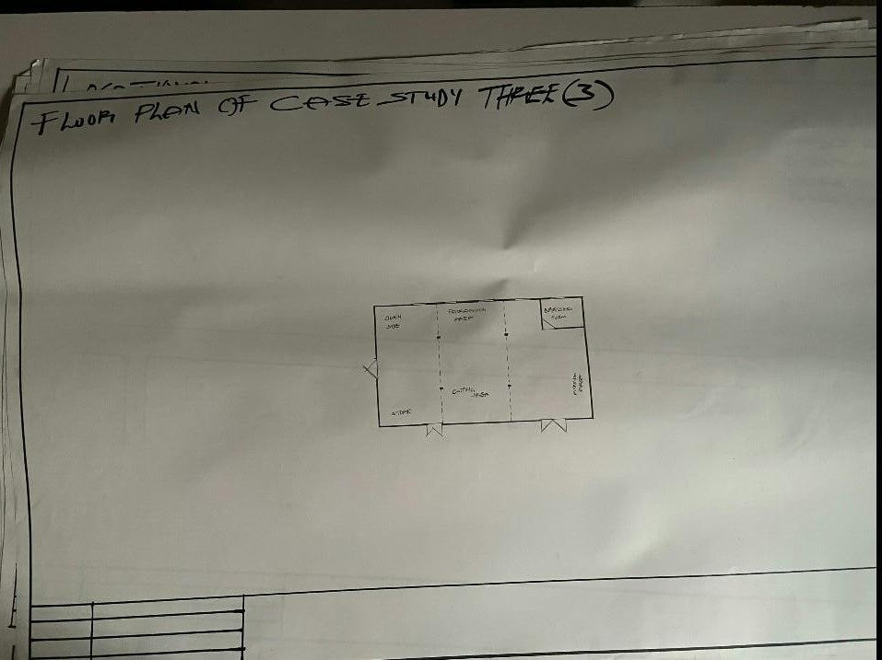

FIGURE3. 6: FLOOR PLAN OF CASE STUDY THREE

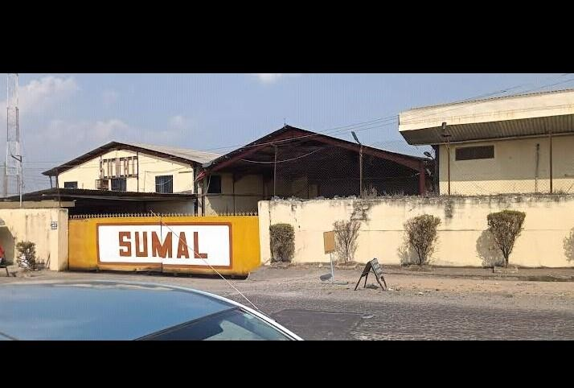
PLATES 3. 5: SHOWING FRONT VIEW OF CASE STUDY THREE
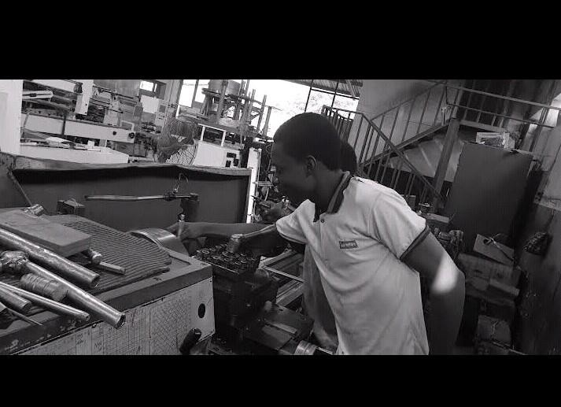
PLATES 3. 6: SHOWING INTERNAL VIEW OF CASE STUDY THREE

CASE STUDY FOUR (ONLINE CASE STUDY) NAME: ULTIMATE BAKERY
LOCATION: AJAX NETHERLAND
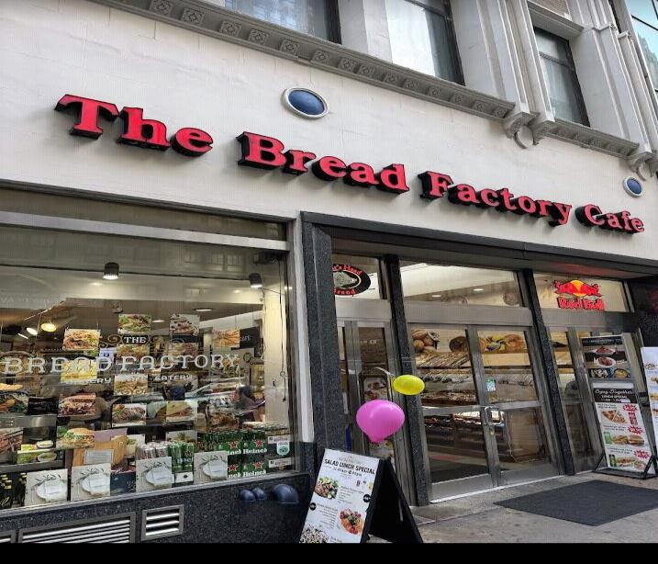

PLATES 3.7: SHOWING VIEW OF ONLINE CASE STUDY
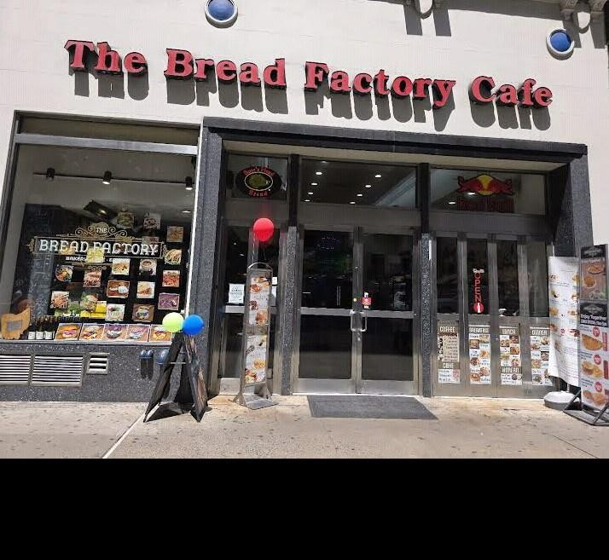

PLATES 3.8: INTERNAL VIEW ONLINE CASE STUDY

CHAPTER FOUR

  - PROJECT LOCATIONAL AREA

  - BRIEF HISTORY OF KWARA STATE

Ilorin South, a Local Government Area in Kwara State, Nigeria, boasts a rich and diverse history that spans centuries, with its ancient roots tracing back to the Fulani people's founding of the Ilorin Emirate in the 18th century. The area's strategic location has made it a significant hub for commerce, agriculture, and culture, with its history reflecting the influences of various ethnic groups, including the Yoruba, Hausa, and Fulani people. Over time, Ilorin South has evolved into a thriving community, shaped by its cultural heritage and historical significance. The area's cultural landscape is characterized by vibrant traditional festivals and celebrations, which showcase its rich cultural diversity and heritage. Ilorin South is also home to several historical sites, including the Ilorin Emir's Palace and the Ojomu of Ilorin's Palace, which serve as testaments to its storied past. The area's economy has experienced significant growth, driven by its agricultural sector, with crops such as maize, cassava, and yams being major staples. Additionally, Ilorin South's markets, including the popular Oja-Kunu market, attract traders from across the region, further solidifying its position as a commercial hub. Despite its many strengths, IlorinSouth faces several challenges, including inadequate infrastructure, poverty, and limited access to education and healthcare. However, the area also presents opportunities for development, particularly in the areas of agriculture, commerce, and tourism. With proper investment and planning, Ilorin South has the potential to become a thriving economic hub and a major contributor to the growth and development of Kwara State. By leveraging its rich history, cultural heritage, and economic potential, Ilorin South can unlock new opportunities for

growth and development, ultimately improving the lives of its residents and solidifying its position as a significant player in the region's economy
    - HISTORY OF KWARA STATE
Kwara State, located in the North-Central region of Nigeria, has a rich and diverse history that dates back to the ancient Nupe and Yoruba kingdoms, with the state being a significant hub for trade, commerce, and culture in the pre-colonial era, and its history reflecting the influences of various ethnic groups, including the Yoruba, Nupe, and Fulani people, who have all contributed to the state's unique cultural heritage and identity, with the state being part of the old Oyo Empire, and later becoming a province during the colonial era, before gaining statehood in 1967. Ilorin is the capital city of kwara state and it is believed to be the sixth of the first ten largest cities in Nigeria, Ilorin is located in the southern part of kwara state in latitude 8.26N and longitude 4E and 2E of Nigeria. It is about 300km away from Abuja (the federal capital city by road) it has a north-south rail line linking it to various part of the country apart from the numerous road networks. Ilorin is also provided with airstrip, which has facilities for standard international airport and a standard 5star hotel.
    - HISTORY OF PROJECT TOWN (ILORIN)

AKATA OSHODI are areas in Ilorin, but I couldn't find specific historical information on "Akata Oshodi" in Ilorin South. However, I can provide some insights on Pakata, a neighborhood in Ilorin, which might be helpful. Pakata has a rich history, with its name possibly derived from a market or economic center. The area is known for its significant contributions to Ilorin's history, particularly in trade and commerce. Pakata Road, a major highway, connects the palace segment to other parts of the city and has historical significance, dating back before the establishment of the Ilorin Emirate. The neighborhood has produced influential individuals who have shaped Ilorin's history in various fields, including religion, culture, politics, education, and entrepreneurship

  - SITE LOCATION / DESCRIPTION

THE SITE FOR THE PROPOSED BAKERY FOR FORTUNATE BREAD INVESTMENT IS LOCATED AT OPPOSITE MOJAGI COMPOUND, AKATA OSHODE VILLAGE, ILORIN SOUTH .LG.A KWARA STATE
  - SITE SELECTION CRITERIA

Site selection is the consideration of certain factors which influence the development ofthe state. Before the execution of any project, the following factor are to be considered for selection of site.
Accessibility Zoning
Availability of infrastructure etc.

The site selection was based on the following, these include

;Location: the choice of location should be in relation to the following.

Zoning: the site should be within an area reserved for institutional facilities and public utilities. It should be free from industrial zones.
  - SITE ANALYSIS/ INVENTORY

This is done on the basic of the purpose for which the site is to serve. Certain steps are considered to obtain vital information of the site; this information is then analyzed after in details for design purpose, the information includes soil condition, geology, topography, vegetation etc. It also involves carrying out a preliminary survey of the site.

Soil condition: the type of soil on the site is loamy and hence aids good vegetation of trees, shrubs and grasses etc. Geology: the soil has a very sound load bearing capacity and hence strip foundation will be used for the structure to be erected on the site. Vegetation cover: the site is covered with shrubs, trees and grass which covers the ground. Which most of it will be retained for landscape. Topography: this is the layout of the site; the site gently slopes toward west
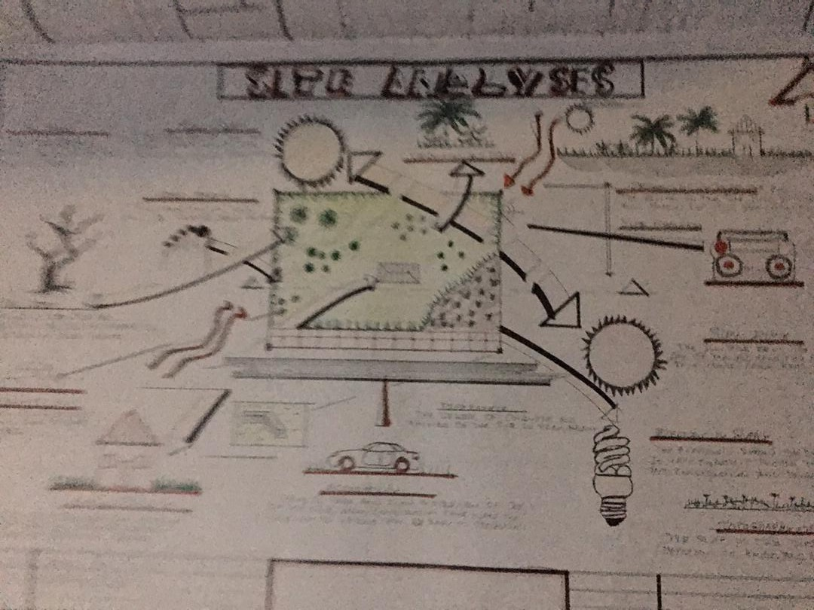

SITE ANALYSIS/ INVENTORY

    - Climatic Data

The environmental and climatic conditions of the project site are analyzed to further understand the factors that will guide the achievement of a functional design.Such factors are;

CLIMATIC DATA OF ILORIN

Ilorin falls under the climatic region referred to as guinea savannah and in the middle belt of the country. The monthly average temperature is quite uniform, having February and march as the hottest months, recording a higher average of about 450c (about 850f) July and august are the coolest (lowest monthly average temperature of 760f) the town is under relative humidity figure of about 80% average.
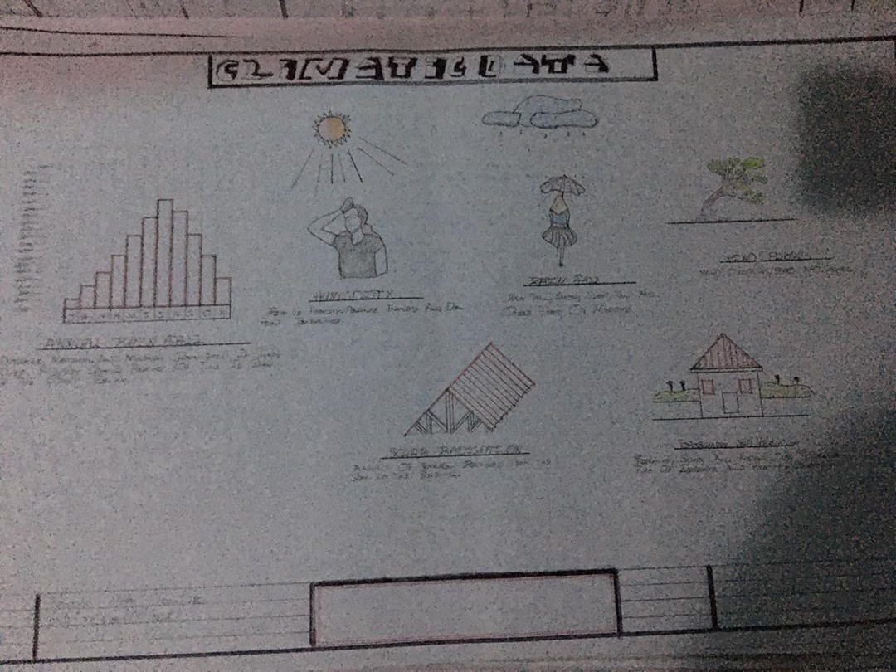

Plate 3.2. Climatic data

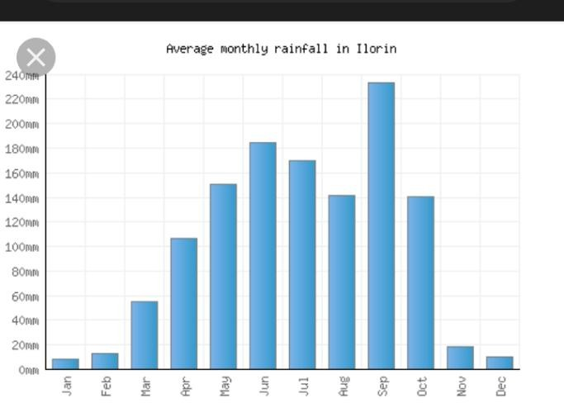

Plate 3.2. Average monthly temperature

    - TEMPERATURE

The monthly temperature in Ilorin ranges between 120c to 240c, the annual range of temperature of the city is 180c meanwhile the city experience it’s highest temperature between april and October every year.The southwest trade wind which carries moisture blows within april and October every year while the northeast trade wind which is dry and carries harmatan blows within February and march and April every year.The south west trade wind which carries moisture blows within October, November and January.
    - DAYLIGHT

The light is adequately and moderate in Ilorin throughout the year. The daylight is between the hours of 7.0 and 18.0GMT.

    - RELATIVE HUMIDITY

The importance of temperature influences that actual amount of water vapor present in air and this decide the moisture and carrying capacity of the air. It decides the rate
of evaporation and condensation and also affect the nature and type of cloud formation and precipitation as relative humidity is directly related to the temperature of the air, the highest humidity in the state is therefore experienced in the month of April.
WIND DIRECTION: the north-east trade wind blows undesirable cold wind, it is dry, dusty and bring harmattan which is prevalent between the month of march and November.
VEGETATION: Ilorin is in the guinea region of the country. The amount of rainfall that is normally experienced between February and November result into this type of vegetation cover over the area of the site.
The thick forest characterized by hard and soft timber with layers of vegetation covers or the low grass covers. The medium highest trees and trees at the highest level of the ground. The vegetation cover is identified with two shapes, the umbrella shapes and conical shape sharing both properties of the vegetation in forest and the region.
SOLAR PATH DIRECTIO: The sunrise from the east and set in the west, the high intensity of the sun normally experienced at this period the shading devices through the conservation and presentations of the existing natural featuring will surely reduce and combat the effect of this heat emission and transmission at the centre.

DESIGN CRITERIA

In this type of design there is need for proper research using both the local (existing similar structure in the same country) and international structure as a case studies to inculcate the new ideas into the design in order to have a well functional conforming and unique structure that suit the international tastes.Some of the criteria are: Accommodation Analysis: I make provision for at least average number of people to be accommodated from two of my cases studies.
Source of supply: in this project design the structure is largely make use of artificial source of lightening and ventilations therefore there should be a provision for a standby source of electricity. Landscaping: the environment must be warmth landscaped for both the visitors and the occupant to feel amused within the environment. Shrubs used for landscape include. Functionality of the units; all the units should be well functional so as to make every activities to be ease i.e provision of internet facilities within the structure and a control office within the building also.
  - BRIEF ANALYSIS

ENTRANCE WAITING ROOM BOOKING DIRECTOR OFFICE DIRECTOR TOILET
ACCOUNTING AND SALES
BAGGING/ PARCKING AND FINISHING PRODUCTION HALL
RAW MATERIA AND GRANDING BEAKING AREA

CHANGING ROOM (MALE) CHANGING ROOM (FEMALE) SUPERVISOR OFFICE GENERAL STORE
STORE MANEGER DELIVARY BAY
EXIT/ OULOADING BAY VISITORS TOILET

  - BUBBLE DIAGRAM

This is to show the problem that is on ground to solve by mentioning all the design brief that present in the proposed design are low all these can be related.
  - CONCEPTUAL DEVELOPMENT (SITE AND BUILDING)

The design concept of this project is based on the principle of FORM follows FUNCTION where the basic design is gotten through the use of bubble and functional relation diagram.
  - SITE CONCEPT

The site design was achieved by taking into considerations some environmental and physical features. They are orientation, circulation and zoning. Orientation: the building is oriented in such a way that as much as possible direct sunlight is prevented from entering the building. Circulation: the site is distinguished in such a way that allows for easy accessibility and circulation of pedestrian and vehicles.zoning: zoning of required functional spaces is done with respect to their various

CHAPTER FIVE

  - APPROACH TO THE DESIGN/DESIGN REALIZATION

  - PROJECT APPRAISAL

The smooth operation of the PROPOSED BAKERY would depend largely on the availability of services such as lightning (mostly artificial), ventilation (mostly natural), electricity services plumbing and water services, fire services and drainage etc.
    - CONSTRUCTION METHODOLOGY AND MATERIAL

In construction of building, the skill and workmanship dose not only brings out the beauty but until the when specification detail of materials and construction method which had been adopted in this project are skillfully built are as followed.
  - SITE CLEARANCE

Trees in all the area where building is to cover would be cut down and carried away from the site in order to get the organic matter, and the top soil is also removed to a depth of 150mmm Both the clearing of the site can either be done manually or with the use of machine i.e bulldozer or grader.
  - FOUNDATION

In these project two type of foundation will be use which are strip and pad foundation. the strip which is the continue spread of concrete shall be use for the load bearing wall and the thickness shall be the same size as the block wall, and the spread will be three times side of the wall, the pad will be use and footing for all the base and also retaining wall of 30mm thick are adopted in some case like rakings in the main conference and will be reinforced.
  - STRUCTURAL SYSTEM

This is a horizontal surface design and constructed to accommodate and serve the purpose of supporting people furniture and equipment in the building.

  - FLOOR

The thickness for the floor slab will be 150mm in the floor, except the generator house which has 300mm thick for generator stand. the following finishing will be use for the project. P.V.C Floor tiles- these are floor tiles made from thermal-plastic binder (vily 1),it is to be use in all available offices, reception, maintenance, V.VI.P, room, restaurant etc. ceramic floor tiles: patterned glazed ceramic floor tiles of brown color will be use for the entire toilet and bath. acoustic carpet underlay: sundown acoustic carpet underlay is a composite material using sundown tuff-mass as a barrier in weight of 1 to 2b and acoustic foam decouple. there is an option for a soft or firm acoustic foam layer that provide a comfortable feel. sundown carpet reduces noise radiating from carpet surface. It may be used alone or to supplement installation applied in spaces sundown carpet underlay is manufactured in 54’ with ¼ and ½ thickness.
  - WALLS

These are vertical continuous solid structure which is usually made by brick, stone. concretes, metals etc to serve the purpose of which it is desired. the walls would be a load bearing or non-load bearing walls. all the walls in the building are 225mm wall and it has been supported by columns a beams running vertically and horizontally for structural rigidity. The walls of the main conference hall are slanted 100 to the floor slab, they are made up of columns at 5.5m interval with a precast reinforced concrete blind of 5500x450x50mm thick arranged in a louver pattern, overlapped by 50mm to each other. all other meeting hall wall is cladded with marble tiles because of its sound absorbent characteristics and of its aesthetics value, except the toilet which shall be tiled white and patterned grazed ceramic tile to door height. The wall finishes for the building interior is marble honeycomb panels wall material as sound insulator within the various unit in the building.
  - ROOF

Roofs in building construction are constructed in order to protect the building from all the weather condition and the materials varies according to the materials available e.g steel

roof or timber roof. steel roof used in this project as a result of large span and is been covered with asbestos roofing sheet with a pitched roof and hipped roof are adopted.
  - STEEL

This is metal which is made of alloy of carbon and iron having a very strength in both tension and compression but it is a very stiff material. steel possess the capacity undergoing a consideration strain after the elastic limit before it fall. steel has the ability to carry dead/imposed load with its limit. it is used in the building construction industry for reinforcement of concrete, windows, and door frame, floor slab etc. it is a very versatile construction material.

CEILING

The material use for the project is an acoustic ceiling tile to reduce noise from the roof.the vacuum between the roof and the ceiling should be filled with rock wool material.

DOOR

These are solid barrier fixed at opening to serve the purpose of gaining and denying access into building and it can be used as security as well as fire barriers which had been adopted for use in the project.

STANDARD DOUBLE LEAVE SINGLE SWING GLAZED ALUMINIUM
DOOR- This are door, which will serve the main entrance into the building this is composed of aluminum frame and glasses glazed.
PURPOSE NADE METAL DOOR -These types of door are provided in three-bed type for proper ventilation and lightening. necessary place that is required.

FIRE CHECKED PURPOSE MADE DOOR –

These type of door will be use in all the door ways in the building like the kitchen, conveniences these is necessary because there is the need to control the spreads of fire in the building.

ALUMINIUM

This is another material that is used in building construction industry and it is made up of alloyed mixed with other element to made a suitable structural material. they are usually corrosion resistance and very light compared to the weight of the steel and highly resistance to corrosion and it is used in the building construction for roofing sheet, partitioningframes, windows frames etc.

TIMBER

Timber is one of the earliest forms of concrete and other material and it is light in weight . it is sometimes used for structural aspect of the building having weight one sixteenth that of steel. timber is a very versatile material and can be used in conjunction with other materials such as steel without any issue arising. it can also be use for constructing room carcass, roof trusses, floor finishes, ceiling finishes, skirting and other building materials.

GLASS

These is another material used in the heating of soda line and sand to a temperature of which they melt and fuse to the stage it can be draw cast rolled on bed of molten tin to be flat glass. Glass can either be transparent or translucent and they come in different ways and types. Clear Sheet Glass: This type of glass is usually transparent and has varying thickness and may cause optical distortion. Wired Glass: This type of glass wire is usually embedded into it, it is glazing because the wire holds the glass together so as to reduce the danger of its breakage. Double Gazing Units: This type of glass can either be transparent or translucent but usually very thick and comprises of float glass spaced apart and sealed around a dehydrated method which had been adopted in the project and are skillfully built. Toughened Glass: This type of glass can either be transparent or translucent but usually very thick it can be broken into fragments and comparatively harmless pieces, it is usually used for doors and softly screens. Pattern Glass: This type of glass is translucent because of the pattern or the texture of the glass. it could also be timed or plane.

WINDOW

These are openings found on walls and also on roofs so that day light can pass through, some transparent materials can also be used to allow passage of light and ventilation into the building. The following are the types of windows to be used in the projects. Aluminum pivoted windows(tinted): this type of window will be used in the guest house and restaurant. Aluminum pivoted window(plane): this type of window will be used in all other units.

SERVICES

  - VENTILATION

The major source of ventilation is a system of natural ventilation, which is centrally controlled. Efforts were made to ensure cross ventilation principle in the design, while the other source of ventilation is the artificial ventilation provided in the form of CENTRAL AIR CONDITIONING SYSTEM (AC)The various components are ventilated by ducts that are linked to the source of the ventilation.

PLUMBERING SERVICES

All the water is to be supplied and distributed to other areas through 50mm diameter 100mm and 150mm diameter. All the bath and showers tray and towel trays, while all the toilets will be provided with tissue rolls holder, man holes, septic tanks and soak away pits shall be placed in suitable location for easy maintenance.

LIGHTNING

Lightning is very important for accuracy, safety and productivity, for this proposal the use of natural lightning provided for by the use of windows on the surrounding walls, the natural light is complemented with artificial lights provided by means of varieties of light fittings.

FIRE SERVICES

In the electrical panel room, a fire control unit box is provided to serve each building on site and each building has its own electrical panel room which has/smoke detector which alert the people if there is outbreak of fire in any part of the building before damage is done

to other part of the building. carbon oxide gas are positioned and strategic locations in the building.

DRAINAGE

The surface water are channeled into 600mm wide and 600mm deep covered drains with inspection chamber at strategic points and emptied into the main municipal city drain. separate drain system has been employed to drain of foul water from the water closets, surface water and pave areas.

SECURITY SERVICE

The entry and exits into the site have been fitted with cctv cameras, this is to monitor the movement of vehicles in and out of the site. The entrances will also be maintained with security men checking incoming and outgoing vehicles.

ELECTRICAL SERVICES

The power holding company of Nigeria (PHCN) mean which pass across the site shall be the major source of power supply into the building but an alternative source will however be provided which s generator and effective 3 phase line will be used and the connection will be armored cables while the internal distributions/connections would be conduit conduct piping.
  - SUMMARY

The establishment of a bakery project in Ilorin South, Kwara State, Nigeria, has the potential to contribute significantly to the local economy and provide employment opportunities for residents. Fortunate Bread, a reputable bakery brand, is well-positioned to capitalize on this opportunity and establish a successful bakery project in the area. To achieve this, the company should invest in modern equipment and technology, develop a strong online presence, and offer a variety of baked goods to cater to different customer preferences and dietary needs. Prioritizing quality and food safety is also crucial, and
Fortunate Bread should implement robust quality control measures, train staff, and

maintain a clean and hygienic production environment. Building strong relationships with suppliers and customers will also be essential to ensure a consistent supply of high-quality ingredients and to understand customer needs and preferences. By providing training and development opportunities for staff, Fortunate Bread can enhance customer service and improve overall business performance. Ultimately, the success of the bakery project will depend on careful planning, monitoring, and evaluation, but with effective implementation, Fortunate Bread can establish a thriving business that contributes to the economic development of Ilorin South and becomes a leading player in the baking industry.
  - RECOMMENDATION
To ensure the success of Fortunate Bread's bakery project in Ilorin South, it is recommended that the company invests in modern equipment and technology to improve efficiency and productivity, develops a strong online presence to showcase its products and engage with customers, and offers a variety of baked goods to cater to different customer preferences and dietary needs. Additionally, Fortunate Bread should prioritize quality and food safety by implementing robust quality control measures, training staff, and maintaining a clean and hygienic production environment. Building strong relationships with suppliers and customers is also crucial to ensure a consistent supply of high-quality ingredients and to understand customer needs and preferences. Furthermore, providing training and development opportunities for staff will enhance customer service andimprove overall business performance. Exploring local and export markets will also increase Fortunate Bread's customer base and revenue streams, ultimately contributing to the economic development of Ilorin South. By implementing these strategies, Fortunate Bread can establish a successful bakery project, increase its market share, and become a leading

player in the baking industry. Effective implementation of these recommendations will require careful planning, monitoring, and evaluation to ensure the long-term sustainability and growth of the business.
  - CONCLUSIONS

In conclusion, the bakery industry is a complex and dynamic market that is influenced by consumer preferences, production and supply chain management, food safety and quality control, and sustainability considerations. By understanding these factors, bakeries can develop effective strategies to meet consumer demands, improve product quality, and reduce their environmental impact. As the industry continues to evolve, it is essential for bakeries to stay ahead of the curve by adopting innovative technologies, sustainable practices, and quality control measures. In conclusion, a bakery is a vital part of any community, providing a wide range of delicious and freshly baked goods that bring people together and satisfy their sweet tooth. From traditional bread and pastries to modern desserts and cakes, bakeries offer a diverse array of products that cater to different tastes and preferences. Whether it's a small, family-owned bakery or a large, industrial-scale operation, the art of baking requires skill, creativity, and attention to detail. A successful bakery relies on a combination of traditional techniques and modern technology, as well as a commitment to quality, safety, and customer satisfaction. By using high-quality ingredients, following proper sanitation and handling procedures, and staying up-to-date with industry trends and best practices, bakeries can build a loyal customer base and establish a reputation for excellence.

  - REFERENCES

- "The Bread Baker's Apprentice" by Peter Reinhart: A comprehensive guide to bread baking.
- "The Art of French Pastry"by Jacquy Pfeiffer: A detailed guide to French pastry-making techniques.
- "The Cake Bible" by Rose Levy Beranbaum: A thorough guide to cake baking and decorating.
- American Bakers Association (ABA): A trade association that represents the interestsof the baking industry.
- Retail Bakers of America (RBA): A professional organization for retail bakers.

- King Arthur Flour: A popular online resource for bakers, including recipes, tutorials, and tips.
- The Kitchn: A food blog with a section dedicated to baking, including recipes, techniques, and product reviews.
- :A community-driven baking resource with recipes, tutorials, and forums.

- "Baking Management" magazine: A publication that covers the business side of baking, including industry trends and equipment reviews.
- "Bake Magazine": A publication that focuses on the art and science of baking, including recipes and techniques.
- International Association of Culinary Professionals (IACP): A professional organization for culinary professionals, including bakers.
- "The Science of Cooking" by Peter Barham: A book that explores the science behind cooking and baking.

LIST OF APPENDIX

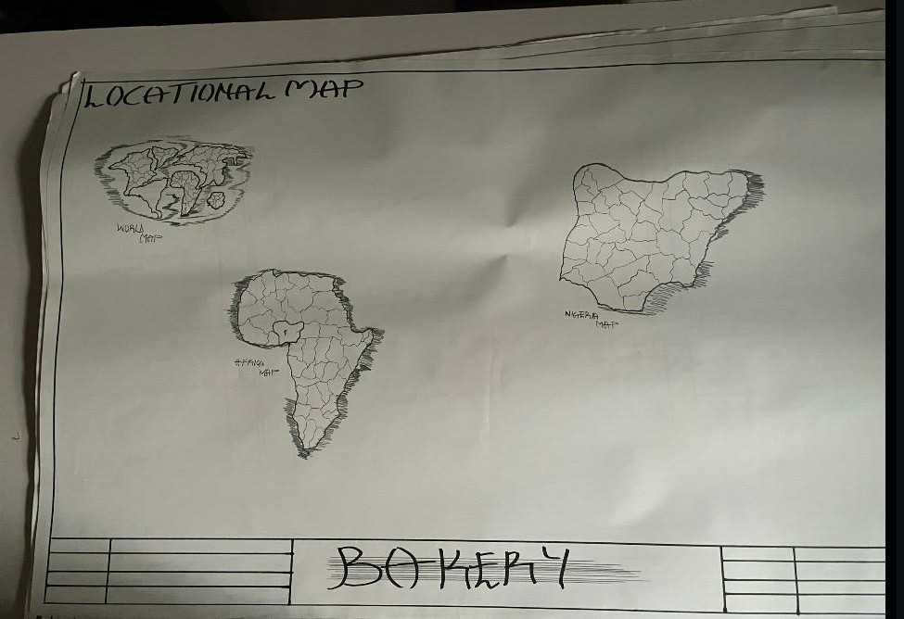

APPENDIX 1. SHOWING LOCATIONAL MAP
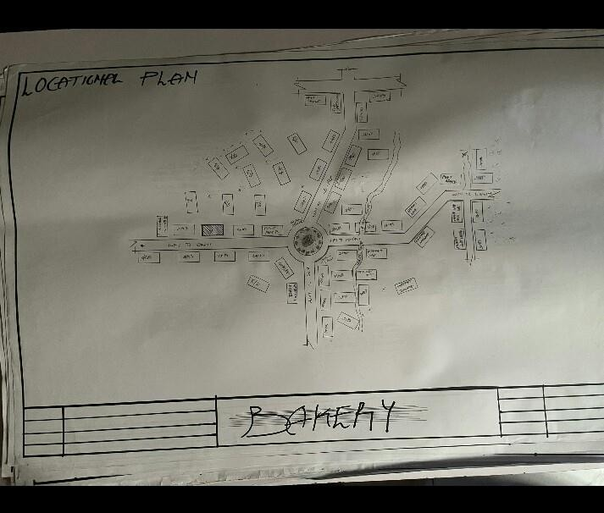

APPENDIX 2. SHOWING LOCATIONAL PLAN

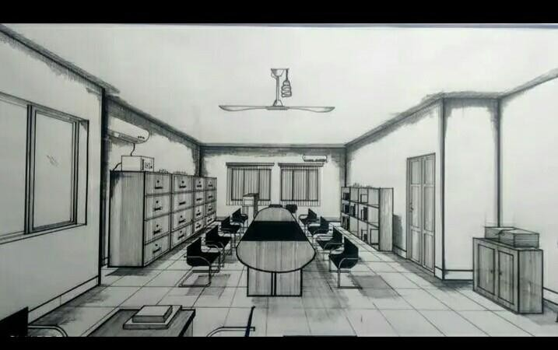

APPENDIX 3. SHOWING INTERNAL PASPECTIVE

APPENDIX 4. SHOWING SITE ANALYSIS

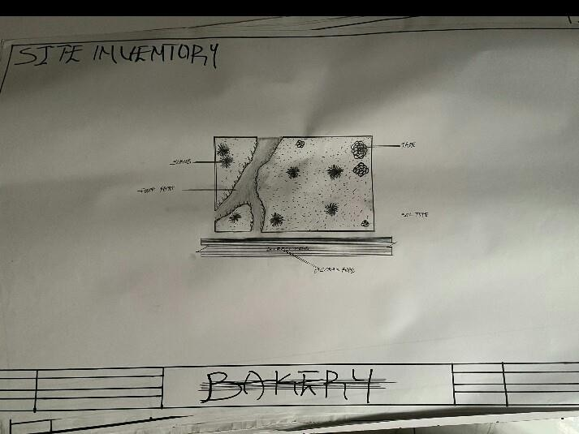

APPENDIX 4. SHOWING SITE INVENTORY

