EXPERIMENTAL STUDY INTO THE USE OF HARDENED BAMBOO AS A REPLACEMENT OF COARSE AGGREGATE IN CONCRETE.
BY:

NURUDEEN HAMMAD SHEU
HND/23/CEC/FT/0221

A PROJECT SUBMITTED TO THE DEPARTMENT OF CIVIL ENGINEERING,
INSTITUTE OF TECHNOLOGY IOT,
KWARA STATE POLYTECHNIC, ILORIN

IN PARTIAL FULFILLMENT OF THE REQUIREMENT FOR THE AWARD OF HIGHER NATIONAL DIPLOMA (HND) IN CIVIL ENGINEERING.

SUPERVISED BY:
ENGR. R. O. SANNI

JULY, 2025

CERTIFICATION
This is to certify that this research study was conducted by NURUDEEN HAMMAD SHEU (HND/23/CEC/FT/0221) has been read and approved as meeting the requirement for the award of Higher National Diploma (HND) in Civil Engineering of the Department of Civil Engineering, Institute of Technology Kwara State Polytechnic, Ilorin.

______________________________ ___________________
ENGR. R.O. SANNI DATE
(Project supervisor)

_______________________________ ___________________
ENGR. A. NA’ALLAH DATE
(Head of Department)

__________________________ ___________________
DATE
(External Examiner)

DECLARATION
I NURUDEEN HAMMAD SHEU (HND/23/CEC/FT/0221) hereby declare that this research project “EXPERIMENTAL STUDY INTO THE USE OF HARDENED BAMBOO AS A REPLACEMENT OF COARSE AGGREGATE IN CONCRETE.” was written by me, it is the record of my research work and investigation. and has not been submitted by any other person for any degree or qualification at any higher institution. I also declare that the information provided there in are mine and those that are mine are properly acknowledged.

NURUDEEN HAMMAD SHEU ______________________
(HND/23/CEC/FT/0221) Date (Signature)

DEDICATION
This work is dedicated to Allah, my creator and my Master.
My great teacher and messenger, Muhammad. S.A.W (May Allah bless and grant him ), who taught us the purpose of life And to our parents who have never failed to give us financial and moral support, for giving all our needs during the time we developed our system and for teaching us that even the largest task can be accomplished if it is done one step as a time.
I dedicate this project to all the people who have worked hard to help us complete this

ACKNOWLEDGMENTS

First and foremost, I would like to express my gratitude to Almighty Allah S.W.T, my creator, the most merciful, for making it possible for me to complete this dissertation and for giving me the strength, knowledge and opportunity to know that there’s light to every tunnel

My special gratitude and thanks goes to my supervisor Engr. R.O. Sanni, for his invaluable advice, continuous support and patience during this study. His immense knowledge and plentiful experience have encourage me in all the time of my academic research and daily life. His expertise and guidance have significantly influenced the direction and quality of my research.

My appreciation goes to the Institute of Technology (IOT) and Department of Civil Engineering Technology (CEC) staff members who provided the facilities and assistance during sampling. Special thanks to my group members and friends (Kamaldeen, David and Emmanuel) for all the countless support. This journey would have been much more difficult without them.

To my parents, it is impossible to extend enough thanks to my family, especially to my respectful father and mother Mr. and Mrs. Nurudeen, and to my lovely brothers Mr. Afeez, and Mr. Kabir, who supported me emotionally financially throughout my years of study. This endeavor would not have been possible without them.
TABLE OF CONTENT
CERTIFICATION ii
DECLARATION iii
DEDICATION iv
ACKNOWLEDGMENTS v
TABLE OF CONTENT vii
LIST OF TABLES x
LIST OF FIGURES xi
ABBREVIATION xii
ABSTRACT xiii
CHAPTER ONE 1
INTRODUCTION 1
1.1. BACKGROUND OF THE STUDY 1
1.2. STATEMENT OF THE PROBLEM 4
1.3. AIM OF THE STUDY 4
1.4. OBJECTIVES OF THE STUDY 4
1.5. JUSTIFICATION OF THE STUDY 5
1.6. SCOPE OF THE STUDY 5
CHAPTER TWO 7
LITERATURE REVIEW 7
2.1. PREAMBLE 7
2.2. MATERIAL COMPOSITE OF BAMBOO AGGREGATE CONCRETE (BAC) 8
2.2.1. Cement 8
2.2.2. Aggregate 9
2.2.3. Water 11
2.3. PHYSICAL AND MECHANICAL PROPERTIES OF BAMBOO 12
2.3.1 Density 13
2.3.2. Water Absorption 13
2.3.3. Tensile Strength 14
2.3.4. Compressive Strength 14
2.4. COMPRESSIVE STRENGTH AND WORKABILITY OF BAMBOO-CONCRETE 15
2.4.1. Compressive Strength 15
2.4.2. Workability 15
2.5. PARTIAL REPLACEMENT OF COARSE AGGREGATE WITH BAMBOO 16
2.5.1 Replacement Ratios 16
2.5.2. Compressive Strength 17
2.5.3. Workability 17
2.6. COMPARISON WITH OTHER SUSTAINABLE MATERIALS 18
2.7. EFFECT OF BAMBOO COARSE AGGREGATE REPLACEMENT RATE 19
2.8. INITIAL ELASTIC MODULUS AND SCANT MODULUS 21
CHAPTER THREE 23
METHODOLOGY 23
3.1. MATERIALS 24
3.1.1. Procurement/Collection of Materials 24
3.1.2. Equipment 26
3.1.3 Testing Equipment 26
3.2. EXPERIMENTAL DESIGN 26
3.3. LABORATORY TESTS ON THE BAMBOO 27
3.3.1 Sieve Analysis 27
3.3.2 Water Absorption 27
3.3.3 Aggregate Impact Value 27
3.4 PRODUCTION OF THE CONCRETE TEST CUBES 28
3.4.1 Compressive Strength Test 28
3.5. SELECTED FIGURE FROM THE PRACTICAL WORKS 30
CHAPTER FOUR 31
RESULTS AND DISCUSSION 31
4.1 SIEVE ANALYSIS 31
4.2. WORKABILITY (SLUMP TEST) RESULTS 33
4.3. DENSITY TEST RESULTS 34
4.4. COMPRESSIVE STRENGTH TEST RESULTS 35
CHAPTER FIVE 38
CONCLUSION AND RECOMMENDATIONS 38
5.1 CONCLUSION 38
5.2 RECOMMENDATIONS 39
REFERENCE 41

LIST OF TABLES
Table 2.1: Monotonic axial compression results for BAC cylinders 23
Table 4.1: Sieve Analysis of Bamboo 31
Table 4.2: Slump Test Results 33
Table 4.3: Density Test Results 34
Table 4.4: Compressive Strength Test Results 35

LIST OF FIGURES
Figure 2.1: Characteristic points of the stress-strain full curve of the BAC cylinder 22
Figure 3.1: Processed Bamboo Chips Used as Partial Coarse Aggregate Replacement 23
Figure 3.2: Cement Bags (PLC) for Concrete Mix Preparation 24
Figure 3.3: Fine Aggregate (Sand) Sourced from Kwara State Polytechnic 24
Figure 4.1: Sieve Analysis Chart of Bamboo 32
Figure 4.2: Workability Chart 33
Figure 4.3: Density Comparison Test Graph 35
Figure 4.4: Compressive Strength Chart 36

ABBREVIATION
BAC: Bamboo Aggregate Concrete
PLC: Portland Limestone Cement
OPC: Ordinary Portland Cement
NAC: Natural Aggregate Concrete

ABSTRACT
This project was carried out to test how hardened bamboo can be used to replace part of the coarse aggregates (like gravel) in concrete. Bamboo is cheap, grows fast, and is easy to find, especially in Nigeria. The aim was to see if concrete made with bamboo can still be strong, workable, and lightweight. In the experiment, bamboo was used to replace coarse aggregate at different levels: 0%, 10%, 20%, and 30%. We tested the workability (slump test), density, and compressive strength of the concrete cubes after 7, 14, and 28 days.
From the slump test, the highest value of 13 cm was recorded at 30% bamboo, showing that concrete became easier to mix and pour. The density test showed that concrete became lighter as bamboo increased, with the lowest density at 2437 kg/m³ on day 28 at 30% replacement. For compressive strength, normal concrete (0% bamboo) had 15.12 N/mm² on day 28, while concrete with 30% bamboo had 12.09 N/mm², which is still useful for small buildings.
These results prove that bamboo can be used to replace up to 20–30% of coarse aggregates in concrete, especially for light structures. This helps reduce construction costs, supports eco-friendly building, and reduces the use of natural stone.

Keywords: Bamboo Aggregate, Lightweight Concrete, Compressive Strength, Slump Value, Sustainable Construction

CHAPTER ONE

INTRODUCTION

1.1. BACKGROUND OF THE STUDY
Concrete is a widely utilized construction material. It plays a pivotal role in civil engineering construction, with demand continuously rising. Coarse aggregates, making up about three quarters of concrete's total volume, serve as its main constituent (Kumar et al., 2019). Traditional extraction of natural stone has historically been the primary source of coarse aggregates, leading to ecological imbalances and depletion of natural resources. In addition, it is estimated that the construction industry's CO emissions account for approximately 7% of global CO emissions, with natural coarse aggregates (NCAs) being the second largest source of CO emissions in concrete raw material (Xiao et al., 2020). Hence, exploring feasible alternatives to aggregates is crucial (Zhou et al., 2024). The adoption of artificial aggregates is gaining traction and advocacy.
Compared with other agricultural byproducts, bamboo is a type of woody plant, has the remarkable characteristic of growing approximately three times faster than most other plant species (Alencar, 2023). Bamboo has become an economically efficient and environmentally friendly alternative to contemporary building materials due to its significant advantages, such as renewability, rapid growth, and reliable mechanical properties (Adesina, 2019) Compared with trees, bamboo plants are believed to possess greater rates of CO₂ absorption and O₂ production, thus contributing to efforts to combat climate change (Correal, 2016). Bamboo can be used to make beams, louvers, frames, tubes, and components subjected to bending stress in structural concrete structures, or it can be made into bamboo fibers and bamboo chips to be added to concrete. (Mansur & Aziz., 2021) used bamboo mesh to reinforce cement mortar, improving its strength, ductility, and toughness. (Moroz et al., 2014) proposed reinforcing concrete masonry walls with rattan bamboo to increase the shear-bearing capacity and ductility of the walls. (Brindha et al., 2017).
Concrete is a composite material made from cement, water, coarse and fine aggregate. The usage of concrete from global societies is after to water. Coarse aggregate is more essential in concrete which is used a compaction material in higher volume ratio. Thus there is a requirement for option coarse aggregates. Considering a worldwide temperature alteration, absence of assets and ecofriendly issues, the utilization of characteristic materials got to be distinctly dynamic in the development business (Kazemi et al., 2023).
There is a need to reduce the high cost of coarse aggregate in order to provide low-cost structure; researchers are always considering the use of some locally available materials for the partial replacement of coarse aggregate in construction works. Bamboo is one of the generally utilized construction materials since old circumstances because of its less cost, high strength, attainability, low weight, seismic resistance, etc. Several researchers have made an attempt to study the use bamboo as one of the reinforcements to replace the steel in construction works. Based on economic analysis and strength aspect of bamboo was used in design and construction of retrofit structures and construction materials (Munir et al., 2022).
Bamboo stands out among agricultural by-products and is highly productive, with over 1200 species covering about 22 million hectares worldwide. In 2021, China's bamboo forest area increased by 1.1511 million hectares, including 599,800Ha of moso bamboo. In tropical and subtropical climates, bamboo can proliferate in 6–8 months and reach maximum height and strength in 3–8 years (Atanda, 2015) Bamboo has a faster CO₂ absorption rate and higher O₂ production. Each kilogram of round bamboo can absorb 5.69kg of CO₂. Bamboo's carbon reduction and carbon sequestration abilities far exceed those of trees, for instance, about 1.46 times higher than fir trees and 1.33 times higher than tropical rainforests (Wang, 2024). Its lightweight nature, toughness, and earthquake resistance make it attractive for construction. Consequently, researchers have increasingly explored its application in this field.

1.2. STATEMENT OF THE PROBLEM
The depletion of natural aggregates and the need for environmentally friendly construction materials necessitate the exploration of sustainable alternatives. Bamboo, though traditionally used in construction, has not yet been fully explored as a coarse aggregate replacement in concrete.

1.3. AIM OF THE STUDY
The aim of this study is to perform an experimental study into the use of hardened bamboo as a replacement of coarse aggregate in concrete.

1.4. OBJECTIVES OF THE STUDY
The objectives of this study will be as follows:
- To determine the particle distribution of the bamboo as coarse aggregate.
- To determine the workability of the partial replacement of bamboo made concrete.
- To determine the Density sustainability of hardened bamboo in concrete as a replacement to coarse aggregate.
- To determine the compressive strength of concrete made of bamboo.

1.5. JUSTIFICATION OF THE STUDY
The growing global demand for sustainable and eco-friendly construction materials has sparked significant interest in alternative materials that can replace traditional concrete components. Coarse aggregates, typically sourced from natural quarries, are a key constituent of concrete and account for a significant proportion of the material's environmental impact. The extraction of these aggregates leads to habitat destruction, depletion of natural resources, and substantial carbon emissions from transport and processing (Olivier et al., 2019). Consequently, there is an urgent need to explore sustainable alternatives to conventional aggregates, such as bamboo, which is both renewable and abundant.

1.6. SCOPE OF THE STUDY
This study will explore the potential of hardened bamboo as a replacement for conventional coarse aggregates in concrete. The study will focus on evaluating the mechanical properties (compressive, durability, environmental impact and flexural strengths) of bamboo-based concrete. Various concrete mixes will be designed, replacing conventional aggregates with different proportions of bamboo for 10%, 20%, and 30%.
Furthermore, the study will be conducted in a controlled laboratory setting, using bamboo species that are locally available and can be sustainably harvested. The findings will be compared to control concrete made with 100% conventional aggregates to assess performance differences.

CHAPTER TWO

LITERATURE REVIEW

2.1. PREAMBLE
This literature review examines existing research on Bamboo as of the agricultural by-product, Based on three current situations, this study unfolds: firstly, natural coarse aggregates (NCAs) are scarce, with excessive extraction causing severe resource depletion and environmental issues, alongside significant CO₂ emissions during extraction and transportation processes; secondly, high-rise buildings, bridges, and large-span structures require weight reduction to lower foundation loads and enhance seismic performance; thirdly, with the proliferation of waste valorization strategies, transforming industrial and agricultural solid wastes into sustainable 2 building materials has become a new research focus. This study innovatively modifies renewable, sustainable, eco-friendly, and cost-effective bamboo as a novel coarse aggregate to replace NCAs within a certain range, forming a novel organic biomass bamboo aggregate concrete (BAC) structure that meets the industry demands for promoting green and sustainable building materials, holding significant practical significance. This study experimentally and theoretically analyzes the compressive performance of novel BAC, proposes the stress-strain constitutive relationship of BAC, fills the research gaps in compressive mechanical properties and stress strain behavior of current BAC, and lays a theoretical foundation for the practical application and structural design promotion of BAC. These efforts establish a theoretical basis for widespread application and structural design of BAC in engineering practice and offer new ideas for efficiently and economically converting agricultural solid waste into sustainable resources for the construction industry, demonstrating significant theoretical importance.

2.2. MATERIAL COMPOSITE OF BAMBOO AGGREGATE CONCRETE (BAC)
Bamboo Aggregate Concrete (BAC) is a sustainable variation of traditional concrete in which bamboo is used as a partial or complete replacement for coarse aggregates. The composition of BAC involves the same fundamental components as conventional concrete but incorporates bamboo aggregates to reduce the environmental impact associated with natural aggregate extraction. This section discusses the primary materials used in BAC, focusing on their roles and characteristics.

2.2.1. Cement
Cement is a critical binding agent in any concrete mix, and it plays the same role in BAC. The primary function of cement is to bond the aggregates (including bamboo) and form a hard, durable material upon hydration.
- Portland Limestone Cement (PLC) is commonly used in BAC, though blended cements that include supplementary materials like fly ash, slag, or silica fume can also be used. These blended cements reduce the environmental impact of BAC by lowering the overall carbon footprint associated with cement production (Kou et al., 2011).
- The cement content must be carefully adjusted based on the bamboo replacement level. Bamboo aggregates have lower density and more variable moisture content than conventional aggregates, which can influence the cement-to-aggregate ratio. The mix must ensure that there is sufficient cement to bind the aggregates effectively without compromising workability.
- Cement in BAC undergoes a hydration reaction that is essential for its hardening. Proper control of water content is necessary because bamboo aggregates may affect the water-to-cement ratio due to their moisture-absorbing properties (Olivier et al., 2019).

2.2.2. Aggregate
In BAC, bamboo is used as a replacement for traditional coarse aggregates (e.g., gravel or crushed stone). Bamboo aggregates offer both environmental benefits and unique mechanical properties. The idea of using bamboo as a coarse aggregate replacement in concrete is relatively recent, driven by the need for more sustainable construction practices. Traditional concrete consists of cement, water, fine aggregates (sand), and coarse aggregates (gravel or crushed stone). Coarse aggregates make up a large portion of concrete’s weight and volume, and their extraction is resource-intensive. Replacing them with bamboo could offer a solution to reduce concrete’s environmental impact.
Kamarudin et al. (2021) reviewed the use of bamboo as a coarse aggregate in concrete and noted that bamboo’s lightweight nature could help produce lighter concrete, reducing transportation costs and energy consumption. Additionally, bamboo’s structural strength and flexibility make it a potential candidate for enhancing concrete’s tensile strength. However, the study also cautioned about challenges related to bamboo’s moisture absorption and bio-degradation. Bamboo can absorb moisture, which may reduce its durability in humid or wet environments, and it is susceptible to pests and fungi unless properly treated.
Gokul et al. (2020) explored the mechanical properties of bamboo-based concrete and found that replacing conventional coarse aggregates with bamboo, up to a certain percentage, did not significantly reduce the compressive strength of the concrete. Their study suggested that bamboo could replace up to 25% of the coarse aggregate without compromising the material’s structural integrity. The incorporation of bamboo also improved the workability of the concrete mix, making it easier to handle and mold, which could be beneficial for certain construction applications.
- Bamboo aggregates used in BAC are typically dried to remove excess moisture, cut into appropriate sizes, and may be treated with preservatives to prevent biological degradation. Bamboo treatment is vital, as untreated bamboo can be vulnerable to mold or decay, which would compromise the durability of BAC.
- Bamboo aggregates have a lower density than traditional aggregates, which results in a lighter concrete mix. Bamboo also has a high flexural strength and ductility, which can enhance the concrete’s tensile strength and impact resistance (Abdullah et al., 2018). However, bamboo aggregates also have relatively smooth surfaces, which may reduce bonding strength with the cement matrix, potentially lowering the concrete's overall compressive strength.
- The bamboo aggregate should be appropriately sized to match the needs of the specific BAC mix. A variety of sizes can be used, but the typical goal is to maintain good particle packing, which helps improve the concrete’s workability and strength.

2.2.3. Water
Water is an essential component in any concrete mix, as it initiates the cement hydration process and influences the workability of the mix. In BAC, the water content must be carefully controlled, especially because bamboo aggregates have a higher moisture content compared to traditional aggregates. The water-to-cement ratio influences the compressive strength and workability of BAC. A lower water-to-cement ratio generally results in stronger concrete but lower workability. However, since bamboo aggregates absorb water, the water-to-cement ratio must be carefully adjusted to ensure proper hydration without over-saturating the mix (Olivier et al., 2019).
Water Absorption by Bamboo: Bamboo aggregates naturally have high water absorption rates, and this can influence the amount of water required in the mix. Careful consideration of bamboo’s moisture content before mixing is essential to avoid excess water and achieve the optimal mix. Water Quality: The water used in BAC must be free from contaminants such as salts, organic matter, and chemicals, which could interfere with the hydration process and negatively affect the performance of the concrete.

2.3. PHYSICAL AND MECHANICAL PROPERTIES OF BAMBOO
Bamboo has gained attention as a sustainable alternative to traditional construction materials due to its favorable physical and mechanical properties. These properties, when utilized as coarse aggregate in concrete, can significantly impact the overall performance of the material.

2.3.1 Density
Bamboo has a lower density compared to conventional coarse aggregates like gravel or crushed stone. Typically, the density of bamboo ranges from approximately 0.575 g/cm³, whereas traditional coarse aggregates have densities ranging between 2.5 to 3.0 g/cm³ (Zhang et al., 2016). This reduced density can contribute to a reduced concrete weight, which is an advantage in applications where lightweight concrete is required, such as in high-rise buildings or structures where the load-bearing capacity of the foundation is a critical consideration. The lower density also enhances the workability of bamboo-based concrete, as it results in lighter, more manageable mixes.

2.3.2. Water Absorption
One of the distinctive features of bamboo as a material is its relatively high-water absorption rate compared to traditional aggregates. Bamboo’s porous nature allows it to absorb moisture from the mix, which can significantly affect the workability and durability of the resulting concrete. Excess water absorption by bamboo may lead to variations in the water-to-cement ratio, which could affect the strength and long-term performance of bamboo-based concrete. It is crucial to treat or dry bamboo aggregates properly before mixing them with concrete to mitigate this effect (Mohammad et al., 2019).

2.3.3. Tensile Strength
Bamboo’s tensile strength is one of its key strengths. With tensile strength values reaching up to 300MPa, bamboo surpasses traditional coarse aggregates, which typically have low tensile strength (Zhang et al., 2016). This exceptional tensile strength can be beneficial for improving the tensile properties of concrete, contributing to enhanced flexural strength and resilience. The higher tensile strength of bamboo can potentially allow bamboo-based concrete to better withstand tensile stresses and cracking under load, making it a suitable alternative for structural applications that require improved flexibility and durability.

2.3.4. Compressive Strength
On the other hand, bamboo's compressive strength is relatively lower compared to traditional aggregates. The compressive strength of bamboo typically ranges from 10-20MPa, which is significantly lower than that of conventional coarse aggregates, which often exceed 30MPa (Zhang et al., 2016). This lower compressive strength of bamboo may impact the overall compressive strength of concrete made with bamboo aggregates, especially if a high replacement ratio is used. However, studies have shown that partial replacement of coarse aggregates with bamboo (such as 20% or 30%) can still result in adequate compressive strength for certain construction applications, especially where lightweight concrete is a priority.

2.4. COMPRESSIVE STRENGTH AND WORKABILITY OF BAMBOO-CONCRETE

2.4.1. Compressive Strength
Studies have investigated the use of bamboo as a partial replacement for coarse aggregates in concrete. The compressive strength of bamboo-based concrete varies depending on the proportion of bamboo used in place of traditional aggregates.
- Research indicates that concrete incorporating hardened bamboo as a replacement for coarse aggregates can achieve comparable compressive strength to traditional concrete, especially when the bamboo replacement rate is kept at a moderate level, such as up to 20% (Mohammad et al., 2019). At higher replacement rates (e.g., above 40%), the compressive strength typically reduces, likely due to the lower compressive strength of bamboo itself compared to conventional aggregates. Despite this reduction, bamboo-concrete can still offer acceptable performance for non-load-bearing applications or as a lightweight alternative.

2.4.2. Workability
Workability is another important property affected by the use of bamboo as an aggregate. Bamboo’s lower density and higher water absorption capacity contribute to improved workability. When used as a partial replacement for coarse aggregates, bamboo helps create a more fluid mix, which is easier to handle and place. This can be especially advantageous in projects that require intricate molds or in areas with complex geometries. Concrete containing bamboo aggregates often exhibits a higher slump value, indicating improved flow ability and ease of mixing (Olivier et al., 2019). The improved workability can also reduce the need for additional water or plasticizers, which could otherwise affect the strength and durability of concrete.

2.5. PARTIAL REPLACEMENT OF COARSE AGGREGATE WITH BAMBOO

2.5.1 Replacement Ratios
Several studies have explored the impact of varying the replacement ratio of traditional coarse aggregates with bamboo aggregates. Typical replacement ratios range from 20% to 40%, with different outcomes in terms of strength and durability. For example:
- Up to 20% replacement: Replacing 20% of coarse aggregates with bamboo generally leads to improved compressive strength and workability. The mix maintains a relatively strong concrete that can be used for structural applications (Kou et al., 2011).
- Up to 30%-40% replacement: Beyond 20%, the compressive strength of the concrete tends to decline. However, it still remains functional for non-structural applications, such as lightweight panels, flooring, or decorative elements (Zhang et al., 2016).
The precise effect of the bamboo replacement ratio depends on the specific characteristics of the bamboo used, such as species, processing, and treatment, as well as the mix design and curing conditions.

2.5.2. Compressive Strength
The compressive strength of bamboo-based concrete decreases as the replacement ratio of bamboo increases. At low replacement rates (up to 20%), the strength is generally maintained or slightly improved due to the lightweight nature of bamboo, which can help optimize the mix's density. However, when the replacement rate exceeds 40%, the reduction in compressive strength becomes more evident. This is due to the lower inherent compressive strength of bamboo compared to traditional aggregates, as well as potential issues with the bond between bamboo and the cement matrix (Zhang et al., 2016).

2.5.3. Workability
One of the consistent findings across studies is that bamboo, regardless of the replacement ratio, improves the workability of concrete. The lower density and higher water absorption characteristics of bamboo aggregates contribute to a smoother mix, which is easier to handle and place. This improvement in workability can make bamboo-based concrete more suitable for applications requiring ease of placement and mold ability, such as precast elements or complex shapes in green buildings.

2.6. COMPARISON WITH OTHER SUSTAINABLE MATERIALS
Bamboo has been compared with other sustainable materials, such as crushed tile and recycled coarse aggregates, in terms of both compressive strength and workability.
- Crushed Tile: Crushed tile has shown to offer improved compressive strength compared to bamboo-based concrete, but it tends to reduce workability due to its angular shape and high density. This makes it less suitable for lightweight concrete applications (Olivier et al., 2019).
- Recycled Coarse Aggregate: Recycled coarse aggregates are another common alternative to natural aggregates. However, recycled aggregates often exhibit reduced compressive strength and workability compared to bamboo aggregates. This makes bamboo a more attractive option for projects requiring sustainable and high-performance concrete (Kou et al., 2011).
- Bamboo’s Unique Properties: Bamboo’s unique combination of lower density, higher tensile strength, and water absorption capacity make it a strong contender for specific applications in lightweight concrete or structures where workability is a key concern.

2.7. EFFECT OF BAMBOO COARSE AGGREGATE REPLACEMENT RATE
The replacement rate of conventional coarse aggregates with bamboo has a significant effect on the mechanical properties and performance of BAC. Various studies have examined different replacement rates of bamboo (ranging from 25% to 100%) and their impacts on the properties of the resulting concrete.
- Low Replacement Rates (Up to 25%): Replacing up to 25% of the coarse aggregates with bamboo typically has minimal impact on the compressive strength and workability of BAC. At this rate, the concrete can maintain its structural performance and show a noticeable improvement in workability due to the lightweight nature of bamboo. The environmental advantages of using bamboo as an aggregate replacement become more pronounced at low replacement levels (Kou et al., 2011).
- Medium Replacement Rates (50%): Replacing 50% of coarse aggregates with bamboo generally results in a slight reduction in compressive strength but can still maintain adequate tensile strength and flexural strength for certain applications. BAC with 50% bamboo replacement is often suitable for non-load-bearing applications or for projects requiring lightweight concrete. However, this level of replacement may lead to increased porosity and water absorption (Abdullah et al., 2018).
- High Replacement Rates (Above 50%): At higher replacement rates (75%-100%), BAC experiences a more significant decrease in compressive strength and durability. The bonding strength between bamboo and cement may weaken due to the smooth surface of bamboo, leading to reduced structural performance. Despite this, BAC with a high bamboo replacement rate may still be used for decorative, non-structural, or lightweight concrete applications. Additionally, at high replacement rates, the concrete becomes more porous and prone to biodegradation and moisture-related issues unless proper bamboo treatment is applied (Olivier et al., 2019).
  - Durability and Performance: The long-term durability of BAC may be compromised at high bamboo replacement rates due to bamboo's susceptibility to moisture absorption and biological degradation. However, effective treatment of bamboo (such as chemical preservation or heat treatment) can reduce these risks and improve the overall performance of the concrete (Abdullah et al., 2018).
  - Additives and Modifications: To mitigate the negative impacts of higher bamboo content, additives like silica fume, fibers, or super plasticizers may be incorporated into the mix. These materials can enhance bonding, improve workability, and boost strength and durability at higher bamboo replacement levels (Kou et al., 2011)

2.8. INITIAL ELASTIC MODULUS AND SCANT MODULUS
Fig. 1. Illustrates the characteristic points of the full stress-strain curve of the BAC cylinder, where the vertical axis represents y=f/f , f is the stress; the horizontal axis represents x=ε/ε , ε is the strain. E is defined as the slope of the tangent line to the ascending segment of the stress-strain curve from the starting point O to the point at f=0.4 f (i.e., the slope of the red dashed line in Fig. 1). The secant modulus (E) is defined as the slope of the secant line of the stress-strain curve from the starting point O to the point at f=f (i.e., the slope of the blue dashed line in Fig. 1). The average E and E for BAC under different r are presented in Table 1 and Fig. 1. The increase in r significantly decreases the deformation modulus of BAC. The deformation modulus is mainly affected by its compressive strength, and lower compressive strength results in a lower deformation modulus. Therefore, the E of BAC with r at 5%, 15%, 25%, 35%, and 45% are 93.7%, 84.7%, 79.5%, 75.0%, and 69.5% of that of the NAC, respectively. Similarly, the E are 88.6%, 70.8%, 62.9%, 57.8%, and 41.5% of that of the NAC, respectively. NAC exhibits the largest value of E /E, while the E /E of the BACs at different r ranged from 0.51 to 0.81. The decline in BAC's deformation modulus correlates with the transition zone quality between its aggregate and cement matrix. The bond between BCA and the cement matrix is inferior to that of NCA, reducing the concrete's deformation modulus.
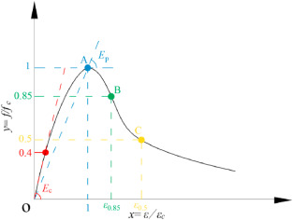

Fig. 2.1: Characteristic points of the stress-strain full curve of the BAC cylinder (Gaofel et al. 2024)
Table 2.1: Monotonic axial compression results for BAC cylinders
Specimen | f (MPa) | εc | ε0 | ε0/εc | E (GPa) | E_{sec} (GPa) | λ
NAC | 41.1 | 0.00164 | 0.00195 | 1.19 | 30.07 | 25.69 | 0.206
MBAC5% | 37.1 | 0.00166 | 0.00257 | 1.55 | 28.19 | 22.76 | 0.213
MBAC15% | 30.8 | 0.00170 | 0.00288 | 1.70 | 25.46 | 18.20 | 0.220
MBAC25% | 28.7 | 0.00179 | 0.00328 | 1.83 | 23.91 | 16.17 | 0.233
MBAC35% | 27.3 | 0.00185 | 0.00395 | 2.13 | 22.55 | 14.84 | 0.257
MBAC45% | 22.1 | 0.00207 | 0.00529 | 2.56 | 20.90 | 10.65 | 0.325
UBAC15% | 15.8 | 0.00120 | 0.00224 | 1.87 | 16.14 | 13.31 | 0.201

CHAPTER THREE

METHODOLOGY
This research was carried out in stages; the first stage involve sourcing and preparation of bamboo for coarse aggregate, and the second stage, preliminary test on the physical properties of bamboo was conducted in the laboratory while the third stage involves the casting of concrete cubes (150mm X 150mm X 150mm) and the last stage involved the testing and determine the strength of the bamboo made concrete at 1:2:4 nominal mix and a water/cement ratio of 0.5

3.1. MATERIALS
The materials used for this research work are mainly cement, water, fine aggregate (sand), and Bamboo as partials replacement of coarse aggregate. These materials were used for casting of 150mm x 150mm x 150mm cubes size. The batching was made for the mix ratio 1:2:4 and the concrete produced were cast into the cube using mold of 150 mm x 150 mm x 150 mm. After the casting, the mold was removed after 24 hours and the samples were immersed into the curing container. The curing period will be for 7, 14 and 28 days and crushing test will be done to determine the compressive strength on the cubes at 7, 14 and 28days. The materials are briefly explained below:

3.1.1. Procurement/Collection of Materials
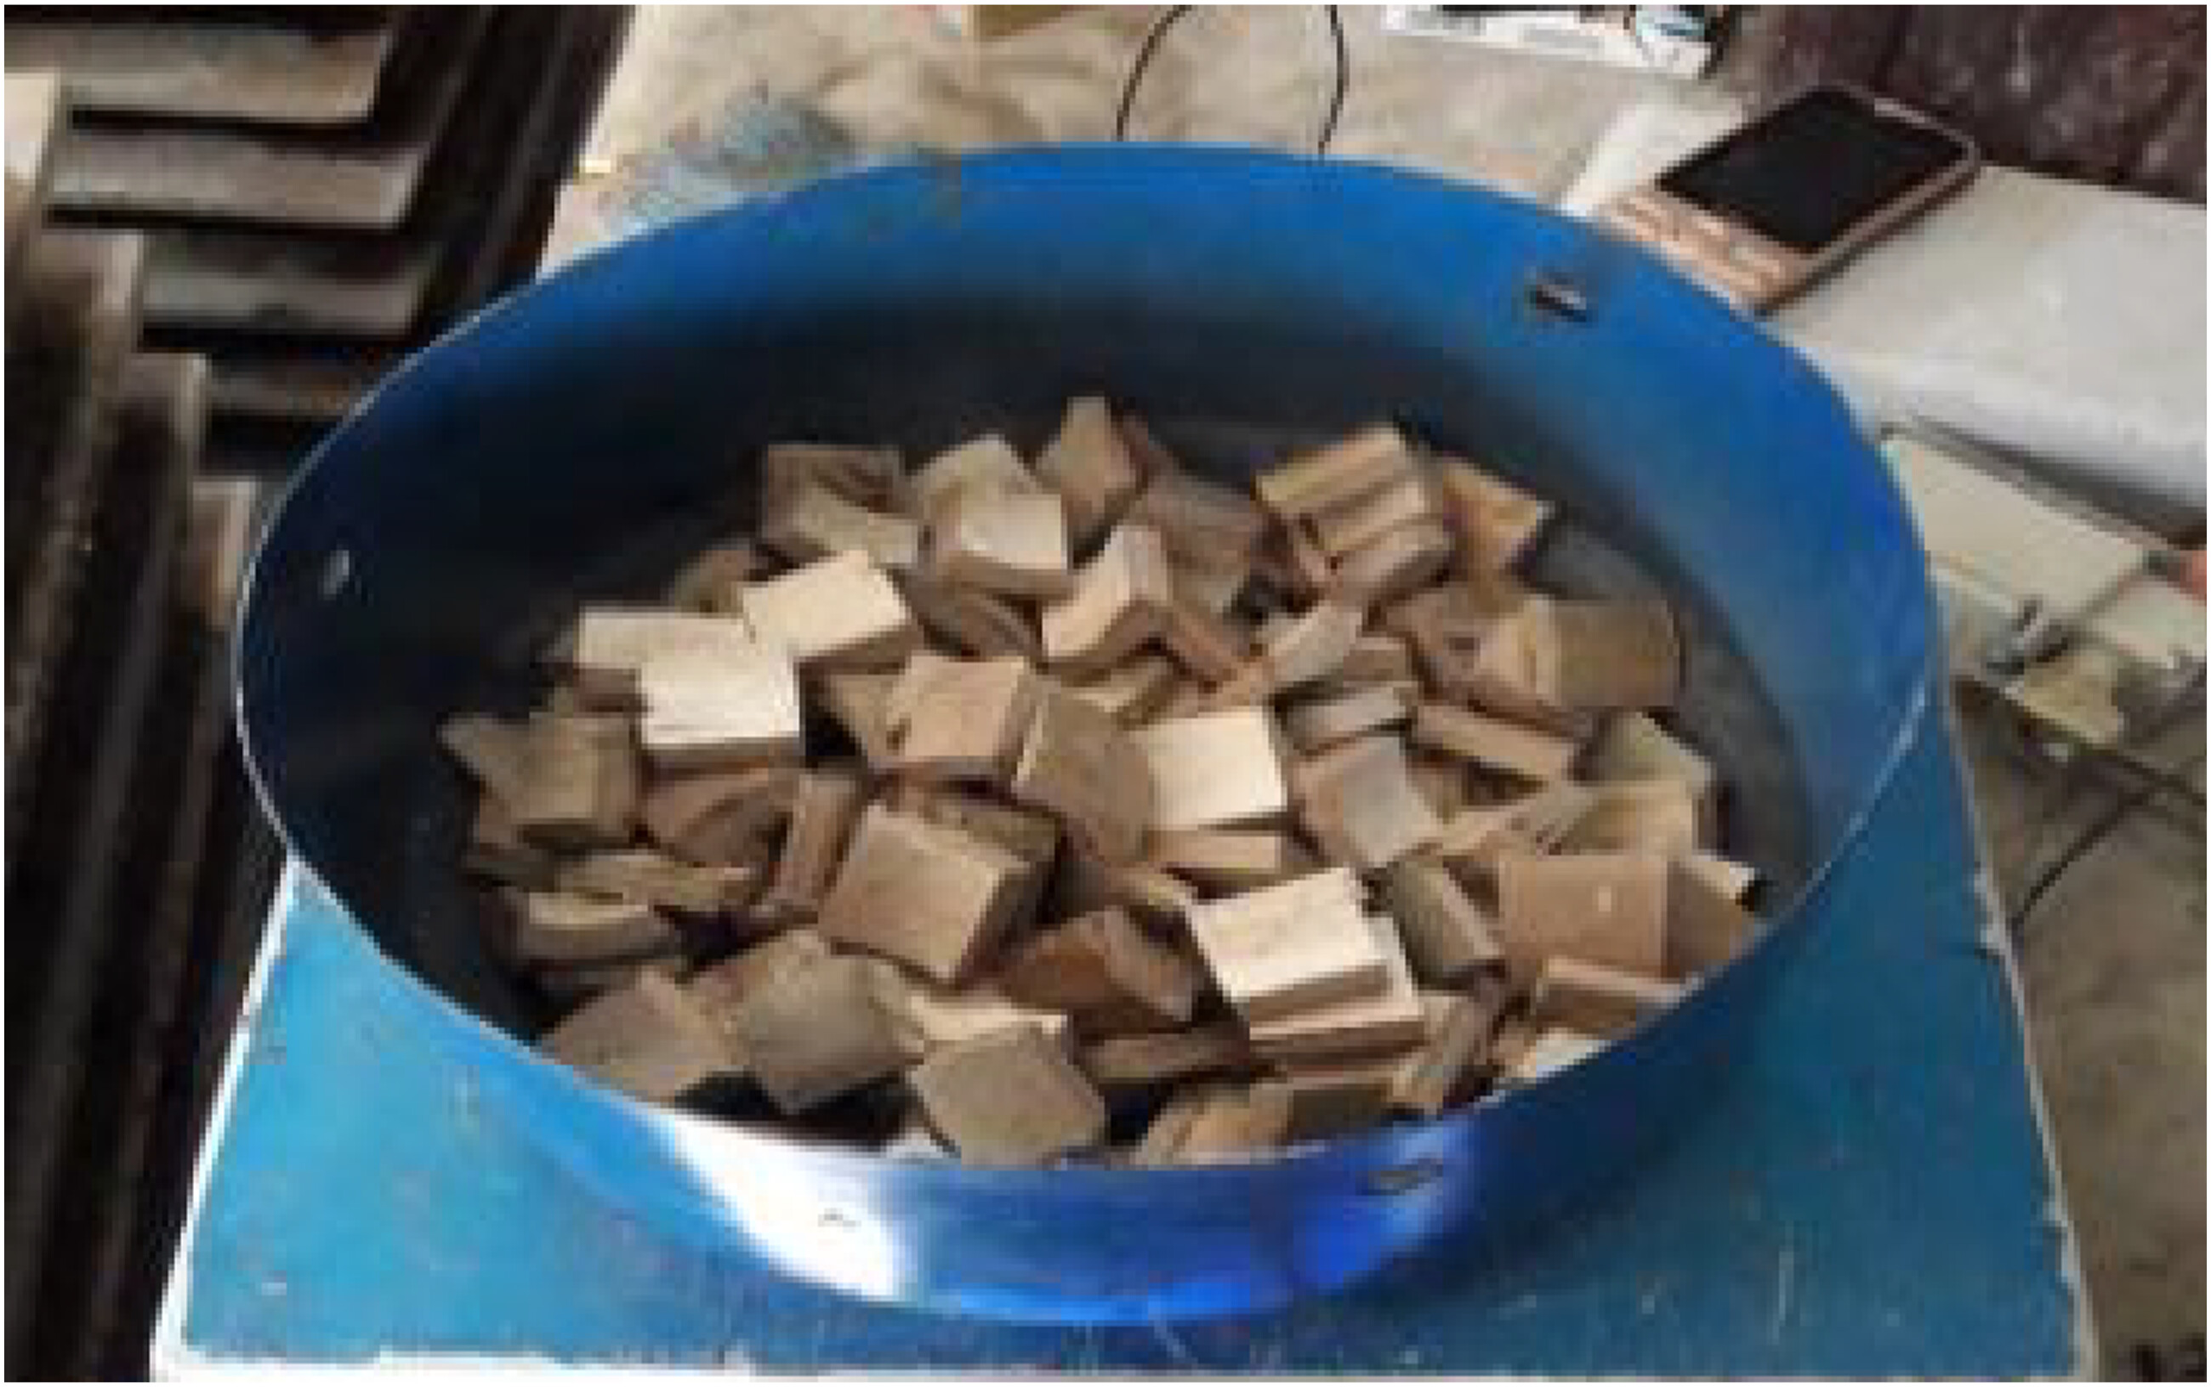
    - Bamboo: For this study, bamboo was harvested from local sources, treated with boron-based preservatives, and dried to a moisture content of 15% (ASTM D4442-16, 2016).

Fig. 3.1: Processed Bamboo Chips Used as Partial Coarse Aggregate Replacement
    - Cement: Portland Limestone Cement (PLC) is a type of cement that contains limestone as a main constituent, in addition to clinker, gypsum, and other minor constituents (ASTM C595/C595M-19, 2019). PLC has been shown to have improved workability, reduced heat of hydration, and enhanced durability compared to traditional Portland cement (PC) (Ramezanianpour et al., 2013.). The OPC was bought from the cement vendor or dealer. Each bag of OPC is 50kg in size.

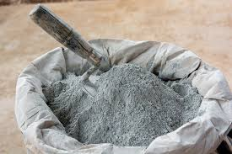

Fig. 3.2: Cement Bags (PLC) for Concrete Mix Preparation
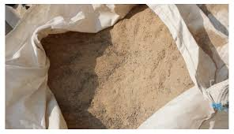
    - Fine Aggregate: Fine aggregates (sand) are chemically inert. The material less than 6.35mm in diameter is designated as fine aggregates and generally refers to sand. All materials over 6.35mm in diameter is called coarse aggregate and includes the broken stone etc. Any crushed rock or slag of durable character or any clean, hard, natural gravel may properly be used as coarse aggregate. Granite, trap rock or hard limestone are preferred and are prepared at the quarries for such use. The fine aggregate was obtained within Kwara State Polytechnic, Ilorin, Kwara State. Campus.

Fig. 3.3: Fine Aggregate (Sand) Sourced from Kwara State Polytechnic

    - Water: Water is a critical component in concrete mixing, accounting for approximately 20-30% of the total mix volume (ACI 211.1-91, 1991). The quality of water used in concrete mixing can significantly impact the concrete's strength, durability, and workability. The water used for this work was obtained from the Institute of Technology, Kwara State Polytechnic, Ilorin, Kwara State. The water was free from injurious amount of oil, acid, organic matter, alkali and other deleterious substances.

3.1.2. Equipment
- Mold (150mm * 150mm * 150mm)
- Hand trowel and shovel
- Scale

3.1.3 Testing Equipment
- Compression testing machine
- slump test apparatus
- sieve analysis equipment.

3.2. EXPERIMENTAL DESIGN
- Replacement Ratios: 0%, 10%, 20%, and 30%, of coarse aggregate replaced with hardened bamboo.
- Mix Design: Concrete mix design will be conforming to ACI 211.1.
- Casting and Curing: Concrete specimens will be cast in marine board molds and cured in a controlled environment (20°C, 60% RH).
- Testing: Compression strength, slump test, and sieve analysis will be performed on concrete specimens.

3.3. LABORATORY TESTS ON THE BAMBOO
The following tests were performed on the PKS. The tests were conducted at the concrete laboratory of the Department of Civil Engineering, University of Ilorin, Ilorin.
- Sieve Analysis
- Water Absorption
- Aggregate Impact Value test
3.3.1 Sieve Analysis
The gradation of Bamboo is done using sieve analysis. This was done by passing Bamboo through a set of standard sieves and cumulative passing percentages were calculated. The total of about 96% of the Bamboo that will be used as coarse aggregate passed through sieve 16 mm but retained on 5mm. This conformed to the literature; hence Bamboo is classified as coarse aggregate (BS 882, 1992).
3.3.2 Water Absorption
This test assists in the determination of the water absorption of the Bamboo. For this test, 1000g of the Bamboo sample was used. The apparatus used for this test were: balance, pan for drying, Water-tight container, pan for saturated drying and duster.
3.3.3 Aggregate Impact Value
This test was performed on the Bamboo in order to determine its impact value. The apparatus used for determining aggregate impact value of the Bamboo are Impact testing machine, BS Sieves of sizes – 14mm, 10mm and 2.36mm, cylindrical metal measure mold of 75 mm diameter and 50mm depth, a tamping rod of 10mm circular cross section and 230mm length.

3.4 PRODUCTION OF THE CONCRETE TEST CUBES
The concrete test cube was cast at the concrete laboratory of the department of Civil Engineering, Institute of Technology, Kwara State Polytechnic, Ilorin using a 150 mm x 150 mm x 150 mm of marine board mould in accordance with BS 1881 (1996). All freshly cast specimen was left in the mould for 24 hours before demoulding and curing. The demoulded cubes were then placed in curing tanks and subjected to crushing test after 7, 14 and 28days of curing respectively. Specimens (cubes) will be loaded to failure in compression testing machine conforming to EN 12390-4. The maximum load sustained by the specimen will be recorded and the compressive strength of the concrete will be calculated.
3.4.1 Compressive Strength Test
The compressive strength was measured by crushing the cube specimen in a compression testing machine. The compressive strength was calculated from the failure load divided by the cross-sectional area resisting the load and reported in N/mm2. During this research, 2 number of concrete cubes of size 150mm × 150mm × 150mm was cured for 7, 14 and 28 days in water of average temperature of 20^{O}C after 24hours of casting. The specimens were tested for compressive strength by applying increasing compressive load until failure occurs. Therefore, the maximum load causing failure was recorded and the load was divided by the cross-sectional area which gave us the compressive strength of each sample as calculated from the equation below.
Fc=F/Ac
Where;
Fc =is the compressive strength in N/mm2
F = is the maximum load at failure in Newton 25
Ac =is the cross-sectional area of the specimen on which the compressive force acts, calculated from the compressive strengths act.

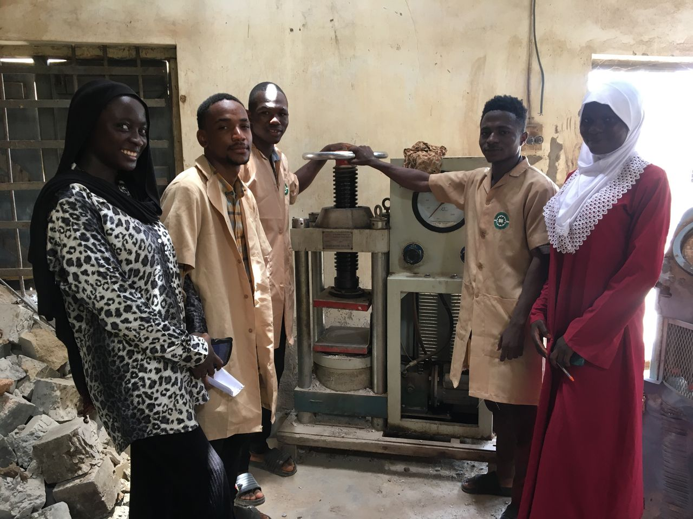
3.5. SELECTED FIGURE FROM THE PRACTICAL WORKS
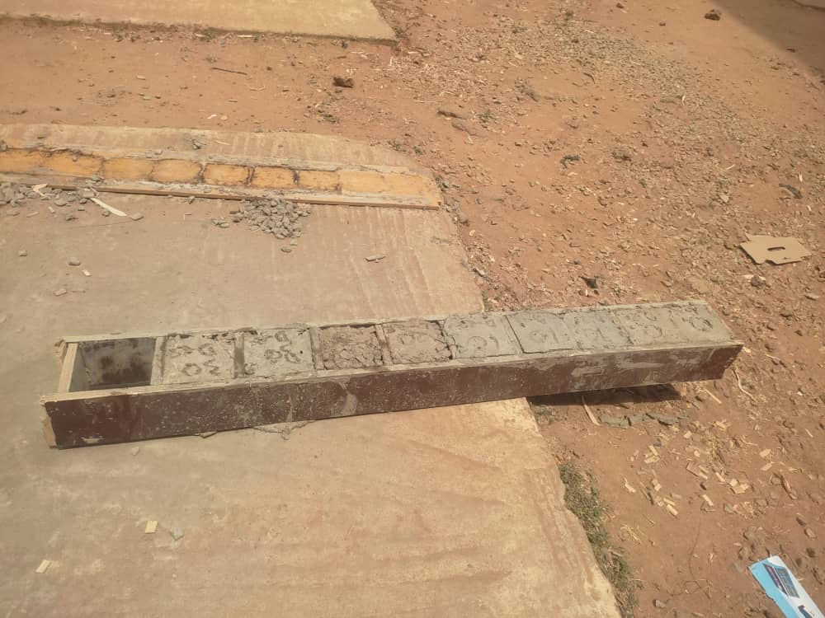

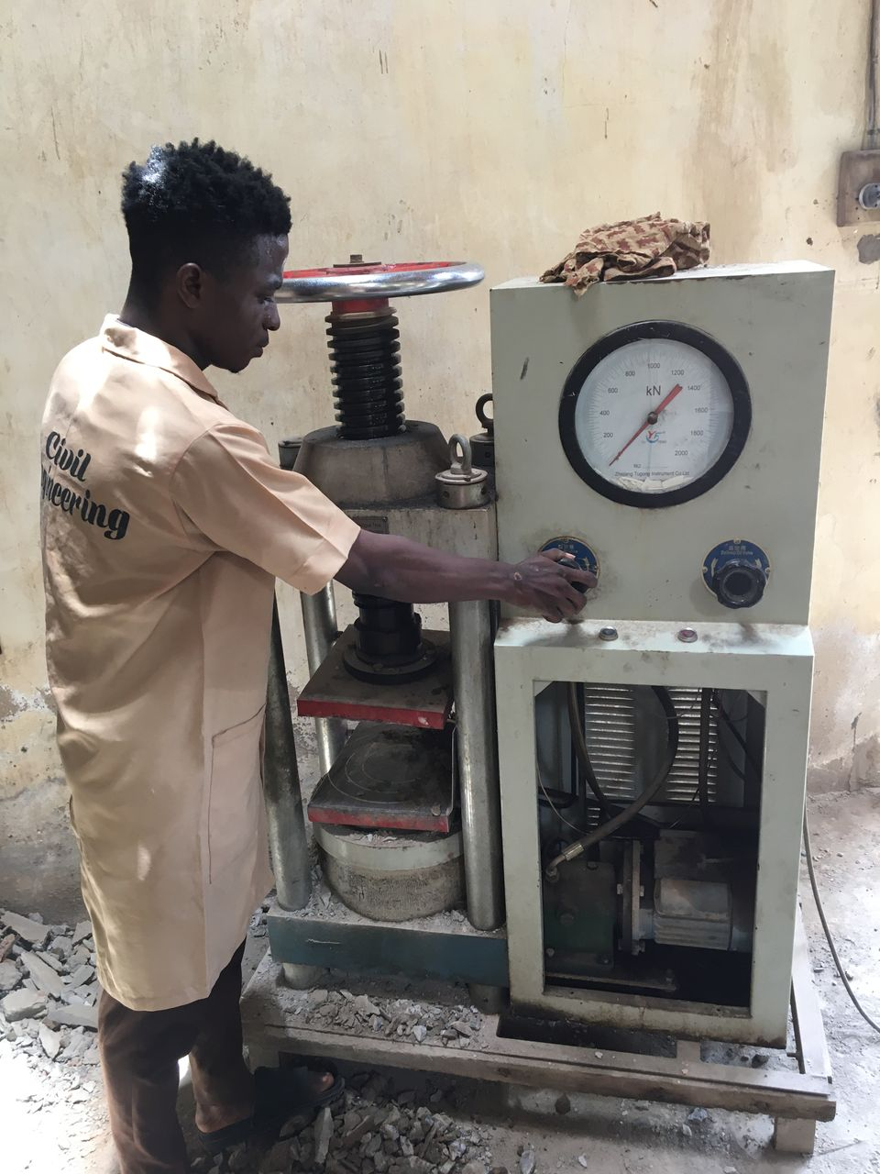
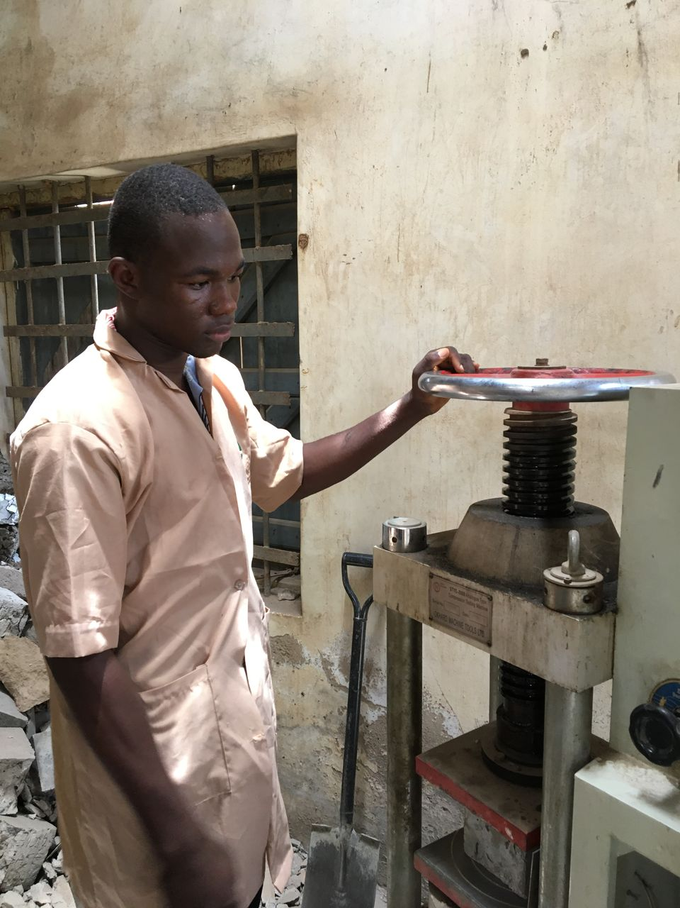
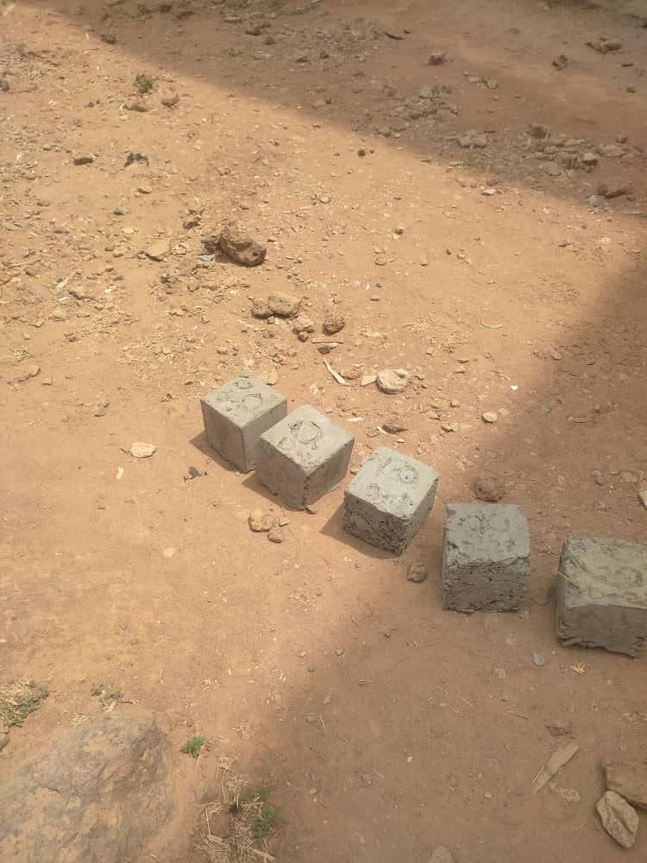

CHAPTER FOUR

RESULTS AND DISCUSSION

4.1 SIEVE ANALYSIS
The particle size distribution is the analysis of soil samples which involves the determination of the percentage by mass of particles within the different size ranges. The particle size distribution of coarse aggregates used was determined by the method of sieving. 3000g of air-dried samples of broken bamboo passed through series of standard test sieves having successively smaller mesh sizes. The mass of sample retained in each sieve was determined and the cumulative percentage by mass passing each sieve was calculated. This was used in analyzing uniformity and gradation of samples. The sieve analysis results for bamboo are shown in Table 4.1, while the graphical representation is shown in figure 4.1
Weight of the sample = 3000g
Table 4.1 Sieve analysis of Bamboo
S/N | Sieve sizes (mm) | Weight of empty sieve (g) | Weight of sieve + sample (g) | Weight of sample retained (g) | % retained | % passing Cumm. | % retained
1 | 37.5 | 1584 | 1584 | 0 | 0 | 100 | 0
2 | 20 | 1455 | 1455 | 0 | 0 | 100 | 0
3 | 14 | 1340 | 1458 | 118 | 3.93 | 96.07 | 3.93
4 | 10 | 1380 | 2306 | 926 | 30.87 | 69.13 | 34.80
5 | 6.35 | 1453 | 3051 | 1598 | 52.27 | 12.93 | 87.07
6 | 4.75 | 495 | 695 | 200 | 6.67 | 6.21 | 93.79
7 | pan | 820 | 978 | 158 | 5.27 | 1.0 | 99.99
 | Total |  |  | 3000

Fig. 4.1 Sieve analysis chart of Bamboo

4.2. WORKABILITY (SLUMP TEST) RESULTS
The slump test is carried out to evaluate the consistency and workability of freshly mixed concrete. This tells us how easy it is to work with during the pouring, and spreading of the concrete before it hardens. In this project, concrete was batched by weight, and different replacement of bamboo (0%, 10%, 20%, and 30%) were incorporated into the mix. A nominal mix ratio of 1:2:4 was used with a water-to-cement ratio of 0.4. The corresponding test results are presented in Table 4.2.
Replacement of Bamboo (%) | Slump Value (cm)
0 | 3
10 | 6
20 | 7
30 | 13
Table 4.2. Slump test

Fig. 4.2 Workability chart

4.3. DENSITY TEST RESULTS
The density of concrete tells us how heavy it is. This is important because heavier concrete makes the building heavier, which means the foundation must be stronger and more expensive. We measured the density of each concrete mix at 7, 14, and 28 days. The results are in the table 4.3. below:
Table 4.3 Density Test
Replacement (%) | Day 7 Density (kg/m³) | Day 14 Density (kg/m³) | Day 28 Density (kg/m³)
0 | 2512 | 2518 | 2540
10 | 2485 | 2490 | 2503
20 | 2466 | 2469 | 2479
30 | 2440 | 2433 | 2437
The traditional concrete (0% of bamboo) got a little heavier over time. It went from 2512 kg/m³ at 7 days to 2540 kg/m³ at 28 days. This happens because the cement hardens and fills small spaces. Also, the result shows that added of bamboo, the concrete became lighter. This is due to the properties of bamboo against coarse aggregate. At 30% replacement of bamboo, the concrete was 4.1% lighter than normal concrete after 28 days.
Fig. 4.3: Density Comparison Test Graph

4.4. COMPRESSIVE STRENGTH TEST RESULTS
Compressive strength is very important for hardened concrete, because it shows us how much weight or pressure a concrete can withstand without been fail. The result of this test is used as a basis for quality control of concrete proportioning, mixing, placing operations and determination of compliance with specification. For this practical 150mmx150mmx150mm cube was use and the results are presented in Table 4.4. for 7 days, 14 days, and 28 days.

Table 4.4. Compressive strength Test Result
Replacement of Bamboo (%) | Compressive Strength at Day 7 (N/mm²) | Compressive Strength at Day 14 (N/mm²) | Compressive Strength at Day 28 (N/mm²)
0 | 9.12 | 14.11 | 15.12
10 | 8.70 | 13.17 | 13.19
20 | 8.17 | 12.79 | 13.02
30 | 7.78 | 11.84 | 12.09
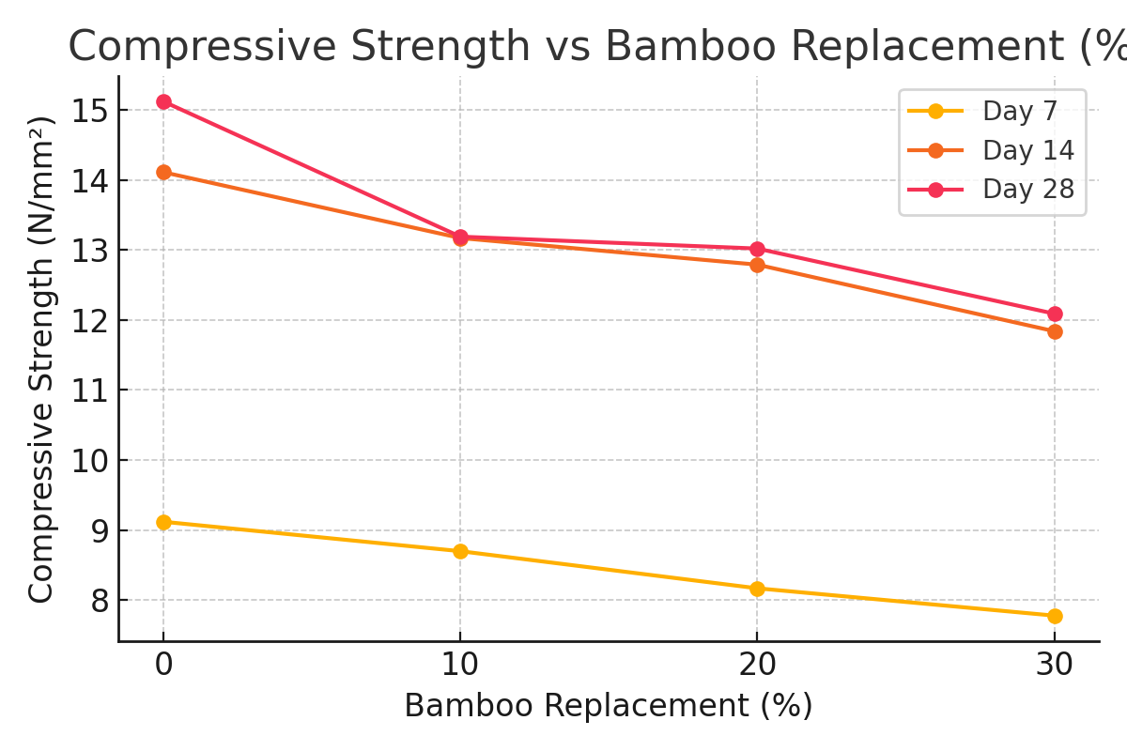

Fig 4.4 Comprehensive strength test

CHAPTER FIVE

CONCLUSION AND RECOMMENDATIONS

5.1 CONCLUSION
This study clearly shows that using hardened bamboo to replace part of the coarse aggregate in concrete is possible and can bring many benefits if done properly. From the tests we carried out, it is clear that up to 20% bamboo replacement still gives good compressive strength and a small reduction in density, which is acceptable for many building projects that are not too heavy or load-bearing. We also saw that the concrete became easier to work with as more bamboo was added, making mixing, pouring, and finishing less stressful. This can help reduce labour costs and speed up construction. The results also show that while strength reduces a little with bamboo, especially at 30% replacement, the concrete can still be useful in areas where very high strength is not required. Bamboo is a natural material that grows fast and is easy to find in many places, especially in countries like Nigeria. By using bamboo, we are not only saving the environment but also reducing the cost of construction. Even though there are some challenges, like the bonding between bamboo and cement and how the concrete behaves over a long time, these problems can be solved with more research. We believe that with more testing, better treatments for bamboo, and support from government and engineers, bamboo-concrete can become a real option for green and affordable construction. In the future, more people can start using bamboo in concrete, especially in rural areas or for small to medium-sized buildings. This can help reduce waste, promote sustainability, and create jobs in the bamboo processing industry. In summary, bamboo-concrete has a bright future if we keep working to improve it, test it properly, and spread awareness of its benefits.

5.2 RECOMMENDATIONS
Based on the tests and results of this research, the following recommendations are made to improve the use of bamboo as a partial replacement for coarse aggregate in concrete:
- Bamboo can absorb a lot of water, which may reduce the strength of the concrete. So, it is important to dry the bamboo well and treat it using chemicals like lime or alkaline water before mixing. This helps make it last longer and mix better with the cement.
- This type of concrete is best for small and light structures like village houses, toilets, walkways, and classrooms. It should not be used for buildings that carry heavy loads unless other materials like steel rods are added to support the strength.
- This project tested the concrete for only 28 days. More research should be done to check how the bamboo concrete performs after 1 year or more. It is important to know if it stays strong or if it breaks down over time.
- Create government standards and rules: There should be rules made by the government to guide how bamboo can be used safely in concrete. This will help more people accept and trust the idea.
- Government should encourage the use bamboo concrete in small public projects like schools, health centers, and roads. This will show people that it is safe and useful.

REFERENCE
Adesina, A. (2019). Sustainable construction materials using bamboo. Nigerian Journal of Construction, 4(2), 20–25.
Alencar, M. (2023). Rapid growth potential of bamboo and its use in eco-construction. Journal of Green Materials, 6(1), 45–52.
ASTM C595/C595M-19. (2019). Standard specification for blended hydraulic cement. ASTM International.
ASTM D4442-16. (2016). Standard test methods for direct moisture content measurement of wood and wood-based materials. ASTM International.
Brindha, D., Prakash, M., & Kumar, A. (2017). Mechanical properties of bamboo reinforced concrete beams. Construction and Building Materials, 151, 215–222.
BS 1881. (1996). Testing concrete – Part 116: Method for determination of compressive strength of concrete cubes. British Standards Institution.
BS 882. (1992). Specification for aggregates from natural sources for concrete. British Standards Institution.
Chen, H., Liu, Y., & Zhang, J. (2020). Sustainable insulation systems for building envelopes. Journal of Building Physics, 43(6), 501–518.
Correal, J. F. (2016). Environmental benefits of bamboo in climate action strategies. International Journal of Ecology and Development, 9(3), 130–137.
Kumar, R., Singh, P., & Patel, R. (2019). Strength characteristics of bamboo concrete composites. Civil Engineering Journal, 5(10), 2032–2039.
Mansur, M. A., & Aziz, M. A. (2021). Bamboo-reinforced cement composites. Materials and Structures, 18(2), 127–134.
Moroz, A., Zhou, Y., & Wang, T. (2014). Rattan bamboo reinforced masonry walls under lateral load. Journal of Structural Engineering, 140(3), 04013063.
Xiao, J., Sun, C., & Li, X. (2020). CO₂ emission reduction in concrete materials: Life cycle assessment. Journal of Cleaner Production, 248, 119180.
Zhou, Z., Wang, H., & Deng, F. (2024). Development of green aggregates in concrete industry. International Journal of Sustainable Materials, 8(1), 15–28.

