PROJECT REPORT
ON
PROPOSED FEDERAL FIRE STATION ILORIN KWARA STATE

BY

AFOLAYAN EBENEZER ABIDEMI
HND/23/ARC/FT/0056

SUBMITTED TO
THE DEPARTMENT ARCHITECTURAL TECHNOLOGY INSTITUTE OF ENVIRONMENTAL STUDY, KWARA STATE POLYTECHNIC, ILORIN, KWARA STATE.

IN POTENTIAL FULFILLMENT OF THE REQUIREMENT FOR THE AWARD OF THE HIGHER NATIONAL DIPLOMA (HND) IN ARCHITECTURAL TECHNOLOGY.

JULY, 2025

DECLARATION
I declare that this research work has been a personal academic undertaker executed under the supervision of Architect TOMORI J.M, call quotation on information utilized and their source has been due acknowledged.

AFOLAYAN EBENEZER ABIDEMI
HND/23/ARC/FT/0056

_____________________________
SIGNATURE/DATE

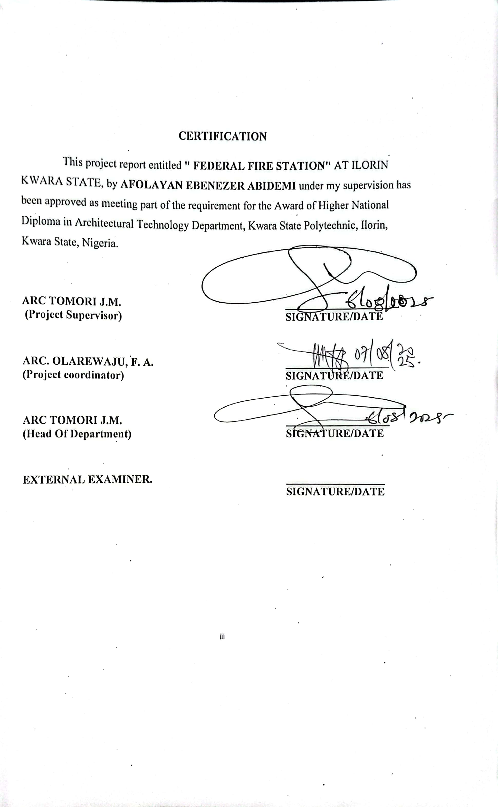

DEDICATION
I will be dedicating this project first to God the Almighty, who has made it the possible for me to come this far against every and all odds.

ACKNOWLEDGMENT
All thanks to Almighty God for the completion of this project. My gratitude goes to my supervisor a person of Architect TOMORI J.M the Head of Department (H.O.D) for her good counsel, corrections and mentorship during the process of the completion of the project and for her on ended support and advice all through the course of project
My appreciation also goes to the project coordinator in person of ARC. OLAREWAJU, F. A., Architect SOLOMON, Architect SHERO They has indeed been a role model to us students for their education to duties. I pray God Almighty to bless and uphold you.

ABSTRACT
In recent years, the frequency and severity of fire-related incidents in Nigeria have raised serious concerns about the adequacy of the nation’s firefighting infrastructure and emergency response capabilities. Urbanization, population growth, and industrial activities have further heightened the demand for well-structured and professionally equipped fire service facilities. This project was conceived in response to this growing need, with the aim of contributing to national efforts toward enhancing public safety and disaster preparedness.
This project focuses on the design and development of a Federal Fire Station, aimed at enhancing fire safety infrastructure and emergency response services at the national level. The study explores the spatial, functional, and operational requirements essential for effective firefighting operations, with special attention to response time, staff welfare, training, equipment maintenance, preparedness, and high-efficiency service delivery. The proposed design incorporates key national fire service infrastructure components that align with international best practices and standards.
Consideration is also given to sustainability, accessibility, and future expansion. The project seeks to contribute to improved public safety, effective disaster management, and the reduction of fire-related loss of life and property, particularly in urban centers such as Kogi State.
Furthermore, this project aims to provide a prototype model for similar fire station developments across other states in Nigeria, promoting national safety resilience and preparedness in the face of increasing fire incidents and urbanization.

TABLE OF CONTENTS

TITLE PAGE ……………………………………………………….…………………i

DECLARATION…………………………………………………….…………...…... ii

CERTIFICATION………………………………………………….…………..…..…iii

ACKNOWLEDGEMENT………………………………………….…………….…..iv

DEDICATION……………………………………………………….……………...…v

TABLE OF CONTENTS………………………………………………..…………….….….........vi

LIST OF FIGURES………………………………………………….……………..………...viii

LIST OF PLATES……………………………………………………….…..............................ix

ABSTRACT……………………………………………………………………….…..x

CHAPTER ONE

1.0 INTRODUCTION………………………..…………………….………………1

1.1 DEFINITION……………………………………………………....................1

1.2 HISTORICAL BACKGROUND ………………………………………………2

1.3 STATEMENT OF DESIGN PROBLEM……………………............................3

1.4 AIM AND OBJECTIVES ……………………………………………..…..… 4

1.5 AIM …………………………………………………………………………. 5

1.6 OBJECTIVES ……………………………………………………………….. 5

1.7 JUSTIFICATION…………………………………………….............................5

1.8 SIGNIFICANCE OF THE STUDY…………………..….………..…………....6

1.9 SCOPE OF THE PROJECT………………………...……………….…..............7

1.10 LIMITATION OF STUDY…………………………………………......…….....8

1.11 RESEARCH METHODOLOGY …………………………………………… 9

CHAPTER TWO

2.0 LITERATURE REVIEW ...………………………………………………….10

2.1 REVIEW OF LITERATURE ON BUILDING TYPE ……………………… 11

2.2 REVIEW OF LITERATURE ON SUB-TOPIC OF THE THESIS ………….12

CHAPTER THREE

3.1 CASE STUDY ………………………………..………………………………14

3.2 CASE STUDY 1: …………………………………………………………….. 14

3.3 CASE STUDY 2: ………………………………………………………………15

3.4 CASE STUDY 3 ………………………………………………………………16

3.5 CASE STUDY 4: ………………………………………………………………17

CHAPTER FOUR

4.0 STUDY AREA/PROJECT SITE……………………………….……..………....18

4.1 HISTORY OF KOGI STATE…………………………………........................19

4.2 LOCATION OF SITE …………………………………………………………20

4.3 SITE INVENTORY AND ANALYSIS …………………………………………21

4.4 SITE CHARACTERISTICS ………………………………………………….22

4.5 CLIMATE…………………………….………...…..............................................23

4.5 RAINFALL …………………………………………………………………….. 24

4.6 HUMIDITY……………………………………………………….…...................25

4.7 SOIL TYPE……………………………………………………….......................26

4.8 TOPOGRAPHY…………………………………………………………………27

4.9 VEGETATION ……………………………………………………….….…...…28

4.10 DRAINAGE …………………………………………………………………29

4.11 ACCESSIBILITY……………………………………………………………....30

4.12 SITE FEATURES AND INFRASTRUCTURE……………………………….29

4.13 NOISE SOURCES …………………………………………………………. 32

4.14 SITE ANALYSIS (PHYSICAL AND CLIMATIC) ………………………..34

TEMPERATURE …………………...…………………………………..……...….34

PRECIPITATION…………..……………………………………….……………......35

SUNSHINE……………………………………...…………………….…...………...36

WIND…………………………………………………...………...…………...……..37

MAN MADE FEATURES ………………………………………………………….38

CHAPTER FIVE

5.0 Appraisal of Proposed Scheme ………………………………………………….39

5.1 Design Appraisal ………………………………………………………………40

5.2 Construction Methodolog ……………………………………………………41

5.3 Orientations

5.4 Recommendation

5.5 Conclusion and summary
Conclusion.........................................................................................................................54
References.......................................................................................................................56
Appendix................................................................................................................................

LIST OF FIGURES
FIG 3.1: Locational Map of Case Study One at Abuja, Gariki…………….. 22
FIG 3.2: Site Plan of Case Study One at Abuja, Gariki……………………. 23
FIG 3.3: Floor Plan of Case Study One at Abuja, Gariki…………………. 23
FIG 3.4: Floor Plan of Case Study One at Abuja, Gariki…………………..25
FIG 3.5: Locational Plan of Case Study Two at Abuja, Asukoro……………28
FIG 3.6: Site Plan of Case Study Two at Abuja, Asukoro…………………..28
FIG 3.7: Floor Plan of Case Study Two at Abuja, Asukoro…………………29
FIG 3.8: Locational Plan of Case Study Three at Lokoja, Otupo Road……..33
FIG 3.9: Site Plan of Case Study Three at Lokoja, Otupo Road………...… 34
FIG 4.0: Floor Plan of Case Study Three at Lokoja, Otupo Road…………. 34
FIG 4.1: Locational Map of Kogi State……...…………………………….. 39
FIG 4.2: The proposed site in Kabba/ Bunnu….…………………………... 41
FIG 4.3: Site Analysis of the project………………………………………. 42
FIG 4.4: Graph of Climate in Kabba/ Bunnu………………………………. 43

LIST OF PLATES
Plate 3.1: Location Map of case study one 22
Plate 3.2: Perspective View of case study one 24
Plate 3.3: Left View of case study one 24
Plate 3.24: Right View of case study one 25
Plate 3.5: Site Location of case study two 27
Plate 3.6: Left View of case study two 30
Plate 3.7: Perspective view of case study two 30
Plate 3.8: Site Location of case study three 32
Plate 3.9: Perspective view of case study three 35
Plate 3.10: internal view of case study three 35

LIST OF APPENDICES
Pages
APPENDICES 5.1: LOCATION PLAN 58
APPENDICES 5.2: ELEVATIONS 59
APPENDICES 5.3: EXTERNAL PERSPECTIVE 60
APPENDICES 5.4: GROUND FLOOR PLAN 61
APPENDICES 5.5: UPPER FLOOR PLAN 62
APPENDICES 5.6: ROOF PLAN 63
APPENDICES 5.7: SIDES PLAN 64

CHAPTER ONE
1.0 INTRODUCTION
What is a fire station: the fire station, Firehouse of fire Hall she structure or other area set aside for storage or firefighters apparatus such as fire engine and related vehicles, personal protective equipment Firehouse and other specialized equipment. It may also have dormitory living facilities and work area for the use of firefighters. Living area are sometimes arranged about the garage bays where personnel without specific station duties during the night shift that allowed to sleep unless a dispatch is called.
In a station whereby any emergency occurs the firefighter may have special means to allow entering to the ground floor quickly where a call for help is received.
An occupied station will usually have a station alarm system for receiving an annunciating an alarm can indicate for where and what caused the alarm. Then the firefighter maybe summoned to the fire station by the seven radio or beggars making a station alarm system superfluous.
Their activities include inspection and cleaning of the apparatus and equipment and contouring education in the fire service weekly or bi-weekly routine typically include various drills in which firefighter practice their skills.
  - DEFINITION
A fire station is a building designed to house firefighter vehicles equipment and personnel. It is a critical infrastructure that supports emergency response operations and serves as a hub for firefighter activities
The federal fire station AC fire station that is built an operated by the Federal government and also built on federal property.

1.2 HISTORICAL BACKGROUND
The concept of organized firefighting dates back to ancient civilizations. One of the earliest recorded firefighting systems was established in Ancient Rome around 24 B.C. by Emperor Augustus, who created the Vigiles, a corps of firefighters responsible for protecting the city from fires. These early fire brigades used simple tools such as buckets, axes, and pumps to control and extinguish fires.
During the Middle Ages, firefighting remained largely a community effort, with citizens forming volunteer groups to respond to fire outbreaks. Firefighting as a public service began to evolve significantly in the 17th century, especially after the Great Fire of London in 1666, which led to the formation of the first organized fire brigades in Europe. Insurance companies initially funded these brigades to protect insured properties.
By the 19th century, as cities grew and industrialization increased, fire services became more formalized. Many countries established municipal fire departments with full-time firefighters, dedicated fire stations, horse-drawn engines (later replaced by motorized vehicles), and structured training programs.
The development of federal or national fire services emerged in response to the growing need for a coordinated approach to fire safety, especially in large nations with complex infrastructure and widespread populations. Governments began establishing federal fire departments or agencies to oversee national fire policies, standardize training, provide support to regional stations, and respond to large-scale emergencies
In the 20th and 21st centuries, modern federal fire stations became integral components of national emergency response systems. These facilities are typically equipped with advanced technologies, communication systems, specialized rescue units, and serve as command centers during disasters. They not only handle firefighting but also provide services such as disaster rescue, hazardous material response, fire safety education, and enforcement of building fire codes.
Today, fire stations particularly federal ones represent a key part of a nation’s public safety infrastructure, evolving from simple community-based efforts into complex, highly organized institutions dedicated to protecting lives, property, and the environment.
1.3 STATEMENT OF PROBLEM
The existing federal fire station in Nigeria might have with inefficient layout leading to congestion or difficulty in emergency response population. On the building design and infrastructure might be outdated, falling to meet modern fire safety standard or sustainability requirement, the sustainability concerned existing design might not incorporate sustainable features leading to high energy consumption, water which or environment degradation.
1.4. AIM AND OBJECTIVES
AIM:
The aim of the project is to design a functional and efficient fire station, with sustainable facility that supports the operational needs of firefighters while promoting community safety and engagement
OBJECTIVES
- To create enough functional and adequate space for the storage of firefighters apparatus as well as related vehicles.
- To create and ensure accessibility to make emergency response easier.
- To update the design tomeet modern fire safety standards incorporating sustainable features and resilient architecture.

- To optimize space planning and equipment to support efficient emergency response operation.
1.5 JUSTIFICATION
A well-designed federal fire station is essential for supporting the operational needs of firefighters promoting communities and engagement, and meaning amazing environment impact. By the incorporation functional design, safety and resilience sustainability well-design federal fire station support efficiency emergency response operation reducing the risk of injury or loss of life.
1.6 SCOPE OF THE PROJECT
The scope of the design focuses on providing a functional and responsive fire service center that meets the emergency and safety needs of Kwara State. It aims to ensure effective planning, accessibility, operational efficiency, and compliance with national fire safety standards.
The design will consider the geographic and climatic conditions of Kwara State, the population density of urban centers like Ilorin, and the strategic location of the station for prompt emergency response across the state. Emphasis will be placed on operational readiness, staff accommodation, safety, ease of vehicle movement, and future expansion potentials
Facilities to be provided in the hostel would include;
- Main building
- Security House
- Parking LOt
- Staff Parking
- Generator house
- Control room / dispatch center
- Administrative offices
- Conference / briefing room
- Dormitories
- Toilets and bathrooms , etc
1.7. RESEARCH METHODOLOGY
The methods that were used in the course of this study are primary data methods which are:
Comprehensive and detailed observation, Asking questions, case studies and documentation and also the secondary data collection methods are from: Internet, Textbooks, Appropriate government agencies

CHAPTER TWO
2.0 LITERATURE REVIEW
Fire stations should explore existing research on spatial distribution, impact on response times, and the effectiveness of different fire station locations. It should also examine factors influencing fire risk, such as urban growth and economic development, and the need for optimized fire station layout to ensure efficient fire incident response. Furthermore, the review should consider the impact of fire stations on air quality and the health of firefighters. Site selection for fire stations is a key factor influencing response time and coverage efficiency. Research by Kuo & Chen (2010) emphasizes the use of geographic information systems (GIS) for optimal station placement, considering population density, road networking, and fire risk zones. The National Fire Protection association (NFPA) also provides guidelines suggesting that stations be located to ensure response times of 4 to 8 minutes within the urban areas.
Modern fire station design integrates operational efficiency with comfort for
personnel. According to schwinghammer (2015), layout should minimize transition time
from living quarters to fire apparatus, support 24/7 readiness, and include spaces for training, maintenance, and administration. Flexibility in design is also encouraged to accommodate future technological and functional changes.
Recent literature, such as that by Pacheco-Torgal (2013), explores the integration of sustainable practices in public buildings, including fire stations. These include energy-
efficient HVAC systems, rainwater harvesting, solar panels, and the use of green materials, which reduce operational costs and environmental impacts.
Modern fire stations are often envisioned as community hubs. Literature shows a
growing trend of including public education rooms, events space, areas for public interaction within station designs (Alexander, 2018). This fosters community trust and awareness while optimizing space usage.
Fire stations are critical public safety facilities that require highly functional and
responsive architectural solutions. Their design must address operational efficiency,
firefighter safety and comfort, spatial clarity, and increasingly, community interaction and sustainability. This literature review examines architectural and planning principles, case studies, and emerging trends in fire station design.
According to Neufert's Architects’ Data (2000), fire stations must be divided into
three main zones: operational (e.g., apparatus bays), administrative (e.g., offices, control
room), and residential (e.g., dormitories, kitchen, and recreational areas). Efficient spatial
zoning ensures quick response times, safe circulation, and clear functional separation.
Studies highlight the importance of direct, obstruction-free movement from rest areas to
vehicle bays to meet target response times (typically under 60 seconds for urban areas).
Response time is a core metric in fire station planning. As per NFPA 1710 (National
Fire Protection Association), fire stations should be strategically located to serve their area within a 4-minute response window. Urban fire stations require integration with traffic patterns, minimal exit obstructions, and clear site access. GIS-based studies (e.g., Zhang et al., 2018) have been used to model ideal fire station locations based on population density, road networks, and risk zones.
Modern designs are increasingly focusing on firefighter wellbeing, recognizing the physical and psychological stress of the job. LEED and WELL standards suggest natural lighting, proper ventilation, and access to fitness and rest spaces as critical factors. Facilities now include decontamination zones to prevent carcinogen exposure after incidents (U.S. Fire Administration, 2021).
Sustainable fire stations are emerging worldwide, using passive design strategies,
solar panels, rainwater harvesting, and green roofs. The Woodlawn Fire Station 21 in
Portland, Oregon, for example, is LEED Platinum-certified, demonstrating how fire stations can become sustainable civic buildings without compromising functionality.
In recent years, fire stations have evolved to include public-facing elements such as
educational rooms, visitor centers, and community halls. This shift reflects a broader
movement toward integrating emergency facilities into the social fabric of neighborhoods.
Research by Lasserre (2015) emphasizes how transparency and public interaction zones
humanize the service and build trust.
While function dominates fire station design, form and identity also matter. Fire
stations often serve as landmarks. Architects such as Zaha Hadid (Vitra Fire Station, 2020) have challenged conventional typologies by merging expressive design with rigorous function, demonstrating the potential for architectural innovation in civic infrastructure.
The literature highlights a growing need for multifunctional, sustainable, and
community-integrated fire station designs. The evolving role of fire stations — from purely operational bases to civic and educational spaces — provides a rich opportunity for architectural exploration. This review informs the thesis design by establishing functional requirements, identifying user needs, and referencing successful global precedents.

2.1 HISTORICAL DEVELOPMENT OF FIRE STATION
The fire service in Nigeria has a historical development beginning as an arm of the Lagos police fire brigade in 1901. In 1963, the federal fire service was officially established by an act of parliament, separating the fire service from the police force. Further reforms in 2007 and the establishment of the federal fire service academy in Abuja have marked the service’s evolution.
- Early development (1901-1963):
The fire service initially operated as part of the Lagos police fire brigades, with
firefighters undergoing combine police and fire service training. This period was
characterized by a close relationship between the two services, which gradually evolved into a need for separation.Firefighting as an organized activity dates back to ancient civilizations.
In Ancient Rome, the first known fire brigade, Vigiles, was formed under Emperor
Augustus around 24 BCE. These early responders had basic tools like buckets, hooks, and pumps and operated out of watchtowers or small shelters rather than dedicated buildings.
- Medieval and Pre-Industrial Era
During the Middle Ages in Europe, firefighting responsibilities often fell on local
communities or informal groups of volunteers. There were no specialized buildings; fire
equipment (often just buckets and ladders) was stored in town halls or churches. Urban fires were common due to wood construction and the lack of regulations.
- The Industrial Revolution and the Rise of Formal Fire Departments (18th–19th
Century)
The growth of cities during the Industrial Revolution brought increased fire hazards. This led to the establishment of formal fire departments and the first dedicated fire stations.
• In London, following the Great Fire of 1666, organized firefighting emerged, culminating in the London Fire Brigade (1866).\
• In the United States, Benjamin Franklin helped form the first volunteer fire company in Philadelphia in 1736, and the first municipal fire station emerged in the early 1800s.
Fire stations from this period were primarily utilitarian buildings, often resembling
barns, with simple garages for horse-drawn engines and a bell tower to alert firefighters.
- Early 20th Century: Mechanization and Standardization
The invention of the motorized fire engine transformed fire station design.
Buildings now needed:
• Wider bays for large vehicles
• Hose drying towers
• Sleeping quarters and mess halls for full-time staff
• Sliding poles for quick movement from upper dormitories to apparatus bays
This era also saw architectural styles reflecting civic pride—many fire stations were
designed in classical, art deco, or mission revival styles, depending on the region
- Post-War Era (1945–1980s):
Functional Modernism
After World War II, fire stations became more standardized and purely functional. Emphasis was placed on response efficiency and practicality over aesthetics.
• Prefabricated materials and minimalist designs became common.
• Suburban expansion required more decentralized, smaller-scale fire stations.
Contemporary Fire Station Design (1990s–Present)
In recent decades, fire stations have evolved into multi-functional civic buildings. They now often include:
• Public education rooms• Community gathering spaces Sustainable design features (LEED-certified buildings)
•Advanced safety zones, such as clean/dirty transition areas to manage contamination
• Spaces promoting firefighter wellness (gyms, quiet rooms, natural lighting)
Iconic modern examples include:
• Vitra Fire Station by Zaha Hadid (Germany, 1993) — a sculptural, deconstructivist design
- Establishment of the fire service (1963- present):
In 1963, an act of parliament officially established the fire service, making the formal
separation from the police force. The actual separation took effect on April 1,1964 and the fire service was established throughout the federal capital territory.
• Further development and reforms:
The federal Government’s reform of the fire service in 2007 redefined as its mandate, including the standardization of fire and rescue equipment, the regulation of private fire outfits, and fire prevention. The federal five service Academy, located in Abuja was established to provide specialized training for firefighters. The service’s mission continues to evolve, focusing on fire prevention, safety, mitigation and emergency preparedness.
- •Contemporary Fire Station Design (1990s–Present)
In recent decades, fire stations have evolved into multi-functional civic buildings.
They now often include:
• Public education rooms
• Community gathering spaces
- Sustainable design features (LEED-certified buildings)
• Advanced safety zones, such as clean/dirty transition areas to manage contamination
• Spaces promoting firefighter wellness (gyms, quiet rooms, natural lighting)
Iconic modern examples include:
- Vitra Fire Station by Zaha Hadid (Germany, 1993) — a sculptural, deconstructivist design
- Woodlawn Fire Station 21 (Portland, USA) — a LEED Platinum-certified green building
- Docklands Fire Station (Melbourne, Australia) — a high-performance, community-centered facility
The design of fire stations has shifted from utilitarian sheds to sophisticated, multi- zoned facilities that reflect advances in technology, urban planning, and public architecture. As critical infrastructure, fire stations today serve not only as emergency response hubs but also as symbols of civic engagement, resilience, and sustainability.

CHAPTER THREE

3.0 CASE STUDIES

3.1 SELECTED CASE STUDIES

Case studies are of paramount important. It is an experimental research or analysis carried out on existing building or group of building functionally similar to the one which the researcher is working.

For any technical design to be meaningful there is always need for Preliminary research effort to be made on this proposal as a very necessary groundwork.

The following case studies of FIRE SERVICE school both private and public were visited and been carried out include the following:
PHYSICAL CASE STUDIES
1. Case Study One: FEDERAL FIRE STATION, AREAA 10 MUHAMADU BUHARI WAY, ABUJA
2. Case Study Two; FEDERAL FIRE SERVICE ASOKORO ABUJA FCT HQ
3. Case Study Three: FEDERAL FIRE STATION, LOKOJA OTUPO, RD IBD WAY, KOGI STATE

ONLINE CASE STUDY

1. CASE STUDY FOUR: THE MORE WITH MUSIC STUDIO, UNITED STATES

3.2 CASE STUDY ONE
LOCATION; FEDERAL FIRE STATION, AREAA 10 MUHAMADU BUHARI WAY, ABUJA.
MERITS
- The building is properly Oriented
- Access to each shop is well taken or observed
- Movement and Pedestrian Connection was Resolved.
- It had a good convenience space.

DEMERITS.
- Ground Floor did not have convenience space.
- It has too much hard landscaping
- Presidential walkway is Limited

FIG. 3.2.1.
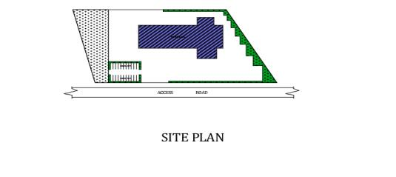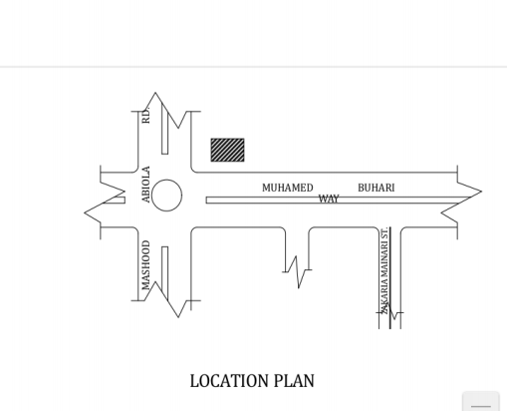
FIG. 3.2.2 SITE PLAN OF CASE STUDY ONE FEDERAL FIRE STATION, ABUJA

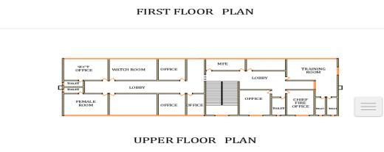
FIG. 3.2.3 FIRST AND GROUND FOOR PLAN OF CASE STUDY ONE FEDERAL FIRE
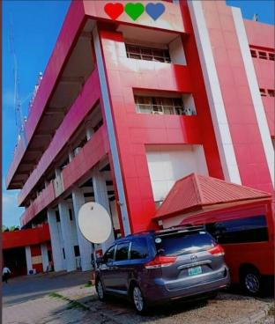

PLATE: 3.2.1 - FRONT VIEW OF CASE STUDY ONE FEDERAL FIRE STATION, ABUJA

3.3 CASE STUDY TWO
LOCATION; FEDERAL FIRE SERVICE ASOKORO ABUJA FCT HQ
MERITS
- Good and Perfect Parking Spaces.
- Building is well ventilated.
- Very easily accessible stair case to access the upper floor.
- Good Functionality
- Good Convenience Spaces
DEMERITS
- Accessibility to some shops is not easily to locate
- Does not meet architectural standards when talking about aesthetic senses
- Convenience Spaces such as toilet is too far from reach

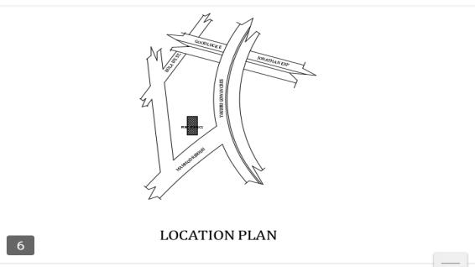

FIG. 3.3.1 LOCATIONAL PLAN OF CASE STUDY TWO FEDERAL FIRE SERVICE ASOKORO ABUJA FCT HQ

`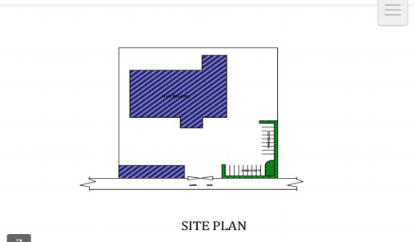
FIG. 3.3.2 SITE PLAN OF CASE STUDY TWO FEDERAL FIRE SERVICE ASOKORO ABUJA FCT HQ

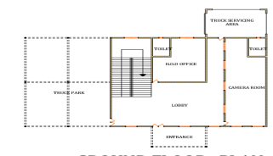

FIG. 3.3.3 TYPICAL FLOOR PLAN O CASE STUDY TWO
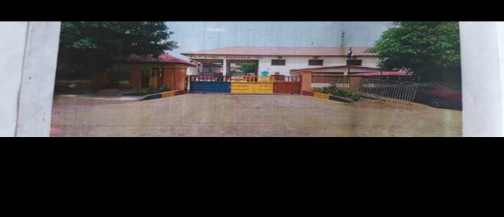
PLATE: 3.3.1 - FRONT ELEVATION OF CASE STUDY TWO FEDERAL FIRE SERVICE ASOKORO ABUJA FCT HQ

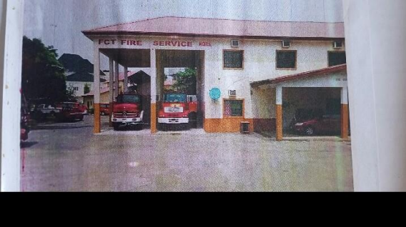
PLATE: 3.3.2 - BACK ELEVATION OF CASE STUDY TWO TWO FEDERAL FIRE SERVICE ASOKORO ABUJA FCT HQ

3.4 CASE STUDY THREE
LOCATION; FEDERAL FIRE STATION, LOKOJA OTUPO, RD IBD WAY, KOGI STATE

MERITS
- The Functional Relationship of the shop was well arranged.
- Good Ventilation in the sense of Natural lightening
- Good Aesthetic sense
- Was properly oriented
DEMERITS
- No space for parking lots
- The site has too much hard landscaping
- Convenience rooms is not easy to locate
- Pedestrian walkway is limited
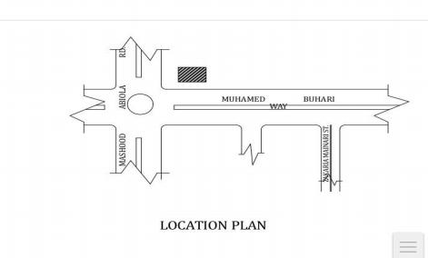
FIG. 3.4.1 LOCATIONAL PLAN OF CASE STUDY THREE FEDERAL FIRE STATION, LOKOJA OTUPO, RD IBD WAY, KOGI STATE

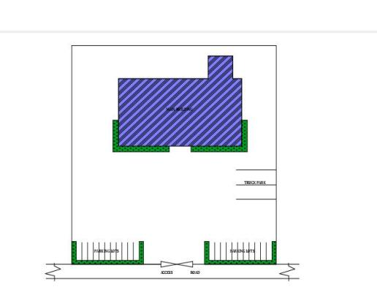

FIG. 3.4.2 SITE PLAN OF CASE STUDY THREE FEDERAL FIRE STATION, LOKOJA OTUPO, RD IBD WAY, KOGI STATE

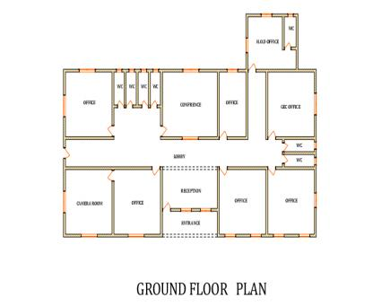
FIG. 3.4.3 FLOOR PLANS OF CASE STUDY THREE FEDERAL FIRE STATION, LOKOJA OTUPO, RD IBD WAY, KOGI STATE
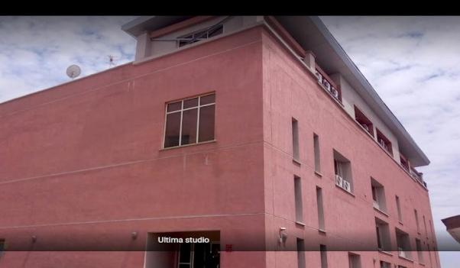
PLATE: 3.4.1 - FRONT ELEVATION OF CASE STUDY THREE FEDERAL FIRE STATION, LOKOJA OTUPO, RD IBD WAY, KOGI STATE

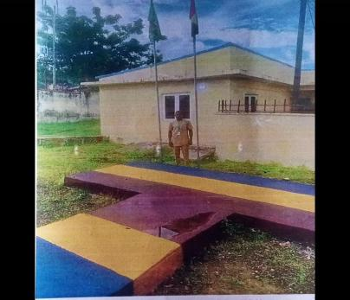
PLATE: 3.4.1 - INTERIOR VIEW OF UPPER FLOOR OF CASE STUDY THREE FEDERAL FIRE STATION, LOKOJA OTUPO, RD IBD WAY, KOGI STATE

3.5 CASE STUDY FOUR [ONLINE CASE STUDY]
THE NICKLE , CLEVELAND, OH, UNITED STATES

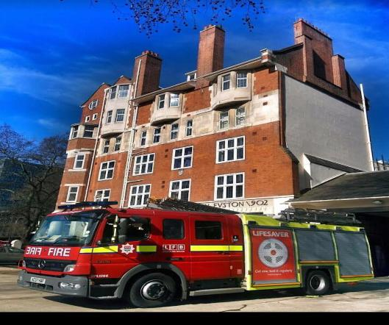

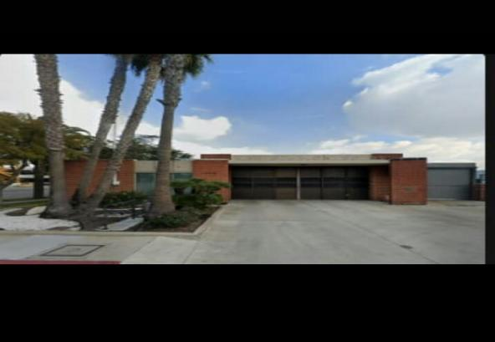

PLATE: 3.5.1 - FRONT ELEVATION OF ONLINE CASE STUDY
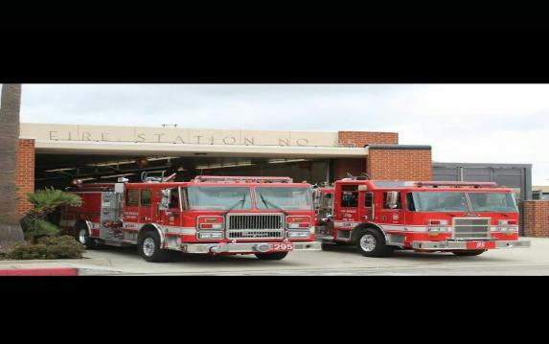

PLATE: 3.5.2 - INETERNAL PERSPECTIVE OF ONLINE CASE STUDY

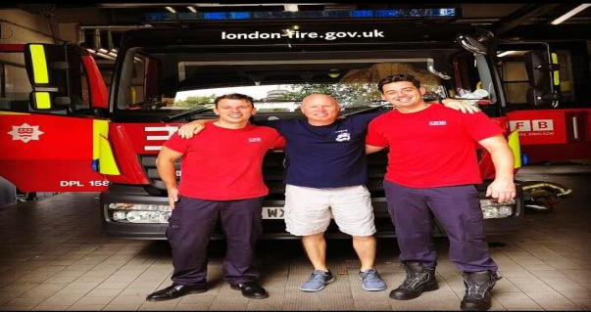
PLATE: 3.5.3 - INETERNAL PERSPECTIVE GROUND FLOOR OF ONLINE CASE STUDY

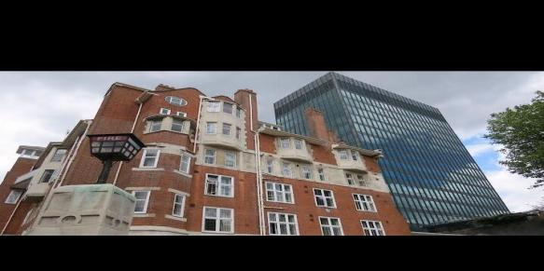

CHAPTER FOUR

4.1 STUDY AREA/PROJECT SITE
4.1.1 ANALYSIS OF THE TOPOGRAPHICAL AND ENVIRONMENTAL CONDITIONS OF THE SITE.

4.1.1.1 INTRODUCTION OF STUDY AREA/SITE SELECTION
Kogi State in Nigeria has diverse areas with unique characteristics that could be of interest for study. The state comprises various local government areas with differing geographical, agricultural, and socio-economic profiles. Here are some areas and aspects that have been studied or highlighted in research:

Koton Karfe: This area inKogi Local Government Area has been studied regarding the impacts of flooding on artisanal fishers. Flooding affects household livelihood through reduced income, with migration to other fishing areas being a major coping strategy.
Research indicates that factors like age, household size, and income influence vulnerability to flooding impacts [1].
Kabba/Bunu Local Government Area: This area has a landmass of 4,350 sq. kms and is in the rainforest belt of Nigeria. It's considered suitable for growing food, cash crops, and
forestry. The area's agricultural potential makes it an interesting location for studies on farming practices or rural development.
Zone-B Agro Ecological Zone: This zone inKogi State includes six extension blocks (Egume, Dekina, Odenyi, Gboloko, Ankpa, and Abejukolo) spread across four local
government areas: Dekina, Bassa, Ankpa, and Omela. Research in such zones often focuses on agricultural practices, crop yields, or ecological impacts [2][4].

Considerations for Study Area Selection in Kogi State
When selecting study areas inKogi State, factors like:
- Flooding impacts: Areas like Koton Karfe experience significant flooding effects on artisanal fishing communities.
- Agricultural potential: Areas like Kabba/Bunu have favorable conditions for agriculture.
- Socio-economic characteristics: Understanding local demographics and livelihoods can inform study area selection.
- Ecological zones: Studying areas within specific agro-ecological zones can provide insights.

SITE SELECTION
Site selection involves choosing a location that meets specific criteria for a particular purpose. For a project inKogi State, considerations for site selection might include:
- Accessibility: How easily can people access the site?
- Resources and Infrastructure: Availability of necessary resources like water, electricity, or specific infrastructure.
- Environmental Factors: Potential impacts of the site on the environment or viceversa.
- Community and Socio-economic Factors: How does the site interact with local communities and their socio-economic conditions?
Site Selection in Kogi State Context
In the context of Kogi State, site selection could be influenced by factors like:
- Agricultural potential: Areas like Kabba/Bunu have potential for agriculture.
- Flooding risks: Areas like Koton Karfe experience flooding impacts on livelihoods.
- Local government areas' characteristics: Different LGAs in Kogi State have unique characteristics

1 Accessibility: Proximity to major roads and public transportation
2 Space: Adequate land area for facilities, including classrooms, dormitories, sports fields, and recreational spaces
3 Safety: A secure environment with minimal risks from environmental hazards
4 Community: Opportunities for community engagement and partnerships with local businesses and organizations

ACCESSIBILITY
The site is easily accessible from jebba road, opposite winner chapel CHURCH, Kogi Local Government.
LOCATION
The site is located at kabba dongari, amoyo community, KOGI LOCAL GOVERNMENT GOVERNMENT AREA (LGA) OF, KOGI STATE. It is located opposite the Federal Road, before getting to Eternal Filling Station close to ganmo Junction.

URBANIZATION
Situating the site in amoyois a method of urban development in the Area. It's a means of adding to the infrastructural facilities in the environment.
INFRASTRUCTURAL FACILITIES
Facilities such as water, electricity, telephone network and road network etc. Hence, it can be easily tapped to the proposed site.
SOIL STRUCTURE
The soil has a very high load bearing capacity; thus, the structure will lie in hard crust and firm land.
TOPOGRAPHY
The topography of the site is a gentle slope towards west which can assist for the sanitary system on the site e.g drainage.

4.1.1.2 SITE LOCATION/ DESCRIPTIONS/ CRITERIA
1. Accessibility: The site should be easily accessible from major transportation routes, including highways, railways, and airports. Proximity to major roads and public transportation hubs is essential to ensure convenient access for both suppliers and customers.
2. Demographics: Consider the surrounding population and demographics. A location with a high concentration of residents, as well as proximity to commercial and residential areas, can ensure a strong customer base for the fire station.
3. Visibility and Foot Traffic: A prime location with high visibility and significant foot traffic is desirable. This could include areas near popular landmarks, educational institutions, or commercial centers.
4. Size and Infrastructure: The site should offer ample space for the secondary school, including parking facilities for customers and delivery vehicles. Additionally, the availability of necessary infrastructure such as water, electricity, and waste management services is crucial.
5. Zoning and Regulations: Ensure that the chosen site complies with local zoning regulations and permits for commercial development. It's important to conduct due diligence to avoid potential legal or regulatory issues.
6. Competition and Complementary Businesses: Consider the presence of existing retail establishments and complementary businesses in the vicinity. A location that offers synergy with other businesses can enhance the appeal of the secondary school.
7. Market Potential: Analyze the market potential for the specific products and services that the aims to offer. Understanding the needs and preferences of the local consumer base is vital for the success of the venture.
8. Future Development Plans: Consider any upcoming infrastructure or development projects in the area, as well as potential changes in traffic patterns or urban growth that could impact the long-term viability of the site.

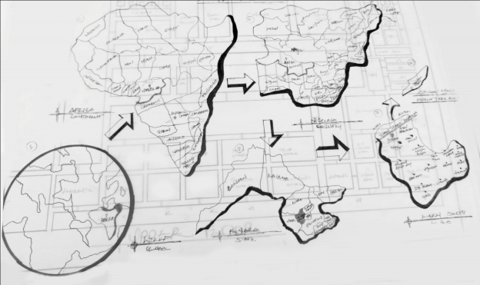

FIG 4.1: LOCATION MAP

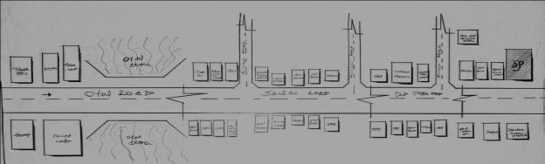
LOCATION PLAN

4.1.1.3 SITE INVENTORY/ANALYSIS
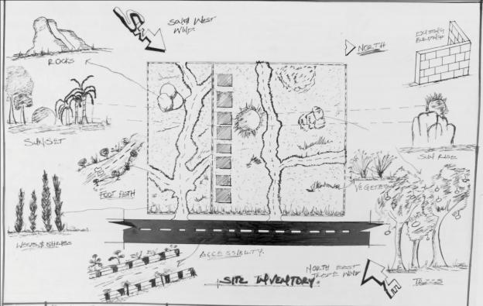
SITE INVENTORY

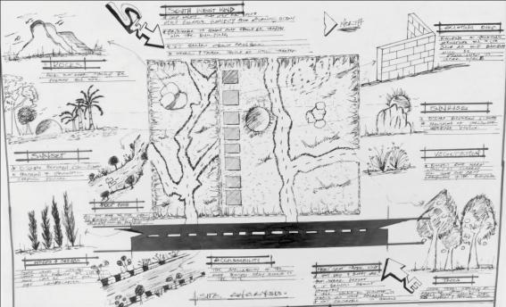
SITE ANALYSIS

4.1.1.4 GEOGRAPHICAL/CLIMATIC DATA
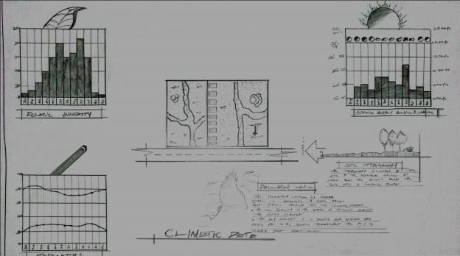
CLIMATIC DATA OF THE AREA

4.1.1.5 ANALYSES OF THE IMMEDIATE ENVIRONMENTAL CONDITIONS OF THE SITE.
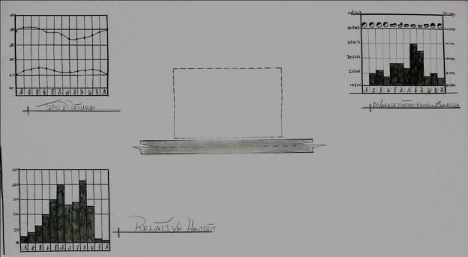

4.2 PROJECT ANALYSIS/ DESIGN CRITERIA

4.2.1 PROJECT GOALS
- Enhance Fire Safety and Response: Goal of a Federal Fire Service Cooperation could be to enhance fire safety, response capabilities, and community protection.
- Efficient Emergency Response: Aim for efficient response to fires and emergencies, minimizing damage and risk to life.
- Community Engagement and Prevention: Include goals for community engagement on fire prevention and safety.

4.2.2 FUNCTIONAL/SPATIAL CRITERIA
- Strategic Location: Location of fire stations for quick response times across areas of operation.
- Facilities for Operations: Adequate space for equipment, training, and operations for firefighting personnel.
- Accessibility and Response Routes: Consider accessibility for emergency vehicles and response routes.
- Accessibility and Flow: Layout should facilitate easy movement and access for users and equipment.

4.2.3 APPRAISAL OF PROPOSED SCHEMES IN THE SPACES, SIZE AND RELATIONSHIPS BOARDING DAY SECONDARY SCHOOL
Spaces for Operations and Training: Assess adequacy of spaces for firefighting operations, training, and equipment storage.
- Size for Efficiency: Ensure size of facilities supports efficient operations and response capabilities.
- Relationship of Spaces for Workflow: Evaluate relationships between spaces for smooth workflow in emergency response.

Equipment and Operations
- Firefighting Equipment and Vehicles: Appropriate equipment and vehicles for effective firefighting and rescue operations.
- Training and Operational Procedures: Develop procedures for operations, training for personnel on equipment use and emergency response.
- Maintenance of Equipment: Regular maintenance for reliability of equipment and vehicles.
.Performance Requirements
- Response Time and Effectiveness: Performance requirements include quick response times and effective firefighting for minimizing damage.
- Safety of Personnel and Public: Ensure performance requirements prioritize safety of firefighting personnel and the public.
- Adaptability to Emergencies: Ability to adapt to various emergency scenarios and scale of fires.
PROJECT GOAL:
The project goal of a Federal Fire Service Cooperation is to enhance fire safety, response capabilities, and community protection across areas of operation. This involves aiming for efficient response to fires and emergencies to minimize damage and risk to life. The cooperation could focus on improving infrastructure, training, and equipment for effective firefighting and rescue operations. Community engagement on fire prevention and safety could also be a significant goal, promoting awareness and preventive measures among the public. By setting clear goals for enhancing fire safety and response, the Federal Fire Service Cooperation can better serve communities and reduce risks associated with fires. Goals should align with national standards for fire safety and consider local needs and challenges for effective implementation. Overall, the project goals should prioritize safety, efficiency, and community involvement for a comprehensive approach to fire service operations.
Functional/Spatial Criteria
Functional and spatial criteria for a Federal Fire Service Cooperation involve strategic considerations for location, facilities, and accessibility. Location of fire stations is crucial for quick response times across areas of operation, ensuring that emergency vehicles can reach incidents promptly. Facilities should provide adequate space for equipment storage, training areas for personnel, and operational spaces for efficient management of firefighting activities. Accessibility for emergency vehicles and consideration of response routes are vital for effective emergency response. Spatial criteria also involve ensuring that facilities meet operational needs for firefighting personnel, including spaces for equipment maintenance and storage. By considering functional and spatial criteria, the Federal Fire Service Cooperation can optimize operations for better response and safety outcomes.
Appraisal of Proposed Scheme in Spaces, Size, and Relationship
Appraising the proposed scheme for a Federal Fire Service Cooperation involves evaluating spaces, size, and relationships between areas for functionality and efficiency. Spaces should be adequate for operations, training, and storage of equipment necessary for firefighting. The size of facilities should support efficient operations and allow for effective use of equipment and personnel. Relationships between spaces, such as proximity of equipment storage to response vehicles, are important for smooth workflow during emergencies. The appraisal should ensure the scheme aligns with project goals of enhancing fire safety and response capabilities. Considering the layout and relationships of spaces helps in optimizing operations for emergency response and daily activities of firefighting personnel.
Equipment and Operations
Equipment and operations for a Federal Fire Service Cooperation are critical for effective firefighting and rescue. Appropriate firefighting equipment and vehicles are necessary for responding to various types of fires and emergencies. Operations should include well- developed procedures for emergency response, training for personnel on equipment use, and strategies for minimizing risks during operations. Maintenance of equipment is essential for reliability and effectiveness in emergencies. By focusing on equipment and operations, the Federal Fire Service Cooperation can enhance its capability to respond to fires efficiently and safely. Training and operational procedures should align with best practices in firefighting and consider local challenges and needs.

Performance Requirements
Performance requirements for a Federal Fire Service Cooperation include achieving quick response times, effective firefighting, and ensuring safety of personnel and the public.
Response time is critical in minimizing damage and risk to life during fires. Effectiveness in firefighting operations involves using appropriate equipment and strategies for different types of emergencies. Safety of firefighting personnel and the public is a paramount consideration in performance requirements. The cooperation should also be adaptable to various emergency scenarios and scales of fires for comprehensive response capabilities. By setting clear performance requirements, the Federal Fire Service Cooperation can measure effectiveness and strive for continuous improvement in fire safety and response.

Performance Requirements
- Sound Quality: High-quality sound capture and playback for professional results.
- User Experience: Comfortable and efficient use of space for musicians, producers, and engineers.
- Reliability and Maintenance: Equipment reliability and regular maintenance for consistent performance.

Considerations for Implementation
- Local Context: Tailoring the studio to fit the cultural and musical context of Ifelodun LGA.
-*Budget and Resources: Balancing project goals with available budget and resources for equipment, space, and operations.

FUNCTIONAL RELATIONSHIP
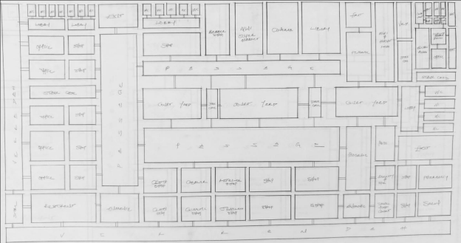
GROUND FLOOR
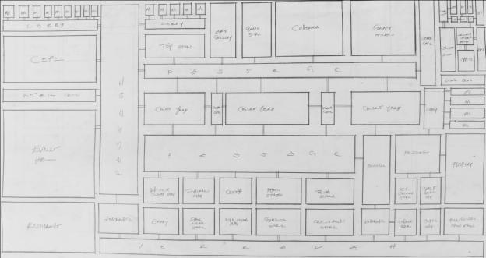

UPPER FLOOR

CHAPTER FIVE

5.1 APPROACH TO THE DESIGN/DESIGN REALIZATION

5.1.1 THE DESIGN IDEAS/CONCEPTS AT DIFFERENT LEVELS OF THE DESIGN PROCESS (SITE /BUILDING) SITE LEVEL
1. Contextual Integration: Incorporating the local culture, history, and urban context into the design to create a unique sense of place that resonates with the community.
2. Pedestrian Accessibility: Designing the site to ensure easy pedestrian access, connectivity to public transportation, and seamless integration with the surrounding urban fabric.
3. Green Spaces: Integrating courtyards into the site to provide areas for relaxation, social interaction, and community engagement.
4. Sustainability: Implementing sustainable site planning strategies such as rainwater harvesting, green infrastructure, and energy-efficient landscaping to minimize environmental impact.

BUILDING LEVEL
1. Flexible Layouts: Designing adaptable floor plans that can accommodate diverse retail concepts, pop-up shops, and temporary installations to create a dynamic and ever-changing environment.
2. Atriums and Skylights: Incorporate atriums and skylights to introduce natural light into the arcade, creating a visually engaging and inviting interior environment.
3. Mixed-Use Spaces: Integrating complementary uses such as restaurants, entertainment venues, or cultural facilities to create a multifaceted destination that offers more than just retail experiences.
4. Technology Integration: Incorporating digital displays, interactive kiosks, and smart wayfinding systems to enhance the shopping experience and provide valuable information to visitors.
5. Material Selection: Using a mix of high-quality materials, textures, and finishes to create a visually appealing and tactile environment that reflects the desired brand image and ambiance.
6. Sustainability Features: Implementing sustainable building design strategies such as energy-efficient HVAC systems, natural ventilation, and green building materials to reduce the environmental footprint of the arcade.

5.1.2 TECHNOLOGICAL AND ENVIRONMENTAL CRITERIA TECHNOLOGYICAL CRITERIA
Include smart building systems, digital signage, Wi-Fi connectivity, security, and e-commerce integration.
ENVIRONMENTAL CRITERIA
Involve energy efficiency, sustainable materials, natural ventilation, daylighting, water conservation, green infrastructure, and waste management.

5.1.3.1 CONSTRUCTION METHODOLOGY AND MATERIAL/FINISHES DESIRED BY THE CLIENTS
CONSTRUCTION METHODOLOGY
1. Prefabrication and modular construction techniques to minimize on-site construction time and disruption.
2. Use of sustainable construction practices such as minimizing waste, recycling materials, and utilizing renewable energy sources during construction.
3. Incorporation of smart building systems for efficient management of construction processes and resources.
MATERIALS AND FINISHES
1. Sustainable building materials such as recycled steel, reclaimed wood, and low-impact concrete.
2. Energy-efficient glazing systems for natural daylighting and insulation.
3. Green roofs or living walls to improve insulation, reduce stormwater runoff, and provide a visually appealing environment.
4. High-quality, durable finishes such as low-VOC paints, sustainable flooring materials (e.g., bamboo, cork, or recycled content carpet), and eco-friendly wall coverings.
5. Integration of digital signage and interactive displays to enhance the overall shopping experience.
ROOF
In areas experiencing tropical climate condition such as Ilorin South where there is rainfall, roof should preferably not be of light weight construction. A corrugated iron sheet should absorb as little solar energy as possible.

CEILING
Acoustic Ceiling Tiles are to be used. These are popular for their sound-absorbing properties, which can help reduce noise levels in a busy shopping arcade. They come in a variety of styles, textures, and colors, allowing for design flexibility.

WALL
The structural walls of the building are to be constructed with 225mm engine molded sand/cement hollow blocks.
Brick walls can add character and warmth to to the shopping arcade, especially in a rustic or industrial design theme. Brick walls can also provide a sense of history and authenticity to the space.
DOORS
The door type and size depends on the door location, but generally range from Sliding doors, revolving doors, metal and panels doors of sizes from 750mm, 900mm, 1200mm, 1500mm, 2100mm etc..... Some doors are purposely made swinging doors for durability, fire resistance and noise control.
WINDOWS
The windows that are to be used range from Glass, Fixed light, and casement windows etc with metal and aluminum frame.
WALKWAYS
The walkways are interlock with " foreign interlock stone" with aligned kerbs which allows for easy movement and appealing walkway for the public including people with range of disabilities within the site.

5.1.2.2 SERVICES REQUIRED: CIRCULATION, VENTILATION, LIGHTING, PLUMBING AND ELECTRICAL INSTALLATION, ACOUSTICS, WASTE DISPOSAL, FIRE PROTECTION AND EXTERNAL WORKS.
CIRCULATION
Efficient circulation spaces are crucial for any fire service. They should be planned in such a way that encourages visitors to explore the entire space without any difficulty. Walkways

should be wide enough for the expected crowd, escalators, lifts, and stairs must also be appropriately positioned.
VENTILATION
A well-planned HVAC system should be installed to maintain air quality and temperature, ensuring that customers are comfortable.

LIGHTING
Ambient and accent lighting is critical to create an inviting atmosphere. Natural light should be utilized wherever possible, and synthetic lighting should supplement it, especially in areas that do not receive adequate daylight.
PLUMBING AND ELECTRICAL INSTALLATIONS
Restrooms should be strategically placed and well-maintained. Water drinking points can also provide relief to customers. Electrical installations, such as outlets for shops, lighting, and HVAC, should be planned early in the design process.
ACOUSTICS
Shopping arcades can become quite noisy, so acoustic treatment is necessary. Strategic placement of noise-absorbing materials can help create a more comfortable environment.
WASTE DISPOSAL
A centralized waste disposal area should be planned, and shops should be educated about waste segregation. It's important to have recycling bins in well-seen places to promote sustainable habits among shoppers.
FIRE PROTECTION
A comprehensive fire protection system should include smoke detectors, fire alarms, extinguishing systems, and clear signage to guide people towards exits during an emergency.

EXTERNAL WORKS
Adequate parking is a must, with clear signage to guide visitors. Landscaping should be appealing and benches can be placed strategically for people needing a break.

5.1.3.3 ENVIRONMENTAL CONDITIONS TO BE ACHIEVED
1. Natural Light: Maximizing the use of natural light can improve the ambiance, save energy, and increase customer satisfaction. Skylights or large, strategically placed windows can be used to achieve this.
2. Air Quality: Indoor environments should be comfortable, clean, and have good air circulation. This can be achieved with efficient ventilation and air conditioning systems.
3. Temperature Control: Proper insulation and HVAC systems are needed to maintain a comfortable temperature throughout the year. Designs should also consider local climate and weather patterns.
4. Noise Control: With lots of people and activities, shopping arcades can get very noisy. The architectural design should use noise-barrier materials and techniques to maintain a pleasant on-site sound environment.
5. Green Spaces: Including indoor plants and green spaces not only enhances aesthetics but also improves air quality and contributes to a sense of well-being.
6. Sustainable Materials: Use of locally sourced, sustainable construction materials reduces the building's carbon footprint and supports local businesses.
7.Energy Efficiency: Design elements should prioritize energy efficiency - this could involve energy-saving lighting systems, efficient HVAC systems, and possibly renewable energy sources (like solar panels).
8. Water Management: Provision for rainwater harvesting and the use of water-efficient systems can help reduce the arcade's water footprint.
9. Waste Management: Adequate facilities for the segregation and collection of waste, including recyclable waste can promote sustainable practices.

5.1.2.4 PERFORMANCE STANDARDS
1. Natural Light and Temperature Control: The design should ensure good indoor climate, using natural light and efficient heating/cooling systems for comfort.
2. Air Quality, Noise Control, and Safety: The design should include efficient ventilation and noise barrier materials, while adhering to safety standards.
3. Sustainable Use of Resources: Using sustainable, locally-sourced materials, and incorporating energy/water-efficient systems are essential.
4. Green Spaces and Waste Management: Including green spaces can enhance aesthetics and air quality, and a comprehensive waste management strategy is crucial.
5. Performance Standards: compliance with safety and accessibility codes, set measures for building efficiency, air quality, lighting, thermal comfort, acoustics, waste management, and sustainability certifications. Visitor satisfaction is also a key indicator of performance.

5.1.3 LEGAL ISSUES AND PLANNING REGULATIONS
1. Planning Permissions: The Kwara State Town Planning and Development Authority (KTPDA) oversees physical development and planning permissions in the state. You'd have to submit your building plans and receive approval before you could start construction.
2. Zoning Laws: The project site must align with Ilorin's zoning policies. Certain zones may be designated specifically for commercial use and you'll want to make sure your shopping arcade fits into the approved zone.
3. Building Codes: Nigeria has a National Building Code that all buildings must adhere to. These codes ensure safety, health, and welfare in both public and private buildings.
4. Environmental Laws: This includes legislation like the National Environmental Standards Regulatory and Enforcement Agency (NESREA) Act, which addresses environmental impact assessments and potential pollution from construction and operation.
5. Land Use Act: In Nigeria, this act controls land ownership and property rights. You need to ensure that you have the legal right to develop the property.
6. Public Health Laws: You will need to abide by public health laws, especially in the design of food and beverage outlets within the arcade.
7. Physical Planning and Development Regulations: These control aesthetic appearances, space optimization, and functionality of the design.
8. Nigerian Urban and Regional Planning Law: Oversees the planning, development, and management of urban and regional areas to ensure sustainable, orderly, and coordinated environments.

5.1.4 BEHAVIORAL PATTERN: Observing where and when shoppers move can provide great insight. High foot traffic areas can be beneficial for merchandising and promoting popular items.
PURCHASING BEHAVIOR
Understanding what persuades customers to make a purchase can help optimize the shopping experience. This might involve assessing the influence of in-store promotions, product placements, or even the structure of the shopping arcade itself.
DWELL TIME
Examining how much time shoppers spend in different parts of the arcade can yield valuable information. Increased dwell time often translates to increased purchases.

VISITOR FREQUENCY
Identifying how often shoppers visit, and which hours/days they prefer, can help optimize staff scheduling, stock management, and promotional activities.

5.2 SUMMARY, RECOMMENDATION AND CONCLUSION

5.2.1 SUMMARY
The proposal for a fire station in KABBA LGA, kogi state State, focuses on promoting local music and arts, fostering community engagement, and supporting local talent development. The studio aims to contribute to the cultural richness of kaba LGA by serving as a hub for musicians, artists, and music enthusiasts. Key considerations include functional and spatial criteria for the studio's design, equipment and operations for music production, and performance requirements for sound quality and user experience. The project aligns with the cultural context of Ifelodun LGA, considering local music practices and needs. Overall, the music studio project inkabba seeks to enhance community engagement, promote local music genres, and provide opportunities for local talent to emerge.

5.2.2 RECOMMENDATION
(FIRE SERVICE)
Recommendations for Fire Service Cooperation
Fire service cooperation is crucial for effective emergency response, fire prevention, and community safety. Based on the mandate of the Federal Fire Service in Nigeria, here are some recommendations for enhancing fire service cooperation in sentences of not less than 200 words:
The Federal Fire Service in Nigeria plays a vital role in preventing and fighting fires in federal establishments and institutions. Enhancing fire service cooperation involves
improving collaboration between federal, state, and private fire services for more effective emergency response and fire prevention. The Federal Fire Service should prioritize training and capacity building for personnel through institutions like the National Fire Academy to improve their skills in firefighting, rescue operations, and emergency management.
Cooperation between fire services can help enhance emergency response times, which is critical in minimizing damage and risk to life during fires. Initiatives like those from the Office of the Vice President to improve response times within the Federal Fire Service highlight the importance of cooperation and efficiency in fire service operations.

Promoting fire safety awareness through public education is another key aspect of fire service cooperation. By educating the public on fire prevention and safety measures, the risk of fires can be reduced, contributing to overall community safety. Ensuring standardization of fire and rescue equipment, as mandated for the Federal Fire Service, can improve cooperation and effectiveness among different fire services. Fostering inter-agency collaboration is essential for effective fire service cooperation and emergency response, allowing for better coordination and resource sharing among fire services. Overall, effective fire service cooperation in Nigeria can lead to improved emergency response, reduced fire risks, and enhanced community safety.

Key Considerations for Effective Cooperation
Effective fire service cooperation requires regulatory compliance, community engagement, and resource sharing and coordination among fire services. Adherence to regulations and standards for fire safety is crucial for effective cooperation and emergency response.
Engaging with communities on fire prevention and safety enhances overall fire service effectiveness. Cooperation can facilitate resource sharing and coordination among fire services for better emergency response and management of fire incidents.
OPTIMIZE PLACEMENT
Use data from foot traffic and consumer surveys to optimally position shops. Placing higher- end stores near the entrance can attract eye traffic, while having anchor stores or popular food spots in the heart of the arcade can retain customers for longer.
ENHANCE EXPERIENAC ADEMICCE
Focus also extends to qualitative aspects like cleanliness, accessible facilities, and well- maintained interior decor. These aspects contribute to a more pleasant shopping environment, which can indirectly promote spending and repeat visits.

EVENTS AND ACTIVITIES
Hosting regular community events, performances, or thematic decorations around holiday seasons will provide a dynamic and lively atmosphere. This not only boosts foot traffic but also elevates the arcade's social image.
IMPROVE PARKING FACILITIES
Ensure sufficient and easy-to-navigate parking space. Consider providing incentives or discounted parking fees for shoppers who make larger purchases.
RETAIL STAFF TRAINING
Regularly train retail staff in customer service and product knowledge. A helpful and friendly interaction with shoppers can significantly enhance customer satisfaction and promote loyalty.

CONTINUOUS REVIEW AND ANALYSIS
Employ a continuous system for feedback, review, and modification of strategies. Regularly collect customer feedback and monitor emerging shopping trends to stay updated and competitive.

5.2.3 CONCLUSION
In conclusion, effective fire service cooperation is essential for enhancing emergency response, fire prevention, and community safety in Nigeria. The Federal Fire Service plays a critical role in preventing and fighting fires in federal establishments and institutions. By fostering cooperation between federal, state, and private fire services, emergency response times can be improved, and overall fire safety can be enhanced. Training and capacity building for fire service personnel are crucial for effective firefighting, rescue operations, and emergency management. Public education on fire safety and prevention is also a key aspect of reducing fire risks and promoting community safety.
The importance of standardization of fire and rescue equipment cannot be overstated, as it improves cooperation and effectiveness among different fire services. Inter-agency
collaboration is vital for effective fire service cooperation, allowing for better coordination and resource sharing among fire services. By prioritizing fire service cooperation, Nigeria can improve its response to fires and emergencies, ultimately reducing risks to life and property. Effective cooperation requires regulatory compliance, community engagement, and resource sharing and coordination among fire services.
In Nigeria, the context of fire service operations and the mandate of the Federal Fire Service highlight the need for structured cooperation and coordination. Enhancing fire service cooperation involves addressing challenges such as training, equipment standardization, and public awareness. With effective cooperation, fire services can better meet the needs of communities, reduce the impact of fires, and enhance overall safety. The benefits of fire service cooperation include improved emergency response, reduced fire risks, and enhanced community safety. Overall, fostering a culture of cooperation among fire services in Nigeria is critical for achieving these benefits and ensuring effective fire safety and emergency
response.
Final Considerations
As fire service cooperation is essential for effective emergency response and fire safety, continued efforts to enhance cooperation among fire services in Nigeria are necessary. This includes investing in training, promoting standardization, and engaging communities on fire safety. By doing so, Nigeria can improve its fire service capabilities and enhance safety for communities across the country. The conclusion emphasizes the importance of fire service cooperation for achieving effective emergency response and fire safety in Nigeria.

REFERENCES
Ademolu Ibem and Gbemisola Amole, “Evaluation of public housing programmes in Nigeria”(2021)
Amamata, Z. A. Safiya, O. &Bala, B. (2015): Integrating Factors of Housing Affordability in as a Scheme in Governmental Policies. Accessed Online.
Arigbola, A. (2011). Housing Affordability as a Factor in the creation of Sustainable Environment in Developing World: The Example of Akure, Nigeria. Journal of Human Ecology, 35(2), pp: 121-131.
Australian Housing and Research Institute (AHURI) (2011). Measuring Housing Affordability. AHURI Research and Policy Bulleting, Issue 45.
Nepal, B., Tanton, R. & Harding, A. (2010). Measuring Housing Stress: How Much Do Definitions Matter? Urban Policy and Research, 28(2), pp: 211-224.
Harri, C. M. (2012): Dictionary of Architecture and Construction. Pub MC Graw Hill. Book Company.
Salvato, A. J. (2017). Environmental Engineering and Sanitation. Third Edition. John Willey and Sons Inc.
Rogers, E. K. (2023). The Modern House: Its Design and Decoration. Harper and Row Pub.
Memullan, R. (2025): Environmental Science in Building Macmillan. Pub First Edition.
Lyneh, K. and Hak, G. (2017): Site Planning. Pub Map Press Cambridge Massachusetts and London, England.
Awotona, A. (2020). Housing Policy Nigeria; Government Policies for housing Nigeria Urban poor and working class, Laudable Great Expectation Colosal Failure Habitat International.
Burrudge, R. AN Ormandy, D. (2019). Unhealthy Housing Research, Remedies and Reforms, First Edition.
Ramsey and Sleeper (2025): Architectural Graphics Standards, Tenth Edition, John Willey and Sons Inc.

APPENDICES

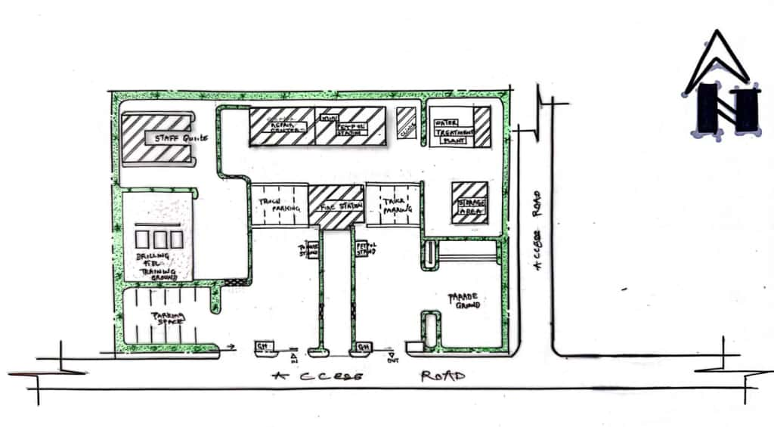

Appendix 5.1: Site Plan
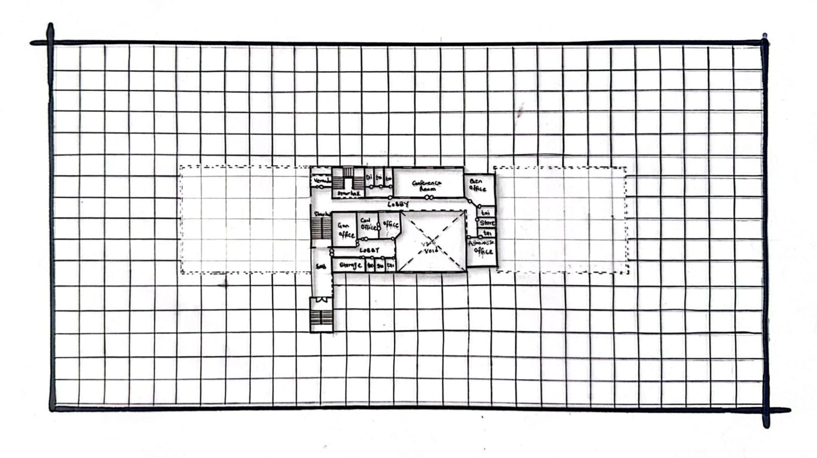

Appendix 5.2: Upper Floor Plan

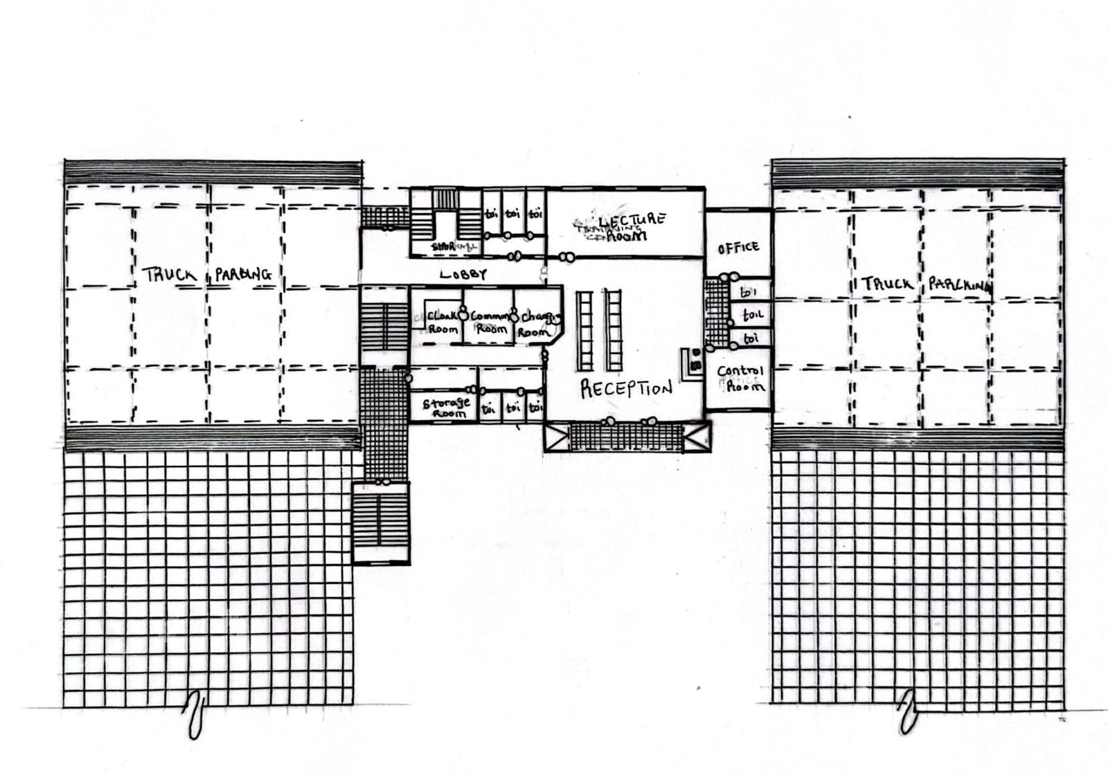

Appendix 5.3: Ground Floor Plan

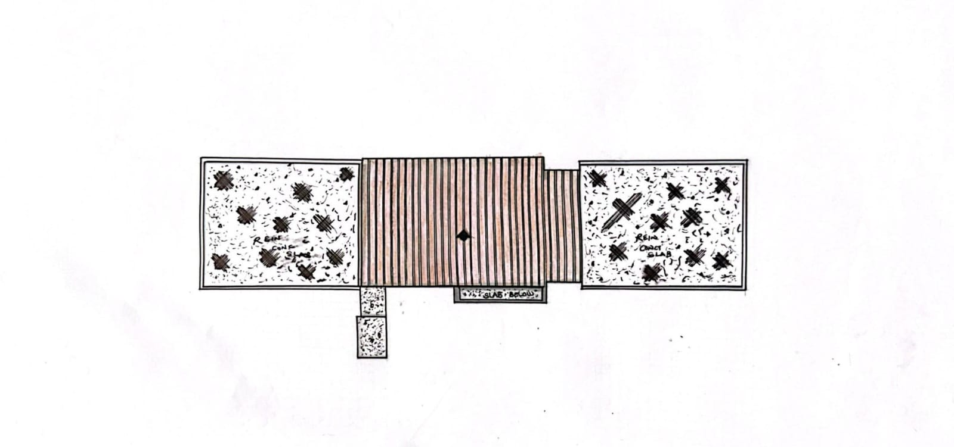

Appendix 5.4: Roof Plan

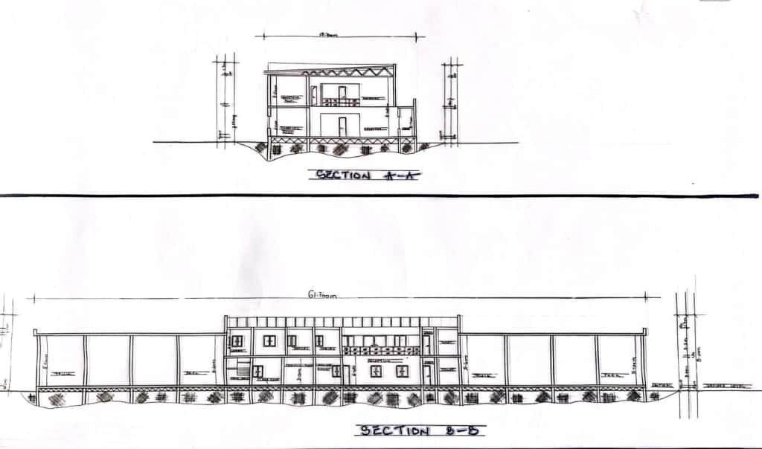

Appendix 5.5: Sections
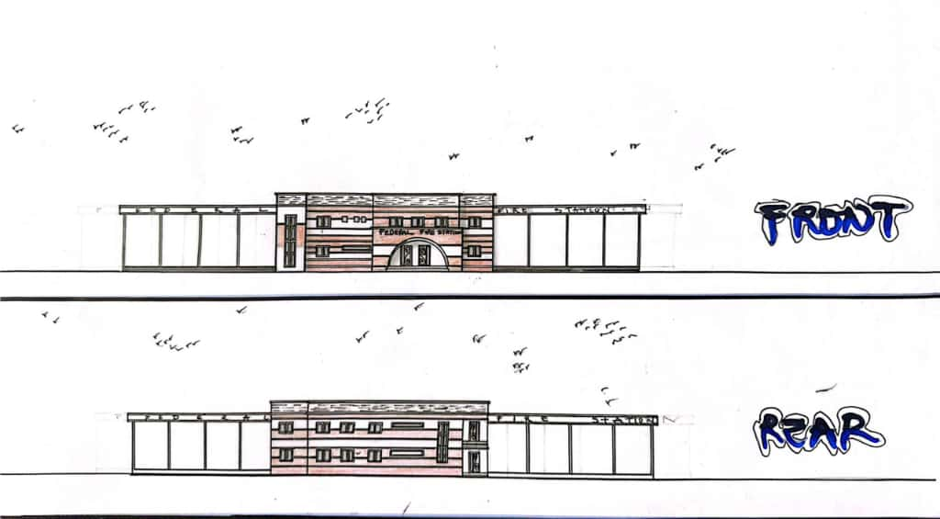

Appendix 5.5: Front and Back View

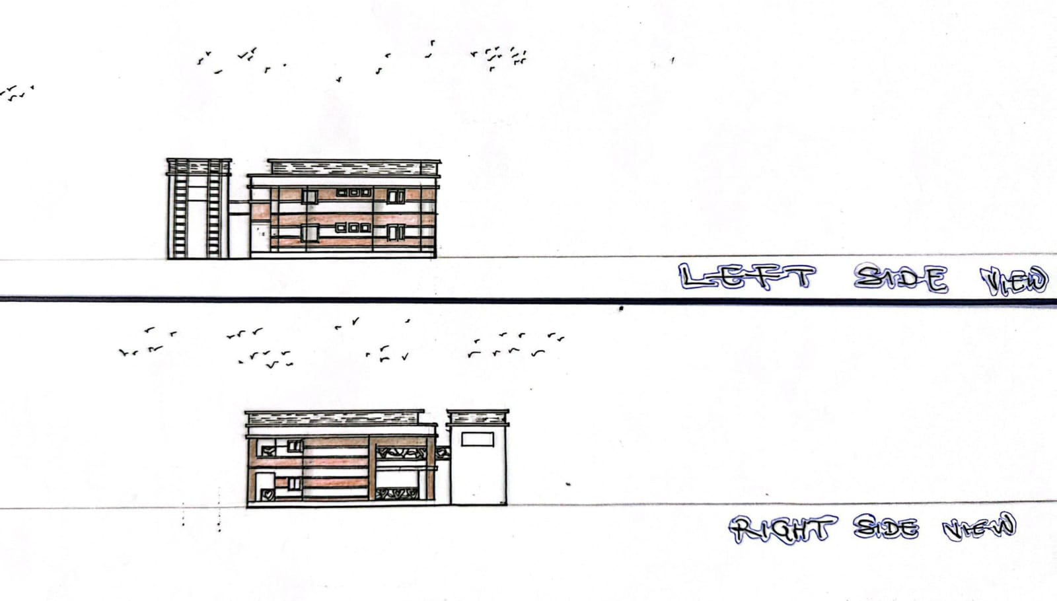

Appendix 5.6: Sides View
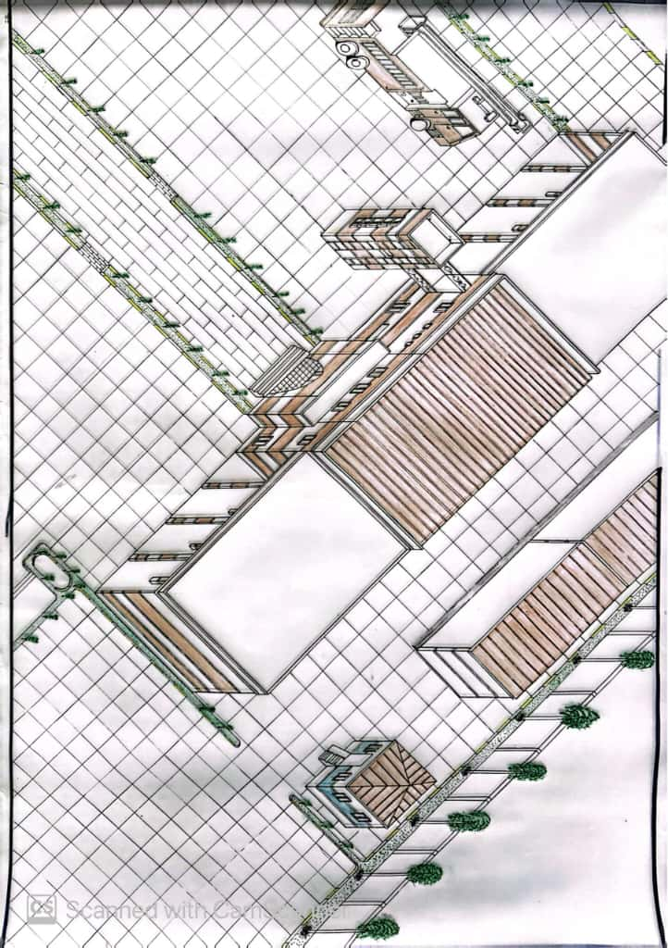

Appendix 5.7: Perspective

