A PROJECT REPORT

ON

POULTRY

AT

ASA L.G.A EIYEKORIN PASA KWARA STATE

BY

ABDULRASAQ ABDULRAFIU OYEDOKUN
ND/23/ARC/PT/OOO7

BEING A PROJECT REPORT SUBMITTED TO
THE DEPARTMENT OF ARCHITECTURAL TECHNOLOGY, INSTITUTE OF ENVIRONMENTAL STUDIES,
KWARA STATE POLYTECHIN, ILORIN.

IN PARTIAL FULFILLMENT OF THE REQUIREMENT FOR
THE AWARD OF NATIONAL DIPLOMA(ND)
IN ARCHITECTURAL TECHNOLOGY.

JULY, 2025

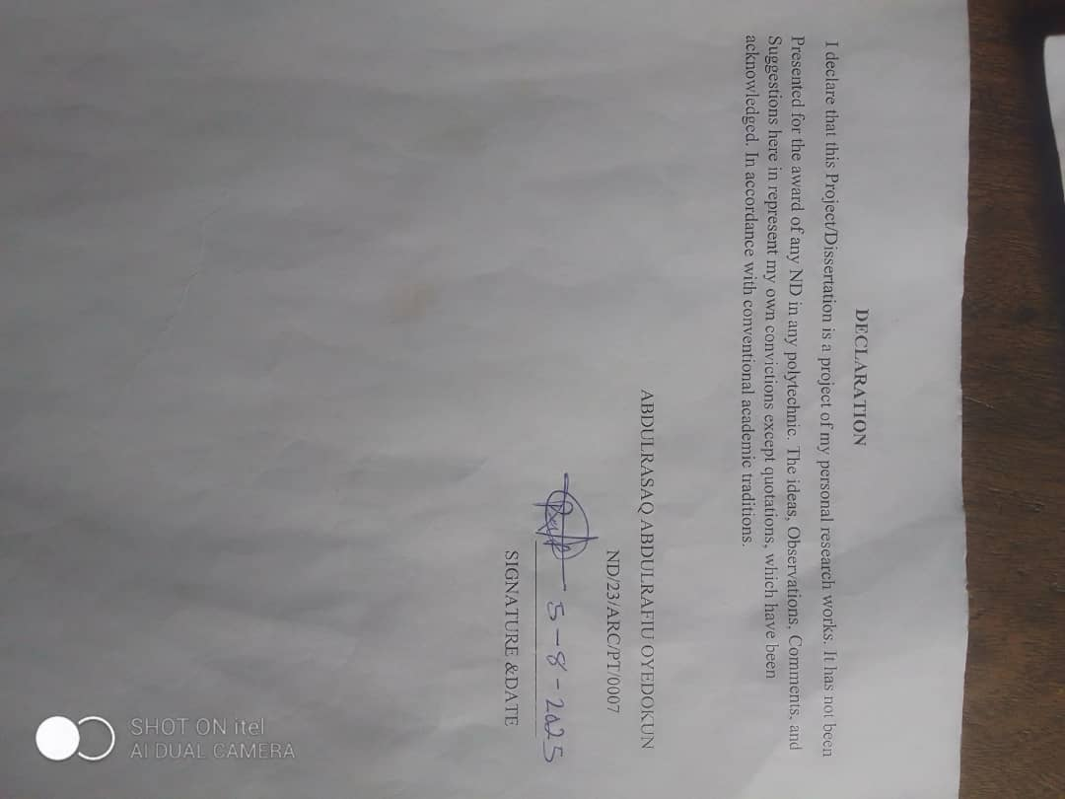

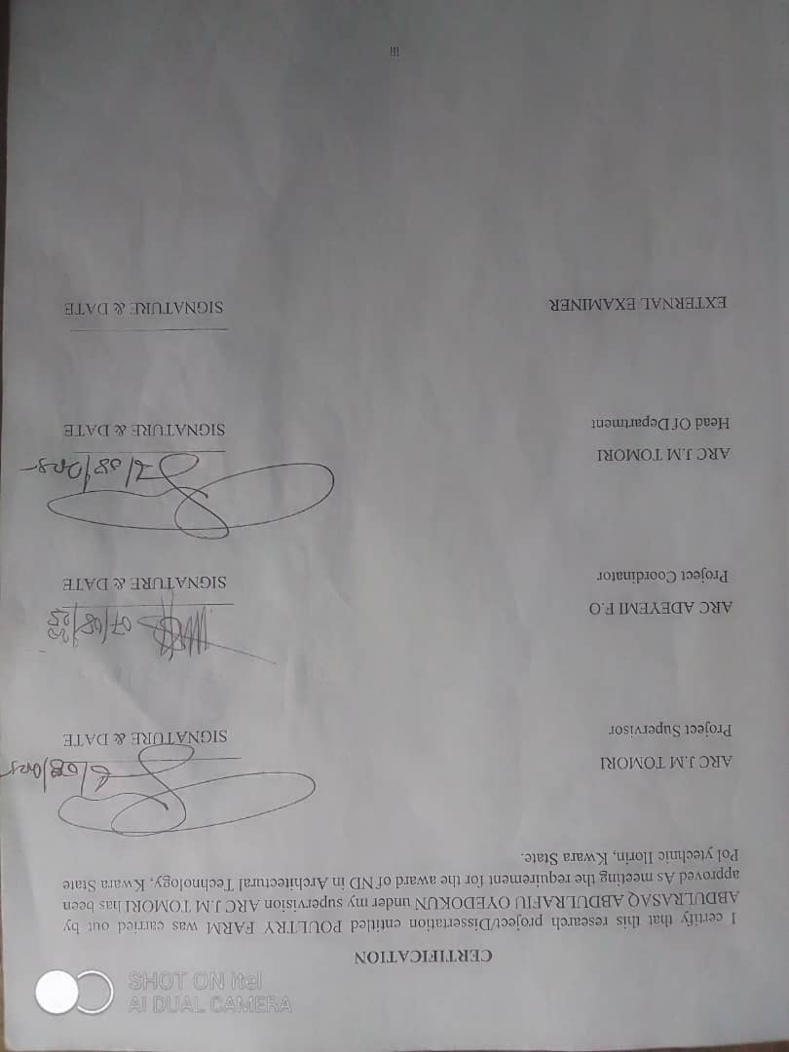
DEDICATION
This project work is dedicated to Almighty God who has been providing all my need for his blessing and mercy over me all through the program.
And to my parent, my sisters, my brothers, friends, love one’s and supervisor who assist me financially, spiritually, mentally and guide me through my academic pursuit. May Almighty God shower his blessing and mercy over you all.

ACKNOWLEDGEMENT
My profound gratitude goes to Almighty God, the creator of universe and fountain of all wisdom whose umbrella of guard and guide. I seek refuge through thick and thin of years of study.
I will also like to appreciate my project supervisor in person of Arc J.M TOMORI, Arc Adeyemi F.O, Arc Solomon and others whose contribution Prepares me for the challenges in the field and for her immense contribution is all ramification towards the completion of this research work. She encourage me and open the door of interaction with her. I pray Almighty God will shower his blessing and mercy over her, your family and may you live to reap the fruit of your Labor.
I also want to thank and appreciate the effort of all the Lectures in Architectural Technology Department, who taught and give lasting advice’s that led to the success of my program, Almighty God will meet everyone at the point of needs.
I would also show my profound gratitude to my parents MR and MRS ABDULRASAQ for their Immeasurable motivation, advices, efforts, and prayers on me for the completion of this program.
My Lovely Brother: ADAM and my lovely sister miss AYOMIDE Almighty God shower his endless blessing, mercy, unlimited grace, joy, happiness without sorrow, sound health overall and may Almighty God meet everyone at the point of your needs.
Precious friends: My lovely friends Adijat, AdelekeToyin, Ayomiposi, Abidoun, Idowu, Faith, Emma. Almighty God shower his blessing, grace, and happiness with sound health over you all and our prayer (AMEEN).
Lastly ,I would like to appreciate the effort of my colleagues in department, school, and hostel, I whole heartedly say a VERY BIG THANK YOU, I appreciate you all, May Almighty God bless you all.
Above all, My utmost thanks go to the all sufficient God, the fountain of my wisdom, for his great and protection over my life, for his undying love, support and guidance throughout my period of learning and also for in sighting writing this project without him am nothing.

TABLEOFCONTENT
Title page i
Declaration ii
Certification iii
Dedication iv
Acknowledgement v
Abstract vi
Table of Contents vii
List of Tables viii
List of Figures ix
List of Plates x
List of Appendix xv
CHAPTER ONE
10. Introduction 1
  - Definition 1
1.2 Historical Background 3
1.3 Aim and Objectives of the Project 3
1.4 Objectives 4
1.5 Project Justification 4
  - Client background 5
1.7 Scope Of The Project 5
1.8 Research Methodology 6
CHAPTER TWO
2.0 Literature Review 8
2.1 Historical Background of A Poultry Farm 8
CHAPTER THREE
3.1 Case Studies 12
3.2 Selected Case Studies 12
  - Case Study One 13
CHAPTER FOUR
4.0 Project Location 17
4.1 Brief historical background of kwara state 17
4.2 Location And Setting Of Kwara State 18
4.3 Population 19
4.4 Site Inventory 19
4.5 Site Analysis 20
4.6 General Climatic Condition 20
4.7 Social Services 22
4.8 Design Criteria 22
4.9 Design Brief 23
4.10 Design Analysis 23

CHAPTER FIVE
5.0 General Requirements 27
5.1 Appraisal of Proposed Scheme 27
5.2 Construction Methodology And Material 28
5.3 Service 28
5.4 Ventilation 29
5.5 Summary 29
5.6 Conclusion 30
5.7 Recommendation 30
References 32
Appendix 34

LIST OF FIGURE
Fig 3.1: Showing location plan of case study one 25
Fig 3.2: Showing floor plan of case study one 25
Fig3.3: Showing Location Plan of case Study Two 26
Fig 3.5: Showing The Site Plan Of Case Study Three 26
Fig 4.1; Showing Location Of The Propose Site 32
Fig 4.2: Showing site inventory of the proposed site 34

LIST OF PLATES
Plate 3.1: Showing front view of case study one 33
Plate 3.2: Showing the views of case study two 33
Plate 3.3: Showing the View of Case Study Three 34

LIST OF TABLE
TABLE 4.1; SHOWING GENDER GROUP 39

ABSTRACT
This researcher work was carried out on the project topic "poultry farm for Ilorin, Kwara state ". I felt caring out this project in Eyenkorin local government will bring out meaningful result. For easy analysis and understanding, the study is being put into five chapters. Chapter one throws light on general introduction, definition of the project, historical background information of the project title, project justification, aim and objectives of the study, scope of the study, Chapter two, a detailed literature review of some books, case studies and deduction from case studies. The third chapter three also mention about the historical background of the study area, site location and description, site analysis, and geographical location, climatic data, population of the area, social services, and health services. The fourth chapter deals with design criteria, design analysis, space allocation and planning principle. Chapter five deals with design appraisal, construction methodology, services, summary, conclusion and references.

CHAPTER ONE
- INTRODUCTION
Poultry farm involves the domestication and raising of birds, primarily chickens, ducks, turkeys, and geese for the production of meat, eggs and feathers. It plays a vital role in providing animal protein in many parts of the world. Poultry can be categorized into layers (for egg production) and boilers (for meat production).
Poultry refers to domesticated birds raised for their meat, eggs, and feathers. The term "poultry" encompasses various species, but the most common ones are chickens, turkeys, ducks, geese, and guinea fowl. These birds are an integral part of human agriculture due to their high reproductive rates, low maintenance costs, and the versatility of the products they provide.
Poultry farming has a long history, dating back thousands of years, and has evolved significantly to meet the growing demand for affordable protein sources. The industry plays a vital role in global food security, as poultry products, particularly chicken and eggs, are among the most widely consumed animal proteins worldwide.
Poultry farming can be done on a small scale (such as in backyard settings) or on a large commercial scale. Advances in breeding, nutrition, and disease control have enabled the poultry industry to thrive, contributing to economic growth in many regions. Additionally, poultry farming has become more industrialized, with automated systems for feeding, egg collection, and meat processing, ensuring a steady and efficient supply of products to consumers.
In addition to its economic importance, poultry farming is also a significant source of employment for millions of people globally. However, the industry also faces challenges such as disease outbreaks (e.g., avian influenza), concerns over animal welfare, and the environmental impact of large-scale operations. Despite these challenges, the poultry sector remains a cornerstone of modern agriculture.
1.1 Definition
Architecturally, poultry refers not just to the birds themselves but to the design requirements, planning, and construction of facilities that support their breeding, feeding, shelter, egg-laying, and waste management.
1.2 Historical Background
Poultry, particularly chickens, were among the first animals to be domesticated by humans. The domestication of the Red Junglefowl, believed to be the ancestor of modern chickens, began around 3,000–4,000 BC in regions of Southeast Asia. Early societies such as those in India, China, and Egypt kept chickens for meat, eggs, religious rituals, and even for sport (cockfighting).
The architectural needs in these times were minimal, with birds kept in open courtyards or simple woven cages, utilizing natural materials like mud, reeds, and palm leaves to create enclosures.
The Egyptians and Romans advanced poultry keeping. In ancient Egypt, archaeological evidence shows that poultry were incubated using heated brick chambers—an early form of environmental control. The Romans designed small wooden or stone poultry coops attached to their villas or farms.
A dual-purpose chicken is a type of chicken that may be used in the production of both eggs and meat. In the past, many chicken breeds were selected for both functions. However, since the advent of laying and meat hybrids, industrial chicken breeding has made a sharp distinction between chickens with either function, so that certain characteristics have been promoted to an extreme degree. Partly due to the discussion about male offspring of laying hens that are not economically viable and are usually gassed or ground alive as day-old chicks, a discussion is currently underway as to whether dual-purpose chickens have a future role on a large or smaller scale.
Historically, the distinction between egg and meat production did not exist. It only appeared with the development of industrial farming and the breeder's specialization (including day-old chicks). Modern laying breeds have become unable to provide enough meat to satisfy consumers accustomed to breeds selected for fattening, which are poor layers and brooders.

1.3 Aim and Objectives of the Project
AIM
To design a functional, sustainable, and hygienic poultry farm structure that enhances poultry production while ensuring animal welfare, environmental safety, and architectural efficiency.
1.4 Objectives
- To study the spatial and functional requirements of a standard poultry farm including hatcheries, brooding, feeding, egg collection, and waste disposal zones.
- To develop an architectural design that promotes natural ventilation, lighting, and temperature control suitable for poultry health and productivity.
- To incorporate modern technologies such as smart monitoring systems, solar energy, and automated feeding in the architectural layout.
- To ensure biosecurity and hygiene through proper zoning, drainage systems, and materials selection.
- To promote sustainability by integrating eco-friendly building materials and systems that reduce environmental impact.
1.5 Project Justification
A well-designed poultry facility can greatly enhance bird productivity, reduce disease outbreaks, minimize maintenance costs, and improve the working conditions for farm personnel. With increasing demand for poultry products and the growing focus on sustainable agriculture, there is a need for farm structures that incorporate modern technology, biosecurity measures, climate adaptability, and animal welfare principles.
  - Client background
The name of my client is KAYODE ALABI Kayode Alabi (born 1 August 1963) is a Nigerian politician, who is deputy governor of Kwara State. He was born in Oro-Ago, Kwara State, Nigeria into the family of late Yahaya Samuel Alabi (1925–2007) Oro-Ago in Kwara State, he is the third child of his parents. He has two elder brothers and a younger sister. Alabi's mother, who was 93 years old, passed away in the early hours of Friday, 5th April 2024. He ran on the same ticket with Governor AbdulRahman AbdulRazaq on the platform of All Progressives Congress (APC) in the 2019 General elections. Few months after he swore into office, he was appointed by Governor AbdulRahman AbdulRazaq of Kwara State as the head of COVID-19 Technical Committee in Kwara State. In the year, 1996, Alabi started private business from. He started a water bottling company in Lagos. He serves as the Chairman of Vantage Heights Nursery and Primary School and Chairman of Little Tots School, both in Lagos. Besides, he also served as the chief executive officer of Bayview Oil and Gas Limited and the chief executive officer of Hot Wings Foods and Investment Limited.

1.7 Scope of the Project
- Proposed Building
- Gate House
- Parking Lot
- Access Road
1.8 Research Methodology
Various avenues were expressed as regards the method of research on order to arrive at a functional and appealing design concepts. The following research methods were employed.
LITERATURE REVIE: Reference to tolerate for ideas of various writer were consulted in order to attain useful and important past work on similar project.
INTERNET: This is are search that was done and gained from the internet in other to get further information.
PERSONAL OBSERVATION: personal initiative coupled within quisitive measure, interview and visualize the daily activities that take place within vicinity and necessary pictures were taken in order to attain there quired motive
CASE STUDIES: This involves the thorough synthesis and analysis of similar existing structure (building) Based on the data collected and better deduction was made for realization of the best.

CHAPTER TWO
2.0 LITERATURE REVIEW
2.1 Historical Background of A Poultry Farm
Charles Darwin believed that present-day hens come from a wild species of fowl known as “Gallus Bankiva”, which originated in a broad area of Asia extending from India to the Philippines, and which was first domesticated 7,000 years ago.
Fowl are the domestic animals which appear most often in written history. In fact, there were references to them in Chinese documents as far back as 1,400 BC.
In 400 BC Aristotle wrote that the Egyptians even practiced “artificial” incubation of hens’ eggs using dung heaps. Greek writers such as Aristophanes also mention hens in 600 BC and the Romans considered them to be an animal sacred to Mars, the God of War.
The first treatise in which there is a reference to poultry farming practices is the one by Cato (200 BC) which describes the fattening of hens for meat production.
The Muslim Abu ZacariaIahia, who lived in Seville (Spain) during the twelfth century, dedicated a chapter of his "Book of Agriculture" to poultry farming.It was at the end of the 19th and the beginning of the 20th century that, thanks to advances in genetics and nutrition, poultry farming became an expanding livestock activity.Commercial hens usually begin laying eggs at 16–21 weeks of age, although production gradually declines soon after from approximately 25 weeks of age. This means that in many countries, by approximately 72 weeks of age, flocks are considered economically unviable and are slaughtered after approximately 12 months of egg production, although chickens will naturally live for 6 or more years. In some countries, hens are force moulted to re-invigorate egg-laying.
Environmental conditions are often automatically controlled in egg-laying systems. For example, the duration of the light phase is initially increased to prompt the beginning of egg-laying at 16–20 weeks of age and then mimics summer day length which stimulates the hens to continue laying eggs all year round; normally, egg production occurs only in the warmer months. Some commercial breeds of hen can produce over 300 eggs a year
Culture, religion, economics, and climate are all factors which influence a country’s perspective of animal welfare, and people from European countries are generally more concerned with animal welfare than those from Asia (Phillips et al. 2012). In Asia in general, animal welfare legislation and regulation are still under development (Murray et al. 2014) and fall behind countries regulated by the EU (Sinclair et al. 2017). There have been multiple incidents where welfare concerns between countries have affected international trade of animal products. For example, Australia implemented a temporary ban on live cattle exports to Indonesia due to recorded animal cruelty at slaughter (BBC 2011), resulting in major economic and animal losses (Phillips 2005). There are also consumer concerns within Europe that imported meat is grown to a lower standard compared to European regulations (Eurogroup for Animals n.d.Sinclair et al. 2017) suggest that to improve animal welfare in Asian countries, an approach tailored to local audiences and climate will be most effective.
Free-range poultry farming allows chickens to roam freely for a period of the day, although they are usually confined in sheds at night to protect them from predators or kept indoors if the weather is particularly bad. In the UK, the Department for Environment, Food and Rural Affairs (DEFRA) states that a free-range chicken must have day-time access to open-air runs during at least half of its life. Unlike in the United States, this definition also applies to free-range egg-laying hens, meaning they can still be confined in high stocking densities with limited outdoors access.[clarification needed] The European Union regulates marketing standards for egg farming which specifies a minimum condition for free-range eggs that "hens have continuous daytime access to open air runs, except in the case of temporary restrictions imposed by veterinary authorities". The RSPCA "Welfare standards for laying hens and pullets" indicates that the stocking rate must not exceed 1,000 birds per hectare (10 m2 per hen) of range available and a minimum area of overhead shade/shelter of 8 m2 per 1,000 hens must be provided.Free-range farming of egg-laying hens is increasing its share of the market. DEFRA figures indicate that 45% of eggs produced in the UK throughout 2010 were free range, 5% were produced in barn systems and 50% from cages. This compares with 41% being free range in 2009.
Suitable land requires adequate drainage to minimise worms and coccidialoocysts, suitable protection from prevailing winds, good ventilation, access and protection from predators. Excess heat, cold or damp can have a harmful effect on the animals and their productivity. Free range farmers have less control than farmers using cages in what food their chickens eat, which can lead to unreliable productivity, though supplementary feeding reduces this uncertainty. In some farms, the manure from free range poultry can be used to benefit crops.
The benefits of free-range poultry farming for laying hens include opportunities for natural behaviours such as pecking, scratching, foraging and exercise outdoors.
Both intensive free-range poultry and "cage-free" farming with hens still being confined in close proximity due to high stocking densities have animal welfare concerns. Cannibalism, feather pecking and vent pecking can be common, prompting some farmers to use beak trimming as a preventative measure, although reducing stocking rates would eliminate these problems. Diseases can be common and the animals are vulnerable to predators. Barn systems have been found to have the worst bird welfare. In South-East Asia, a lack of disease control in free range farming has been associated with outbreaks of avian influenza. Meat chickens, commonly called broilers, are floor-raised on litter such as wood shavings, peanut shells, and rice hulls, indoors in climate-controlled housing. Under modern farming methods, meat chickens reared indoors reach slaughter weight at 5 to 9 weeks of age, as they have been selectively bred to do so. In the first week of a broiler's life, it can grow up to 300 percent of its body size. A nine-week-old broiler averages over 9 pounds (4 kg) in body weight. At nine weeks, a hen will average around 7 pounds (3.2 kg) and a rooster will weigh around 12 pounds (5.5 kg), having a nine-pound (4 kg) average.
Broilers are not raised in cages. They are raised in large, open structures known as grow out houses. A farmer receives the birds from the hatchery at one day old. A grow out consists of 5 to 9 weeks according to how big the kill plant wants the chickens to be. These houses are equipped with mechanical systems to deliver feed and water to the birds. They have ventilation systems and heaters that function as needed. The floor of the house is covered with bedding material consisting of wood chips, rice hulls, or peanut shells. In some cases they can be grown over dry litter or compost. Because dry bedding helps maintain flock health, most growout houses have enclosed watering systems ("nipple drinkers") which reduce spillage. Keeping birds inside a house protects them from predators such as hawks and foxes. Some houses are equipped with curtain walls, which can be rolled up in good weather to admit natural light and fresh air. Most growout houses built in recent years feature "tunnel ventilation," in which a bank of fans draws fresh air through the house.Traditionally, a flock of broilers consist of about 20,000 birds in a growout house that measures 400/500 feet long and 40/50 feet wide, thus providing about eight-tenths of a square foot per bird. The Council for Agricultural Science and Technology (CAST) states that the minimum space is one-half square foot per bird. More modern houses are often larger and contain more birds, but the floor space allotment still meets the needs of the birds. The larger the bird is grown the fewer chickens are put in each house, to give the bigger bird more space per square foot. Because broilers are relatively young and have not reached sexual maturity, they exhibit very little aggressive conduct. Chicken feed consists primarily of corn and soybean meal with the addition of essential vitamins and minerals. No hormones or steroids are allowed in raising chickens.

CHAPTER THREE
3.1 CASE STUDIES
This is are search or an exercise that is carried out on existing building which is similar to the one researcher is writing on. The objective of a case study is to take a critical appraisal of existing related project with a view to identify the positive and negative aspect of such projects. It is only with time that a project can be adjusted so that it can be successful. The information obtained from the appraisal will guide the designer of new and similar project, the positive aspect of it shall be incorporated in the view proposal while attempts will be made to solve the problem of negative aspects. It is only through this that a designer can better enhance the quality and efficiency of building in the society. For a comprehensive analysis their case studies have been conducted.
3.2 Selected Case Studies
Case studies are of paramount important. It is an experimental research or analysis carried out on existing building or group of building functionally similar to the one which there search is working.
For any technical design to be meaningful there is always the need for preliminary research effort to be made on this proposal as a very necessary ground work.
The following case study of some poultry farm.

  - Case Study One

ILORINKWARASTATE
Location: EYENKORIN, OLORUNDA AREA, ILORIN, KWARASTATE OBSEVERATION
MERITS
- Availability of land for proper site zoining
- NaturalVentilationandLightingPotential
- EnvironmentalLearningOpportunity
DEMERITS
- AccessibilityChallenges
- EnvironmentalImpactConcerns
- ClimaticChallenges(Heat&Rainfall)
- InfrastructureDeficiency.

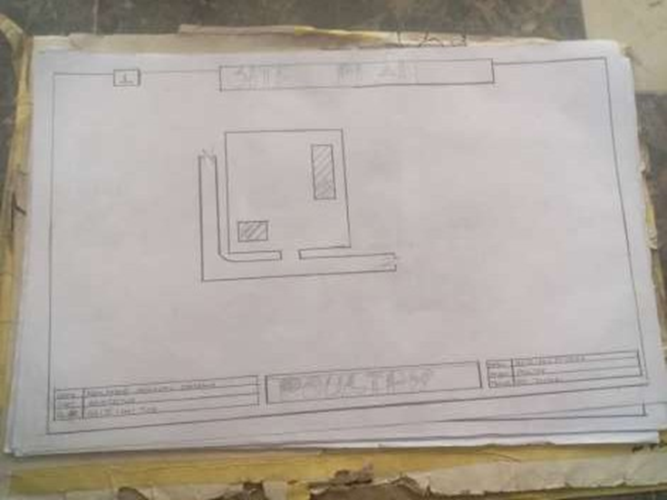
FIG3.1: SHOWINGLOCATIONPLANOFCASESTUDYONE

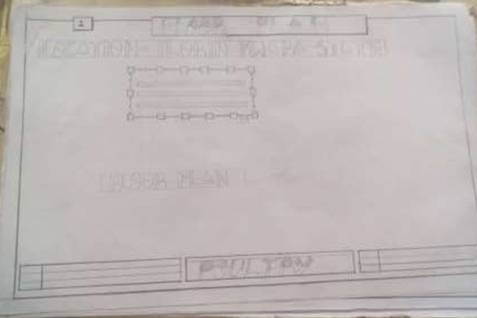
FIG 3.2: SHOWINGFLOORPLANOFCASESTUDYONE

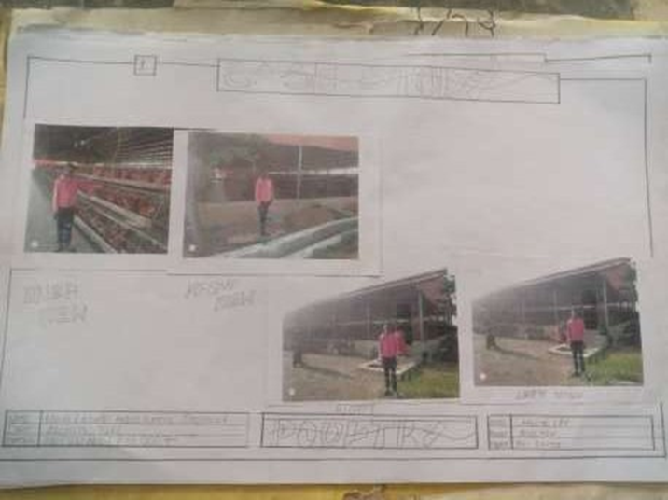

PLATE 3.1: SHOWING FRONT VIEW OF CASE STUDY ONE

3.4 CASE STUDY TWO
Location: OGBOMOSO, OYO STATE OBSERVATION
MERITS
• Spacious and Well-Organized Layout
• Good Road Network (Varies by Specific Location in Ogun)
• Moderate Topography
• Environmental Study Opportunity

DEMERIT
• Inconsistent Infrastructure (Depending on Location)
• Environmental Pollution Risks
• Climatic Factors (Rainfall & Heat)
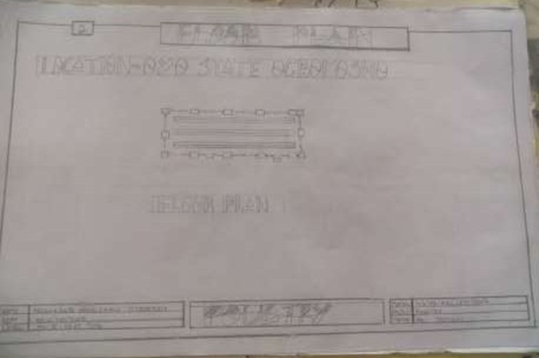

FIG 3.3: SHOWING LOCATION PLAN OFCASE STUDY TWO

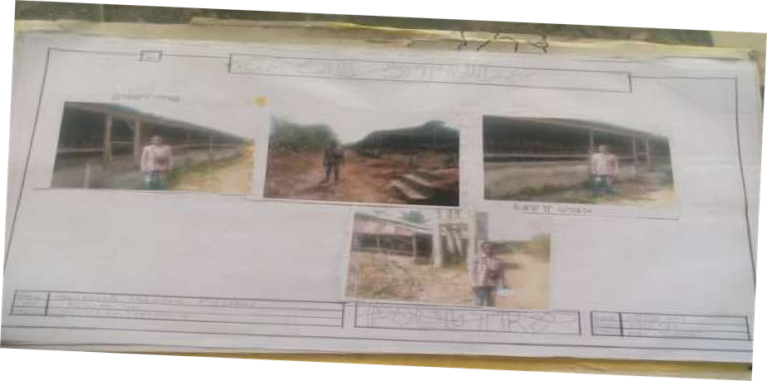
PLATE 3.2: SHOWING THE VIEWS OF CASE STUDY TWO

3.5 CASE STUDY THREE
Location: IFE OSUN OSUN SATATE
MERITS
- Spacious and Well-Organized Layout
- Environmental Learning Opportunity
DEMITS
- Not Easy To Access
- Lack Of Toilet In The Building

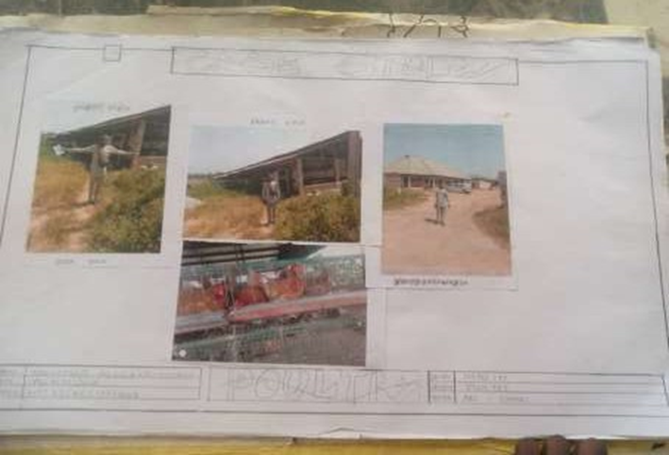
PLATE 3.3: SHOWING THE VIEW OF CASE STUDY THREE

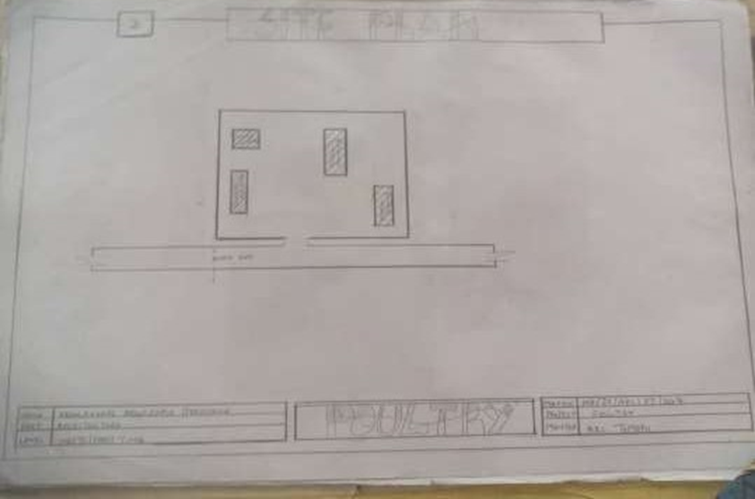
FIG 3.5: SHOWING THE SITE PLAN OF CASE STUDY THREE
3.6 ONLINE CASE STUDY
ONLINE CASE STUDY ONE
PROJECT NAME: ZHENG HOUSE
LOCATION: MOGANSHAN CHINA
ARCHITECT: FAR WORKSHOP
YEAR: 2024
AREA: 500m2

ONLINE CASE STUDY TWO
PROJECT NAME:
LOCATION: KECAMATAN CILANDAK, INDONESIA
ARCHITECT: RAD+ar (RESEARCH ARTISTIC DESIGN+ARCHITECTURE)
LEAD ARCHITECT: ANTONIUS RICHARD RUSLI, DANIEL SUSANTO
YEAR: 2024
AREA: 900m2

DEDUCTION FROM CASE STUDIES
During my visit to the poultry farm. I was opportunities to see what was obtain in the poultry farm, I made a proper studies of their related function and analysis were made to their present situation with the aim of incorporation with their merit in my own final proposal.
The following were deduce from my case study
* Critical Role of Ventilation and Orientation.
* Need for Sustainable Building Materials.
* Drainage is a Major Design Consideration.
* Importance of Proper Site Layout.
* Waste Management Requires Architectural Attention

CHAPTER FOUR
4.0 PROJECT LOCATION
4.1 BRIEF HISTORICAL BACKGROUND OF KWARA STATE
Kwara (Yoruba: Ìpínlẹ̀ Kwárà) is a state in Western Nigeria, bordered to the east by Kogi State, to the north by Niger State, and to the south by Ekiti, Osun, and Oyo states, while its western border makes up part of the international border with Benin. Its capital is the city of Ilorin and the state has 16 local government areas.
Of the 36 states of Nigeria, Kwara is the ninth largest in area but the sixth least populous with an estimated population of about 3.2 million as of 2016.Geographically, Kwara is split between the West Sudanian savanna in the east and the Guinean forest–savanna mosaic ecoregion in the rest of the state. Important geographic features include rivers with the Niger flowing along the northern border into Lake Jeba before continuing as the border while the Awun, Asa, Aluko, and Oyun rivers flow through the interior. In the far northwest of the state is the Borgu section of the Kainji National Park, a large national park that contains populations of grey heron, kob, hippopotamus, African bush elephant, olive baboon, and roan antelope, along with some of the last remaining West African lions on earth. In the far southwest, a small part of the Old Oyo National Park contains crowned eagle, martial eagle, African buffalo, oribi, and patas monkey populations.

4.1.2 Economy of Kwara State
Agriculture is the main source of the state's economy and the principal cash crops are: cotton, cocoa, coffee, kola nut, tobacco, sesame and palm produce. Kwara state is home to Shonga Farms, a product of the Back-to-Farm project of one of the past administrators of the state, Dr. AbubakarBukolaSaraki. Shonga Farms is made up of 13 commercial farmers. Mineral resources in the state are Petroleum, Gold, limestone, marble, feldspar, clay, kaolin, quartz and granite rocks, and laterite found majorly in omuaran.
4.1.3 Organization Structure
An organizational structure is a system that outline shows certain activities that are direct in order to achieve the goals of an organization. These activities can includes rules, roles and responsibilities. The organizational structure also determine show information flows between levels within the poultry farm.
4.2 LOCATION AND SETTING OF KWARA STATE
Kwara State was created on 27 May 1967, when the Federal Military Government of General Yakubu Gowon broke the four regions that then constituted the Federation of Nigeria into 12 states. At its creation, the state was made up of the former Ilorin and Kabba provinces of the then Northern Region and was initially named the West Central State but later changed to "Kwara", a local name for the River Niger, in the Hausa language.
Kwara state has since 1976 reduced considerably in size due to further state creation exercises in Nigeria. On 13 February 1976, the Idah/Dekina part of the state was carved out and merged with a part of the then Benue/Plateau state, to form Benue state.
On 27 August 1991, five Local Government areas, namely Oyi, Yagba, Okene, Okehi and Kogi were also excised to form part of the new Kogi state, while a sixth, Borgu Local Government Area, was merged with Niger state. The major populated local governments are Ilorin and Offa.
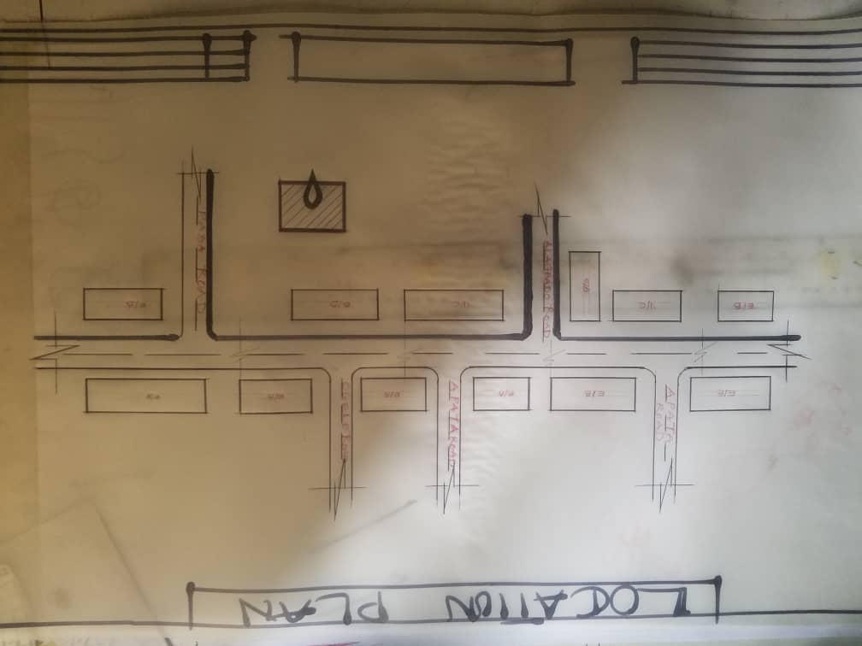
Kwara state has numerous mineral resources such as tourmaline, tantalite, and many mineral deposits in the northern part. Cocoa and Kolanut in the Southern parts Oke - Ero, Ekiti and Isin LGA.

FIG 4.1; SHOWING LOCATION OF THE PROPOSE SITE

4.3 Population
The population development of kwara state as well as related information and services.
The current metro area population of Ilorin in 2025 is 1,100,000, a 3.38% increase from 2024.
The metro area population of Ilorin in 2024 was 1,064,000, a 3.3% increase from 2023.
The metro area population of Ilorin in 2023 was 1,030,000, a 3% increase from 2022.
The metro area population of Ilorin in 2022 was 1,000,000, a 2.67% increase from 2021
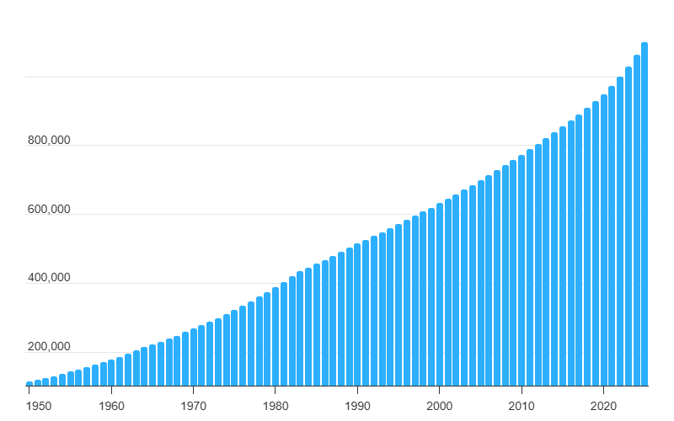
TABLE 4.1; SHOWING GENDER GROUP
4.4 Site Inventory
In the proposed site, some shrubs will be retained on site. It used to reduce sky glare and also serve as soft landscape and wind breaker.
Presence of road network which would serve as a means of accessibility to the site. Presence of electricity pole which serve as source of electricity to the site. Some trees would be retained while some will be removed if they disrupt the construction of building.
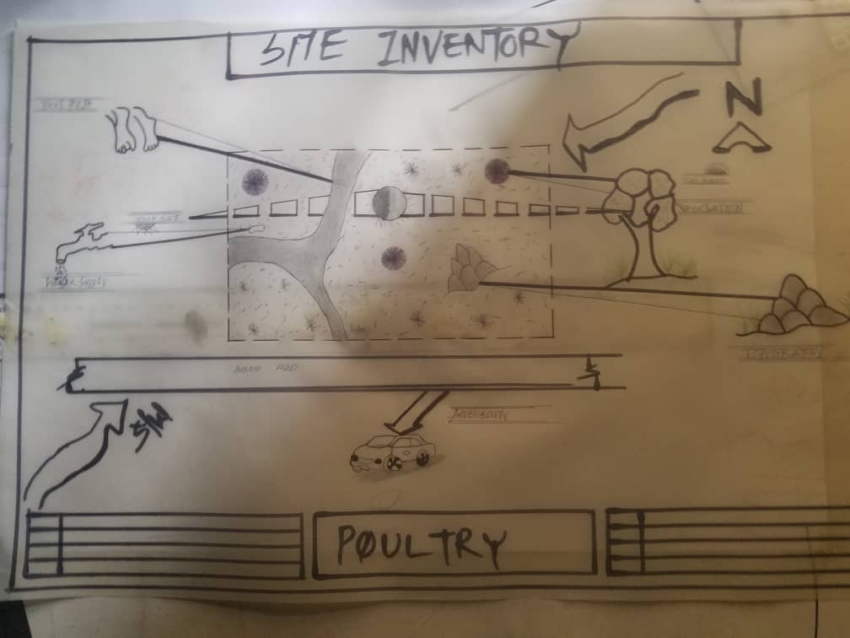

FIG 4.2; SHOWING SITE INVENTORY OF THE PROPOSED SITE

4.5 Site Analysis
The site is benefitted with loamy soil which is a very good soil for grass and shrubs. It has a gentle slope towards the south east. Some of the grasses, shrubs and trees on the site are to be retained to enhance landscape patter of the site while some are to be removed and replanted where necessary. The two noticeable winds are to be directed into the building using landscape pattern to improve ventilation. Noise generated from vehicle traffic is controlled through proper planning, good landscaping and proper orientation of building. Generally, all the feature on the site are best put into different uses to aid control through proper planning, landscape and orientation.
Certainly, steps are considered to obtain vital information of the site, this information is the analysed in details. For design purpose, the information include soil condition, geology, topography, vegetation etc. It also involves carrying out a preliminary survey.
4.5.1 Site Selection/Justification
In the site selection provision is made for interesting facilities that worth emulating since the overall success and efficiency of any project depend not on the functionality of the design but also on a careful choice of site. The site of this project has been carefully selected which is located in the premises of Waterside Eyenkorin, Ilorin kwara state. The proposed site is located at Ilorin, Kwara state.
4.5.2 Location
The site is located at
WATERSIDE EYENKORIN ILORIN, KWARA STATE
Eyenkorin is one of the most prominent commercial corridors in Ilorin. The road is characterized by High vehicular and pedestrian traffic, a mix of commercial establishments such as eateries, banks, retail stores, and offices.
4.5.3 Accessibility
Easy accessibility from different parts of the city, making it a strategic location for commercial developments such as eateries, restaurants, and retail outlets.
4.5.4 Infrastructural Facilities
Facilities such as water electricity, telephone network and road network are all in Ilorin, hence it can easily be tapped to the proposed site.
4.5.5 Topography
The topography of the land is gentle slope which can be filled and levelled up to balance round all the site levels.
4.5.6 Soil Structure
It is made up of clayish laterite soil, which is good for building construction.
4.6 General Climatic Condition
Kwara State generally experiences a tropical savanna climate (Aw) with distinct wet and dry seasons. The temperature is warm throughout the year, with an average around 29.54°C (85.17°F). Rainfall varies, with an annual average of about 101.45 millimeters (3.99 inches), and the state has around 148.38 rainy days annually.
4.6.1 Relative Humidity
Relative humidity is higher during the rainy season, ranging from 75% to 88%, and lower during the dry season, ranging from 35% to 80%.

4.6.2 Wind
The prevailing winds are the south-west monsoon wind and the north-east continental wind.
4.6.3 Temperature
Kwara State is characterized by warm temperatures year-round, with January being the coolest month and April being the hottest. Temperatures can range from a minimum of 14°C (58°F) in January to an average of 27°C (81°F) throughout the year, with April experiencing intense heat that can reach 43°C (109°F).
4.6.4 Vegetation
The proposed site is covered with grasses few trees and shrubs. Some will be removed before the construction while some will be retain for ornamentation.
4.7 Social Services
4.7.1 Road
There are only two access to the site
The southern access which serve as the main entrance and also main access road
4.7.2 Water And Electricity
There are pipe born water networks and borehole water which serves the habitant of Ibadan. There is electricity supply from NEPA that serve the Kwara state in general.

4.8 Design Criteria
There are three (3) methods of designing of any project which are: Function before form method
Form before function method Combination of Shapes
Designing projects, the function, before form method used in line with this method, the following are the design criteria for this project:
Functional: in term of functional requirement, the following design criteria must be considered.Sustainability, Site and Location, Flexibility, Circulation, Accessibility, Organization, Maintenance, Environment and Services
4.9 Design Brief
After research and planning, the next step in the series of the project programed is design itself. To achieve functional and well established design there must be a brief to work on. This brief depends generally on the scope of individual design. The brief of this project is therefore based on the various activities that take place in the hospital. To have enough brief for the proposed Restaurant, case studies were carried out on the existing restaurant. The studies also give me the opportunity to know the nature of the various unit in building and how they are related to each other.
4.10 Design Analysis
This is the process of itemizing units within the component of the entire design with a view to establishing a solid understanding and appreciation of the space relationships.

4.11 Design Analysis
This is the process of itemizing units within the component of the entire design with a view to establishing a solid understanding and appreciation of the space relationships.
GROUND FLOOR PLAN; Entrance, Reception, Laboratory, Record room, Staff lounge, Store, First aid, Account office, Marketing department, sec, Manger office, Active office, Conference room, exist, w/c
Necessary units in the building. A borehole system of water supply is to be adopted alongside the government supplied services and a storage facility is to be provided for effective management of water supply.
4.12 Planning Principle
The planning principle is one of the most important aspects of any design. The planning of various units taking into consideration the activities performed in each unit, how they are related to one another and the users of the various units in the design. In respect to the above factors.
SPACE CALCULATION
S/N | UNIT AREA | LENGTH (MM) | BREATH (MM) | TOTAL AREA (M²)
1. | Entrance | 1.8m | 1.5m | 2.7m²
2. | Reception | 5.0m | 4.5m | 22.5m²
3. | Court Yard | 3.0m | 6.0m | 18.0m²
4. | Sale office | 5.0m | 3.5m | 17.5m²
5. | Production office | 5.0m | 3.5m | 17.5m²
6. | Secretary office | 3.6m | 3.5m | 11.88m²
7. | Staff office | 3.0m | 5.5m | 16.5m²
8. | Management office | 3.6m | 3.6m | 12.96m²
9. | Security office | 3.6m | 3.6m | 12.96m²
10. | Driver office | 3.6m | 3.6m | 12.96m²
11. | Doctor office | 3.0m | 3.0m | 9.0m²
12. | Toilet | 1.8m | 1.500m | 2.7m²
13. | Lobby | 1.2m | 900m | 1.08m²

CHAPTER FIVE
5.0 GENERAL REQUIREMENTS
5.1 Appraisal of Proposed Scheme
The proposed scheme is to satisfy the appropriate building regulation. The project design is to confirm with the intended use of building taking into consideration with both natural factors and human that can pose a throat on the validity and stability of the project design.
5.2 Construction Methodology And Material
The construction is to be carried out following the due process of construction ranging from.
Preliminary: this involves the clearing of the site, setting out and excavation of foundation trench, foundation works down to the basement level.
Sub-Structure: this process also entails the positioning and erection of column and beams, mansonry work etc.
Gypsumboard: is to be used for the Acoustic purpose of the building. This material is often called dry wall, wall board or plaster board. It creates a continuous surface suitable for most types of interior decoration. It comes in different size ranging length of 2.4m, 3.0m, also in thickness of 1/ inch, 3/8 inch.
5.3 Service
A building can be said to be good when it performs the serves required by it. In other to have a well-function building design, there calls for an installation of underground water. This is a means of providing brightness naturally by sun or moon or artificially by lamps. Good natural and artificial lighting is important in lecture rooms, and workshop. It is always easy to make mistake and time the eye in a situation of poor lighting floor. For the purpose of this project, effort is made as much as possible to light up the entire building naturally before the use of artificial lighting. In this project, to obtain maximum lighting more openings are provided for the lecture rooms, workshop and admin. Artificial source of light will still be provided for in case where there is call for the use of it at night or in a situation where the weather condition warrants it.
5.4 Ventilation
As it's relates to architectural, is the intentional introduction of outside AIT into a space through openings (like window/doors and mechanical means (ACs) to provide maximum thermal comfort for human satisfaction. In this design, both means of ventilation ate introduce but majority concentration on the mechanical means of ventilation for all units in the design for the purpose of extracting the used air and introducing fresh air within all spaces for humans consumption and satisfaction.
This is done through installation of mechanical (artificial) ventilation ducts horizontally and vertically all within the units of the design to allow easy floe of free movement of air passage through the ventilation channels and providing well, proper and adequate ventilation for each and every units in the design project.

5.4.2 Lighting
This is a means of providing brightness naturally by sun or moon or artificial by lamps. Good natural and artificial lighting is important in all units. It is always easy to make mistake and time the eye in a situation of poor lighting floor. For the purpose of this project, effort is made as much as possible to light up the entire building naturally before the use of artificial lighting.
5.4.3 Plumbing
The plumbing system in this project design is made easy for waste extraction and brain water extraction through the means of service duct channel and roof gutter drainage.
All waste water and soil waste from the toilet/convenience are extracted through means of drainage pipe running through the walls down to the inspection chamber situated in the service duct, flowing down to the septic tank and soak away for final waste extractions.
5.4.4 Electrical Installation
The type of wiring system chosen should be conduct system of wiring, technical are should be wired with strong durable and light current resistance cables because of the power requirements and consumption of the equipment to be used and installed in them. Connection and distributing cable signal. Also electrical installation is to be done to allow for the use quality electrical fittings and fixtures in the whole of the hospital.
5.4.5 Waste Disposal
Waste disposal are to be put in the building and also some specific areas necessary, this waste bins should be disposed in the incinerator which will be provided within the proposed site premises. The waste should therefore, be burn in the incinerator or taken away from the site.
5.4.6 Fire Protection
Electrically, fire alarms and sensor are to be installed in the building in generally. This should be done in case of the fire occurrence. Fire extinguishers are to be placed at a certain distance in the lobbies and some other necessary areas. It is also serving as protection in case of fire outbreak.
5.4.7 Rain Protection Devices
The rainfall of a place generally determines the living condition and all comfort associated with that environment hence provision should be made for fast dispersal of the rain water as well as the associated condition with rainfall. This calls for the need to study the nature of rainfall of the area. To control the heavy rainfall during the wet season (April - October) the use of simple sloppy system roofing has been adopted. This is provided with roof gutter system which is linked to the ground drainage network by the use of P.V.C.
5.4.8 External Works
The external works are to be earned out generate, kerbs land and shrubs, flowers, grasses and trees planted. Concrete interlocking pavement tiles to be adopted before hard landscape for walk ways and parking spaces and car access roads must be tarred with asphalt finishes.
5.5 Summary
This project, generally, has seriously widen my view and knowledge affecting my observation beyond my expectation. I have been able to deduct what it takes or entails and how to go about designing and achieving a good design of any form of this related project with total seriousness as this project has given out the facts and precise information it comprises.
5.6 Conclusion
The architectural design of a poultry farm goes beyond mere shelter for birds; it directly contributes to the health, productivity, and economic viability of the farm. From the case studies and research conducted, it is evident that successful poultry farm operations rely heavily on functional, climate-responsive, and hygienic architectural solutions.
This project has demonstrated that thoughtful design—incorporating proper building orientation, effective ventilation, durable materials, and biosecurity measures—plays a critical role in ensuring bird welfare, reducing mortality rates, and enhancing operational efficiency. Additionally, sustainable design interventions such as rainwater harvesting, passive cooling, and waste management systems align the project with global best practices for environmentally conscious agricultural facilities.
Furthermore, the integration of worker comfort, circulation flow, and flexibility for future expansion reflects the need for user-centered and adaptable architectural solutions within the agricultural sector.
However, challenges such as high construction costs for sustainable materials, potential biosecurity risks, and the need for regular maintenance were identified. These challenges highlight the importance of strategic design decisions to balance functionality, cost, and long-term sustainability.
5.7 Recommendation
This project reflects the critical role of architecture in enhancing agricultural productivity, environmental sustainability, and animal welfare. The proposed poultry farm design, if implemented effectively, will not only meet functional and operational needs but also contribute positively to food production, economic development, and the well-being of both birds and farm workers.

REFERENCE
Adeyemo, S. B., &Onikoyi, M. P. (2012). Prospects and challenges of large-scale commercial poultry production in Nigeria. World Journal of Agricultural Sciences, 8(3), 256–261.

Akinola, L. A. F. (2008). Environmental management practices in poultry production in Nigeria. Journal of Environmental Issues and Agriculture in Developing Countries, 1(2), 101–106

Albright, L. D. (2000). Environmental Control for Animals and Plants. ASAE.
ASABE Standards (2020). Design of Ventilation Systems for Poultry and Livestock Buildings. American Society of Agricultural and Biological Engineers.

Daghir, N. J. (2008). Poultry Production in Hot Climates (2nd ed.). CABI Publishing.

Federal Ministry of Agriculture and Rural Development. (2010). National Animal Production Guidelines: Poultry. Abuja, Nigeria.

Heritage Poultry Farm, Ogun State, Nigeria – Medium-scale poultry farm with cross-ventilation and biosecurity measures.

Kentimal Farm, Ibadan, Oyo State – Known for commercial broiler and layer production. Used for student case studies.

Mberekpe, J. E., &Okonkwo, J. C. (2017). Site planning for sustainable poultry housing in the humid tropics. Nigerian Journal of Agriculture, Food and Environment, 13(2), 112–117.

National Building Code of Nigeria. (2006). Agricultural and Industrial Buildings Standards. Federal Ministry of Works and Housing.

Neufert, E. (2012). Architects' Data (4th ed.). Wiley-Blackwell.

Obasanjo Farms, Ota, Ogun State – Large-scale integrated poultry operation; useful for large-farm planning and layout.
Olomu, J. M. (2011). Poultry housing and environment in Nigeria: A review. Nigerian Journal of Animal Science, 13(1), 45–53.

Owen, J. E., & D. A. Dykes. (2010). Livestock Housing. Tropical Agriculturalist Series. Macmillan.

Veldkamp, T., & van Harn, J. (2019). Poultry Housing Design and Management. Wageningen UR Livestock Research.

APPENDIX
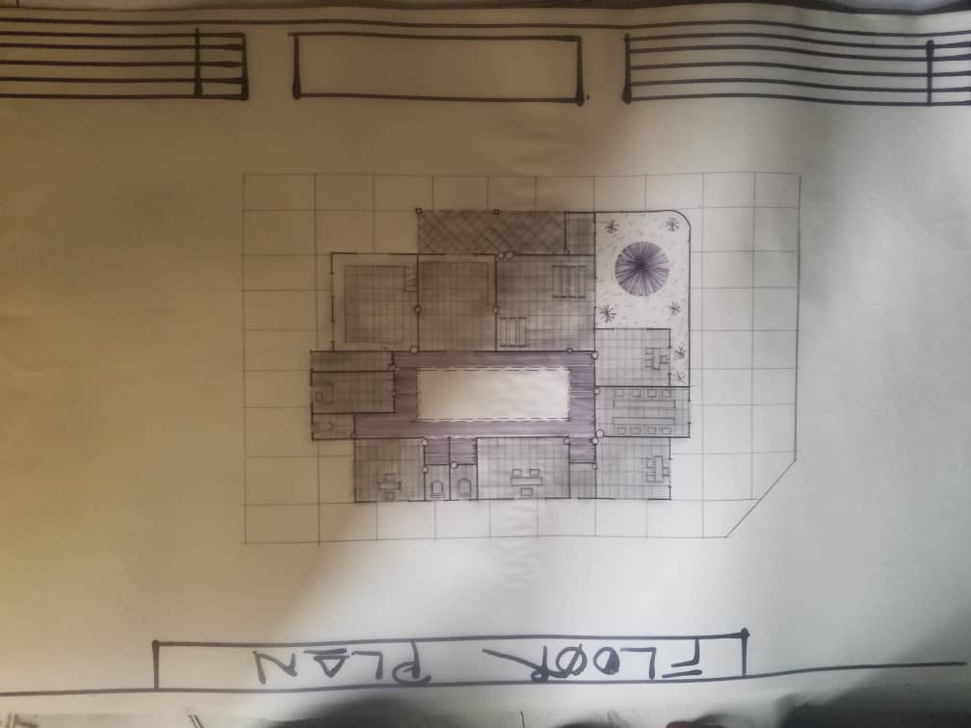

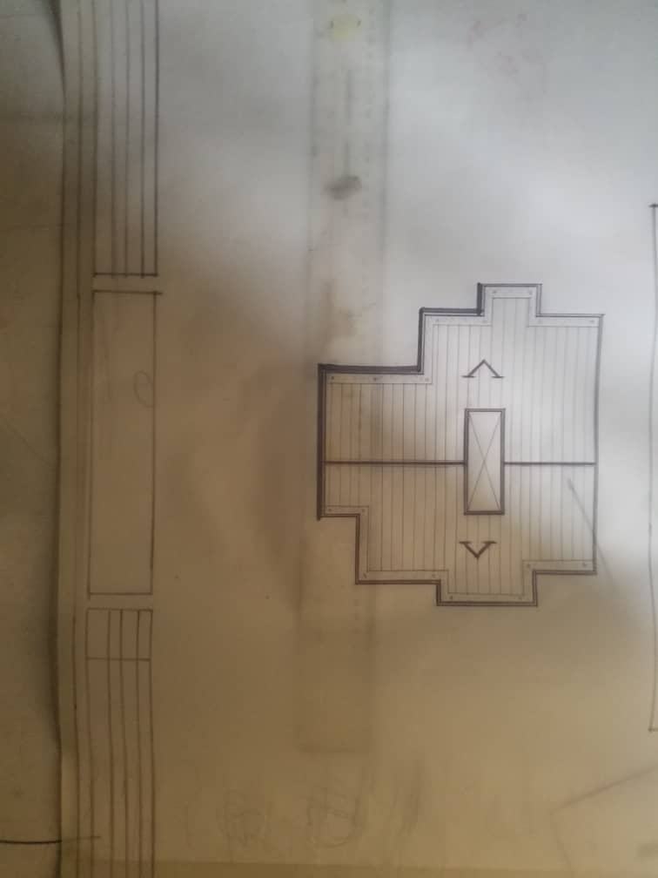

APP1: FLOOR PLAN OF PROPOSED PROJECT

APP2: ROOF PLAN OF PROPOSED PROJECT

APP2: SITE PLAN OF PROPOSED PROJECT
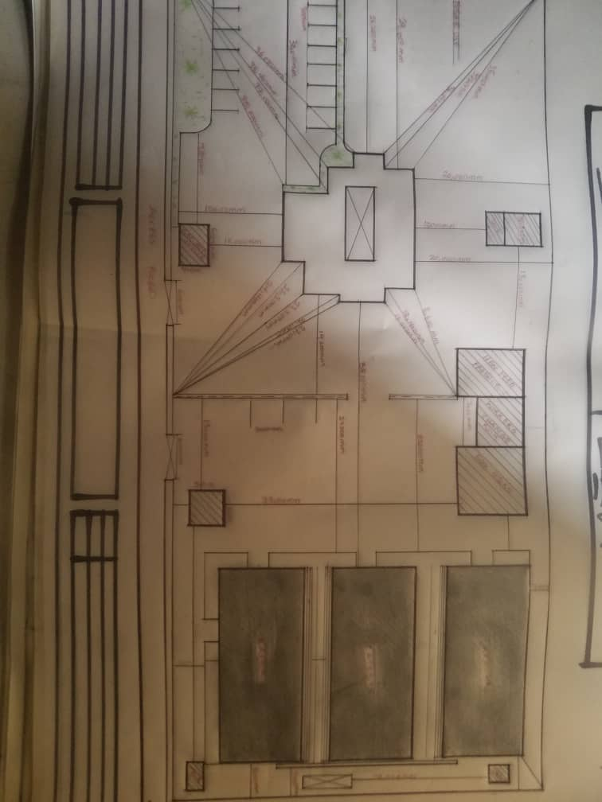

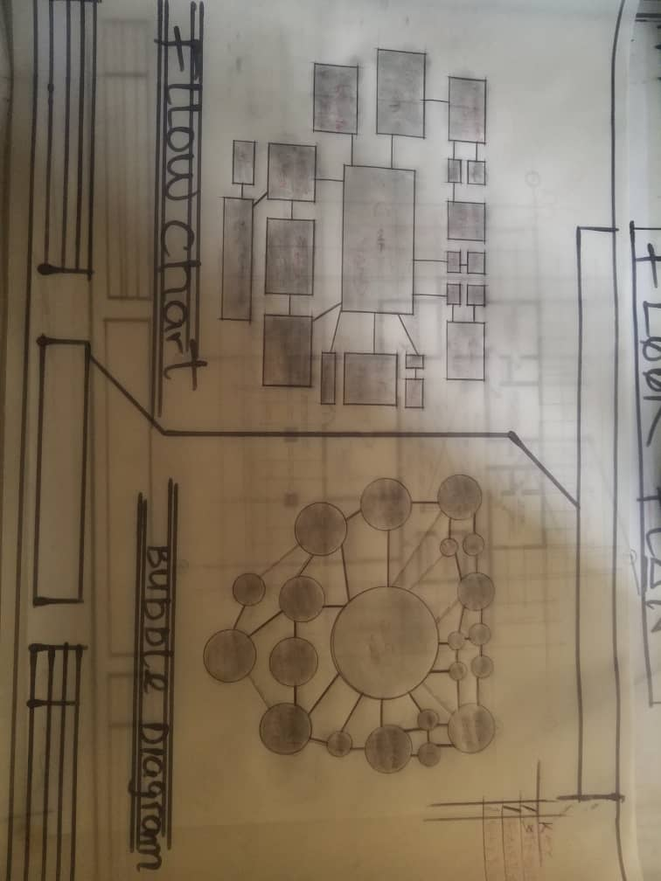

APP3: FUNCTIONAL REQUIREMENT OF PROPOSED PROJECT

APP4: FUNCTIONAL REQUIREMENT OF PROPOSED PROJECT

