A TECHNICAL PROJECT REPORT
ON

A PROPOSED PRIMARY SCHOOL
FOR
FOR MR ALIMI OLAREWAJU (CEO) OF EMBASSY
COMMISION ILORIN KWARA STATE.
BY:
AYOLO FAROUQ AJIBOLA
ND/23/ARC/FT/0003

SUBMITTED TO
THE DEPARTMENT OF ARCHITECTURALTECHNOLOGY,
INSTITUTE OF ENVIRONMENTAL STUDIES, KWARA STATE
POLYTECHNIC, ILORIN.

IN PARTIAL FULFILMENT OF THE REQUIREMENTS FOR THE AWARD OF NATIONAL DIPLOMA (ND)
IN ARCHITECTURAL TECHNOLOGY.

JULY 2025

DECLARATION
I declare that this Project/Dissertation is a product of my personal research work. It has not been presented for the award of any degree in any Polytechnic/University. The ideas, observations, comments, suggestions herein represent my own convictions, except quotations, which have been acknowledged in accordance with conventional academic traditions.

AYOLO FAROUQ AJIBOLA
ND/23/ARC/FT/0003 SIGNATURE/DATE



DEDICATION
This Project is dedicated to: God almighty for his protection and provision throughout my National Diploma [ND] Program. And also, my loving family, for their unwavering support, encouragement, and understanding throughout this journey. Your belief in me has been my greatest strength. And In Loving of my MOM AYOLO MARIAM whose spirit and love
continue to be a source of inspiration and guiding light in all that I do.

ACKNOWLEDGEMENT
This ultimate dominion still belongs to Almighty GOD. All praises to GOD, no partner has He, there is no deity worthy of worship than Him, He is the final resurrection.
Peace and blessing be upon the lord Almighty Allah. and His family, His companion and every one of us who adhere to his teaching till the day of judgement.
I also recognize the support love, care and guidance of my precious parents in person of MR AND MRS AYOLO , I pray Almighty GOD reward you abundantly ,may you reap the fruit of your labour and shall be blessed more than your imagination (Amen)
My sincere gratitude goes to my supervisor ARC. J.M TOMORI for sparing his time to take me through all the stages and exhaustible efforts and constructive remarks in writing this project.
Never must I forget the indefatigable and untiring efforts of my family, my lovely sister,

AYOLO AMINAT and my lovely brother AYOLO ANU,
To all my lecturers ARC OLAREWAJU F. A, ARC ABDULAZEEZ B. Y. F, ARC CHUKUMA NMOM, ARC SOLOMON FAMILUA AND ARC SHERO
Lastly I want to appreciate my lovely friends who render their service for me when I needed them may Almighty GOD bless you all abundantly. (AMEN)

TABLE OF CONTENTS
TITTLE PAGE………………………………………………………………………... i
DECLARATION……………………………………………………………………...ii
CERTIFICATION………………………………………………………………….….iv
ACKNOWLEDGEMENT……………………………………………………………..v
TABLE OF CONTENT…………………………………………………………….... vi
LIST OF FIGURE………………………………………………………………….....vii
LIST OF PLATES……………………………………………………………………viii
LIST OF APPENDIX……………………………………………………………….... ix
ABSTRACT…………………………………………………………………………...x

CHAPTER ONE
1.0 INTRODUCTION…………………………………………………………………1
1.1 PROJECT DEFINITION……………………………………………………….….1
1.2 HISTORICAL BACK GROUND………………………………………………….2
1.3 JUSTIFICATION ………………………………………………………………….2
1.4 AIM…………………………………………………………………………………3
1.5 OBJECTIVES………………………………………………………………………3
1.6 CLIENT BACKGROUND, PHILOSOPHY………………………………………..3
1.7 SCOPE OF STUDY………………………………………………………………...3
1.8 LIMITATION OF DESIGN………………………………………………………..4
1.9 RESEARCH METHODOLOGY…………………………………………………..5

CHAPTER TWO
2.1 LITERATURE REVIEW…………………………………………………………...6
2.2 REVIEW OF ALL LITERATURE ON THE SUB-TOPIC………………………...8 CHAPTER THREE

3.1 CASE STUDY ONE…………………………………………………………………9
3.2 CASE STUDY TWO…………..……………………………………………………12
3.3 CASE STUDY THREE………………………………………………………….….15 CHAPTER FOUR
4.1 INTRODUCTION OF STUDY AREA………………………………………….…18
4.2 SITE LOCATION/DESCRIPTION………………………………………………...19
4.3 SITE ANALYSIS/INVENTORY…………………………………………………...19
4.4 GEOGRAPHICAL/CLIMATIC CONDITIONS……………………………….…..20
4.5 DESIGN CRITERIA…………………………………………………………….….20
4.6 BRIEF ANALYSIS………………………………………………….……………....20
4.7 SPATIAL PROGRAMMING (REAQUIREMENT AND ANALYSIS)……..……21
4.8 CONCEPTUAL DEVELOPMENT…………………………………………...……21
4.9 SITE CONCEPT………………………………………………………………...….22
4.10 BUILDING CONCEPT……………………………………………………...……23

CHAPTER FIVE
5.1 PROJECT APPRAISAL…………………………………………………………..24
5.2 CONSTRUCTION METHODOLOGY AND MATERIALS…………………….26
5.3 BUILDING SERVICE…………………………………………………………….28
5.4 CONCLUSION AND RECOMMENDATION…………………………………...30
5.5 REFERENCES…………………………………………………………………….31

LIST OF FIGURES
FIGURE 2.1: LOCATIONAL PLAN CASE STUDY ONE………………….9
FIGURE 2.2: FLOOR PLAN OF CASE STUDY ONE ……………………..9
FIGURE2. 3: LOCATIONAL PLAN OF CASE STUDY TWO……...……..12
FIGURE2. 4: FLOOR PLAN OKELERIN CASE STUDY TWO …………..13
FIGURE2. 5: LOCATIONAL PLAN OF CASE STUDY THREE.…..……..15
FIGURE2. 6: FLOOR PLAN OF CASE STUDYTHREE… …………….....15
FIGURE3.1. GEOGRAPHICAL/ CLIMATIC DATA ……………………...18
FIGURE3.2. AVERAGE MONTHLY TEMPERATURE …………………..23

FIGURE3.3. AVERAGE MONTHLY RAINFALL IN ILORIN ……………24
FIGURE 4.1 BUILDING CONCEPT ………………………………………..27

LIST OF PLATE

PLATE 2.1 .FRONT VIEW OF CASE STUDY ONE…………………….….10

PLATE 2.2 .INTERNAL VIEWS OF CASE STUDY ONE …….……….…..10

PLATE 2.2 .INTERNAL VIEWS OF CASE STUDY TWO …….……….…..11

PLATE 2.3 .FRONT VIEW OF CASE STUDY TWO ……………………….13

PLATE 2.4 .PICTURES OF CASE STUDY THREE…….…………..…........16

PLATE 2.4 .PICTURES OF CASE STUDY THREE…….…….......................16

LIST OF APPENDIX

APPENDIX 5 .1; SHOWING LOCATIONAL MAP………..…………..……….32

APP ENDIX 5 .2; SHOWING LOCATIONAL PLAN………….……………......32

APPENDIX.5;3 SHOWINGINTERNAL PERSPECTIVE…………….………..33
APPENDIX 5. 4; SHOWING SITE ANALYSIS…………..…………….….…....33

APPENDIX 5. 5; SHOWING ROOF……...…………………………….….….….34

APPENDIX 5 .6; SHOWING FLOOR PLAN…….………………………….…...34

ABSTRACT
Designing a primary school for rural areas in the community is a vital initiative aimed at bridging the educational gap and providing access to quality education for children in underserved regions. This project seeks to create a conducive learning environment that fosters academic excellence, social responsibility, and emotional intelligence. The design will prioritize sustainability, flexibility, and community engagement, ensuring the school's relevance and effectiveness in meeting the needs of rural children.
The proposed school will feature modern facilities, innovative learning spaces, and technology integration, providing students with a holistic education that prepares them for future challenges. The design will also incorporate community-centric elements, such as shared facilities and resources, to promote community engagement and social cohesion.
By providing a good standard primary school in the rural area, this project will empower children to reach their full potential, enhance learning outcomes, and contribute to the socioeconomic development of the community. The school will serve as a hub for community activities, promoting social interaction, and fostering a sense of belonging among residents. Ultimately, this project will have a positive impact on the lives of rural children, their families, and the community at large, setting the stage for a brighter future.

CHAPTER ONE

1.0 INTRODUCTION
Primary school is a foundational stage of education that plays a critical role in shaping the cognitive, social, and emotional development of children. Typically spanning from ages 5 to 11, primary education provides students with a broad range of academic and extracurricular experiences that lay the groundwork for future learning and personal growth. During this period, children are introduced to various subjects, including mathematics, language, science, and social studies, which help them develop essential skills and knowledge. I
Primary schools aim to create a supportive and nurturing environment that fosters curiosity, creativity, and critical thinking. Teachers and educators strive to cater to the diverse needs of students, recognizing that each child learns at their own pace and has unique strengths and challenges. Effective primary education not only focuses on academic achievement but also promotes socialization, emotional intelligence, and physical well-being.
The significance of primary education extends beyond the classroom, as it lays the foundation for future academic success and lifelong learning. A strong primary education can have a lasting impact on a child's educational journey, influencing their ability to navigate more advanced levels of education and ultimately, their career prospects and personal development. As such, primary schools play a vital role in shaping the next generation of learners and citizens.

1.1 HISTORICAL BACKGROUND
The historical background of primary schools is a rich and complex narrative that spans centuries, with various colonial powers leaving an indelible mark on the education system. In the Philippines, for instance, primary education was initially informal, with parents teaching their children essential skills necessary for survival. However, with the arrival of Spanish colonizers, a formal education system was introduced, with primary schools, colleges, and universities established by missionaries to impart Christian values and basic skills such as reading, writing, and arithmetic.
The Spanish regime's primary aim was to make Filipinos obedient and God-fearing Christians, with religion a compulsory subject in schools. This period saw the establishment of parochial schools, which taught vocational skills and prepared students for roles in the church and government. The Americans later introduced a public education system, modeled after the US school system, with English as the primary language of instruction. This marked a significant shift towards a more inclusive and standardized education system, with public schools and teacher training programs established to promote quality education.

The Japanese colonization period saw the promotion of Japanese language and culture, with Nippon-go becoming a compulsory subject in schools. However, this period was marked by significant disruption to the education system, with many schools forced to close or adapt to the new curriculum. Despite these challenges, primary education continued to evolve, with various reforms and policies aimed at improving the quality and accessibility of education.
In recent years, the K to 12 program has been implemented to enhance Filipino students' skills in mathematics, science, and linguistics, making them more globally competitive. This program has built upon the foundations laid by previous colonial powers, recognizing the importance of a strong primary education in preparing students for future academic success and lifelong learning. Today, primary education remains a critical component of the education system, providing students with a broad range of academic and extracurricular experiences that lay the groundwork for future success. By understanding the historical background of primary schools, we can appreciate the complexities and challenges that have shaped the education system into what it is today.
1.2 DEFINITION.
A primary school, also known as an elementary school, is an institution that provides primary education to children, typically between the ages of 5 and 11. It is a foundational stage of education that focuses on imparting basic knowledge, skills, and values to students. Primary schools offer a broad range of subjects, including mathematics, language, science, and social studies, with the aim of promoting cognitive, social, emotional, and physical development in children. The primary school curriculum is designed to provide students with a solid foundation for future learning and personal growth, preparing them for more advanced levels of education and ultimately, their future careers.

1.3 JUSTIFICATION
The design of a primary school in Ilorin South is justified due to the glaring lack of good standard primary schools in the rural areas. Mr. Alimi's initiative to build a high-quality school will address the educational needs of the community, providing parents with a reliable option for their children's primary education. This project will bridge the educational gap, enhance learning outcomes, and empower children to reach their full potential. By investing in education, Mr. Alimi's endeavor will have a positive impact on the community's socioeconomic development, reducing poverty and improving living standards. This initiative is a step towards creating a brighter future

1.4 AIM AND OBJECTIVES
My aim for this project is to design a primary school to create a nurturing and stimulating environment that provides a good standard of education for children in the community. The school will be designed to foster academic excellence, social responsibility, and emotional intelligence, ultimately contributing to the betterment of the community. By providing a safe, inclusive, and supportive learning environment, the school will empower children to reach their full potential, develop a love for learning, and become active participants in their community's growth and development. The school's design will prioritize flexibility, sustainability, and community engagement, ensuring a bright future for generations to come.
.

1.5 OBJECTIVE
1. To design and Provide a safe, inclusive, and supportive learning environment that fosters academic excellence and promotes social responsibility
- To Design a flexible and sustainable school infrastructure that meets the needs of students, teachers, and the community.
- To design and Foster a culture of innovation, creativity, and critical thinking that prepares students for future challenges.
- To design .Support the emotional, physical, and mental well-being of students and staff through a holistic approach to education

1.6 CLIENTS BACKGROUNG, PHYLOSHOPHY
Mr. Alimi, the CEO of Embassy Commission in Ilorin, is a multifaceted individual with a strong presence in politics, business, and marketing. As a seasoned politician, he has demonstrated exceptional leadership skills and a deep understanding of the political landscape. His business acumen has enabled him to navigate complex commercial environments and identify opportunities for growth.
As an affecting marketing pro-manager based in Abuja, Mr. Alimi has developed and implemented successful marketing strategies that drive results. His expertise in promoting products, services, and ideas has earned him recognition in his field.
With his base in Abuja, Mr. Alimi is well-positioned to leverage the city's vibrant business and political ecosystem. His work at Embassy Commission in Ilorin showcases his commitment to community development and economic growth.
Overall, Mr. Alimi's unique blend of political savvy, business expertise, and marketing prowess makes him a respected figure in his field.

1.7 SCOPE AND BRIFE OF PROJECT
* Gate house
*Proposed building (PRIMARY SCHOOL)
*Parking lot
*Playing ground
*School field
1.8 LIMITATION
Limitations in research refer to the constraints or weaknesses that may impact the validity, reliability, or generalizability of the findings. These limitations can arise from various sources, including:

Types of Limitations
- Methodological Limitations: Limitations related to the research design, sampling strategy, or data collection methods.
- Sampling Limitations: Limitations related to the sample size, population, or sampling frame.
- Data Limitations: Limitations related to the quality, accuracy, or completeness of the data.

Examples of Limitations
- Small sample size: Limited statistical power and reduced generalizability.
- Biased sampling: Non-representative sample, which may lead to inaccurate conclusions.
- Limited access to data: Incomplete or inaccurate data, which may impact the validity of the findings.

Importance of Acknowledging Limitations
- Transparency: Acknowledging limitations demonstrates transparency and honesty in research.
- Contextualizing findings: Recognizing limitations helps to contextualize the findings and interpret them accurately.
- Future research directions: Identifying limitations can inform future research directions and improve the quality of subsequent studies.

1.9 RESEARCH METHODOLOGY

Research methodology refers to the systematic and scientific approach used to conduct research, including the methods, techniques, and procedures employed to collect and analyze data. It provides a framework for investigating a research question or hypothesis and ensures the validity, reliability, and accuracy of the findings.

Types of Research Methodologies
- Quantitative Research: Uses numerical data and statistical methods to investigate research questions or hypotheses.
- Qualitative Research: Employs non-numerical data, such as text, images, or observations, to gain insights into research phenomena.
- Mixed-Methods Research: Combines quantitative and qualitative approaches to provide a more comprehensive understanding of the research topic.

Research Methodology Steps
- Literature Review: Conducting a thorough review of existing research on the topic to identify gaps and inform the research question.
- Research Design: Selecting an appropriate research design, such as experimental, quasiexperimental, or descriptive, to investigate the research question.
- Data Collection: Collecting data using various methods, such as surveys, interviews, observations, or experiments.

Importance of Research Methodology
- Ensures Validity and Reliability: A well-designed research methodology ensures that the findings are valid, reliable, and generalizable.
- Provides a Framework: Research methodology provides a systematic approach to conducting research, guiding the researcher through the entire process.
- Enhances Credibility: A rigorous research methodology enhances the credibility of the research findings and contributes to the advancement of knowledge in the field.

CHAPTER TWO

2.1 LITERATURE REVIEW
Lectures in top primary schools are designed to be engaging, interactive, and informative, fostering a love for learning in young minds. Here's an overview of what makes lectures effective in these institutions:

KEY CHARACTERISTICS OF EFFECTIVE LECTURES

- Clarity and Structure: A well-structured lecture with a clear introduction, body, and conclusion helps students follow the content easily and understand key takeaways.
- Relevance and Practical Examples: Effective lectures connect theoretical concepts to realworld scenarios, making the material more relatable and easier to grasp.
- Use of Multimedia: Visual aids like charts, graphs, and videos enhance understanding, particularly for complex topics, and cater to different learning styles.
- Interactive Opportunities: Encouraging questions or facilitating brief discussions during the lecture fosters a sense of involvement and ensures students remain attentive.
- Dynamic Delivery: Lectures delivered with enthusiasm and energy capture and hold students' attention, making learning more enjoyable.

INNOVATIVE APPROACHES TO LECTURES

- Flipped Classroom Model: Students review lecture materials before attending class, allowing for more interactive discussions and practical applications.
- Shorter, Focused Segments: Breaking lectures into shorter segments with brief activities or discussions helps maintain attention and improve knowledge retention.
- Technology Integration: Leveraging technology, such as PowerPoint presentations, video clips, and interactive whiteboards, makes lectures more engaging and accessible.

BENEFITS OF EFFECTIVE LECTURES

- Efficient Information Delivery: Lectures can cover substantial amounts of information in a limited time, making them ideal for subjects with extensive curricula.
- Standardization: Lectures provide a consistent learning experience for all students, ensuring fairness and clarity.
- Engagement: When delivered effectively, lectures can inspire and motivate students, fostering a love for learning.

SOME OF THE TOP PRIMARY SCHOOLS THAT PRIORITIZE EFFECTIVE LECTURES INCLUDE
- Grange School in Ikeja, known for academic excellence and character development
- British International School in Oniru, offering a globally recognized curriculum
- American International School of Lagos, providing an immersive American educational experience
- Anglo-Chinese School (Junior) and Rosyth School in Singapore, recognized for their academic excellence and oversubscription rates

By incorporating these innovative approaches and characteristics, top primary schools can create engaging and effective lectures that inspire young learners and set them up for future success.

2.2 REVIEW OF ALL LITERATURE ON THE SUB-TOPIC

LITERATURE REVIEW: EFFECTIVE LECTURES IN PRIMARY SCHOOLS
Research highlights the significance of effective lectures in primary schools, emphasizing their role in promoting student engagement, motivation, and academic achievement (Hativa, 2013). Studies have shown that lectures can be an efficient way to deliver information, particularly in subjects with extensive curricula (Bligh, 2000). However, lectures must be designed and delivered in a way that caters to the diverse needs and learning styles of primary school students.

The use of multimedia, interactive elements, and real-world examples can enhance the effectiveness of lectures, making them more engaging and relatable for young learners (Mayer, 2009). Additionally, research suggests that lectures should be structured to promote active learning, encouraging students to participate in discussions, ask questions, and think critically (Bonwell & Eison, 1991).

Incorporating technology, such as educational videos and interactive whiteboards, can also increase student engagement and motivation (Kearns & Li, 2013). Furthermore, lectures can be tailored to meet the needs of diverse learners, including those with special educational needs, by incorporating inclusive teaching strategies and adapting content to suit different learning styles (Florian & Black-Hawkins, 2011).

Overall, effective lectures in primary schools require careful planning, delivery, and adaptation to meet the needs of young learners. By incorporating engaging and interactive elements, lectures can promote academic achievement, motivation, and a love of learning in primary school students.
Overall, the literature suggests that high-quality day-care can be a valuable resource for families, supporting the development of young children and promoting positive outcomes. By prioritizing quality and investing in day-care services, policymakers and practitioners can help ensure that children receive the care and support they need to thrive.

CHAPTER THREE

3.0 CASE STUDY
This can be defined as the gathering of information through various means o: was Case Study 2.2 This is a research or an exercise that is carried out on existing building which 1s Similar to the one researcher is writing on. The objective of a case study is to take a critical appraisal of existing related project with a view to identity the positive and negative aspect of such project. It is only with time that a project can be adjusted so that it can be successful. The information obtained from the appraisal will guide the designer of new and similar project, the project position aspect of it shall be incorporated in the View proposal while attempts will be made to solve the problem of negative aspect. lt is only through this that a design can better enhance the quality and efficiency of building in the society, tor a comprehensive analysis their case studies have been conducted.

3.1 CASE STUDY
CASE STUDY ONE
NAME: KINGSTEEP INTERNATIONAL SCHOOL
LOCATION: ITA-ELEPA, ASA-DAM ROAD ILORIN, KWARA STATE
MERIT
1 It has a large and mass area of land
2. it good standard of education facility
DEMERIT
1 it not close to the main road
2. it does not have enough parking space for school bus

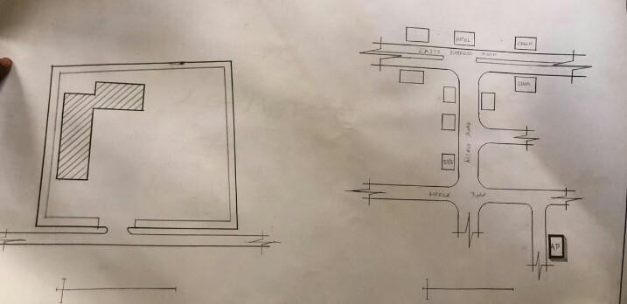

FIGURE3.1: SHOWING LOCATION/SITE PLAN OFCASE STUDY ONE

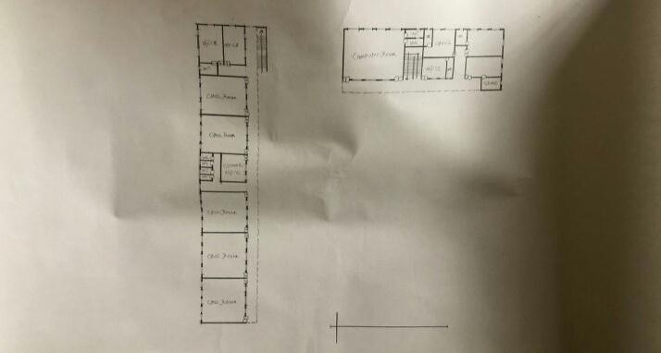
FIGURE3.2: SHOWING FLOOR PLAN OF CASE STUDY ONE

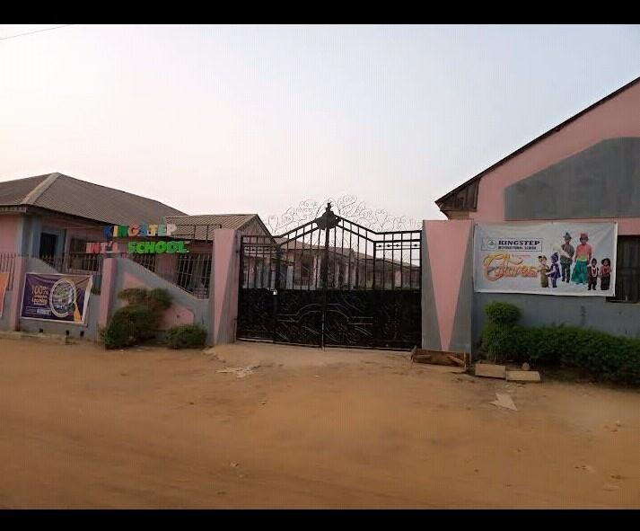

PLATE3.1: FRONT VIEW CASE STUDY ONE
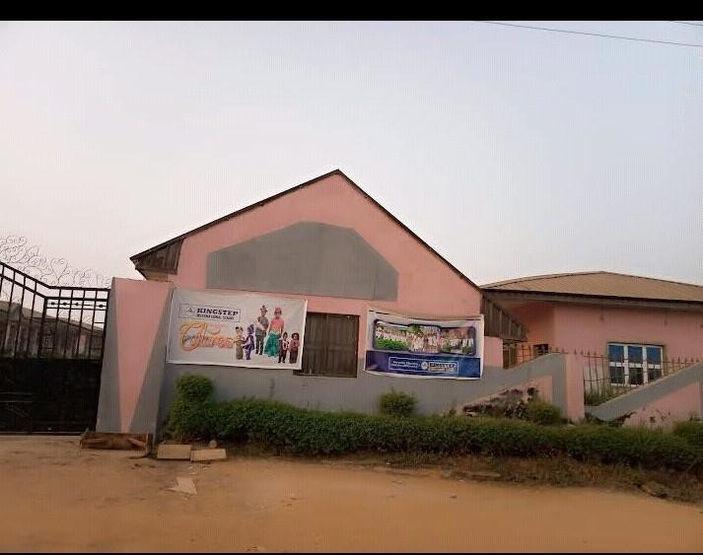

PLATE3.2: SIDE VIEW CASE STUDY ONE

CASE STUDY TWO
NAME: DOOG HART PRIMARY SCHOOL
LOCATION: OGBOMOSHO, OYO STATE.

MERIT
- It is well ventilated
- The approach is well aesthetic/ good environment for learing
DEMERIT
- It has poor landscape only hard landscape
- It has no playing ground/ field for students
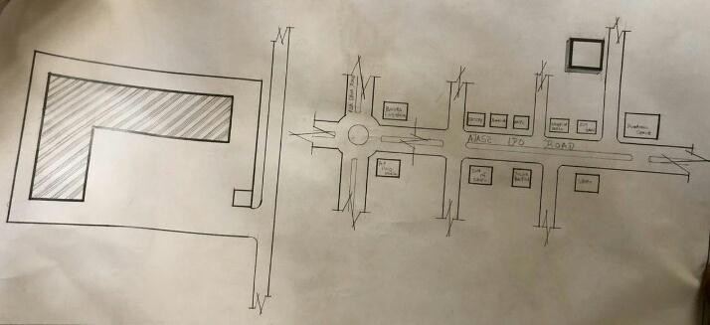
FIGURE3.3: LOCATIONAL PLAN F CASE STUDY THREE

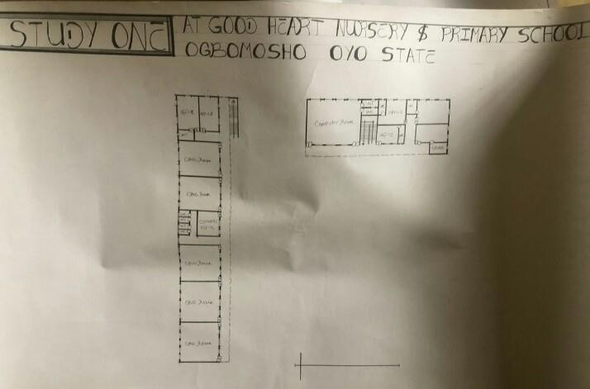
FIGURE3.4: SHOWING FLOOR FLOOR PLAN OF CASE STUDY THREE

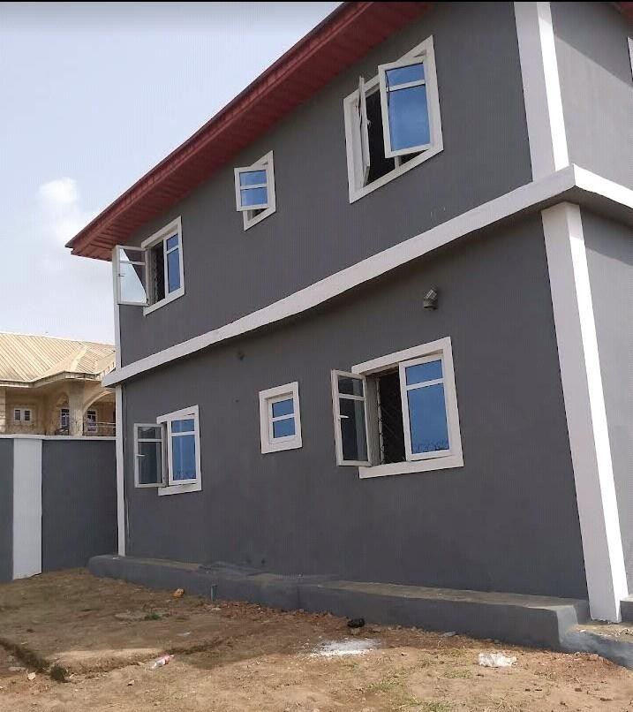
PLATE 3.3 .FRONT VIEW OF CASE STUDY THREE

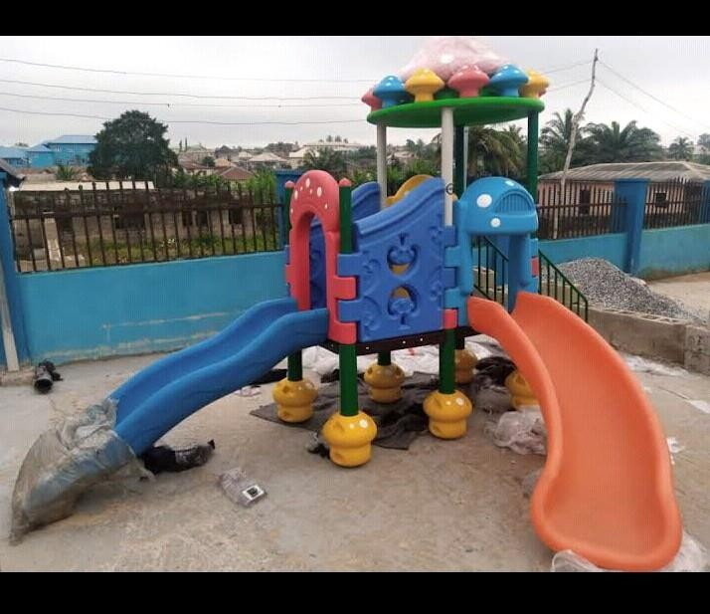

PLATE 3.4 INSIDE VIEW OF CASE STUDY TWO

STUDY THREE
NAME: PURE LUM PRIMARY SCHOOL
LOCATION: IBADAN, OYO STATE
MERIT
1. It is easily accessible through existing road
DEMERIT
- It is not well ventilated
- The approach is aesthetically poor

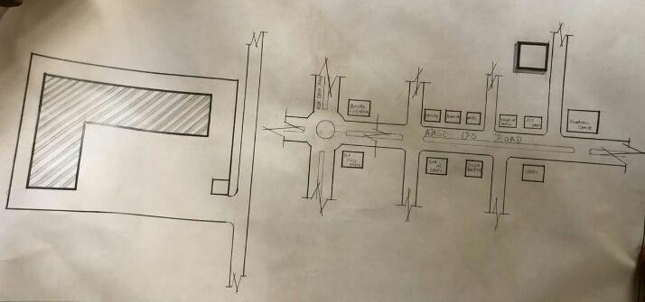
FIGURE3. 5: LOCATIONAL PLAN OF CASE STUDY THREE
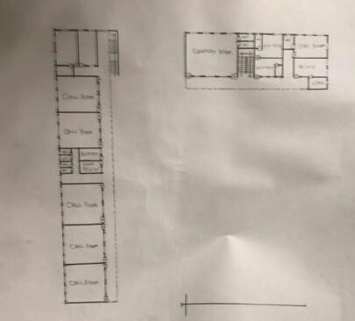

FIGURE3. 6: FLOOR PLAN OF CASE STUDY THREE


PLATES 3. 5: SHOWING FRONT VIEW OF CASE STUDY THREE
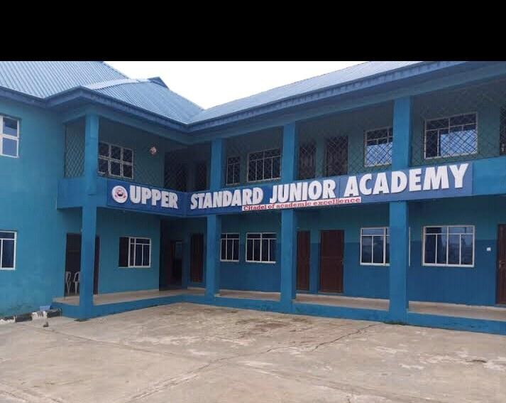
PLATES 3. 6: SHOWING INTERNAL VIEW OF CASE STUDY THREE

CASE STUDY FOUR (ONLINE CASE STUDY)
NAME: MOOD FOR ALL ACADEMIC
LOCATION: MAIMI U.S.A

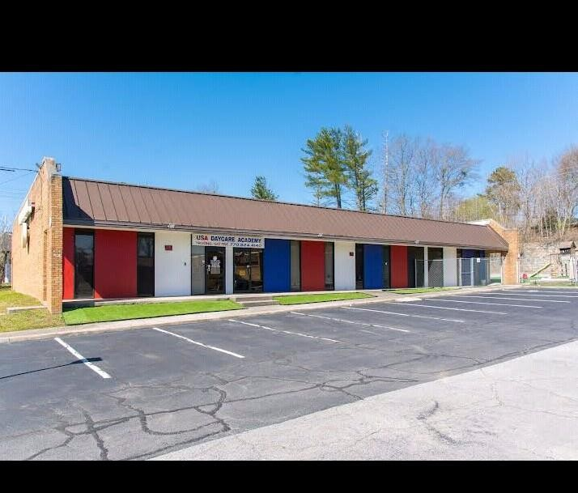
PLATES 3.7: SHOWING VIEW OF ONLINE CASE STUDY
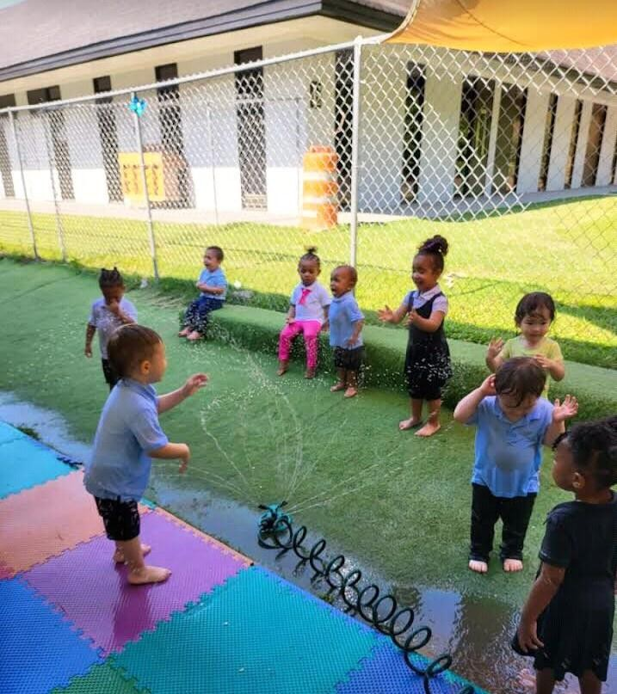
PLATES 3.8: INTERNAL VIEW ONLINE CASE STUDY
CHAPTER FOUR
4.0 PROJECT LOCATIONAL AREA

4.1 BRIEF HISTORY OF KWARA STATE
Kwara state come into existence in 1967 when the country was divided into twelve states by the federal military government of Nigeria (Decree 14), it was then called west central state and later changed to kwara state.
It shares common boundaries with niger, oyo, osun, ondo, kogi, and benin republic. Kwara state ranks among five largest with total area about 75,000smm that is eight percent area of Nigeria.
The area is generally sparsely populated with population of about 1.7milllion in 1983 but presently to be 2.5million. the state is blessed with some natural features, which serve as tourist attraction in the state and nationwide, which including the owu falls, sobi hills, esie museum etc.
The eastern of the state is hill and valley, scenery, vegetation is largely the typical guinea savannah consistency of full-interspersed grasses with trees.
The state also comprises of it local government areas with their respective local government headquarters .Avoid pollution by harmful smokes, fumes, and boots. Ease of access: there should be ease of access to and from site to allow for smooth traffic flow.
There should be adequate space for future expansion. Sufficient and adequate space for parking Compatible with current and probable future zoning regulations Close to parks museum, museums, and other community services Favorable orientation to wind and natural light Size of site, possibility for expansion, suitability and availability.
Commercial potential of surrounding area Land-use compliance Visual and aesthetical potential Proximity to national landmark.

UTILITY SERVICE
Availability of electricity, drainage, sewer feasibility of bringing utilities to site at reasonable cost restrictions on right of way.

4.1.1 HISTORY OF PROJECT TOWN (ILORIN)
Ilorin is the capital city of kwara state and it is believed to be the sixth of the first ten largest cities in Nigeria, Ilorin is located in the southern part of kwara state in latitude 8.26N and longitude 4E and 2E of Nigeria. It is about 300km away from Abuja (the federal capital city by road) it has a north-south rail line linking it to various part of the country apart from the numerous road networks. Ilorin is also provided with airstrip, which has facilities for standard international airport and a standard 5star hotel.

4.2 SITE LOCATION / DESCRIPTION
THE SITE FOR THE PROPOSED PRIMARY SCHOOL FOR MR ALIMI OLAREWAJU CEO EMBARSSY COMMISION ILORIN, ALONG KILANKO ROAD, OFFA-GARRAGE AJASE –IPO ROAD ILORIN SOUTH L.G.A KWARA STATE.

4.3 SITE SELECTION CRITERIA
Site selection is the consideration of certain factors which influence the development of the state. Before the execution of any project, the following factor are to be considered for selection of site.
Accessibility
Zoning
Availability of infrastructure etc.
The site selection was based on the following, these include;
Location: the choice of location should be in relation to the following.
Zoning: the site should be within an area reserved for institutional facilities and public utilities.
It should be free from industrial zones.

4.4 SITE ANALYSIS/ INVENTORY
This is done on the basic of the purpose for which the site is to serve.
Certain steps are considered to obtain vital information of the site; this information is then analyzed after in details for design purpose, the information includes soil condition, geology, topography, vegetation etc.
It also involves carrying out a preliminary survey of the site.
Soil condition: the type of soil on the site is loamy and hence aids good vegetation of trees, shrubs and grasses etc.
Geology: the soil has a very sound load bearing capacity and hence strip foundation will be used for the structure to be erected on the site.
Vegetation cover: the site is covered with shrubs, trees and grass which covers the ground.
Which most of it will be retained for landscape.
Topography: this is the layout of the site; the site gently slopes toward west

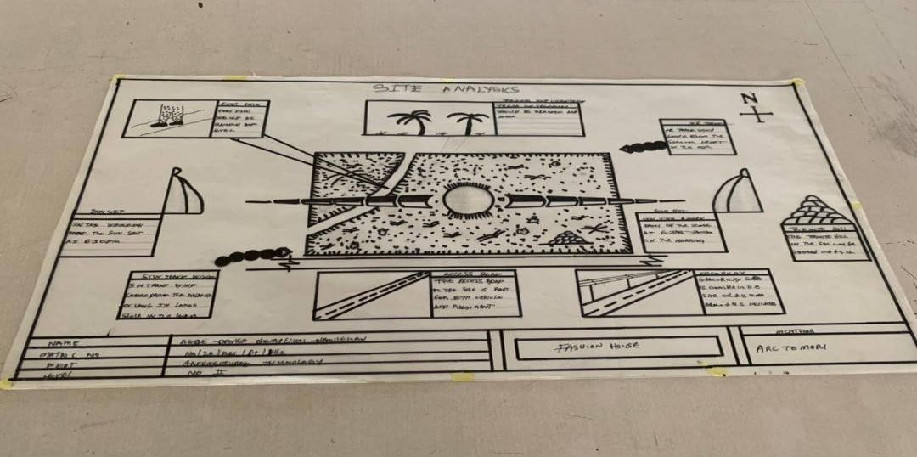

4.5.1 Climatic Data
The environmental and climatic conditions of the project site are analyzed to further understand the factors that will guide the achievement of a functional design.
Such factors are;
Climatic Data of Ilorin
Ilorin falls under the climatic region referred to as guinea savannah and in the middle belt of the country. The monthly average temperature is quite uniform, having February and march as the hottest months, recording a higher average of about 45⁰c (about 85⁰f) July and august are the coolest (lowest monthly average temperature of 76⁰f) the town is under relative humidity figure of about 80% average.

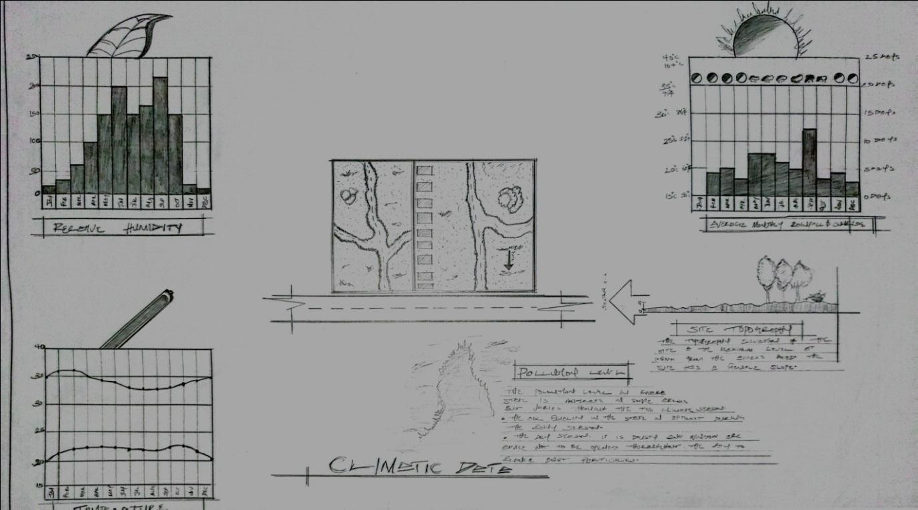

Figure3.2. Average monthly temperature

4.5.2 TEMPERATURE
The monthly temperature in Ilorin ranges between 12⁰c to 24⁰c, the annual range of temperature of the city is 18⁰c meanwhile the city experience it’s highest temperature between april and October every year.
The southwest trade wind which carries moisture blows within april and October every year while the northeast trade wind which is dry and carries harmatan blows within February and march and April every year.
The south west trade wind which carries moisture blows within October, November and January.

4.5.3 DAYLIGHT
The light is adequately and moderate in Ilorin throughout the year. The daylight is between the hours of 7.0 and 18.0GMT.

4.5.4 RELATIVE HUMIDITY
The importance of temperature influences that actual amount of water vapor present in air and this decide the moisture and carrying capacity of the air. It decides the rate
of evaporation and condensation and also affect the nature and type of cloud formation and precipitation as relative humidity is directly related to the temperature of the air, the highest humidity in the state is therefore experienced in the month of April.
WIND DIRECTION: the north-east trade wind blows undesirable cold wind, it is dry, dusty and bring harmattan which is prevalent between the month of march and November.
VEGETATION: Ilorin is in the guinea region of the country. The amount of rainfall that is normally experienced between February and November result into this type of vegetation cover over the area of the site.
The thick forest characterized by hard and soft timber with layers of vegetation covers or the low grass covers. The medium highest trees and trees at the highest level of the ground. The vegetation cover is identified with two shapes, the umbrella shapes and conical shape sharing both properties of the vegetation in forest and the region.
SOLAR PATH DIRECTIO: The sunrise from the east and set in the west, the high intensity of the sun normally experienced at this period the shading devices through the conservation and presentations of the existing natural featuring will surely reduce and combat the effect of this heat emission and transmission at the centre.

4.6 DESIGN CRITERIA In this type of design there is need for proper research using both the local (existing similar structure in the same country) and international structure as a case studies to inculcate the new ideas into the design in order to have a well functional conforming and unique structure that suit the international tastes.
Some of the criteria are:
Accommodation Analysis: I make provision for at least average number of people to be accommodated from two of my cases studies.
Source of supply: in this project design the structure is largely make use of artificial source of lightening and ventilations therefore there should be a provision for a standby source of electricity.
Landscaping: the environment must be warmth landscaped for both the visitors and the occupant to feel amused within the environment. Shrubs used for landscape include.
Functionality of the units; all the units should be well functional so as to make every activities to be ease ie provision of internet facilities within the structure and a control office within the building also.

4.7 BRIEF ANALYSIS
In this type of project, it can be seen that some building are accompany by sub-units which are required in this project and these units form the design scope of this project which are listed below:
ENTRANCE
RECEPTION HALL
ADMIN OFFICE
PRY SCHOOL
STAFF ROOM
ULTILYTY
LAUNDRY
CLASS ROOM
EXAMINATION/ASSAMBLY
LIBARY
TOILET
PRIMARY SCIENCE CLASS
HEADMASTER OFFICE
STORE
DAY CARE
COMPUTER CLASS
EXIT
ACHIVE/ STORE

4.8 BUBBLE DIAGRAM
This is to show the problem that is on ground to solve by mentioning all the design brief that present in the proposed design are low all these can be related.

4.9 CONCEPTUAL DEVELOPMENT (SITE AND BUILDING)
The design concept of this project is based on the principle of FORM follows FUNCTION where the basic design is gotten through the use of bubble and functional relation diagram.

4.10 SITE CONCEPT
The site design was achieved by taking into considerations some environmental and physical features. They are orientation, circulation and zoning.
Orientation: the building is oriented in such a way that as much as possible direct sunlight is prevented from entering the building.
Circulation: the site is distinguished in such a way that allows for easy accessibility and circulation of pedestrian and vehicles.
zoning: zoning of required functional spaces is done with respect to their various

CHAPTER FIVE
5.0 APPROACH TO THE DESIGN/DESIGN REALIZATION

5.1 PROJECT APPRAISAL
The smooth operation of the proposed PRIMARY SCHOOL would depend largely on the availability of services such as lightning (mostly artificial), ventilation (mostly natural), electricity services plumbing and water services, fire services and drainage etc.

5.1.1 CONSTRUCTION METHODOLOGY AND MATERIAL
In construction of building, the skill and workmanship dose not only brings out the beauty but until the when specification detail of materials and construction method which had been adopted in this project are skillfully built are as followed.

5.2 SITE CLEARANCE
Trees in all the area where building is to cover would be cut down and carried away from the site in order to get the organic matter, and the top soil is also removed to a depth of 150mmm Both the clearing of the site can either be done manually or with the use of machine i.e bulldozer or grader.

5.3 FOUNDATION
In these project two type of foundation will be use which are strip and pad foundation. the strip which is the continue spread of concrete shall be use for the load bearing wall and the thickness shall be the same size as the block wall, and the spread will be three times side of the wall, the pad will be use and footing for all the base and also retaining wall of 30mm thick are adopted in some case like rakings in the main conference and will be reinforced.

5.4 STRUCTURAL SYSTEM
This is a horizontal surface design and constructed to accommodate and serve the purpose of supporting people furniture and equipment in the building.
.

5.5 FLOOR
The thickness for the floor slab will be 150mm in the floor, except the generator house which has 300mm thick for generator stand. the following finishing will be use for the project.
P.V.C Floor tiles- these are floor tiles made from thermal-plastic binder (vily 1), it is to be use in all available offices, reception, maintenance, V.VI.P, room, restaurant etc.
ceramic floor tiles: patterned glazed ceramic floor tiles of brown color will be use for the entire toilet and bath.
acoustic carpet underlay: sundown acoustic carpet underlay is a composite material using sundown tuff-mass as a barrier in weight of 1 to 2b and acoustic foam decouple. there is an option for a soft or firm acoustic foam layer that provide a comfortable feel. sundown carpet reduces noise radiating from carpet surface. It may be used alone or to supplement installation applied in spaces sundown carpet underlay is manufactured in 54’ with ¼ and ½ thickness.

5.6 WALLS
These are vertical continuous solid structure which is usually made by brick, stone. concretes, metals etc to serve the purpose of which it is desired. the walls would be a load bearing or nonload bearing walls. all the walls in the building are 225mm wall and it has been supported by columns a beams running vertically and horizontally for structural rigidity.
The walls of the main conference hall are slanted 10⁰ to the floor slab, they are made up of columns at 5.5m interval with a precast reinforced concrete blind of 5500x450x50mm thick arranged in a louver pattern, overlapped by 50mm to each other. all other meeting hall wall is cladded with marble tiles because of its sound absorbent characteristics and of its aesthetics value, except the toilet which shall be tiled white and patterned grazed ceramic tile to door height.
The wall finishes for the building interior is marble honeycomb panels wall material as sound insulator within the various unit in the building.

5.7 ROOF
Roofs in building construction are constructed in order to protect the building from all the weather condition and the materials varies according to the materials available e.g steel roof or timber roof. steel roof used in this project as a result of large span and is been covered with asbestos roofing sheet with a pitched roof and hipped roof are adopted.

5.8 STEEL
This is metal which is made of alloy of carbon and iron having a very strength in both tension and compression but it is a very stiff material.
steel possess the capacity undergoing a consideration strain after the elastic limit before it fall. steel has the ability to carry dead/imposed load with its limit. it is used in the building construction industry for reinforcement of concrete, windows, and door frame, floor slab etc. it is a very versatile construction material.

5.9 CEILING
The material use for the project is an acoustic ceiling tile to reduce noise from the roof. the vacuum between the roof and the ceiling should be filled with rock wool material.

5.10 DOOR
These are solid barrier fixed at opening to serve the purpose of gaining and denying access into building and it can be used as security as well as fire barriers which had been adopted for use in the project.

5.11 STANDARD DOUBLE LEAVE SINGLE SWING GLAZED ALUMINIUM DOOR-
This are door, which will serve the main entrance into the building this is composed of aluminum frame and glasses glazed.
PURPOSE NADE METAL DOOR -These types of door are provided in three-bed type for proper ventilation and lightening. necessary place that is required.
FIRE CHECKED PURPOSE MADE DOOR – These type of door will be use in all the door ways in the building like the kitchen, conveniences these is necessary because there is the need to control the spreads of fire in the building.

ALUMINIUM
This is another material that is used in building construction industry and it is made up of alloyed mixed with other element to made a suitable structural material. they are usually corrosion resistance and very light compared to the weight of the steel and highly resistance to corrosion and it is used in the building construction for roofing sheet, partitioning frames, windows frames etc.

TIMBER
Timber is one of the earliest forms of concrete and other material and it is light in weight . it is sometimes used for structural aspect of the building having weight one sixteenth that of steel. timber is a very versatile material and can be used in conjunction with other materials such as steel without any issue arising. it can also be use for constructing room carcass, roof trusses, floor finishes, ceiling finishes, skirting and other building materials.

GLASS
These is another material used in the heating of soda line and sand to a temperature of which they melt and fuse to the stage it can be draw cast rolled on bed of molten tin to be flat glass. Glass can either be transparent or translucent and they come in different ways and types.
Clear Sheet Glass: This type of glass is usually transparent and has varying thickness and may cause optical distortion.
Wired Glass: This type of glass wire is usually embedded into it, it is glazing because the wire holds the glass together so as to reduce the danger of its breakage.
Double Gazing Units: This type of glass can either be transparent or translucent but usually very thick and comprises of float glass spaced apart and sealed around a dehydrated method which had been adopted in the project and are skillfully built.
Toughened Glass: This type of glass can either be transparent or translucent but usually very thick it can be broken into fragments and comparatively harmless pieces, it is usually used for doors and softly screens.
Pattern Glass: This type of glass is translucent because of the pattern or the texture of the glass. it could also be timed or plane.

WINDOW
These are openings found on walls and also on roofs so that day light can pass through, some transparent materials can also be used to allow passage of light and ventilation into the building. The following are the types of windows to be used in the projects.
Aluminum pivoted windows(tinted): this type of window will be used in the guest house and restaurant.
Aluminum pivoted window(plane): this type of window will be used in all other units.
5.12 SERVICES

5.13 VENTILATION
The major source of ventilation is a system of natural ventilation, which is centrally controlled. Efforts were made to ensure cross ventilation principle in the design, while the other source of ventilation is the artificial ventilation provided in the form of CENTRAL AIR CONDITIONING SYSTEM (AC) The various components are ventilated by ducts that are linked to the source of the ventilation.

5.14 PLUMBERING SERVICES
All the water is to be supplied and distributed to other areas through 50mm diameter 100mm and 150mm diameter. All the bath and showers tray and towel trays, while all the toilets will be provided with tissue rolls holder, man holes, septic tanks and soak away pits shall be placed in suitable location for easy maintenance.

LIGHTNING
Lightning is very important for accuracy, safety and productivity, for this proposal the use of natural lightning provided for by the use of windows on the surrounding walls, the natural light is complemented with artificial lights provided by means of varieties of light fittings.

FIRE SERVICES
In the electrical panel room, a fire control unit box is provided to serve each building on site and each building has its own electrical panel room which has/smoke detector which alert the people if there is outbreak of fire in any part of the building before damage is done to other part of the building. carbon oxide gas are positioned and strategic locations in the building.

DRAINAGE
The surface water are channeled into 600mm wide and 600mm deep covered drains with inspection chamber at strategic points and emptied into the main municipal city drain. separate drain system has been employed to drain of foul water from the water closets, surface water and pave areas.

5.15 SECURITY SERVICE
The entry and exits into the site have been fitted with cctv cameras, this is to monitor the movement of vehicles in and out of the site. The entrances will also be maintained with security men checking incoming and outgoing vehicles.

ELECTRICAL SERVICES
The power holding company of Nigeria (PHCN) mean which pass across the site shall be the major source of power supply into the building but an alternative source will however be provided which s generator and effective 3 phase line will be used and the connection will be armored cables while the internal distributions/connections would be conduit conduct piping.

5.16 SUMMARY
A summary is a concise overview of the main points of a larger piece of information, such as a report, article, or proposal. It highlights the key findings, main ideas, and supporting details, providing readers with a quick understanding of the content. A good summary should be clear, concise, and accurate, capturing the essence of the original material without including unnecessary details. Summaries are useful for busy professionals, researchers, or anyone who needs to quickly grasp the main points of a lengthy document.

5.17 RECOMMENDATIONS
Recommendations are suggestions or proposals for action, often based on the findings of a study, report, or analysis. They provide guidance on what steps to take next, how to address a problem, or how to improve a process. Effective recommendations should be specific, actionable, and feasible, taking into account the resources, constraints, and goals of the organization or individual. Recommendations can be used to inform decision-making, drive change, or improve outcomes.
.

5.18 CONCLUSIONS
A conclusion is the final section of a document, report, or presentation that summarizes the main points and reiterates the key findings or arguments. It provides a final thought or call to action, leaving the reader or audience with a lasting impression. A good conclusion should be concise, clear, and impactful, tying together the various threads of the narrative and reinforcing the main message. Conclusions can be used to summarize complex information, emphasize key takeaways, or inspire action.

REFERENCES
Blackmore, J., Bateman, D., Loughlin, J., O'Mara, J., & Snyder, I. (2011). Innovative learning environments: A review of the literature. Melbourne: Australian Institute for Teaching and School Leadership.
Gao, F., Zhang, J., & Wang, Y. (2013). Exploring the impact of interactive whiteboards on teaching and learning. Journal of Educational Technology Development and Exchange, 5(1), 1-22.
Higgins, S., Hall, E., Wall, K., Woolner, P., & McCaughey, C. (2005). The impact of school environments on student outcomes. London: EPPI-Centre, Social Science Research Unit, Institute of Education, University of London.
Kaplan, S. (1995). The restorative benefits of nature: Toward an integrative framework. Journal of Environmental Psychology, 15(3), 169-182.
Knezek, G., Christensen, R., & Tyler-Wood, T. (2013). The impact of technology on student learning outcomes. Journal of Educational Computing Research, 48(2), 147-164.
Kullmann, S. (2013). Sustainable school design: A review of the literature. Journal of Green Building, 8(2), 137-155.
Myerson, J., Bichard, J., & Erlich, A. (2013). The impact of classroom design on student learning. Journal of Educational Research, 106(4), 281-293.

APPENDIXES

APPENDIX 1
SITE ANALYSIS 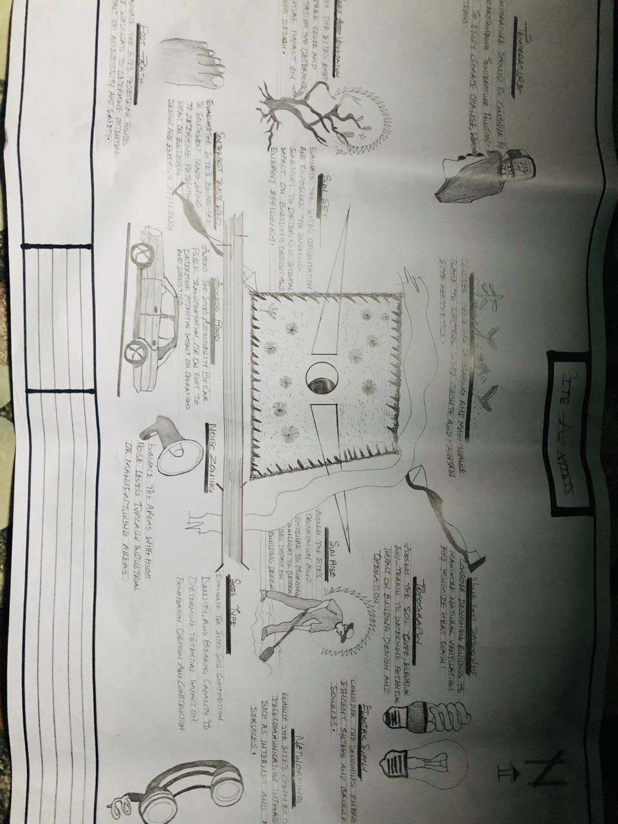

APPENDIX 2
LOCATIONAL PLAN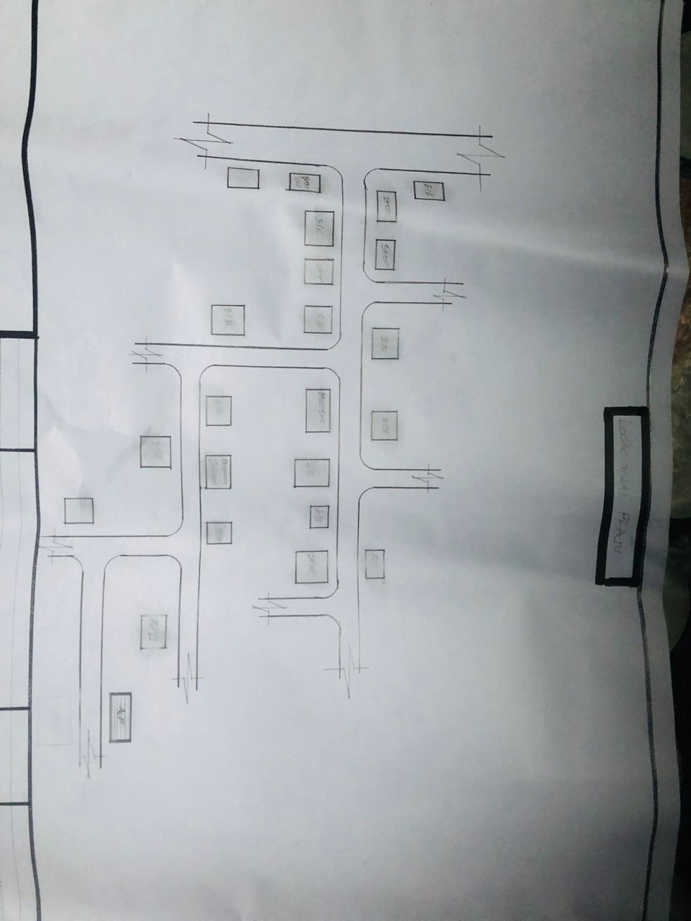

APPENDIX 3
ROOF PLAN

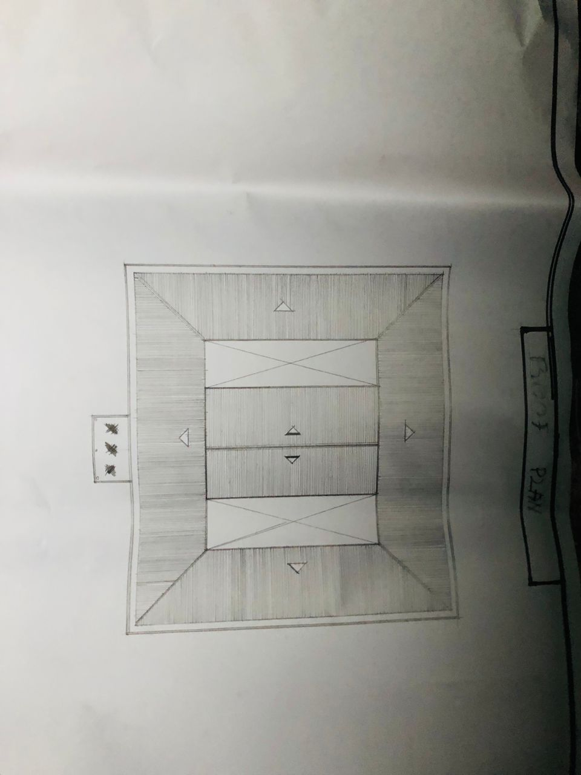

APPENDIX 4
LOCATIONAL MAP
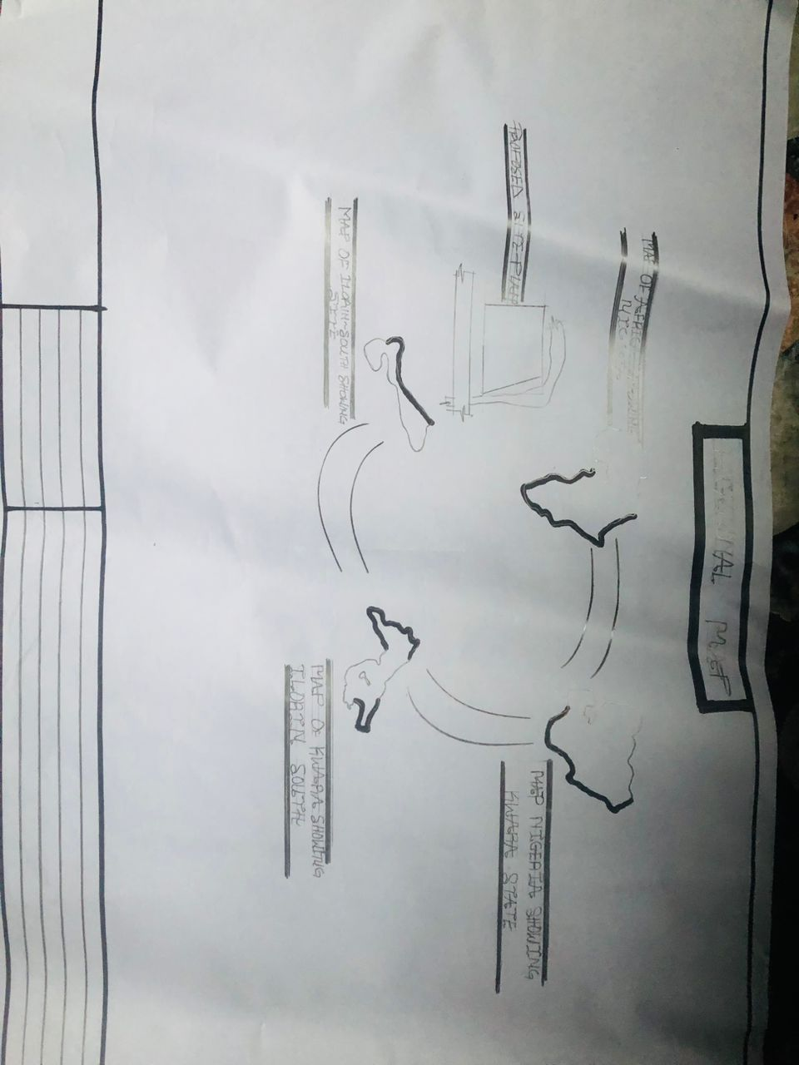

APPENDIX 5
EXTERNAL PERSPECTIVE
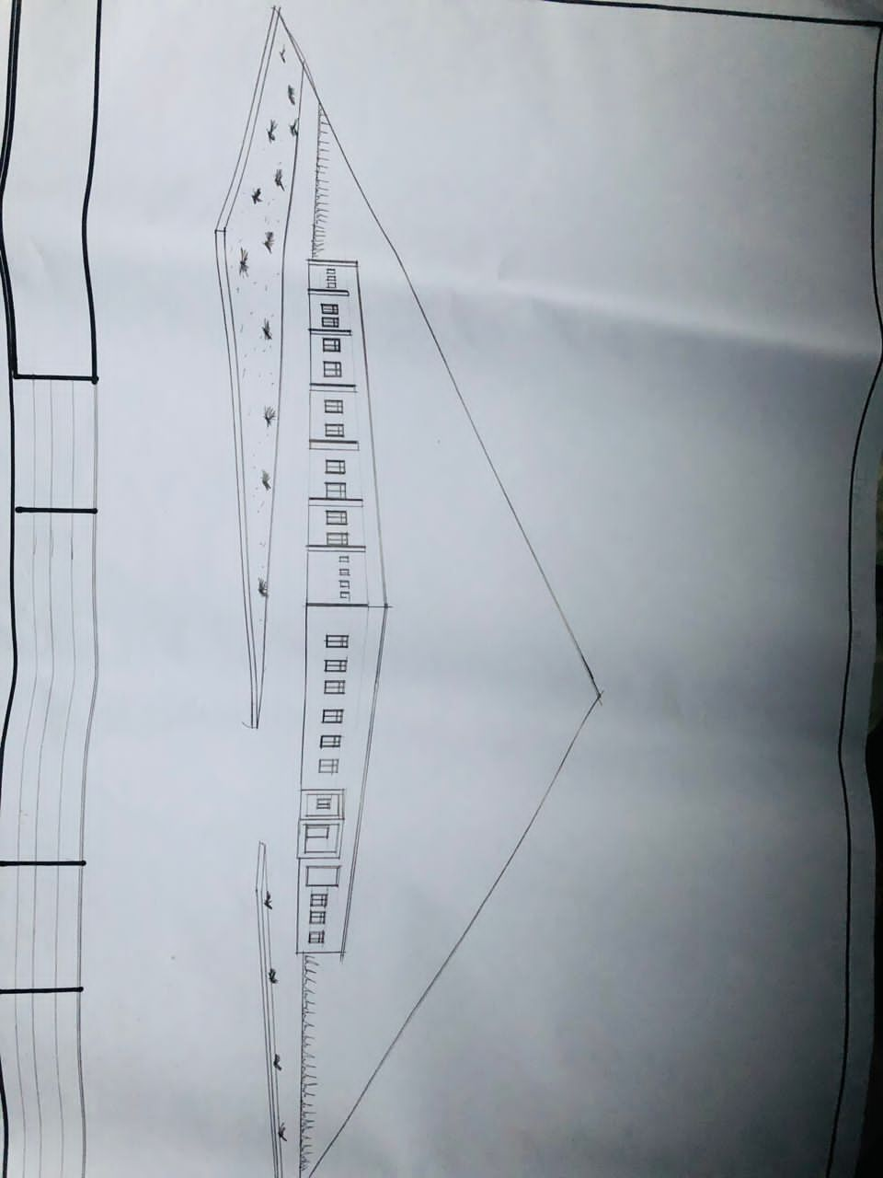

APPENDIX 6
FLOOR PLAN
