INFLUENCE OF SOCIAL MEDIA ON THE SPREAD
OF HATE SPEECH AMONG INHABITANTS OF MORO LOCAL GOVERNMENT AREA

BY

ADEDOYIN MARY PELUMI ND/23/MAC/PT/0277
BEING A RESEARCH PROJECT SUBMITTED TO THE DEPARTMENT OF MASS COMMUNICATION, INSTITUTE OF INFORMATION COMMUNICATION TECHNOLOGY, KWARA STATE POLYTECHNIC, ILORIN

IN PARTIAL FULFILMENT OF THE REQUIREMENTS FOR THE AWARD OF NATIONAL DIPLOMA
(ND) IN MASS COMMUNICATION

JULY, 2025.

CERTIFICATION

This is to certify that lhis research work has been completed, read through and approved as meeting the requirement of the Department of Mass Communicalion, Inslilute Of Information Communication Technology.
Kwara State Polyteclinic, Ilorin In partial fuIfiImenl for the award of NalionaI Diploma (ND) Mass Communicalion.

MALLAM KEULERE LAWAL.
(Project Supervisor)

MRS OPALEKE G T
(Project Coordinator)

MRS OPALEKE G T
(Part Time Coordinator)

DATE

DATE

DATE

DEDICATION
This work is sincerely dedicaled to Almighly, the Most Gracious, the Most Merciful, for granting me life, health, and wisdom throughout the course of lhis study. His divine guidance has been my greatest strength.
I also dedicate this project lo my beloved parenls for their unwavering support, prayers, and encouragement, as well as to my enlire family and well-wishers who stood by me with love and motivalion.

ACKNOWLEDGEMENTS

All praise is due to Almighty, the Lord of the worlds, for giving me the strength, knowledge, and patience to complete this research work successfully
I am deeply grateful to my project supervisor Mallam Keulere for his guidance, constructive criticism, and valuable suggestions throughout this work May Almighty reward you abundantly.
My sincere appreciation goes to all my lecturers and the entire academic staff of the department of Mass Communication for their contributions to my academic journey.
Special thanks to my parent Mr. ADEDOYIN and siblings, for their endless prayers, support, and sacrifices. You are my source of strength, and I am forever indebted to you.
I would also like to appreciate my friends, colleagues and all the respondents who took time to complete the questionnaires. Your support made this work possible.
May Almighty reward everyone who contributed to the success of this project in one way or the other.

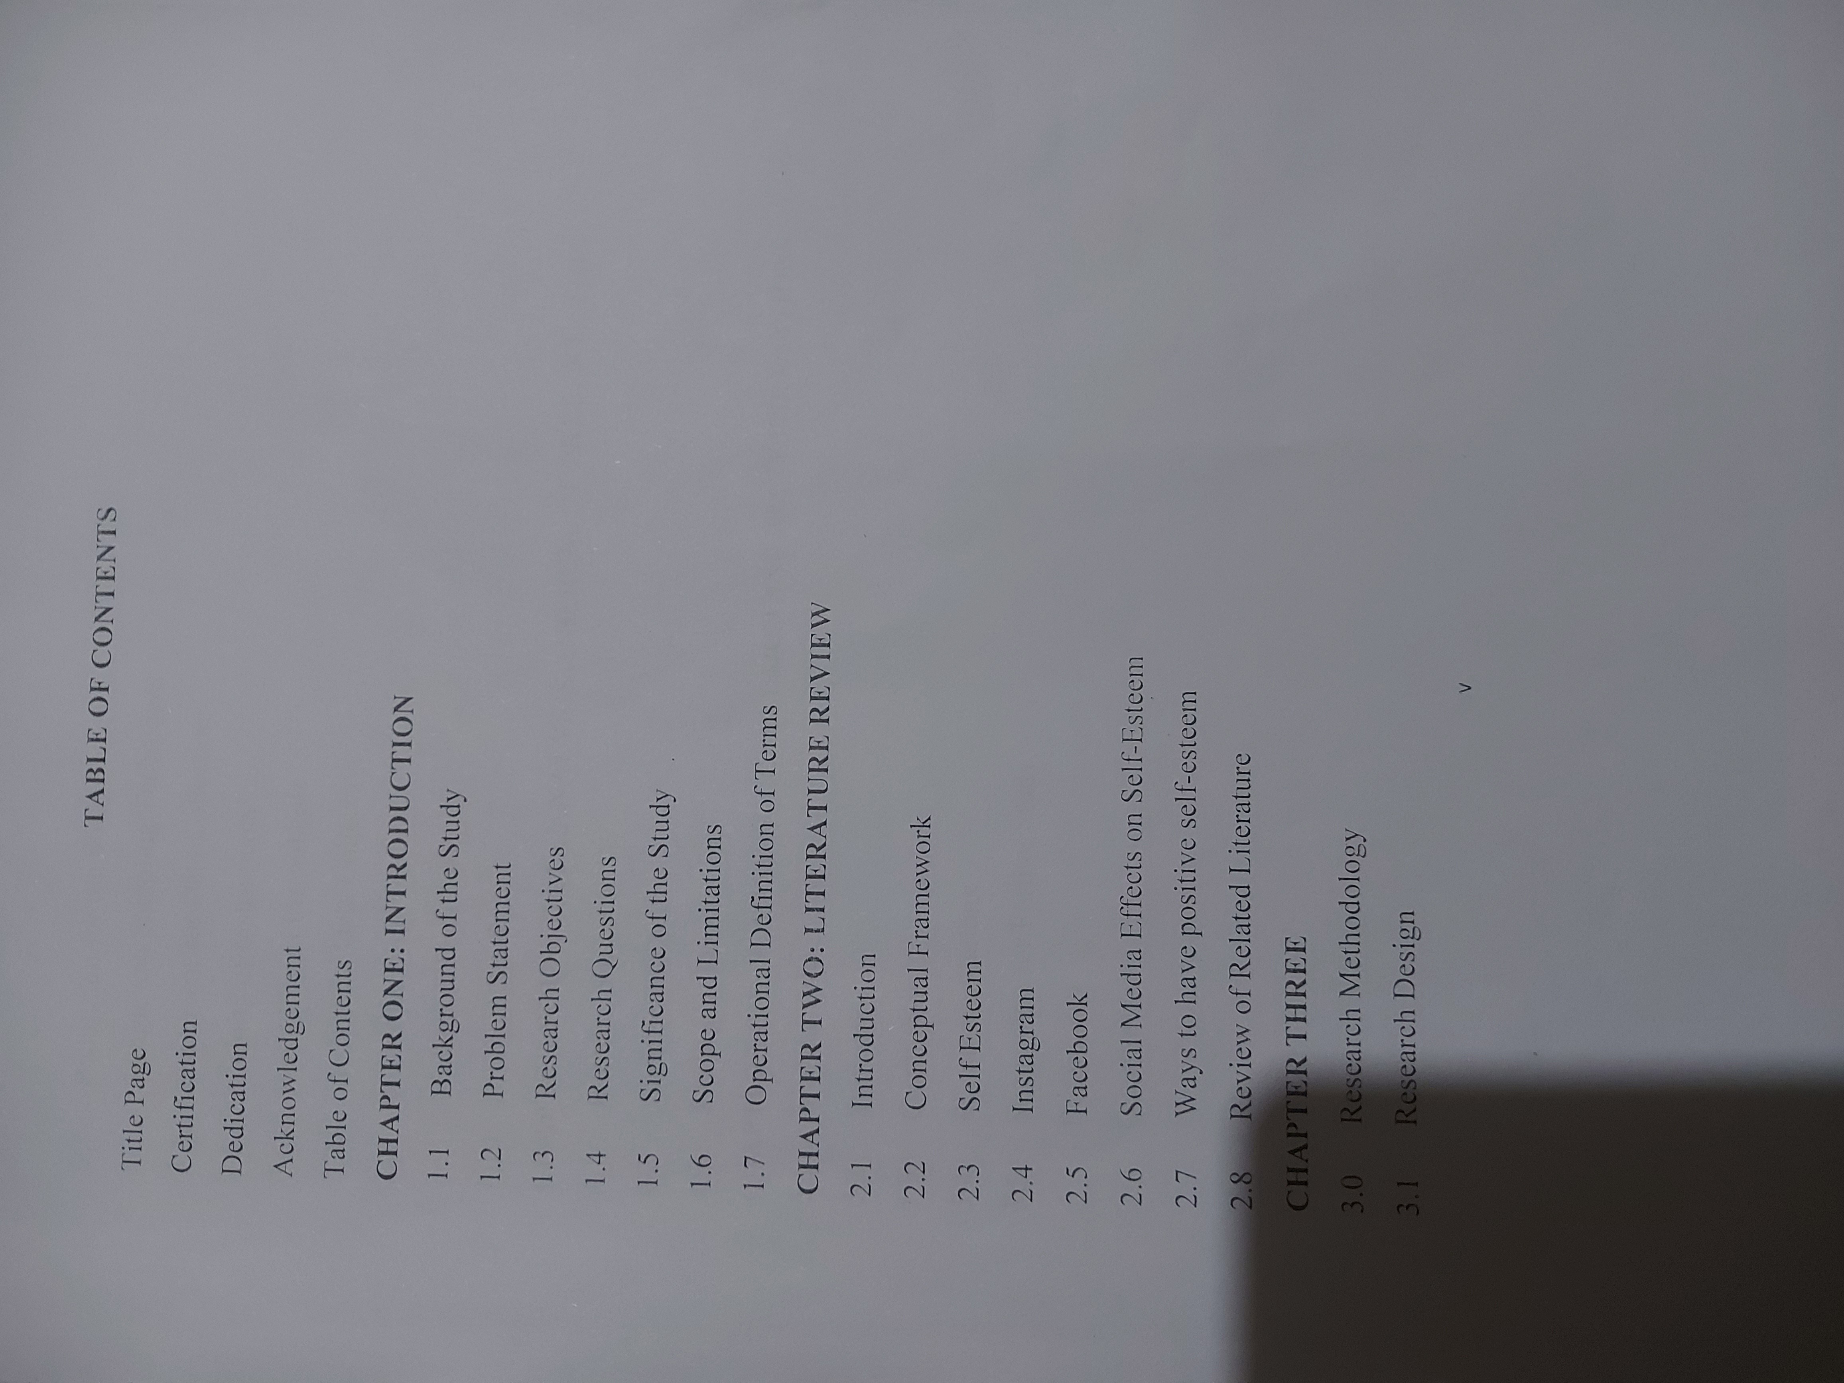

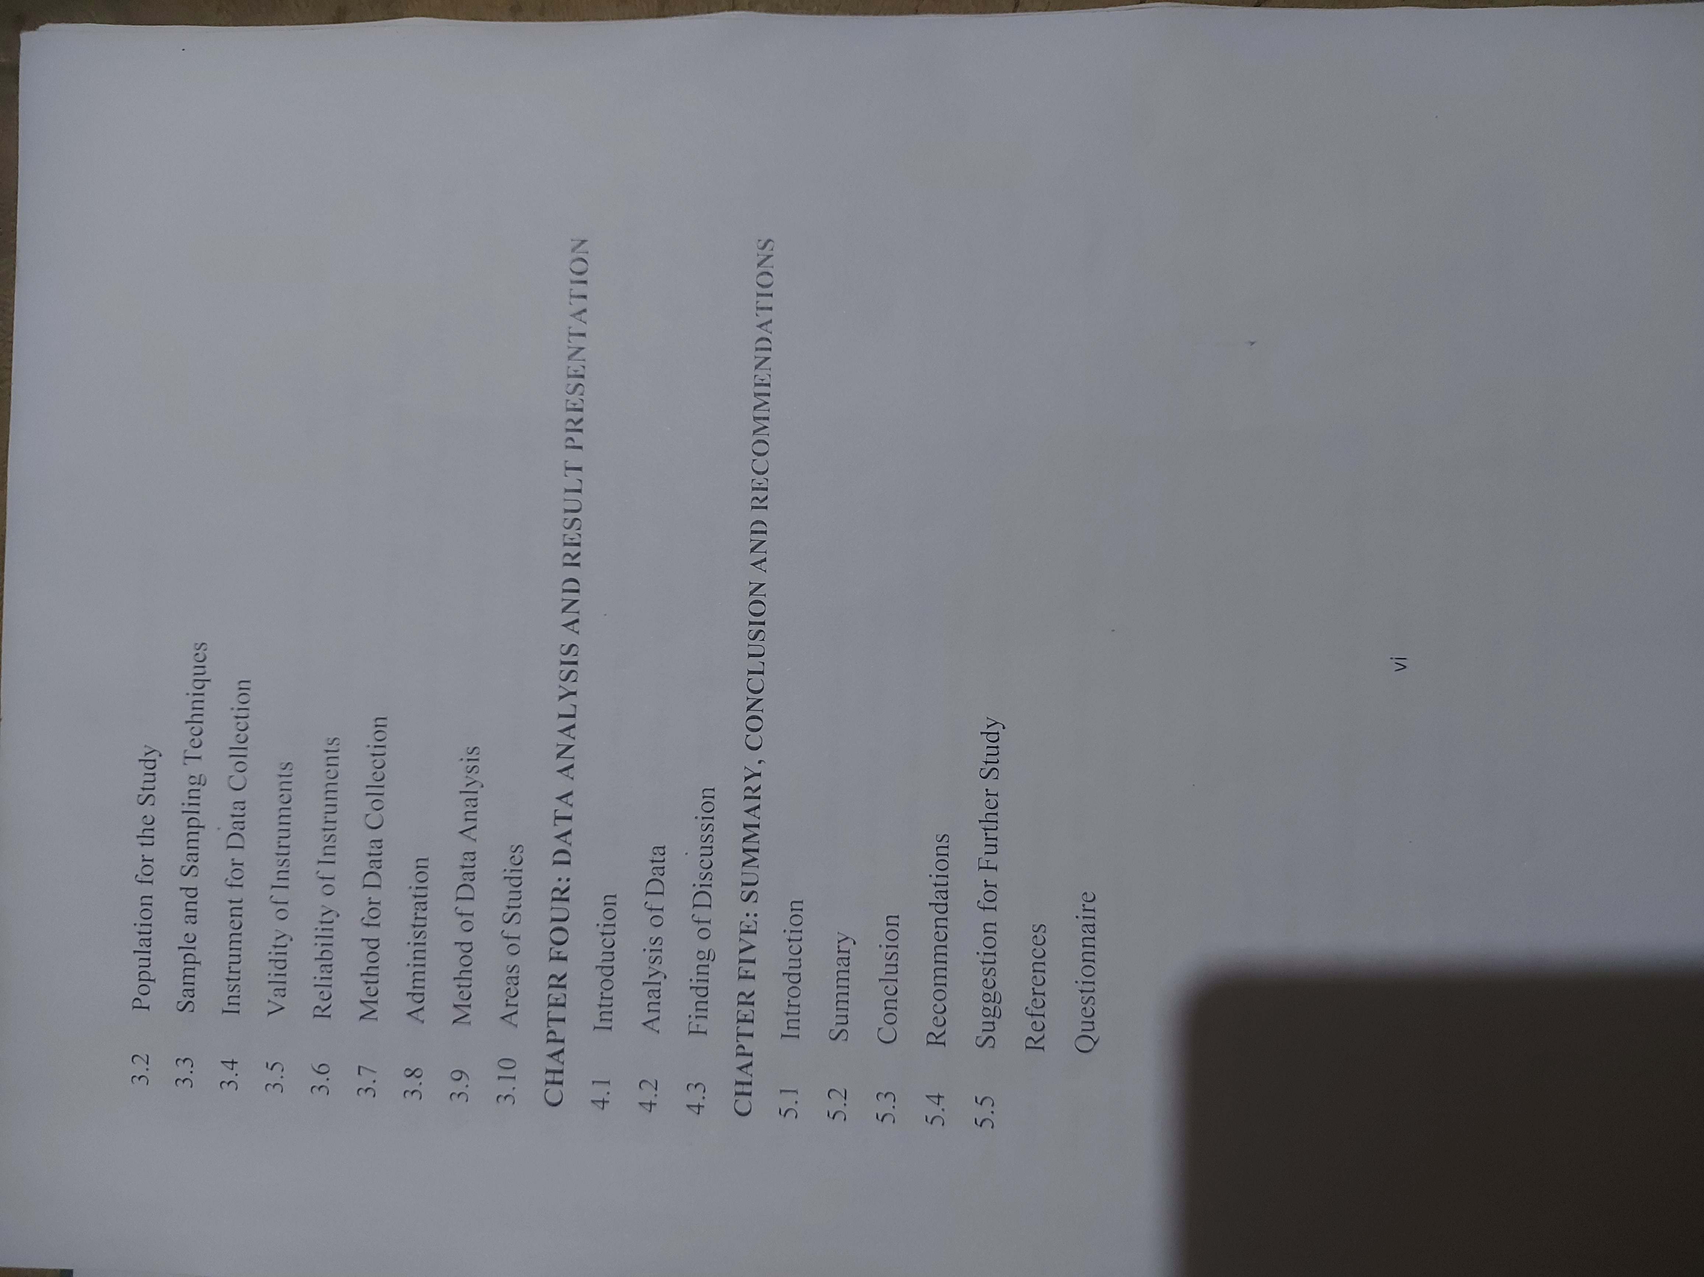

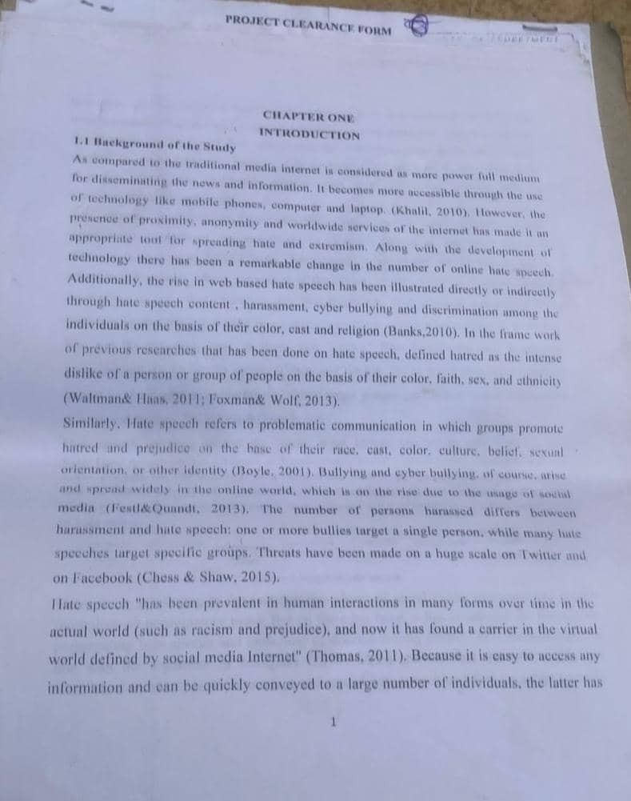

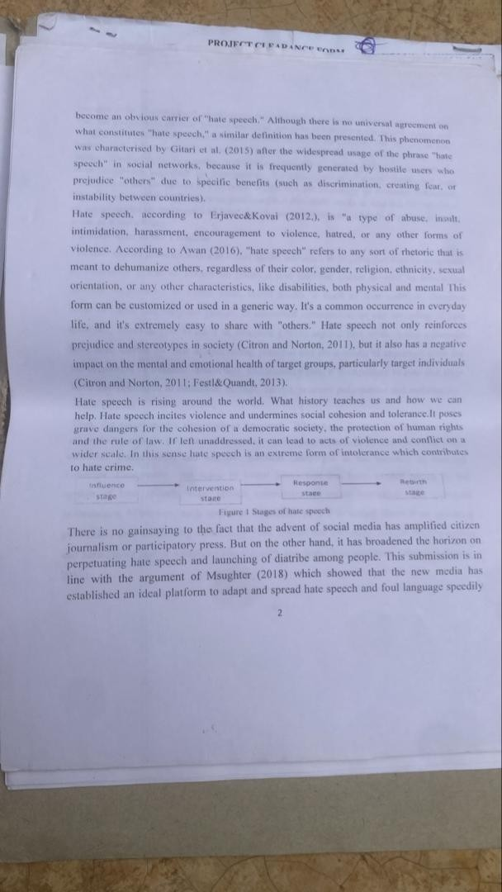

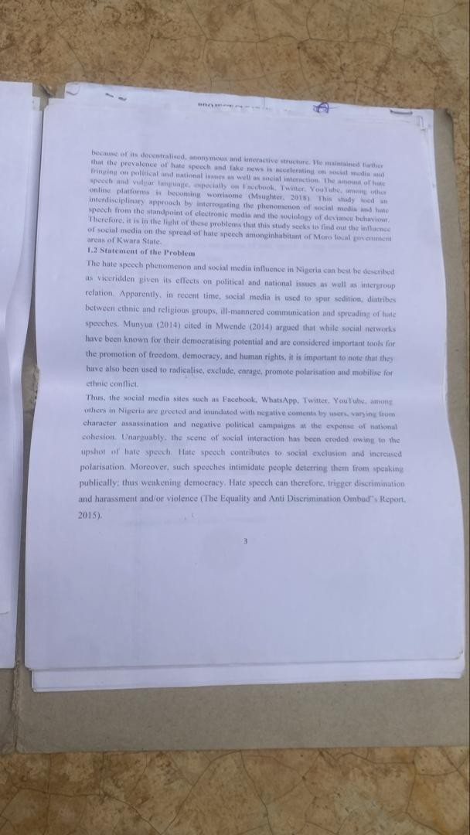

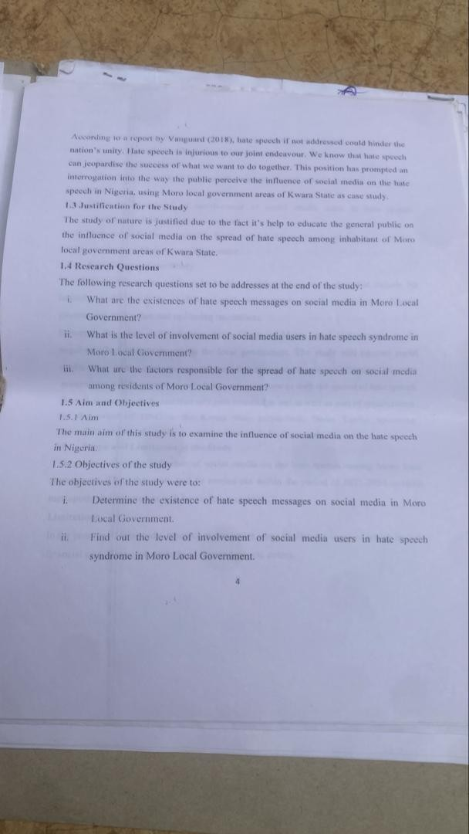

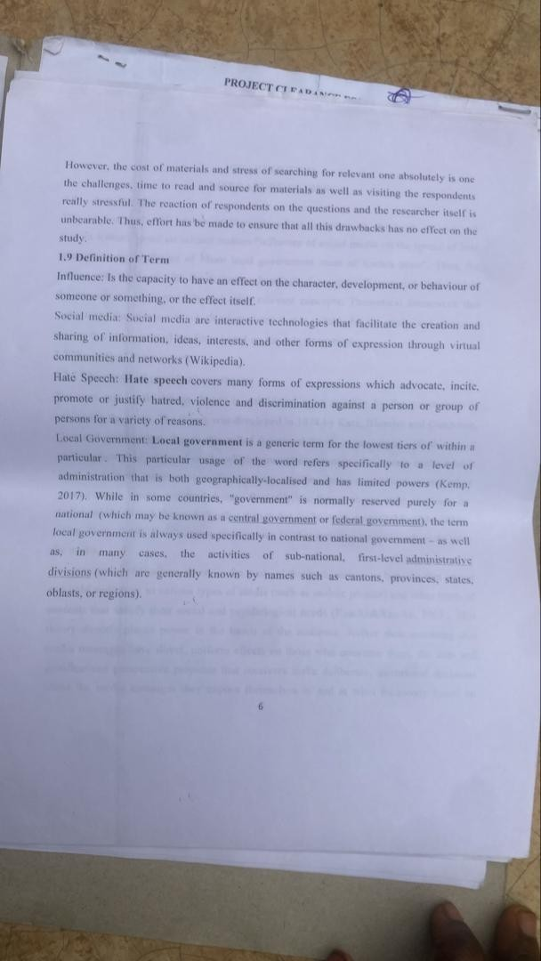

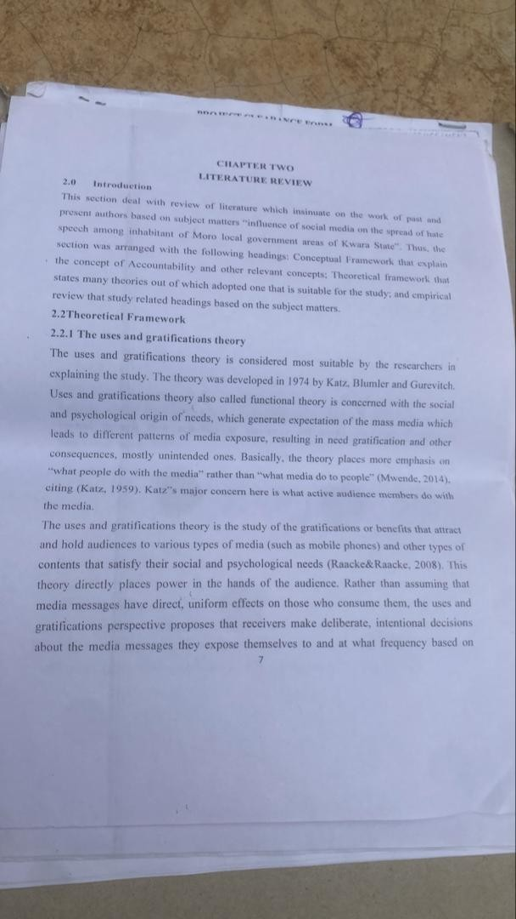

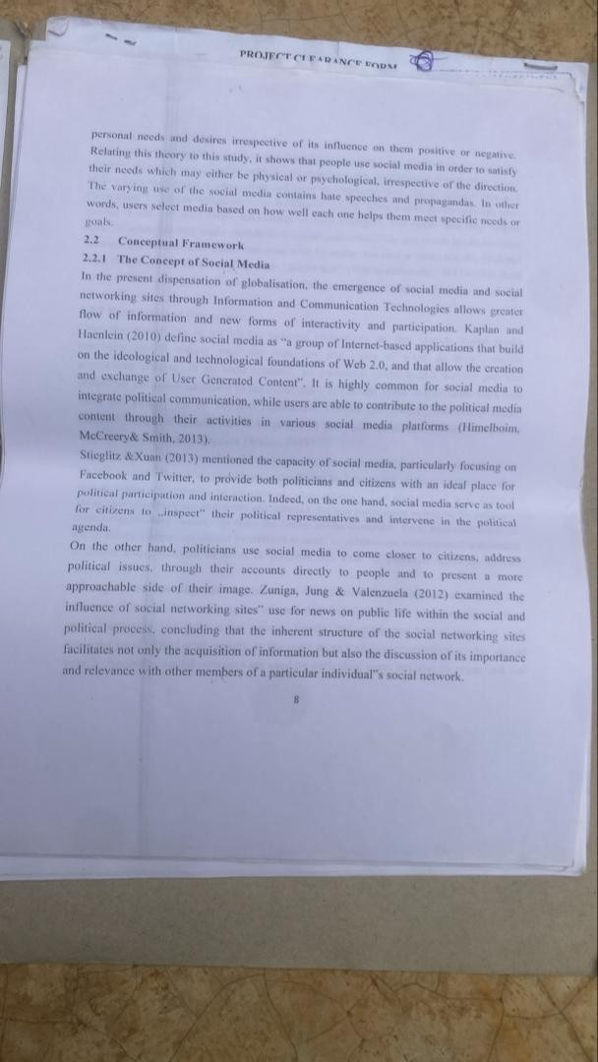

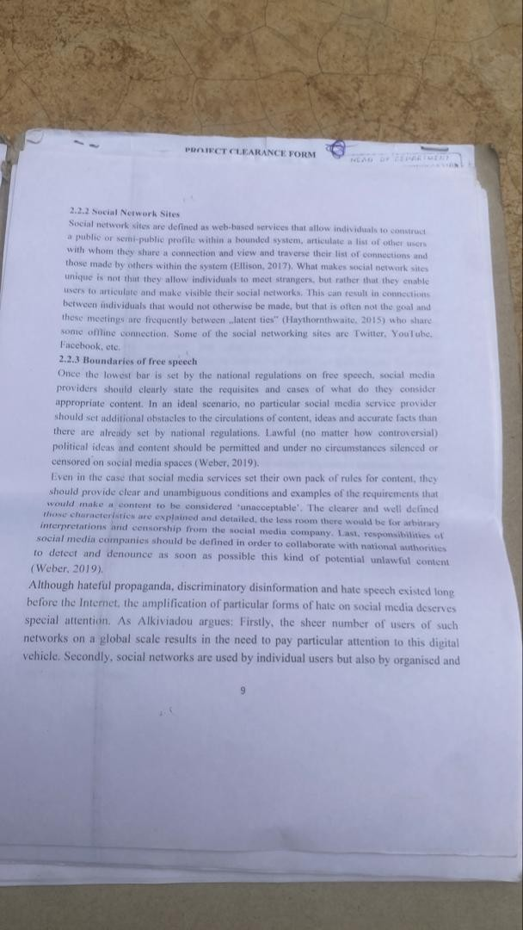

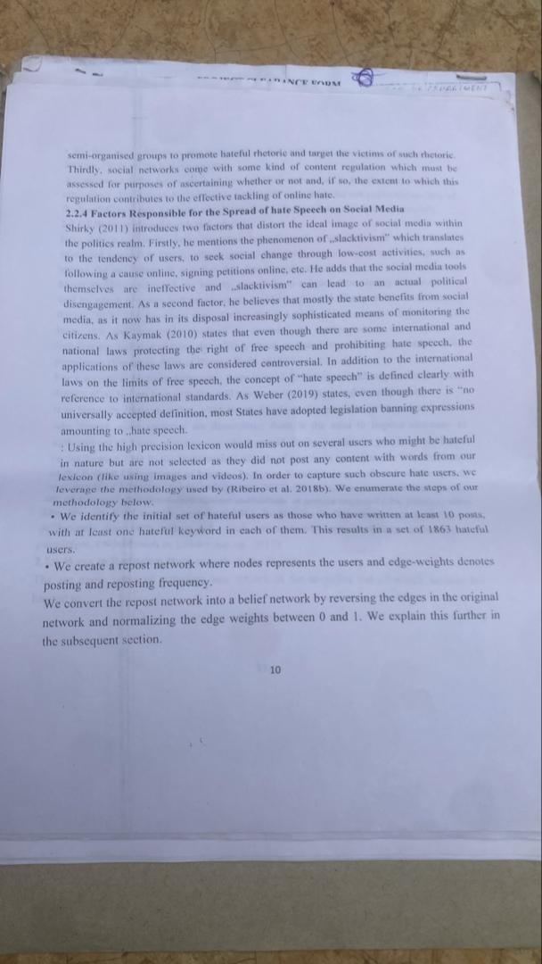

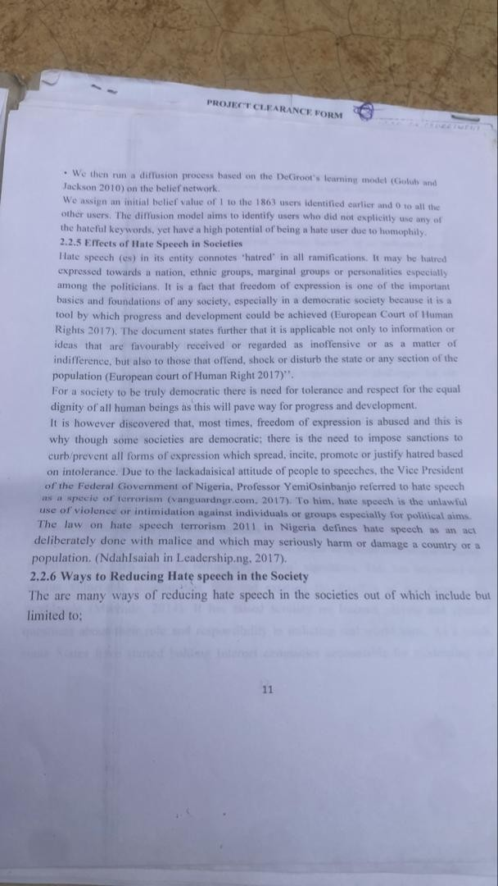

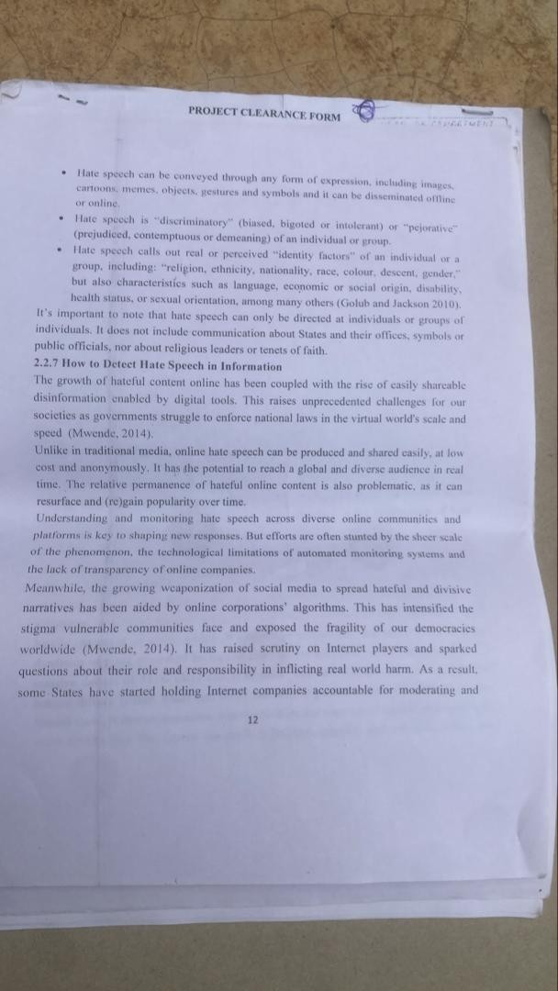

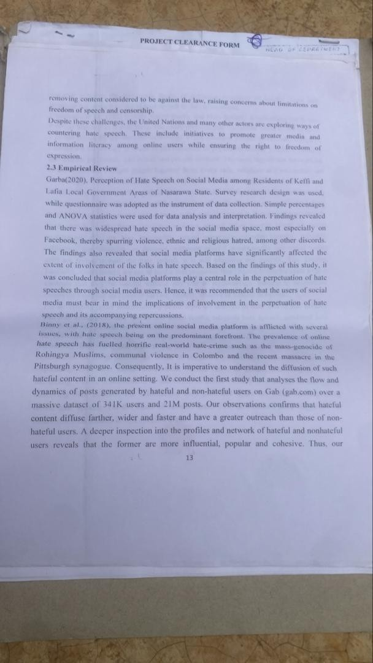

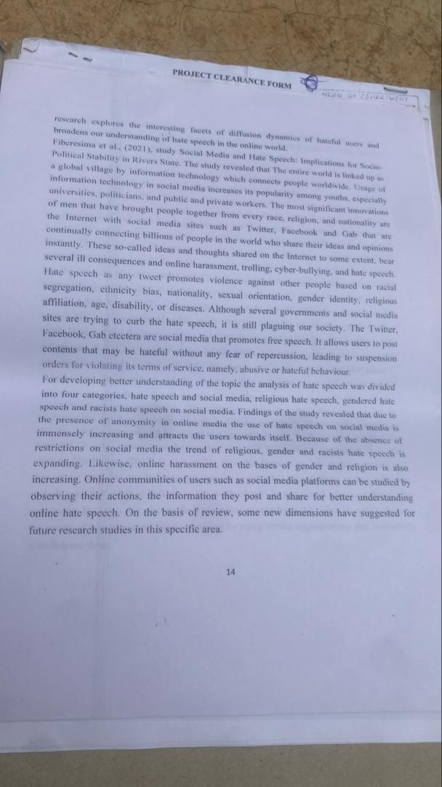

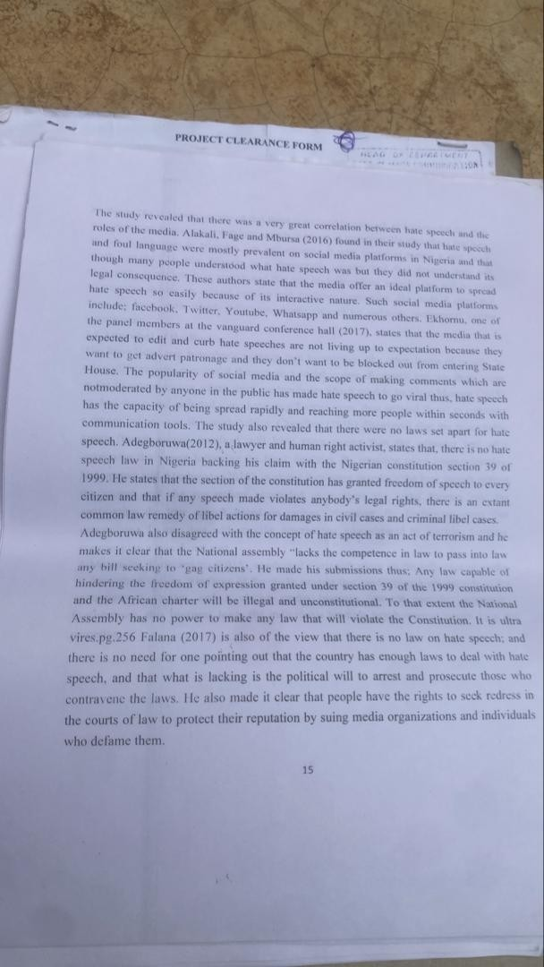

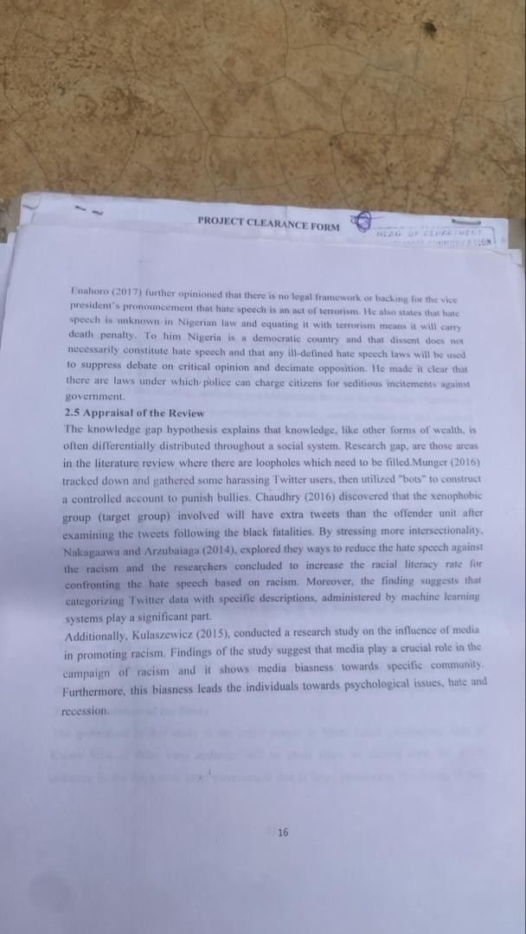

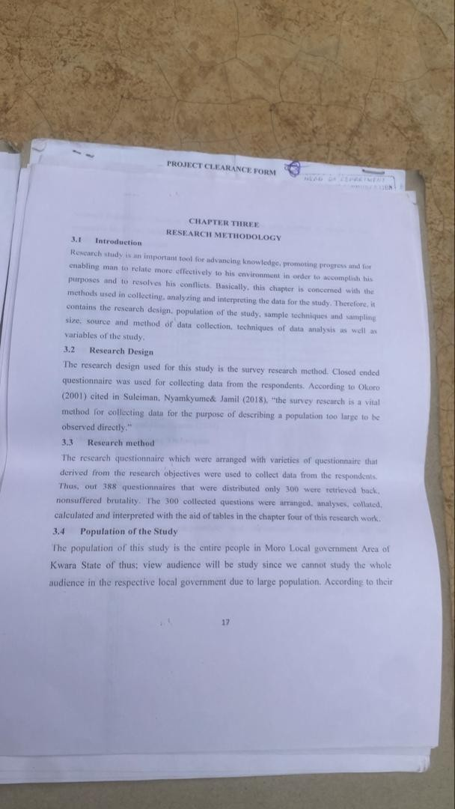

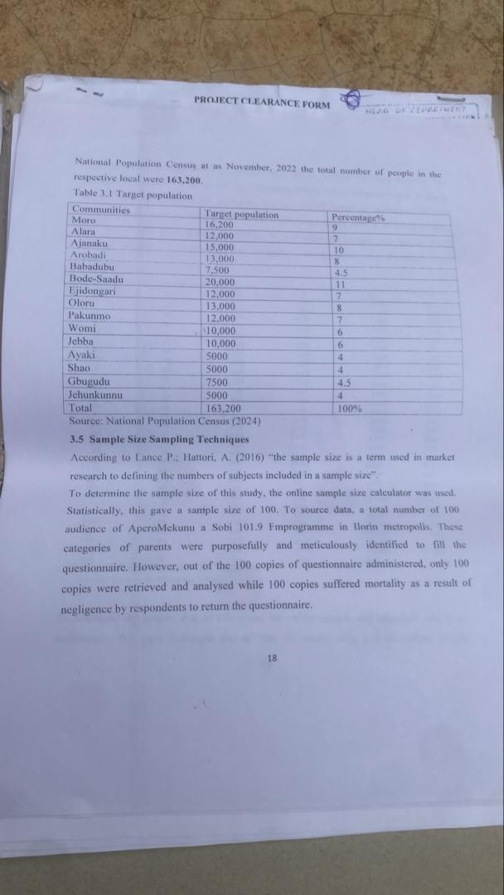

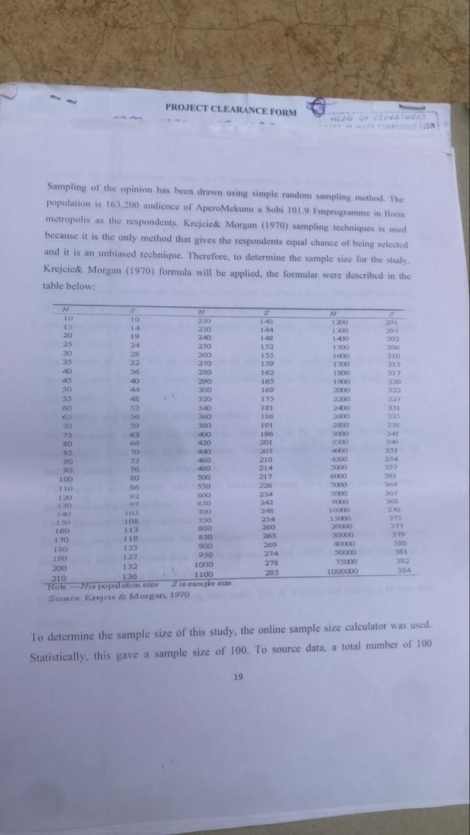

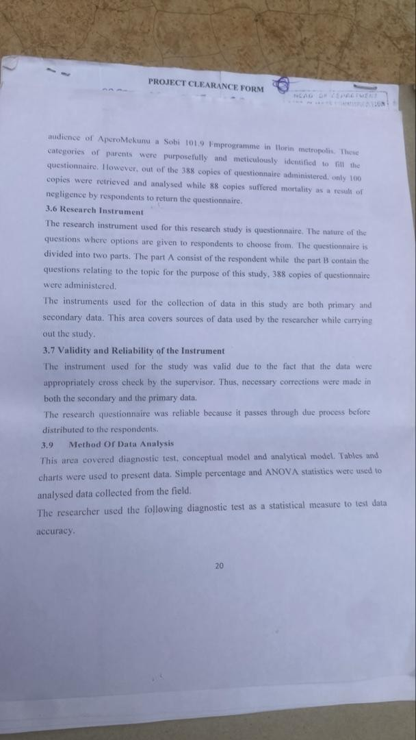

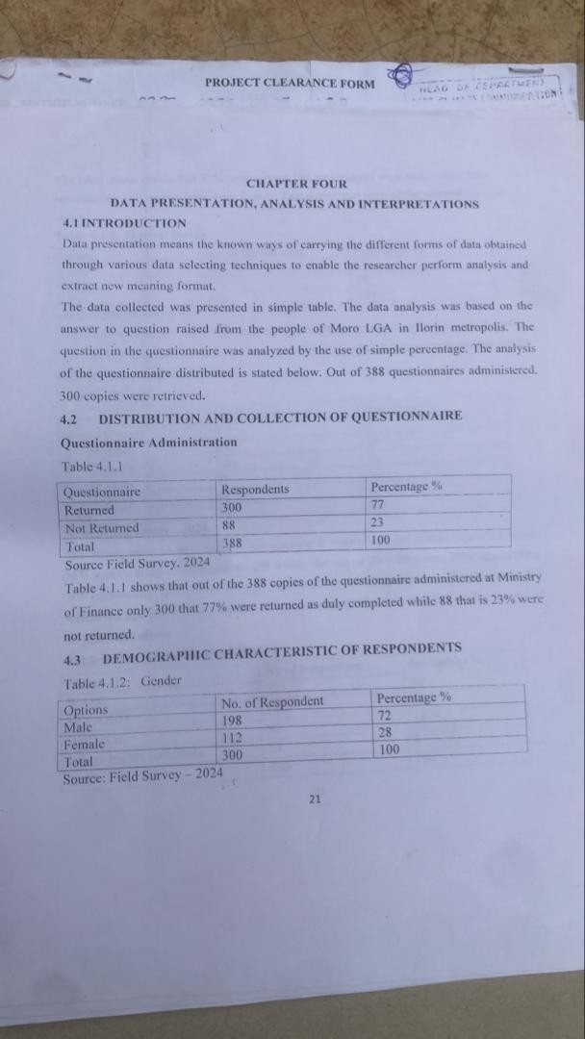

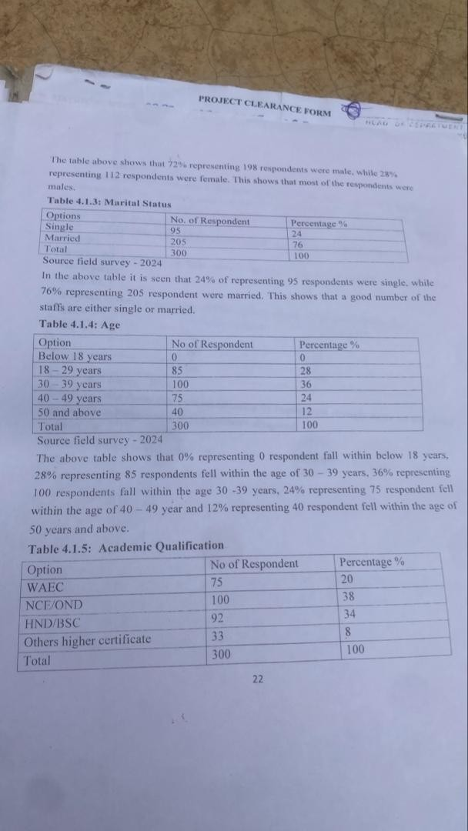

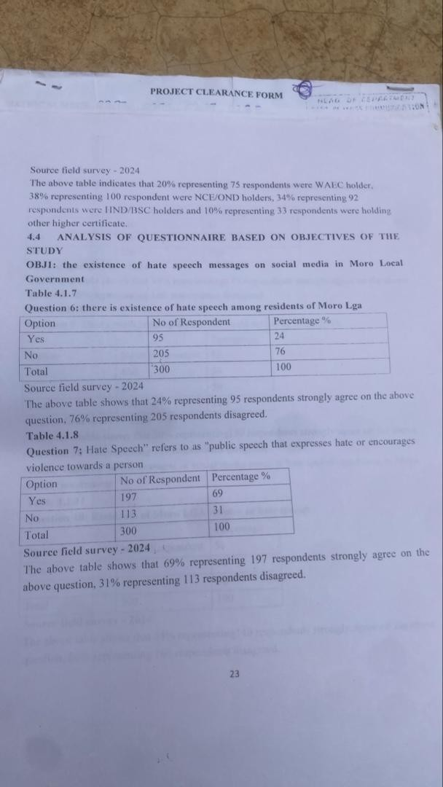

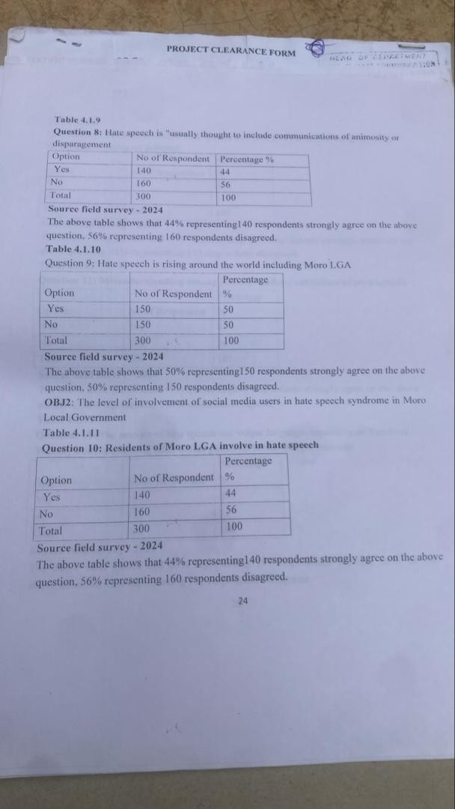

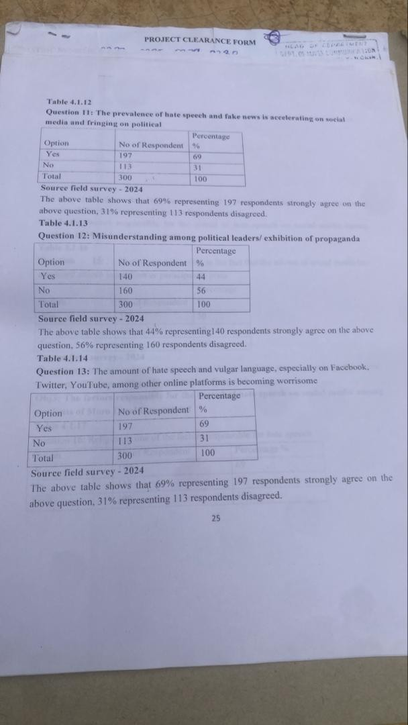

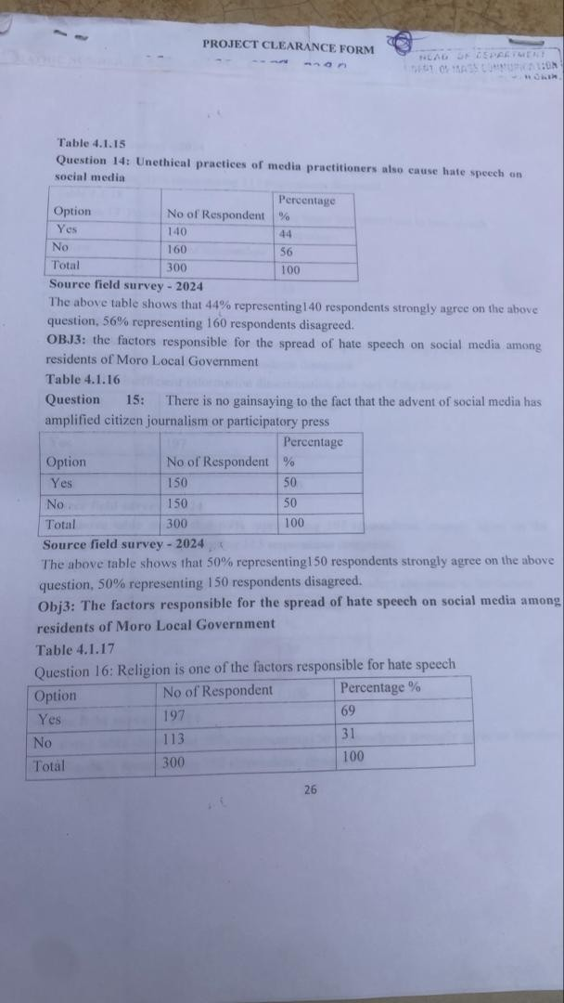

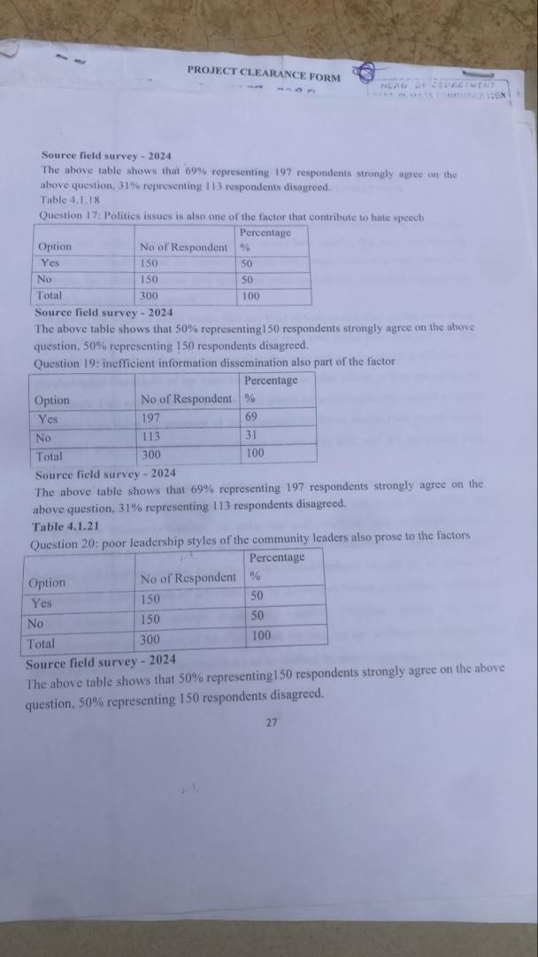

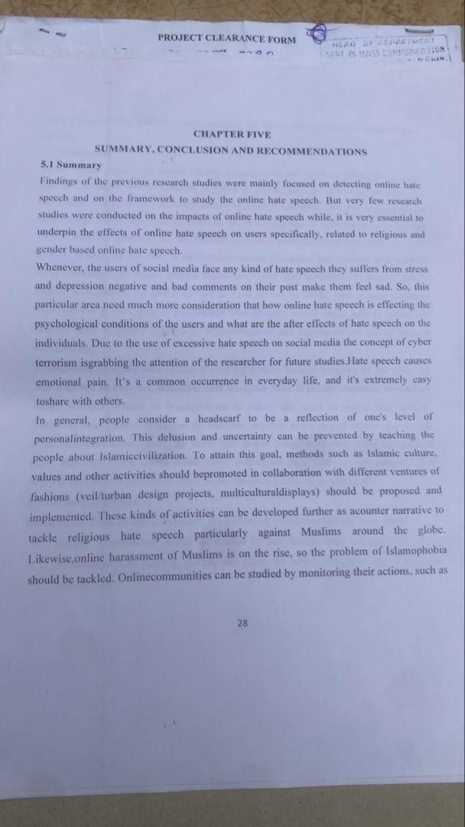

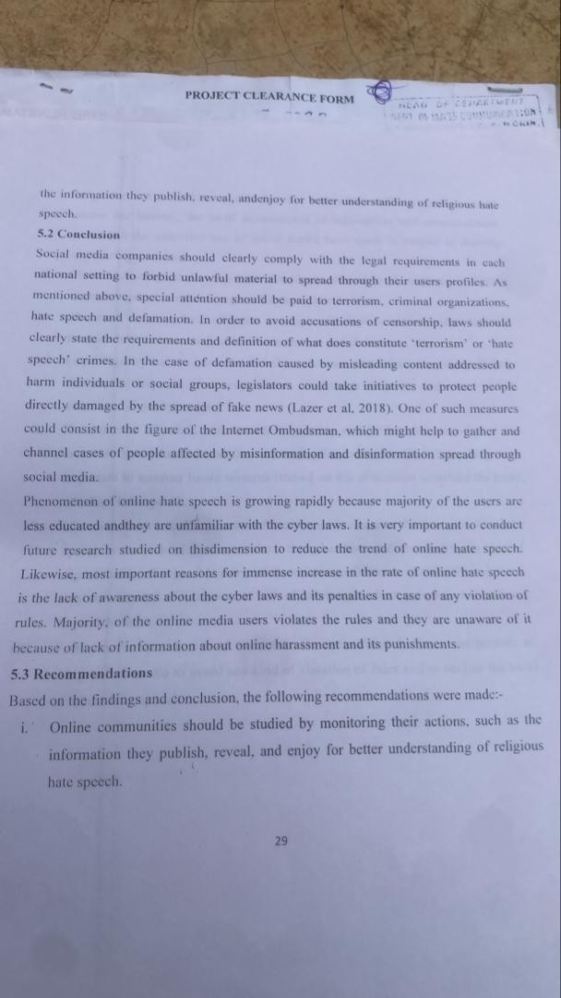

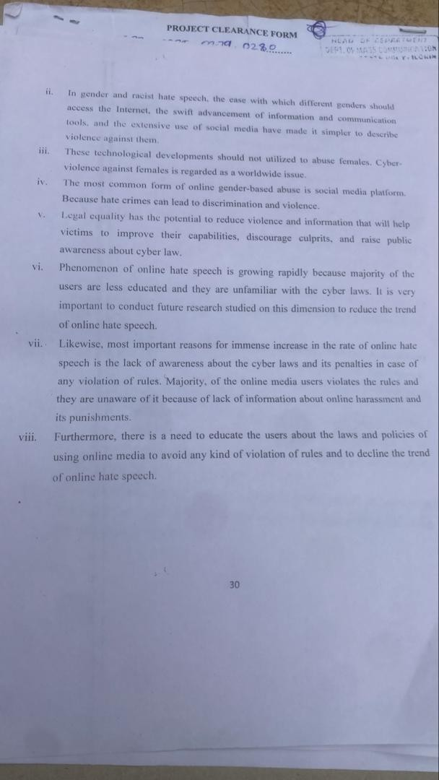

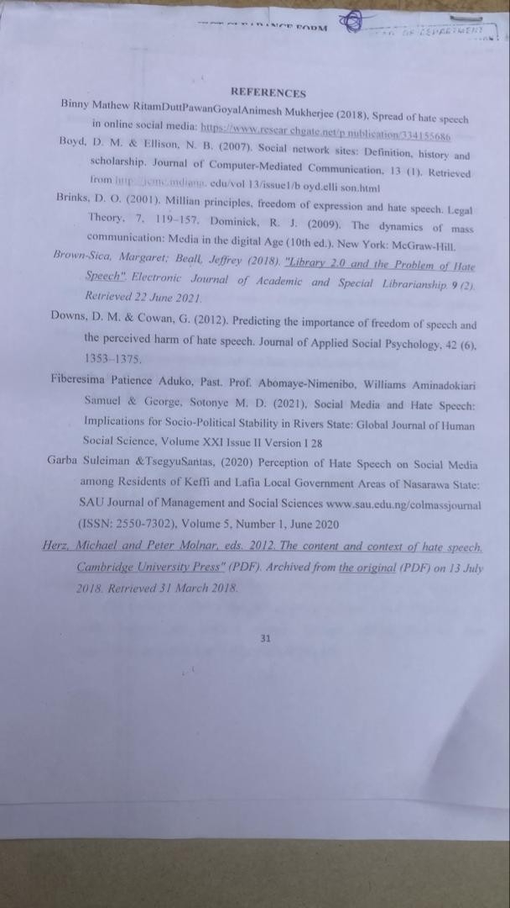

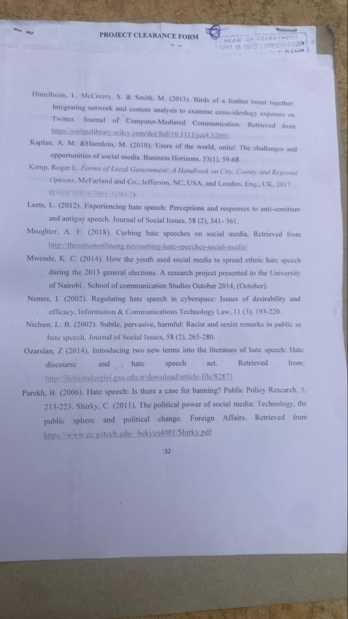

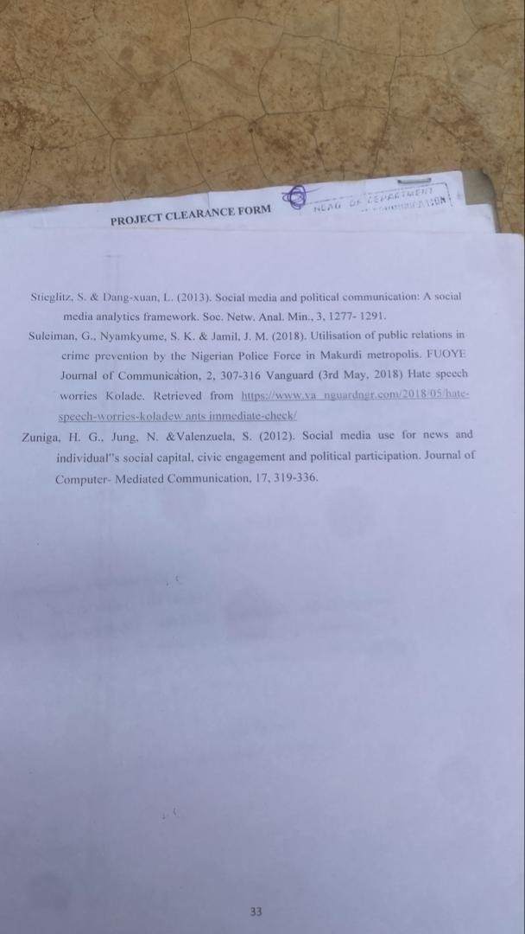

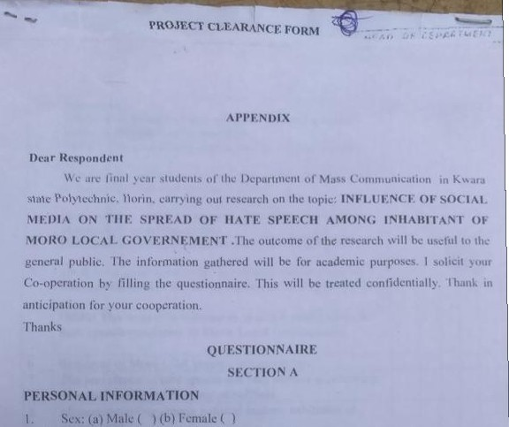
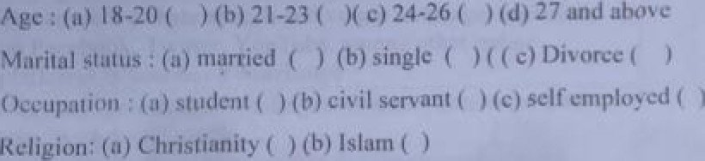
2.

SEC4’ION B
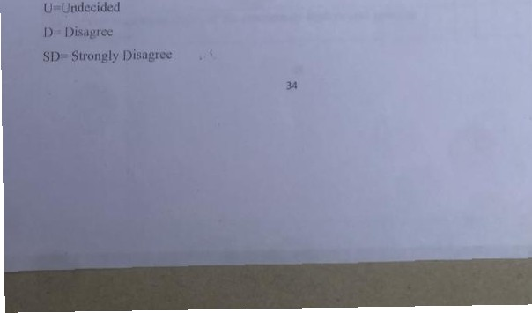
Pim« direct »ppmpriatc t›p'ion in t< *• *• listed ’r""•"

