A PROJECT REPORT
ON
PROPOSED FEDERAL FIRE STATION, OKE OSE, ILORIN EAST LOCAL GOVT, KWARA STATE

BY

OLAWUMI ABDULKABEER TAIWO
HND/23/ARC/FT/0047

SUBMITTED TO
THE DEPARTMENT OF ARCHITECTURAL TECHNOLOGY, INSTITUTE OF ENVIRONMENTAL STUDIES.

IN PARTIAL FULFILLMENT OF THE REQUIREMENTS FOR THE AWARD OF THE HIGHER NATIONAL DIPLOMA (HND) IN ARCHITECTURAL TECHNOLOGY KWARA STATE POLYTECHNIC, ILORIN, KWARA STATE.

JULY, 2025

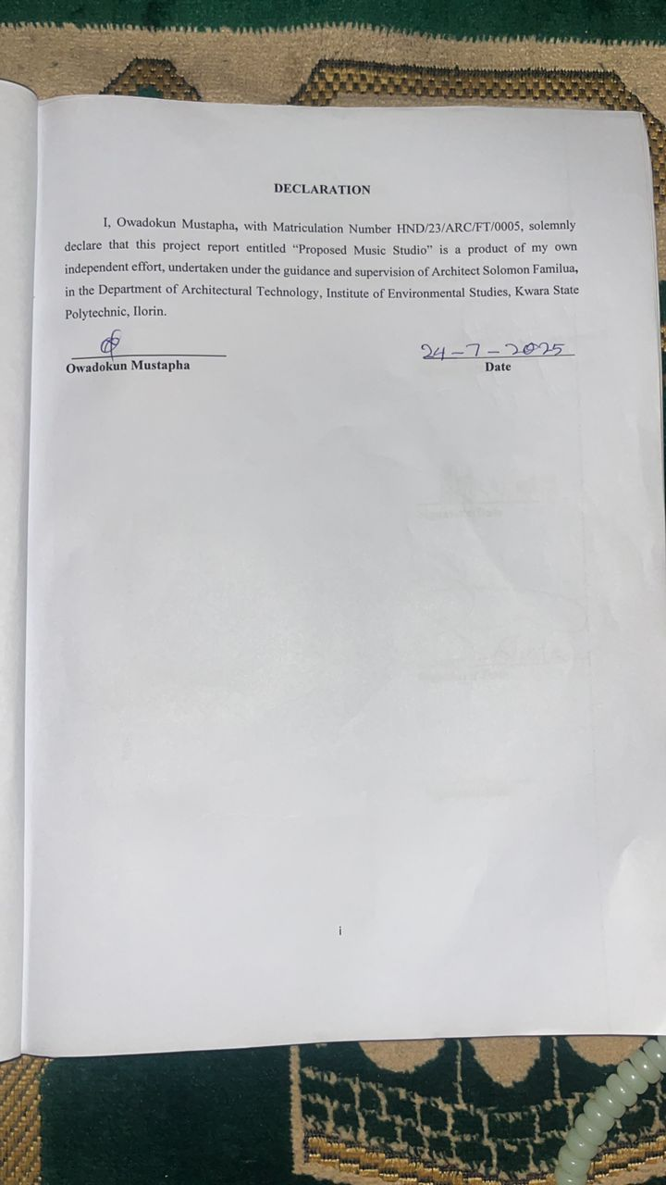
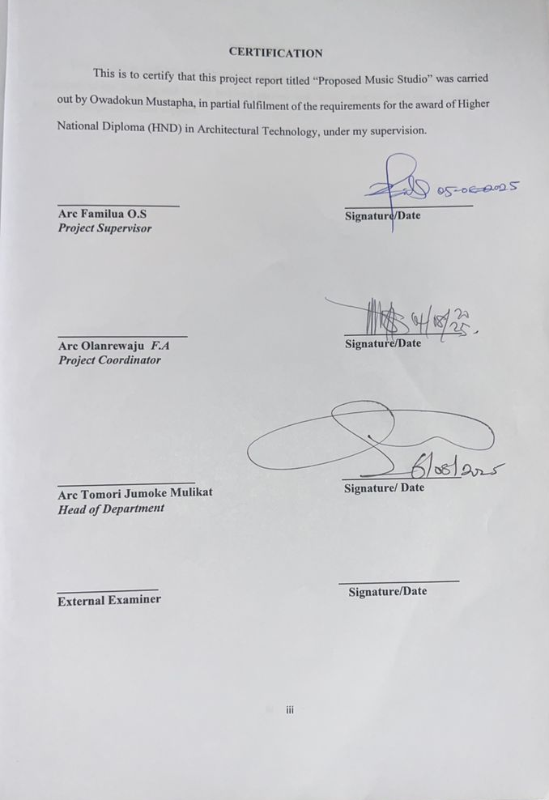
ACKNOWLEDGEMENT
My profound gratitude goes to Almighty Allah who as always be in existence for taking control of this project for is infinite mercy and for giving me the privilege to write the report.
My special gratitude goes to the Department of Architectural Technology the entire staff and my supervisor which is also the HOD of the Department in person of ARC.MRS MULIKAT JUMOKE TOMORI who has been supportive throughout this project, may Allah continue to reward you and your family.
My deepest Appreciation goes to my family whose care, guidance, finance and words of encouragement has given me the strength to come this far. Thanks for all you do God bless and continue to keep us
My appreciation goes to my friends and my special mate thanks for being there always.

DEDICATION

This report is dedicated to Almighty Allah the universe, the creator of all creators and the source of mankind who has always been my strength throughout this project and also for his unconditional and infinite mercy showered upon me through my studies.

ABSTRACT
This project focuses on the design and development of a Federal Fire Station, aimed at enhancing fire safety infrastructure and emergency response services at the national level. The study explores the spatial, functional, and operational requirements essential for effective firefighting operations, with special attention to response time, staff welfare, training, and equipment maintenance. The proposed design incorporates administrative, residential, operational, and training components that align with national fire service standards. Consideration is also given to sustainability, accessibility, and future expansion. The project seeks to contribute to improved public safety, effective disaster management, and the reduction of fire-related loss of life and property, particularly in urban centers such as Ilorin, Kwara State.

TABLE OF CONTENTS
Title Page i
Declaration ii
Certification iii
Dedication iv
Acknowledgment v
Table ofcontent vi
List of figure
List ofplates vii
List ofTables viii
Abstract ix
CHAPTER ONE:
1.0 General Introduction 1
1.1 Definition 2
1.2Historical background ofthe project 2
1.3 Statement ofdesign problem 3
1.4Aim and Objectives ofthestudy 4
1.5Projectjustification 5
1.6 Clients background 5
1.7 Scopeofthestudy 6
1.8Limitation ofdesign 9
1.9Research Methodology 10
CHAPTER TWO:
2.0Review ofrelevant Literature 11
CHAPTER THREE
3.0 Casestudies 14
3.1 Selected casestudies 14
3.2 Casestudy one 15
3.3 Case studytwo 18
3.4 Case studythree 22
3.5 Case studyfour 26
3.6 Case study five(onlinecasestudy) 29
3.7Deduction from Casestudy 29
CHAPTER FOUR
4.0Project location 31
4.1Historical background ofselected location state 31
4.2Historical background of Selected location LGA 32
4.3Physical feature ofthe location 33
4.4Population 33
4.5 Socialservice 33
4.5.1Road 33
4.5.2Health service 33
4.5.3Water and electricity 34
4.6 General climatic condition 34
4.7 Siteanalysis 35
4.7.1Site selection/justification 35
CHAPTER FIVE
5.0Design report 42
5.1Design brief 42
5.2Design analysis 42
5.3Design appraisal 45
5.4Design characteristics 45
5.5Building structure 47
5.6Service 48
5.7 General requirement 48
5.7.1Lighting 48
5.7.2Orientation 49
5.7.3Rain protection devices 50
5.7.4Noise control device 50
5.8Material and finishes 51
6.0 Summary andconclusion 54
6.1 Summary 54
6.2 Conclusion 54
References 56
Appendix

LIST OF PLATES
Location plan 38
Site inventory 38
Site analysis 39
Functional relationship 43
Space calculation 44
Site plan 58
Floor plan administrative building 59-60
Roofplan 60
Elevations 61
Floor plan workshop building I 62
Roofplan 63
Section 64-65
Elevations 65-66

LIST OF FIGURES
Pages
Figure3.1.1: Ground Plan of Case Study One at Yaba, Lagos State 14
Figure3.1.2: Ground Plan of Case Study One at Yaba, Lagos State 14
Figure3.1.3: Second floor Plan of Case Study One at Yaba, Lagos State 15
Figure3.1.4: Upper Floor Plan of Case Study One at Yaba, Lagos State 15
Figure 3.2.1 Locational Plan Of Case Study Two 18
Figure 3.2.2: Ground floor Plan of Case Study Two at opposite oppic estate agbara atan, Ogun State 19
Figure 3.2.3: Upper Floor Plan of Case Study Two at opposite oppic estate agbara atan, Ogun State 19
Figure 3.3.1: Ground floor Plan of Case Study Three at Mahmud Ribadu St. St asokoro Abuja, FCT 22
Figure 3.3.2: Upper floor Plan of Case Study Three at Mahmud Ribadu St. St asokoro Abuja, FCT. 22
Figure 4.1: Locational map of Kwara State 27
Figure 4.3.2: Site Analysis of the proposed site 30
Figure 4.4.1: Graph of Climate in Ilorin 31
Figure 4.4.2: Graph of Rainfall in Ilorin 32
Figure 4.4.4: Graph of temperature in Ilorin 33
Figure 4.4.5: Graph of humidity in kwara state 34

LIST OF APPENDICES
APPENDICES 5.1: LOCATION PLAN 50
APPENDICES 5.2: ELEVATIONS 51
APPENDICES 5.3: EXTERNAL PERSPECTIVE 52
APPENDICES 5.4: GROUND FLOOR PLAN 53
APPENDICES 5.5: UPPER FLOOR PLAN 54
APPENDICES 5.6: ROOF PLAN 55

CHAPTER ONE
1.0 INTRODUCTION
Fire outbreaks pose significant threats to lives, property, and the environment, especially in rapidly growing urban areas. In response to these risks, fire services play a vital role in ensuring public safety through prompt emergency response, rescue operations, and fire prevention initiatives. A well-equipped and strategically located fire station is essential for effective firefighting and emergency management.
The Federal Fire Service, as a national agency, is tasked with safeguarding lives and property across Nigeria (or insert your country, if different) through coordinated fire prevention, suppression, and rescue efforts. Federal fire stations serve as the operational base for this mandate, housing specialized personnel, firefighting equipment, and communication systems necessary for rapid response.
This project seeks to explore the design, planning, and functional layout of a standard Federal Fire Station that meets both national and international standards. It examines critical factors such as location, accessibility, spatial organization, operational efficiency, and sustainability. The study also highlights the importance of integrating modern architectural solutions to address common challenges in the fire service sector, such as outdated facilities, inadequate coverage, and poor infrastructure.
Ultimately, the aim is to propose a fire station design that not only enhances emergency response capabilities but also contributes to the safety, resilience, and well-being of the surrounding community.
In Nigeria, the issue of fire outbreaks remains a persistent threat to lives, properties, and critical infrastructure. These incidents are often worsened by delays in emergency response, inadequate facilities, and poor urban planning. The Federal Fire Service (FFS), under the Ministry of Interior, is the primary national agency responsible for fire prevention, firefighting, rescue operations, and public safety awareness across the country. To carry out its mandate effectively, the service operates through a network of Federal Fire Stations strategically located across states and key urban centers.
The Nigerian Federal Fire Station serves as a central hub for emergency operations, equipped with trained personnel, firefighting trucks, rescue equipment, communication systems, and administrative offices. Despite the efforts of the Federal Government to expand and upgrade these facilities, many fire stations still face challenges such as insufficient funding, obsolete equipment, and inadequate coverage, particularly in rural and underserved areas.
This project explores the architectural and functional design of a modern Federal Fire Station in Nigeria, aimed at improving emergency response time, operational efficiency, and service delivery. The study emphasizes proper site selection, effective space planning, accessibility, staff welfare, and sustainability features such as water harvesting and energy-efficient systems. By addressing these critical aspects, the proposed design seeks to support the Federal Fire Service in fulfilling its duty to protect lives and property, while also aligning with Nigeria’s broader goals for public safety, infrastructure development, and disaster resilience.
  - DEFINITION
A Federal Fire Station is a government-owned and operated facility established by the national (federal) government to provide fire prevention, firefighting, and emergency response services across the country. In Nigeria, it is managed by the Federal Fire Service (FFS) under the supervision of the Federal Ministry of Interior.
Unlike state or local fire stations, a federal fire station serves broader national interests, often covering key federal establishments, high-risk areas, airports, seaports, government institutions, and strategic infrastructures. It is typically equipped with advanced firefighting equipment, trained personnel, communication systems, emergency vehicles, and rescue tools to handle both fire-related and non-fire emergencies such as building collapses, road accidents, and hazardous material incidents.
Overall, a federal fire station is a critical part of the national emergency response system, designed to ensure the protection of lives, property, and the environment at a national level.
1.2 HISTORICAL BACKGROUND
The concept of organized firefighting dates back to ancient civilizations. One of the earliest recorded firefighting systems was established in Ancient Rome around 24 B.C. by Emperor Augustus, who created the Vigiles, a corps of firefighters responsible for protecting the city from fires. These early fire brigades used simple tools such as buckets, axes, and pumps to control and extinguish fires.
During the Middle Ages, firefighting remained largely a community effort, with citizens forming volunteer groups to respond to fire outbreaks. Firefighting as a public service began to evolve significantly in the 17th century, especially after the Great Fire of London in 1666, which led to the formation of the first organized fire brigades in Europe. Insurance companies initially funded these brigades to protect insured properties.
By the 19th century, as cities grew and industrialization increased, fire services became more formalized. Many countries established municipal fire departments with full-time firefighters, dedicated fire stations, horse-drawn engines (later replaced by motorized vehicles), and structured training programs.
The development of federal or national fire services emerged in response to the growing need for a coordinated approach to fire safety, especially in large nations with complex infrastructure and widespread populations. Governments began establishing federal fire departments or agencies to oversee national fire policies, standardize training, provide support to regional stations, and respond to large-scale emergencies
In the 20th and 21st centuries, modern federal fire stations became integral components of national emergency response systems. These facilities are typically equipped with advanced technologies, communication systems, specialized rescue units, and serve as command centers during disasters. They not only handle firefighting but also provide services such as disaster rescue, hazardous material response, fire safety education, and enforcement of building fire codes.
Today, fire stations particularly federal ones represent a key part of a nation’s public safety infrastructure, evolving from simple community-based efforts into complex, highly organized institutions dedicated to protecting lives, property, and the environment.
  - STATEMENT OF DESIGN PROBLEM
Many existing Federal Fire Stations in Nigeria are poorly designed, lacking in functional space planning, modern facilities, and adequate equipment. These shortcomings lead to slow emergency response times, poor staff welfare, and reduced operational efficiency. There is a need for a well-planned, modern Federal Fire Station that ensures quick access, supports staff readiness, accommodates equipment properly, and incorporates sustainable features to improve safety and service delivery.
  - AIM AND OBJECTIVES
1.4.1 AIM
The aim of this project is to design a modern and functional Federal Fire Station that enhances emergency response efficiency, promotes the safety and well-being of fire personnel, and meets national standards for fire service infrastructure in Nigeria.
1.4.2 OBJECTIVES
To achieve the aim, the following objectives are set out;
1. To Ensure fast and efficient emergency response.
2. To Provide secure storage for equipment and vehicles.
3. To Support staff comfort and training needs.
4. To Incorporate sustainable design features.

1.5 JUSTIFICATION FOR THE PROJECT
A well-designed Federal Fire Station is crucial to improving emergency response times, protecting lives and property, and supporting fire personnel’s effectiveness. Current fire stations in Nigeria often lack adequate facilities and strategic planning, which hampers their ability to respond promptly to fire outbreaks and disasters. By creating a modern, efficient, and sustainable fire station, this project aims to enhance the Federal Fire Service’s capacity to save lives, reduce property loss, and promote overall community safety.
1.6 CLIENT BACKGROUND
Kwara State is one of the 36 states in Nigeria, located in the North-Central geopolitical zone, often referred to as the “Middle Belt.” The state was created on May 27, 1967, when the country was reorganized into 12 states from the original 4 regions. Its capital is Ilorin, which is also the largest city in the state.
1.7 SCOPE OF THE PROJECT
The scope of the design focuses on providing a functional and responsive fire service center that meets the emergency and safety needs of Kwara State. It aims to ensure effective planning, accessibility, operational efficiency, and compliance with national fire safety standards.
The design will consider the geographic and climatic conditions of Kwara State, the population density of urban centers like Ilorin, and the strategic location of the station for prompt emergency response across the state. Emphasis will be placed on operational readiness, staff accommodation, safety, ease of vehicle movement, and future expansion potentials
Facilities to be provided in the hostel would include;
• Control room / dispatch center
• Administrative offices
• Conference / briefing room
• Dormitories
• Toilets and bathrooms , etc
1.8. RESEARCH METHODOLOGY
The methods that were used in the course of this study are primary data methods which are:
Comprehensive and detailed observation, Asking questions, case studies and documentation
And also the secondary data collection methods are from: Internet, Textbooks, Appropriate government agencies

CHAPTER TWO
  - LITERATURE REVIEW
2.2 REVIEW ON FEDERAL FIRE STATION
Fire stations are critical infrastructure for public safety, providing rapid response to fire emergencies, rescue operations, and disaster management. Federal fire stations, in particular, are designed to serve at a national level, often with higher standards and capacity compared to local or municipal stations.
Design and Functionality: According to Olawale and Adeyemi (2018), the design of fire stations must prioritize quick mobilization and readiness. They emphasize that functional layout, including the positioning of vehicle bays and administrative areas, directly affects response times. The integration of residential facilities ensures that firefighters can be on-site and ready at all times (Adebola, 2020).
The Federal Fire Service of Nigeria outlines standards requiring stations to be equipped with modern communication systems, training facilities, and proper maintenance areas to uphold operational efficiency (Federal Fire Service Manual, 2019).
Impact on Community Safety: Studies by Eze et al. (2021) highlight the role of federal fire stations in enhancing urban safety, particularly in densely populated areas like state capitals. The presence of a well-equipped federal fire station reduces fire-related casualties and property loss by improving emergency response coverage and coordination
Challenges in Fire Station Implementation: Several scholars point out challenges in the development of federal fire stations, including inadequate funding, poor maintenance, and limited access to modern equipment (Balogun, 2017). In some regions, aging infrastructure and insufficient training facilities hamper the effectiveness of fire services (Usman & Ibrahim, 2022).
Technological Integration: The literature stresses the importance of integrating advanced technologies such as GPS tracking, automated dispatch systems, and fire detection sensors in federal fire stations to improve operational outcomes (Johnson & Akintola, 2020). Sustainable design practices, including energy-efficient buildings and water conservation methods, are also increasingly recommended (Nwankwo, 2023).
2.1 HISTORICAL DEVELOPMENT OF FIRE STATION
The fire service in Nigeria has a historical development beginning as an arm of the Lagos police fire brigade in 1901. In 1963, the federal fire service was officially established by an act of parliament, separating the fire service from the police force. Further reforms in 2007 and the establishment of the federal fire service academy in Abuja have marked the service’s evolution.
- Early development (1901-1963):
The fire service initially operated as part of the Lagos police fire brigades, with
firefighters undergoing combine police and fire service training. This period was
characterized by a close relationship between the two services, which gradually evolved into a need for separation.Firefighting as an organized activity dates back to ancient civilizations.
In Ancient Rome, the first known fire brigade, Vigiles, was formed under Emperor
Augustus around 24 BCE. These early responders had basic tools like buckets, hooks, and pumps and operated out of watchtowers or small shelters rather than dedicated buildings.
- Medieval and Pre-Industrial Era
During the Middle Ages in Europe, firefighting responsibilities often fell on local
communities or informal groups of volunteers. There were no specialized buildings; fire
equipment (often just buckets and ladders) was stored in town halls or churches. Urban fires were common due to wood construction and the lack of regulations.
- The Industrial Revolution and the Rise of Formal Fire Departments (18th–19th
Century)
The growth of cities during the Industrial Revolution brought increased fire hazards. This led to the establishment of formal fire departments and the first dedicated fire stations.
• In London, following the Great Fire of 1666, organized firefighting emerged, culminating in the London Fire Brigade (1866).\
• In the United States, Benjamin Franklin helped form the first volunteer fire company in Philadelphia in 1736, and the first municipal fire station emerged in the early 1800s.
Fire stations from this period were primarily utilitarian buildings, often resembling
barns, with simple garages for horse-drawn engines and a bell tower to alert firefighters.
- Early 20th Century: Mechanization and Standardization
The invention of the motorized fire engine transformed fire station design.
Buildings now needed:
• Wider bays for large vehicles
• Hose drying towers
• Sleeping quarters and mess halls for full-time staff
• Sliding poles for quick movement from upper dormitories to apparatus bays
This era also saw architectural styles reflecting civic pride—many fire stations were designed in classical, art deco, or mission revival styles, depending on the region
- Post-War Era (1945–1980s):
Functional Modernism
After World War II, fire stations became more standardized and purely functional. Emphasis was placed on response efficiency and practicality over aesthetics.
• Prefabricated materials and minimalist designs became common.
• Suburban expansion required more decentralized, smaller-scale fire stations.
Contemporary Fire Station Design (1990s–Present)
In recent decades, fire stations have evolved into multi-functional civic buildings. They now often include:
• Public education rooms• Community gathering spaces Sustainable design features (LEED-certified buildings)
•Advanced safety zones, such as clean/dirty transition areas to manage contamination
• Spaces promoting firefighter wellness (gyms, quiet rooms, natural lighting)
Iconic modern examples include:
• Vitra Fire Station by Zaha Hadid (Germany, 1993) — a sculptural, deconstructivist design
- Establishment of the fire service (1963- present):
In 1963, an act of parliament officially established the fire service, making the formal
separation from the police force. The actual separation took effect on April 1,1964 and the fire service was established throughout the federal capital territory.
• Further development and reforms:
The federal Government’s reform of the fire service in 2007 redefined as its mandate, including the standardization of fire and rescue equipment, the regulation of private fire outfits, and fire prevention. The federal five service Academy, located in Abuja was established to provide specialized training for firefighters. The service’s mission continues to evolve, focusing on fire prevention, safety, mitigation and emergency preparedness.
- •Contemporary Fire Station Design (1990s–Present)
In recent decades, fire stations have evolved into multi-functional civic buildings.
They now often include:
• Public education rooms
• Community gathering spaces
- Sustainable design features (LEED-certified buildings)
• Advanced safety zones, such as clean/dirty transition areas to manage contamination
• Spaces promoting firefighter wellness (gyms, quiet rooms, natural lighting)
Iconic modern examples include:
- Vitra Fire Station by Zaha Hadid (Germany, 1993) — a sculptural, deconstructivist design
- Woodlawn Fire Station 21 (Portland, USA) — a LEED Platinum-certified green building
- Docklands Fire Station (Melbourne, Australia) — a high-performance, community-centered facility
The design of fire stations has shifted from utilitarian sheds to sophisticated, multi- zoned facilities that reflect advances in technology, urban planning, and public architecture. As critical infrastructure, fire stations today serve not only as emergency response hubs but also as symbols of civic engagement, resilience, and sustainability.

CHAPTER THREE
  - CASE STUDY
A case study is a process or record of research in which detailed consideration is given to the development of a particular person, group or situation over a period of time.
- At Yaba, Lagos State
- Epic Estate Agbara, Ogun State
- Mahmud Ribadu ST, Asokoro, Abuja FCT
- At Kubura, Abuja FCT.

  - CASE STUDY 1: 92,CLEGGG STREET YABA, LAGOS STATE
The project involves of a Federal Fire Station at 92 Clegg Street, Yaba, Lagos State. The goal is to create a modern, efficient facility that supports rapid emergency response, effective firefighting operations, and staff welfare. The design must include well-organized zones for administration, operations, training, and accommodation. It should also reflect the urban context of Yaba and incorporate safety, durability, and sustainable features in line with national standards.

MERITS
- Strategic location: Yaba central location enables rapid response to supporting area
- Proximity to critical infrastructure: The federal fire service can protect near by government building

DEMERITS
- Limited space for equipment and personnel
- Lack of aesthetic appeal and landscape in the station

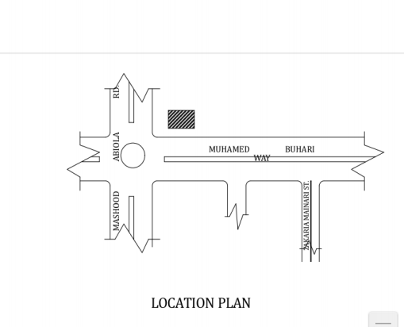 Figure3.1.1: Ground Plan of Case Study One at Yaba, Lagos State

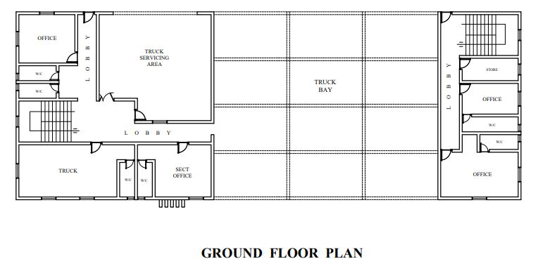

Figure3.1.2: Ground Plan of Case Study One at Yaba, Lagos State

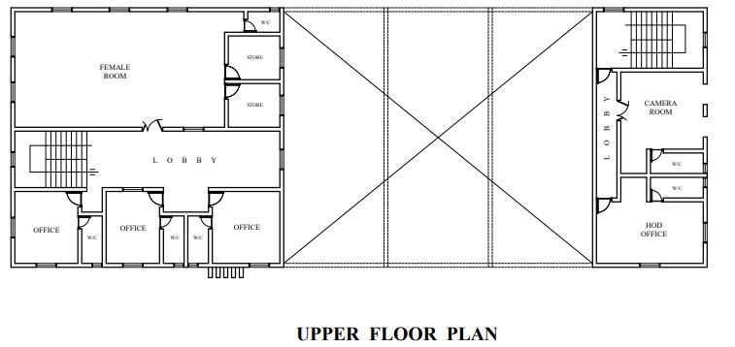

Figure3.1.3: Second floor Plan of Case Study One at Yaba, Lagos State
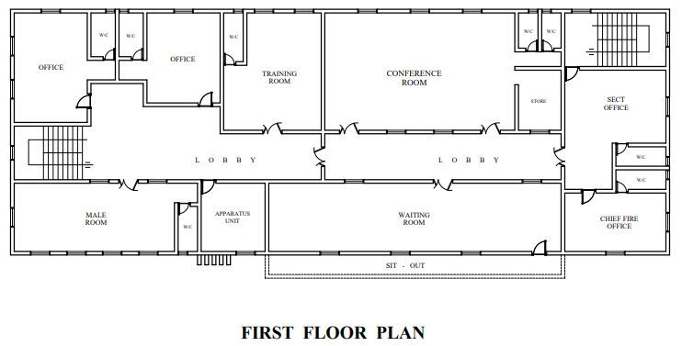

Figure3.1.4: Upper Floor Plan of Case Study One at Yaba, Lagos State

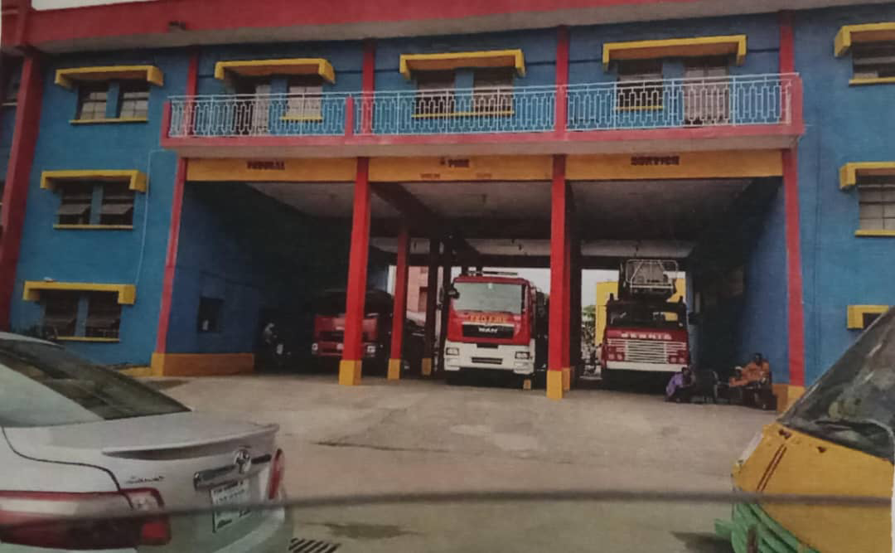
Plate3.1: Perspective View of Federal fire Station of Case Study One at Yaba, Lagos State
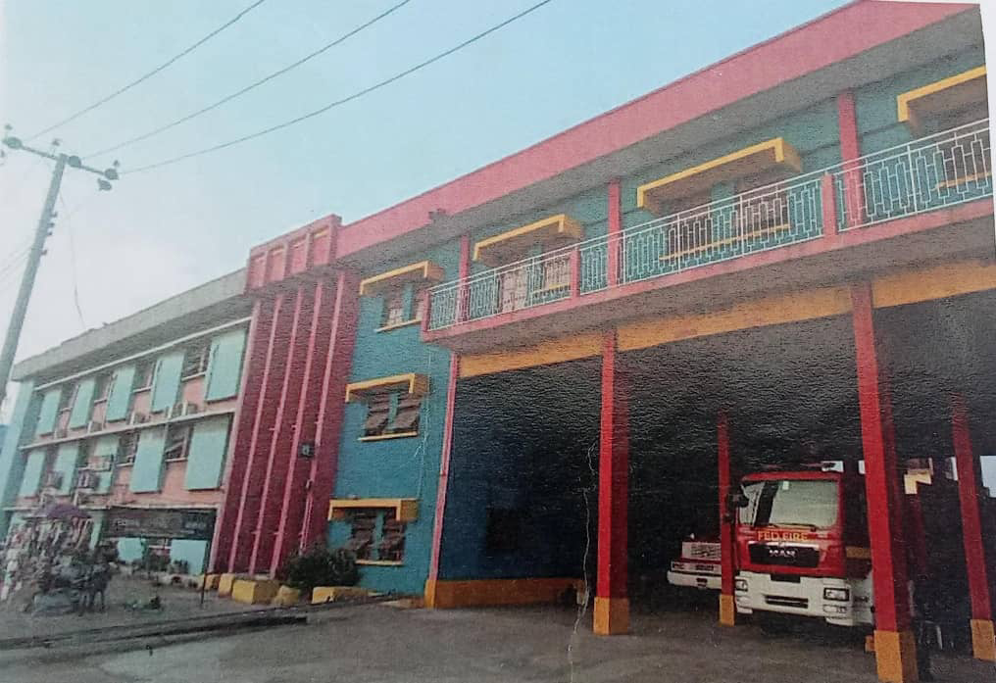
Plate3.2: Perspective View of Federal fire Station of Case Study One at Yaba, Lagos state
3.2 CASE STUDY 2: OPPOSITE OPPIC ESTATE AGBARA ATAN, OGUN STATE :
The project involves the design of a Federal Fire Station located opposite Oppic Estate, Agbara–Atan, Ogun State. The aim is to develop a well-planned, functional facility that enables rapid emergency response and supports the operations of the Federal Fire Service. The design will prioritize operational efficiency, safety, staff welfare, and adaptability to the local environment. It will also reflect the semi-urban setting of AgbaraAtan while incorporating sustainability, proper zoning, and compliance with national fire service standards.

MERITS
- It is easy to locate in case of emergencies

- There’s space area for fire resistance material

DEMERITS
- The truck area is not big enough
- Poor landscaping

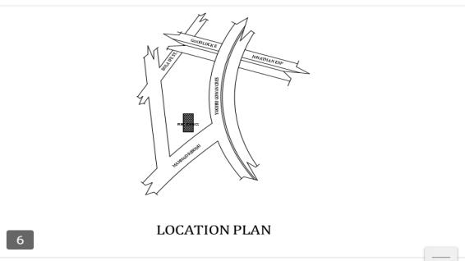

Figure 3.2.1 Locational Plan Of Case Study Two

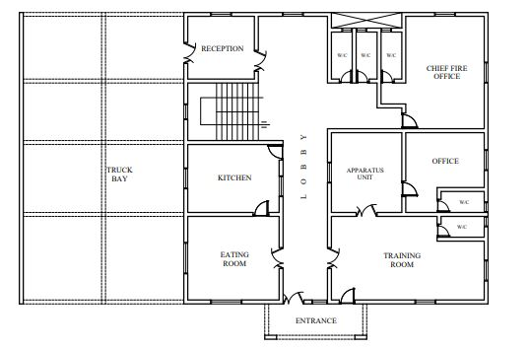

Figure 3.2.2: Ground floor Plan of Case Study Two at opposite oppic estate agbara atan, Ogun State

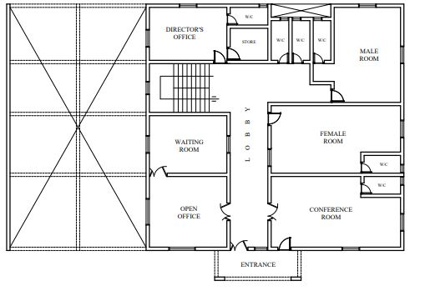

Figure 3.2.3: Upper Floor Plan of Case Study Two at opposite oppic estate agbara atan, Ogun State

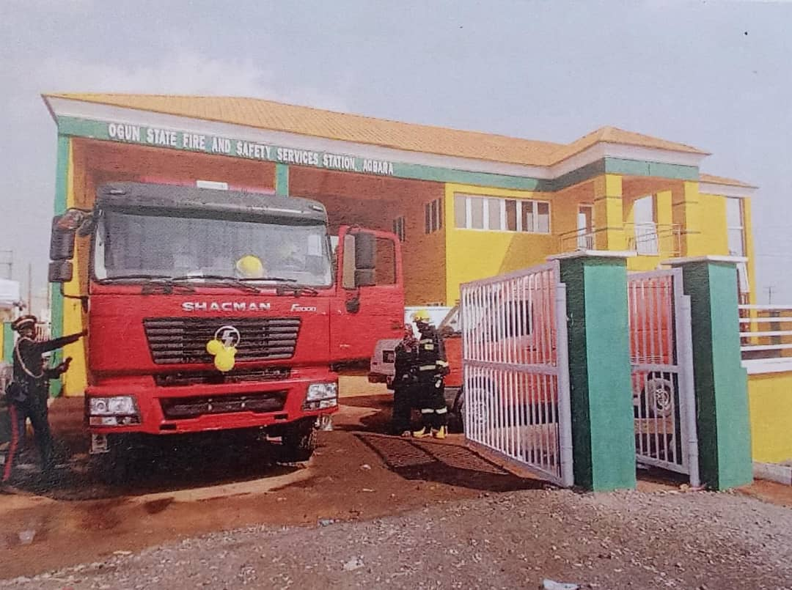
Plate3.3: Approach View of Federal Fire station at oppsite oppic estate agbara atan, Ogun State
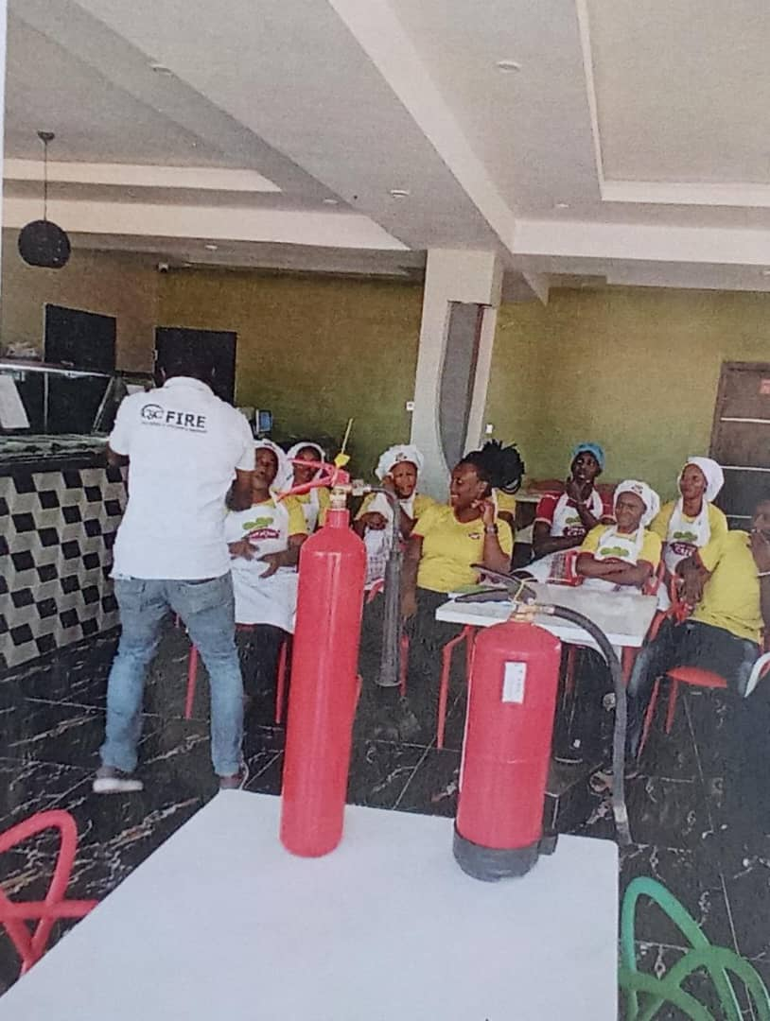
Plate3.4: internal View of federal fire station at opposite oppic estate agbara atan, Ogun State

3.3 CASE STUDY 3:MAHMUD RIBADU ST. ST ASOKORO ABUJA, FCT:
The project entails the design of a Federal Fire Station located at Mahmud Ribadu Street, Asokoro, Abuja, FCT. The goal is to create a modern, high-performance facility that enhances the emergency response capacity of the Federal Fire Service within the capital territory.
It’s easily located
Adequate spacious land for future expansion
DEMERITS
Some areas receive insufficient ventilation on site
Limited natural light to the building

MERITS

- It is easily located
- Enough spaces for future development
- It is well landscaped

DEMERITS

- Some area receive insufficient ventilation on site
- Limited natural light to yhe building

Figure 3.3.1: Ground floor Plan of Case Study Three at Mahmud Ribadu St. St asokoro Abuja, FCT

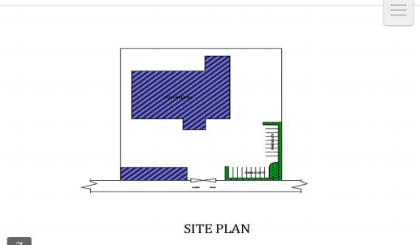

Figure 3.3.2: Upper floor Plan of Case Study Three at Mahmud Ribadu St. St asokoro Abuja, FCT.

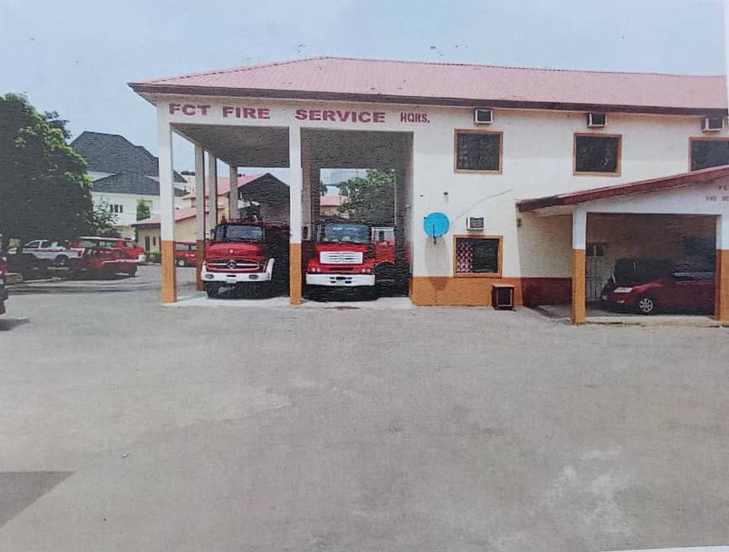
Plate3.5: Perspective View of federal fire station at Mahmud Ribadu St. St asokoro Abuja, FCT
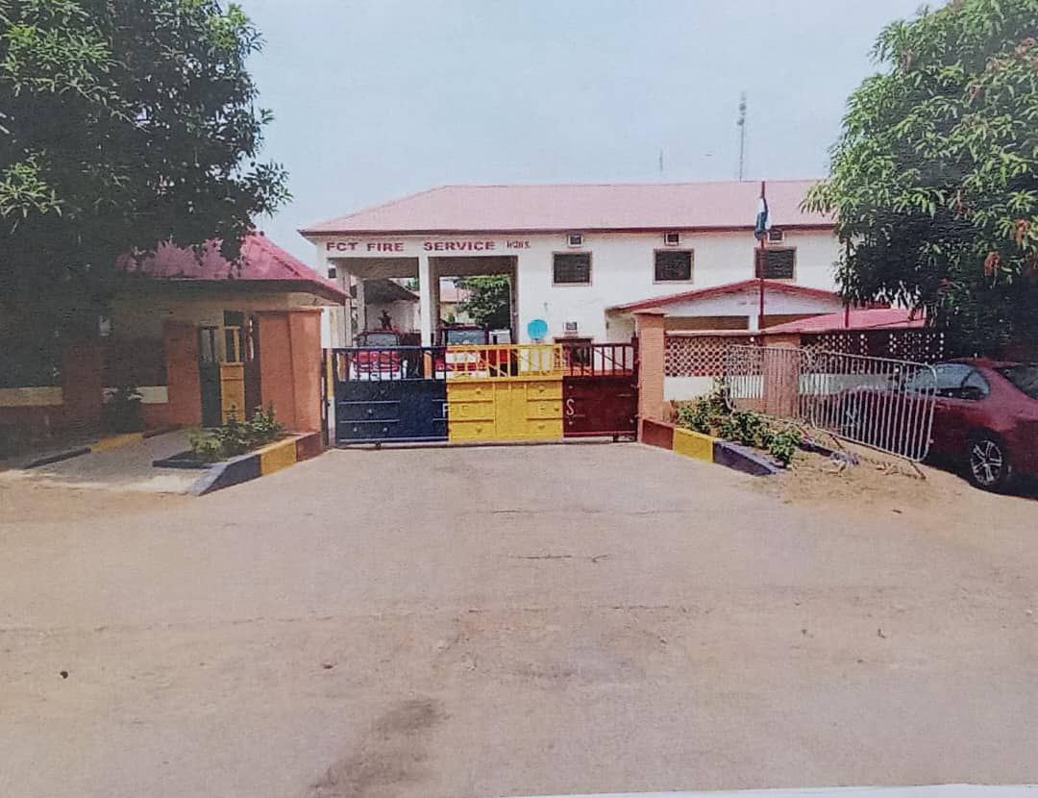
Plate3.6: Perspective View of Federal fire station at Mahmud Ribadu St. St asokoro Abuja, FCT
Online case study 1:M5HIX6 CANADA
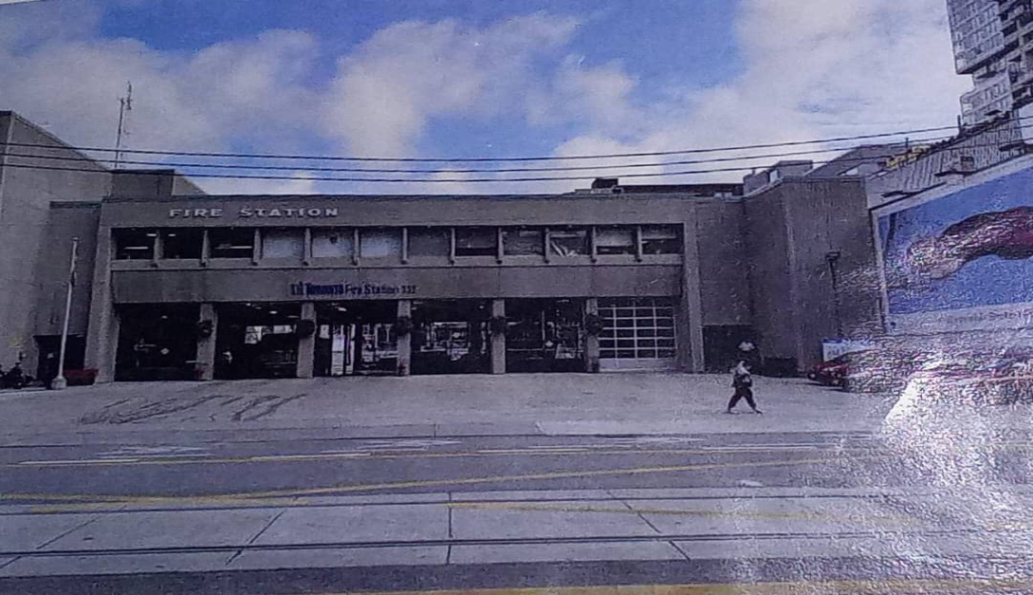
Plate 7: front view
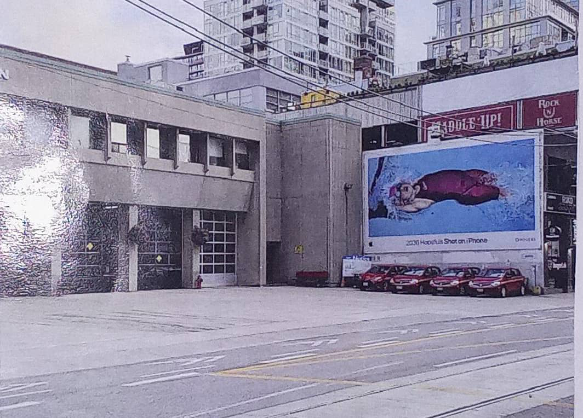
Plate 8: side view
Online case study 2: 50 BUANGKOK, SINGAPORE
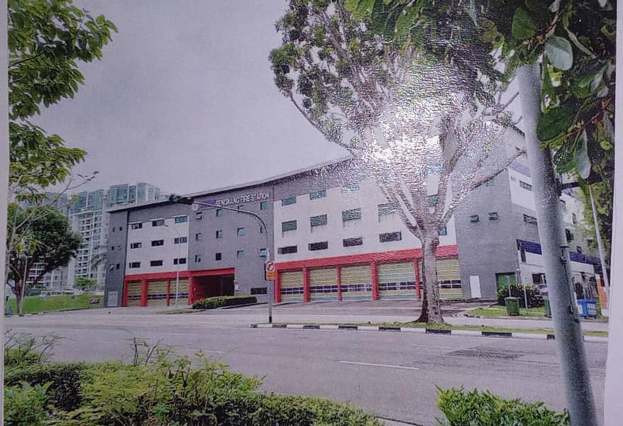
Plate 9: front view
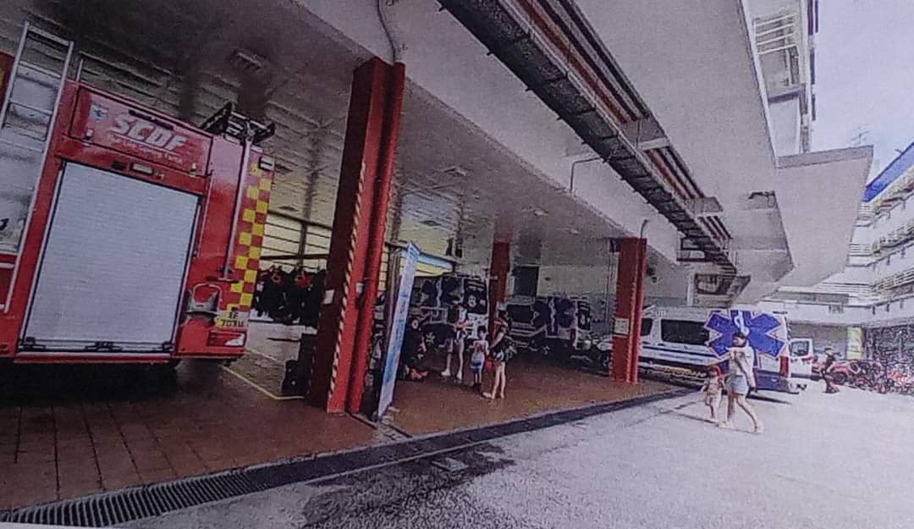
Plate 10: rear view
CHAPTER FOUR
4.0 STUDY AREA/PROJECT SITE
4.1 HISTORY OF KWARA STATE
Kwara state is a state located in the North central region of Nigeria and it was created on May 27,1967, by General Yakubu Gowon, along with 11 other state. It was originally named the west central state but was later renamed kwara, which is a local name for River Niger.
The region was conquered by the Fulani in the 19th century and was part of the greater Fulani empire until it was defeated by the forces of sir George Goldie’s Royal Niger company in 1897. It was then incorporated into the protectorate of Nigeria in 1914.
Kwara state is bordered by Benin to the west and by the Nigerian state of Niger to the North, kogi to the east, and Ekiti, Osun and oyo to the South. The state mostly consists of wooded savanna, but there are also forested regions in the south.
As of 2006, the population of kwara state was around 2.3million, making it the 30th most populous state in Nigeria.
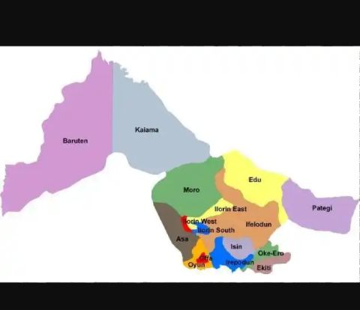

Figure 4.1: Locational map of Kwara State
4.2 LOCATION OF SITE
The site is located at Ilorin east local government, oke-oyi. Ilorin east local government was created on May 27,1967 and the headquarters of Ilorin east local government is in the town of oke-oyi
The population as of 2006, the population of Ilorin east was 204,310 and covers an area of 408 square kilometers. The main language spoken in Ilorin east is Yoruba.

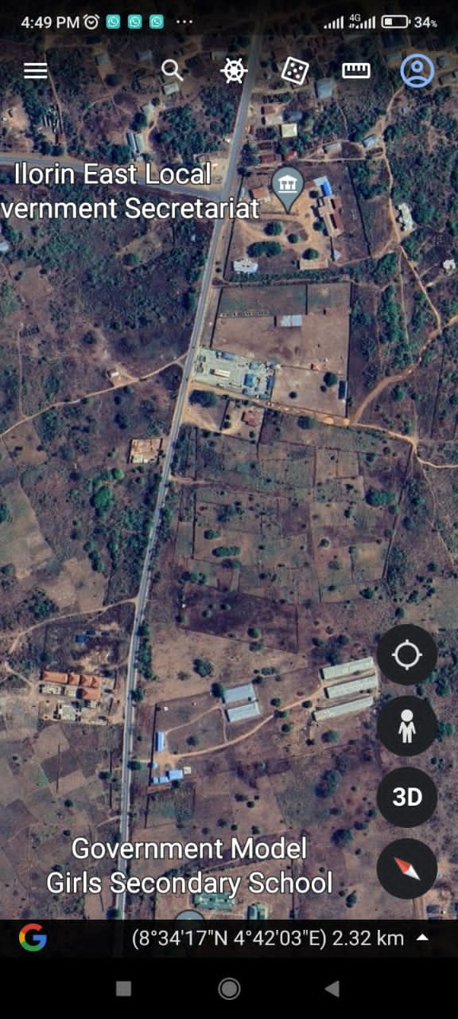
Plate 4.1: The proposed site in Ilorin east local government
4.3 SITE INVENTORY OR SITE ANALYSIS

Site inventory is a comprehensive documentation of the physical characteristics, features and conditions of a site. It typically includes: location and boundaries, topography, and drainage, vegetation, soil and geology, water resources and hydrology, climate and weather patterns, existing infrastructure, land use and zoning, environmental conditions ( if applicable ), photographs and maps.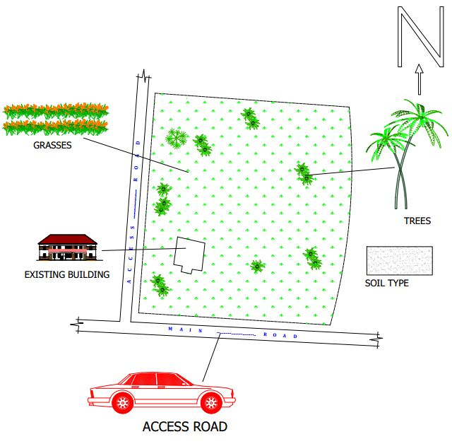Figure 4.3.1: Site inventory of the proposed site

Site Analysis is a thorugh examination and evaluation of site’s conditions, characteristics and context. It involves gathering and analyzing data to understand the site. The goals of the site analysis are to identify site constraints and opportunities, inform design and development decisions, ensure environmental sustainability, respect cultural and historical heritage and enhance the site’s potential.
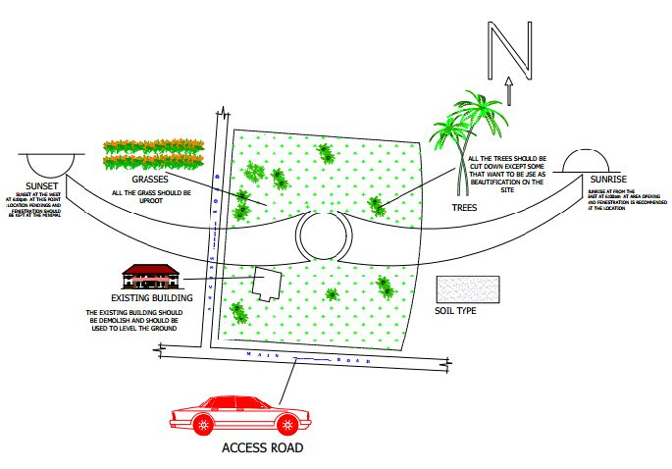

Figure 4.3.2: Site Analysis of the proposed site

4.4 GEOGRAPHICAL / CLIMATIC DATA
4.4.1 CLIMATE
In Ilorin, the wet season is oppressive and overcast, the dry season is humid and partly cloudy and it is hot year round. Over the course of the year, the temperature typically varies from 64⁰F to 95⁰F and is rarely below 57⁰F or above 100⁰F .
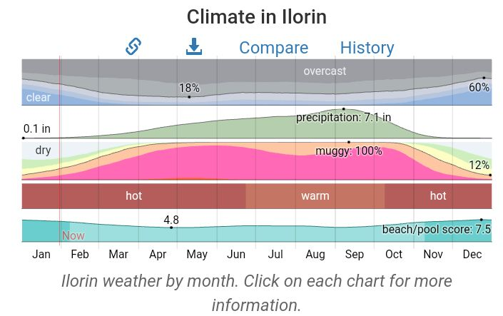

Figure 4.4.1: Graph of Climate in Ilorin
4.4.2 RAINFALL
Kwara typically receives about 101.45millimeters (3.99 inches) of precipitation and has 148.38 rainy days (40.65% of the time) annually.
Ilorin experiences two climatic season i.e rainy and dry season. The rainy season is between march and november with a brief break in august and the annual rainfall varies from 1200mm 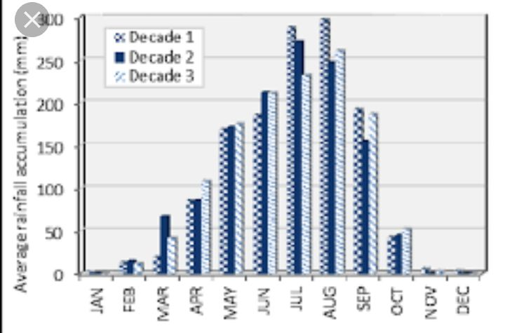

Figure 4.4.2: Graph of Rainfall in Ilorin
4.4.3 WIND
Both tropical continental and tropical maritime air masses affect ilorin. The city experiences thunderstorm, during the beginning and ending of the raining season. The prevailing wind direction is southwest trade wind, which is rain bearing since it takes origin from the sea in the raining season period and from north.
4.4.4 TEMPERATURE
Ilorin is within the climatic zone known as the equatorial zone which has a climatic type of low wet equatorial. The two major influences on Ilorin climate are the two major wind currents. The south west trade wind is warm and moisture laden and the north east trade wind is cold and dry. The two winds current bring about the two different seasons called the rainy and dry season. The raining season is between April and October while thedry season is between November and March. It is accompanied by cold dust and harmattan.
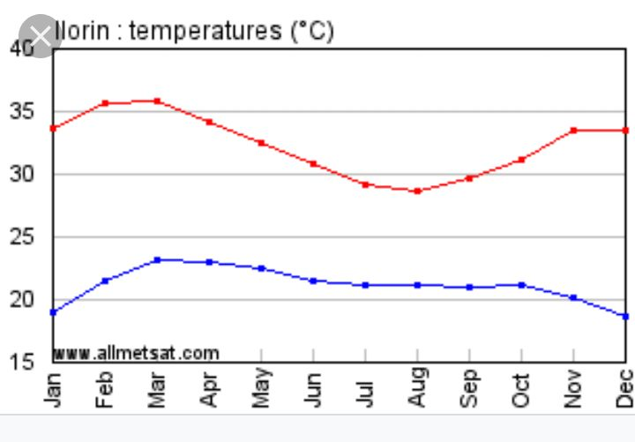

Figure 4.4.4: Graph of temperature in Ilorin
4.4.5 HUMIDITY
Kwara under certain factors experiences high relative humidity with high rainfall during the month june, july, august, and September.
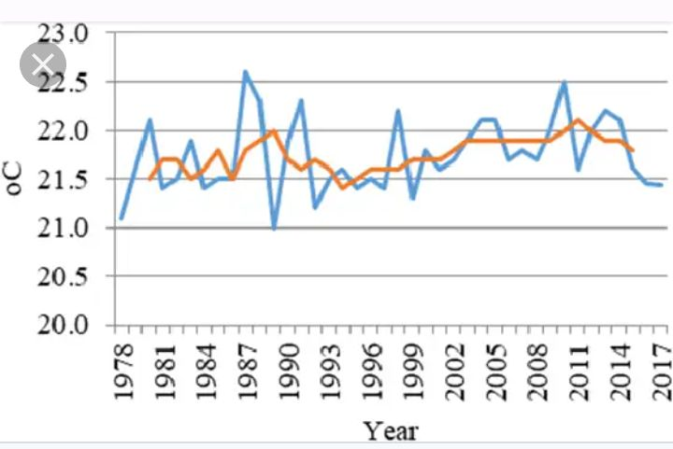

Figure 4.4.5: Graph of humidity in kwara state
4.5 ANALYSIS OF THE IMMEDIATE ENVIRONMENTAL CONDITIONS OF THE SITE
4.5.1 VEGETATION
The site is covered with grass, trees and shrubs are to removed.
4.5.2 SOIL CONDITION
The site has a rite soil with good sub-surface condition for construction and landscaping, it gives satisfactory geological and soil condition with no rock.

4.5.3 TOPOGRAPHY
It has a gentle slope towards the road at 30mm. It does not undulate. The typography of the proposed development site is relatively low that the topsoil and sub-soil firm and buildable. The site is therefore free from any natural of physical constraints and rock outcrops.
4.5.4 WIND DIRECTION
The site is planned in order to give it a defined shape and also to reflect the activities taking place. the location of building and facilities within the site follow these major principles.
- The priority of individual structure within the term zoning (noisy, semi-noisy and quiet zone)
- Parking space located within and around the various units of convenience.
- The police post is located within the entrance of the estate for security purpose.
- The supporting units such as church, mini mart, school, fire station, event center, clinic and market are centralized for easy access for the occupant.
- The site is properly defined with a perfect blend of both natural and artificial attraction as well as soft and hard landscaping.
4.6 PROJECT ANALYSIS / DESIGN CRITERIA
4.6.1 DESIGN CRITERIA
ORIENTATION
The orientation of the building must be designed in such a way that the large side face the north-east and south-west with adequate openings.

4.7 BRIEF ANALYSIS OF PROJECT
As a result of the deductions made from the studies conducted on the project adequate attention shall be given to the seven area/units that make this project. All these end up on mass housing.
THE UNITS/AREAS ARE AS FOLLOWS:
- Residential
- Services
- Recreation
- Maintenance
- Religion
- Institution
- Road network
RESIDENTIAL AREA: this area plays most important area in the housing, it’s the center of focus because it is the place where the occupant will spend most of their time as shelter and this is group into: One bedroom semi-detach block of flat, two bedroom semi-detach block of flat and three bedroom semi-detach block of flat.
The one bedroom semi-detach block of flat is for low income earners and the two bedroom semi-detach block of flat is for the middle income while the three bedroom semi-detach block of flat is for the high income earners.
SERVICES: these units play much important role in the residential area because without services in the housing, the lives of the occupant will not be complete and also services are part of the social amenities and facilities that will improve physical, biological and social of the occupant in the mass housing. the following are services provided in the servicing area; mini-mart, Gate house, Police post, Clinic/health care, Fire station and Event center and market.
RECREATION: recreation area is also an important area in the mass housing and the units include: Garden / sit-outs, Sport area and Children playground.
MAINTENANCE: is a very important section in the mass housing for comfortability of the occupant. This unit includes; Waste disposal and Central sewage system.
RELIGION: Some people find of difficult to worship God due to far distance if worship centers, then, in the proposal housing there is provision of worship center for Muslim and Christian worshippers such as: Mosque and Church.
INSTITUTION: The children of the occupant and the people living around the housing estate can make use of the school present within the housing. The unit includes: Nursery and primary school.
ROAD NETWORK: For proper movement of traffic flow to case activities within the housing estate. The unites provided are follow: Trucks, Bus, Cars.
4.8 FUNCTIONAL ANALYSIS
There is various types of means that is employed in the functional analysis but the most suitable will be used for the project.
- Low income earner
S/N | UNITS | L x B | AREA | NO
1 | ENTRANCE | 3.0m x 1.2m | 3.6m | 2
2 | PARLOUR | 3.0m x 3.6m | 10.8m | 2
3 | BEDROOM | 3.0m x 3.6m | 10.8m | 2
4 | KITCHEN | 2.4m x 1.5m | 3.6m | 2
5 | VISITOR’STOILET | 0.9m x 1.2m | 1.08m | 2
6 | WC & SHW | 1.875m x 1.5m | 2.8125m | 2
7 | STAIRCASE | 1.8m x 6.75m | 12.15m | 2
Table 4.1: Space allocation for one bedroom semi-detach block of flat
- Middle income earner
S/N | UNITS | L x B | AREA | NO
1 | ENTRANCE | 3.925m x 1.2m | 4.71m | 2
2 | VISITOR’STOILET | 0.9m x 1.5m | 1.35m | 2
3 | MAIN LOUNGE | 5.05m x 4.725m | 23.86125m | 2
4 | DINING | 2.425m x 3.6m | 8.73m | 2
5 | KITCHEN | 3.925m x 3.6m | 9.99m | 2
6 | STORE | 0.9m x 2.4m | 2.16m | 2
7 | BEDROOM | 3.6m x 3.75m | 13.5m | 2
8 | BEDROOM | 3.3m x 3.9m | 12.87m | 2
9 | WC & SHW | 2.175m x 1.2m | 2.61m | 2
10 | WC & SHW | 2.175m x 1.2m | 2.61m | 2
11 | EXIT | 2.425m x 1.2m | 2.91m | 2
12 | LOBBY | 3.9m x 0.9m | 3.51m | 2
13 | STAIRCASE | 2.4m x 5.1m | 12.24m | 2
Table 4.2: Space allocation for two bedroom semi-detach block of flat
- High income earner
S/N | UNITS | L x B | AREA | NO
1 | ENTRANCE | 5.04m x 1.2m | 6.048m | 2
2 | VISITOR’STOILET | 0.9m x 1.5m | 1.35m | 2
3 | MAIN LOUNGE | 5.04m x 4.725m | 23.814m | 2
4 | DINING | 2.525m x 4.275m | 10.794375m | 2
5 | KITCHEN | 3.925m x 3.6m | 14.13m | 2
6 | STORE | 1.3m x 2.4m | 3.12m | 2
7 | BEDROOM | 3.6m x 3.675m | 13.23m | 2
8 | BEDROOM | 3.3m x 3.9m | 12.87m | 2
9 | BEDROOM | 3.6m x 3.9m | 14.04m | 2
10 | WC & SHW | 2.1m x 1.2m | 2.52m | 2
11 | WC & SHW | 2.1m x 1.2m | 2.52m | 2
12 | WC & SHW | 1.275m x 2.1m | 2.6775m | 2
13 | EXIT | 2.65m x 1.2m | 3.18m | 2
14 | LOBBY | 5.4m x 1..05m | 5.67m | 2
15 | STAIRCASE | 2.65m x 1.2m | 12.24m | 2
Table 4.3: Space allocation for three bedroom semi-detach block of flat
4.9 APPRAISAL OF PROPOSED SCHEMES
In a project design, there are three basic factors to be considered and they are Stability i.e the strength, capability of the structure, both in exterior and interior of the structure. Functionality i.e the proper chaining of the units block, to meet the purpose of the structure to the users and the Aesthetics of the design i.e the consideration beauty of the structure in both views, environment and the finished. In this design, these three factors are put in place to meet the functional demand and to create a proportionally balanced design.

4.10 EQUIPMENT AND OPERATIONAL AND PERFORMANCE REQUIREMENT
Here attempt is made to group the various units according to the activities taking place in them. Their activities have been grouped into seven zone units but zoning base on the activities taking place in the housing has to go this way.
- Housing area/residential area ( private area): This area is known to be private area on site
- Public area: This area is where the auxiliary facilities is located and this area include Mini-mart, police post, fire station, clinic/healthcare, church, mosque, event center, nursery and primary school, relaxation area and market.
4.11 SPATIAL ALLOCATION/ SCHEDULE OF ACCOMMODATION
It is the allocation of space required in the building design in order to make the most appropriate use of spaces available.
4.12 CONCEPTUAL DEVELOPMENT
The proposed project duly considered functionally which is the paramount factor when embarking on a mass housing project. In the concept, development between the units in the housing and the occupants.

CHAPTER FIVE
5.0 APPROACH TO THE DESIGN/DESIGN REALIZATION
In approaching this design, many factors, strategies and research work were taken into consideration. Some of the factors include functionality, durability, and cost of materials. Their search work that were carried out are the study of the area, the neighborhood value. Statistics and population of the community, the household value, the occupations and social lives of the occupant of the area. These factors and deductions were highly considered in the development of this project to achieve a functional and aesthetically balanced design.
5.1 TECHNOLOGICAL AND ENVIRONMENTAL CRITERIA
5.1.1 CONSTRUCTION METHOD
The method of construction involved in the erection of the building structure is in accordance with the architectural detail required in executing the buildings and the process of construction that is critical to structural component as affected by the site conditions and types of materials to be used.
After the preparation of the overall site plan, many designs are developed to show the specific methods of construction. These details as an integral part of the design process and serve two important purposes. Firstly, they stipulate the aesthetic as structural element of the plan andthey provide the basis for costing project.
This section offers a side of representative details of' the various aspect of site development and summed that the details will act as guild to assist site designer in solving their particular problems. The section is not intended to present aesthetic or design solution alone but also indicate how similar technological difficulties are handled, it is clear that the method of construction of any structure such mass housing is determined from the functional requirement of the facilities provided and its exposure to weather and climatic condition for any use, the following factors are considered; Climatic conditions of the site, Condition of the sub-soil present on the site, Fire protection requirement, Appearance of materials, Durability and easy maintenance, Economy, Availability of materials, Aesthetic, Construction technique and Cost of materials.
The various building components taken into consideration are:
- SUB-STUCTURE: This is the part of the building below the natural ground level. The foundation footing is reinforced for stability of the building to enable it to withstand the load (live, superimposed and wind load). The foundation of the building shall be determined by the structural engineer according to the bearing capacity of the soil.
- SUPER-STRUCTURE: This is the building part that is above the natural ground level. The entire structure is designed with reinforced concert columns, beans and hollow sand screed block.
5.1.2 MATERIALS AND STANDARD FORMS
The following materials are applied in the construction of the structure such as:
- FLOORS: The ground floor will be of solid concrete slab of 150mm with asphalt coating as damp proof course laid on well compacted hardware. The upper floors are reinforced concrete suspended floors of 150mm thick.
Floor finishes are to be specified for each unit depending on the function it is meant to serve. Floor finishes are to be specified for each tiles and terrazzo floor tiles because they are durable, easy to maintain and do not wear easily.
- DOORS: The size and types of doors used depend on its location but generally the size ranges from 1200mm, 900mm and 750mm and the type of materials specified for the construction is in the door schedule which should be strictly followed.
- WINDOWS: A window in a building is designed primarily to allow natural light, natural air, the building issued to allow free flow of carbon dioxide out of the building as well as to allow for outside view.
- ROOFS: Roof members of all building will be made up of timber and long span of aluminum roofing sheet. This is for the easy maintenance of self-support and longer life span.
- CEILING: The kind of ceiling system specified for the building in the housing estate is the asbestos ceiling sheet. The functional requirement of this ceiling is considered under the following: Durability, Easy to maintain, Heat resistance and Cost
5.2 SERVICES REQUIRED
Services are essential for comfort ability security and safety to create a conducive atmosphere for the user of the housing estate to achieve this, the following services must be provided.
1. ELECTRICITY: The main source of electricity is from the national electric power authority and this should be connected to the site from the power in front of the site way.
2. VENTILATION: Ventilation needed in the intention part of building varies from place to place. Natural ventilation is considered best in building construction and is attained with the use pf natural air. Natural air reaches interior part of the building through windows and some other openings. Artificial ventilation is attained with the use of fans and some other atmospheric cooling machines.
3. LIGHTNING: Natural lightning is the best and most effective source of light for the building though artificial sources will be used where necessary.
4. PLUMBING SERVICES: All water supplies and other distribution to all the required areas would be through 50mmdiameter galvanized steel pipe while sewage will be PVP service pipe, which ranges from 50mm, 100mm and 150mm diameter. All the baths and shower will be provided with shower tray, towel trays, washing hand basin and tissue roll holders. The entire toilet WHB will be with a mirror over it. Septic tanks and soak away pit shall be placed and in suitable location for easy maintenance.
5. ACOUSTICS: The major noise comes from the major road and this could be reduced considerably by maintaining a reasonable setback from the major road and the proper landscaping which include planting of trees and grass to serve as noise and sound absorbent.
6. WASTE DISPOSAL: Waste disposal should be provided where unwanted material such as dirty should be dump in order to make the environment clean.
7. FIRE PROTECTION: Structural protection is achieved by using fire resistance elements and limiting the use of combustible materials and finishes. Fire detectors and firefighting equipment should be provided.
8. SECURITY SERVICES: The entry and exit to the site have been restricted to one entrance. This is to monitor the movement of vehicles in and out of the site. The entrance will be maintained with the security men checking incoming and outgoing vehicles. The entire site will be light up with security light and street light within the site. It is necessary tofence the mass housing toensure adequate security, a strong fence is provided in addition to police post in order to keep off intruders of all types.
9. EXTERNAL WORK: These are work carried out outside and around the building. It is otherwise known as Landscaping. These are elements used to provide aesthetics and general human comfort in and around the building.
There are two types of landscaping: Soft Landscaping and Hard Landscaping
i. SOFT LANDSCAPING: This is done by planting trees, shrubs and lowers around the building to serve as barrier to the thermal discomfort and beautify the structures.
ii. HARD LANDSCAPING: This is done by paving the whole of the open ground and such paving area include the parking lots, the walk ways, roadster.
5.2.1 ENVIRONMENTAL CONDITIONS TO BE ACHIEVED
There is plantation of trees to regulate the temperature. The orientation of the building structure to achieve maximum comfort thereby controlling the radiation.
5.2.2 PERFORMANCE STANDARDS
The performance standard of the building construction is to be highly luxurious because of the targeted users and the occupants of the town which have a high taste of social lives.
5.2.3 LEGAL ISSUES AND PLANNING REGULATIONS
The proposed building must pass through various process in order to be approved of the planning regulations of the local government authorities and the board of chiefs because of its being public building. The process for approval in the local planning authority is to provide the following which are: The C of O of the Land, The Survey Plan, The original landpurchase documents, TheStructural Drawings, The Architectural Drawings and The Mechanical and Electrical Drawings.
5.2.4 BEHAVIOURAL PATTERNS AND CONSIDERATIONS
The condition in designing the mass housing is for comfort ability and affordability of the proposed tenant and user of the estate, providing adequate recreational facilities and securities.
5.3 CONCLUSION AND RECOMMENDATIONS
5.3.1 CONCLUSION
This project has examined the contextual and organizational challenges in public housing provision in Ilorin east local government, kwara state.
Research shows that since independence in 1960, government in Nigeria have demonstrated commitment to addressing the housing problems in several ways but due to funding, political and organizational challenges, public housing agencies have provided insufficient number of poor quality and unaffordable housing agencies have provided insufficient number of' poor quality and unaffordable housing units in the country.
5.3.2 RECOMMENDATIONS
To address these challenges this project makes the following recommendations.
Firstly, the government should give more permission to private owners to develop housings that will help to reduce people on the street in various states and towns.
Secondly, mass housing should be built according the proper research about the neighborhood value and household values and also according to the income proportion ofthe community so as to enable more people to be able to able to own convenient houses of their own.
Thirdly, the government should help try to regulate the prices of raw materials as they contribute to the total expense at which the houses are put on rent or sales.
In conclusion, it is clear that the challenges against housing in Nigeria are multi-facet: however, much time can be invested on programme designs. It is therefore expected that the findings and recommendations gotten from the project have advanced my understanding of challenges and solutions to mass housing in Nigeria.

REFERENCES
Ademolu Ibem and Gbemisola Amole (2021), “Evaluation of Public Housing Programmes in Nigeria” Journal of Architectural Technology, Institute of Environmental Science, University of Ibadan, Oyo State
Amamata, Z. A. Safiya, O. &Bala, B. (2015): Integrating Factors of Housing Affordability in as a Scheme in Governmental Policies. Accessed Online. Journal of International Studies on Housing and Building technology, University of Ohio, USA, Pp. 14-21.
Arigbola, A. (2018). Housing Affordability as a Factor in the creation of Sustainable Environment in Developing World: The Example of Akure, Nigeria. Journal of Human Ecology, 35(2), pp: 121-131.
Australian Housing and Research Institute (AHURI) (2021). Measuring Housing Affordability. AHURI Research and Policy Bulleting, Issue 45.
Awotona, A. (2020). Housing Policy Nigeria; Government Policies for housing Nigeria Urban poor and working class, Laudable Great Expectation Colosal Failure Habitat International.
Burrudge, R. AN Ormandy, D. (2019). Unhealthy Housing Research, Remedies and Reforms, First Edition.
Effions-Williams, J. (2025): McGraw Hill Encyclopedia of Science and Technology
Harri, C. M. (2022): Dictionary of Architecture and Construction. Pub MC Graw Hill. Book Company.
Lyneh, K. and Hak, G. (2024): Site Planning. Pub Map Press Cambridge Massachusetts and London, England.
Memullan, R. (2025): Environmental Science in Building Macmillan. Pub First Edition.
Nepal, B., Tanton, R. & Harding, A. (2020). Measuring Housing Stress: How Much Do Definitions Matter? Urban Policy and Research, 28(2), pp: 211-224.
Ramsey and Sleeper (2025): Architectural Graphics Standards, Tenth Edition, John Willey and Sons Inc.
Rogers, E. K. (2023). The Modern House: Its Design and Decoration. Harper and Row Pub.
Salvato, A. J. (2017). Environmental Engineering and Sanitation. Third Edition. John Willey and Sons Inc.

APPENDICES
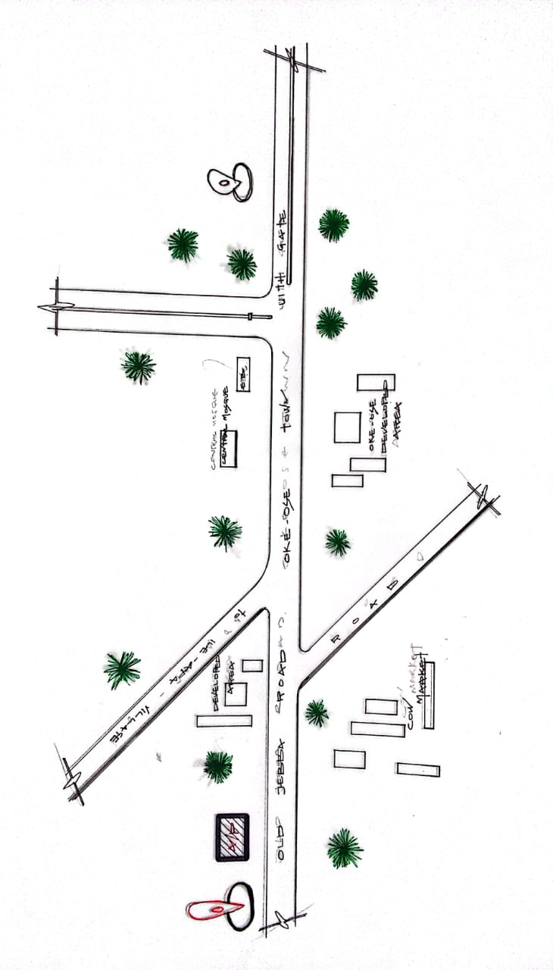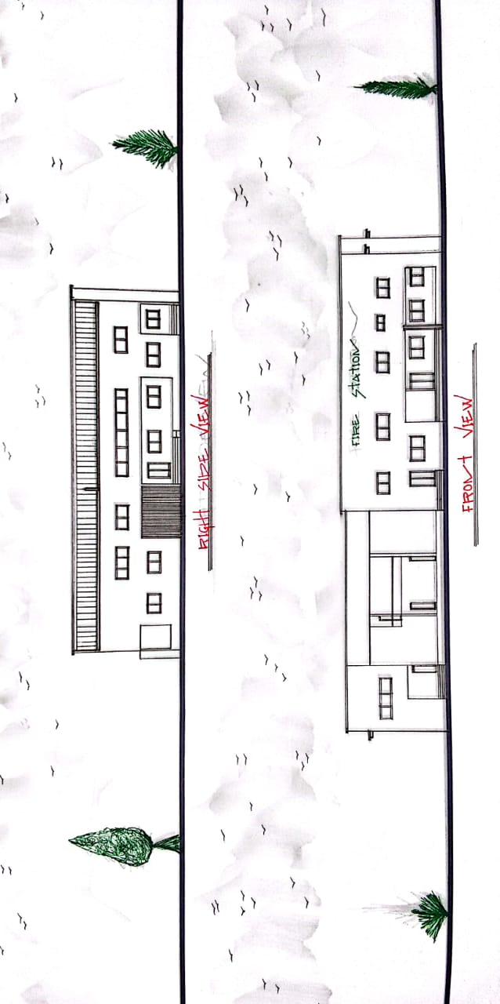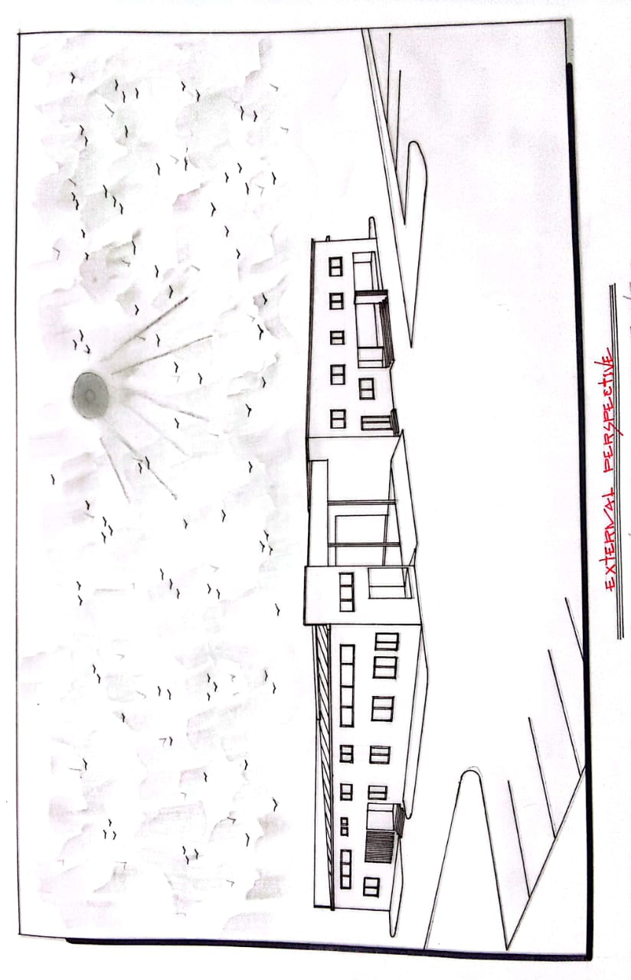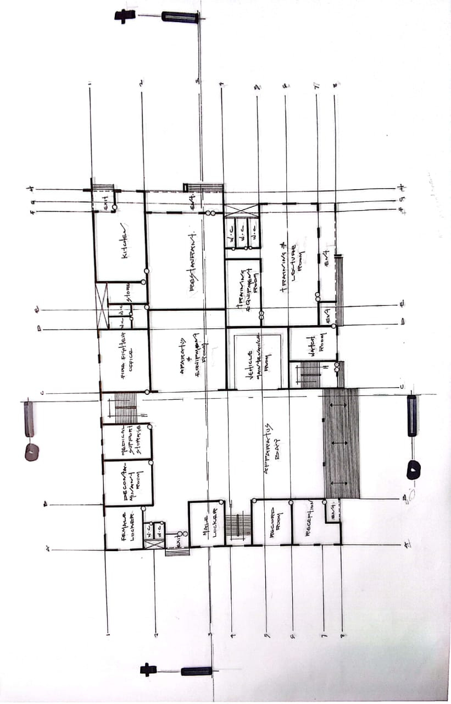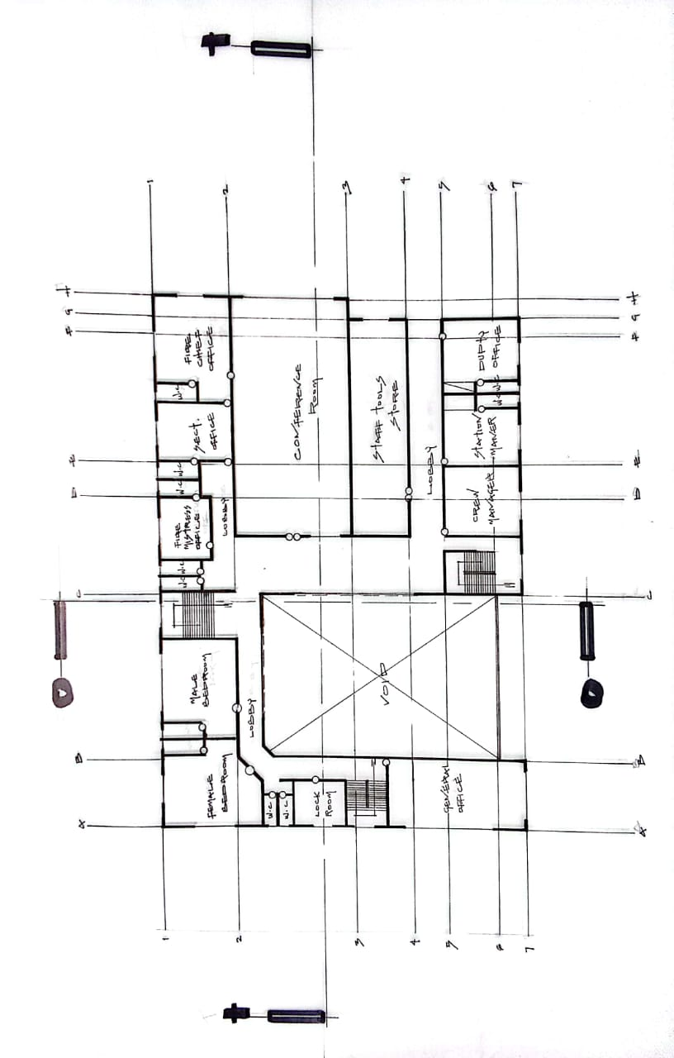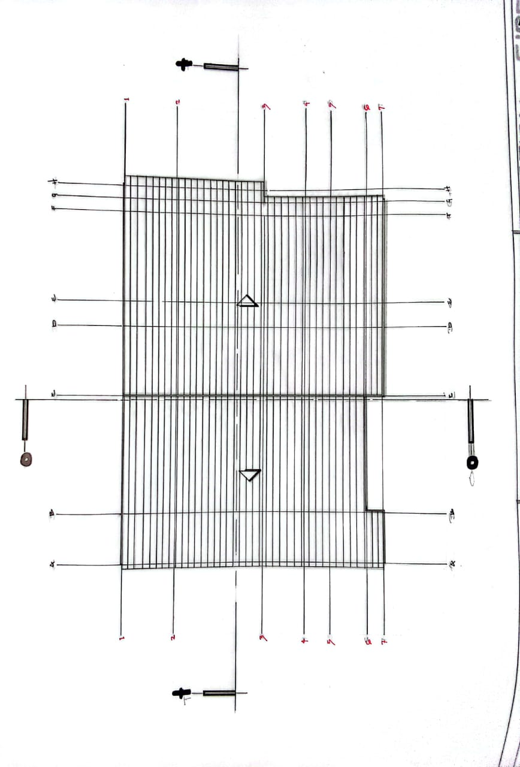

APPENDICES 5.1: LOCATION PLAN

APPENDICES 5.2: ELEVATIONS

APPENDICES 5.3: EXTERNAL PERSPECTIVE

APPENDICES 5.4: GROUND FLOOR PLAN

APPENDICES 5.5: UPPER FLOOR PLAN

APPENDICES 5.6: ROOF PLAN

