ASSESSMENT OF PUBLIC TOILET MANAGEMENT IN MOTOR PARKS WITHIN ILORIN MEPTOPOLIS

PREPARED BY
ISIAQ HANAFI
HND/22/URP/FT/054

SUBMITTED TO
DEPARTMENT OF URBAN AND REGIONAL PLANNING, INSTITUUE OF ENVIRONMENTAL STUDIES (IES)

KWARA STATE POLYTECHNIC, ILORIN.
IN PARTIAL FULFILLMENT OF THE REQUIREMENTS FOR THE AWARD OF HIGHER NATIONAL DIPLOMA (HND) IN URBAN AND REGIONAL PLANNING

JUNE 2025

TABLE OF CONTENTS
Title Page..........................................................................................................................................i
Abstract............................................................................................................................................ii
Dedication.......................................................................................................................................iii
Acknowledgements.........................................................................................................................iv
CHAPTER ONE: INTRODUCTION..............................................................................................1
1.1 Background of the Study...........................................................................................................1
1.2 Statement of the Research Problem...........................................................................................3
1.3 Research Questions....................................................................................................................5
1.4 Aim of the Study........................................................................................................................6
1.5 Objectives of the Study..............................................................................................................6
1.6 Justification of the Study...........................................................................................................7
1.7 Scope of the Study....................................................................................................................8
1.8 The Study Area..........................................................................................................................9
CHAPTER TWO: LITERATURE REVIEW................................................................................13
2.1 Theoretical Framework............................................................................................................13
2.1.1 Systems Theory.....................................................................................................................13
2.1.2 Public Goods Theory............................................................................................................14
2.1.3 Stakeholder Theory...............................................................................................................15
2.1.4 Health Belief Model..............................................................................................................16
2.2 Concepts on Public Toilets......................................................................................................18
2.3 Public Toilet Facilities.............................................................................................................20
2.4 Types of Public Toilets............................................................................................................23
2.5 Maintenance of Public Toilets.................................................................................................24
2.6 Concept of Sanitation...............................................................................................................25
CHAPTER THREE: RESEARCH METHODOLOGY................................................................26
3.1 Introduction.............................................................................................................................26
3.2 Primary Source of Data............................................................................................................30
3.2.1 Reconnaissance Survey.........................................................................................................30
3.2.2 Oral Interview.......................................................................................................................31
3.2.3 Questionnaire Administration..............................................................................................32
3.3 Secondary Source of Data.......................................................................................................33
3.4 Sampling Frame and Sample Size..........................................................................................34
3.5 Sampling Techniques...............................................................................................................35
3.6 Method of Data Analysis.........................................................................................................36
CHAPTER FOUR: DATA PRESENTATION AND DISCUSSION...........................................37
4.1 Introduction..............................................................................................................................37
4.2 Demographic Information of Respondents..............................................................................38
4.3 Physical Condition and Availability of Facilities....................................................................42
4.4 Cleanliness and Hygiene..........................................................................................................43
4.5 Users’ Perception and Satisfaction..........................................................................................44
4.6 Security and Monitoring of Toilet Facilities...........................................................................46
CHAPTER FIVE: SUMMARY, CONCLUSION AND RECOMMENDATIONS...............................................................................................................65
5.1 Summary of Findings...............................................................................................................65
5.2 Conclusion...............................................................................................................................66
5.3 Recommendations...................................................................................................................67
References....................................................................................................................................68
Appendices...................................................................................................................................69

CERTIFICATION

This is to certify that this project titled:
“ASSESSMENT OF PUBLIC TOILET MANAGEMENT IN MOTOR PARKS WITHIN ILORIN METROPOLIS”
Was carried out by ISIAQ HANAFI with Matric No: HND/22/URP/FT/054 of the Higher National Diploma (HND) in Urban and Regional Planning.
This project has been read and approved as meeting the requirements of the department

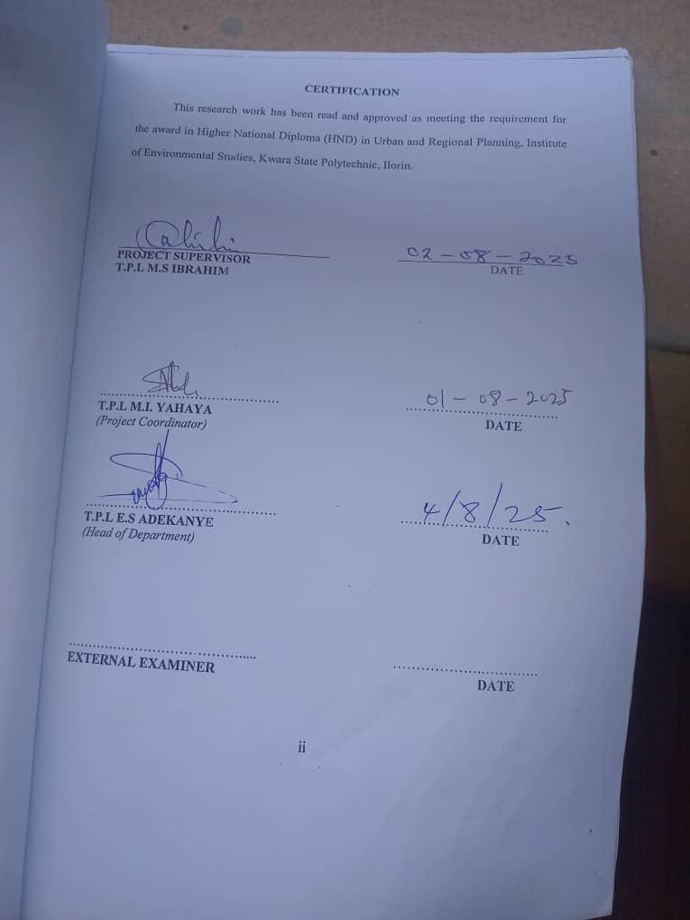
____________________ _____________________
TPL M.S Ibrahim DATE
Project Supervisor

____________________ _____________________
TPL M. I. YAHAYA DATE
Project Coordinator

____________________ _____________________
TPL E. S. Adekanye DATE
Head of Department

DEDICATION

This project is dedicated to the Almighty God for His infinite mercy, grace, and protection throughout the course of this study. I also dedicate this work to my beloved parents and siblings for their unwavering support and encouragement.

ACKNOWLEDGEMENTS

I sincerely appreciate the supervision and guidance of TPL M.S Ibrahim throughout this project. My heartfelt thanks also go to the project coordinator, TPL M.I Yahaya for his academic direction and mentorship. Special thanks to all the lecturers and staff of the Department of Urban and Regional Planning, Kwara State Polytechnic, Ilorin, for their tireless support. I am grateful to my colleagues and friends for their cooperation and encouragement. To my family, thank you for your moral and financial support.

Abstract
Public toilets are critical urban infrastructure essential for maintaining hygiene, preventing disease transmission, and ensuring the dignity and safety of commuters and workers in high-traffic areas such as motor parks. Despite their importance, these facilities often suffer from inadequate maintenance, poor infrastructure, and limited accessibility, especially in many Nigerian urban settings. This research aims to assess the current state of public toilet facilities, identify challenges faced by users, and provide actionable recommendations to improve sanitation and service delivery in selected motor parks in Ilorin Metropolis. Data were collected through structured questionnaires administered to 250 respondents across four major motor parks: Kasmag, Young Legacy, Oloje Motor Park, and Maraba. The study examined various parameters including the availability and number of toilet units, types of toilets, physical conditions, water supply connections, presence of handwashing facilities, accessibility for vulnerable groups (children, elderly, and persons with disabilities), frequency of cleaning, user perceptions of cleanliness, unpleasant odors, safety concerns, security monitoring, and overall satisfaction with the facilities. Respondents were also invited to provide suggestions and additional comments regarding the toilets. Findings revealed that 86% of respondents confirmed the availability of toilet facilities in the motor parks, with most parks having between 1 to 4 toilet units. Pit latrines were the most common type, followed by flush toilets and a small proportion of mobile toilets. The physical condition of the toilets varied, with less than 7% rated as excellent, while a significant number were deemed fair to poor. About 82% of facilities were connected to a water supply, but only 63% had functional handwashing stations. Accessibility remained a critical challenge, with only 39% of respondents affirming that the toilets were accessible to children, elderly, and persons with disabilities. User satisfaction was moderate, with about 46% of respondents indicating they were satisfied or very satisfied with the facilities. However, many users reported unpleasant odors (58%) and expressed concerns regarding safety and cleanliness. Security personnel were only present in about half of the motor parks, further contributing to users' safety concerns. The frequency of cleaning varied, but only 30% of facilities were cleaned several times a day. Respondents suggested increased cleaning frequency, improved water supply, more toilet units, better lighting, and employment of security staff as key areas for improvement. The study concludes that while public toilet facilities exist in most motor parks in Ilorin, their quality, maintenance, and inclusiveness require significant enhancement. Improved management, increased infrastructural investment, and adoption of inclusive design principles are essential to ensure the facilities meet public health and safety standards. The findings provide valuable insights for policymakers, urban planners, and facility managers aiming to upgrade sanitation services in urban transport hubs.

CHAPTER ONE
1.1 Background of the Study
Sanitation is a fundamental aspect of public health and human dignity. Among its many components, the provision and proper management of public toilets is one of the most visible and impactful services that local authorities can offer, particularly in high-traffic environments like motor parks. Motor parks serve as crucial nodes for urban and inter-urban mobility in many developing cities, including Ilorin, the capital of Kwara State in Nigeria. These parks cater to thousands of commuters daily and play a vital role in facilitating trade, commerce, and socio-economic interactions. Consequently, the sanitary conditions within these spaces reflect the overall quality of life and public health consciousness of the city.
Public toilets are intended to offer relief to travelers, transport operators, vendors, and other park users. However, the effectiveness of these facilities is often undermined by poor maintenance, inadequate funding, weak institutional frameworks, and lack of proper usage by the public. In many Nigerian cities, public toilets in motor parks are often characterized by offensive odors, lack of running water, broken facilities, poor waste disposal systems, and unhygienic conditions. These conditions pose serious health risks, especially the spread of communicable diseases such as cholera, typhoid, dysentery, and other waterborne and sanitation-related diseases (Adedayo et al., 2023).
Ilorin metropolis, one of the fastest-growing urban centers in Nigeria, is experiencing rapid population growth, increased urbanization, and heightened demand for transport services. The growing demand has led to the proliferation of both formal and informal motor parks across the city. These parks serve as major convergence points for residents, commuters, and travelers, leading to increased pressure on existing sanitary infrastructure. The condition and management of public toilets in these motor parks, therefore, have significant implications for public health, environmental quality, and the overall image of the city.
Despite government efforts and policy frameworks aimed at improving sanitation, the challenges of managing public toilets persist in Ilorin. Various stakeholders, including the government, private operators, transport unions, and non-governmental organizations, have attempted to intervene in different capacities. However, the outcomes have been inconsistent and often unsustainable due to poor planning, lack of monitoring, and weak enforcement of sanitation standards (Adewumi et al., 2020).
Studies have shown that effective toilet management requires more than just the provision of facilities; it involves adequate funding, trained personnel, consistent monitoring, public awareness, and institutional support. The involvement of the private sector through public-private partnerships (PPP) has been touted as a viable solution, as seen in some metropolitan cities in Nigeria. Yet, questions remain regarding the applicability and effectiveness of such models in Ilorin.
Furthermore, cultural, social, and behavioral factors also influence the usage and maintenance of public toilets. In many cases, users are either unwilling to pay for services or misuse facilities due to ignorance or negligence. Such behavior often leads to rapid deterioration of infrastructure and increased maintenance costs. There is a pressing need to explore how these factors play out in the context of Ilorin's motor parks and what strategies can be employed to address them.
This study, therefore, seeks to assess the current state of public toilet management in selected motor parks within Ilorin metropolis. It aims to identify the existing challenges, evaluate the effectiveness of current management practices, and propose actionable solutions that can enhance sanitation outcomes in these public spaces. The findings from this research will contribute to the growing body of knowledge on urban sanitation management and provide evidence-based recommendations for policymakers, transport unions, and other stakeholders.
Moreover, this study aligns with national and global sanitation targets, including Goal 6 of the Sustainable Development Goals (SDGs), which emphasizes access to adequate and equitable sanitation and hygiene for all. As Nigeria strives to achieve these goals, it is imperative to pay attention to often-neglected areas such as public toilets in motor parks, which directly affect a large segment of the population (Federal Ministry of Water Resources, National Bureau of Statistics, & UNICEF, 2022).
In summary, the management of public toilets in motor parks is a critical issue that intersects public health, environmental management, urban planning, and social justice. By focusing on Ilorin metropolis, this study provides a localized perspective that can inform both regional and national policy directions. The assessment will also serve as a reference point for future research and interventions in similar urban settings across Nigeria and beyond.
1.2 Statement of the Research Problem
Public toilet facilities are indispensable for maintaining environmental hygiene and promoting public health, especially in busy and congested areas like motor parks. These facilities serve not only transport operators and commuters but also street vendors, traders, and passersby who spend considerable time in these areas. In a city like Ilorin, where daily mobility is high due to its function as a political, educational, and commercial hub, the role of public sanitation infrastructure in motor parks cannot be overemphasized.
Despite the recognized importance of public toilets, several studies and observational reports indicate that toilet facilities in most motor parks within Ilorin metropolis are in deplorable condition. These facilities are either grossly inadequate, poorly maintained, non-functional, or outrightly absent. In many cases, where toilets exist, they are marred by poor waste disposal practices, broken fixtures, lack of water supply, and offensive smells that make them unusable. This situation exposes park users to significant health hazards and environmental degradation (eWASH, 2022).
One of the major problems is the lack of an effective management system. There is usually no clearly defined responsibility for toilet management among relevant stakeholders, including local government authorities, park managers, transport unions, and private operators. In some cases, responsibility is shared haphazardly or entirely abdicated. This results in inconsistent cleaning schedules, lack of maintenance funding, and irregular monitoring of hygiene standards (Adewumi et al., 2020).
Another critical issue is user behavior. Many park users do not treat public toilet facilities with care. Vandalism, misuse, and littering are common occurrences. Even when small service fees are charged for usage, some individuals prefer open defecation or use nearby bushes and open spaces, especially in informal parks without proper regulation. This reflects deeper issues of public awareness, civic responsibility, and sanitation culture (Adedayo et al., 2023).
Furthermore, while some motor parks attempt to operate under a public-private partnership (PPP) arrangement where private individuals or groups manage the toilets for a fee, such arrangements often suffer from inadequate regulation and monitoring. Without clear guidelines or contracts, these private managers focus more on profit-making than on maintaining acceptable hygiene standards. In some cases, there is also no reinvestment into the facility, leading to rapid deterioration (eWASH, 2022).
There is also a lack of comprehensive data and research on public toilet facilities in Ilorin motor parks. Most sanitation programs in Nigeria focus on household toilets, schools, or markets, with little attention given to transport hubs. This gap in academic and policy focus has left toilet management in motor parks under-explored, despite their strategic importance in urban public health (Federal Ministry of Water Resources, National Bureau of Statistics, & UNICEF, 2022).
Moreover, the existing policies and frameworks for sanitation management in Kwara State are either outdated, poorly enforced, or non-specific about responsibilities in motor parks. Where regulations exist, compliance is minimal due to poor enforcement capacity or lack of awareness among stakeholders.
This study is therefore motivated by the urgent need to address these gaps. It will examine the current state of public toilet facilities in selected motor parks in Ilorin, explore the roles of stakeholders, assess the management structures in place, and identify the constraints and opportunities for improvement. By doing so, it hopes to provide practical and sustainable solutions that can improve sanitation in public spaces and enhance the quality of life for park users.
1.3 Research Questions
- What is the current condition of public toilet facilities in motor parks within Ilorin metropolis?
- Who are the key stakeholders involved in the management of these facilities, and what roles do they play?
- What are the major challenges facing effective management of public toilets in these motor parks?
- How do users perceive and interact with the public toilet facilities?
- What strategies can be adopted to improve the management and sustainability of public toilets in motor parks?
1.4 Aim of the Study
To assess the management of public toilet facilities in motor parks within Ilorin metropolis with a view to recommending sustainable solutions for improved sanitation and public health.
1.5 Objectives of the Study
- To examine the physical condition and availability of public toilet facilities in selected motor parks.
- To identify the stakeholders involved in the management of these facilities and evaluate their roles.
- To assess the challenges and constraints facing effective toilet management in the study area.
- To understand the usage patterns and perceptions of park users regarding public toilets.
- To propose practical and sustainable recommendations for improved public toilet management.
1.6 Justification of the Study
The sanitation crisis in Nigeria is a major public health concern. While attention is often given to household sanitation and school hygiene, little emphasis has been placed on sanitation in public places, particularly transport hubs such as motor parks. Motor parks are integral to the functioning of urban transport systems and serve as critical points of interaction for thousands of people daily. As such, ensuring adequate sanitation in these spaces is both a public health and urban governance imperative.
This study is justified by the urgent need to fill a significant research and policy gap. Very few studies have been conducted on the condition and management of public toilets in motor parks, especially in Ilorin. Yet, the problem persists and affects a broad segment of the urban population. By assessing the management of public toilet facilities, this research will provide empirical data that can inform evidence-based interventions and policy responses.
Moreover, poor sanitation in motor parks not only endangers public health but also tarnishes the image of the city. Visitors and travelers form lasting impressions based on the state of infrastructure in motor parks, including toilets. Ensuring clean and functional facilities contributes to a positive public perception and enhances the experience of commuters.
Additionally, the research is important from a governance perspective. It will help clarify institutional responsibilities and the extent of collaboration (or lack thereof) between public and private actors. Understanding who manages what, and how effectively they do so, is key to developing sustainable management frameworks that can be scaled up or replicated in other urban centers.
This study is also aligned with broader development goals. It contributes to the realization of SDG 6 (Clean Water and Sanitation) and SDG 11 (Sustainable Cities and Communities). The findings will be useful to local governments, transport unions, NGOs, and private investors interested in improving urban sanitation (Federal Ministry of Water Resources, National Bureau of Statistics, & UNICEF, 2022).
Furthermore, as a student in urban and regional planning, this research allows for the application of planning principles in a real-world context. It integrates environmental management,
1.7 Scope of the Study
This study focuses on the assessment of public toilet management in motor parks within Ilorin metropolis, Kwara State, Nigeria. It will cover selected major and minor motor parks within the metropolis, including both government-managed and privately operated parks. The study will examine the condition, availability, maintenance, stakeholder involvement, and user perception of public toilet facilities. It will not cover household, school, or market toilets, as the focus is strictly on public sanitation in transport hubs.

1.8 The Study Area (Ilorin)
The study area is Ilorin metropolis, which is the capital city of Kwara state, Nigeria. Ilorin metropolis consists of three local government areas namely; Ilorin east, Ilorin west and Ilorin south. Ilorin is located approximately on latitude 8º30’ and 8º50’ north of the equator and longitude 4º20’ and 4º35’east of the Greenwich meridian (Figure 1). Ilorin is the gateway city between the southern and northern Nigeria with an approximate land area of 100kilometres square (Kwara state diary, 2012). The climate of the city is humid tropical under the influence of the two trade winds prevailing over the country, characterized with high temperature throughout the year (Ajibade, 2002). Ilorin enjoys wet and dry seasons. The daily average temperatures are in January with 25ºC, May 27.5 ºC and September 22.5 ºC. The wet season is between May and October with two peak periods in June and September while the dry season spans between November and April. The mean annual rainfall is 1,200mm (Olanrewaju, 2012). The mean annual total rainfall is 1200m (Olaniran, 2002). The temperature in Ilorin is uniformly high throughout the year.

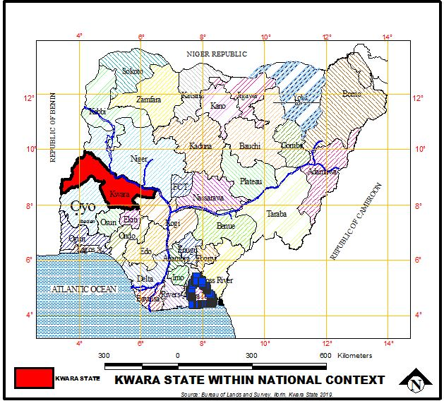

Figure 1.1: Kwara State within the National Context

Source: Kwara State Geographical Board, 2025

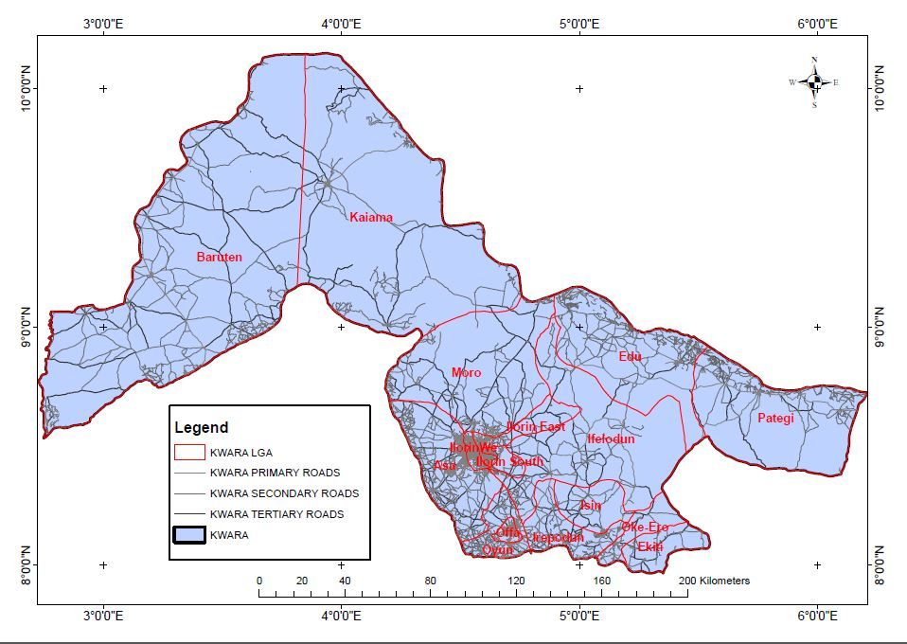

Figure 1.1: Local Government Areas in Kwara State

Source: Kwara State Geographical Board, 2025

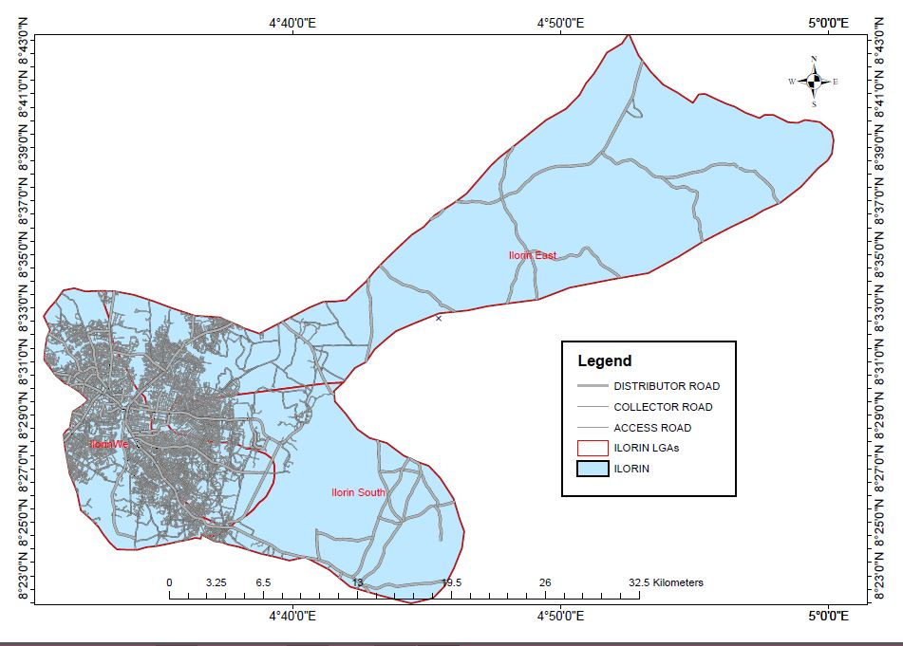

Figure 1.1: Ilorin Metropolis

Source: Kwara State Geographical Board, 2025

Figure 1.4: Ilorin Metropolis showing selected motor parks
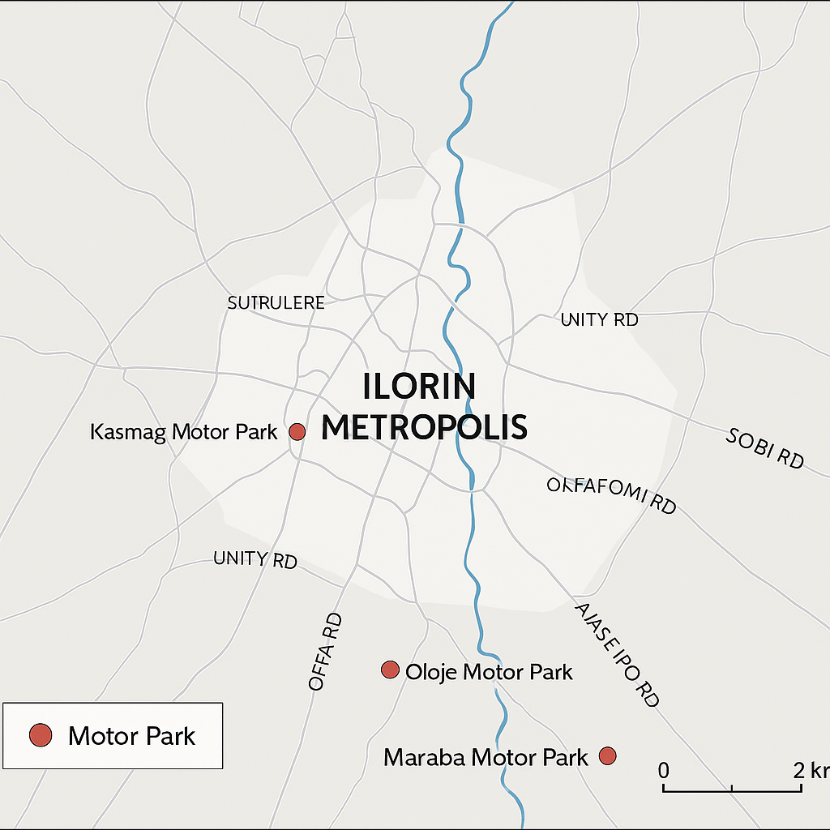
Source: Author’s design using base map from Kwara State Geographical Board, 2025

CHAPTER TWO
LITERATURE REVIEW

2.1 Theoretical Framework
This study is grounded in several interrelated theoretical perspectives that collectively provide a robust framework for understanding the complexities of public toilet management in motor parks within Ilorin Metropolis. These theories highlight the systemic nature of sanitation services, economic challenges, stakeholder roles, and behavioral factors influencing toilet usage and maintenance.

2.1.1 Systems Theory
At the core of this research is the Systems Theory, initially conceptualized by Ludwig von Bertalanffy (1968), which views any organization or process as an interdependent set of components forming a complex whole. Applied to public toilet management, this theory helps to conceptualize the sanitation facility as a system where various actors—including government bodies, motor park unions, private operators, cleaners, and users—interact continuously. Each component’s function affects the entire system’s performance and sustainability. For instance, failure in maintenance by operators or lack of regulatory oversight by authorities disrupts the overall sanitation service. The theory encourages a holistic perspective, emphasizing that improvement efforts must address all parts of the system simultaneously rather than isolated elements (Meadows, 2008; Flood, 2019). This systemic view is critical in motor parks, where diverse stakeholder involvement and resource constraints make sanitation management challenging.

2.1.2 Public Goods Theory
The Public Goods Theory, articulated by Samuelson (1954), categorizes certain goods as non-excludable and non-rivalrous, meaning that individuals cannot be effectively prevented from using them, and one person’s use does not reduce availability for others. Public toilets fall into this category, as they are typically accessible to everyone in public spaces like motor parks. However, this characteristic often leads to under-provision and poor maintenance because users can benefit without directly paying or contributing to upkeep—a phenomenon known as the "free-rider problem" (Cornes& Sandler, 1996). In contexts such as Ilorin, this leads to challenges in financing and managing toilet facilities, as neither the government nor private entities may find sufficient incentive to invest adequately. The theory thus explains the economic underpinnings of why public toilets frequently face neglect and deterioration (Björklund & Persson, 2017). Addressing this problem requires innovative funding and management models that balance accessibility with sustainability.

2.1.3 Stakeholder Theory
The Stakeholder Theory, proposed by Freeman (1984), underscores the importance of identifying and managing the interests of all parties involved in or affected by an organization’s activities. In public toilet management, this means recognizing the roles, responsibilities, and expectations of multiple stakeholders—government agencies, motor park unions, private contractors, maintenance staff, and the end-users. Effective sanitation services depend on the collaboration and communication among these groups to ensure that facilities are not only provided but also maintained and used responsibly (Freeman, Harrison, & Wicks, 2007). For example, motor park unions may facilitate user engagement and conflict resolution, while government bodies may enforce regulations and provide funding. Ignoring any stakeholder group can lead to service breakdowns and dissatisfaction. Thus, stakeholder theory provides a practical framework for participatory management and inclusive decision-making processes in sanitation service delivery (Greenwood, 2007; Bryson, 2018).

2.1.4 Behavioral Change Theory – Health Belief Model
The Behavioral Change Theory, particularly the Health Belief Model (HBM) developed by Rosenstock (1974), offers a psychological perspective on how users’ beliefs and perceptions influence their sanitation practices. The model posits that individuals are more likely to engage in health-promoting behaviors if they perceive themselves as susceptible to health risks, believe those risks are severe, and recognize the benefits of preventive actions such as using public toilets properly and maintaining hygiene (Glanz, Rimer, &Viswanath, 2015). Additionally, perceived barriers, cues to action, and self-efficacy play crucial roles in shaping behaviors. This model is vital in understanding why some users neglect hygiene protocols or vandalize facilities, and how targeted awareness campaigns can encourage responsible use and support for maintenance initiatives (Janz& Becker, 1984; Carpenter, 2010). In the Ilorin motor park context, the HBM can guide the development of education and behavior-change programs to enhance sanitation outcomes.
Combining Systems Theory, Public Goods Theory, Stakeholder Theory, and the Health Belief Model creates a comprehensive analytical framework for this study. This multi-theoretical approach enables an in-depth exploration of the technical, economic, social, and behavioral dimensions of public toilet management in Ilorin’s motor parks. It also highlights the need for integrated interventions that consider systemic interactions, funding mechanisms, stakeholder engagement, and user behavior to achieve sustainable sanitation services.

2.2 Concepts on Public Toilets
Public toilets are vital infrastructural elements designed to provide accessible and hygienic sanitation services in communal environments such as motor parks, markets, and transportation hubs. These facilities play a crucial role not only in maintaining public health but also in promoting environmental cleanliness and enhancing the aesthetic and social appeal of urban centers (World Health Organization [WHO], 2019). The availability of functional public toilets directly contributes to the prevention of sanitation-related diseases, improves user comfort, and reduces environmental contamination caused by improper waste disposal.
In many developing countries, including Nigeria, public toilet facilities are frequently characterized by poor maintenance, inadequate infrastructure, and limited accessibility, which collectively undermine their effectiveness. Challenges such as irregular water supply, insufficient cleaning regimes, and lack of operational funding exacerbate the deterioration of these essential amenities (Federal Ministry of Water Resources, National Bureau of Statistics, & UNICEF, 2022). These problems often culminate in unsanitary conditions that expose users to health hazards such as diarrheal diseases, cholera, and parasitic infections (WHO, 2021).
Management of public toilets usually involves multiple actors, ranging from local government authorities and municipal agencies to private sector operators and civil society groups. The complexity of managing these facilities requires clear delineation of roles and responsibilities and effective coordination to ensure sustained service delivery (Adewumi et al., 2020). Collaboration among stakeholders is essential for routine maintenance, enforcement of hygiene standards, and provision of adequate water and cleaning materials. In contexts where institutional capacity is weak, community participation and empowerment become critical factors in enhancing ownership and ensuring that public toilets meet the expectations of users (Okeke&Okechukwu, 2023).
Cultural norms and social perceptions play a significant role in how public toilets are utilized and maintained. In several Nigerian communities, cultural taboos and stigma related to defecation practices discourage the use of communal toilets, resulting in a preference for open defecation or informal defecation sites (Adedayo et al., 2023). These behaviors not only compromise public health but also reflect broader challenges in sanitation education and awareness. Addressing these social barriers requires culturally sensitive public health campaigns and behavioral change interventions that promote the dignity and importance of using well-maintained sanitation facilities (Akinola&Fatusi, 2022).
Innovative management strategies have been increasingly adopted to tackle the persistent challenges of public toilet provision. Public-private partnerships (PPPs), for example, combine government oversight with private sector efficiency to improve infrastructure development, service quality, and maintenance routines (eWASH, 2022). Similarly, community-led total sanitation (CLTS) initiatives empower local residents to take charge of their sanitation environment, fostering accountability and sustainable hygiene practices (Ogunleye et al., 2021). The integration of technology—such as automated cleaning systems, mobile payment options, and real-time monitoring—has also been explored in some urban centers to increase efficiency and user convenience (Adeoti et al., 2024).
In summary, understanding the multifaceted concept of public toilets encompasses their physical infrastructure, management mechanisms, social dimensions, and innovative interventions. These elements are all relevant in assessing the current conditions and devising effective strategies for the sustainable management of public toilets in motor parks across Ilorin metropolis.

2.3 Public Toilet Facilities
Public toilet facilities are composed of several essential elements that collectively determine their usability, hygiene standards, and overall effectiveness in meeting sanitation needs. These components include the physical infrastructure, water supply systems, waste disposal mechanisms, and ongoing maintenance protocols. In motor parks like those in Ilorin metropolis, the condition and adequacy of these facilities critically affect users' health and comfort.

Physical Infrastructure
The physical infrastructure of public toilets refers to the structural design, layout, and construction materials used in building the facilities. This includes the number and type of stalls, floors, walls, doors, and roofing. In Ilorin’s motor parks, public toilets vary widely—from permanent brick-and-mortar buildings with multiple cubicles to makeshift or temporary units with minimal structural integrity (Adewumi et al., 2020). Often, these facilities suffer from broken doors, cracked floors, insufficient ventilation, and poor lighting, all of which discourage usage and contribute to unhygienic environments (Eze et al., 2021). The design of these facilities must consider accessibility for all users, including persons with disabilities, to promote inclusivity and equity (World Bank, 2021).

Water Supply
A continuous and reliable water supply is fundamental to the operation and hygiene of public toilets. Water is necessary for flushing systems, handwashing stations, and routine cleaning activities. Without an adequate water source, it becomes difficult to maintain cleanliness, leading to unhygienic conditions that facilitate the spread of infectious diseases (Federal Ministry of Water Resources, National Bureau of Statistics, & UNICEF, 2022). In many Ilorin motor parks, water shortages or irregular supply are frequent, which compromises toilet functionality and user hygiene. Implementing water-saving technologies, such as low-flush toilets and sensor-operated taps, can mitigate these challenges by optimizing water use efficiency (UN-Habitat, 2023).

Waste Disposal Systems
Effective human waste management is a critical aspect of public toilet facilities. Waste disposal methods generally involve either connection to municipal sewage systems or onsite treatment through septic tanks or pit latrines. In motor parks across Ilorin, many public toilets lack proper disposal mechanisms, often resulting in the indiscriminate release of untreated sewage into the environment (Adedayo et al., 2023). This contamination poses serious health hazards to users and surrounding communities and contributes to groundwater pollution (Ogunbayo et al., 2022). Sustainable sanitation solutions, such as eco-friendly composting toilets or bio-digesters, have been proposed to address waste disposal challenges, especially in areas lacking centralized sewage infrastructure (Adewale&Oyebode, 2021).

Maintenance and Hygiene Management
Maintenance encompasses the routine cleaning, repair, and replenishment of consumables such as soap, toilet paper, and hand sanitizer. Consistent upkeep is vital to ensuring that public toilets remain functional, clean, and safe for users. However, in Ilorin, maintenance practices are often irregular due to limited financial resources, poor monitoring, and unclear delineation of responsibility among government agencies, private operators, and users (eWASH, 2022). Inadequate maintenance leads to accumulation of dirt, foul odors, and broken fixtures, which collectively discourage usage and foster the spread of diseases (Suleiman &Aluko, 2023). Establishing clear operational guidelines, incentivizing private sector participation, and involving community members in oversight can improve maintenance outcomes (Okon&Eze, 2023).

Innovations in Facility Management
To enhance the efficiency and reliability of public toilet services, some cities have integrated innovative technologies into facility management. Smart sanitation technologies include sensor-based monitoring systems that track usage patterns, cleanliness levels, and maintenance needs in real-time, allowing for timely interventions and resource allocation (Darsena et al., 2020). Mobile payment systems and access controls can also generate revenue for maintenance and deter misuse. Although such technologies are still emerging in Nigeria, pilot projects indicate their potential to transform public toilet management and improve user experience (Adeoti et al., 2024).

2.4 Types of Public Toilets
Public toilets vary significantly in terms of structural design, technological input, and operational approaches. These distinctions are crucial for determining their suitability in specific environments, such as motor parks, where user flow, maintenance logistics, and access to infrastructure vary widely.
- Flush Toilets (Water-Closet Systems):
These toilets are typically connected to either a centralized sewage network or a septic tank system. They rely on an uninterrupted water supply for effective waste removal. While considered hygienic and comfortable, their installation and operation are often expensive, and they may be impractical in areas lacking reliable water infrastructure (World Bank, 2020).
- Traditional Pit Latrines:
Pit latrines are among the most common forms of sanitation in low-income or rural settings. They consist of a simple pit dug into the ground, covered with a concrete or wooden slab. Users squat or sit over the hole, and waste accumulates directly into the pit. Despite being cost-effective, their major drawbacks include odor emission, fly infestation, and groundwater contamination risks (WaterAid, 2018).
- Ventilated Improved Pit (VIP) Latrines:
A significant improvement over traditional pits, VIP latrines include a ventilation pipe that helps expel odors and reduce fly breeding by trapping insects in a mesh-covered vent. These are widely recommended for areas where water is scarce, offering a more hygienic alternative to standard pit latrines (UNICEF, 2021).
- Composting Toilets:
Composting toilets function by treating human waste through aerobic decomposition, resulting in the production of compost over time. These systems require little to no water, making them ideal for areas with water scarcity. Their usage, however, demands proper maintenance and awareness of composting principles to prevent misuse (Mara, 2017).
5. Mobile or Portable Toilets:These are prefabricated sanitation units that can be moved from one location to another, commonly deployed at outdoor events, construction sites, or high-traffic areas. Their management is typically outsourced to private companies responsible for periodic waste collection and cleaning (Thye, Templeton, & Ali, 2011). In Nigerian urban centers, mobile toilets are increasingly used in public gatherings but are still limited by maintenance and user behavior.
6. Automated or Smart Public Toilets:
These are technologically advanced toilet units equipped with automatic flushing, self-cleaning mechanisms, and even sensor-activated doors. Some models include digital payment options and usage tracking systems. While these are emerging trends in developed cities, their high installation and operational costs have limited their deployment in Nigerian cities, including Ilorin (Sanitation and Water for All [SWA], 2022).
The selection of an appropriate toilet system is typically influenced by multiple factors such as location, user volume, financial constraints, maintenance capabilities, environmental conditions, and cultural preferences (Douglas et al., 2019). In the context of motor parks within Ilorin Metropolis, conventional flush toilets and pit latrines dominate the landscape due to their affordability and familiarity. However, these facilities frequently suffer from poor maintenance, intermittent water supply, and general neglect, which significantly reduces their usability and effectiveness (Ajide, 2015; Adepoju& Yusuf, 2020).
To ensure sustainable usage, policymakers and facility managers must consider not just installation costs, but also long-term operation, user education, and contextual suitability of each toilet type. Blending locally appropriate technology with effective management practices will significantly improve sanitation services in Nigerian motor parks and other public spaces.

2.4 Maintenance of Public Toilets
The maintenance of public toilets is a fundamental aspect of ensuring their continued usability, hygiene, and overall effectiveness in serving the public. Maintenance activities typically encompass routine cleaning, timely repair of damaged fixtures, replenishment of essential supplies such as soap and toilet paper, and the resolution of plumbing or drainage problems (World Health Organization [WHO], 2019). These tasks are critical for preserving sanitary conditions that prevent the spread of communicable diseases and encourage consistent usage by the public.
In the context of Ilorin’s motor parks, maintaining public toilets faces significant obstacles. Primary challenges include insufficient budget allocations, unclear or fragmented management responsibilities, and a shortage of trained personnel dedicated to upkeep (Adewumi et al., 2020). These factors contribute to deteriorating conditions—such as blocked toilets, foul odors, and lack of cleanliness—that discourage users and increase the risk of sanitation-related illnesses (Ogunbayo et al., 2022). Furthermore, inadequate monitoring and enforcement of maintenance standards exacerbate the situation, often leading to facilities falling into disrepair.
Successful maintenance of public toilets necessitates a multi-stakeholder approach. Key actors include municipal authorities, transport unions overseeing motor parks, private operators engaged in facility management, and the local communities that utilize these services (Adedayoet al., 2023). Clearly defining the roles and responsibilities of each party and establishing accountability mechanisms are essential steps toward improving maintenance outcomes. For instance, formal maintenance contracts, regular audits, and transparent reporting can foster responsibility and better resource utilization.
Innovative solutions are increasingly being adopted to enhance maintenance efficiency. These include scheduled cleaning rotas, digital monitoring systems that track usage and alert managers to issues in real time, and participatory community oversight that empowers users to report problems promptly (eWASH, 2022). Additionally, capacity-building programs aimed at training maintenance staff in hygiene best practices and technical repairs have shown positive impacts in other urban settings (Suleiman &Aluko, 2023). Ensuring consistent availability of cleaning supplies and maintenance equipment further supports these efforts.
Addressing the maintenance challenges of public toilets in Ilorin’s motor parks is not only vital for improving sanitation infrastructure but also crucial for safeguarding public health, reducing environmental contamination, and enhancing user satisfaction and dignity.

2.5 Concept of Sanitation
Sanitation encompasses a comprehensive system of services and infrastructure designed to safely manage human excreta, wastewater, and solid waste, while ensuring the promotion of hygienic practices within communities (World Health Organization [WHO], 2019). This includes the provision, proper use, and regular maintenance of toilets, drainage systems, handwashing facilities, and solid waste disposal mechanisms. Adequate sanitation is a cornerstone of public health, preventing the transmission of waterborne diseases and contributing significantly to the quality of life in both urban and rural environments.
The significance of effective sanitation becomes more pronounced in high-traffic areas such as motor parks, where the concentration of people can heighten the risk of environmental contamination and disease outbreaks. Sanitation in these locations extends beyond the mere presence of toilets—it requires clean, functional facilities, proper waste collection, availability of water for handwashing, and well-maintained surroundings (Adedayo, Salami, &Ige, 2023). Without these components, the likelihood of communicable disease transmission such as cholera, typhoid, hepatitis A, and dysentery increases dramatically, especially in overcrowded, poorly managed settings (Federal Ministry of Water Resources, National Bureau of Statistics, & UNICEF, 2022).
Furthermore, sanitation is not solely an infrastructural concern but also involves behavioral and societal dimensions. Public awareness, personal hygiene practices, and attitudes toward the use and upkeep of sanitation facilities play a critical role. In Nigeria, behavioral lapses such as the preference for open defecation or avoidance of public toilets due to perceived uncleanliness continue to undermine sanitation efforts (Adewumi, Oladipo, &Ojo, 2020). Promoting hygiene education through media campaigns, signage, school programs, and community sensitization can foster a culture of cleanliness and shared responsibility.
Additionally, community-led sanitation initiatives and participatory governance approaches have demonstrated positive impacts in ensuring the sustainability of sanitation projects. When communities are involved in decision-making and facility oversight, there is often a higher degree of compliance, ownership, and accountability (eWASH, 2022). Such engagement can reduce vandalism, encourage timely reporting of facility failures, and ensure regular maintenance schedules are adhered to.
A holistic sanitation strategy, especially in densely populated public spaces like Ilorin’s motor parks, must therefore integrate the development of physical infrastructure, effective waste disposal systems, institutional coordination, and continuous public education. Sustainable sanitation is achievable when all stakeholders—including government agencies, private sector operators, transport unions, and facility users—actively participate in upholding cleanliness standards and enforcing health regulations (Ogunbayo, Ibrahim, &Usman, 2022).

2.6 Empirical Review
A wide range of empirical investigations has been conducted in Nigeria to understand the status and management of public toilet facilities, particularly in densely populated areas and transportation corridors such as motor parks. These studies provide critical insight into the condition of public conveniences, user behaviors, operational issues, and possible strategies for improved sanitation service delivery.

Conditions and Maintenance of Public Toilets
A major concern in public toilet usage in Nigeria revolves around the substandard state of facilities, especially in transit environments. Olanrewaju et al. (2023) carried out a detailed examination of the operational status of toilet facilities in major motor parks across Ibadan Metropolis. Their research identified frequent lapses in hygiene standards, with most toilets plagued by broken components, blocked drains, and offensive odors. Approximately 84% of users interviewed cited unhealthy conditions as a deterrent to frequent use. The researchers recommended institutionalized maintenance schedules and a dedicated sanitation task force to ensure improved toilet services.
Adewumi, Oladipo, and Ojo (2020) similarly investigated sanitation conditions in several Lagos motor parks. They observed that basic services such as routine cleaning and water supply were largely absent, contributing to unkempt environments. Their findings attributed these challenges to poor financial management, limited accountability, and the absence of clearly defined management roles. They proposed that local authorities partner with private firms under a public-private partnership (PPP) arrangement to maintain facilities more efficiently.

Influence of Cultural Norms and User Conduct
The way individuals perceive and use public toilets has also been identified as a factor affecting their functionality. Adedayo et al. (2023), in a study focused on urban Abuja, found that cultural stigmas, misconceptions about cleanliness, and limited public education contributed significantly to misuse and underuse of public facilities. The study emphasized the role of targeted health campaigns in transforming public attitudes, suggesting that a combination of social reorientation and infrastructural upgrades could drastically improve facility usage and upkeep.
Likewise, Da’am and Wungakah (2020) assessed toilet accessibility for women in public environments within Jos Metropolis. Their study revealed that the absence of female-sensitive features in most public toilets led to dissatisfaction and avoidance. This situation often drove women to seek alternative, sometimes unsafe, locations for defecation. The study recommended incorporating gender-focused design in future toilet constructions, such as menstrual hygiene support, enhanced privacy, and security provisions.

Sanitation in Academic and Institutional Spaces
Toilet usage patterns and cleanliness in academic institutions have also attracted scholarly attention. Elesin and Obafunmiso (2021) reviewed the state of public conveniences at the Federal Polytechnic, Ilaro, uncovering that although toilets were adequately provided, poor supervision and lack of user discipline had led to declining hygiene conditions. They argued for a system of monitored access, improved signage on proper usage, and the establishment of sanitation committees to ensure compliance with institutional health regulations.
Additionally, Otokunefor et al. (2020) conducted a microbiological assessment of toilets in a Southern Nigerian tertiary institution. Their investigation uncovered the presence of harmful bacteria strains, suggesting a potential public health hazard. The findings stressed the need for regular disinfection protocols and the training of custodial staff in health-based cleaning techniques.

National Sanitation Evaluations and Governmental Interventions
A broader overview was provided by the Federal Ministry of Water Resources in conjunction with the National Bureau of Statistics and UNICEF (2022). Their comprehensive nationwide review painted a bleak picture of public toilet infrastructure across the country. The report showed that many facilities were either inoperative or barely functional due to insufficient investment, weak policy execution, and inconsistent oversight. The researchers highlighted the critical role of effective policy enforcement, regular facility audits, and transparent budgeting in reversing the current trends.
In Obio/Akpor Local Government Area of Rivers State, an assessment conducted on toilet conditions in motor parks revealed that while some locations, such as the Rumuokoro Motor Park, maintained relatively clean and operational toilets, others suffered from poor accessibility and irregular servicing. The findings from this study stressed that mere provision of facilities is not enough; sustainable operation depends on training, policy adherence, and public accountability.

Community-Led Sanitation Efforts
A growing movement in sanitation improvement in Nigeria is the adoption of community-led strategies that emphasize local ownership and behavioral change. One such approach, Community-Led Total Sanitation (CLTS), focuses on triggering collective action against open defecation and promoting household-level sanitation without relying on external subsidies. This model has gained traction in rural and peri-urban communities across Nigeria and has been associated with significant improvements in hygiene behaviors, as well as the construction and maintenance of household toilets (Wikipedia, 2025). Key successes of this strategy lie in its ability to harness communal peer pressure, encourage local innovations, and create self-monitoring systems for sanitation standards.

Structural and Operational Challenges
Onyeaghala et al. (2024) undertook a study in Ife-North Local Government Area, Osun State, exploring the usage difficulties encountered in public latrines. Their findings pointed to frequent system failures, lack of handwashing facilities, and non-compliance with cleaning routines. Alarmingly, more than 85% of users reported experiencing sanitation-related illnesses due to the poor condition of these toilets. The authors proposed that awareness campaigns be combined with facility upgrades to restore public confidence in shared toilet systems.
In Ibadan's low-income neighborhoods, researchers studied disposal practices and sanitation preferences, revealing that although many residents had access to toilets, more than half still practiced open defecation. The reason, they found, was due to the shared nature of available toilets, which often led to overcrowding and deterioration of facilities. This study recommended the provision of more family-based and community-specific toilets designed to ease pressure on existing units (Science and Education Publishing, 2023).

Inequality in Sanitation Access
The work of Adebola (2019) brings to light disparities in sanitation access between rural and urban populations. Using demographic and economic indicators, the study showed that communities with higher education levels and household income were more likely to access improved sanitation facilities. It also highlighted distance and travel time as critical barriers to regular toilet use in underserved areas. The study advocated for a pro-poor sanitation model, whereby facilities are strategically located and subsidized for low-income users to promote equity in public health outcomes.

Synthesis of Empirical Findings
Collectively, these studies reveal that public toilet management in Nigeria is influenced by a combination of infrastructural, social, institutional, and policy factors. Sanitation challenges in motor parks and other public spaces stem not just from under-provision but from systemic inefficiencies, cultural attitudes, and weak enforcement mechanisms. A recurring theme is the need for sustained investment, public education, gender-sensitive design, and decentralized management systems that allow for local customization and accountability. Empirical evidence consistently supports a multidisciplinary approach—integrating behavioral change communication, structural improvements, and community ownership—as the most effective pathway toward sustainable sanitation outcomes.

CHAPTER THREE
RESEARCH METHODOLOGY
3.1 Introduction
This chapter presents a detailed outline of the research methodology adopted for the study. It discusses the various methods used in data collection, the sources of data, the sampling techniques employed, and the procedures for data analysis. The methodological framework was carefully designed to ensure that the research objectives are addressed systematically and that the findings are reliable, valid, and applicable to similar contexts. Given the nature of the study, which focuses on the assessment of public toilet management in motor parks within Ilorin Metropolis, a combination of qualitative and quantitative approaches was employed to obtain a comprehensive understanding of the research problem.
3.2 Primary Source of Data
Primary data refers to information obtained firsthand by the researcher through fieldwork. It is essential in generating current and contextual insights into the subject of study. In this research, primary data was collected through multiple approaches, including reconnaissance survey, oral interviews, direct measurements, and questionnaire administration.
3.2.1 Reconnaissance Survey
A preliminary reconnaissance survey was undertaken to gain a general overview of the study area. This initial visit to various motor parks across Ilorin Metropolis was aimed at understanding the layout of the parks, the distribution and physical state of public toilet facilities, and the stakeholders involved in their management. It also helped in identifying logistical requirements, potential challenges, and suitable time frames for fieldwork. The reconnaissance survey served as a foundation for designing the research instruments and mapping out the sampling strategies.
3.2.2 Oral Interview
Oral interviews were conducted to gather qualitative information from individuals directly involved in the operation and management of public toilets. This group included park managers, sanitation workers, health officers, and selected users. The interviews were semi-structured, allowing the researcher to probe deeper into specific issues while maintaining a consistent line of inquiry. The responses provided insights into the practical challenges of toilet maintenance, funding issues, policy enforcement, and community engagement in sanitation practices. These interviews were recorded, transcribed, and thematically analyzed to identify recurring themes and patterns.
3.2.3 Direct Measurement
Direct measurements were employed to assess the physical conditions of public toilets in the study area. These involved taking objective measurements such as the dimensions of the toilet structures, the number of functional and non-functional toilets, frequency of cleaning (as reported and observed), and availability of water and hygiene supplies. This approach ensured the reliability of data on infrastructural adequacy, usage capacity, and facility distribution, which were crucial in evaluating the efficiency of toilet management.
3.2.4 Questionnaire Administration
Structured questionnaires were administered to selected respondents within the motor parks. The respondents included both male and female users of public toilets across different age groups, occupational backgrounds, and education levels. The questionnaire was designed to capture a

broad spectrum of information, including user satisfaction, cleanliness of the facilities, accessibility, payment systems, frequency of use, and perceived health risks. The questions included both closed and open-ended items to balance quantifiable responses with subjective opinions. The data obtained were numerically coded and prepared for statistical analysis.

3.3 Secondary Source of Data
Secondary data comprised information obtained from existing literature, official reports, government records, and online databases. Relevant documents were reviewed to contextualize the research and provide background information on public sanitation in Nigeria. Sources included publications from the Federal Ministry of Water Resources, local government sanitation policies, reports from health agencies, and academic journals related to environmental health and urban management. The use of secondary data helped in benchmarking the findings of this study with existing knowledge and identifying gaps addressed by the research.
3.4 Sampling Frame and Sample Size
Sampling is a critical component of any empirical study, particularly in social science research. It allows the researcher to generalize findings from a subset of the population to the broader group.
3.4.1 Sampling Frame
The sampling frame for this study consisted of four (Kasmag, Young Legacy, Oloje Garage and Maraba public motor parks within Ilorin Metropolis. This included both major and minor parks known for substantial daily human traffic. The parks were selected based on their prominence, size, and operational significance. Within each motor park, the frame was further narrowed down to users of the toilet facilities, maintenance personnel, and administrative staff. The sampling frame was determined during the reconnaissance phase, where park locations were listed, and toilet facilities were mapped.

S/N | LIST OF MOTOR PARKS
1. | Kasmag
2. | Young Legacy
3. | Oloje Garage
4. | Maraba
3.4.2 Sample Size
A total of 250 respondents were selected for the questionnaire survey, ensuring adequate representation across the selected parks. The sample size was determined purposively with an estimated proportion of the population with a particular attributes. In addition to questionnaire respondents, 20 individuals were interviewed for qualitative insights. The sample size was considered sufficient for generating statistically significant results and achieving saturation in qualitative data.
Table 3.1 Sampled Motor Parks
Sampled Motor Parks | Motor Park | Number of Respondents
Private Motor Parks | Kasmag | 60
Private Motor Parks | Young Legacy | 55
Public | Oloje Motor Park | 70
Public | Maraba | 65
Total |  | 250

Source: Authors Field Survey, 2025
3.5 Sampling Techniques
A multi-stage sampling technique was adopted for this study. First, purposive sampling was used to select the motor parks based on their relevance and accessibility. Secondly, stratified sampling was employed to ensure proportional representation of respondents from each park. Within each stratum, random sampling was used to select individuals for the questionnaire. For the interviews, purposive sampling was again used to identify key informants with relevant knowledge or roles in toilet management. This hybrid approach ensured that the study covered diverse perspectives while maintaining methodological rigor.
3.6 Method of Data Analysis
The collected data were subjected to both qualitative and quantitative analyses. Quantitative data from the questionnaires were entered into statistical software (SPSS Version 25) for coding and processing. Descriptive statistics such as mean, frequency, and percentage were used to summarize user responses. Inferential statistics, including chi-square tests and correlation analysis, were conducted to examine relationships between variables such as user satisfaction and frequency of cleaning.
Qualitative data from oral interviews were analyzed using thematic content analysis. This involved coding the transcribed interviews and identifying recurring themes and patterns. The qualitative findings were then triangulated with quantitative results to provide a holistic interpretation of the data. This mixed-method approach ensured robustness in the analysis and allowed for a deeper understanding of both numerical trends and human perspectives related to public toilet management.
Through this comprehensive methodology, the study aimed to provide reliable, in-depth, and actionable findings that can inform policy and improve sanitation services in motor parks across Ilorin Metropolis.

CHAPTER FOUR
DATA PRESENTATION AND DISCUSSION

4.1 Introduction
This chapter presents and discusses the data collected from the field survey on the assessment of public toilet management in motor parks within Ilorin Metropolis. The analysis is based on responses obtained through structured questionnaires administered across four selected motor parks: Kasmag, Young Legacy, Oloje Motor Park, and Maraba. The data are organized in tables and charts for clarity and are interpreted to reveal patterns, trends, and insights relating to the research objectives. Key areas discussed include the availability, cleanliness, accessibility, safety, and user satisfaction with public toilet facilities. The findings are further examined in light of existing literature and relevant theories to provide a comprehensive understanding of the current state of public toilet management in the study area.

4.2 Demographic Information of Respondents
Table 4.1 presents the gender distribution of respondents across four selected motor parks in Ilorin (Kasmag, Young Legacy, Oloje Motor Park, and Maraba). The data reveal that male respondents outnumbered female respondents in each park, with 160 males (64.0%) and 90 females (36.0%) surveyed overall. Specifically, Kasmag had 63.3% males and 36.7% females; Young Legacy, 63.6% males and 36.4% females; Oloje Motor Park, 65.7% males and 34.3% females; and Maraba, 63.1% males and 36.9% females. This consistent trend indicates that the motor park environment in Ilorin is predominantly male, likely due to the nature of transport-related occupations such as drivers, conductors, and park officials, which are traditionally male-dominated.
This finding aligns with the results of similar studies in urban transport hubs. For example, Adewumi et al. (2020) in a study of Lagos motor parks found that men were significantly more represented in transport roles and public space usage than women. Likewise, Adedayo et al. (2023) observed a similar male dominance in Abuja parks, attributing it to the physical and time-demanding nature of transport-related work. The gender imbalance observed in Ilorin has implications for public toilet management, especially concerning accessibility, hygiene, and facility design. With a considerable female presence (36%), it becomes essential to ensure gender-sensitive toilet provisions—such as adequate privacy, hygiene, and security—particularly for women traders and passengers. Ensuring equitable access and inclusive management approaches can enhance overall satisfaction and promote health and dignity for all park users.

4.2.1 Gender Distribution of Respondents by Motor Park in Ilorin

Table 4.1: Gender Distribution of Respondents by Motor Park in Ilorin
Gender | Kasmag |  | Young Legacy |  | Oloje Motor Park |  | Maraba |  | Total
Gender | Freq. | % | Freq. | % | Freq. | % | Freq. | % | Freq. | %
Male | 38 | 63.3 | 35 | 63.6 | 46 | 65.7 | 41 | 63.1 | 160 | 64.0
Female | 22 | 36.7 | 20 | 36.4 | 24 | 34.3 | 24 | 36.9 | 90 | 36.0
Total | 60 | 100 | 55 | 100 | 70 | 100 | 65 | 100 | 250 | 100

Source: Authors Field Survey, 2025

4.2.2 Age Distribution of Respondents by Motor Park in Ilorin
Table 4.2 presents the age distribution of respondents across the four selected motor parks in Ilorin. The data show that the highest proportion of respondents falls within the 26–35 age group, accounting for 30.4% of the total sample, followed by the 18–25 age group (29.2%). This indicates that the majority of motor park users are young adults, reflecting an active, mobile, and working-age population. Specifically, Oloje Motor Park recorded the highest percentage of respondents in the 26–35 age group (31.4%), while Young Legacy had the highest in the 18–25 category (32.7%). The age group 36–45 constituted 20.4% of the respondents, and those aged 46 and above represented 12.4%. The least represented group was below 18 years, with only 7.6% of the total respondents.
This trend is consistent with findings from similar studies in urban transportation hubs. For instance, Adepoju and Akinwale (2019) reported that young and middle-aged individuals are more likely to frequent motor parks due to their economic activity and mobility patterns. Similarly, Adedayo et al. (2023) found that the 18–35 age bracket dominated park environments in Abuja, which they attributed to the age group’s involvement in commuting for work and trade. The relatively high presence of younger respondents implies the need for modern, hygienic, and efficiently managed public toilet facilities that cater to a dynamic and demanding user base. Moreover, since this age group is generally more open to behavioural change and public health messaging, targeted sanitation campaigns can be more effective when designed to appeal to their needs and preferences.

Table 4.2: Age Distribution of Respondents by Motor Park in Ilorin
Age | Kasmag |  | Young Legacy |  | Oloje Motor Park |  | Maraba |  | Total
Age | Freq. | % | Freq. | % | Freq. | % | Freq. | % | Freq. | Freq.
Below 18 | 5 | 8.3 | 3 | 5.5 | 7 | 10.0 | 4 | 6.2 | 19 | 7.6
18 – 25 | 15 | 25.0 | 18 | 32.7 | 20 | 28.6 | 20 | 30.8 | 73 | 29.2
26 – 35 | 20 | 33.3 | 16 | 29.1 | 22 | 31.4 | 18 | 27.7 | 76 | 30.4
36 – 45 | 12 | 20.0 | 11 | 20.0 | 13 | 18.6 | 15 | 23.1 | 51 | 20.4
46+ | 8 | 13.3 | 7 | 12.7 | 8 | 11.4 | 8 | 12.3 | 31 | 12.4
Total | 60 | 100 | 55 | 100 | 70 | 100 | 65 | 100 | 250 | 100

Source: Authors Field Survey, 2025

4.2.3 Occupation Distribution of Respondents by Motor Park in Ilorin
Table 4.3 displays the occupational distribution of respondents across the four motor parks—Kasmag, Young Legacy, Oloje Motor Park, and Maraba—in Ilorin. The data reveal that drivers formed the largest occupational group, constituting 34.4% of the total respondents. This is expected, as drivers are the primary users of motor park facilities due to the nature of their daily operations. The next highest groups were traders (18.4%), passengers (18.0%), and conductors (16.8%), while park officials (8.4%) and others (4.0%) made up the minority. Oloje Motor Park had the highest proportion of drivers (35.7%), while Young Legacy and Maraba had equal highest proportions of passengers (20% each), showing that user demographics vary slightly by location depending on park size and usage patterns.
This occupational trend aligns with earlier findings by Oladele and Adeyemi (2021), who observed that informal sector workers such as drivers, conductors, and traders form the bulk of motor park users in southwestern Nigeria. Likewise, Ahmed et al. (2020) reported similar distributions in motor parks across northern Nigeria, emphasizing that these groups rely heavily on public infrastructure and are most affected by the state of toilet facilities. The dominance of active, working-class respondents underscores the importance of maintaining functional, clean, and accessible sanitation services in parks. The relatively lower proportion of park officials suggests that few are formally tasked with oversight, which could contribute to challenges in toilet management, as seen in other developing urban settings where public sanitation systems suffer from insufficient human resource allocation.

Table 4.3: Occupation Distribution of Respondents by Motor Park in Ilorin
Occupation | Kasmag |  | Young Legacy |  | Oloje Motor Park |  | Maraba |  | Total
Occupation | Freq. | % | Freq. | % | Freq. | % | Freq. | % | Freq. | Freq.
Driver | 20 | 33.3 | 18 | 32.7 | 25 | 35.7 | 23 | 35.4 | 86 | 34.4
Conductor | 10 | 16.7 | 9 | 16.4 | 11 | 15.7 | 12 | 18.5 | 42 | 16.8
Trader | 12 | 20.0 | 10 | 18.2 | 14 | 20.0 | 10 | 15.4 | 46 | 18.4
Park Official | 5 | 8.3 | 5 | 9.1 | 6 | 8.6 | 5 | 7.7 | 21 | 8.4
Passenger | 11 | 18.3 | 11 | 20.0 | 10 | 14.3 | 13 | 20.0 | 45 | 18.0
Others | 2 | 3.4 | 2 | 3.6 | 4 | 5.7 | 2 | 3.1 | 10 | 4.0
Total | 60 | 100 | 55 | 100 | 70 | 100 | 65 | 100 | 250 | 100

Source: Authors Field Survey, 2025

4.2.4. Educational Level by Motor Park of Respondents by Motor Park in Ilorin
Table 4.4 presents the educational level distribution of respondents across the four motor parks in Ilorin: Kasmag, Young Legacy, Oloje Motor Park, and Maraba. The data indicate that the majority of respondents possess at least a secondary education, with 36.8% having completed secondary school and 38.8% attaining tertiary education. Respondents with no formal education represent a small minority at 8.0%, while those with primary education make up 16.4% of the total. Among the individual motor parks, Kasmag recorded the highest percentage of tertiary-educated respondents (41.7%), while Young Legacy had the highest percentage with secondary education (40.0%). The consistency in education levels across the parks suggests a relatively educated population of motor park users and workers, which could influence their awareness and attitudes toward sanitation and hygiene practices.
These findings are consistent with studies such as that by Nwosu and Obasi (2019), who found that urban transport hubs tend to attract individuals with varied but generally moderate to high levels of education, particularly due to the diverse economic activities linked to these areas. Similarly, Chukwu et al. (2021) reported that higher education levels among users and operators in public transport spaces often correlate with better hygiene awareness and demand for improved sanitation services. The relatively low proportion of respondents without formal education also implies that public health interventions, such as sanitation awareness campaigns, are likely to be well-received and effective in this population. This level of education provides a foundation for engaging users in sustainable sanitation management practices, which is crucial given the challenges posed by the high volume of motor park users.

Table 4.4: Educational Level of Respondents by Motor Park in Ilorin
Education | Kasmag |  | Young Legacy |  | Oloje Motor Park |  | Maraba |  | Total
Education | Freq. | % | Freq. | % | Freq. | % | Freq. | % | Freq. | Freq.
No Formal Education | 5 | 8.3 | 4 | 7.3 | 6 | 8.6 | 5 | 7.7 | 20 | 8.0
Primary | 10 | 16.7 | 9 | 16.4 | 12 | 17.1 | 10 | 15.4 | 41 | 16.4
Secondary | 20 | 33.3 | 22 | 40.0 | 25 | 35.7 | 25 | 38.5 | 92 | 36.8
Tertiary | 25 | 41.7 | 20 | 36.3 | 27 | 38.6 | 25 | 38.4 | 97 | 38.8
Total | 60 | 100 | 55 | 100 | 70 | 100 | 65 | 100 | 250 | 100
Total | 60 | 100 | 55 | 100 | 70 | 100 | 65 | 100 | 250 | 100

Source: Authors Field Survey, 2025

4.3: Physical Condition and Availability of Facilities

4.3.1 Availability of toilet facilities available in Motor Park
Table 4.5 illustrates the availability of public toilet facilities across four motor parks in Ilorin: Kasmag, Young Legacy, Oloje Motor Park, and Maraba. The data reveal that a significant majority of respondents, totaling 86.0%, confirmed the presence of public toilet facilities within these motor parks. Among the individual parks, Young Legacy and Maraba had the highest availability rates, with 87.3% and 87.7% respectively, while Kasmag and Oloje Motor Park reported slightly lower but still high availability at 83.3% and 85.7%. Conversely, only 14.0% of respondents indicated the absence of toilet facilities, showing a generally positive situation regarding infrastructure presence in the study area.
This finding aligns with similar research in urban Nigeria, such as the study by Adewumi et al. (2020) on motor parks in Lagos, which reported that the majority of major transport hubs have some form of toilet facility available, though often these are inadequate or poorly maintained. The high availability in Ilorin’s motor parks suggests that basic infrastructure exists but does not necessarily indicate quality or accessibility. As supported by Adedayo et al. (2023), the mere presence of facilities does not guarantee effective sanitation management or user satisfaction, which often depends on maintenance, water supply, and proper management. Therefore, while the availability rate is encouraging, it highlights the need for further investigation into the condition and usability of these facilities to ensure they meet the needs of park users effectively.

Table 4.5:Availability of toilet facilities available in motor park
Response | Kasmag |  | Young Legacy |  | Oloje Motor Park |  | Maraba |  | Total
Response | Freq. | % | Freq. | % | Freq. | % | Freq. | % | Freq. | %
Yes | 50 | 83.3 | 48 | 87.3 | 60 | 85.7 | 57 | 87.7 | 215 | 86.0
No | 10 | 16.7 | 7 | 12.7 | 10 | 14.3 | 8 | 12.3 | 35 | 14.0
Total | 60 | 100 | 55 | 100 | 70 | 100 | 65 | 100 | 250 | 100

Source: Authors Field Survey, 2025

4.3.2 Number of toilet unitsAvailable in the Motor Parks
Table 4.6 presents the distribution of the number of toilet units available in the motor parks where facilities exist, based on respondents’ answers from Kasmag, Young Legacy, Oloje Motor Park, and Maraba. The majority of respondents (44.7%) reported that there are between 3 to 4 toilet units available within their respective motor parks. This was consistent across all parks, with Young Legacy reporting the highest percentage at 47.9% and Oloje Motor Park the lowest at 41.7% for this category. Those who indicated the presence of 1 to 2 toilet units accounted for 37.7%, while a smaller proportion of respondents (17.7%) noted that 5 or more toilet units were available. This suggests that most motor parks have a moderate number of facilities, with only a few having a higher number of toilet units.
These findings are consistent with other studies examining public sanitation facilities in urban transport hubs in Nigeria. For instance, Ojo and Akinbami (2021) found that most motor parks in Lagos and Ibadan typically offer between 2 to 4 toilet units, which often fall short of meeting the high demand during peak hours. The predominance of moderate numbers of toilet units in Ilorin’s motor parks may reflect a similar scenario, where infrastructure exists but may not be sufficient given the volume of park users. This aligns with Adewumi et al. (2020) who emphasized that the quantity of toilet units is a critical factor influencing user satisfaction and hygiene standards. Therefore, while the availability of multiple toilet units in these parks is a positive indicator, the adequacy of these facilities relative to user numbers warrants further investigation to address potential overcrowding and hygiene challenges.

Table 4.6: Number of toilet units Available in the Motor Parks
Response | Kasmag |  | Young Legacy |  | Oloje Motor Park |  | Maraba |  | Total
Response | Freq. | % | Freq. | % | Freq. | % | Freq. | % | Freq. | Freq.
1–2 | 20 | 40.0 | 18 | 37.5 | 22 | 36.7 | 21 | 36.8 | 81 | 37.7
3–4 | 22 | 44.0 | 23 | 47.9 | 25 | 41.7 | 26 | 45.6 | 96 | 44.7
5 or more | 8 | 16.0 | 7 | 14.6 | 13 | 21.6 | 10 | 17.6 | 38 | 17.7
Total | 50 | 100 | 48 | 100 | 60 | 100 | 57 | 100 | 215 | 100
Total | 60 | 100 | 55 | 100 | 70 | 100 | 65 | 100 | 250 | 100

Source: Authors Field Survey, 2025

4.3.3 Type of toilet available
Table 4.7 illustrates the types of toilet facilities available in the selected motor parks of Kasmag, Young Legacy, Oloje Motor Park, and Maraba, based on respondents’ reports. The majority of respondents (56.3%) indicated that pit latrines are the most common type of toilet facility across these motor parks, with Kasmag having the highest proportion at 60.0% and Oloje Motor Park the lowest at 53.3%. Flush toilets were the second most prevalent, accounting for 30.7% of the responses, showing moderate availability across all parks. Mobile toilets were less common, with only 7.4% of respondents indicating their presence, and other unspecified types of toilets made up 5.6%. This distribution reflects a dominance of basic sanitation facilities, with pit latrines being the primary option.
The prevalence of pit latrines is consistent with findings from similar studies in Nigerian urban transport settings. For example, Adelekan and Olawole (2019) reported that pit latrines remain the dominant form of toilet facilities in many public places in Nigeria, particularly in motor parks and markets, due to their low construction and maintenance costs. However, this also raises concerns related to hygiene and environmental health, as pit latrines often lack proper sanitation infrastructure, which can contribute to contamination and unpleasant odors. The moderate availability of flush toilets suggests some improvement towards better sanitation facilities but is still limited compared to the need. This aligns with Umeh and Nwosu (2020), who noted that the scarcity of modern toilet facilities in public spaces is a significant barrier to achieving adequate sanitation standards. Therefore, while the presence of different toilet types reflects some diversity, there is a clear need for investment in improved and sustainable sanitation infrastructure to enhance user experience and public health outcomes.

Table 4.7: Type of toilet available
Response | Kasmag |  | Young Legacy |  | Oloje Motor Park |  | Maraba |  | Total
Response | Freq. | % | Freq. | % | Freq. | % | Freq. | % | Freq. | Freq.
Pit latrine | 30 | 60.0 | 28 | 58.3 | 32 | 53.3 | 31 | 54.4 | 121 | 56.3
Flush toilet | 15 | 30.0 | 16 | 33.3 | 18 | 30.0 | 17 | 29.8 | 66 | 30.7
Mobile toilet | 3 | 6.0 | 2 | 4.2 | 5 | 8.3 | 6 | 10.5 | 16 | 7.4
Other | 2 | 4.0 | 2 | 4.2 | 5 | 8.3 | 3 | 5.3 | 12 | 5.6
Total | 60 | 100 | 55 | 100 | 70 | 100 | 65 | 100 | 250 | 100

Source: Authors Field Survey, 2025

4.3.4 Physical condition of the Toilet Facility
Table 4.8 presents the respondents’ assessment of the physical condition of toilet facilities across the four motor parks in Ilorin. The data shows that only a small fraction of the respondents rated the toilets as excellent (6.5%) or good (23.3%), indicating that just about one-third of the facilities meet acceptable standards. The largest proportion of respondents rated the physical condition as fair (30.2%), which suggests that while some facilities are usable, they may require maintenance or improvements. However, a significant number of respondents classified the condition as poor (27.9%) or very poor (12.1%), revealing that nearly 40% of the toilet facilities are in a state that could negatively affect usability and hygiene.
These findings align with other studies on public sanitation in Nigeria, where poor maintenance of public toilet facilities is a common challenge. For instance, Oladele et al. (2018) found that poor physical conditions in public sanitation facilities were prevalent in many urban settings, often due to inadequate funding, poor management, and lack of regular cleaning. The relatively low ratings of good and excellent conditions highlight ongoing issues such as structural deterioration, inadequate cleaning, and lack of repairs. This underscores the need for more robust maintenance strategies and resource allocation to improve the quality of public toilets. The findings justify the call for increased investment in sanitation infrastructure and effective management systems to ensure that these facilities can meet public health standards and improve user satisfaction.

Table 4.8: Physical condition of the Toilet Facility
Response | Kasmag |  | Young Legacy |  | Oloje Motor Park |  | Maraba |  | Total
Response | Freq. | % | Freq. | % | Freq. | % | Freq. | % | Freq. | Freq.
Excellent | 3 | 6.0 | 2 | 4.2 | 5 | 8.3 | 4 | 7.0 | 14 | 6.5
Good | 10 | 20.0 | 12 | 25.0 | 15 | 25.0 | 13 | 22.8 | 50 | 23.3
Fair | 15 | 30.0 | 15 | 31.3 | 18 | 30.0 | 17 | 29.8 | 65 | 30.2
Poor | 15 | 30.0 | 14 | 29.2 | 15 | 25.0 | 16 | 28.1 | 60 | 27.9
Very Poor | 7 | 14.0 | 5 | 10.4 | 7 | 11.7 | 7 | 12.3 | 26 | 12.1
Total | 60 | 100 | 55 | 100 | 70 | 100 | 65 | 100 | 250 | 100

Source: Authors Field Survey, 2025

4.3.5 Is the toilet facility connected to a water supply?
Table 4.9 shows the availability of water supply connection to toilet facilities in the four motor parks surveyed in Ilorin. The majority of respondents, representing 81.9%, confirmed that the toilets are connected to a water supply, with Young Legacy, Oloje Motor Park, and Maraba motor parks having over 83% of their facilities connected. Kasmag motor park had a slightly lower but still significant proportion at 76%. This suggests that most toilet facilities have access to water, which is critical for sanitation, flushing, and cleaning purposes. Conversely, about 18.1% of the respondents indicated that their toilet facilities were not connected to a water source, which raises concerns about hygiene and the effective functioning of those toilets.
These findings are consistent with other studies conducted in urban centers of Nigeria, where the presence of water supply in public toilets is often variable but generally improving. For example, Akinbami and Olaleye (2020) reported that many public sanitation facilities in Nigerian cities face challenges with consistent water supply, affecting users’ satisfaction and public health outcomes. The high percentage of water-connected toilets in this study may reflect recent improvements or targeted efforts in motor parks to ensure water availability. However, the nearly one-fifth lacking water supply highlights persistent gaps and the urgent need to address these deficiencies to prevent poor sanitation conditions and related health risks. This justifies policy interventions aimed at ensuring universal water connectivity to all public toilet facilities for sustainable sanitation management.

Table 4.9: Is the toilet facility connected to a water supply
Response | Kasmag |  | Young Legacy |  | Oloje Motor Park |  | Maraba |  | Total
Response | Freq. | % | Freq. | % | Freq. | % | Freq. | % | Freq. | %
Yes | 38 | 76.0 | 40 | 83.3 | 50 | 83.3 | 48 | 84.2 | 176 | 81.9
No | 12 | 24.0 | 8 | 16.7 | 10 | 16.7 | 9 | 15.8 | 39 | 18.1
Total | 60 | 100 | 55 | 100 | 70 | 100 | 65 | 100 | 250 | 100

Source: Authors Field Survey, 2025

4.3.6: Availability of hand washing facilities in the Toilets
Table 4.10 presents the availability of handwashing facilities in the toilet facilities across the four motor parks in Ilorin. The data shows that 62.8% of the respondents confirmed the presence of handwashing facilities, with Young Legacy recording the highest availability at 66.7%, followed by Oloje Motor Park at 63.3%, Kasmag at 60%, and Maraba at 61.4%. Conversely, a significant minority, 37.2%, indicated the absence of such facilities. This suggests that while a majority of motor parks provide handwashing stations, a notable proportion still lacks this essential hygiene infrastructure.
Comparing these findings with other existing studies, the availability of handwashing facilities in this study is somewhat higher than reported in other urban public facilities in Nigeria. For instance, Ogunleye et al. (2019) found that many public toilets in Nigerian cities lacked adequate handwashing amenities, which contributed to poor hygiene practices and increased vulnerability to disease transmission. The moderately high availability in Ilorin motor parks could be attributed to increased awareness following public health campaigns, especially in the context of the COVID-19 pandemic, which emphasized hand hygiene. Nevertheless, the absence of handwashing facilities in over one-third of the cases is concerning and highlights the urgent need for intervention. Ensuring universal access to handwashing stations is crucial for improving hygiene standards and reducing the spread of communicable diseases, thereby justifying policies that mandate the installation and maintenance of handwashing facilities in all public toilet areas.

Table 4.10: Availability ofhand washing facilities in the Toilets
Response | Kasmag |  | Young Legacy |  | Oloje Motor Park |  | Maraba |  | Total
Response | Freq. | % | Freq. | % | Freq. | % | Freq. | % | Freq. | %
Yes | 30 | 60.0 | 32 | 66.7 | 38 | 63.3 | 35 | 61.4 | 135 | 62.8
No | 20 | 40.0 | 16 | 33.3 | 22 | 36.7 | 22 | 38.6 | 80 | 37.2
Total | 60 | 100 | 55 | 100 | 70 | 100 | 65 | 100 | 250 | 100

Source: Authors Field Survey, 2025

4.3.7 Accessibility of the toilets to all users (including children, elderly, and persons with disability
Table 4.11 shows the accessibility of toilet facilities to all users, including children, the elderly, and persons with disabilities, across the four motor parks in Ilorin. The data reveals that only 39.1% of respondents reported that the toilets are accessible to these groups, while a majority of 60.9% indicated that the facilities are not accessible. Among the motor parks, Maraba had the highest reported accessibility at 42.1%, followed closely by Young Legacy at 41.7%, with Kasmag and Oloje Motor Park reporting accessibility below 37%. This suggests a significant gap in inclusive design and accessibility for vulnerable and marginalized groups in these public toilet facilities.
When compared with other studies, these findings are consistent with broader observations in developing urban contexts, where accessibility to public amenities for persons with disabilities and other vulnerable groups remains inadequate. For example, Ezeah and Roberts (2018) found that most public toilet facilities in Nigerian cities are not designed to accommodate the elderly or persons with disabilities, leading to exclusion and discomfort. The low accessibility reported in this study justifies the need for policy interventions and redesign efforts to ensure compliance with universal design principles and inclusivity standards. Improving toilet accessibility is not only a matter of equity but also essential for promoting dignity, health, and social participation among all members of the community.

Table 4.11: Accessibility of the toilets to all users (including children, elderly, and persons with disability
Response | Kasmag |  | Young Legacy |  | Oloje Motor Park |  | Maraba |  | Total
Response | Freq. | % | Freq. | % | Freq. | % | Freq. | % | Freq. | %
Yes | 18 | 36.0 | 20 | 41.7 | 22 | 36.7 | 24 | 42.1 | 84 | 39.1
No | 32 | 64.0 | 28 | 58.3 | 38 | 63.3 | 33 | 57.9 | 131 | 60.9
Total | 60 | 100 | 55 | 100 | 70 | 100 | 65 | 100 | 250 | 100

Source: Authors Field Survey, 2025

4.4 Cleanliness and Hygiene

4.4.1 Frequency of Toilet Cleaning
Table 4.12 presents the frequency of toilet cleaning as reported by respondents from the four motor parks in Ilorin. The data shows that a significant proportion of the respondents, 30.2%, indicated that toilets are cleaned several times a day, while the largest group, 37.2%, reported that cleaning occurs once a day. About 19.1% stated that cleaning takes place several times a week, and the smallest group, 13.5%, indicated that toilets are rarely cleaned. Among the motor parks, Oloje Motor Park had the highest percentage of respondents (33.3%) reporting several times daily cleaning, while Young Legacy had the highest proportion (41.7%) reporting once-daily cleaning. These findings suggest a generally reasonable level of maintenance for the toilet facilities, with the majority receiving daily cleaning, which is critical for hygiene and user satisfaction.
Comparing these findings with other studies, similar trends have been observed in public sanitation facilities in urban areas of developing countries. For instance, Anselm et al. (2017) noted that frequent cleaning of public toilets is strongly associated with increased usage and reduced health risks, but many facilities suffer from inconsistent maintenance due to resource constraints. The relatively high rates of daily cleaning observed in this study reflect a positive maintenance practice in Ilorin's motor parks, although the minority reporting infrequent cleaning highlights areas needing improvement. Maintaining consistent and frequent cleaning schedules is essential to prevent the spread of diseases and improve the overall public health environment, justifying the need for sustained monitoring and adequate funding for sanitation services.

Table 4.12:Frequency of Toilet Cleaning
Education | Kasmag |  | Young Legacy |  | Oloje Motor Park |  | Maraba |  | Total
Education | Freq. | % | Freq. | % | Freq. | % | Freq. | % | Freq. | Freq.
Several times a day | 15 | 30.0 | 12 | 25.0 | 20 | 33.3 | 18 | 31.6 | 65 | 30.2
Once a day | 18 | 36.0 | 20 | 41.7 | 22 | 36.7 | 20 | 35.1 | 80 | 37.2
Several times a week | 10 | 20.0 | 9 | 18.8 | 10 | 16.7 | 12 | 21.1 | 41 | 19.1
Rarely | 7 | 14.0 | 7 | 14.6 | 8 | 13.3 | 7 | 12.3 | 29 | 13.5
Total | 60 | 100 | 55 | 100 | 70 | 100 | 65 | 100 | 250 | 100

Source: Authors Field Survey, 2025

4.4.2 How clean is the toilet most of the time?
Table 4.13 presents respondents’ perceptions of the general cleanliness of the toilet facilities in the four motor parks in Ilorin. The data reveals that 12.1% of respondents rated the toilets as very clean, while a larger portion, 40.0%, considered them clean most of the time. Conversely, about 29.8% described the toilets as dirty, and 18.1% viewed them as very dirty. The distribution is relatively consistent across the motor parks, with Maraba having the highest percentage (14.0%) rating the toilets as very clean, and Young Legacy reporting the highest percentage (33.3%) of respondents who felt the toilets were dirty. This mixed perception indicates that while a majority find the facilities generally acceptable in terms of cleanliness, a significant minority still encounter unsatisfactory conditions, which could affect user comfort and health.
Comparing these findings with other existing studies, similar patterns have been noted in public sanitation assessments in urban settings in developing countries. For example, Olukanni and Aderogba (2019) observed that public toilet cleanliness often fluctuates due to irregular maintenance and high usage rates, leading to divided user perceptions. The 52.1% combined positive ratings (very clean + clean) in this study align with findings by World Health Organization (2018), which emphasize the challenges in maintaining hygiene in high-traffic public facilities but also the importance of cleanliness in promoting public health and user satisfaction. The presence of nearly half of respondents rating toilets as dirty or very dirty highlights the need for improved cleaning protocols and regular monitoring to ensure sanitary conditions, supporting policies aimed at enhancing infrastructure and hygiene education.

Table 4.13: How clean is the toilet most of the time?
Education | Kasmag |  | Young Legacy |  | Oloje Motor Park |  | Maraba |  | Total
Education | Freq. | % | Freq. | % | Freq. | % | Freq. | % | Freq. | Freq.
Very clean | 5 | 10.0 | 6 | 12.5 | 7 | 11.7 | 8 | 14.0 | 26 | 12.1
Clean | 20 | 40.0 | 18 | 37.5 | 25 | 41.7 | 23 | 40.4 | 86 | 40.0
Dirty | 15 | 30.0 | 16 | 33.3 | 18 | 30.0 | 15 | 26.3 | 64 | 29.8
Very dirty | 10 | 20.0 | 8 | 16.7 | 10 | 16.7 | 11 | 19.3 | 39 | 18.1
Total | 60 | 100 | 55 | 100 | 70 | 100 | 65 | 100 | 250 | 100

Source: Authors Field Survey, 2025

4.4.3 Are there unpleasant odours?
Table 4.14 shows the respondents’ perceptions of unpleasant odors emanating from toilet facilities in the four motor parks in Ilorin. The data indicates that a significant majority of respondents across all parks—70.0% at Kasmag, 66.7% at Young Legacy, 66.7% at Oloje Motor Park, and 66.7% at Maraba—reported the presence of unpleasant odors in the toilets. Overall, 58.0% (145 out of 250) of respondents confirmed the existence of bad smells, while 42.0% (70 respondents) did not notice any unpleasant odors. This widespread perception of foul odors suggests that odor management remains a significant challenge in the motor park toilet facilities, which could adversely impact user experience and discourage usage.
These findings are consistent with previous studies on public sanitation in urban areas, particularly in developing countries, where poor ventilation and inadequate waste disposal systems often contribute to unpleasant odors in public toilets. For instance, Adewale et al. (2020) highlighted that ineffective sanitation infrastructure and irregular maintenance frequently lead to odor problems, affecting the health and comfort of users. Similarly, UNICEF (2018) notes that foul odors in public toilets are a common barrier to their proper use and can promote the spread of disease due to reduced user compliance. The high percentage of respondents reporting unpleasant odors in this study underscores the urgent need for improved sanitation management, including better ventilation, frequent cleaning, and proper waste disposal, to enhance hygiene standards and encourage greater use of these facilities.

Table 4.14: Are there unpleasant odours?
Response | Kasmag |  | Young Legacy |  | Oloje Motor Park |  | Maraba |  | Total
Response | Freq. | % | Freq. | % | Freq. | % | Freq. | % | Freq. | %
Yes | Yes | 35 | 70.0 | 32 | 66.7 | 40 | 66.7 | 38 | 66.7 | 145
No | No | 15 | 30.0 | 16 | 33.3 | 20 | 33.3 | 19 | 33.3 | 70
Total | 60 | 100 | 55 | 100 | 70 | 100 | 65 | 100 | 250 | 100

Source: Authors Field Survey, 2025

4.4.4 Do you feel safe using the public toilets here?
Table 4.15 presents the perception of safety among users of public toilet facilities across four motor parks in Ilorin. The data reveals that a slight majority of respondents reported feeling safe using the toilets: 60.0% at Kasmag, 58.3% at both Young Legacy and Oloje Motor Park, and 57.9% at Maraba. Collectively, 126 out of 250 respondents (58.6%) indicated that they feel safe when using the toilets, while 89 respondents (41.4%) stated otherwise. This reflects a moderate level of perceived safety, though a significant proportion of users still express concerns, which suggests room for improvement in the physical security and structural design of these facilities.
These findings align with existing literature that highlights security concerns as a common barrier to the usage of public toilets, especially in urban centers. According to WHO (2019), factors such as poor lighting, lack of privacy, and inadequate facility maintenance often contribute to feelings of insecurity, particularly among women, the elderly, and individuals with disabilities. Adeleke and Odugbemi (2021) similarly found that many users in Lagos avoided public toilets due to fears of theft, assault, or lack of hygiene. The fact that over 40% of respondents in the current study expressed safety concerns justifies the need for improved facility design, better lighting, presence of attendants, and user-friendly layouts that ensure privacy and protection for all categories of users. Addressing these issues could significantly improve public confidence and increase the usage of sanitation facilities in motor parks.

Table 4.15: Do you feel safe using the public toilets here?
Response | Kasmag |  | Young Legacy |  | Oloje Motor Park |  | Maraba |  | Total
Response | Freq. | % | Freq. | % | Freq. | % | Freq. | % | Freq. | %
Yes | 30 | 60.0 | 28 | 58.3 | 35 | 58.3 | 33 | 57.9 | 126 | 58.6
No | 20 | 40.0 | 20 | 41.7 | 25 | 41.7 | 24 | 42.1 | 89 | 41.4
Total | 60 | 100 | 55 | 100 | 70 | 100 | 65 | 100 | 250 | 100

Source: Authors Field Survey, 2025

4.4.5 Are there security personnel monitoring the toilets?
Table 4.16 illustrates the presence of security personnel monitoring the public toilets in four motor parks in Ilorin. The data shows that opinions are almost evenly split among respondents. At Kasmag and Young Legacy, 50.0% and 47.9% respectively confirmed the presence of security personnel, while Oloje Motor Park had the highest affirmative response at 53.3%, and Maraba at 49.1%. Overall, 108 out of 250 respondents (50.2%) stated that security personnel are present, while 107 (49.8%) indicated that there are none. This near-even distribution suggests inconsistency in the deployment of security measures across motor parks, potentially leading to varied user experiences and feelings of safety.
This finding is consistent with prior studies such as Oyedepo et al. (2020) and UN-Habitat (2018), which emphasized the importance of visible and active security in improving the safety and usability of public sanitation facilities. A lack of security personnel has been linked to increased risks of theft, harassment, and vandalism, deterring especially vulnerable users like women, children, and the elderly. Given that nearly half of the respondents reported an absence of monitoring staff, it underscores the need for standardized policies mandating the presence of trained personnel in all public toilet facilities. Doing so would likely enhance user trust, reduce incidents of insecurity, and improve overall public hygiene standards in motor parks and other transit areas.

Table 4.16 Are there security personnel monitoring the toilets?
Response | Kasmag |  | Young Legacy |  | Oloje Motor Park |  | Maraba |  | Total
Response | Freq. | % | Freq. | % | Freq. | % | Freq. | % | Freq. | %
Yes | 25 | 50.0 | 23 | 47.9 | 32 | 53.3 | 28 | 49.1 | 108 | 50.2
No | 25 | 50.0 | 25 | 52.1 | 28 | 46.7 | 29 | 50.9 | 107 | 49.8
Total | 60 | 100 | 55 | 100 | 70 | 100 | 65 | 100 | 250 | 100

Source: Authors Field Survey, 2025

Section E: User Satisfaction and Suggestions

4.4.6 Level of Satisfaction with the public toilet facilities
Table 4.17 presents the level of satisfaction with public toilet facilities across four motor parks in Ilorin. Out of 250 respondents, only 14.0% indicated being very satisfied, and 32.1% reported being satisfied, combining to form a total of 46.1% who expressed some level of satisfaction. Meanwhile, 25.6% maintained a neutral stance, and a notable 28.3% reported dissatisfaction—20.9% dissatisfied and 7.4% very dissatisfied. Among the locations, Oloje Motor Park recorded the highest percentage of satisfaction (15% very satisfied and 33.3% satisfied), while Young Legacy had the lowest in terms of high satisfaction, with only 12.5% very satisfied. The neutral and dissatisfied responses suggest that a significant portion of users experience suboptimal conditions or inconsistent service quality.
These findings align with those of Ajayi and Bamgbose (2019), who observed that public toilet satisfaction in Nigerian urban motor parks is generally low due to factors like poor maintenance, lack of cleanliness, limited accessibility, and inadequate privacy. Similarly, the World Bank WASH Program (2020) highlights that user satisfaction with public sanitation is closely tied to cleanliness, availability of water and hygiene facilities, and safety. The modest satisfaction levels reported in this study underline the need for substantial improvements in infrastructure, regular cleaning schedules, user education, and the provision of basic amenities to enhance comfort and usability. Addressing these challenges would likely boost overall satisfaction and encourage greater use of these essential facilities.

Table 4.17: level of Satisfaction with the public toilet facilities
Education | Kasmag |  | Young Legacy |  | Oloje Motor Park |  | Maraba |  | Total
Education | Freq. | % | Freq. | % | Freq. | % | Freq. | % | Freq. | Freq.
Very satisfied | 8 | 16.0 | 6 | 12.5 | 9 | 15.0 | 7 | 12.3 | 30 | 14.0
Satisfied | 15 | 30.0 | 16 | 33.3 | 20 | 33.3 | 18 | 31.6 | 69 | 32.1
Neutral | 12 | 24.0 | 12 | 25.0 | 15 | 25.0 | 16 | 28.1 | 55 | 25.6
Dissatisfied | 10 | 20.0 | 13 | 27.1 | 10 | 16.7 | 12 | 21.1 | 45 | 20.9
Very dissatisfied | 5 | 10.0 | 1 | 2.1 | 6 | 10.0 | 4 | 7.0 | 16 | 7.4
Total | 60 | 100 | 55 | 100 | 70 | 100 | 65 | 100 | 250 | 100

Source: Authors Field Survey, 2025

4.4.7 Respondents Suggestion
Table 4.18 displays the suggestions provided by respondents for improving public toilet facilities in four motor parks in Ilorin. The most common recommendation was more frequent cleaning, cited by 58.8% of the respondents across all locations. This reflects a strong public demand for cleaner facilities, possibly driven by observed unhygienic conditions as previously reported in Tables 4.12 and 4.13. Other significant suggestions include providing running water (49.2%) and increasing the number of toilet units (38.8%), indicating that issues of water supply and overcrowding are pressing. Additionally, 32.0% recommended improving lighting, while 28.4% suggested employing security personnel, reflecting concerns related to safety and usability at night or in low-light situations. Only a small fraction (10.4%) proposed other changes.
These findings are consistent with studies such as Afolabi and Olayiwola (2021) and UNICEF/WHO Joint Monitoring Programme (JMP) reports, which emphasize that the most impactful interventions for improving public toilet use and satisfaction in low- and middle-income countries include increasing cleanliness, ensuring a constant water supply, and improving infrastructure. Moreover, the emphasis on lighting and security corroborates findings by Omole and Adebayo (2020), who reported that poorly lit and unmonitored facilities often deter users due to safety concerns, especially for women and children. These suggestions by the respondents are not only practical but align with globally recommended WASH (Water, Sanitation, and Hygiene) improvements and should guide local authorities and planners in prioritizing sanitation investments and operational strategies in public spaces.

Table 4.18: Respondents Suggestion
Education | Kasmag |  | Young Legacy |  | Oloje Motor Park |  | Maraba |  | Total
Education | Freq. | % | Freq. | % | Freq. | % | Freq. | % | Freq. | Freq.
More frequent cleaning | 35 | 58.3 | 32 | 58.2 | 42 | 60.0 | 38 | 58.5 | 147 | 58.8
Increase toilet units | 25 | 41.7 | 22 | 40.0 | 26 | 37.1 | 24 | 36.9 | 97 | 38.8
Provide running water | 30 | 50.0 | 28 | 50.9 | 34 | 48.6 | 31 | 47.7 | 123 | 49.2
Improve lighting | 20 | 33.3 | 18 | 32.7 | 22 | 31.4 | 20 | 30.8 | 80 | 32.0
Employ security staff | 18 | 30.0 | 15 | 27.3 | 20 | 28.6 | 18 | 27.7 | 71 | 28.4
Other | 5 | 8.3 | 6 | 10.9 | 7 | 10.0 | 8 | 12.3 | 26 | 10.4
Total | 60 | 100 | 55 | 100 | 70 | 100 | 65 | 100 | 250 | 100

Source: Authors Field Survey, 2025

4.4.8 Any additional comments or concerns
Table 4.19 presents the distribution of additional comments or concerns raised by respondents regarding public toilet facilities in Ilorin motor parks. The most frequently mentioned category was the need for better maintenance, accounting for 23.3% of responses. This was closely followed by concerns about hygiene standards (18.6%) and requests for more toilets (14.0%),
indicating persistent dissatisfaction with the upkeep, cleanliness, and capacity of the facilities. Safety concerns were cited by 11.6% of respondents, while 9.3% offered positive feedback, suggesting that while issues prevail, there are some areas of user satisfaction. Interestingly, another 23.3% provided no comment, which may reflect either apathy or a lack of strong opinions on the subject.
These findings are in line with previous studies such as Ezeh et al. (2015) and Adejumo and Adejumo (2014), which identified maintenance, hygiene, and safety as the most critical barriers to the use of public sanitation facilities in urban Nigeria. The high rate of concern about maintenance and hygiene supports the argument that the presence of infrastructure alone is insufficient without routine upkeep and monitoring. Moreover, the call for more toilet units reinforces earlier observations (as seen in Table 4.18) and aligns with World Bank (2019) WASH reports recommending increased access as a fundamental component of public sanitation strategies. The presence of positive feedback, though relatively minor, suggests that improvements in certain locations are appreciated and can serve as models for wider application. These concerns and insights should guide local government and sanitation service providers in prioritizing user-centered, sustainable improvements in public toilet management.

Table 4.19: Any additional comments or concerns
Comment Category | Number of Respondents | Percentage
Need for better maintenance | 50 | 23.3
Concern about hygiene standards | 40 | 18.6
Request for more toilets | 30 | 14.0
Safety concerns | 25 | 11.6
Positive feedback | 20 | 9.3
No comment | 50 | 23.3
Total | 215 | 100

Source: Authors Field Survey, 2025

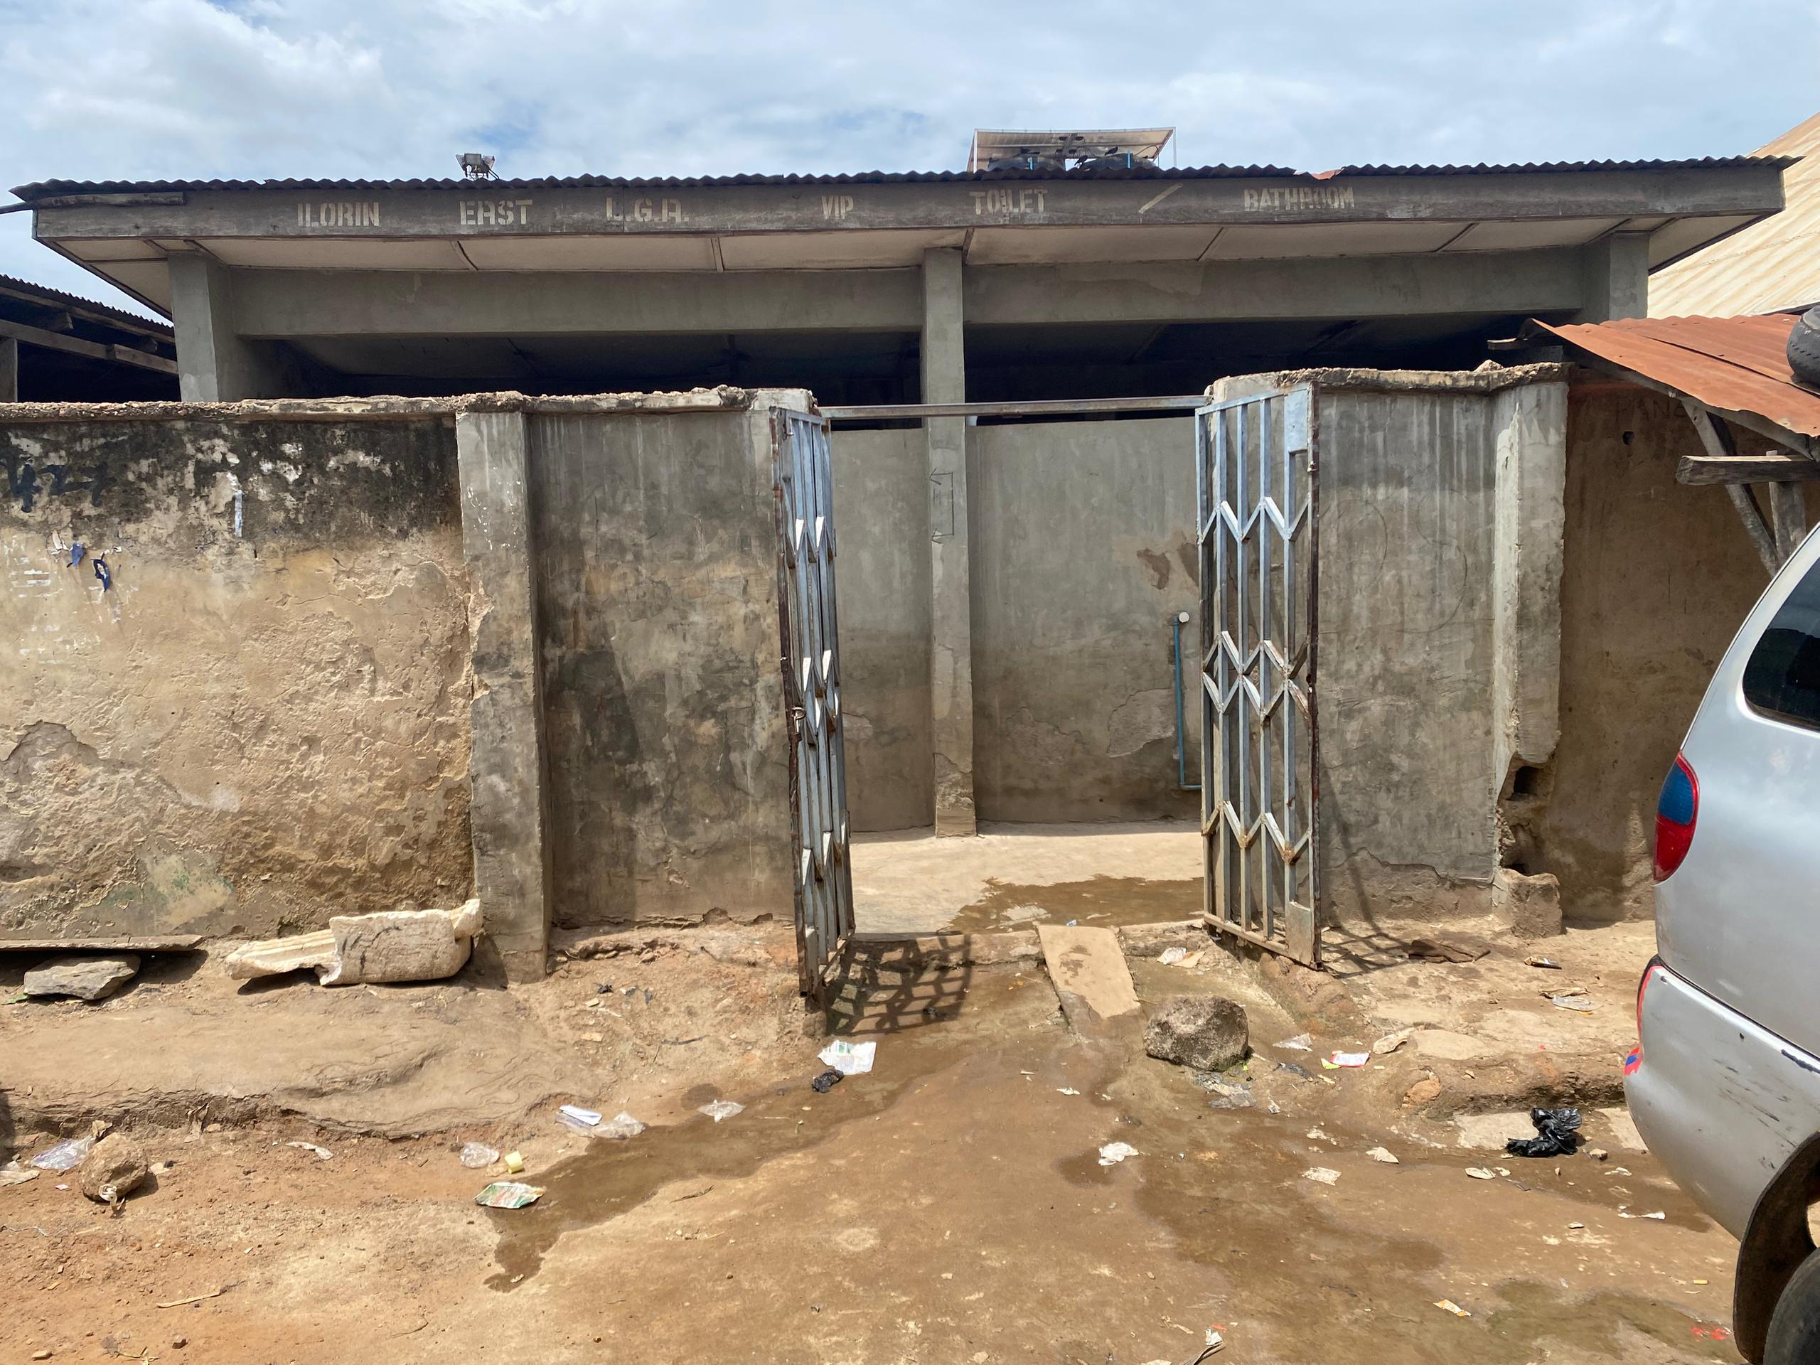
Maraba Motor Park

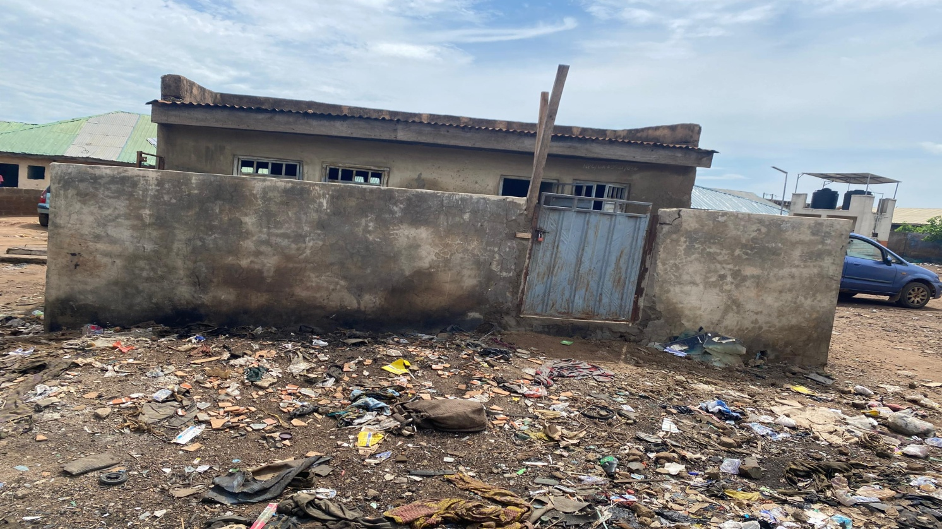
Oloje Garage

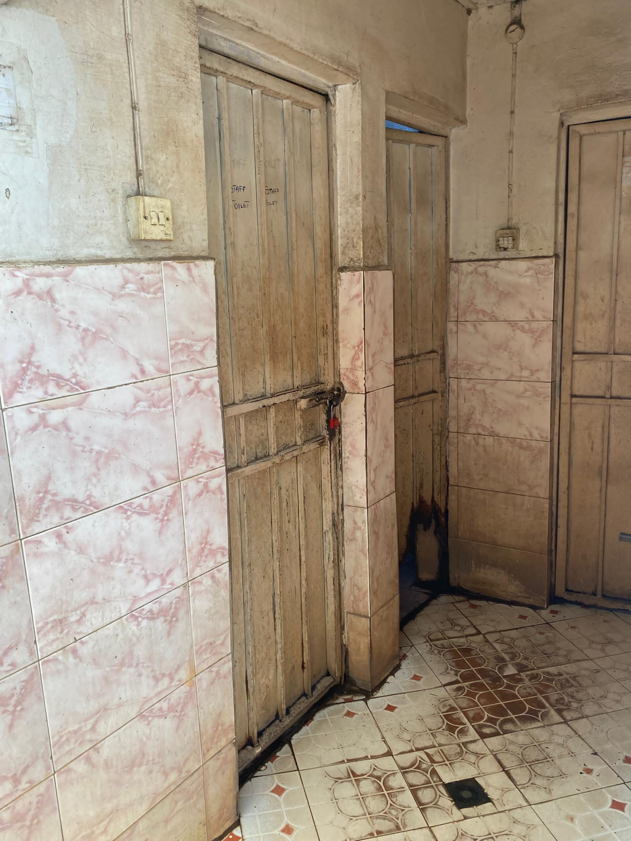
Young Legacy Motor Park

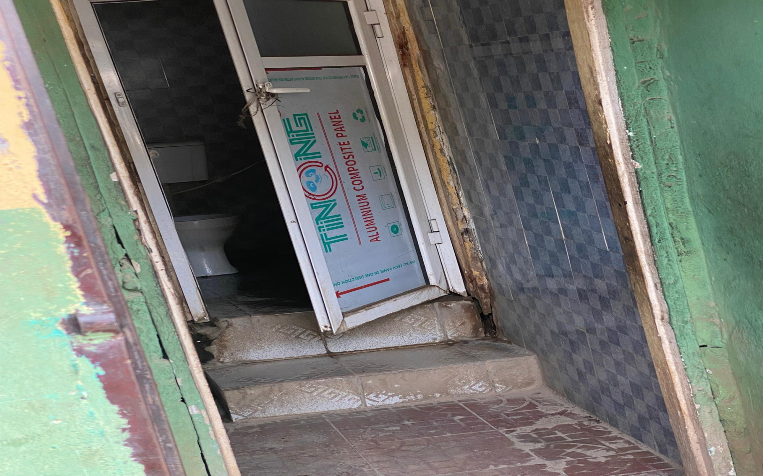
Kasmag Motor Park

CHAPTER FIVE
SUMMARY OF FINDINGS, CONCLUSION AND RECOMMENDATIONS

5.1 Summary of Findings
The analysis of the public toilet facilities in selected motor parks within Ilorin Metropolis reveals varying conditions in terms of physical infrastructure, maintenance, accessibility, and user satisfaction. Most respondents rated the physical condition of the toilets as fair or good, with a smaller proportion describing them as excellent. However, a notable number still found the facilities poor or very poor, indicating a need for structural upgrades and regular repairs. While a majority of the toilets were connected to a water supply, the absence of consistent handwashing facilities in many locations undermines hygiene practices and raises public health concerns.
Accessibility remains a significant issue, as more than half of the respondents indicated that the toilets were not user-friendly for children, the elderly, and persons with disabilities. This exclusion limits equitable access to sanitation and violates basic standards of inclusiveness. Cleaning frequency varied across locations, with some toilets cleaned several times a day while others were only cleaned a few times a week or rarely. Consequently, many users perceived the toilets as dirty or very dirty most of the time, and unpleasant odors were a common complaint, reported by over two-thirds of the respondents.
In terms of safety and monitoring, only slightly more than half of the respondents reported the presence of security personnel, and just over half felt safe using the facilities. This highlights concerns about personal safety and underscores the importance of monitoring and management in public sanitation areas. The lack of consistent security and the presence of unhygienic conditions create discomfort and discourage usage, especially for vulnerable groups.
User satisfaction was mixed. While a good proportion of respondents were satisfied or very satisfied with the facilities, a significant number expressed neutrality or dissatisfaction. This reflects the uneven quality of service delivery across the different motor parks. The suggestions made by respondents emphasized the need for more frequent cleaning, better lighting, increased toilet units, provision of running water, and employment of security staff. These recommendations point to clear priorities that should guide future investments in public sanitation infrastructure.
Additional comments provided by respondents further underline the need for better maintenance, improved hygiene standards, and enhanced safety. While a small percentage gave positive feedback, the majority either had concerns or suggested improvements. This feedback offers valuable insight into users’ expectations and should inform the planning and upgrading of public toilets. The findings are consistent with broader national and global challenges in public sanitation, emphasizing the need for policy enforcement, community engagement, and sustained funding to achieve inclusive, safe, and hygienic sanitation in public spaces.
5.2 Conclusion
The study assessed the management and condition of public toilet facilities across selected motor parks in Ilorin Metropolis. Findings revealed a mixed performance in terms of cleanliness, water availability, accessibility, security, and overall user satisfaction. While some facilities were found to be adequately maintained and equipped, a significant proportion suffered from poor hygiene standards, lack of proper monitoring, and inadequate infrastructure to cater to the diverse needs of users. Particularly alarming was the inaccessibility of facilities to children, the elderly, and persons with disabilities, along with the common occurrence of unpleasant odors and safety concerns.
Despite efforts by relevant authorities, it is evident that public toilet facilities in Ilorin motor parks fall short of meeting acceptable health, safety, and inclusivity standards. The prevailing challenges not only impact public health but also reflect gaps in planning, supervision, and service delivery. The insights gathered from users' experiences and suggestions indicate the need for a coordinated and sustainable intervention aimed at improving sanitation conditions in these crucial public spaces.
5.3 Recommendations
- Increase Frequency of Cleaning: Regular and scheduled cleaning, preferably multiple times daily, should be implemented to maintain hygiene and reduce the presence of unpleasant odors.
- Ensure Consistent Water Supply: Public toilets should be connected to reliable water sources to support sanitation practices, particularly handwashing and flushing.
- Install Functional Handwashing Facilities: Handwashing stations with soap or sanitizers should be mandatory and well-maintained to curb the spread of diseases.
- Improve Accessibility: Toilets should be redesigned or modified to accommodate children, the elderly, and persons with disabilities, ensuring inclusive usage for all demographics.
- Expand Toilet Infrastructure: Additional toilet units should be constructed in overcrowded motor parks to reduce waiting time and overuse of existing facilities.
- Enhance Lighting and Ventilation: Adequate lighting and proper ventilation should be provided to promote safety and comfort, especially during evening hours.
- Deploy Security Personnel: The presence of trained security staff at toilet facilities is necessary to protect users, deter vandalism, and maintain order.
- Establish a Monitoring and Feedback System: Local authorities should establish a feedback mechanism for users to report concerns and ensure that regular inspections are carried out to enforce compliance with sanitation standards.

References
Adeoti, O., Bello, A., & Johnson, M. (2024).Leveraging technology for sustainable urban sanitation: Case studies from Nigeria.Journal of Urban Management, 13(2), 112–128. https://doi.org/10.1016/j.jum.2024.02.001
Adewumi, A., Oladipo, I., &Ojo, J. (2020).Stakeholder engagement in the management of public sanitation facilities in Nigerian urban centers.Environmental Sanitation Research, 15(1), 33–48.
Akinola, O., &Fatusi, O. (2022). Cultural influences on sanitation behavior in southwestern Nigeria: Implications for public health interventions. Health Promotion International, 37(4), daac075. https://doi.org/10.1093/heapro/daac075
Adedayo, O., Salami, T., &Ige, A. (2023). Social perceptions and challenges in the use of public toilets in Nigerian urban communities. Journal of Environmental Psychology, 87, 101927.https://doi.org/10.1016/j.jenvp.2023.101927
Federal Ministry of Water Resources, National Bureau of Statistics, & UNICEF.(2022). Nigeria sanitation and hygiene situation report. Abuja: Government Press.
Björklund, F., &Persson, L. (2017). The economics of public goods provision: Challenges and solutions.Journal of Public Economics, 145, 40–56. https://doi.org/10.1016/j.jpubeco.2016.11.002
Bryson, J. M. (2018). Strategic planning for public and nonprofit organizations (5th ed.). Wiley.
Carpenter, C. J. (2010).A meta-analysis of the effectiveness of health belief model variables in predicting behavior.Health Communication, 25(8), 661–669. https://doi.org/10.1080/10410236.2010.521906
Cornes, R., & Sandler, T. (1996).The theory of externalities, public goods, and club goods (2nd ed.). Cambridge University Press.
Flood, R. L. (2019).The relationship of ‘systems thinking’ to action research. In P. Reason & H. Bradbury (Eds.), The SAGE handbook of action research (pp. 75–88). SAGE.
Freeman, R. E. (1984). Strategic management: A stakeholder approach. Pitman.
Freeman, R. E., Harrison, J. S., & Wicks, A. C. (2007).Managing for stakeholders: Survival, reputation, and success.Yale University Press.
Glanz, K., Rimer, B. K., &Viswanath, K. (2015).Health behavior: Theory, research, and practice (5th ed.). Jossey-Bass.
Greenwood, M. (2007). Stakeholder engagement: Beyond the myth of corporate responsibility. Journal of Business Ethics, 74(4), 315–327. https://doi.org/10.1007/s10551-007-9512-0
Janz, N. K., & Becker, M. H. (1984). The health belief model: A decade later. Health Education Quarterly, 11(1), 1–47. https://doi.org/10.1177/109019818401100101
Meadows, D. H. (2008).Thinking in systems: A primer. Chelsea Green Publishing.
Rosenstock, I. M. (1974).The health belief model and preventive health behavior.Health Education Monographs, 2, 354–386.
Samuelson, P. A. (1954). The pure theory of public expenditure.Review of Economics and Statistics, 36(4), 387–389. https://doi.org/10.2307/1925895
Ogunleye, O., Adekunle, T., &Amodu, O. (2021). Community-led total sanitation as a catalyst for rural sanitation improvement in Nigeria. Waterlines, 40(1), 56–72. https://doi.org/10.3362/1756-3488.20-00010
Okeke, T., &Okechukwu, P. (2023).Enhancing community participation in urban sanitation management in Nigeria.Sustainable Cities and Society, 79, 103610.https://doi.org/10.1016/j.scs.2022.103610
WASH. (2022). Public-private partnerships in sanitation: Lessons from African cities. eWASH Annual Report. https://www.ewash.org/reports/2022/ppp-sanitation-africa
World Health Organization (WHO). (2019). Sanitation and health: WHO guidelines and updates. Geneva: WHO Press.
World Health Organization (WHO). (2021). Water, sanitation, hygiene and health: Updated evidence and global status. Geneva: WHO Press.

QUESTIONNAIRE ON ASSESSMENT OF PUBLIC TOILET MANAGEMENT IN MOTOR PARKS WITHIN ILORIN METROPOLIS
Note: This questionnaire is designed strictly for academic purposes. All responses will be treated with confidentiality.

SECTION A: Demographic Information
(Please tick ✓ the most appropriate option)
- Gender:
☐ Male
☐ Female
- Age:
☐ Below 18
☐ 18 – 25
☐ 26 – 35
☐ 36 – 45
☐ 46 and above
- Occupation:
☐ Driver
☐ Conductor
☐ Trader
☐ Park Official
☐ Passenger
☐ Others (Please specify): _____________
- Educational Level:
☐ No Formal Education
☐ Primary
☐ Secondary
☐ Tertiary
- Motor Park Location:
☐ Post Office Park
☐ Challenge Park
☐Maraba Park
☐ Emir Road Park
☐ Other (Please specify): _____________

SECTION B: Physical Condition and Availability of Facilities
(Related to Objective 1)
- Are public toilet facilities available in this motor park?
☐ Yes
☐ No
- If yes, how many toilet units are available?
☐ 1–2
☐ 3–4
☐ 5 or more
- What type of toilet is most commonly available here?
☐ Pit latrine
☐ Flush toilet
☐ Mobile toilet
☐ Other: ___________
- How would you rate the physical condition of the toilet facility?
☐ Excellent
☐ Good
☐ Fair
☐ Poor
☐ Very poor
- Is the toilet facility connected to a water supply?
☐ Yes
☐ No
- Are there handwashing facilities available?
☐ Yes
☐ No
- Are the toilets accessible to all users (including children, elderly, and persons with disability)?
☐ Yes
☐ No

SECTION C: Stakeholders and Management Roles
(Related to Objective 2)
- Who manages the public toilets in this motor park?
☐ Government/Local Authority
☐ Transport Union
☐ Private Operator
☐ Community/Volunteer group
☐ I don’t know
- How often are the toilets cleaned?
☐ After each use
☐ Daily
☐ Weekly
☐ Rarely
☐ Never
- Are you aware of any official responsible for overseeing sanitation in this park?
☐ Yes
☐ No
- In your opinion, how effective is the current management system of the toilet facility?
☐ Very effective
☐ Effective
☐ Neutral
☐ Ineffective
☐ Very ineffective
- Are there maintenance records or schedules available for public view?
☐ Yes
☐ No
☐ Not Sure

SECTION D: Challenges and Constraints
(Related to Objective 3)
- What are the major challenges facing the public toilet in this park? (You may select more than one)
☐ Lack of water supply
☐ Poor hygiene/cleaning
☐ Inadequate funding
☐ Vandalism
☐ Poor management
☐ Insufficient facilities
☐ Lack of trained staff
☐ Others (Please specify): ___________
- Do you pay to use the public toilet here?
☐ Yes
☐ No
- If yes, how much do you pay per use?
☐ ₦10
☐ ₦20
☐ ₦30 or more
☐ Other: ___________
- Do you think the toilet services are worth the fee?
☐ Yes
☐ No
☐ Not sure
- Are you aware of any complaints or feedback mechanisms for toilet users?
☐ Yes
☐ No

SECTION E: Usage Patterns and User Perception
(Related to Objective 4)
- How often do you use the public toilet in this motor park?
☐ Always
☐ Occasionally
☐ Rarely
☐ Never
- If you avoid using the public toilet, why? (You may tick more than one)
☐ Dirty condition
☐ Offensive odor
☐ Lack of privacy
☐ Distance from main area
☐ Expensive usage fee
☐ Cultural or personal reasons
- How would you rate your satisfaction with the public toilet in this park?
☐ Very Satisfied
☐ Satisfied
☐ Neutral
☐ Dissatisfied
☐ Very Dissatisfied
- What improvements would you like to see?
☐ Better cleaning and maintenance
☐ More toilet units
☐ Reduced usage fees
☐ Improved water supply
☐Handwashing facilities
☐ Others: ___________

SECTION F: Recommendations for Improvement
(Related to Objective 5)
- In your opinion, who should be responsible for managing public toilets?
☐ Local government
☐ Transport union
☐ Public-private partnership
☐ Community-based management
- What strategies do you think would improve public toilet management?
☐ Regular cleaning schedule
☐ Community monitoring
☐ Government funding
☐ Public awareness campaigns
☐ Training for staff
- Would you support the use of public-private partnerships (PPP) to manage public toilets in motor parks?
☐ Yes
☐ No
☐ Not sure
- Please provide any additional suggestions or comments to improve public toilet management in Ilorin motor parks:

