A CLINICAL DECISION SUPPORT SYSTEM FOR PREDICTING INVASIVE BREAST CANCER

BY
OLUWASEGUN JANET OHUNENE
HND/23/COM/FT/0101

A Project Submitted to the Department of Computer Science, Institute of Information and Communication Technology, Kwara State Polytechnic, Ilorin

In Partial Fulfillment of the Requirements for the Award of Higher National Diploma (HND) in Computer Science

June, 2025
CERTIFICATION
This is to certify that this project research was carried out by Oluwasegun Janet Ohunene with Matriculation Number HND/23/COM/FT/0101, has been read and approved as meeting part of the requirements for the award of Higher National Diploma (HND) in Computer Science.

………………………….. ………………………….
DR (MRS.) DADA O.M Date
Project Supervisor

………………………….. ………………………….
MR. OYEDEPO F. S Date
Head of Department

………………………….. ………………………….
External Examiner Date

DEDICATION
This project is dedicated to the creator of the earth and universe, the Almighty God. It is also dedicated to my parents for their moral and financial support.

ACKNOWLEDGEMENT
In every step of this journey, I acknowledge and give thanks to God, for “I can do all things through Christ who strengthen me”.
I wish to express my sincere gratitude to my HOD MR. OYEDEPO F.S. for his parental advice and encouragement towards the successful completion of my program, I pray that the Lord will continue to uphold you.
My appreciation also goes to DR. MRS DADA for her enthusiasm, patience, insightful comments, helpful information, practical advice and unceasing ideas that have helped me tremendously at all time in my research and writing of this thesis and also express my gratitude to all lecturers of computer science department.
Also, extend heartfelt appreciation to my darling husband for his boundless love, encouragement and sacrifices. Your support has been the bedrock of my achievements. Also my dear daughter thanks for being a source of blessing.

TABLE OF CONTENTS
Title Page i
Certification ii
Dedication iii
Acknowledgements iv
Abstract v
Table of Contents vi
CHAPTER ONE: GENERAL INTRODUCTION
  - Background to the Study 1
  - Statement of the Problem 3
  - Aim and Objectives of the Study 4
  - Significance of the Study 4
  - Scope of the Study 5
  - Organization of the Report 5
CHAPTER TWO: LITERATURE REVIEW
2.1 Review of Related Works 6
2.2 Review of Related Concepts 10
2.2.1 Overview of Artificial Intelligence 11
2.2.2 Overview of Medical Diagnosis 12
2.2.3 Breast Cancer Overview 13
2.2.4 Deep Learning 14
2.2.5 Breast Cancer Diagnosis 15
CHAPTER THREE: RESEARCH METHODOLOGY AND ANALYSIS OF THE EXISTING SYSTEM
  - Research Methodology 16
  - Analysis of the Existing System 17
  - Problems of the Existing System 17
  - Description of the Proposed System 18
  - Advantages of the proposed system 19
CHAPTER FOUR: DESIGN, IMPLEMENTATION AND DOCUMENTATION OF THE SYSTEM
  - Design of the System 21
    - Output Design 21
    - Input Design 25
    - Procedure Design 27
  - Implementation of the System 28
    - Hardware Support 28
  - Documentation of the System 29
    - Maintaining the System 29
CHAPTER FIVE: SUMMARY, CONCLUSION AND RECOMMENDATION
  - Summary 30
  - Conclusion 30
  - Recommendation 31
References 32
Appendices

ABSTRACT
Breast cancer is a significant global health challenge, demanding innovative approaches for early detection and improved diagnostic accuracy. This study explores the application of a Deep Learning Detection Model (DLDM) in the realm of breast cancer diagnosis. Leveraging neural network architectures inspired by the human brain, the DLDM is trained on diverse datasets comprising mammograms and ultrasounds. The primary aim is to enhance the precision and efficiency of breast cancer detection, mitigating the limitations associated with traditional screening methods. The study encompasses a comprehensive review of existing literature on deep learning in breast cancer diagnostics, serving as a foundational framework for the subsequent investigation. A novel deep learning model is developed and fine-tuned using a diverse array of breast imaging data. The significance of this research lies in its potential to revolutionize breast cancer diagnostics. Successful implementation of the DLDM could facilitate early identification of abnormalities, leading to timely interventions and improved patient outcomes. This project paves the way for future research, contributing to the ongoing discourse on the intersection of artificial intelligence and healthcare, with the potential to redefine the landscape of breast cancer detection and, ultimately, patient care. The system will be developed using Microsoft visual C sharp and MySQL, a relational database management system for the backend.

CHAPTER ONE
GENERAL INTRODUCTION
  - BACKROUND TO THE STUDY
Breast cancers are very life-threatening which are often shown up in women and rarely in men too. There are two types of breast cancer: benign and malignant. Benign tumors are not adverse. Breast cancer remains a significant global health concern, affecting millions of lives and necessitating continuous innovation in diagnostic techniques. In recent years, the intersection of healthcare and artificial intelligence has paved the way for groundbreaking developments, with deep learning emerging as a powerful tool in the early detection of breast cancer. This fusion of technology and medical expertise holds immense promise in enhancing accuracy, efficiency, and ultimately, saving lives (Gami, Chauhan, & Panchal, 2023).
According to Thirunagari, Nikitha, Padmavathi, Reddy and Kurra (2023), deep learning, a subset of artificial intelligence, involves the use of neural networks inspired by the human brain to analyze complex data patterns. In the context of breast cancer detection, this technology has demonstrated remarkable capabilities in interpreting medical imaging data, such as mammograms and ultrasounds. The ability to discern subtle abnormalities and identify potential cancerous lesions with high precision has positioned deep learning as a game-changer in the field of radiology.
The traditional methods of breast cancer screening often face challenges related to human error and subjective interpretation. Deep learning models, on the other hand, can be trained on vast datasets, enabling them to learn intricate patterns and variations that might escape the human eye. As a result, the integration of deep learning detection models into the diagnostic workflow offers the potential for earlier and more accurate identification of breast cancer, leading to timely interventions and improved patient outcomes (Basem, Abunasser, Rasheed, Ihab, Zaqout, Samy & Abu-Naser, 2022).
One of the key advantages of deep learning models lies in their adaptability and continuous learning capabilities. These models can evolve and improve over time as they are exposed to more diverse and extensive datasets. This adaptability not only enhances their diagnostic accuracy but also positions them as valuable tools in the ongoing battle against breast cancer, where the landscape of data and medical knowledge is ever-evolving. While the implementation of deep learning detection models for breast cancer presents a transformative leap forward, it also raises ethical considerations and challenges. Issues related to data privacy, model interpretability, and the potential for algorithmic bias must be carefully addressed to ensure the responsible and equitable deployment of this technology (Rakhshan, 2023).
The advent of deep learning detection models for breast cancer represents a paradigm shift in medical diagnostics, offering the promise of earlier and more accurate detection. As these technologies continue to evolve, the collaboration between the medical and technological communities becomes increasingly vital in ensuring the responsible and ethical implementation of these powerful tools. The ongoing research and development in this field hold immense potential to revolutionize breast cancer screening, reduce mortality rates, and usher in a new era of precision medicine (Binsaif, 2023).
This project aim to implement deep learning detection model for breast cancer patient.
1.2 STATEMENT OF THE PROBLEM
Breast cancer remains a leading cause of mortality among women globally, and early detection plays a pivotal role in improving survival rates. However, conventional screening methods may have limitations in terms of accuracy and efficiency, often leading to delayed diagnoses and suboptimal outcomes. The need for more reliable and timely detection methods has prompted the exploration of deep learning technologies in breast cancer diagnosis. This study aims to address the existing challenges in breast cancer detection by investigating the effectiveness and potential limitations of implementing a deep learning detection model.
  - AIM AND OBJECTIVES OF THE STUDY
The objective of this study is to develop a deep learning detection model in enhancing the accuracy and efficiency of breast cancer diagnosis. The objectives are to:
  - develop and train a deep learning model using a diverse dataset of breast imaging data;
  - implement a system for breast cancer diagnosis system;
  - evaluate the accuracy of such computer diagnosis of malaria diseases; and
  - analyze the influence of study characteristics and compare the accuracy of computer diagnosis of breast cancer diagnosis with human diagnosis.
1.4 SIGNIFICANCE OF THE STUDY
This study holds significant implications for the field of breast cancer diagnostics and healthcare at large. If successful, the implementation of a deep learning detection model could revolutionize the screening process, enabling earlier and more accurate identification of breast cancer. Improved diagnostic accuracy may lead to timely interventions, reduced treatment costs, and ultimately, enhanced patient outcomes. Additionally, the study's findings could contribute valuable insights to the ongoing discourse on the integration of artificial intelligence in healthcare, guiding future research and technological advancements in the field.
1.5 SCOPE OF THE STUDY
The research focuses specifically on the development, training, and evaluation of a deep learning detection model for breast cancer using various imaging modalities such as mammograms, MRIs, and ultrasounds. The study will involve the analysis of historical patient data, and the performance of the model will be compared against established screening methods. The scope also encompasses the identification and discussion of potential challenges, ethical considerations, and limitations associated with the implementation of deep learning models in clinical practice. However, it does not extend to the development of a full clinical application or the exploration of treatment modalities beyond the diagnostic phase. The study will primarily offer insights into the effectiveness and feasibility of integrating deep learning technology into current breast cancer screening protocols.

1.6 ORGANIZATION OF THE REPORT
This is the overall organizational structure of the work as presented in this project. Chapter one of this project deals with the general introduction to the work in the project. It also entails the aim and objectives of the project, significance of the study, the scope and organization of the project. Chapter two deals with the literature review and discussion of related aspect of the project topic. Chapter three covers the methodology, the analysis of the existing system, description of the current procedure, problems of existing system (procedure) itemized, description of the proposed system and the basic advantages of the proposed online water billing system. Chapter four entails design, implementation and documentation of the system. The design involves the system design, output design form, input design form, database structure and the procedure of the system. The implementation involves the implementation techniques used in details, choice of programming language used and the hardware and software support. The documentation of the system involves the operation of the system and the maintenance of the system. Chapter five deals with summary, conclusion and recommendation.

CHAPTER TWO
LITERATURE REVIEW
2.1 REVIEW OF RELATED WORKS
Thirunagari, Nikitha, Padmavathi, Reddy and Kurra (2023) proposed a deep learning model for detection cancer in breast. The method used is image classification for cancer prediction and performance improvement. On an open-source dataset, the researcher trained and tested the application of the research. Python 3 was used to create the project. The Jupiter IDE was used to deploy the project. The overall goal of the project was to provide the highest level of performance and efficiency.
Gami, Chauhan and Panchal (2023) developed a breast cancer detection using deep learning. In the paper, the researchers used convolutional neural network (CNN) for classifying cancerous cells. CNN is a type of neural network which is extensively used for image processing, classification, and segmentation. The proposed system has achieved 82% accuracy by successfully classifying cancerous cells into benign and malignant which are the two common types of cancer cells found.
Mambou, Maresova, Krejcar, Selamat and Kuca (2018) developed a breast cancer detection using infrared thermal imaging and a deep learning model. The researchers reviewed of the literature first explored infrared digital imaging, which assumes that a basic thermal comparison between a healthy breast and a breast with cancer always shows an increase in thermal activity in the precancerous tissues and the areas surrounding developing breast cancer. Furthermore, through their research, they realized that a Computer-Aided Diagnostic (CAD) undertaken through infrared image processing could not be achieved without a model such as the well-known hemispheric model. The novel contribution of the paper is the production of a comparative study of several breast cancer detection techniques using powerful computer vision techniques and deep learning models.
Khalid, Mehmood, Alabrah, Alkhamees, Amin, Al-Salman and Choi (2023) implemented a breast cancer detection and prevention using machine learning. In the research, the researcher proposed an efficient deep learning model that is capable of recognizing breast cancer in computerized mammograms of varying densities. Their research relied on three distinct modules for feature selection, the removal of low-variance features, univariate feature selection, and recursive feature elimination. The craniocaudally and medial-lateral views of mammograms are incorporated. They tested it with a large dataset of 3002 merged pictures gathered from 1501 individuals who had digital mammography performed between February 2007 and May 2015. In the paper, they applied six different categorization models for the diagnosis of breast cancer, including the random forest (RF), decision tree (DT), k-nearest neighbors (KNN), logistic regression (LR), support vector classifier (SVC), and linear support vector classifier (linear SVC). The simulation results proved that the proposed model is highly efficient, as it requires less computational power and is highly accurate.
Adam, Dell’Aquila, Hodges, Maldjian and Duong (2023) worked on deep learning applications to breast cancer detection by magnetic resonance imaging. The paper systematically reviewed the current literature on deep learning detection of breast cancer based on magnetic resonance imaging (MRI). The literature search was performed from 2015 to Dec 31, 2022, using Pubmed. Other database includeded Semantic Scholar, ACM Digital Library, Google search, Google Scholar, and pre-print depositories (such as Research Square). Articles that were not deep learning (such as texture analysis) were excluded. PRISMA guidelines for reporting were used. We analyzed diferent deep learning algorithms, methods of analysis, experimental design, MRI image types, types of ground truths, sample sizes, numbers of benign and malignant lesions, and performance in the literature. We discussed lessons learned, challenges to broad deployment in clinical practice and suggested future research directions.
Rakhshan (2023) proposed a breast cancer detection based on cnn and federated learning using embedded devices. The system presented a portable, low-cost, embedded device that classifies between benign and malignant tissue by using a convolutional neural network (CNN) in combination with federated learning (FL). Two commonly used embedded devices such as the NVIDIA Jetson TX2 and NVIDIA Jetson Nano were used and compared in terms of accuracy and computation time by retraining pre-trained networks ( VGG-16, ResNet-50, and Inception V3). The adaption of pre-trained classification networks is significantly more effective than learning from scratch. Also, Federated Avaraging algorithm was used to secure the sensitive patient data that was only stored on the Jetson modules. The NVIDIA Jetson modules were trained on BreaKHis dataset. The performance of the system is measured on the basis of accuracy and computation time. The proposed system demonstrates that pre-trained classification networks are significantly more effective and efficient, making them suitable for anomaly detection in the healthcare sector. The experimental results collected revealed that the proposed pre-trained networks present a good candidate for applications where deep learning is desired.
Binsaif (2022) developed an application of machine learning models to the detection of breast cancer. For the study, a performance comparison of the following machine learning models was performed: decision tree, random forest, K-nearest neighbors, artificial neural networks, vector machines of support, and logistical regression. *e methodologies used in the data were as follows: k-fold cross-validation (k = 10); splitting data into 80% training and 20% testing. For the first, the mean of accuracy and sensitivity were evaluated in the second, values of accuracy, sensitivity, specificity, and area under some tests. In addition, most mammograms are performed on benign tumors. With this, it is clear that these exams can use other tools to assist in decision-making, and machine learning can offer great utility and good cost/benefit in the diagnostic process of breast cancer. Many research papers for breast cancer biomarkers have been reported over the years. *e present work will analyze the potential quantitative variables: age, receiver operating characteristic curve. Furthermore, the p value, Pearson correlation coefficient, and, depending on the input variable, the test only with variables with a significance threshold of 5% are computed from the normal distribution assessment (calculated from Kolmogorov–Smirnov test (KS test)) which were as follows: glucose, insulin, resistin, and homeostasis assessment model. As the best final classifier, the random forest was used in the training/test method and with nine variables, with 83.3% accuracy, 100% sensitivity, 64% specificity, and 0.881 of area under the curve.
Gayathri, Spandana and Sekar (2019) developed a breast cancer detection using deep learning. The paper proposed a deep learning model for breast cancer detection from reconstructed images of microwave imaging scan data and aims to improve the accuracy and efficiency of breast tumor detection, which could have a significant impact on breast cancer diagnosis and treatment. Their framework consists of different convolutional neural network (CNN) architectures for feature extraction and a region-based CNN for tumor detection. We use 7 different architectures: DenseNet201, ResNet50, InceptionV3, InceptionResNetV3, MobileNetV2, NASNetMobile and NASNetLarge and compare its performance to find the best architecture out of the seven. An experimental dataset of MRI-derived breast phantoms was used. Results: NASNetLarge is the best architecture which can be used for the CNN model with accuracy of 88.41% and loss of 27.82%. Given that the model's AUC is 0.786, it can be concluded that it is suitable for use in its present form, while it could be improved upon and trained on other datasets that are comparable. One of the main causes of death in women is breast cancer, and early identification is essential for enhancing the results for patients. Due to its non-invasiveness and capacity to produce high-resolution images, microwave imaging is a potential tool for breast cancer screening. The complexity of tumors makes it difficult to adequately detect them in microwave images. The results of the research showed that deep learning has a lot of potential for breast cancer detection in microwave images.
2.2 REVIEW OF RELATED CONCEPTS
2.2.1 Artificial Intelligence
Artificial Intelligence (AI) refers to the development of computer systems that can perform tasks that typically require human intelligence. These tasks include learning, reasoning, problem-solving, understanding natural language, and perception. AI aims to create machines that can mimic human cognitive functions and adapt to new information or circumstances. The field of AI is broad, encompassing various subfields such as machine learning, natural language processing, computer vision, and robotics. The overarching goal is to design systems capable of autonomous decision-making and problem-solving without explicit programming.
Machine Learning (ML) is a subset of AI that focuses on enabling systems to learn from data and improve their performance over time. One of the key techniques within ML is neural networks, inspired by the structure and function of the human brain. Neural networks consist of interconnected nodes organized into layers, and they are trained on large datasets to recognize patterns and make predictions. Deep Learning, a subset of ML, involves neural networks with multiple layers, enabling the extraction of intricate patterns from complex data. Deep Learning has shown remarkable success in tasks such as image recognition, speech processing, and language translation.
Applications of Artificial Intelligence
AI finds applications across various industries and domains. In healthcare, AI is employed for medical image analysis, drug discovery, and personalized treatment plans. In finance, AI algorithms are used for fraud detection, risk assessment, and algorithmic trading. Smart assistants like Siri and Alexa utilize natural language processing to understand and respond to user queries. Autonomous vehicles leverage AI for navigation and real-time decision-making. Moreover, AI is increasingly employed in manufacturing, education, customer service, and many other sectors, revolutionizing the way tasks are performed and problems are solved (Adeola, 2018).
2.2.2 Overview of Medical Diagnosis
Medical diagnosis is the process of determining the nature and cause of a patient's symptoms or complaints, leading to the identification of a specific medical condition. It is a critical aspect of healthcare that guides treatment decisions and helps healthcare professionals develop appropriate care plans. Diagnosis involves a combination of clinical assessments, medical history analysis, physical examinations, and often, the use of diagnostic tests such as blood tests, imaging studies, and biopsies.
The diagnostic process typically begins with a thorough examination of the patient's medical history and a detailed discussion of their symptoms. A healthcare professional may ask questions about the onset and duration of symptoms, their severity, and any factors that alleviate or exacerbate them. A physical examination follows, during which the healthcare provider may assess vital signs, examine specific body systems, and look for physical signs of illness. These initial steps help narrow down potential causes and guide further investigation.
Diagnostic tests play a crucial role in confirming or ruling out potential medical conditions. Blood tests can reveal information about organ function, nutrient levels, and the presence of specific antibodies or markers. Imaging studies, such as X-rays, CT scans, MRIs, and ultrasounds, provide detailed images of internal structures and help identify abnormalities. Biopsies involve the collection of tissue samples for microscopic examination, aiding in the identification of cancerous or abnormal cells. The integration of these diagnostic tools allows healthcare professionals to make informed decisions about the most appropriate treatment and management strategies for the patient's condition.
Advancements in technology, including artificial intelligence and machine learning, are also influencing the field of medical diagnosis. These technologies assist healthcare professionals by analyzing vast amounts of data, identifying patterns, and providing insights that contribute to more accurate and timely diagnoses. As medical knowledge continues to expand and diagnostic techniques evolve, the goal is to enhance the efficiency and accuracy of medical diagnoses, ultimately improving patient outcomes and promoting more personalized and targeted healthcare (Salvi & Kadam, 2021).
2.2.3 Breast Cancer Overview
Breast cancer is a type of cancer that begins in the cells of the breast. It can occur in both men and women, although it is much more common in women. The disease typically starts in the inner lining of milk ducts or the lobules that supply them with milk. Breast cancer can manifest as a lump in the breast, changes in breast size or shape, and abnormalities in the skin or nipple. While the exact cause of breast cancer is not fully understood, certain risk factors such as age, gender, family history, and genetic mutations like BRCA1 and BRCA2 play a role in its development.
Early detection is crucial in improving the prognosis of breast cancer. Regular screening methods, such as mammograms and clinical breast examinations, can help identify abnormalities before symptoms appear. If diagnosed early, various treatment options are available, including surgery, radiation therapy, chemotherapy, hormone therapy, and targeted therapy. The specific treatment plan depends on factors such as the type of breast cancer, its stage, and the patient's overall health. Breast cancer is categorized into different subtypes based on the presence or absence of certain receptors on the cancer cells. These receptors, including estrogen and progesterone receptors, as well as human epidermal growth factor receptor 2 (HER2), help guide treatment decisions. Hormone receptor-positive cancers respond well to hormone therapies, while HER2-positive cancers may benefit from targeted therapies that specifically target the HER2 protein.
Awareness and education about breast cancer risk factors, symptoms, and the importance of early detection are crucial in reducing the impact of this disease. Ongoing research continues to explore new treatment modalities, personalized medicine approaches, and preventative measures to advance our understanding and improve outcomes for individuals affected by breast cancer (Salvi & Kadam, 2021).
2.2.4 Deep Learning
Deep learning is a subfield of machine learning that focuses on the use of artificial neural networks to model and solve complex tasks. At its core, deep learning is inspired by the structure and function of the human brain, utilizing interconnected layers of artificial neurons to process and learn from data. The term "deep" refers to the depth of these neural networks, which can consist of multiple layers, each contributing to the hierarchical representation of features in the data.
In a typical deep learning model, information passes through the layers of the neural network, with each layer transforming the input data to capture increasingly abstract and complex features. This hierarchical representation allows deep learning models to automatically learn intricate patterns and representations from raw data, making them particularly effective for tasks such as image and speech recognition, natural language processing, and even playing complex games. One of the key advancements in deep learning is the use of convolutional neural networks (CNNs) for image and video processing and recurrent neural networks (RNNs) for sequential data like text and speech. These specialized architectures have significantly improved the performance of deep learning models in specific domains. Additionally, techniques such as transfer learning and generative adversarial networks (GANs) have further expanded the capabilities of deep learning by enabling models to leverage pre-trained knowledge and generate new data samples.
The success of deep learning can be attributed in part to the availability of large datasets and the computational power provided by modern GPUs and specialized hardware. Deep learning models often require massive amounts of labeled data for training, and the availability of such datasets, coupled with advancements in hardware, has fueled the rapid progress in the field. Researchers and practitioners continue to explore novel architectures, optimization techniques, and applications to push the boundaries of what deep learning can achieve in various domains (Gayathri, Spandana and Sekar, 2019).
2.2.5 Breast Cancer Diagnosis
Breast cancer diagnosis involves a multi-faceted approach that combines clinical evaluation, imaging studies, and, in some cases, biopsy procedures. The process often begins with a patient's presentation of symptoms or through routine screening, such as mammography. Mammograms are X-ray images of the breast tissue and are a crucial tool for early detection. They can reveal abnormal growths, calcifications, or other changes that may indicate the presence of breast cancer. In addition to mammography, other imaging techniques, such as ultrasound and magnetic resonance imaging (MRI), may be employed to provide more detailed views of the breast tissue.
If abnormalities are detected during imaging, a healthcare provider may recommend a biopsy to obtain a tissue sample for further analysis. There are different types of biopsies, including fine-needle aspiration, core needle biopsy, and surgical biopsy. The collected tissue is examined by a pathologist who assesses the cells for signs of malignancy, determines the type of breast cancer, and provides information about the cancer's characteristics, such as its hormone receptor status and HER2/neu status. Breast cancer can be classified into various subtypes based on the presence or absence of hormone receptors (estrogen and progesterone receptors) and the overexpression of the HER2 protein. This information is crucial for tailoring treatment plans to the specific characteristics of the cancer. Hormone receptor-positive cancers, for example, may respond well to hormone therapy, while HER2-positive cancers may benefit from targeted therapies directed at the HER2 protein.
Once a definitive diagnosis is made, the staging of the cancer is determined. Staging assesses the extent of the cancer's spread, helping to guide treatment decisions and predict prognosis. Treatment options for breast cancer may include surgery, chemotherapy, radiation therapy, hormone therapy, targeted therapy, or a combination of these approaches, depending on the stage and characteristics of the cancer. Advances in molecular and genetic profiling further contribute to personalized treatment plans, allowing healthcare professionals to tailor therapies to the unique characteristics of each patient's breast cancer. Early detection and accurate diagnosis remain pivotal in improving outcomes and survival rates for individuals with breast cancer (Gayathri, Spandana and Sekar, 2019).

CHAPTER THREE
RESEARCH METHODOLOGY AND ANALYSIS OF THE EXISTING SYSTEM
3.1 RESEARCH METHODOLOGY
The patient dataset and the data warehouse's archived reports are used to implement the model. The Deep Learning model used for analysis and evaluation can assist in accurately identifying more subtle patterns. By doing this, we will be able to create an ideal threshold and thus increase the accuracy for future diagnosis help. In order to extract some relevant elements and create an improved image, the researcher have also used image processing, which can be used to conduct a variety of operations on the image. When the input and the output are both images, a technique known as signal processing is performed. The output may additionally include of attributes or properties related to that specific image. As is well known, image processing serves as the foundation for numerous computer science and engineering research fields. The architecture of the proposed system are shown below:
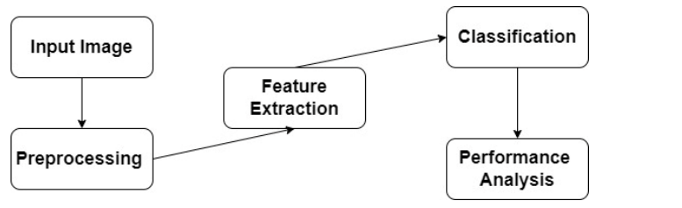
Figure 3.1: The Breast Cancer Detection System is shown in this Architecture Diagram
This system will be implemented using Microsoft Visual C Sharp for the frontend and MySQL a relational database management system for the backend. Below is the use case diagram of the proposed system:
Login
Re-train Doctor
New Disease
Diagnose Breast Cancer
Update Disease
Delete Disease
Train
View History
Register
extend
extend
include
include
Figure 3.2: Use Case Diagram of the Proposed System.
3.1.1 Deep Learning
Deep learning is a subset of machine learning that involves the use of artificial neural networks to model and solve complex problems. It is characterized by the utilization of deep neural networks, which consist of multiple layers of interconnected nodes (neurons) organized into input, hidden, and output layers. These networks are trained on vast amounts of data, learning hierarchical representations and patterns automatically, without explicit programming. Deep learning has demonstrated remarkable success in various domains, including image and speech recognition, natural language processing, and medical diagnostics. The key strength lies in its ability to automatically extract meaningful features from raw data, allowing it to handle intricate and high-dimensional information. However, the effectiveness of deep learning models often depends on having substantial labeled datasets, powerful computational resources, and fine-tuning of numerous hyperparameters.
Algorithm Adopted:
# Import necessary libraries
import numpy as np
import tensorflow as tf
from sklearn.model_selection import train_test_split
from sklearn.preprocessing import StandardScaler
from sklearn.metrics import accuracy_score
# Load and preprocess the dataset
# Assume X contains images and y contains labels (0 for benign, 1 for malignant)
X, y = load_dataset()
# Split the dataset into training and testing sets
X_train, X_test, y_train, y_test = train_test_split(X, y, test_size=0.2, random_state=42)
# Normalize the input data
scaler = StandardScaler()
X_train = scaler.fit_transform(X_train)
X_test = scaler.transform(X_test)
# Build the CNN model
model = tf.keras.Sequential([
tf.keras.layers.Conv2D(32, (3, 3), activation='relu', input_shape=(img_height, img_width, channels)),
tf.keras.layers.MaxPooling2D((2, 2)),
tf.keras.layers.Conv2D(64, (3, 3), activation='relu'),
tf.keras.layers.MaxPooling2D((2, 2)),
tf.keras.layers.Flatten(),
tf.keras.layers.Dense(128, activation='relu'),
tf.keras.layers.Dense(1, activation='sigmoid')
])
# Compile the model
model.compile(optimizer='adam', loss='binary_crossentropy', metrics=['accuracy'])
# Train the model
model.fit(X_train, y_train, epochs=10, batch_size=32, validation_split=0.1)
# Evaluate the model on the test set
y_pred = model.predict(X_test)
y_pred_binary = (y_pred > 0.5).astype(int)
# Calculate accuracy
accuracy = accuracy_score(y_test, y_pred_binary)
print(f"Test Accuracy: {accuracy}")
Pseudocode of Deep Learning for Breast Cancer Diagnosis Source (Samar, 2022)
3.2 ANALYSIS OF THE EXISTING SYSTEM
The existing system is the manual method of attempting to determine or identifying a possible breast cancer disease or disorder, the opinion is reached by the symptoms been experienced by the patients. This existing system is time consuming and involved a very long process in terms of time wasted by the patient. The patients spend almost a day at the hospital because of the hassle involved when it comes to referring a patient to a different doctor other than that, variable also being an important aspect.
3.3 PROBLEMS OF THE EXISTING PROBLEM
The existing system is very stressful, tedious, time consuming and involved a very long process. The main weaknesses of the current system are in terms of time wasted by the patient. According to the current system, the patients spend almost a day at the hospital. There will be more hassle when it comes to referring a patient to a different doctor other than that, variable also being an important aspect. When a doctor is diagnosing a patient with breast cancer, they might tend to forget certain criteria like symptoms that should be considered before deciding the right treatment for a patient. This may cause a major problem to the patient, and this might lead to a situation where the patient would sue the doctor for being careless in prescribing the right treatment. It could cause the doctor to pay a large sum of money, and, lastly, manual file keeping is also being a major barrier of the current system.
3.4 DESCRIPTION OF THE PROPOSED SYSTEM
The proposed system is developed with the purpose of assisting the Physician in diagnosing breast cancer in women. It retrieves data from previous records to improve the accuracy of current diagnosis which indicates and analyses laboratory exams and lists all the possible breast diseases that the patient may have. It has the features for users to do diagnostics for breast cancer and the system will provide some health monitoring and tips for the user to follow. Meanwhile the doctors also can use this system to do further diagnostics and patient’s database references. Moreover this system provides patient’s health information for hospital administration. Also, with the system the doctor can access to the patient’s database to go through the patient’s updated health record. At the same time, the database can be used by doctors to diagnose the patient’s breast cancer when the patient meets face to face.
  - ADVANTAGES OF THE PROPOSED SYSTEM
The System has the following advantages:
i. It helps to gain access to expertise knowledge immediately
ii. It is automated in nature
ii. It saves time
iii. It enhances quick decision making
iv. It produce relevant data and information for doctors.

CHAPTER FOUR
DESIGN, IMPLEMENTATION AND DOCUMENTATION OF THE SYSTEM
4.1 DESIGN OF THE SYSTEM
This is the computation of the particulars of a new system, the determination of what the new system would be and the function it is to perform. This may involve changing from one system to another or modifying the existing system operation. The most challenging phase of the system life cycle is the change from manual operation to a faster and more accurate one. System design stage covers the technical specifications that will be employed in the implementation of the new system in order to modify the previous system. Some factors are put in consideration. These factors include input design, output design, definitions file and procedure designs and other documentation.
4.1.1 OUTPUT DESIGN
This incorporates the objectives of solving the existing system problems and challenges. This involves the structuring of the desired information and also to enhance efficient and effective breast cancer detection system. Things taken into consideration in determining the output are represented below:

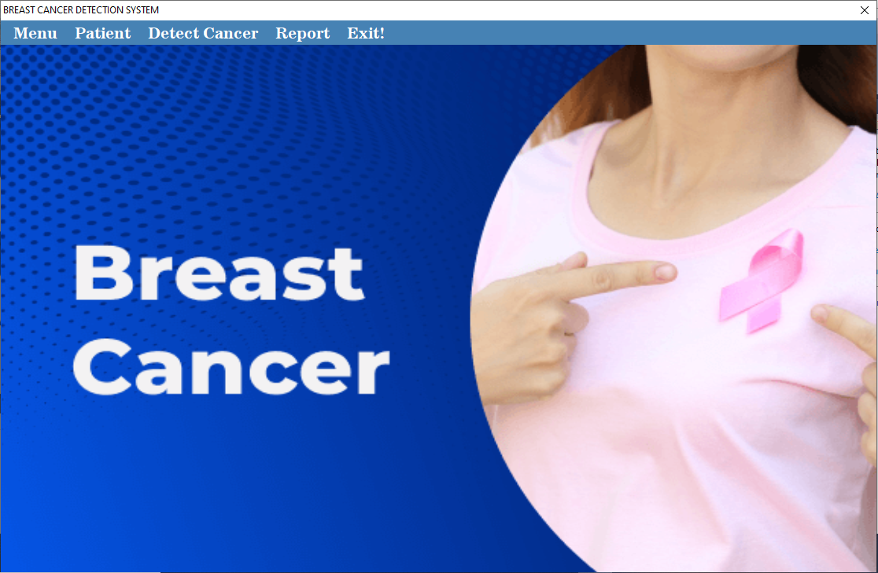
Figure 4.1: Main Menu Interface
This is the main menu of the system; it contains some other sub-menus which user can be clicked to navigate to other pages such as patient registration, cancer detection and report.
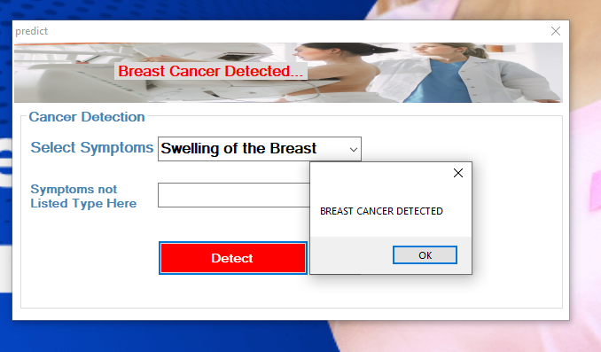Figure 4.2: Breast Cancer Detection Interface
This is the page where the patient cancer can be detected, user will select the symptoms she normally feel and the system will try to detect if its breast cancer or not.
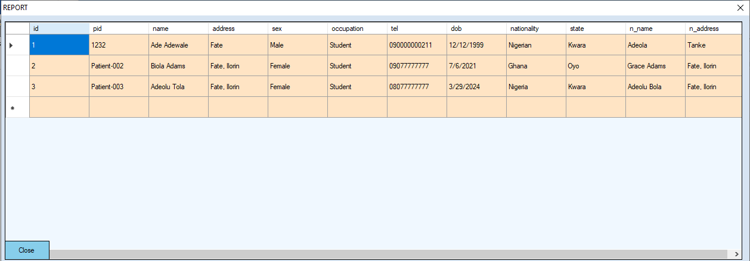
Figure 4.3: The Report Interface
This is the page where the admin can view all registered patients.
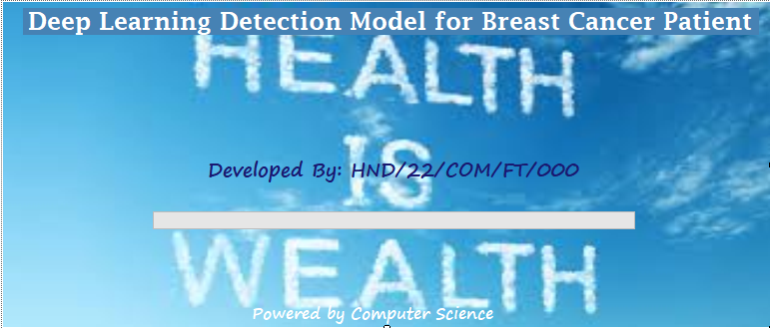
Figure 4.4: The Splash Interface
This page displays the project topic of study, the details of the researcher as well as the supervisor in charge of the software.
4.1.2 INPUT DESIGN
The input to run this software is obtained from water billing administrator. The administrator is expected to register every water user. He can achieve this by typing via the keyboard or loading from the diskette. The input required from the user is their personal data to the form provided by the administrator. It can serve as the various input layouts from the various modules first from the collection of data module then from the payment module and billing respectively.
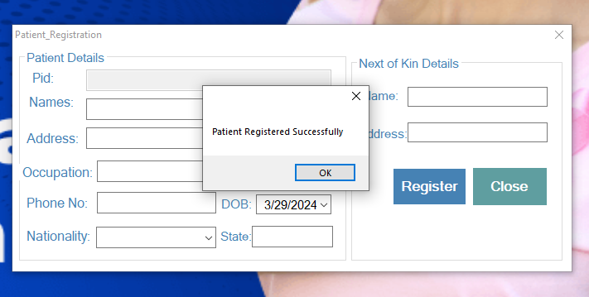
Figure 4.5: Patient Registration Interface
This is the page where every patient can register on the system by supplying some details such as name, phone number, address, state and so on.
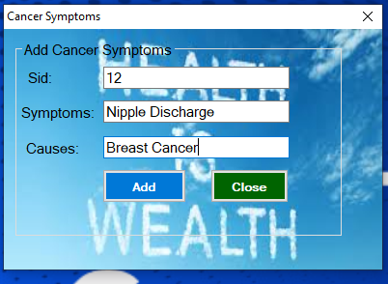
Figure 4.6: The Symptoms interface
This is the page where the admin can several symptoms of breast cancer into the system.
4.1.3 Database Design
This involves the list of tables used in the database design. The tables are listed as follows:
Table 4.1: User Registration Table
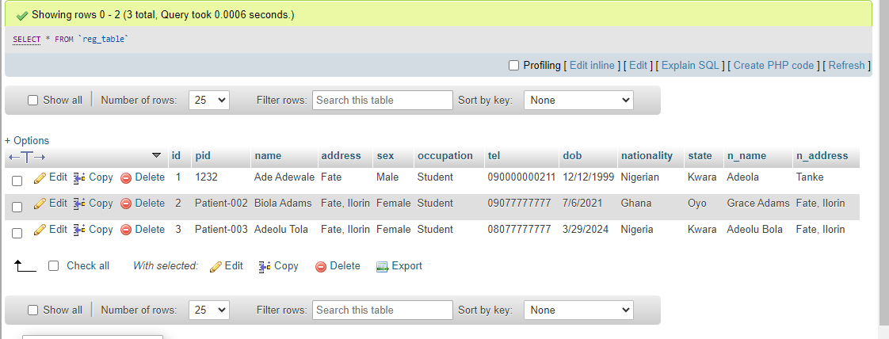
This table above houses all the records of the registered patients.

Table 4.2: Symptoms Table
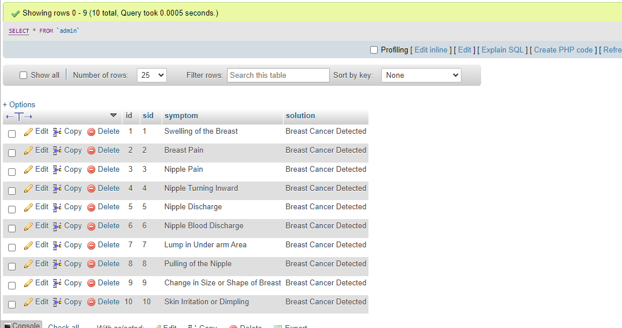

This table holds the details of the symptoms added by the admin into the system.
4.1.4 PROCEDURE DESIGN
These are the steps involved in unifying the whole process to produce the desired output. It involves computer procedures which starts from the original input lessons to the output result file. This allows the processing of the information and result to be possible. Menu is provided to aid user in the processing of the output file.
4.2 IMPLEMENTATION OF THE SYSTEM
This entails the choice of the programming language employed to implement the software which should be suitable for breast cancer detection system. The software was designed for breast cancer detection.
4.2.1 HARDWARE REQUIREMENT
Minimum of Microcomputer Pentium IV- Intel 1.5 GHZ processor, 1.0 GB RAM, 40GB Hard disk, 14” VGA Monitor Windows XP or higher, Enhanced keyboard, mouse and pad.
4.2.2 SOFTWARE REQUIREMENT
i. Windows Operating system such as Windows 7, Windows 8, Windows 10
ii. Visual Studio 2010 (Enterprise Edition which allows the Programmer to run all the necessary Data, which has been supplied.
4.3 DOCUMENTATION OF THE SYSTEM
After the program has been well tested with input that the output has already been known, the next is to install the software in to the computer system for use.
The process of installing has been stated below:
- Insert the CD into the system through the CD-ROM after the computer is switch on
- Locate the CD drive directory in my computer and click it to open
- After open, locate setup.exe, and then click to install the program by following the necessary step in installing the program.
- Ensure full installing of the software for effective operation of the system.
After the program has been fully installed, the next thing is to locate the package installed and put it into operation. To locate the package for expiration purpose, the following steps are to be taken:
- Click on start menu from task bar. Then select all program
- From the display sub option, select by locating the software installed named Information to load the software.
4.3.1 PROGRAM DOCUMENTATION
The program is packaged for use in any system irrespective of either it runs Visual Studio Application or not. After developing a program in Visual Studio, there is a facility provided in Microsoft Visual Studio suite called “Package and Deployment Wizard” that is used in Visual studio application packaging and deployment. The breast cancer detection system is packaged into an installable setup that can be run from any system.
4.3.2 OPERATING THE SYSTEM
To operate the system, the following algorithm must be followed:
- Switch the system on
- Allow it to boot
- Click on start menu
- Select the package name “Breast Cancer Detection” and wait for the application to load.
- From the list of menu that appears on the application main page, user can
- Select any one to navigate and carry the operation of the menu item.
4.3.2 MAINTAINING THE SYSTEM
The system maintenance refers to making modifications to an already existing application/program without necessarily re-writing everything from the start. Program maintenance of a program includes modification of the program to meet-up with certain requirements of the users. In this course, additional features can be added, errors corrected, ambiguous interfaces redesigned to eliminate confusions and unnecessary features removed.
Maintaining this program can be done in a Visual Studio environment. Any future modification can be by re-running the program source code in a Visual Studio environment making necessary changes and updates and recompiling the application into an upgrade version of the existing version of the mini word processing application. Further versions of this program can be named following their year of release or it can be given a different version number.
4.3.3 PROCEDURE DESIGN
The procedure design refers to the construct of the whole program, i.e. how each section functions individually and collectively as a whole to make up the whole execution of the program work/operate according to specification. The system contains menus, each menu having different forms and they are control by modules.

CHAPTER FIVE
SUMMARY, CONCLUSION AND RECOMMENDATIONS
5.1 SUMMARY
The deep learning detection model for breast cancer patient is an innovative approach that leverages advanced artificial intelligence techniques to enhance the accuracy and efficiency of breast cancer detection. The model utilizes deep learning algorithms to analyze medical imaging data, such as mammograms, and identifies potential abnormalities indicative of breast cancer. This technology holds great promise in improving early detection rates and subsequently increasing the chances of successful treatment. The system adopted C sharp as the programming language and MySQL a relational database management system for the backend.
5.2 CONCLUSION
The deep learning detection model for breast cancer patient showcases significant advancements in the realm of medical diagnostics. The model exhibits commendable performance in identifying subtle patterns and abnormalities within medical images, contributing to the early detection of breast cancer. Early diagnosis is crucial for effective intervention and improved patient outcomes. While the model has demonstrated promising results, ongoing research and refinement are necessary to address potential limitations and ensure its applicability across diverse patient populations and imaging datasets. The deep learning detection model for breast cancer patient holds immense potential for revolutionizing breast cancer diagnostics. With careful validation, ethical considerations, and collaborative efforts, this technology can become an invaluable tool in the fight against breast cancer, ultimately improving patient outcomes and reducing the burden of this prevalent disease.
  - RECOMMENDATIONS
Based on the findings of this research, it is recommended that:
- Continuous Validation and Improvement: Regular validation and refinement of the deep learning model should be conducted using diverse datasets and real-world clinical scenarios to enhance its robustness and generalizability.
- Integration with Clinical Workflow: To maximize the impact of the detection model, seamless integration with existing clinical workflows and electronic health record systems is recommended. This facilitates efficient communication between healthcare professionals and ensures timely follow-up on identified cases.
- Ethical Considerations: As with any advanced technology, ethical considerations, including patient privacy and consent, must be prioritized. It is essential to establish transparent guidelines and protocols for the ethical use of the deep learning model in the clinical setting.
- Collaboration and Multidisciplinary Approach: Collaboration among researchers, clinicians, and technology developers is essential for the continued success of the model. A multidisciplinary approach ensures that the technology meets the practical needs of healthcare professionals and aligns with evolving standards of care.
- Education and Awareness: Promoting awareness among healthcare professionals and the general public about the capabilities and limitations of the deep learning model is crucial. Education initiatives can foster trust in the technology and encourage widespread adoption.

REFERENCES
Abunasser, B. S., Rasheed, M. R., AL-Hiealy, R., Ihab, S. Zaqout, A. & Abu-Naser, S. S. (2022). Breast Cancer Detection and Classification using Deep Learning Xception Algorithm, (IJACSA) International Journal of Advanced Computer Science and Applications, Vol. 13, Issue: 7. Pp. 808-809.
Adam, R., Dell’Aquila, K., Hodges, L., Maldjian, T. & Duong, T. Q. (2023). Deep Learning Applications to Breast Cancer Detection By Magnetic Resonance Imaging: A Literature Review, Breast Cancer Research. Pp. 15-16.
Al-Antari, M. A., Al-Masni, M. A., Park, S. U., Park, J., Metwally, M. K., Kadah, Y. M., Han, S. M. & Kim, T. S. (2017). An Automatic Computer-Aided Diagnosis System for Breast Cancer in Digital Mammograms via Deep Belief Network, Journal of Medical and Biological Engineering. Vol. 38. Pp. 443–456.
Binsaif, N. (2022). Application of Machine Learning Models to the Detection of Breast Cancer, International Journal of Advanced Computer Science and Applications, Vol. 1, Issue: 2. Pp. 5-8.
Gami, B., Chauhan, K. & Panchal, B. Y. (2023). Breast Cancer Detection using Deep Learning, International joint conference on neural networks (IJCNN). Vol. 1. Issue: 1. Pp 1–4.
Ismail, N. S., & Sovuthy, C. (2019). Breast Cancer Detection Based On Deep Learning Technique. In 2019 International UNIMAS STEM 12th Engineering Conference (EnCon). Pp. 89-92.
Khalid, A., Mehmood, A., Alabrah, A., Alkhamees, B. F., Amin, F., Al-Salman, H. & Choi, G. S. (2023). Breast Cancer Detection and Prevention Using Machine Learning, International Journal of Recent Technological Engineering. Vol. 8, Issue: 3. Pp. 4879–4881.
Khuriwal, N. & Mishra, N. (2018). Breast Cancer Detection from Histopathological Images using Deep Learning. In 2018 3rd International conference and workshops on recent advances and innovations in engineering (ICRAIE). Pp 1–2.
Mambou, S., Maresova, P., Krejcar, O., Selamat, A. & Kuca, K. (2020). Breast Cancer Detection Using Modern Visual IT Techniques, In Modern Approaches for Intelligent Information and Database Systems. Pp. 4-5.
Mambou, S., Maresova, P., Krejcar, O., Selamat, A. & Kuca, K. (2018). Breast Cancer Detection using Infrared Thermal Imaging and a Deep Learning Model, International Journal of Recent Technological Engineering. Vol. 7, Issue: 4. Pp. 79–81.
Rakhshan, P. (2023). Breast Cancer Detection Based on CNN and Federated Learning using Embedded Devices, International Journal of Recent Technological Engineering. Vol. 2, Issue: 2. Pp. 9–1s1.
Santilli, A. M., Jamzad, A., Sedghi, A., Kaufmann, M., Merchant, S., Engel, J. & Mousavi, P. (2021). Self-Supervised Learning for Detection of Breast Cancer in Surgical Margins With Limited Data. In 2021 IEEE 18th International Symposium on Biomedical Imaging (ISBI). Pp. 980-984.
Thirunagari, S., Nikitha, V., Padmavathi, J. Reddy, A. & Kurra, M. (2023). A Deep Learning Model for Detection Cancer in Breast, International Journal of Advanced Research in Science, Communication and Technology (IJARSCT). Vol. 3, Issue: 1. Pp. 34-35.

