CHAPTER THREE

3.0 METHODOLOGY
This section covers the methods used to address the objectives of the study. The section discusses th procurement of the material for construction, marking out, citting and rolling welding and painting.
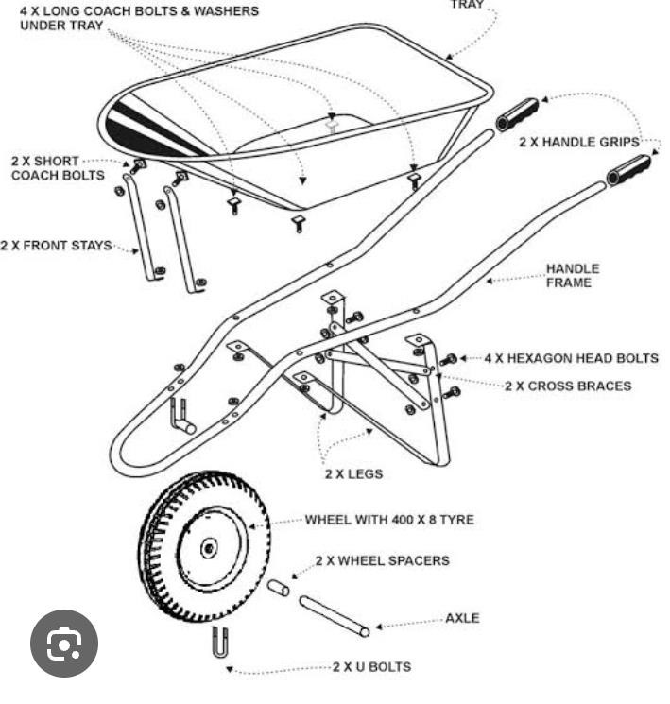

3.1 PROCUREMENT OF THE MATERIAL FOR CONSTRUCTION
This talks about the factors that must be considered before the material for the construction is selected. Some of the more important economic factors and physical and mechanical properties that are involved in material and process selection are discussed briefly in the proceeding paragraphs.
"Availability and cost of materials" vary continually and as the change is towards favourable or unfavourable conditions designs will necessarily undergo corresponding alterations for economic reasons. At times certain materials may become unavailable for general industrial use, and the necessity may arise for substitute designs based on procurable materials. A forceful example of this expediency occurs during national emergencies when alternative designs are required to avoid the use of strategic materials as well as processes that are affected by the unavailability of equipment.
"Strength" is necessary to prevent failure of the member by rupture. However, some steels have the descriable property of high ultimate strength coupled with low ductility, which may be undesirable in members subject to stress concentration. The use of high-ultimate strength steels.
Such as those caused by concentration of mass, surface decarbonization, and quenching cracks.

"Rigidity" is of importance in members whose deflections are limited by service requirement. For instance, the transverse deflection of a shaft of a speed reducer may be limited by the following requirements.
- Clearance in film lubricated bearing which support the shaft for satisfactory bearing life as relatal so wear.
- Alignment for instance, of gears mounted on the shaft, as related to gear- teeth wear, and vibration characteristics of the shaft, which depend mostly on the deflection of the shaft rigidity depends upon the modules of elasticity.
"Resistance to fatigue" should be the basis for the design if members that are subjected to cycle loading. This property is measured by the endurance limit. Notch sensitivity and clamping capacity is designed as the energy dissipated as heat by unit volume of the material during a completely reversed cycle of stress.
"Resilience" should be considered when the material is subjected to shock loading. A material with a suitable yield point should be selected and the member should be designed so as to secure a desirable resilience of the part. "Weight" may be important often it is desirable, as in the case of foundations and flywheels; but it is undesirable in other cases, such as aircraft parts, where light metals, such as aluminum, magnesium alloys or titanium may be used.
"Resistance to wear or corrosion" may be determining properties; the former is unlubricated or poorly lubricated friction surfaces. Generally, like materials in contact are not satisfactory for friction surfaces, although there are exceptions. Corrosion resistance is important in members subjected to a corrosive environment. The effect of corrosion is especially serious in the presence of stress concentration in cyclic loading.
"Law friction" is of importance in bearing materials. The friction conditions are affected by the materials in contact and the surface finish. Certain combinations of materials that are in contact in bearing surfaces produce satisfactory results.

3.2 MARKING OUT/CENTRE PUNCHING
This involves the drawing of lines on the metal surface with use of scribers, metal rule dividers etc indicate the profile or outline of the finished compound and making the necessary holes in the material. The tool used for centre punching is a drill but.

IMPORTANCE OF MARKING OUT
- It helps to define the shape or the outline of the article
- To keep the wastage of material to a minimum
- When metal has to be removed from several faces marking out ensures that correct amount is removal from each face.
- To mark the lines, which will help the machinist set up the work correctly on the machine and to serve as a guide that the correct size has been attained.
- To indicate precisely the position of holes and similar features.

3.3 CUTTING AND ROLLING
Common sheet metal cutting operations include shearing, blanking, piercing and nothing shearing into long strips are usually done with the ciullctine or manual shearen, while blanking, piercing and not clung are usually done with punches and die that are mounted in a standard type the set. There should be a set of die for each different job.
Rolling occupies the most important position of all back defermation processes. Over 95 percent of all materials that is ever defermed is subjected to rolling.
Flat rolling refers to the process of reducing the thickness of a slab to yield a thinner and longer but only slightly wider product. It is the most important primary dyarmation process, because it allows a high degree of automation and very high speeds, and thus provides starting material for various secondary sheet metal working processes at a low cost.
Shape rolling has a long history, beginning with the rolling of channels of lead for stained glass windows. The largest industrial application is nao in the hot rolling of structural shapes, which is a specialized primary deformation. process, practiced in special purpose mills.
Seamless rings, which are examples of ring rolling, are important constructural elements, ranging from the steel gives of railways car wheels to rotating rings of jet engines and races of ball bearings. After making a hole by any suitable technique, the thick-walled ring is rolled out by reducing its thickness and increasing its diameter.
Transverse rolling can be explained or experiences, when a work piece is placed between two counter rotating rolls with its axis parallel to the roll axes, it suffers plastic deformation during its rotation between the rolls. The consequences of this deformation depends on the shape and angular alignment of the rolls and, as in all compression on the h/l ration.
The projected length of contact between roll and work piece is regarded as L of the jerging tool, and the average height is taken as h. when h/l > I, the in homogeneity of deformation predominates and the pressure multiplying factor is Qi. The roll force is estimated from:
Pr = LWQiƠjm
When h/l <I, friction effects are over-riding and the pressure - intensification factor is Ơp. The roll force is estimated from:
Pr = LW Qp Ơfm
Where W is the width of strip and Ơfm is the mean flow stress, used because the strip hardens while it is deformed in the roll gap. In hot working, the flow stress must be taken at the typical average strain rate.
Em = V in ho
L hi
The torque required to rotate the rolls can be obtained by assuming that the rolling force acts in the middle of they are of contact. Since there are two rolls to be driven the total torque will be
MT = 2PrL
2
and the horse power requirement is readily calculate from
hp = 2PrLπN
33,000
where N is rpm, L is in units of feet, and P is in units of pounds. In the SI system the power requirements are calculated in kilowatts units.
KW = 2PrLπN
60,000 where P is the roll force in newtons, L is in meters, and N is rpm.

3.4 WELDING
In mechanical engineering, welding is extensively employed to manufacture structures from plate rolled stock (reservoirs, tanks, hoppers, coverings, limners, etc.) until from pipes and shaped rolled stock (frame structures, trusses, columns, pillars, etc.). Nowadays housings and base members are also made by welding, including the most massive and stressed parts (for example, the beds of presses and hammers).
In individual and small lot production welded structures are used instead of one-piece forgings when the manufacture of dies is not justified by the scale of production and also as a means to make the manufacture of complicated part less expensive. Low-carbon steel (< 0.25 percent c), low alloy steel with a small content of e and nickel steel weld very well. High-carbon, medium and high-alloy steels are more difficult to weld.
The strength of welds is inferior to that of solid material because of the cost structure of the welded joints with its deneritic and acicular crystallites typical of cast metal.
The strength of welds is inferior to that of solid material because of the cost structure of the welded joints with its deneritic and acicular crystallites typical of cast metal.

The strength and resilience of the material is a weld are impaired by penetration of slay, formation of pores and gas bubbles and also because of chemical and structural changes in the weld (alloying elements bum-out, formation of carbides, oxides and nitrides). If the material of a weld is saturated with air nitrogen even in small quantities the weld will lose much of its plasticity and will become much more brittle.
The mechanical properties of welded joints depend on the welding process and in manual work on the skill of cause defects impairing the life of the weld and its strength. Lots of welded products are tested selectively by cutting up of specimens, by tensioning, bending and flattening them and by investigating their microstructure and chemical composition of the metal in the weld.

3.5 PAINTING
This is one of the processes used for the protection of metal surfaces form corrosion. It is used to coat vast amount of mild steel, not only to protect corrosion, but also to provide an attractive finish. Optimum results are obtained by first "phosphate" the surface of the steel. This involves treating it with a phosphoric acid preparation, which not only dissolves rust, but also coats the surface of the steel with a dense and slightly rough surface of iron phosphate. This affords some protection against corrosion, but also acts as an excellent "key" for the priming paint and the under coat of subsequent paint.

CHAPTER FOUR

4.0 PRODUCTION COST
Due to the depreciation of the value of naira the cost of all materials used is not stable but at the time of construction of this project the cost of the materials is as follows:
S/N | Materials  Description | Quantity Used | Cost
1. | One metre square of galvanized carbon  steel sheet | All | N8,500.00
2. | 3,250 steel pipe long | All | N23,000.00
3. | Wheel and Tyre | 1 | N39,000.00
4. | Ball bearing 32 crunchier 50.8mm | All | N5,500.00
5. | Bolt, Nut and washer | 14 | N6,100.00
6. | Paint | All | N7,000.00
7. | Electrode | 10 pieces | N4,000.00
8. | Two plastic handles | All | N2,200.00
9. | Transport |  | N2,500.00
 |  | Total Expenditure | N97,800.00

4.1 Total Expenditure
This project has cost N97,800.00 at the end of construction due to quality of the materials

4.2 Assessment
The construction of this project went successful and we were able to derive additional skills during the course of the construction. One of the major peculiarities of an engineer is that he/she must be able to adopt any piece of information gathered to transform his immediate environment. This can be effected via the use of quality and standardized materials which we have justified.
The wheelbarrow is of a high quality and extremely strong compared to the wheelbarrow produced outside, due to stronger the materials used and some techniques adopted during the process of construction.
Also, in term of aesthetic value, cost and style, the wheelbarrow is completely different from some wheelbarrow produced by welders. This is so because of the knowkedge we acquired in the school on improving technology and also some research carried out on the materials used which make it stronger than those in the market.

CHAPTER FIVE

5.0 RECOMMENDATION AND CONCLUSION
The following recommendations are made on completion of this projects:
- Power supply must be frequently available for works to progress all the time.
- The workshop should be supplied with new and modern technological machines because the ones available at our disposal were worn out and absolute.
- Necessary working tools should be made available for the effective work to be done by students.
We advise that the school management should look into these recommendations to supplement the students effect and the avoid repetition in the near future, and to increase efficiency and safety of students in the workshop.

5.1 CONMCLUSION
Government should encourage technical education and should also try to patronize our locally made mechanical madunes because we look forward to a better tomorrow when our country Nigeria will completely favour the rest of the welding technological advancement.
4. Materials should be provided at the disposal of the students for the project.

REFERENCES
Raymond A. Higgins and Edward Arnold (1988):
"Material for the Engineering Technician" Avolden and Stoughton press. B.R Schlenken (1974):
"Introduction to Material Science" John Wiley & Sons Australasian Press Ltd.
John.A. Schey (1977):
"Introduction to Manufacturing Processes" McGraw-Hill Book Company. P. Orlor (1986):
"Fundamentals of Machine Design" Translated From Russia by A. Trotsky Mir
Publishers.
Paul h. Black and Eugene O. Adams (Jnr) (1968):
"Engineering Materials" McGraw-Hill Book Company.
Syvia Bermin J. (1992):
"Cost Metals Technology" Addison-Wesley Publishing Company.
Mc Gannin H.F (1971):
0"The Making, Shaping and Treating Steel" United State Steel Corporation.
Harfors, William David, and Cadded Reberty M. (1998):
"Metal Forming Mechanical Metatherogy" Prentice Hall Eagle Wood Clidds, N.J.

