A PROJECT REPORT
ON
PROPORSED RESTAURANT
FOR
(MRS OLORUNFEMI ELIZABETH)
AT
AGRIC, VETINARY ROAD, KWARA STATE
BY
OLORUNMAGBA TAIYE SUNKANMI
ND/23/ARC/PT/0024

BEING A PROJECT REPORT SUBMITTED TO
THE DEPARTMENT OF ARCHITECTURAL TECHOLOGY,INSTITUTE OF
ENVIRONMENTAL STUDIES,
KWARA STATE POLYTECHIC,ILORIN.

INPARTIAL FULFILMENT OF THE REQUIREMENT FOR
THE AWARD OF NATIONAL DIPLOMA (ND)
IN ARCHITECTURAL TECHNOLOGY.

JULY, 2025

DECLARATION
This is a work carried out by OLORUNMAGBA TAIYE SUNKANMI with the matric number ND/23/ARC/PT/0024 of the architectural technology, Kwara State Polytechnic under the supervision of ARC F.O. ADEYEMI.
All the sources of information are specifically acknowledge by means of reference

OLORUNMAGBA TAIYE SUNKANMI
ND/23/ARC/PT/0024

________________________
SIGNATURE & DATE

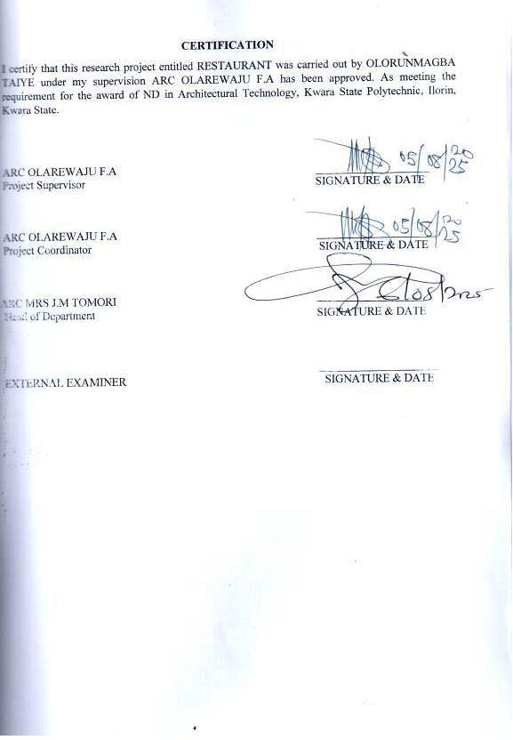

ACKNOWLEDGEMENT
I would like to express my sincere gratitude to Almighty God for giving me the strength, wisdom, and good health to carry out this project successfully.
My heartfelt appreciation goes to my supervisor, ARC F.O ADEYEMI, the HOD ARC J.M TOMORI and other lecturers of the department of Architectural Technology for their valuable guidance, support, and constructive feedback throughout the course of this project. Their dedication and encouragement have been instrumental in the successful completion of this work.
I would also like to thank the entire staff of the Architectural Technology, Kwara State Polytechnic, for providing a conducive environment and resources necessary for my research.
Special thanks to my family, my guardians MR&MRS ADEMOLA AJAYI, my brothers and sisters FLORENCE KEHINDE, ADEYEMI IYABO, ADEYEMI EMMANUEL, OLORUNFEMI VICTOR, OLORUNFEMI TOPE, SAMUEL ILESANMI, and friends for their continuous support, encouragement, and prayers during this project.
Lastly, I am grateful to everyone who contributed in one way or the other to the success of this work. Your support is deeply appreciated.
Thank you all.
DEDICATION
This project is dedicated to Almighty God, whose grace and mercy have been my strength throughout this journey.
I also dedicate this work to my beloved parents for their unwavering love, support, and encouragement. Your sacrifices and prayers have been the foundation of my success.
To my siblings, mentors, and friends who stood by me during the course of this project, your support means the world to me.
This work is a token of appreciation to everyone who believed in me.

TABLEOFCONTENT
Titlepage i
Declaration… ii
Certification… iii
Acknowledgement… ..iv
Dedication… v
Tableofcontents… vi
List of tables… x
List of figures… xi
List of plates… xii
List of Appendices… xiii
Abstract… xiv
CHAPTERONE
  - Introduction……………………………………………………………………………...1
1.2 Defination… 3
1.3 Historical background 3
S1.4 Aims and objectives… … 4
1.5 Project justification… .. 4
1.6 Client background 4
1.7 Scope of the project 5
1.8 Research methodology… 5
CHAPTERTWO
2.1 Literature review…………………………………………………………………….....6
2.2Historical background 6

CHAPTERTHREE
3.1 Case studies……………………………………....……………………………………6
3.2 Selected case studies 6
3.3 Case study one 7
3.3 Case study two… 11
3.4 Case study three………………………………………………………………………13
3.5 Online case study……….……………………………………………………………..15
3.6 Deduction…... ………………………………………………………………………...17
CHAPTERFOUR
Brief historical background…………...…………………………………………………...18
Location and setting out…………….………………………………………………...…....19
Population……………………………………………………………………………..…….19
Site inventory……..………………………………………………………………………...21
Site analysis…….…………………………………………………………………………...21
Site selection and justification……….………………………………………………….......22
Location ….. ………………………………………………………………………………..22
Accessibility………….……………………………………………………………………..22
Infrastructure facilities…………...……………………………………………………….. 23
Topography…………………………………………………………………………………... 23
Soil structure……………………………………………………………………………….. 23
General climate condition…………….……………………………………………………. 23
Relative Humidity………….………………………………………………………............. 23
Wind…................................................................................................................................... 23
Temperature…………………………………………………………………………………24
Vegetation…………………………………………………………………………………...24
Road…………………………………………………………………………………………24
Water and electricity………………………………………………………………………...24
Design criteria……………………………………………………………………………….25
Design brief 25
Design analysis ..25
Spacial allocation 26
Planning principle… 28
CHAPTERFIVE
APPRAISAL OF PROPOSED SCHEME…………………………………………………. 29
CONSTRUCTION METHODOLOGY…………………………………………………… 29
Services…………………………………………………………………………………. 29
VENTILATION 30
Lighting..… 30
PLUMBING 30
ELECTRICAL INSTALLATION… 30
WASTE DISPOSAL 31
FIRE PROTECTION… 31
RAIN PROTECTION… 31
EXTERNALWORK… 31
SUMMARY… 31
CONCLUSION… 32
RECOMMENDATION… 32
REFERENCES 33
APPENDICES 34

- LISTOFTABLES

TABLE1;SHOWING THE POPULATION OF THE GENDER 25

TABLE2;SHOWING SPACIAL ALLOCATION OF FLOOR PLAN… 30
- LIST OF FIGURES
FIG1;SHOWING FLOOR PLAN OF CASE STUDY ONE… 10
FIG2;SHOWING FLOOR PLAN OF CASE STUDY TWO… 13
FIG3;SHOWING FLOOR PLAN OF CASE STUDY THREE… 26
FIG4;SHOWINGLOCATIONAL PLANOFTHEPROPOSEDSITE… 27
FIG5; SHOWING SITE INVENTORY OF THE PROPSED SITE………………..28
FIG6; SHOWING SITE ANALYSIS OF THE PROPSED SITE…………………...29
- LISTOFPLATES

PLATE1;SHOWINGFRONTVIEWOFCASESTUDYONE… 11

PLATE2;SHOWINGLEFTVIEWOFCASESTUDYONE… 11

PLATE3;SHOWINGFRONTVIEWOFCASESTUDYTWO… 14

PLATE4;SHOWINGRIGHT VIEWOFCASESTUDYTWO… 15

PLATE5;SHOWINGFRONTVIEWOFCASESTUDYTHREE 16

PLATE6;SHOWINGRIGHTVIEWOFCASESTUDYTHREE 18

PLATE7;SHOWINGFLOOR PLAN OF ONLINE CASE STUDY 18

PLATE8;SHOWINGFRONTVIEWOFONLINECASESTUDY 19

PLATE9;SHOWINGFLOOR PLANOFONLINECASESTUDY TWO 19

PLATE10;SHOWINGFRONT VIEWOFONLINECASESTUDY TWO 20

- LISTOFAPPENDICES
APP1;SHOWINGSITEPLANOFTHEPROPOSEDPROJECT 38
APP2;SHOWINGFLOORPLANOFTHEPROPOSEDPROJECT 39
APP3;SHOWINGROOFPLANOFTHEPROPOSEDPROJECT 40
APP4;SHOWINGCROSS SECTIONOFTHEPROPOSEDPROJECT 41
APP5;SHOWINGRIGHT&FRONT VIEWOFTHEPROPOSEDPROJECT 42
APP6;SHOWINGLEFTVIEWOFTHEPROPOSEDPROJECT 43
APP7;SHOWINGBACKVIEWOFTHEPROPOSEDPROJECT 44

ABSTRACT
This project focuses on the design, development, and implementation of a modern restaurant located in Kwara State, Nigeria. The primary aim of the project is to provide a comfortable, hygienic, and aesthetically pleasing environment where customers can enjoy quality meals and services. The project incorporates architectural, structural, and service considerations to meet both functional and environmental standards.
The restaurant is designed to accommodate both indoor and outdoor dining areas, with provisions for proper ventilation, natural lighting, and efficient space utilization. Attention is given to kitchen layout, customer flow, accessibility, and safety measures. Sustainable design principles, including the use of locally available materials and energy-efficient systems, are considered to reduce operational costs and environmental impact.
This project also explores the economic and social impact of establishing a restaurant in Kwara State, highlighting its potential to create employment, support local agriculture, and contribute to urban development. The design aligns with current hospitality trends and addresses the specific needs of the local population.

CHAPTER ONE
1.1 INTRODUCTION
The restaurant industry plays a vital role in the economic, cultural, and social development of any region. Restaurants serve not only as places where people gather to eat but also as social hubs where relationships are built, business discussions are held, and leisure is enjoyed. In recent times, the rapid growth of urban centers and the changing lifestyles of individuals have led to an increased demand for organized and quality food services. This has created a significant opportunity for restaurant development, especially in growing regions such as Kwara State, Nigeria.
This project centers on the design and development of a modern restaurant intended to serve the needs of a diverse population in Kwara State. The proposed restaurant is conceptualized as a medium to large-scale facility that accommodates various categories of diners, including families, professionals, students, and tourists. The design takes into account key architectural and environmental considerations such as proper space utilization, natural lighting and ventilation, customer flow, and ambiance enhancement. The structural layout is planned to include indoor and outdoor dining areas, a well-ventilated kitchen, storage rooms, restrooms, and service zones, ensuring both functionality and aesthetic appeal.
In addition to architectural design, the project explores the operational and business aspects of restaurant management, including staffing, supply chain logistics, health and safety regulations, and customer service strategies. Attention is also given to sustainability, with a focus on using eco-friendly materials, energy-efficient systems, and waste management solutions to minimize the environmental impact of the facility.
Kwara State is strategically chosen as the location due to its growing population, educational institutions, increasing urbanization, and developing tourism sector. The restaurant is expected to contribute to the local economy by creating employment opportunities, supporting local farmers and food suppliers, and enhancing the hospitality infrastructure of the area.
Ultimately, this project aims to present a comprehensive plan for a functional and sustainable restaurant that addresses the needs of modern-day consumers while incorporating elements of local culture and cuisine. It serves as a practical model for future restaurant developments within similar socio-economic settings and highlights the importance of integrating design, functionality, and service quality in hospitality architecture.
1.2 DEFINITIONOF A RESTAURANT
A RESTAURANT is an establishment where food and beverages are prepared, served, and consumed by customers in exchange for payment. It is a place designed to provide a comfortable and organized setting for dining, either on-site or through take-away and delivery services.
Restaurants vary in size, style, and service model, ranging from fast food outlets and casual dining spaces to fine dining establishments. They typically include key areas such as a dining space, kitchen, storage, restrooms, and service points. The primary goal of a restaurant is to offer meals that satisfy customer preferences in terms of taste, presentation, and experience.
In broader terms, a restaurant serves as a social and commercial venue where people gather not just to eat, but also to relax, interact, and celebrate.

1.3 HISTORICALBACKGROUND
The history of restaurants dates back to ancient civilizations where inns and taverns provided food and drink to travelers and locals. In ancient Rome, Greece, China, and the Middle East, food was often served in public eating places. The word "restaurant" originated from the French word restaurer, meaning "to restore." The first modern restaurant is believed to have been opened in Paris in 1765 by a man named Boulanger, who served soups and broths described as “restoratives.”
After the French Revolution, many chefs who had served aristocrats opened public restaurants, making the concept more widespread. By the 19th century, restaurants had spread across Europe and into the United States, becoming important in urban centers. The industrial revolution and growing cities increased the demand for food outside the home, further boosting the restaurant industry.
In the 20th century, restaurants evolved into various types such as fast food, fine dining, and cafés. Today, restaurants are found all over the world, serving different cuisines and catering to diverse lifestyles. They are not only places to eat but also centers of culture, social interaction, and economic activity.
1.4 AIM AND OBJECTIVES OF THE PROJECT
AIM OF THE PROJECT
The aim of this project is to design a standard, comfortable and a welcoming restaurant that meets the desire and needs of my client and the customers
OBJECTIVES
Creating enough space that provides adequate accommodation for customers and workers in the restaurant
Designing a comfortable space for dinning and refreshment
Creating a restaurant design building structure that attract customers
Providing enough sustainable materials which support respiration around the building premises and environment.

1.5 PROJECT JUSTIFICATION OF THE PROJECT
This project justify, a well-planned RESTAURANT in Ilorin, Kwara State which will enhance customers standard and advanced place where people can get their desired types of food and drinks.
1.6 CLIENT BACKGROUND
The name of my client is MRS OLORUNFEMI ELIZABETH
MrsOlorunfemi Elizabeth is a vibrant and a charismatic entrepreneur with a passion for good food, warm hospitality and community building. She is a foodie at heart, always on the look-out for unique flavors and doing experiences that brings people together.
1.7 SCOPE OF THE STUDY
- Proposed Building
- Over Head Tank
- Green Area
- Car Park
- Gate House
- Generator House
1.8 RESEACH METHOLODY
Variousavenueswereexpressedasregardsthemethodofresearchonordertoarriveatafunctionalandappealingdesignconcepts.Thefollowingresearchmethodswereemployed.
LITERATURE REVIEW: Literature review was conducted to gather information from textbooks, journals, and academic publications relevant to the project topic.
INTERNET:Thisprovided access to up-to-date data, global trends, and visual references to support the design and planning process.
PERSONAL OBSERVATION:Personal observation was carried out on existing restaurant structures to understand spatial arrangement, customer flow, and functionality.
CASE STUDIES:Case studies of selected restaurants were analyzed to examine real-life applications, design techniques, and operational practices. This multi-source approach ensures that the project is informed by both theoretical knowledge and practical insights.
CHAPTER TWO
2.0 LITERATURE REVIEW
2.1 HISTORICAL BACKGROUND OF A RESTAURANT
The concept of the restaurant has ancient roots, dating back to early civilizations such as Egypt, Greece, Rome, and China, where food and drinks were served in inns, taverns, and food stalls to travelers and locals. The word "restaurant" originates from the French word restaurer, which means "to restore." The first modern restaurant, as we know it today—where customers order meals from a menu and are served at individual tables—was opened in Paris in 1765 by a man named Boulanger, who served soups and broths described as "restoratives."
Following the French Revolution, many chefs formerly employed by aristocrats began opening public restaurants, contributing to their rapid spread throughout France and eventually to other parts of Europe. By the 19th century, restaurants had become common in major European cities and in North America, particularly due to urbanization and the growing middle class. The industrial revolution further fueled the growth of restaurants by increasing the need for quick, accessible meals for workers in busy urban areas.
In the 20th century, the restaurant industry evolved with the emergence of various styles, including fast food, fine dining, cafés, and ethnic cuisine establishments. Technological advancements and changes in consumer behavior also led to the development of take-away services, drive-thrus, and online food ordering. Today, restaurants are an integral part of modern life, serving as places for nourishment, social interaction, and cultural expression across the globe.

2.2 RESTAURANT IN GERMANY
The development of restaurants in Germany can be traced back to the Middle-Ages, when food and drink were commonly provided in taverns, inns, and beer halls, which primarily served travelers, merchants, and local residents in need of warm meals and lodging. These early establishments were not restaurants in the modern sense but served an important social and economic function, offering simple, hearty food such as bread, meat, and beer, often produced locally and consumed communally.
As trade routes expanded and urbanization increased during the Renaissance and early modern periods, German cities began to witness the emergence of more structured eating houses and guild-regulated food vendors, which provided a greater variety of meals and more organized seating arrangements, particularly in larger towns like Frankfurt, Munich, and Berlin. By the 18th century, under the influence of French culinary practices and Enlightenment-era social habits, public dining became more refined in Germany, with the rise of establishments that offered menus, table service, and a greater focus on the dining experience, especially in aristocratic and bourgeois circles.
The 19th century, marked by the industrial revolution and the unification of Germany, brought significant changes to the hospitality industry, as growing urban populations and increased mobility led to the proliferation of gasthauses (guesthouses), konditoreien (pastry shops), and restaurants in major cities, offering both traditional German cuisine and imported dishes. In this period, Berlin and other industrial centers became home to some of the first modern-style restaurants in Germany, with dedicated kitchens, trained chefs, and printed menus, setting the standard for future development.
The two World Wars had a considerable impact on the restaurant industry in Germany, causing widespread destruction and food shortages, but the post-World War II era—particularly during the economic boom of the 1950s and 60s known as the Wirtschaftswunder (economic miracle)—saw a revival of restaurant culture, with the establishment of international cuisine, fine dining venues, and fast food chains reflecting changing consumer lifestyles and growing global influence.
In contemporary times, Germany boasts a highly diverse restaurant scene that ranges from traditional Bavarian and regional German eateries to Michelin-starred restaurants and multicultural establishments, reflecting both the country's rich culinary heritage and its openness to global food trends, with strong regulations on hygiene, quality, and customer service shaping its modern restaurant industry.

\

CHAPTER THREE
3.1 CASE STUDIES
Thisisaresearchoranexercisethatiscarriedoutonexistingbuildingwhichissimilartotheoneresearcheriswritingon.Theobjectiveofacasestudyistotakeacriticalappraisalofexistingrelated project withaviewtoidentifythepositiveandnegativeaspectofsuchprojects.Itisonlywithtimethata project canbeadjustedsothatitcanbesuccessful.Theinformationobtainedfromtheappraisalwillguidethedesignerofnewandsimilarproject,thepositiveaspectofitshallbeincorporatedintheviewproposalswhileattemptswillbemadetosolvetheproblemofnegativeaspects. Itisonlythroughthisthatadesignercanbetterenhancethequalityandefficiencyofbuildinginthesociety.Foracomprehensiveanalysistheircasestudieshavebeenconducted.
3.2 SELETED CASE STUDIES
Casestudiesareofparamountimportant.Itisanexperimentalresearchoranalysiscarriedoutonexistingbuildingorgroupofbuildingfunctionallysimilartotheonewhichtheresearchisworking.
Foranytechnicaldesigntobemeaningfulthereisalwaystheneedforpreliminaryresearchefforttobemadeonthisproposalasaverynecessarygroundwork.
Thefollowingarecasestudiesofsomedentalclinic.
    - Abula Restaurant at OyeEkiti.
    - Kilenfe Restaurant at Kabba, Kogi
    - Abula Restaurant at Akure, Ondo State.

3.3 CASE STUDY ONE
    - Location: Abula Restaurant at OyeEkiti.

OBSEVERATION
MERITS
- It has a bar
- Can be easily accessed
- There is adequate ventilation
- The dinning area is a semi open place which allows enough ventilation

DEMERIT
- No car park
- No conveniences for customers
- Customers are exposed while eating because of openness of the dinning area
- Lack aesthetics
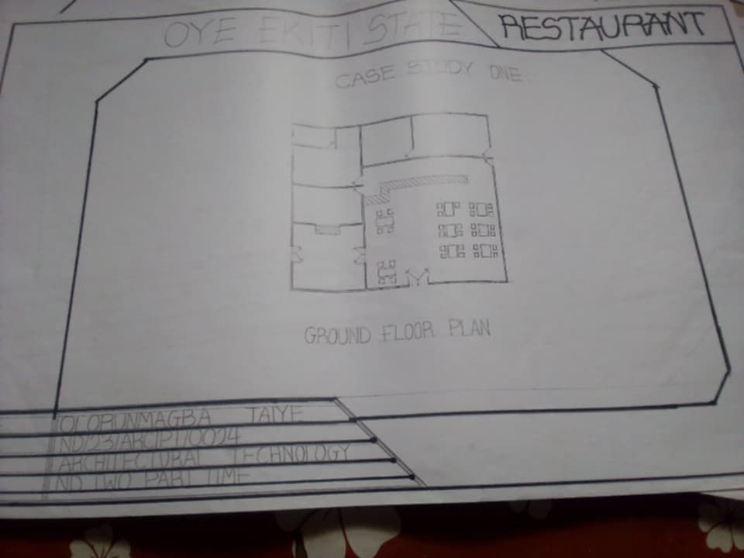

FIG1;SHOWINGFLOORPLANOFCASESTUDYONE

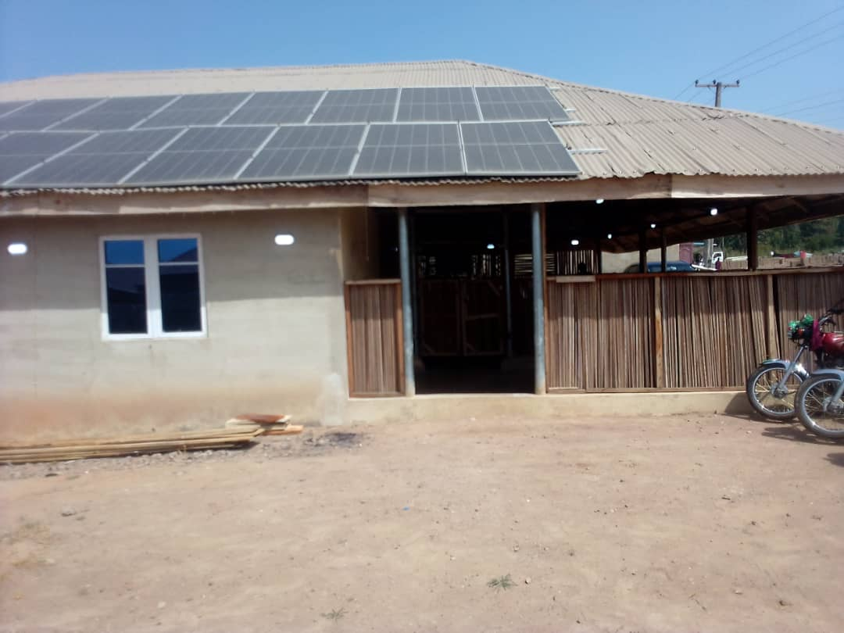

PLATE1; SHOWING FRONT VIEWOFCASESTUDYONE

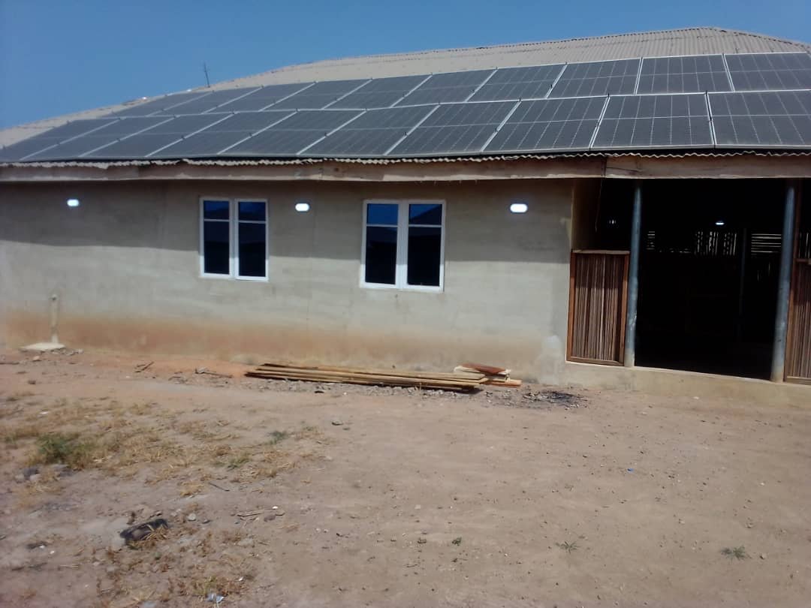

PLATE2;SHOWINGLEFTVIEWOFCASESTUDYONE
3.4 CASE STUDY TWO (2)
    - LOCATION: Kilenfe Restaurant at Kabba, Kogi
MERITS
- Located in a good and condusivearea
- It has enough ventilation
DEMERITS
- Not attractive
- No convenience for customer
- Aesthetically poor
- It lack good and quality finishes

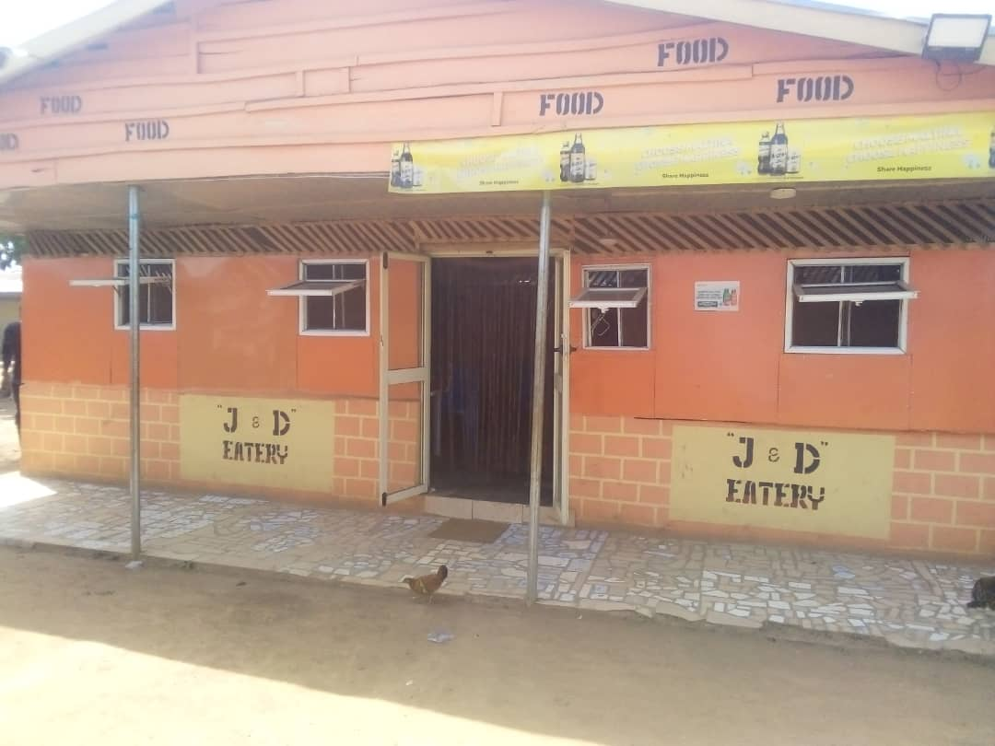
PLATE 3; SHOWING FRONT VIEW OF CASE STUDY TWO
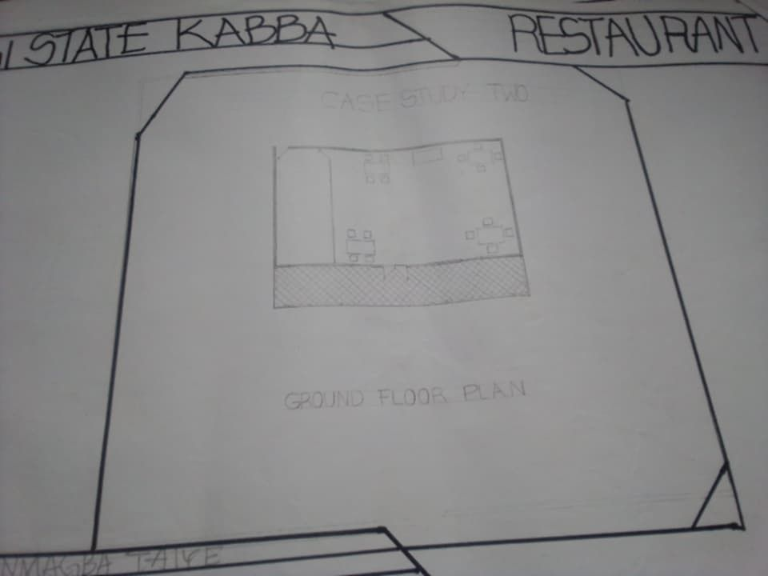
FIG2; SHOWING THE FLOOR PLAN OF CASE STUDY TWO

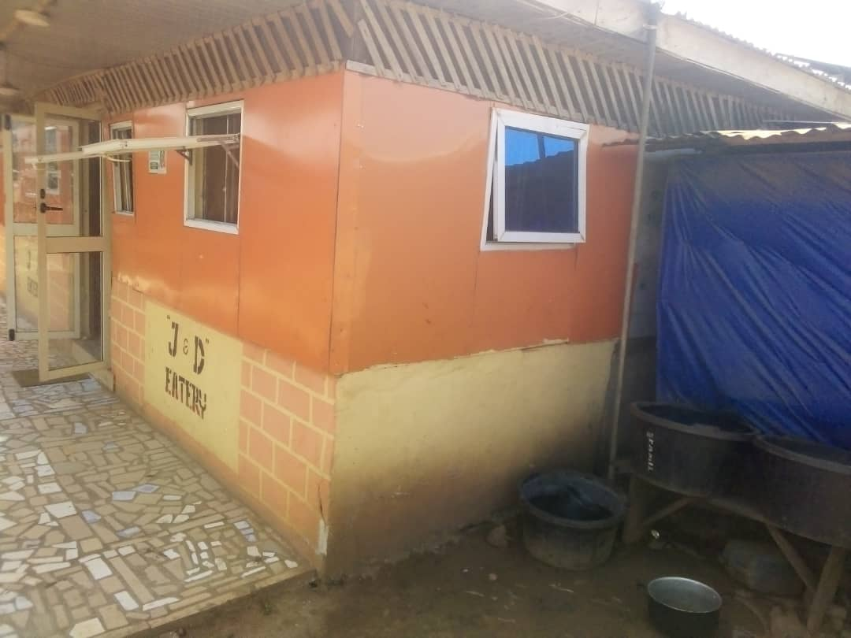PLATE 4; SHOWINGTHE RIGHT VIEWOFCASESTUDY TWO

3.5 CASE STUDY THREE (3)
    - LOCATION:Abula Restaurant at Akure, Ondo State.

MERITS
- All units in the restaurant has enough space
- It is situated in a very busy area
- It has washing hand basin where customers washes their hands
- The restaurants building design two section of dinning area

DEMERIT
- Inadequate ventilation
- Only the front elevation can be seen, other sides left/right are attached to other buildings
- No conviniences for customers
- Aesthetically poor

FIG3; SHOWING FLOOR PLAN OF CASE STUDY THREE

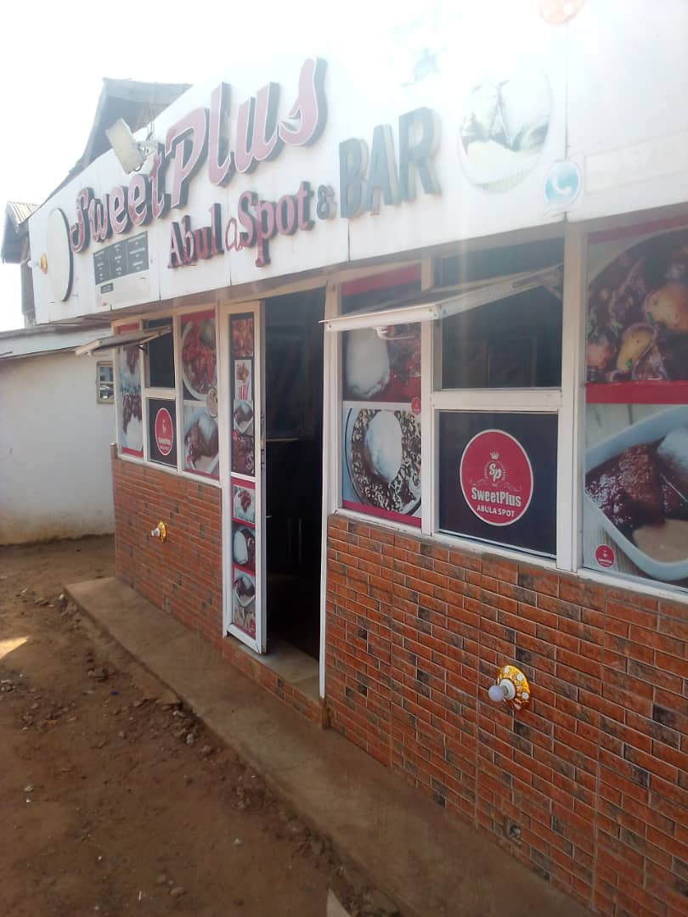

PLATE 5;SHOWINGFRONTVIEWOFCASESTUDYTHREE
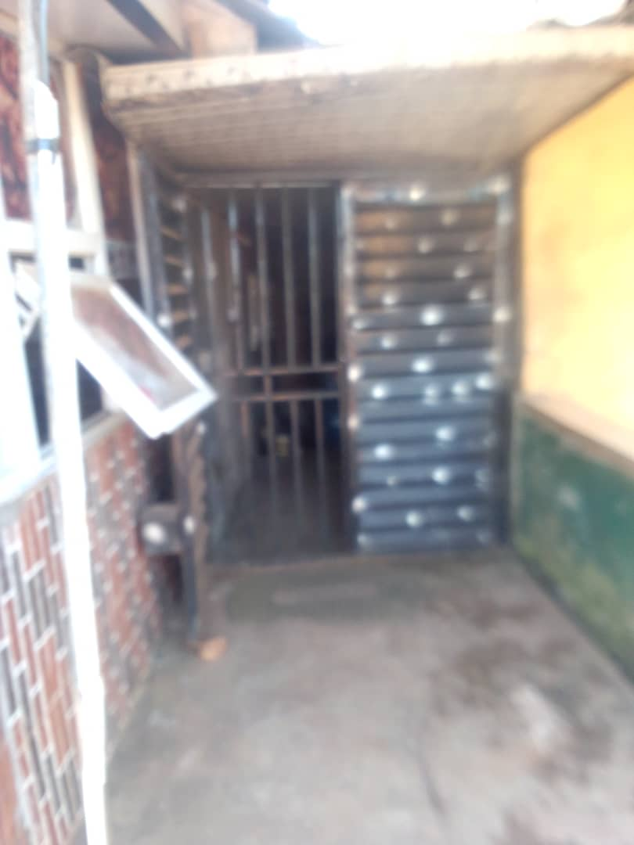

PLATE 6;SHOWINGRIGHT VIEWOFCASESTUDYTHREE

3.6 ONLINE CASE STUDY
ONLINE CASE STUDY ONE
PROJECT NAME: RESTAURANT
LOCATION: AT SEOUL, KOREA
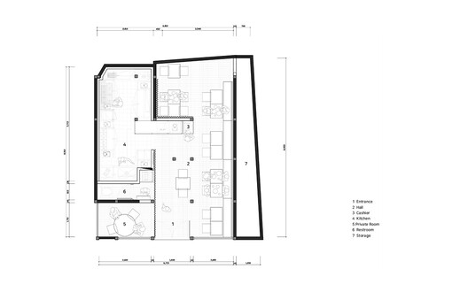
PLATE 7; SHOWING FLOOR PLAN OF ONLINE CASE STUDY
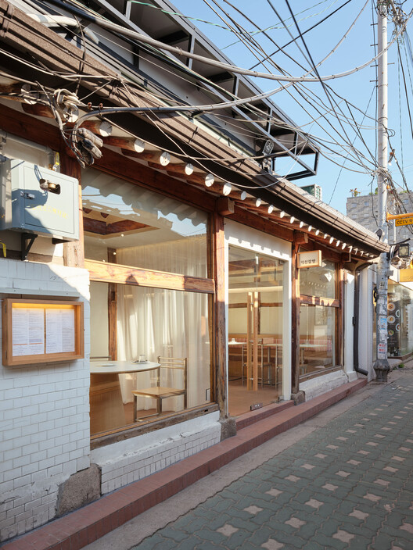
PLATE 8; SHOWING FRONT VIEW OF ONLINE CASE STUDY

ONLINE CASE STUDY TWO
PROJECT NAME:RESTAURANT
LOCATION: MUMBAI, INDIA
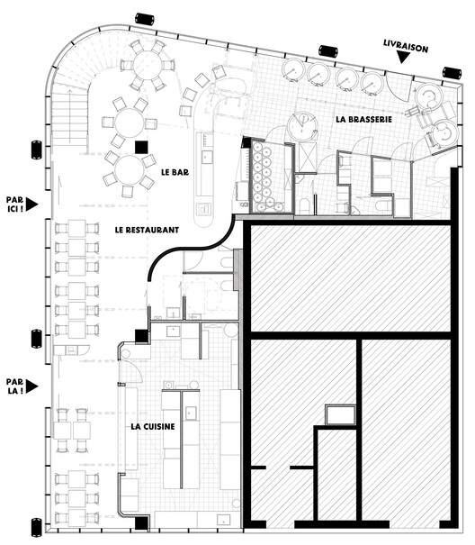
PLATE 9; SHOWING FLOOR PLAN OF ONLINE CASE STUDY TWO
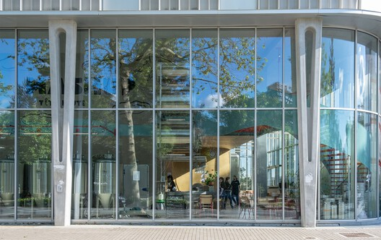
PLATE 10; SHOWING FRONT VIEW OF ONLINE CASE STUDY TWO

DEDUCTION FROM CASE STUDIES
During my visit to the restaurant. I was opportunities to see what was obtain in the clinic, I made a proper studies of their related function and analysis were made to their present situation with the aim of incorporation with their merit in my own final proposal.
The following were deduce from my case study
- Adequate natural ventilation and lighting.
- Good architectural landscaping.
- The units in the restaurant should be properly and well linked.
- Parking spaces should be well defined.

CHAPTER FOUR
4.0PROJECT LOCATION
4.1 BRIEF HISTORICAL BACKGROUND OF KWARA STATE
Kwara State was created on May 27, 1967, as one of the 12 states formed during the restructuring of Nigeria by General Yakubu Gowon’s military government. Formerly part of the Northern Region, it was initially known as the West Central State before it was renamed Kwara, a name derived from the River Niger, which the Nupe people call “Kwara.”
The state originally included parts of what are now Kogi, Niger, and Benue States, but over time, these areas were carved out. Ilorin, the capital of Kwara State, has a rich cultural blend of Yoruba, Fulani, and Hausa influences. Historically, Ilorin was part of the Oyo Empire but became an emirate under the Sokoto Caliphate in the 19th century.
Today, Kwara State is known for its religious harmony, agricultural potential, and educational institutions like the University of Ilorin. It comprises 16 local government areas and is located in Nigeria's North Central geopolitical zone

GEOGRAPHY OF KWARA STATE
Kwara State is located in the North Central region of Nigeria. It shares boundaries with Niger State to the north, Kogi State to the east, Ekiti and Osun States to the south, and Oyo State to the southwest. It also shares an international border with the Republic of Benin to the west.
- Land Area: Approximately 36,825 square kilometers, making it one of the larger states in Nigeria by landmass.
- Topography: The terrain is mostly savannah grassland, with scattered hills and highlands in some parts, particularly in the Baruten and Kaiama areas.
- Climate: Kwara has a tropical climate, with two main seasons—rainy season (April to October) and dry season (November to March). Average annual rainfall ranges between 1,000mm and 1,500mm.
- Vegetation: The state lies in the transitional zone between the Guinea savannah and the forest zone, especially in the southern part.
- Major Rivers: The River Niger forms part of the eastern boundary and flows through the state. Other rivers include Asa, Awon, and Oyun rivers.
Kwara's geography supports agriculture, with fertile soil suitable for crops like maize, yam, cassava, and rice. The state also has mineral resources such as limestone, gold, and kaolin.

ECONOMY OF KWARA STATE
Kwara State has a diversified economy driven mainly by agriculture, commerce, and a growing service sector.
- 1. Agriculture:
Agriculture is the backbone of Kwara State’s economy, employing a large percentage of the population.
- Major Crops: Maize, yam, cassava, rice, sorghum, and groundnut.
- Cash Crops: Cotton, cocoa, and oil palm (especially in southern Kwara).
- Livestock: Cattle rearing, poultry farming, and fishing are also significant.
- Shonga Farms: A notable agricultural initiative introduced in the 2000s that brought Zimbabwean commercial farmers to boost mechanized agriculture.
- 2. Commerce and Trade:
Kwara’s central location in Nigeria makes it a commercial hub linking northern and southern Nigeria.
- Markets: Ilorin (the capital) hosts several major markets such as Oja-Oba, Mandate Market, and Kulende Market.
- Cross-border Trade: Kwara shares a boundary with the Republic of Benin, enhancing regional trade, especially in Baruten LGA.
- 3. Industry and Manufacturing:
Though still developing, the state has several small- and medium-scale industries.
- Key Products: Soap, textiles, furniture, ceramics, and food processing.
- Notable Industries: Kwara Breweries, United Match Company, and Dangote Flour Mills (Ilorin).
- 4. Natural Resources:
Kwara is rich in solid minerals including:
- Limestone, marble, granite, gold, kaolin, and feldspar.
- Mineral exploration is still underdeveloped but holds potential for future economic growth.
- 5. Education and Services:
Kwara has many educational institutions, which contribute to its service economy.
- Institutions like the University of Ilorin, Kwara State University, and Kwara Polytechnic create jobs and attract students from across Nigeria.
- Growth in banking, telecommunication, and hospitality sectors is noticeable in urban areas.

ORGANIZATION STRUCTRE
An organizational structure is a system that outline shows certain activities that are direct in order to achieve the goals of an organization. These activities can includes rules, roles and responsibilities. The organizational structure also determine show information flows between levels within the clinic.

4.2 LOCATION AND SETTING OF KWARA STATE
Kwara State is located in the North Central geopolitical zone of Nigeria. It lies between latitudes 8°00'N and 10°30'N and longitudes 2°30'E and 6°25'E.
- The state shares boundaries with Niger State to the north, Kogi State to the east, Ekiti and Osun States to the south, and Oyo State to the southwest.
- It also has an international border with the Republic of Benin to the west.
The setting of Kwara is characterized by a mix of savannah grasslands in the north and forest vegetation in the southern part. The terrain includes plains, gentle hills, and river valleys, especially along the River Niger, which runs through the eastern part of the state.
Kwara’s central location makes it a gateway between northern and southern Nigeria, and its capital city, Ilorin, is a major urban and administrative center.

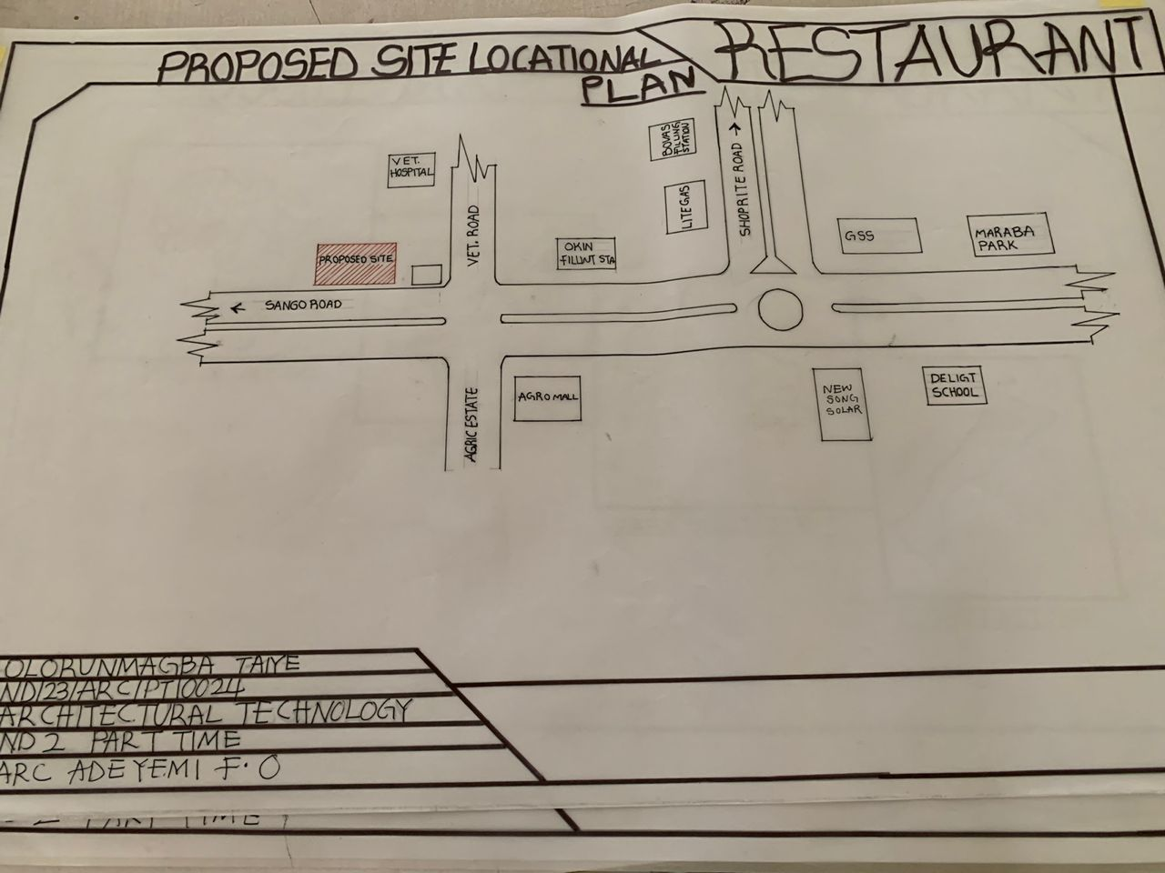
FIG 4; SHOWING LOCATIONAL PLAN OF THE PROPOSE SITE

4.3 POPULATION
Kwara State has an estimated population of about 3.8 million in 2025.
The major ethnic groups are Yoruba, Nupe, Baruba, and Fulani.
The state has a mix of urban and rural populations.
Ilorin is the most populated city.
The population is evenly split between males and females.
Most of the people are young and active in the workforce.

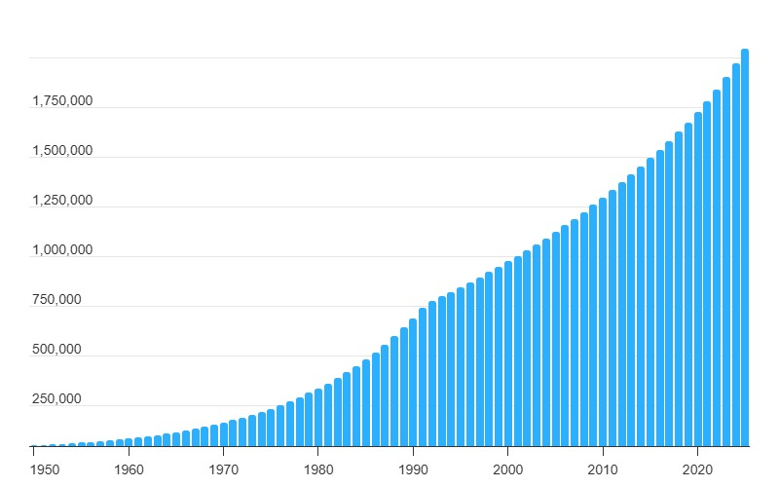
TABLE 1; SHOWING GENDER GROUP

4.4 SITE INVENTORY
In the proposed site, some shrubs will be retained on site. It used to reduce sky glare and also serve as soft landscape and wind breaker.
Presence of road network which would serve as a means of accessibility to the site. Presence of electricity pole which serve as source of electricity to the site. Some trees would be retained while some will be removed if they disrupt the construction of building.

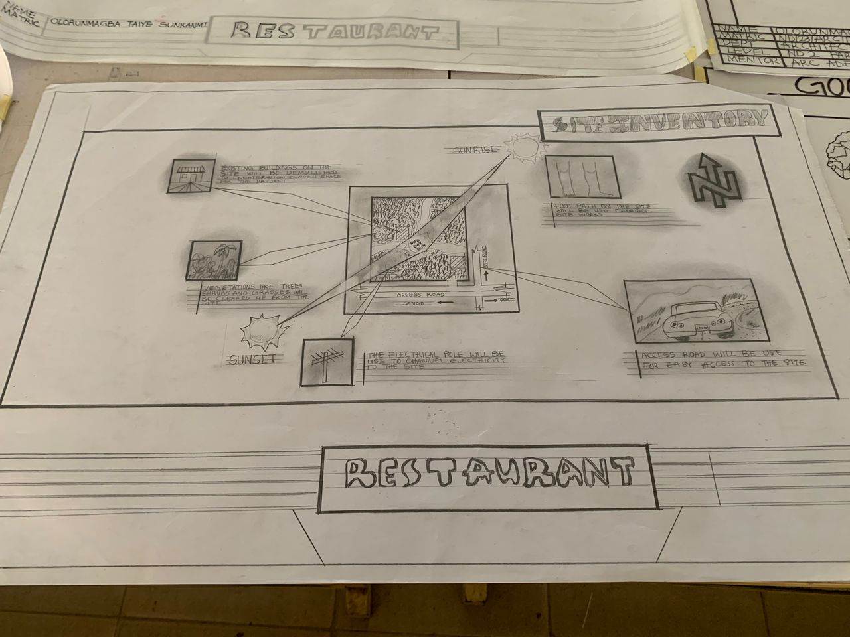
FIG 5; SHOWING SITE INVENTORY OF THE PROPOSED SITE
4.5 SITE ANALYSIS
The site is benefitted with loamy soil which is a very good soil for grass and shrubs. It has a gentle slope towards the south east. Some of the grasses, shrubs and trees on the site are to be retained to enhance landscape patter of the site while some are to be removed and replanted where necessary. The two noticeable winds are to be directed into the building using landscape pattern to improve ventilation. Noise generated from vehicle traffic is controlled through proper planning, good landscaping and proper orientation of building. Generally, all the feature on the site are best put into different uses to aid control through proper planning, landscape and orientation.

Certainly, steps are considered to obtain vital information of the site, this information is the analysed in details. For design purpose, the information include soil condition, geology, topography, vegetation etc. It also involves carrying out a preliminary survey of the site.
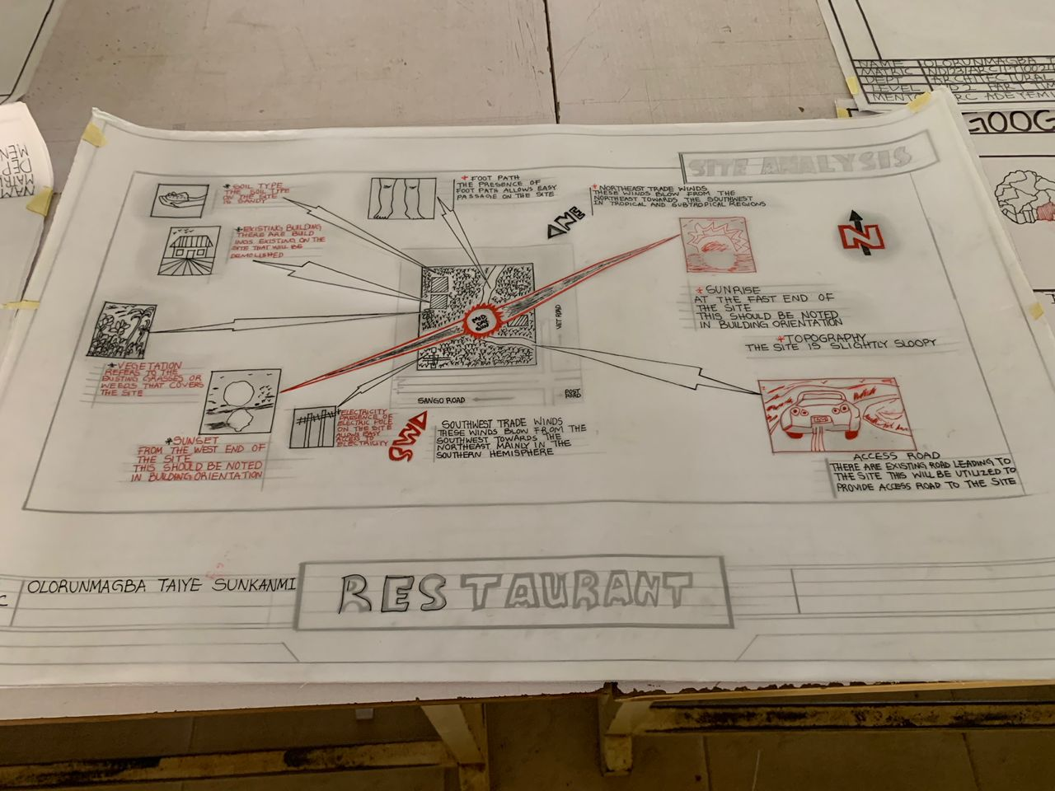
FIG 6; SHOWING SITE ANALYSIS OF THE PROPOSED SITE

4.5.1 SITE SELECTION/JUSTIFICATION
In the site selection provision is made for interesting facilities that worth emulating since the overall success and efficiency of any project depend not on the functionality of the design but also on a careful choice of site. The site of this project has been carefully selected which is located in the premises of Agric, vetinary road, kwara state. The proposed site is located at Vetinary road at agric, Kwara state.
4.5.2 LOCATION
The site is located
Veterinary road at Agric, Kwara state, Nigeria:
Agric roadLocated around Sango/Old Jebba Road in Ilorin (primarily within Ilorin East and West LGAs), Agric Estate is a planned residential zone offering a mix of flats, bungalows, and duplexes
4.5.3ACCESSIBILITY
Agric Estate in Ilorin is highly accessible due to its proximity to major roads like Old Jebba Road and Sango-OkeOyi Road. It is well-connected to key parts of the city, including Tanke, University of Ilorin, and Kwara Mall (Shoprite). Public transport, taxis, and private vehicles can easily reach the area, making it convenient for residents and visitors..
4.5.4 INFRASTRUCTURAL FACILITIES
Facilities such as water electricity, telephone network and road network are all in Ilorin, hence it can easily be tapped to the proposed site.

4.5.5 TOPOGRAPHY
Agric Estate, Ilorin lies on gently undulating terrain with an average elevation of about 320–330 m above sea level. The area has low slopes, well-drained soils, and is generally stable and suitable for buildings, with low flood risk..
4.5.6 SOIL STRUCTURE
The soil structure of Agric Estate, Ilorin is mainly sandy loam to loamy sand, with low clay content, making it well-drained and porous. It is moderately compact, low in fertility, and derived from weathered basement rocks. The soil is suitable for building but may require fertilizer or compost for farming or gardening.
4.6 GENERAL CLIMATIC CONDITION
Ilorin, Kwara State, has a tropical wet and dry climate. It experiences two main seasons:
- Rainy season (April to October)
- Dry season (November to March)
Average annual temperature is about 27°C, with rainfall between 1,000–1,500 mm yearly. Humidity is high during the rainy season and low in the dry season
4.6.1 RELATIVE HUMIDITY
The town is under the influence of high humidity throughout the year with a monthly relative humidity remaining above 60%. This is even higher between May and September with a relative humidity figure of about 80% average.
4.6.2 WIND
Ilorin, Kwara State, experiences moderate wind speeds throughout the year. The most notable wind is the Harmattan, a dry, dusty northeasterly wind that blows from the Sahara between November and February. Average wind speeds range from 4 to 10 km/h, with occasional gusts during storms or dry season transitions
4.6.3 TEMPERATURE
Ilorin, Kwara State, has an average temperature of 26°C to 28°C. It is hottest from February to April (up to 38°C) and coolest from December to January (as low as 18°C at night).
4.6.4 VEGETATION
The proposed site is covered with grasses few trees and shrubs. Some will be removed before the construction while some will be retain for ornamentation.

4.7 SOCIAL SERVICES
4.7.1 ROAD
Agric Estate Junction in Ilorin is mainly accessed through Old Jebba Road via Sango Area. It also connects to the A1/A7 highways, making it easily reachable from major parts of the city. Internal roads like Olusola Close link within the estate.
4.7.2 WATER AND ELECTRICITY
There are pipe born water networks and borehole water which serves the habitant of Benin City. There is electricity supply from NEPA that serve the Ilorin in general
4.8 DESIGN CRITERIA
There are three (3) methods of designing of any project which are: Function before form method
Form before function method Combination of Shapes
Designing projects, the function, before form method used in line with this method, the following are the design criteria for this project:
Functional: in term of functional requirement, the following design criteria must be considered.
Sustainability, Site and Location, Flexibility, Circulation, Accessibility, Organization, Maintenance, Environment and Services
4.9 DESIGN BRIEF
After research and planning, the next step in the series of the project programed is design itself. To achieve functional and well established design there must be a brief to work on. This brief depends generally on the scope of individual design. The brief of this project is therefore based on the various activities that take place in the restaurant. To have enough brief for the proposed restaurant, case studies were carried out on the existing restaurant.
4.10 DESIGN ANALYSIS
This is the process of itemizing units within the component of the entire design with a view to establishing a solid understanding and appreciation of the space relationships.
The units of the design are in three division, the unit of the project division are as follows:
GROUND FLOOR PLAN; Entrance, Eating Area, Serving Area, Cashier Area, VIP Area, Manager Office, Accountant Office, CEO Office, Kitchen, Store, Changing Room, Conviniences, Delivery Bay, Passage, Snacks Room, Ice-Cream/Pop Corn Room.

4.11 SPACE REQUIREMENT
Units Area (m2)
Entrance 8800m2
Exit 1700m2
Lobby 2100m2
Lobby 2700m2
Passage 1 14700m2
Passage 2 9200m2
Toilet 2800m2
Toilet 2600m2
Service Area 9400m2
Cashier Area 5700m2
Eating Area 22900m2
VIP Area 16200m2
Snack Room 6600m2
Ice-Cream/Pop-Corn Room 7900m2
Kitchen 13000m2
Dry Store 4500m2
Cold Store 4600m2
Delivery Bay 9100m2
CEO Office 7100m2
Manager Office 6400m2
Accountant Office 6600m2
Female Changing Room 7700m2
Male Changing Room 6800m2
TABLE 2; SHOWING SPACIAL ALLOCATION OF FLOOR PLAN

Necessary units in the building. A borehole system of water supply is to be adopted alongside the government supplied services and a storage facility is to be provided for effective management of water supply.
4.12 PLANNING PRINCIPLE
The planning principle is one of the most important aspects of any design. The planning of various units taking into consideration the activities performed in each unit, how they are related to one another and the users of the various units in the design. In respect to the above factors.

CHAPTER FIVE
4.13 GENERAL REQUIREMENTS
4.14 APPRAISAL OF PROPOSED SCHEME
The restaurant is located in a commercially viable and easily accessible area, making it suitable for attracting customers. Its design includes a well-organized dining area, kitchen, storage, and sanitary facilities, ensuring comfort and hygiene. The restaurant is equipped with essential services such as water supply, electricity, ventilation, fire protection, and waste disposal. Operations are supported by trained staff, a clear menu, and standard hygiene practices, promoting efficiency and customer satisfaction. Financial analysis shows the project is economically viable, with potential for profitability. Overall, the restaurant is well-planned, functionally designed, and suitable for successful operation.
4.15 CONSTRUCTION METHODOLOGY AND MATERIAL
The construction of a restaurant begins with site clearing and preparation, followed by foundation excavation and laying of a reinforced concrete foundation to support the structure. The walls are constructed using sandcrete blocks or bricks, bonded with cement mortar for durability and insulation. Reinforced concrete columns and beams are used to carry the load and provide structural stability. The roof is typically constructed with timber or steel trusses and covered with aluminium or stone-coated roofing sheets.
Flooring is finished with ceramic tiles or terrazzo, which are easy to clean and maintain. The ceiling may be made from PVC, POP, or suspended gypsum boards, enhancing ventilation and aesthetics. Doors and windows are usually made from aluminium or hardwood frames with glass panels for visibility and lighting. Internal fittings include stainless steel kitchen surfaces, plumbing systems, and electrical wiring for lighting, appliances, and ventilation.
The restaurant construction also includes finishing work such as painting, tiling, plumbing installation, and HVAC systems to ensure comfort, hygiene, and customer satisfaction.
4.16 SERVICE
The restaurant is provided with essential services to ensure smooth operations and customer comfort. These include a reliable water supply for cooking, cleaning, and sanitation. Electricity is installed for lighting, refrigeration, cooking equipment, and air conditioning. The restaurant is equipped with an efficient ventilation system, including extractor fans and air conditioners, to maintain air quality and temperature. Plumbing services are installed for kitchen sinks, restrooms, and waste water management. A waste disposal system is in place for both solid and liquid waste to maintain hygiene. Additionally, fire safety equipment such as extinguishers and fire alarms are installed to meet safety standards. These services are essential for the health, safety, and comfort of both staff and customers.
4.16.1 VENTILATION
Ventilation in the restaurant is designed to ensure a continuous supply of fresh air and the removal of heat, smoke, and odors from cooking areas. The system includes mechanical extractors in the kitchen to expel hot air and fumes, while natural ventilation through windows and vents supports airflow in dining areas. Ceiling fans and air conditioning units are installed to maintain a comfortable indoor temperature for both staff and customers. Proper ventilation enhances air quality, prevents moisture buildup, and ensures a safe and comfortable environment within the restaurant.
4.16.2 LIGHTING
Lighting in the restaurant is carefully planned to create a welcoming and functional environment. The dining area is illuminated with warm, ambient lighting to enhance customer comfort and aesthetics. Bright, focused lighting is installed in the kitchen and food preparation areas to ensure safety and efficiency during operations. Energy-efficient LED lights are used throughout the building to reduce power consumption. Emergency lighting is also provided in key areas such as exits and corridors for safety during power outages. Overall, the lighting system enhances visibility, supports restaurant operations, and contributes to the overall dining experience.
4.16.3 PLUMBING
Plumbing in the restaurant is designed to provide a steady flow of clean water for cooking, cleaning, and sanitation. The system includes pipes and fittings that supply water to the kitchen sinks, dishwashing areas, and restrooms. A hot water system is installed for hygienic cleaning and food preparation. Drainage pipes and grease traps are provided to handle wastewater and prevent blockages caused by food waste and oils. The plumbing layout ensures efficient water distribution, leak prevention, and compliance with health and safety standards.
4.16.4 ELECTRICAL INSTALLATION
The electrical installation in the restaurant is designed to ensure safe and efficient power supply to all areas. It includes a main distribution board connected to the public power grid and supported by a backup generator or inverter for uninterrupted service. Wiring is done using PVC-insulated copper cables, safely concealed in conduits. Power is distributed to lighting fixtures, kitchen appliances, air conditioners, refrigerators, and customer areas. Switches, sockets, and circuit breakers are installed according to safety standards. The system also includes emergency lighting and fire alarm connections to enhance safety and functionality in the restaurant.
4.16.5 WASTE DISPOSAL
Waste disposal in the restaurant is carefully managed to maintain hygiene and environmental safety. The restaurant separates solid and liquid waste at the source. Food and packaging waste are collected in sealed bins and disposed of through municipal waste collection services or private contractors. Grease traps are installed in the kitchen to prevent fats and oils from entering the drainage system. Wastewater from sinks and restrooms is directed through a proper sewage system connected to the public drainage network. These measures help to prevent contamination, control odors, and ensure compliance with health and sanitation regulations.
4.16.6 FIRE PROTECTION
Electrically, fire alarms and sensor are to be installed in the building in generally. This should be done in case of the fire occurrence. Fire extinguishers are to be placed at a certain distance in the lobbies and some other necessary areas. It is also serving as protection in case of fire outbreak. Protection in the restaurant is focused on ensuring the safety of staff, customers, and property. The building is equipped with fire safety measures, including fire extinguishers, smoke detectors, and fire alarms, strategically placed in the kitchen and dining areas. Emergency exits are clearly marked and kept unobstructed. Security measures, such as CCTV cameras, burglar-proof doors, and window locks, are installed to prevent theft and unauthorized access. The restaurant also complies with health and safety regulations, including proper ventilation, sanitation, and hygiene practices, to protect both workers and patrons. These protective features ensure a safe and secure environment for daily operations
4.16.7 RAIN PROTECTION DEVICES
Rain protection in the restaurant is ensured through the use of weather-resistant roofing materials such as aluminium or stone-coated sheets that prevent water leakage. Extended roof overhangs, canopies, and verandahs are provided at entrances and windows to shield against direct rain splash. Proper gutter systems and downpipes are installed to channel rainwater away from the building. Doors and windows are fitted with weather seals to prevent rainwater from entering. These features help to protect the building structure, maintain dry interiors, and ensure customer comfort during rainfall.
4.16.8 EXTERNAL WORKS
The external works are to be earned out generate, kerbs land and shrubs, flowers, grasses and trees planted. Concrete interlocking pavement tiles to be adopted before hard landscape for walk ways and parking spaces and car access roads must be tarred with asphalt finishes.
4.17 SUMMARY
The restaurant project is designed to provide a comfortable and hygienic environment for food preparation and dining. It is strategically located in an accessible area with good road networks and visibility. The building consists of key functional spaces including a dining area, kitchen, storage, restrooms, and staff area. Quality materials and standard construction methods are used to ensure durability and safety. Essential services such as water supply, electricity, ventilation, plumbing, and waste disposal are well integrated. Fire protection and security measures are also provided to ensure safety. Overall, the restaurant is well-planned, structurally sound, and equipped to operate efficiently and meet customer satisfaction.
4.17.1 CONCLUSION
In conclusion, the restaurant project is a well-conceived and functional facility designed to meet the needs of both customers and staff. With its strategic location, solid construction, and provision of essential services such as electricity, water, ventilation, and waste management, the restaurant is built for efficient operation and customer comfort. Safety and hygiene have been prioritized through proper planning and installation of protective systems. The project demonstrates strong potential for sustainability and commercial success if properly managed and maintained.
4.17.2 RECOMMENDATION
It is recommended that the restaurant maintain high standards of hygiene and safety to ensure customer satisfaction and compliance with health regulations. Regular maintenance of facilities such as plumbing, electrical systems, and kitchen equipment should be carried out to avoid operational issues. The use of energy-efficient appliances and lighting is advised to reduce running costs. Staff should receive continuous training on food handling, customer service, and safety procedures. Additionally, the restaurant should adopt a waste segregation and recycling system to promote environmental sustainability. Expanding delivery and online ordering services is also encouraged to reach a wider customer base.

REFERENCES
•Okafor, C. J. (2018). Design and Construction of Commercial Kitchen and Dining Facilities in Urban Areas. Lagos: Urban Design Press.
– This book provides detailed insight into the architectural planning, space management, and construction techniques used in building restaurants, especially in Nigerian urban settings.
•National Restaurant Association. (2020). Restaurant Operations Report. Washington, D.C.: National Restaurant Association.
– This report offers comprehensive information on restaurant operations, customer service, staffing, and kitchen workflow management.
•Adeyemi, M. A. (2019). “Effective Waste Management in Small and Medium Restaurants.” Nigerian Journal of Environmental Health, Vol. 14(2), pp. 55–62.
– This article explains proper disposal techniques, grease trap usage, and the importance of waste separation in restaurant environments.
•Federal Ministry of Health Nigeria. (2017). Guidelines for Food and Restaurant Safety in Nigeria. Abuja: FMOH Publications.
– This official guideline outlines hygiene standards, inspection procedures, and sanitation requirements for food service businesses in Nigeria.
•World Health Organization (WHO). (2015). Food Safety Standards and Regulations. Geneva: WHO Press.
– The WHO manual offers global standards on hygiene, food handling, and restaurant safety protocols.
•Ogunlana, S. A. (2016). Plumbing and Electrical Services for Public Buildings. Ibadan: Nigeria Technical Publishers.
– This book highlights the importance of plumbing and electrical systems in commercial buildings like restaurants.
•Jiji.ng (2024). Commercial Properties at Agric Estate, Ilorin. Retrieved from https://jiji.ng/
– This site was consulted for real estate listings and structural layouts of restaurant properties in Ilorin.
•WorldOrgs.com (2024). Agric Estate Restaurants and Facilities in Ilorin. Retrieved from https://worldorgs.com/
– Used to verify site locations, estate facilities, and service availability near proposed restaurant areas.

APPENDICES
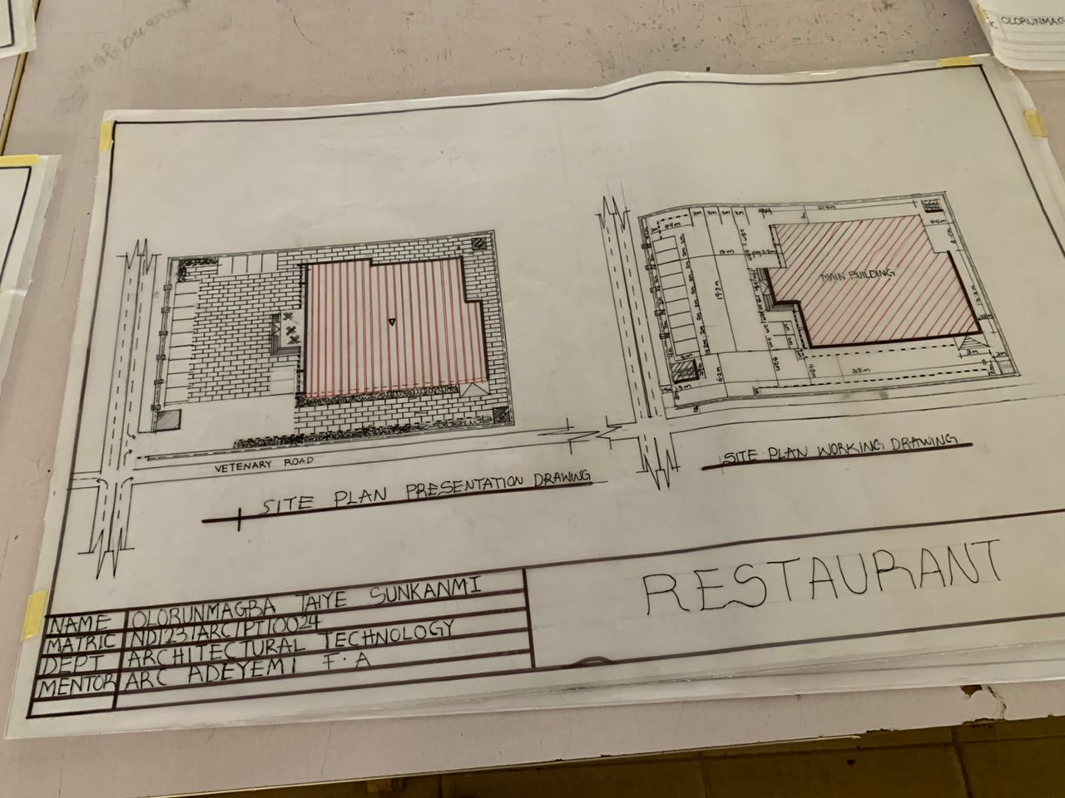
APP1; SHOWING SITE PLAN OF THE PROPSED PROJECT
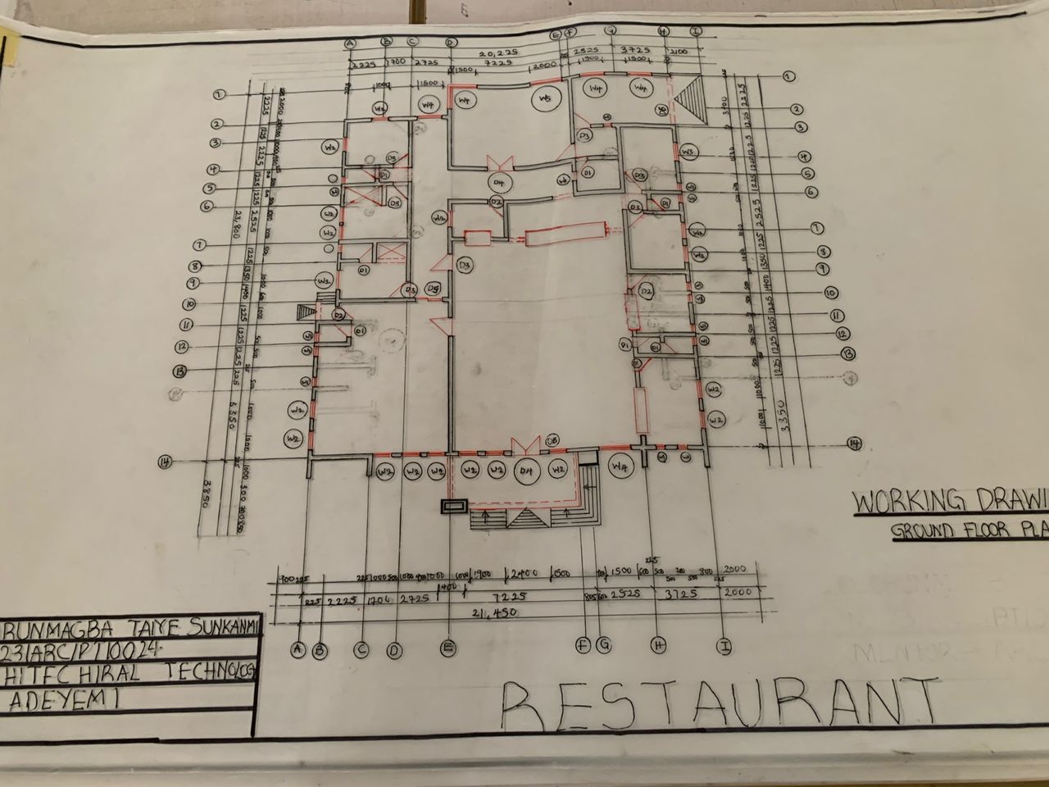
APP2; SHOWING FLOOR PLAN OF THE PROPOSED PROJECT
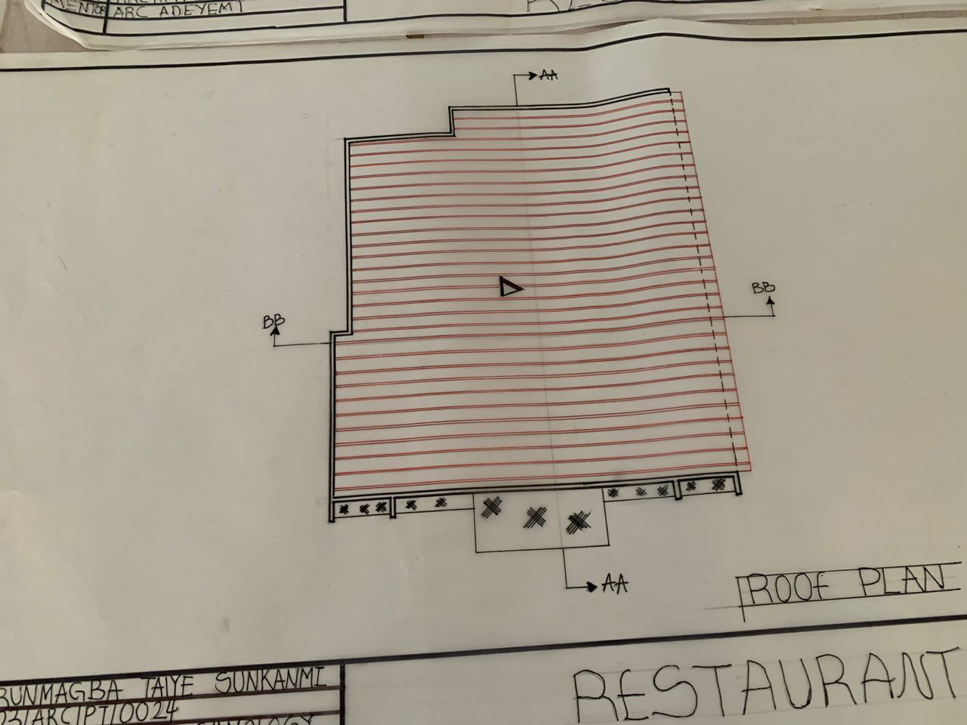
APP3; SHOWING ROOF PLAN OF THE PROPOSED PROJECT
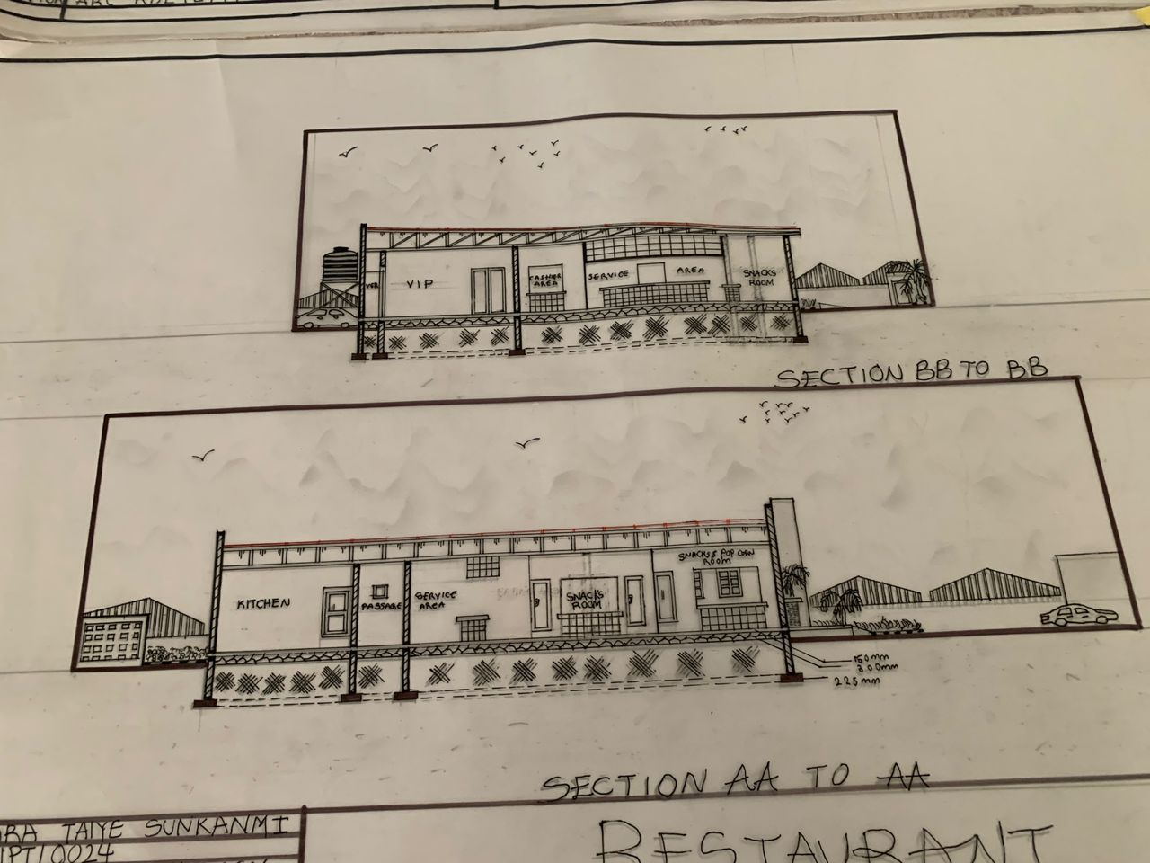
APP4; SHOWING CROSS SECTION OF THE PROPOSED PROJECT
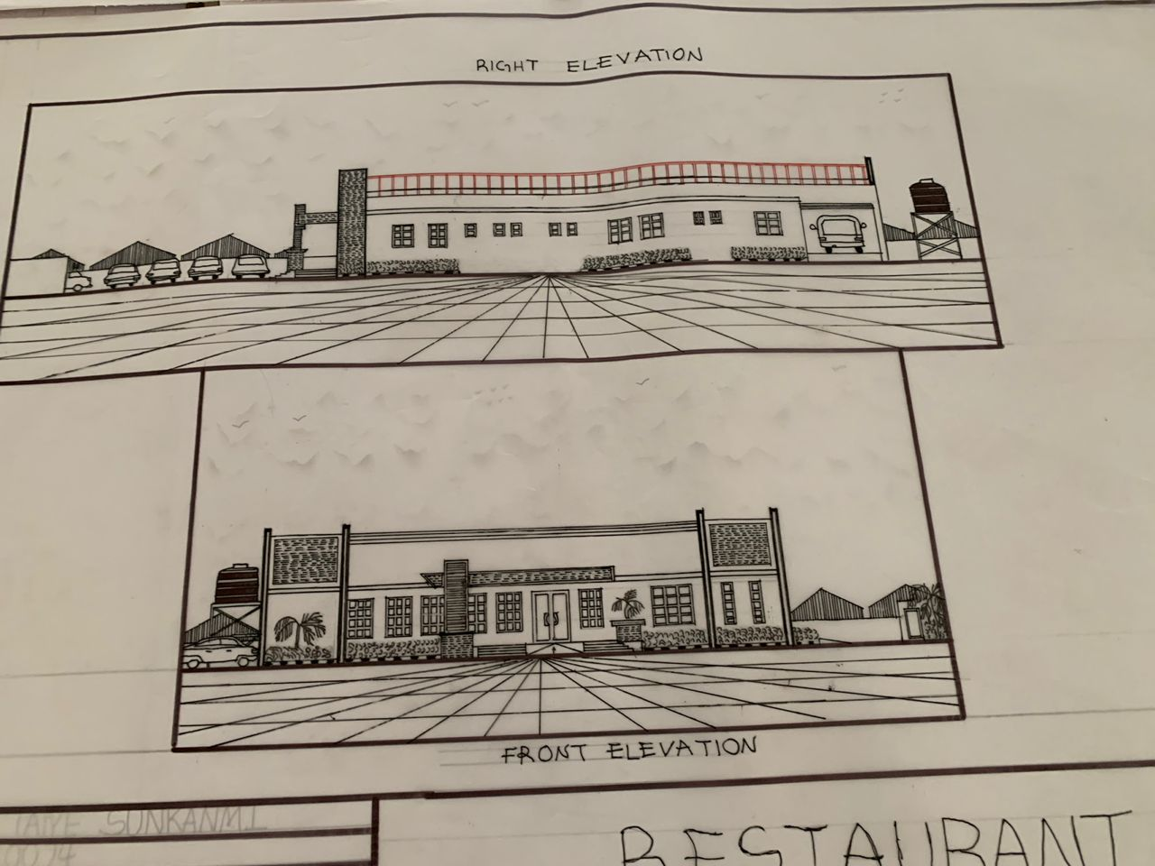
APP5; SHOWING RIGHT&FRONT VIEW OF THE PROPOSED PROJECT
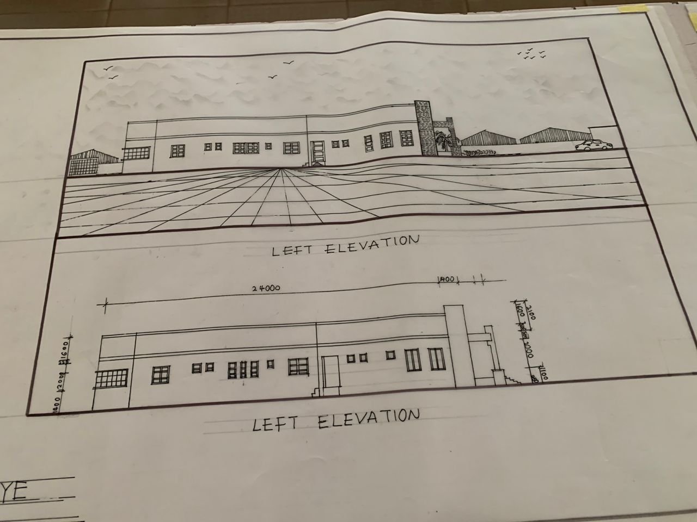
APP6; SHOWING LEFT VIEW OF THE PROPOSED PROJECT
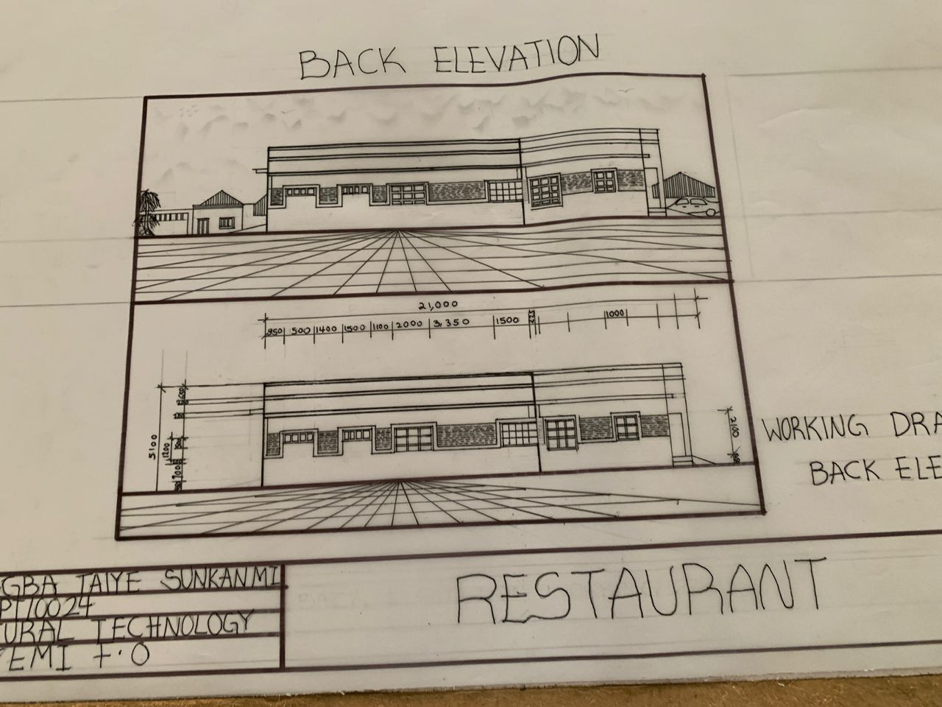
APP7; SHOWING BACK VIEW OF THE PROPOSED PROJECT

