A PROJECT REPORT ON PROPOSED MUSIC STUDIO FOR MR JIMOH OLAYIWOLA, ILORIN, KWARA STATE

BY

NAALLAH .O. ABDULLATEEF
HND/23/ARC/FT/0002

A RESEARCH THESIS SUBMITTED TO THE:
DEPARTMENT OF ARCHITECTURAL TECHNOLOGY INSTITUTE OF ENVIRONMENTAL STUDIES, KWARA STATE POLYTECHNIC, ILORIN
"BEING A DISSERTATION SUBMITTED TO THE DEPARTMENT OF ARCHITECTURAL TECHNOLOGY IN PARTIAL FULFILLMENT OF THE REQUIREMENTS FOR THE AWARD OF HIGHER NATIONAL DIPLOMA IN ARCHITECTURAL TECHNOLOGY KWARA STATE POLYTECHNIC, ILORIN, KWARA STATE

JULY, 2025

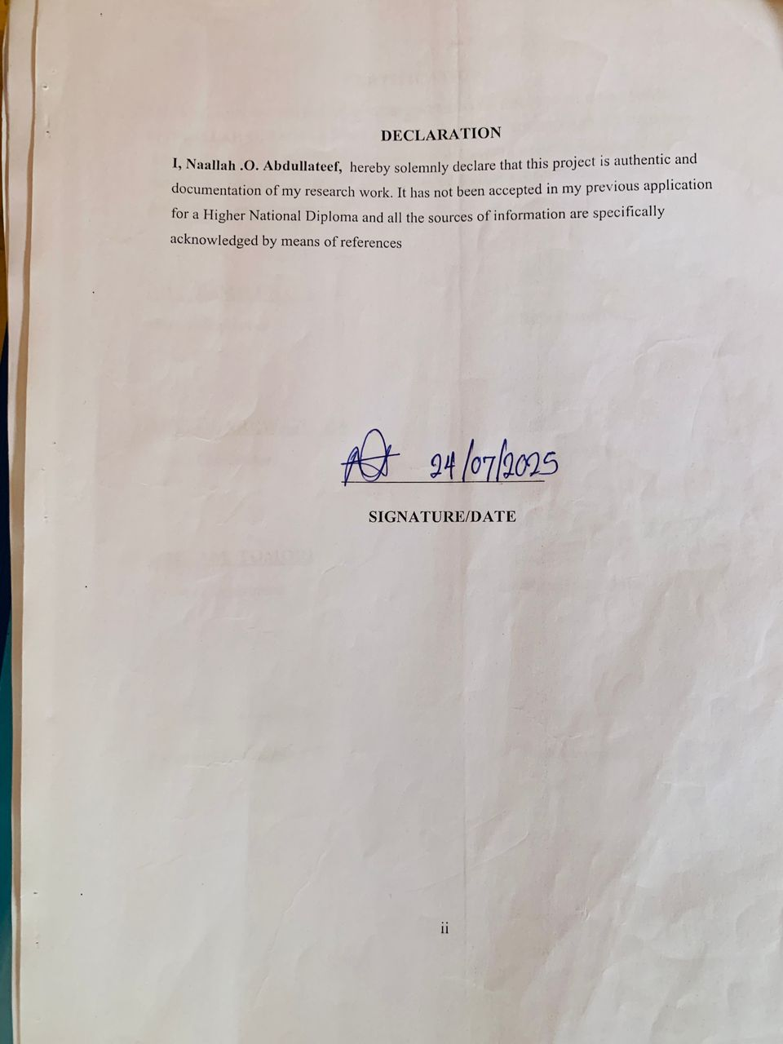

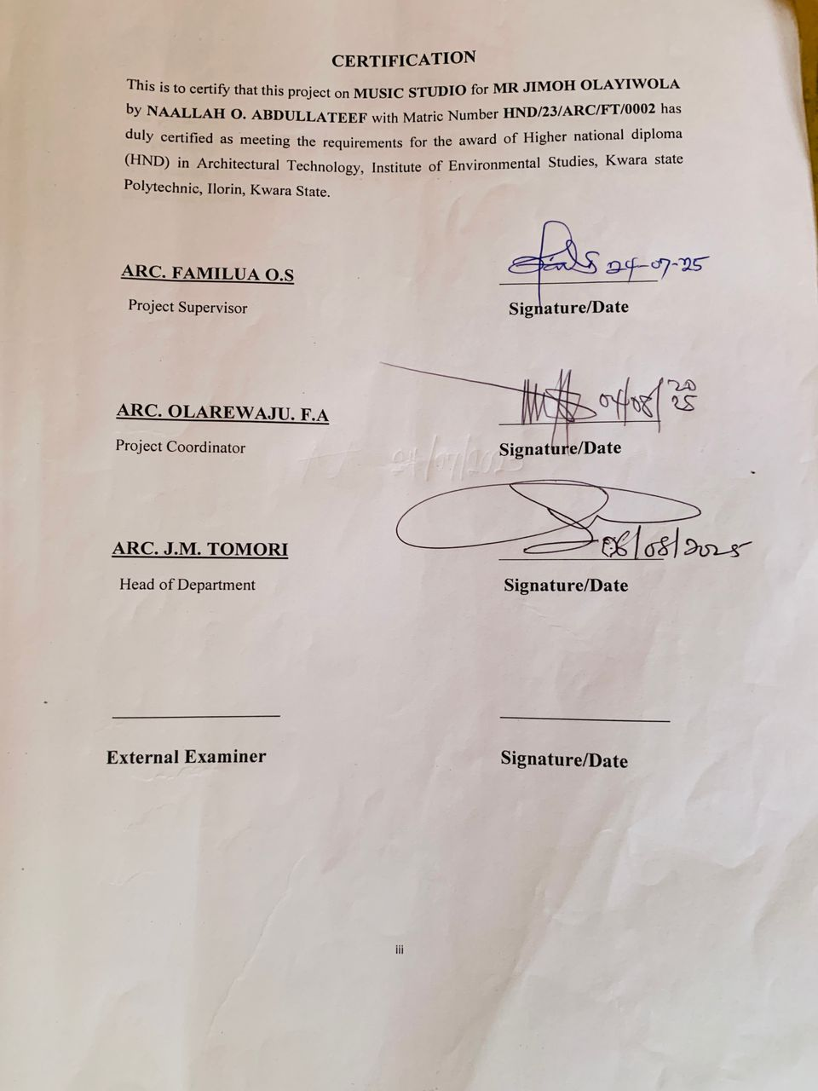

DEDICATION
This project is fully dedicated to the almighty Allah, who is the source of my strength and guidance all the praises to him alone I also dedicate this work to my parent, Mr and Mrs. Naallah for their uncompromising moral and financially support throughout my educational career so far.

iv

ACKNOWLEDGEMENT
I give honour and praises to Almighty Allah the beginning and the end, the knowing of all things and the most knowledgeable one, for his abundant blessing and protection over me.
Inspiration is Mostly from god, Motivation from Man, for the inspiration and motivation singularly given to me by project supervisor in person of Arc. Familua oluwaseun solomon i cannot thank you enough but surely Almighty God shall reward you abundantly.
My sincere appreciation also goes to my departmental lecturers and my able HOD in person of Arc. J.M. Tomoritoward a successful completion of this programme (HND).
My sincere appreciation also goes to my project coodinator in person of Arc. F.A. Olarewajutoward a successful completion of this programme (HND).
My special appreciation goes to my beloved father Alhaji Naallah Abdullah And beloved my mother Alhaja Naallah Sidiqah for their support both financially and morally, I pray Allah will grant them good health and long life to eat the fruit of their labour(Amin)
I also acknowledge and appreciate the support and encouragement of my cleric Sheikh Al Muhadith Muhammad Ibn Jabata Hafidhoullah I am using this medium to say thank you to you.
I also acknowledge and appreciate the support and encouragement of my big brother Naallah Abdulkabir am using this medium to say thank you to you.
My special appreciation goes to my friends Jimoh Olayiwola Ridwanullah Mohammad Abubakar for the support and encouragement of my i am using this medium to say thank you to you.
shamsudeen, Musa fatima, Tijani quadri, Abdulazeez ismail and Mohammed abdulrahmon who has always been there, I am using this medium to say thanks to you all.

TABLE OF CONTENTS
Title Page i
Declaration Page ii
Certification iii
Dedication iv
Acknowlegedment v
Table of contents vi
Abstract vii
List of figures viii
List of plates ix
List of tables x
CHAPTER ONE
  - Introduction 1
  - Background of the study 1
  - Statement of problem 2
  - Aim and objectives 2
  - Client Background 3
  - Scope of study 4
  - Limitation 4
  - Research methodology 5

vi

CHAPTER TWO
2.0 Literature review (Introduction) 7
2.1 Definition 7
2.1 Music studio 7
2.2 Historical development of music studio 8
2.3Music studios in Nigeria 8
CHAPTER THREE
3.0 Case Studies 9
3.1 Case Study 1( Epoch Music studio) 10
3.2 Case Study 2 (JLO Music studio) 11
3.3 Case Study 3 ( Kolseg Music studio) 12
3.4 Case Study 4 ( online Capitol Music studio, USA) 13
3.5 Case Study 5 ( East West Music studio, USA) 14
CHAPTER FOUR
4.0 Design Proposal 17
4.1 Introduction 17
4.2 Site Location 18
4.2.1 Site Location Map 19
4.2.2 Site Selection Criteria 20
4.3 Site Characteristics 21
4.3.1 Soil type 22
4.3.2 Vegetation 23

4.3.3 Topography 24
4.3.4 Drainage 25
4.3.5 Accessibility 26
4.3.6 Climate 27
4.3.7 Site Features and Infrastructure 28
4.3.8 Noise Sources 29
4.4 Site Analysis 30
4.5 Proposed Design 31
4.5.1 Design Considerations 32
4.5.2 Design Concept 33
4.5.3 Brief Analysis 34
4.5.4 Schedule of Accommodation 35
4.6 Specifications and Construction 36
4.6.1 Materials and Finishes 37
4.6.1.1 Walls 38
4.6.1.2 Floors 39
4.6.1.3 Ceiling 40
4.6.1.4 Roof 41
4.6.1.5 Windows and Doors 42
4.6.2 Structural System 43
4.6.3 Building Services 44
4.6.4 Landscaping and External Works 45
4.7 Chapter Summary 46
CHAPTER FIVE
5.0 DESIGN APPRAISAL 47
5.1 Introduction 47
5.2 Design appraisal 48
5.3 Building structure 48
5.4 Recommendation 49
5.5 Summary and conclusion 48
5.6 Summary 48
5.7 Conclusion 48
REFRENCES
APPENDIX

ABSTRACT
In today’s creative industry, the music studio serves not only as a technical environment for sound recording and production but also as a spatial experience that supports creativity, comfort, and acoustic integrity. With increasing demand for high-performance studio environments especially within growing urban contexts like Nigeria the architectural design of such spaces must respond to both functional and sensory needs. This project explores the architectural planning and design of a music studio that harmonizes technical acoustic requirements with visual and spatial aesthetics. The primary aim of this project is to create a music studio that meets professional sound production standards while offering a spatially inspiring and acoustically optimized environment. The design focuses on solving common problems in many existing studios such as poor acoustic isolation, inadequate spatial planning, and lack of ambiance for creativity. Through a combination of sound-absorptive materials, floating floors, diffusive ceilings, and spatial zoning, the proposal ensures effective sound isolation, balanced reverberation, and minimal noise intrusion. Architecturally, the design adopts a contemporary approach using clean geometry, natural light integration, and high-performance materials that serve both aesthetic and functional purposes. The layout strategically separates loud and quiet zones while maintaining visual and acoustic continuity. Emphasis is placed on sustainability, energy efficiency, and user comfort, with provisions for flexible usage and future expansion. This project not only contributes to the development of modern music production spaces in Nigeria but also provides a model for how architecture can enhance both the technical and creative aspects of the music industry through thoughtful design intervention. This project aims to design and construct a professional music studio that harmoniously balances superior acoustic quality with visually appealing interior design. The studio will incorporate scientifically informed acoustic treatments including bass traps, diffusers, and absorbersto optimize sound clarity, minimize reflections, and achieve a neutral listening environment. Alongside these functional elements, the studio will feature modern, creative, and ergonomic design aesthetics intended to inspire and energize users. By focusing equally on auditory precision and atmospheric beauty, the studio will serve as an ideal space for recording, mixing, and creative collaboration. This project addresses the dual need for technical sound integrity and psychological comfort, ultimately supporting enhanced artistic output and a more enjoyable studio experience.

LIST OF FIGURES
Pages
3.1: Showing the location plan of Epoch Music studio 12
3.1: Showing showing the Site plan epoch Music Studio 48
3.1: Showing Floor plan of epoch music studio 48
3.2: Showing the location plan of Beloved Music studio 53
3.2: Showing the Site plan of Beloved Music studio 53
3.2: Showing the Floor plan of Beloved Music studio 53
3.3: Showing the location plan of JLO Music studio 53
3.3: Showing the Site plan of JLO Music studio 53
3.3: Showing the Floor plan of JLO Music studio 53
3.4: Showing the Location plan of Kolseg Music studio 53
3.4: Showing the Site plan of Kolseg Music studio 53
3.4: Showing the Site plan of Kolseg Music studio 53
4.1: Map of Nigeria showing Kwara State 61
4.2: Map of Kwara showing 62
4.3: Bar chart showing Hours of Sunshine per day 65
4.4: Bar chart showing Rainy days per month 65
4.5: Bar chart showing Precipitation per day 66
4.6: Bar chart showing Water Temperature 66
4.7: Bar chart showing Relative Humidity 67

LIST OF PLATES
Pages
3.1: Showing the location of Epoch Music Studio 39
3.1: Showing exterior view of Epoch Music Studio 39
3.1: Showing the interior view of Epoch Music studio 40
3.2: Showing the location of the beloved music studio 40
3.2: Showing the Exterior of the beloved music studio 40
3.2: Showing the Interior of the beloved music studio 40
3.3: Showing Location of Kolseg Music studio 43
3.3: Showing the floor planof Kolseg Music studio 43
4.1: Showing Aerial view of the site 62
4.2: Showing Site Analysis 68

LIST OF TABLES
Pages
2.1: Showing acoustically optimized Music studio 10
2.2: Showing acoustically optimized Music studio materials 28
2.3: Showing acoustically optimized music studio materials 30
2.4: Showing resistance of Concrete wall 31
2.5: Building materials and Fire endurance 31
3.1: Assessment of acoustically optimized variables in Case Study 1 41
3.2: Assessment of acoustically optimized variables in Case Study 2 46
3.3: Assessment of acoustically optimized variables in Case Study 3 50
3.4: Assessment of acoustically optimized variables in Case Study 4 55
3.5:Assessment of acoustically optimized variables in Case Study 5 59
4.1: Schedule of Accommodation 72

CHAPTER ONE
1.0 Introduction
1.1 Back ground of the study
The history of music studios is intertwined with the evolution of sound recording technology. From early attempts to capture sound on wax cylinders to digital recording, the journey has been marked by significant advancements and changes in how music is created and preserved. The first recording studios emerged in the late 19th and early 20th centuries, driven by the invention of the phonograph and the rise of the music industry. Early Days of Sound Recording (1877-1930s) the Phonograph and Wax Cylinders Thomas Edison's invention of the phonograph in 1877, using wax cylinders, marked the beginning of sound recording and playback.
Disc-Based Recording: Emile Berliner's invention of the gramophone in 1887, using discs, allowed for easier mass production of recorded music.
Rise of Recording Studios: Early studios, like the first OKeh Records studio in New York in 1918, were simple spaces where musicians recorded directly onto master discs in real-time.
EMI abbey road in 1931, EMI opened Abbey Road Studios, the world's first purpose built recording studio, marking a significant step towards professional recording environments.
Analog Recording (1930s-1980s) analog tape machines the introduction of magnetic tape in the mid-20th century allowed for more reliable and efficient recording, with studios like Abbey Road using analog tape machines.
Multi-Track Recording the development of multi-track recording techniques allowed artists to capture multiple takes and combine them into a single recording.
Emergence of the Recording Engineer as recording technology advanced, the role of the engineer emerged, overseeing the transfer of musical performances to recording media and making aesthetic choices about the sound.
Digital Recording and Beyond (1980s-Present) Digital Recording Technology The advent of digital recording, particularly with the advent of ADAT, revolutionized the industry, leading to the rise of project studios.
Software-Based DAWs Modern project studios are built around software-based Digital Audio Workstations (DAWs) running on standard PC hardware.
Home Studios the affordability and ease of digital recording have enabled the creation of home studios, allowing musicians more creative control over their recording process.
Key Innovations and Figures: Thomas Edison: Inventor of the phonograph, a pivotal invention for sound recording.
Édouard-Léon Scott de Martinville Inventor of the phonautograph, an early device for recording acoustic waves.
Emile Berliner Inventor of the gramophone, which used discs for recording.
Brian Eno A pioneer of electronic music and sound design, known for his work with studios and experimental sound manipulation.
Norman Cook (DJ Fatboy Slim) A significant figure in dance music, known for
his production and studio work.
Tony visconti a renowned producer known for his work with David Bowie, pushing the boundaries of studio technology and production techniques.
1.2 Statement of Problem
In the realm of music production, the environment in which sound is created plays a critical role in the quality of the final output. Many music studios suffer from poor acoustic treatment, leading to inaccurate sound reproduction, unwanted reverberations, and suboptimal recording conditions. Additionally, the visual and emotional atmosphere of a studio often gets overlooked, even though aesthetic design significantly impacts the creativity, comfort, and productivity of artists. There is a need for a music studio that combines professional-grade acoustic performance with an inspiring, aesthetically pleasing environment, ensuring both technical excellence and an enhanced user experience for musicians, producers, and clients alike.
1.3 Aim and Objectives of the Study
Aim
The aim of the study is to enhance a music studio that is acoustically optimized comfortable and visually Inspiring.
Objectives
The objectives to achieve the aim above are to:
- To use high-quality, sound-absorbing and reflective materials that meet acoustic standards while aligning with the desired visual theme and aesthetics
- To ensure sound isolation from external noise and between rooms (e.g., vocal booth, control room) through proper construction and insulation techniques
- To design an interior layout and lighting system that supports creativity, comfort, andworkflow efficiency for artists and producers

1.5 Justification of the study
This study intends to access how high acoustic performance can be enhanced in the design of music studio one of the significance problem of this study is it will resolve the problem of non high quality of acoustic performance .
1.6 Background of the client
Name: Mr. Jimoh Olayiwola
Profession: Music Producer / Entrepreneur
Mr. Jimoh Olayiwola is a visionary music producer and entrepreneur with over a decade of experience in the Nigerian music industry. He is known for his dedication to nurturing emerging talents and creating high-quality sound productions. His work spans multiple genres, from Afrobeat to gospel and contemporary pop, and he has collaborated with a wide range of artists. With a passion for sound excellence and creativity, Mr. Olayiwola is now investing in a state-of-the-art music studio that will serve as both a professional recording facility and a creative hub for artists, producers, and sound engineers.

1.7 Scope of study
The scope of this project entails the architectural design and spatial planning of a purpose-built music studio facility with a primary focus on acoustic optimization and aesthetic integration. The design will accommodate essential functional zones including a control room, live room, vocal booth, editing suite, reception/lounge, and ancillary support spaces. The project emphasizes the integration of architectural acoustics through the use of sound-isolating wall assemblies, floating floors, acoustic ceilings, and strategically positioned diffusive and absorptive elements. Careful consideration is given to spatial hierarchy, circulation, and zoning to ensure minimal sound transmission between critical spaces.
The architectural language of the studio will reflect a balance between form and function, with interior finishes and material selections chosen not only for their acoustic performance but also for their contribution to the overall visual and experiential quality of the space. Sustainable design principles will be incorporated through natural ventilation strategies, energy-efficient lighting, and the use of eco-friendly materials where applicable. The project also includes the design of building services, fire protection systems, and passive environmental controls, all integrated seamlessly into the architecture to support optimal acoustic conditions without compromising design integrity. Ultimately, the studio will serve as a high-performance creative environment that embodies both technical precision and architectural expression.

1.8 LIMITATIONS
The limitation experienced during this course of study include:
- Time constraint
- Finance: funding of the project research and the project itself has been asurmountable task which God has intervened in its management.
- Research materials: There have not been enough local sources of informationand getting the proper architectural plans required for assessment during case studies was not very easy.
1.9 Research methodology
This outlines the research methods employed in the development of the proposed music studio design. The methodology combines both qualitative and quantitative approaches to gather data, analyze case studies, and evaluate design principles relevant to acoustics, architecture, and user experience. The aim is to establish a sound theoretical andpractical foundation for designing a high-performance, aesthetically engaging studio environment.

Methods of Data Collection
Literature Review
Academic journals, books, standards (e.g., ISO 3382, AES), and industry guidelines on acoustics, studio design, and interior architecture were reviewed.This provided theoretical grounding on sound isolation, room acoustics, building materials, and design aesthetics.
Case Studies
Detailed analysis of selected local and international music studios was conducted to assess spatial organization, acoustic treatment strategies, material use, lighting, and integration of services. Studios such as Mavin Records (Nigeria), Abbey Road Studios (UK), and Electric Lady Studios (USA) were examined.
Interviews and User Surveys
Informal interviews with audio engineers, producers, and studio users provided insight into user needs, functional challenges, and preferences regarding acoustic comfort and visual atmosphere

CHAPTER TWO
2.0 Literature Review
2.1 Introduction
In this chapter, Definition of music studio, history and other related literature are discussed. This Literature were studied in order to know the trend and scope for research in the chosen field. Many doctoral thesis, reports and articles published in leading journals were subjected to analysis.
A music studio is a specialized space designed for the creation, recording, mixing, and mastering of audio content. It serves as a controlled acoustic environment that enables sound engineers and musicians to capture high-quality recordings and manipulate audio with precision. A well-designed music studio typically includes a control room, live room, and sometimes vocal boothseach acoustically treated to ensure accurate monitoring and sound isolation. In today’s creative industries, music studios are critical not only for musical production but also for voice-overs, podcasts, and multimedia content creation.
The effectiveness of a music studio depends on a balance between acoustic performance and environmental comfort. Poorly treated studios can distort sound, leading to inaccurate mixes, while uninspiring or cramped designs can hinder artistic creativity. As the demand for high-quality audio content grows, the importance of building music studios that are both acoustically optimized and aesthetically pleasing becomes increasingly relevant.
2.2 Definition
A music studio is a facility for the recording,mixing and mastering of music typically a music studio will include a control room ,where the engineer and producer will sit and one or more recording rooms,where the music will perform basically the control room has a
mixing console monitor, speakers,mouse, keyboard,sound and many others the recording rooms will have a microphone, headphones percussion instruments if possible etc

2.3 Historical Development of Music Studios
The concept of the music studio has evolved significantly over the past century. In the early 20th century, music recording was limited to large halls or rudimentary sound
rooms with minimal control over acoustics. As technology advanced, the 1930s and 1940s saw the rise of commercial recording studios, with developments in microphones, analog tape machines, and mixing consoles.
By the 1960s and 70s, iconic studios like Abbey Road and Electric Lady Studios set new standards in both acoustic engineering and artistic ambiance, influencing studio design
worldwide. The 1980s introduced digital recording technologies and MIDI systems, revolutionizing the production process and making studios more accessible.
With the advent of personal computers and digital audio workstations (DAWs) in the 1990s and 2000s, home studios became increasingly popular. Today, music studios range from high-end commercial facilities to compact, portable setups, but the importance of sound treatment, spatial design, and technological integration remains fundamental.

2.4 Music Studios in Nigeria
In Nigeria, the development of music studios reflects the country's rich and evolving musical landscape. Early Nigerian music was recorded using limited infrastructure, often requiring artists to travel abroad for high-quality production. However, by the late 1990s and early 2000s, the rise of Afrobeat, hip-hop, and gospel music led to the establishment of professional studios in cities like Lagos, Abuja, and Port Harcourt.
Studios such as Ogidi Brown Studios, Chocolate City Studio, and Don Jazzy’s Mavin Records have played significant roles in shaping the modern Nigerian sound. These studios often combine global production standards with local cultural elements, making them hubs for both technical innovation and artistic collaboration.
Despite these advancements, many Nigerian studios still struggle with poor acoustic design, substandard equipment, or aesthetically uninspiring environments. This presents an opportunity for new studios to raise the bar by integrating advanced acoustic treatment and appealing design features that foster both creativity and productivity.

CHAPTER THREE
3.0 Case studies
3.1 Case Study:
According to JSTOR (January 2019),Acase studyis a detailed, in-depth examination of a specific subjectsuch as an event, individual, group, organization, or project—within its real-life context. It is commonly used in qualitative research to explore complex issues where multiple variables are involved and where generalizing from a larger population is not the goal, but understanding particular dynamics is essential.
3.2 Case Study 1 Epoch Music Studio
Epoch House Studios, located in Ilorin, Kwara State, Nigeria, stands out as one of the leading creative audio spaces in the city. Operating from Top Floor, Suite 7 of the GSS Shopping Complex on Fate Road, the studio has garnered high praise from users for its professional setup, serene atmosphere, and quality acoustic experience.
Location: Along oko erin road, Ilorin kwara state.
Merits
- Good orientation of the building.
- Aesthetically appealing facade.
- Good circulation Around the building
- Brilliant acoustical treatment
Demerits
- Poor landscaping.
- No celebrated entrance.
- Poor utilization

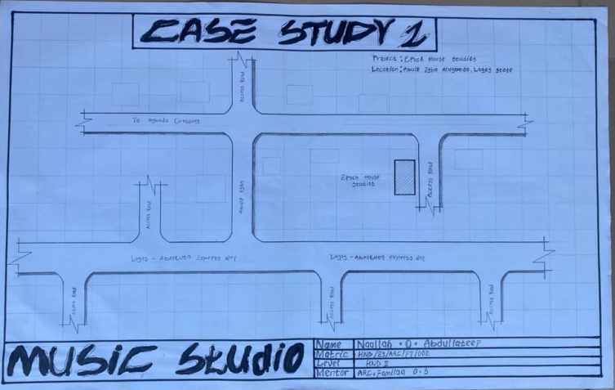
FIG 3.1.1: SHOWING THE LOCATIONAL PLAN OF CASE STUDY ONE
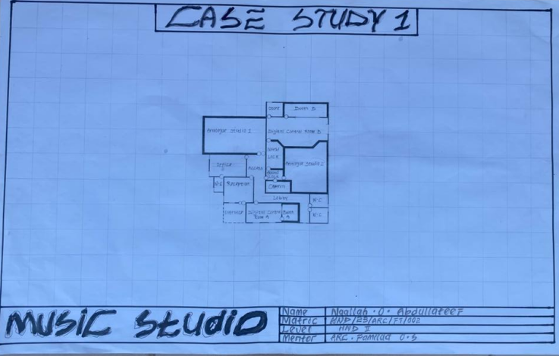
FIG 3.1.2: SHOWING THE LOCATIONAL PLAN OF CASE STUDY ONE

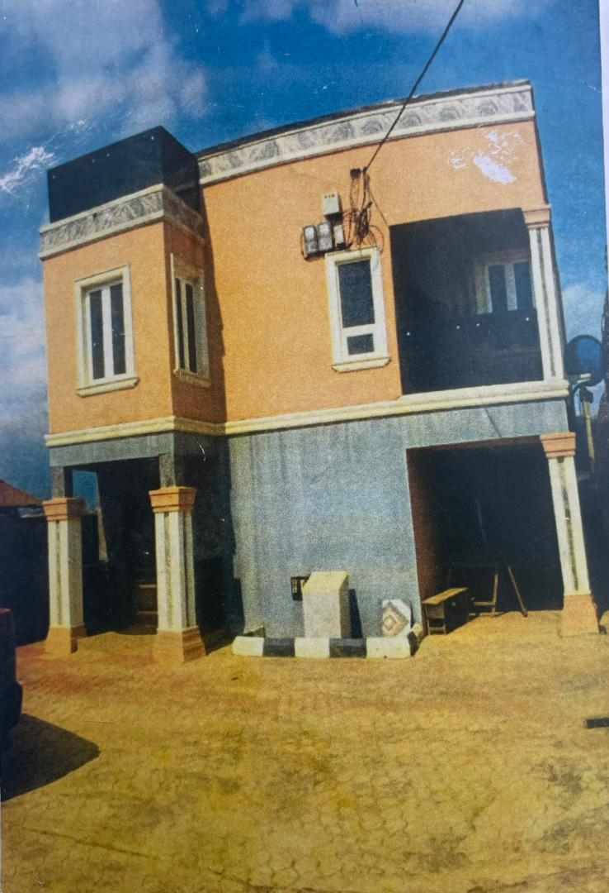
PLATE 3.2.1: SHOWING THE FRONT VIEW OF CASE STUDY ONE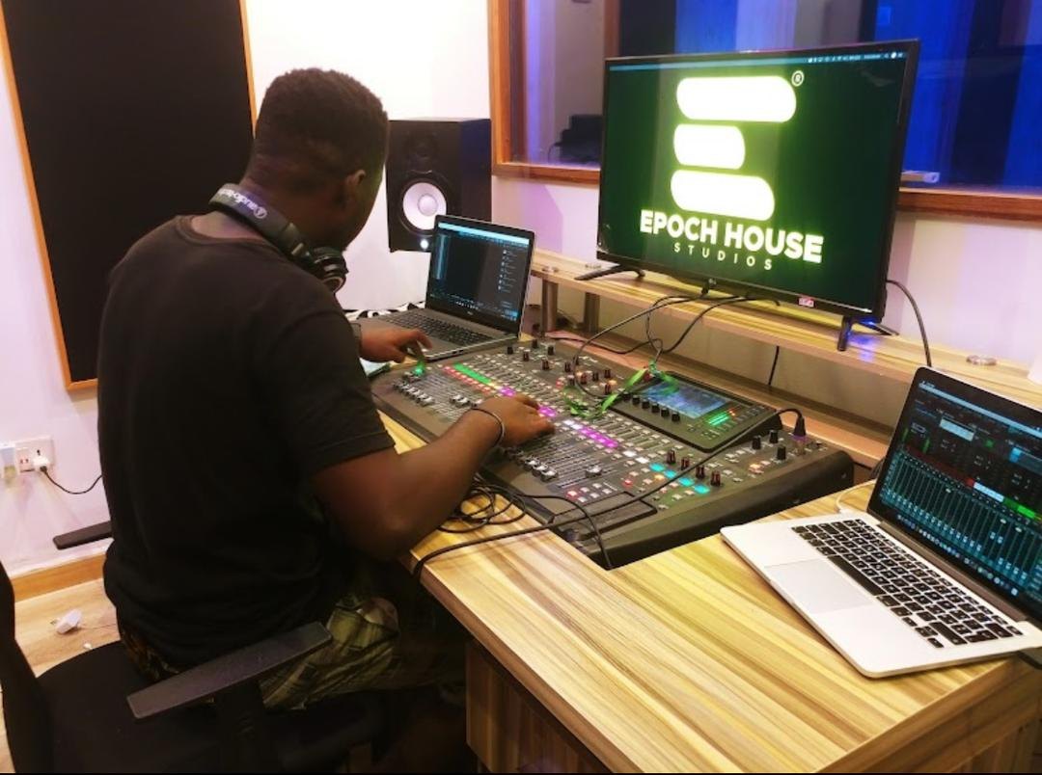PLATE 3.1.2: SHOWING THE FRONT VIEW OF CASE STUDY ONE

3.3 Case Study 2 JLO
JLO Studio, located on Omo Meji Street, Randa, in Ogbomoso, Oyo State, Nigeria, serves as a multidisciplinary creative centre offering music recording, music training, live sound hire, photography, video production, and rehearsal facilities, Though specific founding dates are not publicly documented, the studio has become widely recognized in the region for its state-of-the-art equipment and highly experienced technical staff. It hosts a variety of audio and visual services and is praised in local listings with a perfect five-star rating and comments highlighting its comprehensive services and professionalism
Location: Mama Kes Street, Ogbomosho, Oyo State
Merits
- Good orientation of the building.
- Aesthetically appealing facade.
- Good circulation Around the building
- Brilliant acoustical treatment
Demerits
- Poor landscaping.
- No celebrated entrance.
- Poor utilization

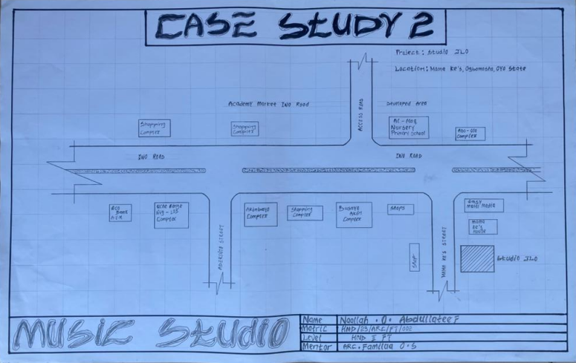
FIG 3.2.3: SHOWING THE LOCATION PLAN CASE STUDY TWO
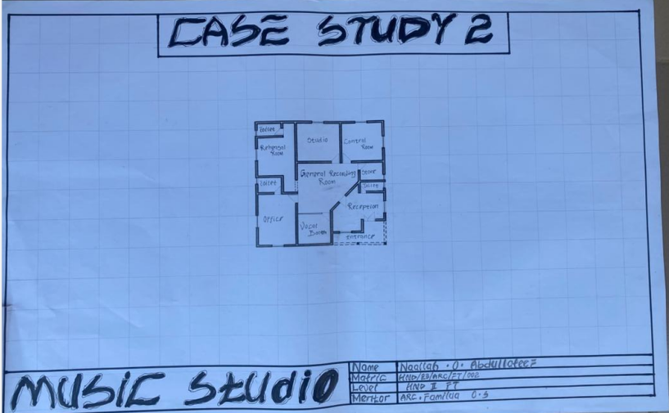
FIG 3.2.4: SHOWING THE FLOOR PLAN CASE STUDY TWO
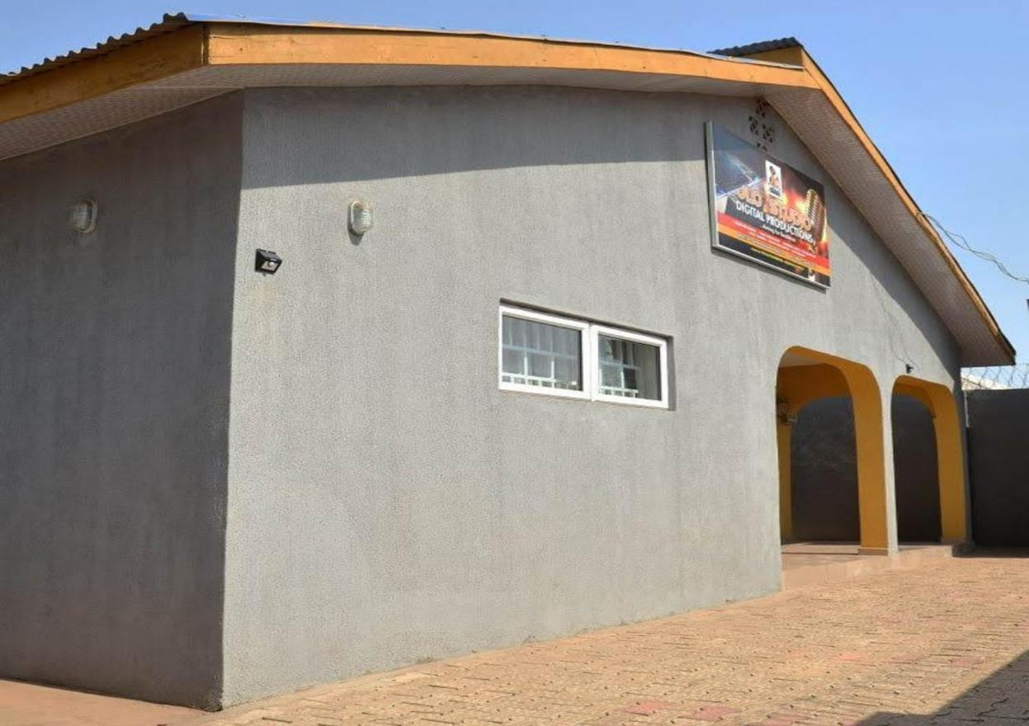
PLATE 3.2.3: SHOWING THE FRONT VIEW OF CASE STUDY TWO
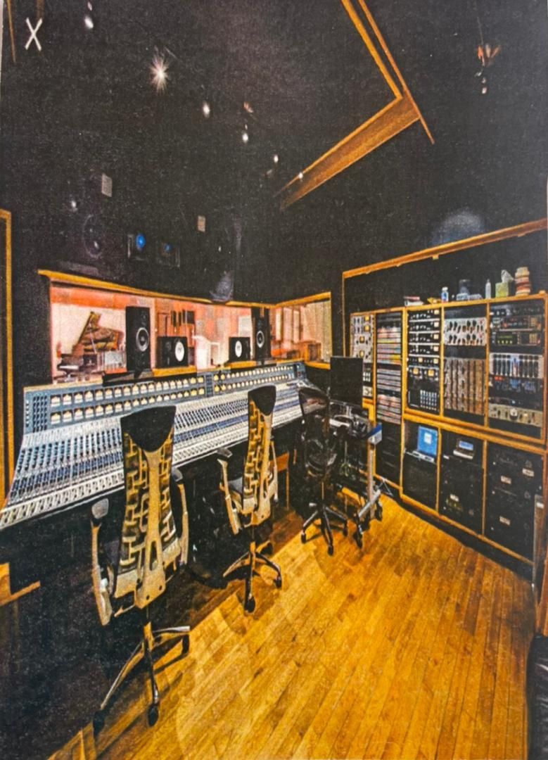
PLATE 3.2.4: SHOWING THE INNER VIEW OF CASE STUDY TWO
3.3 Case Study 3 Kolseg Music Studio
Kolseg Studio, situated in Ewupe near the Lagos-Abeokuta Expressway, stands as a leading creative hub in Ogun State, combining advanced music production and photography services in a two-story facility Operating for over a decade, the studio is celebrated for its SSL mixing console, Neve preamps, Pultec compressors, high-end monitors (e.g. Adam, Genelec, ATC), and professionally treated isolation booths and mastering suites designed for both photography and audio work Kolseg is notable not only for its top-tier infrastructure but also for its community orientation. It hosts workshops, masterclasses, exhibitions, and industry mixers, fostering a collaborative environment for creatives and supporting podcast, photography, and music production initiatives
Location: Segun block road cooperative estate, ewupe ota , Ogun state.
Merits
- Good positioning of the recording booth.
- Good circulation Around the building
- Brilliant acoustical treatment
Demerits
- Poor landscaping.
- No celebrated entrance.
- Poor utilization

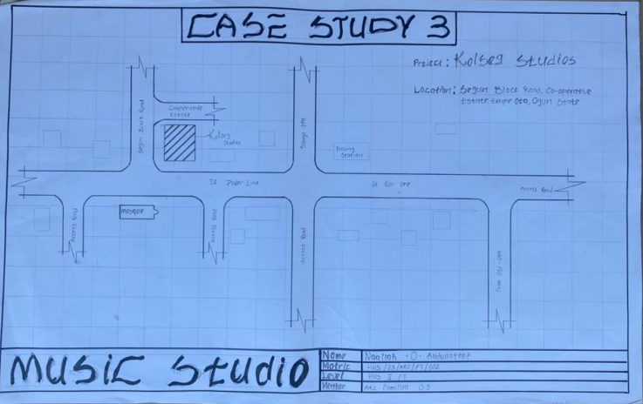
PLATE 3.3.5: SHOWING THE LOCATION PLAN CASE STUDY TWO

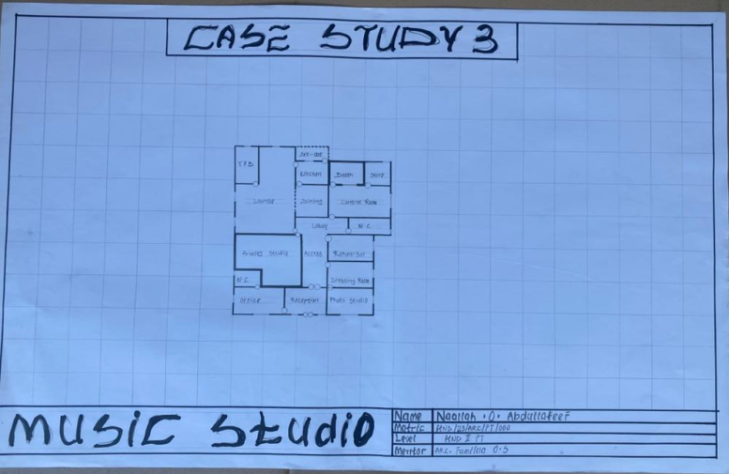
FIG 3.3.6: SHOWING THE FLOOR PLAN CASE STUDY TWO
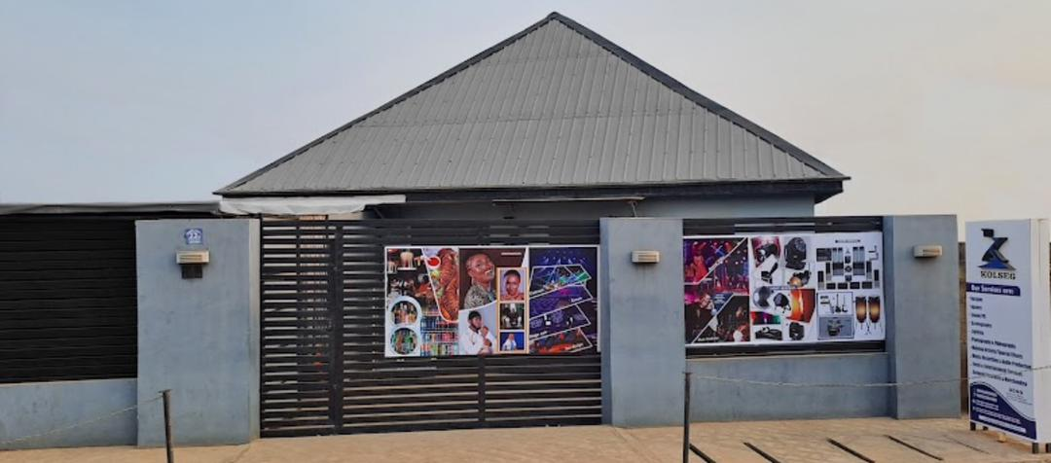
PLATE 3.3.5: SHOWING THE FRONT VIEW OF CASE STUDY THREE
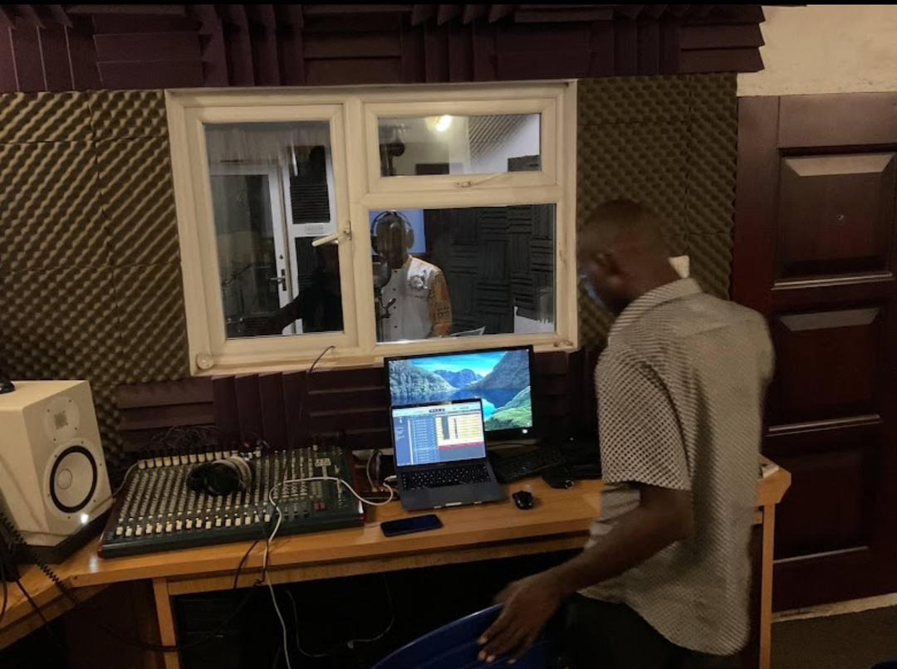
PLATE 3.3.6: SHOWING THE INNER VIEW OF CASE STUDY THREE

3.4 Case Study 4 (Online) Capitol Music Studio
Capitol Studios opened in 1956, housed within the iconic cylindrical Capitol Records Tower on Hollywood Boulevarda landmark architectural icon designed by Louis Naidorf of Welton Becket Associates The studios offered innovative acoustic engineering from the start, including floating inner walls built with rubber and cork for sound isolation and subterranean echo chambers engineered with precise concrete acoustics by Les Paul, enabling up to five seconds of natural reverberation
Location: Los Angeles united state of america (USA).
Merits
- Good positioning of the recording booth.
- Good circulation Around the building
- Brilliant acoustical treatment
Demerits
- Poor landscaping.
- No celebrated entrance.
- Poor utilization

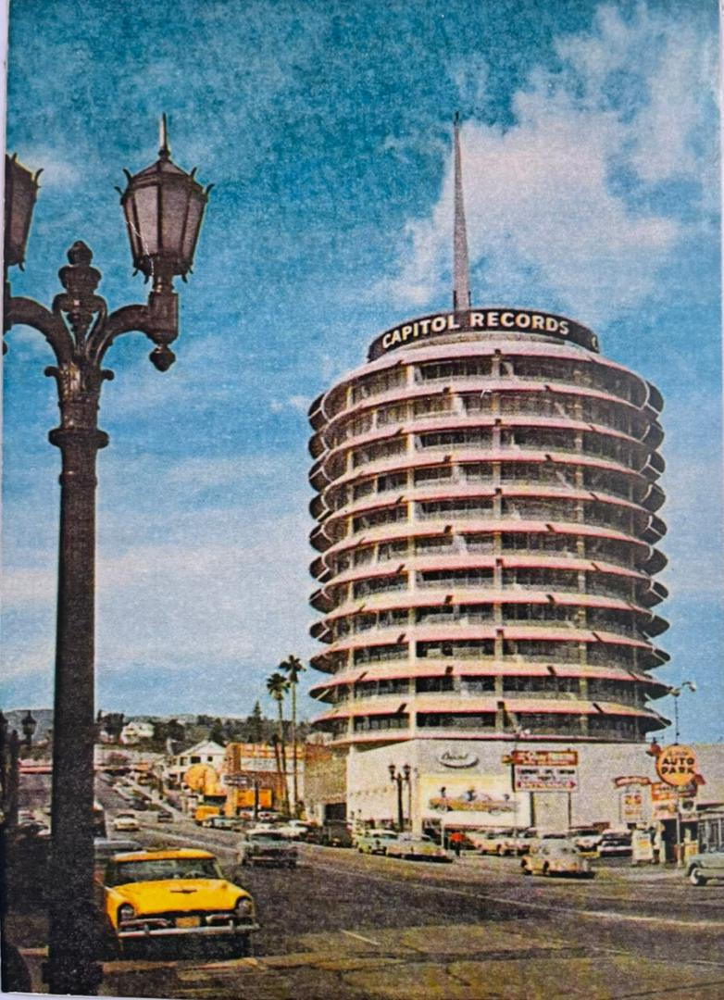
PLATE 3.4.7: SHOWING THE EXTERNAL VIEW OF CASE STUDY FOUR
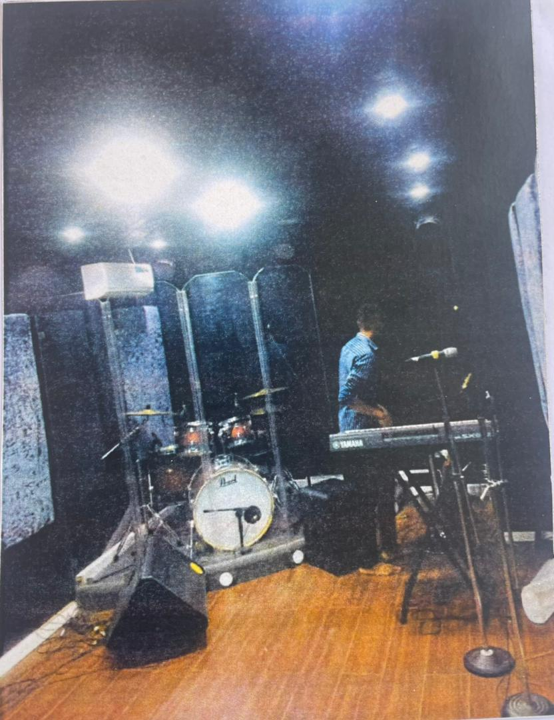
PLATE 3.4.8: SHOWING THE INTERNAL VIEW OF CASE STUDY FOUR

3.5 Case Study 5 (Online) East west Music Studio
EastWest Studios is located at 6000 West Sunset Boulevard in Hollywood, originally established in the early 1960s by pioneering engineer Bill Putnam as part of United Western Recorders The studios gained global renown by hosting legendary recordings from Frank Sinatra (“My Way,” “That’s Life”), The Beach Boys (“Pet Sounds”), Marvin Gaye, Nat King Cole, Elvis Presley, U2, Madonna, Michael Jackson, Tool, Red Hot Chili Peppers and many others throughout its Western and Ocean Way eras
In 1998, the facility operating under Ocean Way was renamed Cello Studios before closing in 2005. Shortly thereafter, soundware developer Doug Rogers acquired the property in January 2006 and undertook a high-profile renovation, bringing in Philippe Starck to redesign public and lounge spaces while preserving Bill Putnam’s original studio acoustics The revamped studio officially reopened as EastWest Studios in March 2009
Location: Holly wood united state of america (USA).
Merits
- It is energy efficient.
- It is visual appealing.
- Brilliant acoustical treatment
Demerits
- Difficult to access.
- Difficult to maintain.
- Not sustainable.

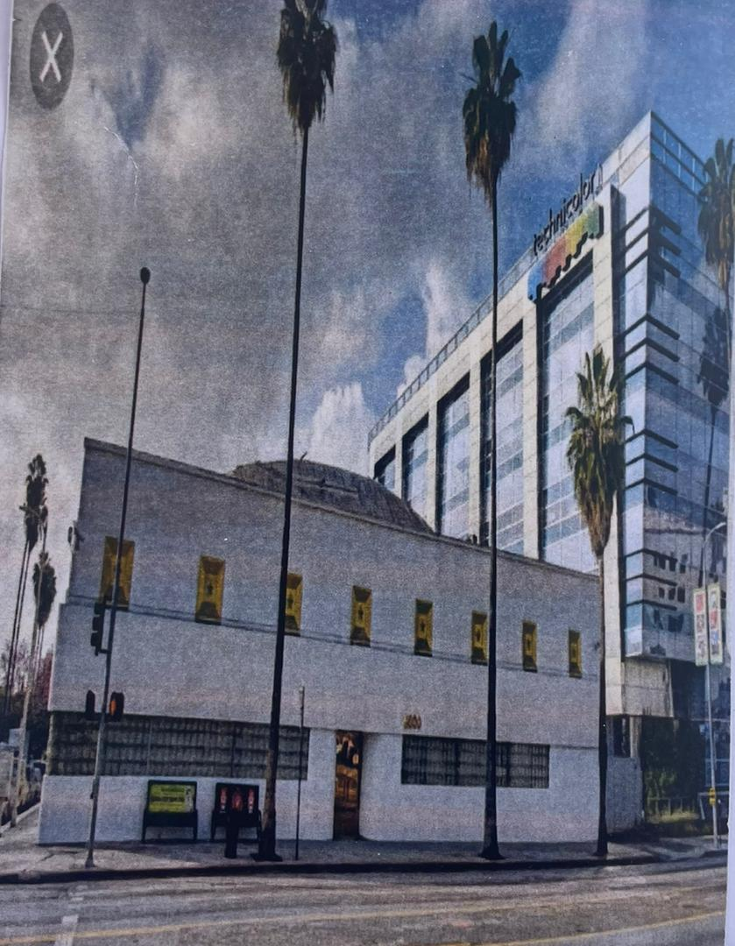
PLATE 3.5.9: SHOWING THE EXTERNAL VIEW OF CASE STUDY FIVE
PLATE 3.5.10: SHOWING THE INTERNAL VIEW OF CASE STUDY FIVE

CHAPTER FOUR
4.0 Design Proposal
4.1 Introduction
This chapter discuss and analyse the proposed site, analysis of its location and an in-depth study into the reasons for the selection of the particular site for the design. Site analysis of the proposed site will be carried out to show suitability of the proposed site for the design of a Music Studio.
4.2 Site Location
The site is located at Olohun sogo, Ilorin , Kwara State is one of the states in Nigeria, at coordinates 6.5244N, 3.3792E located in the southwest of Nigeria.
4.2.1 Site Location Map

Figure 4.1 Map of Nigeria showing location of kwara State
Source: Google images

4.2.2 Site Selection Criteria
The site was selected based on the following category;
- Location
- Ease of access
- Availability of enough land
- Security
- Nature of Site and Vegetation
- Location:
The site is located along Olorun sogo Road, Ilorin, Kwara Sta.
- Ease of Access:
The site can be accessed easily as there is an existing road that leads to it.
- Availability of Enough land:
To adequately provide for the various facilities required in the building and on the site, the area of land required for the project must be adequate. Therefore, the site was selected because it is wide enough to accommodate the proposed design.
- Security:
The site is located in a well secured area in the part of the state .
- Nature of Site and Vegetation:
The topography of the site is fairly levelled and the slightly unlevelled part can be adequately levelled. The sub soil is mainly red lateritic soil, with barches of sandy soil. The site also contains few trees and shrubs, which can help enhance the landscape of the site, and also act as wind-breakers and dust filters during the harmattan.

4.3 Site Characteristics
4.3.1 Soil type
The sub soil is mainly red lateritic soil, with barches of sandy soil. It is a high load bearing capacity soil.
4.3.2 Vegetation
The vegetation on the site consists of few trees of different species and shrubs. Some trees and shrubs will be retained to enhance the landscape of the site, and also act as wind-breakers and dust filters during the harmattan.
4.3.3 Topography
The topography of the site is fairly levelled and the slightly unlevelled part can be adequately levelled.
4.3.4 Drainage
There is no existing drainage on the site, so drainage would be constructed.
4.3.5 Accessibility
The site is accessible by an existing road along the adjoining buildings which leads to the site.
4.3.6 Climate
kwara is one of the cold regions in Nigeria with an average daily high temperature of only 31 degrees centigrade. High humidity and hot temperatures make the weather at times pleasant but also tropical humid. It is warm to hot all year round and invites to bathe at average water temperatures of 27 degrees. Due to the lesser rain the best time for traveling is from November to March. Most precipitation decrease from June to October.

- Hours of sunshine per day

Figure 4.3 Hours of Sunshine per day
Source; Worlddata.info
The number of hours of sunshine refers to the time when the sun is actually visible. That is, without any obstruction of visibility by clouds, fog or mountains. With 7 hours per day, February is the sunniest month in the state of kwara. In August the sun shines the shortest.
- Rainy days per month

Figure 4.4 Rainy days per month
Source; Worlddata.info
A rainy day is a day on which at least an amount of 0.1 mm precipitation (=0.1 liter) per square meter falls. This can be rain, snow, hail or even dew. So it does not have to rain the whole day. With 18 rainy days, June offers the most number of rainy days, and in December the least.
- Precipitation in mm/day

Figure 4.5 Precipitation in mm/day
Source; Worlddata.info
The amount of precipitation is measured in millimeters per square meter. Thus, at two mm/day, two litres of water fall on one square meter within 24 hours. With only 0.4 mm, the least rain falls in December. June, on the other hand, has the most rain.
- Water temperature

Figure 4.6 Water temperature
Source; Worlddata.info
Water temperature depends not only on solar radiation within the same region, but also on ocean currents. For example, depending on the season, cold or warm water masses are moved from other areas. The warmest temperatures in kwara are in March, when the water is 28 °C.
- Relative humidityin %

Figure 4.7 Water temperature
Source; Worlddata.info
Warm air can absorb more moisture than cold air. The relative humidity indicates how much moisture of the physically possible is actually contained in the air. At high humidity, the person feels uncomfortable and perceives this as oppressive. In general, a relative humidity of 40-60% gives as pleasant. With humidity averaging 87%, June is the most uncomfortable. In March, on the other hand, it is easier to endure.
4.3.7 Site Features and Infrastructure
The site features electrical lines which proposes that open power supply is promptly accessible inside the site.
Perfectly drained soil; soils water moves through easily to allow good soil aeration and at the same time sufficient amount is retained for plant growth.
Other features are water supply and an access road.
4.3.8 Noise Sources
There are no much noises on the site but the few noises that can be heard comes from the adjacent structures which are the existing building.
4.4 Site Analysis.
A site analysis involving a study of the site is carried out, it takes into consideration natural and man-made components present in and around the site, as well as climatic conditions of Lagos state. The plate below shows a schematic summary of the analysis of the proposed site.

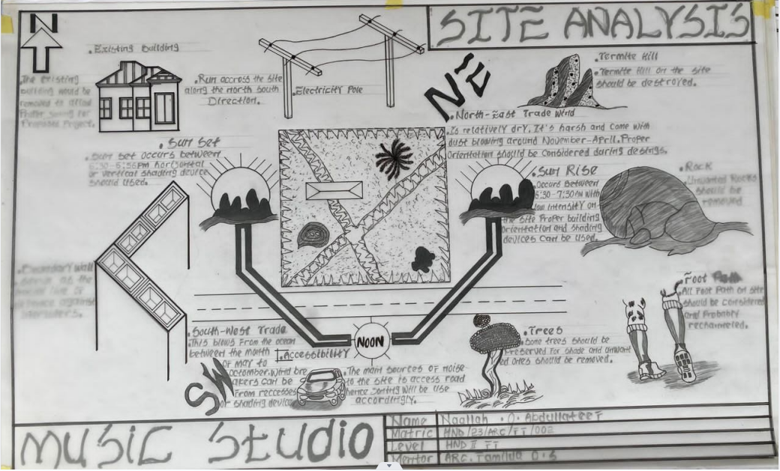
Plate 4.2 Site Analysis
Source; Authors fieldwork

- Rainfall:
Minimum rainfalls are recorded in December, while June offers the most amount of rainfall.
- Vegetation and Topography:
The vegetation on the site consists of few trees of different species and few shrubs. The site is relatively gentle sloping and has a high load bearing capacity soil.
- Prevailing Wind Direction & Sun-Path Angles
The two predominant winds blowing across this area are the South West Trade wind and the North East Trade wind. The former, which blows across the Atlantic Ocean, is characteristically cold and results in the wet season. Being a cold wind, it is capable of holding much moisture contents across the ocean, and hence an increase in relative humidity of the area affected. However, the North East Trade wind, which blows across the Sahara Desert, is dusty and dry wind. Consequently, the two predominant seasons experienced in this area are characteristically marked by the two wind types. The summer (the season between spring autumn when the sun is hot and there are many flowers) is experienced between April and September, when the south west Trade wind is more predominant, while the winter season is shortly marked between November and March, when the north east trade wind is more predominant. This later season {winter} is however characterized by cool and hazy mornings, couple with dusty afternoons, because of the dust particles it brings forth from the desert. To reduce the effects of wind driven, trees were planted.
- Sunrise and sunset:
The sun rises from the east in the early hours of the morning at about 6:30am - 7:00 am and sets in the west at about 6:45 pm in the evening daily.
- Accessibility:
The site is accessible by an existing road along the adjoining buildings which leads to the site.
- Man-made features

- Electricity: Electricity is supply to the site through overhead cables along the site boundary.
- Footpath: There areexisting footpaths on the site which will remove from the site
- Noises: Caused by adjacent structures
  - Proposed Design
The proposed design is the design of a Music studio with emphasis on acoustical optimized and aesthetical pleasing.
    - ​Design Considerations:
The following are the factors considered when designing the building;
- Passive and Active Fire safety: Fire safety measures would be considered in designing the building to increase safety in the building,
- Aesthetics: In any architectural design, aesthetics is most common factor to consider which shall be achieved by the use of attractive and lively finishing materials.
- Functionality: In any architectural design, functionality plays major role, design must be functional to meet the taste and convenience of the occupants.
- Ventilation: This includes the orientation of the building, sizes and locations of fenestrations, vegetation.
- Circulation and Zoning: Appropriate and well-articulated pattern of circulation in a building alleviates confusion and at the same time tailor the movement of students to their respective destination.
- Landscaping: The form of landscaping in the building is aimed at satisfying user requirements, having aesthetic value and improving environmental comfort. Hence, landscaping will be considered in the design
- Security: The provision of security in the hostel involves the protection of the students, the building and its contents.
4.5.2 Design Concept
The design approach was based on functionalism, which is an architectural principle that says that building should be designed based solely on purpose and function of the building.
4.5.3 Brief Analysis
The proposed design is the design of a Music studio with emphasis on fire safety to ensure the safety of the students and occupants.
The hostel is to provide the students with accommodation facilities and other functional spaces and facilities. These facilities include:
- Entrance
- Reception
- Toilets
- Store
- Technical room
- Offices
- Music editing room
- Music studio
- Rehearsal Hall

4.5.4 Schedule of Accommodation
Table 6.1 Schedule of Accommodation
S/NO | SPACE | UNITS | DIMENSION(M) | AREA(M2)
1 | Entrance | 1 | 5.0*11.8 | 59
2 | Reception area | 1 | 7.8*11.8 | 92.4
3 | Toilets | 21.4 | 0.9*2.5 | 2.23
4 | store | 1 | 3.6*5.8 | 20.9
5 | Technical room | 1 | 4.6*4.5 | 14.8
6 | Sectary office | 1 | 2.5*2.0 | 21.4
7 | Director office | 1 | 5.0*4.5 | 28.5
8 | Toilet | 2 | 1.8*8.6 | 4.7
9 | Music editing office | 1 | 7.2*8.0 | 57.6
10 | Cleaners office | 1 | 3.6*4.5 | 16.8
11 | Display room | 1 | 4.5*4.5 | 24.6
12 | Control room | 1 | 3.6*5.8 | 21.6
13 | Music instrument str | 1 | 3.6*4.5 | 16.8
14 | Rehearsal hall | 1 | 7.0*11.25 | 76.6
15 | Changing room | 1 | 3.075*4.5 | 13.9
16 | Toilet | 2 | 1.8*2.5 | 8.8
17 | Music studio | 1 | 7.8*8.0 | 57.6
18 | Toilets | 1 | 2.0*1.2 | 2.4
19 | Exit | 1 | 1.0*1.8 | 1.8
20 | Mixing room | 1 | 4.8*4.5 | 21.6
Source: Author’s fieldwork (2025)
4.6 Specifications and Construction
4.6.1 Material and Finishes
The materials and finishes used plays a vital role to the level of sustainability in the building. To also acoustic considered in the selection of material and finishes. Material and finishes to be used will be discussed further.
4.6.1.1 Walls
Block work will be used in conjunction with double layer gypsum board with acoustic insulation e.g rock wool, which is good for sound insulation and interior acoustic control and the wall will be finish with acoustic fabric panels and timber diffusers.
•4.6.1.2 Floors
The floors will generally be composed of mass concrete of adequate thickness (150mm) as the over site concrete with hard-core filling beneath the mass concrete. The floor finishes would be Floating floor system with vibration isolators, layered with plywood and acoustic mats. toxic fumes which it is called hardwood flooring with rug inserts in performance area which the purpose for this material is to minimize structure borne noise and improve aesthetics.
4.6.1.3 Ceiling
A good ceiling material for a music studio must be durable, easily cleaned, acoustically accepted. Plaster or acoustic tiles are to be used in studio area the noise generated by traffic. The acoustical materials and its wrappings must be those that are non-combustible.
      - Roof
The trusses roofing structure will be used, while the roof covering will be of aluminium long span roofing sheets.
      - Windows and Doors
Music studio facility doors should possess the following qualities:
- The doors must be easily operated
- Escape doors will open in the direction of escape.
So generally, flush and metal doors, glass panels in aluminium frames will be used throughout.
Aluminium frame casement window with integrity and insulation glass will be used for the glazing.
Integrity and insulation glass, when exposed to a fire, prevents flames and hot gases from penetrating through and also maintains the average temperature of the unexposed surface to below 140C.
4.6.2 Structural System
The structural systems of the proposed project (divided into sub-structure and super-structure) include foundation, walls, columns, beams, roof, etc.
- Sub-structure (Foundation)
A foundation is the lower portion of a building structure or substructure that transfers all coming load of the structure to the ground. The foundation system must distribute vertical loads and hold the super structure of the building against uplift and racking forces.
The nature, texture and composition of the soil in the site show that it has a high load bearing capacity. The use of a deep strip foundation is being proposed.
- Super-structure
The super-structural systems such as walls, floors and roofs of the proposed music studio shall be constructed with adherence to the specifications already stated under the materials and finishes section.

    - Building Service
- Power Supply.
The main source of power supply to the proposed building will be from the area PHCN. Due to the fluctuation in power from PHCN, it will be connected to theindependent power source to cater for the requirements of the studio.
Dedicated power lines with isolated grounding are used to prevent electrical hum and interference in audio equipment.
Surge protection systems are installed to protect sensitive gear from power fluctuations.
Electrical panels and cabling are routed away from high-sensitivity recording areas and enclosed in sound-insulated conduits.
Dimmable LED lighting is preferred for its low heat emission and silent operation, allowing control over mood and ambiance without noise.
- Lighting
The effect of natural lighting was greatly considered within the building. This factor is one which is largely considered in buildings. Adequate fenestration is provided within each space for effective luminosity, the courtyards also aid natural lighting flow, artificial lighting will be in the form of incandescent luminaries which will maximize direct light into the space.

HVAC (Heating, Ventilation, and Air Conditioning)
Silent HVAC systems are essential. Equipment such as ductless mini-splits or low-velocity central systems are used.
Ducts are lined with acoustic insulation, and flexible duct connectors reduce vibration transfer into rooms.
Ventilation silencers (acoustic attenuators) are installed at air inlets and outlets to suppress air rush noise.
Separate climate zones ensure that each studio space can be independently conditioned without sharing airflow, which prevents noise leakage.

Plumbing and Drainage
Pipe routing avoids direct contact with studio walls and floors. Pipes are suspended using acoustic hangers to reduce impact sound.
Water supply and waste lines are insulated to prevent flow noise from transmitting into recording spaces.
Bathrooms and plumbing-heavy spaces are located away from acoustically sensitive areas like vocal booths or control rooms.

Fire Protection Systems
Fire alarms and sprinklers are selected for low-noise activation mechanisms.
Firerated acoustic materials are used in doors, walls, and ceilings to maintain both safety and sound isolation.
Ventilation systems include fire dampers with acoustic linings to block both smoke and sound.

Audio/Visual and IT Infrastructure
Integrated cable management systems are built into floors and walls to avoid surface clutter and signal interference.
Use of balanced audio lines, shielded data cables, and isolated grounding pathsensures clean signal flow with minimal noise.
All conduits are sound-isolated from walls and structural components to prevent vibration transmission.
- Drainage and Sewage Disposal
Surface water will be drained out to the direction of flow towards the topography of the site while an underground system of sewage disposal such as inspection chambers, septic tanks and soak away pit shall be utilized through the connection of 300mm poly vinyl chloride (PVC) channels and pipes.
- Refuse Disposal
Solid waste from site is collected by placing dustbins, open cans and baskets at strategic positions in every facility provided in the studio.

4.6.4 Landscaping and External Works
Landscaping deals with an alteration of the earth’s existing feature, planting tree, shrubs and flowers to re-create an environment more habitable, aesthetical and functional to man.
Landscape features provide a major aesthetic benefit to any environment. The main objective is to create a good interrelation between the building and the site. And to also integrate available site features to its utmost advantage.
For the purpose of this project, both the soft and hard landscape were used. such as the use of different shrubs and trees that will survive well and add to the environment positively, well paved walkways for easy access and link to various buildings, Proper vehicular access such that there is a well-coordinated flow of traffic within the premises and also provision of adequate parking spaces.
The site can be accessed from 1 points. The main access (gate) to the studio is from the south-west of the site.
  - Chapter Summary
To conclusively achieve the specific objectives of this project, the broad-based guiding principles have to be anchored on a well thought out design philosophy. This philosophy is one that has to touch on the fundamentals of building with regards to the characteristics of its location and the peculiarities of its environment.
The philosophy here emphasizes the approach of broad based targets in designing for a diverse variety of people, providing them with environment in which the mind and the spirit can be refreshed and the body find relaxation and rest while away from home in pursuit of an academic excellence.

CHAPTER FIVE

5.0 DESIGN APPRAISAL
5.1Introduction
This chapter presents a critical evaluation of the proposed music studio design in terms of functionality, aesthetics, structural composition, and acoustic optimization. It outlines how the design addresses the problems identified earlier in the research and assesses its performance based on architectural and acoustic criteria. It also includes recommendations for future development and concludes with a summary of findings.

5.2 Design appraisal
The proposed music studio design successfully integrates acoustic performance with architectural aesthetics. Key spatial zones such as the control room, live room, vocal booth, and lounge were laid out to support smooth workflow, sound isolation, and sound quality. Materials used in interior finishessuch as acoustic foam, bass traps, carpet tiles, and wooden diffusersenhance the acoustic integrity while contributing to the modern look of the studio. The zoning of noisy and quiet areas ensures minimal sound interference, while adequate lighting, ventilation, and circulation improve user comfort. Overall, the design meets the functional demands of a professional studio while maintaining an inspiring creative atmosphere.

5.3 Building structure
The structural framework is designed to support the studio’s acoustic goals. Reinforced concrete foundations and framed walls with double-layered gypsum and insulation help block external noise and reduce sound transmission between rooms. The floating floor system in the recording areas minimizes structural vibration and impact sound, while isolated ceiling panels help control reverberation. The roof structure is insulated with dense mineral wool and reflective barriers to ensure both thermal and acoustic efficiency.

5.4 Recommendation
Future Expansion: Provision should be made for modular expansion of rehearsal or production rooms.
Sustainability: Integrate more sustainable materials such as bamboo acoustic panels or recycled textile absorbers.
Smart Technology: Future designs can incorporate smart lighting and climate control systems to further improve the studio experience.
Accessibility: Ensure better access for physically challenged users through ramps, acoustic door handles, and wide corridors.

5.5 summary and conclusion
The proposed music studio design demonstrates that acoustic performance and aesthetic appeal can coexist effectively in architectural design. Through careful material selection, spatial planning, and structural integration, the design achieves both functional and sensory goals. All aspects of the studio, from the control room to the soundproof doors and HVAC placement, contribute to a high-performing recording environment.
5.6 Summary
This chapter provided a design evaluation of the proposed music studio. It discussed the design’s strengths, assessed its structural support, and offered practical recommendations for improvement. The acoustic strategies employed were analyzed in relation to their architectural impact.
5.7 Conclusion
The project achieves its aim of creating a well-structured, acoustically treated, and visually appealing music production environment. It responds to identified design challenges while providing flexibility, comfort, and creative ambiance. With slight improvements in sustainability and accessibility, the design stands as a model for future music studios in similar urban Nigerian contexts.

REFERENCES
Akustiks. (2018). Acoustics in recording studios: Design principles and solutions. Retrieved from https://www.akustiks.com
Cox, T. J., & D’Antonio, P. (2004). Acoustic absorbers and diffusers: Theory, design and application (2nd ed.). CRC Press.
Everest, F. A., & Pohlmann, K. C. (2015). Master Handbook of Acoustics (6th ed.). McGraw-Hill Education.
Hodgson, M. (1999). Experimental investigation of the acoustical characteristics of rooms used for music rehearsal. Applied Acoustics, 57(3), 185–208. https://doi.org/10.1016/S0003-682X(98)00056-5
Kolseg. (2023). Best Photography and Music Studio in Ewupe, Sango-Ota. Retrieved from https://kolseg.com.ng
Long, M. (2014). Architectural Acoustics (2nd ed.). Academic Press.
Ng.worldorgs.com. (2023). Epoch House Studios - Ilorin. Retrieved from https://ng.worldorgs.com/catalog/ilorin/recording-studio/epochhousestudios
Ng.worldorgs.com. (2023). JLO Studio - Ogbomosho. Retrieved from https://ng.worldorgs.com/catalog/ogbomosho/music-management-and-promotion/jlostudio
Santucci, A. (2020). Designing small music studios: Acoustics and spatial planning. Journal of Architectural Acoustics, 8(1), 32–47.
Toole, F. E. (2008). Sound reproduction: The acoustics and psychoacoustics of loudspeakers and rooms. Focal Press.

APPENDIX
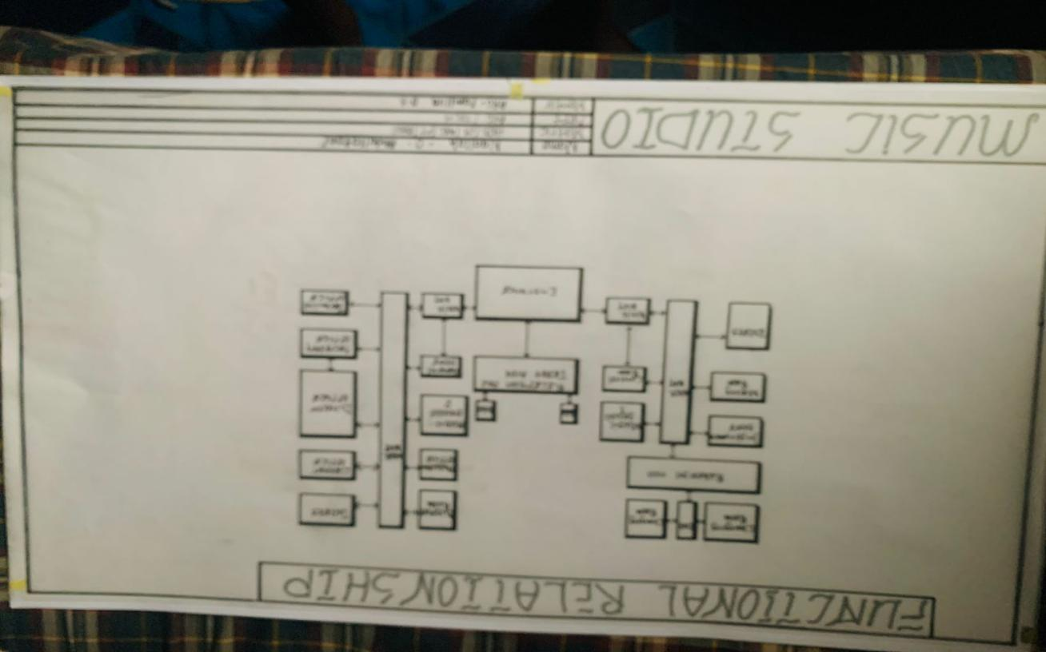
Appendix 1
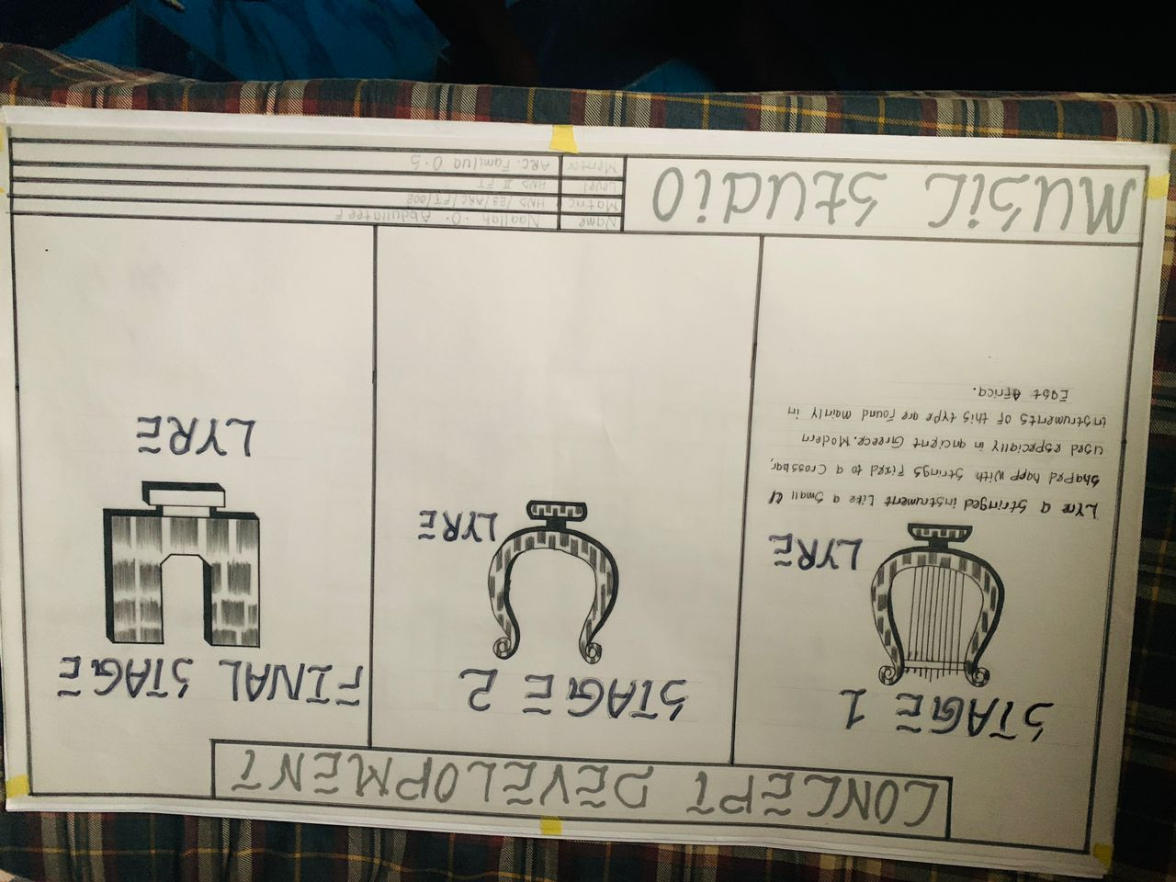
Appendix 2
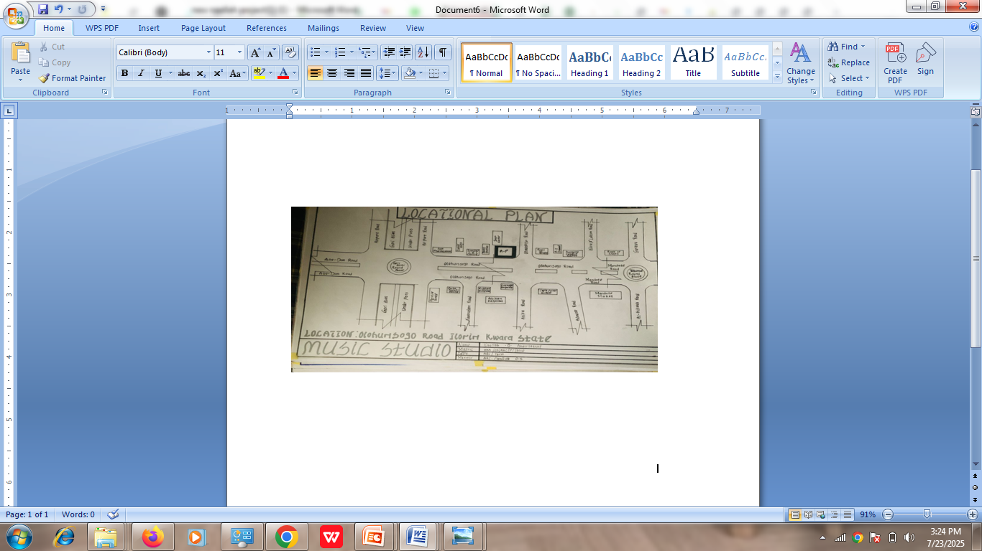
Appendix 3
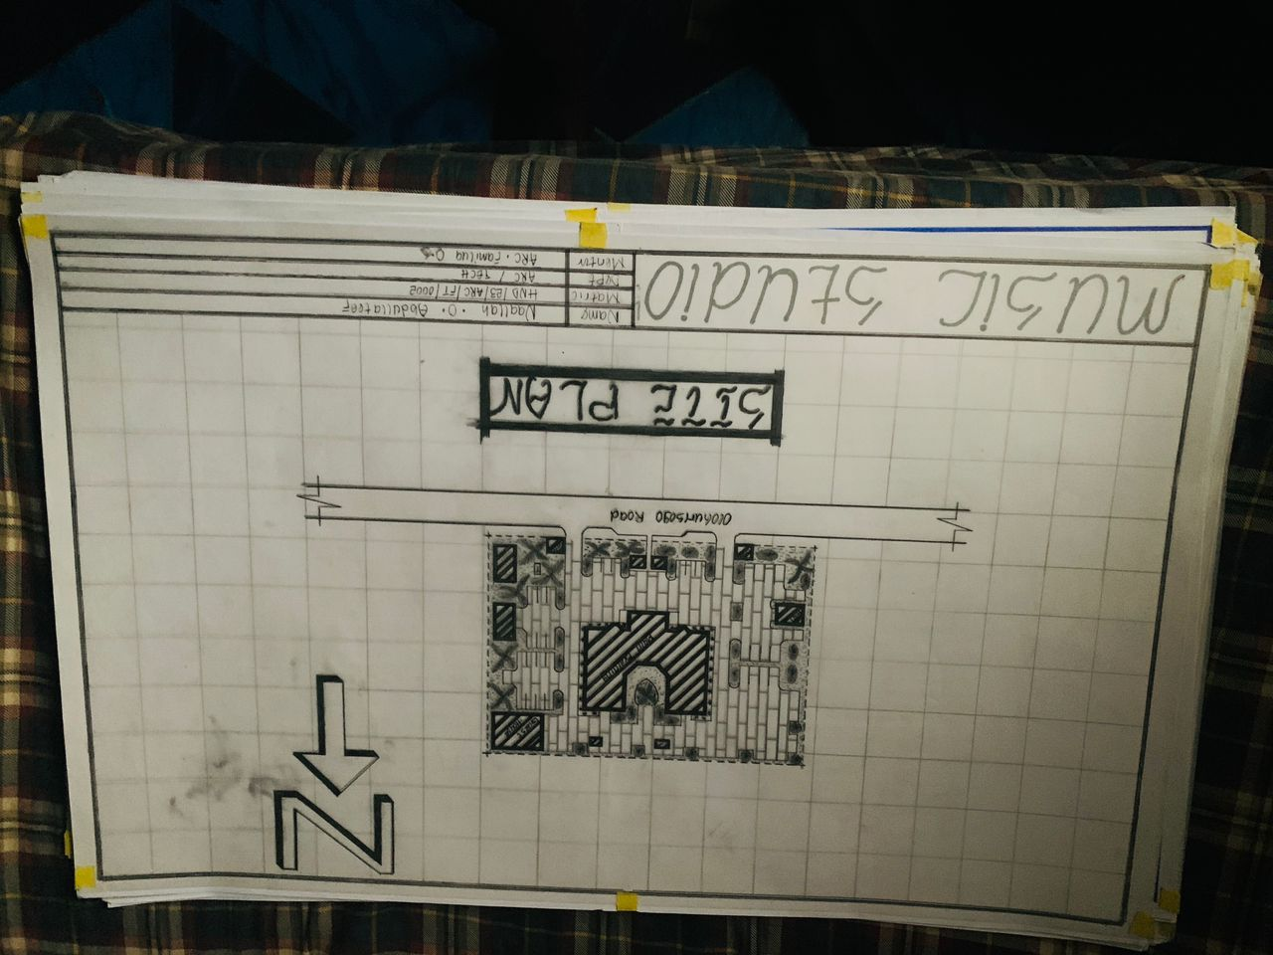
Appendix 4

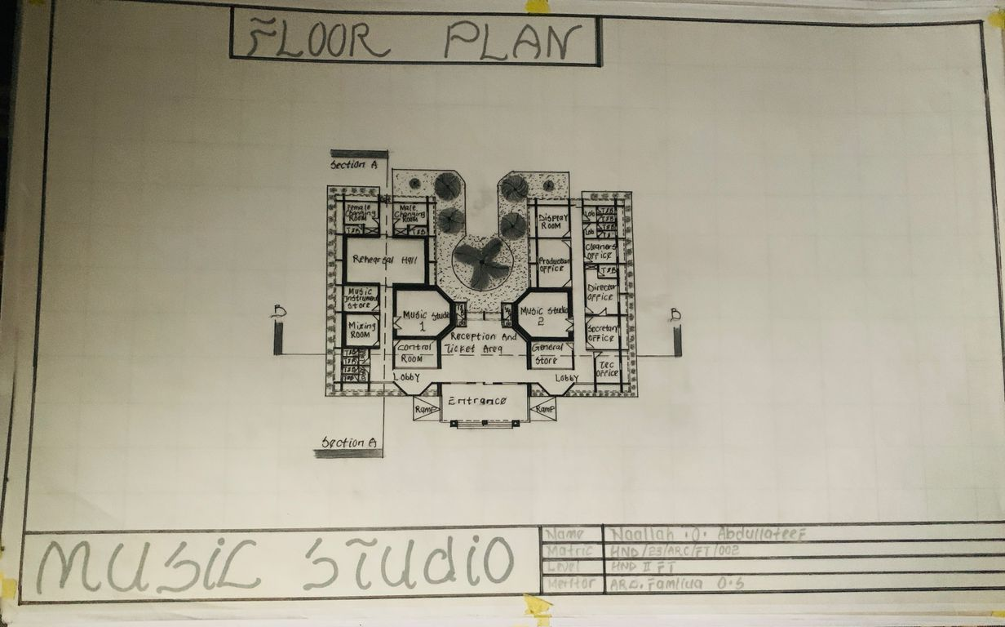
Appendix 5
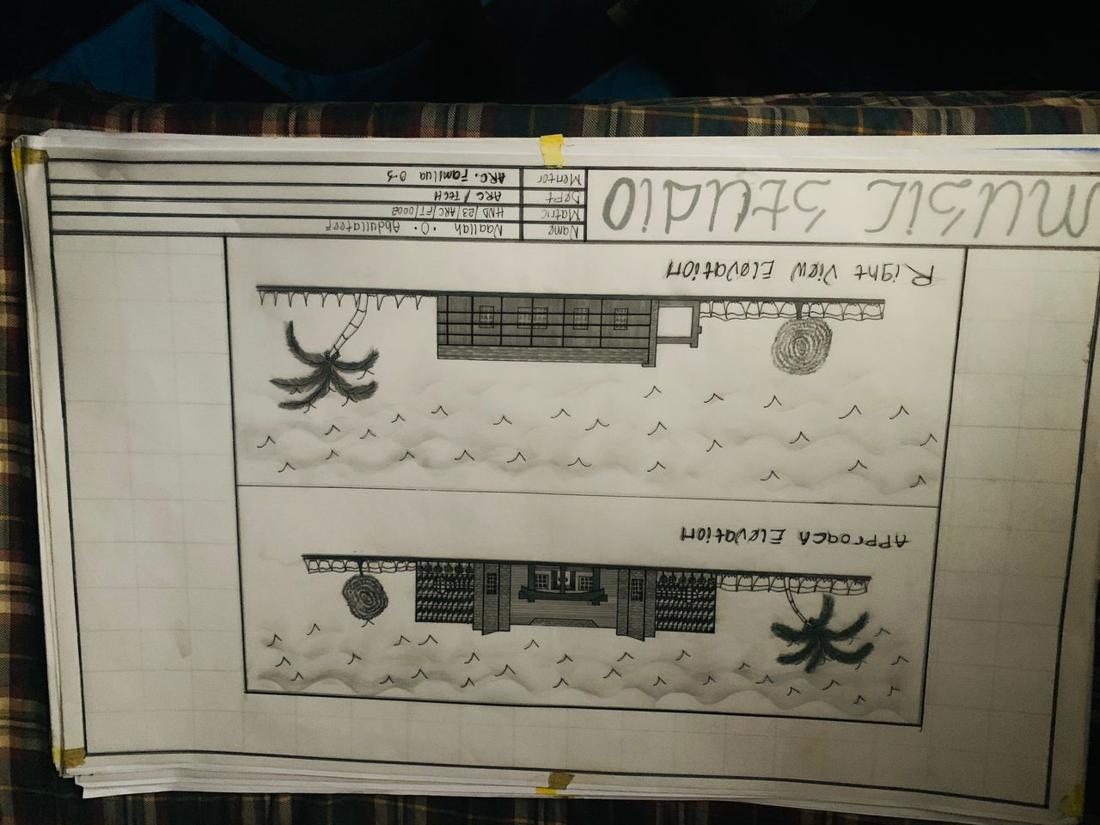
Appendix 6

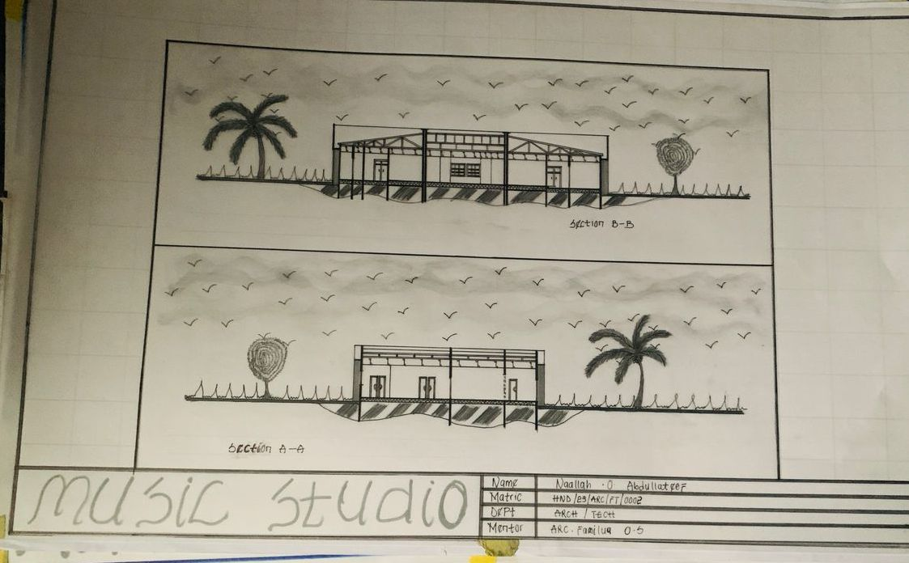
Appendix 7
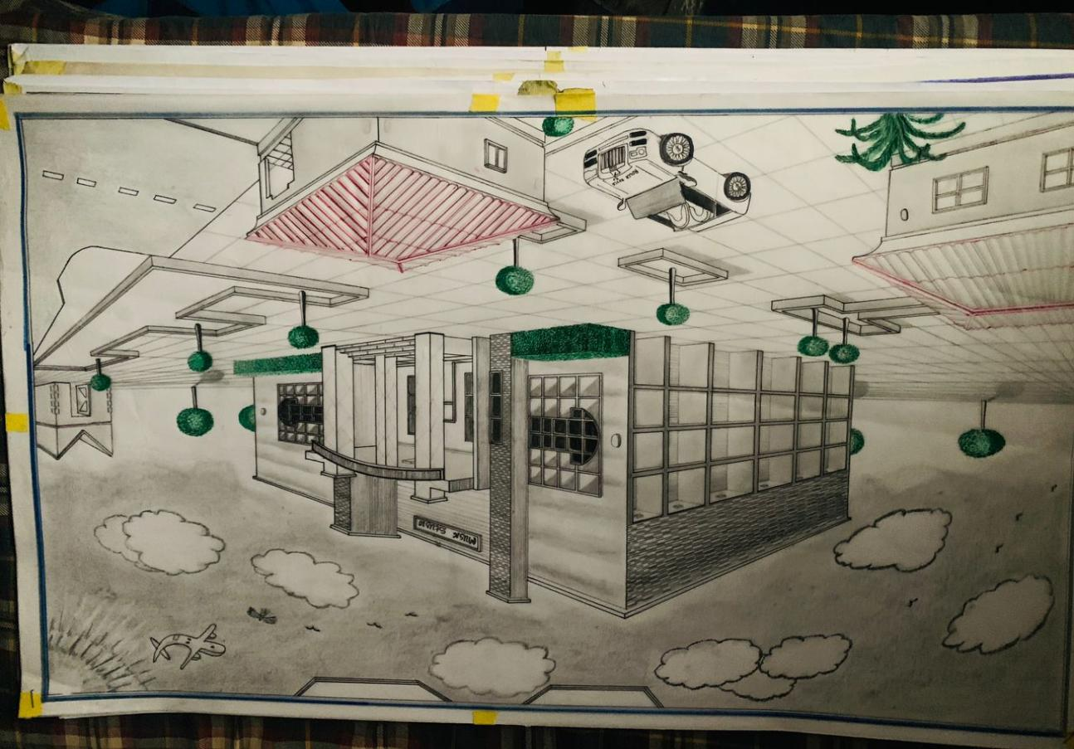
Appendix 8

