A PROJECT REPORT
ON
A PROPOSED FARM SETTLEMENT
For
AGRICULTURAL DEVELOPMENT
BY
ADEBAYO MUBARAK ADESINA
HND/23/ARC/FT/0059

SUBMITTED TO
DEPARTMENT OF ARCHITECTURAL TECHNOLOGY, INSTITUTE OF ENVIRONMENT STUDIES, KWARA STATE POLYTECHNIC, ILORIN

BEING A DISSERTATION SUBMITTED TO THE DEPARTMENT OF ARCHITECTURAL TECHNOLOGY, INSTITUTE OF ENVIRONMENT, KWARA STATE POLYTECHNIC, ILORIN

IN PARTIAL FULFILMENT OF THE REQUIREMENTS FOR THE AWARD OF HIGHER NATIONAL DIPLOMA IN ARCHITECTURAL TECHNOLOGY KWARA STATE POLYTECHNIC,
ILORIN, KWARA STATE.

JULY, 2025

DECLARATION
I declare that this Project/Dissertation is a product of my personal research work. It has not been presented for the award of any degree in any Polytechnic. The ideas, observations, comments, suggestions herein represent my own convictions, except quotations, which have been acknowledged by means of reference under ARC ABDULAZEEZ B.Y.F.

Adebayo Mubarak Adesina
HND/23/ARC/FT/0059

Signature: _____________

Date: _____________

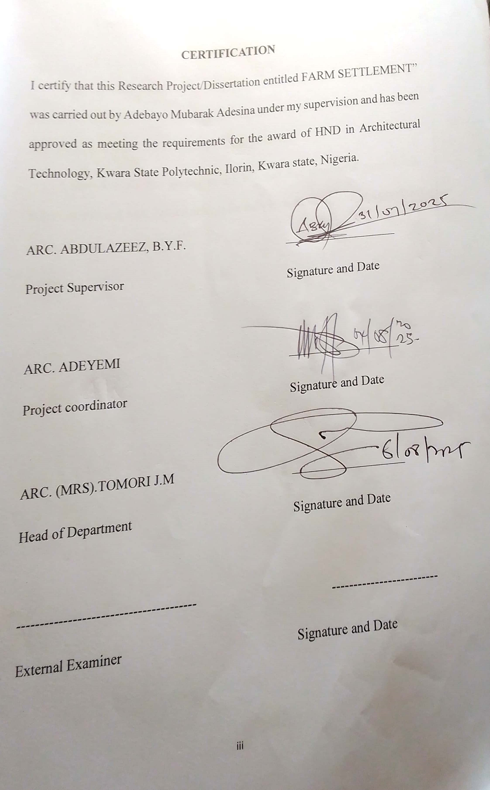
DEDICATION
I dedicate this project to my family, teachers, and friends, whose support and encouragement have helped me throughout this journey. Their guidance, inspiration, and belief in me made this work possible.
I also dedicate this project to my beloved and wonderful parents Alh. Yakub Adebayo & Mrs. Zarat Adebayo for their love, kind, support and provision during the time of this project

ACKNOWLEDGEMENTS
I would like to express my sincere gratitude to all those who supported and guided me throughout this project.
First and foremost, I would like to thank my mentor, ARC. Abdulazeez, B.Y.F for his valuable guidance, encouragement, and constructive feedback during the course of this project.
I also want to appreciate my project coordinator Arc. Olarewaju F.A, my HOD Arc. (MRS) J.M Tomori and all my lecturers in the department of architecture Kwara state polytechnic, Ilorin, both academic and none academic.
A special thanks to my parents Alh. Yakub Adebayo & Mrs. Zarat Adebayo and friends for their continuous support, motivation, and understanding throughout this journey.
Lastly, I am thankful to everyone who directly or indirectly helped me in the completion of this project.

ABSTRACT
Farm settlements are planned rural communities, often established by governments that aim to promote agricultural development and improve the socioeconomic conditions of rural populations according to CABI Digital Library. These settlements typically involve the provision of land, resources, and infrastructure to farmers, with the goals of increasing agricultural productivity, creating employment opportunities, and discouraging rural-urban migration. They can also serve as models for modernizing traditional agriculture and improving living standards in rural area. The research project is limited to farm settlement, other factors that restrict over to the project that most of the respond are negative to true information concerning themselves of heavy and levy or counter action against them. The method of research in order to arrive at a functional and appealing design, different type of matter were adopted in carrying out the research work of the project are CASE STUDIES, ONLINE RESEARCH, AND ORAL OVERVIEW.

TABLE OF CONTENT
TITLE PAGE
DECLARATION
CERTIFICATION
DEDICATION
ACKNOWLEDGEMENT
TABLE OF CONTENT
LIST OF TABLES
LIST OF PLATES AND FIGURE
CHAPTER ONE
- Introduction
  - Historical Background
  - Definition
  - Aim and Objectives
  - Methodology
  - Limits and Constraints
  - Justification
CHAPTER TWO
- Literature Review of Case Study
  - Selected Case Studies
    - Case Study One
    - Case Study Two
    - Case Study Three
CHAPTER THREE
- Site and Environmental Analysis
  - Site Location/Description
  - Site Location Criteria
  - Site Inventory/Analysis
  - Geographical Characteristics
  - Climatic Characteristics
  - Infrastructure
  - Conclusion
CHAPTER FOUR
- Design Criteria
  - Site Planning
  - Brief Analysis
  - Space Allocation
  - Functional Relationship
  - Space Calculation
  - Conceptual Development
CHAPTER FIVE
- Appraisal of Proposed Scheme
  - Design and Construction
  - General Design Consideration
  - Construction Method and Material
  - Landscape Element used in the Design
  - General Maintenance
  - General Conclusion and Recommendation
  - References
  - Appendix

LIST OF FIGURES
Figure 1: The geographical map
Figure 2: The site location of the proposed site
Figure 3: Concept derivation
Figure 4: The site plan of the proposed site
Figure 5: The Floor Plan of the Proposed Project
Figure 6: The Roof Plan
Figure 7: The Approach Elevations
Figure 8: Section
Figure 9: Perspective

LIST OF PLATES
Plate 1: The locational plan of case study one
Plate 2: Showing site plan of case study one
Plate 3: Showing floor plan of case study one
Plate 4: Showing pictures of case study one
Plate 5: the locational plan of case study two
Plate 6: showing site plan of case study two
Plate 7: Showing floor plan of case study two
Plate 3: Showing pictures of case study two
Plate 8: The locational plan of case study three
Plate 9: Showing site plan of case study three
Plate 10: showing floor plan of case study three
Plate 11: Showing pictures of case study three
Plate 12: The locational plan of case study four
Plate 13: Showing site plan of case study four
Plate 14: Showing floor plan of case study four
Plate 15: Showing pictures of case study four
Plate 16: Showing the picture of online case study one
Plate 17: Showing the picture of online case study two

CHAPTER ONE
1.0 Introduction
Farm settlement as a planned agricultural community represent a multifaceted approach to the rural development. The concept of farm settlement is not new historically, these settlements emerged as a strategy to adhere various socio-economics challenges. Post worldwar II, many nation sought to resettle veterans and boost agricultural production. Israel’s Kibbutzim and Moshavim, collective and cooperative agricultural communities respectively serve as notable examples of farm settlement models. These initiative aimed to create self-sufficient communities, while promoting social equality. In Nigeria farm settlement were introduced in the 1950s and 1960s to modernize agriculture, attract young people to farming and increase food production. These early settlement provided infrastructure training and access to resources for participating farmers.
The impact of farm settlements is complex and varies depending on the specific context and implementation strategies. In some, gases these settlement have contributed significantly to increase agricultural output and rural development by providing farmers with access to load, technology and markets farm settlement can enhance productivity and improve live hoods more over these settlement can serve as centres for innovation and knowledge transfer promoting the adoption of sustainable agricultural practices. However farm settlements have also faced numerous challenges poor planning inadequate infrastructure, lack of access to credit and land tenure issues have hindered the success of many initiatives. Social and environmental concerns. Such as displacement of local communities and unsustainable resources management have also been raised.
Looking ahead, the future of farm settlements will depends on their ability to adopt to changing socio-economic and environmental conditions. Climate changes urbanization and globalization pose significant challenges to agricultural productive and rural livelihoods. Farm settlement need to the dynamic environment. Investing in education, training and research is essential to equipment farmers with the skills and knowledge needed to succeed. Promoting collaboration among farmers’ researcher, policy makers and the private sector can be faster innovation and accelerate the adoption of sustainable agricultural practices. Addressing land tenure issues and ensuring equitable access to resource are crucial for promoting social justice and empowering rural communities.
Historical Background
The origin of farm settlements are intertioned with the Neolitic revolution, approximately 10,000 years ago. This period marked a shift from nomadic hunger-gatherer life styles settled agricultural practices. Early farm settlement were characterized by small scale – scale sustenance farming.
These communities cultivated crops like wheat, barleg and rice, the Fertile Crescent in the Middle East is recognize as one of the earliest centre of agricultural innovation. The development of irrigation systems was a pivotal advancement. It enabled farming in drier region. The Mesopotamians were pioneer in irrigation they created elaborate canal network to manage water resources.
The middle ages witnessed significant changes in farm settlement pattern in Europe. The open field system was a common practices, land was divided into large, unfenced fields individual farmers cultivated strip with in these fields, the three field rotation system become widespread.
The Columbian exchange initiated in the 15th century led to the transfer of plants, animals and agricultural techniques between old world and the new world. Crop like potatoes, tomatoes and maize were introduced to Europe. They had a led to the establishment of farm settlement in a territories.
The 18th and 19th centuries marked the onset of the Agricultural Revolution, new farming techniques and technologies dramatically increased agricultural output. Crop rotation become more sophisticated the use of fertilizer improve soil fertility. The invention of the seed drill by Jethro Tull evolutiorized planting practices. The development of farm machinery increased productivity. The 20th and 21st centuries, have witnessed further intersification and industrialization of agriculture. The Green revolution beginning in the mid 20th century, introduced high yielding crop varieties fertilizer and pesticides to a developing countries. Norman Borling is often credited as the father of the Green Revolution, His work significantly increase food production in countries, like India and Mexico. The development of genetically modified (GM) crop has been a subject of debate proponent argues that GM crop can increase yield reduce pesticide use and enhance nutrient content.
The evolution of farm settlement reflect humanity enduring relationship with land from early subsistence farming to modern industrial agriculture farm settlement have undergone a remarkable transformation. As we face the challenges of the 21st century a focus on sustainability innovative and resilience will be essential to ensure the future of farm settlement and global food security.
Definition
Definition of the key words which are “farm” and “settlement”
Farm can be defined as an area of land used for a agricultural production raising livestock or cultivating crops. Settlement in farming is seen as the establishment of a community or village in an area primarily dedicated to agricultural activities, these settlement are typically located near arable land and water sources to support farming practices. The presence of settlement in farming area allows for the development of a local economy based on agriculture as well as formation of social structures and support networks with in the community.
Farm settlements are planned communities designed to promote agriculture, improve rural livelihoods and faster regional development. These settlements typically involves the allocation of land provision of infrastructure and extension services to farmers. Farm settlements are complex agricultural initiative with a rich history and diverse impact while they offer potential benefit in terms of increased productivity and rural development, they also pose challenges related to sustainability and social equity. The successes of farm settlement depends on careful planning effective management and the active participation of all stakeholders. By learning from past experience and embracing innovation, farm settlements can contribute to a more food secure and sustainable future.
Aim
To design a farm settlement employing a holistic architectural approach that integrate agricultural functions with residential and community needs while prioritizing sustainability and local context.
Objectives
- To design appropriate road networks for farm machinery, delivery vehicles and pedestrian access ensuring smooth movement and minimizing congestion
- To design homes that provide adequate space, natural light, ventilation and privacy for farm residents
- To design the settlement to minimize soil erosion, preserve biodiversity and protect natural ecosystems.
- Optimize design and material selection to reduce construction and maintenance costs without compromising quality or functionality.
Justification of Study
This project seek to design a standard farm settlement to improve to production and employment of mechanical input in productions. There is an increase rate of development in the country but agriculture is decreasing throughout the nation and this intends to increase robbery rates, frauds and illegal act in this nation. So I am designing farm settlement in other to enhance large productivity and provide job opportunities for the youth and farmers.
Limitation of the Study
Farm settlements design to boost agricultural production and improve rural livelihood faces numerous limitation, these constraint hinder their effectiveness and overall success necessitating a critical examination to understand their impacts and identify potential solution one of the significant limitation is inadequate infrastructure; many farm settlements lack sufficient roads, storage facility and irrigation system. This deficiency impede the transportation of product to market, lead to post harvest losses and reduce income for farmers.
Another critical limitation is limited access to credit and financial services farmers. In these settlements often lack the collateral required to secure loans from formal financial institution. This financial constraint perpetuates a cycle of low productivity and poverty.
Moreover, inadequate training and extension serves blinder the adoption of modern farming practices many farmers in farm settlement lack the knowledge and skill required to optimized their production.
Social and demographic factor also play a role in limiting the success of farm settlement. Rural area often experience an encode of young people seeking better opportunities in urban centre, leading to an aging faming population.
This demographic shift can result in a shortage of labour and a lack of innovation in agriculture.
Research Methodology
In order to achieve a well-functioning and well organizing farm settlement and to know what the farmers need. The research was done.
Case Study: Visiting the existing on to know what is requirement and demerit.
Literature Survey: Consulting some architecture text book on farm communities.
Internet: Going through online research for more information on how it done in other countries and have more understanding.
Personal Observation: Personal limitation couple with ingenitive inpasure, interview and visitation were made in order to visualize the activities that takes place within the school and necessary pictures were taken in order to attain the require motive.

CHAPTER TWO
LITERATURE REVIEW
A literature review on farm settlements typically explores their historical context¸ socio-economic impacts, challenges, success factors, and the role of government policies. While the concept of “farm settlement” can be broad. It often refers to planed agriculture communities established with specific development goals, frequently seen in developing countries.
Historical context and evolution
Farm settlement schemes have a rich history particularly in post – colonial national aiming for agricultural development, food security and rural employment.
Origin and Objectives
Many farm settlement schemes such as those implemented in Nigeria (particularly in Western Region I the 1950s and 60s), were inspired by models like the Israeli-Mostiavim. Their primary objectives often included.
- Attracting educated young people to farming to curb rural – urban migration.
- Promoting modern agricultural technique and increasing productivity
- Creating employment opportunities in rural areas
- Achieving food self – sufficiency and generating foreign exchange through export crops
- Promoting rural development through the provision of infrastructure and social amenities (Abiola, 2020; Iwuechukwu and Igbokwe, 2012; Jaeger, 1981)
Phases of implementation
Historically, these scheme have undergone various phases, from initial ambitious implementations to periods of decline and attempts at revitalization. For instance, in Nigeria, despite initial successes in job creation, many scheme, deteriorated due to various factors and have seen reintroduction attempts by successive government (ILARD, 2024; Digikogu, 2021).
Socia-Economic Impacts
Farm settlements have had diverse socio-economic impacts both positive and negative.
Employment Generation: Historically, farm settlements have been credited with creating significant employment opportunities, especially for youth and helping to alleviate unemployment in rural areas (JIARD, 2024).
Increased Agricultural Production: The scheme aimed to boost food production for a growing population and provide raw materials for industries. While some successor were recorded, consistent high productivity has been a challenge (Ajadi and Falusi, 2011).
Income Improvement: For participating farmers, farm settlements, could potentially improve income, particularly when coupled with access to credit, improved inputs, and effective marketing channels (Acta Universitis Agriculture Et Silviculturae, Mendelian Brunensis, 2017).
Rural Development: The establishment of farm settlement often included provisions for basic infrastructure like housing, schools, markets, and roads, contributing to overall rural development and improving the quality of life for settlers (CABI Digital Libraryy, 2017; Afribary, 2019).
Challenges and Limitation
Despite their noble objectives farm settlement schemes have faced numerous challenges leading to their often limited success or out right failure.
Insecurity: A major contemporary challenges in many regions is massive insecurity, which distrupts farming activities displaces communities and leads to crop losses (IIARD, 2024; CAFs Africa, 2024).
Inadequate Infrastructure: while infrastructure was planned. Its provision has often been insufficient or poorly maintained (e.g poor road network inadequate power and water supply, storage facilities) hindering efficient farming and transportation of produce (IIARD, 2024; JiVA, 2009)
Success Factors: Lesson from both successful and less successful farm settlement initiatives highlight critical success factors.
Access to Quality Inputs and Technology
Availability of high – quality seeds, fertilizers, moder machinery and appropriate technologies (including ICT for weather information and resource management) can significantly boost productivity (Business Gists, 2024; Jiva, 22019).
Training and Extension Services: Continuous training, skill acquisition, and effective agricultural extension services equip farmers with necessary knowledge and best practices (CBN, 2021).
Government Policies and Interventions
Governments play a pivotal role in the successes or failure of farm settlement scheme through the policies and interventions.
Policy Formulation: Comprehensive and programmatic agricultural policies that address land availability, infrastructure, financing training and marketing are crucial (IIARD, 2024; OSGF).
Support Programmes: Various government initiatives, such as the National Accelerated food production programme (NAFPP), Nigerian Agricultural and Cooperative Bank (NACB), Operation Feed the Nation (OFN) and the Anchor Borrower Programme (ABP) in Nigeria, aim to support farmers and boost food security (IIARD, 2024; CBN, 2021).

Case Study
Visiting the existing one to know what is require with their merit and demerit which contain the pictures of the building and the location plan. The case studies involve collecting and analyzing various types of data such as observation, document and archical records about farm settlement. I use this information to understand the underlying causes and factor that contribute to the farm settlement. It used to explore issues, test theories and generate new hypothesis on farm settlement.
Outline of the Case Studies
- Case Study 1: Alao farm at Royal Castle Tanke, Ilorin, Kwara State
- Case Study 2: T-Farm at Oke-Kinira 2021, Ogbomoso, Oyo State
- Case Study 3: Obasanjo Farm at Iseyin Oyo Road, Oyo State
- Case Study 4: Agboola Farm at Asalu’s Compound, Isundunrin, Osun State.
Case Study One (1)
Location: Alao farm was located at No. 2, Second Avenue, Akata Tanke, Ilorin, Kwara State. The description of information about Alao Farm was controlled by the owner of the farm.
History of the Case Study 1
Alao farm was established in 1999 by Alao Raji in Kwara State. The main building was built for farm production for food reflect in the 70s and the farm was also very secure, Alao Raji was expressed hope that when the farm was established the food production will be more essential in the state for job create an increase of agricultural produces.
Merit of Case Study 1
Proper Zoning
Availability of modern equipment and machine
Demerit of Case Study 1
Improper road
Improper layout
Poor ventilation and lightening

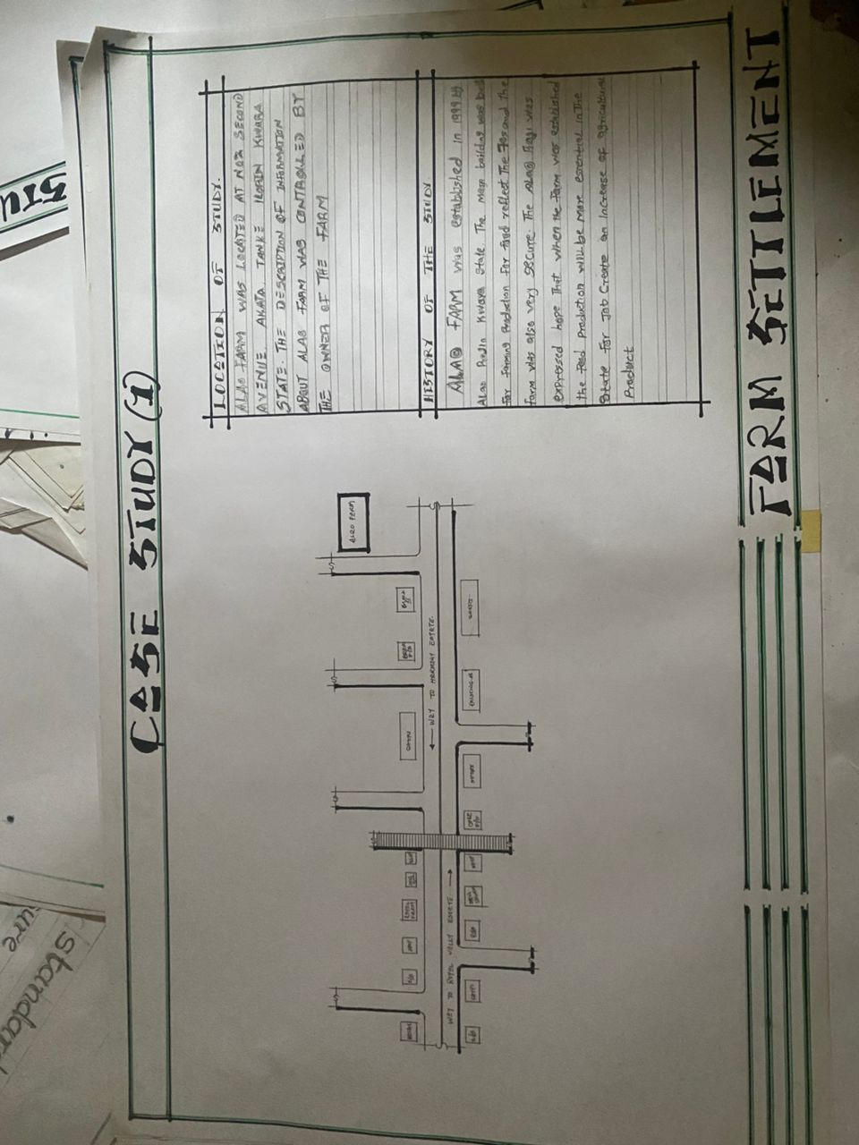
LOCATION PLAN: CASE STUDY 1
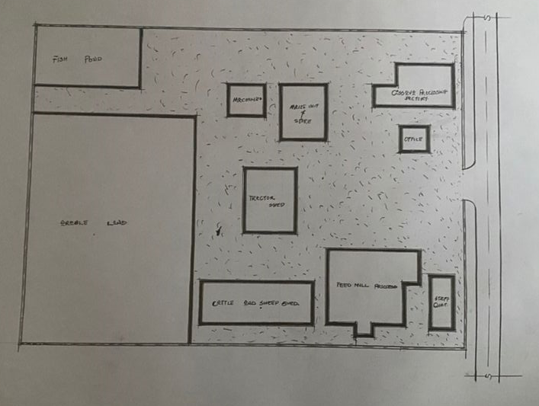
SITE PLAN: CASE STUDY 1
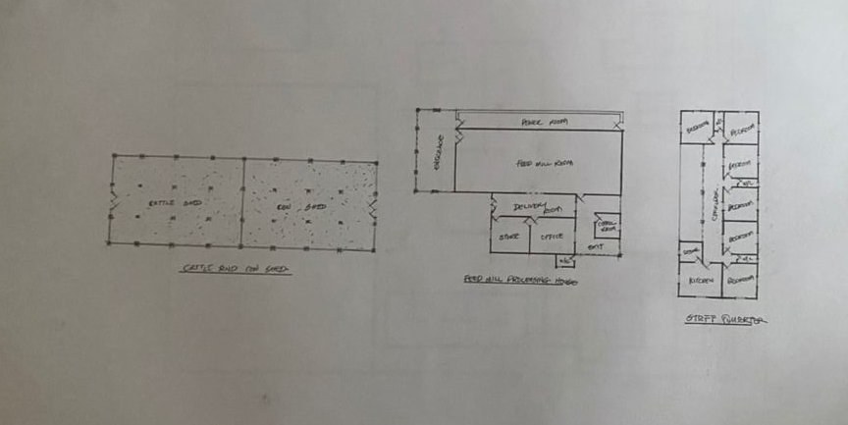
FLOOR PLAN: CASE STUDY 1

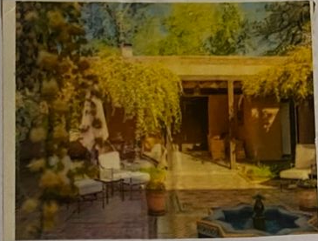

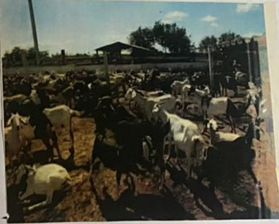

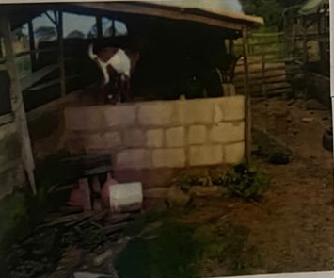


CASE STUDY 1 PICTURES
Case Study Two (2)
Location: T-farm located at No. 5, Ikose road, Kinira 2021, Ogbomoso, Oyo State.
History of the Case Study Two (2)
T-farm was established by Okanlawon Bello in April, (1990) which are used for farming activities and production only in 1996, the settlement was reconstructed for farming, production of food and rearing of livestock to make profit. However, the description of T-farm made for commercial farmers for agricultural productivities and food security.
Merit of Case Study Two (2)
Well organized structure
Availability of trees and shading environment
Demerit of Case Study 2
Unavailability of setback
Unavailability of car park
Inadequate road

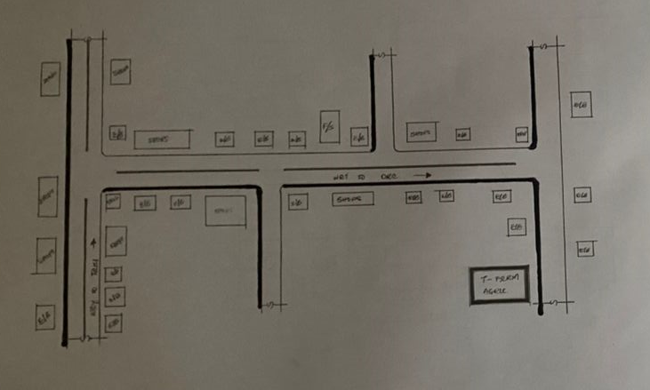
LOCATION PLAN: CASE STUDY 2
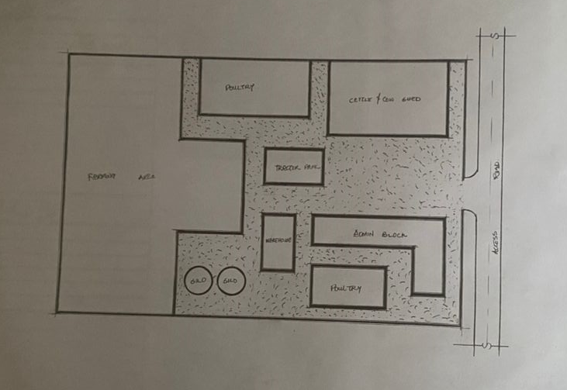
SITE PLAN: CASE STUDY 2
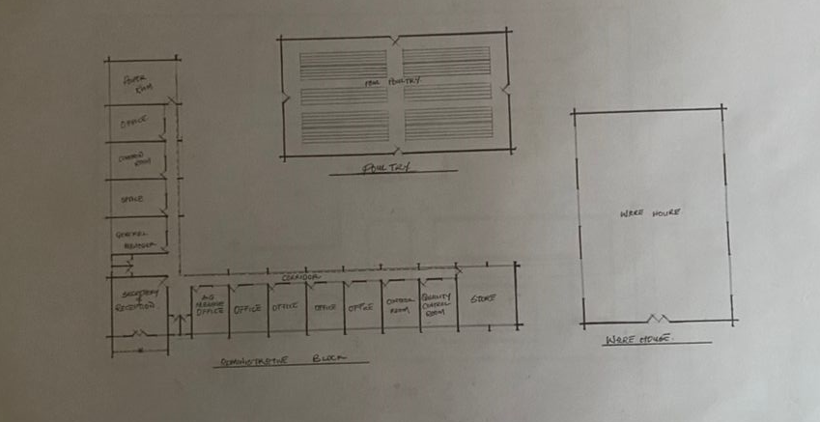
FLOOR PLAN: CASE STUDY 2



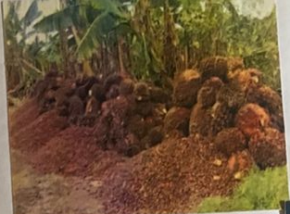

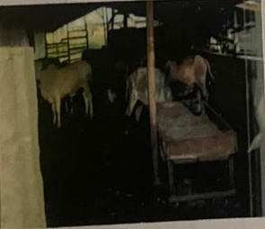

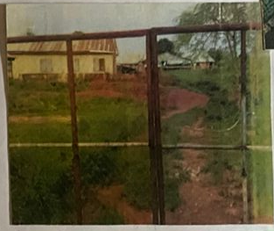
PICTURES OF CASE STUDY 2
Case Study Three (3)
Location: km 29, Iseyin Oyo Road, Oyo State.
History of Case Study 3
Obasanjo farm was established in October 8, 1979 with his poultry farming activities. This initiate agricultural activities, were organized under his temperance Ceterpaso Limited which later become Obasanjo’s farm limited, the farm now Obasanjo Farm Nigeria Limited, has consistently focused on poultry farming including the development of the Obamarshall a Nigeria broiler breed adapted to tropical climate in collaboration with Marshall breeder of India. Over the year, Obasanjo farm has expanded beyond poultry, developing a full circle agribusiness that include livestock, crop field and processing with a focus quality care and innovative.
Merit of Case Study Three (3)
The structure are well placed
It has enough space for future expansion
Easily accessible and enhance patronage
Demerit of Case Study Three (3)
Unavailability of car park
Improper maintenance of farm and amenities

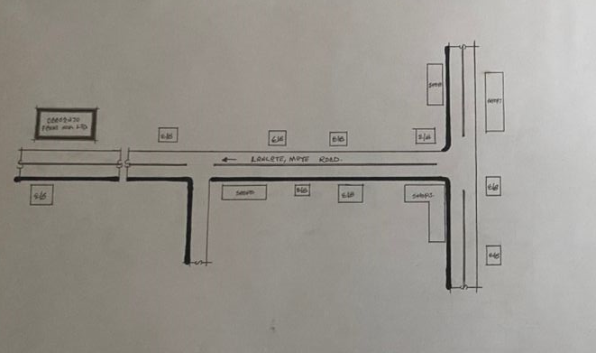
LOCATION PLAN: CASE STUDY 3
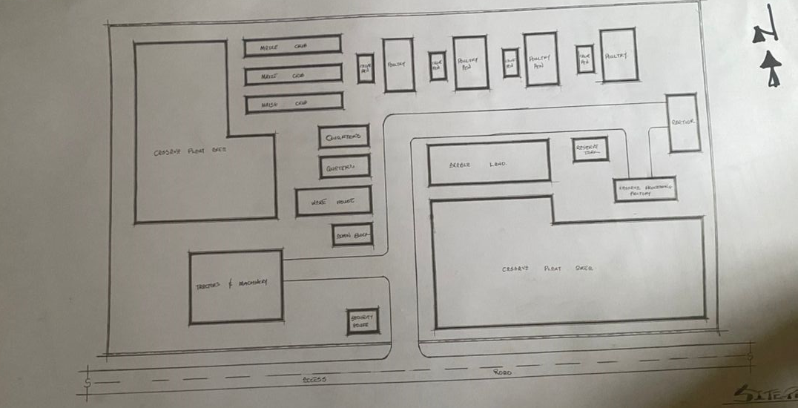
SITE PLAN: CASE STUDY 3
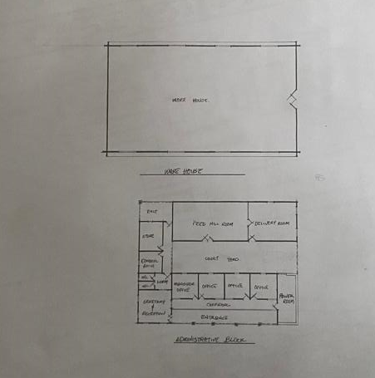
FLOOR PLAN: CASE STUDY 3

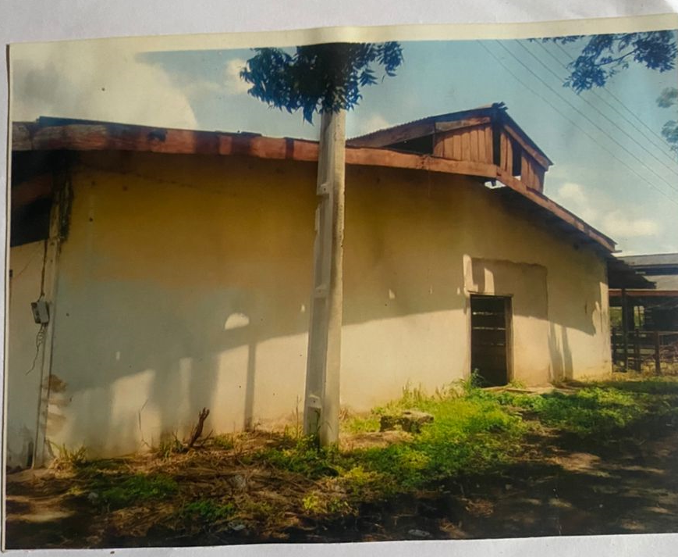

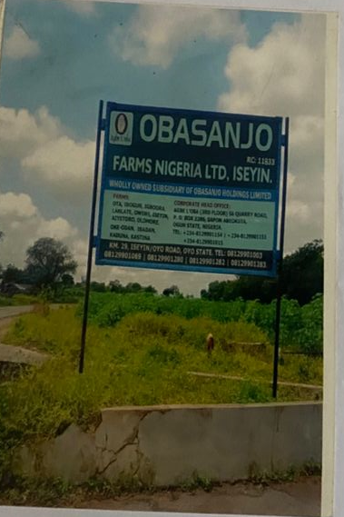

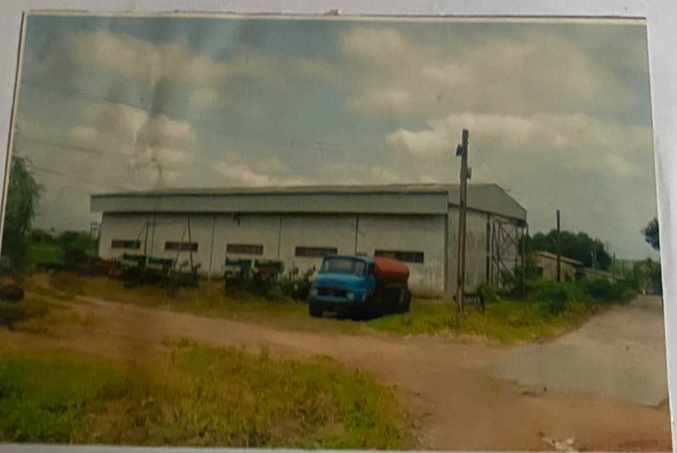
PICTURES OF CASE STUDY 3

Case Study Four (4)
Location: Agboola Farm located at Asalu’s Compound, Isundurin, Osun State.
History of Case Study (4)
Agboola Olarunsogo Farm Limited was incorporated in Isundurin, Osun State, Nigeria with the registration numbers of 199282, it was registered on 25th June 1992 and its based on production and rearing of livestock farming and also crop plantation.
Merit of Case Study Four (4)
Good road network to the site
Structure are well placed
Enough space for future expansion
Easy access to site that enhance patronage
Demerit of Case Study Four (4)
Poor landscaping
Improper maintenance of farm and animals.

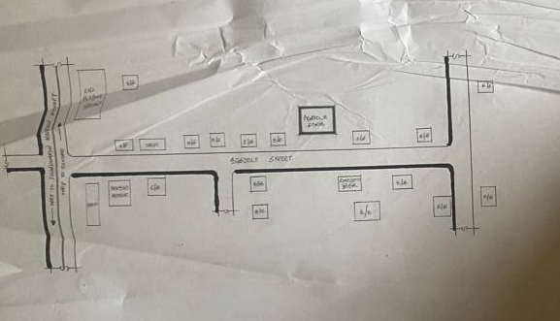
LOCATION PLAN: CASE STUDY 4
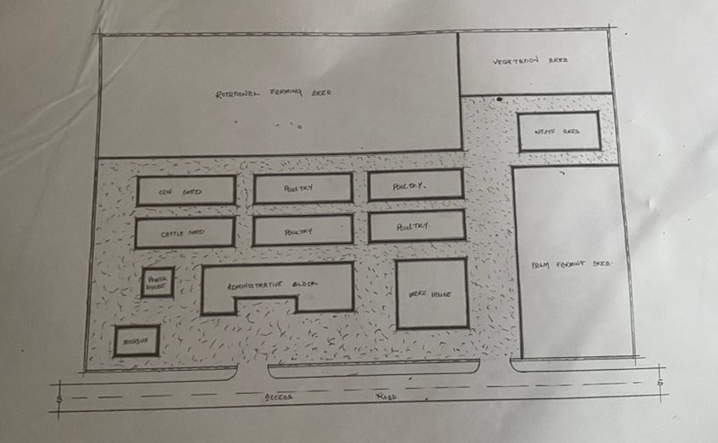
SITE PLAN: CASE STUDY 4

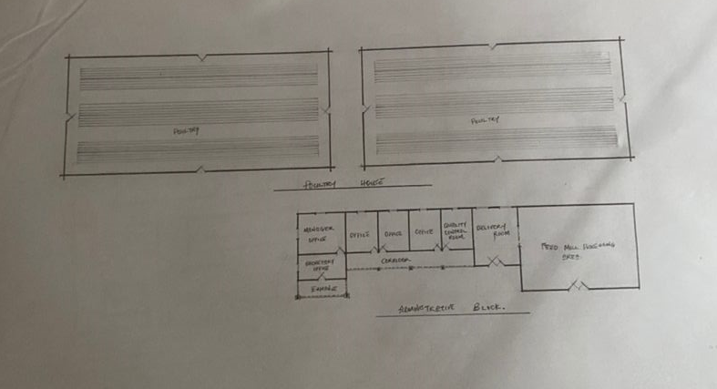
FLOOR PLAN: CASE STUDY 4

ONLINE CASE STUDY 1
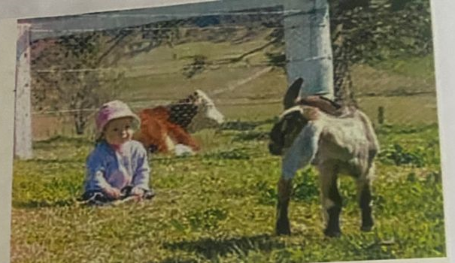

ONLINE CASE STUDY 2

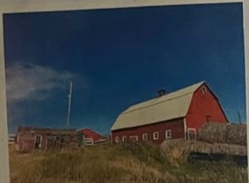
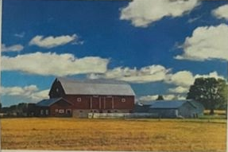

CHAPTER THREE
3.0 INTRODUCTION TO THE SITE (PROPOSED SITE)
3.1 SITE LOCATION (DESCRIPTION)
The site selected for the proposed project is located at OKE OSE ALALUBOSA along SHARE-OJA OBA Ilorin, Kwara State.
Oke-Ose, is a rural area under the Ilorin East Local Government Area of Kwara State. It has a latitude of about 515 – 571m above the sea level.
It is underlain by different type of soil in different kind of location, which some are commonly sandy and clay soil.
Oke-Ose consist of majorly of three different tribes which the Yoruba’s, Hausa’s, and the Fulani with a major market which is the SHARE OJA OBA market situated at the area of Share Oja-Oba Road Ilorin, Kwara State.
3.2 SITE LOCATION CRITERIA
Site selection is the consideration factors which influence the development of the site and spatial activities. Conversely, a site selection criterion is based on screening, factors affecting the site selection includes comfort, thermal control, etc. and the activities taking place on the site.
3.3 SITE ANALYSIS / INVENTORY
The proposed site has scattered trees and grasses and also has flat land but has the end of the east sloppy gently. It has an access road directly in it’s south a footpath. Also, termite house to be removed, cashier tree also to be removed, uprooted and filled. Palm tree should be retained for the uses of farmer to be used to produce palm oil.
Electric pole on the site and also a telecommunication most staring boundaries with the site and the vacant pole behind it.
- VEGETATION: The site is covered with trees, shrubs, and ground cover most of it, would be retained for landscaping.
- GEOLOGY: This soil has a good location bearing capacity and hence raft foundation will be used for the structure to be erected on the site.
- The site longer side facing East and West while the shorter side facing North and South.
- SOIL CONDITION: The type of soil is loamy soil and hence aids goods vegetation’s of shrubs, trees, and grasses
- TOPOGRAPHY: The site is 6f firm ground which is not affected by erosion. The site only required the excavation of the top soil to remove the vegetation soils and shrubs, before the French excavation of the site
3.4 GEOGRAPHICAL / CLIMATIC DATA
Ilorin has an area of 1286square kilometres and a population of 126435 as at the 2006 census (National Population Commission).
Kwara State has two major season which is the wet and dry seasons. The wet season extend from April to October while the dry season extend from October to March, each type of season is characterized by a specific type of preventing wind. The wet season bring with it south westerly wind originating from the equatorials rain belt and blowing from the high-pressure zone which occur over the Atlantis. During the period of the dry season it is accompanied by harmattan a dust laden wind blowing from north west.
- LATITUDE: 8°5ꞌ NORTH
- LONGITUDE: 4°55ꞌ EAST
- ATMOSPHERIC PRESSURE: 1007.1 pa
- AVERAGE RAINFALL: 250 mm/annum
- TEMPERATURE: 31.5ꞌꞌ C
- RELATIVE HUMIDITY: 31.5 %
- WIND SPREAD: 2.1 m/s N.E
- CLOUDINESS: 1.6 %
By understanding the geographical and climate of the site, you can make informed decisions about design development and management of the site.
3.5 GEOGRAPHICAL / CLIMATIC DATA
Geographical characteristic of a site refers to it’s physical features and attributes. We have key geographical characters to be considered
- Elevation: The site’s high above sea level
- Slope: The site slope and gradient
- Aspect: The site orientation (e.g North, South)
Landform and Features
- Hells, Valleys, and Plans: The site landforms and their characteristic
- Water Bodies: The presence of rivers, lakes, or ocean
- Coaster Features: The site coastal characteristics, such as beaches or soil and geology.
- Soil Type: The type and quality of soil on the site.
- Geological Formation: The site underlying geological for mountains and rock types.
Natural Hazard
- Earthquake Risk: The site earthquake risk and seismic activity
- Landslides Risk: The sites landslides risk and potential for soil instability
By considering the geographical characteristics of the site informed decision about development and conservation of the site.
3.6 CLIMATIC CHARACTERISTICS
Climatic characteristics is the long-term atmospheric condition that prevail in a particular region.
TEMPERATURE
- Average Temperature: The average temperature of a region or area
- Temperature Range: The differences between the highest and lowest temperature.
PRECIPITATION
- Rainfall Pattern: The amount and distribution of rainfall through the year.
- Snow Fall: The amount and frequency of snow fully is applicable.
HUMIDITY AND CLOUD COVER
- Relative Humidity: The amount of moisture in the air.
- Cloud Cover: The amount of cloud cover and it’s impact on temperature and precipitation.
WIND AND ATMOSPHERIC CIRCULATION
- Wind Pattern: The precooling wind direction and speed
- Atmospheric Circulation: The movement of our masses and we either patterns
SEASONAL VARIATIONS
- Seasonal Temperature Change: Changes in temperature throughout the year.
- Seasonal Precipitation Pattern: Changes in precipitation pattern throughout the year.
EXTREME WEATHER EVENTS
- Droughts: Prolong period of abnormally law rainfall
- Heat Ware: Prolong period of abnormally high temperature
- Storm: Severe weather events, such as humean or tomators
INFRASTRUCTURE
- Infrastructure: Road and drainage systems, water supply, and irrigation, power supply (grid, solar etc) housing for farmers, labourer, storage and processing facilities.
- Sanitation and Waste Management: Proper system for human and animal waste, run off control, etc.
3.7 CONCLUSION
Having duly observed the above analysis (Climatic Data/Geographical Consideration) site inventory and analysis done, the site is found suitable for the proposed project as it meets up with the site selection criteria.

CHAPTER FOUR
4.0 DESIGN CRITERIA
In the design formation of any project, work, and some necessary steps are needed to be put in place in order to active the desired result and functionality in the proposed design. Such procedure, formulation and steps are therefore analyzed in this chapter.
4.1 SITE PLANNING OF THE PROJECT
The site is planned to give it a defined shape and also to reflect the activities taking place. The location of the farm settlement within the site follow these main principles.
- The zoning principles (Noisy, semi-noisy and quite zoning) is observed which enhance placement of each structure of the design.
- For easy accessibility to various unites, parking spaces are planned.
The site is properly defined with a perfect blend of both natural and artificial attraction as well as soft and hard landscaping to give a quality taste of a desired comfort to all guests.
4.2 BRIEF ANALYSIS OF THE PROJECT
Project scope:
Main building
Mosque
Car parks
Fish pounds
Security house
Shed
Plantation
Poultry
Farm
Processing area
Maize crib
Abattoir
Feed mill
Green house
Hospital
Quarters
Restaurant
Caramel shed
Gale house
Football field
Church

4.3 ANALYSIS OF THE SCOPE
Design brief:
Entrance
Reception
Security
Manager office
Secretary office
Accountant office
Computer room
Staff office
Record room
General store
Show room
Laboratory room
Conference hall
Convenience

Functional Relationship
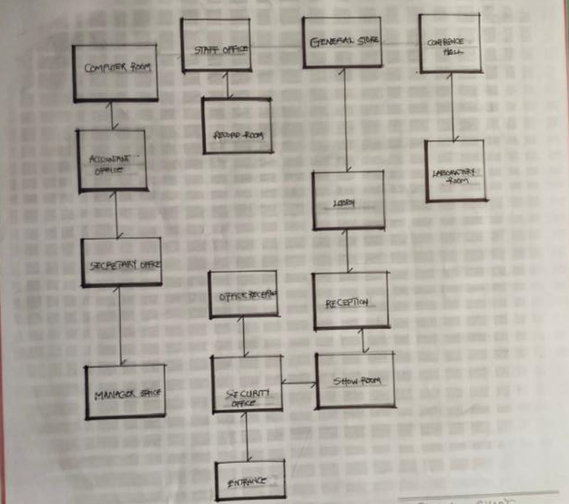
The functional relation determines and show the way different space or element win the building interact and relate with each other to enhance specific purpose and functions.
Space Calculation
This involve measuring and calculating the area and volume of a space or room. A manager office has been chorused to calculate the calculating room and space areas.
1. Wardrobe 3.0 x 0.9 2.7
2. Table 1.5 x 0.5 0.75
3. Chair 1.5 x 0.45 0.63
4. Wardrobe 1.0 x 0.45 0.45
5. Wardrobe 2.5 x 0.6 1.5
4.4
EMA = (1+2+3+4+5)
EMA = 25m²
Calculate = % of A
20%
= 5m²
Total = 25 + 5 = 30m²
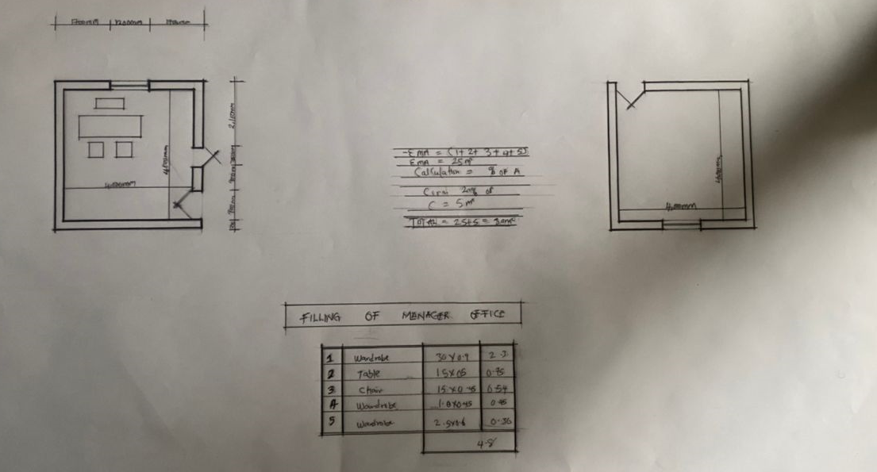
Space Allocation
S/N | Spaces | Length (mm) | Breadth (mm) | Dimension (mm) (LxB) | Area (m²)
1 | Entrance | 4000 | 9200 | 4000 x 9200 | 36,800,000
2 | Reception | 1200 | 14200 | 1200 x 14200 | 170,400,000
3 | Accountancy office | 3000 | 3000 | 3000 x 4000 | 9,000,000
4 | Manager office | 4000 | 4000 | 4000 x 4000 | 16,000,000
5 | Spec office | 3000 | 3000 | 3000 x 3000 | 9,000,000
6 | Computer room | 4000 | 5000 | 4000x5000 | 20,000,000
7 | Staff office | 4500 | 3500 | 4500 x 3500 | 15,750,000
8 | Conference room | 3600 | 5500 | 3600x5500 | 19,900,000
9 | Laboratory room | 3600 | 7000 | 3600x7000 | 125,000,000
10 | Show room | 5500 | 7400 | 5500x7000 | 125,000,000
11 | Record room | 2800 | 3500 | 2800 x 3500 | 9,800,000
12 | Toilet | 1500 | 2400 | 1500x2400 | 5,600,000
13 | General store | 4000 | 5500 | 4000x4500 | 14,000,000
14 | Lobby | 2100 | 2100 | 2100 x 2100 | 44,100,000

Concept Development
Concept development is the process of generating exploring and refining ideas and concept to meet project requirement and goals.
In regards to this project “farm settlement” the proposed concept design for it is STOOL to show that the design is related to farm settlement design in African.
In this project stool is used in several practical ways while “STOOL” typically refer to a seat in the contact of a farm or agricultural settling, it may also refer to plant propagation methods (like stooling in horticulture) or simply as a physical tool was able to create a design that meet user need and aesthetically pleasing. The site concept was formed based on three values.
- VIEW: the building and facility are located facing the road as the site is characterized with see through fence so that the road users can easily view the facility from the highway.
- Accessibility: The parking space provided are located in the most accessible area with good road network linking them together
- Circulation and planning: the turning radius of vehicle was considered for adequate circulation and the building is located at a close proximity to aid easy access.

CHAPTER FIVE
5.0 DESIGN APPROACH
5.1 APPRAISAL OF PROPOSED SCHEME
In any project design, there are two basic factors that should be taken into consideration, these factors are; Forms, Aesthetics, and Functionality of a design of building. The above listed factors were thoroughly taken care of to satisfy the highly demanded functional requirement of the proposed project and also to create aesthetically and proportionally balanced design.
Furthermore, zoning of area with related functions, circulation pattern, security, and safety were highly considered in this project design. The design was carefully zoned into major area such as Noisy, Semi-noisy, and Quite zones.
5.2 DESIGN AND CONSTRUCTION
The resettlement themselves would have been richly decorated with plastered and painted walls, coloured-marble cladding, and some mosaic and opus sectile floors. Supplied by a water cistern, with water drained via ditches into a main sewer, the building would have provided hot rooms, plunge pools, and other area. The cistern was massive, and water would have been hand-pumped up into the tank before a network of water pipes, drains, and sewers would have ensured a continual flow of clean water. The degree of workmanship seen within the remain during the original excavations and the kind of sophisticated and strategic planning involved in the construction.
5.3 GENERAL DESIGN CONSIDERATION
To achieve a functional design, the following factors are essentially needed to give the structure a considerable aesthetic value, some of these things are:
- SERVICES: - These include Electrical services, Filtration, Mechanical services, Sewage disposal, Drainage, Waste disposal etc. the electrical services will be of high quality and cables in concealed conduct wiring will be used. There is a power house to generate constant electricity supply in case of power failure. For effective drainage of both surface and soil waste, appropriate size of pipes is used. All pipes used are run into duct system with leaf net provided on drain pipe to prevent blockage from soil waste.
Also, incinerator will be used to burn waste on site. The element that controls the effect of solar radiation such as roof wall, sun breaker, greenies, and other materials are used.
- VENTILATION: - A primary factor in determining human comfort. They have direct effect on human body through the physiological effect on air purity and motion and indirect erect through their influence on the temperature, humidity of the indoor air and surfaces. To achieve optimum ventilation condition, the use of mechanical means of ventilation and proper orientation of building is ensured and automated windows, adequate sizes, and good positioning within sub-division of internal spaces are provided and also with the provision of dehumidifiers to maintain room humidity level of the hall so as to prevent condensation and deterioration of the building structure.
Also, a proper technique to control humidity will be adopted i.e. fresh air pool dehumidification system, air to air heat exchangers are typically used to recover energy from the pool exhaust air and transfer it to the incoming outdoor air. Because the outdoor air humidity level changes with the temperature, the colder it is the lower the humidity level is of the outside air.
- LIGHTING: - Lighting inside a building must fulfil two functions to illuminate interior and its content, and to illuminate the activities within the building appropriately so that visual mechanism can function at high level of efficiency.
All windows are of adequate sizes and height within and outside the structure. Also, the use of a transparent material “ETFE” which is glazed into the roof materials is employed to throw light into the areas of the structure so as to compliment and reduce the cost of maintaining the artificial light source in the building.
- ACOUSTICS: - Acoustics design controls intrusive noise by the choice or material dimension and shape of building. High level of noise can cause damage to the ear and so careful selection of doors, windows seals, ceiling type, and material will play an effective role in providing acoustic for the building.
- FIRE PROTECTION: - Modern building require not only means of escape, access for fire brigade and structure protection but also first aid equipment like hydrant plant, fire extinguisher to combat any fire outbreak before the intervention of fire brigade. The proposed design, there will be provision for fire alarms and detectors.
Also, fire extinguisher such as hose reels, sprinklers, and drenches are provided at strategies position for easy access.
- EXTERNAL WORKS: - The following specifications are applicable
- The floor surface to be of interlocking materials and asphalt to allow effective drainage.
- The drainage to be conveyed away through suitable sealed gully fitted with strong grating. It should be drained into existing gutter.
- The floor to withstand expected impact and high load bearing capacity.
- The enclosure to be secured against unauthorized entry.
- Surrounding walls to be rendered and painted.
- Tarred and grasses surface should be separated with kerbs.
- Soak-way pits must be avoided with the nature of the soil generally both foul and soil waste must be properly drained.
5.4 CONSTRUCTION METHOD AND MATERIAL
The proposed design of a farm settlement will be based completely on the use of quality materials and modern technology equipment. Highly qualified professional in the building industry will engage from the inception to the completion of the project work. This is done to ensure efficiency and durability of the design after which the design completed and ready for use.
Appropriate foundation type shall be used and such foundation shall be able to withstand the vibration caused by people while walking, standing, to be able to carry successful both live and dead load that is to be imposed on posing any threat to the comfort of the users of the complex.
5.5 LANDSCAPE DESIGN
Landscape design is the determination of the character of different landscaping element and their arrangement on the site to enhance the building works. Landscape design maybe two (2) types, aesthetic design and economic design. Both types are considered in the landscape design of the leisure centre.
It has been known to us that throughout the world people use mainly two (2) types of landscape namely; Soft and Hard Landscape.
5.6 LANDSCAPE ELEMENT USED IN THE DESIGN
In choosing an appropriate landscape element, the following are considered:
- Easy Cleaning
- Durability
- Resistance to Footwear
- Acoustic Properties
The following landscaping elements are employed;
- SOFT LANDSCAPE ELEMENTS
- TREES (VEGETATION): - To reduce solar rays in both paving and structures, reduce radiated heat, and improve comfort. Used as shading device and also used to beautify the environment.
- GRASSES AND LAWN (MATERIALS): - To reduce the reflective effect of the ground and also to control erosion and landslide in case of flooding. Used to reduce the intensity of sole radiation. It absorbs up to 45% of solar rays and disperses the rest of the environment thereby creating comfort for the occupant.
- DECORATIVE FLOWERS: - Different species of flowers are used to enhance the aesthetic appearance of the site.
- HARD LANDSCAPE ELEMENTS
- ASPHALT: - Used for drive ways and parking lots. It is economical and durable both for pedestrian and vehicular traffics.
- CONCRETE KERBS: - Uses to separate tarred surfaces from lawn covered areas.
- INTERLOCKING PAVING: - Used for walkways and outdoor paving to blend with the natural texture of the environment.
Other elements used include fountains, man-made hills, and waterfalls, flower ponds etc. to create visual interest and beautify the environment in a harmoniously blended aesthetical grandeur.
5.7 GENERAL MAINTENANCE
Maintenance cannot be isolated from the initial planning and design of any architectural edifice, most especially a project of this calibre which involves leisure and entertainment.
Timely maintenance of the structure and facilities to put them in proper working condition to enhance functionality and habitability of both structure and facilities for maximum satisfaction of visiting leisure and intending guest must be ensured.
Maintenance work in real technology is defined as work undertaken to keep or restore every facility of a building or site to an acceptable record i.e. planned maintenance or carried out on an emergency basis when the need arises. Due to the lack of the maintenance culture in this part of the globe, adequate provisions are made for security, sanitation, and maintenance department to centre for the facilities and endure high level of hygiene.
The maintenance of the building and facilities will be duly attended to with regular servicing of equipment’s and other facilities. The external works consist of so many factors that are of greater significant and these factors are as follow;
- Parking Space (Administrative and Staff parking, Players parking, and General parking): - This has to be technically considered by investigating the existing parking spaces in some bath house and gym. This has given me a detailed experience and I have been able to deduce to some facts that has assisted me in my own planning principle.
Effective parking space must be sectioned in order to have a proper security survey and manage space to the maximum level.
- Access Road: - This has been professionally achieved by creating or designing a ring road that has been properly linked by the minor road for easy accessibility to each basis unit with this and also case movement and transportation has been achieve affectively.
5.8 SUMMARY AND RECOMMENDATION
Conclusively the project has seriously broaden my view and observation beyond expectation and by this I have been able to deduce that project work of any form must not be taking lightly as it determines how far one can go to get facts and precise information towards assisting one’s self taking of experience and solving societal problems through academic works.
As a student I am recommending this project work to the entire public of Ilorin as a whole as it bring development and civilization to its locality as researched, it also creates healthy fitness, spa fitness, and general body well-being. Above it all it unites the youth and family-friendly.

REFERENCE
Aderamu A.J & Aaina O.A (2021). Journal of Geography and Regional Planning.
Akinbode A (1988). Reactings, in urban and Regional Planning.
Federal Ministry of Agricultural and Rural Development (NG), WORD BANK (2001). Agricultural and Rural Development Strategy Papers.
FOA (1984). Manual on Small Holder Agricultural Settlement.
OKAFOR, FC (1984). Rural Development and the Planning Process in Nigeria.
OLUWASANMI, H.A (1996). Agriculture and Nigerian Economic Development.
OMOTAYO A.M (2003). Ecological Agriculture and Rural Development in Nigeria.

APPENDIX
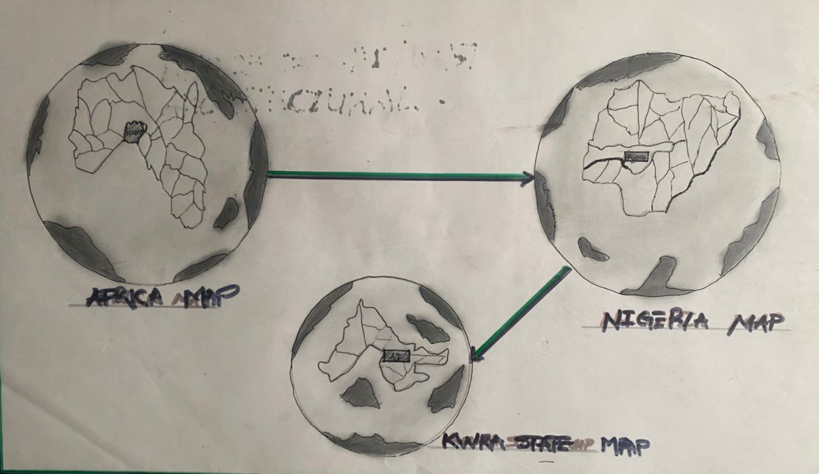
GEOGRAPHICAL MAP
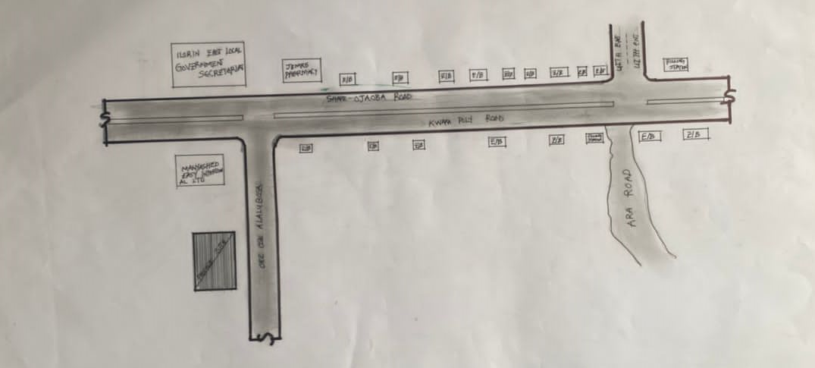
LOCATIONAL PLAN
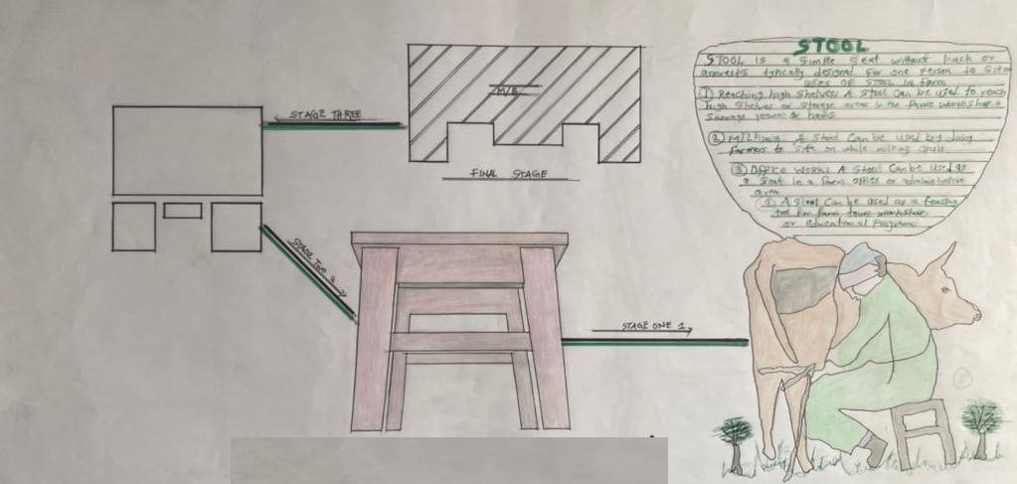
CONCEPT DEPRIVATION
FUNCTIONAL RELATIONSHIP

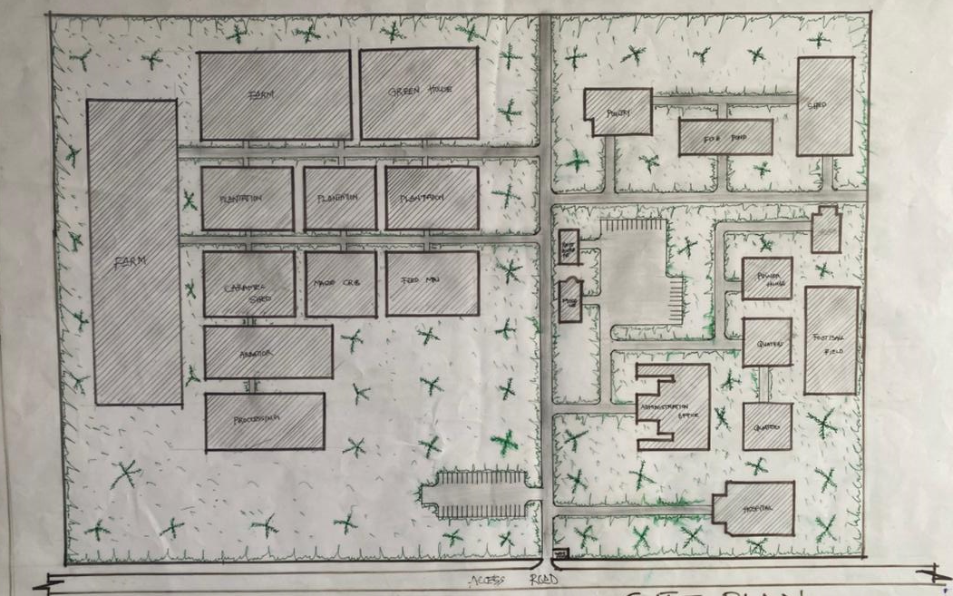
SITE PLAN
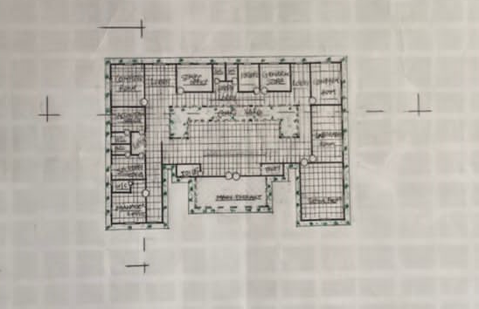
FLOOR PLAN
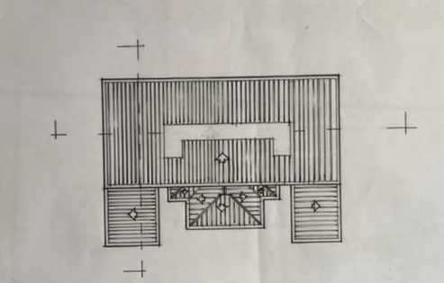
ROOF PLAN
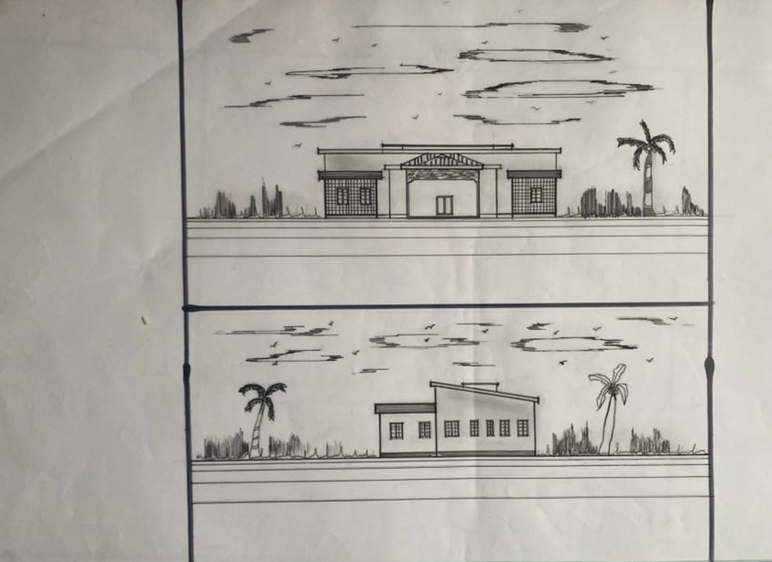
ELEVATIONS
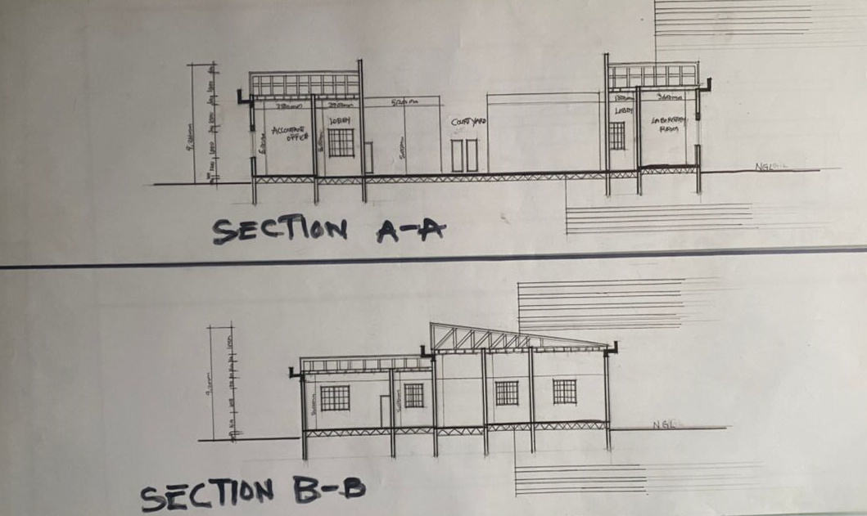
SECTIONS
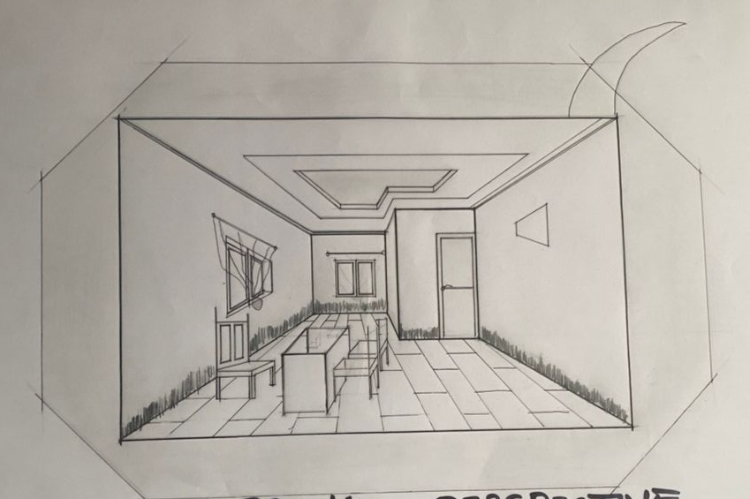
INTERNAL PERSPECTIVE

