A PROJECT REPORT

ON

PROPOSED MODERN CASSAVA PROCESSING FACTORY

FOR

ILORIN WEST LOCAL GOVERNMENT, ILORIN. KWARA STATE.

BY

OLARINOYE MUDDATHEER OKIKIOLA HND/23/ARC/FT/0018

SUBMITTED TO:

THE DEPARTMENT OF ARCHITECTURAL TECHNOLOGY INSTITUTE OF ENVIRONMENTAL STUDIES (I.E.S) KWARA STATE POLYTECHNIC, ILORIN.

IN PARTIAL FULFILMENT OF THE REQUIREMENTS FOR THE AWARD OF HIGHER NATIONAL DEPLOMA (HND) IN ARCHITECTURAL TECHNOLOGY

JULY, 2025.

DECLARATION
I OLARINOYE MUDDATHEER OKIKIOLA with matric no;
HND/23/ARC/FT/0018 of the department of Architectural technology hereby declare that this project ‘MODERN CASSAVA PROCESSING FACTORY’ was compiled by me.


OLARINOYE MUDDATHEER OKIKIOLA HND/23/ARC/FT/0018 SIGNATURE/DATE

CERTIFICATION
I certify that this project research entitled MODERN CASSAVA PROCESSING FACTORY has been read and approved as meeting the requirement for the Award of HIGHER NATIONAL DIPLOMA (HND) in Architectural technology, Institute of Environmental Studies (I.E.S), Kwara State Polytechnic, under the supervision of Arc. Olarewaju F. A.


ARC. OLAREWAJU F.A

(Project supervisor) SIGNATURE/DATE

ARC. OLAREWAJU F.A
(Project Coordinator) SIGNATURE/DATE


ARC. MRS. J.M TOMORI
(Head of Department) SIGNATURE/DATE

EXTERNAL SUPERVISOR SIGNATURE/DATE

DEDICATION
I hereby, dedicate this research to the Almighty God for His mercy, grace, blessings and favor given to me throughout this Academic journey and on my Life.
Also, dedicated to my mother (Mrs O.S Yetunde) for her occupation with her love and support through out the journey.

ACKNOWLEDGEMENT

I give all glory to Almighty God for His infinite grace, mercy, and blessings throughout my academic journey. ALHAMDULILLAH for making this project and my five-year study a success.
My deepest thanks to my mentor, ARC. OLANREWAJU F. A., for his thorough supervision, discipline, and guidance, and to ARC. MRS TOMORI J. M., Head of Department, for her motherly leadership and support. I also appreciate the Director of the Institute, ARC. YUNUS ABDULAZEEZ B. F., ARC. SOLOMON, and all lecturers of the department for their invaluable contributions to my growth.
Special appreciation to my loving parents, MR & MRS OLARINOYE, my families, the IBRAHIM’S, OLARINOYE, and LAWAL families, and MY SIBLINGS for their love, prayers, and support.
Lastly, heartfelt gratitude to my mentors, colleagues, comrades and friends, including Arc. Teslim, Arc. Ndagi, Arc. AbdulGafar, Arc. Sharofdeen, Arc. Muhammad, Arc. Ndakosanna, Engr. AzeemAfolabi, MrsAbdulRahman, Hon. Arc. BabatundeOpeyemi (O’stes), Qs. AlhajiAbdulAzeez Ajani, Hon. AdeyemiAyisha, Hon. Arc. AbdulRasheed, Hon. Keshinro Maryam, Usman Patiko, Ayisha, Iseoluwa Grace, Faruq Mujaheed, Ibrahim Ayodeji Ibrahim, Owoade Mustapha, and others not mentioned but forever appreciated.
May God bless you all abundantly.

TABLE OF CONTENTS
Title Page

Declaration… ii
Certification… iii
Dedication… iv
Acknowledgements… v
Table of Contents… vi-viii
List Of Figures… ix
List of Tables… x
List of Plates… xi
List of Appendices… xii
Abstract… xiii
CHAPTER ONE
  - Introduction… 1-2
  - Historical Background. 2-3
  - Definition of Terms… 3-4
  - Statement of Design Problem… 4-5
  - Aim and Objectives… 5
  - Justification… 6
  - Clients Background… 6-7
  - Scope of the Study… 7-8
  - Limitation to Design… 8
  - Research Methodology… 9
  - Deduction… 9-10
CHAPTER TWO
  - Literature Review 11
  - Review of Literature on the Building Type… 11
    - Evolution and Typology of Agro-Processing Facilities… 11
    - Classification and Functional Typology of Cassava Processing Factories 11-12
    - Functional Relationship and Space Interdependence… 12
    - Structural Considerations in Agro-Processing Buildings 12
    - Technological and Environmental Design Approaches… 13
    - Case Studies on Modern Agro-Industrial Architecture… 13
  - Review Of Literature On The Sub-Topic (Modern Cassava Processing Systems)… 13
    - Cassava: A Strategic Agricultural Crop 13-14
    - The Cassava Processing Workflow and Its Spatial Implications… 14
    - Architectural Contributions to Cassava Factory Performanc 14-15
    - Spatial Zoning for Hygiene and Efficiency… 15
    - Materials, Structure, and Finishes in Cassava Factories… 15
    - Environmental Design Approaches… 15-16
2.1.7 Digital and Mechanical Integration… 16
    - Staff and Welfare Considerations in Design… 16
    - Site Planning and Circulation in Cassava Factories 16-17
    - Summary of Lessons from Literature… 17
  - Summary, Synthesis, and Architectural Reflection… 17
    - Critical Summary of Literature Reviewed… 17-18
    - Lessons and Design Implications for a Modern Cassava Factory… 18-19
    - Theoretical Frameworks and Supportive Concepts… 19
    - Architectural Role in Agro-Industrial Innovation… 19
    - Bridging to Chapter Three (Case Studies) 20
CHAPTER THREE
  - Case Studies… 21
  - Introduction… 21
  - Case Study One… 21-23
  - Case Study Two. 23-25
  - Case Study Three… 25-28
  - Case Study Four [Online Case Study 1] 28-29
  - Case Study Five [Online Case Study 2] 29-31
  - Deduction from Case Studies 31
CHAPTER FOUR
  - Analysis of the Environmental and Topographical Conditions of the Site.32
  - Introduction to the Study Area… 32
    - Environmental Relevance… 32
    - Agricultural and Industrial Context… 32
    - Planning and Zoning Considerations… 32-33
    - Infrastructural Support 33
    - Socio-Economic Impact… 33
    - Environmental Responsibility… 33
  - Historical Background of Ilorin West Local Government Area… 34
    - Pre-Colonial Era… 34
4.2 2 Colonial Era (1900–1960) 34
    - Post-Colonial Era (1960–Present) 34-35
  - Physical Characteristics of the Site 35
  - Population of Ilorin West and Kwara State 35
  - Social Services and Infrastructure… 35
  - Road Network and Accessibility… 36
  - Health Services in Ilorin West Local Government Area 36-37
  - Water and Electricity 37
  - Climatic Conditions 37-38
  - Vegetation and Ecological Features… 38
  - Site Analysis… 38
    - Site Selection and Justification… 38
    - Justification Highlight… 38-41
  - Design Concept and Planning Principles 41
    - Design Concept… 41-42
    - Planning Principles… 42-44
CHAPTER FIVE
  - Design Report… 45
  - Design Brief 45
    - Major Spaces In a Modern Cassava Processing Factory… 45-47
  - Design Analysis 47-48
  - Design Appraisal… 48
  - Design Characteristics. 48-49
  - Structural System and Material Strategy… 49
  - Services… 49-50
  - General Requirements… 50
  - Materials and Finishes… 50
    - Material 50-51
    - Finishes Spec… 51
  - Summary and Conclusion 51
    - Summary… 51-52
    - Conclusion… 52
  - Recommendations… 52-54
References… 55-56
Appendices… 65

LIST OF FIGURES
Fig 3.1: Case Study I Floor Plan… 21
Fig 3.2: Case Study II Floor Plan… 24
Fig 3.3: Floor Plan Case Study III… 26
Fig3.4: Location Plan 28
Fig3.5: Location Plan… 30
Fig 3.6: Aerial View… 30
Fig 3.7: Approach View 31
Fig 4.1: Showing the map of Ilorin West Local Government and it Geopolitical Area… 34
Fig 4.2: Site Zoning… 38

LIST OF TABLE
Table 1.0: Space Analysis… 47-48

LIST OF PLATES
Plate 3.1: Approach View’s Case Study I 22
Plate 3.2: Right Side View Case Study II… 22
Plate 3.3: Approach View Case Study II 24
Plate 3.4: Feed Chopper & Raw Cassava Case Study II… 25
Plate 3.5: Approach View 27
Plate 3.6: Garri Frying Area 27
Plate 3.7: Cassava Drying Area 27
Plate 3.8: Aerial View… 29
Plate 3.9: Approach View 29

LIST OF APPENDICES
Appendix 1: Profile And Locational Map 57
Appendix 2: Locational Plan And Site Analysis… 58
Appendix 3: Site Inventory And Site Selection Criteria… 59
Appendix 4: Site Zoning And Production Flowchart… 60
Appendix 5: Bubble Diagram And Functional Relationship 61
Appendix 6: Project Scope/Brief And Site Plan 62
Appendix 7: Floor Plan And Roof Plan… 63
Appendix 8: Section’s And Elevation’s …………………;… 64
Appendix 9: Interior Perspective 65

ABSTRACT
The rising demand for cassava-derived products in Nigeria, coupled with the limitations of traditional processing techniques, poses a major obstacle to satisfying both domestic consumption and export requirements. This project proposes the development of a contemporary cassava processing facility that emphasizes efficient architectural design, sanitary production flows, and energy-efficient systems to boost output, minimize post-harvest waste, and elevate product standards.
A comprehensive research methodology was adopted, combining field observations, scholarly literature reviews, and analysis of existing cassava processing centers. The design process incorporated site-specific and environmental factors, utilizing advanced tools such as 3D modeling and spatial planning software to create a layout that meets functional, industrial, and safety criteria. Results showed that incorporating modern mechanical equipment within a strategically zoned factory layout significantly enhances processing efficiency, mitigates contamination risks, and promotes occupational safety. The proposed layout ensures a streamlined workflow that covers all stages from cassava reception, cleaning, peeling, grating, and pressing, to drying and packaging within a clean and well-organized space.
Furthermore, the study highlights the importance of integrating staff welfare facilities and administrative support spaces within the factory environment. By ensuring access to hygienic restrooms, changing areas, and break zones, the design supports workforce health and productivity. The inclusion of proper circulation paths for workers, materials, and machinery not only enhances operational efficiency but also aligns with global best practices in agro-industrial facility design. These considerations collectively reinforce the factory’s potential as a replicable model for sustainable agricultural processing infrastructure across Nigeria and similar contexts.
The study concludes that a well-designed, modern cassava processing plant can play a pivotal role in advancing the agro-industrial sector by increasing efficiency, stimulating industrial development in rural areas, and reinforcing food security. It is advised that future processing plants integrate eco-friendly materials, harness renewable energy, and maintain flexible designs that can adapt to emerging technological innovations.

CHAPTER ONE

INTRODUCTION
A modern cassava processing factory represents a transformative leap in agricultural and industrial innovation. It is a technologically advanced facility, purpose-built to convert freshly harvested cassava roots into a wide array of high-quality, market-ready products with speed, efficiency, and precision. Outfitted with state-of-the-art machinery and supported by streamlined production systems, these factories are engineered not only to meet rising demands but also to ensure consistency, safety, and sustainability throughout the processing cycle (Adejumo&Okafor, (2020).In recent years, the role of cassava in the global food system has gained significant attention, especially in Sub-Saharan Africa, where rapid urbanization and changing lifestyles have fueled a growing appetite for convenient, shelf-stable food products (FAO, (2021). Cassava root, known for its neutral flavor and versatile properties, serves as an ideal base ingredient for a wide variety of processed goods, ranging from traditional staples like garri and fufu to modern innovations such as cassava flour, starch, chips, and ethanol (Obi et al., (2019). Despite its value, cassava is a highly perishable crop. Once harvested, the roots begin to deteriorate within 24–48 hours, making timely processing a critical challenge (Okudoh et al., (2014).
Additionally, cassava contains naturally occurring compounds known as
cyanogenic glycosides, which can release toxic cyanide when improperly handled. The cyanide content varies across cassava varieties bitter types contain high concentrations and require thorough processing to make them safe, while sweet varieties contain lower levels and are sometimes consumed raw (Nwokoro et al., (2017). Without modern interventions, these factors pose significant health, logistical, and economic risks. Modern cassava processing facilities are specifically designed to address these challenges. By incorporating cutting-edge technologies such as automated peeling, grating, pressing, drying, and packaging systems, these factories dramatically improve efficiency and throughput. More importantly, they ensure that safety standards are maintained through hygienic production environments, proper detoxification processes, and controlled handling procedures (Eze&Aworh, (2018).
The rise of these advanced processing centers marks a pivotal shift in how cassava
is perceived not merely as a subsistence crop but as a high-potential industrial raw material. With the integration of sustainable energy solutions, environmentally conscious waste management practices, and adaptable factory designs, these facilities are helping to unlock new economic opportunities across sectors

including food and beverage, pharmaceuticals, animal feed, textiles, and biofuel production (Oyeyinka & Oyeyinka, (2022). Ultimately, the development of modern cassava processing factories is a powerful driver of rural industrialization, job creation, and economic empowerment. By reducing post-harvest losses, adding value to agricultural produce, and meeting both domestic and export market demands, these facilities contribute significantly to food security, national income, and the global cassava value chain.

HISTORICAL BACKGROUND

(Cassava Processing History and the Evolution to Modern Factories)
The transformation of cassava processing from rudimentary, labor-intensive practices to sophisticated industrial systems is a remarkable journey shaped by innovation, necessity, and global agricultural development. Historically, cassava processing began at the grassroots level, where local communities relied on manual techniques passed down through generations. In these early stages, cassava roots were peeled, grated, fermented, and dried entirely by hand a time-consuming and physically demanding process that limited production scale and output quality (Nweke, (2013).As cassava became more integral to food security and rural livelihoods across tropical regions, particularly in Africa, Asia, and Latin America, the need for efficiency and higher yields drove significant technological evolution. By the late 20th century, the introduction of mechanized tools such as motorized graters, hydraulic presses, and rotary dryers began to revolutionize cassava processing (IITA, (2019). This period marked the emergence of semi-industrial and eventually industrial-scale cassava factories, capable of handling greater volumes with improved hygiene and consistency. Countries like Nigeria, Thailand, and Vietnam became pioneers in this agricultural shift, investing heavily in mechanization and laying the groundwork for today’s modern cassava processing infrastructure (Egesi & Nwosu,(2020). These nations recognized cassava’s economic potential not just as a subsistence crop, but as a strategic industrial resource with applications in food, pharmaceuticals, textiles, animal feed, and bioenergy. The dawn of the 21st century ushered in a new era defined by automation, sustainability, and innovation. Modern cassava processing factories now operate with integrated processing lines that automate nearly every stage of production from washing and peeling to grating, pressing, fermenting, drying, and packaging (FAO, (2021).
Crucially, as global attention shifted toward environmental sustainability, cassava
processors adapted by adopting greener practices. Energy-efficient machinery,

water recycling systems, and emissions control technologies became standard features (Oyeyinka & Oyeyinka, (2022). In addition, the industry found innovative uses for cassava by-products, converting peels, pulp, and wastewater into valuable outputs such as biofuel, organic fertilizer, and livestock feed further enhancing the economic and ecological footprint of the industry (Okudoh et al., (2014).These developments have not only improved cassava product quality and processing capacity but also significantly contributed to rural industrialization, job creation, and national food security. Today’s modern cassava processing factories stand as a testament to how far the industry has come from humble village-based operations to high-tech industrial hubs capable of serving both domestic and international markets.
In alignment with this progressive evolution, the proposed modern cassava
processing factory aims to embody the latest in design innovation, sustainable engineering, and process efficiency building upon decades of advancement to create a facility that meets the demands of a rapidly changing global agro-industrial landscape. This factory is envisioned not only as a center for cassava transformation but also as a model for future agro-industrial development one that integrates advanced architecture, hygienic workflows, renewable energy systems, and scalable technology. By bridging tradition and innovation, this modern cassava processing facility seeks to redefine cassava’s role in national development, transforming it from a humble root into a cornerstone of economic resilience, food security, and industrial growth (Adejumo & Okafor, (2020).

DEFINITION OF TERMS

Modern:
Denotes something current or aligned with present-day advancements, technologies, or trends. In this context, it refers to innovations and practices that are up-to-date and relevant to the contemporary industrial environment.

Cassava:
A tropical root crop scientifically known as Manihotesculenta, cultivated primarily for its starchy tubers. It is a crucial carbohydrate source and dietary staple in many parts of Africa, Asia, and Latin America.

Factory:
An industrial establishment where raw materials are transformed into finished goods, typically involving the use of specialized machinery and systematic production processes.

Modern Cassava Processing Factory:
An advanced, purpose-built industrial facility equipped with modern technologies and automated systems to process cassava roots into a variety of high-quality products. Such factories are designed to increase operational efficiency, ensure food safety, minimize environmental impact, and support large-scale production with minimal manual intervention.

Processing Line:
A structured series of interconnected machines and equipment that perform step-by-step cassava processing tasks such as washing, peeling, grating, drying, and packaging in a continuous and orderly sequence.

High-Quality Cassava Garri(HQCG):
A refined, gluten-free garri produced from cassava roots, recognized for its smooth texture and versatility. HQCF is used as a cost-effective alternative to garri flavor in food products and also serves various industrial purposes.

Waste Management System:
An integrated system within the processing facility designed to handle and treat cassava processing by-products such as peels, pulp, and waste water in an environmentally responsible manner. This may include recycling, composting, or converting waste into bio energy and animal feed.

Automation:
The implementation of intelligent control systems and machines to perform processing tasks with minimal human supervision. Automation improves operational efficiency, reduces labor costs, enhances precision, and ensures consistent product quality throughout the production cycle.

STATEMENT OF DESIGN PROBLEM
In Kwara State, the increasing demand for cassava-based products is met with a critical lack of modern, architecturally sound processing infrastructure. Existing facilities if any are predominantly informal, operating with minimal design consideration for hygiene, efficiency, worker safety, or environmental sustainability. This architectural gap not only restricts the volume and quality of production but also undermines the economic potential of cassava, a crop that serves as both a staple food and a valuable industrial resource. Many of the cassava processing setups across the state continue to operate in makeshift or poorly ventilated structures, with no clear zoning for clean and contaminated areas, inadequate spatial planning, and substandard waste management systems. These conditions violate basic construction and public health regulations, particularly

those related to ventilation, material durability, structural integrity, and worker safety. Moreover, the absence of noise control, efficient drainage systems, and regulated circulation patterns often results in uncomfortable and hazardous working conditions.
Architecturally, there is a pressing need to create a facility that responds not only to the functional demands of modern cassava processing but also to regulatory frameworks that govern industrial construction in Kwara State and Nigeria at large. These include guidelines on fire safety, accessible building layouts, environmental impact mitigation, and adherence to National Building Code provisions. This project seeks to address these deficiencies through the design of a modern cassava processing factory that integrates sustainable construction practices, efficient spatial organization, and compliance with architectural standards. The proposed facility will feature distinct zones for raw material intake, processing, drying, storage, and packaging, supported by adequate ventilation, noise reduction strategies, hygienic workflows, and energy-efficient technologies. By aligning design with environmental, regulatory, and community needs, this project aims to establish a scalable model for agro-industrial development in Kwara State one that enhances food security, strengthens local economies, and elevates the standard of cassava processing in line with contemporary architectural and construction benchmarks.

AIM AND OBJECTIVES
To design a modern cassava processing factory that ensures efficient production, supports hygienic operations, reduces waste, and meets sustainable building and regulatory standards in Kwara State.

OBJECTIVES
    - To develop a functional and efficient building layout that supports all key stages of cassava processing, with a primary focus on garri production while accommodating starch extraction and other by-product processing.
    - To integrate energy-efficient technologies and systems that reduce operational costs and environmental impact.
    - To implement a sustainable waste management system that minimizes waste generation and promotes the reuse and recycling of cassava by-products.
    - To design the facility with adaptability in mind, allowing for future expansion and changes in production scale or technology.
    - To incorporate staff-focused amenities and welfare facilities that enhance

worker comfort, health, and productivity.

JUSTIFICATION
Despite the prominence of farming activities in Ilorin West Local Government Area of Kwara State, there is currently no modern cassava processing facility to support large-scale transformation of cassava roots into value-added products such as garri, starch, and other derivatives. As a result, local farmers are forced to rely on outdated and inefficient processing methods that limit their productivity, reduce product quality, and hinder access to competitive markets. This lack of infrastructure not only discourages agricultural expansion but also contributes to post-harvest losses, reduced income for farmers, and missed opportunities for economic growth within the area. In response to these challenges, this project proposes the design of a state-of-the-art cassava processing factory that will provide long-term solutions by offering efficient, hygienic, and scalable processing systems.
The proposed facility is intended to empower local producers by transforming raw
cassava into commercially viable products, creating better market opportunities, generating employment, and stimulating industrial development. Ultimately, this design seeks to bridge the infrastructural gap in cassava processing within Ilorin West, aligning with broader goals of food security, sustainable development, and rural industrialization in Kwara State.

CLIENTS BACKGROUND
Ilorin West Local Government Area is one of the sixteen (16) constitutionally recognized Local Government Areas in Kwara State, Nigeria. It forms a core part of the Ilorin metropolis the capital of Kwara State and is one of the most urbanized and densely populated LGAs in the state. Established as part of Nigeria’s local government reforms, Ilorin West has grown to become an important administrative, commercial, and socio-cultural center within the North Central region of Nigeria.
Historically, Ilorin was founded in the early 19th century by the Yoruba people and later rose to prominence under the leadership of Afonja, a Yoruba warlord, and subsequently under the influence of the Fulani through the Sokoto Caliphate. As a result, Ilorin developed a unique cultural and religious identity, blending Yoruba traditions with Islamic influence, which remains evident in its diverse social structure and architectural heritage today. Ilorin West encompasses a wide range of communities and neighborhoods, including but not limited to Adewole, Oja-Oba, Oloje, Ogidi, Warah-Osin, Ita-Amodu, and parts of GaaAkanbi and Sobi. The area

serves as a political, commercial, and educational hub, housing important government institutions, schools, markets, and healthcare facilities. It is also home to various artisans, traders, professionals, and civil servants who contribute to its economic vibrancy. Despite its urban outlook, Ilorin West maintains strong ties to agriculture. Many residents engage in farming activities particularly in the peripheral communities growing staple crops such as cassava, maize, yam, and vegetables. Cassava, in particular, is widely cultivated due to its adaptability to local soil and climatic conditions, as well as its versatility in both household and industrial uses.
However, the area faces a disconnect between cassava production and industrial processing. The majority of cassava harvested is processed using traditional and informal methods, which often result in product loss, inefficiency, and low market competitiveness. While Ilorin West benefits from relatively better infrastructure compared to rural LGAs, it still lacks a modern, dedicated cassava processing facility that can support the conversion of cassava into garri, starch, flour, ethanol, and other derivatives at commercial scale. The absence of such infrastructure has limited value addition, suppressed income generation for local farmers, and stalled agro-industrial development in the area. Moreover, the reliance on outdated processing methods poses risks to food safety, environmental sustainability, and economic viability.
Recognizing these challenges, the establishment of a modern cassava processing
factory within Ilorin West LGA is both necessary and strategic. A facility of this nature would serve as a central hub for efficient cassava transformation, reduce post-harvest losses, improve product quality, and open up market opportunities both locally and beyond. In addition, it would support job creation, stimulate local entrepreneurship, and contribute to Kwara State’s broader goal of agricultural industrialization.
In conclusion, Ilorin West Local Government Area has a rich historical legacy and economic potential that can be further unlocked through strategic investment in agro-processing infrastructure. Leveraging its urban accessibility, growing population, and agricultural capacity, a modern cassava processing facility would play a vital role in bridging the gap between primary production and industrial value addition thereby advancing economic growth, food security, and sustainable development within the region.

SCOPE OF THE STUDY
The modern cassava processing factory will be designed to provide adequate and

purpose-built facilities for its intended users, structured into three (2) primary sections : Production Section and Administrative & Support Section. Each section will be thoughtfully planned to support efficient workflow, user comfort, and sustainability in line with contemporary agro-industrial design standards.
    - The Production Section : will house core processing activities, including raw material intake bays, washing and peeling units, grating and pressing lines, drying areas, fermentation chambers, packaging units, and storage silos. It will also include specialized units for the production of value-added cassava products such as garri, high-quality cassava flour (HQCF), starch, ethanol, and animal feed from cassava by-products.
    - The Administrative & Support Section :will comprise the operational and management offices, control rooms, staff changing rooms, maintenance workshops, security posts, and utility areas (e.g. water treatment and power generation rooms). It will also include a staff cafeteria, restrooms, and a logistics management area to support internal operations and external distribution activities.
The design of the factory will incorporate green spaces, internal courtyards for ventilation and relaxation, vehicular circulation routes, and clearly defined zoning to promote hygiene, safety, and operational efficiency. This integrated approach will ensure that the facility not only serves as a processing hub but also as a center for learning, community development, and agro-industrial

LIMITATION TO DESIGN
This study will focus specifically on the architectural design of a modern cassava processing factory, with particular attention given to spatial organization, workflow optimization, hygienic conditions, and environmental sustainability. The design will prioritize creating functional areas for each stage of cassava processing such as washing, peeling, grating, fermenting, drying, packaging, and storage while ensuring proper ventilation, natural lighting, and smooth circulation throughout the facility. The study will not cover the detailed engineering specifications of the processing machinery, the scientific or biochemical aspects of cassava conversion, or the complexities of industrial-scale automation. Additionally, it will not include comprehensive economic viability assessments or the broader scope of national agricultural policies. Rather, the project is confined to developing architectural solutions that support efficient production, maintain hygienic standards, and facilitate the safe and effective movement of personnel and materials within the factory environment.

RESEARCH METHODOLOGY
The methodology adopted for this study includes a combination of both qualitative and observational research techniques. These methods were selected to ensure a comprehensive understanding of modern cassava processing factories in the Nigerian context. The methodologies employed are as follows:
    - Internet Research: Online resources were utilized to access up-to-date information, technological advancements, and global best practices in cassava processing. This included academic articles, industrial reports, and architectural design references.
    - Case Studies: Existing cassava processing factories in different parts of the country were examined to understand their spatial organization, functional requirements, and technological integration. These case studies provided valuable insights into practical applications and design strategies.
    - Oral Interviews: Interviews were conducted with factory workers, operators, agricultural extension officers, and other stakeholders. This method provided firsthand information on user needs, challenges faced, and opportunities for improvement in cassava processing facilities.
    - Photography: Photographic documentation was carried out during site visits to record architectural features, machinery layout, and environmental context. These visual references aided in the analysis and design process.
    - Literature Review: Relevant textbooks, journals, and publications were reviewed to establish a theoretical foundation for the study. The literature helped in identifying key issues, design considerations, and innovations in cassava processing.

DEDUCTION
Following the comprehensive assessment of the proposed modern cassava processing factory, several critical conclusions were drawn regarding its design efficiency, operational performance, and long-term viability:

Optimized Workflow and Functional Layout:
The architectural layout is designed to support a seamless, linear flow of operations beginning from raw cassava intake, washing, peeling, grating, fermenting, and pressing, through to drying, packaging, and storage. This sequential arrangement of processing units enhances operational efficiency by minimizing delays, reducing

material handling time, and preventing cross-contamination between processing zones.

Enhanced Product Quality Control:
The integration of dedicated quality control zones and the use of standardized, modern processing equipment ensure that the end products such as, high-quality garri, cassava flour, and industrial starch consistently meet both food safety regulations and industry specifications. This design supports traceability and precision at every stage of processing.

Emphasis on Hygiene and Worker Safety:
By incorporating stainless steel, food-grade surfaces, non-slip flooring, and efficient drainage systems, the design upholds high hygiene standards while minimizing contamination risks. Proper zoning and adequate ventilation further contribute to maintaining clean processing conditions and ensuring a safe working environment for personnel.

Commitment to Environmental Sustainability:
The design includes environmentally responsible features such as effluent treatment systems, waste segregation areas, and the repurposing of cassava by-products for secondary uses like animal feed and biogas production. These systems support eco-friendly practices and align the project with global sustainability goals.

Economic and Operational Viability:
The use of mechanized systems significantly increases processing capacity while reducing dependence on manual labor. This enhances cost-effectiveness, scalability, and the potential for commercial expansion. The design positions the factory as a viable long-term investment capable of stimulating local economic development and agro-industrial growth.

CHAPTER TWO

LITERATURE REVIEW

REVIEW OF LITERATURE ON THE BUILDING TYPE

EVOLUTION AND TYPOLOGY OF AGRO-PROCESSING FACILITIES
The architectural typology of agro-processing facilities has evolved from basic utilitarian structures to sophisticated industrial complexes. Historically, food processing was largely domestic, informal, and manually driven. In Nigeria and many African countries, processing activities like cassava peeling, grating, and frying were often performed in open-air environments or temporary sheds, with no regard for environmental safety, hygiene, or workflow efficiency (FAO, (2013).The gradual transition to mechanized agro-processing was influenced by population growth, urbanization, and the increasing demand for food safety and quantity. The late 20th and early 21st centuries saw a shift from open-air systems to enclosed, semi-industrial buildings that provided minimal structural form, often repurposed from garages, warehouses, or residential spaces.
Today, the agro-industrial typology has matured into a specialized architectural
form that incorporates regulated spatial planning, environmental control systems, mechanical zoning, service infrastructure, and quality control labs. Modern cassava processing factories, as a subset of this typology, reflect the transition from informal food production to structured industrial systems.

CLASSIFICATION AND FUNCTIONAL TYPOLOGY OF CASSAVA PROCESSING FACTORIES
Agro-processing buildings, especially cassava factories, can be categorized based on scale and mechanization level:

Traditional/Cottage-Level Facilities:
These are informal or domestic processing setups used by individuals or families. They lack ventilation, zoning, or drainage systems. The main tools are manual graters, mortar and pestle, and open-fire roasting pans. There is no architectural intervention except basic shelter, often constructed with thatch and mud.

Small-Scale Semi-Mechanized Plants:
These processing units incorporate small-scale mechanization such as motorized graters, hydraulic presses, and roasting drums. The facilities are often repurposed

rooms with minimal spatial planning and poor hygiene conditions. Equipment is loosely arranged, and there is usually no separation between clean and unclean operations.

Medium to Large-Scale Mechanized Factories:
These represent modern cassava factories that are architecturally designed. They include formal layout plans, zoning of activities, dedicated drainage and ventilation systems, waste management units, and service integration. They handle 5–50 tons of cassava daily and support multiple product lines (garri, flour, starch, ethanol).
This classification supports the architectural understanding that agro-industrial buildings must be designed to accommodate not only production but also safety, comfort, maintenance, and environmental compatibility.

FUNCTIONAL RELATIONSHIP AND SPACE INTERDEPENDENCE
The functionality of a cassava processing plant depends on how well its various components are spatially interrelated. A good layout enables sequential flow from raw material → washing → peeling → grating → fermentation → pressing → roasting → packaging with minimal crossing or delay. Functional interdependence means:
      - Wet zones like washing and peeling must be isolated from dry zones like roasting and milling to avoid contamination.
      - Packaging and storage areas should be physically separated from raw material zones.
      - Staff welfare units and administrative blocks must be buffered from noise and heat-intensive areas.

STRUCTURAL CONSIDERATIONS IN AGRO-PROCESSING BUILDINGS
Agro-industrial architecture incorporates structural systems capable of supporting heavy machinery, industrial traffic, water-intensive operations, and thermal loads. Key structural elements include:
      - Reinforced concrete foundations and floors to support heavy machines and vehicular movement.
      - Steel roof trusses for long-span coverage and heat dissipation.
      - Sandcrete block walls with tiled finishes for easy washing.
      - High-level windows and roof monitors for natural ventilation.
These structures must also accommodate dynamic expansion and flexibility for

machinery upgrades and changes in processing volume.

TECHNOLOGICAL AND ENVIRONMENTAL DESIGN APPROACHES
Modern cassava factories require architectural responses to climate, technology, and sustainability. According to (Ogunniyi (2011), buildings that ignore airflow, moisture, and waste control fail to meet industrial food processing standards.
Technological features include:
      - Industrial drainage systems
      - Solar lighting panels
      - Overhead tanks for water storage
      - Forced ventilation units
      - Acoustic insulation in noise zones Environmental features include:
      - Natural ventilation using wind paths
      - Use of locally available materials like bamboo, stabilized mud blocks, or fly ash cement
      - Landscaping for dust control and shading
These integrated strategies ensure that factories are not only productive but also climate-responsive, energy-efficient, and ecologically sensitive.

CASE STUDIES ON MODERN AGRO-INDUSTRIAL ARCHITECTURE
In a study by (IITA (2005), cassava processing facilities in Nigeria’s southwest region showed significant improvement in production quality and worker safety when factory layouts were designed with architectural input. Plants that used zoning diagrams, hygienic materials, and separation of processes recorded 40% less waste, 30% better productivity, and reduced health risks.
Similarly, (Adebayo (2009) found that facilities with integrated mechanical systems and ventilation recorded better compliance with NAFDAC standards and were more appealing to international buyers.

REVIEW OF LITERATURE ON THE SUB-TOPIC (MODERN CASSAVA PROCESSING SYSTEMS)

CASSAVA: A STRATEGIC AGRICULTURAL CROP
Cassava (Manihotesculenta) is a staple food for over 800 million people globally, particularly in sub-Saharan Africa, Asia, and Latin America. In Nigeria, cassava

holds a vital position as the most widely cultivated root crop, with over 59 million metric tonnes produced annually (FAO, (2013). It is processed into diverse products such as garri, cassava flour, fufu, starch, chips, and bioethanol, making it a cornerstone of food security, rural employment, and industrial feedstock.
However, cassava is highly perishable. Post-harvest losses are estimated at 20–30% due to inadequate processing and storage. This has prompted the need for integrated, hygienic, and architecturally optimized cassava processing factories to ensure both food preservation and value addition.

THE CASSAVA PROCESSING WORKFLOW AND ITS SPATIAL IMPLICATIONS
Cassava processing follows a linear and sensitive sequence of operations:
- Reception of raw tubers
- Sorting and washing
- Peeling and grating
- Fermentation
- Dehydration (mechanical)
- frying (for garri) or milling (for flour)
- Packaging and storage
Each stage has distinct spatial and environmental needs. For example:
  - Washing and peeling require drainage, water-resistant flooring, and ventilation.
  - Fermentation and drying require airflow, odor control, and minimal solar exposure (unless sun-drying).
  - Frying and milling produce heat and dust, necessitating thermal insulation, dust extractors, and clear space.
  - Poor architectural planning leads to contamination, delays, heat stress, and inefficiency. Therefore, workflow-driven design is crucial.

ARCHITECTURAL CONTRIBUTIONS TO CASSAVA FACTORY PERFORMANCE
Modern cassava processing architecture is no longer about merely “housing machines”; it now addresses:
      - Workflow optimization: ensuring raw materials move logically through production stages.
      - Environmental control: managing airflow, temperature, dust, and waste.
      - Worker safety and comfort: integrating rest areas, toilets, changing rooms,

noise barriers.
      - Compliance: designing to meet standards by NAFDAC, SON, and international HACCP regulations.
(Phillips et al. (2004) emphasize the role of architecture in waste zoning, especially in cassava where solid and liquid waste must be separated. Wet areas like grating and pressing must be distanced from roasting zones to prevent microbial growth and odor.

SPATIAL ZONING FOR HYGIENE AND EFFICIENCY
Architectural zoning is critical in cassava factories. The key zoning divisions are:
      - Wet zones: Washing, peeling, grating, pressing.
      - Dry zones: Drying, roasting, milling.
      - Clean zones: Packaging, labeling, storage.
      - Support zones: Admin block, laboratory, staff facilities.
These zones must be separated using buffer corridors, floor level differences, and flow-controlled doors. For instance, fermentation areas should not allow access to clean packaging rooms without sanitization passage.

MATERIALS, STRUCTURE, AND FINISHES IN CASSAVA FACTORIES
The unique processing needs of cassava demand durable, washable, and pest-resistant materials. The following are commonly used:
      - Wall finishes: Glazed tiles or cement screed for washable surfaces.
      - Floors: Non-slip concrete or epoxy for moisture zones.
      - Roofing: Long-span aluminum sheets with insulation.
      - Doors: Stainless steel or aluminum; must be wide for equipment.
      - Ventilation: High-level windows, ridge ventilators, and industrial fans. According to (Kolawole & Olayemi (2010), use of improper materials in cassava drying rooms leads to high spoilage rates due to condensation and mold growth. Therefore, design materials must consider both process demands and environmental challenges.

ENVIRONMENTAL DESIGN APPROACHES
Modern cassava factories must adopt sustainable environmental practices. These include:
      - Rainwater harvesting: Collecting roof water for cleaning floors and washing tubers.

      - Natural ventilation: Aligning structures with wind direction to cool heat zones.
      - Solar lighting: Reducing electricity bills in daylight production areas.
      - Waste-to-energy systems: Using cassava peel waste to generate biogas or organic fertilizer.
(Akinrele (1990) observed that most rural processing facilities lacked environmental integration, leading to pollution and energy waste. Today, eco-conscious factories integrate waste segregation units, soak-away pits, composting zones, and rain shelters to protect drying areas.

DIGITAL AND MECHANICAL INTEGRATION
Cassava processing now uses automated machines for grating, dewatering, drying, roasting, and milling. This affects architectural space, requiring:
      - Reinforced floor loading for equipment
      - Electrical rooms and backup power systems
      - Noise control zones
      - Clear circulation paths for trucks and forklifts
(Nweke et al. (2002) highlight the need for architectural foresight in laying cable ducts, overhead pipe work, and foundation trenches to accommodate future automation.

STAFF AND WELFARE CONSIDERATIONS IN DESIGN
Workers comfort and safety are critical. This includes:
      - Changing rooms and lockers
      - Toilets with hand-wash stations
      - Staff rest areas and cafeterias
      - Separate walkways for workers vs material handling
(Obayelu et al. (2006) argue that poor staff hygiene facilities contribute to product contamination and absenteeism. Hence, architectural design must prioritize worker dignity and compliance.

SITE PLANNING AND CIRCULATION IN CASSAVA FACTORIES
Site circulation must separate:
      - Raw material trucks
      - Waste disposal vehicles
      - Finished product transport
      - Visitor and staff access

Driveways should be concrete-paved, with turning radii for large trucks. Waste zones should be downwind, and admin blocks located upfront for supervision and reception. Landscape buffers (trees, hedges) improve aesthetics and reduce dust/noise. Open lawns and shaded zones encourage staff relaxation and resilience during long work shifts.

SUMMARY OF LESSONS FROM LITERATURE
The literature review reveals several consistent themes in modern cassava factory architecture:
      - Production efficiency is enhanced by linear layouts and functional zoning.
      - Hygiene requires surface finishes, waste separation, and air control.
      - Worker welfare is critical to output and public health compliance.
      - Environmental features such as passive ventilation and green buffers support sustainability.
      - Material choice and spatial planning affect durability, maintenance, and flexibility.
These findings reinforce the necessity of professional architectural intervention in agro-processing infrastructure. Designing with insight into food systems, user behavior, and environmental context leads to facilities that are safe, efficient, future-ready, and economically viable.

SUMMARY, SYNTHESIS, AND ARCHITECTURAL REFLECTION

CRITICAL SUMMARY OF LITERATURE REVIEWED
From the reviewed literature, it is evident that cassava processing architecture has evolved in tandem with the shift from manual food handling to industrial-scale agro-processing. This transformation is not only technical but spatial and architectural. While cassava remains a traditional crop in Africa, the systems required for its processing have become highly specialized and must be guided by design standards that promote hygiene, workflow, and sustainability.The typology of agro-processing buildings, particularly cassava factories, presents a unique challenge in balancing industrial functionality with public health requirements and environmental conditions. These are not conventional buildings; they are dynamic, multi-functional systems that rely on well-planned movement of raw materials, workers, machines, and outputs. The successful integration of space, structure, and service infrastructure is the foundation for any functional cassava processing plant. Moreover, the literature also reveals that the absence of design thinking in many

local processing centers contributes to:
      - High post-harvest losses
      - Worker fatigue and health risks
      - Process contamination
      - Non-compliance with regulatory bodies like NAFDAC, SON, and international HACCP requirements
On the other hand, factories that are purposefully designed using zoning, mechanical integration, noise and thermal buffering, staff welfare spaces, and climate-responsive principles tend to achieve better efficiency, product quality, and environmental compliance.

LESSONS AND DESIGN IMPLICATIONS FOR A MODERN CASSAVA FACTORY
Based on the insights gained from literature, the following architectural design imperatives are drawn for the development of a model modern cassava processing factory:

Linear and Logical Flow Planning
The building layout must ensure a smooth progression of production stages, from raw material reception to packaging and dispatch. Each space should have a specific function with minimal overlap or backtracking.

Strict Zoning of Activities
The facility must be separated into clean and unclean areas, wet and dry zones, and low- vs. high-noise spaces. These divisions should be supported by physical barriers, changes in floor levels, and air-lock doors.

Integration of Environmental Design
Natural lighting and cross ventilation should be maximized. Hot zones like drying and roasting sections require adequate heat extraction systems. Rainwater harvesting, renewable energy options, and biogas systems can further support environmental goals.

Appropriate Material Selection
Materials used in construction must be durable, pest-resistant, washable, and easy to maintain. This includes tiled surfaces, steel roofing, PVC piping, and epoxy-coated floors.

Staff Support and Human-Centered Design
Workers need clean toilets, restrooms, changing rooms, and safe circulation routes.
Administrative blocks should be acoustically and spatially detached from high-intensity processing areas.

Scalability and Flexibility
The design must allow future upgrades, automation, and process diversification (e.g., from garri alone to ethanol and flour). Hence, open-plan production spaces and modular designs are preferred.

Service Infrastructure Integration
Electrical rooms, water tanks, waste treatment chambers, and storage silos must be incorporated into the initial building plan not added as an afterthought.

Regulatory and Quality Assurance Readiness
Facilities must be designed to pass regulatory inspections and fulfill international standards for food production, safety, and export certification.

THEORETICAL FRAMEWORKS AND SUPPORTIVE CONCEPTS
From the literature, several architectural theories and principles have proven relevant to the cassava processing factory typology:
      - Functionalism (form follows function) – Spaces are defined based on their direct use, especially for industrial and production environments.
      - Hygienic Design Theory – Environments must be easy to clean, free from pest traps, and structured to support sterilization and quality control.
      - Bioclimatic Architecture – Uses climate-responsive strategies like orientation, shading, natural ventilation, and landscape cooling.
      - Zoning and Circulation Theory – Segregates incompatible functions (e.g., dirty vs. clean) to reduce cross-contamination.
These principles inform the spatial and structural choices in the proposed cassava processing factory design.

ARCHITECTURAL ROLE IN AGRO-INDUSTRIAL INNOVATION
One of the most critical takeaways from the review is the increasing importance of architecture in ensuring food system integrity. The challenge is no longer about producing cassava in bulk, but processing it in a safe, fast, and sustainable way. Therefore, architectural innovation must match agricultural innovation.From landscape layout to mechanical service paths, from roofing angles to material chemistry every detail counts.
Modern factories are not just mechanical hubs; they are living systems with spatial logic, human behavior, climatic interaction, and aesthetic value. Thus, the cassava processing factory becomes a representation of agricultural transformation through design.

BRIDGING TO CHAPTER THREE (CASE STUDIES)
Having established the theoretical and practical foundations for cassava processing facility design, Chapter Three will focus on:
      - Local and international case studies of cassava factories
      - The research methods used to gather real-world data (e.g., site visits, interviews, environmental scanning)
      - The basis for selecting design models and architectural tools
      - Environmental and spatial analysis of selected case studies
This transition allows for direct comparison between what literature recommends and what exists on the ground, thereby informing the development of a context-specific, technically sound, and culturally relevant design proposal.

CHAPTER THREE

CASE STUDIES

INTRODUCTION
This chapter is aimed at highlighting the various elements that could make up a modern cassava processing factory. It focuses on identifying the basic concepts employed in the design, such as functional layout, workflow optimization, and building topology.
Various examples were studied from within and outside the country to understand best practices in modern cassava processing and how these influence the architectural and operational planning of such facilities.

CASE STUDY ONE PREMIUM CASSAVA PLC.
LOCATION: ODO -OGBOLU OSOSA 120101, OGUN STATE.

DESCRIPTION & HISTORICAL BACKGROUND
Founded in (2006) as Thai Farm International Ltd by Asian and Nigerian investors; acquired by Flour Mills in (2012) and rebranded to Premium Cassava Products Ltd
in (April 2019) to align with FMN’s agro‑allied operations .
Mission: To process locally grown cassava into staple and industrial products, promoting self‑sufficiency and reducing import dependence.
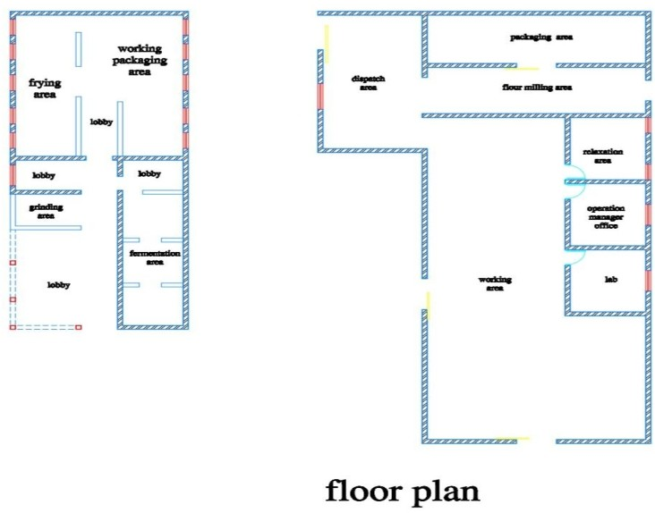

FIG 3.1: CASE STUDY I FLOOR PLAN

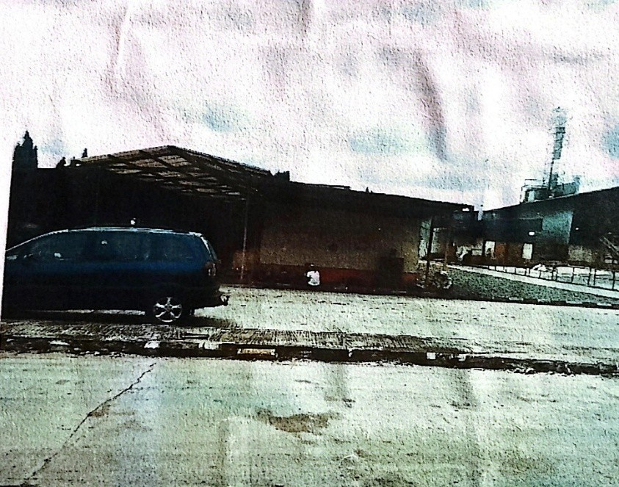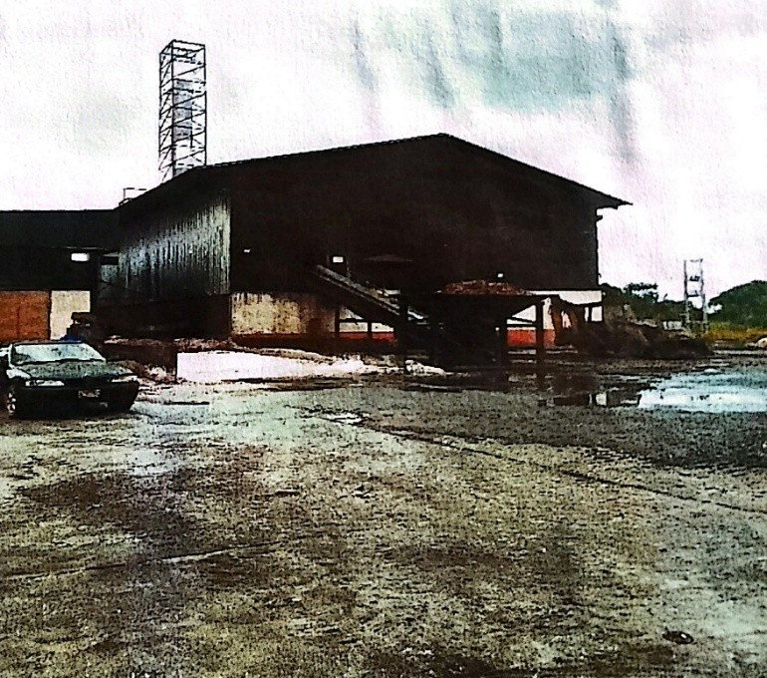
PLATE 3.1: APPROACH VIEWCASE STUDY I

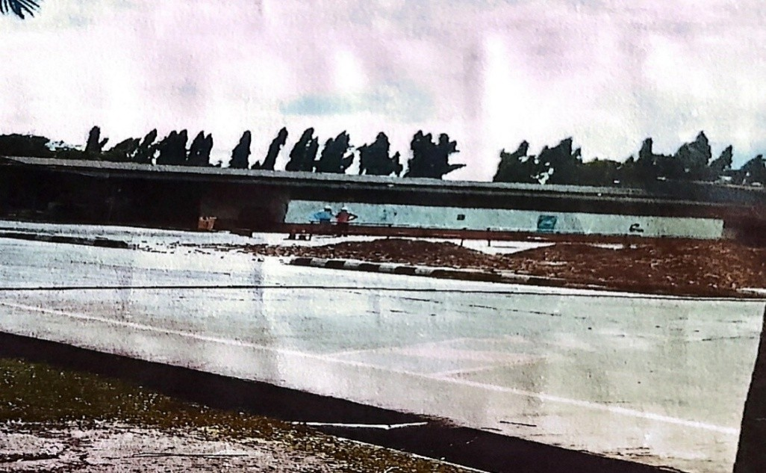
PLATE 3.2: RIGHT SIDE VIEW CASE STUDY I

    - MERITS
      - Clear separation of production zones.
      - Use of durable, easy-to-maintain building materials.
      - Provision for waste management and drainage systems.
      - Good site access for transport and logistics.
      - Inclusion of staff support spaces like toilets and changing rooms.

DEMERITS
      - Poor ventilation in processing areas.
      - Inadequate drainage causing water stagnation.
      - No designated route for waste disposal.

CASE STUDY TWO
PSALTRY INTERNATIONAL COMPANY LIMITED
LOCATION: PLOT 1, PSALTRY ROAD, ALAYIDE VILLAGE, ADO – AWAYE, ISEYIN LOCAL GOVERNMENT OYO STATE.

DESCRIPTION & HISTORICAL BACKGROUND
Psaltry International Company Limited was established in (2005) by Mrs. Oluyemisi Iranloye, a biochemist and entrepreneur, with the aim of transforming Nigeria’s cassava value chain and improving rural livelihoods through agribusiness.
The company began operations as a cassava farming initiative in Alayide Village, Iseyin Local Government Area of Oyo State, Nigeria. Initially focused on cassava cultivation and small-scale processing, Psaltry grew steadily by integrating farmers into its supply chain through an out-grower scheme, helping thousands of rural farmers become key stakeholders in the company’s success.
In (2012), Psaltry commissioned its first industrial starch processing factory, followed by a high-quality cassava flour (HQCF) plant in ( 2015), becoming a major supplier to food and beverage companies in Nigeria.A major milestone came in (2022), when Psaltry launched Africa’s first cassava-based sorbitol factory, in partnership with Unilever Nigeria and FCMB, drastically reducing Nigeria’s reliance on imported sorbitol used in foods, pharmaceuticals, and cosmetics.

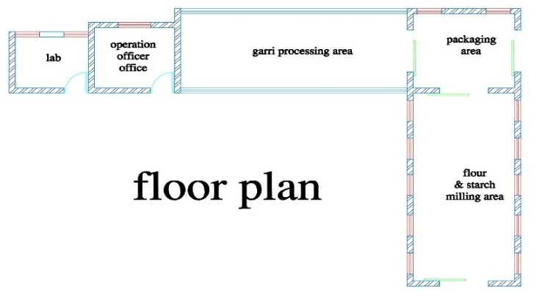

FIG 3.2: CASE STUDY II FLOOR PLAN

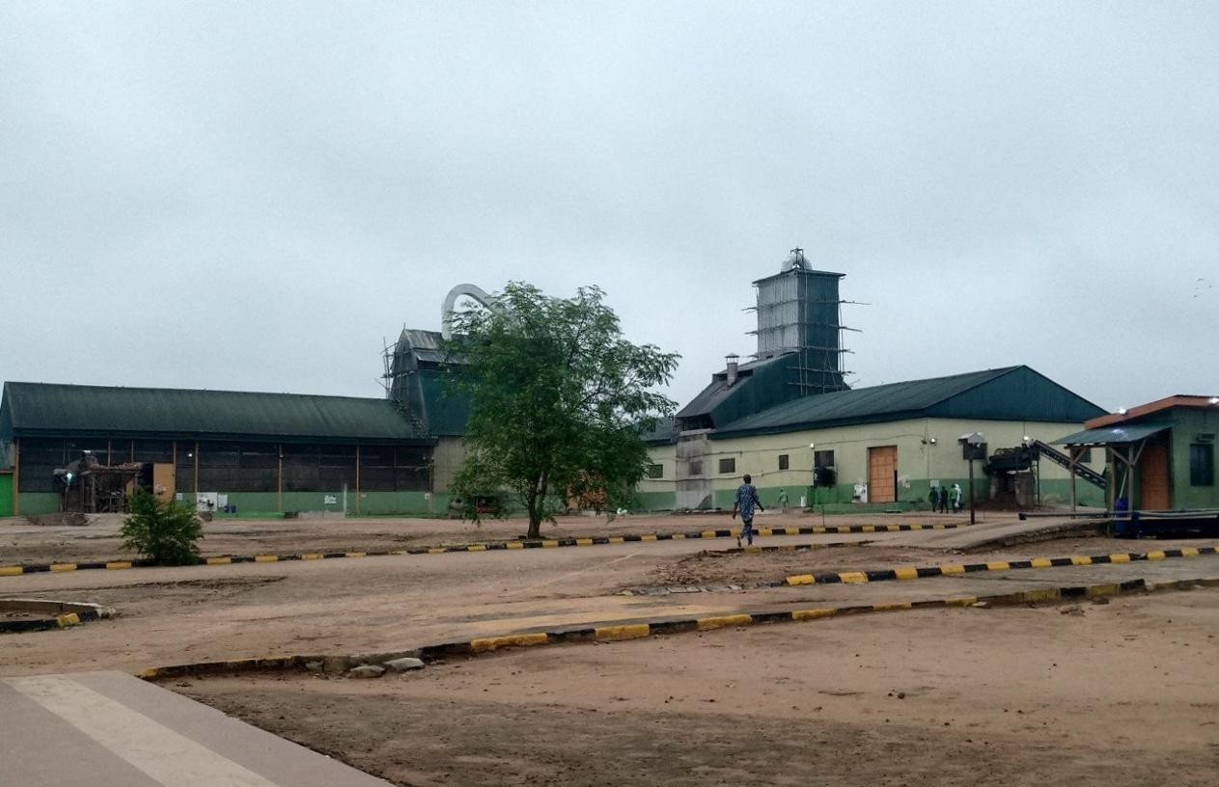
PLATE 3.3: APPROACH VIEWCASE STUDY II

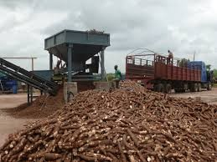
PLATE 3.4: FEED CHOPPER & RAW CASSAVA CASE STUDY II

    - MERITS
      - Energy-efficient lighting and ventilation.
      - Noise and heat control measures.
      - Proper zoning of clean and dirty areas.
      - User-friendly layout for staff and supervisors.

DEMERITS
      - High energy cost without efficient systems.
      - Excessive noise and heat in unregulated spaces
      - Cross-contamination risk due to poor zoning.
      - Confusing layout that affects productivity.

CASE STUDY THREE
AYOSIFARM INTEGRATED SERVICE.
LOCATION: KAJOLA KODIJIALE JUNCTION, OFF ESTATE ROAD, ILORIN.

DESCRIPTION & HISTORICAL BACKGROUND
Founded in (2018) and registered with Nigeria’s Corporate Affairs Commission as a youth-led, women-owned agribusiness based in Ilorin, Kwara State.
Established with the mission to support smallholder cassava (and later potato) farmers especially women by delivering agro-processing services, market access, and farm-level support .

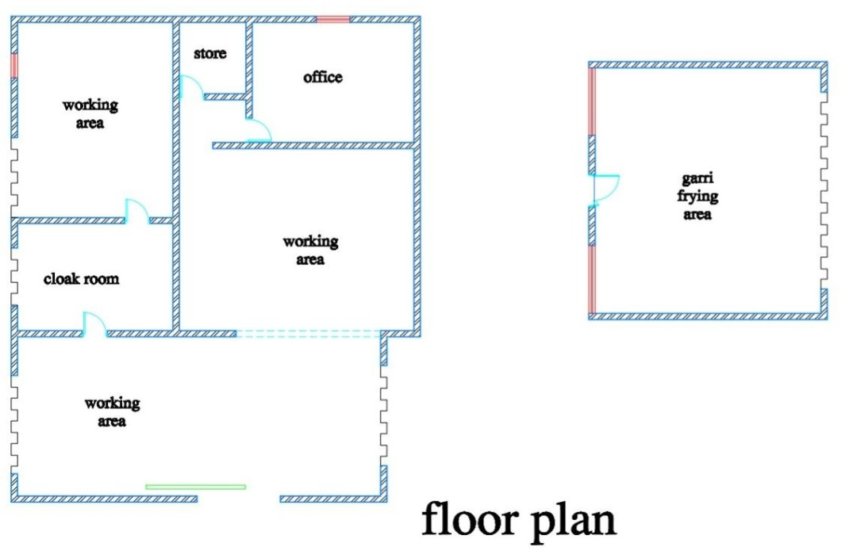

FIG 3.3: CASE STUDY III FLOOR PLAN

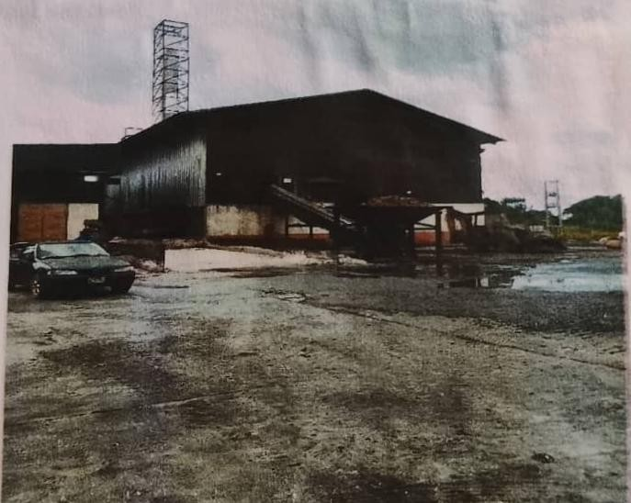
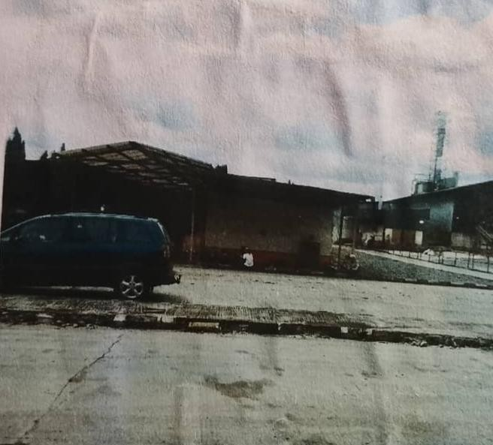
PLATE 3.5: APPROACH VIEW PLATE 3.6: GARRI FRYING AREA
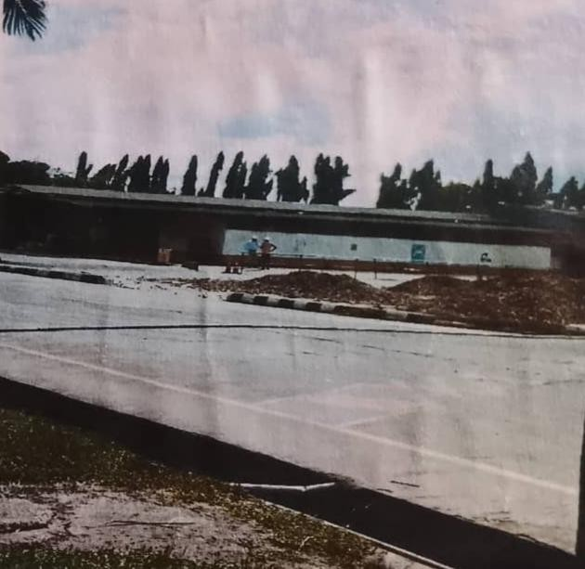
PLATE 3.7: CASSAVA DRYING AREA

    - MERITS
      - Basic production operations are achievable.

      - Location may be accessible for raw material supply.

DEMERIT
      - Lack of proper waste disposal system.
      - Insufficient ventilation and lighting.
      - No separation between wet and dry zones.
      - Limited space for future expansion.
      - Inadequate staff welfare and rest areas.

CASE STUDY FOUR [ONLINE CASE STUDY ] ASIA MODIFIED STARCH CO. LTD..
LOCATION:8 THEENANON RD, PHON THONG, MUEANG KALASIN DISTRICT, KALASIN 46000, THAILAND.

DESCRIPTION&HISTORICAL BACKGROUND
Established in (1987) as a Thai–Japanese joint venture—legally incorporated on September 24, (1987). Founded by Nihon ShokuhinKako Co., Ltd. And Mitsubishi Corporation, combining starch-processing expertise with global marketing support
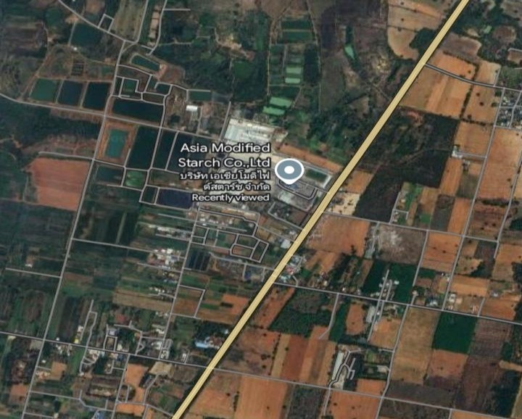
FIG 3.4: LOCATION PLAN

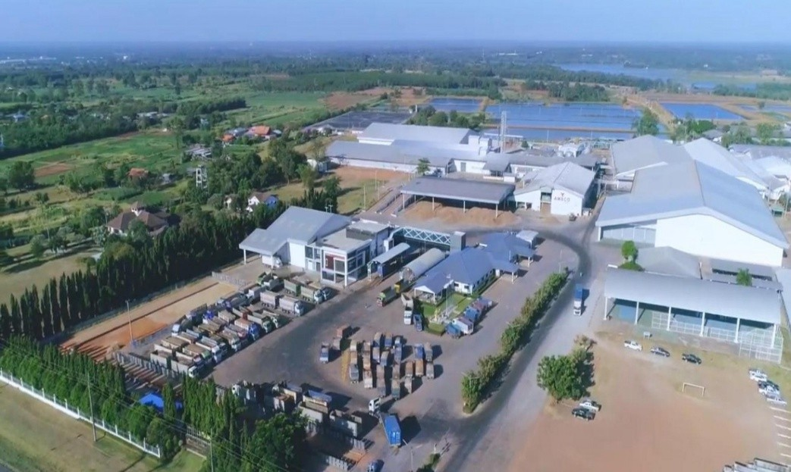
PLATE 3.8: AERIAL VIEW
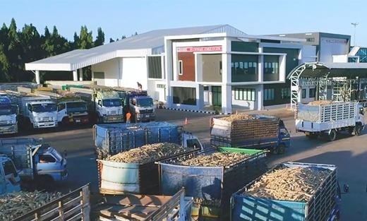
PLATE 3.9: APPROACH VIEW

  - CASE STUDY FIVE [ONLINE CASE STUDY 2] GENERAL STARCH LIMITED.
LOCATION:99–100 MOO 6, CHOKCHAI–KHON BURI ROAD (K.M.19), TAMBON ORAPHIM, AMPHOE KHON BURI, NAKHON RATCHASIMA 30250, THAILAND.

DESCRIPTION& HISTORICAL BACKGROUND
Established in (August 1992) in Thailand with an initial paid-up capital of 10 million Baht, later increased to 300 million Baht in (2007).

Received investment promotion from Thailand’s Board of Investment (BOI) with a project budget of 1 billion Baht.
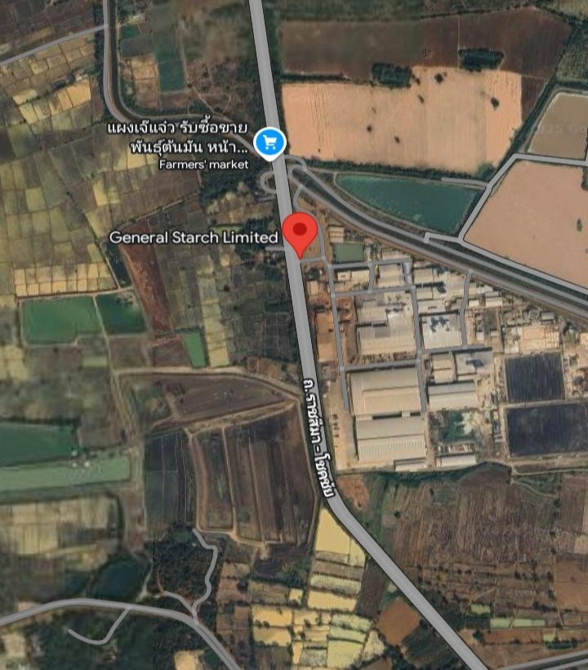
FIG 3.5: LOCATION PLAN

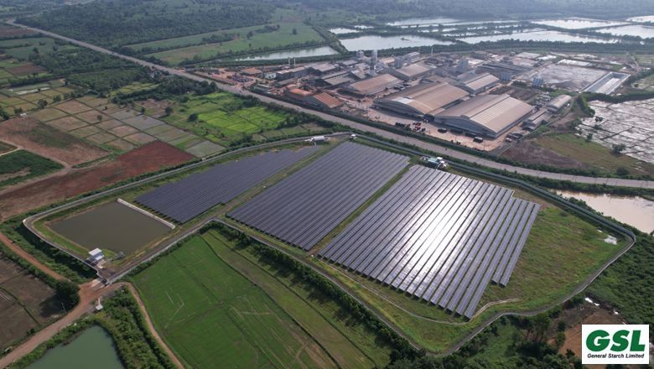
FIG 3.6: AERIAL VIEW


FIG 3.7: APPROACH VIEW

DEDUCTION FROM CASE STUDIES:
These are the common similar knowledge or information derived from the aforementioned case studies. Some of which are:
- Choice of location should be in a developing or already developed area for easy access to the trainings offered.
- Segregation of each department form one another
- Well designed and well positioned landscapes
- Separation of noisy departments from departments with less noise
- Provision of required ventilation and fenestration into each units to serve the spaces well

CHAPTER FOUR
  - ANALYSIS OF THE ENVIRONMENTAL AND TOPOGRAPHICAL CONDITIONS OF THE SITE

INTRODUCTION TO THE STUDY AREA.
This chapter presents a detailed analysis of the study area selected for the proposed Modern Cassava Processing Factory project, located within Ilorin West Local Government Area (LGA) of Kwara State, Nigeria. The purpose of this chapter is to establish an informed understanding of the physical and socio-economic environment of the site, which directly influences the design strategy and implementation of the proposed facility.
The selection of an appropriate site is critical in industrial architectural design, especially for agro-processing facilities where the proximity to raw materials, ease of transportation, availability of labor, and environmental responsiveness play pivotal roles. A thorough analysis of the study area enables the architect or designer to respond effectively to the unique opportunities and constraints presented by the location.

ENVIRONMENTAL RELEVANCE
Ilorin West is situated in the Guinea Savannah zone, characterized by moderate rainfall, adequate vegetation, and fertile soil, all of which support the growth of cassava. The environmental characteristics of the site provide a strong basis for locating a cassava processing factory in this region. Additionally, the relatively flat terrain found in many parts of Ilorin West makes the area suitable for construction and logistics movement, while still allowing for minimal grading and earthworks.

AGRICULTURAL AND INDUSTRIAL CONTEXT
Kwara State is one of the leading producers of cassava in Nigeria. The state has an established base of smallholder farmers and agricultural cooperatives that produce and supply cassava roots across local and inter-state markets. By situating the factory in Ilorin West, the project leverages its strategic location near farming communities, while also being close to the urban center of Ilorin, which ensures access to a ready labor force, electricity, and road infrastructure.

PLANNING AND ZONING CONSIDERATIONS

The study area is zoned under mixed-use development, which accommodates both industrial and agricultural enterprises. This makes it feasible for the project to obtain planning approval and integrate smoothly into the local economy without causing displacement or environmental degradation. Its location outside the densely populated residential zones helps reduce land use conflict, noise complaints, and waste-related health hazards.

INFRASTRUCTURAL SUPPORT
Ilorin West is relatively well-connected to road networks, including major access roads leading to Ganmo, Ogbomosho, Jebba, and Osogbo, allowing for efficient distribution of processed cassava products. It also benefits from electricity supplied by the Ibadan Electricity Distribution Company (IBEDC), along with private boreholes and small-scale water distribution systems commonly used for agricultural and industrial purposes.

SOCIO-ECONOMIC IMPACT
Locating the cassava processing factory in Ilorin West is expected to yield multiple socio-economic benefits, such as:
      - Generating employment opportunities for local residents, especially women and youth.
      - Encouraging cassava farmers to increase productivity with assured off-takers.
      - Promoting local entrepreneurship in packaging, logistics, maintenance, and food distribution.
      - Contributing to food security and rural development.
This makes the study area not only technically suitable but also socially and economically strategic.

ENVIRONMENTAL RESPONSIBILITY
Finally, understanding the ecological and climatic features of the study area is essential for adopting a sustainable design strategy. Proper orientation to prevailing winds, sun path analysis for daylighting, and assessment of soil permeability for wastewater management are all part of context-sensitive architectural planning. Integrating local vegetation, respecting natural contours, and minimizing land disturbance during construction further ensure that the facility will coexist harmoniously with its surrounding environment.

HISTORICAL BACKGROUND OF ILORIN WEST LOCAL GOVERNMENT AREA
Ilorin West is one of the most urbanized and economically significant local government areas in Kwara State. It forms part of Ilorin metropolis and serves as a major hub for commerce, education, and administration in the state
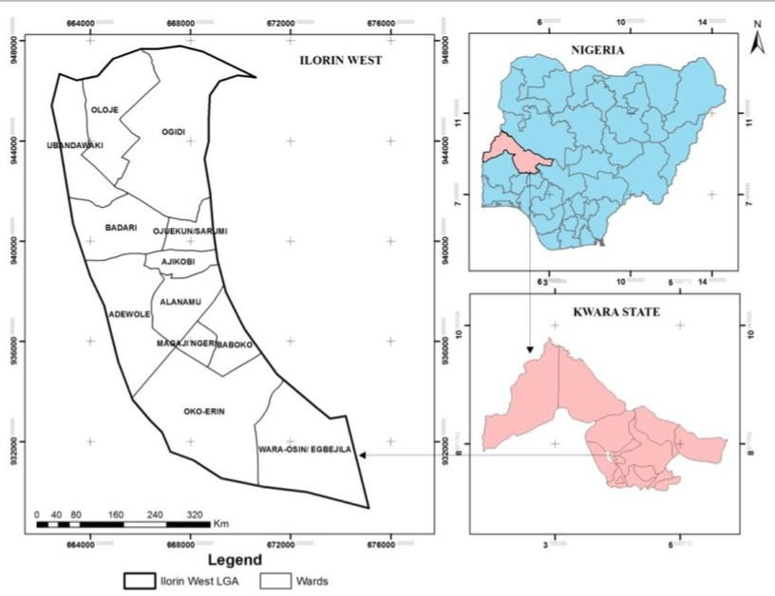

Figure 4.1 : showing the map of ilorin West local government and it geopolitical area.

PRE-COLONIAL ERA:
Ilorin, the capital of Kwara State, was historically a Yoruba settlement that later came under the influence of the Fulani during the 19th century. It became a vital Islamic center and a strategic trade route linking the northern and southern parts of Nigeria.

4.2 2 COLONIAL ERA (1900–1960):
During British rule, Ilorin gained prominence as a provincial headquarters. Colonial infrastructure such as roads, schools, and government buildings were established, creating the foundation for its present administrative role.

POST-COLONIAL ERA (1960–PRESENT):
Following Nigeria’s independence, Ilorin West has continued to develop rapidly. It now hosts numerous institutions, markets, and residential areas. Despite its urban status, the peripheries of the LGA remain semi-rural, with active agricultural engagement, including cassava farming and small-scale agro-processing.

PHYSICAL CHARACTERISTICS OF THE SITE
The selected site is situated in a semi-urban fringe within Ilorin West LGA. The area benefits from proximity to urban infrastructure while retaining the land availability and quiet environment characteristic of peri-urban zones.
- Topography: The land is generally flat with mild undulations, offering ideal conditions for construction with minimal grading or filling required.
- Soil Type: The dominant soil is red lateritic, known for its excellent load-bearing capacitysuitable for heavy-duty industrial structures.
- Drainage: Natural drainage patterns run along shallow gullies with seasonal runoff, requiring integrated site drainage planning to prevent erosion or flooding.

POPULATION OF ILORIN WEST AND KWARA STATE
- Kwara State: As of 2022, the estimated population was approximately
3.6–3.8 million people.
- Ilorin West LGA: It is among the most densely populated LGAs in the state, with an estimated population exceeding 400,000. The demographic is diverse, consisting of traders, civil servants, artisans, and farmers.
- Cassava Relevance: While the urban core is commercial, the outskirts support significant cassava farming activities, often processed at a cottage scale.

SOCIAL SERVICES AND INFRASTRUCTURE
The area is moderately equipped with essential infrastructure:
- Health Facilities: General Hospital Ilorin and multiple primary health centers and private clinics serve the community.
- Education: The area hosts several public and private secondary schools, as well as tertiary institutions such as Kwara State Polytechnic and the University of Ilorin.
- Utilities: Electricity is supplied by the IBEDC, and water is provided via boreholes, wells, and piped systems in some districts.

- Markets: The presence of large local markets like Oja Oba provides a commercial outlet for agricultural produce.

ROAD NETWORK AND ACCESSIBILITY
Ilorin West is well-connected through a network of tarred and untarred roads. Major roads such as the Asa Dam Road, Old Jebba Road, and Western Reservoir Road offer reliable access to the proposed site location.
- Access to Factory Site: The selected site is accessible via a secondary road that branches off a major township route, enabling ease of movement for goods, staff, and raw materials.
- Transport Services: Public transportation is readily available, including tricycles, buses, and motorcycles.

HEALTH SERVICES IN ILORIN WEST LOCAL GOVERNMENT AREA
Healthcare in Ilorin West is supported by a mix of public and private health institutions, including:

Sobi Specialist Hospital, Ilorin
One of the largest public hospitals in Kwara State, offering specialist care and emergency services

University of Ilorin Teaching Hospital (UITH) (Satellite Annex)
Though the main UITH is located in Ilorin East, satellite services are accessible from Ilorin West

Adewole Cottage Hospital
Provides primary and secondary healthcare services within the LGA

Asa Dam Health Centre
Government-run primary healthcare facility offering maternal and child health services

Oko-Erin Primary Health Centre
Well-utilized PHC located in a densely populated residential area

Pakata Health Centre
Provides outpatient, maternity, and immunization services

Alagbado Health Post
Supports basic community-level healthcare and preventive medicine

General Hospital Ilorin (Accessible nearby)
Located close to Ilorin West; serves residents from adjoining districts

Numerous private hospitals and clinics, including:
Ayodele Hospital and Maternity Home

Emmanuel Hospital
Life Line Specialist Hospital Rahmat Specialist Clinic Royal Care Hospital
- Traditional birth attendants and community-based health workers also complement the healthcare system, especially in underserved areas.

WATER AND ELECTRICITY
- Water Supply: Boreholes, open wells, and seasonal streams.
- Electricity: Provided by IBEDC, with stable service in the area.

CLIMATIC CONDITIONS
Ilorin West shares the climatic features typical of the tropical wet and dry (savannah) zone:
- Rainy Season (April – October): Rainfall: 1,200 – 1,500 mm annually Temperature Range: 23°C – 30°C Humidity: 70–85%
- Dry Season (November – March): Temperature Range: 26°C – 36°C Humidity: 30–50%
Presence of Harmattan between December and February

General Features:
Average Annual Temperature: ~27.5°C Sunshine Hours: 2,400–2,800 hours annually
Wind Speed: Moderate, stronger during Harmattan

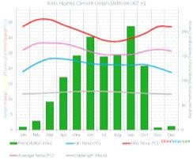
Figure 4.2 : Showing the climatic Data of Ilorin metropolitans

VEGETATION AND ECOLOGICAL FEATURES
Ilorin West lies within the Guinea Savannah belt, featuring:
- Grasses, shrubs, and scattered medium-sized trees
- Mixed-use land farming on the fringes and built-up areas in the urban core
- Some portions of the site will retain existing vegetation for shade and landscape aesthetics.

SITE ANALYSIS

SITE SELECTION AND JUSTIFICATION
The site was chosen based on a combination of accessibility, topography, infrastructure availability, and proximity to cassava-producing zones.

JUSTIFICATION HIGHLIGHTS:
- Accessibility: Well linked by all-season roads to key transport routes within Ilorin metropolis.
- Strategic Location: Positioned between rural supply areas and urban demand

centers.
- Infrastructure: Availability of stable electricity, borehole water systems, and potential for drainage integration.
- Topography: Flat, well-drained terrain suitable for phased factory expansion.
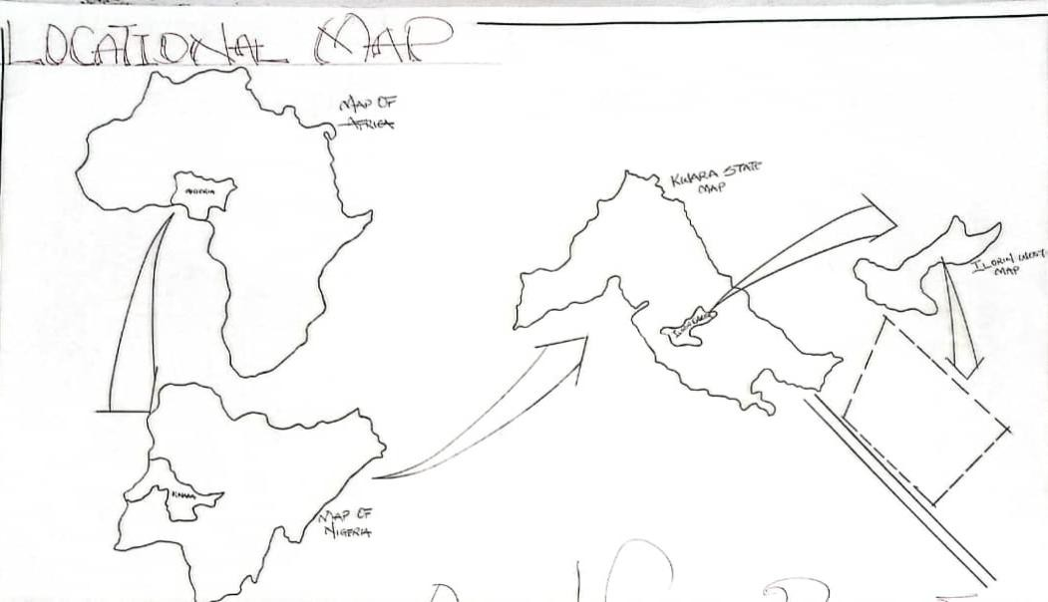
- Community Impact: Proximity to farming communities provides raw material sources and workforce supply, while urban proximity offers market linkage and logistics advantage.

LOCATIONAL MAP
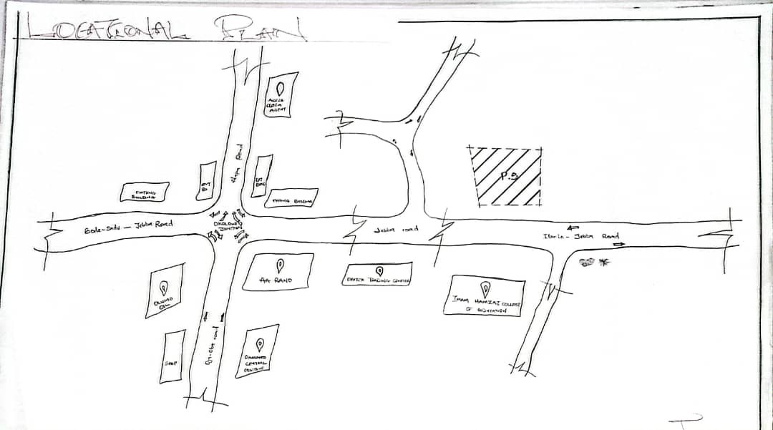

LOCATION PLAN

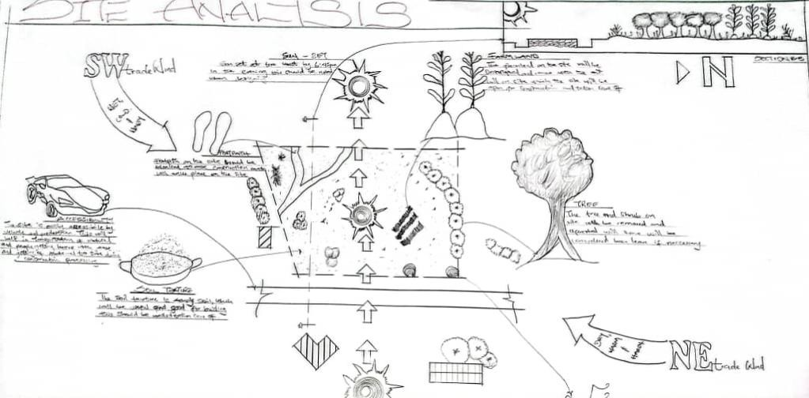
SITE ANALYSIS
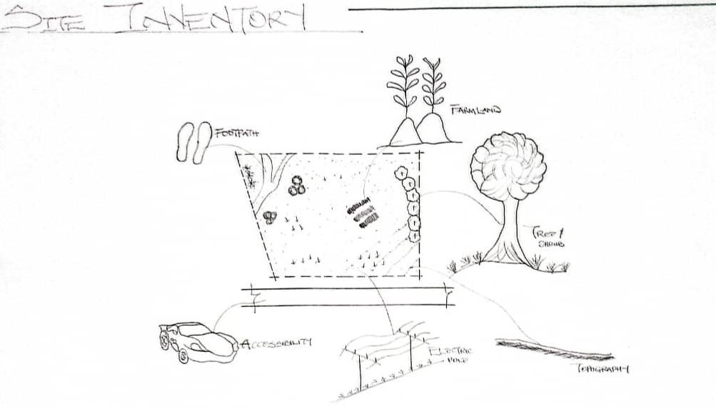

SITE INVENTORY

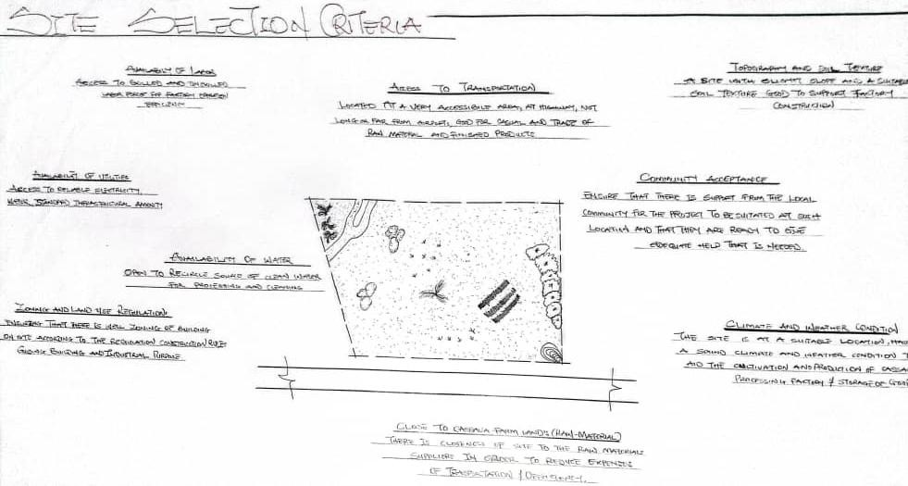

SITE SELECTION CRITERIA

DESIGN CONCEPT AND PLANNING PRINCIPLES

DESIGN CONCEPT
The design concept for the Modern Cassava Processing Factory was developed as a functional response to the specific needs of cassava product transformation from raw tubers to consumable and industrial-grade products. The concept draws on architectural problem-solving principles rooted in workflow logic, environmental adaptation, hygiene control, and spatial clarity.The conceptual approach began with a comprehensive analysis of existing cassava processing layouts, industry guidelines, and health standards for agro-industrial facilities. Case studies of operational cassava plants were reviewed to understand their spatial challenges and merits, while consultations with food technologists and factory supervisors helped refine critical operational zones.
Functional areas such as raw material reception, peeling/washing, grating, pressing,

fermentation, drying, milling, and packaging were identified as core activity nodes. These nodes were organized using bubble diagrams and functional flowcharts to illustrate direct relationships and movement patterns within the facility. This method enabled the smooth transition of materials from one stage to another, minimizing unnecessary backtracking, cross-contamination, or physical strain.
The zoning logic also responded to the nature of activities, particularly regarding:
      - Moisture content (e.g., wet zones like washing and fermentation)
      - Heat generation (e.g., roasting and drying sections)
      - Noise levels (e.g., milling and mechanical operations)
      - Cleanliness standards (e.g., packaging and storage)
The final concept integrates modular, expandable spaces that support future automation and increased production capacity. Open-sided ventilated sheds are used in high-moisture areas, while enclosed climate-controlled rooms are adopted for critical hygiene zones

PLANNING PRINCIPLES
The planning of the cassava processing factory adheres to internationally recommended standards for food processing facilities, while also considering local climate, material availability, labor dynamics, and cost efficiency.

Zoning by Function and Intensity
The site and building layouts are divided based on operational demand, activity level, and user needs. Three primary site zones were established

Zone A: Semi-Quiet Zone
This includes the Administrative Block, which houses offices, reception, supervisor rooms, testing laboratories, meeting rooms, and staff restrooms. Its placement ensures acoustic separation from noisy factory operations and provides oversight access to the processing area.

Zone B: Transitional Processing Zone
This mid-activity zone accommodates washing, peeling, grating, and fermentation. These areas handle organic materials with high moisture content and moderate noise levels. Proper drainage and cross-ventilation were emphasized here.

Zone C: High-Activity Zone
This zone includes pressing, drying, roasting, milling, and packaging units, where mechanical operations generate higher noise, vibration, and heat. The spaces are designed with durable, washable materials, sound buffering walls, and heat exhaust systems.

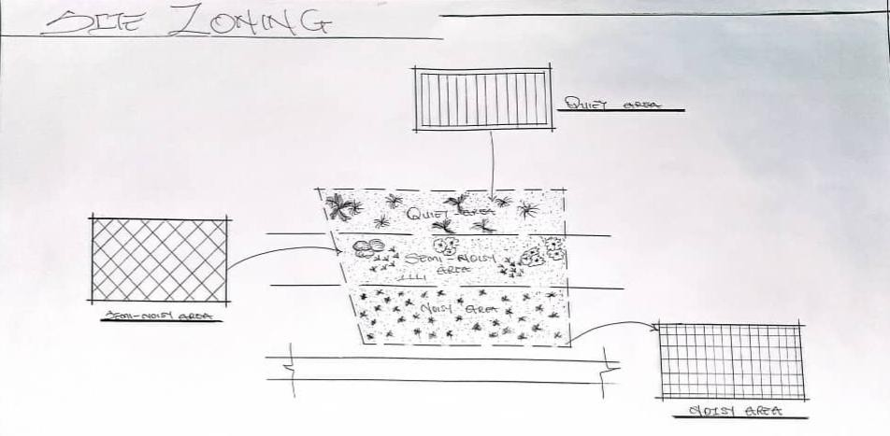

SITE ZONING

Workflow Efficiency
The building’s internal layout follows a linear workflow to support logical material movement from:
  - Cassava tuber reception
  - Initial cleaning
  - Grating and pressing
  - Fermentation/drying
  - Final milling/packaging
  - Storage and dispatch
This flow reduces overlap between raw and processed materials and improves productivity by minimizing worker fatigue and transport time between stages.

Health and Hygiene Control
- Wet and dry processes are separated to reduce contamination.
- Floors are slightly sloped for easy drainage.
- Adequate spacing is provided between machines for cleaning and movement.
- Hand-washing stations and PPE changing rooms are located near entry

points into hygienic zones.

Environmental and User Comfort Integration
- Cross ventilation and stack ventilation were applied in high-heat zones.
- Natural daylighting through clerestory windows and roof monitors reduces energy use.
- Noise-generating equipment is acoustically enclosed where necessary.
- Landscape buffers provide shade, dust reduction, and visual relief.

CHAPTER FIVE

DESIGN REPORT

DESIGN BRIEF
Following extensive research and planning, the next critical stage in the project development is the design process. For a functional, efficient, and aesthetically pleasing facility, it is essential to begin with a clear and detailed design brief. The nature of this brief depends largely on the scope and specific operational requirements of the proposed project.
In the case of this project, the design brief is developed based on the comprehensive understanding of activities involved in a modern cassava processing factory. This includes the entire production chain—from the reception of raw cassava tubers to the final packaging and storage of processed cassava products.To develop an effective and practical brief, detailed case studies were conducted on existing cassava processing facilities within Nigeria and abroad. These studies provided valuable insights into the layout, workflow, hygiene requirements, equipment needs, and functional relationships between the various units in a standard processing factory.
The proposed cassava processing facility is designed to handle multiple product lines such as cassava flour, garri, fufu, and industrial starch. Accordingly, the factory is structured to include essential departments such as:
- Cassava Reception and Inspection Area
- Production Area
- Storage (raw material and finished goods)
- Waste Treatment Area
- Energy Sustainability

MAJOR SPACES IN A MODERN CASSAVA GARRI PROCESSING FACTORY

Raw Material Reception & Preliminary Processing
  - Cassava Reception Bay– for weighing and offloading freshly harvested cassava roots.
  - Sorting Area–for manual or mechanical sorting to remove stones, dirt, and damaged tubers.
  - Washing & Peeling Area–with washing drums, peeling machines, and drainage channels.

Processing & Production Zones
  - Grating Room – equipped with mechanical graters.
  - Fermentation Area – tanks or containers for fermenting grated cassava mash.
  - Pressing Area – with hydraulic/mechanical presses for dewatering.
  - Sieving/Shredding Room – for breaking down pressed cake before roasting.
  - Roasting Section – with stainless steel or mechanized roasting pans.
  - Cooling Area – for cooling roasted garri before packaging.
  - Milling/Grinding Section (optional, if producing flour from dried cassava).

Drying & Packaging
  - Mechanical/Solar Drying Area – for moisture control and shelf-life extension.
  - Packaging Room – clean, dust-free space for packing into bags or containers.
  - Finished Goods Store – for storing packaged garri before distribution.

By-Product Handling & Waste Management
  - Peel Collection & Processing Area – for converting peels into animal feed or compost.
  - Wastewater Treatment Area – soak-away pits or biogas digesters for liquid waste.
  - Solid Waste Storage Area – for temporary holding before disposal orreuse.

Storage & Logistics
  - Raw Cassava Store – shaded, ventilated space for short-term storage of tubers.
  - Material & Equipment Store – for spare parts, tools, and processing supplies.
  - Loading/Dispatch Bay – for loading finished products into distribution vehicles.

Administrative & Support Facilities
  - Administrative Office – for management and clerical work.
  - Laboratory/Quality Control Room – for product testing, moisture content checks, and safety monitoring.
  - Staff Changing Rooms & Lockers – for workers to change into protective clothing.
  - Toilets & Washrooms – gender-separated, hygienic facilities for staff.
  - Staff Canteen/Rest Area – for breaks and meals.

  - Security Post/Gate House – for access control and factory safety.

External & Site Planning Considerations
  - Access Roads & Driveways – for delivery trucks and raw material supply.
  - Parking Space – for staff, visitors, and transport vehicles.
  - Drainage Systems – to prevent flooding and maintain hygiene.
  - Landscaping/Buffer Zones – to reduce dust, noise, and heat impact.

DESIGN ANALYSIS
This is the process of itemizing units within the components of the entire design with a view to establish a solid understanding and appreciation of the space relationships.
Table 1.0: Space Analysis

S/N | FACTORY UNITS | DIMENSIONS(M) | M2
1 | Entrance | 33.3 x2.7 | 89.91m2
2 | Quality Control | 4.9 x 2.4 | 11.76m2
3 | Supervisor Office | 4.9x 4.5 | 22.05m2
4 | Supervisor Toilet | 2.7 x1.5 | 4.05m2
5 | Maintenance Unit | 4.9 x 2.7 | 13.23m2
6 | Rest Room | 4.9 x 4.0 | 19.6m2
7 | Production Hall/Area | 33.3 x 14.0 | 466.2m2
8 | Fermentation Area | 5.4 x 2.7 | 14.58m2
9 | Male Cloakroom | 3.0 x 2.7 | 8.1m2
10 | Male Toilet | 2.1 x 1.2 | 2.52m2
11 | Female Cloakroom | 3.5 x 3.0 | 10.5m2
12 | Female Toilet | 1.8 x 1.2 | 2.16m2
13 | Lobby | 3.8 x 2.0 | 7.6m²
14 | Control Room | 3.0 x 2.7 | 8.1m²
15 | Server Room | 3.0 x 2.7 | 8.1m²
16 | Dispatch Officer unit | 3.0 x 2.7 | 8.1m²
17 | Laboratory | 3.9 x 3 7 | 14.43m²
18 | Laboratory Entrance/Exit | 3.9 x 1.65 | 6.435m²
19 | Packaging Room | 5.7 x 5.7 | 32.49m²
20 | Sorting/Finished Goods store | 5.7 x 4.2 | 23.94m²
21 | Raw Material Spot | 4.6 x 4.2 | 19.32m²
22 | Lobby | 8.3 x 1.2 | 9.96m²
23 | Delivery Bay/ Dispatch Bay | 8.3 x 6.1 | 50.63m²

24 | Entrance/Exit | 6.1 x 2.0 | 12.2m²
 | TOTAL |  | 865.965m2

DESIGN APPRAISAL
In the design of agro-industrial facilities such as a modern cassava processing factory, two essential factors must work in harmony: functionality and environmental appropriateness. While industrial design often prioritizes mechanical performance and efficiency, the modern architectural response goes further by integrating aesthetic quality, environmental sustainability, and human well-being.This design appraisal reflects how the proposed cassava processing facility effectively balances form and function. The spatial layout supports linear workflow logic, where raw materials enter from one axis, and finished products exit through anothereliminating cross-contamination. The arrangement of volumes, massing, access points, and circulation has been guided by empirical research, environmental analysis, and user behavior studies to ensure optimum operational output and safety.
The entire factory campus is designed not just as a place of production, but as a
model environment that enhances productivity, supports hygiene standards, and uplifts user experiencemeeting the physical and emotional needs of workers while aligning with Nigeria’s drive for agro-industrialization.

DESIGN CHARACTERISTICS

Landform and Site Response
The site for the proposed factory is situated on gently sloped terrain, which was intentionally selected to aid gravity-assisted drainage and reduce surface runoff stagnation. This natural slope enhances waste and water management while allowing tiered planning of functional zones without excessive cutting or filling.

Landscape Integration and Buffering
  - To moderate the tropical climate and improve microclimatic comfort:
  - Shade trees such as neem and flamboyant are planted along perimeter boundaries and near rest areas.
  - Landscaped green belts act as acoustic and visual buffers between production areas and administrative zones.
  - Bahama and Kikuyu grasses provide erosion control and visual relief.
  - Ornamental flower beds and hedges define pedestrian walkways and transition spaces, especially around office and welfare facilities.
  - These landscape interventions enhance thermal comfort, promote biodiversity, and provide aesthetic quality to an otherwise industrial site.

Spatial Layout and Zoning
The facility is divided into three main functional zones based on intensity of operation:

Zone A – Semi-Quiet/Admin Zone
Includes the administrative block, testing laboratory, staff restrooms, changing rooms, and cafeteria. This zone is separated from production noise and dust and provides a healthy, supportive working environment.

Zone B- Medium Activity/Processing Transition Zone
Includes washing, peeling, grating, and fermentation units, where materials are still organic and wet. Proper drainage channels and open-sided structures support airflow and cleanliness.

Zone C – High Activity/Mechanical Zone
Includes pressing, roasting, milling, drying, and packaging. This zone generates significant noise, heat, and mechanical vibration, requiring reinforced structures, noise buffers, and overhead exhaust systems.
Each zone is designed with dedicated service access, waste channels, and emergency circulation, ensuring functionality and safety.

STRUCTURAL SYSTEM AND MATERIAL STRATEGY
The structural framework follows a grid-based modular system, allowing flexibility in equipment installation, future expansion, and maintenance.
- Foundations: Strip and pad footings reinforced with concrete, sized according to sub-soil analysis.
- Walls: 225mm sandcrete blocks plastered and painted; processing areas are tiled internally up to 2.1m for easy wash-down and hygiene control.
- Columns and Beams: Reinforced concrete in admin areas; steel stanchions in production halls.
- Roofing: Galvanized long-span aluminum sheets over steel trusses in production halls; timber trusses treated with anti-termite solution in offices.
- Ceilings: Acoustic panels in offices; exposed roofing in ventilated processing zones.
- Doors and Windows: Wide steel doors for equipment access; louvered and aluminum pivot windows for natural lighting and ventilation.

SERVICES

Power Supply:

The factory connects to the national grid with provisions for an industrial generator to support uninterrupted operation.

Water Supply:
An industrial borehole system with overhead tanks ensures a constant supply of clean water for processing and cleaning.

Waste Management:
Solid waste from cassava peels and fiber are processed into animal feed or compost. Liquid waste is directed into treatment pits and soak-away systems. There are provisions for future biogas integration.

Ventilation and Air Conditioning:
Natural ventilation is encouraged through strategic openings. Forced ventilation (industrial fans) is used in processing zones. Offices are air-conditioned for worker comfort.

GENERAL REQUIREMENTS

Lighting:
Natural lighting is prioritized in production and storage zones with skylights and high-level windows. Artificial lighting (LED and fluorescent fixtures) are installed for 24/7 operations.

Orientation:
The factory is oriented to take advantage of prevailing winds and minimize solar heat gain. Production zones face away from direct sun exposure to maintain moderate indoor temperatures.

Rain Protection:
Simple sloped roofing is adopted for quick drainage. Gutters and downspouts direct rainwater to collection points for reuse in non-critical processes. Damp-proof membranes are used in wall and floor junctions to resist water ingress.

Noise Control:
Machinery zones are acoustically insulated. Buffer zones with trees and sound-absorbing materials separate noisy equipment from administrative offices and staff areas.

MATERIALS AND FINISHES

MATERIAL:
Selection Factors:

      - Suitability and durability for industrial use
      - Resistance to moisture, pests, and chemical exposure
      - Availability and cost of materials locally
      - Low-maintenance surfaces

FINISHES SPEC:

Roofing:
Long-span galvanized aluminum sheets with reinforced concrete gutters are used. The processing areas have steel roof structures; other blocks use timber trusses treated against termites.

Ceiling:
Suspended ceilings (e.g., Celotex) in office areas; acoustic panels used where necessary.

Walls:
225mm sandcrete blocks with smooth internal and external plaster finishes. Walls in processing zones have ceramic tiles up to 1.8–2.1 meters high for easy cleaning.

Doors:
Wide industrial metal doors for equipment zones; wooden or aluminum doors for administrative sections.

Windows:
Louvered and aluminum-framed pivot windows for ventilation and ease of maintenance.

Walkways:
All pedestrian and loading paths are paved with concrete slabs for durability. Covered walkways connect key buildings.

SUMMARY AND CONCLUSION

SUMMARY
From concept to detailed drawings, the design of this modern cassava processing factory was guided by principles of functionality, safety, hygiene, and efficiency. The layout supports linear production flow, minimizes cross-contamination, and integrates sustainable elements such as landscaping and waste management strategies. In addition, careful attention was given to the zoning of operational spaces, allowing for logical segregation between wet and dry areas, high-noise and administrative zones, and clean versus contaminated workflows. This thoughtful spatial arrangement enhances both productivity and compliance with food safety standards. The incorporation of durable, easy-to-clean materials, natural ventilation,

and provisions for future expansion further demonstrates the project’s commitment to long-term sustainability and adaptability in Nigeria’s growing agro-industrial landscape.
The design also integrates climate-responsive features such as roof overhangs, proper orientation to prevailing winds, and the use of passive lighting and ventilation systems to reduce reliance on mechanical energy. Furthermore, adequate consideration was given to staff welfare through the inclusion of rest areas, sanitation facilities, and clearly marked pedestrian circulation paths. These elements not only improve user experience but also foster a safer, more organized working environment. Altogether, the proposed factory reflects a model of architectural innovation that balances industrial function, environmental sensitivity, and human-centered design in support of Nigeria’s agricultural transformation agenda.

CONCLUSION
The design reflects insights gained from research into cassava processing facilities across Nigeria and beyond. It showcases a model layout that meets the economic, functional, and environmental needs of a modern agro-industrial facility. With this project, I have contributed to the advancement of sustainable agricultural processing infrastructure, creating a benchmark for future factory developments in Nigeria. This design demonstrates how architecture can play a strategic role in solving real-world agricultural challenges by improving efficiency, enhancing hygiene, reducing post-harvest losses, and supporting value addition. By incorporating climate-responsive elements, waste management systems, and a well-zoned spatial arrangement, the proposal stands as a replicable solution that balances productivity with sustainability. It further reflects a shift from informal, labor-intensive cassava processing to organized, mechanized, and safer operations suitable for both domestic supply and export readiness.
In conclusion, the proposed modern cassava processing factory is not just a
building it is a symbol of innovation in Nigeria’s agricultural sector. It is a model that proves the relevance of thoughtful, functional, and human-centered design in driving rural industrialization, enhancing food security, and opening up economic opportunities for farming communities and beyond.

RECOMMENDATIONS
In view of the findings and design exploration of this project, several key recommendations are proposed to enhance the effectiveness, sustainability, and

future adaptability of modern cassava processing facilities in Nigeria.
First, it is strongly recommended that future cassava factories adopt modular and scalable design principles. By allowing for flexibility in building expansion and equipment installation, such an approach ensures the facility remains responsive to technological advancements and market growth. This modularity supports future diversification into products such as industrial starch, ethanol, and high-quality cassava flour.
Additionally, the integration of renewable energy systems should be prioritized in the design and operation of agro-processing plants. Given the energy-intensive nature of cassava processing and the unreliability of the national power grid, solar panels, biogas digesters (using cassava waste), or hybrid energy systems can significantly improve efficiency, reduce costs, and minimize the facility’s carbon footprint.The project also recommends the incorporation of training and development spaces within the facility. As cassava remains a staple crop with high industrial potential, dedicated areas for staff training, knowledge transfer, and demonstrations will empower local farmers, workers, and entrepreneurs. These spaces may operate in partnership with agricultural institutes, research centers, and cooperatives to strengthen agro-industrial capacity at the grassroots level.
To ensure long-term product quality and access to global markets, the factory must
also be designed in compliance with both local and international food safety and regulatory standards. The inclusion of testing laboratories, contamination control protocols, and hygiene-enhancing architectural features (such as washable surfaces, sealed joints, and designated waste zones) will not only enhance operational excellence but also facilitate export readiness.
Moreover, the future success of such facilities lies in their ability to adopt smart, data-driven technologies. The use of sensors, automation, and real-time monitoring tools can greatly improve efficiency, machine lifespan, and overall traceability in the production process. These digital solutions also help in quality assurance and regulatory reporting, which are critical for large-scale agro-processing ventures. The adoption of a circular economy model is equally encouraged. Instead of treating by-products such as peels, wastewater, and fiber as waste, these can be converted into livestock feed, compost, or energy sources. This not only reduces environmental impact but adds economic value to the factory’s output stream. Furthermore, the design and implementation of cassava factories must reflect a people-centered approach. Adequate welfare facilities, staff safety provisions, and environmental comfort zones are essential to maintaining workforce health and morale. Engaging host communities through job creation, raw material supply

contracts, and local services fosters inclusive development and builds long-term support for the project. Government policies and incentives play a pivotal role in supporting such industrial ventures. It is therefore advised that project proponents seek alignment with existing national agricultural transformation strategies, such as the Agricultural Promotion Policy (APP), and leverage funding platforms like the Anchor Borrowers’ Programme, NIRSAL, or BOI Agro Funding Schemes.
Lastly, this project recommends the adaptation and replication of its design model across cassava-producing regions in Nigeria. With careful customization based on local context, this model can catalyze agro-industrial growth, reduce rural unemployment, and contribute meaningfully to national food security.

REFERENCES
Adegeye, A. J., &Dittoh, J. S. (1985). Essentials of Agricultural Economics. Ibadan: Impact Publishers.
Adebayo, K. (2009). Dynamics of Technology Adoption in Rural-Based Cassava Processing Enterprises in Southwest Nigeria. International Journal of Agricultural Economics & Rural Development, 2(1), 15–24.
Akinrele, I. A. (1990). Fermentation of Cassava. Nigerian Food Journal, 8(1), 24–27.
Ayoade, J. A., &Adeola, A. O. (2018). Improving Post-Harvest Cassava Processing Efficiency through Mechanization: A Case Study of Rural Enterprises in Nigeria. Nigerian Journal of Technological Development, 15(2), 64–71.
Ezedinma, C., &Kormawa, P. (2007). Value Chain Analysis for the Cassava Sub-sector in Nigeria. International Institute of Tropical Agriculture (IITA), Ibadan.
FAO. (2013). Processing of Cassava: Post-Harvest Operations. Food and Agriculture Organization of the United Nations. Retrieved from www.fao.org
IITA. (2005). Cassava: Transformation in Africa. International Institute of Tropical Agriculture, Ibadan.
Kolawole, O. M., &Olayemi, A. B. (2010). Effect of Drying Methods on the Quality Attributes of Cassava Product (Garri). International Food Research Journal, 17(2), 377–382.
Nweke, F. I., Spencer, D. S. C., &Lynam, J. K. (2002). The Cassava Transformation: Africa’s Best-Kept Secret. East Lansing: Michigan State University Press.
National Bureau of Statistics. (2006). 2006 Population and Housing Census of Nigeria. Abuja: Federal Republic of Nigeria.
Ogunniyi, L. T. (2011). Profit Efficiency among Cassava Producers: Empirical Evidence from Southwestern Nigeria. Journal of Agricultural Economics and Development, 1(1), 1–7.
Okoro, E., &Onwualu, A. P. (2012). Design Considerations for Agro-processing Facilities in Rural Nigeria. Journal of Agricultural Engineering and Technology, 20(1), 23–30.
Phillips, T. P., Taylor, D. S., Sanni, L., &Akoroda, M. O. (2004). A Cassava Industrial Revolution in Nigeria: The Potential for a New Industrial Crop. FAO/IITA/IDRC.
G. O. (2009). Successes and Challenges of Cassava Enterprises in West Africa: A Case Study of Nigeria, Benin, and Sierra Leone. IITA and USAID.
UNIDO. (2010). Agro-Processing Facilities Design Manual: Principles and Guidelines for Planning and Design of Agro-industrial Parks. Vienna: United Nations Industrial Development Organization.
World Bank. (2018). Nigeria Agro-Processing, Productivity Enhancement and Livelihood Improvement Support Project (APPEALS). Retrieved from www.worldbank.org

www.iita.org – International Institute of Tropical Agriculture www.fao.org – Food and Agriculture Organization of the United Nations
www.nirsal.com – Nigeria Incentive-Based Risk Sharing System for Agricultural Lending www.nbs.gov.ng – National Bureau of Statistics Nigeria
www.nafdac.gov.ng – National Agency for Food and Drug Administration and Control www.son.gov.ng – Standards Organization of Nigeria
www.ruforum.org – Regional Universities Forum for Capacity Building in Agriculture.

APPENDIX
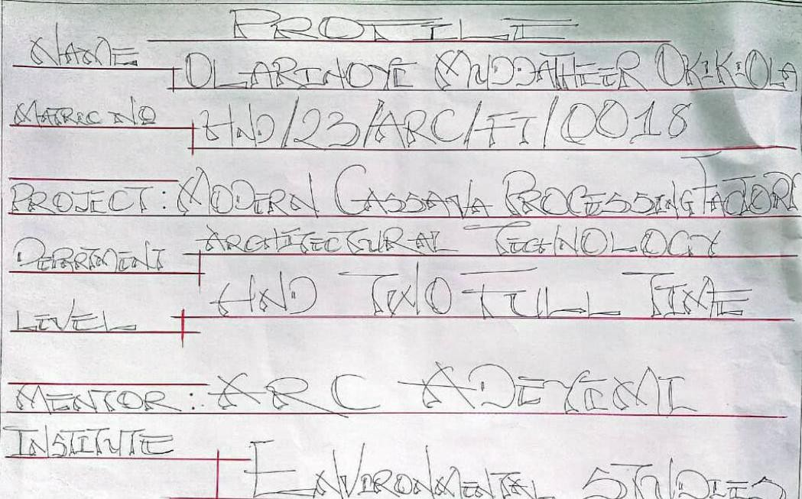
PROFILE
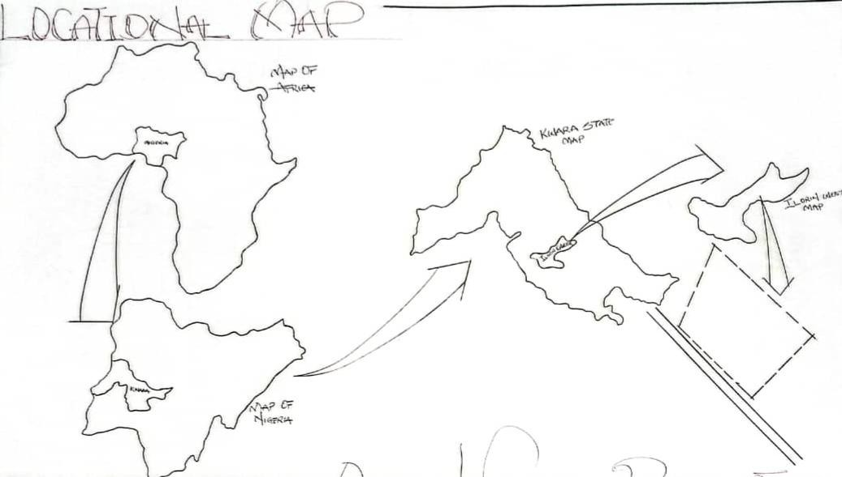

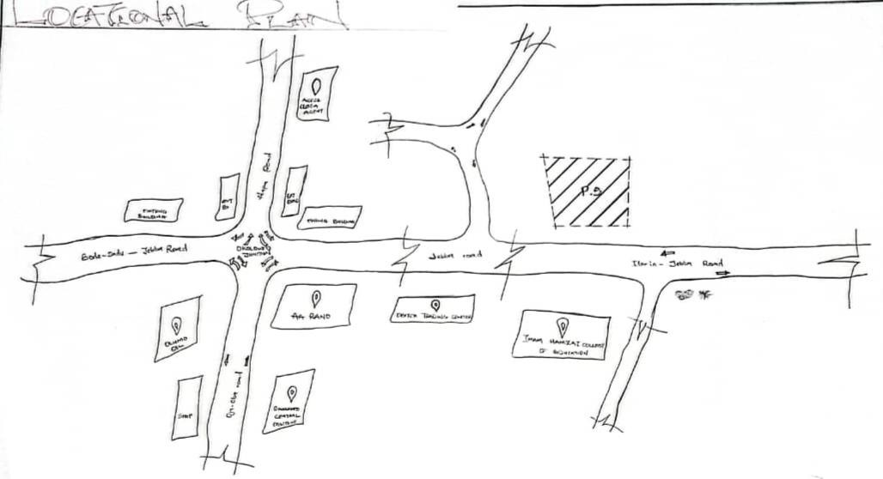
LOCATIONAL MAP

LOCATIONAL PLAN
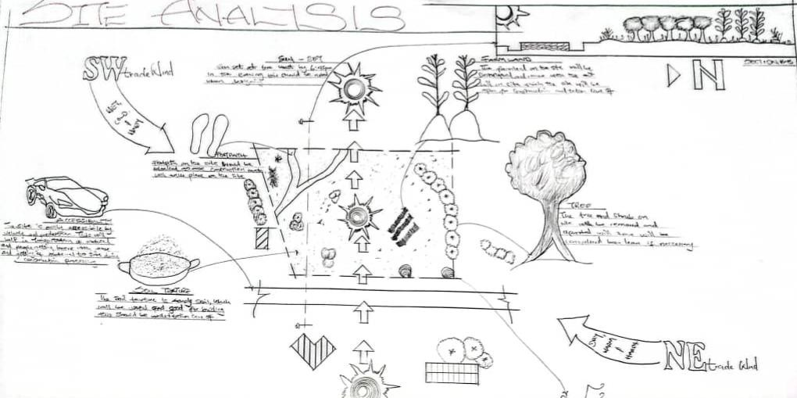
SITE ANALYSIS

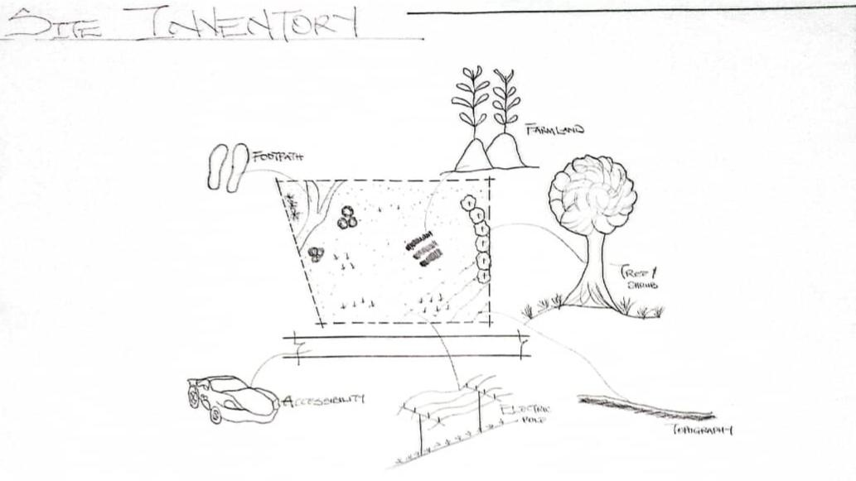
SITE INVENTORY
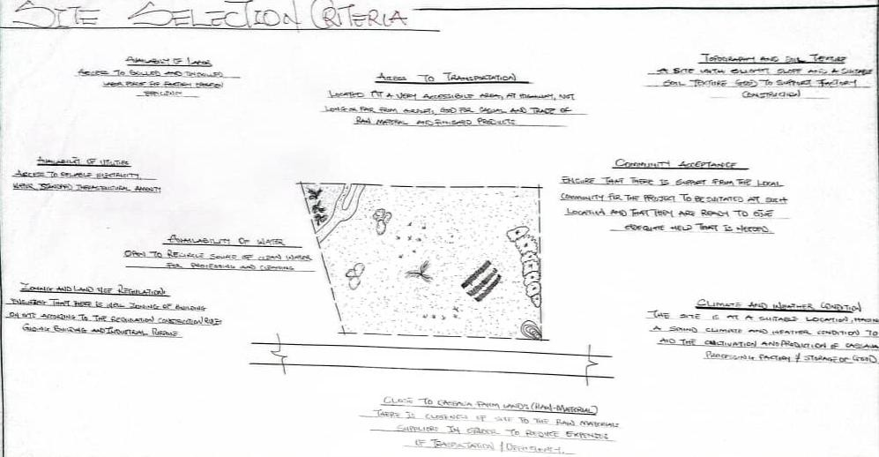

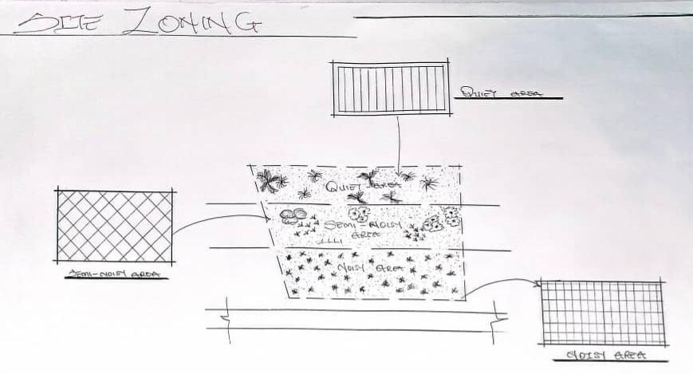
SITE SELECTION CRITERIA

SITE ZONING

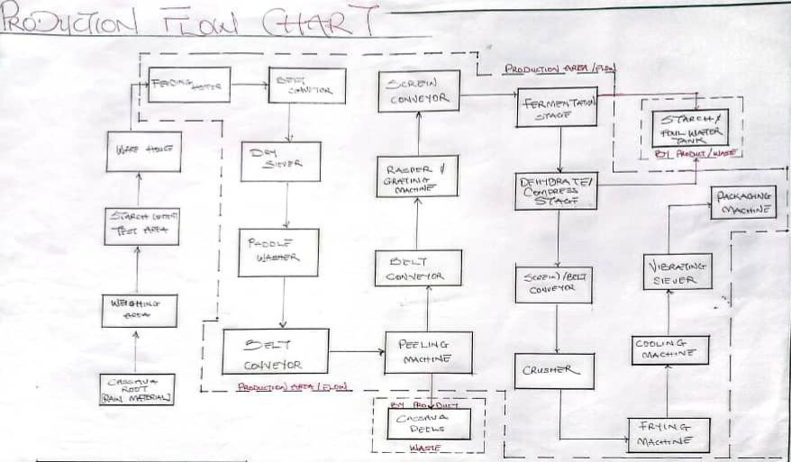

PRODUCTION FLOW CHART
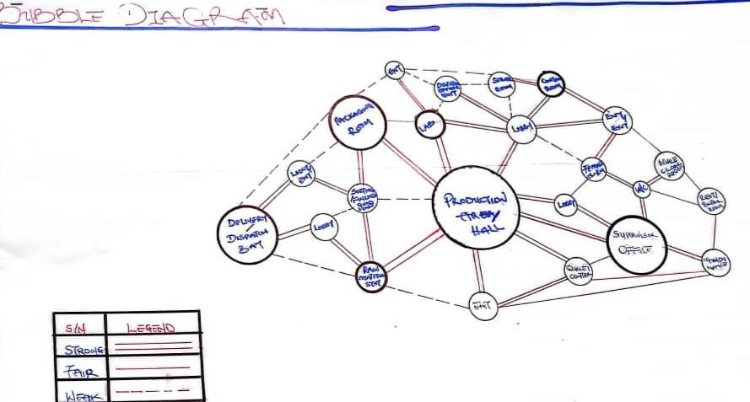
.
BUBBLE DIAGRAM

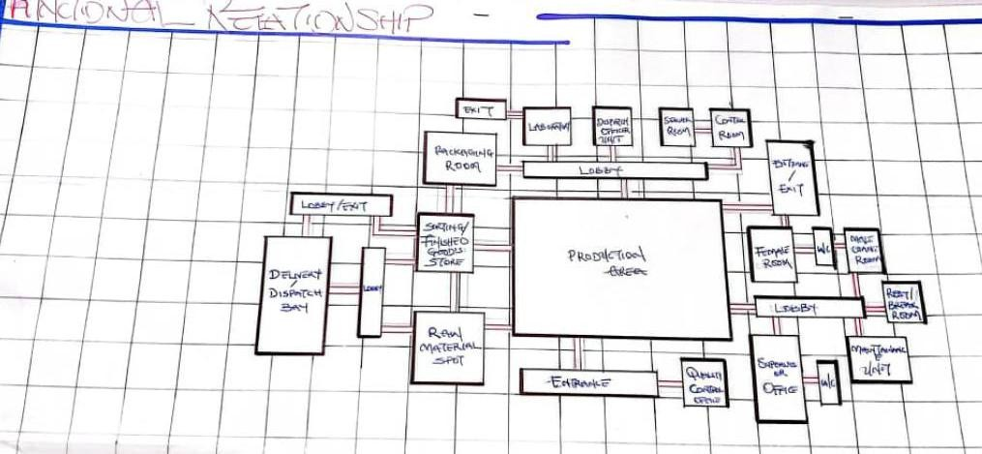
FUNCTIONAL RELATIONSHIP

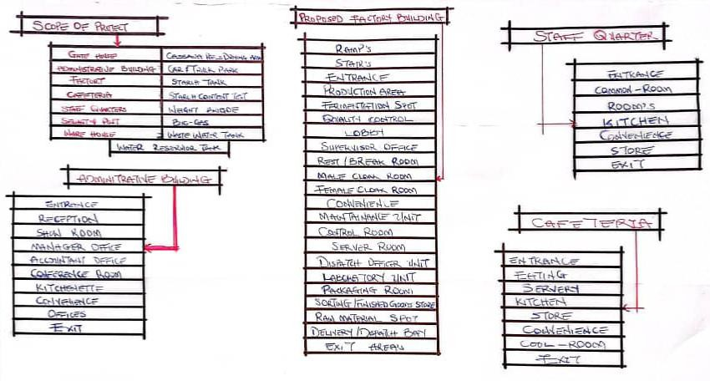
PROJECT SCOPE AND BRIEF
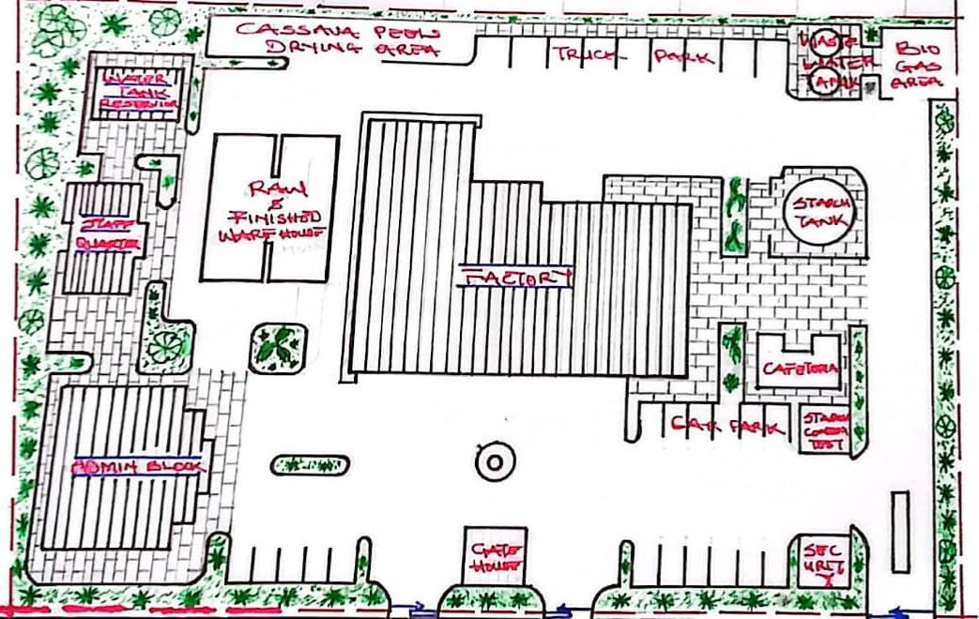

SITE PLAN
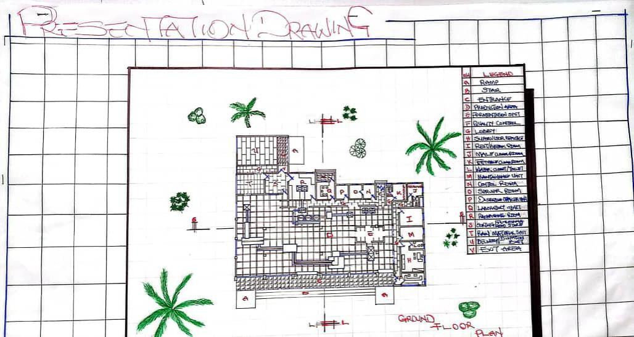
FLOOR PLAN
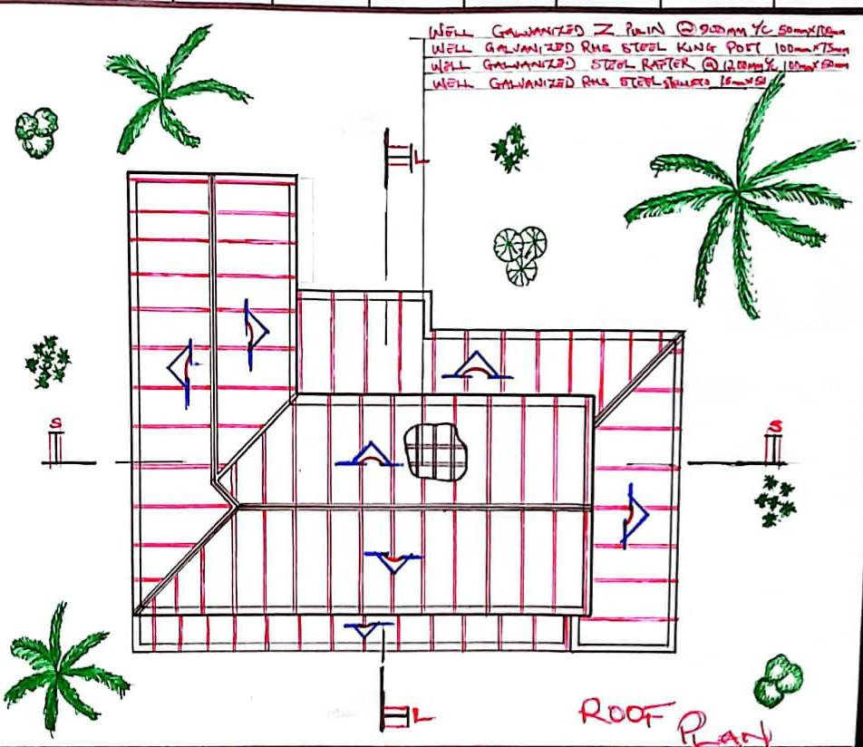

ROOF PLAN
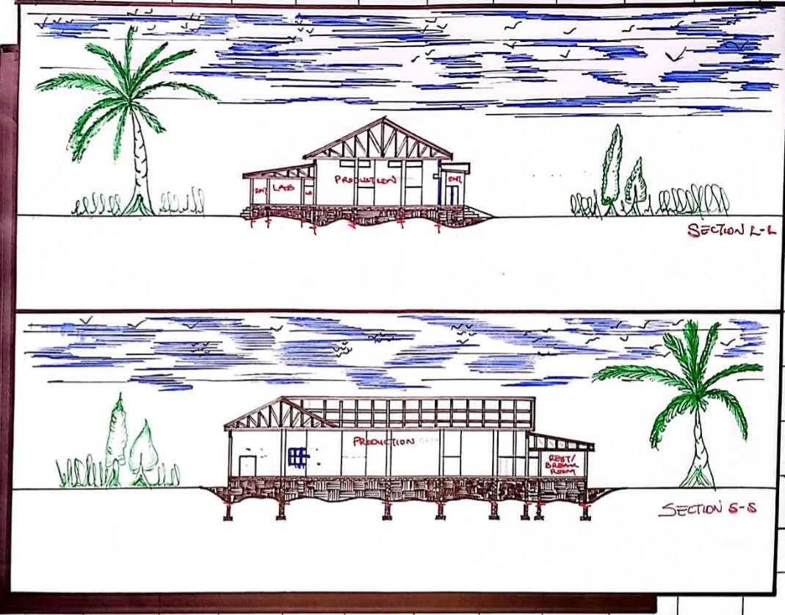
SECTION’S
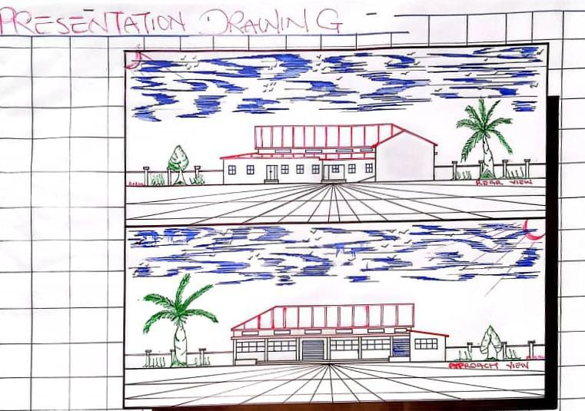

ELEVATION’S

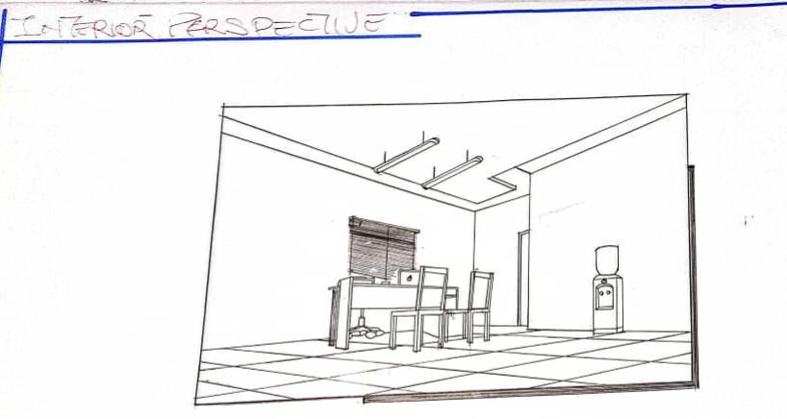

INTERIOR PERSPECTIVE

