A PROJECT REPORT
ON
PROPORSED DAYCARE CENTRE
FOR ILORIN WEST LOCAL GOVERNMENT,
KWARA STATE
BY
ADEGBOYEGA VICTORY IFEOLUWA
ND/23/ARC/PT/027

BEING A PROJECT REPORT SUBMITTED TO
THE DEPARTMENT OF ARCHITECTURAL TECHOLOGY, INSTITUTE OF
ENVIRONMENTAL STUDIES,
KWARA STATE POLYTECHIC, ILORIN.

IN PARTIAL FULFILMENT OF THE REQUIREMENT FOR
THE AWARD OF NATIONAL DIPLOMA (ND)
IN ARCHITECTURAL TECHNOLOGY.

JULY, 2025

DECLARATION
I declare that this Project is a project of my personal research works. It has not been presented for the award of any National Diploma in any polytechnic. The ideas, Observations, Comments, and Suggestions here in represent my own convictions except quotations, which have been acknowledged. In accordance with conventional academic traditions.

ADEGBOYEGA VICTORY IFEOLUWA
ND/23/ARC/PT/0027
________________________
SIGNATURE & DATE

CERTIFICATION
I certify that this research project entitled DAYCARE CENTRE was carried out by ADEGBOYEGA VICTORY IFEOLUWA under the supervision ARC. FAMILUA O. S. has been approved. As meeting the requirement for the award of ND in Architectural Technology, Kwara State Polytechnic, Ilorin, Kwara State.

ARC FAMILUA O. S. ____________________
Project Supervisor SIGNATURE & DATE

ARC OLAREWAJU F.A _____________________
Project Coordinator SIGNATURE & DATE

ARC J.M TOMORI ______________________
Head of Department SIGNATURE & DATE

_____________________
EXTERNAL EXAMINER SIGNATURE & DATE

ACKNOWLEDGEMENT
My profound gratitude goes to Almighty God, the creator of universe and fountain of all wisdom whose umbrella of guard and guide. I seek refuge through thick and thin of years of study.
I wish to express my profound gratitude to my supervisor ARC FAMILUA O.S. For his commitment, concern and support from initial stage of my project, the constructive concern and support from the initial stage to the final stage of completion of this project work, may Almighty Allah continue to enrich you more in knowledge for his thorough supervision for this successful project. I must also be grateful to my H. O. D, ARC. J. M. TOMORI and the whole host of lectures. ARC. MOH. SHERO, ARC. OLAREWAJU F.A, ARC. CHUCKWUMA NMOM, I pray Almighty Allah will continue to bless you all,
I also want thank and appreciate the effort of all the Lectures in Architectural Technology Department, who taught and give lasting advice’s that led to the success of my program, Almighty God will meet everyone at the point of needs.
I would also show my profound gratitude to my parents MR and MRS ADEGBOYEGA for their Immeasurable motivation, advices, efforts, and prayers on me for the completion of this program.
My Lovely sisters and My Lovely Brother. Almighty God shower his endless blessing, mercy, unlimited grace, joy, happiness without sorrow, sound health over all and may Almighty God meet everyone at the point of your needs.
Precious friends: My lovely friends Ayomide, Kaosarat, Lateef, Tohib, Damilola. Almighty God shower his blessing, grace, and happiness with sound health over you all and our prayer (AMEN)
I would also show my appreciation for the effort of an unforgettable of MRS ADEGBOYEGA, who advise me to carry on my journey. Almighty God bless you and grant your heart desires, good health over you.
Lastly ,I would like to appreciate the effort of my colleagues in department, school, and hostel, I whole heartedly say a VERY BIG THANK YOU, I appreciate you all, May Almighty God bless you all.
Above all, my utmost thanks go to the all sufficient God, the fountain of my wisdom, for his great and protection over my life, for his undying love, support and guidance throughout my period of learning and also for in sighting writing this project without him am nothing.

DEDICATION
This project work is dedicated to Almighty God who has been providing all my need for his blessing and mercy over me all through the program.And to my lovely parent, my sisters, my brothers, friends, love one’s and supervisor who assist me financially, spiritually, mentally and guide me through my academic pursuit

TABLE OF CONTENT
TITLE PAGE i
DECLARATION… ii
CERTIFICATION… iii
ACKNOWLEDGEMENT… ..iv
DEDICATION… v
TABLE OF CONTENTS… vi
LIST OF TABLES… x
LIST OF FIGURES… xi
LIST OF PLATES… xii
LIST OF APPENDICES… xiii
ABSRTACT… xiv
CHAPTER ONE
  - INTRODUCTION……………………………………………………………………...1
1.2 DEFINITION… 3
1.3 HISTORICAL BACKGROUND 3
1.4 AIM AND OBJECTIVES … … 4
1.5 PROJECT JUSTIFICATION … .. 4
1.6 CLIENT BACKGROUND 4
1.7 SCOPE OF THE PROJECT 5
1.8 RESEARCH METHODOLOGY… 5
CHAPTER TWO
2.1 LITERATURE REVIEW…………………………………………………………….....6
2.2 HISTORICAL BACKGROUND 6

CHAPTER THREE
3.1 CASE STUDIES………………………………....……………………………………6
3.2 SELECTED CASE STUDIES 6
3.3 CASE STUDY ONE 7
3.3 CASE STUDY TWO… 11
3.4 CASE STUDY THREE………………………………………………………………13
3.5 ONLINE CASE STUDY.……………………………………………………………..15
3.6 DEDUCTION…... …………………………………………………………………...17
CHAPTER FOUR
BRIEF HISTORICAL BACKGROUND…………... …………………………………...18
LOCATION AND SETTING OUT…………….…………………………………...…....19
POPULATION……………………………………………………………………..…….19
SITE INVENTORY……..………………………………………………………………...21
SITE ANALYSIS…….…………………………………………………………………...21
SITE SELECTION AND JUSTIFICATION………………………………………….......22
LOCATION ….. ………………………………………………………………………..22
ACCESSIBILITY………….………………………………………………………………..22
INFRASTRUCTURE FACILITIES……………………………………………………….. 23
TOPOGRAPHY……………………………………………………………………………... 23
SOIL STRUCTURE……………………………………………………………………….. 23
GENERAL CLIMATE CONDITION…………….………………………………………. 23
RELATIVE HUMIDITY…………………………………………………………………... 23
WIND…................................................................................................................................. 23
TEMPERATURE……………………………………………………………………………24
VEGETATION……………………………………………………………………………...24
ROAD………………………………………………………………………………………24
WATER AND ELECTRICITY……………………………………………………………...24
DESIGN CRITERIA………………………………………………………………………….25
DESIGN BRIEF 25
DESIGN ANALYSIS 25
SPACIAL ALLOCATION 26
PLANNING PRINCIPLE… 28
CHAPTER FIVE
APPRAISAL OF PROPOSED SCHEME…………………………………………………. 29
CONSTRUCTION METHODOLOGY…………………………………………………… 29
SERVICES…………………………………………………………………………………. 29
VENTILATION 30
LIGHTING..… 30
PLUMBING 30
ELECTRICAL INSTALLATION… 30
WASTE DISPOSAL 31
FIRE PROTECTION… 31
RAIN PROTECTION… 31
EXTERNALWORK… 31
SUMMARY… 31
CONCLUSION… 32
RECOMMENDATION… 32
REFERENCES 33
APPENDICES 34

LIST OF TABLES

TABLE1;SHOWING THE POPULATION OF THE GENDER 25

TABLE2;SHOWING SPACIAL ALLOCATION OF FLOOR PLAN… 3

LIST OF FIGURES
FIG1;SHOWING LOCATION PLAN OF CASE STUDY ONE… 10
FIG2;SHOWING FLOOR PLAN OF CASE STUDY ONE… 10
FIG3;SHOWING LOCATION PLAN OF CASE STUDY TWO… 13
FIG4;SHOWING FLOOR PLAN OF CASE STUDY TWO… 14
FIG5;SHOWING LOCATION PLAN OF CASE STUDY THRE… 16
FIG6;SHOWING FLOOR PLAN OF CASE STUDY THREE… 17
FIG7;SHOWING LOCATIONAL PLAN OF THE PROPOSED SITE… 24
FIG8;SHOWING SITE INVENTORY OF THE PROPOSED SITE… 26
FIG9;SHOWING SITE ANALYSIS OF THE PROPOSED SITE… 27

LIST OF PLATES

PLATE1;SHOWING FRONT VIEW OF CASE STUDY ONE… 11

PLATE2;SHOWING LEFT VIEW OF CASE STUDY ONE… 11

PLATE3;SHOWING BACK VIEW OF CASE STUDY ONE 12

PLATE4;SHOWING RIGHT VIEW OF CASE STUDY ONE… 12

PLATE5;SHOWING FRONT VIEW OF CASE STUDY TWO… 14

PLATE6; SHOWING BACK VIEW OF CASE STUDY TWO… 15

PLATE7;SHOWING LEFT VIEW OF CASE STUDY TWO… 15

PLATE8;SHOWING FRONT VIEW OF CASE STUDY THREE 16

PLATE9;SHOWING LEFT VIEW OF CASE STUDY THREE 18

PLATE10;SHOWING FLOOR PLAN OF ONLINE CASE STUDY 19

PLATE11;SHOWING FRONT VIEW OF ONLINE CASE STUDY 19

PLATE12;SHOWING LEFT VIEW OF ONLINE CASE STUDY 20
PLATE13;SHOWING FLOOR PLAN OF ONLINE CASE STUDY 20
PLATE14;SHOWING FRONT VIEW OF ONLINE CASE STUDY 21

LIST OF APPENDICES
APP1;SHOWING SITE PLAN OF THE PROPOSED PROJECT 38
APP2; SHOWING FLOOR PLAN OF THE PROPOSED PROJECT 39
APP4;SHOWING ROOF PLAN OF THE PROPOSED PROJECT 40
APP5;SHOWING CROSS SECTION OF THE PROPOSED PROJECT 41
APP6;SHOWING FRONT VIEW OF THE PROPOSED PROJECT 42
APP7;SHOWING SIDE VIEW OF THE PROPOSED PROJECT 43

ABSTRACT
Proposed based learning (PBL) is increasingly being adapted as the effective approach to learning in primary school as teachers realize how authentic and challenging learning experience enable higher level of engagement and self-directed learning. Supporting learning through PBL approaches in school requires rethinking a number of aspects which includes the type of experiences students are exposed to, the process of learning and the output of such learning. The role of assessment as well as student feedback and self-assessment are important features of PBL. This approach further draws on the input of ‘experts’ who supports students to explore real life problems or challenges. Enveloping those experiences is the use of educational technology and how this can enhance the learning process. This chapter explores how PBL can be successfully incorporated into primary school classroom drawing on existing literature and from researchundertaken by authors.

CHAPTER ONE
1.1 INTRODUCTION
A Daycare Centre is a warm and nurturing environment where children can learn, grow, and thrive. We are dedicated to providing high-quality early childhood education and care for infants, toddlers, and preschoolers in a safe, stimulating, and supportive setting.
It is believe that every child is unique and deserves individual attention, respect, and encouragement. Our experienced and passionate caregivers and educators focus on promoting social, emotional, cognitive, and physical development through age-appropriate activities and play-based learning.
We understand the importance of early childhood years in building a strong foundation for lifelong learning. That is why we offer a well-rounded curriculum that includes literacy, numeracy, arts and crafts, music, outdoor play, and social interaction—all tailored to meet the developmental needs of each child.
The facility is equipped with modern, child-friendly resources, secure indoor and outdoor play areas, and a welcoming atmosphere that feels like a second home. We also maintain strong partnerships with parents, recognizing that open communication and collaboration are essential to a child's success.
In today's fast-paced and demanding society, the role of daycare centers has become increasingly important in supporting the developmental needs of children and the economic needs of working families. A daycare center, also known as a childcare center, is an institution that provides supervised care, nurturing, and early childhood education to infants, toddlers, and young children—typically ranging from a few months old to five or six years of age. It serves as a safe, stimulating, and structured environment where children can grow physically, socially, emotionally, and intellectually during the most critical years of their development.
This project report focuses on the design, purpose, and functional requirements of a daycare center, with particular emphasis on how architectural planning, safety measures, and environmental quality contribute to a child-friendly learning atmosphere. A well-designed daycare center does not only serve as a temporary place of care but also plays a foundational role in a child’s early learning experiences. Children in daycare settings are introduced to basic concepts such as numbers, letters, colors, and shapes, while also learning essential life skills like sharing, cooperation, self-regulation, and communication.
The rise in dual-income households and single-parent families has contributed to the growing demand for reliable and professionally run daycare services. Consequently, daycare centers are no longer viewed as optional support services but as an integral part of the early childhood education system. Modern daycare facilities are expected to meet high standards in terms of hygiene, safety, accessibility, staff training, child-to-caregiver ratio, and curriculum delivery. These factors must be carefully considered during the planning and implementation stages of a daycare project.
In this report, attention is given to the architectural layout of daycare centers, including spatial zoning (e.g., sleeping areas, playrooms, diapering stations, feeding areas), lighting and ventilation needs, safety provisions (e.g., emergency exits, fire safety, non-toxic materials), and accessibility for children with special needs. It also addresses regulatory guidelines, best practices in childcare management, and sustainability in design.
Overall, this project aims to explore how a well-conceived daycare center can create a nurturing environment that supports the all-round development of children while providing peace of mind for parents.
1.2 DEFINITIONOF DAYCARE CENTRE
A daycare center is a facility that provides supervised care and early childhood education for young children—typically from infancy to preschool age—during the day while their parents or guardians are at work, school, or otherwise unavailable.
Daycare center offer a safe, structured, and nurturing environment where children can engage in age-appropriate activities, such as play, learning, rest, and social interaction. These centers may operate as part of a private business, community organization, school, or government program.
Key features of a daycare center include:
- Trained caregivers and educators
- Daily routines and developmental programs
- Nutritional meals and rest periods
- Indoor and outdoor play areas
1.3 HISTORICALBACKGROUND
The concept of daycare centers has evolved over centuries, rooted in the growing need for child care support outside the home, especially as societies changed economically and socially.
- Early Origins
The earliest forms of organized child care can be traced back to 18th and early 19th century Europe, particularly during the Industrial Revolution. As more women entered the workforce, especially in factories, the need for safe places to leave young children during working hours became urgent.
- In France, the first official crèche (a type of daycare center) was established in 1844 by Jean-Baptiste FirminMarbeau in Paris, aimed at providing care for children of working-class mothers.
- Similar institutions soon followed in Germany, England, and the United States, with the focus primarily on health, nutrition, and moral education for poor and working-class children.
- Development in the 20th Century
By the early 20th century, the idea of daycare centers expanded beyond charitable services. Governments and social reformers began to recognize the importance of early childhood development, not just custodial care.
- In the United States, daycare services expanded during World War II when women took on roles in wartime industries. The U.S. government funded child care programs through the Lanham Act (1941) to support working mothers.
- The post-war period saw a decline in daycare services, but they resurged in the 1960s and 70s with the rise of the women’s rights movement, more dual-income families, and greater awareness of early education.
- Modern Era
Today, daycare centers are seen as vital parts of both the education system and family support structures. Modern daycare focuses on:
- Early childhood education (ECE)
- Emotional and social development
- Health, safety, and nutrition
- Parental engagement
In many countries, daycare centers are regulated by national or regional governments to ensure safety standards and curriculum quality. They vary in structure—from small, home-based centers to large, institutional programs

1.4 AIM AND OBJECTIVES OF THE PROJECT
AIM OF THE PROJECT
The primary aim of this project is to provide safe, reliable, and nurturing care for young children during the day while supporting their overall development in a structured environment.
OBJECTIVES OF THE PROJECT
To Provide a Safe and Secure Environment Ensure that children are cared for in a well-supervised, hygienic, and child-friendly setting that protects their health and safety.
To Promote Holistic Child Development Support the physical, emotional, social, and cognitive development of children through structured play, interaction, and learning activities.
To Develop Early Learning Skills Introduce children to foundational skills such as language, counting, motor coordination, and critical thinking through age-appropriate programs.
To Encourage Positive Social Behavior Teach children to interact respectfully with others, share, cooperate, and resolve conflicts peacefully.
1.5 PROJECT JUSTIFICATION
As an architect, my justification for this project is rooted in the need to create purpose-built environments that support early childhood development, ensure safety, promote functionality, and enhance the quality of care provided. Architecture plays a crucial role in shaping the experiences of both children and caregivers within a daycare facility.
1.6 CLIENT BACKGROUND
The name of my client is HON. SHEHU ABDULRAHMAN BABATUNDE LADAN
Chairman of Ilorin West Local Government.
- Elected Executive Council Chairman of Ilorin West Local Government, with his tenure beginning after the September 2024 local government elections organized by the Kwara State Independent Electoral Commission.
- Hon. Shehu Abdulrahman Babatunde Ladan is recognized as a proactive and visionary leader in Ilorin West LGA. His focus on infrastructure, youth empowerment, and effective governance reflects both community trust and state-level recognition.
- If you'd like deeper insights into his biography—like education, early career, or political journey—just let me know, and I can dig up more details!

1.7 SCOPE OF THE STUDY
- Proposed Building
- Playing Ground
- Garden
- Security House
- Parking Space

1.8 RESEACH METHOLODY
Various avenues were expressed as regards the method of research on order to arrive at a functional and appealing design concepts. The following research methods were employed.
CASE STUDY: This is the method that carried out in which to gain more detailed experience in my project topic daycare center.
ORAL INTERVIEW: An oral interview in the method I carried out to collect more information by directly engaging with individuals e.g manager the workers, the citizens and other to gain more experience on my project
LITERATURE REVIEW: This is the process by which I carried out in the process of reach, articles, niddles and others materials on my project.

CHAPTER TWO
2.0 LITERATURE REVIEW
2.1 HISTORICAL BACKGROUND OF A DAYCARE CENTRE
DAYCARE CENTRE
In ancient and traditional societies, child-rearing was largely a communal responsibility, shared among extended family members or within tight-knit community groups. Grandparents, older siblings, and neighbors often participated in raising young children while parents, especially mothers, were occupied with domestic or agricultural duties. However, these early forms of child care were largely informal and unregulated, lacking the educational or developmental focus that characterizes modern daycare
The Industrial Revolution of the 18th and 19th centuries marked a significant turning point in the history of childcare. As economies in Europe and North America transitioned from agrarian-based to industrial-based systems, large numbers of people migrated from rural areas to urban centers in search of work. Women, especially those from working-class families, began to take up employment in factories, leaving little time to care for their young children during the day.
This societal shift created an urgent need for organized and reliable childcare services, leading to the establishment of the first formal daycare centers. In France, the first publicly recognized crèche—a type of infant care institution—was founded in 1844 by Jean-Baptiste FirminMarbeau in Paris. This institution was designed to care for the children of poor, working mothers, providing not only supervision but also basic health care and nutrition.

  - DAYCARE CENTRE IN UK

The history of daycare centers in the United Kingdom is deeply interwoven with the nation’s social, economic, and political evolution, especially concerning the roles of women, industrialization, child welfare, and education reform. The development of daycare in the UK progressed from informal charitable efforts to a structured and regulated system that now forms a critical part of the country’s early year education and social care policies
Early Beginnings – Informal Care and Philanthropy (19th Century)
Before the 19th century, most childcare in the UK was handled within the family or by community members. However, with the onset of the Industrial Revolution, more women—particularly from the working class—entered factory work, which created an urgent demand for alternative childcare arrangements.
•The first infant schools emerged in the early 1800s, most notably founded by Robert Owen in New Lanark, Scotland in 1816. While these were not "daycare centers" in the modern sense, they offered early care and education to the children of working parents, marking the beginning of institutional childcare in the UK.

CHAPTER THREE
3.1 CASE STUDIES
This is are search or an exercise that is carried out on existing building which is similar to the one researcher is writing on. The objective of a case study is to take a critical appraisal of existing related project with a view to identify the positive and negative aspect of such projects. It is only with time that a project can be adjusted so that it can be successful. The information obtained from the appraisal will guide the designer of new and similar project, the positive aspect of it shall be incorporated in the view proposal while attempts will be made to solve the problem of negative aspects. It is only through this that a designer can better enhance the quality and efficiency of building in the society. For a comprehensive analysis their case studies have been conducted.
3.2 SELETED CASE STUDIES
Case studies are of paramount important. It is an experimental research or analysis carried out on existing building or group of building functionally similar to the one which there search is working.
For any technical design to be meaningful there is always the need for preliminary research effort to be made on this proposal as a very necessary ground work.
The following are case studies of some daycare.
    - ASADAM, KWARA STATE
    - CROWNFIT CRECHE&PRE SCHOOL, OSERE, KWARA STATE
    - TEMIDIRE ATOYEBI, OGBOMOSHO, OYO STATE

3.3 CASE STUDY ONE
    - Location: ASADAM, KWARA STATE

OBSEVERATION
MERITS
- Conducive Environment
- Well maintained spaces for physical activities
- Quiet area
- Good security arrangement

DEMERIT
- There is no age specific zone for children
- No exit out of the building
- No parking space
- Poor layout

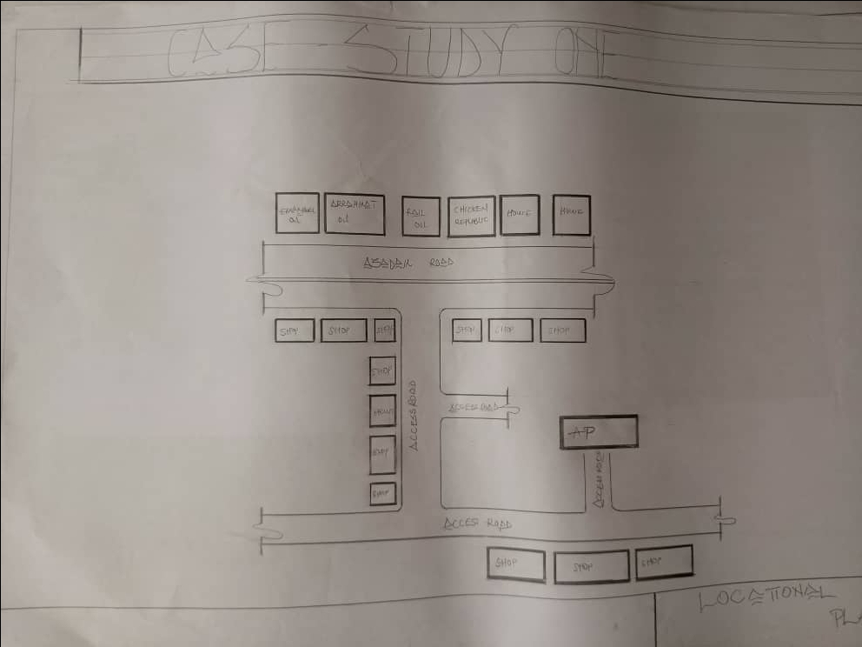

FIG1;SHOWING LOCATION PLAN OFCASE STUDY ONE

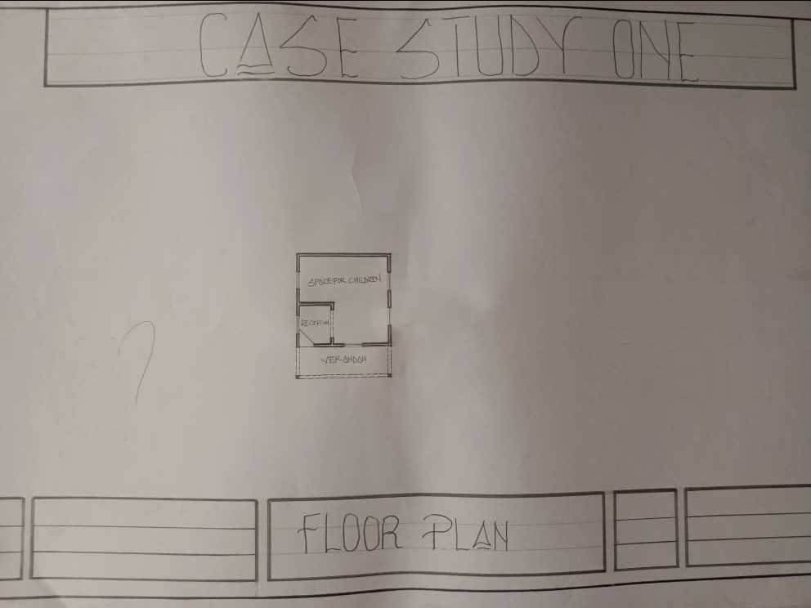

FIG2; SHOWING FLOOR PLAN OF CASE STUDY ONE
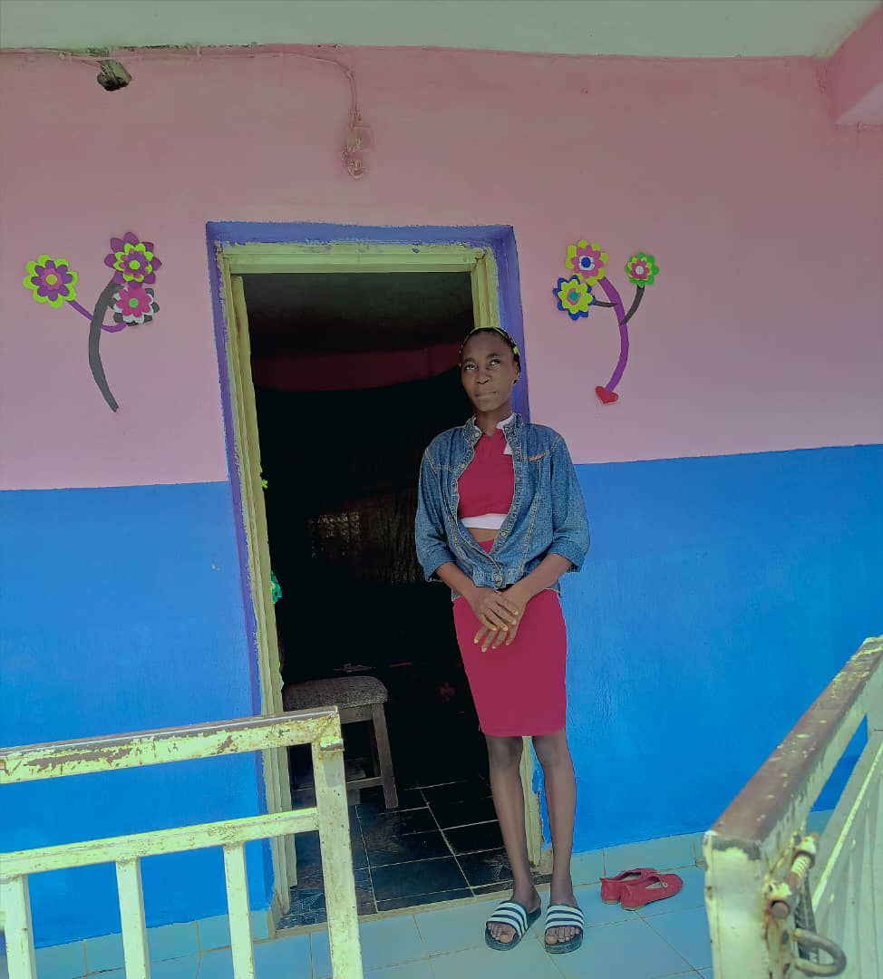

PLATE1; SHOWING FRONT VIEW OF CASE STUDY ONE

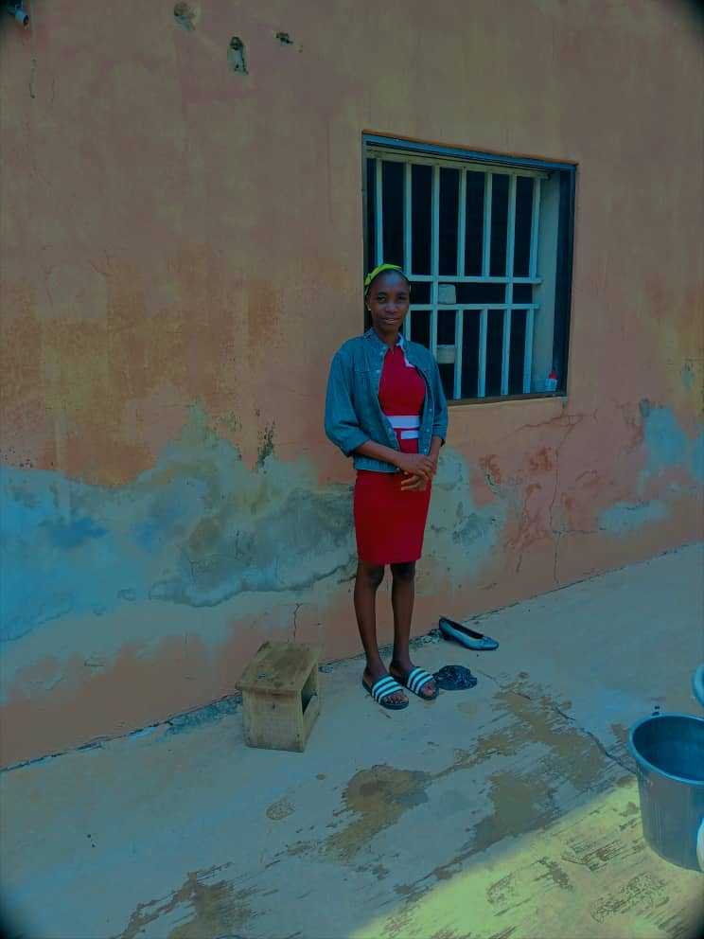

PLATE2; SHOWING LEFT VIEW OF CASE STUDY ONE



PLATE3; SHOWING BACK VIEW OF CASE STUDY ONE

3.4 CASE STUDY TWO (2)
    - LOCATION: CROWNFIT CRECHE&PRE SCHOOL, OSERE, KWARA STATE
MERITS
- Good landscaping
- Easily accessible
- Good ventilation
- There is space for future expansion

DEMERITS
- Noisy area
- No playing ground
- It is very close to nepa tension

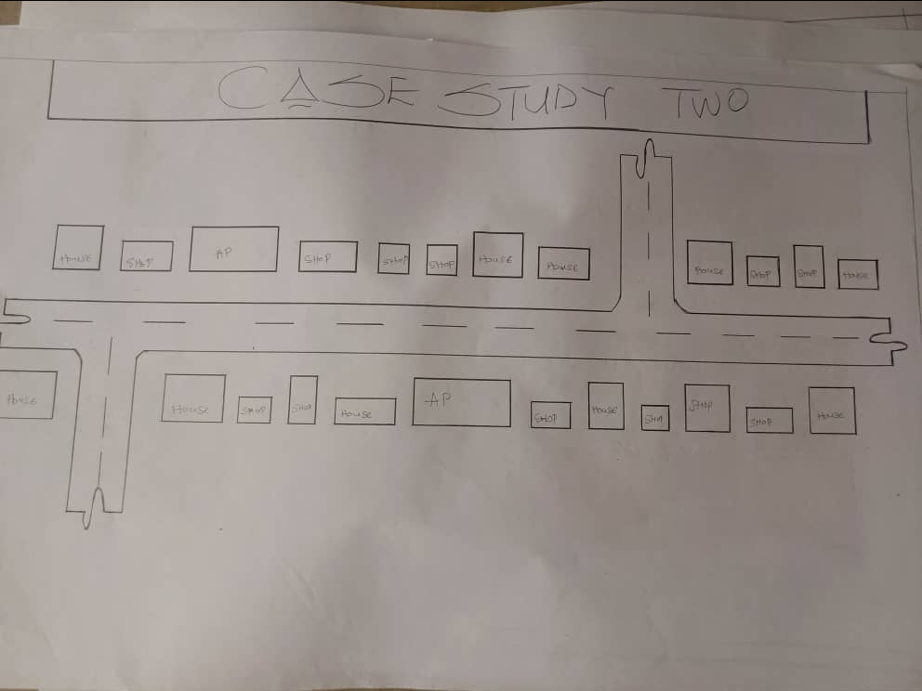

FIG3; SHOWING LOCATION PLAN OF CASE STURDY TWO
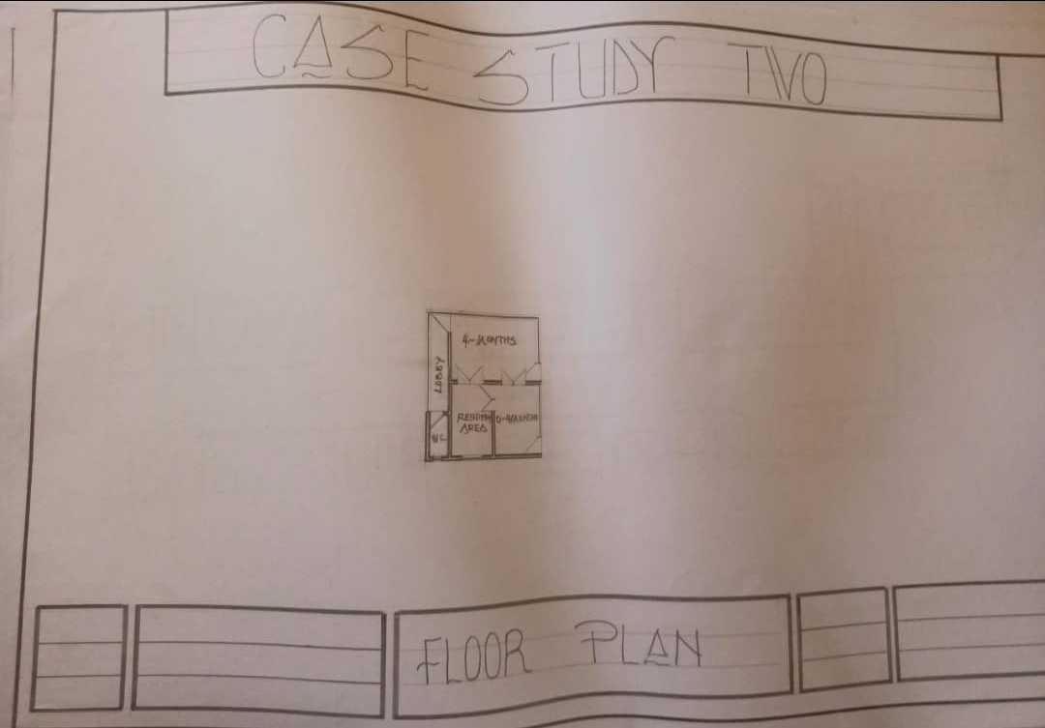
FIG 4; SHOWING THE FLOOR PLAN OF CASE STUDY TWO

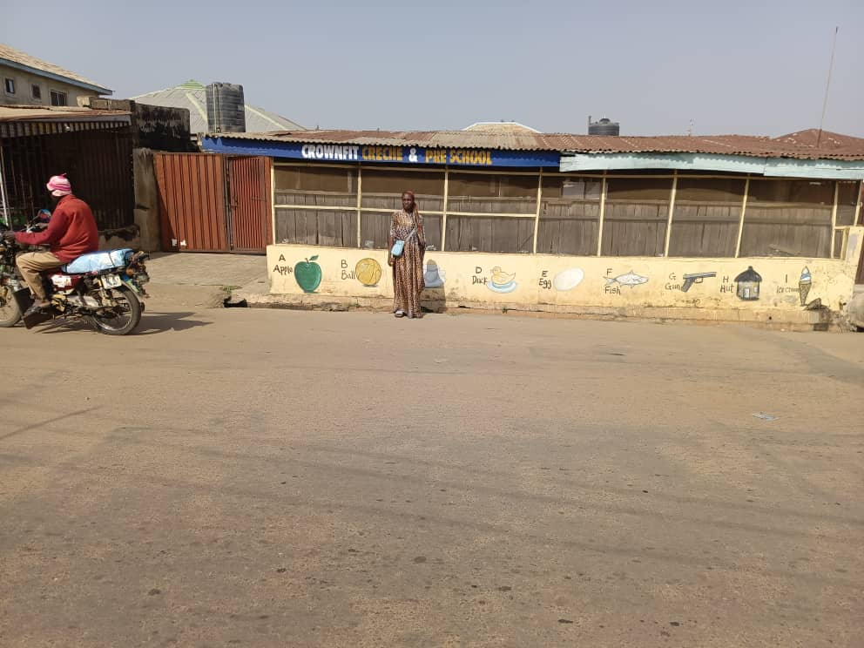

PLATE 5; SHOWING THE FRONT VIEW OF CASE STUDY TWO

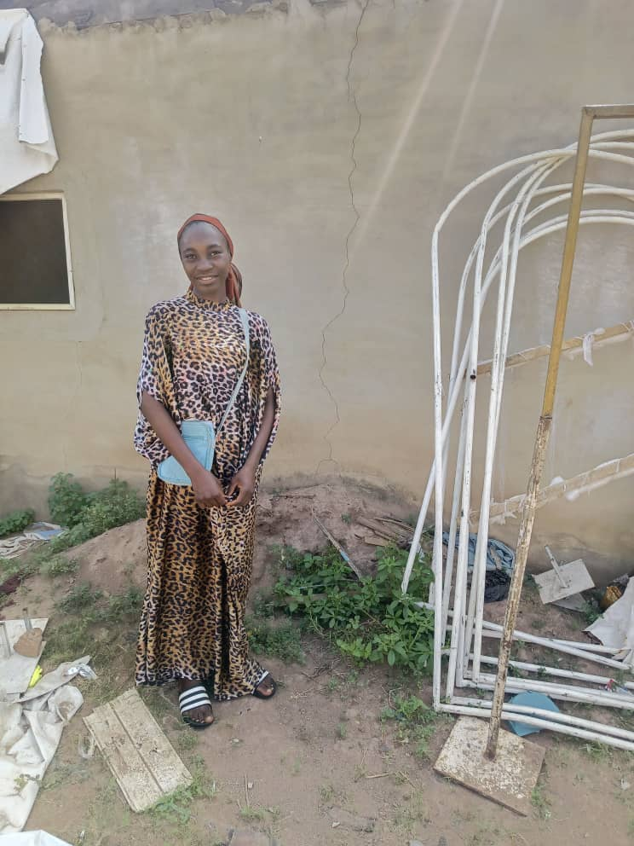

PLATE 6;SHOWING BACK VIEW OF CASE STUDY

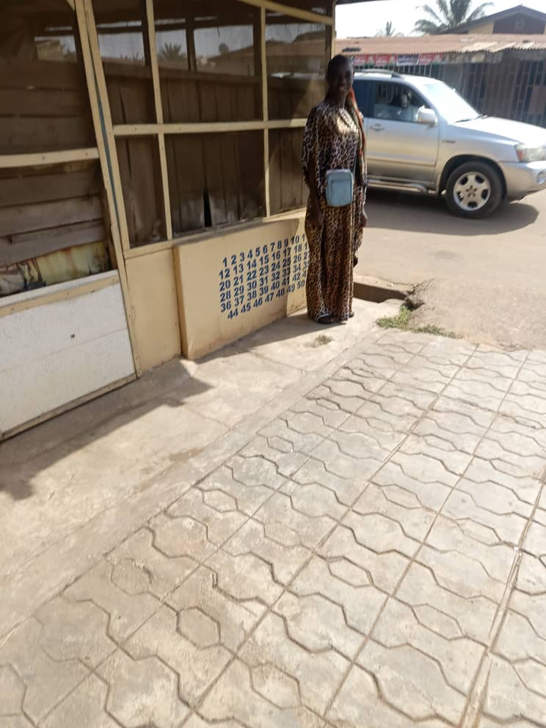

PLATE 7; SHOWING RIGHT VIEW OF CASE STUDY TWO
  - CASE STUDY THREE (3)
3.1.5 LOCATION: TEMIDIRE ATOYEBI, OGBOMOSHO, OYO STATE

MERITS
- Quiet area
- Enough playing ground for children
- Age specific for children
- Well oriented

DEMERIT
- It has no fence which is safety concern
- No relation area
- No marketable area around

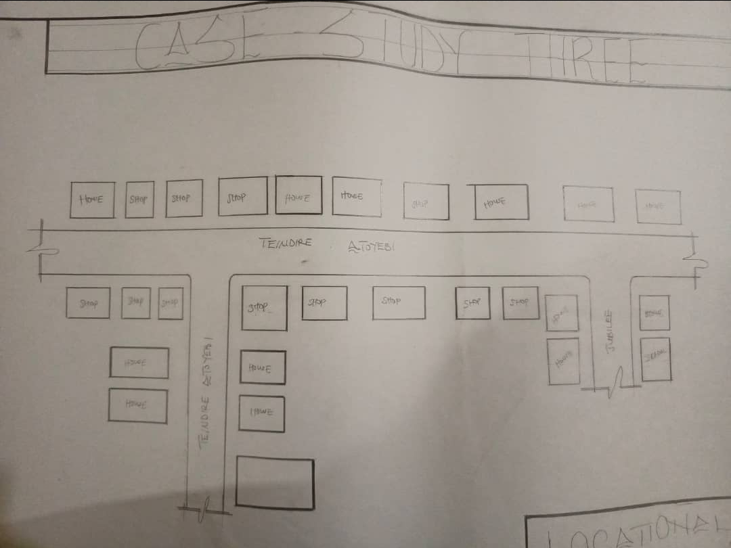

FIG 5; SHOWING LOCATION PLAN OF CASE STUDY THREE

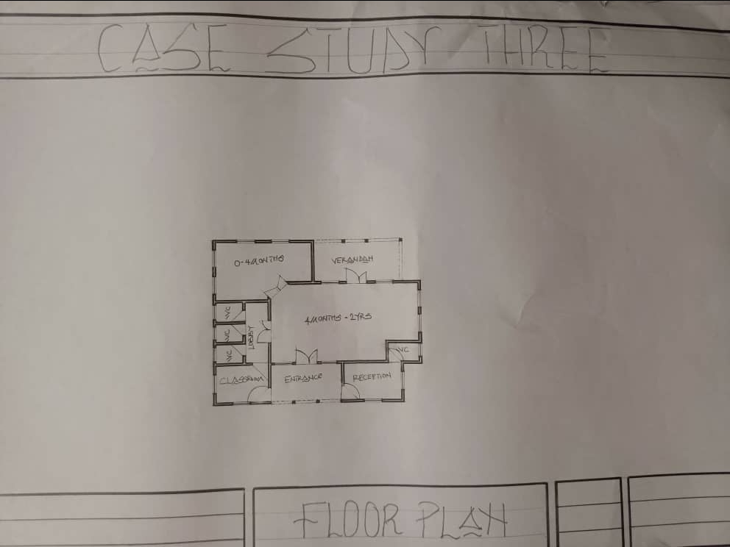
FIG 6; SHOWING FLOOR PLAN OF CASE STUDY THREE

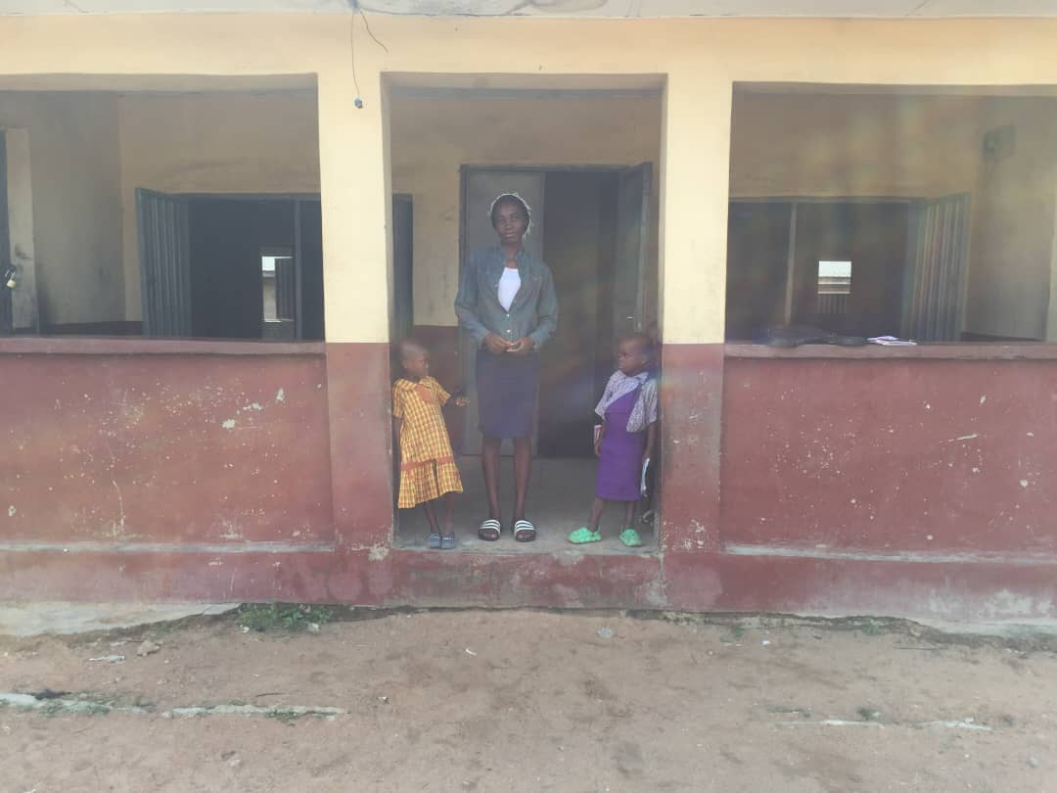

PLATE 8;SHOWING FRONT VIEW OF CASE STUDY THREE



PLATE 9; SHOWING LEFT VIEW OF CASE STUDY THREE

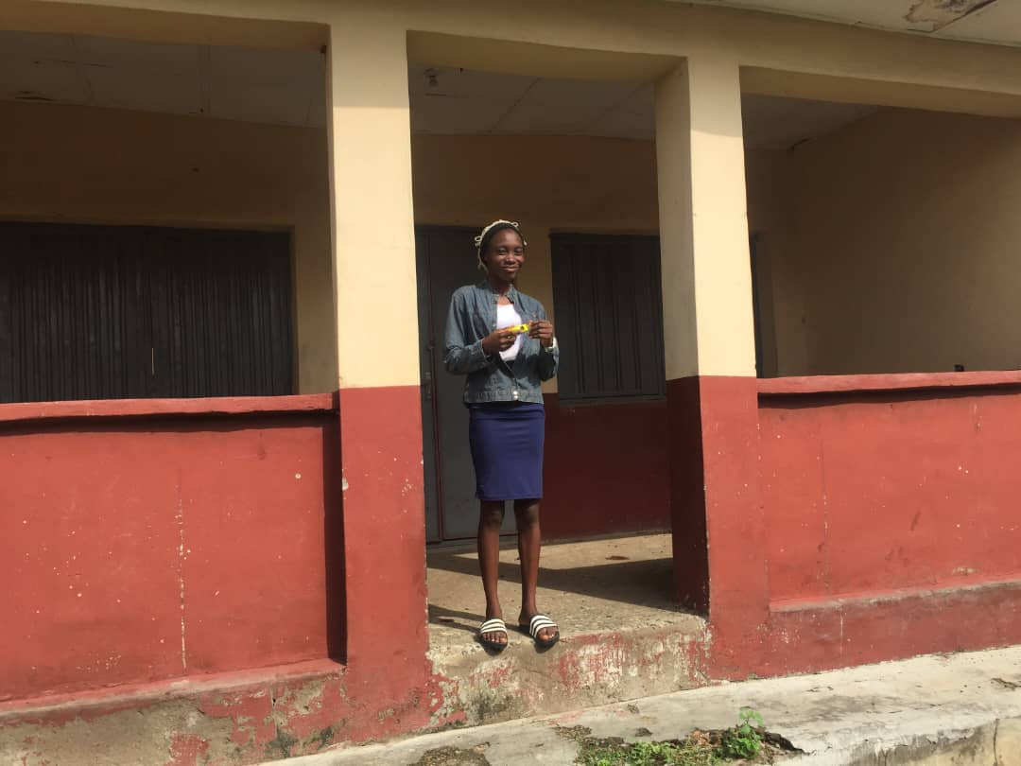
PLATE 10; SHOWING BACK VIEW OF CASE STUDY THREE

3.6 ONLINE CASE STUDY
ONLINE CASE STUDY ONE
PROJECT NAME: ARKANAS HOME CENTER
LOCATION: 124 MATHENY LANE BEEBE, AR 72012

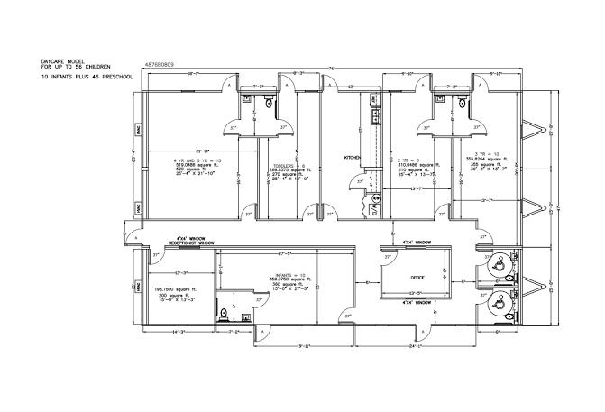
PLATE 11; SHOWING FLOOR PLAN OF ONLINE CASE STUDY

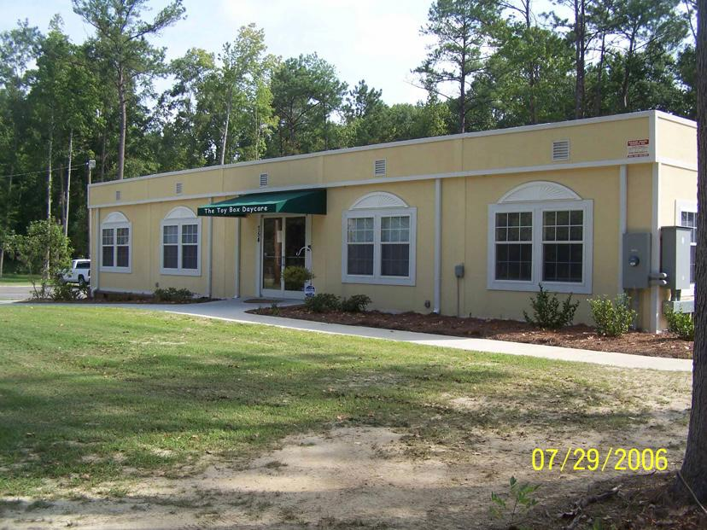
PLATE 12; SHOWING FRONT VIEW OF ONLINE CASE STUDY
DEDUCTION FROM CASE STUDIES
During my visit to the daycare. I was opportunities to see what was obtain in the center, I made a proper studies of their related function and analysis were made to their present situation with the aim of incorporation with their merit in my own final proposal.
The following were deduce from my case study
- Adequate natural ventilation and lighting.
- Good architectural landscaping.
- Parking spaces should be well defined.
- Good drainage system.

CHAPTER FOUR
4.0 PROJECT LOCATION
4.1 BRIEF HISTORICAL BAKGROUND OF ILORIN, KWARA STATE
Ilorin, the capital of Kwara State, is a city with a rich and diverse historical background. It was founded around the late 15th century as a small Yoruba settlement under the Oyo Empire. Its name "Ilorin" is believed to have originated from the word "Ilọirin", meaning "sharpening of iron," as early hunters and blacksmiths used the area as a tool-sharpening site.
In the early 19th century, during the Fulani Jihad led by Shehu Usman Dan Fodio, Ilorin became a significant center. A Yoruba Muslim warrior named Afonja, who was then the Aare OnaKakanfo (generalissimo) of the Oyo Empire, rebelled against the central authority with the help of Fulani warriors led by Alimi, a Fulani Islamic scholar and preacher.
However, after Afonja’s death, the Fulani forces, under Alimi's descendants, took control of Ilorin and established it as an Emirate under the Sokoto Caliphate, making it an Islamic and political hub in the region. This brought a blend of Yoruba and Fulani cultures, which is still evident in Ilorin today.
Ilorin became part of Kwara State upon its creation in 1967, during Nigeria’s state restructuring. Today, it is a center of Islamic scholarship, culture, and governance in Nigeria, serving as a bridge between the north and south of the country

GEOGRAPHY OF ILORIN, KWARA STATE
Ilorin, the capital city of Kwara State, is located in the North-Central region of Nigeria, also referred to as the Middle Belt. It lies approximately 306 km northeast of Lagos and 500 km southwest of Abuja.
- 1. Location and Coordinates
- Latitude: 8°30′N
- Longitude: 4°33′E
- Ilorin sits on the transitional zone between the humid forest of the south and the savannah grassland of the

ECONOMY OF ILORIN, KWARA STATE
Ilorin, the capital of Kwara State, has a diversified economy that blends agriculture, commerce, manufacturing, and public sector employment. As a strategic city located between the north and south of Nigeria, Ilorin serves as an important commercial and administrative center in the Middle Belt region.

ORGANIZATION STRUCTRE
The organizational structure of Ilorin reflects the administrative and governance system within Kwara State, with a focus on local, traditional, and modern governmental frameworks. Ilorin functions as both a traditional emirate and a modern city under state and local government administration.

4.2 LOCATION AND SETTING OF NIGER
Ilorin is located in the North-Central region of Nigeria and serves as the capital city of Kwara State. It lies at approximately latitude 8°30′N and longitude 4°33′E.
Geographically, Ilorin sits at the transitional zone between the forest region of southern Nigeria and the savannah of the north, making it a natural link between the two regions. The city is situated along major transport routes connecting Lagos, Abuja, and northern Nigeria, making it a key administrative and commercial hub.
The city is bounded by:
- Ilorin West, East, and South Local Government Areas
- And partially by Asa Local Government Area
Its setting includes gently rolling plains with scattered hills, crossed by rivers like the Asa River, and surrounded by savannah vegetation. The favorable location and terrain support agriculture, trade, and urban development.

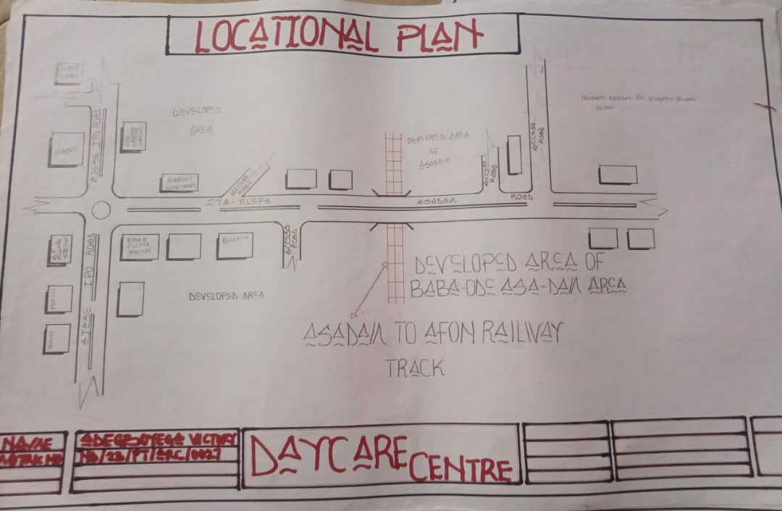
FIG 7; SHOWING LOCATION OF THE PROPOSE SITE
4.3 POPULATION
As of the latest estimates, the population of Ilorin, the capital city of Kwara State, is projected to be over 1 million people.
- Population Breakdown (Estimates):
- 2006 National Population Census:
  - Ilorin West LGA: 365,221
  - Ilorin East LGA: 204,310
  - Ilorin South LGA: 208,691
  - Total (2006): Approximately 778,222
- 2023/2024 Estimate (based on projected growth rates of 2.6%–3% annually):

  - Estimated Total Population: 1.1 to 1.3 million
- Demographic Features:
- Ethnic Composition: Predominantly Yoruba, with significant Fulani, Hausa, and Nupe communities.
- Religion: Majority Muslim, with vibrant Christian and traditional religious communities.
- Age Distribution: A youthful population, with a high proportion under 30 years of age.
Ilorin continues to experience population growth due to:
- Rural-to-urban migration
- Presence of universities and institutions
- Commercial and administrative opportunities

4.4 SITE INVENTORY
In the proposed site, some shrubs will be retained on site. It used to reduce sky glare and also serve as soft landscape and wind breaker.
Presence of road network which would serve as a means of accessibility to the site. Presence of electricity pole which serve as source of electricity to the site. Some trees would be retained while some will be removed if they disrupt the construction of building.

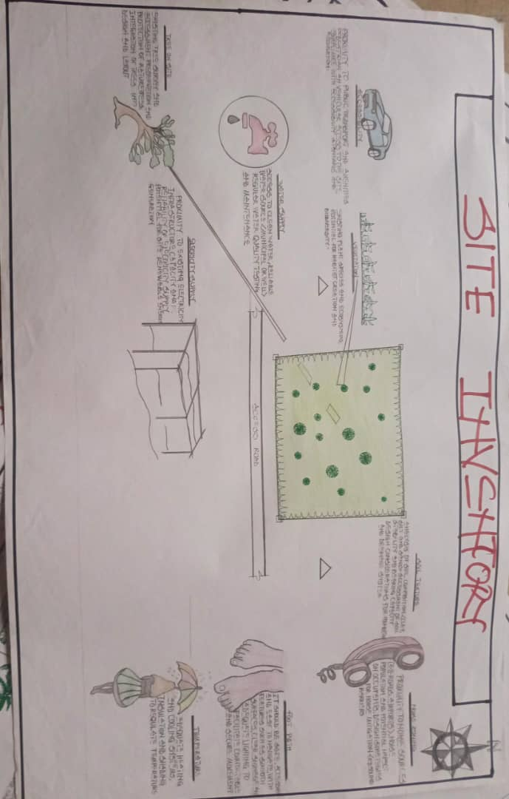
FIG 8; SHOWING SITE INVENTORY OF THE PROPOSED SITE

4.5 SITE ANALYSIS
The site is benefitted with loamy soil which is a very good soil for grass and shrubs. It has a gentle slope towards the south east. Some of the grasses, shrubs and trees on the site are to be retained to enhance landscape patter of the site while some are to be removed and replanted where necessary. The two noticeable winds are to be directed into the building using landscape pattern to improve ventilation. Noise generated from vehicle traffic is controlled through proper planning, good landscaping and proper orientation of building. Generally, all the feature on the site are best put into different uses to aid control through proper planning, landscape and orientation.
Certainly, steps are considered to obtain vital information of the site, this information is the analysed in details. For design purpose, the information include soil condition, geology, topography, vegetation etc. It also involves carrying out a preliminary survey of the site.

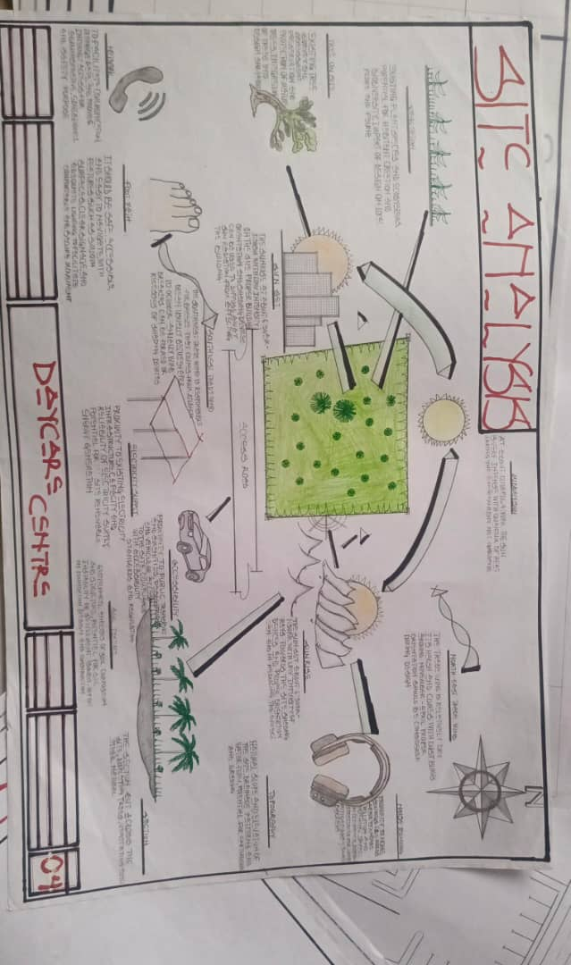
FIG 9; SHOWING SITE ANALYSIS OF THE PROPOSED SITE

4.5.1 SITE SELECTION/JUSTIFICATION
In the site selection provision is made for interesting facilities that worth emulating since the overall success and efficiency of any project depend not on the functionality of the design but also on a careful choice of site. The site of this project has been carefully selected which is located in the premises of Asadam, Ilorin Kwara state. The proposed site is located at Asadam road at Ilorin, Kwara state.
4.5.2 LOCATION
Ilorin West is one of the Local Government Areas (LGAs) in Kwara State, Nigeria. It is located within Ilorin, the state capital, and is considered one of the most densely populated and urbanized parts of the city.
- Asadam Area – Key Location Info:
- Asadam is a residential and commercial district within Ilorin West LGA.
- It lies along the Asa Dam Road, a major road named after the Asa Dam, a key landmark in Ilorin.
- Asadam connects to other key areas such as:
  - Unity Road
  - GRA (Government Reserved Area)
  - Offa Garage
  - Oloje and Basin areas

4.5.3 ACCESSIBILITY
The site is easily accessible from the access road off from the main road that goes to jubilee. The site can also be reached through the access road that lead to stadium.

4.5.4 INFRASTRUCTURAL FACILITIES
Facilities such as water electricity, telephone network and road network are all in Niger, hence it can easily be tapped to the proposed site.
4.5.5 TOPOGRAPHY
The topography of the land is gentle slope which can be filled and levelled up to balance round all the site levels.
4.5.6 SOIL STRUCTURE
.The dominant soil type in Asadam is ferruginous tropical soil, formed under the influence of a seasonal tropical climate.
4.6 GENERAL CLIMATIC CONDITION
Ilorin, the capital of Kwara State, experiences a tropical wet and dry climate, classified as Aw under the Köppen-Geiger climate classification. This type of climate is typical of the Guinea Savannah zone in Nigeria.
4.6.1 RELATIVE HUMIDITY
Relative humidity in Ilorin varies throughout the year due to its tropical wet and dry climate (Köppen Aw classification), with significant differences between the rainy and dry seasons.
- Rainy Season (April – October):
- High humidity levels due to moist southwesterly winds.
- Range: 65% to 85%
- Peak Humidity: July to September (often exceeding 80% in the mornings).
- Dry Season (November – March):
- Lower humidity, especially during the Harmattan (Dec–Feb).
- Range: 20% to 50%
- The air becomes dry and dusty, with very low early morning humidity during peak Harmattan.
4.6.2 WIND
There are two prevailing winds namely: The rain bearing south-west monsoon wind which blows across the Atlantic Ocean between the month of May and October. This is called wet season. The dusty north-east trade wind which laden with dust blows through the Sahara desert during the month of November to April with very title rainfall toward April. This is called the dry season and it brings along Harmattan during its driest period
4.6.3 TEMPERATURE
Ilorin experiences a tropical climate with distinct wet and dry seasons, and its temperatures are generally warm to hot year-round. The city's average temperature reflects its location in Nigeria’s Southern Guinea Savannah zone.

4.6.4 VEGETATION
The proposed site is covered with grasses few trees and shrubs. Some will be removed before the construction while some will be retain for ornamentation.

4.7 SOCIAL SERVICES
4.7.1 ROAD
There are only two access to the site
The southern access which serve as the main entrance and also main access road
4.7.2 WATER AND ELECTRICITY
There are pipe born water networks and borehole water which serves the habitant of Asadam. There is electricity supply from NEPA that serve the Ilorin, Kwara state in general
4.8 DESIGN CRITERIA
There are three (3) methods of designing of any project which are: Function before form method
Form before function method Combination of Shapes
Designing projects, the function, before form method used in line with this method, the following are the design criteria for this project:
Functional: in term of functional requirement, the following design criteria must be considered.
Sustainability, Site and Location, Flexibility, Circulation, Accessibility, Organization, Maintenance, Environment and Services
4.9 DESIGN BRIEF
After research and planning, the next step in the series of the project programed is design itself. To achieve functional and well established design there must be a brief to work on. This brief depends generally on the scope of individual design. The brief of this project is therefore based on the various activities that take place in the daycare. To have enough brief for the proposed Daycare center, case studies were carried out on the existing daycare center. The studies also give me the opportunity to know the nature of the various daycare treatment and how they are related to each other.

4.10 DESIGN ANALYSIS
This is the process of itemizing units within the component of the entire design with a view to establishing a solid understanding and appreciation of the space relationships.
The units of the design are in three division, the unit of the project division are as follows:
GROUND FLOOR PLAN; Entrance, Reception, Waiting Room, Playing Ground, Office, Infant Room, Toddler Room, Pre-school Room, Staff Room, W/C, Conference Room, Clinic, Kitchen, Store, Laundry, Exit, Utility.

4.11 SPACE REQUIREMENT
Units Area (m2)
Entrance 9300m2
Reception 11000m2
Office 9000m2
Infant Room 13700m2
Toddler Room 14000m2
Pre-school Room 14500m2
Staff Room 8000m2
W/C 3200m2
Conference Room 15375m2
Clinic 5600m2
Kitchen 8500m2
Store 3000m2
Laundry 5500m2
Exit 4500m2
Utility 5500m2
TABLE 2; SHOWING SPACIAL ALLOCATION OF FLOOR PLAN
Necessary units in the building. A borehole system of water supply is to be adopted alongside the government supplied services and a storage facility is to be provided for effective management of water supply.

4.12 PLANNING PRINCIPLE
The planning principle is one of the most important aspects of any design. The planning of various units taking into consideration the activities performed in each unit, how they are related to one another and the users of the various units in the design. In respect to the above factors.

CHAPTER FIVE
5.0 APPRAISAL OF PROPOSED SCHEME
A daycare center provides early childhood care and education in a safe, supportive environment while parents or guardians are at work. It plays a vital role in a child’s emotional, social, and intellectual development. A good daycare should have proper architectural design, adequate ventilation, sanitation, safety features, and play areas. Qualified caregivers and structured programs are essential to ensure the well-being and development of the children. The success of a daycare is often measured by child engagement, staff-to-child ratio, and overall facility hygiene and security.

5.1 CONSTRUCTION METHODOLOGY
- The site is carefully selected for safety and accessibility.
- The foundation is laid using child-safe, durable materials.
- Spaces are zoned for learning, sleeping, playing, and eating.
- Classrooms are designed with low-height walls and wide doorways.
- Natural lighting and cross ventilation are prioritized.
- Floors are non-slip and surfaces have smooth, rounded edges.
- Furniture is child-sized and easy to move.
- Outdoor play areas are fenced and equipped with safe equipment.
- Toilets and wash basins are designed at child-friendly heights.
- Electrical and plumbing systems are safely concealed and well maintained.
5.3 SERVICES
A daycare requires clean, constant water supply for drinking, cooking, cleaning, and sanitation. Reliable electricity is needed for lighting, fans or air conditioning, security systems, appliances, and educational tools like computers or projectors.
5.4 VENTILATION
Ventilation in a daycare is essential for maintaining fresh air, reducing odors, and preventing the spread of airborne illnesses. It should include natural ventilation through windows and vents, as well as mechanical systems like fans or air conditioners to ensure proper airflow. Good ventilation creates a healthy and comfortable environment for children and staff.
5.5 LIGHTING
Lighting in a daycare should be bright, soft, and evenly distributed to create a cheerful and safe environment. Natural lighting is preferred through large windows and skylights, supported by artificial lighting like LED fixtures. Proper lighting enhances visibility, supports learning activities, and reduces eye strain for children and staff.
5.6 PLUMBING
Plumbing in a daycare ensures clean water supply and proper waste disposal. It includes child-friendly sinks and toilets, safe drinking water systems, and well-maintained drainage. Plumbing must meet hygiene standards to prevent contamination and support daily activities like hand washing, cleaning, and meal preparation.
5.7 WATER DISPOSAL
Water disposal in a daycare involves safe and efficient drainage of wastewater from sinks, toilets, and cleaning areas. It includes a proper sewage system, covered drains, and regular maintenance to prevent leaks, blockages, and contamination. Effective water disposal ensures hygiene and protects children’s health.
5.8 FIRE PROTECTION
Fire protection in a daycare includes installing smoke detectors, fire alarms, and fire extinguishers in key areas. The building should have clearly marked emergency exits, fire-resistant materials, and an evacuation plan. Staff must be trained in fire safety procedures to ensure quick and safe responses during emergencies.

5.9 EXTERNAL WORK
External work in a daycare includes landscaping, playground installation, perimeter fencing, paved walkways, and drainage systems. It also involves creating safe drop-off and pick-up zones, outdoor lighting, and signage. These features enhance safety, accessibility, and the overall environment for children and parents.
5.10SUMMARY
A daycare center is an organized facility where young children, typically from infancy to pre-school age, are cared for during the day while their parents or guardians are at work or engaged in other responsibilities. These centers provide a safe, structured, and stimulating environment that supports the emotional, physical, social, and cognitive development of children through play, learning, and interaction with peers and caregivers.
Modern daycare centers are designed with child-friendly features, including classrooms, nap areas, outdoor play spaces, and learning materials tailored to specific age groups, all under the supervision of trained early childhood educators and caregivers who ensure the well-being and growth of each child. In addition to offering basic custodial care, daycare centers often incorporate educational programs such as storytelling, language development, creative arts, music, and basic numeracy to prepare children for formal schooling.
They also play a crucial role in supporting working families, especially in urban areas, by providing reliable, affordable, and accessible childcare services that enable parents, particularly mothers, to participate in the workforce without compromising their children's safety and development. Overall, a daycare centre serves as a bridge between home and school, nurturing young minds in their formative years while promoting healthy habits, emotional security, and foundational learning in a communal and professionally supervised setting.

5.11 CONCLUSION
A Daycare center is not merely a place where children are kept in the absence of their parents, but a foundational institution that plays a critical role in the early development and socialization of young children during their most formative years. It serves as a supportive extension of the home environment, offering structured care, educational stimulation, and emotional security that collectively prepare children for future academic success and social integration.
Through the dedication of trained caregivers and the use of age-appropriate educational methods, daycare centers nurture children’s physical health, cognitive abilities, and interpersonal skills, thereby laying a strong groundwork for lifelong learning and character development. Moreover, daycare centers contribute significantly to the broader society by enabling parents, especially working mothers, to participate productively in the economy, confident that their children are in safe and nurturing hands. Ultimately, the importance of a daycare center goes beyond caregiving — it is a vital part of a child's early journey toward becoming a confident, capable, and socially responsible individual.

5.12 RECOMMENDATION
It is highly recommended that daycare centers be given greater recognition and support as essential early childhood development institutions, and that both government and private sectors invest in their proper establishment, regulation, and continuous improvement. Authorities should ensure that daycare facilities are well-equipped with safe infrastructure, trained personnel, age-appropriate learning materials, and health provisions, to create an environment that truly fosters the holistic growth and well-being of every child. Parents are also encouraged to carefully select daycare centers that prioritize not only the safety and hygiene of their children, but also their emotional, intellectual, and social development through structured learning activities and guided play.
Furthermore, it is recommended that community stakeholders, including educational planners and public health officials, integrate daycare services into broader social welfare and educational policies, recognizing that early childhood care is not a luxury, but a necessity for the sustainable development of any society. Lastly, ongoing training and professional development for caregivers should be prioritized to ensure that those responsible for the care of children remain updated with modern techniques in child development, safety, and inclusive learning practices, thereby enhancing the overall quality and impact of daycare services.

REFERENCE
• UNICEF (2017).
Early Childhood Development: The Foundation of Sustainable Development.
New York: United Nations Children’s Fund.
https://www.unicef.org/early-childhood-development
— Thisdocument outlines the global importance of quality daycare and early childhood education.
•National Association for the Education of Young Children (NAEYC) (2020).
The Case for Early Education and Daycare Programs.
Washington, D.C.: NAEYC.
https://www.naeyc.org
— Offers guidelines for best practices in early childhood programs.
• Berk, L. E. (2013).
Child Development (9th ed.). Boston: Pearson Education.
— A textbook that discusses the impact of daycare environments on child development.
•Federal Ministry of Women Affairs, Nigeria (2006).
National Policy on Integrated Early Childhood Development in Nigeria.
Abuja: Government of Nigeria Press.
— A key Nigerian government document guiding the establishment and running of daycare centers.
•World Bank (2018).
Early Learning and Childcare: The Key to Unlocking Human Capital.
Washington, D.C.: World Bank Group.
https://www.worldbank.org

APPENDICES
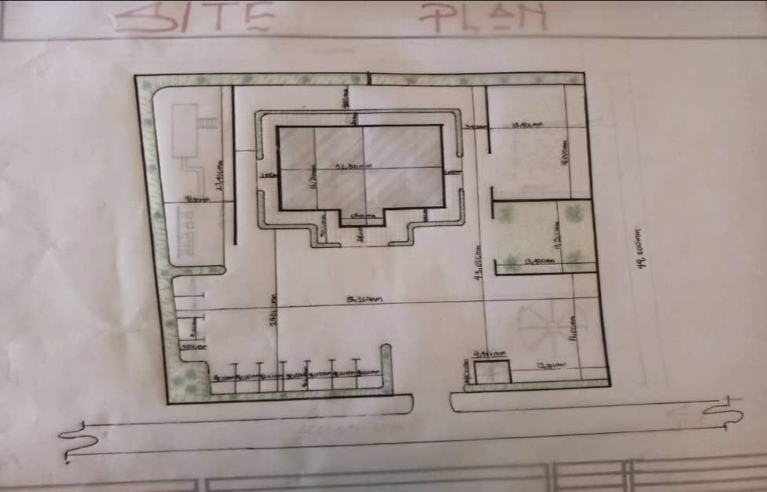
APP1; SHOWING SITE PLAN OF THE PROPOSED SITE
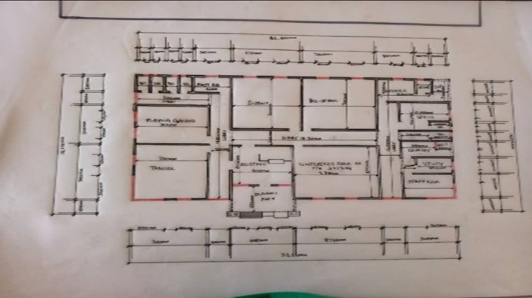
APP2; SHOWING FLOOR PLAN OF THE PROPOSED SITE
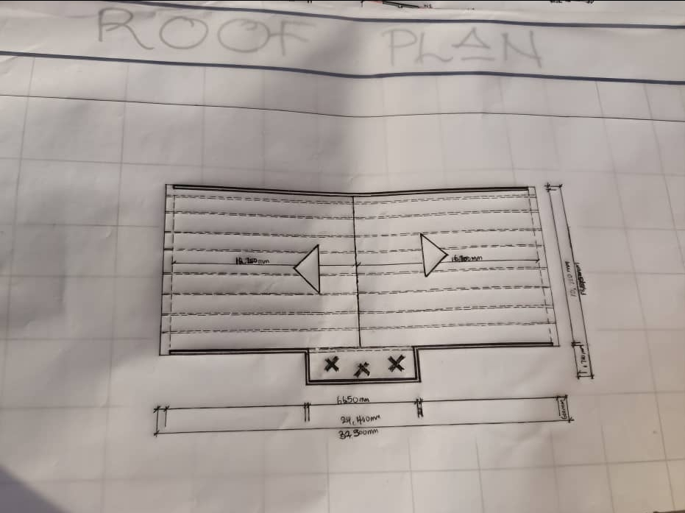
APP3; SHOWING ROOF PLAN OF THE PROPOSED PLAN
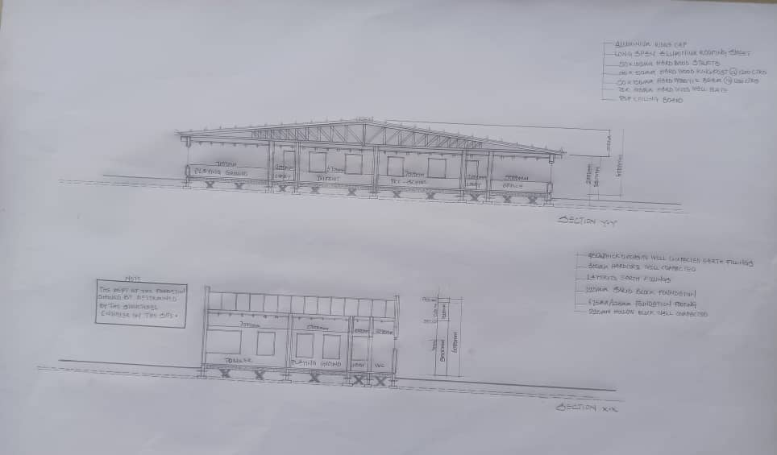
APP4; SHOWING CROSS SECTION OF THE PROPOSED PLAN

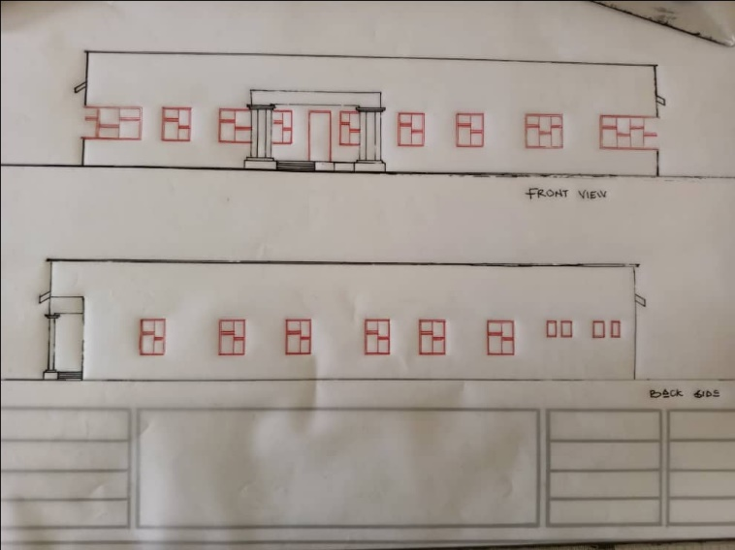
APP5; SHOWING FRONT&BACK VIEW OF THE PROPOSED PLAN
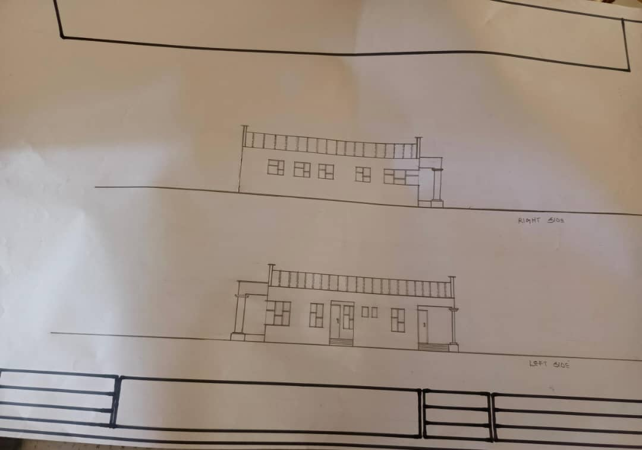
APP6; SHOWING RIGHT&LEFT VIEW OF THE PROPOSED PLAN

