A PROJECT REPORT
ON
PROPOSED DAYCARE FOR OKE-AGBO,
OJO, LAGOS STATE.
BY
AZEEZ LATEEF OPEYEMI
ND/23/ARC/PT/0031

SUBMITTED TO
THE DEPARTMENT OF ARCHITECTURAL TECHNOLOGY,
INSTITUTE OF ENVIRONMENTAL STUDIES (IES) KWARA STATE
POLYTECHNIC, ILORIN

IN STUDIES OF PARTIAL FULFILMENT
OF THE REQUIREMENTS FOR THE
AWARD OF NATIONAL DIPLOMA
(ND) IN ARCHITECTURAL TECHNOLOGY

JULY,2025

DECLARATION

This is a work carried out by AZEEZ LATEEF OPEYEMI with the matric number ND/23/ARC/PT/0031 of the department of architectural technology, Kwara state polytechnic under the supervision of ARC FAMILUA O.S
All the sources of information are specifically acknowledge by means of reference.

AZEEZ LATEEF OPEYEMI
ND/23/ARC/PT/0031
________________________
SIGNATURE & DATE

CERTIFICATION
I certify that this research project DAYCARE CENTRE was carried out byAZEEZ LATEEF OPEYEMI under the supervision ARC FAMILUA O.S has been approved as meeting part of the requirement for the award of National Diploma in Architectural Technology, Institute Of Environmental Studies,Kwara State Polytechnic, Ilorin, Kwara State.

ARC FAMILUA O.S ____________________
Project Supervisor SIGNATURE & DATE

ARC OLAREWAJU F.A _____________________
Project Coordinator SIGNATURE & DATE

ARC J.M TOMORI ______________________
Head of Department SIGNATURE & DATE

_____________________
EXTERNAL EXAMINER SIGNATURE & DATE

ACKNOWLEDGEMENT
All praise and adoration to Almighty Allah for the endless blessings, uncountable mercy and protection from the first breath of my existence till today.
I wish to express my profound gratitude to my supervisor ARC FAMILUA O.S. For his commitment, concern and support from initial stage of my project, the constructive concern and support from the initial stage to the final stage of completion of this project work, may Almighty Allah continue to enrich you more in knowledge for his thorough supervision for this successful project. I must also be grateful to my H. O. D, ARC. J. M. TOMORI and the whole host of lectures. ARC. MOH. SHERO, ARC. OLAREWAJU F.A, ARC. CHUCKWUMA NMOM, I pray Almighty Allah will continue to bless you all,
My sincere appreciation also goes all lecturers that tolerate me out through National Diploma (ND) in Architectural Technology, and also I cannot but to express my profound gratitude to my parents MR AND MRS AZEEZ ALAANU, for their financial, spiritual and moral support, my prayer is that you will surely eat the fruit of your labourInsha Allah.
My profound gratitude to my lovely sisters and brothers, for their support and encouragement throughout my project.
Finally my gratitude goes to all my colleagues starting from VICTORY, TUNDE, OLATOMOLA, TOHIB, KAOSARA, HAMIDA, AISHAT, TAIWO, KENNY, AYOMIKUN, CHIBOY, for all their support and guidelines. May Allah bless you all abundantly.

DEDICATION
This project is dedicated to Almighty Allah, the Guidance to the righteous path, And also to my admirable parent, brothers, sisters, friends, for their support and guidance through this journey of life.

TABLE OF CONTENT
TITLE i
DECLARATION… ii
CERTIFICATION… iii
ACKNOWLEDGEMENT… ..iv
DEDICATION… v
TABLE OF CONTENTS… vi
LIST OF TABLES… x
LIST OF FIGURES… xi
LIST OF PLATES… xii
LIST OF APPENDICES… xiii
ABSTRACT… xiv
CHAPTER ONE
  - INTRODUCTION……………………………………………………………………...1
1.2 DEFINITION… 3
1.3 HISTORICAL BACKGROUND 3
1.4 AIM AND OBJECTIVES… … 4
1.5 PROJECT JUSTICATION… .. 4
1.6 CLIENT BACKGROUND 4
1.7 SCOPE OF THE PROJECT 5
1.8 RESEACRH METHODOLOGY… 5
CHAPTER TWO
2.1 LITERATURE REVIEW…… ……………………………………………………….....6
2.2HISTORICAL BACKGROUND 6

CHAPTER THREE
3.1 CASE STUDIES………………………………....……………………………………6
3.2 SELECTED CASE STUDIES 6
3.3 CASE STUDY ONE 7
3.3 CASE STUDY TWO… 11
3.4 CASE STUDY THREE………………………………………………………………13
3.5 ONLINE CASE STUDY……….……………………………………………………..15
3.6 DEDUCTION ………………………………………………………………………...17
CHAPTER FOUR
BRIEF HISTORICAL BACKGROUND…………...…………………………………...18
LOCATION AND SETTING OUT……….………………………………………...…....19
POPULATION……………………………………………………………………..…….19
SITE INVENTORY……………… ……………………………………………………...21
SITE ANALYSIS…….………… ………………………………………………………...21
SITE SELECTION AND JUSTIFICATION……….………………………………….......22
LOCATION ….……………………………………………………………………………..22
ACCESSIBILITY…………………………………………………………………………..22
INFRASTRUCTURAL FACILITIES…………...……………………………………….. 23
TOPOGRAPHY……………………………………………………………………………... 23
SOIL STRUCTURE…………………………………………………………………….. 23
GENERAL CLIMATIC CONDITION……………………………………………………. 23
RELATIVE HUMIDITY…………………………………………………………………... 23
WIND…................................................................................................................................. 23
TEMPERATURE……………………………………………………………………………24
VEGETATION……………………………………………………………………………...24
ROAD………………………………………………………………………………………24
WATER AND ELECTRICITY…………………………………………………………...24
DESIGN CRITERI ……………………………………………………………………….25
DESIGN BRIEF 25
DESIGN ANALYSIS 25
SPACIAL ALLOCATION 26
PLANNING PRINCIPLE… 28
CHAPTER FIVE
APPRAISAL OF PROPOSED SCHEME…………………………………………………. 39
CONSTRUCTION METHODOLOGY…………………………………………………… 39
SERVICES…………………………………………………………………………………. 39
VENTILATION………………………..……………………………………………………39
LIGHTING……………….…… 39
PLUMBING 40
WATER DISPOSAL 40
FIRE PROTECTION… 40
EXTERNALWORK… 40
SUMMARY… 40
CONCLUSION… 41
RECOMMENDATION… 41
REFERENCES 42
APPENDICES 43

LIST OF TABLES

TABLE1;SHOWING THE POPULATION OF THE GENDER 25

TABLE2;SHOWING SPACIAL ALLOCATION OF FLOOR PLAN… 30

LIST OF FIGURES
FIG1;SHOWING LOCATION PLAN OF CASE STUDY ONE… 10
FIG2;SHOWING FLOOR PLAN OF CASE STUDY ONE… 10
FIG3;SHOWING LOCATION PLAN OF CASE STUDY TWO… 13
FIG4; SHOWING FLOOR PLAN OF CASE STUDY TWO… 14
FIG5; SHOWING FLOOR PLAN OF CASE STUDY THREE… 17
FIG6; SHOWING LOCATIONAL PLAN OF THE PROPSED SITE… 24
FIG7;SHOWING SITE INVENTORY OF THE PROPOSED SITE… 26
FIG8;SHOWINGSITEANALYSISOFTHEPROPOSEDSITE… 27

LIST OF PLATES

PLATE1;SHOWINGFRONTVIEWOFCASESTUDYONE… 11

PLATE2;SHOWINGRIGHTVIEWOFCASESTUDYONE… 11

PLATE3;SHOWINGBACKVIEWOFCASESTUDYONE 12

PLATE4;SHOWINGFRONT VIEWOFCASESTUDYONE… 12

PLATE5;SHOWING RIGHT VIEWOFCASESTUDYTWO… 15

PLATE6;SHOWINGLEFT VIEWOFCASESTUDYTWO… 15

PLATE7;SHOWINGFRONT VIEWOFCASESTUDYTHREE 18

PLATE8;SHOWINGRIGHTVIEWOFCASESTUDY THREE 19

PLATE9;SHOWINGBACK VIEW OFCASESTUDY THREE 19

PLATE10;SHOWINGFLOOR PLANOFONLINECASESTUDY 20
PLATE11;SHOWINGFRONT VIEWOFONLINECASESTUDY 20
PLATE12;SHOWINGBACKVIEWOFONLINECASESTUDY 21
PLATE13;SHOWINGFLOOR PLANOFONLINECASESTUDY TWO 21
PLATE14; SHOWING FRONT VIEW OF ONLINE CASE STUDY TWO………21

LIST OF APPENDICES
APP1;SHOWINGSITEPLANOFTHEPROPOSEDPROJECT 38
APP2;SHOWINGGROUNDFLOORPLANOFTHEPROPOSEDPROJECT 39
APP3;SHOWINGROOFPLANOFTHEPROPOSEDPROJECT 40
APP4;SHOWINGCROSS SECTIONOFTHEPROPOSEDPROJECT 41
APP5;SHOWINGFRONT&BACKOFTHEPROPOSEDPROJECT 42
APP6;SHOWINGSIDES VIEWOFTHEPROPOSEDPROJECT 43

ABSTRACT
This study addressed the shortage of affordable Daycare Centre services in urban areas, aiming to access demand, evaluate existing facilities, and proposed a sustainable Daycare Centre. The study recommends establishing community base Daycare Centre, providing training and resources, and offering subsidies to address the Daycare shortage.

CHAPTER ONE
  - INTRODUCTION
Daycare refers to facilities that provide care and supervision for young children, typically while their parents are at work or in school. Daycare center offer a safe and nurturing environment for children to learn, play, and develop social skills. The term “daycare” encompasses various type of facilities, but the most common ones are center based, home based care, and drop-in care.
Daycare centers are an integral part of modern society, providing a vital services for working parents and contributing to the cognitive, emotional, and social development of young children. The industry has evolved significantly to meet the growing demand for quality childcare, with advances in curriculum design, teacher training, and facility design.
Daycare center is an essential component of a balanced and thriving society. As urbanization and workforce participation continue to increase, especially among women, the demand for reliable, professional, and safe daycare centers has grown significantly. A daycare center, also known as a crèche or nursery, provides supervised care and early childhood education to infants and young children, typically ranging from three months to five years of age. These centers are designed to support parents and guardians by ensuring their children receive proper attention, developmental stimulation, and social interaction during working hours or periods when home supervision is not available.
The concept of daycare is not merely about babysitting; rather, it encompasses a structured environment where trained caregivers offer a variety of age-appropriate educational and recreational activities. This enables children to build foundational skills in communication, motor development, emotional intelligence, and early literacy. By providing a safe and nurturing environment, daycare centers play a critical role in the holistic development of a child during their formative years.
This report focuses on the establishment and management of a daycare center, examining key aspects such as infrastructure, staffing, safety standards, educational programs, health policies, and regulatory compliance. The primary objective of this project is to create a daycare facility that not only meets the immediate custodial needs of working parents but also contributes positively to the early development of children. In doing so, the center aims to uphold the highest standards of professionalism, care, and educational value.
Furthermore, the report outlines the socioeconomic importance of daycare centers, including their contribution to parental workforce productivity, female employment opportunities, and the reduction of early childhood neglect. Through well-defined operational procedures and adherence to child welfare guidelines, the daycare center described in this report aspires to be a model institution that supports families and promotes child well-being in the community.
1.2 DEFINITIONOF DAYCARE CENTRE
A DAYCARE CENTRE is an establishment that offers a safe nurturing environments for children, typically ranging from infants to preschool-age, during the daytime. These centers are designed to provide care, supervision, and age-appropriate activities for children while their parents or guardians are at work or unable to provide full-time care.

1.3 HISTORICAL BACKGROUND
Daycare centers, initially known as "crèches," originated in France around 1840 as a charitable means to care for children of working-class mothers. These institutions gained recognition and formalization, with the French government recognizing the Société des Crèches in 1869. Daycares then spread to other European cities and industrial centers during the late 19th century, with the first in Great Britain established in 1860. The concept then expanded to the United States, primarily through private charities.
Key Historical Developments:
Early 19th Century:The rise of industrialization led to increased female employment, creating a need for childcare solutions.
1840s (France):
The first "crèches" appeared, offering daytime care for children of working mothers.
1860s (Great Britain):
The first daycare center opened, marking the beginning of formal childcare outside of France.
Late 19th Century (Europe):
Daycares became more widespread in major European cities and industrial areas Mid-19th Century (US):
Private charities established day nurseries, with the New York Day Nursery being one of the earliest.
20th Century:
Daycare's importance grew as more women entered the workforce, and the focus shifted towards providing both care and early education
1.4 AIM AND OBJECTIVES OF THE PROJECT
AIM OF THE PROJECT
The aim of this project DAYCARE CENTRE is to support the growth, development of children through structured activities and care in a safe environment.
OBJECTIVES OF THE PROJECT
The objectives of a this project DAYCARE CENTRE revolve around creating a safe, stimulating, and developmentally appropriate environment that supports children's social, emotional, and cognitive growth. This includes fostering independent play, enabling proper supervision, and facilitating positive interactions with space, materials, and people. Below are more breakdown details;

1. Safety and Security

2. Stimulation and Learning
3. Social and Emotional Development
4. Functionality and Usability
5. Connection to Community and Culture

1.5 PROJECT JUSTIFICATION OF THE PROJECT
As an architect, I justify the DAYCARE CENTRE design by prioritizing natural light, flexible spaces, and sustainable materials. This thoughtful design promotes a healthy environment, fosters social interaction, and supports the cognitive development of children. By incorporating these elements, I aim to create a nurturing space that inspires young mind at OJO LAGOS STATE.
1.6 CLIENT BACKGROUND
The name of my client is OBA GALIB RUFAI
Oba GalibAdeniyi-Rufai is the Baale (traditional ruler) of Ojo Kingdom in Lagos State, Nigeria. He is also known as the Olojo of Ojo. Before becoming Oba, he had a career in the public sector as an internal auditor and council treasurer in various Lagos State local governments, including Ojo. He is committed to preserving the cultural heritage of the Awori people and promoting unity and development in Ojo
1.7 SCOPE OF THE STUDY
- Entrance
- Reception
- Office
- First-Aid Room
- Playing Ground
- Laundry
- Classroom for children based on their Age
- Sleeping Area
- Conference or Skill Room
- Kitchen
- Store
- Toilets
1.8 RESEACH METHOLODY
Various avenues were expressed as regards the method of research on order to arrive at a functional and appealing design concepts. The following research methods were employed.
LITERATURE REVIEW: Reference to tolerate for ideas of various writer were consulted in order to attain useful and important past work on similar project.
INTERNET: This is a research that was done and gained from the internet in other to get further information.
PERSONAL OBSERVATION: personal initiative coupled within inquisitive measure, interview and visualize the daily activities that take place within vicinity and necessary pictures were taken in order to attain there required motive
CASE STUDIES: This involves the thorough synthesis and analysis of similar existing structure (building) Based on the data collected and better deduction was made for realization of the best.

CHAPTER TWO
2.0 LITERATURE REVIEW
2.1 HISTORICAL BACKGROUND OF A DAYCARE CENTER
DAYCARE CENTRE
Daycare centers, initially known as "crèches," emerged in France around 1840 primarily to provide care for infants of working-class mothers. These institutions were officially recognized by the French government in 1869, with similar centers spreading throughout Europe during the late 19th century. The rise of women in the workforce during the 20th century significantly increased the need and availability of daycare centers, solidifying their role in supporting working parents and offering early childhood education.
Here's a more detailed look at the historical background:
Early forms of daycare:
The concept of providing care for children outside the home, particularly for those whose mothers worked, has roots in the 19th century.
France's pioneering role:
The first crèches appeared in France around 1840, offering a charitable solution for the children of working-class mothers.
Formal recognition and expansion:
The French government's recognition of the Société des Crèches in 1869 marked a significant step in legitimizing and supporting these institutions.
European spread:
Daycare centers quickly spread to other European cities, particularly in industrial areas, during the late 1800s
US beginnings:
Private charities in the US also established daycare centers in the mid-19th century, with the New York Day Nursery being one of the first in 1854.
20th-century growth:
The 20th century saw a dramatic increase in daycare centers, driven by the growing number of women in the workforce and a greater understanding of the importance of early childhood development.
Shifting perceptions:
While initially viewed as a form of welfare for the poor, daycare centers gradually gained recognition for their educational value, especially with the rise of nursery schools.
Government involvement:
Government involvement in daycare increased over time, particularly during the 20th century, with initiatives like the WPA nursery schools and later, programs like Head Start.
2.2 DAYCARE CENTRE IN THE USA
Daycare centers in the USA have evolved significantly, initially rooted in social welfare and later developing into a more education-focused system, especially for low-income families. The modern daycare landscape includes a mix of for-profit and non-profit providers, with ongoing debates about funding and accessibility.
Early Daycares and Social Welfare:
19th and early 20th centuries:Day nurseries emerged, primarily serving low-income families to allow parents to work. These were often custodial and focused on supervision rather than education.
Late 19th century:Day nurseries were often associated with philanthropic institutions, settlement houses, or community service organizations.
The Rise of Education and Federal Involvement:
Post-World War II:Kindergarten programs expanded, challenging the two-tiered system of early childhood education.
1960s:Head Start programs were introduced to address educational and nutritional needs of low-income preschool children.
1970s:Proposals for federal child care standards and expanded subsidies for low-income families emerged.
World War II Era:The Lanham Act provided federal funding for community facilities, including childcare centers, during wartime.

Challenges and Contemporary Issues:
Veto of the Child Care and Development Act (CCDA) by President Nixon in 1971:Marked a setback for universal childcare, emphasizing a "family values" approach and hindering progress towards a more inclusive society.
Current Situation:Daycare costs have increased significantly, with some parents struggling to afford care or facing choices between jobs and childcare.
Childcare Deserts:Many areas lack sufficient childcare options, particularly in low-income communities.
Ongoing debate about funding and accessibility:There is a persistent need for affordable, high-quality childcare options for all families.
Modern Daycare Landscape:
Diverse Providers:Today's daycare landscape includes a mix of for-profit and non-profit centers, religious-based programs, and in-home daycare.
Focus on Early Education:Many centers emphasize early childhood education, with programs designed to prepare children for school.
Military Childcare:The U.S. military provides a model for high-quality, affordable, and regulated childcare for its families.

CHAPTER THREE
3.1 CASE STUDIES
This is a research or an exercise that is carried out on existing building which is similar to the one researcher is writing on. The objective of a case study is to take a critical appraisal of existing related project with a view to identify the positive and negative aspect of such projects. It is only with time that a project can be adjusted so that it can be successful. The information obtained from the appraisal will guide the designer of new and similar project, the positive aspect of it shall be incorporated in the view proposal while attempts will be made to solve the problem of negative aspects. It is only through this that a designer can better enhance the quality and efficiency of building in the society. For a comprehensive analysis their case studies have been conducted.
3.2 SELETED CASE STUDIES
Case studies are of paramount important. It is an experimental research or analysis carried out on existing building or group of building functionally similar to the one which the research is working.
For any technical design to be meaningful there is always the need for preliminary research effort to be made on this proposal as a very necessary ground work.
The following are case studies of some daycare center.
    - ; New Glory at Ojo, Lagos State.
    - Child Development Centre at TASUED University, Ogun State.
    - Women In Technical Education and Development (WITED)Ilorin, kwarastate.

3.3 CASE STUDY ONE
    - Location: NEW GLORY DAYCARE AT OJO, LAGOS STATE.

OBSEVERATION
MERITS
- Access to educational resources and materials
- Itiswelllandscape
- There is space for outdoor play
- Goodsecurityarrangement

DEMERIT
- Nospaceforfutureexpansion
- No visitor waiting area
- Noisy area

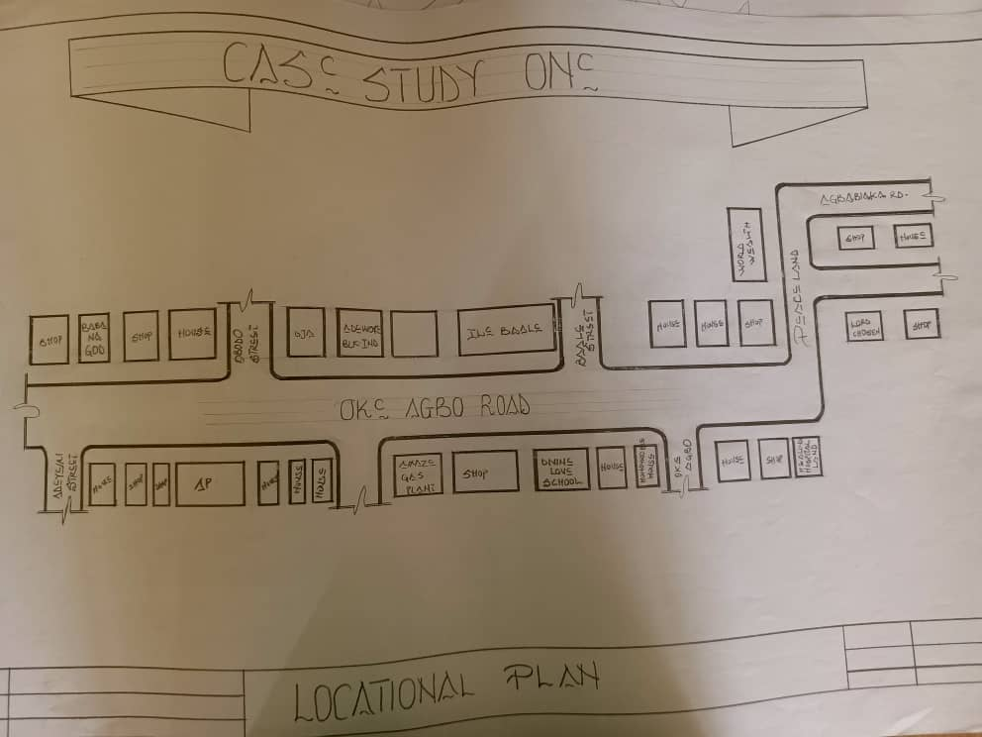

- FIG1;SHOWINGLOCATIONPLANOFCASESTUDYONE
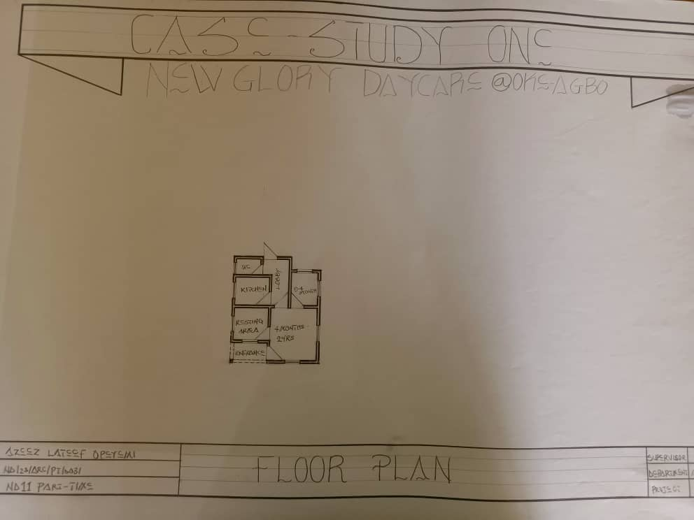

FIG2;SHOWINGFLOORPLANOFCASESTUDYONE

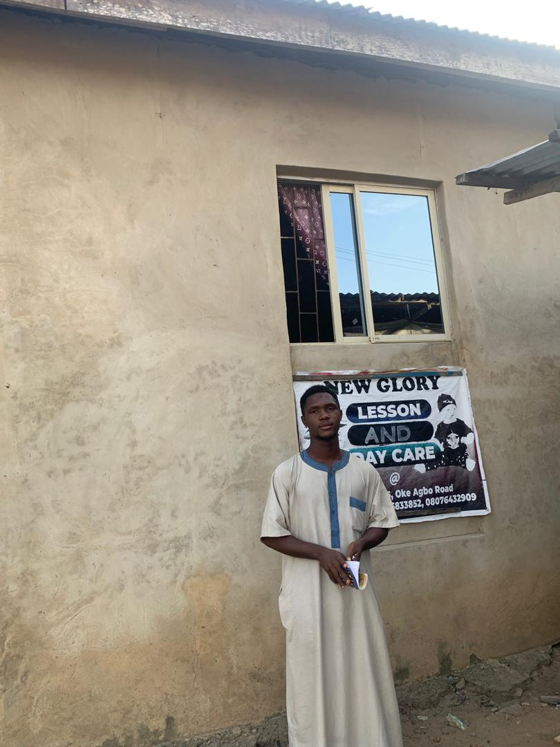

- PLATE1;SHOWINGFRONTVIEWOFCASESTUDYONE

3.4 CASE STUDY TWO (2)
LOCATION: CHILD DEVELOPMENT CENTRE AT TASUED UNIVERSITY, OGUN STATE.

OBSERVATION
MERITS
- Adequateparkingspace
- Provisionofdrainagefacilities
- It is well landscape
- There is space for future expansion
- There is space for outdoor play

DEMERITS
- No separate rooms for age groups
- Parking space are not well defined

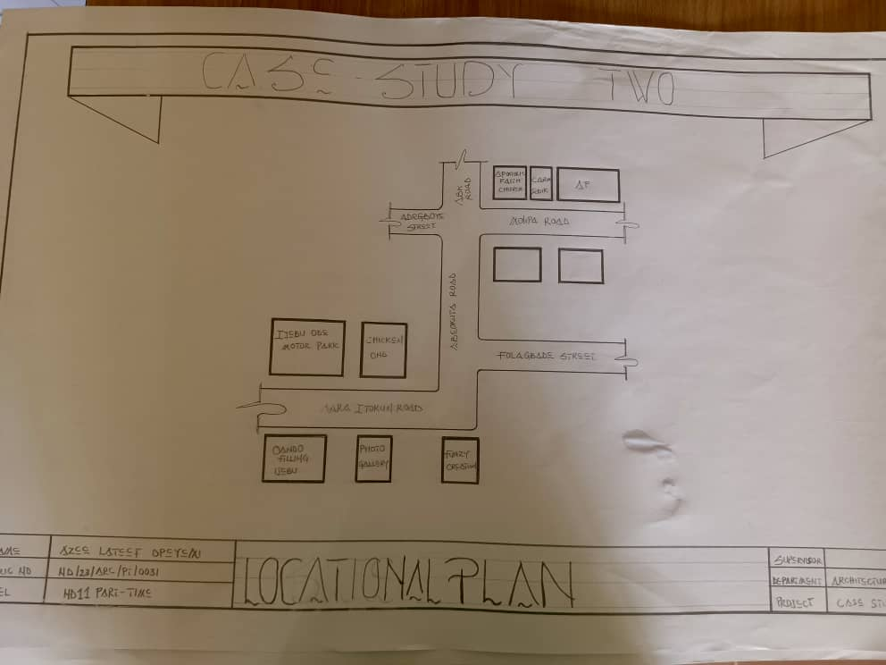

- FIG3;SHOWINGLOCATIONPLANOFCASESTUDY TWO
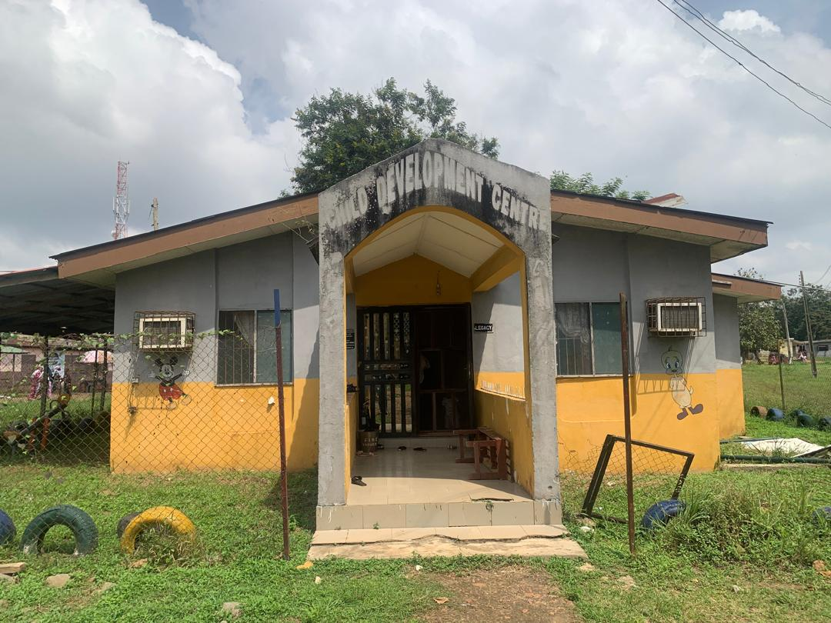
PLATE 4; SHOWING FRONT VIEW OF CASE STUDY TWO
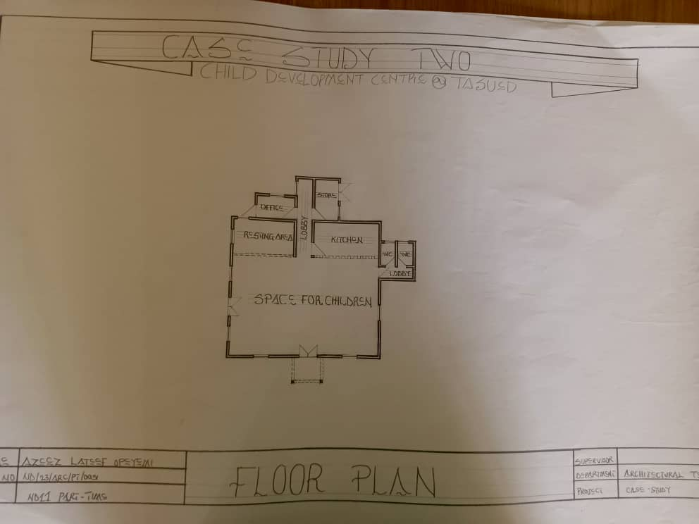

FIG4; SHOWING FLOOR PLAN OF CASE STUDY TWO

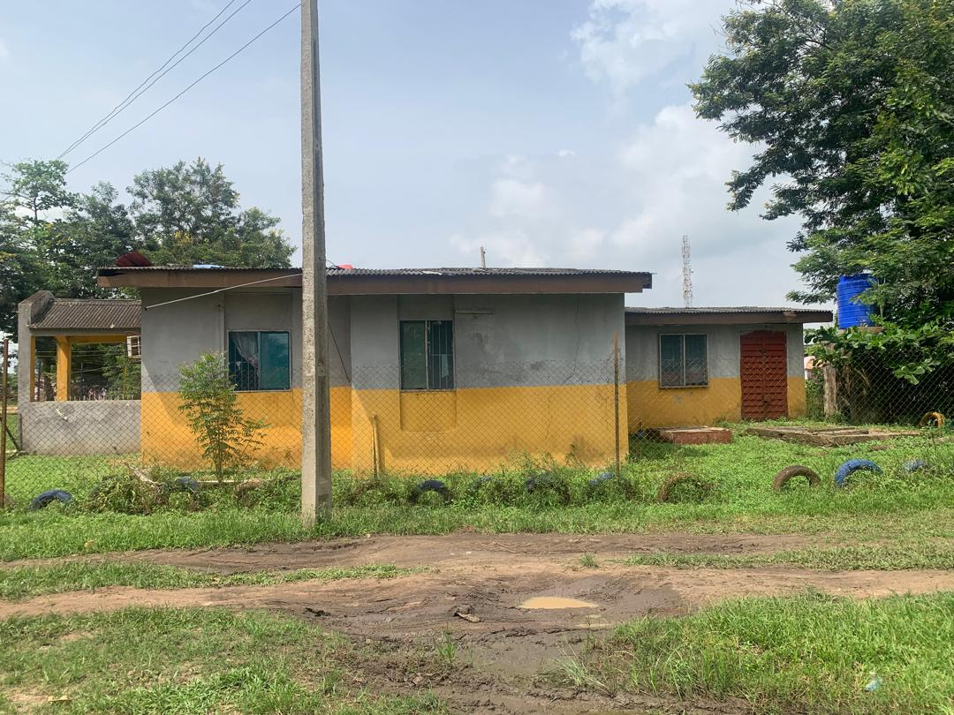

PLATE 5;SHOWINGRIGHT VIEWOFCASESTUDY

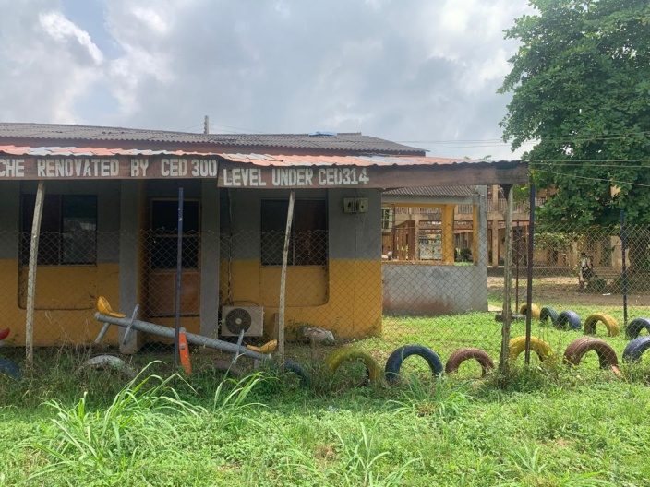
PLATE 6;SHOWING LEFT VIEWOFCASESTUDYTWO

3.5 CASE STUDY THREE (3)
LOCATION: WOMEN IN TECHNICAL EDUCATION AND DEVELOPMENT (WITED) ILORIN, KWARA STATE.
OBSERVATION
MERITS
- Easy to locate
- Quiet area
- Good ventilation

DEMERIT
- Inadequateparking space
- Not well organized
- Poor environment layout

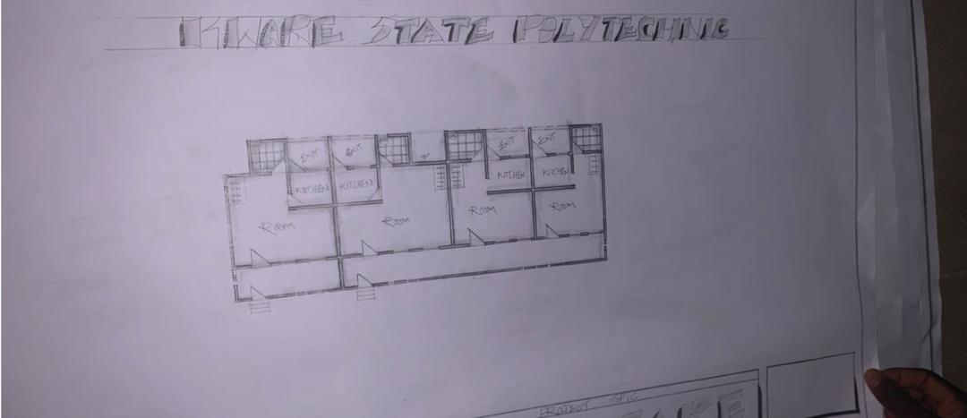
FIG5; SHOWING FLOOR PLAN OF CASE STUDY THRE

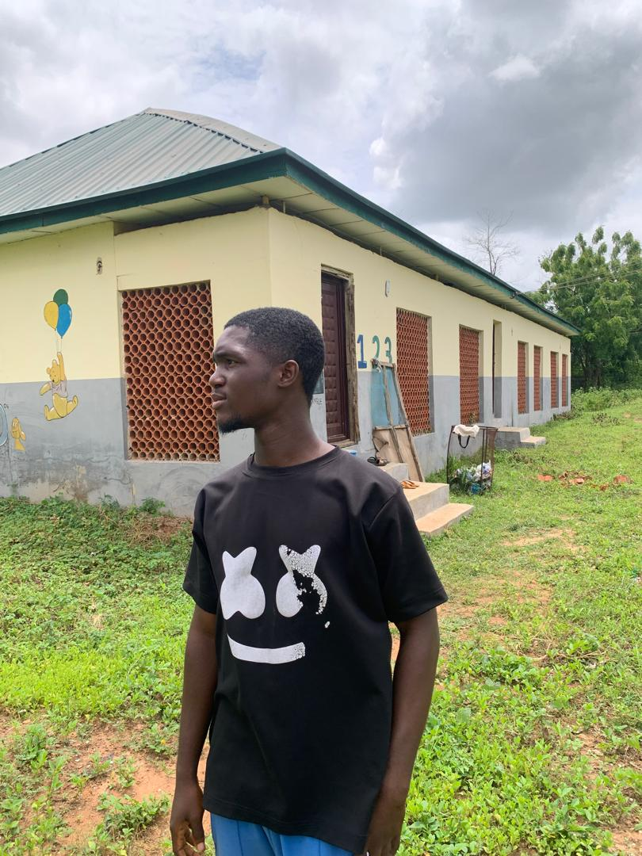

PLATE 7;SHOWINGFRONTVIEWOFCASESTUDYTHREE
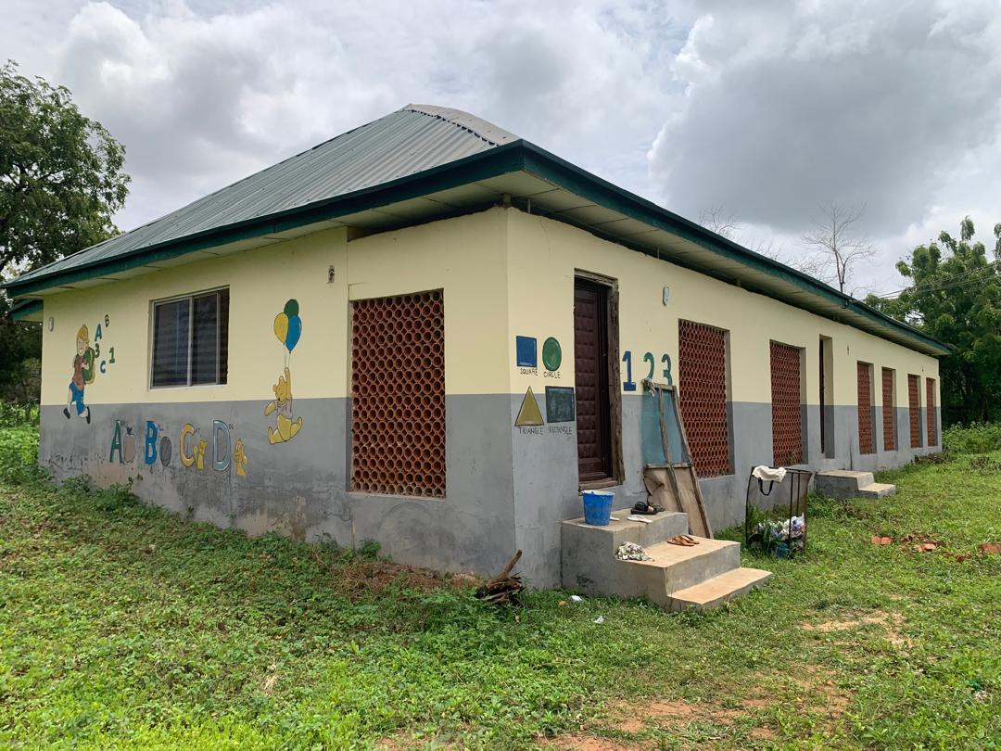

PLATE 8;SHOWINGRIGHTOFCASESTUDYTHREE

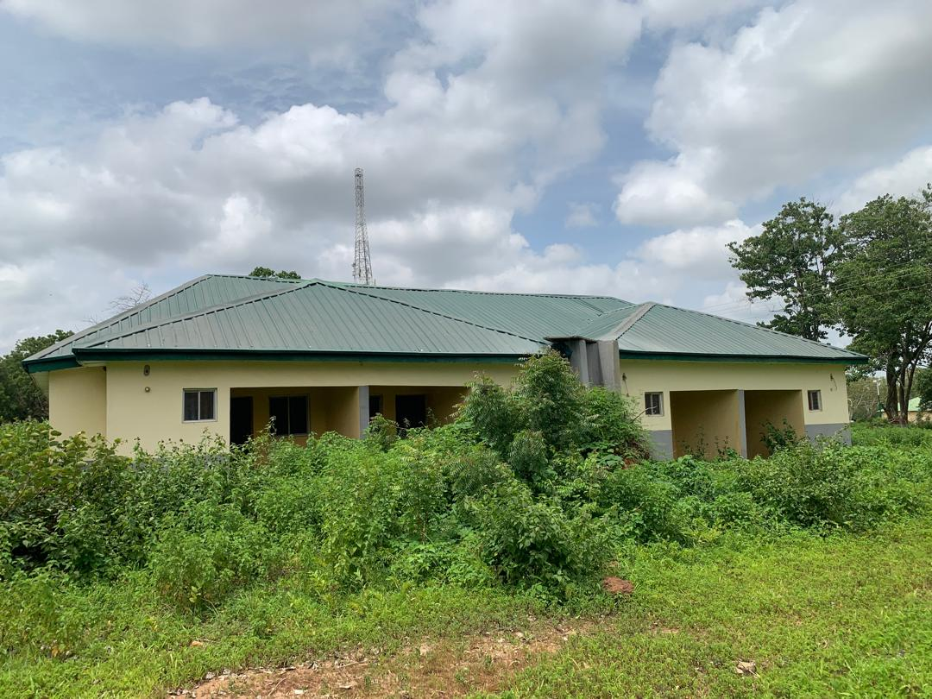

PLATE 9;SHOWINGBACK VIEWOFCASESTUDYTHREE

3.6 ONLINE CASE STUDY
ONLINE CASE STUDY ONE
PROJECT NAME: BOYS & GIRLS NURSERY CROXLEY GREEN
LOCATION: AT WOODSHOTS MEADOW, CROXLEY PARK, ENGLAND
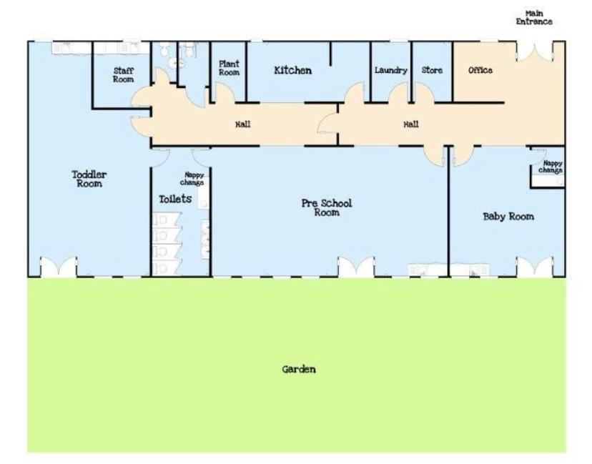
PLATE 10; SHOWING FLOOR PLAN OF ONLINE CASE STUDY
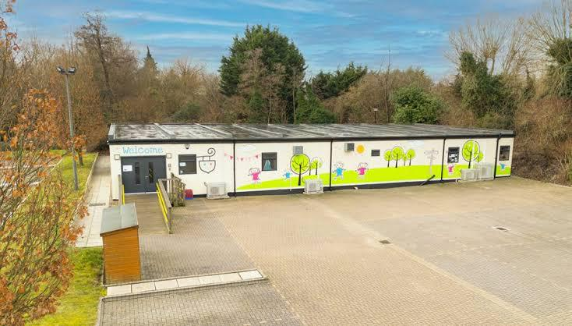
PLATE 11; SHOWING FRONT VIEW OF ONLINE CASE STUDY
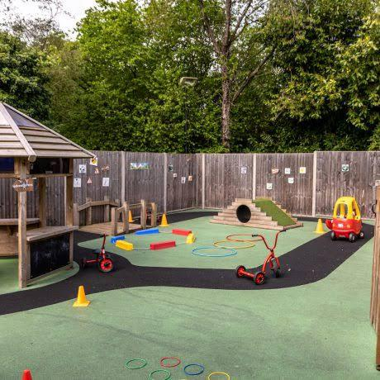
PLATE 12; SHOWING BACKVIEW OF ONLINE CASE STUDY
ONLINE CASE STUDY TWO
PROJECT NAME: DAYCARE CENTRE
LOCATION: ITALY
AREA: 4715 SQ. FT. BUILDING AREA
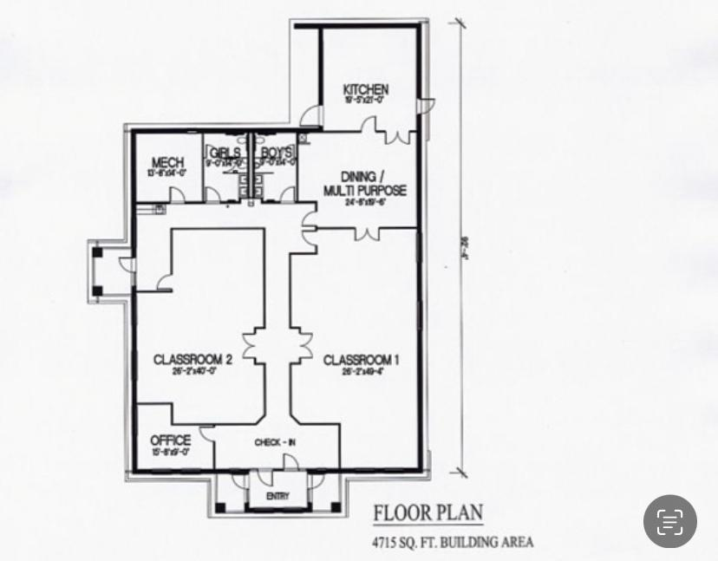
PLATE 13; SHOWING FLOOR PLAN OF ONLINE CASE STUDY TWO
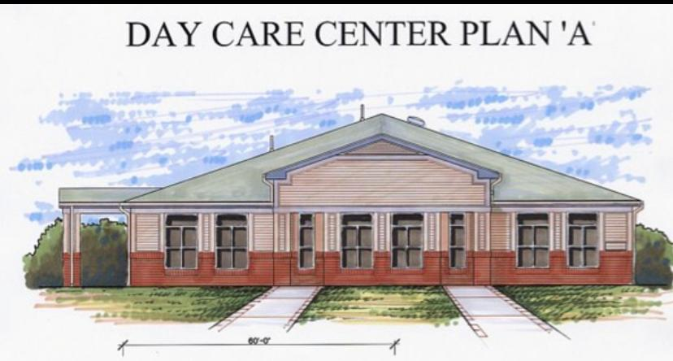
PLATE 14; SHOWING FRONT VIEW OF CASE STUDY TWO

DEDUCTION FROM CASE STUDIES
During my visit to the daycare center. I was opportunities to see what was obtain in the center, I made a proper studies of their related function and analysis were made to their present situation with the aim of incorporation with their merit in my own final proposal.
The following were deduce from my case study
- Adequate natural ventilation and lighting.
- Good architectural landscaping.
- Parking spaces should be well defined.
- Good drainage system

CHAPTER FOUR
4.0PROJECT LOCATION
4.1 BRIEF HISTORICAL BACKGROUND OF LAGOS STATE
Lagos State, as it is known today, was created on May 27, 1967, from the former Lagos Federal Territory and parts of the Western Region. Initially, Lagos city, which was the federal capital, was directly administered by the Federal Government. Other areas, like Ikeja and Badagry, were under the Western Region. The creation of Lagos State brought these areas together under a single administrative structure
LagosState is the largest city in Nigeria, and its former capital; it is the largest city in Africa in terms of population, with about 15.3 million people. It is also the 4th largest economy in Africa. Founded in the 16th century by the Awori people as Eko, it was for centuries a small but important commercial kingdom on the Bight of Benin. In 1851, the British intervened in an internal political dispute, establishing their influence. It formally became a protectorate in 1861.
GEOGRAPHY OF LAGOS STATE
Lagos State, located in southwestern Nigeria, is characterized by its coastal geography, featuring numerous islands, sandbars, and lagoons. A significant portion of the state's area is covered by water bodies, including the Lagos Lagoon and various creeks. The state is bordered by Ogun State to the north and west, and the Bight of Benin to the south

ECONOMY OF LAGOS STATE
Lagos has the second-largest city economy in Africa, with a GDP of $259 billion based on Purchasing Power Parity (PPP). The city is a major economic center for Nigeria and a hub for trade, investment, and opportunity. Key sectors include finance, with notable presence of multinational corporations and investment firms, and a growing tech ecosystem known as "Tech Lagos"

ORGANIZATION STRUCTRE
An organizational structure defines how activities are directed within a company to achieve its goals. It outlines the framework for how tasks are delegated, how information flows, and how different parts of the business are connected. Essentially, it's the blueprint for how a business operates and makes decisions.
4.2 LOCATION AND SETTING OF LAGOS STATE
Lagos is a coastal megacity located in southwestern Nigeria, situated on the Atlantic coast in the Gulf of Guinea. It's known for its large lagoon system, which includes Lagos Island and several other islands, as well as its mainland coastal area. The city is characterized by a tropical savanna climate and experiences two rainy seasons.
Location Details:
Region: Southwestern Nigeria, West Africa.
Coast: Atlantic coast, Gulf of Guinea.
Proximity: West of the Niger River delta.
Coordinates: 6°35′N 3°45′E
Surrounding Waters: Lagos Lagoon, separated from the ocean by a sand spit.
Main Islands: Lagos Island, Victoria Island, Ikoyi.
SETTING:
Topography: Low-lying and subject to flooding and coastal erosion.
Climate: Tropical savanna with two rainy seasons.
Ecosystem: Swampy region with rivers, creeks, sandbars, and lagoons.
Urban Landscape: A mix of islands and mainland, with extensive development and reclamation projects.
Cultural Significance: Historically a major port and trading center, and now a bustling megacity with a vibrant cultural scene
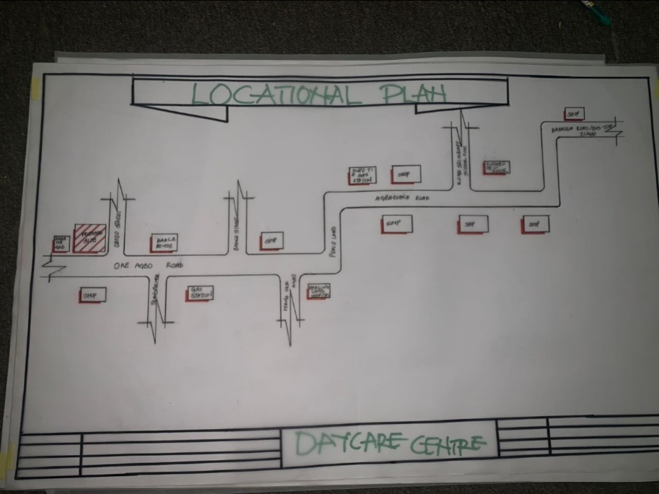
FIG 6; SHOWING LOCATION OF THE PROPOSE SITE

4.3 POPULATION

Ojo, Lagos, Nigeria
Area of Ojo, Lagos, Nigeria | 156.9 km²
Population | 820,178
Male Population | 425,599 (51.9%)
Female Population | 394,579 (48.1%)
Population change from 1975 to 2015 | +191.4%
Population change from 2000 to 2015 | +48.7%
Median Age | 22.1 years
Male Median Age | 23 years
Female Median Age | 21.1 years
Timezone | West Africa Standard Time

4.4 SITE INVETORY
In the proposed site, some shrubs will be retained on the site. It used to reduce sky glare and also serve as soft landscape and wind breaker.
Presence of road network which would serve as a means of accessibility to the site. Presence of electricity pole which serve as source of electricity to the site. Some trees will be retained while some will be removed if they disrupt the construction of building.
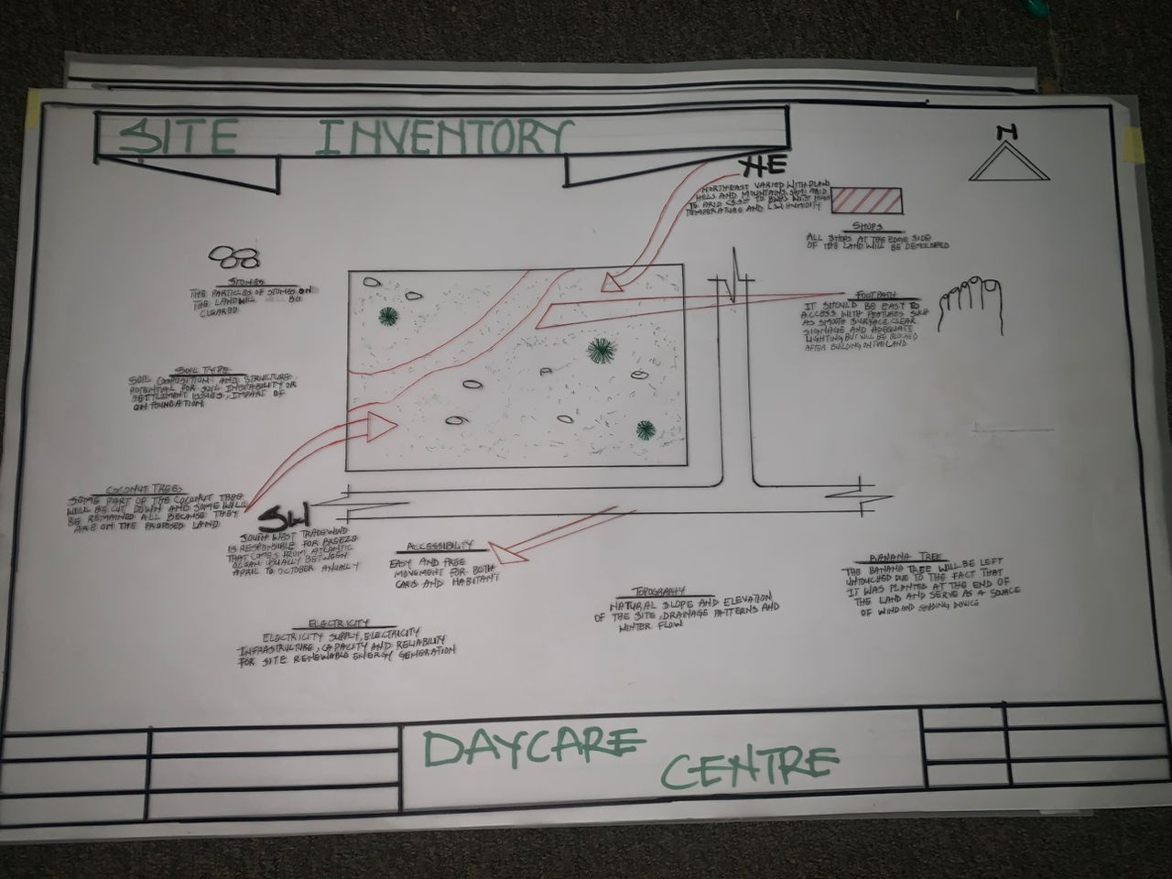
FIG 7; SHOWING SITE INVENTORY OF THE PROPOSED SITE

4.5 SITE ANALYSIS
The site is benefited with loamy soil which is very good soil for grass and shrubs. It has a gentle slope towards the south east. Some of the grasses, shrubs and trees on the site are to be retained to enhance landscape patter of the site while some are to be removed and replanted where necessary. The two noticeable winds are to be directed into the building using landscape pattern to improve ventilation. Noise generated from vehicle traffic is controlled through proper planning, good landscaping and proper orientation of building. Generally, all the features on the site are best put into different use to aid control through proper planning, landscape and orientation.
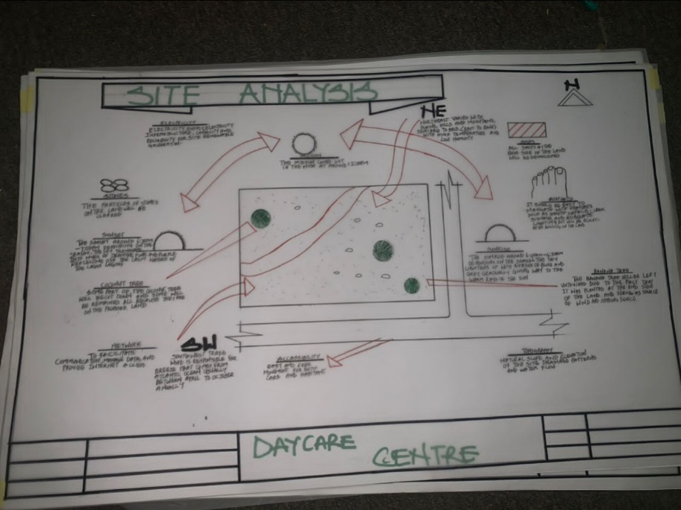
FIG 8; SHOWING SITE ANALYSIS OF THE PROPOSED SITE

4.5.1 SITE SELECTION/JUSTIFICATION
In the site selection provision is made for interesting facilities that worth emulating since the overall success and efficiency of any project depend not on the functionality of the design but also on a careful choice on site. The site of this project has been carefully selected which is located in the premises of Lagos State, Ojo Lagos State.
4.5.4 LOCATION
Oke-Agbo is a town within Ojo Local Government Area in Lagos State, Nigeria. It's located in the southwestern part of Lagos, near the Lagos Lagoon. Ojo is known for being a primarily residential area with major markets like Alaba International Market and Iyana-Iba Market.
4.5.3 ACCESSIBILITY
The site is easily accessible from the access road off from the main road that goes to jubilee. The site can also be reached through the access road.
4.5.4 INFRASTRUCTURAL FACILITIES
Facilities such as water, electricity, telephone network and road network are all in Lagos, hence it can easily be tapped to the proposed site.
4.5.5 TOPOGRAPHY
The topography of the land is levelled up to the balance of the site levels.
4.5.6 SOIL STRUCTURE
It is made up of loamy laterite soil, which is good for building construction.

4.6 GENERAL CLIMATIC CONDITION
Lagos State generally experiences a warm and humid tropical climate with distinct wet and dry seasons. The weather is typically warm and cloudy, with average temperatures ranging from 28-32°C during the day and 22-24°C at night. Humidity is high, but coastal breezes offer some relief. The wet season lasts from April to October, while the dry season, influenced by the Harmattan winds, runs from November to March.
Temperature:Lagos maintains relatively stable temperatures throughout the year, with little seasonal variation. The hottest months are typically March and May, while the coolest is usually August.
Rainfall:The rainy season is characterized by heavy rainfall and occasional thunderstorms, with the wettest months being June and October. The dry season is marked by the Harmattan winds, which bring dry, dusty air from the Sahara.
Humidity:Humidity remains high throughout the year, even during the dry season.
Cloud Cover:Lagos is often cloudy, with less sunshine than some other Nigerian cities like Abuja

4.6.1 RELATIVE HUMIDITY
Lagos experiences high relative humidity, typically averaging around 83.01% annually, with monthly averages ranging from 80% in March to 88% in June. This high humidity is characteristic of a tropical wet and dry or savanna climate, influenced by the city's coastal location. The wet season, from May to October, brings higher humidity due to increased rainfall, while the dry season, from November to April, experiences slightly lower humidity levels
4.6.2 WIND
Wind direction is Southwest wind speed varies between 13.4 and 15.6 mph with gusts up to 20.1 mph. The sky is cloudy with a chance of rain 0%.
Wind and wave weather forecast for Lagos Nigeria, Nigeria contains detailed information about local wind speed, direction, and gusts. Wave forecast includes wave height and period.
These forecasts for Lagos Nigeriaare based on the GFS model and were created for windsurfing, kitesurfing, sailing and other extreme sports activities. All data updates 4 times a day. Predictions are available in steps from 1 to 3 hours for up to 10 days.
4.6.3 TEMPERATURE
The average annual highest temperature in Lagos is 30.5°C (86.9°F), and the March 20th is the hottest day on average
4.6.4 VEGETATION
The proposed site is covered with grasses few trees. Some will be removed before the construction while some will be retain for ornamentation and shading device.
4.7 SOCIAL SERVICES
4.7.1 ROAD
There are only three access to the site
Which they all serve as main entrance and also main access road
4.7.2 WATER AND ELECTRICITY
There are pipe borne water networks and borehole water which serves the habitant of Ojo. There is electricity supply from PHCN (NEPA) that serve the Lagos State general

4.8 DESIGN CRITERA
There are three methods of designing of any project which are; Function before form method
Form before function method Combination of Shapes, Designing projects, the function, before form method used in line with this method, the following are the design criteria for this project:
Functional: In term of functional requirement, the following design criteria must be considered.
Sustainability, Site and Location, Flexibility, Circulation, Accessibility, Organization, Maintenance, Environment and Services
4.9 DESIGN BRIEF
After research and planning, the next step in the series of the project programmed is design itself. To achieve functional and well established design there must be a brief to work on. This brief depends generally on the scope of individual design. The brief of this project is therefore based on the various activities that take place in the daycare center. To have enough brief for the proposed Daycare Centre, case studies also give me the opportunity to know the nature of the various daycare treatment and how they are related to each other.
4.10 DESIGN ANALYSIS
This is the process of itemizing units within the component of the entire design with a view to establishing a solid understanding and appreciation of the space relationships.
The units of the design of the project are as follows;
FLOOR PLAN; Entrance, Reception, Office, First-Aid Room, Playing Ground, Laundry, Classroom for the children based on their ages, Sleeping Area, Conference or Skill Room, Kitchen, Store, Toilets, Exit

4.11 SPACE REQUIREMENT

UNITS AREA (m2)
Entrance 9000m2
Reception 10,000m2
Office 8000m2
First-Aid Room 7600m2
Playing Ground 12,000m2
Laundry 5625m2
Classrooms 11,000m2
Sleeping Area 9000m2
Conference room 13,500m2
Kitchen 7200m2
Store 4000m2
Toilets 4000m2
Exit 2825m2
Exit2 4375m2
TABLE 2; SHOWING SPACIAL ALLOCATION OF FLOOR PLAN
Necessary units in the building. A borehole system of water supply is to be adopted alongside the government supplied services and a storage facility is to be provided for effective management of water supply.
4.12 PLANNING PRINCIPLE
The planning principle is one of the most important aspects of any design. The planning of various units taking into consideration the activities performed in each unit, how they are related to one another and the users of the various units in the design. In respect to the above factors.

CHAPTER FIVE
5.0 APPRAISAL OF PROPOSED SCHEME
From an architectural standpoint, a daycare center should be designed to prioritize safety, accessibility, and comfort for children. Key features include child-friendly spaces, natural lighting, proper ventilation, secure outdoor play areas, and flexible classroom layouts. The design should support visual supervision, ease of movement, and hygiene facilities suited to children's needs. Good architectural planning also considers zoning for different age groups, noise control, and emergency exits, ensuring a functional and stimulating environment for early childhood development.
5.1 CONSTRUCTION METHODOLOGY
The construction begins with site preparation and zoning for safety and function. A child-friendly layout is followed using reinforced concrete or steel framing. Walls are built with smooth, non-toxic materials, and slip-resistant floors are installed. Windows and doors are designed for child safety and natural lighting. Roofing ensures insulation and protection. MEP systems are child-appropriate, and interior spaces are furnished with safe, low-height furniture. Outdoor play areas use soft, durable materials. The entire structure is completed with finishes that prioritize hygiene, safety, and comfort, adhering to building codes and child-care standards.
5.2 SERVICES
The handling of building services are very important in a project, services like electricity and water supply.
Electricity is supplied by Lagos electricity (LE) pole in and around the site for use in daycare
Bore-hole water system is to be provided in the site and channel to the building for adequate and regular provision of water
5.3 VENTILATION
Adequate ventilation in an opening of the building is located strategic and adjacent position of each other, artificial ventilation is attained by creating opening in the proposed building
5.4 LIGHTING
Adequate natural lighting is expected within this unit of the building and visual performance depends on the total perception of space, quality as well as total amount of light.
Interiors of the building are lighted naturally with the use of florescent and bulb to provide lightning to this apart of building.
5.5 PLUMBING
Plumbing is the system of pipe & system etc. That supply and stop water for use on a holding. The water will be supplied to the building through the water main as reticulated on this alternative borehole supply.
5.6 WATER DISPOSAL
Water disposal is the method of collecting both liquid and solid waste in the building as regarded this project (DAYCARE CENTER) there will be a septic tank for solid waste, human excrete as well as discharge from toilet should be located away from public area in order to avoid irritating odor.
5.7 FIRE PROTECTION
Fire protection can be needed In two ways, fire prevention and fire protection, fire prevention is to be conserved by providing a fire selection alarm to alert the building maintenance officer to find a way of preventing the fire from widespread. Fire-fighting equipment is to be provided such as hose reels, sprinklers and drenches, these equipment are to be fixed at strategic position for easy access in other to protect the building by extinguishing the fire automated sprinkler.
5.8 EXTERNAL WORK
WORKSWALL
Load bearing wall of the toilet are finished with ceramics tiles of the height 2.1m which make up the bearing works are wall filled with some concrete slab and beam finished with sand screed.
5.9 SUMMARY
A daycare center project aims to establish a facility that provides care and supervision for children, primarily during working hours, to support their social, emotional, and developmental growth. These centers offer a safe and structured environment where children can engage in age-appropriate activities, learn, and socialize with peers, while also allowing parents to work. The project involves planning for space, designing the facility for users, and managing various aspects like staffing, curriculum, and safety protocols

5.10 RECOMMENDATION AND CONCLUSION
In this thesis, I have attempted to state and define the problem and suggestion the possible solution in mentioned design.
However, I would like to recommend that instruction and details given to the design is saintly adhered to and both in the choice of materials and the construction techniques. The project should be handed over to a qualified professional contractor and upon completion of the project it should be maintained or put under the care of physical planning units.

REFERENCE
ACF (Administration for Children and Families). 2006. Head Start performance measures center. Family and Child Experiences Survey (FACES 2000). Technical report. HHS-105-96-1912. Washington, DC: U.S. Department of Health and Human Services.

Austin, L. J. E., M. Whitebook, M. Connors, and R. Darrah. 2011. Staff preparation, reward, and support: Are quality rating and improvement systems addressing all of the key ingredients necessary for change? Berkeley, CA: Center for the Study of Child Care Employment, University of California, Berkeley.

Badanes, L., M. Mendoza, and S. Watamura. 2011 (unpublished). Differential susceptibility to stress reactivity at child care for behaviorally inhibited children. Paper presented at the 2011 Society for Research in Child Development biennial meeting, Montréal, Québec, Canada. University of Denver.

Barbarin, O. A., J. Downer, E. Odom, and D. Head. 2010. Home-school differences in beliefs, support, and control during public pre-kindergarten and their link to children’s kindergarten readiness. Early Childhood Research Quarterly 25(3):358-372.

Barnett, W. S. 2011. Preparing highly effective pre-K teachers. Paper presented at The Early Childhood Care and Education Workforce: A Workshop, Washington, DC, February 28 and March 1.
National Academies of Sciences, Engineering, and Medicine. 2012. The Early Childhood Care and Education Workforce: Challenges and Opportunities: A Workshop Report. Washington, DC: The National Academies Press. https://doi.org/10.17226/13238.

APPENDICES

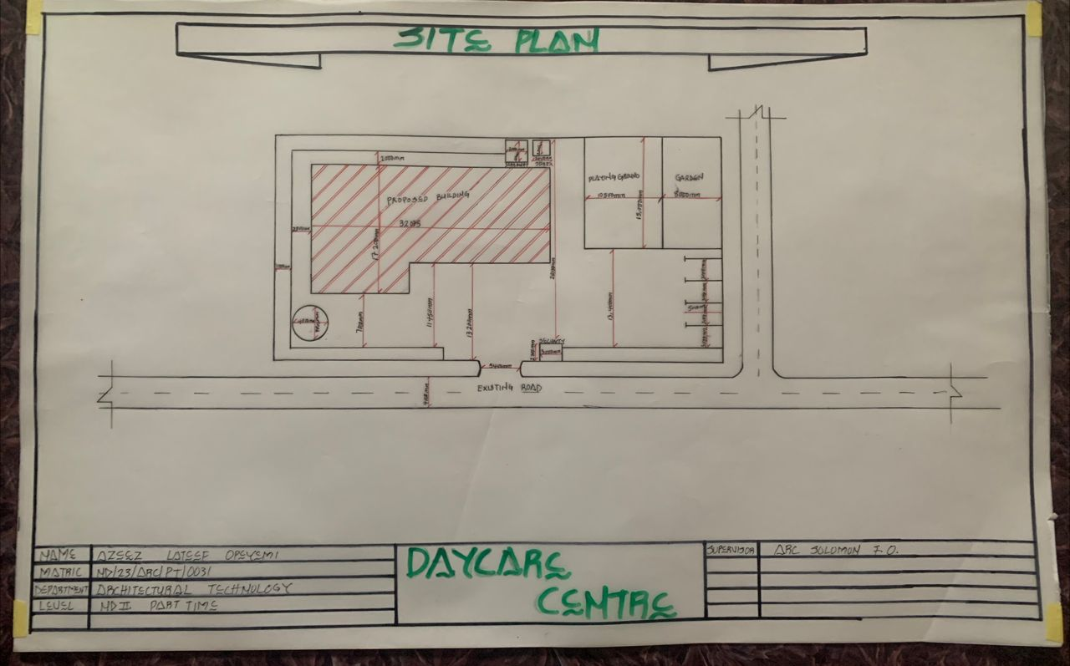
APP1; SHOWING SITE PLAN OF THE PROPOSED PROJECT
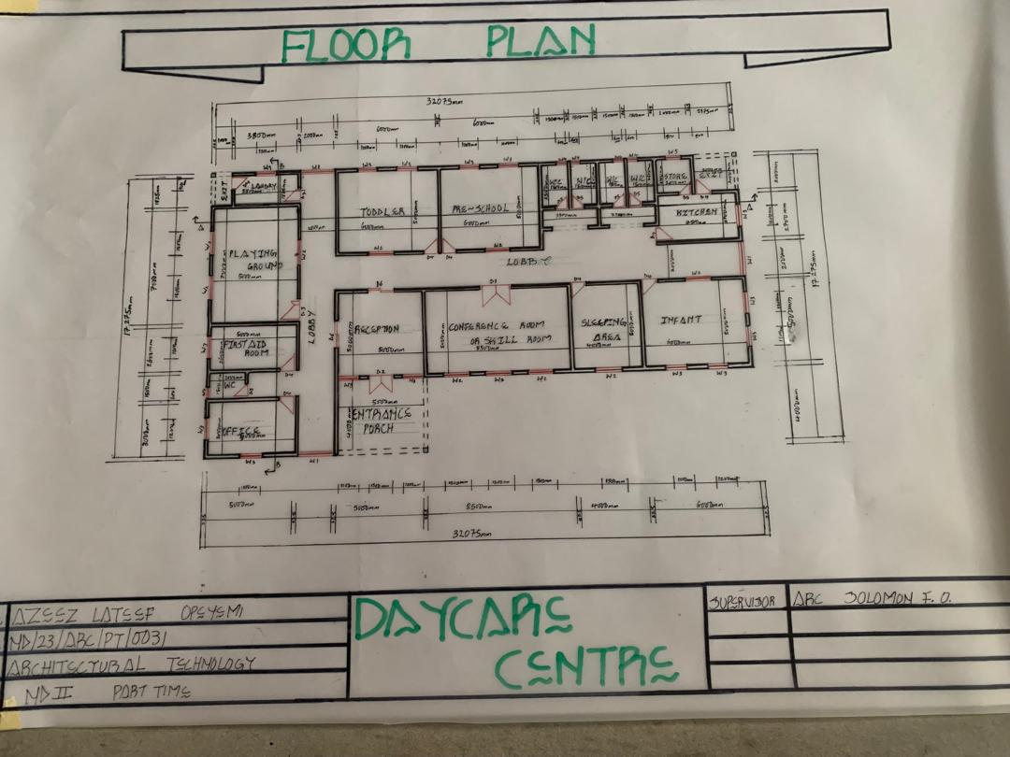
APP2; SHOWING FLOOR PLAN OF THE PROPOSED PROJECT

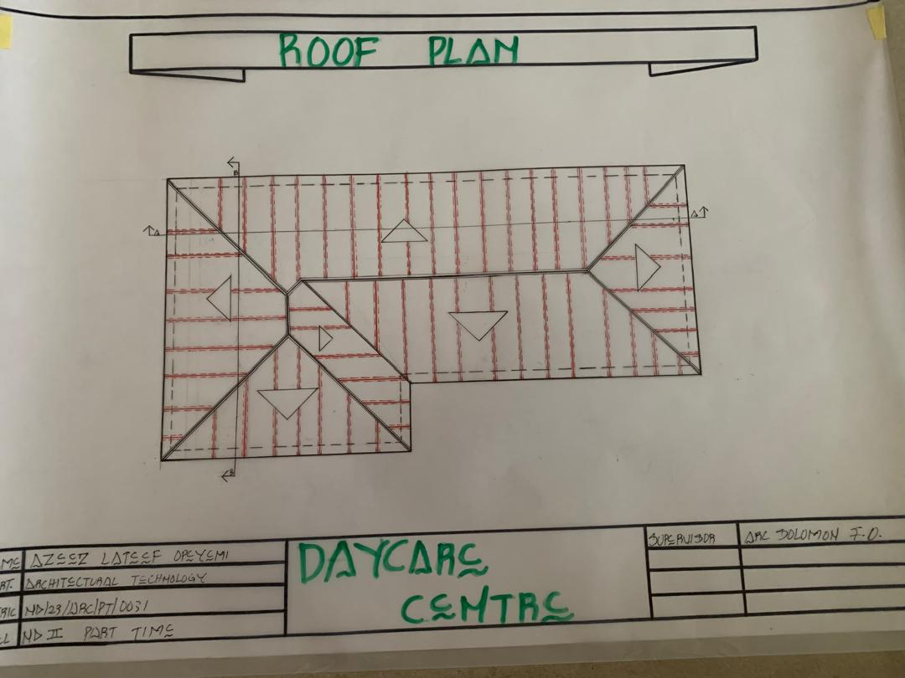
APP3; SHOWING ROOF PLAN OF THE PROPOSED PROJECT
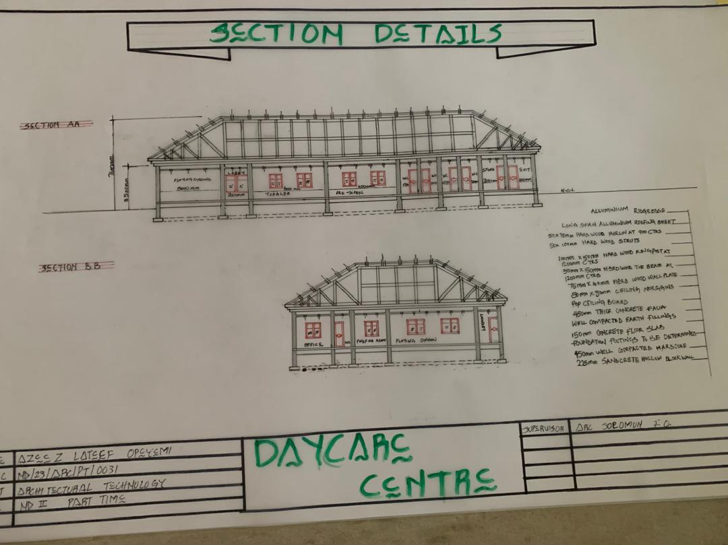
APP4; SHOWING CROSS SECTION OF THE PROPOSED PROJECT
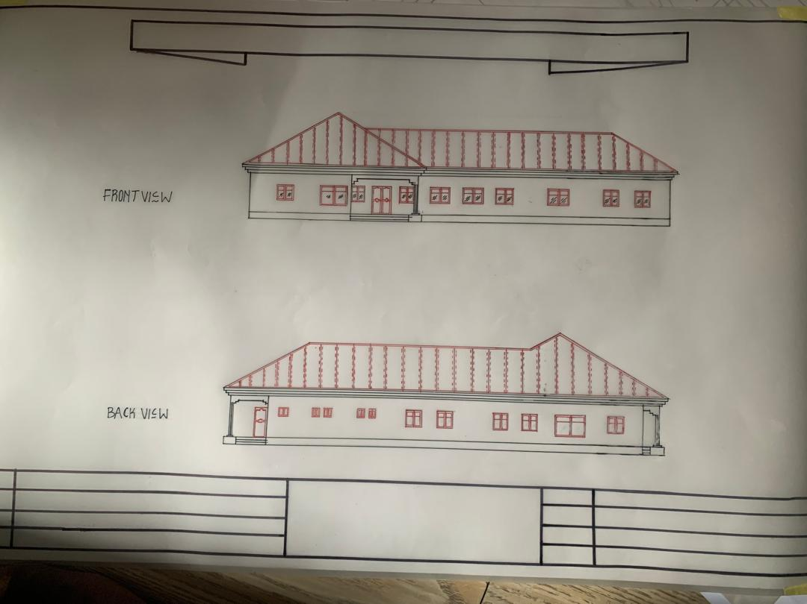
APP5; SHOWING FRONT&BACK VIEW OF THE PROPOSED PROJECT
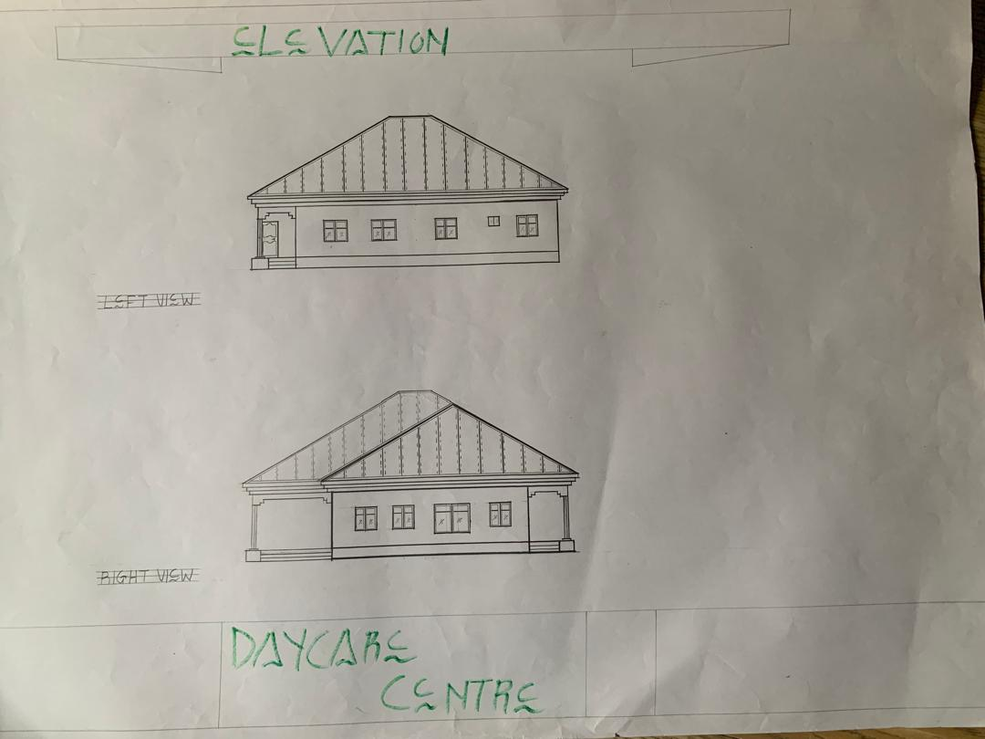
APP6; SHOWING SIDES VIEW OF THE PROPOSED PROJECT

