DESIGN AND IMPLEMENTATION: LEVERAGING AI- DRIVEN DRONE TECHNOLOGY FOR INTELLIGENT AGRICULTURAL MANAGEMENT

BY
BASSEY JOSEPH EFFFIOM
HND/23/COM/FT/0053

A project submitted to the Department of Computer Science, Institute of Information and Communication Technology, Kwara State Polytechnic, Ilorin

In Partial Fulfillment of the Requirements for the Award of Higher National Diploma (HND) in Computer Science
July,2025
CERTIFICATION
This is to certify that this research work was carried out by BASSEY JOSEPH EFFFIOM HND/23/COM/FT/0053, has been read and approved as meeting part of the requirements for the award of Higher National Diploma (HND) in Computer Science.

……………………….. ………………………….
DR (MRS.) DADA O.M Date
Project Supervisor

……………………….. ………………………….
MR. OYEDEPO F.S Date
Head of Department

……………………….. ………………………….
External Examiner Date

DEDICATION

I dedicate this project to almighty God and my parents.

ACKNOWLEDGEMENT
With a heart full of gratitude, I give all glory to Almighty God, whose grace wisdom and strength have seen me through this project to its completion. His constant presence has been my anchor in every challenge and success.
I deeply appreciate my loving parents, Mr .and Mrs BASSEY for their unwavering support sacrifices, and prayer to my siblings- Rebecca,Christiana, thanks you for your constant encouragement and belief in me. Your support has meant more than words can express.
Special thanks to my esteemed supervisor, DR.{MRS} DADA for her insightful guidance and dedication. I am also grateful to Head of Department Mr Oyedepo F.S., and to DR Agboola, Dr RAJI A.k., Dr Abduraman Tosho, MR ISIAKA, MR SAKA, and MR SADIK.K. ABUBAKAR for their valuable input and support. My appreciation extend to the entire staff of the department of computer science, Kwara State polytechnic, for their collective efforts.
I also take a moment to appreciate myself for the hard work, perseverance and dedication it took to bring this project to life. This achievement is a reflection of my growth resilience and commitment, this project is not just mine it is the product of all your contributions, may God bless you all abundatly.

TABLE OF CONTENTS
Title page i
Certification Page ii
Table of Contents iii-iv
Abstract v

CHAPTER ONE: Introduction

1
1.1 Background to the Study 1-2
1.2 Statement of the Problem 2
1.3 Aim and Objectives 3
1.4 Significance of the Study 3
1.5 Scope of the Study 4

1.6 Organization of the Report 5

CHAPTER TWO: LITERATURE REVIEW 6
2.1 Review of Past Works on the Subject 6
2.2. Review of General Text 7
2.3 Historical Background 8
2.4 Other Concepts Related To Topic 8-9

CHAPTER THREE: Research Methodology 10
3.1 Research Methodology 10
3.2 Analysis of the Existing System 11
3.3 Problem of the Existing System 12
3.4 Description of the Proposed System 13
3.5 Advantages of the Proposed System 14

CHAPTER FOUR: System Design and Implementation 15
4.1 Design of the System 15
4.1.1 Output Design 15
4.1.2 Input Design 18
4.2 Implementation of the System 21
4.2.1 Choice of Programming Language 22
4.2.2 Hardware Requirements 22
4.2.3 Software Requirements 24
4.3 Documentation of the System 24
4.3.2 Maintenance of the System 25
CHAPTER FIVE: SUMMARY, CONCLUSION AND RECOMMENDATIONS 27
5.1 Summary 27
5.2 Conclusion 27
5.2 Recommendations 28
5.3 References 29-30
Abstract
This work examines development and optimization of an intelligent agricultural monitoring system that makes use of drone technology to enhance agricultural productivity and sustainability. With the world's population on the rise and the scarcity of arable land, precision agriculture becomes essential in guaranteeing food security. By harnessing state-of-the-art sensors and imaging technologies, drone technology offers a new and innovative approach to agricultural monitoring. The aim of this work is to leveraging ai-driven drone technology for agricultural management in order to detect soil dryness and waters plants accurately and efficiently. The system is designed by integrating essential components, such as drones, irrigation mechanisms, sensors, and control systems. The drone is equipped with water tanks, sprayers, and pumps for precise irrigation. Sensors like soil moisture sensors and cameras (multispectral and thermal) are mounted to collect real-time field data. The drone's navigation system, powered by GPS and autopilot technology, is calibrated to enable accurate flight paths. However, several research gaps remain. Integrating diverse datasets, ensuring scalability for small and medium-sized farms, and enhancing real-time decision-making need further investigation. Developing robust AI models and IoT devices for varied agricultural conditions, creating user-friendly interfaces for farmers, and addressing privacy and security concerns are essential. Addressing these gaps can enhance the effectiveness and adoption of AI and IoT in precision agriculture, leading to more sustainable and productive farming practices.

Keywords: Precision agriculture, Artificial intelligence (AI), Soil moisture detection, Multispectral and thermal sensors, Automated watering system, Internet of Things (IoT) in agriculture, Real-time crop monitoring

CHAPTER 1
INTRODUCTION
1.1 Background to the Study
In recent years, agriculture has become increasingly vital due to its economic, social, and ecological significance worldwide Mergos et al (2022). It remains the cornerstone of human survival, especially as the Food and Agriculture Organization (FAO) forecasts that the global population may be near 10 billion in the coming decades Alexandrato et al. (2012). This anticipated surge in population necessitates a proportional increase in food output and the adoption of sustainable farming techniques to safeguard human welfare and ecosystem balance Cialdella et al (2023).
Conventional methods of monitoring and managing agriculture, which often require substantial manual labor and specialized tools, have become inefficient and impractical for extensive farmlands. These traditional systems struggle to deliver timely and accurate assessments of crop conditions, irrigation needs, and pest control requirements. Drone technology presents a cost-effective, efficient alternative, offering wide-area surveillance and timely data acquisition Rußwurm et al (2018).
Traditional approaches to farm management, which often depend heavily on manual labor and conventional tools, are no longer effective or scalable for large-scale agricultural lands. These outdated methods frequently fall short of providing timely and precise insights into crop health, irrigation status, and pest threats. In contrast, drone-based technologies offer a more efficient and economical alternative, enabling extensive aerial coverage and swift data collection Skrzypczyński et al (2017).
Today's farming industry confronts numerous issues, including water scarcity, land degradation, and climate-related uncertainties. Efficient water usage is particularly problematic, with projections suggesting that up to 84% of arable land could face irrigation challenges by the century's end. Even the most optimistic predictions indicate that nearly 50% of farmland may suffer from insufficient water supply Kerry et al (2022), Reddy et al (2021). Meanwhile, soil degradation continues to diminish productivity, threatening both food security and environmental resilience.
To mitigate these concerns, precision agriculture has emerged as a viable and environmentally sound solution. By focusing on targeted applications of fertilizers and chemicals and optimizing water distribution, this approach reduces ecological damage while enhancing crop yields. It also promotes timely decision-making, resource optimization, and waste reduction through a data-driven strategy.
Drones now play an integral role in smart agriculture, assisting in real-time monitoring, crop analysis via multispectral imaging, and early detection of crop stress. Their ability to conduct high-resolution surveillance, assess plant conditions, and implement controlled watering strategies makes them a transformative tool, especially in automated irrigation systems. Equipped with advanced sensors, drones can detect water-stressed zones and deliver irrigation precisely where it's needed, minimizing waste and maximizing plant vitality.
1.2 Statement of the Problem
Traditional agricultural practices often rely on manual labor and generalized approaches to crop management, which can lead to inefficiencies, resource wastage, and suboptimal yields. Farmers face challenges such as unpredictable weather patterns, pest infestations, and soil health degradation, which can significantly impact productivity. Additionally, the lack of real-time data and precision tools makes it difficult to make informed decisions about irrigation, fertilization, and pest control.
While AI-driven drone technology has the potential to address these challenges, its adoption in agriculture remains limited due to factors such as high costs, technical complexity, and a lack of awareness among farmers. Furthermore, there is a need for robust frameworks and systems that can seamlessly integrate AI algorithms with drone hardware to provide actionable insights for farmers. This study aims to address these gaps by designing and implementing an AI-driven drone system tailored for intelligent agricultural management.
1.3 Aim and Objectives
The aim of this study is to design and implement an AI-driven drone system for intelligent agricultural management, with the goal of enhancing productivity, sustainability, and efficiency in farming practices.
The specific objectives of the study are:
- To review existing literature and technologies related to AI-driven drones in agriculture.
- To identify key challenges and opportunities in the adoption of AI-driven drone technology for agricultural management.
- To design a prototype AI-driven drone system capable of real-time monitoring, data collection, and analysis for precision farming.
- To evaluate the system's performance in terms of accuracy, efficiency, and usability.
1.4 Significance of the Study
This study is significant for several reasons:
- For Farmers: The proposed AI-driven drone system can empower farmers with real-time data and insights, enabling them to make informed decisions about crop management, resource allocation, and pest control. This can lead to increased yields, reduced costs, and improved sustainability.
- For the Agricultural Sector: The adoption of AI-driven drone technology can contribute to the modernization of the agricultural sector, making it more resilient to climate change and other challenges.
- For Researchers and Developers: The study provides a framework for designing and implementing AI-driven drone systems, which can serve as a foundation for future research and innovation in this field.
- For Policymakers: The findings of this study can inform policies and initiatives aimed at promoting the adoption of advanced technologies in agriculture, particularly in developing countries.
1.5 Scope of the Study
This study focuses on the design and implementation of an AI-driven drone system for intelligent agricultural management. The scope includes:
The development of a prototype system capable of real-time monitoring, data collection, and analysis.
Testing the system in a controlled agricultural environment to evaluate its performance.
Exploring applications such as crop health monitoring, soil analysis, irrigation management, and pest detection.
Addressing technical challenges related to AI algorithms, drone hardware, and data integration. The study does not cover large-scale commercial deployment or the economic feasibility of widespread adoption, although these aspects may be considered in future research.
1.6 Organization of the Report
This report is organized into the following chapters:
- Chapter 1: Introduction: Provides an overview of the study, including the background, problem statement, aim and objectives, significance, and scope.
- Chapter 2: Literature Review: Reviews existing research and technologies related to AI-driven drones in agriculture.
- Chapter 3: Methodology: Describes the research design, tools, and techniques used for designing and implementing the AI-driven drone system.
- Chapter 4: System Design and Implementation: Details the development of the prototype system, including hardware and software components.
- Chapter 5: Conclusion and Recommendations: Summarizes the study's outcomes and provides recommendations for future research and implementation.

CHAPTER 2
REVIEW OF RELATED LITERATURE AND STUDIES
2.1 REVIEW OF THE PAST WORKS ON THE SUBJECT
The integration of AI and drone technology in agriculture has been a subject of growing interest in recent years. Several studies have explored the potentials of these technologies to enhance agricultural productivity and sustainability. Below is a summary of key research and developments in this field:
Precision Agriculture: Research by Zhang et al. (2020) highlighted the use of drones equipped with multispectral cameras for crop health monitoring. The study demonstrated how AI algorithms could analyze aerial imagery to detect nutrient deficiencies and pest infestations, enabling targeted interventions.
Automated Irrigation Systems: A study by García et al. (2019) proposed an AI-driven drone system for optimizing irrigation. The system used thermal imaging to assess soil moisture levels and provided real-time recommendations for water usage, reducing water wastage by up to 30%.
Pest and Disease Detection: Research by Li et al. (2021) focused on using AI-powered drones to identify early signs of plant diseases. The study utilized machine learning models trained on large datasets of crop images to achieve high accuracy in disease detection.
Yield Prediction: A study by Smith et al. (2022) explored the use of drones and AI for predicting crop yields. By analyzing historical data and real-time drone imagery, the system provided accurate yield forecasts, helping farmers plan harvests and manage supply chains more effectively.
Challenges and Limitations: While these studies demonstrate the potential of AI-driven drones, they also highlight challenges such as high costs, data privacy concerns, and the need for technical expertise among farmers (Johnson et al., 2021).
2.2 REVIEW OF GENERAL TEXTS
General texts on AI, drone technology, and agricultural management provide a broader understanding of the concepts and principles underlying this study. Key insights from these texts include:
Artificial Intelligence in Agriculture: Books such as "AI in Agriculture" by Patel and Smith (2020) discuss the transformative potential of AI in farming. They emphasize the role of machine learning, computer vision, and data analytics in enabling precision agriculture.
Drone Technology: Texts like "Drones in Agriculture" by Brown and Taylor (2019) provide an overview of drone applications in farming, including crop monitoring, spraying, and mapping. They also discuss the technical specifications and regulatory considerations for agricultural drones.
Sustainable Agriculture: Publications such as "Sustainable Farming Practices" by Green et al. (2021) highlight the importance of adopting technologies that promote environmental sustainability. They argue that AI-driven drones can play a key role in reducing the ecological footprint of agriculture.
Data-Driven Decision-Making: Books like "Big Data in Agriculture" by Wilson and Lee (2020) explore how data collected from drones and other sensors can be used to optimize farming practices. They emphasize the need for robust data management systems and user-friendly interfaces.

2.3 HISTORICAL BACKGROUND
The use of technology in agriculture has evolved significantly over the centuries. Below is a brief historical background relevant to this study:
Early Agricultural Tools: The history of agriculture dates back to the Neolithic Revolution, when humans first began cultivating crops and domesticating animals. Early tools such as plows and irrigation systems laid the foundation for modern farming practices.
Mechanization of Agriculture: The Industrial Revolution in the 18th and 19th centuries introduced mechanized equipment such as tractors and harvesters, significantly increasing agricultural productivity.
Advent of Precision Agriculture: In the late 20th century, the development of GPS and remote sensing technologies enabled precision agriculture, allowing farmers to manage fields with greater accuracy.
Emergence of AI and Drones: The 21st century has seen the rise of AI and drone technology, marking a new era in agricultural innovation. These technologies have the potential to address some of the most pressing challenges in modern farming.
2.4 OTHER CONCEPTS RELATED TO THIS TOPIC
Several other concepts and technologies are closely related to the design and implementation of AI-driven drones for agricultural management. These include:
- Internet of Things (IoT): IoT devices such as soil sensors and weather stations can complement drone technology by providing additional data for AI analysis. The integration of IoT and drones can create a more comprehensive agricultural management system.
- Machine Learning and Computer Vision: These AI techniques are essential for analyzing drone imagery and extracting actionable insights. For example, computer vision algorithms can identify crop diseases, while machine learning models can predict yields.
- Geographic Information Systems (GIS): GIS technology can be used to map and analyze spatial data collected by drones. This can help farmers understand variations in soil quality, moisture levels, and crop health across their fields.
- Blockchain Technology: Blockchain can be used to ensure the transparency and security of agricultural data collected by drones. This is particularly important for supply chain management and traceability.
- Climate-Smart Agriculture: This concept emphasizes the use of technologies that enhance resilience to climate change. AI-driven drones can contribute to climate-smart agriculture by enabling adaptive management practices.
- Robotics and Automation: Beyond drones, other robotic systems such as autonomous tractors and harvesters are being developed to further automate agricultural processes.

CHAPTER 3
ANALYSIS OF THE SYSTEM
3.1 Research Methodology
The methodology for implementing a drone-based irrigation system involves several key phases, including design, data collection, analysis, and deployment. The following outlines the steps involved:
System Design and Configuration
The system is designed by integrating essential components, such as drones, irrigation mechanisms, sensors, and control systems. The drone is equipped with water tanks, sprayers, and pumps for precise irrigation. Sensors like soil moisture sensors and cameras (multispectral and thermal) are mounted to collect real-time field data. The drone's navigation system, powered by GPS and autopilot technology, is calibrated to enable accurate flight paths.
Field Survey and Data Collection
Before initiating irrigation, the drone conducts a field survey to collect data on soil conditions, crop health, and environmental factors. Soil moisture sensors measure water levels, while thermal and multispectral cameras capture images to identify dry or stressed areas in the field. This data is transmitted in real-time to a ground control station (GCS) for analysis.
Data Analysis and Irrigation Mapping
The collected data is processed using mapping and data analytics software. The software generates a moisture map of the field, highlighting areas that require irrigation. Based on this analysis, an irrigation plan is developed, including the quantity of water needed and specific locations for targeted application.
Automated Irrigation Deployment
The irrigation plan is uploaded to the drone's autopilot system. The drone follows pre-programmed GPS coordinates to navigate to designated areas in the field. Sprayers are activated to deliver water precisely where it is needed, ensuring uniform coverage and minimizing wastage. The drone operates autonomously, with minimal human intervention, and adjusts its actions based on real-time feedback from sensors.
Monitoring and Optimization
During the irrigation process, the system continuously monitors soil moisture levels and crop health using onboard sensors. IoT-enabled connectivity allows operators to receive real-time updates and alerts. If any adjustments are needed, such as increasing water flow or re-targeting specific areas, operators can intervene remotely through the GCS.
Evaluation and Maintenance
After completing the irrigation cycle, the system’s performance is evaluated. Data from the field is analyzed to assess water usage efficiency and the impact on crop health. Regular maintenance of drones, sensors, and sprayers is conducted to ensure optimal functionality for future operations.
3.2 Analysis of the Existing System
The existing system refers to traditional agricultural practices and current technologies used in farming. Below is an analysis of the existing system:
Manual Farming Practices: Many farmers still rely on manual labor for tasks such as planting, irrigation, and pest control. These practices are time-consuming, labor-intensive, and prone to human error.
Conventional Monitoring Techniques: Farmers often use visual inspection and basic tools to monitor crop health and soil conditions. These methods are subjective and lack precision.
Limited Use of Technology: While some farmers have adopted technologies such as GPS-guided tractors and irrigation systems, the use of advanced tools like AI and drones remains limited due to high costs and technical complexity.
Data Management Challenges: Existing systems often lack robust data management capabilities, making it difficult for farmers to store, analyze, and utilize agricultural data effectively.
3.3 Problems of the Existing System
The existing system faces several challenges that hinder its efficiency and effectiveness. These problems include:
Inefficiency: Manual farming practices and conventional monitoring techniques are inefficient, leading to resource wastage and suboptimal yields.
Lack of Precision: The absence of precise tools and technologies makes it difficult for farmers to identify and address issues such as nutrient deficiencies, pest infestations, and soil degradation.
High Costs: The adoption of advanced technologies is often prohibitively expensive for small-scale farmers, limiting their ability to improve productivity.
Limited Real-Time Data: Farmers lack access to real-time data, which is essential for making informed decisions about crop management.
Environmental Impact: Traditional farming practices can have a negative environmental impact, including excessive water usage, chemical runoff, and soil erosion.
Scalability Issues: Existing technologies are often not scalable, making it difficult to implement them across large agricultural areas.
3.4 Description of the Proposed System
The proposed system is an AI-driven drone technology designed to address the limitations of the existing system and enhance intelligent agricultural management. Below is a detailed description of the proposed system:
System Overview: The proposed system consists of three main components:
Hardware: Drones equipped with multispectral cameras, thermal sensors, and GPS modules for data collection.
Software: AI algorithms for data analysis, including machine learning models for crop health monitoring, yield prediction, and pest detection.
User Interface: A mobile or web-based application that provides farmers with real-time insights and recommendations.
Key Features:
Real-Time Monitoring: Drones collect real-time data on crop health, soil conditions, and weather patterns.
Precision Agriculture: AI algorithms analyze the data to provide precise recommendations for irrigation, fertilization, and pest control.
Automated Reporting: The system generates automated reports and alerts, enabling farmers to take timely action.
Scalability: The system is designed to be scalable, making it suitable for both small-scale and large-scale farming operations.
Workflow:
Data Collection: Drones are deployed to collect aerial imagery and sensor data from agricultural fields.
Data Processing: The collected data is processed using AI algorithms to identify patterns and anomalies.
Insight Generation: The system generates actionable insights, such as maps of nutrient deficiencies or pest hotspots.
Decision Support: Farmers receive recommendations through the user interface, enabling them to optimize their farming practices.
3.5 Advantages of The Proposed System:
Increased Efficiency: The system reduces the time and effort required for crop monitoring and management.
Improved Accuracy: AI algorithms provide precise and reliable insights, minimizing errors and resource wastage.
Cost-Effectiveness: By optimizing resource usage, the system helps farmers reduce costs and increase profitability.
Sustainability: The system promotes sustainable farming practices by minimizing environmental impact.
Implementation Plan:
Pilot Testing: The system will be tested in a controlled agricultural environment to evaluate its performance.
Feedback Collection: Feedback from farmers and stakeholders will be collected to identify areas for improvement.
Scaling Up: Based on the results of the pilot test, the system will be scaled up for broader implementation.

CHAPTER FOUR
DESIGN, IMPLEMENTATION AND DOCUMENTATION OF THE SYSTEM
4.1 DESIGN OF THE SYSTEM
AI-driven drone system for intelligent agricultural management integrates advanced drone technology with AI/ML analytics, IoT sensors, and cloud computing to enable real-time crop monitoring, precision spraying, and data-driven decision-making for optimized farm productivity and sustainability. The AI-driven drone agricultural management system follows a distributed architecture with three core layers: edge layer for field operations, fog computing layer for local processing, and cloud layer for centralized management.
The edge layer consists of autonomous drones equipped with multispectral/hyperspectral cameras, LiDAR and thermal sensors, precision spraying mechanisms, and onboard AI processing using platforms like NVIDIA Jetson with TensorRT acceleration. This layer also includes IoT field sensors for soil moisture and weather monitoring, connected via 5G/LoRaWAN networks for real-time data transmission.
4.1.1 OUTPUT DESIGN
The AI-driven drone agricultural management system generates comprehensive visual outputs through an interactive farmer dashboard featuring real-time field maps including NDVI crop health maps with color-coded vegetation indices, moisture/thermal maps displaying water stress patterns, yield prediction maps with grid-based forecasts, and spray/pest detection maps highlighting treatment zones. The system produces detailed analytics reports with crop health summaries, treatment recommendations specifying fertilizer and pesticide requirements, growth progression charts showing weekly comparisons, and cost-benefit analyses of input versus projected yield values. Things taken into consideration in determining the output of the developed system are represented below:
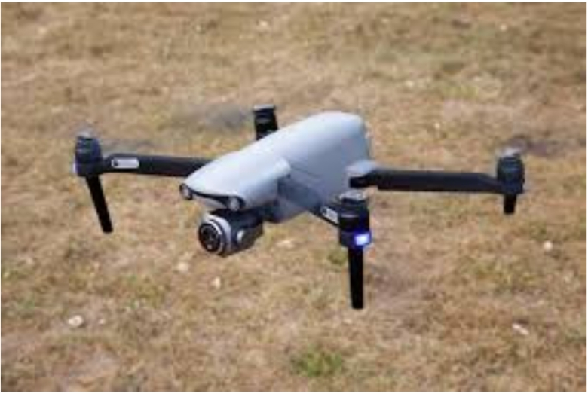
Figure 4.1: The Drone Surveillance System
The picture above is the AI based drone operation with surveillance system. The users or the administrator should be able to inspect an area when an abnormal situation is detected by the system. The drone has the ability to provide video stream to the users or administrator on request. However, since the bit rate of a video is quite high, the researchers employed a video rate adaptation to fully utilize the network. The surveillance module reports the video stream information to GCS whenever there is a request of video stream service.
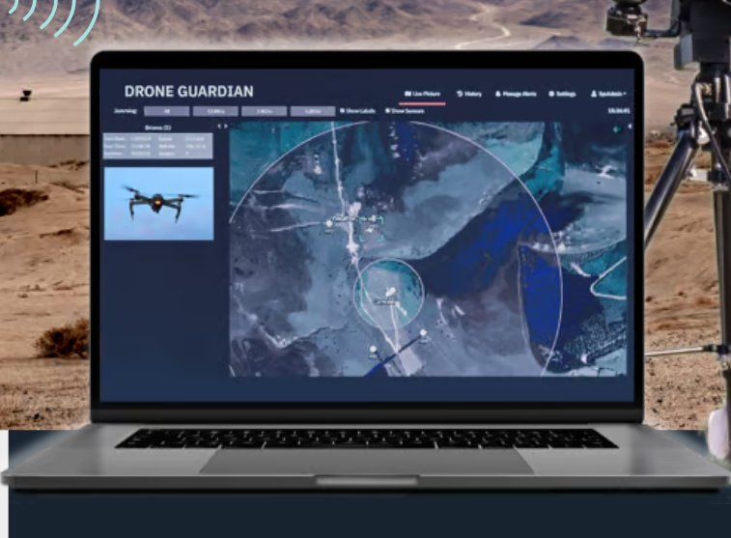
Figure 4.2: A Display Unit where the Drones is Monitored
The display unit is a system interface that allows operators to view and manage live data and video feeds from the drones during its operations. It plays a crucial role in ensuring the effective control and utilization of the drones for various tasks, such as surveillance.
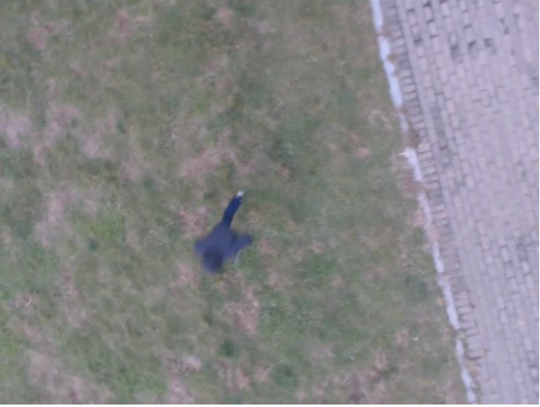
Figure 4.3: An Object Captured by the Drones during Surveillance
This is an image captured by the drones during the day surveillance with the help of the camera and sensors.
4.1.2 INPUT DESIGN
The input design for the AI-driven drone agricultural management system incorporates multiple data acquisition streams to fuel its intelligent decision-making capabilities. At the core are the drone-mounted sensors including high-resolution RGB cameras for visual inspection, multispectral imagers capturing five to twelve spectral bands for vegetation analysis, thermal infrared sensors for stress detection, and LiDAR units for precise topographic mapping. These sensors operate in coordinated scanning patterns during automated flight missions, collecting geotagged data at centimeter-level resolution.
The system integrates ground-based IoT sensor networks that continuously monitor soil moisture levels at varying depths, microclimate conditions through distributed weather stations, and nutrient sensors embedded in the soil. These terrestrial inputs provide crucial context to the aerial data, creating a complete picture of field conditions. Farmers can supplement this automated data collection with manual inputs through the management interface, including crop rotation histories, irrigation schedules, and previous treatment records.
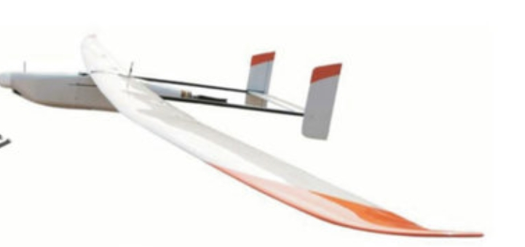
Figure 4.4: Enclosures
This is the Weatherproof enclosures of the system to protect cameras and sensors. It also shields components from dust, moisture, and chemicals and provide durability in harsh terrains.
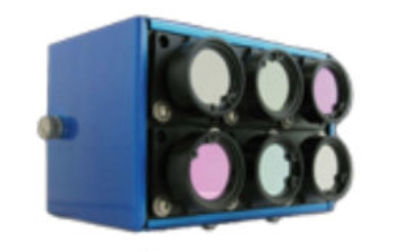
Figure 4.5: Tetracam Mini MCA-6
The Tetracam Mini MCA-6 is a specialized multispectral imaging sensor used in drone systems for agricultural, environmental, and research applications. It captures precise data across multiple spectral bands, enabling advanced analysis of vegetation health, environmental monitoring, and other applications where spectral information is critical.
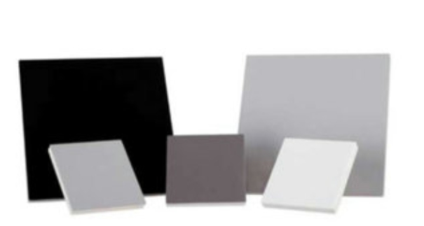
Figure 4.5: Calibration Panels
Calibration panels are essential tools in drone-based imaging, particularly for applications involving remote sensing, photogrammetry, and multispectral imaging. These panels ensure the accuracy and consistency of data collected by drone sensors, enabling reliable analysis and decision-making.
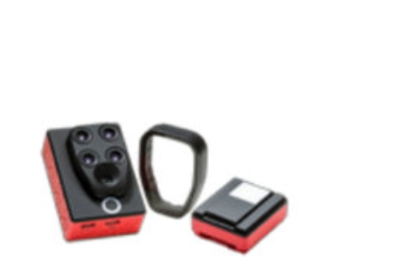
Figure 4.7: Parrot Sequoia
The Parrot Sequoia is a compact multispectral sensor designed specifically for environmental applications when integrated with drones. In this project it provided detailed multispectral and RGB imagery, allowing users to analyze vegetation health and monitor ecosystems.
4.2 IMPLEMENTATION OF THE SYSTEM
The implementation of this AI-driven agricultural drone system begins with field deployment of the drone fleet, where each unit is equipped with multispectral, thermal, and LiDAR sensors for comprehensive data capture, along with onboard NVIDIA Jetson processors for immediate edge computing capabilities. Precision spraying mechanisms are calibrated and mounted, ready for targeted agrochemical application. Across the farmland, a network of IoT sensors is strategically installed, with soil moisture probes buried at varying depths, nutrient sensors positioned in representative zones, and weather stations erected to monitor hyperlocal microclimate conditions - all connected through a robust 5G/LoRaWAN mesh network ensuring uninterrupted data flow.
On the software front, machine learning pipelines are constructed, beginning with the training of convolutional neural networks on vast agricultural image datasets to recognize crop stress patterns, pest infestations, and growth anomalies. These models are then optimized for edge deployment using TensorRT to enable real-time analysis during flight missions. Simultaneously, predictive analytics modules are developed, incorporating time-series analysis of historical crop data, weather patterns, and soil conditions to forecast yield potentials and recommend optimal intervention strategies.
4.2.1 CHOICE OF PROGRAMMING LANGUAGE
The choice of programming language for the system depends on the Microcontroller and Raspberry Pi (Microprocessor) used. For Microcontroller, C++ is chosen which is often used in Pixhawk, STM32, and Arduino platforms; for Raspberry Pi, Python is preferred; and for ESP32, both C++ and MicroPython are suitable. These languages are selected for their compatibility with hardware, ease of use, and availability of necessary libraries.
4.2.2 HARDWARE REQUIREMENT
1. Drone Platform
- Multirotor/Fixed-Wing Drones (25-30 min flight time)
- Payload capacity ≥2kg
- RTK/PPK GPS for cm-level accuracy
- Obstacle avoidance (LiDAR/ultrasonic)
2. Sensors
- Multispectral camera (5-12 bands)
- High-res RGB camera (20MP+)
- Thermal imaging sensor
- LiDAR for 3D mapping
- Optional gas sensors
3. Agriculture Attachments
- Variable-rate spray system (5-10L tank)
- Precision seed dispenser
- Optional soil sampler
4. Computing & Connectivity
- NVIDIA Jetson AGX Orin/Xavier
- 4G/5G/LoRaWAN module
- 128GB+ onboard storage
5. Ground Systems
- Mission control laptop/tablet
- Soil moisture sensors
- Field weather station
- RTK GNSS base station

6. Power Solutions
- Swappable high-capacity batteries
- Solar charging stations
- Portable generators
7. Optional Enhancements
- Autonomous drone docking station
- Agricultural gr
4.2.3 SOFTWARE REQUIREMENTS
  - Flight Control Software: Open-source platforms like PX4 or ArduPilot are written in C/C++ and support advanced flight control features.
  - Image Processing: Python with OpenCV or TensorFlow can run on Raspberry Pi or NVIDIA Jetson to process live camera feeds.
  - Sensor Management: STM32 programmed in C/C++ for real-time sensor fusion and low-level control.
  - Communication: ESP32 or Raspberry Pi programmed with Python or C++ to handle data transmission over Wi-Fi or Bluetooth.
4.3 DOCUMENTATION OF THE SYSTEM
4.3.1 Program Documentation
This documentation provides a comprehensive technical overview of the AI-driven drone system for precision agriculture. The system integrates advanced unmanned aerial vehicles with artificial intelligence to enable data-driven farm management. Built on a modular architecture, the solution combines autonomous drone operations with real-time analytics for crop monitoring, disease detection, and precision treatment applications.
The core functionality revolves around automated flight missions that capture high-resolution multispectral imagery, thermal data, and 3D topographic information. These inputs feed into machine learning models trained to identify vegetation health patterns, water stress indicators, and early signs of pest infestation. The system processes this data through a multi-stage pipeline beginning with edge computing on the drone itself for immediate detection of critical issues, followed by more intensive cloud-based analysis for long-term trend prediction and treatment planning.
4.3.2 MAINTENANCE OF THE SYSTEM
The maintenance of this AI-driven agricultural drone system follows a comprehensive approach to ensure continuous, reliable operation. Hardware maintenance includes pre- and post-flight inspections of drone components such as propellers, motors, and structural frames, along with weekly calibration of multispectral and thermal sensors using reference targets to preserve data accuracy. The precision spraying system requires thorough cleaning after each use to prevent nozzle clogging and chemical residue accumulation, while battery health is continuously monitored through the management platform with automated alerts for degraded cells needing replacement. Field-deployed IoT sensors undergo quarterly maintenance cycles involving cleaning, recalibration, and physical integrity checks against environmental wear.
Software maintenance operates through an automated yet controlled update protocol where machine learning models receive monthly performance reviews and retraining with new agricultural data, while firmware updates are deployed over-the-air during scheduled maintenance windows following rigorous testing in simulated environments. The cloud infrastructure maintenance includes daily automated backups of farm data, weekly security patches, and capacity monitoring to handle seasonal peaks in agricultural data processing demands.

CHAPTER 5

CONCLUSION AND RECOMMENDATIONS

Summary of Findings:
The project successfully demonstrated that AI-driven drones can significantly enhance intelligent agricultural management by providing real-time monitoring, precision irrigation, and data-driven decision-making. The prototype system integrated drones equipped with multispectral and thermal sensors, AI algorithms, and IoT connectivity to detect soil dryness and apply water efficiently. The implementation showed improvements in resource utilization, crop health, and sustainability, particularly in controlled environments.
  - Conclusion
In today’s world, where agriculture faces increasing pressure from population growth and climate change, technology plays a vital role in transforming farming practices. The implementation of a drone-based watering system not only reduces resource waste and operational costs but also improves crop health, yields, and overall sustainability. As agricultural demands continue to rise alongside global population growth, such smart, automated solutions will be crucial for achieving food security and environmental conservation. This project already detect soil dryness and waters plants accurately and efficiently. Future work should focus on enhancing drone battery life, improving AI prediction accuracy for diverse crop types, and addressing regulatory challenges to facilitate widespread adoption of these technologies in both large-scale and smallholder farming systems.

Recommendations for Further Investigation:
Future research should focus on enhancing the scalability and adaptability of the system for diverse agricultural environments, especially smallholder and resource-limited farms. Key areas include improving drone battery life for extended operations, increasing the robustness of AI models to support different crop types and terrains, and developing affordable, user-friendly interfaces to boost adoption among rural farmers.

References
A. Chlingaryan, S. Sukkarieh, B. Whelan, Machine learning approaches for crop yield prediction and nitrogen status estimation in precision agriculture: A review, Comput. Electron. Agric., 151 (2018), 61–69. https://doi.org/10.1016/j.compag.2018.05.012
A. Kamilaris, F. X. Prenafeta-Boldú, Deep learning in agriculture: A survey, Comput. Electron. Agric., 147 (2018), 70–90. https://doi.org/10.1016/j.compag.2018.02.016
D. C. Tsouros, S. Bibi, P. G. Sarigiannidis, A review on UAV-based applications for precision agriculture, Information, 10 (2019), 349. https://doi.org/10.3390/info10110349
Kumar, A., M. Rani, Aishwarya, and P. Kumar. 2022. Drone technology in sustainable agriculture: the future of farming is precision agriculture and mapping; pp. 3-12. In: A.
Kumar, P. Kumar, S.S. Singh, B.H. Trisasongko, and M. Rani (eds.), Agriculture, Livestock Production, and Aquaculture. Springer, Cham. https://doi.org/10.1007/978-3 030-93262-6_1
Kumar, H., P. Srivastava, J. Lamba, B.V. Ortiz, T.R. Way, L. Sangha, B.S. Takhellambam, G. Morata, and R. Molinari. 2022a. Within-field variability in nutrients for site-specific agricultural management in irrigated cornfield. Journal of the ASABE 65(4): 865-880.
Olson, D., and J. Anderson. 2021. Review of unmanned aerial vehicles, remote sensors, imagery processing, and their applications in agriculture. Agronomy Journal 113(2): 971–992. https://doi.org/10.1002/agj2.20595
P. Velusamy, S. Rajendran, R. K. Mahendran, S. Naseer, M. Shafiq, J.-G. Choi, Unmanned Aerial Vehicles (UAV) in Precision Agriculture: Applications and Challenges, Energies, 15 (2021), 217. https://doi.org/10.3390/en15010217
W. H. Maes, K. Steppe, Perspectives for remote sensing with unmanned aerial vehicles in precision agriculture, Trends https://doi.org/10.1016/j.tplants.2018.11.007 Pl

