A PROJECT REPORT ON
A PROPOSED DEPARTMENTAL STORE FOR UNIVERSITY OF ILORIN TEACHING HOSPITAL (UITH)

BY

HINMIKAYE TEMITOPE BRIDGET
HND/23/ARC/FT/0080

SUBMITTED TO THE
DEPARTMENT OF ARCHITECTURAL TECHNOLOGY,
INSTITUTE OF ENVIRONMENTAL STUDIES (I.E.S)
KWARA STATE POLYTECHNIC, ILORIN.

IN PARTIAL FULFILLMENT OF THE REQUIREMENTS FOR THE
AWARD OF HIGHER NATIONAL DIPLOMA (HND) IN ARCHITECTURAL TECHNOLOGY.

JULY, 2025
DECLARATION
This is a work undertaking by me HINMIKAYE TEMITOPE BRIDGET with matric number HND/23/ARC/FT/0080 under the supervision of ARC. NMOM CHUKWUMA of the department of ARCHITECTURAL TECHNOLOGY, Institute of ENVIRONMENTAL STUDIES, Kwara State Polytechnic Ilorin. I hereby declare that this Project is a Product of my personal research work. It has not been presented for the award of any higher national diploma (HND) in any Polytechnic. The ideas, observation, comments and suggestion here has been acknowledged in accordance with Conventional academic traditions.

HINMIKAYE TEMITOPE BRIDGET …………………………..
SIGNATURE / DATE

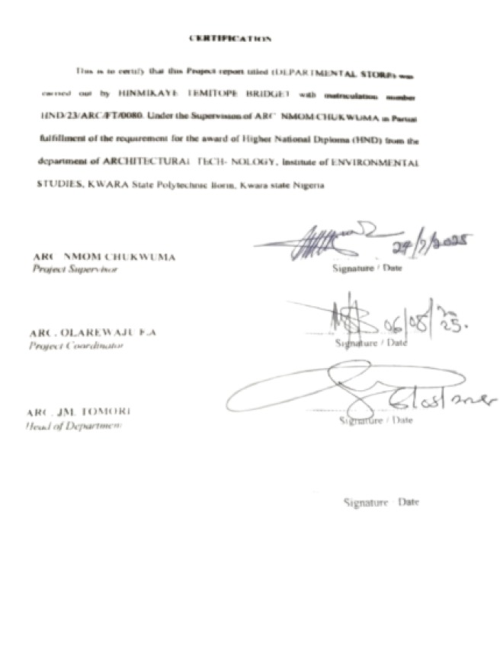

DEDICATION
This report is dedicated to Almighty God for making it possible, and also to my parent, and all architects in the world.

ACKNOWLEDGEMENT
My profound gratitude goes to Almighty God who has Always been in existence for taking control over this project for His infinite mercy and for giving me the privilege to write the report of Him alone be the glory. My immediate gratitude goes to the Department of ARCHITECTURAL TECHNOLOGY, the entire staff and also my supervisor ARC. NMOM CHUKWUMA who has been supporting throughout this project may God continue to reward you also to Arc Amada A.T, Arc. J.M Tomori, Arc. B.Y.F ABDULAZER, Arc. F.A Olarewaju. My sincere gratitude goes to my parent MR & MRS HINMIKAYE who brought me to this world may you eat the fruit of your labour.
And I also appreciate my grandparent for their guidance and support to for making this a success, However, my greetings goes to my coursemates for their support and advice. May God reward you Abundantly.

TABLE OF CONTENTS
TITLE PAGE I
DECLARATION ii
CERTIFICATION III
DEDICATION Iv
ACKNOWLEDGEMENT v
TABLE OF CONTENTS vi
ABSTRACT X
CHAPTER ONE 1
1.1 INTRODUCTION 1
1.2 HISTORICAL BACKGROUND 1
1.3 DEFINITION 2
1.4 AIM & OBJECTIVES 3
1.5 JUSTIFICATION 3
1.6 STATEMENT OF DESIGN PROBLEM 4
1.7 LIMITATION/CONSTRAINT 5
1.8 SCOPE OF THE PROJECT 5
1.9 RESEARCH METHODOLOGY 6
CHAPTER TWO 7
2.1 LITERATURE REVIEW 7
2.2 REVIEW OF RELEVANT LITERATURE ON BUILDING TYPE 8
CHAPTER THREE 9
3.1 INTRODUCTION 9
3.2. CASE STUDY 1 9
3.2.1 HISTORICAL BACKGROUND 9
3.2.2 LOCATION AND DESCRIPTION 9
3.2.3 MERITS 12
3.2.4 DEMERITS 12
3.3 CASE STUDY 2 13
3.3.1 LOCATION AND DESCRIPTION 13
3.3.2 MERITS 16
3.3.3 DEMERITS 16
3.4 CASE STUDY 3 16
3.4.1 LOCATION AND DESCRIPTION 16
3.4.2 MERITS 19
3.4.3 DEMERITS 19
3.5 CASE STUDY 4 19
3.5.1 HISTORICAL BACKGROUND 19
3.5.2 LOCATION AND DESCRIPTION 19
3.5.3 MERITS 22
3.5.4 DEMERITS 22
CHAPTER FOUR 23
4.1 INTRODUCTION OF STUDY AREA/SITE SELECTION 23
4.1.1 HISTORICAL BACKGROUND OF SITE'S STATE 23
4.1.2 HISTORICAL BACKGROUND OF SITE'S L.G.A 24
4.2 SITE CRITERIA 25
4.3 SITE ANALYSIS 27
4.3.1 SITE INVENTORY 27
4.3.2 TOPOGRAPHY 28
4.3.3 CLIMATIC DATA 28
4.3.4 RAINFALL 29
4.3.5 TEMPERATURE 29
4.3.6 PREVAILING WIND 31
4.4 PROJECT ANALYSIS 31
4.4.1 DESIGN BRIEF 31
4.4.2 FUNCTIONAL RELATIONSHIP 32
4.4.3 SPACE ALLOCATION 34
4.4.4 CONCEPTUAL DEVELOPMENT 36
CHAPTER FIVE 38
5.1 APPROACHES TO DESIGN 38
5.2 CONSTRUCTION METHODOLOGY AND MATERIALS 38
5.3 SERVICES PROVIDED 38
5.3.1 VENTILATION 39
5.3.2 LIGHTENING AND ELECTRICAL SUPPLIES 39
5.3.3 AIR CONDITIONING 39

5.4 CONCLUSION 39
5.5 RECOMMENDATION 40
REFERENCE 42
APPENDIX 43
LIST OF FIGURES
Front view of Hutoos Superstore 10
Hyper market View of Hutoos Superstore 11
Floor Plan of Hutoos Superstore 11
Location Plan of Hutoos Superstore 12
Front view of Tumac mall 13
Side View of Tumac mall 14
Ground and first floor Plan of Tumac mall 15
Location Plan of Tumac mall 15
Front View of Mamtess Shopping mall 17
Hyper market View of Mamtess Shopping mall 17
Ground and upper floor plan of Mamtess Shopping mall 18
Location Plan of Mamtess Shopping mall 18
Front view of Covenant harvest megastore 20
Payment and Checkpoint area of Covenant harvest megastore 20
Floor Plan of Covenant harvest megastore 21
Location Plan of Covenant harvest megastore 21
LIST OF TABLES
Space Allocation 34
LIST OF APPENDICES
Appendix 1 → Location Map 44
Appendix 2 → Location Plan 44
Appendix 3 → Concept derivation 45
Appendix 4 → Proposed site plan 45
Appendix 5 → Proposed Ground floor plan 46
Appendix 6 → Proposed first floor plan 46
Appendix 7 → Proposed second floor plan 47
Appendix 8 → Roof plan 47
Appendix 9 → Section B-B 48
Appendix 10 → Section A-A 48
Appendix 11 → front Elevation 49
Appendix 12 → Right side Elevation 49
Appendix 13 → Left side Elevation 50
Appendix 14 → Rear Elevation 50

ABSTRACT
The architectural design of a Departmental store plays a Crucial role in shaping the Client experience. This abstract explores the fundamental aspects of designing Departmental store building, focusing on the integration of functional requirements, aesthetic considerations and technological advancements.
Departmental store requires a variety of spaces including payment and check point area, display area, loading bay, and offices and store. This study explores the impact of departmental store layout on customer behaviour and Satisfaction and different methods were adopted in carrying out the research work of this project which are CASE STUDIES, ONLINE RESEARCH AND ORAL OVERVIEW.

CHAPTER ONE
  - INTRODUCTION
The retail industry plays a crucial role in the economy by providing goods and services to customers. (Lovelock, C. H., & Wirtz, J. (2004)). Departmental stores are large scale retail establishment that offer a wide range of products across various categories, including clothing, electronics, home appliances and more. These stores are to provide a one-stop shopping experience for customers, allowing them to fulfill their diverse needs conveniently. (Smith, R. E., & Reinertsen, D. G. (1998)) The decision to establish a Departmental store arises from the recognition of market demand, (Levitt, T (1983)) the potential for growth and the opportunity to serve a wide customer base. This project report delves into the various aspects involved in the planning and execution of a departmental store, including its design, operations and management. (Christopher, M. (1998)) The background of the study provides context and understanding of the factors that have influenced the decision to establish a departmental store. It encompasses the market conditions, consumer trends and industry dyna- mics that have contributed to the recognition of the potential for a successful Departmental store venture.
1.2 HISTORICAL BACKGROUND
The development of Department stores was linked to growth in the 19th Century of large Population Centers, Transportation and the harnessing of electricity for power and lighting. (Laudon, K.C. and Laudon, J.P. (2001)) The BON MARCHE in Paris which began as a small shop in the early 19th Century is widely considered the first department store. JOHN WANAMAKER carried the Concept to the United State in 1875 by purchasing a nail-freight depot in his native Philadelphia and populating it with a collection of specialty retailers. Among his innovations were the introduction of price tags and the development of aggressive advertising programs for his growing chain of stores. (Drucker, P.F. (1995)) (He quipped that while half of his company's advertising budget was wasted, he could never identify which half it was.) The early Department stores were helped by ICONIC FIGURES who shaped the retail landscape and left a legacy. In London, England, WILLIAM WHITELEY known as "The Universal Provider" was a visionary merchant whose eponymous store set the standard for future Department Stores. Atlantis, in New York City, Rowland Hussey Macy founded the world-renowned Macy's in 1858, beginning a retail dynasty that would endure for generations.
1.3 DEFINITION
A Departmental Store is a large retail store that provides customers with a comprehensive shopping experience, offering a wide range of products and services. (Lovelock, C. H., & Wirtz, J. (2004)) In other words, a Departmental Store is a retail establishment offering a wide range of consumer goods in different areas of the store. Each area (DEPARTMENT) specializing in a product category. Departments often includes the following: Clothing, Cosmetics, furniture, home appliances, Housewares, sporting goods, toiletries and toys. Additionally, other lines of products such as Food, Books, Jewelry, Electronics, Stationery, Photographic Equipment, Baby Products and Products for Pets are sometimes included.

1.4 AIM AND OBJECTIVES
AIM: The aim of this Project is to design a Balanced and Aesthetic structure which will create a standard shopping environment for people.
OBJECTIVES
- To design a well oriented structure
- To design a structure that will abide with codes of the building.
- To design a well landscaped and well-balanced Structure
- To design a structure that will meet with Client Budgets
- To design a well aesthetic structure which will enhance a better environment.
1.5 JUSTIFICATION
Designing a Departmental Store centers on achieving a balance between functionality, security, customer experience and brand identity. By addressing these aspects thoughtfully, the design does not only meet operational and regulatory requirements, but also enhances overall performance, sustainability and customer satisfaction. Each design choice contributes to the Department Store's success by supporting efficient operations, protecting assets, and creating a positive and engaging environment for both customers and staffs.

1.6 STATEMENT OF DESIGN PROBLEM
The statement of the design problem articulates the specific challenges and considerations related to the design of the departmental store. It identifies the key areas where design decisions and solutions are required to create an efficient, customer friendly and visually appealing store environment. Some aspects to address in the statement of design Problem include: -
- CUSTOMER SERVICE AND CHECKOUT PROCESS: - Design the customer service area and checkout process to provide a seamless and positive experience for customers. Considering factors such as queue management, staffing requirements, payment options and after Sales Service.
- STORE LAYOUT AND SPACE OPTIMIZATION: - Determine the most effective layout for the departmental store, considering factors such as customer flow, product placement and utilization of available spaces. Address challenges related to maximizing product visibility, creating well defined departments and ensuring easy navigation for customers.
- INVENTORY MANAGEMENT AND STOCK CONTROL: - Design an efficient inventory management system to ensure optimal stock levels, minimize stockouts, and reduce excess inventory. Consider factors such as storage space, shelving solutions, barcode systems and software for inventory tracking.
- ACCESSIBILITY AND SAFETY: - Ensure the store design meets accessibility standards and provides a safe environment for customers and staff. Address
challenges related to wheelchair accessibility, Emergency exits, lighting and security measures.
1.7 LIMITATION / CONSTRAINTS
During the process of carrying out each of my case study, I faced a lot of restriction protocol were faced because of Privacy.
- Limited access to some part of the UITH
- Prohibition from taking pictures
1.8 SCOPE OF THE PROJECT
The Scope of this study focuses on the planning and establishment of a departmental Store. It encompasses the various aspects involved in the design, operations and management of the Store. Key areas of study include Store layout, product selection and placement, inventory management, customer service strategies, pricing and promotion, technology integration and market planning.
- Car Park
- Snacks bar
- Security post
- Powerhouse
- Warehouse
- Water tank
- Public toilet
- Restaurant
- A.T.M Gallery
1.9 RESEARCH METHODOLOGY
To gather the necessary information and insights, a combination of primary and secondary research methods was employed. Primary research involved conducting surveys, interviews and focus groups with potential customers, industry experts and store management personnel. Secondary research involved reviewing existing literature, industry reports, and relevant studies.
The data collected was analyzed using qualitative and quantitative techniques to derive meaningful findings and recommendations.
The research methodology employed a robust and well-informed approach to address the project's objectives and provide valuable insights for the establishment and management of a departmental store.

CHAPTER TWO
2.1 LITERATURE REVIEW
A literature review on departmental stores should analyze existing research to understand the evolution, current state and future trends of these retail businesses. It should explore factors like consumer behavior, marketing strategies and the impact of E-commerce on the department store Industry.
KEY AREAS TO COVER IN A LITERATURE REVIEW ON DEPARTMENTAL STORES
- Historical context Explore the origins of departmental stores, their rise and fall in popularity, and the factors that contributed to their evolution.
- Consumer behaviour Examine studies on how consumers choose department stores, their shopping habits and their perception of different departments and brands.
- Marketing and branding Analyze the marketing strategies used by department stores, including advertising promotions and customer loyalty programs.
- Store location and design Explore the factors that influence store location decisions, the importance of creating a positive shopping environment and the role of store design in attracting and retaining customers.

2.2 REVIEW OF RELEVANT LITERATURES
A departmental store is a large retail establishment that offers a wide range of products across multiple department and categories. It is a one-stop shopping destination where customers can find various items such as clothing, accessories, cosmetics, household goods, furniture, electronics, toys and more.
Motives for Departmental stores were divided into personal and social motives.
- One-stop Shopping: Department stores aim to be a comprehensive shopping destination, fulfilling various needs of customers by offering different departments and product categories, they provide a one-stop solution of customers to purchase multiple items in a single visit.
- Convenience: Department stores aim to provide a convenient shopping experience for customers by offering a wide range of products in one location.
- Customer experience: Department stores focus on enhancing the overall shopping experience for customers. They invest in store layouts, attractive displays, and customer service to create an enjoyable and engaging environment. This includes features like dressing rooms, helpful staff, product demonstrations and sometimes additional services like personal styling or alterations.

CHAPTER 3
3.1 INTRODUCTION
This Chapter is aimed at highlighting the various elements that could make up a departmental store. This will help to identify the core concept employed in design such as building topology. Various examples were studied from within the country.
- Hutoos Superstores at Lagos State
- Tumac mall at Lagos State
- Mamtess Shopping mall at Kwara State
- Covenant Mega Store at Ogun State
3.2 CASE STUDY 1 HUTOOS SUPERSTORES AT LAGOS STATE
Historical Background, Location, Description
3.2.1 Historical Background
Hutoos Superstores was incorporated in AGERE Nigeria with registration number 2355750. It was registered on 11th of August 2015 and its current status is unknown. Company's registered office address is at No. 79, Iju Road.
3.2.2 Location
It is located at No. 26 Old Abeokuta Road, Abule Egba, Lagos State
Description
Hutoos Super Stores is an impressive supermarket of the area with a wide range of goods for the casual and heavy-duty shoppers.
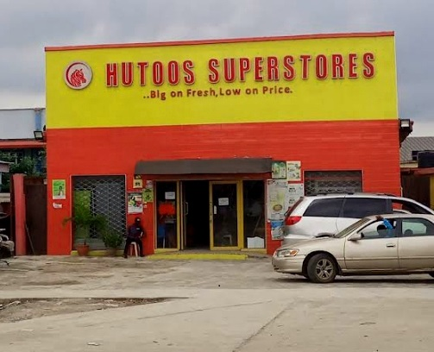
FROMT VIEW OF HUTOOS SUPER STORES
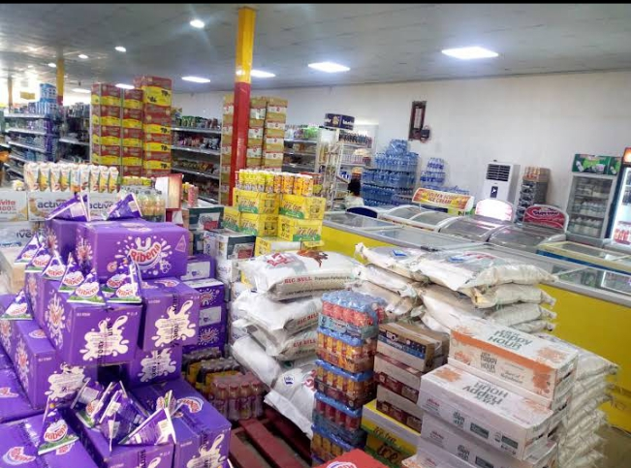
HYPER MARKET VIEW OF HUTOOS SUPER STORE
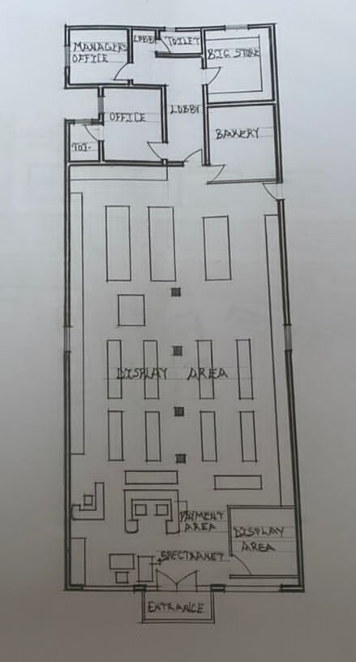
FLOOR PLAN OF HUTOOS SUPER STORE
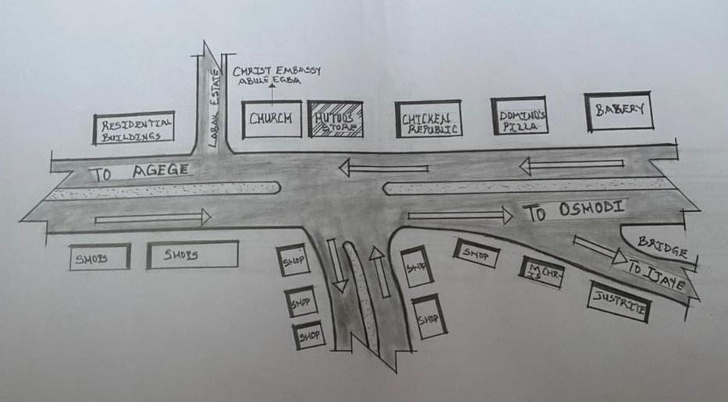
LOCATION PLAN OF HUTOOS SUPER STORE
3.2.3 MERITS
- It is well located
- It is well oriented
- It has sufficient parking space
3.2.4 DEMERITS
- No provision of toilet for customers

3.3 CASE STUDY 2 TUMAC MALL AT LAGOS STATE
3.3.1 Location
It is located at No. 39 old Otta road off AIT road Joke Ayo Otta, Lagos State.
Description
Tumac Mall is a store that focuses on providing exceptional customer service with well-trained staff members assisting customers and ensuring a pleasant shopping experience.
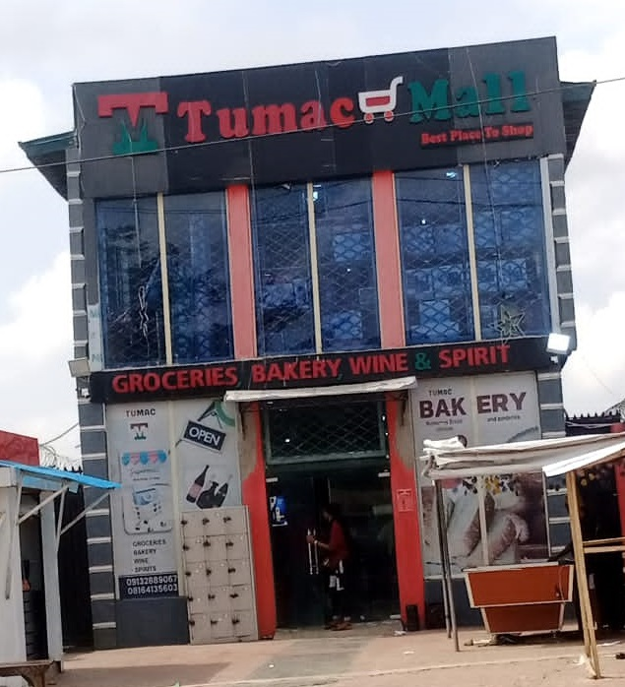
FRONT VIEW OF TUMAC MALL
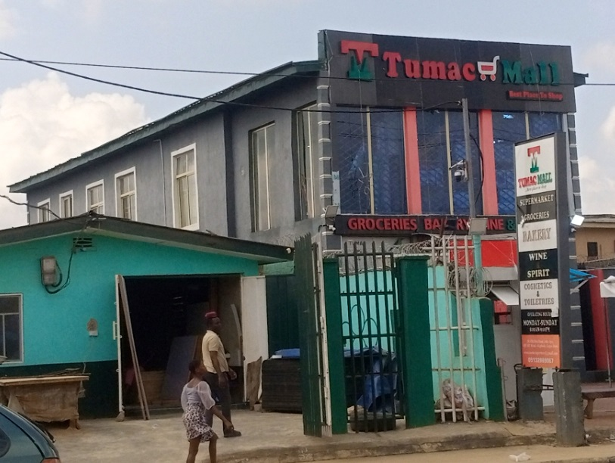
SIDE VIEW OF TUMAC MALL
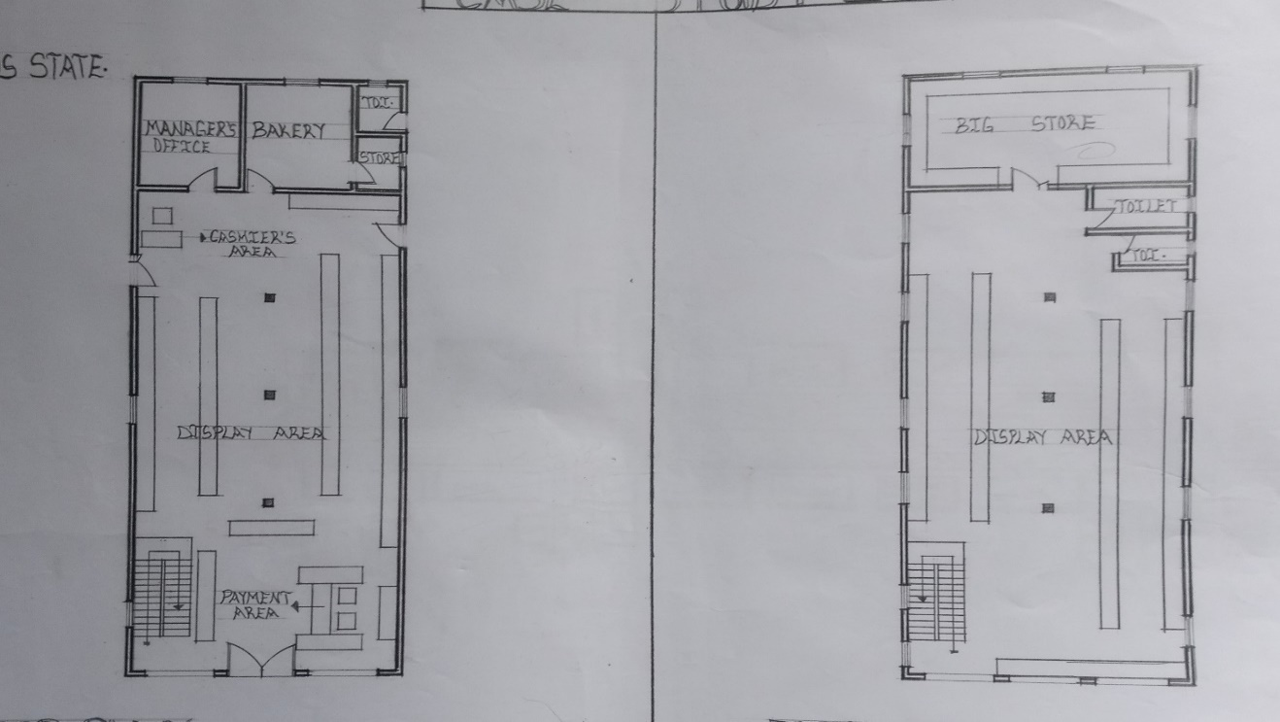
GROUND FLOOR PLAN AND FIRST FLOOR PLAN OF TUMAC MALL
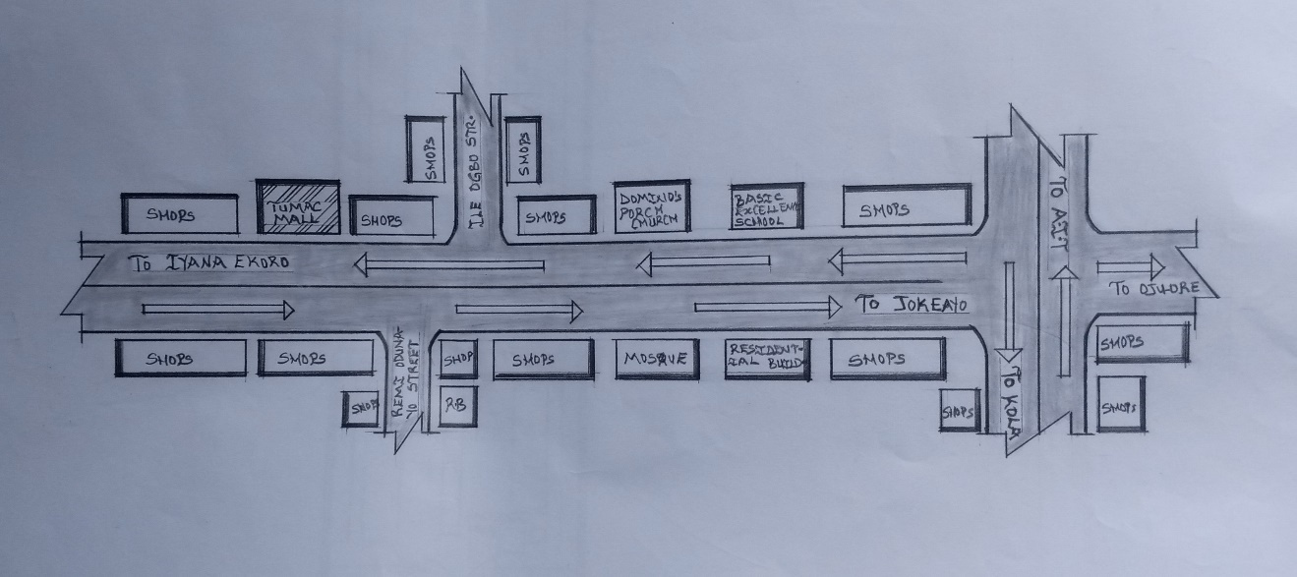
LOCATION PLAN OF TUMAC MALL
3.3.2 MERIT
- It is adequately lightened in both natural and Artificial
- It has good orientation
- It has interconnecting walkway to move easily from one unit to another
3.3.3 DEMERIT
- It has limited parking space
- It has insufficient toilet facilities
- It is not well landscaped.
3.4 CASE STUDY 3 MANTERS STORE AT ILORIN KWARA STATE
3.4.1 Location
It is located at Taiwo Isale in Ilorin, Kwara State.
Description
Mamtess shopping mall is a notable departmental store in Nigeria. The store has garnered a reputation for its diverse product range, catering to the needs of various customer segments. The store emphasizes customer satisfaction by offering personalized assistance and efficient checkout processes.
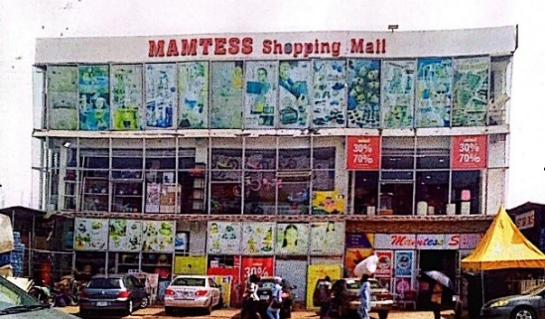
FRONT VIEW OF MAMTESS SHOPPING MALL
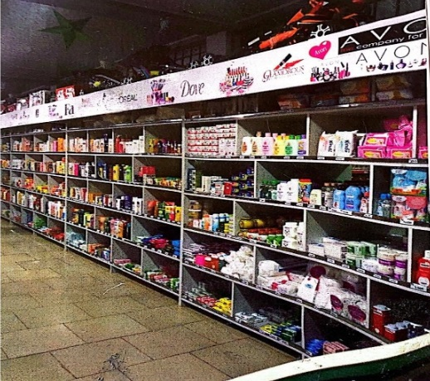
HYPER MARKET VIEW OF MAMTESS SHOPPING MALL
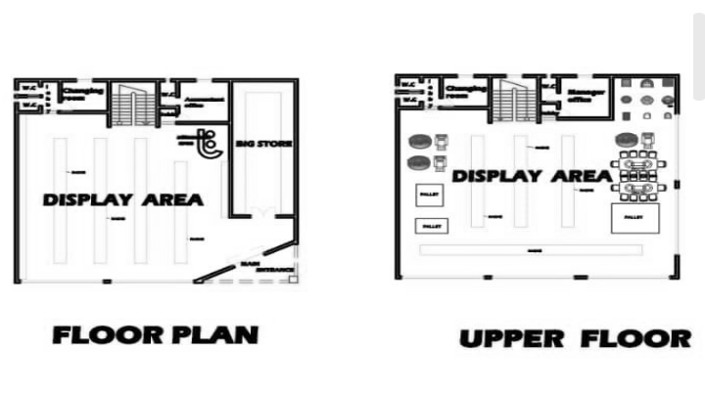
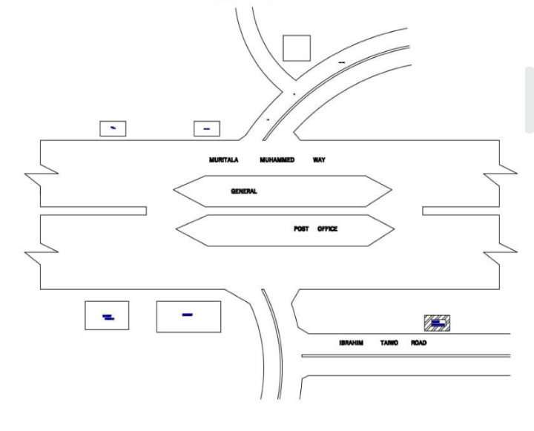
LOCATION PLAN OF MAMTESS SHOPPING MALL
3.4.2 MERIT
- It is well located
- The lobbies are well lighted (natural)
- It has interconnecting walkway to easily move from one unit to another
3.4.3 DEMERIT
- Not well Landscaped
- Insufficient Parking Space
3.5 CASE STUDY 4 COVENANT HARVEST MEGA STORE
3.5.1 Historical background Covenant Harvest Mega Store was started in 2021.
3.5.2 Location
It is located at No 162 Idiroko road Ojuore, Ota, Ogun State.
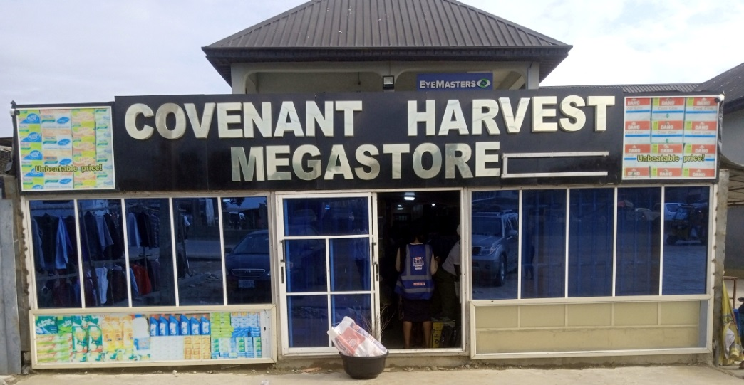
FRONT VIEW OF COVENANT HARVEST MEGASTORE
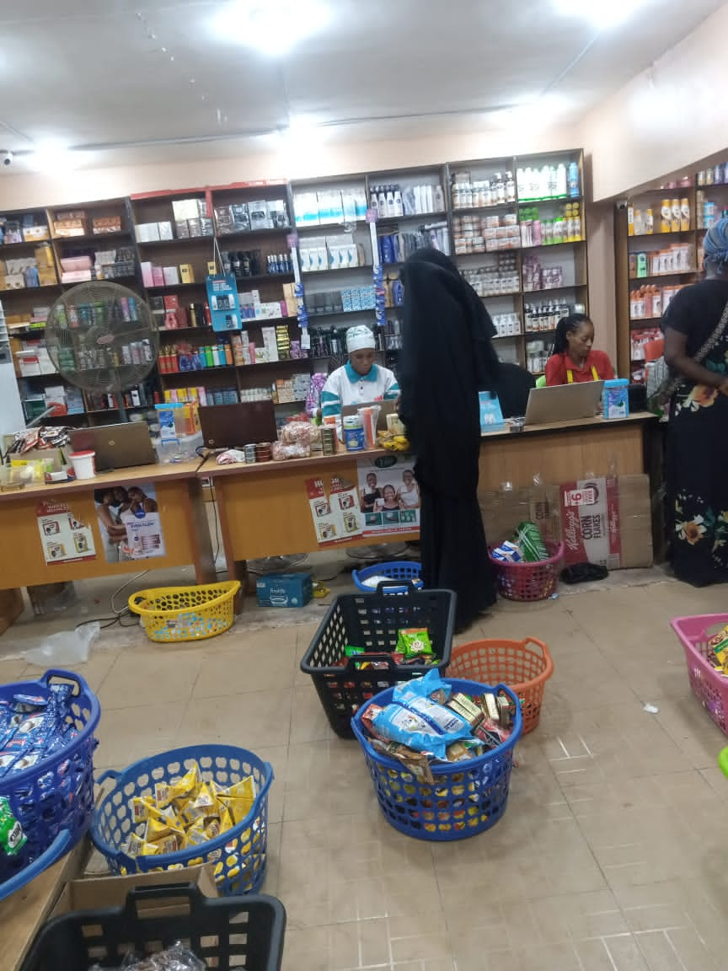
PAYMENT & CHECKPOINT AREA OF COVENANT HARVEST MEGASTORE
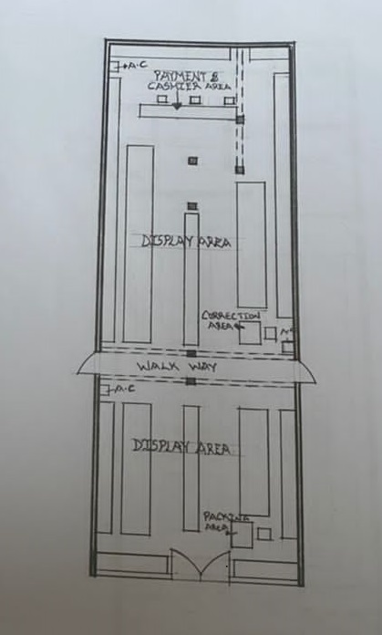
FLOOR PLAN OF COVENANT HARVEST MEGASTORE
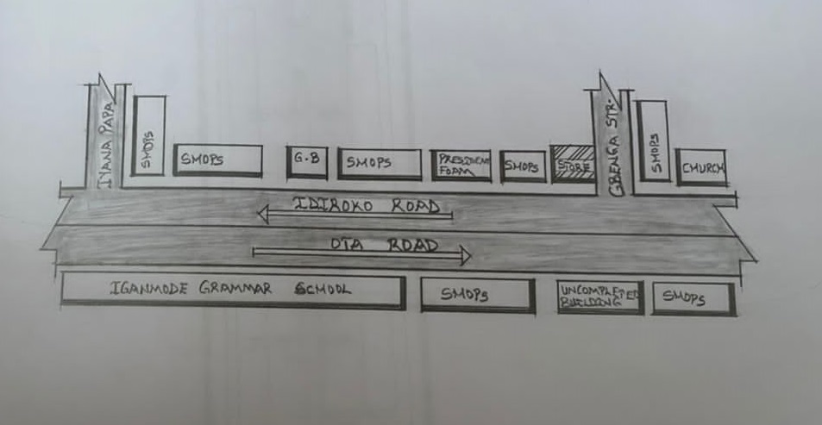
LOCATION PLAN OF COVENANT HARVEST MEGASTORE
3.5.3 MERIT
- It has Adequate Air Conditioning
3.5.4 DEMERIT
- The display area is not well arranged
- No provision of toilets and offices in the store

CHAPTER 4
4.1 INTRODUCTION OF STUDY AREA / PROJECT SITE
This chapter discusses extensively on the brief history and culture of the site location, the accessibility, physical characteristics, site analysis, and various factors, climatic and temperature, topography and a deep understanding of the project analysis.
4.1.1 HISTORICAL BACKGROUND OF SITE STATE
Kwara state (Yoruba - Ipinle Kwara) is a state in western Nigeria. Its capital is Ilorin. Kwara is located within the North Central geopolitical Zone, commonly referred to as the "state of Harmony". It was created on 27th May 1967, when the Federal military Government of General Yakubu Gowon broke the four regions that then constituted the Federation of Nigeria into 12 states. It covers a land area of 36,825 Km² (14,218 sqm) a population of 799,669 as of the 2006 Census, making it the 7th largest city by population in Nigeria. The primary ethnic group is Yoruba, with significant Nupe, Bariba and Fulani minorities.
At its creation, the state was made up of the former Ilorin and Kabba provinces of the Northern Region and was initially named the West Central State but later changed to "Kwara" a local name for the River Niger. Kwara state has since 1976 reduced considerably in size as a result of further state creation exercises in Nigerian.

4.1.2 HISTORICAL BACKGROUND OF SITE'S L.G.A
Oke-Ose is located in Ilorin South- East Local Government Area of Kwara State, Nigeria. Ilorin South is one of the 16 local Government Areas in Kwara State. It's a significant area with various communities, including Oke-Ose. The local government is known for its agricultural activities with crops like maize, Yam and Cassava being prominent. As a community within Ilorin South, Oke-Ose likely shares cultural and historical ties with the broader Ilorin and Kwara state regions.
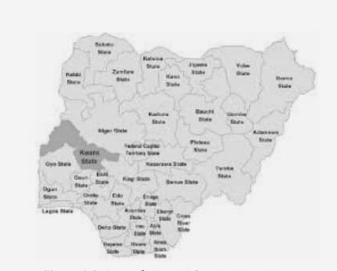
MAP OF NIGERIA SHOWING KWARA STATE
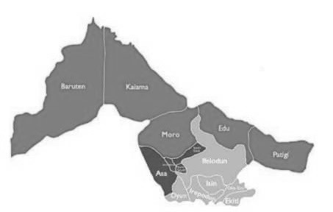
MAP OF KWARA STATE
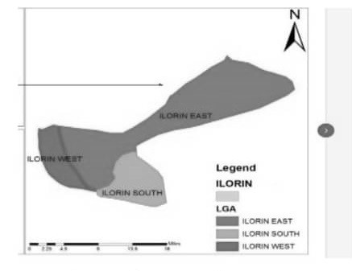
MAP OF ILORIN
4.2 SITE CRITERIA
- Accessibility: The site must have a motor access, which is to be a major road, preferably dual carriage and with less traffic.
- Vegetation: The site is covered by a short green grass with shrubs, this confirms that due to the position close to low land and water body, vegetation is mostly evergreen.
- Utilities: Existing electricity, water and telecommunications network are available around the site.
- Safety: The site is located in an area with less security threats to life and property.
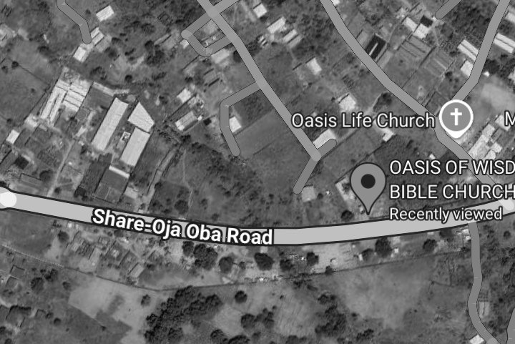
AERIAL VIEW OF THE SITE
4.3 SITE ANALYSIS
Site analysis is a crucial phase in architectural design, providing the foundational understanding needed to inform and shape a project's development.
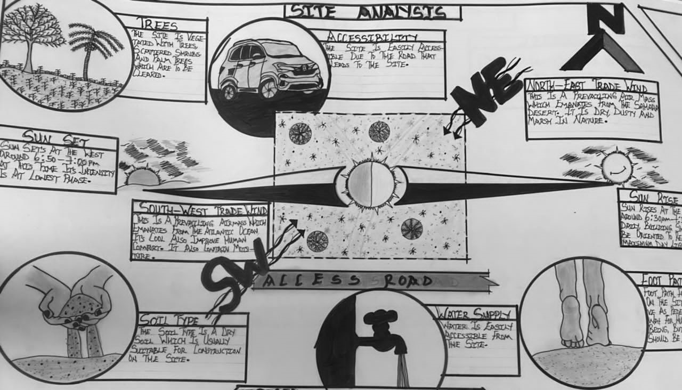
4.3.1 SITE INVENTORY
Site inventory provides the foundation for informed design and planning decisions. By documenting physical characteristics, legal and regulatory information, environmental considerations, and social factors, designers and planners can address site-specific challenges and opportunities effectively.
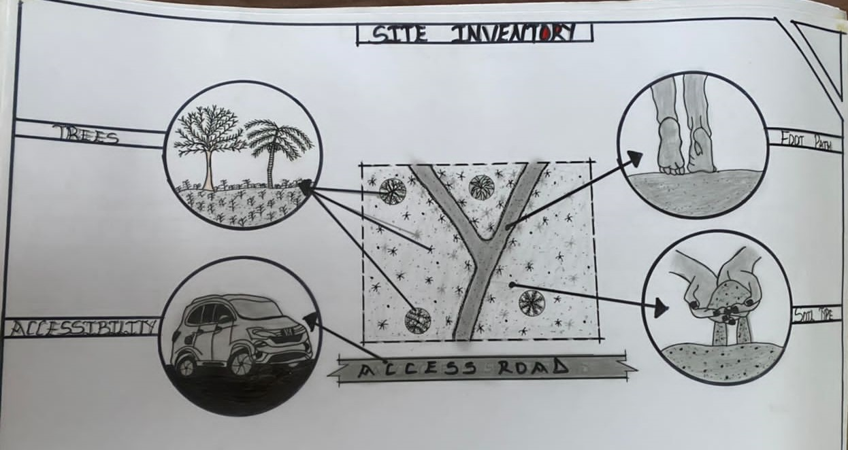
4.3.2 TOPOGRAPHY
The topography of the site selected for the proposed design is even and characterized with mild gradients.
4.3.3 CLIMATIC DATA
Climatic conditions characteristically are measured over wider areas and lengthier time frames. In considering the climatic condition of the site, Rainfall, temperature and humidity and wind speed were carefully considered using available climatic data from various sources.

4.3.4 RAINFALL
The driest month is January with 18mm of rainfall / 47.9 per year. The rainy season is characterized by continuous rainfall, which is usually referred to as wet season. Sunshine period without rain increases the temperature of the surroundings thereby causing discomfort during afternoon period.
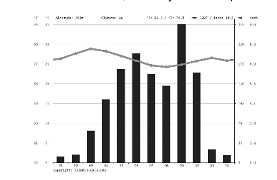
RAINFALL

4.3.5 TEMPERATURE
The temperatures are highest on average March, at around 29.8°C. The lowest average temperatures in the year occur in August, when it is around 24.5°C. Hence the problem of temperature should be considered from the conceptualization stage all through to the construction stage, this will provide the effective use of the building in terms of
comfort and environmental adaptability to enhance a acceptable and usable architectural place.
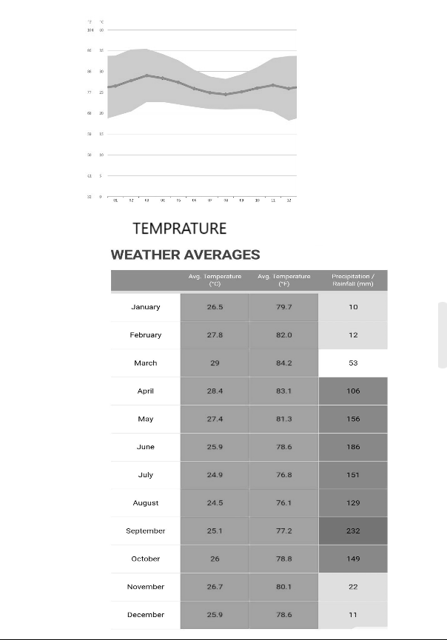
4.3.6 PREVAILING WIND
The prevailing wind over the site determines the quality and intensity of the air around the building, this further determines the level of comfort within and around the building. If the air is static, discomfort is experienced which in other words increases the heat in buildings.
4.4 PROJECT ANALYSIS
4.4.1 DESIGN BRIEF
The Proposed Departmental store is to serve the whole of Kwara State and its environment, this environment includes all the Southeastern states and beyond. This store will be of immense benefited to the citizens of the 3 local government, household, students, exhibitors within the city.
The Civic Centre would have the following facilities:
- Entrance
- Staircase
- Escalator
- Display area
- Hyper market
- Cosmetic and shoes / bags store
- Kitchen utensils and electronic store

- Payment area
- Check point
- Loading bay
- Lift
- Store
- Control room
- Equipment room
- Accountant office
- Head of Cashiers office
- Conference room
- Convenience
4.4.2 FUNCTIONAL RELATIONSHIP
The layout should be designed to facilitate smooth workflows, minimize unnecessary movements and ensure that different departments and sections are interlinked effectively.
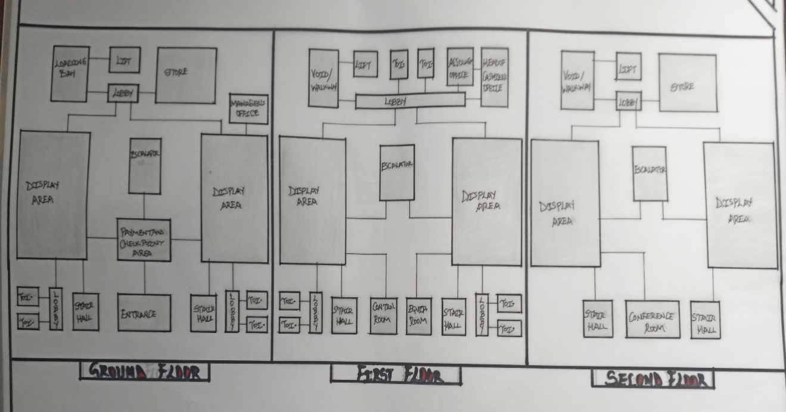
FUNCTIONAL RELATIONSHIP
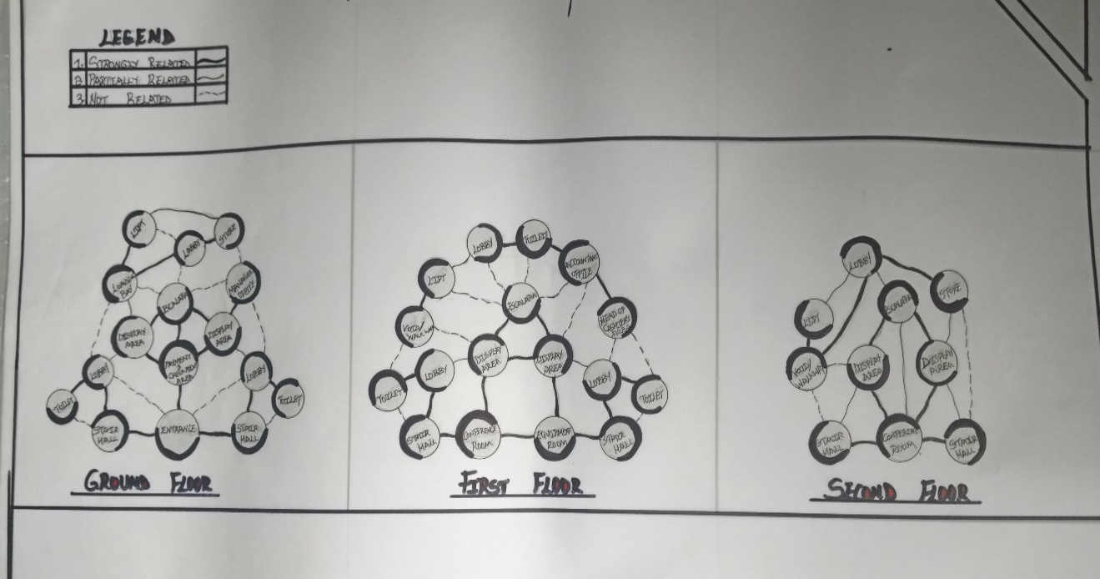
BUBBLE DIAGRAM
4.4.3 SPACE ALLOCATION
Space allocation involves determining how the available area within the store will be allocated for different purposes. This includes the sales floor, storage areas, staff facilities, customer amenities and administrative spaces.
GROUND FLOOR
S/N | UNITS | LENGTH X BREADTH | METRE | NO. REQ
1 | DISPLAY AREA | 20,000mm X 27,000mm = 540,000,000mm | 540,000 | 1
2 | ESCALATOR | 8,500mm X 3,000mm = 25,500,000mm | 25,500 | 1
3 | STAIR CASE | 5,400mm X 2,600mm = 14,040,000mm | 14,040 | 2
4 | LIFT | 2.500mm X 2,000mm = 5,000,000mm | 5,000 | 1
5 | LOADING BAY | 4,300mm X 3,400mm = 14,620,000mm | 14,620 | 1
6 | STORE | 4,300mm X 9,000mm = 38,700,000mm | 38,700 | 1
7 | TOILET | 1,200mm X 2,200mm = 2,640,000mm | 2,640 | 4
8 | ENTRANCE | 2,900mm X 6,800mm = 19,720,000mm | 19,720 | 1
9 | MANAGER’S OFFICE | 3,200mm X 3,000mm = 9,600,000mm | 9,600 | 1

FIRST FLOOR
S/N | UNITS | LENGTH X BREADTH | METRE | NO. REQ
1 | DISPLAY AREA | 20,000mm X 27,000mm = 540,000,000mm | 540,000 | 1
2 | ESCALATOR | 8,500mm X 3,000mm = 25,500,000mm | 25,500 | 1
3 | STAIR CASE | 5,400mm X 2,600mm = 14,040,000mm | 14,040 | 2
4 | LIFT | 2.500mm X 2,000mm = 5,000,000mm | 5,000 | 1
5 | VOID/WALKWAY | 4,300mm X 3,400mm = 14,620,000mm | 14,620 | 1
6 | ACCOUNTANT OFFICE | 4,000mm X 3,000mm = 12,000,000mm | 12,000 | 1
7 | HEAD OF CASHIER’S OFFICE | 4,300mm X 3,000mm = 12,900,000mm | 12,900 | 1
8 | CONTROL ROOM | 3,000mm X 3,400mm = 10,200,000mm | 10,200 | 1
9 | EQUIPMENT ROOM | 3,000mm X 3,400mm = 10,200,000mm | 10,200 | 1
10 | TOILET | 1,200mm X 2,200mm = 2,640,000mm | 2.640 | 6

SECOND FLOOR
S/N | UNITS | LENGTH X BREADTH | METRE | NO. REQ
1 | DISPLAY AREA | 20,000mm X 27,000mm = 540,000,000mm | 540,000 | 1
2 | ESCALATOR | 8,500mm X 3,000mm = 25,500,000mm | 25,500 | 1
3 | STAIR CASE | 5,400mm X 2,600mm = 14,040,000mm | 14,040 | 2
4 | LIFT | 2.500mm X 2,000mm = 5,000,000mm | 5,000 | 1
5 | CONFERENCE ROOM | 5,400mm X 6,400mm = 34,560,000mm | 34,560 | 1

4.4.4 CONCEPT DERIVATION
The concept derivation stage involves translating the design goals and objectives into a tangible concept that guides the overall aesthetic and appearance of the store. This includes decisions regarding color schemes, interior design elements, lighting, signage, and overall branding.
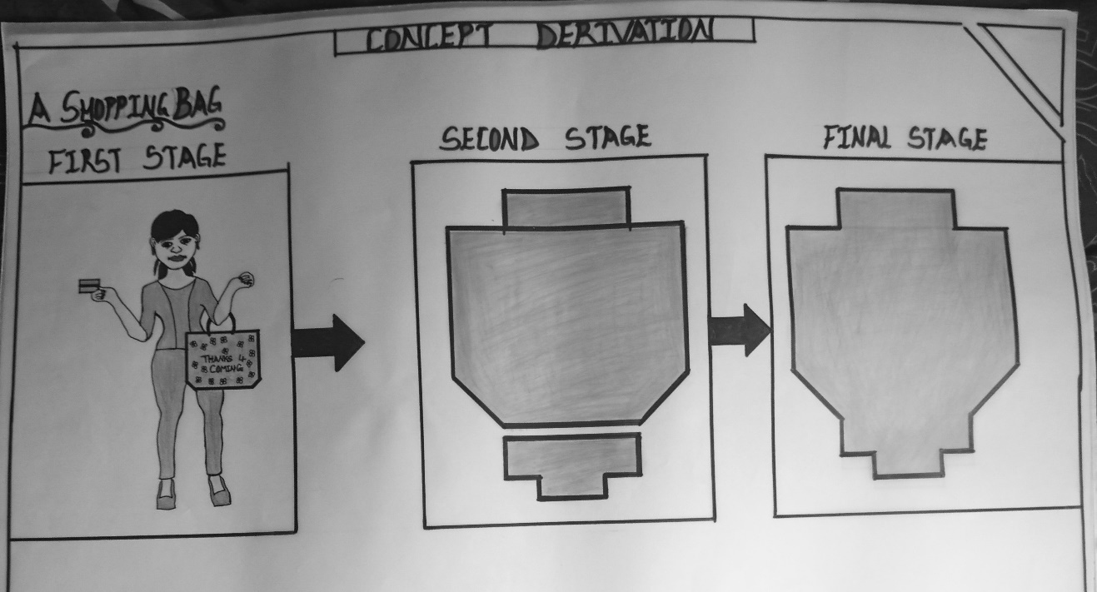
CONCEPT DERIVATION

CHAPTER 5
5.1 APPROACHES TO DESIGN / DESIGN REALIZATION
In this section, we will explore the different approaches to design that can be applied to the departmental store Project. This includes considering factors such as the store's branding, target market preferences and desired customer experience. The design approach should align with the overall concept and goals of the store, creating a cohesive and visually appealing environment.
5.2 CONSTRUCTION METHODOLOGY AND MATERIALS
The Construction methodology and materials used in building the depart- mental Store are crucial for ensuring durability, cost-effectiveness and sustainability. The appropriate construction methods should be selected, taking into account factors such as the site conditions, budget and project timeline.
- WALLS
This generally defines the outside and inside space of a building structure. Its primary function is to enclose or divide space, offer privacy and specially to provide support to different kinds of loads (live, dead, wind).
Walls can be categorized into load-bearing and non-load bearing walls. Load bearing walls are walls which carry vertical imposed load from roofs and floors while non-load bearing walls are walls which carry only their self-weight and are mainly used as dividing walls, partition and dwarf walls.
For the construction of the walls, block of 450mm×225mm×225mm would be suitable, curtain walls are also used. These are fixed to the face of the structure so as to perform the function of windows and walls.
- ROOF
A roof is usually the uppermost part of the building which protects them from weather i.e rain and wind etc .for the uppermost part of the project, it consists of steel structural element aluminum roofing sheet.
- FLOORS
Floors are the structural part of a horizontal supporting elements as distinct firm the wearing surface. The solid ground floor which is otherwise called German floor in Nigeria. Its consist of concrete not less than 150mm thick laid on a hardcore of a least 250mm thick compacted in layer of 59-75mm.the damp proof membrane should be placed below. The over site concrete which compacted before cement and sand (1:3) screed is finally laid on it to a thickness of not less than 19mm.
- CEILING
Suspended ceiling of aluminum railing with paper pulp sheet are use in the project. This product has an advantage of smooth, flame resistance and good acoustic value.
5.3 SERVICES REQUIRED
The departmental store will require various services to ensure its smooth operation. This includes Utilities such as electricity, water supply, heating ventilation and air conditioning (HVAC) as well as Communication and Security Systems.
The specific services required should be assessed and planned for to meet the needs of the store and its customers.
5.3.1 VENTILATION
Ventilation is required for the com- fort of the building users, therefore effort have been made to provide natural ventilation with the aid of orientation of the building.
5.3.2 LIGHTENING AND ELECTRICAL SUPPLIES
To enhance clear illumination especially by the stores and supermarkets. The most efficient and economical lighting is the LED is the LED lamp. Though there are other forms in the process of development LED lamp are found to be the best of all.
5.3.3 AIR CONDITIONING
Split air conditioning system will be installed in some required place for effective control of temperature to provide comfort for the user by providing the requ- ired amount of fresh sterile air at the proper temperature and humidity.
5.4 CONCLUSION
In Conclusion, the development of a department store in Kwara state presents an opportunity to cater to the retail needs of the local population and promote economic growth in the area. The historical significance of Cultural Value to the project and careful consideration should be given to preserve the heritage while creating a modern and functional retail space. The design considerations, planning principles and approaches discussed in this report provides a foundation for the successful implementation of the project.
5.5 RECOMMENDATION
Based on the analysis and considerations discussed throughout this Project report, the following recommendations are made:
- Conduct a comprehensive market analysis to understand the specific needs and preferences of the target market.
- Engage professional architects and designers with experience in retail store design to create an aesthetically pleasing and functional layout.
- Prioritize customer comfort and convenience by designing clear circulation paths, providing ample parking facilities and incorporating customer amenities.
- Collaborate with local authorities and heritage preservation organizations to ensure the Project respects and promotes the historical significance of the area.

REFERENCE
Aaker, D.A. (1991). Managing Brand Equity: Capitalizing on the Value of a Brand Name. New York: Free Press.
Christopher, M. (1998). Logistics and Supply Chain Management: Strategies for Reducing Costs and Improving Performance. London: Financial Times/Prentice Hall.
Drucker, P.F. (1995). Managing in a Time of Great Change. New York: Truman Talley Books/Dutton.
Garvin, D.A. (1988). Managing Quality: The Strategic and Competitive Edge. New York: Free Press.
Laudon, K.C. and Laudon, J.P. (2001). Management Information Systems: Organization and Technology in the Networked Enterprise (7th Edition).
Levitt, T (1983). The Marketing Imagination. New York: Free Press.
Lovelock, C. H., & Wirtz, J. (2004). Services marketing: People, technology, strategy (5th ed.). Upper Saddle River, NJ: Prentice Hall.
Porter, M. E. (1980). Competitive strategy: Techniques for analyzing industries and competitors. New York: Free Press.
Porter, M. E. (1985). Competitive advantage: Creating and sustaining superior performance. New York: Free Press.
Rackham, N. (1995). SPIN selling: The new psychology of selling. New York: McGraw-Hill.
Sheth, J. N., & Parvatiyar, A. (1995). The evolution of relationship marketing. Journal of the Academy of Marketing Science, 23(4), 255-271.
Smith, R. E., & Reinertsen, D. G. (1998). Developing new products in half the time (2nd ed.). New York: John Wiley & Sons.
Tersine, R. J. (1997). Principles of inventory and materials management (5th ed.). New York: John Wiley & Sons.
Turban, E., Leidner, D., McLean, E., & Wetherbe, J. (2005). Information technology for management: Making connections for strategic advantage (6th ed.). Upper Saddle River, NJ: Prentice Hall.
Weber, M. (1947). The theory of social and economic organization (T. Parsons, Ed.). New York: Free Press.

APPENDIX

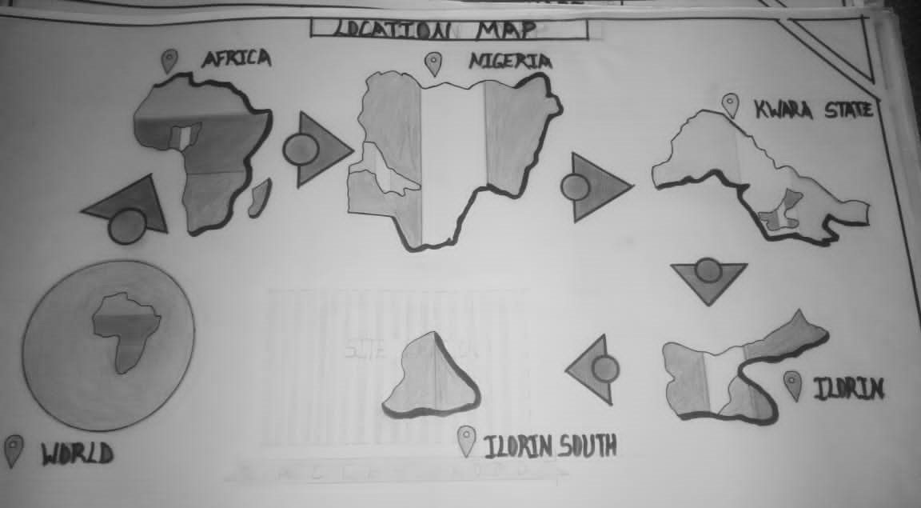
APPENDIX 1: LOCATION MAP

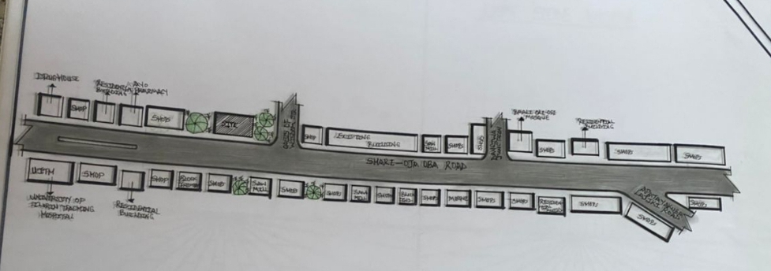
APPENDIX 2: LOCATION PLAN
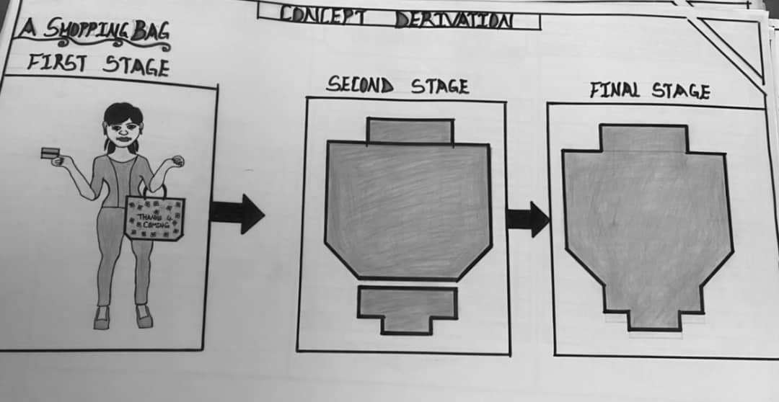
APPENDIX 3: CONCEPT DERIVATION

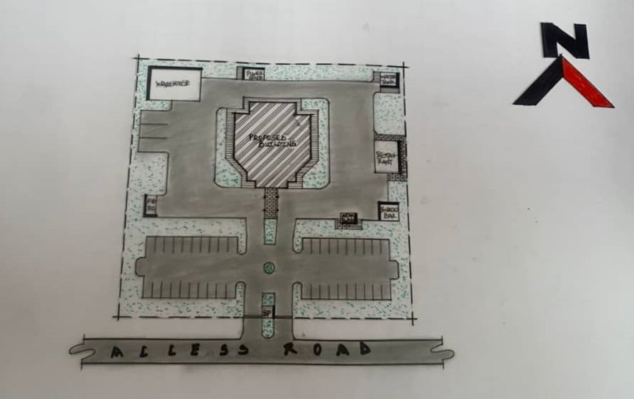
APPENDIX 4: PROPOSED SITE PLAN
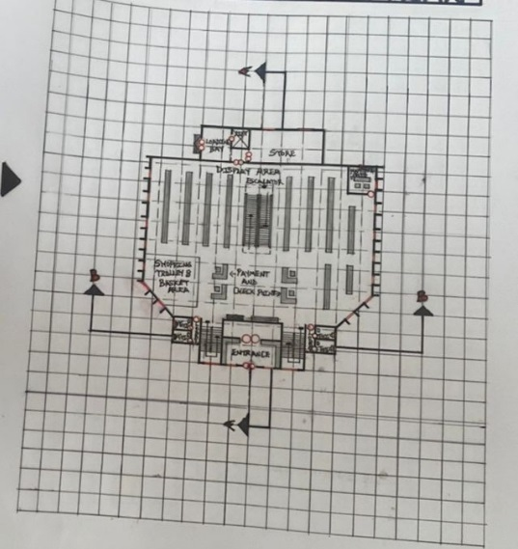
APPENDIX 5: PROPOSED GROUND FLOOR PLAN

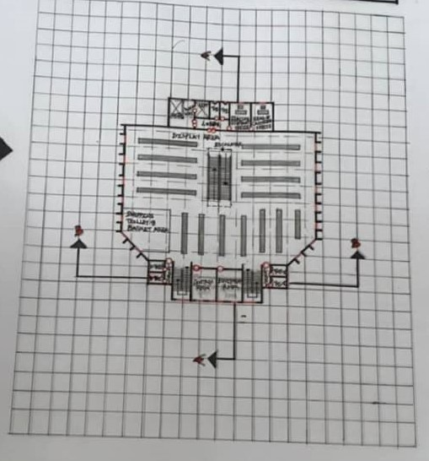
APPENDIX 6: PROPOSED FIRST FLOOR PLAN
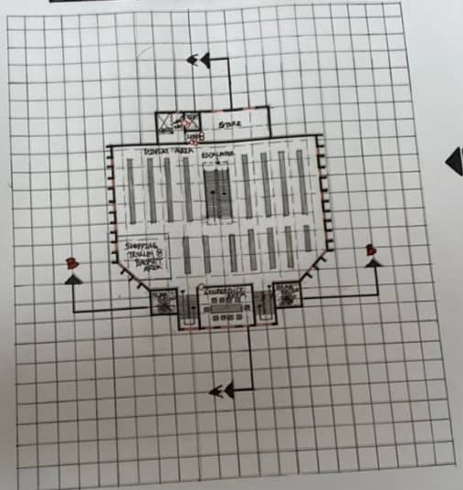
APPENDIX 7: PROPOSED SECOND FLOOR PLAN

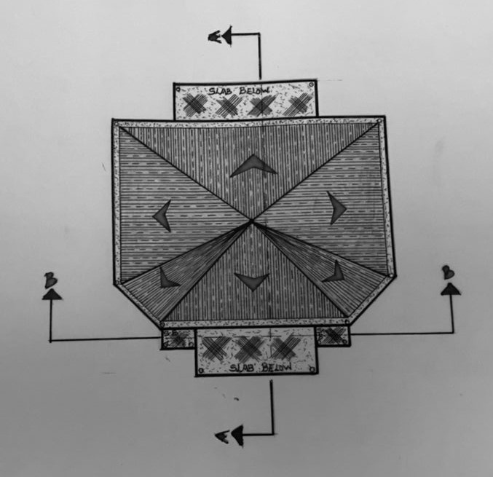
APPENDIX 8: ROOF PLAN
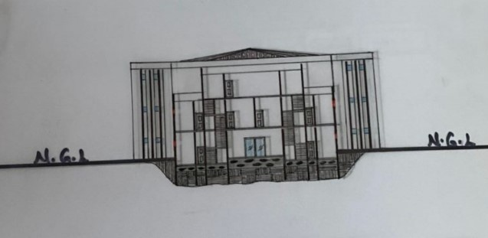
APPENDIX 9: SECTION B-B

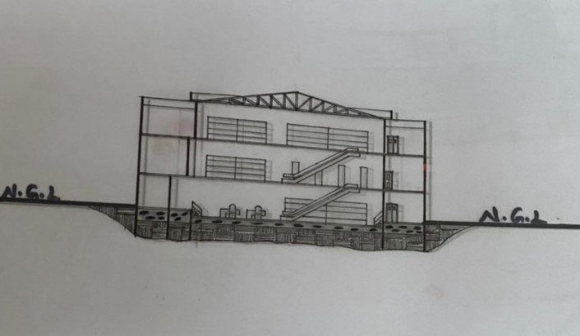
APPENDIX 10: SECTION A-A
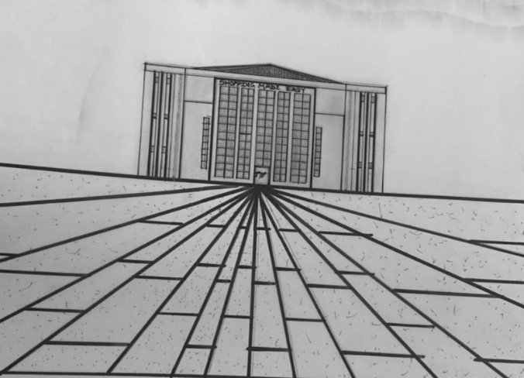
APPENDIX 11: FRONT ELEVATION

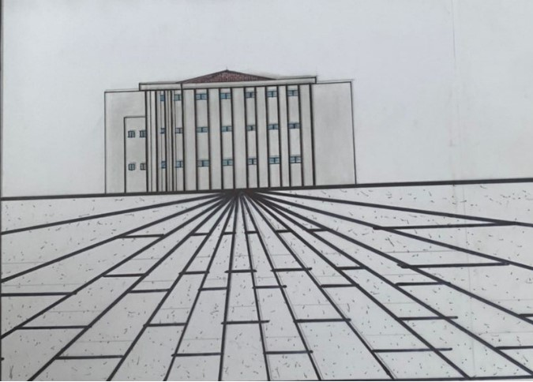
APPENDIX 12: RIGHT SIDE ELEVATION
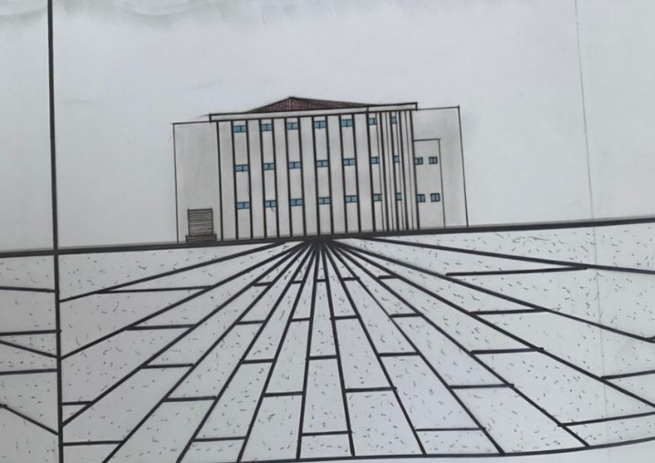
APPENDIX 13: LEFT SIDE ELEVATION

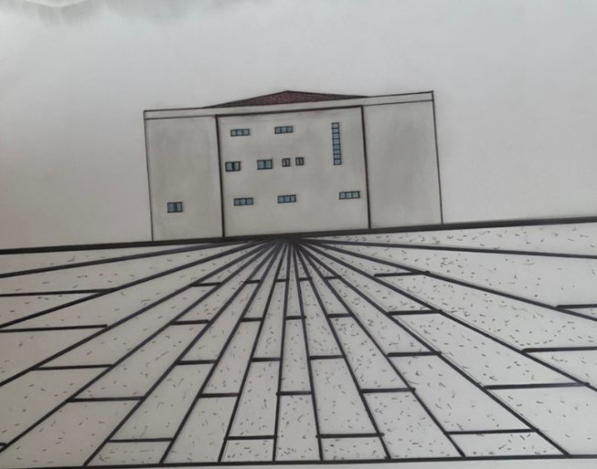
APPENDIX 14: REAR ELEVATION

