EVALUATION OF IMPACT OF GOLD MINING ON THE WATER OF ALAGBEDE-DABA COMMUNITY AREAS OF KWARA STATE

BY

Victoria Folasayo OLALEKAN
HND/23/MNE/FT/0019

BEING A RESEARCH PROJECT SUBMITTED TO THE DEPARTMENT OF MINERAL AND PETROLEUM RESOURCES ENGINEERING TECHNOLOGY, INSTITUTE OF TECHNOLOGY, (IOT)
KWARA STATE POLYTECHNIC, ILORIN

IN PARTIAL FULFILLMENT OF THE REQUIREMENTS FOR THE AWARD OF HIGHER NATIONAL DIPLOMA (HND) IN MINERAL AND PETROLEUM RESOURCES ENGINEERING TECHNOLOGY.

JULY, 2025

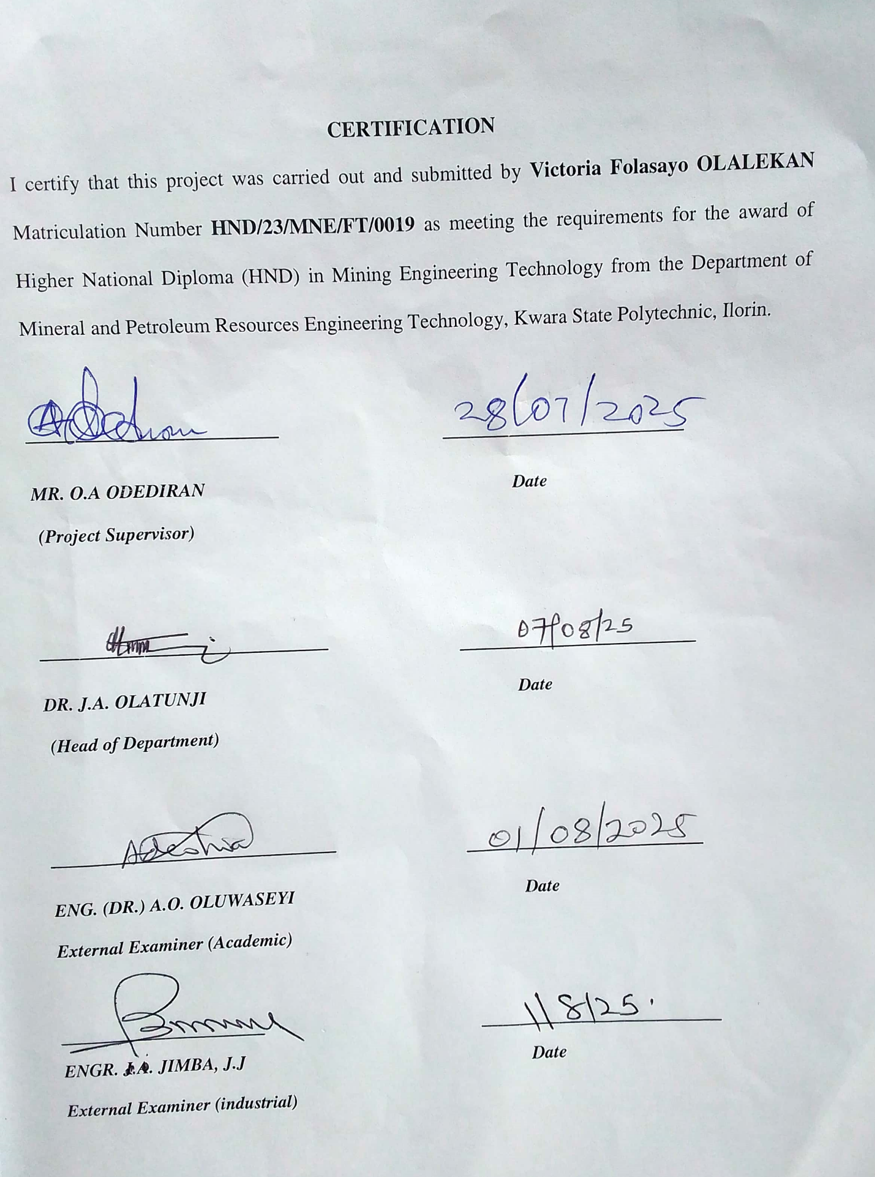Dedication
This project is dedicated to God Almighy, my creator, who has seen me through to this stage of my life. To my wonderful parents, Mr. & Mrs. Olalekan and to my lovely brother, and sisters.

Acknowledgement
My profound appreciation goes to the Almighty God for His love ad protection and also for supplying me with good health and sound mind.
I want to appreciate the effort of my supervisor, Mr. O.A Odediran for guiding me during the writing of this project, and also for being a father. It really gladdens my heart to have worked under you sir. May God always guide you in all your endeavors in Jesus name.
I appreciate my parent for their love, support, provision and for their relentless effort towards making me somebody in life, and to my lovely elder brother and elder sister, Mr. Olalekan Matthew and Mrs. Ibrahim Janet, I say a big thank you, a sister like you is very rare.
To my younger sister, Olalekan Grace, you are indeed the best. Words cannot express what you have done for me and for what you are to me. Thanks for your love, prayer and support inspite all the challenges I faced, thanks for still believing in me as your big sister. May God Almighy spare you all for me.
I also appreciate my frineds; Mary, Taiwo,Morufat, Taiwo (iya ibeji) for the helping hands they all rendered. I love you all.
To my Spiritual parents both here in Ilorin and at home, the Ibrahim’s family and Fawenu’s family, I say a big thank you. Thanks for the prayer and everything. And to everyone that has once contributed to my success in one way or the other, I say thank you.

Abstract

This study assessed the impact of gold mining activities on waters quality in Alagbede-Daba community, kwara State. Ten samples were collected randomly from selected water bodies and physico-chemical parameters, such as, TDS, EC, Turbidity, pH, and Temperature were measured on the field. Selected Heavy metals that is Mn, Cd, Cr, Ni and Pb were also determined by AAS method of analysis. The results showed elevated levels of heavy metals, including Cadium, Nickel, and Lead, in water sources, exceeding recommended standards. Pysico-chemical parameters, such as pH and temperature, were also affected. The findings suggest that gold mining activities have potentially contaminated water sources, posing health risks to the community. The study results can inform policy decisions and interventions to mitigatethe environmental and health impacts of gold mining in the area.

Table of Content

Title Page i
Certification ii
Dedication ii
Acknowledgement ii
Abstract ii
Table of content ii
List of tables ii
List of figures ii
CHAPTER ONE 2
1.0 INTRODUCTION 2
1.1 Location and Accessibility 2
1.2 Climate and Vegetation 2
1.3 Relief and Drainage 2
1.4 Aim of the Study 2
1.5 Objective of the Study 2
1.6 Problem Statement 2
1.7 Justification of the Study 2
1.8 Scope and Limitation of the Study 2
CHAPTER TWO 2
2.0 LITERATURE REVIEW 2
2.1 Review of Previous Works 2
2.2 Review of Gold Mining and Its Environmental Impact 2
2.3 Water Pollution and Its Effects on Human Health and the Environment 2
2.4 Review of Existing Studies on Gold Mining and Water Quality 2
CHAPTER THREE 2
3.0 RESEARCH METHODOLOGY 2
3.1 Sample Collection and Preparation 2
3.2.1 Field Techniques 2
3.3.2 Atomic Absorption Spectroscopy (AAS) 2
3.4.3 Potential Of Hydrogen (pH) 2
3.5.4 Turbidity 2
3.6.5 Temperature 2
3.7.6 Measurement Of Physicochemical Parameter 2
3.8.7 Electrical Conductivity (EC) 2
3.9.8 Total Dissolved Solid (TDS) 2
3.10.9 Digestion of Water Samples Using Aqua-Regina Method 2
CHAPTER FOUR 2
4.0 RESULTS AND DISCUSSION 2
4.1 Results of Heavy Metal Analyses 2
4.2 Result of Physio-Chemical Parameters 2
CHAPTER FIVE 2
5.0 CONCLUSION AND RECOMMENDATION 2
5.1 Conclusion 2
5.2 Recommendations 2
REFERENCE 2

List of Tables
Table 1: Coordinate of the Study Area 8
Table 2: Measured Physico-Chemical Parameters 15
Table 3: Heavy Metals of Water 16
Table 4: Standard Values of Water Samples 18

List of Figures
Figure 1: Geological Map Showing Alagbede-daba Area (bayode et al., 2023) 2
Figure 2: Geological Map of Nigeria Showing Study Area (ajadi et al., 2018) 2

CHAPTER ONE

INTRODUCTION

1.1 Location and Accessibility
The Alagbede-Daba communities are located in Moro local government area of Kwara State, Nigeria. Alagbede-Daba communities are situated in a rural area with surrounding communities like Lanwa, Ejidongari and Olooru. The area is characterized by natural resources such as yam, corn, cassava: minerals resources like gold, granite, talc, and silica. Sand also present. The road network in Alagbede-Daba appears to be connected to major towns like Bode-Saadu, the local government headquarters which is about 85km from Ilorin. Buses and motorcycles are common modes of transportation in the areas, during the rainy season, some of the roads may become impassable due to flooding. Due to poor road maintenance.
The roads are prone to damage from flooding accompany by lack of drainage infrastructure. Alagbede-Daba communities are situated in a relatively flat terrace. Ilorin East is well drained i.e the major rivers in Ilorin are river Asa (most popular) and river Oyun (the longest). Inadequate drainage systems can exacerbate flooding, making it more likely for road to becomes impassable.

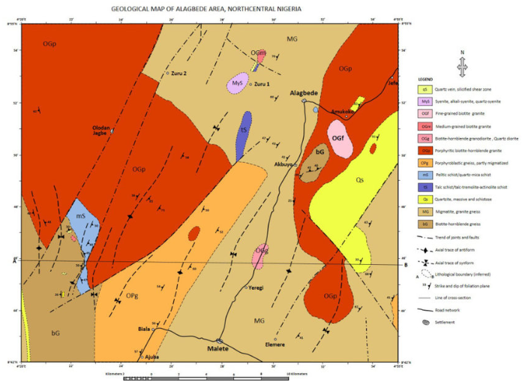
Figure 1: Geological Map Showing Alagbede-Daba Area (Bayode et al., 2023)
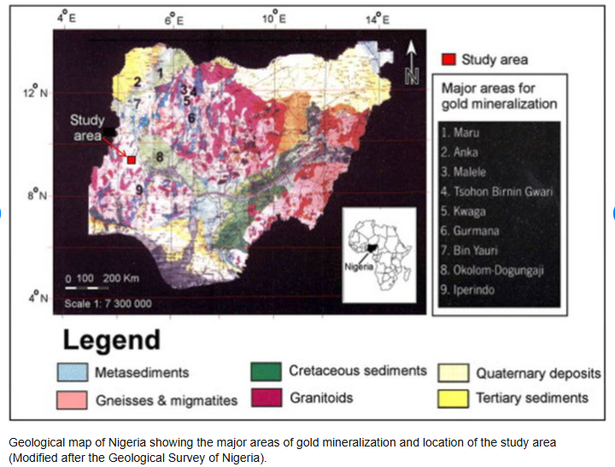
Figure 2: Geological Map of Nigeria Showing Study Area (Ajadi et al., 2018)

1.2 Climate and Vegetation
The climate of the Alagbede-Daba community’s area of Kwara is characterized by tropical savanna climate, typified by worm temperatures and distinct wet and dry seasons.
The region experiences a wet season, which might impact gold mining activities and water quality. The area is covered with savanna vegetation, which include grasses and scattered trees. The average temperature ranges from 20⁰c to 35⁰c (68ºf to 95ºf) throughout the year.
The area receives moderate to high rainfall with an average annual rainfall of around 1,000 – 1,500mm (39 – 59). The relative’s humidity is relatively high especially during the wet season, ranging from 60-80%. The prevailing wind direction is typically from the southwest during the dry season.
Gold mining activities might alter the natural vegetation leading to environmental degradation and potential waters pollution. The climate is humid tropical type and is typified by wet and dry seasons (Ilorin Atlas, 1981).

1.3 Relief and Drainage
The Alagbede-Daba communities are situated in a relatively flat terrain within Ilorin East local government. Elevation within the Local government area ranges from 250m – 400m above sea level. The area is well drained by major rivers such as River Asa (most popular), and River Oyun (the longest) as well as other minor rivers and streams.

1.4 Aim of the Study
The aim of the study is to evaluate the impact of gold mining on the waters of Alagbede-Daba communities, in Moro local government areas of Kwara State.

1.5 Objective of the Study
The objectives of the study include the following:
- to determine the major elemental composition of the waters.
- to determines the heavy metal composition of the waters.
- to compare results with established standard.

1.6 Problem Statement
Alagbede-Daba communities like any other mining community is prone to environmental hazards and risks occasioned by activities of the mining industry. The use of heavy duty equipment’s and extractive chemicals usually leads to contamination of the environment, the waters and soils inclusive be negatively imparted. This study enables the acquisition of insightful information about the level of contamination of the waters of the study area and also prefer means of mitigation.

1.7 Justification of the Study
Limited research on the impact of gold mining on waters in Alagbede-Daba communities making it essential to conduct a study. Local communities may have concerns about the impact of gold mining on their water sources, which need to be addressed. By studying the impact of gold mining on the waters of Alagbede-Daba communities researchers can better understand the environmental, health, and socio-economic implication and provide recommendation for sustainable mining practices, gold mining can disrupt the livehoods of local communities, particularly those dependent on fishing and agricultures contaminated water sources can lead to the spread of water borne diseases, such as cholera and diarrhea. Mining activities can cause soil erosion, which can lead to increased sedimentation in waters bodies.

1.8 Scope and Limitation of the Study
The scope of this study is to evaluate the impact of gold mining on the surface water and ground water sources in the Alagbede-Daba communities. The study assesses the following water quality parameters: pH, Turbidity, Total Dissolve Solids (TDS), Heavy metals.
The chemical analyses include major element and heavy metals were analyzed by ion by using Atomic Absorption Spectrometry (AAS). AAS is a spectroscopy technique used to determine the concentration of trace metals.
The study is limited to study location but may be or guide to understanding similar locations.

CHAPTER TWO

LITERATURE REVIEW

2.1 Review of Previous Works
Several researchers reported that gold mining activities can significantly affect the quality of nearby water sources and also reported that the deposits consist of gold beading quartz veins, which suggests that gold mining activities in the area may involve the use of chemicals and processes that contaminate the water. Furthermore, research on gold mining areas in Osun State, Nigeria has highlited the importance of comprehensive hydro-geochemical evaluation of ground water quality dynamics in area affected by gold mining.
The development of methods improving waste quality, distributing drinking water to people and conserving ecological systems are significant problems in answering questions about sustainable development. Gold have been researched extensively in comparison to other bodies of water in terms of water quality which is not surprising considering that humans and aquatic species interact with them frequently and are thus more susceptible to contaminants transported there.
According to Falconer et al. (2012), water is the most important plentiful and beneficial natural resources on the planet and life cannot exist without it. It is a requirement of human life and, should be of highest possible quality. Waters quality is determined by its physico-chemical qualities. The impact of gold mining activities on water quality of surface and ground water have been conducted around the world.
Gold mining is a significant economic activity in many parts of the world, including Nigeria. However gold mining can have severe environmental impacts, particularly on waters resources. The Alagbede-Daba communities in Moro local government area of Kwara State are known for their gold deposits and mining activities have been ongoing in the area for several years.

2.2 Review of Gold Mining and Its Environmental Impact
Gold mining is a significant economic activity in many parts of the world. However gold mining can have severe environmental impact, including deforestation, solid erosion and water pollution. However by implementing sustainable mining practices and using environmentally friendly technologies, these impacts can be mitigated.

2.3 Water Pollution and Its Effects on Human Health and the Environment
According to WHO (2017), water pollution is a major environmental problem worldwide. The consumption of contaminated water can lead to a range of health problems, including cancer, neurological damage, and reproductive problems consuming contaminated water can lead to waterborne diseases like cholera, typhoid, and diarrhea. Prolonged exposure to contaminated water can lead to long-term health problems such as cancer, neurological damage.
Contaminated water can lead to soil contamination, affecting plant growth and agricultural productivity.
According to Olaniran et. al (1995), is define as the presence of excessive concentration of a danger (pollutant) in waters to the point where it is no longer appropriate for bathing, cooking, drinking, or other purposes.
According to Webster.com (2010), the introduction of contaminants into the environment is referred to as pollution. Water pollution can disrupt the aquatic ecosystem affecting fish and other aquatic life.
The impact of gold mining on the waters of Alagbade-Daba communities is a significant concern. It is essential to implement measures to prevent water pollution, ensure proper waste management and promote sustainable mining practices to protect human health and the environment.
River flora and wildlife fluctuate and diminish in number as a result of suffocation death. According to Tudge et. al (1991), polluted rivers have an unpleasant engines in enterprises is another form of water contamination.
Human health is harmed as a result of water contamination. Bacteria and viruses that transit diseases are carry into exterior and earth water, drinking water is tainted, putting people’s health at danger.

2.4 Review of Existing Studies on Gold Mining and Water Quality
According to WGC (2020). The impact of gold mining on water quality can lead to significant changes in water quality, including increased levels of heavy metals and other pollutants, posing risks to human health and aquatic ecosystem. Studies have consistently shown elevated levels of heavy metals such as mercury and lead, in water sources near gold mining sites. These matals can cause severe health problems, including neurological damage cancer and organ damage. Research assessed various water quality parameters, including pH, Total Dissolved Solids (TDs), Turbidity, These parameters help determine the overall health of the water body. Gold mining can disrupt aquatic ecosystem, affecting fish population and other aquatic organisms. Existing studies demonstrate the significant impact of gold mining on water quality, highlighting the need for proper waste management, sustainable mining practices and regular water quality monitoring the mitigate these effects.
The consumption of water containing high concentrations of heavy metals has a high cancer risk, so drinking and dermal contact with water resources cause’s cancer. According to Adewumi & Laiyan (2020). Also, in a study conducted by Hadzi et.,al (2018), health risks for metals and Pb were more likely to be associated with drinking than health risks caused by dermal contact. High health risks and carcinogenicity of heavy metals in water resources are potential threats to ecological conditions. It is not possible to use this water for cultivation, entering the environment and watering animals and animals causing diseases and problems according to Adewumi & Laniyan (2020).
Heavy metals can leach into soil, affecting plant growth and potentially entering the food chain. According to Fashola et., al (2016), reviews of environmental impacts of gold mining.

CHAPTER THREE

RESEARCH METHODOLOGY

3.1 Sample Collection and Preparation
Water samples were collected from ten different location in Alagbede-Daba communities. The sampling points were selected based on the criteria of accessibility of the site. The geographical coordinate of the selected sampling points were obtained. Sample location are presented in table below:
Table 3.1.1 Details of Coordinate of the Study Area
S/N | Location | Longitude | Latitude | Remark
1 | L1 | 8⁰ 28’ 23.0” | 4⁰ 40’ 507” | Stream
2 | L2 | 8⁰ 52’ 28.7” | 4⁰ 29’ 33.8” | Borehole
3 | L3 | 8⁰ 52’ 23.8” | 4⁰ 29’ 33.8” | Stream
4 | L4 | 8⁰ 52’ 22.1” | 4⁰ 29’ 29.2” | Stream
5 | L5 | 8⁰ 52’ 20.4” | 4⁰ 29’ 26.0” | Stream
6 | L6 | 8⁰ 51’ 18.9” | 4⁰ 29’ 20.1” | Stream
7 | L7 | 8⁰ 17’ 0” | 4⁰ 29’ 16.3” | Stream
8 | L8 | 8⁰ 15’ 6” | 4⁰ 29’ 9.1” | Stream
9 | L9 | 8⁰ 15’ 4” | 4⁰ 29’ 9.0” | Stream
10 | L10 | 8⁰ 51’ 15.6” | 4⁰ 29’ 9.2” | Stream

Using Global Positioning System GPs receiver. All the samples were taken from the Alagbede-Daba sampling was done manually, and water samples were obtained in sterile containers. Before the sampling, the containers were washed with water at the sampling site during field sampling. The samples were placed in sterilized polyethylene bags and then stored and transported to the laboratory for further analyses.

3.2.1 Field Techniques
In the course of field visits, ten samples of waters were collected from different locations and subjected to detailed analysis. This include laboratory analysis for Total Dissolved solids (TDs), Heavy metals, pH, Temperature, and major elemental composition of the study.
The water samples were analyzed for physical and chemical parameters including pH, Temperature, Turbidity, Total Dissolved Solids, Heavy metal concentrations and major elemental composition, these analytical techniques help assess to the impact of gold mining on water quality and aquatic life in Alagbede-daba communities

3.3.2 Atomic Absorption Spectroscopy (AAS)
Atomic Absorption Spectroscopy (AAS), was used to analyze the waters sample for heavy metals concentrations and elemental composition. According to PerkinElmer (2020). The principles of AAS is based on the absorption of light by atoms in the samples. The procedures involve the following steps: preparation of the sample, setting up the AAS instrument, measuring the absorbance of the sample, calculating the concentration of the heavy metal.
Atomic Absorption Spectroscopy (AAS), measure heavy metals concentration. AAS is based on the principles that atoms absorb light at specific wavelengths, when a samples is atomized, the atoms absorb light at a specific wavelength corresponding to the element being analyzed.
AAS works on the principle that atoms absorb light at specific wavelengths. When a sample is atomized, the atoms absorb light from a light source, and the amount of light absorbed is directly proportional to the concentration of the element in the sample.
AAS can detect elements at very low concentrations, it is highly specific, allowing for the analysis of individual elements. AAS provides accurate results when properly calibrated and operated.
According to Bernhard Welz and Michael Sperling. Chemical and physical interferences can affect the accuracy of AAS analysis.
According to J.A.C Broekaert. Sample preparation is critical to ensure accurate results.
AAS is a powerful analytical techniques that provides accurate and reliable results when used correctly. According to Journal of Analytic Atomic spectrometry (JAAS) (2008). AAS requires a specific light source for each element being analyzed standard for AAS include American Public Health Association APHA (1872): standard method for the examination of water and wastewater, international organization for standardization: ISO 3619 Determination of metals in water by Atomic Absorption Spectroscopy.

3.4.3 Potential of Hydrogen (pH)
pH measures the acidity or alkalinity of water ranging from 0-14, with 7 being neutral. pH levels significantly impact water quality, influencing the solubility and toxicity of metals and pollutants.
According to Soren Soresen a (Danish Scientiststs, 1909). He defines pH as the negatives. Logarithms of the hydrogen ion concentration in a solution.
Gold mining can alter pH levels through: Acidic mine drainage, chemical use. pH is determined by measuring the concentration of Hydrogen ions (H+) in a solution.
Procedures for measuring pH include using pH paper, prepare the pH paper using indicator, dip the paper and compare the color using a pH meters can be used depending on the required level of precision.
According to International Union of Pure and Applied Chemistry (IUPAC). pH is a fundamental parameter that plays a crucial role in various fields.
Determination of pH. The pH of water is a measure of hydrogen ion concentration in water. It ranges from 0 to 14, with neutral water at 7. While lower of it is acidic and pH greater than 7 is known as basic. Drinking water with a pH ranging from 6.5 to 8.5 is generally considered satisfactory. It is noticed that water with low pH tends to be toxic and with high degree of pH tastes bitter. The pH of the studied water samples were measured by dipping the electrode of the pH meter into the bowl of the water samples.

3.5.4 Turbidity
Turbidity measures the cloudiness or haziness of water, caused by suspended particles such as sediment algae or their impurities.
According to WHO (2022), turbidity is an important water quality parameter because it can affect the aesthetic value of water, as well as its safety for human consumption.
It is an important parameter in water quality assessment, as high turbidity can indicate the presence of pollutants, sediments or microorganisms.
Turbidity can indicate the presence of pollutant, high turbidity can affect the effectiveness of water treatment processes. Also turbidity measurement is essential for monitoring water quality and treatment effectiveness.
ASTM D7726-11 (2016) el standard guide for the use of various turbid meter technologies for measurement of turbidy in water. This standard provides guidelines for calibrating turbid meters using primary standard reference material.
A review of the principles of turbidity measurement according to Ben Kitchener et. al (2017). This article discusses the principles and inconsistencies in turbidity measurement.
According to Anna Rymsozewicz et, al. (2017), published in journal of environmental management. This study highlights the important of harmonizing sensor monitoring techniques.

3.6.5 Temperature
Temperature measures the thermal energy of water, affecting chemical reactions, and the solubility of substances. Temperature is a crucial water quality parameter as it impacts the health and survival of aquatic life.
According to International temperature scale (1990). (ITS-90) is the current international standard for temperature measurement. It provides a practical way to realize the kelvin unit over a wide range of temperatures.
Temperature is a fundamental concept in physics that measures the degree of hotness or coldness of a water.
Temperature has a significant impact on the mining activities in ground water. Chemical reactions and the bio sorption of dissolved heavy metals are all influenced by it. An increase in groundwater temperature is caused by the urban heat island effect, hot water outflow from site, and abrupt climate changes.
The values ranges from 24.0 to 35.0⁰c. During the month of June (35.0mg/L), a definite temperature peak was noted. Additionally, a spike in temperature could not lead to an algae bloom which would lower water’s oxygen content and kill aquatic life. It is claimed that warm water has lower quantities of dissolved oxygen than chilly water. Furthermore, when exposed to temperature increases, some chemicals become more to aquatic life. It appears that seasons have more of an impact on groundwater temperature than anthropogenic activity. Higher chloride concentrations recorded are similar to those reported according to Raimi et., al. and Olalekan et., al. All chloride concentrations were below permissible limits (200mg/L) for drinking water.
One of the main contributors to arsenic toxicity is more than 30 nations throughout the world is drink in water. Human health may be at risk if the quality of arsenic in ground water is 10-100 times higher than what is recommended by (WHO) for drinking water (0.01mg/L). Natural mineral deposit or poorly disposed of arsenical chemicals or pesticides may contaminate groundwater.
The temperature of the water is one of the most important characteristics which determines, to a considerable extent and tendencies of changes in the quality of water. It is taken with the aid of multifunction water kit, and measured in degree Celsius. The water temperature was taken before the other water measurements, because the temperature tends to change very rapidly after a sample is collected.

3.7.6 Measurement of Physicochemical Parameter
Prior to the samples being delivered to the laboratory for analysis, the samples underwent some quick probing during sampling, sometimes known as physical examination, using a portable water kit. pH, temperature, electrical conductivity, and total dissolved solids (TDS) are among the physio-chemical characteristics that were measured.

3.8.7 Electrical Conductivity (EC)
Electrical conductivity is a good measure of salinity hazard to crops as it reflects the TDS in water and soil. Electrical conductivity of natural waters is determined by the presence of substances, which dissociate into cations and anions. Measurement of EC can be used to monitor and determine the degree of water pollution. The value of EC may serve as an appropriate index of the total content of the dissolved substances for the bodies of waters, which have been subjected to considerable influence run-off waters, to establish the origin and distribution of various waters in the body of water and delineation pollution zones.
The measurement of electrical conductivity in microsiemen per centimeter (us/cm) was determined using portable field conductivity meter for each of the water samples. Conductivity is a measure of the ability of water to conduct an electric current. It increases as the amount of the dissolved minerals (ions) increases.

3.9.8 Total Dissolved Solid (TDS)
The concentration of impurities is often termed Total Dissolved Solid (TDS). It is often measured in ppm or mg/l and can be determined using conductivity method or TDS meter. Water has the ability to dissolve a wide range of inorganic and some organic minerals or salts such as potassium, calcium, sodium, bicarbonates, chlorides, magnesium, sulfates etc. these minerals produced unwanted taste and diluted color in appearance of water which may be injurious to animals and plants.

3.10.9 Digestion of Water Samples Using Aqua-Regina Method
100mls of each water sample was measured into clean 250mls digestion flask. 15mls of conc HNO₃ and 5mls of con Hcl [ 3:1] were added. The digestion flask was heated on a hot plate for 15mins and the sample continuously evaporated to less than 50mls, it was ensured that the sample did not dry and no areas of the bottom of the digestion flask allowed to get dried. The digestion flask was removed from the hot plate and allow to cool at room temperature. Then, the digested sample was filtered through Whatman filter paper into 50mls standard flask and it was transferred into plastic reagent bottle for atomic absorption spectrometry (A.A.S) at Central Research Laboratory, University of Ilorin for determination of heavy metals such as Cd, Cr, Ni, Pb, and Mn.

CHAPTER FOUR

RESULTS AND DISCUSSION

4.1 Results of Heavy Metal Analyses
The result of heavy metals of the analyzed water samples are presented in table below:
Table 4.1 Results of heavy metals of the analyzed water samples.
S/N | Sample code | Cd  (mg/l) |  | Cr  (mg/l) |  | Ni  (mg/l) |  | Pb²⁺  (mg/l) |  | Mn²⁺  (mg/l)
1 | LW1 | 0.038 |  | 0.041 |  | 0.063 |  | 0.019 |  | 0.013
2 | LW2 | 0.001 |  | 0.013 |  | 0.011 |  | 0.001 |  | 0.004
3 | LW3 | 0.044 |  | 0.025 |  | 0.043 |  | 0.003 |  | 0.007
4 | LW4 | 0.002 |  | 0.040 |  | 0.013 |  | 0.006 |  | 0.031
5 | LW5 | 0.037 |  | 0.021 |  | 0.015 |  | 0.018 |  | 0.043
6 | LW6 | 0.063 |  | 0.019 |  | 0.018 |  | 0.002 |  | 0.051
7 | LW7 | 0.035 |  | 0.021 |  | 0.043 |  | 0.004 |  | 0.002
8 | LW8 | 0.052 |  | 0.018 |  | 0.036 |  | 0.017 |  | 0.006
9 | LW9 | 0.071 |  | 0.022 |  | 0.019 |  | 0.019 |  | 0.013
10 | LW10 | 0.043 |  | 0.027 |  | 0.015 |  | 0.003 |  | 0.015
Mean value |  |  | Cd  (mg/l) |  | Cr  (mg/l) |  | Ni  (mg/l) |  | Pb²⁺  (mg/l) |  | Mn²⁺  (mg/l)
8’NSDWQ 2007 |  |  | 0.0386 |  | 0.0247 |  | 0.0276 |  | 0.092 |  | 0.0185
WHO 2012 |  |  | 0.00386 |  | 0.0247 |  | 0.0276 |  | 0.092 |  | 0.0185

4.1.2 Standard Value for Interpretation of Waters
Standard value | Cd  (mg/l) | Cr  (mg/l) | Ni  (mg/l) | Pb²⁺  (mg/l) | Mn²⁺  (mg/l)
NSDWQ(2007) | 0.003 | 0.05 | 0.02 | 0.01 | 0.20
WHO (2012) | 0.003 | 0.05 | 0.02 | 0.01 | 0.20

Cadium (Cd)
Cadium is a chemical elements with the atomic number 48. It’s a soft, bluish-white metal that’s highly toxic and can cause environmental and health problem. Cadium can also occur through contaminated food, water, air which can lead to serious health problems. It accumulate in the environment contaminating water and soil. The concentration of Cadium (Cd) ranges from 0.001 to 0.071 mg/L with a mean of 0.0386 which is above the permissible limit of Nigerian Standard for Drinking Water Quality NSDWQ (2007). Therefore, the water samples are considered unsafe for consumption, and it can also cause kidney damage and bone disease.
Chromium (Cr)
Chromium (Cr) is a chemical element with the atomic number 24. It’s a hard, silver-white metal. Chromium in water can exist in two main forms: Travalent Chromium and Hexavalent Chromium. The concentration of Chromium (Cr) range from 0.013 to 0.041mg/L with a mean of 0.0247mg/L which is remain the limit of Nigeria Standard for Drinking Water Quality NSDWQ (2007) and WHO (2013) that’s 0.05mg/L. therefore the water samples are considered safe for consumption, and the risk of Chromium related issues is minimal.
Nickel (Ni)
Nickel (Ni) is an important metal with a wide range of uses but it can also pose health and environmental risks if not handled properly.
The concentration of Nickel (Ni) ranges from 0.011 to 0.063 with a mean of 0.0276 which is above the permissible limit of Nigeria Standard for Drinking Water Quality NSDWQ (2007) and World Health Organization WHO (2019), that’s 0.02mg/L. The Nickel concentration are considered unsafe for consumption and the water sample may cause respiratory problems and skin irritation.
Lead (Pb²⁺)
Lead is a toxic metal that can cause significant health problem, particularly in children.
The concentration of Lead (Pb²⁺) range from 0.001 to 0.019mg/L with a mean of 0.0092mg/L which is above the permissible limit of Nigeria Standard for Drinking Water Quality NSDWQ (2007) and World Health Organization WHO (2012) that’s 0.01mg/L. The concentration of water samples are considered unsafe for consumption, lead can leach into water from pipes and filters.
Manganese (Mn²⁺)
Manganese is a metal that’s widely distributed in nature, Manganese (Mn²⁺) can be present in drinking water particularly in the area where the water source is contaminated. Manganese can cause aesteasent taste, and odor. The concentration of Manganese (Mn²⁺) range from 0.002 to 0.051mg/L with a mean of 0.0185mg/L which is within Standard of Nigeria Drinking Water Quality (2007) and World Health Organization WHO (2012) that’s 0.020mg/L. therefore the water are considered safe for consumption.

4.2 Result of Physio-Chemical Parameters
The results of the physio-chemical parameter carries out in the area are presented in table below:
Table 4.2 Measured physio-chemical parameters
S/N | Location  Code | pH | EC  (${μs}/{cm}$) | TDS  (ppm) | Temp  (c⁰) | Remark
1 | Lw1 | 0.1 | 777 | 432 | 403.0 | Stream
2 | Lw2 | 6.81 | 486 | 274 | 89.2 | Borehole
3 | Lw3 | 7.58 | 349 | 175 | 89.6 | River
4 | Lw4 | 7.15 | 359 | 180 | 85.1 | River
5 | Lw5 | 7.09 | 345 | 171 | 42.2 | River
6 | Lw6 | 7.30 | 399 | 196 | 87.4 | River
7 | Lw7 | 7.55 | 389 | 191 | 83.1 | River
8 | Lw8 | 7.68 | 414 | 205 | 83.6 | River
9 | Lw9 | 7.81 | 391 | 199 | 89.7 | River
10 | Lw10 | 6.95 | 303 | 150 | 99.3 | River
 | Mean value | 6.602 | 421.2 | 217.3 | 106.27

pH
pH indicates the acidity or alkalinity of the water. The concentration range from 0.1 to 7.81, with a mean of 6.602. The mean value falls within the acceptable limit suggested by WHO (2012).This indicate mostly neutral to slightly alkaline water, which is suitable for most aquatic life and human use. Sample Lw1 with a pH of 0.1 is unusually acidic, which may have resulted from localized contaminated.

Electrical Conductivity (Ec)
Electrical conductivity (Ec) ranges from 303 to 777 ${μs}/{cm}$ with a mean of 421.2${μs}/{cm}$which is within limit. According to Nigeria standard for Drinking Water Quality NSDWQ (2007) that’s 1000${μs}/{cm}$. Sample Lw1 has an Ec which suggesting high dissolved salts possibly from pollution or mineral-rich water.
Electrical conductivity (Ec) below 500${μs}/{cm}$ are suggested the water are likely potable and safe for consumption, with a moderate level of dissolved substances that may not pose significant health risks according to NSDWQ (2012).
Total Dissolved Solids (TDs)
Total Dissolved Solids representing the combined content of all inorganic and organic substances in the water. TDs range from 150 to 432 ppm within a mean of 217.3ppm which is within the limit TDs values below 500ppm are generally acceptable for drinking water according to WHO (1983) guidelines. The value in this dataset suggest the water is within safe limits for TDs.
Temperature
Temperature which influences chemical and biological process in water. It range from 42.2⁰c to 403.1⁰c with the mean of 106.27⁰c. The mean value is above the standard according to WHO (2017) which fall between 10⁰c to 30⁰c for generally suitable for aquatic life and human use. Sample Lw1 with a temperature of 403.1⁰c are excessively high, which means all values appear excessively high which is above boiling point at river level.

CHAPTER FIVE

CONCLUSION AND RECOMMENDATION

5.1 Conclusion
This project investigated the level of heavy contamination and physico-chemical parameters of the waters of Alagbede-Daba community. It was discovered that the sampled water sources contain the selected heavy metals that is; Cd, Cr, Ni, Pb and Mn in various proportions. Cd, Ni, and Pb in the studied exceeded water samples or were close to the recommended standards by NSDWQ and WHO. Cd and Ni were above the standard while Pb was slightly below the WHO limit. The extensive analysis of water resources in the community reveal high metal concentrations and associated health hazards, and carcinogens potential, while Cr and Mn remain within acceptable limit, which is suitable for aquatic life and human use.
pH, EC, TDs, also fall within acceptable limit while Temperature mean of 115.220 significatlly exceeds the standard limit recommended by WHO which typically falls between 10 and 30 for safe and suitable drinking water.
This elevated temperature suggests potential issues with the water source or measurement errors, as water at this temperature would likely vaporize.
The water sampled from Lw1 shows unusual readings, due to possibly measurement errors.

5.2 Recommendations
Based on the findings the following recommendation are made:
i. Conduct frequent tests to assess water quality parameters, including pH, Temperature, TDs and heavy metal concentrations.
ii. Implement effective water treatment measures to reduce heavy metal concentrations and adjust pH levels to acceptable ranges.
iii. Identify and address potential sources of contamination such as industrial effluent or agricultural run-off.
iv. Verify the accuracy of water quality data to ensure reliable results.
v. Inform the public about potential health risks associated with consuming contaminated water and provide alternative safe drinking water sources if necessary.

REFERENCE
Adewumi, A.J. and Laniyan, T.A. (2020). Contamination, sources and risk assessments of metals in media from Anka Artisanal Gold Mining area, Northwest Nigeria. Science of the Total Environment. 718:137235.
Anna Rymszewicz., (2017) Published In Journal of Environmental Management: This Study Highlights the Importance of Harmonizing Sensor Monitoring Techniques.
ASTMD 7726-11 (2016). “Standard Test Method for Time of Setting of Concrete Mixtures by Penetration Resistance,” C-403, Philadelphia.
Bernhard Welz and Micheal Sperling (2017). Chemical and Physical Interferences Can Affect the Accuracy of AAS Analysis.
Falconer, M. Hills, U. Naumann, S.S. Poon, E.A. Chavez, A.D. Sanders, Y. Zhao, M. Hirst, P.M (2012). Lansdorp DNA Template Strand Sequencing of Single-Cells Maps Genomic Rearrangements at High Resolution Nat. Methods, 9 (2012), pp. 1107-1112, 10.1038/nmeth.2206
Fashola, M. O., Ngole-Jeme, V. M., and Babalola, O. O. 2016. Heavy Metal Pollution from Gold Mines: Environmental Effects and Bacterial Strategies for Resistance. International Journal of Environmental Research and Public Health, 13(11), 1047
Hadzi, G. Y., Appiah, D. O., Agyemang, E., and Osman, M. A. (2018). Health Risk Assessment of Exposure to Heavy Metals in Drinking Water. Journal of Health & Pollution, 8(20), 1–11. https://doi.org/10.5696/2156-9614-8.20.181203
Ilorin Atlas (1981). Ilorin maps, Macmillan publication, Nigeria.
International Union of Pure and Applied Chemistry (IUPAC). pH is a fundamental parameter that plays a crucial role in various fields.
International Temperature Scale (ITS-90). (1990). International Committee for Weights and Measures (CIPM). Preston-Thomas, H. (1990). The international Temperature Scale of 1990 (ITS-90). Metrologia, 27(1), 3-10; with Erratum in Metrologia, 27, p.107 ITS-90 Adopted January 1, 1990 by CIPM.
Journal of analytical Atomic Spectrometry (JAAS) (2008). AAS Requires a Specific Light Source for Each Element Being Analyzed.
J.A.C. Broekeart (1998). Hydrochemical Analysis of Groundwater in the e Lower PraBasin of Ghana. Journal of Water Resource and Protection, Vol. 2 No.10, October 29, 2010.
Kitchener, B.G.B., Wainwright, J. And Parsons, A.J., (2017). A Review of the Principles of Turbidity Measurement. Progress in Physical Geography, 41(5), pp 10-19
Nigeria Standard for Drinking Water Quality (NSDWQ). (2007). National Guidelines and Standards for Water Quality in Nigeria. Federal Ministry of Water Resources.
Olaniran, N. S., and Oluwande, P.A., (1995). Water pollution: Causes and Consequences. Journal of Environmental Studies, vol. 3, No. 4, (pp.34-151). MacMillan Nigeria for the Nigerian Conservation Foundation (NCF).
PerkinElmer. (2020). Analytical Methods for Atomic Absorption Spectroscopy. PerkinElmer's official AAS guides (pinAAcle systems fibre-opticsAA)
Raimi, M. O., Moruf Olalekan Olalekan, Olalekan, R. M.,(2018/2020). Health Risk Assessment on Heavy Metals Ingestion through Groundwater Drinking Pathway for Residents in an Oil and Gas Producing Area of Rivers State, Nigeria. Open Journal of Yangtze Oil and Gas, 3, 191–206 (Published July 17, 2018).10.4236/ojogas.2018.33017
Rymszewicz, A , O’Sullivan, J.J. , Bruen, M. , Turner, J.N. , Lawler, D.M. , Conroy, E. , Kelly-Quinn, M. (2017). Measurement Differences between Turbidity Instruments, and their implications for Suspendedsediment Concentration and Load Calculations: a Sensor Inter-comparison study. Published in Journal of Environmental Management Final version published Online: 17-May-2017 DOI Information: 10.1016/j.jenvman.2017.05.017
Sörensen, S. P. L. (1909). Definition of pH and Hydrogen ion Concentration. [Original Publication in Biochemische Zeitschrift]. 21,131-200.
Tudge, C., (1991). The Impact of Pollution on River Ecosystems. Oxford University Press.
Webster.com (2010). The introduction of Contaminants into the Environment is referred to as Pollution.
WGC (2020): World Geothermal Congress: Journal of Geological Survey. University of Washington Dc.
WHO (2012) Mortality Database: Tables. Geneva, World Health Organization, 2012 (http://
www.who.int/healthinfo/morttables)
WHO (2013). Evaluating Students from a Public School: Mental Health Promotion and prevention in High School. Open Access Library Journal, Vol. 8 No. 9, September 7, 2021.
WHO (2017). The Ethics of Direct Primary Care. Open Journal of Philosophy, Vol.9 No. 1, February 19, 2019
WHO (2019). An Analysis of Moral Factors Regarding the Use of Masks During Covid-19 Pandemic: An Understanding Based on Dewey's View Open Journal of Social Sciences, Vol. 11 No. 2, February 21, 2023.
WHO (2022). Health Challenges of the Municipal Area; Mining and Groundwater Implication. Journal of Health Science. University of Ohio, USA,

