TIME SERIES ANALYSIS ON THE CONSUMPTION OF ELECTRICITY IN ILORIN METROPOLIS
(A CASE STUDY OF ENERGY BUSINESS HUB CHALLENGE ILORIN KWARA STATE)

BY

ISSA SANUSI
HND/23/STA/FT/0002

SUBMITTED TO THE DEPARTMENT OF STATISTICS,
INSTITUTE OF APPLIED SCIENCES,
KWARA STATE POLYTECHNIC ILORIN, KWARA STATE

IN PARTIAL FULFILMENT OF THE REQUIREMENT FOR THE AWARD OF HIGHER NATIONAL DIPLOMA (HND) IN STATISTICS.

JULY, 2025.

CERTIFICATION
I certify that this project was carried out by ISSA SANUSI with matriculation number HND/23/STA/FT/0002 as meeting the requirement for the award of Higher National Diploma in the department of Statistics, Kwara State Polytechnic, Ilorin.

………………………. ………….................
MR. SAFIHI, F.G DATE
Project Supervisor

………………………. ………….................
MISS. AJIBOYE, R.A DATE
Project Coordinator

………………………. ………….................
MRS. ELEPO, T.A DATE
Head of Department

………………………. ………….................
EXTERNAL EXAMINER DATE

DEDICATION
This project is dedicated to Almighty ALLAH, The creator of the universe. All Glory and Adoration belong to him, who is, who was and who shall always be.

ACKNOWLEDGMENTS
All thanks due to Almighty Allah, the owner and the creator of Universe for His divine protection and guidance throughout my life in school and this research project work.
First and foremost, I give thanks and I appreciate the efforts of my distinguished project supervisor, Mr. SAFIHI, F.G. who made sure I acquired all the necessary information and Knowledge during the course of this project work may Allah reward him abundantly.
My gratitude goes to my beloved mother MRS. SANUSI , I can’t thank her enough for her parental advice and financial support since the beginning of this program, JAZAAAKUMLLAH KHAYR. I pray Allah (SWT) spare her lives and make her reap the fruit of her labour.
My special thanks and appreciation goes to my older sister and my siblings, who stood behind my back, in person of SISTER BALIKIS, KAZEEM AND JAMIU . Thank you all for the love and support.
I also give thanks to my supervisor at my working place the person of Mrs BABAMALE (MUMMY AMIRA) and my co-workers SISTER RASHEEDAT and FEDRICK thanks for all you do .JAZAKMULLAH KHAYR.
This acknowledgement will be incomplete if I fail to appreciate my mummy MISS. AJIBOYE, R.A for her support and advice throughout my academic journey thank you so much ma JAZZAKMULLAH KHAYR.
Special greetings goes to all my friends, most especially MALEEK (MY PRESIDENT), FEEZO (MY RT. HONOURABLE SPEAKING SPEAKER), HAJARA AND TAIWO. I love you all my entire course mate in the department of STATISTICS 2025 set. Thank you all. JAZAAKULLAH KHAYR. I pray Allah (SWT) guide and protect us till we reach the peak we’re all eyeing.
Lastly, my sincere gratitude also goes to the Head of Statistics Department, in person of Mrs. Elepo, T.A and all the lecturers of Statistics Department, Kwara State Polytechnic, Ilorin in person of Dr. (Mrs.) Aiyelabegan, A.B; Mr. Yusuff, K.N; Miss Ajiboye, R.A; Mr. Beki, D.O; Mr. Safihi, F.G; Mr. Kuranga, J.O; Mrs. Yusuf, G.A; Mrs. Abdulrahman; and for the good academic support given since the beginning of our program till point on time.

ABSTRACT
This Project is to determine the appropriate Trend for the Monthly Electricity Consumption in Ilorin Metropolis for Twenty one Consecutive Years. The Time Series Data on Electricity Consumption cover the period from 2004 to 2024 and was sourced from the Electricity Business Hub, Challenge, Ilorin, Kwara State. The Data used is a Secondary Data. In this Project, i fit a Time Series Trend that best describes the Monthly Electricity Consumption in Ilorin Metropolis using Least Square and ARIMA Modeling Analysis. The Adequate Trend Model that was obtained from the Least Square Method; y_{t} = 25.09-0.059t. The trend line also indicates decrease of electricity consumption as time goes on. The value of R² obtained is 0.860 which implies that 86% of the consumption of electricity has been accounted for by the time. The value of coefficient of determination also close to one, it is a good measure of the trend line obtained which revealed that the model is adequate for use. The MAPE (Mean Absolute Percentage Error) is used to measure the Forecast accuracy, the Model obtained was able to Forecast with an Error of 4.61% which implies a good measure of accuracy. The result obtained on the ARIMA Model after the Series have been Differenced once to achieve Stationarity based on the selected criterion shows that ARIMA (0, 1, 2) is the best Model. The Model was used to forecast for five years (2025-2029). The result obtained from the Forecast also shows that the Consumption of Electricity in Ilorin Metropolis is decreasing as time goes on.

Keywords: Electricity Consumption, ARIMA, Least Square Analysis, Multiplicative Model, Trend, Coefficient of Determination, Mean Absolute Percentage Error (MAPE)

TABLE OF CONTENTS
Title Page i Certification ii
Dedication iii
Acknowledgments iv
Abstract vi Table of Contents vii
CHAPTER ONE
1.1 Introduction 1
1.2 Historical Background of Electricity 3
1.3 Statement of the Problem 5
1.4 Aim and Objectives of the Study 5
1.5 Significance of the Study 6
1.6 Scope and Limitation of the Study 6
CHAPTER TWO
2.1 Literature Review 7
CHAPTER THREE
3.0 Research Methodology 14
3.1 Method of Data Collection 14
3.2 Source and Method of Data Analysis 14
3.3 Time Series 14
3.4 Accuracy Measure 15
3.4.1 ARIMA Modeling 16
3.4.2 Autoregressive (AR) Model 17
3.4.3 Moving Average (MA) Model 19
3.4.4 Autoregressive Moving Average (ARMA) models 20
3.4.5 Autoregressive Integrated Moving Average (ARIMA) models 20
3.5 Signal and Noise 21
3.6 Model Selection Criteria 21
3.7 Software Package Used 22
CHAPTER FOUR
4.0 Data Presentation and Analysis 23
4.1 Analysis on Least square 25
4.2 Parameter Estimates of the Model 27
4.3 Forecast 28
CHAPTER FIVE
5.0 Summary and conclusion and Recommendation 31
5.1 Summary of Findings 31
5.2 Conclusion 32
5.3 Recommendation 33
References 34

CHAPTER ONE
  - INTRODUCTION
Time Series can be defined as the collection of observations made sequentially in time. Time Series is a collection of equally spaced temporal data. A Time Series can consist some or all of the components such as Trend (Long Term Pattern), Cyclical (Repeated Up and Down Movements), Seasonal (Regular Fluctuations during the same Month or Quarter) and Irregular (Unexplained Random Component) (Molaei et al., 2015).
Time Series Data are collected based on certain periods which have constants value (e.g. Daily, Weekly or Monthly), it can be used to Forecast or Predict Future Circumstance. Prediction is one of the objectives of the Time Series Analysis by identifying the Model from Previous Data and assuming the Current Information will also occur in the Future. In Big Data Trend, huge amount of Time Series Data come from different Heterogeneous sources and Multiple Application Domains. These present a new challenge for Time Series Forecasting. Time Series Modeling has been widely applied and proposed in various Fields to improve its accuracy and efficiency of Forecasting.
The result of Time Series Data Analysis is usually in the form of Prediction, Classification, Clustering, Segmentation and Detection. The most challenges in analyzing Time Series Data are High Dimensional Data, Noise on Data, Non-Stationary Data, and lack of Privacy Protection (Popeanga et al., 2014). It is clear that the success of Time Series Forecasting depends on using the right Model. Time Series Data in predicting Electricity Consumption have been applied using the Least Square Analysis and ARIMA Modeling. Forecasting is predicting future values based on past and current Time Series Data.
Electricity Demand Forecasts can help determine the number of Resources needed to generate the Forecasted Electricity Demand. Decisions based on accurate Forecasts can help avoid Power shortages and forced outages, leading to Productivity and Economic consequences (Steinbuks et al., 2017).
Electricity is important for development of every Country from the Social, Economic and Environmental perspective. It has magnificent effect on Industrial and Agricultural Products, Health, Sanitary, Population, Education and Human Life Quality (Abbasimehr et al., 2011). As Electricity is a crucial input to Industrial part of the Country, Electricity demand increases along the Industrial Function Increase. Rapid changes in Industry and Economy strongly affect Electricity Consumption. Therefore, Electricity Consumption is an important Economical Index that represents Economic Development of a City or a Country (Lee et al., 2011). According to the International Electricity Agent report, there should be many transformations in amount and type of future Electricity Consumption (year 2030). As over the past decade Global Electricity Consumption has increased rapidly because of Population and Economic Growth (Suganthi et al., 2014). According to wide growth of Electricity Consumption in the last decade, Electricity Demand Management is very important for achieving Economic success, Environment preservation and suitable planning for existing resources that result in self-sufficiency and Economic Development.
One of the most critical Electricity source is Electricity. It is considered an essential part of Modern Life. People use it daily in different activities, routines, and work (Gumari et al., 2019). In the past Years, due to increased Population and Economic Growth, Electricity Consumption across many Countries in the World increased continuously.
Nowadays, efficient Electricity management is extremely important in large Cities. There are several benefits that can be derived from an accurate description and Forecasting of Electricity Consumption. The first relates to the Management of the Electricity System of the City. The Electricity Provider requires large Consumer prior to declaring needed Electricity for a given period of time. The second benefit is Economic.
1.2 HISTORICAL BACKGROUND OF ELECTRICITY
Electricity was established in Nigeria towards the end of the 18th Century when the first Generation Plant was installed in the City of Lagos. In 1950, the Federal Government of Nigeria in a bid to integrate the activities of smaller Generating Plant in order to boast Power development in Nigeria passed the Electrify Cooperating in Nigeria Ordinance 15 of 1950. The Ordinance brought under one control and electrifies undertaking previously administered by Private Individual Native Authority, Municipal Ownership and Electricity Sector of the Public Works Department. Hence, tthe Electricity Corporation of Nigeria (ECN) became the Statutory to all Consumers in Nigeria.
In order to separate some of the Power burden being carried by E.C.N, the Federal Government by an Act of Pediment in 1962 acts on the Nigeria Dam Authority (N.D.A). The Nigeria Dam Authority (NDA) was responsible for the construction and maintenance of Dams and other Project Works on the River Niger and elsewhere generating Electricity by means of Water Power (Hydro – electricity) improve Navigation and promote Fishery and Irrigation. The Kanji Dam was constructed in Upper – Niger decided that E.C.N and N.D.A should come under one control by Decree No 24 of 1972. The E.C.N and N.D.A was merged together to become the National Electricity Power Authority (NEPA).
The Authority was then charged with the responsible to develop and control efficient, coordinate the Economic System of Electricity Supply for all part of the Federation. In 1992 the Federal Government decides that N.E.P.A should become a Public Company by Decree No 75 of 1992 Constitution by selling Shares to Public for the effective use of Electricity Consumption in Nigeria. The National Electricity Power Authority (NEPA) came to Ilorin during the period of the ECN. During this time, the ECN was able to cope with 45 obligations due to the Towns low Population Density and few Industrial Concerns.

1.3 Statement of the problems
Electricity Consumption is very expensive to bring under control when Monetary Policy is used to show Aggregate Demand. The problem of Electricity Consumption in Nigeria is particularly not worthy. It is disturbing to observe that with Nigeria as one of the most Developed Country in Africa, Electricity Consumption and other related issues should not be a problem to the Country.
Over the years, the frequent downward rate of Electricity Consumption has created hardship for the Citizens. In view of this, this Project intends to fit an appropriate Model of Monthly Electricity Consumption in Ilorin Metropolis from (2004-2024) and to make reasonable recommendations on the result obtained.
1.4Aim and Objectives
The aim of the Research is to study the pattern of Monthly Electricity Consumption in Ilorin Metropolis from 2004-2024. The objectives of this study are to:
- Plot the Monthly Electricity Consumption Data in Ilorin Metropolis;
- Fit appropriate Model to the Data ; and
- Forecast Electricity Consumption in Ilorin Metropolis from 2025-2029

1.5 Significance of the Study
The result of this Project will serve as relevance and contribution to the existing Studies on Electricity Consumption. This Project will in no doubt add to the knowledge of the Researchers, The Electricity Business Hubs and subsequent Researchers who intend to carry out Studies related to this topic. It also helps in an effort to shed more light on the Electricity Consumption rate in Ilorin.
1.6 Scope of the study
The Scope for any Research Work is usually discovered in order to give account to the extent of its inference. For this particular Research, the Scope is restricted to the Monthly Electricity Consumption in Ilorin Metropolis between 2004 -2024 and to fit a Model that can be used for future prediction.
1.7 Source of the data
The Data used for this Research was sourced from the Electricity Business Hub, Challenge, Ilorin, Kwara State.

CHAPTER TWO
2.0 LITERATURE REVIEW
Increasing Global Electricity demand requires intelligent Forecasting Algorithms and Models. Suganthi and Samuel (2014) have surveyed many different Models in the Field of Electricity Forecasting and introduced two types of Models including: 1- Traditional Forecasting Models such as: Time Series, Regression, Econometrics Models, and ARIMA, 2- Soft ComputingModels such as Fuzzy Logic, Genetic Algorithm, Neural Network, Support Vector Regression Models for Forecasting National and Regional Electricity Demand.
Time Series Models are the simplest Models for Trend Analysis in Electricity Forecasting. Some Time Series Approaches like Traditional Statistical Models including: Moving Average, Exponential Smoothing and ARIMA are Linear Forecasting Methods. ARIMA Model is one of the most popular Time Series Models and has been broadly used (Zhang, 2003).
Various Techniques have been used for Electricity Demand Management to Forecast Future Electricity demands accurately (Suganthi et al., 2014). However, Electricity Forecasting is difficult, because it is affected by rapid development of Economy, Technology, Government decisions and other Factors (Yu et al., 2015). As far as Electricity prediction is concerned, especially in Developing Countries like Iran, lack of data are a critical problem in Forecasting. Moreover, missing values and lack of a Standard and precise System for Data collection raised other issues in such Countries (Azadeh et al., 2016).
Pappas, Ekonomou (2008), proposed ARIMA Model for Forecasting Greek Electricity Consumption and compared the proposed Model with three Analytical Time-Series Models. Results showed that ARIMA Model is more efficient than the other Time-Series Models.From the other point of view, Statistical Forecasting Methods usually require normal Data, while large Data sets are Trendy or Seasonal Data Pattern are often inadequate or Noisy. ARIMA Models are Linear but Real Time Series rarely has Linear Structure (Lee et al., 2011).
Electricity demand is forecasted based on Economic and Non-Economic Indexes. The Nonlinearity of these Indexes and Electricity Demand has led to a search in the Field of Artificial Intelligence Approaches such as Neural Network and Fuzzy models. These Methods are used because of high flexibility and power of Forecasting, Estimating and Overcoming with Noisy Data (Azadeh et al., 2008).
Pao (2006) Forecasted Taiwan Electricity Consumption by Neural Networks and Linear Models. Neural Network has functioned better than the Linear Models.But depending on situation, accuracy of ANN Methods decrease because of several reasons. Forecasting accuracy of ANN depends on learning data set and their adequacy. Moreover ANN Methods sometimes get stuck in Local Minimum, so choosing proper Data Set, is too critical in Neural Network Models and these Models get good results only when the number of Data is high.
Fuzzy Models have good results in varying situations with inadequate Data. Recently, Fuzzy Logic has been widely used to deal with high level of uncertainty issues (Ciabattoni et al., 2014). Accuracy of Electricity Forecasting is usually impressed by Data uncertainty and Interdependency between Model's Variables. These relations are eliminated by classification of Fuzzy Model (Hao et al., 2012).
Mamlook et al. (2009) forecasted short term Electricity Consumption of Jordan by Fuzzy Model was found that Fuzzy Model performed much better than the usual Statistical Forecasting Models. Yet, Probabilistic Consumption pattern cannot be correctly forecasted just by Fuzzy based or Time- Series Models.
(Azadeh et al., 2011) proposed Fuzzy-Regression Hybrid Model to improve Estimation and Forecasting of Electricity Consumption, with use of small set of (inadequate) Data, Population and GDP as inputs. They used Annual Data from Iran and some other Countries from 1995 to 2005 and the results showed the superiority of proposed Hybrid Model compared to Single Models. The application of Fuzzy Models in Electricity is reviewed by (Sughanthi et al., 2015) [19]. The review indicates that Fuzzy based Models in Electricity Field provide realistic estimates.
The Philippines Electricity Market has a rapidly developing structure because of the increasing Population and Government-Initiated Infrastructure Boom. However, Electricity Sources are scarce, and the Country heavily relies on Import sources for its Electricity Generation. In 2020, 76% or 17 Giga watts (GW) of the Country’s Total Electricity capacity was generated by Coal, Natural Gas, and Oil. Geothermal and other renewable sources generated the remaining 6 GW. Out of the total Coal consumed by Power Plants, 87% or 25,921,662 Metric Tons mainly were imported from China. A reduction of about 4% or 4,286 Giga Watt-Hours (GWH) in Power Generation was observed from 2019 to 2020. The decrease was caused by lower demand, which can be significantly attributed to the effect of the COVID-19 pandemic. The Residential Sector has the largest Electricity Consumption with a share of 33.7%, followed by the Industrial (25.1%) and the Commercial (20.4%) Sectors (Philippines Electricity Market and 2020 Coal Statistics).
By using Regression analysis, Guzman and Rey (2020) have forecasted the residential power consumption of Bogotá, Colombia. The Model used includes the Economic Interpretation of Coefficients. Regression Analysis can be used for prediction and explicating purposes, as it can explain which combination of variables is strongly associated with the outcome variable. However, it is not realistic to include all the potential predictors (Lewis et al., 2002).
Furthermore, ARIMA Models were used to predict Ghana's Electricity Consumption. The Study found that ARIMA (0,1,0) was the statistically appropriate Model. It predicted that by 2030, Ghana would consume 9.5597 billion KWh of Electricity (Sarkodie, 2017). Nyoni (2019) using the Box-Jenkins ARIMA Model. He study the estimated Electricity Demand in Zimbabwe up to 2025. The Study found that ARIMA (1,1,6) was the most stable and best-fitting Model for projecting Electricity Demand. The Study estimated that the Electricity Demand in Zimbabwe would decrease.
Zhao and Magoules (2012) reviewed the prediction of Electricity Consumption in Buildings using Technical Expertise Methods, Time Series Statistical Methods, and Artificial Methods. Sandel et al. (2015) used Regression Methods to predict Electricity Consumption one day in the future in Office Buildings.
Ostertagova and Ostertag (2011) used Simple Exponential Smoothing (SES) on number of personnel in the Industrial Production in Slovakia over the years 2001 – 2010. Meanwhile, Ostertagova and Ostertag (2012) utilized SES on Primary Production of Electricity in Terajoules in Slovakia over the Year 2001-2009. The accuracy of the SES depends on the value of Smoothing Factor, α.They determined the Optimal Value of α used Traditional Optimization Method based on the Lowest Mean Absolute Error (MAE), Mean Absolute Percentage Error (MAPE) and Root Mean Square Error (RMSE).
Abd Jalil, Ahmad and Mohamed (2013) applied Holt-Winters (HW), Holt-Winters for Double Multiplicative Seasonality proposed by Taylor (HWT) and two variations of HWT on a half-hourly load demand of Malaysia from September 01, 2005 to August 31, 2006. They used the 11 Months of Data to estimate Methods Parameters and the remaining 1 Month to evaluate Post-Sample Forecasting performance. They concluded that HWT performed better than HW.
Nazim and Afthanorhan (2014) compared SES, Double Exponential Smoothing (DES), Holt’s (Brown) and Adaptive Response Rate Exponential Smoothing (ARRES) Techniques on the Secondary Data of Malaysia Population covering the period 1957 up to 2013. Holt’s Method was found to be the best Method to Forecast the Malaysia Population as produces the Lowest Mean Square Error (MSE) value.
Muhamad and Mohamad Din (2015) employed Single and Double Exponential Smoothing as well as Holt’s Method on River Water level Data from three Rivers in Perlis Malaysia. They found that Double Exponential Smoothing Technique was the best in this problem. Kavanagh (2017) employed Double Seasonal Exponential Smoothing Variations of Holt-Winters Method on STLF. He obtained an Average Daily MAPE of 2.99% over a period of nearly Four Weeks.
Tirkes et al., (2017) examined the performances between Trend Analysis, Decomposition and HW Models on Monthly Time Series Data by a group of Jam and Sherbet Product demands from January 2013 to December 2014. HW and Decomposition Models obtained better results in their Study.
Therefore, in this Project, Time Series Methods will be applied to the Monthly Data on Electricity Consumption in Ilorin Metropolis from January 2003 to December 2022 and to forecast the Monthly Electricity Consumption for the Year 2023-2030.

CHAPTER THREE
3.0 RESEARCH METHODOLOGY
In this chapter, the Procedure and Methodology of the Research were discussed
3.1 METHOD OF DATA COLLECTION
The Data is Secondary Data since the Method of collecting the Data is documentary.
3.2 SOURCE AND METHOD OF DATA ANALYSIS
The Data used for this Research was sourced from the Electricity Business Hub, Challenge, Ilorin, Kwara State
3.3 Time Series
Time Series can be defined as the collection of Observation made sequentially in Time.
This is denoted by (Y_{t}), the Y_{t} represent Observation value at a Time t. it is Stochastic Process. A Stochastic Process is a Collection of Random Variable which is ordered in Time.
Mathematically; it is defined as collection of Random Variable (Y_{t} t € T) where T denote the sum of Time Points at which the process is defined we donate the Random Variables at Time t by Y_{(t)}, if T is continuous (usually 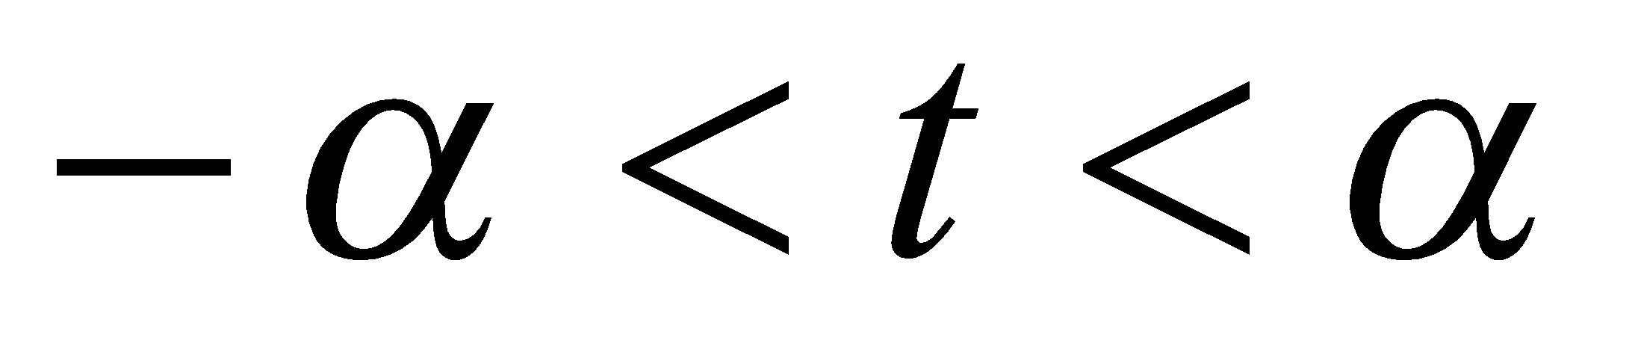) and Y_{(t)}, if T discrete 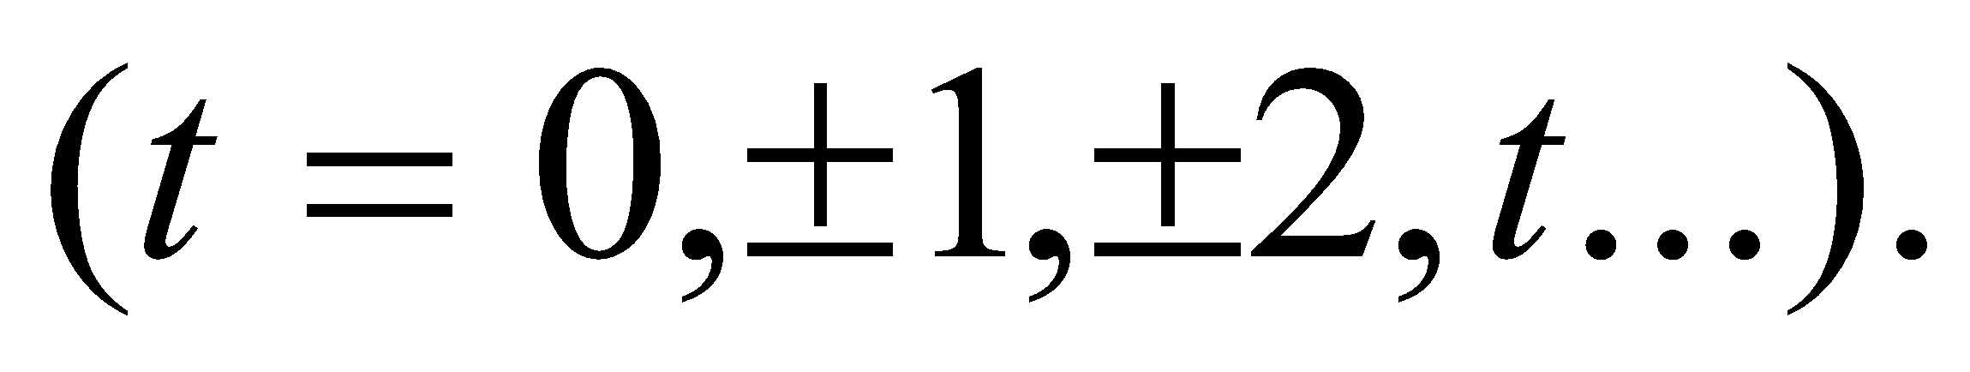
Thus Time Series Analysis is Sub -Class of Stochastic Process. Stochastic Process is to specify the Joint Probability Distribution of Y_{(t)}…… Y_{tn} for any Set of Time t₁, t₂….. t_{n} value of n.

3.4 Accuracy Measure
MAPE: Mean Absolute Percentage Error. This measures the accuracy of fitted time series values. It expresses accuracy as a percentage.
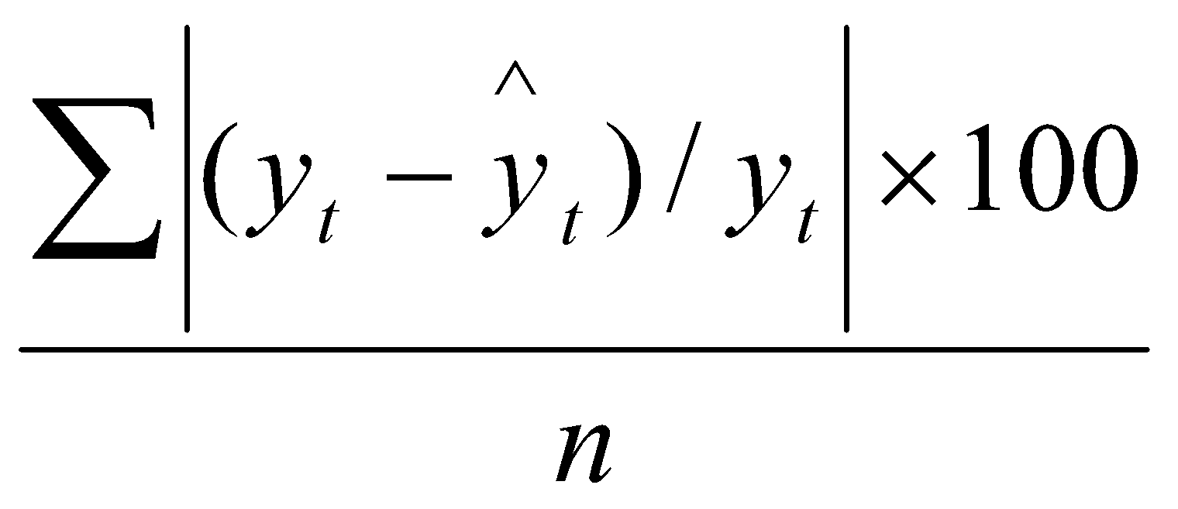
where 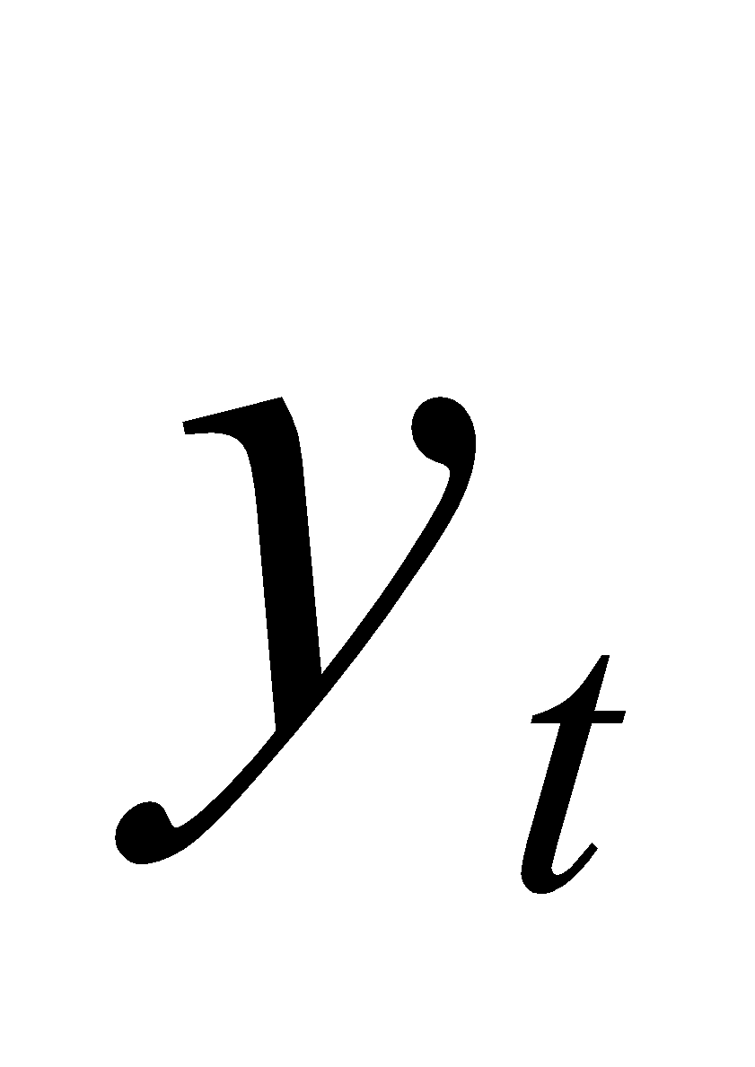= Actual Value, 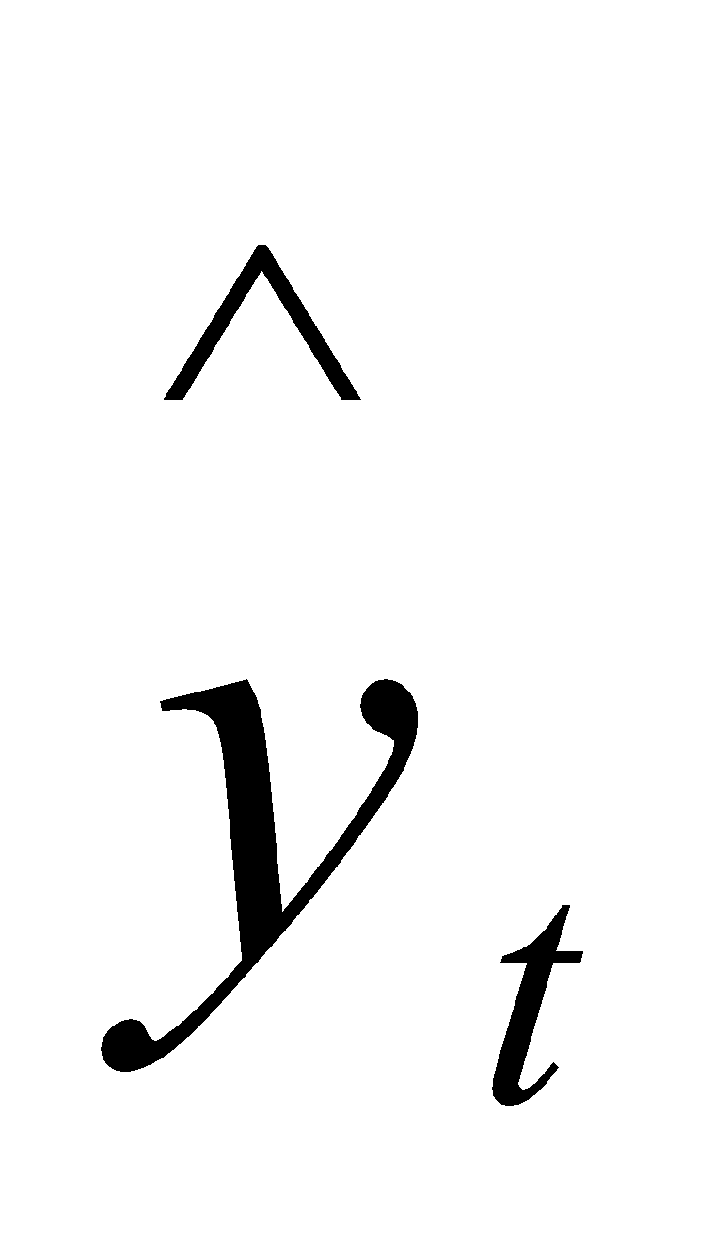= Fitted Value and n = number of observations.
MAD: Mean Absolute Deviation. This measures the accuracy of fitted time series values. It expresses accuracy in the same units as the data, which helps conceptualize the amount of error.
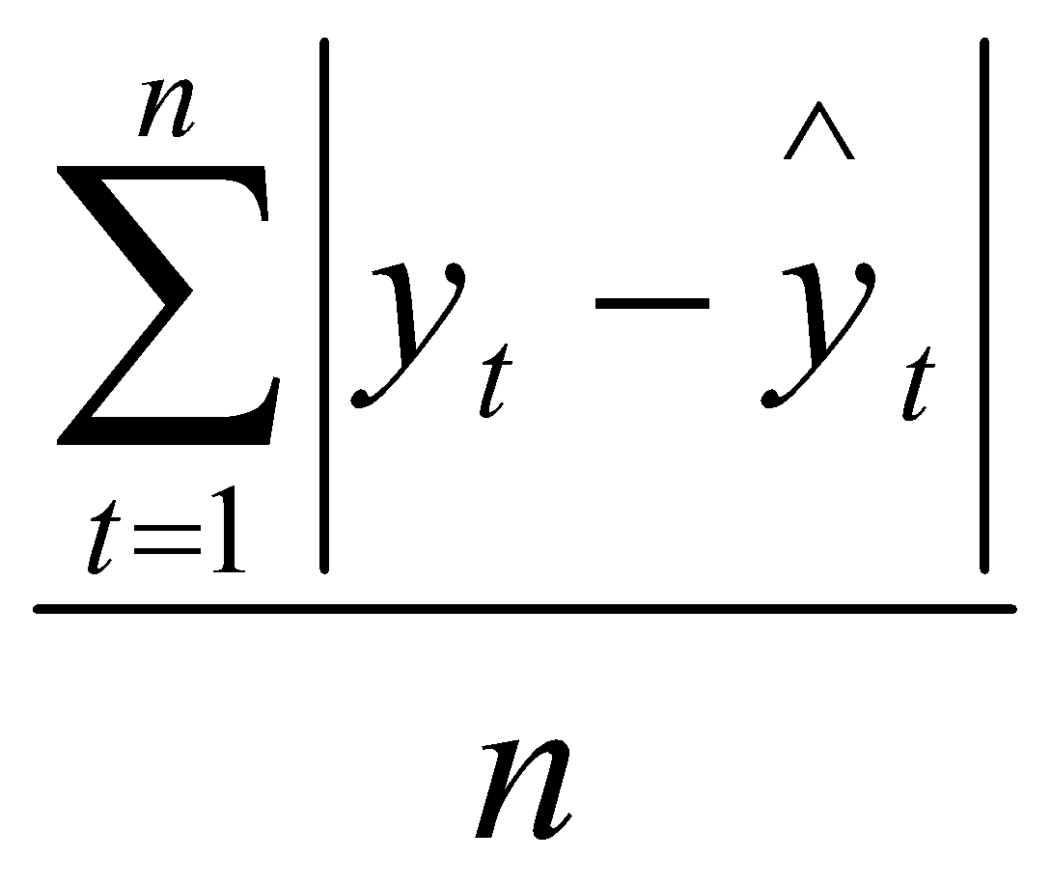 where = Actual Value, = Fitted Value and n = number of observations.
MSD: Mean Squared Deviation. MSD is always computed using the same denominator, n, regardless of the model, so we can compare MSD values across models. MSD is a more sensitive measure of an unusually large forecast error than MAD.
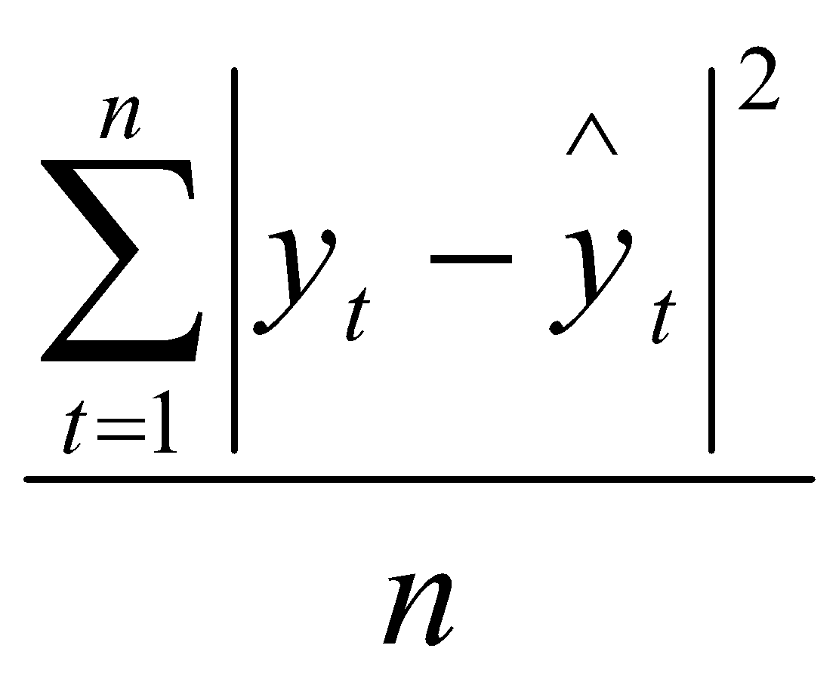

3.4.1 ARIMA Modeling

Autocorrelation Function (ACF) and Partial Autocorrelation Function (PACF)
Autocorrelation Function (ACF) and Partial Autocorrelation Function (PACF) of a Stationary Series are collected over Time. The procedure usually serve as a prelude to selecting Series of Models that are subjected to Statistical Test to confirmation as the best and Optimal Model for a particular case. The Methodology emphasized the use of some vital Statistical Approach such as determination of the Model order, Parameter Estimation as well as Model Testing and Forecast .behavior of ACF and PACF provide a suggestion of where the Model can build from and corresponding Model Order. While use of ACF and PACF to determine Model Order is because both give sight information about the behavior of the Time Series. It is paramount and necessary requirement if a giving Series is Cyclical, Irregular, Seasonal /Secular or process any of the two attributes must be Stationary (Box and Jenkins 1970). When the Series is Stationary the Order of the Model that is the coefficients number can be determined.

3.4.2 Autoregressive (AR) Model
Autoregressive Model are based on the idea that the current value of the Series, x_{t} can be explained as a function of p Pass value 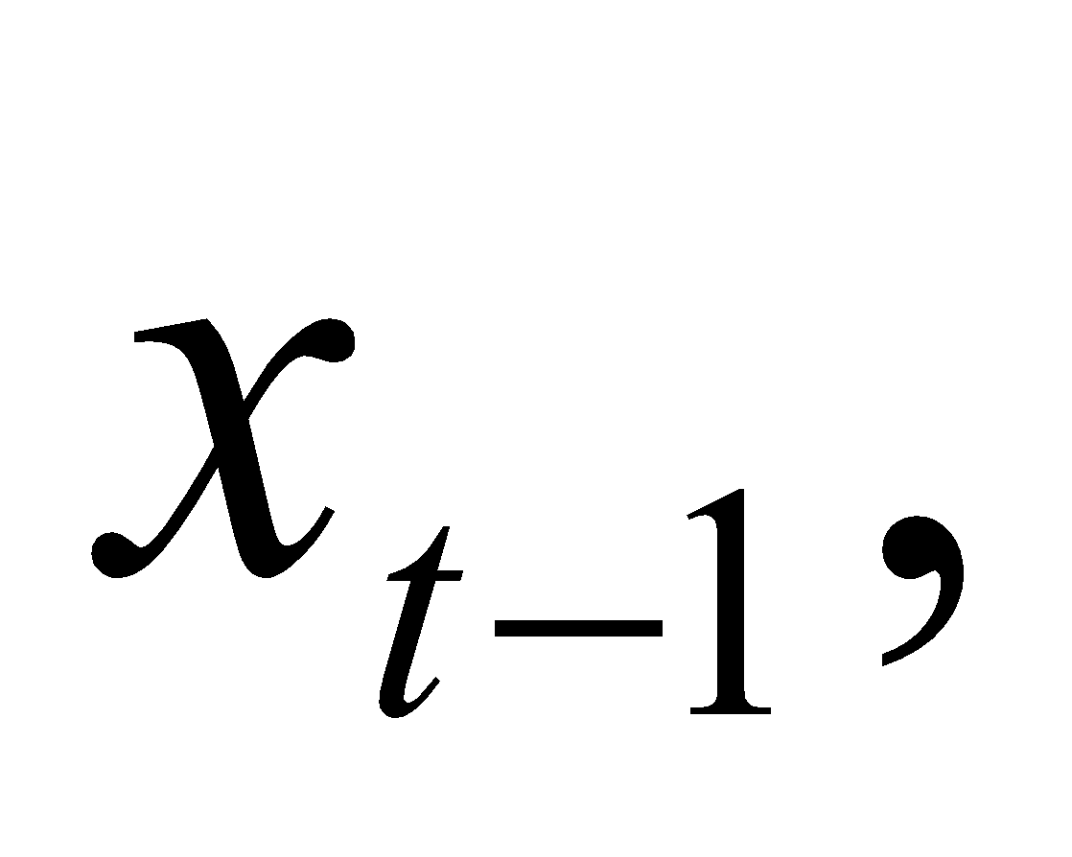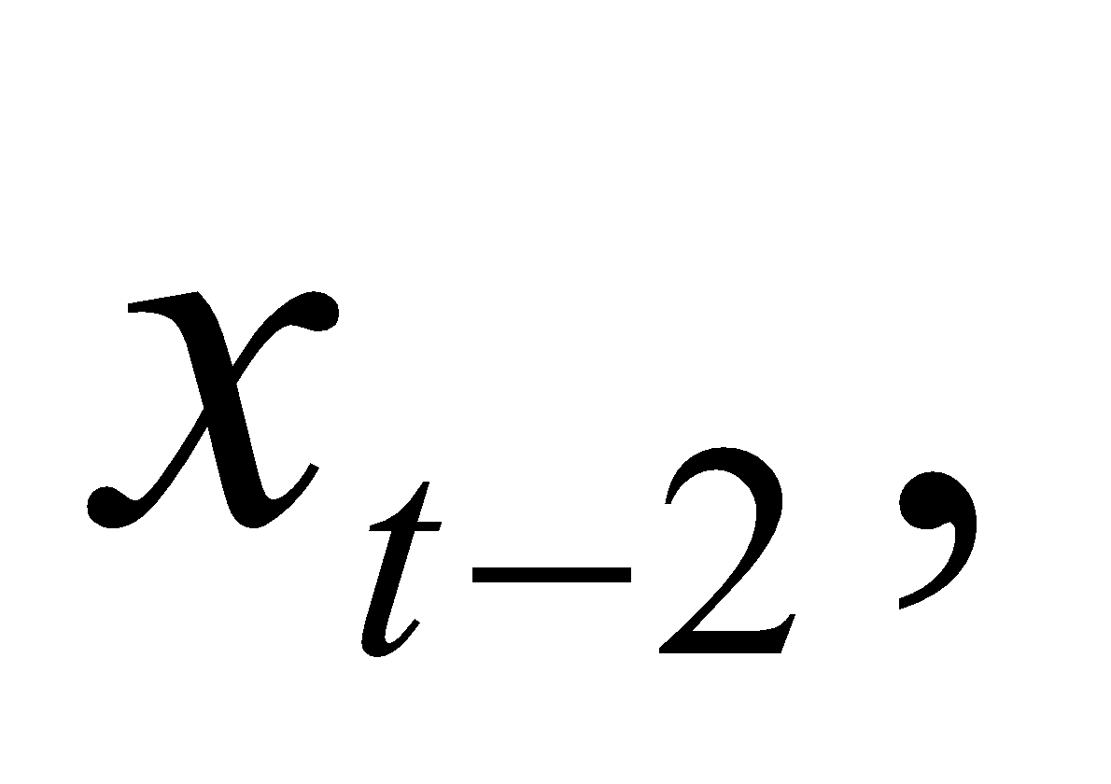…. 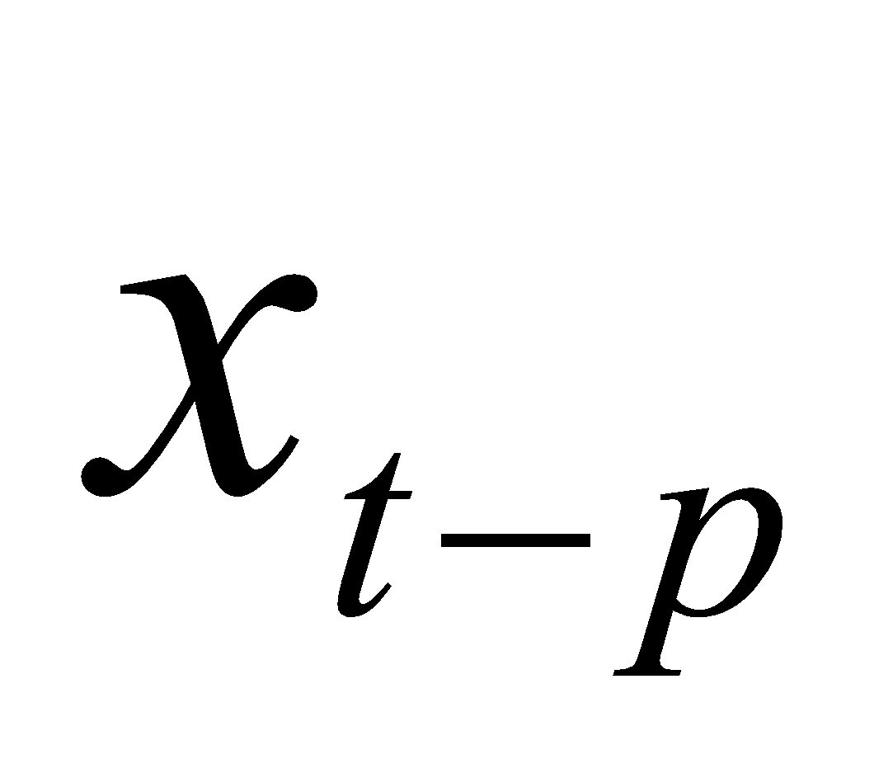
where p determines the number of steps into the Pass needed to Forecast the Current Value.
An autoregressive Model of Order p, abbreviated as AR (p) can be written as;
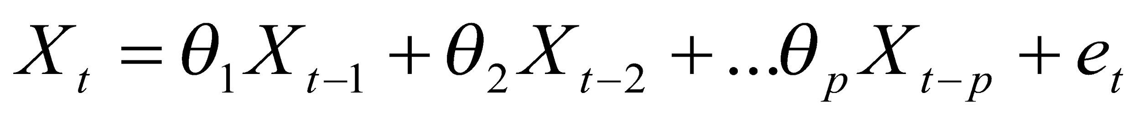 … (1)
where 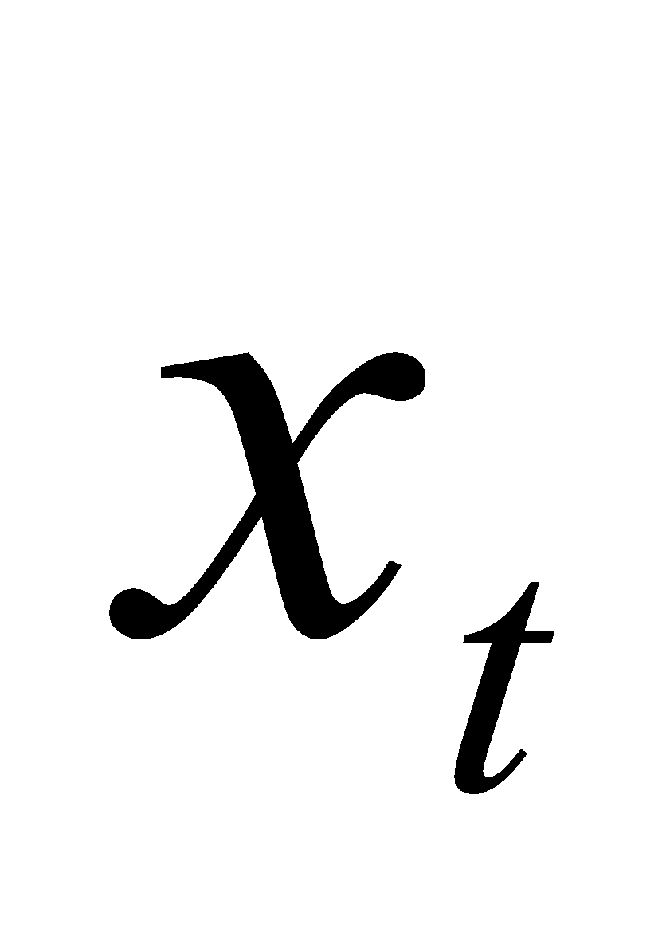 represent the Time Series Data at point t, 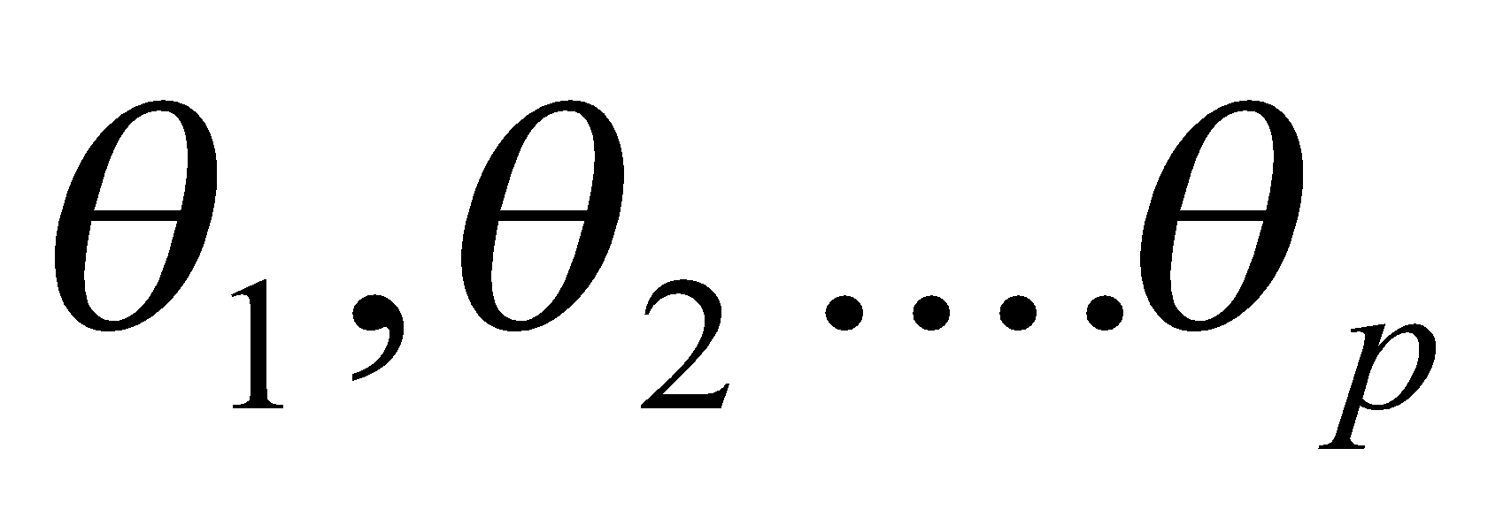 are the Parameters of the AR Model and 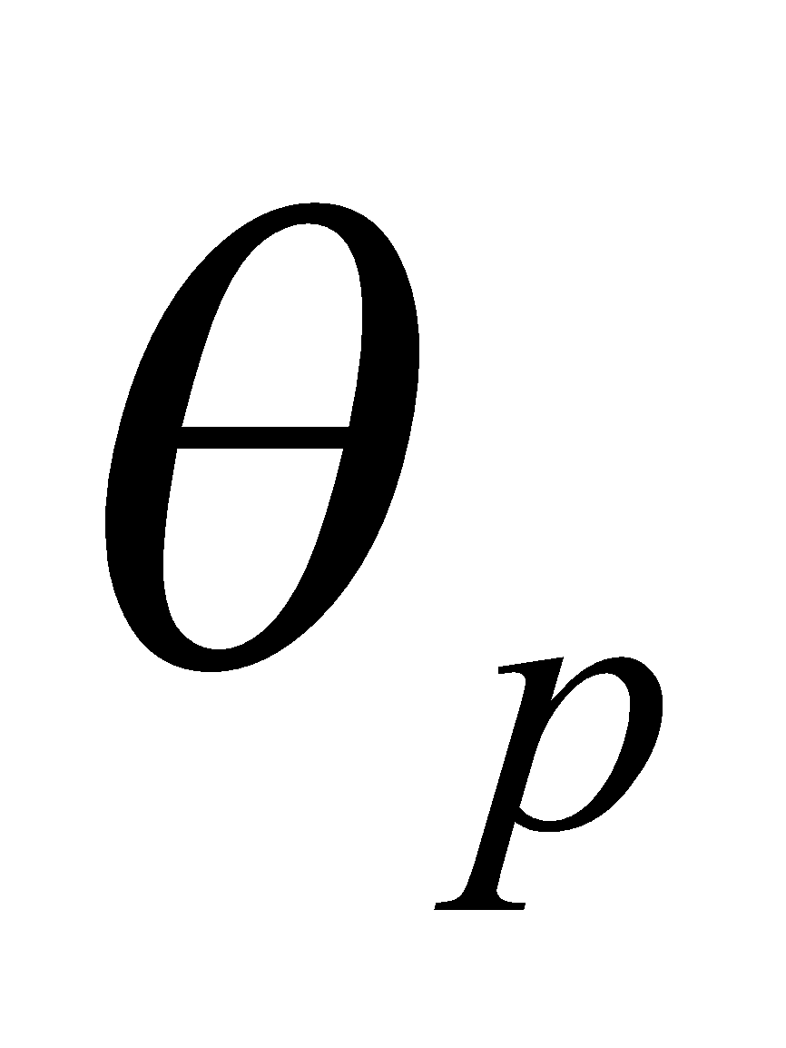= 0 unless otherwise stated.
The letter p denotes the Order of Autoregressive Model, defining how many previous values the current value is related to. The Model is called Autoregressive because the Series is Regressed on to past values of itself.
The Error Term {e_{t}} in Equation (1) refers to the Noise in the Time Series. Above, the Errors were said to be iid. Commonly, they are also assumed to have a Normal Distribution with Mean Zero and Variance 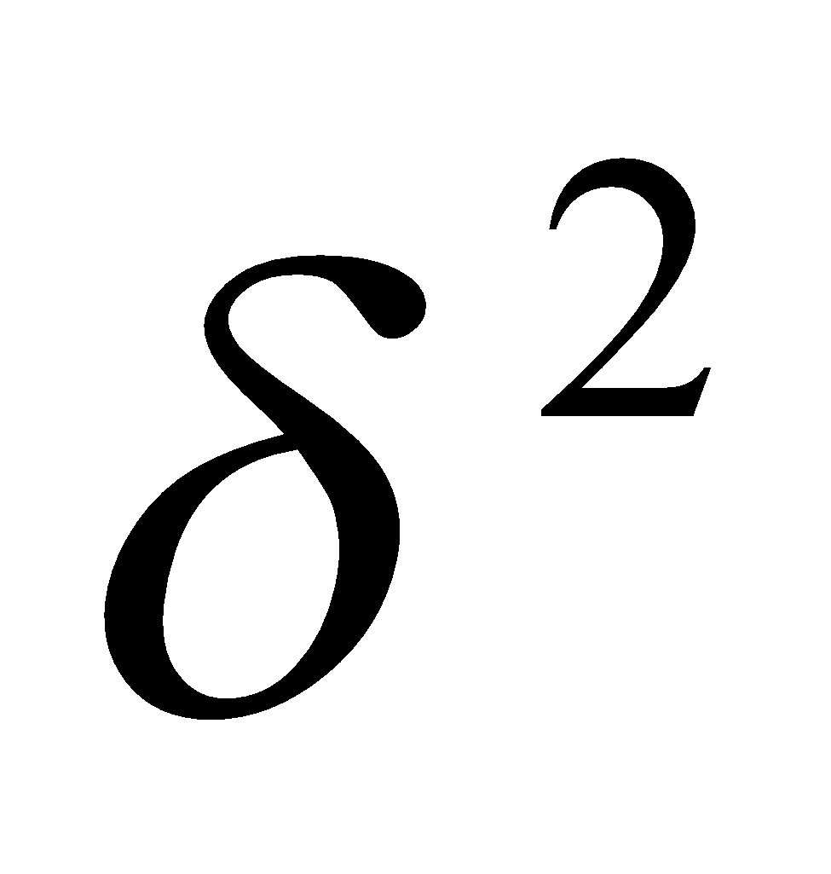.written as (NID 0,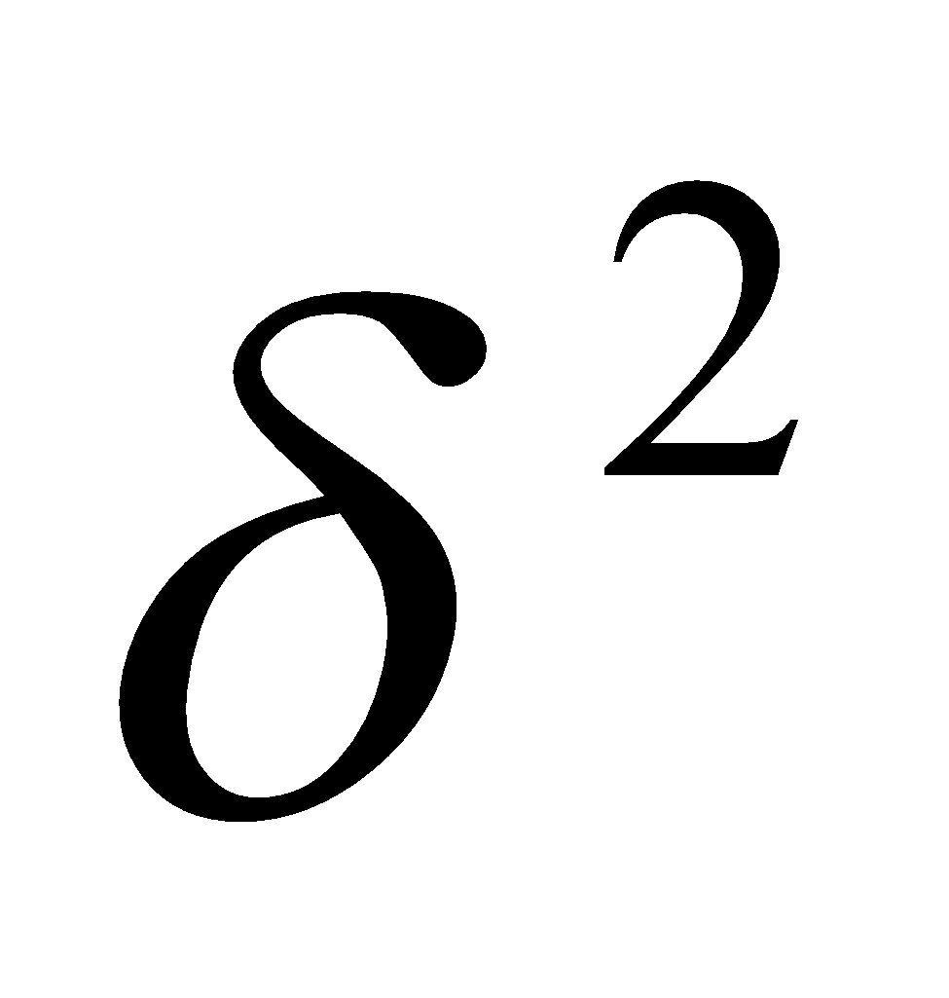). The highest Order p is referred to as the order of the Model. By introducing the Log Operator (back shift) B in equation (1) we obtain;
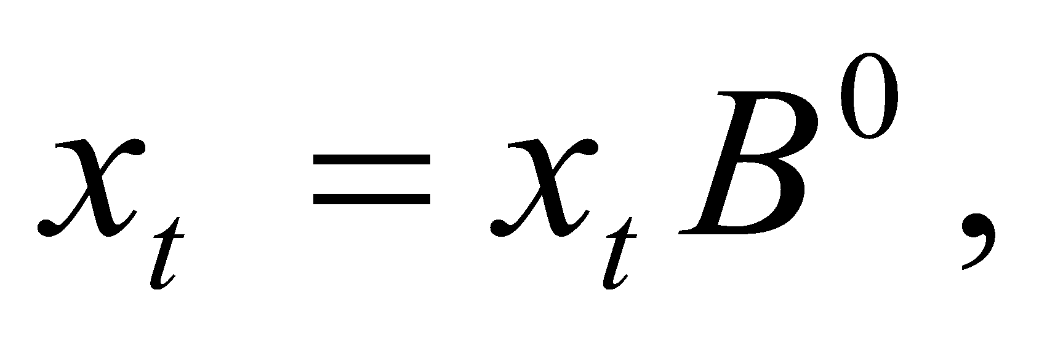
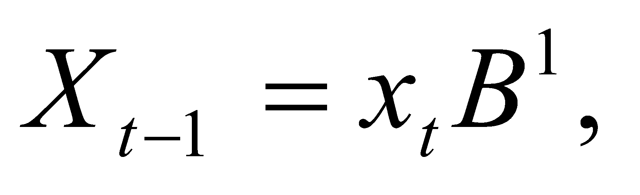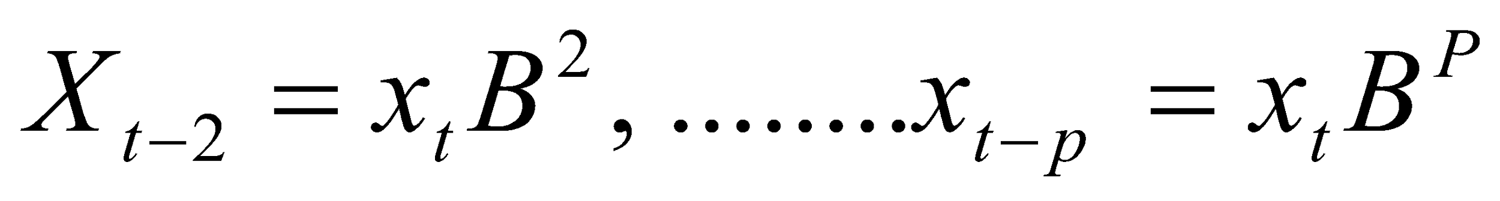
From the characteristics Polynomial of Order p, the Model in Lag Operators takes the following form
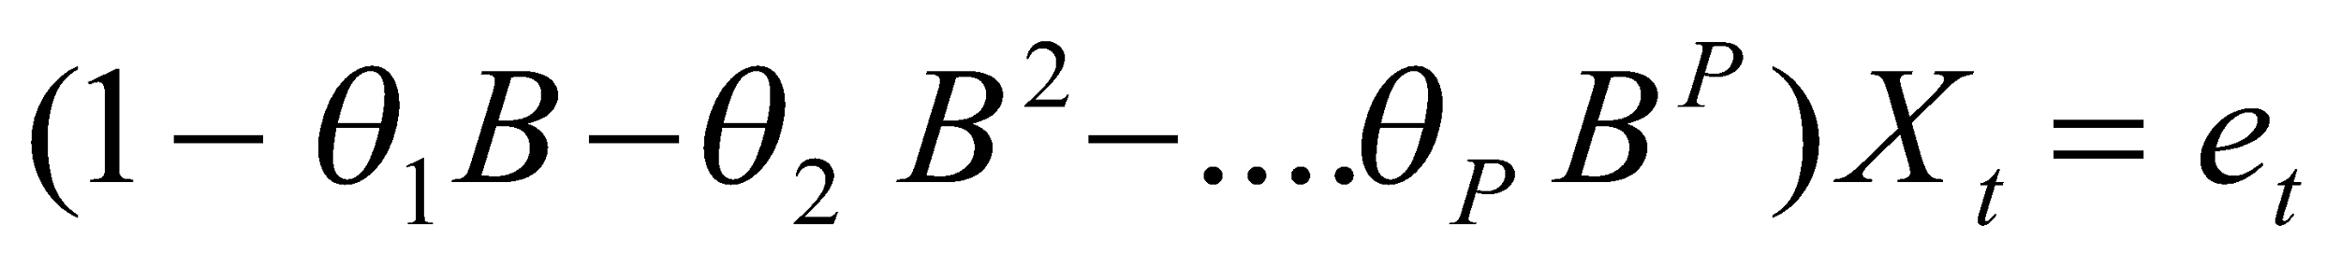 …(2)
The Autoregressive Operator 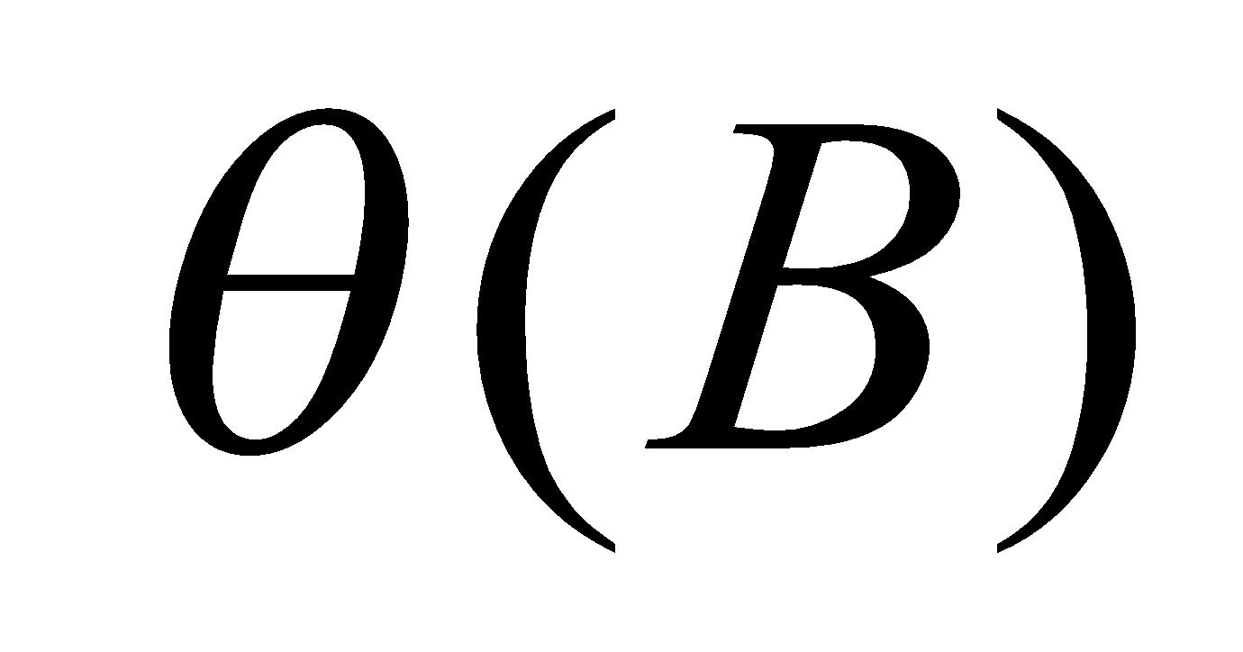 is defined to be
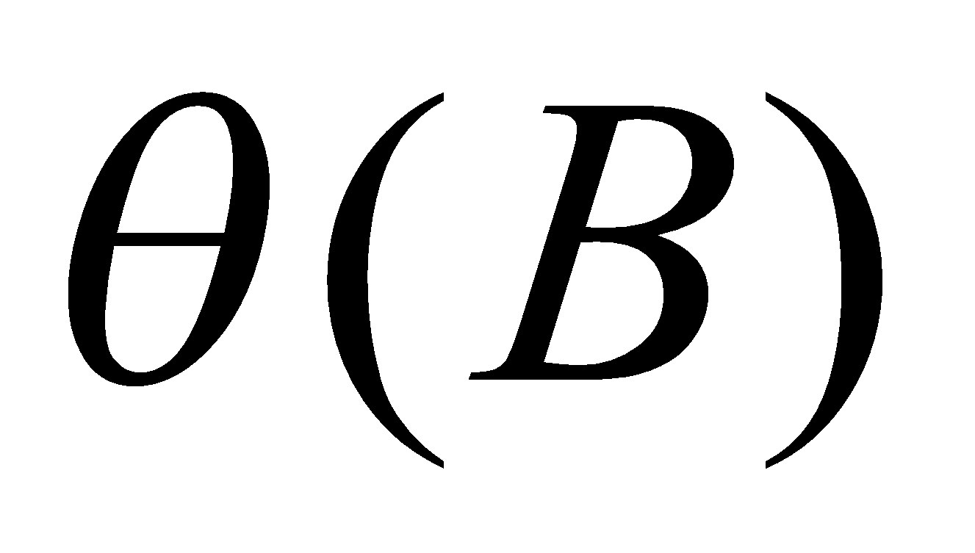 = 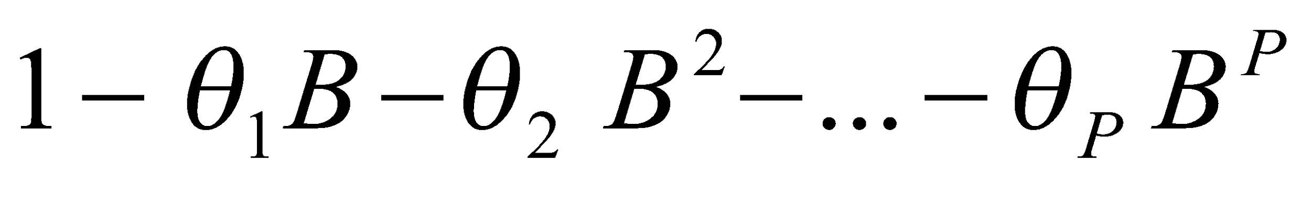 …(3)
More concise the AR Model can be expressed as;
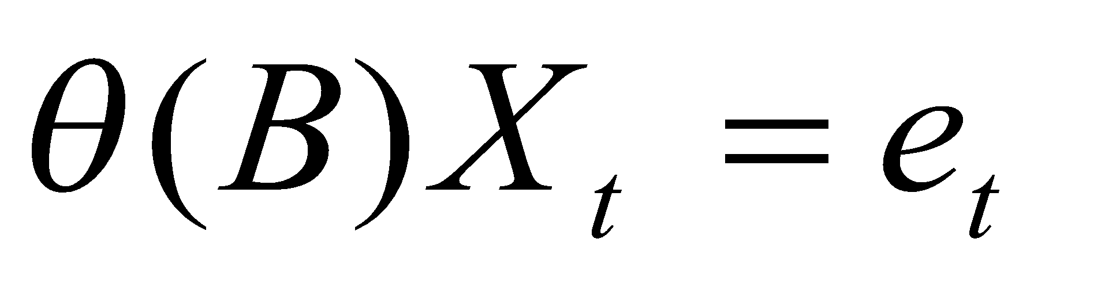 …(4)
The Mean of AR (2) Model can be computed as follows (bear in mind that the Model is Stationary)
Due to Stationary condition
Mean = 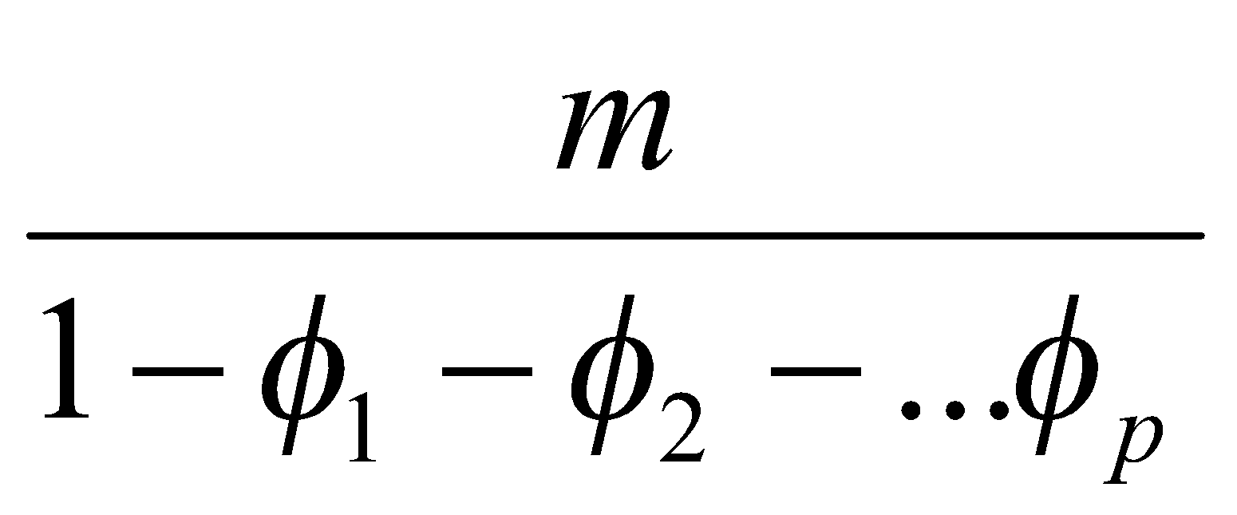
and Variance is defined as
Variance = 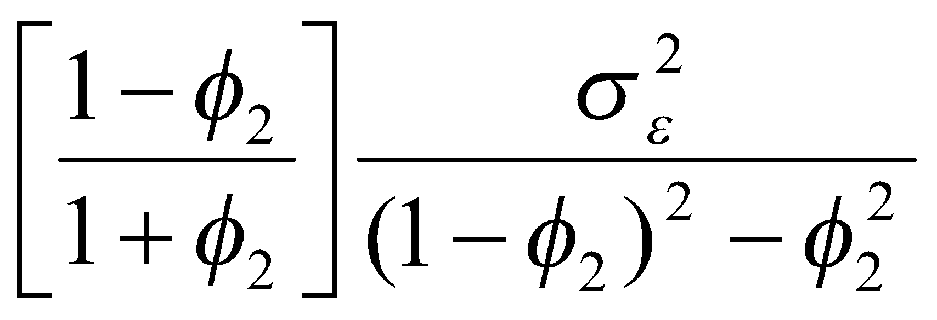

3.4.3 Moving Average (MA) Model
A Moving Average Model an alternative to the Autoregressive representation in which the
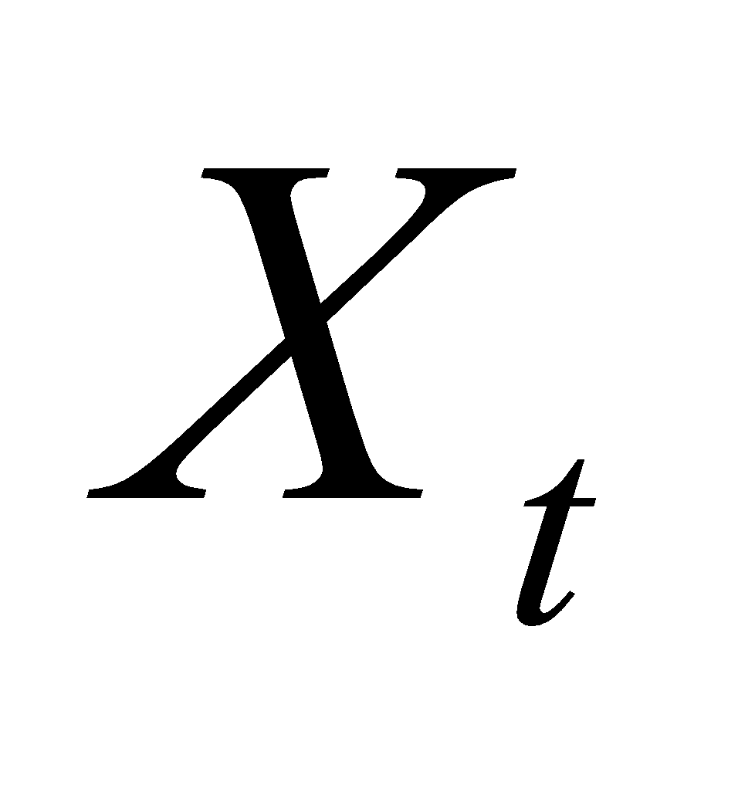on the left-hand side of the equation are assumed to be combined Linearly, the Moving Average Model of Order q, abbreviated as MA (q) assumes the White Noise (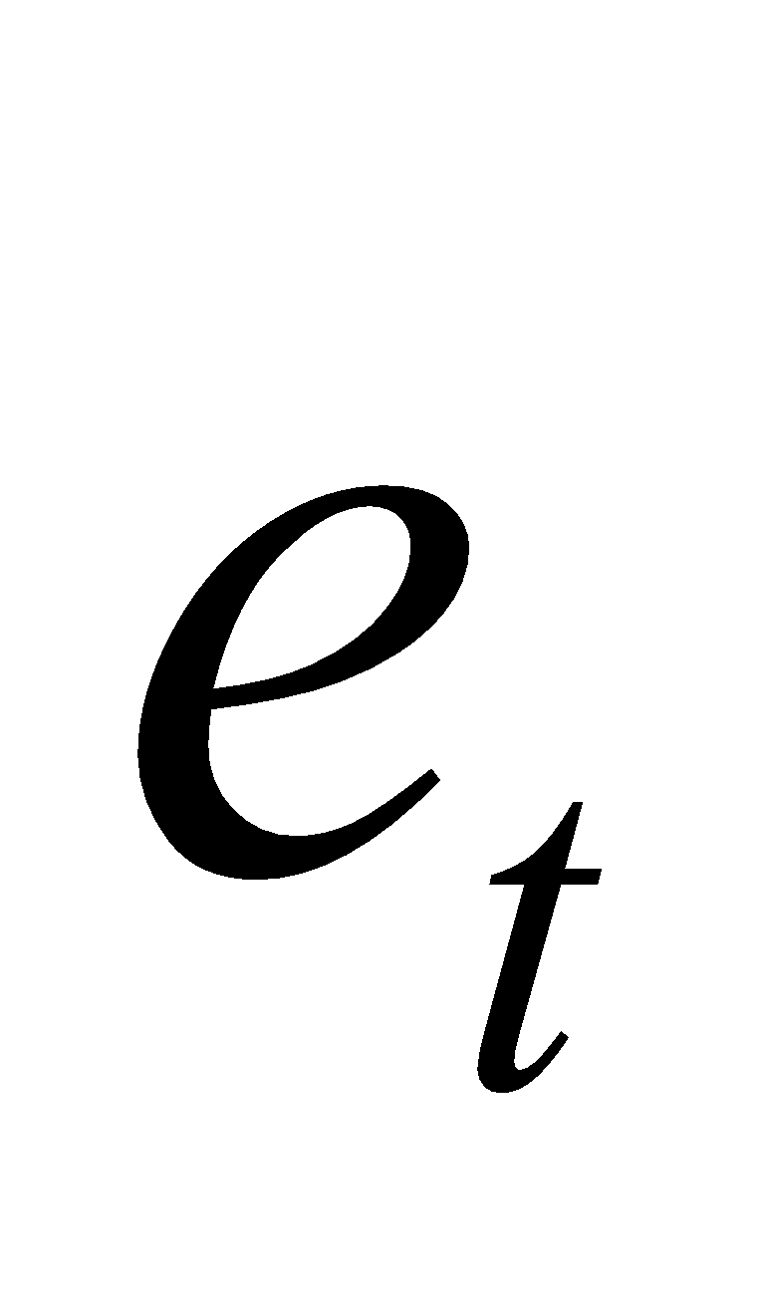) on the right –hand side of the defining equation are combined Linearly to form the Observed Data .
A moving average model of order q, abbreviated as MA (q) can be written as; MA (q) can be written as;
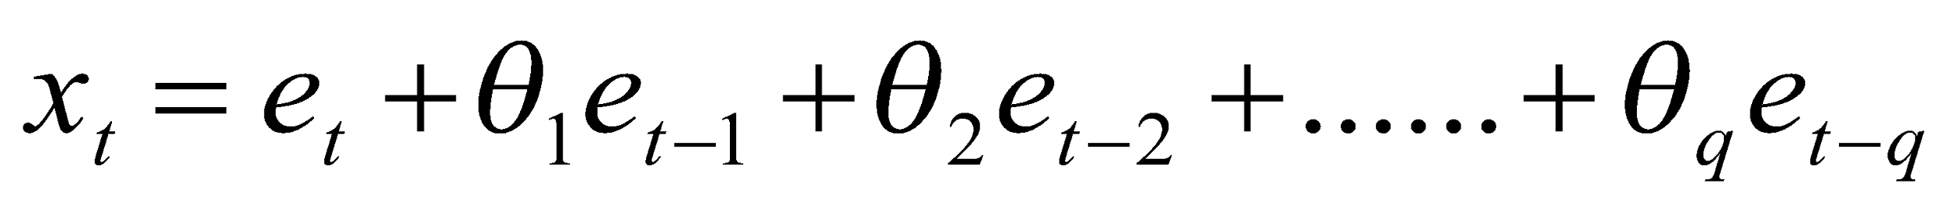 … (5)
Where 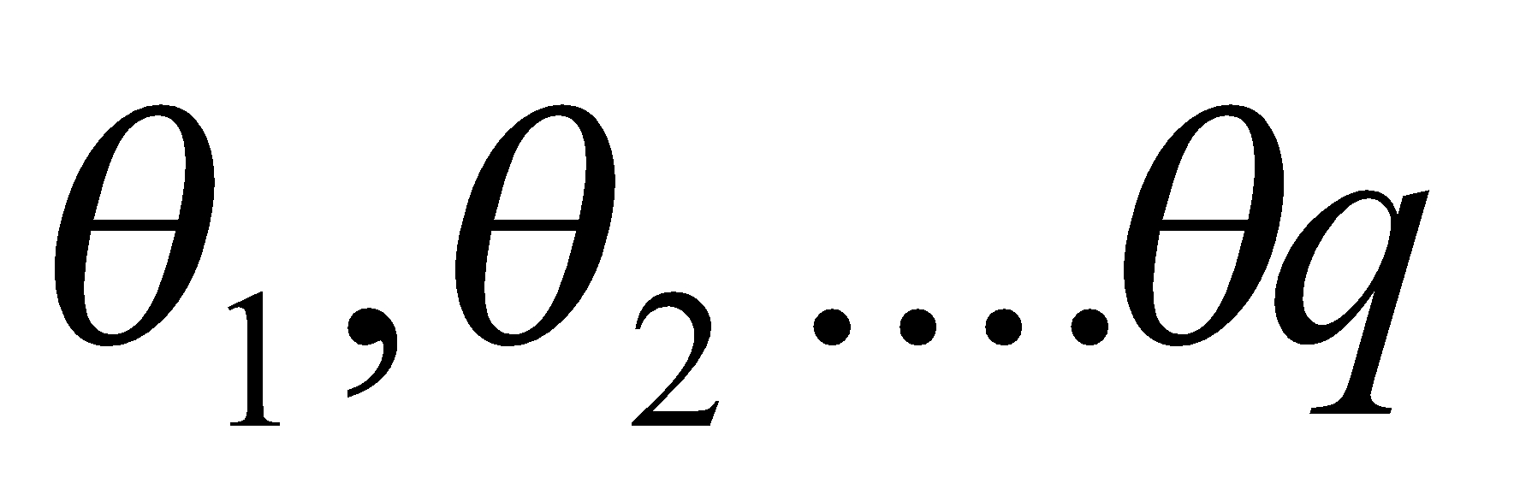are the Moving Average (MA) Parameters in the Model and 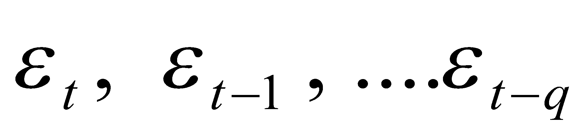 are the White Noise Error Terms 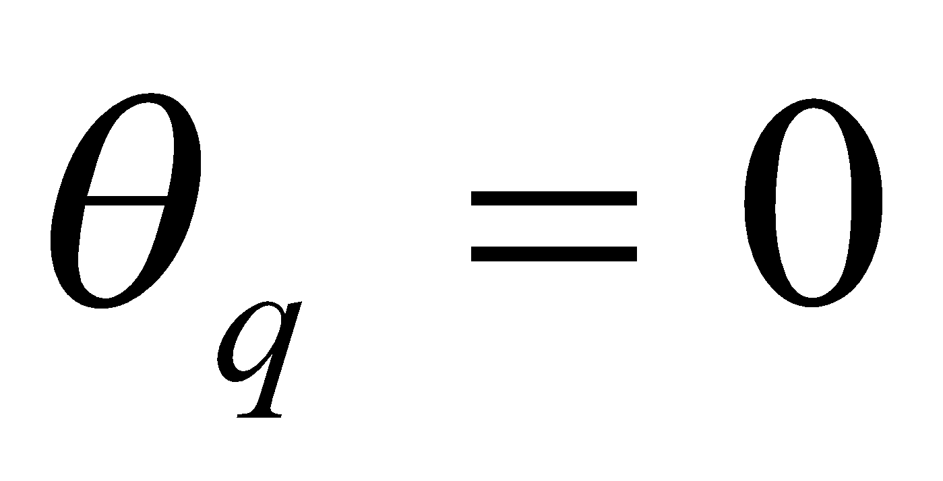 and 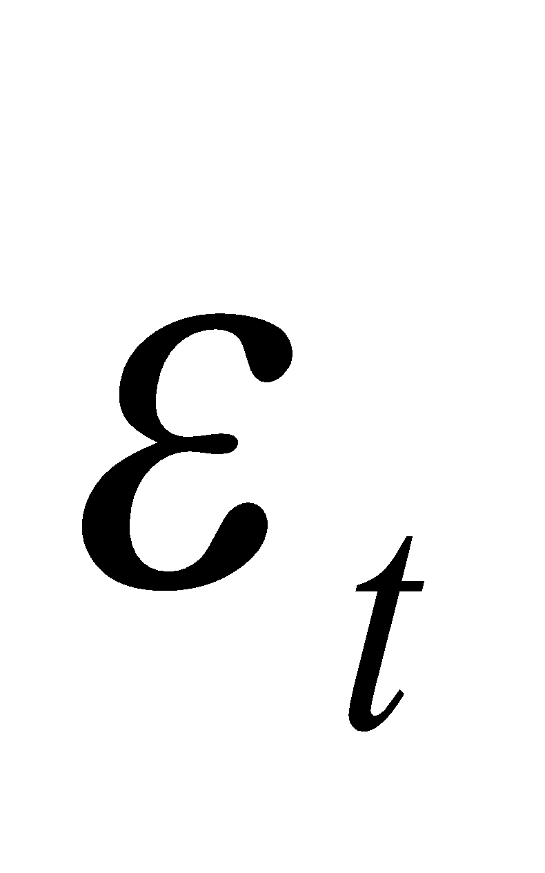 is a Gaussian White Noise Series, with Mean Zero and Variance 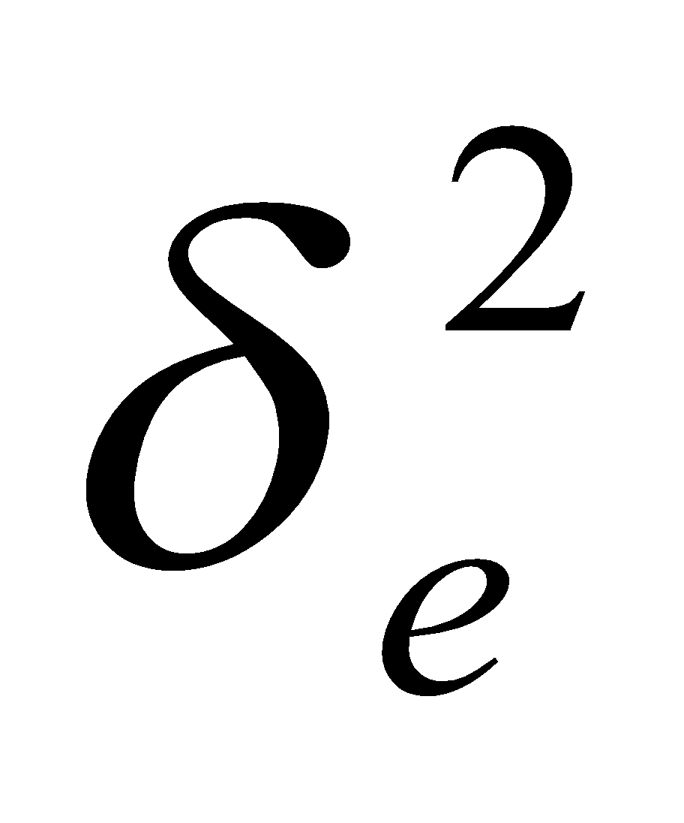unless otherwise stated. The Moving Average Model in lag operation is of form
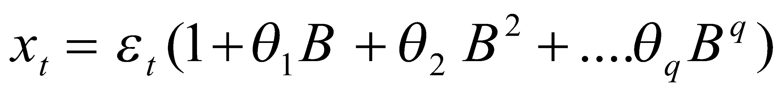 … (6)
The Moving Average operator 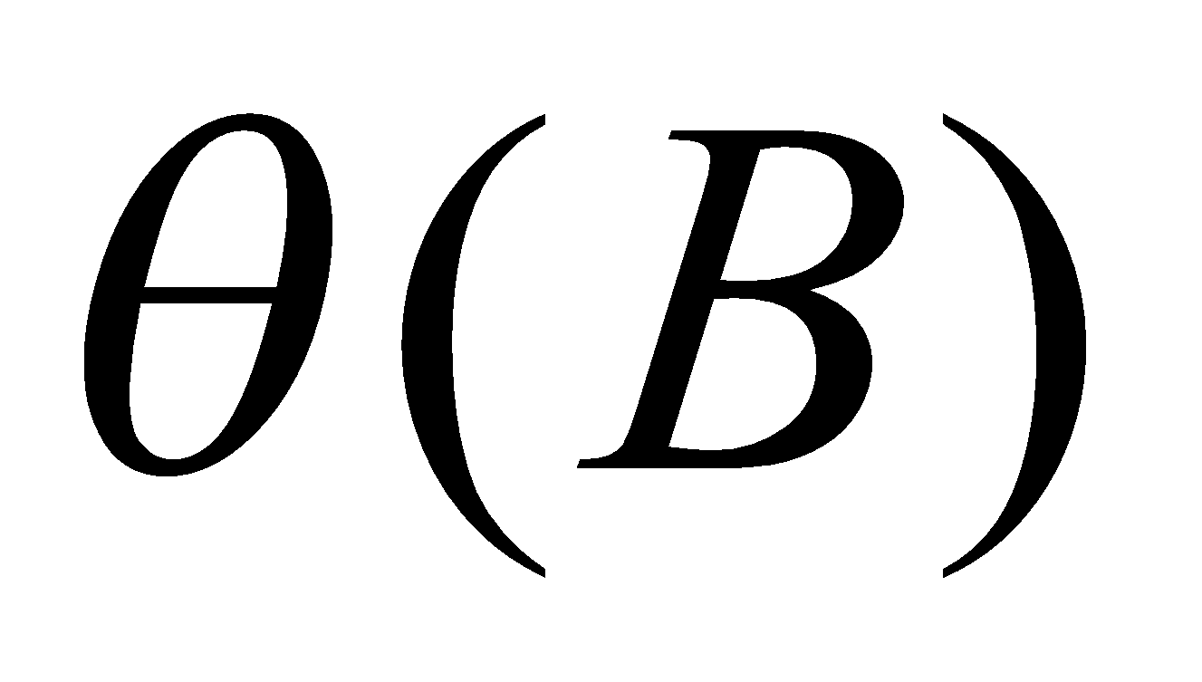is of form;
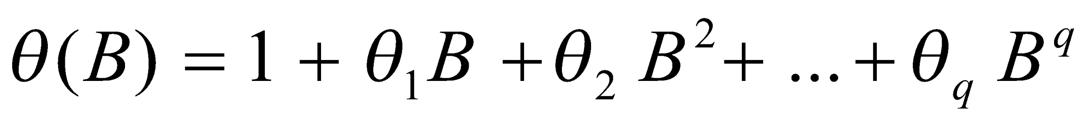 … (7)

3.4.4 Autoregressive Moving Average (ARMA) models
This is a process of maxing Autoregressive and Moving Average model to form an Autoregressive Moving Average (ARMA) models for stationary time series. A general ARMA (p,q) model can be written as follows;

3.4.5 Autoregressive Integrated Moving Average (ARIMA) models
Autoregressive Integrated Moving Average (ARIMA) Models are an extension to the class of ARMA Models by adding the possibility to integrate a Non-Stationary Process to a Stationary. ARIMA (p,d,q) Models are Univariate Time Series Models that consist of an Autoregressive Parameter (p), an Order of Integration (d) and Moving Average (q).
A process (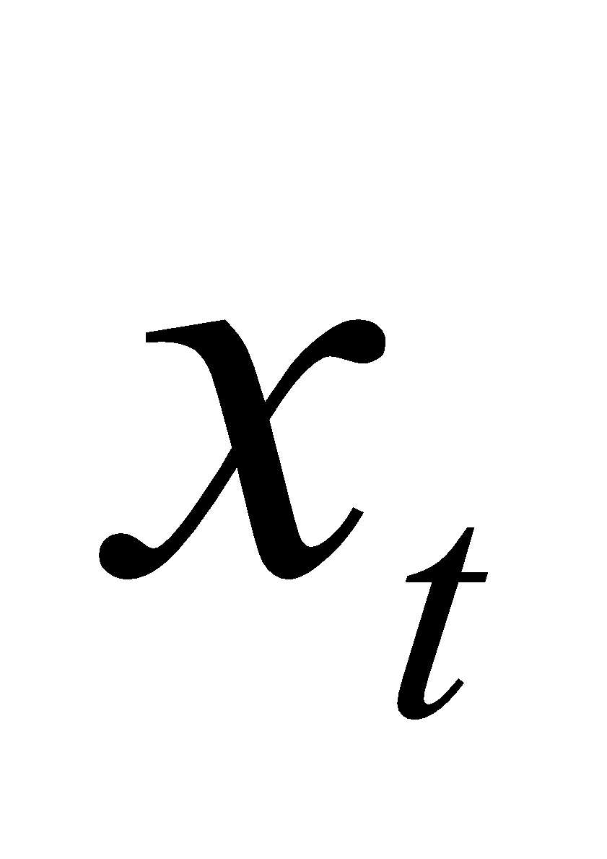) is said to be an Autoregressive Integrated Moving Average (ARIMA) Process if 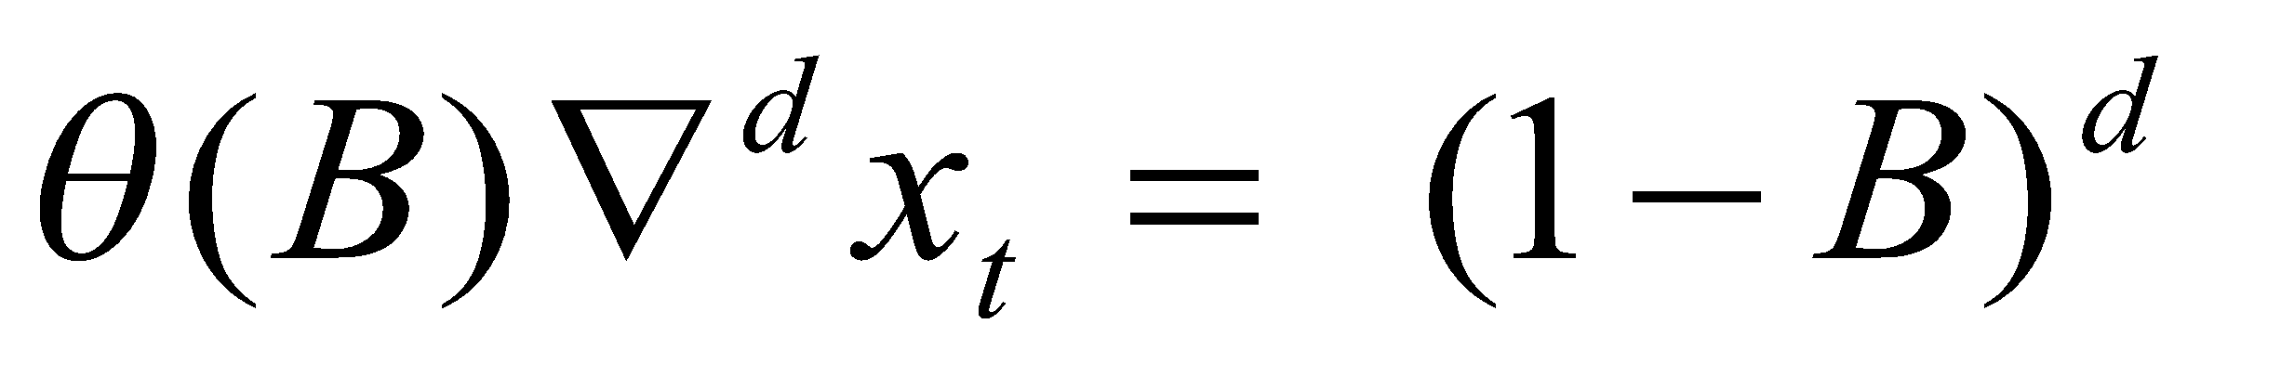is the Non- Seasonal Differencing Operator of Order d. to produce Non-Seasonal Stationary of the d^{th} Difference. Usually d = 1 or 2.

3.5 Signal and Noise
The observed and recorded Time Series, say {X_{n}}, consists of two components:
1. The signal. This is the component of the Data that contains information, Say {S_{n}} this is the component of the Time Series that can be forecasted.
2. The Noise. This is the Randomness that is observed, which may be due to numerous other Variables affecting the Signal, Measurement imperfections, etc. Because the Noise is Random, it cannot be forecasted.

3.6 Model Selection Criteria
When fitting Models, there is the tendency of two or more Models competing and for that reason it is appropriate to use good Model selection criteria to select the most adequate Model. In this Study, the Akaike Information Criterion (AIC) and the Bayesian Information Criterion (BIC) were the measures of goodness of ﬁt that were employed to select the most adequate Model. For a given Data Set, several competing Models may be ranked according to their AIC, or BIC values with the one having the lowest information criterion value being the best.
In general the AIC, and BIC are given by;
AIC = 2k+nlog (RSS/n)
BIC = log ($δ_{e}^{2}$) +k/n xlog (n)
where
k is the number of Parameters in the Statistical Model,
RSS is the Residual Sum of Squares of the Estimated Model,
n is the number of observations in the data, $δ_{e}^{2}$ is the error variance.
3.7 Software Package Used
Gretl and Minitab software package would be used in this project work to achieve our pre-selected aim and objectives.

CHAPTER FOUR
DATA PRESENTATION
Table 1: Data on Monthly Consumption of Electricity in Ilorin Metropolis between 2004-2024
Years/Months | Jan | Feb | Mar | Apr | May | Jun | July | Aug | Sept | Oct | Nov | Dec
2004 | 28.24847 | 27.45631 | 24.93659 | 24.38119 | 24.79019 | 22.08178 | 22.94519 | 24.87314 | 23.76159 | 22.41509 | 24.80025 | 25.10589
2005 | 27.45218 | 26.68053 | 24.23034 | 23.68904 | 24.08476 | 21.45193 | 22.28915 | 24.16028 | 23.07896 | 21.7696 | 24.08434 | 24.37942
2006 | 26.65589 | 25.90475 | 23.52409 | 22.99688 | 23.37933 | 20.82207 | 21.63311 | 23.44742 | 22.39632 | 21.1241 | 23.36844 | 23.65294
2007 | 25.85961 | 25.12897 | 22.81785 | 22.30473 | 22.6739 | 20.19222 | 20.97707 | 22.73455 | 21.71368 | 20.4786 | 22.65254 | 22.92647
2008 | 25.06332 | 24.35319 | 22.1116 | 21.61258 | 21.96847 | 19.56236 | 20.32102 | 22.02169 | 21.03104 | 19.8331 | 21.93663 | 22.19999
2009 | 24.26703 | 23.57741 | 21.40535 | 20.92043 | 21.26303 | 18.93251 | 19.66498 | 21.30883 | 20.34841 | 19.1876 | 21.22073 | 21.47352
2010 | 23.47074 | 22.80163 | 20.6991 | 20.22828 | 20.5576 | 18.30265 | 19.00894 | 20.59596 | 19.66577 | 18.5421 | 20.50482 | 20.74704
2011 | 22.67446 | 22.02585 | 19.99285 | 19.53612 | 19.85217 | 17.6728 | 18.3529 | 19.8831 | 18.98313 | 17.8966 | 19.78892 | 20.02057
2012 | 21.87817 | 21.25007 | 19.2866 | 18.84397 | 19.14674 | 17.04294 | 17.69686 | 19.17023 | 18.3005 | 17.2511 | 19.07302 | 19.2941
2013 | 21.08188 | 20.47429 | 18.58036 | 18.15182 | 18.44131 | 16.41309 | 17.04082 | 18.45737 | 17.61786 | 16.6056 | 18.35711 | 18.56762
2014 | 20.28559 | 19.69851 | 17.87411 | 17.45967 | 17.73587 | 15.78323 | 16.38477 | 17.74451 | 16.93522 | 15.9601 | 17.64121 | 17.84115
2015 | 19.4893 | 18.92273 | 17.16786 | 16.76752 | 17.03044 | 15.15338 | 15.72873 | 17.03164 | 16.25259 | 15.3146 | 16.9253 | 17.11467
2016 | 13.3546 | 17.2077 | 15.8898 | 15.0132 | 15.5949 | 15.8968 | 13.4512 | 16.4865 | 15.7535 | 17.6713 | 15.8532 | 16.7532
2017 | 15.4939 | 14.4939 | 17.1422 | 16.9812 | 17.3546 | 18.0132 | 18.6411 | 17.2641 | 15.8491 | 16.3546 | 18.974 | 16.997
2018 | 13.4809 | 16.1422 | 11.6547 | 13.7072 | 16.184 | 10.4126 | 10.7491 | 12.997 | 16.0132 | 12.8082 | 13.0593 | 12.4944
2019 | 17.8217 | 16.0536 | 11.2551 | 12.4944 | 11.974 | 12.178 | 16.1422 | 13.0593 | 9.24135 | 9.35455 | 16.1422 | 11.997
2020 | 15.3546 | 14.8077 | 14.3598 | 16.0132 | 14.4939 | 14.7987 | 14.9812 | 15.4865 | 15.7535 | 13.6713 | 14.6432 | 16.0536
2021 | 16.184 | 16.0031 | 16.1422 | 12.178 | 9.24135 | 9.64108 | 10.3811 | 9.96406 | 10 | 9.35455 | 11.974 | 11.997
2022 | 13.4809 | 12.8082 | 11.6547 | 13.7072 | 13.0621 | 10.4126 | 9.12867 | 11.2551 | 10.7491 | 11.7964 | 12.4944 | 13.0593
2023 | 13.0531 | 12.6523 | 11.4594 | 11.173 | 11.3286 | 10.0624 | 10.4261 | 11.2697 | 10.7349 | 10.0972 | 11.1387 | 11.2427

4.1 Analysis on Least square
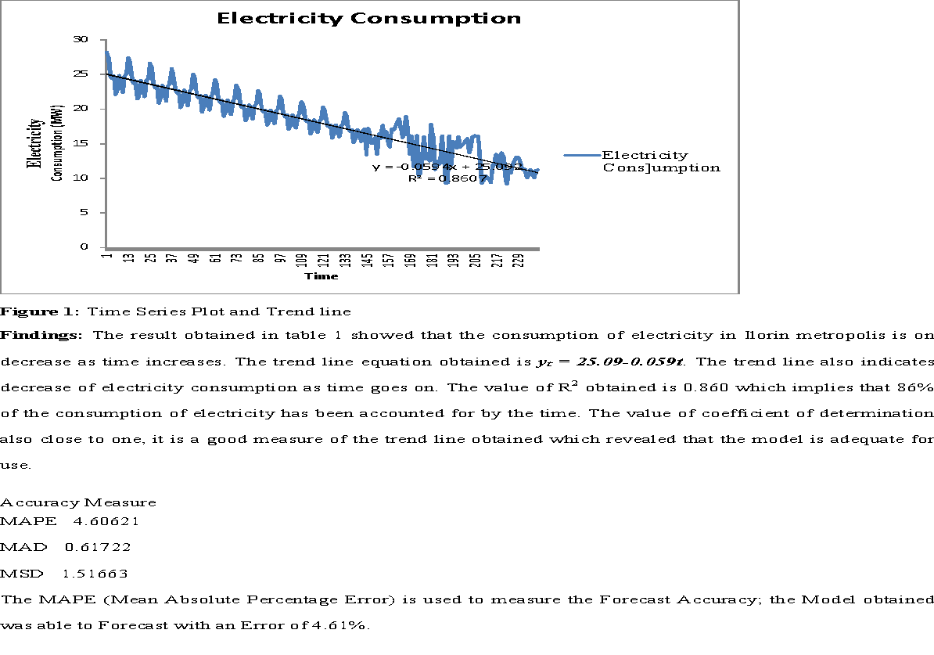
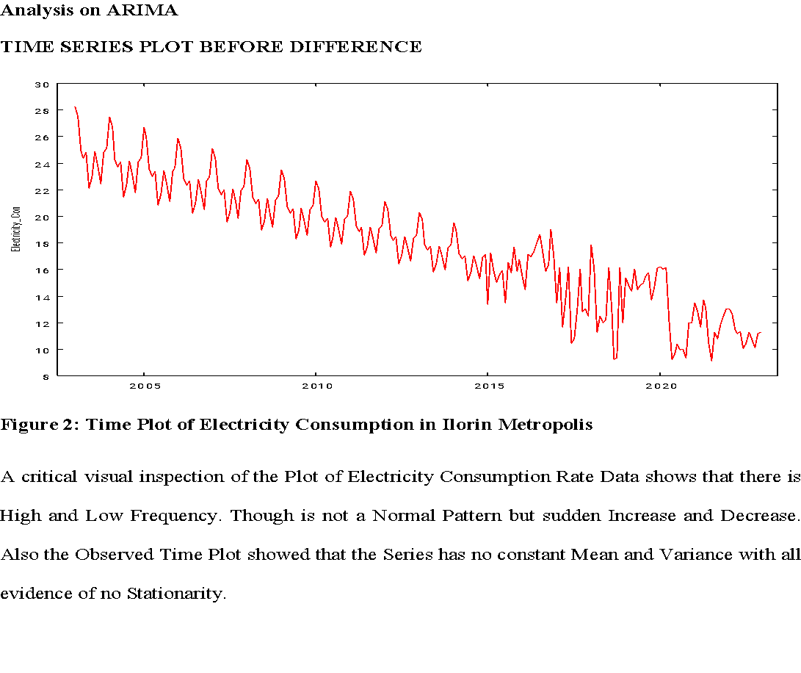Table 2: Results of ARIMA Model Identification for Electricity Consumption Rate Data in Ilorin Metropolis
MODEL | A I C | S IC | H QC
ARIMA (0, 1, 1) | 922.3759 | 932.8035 | 926.5787
ARIMA (0, 1, 2) | 878.1535 | 892.0598 | 883.7572
ARIMA (0, 1, 3) | 878.9580 | 896.3404 | 885.9626
ARIMA (1, 1, 0) | 936.9862 | 947.4156 | 941.1890
ARIMA (1, 1, 1) | 879.5979 | 893.5038 | 885.2016
ARIMA (1, 1, 2) | 878.4783 | 895.8606 | 885.4829
ARIMA (1, 1, 3) | 879.4752 | 900.3340 | 887.8807
ARIMA (2, 1, 0) | 912.4123 | 926.3181 | 918.0159
ARIMA (2, 1, 1) | 880.1460 | 897.5283 | 887.1506
ARIMA (2, 1, 2) | 879.4905 | 900.3493 | 887.8960
ARIMA (2, 1, 3) | 880.8798 | 905.2151 | 890.6863
ARIMA (3, 1, 0) | 914.1242 | 931.5065 | 921.1288
ARIMA (3, 1, 1) | 879.0711 | 899.9299 | 887.4766
ARIMA (3, 1, 2) | 879.4899 | 903.8252 | 889.2964
From the table 3 above, we found that ARIMA (0, 1, 2) Model has the Least Values of all the Criterion considered, therefore we will make use of these Model for further Analysis.

4.2 Parameter Estimates of the Model
Table 3: Results of ARIMA (0, 1, 2) Model Estimation for the Electricity Consumption Data in Ilorin
Parameter | Coefficient | std. error | Z | p-value
Const  Theta_1  Theta_2 | -0.0595171  -0.524021  -0.475979 | 0.00202516  0.0532398  0.0523792 | -29.39  -9.843  -9.087 | 7.63-190***  7.37e-023***  1.02e-019***
Key (1% ***) (5 %**) (10 %*)
All the parameters are found to be Significant at all Level of Significance, 1%, 5% and 10% in table 4.

4.3 Forecast
The ability of good Fitted ARIMA Model is in its ability to forecast the time series data that is tested. This further testifies the Validity of the Model.
Table 4: Result of ARIMA (0, 1, 2) Forecast Value for Five Years
TIME | PREDICTION | STANDARD ERROR
2025:01 | 10.83393 | 1.47859
2025:02 | 10.70360 | 1.63753
2025:03 | 10.64408 | 1.63753
2025:04 | 10.58456 | 1.63753
2025:05 | 10.52505 | 1.63753
2025:06 | 10.46553 | 1.63753
2025:07 | 10.40601 | 1.63753
2025:08 | 10.34650 | 1.63753
2025:09 | 10.28698 | 1.63753
2025:10 | 10.22746 | 1.63753
2025:11 | 10.16794 | 1.63753
2025:12 | 10.10843 | 1.63753
2026:01 | 10.04891 | 1.63753
2026:02 | 9.98939 | 1.63753
2026:03 | 9.92988 | 1.63753
2026:04 | 9.87036 | 1.63753
2026:05 | 9.81084 | 1.63753
2026:06 | 9.75132 | 1.63753
2026:07 | 9.69181 | 1.63753
2026:08 | 9.63229 | 1.63753
2026:09 | 9.57277 | 1.63753
2026:10 | 9.51326 | 1.63753
2026:11 | 9.45374 | 1.63753
2026:12 | 9.39422 | 1.63753
2027:01 | 9.33471 | 1.63753
2027:02 | 9.27519 | 1.63753
2027:03 | 9.21567 | 1.63753
2027:04 | 9.15615 | 1.63753
2027:05 | 9.09664 | 1.63753
2027:06 | 9.03712 | 1.63753
2027:07 | 8.97760 | 1.63753
2027:08 | 8.91809 | 1.63753
2027:09 | 8.85857 | 1.63753
2027:10 | 8.79905 | 1.63753
2027:11 | 8.73953 | 1.63753
2027:12 | 8.68002 | 1.63753
2028:01 | 8.62050 | 1.63753
2028:02 | 8.56098 | 1.63753
2028:03 | 8.50147 | 1.63753
2028:04 | 8.44195 | 1.63753
2028:05 | 8.38243 | 1.63753
2028:06 | 8.32291 | 1.63753
2028:07 | 8.26340 | 1.63753
2028:08 | 8.20388 | 1.63753
2028:09 | 8.14436 | 1.63753
2028:10 | 8.08485 | 1.63753
2028:11 | 8.02533 | 1.63753
2028:12 | 7.96581 | 1.63753
2029:01 | 7.90629 | 1.63753
2029:02 | 7.84678 | 1.63753
2029:03 | 7.78726 | 1.63753
2029:04 | 7.72774 | 1.63753
2029:05 | 7.66823 | 1.63753
2029:06 | 7.60871 | 1.63753
2029:07 | 7.54919 | 1.63753
2029:08 | 7.48967 | 1.63753
2029:09 | 7.43016 | 1.63753
2029:10 | 7.37064 | 1.63753
2029:11 | 7.31112 | 1.63753
2029:12 | 7.25161 | 1.63753
Findings: The result from figure 4 showed that the actual data and forecast values till 2029 exhibits the same movement which further validates the adequacy of the ARIMA (0,1,2) model and the projected values showed that the future consumption of electricity is declining.

CHAPTER FIVE
SUMMARY, CONCLUSION RECOMMENDATIONS
5.1 Summary
This Project Work is aimed to carry out Time Series Analysis base on the Study of Monthly Consumption of Electricity in Ilorin Metropolis between the Years 2004 to 2024. The Study will not only help in building a Model but also help to Forecast for the monthly Consumption of Electricity in Ilorin Metropolis for five Years (2025-2029).The Data used for this Study was sourced from Electricity Business Hub, Challenge, Ilorin, Kwara State. The result of the Data collected was analyzed using Least Square Analysis and ARIMA Model.
The trend line equation obtained is y_{t} = 25.09-0.059t. The trend line also indicates decrease of electricity consumption as time goes on. The value of R² obtained is 0.860 which implies that 86% of the consumption of electricity has been accounted for by the time. The value of coefficient of determination also close to one, it is a good measure of the trend line obtained which revealed that the model is adequate for use.
The MAPE (Mean Absolute Percentage Error) is used to measure the Forecast accuracy, the Model obtained was able to Forecast with an Error of 4.61% which implies a good measure of accuracy.
The result obtained on the ARIMA Model after the Series have been Differenced once to achieve Stationarity based on the selected criterion shows that ARIMA (0, 1, 2) is the best Model. The Model was used to forecast for five years (2025-2029). The result obtained from the Forecast also shows that the Consumption of Electricity in Ilorin Metropolis is decreasing as time goes on.
5.2 Conclusion
Data on Monthly Consumption of Electricity in Ilorin Metropolis from Year 2004 to 2024 was collected from Electricity Business Hub, Challenge, Ilorin, Kwara State was studied using Least Square Analysis and ARIMA modeling. Based on the results obtained from the Methods of Analysis used, it was concluded that the monthly Electricity Consumption in Ilorin Metropolis would be decreasing as time goes on. The result of MAPE obtained on the Least Square Analysis is 4.61% which implies a good measure of accuracy. The result obtained on the ARIMA Model after the Series have been Differenced once to achieve Stationarity based on the selected criterion shows that ARIMA (0, 1, 2) is the best Model. The Model and Forecast obtained from both analyses can be used for future purpose based on accuracy measures conducted.

5.3 Recommendations
In the light of the findings of this Study, it is recommended that
- The Electricity Business Hub should always give Electricity (Light) to the Populace in the Metropolis to enable them make payment as at when due and to encourage them to maintain stability on the Electricity Usage and Consumption to make the Trend of the Electricity Consumption Rate be on an Increase Trend.
- The Business Hub should also work on the improvement of their Services and Customers Satisfaction in order to increase and maintain their Generated Revenue.

REFERENCES
Abbasimehr H, Setak M & Tarokh M. A (2011) Neuro-fuzzy classifier for customer churn prediction. Int J Comput Appl.;19:35-41.
Abd Jalil NA, Ahmad MH & Mohamed N, (2013) “Electricity Load Demand Forecasting Using Exponential Smoothing Methods”, WorldApplied Sciences Journal, Vol. 22, No. 11, pp. 1540-1543.
Azadeh A, et. al (2011) Neuro-fuzzy-stochastic frontier analysis approach for long-term natural gas consumption forecasting and behavior analysis: the cases of Bahrain, Saudi Arabia, Syria and UAE. Applied Electricity.;88:3850-9.
Carpio, K. Go & C. Roncal, (2012)“Forecasting day-ahead electricity prices of Singapore through ARIMA and wavelet-ARIMA,” DLSU Business & Economics Review, vol. 22, pp. 97- 118.
Chae, Y, et, al (2016), “Artificial neural network model for forecasting sub hourly electricity usage in commercial buildings,” Electricity and Buildings, vol. 111, pp. 184-194, 2016.
Chujai, N. Kerdprasop, & Kerdprasop, K (2013) “Time series analysis of household electric consumption with ARIMA and ARIMA models,” in Proc. the International Multiconference of Engineers and Computer Scientist, Hong Kong
Ciabattoni L, et. al (2014) Fuzzy logic Home Electricity consumption modeling for residential photovoltaic plant sizing in the new Italian scenario. Electricity. ;74:359-67.
consumption in a Swedish office building from weather, occupancy and temporal data (Elsivier,Electricity Building)
Deihimi, A, Orang, O & Showkati, H (2013) “Short-term electric load and temperature forecasting using wavelet echo state networks with neural reconstruction,” Electricity, vol. 57, pp. 382- 401.
Delima, A, (2019) “Application of time series analysis in projecting Philippines' electric consumption,” International Journal of Machine Learning and Computing, vol. 9, pp. 694-69.
Deng S .J, Oren S. & Gross G., (2012) Design and valuation of demand response mechanism and instruments for integrating renewable generation resources in a smart grid environment , PSERC Report 12-24, September
Guarnaccia C., et. al (2014) Acoustic noise levels predictive model based on Time Series Analysis, in “Latest Trend in Circuits, Systems, Signal Processing and Automatic Control” Proc. of the 2nd International Conf. on Acoustics, Speech and Audio Processing (ASAP ’14), Salemo, Italy, June 3-5, pp. 140-147
Gumaru, R. & Banta, R, (2019) “A comprehensive study of electricity consumption of people in each region in the Philippines,” American Journal of Mechanics Application, vol. 7, pp.45-48.
Guzman, C & Rey, J (2020) “Forecasting residential electric power consumption for Bogotá Colombia using regression models,” Electricity reports, vol. 6, supp. 1, pp. 561-566.
Hao J, et. al (2012), Power system load forecasting based on fuzzy clustering and gray target theory. Electricity Procedia;16:1852-9.
Kandananond, K, (2019) “Electricity demand forecasting in buildings based on ARIMA and ARX models,” in Proc. the 8th International Conference on Informatics, Environment, Electricity and Applications.
Kavanagh K, (2017) “Short Term Demand Forecasting for the Integrated Electricity Market”, Vol. 2, No. 1, pp.1-10.
Lakshmipriya, P & Enigo, F (2018) “Fuzzy logic based short-term electricity demand forecast,” International Journal of Engineering and Technology, vol. 10, pp. 529-534.
Lee Y-S &Tong L-I (2011). Forecasting Electricity consumption using a grey model improved by incorporating genetic programming. Electricity conversion and Management.;52:147- 52.
Lewis-Beck, M. et. al (2002), The SAGE Encyclopedia of Social Science Research Methods, Thousand Oaks, CA: Sage Publications, Inc.
Mahia, F. et. al, (2019) “Forecasting electricity consumption using ARIMA model,” in Proc. 2019 International Conference on Sustainable Industry 4.0(STI), pp. 1-6.

