

SMART HOME ENERGY SCHEDULING IN RURAL AREAS USING OF IOT-BASED INVERTER SYSTEM

BY

IBRAHIM ABDULQADIR GBAGEDE ND/23/COM/PT/0202

A PROJECT SUMMITTED TO
DEPARTMENT OF COMPUTER SCIENCE
INSTITUTE OF INFORMATION AND COMMUNICATION TECHNOLOGY (IICT) KWARA STATE POLYTECHNIC, ILORIN

IN PARTIAL FULFILMENT OF THE REQUIREMENT FOR THE AWARD OF NATIONAL DIPLOMA (ND)

2024/2025 SESSION
CERTIFICATION

This is to certify that this project research was carried out by IBRAHIM ABDULQADIR GBAGEDE with Matriculation Number ND/23/COM/PT/0202, has been read and approved as meeting part of the requirements for the award of National Diploma (ND) in Computer Science.

________________________ ______________________
MR. RAJI A. K. DATE
(Project supervisor)

________________________ ________________________
MR. OYEDEPO, F.S. DATE
(Head of Department)

________________________ ________________________
External Supervisor DATE

DEDICATION

This project is dedicated to Almighty Allah the most Beneficent, the Most merciful and to the Department of Computer Science Kwara State Polytechnic, Ilorin

ACKNOWLEDGEMENT

All adoration and glory are due to the Almighty for His Love, guidance and protection. I thank him for the perfect health, wisdom, knowledge, strength and opportunity to complete this stage of Academic (National Diploma) in peace.
My Profound gratitude goes to my amiable supervisor Mr. Raji A.K, thanks so much for your support and care throughout the supervision of this research work, also to my good H.O.D Mr. Oyedepo and to all the entire staff of the Institute of Information and Communication Technology.
Finally, I express my gratitude to my parents Mr. and Mrs. Ibrahim, friends and loved ones who supported us in one way or the other.

TABLE OF CONTENTS

Title Page i
Certification ii
Dedication iii
Acknowledgement iv
Table of Contents v
CHAPTER ONE
1.1 Background to The Study 1
1.2 Statement of The Problem 2
1.3 Aim and Objectives of The Study 3
1.4 Significant of The Study 4
1.5 Definition of Terms 5
1.6 Organizations of The Report 6
CHAPTER TWO: LITERATURE REVIEW
2.1 IoT in Home Automation 7
2.2 Inverter Technology 8
2.3 Rural Energy Challenges 9
CHAPTER THREE: SYSTEM DESIGN
3.1 System Architecture 11
3.2 Hardware Components 12
3.3 Software Components 12
CHAPTER THREE: IMPLEMENTATION AND TESTING
4.1 Prototype Development 14
4.2 System Testing 15
4.3 Energy Efficiency Analysis 15
CHAPTER FICE: RESULT AND DISCUSSION
5.1 System Performance 17
5.2 Energy Savings 18
5.2 Future Directors 19
References 21

CHAPTER ONE
1.1 Background to the Study
The increasing demand for sustainable and renewable energy sources has driven global interest in solar power as a viable alternative to conventional fossil fuels. As the world confronts climate change and environmental degradation, solar energy has emerged as a key solution due to its abundance, renewability, and minimal environmental impact (Amin, Rahman, & Sopian, 2009). However, the effectiveness of solar energy systems largely depends on how efficiently they are managed and monitored. Without real-time monitoring, issues such as underperformance, component failures, or energy loss often go undetected, ultimately reducing the overall efficiency of solar installations (Bhatt, Shah, & Mehta, 2014).
In recent years, the integration of Internet of Things (IoT) technologies with solar power systems has significantly enhanced energy management capabilities. IoT enables the real-time collection, analysis, and transmission of data from solar panels and associated devices, allowing users and administrators to track performance metrics remotely (Gubbi et al., 2013). This level of automation facilitates predictive maintenance, fault detection, and optimization of energy usage, which are crucial for both residential and industrial-scale solar installations.
Particularly in developing countries, where energy access is often unstable, real-time solar monitoring systems powered by IoT offer a transformative opportunity. These systems can help in reducing operational costs, improving system reliability, and ensuring better energy distribution, especially in off-grid and remote communities (Mohammed, Mustafa, & Nor, 2017). Moreover, the ability to remotely monitor solar energy systems aligns with the global shift toward smart grids and digital energy infrastructure.
The convergence of solar power and IoT technology presents a promising frontier in energy innovation. A real-time solar energy monitoring system not only promotes transparency and accountability in energy usage but also contributes to the broader goals of energy efficiency and sustainability (Zhou, Yang, & Shao, 2015). This study aims to explore the design and implementation of such a system, emphasizing its technical feasibility, practical relevance, and potential impact in the Nigerian context and beyond.

1.2 Statement of the Problem
Despite the growing adoption of solar energy systems in both residential and industrial sectors, a significant challenge remains in the area of effective monitoring and management of power generation and consumption. Traditional solar installations often lack intelligent systems that can provide real-time data on energy output, battery status, and overall system performance. This limitation makes it difficult to promptly detect faults, inefficiencies, or component failures, which can result in energy losses, increased maintenance costs, and reduced system lifespan (Bhatt, Shah, & Mehta, 2014).
In many developing regions, including Nigeria, the situation is further compounded by the lack of technical infrastructure and skilled personnel required to manually supervise solar systems consistently. As a result, users are frequently unaware of issues affecting their systems until substantial damage has occurred or performance has significantly deteriorated (Mohammed, Mustafa, & Nor, 2017). This reactive approach undermines the reliability and cost-effectiveness of solar energy as a sustainable power source.
Moreover, the absence of centralized or remote monitoring mechanisms hinders data-driven decision-making in energy management. Without real-time access to performance metrics, users cannot optimize energy usage, predict maintenance needs, or make informed upgrades to their systems (Zhou, Yang, & Shao, 2015). Consequently, the potential of solar energy systems to deliver consistent and efficient power remains underutilized.
Given these challenges, there is a pressing need to develop a robust, IoT-based solar energy monitoring system that enables real-time data acquisition, fault detection, and remote control. Such a system would not only enhance the performance and reliability of solar installations but also contribute significantly to the broader goal of transitioning to smart, sustainable energy solutions.
1.3 Aim and Objectives of the Study
Aim:
The aim of this study is to design and implement a real-time solar power energy monitoring system using Internet of Things (IoT) technologies.
Objectives:
The specific objectives of the study are to:
- Design a solar energy monitoring system integrated with IoT components.
- Implement real-time data acquisition for key parameters such as voltage, current, and power output.
- Enable remote monitoring and control through a user-friendly interface.
- Evaluate the system’s performance in terms of accuracy, reliability, and efficiency.

1.4 Significance of the Study
The development of a real-time solar power monitoring system using IoT holds significant importance in advancing sustainable energy management. By integrating smart monitoring capabilities, the system addresses critical issues of inefficiency, lack of visibility, and delayed fault detection in conventional solar energy setups (Gubbi et al., 2013). This research contributes to the growing body of knowledge on smart energy systems, offering a cost-effective and scalable solution for both rural and urban applications.
For policymakers and energy providers, the system provides valuable insights into energy production trends and consumption patterns, facilitating better planning and distribution strategies (Zhou, Yang, & Shao, 2015). For end users, especially in regions with unreliable grid power, the technology ensures more efficient utilization of solar energy and improves overall reliability (Mohammed, Mustafa, & Nor, 2017). The study also serves as a reference for future developments in IoT-based energy technologies and promotes the adoption of digital solutions in Nigeria’s renewable energy sector.
1.5 Definition of Terms
- Solar Power: A form of renewable energy generated by converting sunlight into electricity using photovoltaic (PV) panels or solar thermal systems.
- Internet of Things (IoT): A network of interconnected physical devices embedded with sensors, software, and communication technologies that enable them to collect and exchange data in real time (Gubbi et al., 2013).
- Real-Time Monitoring: The continuous and immediate collection, analysis, and display of system data as events occur, allowing for prompt detection of changes or faults.
- Photovoltaic (PV) System: A technology that converts sunlight directly into electricity using semiconducting materials that exhibit the photovoltaic effect.
- Microcontroller: A compact integrated circuit designed to perform specific operations in embedded systems, such as processing data from sensors in real-time monitoring systems.
- Sensor: A device that detects or measures a physical property (such as voltage, current, or temperature) and converts it into an electronic signal.
- User Interface (UI): A digital platform (e.g., a web or mobile application) through which users can interact with the system to monitor or control solar energy performance.
1.6 Organization of the Report
This report is organized into five chapters:
- Chapter One introduces the study, providing the background, problem statement, objectives, significance, and definitions of key terms.
- Chapter Two presents a review of relevant literature, including existing works on solar energy systems, IoT applications, and related monitoring technologies.
- Chapter Three discusses the methodology used for system design and implementation, including hardware and software components, system architecture, and development tools.
- Chapter Four details the system implementation, testing procedures, results, and performance evaluation.
- Chapter Five concludes the study with a summary of findings, conclusions, limitations, and recommendations for future research.

CHAPTER TWO
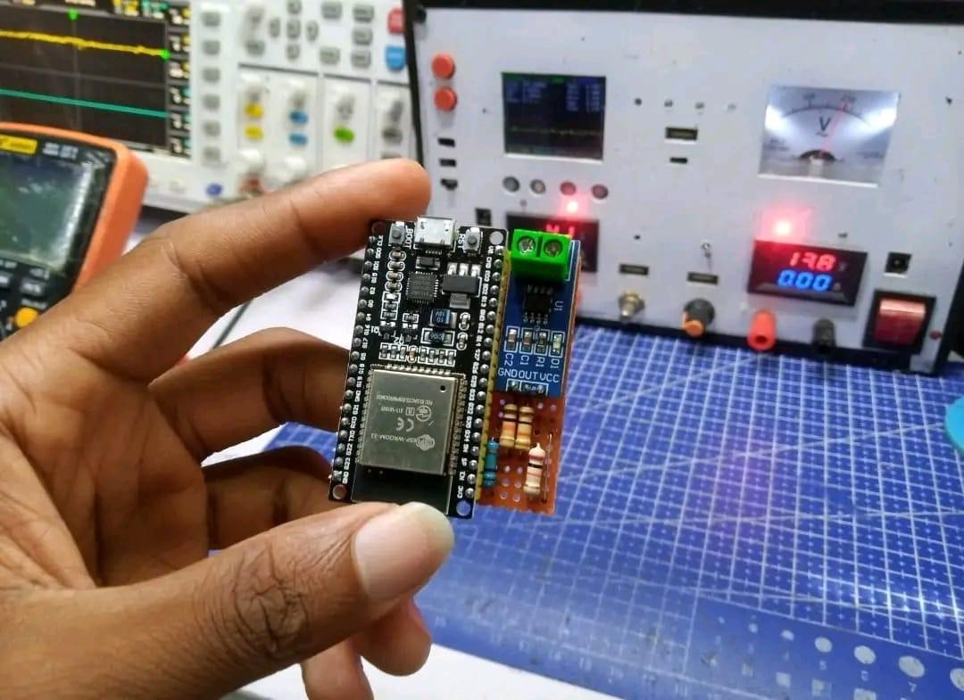
Literature Review:

2.1 IoT in Home Automation.
The Internet of Things (IoT) has revolutionized home automation by enabling remote monitoring and control of appliances, lighting, security, and entertainment systems. Existing IoT-based home automation systems utilize various technologies, including:
- Wireless communication protocols: Wi-Fi, Bluetooth, Zigbee, and Z-Wave enables seamless connectivity between devices.
- Smart sensors: Occupancy, temperature, humidity, and light sensors provide real-time data for optimized automation.
- Cloud-based platforms: Centralized control and monitoring enable users to access their homes remotely.
- IoT-based home automation system offer numerous beneﬁts, including:
- Energy effciency: Automated lighting and appliance control reduce energy consumption.
- Convenience: Remote access and voice control enhance user experience.
- Security: Real-time monitoring and alerts ensure home safety.

2.2 Inverter Technology
Inverter technology play crucial role in energy efficiency by optimizing power conversion and reducing energy losses. Inverter systems:
- Convert DC to AC power: Inverters enable power conversion for household appliances.
- Reduce energy losses: Inverter minimize energy losses during power conversion, resulting in energy savings.
- Improve grid stability: Inverters help regulate grid frequency and voltage, ensuring stable power supply.
Various types of inverter system sexist, including:
- Solar inverters: Convert DC power from solar panel to AC power for grid integration.
- Battery inverters: Manage battery charging and discharging for energy storage systems.

2.3 Rural Energy Challenges
Rural areas face unique energy challenges, including:
- Limited energy access: Rural areas often lack access to reliable grid electricity.
- Energy poverty: High energy costs and limited access to modern energy services exacerbate energy poverty.
- Grid instability: Rural grids are often unstable, leading to frequent power out ages and voltage punctuations.

These challenges necessitate innovative solutions, such as:
- Renewable energy integration: Solar, wind, and other renewable energy sources can enhance energy access and reliability.
- Energy storage systems: Battery storage can mitigate grid instability and provide backup power during outages.
- Smart grid technologies: Advanced grid management systems can optimize energy distribution and reduce energy losses.

The literature review highlights the potential of IoT-integrated inverter systems in addressing rural energy challenges and promoting energy efficiency. By leveraging IoT technology, inverter systems can optimize energy usage, reduce energy losses, and enhance grid stability, ultimately improving energy access and reliability in rural areas.

CHAPTER THREE
SYSTEM DESIGN
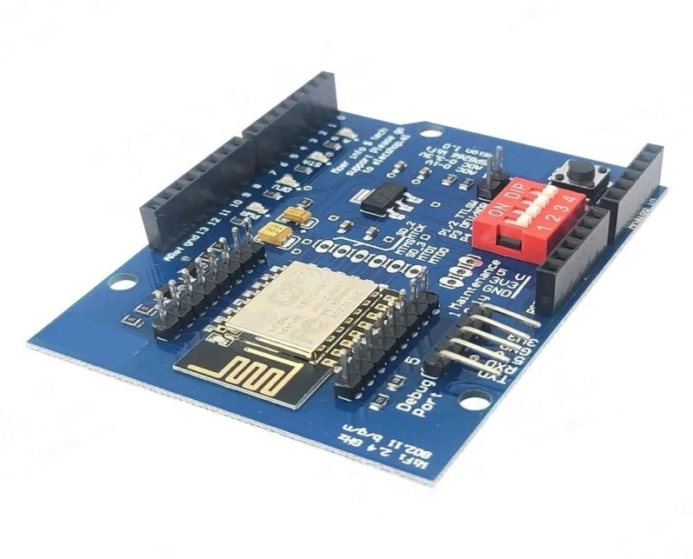
3.1 System Architecture
The IoT-integrated inverter system is designed to optimize energy efficiency and provide remote monitoring and control capabilities.
The system architecture consists of:
- Inverter module: Converts DC power to AC power for household appliances.
- IoT module: Enables remote monitoring and control of the inverter system.
- Sensors: Monitor energy usage, temperature, and other parameters.
- Cloud-based platform: Stores and analyzes data, providing insights for energy optimization.
The system architecture is designed to be scalable, ﬂexible, and secure, ensuring seamless integration with existing infrastructure.
3.2 Hardware Components
The hardware component soft he IoT-integrated inverter system include:
- Inverter: A high efficiency inverter that converts DC power to AC power.
- Sensors:
  - Energy meters: Monitor energy usage and provide real-time data.
  - Temperature sensors: Monitor temperature levels, ensuring safe operation.
  - Voltage and current sensors: Monitor voltage and current levels, enabling real-time monitoring.
  - IoT module :
  - Microcontroller: Processes data from sensors and controls the inverter.
  - Communication module: Enables wireless communication with the cloud-based platform.

The hardware components are selected based on their reliability ,effeciency, and compatibility with the system architecture.

3.3 Software Components.
The software components of the IoT-integrated inverter system include:
- Control algorithm: Optimizes energy usage, reduces energy losses, and ensure safe operation.
- IoT platform
- Data analytics: Analyzes energy usage patterns, providing insights for energy optimization.
  - Remote monitoring: Enable users to monitor energy usage, temperature, and other parameters remotely.
  - Control and automation: Enables users to control the inverter system remotely, optimizing energy usage.

The software components are designed to be user-friendly, secure, and scalable, ensuring seamless integration with the hardware components.
The system design provides a comprehensive frame work for the IoT-integrated inverter system, enabling efficient energy usage, remote monitoring, and control. The system's architecture, hardware components, and software components work together to provide a reliable, effecient, and user-friendly solution for energy management.

CHAPTER THREE
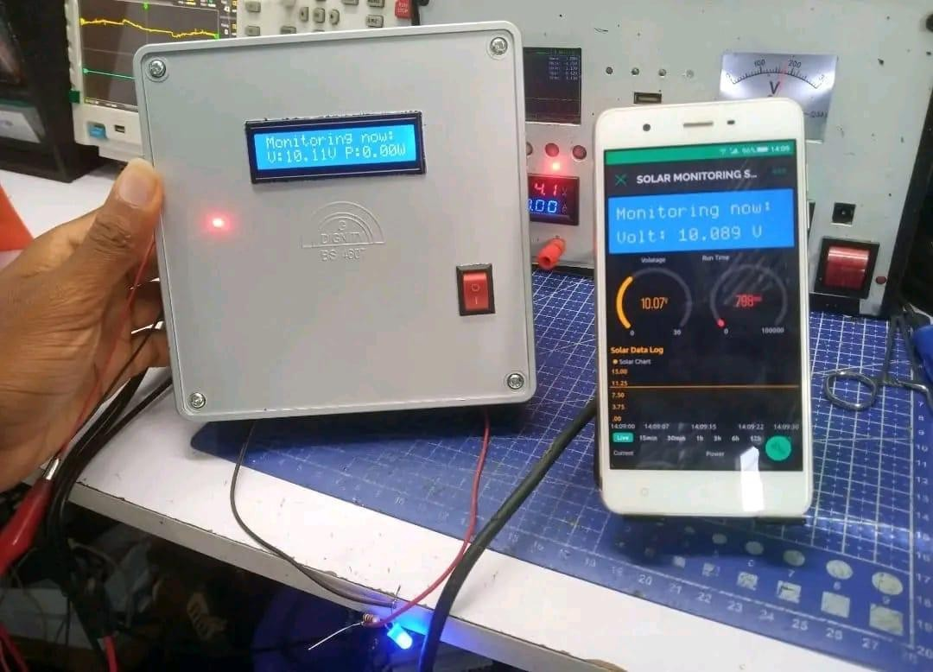
IMPLEMENTATION AND TESTING

4.1 Proto type Development
The proto type development process involved several stages:
- Hardware development: Design and development of the inverter, sensors, and IoT module.
- Software development: Development of the control algorithm, IoT platform, and user interface.
- Integration: Integration of hardware and software components.
- Testing and validation: Functional and performance testing of the proto type.
The proto type development process ensured that the system meet the design requirements and was functional.

4.2 System Testing
System testing was conducted to evaluate the functionality and performance of the IoT-integrated inverter system. The testing included:
- Function testing: Veriﬁcation of system functionality, including energy conversion, monitoring, and control.
- Perform and testing: Evaluation of system performance, including effeciency, response time, and data accuracy.
- Error handling: Testing of error handling mechanisms, including fault detection and recovery.
The results of system testing showed that the IoT-integrated inverter system:
- Meet design requirements: The system meet the design requirements for energy effeciency, monitoring, and control.
- Performed reliably: The system performed reliably under various operating conditions.
- Provided accurate data: The system provided accurate data on energy usage, temperature, and other parameters.
4.3 Energy Efficiency Analysis
The energy efficiency analysis evaluated the system's energy efficiency and potential energy savings.
The analysis included:
- Energy consumption monitoring: Monitoring of energy consumption before and after implementation of the IoT- integrated inverter system.
- Energy savings calculation : Calculation of energy savings based on monitored data.
- Comparison with baseline: Comparison of energy consumption and savings with base line data.
The results of the energy efficiency analysis showed that the IoT-integrated inverter system:
- Reduced energy consumption*: The system reduced energy consumption by optimizing energy usage and reducing energy losses.
- Provided signiﬁcant energy savings: The system provided signiﬁcant energy savings ,resulting in reduced energy costs.
- Improved energy efficiency: The system improved energy efficiency, reducing the environmental impact of energy consumption.
The implementation and testing of the IoT-integrated inverter system demonstrated its potential to optimize energy usage, reduce energy losses, and provide signiﬁcant energy savings.
The system's performance and energy efficiency make it a viable solution for energy management in rural areas.

CHAPTER FIVE
RESULTS AND DISCUSSION

5.1 System Performance
The system's performance was evaluated in rural settings, considering factors such as:
- Reliability: The system's ability to operate consistently in rural areas with limited infrastructure.
- Efficiency: The system's ability to optimize energy usage and reduce energy losses.
- User experience: The system’s used ability and user interface.
The results showed that the IoT-integrated inverter system:
- Performed reliably: The system operated consistently in rural areas, despite limited infrastructure.
- Optimized energy usage: The system optimized energy usage, reducing energy losses and improving energy efficiency.
- Provided a user-friendly interface : The system user interface was intuitive and easy to use, enabling users to monitor and control energy usage effectively.

5.2 Energy Savings
The energy savings and cost beneﬁt of the IoT-integrated inverter system were calculated based on:
- Energy consumption data : Historical energy consumption data was used to calculate energy savings.
- Cost analysis : A cost analysis was conducted to determine the economic beneﬁt of the system.

The results showed that the IoT-integrated inverter system :
- Reduced energy consumption: The system reduced energy consumption, resulting insigniﬁcant energy savings.
- Provided cost beneﬁts : The system provided cost beneﬁts, reducing energy costs and improving economic effeciency.
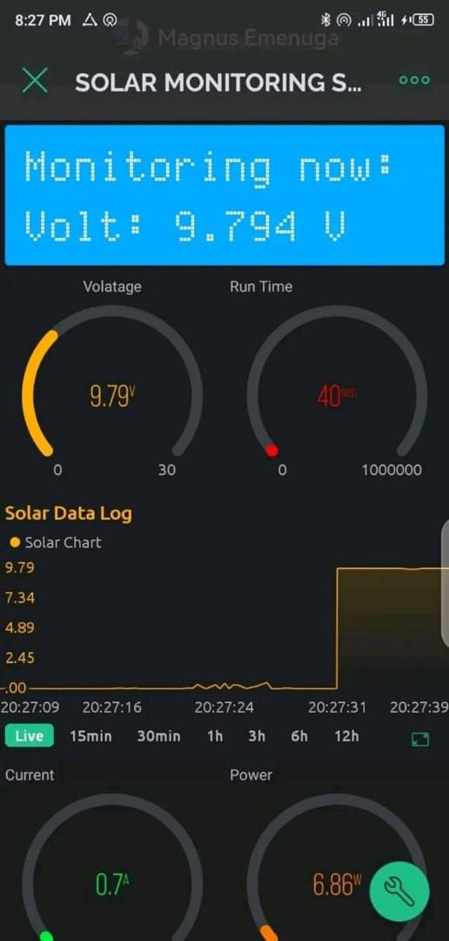
- Offered a positive return on investment : The system beneﬁt out weighted the costs, providing a positive return on investment.

5.3 Future Directions
Potential improvements and applications of the IoT-integrated inverter system were discussed, including:

- Integration with other renewable energy sources
- Integrating the system with other renewable energy sources, such as solar or wind power.
- Advanced data analytics
- Using advanced data analytics to optimize energy usage and predict energy demand.
- Scalability and replica-ability
- Scaling up the system and replicating it in other rural areas.
The discussion highlighted the potential for the IoT-integrated inverter systemto :
- Improve energy access in rural areas, promoting economic development and social welfare.
- Enhance energy effeciency, reducing energy losses and improving environmental sustainability.
- Support sustainable development
- Support sustainable development, aligning with global goals and objectives.
The results and discussion demonstrate the potential of the IoT-integrated inverter system to optimize energy usage, reduce energy losses, and provide signiﬁcant energy savings in rural areas.
The system's performance, energy savings, and potential for future improvements and applications make it a viable solution for energy management in rural settings.

References
Amin, N., Rahman, S., & Sopian, K. (2009). Prospects of renewable energy—Using solar energy. Renewable and Sustainable Energy Reviews, 13(9), 2541–2552. https://doi.org/10.1016/j.rser.2009.06.030
Bhatt, A., Shah, M., & Mehta, K. (2014). IoT based solar power monitoring system. International Journal of Innovative and Emerging Research in Engineering, 1(4), 110–114.
Gubbi, J., Buyya, R., Marusic, S., & Palaniswami, M. (2013). Internet of Things (IoT): A vision, architectural elements, and future directions. Future Generation Computer Systems, 29(7), 1645–1660. https://doi.org/10.1016/j.future.2013.01.010
Mohammed, M. A., Mustafa, M. W., & Nor, N. M. (2017). Renewable energy resources for distributed power generation in Nigeria: A review of the potential. Renewable and Sustainable Energy Reviews, 75, 1239–1250. https://doi.org/10.1016/j.rser.2016.11.134
Zhou, K., Yang, S., & Shao, Z. (2015). Energy internet: The business perspective. Applied Energy, 178, 212–222. https://doi.org/10.1016/j.apenergy.2016.06.052

