EVALUATION OF THE IMPACT OF GOLD MINING ON THE WATERS OF ALAGBEDE DABA COMMUNITY MORO LOCAL GOVERNMENT AREA, OF KWARA STATE.

OYEBAMIJI RHODA AWEKE
HND/23/MNE/FT/0009

SUBMITTED TO THE DEPARTMENT OF MINERALS AND PETROLEUM RESOURCES ENGINEERING TECHNOLOGY,
INSTITUTE OF TECHNOLOGY,
KWARA STATE POLYTECHNIC, ILORIN

IN PARTIAL FULFILLMENT FOR THE REQUIREMENTS OF THE AWARD OF HIGHER NATIONAL DIPLOMA (HND) IN MINING ENGINEERING,
KWARA STATE POLYTECHNIC, ILORIN.

JULY, 2025.

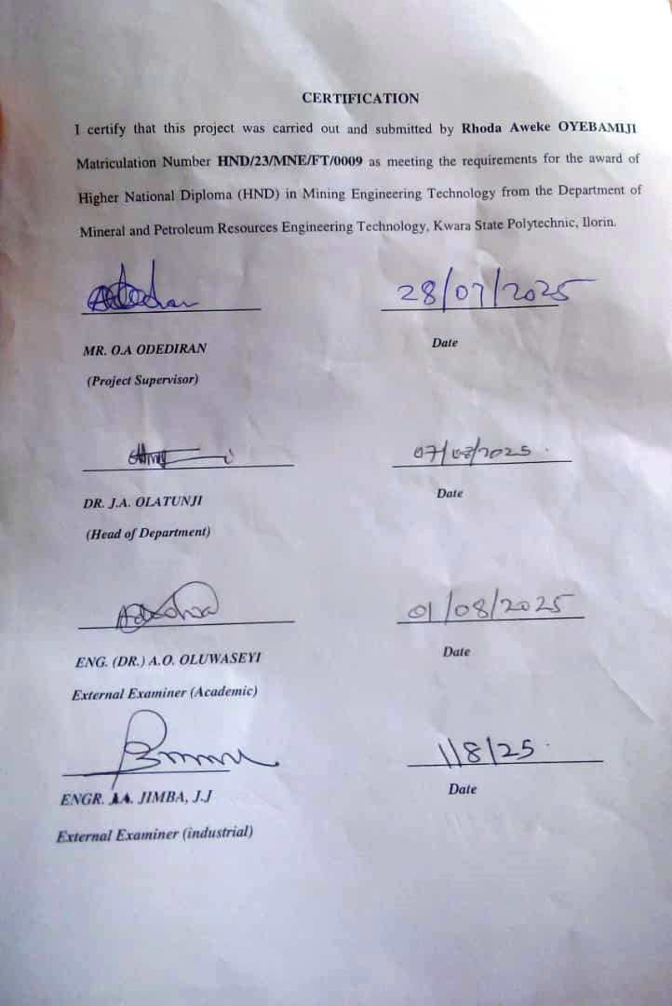
DEDICATION
This project work is dedicated to God Almighty who granted me strength, knowledge and wisdom to complete my project successfully. Also to my parents, Mr. and Mrs. Oyebamiji for their support, financially, morally and spiritually, also for their parental advice.

ACKNOWLEDGEMENT
All praises belong to Almighty God for all his wondrous work in my life and for giving me the wisdom, knowledge, strength and understanding to complete this project work successfully. I sincerely express my profound gratitude to my supervisor Mr. Odediran, O.A for his fatherly support, advice, time and correction toward the completion of this project. Indeed I and my project partners can testify that you are a father to us, may God bless you sir.
I'm extremely grateful to my lovely and beloved parents and siblings for their support throughout my academic pursuit, may Almighty God bestow you long life and good health to eat the fruit of your labour. (Amen).

ABSTRACT
This study assessed the impact of gold mining activities on water quality in Alagbede Daba community, kwara state. Ten (10) samples were collected randomly from selected water bodies and Physico-chemical parameters, such as TDS, EC, pH and temperature were measured on the field. Selected heavy metals that is Ni, cadmium we're also determined by AAS method of analysis. The results showed elevated levels of heavy metals including cadmium, nickel and lead in water sources, exceeding recommended standard Physico-chemical parameters, such as pH and temperature were also affected. The findings suggest that gold mining activities have potentially contaminated water sources, posing health risks to the community. The study results can inform policy decisions and intervention to mitigate the environmental and health impacts of gold mining in the area.
TABLE OF CONTENTS
Title Page i
Certification ii
Dedication iii
Acknowledgements iv Abstract v
Table of Contents vi
List of Table viii
List of Figure ix
CHAPTER ONE
1.1 Location and Accessibility 1
1.2 Climate and Vegetation 3
1.3 Relief and Drainage 4
1.4 Aim 4
1.5 Objectives 4
1.6 Statement of the Problem 5
1.7 Justification 5
1.8 Scope and Limitations 5
CHAPTER TWO
2.0 Literature Review 6
2.1 Environmental Impacts of Gold Mining 6
2.2 Water Pollution and it Effect On Human Health and the Environment 7
2.3 Review of Existing Studies of Gold Mining on Water Quality 8
CHAPTER THREE
3.0 Research Methodology 9
3.1 Sample Collection and Preparation 9
3.1.1 Analytics Techniques (Ph, Temperature, Turbidity, Total Dissolved Solvent, AAS) 11
3.1.2 Electrical Conductivity (EC) 11
3.1.3 pH Test 12
3.1.4 Total Dissolved Solvent 12
3.1.5 Temperature 12
3.1.6 Atomic Absorption Spectroscopy (AAS) 13
3.2 Digestion of Water Samples using Aqua Regina Method 13
CHAPTER FOUR
4.0 Result and Discussion 15
4.1 Results of Heavy metals and interpretation 15
4.1.1 Cadmium (Cd) 16
4.1.2 Chromium (cr) 16
4.1.3 Nickel (Ni) 16
4.1.4 Lead (pb²⁺) 16
4.1.5 Manganese (mn²⁺) 17
4.1.6 Implications of findings 17
4.2 Interpretation of the Physico-chemical parameters 17
4.2.1 pH Test 17
4.2.2 Electrical Conductivity (EC) 17
4.2.3 Total Dissolved Solvent (TDS) 17
4.2.4 Temperature 18
CHAPTER FIVE
5.0 Conclusion and Recommendations 19
5.1 Conclusion 19
5.2 Recommendations 20
References 21

LIST OF TABLE
Table 1: Coordinates of the study area 9
Table 2: Measured Physico-chemical Parameters 13
Table 3: Heavy Metals of water sample analysed 14
Table 4: Standard values for Interpretation of Water Samples 14

LIST OF FIGURES
Figure 1: Geological Map of Nigeria Showing Study Area 2
Figure 2: Geological Map Showing Alagbede Daba Area 2

CHAPTER ONE
1.1 Location and Accessibility
Alagbede daba is a rural community situated within the Moro local government area of approximately 3,772 square kilometer and had a population of 108,792 people (2006, census). It is situated approximately 25 kilometer, North west of malete, a town known for housing the Kwara State University. Alagbede daba community is about 60km from Ilorin. The route is essentially from Ilorin - Shao- Malete - Alagbede.
Alagbede daba like many other communities in Moro L.G.A, faces significant infrastructural challenges and access to the community is primarily through unpaved road which can become particularly difficult to navigate during the rainy season due to the dust on pathways since the road is an untiled road, some paths are also sloapy making it difficult for cars to pass through. The lack of reliable transportation hampers mobility and limits access to essential services in the area and the community's proximity to gold mining operations makes it susceptible to environmental challenges.
The area is underlain by rocks of the basement complex of Nigeria and in fact forms the southern extension of the North western end of Yauri gold field, resulting from the development of the intercontinental Anka Yauri-Iseyin (AYI) trans current fault during the pan African (Grant et al., 1985). Structural features mapped in the area include folds, faults, and joints. Discordant and concordant shear planes are partly healed with Vein quartz ranging from 2-8m depth (Turner, 1983).

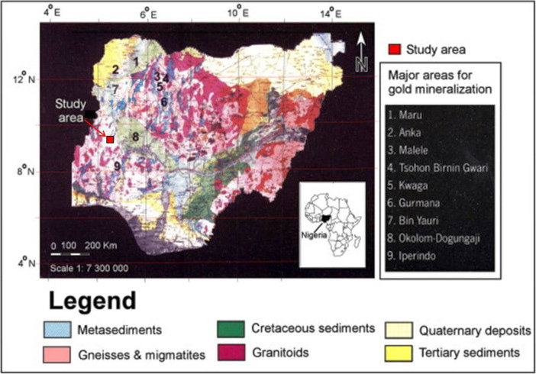
Figure 1. Geological Map of Nigeria Showing Study Area (Ajadi et al. 2018).
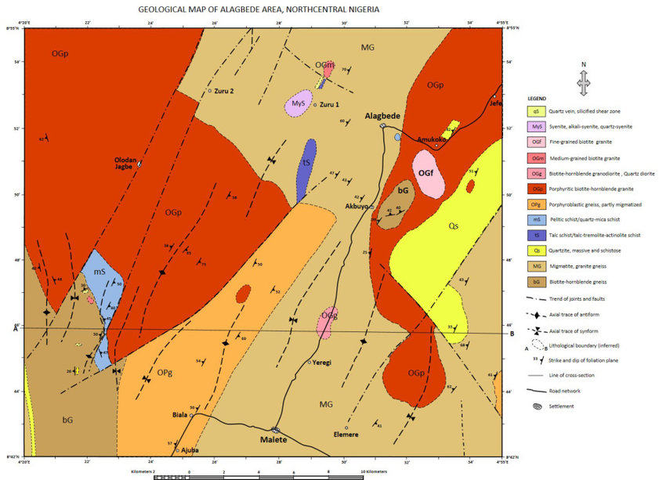
Figure 2: Geological Map Showing Alagbede Daba Area(Bayode et al., 2023)

1.2 Climate and Vegetation
Alagbede daba community in Moro local government area of kwara state government experiences a tropical climate with distinct wet and dry season. Specifically, Alagbede daba community within Moro experiencing high humidity and warm temperatures throughout the year, the regions climate is characterized by the temperature which ranges from 20C to 30C throughout the year and the wet season typically occurs from May to October, with most rainfall concentrated in these months (Kwara State government, 2020). The dry season from November to April is marked by dry harmattan wind. The area receives approximately 1302mm of rainfall annually, with an average temperatures reaching 34C (EPA, 2020). The humidity is around 70percent and UV index is 7, with 88 dry days per year. Alagbede daba forest reserve has a mix of tree species, but specific types are not well documented. However, nearby regions have herophytic trees with short seasonal grasses. this vegetation tyle dominates the region (EPA, 2020).
The surrounding areas practice Agriculture with crops like cassava, rice and sorghum being common. Home gardening is also a prevalent practice in nearby regions. human activities like farming and urbanization can impact vegetation cover leading to deforestation and loss of biodiversity (Climate, 2019). The areas natural resources include: Yam, Cassava, Corn, Groundnut and Rice.
1.3 Relief and Drainage
The relief and drainage of Alagbede daba community in Moro local government area of Kwara State can be understood based on the regions geography, and the area features a mine of planes and gentle slopes, characteristic of the savannah region. The elevation ranges from approximately 200 to 400 meters above sea level (Adebayo, 2019).
The area is drained by nearby rivers, such as the Niger river or it's tributaries which includes water from the river Niger which flow into the community and contribute water, sediment, and nutrients to the main river, helping to shape it's course and support aquatic ecosystems. they may also be dams, lakes or ponds in the area, which can support agriculture, fishing and other local activities.
1.4 Aim
The aim of this study is to evaluate the impact of gold mining on the waters of Alagbede daba community Moro local government area of kwara state.
1.5 Objectives
The objectives of this project work are to
i. determine the physical and chemical properties of the waters in Alagbede daba community.
ii. evaluate the health risks associated with gold mining activities in the study area.
1.5 Scope and Limitations
The focus of this is study is to evaluate the impact of gold mining and determine the pH, electric conductivity (EC) Temperature, Total dissolve solvent (TDS) and heavy metals on the waters of Alagbede daba community, Moro local government area of kwara state.
This study has several limitations, firstly the study will only focus on the Alagbede daba community and the findings may not be generalized to other communities. Secondly, the study will only determine the physical and chemical properties of the waters of the community and will not determine the biological properties. Finally, the study will be conducted over a relatively short period of time and may not capture the long term impact of gold mining on the waters of the community.

1.7 Justification
The community's reliance on the water of Alagbede daba for drinking, fishing and irrigation makes it essential to evaluate the impact of gold mining on the waters of the community. the findings of this study will provide valuable insight for the community and also provide strategies for the environmental and health impacts of gold mining.
1.8 Statement of the Problem
Gold mining has become a rapidly expanding activity in the Alagbede daba community, predominantly through small scale and artisanal operations while mining offers potential economic benefits, it's environmental consequences particularly on water resources are increasingly alarming
Resident rely heavily on surface water (streams, rains) and shallow wells for daily domestic and agricultural use. However, these water sources are under threat from pollution due to unregulated mining activities. this study evaluates the presents condition of the water sources, with the view to determining their stability and risk factors.

CHAPTER TWO
2.0 LITERATURE REVIEW
2.1 Environmental Impacts of the Gold Mining
Gold mining has a significant economic activity in Kwara State and Nigeria generally. The state is richly endowed with mineral deposits including gold. The Alagbede daba community, located in the Moro local government area of kwara state is one of the areas where gold mining is common. However gold mining activities have been linked to environmental degradation, particularly water pollution (UNEP, 2019). The use of mercury and other chemicals in gold extraction process can contaminate water sources, posing serious health risks to humans and wildlife (WHO, 2019). Gold mining especially artisanal and small scale mining is the leading cause of water pollution in rural communities in Alagbede daba, where informal activities often involves the use of harmful chemicals such as mercury, cyanide and lead which are either directly discharged into nearby streams or seep into ground water system.(Kwara State Ministry of health, 2020).
Gold mining has severe environmental impacts including water pollution, soul erosion and deforestation (Kumar et al., 2017). Despite the potential economic benefits of gold mining activities, the environmental and health impacts are a major concern. Though gold mining has been a significant economic activity in Nigeria, particularly in the northern part of the country (Adebayo and ogunlele, 2017). The Alagbede Daba community in Moro local government area of kwara state is one of the areas where gold mining has been reported to have been a subject of concern, particularly in relation to water pollution (Hilson, 2013). In mining communities the rate of waterborne diseases, heavy metal poisoning and skin diseases was significantly higher compared to non- mining areas and women and children are particularly, vulnerable to these effects due to exposure, through contaminated food chains and water.
2.2 Water Pollution and It Effect On Human Health And The Environment
Water pollution from gold mining is a major concern as it can affect both surface and ground water quality (EPA, 2019). The effect on human health and the environment is a significant concern, particularly in communities where gold mining is a major economic activity. the release of pollution into water bodies can have severe consequences including the contamination of drinking water (Bender, 2017).
Toxic mine waste can lead to acid mine drainage, a toxic cocktail uniquely destructive to affecting human health (EPA, 2019). Miners and nearby communities are at risks of exposures to toxic chemicals like cyanide and mercury which can cause long term health issues, kidney damage and various forms of cancer and pollutants, it can also alter the chemical composition of water bodies thereby affecting their quality and human health. Consuming polluted water can lead to borne diseases such as cholera and diarrhoea, contaminated fish and other aquatic organisms can transfer pollutants to humans, potentially causing long term health problems (WHO, 2017). Exposure to heavy metals and other pollutants in water can also cause developmental delays in human.
The effect on the environment includes: Habitat destruction and ecosystem thereby causing loss of biodiversity and it can also damage fisheries, tourism and other industries.

2.3 Review of Existing Studies of Gold Mining on Water Quality:
Studies have shown that gold mining can lead to the release of heavy metals such as mercury, arsenic and lead into nearby water sources and exposure to Mercury from gold mining has been linked to neurological damage, birth defects and other health problem (WHO, 2017).
Cyanide contamination in gold mining has been linked to water pollution with studies showing that cyanide can contaminate surface and ground water posing risks to huma health and the environment. Arsenic often found in combination with gold can cause serious health problems including cancer and neurological damage, exposure to lead can also cause kidney damage, bone fractures and reproductive problems ( Mudder et al., 2019). Chromium exposure can also lead to skin irritation, respiratory problems and cancer (UNEP, 2018).
The release of sediment and other particles from gold mining activities can increase turbidity in nearby water sources, making it difficult for life to survive ( Kumar et al., 2019).

CHAPTER THREE
3.0 RESEARCH METHODOLOGY
3.1 Sample Collection and Preparation
The methodology that was used in this study essentially involves both the field and laboratory components. A number of geological tools were employed for this study and they include the Global Positioning System (GPS receiver), field notebooks, sampling plastic and water kit.
The GPS receiver was used to determine the coordinates of samples location while the water kit was used to check the water pH, Temperature, Electric conductivity (EC) and Total dissolve solvent (TDS). Sample were taken from 10 (Ten) different locations.
A total of 10 water samples were collected from different locations of which only 1 was groundwater and the remaining 9 was stream water in the Alagbede daba community. Plastic sampling bottles of 1.2 litres were used, pre washed and rinse with the water sample to be collected.
Water samples were collected using grab sampling method and the samples were collected in a sterile plastic bottles and transported to the laboratory less than 24hours after collection. The laboratory test were carried out at the Unilorin central research laboratory.

Table 1: Coordinates of the study area
Sample location. | Latitude | Longitude | Remarks
A | 07⁰ 28’ 23.0’’ | 4⁰ 40’ 5.7’’ | Stream
B | 08⁰ 52’ 28.7’’ | 4⁰ 29’ 33.8’’ | Borehole
C | 08⁰ 52’ 23.8’’ | 4⁰ 29’ 33.5’’ | Stream
D | 08⁰ 52’ 22.1’’ | 4⁰ 29’ 29.2’’ | Stream
E | 08⁰ 52’ 20.4’’ | 4⁰ 29’ 26.0’’ | Stream
F | 08⁰ 51’ 18.9’’ | 4⁰ 29’ 20.1’’ | Stream
G | 08⁰ 52’ 17.2’’ | 4⁰ 29’ 16.3’’ | Stream
H | 08⁰ 52’15.6’’ | 4⁰ 29’ 9.1’’ | Stream
I | 08⁰ 52’ 15.4’’ | 4⁰ 29’ 9.0’’ | Stream`
J | 08⁰ 52’ 15.6’’ | 4⁰ 29’ 9.2’’ | Stream

Laboratory Preparation
In the laboratory, sample are filtered ( if need) using filter paper to remove suspended solids prepared for analysis using standard procedures as outline by the American Public Health Association (APHA ) and world health organization (WHO) water tasting guidelines, these also involves the analysis for physical and chemical parameters which are PH, Temperature, Turbidity, and Electrical Conductivity (EC). Chemical parameters: dissolved oxygen, total dissolved solvent (TDS) heavy metals (lead, mercury, arsenic, radium).

3.1.1 ANALYTICS TECHNIQUES (PH, TEMPERATURE, ELECTRICAL CONDUCTIVITY, TOTAL DISSOLVED SOLVENT (TDS), ATOMIC ABSORPTION SPECTROSCOPY (AAS):
Analytical Technique
To evaluate the extent of water pollution caused by gold mining in Alagbede daba, various physicochemical and heavy metals analysis technique will be used. These technique help determine the quality of the waters and it's potentials risk to human health and the environment. To access the acidity of alkalinity of the water, which influence chemical reaction and metal solubility, calibate the pH meter with standard buffer solutions (pH 4,7 and 10) then imperse the electrode into the water sample and record the reading standard range. The World health organization (WHO) recommends a PH range of 6.5 - 8.5 for drinking water.
3.1.2 Electrical Conductivity (EC)
Electrical Conductivity is a good. Measure of salinity hazard to crops as it reflects the TDS in water and soil. Electrical Conductivity of natural water is determined by the presence of substances, which dissociate into cations and anions. Measurement of EC can be used to monitor and determine the degree of water pollution. The value of EC may serve an appropriate index of the total content of the dissolved substances for the bodies of water, which have been subjected to considerable influence run off waters, to establish the origin and distribution of various waters in the body of water and delineation of pollution zones.
The measurements of electrical Conductivity in microsiemen per centimeters (us/cm) was determined using a portable field conductivity meter for each of the water samples. Conductivity is a measure of the ability of water to conduct an electric current. It increases as the amount of the dissolved minerals (ions) increases.
3.1.3 pH Test:
The pH of water is a measure of hydrogen ion concentration in water. It ranges from 0.14 with neutral water at 7. While lower of it is acidic and pH greater than 7 is known as basic. Drinking water with a pH ranging from 6.5 to 8.5 is generally considered satisfactory. It is noticed that water with low pH tends to be toxic and with high degree of pH tastes bitter. The pH of the studied water samples were measured by dipping the electrode of the pH meter into the bowl of the samples. World health organization (WHO) standard recommend range of 6.5 to 8.5 for acceptable drinking water.
3.1.4 Total Dissolved Solvent:
The concentration of impurities is often termed total dissolved solid (TDS). It is often measured in ppm or mg/l and can be determined using conductivity method or TDS meter. Water has the ability to dissolve a wide range of inorganic and some organic minerals or salts such as potassium, calcium, sodium, bicarbonates, chlorides, magnesium sulfates e.t.c. these minerals is produced unwanted taste and diluted color in appearance of water which may be injurious to plants and animals. According to World Health Organization (WHO,2017).
3.1.5 Temperature
The temperature of the water is one of the most important characteristics which determines to a considerable extent and tendencies of changes in the quality of water. It is taken with the aid of multifunction water kit, and measured in degree Celsius. The water temperature was taken before the other water measurements because temperature tends to change very rapidly after a sample is collected.

3.1.6 Atomic Absorption Spectroscopy (AAS)
Atomic Absorption Spectroscopy is a widely used analytical technique for determining the concentration of specific elements in a sample, it is used to detect trace loads of heavy metals in water samples. It is one of the most accurate and widely used method for water quality assessment, especially areas impacted by mercury. Samples are digested using acids ( Nutric acid) to break down the matrix and release the analytes then samples are filtered to remove particulate matter. The instrument is set up according to the manufacturer's instrument, a hollow cathode lamp specific to the element of interest is selected and the wavelength is set to the specific absorption line of the element. The prepared sample was introduced into the instrument, typically using a nebulizer, then the sample is atomized in a frame or graphite furnace, creating free atoms, the instrument measures the absorption of light by the atoms at the specific wavelength.
AAS is a powerful tool for elemental analysis offering high sensitivity and selectivity. However, it requires careful sample preparation, instrument set up and data analysis to ensure accurate results.
3.2 Digestion of Water Samples using Aqua Regina Method:
100mls of each water samples was measured into 250mls digestion flask. 15mls of conc. HNO3 and 5mls of con HCL(3:1) were added. The digestion flask was healed on a hot plate for 15mins and the sample continuously evaporated to less than 50mls, it was ensured that the samples did not dry and no areas of the bottom of the digestion flask allowed to get dried. The digestion flask was removed from the hot plate and allow to cool at room temperature, then the digested sample was filtered through whatman filter paper into 50mls standard flask and it was transferred into plastic reagent bottle for atomic Absorption Spectroscopy (AAS) at central research laboratory, University of Ilorin for determination of heavy metals such as Cd (cadmium), Cr ( chromium), Ni( nickel), Pb ( lead), and Mn ( Manganese).
Results of Physico-chemical Parameters
The results of the Physico- chemical parameters carried out in the area are presented in Table.
Table 2: Measured Physico-chemical Parameters
S/N | LOCATION CODE | pH | EC( MS/CM) | TDS ( PPM) | TEMP (C)
1 | LW1 | 0.1 | 777 | 432 | 403.1
2. | LW2 | 6.81 | 486 | 274 | 89.2
3 | LW3 | 7.58 | 349 | 175 | 89.6
4 | LW4 | 7.15 | 359 | 180 | 85.1
5 | LW5 | 7.09 | 345 | 171 | 42.2
6 | LW6 | 7.30 | 399 | 796 | 87.4
7 | LW7 | 7.55 | 38.9 | 191 | 83.1
8 | LW8 | 7.68 | 414 | 205 | 83.6
9 | LW9 | 7.81 | 391 | 199 | 89.7
10 | LW10 | 6.95 | 303 | 150 | 99.3

CHAPTER FOUR
4.0 RESULT AND DISCUSSION
4.1 Results of Heavy Metals Analysis:
The results of the heavy metals of the analyzed samples is presented in table 5:
Table 3: Heavy Metals of water samples Analysed:
S/N | SAMPLE CODE | CD (MG/L) | CR (MG/L) | NI (MG/L) | PB²⁺ (MG/L) | MN²⁺ | RANGE | AVERAGE
1 | LW1 | 0.038 | 0.041 | 0.063 | 0.019 | 0.013 | 0.035 | 0.013-0.063
2 | LW2 | 0.001 | 0.013 | 0.011 | 0.001 | 0.004 | 0.006 | 0.001-0.013
3 | LW3 | 0.044 | 0.025 | 0.043 | 0.003 | 0.007 | 0.024 | 0.003-0.044
4 | LW4 | 0.002 | 0.040 | 0.013 | 0.006 | 0.031 | 0.018 | 0.002-0.040
5 | LW5 | 0.037 | 0.021 | 0.015 | 0.018 | 0.043 | 0.027 | 0.015-0.043
6 | LW6 | 0.063 | 0.019 | 0.018 | 0.002 | 0.051 | 0.031 | 0.002-0.063
7 | LW7 | 0.035 | 0.021 | 0.043 | 0.004 | 0.002 | 0.021 | 0.004-0.043
8 | LW8 | 0.052 | 0.018 | 0.036 | 0.017 | 0.006 | 0.119 | 0.006-0.32
9 | LW9 | 0.071 | 0.022 | 0.019 | 0.019 | 0.013 | 0.029 | 0.019-0.071
10 | LW10 | 0.043 | 0.027 | 0.015 | 0.003 | 0.015 | 0.021 | 0.003-0.043

Table 4: Standard Values for Interpretation of Water Samples
 | Cd  (mg/l) | Cr  (mg/l) | Ni  (mg/l) | Pb²⁺  (mg/l) | Mn²⁺  (mg/l)
NSDWQ  (2007) | 0.003 | 0.05 | 0.02 | 0.01 | 0.20
WHO (2012) | 0.003 | 0.05 | 0.02 | 0.01 | 0.20

4.1.1 Cadmium (Cd)
Cadmium levels in most of the samples exceeded the WHO (World Health organization) drinking water limit of 0.003mg/l) except LW2 and LW4. The highest concentration was observed in LW9 (0.71mg/l) followed by LW6 (0.063 mg/l) cadmium is highly toxic and it presence in water may cause kidney damage and bone demineralization. It elevated levels likely originate from mining waste and tailings leachate.
4.1.2 Chromium (Cr)
Chromium concentration ranged from 0.013mg/l to 0.041mg/l which are within the World Health organization (WHO, 2017) limit of 0.05mg/l. However, values in LW1 and LW4 were close to this threshold. Prolonged exposure may still pose carcinogenic risks especially if hexavalent chromium is present.
4.1.3 Nickel (Ni)
Nickel concentrations in all samples except LW2 and LW4 were above the World Health organization (WHO, 2017) limit 0.02 mg/l. The highest level was found in LW1 (0.063mg/l). High Nickel levels are often linked to mining zones and may cause dermatitis and internal organ damage upon prolonged exposure.
4.1.4 Lead (Pb²⁺)
Lead was detected in all samples with LW1 and LW 9 (0.019mg/l) showing the highest values. The World Health organization (WHO, 2019) limit is 0.01mg/l, meaning that 40percent of the samples exceeded safe levels. Lead exposure is particularly dangerous to children, causing neurodevelopmental and cognitive impairments.

4.1.5 Manganese (Mn²⁺⁾
All samples recorded in manganese concentration are well below the World Health organization (WHO, 2017) guidelines of 0.1mg/l. However, aesthetic issues like taste and staining may arise in LW6 (0.051 mg/l) and LW5 ( 0.043mg/l).
4.1.6 Implications of Findings
The pressure of elevation levels of Cd, Ni, and Pb in several water samples is a strong indicator of pollution resulting from gold mining activities in the area. These heavy metals pose significant risks to aquatic life, the environment and Public Health especially when the contaminated water is used for drinking, cooking or irrigation.
4.2 Interpretation of the Physicochemical Parameters
The pH test range from 0.1 to 7.95, samples Lw 1 has a pH of 0.1 which is extremely acidic while other samples range between 6.81 and 7.95. indicating mostly neutral to slightly alkaline water which is suitable for most aquatic life and human use. World Health Organization (WHO, 2017).
4.2.2: Electrical Conductivity (EC)
Ranges from 303 to 777(us/cm). EC values below 500us/cm are generally considered low to moderate conductivity, suitable for drinking and irrigation. Sample Lw 1 has a high EC of 777us/cm suggesting high dissolved salt possible from pollution or mineral rich water. World Health organization (WHO, 2017).
4.2.3. : Total Dissolved Solids (TDS)
The total dissolve solvent value below 500ppm are generally acceptable for drinking water according to world Health organization (WHO, 2017). The values in the dataset suggest the water is within safe limits for TDS, through Lw 1 is on the higher end.
4.2.4 Temperature
The temperature range 42.2⁰C and 35⁰C. The recorded values suggest either thermal pollution or instrument error, particularly for samples LW 1, LW 2 AND LW 10, which exceed the boiling point, World Health organization (WHO, 2017).
Implications of Findings
Most of the water samples fall within accepted physico-chemical standards except for sample LW1 which shows extreme values in pH, EC, TDS and Temperature. These anomalies suggest either contamination or possible instrument error, necessitating further investigation and re-sampling.

CHAPTER FIVE
5.0 CONCLUSION AND RECOMMENDATIONS
5.1 Conclusion
The study evaluate the concentration of heavy metals cadmium (Cd), chromium (Cr), Nickel (Ni), lead ( pb²⁺⁾ and manganese (Mn²⁺) in the water samples collected from the gold mining area in Alagbede daba community. The results revealed that;
Cadmium concentrations exceeded the World Health organization (WHO) permissible limit (0.003mg/l) in 8 out of 10 samples
- Nickel levels were also above the recommended limit (0.02mg/l) in the majority of samples.
- Lead exceeded the World Health Organization (WHO 2020) threshold (0.01mg/l) in four samples posing a serious health risks
- Chromium and manganese remained within acceptable limits in all samples, although chromium values in some samples approached the World Health Organization limit.
These findings indicates significant contamination of local water sources, likely resulting from gold mining activities and related environmental degradation. The presence of toxic Metals like cadmium and lead in drinking water sources poses a serious public health risk especially to vulnerable populations such as children, pregnant women and the elderly.
The reason why the LW1 table under the measured Physico- chemical Parameter in table 2 might be low and not up to the standard of the World Health Organization (WHO, 2019) is because the stream is not a stagnant water but instead a flowing stream so they might be a possibility of the chemicals settling down along the pathway before getting to LW3.

5.2 Recommendations
Based on the findings, the following recommendations are made;
- Water Treatment: immediate implementation of appropriate water treatment technologies such as reverse osmosis or activated carbon filtration in affected areas.
- Monitoring and Regulations: regular environmental monitoring by local authorities (e.g Ministry of Environment, Water Resources Agencies) to track heavy metals level in both surface and groundwater.
- Public Health Awareness: launching community awareness programs to educate residents on the dangers of using untreated water especially near mining sites.
- Mining Regulations Enforcement: stricter enforcement of environmental regulations on mining operations to minimize waste discharge and groundwater contamination
- Alternative Water Sources: Development and provision of safe, alternative Water Sources ( e.g boreholes, rainwater, harvesting) in highly contaminated communities.

REFERENCES
Adebayo, A. A. (2019). Geographical Perspectives on Kwara State: Relief and Drainage Patterns. Ilorin: Kwara State University Press.
Adebayo, S. B. & Ogunlele, A. O. (2017). Environmental and Health Impacts of Gold Mining in Nigeria. Journal of Environmental Research, 9(2), 112–119.
Ajadi, B. S., Aderoju, M. A., & Alabi, K. M. (2018). Geological and geophysical investigation of groundwater potential in a basement complex terrain: A case study from Nigeria. Journal of African Earth Sciences, 141, 120–132. https://doi.org/10.1016/j.jafrearsci.2018.01.010
APHA (2017). Standard Methods for the Examination of Water and Wastewater, 23rd Edition. American Public Health Association, American Water Works Association, Water Environment Federation.
Bayode, S. F., Adekeye, O. A., & Ibrahim, M. T. (2023). Geological mapping and structural interpretation of Alagbede Daba area, Moro LGA, Kwara State, Nigeria. Nigerian Journal of Geosciences, 59(2), 45–58.
Bender, M. T. (2017). Water Pollution: Causes, Effects and Control. New York: Nova Science Publishers.
Climate (2019). Climate Data for Nigeria – Kwara State Region. Retrieved from https://climate-data.orgs
EPA (2019). Effects of Mining on the Environment and Human Health. Environmental Protection Agency Report. www.epa.gov
EPA (2020). Climatic and Environmental Data for Nigeria. Environmental Protection Agency Publications.
Grant, N.K., Rex, D.C., Freeth, S.J. & Bandyopadhyay, B.K. (1985). Pan-African tectonics in the Nigerian Basement Complex. Journal of African Earth Sciences, 3(4), 457–466.
Hilson, G. (2013). The Socioeconomic and Environmental Impact of Small-Scale Mining in Developing Countries. Natural Resources Forum, 27(1), 3–15.
Kumar, A., Singh, P. & Meena, R. K. (2017). Environmental Degradation from Mining Activities in Developing Nations: A Case Study Approach. Journal of Earth and Environmental Sciences, 5(1), 50–58.
Kumar, R., Sharma, P. & Verma, S. (2019). Impact of Mining on Water Resources: A Review. International Journal of Hydrology, 3(2), 75–82.
Kwara State Government (2020). Kwara State Development Profile: Environment, Climate, and Resources. Ministry of Information, Ilorin.
Kwara State Ministry of Health (2020). Report on the Health Effects of Mining in Moro LGA. Government Publication.
Mudder, T., Botz, M., & Smith, A. (2019). Environmental Management in Small-Scale Mining: Risks and Strategies. Mining Engineering Journal, 44(3), 24–30.
Turner, D.C. (1983). Upper Proterozoic to Lower Palaeozoic rocks of the Nigerian Sector of the Pan-African mobile belt. In C.A. Cratchley et al. (eds), Geology of Nigeria, 2nd edition. Nigerian Mining Corporation, Jos.
UNEP (2018). Environmental Risks of Heavy Metals in Water Bodies Affected by Mining. United Nations Environment Programme Technical Report.
UNEP (2019). Mining and Water Pollution in Sub-Saharan Africa. United Nations Environment Programme.
WHO (2017). Guidelines for Drinking-Water Quality, 4th ed. Geneva: World Health Organization.
WHO (2019). Mercury and Health. World Health Organization Fact Sheet. www.who.int

