A PROJECT REPORT
ON
PROPORSED DENTAL CLINIC
FOR
MR GODWIN NOGHEGHASE OBASEKI
AT BENIN CITY, EDO STATE

BY.
MUHAMMED ADIJAT OPEYEMI
ND/23/ARC/PT/0010

BEING A PROJECT REPORT SUBMITTED TO
THE DEPARTMENT OF ARCHITECTURAL TECHOLOGY,INSTITUTE OF
ENVIRONMENTAL STUDIES (IES),
KWARA STATE POLYTECHIC,ILORIN.

INPARTIAL FULFILMENT OF THE REQUIREMENT FOR
THE AWARD OF NATIONAL DIPLOMA (ND)
IN ARCHITECTURAL TECHNOLOGY.

JULY,2025

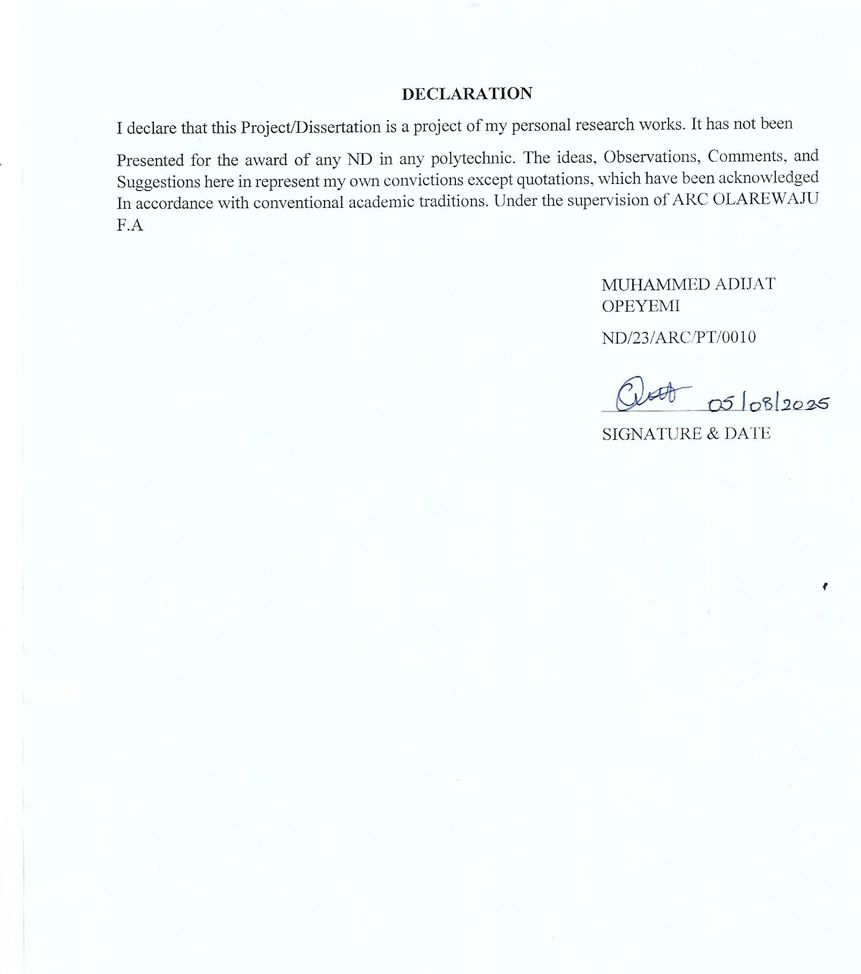

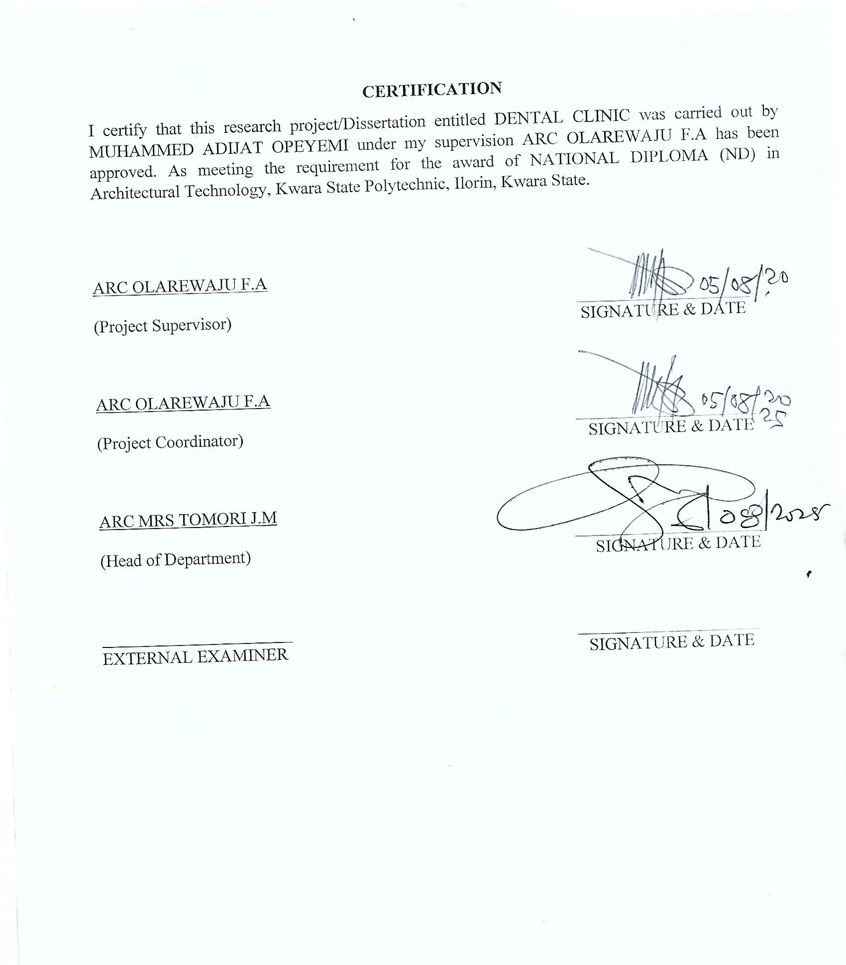
ACKNOWLEDGEMENT
My profound gratitude goes to Almighty Allah,the creator of universe and fountain of all wisdom whose umbrella of guard and guide. I seek refuge through thick and thin of years of study.
I will also like to appreciate my project supervisor in person of ARC OLAREWAJU F.A whose contribution prepare me for the challenges in the field and for his immense contribution is all ramification towards the completion of this research work. He encourage me and open the door of interaction with him. I pray Almighty Allah will shower his blessing and mercy over him, your family and may you live to reapthe fruit of your labour.
I also want thank and appreciate the effort of all the Lectures in Architectural Technology Department my H.O.D ARC MRS TOMORI and the host of lectures ARC FAMILUA O.S, ARC CHUCKWUMA NMOM, ARC MOH. SHERO, who taught and give lasting advice’s that led to the success of my program, Almighty Allah will meet everyone at the point of needs.
I would also show my profound gratitude to my parents MR and MRS MUHAMMED for their Immeasurable motivation, advices, efforts, and prayers on me for the completion of this program.
My Lovely sisters: Miss Lateefah, Rahmah, mutiah and My Lovely Brother Adam, brother Ahmed,brother Dekola and Aunty Islamiyat. Almighty Allah shower his endless blessing, mercy, unlimited grace, joy, happiness without sorrow, sound health overall and may Almighty Allah meet everyone at the point of your needs.
Precious friends: My lovely friends Damilola, Ifeoluwa mi, Semilore, Timileyin, Adeola mi, Khadijat, Amos. Almighty Allah shower his blessing, grace, and happiness with sound health over you all and our prayer (AMEEN)
I would also show my appreciation for the effort of an unforgettable of MR ADEGOKE ADELABU, who advise me to carry on my journey. Almighty Allah bless you and grant your heart desires, good health over you.
Lastly ,I would like to appreciate the effort of my colleagues in department, school, and hostel, I whole heartedly say a VERY BIG THANK YOU, I appreciate you all, May Almighty Allah bless you all.
Above all, my utmost thanks go to the all sufficient God, the fountain of my wisdom, for his great and protection over my life, for his undying love, support and guidance throughout my period of learning and also for in sighting writing this project without him am nothing.

DEDICATION
This project work is dedicated to Almighty Allah who has been providing all my need for his blessing and mercy over me all through the program.
And to my parent, my sisters, my brothers, friends, love one’s and supervisor who assist me financially, spiritually, mentally and guide me through my academic pursuit. May Almighty Allah shower his blessing and mercy over you All.

TABLEOFCONTENT
Titlepage………………………………………………………………………………....i
Declaration………………………………………………………………………………..ii
Certification………………………………………………………………………………iii
Acknowledgement………………………………………………………………………..iv
Dedication…………………………………………………………………………….......v
Tableofcontents………………………………………………………………………....vi
List of tables… .ix
List of figures…………………………………………………………………………….x
List of plates…………………………………………………………………………….xi
List of Appendices……………………………………………………………………..xii
Abstract………………………………………………………………………………...xiii
CHAPTERONE
1.1 INTRODUCTION…………………………………………………………………...1
1.2 DEFINITION…………………………………………………………………………3
1.3 HISTORICALBACKGROUND……………………………………………………..3
1.4 AIMAND OBJECTIVES ……………………………………………………………4
1.5 PROJECT JUSTIFICATION ………………………………………………………...5
1.6 CLIENT BACKGROUND…………………………………………………………....5
1.7 SCOPE OFTHEPROJECT…………………………………………………………..5
1.8 RESEARCHMETHODOLOGY……………………………………………………..5
CHAPTERTWO
2.1 LITERATURE REVIEW……………………………………………………………7
2.2 HISTORICALBACKGROUND……………………………………………………7

CHAPTERTHREE
3.1 CASESTUDIES………………………………………………………………...........9
3.2 SELECTEDCASE STUDIES 9
3.3 CASESTUDYONE………………………………………………………………….9
3.4 CASESTUDYTWO………………………………………………………………..12
3.5 CASE STUDY THREE……………………………………………………………...15
3.5 ONLINECASESTUDY…………………………………………………………….18
3.6 DEDUCTION………………………………………………………………………..18
CHAPTERFOUR
4.1 BRIEF HISTORICAL BACKGROUND………………………………………19
4.2 LOCATION AND SETTING OUT………………………………………….....19
4.3 POPULATION………………………………………………………………….21
4.4 SITE INVENTORY……………………………………………..………………21
4.5 SITE ANALYSIS………………………………………………………………..22
4.5.1 SITE SELECTION AND JUSTIFICATION… ……………………… ..……23
4.5.2LOCATION …………………………………………………………………..23
4.5.3 ACCESSIBILITY………….………………………………………………….23
4.5.4 INFRASTRUCTURE FACILITES….………………………………………..23
4.5.5 TOPOGRAPHY………………………………………………………….........23
4.5.6 SOIL STRUCTURE…………………………………………………………...24
4.6 GENERAL CLIMATE CONDITION.…………………………………………..24
4.6.1RELATIVE HUMIDITY……………………………………………………………...24
4.6.2 WIND…........................................................................................................................24
4.6.3 TEMPERATURE……………………………………………………………………..24
4.6.4 VEGETATION………………………………………………………………………..24
4.7 SOCIAL SERVICES…………………………………………………………………….24
4.7.1 ROAD………………………………………………………………………………….24
4.7.2 WATER AND ELECTRICITY………………………………………………………..25
4.8 DESIGN CRITERIA……………………………………………………………………..25
4.9 DESIGN BRIEF ………………………………………………………………….………25
4.10 DESIGN ANALYSIS… …………………………………………………………...25
4.11 SPACIAL ALLOCATION …………………………………………………………...25
4.12 PLANNING PRINCIPLE……………………………………………………………….26
CHAPTERFIVE
5.1 APPRAISAL OF PROPOSED SCHEME………………………………………………..27
5.2 CONSTRUCTION METHODOLOGY…………………………………………………..27
5.3 SERVICES………………………………………………………………………………..27
5.3.1 VENTILATION…………………………………………………………………………27
5.3.2 LIGHTING………………………………………………………………………………28
5.3.3 PLUMBING……………………………………………………………………………..28
5.3.4 ELECTRICAL INSTALLATION………………………………………………………28
5.3.5 WASTE DISPOSAL…………………………………………………………………….28
5.3.6 FIRE PROTECTION…………………………………………………………………….28
5.3.7 RAIN PROTECTION……………………………………………………………………29
5.3.8 EXTERNALWORK……………………………………………………………………..29
5.4 SUMMARY………………………………………………………………………………..29
5.5 CONCLUSION…………………………………………………………………………….29
5.6 RECOMMENDATION……………………………………………………………………29
5.7 REFERENCES……………………………………………………………………………..30
5.8 APPENDICES……………………………………………………………………………...31

LISTOFTABLES

TABLE4.1;SHOWING THE POPULATION OF THE GENDER 21

TABLE4.2;SHOWING SPACIAL ALLOCATION OF FLOOR PLAN… 26

LIST OF FIGURES
FIG3.1;SHOWING LOCATION PLAN OF CASE STUDY ONE… 10
FIG3.2;SHOWING FLOOR PLAN OF CASE STUDY ONE… 10
FIG3.3;SHOWING LOCATION PLAN OF CASE STUDY TWO… 13
FIG3.4;SHOWING FLOOR PLAN OF CASE STUDY TWO… 13
FIG3.5;SHOWING LOCATION PLAN OF CASE STUDY THRE… 15
FIG3.6;SHOWING FLOOR PLAN OF CASE STUDY THREE… 16
FIG4.1;SHOWING LOCATIONAL PLAN OF THE PROPOSED SITE… 20
FIG4.2;SHOWING SITE INVENTORY OF THE PROPOSED SITE… 22
FIG4.3;SHOWINGSITEANALYSISOFTHEPROPOSEDSITE… 23

LISTOFPLATES

PLATE3.1;SHOWINGFRONTVIEWOFCASESTUDYONE… 11

PLATE3.2;SHOWINGRIGHTVIEWOFCASESTUDYONE… 11

PLATE3.3;SHOWINGBACKVIEWOFCASESTUDYONE 12

PLATE3.4;SHOWINGSURGERYROOMOFCASESTUDYONE… 12

PLATE3.5;SHOWINGFRONTVIEWOFCASESTUDYTWO… 14

PLATE3.6;SHOWINGWAITINGAREAOFCASESTUDYTWO… 14

PLATE3.7;SHOWINGSURGERYROOMOFCASESTUDYTWO… 15

PLATE3.8;SHOWINGFRONTVIEWOFCASESTUDYTHREE 16

PLATE3.9;SHOWINGRIGHTVIEWOFCASESTUDYTHREE 17

PLATE3.10;SHOWINGSURGERYROOMOFCASESTUDYTHREE 17

LISTOFAPPENDICES
APP1;SHOWINGSITEPLANOFTHEPROPOSEDPROJECT 32
APP2;SHOWINGGROUNDFLOORPLANOFTHEPROPOSEDPROJECT 32
APP3;SHOWINGROOFPLANOFTHEPROPOSEDPROJECT 33
APP4;SHOWINGCROSSSECTIONOFTHEPROPOSEDPROJECT 33
APP5;SHOWINGFRONTVIEWOFTHEPROPOSEDPROJECT 34
APP6;SHOWINGSIDEVIEWOFTHEPROPOSEDPROJECT 34

ABSTRACT
This researcher work was carried out on the project topic "Dental clinic for Benin city Edo state". I felt caring out this project in ovallocal government will bring out meaningful result. For easy analysis and understanding, the study is being put into five chapters. Chapter one throws light on general introduction, definition of the project, historical background information of the project title, project justification, aim and objectives of the study, scope of the study, Chapter two, a detailed literature review of some books. The third chapter three also mention about the case studies and deduction from case studies. The fourth chapter deals with historical background of the study area, site location and description, site analysis, and geographical location, climatic data, population of the area, social services, and health services design criteria, design analysis, space allocation and planning principle. Chapter five deals with design appraisal, construction methodology, services, summary, conclusion and references.

CHAPTER ONE
1.1 INTRODUCTION
Dental education has arrived at a crossroads. During the last 150 years, it has evolved from aprelude to apprenticeship into a comprehensive program of professional education. Advancesinscience,technology,andpublichealthprogramshavegreatlyreducedtoothdecayandtoothloss. Dentists are respected professionals, and dental schools are part of many of the nation'sleadingpublicand privateuniversities.
This progress notwithstanding, the position of dental education within the university is beingquestioned as is its relationship to medicine and the larger health care system. Six dentalschools—all private—have closed in the last decade, and others among the 54remaining schools are in jeopardy. The dental profession is at odds with itself on a number ofissuesincludingworkforcepolicies,licensure,andhealthcarerestructuring.Tensionsbetweenpractitionersandeducatorscanundercuttheprofession'spositionwithintheuniversity.
The future of dental education will be shaped, in part, by scientific, technological, political,and economic factors that are largely beyond the profession's control. Nonetheless, dentaleducators—individuallyandcollectively—haveimportantchoicestomake.Theymayattempttopreservethestatusquo—ineffect,apathtowardstagnationandeventualdecline.Alternatively,theycanchooseamoredifficultpathofreassessingandrenewingtheirmissionsofeducation,research,andpatientcaresothattheycontributemore—andmorevisibly—totheuniversityandthe community.Takingthislatterpathwill requiremorevigorin implementinglong-standing recommendations for educational reform as well as attention to new issues andobjectives. For dental educators to pursue change successfully, they will need the activecooperation of the larger dental community as well as support from university officials andstateand national policymakers.
ThisInstituteofMedicine(IOM)studywaspromptedbyconcernsthatthechallengesconfrontingdentaleducation,althoughgenerallyrecognized,werenotunderstoodorappreciated adequately and that effective responses had yet to be identified or presented in apersuasive manner. The purpose of the study was "to assess dental education in the UnitedStates and make recommendations regarding its future." It was overseen by an 18-membercommitteethatwasappointedafterextensiveconsultationwithdentalandrelatedorganizations. The group included members with expertise and experience in dental practiceandeducation,oralhealthandhealthservicesresearch,otherareasofhealthprofessionsand Higher education, health care delivery and financing, and public policy. The committee as awhole met six times between February 1993 and May 1994. As described in the Preface andsummarized,itundertookawiderangeofactivitiestocollectinformationandperspectives from all segments of the dental community and other relevant, interested groups.(The papers commissioned by the committee will be published in the Journal of DentalEducation) This document, which was submitted for outsidereview in accordance with IOM and National Research Council procedures and policies,constitutesthecommittee's finalreport.
Dental care utilization can be defined as the percentage of the population who access dentalservices over a specified period of time1. Measures of actual dental care utilization describethe percentage of the population who have seen a dentist at different time M intervals. Dentaldisease is a serious public health problem with universal distribution and affecting all M agegroups2.However,despitethisuniversaldistribution,onlyafewseekdentalcare.Thusawidegap is created between the actual dental needs of the population and the demand for dentalcare3.Althoughdentistsagreethatregulardentalvisitsareessentialformaintaininggoodoralhealth, national studies in the United States of America estimate that only 41-50% of allAmericans visit the dentist each year4. In Nigeria, Savage and Arowojolu reported that M 24(31.58%) of the 76 subjects investigated perceived it as being normal for them to bleed fromthegum5.
Therefore,theyhavenoreasontoseekdentalcareforthisobviouspathologicalcondition.ThestudybySavageandArowojolufurtherreportedthat164(82.4%)oftheirsubjectsclaimednotto notice bleeding from their gum and believed that they do not have gum disease but dentalexamination revealed that none of the subjects seen had healthy periodontal status. Amongstthosethatadmittedtohavingnoticedthebleedingfromtheirgum,justabouthalfadmittedthatit is a sign of gingival disease yet none of them sought for dental care5. This observation inNigeriaisinlinewiththatofAinamoandAinamo6.Therearereportsthatdentalpatientsonlyvisit the dentist when in pain and never bother to return for M follow-up in most cases 7. Tothe best of our knowledge, only few studies have been carried out to either confirm or disputethisclaim in Nigeria.
1.2 DEFINITIONOFDENTAL CLINIC
CLINIC can be define as a healthcare facility where patients receive medical treatment, consultation and care from doctors, nurses or other healthcare professionals.
DENTAL CLINIC can be define as a specialized healthcare facility designed to accommodate dental examination, treatment and procedures. The design of a dental clinic incorporates functional spaces such as reception and waiting area, consultation room, sterilization zones, treatment rooms, x-ray or imaging room and storage for dental equipment and supplies.

1.3 HISTORICALBACKGROUND
Dentistryisoneoftheoldestmedicalprofessions,datingbackto7000B.C.withtheIndusValley Civilization.However, it wasn’t until 5000 B.C. that descriptions related to dentistryandtoothdecaywereavailable.Atthetime,aSumeriantextdescribedtoothwormsascausingdentaldecay, an ideathat wasn’tprovenfalse until the1700s!
In ancient Greece, Hippocrates and Aristotle wrote about dentistry, specifically about treatingdecaying teeth, but it wasn’t until 1530 that the first book entirely devoted to dentistry—TheLittleMedicinalBookforAllKindsofDiseasesandInfirmitiesoftheTeeth—waspublished.
By the 1700s, dentistry had become a more defined profession.In 1723, Pierre Fauchard, aFrenchsurgeoncreditedastheFatherofModernDentistry,publishedhisinfluentialbook,TheSurgeonDentist,aTreatiseonTeeth,whichforthefirsttimedefinedacomprehensivesystemfor caring for and treating teeth.Additionally, Fauchardfirst introduced the idea of dentalfillings and the use of dental prosthesis, and he identified that acids from sugar led to toothdecay.
In1840,thefirstdentalcollege(BaltimoreCollegeofDentalSurgery)opened,establishingtheneedformoreoversight.IntheUnitedStates,Alabamaledthewaybyenactingthefirstdentalpractice act in 1841, and nearly 20 years later, the American Dental Association (ADA) wasformed.Thefirstuniversity-affiliateddentalinstitution,theHarvardUniversityDentalSchool,wasfounded in 1867
By 1873, Colgate had mass produced the first toothpaste, and mass-produced toothbrushesfollowedafewyears later. What may come as a surprise is that the first African American to earn a dental degree datesallthewaybackto1869,andthefirstfemaledentalassistantwasemployedinNewOrleansin1885.WhatmightbemostsurprisingofallisthatmostAmericansdidnotadoptgoodbrushinghabits until after World War II, when soldiers stationed abroad brought the concept of goodoralhealth back to theUnited States.
1.4 AIM AND OBJECTIVES OF THE PROJECT
AIM OF THE PROJECT
To design a functional, efficient and culturally appropriate dental clinic in Benin city, Edo states that enhance patient care, ensures hygiene and integrates modern dental technologies while considering the local climate, infrastructure and community needs.
OBJECTIVES OF THE PROJECT
- To use heat-resistant roofing and locally sourced materials suitable for Benin City humid climate.
- To utilize passive cooling techniques, such as cross-ventilation and shading, to reduce reliance on air conditioning.
- To ensure barrier-free access for people with disabilities, including ramps and wide doorways.
- To allocate space for modern dental equipment, digital imaging and telemedicine facilities.
- To incorporate calming colors, natural lights and noise reduction features to ease patient anxiety.

1.5 PROJECT JUSTIFICATION OF THE PROJECT
This project justify, a well-planned dental clinic in Benin City which will enhance patient care, optimize operational patient efficiency and support infection control. Architectural consideration will ensure a functional, aesthetically pleasing, and sustainable healthcare facility that meets modern medical standards.

1.6 CLIENT BACKGROUND
The name of my client is GODWIN NOGHEGHASE OBASEKI.
Former Governor of Edo state.
Godwin NogheghaseObaseki is a Nigerian politician and a businessman who is the former Governor of Edo State. He was first elected governor under the platform of the All Progressive Congress in the year 2016 where he defected Mr. Osagieize-iyamu of the PDP and was sworn in as the governor on 12 November 2016 to 2024Born : 1 July 1957[age 68 years], Benin city organization founded : Afrinvest office, Former governor of Edo state since 2016, Party : People Democracy Party , Education : Columbia University, Pace University and University of Lagos, University of Ibadan Nationality : Nigerian.

1.7 SCOPE OF THE STUDY
- Proposed Building
- Quarters
- Cafeteria
- Gate House
- Generator House
- Parking Lot
- Interlock
- Access Road
1.8 RESEACH METHOLODY
Variousavenueswereexpressedasregardsthemethodofresearchonordertoarriveatafunctionalandappealingdesignconcepts.Thefollowingresearchmethodswereemployed.
LITERATURE REVIEW: Referencetotolerateforideasofvariouswriterwereconsultedinordertoattainusefulandimportantpastworkonsimilarproject.
INTERNET:Thisisaresearchthatwasdoneandgainedfromtheinternetinothertogetfurtherinformation.
PERSONAL OBSERVATION:personalinitiativecoupledwithinquisitivemeasure,interviewandvisualizethedailyactivitiesthattakeplacewithinvicinityandnecessarypicturesweretakeninordertoattaintherequiredmotive
CASE STUDIES:Thisinvolvesthethoroughsynthesisandanalysisofsimilarexistingstructure(building)Basedonthedatacollectedandbetterdeductionwasmadeforrealizationofthebest.
CHAPTER TWO
2.0 LITERATURE REVIEW
2.1 HISTORICAL BACKGROUND OF A DENTAL CLINIC
DENTAL CLINIC
Dentalclinicistechnicallyanyplacewheredentalservicesrendered.Itprovidestreatmentthatiscustomizedfromcustomerneedsandpreference(PennDental,2017).Dentalclinicisusuallyasingleroomlodgingalldentalequipmentandtools.Itcanalsobeabusinessestablishmentownedorrunbyadentalprofessional.Dentalcliniccanbefoundin hospital,schools,governmentoffices,andotherhealth-relatedestablishments.Componentsofadentalclinicorofficeare,receptionarea,computersandpatientrecords,dentalclinic,storageandotherareas(GordonK.2015).
Dentistryisoneoftheoldestmedicalprofessions,datingbackto7000B.C.withtheIndusValleyCivilization.However,itwasn’tuntil5000B.C.thatdescriptionsrelatedtodentistryandtoothdecaywereavailable.Atthetime,aSumeriantextdescribedtoothwormsascausingdentaldecay,anideathatwasn’tprovenfalseuntilthe1700s!
InancientGreece,HippocratesandAristotlewroteaboutdentistry,specificallyabouttreatingdecayingteeth,butitwasn’tuntil1530thatthefirstbookentirelydevotedtodentistry—TheLittleMedicinalBookforAllKindsofDiseasesandInfirmitiesoftheTeeth—waspublished.
2.2DENTAL CLINIC IN THE PHILIPPINES
ThedentaltourisminthePhilippineshaslatelyseenariseindemand.Thisispartlyduetowesternerslookingforcheaperdentistryoptionsaswellthecountry’spopularityasabeautifulvacationdestination(Sangkularb,P.M.2017).ThesurprisingcostsofdentalservicesinmanywesterncountriesexplainwhydentaltourismissuccessfulinthePhilippines.CaseinpointisthatthedentalserviceinwesterncountryisquitehighthanthepriceofdentalservicesinPhilippines.Thecostisnotonlythecausewhymanyforeignersseekingaffordabledentalimplantsoranydentalservices.ForeignpeoplewantsdentalserviceinPhilippinesbecauseoftopqualitydentalservicesata fractionofthecostpaidinmostwesterncountriesandtheycanexperiencethehospitalityofthelocals.(“3goodreasonswhydentaltourisminthePhilippinesisblooming”2019).AccordingtoLeyco-ChuaE.A.(2015),thePhilippinedentalindustrylookspromisingcomparedtothelastdecade,andthisistheevidentwiththeriseofgiantdental2clinicsandtheemergenceofsmallonesalloverthecountry.Dentistscanbesurelyfindeveninremoteareas.Thefieldofdentalcareisrapidlychangingandevolving.Fromthebasictoothextraction,theindustrynowoffersa wide rangeofservices.Technologiesandinnovationsarealsoprogressingwhichhasabigimpactthepracticeofcliniciansanddentallaboratorytechnicians.Theseresultedtostrongerandqualitymaterials,andmorereliableandefficientservices.Theprocessisnoweasierandfaster.Inthereportentitled“PhilippinesDentalCareMarketOutlookto2019–IncreasingAwarenessonOralCareandPopularityofDentalTourismtoFosterGrowth“whichprovidesacomprehensiveanalysisofthevariousaspectssuchasmarketsizeofPhilippinesdentalcaremarket,dentalcareservicesmarket,dentalequipment’s,andconsumablemarketandoralcaremarket,thesereportsaidthatthedentalcareserviceshavebeenthelargestsegmentofdentalcaremarketandhavecommandedthelargestshareofpercentinthetotalrevenuegeneratedbythePhilippinesdentalcaremarketin2014.Thedentalcaremarketmajorlygeneratesrevenuefromthefeechargedbytheclinicsfordiagnosisandtreatmentofdentalproblems.ThePhilippinesdentalcareservicesmarkethasregisteredrevenuesofUSDmillionin2014,drivenbythegrowingconcernsovermaintainingproperoralhygiene,increasedconsumptionoftobaccoandliquor,risingelderlypopulationandrisingnumberofdentalclinicsinthecountry(ReportBuyer2016).ProblemsencounteredbytheDentalClinicThereare6biggestchallengesthatdentalbusinessesarefacingtheyarecashflowissues,tiredness,findingandretainingprofitablepatients,motivatingemployees.
DENTISITY IN 18TH AND 19TH CENTURY AMERICA
The beginnings of dentistry in the United States came in the 1630s with the settlers of the Massachusetts Bay Colony, who were accompanied by barber-surgeons. One of the first dentists in America was English surgeon and dentist John Baker, who settled in Boston in 1763. Other immigrants to follow included Robert Wooffendale, who emigrated from England in 1766 and practiced in New York City, and Jacques Gardette, who moved from France in 1778, eventually settling in Philadelphia. In early colonial America, dental care was also rendered by artisans such as ivory turners. One such artisan was Isaac Greenwood, who began practicing dentistry in 1779 and is considered to be the first American-born dentist. Four of his six sons became dentists. The most prominent, John Greenwood, served as George Washington’s dentist. Other craftsmen performed a variety of dental services, the most well known being Paul Revere, who practiced dentistry for seven years in Boston. The first book on dentistry to be published in the United States appeared in 1801 and was written by Richard Cortland Skinner, a young immigrant from England.
By the first quarter of the 19th century, the United States had become the leading center in the world for dental developments. From 1839 to 1840 three major events in dental practice facilitated the establishment of dentistry as a true profession. In 1839 the first dental journal, the American Journal of Dental Science, was launched; in 1840 the first dental school, the Baltimore College of Dental Surgery, was established; and in 1840 the first national society of dentists, the American Society of Dental Surgeons, was founded in New York City.

CHAPTER THREE
3.1 CASE STUDIES
Thisisaresearchoranexercisethatiscarriedoutonexistingbuildingwhichissimilartotheoneresearcheriswritingon.Theobjectiveofacasestudyistotakeacriticalappraisalofexistingrelated project withaviewtoidentifythepositiveandnegativeaspectofsuchprojects.Itisonlywithtimethata project canbeadjustedsothatitcanbesuccessful.Theinformationobtainedfromtheappraisalwillguidethedesignerofnewandsimilarproject,thepositiveaspectofitshallbeincorporatedintheviewproposalwhileattemptswillbemadetosolvetheproblemofnegativeaspects. Itisonlythroughthisthatadesignercanbetterenhancethequalityandefficiencyofbuildinginthesociety.Foracomprehensiveanalysistheircasestudieshavebeenconducted.
3.2 SELETED CASE STUDIES
Casestudiesareofparamountimportant.Itisanexperimentalresearchoranalysiscarriedoutonexistingbuildingorgroupofbuildingfunctionallysimilartotheonewhichtheresearchisworking.
Foranytechnicaldesigntobemeaningfulthereisalwaystheneedforpreliminaryresearchefforttobemadeonthisproposalasaverynecessarygroundwork.
Thefollowingarecasestudiesofsomedentalclinic.
    - BozidDentalClinicatoluyoleIbadan,Oyostate.
    - IreAyoDentalClinicatawolowobodijaIbadan,OyoState.
    - EmpiredentalclinicAsadamIlorin, kwarastate.

3.3 CASE STUDY ONE
Location: Bozid Dental Clinic at Oluyole Ibadan, Oyo state

OBSEVERATION
MERITS
- Adequateparkingspace
- Itiswelllandscape
- Easilyaccessiblefromthegate
- Provisionofdrainage facilities
- Goodsecurityarrangement

DEMERIT
- Nospaceforfutureexpansion
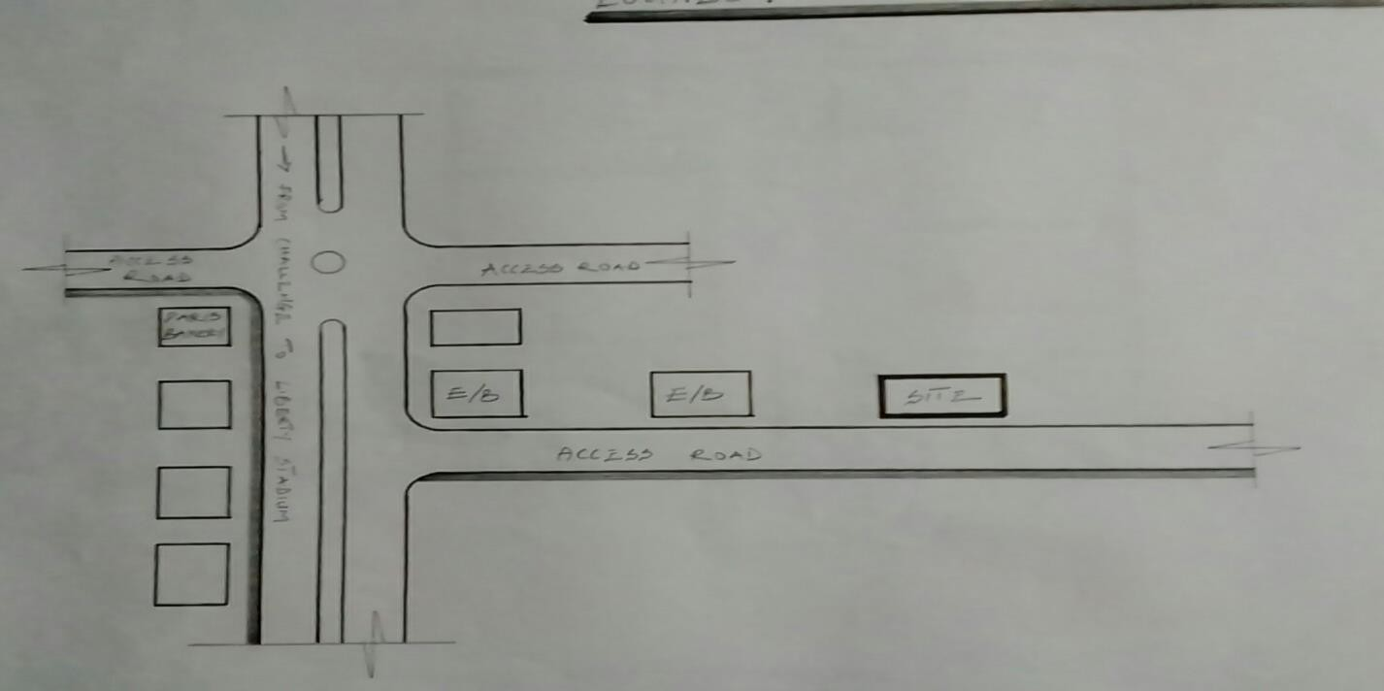

FIG3.1;SHOWINGLOCATIONPLANOFCASESTUDYONE
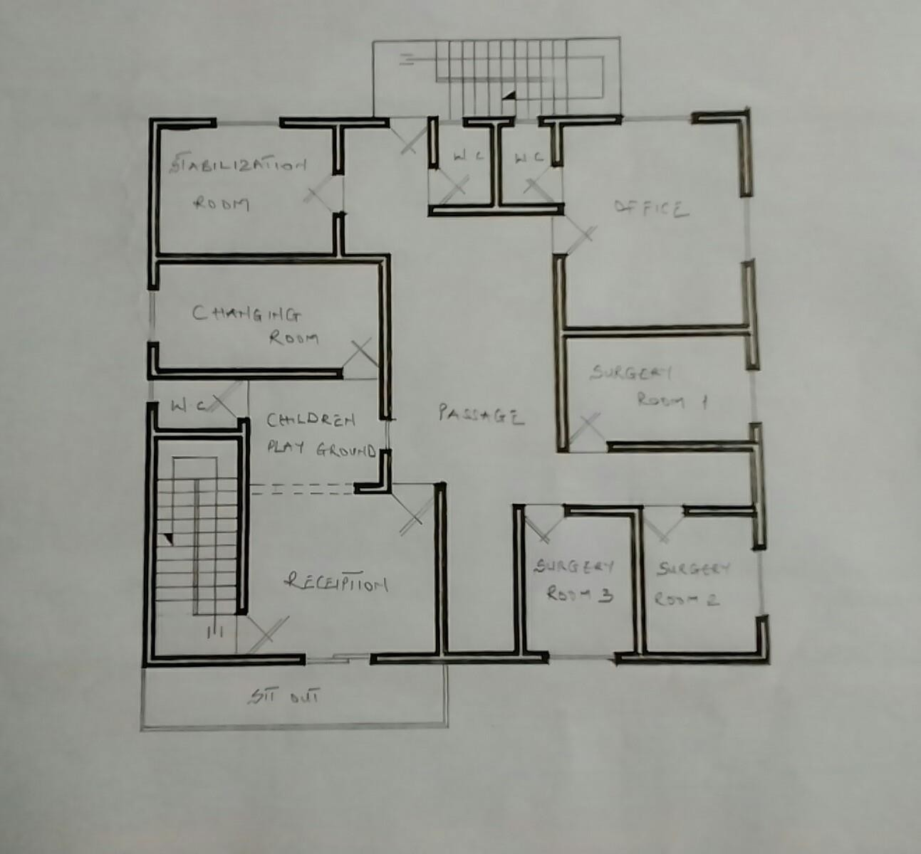

FIG3.2;SHOWINGFLOORPLANOFCASESTUDYONE

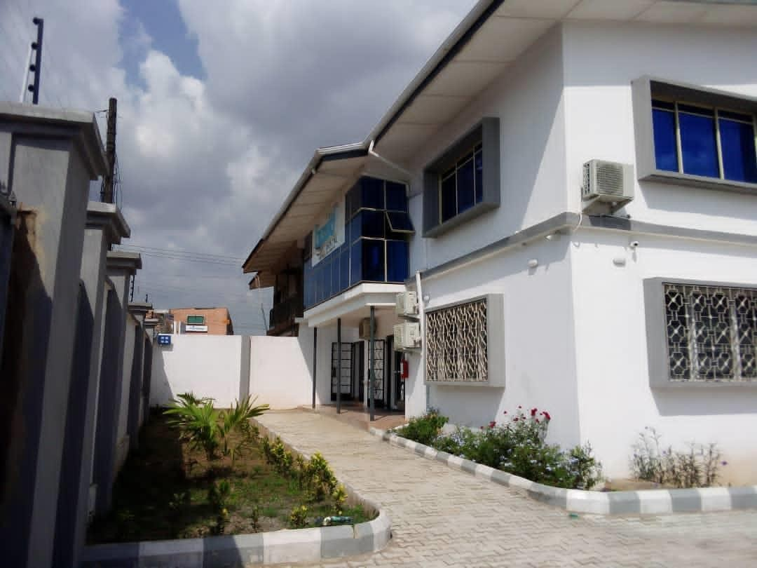

PLATE3.1;SHOWINGFRONTVIEWOFCASESTUDYONE

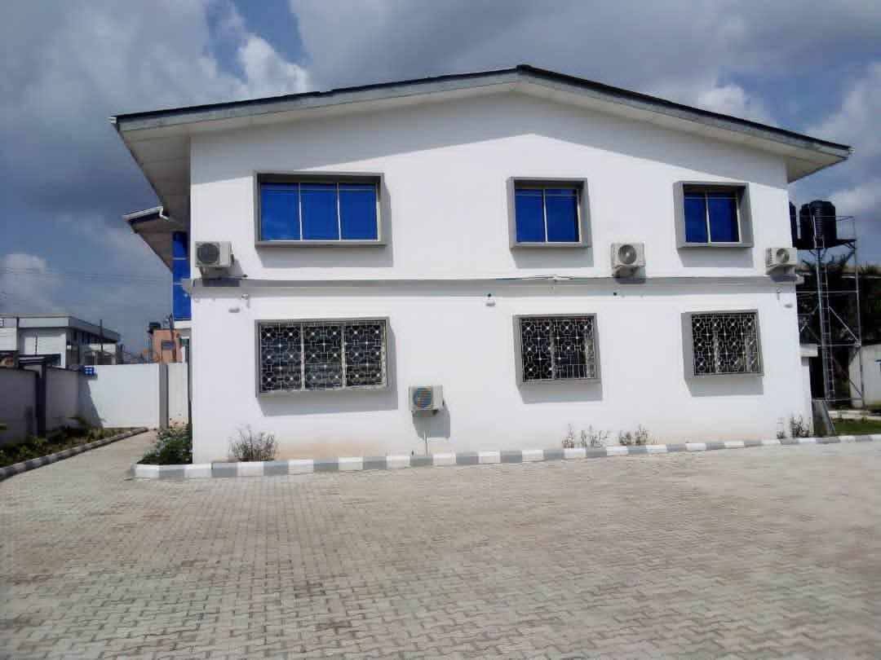

PLATE3.2;SHOWINGRIGHTVIEWOFCASESTUDYONE
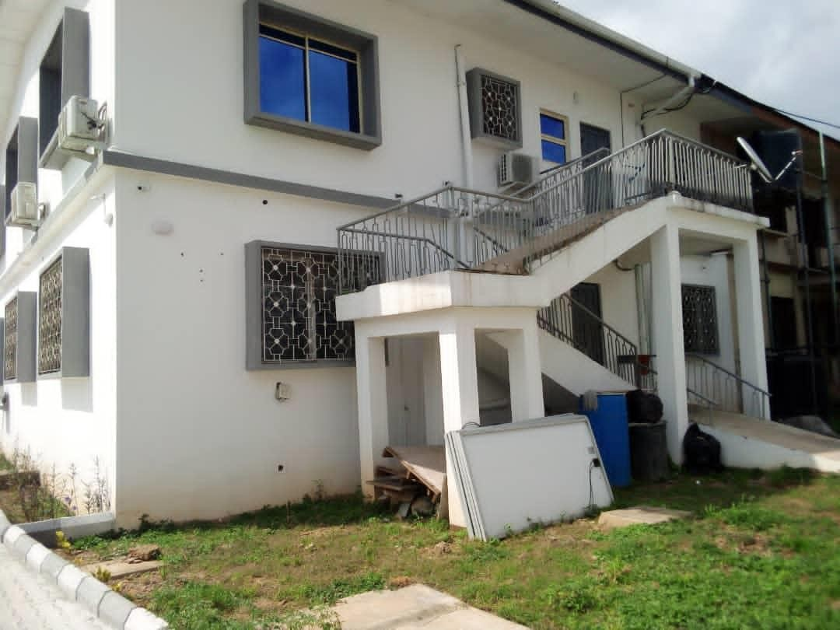

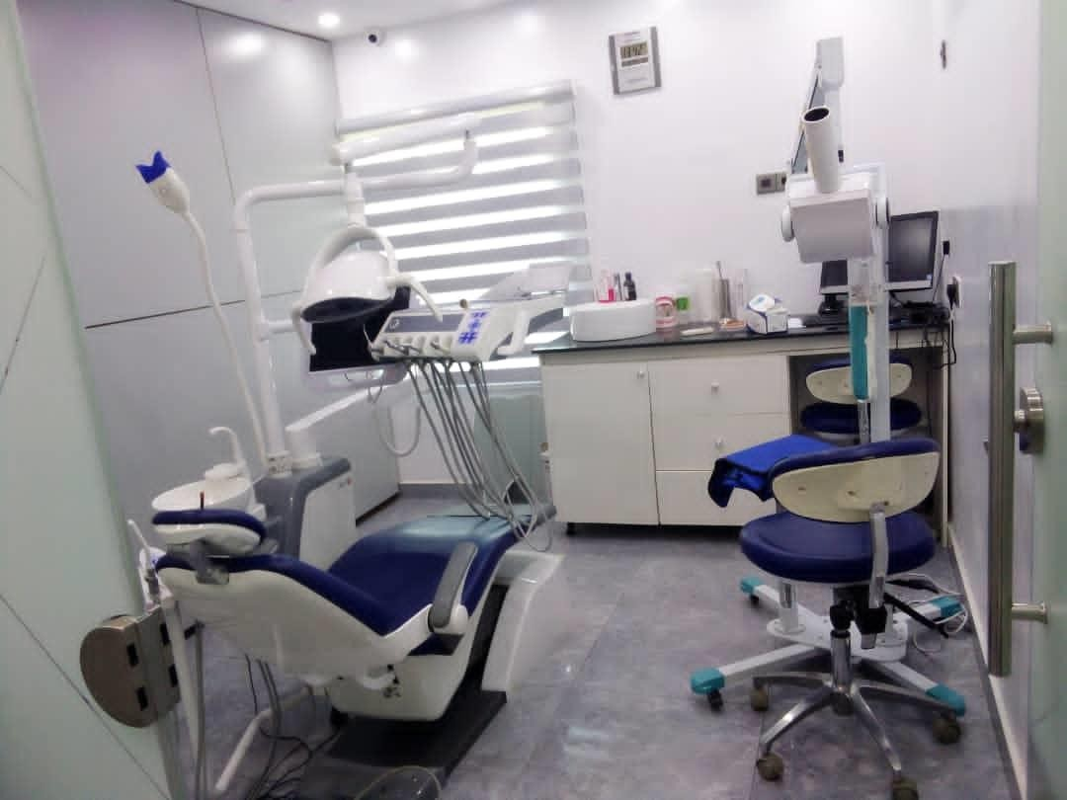
PLATE3.3;SHOWINGBACKVIEWOFCASESTUDYONE

PLATE3.4;SHOWINGSURGERYROOMOFCASESTUDYONE
3.4 CASE STUDY TWO (2)
LOCATION: IRE AYO DENTAL CLINIC AT AWOLOWO BODIJA,IBADAN,OYO STATE

MERITS
- Adequateparkingspace
- Provisionofdrainagefacilities

DEMERITS
- Noteasytoaccess
- Itisnotwelllandscape
- Notinaconduciveenvironment

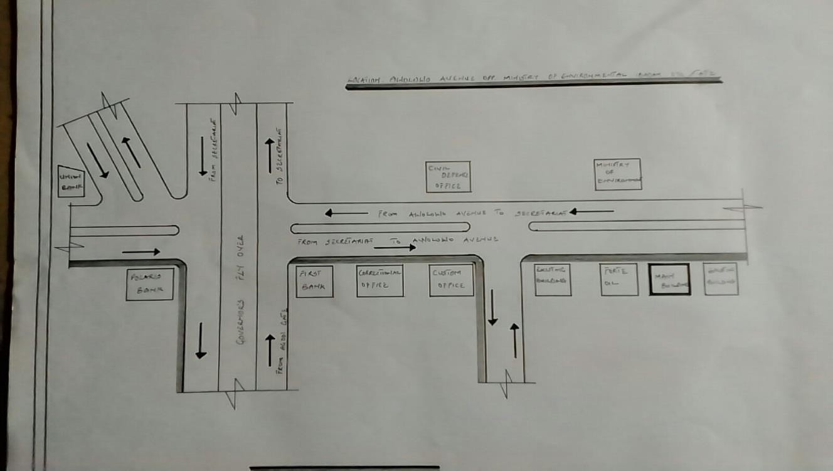

FIG3.3;SHOWINGLOCATIONPLANOFCASESTUDY TWO
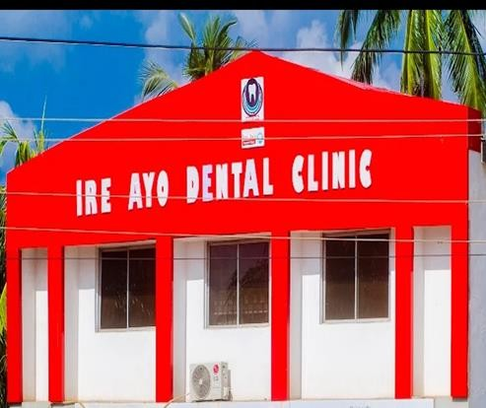
PLATE 3.5; SHOWING FRONT VIEW OF CASE STUDY TWO
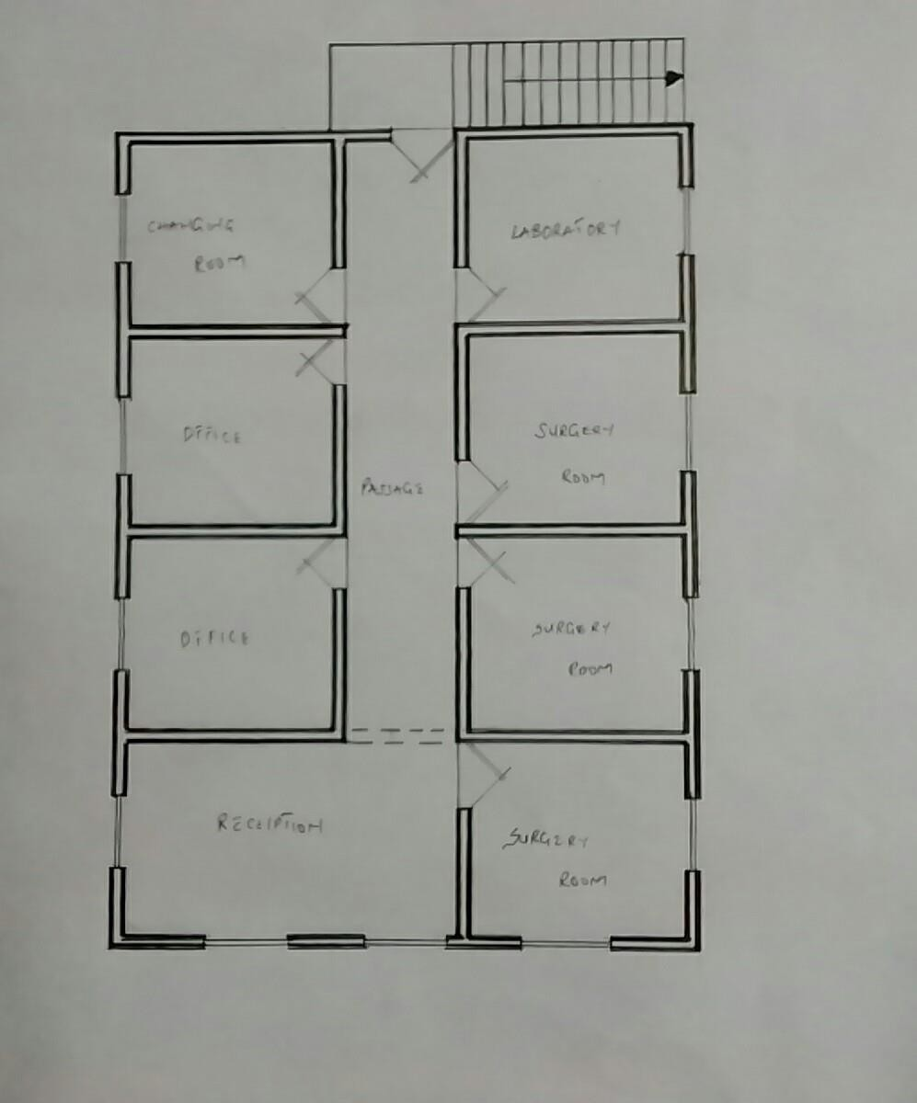

FIG3.5; SHOWING THE FLOOR PLAN OF CASE STUDY TWO

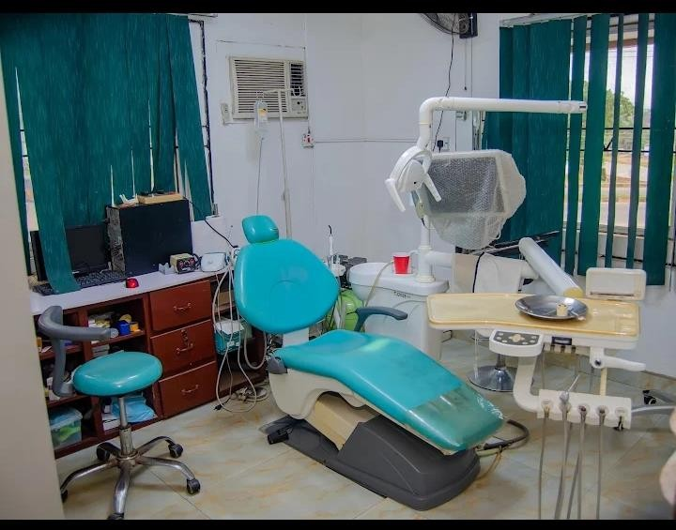

PLATE3.6;SHOWINGSURGERYROOMOFCASESTUDY

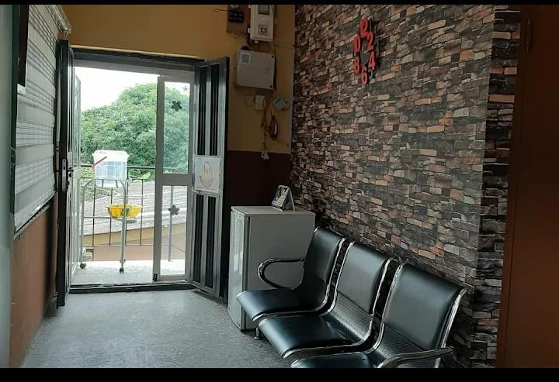
PLATE 3.7;SHOWINGWAITINGAREAOFCASESTUDYTWO

3.5 CASE STUDY THREE (3)
LOCATION: EMIPIRE DENTAL CLINIC AT ASADAM ILORIN, KWARA STATE

MERITS
- Easy to locate
- Good security
- Well landscaping

DEMERIT
- Inadequateparking space

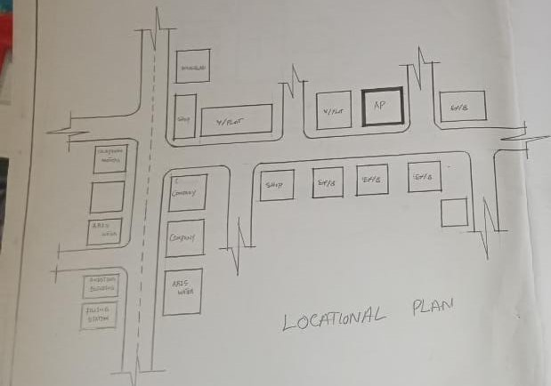

FIG3.6;SHOWINGLOCATIONPLANOFCASESTUDY THREE

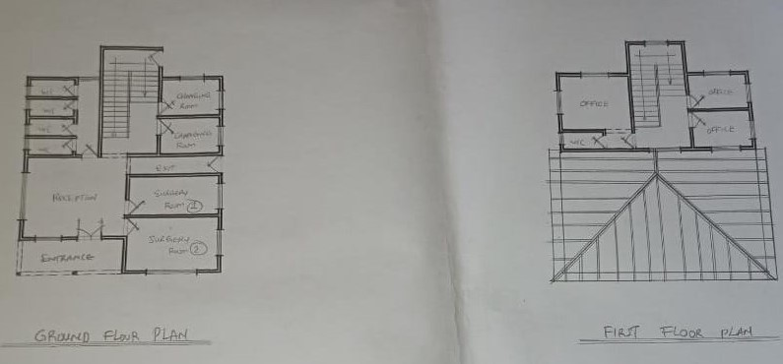
FIG3.7; SHOWING FLOOR PLAN OF CASE STUDY THREE

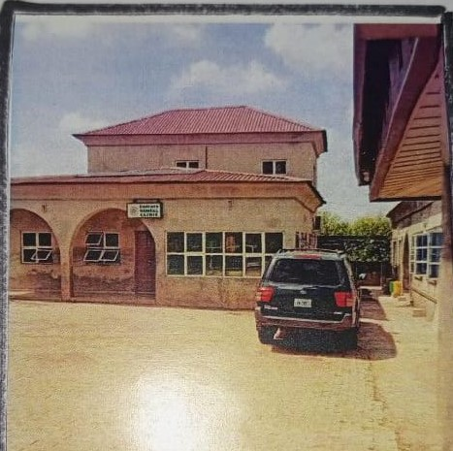

PLATE 3.8;SHOWINGFRONTVIEWOFCASESTUDYTHREE
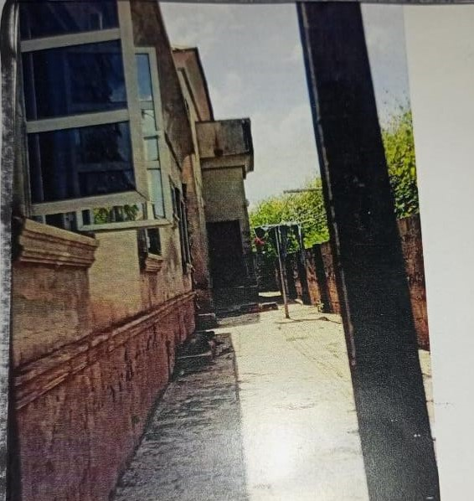

PLATE 3.9;SHOWINGRIGHTOFCASESTUDYTHREE

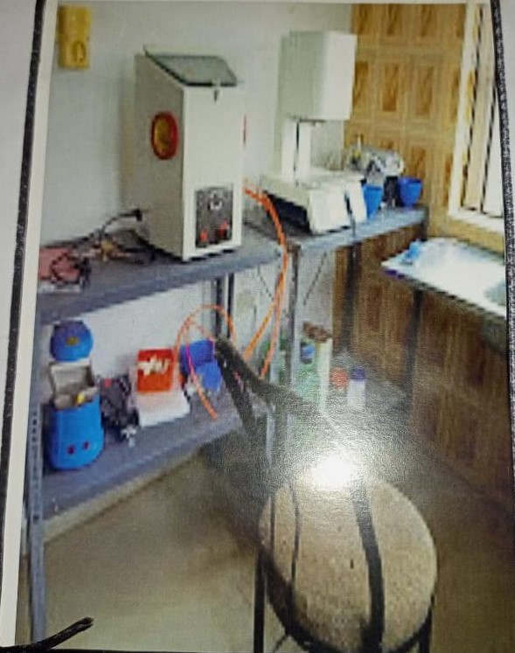

PLATE 3.10;SHOWINGSURGERYROOMOFCASESTUDYTHREE

3.6 ONLINE CASE STUDY
ONLINE CASE STUDY ONE
PROJECT NAME: IMAGE DENTAL CLINIC
LOCATION: AT TAKHQSSOUSI, AL MATHAR ASH SHAMALI,RIYADH 11564,SAUDI ARABIA
ARCHITECT: PADILLA NICAS ARQUITECTAS
YEAR: 2013
AREA: 485m
ONLINE CASE STUDY TWO
PROJECT NAME: DENTAL CLINIC
LOCATION: JARKOV,UKRAINE
ARCHITECT: DROZDOV&PARTNERS
YEAR: 2018
AREA: 359m
DEDUCTION FROM CASE STUDIES
During my visit to the dental clinics. I was opportunities to see what was obtain in the clinic, I made a proper studies of their related function and analysis were made to their present situation with the aim of incorporation with their merit in my own final proposal.
The following were deduce from my case study
- Adequate natural ventilation and lighting.
- Good architectural landscaping.
- The units in the hospital should be properly and well linked.
- There is need for consultation rooms.
- Parking spaces should be well defined.
- Good drainage system.
CHAPTER FOUR
4.0PROJECT LOCATION
4.1 BRIEF HISTORICAL BACKGROUND OF EDO STATE
Edo state, southern Nigeria. It is bounded by the states of kogi to the northeast andAnambra to the east, Delta to the southeast and south and Ondo to the west and northwest, the Niger River flows along the state’s eastern boundary. Benin City is the capital and largest urban centre.
Edo state was formed in 1991 from the northern portion of Bendel state, the southern portion of Delta state. Priort to this in 1963, the citizens of the territory had voted to separate from what was then the western region and the mid-West region was created. This became Mid-Western state following the federal re-organization in 1967,from a second re-organization in 1967 until it division in 1991,it was named Bendel State.
Edo state lies a televisions between 500feet(150m)in the south and more than 1800feet(550m)in the north.Tropical rain forest covers most of the area. The state is in habited largely by the Edo(Bini)people, who are linked to the historic kingdom of Benin.
4.1.2 GEOGRAPHY OF BENIN CITY
Benin City is situated on a branch of the Benin River and lies along the main highways from Lagos to the eastern states. The city is also linked by roads to Sapele, Siluko, Okene and Ubiajaan disserved by air and the Niger river delta parts of koko and sapele.
4.1.3 ECONOMY OF BENIN CITY
Agriculture is the main stay of the economy. Yams, cassava(manioc),oil palm produce, rice and corn(maize) are the major subsistence crops, while rubber, timber and palm oil and kernel are cash crop. The Nigeria institute of palm research , the rubber research institute of Nigeria and the university of benin (founded in 1970) are located at benin city, while the state university (founded in 1981) is at Ekpoma pop(2006) 3,218,332.
4.1.4 ORGANIZATION STRUCTRE
An organizational structure is a system that outline shows certain activities that are direct in order to achieve the goals of an organization. These activities can includes rules, roles and responsibilities. The organizational structure also determine show information flows between levels within the clinic.
4.2 LOCATION AND SETTING OF BENIN CITY
Benin city also called Edo capital and the largest city of Edo state, southern Nigeria. Benin city is situated on a branch of the Benin River and lies along the main highways from Lagos to the eastern states. The city is also linked by road to Sapele, Siluko, Okene and Ubiaja and disserved by air and the Niger River delta port of Koko and Sapele.
Benin City was the principal city of the Edo(Bini) Kingdom of Benin (flourished 13th-19th century). It was destroy in 1987 by the British, who attacked after the Edo assaulted an earlier British expedition, which has been told not to enter the city during religious festival but none the less attempt to do so. Traces of the old wall and moat remain, but the new city is a close-packed pattern of the house and streets converging on the palace and compound of the Oba (sacred king) and the government offices. In the main square is a statue of Emotan, a woman hounoured for assisting a 15th century prince attempting to regain power and later became Oba Eware. The present Oba retains traditional and advisory roles in government.
Benin City has long been famous for its “Bronzes” actually brass work, some of which is said to date from the 13th century and for it sivory and wood carvings. Its museum (1960) has a notable collection of the some of the kingdom’s early pieces. The city’s present artisan still practice the ancient method of cireper due (lost-wax) casting and its wood-carvers are organized into a cooperative craft society.
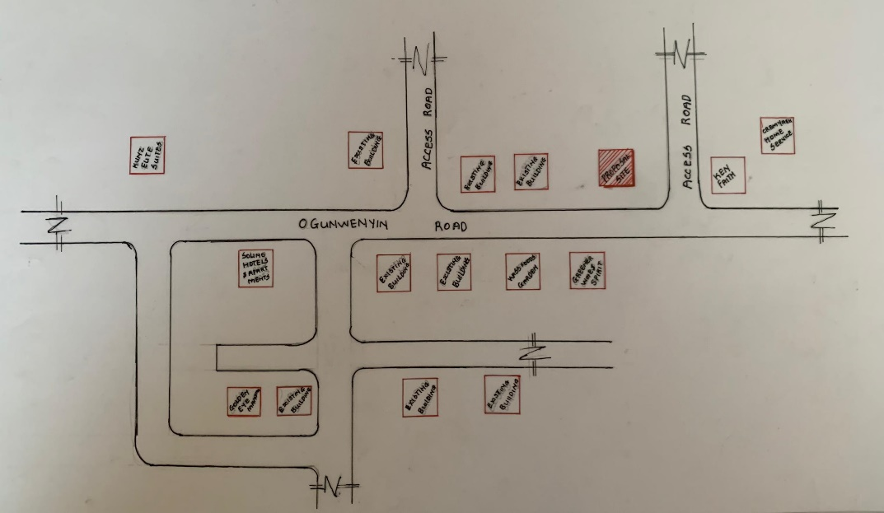
FIG 4.1; SHOWING LOCATION OF THE PROPOSE SITE
4.3 POPULATION
The population development of Benin city as well as related information and services.
The current metro area population of Benin City in 2025 is 2,045,000, a 3.65% increase from 2024
The metro area population of Benin City in 2024 is 1,973,000, a 3.57% increase from 2023
The metro area population of Benin City in 2023 is 1,905,000, a 3.48% increase from 2022.
The metro area population of Benin City in 2022 is 1,841,000, a 3.31% increase from 2021.
The metro area population of Benin City in 2021 is 1,782,000, a 3.18% increase from 2020.
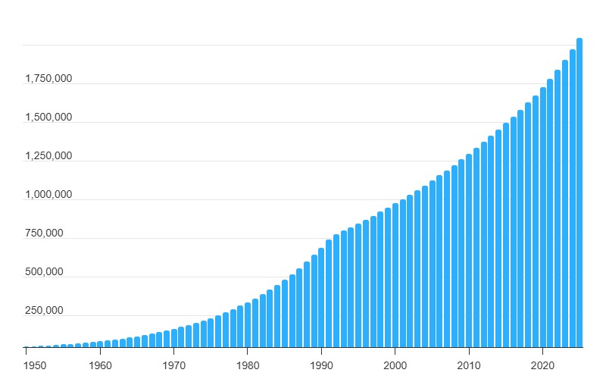
TABLE3.1; SHOWING GENDER GROUP
4.4 SITE INVENTORY
In the proposed site, some shrubs will be retained on site. It used to reduce sky glare and also serve as soft landscape and wind breaker.
Presence of road network which would serve as a means of accessibility to the site. Presence of electricity pole which serve as source of electricity to the site. Some trees would be retained while some will be removed if they disrupt the construction of building.
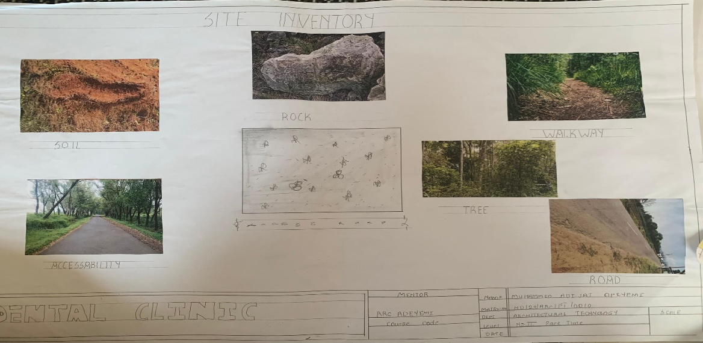
FIG 4.2; SHOWING SITE INVENTORY OF THE PROPOSED SITE
4.5 SITE ANALYSIS
The site is benefitted with loamy soil which is a very good soil for grass and shrubs. It has a gentle slope towards the south east. Some of the grasses, shrubs and trees on the site are to be retained to enhance landscape patter of the site while some are to be removed and replanted where necessary. The two noticeable winds are to be directed into the building using landscape pattern to improve ventilation. Noise generated from vehicle traffic is controlled through proper planning, good landscaping and proper orientation of building. Generally, all the feature on the site are best put into different uses to aid control through proper planning, landscape and orientation.
Certainly, steps are considered to obtain vital information of the site, this information is the analysed in details. For design purpose, the information include soil condition, geology, topography, vegetation etc. It also involves carrying out a preliminary survey of the site.
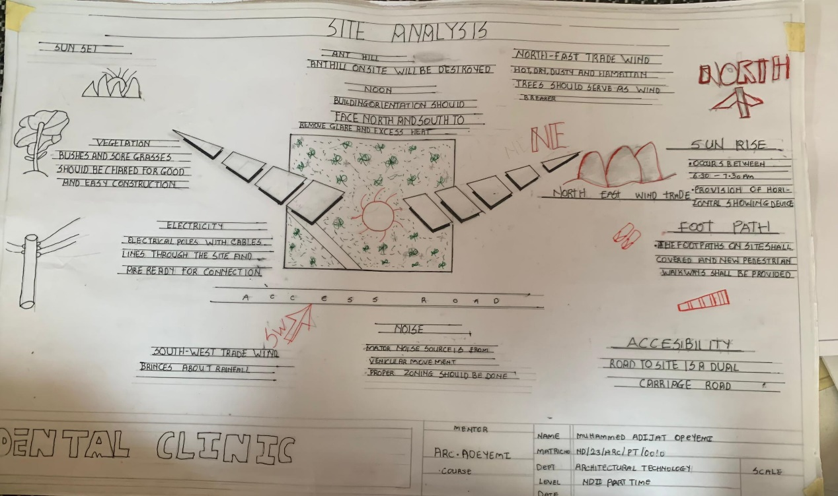
FIG 4.3; SHOWING SITE ANALYSIS OF THE PROPOSED SITE
4.5.1 SITE SELECTION/JUSTIFICATION
In the site selection provision is made for interesting facilities that worth emulating since the overall success and efficiency of any project depend not on the functionality of the design but also on a careful choice of site. The site of this project has been carefully selected which is located in the premises of Benin city, local government Edo state. The proposed site is located at Ogunwenyin road at benin city, Edo state.
4.5.2 LOCATION
The site is located at Ogunwenyin Road oka 300102 Benin city, Edo Nigeria:
Benin City is situated on a branch of the Benin River and lies along the main highways from Lagos to the eastern states. The city is also linked by roads to Sapele, Siluko, Okene, and Ubiaja and is served by air and the Niger River delta ports of Koko and Sapele.
4.5.3 ACCESSIBILITY
The site is easily accessible from the access road off from the main road that goes to sapele. The site can also be reached through the access road that lead to siluka.
4.5.4 INFRASTRUCTURAL FACILITIES
Facilities such as water electricity, telephone network and road network are all in Benin, hence it can easily be tapped to the proposed site.
4.5.5 TOPOGRAPHY
The topography of the land is gentle slope which can be filled and levelled up to balance round all the site levels.
4.5.6 SOIL STRUCTURE
It is made up of clayish laterite soil, which is good for building construction.
4.6 GENERAL CLIMATIC CONDITION
Benin has a tropical or equatorial climate, and is hot and humid year-round, with temperatures and humidity particularly high along the coast. In Cotonou, the average maximum temperature is 87F (31C) and the average minimum temperature is 75F (24C). Rainfall varies in Benin. There are two rainy seasons in the south, from April to mid-July, and from mid-September to late October; and a rainy season in the north from June to early October. During the rainy season smaller roads in Benin often become impassable and national parks tend to close during the wet season for this reason. The Harmattan wind blows in from the Sahara Desert between December and March, during the dry season, bringing heat and dust; but the hottest time of year is between February and April. The best time to visit Benin is between November and February, when travellers may have to contend with the hot Harmattan winds, but miss the rain and the worst of the heat
4.6.1 RELATIVE HUMIDITY
The town is under the influence of high humidity throughout the year with a monthly relative humidity remaining above 60%. This is even higher between May and September with a relative humidity figure of about 80% average.
4.6.2 WIND
There are two prevailing winds namely: The rain bearing south-west monsoon wind which blows across the Atlantic Ocean between the month of May and October. This is called wet season. The dusty north-east trade wind which laden with dust blows through the Sahara desert during the month of November to April with very title rainfall toward April. This is called the dry season and it brings along Harmattan during its driest period
4.6.3 TEMPERATURE
The monthly average temperature is quite uniform having February and March as the hottest months recording a higher average of about 48°C (about 85"F). July and August are the coolest (lowest monthly average of 76'F).
4.6.4 VEGETATION
The proposed site is covered with grasses few trees and shrubs. Some will be removed before the construction while some will be retain for ornamentation.
4.7 SOCIAL SERVICES
4.7.1 ROAD
There are only two access to the site
The southern access which serve as the main entrance and also main access road
4.7.2 WATER AND ELECTRICITY
There are pipe born water networks and borehole water which serves the habitant of Benin City. There is electricity supply from NEPA that serve the Benin City in general
4.8 DESIGN CRITERIA
There are three (3) methods of designing of any project which are: Function before form method
Form before function method Combination of Shapes
Designing projects, the function, before form method used in line with this method, the following are the design criteria for this project:
Functional: in term of functional requirement, the following design criteria must be considered.
Sustainability, Site and Location, Flexibility, Circulation, Accessibility, Organization, Maintenance, Environment and Services
4.9 DESIGN BRIEF
After research and planning, the next step in the series of the project programed is design itself. To achieve functional and well established design there must be a brief to work on. This brief depends generally on the scope of individual design. The brief of this project is therefore based on the various activities that take place in the hospital. To have enough brief for the proposed dental hospital, case studies were carried out on the existing dental hospital. The studies also give me the opportunity to know the nature of the various dental treatment and how they are related to each other.
4.10 DESIGN ANALYSIS
This is the process of itemizing units within the component of the entire design with a view to establishing a solid understanding and appreciation of the space relationships.
GROUND FLOOR PLAN; Entrance, Reception, Security Room, Cosmetic Room, Waiting Room, Consultation Room, Isolation Room, Dentistry Office, Account Room, Pharmacy, Surgery Room, Maxillofacial Surgery Room, X – Ray Room, Card Room, Store, Male Ward, Female Ward, Operational Room, Toilet, Changing Room, Conference Room, Control Room, Nurse Office, Laboratory, Exit.
4.11 SPACE REQUIREMENT
UNITS | AREA[M2]
ENTRANCE | 24.6m2
RECPETION
SECURITY ROOM | 20.8m2
COSMETIC ROOM | 15.9m2
CONSULTATION ROOM | 18.5
DENTISTRY OFFICE | 15.2
ACCOUNT ROOM | 18.5
PHARMACY | 16.5
SURGERY ROOM | 21.5
MAXILOFACIAL SURGERY ROOM | 22.6
X-RAY ROOM | 31.5
STORE | 31.5
MALE WARD | 48.1
FEMALE WARD | 48.3
OPERATIONAL ROOM | 15.9
TOILET | 22.2
CHANGING ROOM | 12.1
CONFERENCE ROOM | 38.9
CONTROL ROOM | 31.2
NURSE OFFICE | 21.9m2
LABORATORY | 21.5
TABLE3. 2; SHOWING SPACIAL ALLOCATION OF FLOOR PLAN
Necessary units in the building. A borehole system of water supply is to be adopted alongside the government supplied services and a storage facility is to be provided for effective management of water supply.
4.12 PLANNING PRINCIPLE
The planning principle is one of the most important aspects of any design. The planning of various units taking into consideration the activities performed in each unit, how they are related to one another and the users of the various units in the design. In respect to the above factors.

CHAPTER FIVE
5.0 GENERAL REQUIREMENTS
5.1 APPRAISAL OF PROPOSED SCHEME
The proposed scheme is to satisfy the appropriate building regulation. The project design is to confirm with the intended use of building taking into consideration with both natural factors and human that can pose a throat on the validity and stability of the project design.
5.2 CONSTRUCTION METHODOLOGY AND MATERIAL
The construction is to be carried out following the due process of construction ranging from.
Preliminary: this involves the clearing of the site, setting out and excavation of foundation trench, foundation works down to the basement level.
Sub-Structure: this process also entails the positioning and erection of column and beams, mansonry work etc.
Gypsumboard: is to be used for the Acoustic purpose of the building. This material is often called dry wall, wall board or plaster board. It creates a continuous surface suitable for most types of interior decoration. It comes in different size ranging length of 2.4m, 3.0m, also in thickness of 1/ inch, 3/8 inch.
5.3 SERVICE
A building can be said to be good when it performs the serves required by it. In other to have a well-function building design, there calls for an installation of underground water. This is a means of providing brightness naturally by sun or moon or artificially by lamps. Good natural and artificial lighting is important in lecture rooms, and workshop. It is always easy to make mistake and time the eye in a situation of poor lighting floor. For the purpose of this project, effort is made as much as possible to light up the entire building naturally before the use of artificial lighting. In this project, to obtain maximum lighting more openings are provided for the lecture rooms, workshop and admin. Artificial source of light will still be provided for in case where there is call for the use of it at night or in a situation where the weather condition warrants it.
5.3.1 VENTILATION
As it's relates to architectural, is the intentional introduction of outside AIT into a space through openings (like window/doors and mechanical means (ACs) to provide maximum thermal comfort for human satisfaction. In this design, both means of ventilation ate introduce but majority concentration on the mechanical means of ventilation for all units in the design for the purpose of extracting the used air and introducing fresh air within all spaces for humans consumption and satisfaction.
This is done through installation of mechanical (artificial) ventilation ducts horizontally and vertically all within the units of the design to allow easy floe of free movement of air passage through the ventilation channels and providing well, proper and adequate ventilation for each and every units in the design project.
5.3.2 LIGHTING
This is a means of providing brightness naturally by sun or moon or artificial by lamps. Good natural and artificial lighting is important in all units. It is always easy to make mistake and time the eye in a situation of poor lighting floor. For the purpose of this project, effort is made as much as possible to light up the entire building naturally before the use of artificial lighting.
5.3.3 PLUMBING
The plumbing system in this project design is made easy for waste extraction and brain water extraction through the means of service duct channel and roof gutter drainage.
All waste water and soil waste from the toilet/convenience are extracted through means of drainage pipe running through the walls down to the inspection chamber situated in the service duct, flowing down to the septic tank and soak away for final waste extractions.
5.3.4 ELECTRICAL INSTALLATION
The type of wiring system chosen should be conduct system of wiring, technical are should be wired with strong durable and light current resistance cables because of the power requirements and consumption of the equipment to be used and installed in them. Connection and distributing cable signal. Also electrical installation is to be done to allow for the use quality electrical fittings and fixtures in the whole of the hospital.
5.3.5 WASTE DISPOSAL
Waste disposal are to be put in the building and also some specific areas necessary, this waste bins should be disposed in the incinerator which will be provided within the proposed site premises. The waste should therefore, be burn in the incinerator or taken away from the site.
5.3.6 FIRE PROTECTION
Electrically, fire alarms and sensor are to be installed in the building in generally. This should be done in case of the fire occurrence. Fire extinguishers are to be placed at a certain distance in the lobbies and some other necessary areas. It is also serving as protection in case of fire outbreak.
5.3.8 RAIN PROTECTION DEVICES
The rainfall of a place generally determines the living condition and all comfort associated with that environment hence provision should be made for fast dispersal of the rain water as well as the associated condition with rainfall. This calls for the need to study the nature of rainfall of the area. To control the heavy rainfall during the wet season (April - October) the use of simple sloppy system roofing has been adopted. This is provided with roof gutter system which is linked to the ground drainage network by the use of P.V.C.
5.3.9 EXTERNAL WORKS
The external works are to be earned out generate, kerbs land and shrubs, flowers, grasses and trees planted. Concrete interlocking pavement tiles to be adopted before hard landscape for walk ways and parking spaces and car access roads must be tarred with asphalt finishes.
5.4 SUMMARY
This project, generally, has seriously widen my view and knowledge affecting my observation beyond my expectation. I have been able to deduct what it takes or entails and how to go about designing and achieving a good design of any form of this related project with total seriousness as this project has given out the facts and precise information it comprises.
5.5 CONCLUSION
It is obvious that majority of our patients still visit dental clinic for symptomatic treatment and pain account for the reason why majority present in the clinic. However, some factors such as low level of dental awareness and financial constraint of patient could have led to this pattern of presentation.
Nevertheless, the possibility of peoples’ negligence of their health, lack of time and fear of undergoing treatment in dental clinic cannot be ruled out.
This suggest that Dental surgeons and dental health workers have not been playing their role adequately in facilitating public enlightenment that people may appreciate the need for regular dental care and make adequate and proper use of the available dental care facilities.
5.6 RECOMMENDATION
There is need to emphasize more on the preventive aspect of dentistry. There is need to improve on the present state of dental awareness programs. The issue of cost of dental care should be better addressed than it is presently being done, e.g. through the National health insurance scheme program (NHIS).

REFERENCES
1. Brown L.J. and Lazer V. Dental care utilisation: How saturated is the patient’s market? J Am Dent Assoc 1999; 130: 573-580.
10. Woosung S., Amid I., Ashley A., James L. Determinants of Dental care visits among low- income African-American children: J.Am Dent Ass 2007; 138:301-318
11. Lo G.L. The use of Dental services by adult Singaporeans. Singapore Dent J 1993; 18:22- 25.
12. Manski R.J. and Moeller J.F. Use of dental services An analysis of visits, procedures and providers, 1996. J Am Dent Assoc 2002; 133: 167-175.
13. Sa’adu and Abdulraheem. Oral health care practice and socio-demographic findings among the physicians in Ilorin, Nigeria. Niger J Med 2003; 12: 211-216.
14. Manski R.J., Moeller J.F. and Maas W.R. Dental services: use, expenditures and sources of payment, 1987. J Am Dent Assoc 1999; 130: 500-508.
15. Manski R.J., Edelstein B.L. and Moeller J.F. The impact of insurance coverage on children’s dental visits and expenditures, 1996. J Am Dent Assoc 2001; 132: 1137-1145.
16. Newman M.G., Takei H.H and Carranza F.A. Carranza’s clinical periodontology. 9th ed..W.B. Saunders co., pp 82.
2. Allukian M. Dentistry at the crossroads: The future is uncertain: The challenges are many. Am J Public Health 1982; 72: 653-654.
3. Grembowski D., Comrad D. And Milgrom P. Utilisation of dental services in the United States and an insured Population. Am J Public Health 1985; 75: 87-89.
4. Douglas C.W. and Cole K. Utilization of dental services in the US. J Dent Educ 1979 43:223- 38.
5. Savage K.O. and Arowojolu M.O. Perception of gingival bleeding by Nigerian. Afr J Med Sci; 26: 91-93.
6. Ainamo J. And Ainamo A. Prevention of Periodontal Diseases in a mixed dentition. Int Dent J 1981; 31:125-132.
7. De Lacerda J.T., Simionato E.M., Peres K.G., Peres M.A., Traebert J. And Marcenes W. Dental pain as the reason for visiting a dentist in a Brazilian adult population. Rev SaúdePública 2004; 38 (3): 1-6.
8. Kolude B. And Gbadebo S.O. Orofacial Pain: Pattern of Presentation at Dental Clinic University College Hospital Ibadan. MDS Thesis, 2007.
9. Famuyiwa O.O., Olorunsola D.A. and Derin A. Some family factors in sickle cell anaemia in Lagos, Nigeria. Nig Med Practitioner 1998; 35:70-73.


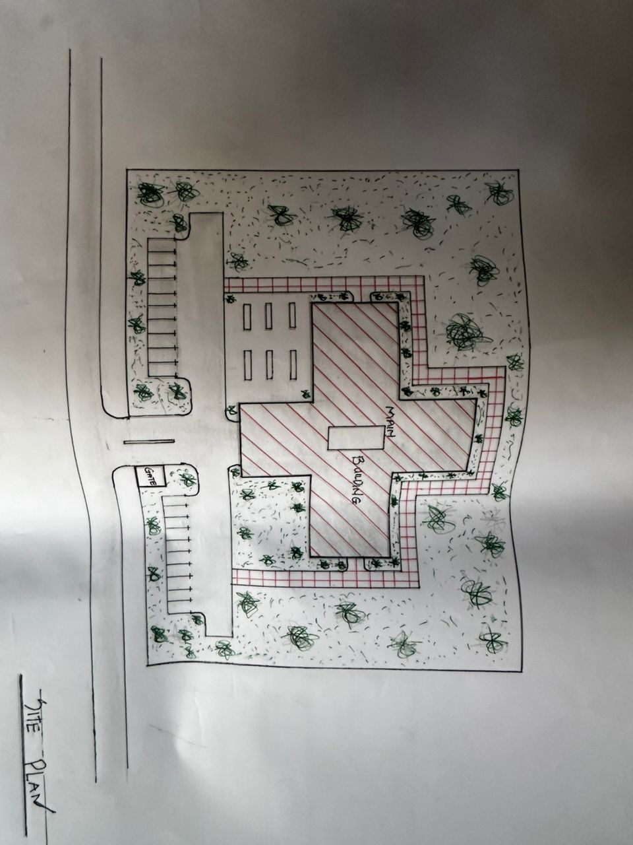
APP1: SHOWING THE SITE PLAN OF THE PROPOSED PROJECT
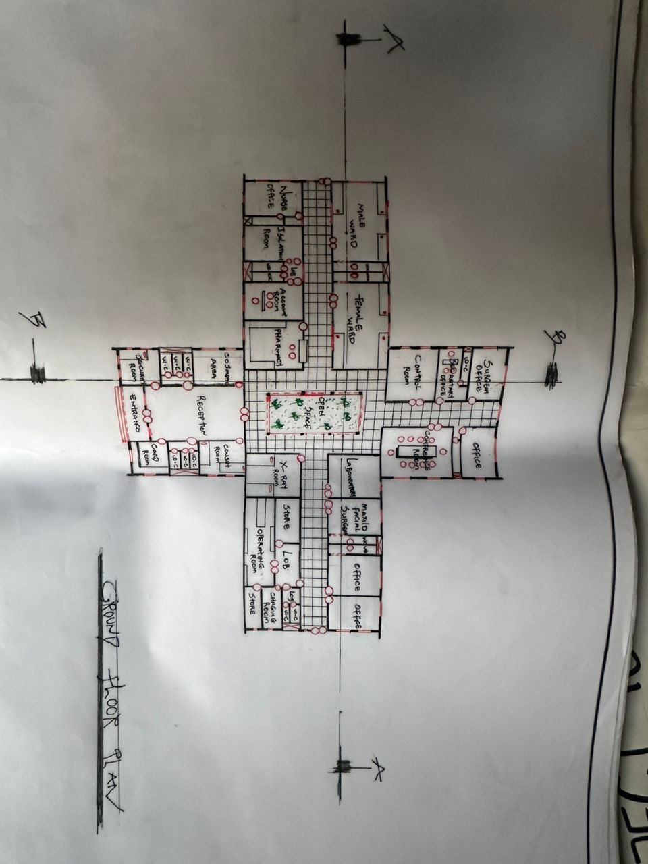
APP2: SHOWING THE GROUND FLOOR PLAN OF THE PROPOSED PROJECT
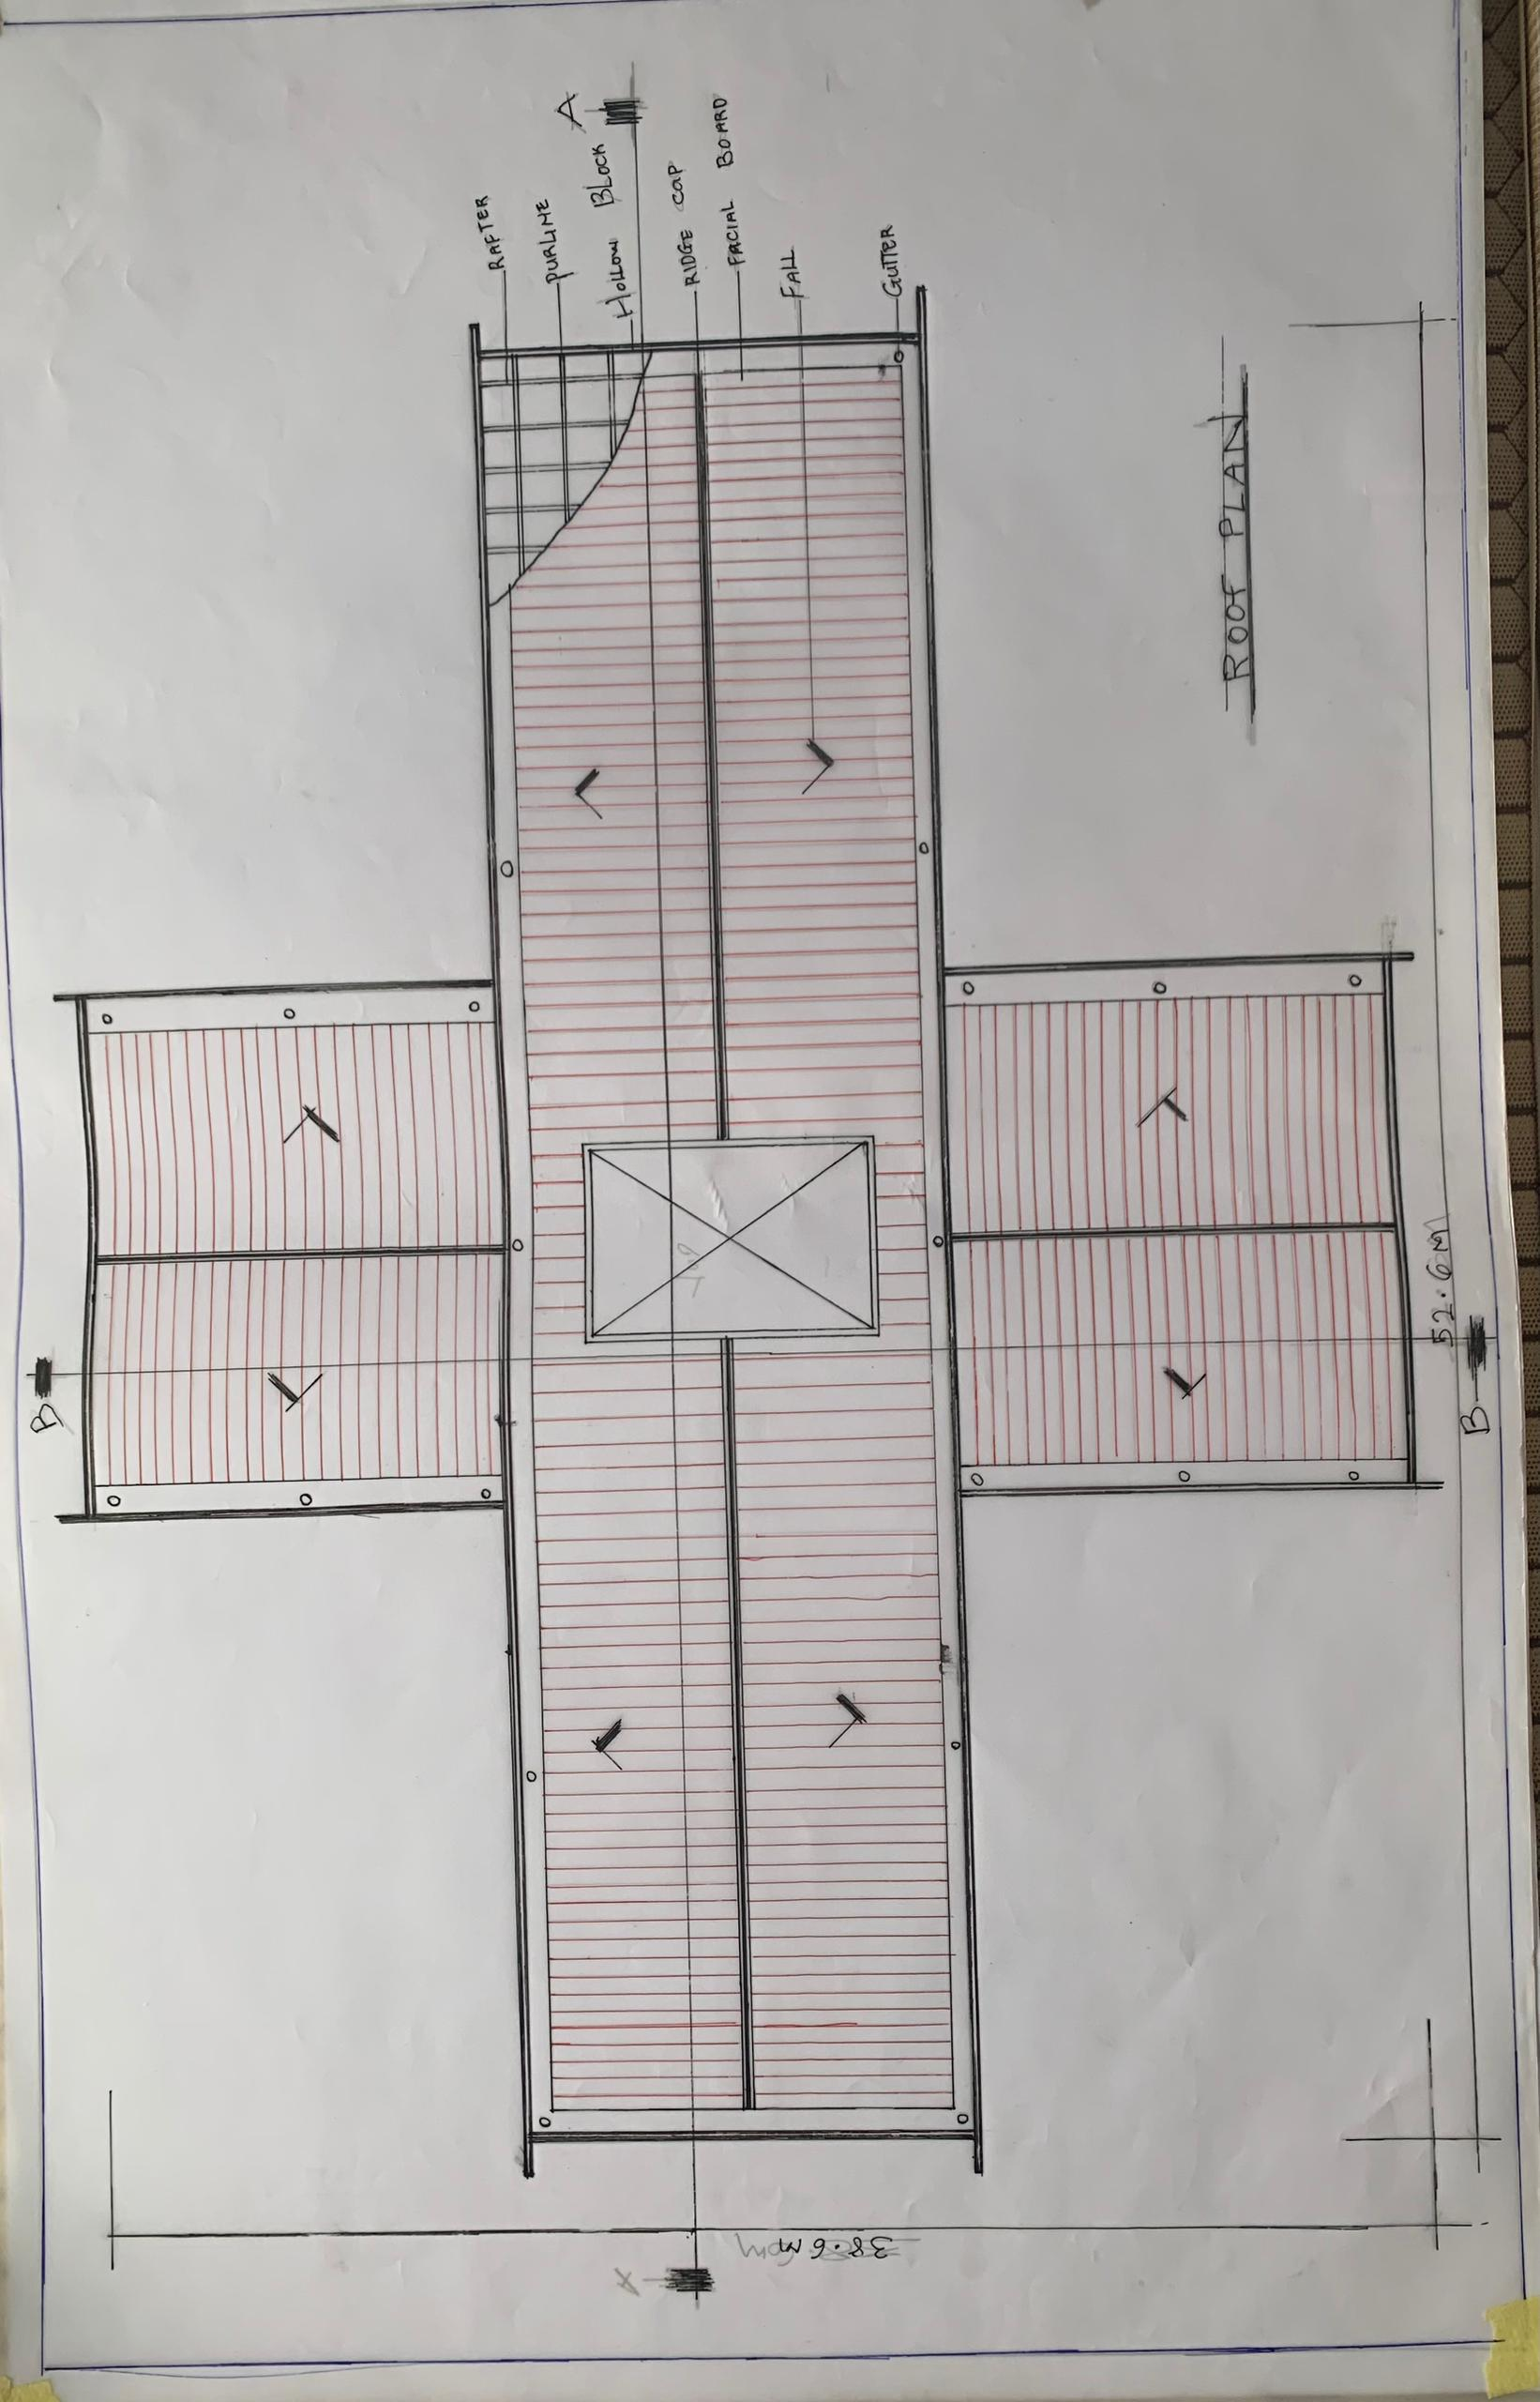
APP3; SHOWING ROOF PLAN OF PROPOSED PROJECT
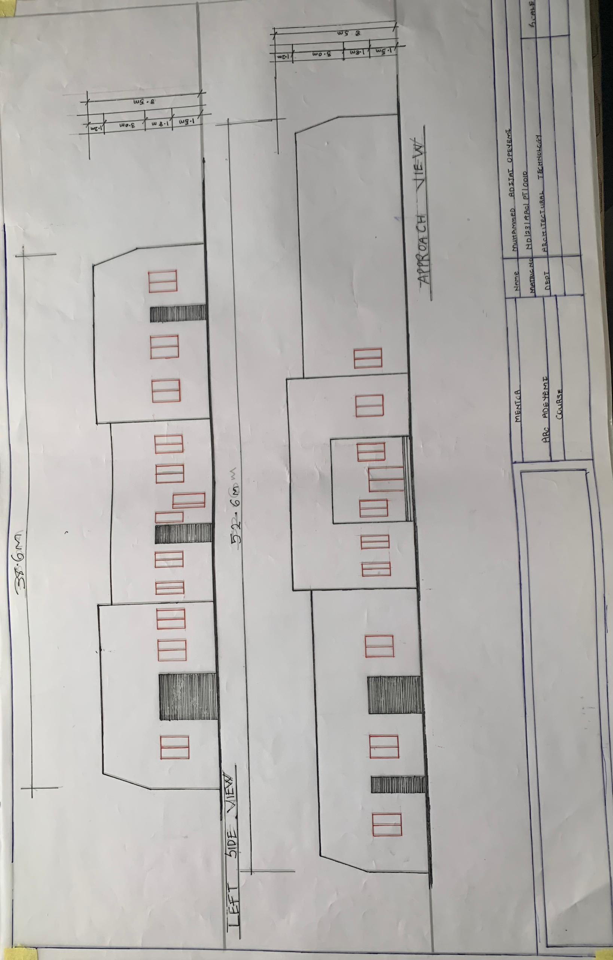
APP4: SHOWING ELEVATION OF PROPOSED PROJECT

