A PROJECT REPORT
ON
PROPOSED CENTRAL MOSQUE
For
ODO-EKU COMMUNITY , ISIN LOCAL
GOVERNMENT KWARA STATE
BY
ABDULFATAI IDRIS DAMILARE
HND/23/ARC/FT/0043

SUBMITTED TO
DEPARTMENT OF ARCHITECTURAL TECHNOLOGY, INSTITUTE OF ENVIRONMENT ARCHITECTURAL STUDIES, KWARA STATE POLYTECHNIC, ILORIN

IN PARTIAL FULFILLMENT OF THE REQUIREMENTS FOR THE AWARD OF HIGHER NATIONAL DIPLOMA [HND] IN ARCHITECTURAL TECHNOLOGY KWARA STATE POLYTECHNIC, ILORN KWARA STATE.

JULY,2025

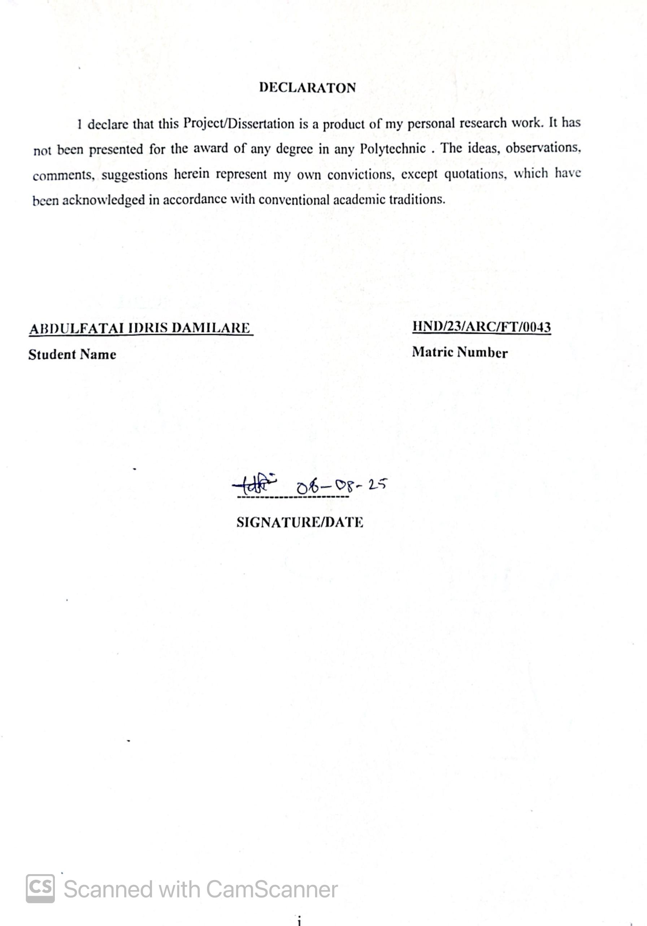
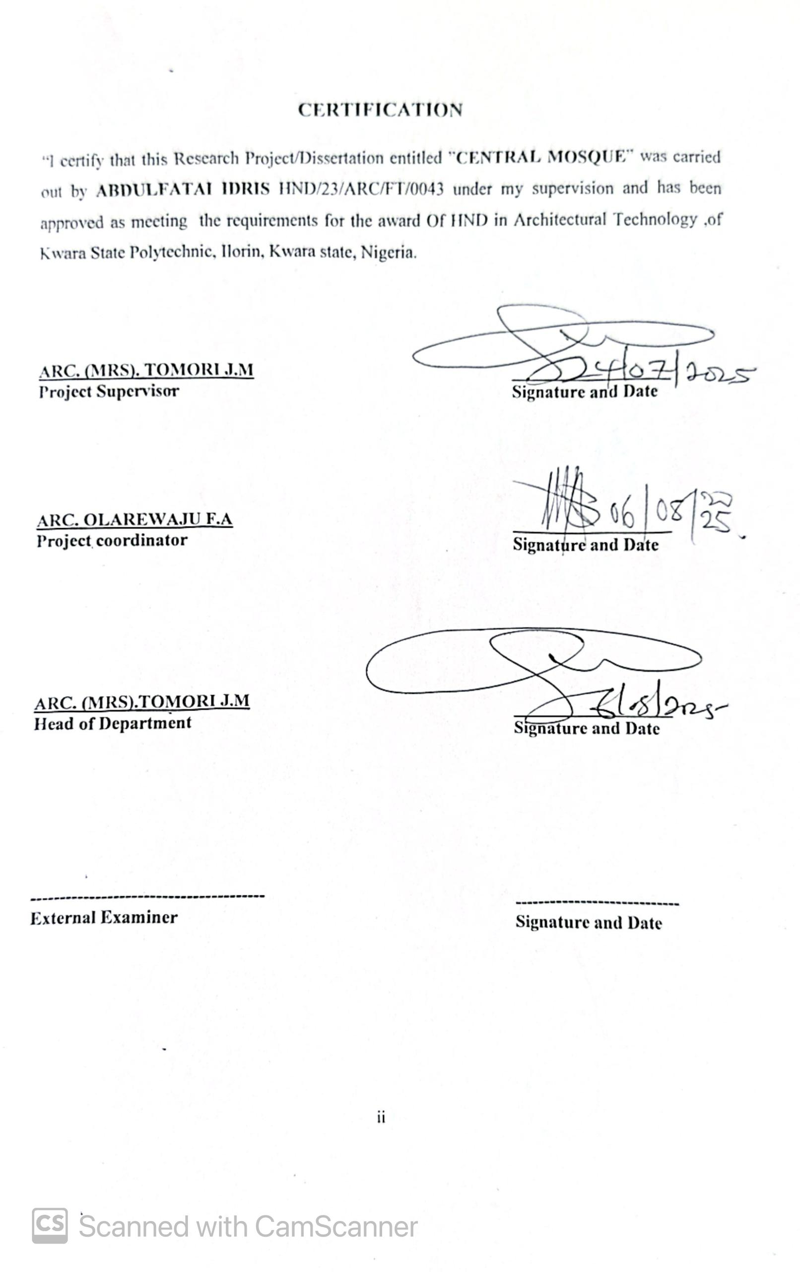 DEDICATION
I dedicate this project to my parent Mr. & Mrs. Aribidesi Abdulfatai for their prayer and supporting me

ACKNOWLEDGEMENT
Everything that has beginning must have an end, therefore, all praises and adoration is unto God for the strength and courage he has accorded me in the process of this project.
Special thanks to my project supervisor ARC (MRS TOMORI J M for taking her time to go through my research work, may Almighty Allah bless you abundantly. To all academics member and non academic members of architectural technology, ARC. CHUCKWUMA NMOM. ARC AMADA A.T, ARC ABDULAZEEZ B.Y.F, ARC SOLOMON FAMILUA, ARC OLAREWAJU F A God bless you all.
My deepest appreciation goes to My Parents Mr & Mrs ABDULFATAI for their prayer and support And to My entire family and friends.
I sincerely appreciate the support and assistance of everyone who contributed to this project, especially those who offered help, guidance, or information even without knowing me personally. Your kindness and willingness to assist made a significant difference, and I am truly grateful.
I appreciate my course mates, my sweet good friends AISHAT , FARUQ , and the rest for their support, encouragement, and collaboration throughout the course of this project. Your contributions, whether big or small, did not go unnoticed

LIST OF PLATES
Plate 3.1.1: Exterior view of the of Abdulazeez Arisekola central mosque 18
Plate 3.1.2: The Back view 18
Plate 3.2.1: Entrance of the mosque 21
Plate 3.2.2: The view of the Mosque 21
Plate 3.3.1: Lekki Front View 23
Plate 3.3.2: The view of the mosque 24
Plate 3.4.1: The view of the Mosque 25
Plate 3.4.2: The view of the Mosque 25
Plate 3.5.1: View of the Mosque 27
Plate 3.5.2: View of the mosque 27

TABLE OF FIGURES
FIGURE 3.1.1: Location layout 16
FIGURE 3.1.2: Site plan 17
FIGURE 3.1.3locational plan of mosque 17
Figure 3.2.1: Location layout 19
Figure 3.2.2: Site plan 20
Figure 3.2.3: Ground Floor plan 20
Figure 3.3.1: Location layout 22
FIGURE 3.3.2: Site plan 23
Figure 4.1.1: Site Map 31
Figure 4.1.2: Location Plan of the proposed building 32
Figure 4.1.3: Google map of the proposed building 32
Figure 4.1.4: Site Analysis 33
Figure 4.1.5: Climatic Data 34

LIST OF TABLES
Table 4.1.1: Appraisal of proposed schemes in the spaces, size and relationships 36
Table 4.1.1: Appraisal of proposed schemes in the spaces, size and relationships 37
Table 4.1.3: Spatial allocation / schedule of accommodation 39
Table 5.1.1: 5.2 Service Required 42
Table 5.1.3: Legal Issues and Planning Regulations in Mosque Design & Construction (Nigeria 43

TABLE OF CONTENTS
TITLEPAGE…………………………………………………………………………………… i
DECLARATION……………………………………………………….…………………………ii
CERTIFICATION……………………………………………………….………………………..ii
ACKNOWLEDGEMENT………………………………………………………………………..iv
DEDICATION……………………………………………………….……………………………v
LIST OF TABLES………………………………………………..………………………………vi
LIST OF FIGURES……………………..……………………….……………………….……..vii
LIST OF PLATES………………………………………………………………….……...……viii
ABSTRACT………………………………………………………………………..…………….ix
CHAPTER ONE
1.0 INTRODUCTION………………………………….………….……………….…………1
1.1 HISTORICAL BACKGROUND………...………………….……………………………1
1.2 STATEMENT OF INSTITUTIONAL HOSTEL …………..……………………….……2
1.3 AIM AND OBJECTIVES………………………………………..……………………..…2
1.4 JUSTIFICATION………………………………………………………………..…..……3
1.5 CLIENT’S BACKGOUND…………………………………………………………….…3
1.6 SCOPE OF STUDY…………………………………………………………………….…3
1.7 LIMITATIONS OF CONSTRANTS ………………………..…....……………..…….…4
1.8 RESEARCH METHODOLOGY…………………………………………………………4
1.9 DEFINITION OF TERMS………………………………………………..……………..13

CHAPTER TWO

2.1 LITERATURE REVIEW AND CASE STUDY………………………………………. 15
2.2 DEFINITION OF HOSTEL ……………………………………………….…………....15
2.3 HISTORICAL DEVELOPMENT OF HOSTEL ………………………...…..………..16
CHAPTER THREE
3.0 CASE STUDY………………………………………………………………..………… 18
3.1 CASE STUDY 1 ONE (ABDULAZEEZ ARIEKESOLA CENTRAL MOSQUE, IBADAN OYO STATE)……………………………………………………………………..….18
3.2 CASE STUDY TWO (AIYEPE CENTRAL MOSQUE , OGUN STATE)…………….21
3.3 CASE STUDY THREE (LEKKI CENTRAL MOSQUE, HAKEEM DICKSON LINK ROAD LEKKI PHASE 1 LAGOS STATE )…………………………………………………. 24
3.4 CASE STUDY FOUR ……………………………………………………………….….25
3.5 ONLINE CASE STUDY ONE (GRAND BUR DUBAI (MASJID) CENTRAL MOSQUE)……………………………………………………………………………………...28
3.6 ONLINE CASE STUDY TWO (AL AHZAR MOSQUE ,CAIRO EL GAMALIYAH EGYPT)……………………………………………………………………………………….....32

CHAPTER FOUR
3.7 DESIGN PROPOSAL………………………………………………………………………..38
3.8 STUDY AREA / PROJECT SITE……………….……………………………...……………38
3.9 SITE LOCATION …………….…………………………………………………………… 33
4.0 SiteLocation Map………………………………………………………………..……………39
4.1 Site Characteristics ………………….……………………………………….…………….41
4.2 SITE ANALYSIS. ……………………………….……………………………………..42
4.3 GEOGRAPHICAL/ CLIMATIC DATA……………………………………………………. 43
4.4 ANALYSES OF THE IMMEDIATE ENVIRONMENTAL CONDITIONS OF THE SITE………….45
4.5 PROJECT ANALYSIS/DESIGN CRITERIA…………………………………………….. …47
4.6 DESIGN CONCEPT…………………………………………………………………………..48
4.7 PROJECT GOAL………………………………………………………………….………………………..…48
4.8 APPRAISAL OF PROPOSED SCHEMES………………………………………………….. 48
4.9 EQUIPMENT AND OPERATIONAL AND PERFORMANCE REQUIREMENT ………………..... 50
5.0 SPATIAL ALLOCATION / SCHEDULE OF ACCOMMODATION ……………..… 53
5.1 FUNCTIONAL RELATIONSHIP……………………………………………………….54
5.2 CONCEPTUAL DEVELOPMENT ……………………………………………………..55
CHAPTER FIVE
5.3 APPROACH TO THE DESIGN / DESIGN REALIZATION…………………..……….56
5.4 DESIGN CONCEPT………………………………………………………………………………………….56
5.5 CONSTRUCTION METHODS………………………………………………….……….56
5.6 SUB-STRUCTURE……………………………………………………………………….57
5.7 SUPER STRUCTURE…………………………………………………………………….57
5.8 CONSTRUCTION MATERIALS………………………………………………..............58
5.9 SUBSTRUCTURE AND SUPERSTRUCTURE…………………………………………58
6.0 SERVICES/ INFRASTRUCTURE………………………………………………………..59

6.1 DESIGN CONTRIBUTION…………………………………………………………………………..………..60
6.2 Introduction…………………………………………………………………………………62
6.3 Recommendations…………………………………………………………………………..62
6.4 Conclusion…………………………………………………………………………………..62
REFERENCES………………………………………………………………………………
APPENDICES…………………………………………………………………………………

ABSTRACT

This write-up explores the architectural, cultural, and religious significance of the Central Mosque, a pivotal institution in the spiritual and social life of the Muslim community. The study examines the mosque's design elements, including its domes, minarets, prayer halls, and decorative calligraphy, highlighting how these features reflect Islamic art and architecture. It also discusses the mosque's role beyond a place of worship as a center for education, community gatherings, and charitable activities. By analyzing both historical and contemporary perspectives, this write-up emphasizes the mosque's continued relevance in promoting unity, peace, and cultural identity within its community. The Central Mosque serves as a pivotal architectural and spiritual landmark within Muslim communities, embodying religious, cultural, and social functions. This study examines the construction, design principles, and socio-religious significance of Central Mosques in southwestern Nigeria, with a particular focus on rural settlements such as Odo -Eku in Kwara State. Using a combination of architectural analysis, field observation, and historical context, the research highlights the integration of traditional Yoruba building techniques such as adobe and laterite masonry with Islamic architectural motifs like domes, minarets, and mihrabs. Findings show that Central Mosques in such communities are typically constructed using reinforced concrete frames or load-bearing block walls, with gable or hipped roofs supported by timber or steel trusses. In many cases, mosque construction is carried out through communal effort, with funding sourced from local donations and coordinated by religious leaders. The spatial layout generally features a large, column-free prayer hall oriented towards the gibla, supported by ancillary spaces such as ablution facilities and sometimes classrooms or Islamic libraries. This study concludes that Central Mosques in rural Nigeria not only serve liturgical needs but also function as centers for community mobilization, education, and identity preservation. Their evolving architecture reflects a blend of local craftsmanship, religious symbolism, and adaptation to contemporary building materials and methods.

CHAPTER ONE
INTRODUCTION
1.1 BACKGROUND TO THE STUDY

The Central Mosque holds a distinguished position within the Muslim community, serving not only as a place of worship but also as a hub for education, social interaction, and community development. Its presence is often a physical and spiritual landmark, symbolizing the unity and collective identity of Muslims in the area. With its grand architecture and serene atmosphere, the Central Mosque stands as a testament to Islamic values, heritage, and tradition.

The mosque’s significance extends beyond daily prayers; it is a venue for major religious observances, such as Jumu’ah (Friday prayers), Eid celebrations, and Ramadan activities. It also plays a crucial role in shaping the moral and spiritual life of its congregation, offering religious education and guidance to both young and old. As a community center, the mosque provides support services, promotes social welfare, and often participates in interfaith dialogue to foster understanding and peaceful coexistence.

This study is motivated by the need to explore and document the roles and relevance of the Central Mosque in contemporary society. It seeks to examine how the mosque has evolved in its functions, how it continues to meet the changing needs of its community, and how its architectural and cultural elements reflect Islamic identity. By focusing on the Central Mosque, this research contributes to a deeper understanding of the mosque’s enduring importance in both spiritual and socio-cultural contexts.

1.2 STATEMENT OF PROBLEM
The Odo-Eku Muslim Community Mosque has long served as a spiritual, educational, and social hub for Muslims in the Odo-Eku area. However, over the years, the mosque has faced numerous challenges thatt have hindered its ability to effectively meet the growing needs of its congregation. The structure, originally built to serve a smaller population, now struggles with issues of limited capacity, deteriorating infrastructure, and inadequate facilities for prayer, ablution, and community programs.
The Odo-Eku Muslim Community Mosque has long served as a spiritual, educational, and social hub for Muslims in the Odo-Eku area. However, over the years, the mosque has faced numerous challenges that have hindered its ability to effectively meet the growing needs of its congregation. The structure, originally built to serve a smaller population, now struggles with issues of limited capacity, deteriorating infrastructure, and inadequate facilities for prayer, ablution, and community programs.
Additionally, the architectural and historical significance of these mosques is frequently underappreciated or neglected, leading to insufficient preservation and maintenance. In some cases, the broader community may not fully recognize the mosque’s contributions beyond spiritual services, such as its educational, charitable, and peace-building efforts.

This study seeks to address these gaps by critically examining the current state of the Central Mosque—its structure, usage, challenges, and community impactto provide a more complete picture of its role in modern society and offer recommendations for improvement and sustainability.

1.3 AIM AND OBJECTIVES OF THE STUDY
Aim

The aim of the central mosque is to design a functional and aesthetically applicable structure that enhance or serve as the focal point for the muslim community, encompassing religion, social and educational functions. It acts as the place for worship, community gardering and the advancement of Islamic knowledge and values. Central mosque also often play a role in social welfare, providing support vulnerable population and fostering interfaith dialogue.

Objectives
To ensure a efficient environment that enable religious activities
- To create a project orientation that enable natural ventilation and reduce hot wind impact.
- To create a design that is appeally landscape that will attract the worshiper.
- To create a design meeting the practical requirement of the Islamic worship and community activities.
- To create a accommodation core mosque functions.

1.4 JUSTIFICATION OF STUDY
Due to the deterioration of the existing central mosque at odo-eku isin local government kwara state and also the existing central mosques the region can not accommodate the population of Muslim in the area.

1.5 CLIENT BACKGROUND
The Odo-Eku Muslim Center Mosque is located in Odo-Eku, a community within the Isin Local Government Area of Kwara State, Nigeria. The community is recognized for its deep-rooted Islamic traditions and commitment to religious education, as reflected in institutions like the Muslim Community Secondary School. Although precise records of the mosque’s establishment are limited, its existence signifies a long-standing devotion to Islamic faith and communal worship within the area.
Establishment: While the exact date and founders of the Odo-Eku Muslim Center Mosque are not officially documented in public records, it stands as a central institution in the spiritual and social life of the community. It likely evolved through the collective efforts of local Muslim leaders dedicated to promoting Islamic values and practices.
Vision and Mission
- Vision: To be a leading Islamic center that fosters spiritual growth, moral integrity, and community development in line with Islamic teachings.
- Mission: To provide a dedicated place of worship, promote Islamic education, support youth and adult religious learning, and engage in social welfare initiatives that benefit the wider Odo-Eku community.

1.6 SCOPE OF THE PROJECT

This study focuses on the architectural, functional, and cultural significance of the Odo-Eku Muslim Center Mosque located in Odo-Eku, Isin Local Government Area, Kwara State, Nigeria. It examines the mosque’s role as a religious, educational, and social hub for the Muslim community in the region. The study covers the historical background, architectural design, spatial organization, materials used, and the mosque’s influence on community development. It also explores the mosque’s vision, mission, and the client’s expectations for its continued relevance and functionality.
The scope is limited to the physical and social environment of the mosque and does not include other religious institutions or mosques outside the Odo-Eku community.
Facilities to be provided in the central mosque would include;
- Male congregation area
- Female congregation area
- Imam mihbar
- Lecture area
- Imam office
- Qur'an store
- Private prayer room
- Stair hall
- Store, etc.

1.7 LIMITATION OF STUDY
The limitation experienced during this course of study include:
- Time constraint
- Finance: funding of the project research and the project itself has been asurmountable task which God has intervened in its management.
- Research materials: There have not been enough local sources of information and getting the proper architectural plans required for assessment during case studies was not very easy.

1.8 RESEARCH METHODOLOGY
Research Methodology for Studying a Central Mosque
Research Design
  - Type: Qualitative, Quantitative, or Mixed-Methods.
  - Purpose: To explore the religious, educational, social, and administrative roles of a central mosque in a given community.
  - Approach: Descriptive and analytical.
2. Research Questions / Objectives
Examples:
  - What are the key functions and services offered by the central mosque?
  - How does the mosque contribute to community development?
  - What are the challenges faced in managing the mosque?
3. Data Collection Methods
a. Primary Data
  - Interviews:
  - With mosque leaders (imams, trustees, committee members).
  - With regular attendees and community members.
  - With teachers or volunteers involved in mosque programs.
  - Questionnaires / Surveys:
  - Distributed to the community to assess their use and views of the mosque.
  - Can include both closed and open-ended questions.
  - Observations:
  - On-site observation of mosque activities (prayers, classes, community events).
  - Noting infrastructure, attendance, gender inclusion, accessibility, etc.
b. Secondary Data
  - Review of mosque documents (annual reports, strategic plans, event records).
  - Literature review of academic sources, books, articles on mosque functions.
  - Analysis of government or local authority records relating to religious institutions.
4. Sampling Method
  - Sampling Technique: Purposive or stratified sampling.
  - Sample Size: Based on the mosque’s size, scope of study, and time/resources.
  - E.g., 10–15 key interviews + 50–100 survey responses.
5. Data Analysis
    - Qualitative Data:
    - Thematic analysis of interview transcripts and observation notes.
    - Identification of key themes like religious services, education, outreach, etc.
    - Quantitative Data:
    - Statistical analysis of survey responses (percentages, frequency, correlation).
    - Graphs and charts to present data clearly.
6. Ethical Considerations
        - Informed consent from participants.
        - Confidentiality and anonymity.
        - Respect for religious and cultural sensitivities.
        - Approval from relevant authorities (e.g., mosque committee or ethics board).
7. Limitations of the Study
    - Limited access to internal mosque data.
    - Potential bias in self-reported responses.
    - Cultural or language barriers.
8. Timeline and Resources
- Outline of phases: planning, data collection, analysis, and reporting.
- Required resources (recorders, surveys, transportation, etc.)

CHAPTER TWO
INTRODUCTION
2.1 LITERATURE REVIEW
In this chapter, Definition of Mosque , history, and other related literatures are discussed. This Literatures were studied in order to know the trend and scope for research in the chosen field. Many doctoral thesis, reports and articles published in leading journals were subjected to analysis
The mosque, as an institution in Islam, has been extensively studied from various perspectives, including religious, historical, sociological, and architectural viewpoints. Scholars generally agree that the mosque is not only a place for prayer but also a vital center for education, community engagement, and socio-political dialogue in Muslim societies (Nasir, 2021; Abdallah, 2020).
Religious Significance of the Mosque: Islamic literature emphasizes the central role of the mosque in the spiritual life of Muslims. According to Al-Qaradawi (2023), the mosque is the heart of the Islamic community, where worshippers gather to pray, learn, and strengthen their faith. Early Islamic history, as seen in the Prophet Muhammad’s Mosque in Medina, shows how mosques served as places for religious teaching, decision-making, and social services.
The Mosque as a Community Institution: In contemporary Muslim societies, central mosques often serve as the focal point for communal gatherings, especially during Jumu’ah (Friday) prayers, Ramadan, and Eid festivals. Studies by Oladosu (2022) and Salihu (2023) on Nigerian mosques highlight their roles in promoting Islamic education, supporting charitable activities (zakat), and providing conflict mediation within local communities.
Architectural and Cultural Importance: The architecture of mosques reflects Islamic aesthetics and local cultural influences. According to Hillenbrand (2021), mosque architecture—marked by domes, minarets, and calligraphy—symbolizes unity and devotion in Islam. In the Nigerian context, Adeyemi (2021) explores how mosque architecture blends Islamic design with indigenous materials and styles, thereby serving as a cultural landmark.
Challenges Facing Central Mosques Recent literature has also addressed challenges facing central mosques, especially in developing areas. These include overcrowding, lack of maintenance, limited funding, and the need to engage youth in religious and community activities (Yusuf, 2024). Studies recommend greater community involvement, modernization efforts, and strategic leadership to sustain the relevance of mosques in the 21st century.
Gap in the Literature: While many studies explore the general functions and importance of mosques, there is limited documentation on specific central mosques in rural areas such as Odo Eku. This study seeks to fill that gap by providing a detailed examination of the Odo Eku Muslim Central Mosque—its history, functions, challenges, and future prospects.
The mosque, as a building typology, is central to Islamic religious and community life. Its evolution reflects broader shifts in theology, culture, technology, and socio-political dynamics. This review explores the transformation of mosque architecture from its origin in the 7th century to contemporary forms, with a specific contextual focus on the Odo-Eku Community Central Mosque in Nigeria, reflecting the hybridization of global Islamic design and local Yoruba building traditions.
Early Mosque Typologies (7th–10th Century)
2.1.1 Prophet’s Mosque in Medina (622 CE)
The first mosque, the Prophet’s Mosque, set the precedent for early mosque architecture. A simple hypostyle layout with a prayer hall, open courtyard, and qibla wall with a mihrab, this form was adaptable and became the prototype for early Islamic structures.
2.1.2 Umayyad and Abbasid Periods
The Umayyad Caliphate saw the expansion of mosque architecture with grand hypostyle mosques such as the Great Mosque of Damascus (705 CE) and al-Aqsa Mosque in Jerusalem. These reflected monumentalism and incorporated domes, minarets, and intricate ornamentation.
Key sources:
- Creswell, K.A.C. A Short Account of Early Muslim Architecture
- Hillenbrand, R. Islamic Architecture: Form, Function and Meaning
- Regional Diversification and Vernacular Interpretations (11th–18th Century)
Ottoman, Safavid, and Mughal Influences
Mosques during this period reflected regional aesthetics. Ottoman mosques (e.g., Süleymaniye Mosque) used centralized domes and semi-domes. The Safavids introduced more decorative iwans and tilework, while the Mughals emphasized grandeur and symmetry (e.g., Jama Masjid, Delhi).
Sub-Saharan African Mosque Architecture
In West Africa, Islamic architecture adapted to local materials and climate, resulting in Sudano-Sahelian forms like the Great Mosque of Djenné—characterized by mud construction, wooden toron beams, and earth-based aesthetics.
Key sources:
  - Prussin, L. African Nomadic Architecture
  - Bourgeois, J. Mosques: The Heart of Islam
- Colonial and Post-Colonial Mosque Architecture in Nigeria
Islamic Architecture in Yoruba Land
Islam reached southwestern Nigeria (Yorubaland) in the 19th century. Early mosques were modest, using indigenous construction techniques (adobe, thatch, timber). Over time, influences from North African and Middle Eastern styles became visible, particularly with colonial and post-independence urbanization.
Syncretism in Design
Mosques began to incorporate Nigerian vernacular elements—such as courtyard-focused layouts, decorative plasterwork, and Yoruba motifs—alongside domes and minarets inspired by Arab-Islamic forms.
Key sources:
  - Udo, R. K. Geographical Regions of Nigeria
  - Omer, S. Traditional Islamic Built Environment in Africa
  - Omotayo, A. Islamic Architecture in Yoruba Cities
III. Contemporary and “State-of-the-Art” Mosque Expressions
Global Trends
Modern mosque architecture incorporates contemporary materials (glass, steel, reinforced concrete), sustainability features, and minimalist aesthetics, while sometimes abstracting traditional motifs (e.g., Foster + Partners’ Central Mosque in Cambridge).
Technology and Symbolism
New mosques often emphasize community engagement, multi-functionality, and the use of digital tools for design. However, they still retain essential elements like the mihrab, minbar, and qibla orientation.
Key sources:
  - Steele, J. Contemporary Islamic Architecture
  - Frishman, M. & Khan, H. U. The Mosque: History, Architectural Development and Regional Diversity
IV. The Odo-Eku Community Central Mosque: Local Expression of a Global Typology
Socio-Cultural Context
Odo-Eku, located in Kwara State, reflects a traditional Yoruba-Muslim community. The Central Mosque serves not just religious but educational and communal functions, often housing madrasa classrooms, prayer halls, and meeting spaces.
Architectural Features
The Odo-Eku Central Mosque typically blends:
  - Load-bearing masonry or sandcrete blocks
  - Use of corrugated roofing or concrete slab roofs
  - Domes and minarets (symbolic rather than structural)
  - Yoruba decorative motifs and locally sourced materials
  - Ventilation-focused layouts to cope with the tropical climate
This typology reflects the hybridization of traditional Islamic spatial needs with local building practices, economic constraints, and community values.
Key sources (likely to be grey literature or case studies):
  - Oral interviews with local builders or religious leaders
  - Local government development reports
  - University theses from Nigerian architecture departments
2.1.3 Classical Origins
The earliest mosques, particularly the Prophet’s Mosque in Medina (622 CE), featured open courtyards, hypostyle halls, and minimal ornamentation—designed for congregational worship and community gathering.
2.1.4 Regional Diversification
With the expansion of Islam, mosque forms diversified:
  - Hypostyle mosques in North Africa and the Middle East
  - Centralized domed mosques in Ottoman regions
  - Iwan-based courtyards in Persian lands
  - Earth-based mosques in West Africa (e.g., Djenné, Timbuktu)
This variety reflects the interplay between ritual requirements, climate, available materials, and cultural values.
2.2 Historical Introduction of Islam to Yoruba Regions
Islam spread into Yorubaland by the 18th century via trade and migration. Mosques became central to town life, but their architecture adapted to local materials (mud, stone, timber) and techniques.
  - 1 Typological Features
  - Rectangular floor plans
  - Absence of large domes in early forms
  - Flat or gable roofs made from thatch, zinc, or concrete
  - Emphasis on cross-ventilation due to tropical climate
  - Aesthetic infusion of Yoruba motifs and finishes
These mosques served multiple roles: worship, Islamic education (madrasa), community meetings, and even dispute resolution.
2.3 The Odo-Eku Community Central Mosque: Context and Significance
2.3.1 Geographic and Cultural Setting
Odo-Eku is located in Kwara State, Nigeria—a region where Islam and Yoruba culture coexist and intertwine. The Central Mosque functions as the spiritual, educational, and social hub of the community.
2.3.2 Architectural Characteristics
  - Mixed-material construction (sandcrete block, plastered concrete, corrugated roofing, or reinforced slab roofs)
  - Moderate-sized dome (often decorative rather than structural)
  - Attached minarets (frequently symbolic, not functional)
  - Gender-segregated prayer areas
  - Multipurpose spaces for Quranic school and community activities
2.4 Variants of the Odo-Eku Mosque Building Type
The mosque typology in Odo-Eku presents at least three observable variants based on scale, function, and architectural expression:
2.4.1 Traditional Vernacular Mosques (Type A)
  - Usually small and village-based
  - Built using mud walls, timber rafters, and thatch or zinc roofs
  - Minimal ornamentation
  - Emphasis on functionality over form

2.4.2 Transitional/Hybrid Mosques (Type B)
  - Mid-20th-century structures
  - Use of cement blocks and metal roofing
  - Incorporates both vernacular features and Islamic architectural symbols (e.g., symbolic domes, crescent finials)
  - Often community-funded, resulting in incremental construction
2.4.3 Contemporary Central Mosques (Type C)
  - Structurally formalized with reinforced concrete and ceramic tiling
  - Integration of domes, minarets, parapets, arches
  - Often larger in size and better ventilated
  - Designed to symbolize Islamic presence and status
  - Incorporates community halls, offices, and ablution blocks
2.5 Bases for Typological Classification
To systematize classification, mosque types in the Odo-Eku context can be grouped based on the following:
2.6 DEFINITION OF MOSQUE
A mosque (Arabic: masjid) is a place of worship for Muslims, where congregational prayers and various religious activities are conducted. It serves as a central location for spiritual, educational, and community gatherings. Traditionally, a mosque includes architectural elements such as a prayer hall, mihrab (a niche indicating the direction of Mecca), minbar (a pulpit for sermons), and sometimes a minaret. Beyond being a religious center, the mosque also functions as a place for teaching Islamic principles, offering social services, and fostering communal unity.
2.6.1 Growth and Renovation Phases
The evolution of the mosque can be divided into three main construction phases:
Phase 1: Vernacular Origin (1950s–1970s)
- Constructed with local materials
  - Featured earthen floors and open-air ventilation
  - Functioned as both mosque and Quranic school
Phase 2: Structural Upgrading (1980s–1990s)
  - Rebuilding with cement blocks and corrugated metal roofing
  - Addition of a minaret tower and partitioned prayer areas
  - Introduction of formal madrasa classrooms attached to the mosque
Phase 3: Modern Expansion (2000s–Present)
- Adoption of reinforced concrete frame structure
- Construction of a symbolic dome and enhanced façade
- Addition of multi-purpose community halls, offices, and gender-segregated prayer and ablution areas
  - Improved ventilation systems, tiled flooring, and amplification equipment for sermons
Most of the construction and upgrades were community-funded, often supported by local philanthropists, Muslim organizations, and diaspora donations.
2.6.2 Role and Influence in the Community
The mosque has played a pivotal role beyond religious worship:
  - Hosting Islamic scholars and preachers for special lectures and Ramadan events
  - Providing Islamic and Arabic education to hundreds of students
  - Acting as a community mediation center for dispute resolution
  - Hosting interfaith discussions and community planning meetings
The Imam of the mosque is a central spiritual leader, often involved in both religious guidance and broader social development initiatives.
2.6.3 Symbolic and Cultural Significance
The Odo-Eku Central Mosque is not only a religious symbol but a reflection of the community’s identity. The architectural choices, such as the incorporation of Islamic domes, crescents, and local Yoruba decorative styles, reveal a syncretic blend of global Islamic identity and indigenous cultural aesthetics.
The mosque has also come to symbolize unity, as it was built through the collective efforts of various family lineages and quarters (compounds) in Odo-Eku.
The Odo Eku Muslim Central Mosque likely followed this organic path of development—initially serving a small group of worshippers and later becoming a major religious institution in the area. Over time, it has grown in both physical structure and community significance, incorporating educational facilities, hosting large congregations during religious festivals, and becoming a central voice in local Islamic affairs.

The mosque’s historical growth reflects the spiritual resilience and collective unity of the Odo Eku Muslim community, making it not only a place of worship but also a symbol of identity, heritage, and continuity for future generations.

CHAPTER THREE
3.0 CASE STUDY:
According to JSTOR (January 2021), a case study is about a person, group, or situation that has been studied over time. It can be defined as an intensive, systematic investigation about a person, group of people, or a unit in which the researcher examines in depth data relating to several variables. Case studies can be produced by following a formal research method. These case studies are likely to appear in formal research venues, as journals and professional conferences, rather than popular works.
OUTLINE OF CASES STUDIED
- Abdulazeez Arisekola central mosque Iwo road Ibadan Oyo state
- Aiyepe central mosque Ijebu Ode Aiyepe Ogun State
- Lekki central mosque Hakeem Dikson link Road Lekki Phase 1 Lagos state
- Grand Bur Dubai (masjid) central mosque opposite Dubai Museum near rulers court office dubai United Arab Emirate
- Al Ahzar mosque Cairo El gamaliyah Egypt
3.1 Case Study 1: Abdulazeez Arisekola central mosque
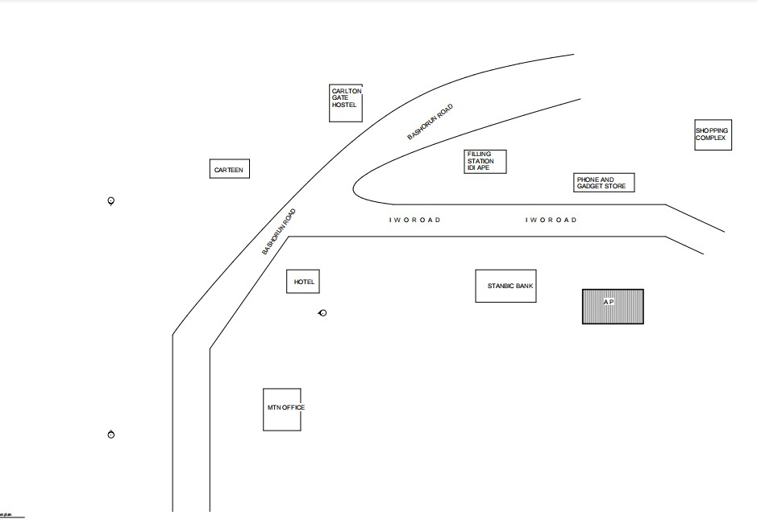

FIGURE 3.1.1: Location layout
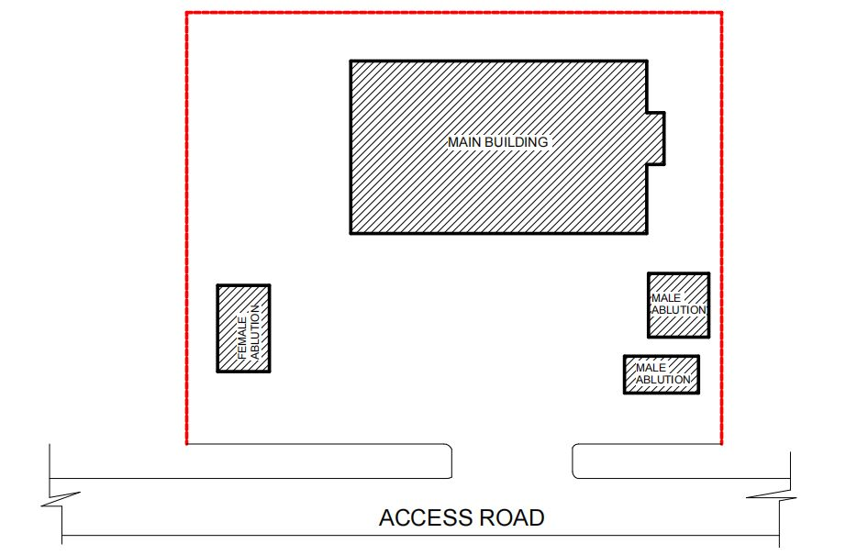
N

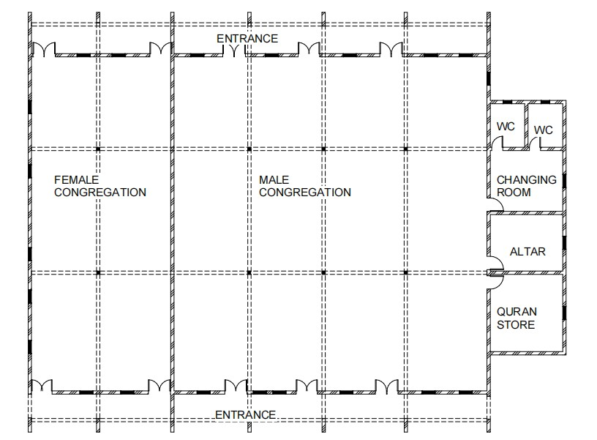
FIGURE 3.1.2: Site plan

FIGURE 3.1.3locational plan of mosque

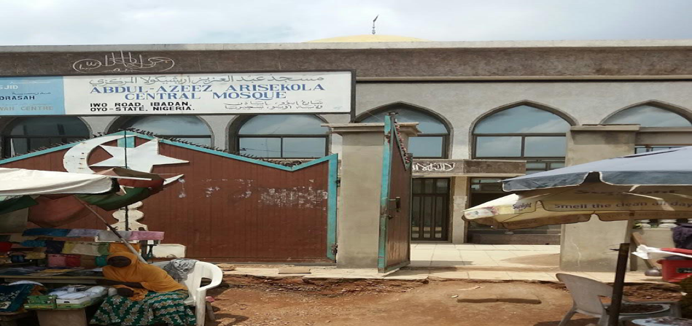
Plate 3.1.1: Exterior view of the of Abdulazeez Arisekola central mosque
Source: Researcher field work 2025

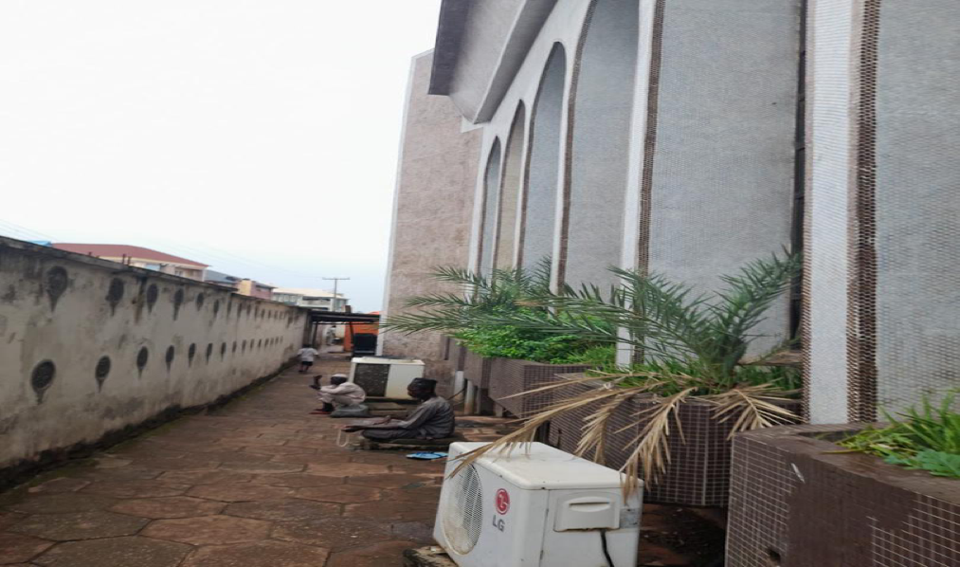

Plate 3.1.2: The Back view
Source: Researcher field work 2025
Merits
- The building is well enclosed to prevent heat
- location is well easily accessible
- shading devices is well considered in the Structure
Demerits
- Site space (area) are not wide
- No space for car entry
3.2 Case Study 2: AIYEPE CENTRAL MOSQUE
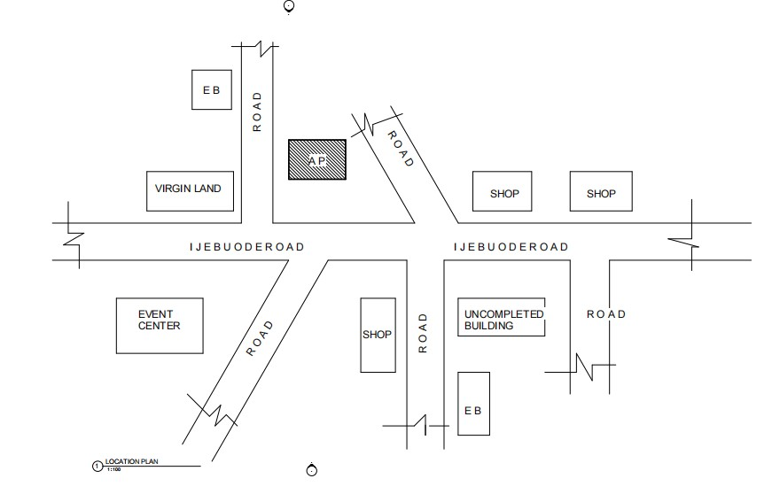

Figure 3.2.1: Location layout

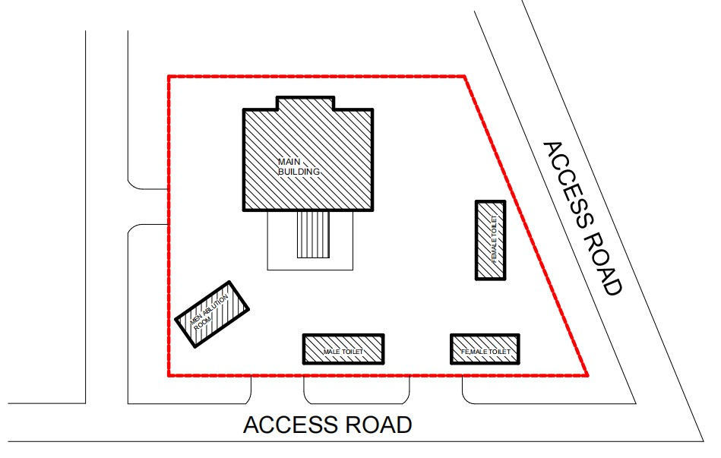
N

Figure 3.2.2: Site plan
LOCATIONAL PLAN

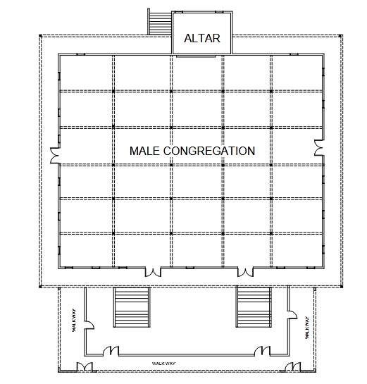

Figure 3.2.3: Ground Floor plan

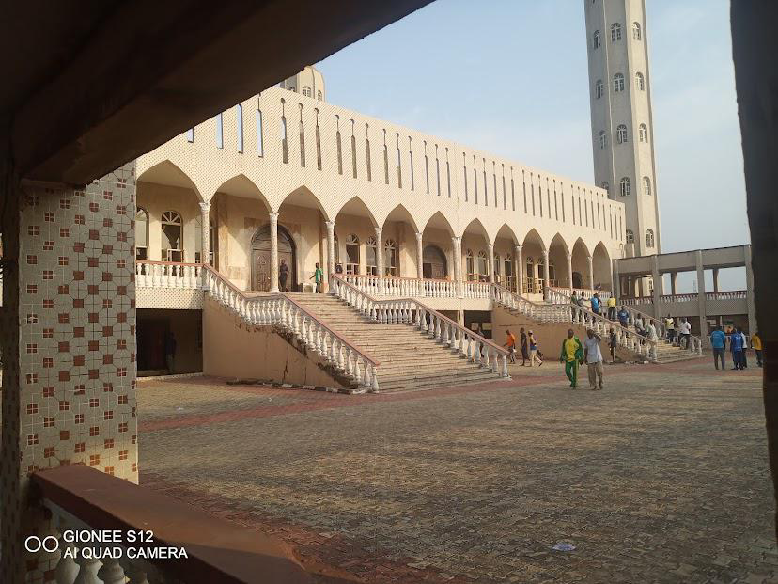
Plate 3.2.1: Entrance of the mosque

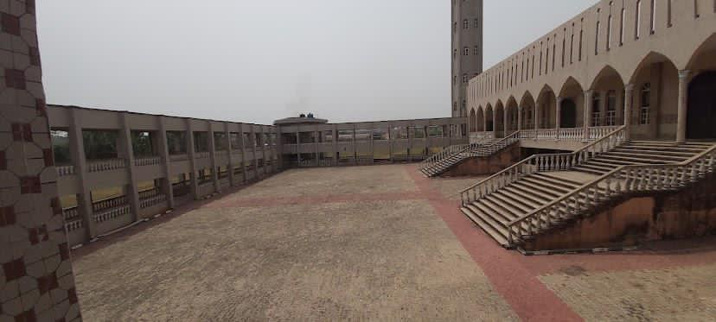
Plate 3.2.2: The view of the Mosque
Merits
- The structure is well cuturally designed
- There’s privacy created for next gender worship area
- The dome well structurally placed on the roof

Demerits
- There’s no security unity block
- The site is not aesthetically landscaped

ONLINE CASE STUDY
3.3 Case Study 3: Lekki Central Mosque
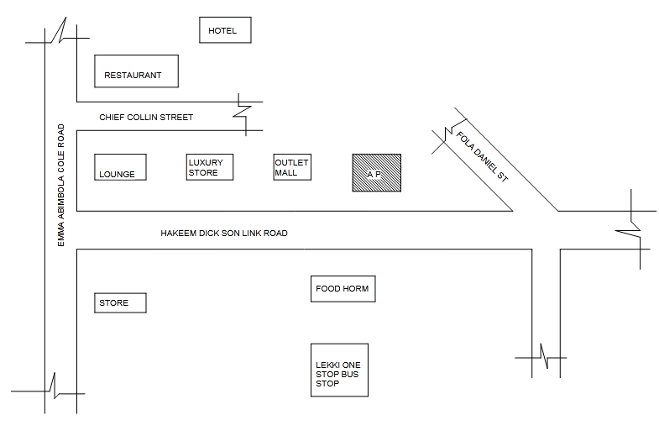
Figure 3.3.1: Location layout

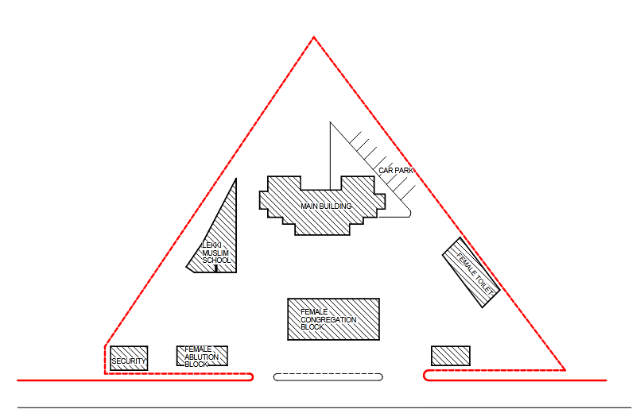
Figure 3.3.2: Site plan

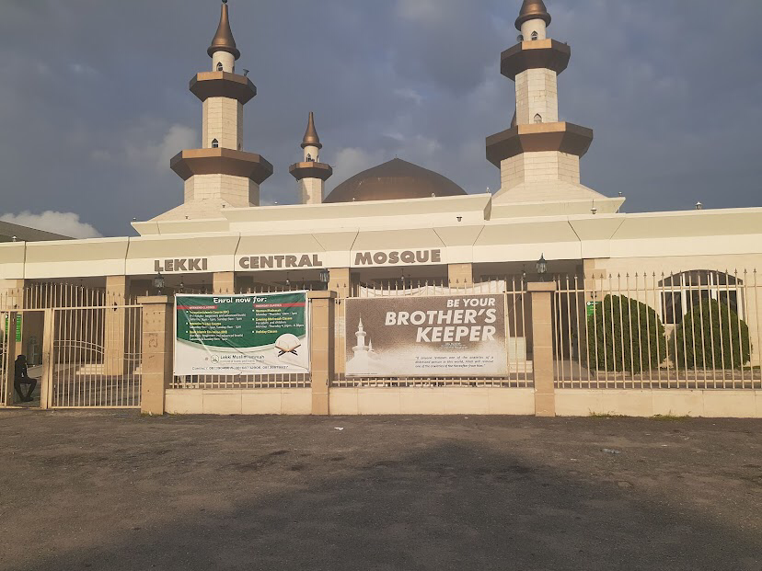

Plate 3.3.1: Lekki Front View

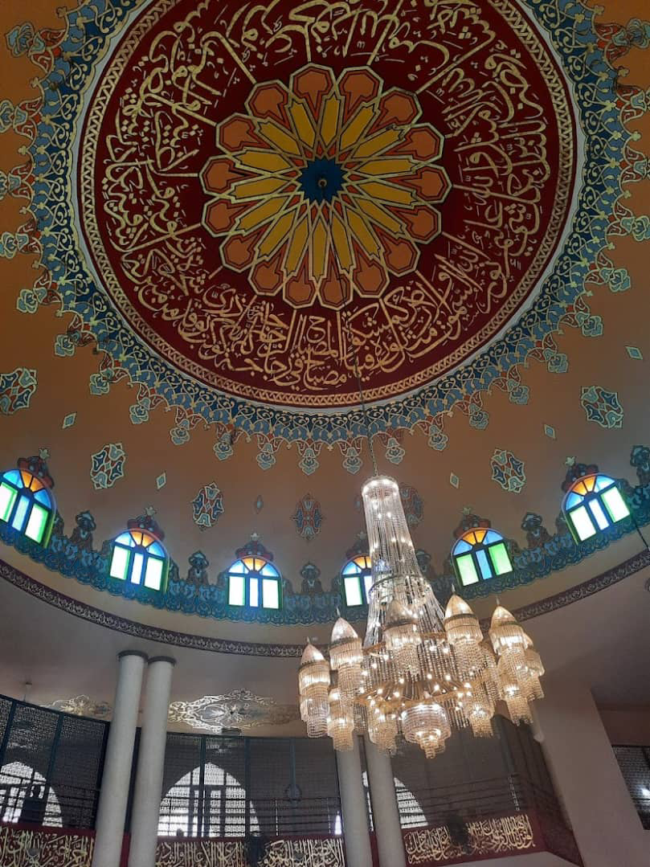

Plate 3.3.2: The view of the mosque

Merits
- spacious prayer hall which accommodate large congregation
- Impressive main entrance with majestic arc
- Strategic use of natural light through clerestory window

Demerits
- Limited Natural Ventilation , depends mostly on mechanical ventilation
- No packing slot

3.4: Case study 4
Grand Bur Dubai Mosque
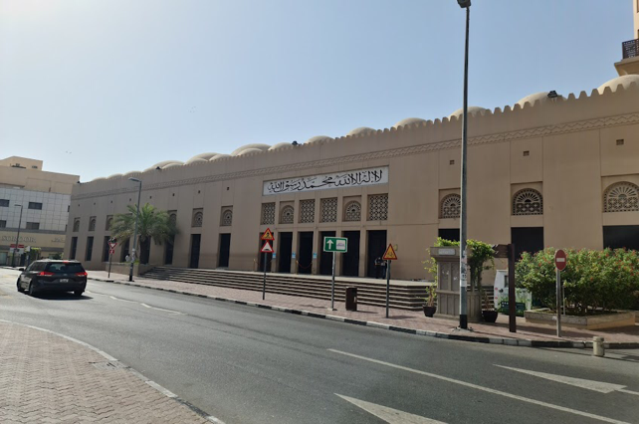
Plate 3.4.1: The view of the Mosque

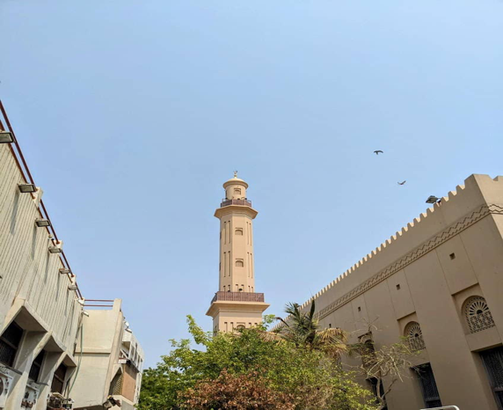

Plate 3.4.2: The view of the Mosque

Brief Description:
The Grand Bur Dubai Mosque, located in the historic Bur Dubai district of Dubai, United Arab Emirates, is one of the city’s most prominent places of worship. Originally built in 1900 and later reconstructed in 1960, the mosque reflects traditional Islamic architecture with its large domes, tall minaret, and intricate Arabic calligraphy. It serves as a spiritual and cultural center for the Muslim community and accommodates thousands of worshippers, especially during Friday prayers and religious festivals. The mosque is also a symbol of Dubai’s rich heritage and commitment to preserving its Islamic identity.
Orientation: Oriented to allow natural ventilation and reduce hot wind impact.
Activities: Activities in building
Climate: Hot desert climate with very hot summers, mild winters, low rainfall, and high humidity.
Topography: Flat, low-lying coastal area with desert surroundings and urban development.
Vegetation: Sparse vegetation.
Site Area: 9000 m²
Facilities:
Available spaces and facilities provided are:
- Main prayer hall
- Women’s prayer area
- Ablution (wudu) areas
- Courtyard
- Minaret
- Imam’s office
- Administrative office
- Shoe racks/storage
- Limited parking space
- Restrooms

Site Zoning:Praying, performing ablution ,Circulation area open space.
Circulation Pattern: Passageways are provided or internal circulation while the open spaces at each centre on the wings gives space for free flow of users.
3.5 Case Study 5: Al Ahzar Mosque
Date of Establishment: 970 AD(356 AH)
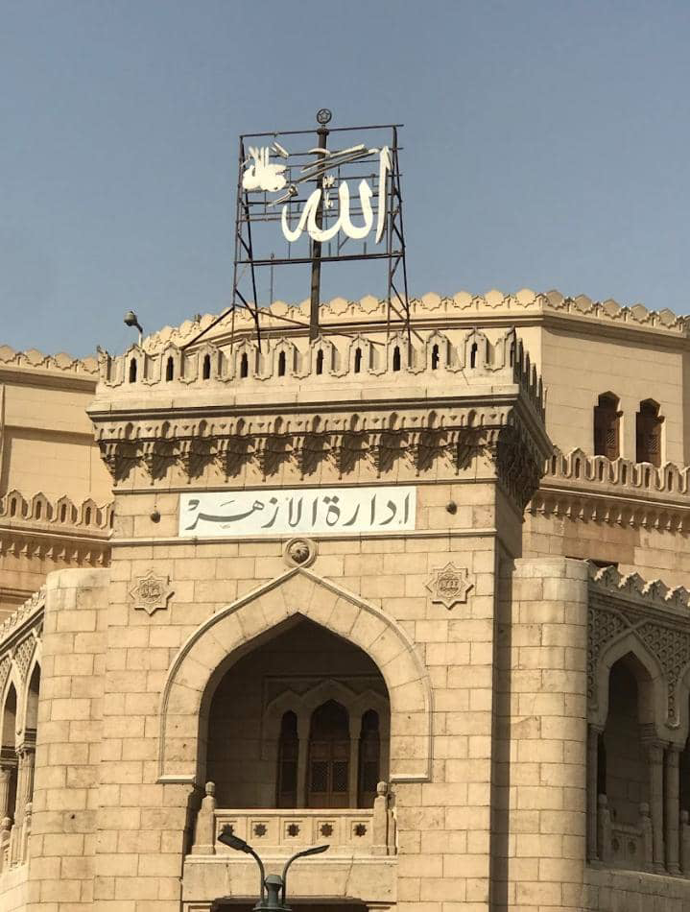
Location: Cairo El gamaliyah Egypt
Plate 3.5.1: View of the Mosque
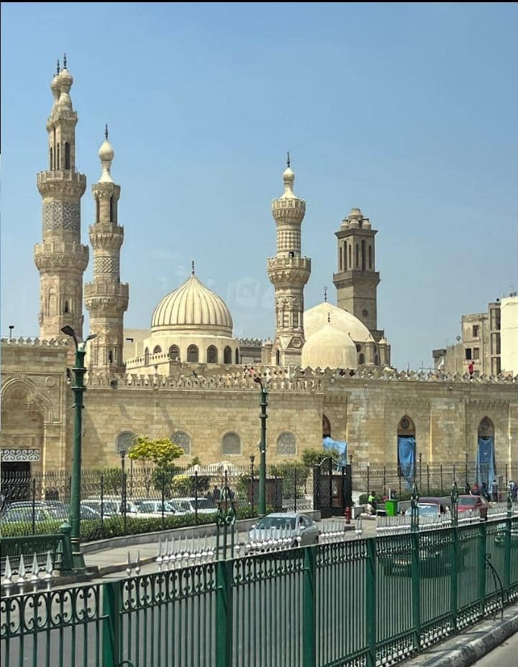

Plate 3.5.2: View of the mosque
Brief Description:
Al-Azhar Mosque, located in Cairo, Egypt, is one of the most renowned and historic mosques in the Islamic world. It is also the seat of Al-Azhar University, one of the oldest and most respected centers for Islamic learning. The mosque is a symbol of Islamic scholarship and Sunni religious authority, with architectural elements from various Islamic eras including Fatimid, Mamluk, and Ottoman.
Climate: Cairo experiences a hot desert climate (BWh under the Köppen classification), characterized by:
• Hot, dry summers (temperatures often above 35°C)
• Mild winters
• Low annual rainfall, mostly occurring in winter months

Topography: The mosque is situated in Cairo’s urban lowland area, part of the Nile River Valley. The terrain is flat with some surrounding elevations, and the area is densely built-up with historic Islamic architecture.
Vegetation: The vegetation on the site sparse.
Building Materials: Reinforced concrete base, wood shingles, glass, brick.
Site Area: 6000 m²
Facilities:
- Large prayer halls
- Islamic library and archives
- Classrooms and lecture halls (part of Al-Azhar University)
- Administrative offices
- Courtyards and ablution areas
- Access to religious scholars and fatwa committees

Site Zoning: Praying, performing ablution ,Circulation area open space.
Circulation Pattern: Passageways are provided or internal circulation while the open spaces at each centre on the wings gives space for free flow of users.

CHAPTER FOUR
DESIGN PROPOSAL
4.1 INTRODUCTION OF STUDY AREA/SITE SELECTION
Historical Background
Settlement Origins: Though specific founding dates for Odo‑Eku are not well documented in public records, the village is part of the broader Isin region, which consists of several urban centers and rural communities sharing a collective identity under the Isin name since at least the mid‑1990.
The name “Isin” reportedly became a unifying identifier for diverse settlements—including Odo‑Eku—reflecting cultural and historical coalescence over centuries.
Community & Infrastructure
Education: Odo‑Eku hosts the Odo‑Eku Muslim Community Secondary School, serving local students and underlying the presence of Muslim community institutions in the area.
Postal Identity: The village has the postal code 251105, as part of Isin’s wider addressing system Odo‑Eku is a village in Isin Local Government Area, Kwara State, Nigeria (coordinates approx. 8.3347° N, 4.9805° E) .
It lies within Ìgbómìnàland, a predominantly Yoruba‑speaking, largely Muslim area of Kwara State.
Ethnic & Cultural Identity
Ethnic Heritage: The inhabitants belong to the Ìgbómìnà subgroup of the Yoruba, a major ethnic group in Kwara and parts of Osun State. Ìgbómìnà are recognized for being one of the older Yoruba subgroups with distinctive dialects, artistic traditions (notably woodcarving, leatherwork), and cultural festivals such as Egungun.
Language & Origin: While Yoruba is the common language, residents speak the Ìgbómìnà dialect. Local oral histories tie their origins to migrations from Ile‑Ife and Oyo, common to much of Yoruba heritage.
4.2 Site Location
Location & Administrative Context
Geographic Setting: Odo‑Eku is a village in Isin LGA, situated in north-central Nigeria, Kwara State .
Coordinates & Altitude: It lies approximately at latitude 8.3347° N, longitude 4.9805° E, and has an elevation around 382–412 m above sea level.
• Local Governance: Isin LGA was carved out of the old Irepodun LGA in 1996, with its administrative center at Owu‑Isin. Odo‑Eku is one of the many villages in the LGA, alongside towns like Isanlu‑Isin, Ijara‑Isin, Owu‑Isin, Iwo, Oke‑Aba, and others.
4.3 Site Location Map
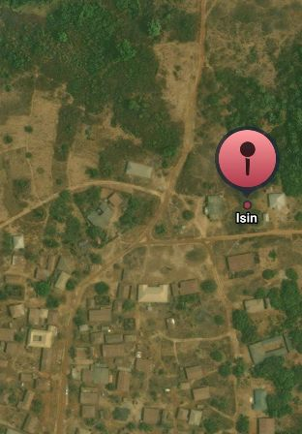
N

Figure 4.1: Site Map
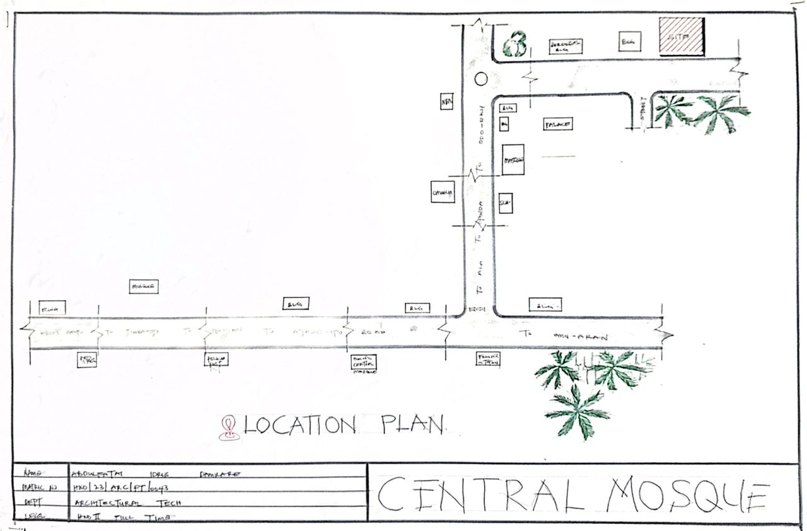

Figure 4.1.: Location Plan of the proposed building
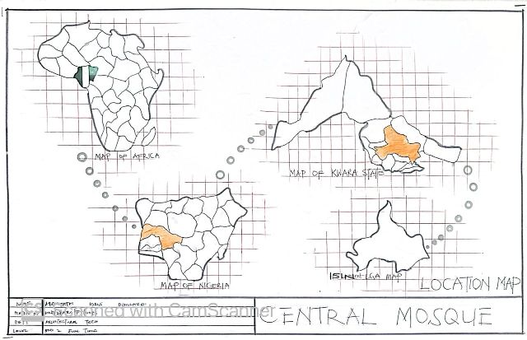

Figure 4.2: Google map of the proposed building

4.4 SITE ANALYSIS.
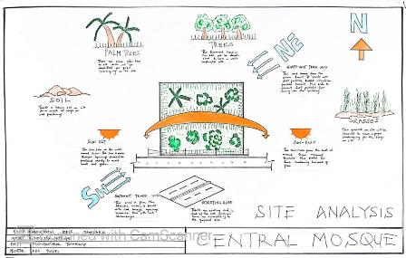
A site analysis involving a study of the site is carried out, it takes into consideration natural and man-made components present in and around the site, as well as climatic conditions of Kwara state. The plate below shows a schematic summary of the analysis of the proposed site.

Figure 4.3
4.5 Geographical/Climatic Data
Odo-Eku is a town located in Kwara State, Nigeria. It is situated at approximately latitude 8.3331849 and longitude 4.978602899999999. The town falls within the West Africa Standard Time zone.
Here's a more detailed breakdown:
- State: Kwara State, Nigeria.
- Coordinates: Approximately 8.3331849°N latitude and 4.978602899999999°E longitude.
- Time Zone: West Africa Standard Time.
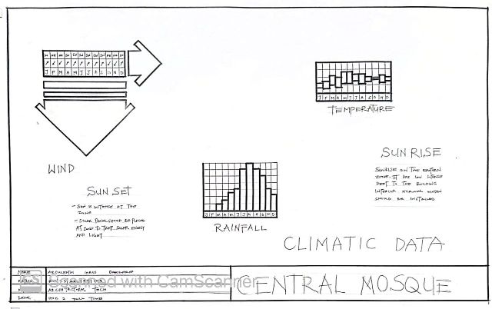

Figure 4.4: Climatic Data
4.6 Analyses of the immediate environmental conditions of the site
4.4.1 Soil Type
The sub soil is mainly red lateritic soil, with barches of sandy soil. It is a high load bearing capacity soil.
Vegetation
The vegetation on the site consists of few trees of different species and shrubs. Some trees and shrubs will be retained to enhance the landscape of the site, and also act as wind-breakers and dust filters during the harmattan.
Topography
The topography of the site is fairly levelled and the slightly unlevelled part can be adequately levelled.
Drainage
There is no existing drainage on the site, so drainage would be constructed.
Accessibility
The site is accessible by an existing road along the adjoining buildings which leads to the site.
4.7 PROJECT GOAL
1. Spiritual & Religious Objectives
- Provide a dedicated space for the five daily prayers, Jumu’ah (Friday prayer), Tarawih (during Ramadan), Eid prayers, and other Islamic rituals.
- Serve as a center for Islamic teachings, including Qur’an recitation, Hadith study, and Fiqh (Islamic jurisprudence).
- Promote community piety and moral conduct in accordance with Islamic principles.
The facilities include:
DESIGN BRIEF
- Entrance
- Walkway
- Male congregation area
- Female congregation area
- Imam mihbar
- Lecture area
- Imam office
- Qur'an store
- Private prayer room
- Stair hall
- Store
4.8 Design Concept
1. Religious & Spiritual Functions
- Congregational Prayers: Especially Jumu’ah (Friday) prayers and Eid prayers, often led by a chief Imam.
- Daily Worship: Open for all five daily prayers (Salat).
- Taraweeh & Ramadan Activities: Hosting special prayers, Iftar meals, and Qur’an recitations during Ramadan.
- Islamic Rituals: Conducting Nikah (marriage), Janazah (funeral), naming ceremonies (Aqeeqah), and Dua sessions.

2. Educational Functions
- Qur’anic and Arabic Studies: Classes for children and adults (often madrasa-style).
- Islamic Seminars & Tafsir: Lectures and Qur’anic exegesis, especially during Ramadan or Islamic holidays.
- Youth Programs: Workshops and training for leadership, morality, and vocational awareness.

3. Social & Community Functions
- Gathering Point: A central hub for the Muslim community to gather for religious and social occasions.
- Conflict Resolution: Acts as a traditional arbitration center or shura (consultative council) for family, marital, or land disputes.
- Zakat & Charity Distribution: Collecting and distributing zakat, sadaqah, and welfare materials to the needy.
Administrative & Leadership Role
- Religious Leadership: Seat of the Chief Imam and mosque committee who guide spiritual and social affairs of the community.
- Policy Dissemination: A place where important religious or community decisions and announcements are made.

Table 4.1.1: Appraisal of proposed schemes in the spaces, size and relationships
Space | Appraisal Focus
Main Prayer Hall (Men) | Is the capacity aligned with projected congregation numbers?
Women’s Prayer Area | Is it accessible, secure, private, and proportionally sized?
Mihrab & Minbar Area | Is it properly oriented (Qiblah)? Is the Imam visible/audible from all sides?
Ablution (Wudu) Areas | Are they hygienic, ventilated, and located near prayer spaces?
Toilets | Are there enough units? Are they separated by gender? Drainage/plumbing adequate?
Entrance/Lobby | Does it allow smooth entry/exit during peak times?
Admin Offices/Imam Quarters | Are they positioned for operational control without interfering with worship?
Multipurpose Hall/Classrooms | Are they adaptable for Islamic classes, youth programs, and community meetings?
Library/Study Room | Is there a designated quiet zone for learning and reading?
Minarets/Dome Area | Are they decorative, symbolic, and structurally sound?

2. Appraisal of Sizes
- Prayer Halls:
- Standard space allocation is 1.2 to 1.5 m² per worshipper.
- Ensure sufficient shoulder-to-shoulder space during prayer rows.
- Wudu Area:
- Minimum of 1 unit per 40 worshippers.
- Avoid cramping; allow circulation for disabled users where applicable.
- Toilets:
- At least 1 unit per 50 people, with separate male/female facilities.
- Classrooms:
- Depending on age group, 1.5–2.0 m² per student.
- Room size may vary between 15–25 students per class.
- Circulation Areas (Hallways, Lobbies):
- Should accommodate flow before/after Friday prayers and Eid, with minimum 1.5 m width or more.
Table 4.1.2: Appraisal of spatial Relationship
Relationship | Considerations
Prayer Hall- Ablution Area | Must be close but with a dry transition zone to avoid wet floors.
Men-Women Sections | Ensure visual and acoustic privacy but equitable access to all services.
Imaxm’s Office-Mihrab | Should allow quick access, especially during emergencies or ceremonies.
Admin-Main Entrance | Positioned for supervision, visitor interaction, and security control.
Library-Classrooms | Logical pairing to support learning and research.
Multiuse Hall-Restrooms | Ensure proximity for events or lectures.
Minaret/Dome-Main Prayer Hall | Should align structurally and visually with the Qiblah wall.

  - Equipment and operational and performance requirements

- Equipment Requirements (by Functional Area)
Prayer Hall
- Prayer Rugs / Carpets (durable, wall-to-wall, cleanable)
- Sound System (microphones, speakers, amplifier, sound mixer)
- Digital Clock / Azan System (with prayer time display)
- Qur’an Stands (Rihal) and storage shelves
- Air Conditioning / Ceiling Fans
- Lighting: Bright, evenly distributed, preferably with backup system
Ablution & Toilets
- Ablution Taps (wall-mounted, anti-rust, ergonomic)
- Footrests / Raised Platforms
- Toilet Facilities: Water-efficient flush systems, hand dryers or towels
- Soap Dispensers, Hand washing Sinks
- Non-slip Tiles & Proper Drainage
Classrooms / Library
- Desks and chairs (adjustable for youth or adults)
- Whiteboards or Smartboards
- Bookshelves for Qur’an and Islamic books
- Projector / Screens (for lectures or teaching)
- Ventilation / Fans / Air conditioners
Administrative & Office Areas
- Office furniture (desks, chairs, cabinets)
- Computers and Printers
- Filing Systems (for records, waqf, zakat, marriages, etc.)
- Internet Router (for online classes or virtual da’wah)
Safety & Security
- CCTV Cameras and security lights
- Fire Extinguishers (strategically placed)
- Smoke Detectors / Alarm System
- First Aid Kit
- Emergency exits clearly marked and accessible

Backup & Utilities
- Inverter / Generator / Solar Panels for power backup
- Water Tank / Borehole / Filtration Unit
- UPS system for sound and lighting
2. Operational Requirements

Daily Operations
- Open mosque for Fajr to Isha prayers
- Ensure cleanliness and sanitation daily
- Maintain audio systems, fans, and lights
- Staff schedules: Imam, mu’adhin, cleaner, admin personnel
Weekly Operations
- Conduct Jumu’ah prayer with khutbah prep
- Host Islamic study circles (Halaqah) or Tafsir classes
- Organize youth or women’s programs if available
Administrative Functions
- Record marriages, donations, waqf, and zakat distributions
- Maintain financial transparency and public reports
- Coordinate with other mosques or Islamic organizations

Community Interaction
- Serve as a center for counseling and conflict mediation
- Offer social welfare (e.g. food bank, charity aid)
- Welcome non-Muslims for open house or educational visits
Serial No | Units | Length | Breadth | Area (m)
1 | Imam minbar | 4m | 4m | 16m²
2 | Quran store | 1.8m | 3m | 54 m²
3 | Office | 18m | 2.5m | 45 m²
4 | Store | 2m | 2.5m | 50 m²
5 | Male congregation | 45m | 35m | 1575 m²
6 | Female congregation | 45m | 35m | 1575 m²
7 | Pass way | 45m | 30m | 135 m²
8 | Ablution area | 15m | 6m | 90.0 m²
9 | Toilets | 1.2m | 2.1m | 2.52 m²
10 | Stair wall | 7.0m | 3.0m | 21.0 m²

Table 4.1.3: Spatial allocation / schedule of accommodation

Conceptual development

1. Project Vision and Philosophy

To create a spiritually uplifting, architecturally functional, and socially inclusive mosque that reflects Islamic values while serving as a religious, educational, and cultural nucleus for the community.

2. Key Conceptual Themes

A. Spiritual Symbolism
- Orienting the mosque toward Qiblah (Makkah)
- Incorporating sacred geometry, calligraphy, arches, domes, and minarets as visual metaphors of divine unity and submission.
- Creating a sacred atmosphere through lighting, acoustics, and material choices.
B. Functionality & Flow
- Logical arrangement of spaces: entrance → lobby → ablution → prayer hall → exit
- Separate but equitable access for male and female worshippers
- Smooth circulation to avoid congestion, especially during Jumu’ah and Eid prayers
C. Community-Centric Design
- Multipurpose hall, classrooms, library, and office spaces for long-term community service
- Flexible spaces for youth development, women’s programs, charity services, and interfaith events
D. Local Relevance
- Using indigenous building materials (e.g., mud brick, stone, timber) where possible
- Adapting to climate (natural ventilation, overhangs, shading, high ceilings)
- Reflecting local Islamic culture and heritage, especially in ornamentation and art

CHAPTER FIVE

5.0 DESIGN CONCEPT
In any project design, there are two basics factors that should be taken into consideration. These factors are functionally and aesthetics of the design, although to some designers, aesthetics and functionally of any building are impartibly but in the case of project both aesthetics and functionality of the design were take care of to satisfy the highly demanded functional requirement and to create aesthetically and proportionally balanced design.
The functional efficiency of institute of business and vocational studies depends largely on the closeness of the immediate section that are strongly related in function all these are being taken up as seen on the site and floor respectively.
5.1 CONSTRUCTION METHODS
1. Site Selection & Foundation
- Chosen centrally within the community for accessibility.
- Soil testing may be basic or skipped in rural builds, but important in larger projects.
- A concrete strip or raft foundation is usually laid, depending on soil type and budget.
2. Structural Materials
- Load-bearing block walls made from:
- Cement-sand hollow blocks (manufactured locally)
- Sometimes laterite bricks in rural areas
- Reinforced concrete columns and beams if building a larger, multi-level structure
3. Prayer Hall Construction
- Large open space without columns (if budget permits a column-free span using steel or reinforced concrete)
- Mihrab (niche) built into the Qibla wall to indicate the direction of prayer
- Minbar (pulpit) constructed beside the mihrab for sermons
4. Roofing
- Wooden or steel trusses topped with:
- Corrugated metal roofing sheets (common in rural settings)
- Reinforced concrete slab with parapet in larger urban mosques
- Dome (optional):
- Constructed with reinforced concrete or lightweight materials over a steel frame
- Often symbolic and not load-bearing
5. Minaret(s)
- May be simple or ornate, depending on funding
- Built with reinforced concrete blocks, circular or square in shape
Used symbolically and occasionally for the call to prayer
6. Finishing Works
- Tiling in ablution areas, entryways, and sometimes inside the main prayer hall
- Plastering and painting inside and outside
- Ceiling boards or POP (Plaster of Paris) to enhance acoustics and aesthetics
- Windows with louvered glass or aluminum frames for ventilation
- Electrical installations for lighting and sound systems
7. Ablution Facilities (Wudu Area)
- Constructed with proper plumbing
- Tiles used for hygiene
- Often located adjacent to the mosque’s entrance

Service | Key Consideration
Circulation | Efficient flow, clear zoning, accessibility
Ventilation | Natural + mechanical airflow, exhaust fans
Lighting | LED, ambient + functional, emergency backup
Plumbing | Reliable supply, drainage, water-saving taps
Electrical | Full wiring, PA system, solar-ready
Acoustics | Echo control, clear speaker system
Waste Disposal | Segregation, drainage, septic/biodigester
Fire Protection | Extinguishers, smoke alarms, emergency lights
External Works | Landscape, paving, parking, security fencing
Table 5.2: Service Required

Environmental Factor | Target Condition | Key Strategies
Thermal Comfort | 22°C – 28°C | Cross ventilation, shading, fans
Air Quality | Fresh, odorless, well-circulated | Natural/mechanical ventilation
Natural Lighting | 300–500 lux (prayer hall) | Skylights, clerestories, domes
Acoustics | Echo-free, clear speech | Acoustic panels, soft finishes
Water Efficiency | Low water consumption in all areas | Low-flow taps, rainwater use
Energy Efficiency | Reduced energy use & bills | Solar, LEDs, passive cooling
Waste Control | Clean, sanitary, no odors | Proper drainage, bins, waste pickup
Fire Safety | Preventive & responsive safety | Extinguishers, alarms, escape routes
Sustainability | Long-term low environmental impact | Local materials, renewable energy
Table 5.3

Area | Requirement
Land & Title | Town Planning Approval
Setbacks & Zoning | Conformity with urban development standards
Health & Fire Safety | Fire exits, sanitation, health clearance
Environmental Compliance | EIA/EIS for large projects, drainage, erosion control
Construction Permits | Professional stamps (ARCON, COREN), contractor registration
Religious Consideration | Noise control, peaceful coexistence
Occupation Certificate | Issued after final approval and inspection
Table 5.1.3: Legal Issues and Planning Regulations in Mosque Design & Construction (Nigeria

1. Worship Behavior
Key Patterns:
- Worshippers enter barefoot, with ritual cleanliness
- Movements during prayer include standing, bowing, prostrating, and sitting
- Users line up in parallel rows facing Qibla (direction of Mecca)
- Friday prayers and Ramadan attract large congregations
- Silence, modesty, and reverence are expected in the prayer hall
5.3 Design Considerations:
- Provide clear Qibla orientation
- Allocate minimum 1.2–1.5 m² per worshipper
- Carpet or flooring must allow smooth movements
- Avoid visual or physical obstructions (e.g., columns in main prayer hall)
- Include sound zoning to maintain quiet in prayer areas
2. Circulation & Movement Patterns
Key Patterns:
- Entry from street → shoe removal → ablution → prayer
- Separate flow for men and women, especially in larger mosques
- Surge of movement occurs during Friday prayers, Eid, and Ramadan nights
Design Considerations:
- Provide shoe racks outside or near entrances
- Circulation paths should avoid crossing prayer rows
- Use ramps and wide entrances for accessibility and crowd flow
- Minimize bottlenecks at ablution and toilet areas
- Consider multiple exits to reduce congestion
3. Ablution & Hygiene Behavior
Key Patterns:
- Worshippers perform wudu (ablution) before every prayer (5x daily)
- Need for privacy, hygiene, and non-slip surfaces
- Toilet use precedes wudu in many cases
Design Considerations:
- Wudu space should be close to prayer hall but acoustically isolated
- Provide adequate drainage, soap areas, and hand-drying options
- Gender separation in ablution and toilet zones
- Allow for non-contact water use where possible (e.g., sensor taps)
4. Gender and Privacy Patterns
Key Patterns:
- In many communities, men and women worship separately
- Women often require separate entrances, prayer areas, and facilities
Design Considerations:
- Include dedicated women’s prayer area (either on a mezzanine or separate zone)
- Provide separate toilets, wudu, and nursery/breastfeeding areas
- Ensure visual and acoustic privacy in women’s sections
- Allow women easy, direct access without passing through men’s zones
5. Social Interaction & Community Use
Key Patterns:
- Mosque serves as a community center, not just for prayer
- Used for lectures, meetings, Quran classes, counseling, and conflict resolution
- Users linger before/after prayers, especially in shaded or courtyard areas
Design Considerations:
- Provide multipurpose rooms (classrooms, admin, library, etc.)
- Outdoor courtyards or verandas for social gathering
- Seating areas for elders and waiting parents
- Entry foyers that function as transitional social spaces
6. Special User Behavior (Elderly, Children, Disabled)
Key Patterns:
- Elderly may need seating for prayer and mobility assistance
- Children accompany parents (especially during weekend or evening events)
- Disabled persons require step-free access and rest areas
Design Considerations:
- Install ramps, handrails, and wide corridors
- Provide seating benches near entrances
- Add baby-changing and childcare-friendly spaces
- Use non-slip, even flooring throughout
7. Sound Behavior and Acoustics
Key Patterns:
- Use of public address system for sermon (khutbah), prayers, announcements
- Echo or excessive reverb hinders clarity of speech and Quran recitation
Design Considerations:
- Use acoustic paneling, soft finishes, and well-placed speakers
- Avoid excessive hard surfaces without treatment
- Maintain zoning to isolate noisy areas (e.g., ablution, admin, or exterior)
8. Time-Based Behavior
Key Patterns:
- Peak usage 5x daily, especially at Fajr, Maghrib, and Jumu’ah (Friday) prayer
- Friday and Eid prayers create surges in attendance
- Taraweeh during Ramadan involves extended night use
Design Considerations:
- Provide overflow spaces (outdoor courtyards, temporary prayer mats)
- Include external lighting, security, and ventilation for night-time usage
- Parking and traffic control for high-use times
Conclusion & Recommendations
(For a Central Mosque Design Proposal – Odo-Eku Muslim Community)

5.4 Conclusion
The design and development of the Odo-Eku Muslim Community Central Mosque presents an opportunity to create a spiritually uplifting, socially inclusive, and functionally efficient religious and cultural landmark. Through a careful study of behavioral patterns, environmental conditions, planning regulations, and user needs, the proposed mosque will serve not only as a place of worship but also as a community hub that promotes education, unity, and moral development.

All architectural, structural, and environmental considerations—including spatial relationships, ventilation, acoustics, lighting, safety, and sustainability—have been integrated to ensure that the facility meets modern expectations while respecting Islamic traditions. The proposal aligns with legal, functional, and cultural standards, ensuring longevity, ease of maintenance, and adaptability for future community needs.

5.5 Recommendations
To ensure the success of this project, the following are strongly recommended:

1. Early Stakeholder Engagement
- Involve religious leaders, community elders, women, youth, and urban planners from the beginning.
- Facilitate town hall meetings to collect feedback and foster community ownership.
2. Compliance with Legal and Planning Standards
- Obtain all necessary approvals: land title documents, building permits, and environmental clearances.
- Follow Kwara State Urban and Regional Planning Authority (KWSURPA) and national building codes.
- Phased Construction Strategy
- Execute the project in phases, beginning with core prayer facilities, followed by admin blocks, classrooms, and landscaping.
- Use a modular approach to accommodate future expansion as the congregation grows.
3. Sustainability and Efficiency
- Integrate natural ventilation, day lighting, low-flow plumbing fixtures, and solar energy for long-term operational cost savings.
- Use local materials to reduce costs and promote community labor involvement.

4. Inclusive Design
- Ensure spaces are accessible to women, elderly, children, and people with disabilities.
- Provide separate but equal amenities for both men and women without compromising on privacy or dignity.

5. Quality Construction and Supervision
- Hire only licensed professionals (ARCON, COREN, NIOB) for design and execution.
- Implement strict quality control, supervision, and routine inspections during all construction phases.

6. Maintenance and Management Plan
- Develop a facility management plan post-construction.
- Train local custodians on cleaning, minor repairs, and operation of installed systems (PA system, lighting, plumbing).
7. Security and Safety
- Install adequate lighting, CCTV cameras, fire safety systems, and provide emergency exits as per code.
- Plan for controlled access gates and clear wayfinding signage.

REFERENCES
Abdul Wahid, W.M. et al. (2015). “Design Considerations for Contemporary Mosque Architecture.” International Journal of Built Environment and Sustainability.
Al-Mufleh, M. (2020). “Designing Mosques for Community Development.” International Journal of Architecture and Urban Development, Vol. 10(3).
ARCON / COREN Guidelines – Architects Registration Council of Nigeria / Council for the Regulation of Engineering in Nigeria (Various Editions).
ASHRAE Standards – Standard 55: Thermal Environmental Conditions for Human Occupancy.
Beryl Menzies (2018); Metric handbook planning and design data, second edition, edited by David Adler, Architectural press. Linacre House, Jordan Hill, Oxford OX2 8DP.

Brembeck, C.S, (2021); Social foundation of education: environmental factors inteaching and ​learning. London: john: Herper and Roy publishers
Coburn, Oliver (2019). Youth Hostel Story. London: National Council of Social Service.
David V. Chadderton, Building Service Engineering, fifth edition (2007), Taylor & Francis, 2 ​Park Square, Milton Park, Abingdon, Oxon OX14 4RN.
D. Michell (2022) – Architecture of the Islamic World. Thames & Hudson.
Ernst and peter Neufert (2015); Architects’ data, third edition, Blackwell science publishers.
FEMA - Federal Emergency Management Agency, 2019, Fire in the United States 2015-2016 ​11th Edition, US Fire Administration, Federal Emergency Management Agency, ​Maryland, 21727
Fred Malven (2020); Time savers standards, for architectural design standards, seventh ​edition, McGraw-Hill, Inc.
Federal Republic of Nigeria (2006) – National Building Code.
Frishman, M., & Khan, H.-U. (2025) – The Mosque: History, Architectural Development & Regional Diversity. Thames & Hudson.
Hillenbrand, R. (2020) – Islamic Architecture: Form, Function, and Meaning. Edinburgh University Press.
Kuban, D. (2017) – The Mosque and Its Early Development. Brill Academic Publishers.
Kwara State Town Planning and Development Authority – Planning Approval Guidelines and Zoning Regulations (Latest version).

JOURNALS, NEWSPAPERS AND ARTICLES.
Odeleye A. (2019) Fire protection in buildings: Nigerian Institute of Architects Journal; edited ​by Aku Omokhodion.

Olaitan P. B, Dairo M. D, (Feb. 2009) Journal of Rescue and Disaster Medicine™ ISSN: 1531-​2992, Domestic Fire Accidents In A Developing Country: Reducing Morbidity / ​Mortality By Modifying The "Burglar Proofs".
Oliver, P. (2018) – Encyclopedia of Vernacular Architecture of the World. Cambridge University Press.
Salama, A. (2018). “Mosque Architecture in the Contemporary Urban Context.” Journal of Islamic Architecture, Vol. 5(1).

Ger Herbert (2021), Fire safety in hostels. McGraw-Hill, Inc.

James Patterson, (2023); Simplified design for building fire safety. John Wiley and sons Inc.

Neal, Tim; Neal, Simon (2016). Youth Hostels of England and Wales 2020-2023. St Albans: ​YHA. ISBN 0952225409.

Nikolas Davies, Erkki Jokiniemi (2018); Dictionary of Architecture and buildingconstruction, ​first edition; Architectural press. Linacre House, Jordan Hill, Oxford OX2 8DP.

Perkin & Will (2001); Time savers standards, Building types, fourth edition, McGraw-Hill, Inc.

Schmerts H.T. (2017); Institutional Housing Strategies Educational andRealisation. London: ​Patrick Wakely.

Schneider, T., & Till, J. (2017). Flexible Housing. Oxford, United Kingdom: Architectural ​Press.

The Guardian (2016). Nigerians Fire Incidents and Safety at Workplace. The Guardian ​Newspaper, May 2016

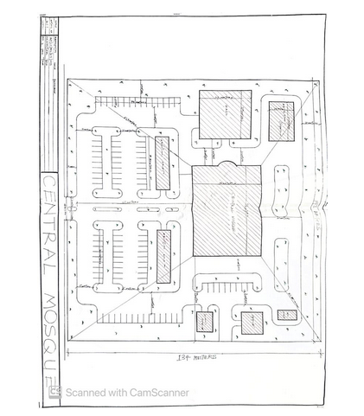
Appendix 1: Site plan of the proposed central mosque
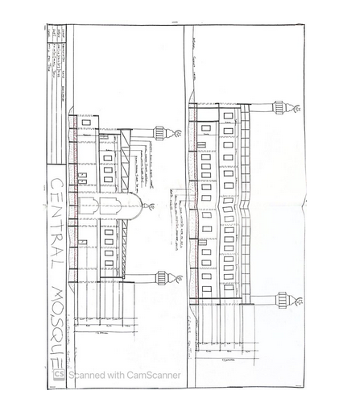
Appendix 2: Section of the proposed central mosque
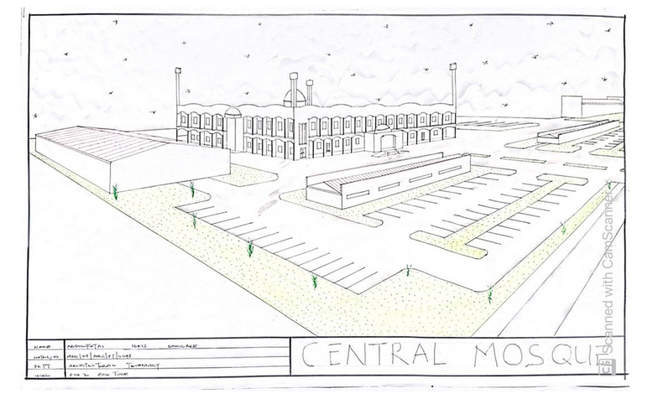
Appendix 3: External Perspective of the proposed central mosque
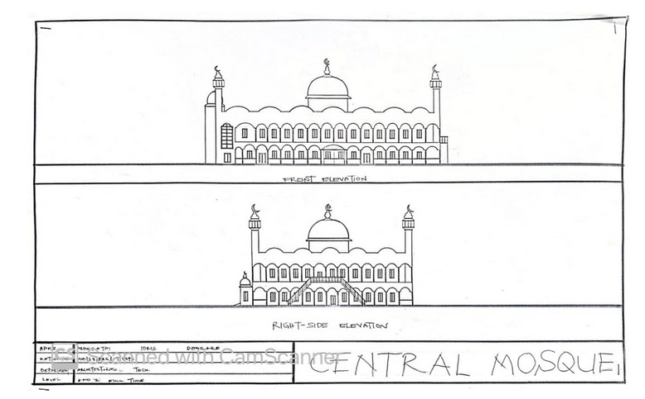
Appendix 4: Elevation of the proposed central Mosque
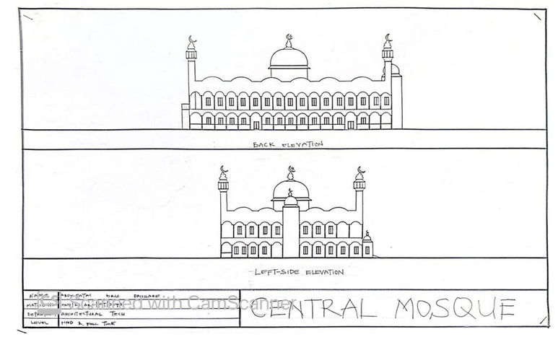
Appendix 5: Elevation of the proposed central mosque
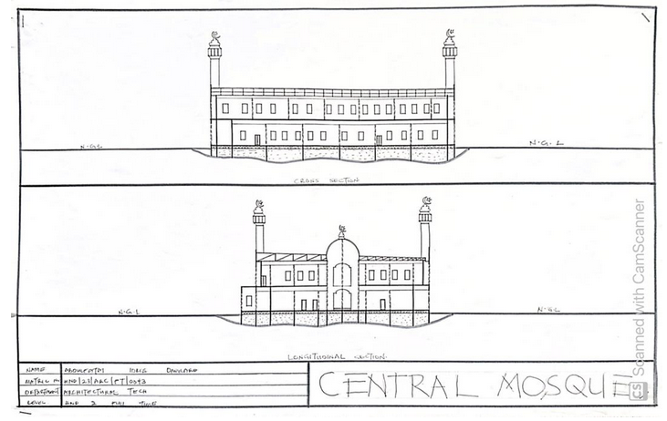
Appendix 6: Section of the proposed central Mosque

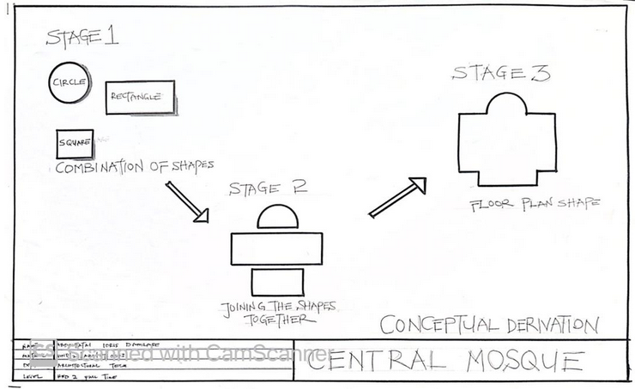
Appendix 7: Conceptual Derivation of the proposed central Mosque
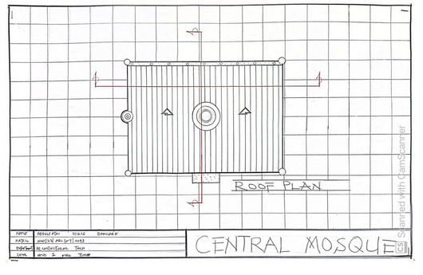

Appendix 8: Roof plan of the proposed central mosque

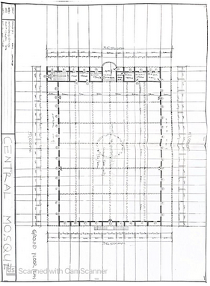
Appendix 9: Ground Floor plan of the male congregation of the proposed central mosque

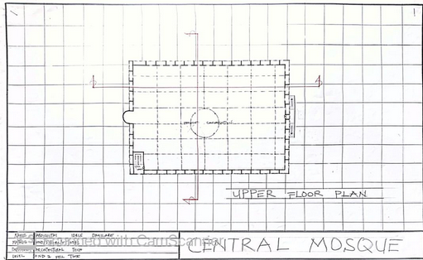
Appendix 9: Upper Floor plan of the Female congregation of the proposed central mosque

