PROJECT REPORT ON

‎PROPOSE CENTRAL MOSQUE

FOR

‎(IPEE, OYUN LOCAL GOVERNMENT AREA, KWARA STATE)

‎BY

‎MARUF FARUQ ABODUNRIN

‎HND/23/ARC/FT/0011

SUBMITTED TO

‎‎THE DEPARTMENT OF ARCHITECTURAL TECHNOLOGY INSTITUTE OF ENVIRONMENTAL STUDIES, KWARA STATE POLYTECHNIC, ILORIN

‎IN PARTIAL FULFILMENT OF THE REQUIREMENTS FOR THE AWARD OF HIGHER NATIONAL DIPLOMA (HND) IN ARCHITECTURAL TECHNOLOGY

‎

JULY 2025

DECLARATION

“I declare that this project/dissertation is a product of my personal research work. It has not been presented for the award of any degree in any polytechnic. The ideas, observations, comments, suggestions herein represent my own convictions, except quotations, which have been acknowledged in accordance with conventional academic traditions.

Name: MARUF FARUQ ABODUNRIN

Matric no: HND/22/ARC/FT/0011

Signature Date

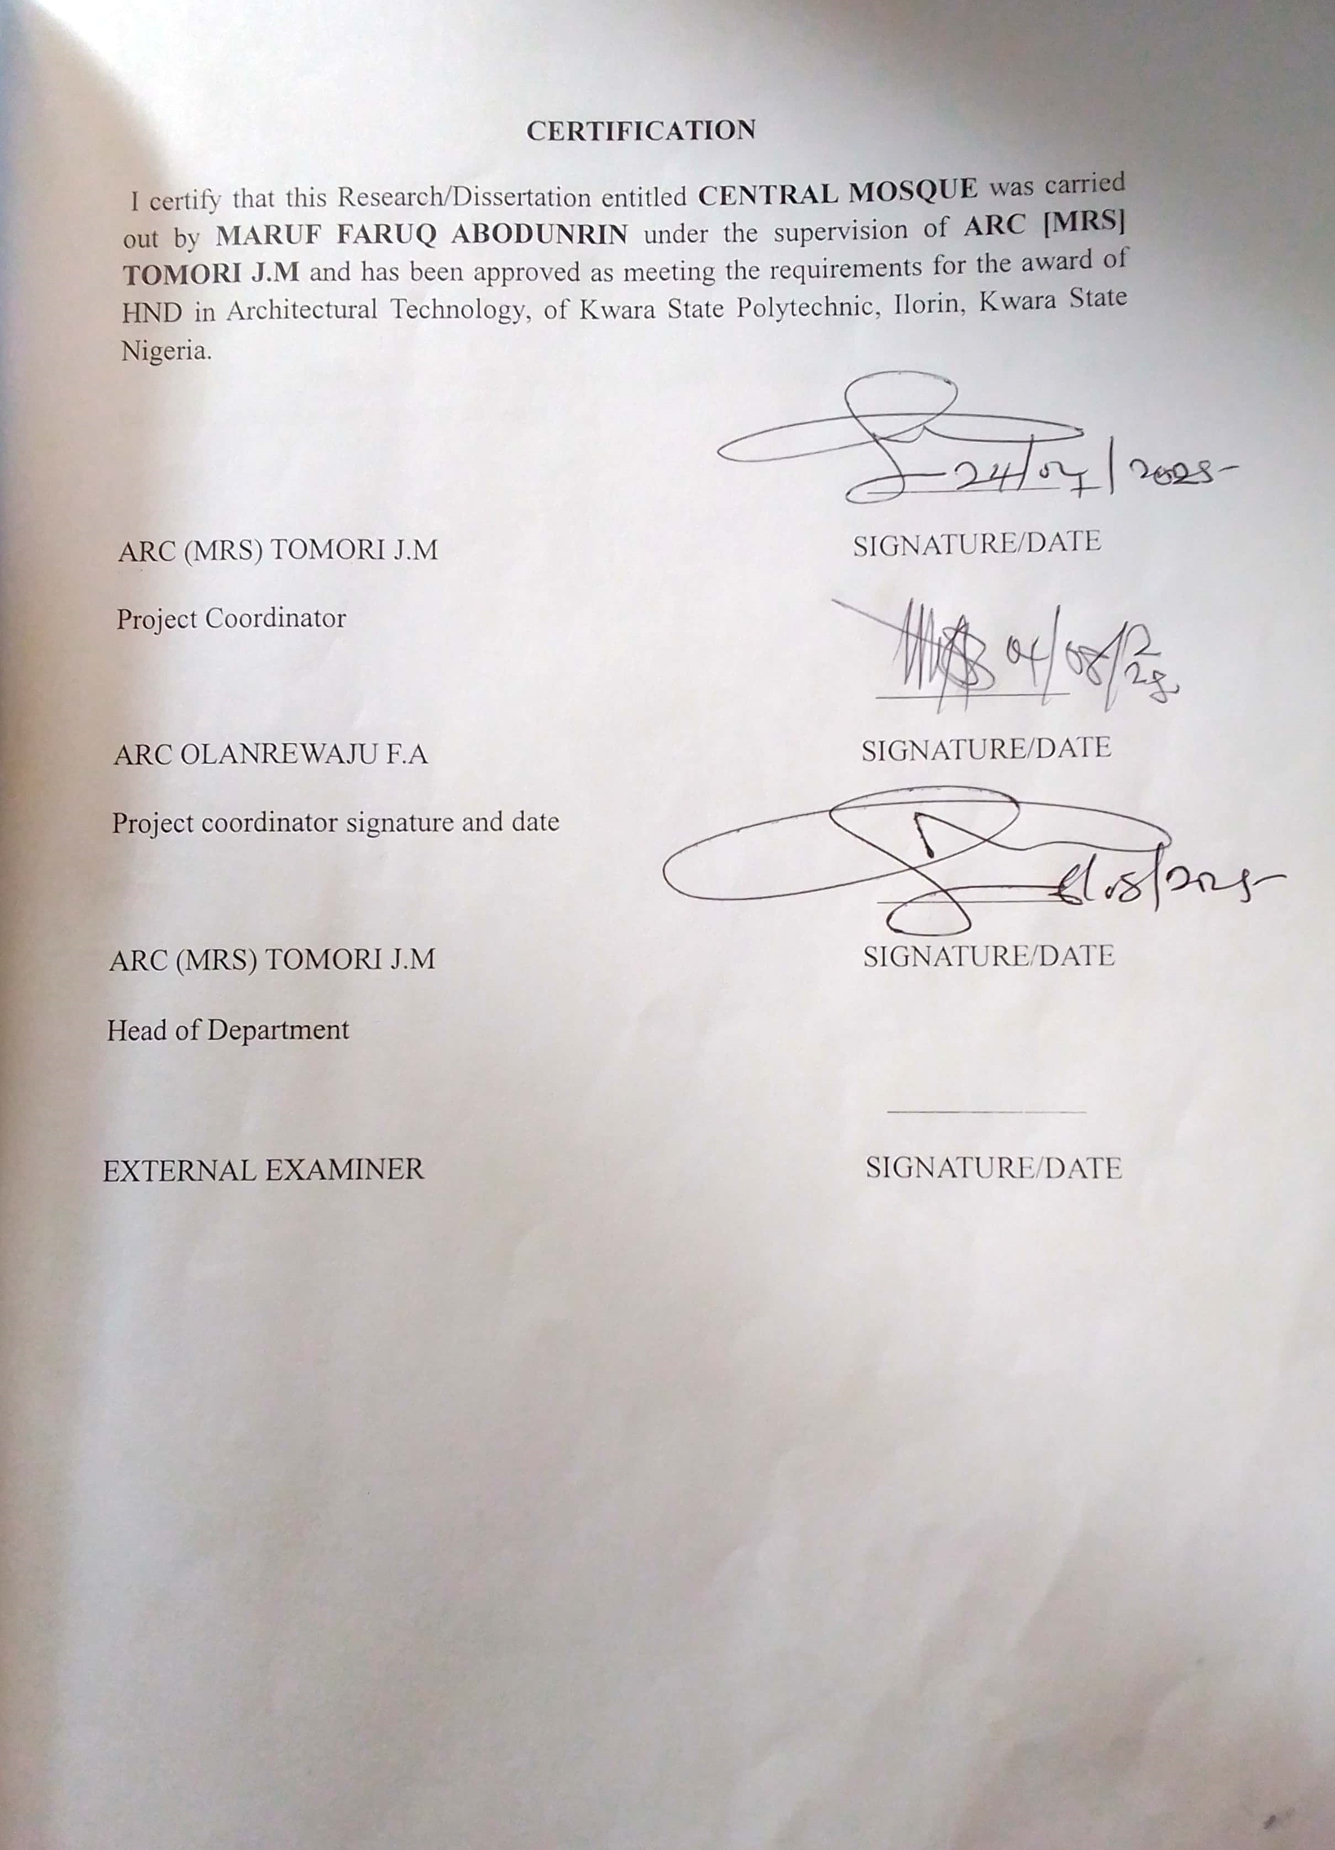

DEDICATION

This report is dedicated to Almighty Allah the universe, the creator of all creators and the source of mankind who has always been my strength throughout this project and also for his unconditional and infinite mercy showered upon me through my studies.

Also, I dedicated this project to my parent Mr. and Mrs. MARUF for their parental, financial and moral support.

ACKNOWLEDGEMENT

My profound gratitude goes to ALLAH (SAW) for the grace and mercy endowed on me throughout my journey in life and for His help over me in achieving this important phase of my academic pursuit.

I express my profound gratitude to my project supervisor Arc J.M TOMORI, despite her incredible tight schedule coupled with her multifarious commitments, still carved out time to go through my work and guide me diligently all through this project work.

My sincere gratitude goes to the Department of Architectural Technology and the entire staff and the project coordinator Arc. OLAREWAJU F. A. for the part they played in the completion of this project work.

I am highly grateful and indebted to my lovely parents, Mr. and MARUF, for their overwhelming love, financial support and words of encouragement. Also, my appreciation goes to my siblings, ODUNAYO MARUF AND CHRISTIANA MARUF. May Almighty ALLAH protect and shower his infinite mercy on them all. I also wish to appreciate my boss, ARCHIDONE. My sincere gratitude also extends to my cherished friends, whose support has made this journey memorable and lastly, my course mates and every person who in one way or the other has contributed to the success of this project. I wish every one of us a very fruitful future.

TABLE OF CONTENTS

TITLE PAGE ……………………………………………………….…………………i

DECLARATION…………………………………………………….…………...…... ii

CERTIFICATION………………………………………………….…………..…..…iii

ACKNOWLEDGEMENT………………………………………….………………....iv

DEDICATION……………………………………………………….………………...v

TABLE OF CONTENTS………………………………………………….….….........vi

LIST OF FIGURES………………………………………………………..………...viii

LIST OF PLATES…………………………………………………..............................ix
LIST OF APPENDICES……………………………………………………………….x
ABSTRACT………………………………………………………………………..….x
CHAPTER ONE
1.0 INTRODUCTION……………………………………………….………………1
1.1 DEFINITION…………………………………………………...........................2 HISTORICAL BACKGROUND……………………………………….........................2
1.3 STATEMENT OF DESIGN PROBLEM……………………...............................3
1.4 AIM AND OBJECTIVES…………………………………….………………....4
1.5 AIM…………………………………………………………...……………..…..4
1.6 OBJECTIVES…………………………………………………………..………..4
1.7 JUSTIFICATION……………………………………………...............................5
1.8 SIGNIFICANCE OF THE STUDY…………………..….………....…………....6
1.9 SCOPE OF THE PROJECT………………………...…………..…….…..............7
1.10 LIMITATION OF STUDY……………………………………..……......…….....8
1.11 RESEARCH METHODOLOGY……..…………………….…….........................9
CHAPTER TWO

2.0 LITERATURE REVIEW ...……………………………………………..……..10

2.1 REVIEW OF LITERATURE ON BUILDING TYPE…………………………..11

2.2 REVIEW OF LITERATURE ON SUB-TOPIC OF THE THESIS……………12

CHAPTER THREE

3.1 CASE STUDY……………………………………………………………..........13

3.2 CASE STUDY 1: ….………………………………………….…………............14

3.3 CASE STUDY 2:…………….……………………………………………..........15

3.4 CASE STUDY 3…………………………………………………………………16

3.5 CASE STUDY 4:……. ………………………… …………………....................17

CHAPTER FOUR

4.0 STUDY AREA/PROJECT SITE……………………………….……..………....18

4.1 HISTORY OF KWARA STATE…………………………………........................19

4.2 LOCATION OF SITE………………………..…………......................................20

4.3 SITE INVENTORY AND ANALYSIS ……………………….………..………..21

4.4 SITE CHARACTERISTICS……………………………………………..............22

4.5 CLIMATE…………………………….………...…..............................................23

4.5 RAINFALL……………………………………………….……...........................24

4.6 HUMIDITY……………………………………………………….…...................25

4.7 SOIL TYPE……………………………………………………….......................26

4.8 TOPOGRAPHY…………………………………………………….………...….27

4.9 VEGETATION ………………………………………………………...……...…28

4.10 DRAINAGE……………………………………………………………….........29

4.11 ACCESSIBILITY……………………………………………………………....30

4.12 SITE FEATURES AND INFRASTRUCTURE………………………...............31

4.13 NOISE SOURCES………………………………………...…............................32

4.14 SITE ANALYSIS (PHYSICAL AND CLIMATIC……………………………..33

TEMPERATURE …………………...……………………………………..……...….34

PRECIPITATION…………..……………………………………….……………......35

SUNSHINE……………………………………...…………………….…...………...36

WIND…………………………………………………...………...…………...……..37

MAN MADE FEATURES……………………………………………………………37

CHAPTER FIVE

5.0 APPRAISAL OF PROPOSED SCHEME ….………………………...……...38

5.1 DESIGN APPRAISAL…………………..………………….…………..…..…...39

5.2 CONSTRUCTION METHODOLOG……………..………………………....40

5.3 ORIENTATIONS

5.4 RECOMMENDATION

5.5 CONCLUSION AND SUMMARY

LIST OF FIGURES

FIGURE3.1: LOCATIONAL PLAN OF CASE STUDY ONE

FIGURE3.2: FLOOR PLAN OF CASE STUDY ONE

FIGURE3.3: LOCATION PLAN OF CASE STUDY TWO

FIGURE3.4: FLOOR PLAN OF CASE STUDY TWO

FIGURE 3.5: LOCATION PLAN OF CASE STUDY THREE

FIGURE 3.6: FLOOR PLAN OF CASE STUDY THREE

FIGURE 3.7: LOCATION PLAN OF CASE STUDY FOUR

FIGURE 3.8: FLOOR PLAN OF CASE STUDY FOUR

FIGURE 4.1: MAP OF NIGERIA SHOWING KWARA STATE

FIGURE 4.2: MAP OF KWARA STATE

FIGURE 4.3: SITE INVENTORY OF THE PROPOSED SITE

FIGURE 4.4: SITE ANALYSIS OF THE PROPOSED SITE

FIGURE 4.5: CLIMATE OF THE SITE

FIGURE 4.6: GRAPH OF RAINFALL IN ILORIN

FIGURE 4.7: GRAPH OF HUMIDITY IN KWARA STATE

FIGURE 4.8: GRAPH OF TEMPERATURE IN ILORIN

FIGURE 4.9: SHOWING SITE ANALYSIS

LIST OF PLATES

Plate3.1: Exterior of case study one………………..……….……..............................1

Plate 3.2: Entrance Gate of case study one…….……….........……..………………....2

Plate 3.3: Interior view of case study one……..............................................................3

Plate 3.4: Site location of case study two…..………………........………..………….4

Plate 3.5 Exterior area of case study two: ……………………………….....…..……5

Plate 3.6 Entrance view of case study two ……………………..................................6

Plate 3.7 Site location of case study three …………………………….………..……7

Plate 3.8 Exterior view of case study three…………………………………….....…..8

Plate 3.9 Entrance view of case study three ……………………..…….………….…..9

Plate 3.10 Interior view of case study three…………………………………..............10

ABSTRACT

This project propose a design for a central mosque that seamlessly integrates traditional Islamic architectural elements with modern functional and sustainability. The design aims to create a serene and inclusive space for worship, community gatherings, and spiritual growth. Key features include a majestic dome, slender minarets and intricate geometric patterns. The project is prioritize natural light, ventilation, and energy efficiency, while incorporating cutting-edge technology and innovative materials. This design present a comprehensive plan for a central mosque that embodies the principles of Islamic architecture while incorporating modern elements and sustainable practice. This project aims to create a vibrant and inclusive space for worship, community gatherings and spiritual growth.

CHAPTER ONE

1.0 INTRODUCTION

Mosques vary in shape and structure depending on the Architectural influences of certain regions. There are, however, common features that are found within all mosques. One necessary feature, the mihrab, for example, is a shallow area in a wall that indicates the direction of Mecca. Mecca, which is also the birthplace of the prophet Mohammed, is considered to be the holiest city in the Islamic religion and the direction towards which Muslims pray. Muslims are also required to travel to Mecca on a religious pilgrimage or “Hajj” at least once in their lifetime. Mecca also houses the largest mosque, the Masjid al-Haram (also known as The Holy Mosque) which was first built in the 7th century under the leadership of Caliph Omar Ibn al-Khattab, one of the most prominent Muslim leaders in history. The mosque has also gone through many renovations and modifications since its establishment. Most people view the mosque as a house of worship, the place where Muslims offer prayer, but the mosque is much more than that. Mosques were erected in order to tend to the community and provide spiritual growth, knowledge and a place that all were welcomed. Since the 7th century, mosques have remained an essential space for community development and education.

Central Mosque is a prominent and symbolic structure that serves not only as a place of worship but also as a cultural and community landmark. It reflects the spiritual values of Islam through its design while accommodating large congregations and multiple religious functions.

At its core, the architecture of a central mosque combines functionality, spiritual symbolism, and aesthetic beauty. Traditional elements such as the dome, minaret, mihrab (niche indicating the direction of Mecca), and minbar (pulpit for sermons) are commonly incorporated, often enhanced by intricate geometric patterns, calligraphy, and ornamental tilework. These features not only serve practical purposes but also inspire a sense of reverence and unity.

The layout typically includes a large prayer hall, separate ablution areas, courtyards, and sometimes auxiliary spaces like classrooms, libraries, or community halls. Central mosques are often situated in key urban locations, and their architectural scale and detail emphasize their importance as religious, educational, and social centers.

1.0 DEFINITION

A central mosque, also known as a congregational mosque or jami masjid, is a mosque that serves as the primary place of worship and community gathering for muslims in a particular area or city. It is typically the largest and most prominent mosque in the region, and often features impressive architecture and design.

HISTORICAL BACKGROUND

According to the Qu'ran, the first mosque was the Kaaba built by Abraham on Allah's instruction According to Islamic beliefs, the first mosque in the world was the Kaaba (or Kaabah), which was built by Abraham upon an order from Allah. The word "masjid" is found throughout the Qur'an, most frequently with the reference to the sanctuary of Kaaba in the city of Mecca. The Qur'an applies the term "masjid" to places of worship of different religions, including Judaism and Christianity; in the same general meaning of a place of worship, the word is used in the hadith, collections of Muslim traditions about the deeds and saying of their prophet Muhammad and his companions. When Muhammad lived in Mecca, he viewed Kaaba as his first and principal mosque and performed prayers there together with his followers. Even during times when the pagan Arabs performed their rituals inside the Kaaba, Muhammad always held the Kaaba in very high esteem. The Meccan tribe of Quraish, which was responsible for guarding Kaaba, attempted to exclude Muhammad's followers from the sanctuary, which became a subject of Muslim complaints recorded in the Qur'an. When Muhammad conquered Mecca in 630, he converted Kaaba to a mosque, which has since become known as the Masjid al-Haram, or “Sacred Mosque.” The Masjid al-Haram was significantly expanded and improved in the early centuries of Islam in order to accommodate the increasing number of Muslims who either lived in the area or made the annual Hajj, or pilgrimage, to Mecca, before it acquired its present shape in 1577 in the reign of the Ottoman sultan Selim. The Masjid al-Nabawi in Medina as it exists today.

The first thing Muhammad did upon arriving with his followers near Medina (then named Yathrib) after the emigration from Mecca in 622, was build the Quba Mosque in a village outside Medina. Just days after beginning work on the Quba' Mosque, Muhammad went on to establish another mosque in Medina, known today as the Masjid al-Nabawi, or “the Prophet's Mosque.” The location of the mosque was declared as such after it hosted Muhammad's first Friday prayer. Following its establishment, the Masjid al-Nabawi continued to introduce some of the practices now considered common in today's mosques. For example, the adhan, or call to prayer, was developed in the form still used in mosques today. The Masjid al-Nabawi was built with a large courtyard, a motif common among mosques built since then. Muhammad would stand up at one end of the arcade to preach. Later on, he would develop a three-step pulpit as a platform from which he would give sermons. The pulpit, now known as a minbar, is still a common feature of mosques. Muhammad lived beside the mosque in Medina, which doubled as both a religious and political center for the early Muslim community. Negotiations were conducted, military actions planned, prisoners of war held, disputes settled, religious information disseminated, gifts received and distributed among his companions. His followers treated the wounded there and some people even lived in the mosque permanently in tents and huts. Hagia Sophia, an Eastern Orthodox church converted into a mosque on the day of the Fall of Constantinople; now a museum .Conversion of non-Muslim houses of worship into mosques began during the life of Muhammad, who turned the pagan sanctuary of Kaaba into a mosque, and continued during subsequent Islamic conquests and under the Muslim rule. As a result,

numerous churches, synagogues, Zoroastrian and Hindu temples became Muslim places of worship. According to Islamic law, non-Muslims should not continue to use their places of worship for their intended purposes if they are conquered by Muslims and if there exists no treaty of surrender that explicitly mentions the right of non-Muslims to continue to use their places of worship According to early Muslim historians, towns that surrendered without resistance and made treaties with the Muslims received permission to retain their churches and synagogues, while in towns taken by conquest, Jewish and Christian places of worship were seized by the Muslims.

1.2 STATEMENT OF DESIGN PROBLEM

Inadequate space. The current mosque can no longer accommodate the growing Muslim populations. Leading to overcrowding during prayers and community events.

Outdated facilities; The mosque infrastructure including its electrical, plumbing, and HVAC system is outdated and in need of upgrading.

Limited accessibilities; The mosque parking capacity is insufficient causing congestion.

Lack of community spaces; The mosque lacks dedicated spaces for community activities.

1.3 AIM AND OBJECTIVES

1.3.1 AIM

The aim of a central mosque is to design a functional and aesthetically applicably structure that enhance or serve as a focal point for the Muslim community, encompansing religious, social, and educational functions. It acts as a place for worship, community gathering, and the advancement of Islamic knowledge and values. Central mosques also often play a role in social welfare, providing support to vulnerable populations and fostering interfaith dialogue.

1.3.2 OBJECTIVE

To create functional space and efficient layout for prayer.

To design a space that fosters religion community gatherings

To create a design that is appeaally landscape that will attract the worshippers
To create a accommodation core mosque functions

1.4 JUSTIFICATION

Due to the deterioration of the existing central mosque at ipee oyun local government area kwara state, and also the existing central mosque the region can not accomodate the population of muslims in the area

1.5 SCOPE OF THE PROJECT

construction, and outfitting of a large mosque to serve as a focal point for Islamic worship, community activities, and religious education. This includes the.

Gate

Main prayer hall

Ablution facilities

Administrative office

Library

The project also involves landscaping, parking, and ensuring accessibility for all worshiper

1.6 LIMITATION OF STUDY

Limitation to the research are very many but some of them were overcome in the course of the study.

The economic situation of the country is really biting hard on a lot of things such as transportation fare, accommodation expenses which are part of the setbacks experience during the course of carrying out this research work. The following to an extent limited the study.

lack of access to relevant drawings, due to the security code by developer.

It was difficult to access useful books from the library, and to get officials from various existing housing estate to cooperate in getting information from them.

1.7 RESEARCH METHODOLOGY

This project (central mosque) is well exceptionally and thoroughly searched for through the listed unit:

Net browsing,

Field survey (Case studies)

Literature Review

hotograph, Oral interview.

CHAPTER TWO

2.0 LITERATURE REVIEW

2.1. Historical Evolution of Mosque Architecture

Early foundational texts, such as K.A.C. Creswell’s A Short Account of Early Muslim Architecture, trace the architectural lineage of mosques from the Prophet’s Mosque in Medina (7th century) to later classical examples in the Umayyad, Abbasid, and Ottoman periods. These works emphasize how early central mosques served as architectural prototypes, combining religious, administrative, and community functions under one roof.

The traditional courtyard (sahn), hypostyle halls, domes, and minarets became standardized features.

The central mosque was often designed to be the largest and most prominent structure in a city or town, influencing the urban layout.
Mosque Typology: Issues and Problems
Mosque architecture encompasses various styles, forms, and functions, reflecting the diversity of Islamic cultures and communities. Some key issues and problems peculiar to mosque typology include:
1. Functional vs. Symbolic: Balancing functional requirements (e.g., prayer space, ablution facilities) with symbolic elements (e.g., minarets, domes) that reflect Islamic identity.
2. Cultural and Contextual Adaptations: Incorporating local architectural styles, materials, and cultural practices while maintaining Islamic principles.
3. Scale and Proportion: Designing mosques that are proportional to the community's needs and respectful of surrounding architecture.
*4. Orientation and Qibla*: Ensuring the mosque's orientation towards the Kaaba in Mecca (Qibla) while adapting to local site conditions.
*Variants of Mosques*
Mosques can be classified based on various factors, including:
*1. Architectural Style*:
* Traditional (e.g., Ottoman, Moorish)
* Modern (e.g., contemporary materials, innovative designs)
* Hybrid (blending traditional and modern elements)

*2. Function*:
* Congregational mosques (for Friday prayers and community gatherings)
* Neighborhood mosques (for daily prayers and local community activities)
* University or institutional mosques (serving specific communities)
*3. Size and Scale*:
* Small, intimate mosques
* Large, grand mosques (often serving as community hubs)
*4. Cultural and Regional Influences*:
* Middle Eastern
* South Asian
* Southeast Asian
* African
* European
*Bases of Classification*
Mosque classification can be based on:
*1. Historical Development*: Mosques can be categorized by their historical period, architectural style, or notable features.
*2. Geographical Location*: Mosques can be classified by region, country, or city, reflecting local architectural traditions and cultural influences.
*3. Functional Requirements*: Mosques can be categorized by their functional needs, such as prayer space, community facilities, or educational programs.
*4. Architectural Characteristics*: Mosques can be classified by their design elements, such as domes, minarets, arches, or ornamentation.
Functions and Relationships between Spaces in Mosques*
Mosques typically consist of various spaces, each serving specific functions:
1. *Prayer Hall (Musalla)*: The main space for congregational prayers.
2. *Mihrab*: A niche or alcove indicating the direction of the Kaaba in Mecca (Qibla).
3. *Minbar*: A pulpit for the Imam to lead prayers and deliver sermons.
4. *Ablution Area*: A space for ritual washing before prayers.
5. *Courtyard*: An open area for additional prayer space, community gatherings, or relaxation.
*Relationships between Spaces*
1. *Prayer Hall and Mihrab*: The Mihrab is typically located in the Qibla wall, guiding the congregation's prayer direction.
2. *Prayer Hall and Minbar*: The Minbar is often positioned near the Mihrab, allowing the Imam to lead prayers and deliver sermons.
3. *Ablution Area and Prayer Hall*: The Ablution Area is usually located near the Prayer Hall, facilitating easy access for worshippers.
*Unique Solutions to Specific Problems*
1. *Acoustic Design*: Mosques require careful acoustic design to ensure the Imam's voice is audible to the congregation. Solutions include:
- Strategic placement of sound-absorbing materials.
- Use of acoustic panels or reflectors.
2. *Directional Orientation*: Mosques must be oriented towards the Kaaba in Mecca (Qibla). Solutions include:
- Using compasses or astronomical calculations to determine the Qibla direction.
- Incorporating design elements that subtly indicate the Qibla direction.
3. *Flexibility and Adaptability*: Mosques often serve multiple functions beyond prayer, such as community gatherings or educational programs. Solutions include:
- Incorporating flexible, multi-purpose spaces.
- Designing spaces that can be easily adapted for different activities.
*Design Considerations*
1. *Natural Light and Ventilation*: Mosques can benefit from natural light and ventilation, reducing energy consumption and enhancing the worship experience.
2. *Acoustic Comfort*: Mosques require careful acoustic design to ensure a comfortable and distraction-free worship environment.
3. *Cultural and Contextual Sensitivity*: Mosques should be designed with sensitivity to local cultural and architectural traditions.
Technological and Environmental Approaches in Mosque Design*

Mosque design incorporates various technological and environmental approaches to create functional, sustainable, and comfortable spaces. Here are some key considerations:

*Structural Types*

1. *Domes*: Traditional mosques often feature domes, which provide excellent acoustic properties and create a sense of grandeur.
2. *Minarets*: Tall, slender structures used for the call to prayer (Adhan).
3. *Arches and Vaults*: Used to create open, airy spaces and add visual interest.
*Materials*
1. *Natural Materials*: Stone, wood, and brick are popular choices for their durability and aesthetic appeal.
2. *Sustainable Materials*: Mosques can incorporate sustainable materials like recycled materials, low-VOC paints, and locally sourced materials.
3. *Modern Materials*: Steel, glass, and concrete can be used to create modern, innovative designs.

*Lighting*

1. *Natural Light*: Mosques can be designed to maximize natural light, reducing energy consumption and creating a sense of warmth.
2. *Artificial Lighting*: Energy-efficient lighting systems, such as LED lighting, can be used to highlight architectural features and create ambiance.
*Ventilation*
1. *Natural Ventilation*: Mosques can be designed to take advantage of natural ventilation, reducing the need for mechanical systems.
2. *Mechanical Ventilation*: When necessary, mechanical ventilation systems can be used to provide a comfortable indoor environment.
*Mechanical and Services*

1. *Heating, Ventilation, and Air Conditioning (HVAC)*: Mosques require efficient HVAC systems to maintain a comfortable temperature and humidity level.
2. *Acoustic Design*: Mosques need careful acoustic design to ensure the Imam's voice is audible to the congregation.
3. *Lighting Control Systems*: Intelligent lighting control systems can be used to optimize energy efficiency and create different ambiance settings.
*Sustainable Design*
1. *Renewable Energy*: Mosques can incorporate renewable energy sources, such as solar panels or wind turbines, to reduce their carbon footprint.
2. *Water Conservation*: Mosques can implement water-saving measures, such as low-flow fixtures and grey water reuse systems.
3. *Green Roofs*: Green roofs can provide insulation, reduce energy consumption, and create additional outdoor space.
*Innovative Technologies*
1. *Building Information Modeling (BIM)*: BIM can be used to create detailed digital models of mosques, facilitating collaboration and improving construction efficiency.
2. *Energy-Efficient Systems*: Mosques can incorporate energy-efficient systems, such as LED lighting and solar panels, to reduce their energy consumption.
3. *Smart Building Technologies*: Mosques can be equipped with smart building technologies, such as sensors and automation systems, to optimize energy efficiency and improve occupant comfort.

CHAPTER THREE

3.0 CASE STUDY

3.1 INTRODUCTION

Case study is a process of researching into a project and documenting through writing, sketching, diagrams and photos. To understand the various aspects of designing and constructing a building

One must consider learning from other people's mistakes. As Albert Einsten quoted. learn from yesterday, live for today and hope for tomorrow. The important thing is not to stop questioning.

A Case study can be a starting part of any project or it can also serve as a link or reference which Can help in explaining the project with ease. It is not necessary that the building we choose for our case study should be the true representation of our project. the man purpose is to research and Understand the Concepts that an architect has used while designing that project and how it worked and air Own should be to learn from It's perfections as well as from It mistakes two while adding our creativity

3.2 CASE STUDY 1: CENTRAL MOSQUE AJASE IPO, AJASE KWARA STATE

Founding (1963): The mosque was established in 1963 by Alhaji AbdulRaheem Akanji and the Ilorin Peoples Organization (IPO). The IPO was a group dedicated to Islamic propagation and community development.

Location: It is situated in the Ajase area of Ilorin, a significant neighborhood within the city.

Purpose & Significance: From its inception, it served as a central place of worship for the growing Muslim population in Ajase and surrounding areas. It quickly became a hub for Islamic activities.

Growth & Expansion: Over the decades, the mosque underwent significant physical expansion to accommodate the increasing congregation. This included adding more prayer halls, educational facilities, offices, and other amenities.

Architectural Style: The mosque features a prominent and recognizable traditional Yoruba-Sudanic architectural style, characterized by its distinctive minarets and domes.

Role: Beyond daily prayers and Jumat services, the Ajase IPO Central Mosque plays a vital role in:

Islamic Education: Hosting Quranic schools (Makaranta), Arabic classes, and Islamic studies for children and adults.

Community Center: Serving as a focal point for community gatherings, religious lectures, and social welfare activities.

Religious Leadership: Providing guidance and leadership for Muslims in the Ajase area.

Ongoing Significance: Today, it remains one of the major and most prominent central mosques in Ilorin, a testament to its historical roots and continued importance in the religious and social life of the city's Muslim community.

MERITS

.Good accessibility

.Well structure

.Well organized and equipped

DEMERITS

.Absence of landscaping in the area

.No parking Slots (car park

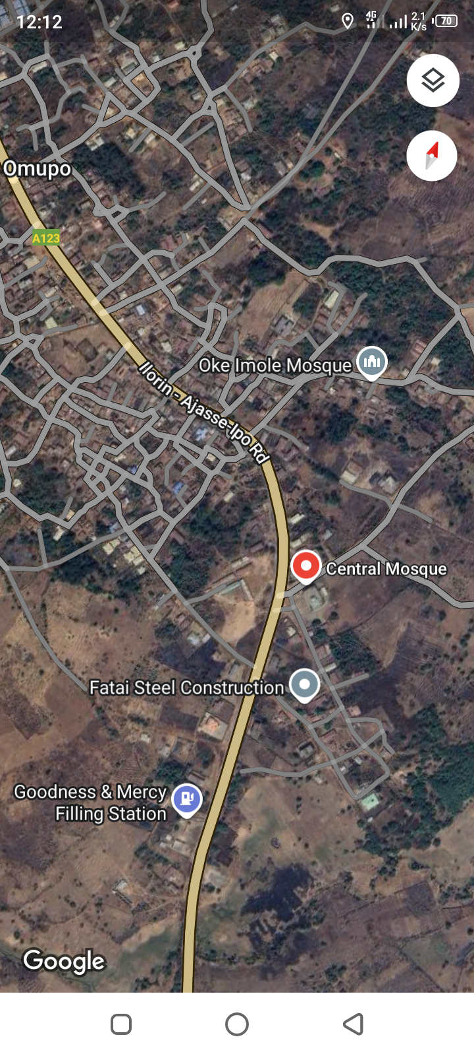

Plate 3.1: Site Location of Case Study One at Ajase Ipo, Ajase, kwara State
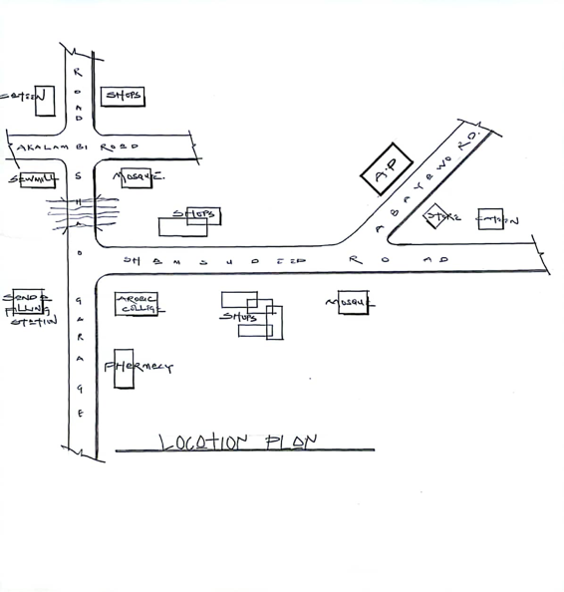
Figure 3.1: Locational Plan of Case Study One at Ajase Ipo, Ajase, kwara State.

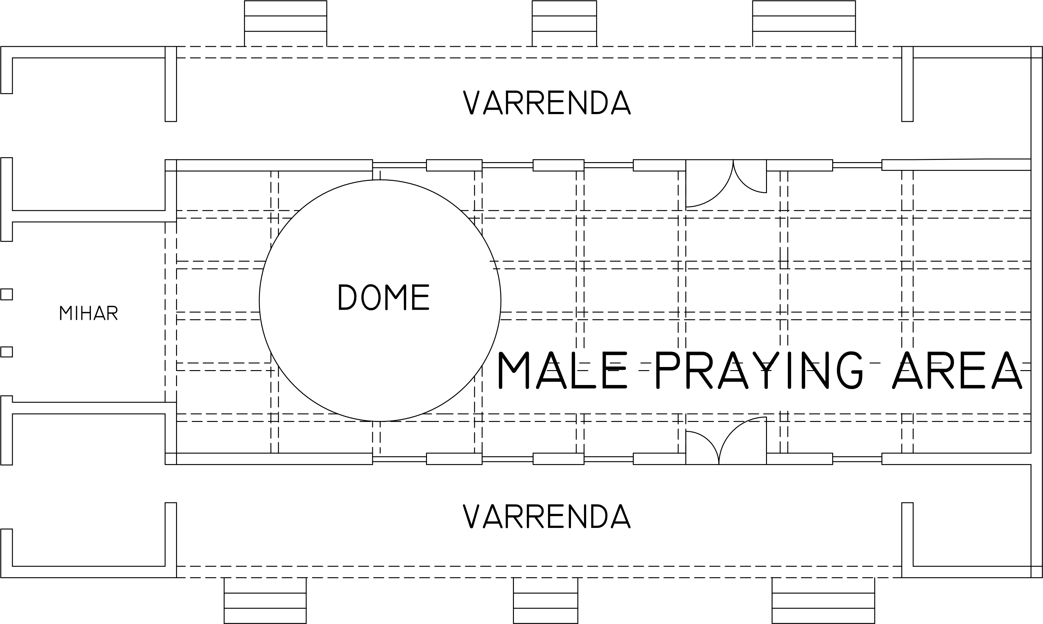
Figure 3.2: First floor plan of Ajase Ipo central mosque, Ajase, kwara state
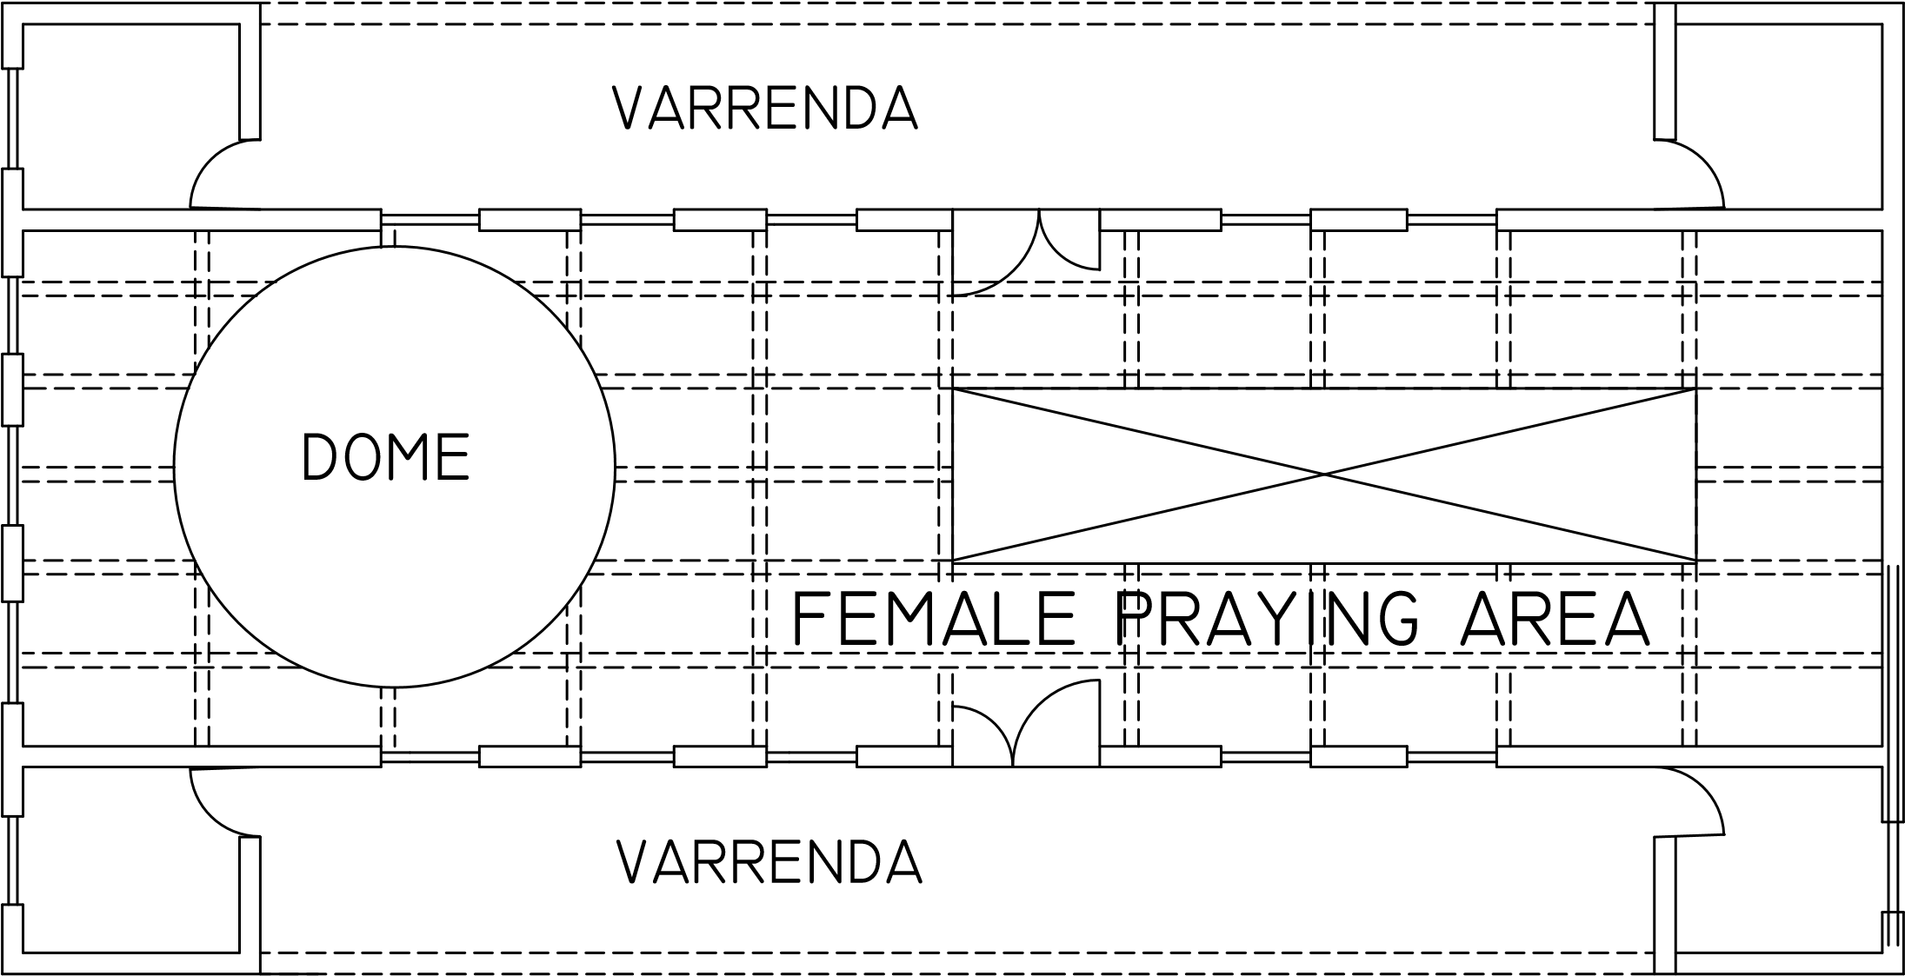

Figure 3.3: Second floor plan of Ajase Ipo central mosque, Ajase, kwara state

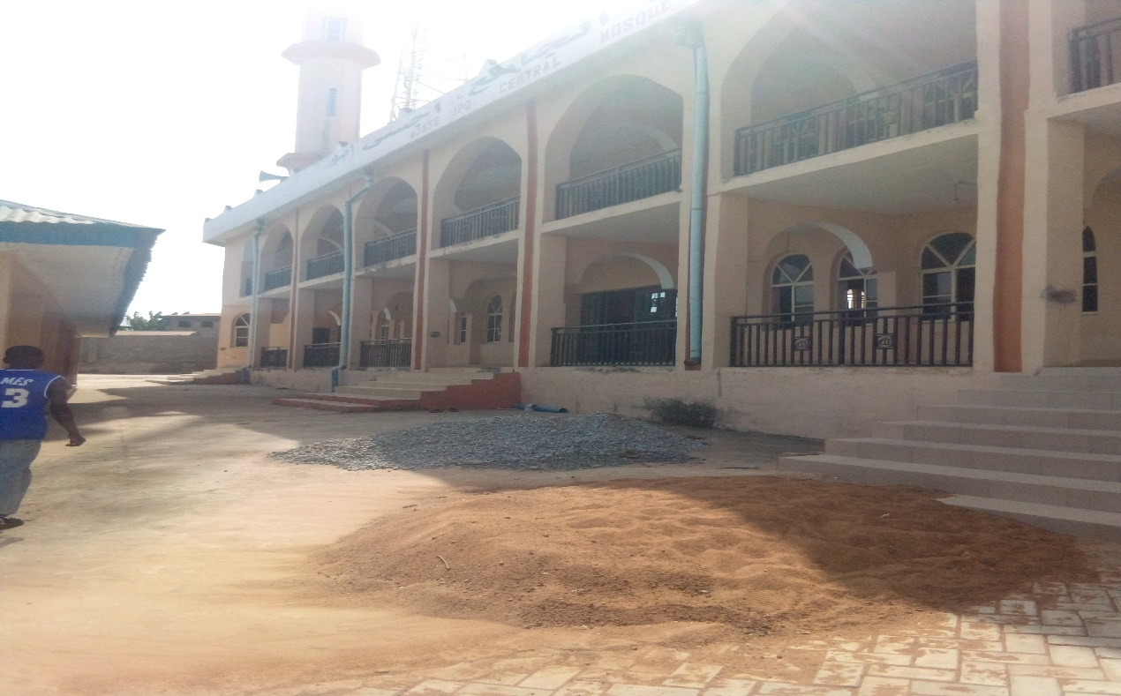

Plate 3.2: Exterior view of central mosque, at Ajase Ipo central mosque, Ajase, kwara State.

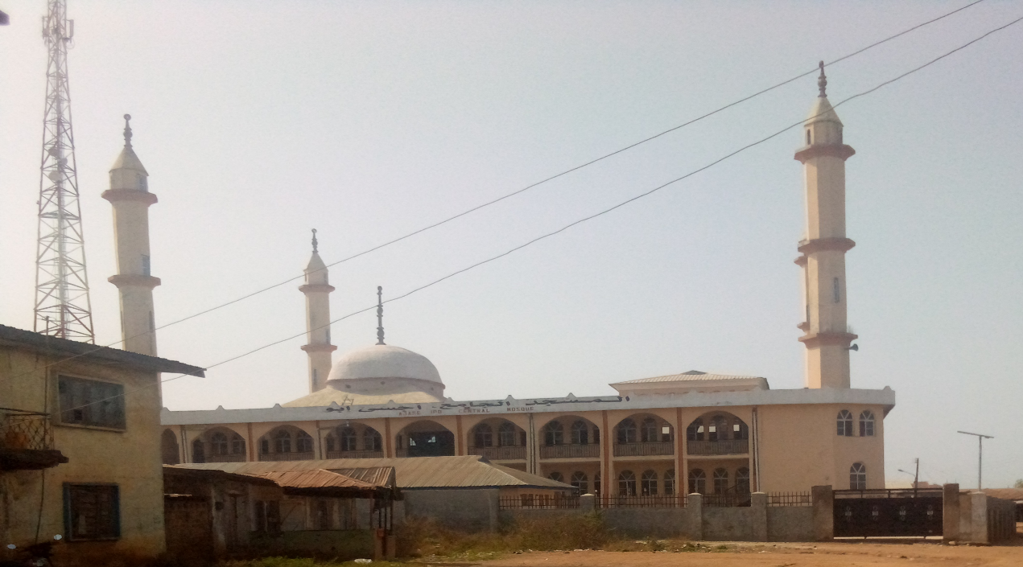

Plate 3.3: Entrance Gate of Ajase Ipo central mosque, Ajase, kwara State.

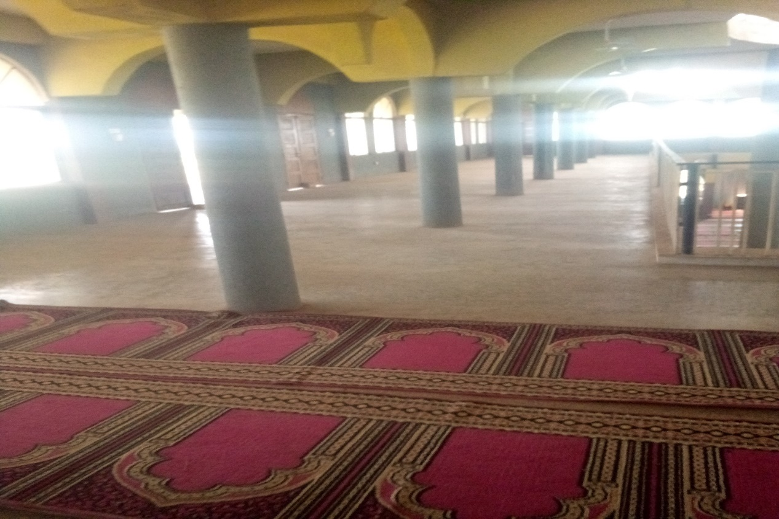
Plate 3.4: Interior view of Ajase Ipo central mosque, Ajase, kwara state

3.3.1 CASE STUDY 2: OMUPO CENTRAL MOSQUE, OMUPO, KWARA STATE

MERTS

.Units are well arrange in the building placement

DEMERITS

.There is no space for future extension

.There is less ablution area

Figure 3.5: Site locational map of case study two at Omupo central Mosque, Omupo, kwara state
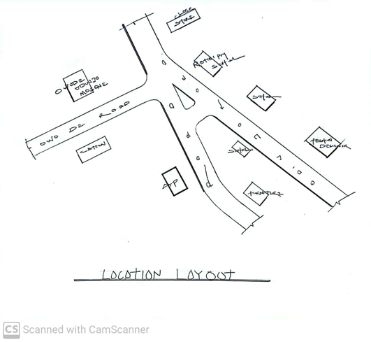

Figure 3.4 location plan of case study two at omupo central mosque, omupo kwara state

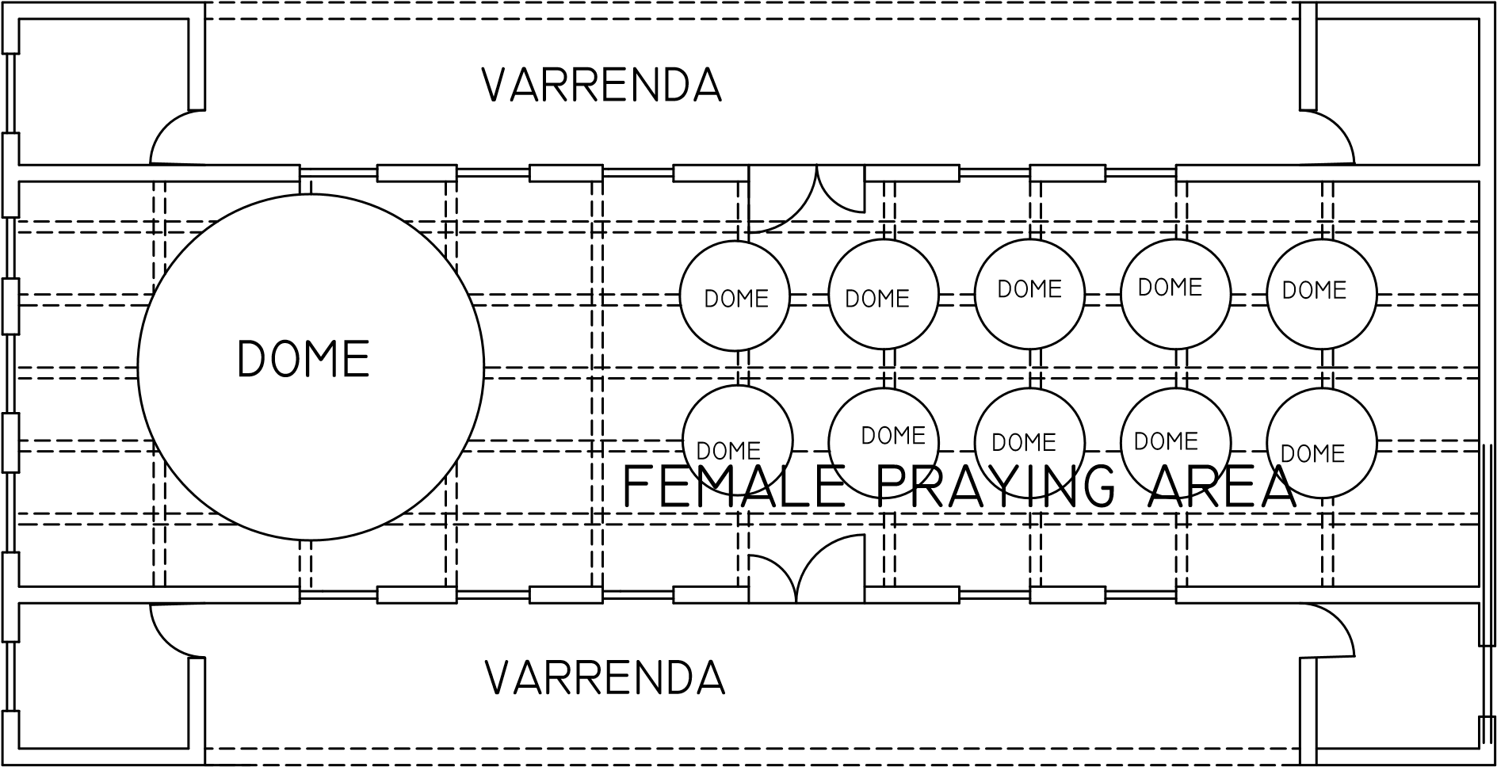
Figure 3.5: Floor plan of case study two at Omupo central Mosque, Omupo kwara state
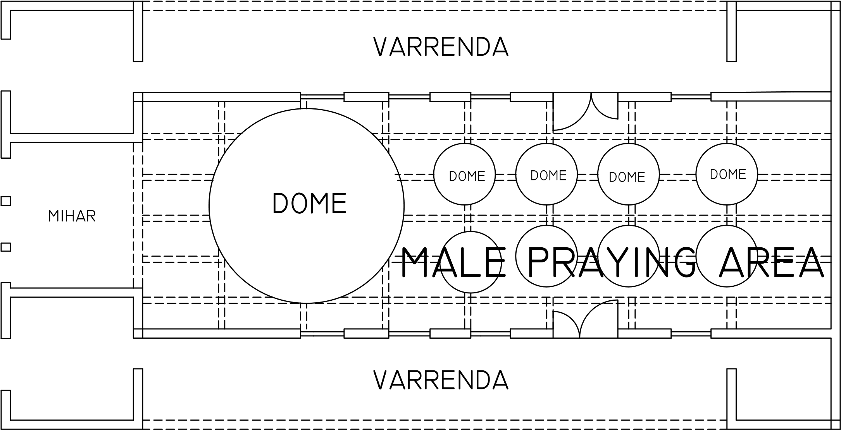
Figure 3.6: Second plan of case study two at Omupo central Mosque, Omupo kwara state

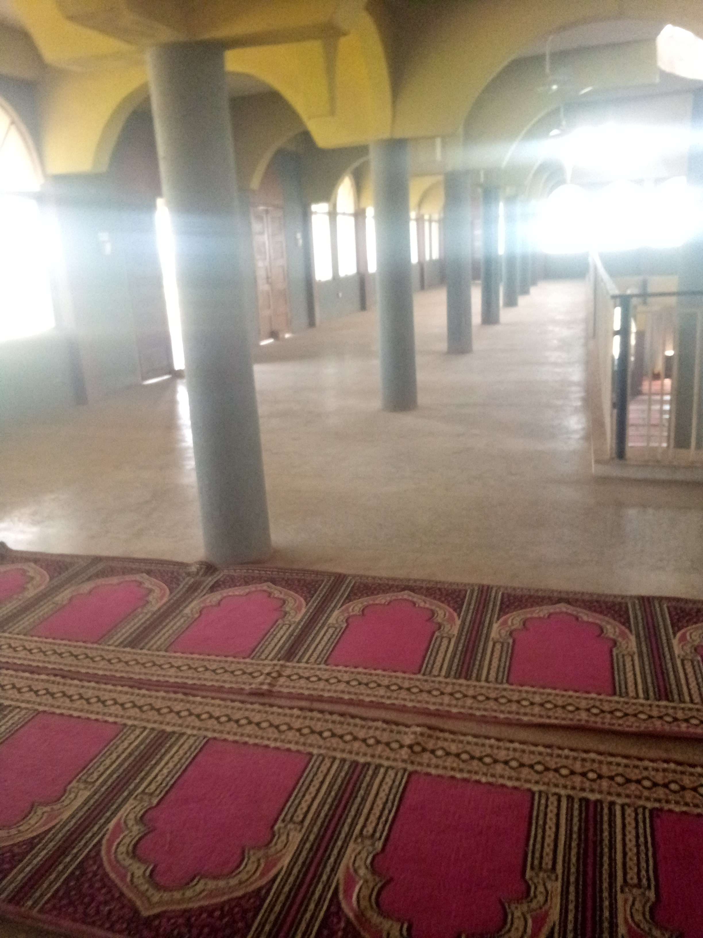
Plate 3.6: Praying room of case study two at omupo central mosque, omupo, kwara state.
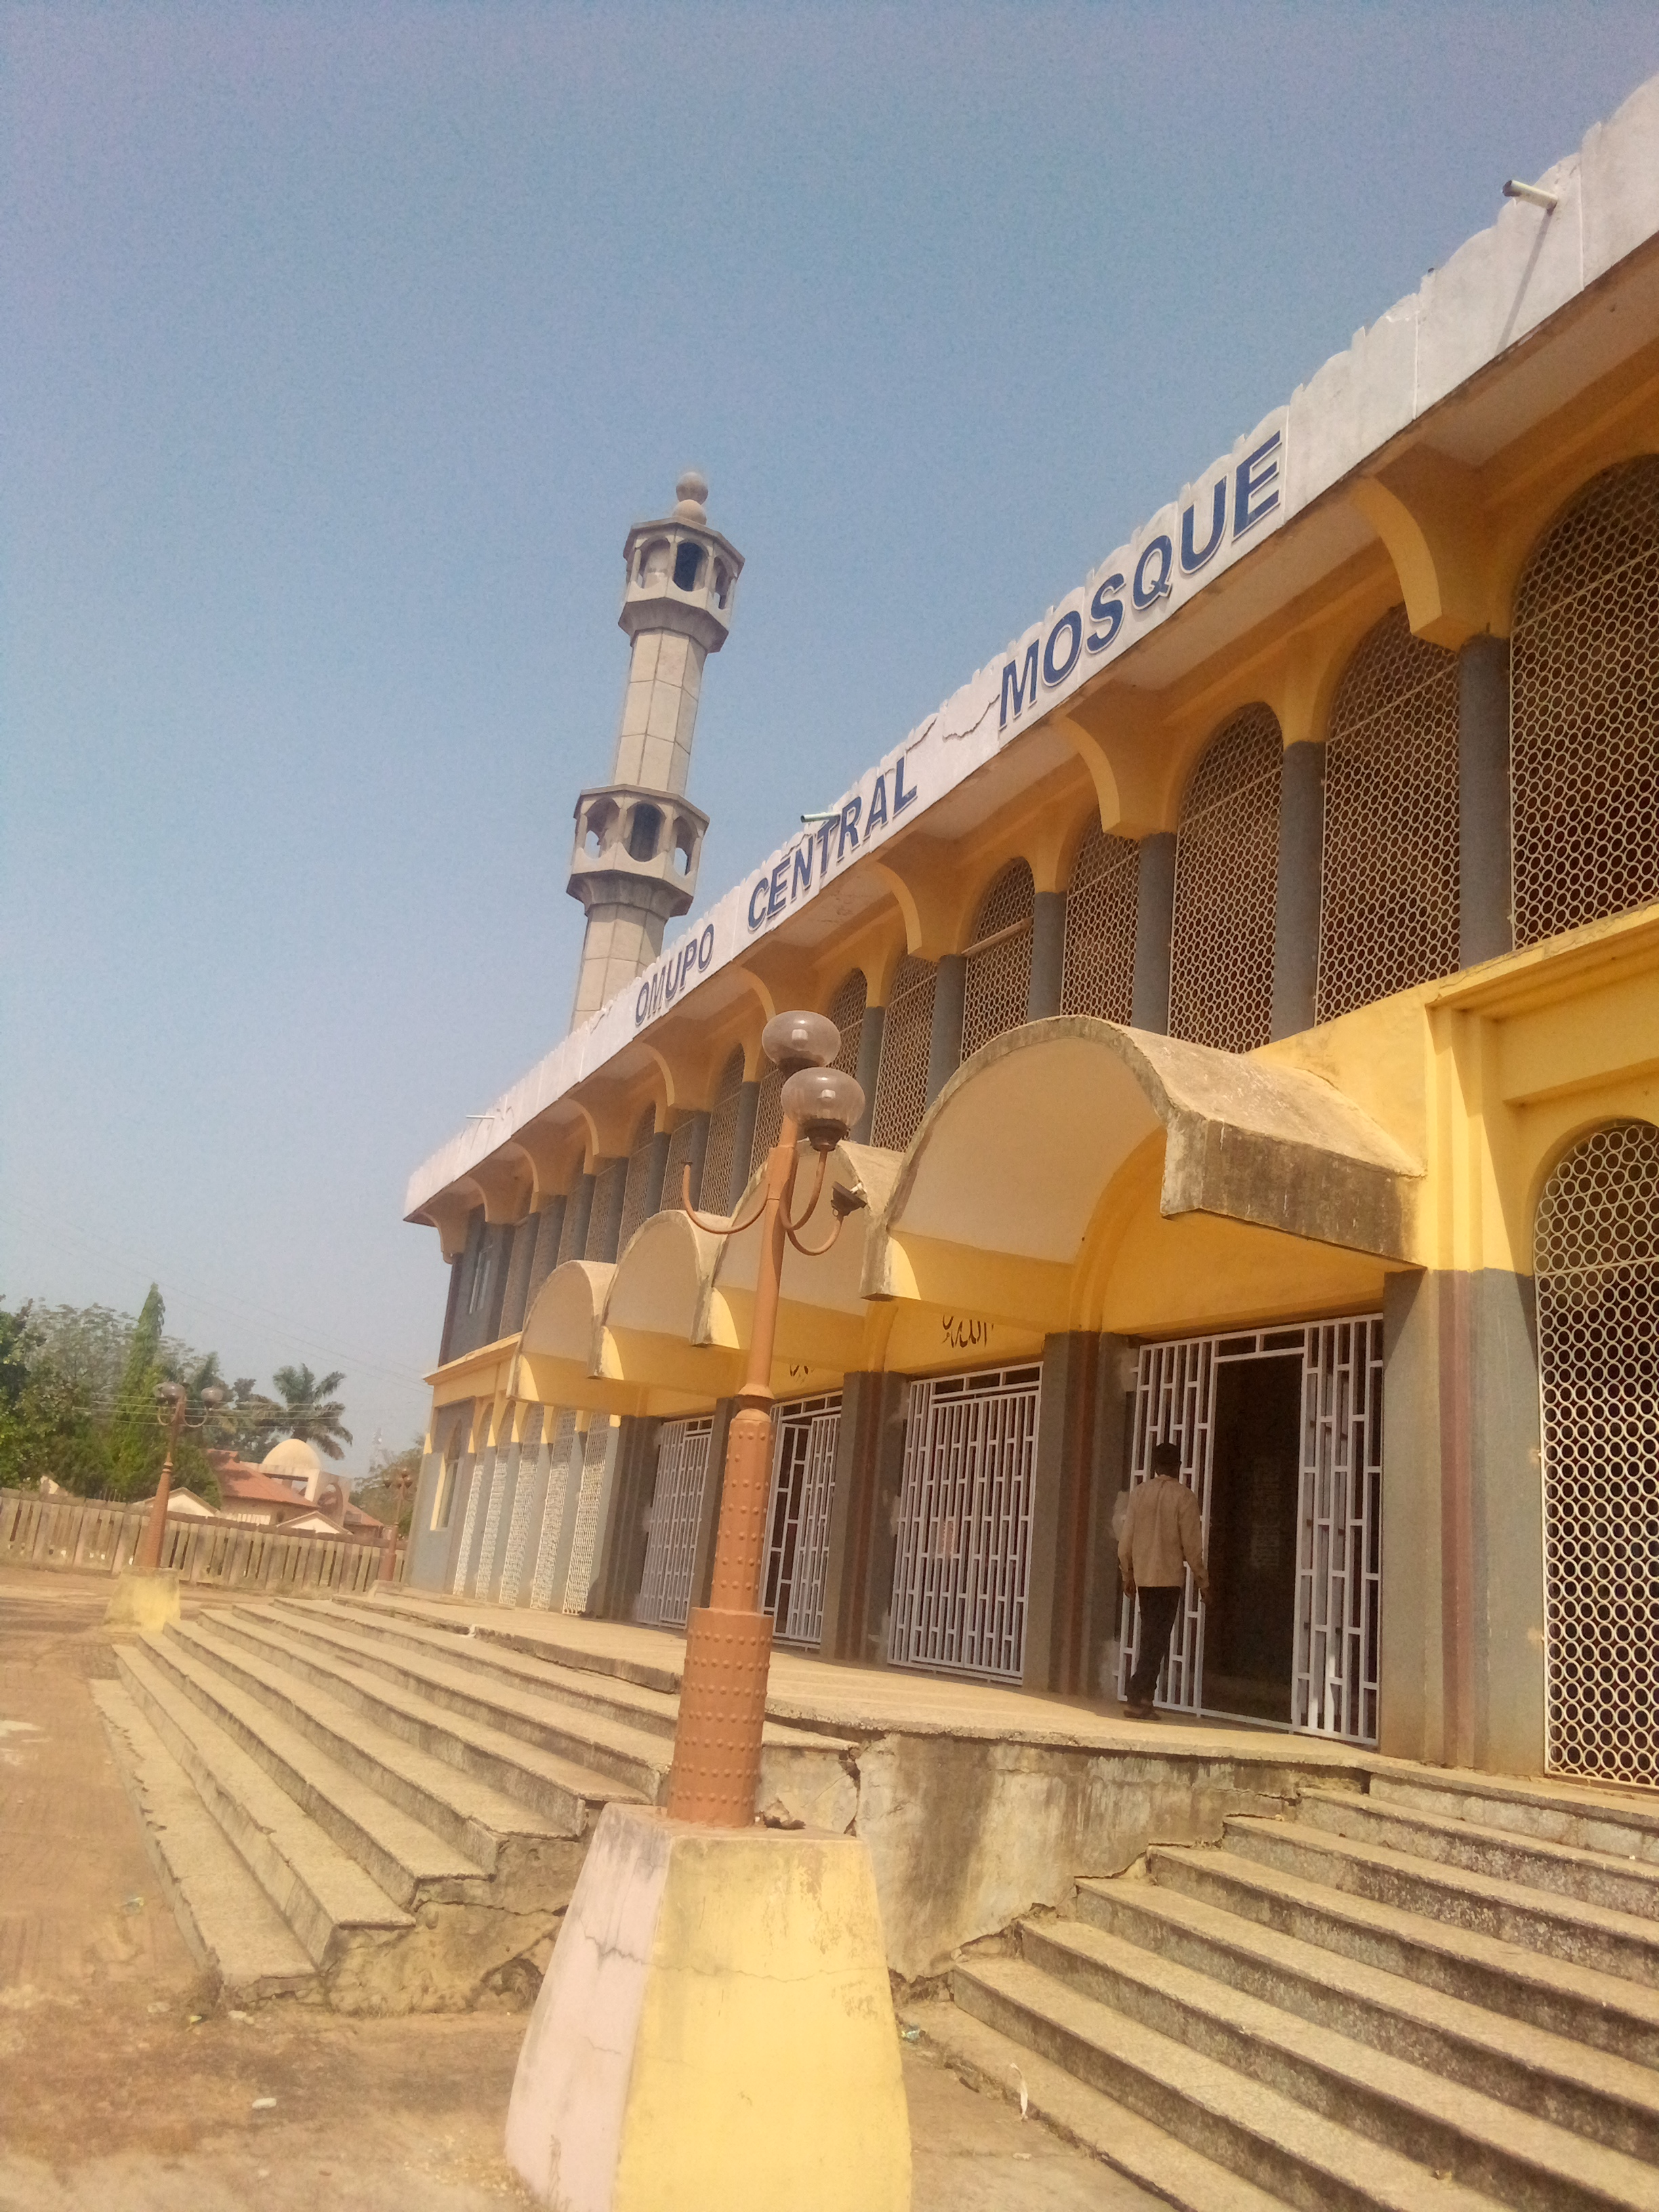

Plate 3.7: Exterior view of Omupo, Omupo kwara state

3.4 CASE STUDY 3: OWONIKOKO CENTRAL MOSQUE, IWO ROAD IBADAN, OYO STATE

MERITS

.Well and adequate ventilation and well design structure

.It’s well spacious

. It is easy to locate.

DEMERITS

.No security consideration in the building

.The parking space is not well defined

.Poor landscape

. The building are not well organized






























Figure 3.7: Location plan of case study three owonikoko central mosque, iwo raod, Ibadan, Oyo state.









Figure 3.8: Floor plan of case study three at owonikoko central mosque, iwo-road, Ibadan, oyo state

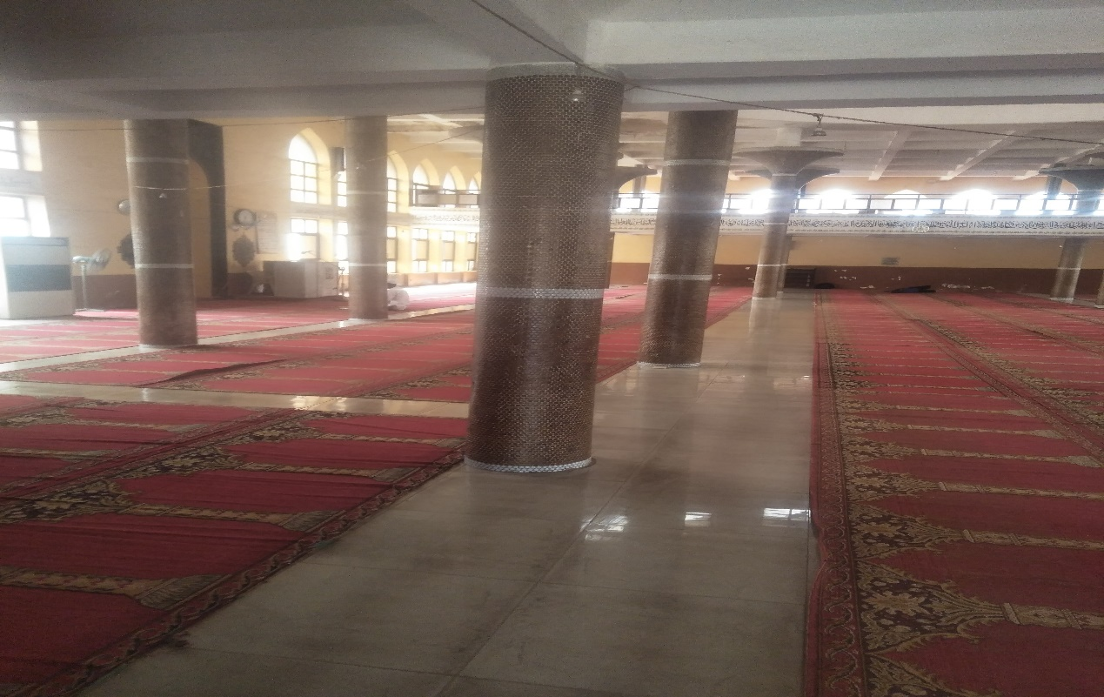

Plate 3.8: Interior of owonikoko iwo road central mosque, oyo state

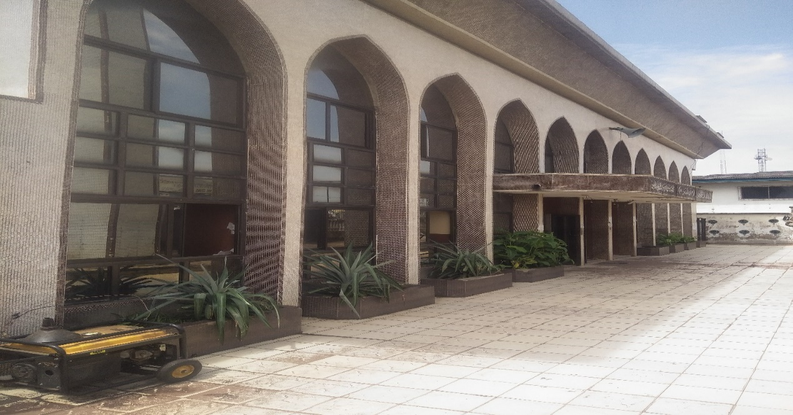

Plate 3.9: Exterior view of owonikoko iwo road central Mosque, Oyo state.

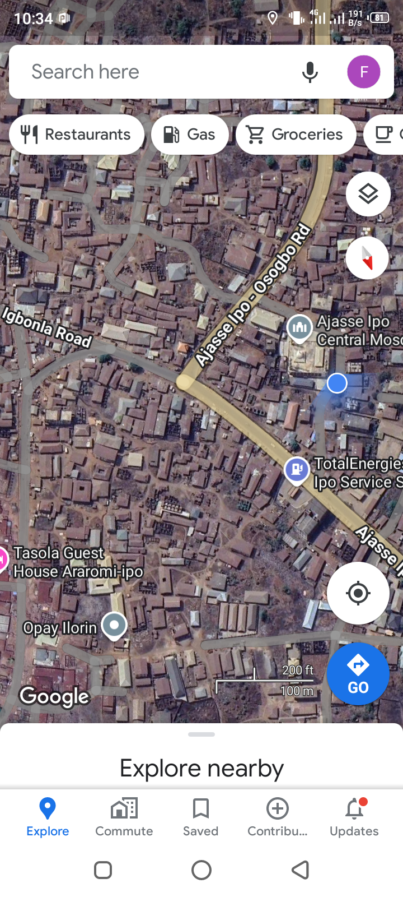

Plate 3.10; location plan of oshogbo central mosque, osun state
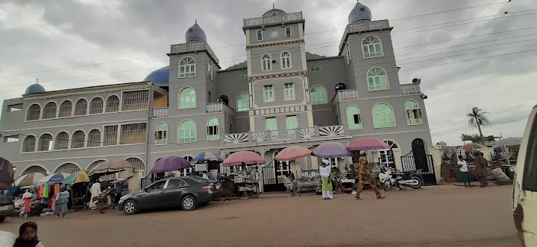
Plate 3.11: Exterior view of Oshogbo central mosque

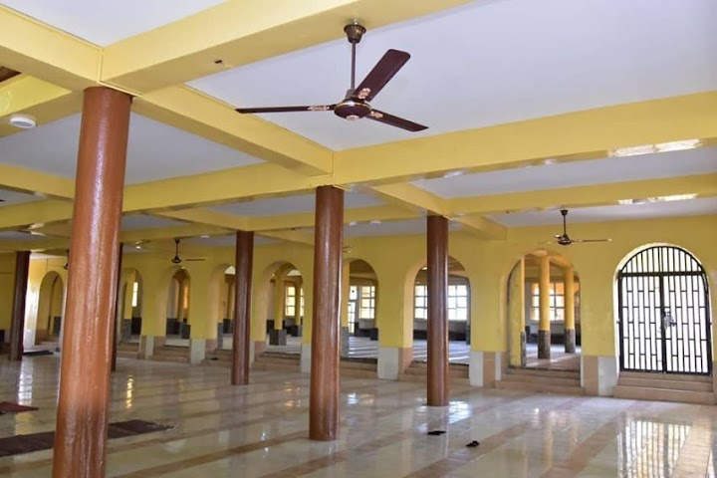
Plate 3.12; Interior view of Oshogbo central mosque, osun state

ONLINE CASE STUDY 1: AT MECCA CENTRAL MOSQUE
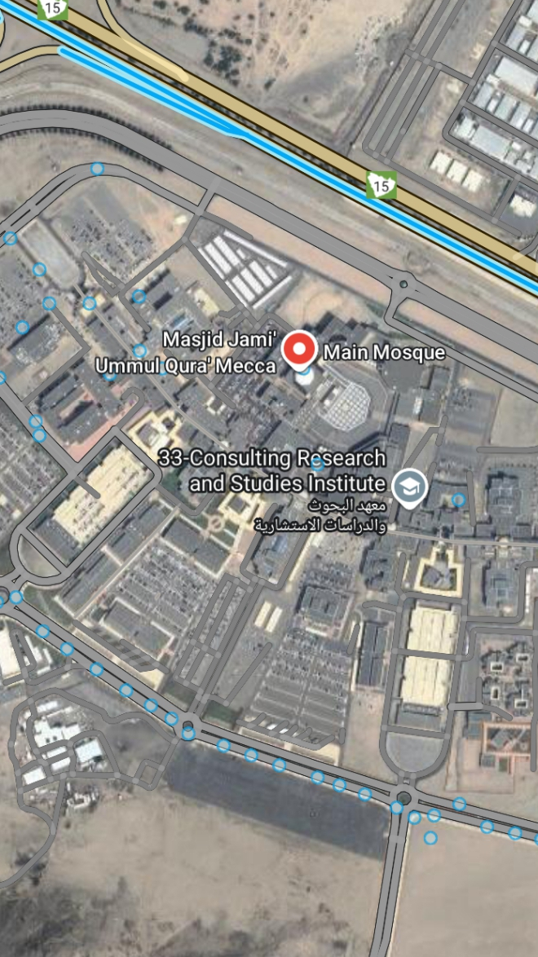
Plate 3.13; Location Plan of Mecca Central Mosque
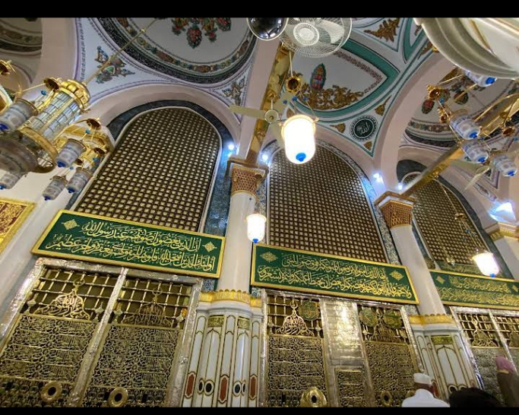
Plate 3.14: Interior View of Mecca Central Mosque
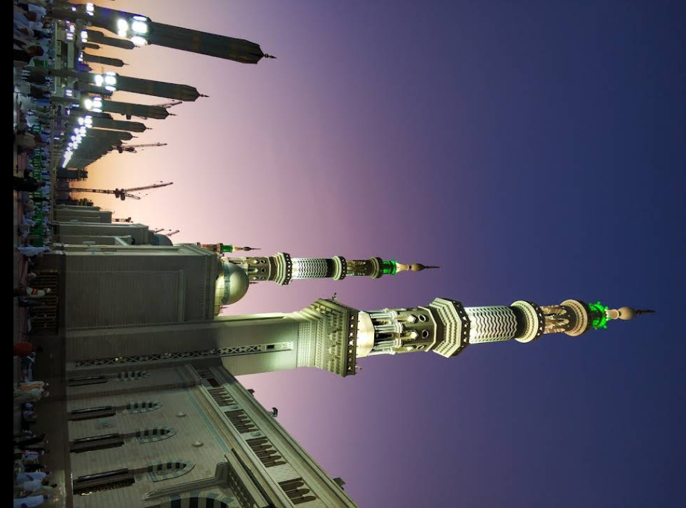
Plate 3.15: Exterior View

ONLINE CASE STUDY 2: LOCATION PLAN OF ONLINE CASE STUDY 2 AT MEDINA CENTRAL MOSQUE
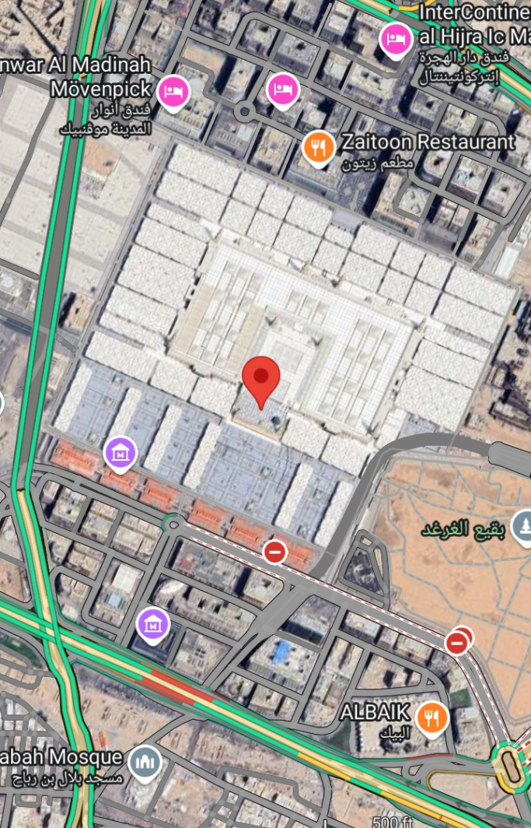
Plate 3.16: Location Plan of Online Case Study 2 at Medina Central Mosque
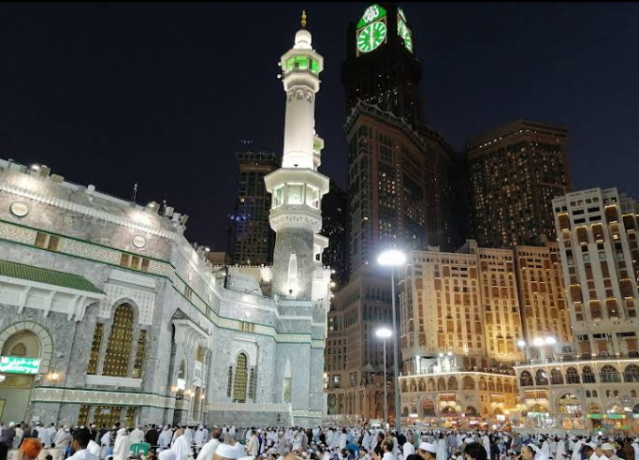

Plate 3.16: Exterior View of Medina Central Mosque

CHAPTER FOUR

4.1.0 STUDY AREA/PROJECT SITE

4.1.2 HISTORY OF KWARA STATE

Kwara state is a state located in the North central region of Nigeria and it was created on May 27,1967, by General Yakubu Gowon, along with 11 other state. It was originally named the west central state but was later renamed kwara, which is a local name for River Niger. The region was conquered by the Fulani in the 19th century and was part of the greater Fulani empire until it was defeated by the forces of sir George Goldie’s Royal Niger company in 1897. It was then incorporated into the protectorate of Nigeria in 1914. Kwara state is bordered by Benin to the west and by the Nigerian state of Niger to the North, kogi to the east, and Ekiti, Osun and oyo to the South. The state mostly consists of wooded savanna, but there are also forested regions in the south.

As of 2006, the population of kwara state was around 2.3million, making it the 30th most populous state in Nigeria.

4.1.3 LOCATION OF SITE

The Site proposed for this project is located at Ipee, kwara state.

Kwara State is situated in central Nigeria. It is bordered by Niger State to the north, Kogi State to the east, Benue State to the south, and Osun State to the west. Its capital is Ilorin Kwara State was created on July 3, 1967, during the military regime of General Yakubu Gowon. The state was carved out of the Western Region, which at that time included the present-day states of Lagos, Ogun, Oyo, Osun, and Kwara. The creation of Kwara State was aimed at providing better administration and development opportunities for the people of the region. The state is named after the Kwara River, which runs through it. Kwara State has an area of approximately 27,500 square kilometers (10,599 square miles). This makes it the 16th largest state in Nigeria in terms of land size. Kwara State has a geographical coordinate of approximately 8.5298° North latitude and 4.7540° East longitude. Its location in central Nigeria places it within the tropical climate zone, characterized by hot temperatures and significant rainfall during the rainy season. The capital city of Kwara State is Ilorin. Ilorin is the largest city in the state and serves as the administrative, economic, and cultural center. The city has a rich history and is known for its diverse population, traditional markets, and educational institutions.

4.1.4 Site Location Map

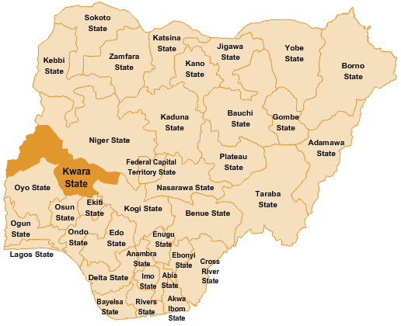

Figure 4.1.4: Map of Nigeria Showing kwara State
Source: google, 2025

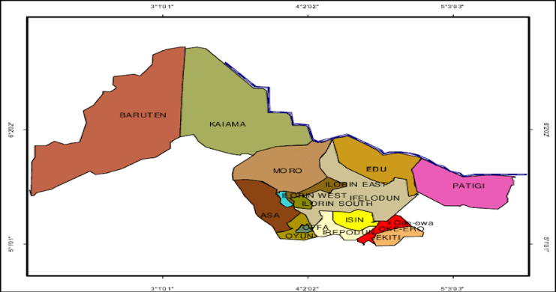
Figure 4.1.5: Map of kwara State
Source: google, 2025

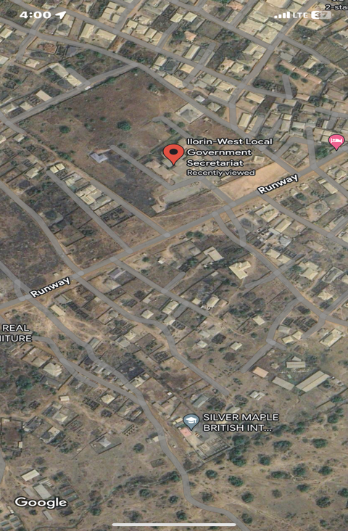

Plate 4.1.6: The proposed site in Ipee kwara state

4.3 SITE INVENTORY AND SITE ANALYSIS

Site inventory is a comprehensive documentation of the physical characteristics, features and conditions of a site. It typically includes: location and boundaries, topography, and drainage, vegetation, soil and geology, water resources and hydrology, climate and weather patterns, existing infrastructure, land use and zoning, environmental conditions ( if applicable ), photographs and maps.

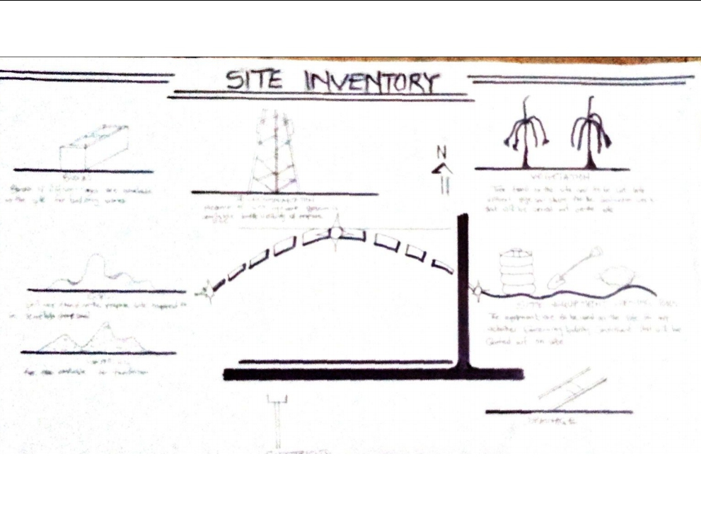Figure 4.1.7: Site inventory of the proposed site

Source: Author’s field work 2025

Site Analysis is a through examination and evaluation of site’s conditions, characteristics and context. It involves gathering and analyzing data to understand the site. The goals of the site analysis are to identify site constraints and opportunities, inform design and development decisions, ensure environmental sustainability, respect cultural and historical heritage and enhance the site’s potential.

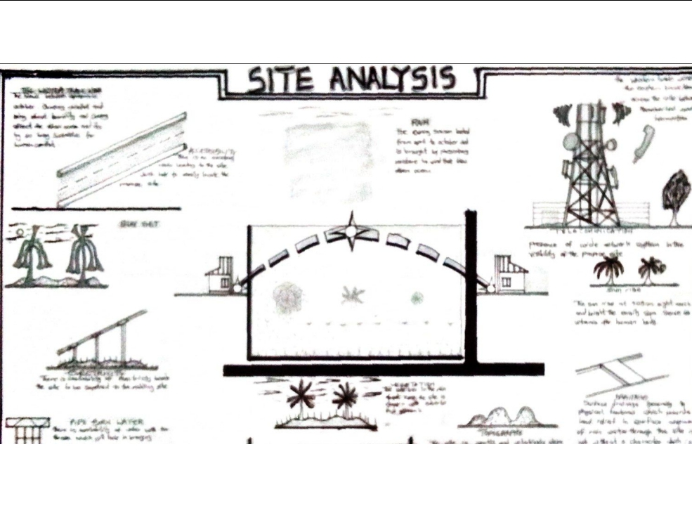

Figure 4.1.8: Site Analysis of the proposed site

Source: Author’s field work 2025

4.1.9 SITE CHARACTERISTICS

Site characteristics are the features of the site. They are realized during the inventory of the site for analysis of impact on the proposed project on the chosen site.

4.1.10 CLIMATE

Mild heat can be experienced throughout the major period of the year on the site, the climatic condition is still considered favourable and heat gain is at normal level. Solar energy can be adopted for energy usage on site.
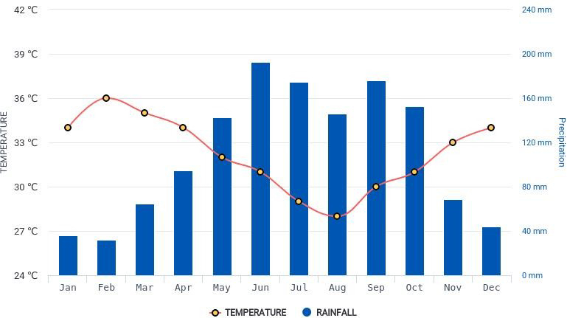

Figure 4.1.11: Climate of the Site

Source: hikersbay, 2025

4.1.12 RAINFALL

Kwara typically receives about 101.45millimeters (3.99 inches) of precipitation and has 148.38 rainy days (40.65% of the time) annually.

Ilorin experiences two climatic season i.e rainy and dry season. The rainy season is between march and november with a brief break in august and the annual rainfall varies from 1200mm
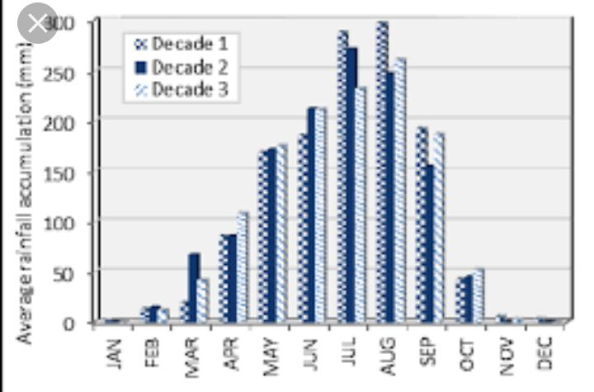

Figure 4.1.12: Graph of Rainfall in Ilorin

4.1.13 HUMIDITY

Kwara under certain factors experiences high relative humidity with high rainfall during the month june, july, august, and September.
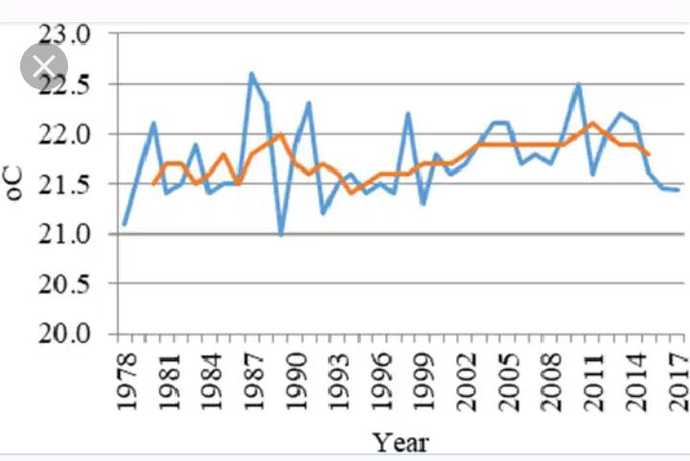

Figure 4.1.13: Graph of humidity in kwara state

4.1. : SOIL TYPE

The nature of the site is confirmed during the inventory to be wet and clumpy. This is known to be a loamy/clayey soil

4.4.5 : TOPOGRAPHY

The site is slightly sloppy towards the south of the site and this can be a good consideration for the drainage system.

4.4.6 : VEGETATION

The site is majorly a Savannah grassland with scattered trees and shrubs. It is specified that the some existing trees will also be retained to beauty of landscape

4.4.7 : DRAINAGE

The drainage available in proximity to the site is along the access road axis. It is through this axis all drainage to be designed on the site would be channels and directed towards following the site topography.

4.4.8 ACCESSIBILITY

There is a major express road along the North axis of the site which allow for efficient and effective vehicular movement. There will be a proposed access road that will lead to the site from the major road.

4.4.9: SITE FEATURES AND INFRASTRUCTURE

There is no existing building on the site. The site is composed mainly of grass and trees which are to be uprooted. Any further excavations can be used in the backfilling of the foundation.

4.4.10: Noise Sources

Minor noise source on the site originates from the major express road to the site. It is regarded as minor because the proposed buildings are quite at a distance from the major road. Major noise will originate from the service centre within the site through use of tools and machinery.

4.5:0 SITE ANALYSIS (PHYSICAL AND CLIMATIC

4.5.1: TEMPERATURE

Ilorin, Nigeria, experiences a tropical savanna climate, characterized by high temperatures and distinct wet and dry seasons. The average annual temperature in Ilorin ranges from 23°C to 28°C (73°F to 82°F).The wet season, which lasts from March to October, is typically hot and humid, with average temperatures ranging from 25°C to 32°C (77°F to 90°F). The dry season, lasting from November to February, is cooler with average temperatures ranging from 20°C to 30°C (68°F to 86°F). However, temperatures can sometimes reach up to 38°C (100°F) during the hottest months of the dry season. It is also important to note that Ilorin's elevation and its location in the interior of Nigeria can result in slightly cooler temperatures compared to coastal areas.

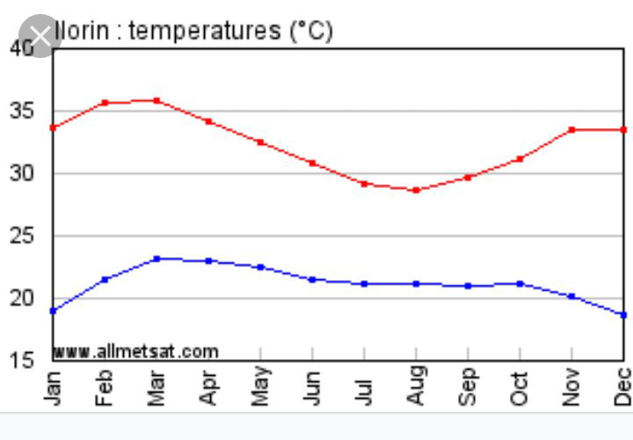

Figure 4.1.14: Graph of temperature in Ilorin

4.1.15 :Precipitation

The average annual precipitation in Ilorin, Nigeria, is approximately 1400-1600mm (55-63 inches). However, the amounts can vary greatly from year to year and between different parts of the city. The city experiences two distinct seasons: the wet season, which lasts from March to October, and the dry season, which lasts from November to February. The wet season is characterized by heavy rainfall, while the dry season is typically hot and dry with little to no rainfall. It is important to note that these averages are subject to change due to factors such as climate change and local weather patterns.

4.5.3: Sunshine

Ilorin, Nigeria, enjoys a significant amount of sunshine throughout the year due to its tropical savanna climate. The city experiences two distinct seasons: the wet season and the dry season. The wet season lasts from March to October and is characterized by heavy rainfall. During this period, the daily duration of sunshine can be shorter due to the cloud cover, but the city still receives a considerable amount of sunlight. The dry season lasts from November to February and is marked by hot and dry weather. This is the period when Ilorin experiences the most sunshine, with long hours of daylight and relatively clear skies. The average daily duration of sunshine during the dry season can range from 7 to 9 hours. It is important to note that sunshine hours can vary from year to year and may be influenced by factors such as local weather patterns and climate change.

4.1.16: Wind

Ilorin, like many other parts of Nigeria, experiences varying wind conditions throughout the year. However, specific wind patterns and speeds for Ilorin are not widely available. In general, the country experiences two wind seasons: the southwest monsoon and the harmattan. The southwest monsoon occurs during the wet season (March to October), when winds blow from the southwest, bringing in moisture from the Atlantic Ocean. These winds can sometimes be strong and gusty, particularly during the peak of the rainy season.Theharmattan is a dry, dusty wind that occurs during the dry season (November to February). It originates from the Sahara Desert and blows from the northern direction. The harmattan can cause significant temperature drops, reduced visibility, and increased air pollution. It's important to note that wind patterns can vary from year to year and can be influenced by local geography and weather conditions.

4.1.16: Man Made Features:i. Electricity: Electricity is supply to the site through overhead cables along the site boundary.

ii. Drainage system: The drainage flow through the site towards the road where there is provision of covert along the road.

iii. Footpath: Presence of footpath across the site.

Figure 4.1.16: Showing site analysis.
Source: Author’s field work 2025

CHAPTER FIVE

5.0 Appraisal of Proposed Scheme

5.1 Design Appraisal

In any project design, there are two basics factors that should be taken into consideration. These factors are functionally and aesthetics of the design, although to some designers, aesthetics and functionally of any building are impartibly but in the case of project both aesthetics and functionality of the design were take care of to satisfy the highly demanded functional requirement and to create aesthetically and proportionally balanced design.

The functional efficiency of institute of business and vocational studies depends largely on the closeness of the immediate section that are strongly related in function all these are being taken up as seen on the site and floor respectively.

Construction Methodology

The choice of materials and constructions techniques is influence by a number of factors.

The cost of Materials

The climate condition as it affects material

The topography of the site

Economics: the initial cost and maintenance cost should be reasonable.

The availability of construction materials. vi.​The durability and suitability of materials.

SERVICES
Electricity to trap from the nearest pole of the institute building. The main water pipeline is closely located to the site where drinking water can be tapped telephone line is within the polytechnic which makes connection easy. All of the drains ruins to the surrounding gutter which finally drains to the solid and liquid waste are effectively dispose of by the soak away put and septic tanks.

CIRCULATION
Horizontal circulation based on guided principle of separating human activities from reticular activities.

VENTILATION
1. Natural Ventilation: these ventilation is experienced in the building through openings. This depends on material wind force and their directions of movement due to the temperature, different between the air and the building.
2. Artificial Ventilation: this method of ventilation is often used to improve the colonies of the interior of the units. Such artificial mechanism include fan and air conditioners where necessary.

LIGHTING
This is a means of providing brightness naturally by sun or moon or artificially by lamps good natural and artificial lighting is important in lecture room and library. It always easy to make mistake and time the eye is in a situation of poor lightening.

PLUMBING
Water services are necessary in an installation and both the scope and design of these systems are subjected to statutory and water authority regulation. There is need to install water system to guide against water supply failure. Adequate installation of pipes are recommend.

ELECTRICAL INSTALLATION

The light fitting should be designed to avoid glare and should be easy to clean and maintain the main sources of electricity supply shall be from the Power Bolding Company of Nigeria but since it is well known that PHCN cannot guarantee uninterrupted services of electricity supply.

WATER DISPOSAL

Site slopes is of major factors to be considered in the location and changeling of drains, the use of reinforced concrete drainage covered with precast lead and drainage pipe will be constructed from where waste water will be carried to the drainage zones on the site using surface drainage system.

FIRE PROTECTION

Building regulations and construction with local fire authority backed up by insurance policy survey takes care of fire protection.

NOISE CONTROL

The is an unpleasant sound often load harsh excessive noise and liberation can cause fatigue, leading to errors and general dissatisfaction in the classrooms, lecture, library, external noise could be easily be controlled with the aid of landscape materials and enough setbacks.

ORIENTATIONS
The orientation of a building involves the arrangement of the building toward a way from the surreys across or along the trade winds normally determine the thermal comfort in the building.

SUN AND WIND BREAKING

In the pre-ventilation design gets rid excessive heat moisture and obvious product such as smoke moisture (generator house) and dust the use of terrace couple with spacious and useful often courtyard to avoid all functional part of the building enough natural ventilation

MATERIALS AND FINISH

The influencer of building material on construction work in Ibadan and its environment is similar to what prevail in the middle belt of the country.
The materials choice and finishes are influenced by the following:

i.​The durability and suitability of materials

ii.​Geology and topography of the site

iii.​Availability of materials

iv.​The climatic condition

v.​Prospective of materials

vi.​The cost of materials

ROOF
Roof should preferably of light weight construction with parapet converging it and the external super should absorb as little solar energy as possible.

CEILINGS
Suspended ceiling is used in some lecture room with fang ceiling suitable center to center.

DOORS

The door type and size depend on the door location but generally metal door are used for the administrative block, mechanical workshop, aluminum glass door and steel door are used.

WINDOW

The windows uses are glassed pivot aluminum windows.

5.2​ RECOMMENDATIONS
In carrying out the research works, there are several problems challenges and shortcomings noticed thereby using this medium to recommend some solutions.
The government should try to build more standard comprehensive health care center.

5.3 CONCLUSION AND SUMMARY

There is ongoing debate over the Universal health coverage that it can be achieved through primary health care services. To accomplish the universal health coverage India has taken so many steps starting from primary health care services strengthening by upgrading the infrastructure of primary, secondary health care delivery system in health and wellness centers through which comprehensive
primary health care services are disseminating all over the country. We have come so far from our lacking and bringing up the public health system to another level. But still there are some challenges to nail our vision of health for all. Challenges like funding issues of services, shortage of manpower in health care centers, vague role of private sector towards the goal of achieving universal health coverage are the speed breakers in our path. We have more to go towards our dream to achieve “Health for all”.

REFERENCES

Colledge, R. (2017). "The mosque". In: Mastering World Religions. Macmillan Master

Series. Palgrave, London. doi:10.1007/978-1-349-14329-0_16 "A mosque is a building where Muslims bow before Allah to show their submission to His will. It is not necessary to have a building to do this. Muhammad said that 'Wherever the hour of prayer overtakes you, you shall perform the prayer. That place is the mosque'. In his early days in Makkah there was no mosque, so he and his friends would pray anywhere."

Grabar 2020, pp. 34–35: "A second stage occurred between 650 and 750. To my

knowledge, twenty-seven masjids from this period are archaeologically definable... All mosques had a certain relationship between open and closed covered spaces. The problems posed by this relationship pertain primarily to the history of art, except on one point, which is the apparent tendency to consider the covered parts as the bayt al-salat, i.e. place of prayer, and the rest of the building as an overflow area for prayer. All these buildings were enclosed by walls and did not have an exterior façade. Their orderly form appeared only from the inside where the balance between open and covered spaces served, among other things, to indicate the direction of qibla. Their only outward symbol was the minaret, a feature which appeared early in mosques built in old cities with predominantly non-Muslim populations and only later in primarily Muslim ones."

Grabar 2015, p. 34: "The main characteristic, then, of this first stage was the creation

of a space which served exclusively Muslim purposes and which, in cities that were entirely Muslim, existed on two separate levels of exclusivity. The word masjid is always associated with these spaces, but it does not yet possess any formal structure nor does it have any precise function other than that of excluding non-Muslims."

John L. Esposito, ed. (2018). "Mosque". The Oxford Dictionary of Islam. Oxford

University Press. Archived from the original on December 25, 2017.

Longhurst, Christopher E., "Theology of a Mosque: The Sacred Inspiring Form,

Function and Design in Islamic Architecture", Lonaard Journal. Mar 2012, Vol. 2 Issue 8, pp. 3–13 [11]. "Since submission to God is the essence of divine worship, the place of worship is intrinsic to Islam's self-identity. This 'place' is not a building per se but what is evidenced by the etymology of the word 'mosque' which derives from the Arabic 'masjid' meaning 'a place of sujud (prostration).'

Nuha N. N. Khoury (2009). "Mosque". In Juan Eduardo Campo (ed.). Encyclopedia of

Islam. Infobase Publishing.

Patrick D. Gaffney (2004). "Masjid". In Richard C. Martin (ed.). Encyclopedia of Islam

and the Muslim World. MacMillan Reference.

Utaberta, Nangkula; Asif, Nayeem; Rasdi, Mohd Tajuddin Mohd; Yunos, Mohd Yazid

Mohd; Ismail, Nor Atiah; Ismail, Sumarni (2015-04-01). "The Concept of Mosque Based on Islamic Philosophy: A Review Based on Early Islamic Texts and Practices of the Early Generation of the Muslims". Advances in Environmental Biology. 9 (5): 371–375. Archived from the original on 2024-02-24. Retrieved 2024-03-03.

APPENDIX

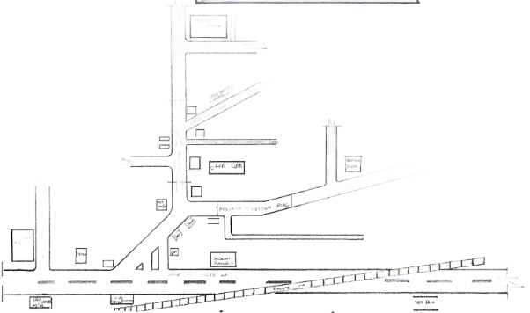

Appendix I ; locational plan

Appendix ii; Site inventory

Appendix iii; site analysis

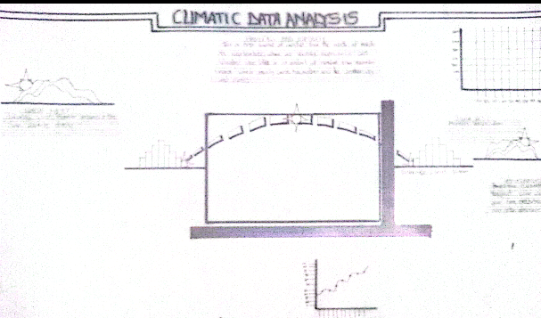

Appendix iv; climatic data
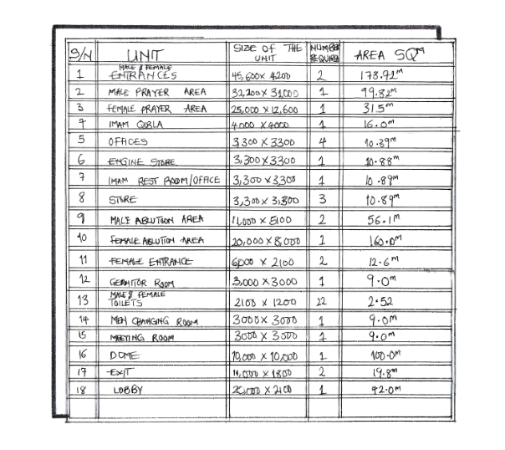
Appendix v; space schedule

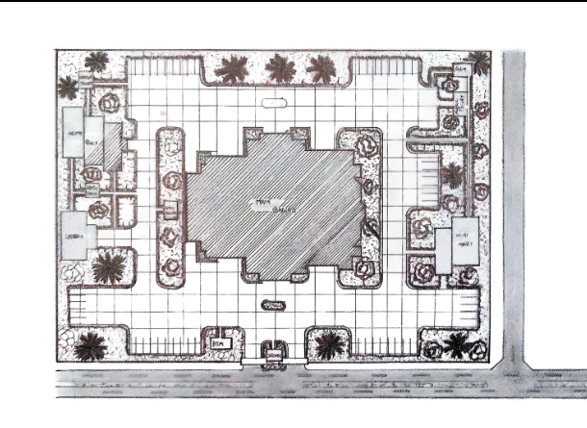

Appendix vi; site plan

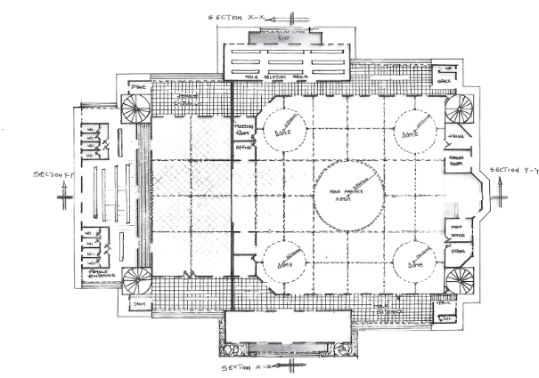

Appendix vii; floor plan

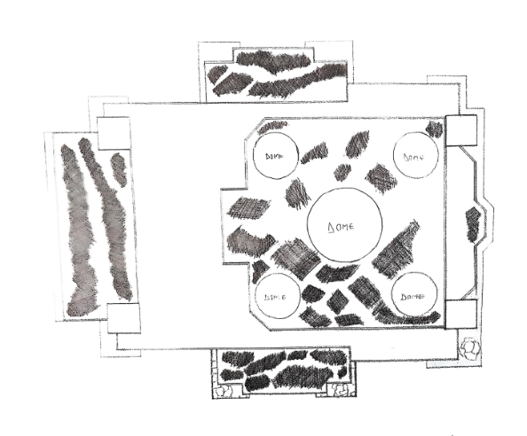
Appendix x; Roof plan

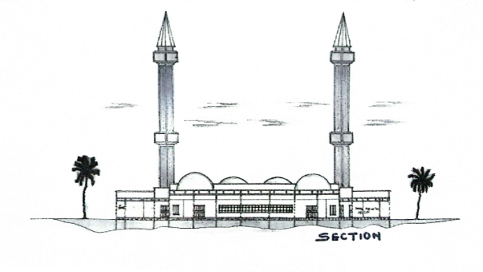
Appendix xi; section

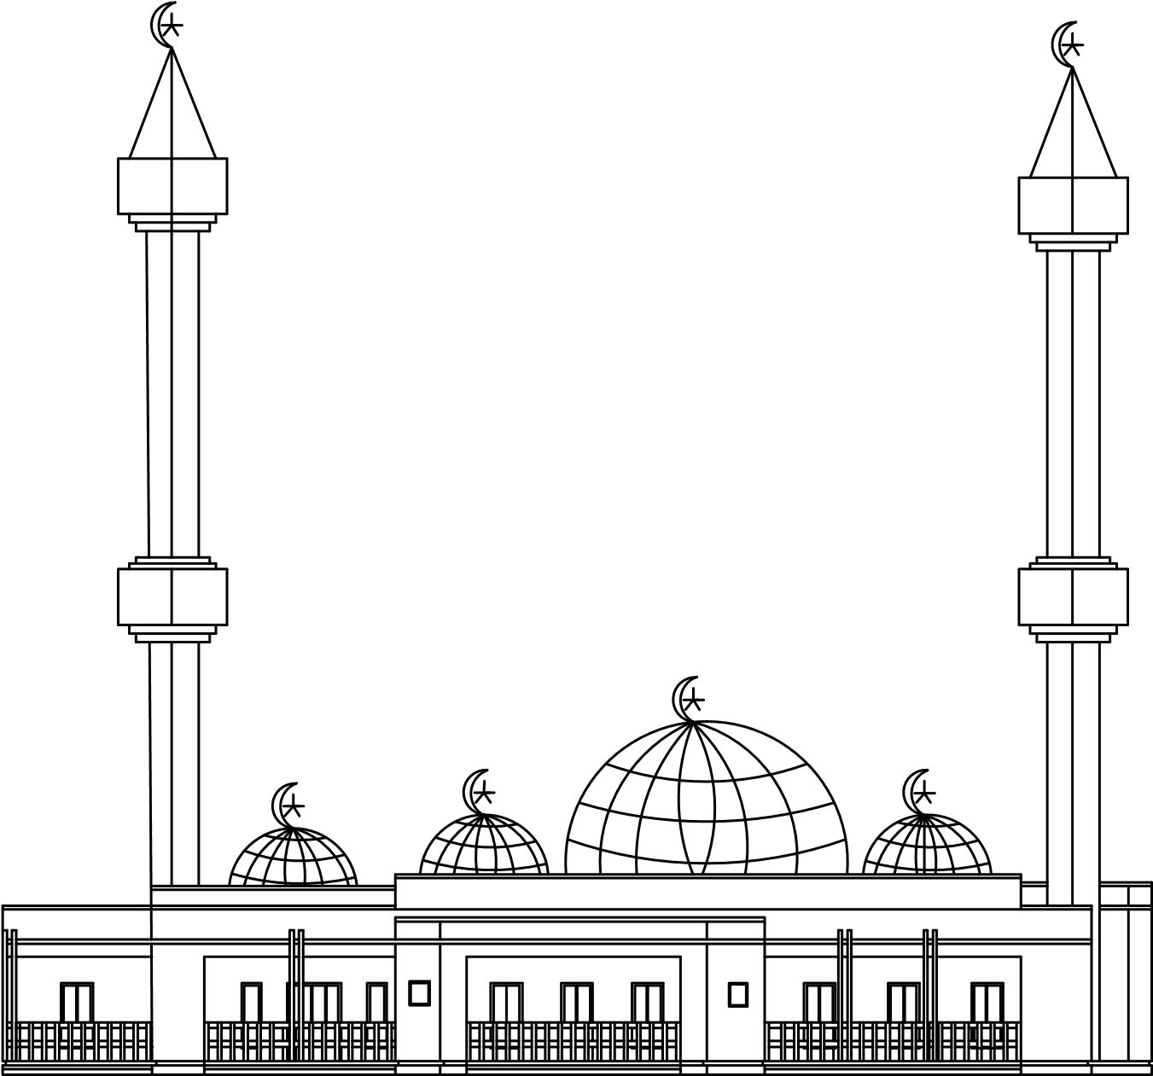

Appendix; left side view

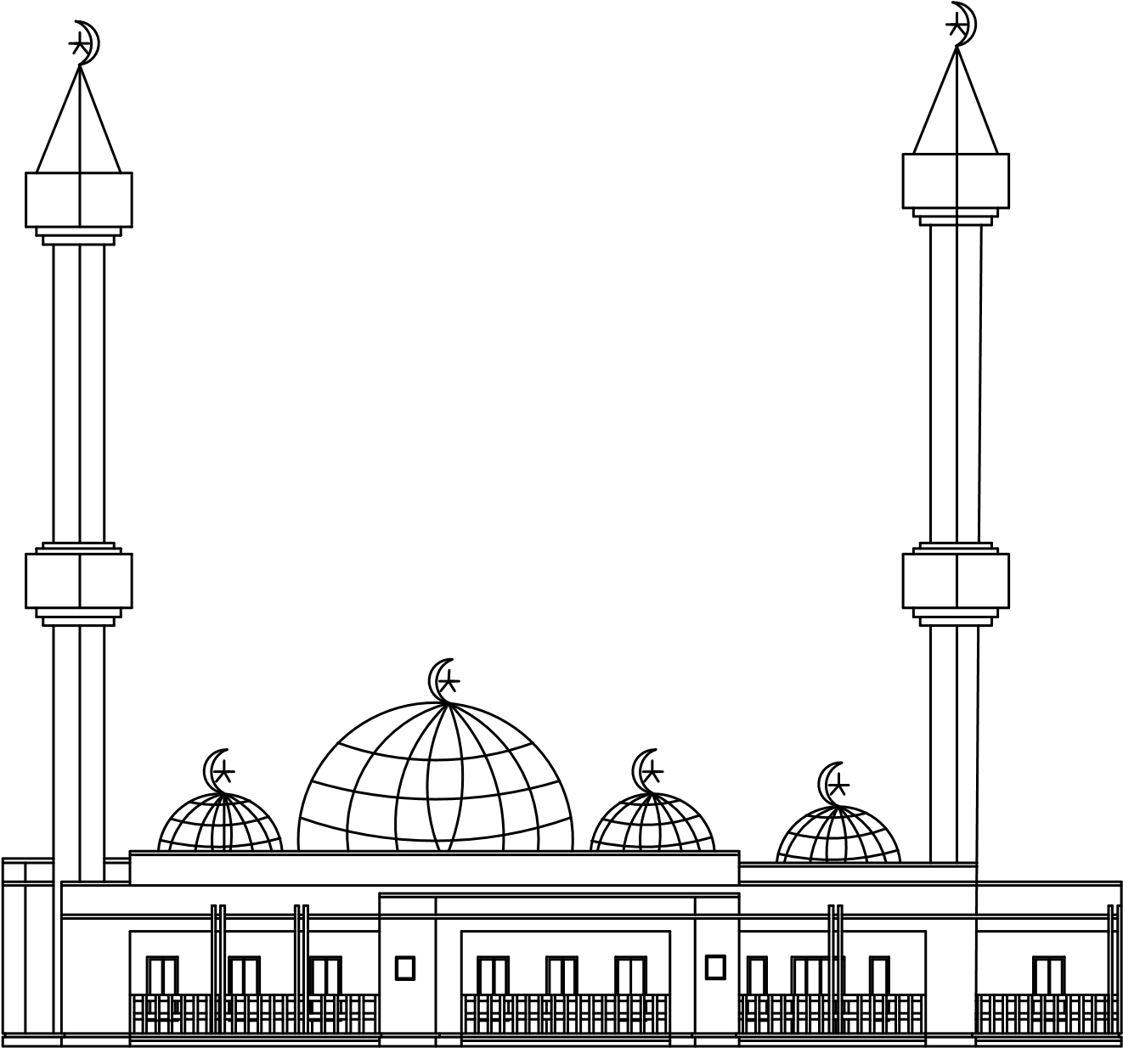

Appendix;Right side view

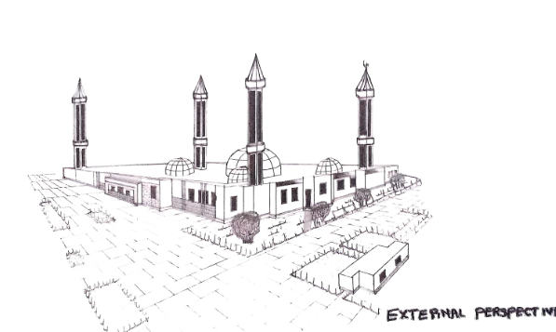

Appendix; perspective

