A PROJECT REPORT
ON
PROPOSED OFFICE BUILDING COMPLEX
BY
HAMEED SHAMSUDEEN ENIOLA
HND/23/ARC/FT/0004
SUBMITTED TO:
DEPARTMENTAL OF ARCHITECTURAL TECHNOLOGY,
INSTITUTE OF ENVIRONMENTAL STUDIES KWARA STATE POLYTECHNIC,ILORIN.

IN PARTIAL FULFILLMENT OF THE REQUIREMENTS FOR THE AWARD OF HIGHER NATIONAL DIPLOMA (HND) IN ARCHITECTURAL KWARA STATE POLYTECHNIC, ILORIN, KWARA STATE.

JULY 2025.

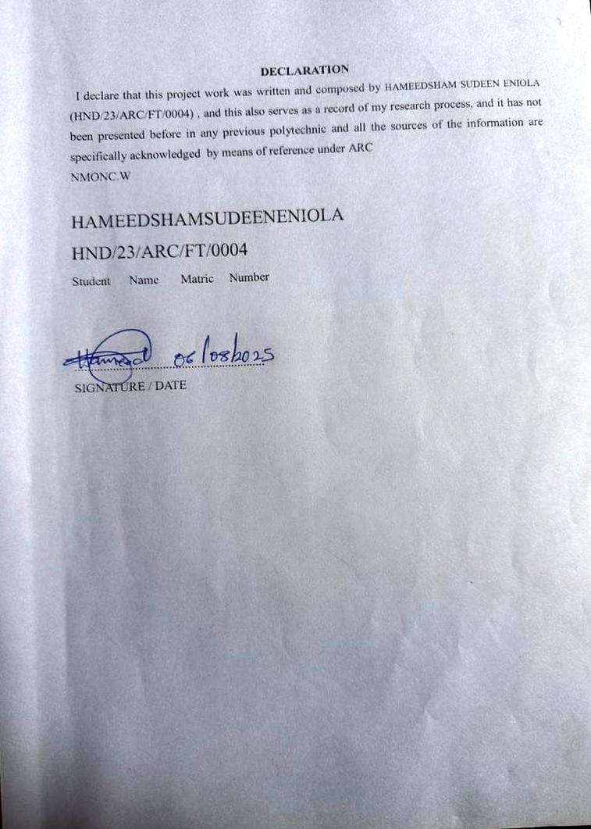
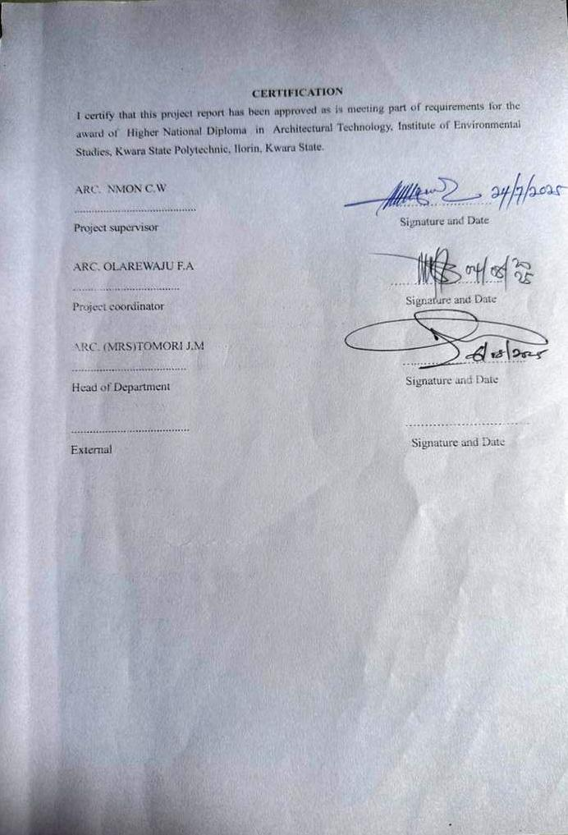
DEDICATION
I dedicate this project to Almighty Allah,The most beneficent and the most merciful, myparents Mr & Mrs Hameed,my sister Ajuwonsekinat,my family members, Dada Aishatomobolanle and a brother from another mother AdeogunMojeeb for there prays and support that makes the journey easy .

ACKNOWLEDGEMENT
Everything that has starting will surely have an end ,therefore all praise to the Almighty Allah the most Merciful and sufficient for strength and courage that he has added me in the process of my project.
A special thanks to my project supervisor ARC.NMONC.W for taking is time to go through my project research work,may Almighty Allah continue to bless you abundantly ( AMEEN).
- My appreciation to my lovely parent Mr&MrsHameed,Ajuwonsekinat,ChiefOlaofe ,Hameed Hameed, and my class Rep Usman zubair for there prayer and supports.
- And all Hameed family for their moral and financial support towards my education program.

ABSTRACT
This office building complex project encompasses the design, development, and construction of a cutting-edge facility, tailored to meet the evolving needs of modern businesses and professionals. Strategically located in [Epe express road etiosalagos], the complex will feature premium office spaces, state-of-the-art amenities, and innovative technologies, fostering a productive and collaborative work environment. With a focus on sustainability, energy efficiency, and occupant well-being, the complex aims to enhance the quality of life for its tenants while contributing to the economic growth and urban development of the surrounding area. Through its modern design, advanced infrastructure, and commitment to excellence, this office building complex will establish itself as a landmark destination for businesses, entrepreneurs, and innovators.

TABLE OF CONTENT
TITTLE PAGE ...........................................................I
DECLARATION.....................................ii
CERTIFICATION..................................iii
ACKNOWLEDGEMENT.............................iv
DEDICATION........................................v
LIST OF TABLE....................................vi
LIST OF FIGURES...............................vii
LIST OF PLATES...............................viii
ABSTRACT..........................................ix

CHAPTER ONE
1.0 INTRODUCTION.............................................1
1.1 HISTORICAL BACKGROUND...............................................1
1.2 DEFINITION..................................2
1.3 AIM AND OBJECTIVES ..............................2
1.4 SCOPE OF STUDY...............................................
1.5STATEMENTOFPROBLEM.............................................3
1.6RESEARCH METHODOLOGY................................................
1.7 LIMITATIONS AND CONSTRAINTS.......................................
1.8 JUSTIFICATION.................................

CHAPTER TWO
2.0 LITERATURE REVIEW AND CASE STUDY................................................
2.1 REVIEW OF RELEVANT LITERATURE
2.2IMPORTANCE......................................
2.3 SELECTED CASE STUDY ...........................................
2.3.1 CASE STUDY ONE.........................
2.3.2 CASESTUDYTWO ..........................
2.3.3 CASE STUDY THREE......................
2.3.4 ONLINE CASE STUDY 1 ...........................
2.3.5 ONLINE CASE STUDY 2…………………..
2.3.6 CONCLUSION……………………….
CHAPTER THREE
3.0 SITE AND ENVIRONMENTAL ANALYSIS..............................................
3.1 BRIEFHISTORY................................
3.2 SITE LOCATION ..................................................
3.3 SITE SELECTION/LOCATION CRITERIA...............................................
3.4 SITE ANALYSIS/ SITE INVENTORY...........................................
3.5 CLIMATIC DATA / GEOGRAPHICAL CONSIDERATION...................................................
3.6 CONCLUSION .................................................
CHAPTER FOUR
4.0 DESIGN CRITERIA....................................
4.1 SITE PLANNING .................................................
4.2 BRIEF ANALYSIS........................................
4.3 ANALYSIS OF THE SCOPE..................................................
4.4 SPACE ALLOCATION ...........................
4.5 FUNCTIONAL RELATIONSHIP.......................................
4.6 CONCEPTUAL DEVELOPMENT................................................

CHAPTER FIVE
5.0APPROVAL OF PROPOSED SCHEME.....................................
5.1 DESIGN AND CONSTRUCTION...................................
5.2 GENERAL DESIGN CONSIDERATION...................................
5.3 CONSTRUCTION METHOD AND MATERIAL.......................................
5.3.1 LANDSCAPE DESIGN.....................................
5.3.2 LANDSCAPE ELEMENT USED INTHECONSTRUCTION..........................
5.4GENERAL CONCLUSION AND RECOMMENDATION..............................

APPENDEX
LIST OF TABLE
Table 1: shown the classification and categories
i.e Space allocation……………………………..

LIST OF FIGURES
Figure 1: showing the locational plan of case study one…………………….
Figure 2: showing the proposed plan of case study one…………………….
Figure 3: showing the locational plan of case study two…………………..
Figure 4: showing the proposed plan of case study two…………………..
Figure 5: showing the locational plan case study three………………….
Figure 6: showing the proposed plan case study three………………….

LIST OF PLATES
Plate 1: showing the front elevation of the case study one
Plate 2: showing the sides elevation of the case study one
Plate3: showing the front elevation of the case study two
Plate 4: showing the sides elevation of the case study two
Plate 5: showing the front elevation of the case study three
Plate 6: showing the sides elevation of the case study three

CHAPTERONE
1.0 INTRODUCTION
- Office building complexes are large-scale developments that provide a comprehensive range of facilities and services for businesses and organizations. These complexes typically feature:
- . Multiple office spaces: Various sizes and types of office spaces to accommodate different business needs.
- . Amenities and services: Facilities like fitness centers, restaurants, convenience stores, security, and maintenance services.
- . Strategic locations: Prime business districts or areas with good transportation links.
- Office building complexes offer benefits like convenience, networking opportunities, and increased property value. They can be designed with sustainability and modern architecture in mind, incorporating features like green roofs and energy-efficient systems.

1.1 BACKGROUND OF THE STUDY
The concept Office spaces emerged in ancient civilizations, such as Greece and Rome, where merchants and administrators worked. However, modern office buildings began taking shape during the Industrial Revolution, with the development of factories and commercial centers of office building complex involved significantly over centuries, reflecting changes in business, technology, and urbanization. Early Beginnings (18th-19thcen
Industrial Era ( Late 19th-Early 20th centuries):
As industries grew, office buildings became more prominent, often located near factories or transportation hubs. Early office buildings featured simple, functional designs, prioritizing efficiency over aesthetics.
Mid-Century Modern (Mid-20th century):Post-WWII, office building design shifted towards modernism, emphasizing functionality, minimalism, and open spaces. Iconic buildings like Lever House (New York, 1952) and the Seagram Building (New York, 1958) showcased sleek, glass-and-steel designs.
Corporate Era ( Late 20th century):The 1960s-1980s saw the rise of corporate headquarters, often featuring monumental architecture and luxurious amenities. Examples include the IBM Building (New York, 1983) and the AT&T Building (New York, 1984).
Sustainable Era ( Late 20th century-Present):Growing concerns about energy efficiency, sustainability, and occupant well-being led to a new generation of office buildings. Green building certifications like LEED (Leadership in Energy and Environmental Design) encouraged architects to prioritize eco-friendly design, natural light, and ventilation.
Modern Office Complexes (21st century):Today's office building complexes prioritize flexibility, collaboration, and employee experience. Featuresinclude:

. Open workspaces and flexible layouts
.Advanced technology integration
.Sustainable materials and energy-efficient systems
. Wellness-focused design (e.g., natural light, air quality)
.Amenities like fitness centers, cafés, and community spaces

Notable Examples:
. The Shard (London, 2012)
. One World Trade Center (New York, 2014)
. The Edge (Amsterdam, 2015)
. Apple Park (Cupertino, 2017)

The evolution of office building complexes reflects changing business needs, technological advancements, and shifting priorities. As the modern workplace continues to evolve, office building design will likely adapt to emerging trends, such as remote work, sustainability, and employee well-being.
1.2 DEFINITION
- An office building also known as an office block or business centre is a form of commercial building which contain space ,mainly designed to be used for offices.
- The primary purpose of an office building is to provide a workplace and working environment primarily for administrative and managerial workers.
1.3 AIMS AND OBJECTIVES OF THE STUDY AIM
To create a functional , sustainable and inspiring workspaces that enhance productivity, collaboration, and well-being for employees, while reflecting the organisation values and identity.

OBJECTIVES
- To design a visually appealing and modern building
- To optimize spaces utilisation and efficiency
- To ensure natural light and ventilation
- To provide adequate parking and accessibility
- To design efficient circulation and navigation.

  - STATEMENT OF PROBLEM
The growing demand for modern, efficient, and sustainable office spaces in urban areas is not being adequately met, resulting in:
Limited availability: Insufficient supply of high-quality office spaces.
Inefficient design: Outdated layouts and inadequate amenities.
Sustainability concerns: High energy consumption and environmental impact.
Talent attraction and retention: Difficulty attracting and retaining top talent due to subpar work environments.
Urban planning challenges: Inadequate integration with surrounding infrastructure and community needs.
The office building complex aims to address these challenges by providing modern, sustainable, and efficient office spaces that meet the evolving needs of businesses and professionals.

  - RESEARCH METHODOLOGY

Conducting research on office building complex including the following
I CASE STUDIES: This includes inventory of the existing site of the project building , also survey of existing facilities (surrounding environmental) related to the context.
II ORAL INTERVIEW: Information on the satisfaction and design parameters concerning the facility gotten from architects, builders and users of the existing facilities, (Case studies).
III LITERATURE REVIEW: past literatures books and journals that deal with the design of the facility were consulted also Information on the facility was gotten through Internet.
IV PHOTOGRAPHY: Photographs of the existing facilities were taken their present state of use and deterioration.

CONCLUSION
This really assisted me to give out a well functional and aesthetically balanced design.

  - LIMITATIONS AND CONSTRAINTS
From the case studies that I did,I was registered from getting into some unit of the existing building and some areas was not enlighten to me ,but from this information that I got ,these will limited my design scope

  - JUSTIFICATION OF THE STUDY
The proposed office building complex ETI OSA form and thinking project that address the demand for modern office infrastructure while contributing to the socio-economic development of ETI-OSA local government and logos state at large .
The design will incorporate sustainable practices to minimize the environmental impact promoting green building standards and harmonizing with the surrounding environment.

CHAPTER TWO
2.2 LITERATURE REVIEW AND CASE STUDY
Office building complex have evolved significantly reflecting changes in technology, work culture, and environmental cancerous.
Early studies focused on functional aspect such as space planning and efficiency mid-century research explored architectural styles and the impact design on worker productivity. More recently, literature has emphasized the sustainability office building practice and focusing on the well-being of occupants.
Key theme includes:
- Sustainability: need certificate, energy efficiency and use of renewable resources
- Technology integration: smart building system data connectivity, and flexible work spaces.
- Work place design: open plans enclosed office the importance of natural light, and the provision of amenities
2.2 IMPORTANCE OF THE PROJECT
- Social and economic important: they serve as for business, generating job and contribution to local economy.
- Collaboration and networking : they create space for people to connect, share I deal and build relationships.
- Urban development: they contribute to the growth and modernization of cities.
- Innovation they encourage creativity and innovation by building defense talent together
- Sustainability: many complete now incorporate green building practice, promoting environment responsibility
- Infrastructure: there offer essential amenities like, parking space internet, and security
2.3 SELECTED CASE STUDY

The objectives of a case study is to appraised of the existing project with a view to identify positive aspect of such a project. The positive aspect shall be incorporated in the view proposal while attempt mode to solve the problems of negative aspects.
2.4 CONCLUSION
significant in a project of the magnitude and the essence is to study existing building both internal and external of the structure, in the process of student get acquainted with fact and nouns, functionality and space and merit and demerits of an existing structure.
At the end of exercise, the study will allow student to take necessary precaution against the failure of the proposal project
2.3.1 CASE STUDY ONE
Name: Abdulsalau Ayiyemojuba and associate office building
Location: Isale onireke Road, Ibadan, Oyo state.
MERITS
- Prime location for business networking
- Modern amenities including high-speed internet and power backup
- Aesthetically appealing design
DEMERITS
- Limited office space due high demand
- Higher mental rates compared to other location
- Lack of enough parking space
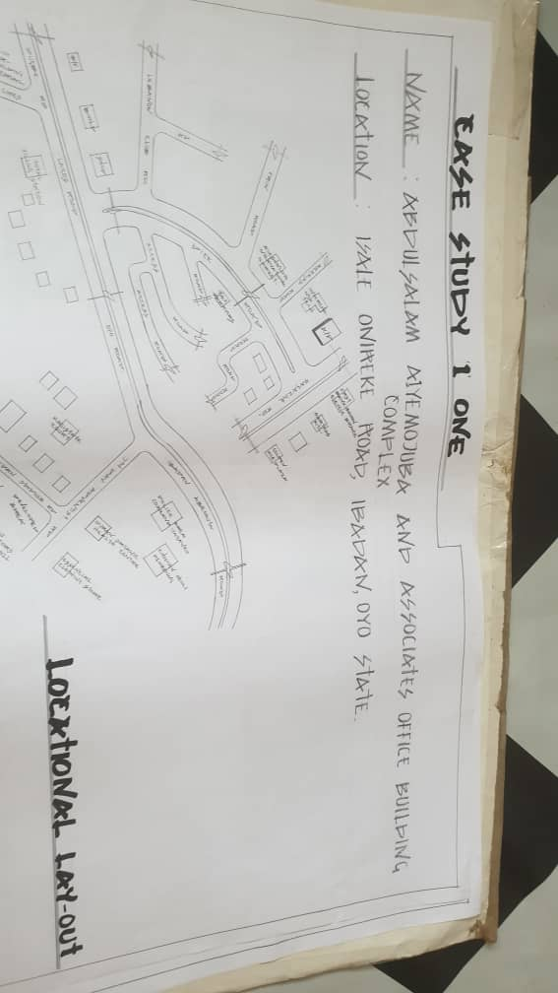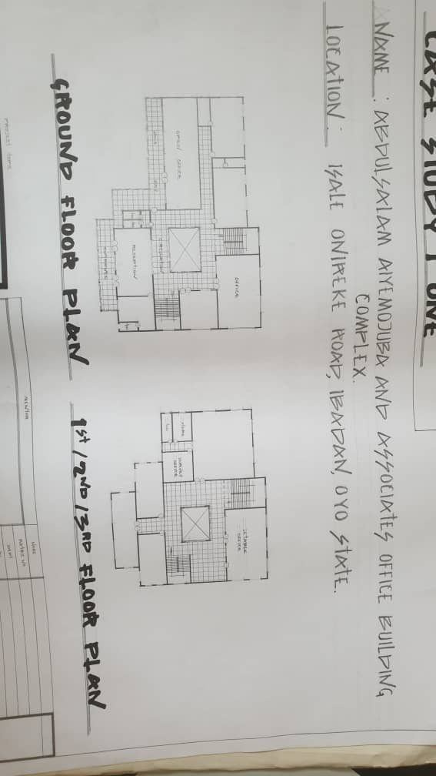

2.3.2 CASE STUDY TWO
Name: Opic Building
Location: At Ibara Abeokuta, Ogun State
MERIT
- Energy efficient and environmentally friendly
- Excellent parking and security facilities
- It easily to accessible
DEMERIT
- Expensive recent
- Know enough parking space
- Traffic congestion around the area
- Over overworking and limit space

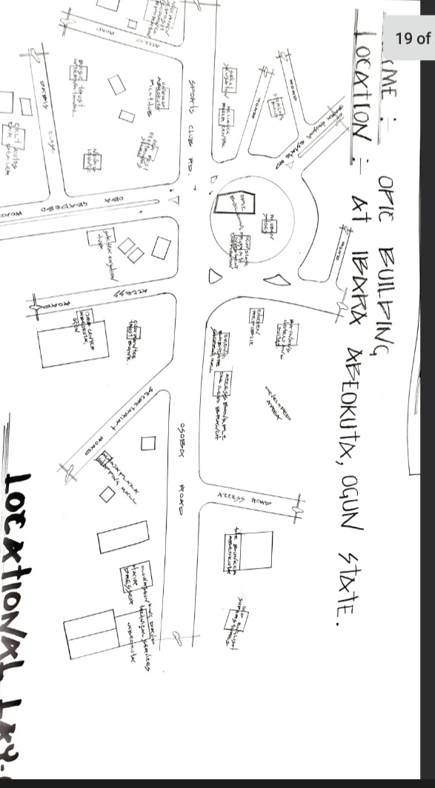
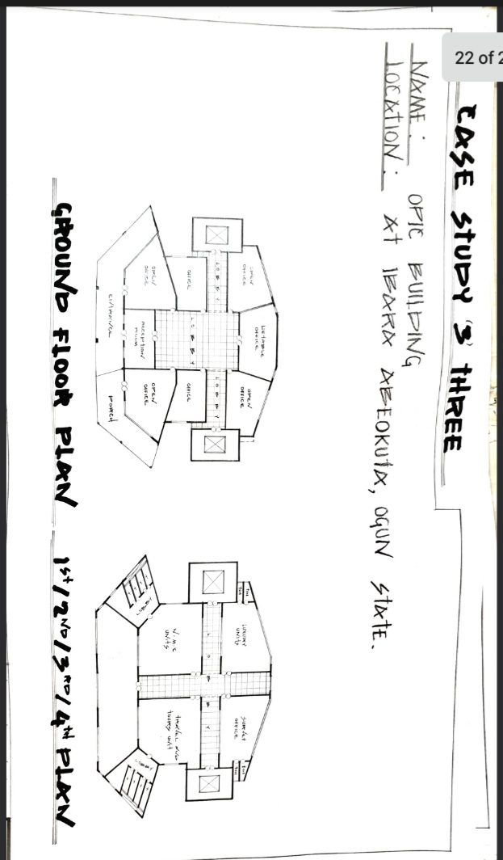
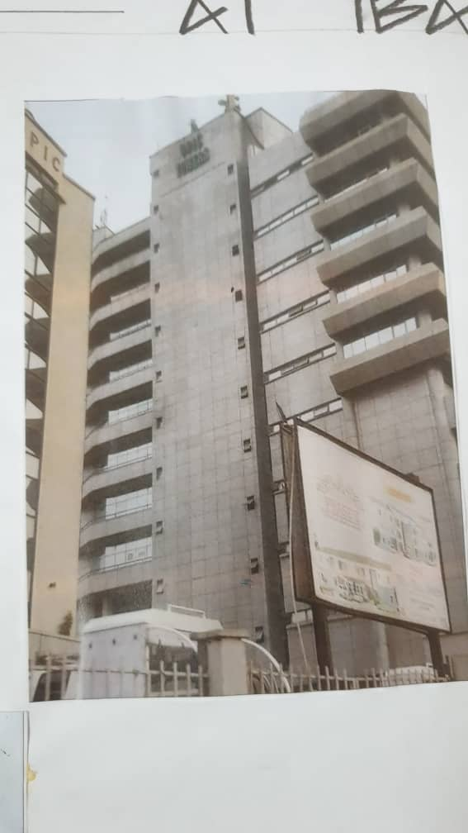
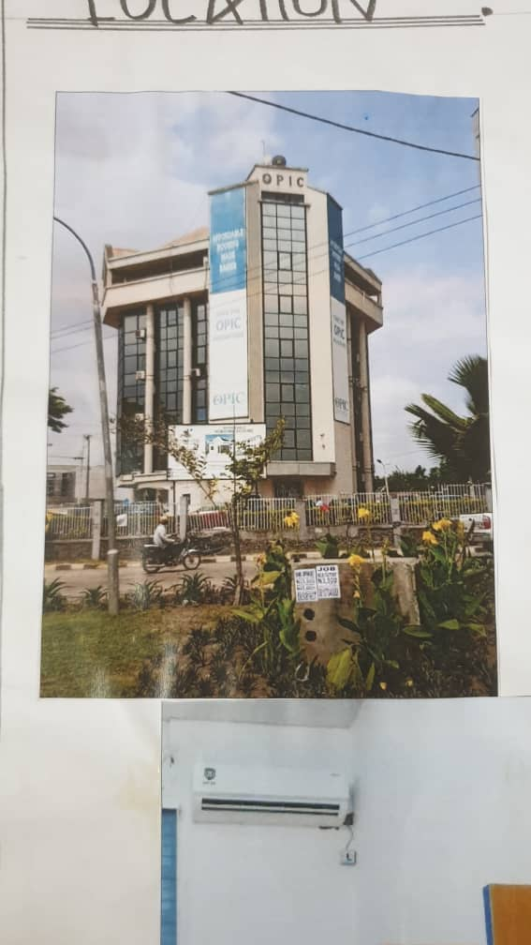
2.3.3 CASE STUDY THREE
Name: Alafia Complex
Location: Along Opomalu Isale, Ilorin, kwara State

MERIT
- It easily accessible
- It is well ventilated and lightning
DEMERIT
- No proper planning
- Traffic congestion
- No room for future expansion
- No future expansion in case of any another development
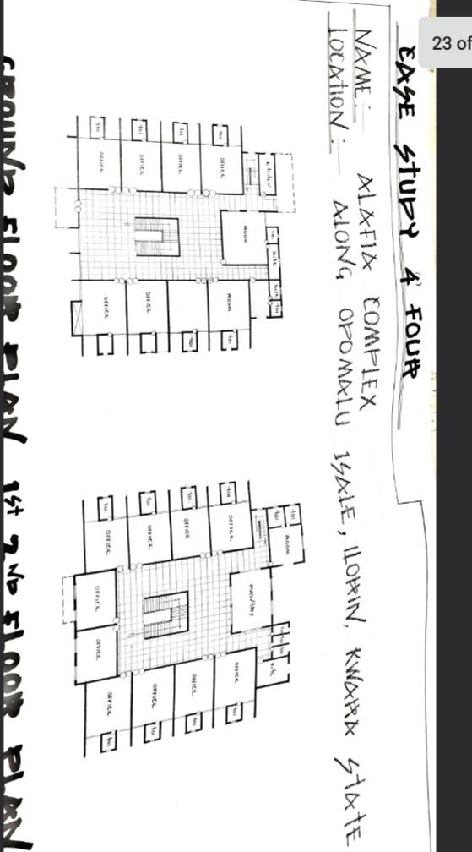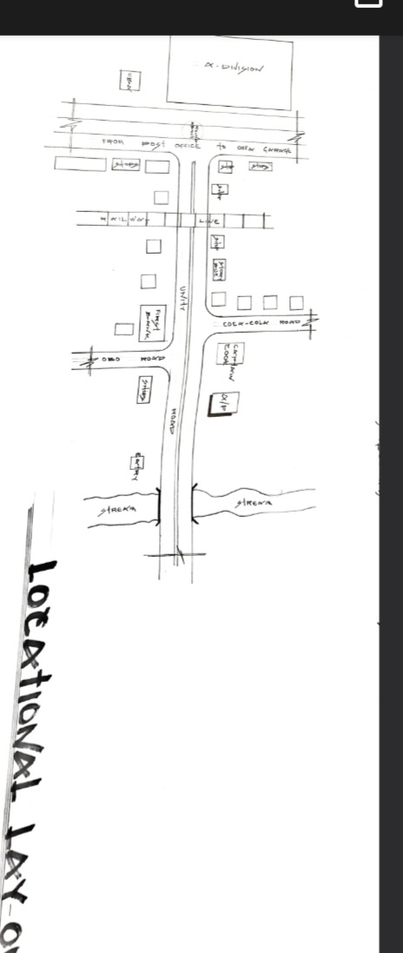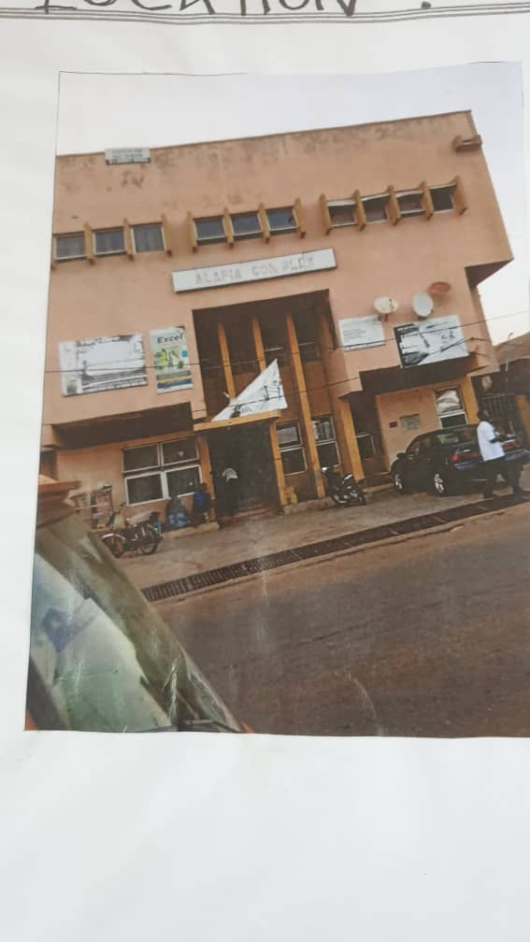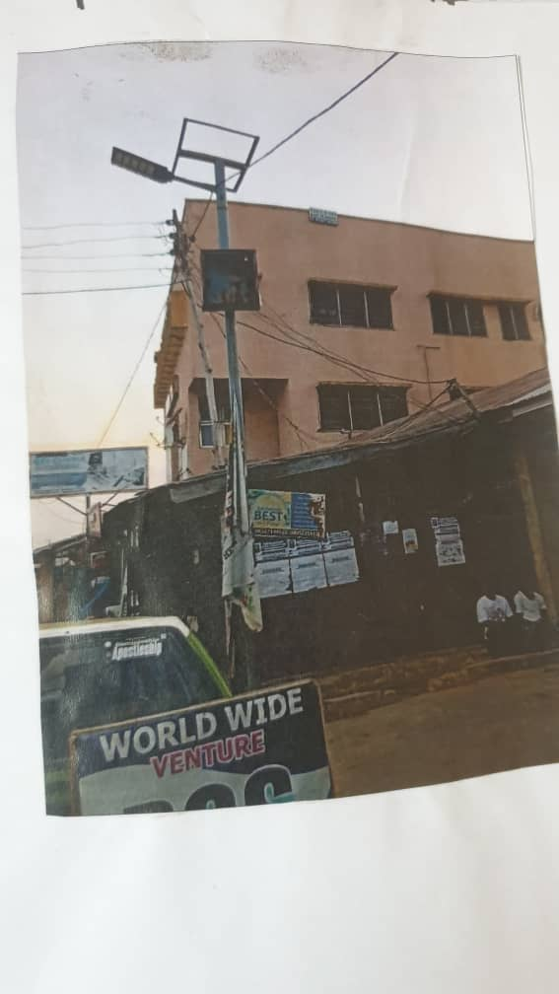
2.3.4 OLINE CASE STUDY ONE
NAME: MANCHESTER INTERNATIONAL OFFICE CENTRE
LOCATION: 11 STYAL RD WYTHENSHAWE MANCHESTER M 22 5WB

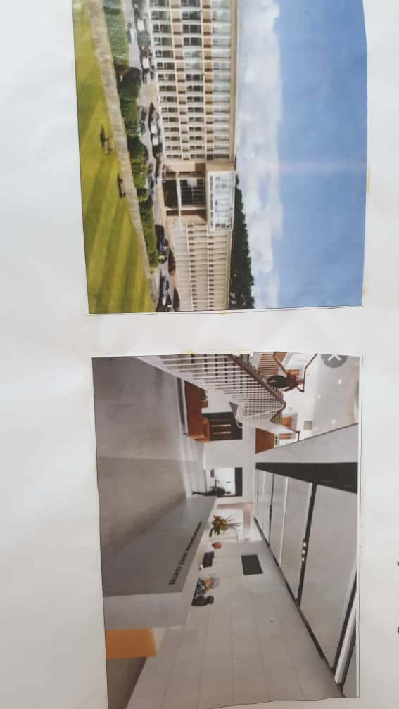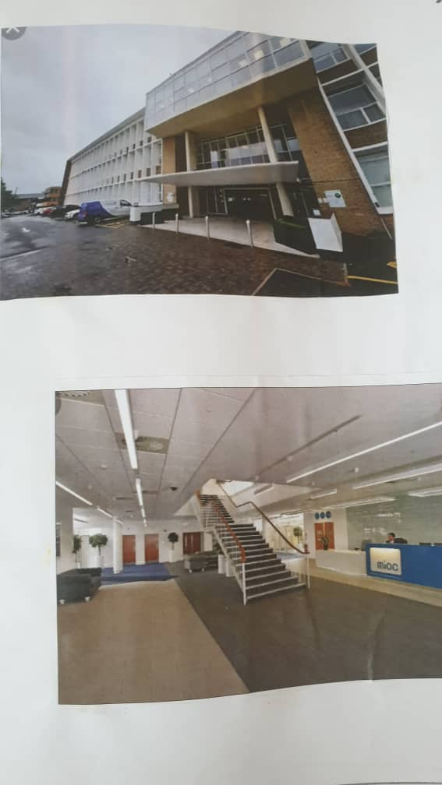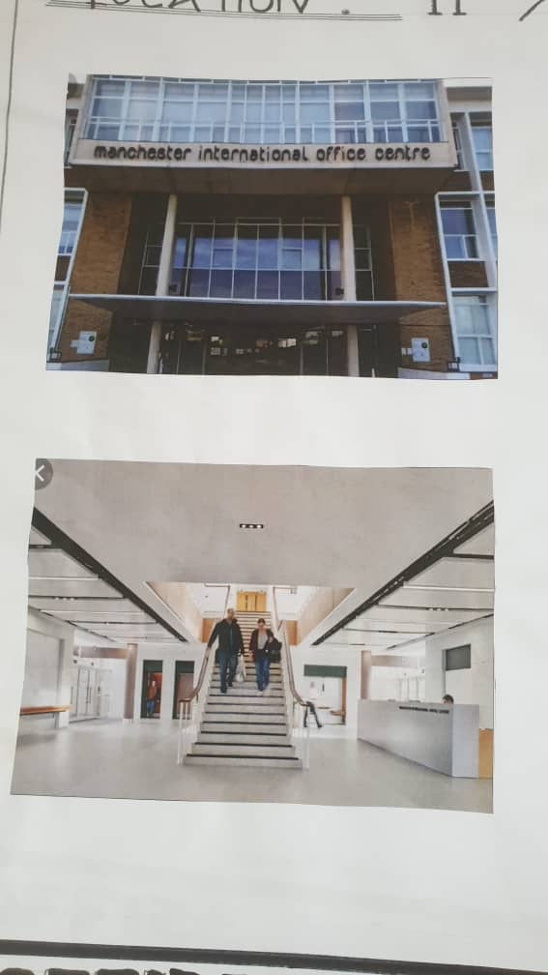
CHAPTER THREE
SITE AND ENVIROMENTAL ANALYSIS
  - BRIEF HISTORY / INTRODUCTION OF THE STUDY SITE/AREA
Eti-osa is a local government area (LGA) Lagos State, Nigeria its located on the Lekki peninsula and is known for it up scale residential area, commercial center and vibrant right life.
Eti-osa history is intertwined with broader development of Lagos-State, before the 20th century the area was largely undeveloped, characterized by lagoons creeks and man grove swamps.The indigenous inhabitant were primarily involve in fishing and farming
The transformation of Eti-osa began to accelerate in the mod in 20th century, with the growth of major commercial and administrative center. The discovery of oil in Nigeria further fueled economic growth, attracting both local and international independent Lagos. The establishment Victoria Island and Ikoyi as prime residential and commercial hubs spurred the expansion of development east ward into Eti-osa. The area proximity to the Atlantic ocean coupled with real estate development. Eti-osa is a diverse and dynamic area. It is home to a mix of residential communication and recreation facilities the area is known for its upscale neighborhood like Lekki,Ikate and Osapa London
However the rapid development in Eti-osa has also brought challenges include traffic congestion in adequate infrastructure and environment concern the area is also grappling with issue of urban planning, house affordability and social equability. Despite these challenges Eti-osa remains a vital and evolving part of Lagos continuing to shape the city s economic and social landscape
  - SITE LOCATION /DESCRIPTION
The site selected for the proposed project is located of Eti-osa Lekki express way, Lagos State.
  - SITE SELECTION /LOCATION CRITERIA
The selection is the coordination of certain before which influence the development of the site and special activities. A site selection criteria is based on screaming factors affecting site selection which include: ventilation and solar control, thermal control, confront of occupant, etc and availability of service
More over, due to the nature of project, the site selection should meet the requirement for the affiance and function ability of the proposal design, the size of the site available for development should be adequately reasonable to account date such functions/ structures.
  - SITE ANALYSIS /INVENTORY
This is done on the basis of the purpose for which the site is to serve. Certain steps are considered to obtain vital information of /from the site. This information is them analyzed after site survey in details for design purpose the information include vegetation, photograph, wind trade, geology, long and short site, soil condition and so on
- Vegetation the site is covered with three shrubs and ground covered most of it would be retained for landing scalping purpose
- The shorter and longer site the longer site facing east and west while the shorter facing north and south
- Soil condition the type of soil and is loamy and hence aids good vegetation of shrub grasses
- Sunrise and sunset will be considered for building orientation
- Orientation of the building will give due consideration for effective ventilation and solar radiation control for total comfort of an occupants.
3.1 CLIMATIC DATA /GEOGRAPHICAL CONSIDERATION
Eti-osa, Lagos has a tropical savanna climate under the koppen-geger classification which are :
Temperature:
- Average annual temperature 25⁰-25⁰c (77-82⁰f)
- Warmest months: February, March, and April (28⁰c/82⁰f)
- Coolest months: July, August, September (25-26⁰c/77-79⁰f)
- Average high temperature:30⁰c (86⁰)
PRECIPITATION
- Rainy days: 269 days per year
- Average annual precipitation: 2004 mm(78.9 inches)
- Wettest month: June, July and October (301mm/11.9 inches)
- Driest month: January, February and December (43mm/1.7 inches)
SUNSHINE
- Average annual sunshine hour: 3582 hours
- Sunniest month, April, May and December (10 hours 17min/day)
- Driest months: January June and September (9 hours 6 min/day)
GEOGRAPHICAL CONSIDERATION
- Eti-osa is a coastal area making it valuable to climate change and sea-level rise
- The local government area is located in Lagos State, which is prone to flooding clue to heavy rainfall and storm surges
- The area’s geography and climate make it essential to implement sustainable development strategies and climate action plans
3.6 CONCLUSION
Having dully observed the above analysis (climatic data/geographical consideration) site analysis inventory due, the site is found suitable for the proposed as it meet up with site selection criteria

CHAPTER FOUR
4.0 DESIGN CRITERIA
4.1 SITE PLANNING OF THE PROJECT
The site is planned to give a defined shape and also to reflect the activities taking place. The location of the office building complex within the site follows these major criteria which as follows.
- The zoning principle (Noisy Semi Noisy and Quite zone ): is observed which enhance placement of each unit in the structure
- For easy accessibility to various unity parking space are planned.
The site is properly defined with a proper blend of both natural and artificial attraction as well as soft and hard landscaping to give a quality desired and comfort to all occupant.
4.2 BRIEF ANALYSIS
Project Brief
- Main building
- Sit out
- Parking lot
- Gate house /security post
- Generator house
4.3 ANALYSIS OF THE SCOPE
DESIGN SCOPE
- Reception
- Open office area
- Director office
- Convenience
- Manager office
- Conference office
- Latable office

4.4 SPACE ALLOCATION
Space Allocation for Proposed office building complexes

The office complex is designed with a functional layout that ensures smooth workflow, accessibility, and comfort. Each space has been strategically allocated to meet both administrative and service needs:

1. Entrance
The main point of access into the building, designed with adequate space for controlled movement of staff and visitors. It leads directly into the reception.

2. Reception
Centrally positioned at the front of the building, the reception serves as the welcoming and information area. It includes a waiting zone and connects to major office units.

3. Travels and Tours Office
Located near the reception for easy client access, this office provides consultation and booking services. It is semi-private and designed for frequent interaction.
4. Open Offices
These form the core work zone of the complex, allowing for flexible desk arrangements, collaboration, and supervision. Positioned centrally with access to support units.

5. Toilet
Placed at convenient locations near work and public areas to serve both staff and visitors. Separate male and female units ensure comfort and hygiene.

6. First Aid Room
Located close to the open office area for easy access in case of emergencies. It is equipped for minor medical attention and staff health support.

7. NIMC Unit
A specialized office for handling National Identity enrolment and related tasks. Positioned in a semi-private section with access control to protect sensitive data.

8. Printing Area
Located close to the open office for quick access. This unit includes print machines and storage for print supplies.

9. Laminating Area
Adjacent to the printing area, this space is used for laminating documents. It’s kept separate to avoid workflow interference.

10. Director’s Office
Positioned in a quiet, private zone of the layout. It includes a personal workspace, small meeting area, and controlled access, ensuring executive privacy.

4.5 FUNCTIONAL RELATIONSHIP
The functional relationship of an office building complex refers to the interactions and connections between different spaces, elements, and systems that support the work activities and needs of occupants.

Vertical and Horizontal Circulation
- Elevators: Strategically locate elevators to serve different zones or floors, ensuring efficient vertical circulation.
- Stairwells: Design stairwells to promote physical activity, provide emergency egress, and connect floors.

Workspace and Amenities
- Office spaces: Design workspaces to accommodate different work styles, such as open-plan offices, private offices, or collaborative areas.
- Meeting rooms: Provide meeting rooms with varying capacities to support different types of meetings and collaborations.
- Amenities: Incorporate amenities like cafeterias, fitness centers, or lounges to support occupant well-being and productivity.

Support Spaces
- Reception areas: Design reception areas to provide a welcoming and secure entrance to the building.
- Storage and file rooms: Provide adequate storage and file rooms to support office operations.
- IT and server rooms: Design IT and server rooms to house critical infrastructure and ensure business continuity.

Sustainability and Efficiency
- Energy-efficient systems: Incorporate energy-efficient systems, such as HVAC, lighting, and water conservation systems.
- Green spaces: Incorporate green spaces, such as rooftop gardens or interior plants, to improve air quality and occupant well-being.

Safety and Security
- Access control: Implement access control systems to ensure secure entry and exit points.
- Emergency response: Design emergency response systems, such as fire suppression and emergency lighting, to ensure occupant safety.

Functional Zones
- Public zone: Design the public zone, including reception areas and lobbies, to provide a welcoming and secure entrance to the building.
- Work zone: Design the work zone, including office spaces and meeting rooms, to support productivity and collaboration.
- Support zone: Design the support zone, including storage and file rooms, to support office operations.

4.6 CONCEPTUAL DEVELOPMENT
The site concept was derived or formed on three main value which are:
- CIRCULATION AND PLANNING: The turning radius of vehicles was considered for adequate moving and the building is located at a close proximity to aid easy access.
- VIEW: the building and facilities are located facing the road as the site is characterized with. See through fence so that the road users can easily view the facility from the highway
- ACCESSIBILITY: The parking lot provide are located in the accessibility area with the good work networking linking the floors together.

CHAPTER FIVE
5.0 APPRAISAL OF PROPOSED SCHEM
In any project design, there are two basic factors that should be taken into consideration, these factor are forms aesthetic and functionality of a design of building.
The above listed factors were thoroughly taken to satisfy the highly demanded functional requirement of the proposed project and also to create aesthetically and proportional balanced designed.
Furthermore, zoning of area with related functions circulation pattern, security and safety were highly considered in this project design. The design was carefully zoned into major area such as noisy, semi-noisy and quiet areas.
5.1 DESIGN AND CONSTRUCTION
The office couple is highly decorated with plastered and painted walls, colored-marble cladding and some mosaic and opus sectile floors, supplied by water astern, with water chained via ditches into a main sewer, the building would have provided hot and cool air condition in the office spaces and other area. The astern was massive and water would have been hand pumped up into the tank before a network of water pipes drains and sewers would have ensured a continual flow of clean water. The degree of workmanship seen within the remain during the original excavation was compared with that seen at roman building, and the kind of sophisticated and strategic planning involved in the construction of both mall and the office complex is also comparable.
5.2 GENERAL DESIGN CONSIDERATION
To achieve a functional design, the following factor are essentially needed to give the structure a considerable aesthetic value, some of these things are :-
- SERVICE:- these include electrical service, mechanical service, sewage disposal, drainage e.t.c The electrical service will be a high quantity and cable in concreted conduct wiring will be used. This is a power house to generate constant electricity supply in case of power failure for effective drainage of both surface and soil waste.
- EXTERNAL WORKS: The following specifications are applicable
- The floor surface to be interlock material and asphalt to allow effective drainage
- The drainage to be conveyed away always through suitable seated gully fitted with strong granting. It should be drained into exist gutter.
- The floor to withstand expected impact and high bearing load capacity.
- The enclose to be secured against authorized entry.
- Surrounding wall to be rendered and painted.
- Trade and grasses surface should be separated with kerbs.
- Soak way pits must be avoided with the nature of the soil generally both foul and soil must be properly drained.
- ACOUSTICS: acoustic design control instructive noise by the choice of material dimension and shape of building. High level of noise can cause damage to ear and also care selected of door windows and ceiling type and material will play an effective role in providing acoustic for building.
5.3 CONSTRUCTION METHOD AND MATERIAL
The soil type of the proposal site will highly be instrumental to the construction and consideration to be explored in order to bring about the structure build ability however, the proposed site is a gently slope site with good drainage capacity and good safe load bearing capacity and as such the need for additional strong thing and treatment of soil before construction may not be need unless the geological experts request so. Sub soil water drainage is necessary to improve the run-off of ground water to maintain water table at some depth below the surface with purpose of the following
- Prevent surface flooding
- Improving soil stability
- Reducing immunity in the immediate environment of the building structure
- Avoiding dampness in underground occupation such as basement or the ground floor
The building live are taken into consideration at the inception of the design so with the building lines and the existing access road other wall flanks can be set out right angle to the building line
- By using a large building square place against the building line and side live produce to tenth required
- By using the proprietary optical square which comprise of two small sighting telescope permanently set at precise sight angle to one another
- By using and optical instrument with a base ring graduated to degree and sighting along angle required.
The method of construction is a follow
Digging of trenches
Filling of hard care
Block lying
Filling of allow block with hard care
Filling of literate into foundation
Casting of mass oversight slab
Laying of block wall
Casting of enforcement slab
Laying of block wall
Roof construction
Plastering
Fixing of window frame
Finishing
Construction materials
The choice of materials to be wood is implemented by several factor which are
- The cost of material
- The demotic situation situation/ condition
- The durability of material
- The availability of material
- Suitability of such material
    - LANSCAPE DESIGN
Landscape design is the determination of the character of different landscaping element and their arrangement on the site to enhance the building works land design may be two types which are aseptic and economic design both types and considered in the landscape design of the leisure centre.
It has been known to use that throughout the world people use mainly two types of landscape namely soft and landscape
    - LANDSCAPE ELEMENT USED IN THE DESIGN
In choosing and appropriate landscape elements the following considered:
- Acoustic properties
- Easy cleaning
- Resistance to foot wear
- Durability
The following landscaping element are employed:
- SOFT LANDSCAPE ELEMENT
- Tress (vegetation) to reduce solar system ray in both power and structures, reduce radiated heat and improve comfort used as shading device.
- GRASS AND LAND: To reduce the reflective affect of ground and also to control erosion and landslide in case of flooding used to reduce the intensity of solar radiation.
It absorb up to 45% of solar ray and disperses the rest to the environment thereby creating comfort for the occupant
- DECORATIVE FLOWER: Different species of flowers are used to enhance the aesthetic appearance of the site.
- HARD LANDSCAPE ELEMENT:
- ASPHALT: Used for drive ways and parking lots. It is economical and durable both for pedestrian and vehicular traffics.
- CONCRETE KERBS: Use to separate tarred surface from lawn covered areas.
- INTER LOCKING PAVING: use for walking and outdoors paving to blend with the natural texture of the environment.
The other element used include fountains man-made hills and water fall, flower ponds e.t.c. to create usual interest and beautify the environment in an harmoniously blended aesthetic grander.
  - GENERAL CONLUSION AND RECOMMENDATION
Conclusively this project has seriously broaden by view and observation beyond expectation and by this I have been able to reduce that project work of any form must not be taking lightly as it determines. How far one go to get the fact and precise information towards assisting one’s self taking of experience and solving societal problems through academic works.
As a student I am recommending this project works to the entire public of Eti-osa Lagos as a whole, as it bring development and civilization to its locality as researched, it also create health fitness, spiffiness and queued body well-being above it all it ultimate the youth and family friendly.
