THE EFFECT OF INVESTMENT TECHNIQUES ON MANAGEMENT DECISION MAKING IN MANUFACTURING COMPANY
(A CASE STUDY OF NIGERIA BOTTLING COMPANY, PLC)

PRESENTED BY
ADEBAYO IBRAHIM AKINDELE
ND/23/ACC/FT/0091

BEING A RESEARCH PROJECT SUBMITTED TO THE DEPARTMENT OF ACCOUNTANCY, INSTITUTE OF FINANCE AND MANAGEMENT STUDIES, KWARA STATE POLYTECHNIC, ILORIN

IN PARTIAL FULFILMENT OF THE REQUIREMENTS
FOR THE AWARD OF NATIONAL DIPLOMA
(ND) IN ACCTOUNTANCY

JUNE 2025

CERTIFICATION
This is to certify that this research study was conducted by ADEBAYO, Ibrahim Akindele (ND/23/ACC/FT/0091) has been completed, read through and Approved as Meeting the Requirement of the Department of Accounting Institute of Financial and Management Studies, Kwara State Polytechnic Ilorin. In Partial Fulfillment for the Award of National Diploma (ND) in Accountancy.

______________________________ ________________________
MRS. ALAAYA B. DATE
(Project Supervisor)

_______________________________ ________________________
MR. AKANBI K.A DATE
(Project Coordinator)

_____________________________ _________________________
MR. ELELU M.O DATE
(Head of Department)

_______________________________ __________________________
ABDULRAHAMAN ABDULLATEEF (FAC DATE
(External Examiner)

DEDICATION
This project work is dedicated to Almighty ALLAH, the most beneficent, the merciful and my adorable Parents Mr. and Mrs. ADEBAYO for moral and financial support, towards the successful completion of my program in Kwara State Polytechnic.

ACKNOWLEDGMENT
All praise goes to Almighty Allah for His Grace, Protection and Knowledge over me which I use to start and complete this project. Therefore I say all Glory, honour, adoration and thank be ascribed to the Almighty Allah.
I am very grateful to my Supervisor in person of Mrs. ALAAYA for her through checking and correction throughout my project writing. I also appreciate the amiable Head of Department (HOD), my project Coordinator and all other Lecturers and staff in Accounting Department of Kwara State Polytechnic, Ilorin for their positive impacts and contributions.
I also recognized the moral support of my parent Mr. and Mrs. ADEBAYO for their supports. May Almighty Allah grant them good health and they shall eat the fruit of their labour (Amen).
My special thanks also goes to my brothers and Sister they have always been there for me all the time. I really appreciate your effort both financially and morally. Almighty Allah will continue to bless you guys abundantly.
I would like to thank all my lovely friends, for their corporation, understanding and support in one way or the other. I love you all.

TABLE CONTENTS
Title Pages i
Certification ii
Dedication iii
Acknowledgment iv
Table of Contents v-vi
INTRODUCTION
1.1 Background to the Study 1
1.2 Statement of the Problem 1
1.3 Research Question 2
1.4 Objectives of the Study 2
1.5 Research Hypothesis 2
1.6 Significance of the Study 3
1.7 Scope of the Study 3
1.8 Limitation of the Study 4
1.9 Definitions of Key Terms 4
CHAPTER TWO
LITERATURE REVIEW
2.0 Introduction 5
2.1 Conceptual Frame Work 5
2.1.1 Purpose of Investment Decision 6
2.1.2 Types of Investment Decision 7
2.1.3 Decision Making Model for Capital Investment Decision 7
2.2 Theoretical Framework 14
2.2.1 Contemporary Capital Budgeting Theory 14
2.2.2 Conventional Capital Budgeting Theory 15
2.2.3 Neo Classical Theory of Finance and Investment 15
2.3 Empirical Review 17
2.3.1 Empirical ten Steps to Investment Success 17
2.3.2 Review of Related Empirical Literature 19
CHAPTER THREE
RESEARCH METHODOLOGY
3.0 Introduction 22
3.1 Design of the Study 22
3.2 Population of the Study 22
3.3 Sample Size/ Sampling Techniques 22
3.4 Method of Data Collection 23
3.5 Method of Data Analysis 24
3.6 Test Hypothesis 22
CHAPTER FOUR
DATA PRESENTATION AND ANALYSIS
4.1 Introduction 26
4.2 Data Presentation and Analysis 26
4.3 Test of Hypothesis 38
4.5 Discussion of Research Findings 38
CHAPTER FIVE
SUMMARY, CONCLUSION AND RECOMMENDATIONS
5.1 Summary 48
5.2 Conclusion 49
5.3 Recommendations 49
Reference 50

CHAPTER ONE
INTRODUCTION

Background to the study
Investment technique plays crucial roles in management decision. Management decision making involves the process of identifying, evaluating and selecting among projects that are likely to have a significant impact on the organizations competitive advantage. More so specifically, the decision will influence what the organization does (i.e. the product and services of the organization), where it does it (i.e. the location of the organization) and how it does (i.e. work practices or operating process of the organization).
Investment decision making process is arguably one of management greatest challenges. There is a critical need to get these decisions right, if decision proves successful, the firm reaps major strategic and operational advantages and if decision is wrong, then an important opportunity is forever lost (by the virtue of the firm’s failure to invest when it should have) or it has needlessly squandered substantial resources by virtue of making fruitless investment. Thus, the various investment techniques such as the Net Present Value (NPV), Accounting Rate of Return (ARR), Internal Rate of Return (IRR) etc are tools that management can make use to determine the viability, profitability and the long term survival of the investment in relation to the objectives of the organization. This technique will help the management team to factor in variables and see what the possible outcomes are, should investment be made in such project. With the aid of these investment techniques, management of organizations will make decisions that are productive.
Therefore, this research is carried out to assess the impact of the various investment techniques or tools on management decision making as regard capital budgeting.

Statement of the research problem
In many organizations, investment decision making is a big challenge, as most organization invest in projects that will bring returns in the long term basis, so as to increase shareholders wealth. Investment requires capital which is scarce and tightly controlled resource. Investment decision making means making decision on how to allocate capital to a project, this can also be termed as capital budgeting. A way of assessing, this critical decision is the use of various investment techniques which will ensure that a decision making will not only be reliable but accurate. However, firms substantially ignore various techniques open to them to appraise various investment opportunities and as a result, commit their limited resources to wrong investment opportunity that is capital in nature. According to capital–investment.co.uk2015, Some of the factor that affect capital investment decisions include; The outlook of management, Opportunities which are created by technological changes, strategy of the competitor, Cash flow budget, Fiscal incentives, Market Forecast and; Other non-economic factors.
Therefore, this research is designed to determine whether Nigerian Bottling Company (NBC) uses the various investment techniques in making decisions.

Objectives of the study
The main objective of this study is to determine the effect of investment techniques on management decision of NBC Plc.
However, the specific objectives are:-
- To determine the concept of investment techniques in relation to management decision making;
- To examine the various techniques opened to management of
N.B.C Ilorin in the decision making and why it should be adhered to and;

- To examine the effect of Net present value, taxation, inflation risk and uncertainty on investment and its various techniques.

Research questions
The research seeks to answer the following questions

- What is the understanding of the concept of investment in relation to management decision making?
- What are the various techniques available to the management in decision making?
- Among the various techniques, is Net present value (NPV) strictly adhered by the management of Nigerian Bottling Company plc Ilorin?

1.5 Research hypotheses
From the research questions stated earlier the following null hypotheses were generated:
Ho₁: There is no significant difference in any of the concepts of Investment technique on management decision making.
Ho₂: Significant difference does not exist from the Results obtained from the various investment techniques.
Ho₃: Net present value (NPV) is not the most considered investment techniques in management decision making.

1.6 Significance of the study
All countries, particularly the developing countries which Nigeria is inclusive are faced with basic economic problem of allocating limited resources such as labour at all level of skills, management and administrative capacity, land and other natural resources, foreign exchange particularly the capital to many different uses such as production of goods and public services.
With investment, researcher discover that if management can be able to make critical decision such as setting of a project which is capable of generating employment Opportunities and achieve an income redistribution objective for the government. This will benefit though unclassifiable qualitative consideration that will be Included in the investment. Researcher sees Private enterprise project choice as a simple exercise having to determine its objectives, all it has to do is to ascertain the projects that will satisfy its objectives but for an economic planner, it is but a bit complex, project choice which involves ascertaining one which best satisfy national interest and objectives. National interest is however not easy to define and this may be perceived differently by different planners.
Finally, the absence of a complete declaratory between project choice and national planning is another reason for carrying out investment analysis of projects. For example, the choice of one particular project has consequence for output, Consumption, Saving, Foreign exchange earnings and other things of relevance to national planning.

1.7 Scope and limitation of the study
The study will be strictly limited to some selected staff of Nigerian Bottling Company (NBC) Plc Ilorin, due to time constraint and small number of the staff at the management level and those involved in the decision making of the organization. The research focus on what impact the use of investment techniques has on management decision in all investment between year 2000 and 2016.

CHAPTER TWO LITERATURE REVIEW

Introduction
A business is a series of capital investment project and each investment is an attempt to ensure some of the company’s future wellbeing.
According to nibusinessinfo.co.uk. Investment is a key part of building your business, new assets such as machinery can boost productivity cut costs and give a competitive edge.
According to Lawal, (2008) investment decision otherwise known as capital budgeting in an accounting terminology related to any money spent on fixed by an enterprise. The distinguishing feature is the expectation that the asset purchase will be used for producing, setting or other functions over a long range such as five or ten years. Van Horne, (2008) said that capital budgeting is the process of allocating the firms fund to a capital project whose benefit lie in the future. In another words, Pandey (2000) defines investment decision as the firms decision to put in its current funds most efficiently in the long-term assets in anticipation of an expected flow of benefit over a series. According to Shuaib and Asemota (2010) defines capital budgeting as a long term planning for proposed capital outlays and their financing. It includes both raising of long term funds as well as their utilization. It is the decision making process by which the firms evaluate the purchase of major fixed assets. Gilman L.J. (2002) define capital budgeting as the total process of generating, evaluating, selecting and following up on capital expenditures alternatives. Lynch R.M. (1999): said that capital budgeting consists in planning for development of available capital for the purpose of minimizing the long term profitability of firm.. According to Adeniyi (2006) in his words says the field of investment involves the study of investment process, Investment is concerned with the management of an investors wealth which is the current income and the present value of all future income: though the field of investment encompasses many aspects, it can be thought of in terms of two primary function analysis and management. The firms’ worth will increase if investment are profitable and added to shareholders wealth. Thus, investment proposal should be evaluated on the basis of criterion which is compatible with the objects of the shareholders wealth maximization likewise; it’s significant to measure an investment in cash. Researcher discovers that every capital budgeting literature will stresses the evaluation of individual investments whose cost and benefit can be expressed as each flow includes project cost that is the outlays off set by the disposal of replace assets and various cash flows. Outlays offset by the disposal assets and various cash flows,. Outlays can be made to modernize facilities to expand capacity for growing market share to develop, produce and market a new product or to develop human resources thus, the firm’s investment will generally include, expansion, acquisition, modernization and the replacement of the long term assets sales of the Division of a business, change in methods of sales distribution undertaking and advertisement campaign or research and development programme will have long term implication on the firm’s expenditures and benefits will also be analyzed as investment decision. However, investment has laid down procedures and investment decision which must be expressed by some people or department. The decision will depend on the need of individual department in an organization. Business research in this area will show that most of decisions on investment are initiated by the marketing department and the research and development units of an organization. Apart from the initiation of investment proposals, through analysis will be taken to measure the worthiness of each investment proposal and the best promising project will be embark upon by the management and one thing is to choose a course of action another things is to implement the selected course of action. Implementation therefore, include the financing, monitoring and post completion and it exercise of the project. According to Pandey (2000), firms may incure heavy losses if due care is not taken in the capital investment decision processes.Capital investment decisions are complicated by the fact that, decision must be made from estimate of future operating result, which by their nature involve a Considerable degree of uncertainty. Yet, those decisions will be crucial to long run financial wealth of a business.
Finally, Lucey (1999) said, capital budgeting decision involves many sophisticated techniques for evaluating financial and non-financial consideration. In this respect, it’s imperative for the firm to plan investment programme very carefully and make-advance arrangement for procuring adequate finance internally or externally because most investment decision are irreversible.
According to capital-investment.co.uk 2015, capital investment, also known as capital budgeting is primarily a planning process which facilitates the determination of the concerned firms investments, both long term and short term. Also ten capital investment technique were highlighted which includes;
Net present value, Accounting rate of return, Internal rate of return, Modified internal rate of return, Adjusted present value, Profitability index, Equivalent annuity, Payback period, Discounted payback period, Real option analysis.
i. Net Present Value (NPV) - this capital investment technique measure the cash in-flow, whether excesses or shortfall, after the routine finance commitments are met with. The NPV is a mathematical calculation involving net cash flow at a particular present time “t” at discount rate at the same time i.e (t-initial capital outlay),
ii .Accounting Rate of Return(ARR)- this capital investment technique compares the profit that can be earned by the concerned project to the amount of initial investment capital that would be required for the project,
- Internal Rate of Return (IRR)-capital investment technique define IRR as discount rate that gives a value of zero to NPV .among all capital investment techniques IRR is generally considered to measure the efficiency of the capital investment,
- Modified Internal Rate of Return (MIRR)- the IRR does not give the actual annual profitability of a capital investment since it does not take into consideration the intermediate cash flows which is never reinvested equaling project IRR.MIRR evaluates capital investment projects assuming the reinvestment rate equals the company’s cost of capital,
- Adjusted Present Value (APV)-APV capital investment technique overcomes the shortcomings of NPV technique and evaluates a project on the basis of risks associated to prospective company undertaking the investment,
- Profitability Index (PI)- evaluates a project based on calculation of value per unit of investment. Also known as value investment ratio and profit investment ratio, this capital investment technique is a ratio of money invested to profit or pay off of the project,
- Equivalent Annuity-capital investment done using equivalent annuity usually compares projects with different life spans.in cases where two projects have different time spans; NPV would not justify a fair comparison. This capital investment technique divides the NPV value with annuity factor resulting in expressing NPV in relation to annualized cash flow,
- Payback Period-appraising capital investment on the basis of time that would be taken to get back your initial investment is called the payback period. Payback period is one of the easiest methods of capital investment techniques .projects with a shorter payback period are usually preferred for investment when compared to ones with longer payback period,
- Discounted Payback period-capital investment using discounted payback period is similar to payback period but here, the time value of money or discounted value of cash flow is considered for calculation of payback period and;
- Real Option Analysis-capital investment using real option analysis considers and values the various options that managers would have while managing their projects in terms of increasing cash inflow and decreasing cash outflow. these values are added to NPV in the course of capital investment.
However, according to “Kaplan financial knowledge bank” the nexus between investment techniques and management decision can be viewed from their tools and their features these includes;

Investment Techniques Features are;
- assessment of the level of expected returns earned for the level of expenditure made ;and
- estimates of future costs and benefits over the project life.

Management Decision Tools includes;
Business rules, Business Intelligence (B.I), Continuous Improvement, Artificial Intelligence (A.I), and Predictive analytics.

Purpose of Investment Decisions
Investments decisions are concerned with the question whether adding to capital assets today will double the revenues of tomorrow to cover costs. Thus investment decision are commitment of money resources at different time in an expectation of economic return in future dates, choice will be required to be made amongst available alternative revenues for investments. As such investment decisions are concerned with the choice of acquiring real assets over the time period in a productive process.
The impact of investment decision extends into future and has to be ensured for a long period. Therefore firm’s investment decision has a tremendous influence on the rate and direction of it growth. A well-meaning decision can impair profitability and survival of the firm.
According to Olowe (2000) and Adeniyi (2006), the outstanding importance of investments are as follows:
- Maximize shareholders wealth by selecting optimal investment project.
- Assist firms to determine the total amount of capital expenditure that is desirable to be undertaken.
- Determine how the portfolio project should be financial.
- Ensure the future survival between risk and profitability.

Types of Investment Decision
According to Adeniyi (2006), a very important part of a management accounting’s job is to provide information which will assist the making of decision concerning the investment of capital funds. This process is known as capital budgeting. The following are the classification of investment decision.
- replacement decision e.g. decision to replace semi-automatic machine with a fully automated machine.
- Investment for expansion of existing business.

- Investment for product improvement and or cost reduction.
- New ventures (diversification).

- Strategies investment where investment may be undertaken to the benefit of the overall objectives but might not satisfy the normal financial criteria.
Another useful classification of investment decision according to Olowe (1990) are as follows:-
  - Mutually exclusive investment.
  - Independent investment.

  - Contingent investment.

Decision Making Model for Capital Investment Decision
This is the way the capital investment decisions will be applied to the overall framework for decision making. There are many stages which decision making process pass through. The diagram below represents the role of quantitative analysis in managerial decision making.

A Decision Making Model
According to” business dictionary” is the process for concluding which decision need to be made and how to find alternatives for each decision.

According to smallbiz.nsw2014, there are two models used to describe the decision making process these are, the rational model and simons normative model. The rational model proposes that people should follow a four step sequence when making decisions. The four steps are;
      - identifying the problems,
      - generating solutions,
      - selecting a solutions and;

      - Implementing and evaluating the solution.

The Steps involved in the Decision making
According to David 2009, the steps involved in decision making include;
      - identify problems
The first step in the process is to recognize that there is a decision to be made. Decisions are not made arbitrarily; they result from an attempt to address a specific problem, need, or opportunity.
      - seek Information
Managers seek out a range of information to clarify their options once they have identified an issue that requires a decision.
- brainstorming Solutions
Having a more complete understanding of the issue at hand, manager’s move on to make a list of potential solutions.
- choose an Alternative
Managers weigh the pros and cons of each potential solution, seek additional information needed and select the opinion they feel has the best chance of success at the least cost.
- implement the plan
Here once committed to putting a specific solution in place, get the entire employee on board and put the decision in action with conviction.
- evaluate actions
These involves monitoring the result of strategic decisions being made, ready to adapt the plan as necessary or to switch to another potential solution if the chosen solution does not work out as planned.

Measurement of Investment Worth
There are type of decision to make, accept or reject decision can be arrived without knowing, how investment worth are measure. Therefore, there are various techniques for measuring investment decision. These include:
- Discounted cash flow methods.
- Non discounted cash flow methods.

Basic Assumption of Investment Decision
For simplicity, various scholars in the field of financial management have succeeded in establishing their theoretical justification for some assumption which may not hold in reality.
According to Charles (1997), the various assumptions include:
      - investment should be measured in cash
      - there is no capital rationing
      - inflation does not exist in the economy
      - there is no effect of taxation on the investment

      - investment project are independent
      - Item cash flow will be reinvested before the project lapses.
      - The cash flow are assumed to be conventional i.e. they consist an initial negative cash flow follows by positive cash inflows in later year. However, they pointed out that some of these assumptions will be released in face of reality.

Steps in Investment Evaluation
The following steps will be taken while evaluating investment worthiness.
      - Estimation of Investment Cash Flows: - According to Oyewole (2001) the cash flow associated with the project is defined as a cash receipt and expenditure solely attribute to the settings of the project. Computing cash flow as to do with inflow and outflows of funds and it is likely to occur at various times throughout the year to allow for time value of money.
      - Estimation of cost Capital: - According to Pandey (2000), the cost of capital In firm is the minimum return which the supplied capital requires i.e. the price of obtaining capital. It is compensation for time and risk.
Firms obtain it supply of capital for financing it investment in the form of equity, debtor. Pandey therefore, emphasized that, the firms cost of capital means the firms maintain a target debt equity mix. The firms weighted average cost of capital (WACO) reflects the average risk of all projects. Therefore, it can be used for investment, evaluation only when the risk of the project is equal to the firms average risk. In practice, the firms (WACO) should be adjusted for the risk characteristics of the project that is the project cost of capital equal to WACI risk adjustment. The risk adjustment factors will be determined by decision maker based on his express and judgment. This estimated cost of capital will then be used as project present value and serves as the standard for testability of the project.
      - Application for investment criteria: - These are basically the various techniques of evaluating the worth of an investment project having ascertain the cash flows and the cost of capital i.e. the required rate of return is a sound. A known objective of the shareholder is the maximization of their wealth, therefore, is selected for the evaluation. A number of capital budgeting techniques will be used and practice however, they may be broadly categorized into two. They include, discounted cash flow criteria and non-discounted cash flow criteria. The subsequent explanation will described what each of the above grouping entails.

Investment Evaluation Criteria

The investment evaluation criteria, according to Pandey (2000) may be

used as the capital budgeting techniques or investment decision rules. Olowe (2000) state that, the essential property of a sound technique is that, it should maximize shareholders wealth. Therefore, a sound techniques should be used to measure the economic with any investment project and to achieve shareholders objective.

Theoretical framework
The theoretical framework of this study is based on the Modigliani and Miller’s

neo classical theory of finance and investment (1958) as discussed below.

Modigliani and Miller’s theory on investment (1958)

Modigliani and Miller (1958) argue that managers should ignore financing and dividend decisions as irrelevant and focus on positive net present value (NPV) investment opportunities that would maximize the value of the firm. Thus the analytical framework for determining a project’s NPV as derived from discounted cash flows analysis (DCF) came to provide a rational basis for collective decision-making. The classical theory by Modigliani and Miller (1958) identifies sophisticated evaluation methods as a tool for maximizing the profitability of the firms.
Hastie (1998) on the contrary regarded the financial theory that recommends the utilization of sophisticated techniques such as net present value to improve

decision making and maximize the value of the firm as unwarranted. Hastie objected to these assumptions (a statement that is assumed to be true and from which a conclusion can be drawn) because there are many more “apparently acceptable” projects than a firm can approve either because of limited raw materials or because of limited management or technical talent which is common amongst firms. Hastie noted that the use of incorrect assumptions has been a more significant source of bad investment decisions than the use of simple measurement techniques. Investment decision making could be improved significantly if the emphasis were placed on asking the appropriate strategic questions (important) and providing better assumptions rather than on increasing the sophistication of measurement techniques.
Adler (2006) argued that discounted cash flow (DCF) should be removed from financial theory as it is increasingly irrelevant to contemporary business practice and can be dangerous in evaluating proposed projects. He further illustrated that DCF can be used accurately from the position of hindsight, but it is little help in predicting the future course of business. He argued that a “gut feeling” can be put to better use than strict mathematical models of potential profits in deciding to pursue a new venture. He concluded that DCF is meaningless and as such should not be applied in evaluating capital budgeting decisions or rather should be replaced with less restrictive and more optimistic methods. The internal rate of return (IRR) method assumes re-investment of the funds at the IRR. Finally, the net present value (NPV) method requires an appropriate discount rate to

Value expected cash flows. The NPV method may underestimate the value of the investment project and may cause the management to pass up valuable investment opportunities, therefore, in general, they do not provide owner/managers with the flexibility they need when making strategic investment decisions.

Qualities of Sound Investment Evaluation Criteria
According to Adeniyi (2006), he provides the following as the characteristics which should be possessed by sound investment evaluation criteria.
      - it should be measure of project profitability by considering all cash flow.
      - it should provide a ranking of project is in order of their economic desirability.
      - it should be recognized that the bigger cash flow are preferable to smaller ones and early cash flows are preferable to bigger ones.
      - it should help to choose among mutually exclusive project which maximized the shareholders wealth.
      - it should be a criterion which is applicable to any conceivable investment project independent of others.

Limitation of basic Assumptions

From the foregoing explanation, all the technique are considered and treated with a lot of over simplicity assumption. According to Pandey (2000). However, in reality, investment is not independent of all the conditions that were hold constant in the foregoing analyses. Scholars in the field where there is certainty, not taxation, adequate capital or fund and inflation. However, all those situations are very evidence in practice thus, it is worthwhile to examine an optional investment plan that can guarantee the achievement of the shareholders wealth maximization.

Uses of profitability Index in Capital Rationing
According to Ogunsan (2002), under capital rationing, a method of selecting portfolio or project which yield highest possible NPV within the available funds is needed. The firm should intend to get the largest benefit for the available fund that is, those project shall be selected which give the highest ratio or present value to initial outlay. This ration is the profitability index (PI).
Pandey (2000), suggested that capital budgeting procedures under soft or simple situation capital rationing is to rank projects by their profitability index and top ranked projects should be undertaken until funds are exhausted.
However, a serious limitation in using the PI rule is caused by the multi- period capital constraints. Therefore, better method for investment decision under capital rationing problem (especially multi-period) is though programming approaching.

Investment Decision under Capital Rationing
According to online Open learningworld 2015, Capital rationing refers to a situation where the firm is constrained for external, or self-imposed ,reasons to obtain necessary funds to invest projects with positive net present value (NPV).Firm may have choose among profitable investment because of the limited financial resources.
Drury (2008), suggested that, capital rationing occurs whenever there is a budget ceiling or a marked constraint and the amount of funds that can be invested during a specific period of time.

Investment Decision Under Inflation
According to Pandey (2000), a common problem which complicated the Practical investment decision making is inflation. The rule of the game will be consistent in treating inflations in the cash flows and the discount rate. Van Horne (2008), said that although the discount cash flow (DCF) techniques provides for the value of money, it fails to consider the possible changes in purchasing power of money. The impact of inflation is to depreciate the real value of money. Wrong investment will be ignored because both the cash flows and the cost of the capital are affected by inflation.
Olowe (2000) opened that NPV gives correct answer to choose an investment under inflation if the cash flow and the discount rate are expressed in the same denominator (i.e. real nominal terms). The discount rate is the market determinator rate and therefore include the expected inflation rate. It is generally stated in nominal terms to obtain an unbiased NPV. Alternatively, the real cash flows can be discounted at the real discount rate to calculate unbiased NPV. The equation is of the relationship between nominal and real cost of capital.

Investment Techniques under Risk and Uncertainty
According to online Open learningworld 2015,Risk is used to describe a situation in which there are a number of possible states of nature ,hence outcomes ,but in which the decision maker can reasonably assess the probability of occurrence of each. Thus risk can be expressed in quantitative terms.
From the going we have so far, assumed that the proposed investment projects do not involve any risk or uncertainty. The over simplified assumption was just made to facilitate the quick understanding of situation, risk exist because of the inability of the decision maker to make perfect for casts.

According to Drury (2008), a line of distinction is often drawn by decision theorists between risk and uncertainty. He states further that risk is applied to a situation where there are several possible outcomes and there is relevant past experience to enable statistical evidence to be produce for predicting the possible outcomes. Uncertainty exists where there are several possible outcomes but there is little previous statistical evidence to enable the possible outcomes to be predicted. However, the distinction between risk and uncertainty is of little importance in the analysis and a better definition of that risk arises in investment evaluation because researcher cannot anticipate the occurrence of the possible future events with certainty and as a result he cannot make any correct prediction about the cash flow sequence.

Empirical steps to investment success

According to empirical wealth management2013, these 10 steps are considered most valuables;

. Develop an investment strategy
the first thing an investor should do before committing any money to financial markets is develop an explicit investment strategy .this means establishing investment goals and making a plan to achieve those goals. key factors include time horizons, willingness and ability to take risk and personal financial situation.

. Make investment decisions based on evidence-based research
Today’s investors are inundated with investment advice nearly everywhere they

turn. Make sure that investment strategies are based on evidence–based research; this requires shifting through academic and practitioner research to determine the best possible investment methods, and verifying these findings whenever possible.

. Diversify your portfolio
Diversification is often referred to as the “only free lunch” in investing.by investing in assets that are not perfectly correlated (i.e., do not move exactly together through time) an investor may be able to achieve a less volatile portfolio than would be expected by the average volatile of each asset.

Control your risk exposure
Willingness to take risk is a straightforward concept, some investors cannot stomach a volatile portfolio, while others are willing to tolerate large amounts of price movements if it means high expected returns.

Beat the market “by outsmarting the market
The idea of outperforming the market is one of the most vigorously debated topics. every active fund manager has a story for why their fund will gain superior risk adjusted returns relative to a particular market index.

SUMMARY OF FINDINGS
Various researchers have examined the impact of investment technique on management decision in varying dimensions.

Choppra and Ziemba (1993) study on ten selected Dow Jones Industrial Average (DJIA) securities, the study analyzed mean variance optimization forecasts like mean returns, variances and covariance’s using historical data on the assumption that they are true values of these parameters. Research findings revealed that small changes in input parameters results in large changes in composition of the optimal portfolio. They concluded that the use of historical inputs or data based on complex forecasting scheme, the results continue to hold as long as the inputs have errors.
Fatoki O. (2010), employed multiple regression to investigate the impact of investment on the profitability of the small manufacturing firm. The study revealed that the use of non-sophisticated investment techniques has a negative impact on the profitability of small firms.
Anne h. (2012), studied the role of investment methods and versatility of expertise in energy efficiency investment decision. The result indicate that companies that are using sophisticated financial investment methods and more specifically IRR when evaluating energy efficiency investments go on to implement more energy efficiency investments than other Finnish industrial companies.
Mukra, et al. (2015), investigated the contribution of investment on efficient portfolio selection in Kenya soft drink industry. They adopted a survey design with a target population of 250 respondents selected by census technique. Primary data was collected using an interview schedule and secondary data was collected from respondent’s records relating to real and financial assets. Study revealed that investments techniques application influence efficient portfolio selection in the soft drink industry. Study results suggest the need for firms to maximize the application of net present value and payback period to enhance portfolio efficiency to realize optimal performance.

CHAPTER THREE

METHODOLOGY

Introduction
Research methodology forms the background on which the procedures and techniques adopted in the study are based. Research methodology plays an important role in the gathering of data and their effective presentation and analysis.

Design of the Study
The present study is designed with the purpose of achieving the study objectives. Data will be collected and analyzed to enable the study know which of the investment techniques affect management in their decision making. The study is also designed in such a way that both primary and secondary data will be used for the investigation, the primary source will be gotten through questionnaire and oral interview which will be administered to the respondent
,the secondary data will be gathered from textbooks, journals, newspapers, magazines, internet etc.

Population
The population refers to the entire group of individual or items whose members unit possesses the same basic and clearly defined characteristics. It is the whole set of the subject or individuals about whom a statistical investigation was carried out. Since the case study was employed to conduct the research, the population of this research work therefore, consists of the staff of the Nigerian

Bottling Company Plc. Ilorin, Though the current workforce strength of NBC Ilorin is 286 personnel, and 70 personnel are in the management circle, out of which researcher intends to use 70 staff out of the total employee in NBC Ilorin branch.

Sample Size/ Sampling techniques
It is always not possible to study the entire population because of time and financial constraints hence, efforts will be focused mainly on management staff that are involved in decision making. Random sampling or judgmental sampling techniques is the best way of drawing samples based on the researcher’s knowledge of the population. That is, Senior and junior staff stratified random sample will be used to give equal representation of the staff categories in the organization. As a result of these suggestions random sampling will be used to sample, seventy (70) staff of the Nigerian Bottling Company Ilorin. Out of which contain 40 males and 30 females staff because researcher discover that out of the total population of the management staff of NBC Ilorin the population of male are higher than the female staff.

Methods of Data Collection
The main source of data collection for this study is both primary and secondary source.
The primary source involves administration of questionnaire, and interview of personnel, in the study of Nigeria Bottling Company (NBC).

The secondary data will be obtained from all relevant literature in related field. The study is conducted with a view to providing concrete evidence of the validity of impact of techniques on management decision.

Primary Data these includes, Questionnaire method:
This method involves writing schedule of questions sent to an organization either by post or hand delivery to respondents in order to collect the required information.
In this case, questionnaires were delivered by hand and it was personally for the purpose of obtaining data. This method does not put pressure on the respondents. In addition, anonymity was ensured to make it more objective, couple with the fact that it covers the major determinant of the existence of the NBC Ilorin.

Personal Interview:
This involves verbal interaction mechanism employed for the research work. The researcher, embarked on this method in order to overcome some of the anticipated lapses among others which include low rate of return of the questionnaire and some of the questions which respondents filled were not properly answered, the researcher also intend making objective comparison between the respondents of questionnaires and interview method for the purpose of ascertaining the accuracy of the data.

Secondary Data
The secondary source of information will constitute extracted and culled data from companys annual reports, journals, magazines, newspapers, seminar, papers, the companys website and other related publications on the topic of study.

Justification for the method used
The method to be used for this study will be questionnaire and oral interviews. The questionnaire will be used as a major research instrument because it is cheaper, convenient and time saving to adopt.
The questionnaire will be divided into sections. One part will attempt to gather information relating to the personal data of respondents, as well as productivity using varying degrees of responses in the questionnaire.
The other part will try to seek for information relating to the study as a whole. It will consist of open and close-ended questions relating to the study and the questionnaire combined with interview is excellent both for reliability and validity as each of these methods complement each other as there will aid the research accuracy of NBC Ilorin .

Method of Data Analysis
The method of analysis will focus on the provisions of theoretical and empirical evidence data on substantive findings of this study. However, Data analysis was done using Regression analysis method.

Hypothesis Testing
This research is aimed at testing the following hypothesis:
Ho₁: Investment techniques do not have an impact on management decision making. Regression Analysis
Ha₁: Investment techniques do have impact on management decision making. Regression Analysis
Ho₂: Result obtained from the various investment techniques are not strictly adhered to by management. Regression Analysis
Ha₂: Result obtained from the various investment techniques are strictly adhered to by management. Regression Analysis
Ho₃: Net present value (NPV) is not the most considered investment techniques. Regression Analysis
Ha₃: Net present value (NPV) is the most considered investment techniques. Regression Analysis
Decision Rule: The level of significant for testing the hypothesis will be 0.05%. Hence, if calculated P – value is less than tabulated P – value, the Null hypothesis (Ho) will be rejected and the alternative hypothesis will be accepted.

CHAPTER FOUR
DATA PRESENTATION AND ANALYSIS

Introduction
This chapter presents, analyzes and interprets the relevant data collected as regards “impact of investment techniques on management decision”. This chapter deals with the major aspect of the research work, in doing so attempts were made to highlight and analyze the facts collected from the fifty questionnaires collected. However, the researcher made use of statistical tools in analyzing the data collected, i.e. regression analysis for the hypothesis formulated.

CHAPTER FOUR
DATA PRESENTATION AND ANALYSIS

Introduction
This chapter presents, analyzes and interprets the relevant data collected as regards “impact of investment techniques on management decision”. This chapter deals with the major aspect of the research work, in doing so attempts were made to highlight and analyze the facts collected from the fifty questionnaires collected. However, the researcher made use of statistical tools in analyzing the data collected, i.e. regression analysis for the hypothesis formulated

Data presentation and analysis
Table 4.1: Distribution of respondents by age group
 | Frequency | Percent
BELOW 30 YEARS | 7 | 14.0
31-35 YEARS | 6 | 12.0
36-40 YEARS | 24 | 48.0
41-50 YEARS | 8 | 16.0
50 YEARS AND ABOVE | 5 | 10.0
Total | 50 | 100.0
Source: researcher’s field work 2025

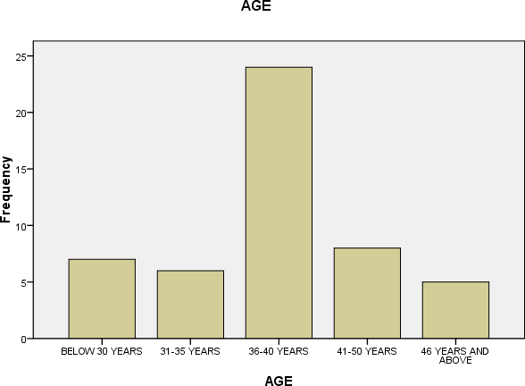

Figure 4.1: showing Bar chart of respondents distributed by age group
Source: researcher’s field work 2025
Table 4.1 above reveals that 7 respondents representing 14% of the total respondents are within the age of 18years and below, 6 respondents representing 12% of the total respondents are within age 31-35 years, 24 respondents representing 48% of the total respondents fall within the age range of 36-40, 8 respondents representing 16% of total respondents fall within the age of 41- 50years and finally 5 respondents representing 10% of total respondents fall outside the outlined categories of age limit i.e above 50 years. This indicates that larger proportions of the respondents are adults and we can conclude that they are matured minds which are relevant to the reliability of the outcome of this research work.

Table 4.2: Distribution of respondents by sex

SEX | Frequency | Percentage (%)
Male | 40 | 80.0
Female | 10 | 20.0
Total | 50 | 100.0
Source: researcher’s field work 2025

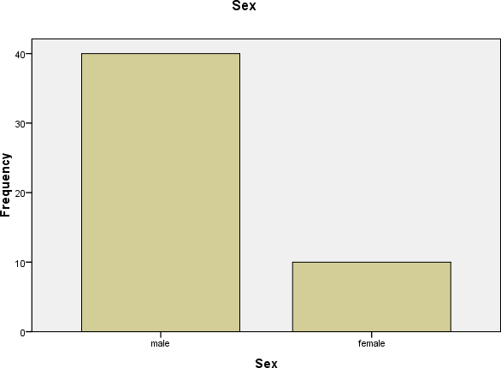
Figure 4.2 Bar chart of respondents distributed by Sex
Source: researcher’s field work 2025
Table 4.2 above shows that 40 respondents representing 80% of the total respondents are male, while 10 respondents representing 20% of the total respondents re females. This indicates that higher proportions of the respondents are females i.e. male constitute the larger percentage of NBC Ilorin.

Table 4.3: Distribution of respondents by marital status

Marital Status | Frequency | Percentage (%)
Married | 19 | 38.0
Single | 30 | 60.0
Divorced | 1 | 2.0
Widowed | 0 | 0
Total | 50 | 100.0
Source: researcher’s field work 2025

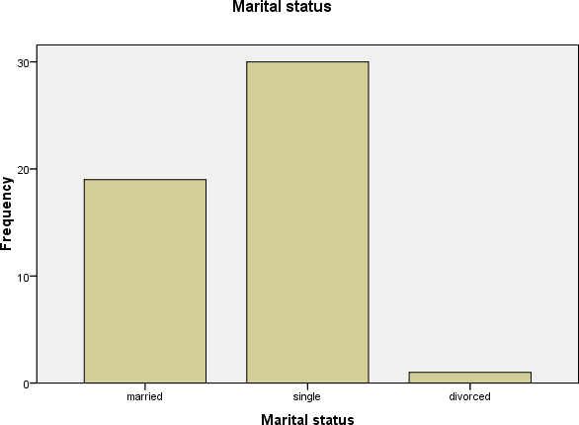
Figure 4.3: Bar chart of respondents distributed by marital status
Source: researcher’s field work 2025
Table 4.3 above shows that the majority of the respondents are single with a frequency of 30 (60%), while 19 (38%) are married; one of the respondents is divorced, while none of them is widowed. Giving cognizance to the above indices, we can conclude that reasonable percentage of the respondents can be referred to as responsible people.

Management level Table 4.4: Distribution of respondents by management

 | Frequency | Percent | Valid Percent
TOP | 12 | 24.0 | 24.0
MIDDLE | 21 | 42.0 | 42.0
LOWER | 17 | 34.0 | 34.0
Total | 50 | 100.0 | 100.0
Source: researcher’s field work 2025

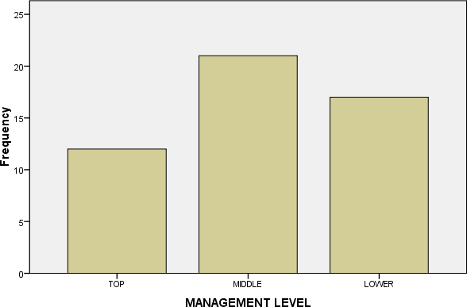

Figure 4.4 Bar chart of respondents distributed by management
Source: researcher’s field work 2025

Table 4.4 above shows that 12 respondents representing 24% of the total respondents are top level management, 21 respondents representing 42% of the total respondents are in middle management level, while 17 respondents representing 34% of the total respondents are lower level management. This indicates that higher proportions of the respondents are middle level management and this further backs the reliability of the results of this research work

Salary grade
Table 4.5: Distribution of respondents by Salary Grade

 | Frequency | Percent | Valid Percent
1-7 | 8 | 16.0 | 16.0
8-13 | 22 | 44.0 | 44.0
14-15 | 14 | 28.0 | 28.0
15 AND ABOVE | 6 | 12.0 | 12.0
Total | 50 | 100.0 | 100.0
Source: researcher’s field work 2025
Table 4.5 above reveals that 8 respondents representing 16% of the total respondents are within the salary grade 1-7, 22 respondents representing 44% of the total respondents are within the salary grade 8-13, 14 respondents representing 28% of the total respondents fall within the salary grade 14-15 while 6 respondents representing 12% of total respondents fall within the grade of 15 and above.

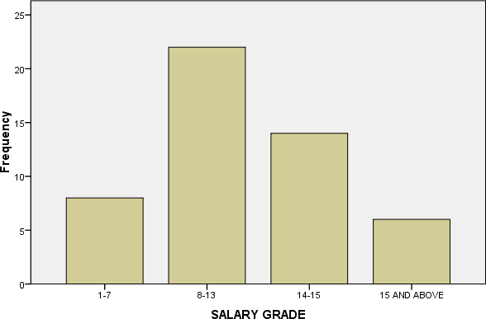
Figure 4.5: Bar chart of respondents distributed by Salary grade
Source: researcher’s field work 2025
Figure 4.5 above reveals that 8 respondents representing 16% of the total respondents are within the salary grade 1-7, 22 respondents representing 44% of the total respondents are within the salary grade 8-13, 14 respondents representing 28% of the total respondents fall within the salary grade 14-15 while 6 respondents representing 12% of total respondents fall within the grade of 15 and above.

Length of Service.
Table 4.6: Distribution of respondents by length of service

LENGTH OF SERVICE | Frequency | Percentage (%)
1-5 | 24 | 48.0
6-10 | 17 | 34.0
11-15 | 8 | 16.0
16-20 | 1 | 2.0

LENGTH OF SERVICE | Frequency | Percentage (%)
1-5 | 24 | 48.0
6-10 | 17 | 34.0
11-15 | 8 | 16.0
16-20 | 1 | 2.0
Total | 50 | 100.0
Source: researcher’s field work 2025

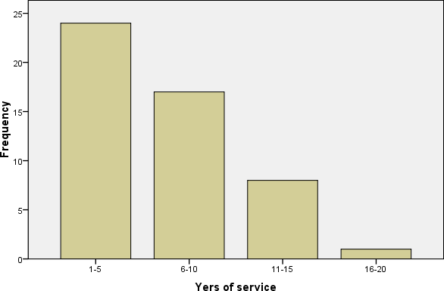
Figure 4. 6: Bar chart of respondents distributed by number of years of service
Source: researcher’s field work 2025

Table 4.6 above shows that 24 representing 48% of the total respondents have spent 1-5 years in service, 17 representing 34% of the total respondents have spent 6-10 years in service, 8 representing 16% of the total respondent have spent 11-15 years, while just 1 respondent representing 2% of the total respondents have spent 16-20 years in service.

Table 4.7: Distribution of respondents by Qualification
QUALIFICATION
 |  | Frequency | Percent | Valid Percent | Cumulative Percent
Valid | OND/N CE | 10 | 20.0 | 20.0 | 20.0
 | HND/BS C | 23 | 46.0 | 46.0 | 66.0
 | MBA/M SC | 17 | 34.0 | 34.0 | 100.0
 | Total | 50 | 100.0 | 100.0
Source: researcher’s field work 2025

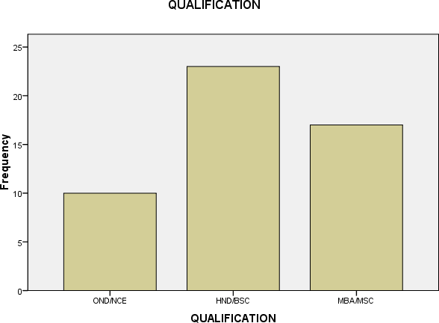
Figure 4. 7: Bar chart of respondents distributed by Qualification
Source: researcher’s field work 2025
Table 4.7 above shows that 10 respondents representing 20% of the total respondents are OND/NCE holders, 23 respondents representing 46% of the total respondents are HND/B.Sc holders, 17 respondents representing 34% of the total respondents are MBA/M.Sc. This implies that majority of the respondents are well educated and enlightened and this further backs the reliability of the results of this research work

DEPARTMENT/DIVISION

Table 4.8: Distribution of respondents by Department/Division
 | Frequency | Percent | Valid Percent | Cumulative Percent
Valid FINANCE/ACCOU NTING | 21 | 42.0 | 42.0 | 42.0
RESEARCH/DEVE LOPMENT | 14 | 28.0 | 28.0 | 70.0
MARKETING/SAL ES | 15 | 30.0 | 30.0 | 100.0
Total | 50 | 100.0 | 100.0
Source: researcher’s field work 2025

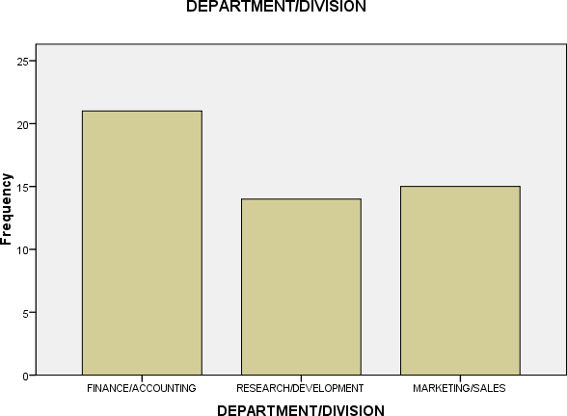
Figure 4. 8: Bar chart of respondents distributed by Department/Division
Source: researcher’s field work 2025
Table 4.8 above reveals that 21 respondents representing 42% of the total respondents are in finance/accounting department, 14 respondents representing 28% of the total respondents are in research/development department, 15 respondents representing 30% of the total respondents are in marketing/sales department. This implies that majority of the respondents were in finance and accounting department and this further backs the reliability of the results of this research work.

SECTION B

Table 4.9 WHICH DEPARTMENT IS RESPONSIBLE FOR CAPITALEXPENDITURE PROPOSAL IN YOUR COMPANY
 | Frequenc y | Percent | Valid Percent | Cumulative Percent
Valid RESEARCH & DEVELOPMENT | 26 | 52.0 | 52.0 | 52.0
BOARD OF MANAGEMENT | 19 | 38.0 | 38.0 | 90.0
MARKETING DEPT | 5 | 10.0 | 10.0 | 100.0
Total | 50 | 100.0 | 100.0
Source: researcher’s field work 2025
Table 4.9 above reveals that 26 respondents representing 52% of the total respondents agree that research and development department is responsible for capital expenditure in NBC, 19 respondents representing 38% of the total respondents agree that board of management that are in charge of capital expenditure in NBC Ilorin, while 5 respondents representing 10% of the total respondents were agree that marketing department are responsible for capital expenditure. This implies that research and development department are responsible for capital expenditure in NBC Ilorin base on the survey result.

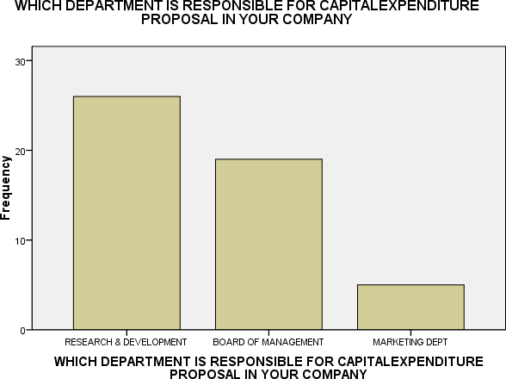
Figure 4.9 Bar chart showing which department is responsible for capital expenditure proposal in your company.
Table 4.9 above reveals that 26 respondents representing 52% of the total respondents agree that research and development department is responsible for capital expenditure in NBC, 19 respondents representing 38% of the total respondents agree that board of management that are in charge of capital expenditure in NBC Ilorin, while 5 respondents representing 10% of the total respondents were agree that marketing department are responsible for capital expenditure. This implies that research and development department are responsible for capital expenditure in NBC Ilorin base on the survey result.

Table 4.10 WHAT DEPARTMENT IS RESPONSIBLE FOR WORKING THE PRACTICAL DETAILS OF PROJECT PROPOSAL
 | Frequency | Percent | Valid Percent | Cumulative Percent
Valid MARKETING  DEPARTMENT | 11 | 22.0 | 22.0 | 22.0
FINANCE DEPARTMENT | 36 | 72.0 | 72.0 | 94.0
NONE OF THE ABOVE | 3 | 6.0 | 6.0 | 100.0
Total | 50 | 100.0 | 100.0
Source: researcher’s field work 2025

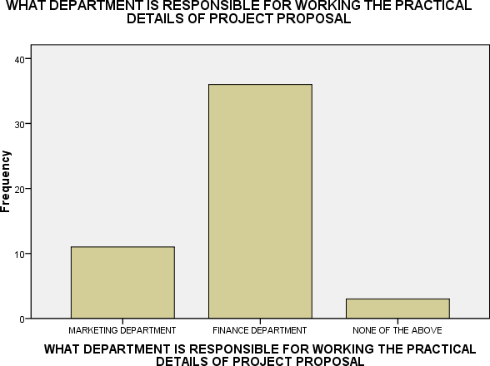
Figure 4.10 showing what department is responsible for working the practical details of project proposal
Source: researcher’s field work 2025

Table 4.10 above reveals that 11 respondents representing 22% of the total respondents agree that marketing department is responsible for the practical detail of project proposal, 36 respondents representing 72% of the total respondents agree that finance department is responsible for the practical detail of project proposal in NBC Ilorin, while 3 respondents representing 6% of the total respondents disagree that nor finance department neither finance department is responsible for working the practical detail of project proposal. This implies that finance department is responsible for working the practical detail of project proposal in NBC Ilorin.

Table 4.11 your company explicitly consider risk and uncertainty in the analysis of projects
 | Frequenc y | Percent | Valid Percent | Cumulative Percent
Valid strongly  disagree | 3 | 6.0 | 6.0 | 6.0
disagree | 3 | 6.0 | 6.0 | 12.0
undecided | 2 | 4.0 | 4.0 | 16.0
Agree | 27 | 54.0 | 54.0 | 70.0
strongly agree | 15 | 30.0 | 30.0 | 100.0
Total | 50 | 100.0 | 100.0
Source: researcher’s field work 2025

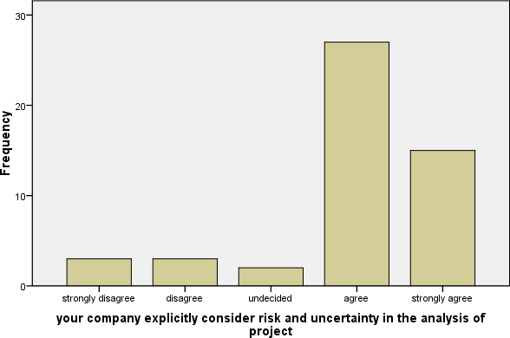
Figure 4.11shows if your company explicitly consider risk and uncertainty in the analysis of Source: researcher’s field work 2025

Table 4.11 above shows that 15 respondents representing 30% of the total respondents strongly agree to the statement, 27 respondents representing 54% of the total respondents agree, 2 respondents representing 4% were not decisive, 3 respondents representing 6% of the total respondents disagree and 3 respondents representing 6% of the total respondents strongly disagree with the statement. With the above analysis, we can conclude that NBC Ilorin explicitly consider risk and uncertainty in the analysis of projects evidenced by the higher level of agreement against the disagreement of respondents to the statement.

Table 4.12 your company consider inflation when analyzing investment decision
 | Frequency | Percent | Valid Percent | Cumulative Percent
Valid disagree | 6 | 12.0 | 12.0 | 12.0
undecided | 5 | 10.0 | 10.0 | 22.0
Agree | 25 | 50.0 | 50.0 | 72.0
strongly agree | 14 | 28.0 | 28.0 | 100.0
Total | 50 | 100.0 | 100.0
Source: researcher’s field work 2025

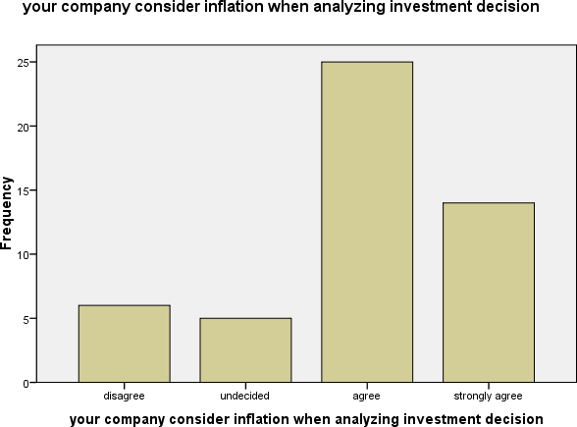
Figure 4.12 showing how your company consider inflation when analyzing investment decision.
Source: researcher’s field work 2025
Table 4.12 above shows that 14 respondents representing 28% of the total respondents strongly agree to the statement, 25 respondents representing 50% of the total respondents agree, 5 respondents representing 4% were not decisive, 5 respondents representing 10% of the total respondents disagree and 6 respondents representing 12% of the total respondents strongly disagree with the statement. With the above analysis, we can conclude that NBC Ilorin do consider inflation when analyzing investment decision.

Table 4.13 your company occasionally face with fund constrain while making investment decision
 | Frequency | Percent | Valid Percent | Cumulative Percent
Valid strongly  disagree | 8 | 16.0 | 16.3 | 16.3
disagree | 10 | 20.0 | 20.4 | 36.7
undecided | 9 | 18.0 | 18.4 | 55.1
agree | 19 | 38.0 | 38.8 | 93.9
strongly agree | 3 | 6.0 | 6.1 | 100.0
Total | 49 | 98.0 | 100.0
Missing System | 1 | 2.0
Total | 50 | 100.0
Source: researcher’s field work 2025
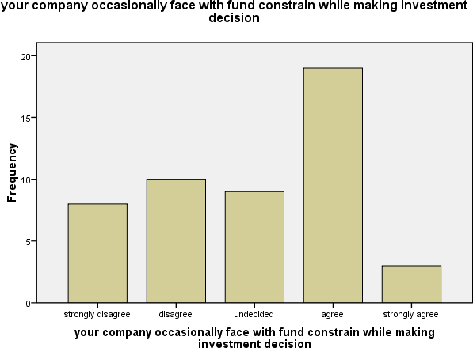

Figure 4.13 shows your company occasionally face with fund constrain while making
Table 4.13 above shows that 3 respondents representing 6% of the total respondents strongly agree to the statement, 19 respondents representing 38% of the total respondents agree, 9 respondents representing 4% were not decisive,
10 respondents representing 20% of the total respondents disagree and 8 respondents representing 16% of the total respondents strongly disagree with the statement. With the above analysis, we can conclude that NBC Ilorin occasionally face with fund constrain while making investment decision.

Table 4.14 investment techniques have impact on management decision making
 | Frequenc y | Percent | Valid Percent | Cumulative Percent
Valid disagree | 9 | 18.0 | 18.0 | 18.0
undecided | 4 | 8.0 | 8.0 | 26.0
Agree | 19 | 38.0 | 38.0 | 64.0
strongly agree | 18 | 36.0 | 36.0 | 100.0
Total | 50 | 100.0 | 100.0
Source: researcher’s field work 2025

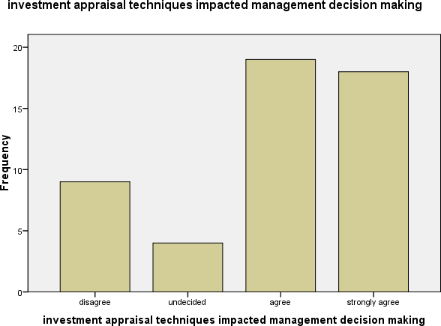
Figure 4.14 Shows how investment techniques have impact on management decision Source: researcher’s field work 2025
Table 4.14 above shows that 18 respondents representing 36% of the total respondents strongly agree to the statement, 19 respondents representing 38% of the total respondents agree, 4 respondents representing 8% were not decisive while 9 respondents representing 18% of the total respondents disagree. With the above analysis, we can conclude that truly investment techniques impacted decision making.

Table 4.15 your organization uses any investment techniques for its project
 | Frequency | Percent | Valid Percent | Cumulative Percent
Valid disagree | 21 | 42.0 | 42.0 | 42.0
undecide d | 5 | 10.0 | 10.0 | 52.0
agree | 24 | 48.0 | 48.0 | 100.0
Total | 50 | 100.0 | 100.0
Source: researcher’s field work 2025
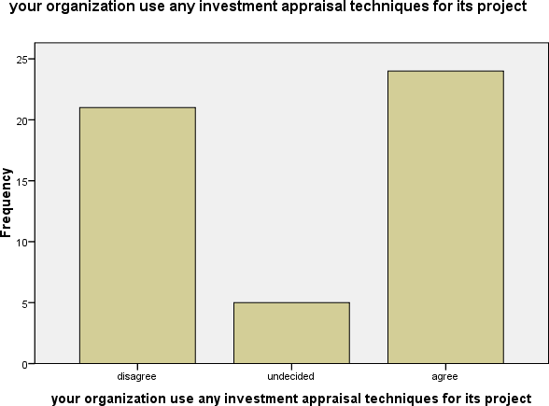
Figure 4.15 shows if your organization uses any investment techniques for its projects.
Source: researcher’s field work 2025
Table 4.15 above shows that 24 respondents representing 48% of the total respondents agree to the statement, 5 respondents representing 10% were not decisive, 21 respondents representing 42% of the total respondents disagree. With the above analysis, we can conclude that NBC Ilorin uses any investment techniques for its project

Table 4.16 the management strictly adhered to the results obtained from various investment techniques
 | Frequency | Percent | Valid Percent | Cumulative Percent
Valid disagree | 13 | 26.0 | 26.0 | 26.0
undecided | 1 | 2.0 | 2.0 | 28.0
agree | 24 | 48.0 | 48.0 | 76.0
strongly agree | 12 | 24.0 | 24.0 | 100.0
Total | 50 | 100.0 | 100.0
Source: researcher’s field work 2025

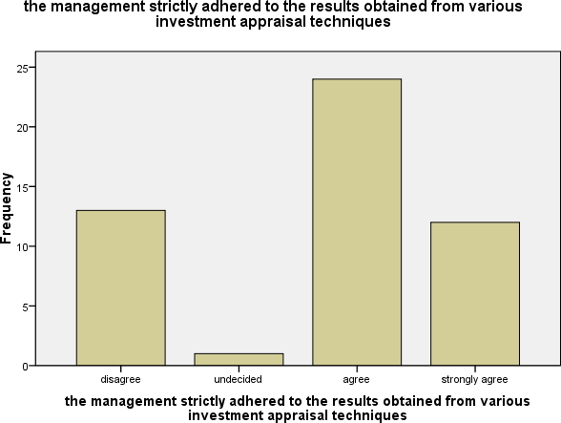

Figure 4.16 shows if the management strictly adhered to the results obtained from various investment techniques
Source: researcher’s field work 2025
Table 4.16 above shows that 12 respondents representing 24% of the total respondents strongly agree to the statement, 24 respondents representing 48% of the total respondents agree, 1 respondent representing 2% were not decisive and 13 respondents representing 26% of the total respondents disagree. With the above analysis, we can conclude NBC management strictly adghere to the results obtained from various investment techniques.

Table 4.17 Of all the investment techniques, NPV is considered most desirable
 | Frequency | Percent | Valid Percent | Cumulative Percent
Valid disagree | 5 | 10.0 | 10.0 | 10.0
undecided | 1 | 2.0 | 2.0 | 12.0
agree | 33 | 66.0 | 66.0 | 78.0
strongly agree | 11 | 22.0 | 22.0 | 100.0
Total | 50 | 100.0 | 100.0
Source: researcher’s field work 2025
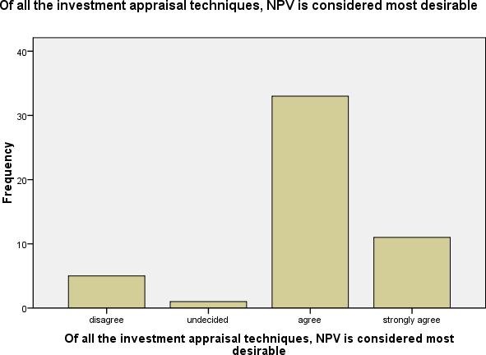

Figure 4.17 shows if of all the investment techniques, NPV is considered most desirable.
Source: researcher’s field work 2025
Table 4.17 above shows that 11 respondents representing 22% of the total respondents strongly agree to the statement, 33 respondents representing 66% of the total respondents agree, 1 respondent representing 2% were not decisive and 5 respondents representing 10% of the total respondents disagree. With the above analysis, we can conclude of all investment techniques, NPV is considered most desirable.

4.18 investment techniques used in decision making considers/guarantees shareholders wealth maximization
 | Frequency | Percent | Valid Percent | Cumulative Percent
Valid disagree | 8 | 16.0 | 16.0 | 16.0
undecided | 5 | 10.0 | 10.0 | 26.0
agree | 18 | 36.0 | 36.0 | 62.0
strongly agree | 19 | 38.0 | 38.0 | 100.0
Total | 50 | 100.0 | 100.0
Source: researcher’s field work 2025

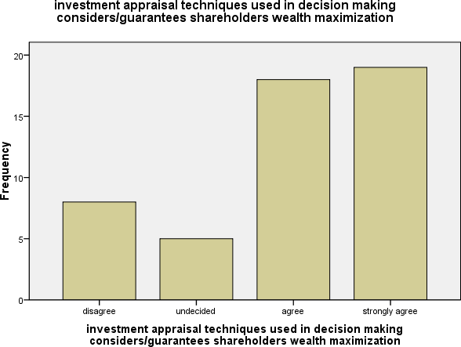

Figure 4.18 shows if the management strictly adhered to the results obtained from various investment techniques
Source: researcher’s field work 2016
Figure 4.18 above shows that 19 respondents representing 38% of the total respondents strongly agree to the statement, 18 respondents representing 36% of the total respondents agree, 5 respondent representing 10% were not decisive and 8 respondents representing 16% of the total respondents disagree.

4.19 Test of hypotheses Hypothesis one
Ho: There is no significant difference in any of the concepts of Investment technique on management decision making.
H₁: There is significant difference in any of the concepts of Investment technique on management decision making.

The decision rule is to reject H₀ if the p-value is less than our chosen level of significance (0.05).

Table 4.20 Regression model summary

Model Summary
R | R2
0.74 | 0.62
spss output Source: researcher’s field work 2025

Table 4.21

ANOVA
Model | Sum of Squares | Df | Mean Square | F | p-value
Regression | 3.8207 | 1 | 3.8207 | 7.9104 | 0.0071
Residual | 23.179 | 48 | 0.483
Total | 26.986 | 49
Source: researcher’s field work 2025
Decision: since the p-value is less than α= 0.05 level of significance, we therefore can reject the null hypothesis which says that there is no significant difference in any of the concepts of Investment technique on management decision making.
Conclusion: since is rejected it can be concluded that there is significant difference in any of the concepts of Investment technique on management decision making.

Hypothesis two
Ho: Significant difference does not exist from the Results obtained from the various investment techniques.
H₁: There are significant differences from the Results obtained from the various investment techniques.
The decision rule is to reject H₀ if the p-value is less than our chosen level of significance (0.05).

Table 4.22: Regression model summary
Model Summary
R | R2
0.68 | 0.51
Spss output Source: researcher’s field work 2016

Table 4.23: Regression ANOVA table
ANOVA
Model | Sum of Squares | Df | Mean Square | F | p-value
Regression | 4.47539 | 1 | 4.47539 | 8.1370 | 0.0064
Residual | 26.377 | 48 | 0.550
Total | 30.8524 | 49

Spss output Source: researcher’s field work 2025
Decision: since the p-value (0.0064) is less than α= 0.05 level of significance, we therefore can reject the null hypothesis which says that significant difference does not exist from the Results obtained from the various investment techniques.
Conclusion: since is rejected it can be concluded that there there are significant differences from the Results obtained from the various investment techniques.

Hypothesis three
Ho: Net present value (NPV) is not the most considered investment techniques in management decision making.
H₁: Net present value (NPV) is the most considered investment techniques in management decision making.

Table 4.24: Regression model summary
Model Summary
R | R2
0.282 | 0.080

Spss output Source: researcher’s field work 2025

Table 4.25: Regression ANOVA table
ANOVA
Model | Sum of Squares | Df | Mean Square | F | p-value
Regression | 2.363 | 1 | 2.363 | 4.161 | 0.047
Residual | 27.257 | 48 | 0.568
Total | 29.620 | 49

Source: researcher’s field work 2025
Decision: since the p-value (0.047) is less than α= 0.05 level of significance, we therefore can reject the null hypothesis which says Net Present Value (NPV) is not the most considered investment techniques in management decision making.
Conclusion: since is rejected it can be concluded that Net present value (NPV) is the most considered investment techniques in management decision making.

4.26 Discussion of Research Findings
- NBC Ilorin definitely considers inflation when analyzing investment decisions.
- NBC Ilorin explicitly considers risk and uncertainty in the analysis of project in order to beat the market demand and meet up customers’ expectations.
- Of all the investment techniques Net present value is considered most desirable by NBC Ilorin because it has a positive effect on its profit maximization.
- NBC occasionally face fund constrains while making investment decision because the company is faced with a lot of projects, likewise the market research consume a lot of fund and customers demand must be met.
- The investment techniques used in decision making considers and guarantees shareholders wealth maximization and that is why NBC keeps having tons of shareholders willing to invest and partner with the company.

CHAPTER FIVE

SUMMARY, CONCLUSION AND RECOMMENDATIONS

Summary
This study is aimed at providing general review of impact of investment techniques on management decision. The review of indifference literatures depicted the various techniques that are available to evaluate the desirability of investment expenditure. Capital expenditure decision normally represent the most important decision that a firm makes because a substantial proportion of a firms resources are committed to actions that are likely to be immovable and this also makes it inoperative for the firm to plan its investment programmes very carefully. Therefore, it’s revealed that investment is a way of deploying scarce resources in a convenient and comprehensible manner.
The summary of findings of this study can be drawn from the empirical findings and from the hypothesis. However, the hypothesis proves thus:
- The study confirms that most investment decision are originated by the marketing department
- All types of capital expenditure proposals are subjected to formal financial evaluation.
- Risk and uncertainty are explicitly considered and certainty equivalent cash flows method is mostly used to incorporate the effect.
- The effect of inflation is considered when analyzing investment decision.

- Of all investment techniques, net present value (NPV) is slightly considered as desirable.
- The study revealed that, the attributed theoretical justifications for the use of various investment criteria are achievable in practice provided that the effect of taxation, risk uncertainty and inflation are fully considered.
- It can also be concluded that without Training and Development programme for employees or workers, productivity will be low.

Conclusion
Based on the report of this study, the need for sound evaluation of investment cannot be over emphasized because it has been seen that firms that fails to plan very well for its investment expenditure has planned to fail its objectives. In as much as most investment decision is not likely to be reversible, there is a greater need to apply sound investment techniques. Findings revealed that, despite the theoretical justification of discounted cash flow techniques, net present value (NPV) and internal rate of return (IRR), firms use other non discounted cash flow like accounting rate of return (ARR) ,profitability index (PI) etc.
This is probably due to the simplicity of the techniques. By and large, the most desirable techniques are net present value (NPV) because it is consistent with the shareholders wealth maximization objectives.
All along, the objective of the study has examined the impact of the techniques on management decision and it was found that almost all

investment decision are subjected to thorough evaluation using any of the techniques.
However, the choice of which project to implement before others in the list does not follow a given order, one would have thought that more profitable projects would have been implemented before less ones but capital constraint and technical difficulty may call for the reverse so that, the intended objectives will be achieved.

Recommendations
In view of the observation and conclusion made in the preceding sections, the following recommendation were made
- It is suggested that firm should be as good practice subject of every investment proposal to formal financial evaluation.
- Investment should be carried out using any techniques that allows for the time value of money because of the reality of inflation and uncertainty.
- It is suggested that firm should have rules as much as possible to implement projects in their order of profitability where constraints allows such order. This will enable them to use funds generated by such implementation for further expansion.
- There is need for proper monitoring and post completion and it of capital expenditure in other to achieve the objective of their investment proposals.

REFERENCE
Adeniyi A. (2006). An insight into management accounting value analysis consults publishers, Lagos.
Adler RW (2006). Why DCF Capital Budgeting is bad for business and why business school should stop teaching Accounting Education. Int. J. Bus. 15(1): 3-25.
Anne, H. (2012). The Role of Investment and Versatility of Expertise in Energy Efficiency investment decisison. Unpublished master’s dissertation. Aalto University.
Asaolu E.O (2002). Business finance concept and analysis, Ibadan printing press.Nigeria.
Asemota O.(2010). Research design and interpretation in accounting and finance. University of Benin publication Benin, Nigeria.
Brian M.L (1999). Determinant of capital structure in Irish Smes Ashford colour press, New York.
Business and management Journal.A quarterly publication of Michael Stevens and associates.April-June, vol-2, pp. 47-49.
Charles C. (1997) element of the social science statistics, ijebu ode Printing press, Nigeria.
[
Collins D. (2008) Management and Cost Accounting cengage learning EMEA trindad publishers. United States.
Fatoki O. (2010). An Investigation into the Impact of investment on the Profitability of Small Manufacturing firms. Unpublished master’s dissertation. University of Fort Hare.
Gilman L.J (2002). Statistics, London MC Graw hall selievnis science. United Kindom.

Gitman, L. and J. Forrester (1977). “A Survey of Capital Budgeting Techniques used by Major US Firms.” Financial Management, 6: 66-71.
Graham, J.R., and Harvey, C.R., (2001), The theory and practice of corporate finance: evidence from the field. Journal of financial economics, 60 (2 & 3), 187-243.
Hampton J. (1989). Investment and financial decision 4th edition Prentice Hall, London.
Hastie KL (1998). One Businessman’s view of Capital Budgeting. Fin. Manage.
3(4): 36-44.
Lawal G.I. (2008) social science research reporting manual for beginners.lucky printing press ,Nigeria.
Lucey.T. (1999). Management accounting 4th edition, martins publishing Berwick, London.
McDaniel, W.R, Daniel, E.M. & Kenneth, A.J.(1988). Discounted Cash Flow with Explicit Reinvestment Rates: Tutorial and Extension”, The Financial review, Vol. 23. No 3, August 1988, pp.369-385.
Modigliani F. and Miller M. (1958) the cost of capital corporation finance and the theory of investment.American economic Review 48 (3): 261-297
Ogunsan C. (2002) research methodology, leaving issue in general studies humanities and social science, general studies division, university of Ibadan, Nigeria.
Olowe, R.A (2000), financial management concept analysis and capital investment, panel press limited, Nigeria.
Pandey R. (2003) financial management 8th edition new Delhi Vikes publishing.
India.

Ryan, P.A. and Ryan, G.P., (2002). Capital budgeting practices of the fortune 1000: How havethings changed? Journal of Business and Management, 8 (4).
Shao,J.K. (1996). “Analysing Technology Investments: from NPV to strategic Cost Management (SCM)”,Management Accounting Research, Vo. 7 No. 2
Stephen A. Ross, Randolph Westerfield and Bradford D. Jordan (2008) Fundamentals of Corporate Finance, 8th Edition McGraw-Hill/Irwin United States.
Trahan, Emery A., & Lawrence J. Gitman ( 1995): Bridging the theory-practice gap in corporate finance: A
survey of chief financial officers, Quarterly Review of Economics and Finance 35(1), 73-87.
Van Horne (2008): fundamental of financial management and policy 13th edition Engle wood cliff N.J practice Hall Inc, United States.

