A PROJECT REPORT

ON

PROPOSED CHURCH AUDITORIUM (CHRIST APOSTOLIC CHURCH AREA HEADQUARTER)
FOR

CHRIST APOSTOLIC CHURCH, DISTRICT CORDINATING COUNCIL, OMU ARAN, KWARA STATE.

BY

ABIODUN ADEDOYIN KEHINDE HND/23/ARC/FT/0008

SUBMITTED TO:

THE DEPARTMENT OF ARCHITECTURAL TECHNOLOGY, INSTITUTE OF ENVIRONMENTAL STUDIES (I.E.S) KWARA STATE POLYTECHNIC, ILORIN.

IN PARTIAL FULFILMENT OF THE REQUIREMENT FOR THE AWARD OF HIGHER NATIONAL DIPLOMA (HND) IN ARCHITECTURAL TECHNOLOGY
JULY, 2025.

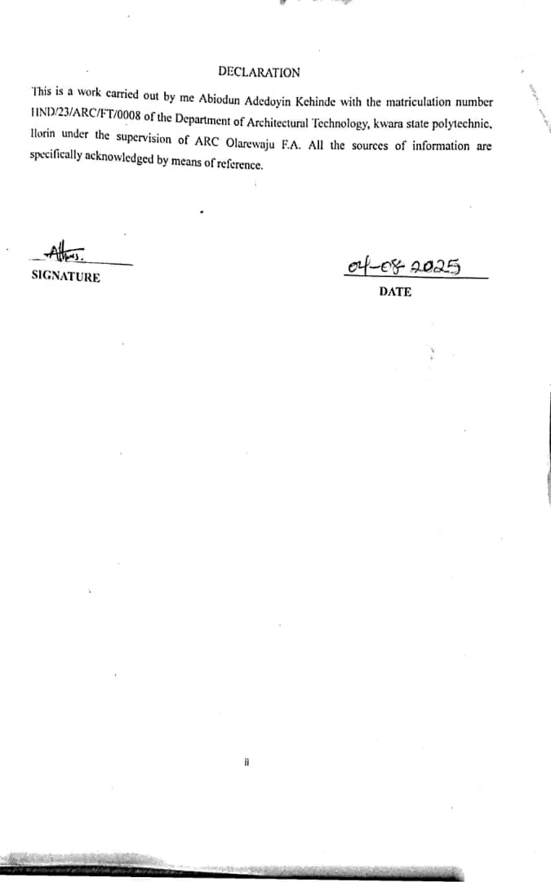

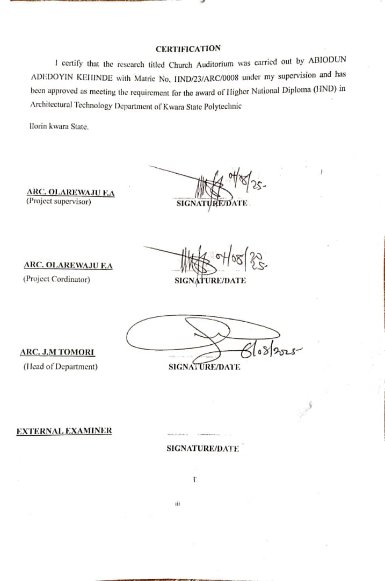

DEDICATION
I would like to dedicate this project to Almighty God, who gave me the opportunity to make it this far, all glory, honour and adoration to his Holy Name. And also to my beloved parents in person of MR and MRS Abiodun O.S.

ACKNOWLEDGEMENTS
All thanks and adoration to the God of all flesh, the one who is ,was and is to come.

My sincere gratitude goes to my supervisor in person of ARC OLAREWAJU F.A. for his counsel, corrections and guidance during the course of this project.
My Appreciation also goes to the Head of Department, in person of ARC J.M Tomori for her guidance during the course of this project and also to all Academic staff of the Architectural Department.
My sincere gratitude goes to my parents in person of Late MR and MRS ABIODUN for their never ending support, I can’t thank you enough Ma I Love you, I pray that all your efforts and support will not be in vain and you will reap the fruit of your labour, Amen.

ABSTRACT
A church auditorium is a building designed for and a large indoor space designed for worship, religious gatherings and community events and have the capacity to accommodate a large number of people. This work describes and analysis the principal contributions to the acoustics of occidental christian churches from ancient historical churches. It emphasises on the need and importance of acoustical designs which has been often neglected in most church designs in Nigeria and also emphasises the goal and importance of acoustical control designs which involves managing sound transmitted and received within a space to enhance clarity ,reduce unwanted noise and create an acoustically pleasant environment by adopting methods such as sound insulation, absorption, reflection and diffusion..
Part of this work is to identify how acoustics were generally achieved in auditoriums based on the method, technics and materials used. This work will discuss the transition overtime and how the design began from the past, it will also include case studies done in the process of this project and provide the understanding on how acoustics solutions is not achieved in most of the auditorium built without acoustics design incorporation. And finally it will point out some major benefits of acoustics using acoustics in auditoriums and then suggest the use of flat panels technology and line stone materials as it has great impact in achieving good and qualitative acoustics in the past. Acoustic shortfalls in places of worship are unwanted disturbances and as a matter of necessity should be checked. Such acoustic shortfalls were were treated with regard to the following issues such as poor speech intelligibility and poor music quality which are commonly experienced in church auditoriums, To achieve proper acoustics the following objectives should be considered ; Application of appropriate passive and active noise Defense mechanisms in building design ,application of architectural acoustic design principles and criteria that impact the choice of acoustical development and support sound and research has shown that one of the factors that affects acoustics in auditoriums and based on the study carried out was found out that the rectangular and fan shapes were commonly used and nearly the best in terms of acoustic efficiency, congregational unity and sight line. Rectangular shape provides early lateral reflection, desirable acoustics characteristics and minimised reflections from overhead and hence formed a basis for the design. used and nearly the best in terms of acoustic efficiency, congregational unity and sight line. Rectangular shape provides early lateral

reflection, desirable acoustics characteristics and minimised reflections from overhead and hence formed a basis for the design.

TABLE OF CONTENTS
DECLARATION ii
CERTIFICATION iii
DEDICATION iv
ACKNOWLEDGEMENTS v
ABSTRACT vi
LIST OF FIGURES ix
LIST OF PLATES x
CHAPTER ONE x
  - Introduction 1
  - Definition 1
  - Historical Background 2
  - Statement Of Problem 3
  - Aim And Objectives 3
  - Justification 4
  - Scope Of The Study 4
  - Limitation Of The Study 4
CHAPTER TWO 6
  - LITERATURE REVIEW 6
  - The Design Considerations 7
  - Evolution Of Church Auditorium Topology 8
  - Review Of Literature On Building Type 9
  - Important Issues And Problems 10
  - Unique Solutions To Specific Problems 11
CHAPTER THREE 12
  - Case Study 12
CHAPTER FOUR 24
  - Locational Map (Fig) 24
  - Historical Background Of Kwara State 24
  - Historical Background Of Irepodun Local Government Area 25
  - Physical Features Of The Site 25
  - Population Of Kwara State 25
CHAPTER FIVE 28
  - Approach To Design/ Design Realization 28
  - Acoustic Requirement for an Auditorium 29
  - Design Considerations 31
  - Acoustic Objectives 34
  - Technological And Environmental Criteria Construction Method 35
  - Material Used 35
  - Services Required 35
  - Conclusion 36
  - Recommendations 36

LIST OF FIGURES
Case study one locational plan 13

Case study one floor plan 14

Case study one front elevation 14

Case study one side elevation 15

Case study two locational plan 16

Case study two floor plan 16

Case study two front elevation 17

Case study two side elevation 17

Case study three locational plan 18

Case study three floor plan 19

Case study three front elevation 19

Case study three side elevation 20

Case study four locational plan 21

Case study four floor plan 21

Case study four front elevation 21

Case study four side elevation 22

Online case study one front elevation 22

Online case study two front elevation 23

Locational Plan 24

LIST OF PLATES
    - Locational map 33
    - Locational plan 33
    - Site analysis 34
    - Site Inventory 34
    - Functional relationship 35
    - Functional analysis 35
    - Space calculation 36
    - Site plan 36
    - Floor plan 37
    - Roof plan 37
    - Elevations 38
    - Section 38

CHAPTER ONE

Introduction
A church auditorium is a sacred and communal space where believers gather for worship, spiritual edification, learning, and fellowship. It serves not only as a center for religious ceremonies but also as a hub for community engagement and social interaction. The significance of a church auditorium lies in its ability to foster spiritual growth, deepen communal bonds, and provide emotional and social support to its members. Therefore, designing such a space demands careful planning and thoughtful integration of both functional and spiritual considerations. This proposed project focuses on the architectural design of a church auditorium that not only fulfills the practical needs of the congregation but also inspires spiritual reflection, promotes a sense of unity, and supports the holistic development of individuals and the community at large.
Designing a church auditorium is a sacred task that must reflect the values, mission, and identity of the church. It requires a deep understanding of the congregation's needs, the nature of their worship, and how they engage with one another and the broader community. The design must embody both reverence and utility, ensuring that the spiritual atmosphere is preserved while also accommodating various church activities such as services, musical performances, teaching sessions, and community outreach programs.
The Christ Apostolic Church (CAC), one of the largest and most influential Pentecostal denominations in Nigeria, has a rich historical and spiritual legacy that dates back to 1918. As the church continues to expand, there is a pressing need for a modern, sustainable, and purpose- built auditorium that aligns with its theological principles and evolving congregational demands. The rapid growth of the church’s membership has made it necessary to design a larger, more functional worship center that can accommodate its ever-increasing population.
This project aims to design a modern, functional, and environmentally sustainable church auditorium tailored to the needs of the growing CAC congregation. It emphasizes creating a conducive space for worship, fellowship, and various religious and community activities. One key area of focus in this research is the integration of architectural acoustics, which plays a crucial role in sound clarity and overall worship experience.
In contemporary religious buildings, especially Pentecostal worship spaces, sound plays a central role in sermons, music, prayers, and announcements. However, the proliferation of noise both internal and external and the shift from traditional to lightweight construction materials have

created challenges in achieving optimal acoustical conditions. According to Baron (2009), good acoustical design is now a necessity rather than a luxury. The acoustics of a worship space significantly affect verbal communication, musical expression, and emotional engagement, making it a vital consideration in church design.

Historical Background
The concept of a church auditorium has evolved over centuries, influenced by various architectural styles, theological traditions and cultural contexts. Structures ranging from the ancient era (300 - 500 BC) e.g Early Christian worship spaces and basilicas, Medieval Era (500 - 1500 AD) e.g Gothic Architecture and Cathedral Architecture, The Renaissance and Baroque Eras (1500 - 1800 AD), The Modern Era (1800 - 2000 AD) e.g industrial and technological advancements and modernist and contemporary church design, The contemporary Era (2000 AD
- till present). Examples are mega churches and multisite churches and sustainable and community -focused design.
Throughout history, church auditorium design has reflected the cultural, theological and technological contexts of time. Today church auditoriums continues to evolve, incorporating innovative designs, technologies and sustainable practices.
The Christ Apostolic Church in Nigeria has a rich and fascinating history founded in 1918 as the previous stone society, The church emerged from a prayer group within the Anglican Church Ijebu -Ode. The group led by Joseph Sadere, Sophia Odunlami and David Odubanjo emphasised divine healing, prayer and a return to biblical practices.
As the group grew, it faced persecution from the Anglican Church leadership leading to the formation of the Faith Tabernacle in 1930 which masked a turning point as the church began to establish branches across Nigeria.
A pivotal figure in the Church’s history is Apostle Joseph Ayo Babalola, who received a divine call in 1928 to quit his job and dedicate himself to God’ s work. His ministry was marked by remarkable healings, miracles and evangelistic crusades which helped establish CAC major Nigerian Christianity.

Definition
Definition of Church: A church is a specifically designed building that accommodate various function including worship, prayer community activities while also providing a sacred symbolic space for reflection and connection.
Definition of an Auditorium: An auditorium is a building designed for public gatherings, performances and presentations.
Therefore a church auditorium is a building designed for and a large indoor space designed for worship, religious gatherings and community events and have the capacity to accommodate a large number of people. A church auditorium is a place where congregants meet for worship on a regular basis.

Statement Of Problem
The lack of a sustainable and adaptable auditorium is hindering the church’s ability to affectively serve its growing community and congregation and engage with the local community.
The lack of incorporating acoustic technologies in the design of church auditorium. The lack of effective and efficient sound control.

Aim And Objectives Proposed Project Aim
This project aim to design and develop a sustainable, self-efficient and a church auditorium with an acoustically pleasant environment.

Objectives

- To identify and adopt the design criteria for good acoustics in large auditoriums and relate it to the project.
- Application of appropriate passive and active noise defense mechanisms in the building design

- Application of architectural acoustic design principles and criteria that impact the choice of acoustical development and support of sound during the design.

- To improve indoor air quality by 90% through the use of natural ventilation, air filtration systems and non-toxic materials.
- To ensure Acoustic Harmony; ensuring clarity and reverence.

- Speech intelligibility; sermons and readings needs to be crystal clear reaching every listener without strain. This requires minimising echoes and unwanted reflections and the strategies includes strategically placed acoustics panels, diffusers and sound absorbing materials.

Justification
Due to the ever present problem of noises such as echoes and reverberation which can cause blurring of speech within a church auditorium, This project is based on the need for incorporating Acoustical design and acoustic principles in church auditorium designs in order to create acoustically pleasant environment.

Scope Of The Study
The church auditorium will ensure the provision of a space that is sustainable with an acoustical pleasant environment and also the provision of other units e.g (fellowship hall, praying ground, youth church, hen house, gate house, pastors residence) amongst others.

Limitation Of The Study
Access to the offices and other units was denied and the only unit I was allowed to enter was the Auditorium and also failure to get accurate dimensions of the structure as I was only allowed to take pictures within a limited time.

Research Methodology

- Internet browsing

- Case studies

- Literature review

- Oral interviews

Internet Browsing: also known as web browsing or surfing the web is the process of using a web browser to navigate and view websites on the internet. It involves using a software application to view web pages, follow links and access various online resources and it is used to search for and retrieve information from various websites, making it a primary tool for online research and knowledge gathering.
Case Studies: Case study is a research methodology typically seen in social and life science. Case study is an intensive, systematic investigation of a single individual, group, community or some other unit in which the researcher examines in-depth data relating to several variables.
Literature Review: A literature review discuses and analyses published information in a particular subject area. Sometimes the information covers a certain time and period, A literature review is more than a summary of the sources, it has an organizational pattern that combines both summary and synthesis.
Oral Interview: this requires a student to respond verbally to unpredictable prompts and therefore much less vulnerable to cheating. They can also allow for in-depth assessment of students understanding through interactions and dialogue in which student students explain their thoughts and reasoning, it allows for verbal exchange allowing for assessment of communication skills, knowledge and ability to articulate ideas.
Deductions: In all the case studies carried out,none of the church auditoriums are incorporated with acoustic design or took acoustics into consideration during design..

CHAPTER TWO

LITERATURE REVIEW
In the study of Bartalucci et al (2018) the acoustic design of an auditorium on a church and of a historical theatre.
Environmental sustainability is the ability to keep ecological process within an ecosystem and its biodiversity in the future and together with economic and social sustainability, contributes to the definition of wellbeing and progress.
In this frame circular economy and designing public and private buildings play a decisive role, in the case of restoration, it can even be critical to achieve the best compromise between the desired acoustic quality and the architectural constraints imposed by the structure being restored.
Software for simulating sound response in enclosed spaces can help to solve this issue, the paper reports the numerical experimental method used for the acoustics design and main results obtained in the acoustic re qualification design is a church and a historical theatre both located in Italy (Tuscany).
Acoustics is a developing science in Nigeria like everywhere else in the world, Acoustic re qualification can be used to transform a church auditorium by using sustainable architecture.
What is acoustics? Acoustics is a branch of physics that deals with the study of mechanical waves in gases, liquids and solids including topics such as vibration, sound, ultrasound, infrasound (Baron 2009). It is a science governed by the law of physics, which helps us understand and predict the way sound behaves in an environment. Webster (2017) defined acoustics as the science that deals with the production, transmission, reception, effects and control of sound. A space is said to have a good acoustics if it provides the sound in a conducive way that we want to use it, for a worship space to have a good acoustics it must allow verbal and musical communication and it has poor acoustics if it makes the communication difficult.
The acoustics of a space is determined by its architecture, its geometry shape and the way it is finished and the number of people that occupy it at a given time. Sound waves travel in approximately straight lines, bouncing off hard surface or being absorbed or soaked up by soft

ones before it dies out and such a space is said to be reverberant or live and the sound bouncing around the room is called reverberation (Umaru, 2017).
Similarly the sound from a person speaking in a room with soft walls ( curtains, carpet, cushions, people e.t.c ) will not bounce much at all before it dies out, it will take a lot of vocal effort to be heard over an equivalent distance in this non reverberant or dead space but the sound that gets through will be easier to understand and therefore a good worship centre will have a good intelligibility rating.
Sound from a person speaking in a reverberant space will consist of one sound wave travelling in a straight line and a lot of sound wave that have bounced around the room for a long time. All these sound waves will take different length of time to get to the listener, arriving at different times(Author, 2014).
In summary a good worship auditorium is designed to eliminate unwanted reflections and echoes and optimize the quality of sound heard by the audience and this is done by engineering the shape and walls, as well as including sound absorbing materials in areas that may cause echoes to ensure clear intelligibility for the spoken elements of the liturgy.

The Design Considerations
- Acoustics: Research highlights the importance of the optimal acoustics in church auditoriums, ensuring clear sound and minimal echo.
- Seating and layout: Studies emphasises the need for comfortable seating, adequate sight lines and flexible layouts to accommodate various worship styles.
- Lighting: literature suggests that thoughtful lighting design can enhance the ambience and create sense of reverence.
Church auditoriums can foster a sense of community among congregants promoting connection and shared experience and research has shown that acoustics plays a crucial and vital role during the design. Research discuses the integration of technology such as sound and video systems to enhance worship experience and explores the eco-friendly sustainable design principles and sustainable practices in church auditorium construction and operation.

These themes highlights the complexities of designing and utilising church auditoriums, balancing functional needs with spiritual and community goals.

Evolution Of Church Auditorium Topology
In the early days of Christianity, worship often took place in homes or secret locations due to persecution, with the legalisation of Christianity in the Roman Empire after 313 AD, The need for formal places of worship grew. Early churches known as basilicas were inspired by Roman civic architecture featuring long central aisles and semicircular apses though simple, these structures laid the foundation and community while symbolically representing the journey toward salvation.
As the faith expanded, Catholic architecture began to take symbolic meaning, the basilicas designs fostered unity bringing the congregation together in a shared space of prayer and devotion though not yet ornate. The 11th abs 12th centuries marked a significant shift in Christian architecture as Europe emerged from the dark ages and began Romanesque style, which became dominant form of church construction throughout Western Europe. In recent decades Christian Architecture has taken a turn toward modernism often leaving behind sacred spaces, instead of inspiring awe with soaring ceilings and intricate details many contemporary churches now embrace minimalism, favouring stark concrete walls, angular designs and glass facades.
Evolution of church auditorium ranges from the towering Gothic cathedrals of medieval Europe to the modern chapels of today, Christian architecture has continuously evolved reflecting changes in theology, culture and art meanwhile each Era has left its own mark.

The Historical Evolution Of Christian Church

The buildings were of two types: the longitudinal hall or basilica and the centralised building, the two could be composed as follows;

The Basilica

The Christian worship being congregational requires a hall and the Roman basilica a civil hall became the model for both large and small churches, the plan always included an atrium or

forecourt or porch along nave (central hall) flanked side by aisles, a transept crossing the nave and a semicircular or polygonal apse opposite the nave, in front of the nave the alter was set directly over the decorative panels, columns, masonry and bronze roof tiles from imperial buildings were incorporated in the new structures (Banister, 2017).

The centralised building

Baptisteries, mausoleums, martyr shrines were built in centralised form, they were either circular or polygonal with the object or veneration, the baptismal font, the sarcophagus or the holy place visible to the faithful from the aisles circling the site but entirely of spoils, the elegant circular building has massive bronze doors and for the font a huge porphyry (very beautiful and hard rock) Basin both from the bath of caracalla (Collins, 2009).

Review Of Literature On Building Type
Acoustics is a developing science in Nigeria like elsewhere in the world. However, it is fast gaining popularity as the country is faced with acoustical challenges from industries, road traffic, power generating e.t.c, hence the need to proffer solution to the menace. The church auditorium is a space meant for worship, listening and preaching the word of God, this makes it a spiritual environment that requires serenity to enable the audience hear and understand what is being preached from the altar (stage). A sermon preached in the auditorium should be reasonably loud and clear, it therefore is necessary for auditorium to be acoustically equipped to ensure clarity of sound within it as failure to do so could promote noise that can impede hearing, noise such as echo and reverberation can cause blurring on a speech within a church auditorium thereby creating difficulties for an effective communication between the listeners and the preacher. The two major kinds of noise that could mar good communication in a church auditorium are background noise and acoustic noise (international journal of advancements on capturing technology 2015).
Therefore, acoustic design interstates room layout materials and components to optimize sound quality and minimize noise in Architectural and interior spaces. Acoustic design refers to the strategic planning and implementation of elements within a building to achieve optimal sound quality and control, designing with acoustics in mind helps you to create an atmosphere that is conducive and additionally balanced acoustics can also improve communication and social

interactions by minimizing distractions, the first goal of acoustics standards is to reduce excessive reverberation and loudness.

Important Issues And Problems
- The design functionality problems:

  - Balancing aesthetic and functional requirements.

  - Ensuring optimal acoustics for speech and music.

  - Designing flexible spaces for various worship styles.

- Preservation and sustainability problems.

  - Preserving historical and cultural significance of church buildings.

  - Incorporating sustainable design and practices.

  - Managing, maintenance and upkeep of ageing structures.

Inclusivity and accessibility problems

  - Designing spaces that accommodate diverse needs and abilities.

  - Ensuring accessibility for people with disabilities.

  - Creating welcoming environments for all members.

Acoustics problems.

  - measuring and simulating acoustic parameters such as reverberation time,clarity and speech transmission index.

Unique Solutions To Specific Problems
- Design and functionality

- Incorporating modular elements that can be easily re arranged or repurposed to accommodate different worship styles and events.
- Using movable acoustic panels to optimise sound quality for various types of music and speech.
- Smart lighting which includes implementing intelligent lighting systems that adjusts to different liturgical seasons, events and moods.

Design preservation and sustainability

- Green building practices: Incorporating sustainable practices, materials, energy efficient systems and eco-friendly practices in church design and renovation.
- Digital preservation by creating digital archives of church history, documents and artefacts to preserve cultural heritage.
- Inclusivity and accessibility.

i. Accessible design by incorporating universal design principles to create spaces that is accessible and useable for all people of all age’s abilities.
- Adopting acoustic design principles by incorporating acoustic panels in walls and use of movable acoustic equipment.

CHAPTER THREE

Case Study
Case studies are of paramount importance as it is an experimental research or analysis carried out on existing building or group of building functionally similar to the one which the researcher is working on.
For any technical design to be meaningful there is always need for preliminary research effort to be made on this proposal as a very necessary ground work .The following case studies of church auditorium were visited and carried out.
- At Omu-Aran, Kwara State

- At Auyetoro gbede, Kogi State

- At Basorun Ibadan, Oyo State

- At Taiwo Ilorin, Kwara State

Client’s Background

Pastor J.A Olusegun DCC Superintendent, CAC DCC Omu Aran,Kwara State.

CASE STUDY ONE: C.A.C OKE ISEGUN CHURCH NO 1 OMU ARAN, DCC HEADQUARTER
It is located at Omu Aran, irelodun local government area in Kwara State and it is located around the popularly known roundabout area, also known as Babajide region Omu Aran, The church’s site has a school named ST. Dorcas CAC group of schools and also a residential building for the pastors.

MERIT

- The Church Auditorium is relatively enough to accommodate the congregations population.

- The building is designed in such a way that it allows for maximum airflow and natural ventilation.

DEMERIT

- No design for car spaces.

- Two of the three available entrance/exit are afterthoughts, only joined to the building after the initial construction.
- The external space lacks proper landscaping.

- Lack of conveniences.
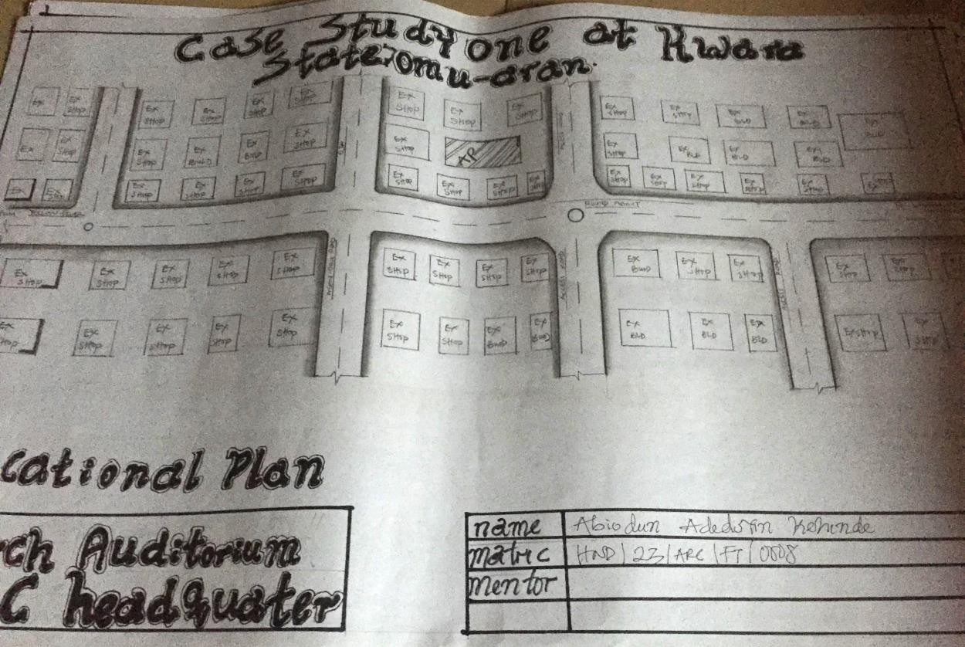

Figure 1 showing Locational Plan

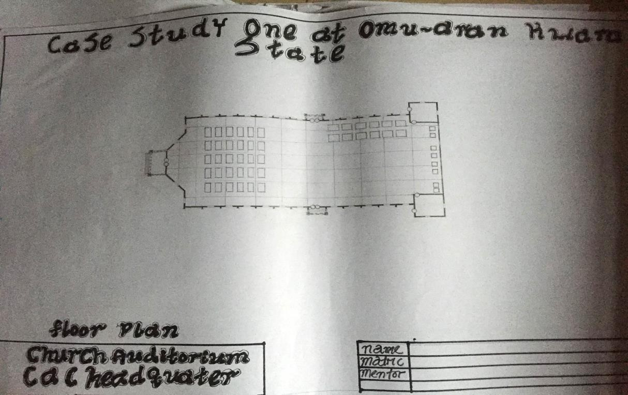

Figure 2 Showing Floor Plan
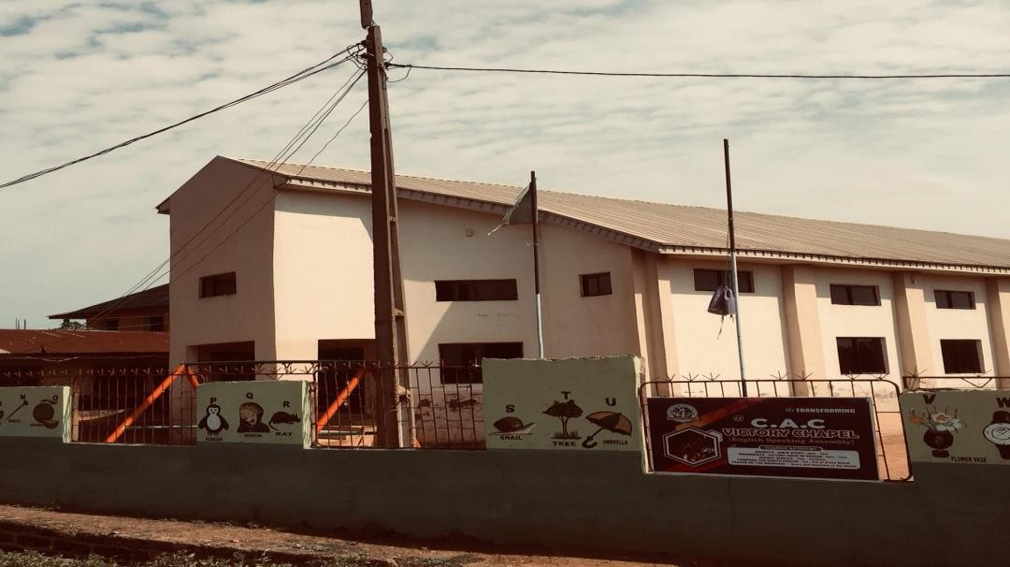

Figure 3 Showing Front view

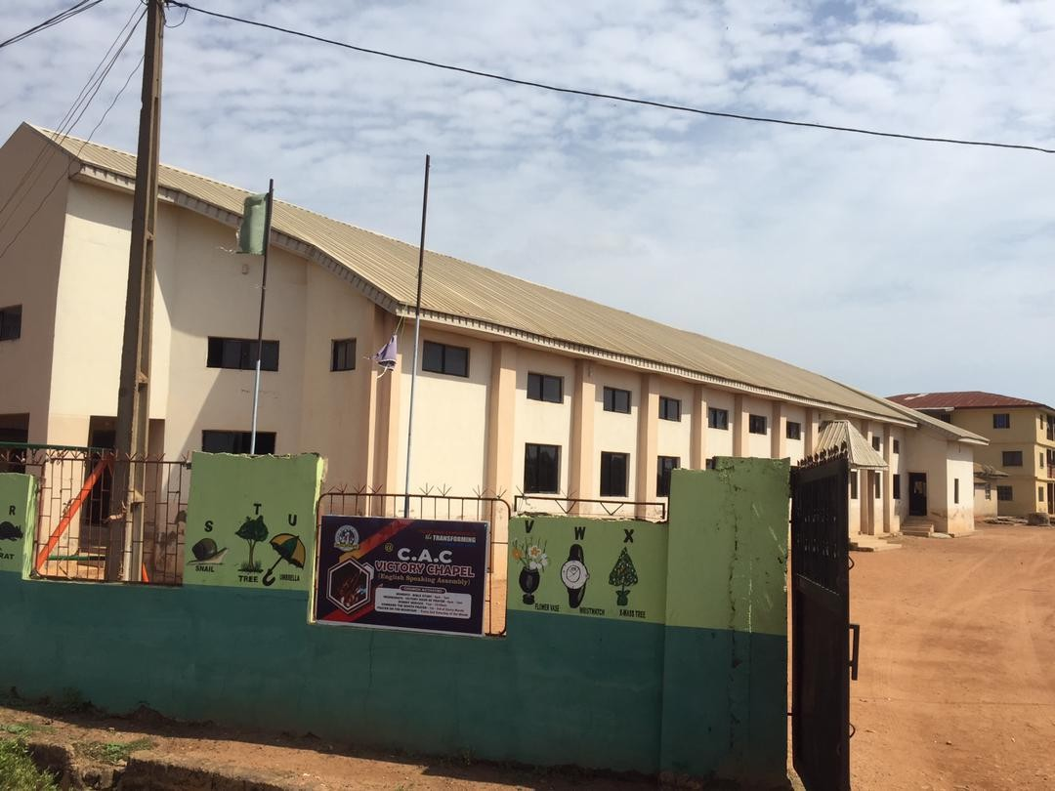

Figure 4 Showing Side view

CASE STUDY TWO

CHRIST APOSTOLIC CHURCH AIYETORO GBEDE, KOGI STATE

It is located at Adokoro, Aiyetoro Gbede in Kogi State and Is located in a remote area in the Adokoro community, this church mainly consist of just the church auditorium.

MERIT

- Enough sitting spaces as the population of the congregation is relatively small because the auditorium is located in a relatively small region.

DEMERIT

  - The auditorium overall appearance is worn and old which affects the building Aesthetics.

  - Lack of conveniences

  - The surrounding lacks landscape

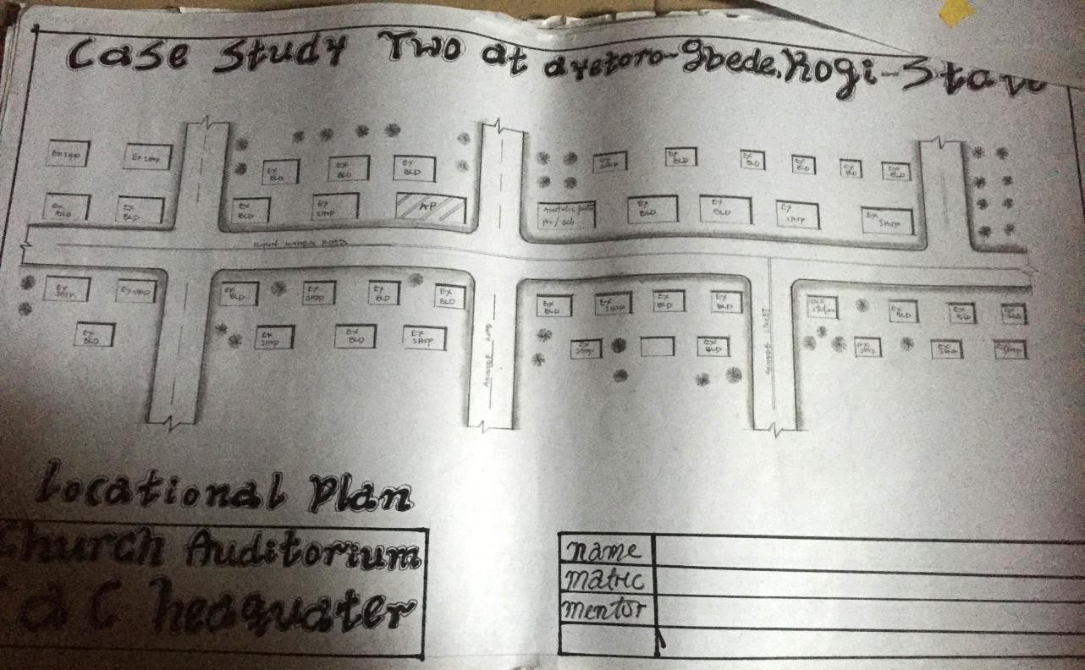
Figure 5 Showing Locational Plan
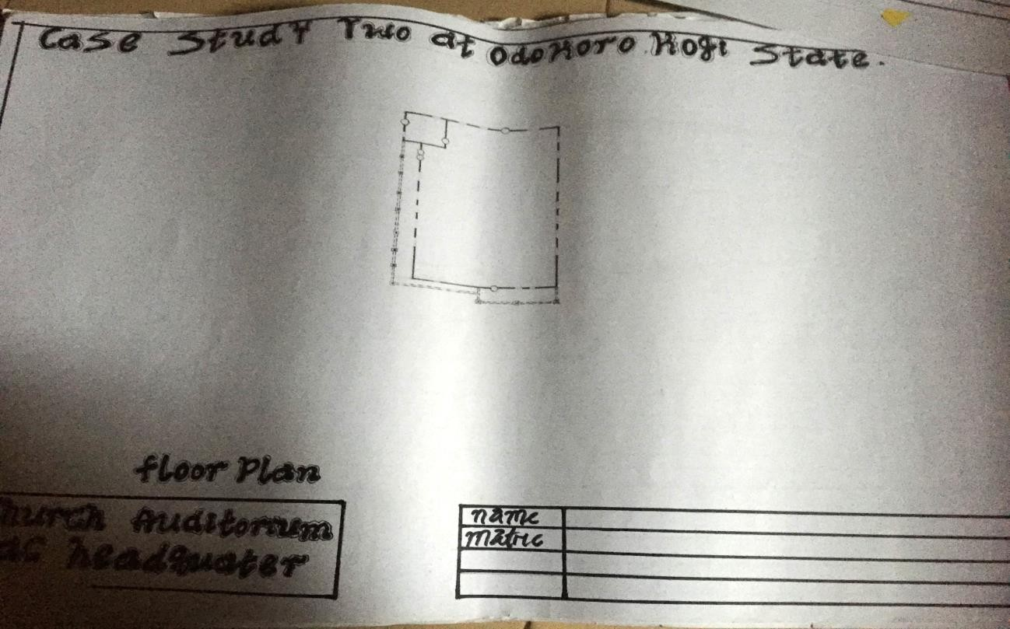
Figure 6 Showing Floor Plan

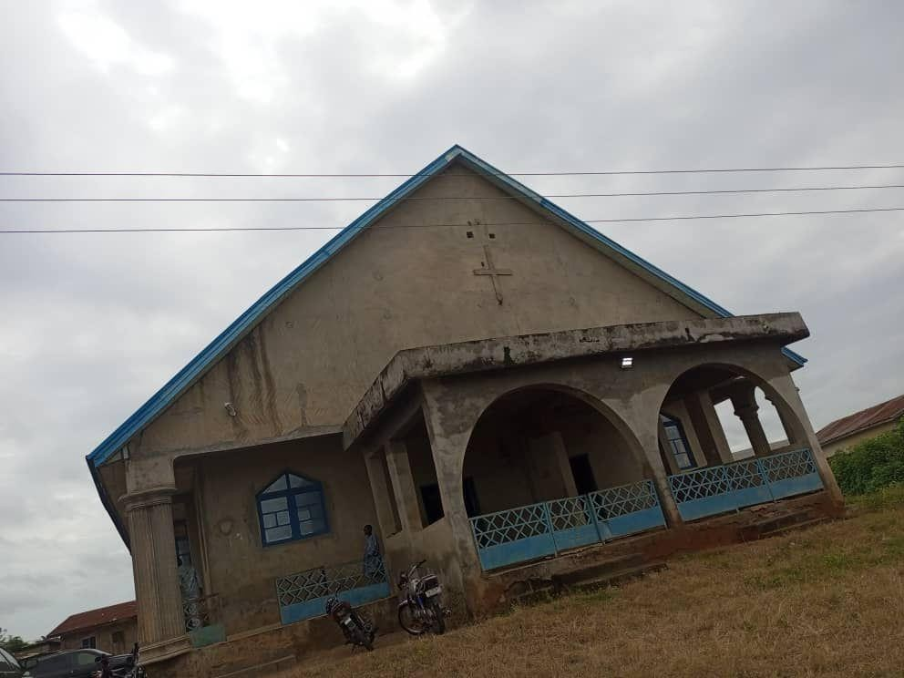

Figure 7 Showing Front view

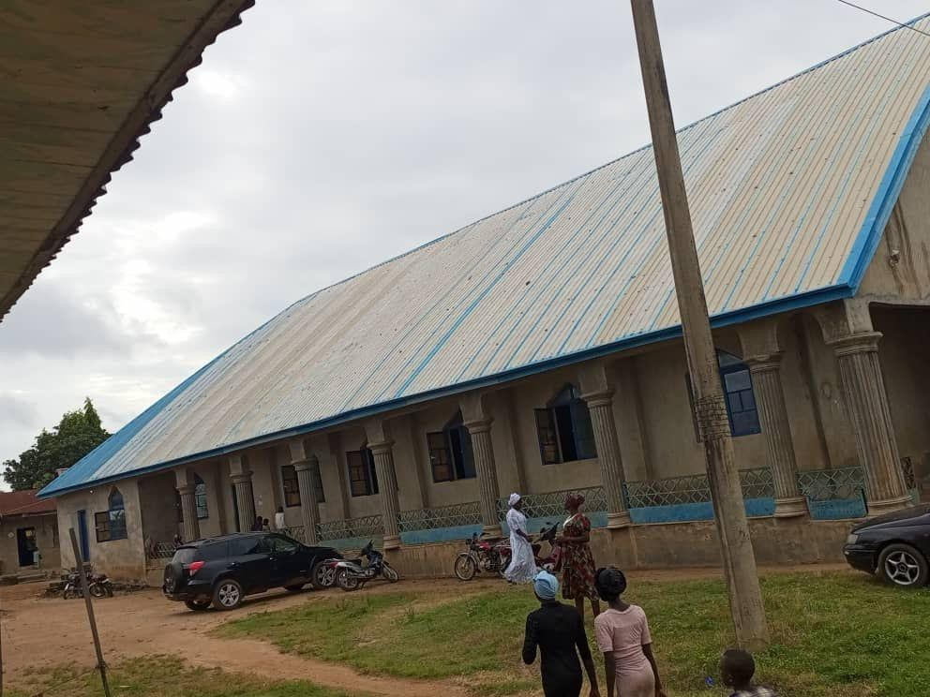

Figure 8 Showing Side view

CASE STUDY THREE

CHRIST APOSTOLIC CHURCH ALL SAINTS CHAPEL ANLUGBUA BASORUN, IBADAN, OYO STATE
This is where the C.A.C general secretariat is located and it contains a church auditorium with a gallery, security house, office, secretariat, mission house which is the living quarters built for pastors and other church officials.
This church is a place with a mandate to bring Glory to God through the word of God and to build and raise leaders that will populate the kingdom of God

MERIT

- The buildings overall appearance is in good condition and aesthetically pleasing.

DEMERIT

- Lack of enough space in the site

- Lack of proper landscaping (soft landscape)
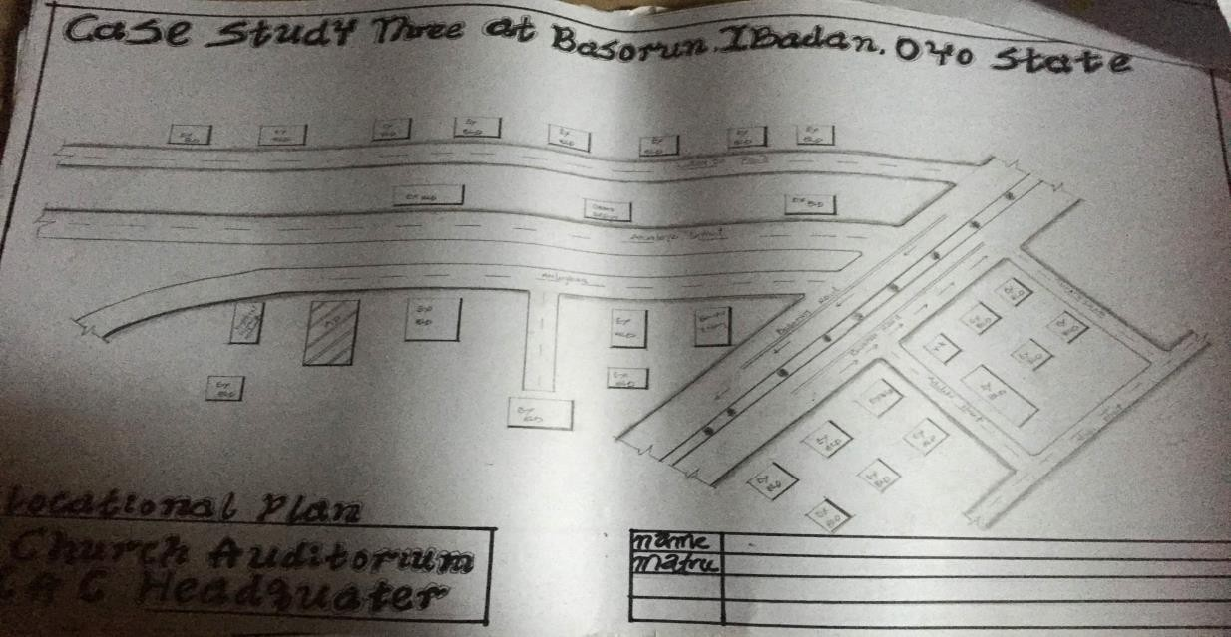

Figure 9 Showing Locational Plan

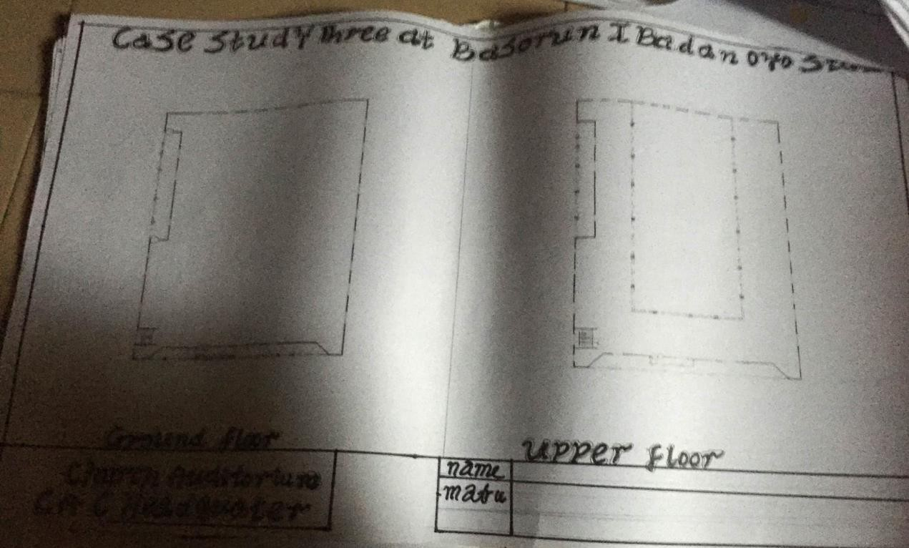

Figure 10 Showing Floor Plan

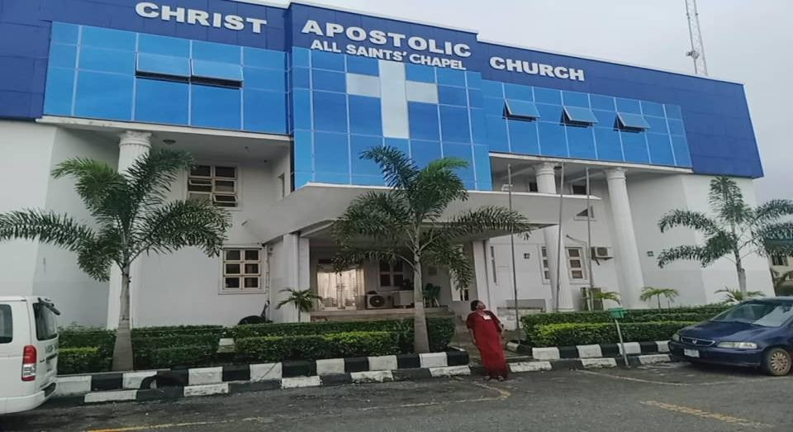
Figure 11 Showing Front view

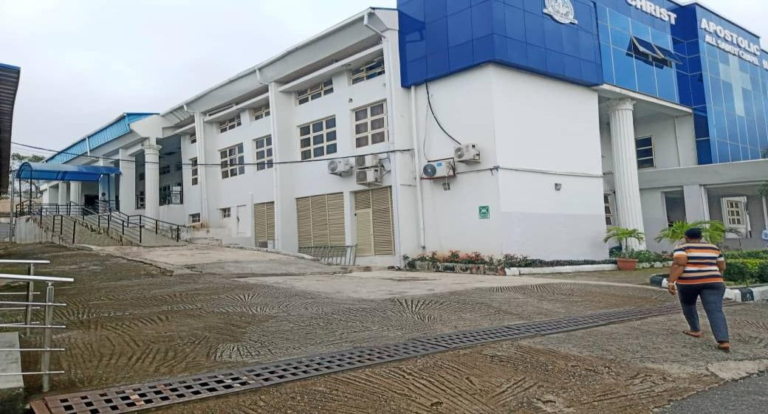

Figure 12 Showing Side view

CASE STUDY FOUR

CHRIST APOSTOLIC CHURCH OKE ISEGUN ZONAL HEADQUARTER

This is located at the capital city of Kwara State Ilorin at Taiwo Isale Ilorin, Kwara State. It is also known as the C.A.C church Taiwo Isale and is a prominent place of worship situated on Ibrahim Taiwo road in Ilorin, established in 1947 and serves as the headquarter for the Ilorin district coordinating council (DCC).

MERIT

- The building design is well ventilated.

DEMERIT

- Lack of proper maintenance/adequate maintenance.

- Lack of parking spaces.

- Lack of proper landscaping.

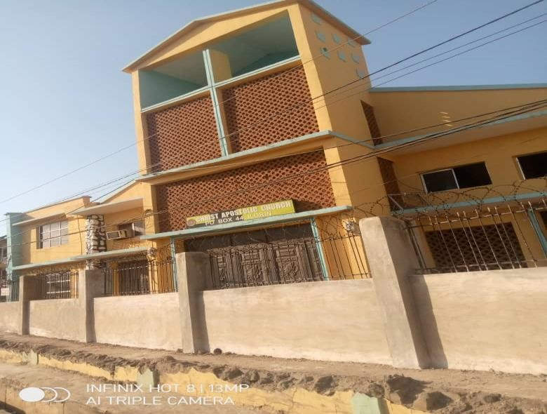

Figure 13 Showing Front view

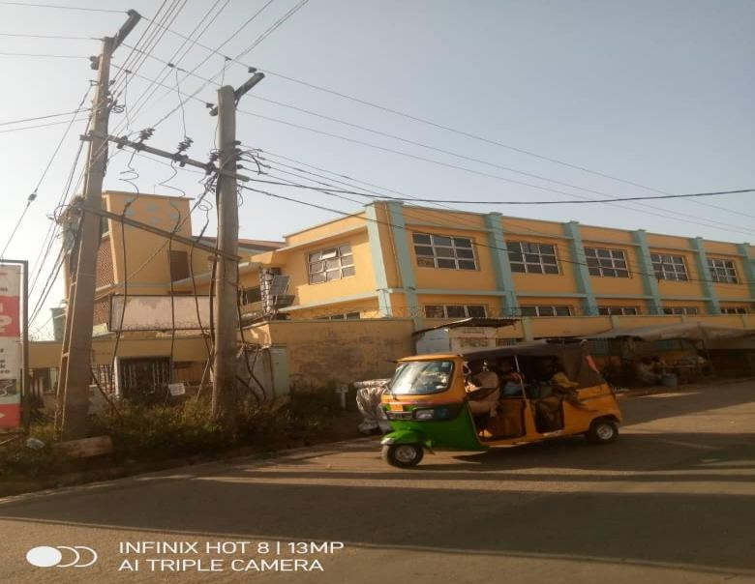

Figure 14 Showing Side view

ONLINE CASE STUDY
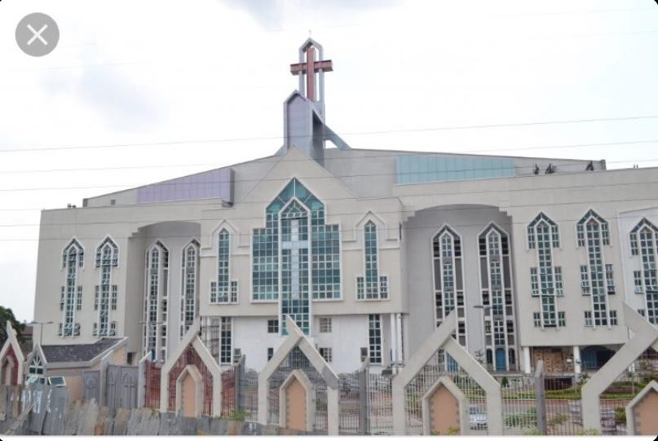
Figure 14 Showing Christ Apostolic Church, Nigeria. Mbierebe Obio Area Headquarter Uyo field.

ONLINE CASE STUDY TWO
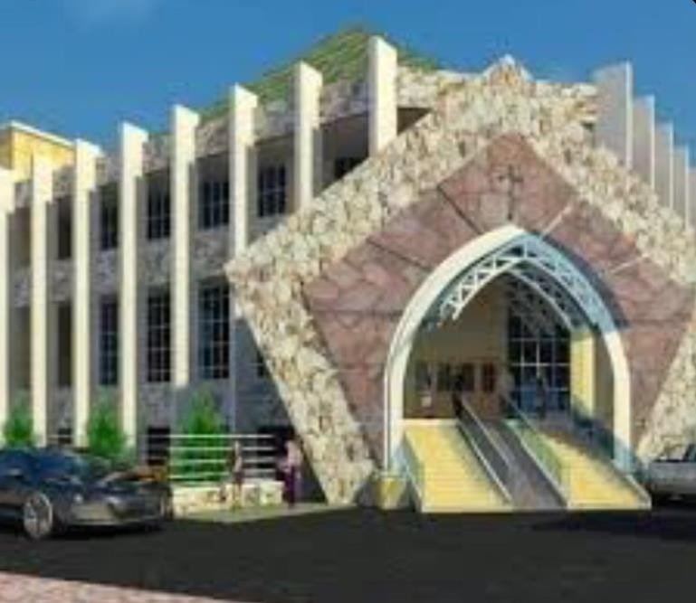

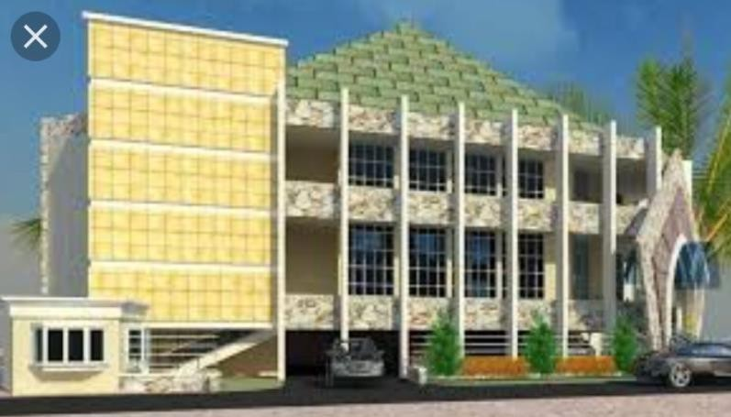
Figure 15 showing The Christ Apostolic Church Nigeria, Maboju Area Headquarter Ikeja, Lagos State.

CHAPTER FOUR

Locational Map (Fig)
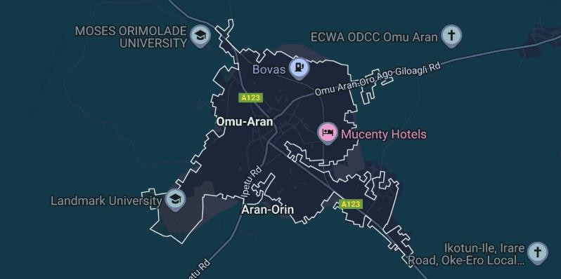

Historical Background Of Kwara State
Kwara state is one of the 36 states that makes up the Federal Republic of Nigeria, Africa’s most populous country. Kwara state shares her boundaries with the republic of Benin at her west and the Niger River at her north. The capital city of Kwara state Ilorin is situated 306km in land from the coastal town of Lagos and 500km from the federal capital territory Abuja, major towns include Ilorin, Offa and Jebba. Other cities include Patigi, Erinle, Illofa, Afon, Kaiama, Isanlu Isin, Omu Aran and Igbaja.
The history of kwara state starts with Ilorin as a Yoruba town which were originally used as a military outpost by the Aladdin, paramount ruler of the old Oyo empire (Oyo ile).At the period of creation, Ilorin was administered by Afonja, the sixth Are-Ona-Kakanfo (generalissimo) of Oyo army and successor of Are-Ona oku of jabata. Ilorin became the capital of a kingdom that was a vassal state of the Oyo empire in 1750.
Kwara state was created in 1967, the Federal military government of General Yakubu Gowon broke the four regions that then constituted the federation of Nigeria into 12 states and at its creation, the state was made up of the former Ilorin and kabba provinces of the then northern region and was initially named the west central state but later changed to kwara a local name for

the river niger. Then when 19 states were formed, it lost to Benue state the three Igala divisions East of the Niger River in 1991, It also lost some of its territory in the North-West to Niger state and some of its territory in the South-East to the newly created Kogi state.

Historical Background Of Irepodun Local Government Area
Irepodun local government was created out of the defunct Ekiti Local Government Area in 1976 with headquarters at Omu Aran, the local government has 10 wards and it has an area of 737km(square) and a population of 148,610 at the 2006 census. It has very significant Yoruba cultural and historical significance and is populated by the igbomina people.
The major towns are Omu Aran, Arandun, Oro, Esie, Ijan, Ajase-Ipo, Oko, Iludun and so on. Yoruba is predominant language spoken here, Irepodun is famous for its yam and grains and it also has large deposits of Granite, Talc, Columbite, Tantalite, Feldspar, Quartz and miza. The major festivals are Egungun, Ogun and Sango festivals and Tourists can visit the Esie Museum, the museum was the first to be established in Nigeria when it opened in 1945, the museum once housed over one thousand tombstones figures or images representing human beings. It is reputed to have the largest collection of soapstone images in the world.

Physical Features Of The Site
- Road networks

- Residential Areas

- Farmlands

Population Of Kwara State
The estimated population of Kwara State, Nigeria as of July 2024 is 3,390,330. While the state is the ninth largest in area and it is the sixth least populous, the state is composed of 16 LGA and its capital is Ilorin city.

Social Services

The social services are available in irepodun local government area

- Health services : Healthcare facilities and services are provided to the residents.

- Agricultural support: The Irepodun local government provides support to the farmers and promote agricultural development.
- Education: The residents of the LGA have undeniable access to adequate education.

- Social welfare: Social welfare programs are created to support the vulnerable individuals and families in the community,through the aid from the National social investment program of Nigeria.
- Electricity Supply: Electricity supply os available in the region.

- Adequate Water Supply : Access to clean, healthy and drinkable water in the region.

Site Selection /Justification

The site of the proposed project is said to be in Omu Aran Kwara State,Irepodun Local Government Area.
The factors considered are;

- Location

- Urbanisation

- Soil structure

- Accessibility

- Site topography

- Location: The site is located at Omu-Aran ,Kwara State,location is one of the important factor to be considered as the site must be in a strategical location.

- Accessibility: The prior existence of roads which aid in easy movement and makes the site accessible.
- Soil Structure: The soil type and soil bearing capacity needs to to considered and appropriate soil testing is to be done to determine the soil condition and structure and in this case the soil has high load bearing capacity.
- Site Topography: This is related to the gradient slope of the said site and land which is important to determine and in the design of appropriate drainage systems/ water systems .
- Urbanisation: There are existing structures on the sites surrounding.

CHAPTER FIVE

Approach To Design/ Design Realization
In approaching the proposed project design, many factors were taken into consideration and these factors includes the cost of materials, functionality of design and durability.
In the approach to design of a Church Auditorium acoustics is a very important factor to be considered as if determines the functionality of the church when it comes to sound transmission, which is essential in the Auditorium during services and programs. To be able to design an auditorium that is acoustically pleasing, acoustics principles must be used during the design and construction.

Importance Of Auditorium In A Church

The importance of an auditorium in a church cannot be overemphasized as without the auditorium the church cannot exist, the auditorium serves as the central gathering space for church activities such as services revivals and so on. It plays a pivotal role in fostering connection and enhancing the worship experience. Designing an effective auditorium for a church requires careful consideration of acoustics, sight lines and the overall sense of community. Auditorium spaces are designed to accommodate large audiences such as they tend to have wide spaces and maybe multiple stories high in order to accommodate seating, sight lines and acoustical requirement.

Effect Of Acoustics in a Auditorium

Acoustics are a fundamental element in the design and operation of an auditorium, the quality of sound impacts the audience experience and effects the effectiveness of presentations, services and lectures. When an auditorium has echo and reverberation problems comprehension of content or clarity of sound is compromised. Acoustics treatments must balance reverberation to create a resonant and immersive auditory experience without overwhelming the listeners with excessive echoes. Acoustics that are not optimal distort the sound we hear. For example, reverberation fills the pauses between words, reducing intelligibly. Multiple sound sources fill a room faster making it noisy and too high background noise level can mask the message.

Understanding Church Acoustics

Sound energy will bounce off hard surfaces such as walls floors and ceilings and travel back across the open space, when these reflections are left untreated reverberation problems can occur making speech difficult to understand and music to sound muddy. A well-designed auditorium should have good acoustics which means that sound clear, balanced and evenly distributed throughout the space.

Acoustic Requirement for an Auditorium
According to classic acoustics theory, there are five requirements which when met results in good acoustics.
- An appropriate reverberation time.

- Uniform sound distribution.

- An appropriate sound level.

- No echo or flutter echo.

Classification Of Acoustic Materials

They are typically porous or fibrous materials such as acoustic foam, fiber glass panels and mineral wool. Absorbers are used to reduce reverberation time and improve speech intelligibility in rooms and reflectors are materials that reflect sound waves.
Acoustic materials that can be used are as follows;

- Wall Covering.

- Acoustic Foam.

- Acoustic Board Black.

- Acousta Blanket Black.

- Wood Wool Acoustic Board.

- Noiseblok Mass Loaded Vinyl Barrier.
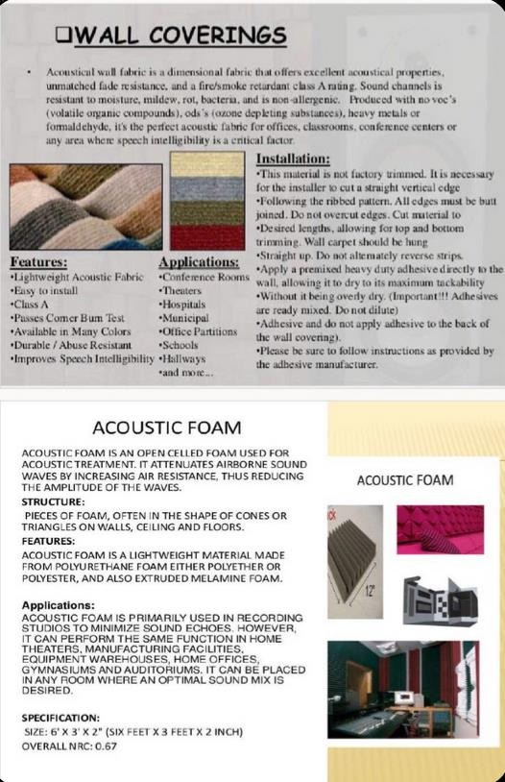

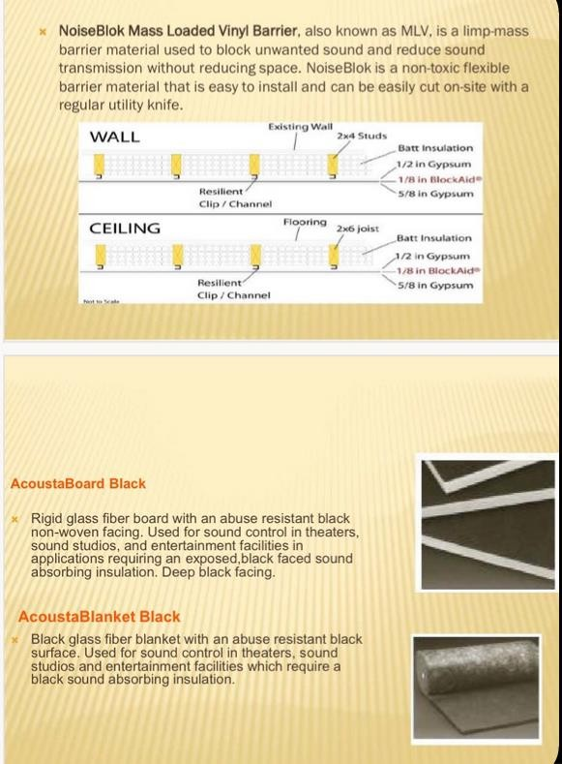
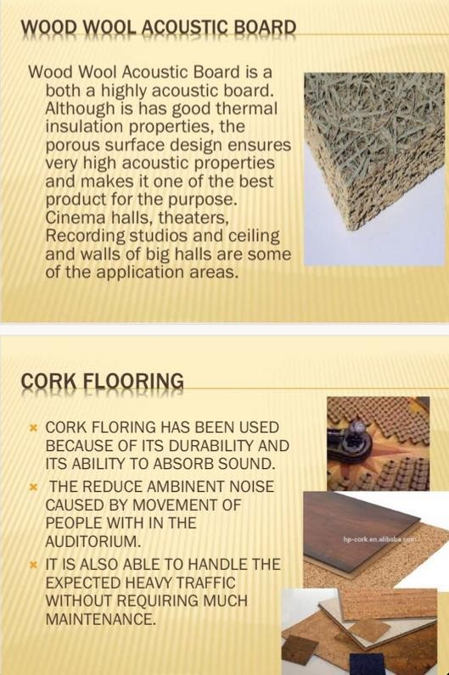

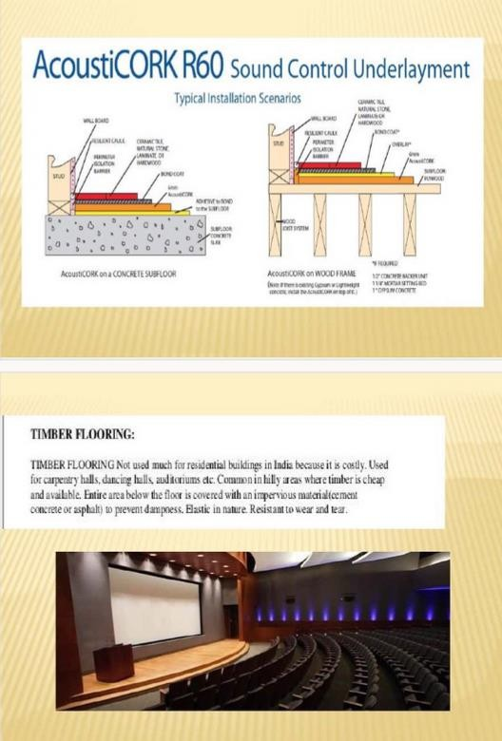
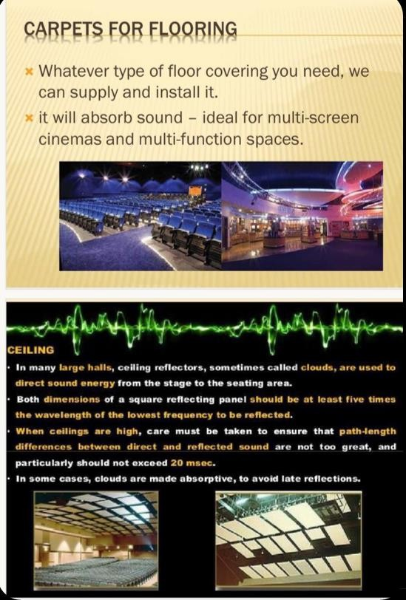

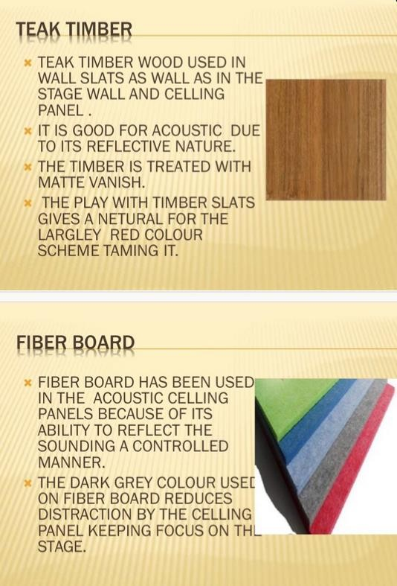

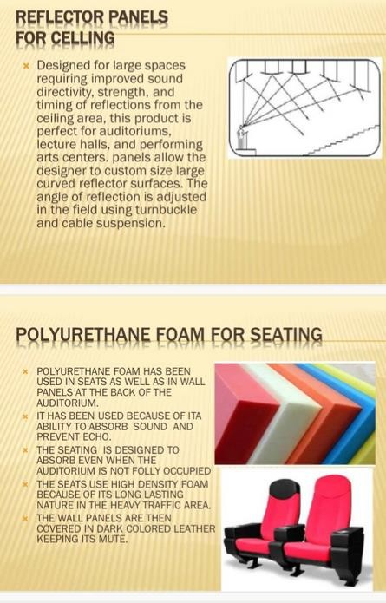

The acoustical design of a church auditorium is of equal importance to that of the architectural design. It is essential that the acoustical design follow the principles of projecting sound from the source to the listeners with maximum fidelity both for the listeners and the performers. Church acoustics has varied from dead to, low reverberant type at one extreme to the excessively reverberant type at the other extreme, In between these extremes there is a range of good listening conditions for music and speech, for all type of liturgy. Longer reverberant time than usual are recommended for small and medium size auditoriums and the enhancement effect of reverberation on musical tones is shown to be related to the optimum reverberation characteristic. A new design of church auditorium is submitted which is interesting in its novelty and is still practical from a modern architecture point of view.

Design Considerations
The primary design consideration of an Auditorium is almost always its sound quality, Again sound quality is the same for every source or every listener and a typical space will sound best for spoken word if the reverberation time RT 60 is between 0.90 second and 1.00 second.

Acoustic Objectives
The room should be free from acoustical defects (distinct echoes ,flutter echoes, picket fence echo, sound shadowing, room resonance, sound concentrations and expressive reverberation) first of all there should be adequate loudness in every part of the auditorium especially in remote seats.

Factors That Affects Auditorium Acoustics

- Size of auditorium.

- Shape of the room.

- Materials in the room.

- Balconies and orchestra.

Technological And Environmental Criteria Construction Method
Church auditoriums are designed to accommodate a large number of people and make sure there is good sound quality in the building, the study analyses the construction of the structure and materials used.
Foundation Works: It is assumed that the foundation works will be time consuming and it requires a setting out before excavation begins ,excavation and back filling for the improvement of the soil.
Super Structure: This has to do with laying of blocks and marking out the windows ,doors and other openings up the roof.
Roof Works: The roof is the structure that covers the entire building and the materials used for the roof are zinc sheets and timber roof members to hold it firmly to give a contemporary look to the structure

Material Used
In the construction of the proposed structure, blocks were used for the walls and other materials to hold it in place (cement paste),cement, water, aggregates .
Interior Finishes: The interior is of different categories and we have wall finishes, floor finishes and ceiling finishes. The chosen floor finishes is Marble tiles and the wall finishes is paint.
Exterior Finishes: The material/ finishes used for the exterior will be paint.

Services Required
Building services are the systems installed in the building to make them comfortable, functional, efficient and safe.
Fire Safety And Precautions: The building needs to be designed to provide an acceptable level of fire safety and minimize the risk from heat and smoke. Building service can prevent a major ignition risk, optical smoke alarm, Ionization smoke alarm, multi sensor alarm.
Heating And Ventilation And Air Conditioning (Hvac): Maintaining internal air quality regulation, internal humidity, HVAC system can be centralized in a building.

Water Drainage: Drainage is the removal of surface and subsurface water, sustainable urban drainage system are systems designed to effectively manage surface water.
Plumbing: Plumbing refers to any system that allows the movement of fluid typically involving pipes, valves, plumbing fixtures, tanks and other apparatus.
Electrical Service: This has to do with electrical design and installation, the legend, the load chart/balancing and fuse arrangements. The type of wiring system used in the project is concealed conduit wiring system which employs the use of pvc pipes, cables of various size and electrical fittings of various types.

Conclusion
This proposed design aim to produce a church auditorium that is acoustically pleasing and designed with acoustic principles in mind. A church sound system takes an audible but low decibel sound and amplifies it so all the people in the room can hear it, since buildings tends to have vast halls and high ceilings which are prone to produce echoes and river be rations, a well- structured sound system is critical to ensuring clarity.

Recommendations
Based on the many research done during the course of this project/proposed design, it is glaring that the Acoustics design in a church auditorium/auditorium at large differs from that of a studio. Acoustic treatment in church auditoriums should not transform the room into a sterile recording studio but should provide control over sound while preserving some room reverbs; this balance ensures that the worship space remains dynamic and lively while enhancing audio quality.

REFERENCES

A comparative analysis of acoustics materials and effects on church auditorium old/new church in Nigeria, William white.
Bartalicci et al (2018) the acoustics design of an auditorium in a church and historical theatre.

Case Studies in Ressourcement. Pickwick Publications (Chapter 3) Levy. Cathedrals and the Church. p. 12.
Church | Definition, History, & Types | Britannica". 22 June 2023..Archived from the original on 12 January 2019. Retrieved 21 July 2021.
Church. Online Etymology Dictionary. Archived from the original on 31 July 2016. Retrieved 8 August 2016.
Givoni B. (1979) man climate and Architecture, London Applied science publishers ltd.

Hartog, Paul, ed. (February 2010). The Contemporary Church and the Early Church:

International journal of advancements in technology 2016,Albaba Hz itontei EE (2016).

Snyder, Graydon F. (2003). Ante Pacem: Archaeological Evidence of Church Life Before Constantine. Mercer University Press. p. 128.
Toman, Rolf (30 April 2015). Romanesque: Architecture, Sculpture, Painting. h.f.ullmann.

Tsivolas, Theodosios (2014). Law and Religious Cultural Heritage in Europe. Springer International Publishing. "church". www.etymonline.com. Retrieved 20 November 2024.

APPENDICES
