A PROJECT REPORT
ON

PROPOSED VOCATIONAL CENTER
FOR
ILORIN EAST LOCAL GOVERNMENT, KWARA STATE.

BY
TAOFEEK SAMOD BANJI
HND/23/ARC/FT/0035

SUBMITTED TO:
THE DEPARTMENT OF ARCHITECTURAL TECHNOLOGY INSTITUTE OF ENVIRONMENTAL STUDIES (I.E.S)
KWARA STATE POLYTECHNIC, ILORIN.

IN PARTIAL FULFILMENT OF THE REQUIREMENTS FOR THE AWARD OF HIGHER NATIONAL DEPLOMA (HND) IN ARCHITECTURAL TECHNOLOGY

JULY, 2025.

DECLARATION
This is a work carried out by me TAOFEEK SAMOD BANJI, with the matriculation number HND/23/ARC/FT/035 of the department of Architectural Technology, Kwara State Polytechnic, Ilorin under the supervision of ARC. OLAREWAJU F.A
All the sources of information are specifically acknowledged by means of reference.



CERTIFICATION
I certify that this research project has been approved as meeting part of the requirement for the award of Higher National Diploma (HND) in Architectural Technology, Institute of Environment Studies, Kwara State Polytechnic, Ilorin Kwara State.

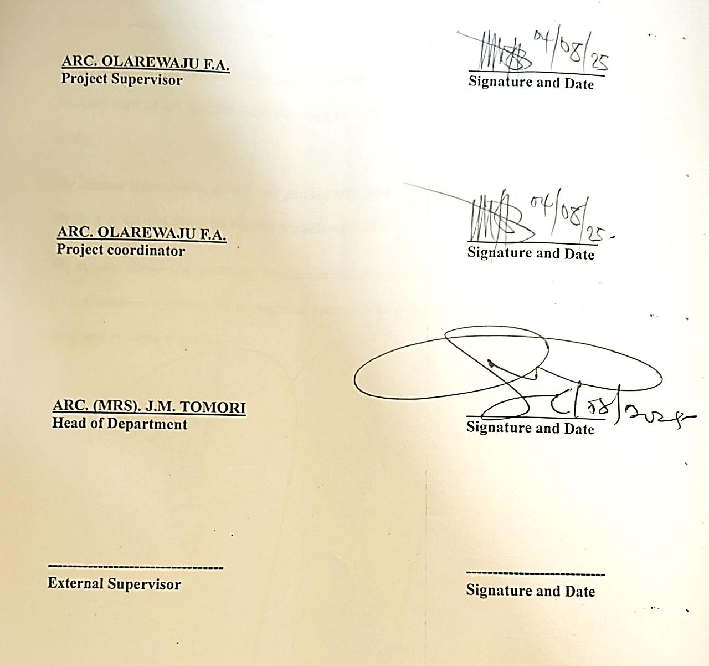

ARC. OLAREWAJU F.A __________________
(Project supervisor) SIGNATURE/DATE

ARC. OLAREWAJU F.A __________________
(Project Coordinator) SIGNATURE/DATE

ARC. MRS. J.M TOMORI __________________
(Head of Department) SIGNATURE/DATE

_________________ __________________
External Supervisor SIGNATURE/DATE

DEDICATION
This project is primarily dedicated to Almighty Allah, the Giver of Knowledge, Wisdom, and Understanding, for His Grace and Strength Throughout the Course of My Higher National Diploma, and for Counting Me Worthy of His Mercy, as well as to My Parents, MR & MRS TAOFEEK, My Entire Family and everyone who has supported me directly or indirectly.

ACKNOWLEDGEMENTS
I humbly acknowledge Allah, the maker of heaven and earth and who has kept me alive to this day. I am grateful to him for the epitome of greatness he has shown me through his love, concern, and guidance in all ramification of my life.
My sincere and genuine appreciation goes to my project supervisor ARC. OLAREWAJU F.A for his selfless support and motivation to keep me focus till this very time and inculcated in me the necessities to keep me on track after my HND program. My Head of Department, Arc. Mrs. Tomori and also the entire lecturer/staff of the Department of Architecture, for making my learning experience in the Department a great and productive one.
I cannot but appreciate my lovely family: MR & MRS TAOFEEK for your love, support and care during the course of study. Big appreciation to my Siblings, for all of their support and tireless work to see me succeed, may Almighty Allah provide you all ample reward. My sincere thanks also go to my friends and classmates. I can only express my gratitude for your assistance in getting me through this journey. May Allah continue to provide you all his favor and blessing (Ameen).

ABSTRACT
This design project covers the developmental nature of vocational studies centre including the relevant influence of these studies centre on their immediate environment. Chapter one covers the historical background, introduction, definition, scope of the study, justification etc. while Chapter two covers the relevant/related literature and the case study. Chapter three on the other hand covers fact about the proposed site which includes; Brief history of Ilorin, the climatic consideration, site location, site description, site analysis, existing infrastructure, site selection criteria and site planning. Chapter four also cover project concept, design scopes and briefs, analysis of the scopes and briefs, details of the parapet / drainage, expansion joint, steel roof details and space allocation etc. chapter five cover design solution e.g. acoustic, ventilation, lighting, orientation, fire protection and control, services, landscape design, construction specification and materials finishes and maintenance while Chapter six cover project summary, conclusion and reference.

TABLE OF CONTENTS
Title Page
Declaration…………………………………………………………………………. ………ii
Certification ………………………………………………………………………................iii
Dedication …………………………………………………………………………...............iv
Acknowledgment ……………………………………………………………………………...v
Table of content ……………………………………………………………………...............vi
List of plates ……………………………………………………………………...………….vii
List of Tables………………………………………………………….…………………….viii
Abstract ………………………………………………………………………………………ix
CHAPTER ONE:
1.0 General Introduction ………………………………………..…………………………1
1.1 Definition……………………………………………………..………………………..2
1.2 Historical Background of the Project. ………………………………………………...2
1.3 Statement of design problem ………………………………………………………….3
1.4 Aim and Objectives of the study……………….……………………………………...4
1.5 Project Justification …..….………………………………………….……..................5
1.6 Clients Background……………………….…………………………………………...5
1.7 Scope of the Study ……………..…………………………………………………..6
1.8 Limitation of Design……………………………………………………….................9
1.9 Research Methodology ………………………………………………………………10
CHAPTER TWO:
2.0 Review of Relevant Literature……………………………..………….….………….11
CHAPTER THREE:
3.0 Case Studies………………………………………………………………………….14
3.1 Selected Case Studies ……………………………………………………………….14
3.2 Case Study One….………………………………………………...………..............15
3.3 Case Study Two…..……………………………………………….…………………18
3.4 Case Study Three…………………………………………………………………….22
3.5 Case Study Four….…………………………………………………………………..26
3.6 Case Study Five (online case study) …………………………………………………29
3.7 Deduction from Case Study …………………………………………………………29
CHAPTER FOUR
4.0 Project Location.……………………………………………………………………..31
4.1 Historical Background of Selected Location State ………………………..31
4.2 Historical Background of Selected Location LGA…………….……………32
4.3 Physical Feature of the Location …………………………………………...33
4.4 Population...……………………………………………………………...….33
4.5 Social Service ……………………………………………………………….33
4.5.1 Road …………………………………………………………………………33
4.5.2 Health Service ……………………………………………………………….33
4.5.3 Water and Electricity ………………………………………………………..34
4.6 General Climatic Condition ………………………………………………....34
4.7 Site Analysis …………………………………………………………………35
4.7.1 Site Selection/ Justification …………………………………….……………35
CHAPTER FIVE
5.0 Design Report…………………………………………………………………42
5.1 Design Brief …………………………………………………………………..42
5.2 Design Analysis …………………………………………………………42
5.3 Design Appraisal ……………………………………………………………...45
5.4 Design Characteristics ………………………………………………………..45
5.5 Building Structure ……………………………………………………………47
5.6 Service ..………………………………………………………………………48
5.7 General Requirement …………………………………………………………48
5.7.1 Lighting ……….……………………………………………………………...48
5.7.2 Orientation …………………………………………………………………...49
5.7.3 Rain Protection Devices ……………………………………………………...50
5.7.4 Noise Control Device ………………………………………………………...50
5.8 Material and Finishes …………………………………………………………51
CHAPTER SIX
6.0 Summary and Conclusion ……………………………………………………54
6.1 Summary ……………………………………………………………………..54
6.2 Conclusion …………………………………………………………………...54
References …………………………………………………………………………...56
Appendix
CHAPTER ONE
1.0 GENERAL INTRODUCTION
A vocational center is a facility that provides training and education to individuals seeking to acquire skills and knowledge in a specific trade or profession. These centers offer a variety of programs and courses designed to prepare students for entry-level positions in various industries, including healthcare, construction, technology, hospitality, and more. Vocational centers may be operated by public or private institutions, and they typically offer a mix of classroom instruction and hands-on training. Students may learn through lectures, demonstrations, simulations, and practical exercises that allow them to apply their knowledge in real-world settings.
Vocational centres offer a diverse array of training programs in sectors such as tailoring, carpentry, ICT, hairdressing, welding, catering, plumbing, and electrical installations. These programs are often short to medium in duration and are tailored to address specific market demands and regional labor needs. As the global economy becomes more skill-driven, countries must empower their citizens not just with academic qualifications but with tangible skills that can generate income, promote self-reliance, and foster entrepreneurship.
Nigeria, with its burgeoning youth population, faces a significant challenge of aligning its educational outputs with labor market requirements. According to the National Bureau of Statistics (NBS), youth unemployment hovers around 40%, with thousands of graduates annually unable to find suitable employment. This scenario is compounded by the inadequacy of practical training in conventional educational institutions. Vocational centres, therefore, represent a strategic response to bridge this gap. By focusing on practical competencies and industry-relevant skills, they help create a productive labor force that can drive economic transformation at the grassroots level.
The goal of vocational centers is to equip students with the skills and knowledge they need to succeed in their chosen field. This includes not only technical skills but also soft skills such as communication, teamwork, problem-solving, and critical thinking. Many vocational centers also provide job placement assistance to help graduates find employment in their field.
Overall, vocational centers play an important role in preparing individuals for the workforce and helping to meet the needs of employers in various industries.
1.1 HISTORICAL BACKGROUND OF THE PROJECT
Vocational education has a long history dating back to the early 1900s when trade schools were established to provide practical training to individuals seeking employment in skilled trades. These schools focused on providing training in areas such as carpentry, plumbing, electrical work, and mechanics. In the 1960s and 1970s, vocational education underwent a significant transformation with the passage of the Vocational Education Act of 1963 and the Carl D. Perkins Vocational and Technical Education Act of 1984. These acts aimed to expand vocational education opportunities and provide funding for vocational programs in public schools and community colleges.
Today, vocational centers continue to play an important role in preparing individuals for careers in a wide range of industries. They offer a variety of programs and courses designed to provide students with the skills and knowledge they need to succeed in their chosen field. Many vocational centers also provide job placement assistance to help graduates find employment after completing their training.
The history of vocational education globally is rooted in the necessity of societies to pass on skills critical to economic survival. In pre-industrial societies, vocational learning was often informal and passed down through apprenticeships in trades such as blacksmithing, farming, tailoring, and masonry. Over time, industrialization transformed the nature of work, and with it, the structures for skill acquisition. The emergence of formal trade schools in the 19th and early 20th centuries laid the groundwork for modern vocational education systems.
In Nigeria, vocational education has evolved from its indigenous roots—where traditional guilds, families, and local mentors served as informal training platforms—to more formalized structures introduced during colonial and post-colonial eras. The colonial administration recognized the need for skilled labor and thus established vocational institutions focused on technical trades. After independence, the Nigerian government made concerted efforts to expand technical and vocational education through policies, national plans, and funding support. Institutions like Technical Colleges and Polytechnics were established to provide hands-on training across various skill areas.

1.2 DEFINITION OF VOCATIONAL CENTER
A facility that provides training and education to individuals seeking to acquire skills and knowledge in a specific trade or profession. A center that focuses on developing both technical skills and soft skills such as communication, teamwork, problem-solving, and critical thinking. A vocational center may be operated by public or private institutions and may also provide job placement assistance to help graduates find employment in their field.
1.3 STATEMENT OF DESIGN PROBLEM
INADEQUATE FUNDING OF TECHNICAL AND VOCATIONAL EDUCATION
This has caused the turning out of half -baked graduate because there is no fund to build and maintain workshops, laboratories or even purchase modern equipment. Staffing of vocational education is generally inadequate because of poor funding. Experience of skillful teachers may not be employed. Those that are employed, because of poor remuneration do not stay long in the teaching profession, but drift to some other more lucrative jobs especially in the industries and abroad.
INADEQUATE FACILITIES
Most vocational education departments in Nigerian universities do not have laboratories or workshop space, let alone useable equipment and where they exist, they are grossly inadequate as the workshops, only have items or equipment that were produced or provided when the departments were firstly established of which most of them are already obsolete or grounded.
1.4 AIM AND OBJECTIVES
The aim of providing a vocational center is to offer practical training and education to individuals seeking employment in skilled trades and other industries. These centers provide an alternative to traditional academic programs by focusing on hands-on training and real-world experience. Vocational centers often work closely with local employers to ensure that their programs are aligned with industry needs and that graduates are well-prepared for the workforce.
OBJECTIVES
- To design a well and proper building and well orientated vocational center, so as to avoid inconvenience while studying/training.
- To design a center that will conveniently accommodate the numbers of population in the entire vocational center.
- To design with the objective of providing more spaces for extra or future additional usage in the vocational center.
- Provision of easy and walkable functional link within each training sections.
1.5 PROJECT JUSTIFICATION
There are some motivating factors, which justify the choice and location of this project to be at Ilorin east local government, Kwara State.
The goal of vocational center is to prepare people to work as technician or take up employment skill craft or trade as a trade person or artesian.
Hence it has become a thing of necessity to provide a conducive and habitable environment to study vocational trainings. This is important because of the increasing rate of unemployment among the youth.
1.6 CLIENTS BACKGROUND
In terms of infrastructure, Ilorin East Local Government has made significant progress in recent years in communities, and built schools and health care centers to improve the standard of living of its people and also with access roads.
PHILOSOPHICAL REVIEW ON CLIENT
In the case of Ilorin East Local Government, its philosophy is centered around promoting the welfare and development of the community, fostering participatory governance, and ensuring transparency and accountability in its operations. It also prioritizes the provision of basic amenities such as healthcare, education, and infrastructure to improve the quality of life of its citizens.
OPERATIONAL STRUCTURE AND GOAL OF THE PROPOSAL
The essentialism of the project is to reduce unemployment and thuggery in the society. Government provision of vocational education to youth should be one of the major national infrastructural goals.
1.8 LIMITATION TO DESIGN
The project research and itself have exerted a good deal of financial pressure.
Many of the projects studied do not meet up with the scope required of a standard vocational school.
Due to financial constraint, the study is limited to some areas in some certain community, rather it would have covered majority of the places.
1.9 RESEARCH METHODOLOGY
Various avenues were explored as regard the method of research in order to arrive at a functional and appealing design concept. The following research methods were employed.
Literature review: reference to tolerance for ideas of various writer were consulted in order to attain useful and important past thesis work on similar project.
Oral interview: practicing architects, engineers, allied professional as well as students of various schools were interviewed and better deduction from their information sources also influence the end design.
Personal observation: personal initiations coupled with inquisitive measure, interviewed and visitation was made in order to actually visualize the daily activities that take place within the required motive.
Case study: This involves the thorough synthesis and analysis of similar existing structure building based on the data collected and better seduction was made for realization of the design best.

CHAPTER TWO
REVIEW OF RELEVANT LITERATURE
A. Review of Literature on rage building type:
According to study by Adeyemi and Ojo (2016), Vocational education and training is crucial for the economic development of Nigeria. The study highlights the needs for vocational education to be integrated into the formal education system, as well as the need for vocational centers to be equipped with modern facilities and equipment.
Another study emphasizes the importance of vocational education in reducing unemployment and poverty in Nigeria. The study recommends the establishment of more vocational centers as well as the provision of funding and support for existing centers.

B. Review of Literature on the sub-topics of the thesis.
In terms of vocational centers in Ogun state specifically, a report by the national bureau of statistics (2017) found that there were 16 vocational centers in the state. The report notes that these centers offer training in various fields, including agriculture, fashion design and ICT.
Overall, the literature suggests that vocational education and training is important for the economic development and social wellbeing of Nigeria, including kwara state. While there is limited literature specifically focused on vocational centers in kwara state. It’s clear that there is a need for more investment and support in this areas.

Complexity of Vocational Education Training (VET System i.e. Issues)
Although VET is used to describe a type of education and training, what constitutes VET and how it is delivered varies across countries (Grubb, 2006). Among the issues which are treated differently by countries are definition and status of vet, the balance between academic and practical content of vet programs. Where vet is provided in an institution (if so, what type) or at work the types of training delivered or needed the flexibility of programs to meet market need.
Countries also focus differently on the type of skill and vet should be address and whether they should be more academic or practical (Grubb2006) linked to this, the boundaries between the education component of vet and the training component are often imprecise. In many countries, training refers to short term job training programs to retains or upgrade skills and education is seen as a longer duration exercise with broader implications for knowledge as well as skills.

Planning and Design Vet Facilities.
The education infrastructure for vet programs also serve as more specific purposes in that of prepares students to enters the workforce with a set of specific technical skills while the issues of facility planning for technical school are not markedly different from those in other academic facilities, there are other challenges with regards to the maintenance and improvement of specialized equipment that is needed for instruction. Cutshall,2003) Spaces for VET have distinct requirements for constructing the infrastructure, which include equipment room size and providing resources for a range of activities to addition to provide conventional classroom for academic activities (JISC 2006) spatial and equipment needs vary depending on the country job market demands curriculum requires the programme funding and organization.

Evolution of Vocational Architecture in Nigeria
The architecture of vocational education has evolved significantly over the past decades. Traditionally, vocational training in Nigeria occurred in informal workshops, apprenticeships, or basic technical classrooms with limited infrastructure. These spaces were often poorly ventilated, lacked specialized equipment, and were not inclusive of women, youth, or persons with disabilities.
With increasing policy emphasis on Technical and Vocational Education and Training (TVET), particularly through agencies like the Industrial Training Fund (ITF) and National Board for Technical Education (NBTE), there has been a shift toward purpose-built vocational centres. These newer buildings incorporate workshop studios, digital labs, smart classrooms, administrative blocks, and communal areas—designed to support a modern, inclusive learning environment.
In Kwara State, initiatives such as the Kwara Vocational Training Centre and community skill acquisition programmes have demonstrated a growing recognition of the role architecture plays in shaping productive learning environments.

Classification of Vocational Centre Typologies
Vocational training centres can be categorized based on:
Function-Based Typologies:
- Technical skill training centres (e.g., mechanical, electrical, ICT)
- Agro-based vocational centres (e.g., food processing, animal husbandry)
- Arts and craft centres (e.g., tailoring, carpentry, bead making)
- Entrepreneurship incubation centres

Scale-Based Typologies:
- Cottage or community-based centres (small-scale, informal)
- Medium-sized regional institutes (state-supported institutions)
- Large-scale multi-campus vocational colleges
Ownership-Based Typologies:
- Public: State or federally funded centres
- Private: NGO or private-sector led institutions
- Public-Private Partnerships (PPP)
Layout Typologies:
- Linear block models
- Cluster or courtyard-based systems
- Modular or expandable container-type units
- Campus-style with zoning for workshops, classrooms, hostels, and administration
The typology selected affects spatial hierarchy, safety design, energy use, and adaptability to curriculum changes.

Functional Space Relationships in Vocational Centres
A well-designed vocational training centre must promote flow, safety, and flexibility. Workshops must be isolated from quiet academic zones to reduce noise, while ensuring proximity to tool storage and instructor offices.
Typical spatial components include:
- Reception and Administrative Wing
- Multi-skill Training Workshops (metalwork, fashion, ICT, etc.)
- Theory Classrooms and Digital Labs
- Instructor and Resource Rooms
- Sanitary Facilities and Lockers
- Exhibition or Demo Zones
- Outdoor Practical Spaces (e.g., farming plots, fabrication sheds)
- Student Lounge and Meeting Rooms
- Storage, Generator House, and Security Posts
Clear zoning and circulation ensure user safety, efficiency, and compliance with training protocols. Zoning also supports separation of theoretical learning from hands-on practice.
Innovative and Contextual Design Strategies
In Ilorin, the semi-urban context and hot climate present both challenges and opportunities. Design strategies must optimize natural ventilation, thermal comfort, and low-cost materials.

Context-Sensitive Approaches Includes:
- Use of deep eaves and shaded corridors
- Courtyard planning for airflow and daylight access
- Rammed earth, laterite, or stabilized blocks for walls
- High louvre windows and roof vents for heat escape
- Flexible spaces with movable partitions
- Rainwater harvesting systems for plumbing and cleaning
- Such designs reduce operational costs and improve durability while leveraging local building practices.

Technological and Environmental Design Trends
Modern vocational centres increasingly integrate technology for training relevance and sustainability:
- Smart classrooms with interactive boards and online learning tools
- Solar-powered workshops and LED lighting
- ICT hubs for computer literacy training
- Use of energy-efficient roofing and ceiling insulation
- Green landscaping to reduce site heat

CHAPTER THREE
3.0 CASE STUDIES
- INSTITUTE OF ENTREPRENEURSHIP AND DEVELOPMENT STUDIES (IEDS) OAU, ILE-IFE.
- INSPIRE VOCATIONAL ACADEMICS JIBOWU, LAGOS STATE.
- THE STONE TECHNICAL COLLEGE AT ADERINOLA, IBADAN.
- W.A.P.A SKILL ACQUISITION AND VOCATIONAL CENTER LOCATED AT EGBEDA, LAGOS STATE.
- NORTH VALLEY OCCUPATIONAL CENTER LOCATED IN LOS ANGELES, CALIFORNIA.
- TOULON VOCATIONAL CENTER LOCATED IN TORONTO, CANADA.
3.1 CASE STUDY ONE
INSTITUTE OF ENTREPRENEURSHIP AND DEVELOPMENT STUDIES (IEDS) OAU, ILE-IFE.
BRIEF INTRODUCTION
The (IEDS) was established in response to the growing need for entrepreneurship education in Nigeria. Founded to equip students with the skills necessary to become job creators and foster, An entrepreneurial culture, IEDS aim to address youth unemployment and contribute to economic development. Since its establishment, the institute has offered various undergraduate and postgraduate programs focused on entrepreneurship, business development, and innovation.
Its efforts have significantly impacted the local and national economy, producing graduates who have gone on to create successful businesses and contribute to Nigeria’s economic growth. IEDS continues to collaborate with both local and international organizations to promote entrepreneurship in Nigeria.
COURSES OFFERED:
- Tailoring
- Electrical and Electronic
- Computer Engineering
- Mechanical engineering
- Carpentry

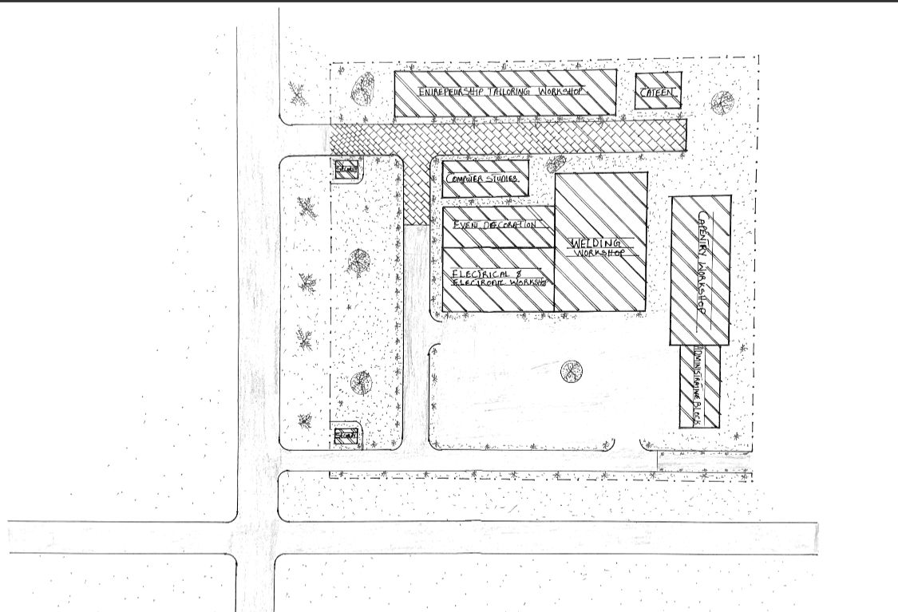

Fig 3.1: Site Plan
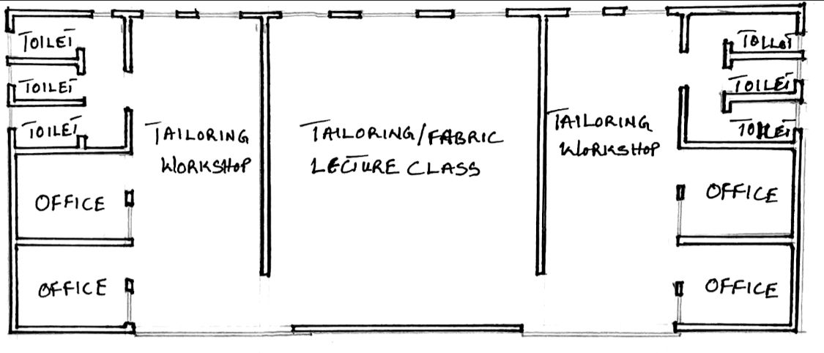

Fig 3.2: Tailoring Workshop

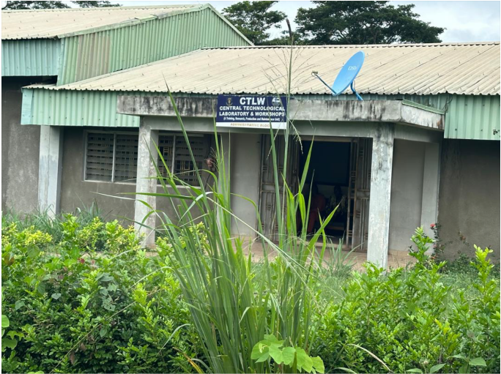

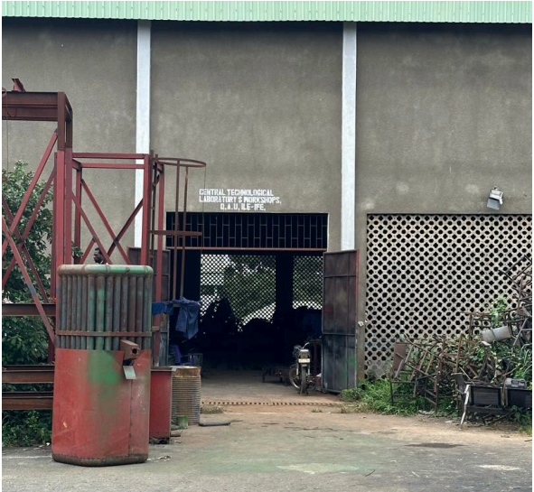
Plate 3.1: Administrative Block

PLATE 3.2: Mechanical and Welding Workshop
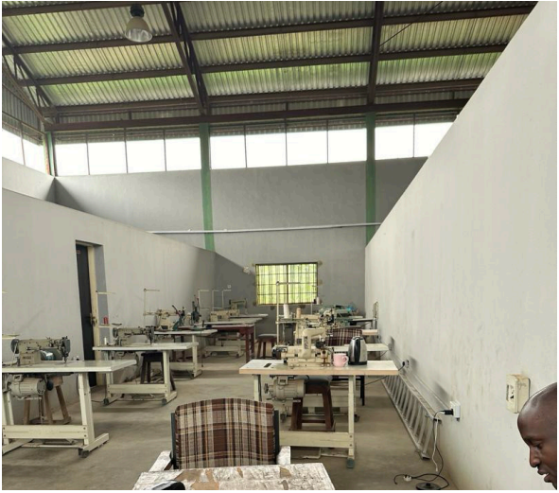

Plate 3.3: Tailoring Workshop
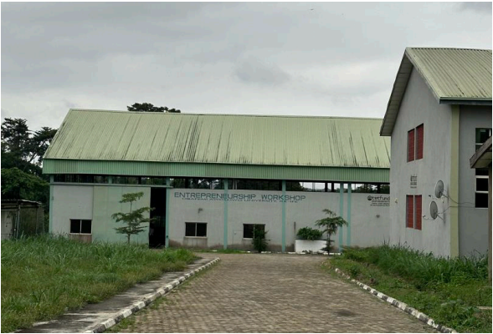

Plate 3.4: Way to Computer Engineering and Tailoring Workshop
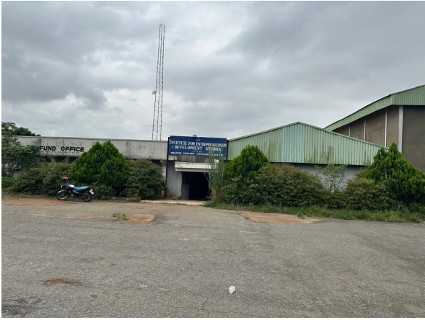

Plate 3.5: Electrical and Electronic Workshop
3.1.1 MERITS
- The facility is easily accessed.
- It’s units are well ventilated.
- Probably built for its purpose.
3.1.2 DEMERITS
- Poor drainage system.
- Site scope is not well segmented.

3.2 CASE STUDY TWO
INSPIRE VOCATIONAL ACADEMICS JIBOWU, LAGOS STATE.
Inspire vocational academics was established in response to the growing challenge of youth unemployment and the need for more accessible vocational education in Nigeria by offering programs that combine theoretical knowledge with practical experience, the institute seeks to empower individuals, particularly in urban areas like lagos with the necessary skills for self-employment and to meet the needs of the rapidly changing job market.
COURSES OFFERED:
- Baking and Cooking
- Shoe making
- Electrical engineering
- Phone repairs
- Event decorations
- Computer studies
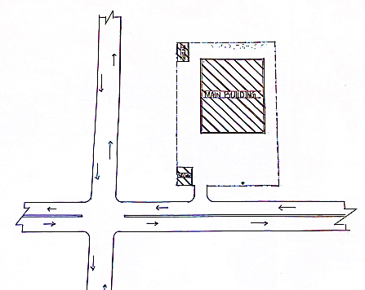

Fig 3.4: Site Plan
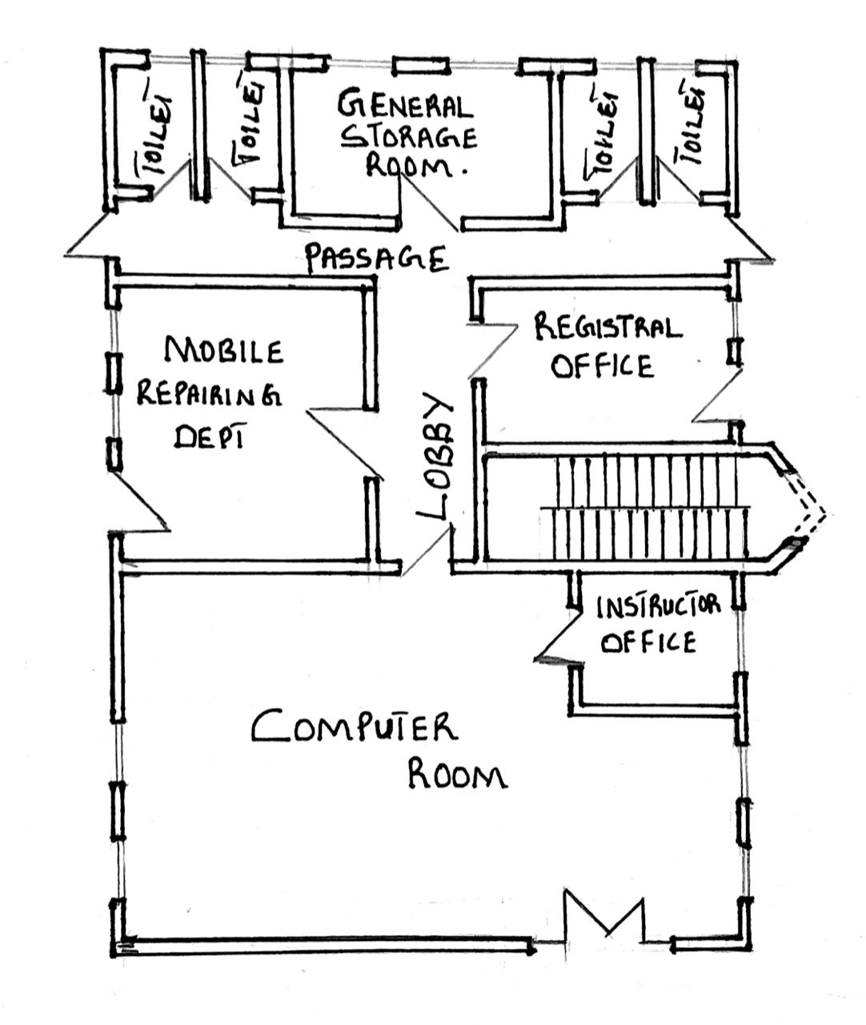

Fig 3.5: Ground Floor Plan
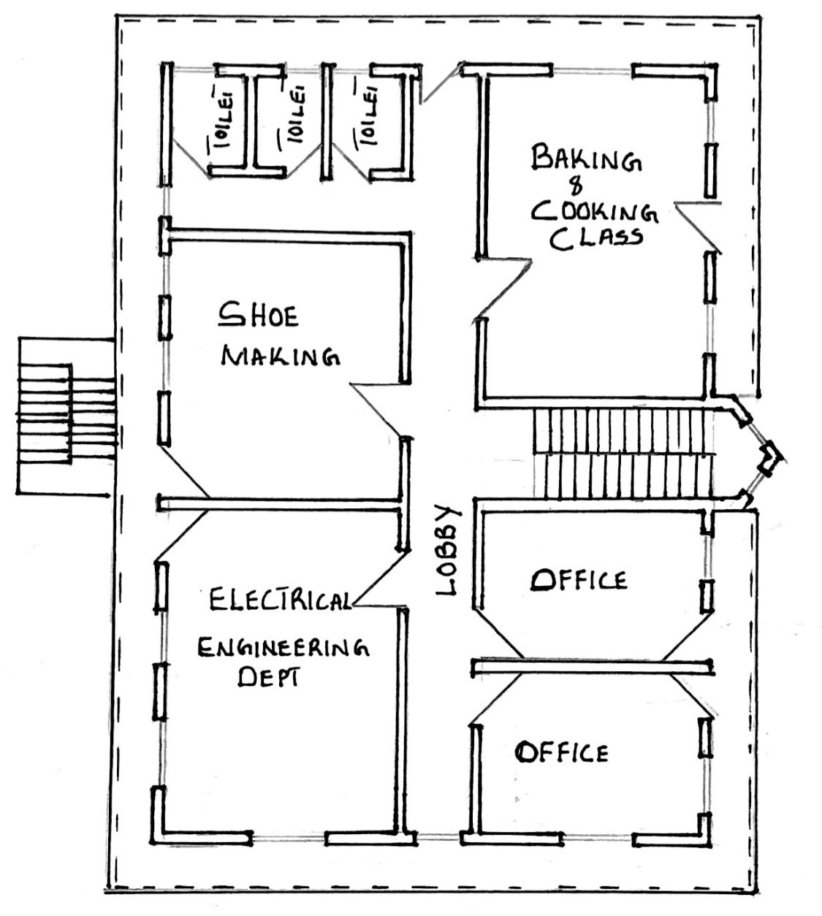

Fig 3.6: First Floor Plan

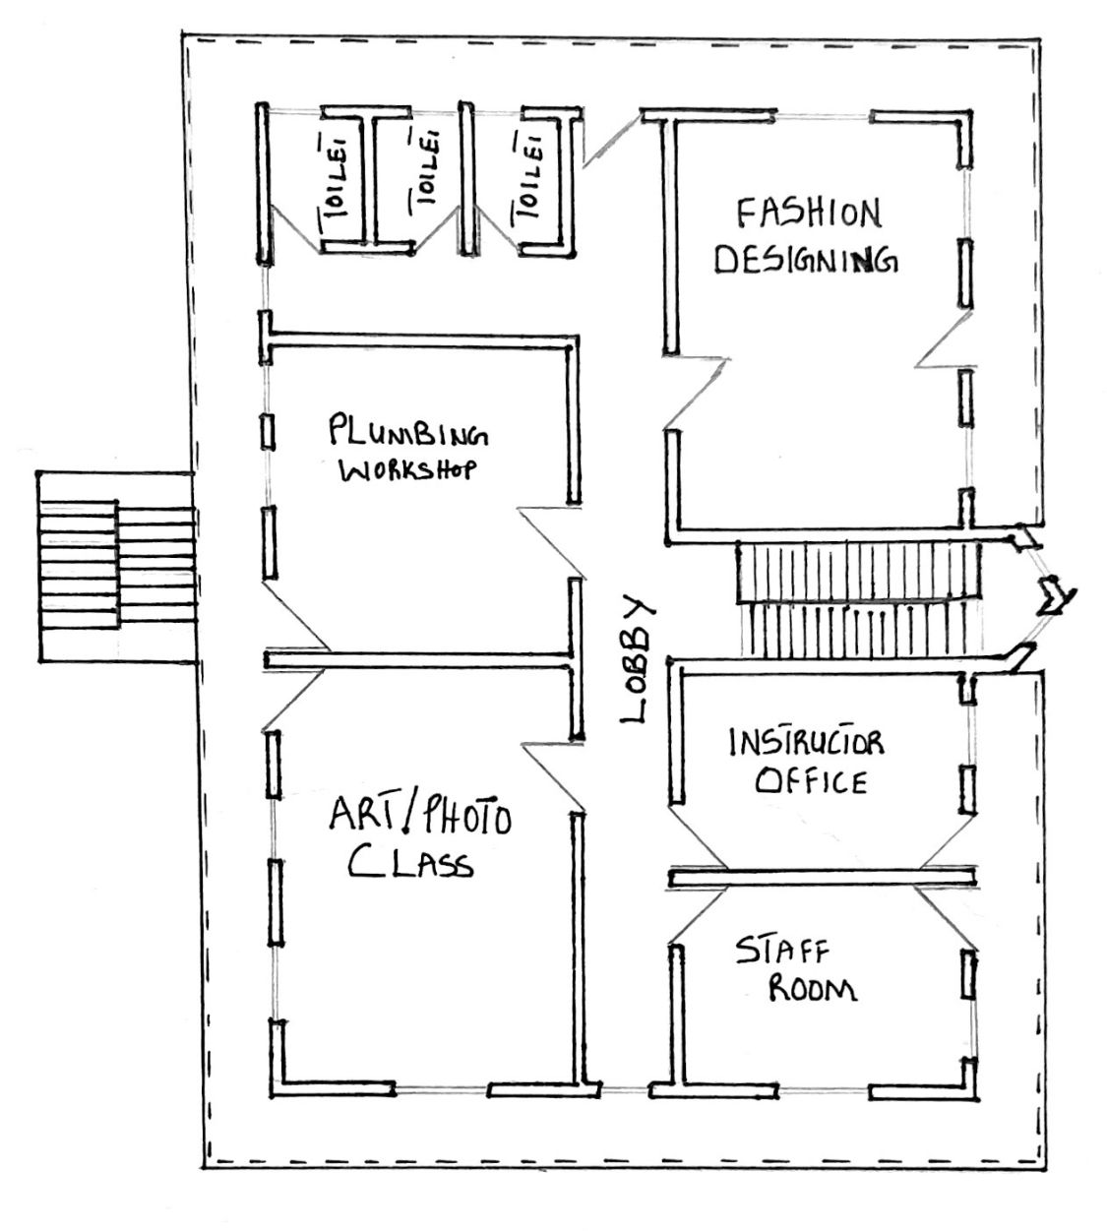

Fig 3.7: Second Floor Plan
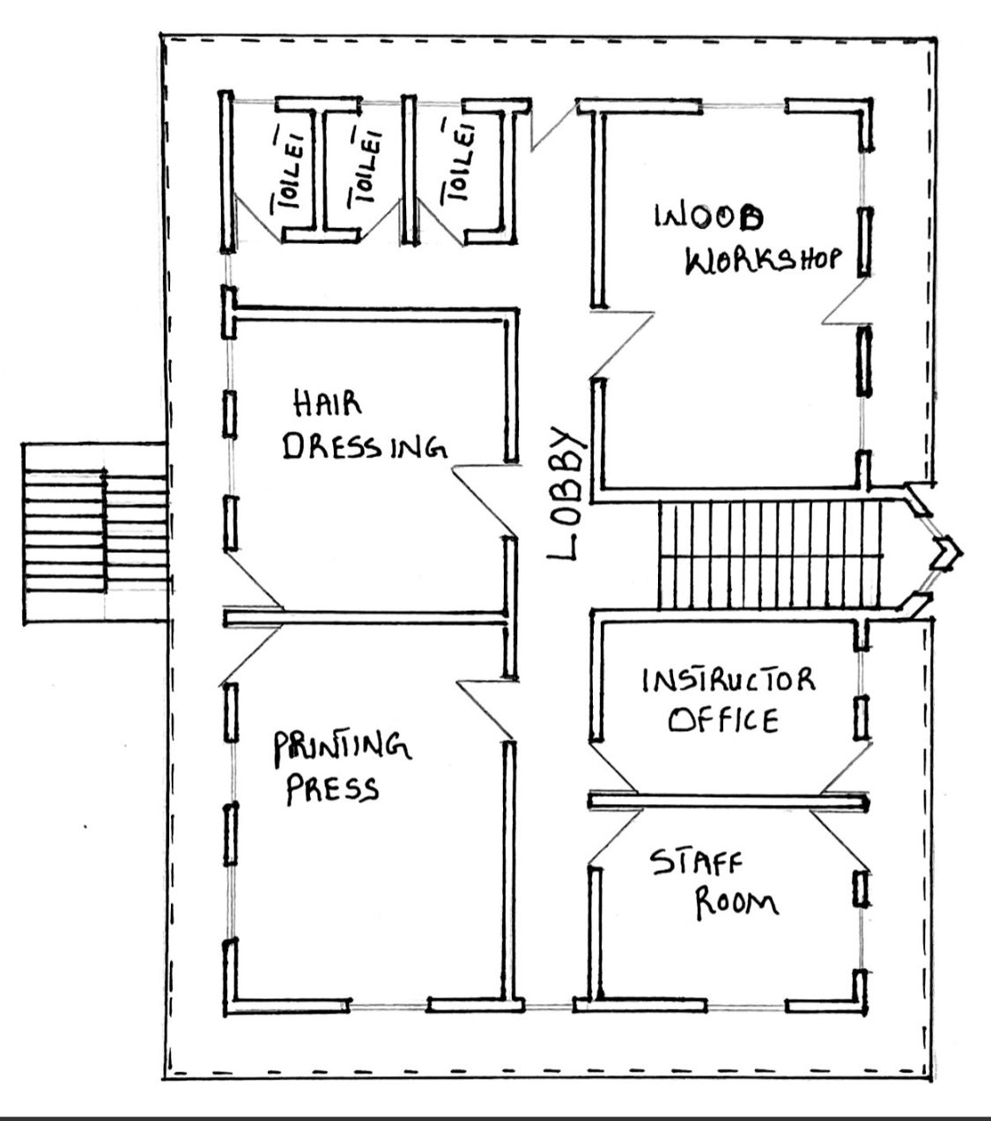

Fig 3.8: Third Floor Plan

Plate 3.6: Electrical and Electronic Dept.
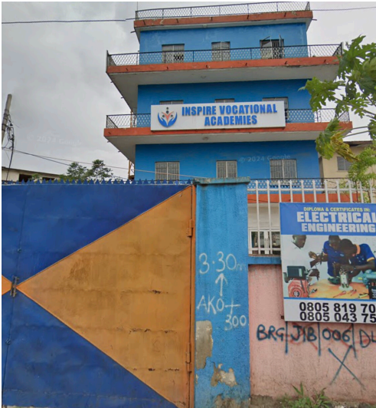

Plate 3.7: Front View
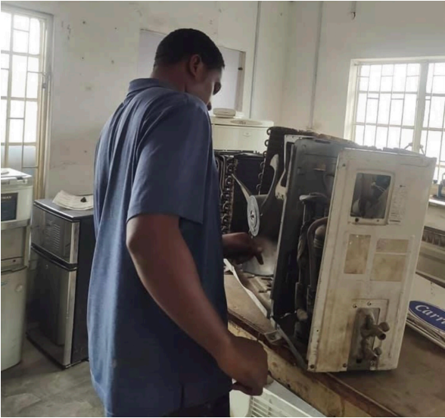

3.2.1 MERITS
- Easily accessed
- Enough lectures
3.2.2 DEMERITS
- It was built in a noisy environment
- The building is a mix-use building
- Poor landscaping of the site

3.3 CASE STUDY THREE
THE STONE TECHNICAL COLLEGE AT ADERINOLA, IBADAN.
IBADAN is one of Nigeria’s largest cities and a hub for education and commence, STONE TECHNICAL COLLEGE was created in response to the rising need for vocational and technical education to bridge the gap between academic education and the practical demands of the labor market.
Since its establishment, stone technical college has been committed to offering programs that combine theoretical learning with practical training, ensuring that graduates are well prepared to meet industry standards. The institution plays an important role in addressing youth unemployment by providing skills that are directly relevant to the workforce. They’re by contributing to the growth of Nigeria’s economy through a more skilled and capable labor force.
COURSES OFFERED:
- Tailoring
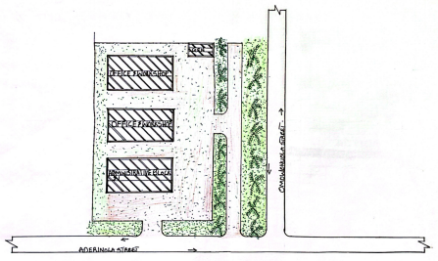
- Hair styling
- Plumbing
- Baking and Cooking
- Event decoration

Fig 3.9: Site Plan

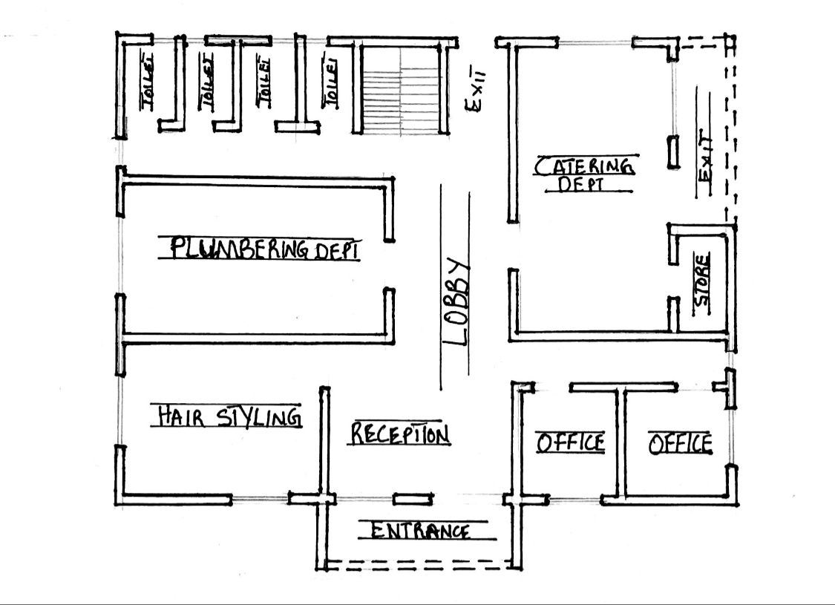

Fig 3.10: Ground Floor Plan
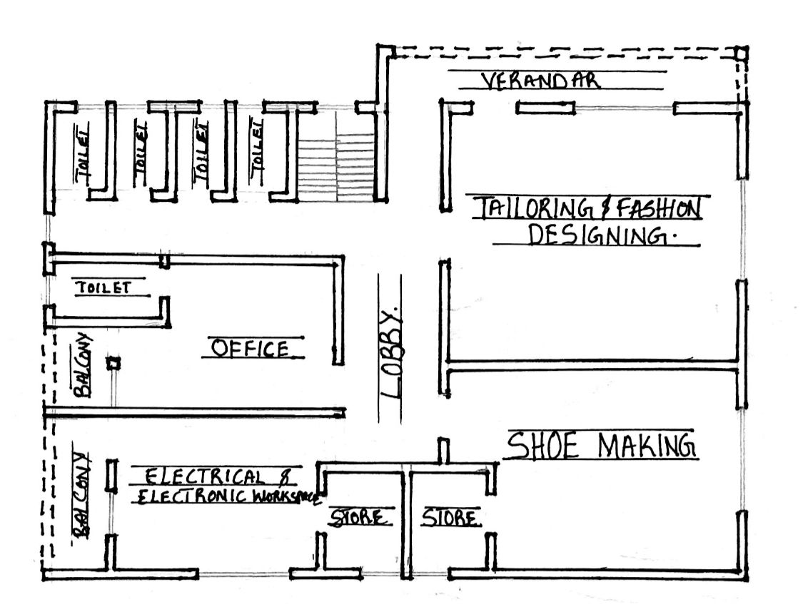

Fig 3.11: First Floor Plan

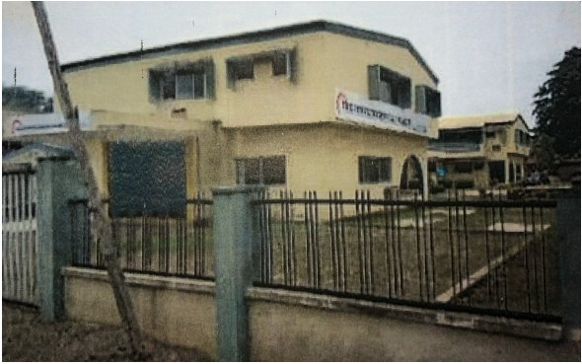

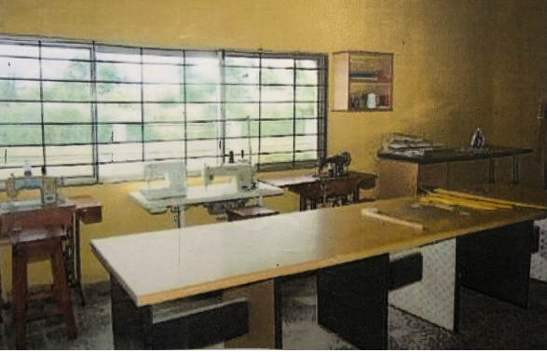
Plate 3.9: Side View

Plate 3.10: Tailoring Workshop
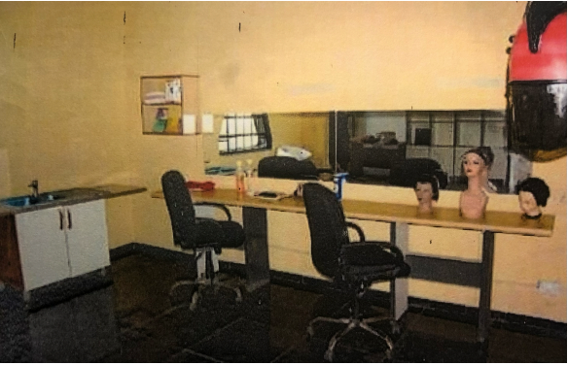

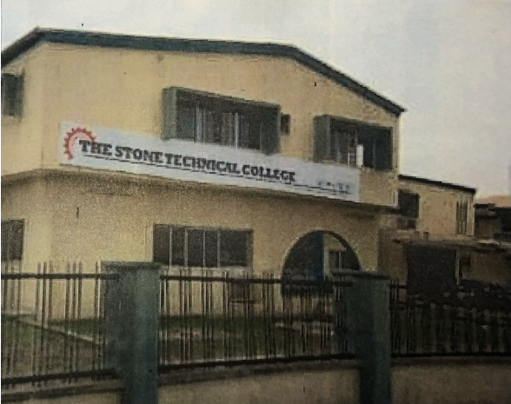
Plate 3.11: Hair Styling

Plate 3.12: Side View
3.3.1 MERITS
- Easily accessible from the gate
- Good security
3.3.2 DEMERITS
- Poor landscaping
- Poor drainage system
- Poor ventilation for the lecture rooms

3.4 CASE STUDY FOUR
W.A.P.A SKILL ACQUISITION AND VOCATIONAL CENTER LOCATED AT EGBEDA, LAGOS STATE.
BRIEF INTRODUCTION
WAPA means Women Affairs and Poverty Alleviation. The Ministry was established in 1999. Prior to its becoming fully ledged Ministry, it had passed through various stages of evolvement. The Ministry comprises of different and various types of departments, units and agencies. Under the section of poverty alleviation and Skill Acquisition Development Unit(SADU) felt the idea of creating a Vocational training scheme which has literally birthed the WAPA skill acquisition center in Egbeda, Lagos state. They commenced academic activities with just 30 students admitted into the school and has gradually increased into numerous amount of students. The following are some of the courses offered in the school:
- Aluminum studies
- Computer studies
- Fashion Designing
- Catering
- Hair Making/Dressing
- Welding

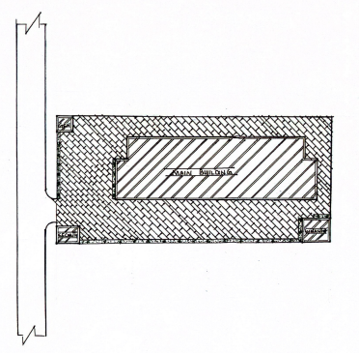

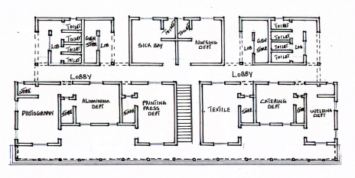
Fig 3.12: Site Plan

Fig 3.13: Ground Floor Plan
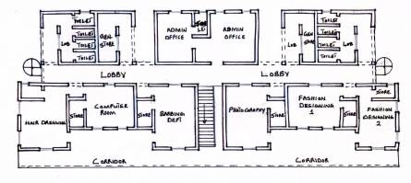

Fig 3.14: First Floor Plan

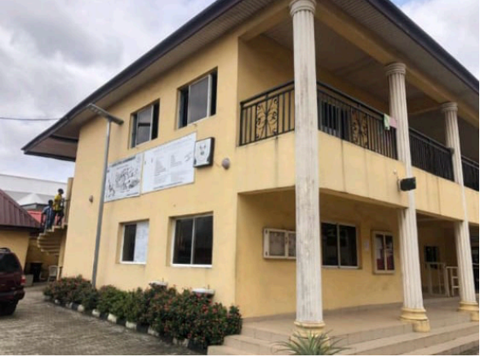

Plate 3.13: Side View
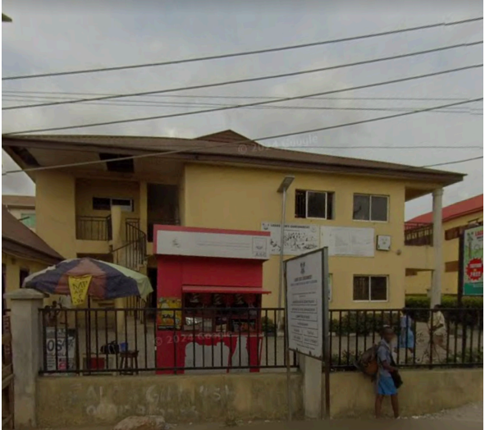

Plate 3.14: External View
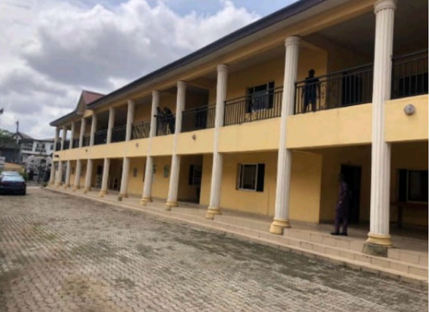

Plate 3.15: Side View
3.4.1 MERITS
- The facility is easily accessed
- Properly built for its purpose
- It’s units are well ventilated
3.4.2 DEMERITS
- It was built in a noisy environment
- Poor drainage system
- Site scopes is not well segmented
3.5 CASE STUDY FIVE (ONLINE)
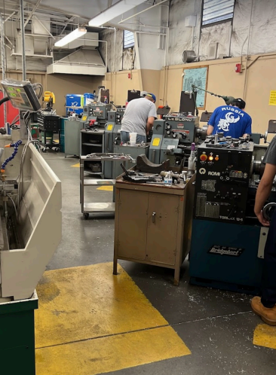
NORTH VALLEY OCCUPATIONAL CENTER LOCATED IN LOS ANGELES, CALIFORNIA.

Plate 3.16: Mechanical/Electrical & Electronic Workshop
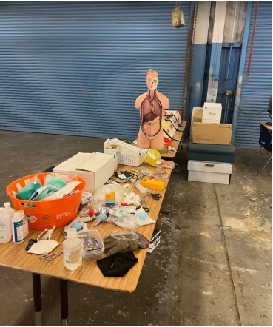

Plate 3.17: Science Laboratory
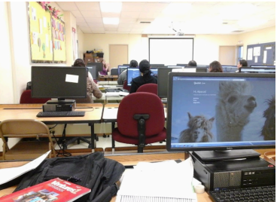

Plate 3.18: Computer Room
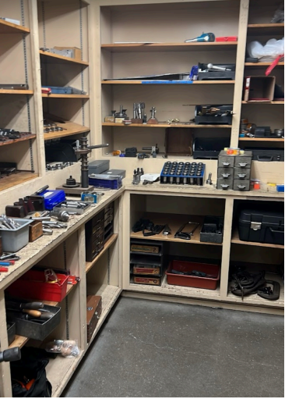

Plate 3.19: Tools Shop
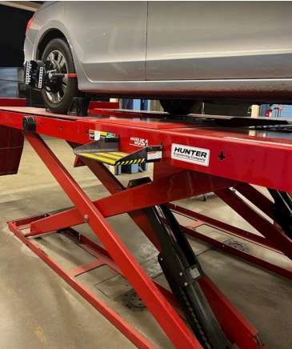

Plate 3.20: Automobile Workshop
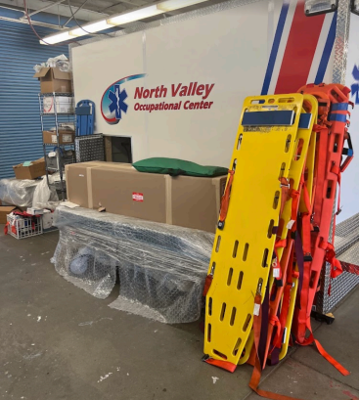

Plate 3.21:-
3.6 CASE STUDY SIX (ONLINE)
TOULON VOCATIONAL CENTER LOCATED IN TORONTO, CANADA
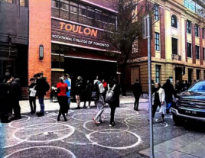

Plate 3.22: Outside View
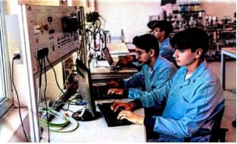

Plate 3.23: Computer Studies
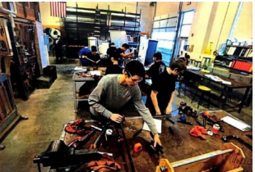

Plate 3.24: Carpentry and Wood Workshop


Plate 3.25: Automobile Workshop


Plate 3.26: Metal/ Mechanical Workshop
3.7 DEDUCTION FROM CASE STUDIES:
These are the common similar knowledge or information derived from the aforementioned case studies. Some of which are:
- Choice of location should be in a developing or already developed area for easy access to the trainings offered.
- Segregation of each department from one another.
- Well designed and well positioned landscapes.
- Separation of noisy departments from departments with less noise.
- Provision of required ventilation and fenestration into each units to serve the spaces well.

CHAPTER FOUR
4.0 ANALYSIS OF THE ENVIRONMENTAL AND TOPOGRAPHICAL CONDITIONS OF THE SITE
4.1 INTRODUCTION TO STUDY AREA
HISTORICAL BACKGROUND OF KWARA STATE
Kwara State, located in North-Central Nigeria, boasts a rich and diverse history. Here's a summary of its historical background till date:
Early History:
Kwara State was part of the Oyo Empire, a powerful West African kingdom, during the pre-colonial era. The region was influenced by Yoruba culture, language, and politics .

Formation of Kwara State:
Kwara State was created on May 27, 1967, by General Yakubu Gowon as part of Nigeria's restructuring into 12 states. Initially named West Central State, it was later renamed Kwara after the local name for the River Niger .

Colonial and Post-Colonial Period:
The Fulani Jihad led by Usman dan Fodio brought Islamic influence to the region in the 19th century. Ilorin, the capital, became a prominent emirate under the Sokoto Caliphate. The British incorporated the region into the Northern Nigeria Protectorate in the 1890s and 1900s.

Culture and Ethnic Diversity:
Kwara State is home to various ethnic groups, including Yoruba, Nupe, Bariba, and Fulani. The state is known for its peaceful coexistence among its people, earning it the nickname "State of Harmony”.

Recent Developments:
As of June 2025, Kwara State faced challenges with insecurity, including abductions and protests in Lafiagi. The state government and local leaders are working to address these issues.
4.2 HISTORICAL BACKGROUND OF ILORIN EAST LOCAL GOVERNMENT
Ilorin East Local Government is located in Kwara State, Nigeria and Here's what we know about its historical background:

Overview of Ilorin East
- Location: Ilorin East is one of the 16 Local Government Areas in Kwara State.
- Headquarters: The headquarters of Ilorin East Local Government is in the town of Oke Oyi.
- Population: As of the 2006 census, Ilorin East had a population of 204,310 people.

Historical Context of Ilorin and Kwara State
- Ilorin was originally a Yoruba town used as a military outpost by the Alaafin of the Oyo Empire.
- Kwara State was created on May 27, 1967, from the former Ilorin and Kabba provinces of the Northern Region.

4.3 PHYSICAL FEATURE OF THE LOCATION
- Location: Ilorin East is one of the 16 Local Government Areas in Kwara State, with its headquarters in Oke Oyi.
- Districts: Ilorin East comprises districts like Magaji Are, Iponrin, Ibagan, Agbeyangi, and Oke Ose.
- Geography: Ilorin East covers about 486 square kilometers with an average temperature of 29 degrees centigrade and average humidity of 52 percent.
Natural Resources and Features in Ilorin East
- Natural Resources: Maize, cereal, locust beans, and cassava are grown in the area.
- Mineral Resources: Granite, clay, and kaolin are found in Ilorin East.
- Tourist Attractions: Sobi Hills and pottery in Ilorin are notable.
4.4 POPULATION OF KWARA STATE
The population of Kwara State in Nigeria is projected to be approximately 3,834,000 in 2025. This represents a growth of about 7.96% from the 2022 population of 3,551,000. Kwara State is experiencing steady growth mainly due to urban development.

Breakdown of Population by Local Government Area (2025)
- Ilorin West : 591,980
- Ilorin East : 336,315
- Ilorin South : 339,122
- Baruten: 335,020
- Edu : 326,814
- Other local governments have populations ranging from about 88,000 to over 330,000

Demographics
- Age Group: 32.6% are 0-14 years, 62.5% are 15-64 years, and 4.8% are 65 years and over.
- Ethnicity: Yoruba (65.2%), Nupe (18.3%), Fulani (7.8%), Baruba (5.2%), and others.

4.5 SOCIAL SERVICES
- Health Care Delivery: Primary health care and immunizations in local governments like Ilorin East.
- NGOs: Organizations like Society for Family Health and Giving Hands Food Initiative work on health, food security, and poverty alleviation.
- Community Development: Programs like KWASSIP contribute to social infrastructure.

4.5.1 ROAD
The tarred regional road of Oke ose pass through 2go road from Dangiwa to Agbede. Access road to the proposed site has its connection to this major road and other neighboring areas.

4.5.2 HEALTH SERVICE
Among other social infrastructural facilities in the school is health service center and, in the town, indeed government owned general hospital, private hospital, clinic and maternity home.

4.5.3 WATER AND ELECTRICITY
There is well and borehole water which serves as the inhabitant of Oke ose and its environs. There is electricity supply from ilorin Electric that serve the institute, the community and Kwara state at large.

4.6 GENERAL CLIMATIC CONDITION
Kwara State in Nigeria has a tropical climate, classified as Aw according to the Köppen-Geiger climate classification. This means the state experiences a significant decrease in precipitation during the winter season compared to summer.

General Climatic Conditions
- Temperature: Average temperature is around 26.7°C (80.1°F), with highs of 36°C and lows of 22°C.
- Precipitation: Annual precipitation is approximately 120.6 mm in some areas, with the wettest month being September (274.6 mm avg) and the driest months typically during winter.
- Humidity: Humidity ranges from 37% in January to 84% in August.
- Seasonal Variations: Summer months experience more rainfall than winter months.
Current Weather Conditions (July 17, 2025)
- Temperature: Currently 22°C with overcast skies.
- Forecast: Expect isolated thunderstorms with highs in the mid-80s (°F) and lows in the low 70s (°F).

RELATIVE HUMIDITY
Relative humidity in Ilorin, Kwara State, Nigeria is currently at 90% with temperatures around 72°F (22°C). Looking ahead to tonight, humidity is expected to be at 88% with lows near 70°F.
General Climate Patterns in Kwara State
- Seasonal Variations: Kwara State experiences a tropical climate with rainy seasons between March and October, and dry seasons from November to February.
- Humidity Levels: Humidity is moderately high, with rainfall amounts in the south being higher than in the northern part of the state.

WIND
In Kwara State, particularly in Ilorin, today's wind conditions are as follows:
- Wind Direction: Southwest (SW)
- Wind Speed: 10 to 15 mph
- Gusts: Up to 41 km/h (according to AccuWeather).

TEMPERATURE
In Ilorin, Kwara State, today's temperature is expected to range from a low of 70°F (21°C) to a high of 85°F (30°C).

4.6.4 VEGETATION
The proposed site is partially covered with grasses, few trees and shrubs. Some will be removed before the construction while some will be retained for ornamentation.

4.7 SITE ANALYSIS
4.7.1 SITE SELECTION/JUSTIFICATION
In the site selection provision is made for interesting facilities that Worth emulating since the overall success and efficiency of any project depend not only on the functionality of the design but also careful choice of Site. The site of this project has been carefully selected which is located at Oke-Ose , 2go Road Dangiwa, Agbede, Ilorin east local government area,Kwara State, resident building as appears on the layout plan of kwara state.
The following factors affect the site selection
- Accessibility
- Location
- Infrastructural facilities
- Topography
- Soil structure.

ACCESSIBILITY
The major road connecting 2go road to Agbede is the closest way to the site and the site can also be easily accessed through Oke ose, Dangiwa road.

LOCATION
Site location: The site is located at Ilorin east Local Government, Oke ose , 2go Road Dangiwa, Agbede, Kwara State. It is a well-located site for the proposed project as the location is under developed and good of educational facilities. The site is conducive and effective for learning, it is a very wide land suitable for the proposed project and giving numerous advantages to the community around the site.

INFRASTRUCTURAL FACILITIES
Facilities such as water, electricity, telephone network and road network etc. Hence it can easily be tapped to the proposed site.

TOPOGRAPHY
The topography of the land is gentle slope towards cast which can assist for the construction of drainage on site.

SOIL STRUCTURE
Soils in Kwara State are generally alfisols,common in savanna regions of Nigeria, with varying fertility supporting crops like maize, yam, and cassava.

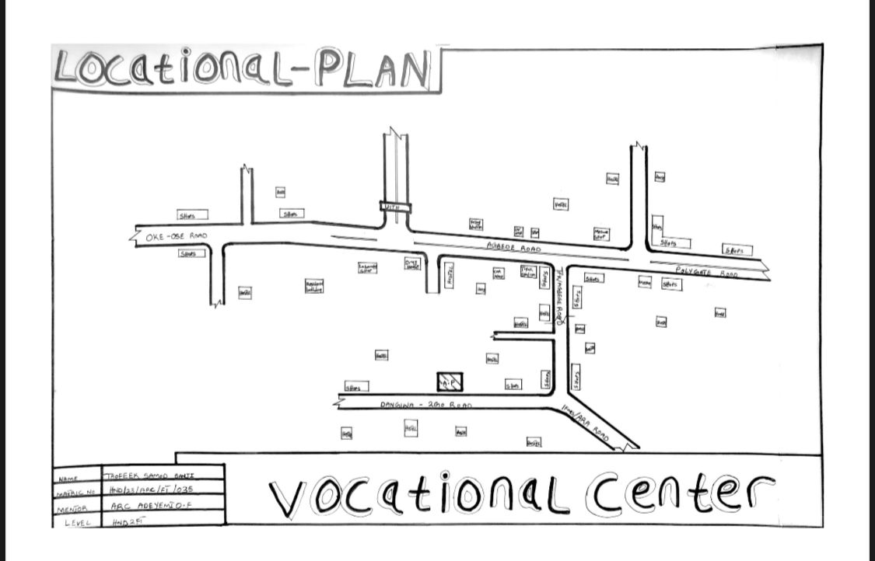
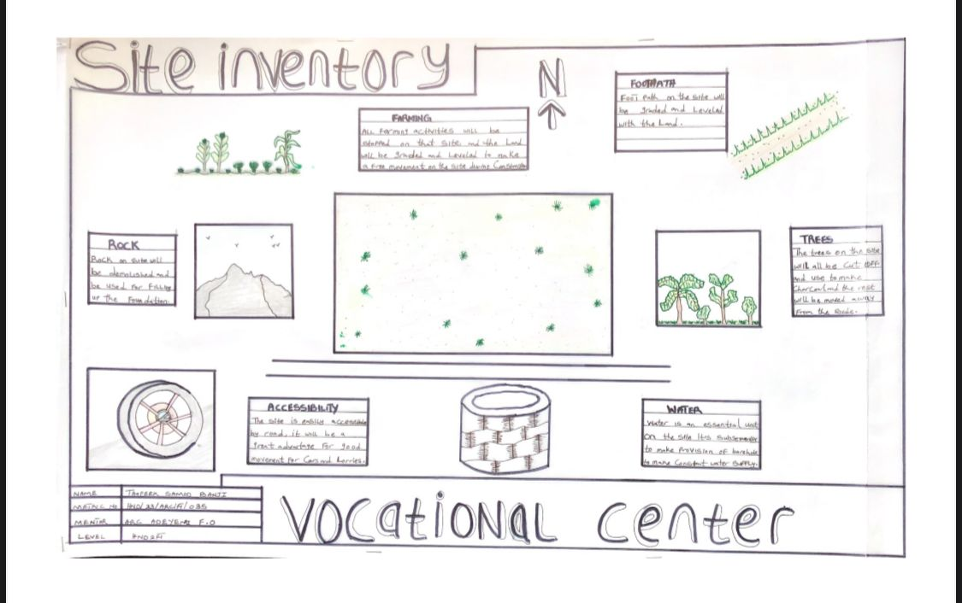
FIGURE 4.2: SITE INVENTORY
FIGURE 4.1: LOCATION PLAN
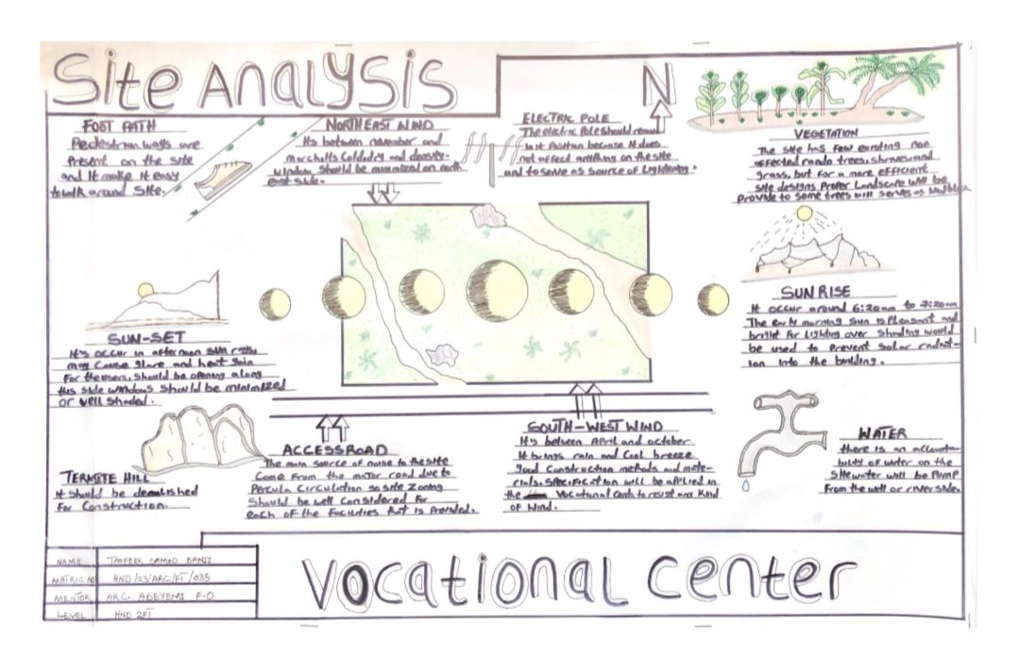

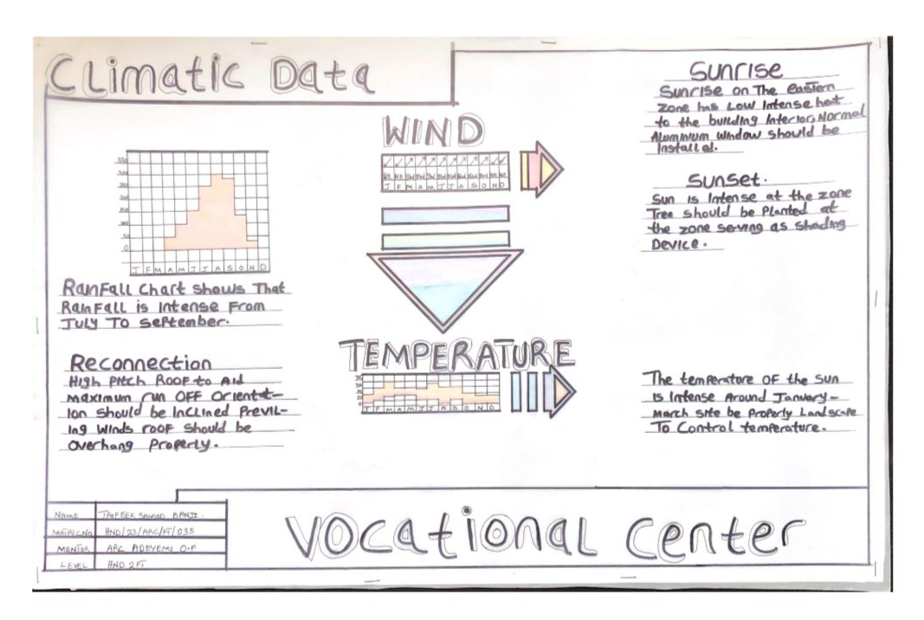
Figure 4.4: CLIMATIC DATA
FIGURE 4.3: SITE ANALYSIS
DESIGN CONCEPT/PLANNING PRINCIPLE
DESIGN PLANNING
Firstly, the process of analysis in the design into the necessary units required for the design is based on the data collected through research methodologies.
Secondly, the grouping of the various unit together according to their relationship with one another also based on the data and information gathered.
The concept of the design was arrived at from the functional relationship and bubble diagrams prepared out of the design brief which is based on the activities performed within the institute/school. The relationship of these various activities with one another within different units that makes up the design and also based on the zoning in accordance with the level of noise produce by each unit.

PLANNING PRINCIPLE
The planning principle is one of the most important aspect of any design. The planning of various units taking into consideration the activities performed in each unit, how they are related to one another and the users of the various units in the design.
In respect to the design above factors, the building is divided into two blocks. The first block is the administrative building; while the second block is the workshop building which is well positioned on the site taking cognizance and into consideration the works going on in the workshops and possible noises that might be produce.
In respect to the sit zoning, the safe zoning is divided into three parts. The first division as semi quite area while third division C is quite and noisy area.

CHAPTER FIVE
5.0 DESIGN REPORT
5.1 DESIGN BRIEF
After research and planning, the next step in the series of the project programme is designing itself. To achieve functional and well aesthetic design which must be a brief to work on. This brief depends generally on the scope of individual design. The brief of this project is therefore based on the various activities that take place in the institute of vocational studies.
To have enough brief for the proposed institute case studies were carried out on the existing schools both in the Nigeria universities and polytechnics. The studies also give me the opportunity to know the nature of the course offered in the schools and how related to each other.
The institute of vocational studies train six different department, they are computer studio, tie and dye, electrical engineering, plumbing, fashion, design and carpentry.
5.2 DESIGN ANALYSIS
This is the process of itemizing units within the components of the entire design with a view to establish a solid understanding and appreciation of the space relationships.
5.3 DESIGN APPRAISAL
In any project design, there are two basic factors that should be taken into consideration. These factors are functionality and aesthetics and functionality of any building are incompatible but in the case of this project, both aesthetic and functionality of the design were taken care of to satisfy the highly demanded functional requirement and to create aesthetically and proportionally balanced design.
The functional efficiency of institute of Vocational studies depends largely on the enclosures of the immediate section that are strongly related in function all these are being taken up as seen on the site and floor plans respectively.

5.4 DESIGN CHARACTERISTICS
The idea of planning a good surrounding involves from the primary function. It gives a good aesthetic view to the structure; it enhances the psychological feeling of the public, making use of the area: it makes the entire environment healthy, as an adage says "cleanliness is next to godliness". A clean and well-planned site is a healthy environment in view of these following had been adopted in planning the site.
1. LANDFORM: As earlier discussed under the topography the land is gentle slope hence it will affect good planning.
2. TREES: Trees are planted within the institute building to effect natural Ventilation. Trees which will not be more than 2.5m high when grown are to be planted at reasonable spacing to provide shade for the car park. Shrubs and trees such as Amelina, Aborea, Flamboyant, Alternance etc. with good foliage are to be planted along with the fence and some strategic places within the site to provide shade and serve as sun's and wig breakers. ‘The trees also reduce the atmospheric temperature and release of oxygen during photosynthesis makes the atmosphere cold.
3. GRASSES: Grasses give good impression of an environment and also protect. the land surface from erosion for this project, Bahama grass is recommended for all the lawn area. Some courtyard that are busy are covered with lawns, fines grasses like Kikuyu grass planted in the courtyard and some parts are paved for relaxation purpose.
4. FLOWER BEDS: A well planned flower arrangement gives aesthetic to environment. Flower is grown along the walkways around the main building generally except where it can obstruct vehicular pedestrian movement. Flower such as slender, Bryphallion roses, lady on boat, ice plant etc. are planted.
5. HEDGES: Hedges are also planted along some part of the walkway. In the courtyard while shrubs are also used along vehicular ways. The following shrubs are used for the hedge. Dodoneaviscosal (Josorevet). The vital (bush mil) casavatinalequstifolic (Whistling pic). Shrub such as spotted croton. Euphobiasplender (desert rose) are planted for their beautiful leaves and good scents also for ornamentation.
6. PARKING SPACE: Parking lots are located in front of administrative offices to service the administrative. Loading send concrete block should be Portland cement delivered in good condition to the construction site all the instruction given in civil engineering drawing will be thoroughly and strictly adhered to in order to avoid failure. The walkways should be constructed of concrete roof laid to fall with 2 layer of bitumen fact. The roof member should be firmly secured. The mortar bed should at least 25mm thick bond of block should be stretcher bond.
5.5 BUILDING STRUCTURE
The whole institute building has administrative building complex and workshop building which makes the environment more comfortable for both the student and the staff in that environment. The story building supported by beans and column at appropriate intervals. Most modern school buildings are usually constructed by introducing grid into the design. This make for easy and accurate consideration of frame structure used in school buildings. ‘There are two types of grid system:
1. Modular grid
2. Structure grid
For this project, structure grid system was employed in filled sand Crete blocks were used for all the retaining walls of the institute. The roofing system used for the lecture theatre is steel truss roofing.
Some part concrete roof were also used along with timber the prevalent damage usually caused by termites is prevented by the application termitarium treatment like Gamalin 20 solignum etc.
5.6 SERVICE
Electricity is tapped from the nearest pole of the institute building. The main water pipeline is closely located to the site where drinking water can be tapped telephone line is within the polytechnic which makes connection easy.
The entire roof drains runs to the surrounding gutter which finally drains to the main gutter along the public drainage all the solid and liquid wastes are effectively disposed of by the soak away pits and septic tanks, a central AC system shall be fixed where appropriate.
5.7 GENERAL REQUIREMENT
5.7.1 LIGHTING
This is a means of providing brightness naturally by sun or moon or artificially by lamps. Good natural and artificial lighting is important in the lecture rooms, students and library. It is always easy to make mistake and the eye in a situation poor lightning floor. For the purpose of this project, effort is made as much as possible to light up the entire building naturally before the use of artificial lighting.
In this project, to obtain maximum lighting more openings are provided for the lecture rooms, studios, seminar hall and library. Artificial source of light will still be provided for in case where there is call for the use of it at night or in a situation where the weather condition warrants it.
5.7.2 ORIENTATION
The orientation of a building involves the arrangement of the building forward or away from the sunrays, across or along the trade winds normally determines the thermal comfort in the building. In view of these, the building is oriented in the safe plan in such a way that be short facts is facing the east with no opening at all and the fact away from the sunrays and forward the north east trade wind and south west monsoon wind to produce thermal comfort since the facet towards the sun always tap temperature the sun and the long facet away from the sun but long the trade winds will always tap the advantage of other winds while the harsh effect of the north east trade wind will be reduced by planting trees along the side facing it. This will enhance Permeable screening order words serving as wind breaker.
5.7.3 RAIN PROTECTION DEVICES
The rainfall of a place generally determines the living condition and all comfort associated with that environment hence provision should be made for fast dispersal of the rain as well as associated condition with rainfall. This calls for the need to study the nature of rainfall of the area. To control the heavy rainfall during the wet season (April-October). The use of simply sloppy system roofing has been adapted.
Damp proof draught proof materials are used by various joint of the roof to withstand the passage of rain water.
25mm thickness is used for rendering so that water absorbed from the external wall will not reflect on the internal side of the wall.
5.7.4 NOISE CONTROL DEVICE
This is an unpleasant sound of ten lauded harsh. Excessive noise and vibration can cause fatigue, leading to errors and general dissatisfaction in the classrooms, studio, seminar hall. External noise could be easily controlled with the aid of landscape materials and rough setbacks.
The workshop departments is separated from the administrative building with the use of comfier in the workshop building and landscape clement such as tree, shrubs, are introduced as buffer zones that is noisy semi-noisy and quiet zone.
Acoustic ceiling tiles offer much help reducing overall noise level thus it is recommended for the school offices, lecture rooms, departmental studios, library and other units where conversation are confidential in nature e.g. the board room.
5.8 MATERIAL AND FINISHES
The influence of building material on construction works in Abeokuta and its environs is similar to what prevail in the middle belt of the country. In the south the rainfall encourages the use of parapet wall to reduce falling out of the roof by heavy wind (either North-East or South-West trade wind). Concrete/Sand Crete blocks in regular molds are often used for wall construction with a standard of 100mm, 150mm and thickness.
The material choice and finishes are influence by a number of factors such as follows:
  - The durability and suitability of materials
  - Geology and topography of the site
  - Availability of material
  - The climate conditions
  - Properties of materials
  - The coast of the materials
ROOF
In areas experiencing tropical climate condition such as Lagos where there is rainfall, roof should preferably not be of light weight construction. A corrugated iron sheet with parapet covering it and the external surface should absorb as little solar energy as possible. For these reasons, long span galvanized aluminum roofing sheets is recommended for all parts of the complex in addition to the reinforced concrete roof gutter and concrete roof slab. Steel is recommended as roofing strimhire of the lecture theater and other unit's timber are to be used.
CEILING
Suspended ceiling is used in some lecture roof with metal hangers with fanny ceiling at suitable center to center. The ceiling material is prepared to be attractive and easily cleaned. It should be of moderate cost for the above reasons the recommendation furnishing of all the offices is Celotex expect the lecture theatre that acoustic material is used to reduce the effect of the noise.
WALL
The structural walls of the building are to be constructed with 225mm engine molded sand/cement hollow blocks. The column and beans are properly reinforcing with wall the wall whole applicable column and beans are furnished with 25mm gauged smooth. Also, most if the unit are of framed structured which carried most of the loads. Load bearing masonry wall are also used and furnished with 25mm thick wall rendering and finally painted according to color specification schedule in the toilet/lavatories, the wall is to be furnished with ceramic tile to height of about 2100mm.

DOORS
The door type and size depend on the door location, but generally range from paneled door to panel folding doors of sizes from 750mm for toilets to 2700mm for the lecture theatre, library and main entrances to departments. Some doors are purposely made swinging doors for durability, fire resistance and noise control.
WINDOWS
The windows that are to be used range from pivoted windows, projected and Naco louvers blade with metal and aluminum frame.
COVERED WALKWAYS
The roofing to all covered walkways with the institute should be made of reinforced concrete slab finish laid to fall two layers of bitumen felt, the walking paying should be made of present concrete slab finished roughly to prevent slippery when wet.
6.0 SUMMARY AND CONCLUSION
6.1 SUMMARY
Throughout the design process (from inception to the final detailed drawing). Consideration has been given to a simple hut functional design, which take care of all problem in the existing institute of business and vocational studies. However, this project is part of the pace to a conventional institute of business and vocational studies in any higher institution of learning.
Since design generally are affected by various factors ranging from finance, nature of site, material choice and availability as well as various other factors, the design could vary but the approach and concept are basically within a range everywhere.
6.2 CONCLUSION
In conclusion, the deduction and experience learnt and gained from the essential research which was carried out on the school of business and vocational studies in some Nigerian Polytechnic and Universities have extremely exposed me and of course the reader of the project report to what is obtainable in school of business and vocational studies in Nigeria.
Institution design, especially as I have realized from the research has follow functions that follow one another. It also enables me to know what is needed in school design, with particular reference of business discipline. In my design, I have made sure that all the functional aspect of the project was located at a particular point.
Finally, this project fulfills my ambition to contribute my own quota to the enhancement of educational development of the school generally in Nigeria.

REFERENCES
Abia Govt and Youth Empowerment (2013): Available online at www.vanguardngr.com/2013/05/abiagovt-andyouthempowerment accessed on 22nd june, 2013.
Adegbite, S.A Ilori, M.O, Irefin, I.A, Abereijo, I.O and Aderemi, H.O.S (2006): Evaluation of the Impact of Entrepreneurial Characteristics on the Performance of Small Scale Manufacturing Industries in Nigeria Journal of Asia Entrepreneurship and Sustainability, Vol 3(1) pp 1-15.
Andow, A.A (2011): Impact of Entreneurial Skill Development Programmes on Women Entrepreneurs in Kaduna State. Unpublished Doctoral Dissertation, Department of Economics and Management Science Kaduna, Nigeria Defence Academy.
Awogbonle A.C and Iwuamadi, K.C (2010): Youths Unempolyment: Entrepreneurship Development Programme as Intervation Mechanism.
African Journal of Business Management Vol 4(6) pp 831-835. www.academicjournals.org/ajom. Fatunla, G.T.(1989): lntrepreneurship Development Programme in Nigeria. International Small Business Journal Vol 7(3) pp47-58.
Ige, C. (2007): Promoting Entrepreneurship for Economic Development of Nigeria. Text of the 2007 C B N annual Lecture Presented at Bankers House, Lagos.
Meredith,G.G, Nelson, R.E and Neck, P.A (1996):The Practice of Entrepreneurship, Lagos: University of Lagos Press. 2006 population and Housing Census, Priority Table, Vol 111, April, Abuja.
Oghojafor, B.E.A, Kuye, OJ. Sulaimon, A.A.J and Okonji, P.S.(2010):"Empowering Nigeria Youths for National Economic Development": the Role of Entrepreneurship Education Lecture Series, Department of Business Administration Lagos: University of Lagos press.
Omoruyi, F.E.O, and Osunde, A.U (2004):Evaluting the Effectiveness of the National Youths Empowerment and Vocational Skills acquisition programme in Midwestern Nigeria. www.iz.dvv.de/index..

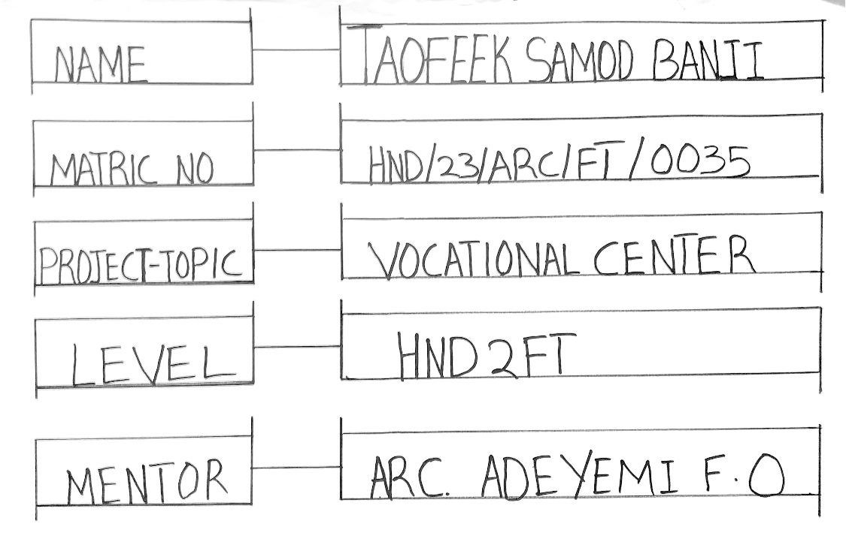
APPENDIX

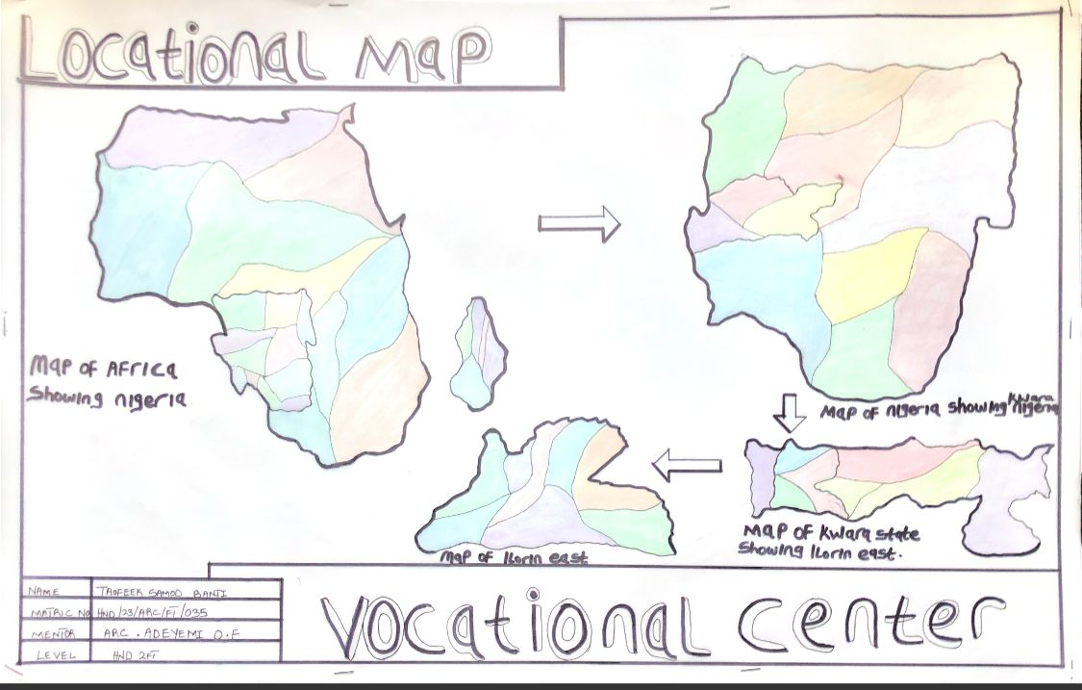
LOCATIONAL MAP
PROFILE
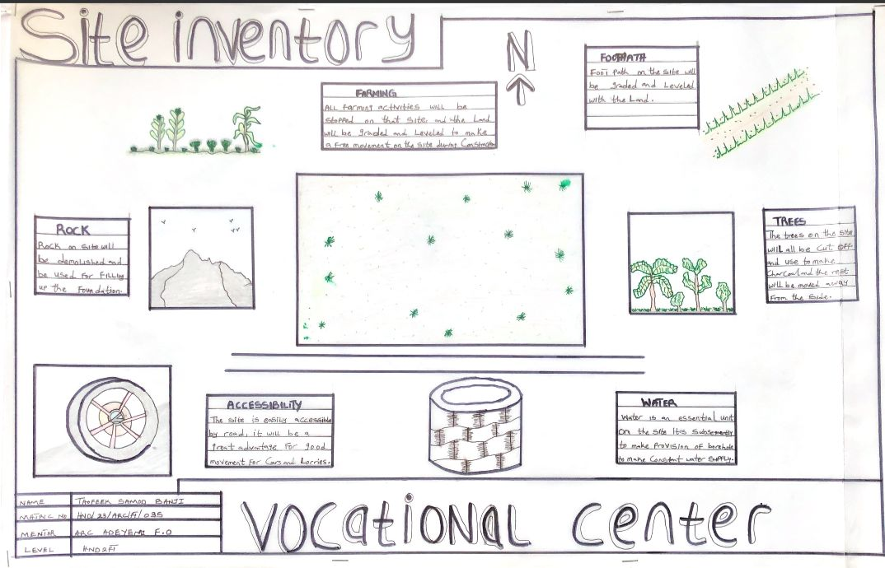
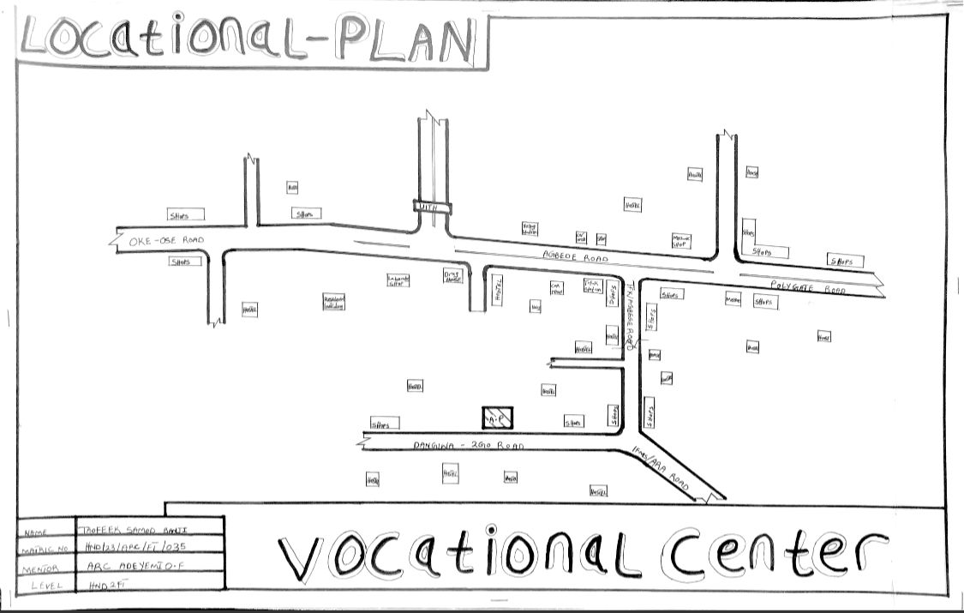
SITE INVENTORY
LOCATIONAL PLAN
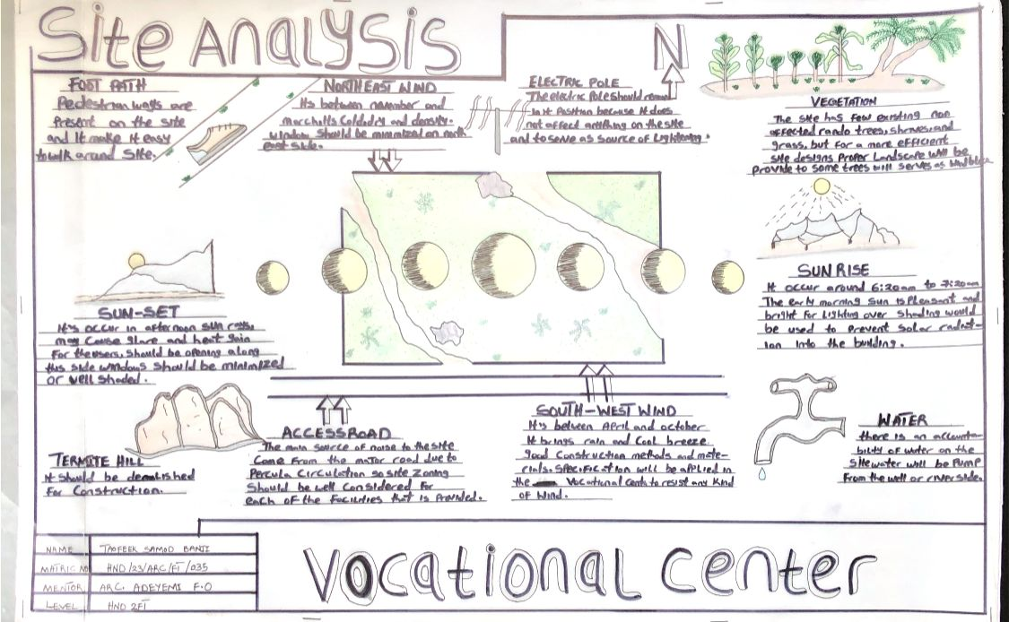

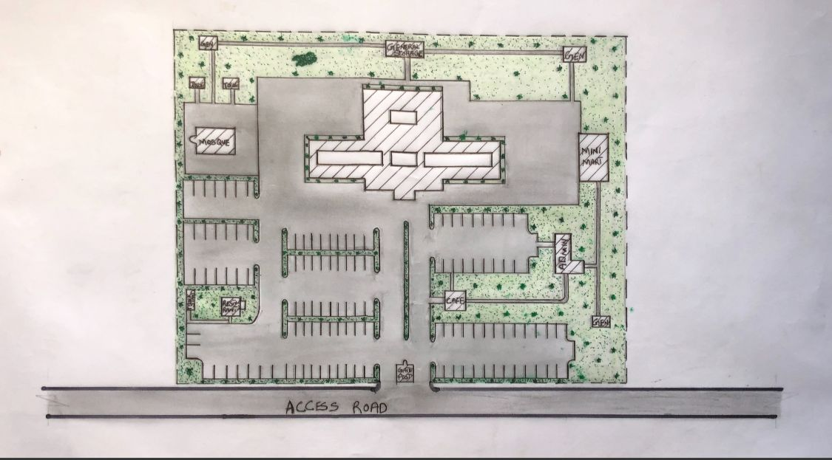
SITE PLAN
SITE ANALYSIS
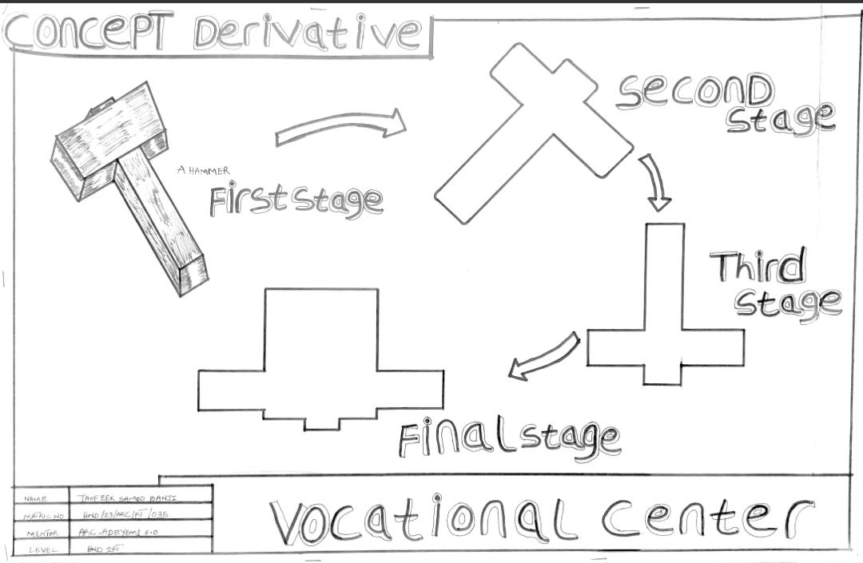
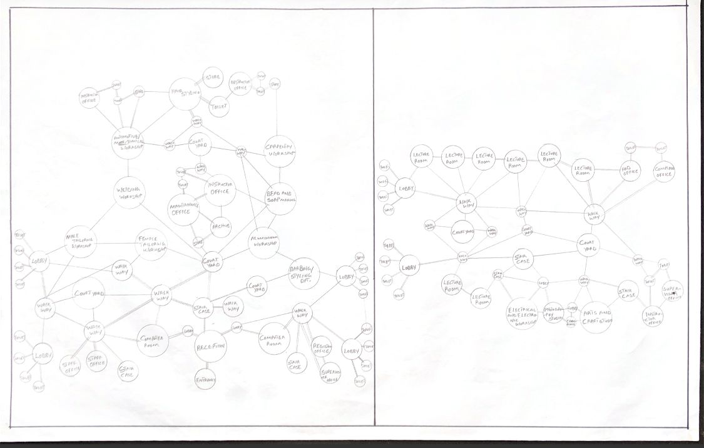
BUBBLE DIAGRAM
