A TECHNICAL REPORT
ON
PROPOSED CLUBHOUSE
For
MR. DORCSON EMMANUEL
BY
ADESHOLA PETER TEMITOPE
HND/23/ARC/FT/0031

BEING PROJECT REPORT SUBMITTED TO THE DEPARTMENT OF ARCHITECTURAL TECHNOLOGY, INSTITUTE OF ENVIRONMENT STUDIES, KWARA STATE POLYTECHNIC, ILORIN

IN PARTIAL FULFILMENT OF THE REQUIREMENTS FOR THE AWARD OF HIGHER NATIONAL DIPLOMA [HND] IN ARCHITECTURAL TECHNOLOGY KWARA STATE POLYTECHNIC, ILORIN KWARA STATE

JULY, 2025

DECLARATION
I, Adeshola Peter Temitope hereby declare that this report titled: “Proposed Club House” is my original work, carried out in partial fulfillment of the requirements for the award of Higher National Diploma in Architectural Technology at Kwara State Polytechnic, Ilorin.


_______________________ ________________________
Adeshola Peter Temitope Date

CERTIFICATION
This is to certify that this project report titled “Proposed Club House” was carried out by Adeshola Peter Temitope with Matric No: HND/23/arc/ft/0031, in partial fulfillment of the requirements for the award of Higher National Diploma in Architectural Technology, Kwara State Polytechnic, Ilorin.

_______________________ ______________________
Arc Solomon Familua O.S Date

Project Supervisor

_______________________ ____________________
Arc Olanrewaju F.A Date
Project Coordinator


_______________________ ____________________
Arc Tomori Jumoke Mulikat Date
Head of Department

_______________________ ____________________
External Supervisor Date

DEDICATION
This project is dedicated to Almighty God, whose guidance and mercy have seen me through this academic journey. I also dedicate it to my parents and mentors for their unending support.

ACKNOWLEDGEMENT
I give all praises to Almighty God for granting me the knowledge, wisdom, and understanding which I used in carrying out this design project and making it a success.
I want to thank my project supervisor, ARC. FAMILUA O.S., and also my H.O.D, ARC. J.M. TOMORI, for the countless support they rendered in the course of executing this design project and compiling this report. May God bless you all abundantly. (Ameen)
My profound gratitude goes to my dear parents for their financial and moral support in making this project a success.
I salute the courage and support of amiable friends and mentors who stood by my side during the challenging moments of this work. May the good Lord bless you all.

ABSTRACT
This technical report presents the design of a Club House facility intended to serve as a recreational and social hub within a community setting. The project was carried out as part of the requirements for the award of a Higher National Diploma in Architectural Technology at the Institute of Environmental Studies, Kwara State Polytechnic, Ilorin.
The primary aim of this design was to create a functional, inclusive, and aesthetically pleasing environment where individuals can engage in leisure, social interaction, and community activities. The clubhouse is envisioned as more than just a building, it is a supportive space that promotes well-being, meaningful engagement, and personal development.
The design process involved site analysis, user requirement studies, space programming, and architectural planning that responds to climate, sustainability, accessibility, and comfort. Key facilities in the design include a multipurpose hall, recreational areas, lounge, administrative spaces, and outdoor relaxation zones.
Architectural drawings, models, and visual illustrations were used to communicate the proposed design solution. The outcome reflects a thoughtful integration of design principles with the social needs of the users, emphasizing the importance of community-based architecture in today's built environment.
The project demonstrates the practical application of knowledge acquired during the diploma program and contributes meaningfully to the development of communal architecture in Nigeria.

TABLE OF CONTENTS
DECLARATION i
CERTIFICATION ii
DEDICATION iii
ACKNOWLEDGEMENT iv
ABSTRACT v
CHAPTER ONE 1
INTRODUCTION 1
1.1 BACKGROUND OF THE STUDY 1
1.2 STATEMENT OF THE PROBLEM 2
1.3 AIM AND OBJECTIVE 3
1.3.1 AIM 3
1.3.2 OBJECTIVES 3
1.4 JUSTIFICATION OF THE STUDY 4
1.5 SCOPE OF THE STUDY 4
1.6 CLIENT BACKGROUND 4
1.7 LIMITATION OF THE STUDY 5
CHAPTER TWO 6
LITERATURE REVIEW 6
2.1 INTRODUCTION 6
2.2 DEFINITION AND HISTORICAL BACKGROUND OF CLUBHOUSES 7
2.2.1 DEFINITION OF A CLUBHOUSE 7
2.2.2 HISTORICAL BACKGROUND OF CLUBHOUSES 7
2.3 FUNCTIONS OF CLUBHOUSES 8
2.4 CLASSIFICATION AND TYPES OF CLUBHOUSES 9
2.5 DESIGN CONSIDERATIONS FOR CLUBHOUSES 9
CHAPTER THREE 10
3.1 CASE STUDIES 10
3.3 DATA COLLECTION METHODS 18
3.4 DATA COLLECTION INSTRUMENTS 19
3.5 METHOD OF DATA ANALYSIS 19
3.5.1 QUALITATIVE DATA ANALYSIS 19
3.5.2 QUANTITATIVE DATA ANALYSIS 20
CHAPTER FOUR 21
PROJECT SITE AND ENVIRONMENTAL ANALYSIS 21
4.1 INTRODUCTION TO PROJECT SITE ANALYSIS 21
4.2 SITE LOCATION, SELECTION CRITERIA AND DESCRIPTION 21
4.2.1 SITE LOCATION 21
4.2.2 SITE SELECTION CRITERIA 22
4.2.3 SITE DESCRIPTION 22
4.3 SITE ANALYSIS 23
4.4 CLIMATIC DATA 24
4.5.1 BUBBLE DIAGRAM 25
4.5.3 SPACE ALLOCATION 26
4.5.4 ZONING AND SPACE PLANNING 28
4.6 DESIGN CRITERIA 28
4.7 CONCEPTUAL DEVELOPMENT 29
CHAPTER FIVE 30
DESIGN APPROACH AND REALIZATION 30
5.1 DESIGN CONCEPT 30
5.2 BEHAVIOURAL PATTERNS AND CONSIDERATIONS 30
5.3 LEGAL ISSUES AND PLANNING REGULATIONS 31
5.4 TECHNOLOGICAL AND ENVIRONMENTAL CRITERIA 31
5.2 CONCLUSION 32
5.3 RECOMMENDATION 32
REFERENCES 33
APPENDIX 36

LIST OF FIGURES
FIGURE 3.1.1: SHOWING THE SITE PLAN OF THE CASE STUDY ONE 12
FIGURE 3.1.2: FRONT ELEVATION OF THE CASE STUDY ONE 12
FIGURE 3.1.3: SHOWING THE SITE PLAN OF THE CASE STUDY TWO 14
FIGURE 3.1.4: FRONT ELEVATION OF THE CASE STUDY TWO 15
FIGURE 3.1.5: FRONT ELEVATION OF THE CASE STUDY THREE 17
FIGURE 4.2.1.1: LOCATIONAL PLAN 22
FIGURE 4.3.1: SITE ANALYSIS 24
FIGURE 4.4.1: CLIMATIC DATA 25
FIGURE 4.5.1.1: BUBBLE DIAGRAM 26

LIST OF APPENDICES
APPENDIX 1: SITE PLAN 36
APPENDIX 2: GROUND FLOOR PLAN 37
APPENDIX 3: FIRST FLOOR PLAN 38
APPENDIX 4: ROOF PLAN 39
APPENDIX 5: DETAILS 40
APPENDIX 7: ELEVATION PLAN 42
APPENDIX 9: EXTERNAL PERSPECTIVE VIEW 44

CHAPTER ONE

INTRODUCTION

1.1 BACKGROUND OF THE STUDY
A Club House is primarily a community space designed to support social interaction, meaningful work, and personal relationships. It often serves individuals and groups who require a supportive environment for example, people recovering from mental illness by helping them reintegrate into society and rebuild confidence through structured activities and programs.
More than just a building, a club house represents a supportive community where members have guaranteed rights and access to resources, including a welcoming place to return to, participate in activities, and feel a sense of belonging. These spaces often include facilities that promote relaxation, recreation, wellness, and education. In many cases, they provide opportunities such as transitional employment programs that help members gain paid work experience and develop skills that build their self-worth and confidence.
In modern architectural practice, the role of social and communal spaces has expanded significantly. With increasing urbanization and changing lifestyles, people are in greater need of environments that promote well-being, connection, and recreation. Club houses have evolved as architectural responses to these social needs, particularly in residential estates, academic institutions, and planned communities.
Architecturally, designing a club house involves the integration of both functional and aesthetic considerations. These include the arrangement of multipurpose halls, lounges, fitness rooms, libraries, cafés, and offices to serve the different needs of its users. The design must also take into account sustainability, natural ventilation, lighting, spatial circulation, accessibility for all users, and harmony with the surrounding environment.
In the context of Nigeria especially within growing urban areas like Ilorin, Kwara State the demand for social and recreational facilities is increasing due to rising population density and awareness of mental and physical health. However, there remains a gap in the adequate provision of such communal facilities. This study aims to bridge that gap by exploring the design of a functional and inclusive club house facility that meets the social, recreational, and emotional needs of users.
This project is undertaken as part of the requirements for the award of a Higher National Diploma in Architectural Technology. It combines academic research with design innovation to propose a viable club house structure that is contextually appropriate, user-friendly, and sustainable. It highlights the importance of community-based architecture and the role of architectural technology in enhancing lives through thoughtful design.

1.2 STATEMENT OF THE PROBLEM
In recent years, the need for purposefully designed communal spaces has grown significantly due to urbanization, changing lifestyles, and increased awareness of mental and social well-being. Clubhouses, as multifunctional communal facilities, are essential in creating environments that support recreation, social interaction, cultural engagement, and community development. However, in many urban and semi-urban areas of Nigeria—such as Ilorin—there remains a shortage of well-planned, inclusive, and accessible clubhouse facilities that reflect contemporary needs.
Many existing clubhouse structures suffer from poor spatial planning, inadequate facilities, lack of environmental consideration, and insufficient integration with their surrounding contexts. These shortcomings often lead to underutilization, deterioration, and a general lack of interest from the intended users. Additionally, most clubhouse designs do not adequately cater to diverse user groups, including children, the elderly, and persons with disabilities, thus failing to promote inclusivity and social equity.
Moreover, the absence of sustainable design practices in many existing facilities poses environmental and maintenance challenges. There is a need for clubhouses that not only serve their immediate social and recreational functions but also demonstrate architectural innovation, environmental responsibility, and long-term durability.
This project seeks to address these gaps by designing a modern, multipurpose clubhouse that responds to user needs, promotes social cohesion, utilizes sustainable materials and practices, and stands as a model for future developments in similar urban contexts.

1.3 AIM AND OBJECTIVE

1.3.1 AIM
The primary aim of this project is to design a functional, inclusive, and aesthetically appealing Club House facility that serves as a recreational and social hub for members of a community or institution, promoting mental well-being, social interaction, and community development.

1.3.2 OBJECTIVES
- To achieve the above aim, the following specific objectives have been identified:
- To create a versatile space that accommodates diverse activities such as meetings, events, fitness, and leisure.
- To foster community engagement and interaction among members through shared activities and open spaces.
- To ensure sustainable and aesthetically pleasing architectural design that blends with the environment.
- To provide modern amenities and facilities that promote health, wellness, and entertainment for users.
- To incorporate flexible and adaptive design elements that allow for future expansion or reconfiguration based on evolving user needs and community growth.
- To integrate principles of universal design that ensure accessibility and usability for all individuals, including those with disabilities.

1.4 JUSTIFICATION OF THE STUDY
The provision of well-designed clubhouses is essential in modern residential and recreational developments as they promote social interaction, recreation, and community bonding. However, many areas in Ilorin and similar urbanizing regions lack properly planned clubhouse facilities that meet users’ social, cultural, and environmental needs.
This study bridges the gap between functional architecture and community-centered design by proposing a facility that enhances user experience through thoughtful spatial planning, accessibility, and aesthetics. It also promotes inclusivity by accommodating diverse user groups within an adaptable structure.
As a final year project, it allows the researcher to apply theoretical knowledge to a real-life architectural challenge, demonstrating competence in design thinking, site analysis, and presentation. Thus, the study is timely and relevant in addressing community needs while contributing to socially responsive architectural solutions.

1.5 SCOPE OF THE STUDY
This project involves designing a modern single-story clubhouse that supports recreation, social interaction, and wellness within the community. It covers conceptualization, spatial planning, and design detailing to ensure functionality and aesthetic quality.
Key areas include lounges for gatherings, indoor game rooms for leisure, administrative offices for operations, a gym for fitness, a kitchen and bar for food services, and landscaped outdoor spaces for relaxation. The design also considers circulation, lighting, acoustics, materials, sustainability, safety, and accessibility to cater to all user groups.
Despite focusing on a single-story structure, the project aims to create a versatile and user-friendly facility that meets modern architectural standards.

1.6 CLIENT BACKGROUND
The client for this clubhouse design project is Mr. Dorcson Emmanuel, a resident of Ilorin, Kwara State. As an active member of the community, the client expressed interest in developing a multi-functional clubhouse that would serve both social and recreational purposes. His vision is to create a welcoming and inclusive environment where individuals can gather for events, relaxation, sports, and entertainment. The design reflects his desire for a structure that is both functional and aesthetically appealing, while also responding to the local climate and cultural context of Ilorin.

1.7 LIMITATION OF THE STUDY
This project focuses on designing a clubhouse to support recreation, wellness, and social interaction, but some limitations were encountered:
- Site Limitation: The absence of a specific site restricted analysis of environmental factors such as soil type, climate, and orientation, which are essential for fully integrated design solutions.
- Time Constraint: Limited academic time prevented extensive research, multiple design options, and detailed refinement.
- Technical Scope: The project is limited to architectural drawings and spatial planning without detailed structural, electrical, or mechanical designs.
- Budget Exclusion: Costing and financial feasibility analyses were not carried out, which would typically guide material selection and construction decisions.
- Social and Audio Considerations: Inspired partly by digital social platforms, the design acknowledges abstract challenges such as overcrowding, noise distractions, lack of privacy, and poor interaction control, which can affect user experience.
Despite these limitations, the project presents a functional and human-centered clubhouse design concept suited to modern community needs.

CHAPTER TWO

LITERATURE REVIEW

2.1 INTRODUCTION
Architecture is not merely the creation of physical structures; it is the thoughtful response to human needs, environmental contexts, and evolving cultural dynamics. The design of a clubhouse facility reflects this ethos, as it encompasses elements of social, recreational, and communal architecture. Clubhouses serve as important nodes of social interaction, offering users a space to unwind, collaborate, and engage in a range of leisure and wellness activities. As such, they represent more than just buildings, they are experiences crafted to enhance the quality of life within a community or institution.
This chapter explores the conceptual and functional framework of clubhouses by analyzing existing literature, architectural theories, and notable case studies. It seeks to understand how clubhouse designs have evolved over time in response to changing user behaviors, lifestyle trends, and advancements in building technology. A comprehensive understanding of these elements will inform the design of a modern, human-centered clubhouse that caters to the social and psychological needs of its users while aligning with environmental best practices.
Additionally, the review delves into the principles that govern the spatial planning, functionality, sustainability, and aesthetic value of clubhouse facilities. Design considerations such as accessibility, acoustics, spatial flow, materiality, lighting, and thermal comfort are crucial in creating a successful architectural intervention. Each of these aspects contributes not only to the functionality of the space but also to its ability to foster social interaction and personal well-being.
In today’s fast-paced world marked by social isolation and digital distractions, the need for inclusive communal spaces is more important than ever. Clubhouses provide an architectural response by fostering real-time human interaction. This chapter lays the theoretical groundwork for designing a clubhouse that is not only functional and visually appealing but also socially relevant and environmentally conscious.

2.2 DEFINITION AND HISTORICAL BACKGROUND OF CLUBHOUSES

2.2.1 DEFINITION OF A CLUBHOUSE
A clubhouse is a building or space used by club members for social, recreational, and leisure activities. It serves as a communal area for relaxation, interaction, and organized events, often including lounges, gyms, halls, and game rooms. In sports, it can also mean changing rooms or team lounges. While the term now extends to virtual platforms like the Clubhouse app for live audio discussions, in architecture it refers to physical spaces that foster community and connection.

2.2.2 HISTORICAL BACKGROUND OF CLUBHOUSES
The concept of clubhouses has diverse historical origins rooted in different cultures and societies. Historically, clubhouses were established as physical spaces to foster a sense of community, serving social, recreational, intellectual, and networking functions.
In Europe and the Ottoman Empire between the 15th and 18th centuries, early forms of clubhouses were found in social clubs and coffeehouses. These spaces emerged as important venues for social interaction, intellectual discussions, and information exchange among elites, scholars, and merchants.
During the 17th century in England, the rise of gentlemen’s clubs marked a significant evolution in clubhouse history. These exclusive clubs catered to aristocrats and the emerging bourgeoisie, providing spaces for leisure activities, political debates, and business networking. The design of such clubhouses often featured grand architectural styles that reflected prestige and social status, with facilities such as lounges, dining areas, and libraries to accommodate various member needs.
Across the Atlantic in colonial America, the concept of clubhouses manifested in the form of meeting houses and taverns. These served as central venues for settlers to hold public meetings, social gatherings, and celebrations, strengthening community ties and fostering civic engagement.
The 19th and 20th centuries witnessed the development of country clubs and sports clubs, particularly in the United States and Europe. These clubhouses catered to growing leisure activities associated with wealth and social class, incorporating facilities such as dining rooms, lounges, tennis courts, swimming pools, and golf courses, reflecting a shift towards recreational and family-oriented functions.
Today, clubhouses have evolved into versatile architectural facilities found in residential estates, recreational complexes, institutions, and corporate environments. Modern clubhouses emphasize inclusivity, flexibility, and community engagement. Their designs often incorporate sustainable materials, energy-efficient systems, and aesthetically pleasing forms that balance functionality with user comfort.
In summary, the historical development of clubhouses shows their enduring role as social catalysts and community spaces. From exclusive gentlemen’s clubs to inclusive community centers, clubhouses continue to foster social interaction, leisure, and collective identity in contemporary society.

2.3 FUNCTIONS OF CLUBHOUSES
Clubhouses serve various roles that enhance social, recreational, and cultural life within a community:
- Social Function: They act as gathering hubs for events, meetings, and informal interactions, fostering unity and belonging.
- Recreational Function: They provide facilities for sports, fitness, and leisure activities like gyms, pools, and lounges, promoting healthy lifestyles.
- Cultural and Educational Function: They host cultural programs, exhibitions, and workshops, supporting learning and local talent development.
- Support Services: Many include cafés, libraries, offices, and children’s play areas to improve functionality and user convenience.

2.4 CLASSIFICATION AND TYPES OF CLUBHOUSES
Clubhouses are classified based on their functions, users, and locations, and include:
- Recreational Clubhouses: For leisure activities like lounging, gym, and games, common in estates and resorts.
- Sports Clubhouses: Linked to sports facilities, providing changing rooms, lounges, and viewing areas.
- Community Clubhouses: Serve neighborhoods for meetings, events, and social gatherings.
- Corporate Clubhouses: For staff relaxation, meetings, and recreation within organizations.
- Youth Clubhouses: Offer safe spaces for youth recreation, education, and skill development.
- Gentlemen’s Clubs: Exclusive clubs for elites, focused on networking, leisure, and privacy.
- Country Clubhouses: Combine sports, dining, and recreation with grand designs, often in golf or tennis clubs.

2.5 DESIGN CONSIDERATIONS FOR CLUBHOUSES
Designing a clubhouse involves thoughtful planning to ensure it is functional, comfortable, and attractive. This includes proper spatial organization to support various activities, accessibility features for all users, and clear circulation paths to enhance movement. Adequate natural lighting and ventilation improve indoor comfort and reduce energy costs. Material selection should prioritize durability and aesthetics suitable for the climate. The design must be visually appealing, reflect its purpose, and blend with the surroundings. Safety measures such as fire exits and security systems are essential, alongside sustainable practices like rainwater harvesting and energy-efficient technologies for environmental responsibility.

CHAPTER THREE

3.1 CASE STUDIES
Examining existing clubhouses in Nigeria provides practical insights into spatial planning, material use, and community relevance, helping to guide the design of a functional and user-friendly facility suited to local culture and environment.
CASE STUDY ONE: Osogbo Sport Club House, Osogbo, Osun State
LOCATION: Fagbewesa St, Osogbo 230284, Osun
The Osogbo Sports Club House is a long-standing multi-purpose facility designed to support both sports and social activities. Located in a quiet and accessible part of Osogbo, it has historically served as a center for leisure, athletic competitions, community interaction, and events.
ARCHITECTURAL DESCRIPTION:
- Building Type: Two-storey structure with attached single-storey extensions.
- Construction Style: Colonial-era influence with basic concrete blockwork.
- Roof Type: Pitched roof covered with rusted corrugated metal sheets, indicating aging infrastructure.
- Facade Color: Dominantly painted in yellow and blue, giving it a vibrant yet traditional look.
- Veranda: Front and upper-level verandas for relaxation and social interaction.
- Entrance: Simple entrance with a fabric shade and emblem above, marking the identity of the club.
- Fenestration: Combination of sliding and louvered windows for natural ventilation.
- Landscaping: Decorative flower beds and shrubs line the walkway, enhancing curb appeal despite the dated appearance.

LESSONS LEARNED:
- Clubhouses that integrate sports and social spaces tend to attract a wide range of users and support community bonding.
- Without regular updates or modern renovations, even a well-located and multifunctional clubhouse can fall into underuse or become less appealing to modern users.
MERIT
- Spacious Layout: The building appears to have ample open space in front, which allows for landscaping, circulation, and recreational activities.
- Natural Ventilation: The presence of verandas and open sections on the upper floor supports cross ventilation, improving internal comfort without excessive reliance on mechanical cooling.
- Accessibility and Entry Canopy: The entrance canopy provides shade and defines the main access point, aiding wayfinding and protecting visitors from direct sun or rain.
DEMERITS
- Deteriorated Roofing: The rusted metal roofing is a clear sign of wear and tear, which may lead to leakage issues and negatively impact the facility's aesthetics.
- Aging Facade: The exterior walls and finishes appear worn and in need of repainting or renovation, which could affect the building’s appeal and first impression.
- Lack of Modern Accessibility Features: There are no visible ramps or handrails for people with disabilities, indicating a lack of inclusive design elements.

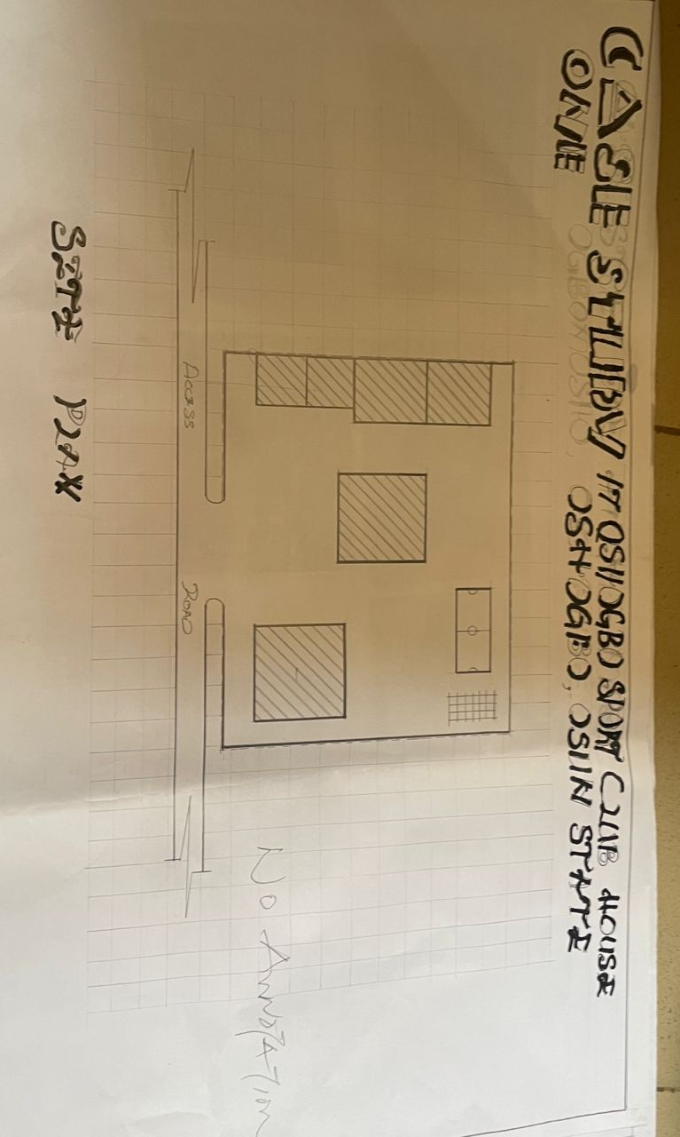
FIGURE 3.1.1: SHOWING THE SITE PLAN OF THE CASE STUDY ONE
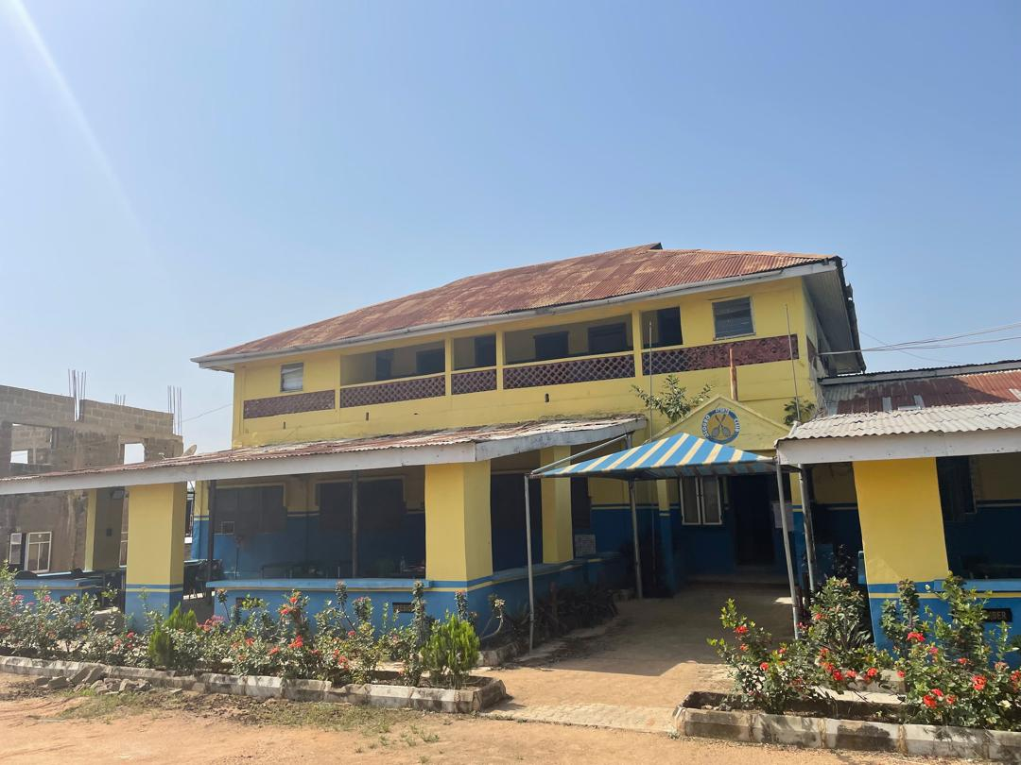
FIGURE 3.1.2: FRONT ELEVATION OF THE CASE STUDY ONE
CASE STUDY TWO: Zeus Club House, Osogbo, Osun
LOCATION: East, Osogbo 230103, Osun, Nigeria
Zeus Club House is a modern leisure center focused on nightlife and entertainment. It includes lounges, an open-air bar, and event hosting spaces. The design emphasizes aesthetics and atmosphere, appealing primarily to a youthful demographic.
ARCHITECTURAL DESCRIPTION:
- Building Type: Three-story modern commercial structure
- Design Style: Contemporary, with clean lines and glass façades
- Roof Style: Flat roof with parapet wall, allowing rooftop use
- Facade: Mix of grey stone, white-painted concrete, and dark glass
- Windows: Floor-to-ceiling glass for lighting and openness
- Entrance: Recessed entry with security fencing and canopy
- Branding: Prominent "ZEUS CLUB & LOUNGE" signage
- Parking: Paved compound with marked parking spaces
LESSONS LEARNED:
- Aesthetic appeal and ambiance boost engagement, especially among youth
- Over-specialization (e.g., nightlife focus) can limit broader usability
MERITS
- Contemporary Aesthetic Design: The building features a sleek, modern façade with clean lines, glass railings, and a mix of materials that enhance visual appeal and brand identity.
- Ample Parking Space: The foreground has a well-paved and spacious parking area that supports user convenience and vehicular access.
- Security and Access Control: The presence of a gated perimeter and signage indicates a controlled entry system, enhancing safety for patrons and staff.

DEMERITS
- Limited Green Landscaping: The paved surface dominates the site with minimal visible greenery, which can reduce environmental comfort and visual softness.
- Glare from Extensive Glazing: Large glass surfaces may cause glare and heat gain if not properly treated with shading devices or tinted panels.
- Potential Accessibility Constraints:
The steps at the entrance suggest a possible lack of wheelchair access unless a ramp is provided elsewhere, which is not visible in the image.

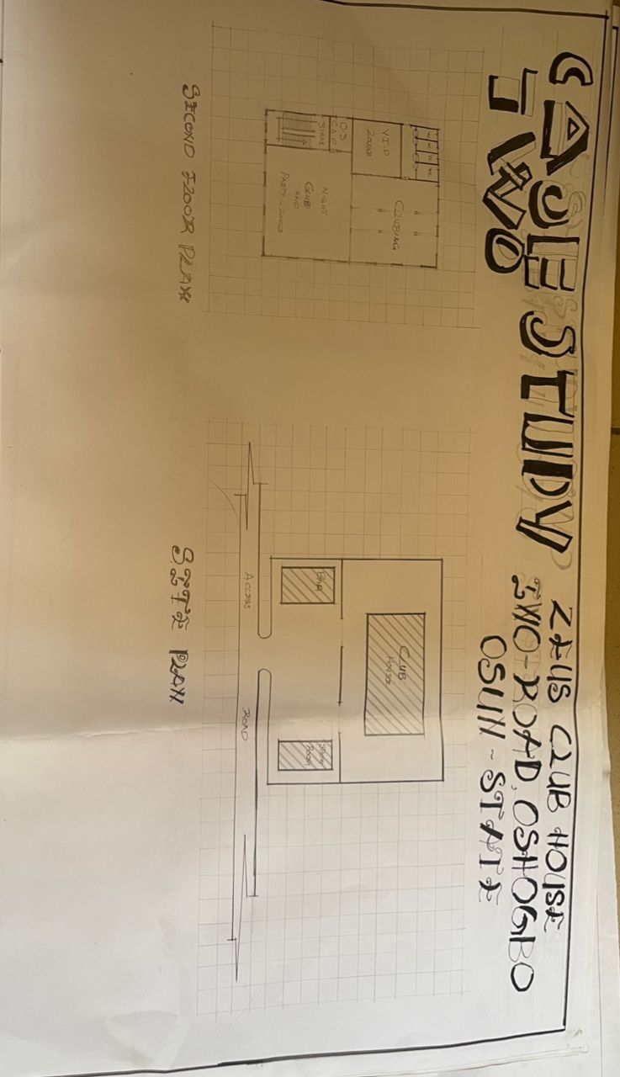
FIGURE 3.1.3: SHOWING THE SITE PLAN OF THE CASE STUDY TWO

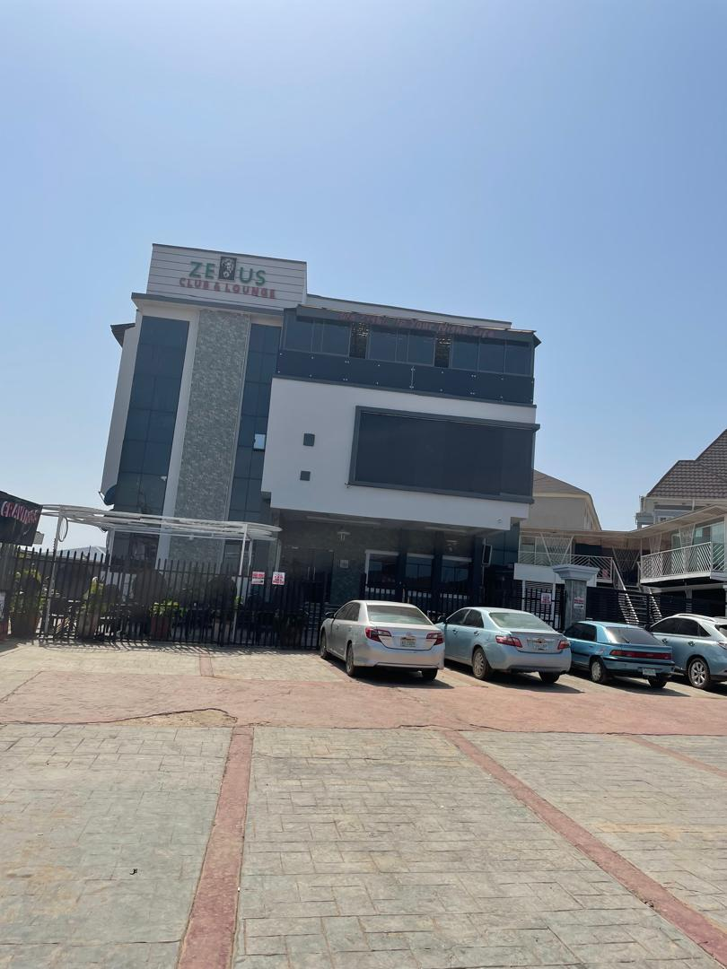
FIGURE 3.1.4: FRONT ELEVATION OF THE CASE STUDY TWO

CASE STUDY THREE: Ogbomoso Recreation Club House, Ogbomoso, Oyo State
LOCATION: Isale General, Ilorin Rd, Sabo, Ogbomoso 212102, Oyo State, Nigeria
The Osogbo Sports Club House is a long-standing multi-purpose facility designed to support both sports and social activities. Located in a quiet and accessible part of Osogbo, it has historically served as a center for leisure, athletic competitions, community interaction, and events.
ARCHITECTURAL DESCRIPTION:
- Building Type: Two-storey structure with attached single-storey extensions
- Construction Style: Colonial-era influence with basic concrete blockwork
- Roof Type: Pitched roof with rusted corrugated metal sheets
- Facade Color: Yellow and blue
- Veranda: Front and upper-level verandas
- Entrance: Simple, with fabric shade and emblem
- Fenestration: Sliding and louvered windows
- Landscaping: Flower beds and shrubs
LESSONS LEARNED:
- Clubhouses that integrate sports and social use support strong community bonding
- Regular updates are essential to retain modern appeal
MERITS
- Spacious Layout with Greenery: The building is surrounded by well-maintained shrubs and open space, promoting a calm and natural atmosphere.
- Simple, Functional Design: The architecture is straightforward, making it easy to navigate and maintain, and suitable for recreational purposes.
- Flag Display and Branding: Flags and signage in front of the building help with identity and enhance the institutional appearance.

DEMERITS
- Aging Infrastructure: The exterior paint appears faded and outdated, which may affect the overall appeal and perception of modernity.
- Limited Parking Organization: The parking area lacks proper demarcation or surfacing, which can lead to disorganized parking and poor vehicle management.
- Lack of Architectural Appeal: Compared to more modern recreational centers, the design lacks visual dynamics or contemporary features, making it less attractive.
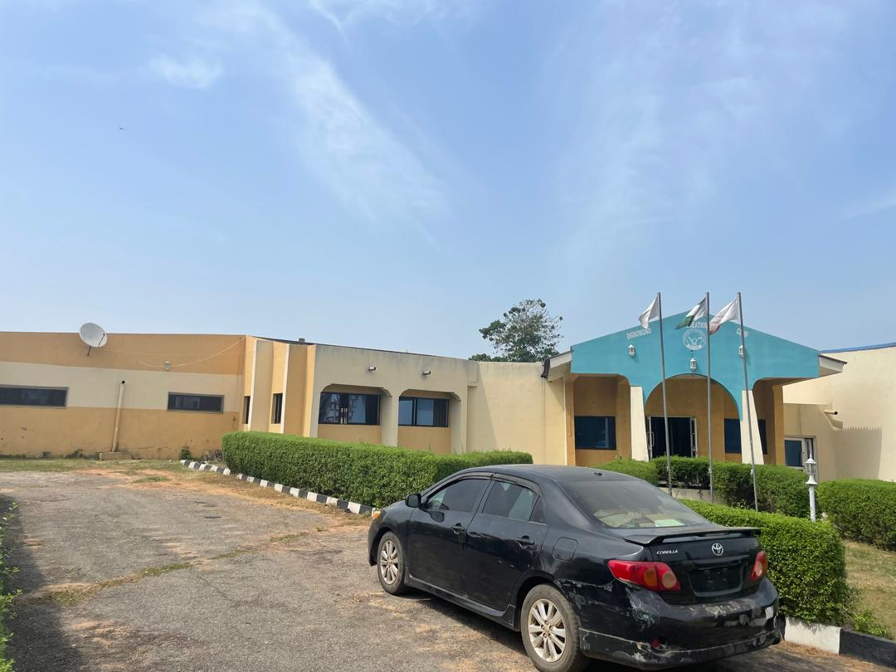
FIGURE 3.1.5: FRONT ELEVATION OF THE CASE STUDY THREE

CONCLUSION FROM CASE STUDIES
The case studies reviewed showcase different clubhouse designs, from sport-focused to community-centered models, providing insights into functional zoning, user needs, and aesthetics.
Zeus Club & Lounge has a modern façade and nightlife appeal but lacks green spaces and age diversity.
Osogbo Recreation Club offers a relaxed, community-driven setting with a simple, accessible layout but shows aging structures and limited parking.
Ogbomoso Recreation Club features greenery and practicality but has an outdated appearance with minimal visual impact.
The proposed clubhouse design will integrate their strengths, such as multi-use spaces, efficient zoning, and landscaping, while addressing their limitations with modern, sustainable, and inclusive architectural solutions.

3.3 DATA COLLECTION METHODS
The primary data collection methods employed in this research include site visits, case studies, and informal interviews. Site visits were conducted to observe the physical layout, architectural features, and functional elements of existing clubhouse facilities. These visits allowed for photographic documentation, spatial analysis, and assessment of user interaction with the environment. Case studies of selected clubhouses provided insight into successful design approaches, materials used, and spatial configurations. Informal interviews with users and facility managers helped to gather firsthand perspectives on the strengths and limitations of the current designs. These methods were chosen for their ability to provide contextual, real-world understanding of clubhouse architecture. Their combined use ensured triangulation of data, improving the validity of findings. All data collection was conducted ethically, respecting privacy and consent of participants involved.

3.4 DATA COLLECTION INSTRUMENTS
The following instruments were used to gather data for this study:
- Measuring Tape: For taking accurate measurements of the site and existing structures.
- Digital Camera: Used to capture photographs of the site and its surroundings for proper documentation and analysis.
- Sketch Book and Drawing Materials: For recording quick sketches and observations during site visits.
- GPS Device / Google Maps: To identify site coordinates, access routes, and contextual information.
- Notebook and Pen: For noting observations, measurements, and relevant information obtained during the study.

3.5 METHOD OF DATA ANALYSIS
The data analysis for this study employed a comprehensive analytical framework that integrates both qualitative and quantitative approaches to ensure thorough examination of all collected information. The analysis process was structured to derive meaningful insights that would directly inform the architectural design decisions for the proposed clubhouse facility.

3.5.1 QUALITATIVE DATA ANALYSIS
- Thematic Analysis: Data from interviews, observations, and case studies were analysed by identifying and grouping patterns into themes related to spatial needs and design considerations.
- Content Analysis: Architectural drawings, regulations, and guidelines were reviewed to extract relevant design standards and spatial requirements for the clubhouse.
- Comparative Analysis: Existing clubhouse case studies were compared to identify best practices and design strategies to enhance functionality and user experience in the proposed design.
This analysis revealed successful design strategies that could be adapted for the proposed facility.

3.5.2 QUANTITATIVE DATA ANALYSIS
Descriptive Statistics: Numerical data from surveys and questionnaires were analyzed using descriptive statistical methods including:
- Frequency Distribution: To understand user preferences, facility usage patterns, and demographic characteristics
- Central Tendency Measures: Mean, median, and mode calculations to identify typical user requirements and space utilization patterns
- Variability Measures: Standard deviation and range calculations to understand the diversity of user needs and preferences
Spatial Analysis: Quantitative spatial data including area requirements, capacity calculations, and dimensional specifications were analyzed using:
- Space Programming Analysis: Calculation of required areas for different functional zones based on user capacity and activity requirements
- Circulation Analysis: Quantitative assessment of movement patterns and required circulation spaces
- Efficiency Ratios: Analysis of net-to-gross area ratios to optimize space utilization.

CHAPTER FOUR

PROJECT SITE AND ENVIRONMENTAL ANALYSIS

4.1 INTRODUCTION TO PROJECT SITE ANALYSIS
This chapter provides a comprehensive analysis of the project site for the proposed clubhouse design. It examines the site’s location, physical characteristics, environmental conditions, and available infrastructure. The analysis aims to identify opportunities and constraints that will influence design decisions, ensuring that the proposed facility is functional, sustainable, and well-integrated into its surrounding environment.
A thorough understanding of the site is essential for developing a design that responds effectively to climatic factors, topography, accessibility, and user needs. This chapter also highlights how the existing site features can be utilized or improved to enhance the clubhouse’s overall performance and user experience.

4.2 SITE LOCATION, SELECTION CRITERIA AND DESCRIPTION

4.2.1 SITE LOCATION
The proposed clubhouse site is located at Etalamu, along Ajase Ipo Road, Ilorin, Kwara State, Nigeria. It is situated within a predominantly residential area of Ilorin, with direct access from Ajase Ipo Road, ensuring convenient entry for users and visitors.
The surrounding environment includes residential buildings, local shops, and open plots, making it suitable for a community clubhouse. Its strategic location along this major road enhances its visibility and accessibility, which are vital for the functionality and patronage of the proposed facility.
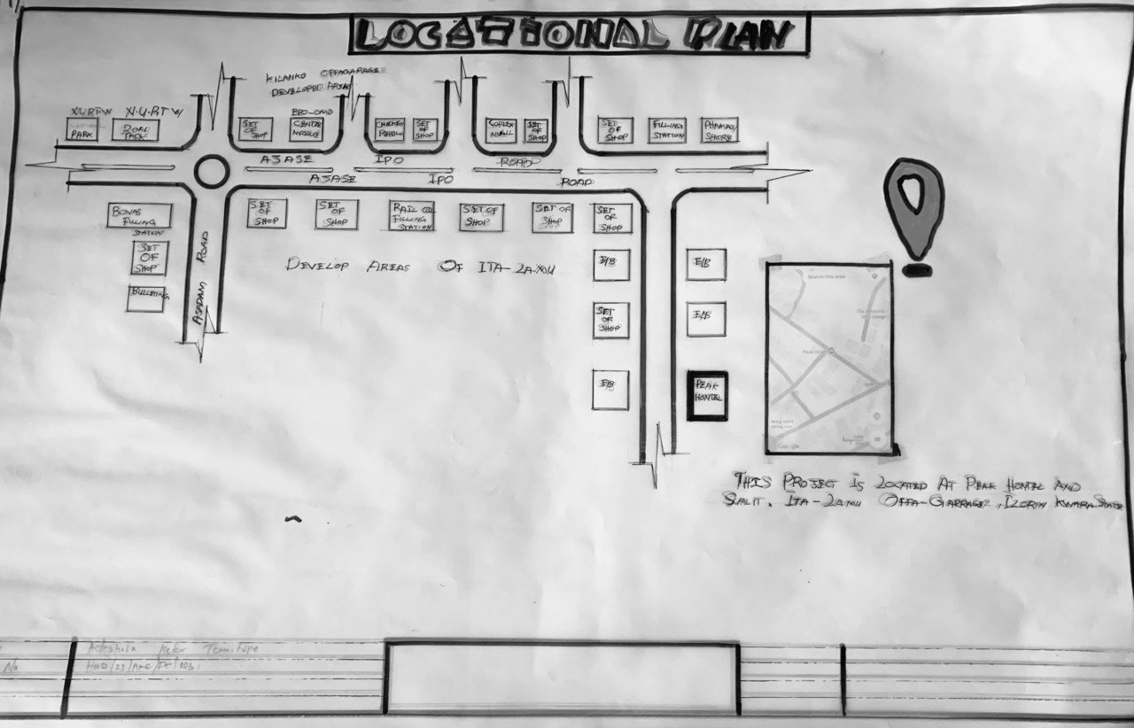
FIGURE 4.2.1.1: LOCATIONAL PLAN

4.2.2 SITE SELECTION CRITERIA
The site was chosen for its easy accessibility along Ajase Ipo Road, adequate land area for facilities, and favorable topography with minimal flooding risk. Its location within a residential area ensures it serves the community effectively. Additionally, the site has available infrastructure such as water, electricity, and good road networks, and it is situated in a safe and secure environment for all users.

4.2.3 SITE DESCRIPTION
The proposed site is located at Etalamu, along Ajase Ipo Road, Ilorin, Kwara State. It is approximately [insert exact size if known, e.g. 2,000 sqm] with a [rectangular/irregular] shape, making it suitable for efficient space planning and zoning.
Currently, the site is vacant land with sparse vegetation, consisting mainly of grasses and a few scattered shrubs. The terrain is generally flat to gently sloping, which will require minimal earthworks during construction. The site boundaries include Ajase Ipo Road to the front (north), residential buildings to the south and west, and open land to the east.
Overall, the site’s size, shape, and physical characteristics make it suitable for the proposed clubhouse design, allowing for optimal circulation, landscaping, and integration with the surrounding environment.

4.3 SITE ANALYSIS
A comprehensive analysis of the selected site for the proposed clubhouse facility revealed several advantageous characteristics that significantly influenced the design approach.
The accessibility of the site is a key strength, as it is strategically located along well-connected major roads, ensuring ease of movement for users and seamless integration with surrounding developments.
In terms of topography, the site exhibits a relatively flat terrain, making it highly suitable for construction activities without the need for extensive grading or land modification. This natural levelness supports a cost-effective and structurally stable foundation.
The climatic condition of the area is typically tropical, characterized by warm temperatures and seasonal rainfall. This necessitated the integration of passive design strategies such as cross ventilation, wide roof overhangs, and solar control elements to enhance indoor comfort and reduce energy consumption.
The existing vegetation on the site, comprising mostly of native shrubs and trees, offers a unique opportunity to enhance the aesthetic quality of the landscape design. Rather than clearing the land entirely, the design seeks to preserve and incorporate these natural elements into green courtyards and shaded relaxation zones.
Overall, the insights obtained from the site analysis played a vital role in determining the building’s orientation, functional zoning, and environmental response, all aimed at achieving a harmonious blend of comfort, sustainability, and user experience.
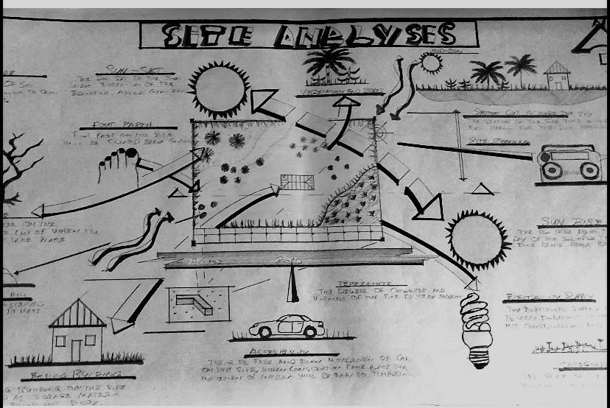
FIGURE 4.3.1: SITE ANALYSIS

4.4 CLIMATIC DATA
Ilorin, Kwara State has a tropical climate with high temperatures ranging from 25°C to 35°C throughout the year. The rainy season (April–October) brings significant rainfall (1,200–1,500 mm) and high humidity (65%–85%), while the dry season (November–March) features lower humidity and harmattan winds from the northeast, causing cooler and drier conditions.
Prevailing winds come from the southwest during the rainy season, aiding natural ventilation, while harmattan winds bring dryness and dust. These climatic conditions influence the clubhouse design, requiring effective shading, roof design, cross ventilation, and suitable material selection to ensure comfort and environmental responsiveness.
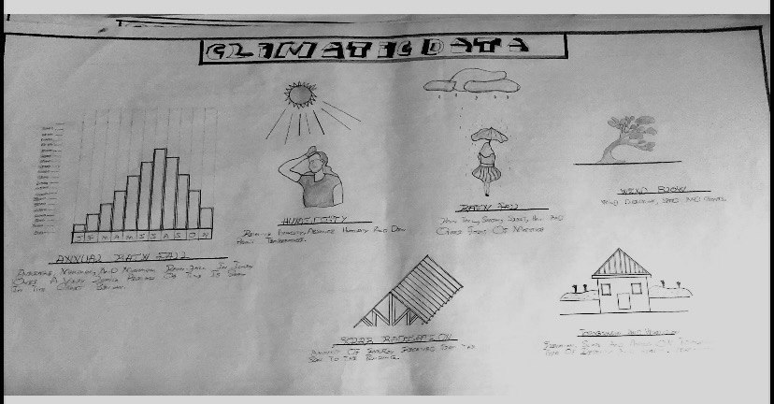
FIGURE 4.4.1: CLIMATIC DATA

4.5 DESIGN PRELIMINARIES
Design preliminaries involve initial studies and schematic analyses carried out to guide the development of the proposed event center.

4.5.1 BUBBLE DIAGRAM
The bubble diagram is a schematic representation used during the design preliminary stage to illustrate spatial zoning and functional relationships between different areas of the proposed event center. It shows how spaces relate to one another before detailed planning and drafting are carried out.
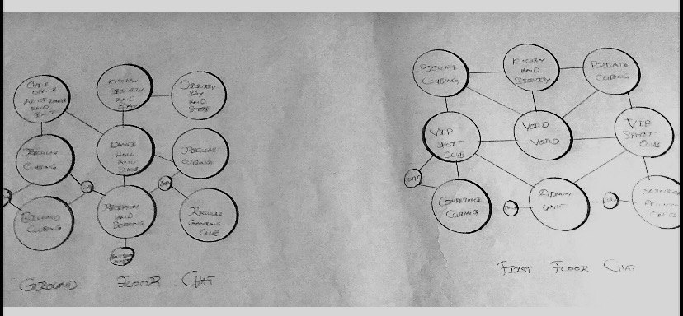
FIGURE 4.5.1.1: BUBBLE DIAGRAM

4.5.2 SCHEDULE
This is the appendix that is use to show the quantity, types, descriptions and size of doors and windows use in the construction of a design

4.5.3 SPACE ALLOCATION
Space allocation involves assigning appropriate floor areas to each functional unit within the clubhouse based on its purpose and expected usage. This ensures that all spaces are adequately sized for comfort, efficiency, and flexibility. The allocation reflects thoughtful planning to meet user needs and maintain smooth circulation throughout the building.
S/N | Units | Length x Breadth | Dimension (mm)
1 | Entrance Pouch | 5.1 x 5.7 | 29.07
2 | Reception Hall | 6.0 x 7.5 | 45
3 | Booking | 3.6 x 4.2 | 15.12
4 | Store | 1.8 x 2.1 | 3.78
5 | Stair In Rec | 3.0 x 4.5 | 13.5
6 | Visitor Toilet | 1.2 x 1.8 | 2.16
7 | Regular Club House | 16.7 x 14.2 | 237.14
8 | Stage Regular Club | 3.9 x 4.2 | 16.38
9 | Dance Stage Regular | 4.2 x 3.6 | 15.12
10 | Kitchen | 6.0 x 7.5 | 45
11 | Cool Stage | 4.2 x 3.6 | 15.12
12 | Servery | 6.0 x 7.5 | 45
13 | Delivery Bay | 6.0 x 4.2 | 25.2
14 | VIP Club House | 16.7 x 14.2 | 237.14
15 | Sport Club House | 4.2 x 8.7 | 36.54
16 | Indoor Sport Club | 6.0 x 8.5 | 51
17 | Sever Bar/Private | 6.0 x 4.2 | 25.2
18 | Private Club | 6.0 x 7.5 | 45
19 | Staff Station | 3.6 x 4.2 | 15.12
20 | Conference Room | 7.5 x 4.5 | 33.75
21 | Accountant Office | 3.6 x 3.6 | 12.96
22 | Secetory To Manager | 3.3 x 3.0 | 9.9
23 | Walk - Way | 1.8 x 6.0 | 10.8
24 | Voild Space | 6.0 x 7.5 | 45
25 | General Stage | 7.5 x 3.0 | 22.5
26 | Exit | 1.5 x 1.8 | 2.7
27 | Manager Office | 4.2 x 4.5 | 18.9

4.5.4 ZONING AND SPACE PLANNING
The clubhouse layout is zoned into three main functional areas to ensure efficient circulation and privacy.
The Public Zone includes the reception/lobby, lounge and bar, multi-purpose hall, and outdoor relaxation area, designed for easy access and social interaction.
The Semi-Public Zone consists of the indoor game rooms, gymnasium, and changing rooms, which serve members and guests engaging in recreational activities.
The Private/Administrative Zone includes offices, staff areas, and storage, restricted for operational use.
This zoning approach ensures smooth movement within the facility and minimizes interference between different user groups.
Public Zone  Reception/Lobby  Lounge & Bar  Multi-purpose Hall  Outdoor Relaxation Area | Semi-Public Zone  Game Rooms  Gymnasium  Changing Rooms | Private Zone  Offices  Staff Areas  Storage

4.6 DESIGN CRITERIA
CLIENTS BRIEF
The proposed clubhouse is intended to serve as a multi-functional social and recreational facility. The client’s requirements, as stated in the design brief, include:
- A reception and lobby area
- Multi-purpose hall
- Lounge and bar
- Indoor game rooms
- Gymnasium
- Administrative offices
- Changing rooms
- Restrooms
- Outdoor relaxation spaces
- Parking and landscaping

4.7 CONCEPTUAL DEVELOPMENT
The design concept for the proposed clubhouse facility is centered around creating a seamless connection between indoor and outdoor spaces to promote relaxation, social interaction, and functional flexibility. Inspired by modern tropical architecture, the building design incorporates open layouts, shaded verandas, and natural ventilation to suit the local climate.
Nature is integrated into the design through landscaped courtyards and gardens that enhance aesthetics and support a tranquil atmosphere. These green spaces also serve environmental purposes such as cooling and air purification.
Passive design elements such as deep overhangs, louvers, and wide openings are strategically employed to reduce solar heat gain and enhance natural lighting and airflow, improving energy efficiency and indoor comfort.
Visually, the clubhouse combines clean geometric forms with subtle organic shapes, creating a structure that is both modern and inviting. The result is a sustainable, user-friendly facility that balances aesthetics with functionality and environmental responsiveness.

CHAPTER FIVE

DESIGN APPROACH AND REALIZATION

5.1 DESIGN CONCEPT
The proposed clubhouse is designed to reflect community, flexibility, and sustainability, which are key elements of a modern social facility. The layout encourages interaction by organizing major activity areas like the lounge, games room, and hall around a central courtyard that promotes connection and openness.
Spaces are divided into public, semi-public, and private zones to promote proper circulation and privacy. Climate-responsive features such as wide eaves, shaded verandas, and cross-ventilation help reduce heat and decrease reliance on mechanical systems, naturally improving comfort.
Visually, the design balances modern elements with subtle traditional cues using clean lines, earthy tones, and local materials to create a structure that feels both contemporary and familiar. Interiors are flexible, allowing rooms to host a variety of events, from meetings to celebrations.
Sustainability is a key focus, with provisions for solar energy, rainwater harvesting, and green landscaping for thermal control and environmental harmony. Overall, the design aims to create an inclusive, functional, and eco-conscious clubhouse that brings people together and evolves with their needs.

5.2 BEHAVIOURAL PATTERNS AND CONSIDERATIONS
The proposed clubhouse design considers user behavior to ensure functionality and comfort. Spaces are arranged for easy movement, with public areas like the lounge and hall placed at the front for accessibility, while private areas such as offices are positioned for privacy.
Seating and circulation are planned to encourage social interaction without congestion. Accessibility features such as ramps and wide pathways cater to users with disabilities, ensuring inclusiveness. Safety is enhanced through clear sightlines, adequate lighting, and identifiable exits. Overall, the design responds to user needs by creating a comfortable, inclusive, and user-friendly environment.
Furthermore, the design takes into account patterns of group activity and individual retreat. Social zones such as the bar, lounge, and recreational areas are designed to support group gatherings, entertainment, and interaction, while quieter zones like the offices and conference room provide spaces for focused work or private meetings. The use of natural ventilation, visual connectivity to outdoor areas, and intuitive spatial flow encourages users to navigate the space comfortably and engage with it meaningfully. These behavioral considerations help enhance user experience and ensure that the clubhouse adapts to various activities and moods throughout the day.

5.3 LEGAL ISSUES AND PLANNING REGULATIONS
The proposed clubhouse design meets local planning regulations and building codes established by the Kwara State Physical Planning Authority. It conforms to zoning rules, setbacks, site coverage limits, and building height restrictions for public facilities. Necessary approvals, including land ownership documents and development permits, will be secured to ensure legal compliance and smooth project execution.

5.4 TECHNOLOGICAL AND ENVIRONMENTAL CRITERIA
The proposed clubhouse integrates both technological and environmental considerations to create a functional and sustainable facility. Technologically, it adopts a reinforced concrete structural system for durability and stability, with provisions for efficient electrical, water, and sanitary installations to enhance user comfort and safety. Mechanical systems such as fans and air conditioning are incorporated where necessary to maintain thermal comfort, while ICT infrastructure is integrated to support administrative and digital functions.
Environmentally, the design responds to the tropical climate by incorporating passive cooling strategies such as wide openings, cross ventilation, shaded verandas, and deep overhangs to minimize heat gain. The building orientation optimizes natural lighting and airflow, while sustainable materials are selected for their durability and low environmental impact. Green landscaping is integrated to improve aesthetics and microclimate, and a rainwater harvesting system is included to promote water conservation and environmental responsibility.

5.2 CONCLUSION
The design of a clubhouse facility, as detailed in this report, emphasizes the importance of architecture that supports social interaction, environmental responsibility, and adaptable use. The project draws from real-world insights and analytical approaches, shaping a space that is both functionally rich and contextually grounded. Though not intended for immediate construction, the design serves as a blueprint that illustrates how thoughtful planning and creative architectural solutions can enhance community living. Ultimately, the work showcases the student’s understanding of core architectural principles and the ability to translate research into a responsive and aesthetically appealing design concept.
Furthermore, the inclusion of detailed sectional drawings and cross sections in the design process demonstrates a clear understanding of spatial organization, structural relationships, and user circulation within the clubhouse. This highlights the importance of technical drawings in conveying the practical feasibility and overall functionality of architectural designs to supervisors, engineers, and future users.

5.3 RECOMMENDATION
Future students working on similar clubhouse design projects are encouraged to engage more deeply with community members to gain insight into user-specific needs and cultural expectations. The use of advanced digital tools such as 3D visualization, BIM software, and virtual walkthroughs is also recommended to improve design communication and analysis. Furthermore, developers and institutions should consider incorporating flexible and sustainable clubhouse designs into community planning, as these facilities can support a wide range of social, recreational, and civic functions in both urban and semi-urban settings.
Additionally, it is recommended that students pay close attention to producing detailed sectional drawings, as shown in this project, to clearly demonstrate the internal spatial arrangements, heights, and structural relationships within the design. Sections not only enhance technical documentation but also communicate the building's functionality, user circulation, and construction feasibility effectively to stakeholders, supervisors, and contractors.

REFERENCES
Adebayo, A. A. (2000). Principles and Practice of Architecture in Nigeria. Ibadan: Spectrum Books Limited.
Akintoye, A., Goulding, J., & Zawdie, G. (2012). Construction Innovation and Process Improvement. Wiley-Blackwell.
Alexander, C., Ishikawa, S., & Silverstein, M. (1977). A Pattern Language: Towns, Buildings, Construction. Oxford University Press.
Ching, F. D. K. (2015). Architecture: Form, Space, and Order. John Wiley & Sons.
Chudley, R., & Greeno, R. (2016). Building Construction Handbook (11th ed.). Routledge.
Emmitt, S., & Gorse, C. (2014). Barry’s Introducti aq WQ 1`on to Construction of Buildings (3rd ed.). Wiley Blackwell.
Ghyka, M. (1977). The Geometry of Art and Life. New York: Dover Publications.
Interviews and Observations: Osogbo Club, Ogbomoso Club, and Osogbo Sport Club (2025).
Lawson, B. (2001). The Language of Space. Oxford: Architectural Press.
Lechner, N. (2015). Heating, Cooling, Lighting: Sustainable Design Methods for Architects (4th ed.). John Wiley & Sons.
National Population Commission (NPC). (2006). Population and Housing Census of the Federal Republic of Nigeria: National and State Population and Housing Tables. Abuja: NPC.
Neufert, E. (2012). Architects’ Data. Wiley-Blackwell.
Olajide, C. J. (2018). Design considerations for contemporary event centres in Nigeria. International Journal of Architecture and Urban Development, 8(4), 11-18.
Onibokun, A. G., & Faniran, A. (1995). Urban Research in Nigeria. Ibadan: French Institute for Research in Africa (IFRA).
Olotuah, A. O. (2006). Housing and Urban Infrastructure Development in Nigeria. Environmental Studies Journal.
Oluwatayo, A. A., & Amole, D. (2011). Design and functionality of social facilities in residential estates in Nigeria. Journal of Sustainable Development, 4(2), 278-284.
Oyetola, O. O. (2019). Sustainable design strategies for public event centres. Nigerian Journal of Environmental Design and Management, 11(2), 45-53.
Smith, P. F. (2001). Architecture in a Climate of Change: A Guide to Sustainable Design. Architectural Press.
Steinfeld, E., & Maisel, J. (2012). Universal Design: Creating Inclusive Environments. John Wiley & Sons.
Tindall, D. B. (2019). The Sociology of Social Networks. Oxford University Press.
Unwin, S. (2009). Analysing Architecture (3rd ed.). Routledge.
Yeang, K. (2006). Ecodesign: A Manual for Ecological Design. Wiley-Academy.
Gehl, J. (2011). Life Between Buildings: Using Public Space. Island Press.
This book discusses the importance of designing for human interaction in communal spaces, highly relevant for clubhouses as social environments.
Rapoport, A. (1982). The Meaning of the Built Environment: A Nonverbal Communication Approach. Sage Publications.
Offers insights into how architecture communicates and supports cultural and social behavior.
Duffy, F. (1997). The New Office. Conran Octopus.
While focused on office design, it provides valuable frameworks for understanding spatial flexibility and multifunctional use—relevant to modern clubhouse layouts.
Hall, E. T. (1966). The Hidden Dimension. Doubleday.
Addresses proxemics—the study of personal space—which is crucial for designing user-comfortable communal areas.
UN-Habitat. (2010). Planning Sustainable Cities: Global Report on Human Settlements. Earthscan.
Adds global context on sustainable community development and public facility planning.
Jencks, C. (2005). The Iconic Building: The Power of Enigma. Frances Lincoln.
For understanding architectural symbolism and the visual identity of buildings like clubhouses.
Krier, R. (1979). Urban Space. Academy Editions.
Discusses the spatial organization of communal areas and its psychological and functional impact.
Brand, S. (1994). How Buildings Learn: What Happens After They’re Built. Viking Press.
Excellent for exploring long-term adaptability in architecture—a key concern for evolving clubhouse needs.
Habraken, N. J. (1998). The Structure of the Ordinary: Form and Control in the Built Environment. MIT Press.
Offers theory on participatory and user-centered design, useful for community-based clubhouse projects.
Lynch, K. (1960). The Image of the City. MIT Press.
A foundational work on how users perceive and navigate space, applicable to clubhouse layout and orientation.

APPENDIX
SITE PLAN
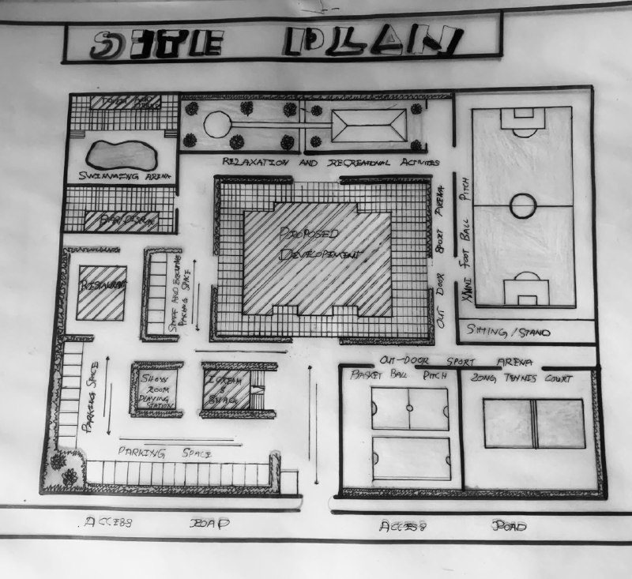
APPENDIX 1: SITE PLAN
GROUND FLOOR PLAN
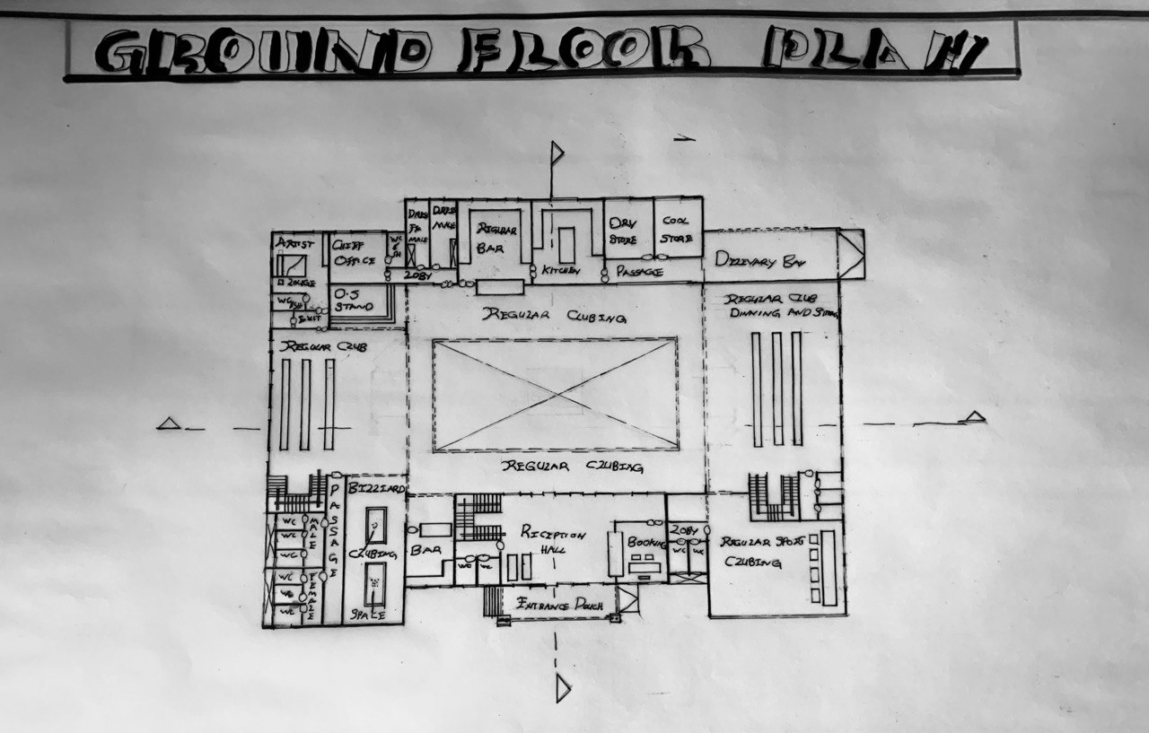
APPENDIX 2: GROUND FLOOR PLAN

FIRST FLOOR PLAN
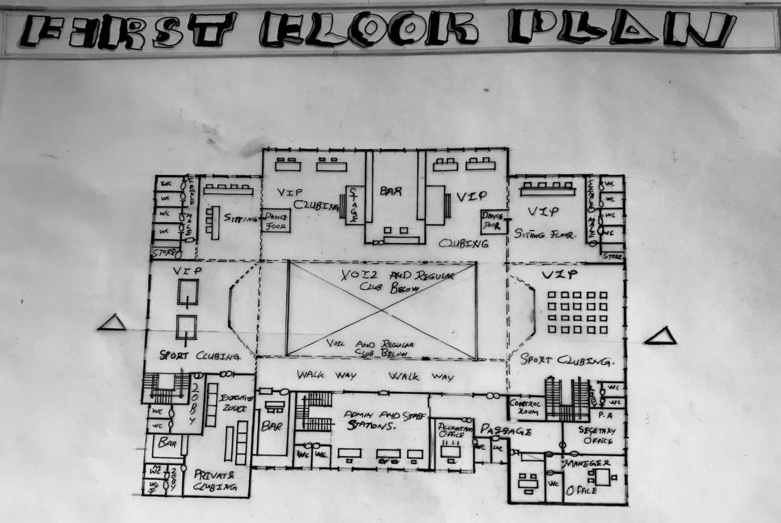
APPENDIX 3: FIRST FLOOR PLAN

ROOF PLAN
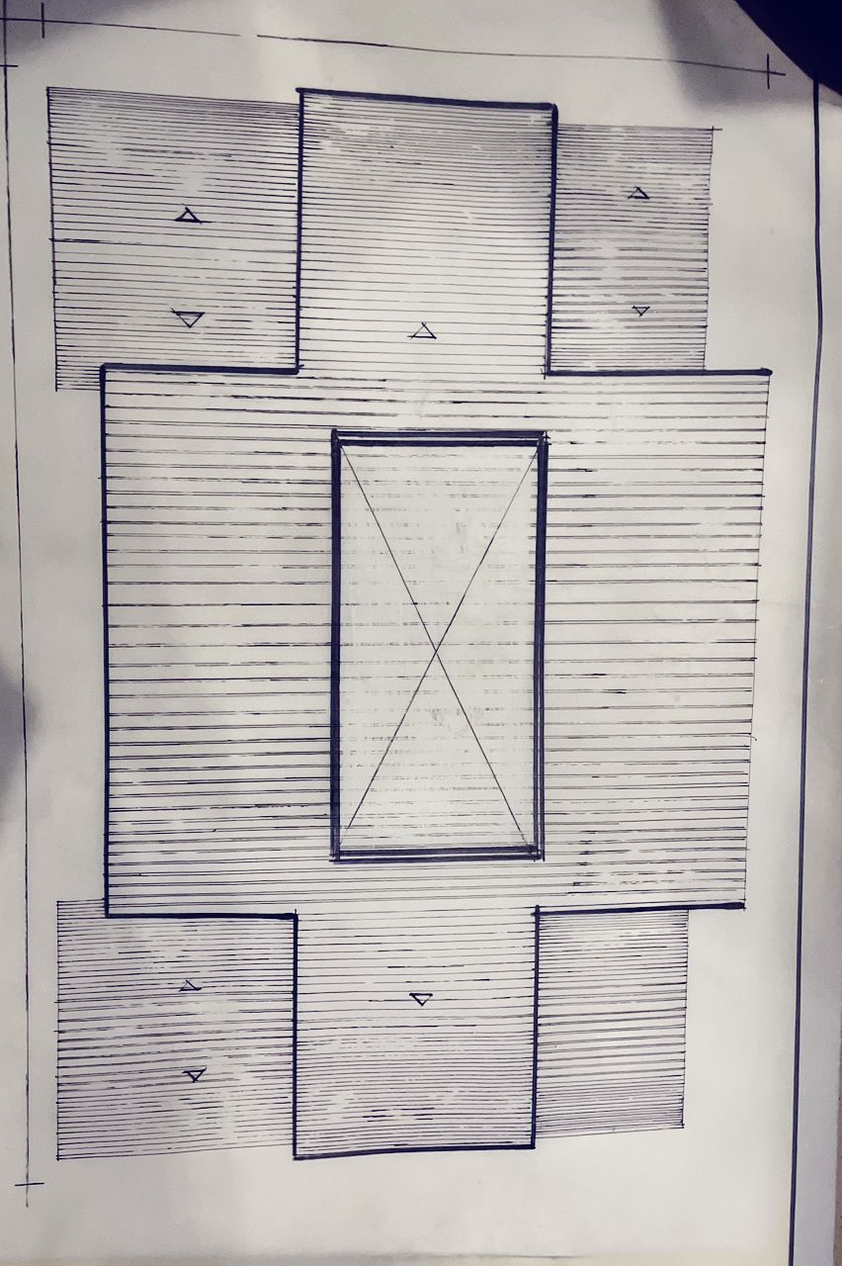
APPENDIX 4: ROOF PLAN
DETAILS
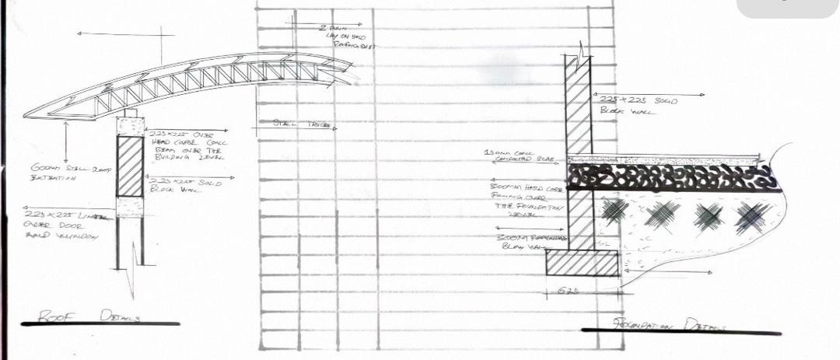
APPENDIX 5: DETAILS

CROSS SECTION AND LONGITUDINAL SECTION
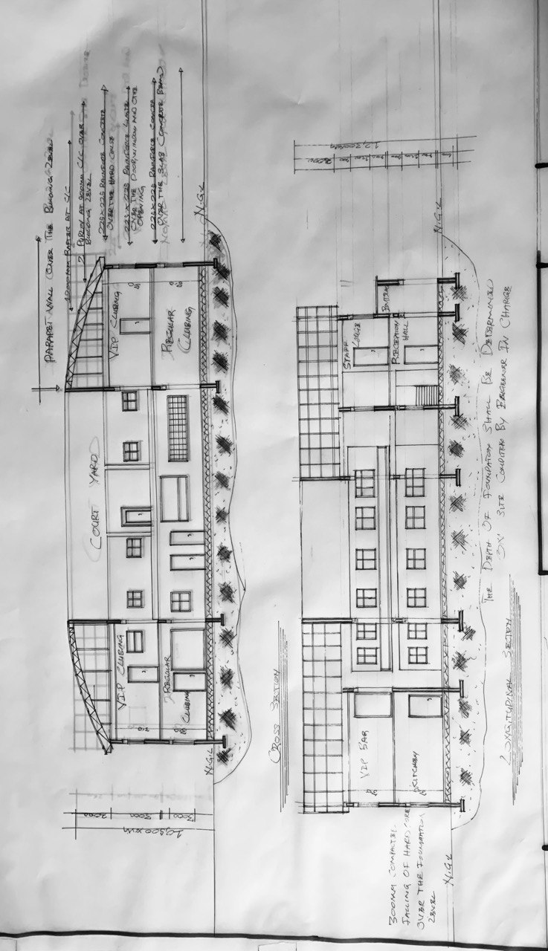
APPENDIX 6: CROSS SECTION AND LONGITUDINAL SECTION PLAN

ELEVATION
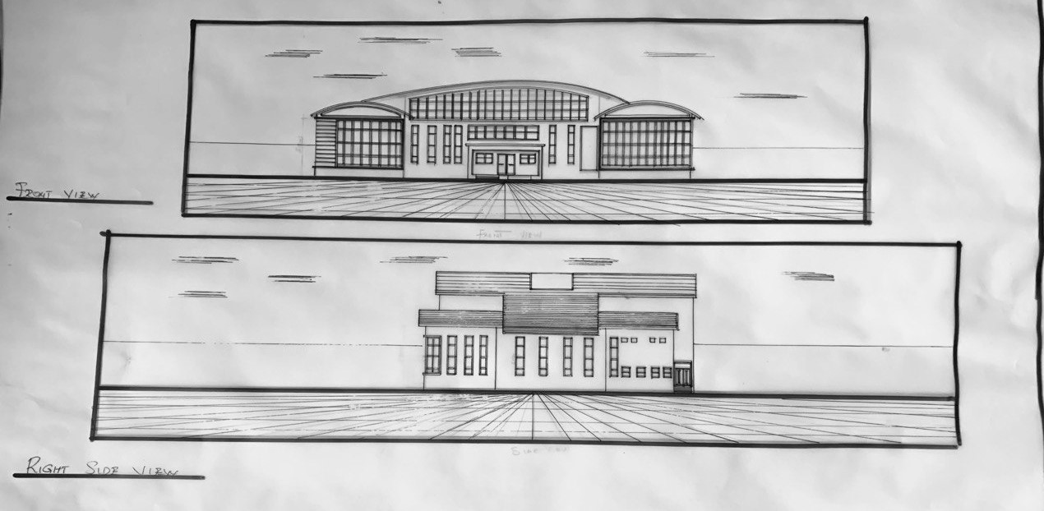
APPENDIX 7: ELEVATION PLAN

INTERNAL PERSPECTIVE VIEW

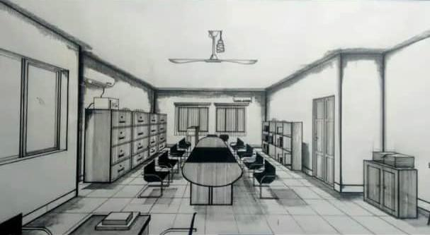

APPENDIX 8: INTERNAL PERSPECTIVE VIEW

EXTERNAL PERSPECTIVE VIEW
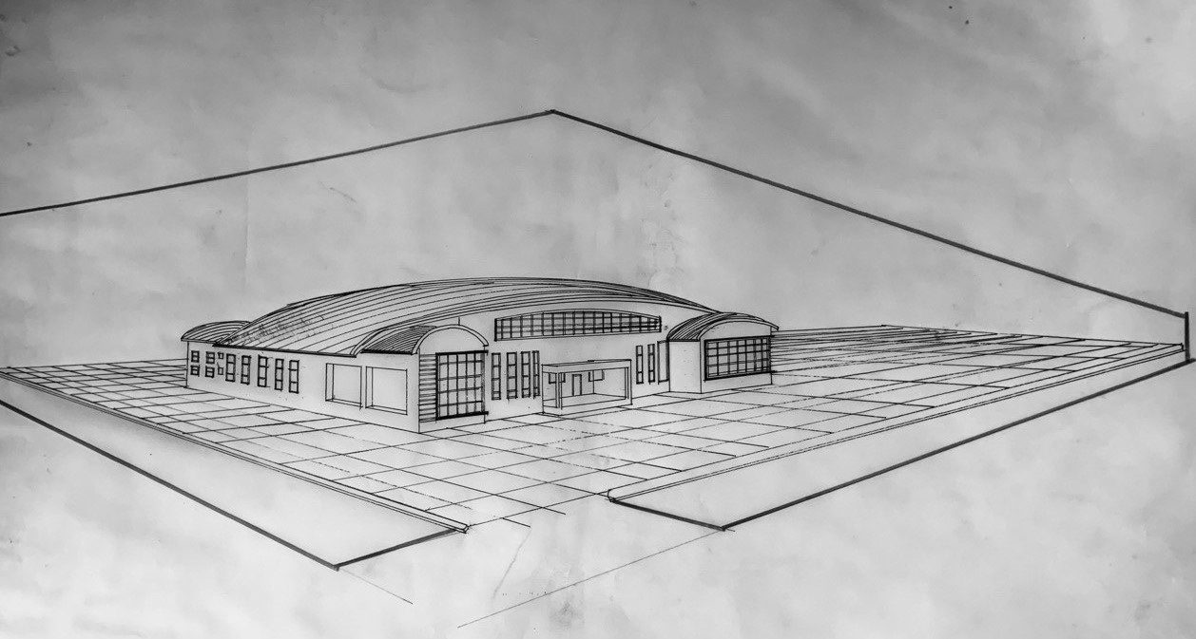
APPENDIX 9: EXTERNAL PERSPECTIVE VIEW

