A PROJECT REPORT

ON

PROPOSED CLUBHOUSE FOR

ROTARY CLUB

AT

IKORODU, LAGOS STATE

BY

TIJANI QUADRI ADESHINA
HND/23/ARC/FT/0068

SUMMITED TO
THE DEPARTMENT OF ACHITECTURAL TECHNOLOGY
INSTITUTE OF ENVIRONMENTAL STUDIES (I.E.S), KWARA STATE POLYTECHNIC ILORIN KWARA STATE

IN PARTIAL FULFILLMENT OF THE REUIREMENTS FOR THE AWARD OF HIGHER NATIONAL DIPLOMA (HND) IN THEDEPARTMENTOFARCHITECHTURALTECHNOLOGY, INSTITUTE OF ENVIRONMENTAL STUDIES (IES)

JULY, 2025


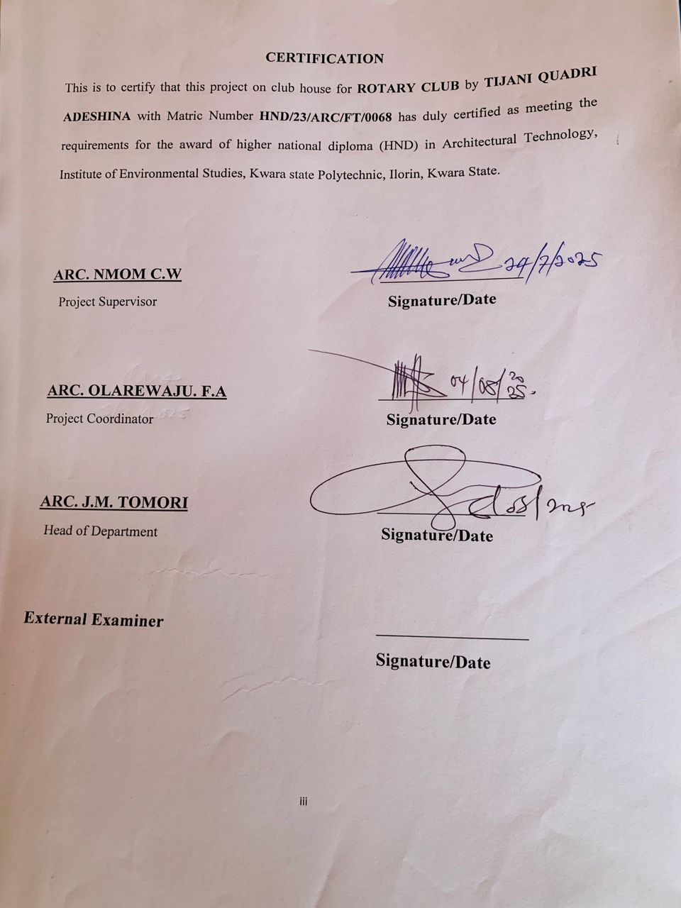
DEDICATION
This project is fully dedicated to the almighty Allah, who is the source of my strength and guidance all the praises to him alone, I also dedicate this work to my parent, Mr and Mrs. Tijani for their uncompromising moral and financially support throughout my educational career so far.

ACKNOWLEDGEMENT
My appreciation goes to Almighty Allah for His guidance and support over me.
I acknowledge with profound gratitude the moral and material support given to me by my mentor, Arc. NMOM C.W (MSc.), for his constructive criticisms, encouragement, and assistance throughout the course of this project.
I must also express my sincere thanks to Arc. FAMILUA O.S (MSc.) for his relentless efforts and impactful support.
My gratitude extends to Arc. Olanrewaju F.A (MSc.) for his immense encouragement, and Arc. (Mrs.) Tomori (MSc.) for her academic and moral contributions.
I wholeheartedly appreciate the support of my parents, Mr. and Mrs. Tijani, for their moral, emotional, and financial support throughout my academic journey.
Special thanks to my supportive family members, Mr. and Mrs. Sharafadeen thank you for all you do.
To all my coursemates who made this journey both a challenging and fulfilling experience, I truly appreciate you all: Shamsudeen, Fathima, Ramon, Naallah, Az, and to my kinsmen Baddo, Ope, Benedith, Habeeb, Faruq, and Michigan.
To my dear friends Ayinke, Fathima, Awa, and Rashidat thank you for your immense support and love.
Finally, to everyone who has shaped me into who I am today, I sincerely appreciate your genuine kindness.

TABLE OF CONTENTS
Title page i
Declaration ii
Certification iii
Dedication iv
Acknowledgement v
Table of contents vi
List of figure ix
List of plate x
Abstract xi
CHAPTER ONE
1.0 Introduction 1
1.1 Historical Background 1
1.2 Definition 2
1.3 Aim and Objectives 2
1.4 Scope 3
1.5 Statement of the Problem 3
1.6 Research Methodology 4
1.7 Limits of Constraint 4
1.8 Justification 5
CHAPTER TWO
2.0 Literature Review and Case Study 6
2.1 Review of Relevant Literature
2.2 Importance 6
2.3 Selected Case Studies 7
2.3.1 Case Study One 7
2.3.2 Case Study Two 10
2.3.3 Case Study Three 13
2.3.3 Case Study Four 16
2.3.3 Case Study Five 18
CHAPTER THREE
3.0 Site and Environmental Analysis 20
3.1 Brief History and Introduction of Study Site 21
3.2 Site Location / Description 22
3.3 Site Selection / Location Criteria 23
3.4 Site Analysis / Inventory 24
3.5 Climatic Data / Geographical Consideration 25
CHAPTER FOUR
4.0 Design Criteria 28
4.1 Site Planning 29
4.2 Brief Analysis 32
4.3 Analysis of the Spaces 33
4.4 Space Allocation 34
4.5 Functional Relationship 35
4.6 Conceptual Development 36

CHAPTER FIVE
5.0 Approval of Proposal 38
5.1 Design and Construction 40
5.2 General Design Consideration 42
5.3 Construction Method and Material 43
5.4 Landscape Design 44
5.5 Landscape Elements Used in the Design 45
5.6 General Conclusion and Recommendation 46
References 48
Appendix 50

List of Figures
Fig 2.3.1: Showing the location plan of Ilorin Golf Club 8
Fig 2.3.2: Showing the floor plan of Ilorin Golf Club 8
Fig 2.3.3: Showing the location plan of Ilorin Club 11
Fig 2.3.4: Showing the layout of Ilorin Club 11
Fig 2.3.5: Showing the location plan of Ibadan Golf Club 14
Fig 2.3.6: Showing the floor plan of Ibadan Golf Club 14
Fig 2.3.7: Showing the inventory of the proposed site 24
Fig 2.3.8: Showing the analysis of the proposed site 25
Fig 2.3.9: Showing the climatic data of the proposed site 27
Fig 2.3.10: Showing the site plan of the proposed site 30
Fig 2.3.11: Showing the space allocation of the proposed site 35
Fig 2.3.12: Showing the functional relationship of the proposed site 36
Fig 2.3.13: Showing the concept of the proposed site 37

List of Plates
Plate 2.3.1: Showing the front elevation of Ilorin Golf Club 9
Plate 2.3.2: Showing the internal perspective of Ilorin Golf Club 9
Plate 2.3.3: Showing the entrance of Ilorin Club 12
Plate 2.3.4: Showing the side elevation of Ilorin Club 12
Plate 2.3.5: Showing the entrance of Ibadan Golf Club 15
Plate 2.3.6: Showing the front elevation of Ibadan Golf Club 15
Plate 2.3.7: Showing the front elevation of Highland Club Alabama 17
Plate 2.3.8: Showing the left side elevation of Highland Club Alabama 17
Plate 2.3.9: Showing the front elevation of the lake view club New York 19
Plate 2.3.10: Showing the internal perspective of the lake view club New York 19

ABSTRACT
This project focuses on the design of a proposed clubhouse located in Ikorodu, Lagos State. The goal is to create a recreational facility that fosters social interaction, relaxation, and community bonding through thoughtful architectural and landscape design. The proposal integrates elements such as green spaces, shaded seating zones, walkways, and buffer plantings to enhance user comfort, environmental quality, and aesthetics. Special attention was given to zoning, circulation, and the use of natural features to promote sustainability, accessibility, and functionality. The clubhouse is designed as a multifunctional space, incorporating areas for indoor and outdoor games, flexible event halls, reading spaces, and wellness zones to serve a wide range of users.The design promotes sustainability by using local materials, natural lighting, and ventilation strategies. It contributes positively to the built environment while offering a welcoming space for community engagement, development, and recreation in the Ikorodu area.

CHAPTER ONE
INTRODUCTION
This project involves the architectural design of a sustainable and innovative clubhouse that meets functional, social, and environmental needs of its users. The aim is to create a space that supports recreational and community activities while aligning with contemporary design standards and sustainable building practices.
A clubhouse, in architectural terms, is a multifunctional facility that integrates various spaces such as guest lounge, gym, dining area, game room, meeting room, and event halls. It acts as a social hub, encouraging interaction, relaxation and organized events while ensuring the design is user-friendly and blends functionality with aesthetics ensuring proper spatial planning, user flow, structured integrity and environmental performance (David and Chadderton, 2007).
Key considerations in this project include site analysis, zoning requirements, spatial hierarchy, natural lighting and ventilation, material selection, structural systems and easy accessibility. The design will incorporate principles of sustainable architecture, energy efficiency, and cultural relevance to create a sustainable solution (Ernst and Peter Neufert, 1993).
1.1 HISTORICAL BACKGROUND
The concept of clubhouse originated in 17th century Europe as an exclusive space for social clubs, where people with shared interests gathered for discussions, relaxation and leisure. These early clubhouses were architecturally designed to reflect prestige and privacy, often situated in prominent urban locations.
By the 19th century, the concept evolved to include recreational and wellness facilities, particularly in country clubs and sporting clubs.
In Nigeria, the emergence of clubhouses dates back to the colonial era, particularly in the early 20th century. Both colonial administrators and expatriates established clubs as social and recreational outlets. Examples include Ibadan Club, Ikoyi Club (1938) and Lagos Polo Club, which were often exclusive to elite populations. These early clubhouses were designed with colonial architecture large verandas, high ceilings, and expansive open space tailored to tropical climates.
Over time, the clubhouse culture evolved locally, becoming more inclusive and adapting to Nigerian social life. Today, modern clubhouses in Nigeria serve multifunctional purposes, blending leisure, fitness and community engagement.
1.2 DEFINITION
A clubhouse is a building used as a central meeting place for a group, organization, or community. It typically provides space for social, recreation, and administrative activities, often tailored to the needs of its members or users.
1.3 AIM
To design a functional and sustainable clubhouse that serves as a central hub for community engagement, recreation, social interaction, and educational activities, promoting a safe and inclusive environment for all members or users.
OBJECTIVES
- To provide a multifunctional space for recreation and social activities.
- To promote community engagement by offering a central meeting point for events and programs.
- To foster a sense of belonging among community members.
- To ensure a safe, inclusive, and accessible environment for all individuals.
- To integrate sustainable and efficient design practices for long-term functionality and environmental responsibility.
- To encourage skill development and education through training sessions and other learning initiatives.
1.4 SCOPE
The study will cover the entire approved space with consideration to functional arrangement and utilization of space based on architectural standards and design elements.
- Gym House
- Lawn Tennis
- Basket Ball Court
- Recreation House
- Garden Area
- Car Park
- Walk Area
- Gate Area
- Green Area
- Main Building
1.5 STATEMENT OF PROBLEM
Despite the increasing popularity of clubhouses as social and recreational centers, many existing designs lack innovative architectural character and fail to fully address the diverse needs of users. Often, these buildings are designed with generic input that does not optimize spatial flow, natural lighting, or meet the surrounding environmental conditions.

Problems of common concern include occupant safety, accessibility to specialized spaces and reduce occupancy load at only expert level. A number of community hubs are frequently overlooked as a need for a vibrant community hub.
There is a need for an architectural design approach that integrates architectural solutions to encourage social venues and provide a safe and friendly environment for users.
1.6 RESEARCH METHODOLOGY
This section explains the research methodology adopted based on the diverse typologies of the selected case studies. The research approach was directed towards understanding the functional and user experience framework of the case study clubhouses. The methodology focuses on understanding how clubhouses serve their communities and identifying design elements that support their effectiveness.
Interviews: Conducted interviews with clubhouse managers, users and architects to gather first-hand perspectives on usability and design experiences.
Literature Review: Reviewed academic articles, architectural design guidelines related to clubhouse design and community space.
Online Review: Explored digital platforms and social media for user feedback, trends and innovative clubhouse concepts.
This multifaceted approach ensures a comprehensive understanding that informs the development of a clubhouse design that is both functional and development-inspiring.
1.7 LIMITATION OF CONSTRAINTS
- Time constraints: The limited time allocated for research and design development affected the depth of analysis and exploration of alternative architectural solutions.
- Finance: Funding the research and the design project posed significant challenges, impacting the ability to conduct extensive fieldwork.
- Access to stakeholders: Limited availability of key users and managers for interviews sometimes restricted the depth of insight into user experience and operational challenges.
- Research material: There was a scarcity of detailed architectural documentation and case studies specific to clubhouses, particularly locally relevant examples, which made it difficult to perform comprehensive assessments during site analyses.
1.8 JUSTIFICATION
A clubhouse plays a crucial role in fostering community interaction, recreation, and social cohesion. It serves as a versatile space for activities such as meetings, events, and leisure, enhancing the quality of life for its users. By offering facilities that promote engagement and wellness, a clubhouse adds significant value to residential or corporate and community environments, making it an essential feature of modern development.

CHAPTER TWO
Literature Review and Case Study
2.1 Review and Case Study
This chapter provides a comprehensive review of existing literature relevant to the concept of a clubhouse. It includes definitions, historical background, common causes of fire outbreaks, types of fire, fire behavior, and core principles of fire safety. Additionally, the review explores existing fire protection systems and safety measures typically implemented in recreational and social buildings like clubhouses.
The study aims to develop a clubhouse design that responds to these challenges by combining thoughtful spatial planning, sustainable innovation, and functional emphasis to enhance user experience and community engagement.
The purpose of this review is to understand the prevailing trends, challenges, and research gaps in fire safety management as it pertains to clubhouses. Various doctoral theses, technical reports, and peer-reviewed journal articles were critically analyzed to gain insight into the scope and direction of research in the domain. These studies offer foundational knowledge essential for developing effective fire safety strategies tailored to the specific use, occupancy, and risk profile of clubhouse facilities.
2.2 Importance of Clubhouse
- Provide unity: serves as a social place for members to gather, bond, and build a sense of community
- Encourages relaxation: It provides a space for leisure activities and stress relief
- Support skill development: host workshops and meetings that keep improve leadership and teamwork
- Facilitate events: ideal venue for organizing social meetings and social gatherings
- Foster belonging: creates a sense of identity and pride among members
- Improves communication: enhances interaction and sharing of ideas among members
- Provides storage: offers a secure place for keeping equipment and club materials
- Boosts productivity: helps maintain structure and focus in club activities and planning
2.3 SELECTED CASE STUDIES
2.3.1 CASE STUDY ONE
ILORIN GOLF CLUB
HISTORICAL BACKGROUND
Historic and located in the capital of Kwara State, Ilorin Golf Club and social hub in Nigeria. Though its exact founding date isn't widely documented, it features an 18-hole course known first Scenic layout and clubhouse. Only under 5000 members and mostly from 100 capacity. It holds a monthly club plays a key role in promoting golf and fostering community interaction in Ilorin.
Merit
- The design allows for future expansion and modification to meet growing needs
- Incorporation to eco-friendly materials and designs
Demerit
- Poor architectural design can lead to insufficient natural airflow and lighting
- Improper site grading can cause water logging and structural damage

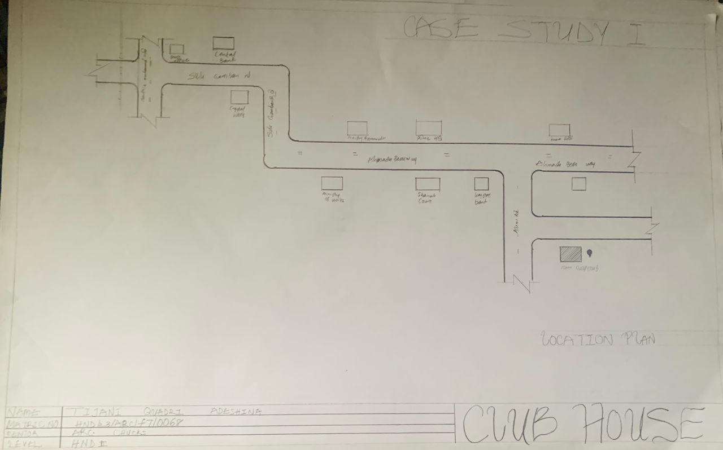
Fig 2.3.1: Showing the location plan of Ilorin Golf Club

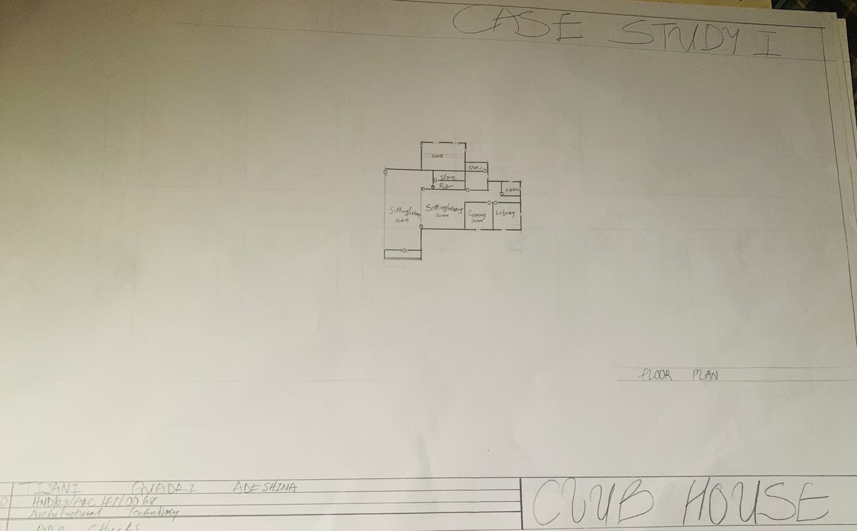
Fig 2.3.2: Showing the floor plan of Ilorin Golf Club

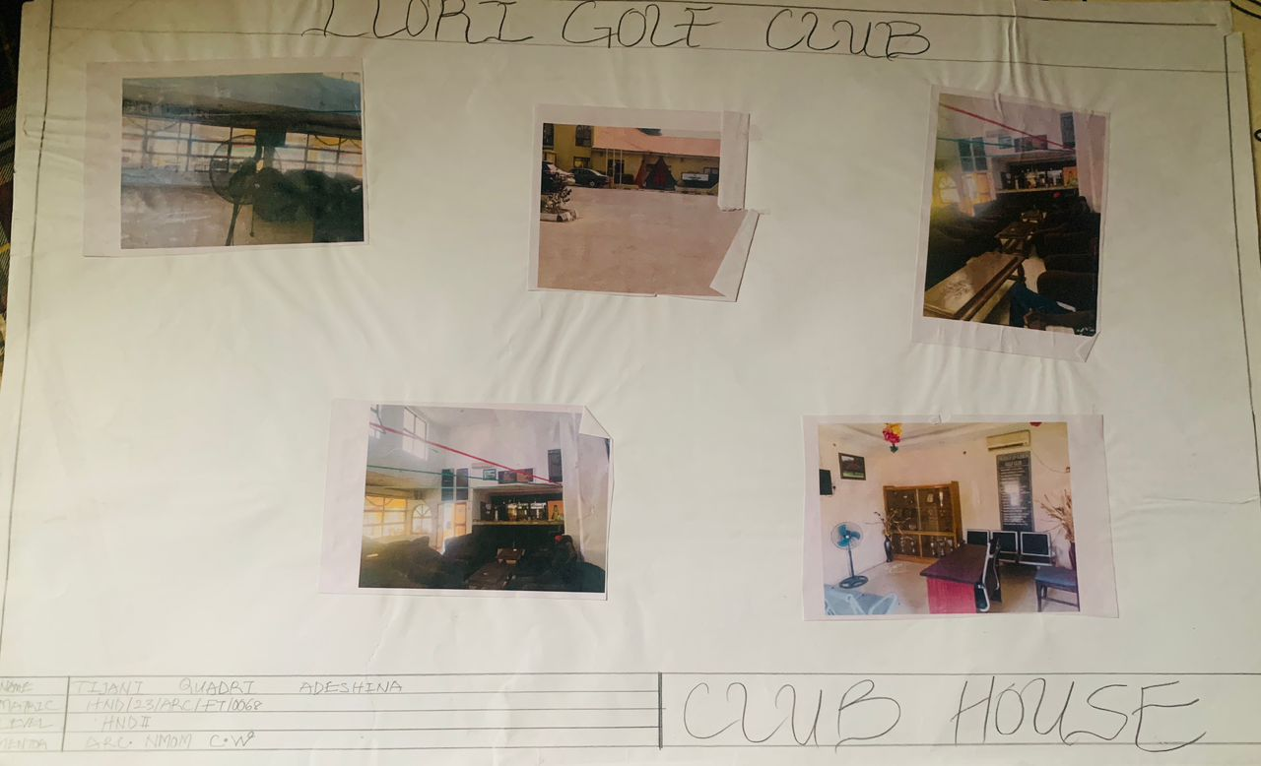
Plate 2.3.1: Showing the front elevation of Ilorin Golf Club

Plate 2.3.2: Showing the internal perspective of Ilorin Golf Club

2.3.2 CASE STUDY TWO
ILORIN CLUB
HISTORICAL BACKGROUND
The Ilorin Club, founded in 1954, is a cultural and social institution in Ilorin, Kwara State. Established to serve as a hub for the lifestyle and community development of Ilorin, the club preserves the city’s cultural traditions while hosting intellectual, social, and cultural events.
MERIT
- Well planned circulation patterns ensure easy navigation and movement
- A thoughtfully designed clubhouse can enhance the beauty of surroundings
- Demonstrates integrated facilities like sport and recreation can reduce users’ stress levels
- Exercise coordination limits green areas and natural element
Demerit
- Poor architectural design can lead to insufficient natural airflow and lighting
- Improper site grading can cause water logging and structural damage

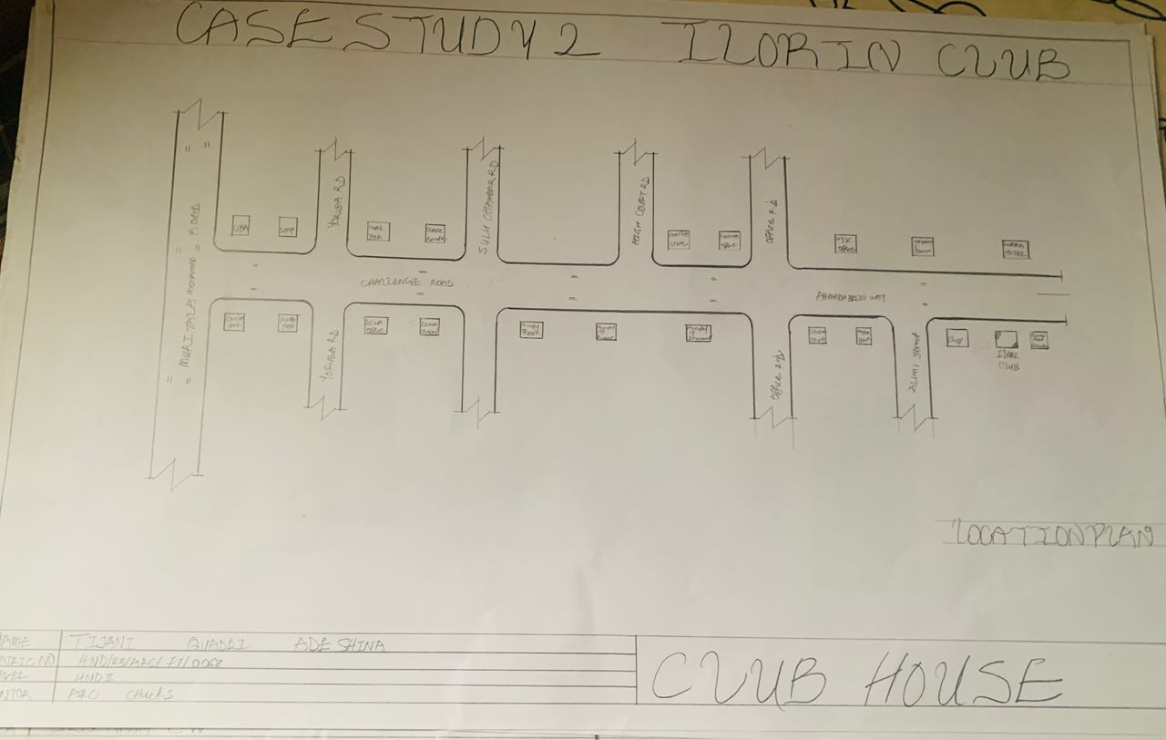
Fig 2.3.3: Showing the location plan of Ilorin Club

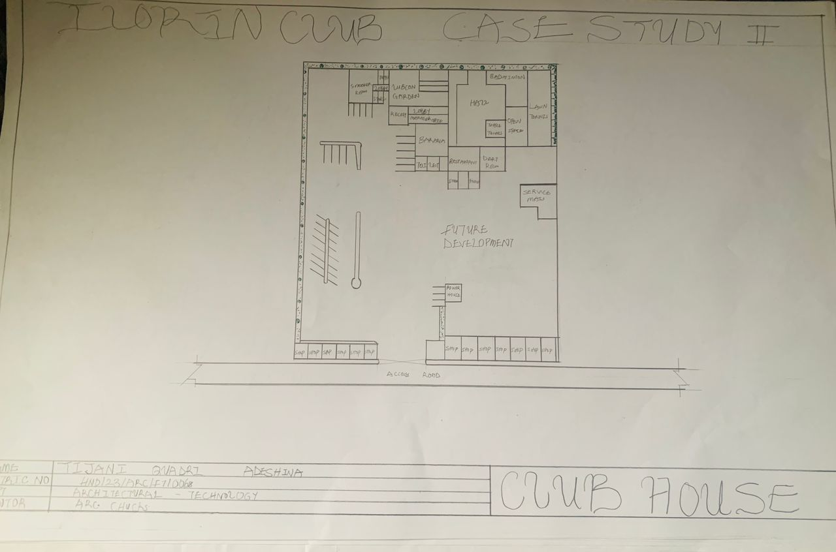
Fig 2.3.4: Showing the layout of Ilorin Club

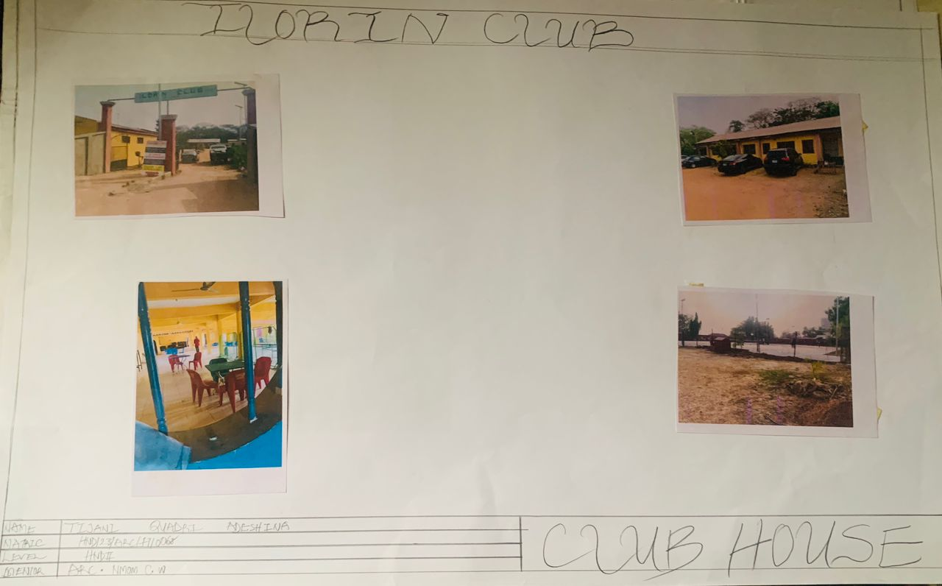
Plate 2.3.3: Showing the entrance of Ilorin Club
Plate 2.3.4: Showing the side elevation of Ilorin Club

2.3.3 CASE STUDY THREE
HISTORICAL BACKGROUND OF IBADAN GOLF CLUB
The Ibadan Golf Club, established in 1990, is a premier golf institution in Ibadan, Oyo State. Known for its scenic 18-hole course, it promotes golf and serves as a hub for social networking and community development.
The club has hosted numerous tournaments, playing a key role in advancing golf in Nigeria and enriching Ibadan’s sporting culture.
MERIT
- Multifunctional halls and adaptable room allow diverse usage
- Unique architectural design serves as a landmark for community
DEMERIT
- Complex architectural design might require expensive maintenance over time
- Poor zoned areas can lead to inefficient use of resources

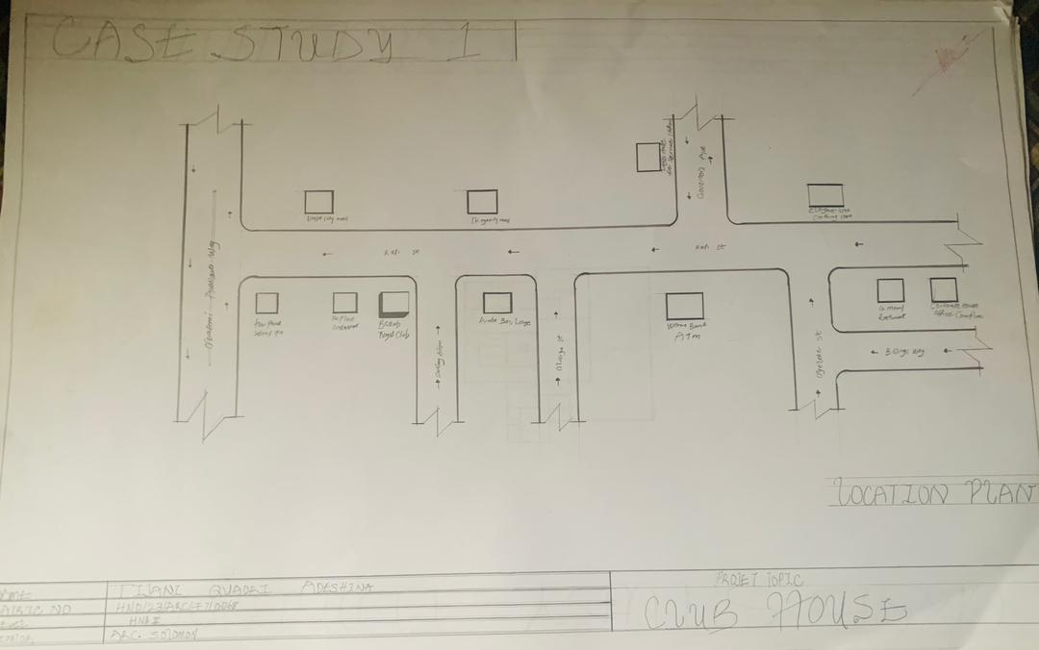
Fig 2.3.5: Showing the location plan of Ibadan Golf Club
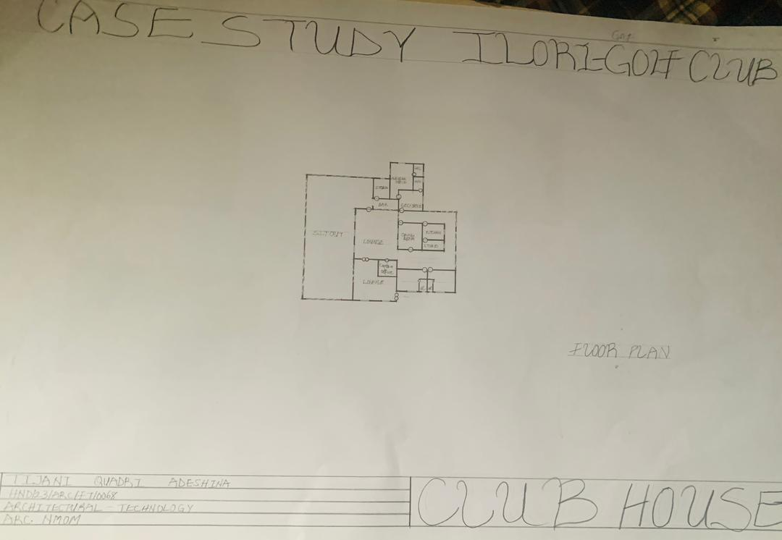
Fig 2.3.6: Showing the floor plan of Ibadan Golf Club

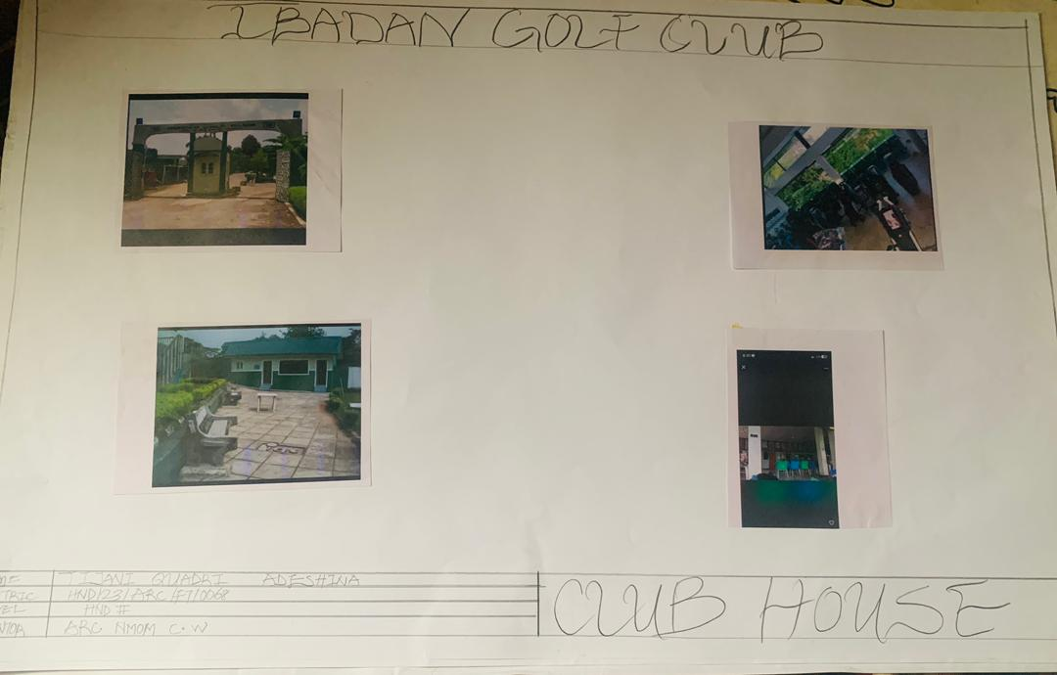
Plate 2.3.5: Showing the entrance of Ibadan Golf Club

Plate 2.3.6: Showing the front elevation of Ibadan Golf Club

2.3.4 CASE STUDY FOUR (Online)
Historical Background of Highland Club Alabama
The clubhouse is a historical and cultural event venue located on 2908 Highland Avenue South, Birmingham, Alabama. Built in 1903 by architect William S. Brown, this art and crafts-style mansion originally served as a private residence. It was later transformed into a clubhouse that provides an elegant backdrop to wedding, corporate gatherings, and educational functions. Its refined architecture and commitment to inclusivity make it a cherished landmark in Birmingham.
Merit
- Offers scope for creative, context-sensitive design that blends with the environment and reflects the community identity.
- It accommodates diverse activities social, recreational, and administrative within a single design.
Demerit
- High user traffic and diverse functions can lead to increased wear and tear requiring frequent repairs.
- Balancing varied functions (gym, lounge, and meeting rooms) can complicate space planning and zoning.

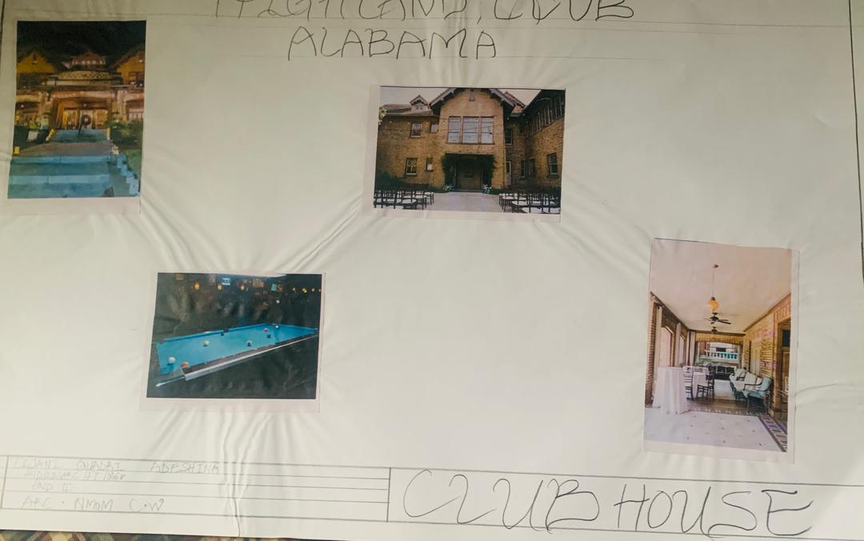
Plate 2.3.7: Showing the front elevation of Highland Club Alabama
Plate 2.3.8: Showing the left side elevation of Highland Club Alabama

2.3.5 CASE STUDY FIVE: ONLINE
HISTORICAL BACKGROUND OF LAKE VIEW CLUB, NEW YORK
The Lake Club in Springfield Village was a famous entertainment venue from the 1930s. Known for live music and dances, it also gained notoriety for drawing large crowds. It served as a disco and rock spot in the 1950s.
Merit
- Effective separation of space (lounge, meeting room) improves user experience
- Incorporating energy-efficient systems reduces environmental impact
Demerit
- Poorly layout may not adapt well to changing community needs or different activity
- Insufficient space planning may lead to cramped areas during peak usage

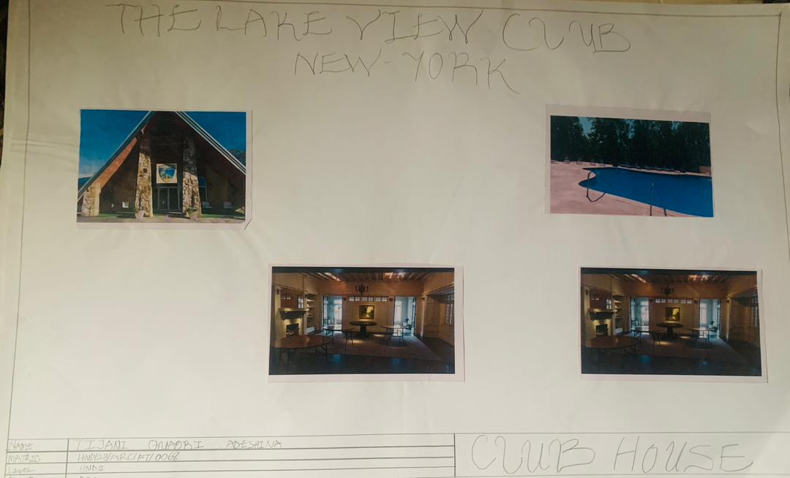
Plate 2.3.9: Showing the front elevation of the lake view club New York
Plate 2.3.10: Showing the internal perspective of the lake view club New York

CHAPTER THREE
SITE AND ENVIRONMENTAL ANALYSIS
Ikorodu is a rapidly growing suburban area on the north-east side of Lagos State. It has transitioned from a quiet zone to a more urbanized and mixed-use environment due to increased population and infrastructure development. The proposed site is located within a residential zone with nearby commercial and institutional facilities, making it ideal for a community-centered clubhouse.
Topography
The terrain is generally flat with minimal elevation changes, which supports ease of construction and accessibility. However, proper drainage planning is essential due to seasonal rainfall and occasional flooding in parts of Ikorodu.
Climate
Ikorodu experiences a tropical wet and dry climate. Key climate factors affecting design include:
- High humidity
- Heavy rainfall between April and October
- Average temperature between 25°C and 34°C
These factors call for effective natural ventilation, shaded outdoor spaces, and durable weather-resistant materials.
Vegetation and Ecology
The site has sparse vegetation, mostly low shrubs and scattered trees. Preserving some of the natural vegetation can aid in landscaping and microclimate control. Incorporating green space and permeable surface will enhance sustainability.

Accessibility and Transportation
The site is accessible via major roads such as the Ibadan road and the Lagos-Ibadan expressway. Public transportation is readily available, but traffic congestion during peak hours must be considered when planning access and parking.
Utilities and Infrastructure
The area has access to electricity, water supply, and telecommunication networks. However, backup systems (solar, inverters, generators) are recommended to ensure uninterrupted service.
Design Implication
- Maximize cross ventilation using building orientation
- Incorporate shading devices and overhangs
- Use water management systems (gutters, soakaway, rainwater harvesting)
- Ensure ADA-compliant and inclusive design for community access
3.1 Brief History and Introduction of Study Site – Ikorodu
Ikorodu is a fast-developing urban district located in the northeastern part of Lagos State. Historically, it was founded by Yoruba settlers and was known as an agricultural and traditional trading town due to its proximity to the Lagos Lagoon and farmland. Over time, Ikorodu has grown significantly in population and infrastructure, transitioning into a suburban extension of metropolitan Lagos.
The area has seen increased urbanization in recent decades, driven by Lagos expansion and the overflow of residential demand from the city center. Key developments include residential estates, markets, schools, and transport terminals. Despite this growth, Ikorodu still retains a mix of traditional and communal characteristics, offering a calm but connected environment ideal for community-centered development.
Relevance to the Project
The site's location in Ikorodu makes it strategically suitable for a clubhouse that serves both relaxation and community purposes. Its growing population, mixed land use, and improving road networks support the need for recreational and social spaces. The project aims to respond architecturally to the climate, cultural context, and social needs of the area through thoughtful planning, sustainable design, and community-focused amenities.
3.2 Site Selection and Location Criteria
Selecting an appropriate site is crucial for the success of a clubhouse project. Site selection was based on the following criteria, which are essential to achieve a functional, accessible, and sustainable environment. Each factor contributes to the success of the site in Ibadan, Oyo State:
Accessibility: Site is located near major road networks, making access easy for both vehicles and public transportation. This enhances usability and attracts a diverse range of users.
Previously Residential Area: Being close to a densely populated residential zone increases the demand for recreational and communal spaces, making the clubhouse relevant and well-utilized.
Land Availability and Size: The site offers adequate land for proper spatial planning, including green areas, parking, circulation, and future expansion.
Environmental Suitability: The site is located in a low-risk flood zone with natural vegetation that can be integrated into landscape design. The climate supports the use of passive cooling techniques such as natural ventilation and shading.
Infrastructure and Utilities: Availability of basic infrastructure such as electricity, water supply, road network, and drainage system makes the site suitable for development without heavy off-site investment.

Social and Cultural Factors: Steady-growing urban population and evolving lifestyle patterns indicate a need for multifunctional space that promotes relaxation, fitness, and social engagement. The site falls into the area…
3.3 SITE Inventory and Analysis
The proposed site for the club house project is located in Ikorodu, Lagos state, a developing suburban area with a balance of urbanization and natural features. Site analysis and inventory were conducted through direct observation, measurement and environmental assessment to support appropriate architectural planning and design decisions.
Inventory (Existing Site Features)
The site presents the following notable features:
Access road: a major road runs along one edge of the site, providing convenient vehicular access for users. This improves connectivity and supports both private and public transport.
Electric Poles: Presence of electric poles along the road confirms access to power infrastructure which is essential for lighting, HVAC system and other building services.
Vegetation: The site includes:
1. Trees (broadleaf and palm) offering natural shading and landscape potential.
2. Low vegetation and shrubs scattered throughout the site, contributing to ecological value and microclimate regulation.
Foot path: An informal footpath crosses the site indicating an existing pedestrian circulation pattern. This can inform the internal pathway network of the design.

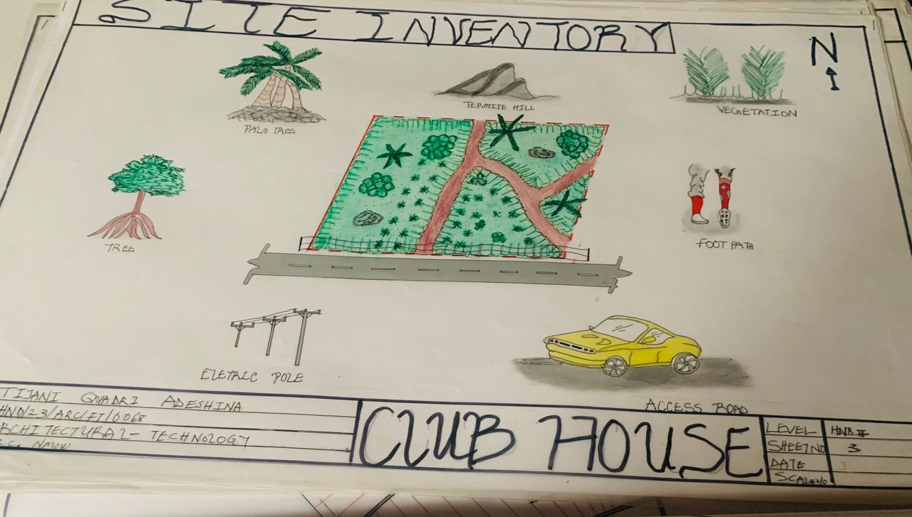
Fig 2.3.7: Showing the inventory of the proposed site
3.4 Site Analysis
- The site selected for the proposed clubhouse project is located by a motorable road, providing direct and convenient access for vehicles and pedestrians. This ensures smooth entry to the site, critical for a public facility like a clubhouse.
- Electric poles are visible along the boundary of the site, confirming the availability of power infrastructure. This reduces the cost of utility installation and supports the inclusion of lighting, air conditioning, and other technical systems.
- Vegetation (trees, palm, shrubs): The site contains various forms of vegetation.
- Broadleaf trees that offer shade and environmental cooling.
- Palm trees which enhance aesthetic value and tropical identity.
- Shrubs and low vegetation that can be incorporated into soft landscaping.
- Foot path (existing circulation route): A visible informal footpath runs across the site, indicating regular pedestrian movement. The path can be formalized in the site layout to maintain natural circulation patterns and encourage walkability.
- Rocky hill: A rocky hill consists on part of the site, creating a slight elevation. This feature presents opportunities for:
- Scenic viewing point
- Elevated terraces
The slope must be managed properly for drainage and stability, but it offers strong design potential.
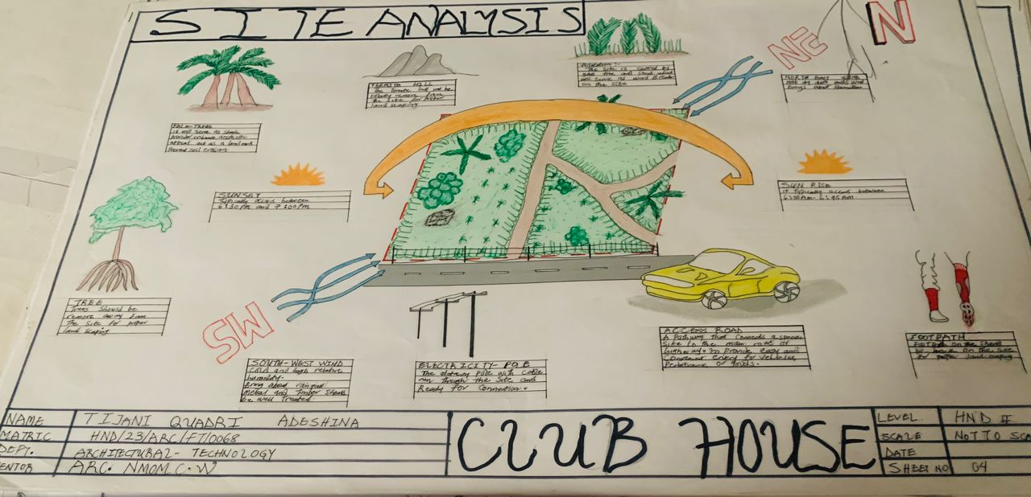
Fig 2.3.8: Showing the analysis of the proposed site
3.5 Climatic Data and Geographical Consideration
Geographical location: Ikorodu is located in the eastern part of Lagos state, Nigeria. It lies approximately at latitude 6° 36'N and longitude 3° 35'E within the tropical coastal zone of West Africa. The area is bordered by the Lagos state lagoon to the south and a mangrove both within and suburban development patterns.
Climate Data:
- Climate type: Tropical wet and dry, under the Koppen climate classification.
Temperature:
- Average annual temperature: 25°C - 34°C
- Hottest months: February to April
- Coldest months: July to September
Rainfall:
- Annual rainfall: 1500 - 1800 mm
- Rainy season: April to October
- Peak rainy season: June to September
- Dry season: November to March
Humidity:
- High relative humidity year-round (60% - 90%)
- Highest during the rainy season
Wind:
- Dominant wind direction: Southwest to Northeast
- Agent to moderate speeds, important for passive ventilation
Sun Path and Solar Radiation:
- High solar exposure, especially on east and west facade
- Required sun-shading device like louvers, deep overhangs, and vegetation

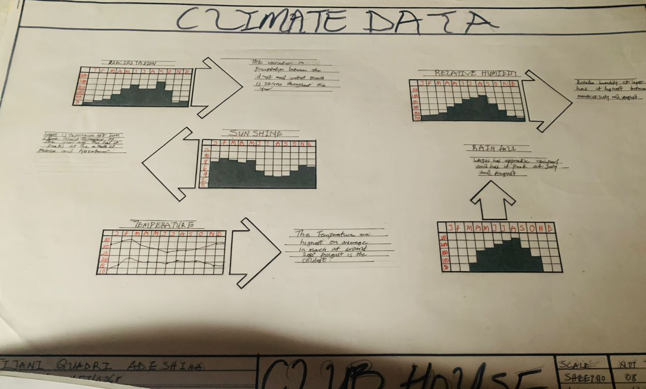
Fig 2.3.9: Showing the climatic data of the proposed site
Geographical Considerations
Topography:
The site is generally flat with slight rocky outcrops. This supports ease of construction while offering design opportunities for raised platform and natural drainage flow.
Soil type:
Predominantly lateritic soil – commonly stable and good for shallow foundations, though a geotechnical test is advised.
Drainage and Flooding:
The site is not a designated flood-prone area, but due to heavy rainfall, effective drainage systems such as soakaways, gutters, and site grading are necessary to prevent surface water accumulation.
Proximity to Lagoon:
While Ikorodu is close to the Lagos lagoon, the specific site location is far enough inland to avoid direct influence from coastal erosion or saline intrusion.
CHAPTER FOUR
Design Criteria
The design of the proposed club house in Ikorodu, Lagos state, is guided by architectural principles that respond to functional needs, environmental conditions, and user comfort. The following criteria serve as the foundation for developing a sustainable, relevant, and contextually appropriate design.
Functionality:
Space must support social, recreational, and wellness activities. Core facilities include reception, gym, event hall, private restrooms, and outdoor recreation zone. Zoning should ensure smooth flow between public, semi-public, and private areas.
Spatial Planning:
1. Efficient layout to maximize site use while maintaining comfort.
2. Clear circulation paths for both pedestrians and vehicles.
3. Integration of green spaces and relaxation areas into the spatial hierarchy.
Accessibility:
1. Universal design principle applied to ensure access for people of all abilities.
2. Inclusion of ramps, wide doors, ways for accessible restrooms.
Environmental Responsiveness:
- Orientation of buildings to minimize solar heat gain and maximize cross ventilation.
- Use of passive cooling techniques, natural lighting, and shaded walkways.
- Integration of rainwater harvesting and proper site drainage.
Aesthetic Consideration
1. Blending modern architecture / expressions with local materials
2. Use of natural materials and finishes that respect the environment and culture
3. Visual harmony between building forms, landscape, and topography
Sustainability
1. Selection of eco-friendly, locally available materials
2. Inclusion of renewable energy sources such as solar panels
3. Water-saving plumbing fixtures and energy-efficient lighting systems
Safety and Security
1. Provision for fire exits, emergency lighting, and security checkpoints
2. Site fencing, surveillance, and controlled access to key zones
Parking and Circulation
1. Adequate parking space for cars and motorbikes
2. Separate pedestrian paths to ensure safety and ease of movement
Flexibility
1. Multi-purpose space that can adapt to different community activities
2. Future expansion possibilities considered in the site layout
4.1 Site Planning
The proposed site plan of the Clubhouse project on Ikorodu Lagos is developed with careful attention to zoning, user circulation, environmental factors, and functional relationship between spaces. The layout provides well-organized arrangement of facilities and supports social interaction, social and support activities, where ensuring comfort, accessibility, and sustainability.

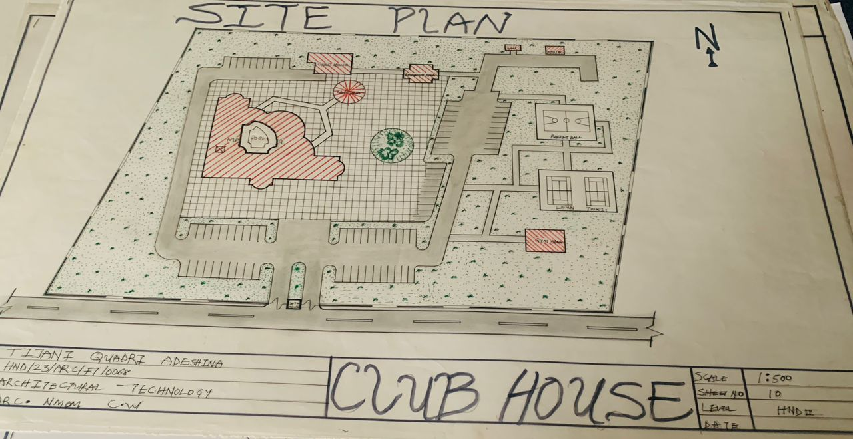
Fig 2.3.10: Showing the site plan of the proposed site
Functional zoning and building distribution
The site is divided into distinct zones based on activity type and functional requirements.
- Main clubhouse building: Positioned centrally as a core facility that houses multipurpose, space, service, indoor event area, administrative office, and event hall. Its location allows for easy access from any part of the site and makes it the visual and functional focus of the design.
- Gym House: Located close to the main entrance and outdoor zones, this facility provides fitness and wellness services. Its separation from the main block helps reduce noise disturbance and promotes a dedicated exercise environment.
- Guest House: Situated in a more private and quiet section of the site, the guest house accommodates visitors overnight. Its placement ensures privacy and proximity to key facilities without interrupting public activity flow.
- Cafeteria: Strategically placed near the clubhouse and relaxation areas, the cafeteria supports both indoor and outdoor users. It serves as a food and beverage hub while promoting casual interaction.
- Recreation Area: This landscape open space with seating and shaded zones is centrally integrated within the site, offering opportunities for social gathering, informal meeting, and natural refreshment.
Here’s the transcription of the text on this page:
A.
1. Gate House: Located at the entrance for security function as control and security point for monitoring premises, managing entry, monitoring visitor's safety across the facility.
2. Waste management and Sanitary: Sewage treatment activity zones, waste source areas handled in septic tanks and sewage treatment. Its position possible to control by flow without interfering with daily user activities.
B. Circulation and Accessibility
1. A looped access road connects all major buildings with a central driveway.
2. Adequate parking space provided along the circulation path for staff and visitors.
3. Pedestrian walkway are clearly separated from vehicle zones.
C. Landscaping and Environmental Integration
1. Natural vegetation and tree are retained or added to enhance shade, reduce heat and improve site aesthetics.
2. Pave and green surfaces are balanced to encourage drainage and outdoor usability.
3. Central green zones act as visual focal point and relaxation spaces.

D. Design principle Reflected in the Site Plan
i. Functionality: Clear zoning of public, semi-public and private areas.
ii. Orientation: Maximize daylight and cross ventilation.
iii. Accessibility: Barrier-free movement across all paths.
iv. Sustainability: Inclusion of green buffers, waste management and stormwater control.
v. Security: Controlled entry and exit through the gatehouse and defined perimeter.
4.2 BRIEF ANALYSIS
The site plan for the proposed club house in Ikoyi is designed to reflect effective spatial organization, user convenience and environmental responsiveness. The layout clearly separates functional zones such as recreation, administration, guest house and services, ensuring smooth circulation and optimal land use.
The main club house building occupied a central, accessible position to serve as the focal point, while the gym house, guest house and cafeteria are positioned for ease of use and privacy where needed. Adequate parking space, a well-defined driveway and pedestrian walkways support efficient movement within the site.
Environmental features such as green buffers, tree vegetation and relaxation space enhance user experience and reduce heat gain. Service elements like waste area and soak away are discreetly located to avoid water contact with public use areas. The gate house ensures site security and access control.
Overall, the site plan demonstrates a balanced approach to function, accessibility, sustainability and aesthetic appeal.

4.3 Analysis of Space
The layout of the main clubhouse building creates a well-structured spatial arrangement tailored to accommodate multiple user activities: recreational, administrative, and social. The building is zoned to ensure functional relationships, smooth flow, and spatial consistency.
1. Functional Zone
- Entrance and reception
- Entrance canopy and waiting area: welcomes guests and provides transition into the interior
- Reception area is centrally placed providing visual access to various parts of the building
- Admin offices and security are adjacent for operational control
2. Social and Leisure Zone
- Multipurpose hall: A large flexible space suitable for events, gatherings, or conferences
- Bar and lounge area: Open seating integrated with bar service, ideal for informal meetings and relaxation
- Restaurant, kitchen, and store: Positioned near the bar for easy food service and operation
- Male and female toilets: Provided for user comfort
3. Wellness and Recreation Zone
- Indoor game: Enclosed recreational area separated for noise control and privacy
- Pool area: Centrally placed for both aesthetics and function, serving as visual and recreational core
- Conference room: Attached to game zone for seminars, meetings, or workshops
- Changing room and locker: Provided close to the pool
A. Utility and Service Zone
- Laundry store and housekeeping area are located within service corridors.
- Service lobbies allow vertical and horizontal movement.
- Multiple lobbies act as transition and hold spaces between zones.
B. Spatial Relationship and Flow
- Clear zoning separates quiet (conference) from active (gym, hall, bar) areas.
- The central lobby and pool act as the core linking all wings visually and physically.
- Symmetry and curved lines in design improve aesthetics and user experience.
- Circulation paths are direct, minimizing confusion and congestion.
C. Accessibility and Comfort
- All spaces are easily accessible from the main lobby.
- Public, semi-public, and staff-only areas are well defined.
- Provision for toilets, ventilation, and storage support comfort and maintenance.
4.4 Space Allocation
Space allocations for the proposed clubhouse is based on functional needs, occupant comfort, and user comfort. Each space is sized appropriately for its intended use, ensuring a balance between built-up area and open space.
Space allocation for the proposed clubhouse project was carefully developed to accommodate diverse user needs while maintaining functionality, comfort, and flow. Each space dimensioned to meet standard requirements for architectural design and usage.
The total spatial distribution includes administrative, recreational, service, circulation, and support space. Below is a summary of the major space and their allocations.
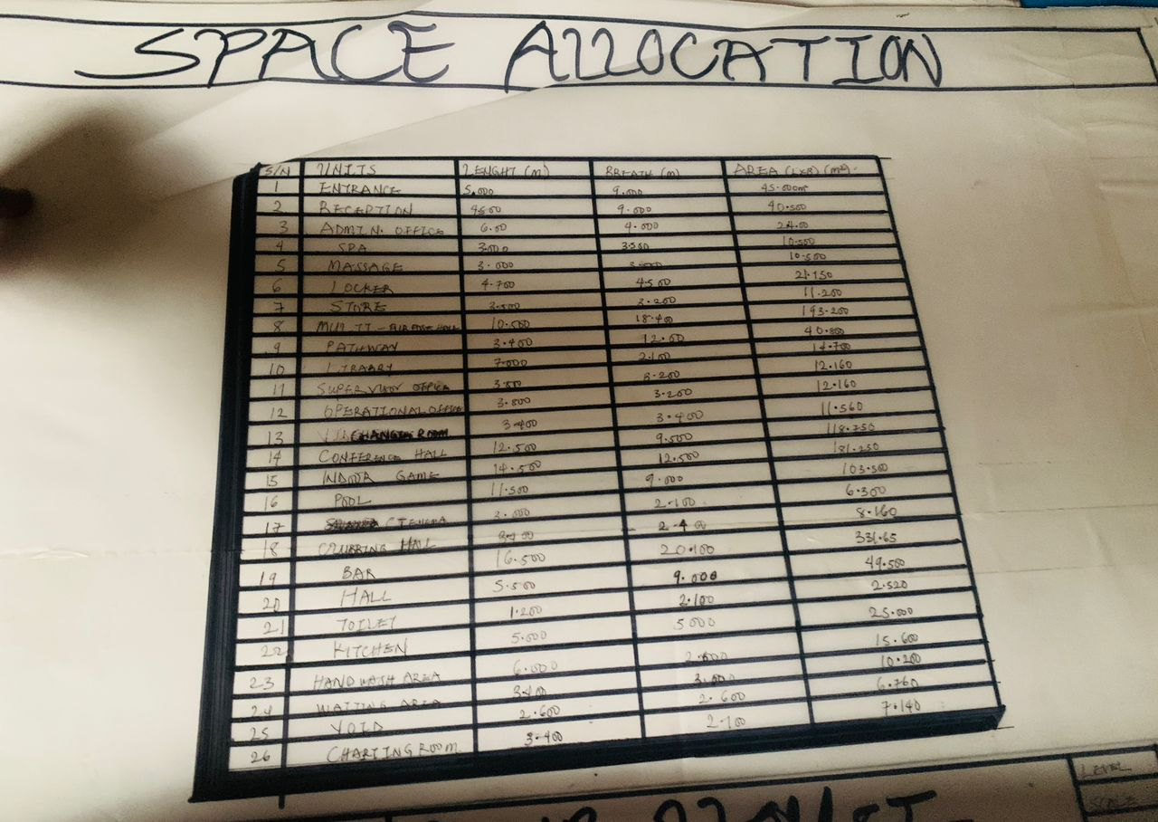
Fig 2.3.11: Showing the space allocation of the proposed site
4.5 Functional Relationship
The functional relationship diagram demonstrates the logical and efficient connection between the various spaces within the clubhouse. Key public areas such as the entrance, reception, bar, pool, and restaurant are centrally located to allow smooth flow and easy access for users. Recreational facilities like indoor games, conference room, and game room are grouped together to minimize distraction and promote usability.
Service areas, including the kitchen, store, and waste management, are positioned strategically to support operations while remaining unobtrusive to guests. Administrative and private zones are separated from noisy recreational spaces to ensure privacy and effective management.
Overall, the layout prioritizes clear circulation paths, optimal adjacency of related spaces, and balanced zoning between public, semi-public, and service areas, enhancing functionality and user experience.

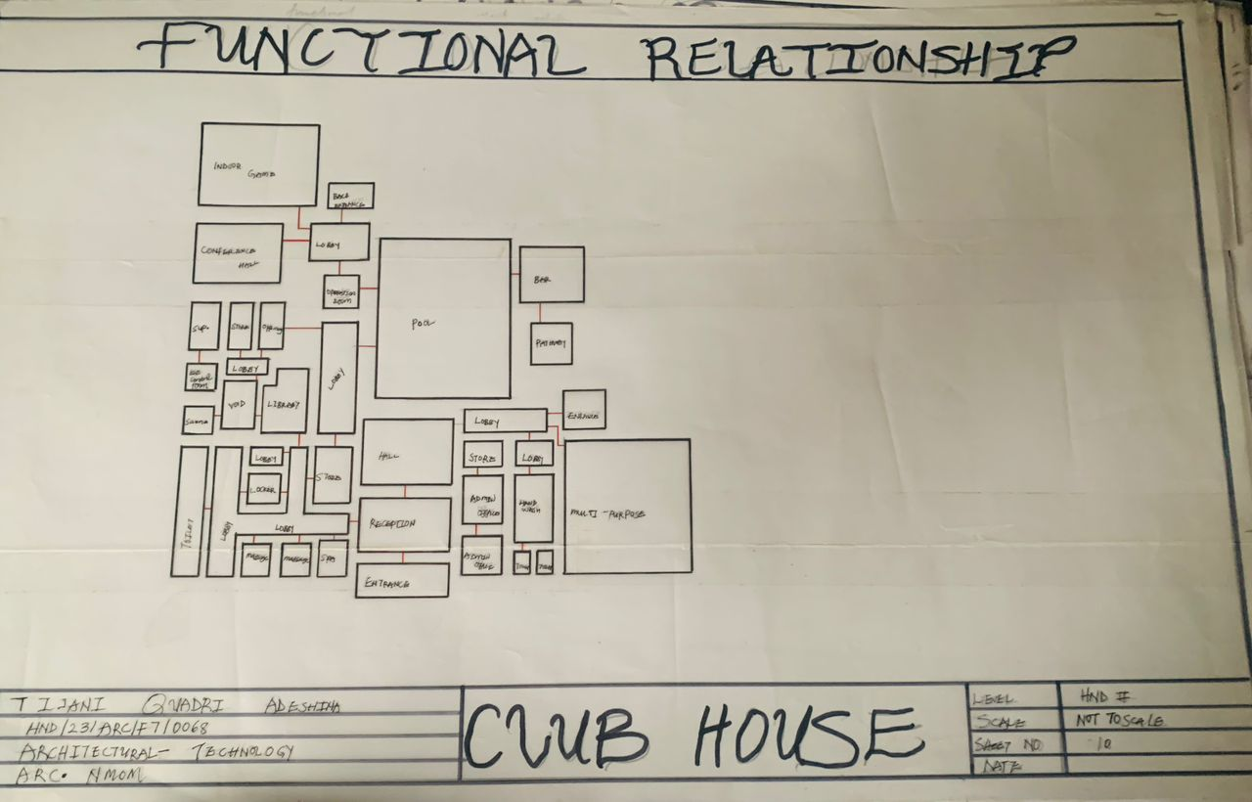
Fig 2.3.12: Showing the functional relationship of the proposed site
4.6 Conceptual Development
The design concept for the clubhouse is organized into three main stages: the first stage, second stage, and the final stage. This phased approach allows for gradual development and expansion of the project.
- First Stage: The initial stage focuses on essential functional areas such as the bar, grill, and entertainment space. These components are designed to create an inviting social atmosphere and accommodate immediate user needs.
- Second Stage: This stage introduces additional facilities and space to support the growing demands of the clubhouse users. It serves as a transitional phase, linking the initial and final stages while enhancing the overall user experience.
- Final Stage: The final stage represents the completion of the design with the construction of the main building, which houses key areas for administration, reception, and larger social gatherings. This stage solidifies the clubhouse's identity as a fully functional and comprehensive facility.
The directional flow indicated by arrows in the concept diagram emphasizes a natural progression through the stages, ensuring seamless integration and circulation between zones. This phased development strategy balances immediate usability with long-term growth, promoting flexibility and sustainability in the overall design.
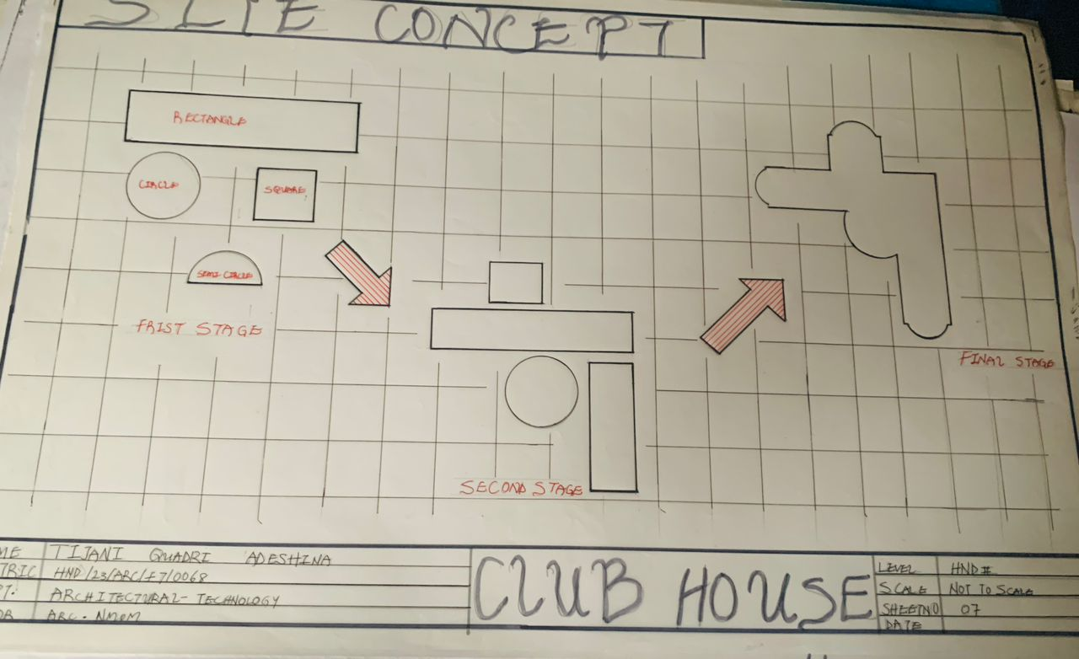
Fig 2.3.13: Showing the concept of the proposed site

CHAPTER FIVE
APPROVAL OF PROPOSAL
This is to certify that the proposal titled
"DESIGN OF A CLUBHOUSE FACILITY FOR IKORODU, LAGOS STATE"
Was prepared and submitted by
Name: Tijani Quadri Adebina
Reg No: HND/237/PreFT/0684
Department: Architectural Technology
Institution: Environmental Studies
Level: HND II
Academic Session: 2024/2025
In partial fulfillment of the requirements for the award of the Higher National Diploma (HND) in Architectural Technology.
This proposal has been read and approved by the undersigned.

Supervisor's Name:
Signature:
Date:

HND's Name:
Signature:
Date:

Construction materials
- Walls: Sandcrete blocks with plaster finish
- Roofing: Sandcrete roofing sheets on timber roof trusses and purlins
- Windows: Powder-coated aluminum windows with glass
- Doors: Flush wood doors for internal spaces and security doors for external doors and service areas
- Flooring: Ceramic tiles and mosaic for internal spaces like security and service areas
- P.V.C. ceiling in offices
Services Integration
The design accommodates:
- Electrical and lighting layouts with emergency provisions
- Mechanical ventilation and plumbing
- Manage systems with stack vents, pits, and waste management
- Water supply from borehole and overhead tanks
Construction Phases
- Site clearing and setting out
- Foundation construction using strip or pad foundations
- Brickwork, framing, and walling
- Roofing and external works
- Finishes and internal installations
- Landscaping and finishing
Safety and Environmental Considerations
- Force drainage and waste disposal system
- Site construction practices and supervision
- Landscaping to reduce heat and improve microclimate
5.1 DESIGN AND CONSTRUCTION
The design and construction of the proposed clubhouse in Ikoyi, Lagos, are guided by principles of functionality, aesthetics, sustainability, and user comfort. The project integrates architectural creativity with practical construction techniques to deliver a well-rounded recreational and community facility.
A. Design Concept
The architectural design is inspired by fluid dynamic forms that encourage interaction and movement. The layout incorporates open, semi-open, and enclosed spaces to accommodate a variety of functions such as leisure, fitness, social events, administration, and support services.
Key design considerations include:
- Clear zoning of activities for efficient space use
- Proper orientation for natural lighting and ventilation
- Easy navigation and flow between spaces
- Aesthetic blend of modern and local architectural elements
B. Structural System
The building adopts a reinforced concrete frame structure, offering strength, durability, and flexibility for open interior spaces. Columns, beams, and slabs form the primary load-bearing system.
C. Construction Materials
Walls: Sandcrete blocks with plaster finish
Roofing: Long span aluminum roofing sheets on lumber or steel trusses
Windows: Powder-coated aluminum sliding or louvered windows
Doors: Flush wooden doors for internal spaces, steel security doors for entry points
Flooring: Ceramic tiles for wet areas and general spaces, concrete finish for service zones
Ceiling: Suspended acoustic ceiling boards in public areas, PVC ceiling in others
D. Services Integration
The design accommodates:
- Electrical and lighting layouts with emergency provisions
- Mechanical ventilation and plumbing
- Drainage systems with soakaway pits and waste management zone
- Water supply from borehole and overhead tanks
E. Construction Phases
- Site clearing and setting out
- Foundation construction using strip or pad foundations
- Structural framing and walling
- Roofing and external works
- Finishes and internal installations
- Landscaping and furnishing
F. Safety and Environmental Considerations
- Proper drainage and waste disposal system
- Safe construction practices and supervision
- Landscaping to reduce heat and improve microclimate
- Use of durable, low-maintenance materials

5.2 GENERAL DESIGN CONSIDERATIONS
The general design of the proposed clubhouse in Ikorodu, Lagos is based on functionality, aesthetics, user comfort, sustainability and safety. These considerations for guidance and structure and service elements of the project are meant both user needs and professional design standards.
A. Functionality and Zoning
Uses are zoned based on public, semi-public, public, and private uses.
Facilities such as the gym, multipurpose hall, lounge, and pool are positioned for easy access and smooth circulation.
Administrative and service areas are placed for operational efficiency and may interference with guest activities.
B. Climate and Environmental Response
Building orientation allows for cross ventilation and natural lighting minimizing energy use.
Overhangs, shading devices, and landscaping reduce solar heat gain.
Green buffers and trees help in controlling microclimate and stormwater runoff.
C. Accessibility and circulation
All paths, lobbies, and entries are wide and accessible to all users, including people with disabilities.
Internal circulation is simple and clear, with visible signage and minimal congestion points.
Parking and drop-off zones are placed for convenience and safety.
D: Aesthetics and Visual Appeal
The architectural form features a blend of curves and symmetry to express elegance and fluidity.
Use of modern materials and finishes ensures a contemporary yet welcoming appearance.
Landscaping complements the built form and enhance the site’s identity.
E. Materials and Maintenance
Materials were selected for durability, affordability, and ease of maintenance in Lagos’ tropical climate. Flooring, wall finishes, and roof coverings are resistant to moisture and wear.
F. Structural and Service Integration
The structural supports flexibility in interior planning with minimal columns in large spaces.
Service ducts and maintenance access are planned without disrupting aesthetics.
Safety systems like fire exits, lighting, and ventilation are included.
G. Sustainability
Provision for water reuse, soakaway systems, and proper waste disposal.
Use of locally sourced materials to reduce environmental impact and support local economy.
Low energy lighting and ventilation systems planned where possible.
5.3 Construction methods
Foundation
- Soil foundation is used due to the matching tasks
- Reinforced concrete footings ensure strength and load distribution
- Damp proof membrane and termite treatment are applied
Walls
- 225 mm thick sandcrete block walls are used for external walls
- 150 mm block are used for internal and external partition walls
Flooring
- Reinforced concrete slab cast in-situ
- Ceramic tiles for lobby, lounge, and restroom and halls
Roofing
- Timber/steel trusses depending on span requirement
- Long span aluminum roofing sheet for weather durability
- Insulation layers to reduce internal heat
5.4 LANDSCAPE DESIGN
The landscape design of the proposed clubhouse in Ikorodu complements the architectural layout by enhancing environmental quality, user comfort, and site aesthetics. It blends natural and built elements to create a relaxing and functional outdoor environment.
A. Design Objectives
1. To provide shaded, serene, and inviting outdoor areas
2. To improve microclimate through tree planting and greenery
3. To guide circulation and define walkways and visual cues
4. To soften hardscape areas like driveways and parking
B. Key Landscape Elements
- Green area
- Lawns and green fronts around the clubhouse for aesthetics and relaxation
- Native trees (e.g. palms, shade trees) for shade and sun control
- Shrubs and flower beds near paths and building edge
C. Walkways and Paths
1. Paved footpaths linking the gate, relaxation area, cafeteria, and main building
2. Interlocking tiles used for durability and easy maintenance
3. Curve paths to follow natural site flow and create a pleasant walking experience

D. Relaxation Zone
- Open sitting area with benches under tree canopies
- Pergolas or shaded outdoor lounges to serve as social spots
- Positioned away from vehicle path to minimize disturbance
5. Parking and Buffer Planting
i. Tree and hedge around parking bays to reduce heat and dust
ii. Visual screening between service area and public zones
6. Lighting and Furniture
- Garden lights for night use and safety
- Outdoor seating and bins placed strategically
C. Environmental Benefits
i. Improved air quality and reduction in heat island effect
ii. Rainwater absorption and reduced surface runoff
iii. Biodiversity support by using native plants
5.5 LANDSCAPE ELEMENT USED IN THE DESIGN
The landscape design of the proposed clubhouse project enhances both functionality and aesthetics while supporting sustainability and user comfort. Key landscape elements used in the site include:
Vegetation and Green Areas:
(e.g. planted trees and shade trees)
Planted to provide shade, improve microclimate, and enhance visual appeal.
Grassed and planted areas soften the hardscape and provide contrast to reflection from paved surfaces.

Walkways and Foot Paths:
Well-laid pedestrian paths ensure safe and easy circulation throughout the site, connecting major functional units such as gym house, guest house, cafeteria, and main building.
Open Recreational Space:
Relaxation zones and open green courts are provided for informal gatherings, social interaction and outdoor activities.
Parking and Access Roads:
Landscaped buffer around parking areas improve the aesthetics and manage vehicular movement effectively.
Waste Management Zone:
A designated waste collection and soakaway area is landscaped to minimize environmental impact and visual disturbance.
Fencing and Boundary Planting:
Natural and softscape elements are used along boundaries for privacy, security and noise reduction.
5.6 General Conclusion and Recommendation
In conclusion, the design and development of the proposed clubhouse facility aim to provide a multi-functional space that supports active, recreational, and enhanced community use.
Architectural planning of the project integrates thoughtful components such as site layout, zoning zones, functional facilities, and guest accommodation. It emphasizes aesthetics, functionality, and sustainability.
Key site elements such as proper zoning, vehicular and pedestrian circulation, landscaping, and environmental responsiveness were carefully considered to enhance user experience and support community interaction. The incorporation of passive design strategies, appropriate materials, and DQL layouts further strengthen the overall design approach.
Recommendations
Sustainability: Incorporate more green building strategies such as solar lighting, rainwater harvesting, and eco-friendly materials.
Maintenance: Develop a comprehensive maintenance plan to preserve building integrity and landscape quality.
Flexibility: Ensure interior spaces are adaptable for multiple uses to cater to evolving community needs.
Security and Safety: Maintain good site lighting, safety features, and security infrastructure throughout the facility.

References
Aqua group (1984). Fire and Building, Granada Publishing, Great Britain.
Beryl Menzies (1999); Metric handbook planning and design data, second edition, edited by David Adler, Architectural press. Linacre House, Jordan Hill, Oxford OX2 8DP.
Brembeck, C.S, (1971); Social foundation of education: environmental factors in teaching and learning. London: John: Herper and Roy publishers
Christianity Today magazine, March edition, 2004.
Coburn, Oliver (1950). Youth Hostel Story. London: National Council of Social Service.
Daily Independent, 26 August 2010.
Daily Sun (2006). It was Like Armageddon. Daily Sun, Thursday, March 23.
David N. Bilow, Mahmoud E. Kamara (2008); Fire and Concrete Structures.
David V. Chadderton, Building Service Engineering, fifth edition (2007), Taylor & Francis, 2 Park Square, Milton Park, Abingdon, Oxon OX14 4RN.
Ernst and Peter Neufert (1993); Architects’ data, third edition, Blackwell science publishers.
FEMA - Federal Emergency Management Agency, 1999, Fire in the United States 1987-1996, 11th Edition, US Fire Administration, Federal Emergency Management Agency, Maryland, 21727
Fred Malven (1997); Time savers standards, for architectural design standards, seventh edition, McGraw-Hill, Inc.
Ger Herbert (1999), Fire safety in hostels. McGraw-Hill, Inc.
Hassan, H (1999); Fire and safety management in Building. National University commission produces guide and physical developmental material for the University system in Nigeria (2004); Third edition.
James Patterson, (1993); Simplified design for building fire safety. John Wiley and sons Inc.
Neal, Tim; Neal, Simon (1993). Youth Hostels of England and Wales 1931-1993. St Albans: YHA. ISBN 0952225409.
Nikolas Davies, Erkki Jokiniemi (2008); Dictionary of Architecture and building construction, first edition; Architectural press. Linacre House, Jordan Hill, Oxford OX2 8DP.
Odeleye A. (1985); Fire protection in buildings. Nigerian Institute of Architects Journal; edited by Aku Omokhodion.
Perkin & Will (2001); Time savers standards, Building types, fourth edition, McGraw-Hill, Inc.
Schmerts H.T. (1972); Institutional Housing Strategies Educational and Realisation. London: Patrick Wakely.
Schneider, T., & Till, J. (2007). Flexible Housing. Oxford, United Kingdom: Architectural Press.

APPENDIX
