A PROJECT REPORT
ON
PROPOSED OFFICE BUILDING COMPLEX
BY
HAMEED SHAMSUDEEN ENIOLA
HND/23/ARC/FT/0004
SUBMITTED TO:
DEPARTMENTAL OF ARCHITECTURAL TECHNOLOGY,
INSTITUTE OF ENVIRONMENTAL STUDIES KWARA STATE POLYTECHNIC,ILORIN.

IN PARTIAL FULFILLMENT OF THE REQUIREMENTS FOR THE AWARD OF HIGHER NATIONAL DIPLOMA (HND) IN ARCHITECTURAL KWARA STATE POLYTECHNIC, ILORIN, KWARA STATE.

JULY 2025.

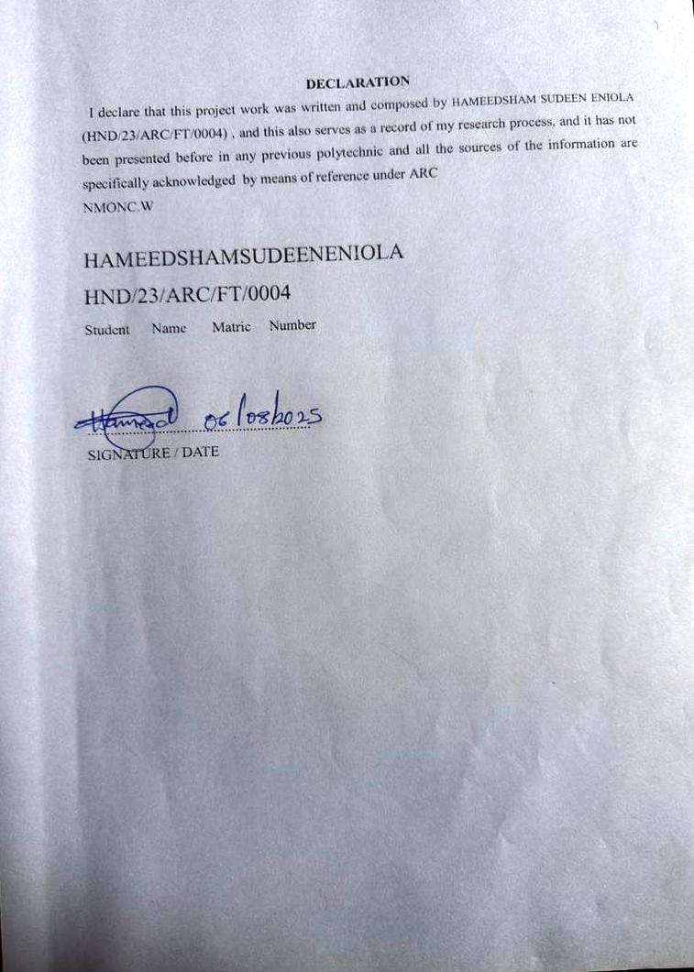

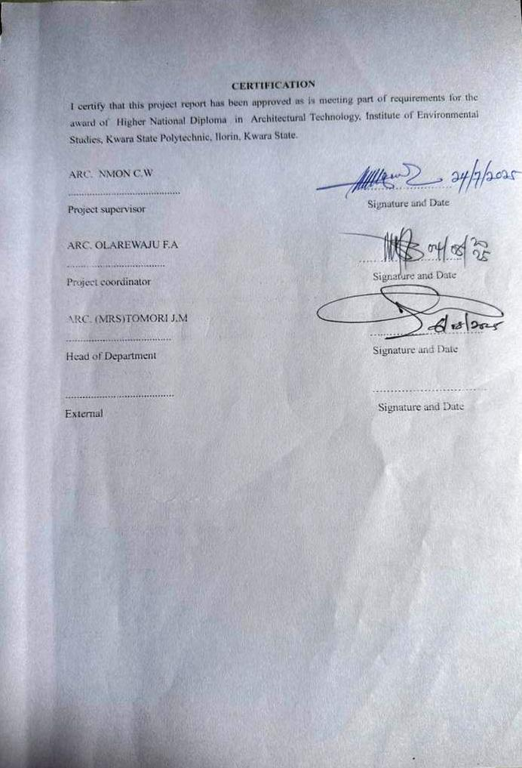
DEDICATION
I dedicate this project to Almighty Allah,The most beneficent and the most merciful, myparents Mr & Mrs Hameed,my sister Ajuwonsekinat,my family members, Dada Aishatomobolanle and a brother from another mother AdeogunMojeeb for there prays and support that makes the journey easy .

ACKNOWLEDGEMENT
Everything that has starting will surely have an end ,therefore all praise to the Almighty Allah the most Merciful and sufficient for strength and courage that he has added me in the process of my project.
A special thanks to my project supervisor ARC.NMONC.W for taking is time to go through my project research work,may Almighty Allah continue to bless you abundantly ( AMEEN).
- My appreciation to my lovely parent Mr&MrsHameed,Ajuwonsekinat,ChiefOlaofe ,Hameed Hameed, and my class Rep Usman zubair for there prayer and supports.
- And all Hameed family for their moral and financial support towards my education program.

ABSTRACT
This office building complex project encompasses the design, development, and construction of a cutting-edge facility, tailored to meet the evolving needs of modern businesses and professionals. Strategically located in [Epe express road etiosalagos], the complex will feature premium office spaces, state-of-the-art amenities, and innovative technologies, fostering a productive and collaborative work environment. With a focus on sustainability, energy efficiency, and occupant well-being, the complex aims to enhance the quality of life for its tenants while contributing to the economic growth and urban development of the surrounding area. Through its modern design, advanced infrastructure, and commitment to excellence, this office building complex will establish itself as a landmark destination for businesses, entrepreneurs, and innovators.

TABLE OF CONTENT
TITTLE PAGE ...........................................................I
DECLARATION.....................................ii
CERTIFICATION..................................iii
ACKNOWLEDGEMENT.............................iv
DEDICATION........................................v
LIST OF TABLE....................................vi
LIST OF FIGURES...............................vii
LIST OF PLATES...............................viii
ABSTRACT..........................................ix

CHAPTER ONE
1.0 INTRODUCTION.............................................1
1.1 HISTORICAL BACKGROUND...............................................1
1.2 DEFINITION..................................2
1.3 AIM AND OBJECTIVES ..............................2
1.4 SCOPE OF STUDY...............................................
1.5STATEMENTOFPROBLEM.............................................3
1.6RESEARCH METHODOLOGY................................................
1.7 LIMITATIONS AND CONSTRAINTS.......................................
1.8 JUSTIFICATION.................................

CHAPTER TWO
2.0 LITERATURE REVIEW AND CASE STUDY................................................
2.1 REVIEW OF RELEVANT LITERATURE
2.2IMPORTANCE......................................
2.3 SELECTED CASE STUDY ...........................................
2.3.1 CASE STUDY ONE.........................
2.3.2 CASESTUDYTWO ..........................
2.3.3 CASE STUDY THREE......................
2.3.4 ONLINE CASE STUDY 1 ...........................
2.3.5 ONLINE CASE STUDY 2…………………..
2.3.6 CONCLUSION……………………….
CHAPTER THREE
3.0 SITE AND ENVIRONMENTAL ANALYSIS..............................................
3.1 BRIEFHISTORY................................
3.2 SITE LOCATION ..................................................
3.3 SITE SELECTION/LOCATION CRITERIA...............................................
3.4 SITE ANALYSIS/ SITE INVENTORY...........................................
3.5 CLIMATIC DATA / GEOGRAPHICAL CONSIDERATION...................................................
3.6 CONCLUSION .................................................
CHAPTER FOUR
4.0 DESIGN CRITERIA....................................
4.1 SITE PLANNING .................................................
4.2 BRIEF ANALYSIS........................................
4.3 ANALYSIS OF THE SCOPE..................................................
4.4 SPACE ALLOCATION ...........................
4.5 FUNCTIONAL RELATIONSHIP.......................................
4.6 CONCEPTUAL DEVELOPMENT................................................

CHAPTER FIVE
5.0APPROVAL OF PROPOSED SCHEME.....................................
5.1 DESIGN AND CONSTRUCTION...................................
5.2 GENERAL DESIGN CONSIDERATION...................................
5.3 CONSTRUCTION METHOD AND MATERIAL.......................................
5.3.1 LANDSCAPE DESIGN.....................................
5.3.2 LANDSCAPE ELEMENT USED INTHECONSTRUCTION..........................
5.4GENERAL CONCLUSION AND RECOMMENDATION..............................

APPENDEX
LIST OF TABLE
Table 1: shown the classification and categories
i.e Space allocation……………………………..

LIST OF FIGURES
Figure 1: showing the locational plan of case study one…………………….
Figure 2: showing the proposed plan of case study one…………………….
Figure 3: showing the locational plan of case study two…………………..
Figure 4: showing the proposed plan of case study two…………………..
Figure 5: showing the locational plan case study three………………….
Figure 6: showing the proposed plan case study three………………….

LIST OF PLATES
Plate 1: showing the front elevation of the case study one
Plate 2: showing the sides elevation of the case study one
Plate3: showing the front elevation of the case study two
Plate 4: showing the sides elevation of the case study two
Plate 5: showing the front elevation of the case study three
Plate 6: showing the sides elevation of the case study three

